PANDEMIC PREPAREDNESS PLAN
AMBALAPPUZHA NORTH GRAMA PANCHAYAT
Dr Arun Alphonse
phcambalappuzhanorth@gmail.com

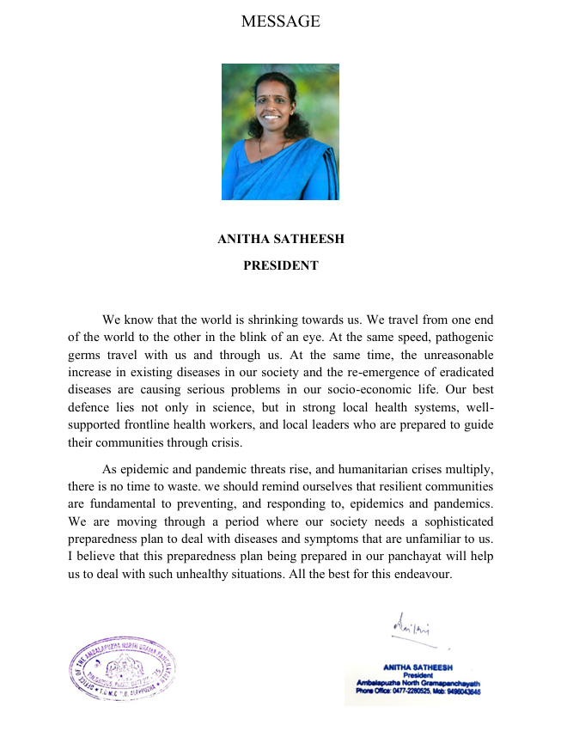



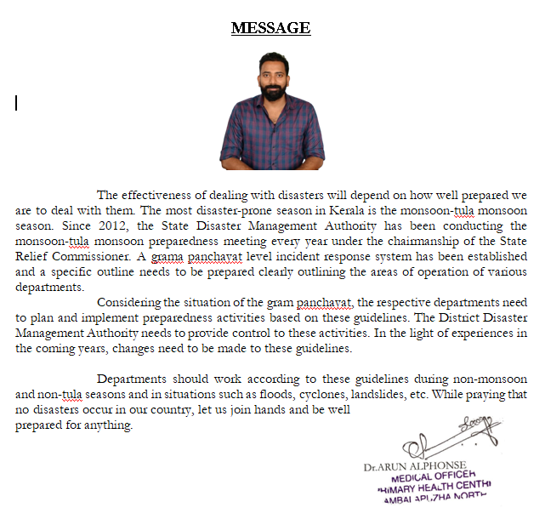
Dr.Arun Alphonse
phcambalappuzhanorth@gmail.com

EXECUTIVE SUMMARY
Ambalappuzha North Primary Health Centre (PHC) functions as the primary public healthcare institution serving the population of Ambalappuzha North Grama Panchayath. The PHC plays a pivotal role in delivering comprehensive, accessible, and affordable healthcare services, with a strong focus on preventive, promotive, curative, and rehabilitative care in accordance with national and state health programmes.
The PHC caters to a predominantly rural population, addressing key public health priorities such as maternal and child health, communicable and non-communicable disease control, immunization, family welfare, adolescent health, and geriatric care. Regular outpatient services, home-based care through field health staff, and outreach activities ensure healthcare coverage even in geographically challenging areas. The institution actively implements national health missions, including the National Health Mission (NHM), National Tuberculosis Elimination Programme, National Programme for Prevention and Control of Cancer, Diabetes, Cardiovascular Diseases and Stroke (NPCDCS), and other disease surveillance initiatives.
Ambalappuzha North PHC works in close coordination with the Grama Panchayath, ASHA workers, Anganwadi centres, schools, and community-based organizations to strengthen community participation and improve health awareness. Emphasis is placed on early detection, timely referral, health education, and lifestyle modification to reduce disease burden and improve overall health outcomes.
Despite constraints related to infrastructure, manpower, and increasing service demand, the PHC continues to enhance service delivery through effective planning, data-driven decision-making, and community engagement. Strengthening facilities, upgrading digital health systems, and expanding preventive services remain key focus areas for future development.
Overall, Ambalappuzha North Primary Health Centre stands as a vital institution in safeguarding public health and improving the quality of life of the residents of Ambalappuzha North Grama Panchayath.

LIST OF ABBREVIATIONS

LSGD/LSGI | Local Self Government Department / Local Self Government Institution
BMO | Block Medical Officer
IDSP | Integrated Disease Surveillance Programme
PHC | Primary Health Centre
NHM | National Health Mission
NDMA | National Disaster Management Authority
PPE | Personal Protective Equipment
ICMR | Indian Council of Medical Research
CD | Communicable Diseases
NCD | NON-COMMUNICABLE Diseases
NPCDCS | National Programme for Prevention and Control of Cancer, Diabetes, Cardiovascular Diseases and Stroke
ASHA | Accredited Social Health Activist
MO | Medical Officer
HS | Health Supervisor
HI | Health Inspector
PHNS | Public Health Nursing Supervisor
PHN | Public Health Nurse
JHI | Junior Health Inspector
JPHN | Junior Public Health Nurse
MLSP | Mid Level Service Provider
SSU | State Surveillance Unit
DSU | District Surveillance Unit
KMSCL | Kerala Medical Service Corporation Ltd.
AYUSH | Ayurveda, Yoga& Naturopathy, Unani, Siddha& Homoeopathy

TABLE OF CONTENTS

INTRODUCTION 11
Background of the PPP 11
LSGD at a glance 11
LSGD AT A GLANCE 12
Risk stratification among wards in the context of Communicable diseases and hazards 16
Major Roads 17
Rivers 17
Occupational groups, socio cultural groups, migration & mobility patterns 17
Vulnerability mapping 17
❖ Lepto vulnerable- 434 17
Disaster prone areas (geographic vulnerability) 18
INTEGRATED HEALTH INFRASTRUCTURE MAP OF AMBALAPUZHA NORTH PANCHAYAT 18
MAJOR ESTABLISHMENTS MAP OF AMBALAPUZHA NORTH PANCHAYAT 19
DISASTER PRONE AREA MAP OF AMBALAPUZHA NORTH PANCHAYAT 20
CD HOT SPOT MAP OF AMBALAPUZHA NORTH PANCHAYAT 21
GENERAL PROFILE OF THE LSGI’S 22
Background of the LSGI 22
Demographic and Vulnerable Population 24
Clinical Vulnerability 25
INFRASTRUCTURE & RESOURCE INVENTORY 28
Health Facility Directory & Basic Capacity in the LSGD 28
Private Clinics 29
Healthcare Education & Training Institutions 31
Specialized Services & Emergency Inventory 32
Oxygen & Diagnostic Capacity 33
Diagnostics facility mapping at the LSGI level 34
Laboratory Identification & Basic Details 34
Social and Community Infrastructure for surge plan 36
Human resources 38
Community & Support Cadre 40
Community Organizations 41
Administrative & Emergency Services 42
Information regarding resources 42
ONE HEALTH & ENVIRONMENTAL SURVEILLANCE 43
Animal & Bird Population 43
Veterinary Infrastructure 45
Veterinary Doctors & Workforce 46
High-Risk Interface Points (Surveillance Sites) 46
Environmental Risk Mapping 48
Disease Seasonality Mapping 49
Vulnerability Mapping 50
EPIDEMIOLOGICAL TRENDS (2021–2025) 52
Disease Burden among human beings(Last 5 Years) 52
Hepatitis A Risk Stratification (Ward-wise) 64
Interpretation 65
Outcome-Based Trend Analysis- 2025 65
Integrated Disease Hotspot Map 68
Integrated Disease Hotspot Map 2021 68
Preparedness and Response Protocol at LSG Level 75
Constitution of One Health Committee 75
Pandemic Response Workforce 77
Activities and Measures before and during Pandemic 78
PHASE 1 - Alert / Preparation 78
PHASE 2 - Active Response 81
Standard Screening Protocol 83
PHASE 3 - Surge Capacity 94
Conversion of Community Facilities 94
CONCLUSION 98
RECOMMENDATIONS 98
MOCK DRILL PLAN 100
Communicable Disease Outbreak Response 100
Objectives of the Mock Drill 100
Scenario for Mock Drill (Example) 100
Departments Involved 100
Steps in Mock Drill Execution 101
Logistics Required 102
Observation & Evaluation Checklist 102
Expected Outcomes 102
ANNEXURE 103
1. IMPORTANT PHONE NUMBERS 103

INTRODUCTION

Background of the PPP
Pandemics are epidemics when it occurs worldwide, crossing international borders and affecting a large number of people. They are some of the biggest threats to global health security. We are facing a situation of unreasonable increase of certain diseases, re-emergence of eradicated disease, occurrence of new diseases like Nipah, Zika, Ebola etc. At the same time natural calamities like tsunami, flood etc. occur accidentally. The frontline health workers face lots of difficulties to tackle the situation. Lack of availability of manpower, vehicle, equipment etc. is a hindrance in such situations. A well developed pandemic preparedness plan is necessary for facing all these situations. Simultaneously effective training to the front line workers is also necessary for the effective adoption of the plan. Through this PPP we are trying to design a skilled plan and act according to this.

LSGD at a glance
Family Health Centre, Ambalapuzha North lies between the parallel of 9.4030° north Latitude and 76.3724° east longitude and is situated in Kanjippadam, the South-East extremity of Ambalapuzha North panchayath. It is on the banks of Pookkaitha River, a tributary of Pamba River. Ambalapuzha North Grama Panchayat is a local governing body in the Ambalapuzha Block Panchayath of Alappuzha district. It falls under the Ambalapuzha Taluk and is known for its areas like Vandanam and Kanjippadam. The former place is known for the famous medical college and the latter for its back water areas. The distance between FHC and LSGI is 6 km. The East side of the panchayat is Nedumudy panchayat and the West is the Arabian Sea. The North side is Punnapra South panchayat and the south belongs to Ambalapuzha South. The NH 66 divides the panchayat into eastern and western parts. The western part belongs to the coastal area and the eastern part belongs to the low lying land.
The people in the western part are afraid of tidal attacks whereas the people of the eastern part are afraid of floods and difficulties due to water stagnation. In 2004, the Tsunami affected the coastal area and the floods of 2018& 2019 caused heavy damage in the area. The majority of the area was affected with flood water. The eastern side has beautiful paddy fields along with marshy lands. Migratory birds can also be seen here. These areas are a hot spot of leptospirosis, H5N1. Lots of farmers and cattle rearers are living here. All these people are at risk of leptospirosis. One poultry farm is also working in this area every year and due to the H5N1 attack lots of bird deaths occur here. This year also there was bird death and confirmed H5N1.
Availability of potable water is another menace in this area. The water distribution pipes are broken in different areas. The water contains elevated levels of fluoride in it. Majority of the people rely on RO plant water for drinking purposes. Usage of manure and pesticides in paddy fields cause the presence of harmful chemicals in inland water. House boats in the inland back water cause the pollution of inland back water. A moving AYUSH clinic is also working here for the help of unreachable persons living on the bank of river and canals.

LSGD AT A GLANCE
Geographical boundaries with political map ( based on latest delimitation)

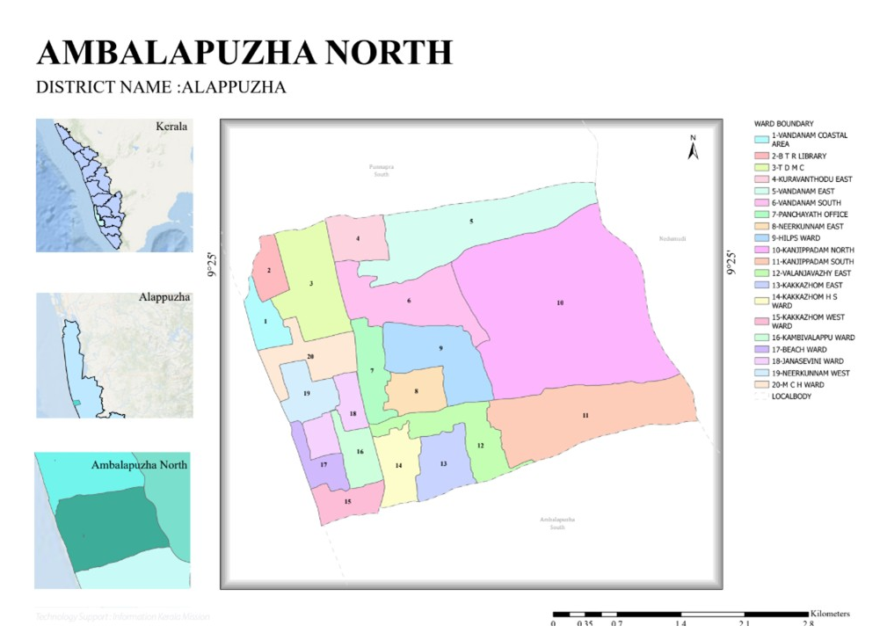

Baseline data
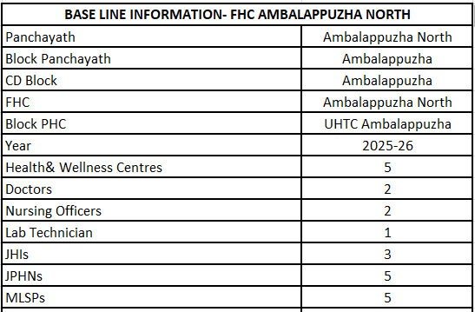
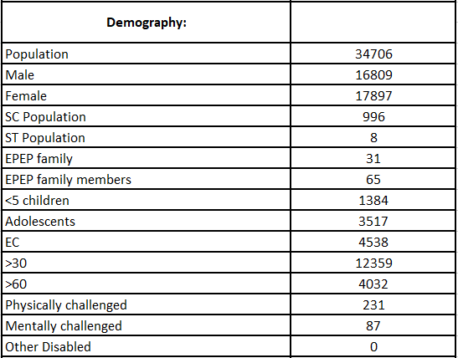

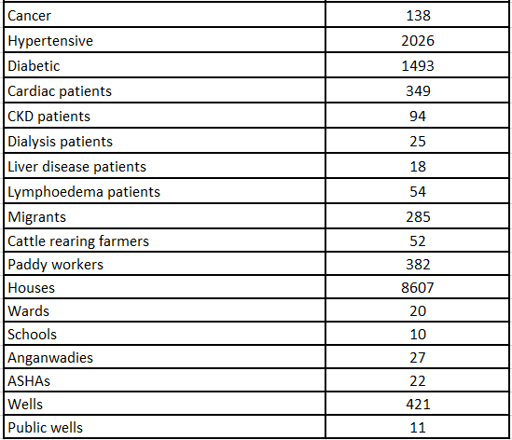

Ward division
Ward | Houses | Population | Migrants | Wells | Hot  spots | Ed. Institutions | Hosp pvt/govt.
1 | 476 | 1723 | 8 | 20 | mosquito borne diseases | - | -
2 | 481 | 1682 | 8 | 22 | mosquito borne diseases | - | -
3 | 461 | 1703 | 9 | 19 | Dengue | 2 | G-1  P-1
4 | 448 | 1754 | 0 | 25 | - | - | -
5 | 383 | 1821 | 0 | 18 | lepto  H5N1 | - | P-1
6 | 364 | 1884 | 0 | 19 | lepto  H5N1
Ward | Houses | Population | Migrants | Wells | Hot  spots | Ed. Institutions | Hosp pvt/govt.
7 | 378 | 1608 | 0 | 23 |  |  | G-1
8 | 422 | 1623 | 25 | 27
9 | 453 | 1647 | 0 | 19 | Dengue  lepto | 1
10 | 438 | 1719 | 0 | 20 | lepto  H5N1 | 1
11 | 436 | 1852 | 0 | 23 | lepto  H5N1 |  | G-1
12 | 424 | 1604 | 70 | 21 | lepto  H5N1 |  | P-2
13 | 414 | 1738 | 25 | 22
14 | 417 | 1607 |  | 18 |  | 2
15 | 432 | 1722 | 40 | 19 | mosquito borne diseases | 1
16 | 438 | 1677 | 45 | 23
17 | 431 | 1671 | 49 | 15 | mosquito borne diseases
18 | 434 | 1893 | 6 | 28 |  | 1
19 | 418 | 1882 | 0 | 26 | mosquito borne diseases | 1
20 | 459 | 1896 | 0 | 14 | Dengue | 1
 | 8607 | 34706 | 285 | 421

Risk stratification among wards in the context of Communicable diseases and hazards
- Presence of Scrap shops in ward 1,2&3 is a risk of Dengue
- Presence of Medical College and Scrap shops in ward 20 is a risk of Dengue
- Presence of stagnant water in the low lying land and presence of paddy field in wards 5,6,9,10,11 & 12 enhances the risk of leptospirosis.
- Presence of migratory birds in paddy field in wards 5,6,9,10,11& 12 enhances the risk of H5N1
- Water stagnation in idle boats in the coastal area in wards 1,2,15,17,19& 20 causes the chance of .VBD like malaria, JE.

Major Roads
- NH66
- Valanjavazhy- Champakulam road
- Kanjippadam- Ambalapuzha Temple road

Rivers
- Pookkaitha river (tributary of Pamba river)
- Kakkazham- Kanjippadam Canal
- Kappithodu
Major establishments
- Family Health Centre
- Government Medical College
- Government Dental College
- Government Nursing College
- Government Paramedical College
- Government Higher Secondary School
- Panchayat Office
- Village Office
- AYUSH Dispensary
- Government Veterinary Dispensary

Occupational groups, socio cultural groups, migration & mobility patterns
- Farmers
- Cattle rearing
- Fishermen
- MNREG workers
- Manual labourers
- Migrant labourers
- Prawn peeling labourers

Vulnerability mapping

Lepto vulnerable- 434
- Differently abled- 318
- >60 Years- 4032

Disaster prone areas (geographic vulnerability)
- Wards 1,2,16,17,19& 20- Coastal areas
- Wards- 5,6,10,11,12- Flood prone areas

INTEGRATED HEALTH INFRASTRUCTURE MAP OF AMBALAPUZHA NORTH PANCHAYAT

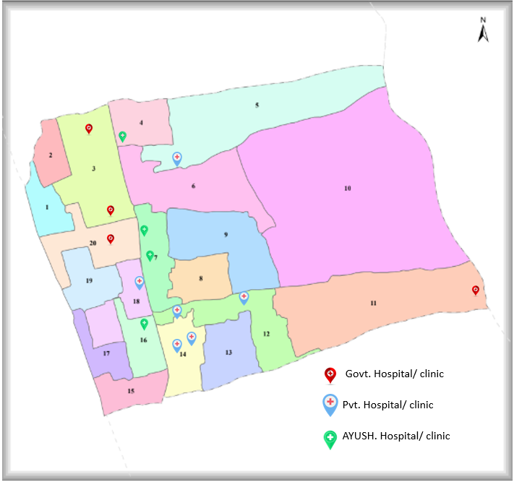

MAJOR ESTABLISHMENTS MAP OF AMBALAPUZHA NORTH PANCHAYAT

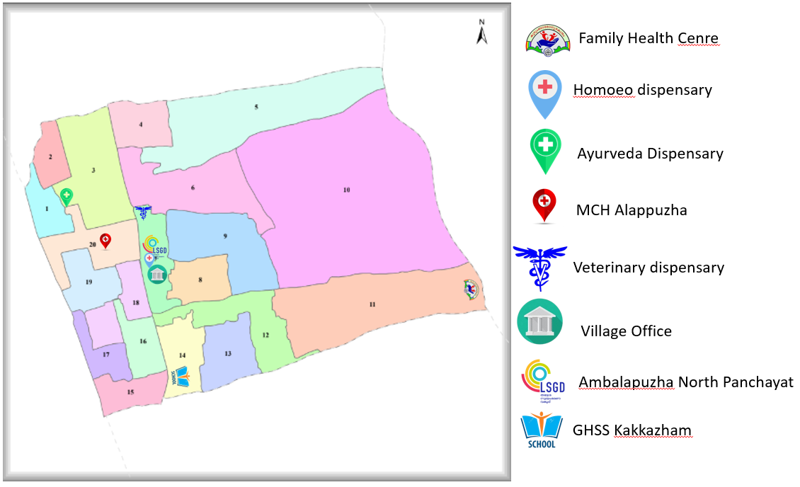

DISASTER PRONE AREA MAP OF AMBALAPUZHA NORTH PANCHAYAT

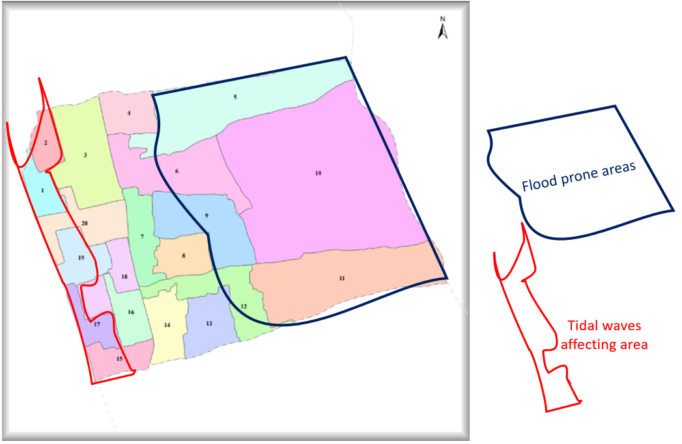

COMMUNICABLE DISEASES HOT SPOT MAP OF AMBALAPUZHA NORTH PANCHAYAT

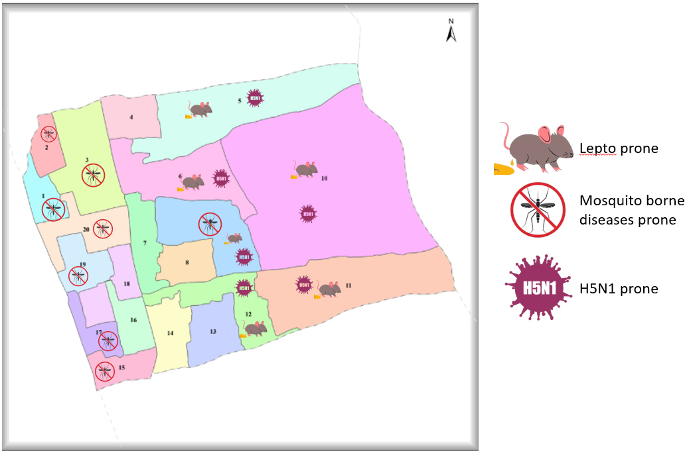

GENERAL PROFILE OF THE LSGI’S

Background of the LSGI
Ambalapuzha North Grama Panchayat is situated in the middle part of Alappuzha district, Kerala. The geographical landscape of the Panchayat is predominantly low-lying, characterized by extensive paddy fields (Kole lands) and a dense network of rivers, canals, and backwaters. This unique terrain plays a significant role in shaping the local microclimate and poses distinct challenges to transportation, emergency response, and service delivery, particularly during monsoon seasons and flood events.
The Panchayat is administratively divided into multiple wards, with a population largely dependent on traditional livelihoods. Agriculture—especially paddy cultivation—fishing, coir and coconut husk processing, and allied activities form the backbone of the local economy. In recent years, tourism-related activities and service-sector employment have also shown gradual growth. The area hosts a diverse workforce, including a notable presence of migrant labourers, particularly in construction, agriculture, and allied sectors.
From a public health and disaster management perspective, Ambalapuzha North LSGI has historically been vulnerable to seasonal flooding, waterborne diseases, and vector-borne illnesses such as Dengue and Leptospirosis. The severe floods experienced during recent years, including the 2018 flood disaster, significantly impacted life, livelihoods, and infrastructure within the Panchayat. These recurring emergencies have underscored the importance of strengthening local preparedness, response mechanisms, and inter-departmental coordination.
In this context, the development of a localized, data-driven Auxiliary Infrastructure and Logistical Resource Map is essential to support effective planning, timely emergency response, and sustainable development initiatives. Such mapping enables the Panchayat to identify critical resources, improve accessibility during disasters, and enhance overall resilience of the community.
Table 1: Background of LSGD
Description | Details
Name of LSGI | Ambalapuzha North
Type (GP/Municipality / Corporation etc.) | Grama Panchayath
Block | Ambalapuzha
District | Alappuzha
Number of wards | 20
Total area (sq. km) | 10.88
Population(Projected) | 34706
Population density | 3190 persons/sq km
Terrain (coastal/low-lying/backwaters/foothills, etc.) | coastal, low-lying& back water
Number of rivers passing through LSGI | 1
Number of water bodies in the LSGI | 11
Number of educational institutions | 16
Factories / small-scale industries | 5
Flood-prone wards | 6
Landslide-prone wards | 0
Death Management and Disposal Facilities (mortuaries/crematorium, including electric) | 1
Auditoriums/Marriage halls/convention centres/community halls | 3

Demographic and Vulnerable Population
Understanding the demographic composition and vulnerable population groups is essential for pandemic preparedness. Children, elderly, economically deprived families, migrant workers, and socially vulnerable groups are at increased risk during public health emergencies due to higher exposure, limited access to services, and dependency on public systems..

Description |  | Details (in numbers)
DEMOGRAPHIC PROFILE
Total population |  | 34706
Male |  | 16809
Female |  | 17897
Transgender |  | 0
Children under 5 |  | 1384
Adolescent |  | 3517
Elderly (>60) |  | 4032
SOCIAL/LIVELIHOOD VULNERABILITY
Previous EPEP family |  | 41
BPL family |  | 3547
Tribal communities |  | 8
Migration | Immigrant | 289
Migration | Emigrant | 106
Socio-economically deprived |  | 3
Fisherfolk |  | 1316
SC Community |  | 996
ST Community |  | 8

Clinical Vulnerability
Certain population groups need priority healthcare & are at higher risk of severe illness, complications, and mortality during pandemics. Patients with chronic diseases, those requiring regular medical care, and individuals with mobility or functional limitations face challenges in accessing timely care during emergencies. Mapping these groups helps in prioritizing continuity of treatment, medicine stock planning, oxygen support, referral transport, and targeted home-based care.
Description | Details (in numbers)
Pregnant women | 268
Lactating mothers | 116
Bedbound patients | 158
Patients under palliative care other than bedbound | 321
Patients on Haemodialysis | 25
Patients on CAPD | 349
Cancer patients (currently on treatment) | 138
Haemophilic patients | 0
Mentally challenged | 87
Differently abled | 231
Diabetic patients | 1493
Hypertensive patients | 2026
TB patients | 5

Major Festivals & Events specific to the LSGI

Sl. No. | Name of festival | Month detailing the periodicity
1 | Festival at Thalithara Temple, Neerkunnam | March
2 | Al-Huda Mosque, Neerkunnam | February- May
3 | Festival at Melepandaram Temple, Neerkunnam | March
4 | Festival at Anavelil Temple, Kopparakadavu | April
5 | Festival at Koottuvelil Temple. Koottuveli | April
6 | Festival at Vattapayithara Temple, Vattapayithara | April
7 | Festival at Cheruvallithara Temple, Kanjippadam | January
8 | Feast at Vyakulamatha Church, Kanjippadam | September
9 | Festival at Raktheswari Temple, Vandanam West | April
10 | Festival at Sree Balamuruka Temple, Vandanam | January
11 | Festival at Sree Dharmasastha Temple, Vandanam | January
12 | Festival at Sree Khantakarana Temple, Neerkunnam W | January- February
13 | Festival at Iruathirandil Thykavu Mosque, Kakkazham E | February- May
14 | Festival at Anjilippuram Thykavu Mosque, Valanjavazhy E | February- May
15 | Festival at Huda Mazjid, SN Kavala East | February- May
16 | Festival at Thachutharayil Temple, Chalady | December
17 | Festival at Pattassery Vinayaka Temple, Kuravanthodu E | August
18 | Festival at Kuthirakulam Mosque, Vandanam E | February- May

INFRASTRUCTURE & RESOURCE INVENTORY

Health Facility Directory & Basic Capacity in the LSGD
This section provides an overview of the healthcare infrastructure available within the LSGD area. It outlines the distribution and basic capacity of health facilities that form the backbone of service delivery during routine times and public health emergencies.

Family Health Centres (FHCs) and Community Health Centres (CHCs) generally function as the first point of contact for the community, providing essential outpatient and inpatient services. General Hospitals (GH) and Medical College Hospitals (MCH), where accessible, serve as the main referral centres for advanced diagnostics, specialist care, and critical services during public health emergencies. This inventory helps identify existing strengths, gaps, and potential surge capacity that can be mobilised during a pandemic or disaster.

Table 5. Health Facility Resource Summary
Sl.no. | Health Facility | Type of Facility (MCH/GH/CHC/FHC/SC etc.) | Contact Number | Total beds | ICU Beds | Oxygen-Supported Beds | No. of Ventilator Support Beds | No. of ambulances
Government Healthcare Facilities
1 | Family Health Centre, Ambalapuzha North | FHC | 9544970588 | 0 | 0 | 0 | 0 | 1
2 | MCH Alappuzha | MCH | 0477 2251443 | 1051
3 | AAM Chalady | SC | 7356464112 | 0 | 0 | 0 | 0 | 0
4 | AAM Kakkazham | SC | 8281502267 | 0 | 0 | 0 | 0 | 0
5 | AAM Kanjippadam | SC | 9645561742 | 0 | 0 | 0 | 0 | 0
6 | AAM Neerkunnam | SC | 9744732004 | 0 | 0 | 0 | 0 | 0
7 | AAM Valanjavazhy | SC | 9048241994 | 0 | 0 | 0 | 0 | 0
Private Healthcare Facilities
1 | PKM Clinic, Valanjavazhy | Poly clinic | 9495162779 | 0 | 0 | 0 | 0 | 0
2 | Charitable Hospital, Valanjavazhy | Poly clinic | 9847267214 | 0 | 0 | 0 | 0 | 0
3 | Vitals Clinic | Poly clinic | 9846184859 | 0 | 0 | 0 | 0 | 0
AYUSH Healthcare Facilities
1 | AYUSH Homoeo Dispensary | Dispensary | 9809321815 | 0 | 0 | 0 | 0 | 0
2 | AYUSH Ayurveda Dispensary | Dispensary | 9496329651 | 0 | 0 | 0 | 0 | 0

Private Clinics
Private clinics are an essential part of pandemic preparedness, as they are often the first place people seek care when symptoms begin. In many communities, private clinics manage a significant share of outpatient visits and therefore play a critical role in early case detection, timely referrals, and disease surveillance. Having an up-to-date understanding of where these clinics are located, the services they provide, and how they are linked to the public health system helps ensure that no cases are missed during an outbreak. It also allows health authorities to engage private practitioners more effectively for reporting, risk communication, and coordinated response, strengthening the overall capacity of the health system to manage public health emergencies.

Table 6. Private Clinic Resource Summary
Sl No. | Name of Clinic | Registered (Y/N) | Clinic (General / Speciality) | Speciality (if any) | Address | Contact Number | Diagnostic Facility (Y/N) | Ambulance Linkage (Y/N)
1 | Dr.Udayamma | Y | General | Nil | Narayana Bhavanam, Vandanam | 9447794377 | N | N
2 | Dr.Thankappan | Y | Speciality | Dermatology | Sandram, Vandanam | 0477 2281619 | N | N
3 | Dr.Abdul Salam | Y | Speciality | Cardiology | Vellappally, Vandanam | 9447640609 | N | Y
4 | Dr.Unnikrishnan | Y | Speciality | Ortho | Shahanas, Near MCH | 9995332620 | N | N
5 | Dr.Chithralekha | Y | Speciality | Paediatric | Near MCH | 9447126170 | N | N
6 | Dr.Sinu Sankar | Y | General | Nil | Padma, Vandanam | 9495242556 | N | N
7 | Dr.Harikumar | Y | General | Nil | Padma, Vandanam | 8848466048 | N | N
8 | UV Dental Clinic | Y | Dental | Nil | Dr.Uma Venugopal | 9495961987 | N | N
9 | Root Canal Home Family Dental Clinic | Y | Dental | Nil | Dr. Thomas Vargheese | 9496670436 | N | N
10 | Smile Zone Dental Care | Y | Dental | Nil | Dr.Rimsha Ashraf | 7403383417 | N | N

Healthcare Education & Training Institutions
This section tracks the educational infrastructure available, which is vital for human resource planning in the health sector.

Category of Institution | Govt | Private | AYUSH | Total
Medical Colleges | 1 | 0 | 0 | 0
Nursing Colleges | 1 | 0 | 0 | 0
Dental Colleges | 1 | 0 | 0 | 0
Para-medical / Allied Health | 1 | 0 | 0 | 0
Pharmacy Colleges | 1 | 0 | 0 | 0

Specialized Services & Emergency Inventory
This section provides a detailed view of the specialized medical resources available to the community, focusing on emergency response and critical care capabilities. This table tracks the vital assets required for managing severe illnesses and emergencies across Government, Private, and AYUSH sectors.

Item | Govt | Private | AYUSH | Total
Hospital beds | 0 | 0 | 0 | 0
Oxygen-generating systems(Y/N) | 0 | 0 | 0 | 0
Oxygen-supported beds(Numbers) | 0 | 0 | 0 | 0
Ventilator-supported beds | 0 | 0 | 0 | 0
ICU beds | 0 | 0 | 0 | 0
Burns units | 1 | 0 | 0 | 1
Blood centres | 1 | 0 | 0 | 1
BLS ambulances
ALS ambulances | 0 | 0 | 0 | 0
Dialysis facilities | 1 | 0 | 0 | 1
Dispensaries | 3 | 0 | 2 | 5
Medical store | 3 | 36 | 1 | 40
Industrial establishments(Medium-scale industries/small-scale industries establishments to whom we can depend in a worst-case scenario) | 0 | 0 | 0 | 0

Oxygen & Diagnostic Capacity
Monitoring oxygen and diagnostic capacity is a critical component of public health preparedness, ensuring that the LSGD can handle both chronic care and sudden surges in respiratory or infectious diseases.

Name of Health Facility | Oxygen-generating System (Y/N) | Backup Oxygen Source (Y/N) | Diagnostic Facilities Available(Y/N)
Name of Health Facility | Oxygen-generating System (Y/N) | Backup Oxygen Source (Y/N) | Lab | USG | X-ray | CT/MRI | RT-PCR
Government Healthcare Facilities
Family Health Centre, Ambalapuzha North | N | N | Y | N | N | N | N
Govt.MCH | Y | Y | Y | Y | Y | Y | Y

Diagnostics facility mapping at the LSGI level
The diagnostic capacity of Ambalappuzha North G.P represents the "intelligence network" of our healthcare system. The speed and accuracy of disease identification depend entirely on the distribution and technical level of these facilities.

Item | Govt | Private | AYUSH | Total
General labs | 2 | 7 | 0 | 9
Microbiology labs | 1 | 0 | 0 | 1
RT-PCR labs | 1 | 1 | 0 | 2
USG units | 1 | 3 | 0 | 4
CT/MRI units | 2 | 2 | 0 | 4
Research labs | 1 | 0 | 0 | 0
Labs of other departments that can be repurposed | 0 | 0 | 0 | 0

Laboratory Identification & Basic Details
Sl. No. | Name of Laboratory | Ownership (Govt / Private / Academic) | Address | Contact No. | 24×7 Services (Yes/No) | NABL / Govt Approved (Yes/No)
1 | NIV Alappuzha | Govt | Vandanam | 9747173963 | No | Y
2 | MCH Alappuzha | Govt | Neerkunnam, Vandanam | 9895688163 | Yes | Yes
3 | TDMC Alappuzha | Academic | Neerkunnam, Vandanam |  | No | Yes
4 | FHC Ambalapuzha North | Govt | Kanjippadam | 9645526118 | No | No
5 | Life Mission Neethi Lab, Valanjavazhy | Private | Beach road, Valanjavazhy | 9048777447 | No | No
6 | Karunya Health Care Lab | Private | Near MCH | 9961917124 | No | No
7 | Neuberg Diagnostics | Private | Opp. MCH | 7994451703 | No | No
8 | Meditech Medical Lab | Private | MCH Jn. | 9446170100 | No | No
9 | ACRL | Private | MCH Alp | 9188917459 | Yes | No
10 | Kochin Labs | Private | Near MCH | 9846104086 | No | No
11 | Chethana Jankeeya Lab | Private | Near MCH | 8593082277 | Yes | Yes
12 | DDRC agilus | Private | Near MCH | 9496005140 | Yes | Yes
13 | STM Labs& Scans | Private | Near MCH | 7025684625 | Yes | No
14 | Sankar’s Healthcare Scans& diagnosticsq | Private | Opp. MCH | 0477 2282025  9526204488 | Yes | Yes
15 | Midas Scans& diagnostics | Private | Near MCH | 9605146606 | No | No
16 | Hind Labs MRI Scan | Govt | MCH Alp | 9400027937 | Yes | Yes

Social and Community Infrastructure for surge plan
This table serves as our logistics and shelter inventory. By mapping these locations, quickly we can identify where to house displaced citizens, where to set up temporary medical clinics, and how to manage the deceased with dignity during a crisis.

Category | Total Count | Ward | Est. Capacity (Persons)
Educational Institutions
Anganwadis | 27 | All wards | 1251
Schools | 10 | All wards | 4872
Colleges | 4 | Ward | 600
Healthcare Educational Institutions
Medical colleges (Govt/Private) | 1 | Ward 20 | 200
Nursing colleges (Govt/Private) | 1 | Ward 3 | 150
Dental colleges (Govt/Private) | 1 | Ward 3 | 150
Paramedical institutes (Govt/Private) | 1 | Ward 3 | 100
Community Gathering Spaces
Community halls | 10 | All wards | 500
Auditoriums | 3 |  | 225
Religious buildings | 3 |  | 150
Vulnerable Group Support Facility
Destitute homes | 0 | - | -
Elderly homes | 0 | - | -
LSGD owned other buildings | 1 | Ward 4 | -
Mass Fatality Management (MFM) Infrastructure
Mortuary | 1 |  | 5
Crematorium | 0 | -
*refer annexure 1 for contact details

Human resources
This section focuses on the human capital available within the LSGI. In any emergency—be it a pandemic, flood, or industrial accident—infrastructure is only as effective as the people operating it.

Medical & Clinical Personnel
This table tracks the "Frontline" providers responsible for diagnosis, treatment, and clinical management. Narrative sentence: eg., "Total health workforce: 450 personnel, with 60% in government facilities serving as primary surge capacity." A detailed directory with the contact numbers of all workers is maintained (Annexure in 1).

Cadre | Govt (No.) | Private (No.) | Total
Doctors—Modern Medicine | 1 MO, and TDMCH Doctors | 9 | 10+
Doctors – AYUSH | 1 | 2 | 3
Doctors – Veterinary | 1 | 0 | 1
Doctors – Dental | 1 | 3 | 4
Nursing officers | 1 | 2 | 3
Lab technicians | 8 | 26 | 34
Optometrist | 2 | 1 | 3
Pharmacists | 6 | 6 | 12
Psychologists | 1 | 0 | 1
Counsellors | 2 | 0 | 2

Public Health & Field-Level Workforce
These individuals are the backbone of surveillance, maternal-child health, and decentralized care.

Cadre | Health services | Municipal common services | Total
HS (Health Supervisors)  (1 HS for whole block) | 1 | 0 | 1
HI (Health Inspectors)  (1 HI common for Ambalapuzha South& Ambalapuzha North) | 1 | 1 | 1
PHNHS (Public Health Nurse Supervisor)  (1 PHNS for whole block) | 1 | 0 | 1
PHN (Public Health Nurse)  (1 PHN common for Ambalapuzha South& Ambalapuzha North) | 1 | 0 | 1
JPHN (Jr Public Health Nurses) | 5 | 0 | 5
JHI (Jr Health Inspectors) | 3 | 0 | 3
MLSP (Mid-Level Service Providers) | 5 | 0 | 5
Palliative Nurses | 0 | 1 | 1
RBSK Nurses | 1 | 0 | 1
PRO  (1 PRO for whole block) | 1 | 0 | 1
Epidemiologist  (1 Epidemiologist for whole block) | 1 | 0 | 1
Data Manager  (1 Data Manager for whole block) | 1 | 0 | 1

Community & Support Cadre
This group represents the surge capacity of the LSGI—people who can be called upon for logistics, rescue, and specialized support.

Cadre | Number
ASHA Workers | 22
AWW (Anganwadi Workers) | 27
Emergency Medical Volunteers (Trained) | 6
Kudumbashree | 304
MNREGS | 2600
Purusha Swayam Sahaya Sangham | 6
Ex-Servicemen | 8
Retired Police Officers | 11
NCC/NSS Volunteers | 43
Red Cross volunteers | 0
One Health Community Volunteers | 980
One Health Community Mentors | 140

Community Organizations
This section details the presence of community-based organisations (CBOs), non-governmental organisations (NGOs), faith-based organisations (FBOs), Kudumbashree Self-Help Groups (SHGs), and Ayalkootams within the Local Self-Government Institution (LSGI). These groups enhance grassroots mobilization, resource distribution, and support networks crucial for pandemic response and community resilience.

Category | Total Count
NGOs | 3
Religious based organizations | 4
Foreign based organizations | 0
Sports Club/youth clubs | 9
Kudumbashree SHGs | 304
Ayalkootams | 304
Political organizations | 3
Residential organizations | 4

Administrative & Emergency Services
This section outlines the availability of key non-health emergency support services and infrastructure within the LSGI, which are essential for effective pandemic preparedness and response. These facilities support law enforcement, disaster response, water supply, logistics, mobility, and community-level interventions during public health emergencies.

Category | Total Count | Contact details
Police Stations | 0 | 0477-2272022  9497987060
Fire & Rescue Stations  Thakazhy  Alappuzha | 0 | 101  0477-2275570  0477-2230303
Water Pumping Points | 1 | 7012658162
Public Distribution System (PDS) | 10 | 9188527633  9188527449

Information regarding resources
The availability of essential transport and support resources plays a quiet but critical role in saving lives. Equipment such as ambulances, mobile mortuaries, amphibian ambulances, and motorized boats ensures that patients, samples, and healthcare teams can move swiftly—even in flooded, remote, or difficult terrains. Heavy vehicles like JCBs, cranes, tractors, and torus lorries support logistics, waste management, emergency infrastructure, and rapid conversion of spaces into care or isolation facilities. Taxis, four-wheel-drive vehicles, and trucks help maintain continuity of essential services, reach vulnerable populations, and support home-based care and supply delivery.

Means of transportation | Total Count
JCB | 2
Crane | 1
Heavy Trucks | 3
Tractor | 3
Ambulances | 4
Mobile mortuaries | 1
Boats | 5
Taxi service | 6
Note: For specific details regarding vehicle owners and contact information, please refer to Annexure [X].

ONE HEALTH & ENVIRONMENTAL SURVEILLANCE
The One Health method integrates environmental, animal, and human health to enable proactive pandemic preparedness. Panchayat-level surveillance needs to be improved in order to detect and treat zoonotic and environmentally generated diseases early. Surveillance is strengthened through systematic assessment of animal populations, veterinary infrastructure, poultry and slaughter facilities, inter-sectoral coordination, and specialised tools like avian influenza seasonality mapping using GIS in previous outbreaks to enable predictive alerts and ward-specific sampling to support effective pandemic preparedness in high-risk areas like Ambalapuzha North.

Animal & Bird Population
Mapping animal and bird populations at the Panchayat level is essential for identifying and prioritising zoonotic disease hazards like rabies, avian influenza (H5N1), leptospirosis, anthrax, and Nipah-like spillover occurrences. Risk classification, targeted surveillance, vaccination planning, and early epidemic detection made feasible by comprehensive population mapping all enhance One Health-based pandemic preparedness.

Category | Item | Estimated Population | Wards
Animal Population | Livestock (Cattle/Goats/Buffalo) | 783 | whole wards
Animal Population | Pet Animals (Dogs/Cats) | 410 | whole wards
Animal Population | Stray Dog Population | 762 | whole wards
Animal Population | Pig Farms (Number of heads) | 0 | N/A
 | Small Units (Sheep / Goats – clustered) | 0 | N/A
Bird Population | Poultry Units (Birds) | 4
Bird Population | Poultry- (FOWL) | 3000 | ward 11
Bird Population | Wild/Migratory Birds (Observed) | Numerous | 5,6,10,11,12
Bird Population | Crow Mortality Events (Reported) | 0

The main risk of zoonotic diseases in Ambalapuzha North is concentrated in Wards 10, 11 which is explained by the high density of pig farms, cattle congregation areas, and poultry units. The stray dog population in market areas, fish landing sites, bus stations continues to be a substantial problem for rabies surveillance and bite prevention. There is a considerable risk of avian influenza introduction and amplification during November - December due to the seasonal presence of migratory and resident water birds near ponds/ canal / river / backwater / paddy field. Clusters of pig farms and animal shelters vulnerable to flooding further raise the risk of leptospirosis and other zoonoses mediated by the environment, especially during monsoon floods.

Veterinary Infrastructure
Veterinary institutions are a core pillar of One Health surveillance, enabling early zoonotic disease detection through vaccination, investigation of unusual animal illness or deaths, sample collection, and timely outbreak reporting. A well-mapped and responsive veterinary network strengthens coordination with human health and LSGI systems, ensuring rapid response during zoonotic events and pandemics.
Facility Type | Name of Facility | Ownership Govt / Pvt | Location(Ward No) | Contact number
Veterinary Dispensary | Govt.dispensary | Govt | 7 | 9605708802
Veterinary Hospital / Polyclinic | 0 | N/A | N/A | N/A
Private Veterinary Clinics | 0 | N/A | N/A | N/A
Mobile / Emergency Vet Service (incl. night services) | Mobile Veterinary Unit | Govt | N/A | 9400440996
Pet Homes / Animal Shelters | 0 | N/A | N/A | N/A
Slaughterhouse-linked Veterinary Inspection Unit | 0 | N/A | N/A | N/A

Veterinary Doctors & Workforce
Early detection, diagnosis, reporting, and reaction to animal illness epidemics depend on the availability and accessibility of qualified veterinary specialists. By identifying unusual animal morbidity or mortality promptly, collecting samples promptly, and coordinating efficiently with human health and LSGI systems—especially during zoonotic outbreaks and pandemic-prone situations—a clearly defined veterinary workforce enhances One Health surveillance.

Category | Number Available | Type (Govt/Pvt) | Contact number
Government Veterinary Doctors | 1 | Govt | 9605708802
Private Veterinary Doctors | 0 | N/A | N/A
Livestock Inspectors | 1 | Govt | 9746210126
Para-veterinary Staff / Attenders | 2 | Govt | 9605708802
Contract / On-call Veterinary Support (if any) | 1 | Govt | 9400440996

High-Risk Interface Points (Surveillance Sites)
High-risk interface points for zoonotic disease surveillance in Ambalapuzha North Grama Panchayath include wetland–livestock–human contact zones, backyard poultry farms, cattle sheds near water bodies, fish markets, and areas of high human–animal interaction such as community slaughter points and migratory bird congregation sites. These are the primary surveillance sites where zoonotic spillover risks are elevated.

Type of Habitat | Type of High risk interface | Geographical vulnerability
Wetlands & Backwaters | Leptospirosis, H5N1, Filariasis | Paddy lands, water logging area
Backyard Poultry Farms | H5N1 | water logging area
Cattle Sheds near Water Bodies | Leptospirosis, water pollution | water logging area

Category | Total Count | Key Locations (wards)
Poultry Farms | 4 | 11
Backyard / Clustered Poultry Units | 0 | 0
Duck Rearing Units (open water access) | 8 | 5,6,8,9,10
Slaughterhouses/ Slaughter Points | 0 | 0
Meat/Fish Markets | 7 | 3,4,12,13,14
Live Bird Sale Points | 0 | 0
Cattle Markets / Weekly Animal Fairs | 0 | 0
Pet Shops / Breeders | 0 | 0
Animal Shelters / Pet Homes | 0 | 0
Waste Disposal Sites near Animal Units | 0 | 0

Environmental Risk Mapping
Environmental risk mapping identifies monsoon/flood hotspots for vector-borne (dengue, chikungunya), water-borne (leptospirosis, diarrhoea), and zoonotic diseases in Kerala's wetlands. Systematic surveillance supports early warnings, targeted interventions, and Panchayat pandemic preparedness.
Waterborne exposure: Flood-prone areas and stagnant water bodies facilitate leptospira survival, raising leptospirosis risk.

Traditional practices: Informal slaughter and fish markets lack standardized hygiene, creating spillover opportunities.
Risk Factor | High-Risk Wards | Key Locations | Risk Level (High/Med/Low)
Flood-prone areas | 5,6,9,10,11,12 | Chalady, Kanjippadam, Kakkazham | Medium
Water bodies/wetlands | 10,11 | Kanjippadam | high
Solid waste accumulation | 0 | NA | NA
Animal waste disposal issues | 0 | NA | NA
Rodent infestation zones | 11 | Kanjippadam, Valanjavazhy  Beach | Medium
Industrial effluent discharge | 15,16,18 | Valanjavazhy | High
Construction sites / abandoned buildings | 14,15 | Kakkazham | Low
Poor drainage/blocked canals | 11,12,13,14,15,16,18 | Kanjippadam, Kakkazham, Valanjavazhy | High
Drinking water source contamination risk | 1-20 | Whole wards | low

Disease Seasonality Mapping
1, Flooding & waterlogging → amplifies leptospirosis, malaria, diarrheal diseases.
·
2, Migratory bird influx (Nov–Feb) → avian influenza risk.

3, Mosquito breeding cycles → vector-borne disease peaks in monsoon.

4, Agricultural practices → close human–animal contact in paddy fields.

Disease | Peak Risk Season | Key Drivers | High-Risk Locations | Surveillance Focus
Avian Influenza | Nov, Dec,Jan | Duck, fowl, quail | 5,6,8,9,10,11 | farms  ducks
Leptospirosis | Aug,Sep,Oct | farmers  cattle rearing people | 5,6,10,11,12 | farmers  milk producers
Dengue/Chikungunya | Jun, Jul, Aug | - | 1,2,3,8,9,15,17,19,20 | scrap shop
Acute Diarrheal Diseases | Oct, Nov | - | 10,11 | Fever, Diarrhoea
Rabies | Nil
Anthrax (rare) | Nil

Vulnerability Mapping
Vulnerability mapping pinpoints high-risk populations, occupations, and areas exposed via environment, livelihoods, socio-economics, and poor service access. Paired with environmental/seasonality mapping, it enables risk-based surveillance, targeted actions, and optimal resource use in One Health and pandemic planning.

Vulnerability Factor | High-Risk Wards | Key Groups / Locations | Risk Level
Flood-prone households | 5,6,9,10,11,12 | Chalady, Kanjippadam, Kakkazham | High
Wetland-adjacent communities | 5,10,11 | Chalady, Kanjippadam | High
Backyard poultry / duck rearing households | 5,6,8,9,10,11 | Chalady, Mukkayil, Kopparakadavu, Kanjippadam | High
Livestock-rearing households | Nil | 0 | 0
Slaughterhouse & meat market workers | 15,16,17,18 | Valanjavazhy | Medium
Fisherfolk & fish market workers | 15,16,17,18 | Valanjavazhy | Medium
Sanitation workers | Nil | 0 | 0
Daily wage / migrant workers | 15,16,17,18 | Valanjavazhy | Medium
Elderly & chronically ill populations | All wards |  | low
Pregnant Women | All wards |  | low
Children (schools, Anganwadi’s) | All wards |  | low
Limited access to safe water & sanitation | 10 | Kanjippadam | medium

EPIDEMIOLOGICAL TRENDS (2021–2025)

Disease surveillance is the systematic collection, analysis, and interpretation of health data for planning, implementation, and evaluation of public health practice. This section presents the disease surveillance profile of the LSGI based on routine reporting systems and outbreak investigations to identify priority diseases, seasonal patterns, and emerging public health threats.

Disease Burden among human beings(Last 5 Years)
Analysis of disease-wise data for the last five years helps identify persistent public health problems, emerging diseases, and changes in disease burden. This information supports prioritisation of prevention, preparedness, and response activities at the Panchayat level.

Disease | 2021 | 2022 | 2023 | 2024 | 2025 | Trend(Increasing/Stable/Decreasing)
Dengue | 8 | 22 | 21 | 15 | 6 | Decreasing
Leptospirosis | 6 | 13 | 8 | 3 | 5 | stable
Hepatitis A | 0 | 2 | 0 | 1 | 4 | stable
Malaria | 0 | 0 | 0 | 0 | 0 | stable
Scrub Typhus | 0 | 0 | 0 | 0 | 0 | stable
Typhoid | 0 | 0 | 0 | 1 | 0 | stable
H1N1 | 0 | 0 | 4 | 3 | 2 | stable
H3N2 | 0 | 0 | 0 | 0 | 5 | increasing
ADD | 8 | 11 | 11 | 39 | 88 | increasing
Mumps | 0 | 0 | 0 | 1 | 114 | increasing
Measles | 0 | 0 | 0 | 0 | 0 | stable
Hepatitis B | 0 | 1 | 2 | 0 | 0 | stable
Hepatitis C | 0 | 0 | 0 | 0 | 0 | stable
Tuberculosis | 0 | 0 | 0 | 4 | 5 | stable
Leprosy | 0 | 0 | 0 | 0 | 0 | stable
COVID-19 | 61 | 8 | 0 | 0 | 0 | decreasing

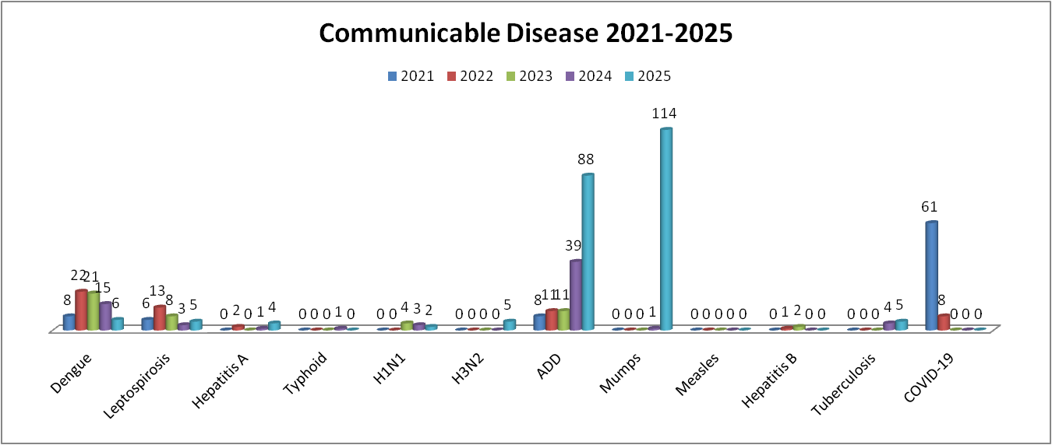

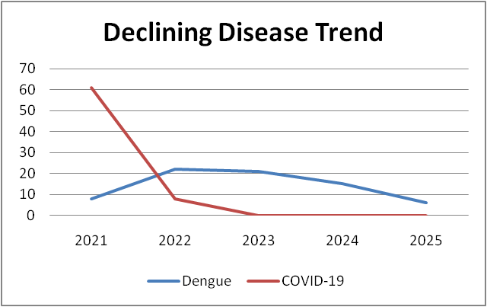

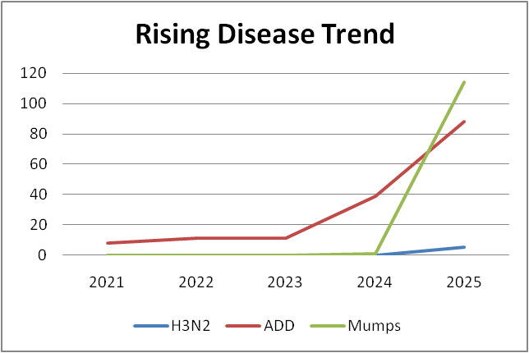
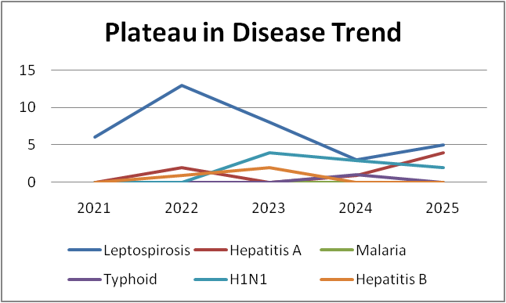
Seasonal Trend Analysis

Seasonal analysis helps anticipate surges (e.g. dengue in monsoon, leptospirosis after floods, and influenza in cooler months and vector control, stockpiling of IV fluids, and awareness campaigns at Panchayat level.

DENGUE
Dengue is a major seasonal vector-borne disease strongly associated with rainfall, water stagnation, and increased mosquito breeding during the monsoon period.

Peak: July–November

Dengue – Ward-wise Yearly Distribution (2021–2025)

Ward | Dengue – Ward-wise Yearly Distribution
Ward | 2021 | 2022 | 2023 | 2024 | 2025 | Total
1 | 0 | 0 | 1 | 1 | 0 | 2
2 | 1 | 2 | 3 | 1 | 0 | 7
3 | 0 | 2 | 1 | 1 | 0 | 4
4 | 1 | 0 | 3 | 1 | 0 | 5
5 | 1 | 0 | 2 | 1 | 1 | 5
6 | 1 | 0 | 1 | 0 | 1 | 3
7 | 0 | 0 | 1 | 0 | 0 | 1
8 | 0 | 0 | 0 | 0 | 0 | 0
9 | 2 | 3 | 2 | 2 | 1 | 10
10 | 0 | 0 | 0 | 0 | 0 | 0
11 | 0 | 1 | 0 | 1 | 0 | 2
12 | 0 | 2 | 0 | 1 | 0 | 3
13 | 0 | 1 | 1 | 2 | 0 | 4
14 | 0 | 1 | 0 | 0 | 2 | 3
15 | 1 | 2 | 0 | 1 | 1 | 5
16 | 0 | 3 | 4 | 0 | 0 | 7
17 | 0 | 3 | 2 | 1 | 0 | 6
18 | 1 | 2 | 1 | 1 | 0 | 5
19 | 0 | 0 | 0 | 0 | 0 | 0
20 | 0 | 0 | 0 | 0 | 0 | 0

Dengue Risk Stratification (Ward-wise)
Using the same public health risk stratification method (based on total cases over the years), we can classify wards for Dengue risk as:
    - High Risk: ≥7 cases
    - Moderate Risk: 4–6 cases
    - Low Risk: 1–3 cases
    - No Risk: 0 cases
Ward | Total Cases | Risk Category
1 | 2 | Low Risk
2 | 7 | High Risk
3 | 4 | Moderate Risk
4 | 5 | Moderate Risk
5 | 5 | Moderate Risk
6 | 3 | Low Risk
7 | 1 | Low Risk
8 | 0 | No Risk
9 | 10 | High Risk
10 | 0 | No Risk
11 | 2 | Low Risk
12 | 3 | Low Risk
13 | 4 | Moderate Risk
14 | 3 | Low Risk
15 | 5 | Moderate Risk
16 | 7 | High Risk
17 | 6 | Moderate Risk
18 | 5 | Moderate Risk
19 | 0 | No Risk
20 | 0 | No Risk

- High Risk Wards: 2, 9, 16
- Moderate Risk Wards: 3, 4, 5, 13, 15, 17, 18
- Low Risk Wards: 1, 6, 7, 11, 12, 14
- No Risk Wards: 8, 10, 19, 20

LEPTOSPIROSIS
Leptospirosis cases are closely linked to monsoon rains, flooding, and occupational exposure, particularly in low-lying and waterlogged areas.

Peak: June - August

Leptospirosis – Ward-wise Yearly Distribution (2021–2025)

Ward | Leptospirosis – Ward-wise Yearly Distribution
Ward | 2021 | 2022 | 2023 | 2024 | 2025 | Total
1 | 0 | 3 | 1 | 0 | 0 | 4
2 | 0 | 1 | 1 | 0 | 0 | 2
3 | 1 | 0 | 0 | 0 | 0 | 1
4 | 1 | 0 | 0 | 0 | 0 | 1
5 | 0 | 0 | 0 | 0 | 0 | 0
6 | 0 | 2 | 0 | 0 | 0 | 2
7 | 0 | 1 | 0 | 1 | 0 | 2
8 | 1 | 0 | 0 | 1 | 1 | 3
9 | 1 | 3 | 0 | 0 | 1 | 5
10 | 0 | 0 | 0 | 0 | 0 | 0
11 | 0 | 1 | 1 | 0 | 1 | 3
12 | 0 | 0 | 0 | 1 | 0 | 1
13 | 0 | 1 | 2 | 0 | 0 | 3
14 | 0 | 0 | 1 | 0 | 0 | 1
15 | 0 | 1 | 1 | 0 | 2 | 4
16 | 0 | 0 | 0 | 0 | 0 | 0
17 | 1 | 0 | 0 | 0 | 0 | 1
18 | 1 | 1 | 1 | 0 | 0 | 3
19 | 0 | 0 | 0 | 0 | 0 | 0
20 | 0 | 0 | 0 | 0 | 0 | 0

Leptospirosis Risk Stratification (Ward-wise)
Using the same public health risk stratification method (based on total cases over the years), we can classify wards for Leptospirosis risk as:
- High Risk: ≥5 cases
- Moderate Risk: 3–4 cases
- Low Risk: 1–2 cases
- No Risk: 0 cases
Ward | Total Cases | Risk Category
1 | 4 | Moderate Risk
2 | 2 | Low Risk
3 | 1 | Low Risk
4 | 1 | Low Risk
5 | 0 | No Risk
6 | 2 | Low Risk
7 | 2 | Low Risk
8 | 3 | Moderate Risk
9 | 5 | High Risk
10 | 0 | No Risk
11 | 3 | Moderate Risk
12 | 1 | Low Risk
13 | 3 | Moderate Risk
14 | 1 | Low Risk
15 | 4 | Moderate Risk
16 | 0 | No Risk
17 | 1 | Low Risk
18 | 3 | Moderate Risk
19 | 0 | No Risk
20 | 0 | No Risk

- High Risk Ward- 9
- Moderate Risk Wards 1, 8, 11, 13, 15, 18
- Low Risk Wards 2, 3, 4, 6, 7, 12, 14, 17
- No Risk Wards 5, 10, 16, 19, 20

VIRAL HEPATITIS - A
Hepatitis A cases are commonly associated with unsafe drinking water, food contamination, and breakdowns in sanitation, often presenting as clusters or outbreaks.

Peak: October - December

Hepatitis A – Ward-wise Yearly Distribution (2021–2025)

Ward | Hep A – Ward-wise Yearly Distribution
Ward | 2021 | 2022 | 2023 | 2024 | 2025 | Total
1 | 0 | 0 | 0 | 0 | 0 | 0
2 | 0 | 0 | 0 | 1 | 0 | 1
3 | 0 | 1 | 0 | 0 | 0 | 1
4 | 0 | 0 | 0 | 0 | 0 | 0
5 | 0 | 0 | 0 | 0 | 0 | 0
6 | 0 | 0 | 0 | 0 | 2 | 2
7 | 0 | 0 | 0 | 0 | 0 | 0
8 | 0 | 0 | 0 | 0 | 0 | 0
9 | 0 | 0 | 0 | 0 | 0 | 0
10 | 0 | 1 | 0 | 0 | 1 | 2
11 | 0 | 0 | 0 | 0 | 0 | 0
12 | 0 | 0 | 0 | 0 | 0 | 0
13 | 0 | 0 | 0 | 0 | 0 | 0
14 | 0 | 0 | 0 | 0 | 0 | 0
15 | 0 | 0 | 0 | 0 | 1 | 1
16 | 0 | 0 | 0 | 0 | 0 | 0
17 | 0 | 0 | 0 | 0 | 0 | 0
18 | 0 | 0 | 0 | 0 | 0 | 0
19 | 0 | 0 | 0 | 0 | 0 | 0
20 | 0 | 0 | 0 | 0 | 0 | 0
For Hepatitis A risk stratification, since the total number of cases is very small, a simpler classification is usually used in public health reports:
- High Risk: ≥3 cases
- Moderate Risk: 2 cases
- Low Risk: 1 case
- No Risk: 0 cases

Hepatitis A Risk Stratification (Ward-wise)
Ward | Total Cases | Risk Category
1 | 0 | No Risk
2 | 1 | Low Risk
3 | 1 | Low Risk
4 | 0 | No Risk
5 | 0 | No Risk
6 | 2 | Moderate Risk
7 | 0 | No Risk
8 | 0 | No Risk
9 | 0 | No Risk
10 | 2 | Moderate Risk
11 | 0 | No Risk
12 | 0 | No Risk
13 | 0 | No Risk
14 | 0 | No Risk
15 | 1 | Low Risk
16 | 0 | No Risk
17 | 0 | No Risk
18 | 0 | No Risk
19 | 0 | No Risk
20 | 0 | No Risk
Moderate Risk Wards 6, 10
Low Risk Wards 2, 3, 15
No Risk Wards 1, 4, 5, 7, 8, 9, 11, 12, 13, 14, 16, 17, 18, 19, 20

Interpretation
- Moderate risk wards: Need monitoring of drinking water quality, sanitation, and food hygiene.
- Low risk wards: Strengthen awareness about safe water and hand hygiene.
- No risk wards: Maintain routine surveillance.

Outcome-Based Trend Analysis- 2025
Transmission Trend- 2025
For effective management of public health issues, it is important to track the trend of disease transmission mode. It helps identify the population or place at high risk that can be used to predict outbreaks and implement targeted interventions as quickly as possible. Understanding these kinds of trends enables authorities to allocate resources efficiently and change the strategies adequately based on the trend that follows.

Mode of Transmission | No. of cases | No. of Deaths
Vector Borne Diseases | 6 | 0
Water Borne Diseases | 5 | 0
Air Borne Diseases | 145 | 0
Blood Borne Diseases | 0 | 0
Food Borne Diseases | 0 | 0

Vector-Borne Disease

Disease | No. of Cases | No. of Deaths
Dengue | 6 | 0
Malaria | 0 | 0
Chikungunya | 0 | 0
Water Borne Disease

Disease | No. of Cases | No. of Deaths
Cholera | 0 | 0
Typhoid | 1 | 0
Hep- A | 4 | 0
Dysentery | 0 | 0
Amoebiasis | 0 | 0
E- Coli infections | 0 | 0

Blood-Borne Disease

Disease | No. of Cases | No. of Deaths
AIDS | 0 | 0
Hep- B | 0 | 0
Hep- C | 0 | 0

Zoonotic Disease

Disease | No. of Cases | No. of Deaths
Rabies | 0 | 0
Leptospirosis | 5 | 0
Avian influenza | 0 | 0
West nile | 0 | 0
Anthrax | 0 | 0
Nipah | 0 | 0
Scrub Typhus | 0 | 0

Integrated Disease Hotspot Map

Integrated Disease Hotspot Map 2021
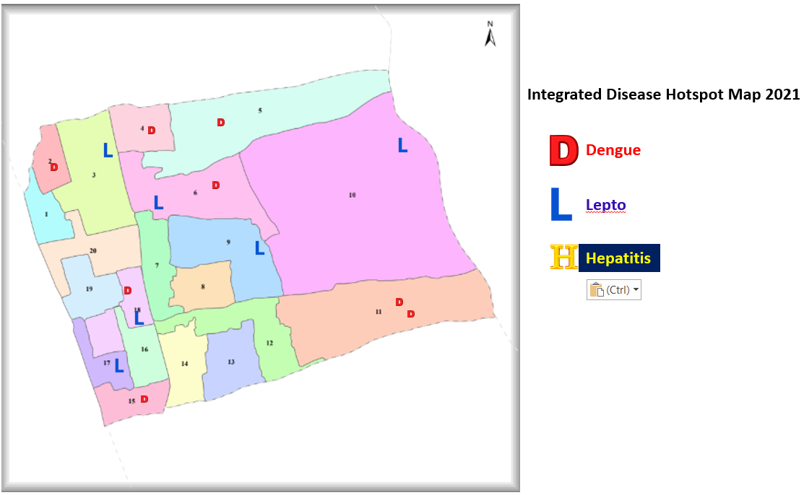
Integrated Disease Hotspot Map 2022
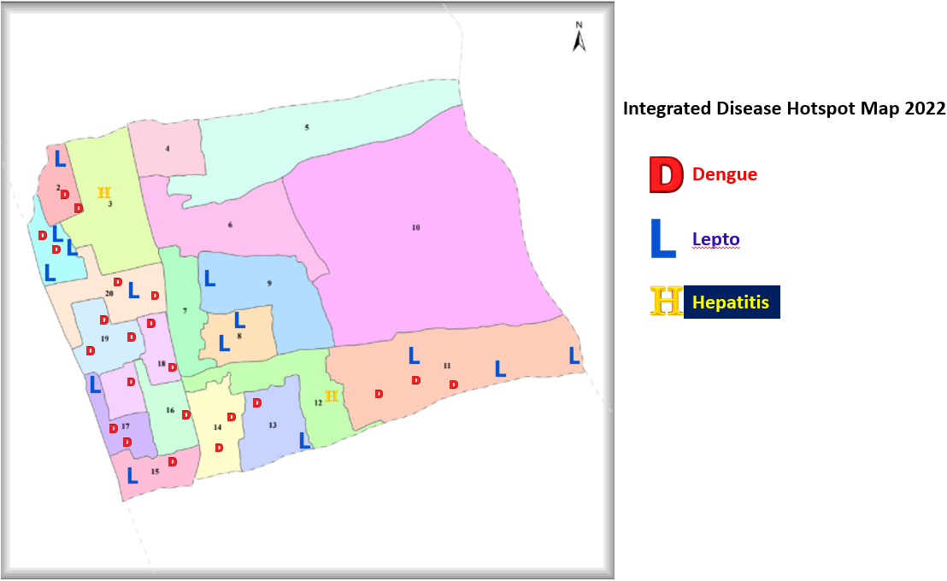

Integrated Disease Hotspot Map 2023
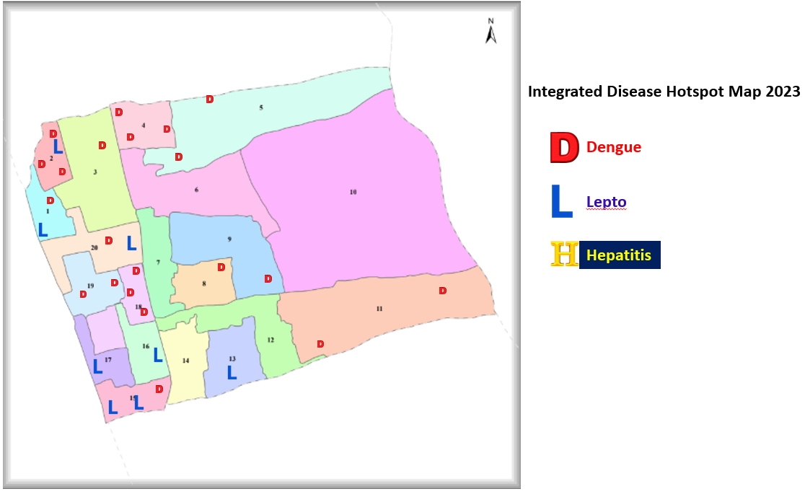

Integrated Disease Hotspot Map 2024
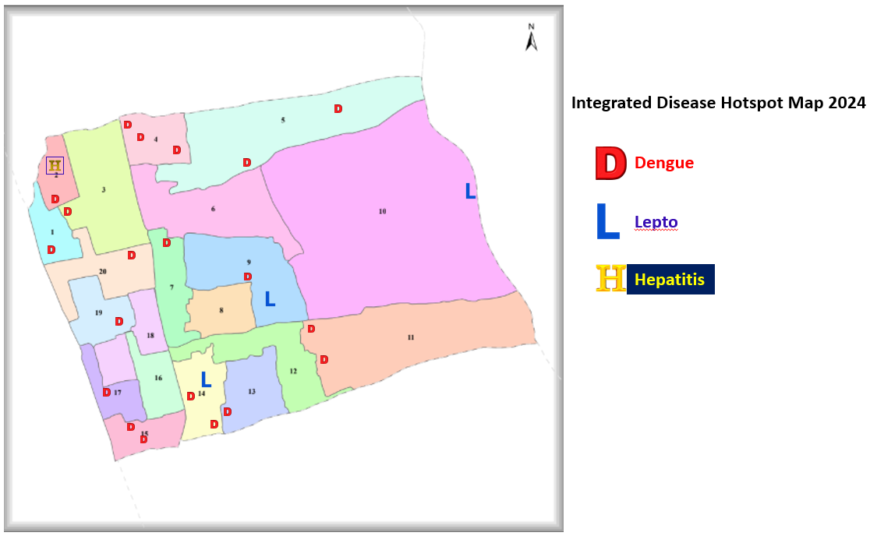

Integrated Disease Hotspot Map 2025
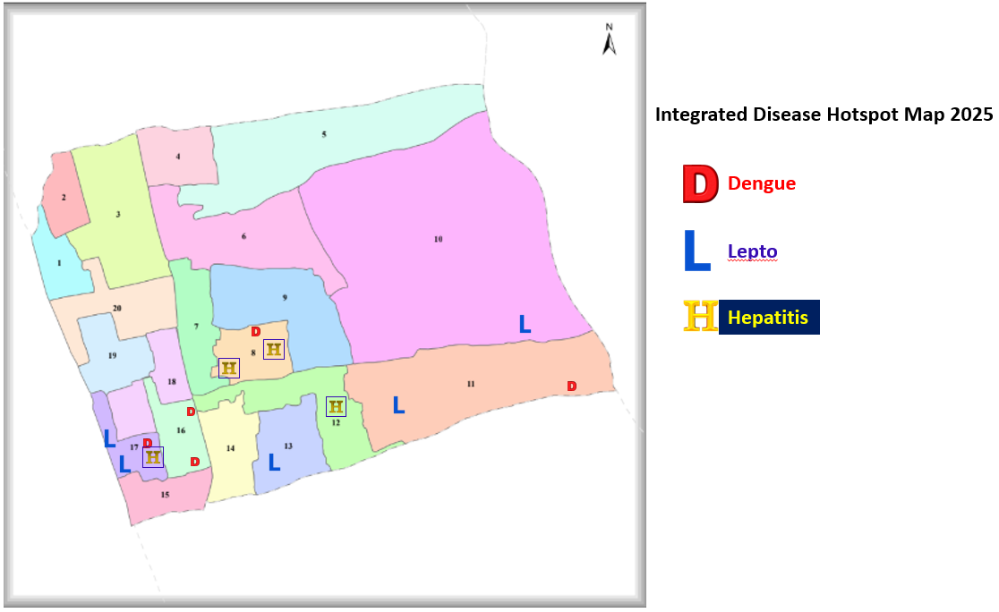

Ward-wise distribution of Communicable diseases

Ward No | Dengue Total (2021-25) | Leptospirosis Total (2021-25) | Hepatitis A Total (2021-25) | Mumps (2021-25) | ADD (2021-25) | Total Cases
1 | 2 | 4 | 0 | 10 | 1 | 17
2 | 7 | 2 | 1 | 3 | 2 | 15
3 | 5 | 1 | 1 | 0 | 1 | 8
4 | 5 | 1 | 0 | 1 | 13 | 20
5 | 5 | 0 | 0 | 2 | 1 | 8
6 | 3 | 2 | 2 | 3 | 0 | 10
7 | 1 | 2 | 0 | 6 | 0 | 9
8 | 0 | 3 | 0 | 1 | 0 | 4
9 | 0 | 5 | 0 | 8 | 24 | 37
10 | 0 | 0 | 2 | 4 | 0 | 6
11 | 2 | 3 | 0 | 12 | 0 | 17
12 | 0 | 1 | 0 | 2 | 0 | 3
13 | 0 | 3 | 0 | 0 | 0 | 3
14 | 0 | 0 | 0 | 2 | 0 | 2
15 | 1 | 3 | 1 | 4 | 0 | 9
16 | 0 | 0 | 0 | 3 | 1 | 4
17 | 0 | 1 | 0 | 1 | 3 | 5
18 | 1 | 3 | 0 | 3 | 2 | 9
19 | 0 | 0 | 0 | 0 | 0 | 0
20 | 0 | 0 | 0 | 0 | 0 | 0

By overlaying five years of data, we have identified 3 'Red Zone' Wards. These are wards where at least two different categories of diseases (e.g., Dengue and Lepto) recurred in consecutive years. Ward 6 is categorized as the Highest Priority Hotspot due to its combination of flood vulnerability and high vector density. Future health infrastructure, such as the proposed R.O plants at ward 9,11 should be prioritized.

Risk stratification of communicable diseases
Ward | Dengue | Leptospirosis | Hepatitis A | Mumps | ADD | Overall Total | Overall Risk
1 | Low | Moderate | No Risk | High | Low | 17 | Moderate
2 | High | Low | Low | Low | Low | 15 | Moderate
3 | Moderate | Low | Low | No Risk | Low | 8 | Low
4 | Moderate | Low | No Risk | Low | High | 20 | High
5 | Moderate | No Risk | No Risk | Low | Low | 8 | Low
6 | Low | Low | Moderate | Low | No Risk | 10 | Moderate
7 | Low | Low | No Risk | Moderate | No Risk | 9 | Low
8 | No Risk | Moderate | No Risk | Low | No Risk | 4 | Low
9 | No Risk | High | No Risk | Moderate | High | 37 | High
10 | No Risk | No Risk | Moderate | Low | No Risk | 6 | Low
11 | Low | Moderate | No Risk | High | No Risk | 17 | Moderate
12 | No Risk | Low | No Risk | Low | No Risk | 3 | Low
13 | No Risk | Moderate | No Risk | No Risk | No Risk | 3 | Low
14 | No Risk | No Risk | No Risk | Low | No Risk | 2 | Low
15 | Low | Moderate | Low | Low | No Risk | 9 | Low
16 | No Risk | No Risk | No Risk | Low | Low | 4 | Low
17 | No Risk | Low | No Risk | Low | Low | 5 | Low
18 | Low | Moderate | No Risk | Low | Low | 9 | Low
19 | No Risk | No Risk | No Risk | No Risk | No Risk | 0 | No Risk
20 | No Risk | No Risk | No Risk | No Risk | No Risk | 0 | No Risk
Preparedness and Response Protocol at LSG Level
This section describes the operational framework for the LSGI once a pandemic is declared. It explains how the LSGI and health system will move from routine data collection to active response, using a One Health approach.

Constitution of One Health Committee
The LSGD shall constitute a One Health Committee comprising the LSGI President, Medical Officers (Modern Medicine, AYUSH, and Veterinary), the Health Inspector, and the Veterinary Surgeon.

Objective: The One Health Committee coordinates human, animal, and environmental health to prevent and control pandemics.

Sl No | Name | Designation | Department/Institution | Role in Committee | Contact Number
1 | Anitha Satheesh | Panchayat President  official | LSGD | Chairperson | 9526197522  9496043646
2 | Dr.Arun Alphonse | Medical Officer (PHC/CHC) | Health Dept | Member Secretary | 9544970588
3 | Dr.Abdul Jaleel | Veterinary Officer | Animal Husbandry | Member | 9605708802
4 | Dr.Bhagyalekshmi | Epidemiologist | Health Dept | Member | 8848186525
5 | Jayesh  Shijumol | Health Inspector/PHN | Health Dept | Surveillance | 9447525879  8330847596
6 | Archana | ASHA Supervisor | Health Dept | Community link | 8943341395
7 | Neethu | ICDS Supervisor | Social Welfare | Vulnerable groups | 8129905140
8 | Rajasree | LSGD Secretary | LSGD | Member | 9496043647
9 |  | Police Station Officer | Police Dept | Law & order | 9497987060
10 | Lekshmi | Ward Councillor Representative | LSGD | Community coordination | 8078479847
11 | officer | Fire& Safety | Fire Force | Emergency | 04772275570
12 | officer | Food Safety | Food Safety |  | 7593873318
13 | officer | Village Officer |  |  | 8547618423
10 | Lekhaprabha | Kudumbashree CDO | Kudumbashree | Community mobilisation | 9526360869

Key Responsibilities:
- Review disease surveillance data (human + animal)
- Conduct ward-wise risk assessment and vulnerability mapping
- Approve quarantine/isolation centre locations
- Coordinate with district for resources (PPE, oxygen, ambulances)
- Periodically review health system surge capacity, including beds, oxygen, human resources, and ambulances.
- Approve and monitor risk communication and community engagement strategies, including rumour management.
- Ensure protection and service continuity for vulnerable groups (elderly, persons with disabilities, dialysis patients, coastal populations).
- Conduct quarterly mock drills
- Monitor equity measures for vulnerable groups

Meeting Schedule:
Quarterly (normal times) | Weekly (outbreak alert) | Daily (pandemic phase)

Pandemic Response Workforce
To ensure a coordinated and timely response during a pandemic, a dedicated Pandemic Response Workforce shall be constituted at the LSG level. The workforce will function under the overall supervision of the One Health Committee and in close coordination with the health authorities. Team-based deployment will enable efficient surveillance, case management, quarantine and isolation management, logistics support, and risk communication. Each team shall have a clearly designated team leader, defined roles, and an identified pool of personnel to allow rapid activation, rotation of duties, and continuity of services during prolonged emergencies.

Total Response Workforce Available: 300 persons

Team Name | Composition | Key Responsibilities | Team Leader
Surveillance and Contact Tracing Team | HI, JHI, JPHN, ASHAs and Volunteers | Case detection, contact listing, home visits, reporting | HI
Case Management Team | Doctors, Nurses, MLSP, Palliative Nurses | Patient care, clinical management, referral to higher centres | Doctor
Quarantine & Isolation Team | LSGD staff, Volunteers | Facility management, monitoring quarantine compliance | JHI
Psychosocial Support Team | JPHN, ASHA, Counsellors, Kudumbashree members | Mental health support, counselling of patients and families, stress management | JPHN
Logistics & Supply Chain Team | LSGD staff, Storekeepers, Drivers | Supplies & transport (PPE, medicines, oxygen), transport arrangement, waste management | Ward Member
Communication Team | Ward members, Kudumbashree, Youth clubs, AWW workers and other self-help groups | IEC activities, community meetings, awareness campaigns, countering misinformation | Medical Officer in Charge
Transportation Team | KSRTC staff, Educational institutional buses, Local drivers | Transport of patients, staff movement, emergency transport support | LSGD Secretary / Ward Member
Media Surveillance Team | Medical Officer, Health Inspector, Data entry staff | Monitoring news and social media for outbreaks, rumor verification, reporting | Medical Officer
Intersectoral Coordination & Convergence Team | Health department, Veterinary department, LSGD, ICDS, Education department | Coordination between departments, joint outbreak response activities | Medical Officer in Charge
Collaborative Surveillance Team | Health Supervisor, Health Inspector, JHI, JPHN | Data collection, analysis, reporting, monitoring disease trends | Health Supervisor

All teams shall be activated immediately upon outbreak alert or pandemic declaration and shall report daily to the LSG Incident Commander/Medical Officer, with consolidated reporting to the Block PHC. Duty rosters and alternate personnel shall be maintained to ensure uninterrupted services during staff shortages or prolonged response periods. Team composition and numbers may be revised based on the magnitude of the outbreak and availability of human resources.

Activities and Measures before and during Pandemic

PHASE 1 - Alert / Preparation
Surveillance and Reporting-Enhanced syndromic surveillance:
- Data sources for surveillance:
- Event-based triggers (to be monitored and reported):
- Zoonotic and animal health surveillance
- Logistics and Stock Preparedness
  - Identify and empanel local vendors and define emergency procurement mechanisms in accordance with existing LSGD and Health Department norms.
  - Prepare and maintain an essential logistics checklist covering medical supplies, consumables, and support equipment.
  - Pre-identify secure storage locations for emergency stocks and ensure maintenance of stock registers with regular updating.
  - Finalise emergency transport arrangements, including availability of vehicles and identified drivers for rapid deployment during alerts.
  - Designate a Nodal Officer for Logistics to enable prompt decision-making, coordination, and communication during emergencies.
  - Conduct rapid stock verification and ensure availability of minimum buffer stock, including:
- PPE kits 15 numbers
- Pulse oximeters 50 numbers
- Hand sanitizers 100 litres
- Masks, gloves, disinfectants – adequate quantity
Identify critical gaps in logistics and immediately communicate requirements to the Block and District authorities for timely replenishment and support. Monitor expiry dates and stock rotation.

Identification of Quarantine and Isolation Facilities
  - Identify and list suitable buildings for quarantine and isolation (schools, hostels, community halls, etc.).
  - Categorise cases as per the severity and allocate to appropriate facilities (for instance, severe cases to classrooms, mild cases to an assembly hall in case of a school).
  - Facility readiness checklist needed (beds, toilets, ventilation) etc.
  - Find an alternate site if the primary sites are not available or not in use.
  - Identify facility managers and support staff
  - Prepare basic SOPs for:
    - Admission and discharge
    - Food, water, sanitation
    - Infection prevention and waste disposal
  - Ensure availability of basic amenities: water, sanitation, electricity, ventilation, and waste disposal. Prepare a rapid activation plan for these facilities if case numbers increase.

Risk Communication and Community Preparedness
  - Disseminate early warning messages on symptoms, preventive measures, and reporting mechanisms. Display IEC materials both in English and the local language in public places and ensure ward-level awareness.
  - Sensitize elected representatives and community leaders on preparedness measures.
  - Establish a rumour tracking and misinformation response mechanism to identify, verify, and promptly counter false or misleading information.
  - Engage trusted local persons (ward members, ASHA workers, religious leaders, teachers, community volunteers) to communicate official public health messages and reinforce correct practices.
  - Develop and deploy targeted IEC materials for:
    - Schools and educational institutions
    - Markets and commercial areas
    - Work sites and labour settings
  - Conduct community sensitization meetings at the ward level to promote preventive behaviors, address concerns, and strengthen community participation in preparedness and response.

Protection of Vulnerable Groups
Vulnerable populations require priority protection through targeted line-listing, service continuity, and delivery mechanisms.
- Prepare and regularly update line-lists of vulnerable populations, including:
  - Elderly persons living alone
  - Persons with disabilities
  - Pregnant women
  - Migrant workers
  - Dialysis patients
The detailed line-lists shall be maintained as Annexure ___ and updated periodically.

Clinical Dependency Mapping
Develop ward-wise dependency and vulnerability maps to identify households requiring regular support during emergencies. Ensure continuity of essential health services for vulnerable groups, including
- Dialysis services (facility mapping, transport arrangements, and scheduling)
- Continuity of treatment for TB, HIV, and other chronic conditions requiring uninterrupted medication
- Mental health and psychosocial support services
Establish delivery mechanisms for food, essential commodities, and medicines to vulnerable households through coordinated action involving ASHAs, JPHNs, Kudumbashree, volunteers, and local administration.

PHASE 2 - Active Response

Case Identification and Contact Tracing
Case detection and contact tracing activities will be carried out in coordination with the Health authorities, following disease-specific SOPs and IDSP guidelines.
Field Staff Involved
- Health Inspector (HI)
- Junior Health Inspector (JHI)
- Junior Public Health Nurse (JPHN)
- ASHAs and ASHA Supervisors
- Ward-level volunteers and Kudumbashree members (as required)

Screening Checkpoints
Screening checkpoints at high-traffic locations (transport hubs, markets, religious gatherings) for early detection of symptomatic travellers and crowd screening during outbreaks. Potential locations include bus stands, market entry points, and boat jetties, based on local context and risk assessment.
Screening activities will be carried out by trained personnel such as ASHAs, ward members, and volunteers, with support from Health Department staff. Necessary equipment, including non-contact thermometers and appropriate PPE, shall be ensured prior to activation.
Location | Type (Bus stand/Jetty/Market/Railway) | Staff Deployed (ASHAs/Volunteers) | Screening Method | Reporting authority
Bus stand | Transport hub | One JHI  One ASHA  One health Mentors | 1.Swab Collection.  2. Blood smears collection (RDT)  3.Thermal Scanners | Surveillance Nodal Officer in control room
Market entry | Market | One JHI  One ASHA  Male health volunteers | 1.Swab Collection.  2. Blood smears collection (RDT)  3.Thermal Scanners | Surveillance Nodal Officer in control room
Boat jetty | Water transport | One JHI  One ASHA  Male health volunteers | 1.Swab Collection.  2. Blood smears collection (RDT)  3.Thermal Scanners | Surveillance Nodal Officer in control room

Standard Screening Protocol

The screening protocol shall include temperature screening, observation for visible symptoms, and inquiry regarding recent travel or exposure history. Individuals identified as suspects during screening shall be immediately referred to the nearest PHC/FHC for further evaluation, testing, and appropriate action as per prevailing guidelines.

Pandemic Control Room
The Pandemic Control Room (PCR) serves as the central nerve center for real-time coordination, data aggregation, decision support, and communication during outbreaks. It consolidates information from all LSGD teams, health facilities and community sources to enable rapid response decisions.

Control Room Infrastructure and Location
Primary Location: Ambalapuzha North Panchayath Office.
Backup Location: Community Hall in Ambalapuzha North G.P.

Health System Control Room Framework
The PCR is organized into seven functional pillars to ensure no aspect of the response is overlooked:

Rapid Response Team (RRT)
  - Provides immediate intervention during emergencies, clusters, and field alerts.​
  - Coordinates urgent actions such as case investigation, contact tracing, isolation, and inter‑facility referrals.

Data Management & Analytics Team
  - Collects, validates, and manages key health system indicators (cases, tests, beds, HR, supplies).​
  - Analyzes data trends, generates projections, and supports evidence‑based decision‑making for local authorities.

Human Resource Deployment Team
  - Allocates healthcare staff efficiently based on workload and need
  - Ensures adequate and equitable workforce distribution across facilities

Laboratory Surveillance Team
  - Oversees diagnostic testing coordination, sample transport, and timely reporting of results.​
  - Monitors lab indicators (testing volume, positivity rate, turnaround time) for early detection of outbreaks

Vaccination Cell (If Required)
  - Plans and executes vaccination campaigns, including micro‑planning and session scheduling.​
  - Tracks coverage, identifies gaps, and coordinates corrective actions with field teams and outreach services.

Infrastructure & Patient Occupancy Team
  - Monitors facility capacity, earmarked beds, oxygen and critical care resources across all linked facilities.​
  - Ensures optimal patient distribution and referral management using updated bed‑status and resource data.
  - BMWM

Key Control Room Team
The Control Room Team coordinates all pandemic response activities within the LSGD and serves as the single command and communication hub during activation. It integrates information, field actions, logistics, and policy execution across all participating departments and health facilities.

Role | Name | Designation | Contact Number | Responsibility
In-charge/Nodal Officer | Dr. Arun Alphonse | Medical Officer | 9544970588 | Overall coordination, decision-making, and reporting to the District level.
Data Entry Operator | Meenumol | JHI | 9074577972 | Managing the line list, updating dashboards, and tracking testing results.
Communication Officer | Lavanya | MLSP | 8281580520 | Handling the public helpline, coordinating ambulance dispatch, and contact tracing calls.
Logistics Coordinator | Jincy | JPHN | 9645561742
  Planning and coordinating supply of essential materials such as PPE, medicines, disinfectants, and equipment; maintaining stock registers; arranging transportation of supplies; ensuring timely distribution to field teams; coordinating with LSGD and health department for resource mobilization; supervising waste management and storage.
Technical Support (IT/Data) | Harikumar | JHI | 9446918928 | Data collection and entry, maintaining digital surveillance records, updating disease reporting systems, preparing daily/weekly reports, supporting online communication and information sharing, maintaining databases and dashboards, assisting in analysis of outbreak data.

SOP for alert escalation/trigger point with mapping of responsibilities.
Key Points:
- The Control Room shall be staffed with a designated In-charge, data entry personnel, and communication staff with clearly defined roles and shift arrangements.
- It shall maintain updated records on daily monitoring indicators including new cases, persons under active quarantine, and hospital bed occupancy.
- All reports and situation updates shall be shared daily with the Block and District Surveillance Unit.
- The Control Room shall act as a single point of contact for coordination with response teams, health institutions, and other departments.
- Contact details of the Control Room shall be widely communicated to field staff and stakeholders during activation.

Daily Monitoring Indicators
To ensure timely decision-making and effective response, the following key indicators shall be monitored and updated on a daily basis by the Pandemic Control Room:

Epidemiological Indicators:
New cases reported today, Total active cases, Test Positivity Rate (TPR), Case Fatality Rate (CFR)
- Surveillance Indicators:
Persons under home quarantine, High-risk contacts identified, Fever, ILI, SARI or other symptoms (syndromic surges), Travellers (symptomatic or high-risk arrivals), Animal husbandry surveillance (zoonotic alerts, unusual animal deaths, poultry/bird flu signals), Mortality surveillance (excess deaths, unexplained fatalities, verbal autopsy reports)
- Logistics and Infrastructure Indicators:
Hospital / CFLTC beds occupied, Oxygen cylinders/concentrators available, Ambulances on standby
- Alert Findings
The following table outlines category-specific trigger points (red flags) from surveillance indicators and corresponding immediate actions for the Pandemic Control Room. These enable rapid response to alert findings like testing anomalies, positive cases exceeding thresholds, clusters, and WGS reports.
Category | Trigger Pophint (Red Flag) | Immediate Action
Clusters | Geographical or facility-based: 5+ cases linked to one location (office, school, street). | Declare a micro-containment zone; perimeter control and active case finding.
Testing | Sudden drop in testing volume / delay in reporting / unusual testing trends | Review the sample collection process, address lab bottlenecks, deploy additional testing teams, and notify the District Lab.
Lab | Test Positivity rate increases | Increase testing sites in that ward.
Hospital | >80% Oxygen bed occupancy | Activate backup/CFLTC beds.
Travel | Cluster of cases from a single flight/train or high-risk arrival group. | Trace all passengers in adjacent seats; implement mandatory institutional quarantine.
Animal | Mass poultry/wildlife death or unusual sickness | Notify Animal Husbandry, sample the area, and dispatch RRT for environmental sampling and zoonotic check.
Mortality | Sudden spike in home deaths or brought-in-dead (BID) cases | Audit the deaths and Active Case Search drive
Additional investigations like Whole Genome Sequencing (WGS) | Detection of a Variant of Concern (VOC) or Variant of Interest (VOI) | Implement strict micro-containment; update clinical protocols to match variant severity.

Communication of Public Health Information
A Community Communication Hub shall be established to ensure timely, accurate, and consistent dissemination of information during a pandemic. The Hub will function under the coordination of Nodal officers of the control room and act as the nodal point for public communication, risk messaging, and community engagement. It will support dissemination of official advisories, promote preventive behaviors, address rumors and misinformation, and ensure that messages reach all sections of the population through trusted local channels and leaders.

Key communicators
Channel | Responsible Person | Contact
Ward-level announcements | JPHN | 9645561742
Social media | MLSP | 8593892788
Local Cable TV / Radio | JHI | 9446918928

- All messages disseminated through the Hub shall align with advisories issued by the Health Department and District authorities.
- Community leaders shall be sensitized to support behavior change, reduce stigma, and counter misinformation.
- Special efforts shall be made to reach vulnerable and hard-to-reach populations using locally appropriate communication methods.

Rumor Tracking: A designated volunteer will monitor local social media/WhatsApp groups daily to identify misinformation and issue official clarifications via the Communication Hub.

Coordination with District/State Authorities & Other Organisations
Effective coordination with Block, District, and State authorities is essential to ensure timely reporting, technical guidance, and uninterrupted supply of essential resources during a pandemic. The LSG shall establish clear communication channels, designate responsible officers, and adhere to prescribed reporting timelines to support coordinated public health action and efficient resource mobilisation.

Key Details:
- Nodal Officer for Reporting: Dr Arun Alphonse
- Contact Number: 9544970588
Reporting Schedule and Protocols:

To Whom | What to Report | Frequency | Nodal Person
Block PHC | Complete Situation Report (Cases, Quarantine, Beds, Screening, Deaths) | Within 24 hours | Health supervisor,
District IDSP Unit | Outbreaks/Clusters/Unusual Events (>5 cases same ward) | Within 48 hours | DSO
Veterinary Officer | Animal health events/Zoonotic alerts | Within 24 hours | Veterinary Officer
State Cell | Zoonotic cross-sector events | Within 48 hours | State Epidemiologist

Supply Chain Coordination
The LSG shall coordinate closely with Block, District, and State authorities (KMSCL) to ensure uninterrupted availability of essential goods, medical supplies, and logistics during a pandemic. Supply requirements shall be assessed regularly based on case load and communicated promptly to the appropriate authorities for timely replenishment.
Key Points:
- Maintain updated contact details of District and Block nodal officers for health logistics, oxygen supply, ambulances, and essential medicines.
- Submit timely indent requests for PPE, testing kits, medicines, oxygen, and other critical supplies through prescribed channels.
- Monitor stock levels at LSGD facilities, quarantine/isolation centres, and field teams through daily stock registers and dispensing logs to prevent shortages.
- Coordinate with District authorities, Karunya/Neethi medical shops, and local purchase committees for funds allocation and emergency procurement.

- Ensure regular monitoring of dispensing registers at all facilities to track usage, expiry, and pilferage—shortages being a perennial issue requiring proactive weekly audits.

- Activate surge procurement protocols during high caseloads, leveraging local purchase powers under LSGD funds alongside state supplies.

Resource Inventory and Contacts
Resource Category | Source  (District/State/Private) | Contact
PPE Kits/Masks/Gloves | KMSCL | 0477 2280060  9895214070
PPE Kits/Masks/Gloves | Local Vendors- Midhun V .Kurup | 9061191997
Oxygen  Cylinders/Concentrators | KMSCL | 477 2280060  9895214070
Medicines/Antivirals | KMSCL | 477 2280060  9895214070
Medicines/Antivirals | Neethi Shops | 9400327352
Test Kits (RTPCR/Rapid) | KMSCL | 477 2280060  9895214070

Collaboration with NGOs, PPP, and CSR
To augment government efforts during a pandemic, the LSG shall collaborate with NGOs, voluntary organisations, and private sector partners through public–private partnerships and Corporate Social Responsibility (CSR) initiatives, in coordination with District authorities.

Key Points:
- Engage NGOs and community-based organisations for community outreach, awareness, and support to vulnerable populations.
- Leverage CSR support for procurement of medical equipment, PPE, oxygen concentrators, food kits, and sanitation materials, as permitted.
- Ensure all collaborations align with government guidelines and are routed through approved administrative and financial procedures.
- Maintain transparency and documentation for all external support received and utilised.
Organization | Type | Support Offered | Contact Person
Youth Clubs/Student Unions | CBO | youth co-ordination | Nidheesh- 9398023808

Interdepartmental Coordination
Coordination among departments during a pandemic shall be ensured through regular review meetings convened by the LSGD President. These meetings will provide a structured platform for sharing situational updates, assessing resource availability, resolving operational gaps, and taking joint decisions to ensure a coordinated and timely response.

Department | Representative | Key Role | Contact
Health (PHC) | Staff Nurse : Cinu Paul | Case management | 9847544410
Veterinary | Veterinary Surgeon: Dr.Abdul Jaleel | Animal surveillance | 9605708802
ICDS | Supervisor: Neethu | Nutrition support | 8129905140
Education | Head Teacher: | School coordination | 9446328296
Police | SHO | Containment enforcement | 9497987060
Water Authority | Aneesh | Water supply | 7012658162
LSGD Engineering | Bincy | Quarantine infrastructure | 9446139341

PHASE 3 - Surge Capacity
Phase 3 is activated when there is a rapid increase in cases, high test positivity rates, or when existing health facilities and quarantine arrangements approach saturation. The focus of this phase is to expand isolation capacity, augment clinical care services, and mobilise additional resources through district and state support mechanisms.

Conversion of Community Facilities
To manage increased case load, the LSGD shall activate additional isolation facilities by repurposing identified community infrastructure such as community halls, auditoriums, schools, hostels, or other suitable buildings.

Name of facility | Facility Type | No. of Buildings | Ward | Surge Capacity (Beds) | Nodal Person
Pattasseri Temple Auditorium | Auditoriums | 1 | 4 | 50 | Balachandran  9895023968
SBDP Auditorium | Auditoriums | 1 | 3 | 30 | Shaji 9447080969
TDMC Auditorium | Auditoriums | 2 | 3 | 100 | Dr.Viswakala 8113092483
Nursing College | Hostel | 1 | 3 | 200 | Dr.Viswakala 8113092483
Dental College | Hostel | 1 | 3 | 200 | Dr.Viswakala 8113092483
Nursing Hostel | Hostel | 2 | 3 | 100 | Dr.Viswakala 8113092483
Medical Education Hostel | Hostel | 3 | 3 | 100 | Dr.Viswakala 8113092483
Mary Queens Hostel | Hostel | 1 | 3 | 100 | Sabeenamma  9496658556

Post-Disaster / Post-Outbreak Recovery Plan – Application Aspects in Ambalappuzha North
1. Recovery
In Ambalappuzha North, recovery activities will be implemented through coordinated efforts of the Primary Health Centre, Health Inspector, ASHAs, and the Local Self Government Department (LSGD). Immediate steps will focus on restoring normal public health services and community activities.
2. Damage and Impact Assessment
Health workers including JHI, JPHN, and ASHAs will conduct household-level surveys in affected wards of Ambalappuzha North to identify disease cases, damaged sanitation facilities, contaminated water sources, and vulnerable populations. Findings will be reported to the Medical Officer for planning interventions.
3. Restoration of Health Services
The PHC and subcentres in Ambalappuzha North will resume regular outpatient services, immunization, maternal and child health programs, and communicable disease control activities. If needed, special medical camps will be organized in affected areas.
4. Rehabilitation of Affected Population
Affected families will be supported through medical treatment, nutritional support, and referral services. Coordination with LSGD and welfare departments will ensure assistance to vulnerable groups such as elderly persons, children, and pregnant women.
5. Psychosocial and Mental Health Support
Health staff and trained counsellors will provide psychological counselling and stress management support to affected individuals and families. Community volunteers and Kudumbashree members may assist in identifying people who require support.
6. Disease Surveillance During Recovery Phase
Active surveillance will continue in Ambalappuzha North through daily reporting by ASHAs and JHIs. Special attention will be given to early detection of diseases such as dengue, leptospirosis, hepatitis, and diarrhoeal diseases.
7. Environmental Cleanup and Sanitation
Vector control and sanitation measures will be implemented including source reduction, drainage cleaning, waste removal, and chlorination of drinking water sources. Public health workers will conduct field inspections in high-risk wards.
8. Livelihood Restoration
The local government and relevant departments will support affected families through employment programs, financial assistance schemes, and rehabilitation initiatives to restore their livelihoods.
9. Community Engagement and Confidence Building
Awareness campaigns, community meetings, and IEC activities will be organized in Ambalappuzha North with the support of Kudumbashree groups, youth clubs, and ward representatives to encourage community participation in recovery activities.
10. Documentation and After-Action Review
All activities carried out during the response and recovery phase will be documented by the health team. Review meetings will be conducted at the PHC level to evaluate the response and identify areas for improvement.
11. Lessons Learned and Best Practices
Experiences from the event will be analyzed to identify effective strategies and challenges faced. These insights will guide improvements in future public health responses in Ambalappuzha North.
12. Health System Strengthening
Training programs will be conducted for health workers on disease surveillance, outbreak response, and disaster management. Infrastructure and resources in local health facilities will also be strengthened.
13. Policy Revision and Preparedness Enhancement
Based on the experience, local health authorities and LSGD will update emergency preparedness plans and standard operating procedures to improve readiness for future outbreaks or disasters.
14. Research
Data collected from the event in Ambalappuzha North will be analyzed to study disease patterns, risk factors, and effectiveness of control measures. The findings will support evidence-based planning and improved public health strategies in the area.

CONCLUSION
A robust pandemic preparedness plan is essential to protect public health, minimize morbidity and mortality, and ensure continuity of essential services in Ambalappuzha North. This plan emphasizes early detection, rapid response, coordinated intersectoral action, and community engagement as the cornerstones of effective outbreak management. By integrating surveillance, case management, logistics, risk communication, and psychosocial support, the local health system can respond efficiently to emerging threats.
Moreover, the plan highlights the importance of capacity building, continuous training, infrastructure strengthening, and evidence-based decision-making. Through proactive planning, clear roles and responsibilities, and lessons learned from past outbreaks, Ambalappuzha North can enhance resilience against future pandemics, safeguard vulnerable populations, and maintain public trust. Continuous monitoring, periodic evaluation, and adaptive policy revisions will ensure that the preparedness framework remains dynamic, comprehensive, and effective in protecting community health

RECOMMENDATIONS

Strengthening Healthcare Infrastructure
- Establish a primary health response unit within the Panchayat with trained staff.
- Ensure availability of basic medical supplies (masks, sanitizers, PPE kits, oxygen cylinders).
- Create tie-ups with nearby hospitals inAmbalapuzha North for emergency referral and transport.

2. Community Awareness & Education
- Conduct regular awareness campaigns on hygiene, vaccination, and preventive measures.
- Use local communication channels (community radio, WhatsApp groups, notice boards) to spread verified information.
- Train volunteers to act as health ambassadors in each ward.

3. Emergency Response & Coordination
- Form a Pandemic Preparedness Committee at Panchayat level including health workers, ward members, and NGOs.
- Develop a clear action plan for lockdowns, quarantine, and distribution of essentials.
- Maintain a database of vulnerable groups (elderly, differently-abled, chronically ill) for targeted support.

4. Supply Chain & Food Security
- Identify and support local suppliers and farmers to ensure uninterrupted food supply.
- Create community kitchens during emergencies to serve vulnerable populations.
- Stockpile essential commodities in Panchayat-run outlets for crisis periods.

5. Digital Preparedness
- Promote digital platforms for telemedicine consultations.
- Use Panchayat’s website/social media for real-time updates on health advisories.
- Encourage online grievance redressal to reduce crowding in offices.

6. Training & Capacity Building
- Organize mock drills for pandemic response in schools, offices, and public spaces.
- Train Panchayat staff and volunteers in first aid, infection control, and crowd management.
- Collaborate with NGOs and health departments for capacity-building workshops.

7. Long-Term Resilience
- Integrate pandemic preparedness into the Panchayat Development Plan.
- Allocate a dedicated budget for health emergencies.
- Encourage community participation in planning and monitoring preparedness measures.

MOCK DRILL PLAN

Communicable Disease Outbreak Response
Location: Ambalappuzha North
Objective: To assess preparedness, response coordination, and containment measures during a communicable disease outbreak.

Objectives of the Mock Drill
- Test rapid response system for outbreak detection.
- Evaluate coordination between Health Department, Local Self Government, Police, and ICDS.
- Assess isolation, contact tracing, and containment procedures.
- Identify gaps in logistics, manpower, and communication.
- Improve community awareness and risk communication strategies.

Scenario for Mock Drill (Example)
Simulated Situation:
Three suspected cases of acute diarrheal disease reported from one ward in Ambalappuzha North. Symptoms include fever, vomiting, and dehydration. Laboratory confirmation pending.
Trigger Point:
ASHA worker reports cluster of cases to Primary Health Centre (PHC).

Departments Involved
- Health Department (Medical Officer, JPHN, JHI)
- Primary Health Centre
- Local Panchayat Authorities
- Police Department
- ICDS / Anganwadi Workers
- Water Authority
- Sanitation Team
- Disaster Management Team

Steps in Mock Drill Execution

Step 1: Alert & Reporting
- ASHA informs JHI.
- Medical Officer activates Rapid Response Team (RRT).
- Information passed to District Surveillance Unit.

Step 2: Field Investigation
- House-to-house survey in affected ward.
- Collection of water samples.
- Identification of suspected and contact cases.
- Line listing of cases.

Step 3: Medical Response
- Set up temporary medical camp.
- ORS distribution.
- Isolation of severe cases.
- Referral to Taluk/District Hospital if required.

Step 4: Containment Measures
- Chlorination of water sources.
- Disinfection of affected households.
- Health awareness campaign.
- Ban on public gatherings (if required).

Step 5: Risk Communication
- Public announcement through Panchayat.
- IEC material distribution.
- Social media & WhatsApp alert groups activated.

Step 6: Review & Evaluation
- Debriefing meeting.
- Identify response gaps.
- Prepare improvement plan.

Logistics Required
- PPE Kits
- ORS packets
- Chlorine tablets
- Rapid diagnostic kits
- Ambulance
- Registers for line listing
- Public address system

Observation & Evaluation Checklist
Component | Status | Remarks
Timely reporting | ✅ / ❌
RRT activation | ✅ / ❌
Field survey completed | ✅ / ❌
Water testing done | ✅ / ❌
Public awareness conducted | ✅ / ❌

Expected Outcomes
- Improved outbreak preparedness.
- Faster response time.
- Better interdepartmental coordination.
- Strengthened surveillance system.

ANNEXURE

IMPORTANT PHONE NUMBERS

Phone numbers and particulars of persons responsible for providing guidance, assistance, and support for pandemic preparedness operations may be provided here in a manner that allows easy reference at a glance. The information recorded here could be exhibited elsewhere at the time of emergencies. LSG institutions shall give special attention to collect and record the above data of persons and institutions who/which are supposed to give technical and co-ordination support to reduce the impact of pandemic.

1.1. Details of grama panchayat/municipality/corporation wards
Sl.No | Name of the ward | Ward number | Name of the ward  member | Contact number
1 | Vandanam Coastal | 1 | Bushara | 9142949911
2 | BTR Vayanasala | 2 | Shameer | 8078143469
3 | TDMC | 3 | Sheeja Noushad | 7293181053
4 | Kuravanthodu East | 4 | Kabeer | 8304090180
5 | Vandanam East | 5 | S. Haris | 7736196747
6 | Vandanam South | 6 | Suma Sathyan | 7510766623
7 | Panchayat Office | 7 | Safiyath | 9447728110
8 | Neerkunnam East | 8 | Najeef | 8943376267
9 | HI LPS | 9 | Rejitha | 9747353929
10 | Kanjippadam North | 10 | P. Arun | 7909133530
11 | Kanjippadam South | 11 | Nisha | 9142449073
12 | Valanjavazhy East | 12 | Suneera M. | 9061566118
13 | Kakkazham East | 13 | Reshma | 9544758901
14 | Kakkazham HS | 14 | Sheeja | 8921005562
15 | Kakkazham West | 15 | Aliyar Kunjumon | 9961920488
16 | Kambivalappu | 16 | Shaheera | 9778762796
17 | Beach Ward | 17 | Anitha Satheesh | 9526197522
18 | Janasevini | 18 | Sasi | 9446483593
19 | Neerkunnam West | 19 | Dhanya | 9946710282
20 | MCH Ward | 20 | Jeethu Praven | 9539211650

1.2. Other important phone numbers of grama panchayat/municipality/corporation area
Sl. No. | Name | Contact number
1. | President | 9496043646
2. | Vice President | 9747353929
3. | Chairperson- Health& Education | 9142949911
4. | Chairperson- Finance | 9747353929
5. | Chairperson- Development | 9142449073
6. | Chairperson- Welfare | 7736196747
7 | Secretary | 9496043647
8 | VEO | 9447037087
9 | Counsellor | 9778173848
7. | Excise department- Excise Inspector | 0477 - 2704851 9400069499
8. | Forest department- Range Forest Officer | 0477-2246034 8281004595

1.3. Important offices of grama panchayat/municipality/ corporation
Sl.No | Name of the office | Contact person | Contact number
1. | Village Office | Village Officer | 0477 2969222 8547618423
2. | Agriculture Office | Agriculture Officer | 9539115117
3. | Animal Husbandry Office | Animal Husbandry Doctor | 9605708802
4. | Police Station | Police Officer | 0477- 2272022 9497987060
5. | BSNL Office | Officer | 0477 2272727
6. | Block Office | Officer | 0477-2266206 0477-2267205 9400788076
7. | KSEB Office | Officer | 0477-2272058 9496001912
8. | Fisheries Office | Officer DD Fisheries | 0477-2239597 9496007028
9. | Fire and Rescue | Officer  Thakazhy  Alappuzha | 0477-2275570  9497920114

1.4. Health Services

Sl. No | Name of the hospital/institution | Location | Phone number
1. | Government hospitals/PHC | Kanjippadam | 9544970588
2. | Private hospitals | S.N.Kavala | 9846184859
3. | Clinical laboratories | Kanjippadam | 9645526118
4. | Chemist/pharmacy | Kanjippadam | 8921748751

1.5. Veterinary Services
Sl.No | Name of the Clinic | Name of the  Surgeon/Doctor | Place/location | Phone  number
1 | Govt.Veterinary Hospital | Dr.Abdul Jaleel | Neerkunnam | 9605708802

1.6. Helpline numbers
Helpline | Phone number
Police | 100
Fire and Rescue | 101
KSEB | 1912

1.7. Public and Private Schools Contact details

S.No | Name of School | Institution type | Phone number
1 | Govt.SDV UPS, Neerkunnam | Govt | 9446328296
2 | GHSS Kakkazham | Govt | 9061723528
3 | GHS Kakkazham | Govt | 9074723136
4 | SNVTTI LPS | Aided | 9446333446
5 | HI LPS Neer | Aided | 9656277281
6 | TDLPS Kakkazham | Aided | 7012815527
7 | GLPS Kanjippadam | Govt | 8593052557
8 | Ejaba English Medium School, Valanjavazhy | Private | 9207733003
9 | Al Huda English School, Neerkunnam | Private | 9447946330
10 | St.Peter’s Cessation EMS, Kanjippadam | Private | 9847879092

1.9. Anganwadi Contact Details

Ward No | AW No.& Name of Anganwadi Teachers | Phone number
1 | 39 Aswathy | 7907637388
2 | 38 Aseela | 9048944776
3 | 118 Maniyamma | 9633091127
4 | 69 Ramlath | 9747095767
5 | 112 Sreepriya | 9400148956
5 | 113 Lekha | 9037313535
6 | 40 Radhika | 9497221119
7 | 101 Mini | 9961748745
8 | 43 Leenamol | 9045046828
9 | 42 Seema K K | 9746759405
10 | 51 Mayamol A | 8943826984
11 | 48 Savithamol S | 9142215014
11 | 50 Girija R | 9142906858
13 | 57 Sumadevi | 9746908170
13 | 58 Kamalam | 9048638580
14 | 47 Nisha | 9995261963
14 | 70 Silpa | 7902739480
15 | 53 Lethika | 7034657933
15 | 54 Sreetha | 8089750087
16 | 56 Sudhamani | 8156989183
17 | 129 Kulsamma K H | 9526873131
18 | 44 Aryasanth N | 7736179036
18 | 45 Shahida | 9995941056
18 | 125 Zeenath | 9895114365
20 | 41 Beena | 9744859980
20 | 46 Raji | 9142942272

1.12. Information regarding resources

Means of transportation | Name of Owner | Phone Number
Heavy Trucks | Biju  Ambadi  Najaf  Ajmal | 9846628264  9526696807  8943376267  9895901056
Tractor | Sunil  Roy  Suresh | 7994164738  9947407143  8157030689
Ambulances | Sevabharathi | 9656243059
Boats | Renadevan  Uthaman  Vipindas  Prajeesh  Rajesh | 8590378336  9526696731  8075016133  9037053298  8590401860
Taxi service | Praveen P.  Satheesh  Shalu  Sujith  Vishnu  Hariprasad | 9746468378  9747655575  7558918589  9847020153  9447787809  9947829459

Annexure: LSG Baseline Data Collection Format
A. Baseline data
Sl. No. | Indicator / Field | Baseline Data | Source / Remarks
1 | Name of LSG | Ambalapuzha North | LSGD Data
2 | District | Alappuzha | LSGD Data
3 | Block / Taluk | Ambalapuzha | LSGD Data
4 | Type of LSG (Gram Panchayat / Municipality / Corporation) | GP | LSGD Data
5 | Area (sq. km) | 1088 | LSGD Data
6 | No. of wards | 20 | LSGD Data
7 | GIS boundary file available | No
8 | Key contact person & phone | Secretary- 9496043647 | LSGD Data

B. Demography
Indicator / Field | Baseline Data | Source / Remarks
Total population | 34706 | ASHA Survey
Males | 16809 | ASHA Survey
Females | 17897 | ASHA Survey
Transgender population | 0 | ASHA Survey
Age distribution  (<5, 5–14, 15–59, ≥60) | 1384  4032 | ASHA Survey
No. of households | 8607 | ASHA Survey
Population density (persons/sq.km) | 3190 | ASHA Survey
No. of migrant workers | 289 | ASHA Survey
Major occupational groups | Fishermen, Farmers | ASHA Survey

C. Vulnerable Populations & Social Risks
Sl. No. | Indicator / Field | Baseline Data (Value / Description) | Source / Remarks
1 | No. of elderly (≥60) | 4032 | ASHA Survey
2 | No. of persons with disability | 318 | ASHA Survey
3 | No. of bedridden persons | 8 | ASHA Survey
4 | No. of chronic disease cases (DM/HTN/COPD/CKD etc.) | 4144 | ASHA Survey
5 | Pregnant women (current estimate) | 268 | RCH Data
6 | Children <5 years | 1384 | RCH Data
7 | Tribal population (if any) | 8 | ASHA Survey
8 | Fisherfolk / coastal vulnerable groups (if any) | 1316 | ASHA Survey
9 | Urban slums / unnotified settlements (if any) | 0 | ASHA Survey
10 | Homeless population | 0 | ASHA Survey
11 | Orphanages / old age homes (number & capacity) | 0 | ASHA Survey
12 | Hostels / prisons / shelters (number & capacity) | 8 | ASHA Survey
13 | Poverty / BPL estimate | 3588 | LSGD Data
14 | Food insecurity hotspots | 0 | ASHA Survey
15 | Any history of stigma/discrimination issues (Yes/No) | No
D. Health System & Service Readiness
Sl. No. | Indicator / Field | Baseline Data (Value / Description)
1 | No. of health facilities in LSG (PHC/CHC/TH/DH/Private) | MCH-1  PHC-1
2 | PHC/Family Health Centre details (name, location) | FHC Ambalapuzha North, Kanjippadam
3 | Subcentres / Health & Wellness Centres (number) | 5
4 | Private clinics / hospitals (number) | 10
5 | Labs available (public/private) | Public- 4  Private- 11
6 | Availability of ambulance services (Yes/No, number) | Yes- 1
7 | Availability of isolation/quarantine facilities (Yes/No, details) | Yes- 1
8 | Cold chain facilities (Yes/No, details) | Yes
9 | Stockpile space available (Yes/No) | No
10 | PPE / mask / sanitizer availability plan (Yes/No) | Yes
11 | Surveillance staff available (JHI/JPHN/ASHA count) | Yes
12 | Existing emergency referral pathways (Yes/No) | Yes

E. Points of Entry & Mobility
Sl. No. | Indicator / Field | Baseline Data (Value / Description)
1 | Bus stands / depots (number) | 1- MCH
2 | Railway stations (number) | 0
3 | Boat jetties / fishing harbours (number) | Boat Jetty- 1- Kanjippadam
4 | Ports / airports nearby (specify distance) | 0
5 | Major highways/roads passing through | NH 66  Raods-2
6 | Border crossings (state/district) | 0
7 | Major markets / weekly markets | 0
8 | Tourism hubs / major event venues | 0
9 | Schools/colleges with hostels (number) | 3
10 | Factories / large workplaces (number) | 0
F. Water, Sanitation & Hygiene (WASH)
Sl. No. | Indicator / Field | Baseline Data (Value / Description)
1 | Major drinking water sources (piped / wells / borewells / springs) | Piped water
2 | No. of public wells | 11
3 | No. of households with piped water connection | 8584
4 | Water quality testing routine (Yes/No) | No
5 | Common contamination risks (flooding, salinity, industrial waste) | Salinity, broken pipe line
6 | Open defecation free status (Yes/No) | Yes
7 | Solid waste management system (Yes/No) | No
8 | Bio-medical waste disposal mechanism (Yes/No) | Yes
9 | No. of public toilets | 4
10 | Handwashing stations in public places (Yes/No) | No
G. Zoonotic Risks & One Health
Sl. No. | Indicator / Field | Baseline Data (Value / Description) | Source / Remarks
1 | Livestock population (cattle/goats/pigs/poultry) – estimates | 29289 | Veterinary Dispensary
2 | No. of dairy farms / poultry farms / pig farms | 4 | Veterinary Dispensary
3 | Slaughterhouses / meat shops (number) | 0 | Veterinary Dispensary
4 | Animal markets (Yes/No, details) | 0 | Veterinary Dispensary
5 | Veterinary dispensaries (number) | 1 | Veterinary Dispensary
6 | History of zoonotic outbreaks (rabies, leptospirosis, avian flu etc.) | 1- Avian Inflenza | Veterinary Dispensary
7 | Stray dog population management measures (Yes/No) | Yes | Veterinary Dispensary
8 | Rodent infestation hotspots (Yes/No) | No | Veterinary Dispensary
9 | Wetlands / waterlogged areas prone to leptospirosis | Yes
10 | Bat roosting areas / caves / fruit orchards (if any) | Yes
11 | Human-animal interface hotspots (farms near residences) | Yes
H. Climate & Disaster Risks (Pandemic Amplifiers)
Sl. No. | Indicator / Field | Baseline Data (Value / Description) | Source / Remarks
1 | Flood-prone wards (list) | 6 | previous incident
2 | Landslide-prone wards (list) | 0
3 | Cyclone/sea surge risk (Yes/No) | 1,2,,15,17,19,20 | coastal line
4 | Heatwave risk zones (Yes/No) | 0
5 | Waterlogging areas (list) | 5,6,9,10,11,12 | previous incident
6 | Shelter homes / relief camps (number, capacity) | 0
7 | Past disaster displacement history | 0
8 | Disruption to water supply/transport common (Yes/No) | Yes
I. Critical Infrastructure & Logistics
Sl. No. | Indicator / Field | Baseline Data (Value / Description)
1 | Schools (number) | 10
2 | Anganwadis (number) | 27
3 | Colleges (number) | 4
4 | Community halls (number) | 10
5 | Places of worship with large gatherings (number) | 18
6 | Large markets / shopping areas (number) | 0
7 | Warehouses / cold storages (number) | 0
8 | Telecom/mobile network coverage gaps (Yes/No) | Yes- W11
9 | Power outage frequency (high/medium/low) | low
10 | Availability of generators in key facilities | 1 inverter

J. Risk Communication & Community Networks
Sl. No. | Indicator / Field | Baseline Data (Value / Description)
1 | Ward-level rapid response teams (Yes/No) | Yes
2 | Jagratha samithis / committees active (Yes/No) | Yes
3 | Kudumbashree presence and strength (number of units) | Yes
4 | Volunteer network (number, coverage) | No
5 | Community-based surveillance mechanisms (Yes/No) | No- in progress
6 | IEC dissemination channels (WhatsApp groups, community radio, PA systems) | Yes
7 | Rumour tracking mechanisms (Yes/No) | Yes
8 | Languages spoken / literacy considerations
9 | Vulnerable groups communication strategy available (Yes/No) | Yes

K. Preparedness Planning & Governance
Sl. No. | Indicator / Field | Baseline Data (Value / Description)
1 | LSG emergency plan available (Yes/No)
2 | Pandemic preparedness plan available (Yes/No) | Yes
3 | Incident Command System identified (Yes/No)
4 | Rapid procurement mechanism available (Yes/No) | Yes
5 | Emergency fund available (Yes/No, amount) | Yes
6 | Past outbreak response experience (Yes/No, details) | Yes
7 | Intersectoral coordination mechanism (Health, Police, LSG, Veterinary, Education) | Yes
8 | Mock drills conducted in last 12 months (Yes/No) | Yes
9 | Training coverage for staff/volunteers (Yes/No) | Yes
L. Surveillance & Data Systems
Sl. No. | Indicator / Field | Baseline Data (Value / Description)
1 | Digital reporting tools used (e.g., DHIS2, portals) | Yes
2 | Availability of line-listing format (Yes/No) | Yes
3 | Contact tracing team identified (Yes/No) | Yes
4 | Mapping of high-risk households available (Yes/No) | No
5 | Testing sample transport mechanism (Yes/No) | No
6 | Reporting timeline adherence (good/average/poor) | average
7 | Data sharing between departments (Yes/No) | Yes
8 | Availability of dashboard for monitoring (Yes/No) | No
M. Additional Notes & Observations
Sl. No. | Indicator / Field | Baseline Data (Value / Description) | Source / Remarks
1 | Key challenges perceived by LSG | nil
2 | Top 5 high-risk wards (reason) | 9,10,11,15,16 | flood prone area, presence of migrants
3 | Any unique local risks (industrial pollution, refugee camps, etc.) | No
4 | Recommendations for preparedness strengthening

