PANDEMIC PREPAREDNESS PLAN
PURAKKAD GRAMA PANCHAYAT
Dr Shibu S(Medical Officer, PHC Purakkad ) Dr Lekshmy V (Medical Officer, PHC Thottapally)

MESSAGE FROM PRESIDENT/CHAIR LSGI
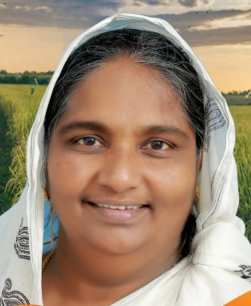

RAHMATH HAMID
PANCHAYAT PRESIDENT

Public health is a main responsibility of the Local Self-Government Department. Local bodies have an important role in providing basic healthcare to the people. The department works to improve public health by ensuring clean drinking water, proper waste disposal, sanitation, disease prevention, and health awareness programs. Local bodies also support the Health Department in improving the services of Primary Health Centres and Family Health Centres.
Public health programs cannot succeed without the support of the people. When people actively take part, health projects become more effective. Public participation is very important in cleanliness activities, waste segregation, and disease prevention campaigns. Community support is also needed to build health awareness and promote a healthy way of life.
Public health protection is not the duty of one department alone. It is a shared responsibility of both the government and the people, together a healthy and safe society can be created.



MESSAGE FROM HEALTH STANDING COMMITTEE CHAIRPERSON

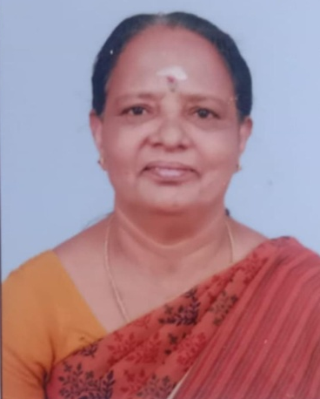

SULEKHA

Panchayat Health standing committee Chairperson

Public health is very important for Purakkad Grama Panchayat. Our panchayat is a coastal and farming area, and we face many health problems such as infectious disease, environmental issues, and increasing lifestyle diseases like diabetes and high blood pressure. The local self Government department, along with the health department is committed to improving health services for everyone.
This guideline shows our aim to focus on disease prevention, cleanliness, safe drinking water, mosquito control and early detection of lifestyle diseases. Good health cannot be achieved by the Government alone. Active participation from the public is necessary.

The support of elected representatives, health workers, Kudumbashree units, Harithakarma sena, schools, institutions and voluntary organisations is necessary. We also request the public to follow health guidelines, maintain cleanliness and adopt healthy lifestyles.

Let us all work together to make Purakkad a healthy, safe and strong Panchayat.

MESSAGE BY MEDICAL OFFICER
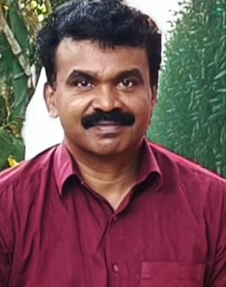
DR SHIBU S
MEDICAL OFFICER, PHC PURAKKAD

PHC Purakkad caters to a coastal population of 14,361 across 9 wards, with a high proportion of elderly (5,750) and other vulnerable groups including 71 bed-bound/palliative patients, 44 pregnant women, and 1,574 adolescents. With 2 medical officers, trained nursing and field staff, 13 ASHAs, 12 Anganwadi workers, and strong One Health community volunteer support, we ensure continuous disease surveillance and early response.
Recent reports of dengue, ADD, TB, H1N1, and leptospirosis underline the importance of preparedness. Through timely reporting, infection prevention measures, community participation, and inter-sectoral coordination, PHC Purakkad remains committed to effective pandemic preparedness and protection of public health.


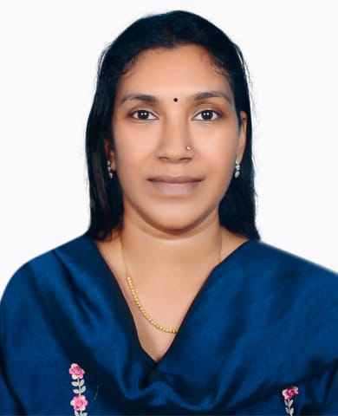
MESSAGE BY MEDICAL OFFICER

DR LEKSHMI V
MEDICAL OFFICER, PHC THOTTAPALLY

PHC Thottapally serves a coastal population of 17,380 across 10 wards, with special focus on vulnerable groups including 3,105 elderly, 97 bed-bound patients, 136 palliative care patients, 71 pregnant women, and 1,885 adolescents. With support from 2 government doctors, 17 ASHAs, 44 Anganwadi workers, and trained field staff, we ensure continuous disease surveillance and early response.
Recent trends show continued occurrence of dengue,Leptospirosis, ADD, TB, H3N2, and sporadic COVID cases, highlighting the need for preparedness. Strengthening sanitation, safe water practices, early reporting, and community participation remains critical. PHC Thottapally is committed to coordinated action with local bodies and the public to prevent outbreaks and ensure timely care during any pandemic situation.

EXECUTIVE SUMMARY

Purakkad Primary Health Centre (PHC) and Thottapally Primary Health Centre (PHC) function as the primary public healthcare institutions serving the population of 31741 spread across 19 wards of the Grama Panchayath. The PHC plays a pivotal role in delivering comprehensive, accessible, and affordable healthcare services, with a strong focus on preventive, promotive, curative, and rehabilitative care in accordance with national and state health programmes.
The PHC caters to a predominantly rural population, addressing key public health priorities such as maternal and child health, communicable and non-communicable disease control, immunization, family welfare, adolescent health, and geriatric care. Regular outpatient services, home-based care through field health staff, and outreach activities ensure healthcare coverage even in geographically challenging areas. The institution actively implements national health missions, including the National Health Mission (NHM), National Tuberculosis Elimination Programme, National Programme for Prevention and Control of Cancer, Diabetes, Cardiovascular Diseases and Stroke (NPCDCS), and other disease surveillance initiatives.
Purakkad and Thottapally PHC works in close coordination with the Grama Panchayath, ASHA workers, Anganwadi centres, schools, and community-based organizations to strengthen community participation and improve health awareness. Emphasis is placed on early detection, timely referral, health education, and lifestyle modification to reduce disease burden and improve overall health outcomes.
Despite constraints related to infrastructure, manpower, and increasing service demand, the PHC continues to enhance service delivery through effective planning, data-driven decision-making, and community engagement. Strengthening facilities, upgrading digital health systems, and expanding preventive services remain key focus areas for future development.
Overall, Purakkad and Tottapally Primary Health Centres stands as a vital institution in safeguarding public health and improving the quality of life of the residents of Purakkad Grama Panchayt

LIST OF ABBREVIATIONS

LSGD/LSGI | Local Self Government Department / Local Self Government Institution
BMO | Block Medical Officer
IDSP | Integrated Disease Surveillance Programme
PHC | Primary Health Centre
NHM | National Health Mission
NDMA | National Disaster Management Authority
PPE | Personal Protective Equipment
ICMR | Indian Council of Medical Research
CD | Communicable Diseases
NCD | NON-COMMUNICABLE Diseases
NPCDCS | National Programme for Prevention and Control of Cancer, Diabetes, Cardiovascular Diseases and Stroke
ASHA | Accredited Social Health Activist
MO | Medical Officer
HS | Health Supervisor
HI | Health Inspector
PHNS | Public Health Nursing Supervisor
PHN | Public Health Nurse
JHI | Junior Health Inspector
JPHN | Junior Public Health Nurse
MLSP | Mid Level Service Provider
SSU | State Surveillance Unit
DSU | District Surveillance Unit
KMSCL | Kerala Medical Service Corporation Ltd.
AYUSH | Ayurveda, Yoga& Naturopathy, Unani, Siddha& Homoeopathy

TABLE OF CONTENTS
INTRODUCTION 10
LSGD AT A GLANCE 12
INTEGRATED HEALTH INFRASTRUCTURE MAP OF PURAKKAD PANCHAYAT 15
GENERAL PROFILE OF THE LSGI 20
Demographic and Vulnerable Population 21
Clinical Vulnerability 22
INFRASTRUCTURE & RESOURCE INVENTORY 25
Health Facility Directory & Basic Capacity in the LSGD 25
Private Clinics 27
Healthcare Education & Training Institutions 27
Specialized Services & Emergency Inventory 28
Oxygen & Diagnostic Capacity 29
Diagnostics facility mapping at the LSGI level 30
Laboratory Identification & Basic Details 31
Social and Community Infrastructure for surge plan 31
Medical & Clinical Personnel 33
Public Health & Field-Level Workforce 34
Community & Support Cadre 37
Community Organizations 38
Administrative & Emergency Services 39
Information regarding resources 39
ONE HEALTH & ENVIRONMENTAL SURVEILLANCE 40
Veterinary Infrastructure 41
Veterinary Doctors & Workforce 42
High-Risk Interface Points (Surveillance Sites) 43
Environmental Risk Mapping 44
Disease Seasonality Mapping 46
Vulnerability Mapping 47
EPIDEMIOLOGICAL TRENDS (2021–2025) 48
Disease Burden among human beings(Last 5 Years) 48
*(use the above table data to create the graph/diagram) 49
Seasonal Trend Analysis 49
DENGUE 49
Dengue – Ward-wise Yearly Distribution (2021–2025) 50
LEPTOSPIROSIS 50
Leptospirosis – Ward-wise Yearly Distribution (2021–2025) 51
VIRAL HEPATITIS - A 51
Hepatitis A – Ward-wise Yearly Distribution (2021–2025) 52
Outcome-Based Trend Analysis- 2025 52
Transmission Trend- 2025 55
Integrated Disease Hotspot (2021–2025) 58
Preparedness and Response Protocol at LSG Level 61
Constitution of One Health Committee 61
Key Responsibilities: 62
Meeting Schedule: 62
Pandemic Response Workforce 62
Activities and Measures before and during Pandemic 63
PHASE 1 - Alert / Preparation 63
➢ Identification of Quarantine and Isolation Facilities 64
➢ Risk Communication and Community Preparedness 65
➢ Protection of Vulnerable Groups 65
➢ Clinical Dependency Mapping 66
PHASE 2 - Active Response 66
1. Case Identification and Contact Tracing 66
2. Screening Checkpoints 66
Standard Screening Protocol 67
3. Pandemic Control Room 68
Control Room Infrastructure and Location 68
Health System Control Room Framework 68
Key Control Room Team 69
Daily Monitoring Indicators 70
1. Epidemiological Indicators: 70
4. Communication of Public Health Information 72
Key communicators 73
5. Coordination with District/State Authorities & Other Organisations 73
Key Details: 73
Supply Chain Coordination 74
Resource Inventory and Contacts 75
Collaboration with NGOs, PPP, and CSR 75
Interdepartmental Coordination 76
PHASE 3 - Surge Capacity 76
Conversion of Community Facilities 77
Recovery Phase – Purakkad Grama Panchayath Pandemic Preparedness Plan 77
Damage & Impact Assessment 77
Restoration of Health Services 77
Rehabilitation of Affected Population 77
Psychosocial & Mental Health Support 78
Disease Surveillance During Recovery Phase 78
Environmental Cleanup & Sanitation 78
Livelihood Restoration 78
Community Engagement & Confidence Building 78
Documentation & After-Action Review 78
Lessons Learned & Best Practices 79
Health System Strengthening 79
Policy Revision & Preparedness Enhancement 79
Research 79
CONCLUSION 80
RECOMMENDATIONS 81
1. Strengthening Healthcare Infrastructure 81
2. Community Awareness & Education 81
3. Emergency Response & Coordination 81
4. Supply Chain & Food Security 81
5. Digital Preparedness 81
6. Training & Capacity Building 81
7. Long-Term Resilience 81
ANNEXURE 88
1. IMPORTANT PHONE NUMBERS 88
1.1. Details of grama panchayat/municipality/corporation wards 88
1.2. Other important phone numbers of grama panchayat/municipality/corporation area 89
1.3. Important offices of grama panchayat/municipality/ corporation 90
1.4. Health Services 90
1.5. Veterinary Services 91
1.6. Helpline numbers 91
1.7. Public and Private Schools Contact details 92
1.9. Anganwadi Contact Details 92
1.12. Information regarding resources 94

INTRODUCTION

Purakkad is situated in the coastal belt of Alappuzha. The landscape is primarily characterized by low-lying paddy fields and a dense network of backwaters, which significantly influences the local climate and emergency accessibility. With a total population of 31741 spread across 19 wards, the region serves as a vital hub for traditional fishing and cultivation.
The diverse population consists of fishing communities, farmers, elderly persons, children, and individuals with chronic health conditions. These geographical and demographic factors increase the Panchayath’s vulnerability to natural disasters, climate-related hazards, and public health emergencies.
Past experiences have clearly shown that health emergencies and disasters can exert considerable strain on the local health system.. Timely preparedness and coordinated response at the Panchayath level are critical to minimize health risks and prevent loss of life. A structured Health Emergency Preparedness and Response Plan is therefore essential to guide local authorities, health institutions, and community stakeholders in managing emergencies effectively.
The purpose of this document is to establish a systematic framework for health emergency preparedness and response in Purakkad Grama Panchayath. The specific objectives are:
1. Provide a baseline for rapid mobilization of resources and services during health emergencies
2. Identify gaps in health resources and high-risk populations to improve readiness
3. Ensure coordinated action among government departments, private healthcare providers, and AYUSH systems of medicine, supporting an integrated and efficient emergency response.
The framework is aligned with national and state policies that guide disaster preparedness and health emergency management. The Disaster Management Act, 2005, enacted by the Government of India, mandates the preparation of disaster management plans at national, state and district levels. These plans must address disaster vulnerability, capacity building, preparedness, and roles and responsibilities of all relevant authorities, including local bodies like Panchayaths.
At the state level, the Kerala State Disaster Management Plan provides guidance on planning and responding to potential threats by strengthening preparedness, response, mitigation, and community-based resilience activities. It emphasizes that local self-governments should be equipped with disaster management plans and supported with capacity building to address hazards that exceed community coping capacity.
Purakkad Panchayath has experienced several significant emergencies in recent years that highlight the need for a comprehensive preparedness plan:
- Tsunami (2004): Though impacts varied along the coastline, the event caused disruptions to coastal livelihoods and infrastructure, demonstrating the importance of early warning systems, community awareness, and coordinated rescue planning at the local level.
- Kerala Floods (2018 and 2019): These extreme monsoon floods affected homes, public health services, and sanitation across the Panchayath, revealing critical needs in water quality management, rapid health outreach, and synchronized response among departments.
- COVID-19 Pandemic (2020–2022): The pandemic exposed gaps in surveillance, testing, quarantine support, and vaccine deployment at the grassroots level. It also showed the value of coordinated efforts between public health teams, private providers, AYUSH practitioners, and volunteers to reduce disease spread and provide community care.
- Avian Influenza Alerts: Periodic outbreaks of Avian Influenza among poultry and birds in the region have underscored the importance of cooperation between human health and animal health sectors. Close collaboration between human health and animal husbandry sectors, along with active surveillance, public awareness, and strengthened biosecurity measures, has been crucial in reducing the risk of transmission.
Collectively, these events demonstrate the necessity of early preparedness, resource planning, and strong intersectoral coordination to reduce health risks and respond effectively to emergencies. By integrating lessons from past experiences with national and state policy frameworks, this plan strengthens Purakkad Grama Panchayath’s ability to protect lives, safeguard public health, and improve community resilience in the face of future threats.

LSGD AT A GLANCE
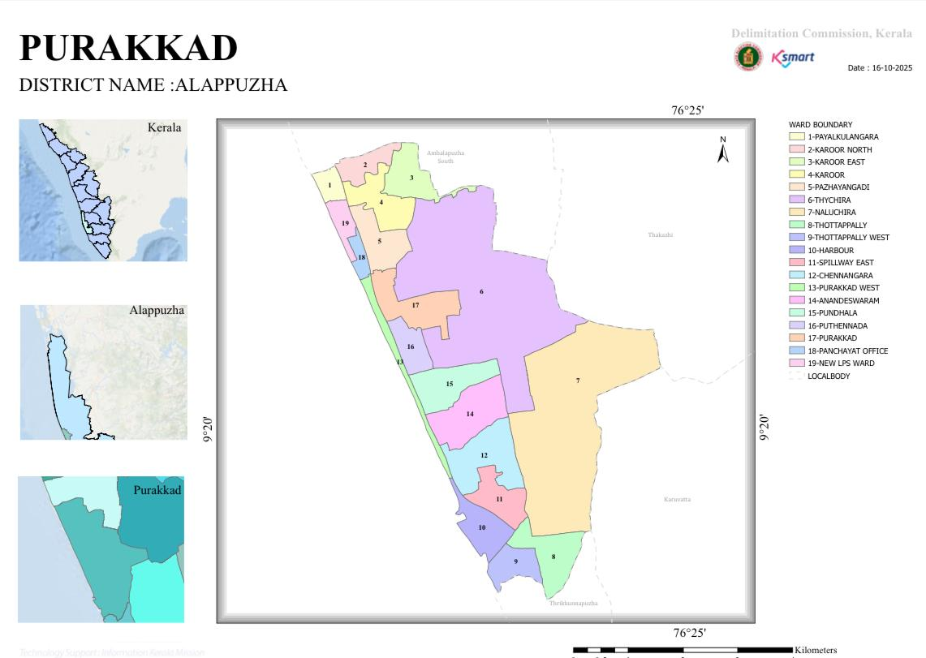

Purakkad is a coastal village located in the Ambalappuzha taluka of Alappuzha district in Kerala, India. It is situated roughly 17 kilometers south of Alappuzha town.
Geographical Boundaries
- West: Lakshadweep Sea (Arabian Sea).
- East: Thakazhy and Champakulam panchayats.
- North: Ambalappuzha town/panchayat.
- South: Karuvatta and Veeyapuram panchayats.
Geographical Features
- Area: Approximately 23.21 square kilometers.
- Terrain: Characterized as a coastal plain with low-lying land, sandy ridges, and inter-tidal flats.
- Waterways: The area is part of the Kuttanad region, characterized by a network of backwaters and canals, with proximity to the Pamba River system.
- Coordinates: Situated at roughly 9° 21' N latitude and 76° 22' E longitude (approximate for Ambalappuzha region).
For a visual representation, Purakkad is best located on maps showing the coastal stretch between Ambalappuzha and Haripad in Alappuzha District.

Ward division

Ward | Houses | Population | Migrants | Wells | Hot  spots | Ed. Institutions | Hosp pvt/govt.
1 | 430 | 1860 | 2 | 44 | 0 | 0 | 0
2 | 582 | 2151 | 10 | 93 | 0 | 0 | 0
3 | 483 | 1566 | 9 | 102 | 0 | 1 | 0
4 | 491 | 1985 | 6 | 44 | 0 | 0 | 0
5 | 460 | 1766 | 15 | 46 | 0 | 2 | 0
6 | 498 | 1972 | 25 | 0 | 0 | 0 | 0
7 | 463 | 2090 | 4 | 0 | 0 | 0 | 0
8 | 374 | 1565 | 21 | 3 | 0 | 0 | 2
9 | 460 | 1935 | 0 | 18 | 0 | 0 | 0
10 | 406 | 1770 | 16 | 17 | 0 | 0 | 1
11 | 365 | 1644 | 22 | 9 | 0 | 1 | 0
12 | 395 | 1630 | 19 | 26 | 0 | 0 | 1
13 | 365 | 1433 | 0 | 34 | 0 | 0 | 0
14 | 490 | 1858 | 4 | 72 | 0 | 1 | 0
15 | 367 | 1415 | 8 | 32 | 0 | 0 | 0
16 | 384 | 1461 | 6 | 110 | 0 | 2 | 3
17 | 460 | 1200 | 5 | 89 | 0 | 1 | 1
18 | 517 | 2090 | 4 | 75 | 0 | 1 | 0
19 | 325 | 1250 | 4 | 25 | 0 | 0 | 0

MajorRoads/rivers

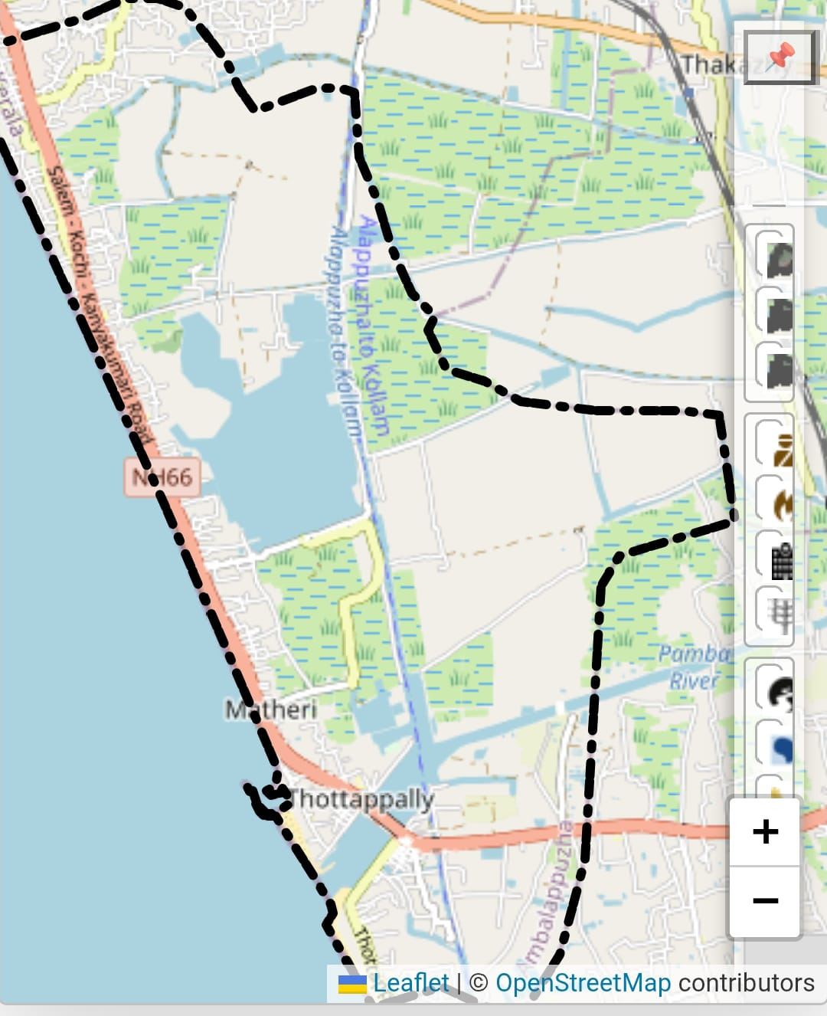

INTEGRATED HEALTH INFRASTRUCTURE MAP OF PURAKKAD PANCHAYAT

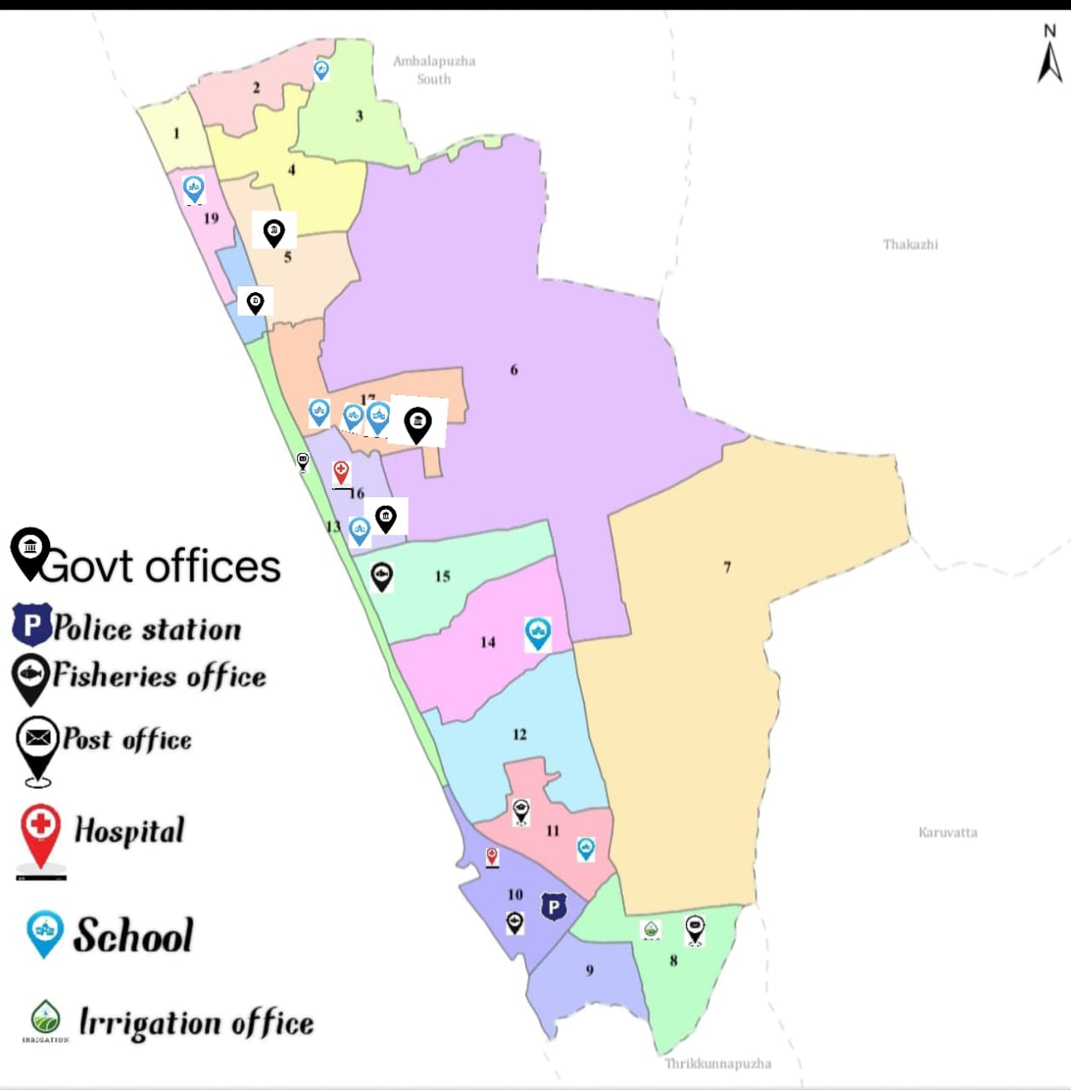

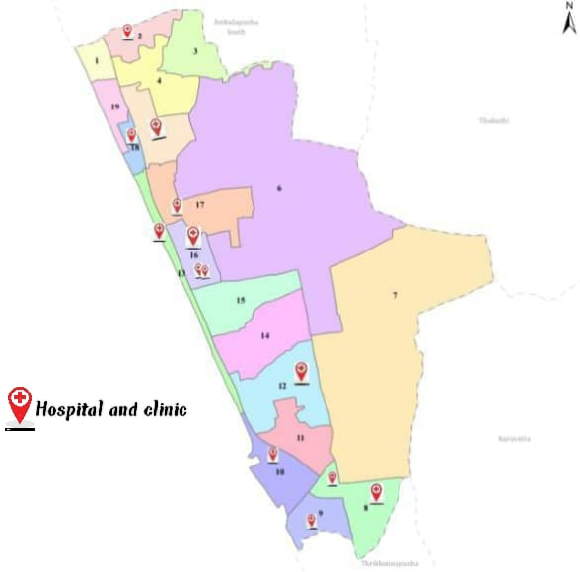

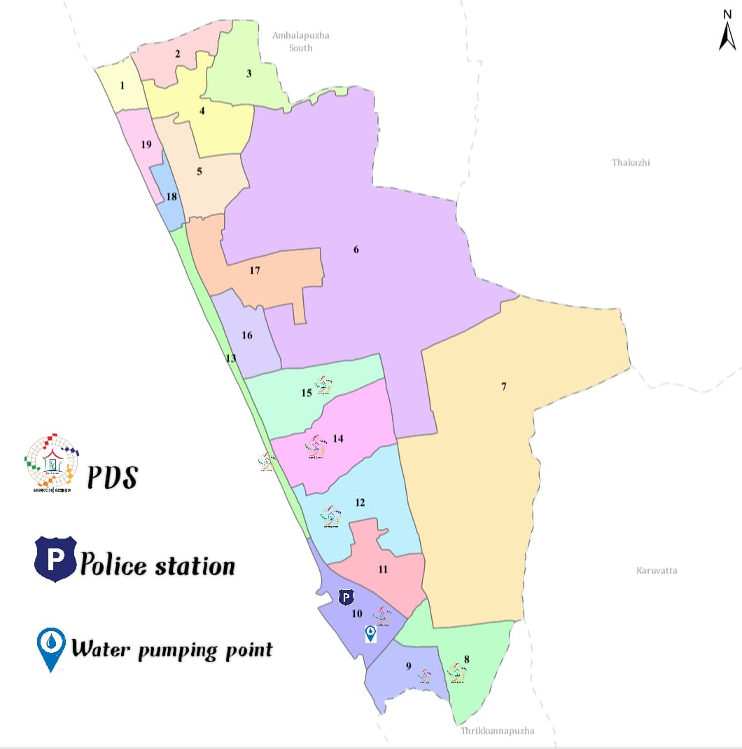

Vulnerability mapping

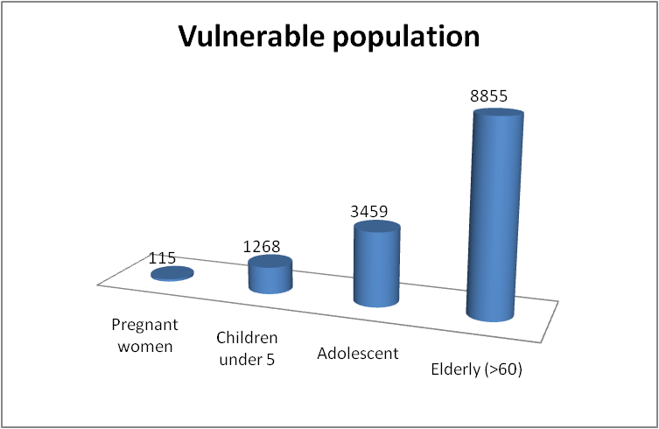
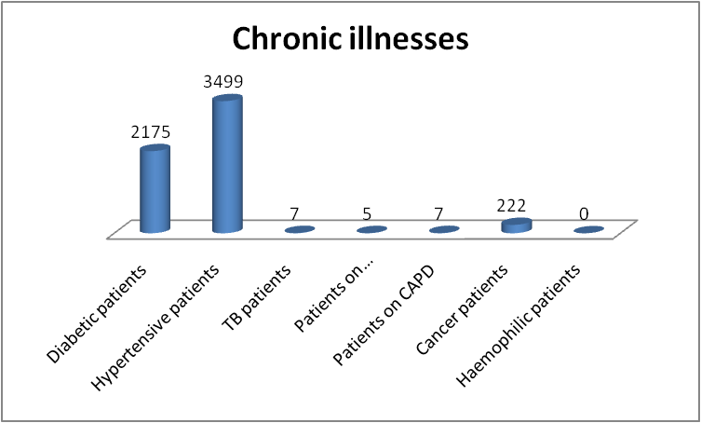
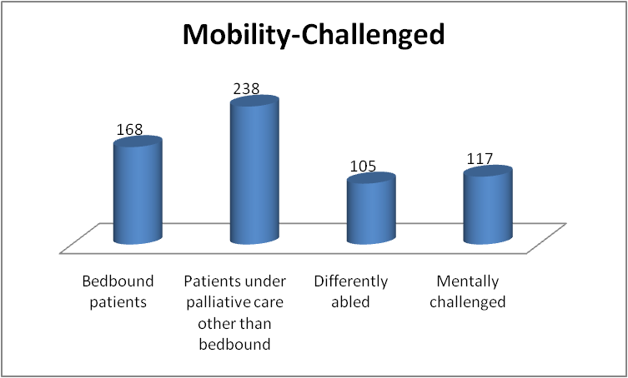

Disaster prone areas (geographic vulnerability)

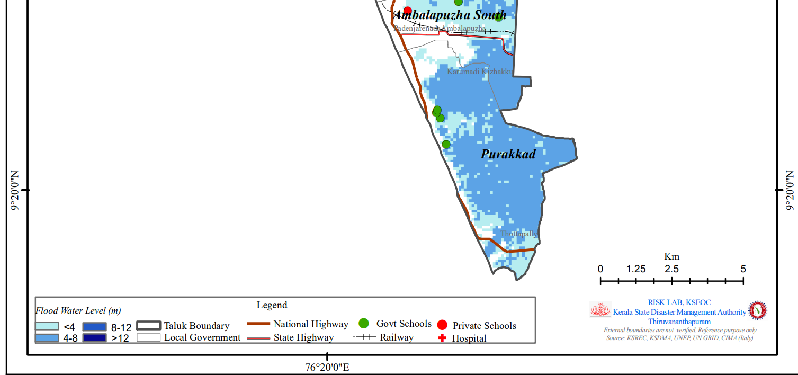

GENERAL PROFILE OF THE LSGI
Purakkad Grama Panchayat is located in Ambalappuzha Taluk of Alappuzha district, Kerala, along the state’s coastal belt bordering the Arabian Sea. The Panchayat is predominantly low-lying and coastal, characterized by backwaters, canals, wetlands, and paddy fields typical of the greater Kuttanad and Alappuzha wetland systems. This distinctive geographical setting strongly influences the local microclimate and hydrology, while also posing challenges to mobility, infrastructure maintenance, and service delivery—particularly during the southwest monsoon and extreme weather events.
The Panchayat is administratively divided into multiple wards, with a population largely dependent on traditional livelihoods. Agriculture, especially paddy cultivation, marine and inland fishing, coir production, and coconut-based activities form the economic foundation of the area. In recent years, tourism-related activities, small-scale enterprises, and service-sector employment have gradually expanded, contributing to livelihood diversification. The local workforce also includes a substantial number of migrant labourers engaged in construction, agriculture, fisheries, and allied sectors.
From a public health and disaster management perspective, Purakkad Grama Panchayat is highly vulnerable to seasonal flooding, coastal erosion, saline water intrusion, and waterlogging. These conditions increase the risk of waterborne and vector-borne diseases, including Dengue and Leptospirosis. The catastrophic 2018 Kerala floods and subsequent monsoon-related flooding events caused significant damage to housing, livelihoods, agriculture, and public infrastructure in the Panchayat, highlighting the area’s exposure to climate-induced disasters and extreme weather variability.
Given the Panchayat’s ecological sensitivity and recurring disaster risks, there is a critical need to strengthen local preparedness, emergency response capacity, and inter-departmental coordination. In this context, the development of a localized, data-driven Auxiliary Infrastructure and Logistical Resource Map is essential. Such a tool will support evidence-based planning, ensure timely and effective emergency response, improve access to critical infrastructure during disasters, and enhance the overall resilience and sustainable development of Purakkad Grama Panchayat

Table 1: Background of LSGD
Description | Details
Name of LSGI | Purakkad
Type (GP/Municipality / Corporation etc.) | Grama Panchayath
Block | Ambalappuzha
District | Alappuzha
Number of wards | 19
Total area (sq. km) | 21.19 sq.Km
Population(Projected) | 31741
Population density | 1498 persons/sq km
Terrain (coastal/low-lying/backwaters/foothills, etc.) | Coastal
Number of rivers passing through LSGI | 1
Number of water bodies in the LSGI | 16
Number of educational institutions | 9
Factories / small-scale industries | 0
Flood-prone wards | Ward 6,7,9,10,12,14
Landslide-prone wards | 0
Death Management and Disposal Facilities (mortuaries/crematorium, including electric) | nil
Auditoriums/Marriage halls/convention centres/community halls | 16

Demographic and Vulnerable Population
Understanding the demographic composition and vulnerable population groups is essential for pandemic preparedness. Children, elderly, economically deprived families, migrant workers, and socially vulnerable groups are at increased risk during public health emergencies due to higher exposure, limited access to services, and dependency on public systems..

Description |  | Details (in numbers)
DEMOGRAPHIC PROFILE
Total population |  | 31741
Male |  | 15234
Female |  | 16507
Transgender |  | 1
Children under 5 |  | 1268
Adolescent |  | 3459
Elderly (>60) |  | 8855
SOCIAL/LIVELIHOOD VULNERABILITY
Previous EPEP family |  | 42
BPL family |  | 12185
Tribal communities |  | 0
Migration | Immigrant | 385
Migration | Emigrant | 1218
Socio-economically deprived |  | 140
Fisherfolk |  | 2468
SC Community |  | 744
ST Community |  | 11

Clinical Vulnerability
Certain population groups need priority healthcare & are at higher risk of severe illness, complications, and mortality during pandemics. Patients with chronic diseases, those requiring regular medical care, and individuals with mobility or functional limitations face challenges in accessing timely care during emergencies. Mapping these groups helps in prioritizing continuity of treatment, medicine stock planning, oxygen support, referral transport, and targeted home-based care.
Description | Details in numbers
Pregnant women | 115
Lactating mothers | 110
Bedbound patients | 168
Patients under palliative care other than bedbound | 238
Patients on Haemodialysis | 5
Patients on CAPD | 7
Cancer patients (currently on treatment) | 222
Haemophilic patients | 0
Mentally challenged | 117
Differently abled | 105
Diabetic patients | 2175
Hypertensive patients | 3499
TB patients | 7

Major Festivals & Events specific to the LSGI
Purakkad Panchayath observes major festivals such as Tottapally Festival (September), Purakkad Mosque Festival, and Punthala Temple Festival (February–March), which involve large public gatherings and increased population movement. These periods pose a high risk for communicable disease transmission due to overcrowding, inadequate sanitation, food safety issues, and difficulty in monitoring health protocols.
Before each festival season, intersectoral coordination meetings are conducted to ensure effective preparedness and response. From the Health Department, the Medical Officers, Health Supervisor (HS), and the concerned Health Inspector (HI) take the initiative in organizing these meetings with relevant line departments to plan preventive measures.
The Epidemiologist analyses previous surveillance data, including disease trends and outbreaks reported during earlier festival periods in the area. Based on this analysis, necessary preventive and control measures—such as strengthening surveillance, sanitation, food safety monitoring, and emergency health services—are adopted to prevent recurrence of similar situations during upcoming festivals.
Strong intersectoral coordination and evidence-based planning help minimize public health risks and ensure safe conduct of festivals in Purakkad Panchayath.

Sl. No. | Name of festivals | Month detailing the periodicity
1 | Thottapally beach festival | September
2 | Purakkad Mosque festival | August-september
3 | Punthala Temple festival | February - March

INFRASTRUCTURE & RESOURCE INVENTORY

Health Facility Directory & Basic Capacity in the LSGD
Purakkad LSGD has limited healthcare infrastructure comprising FHC Purakkad and FHC Thottappaly in the government sector, each with 1 inpatient bed and 1 oxygen-supported bed, but without ICU beds, ventilators, or ambulance services. The private facility (Mathery) strengthens local capacity with 25 beds, including 8 ICU beds and 8 oxygen-supported beds. In view of the limited critical care capacity within the LSGD, a surge plan is in place whereby stable cases will be managed at FHCs, moderate cases referred to the private facility, and severe cases promptly referred to nearby UHTC Ambalappuzha or Medical College Alappuzha. During public health emergencies or outbreaks, temporary expansion of beds, oxygen support, staff redeployment, and inter-facility coordination, along with ambulance support from neighboring LSGDs, will be mobilized to meet increased demand.

Table 5. Health Facility Resource Summary
Sl.no. | Health Facility | Type of Facility (MCH/GH/CHC/FHC/SC etc.) | Contact Number | Total beds | ICU Beds | Oxygen-Supported Beds | No. of Ventilator Support | No. of ambulances
Government Healthcare Facilities
1 | FHC PURAKKAD | FHC | 944785637 | 1 | 0 | 1 | 0 | 0
2 | FHC THOTTAPPALY | FHC | 8281215764 | 1 | 0 | 1 | 0 | 0
3 | HWC maincenter Thottapally | Subcentre | 9567876650 | 0 | 0 | 0 | 0 | 0
4 | HWC Kottaravalavu | Subcentre | 8943332388 | 0 | 0 | 0 | 0 | 0
5 | HWC ICDS Ottapana | Subcentre | 907247580 | 0 | 0 | 0 | 0 | 0
6 | HWC maincenter Purakkad | Subcentre | 9847586672 | 0 | 0 | 0 | 0 | 0
7 | HWC Purakkad | Subcentre | 89437 92654 | 0 | 0 | 0 | 0 | 0
Private Healthcare Facilities
1 | Mathery | Private hospital | 7034356252 | 25 | 8 | 8 | 0 | 0
2 | Relief | Private hospital | 9895603762 | 5 | 0 | 0 | 0 | 0
3 | Zains poly clinic | private clinic | 8089429977 | 1 | 0 | 0 | 0 | 0
AYUSH Healthcare Facilities
1 | Hari Narayan Ayurkshetra | Private | 8606766211 | 0 | 0 | 0 | 0 | 0
*refer annexure 1 for contact details

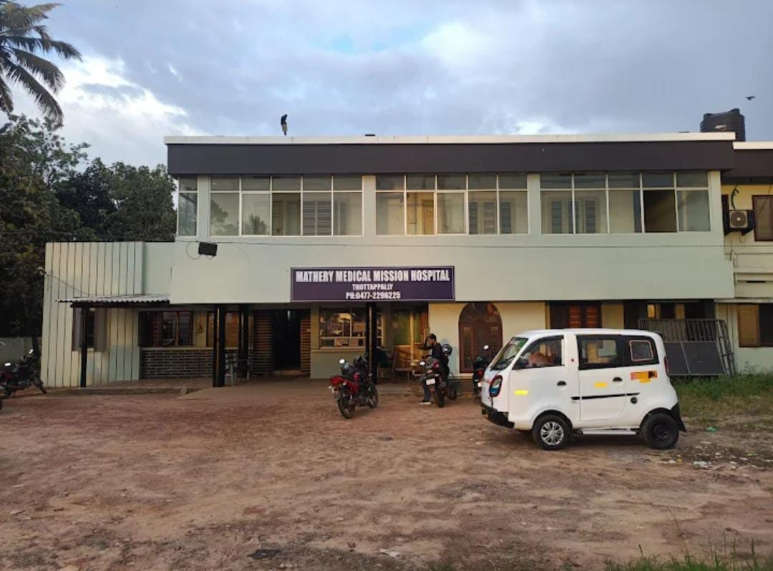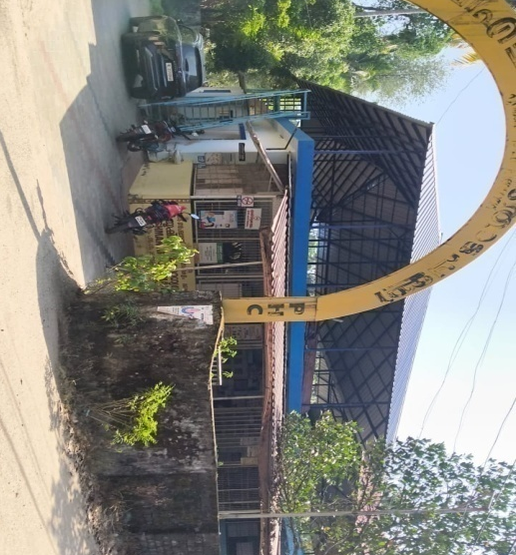
MATHERY PRIVATE HOSPITAL FHC THOTTAPPALLY

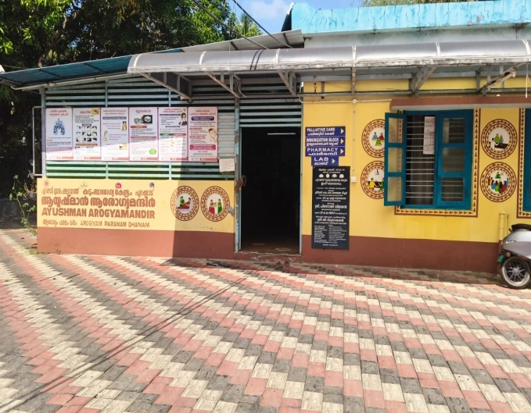
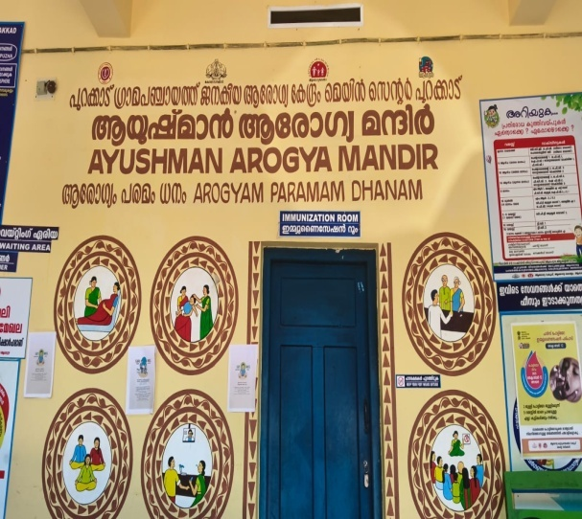
SUB CENTER M/C PURAKKAD FHC PURAKKAD

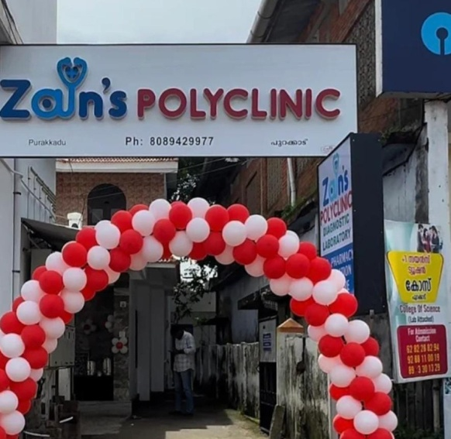 ZAIN’S POLYCLINIC

For this LSGD, the MCH Alappuzha serves as the primary referral point for critical emergencies and multi-specialty care, whereas the UHTC Ambalappuzha (CHC Ambalappuzha) handles secondary-level referrals from local Sub-centres and FHCs.

Private Clinics
Private clinics are an essential part of pandemic preparedness, as they are often the first place people seek care when symptoms begin. In many communities, private clinics manage a significant share of outpatient visits and therefore play a critical role in early case detection, timely referrals, and disease surveillance. Having an up-to-date understanding of where these clinics are located, the services they provide, and how they are linked to the public health system helps ensure that no cases are missed during an outbreak. It also allows health authorities to engage private practitioners more effectively for reporting, risk communication, and coordinated response, strengthening the overall capacity of the health system to manage public health emergencies.

Table 6. Private Clinic Resource Summary
Sl No. | Name of Clinic | Registered (Y/N) | Clinic (General / Speciality) | Speciality (if any) | Address | Contact Number | Diagnostic Facility (Y/N) | Ambulance Linkage (Y/N)
1 | Mathery | Y | General | nil | Ottapana (ward 12) | 7034356252 | Y | Y
2 | Relief | Y | General | nil | Thottappally ( ward 8) | 9895603762 | Y | Y
3 | Hari Narayan Ayurkshetra | Y | Ayurveda | nil | Thottappally(ward 8) | 8606766211 | N | N
4 | Zains poly Clinic | N | General | Nil | Purakkad | 8089429977 | Y | N

Healthcare Education & Training Institutions
This section tracks the educational infrastructure available, which is vital for human resource planning in the health sector.

Category of Institution | Govt | Private | AYUSH | Total
Medical Colleges | 0 | 0 | 0 | 0
Nursing Colleges | 0 | 0 | 0 | 0
Dental Colleges | 0 | 0 | 0 | 0
Para-medical / Allied Health | 0 | 1 | 0 | 1
Pharmacy Colleges | 0 | 0 | 0 | 0

Specialized Services & Emergency Inventory
This section provides a detailed view of the specialized medical resources available to the community, focusing on emergency response and critical care capabilities. This table tracks the vital assets required for managing severe illnesses and emergencies across Government, Private, and AYUSH sectors.

Item | Govt | Private | AYUSH | Total
Hospital beds | 2 | 30 | 0 | 32
Oxygen-generating systems(Y/N) | N | Y | 0 | 0
Oxygen-supported beds(Numbers) | 0 | 8 | 0 | 8
Ventilator-supported beds | 0 | 0 | 0 | 0
ICU beds | 0 | 8 | 0 | 8
Burns units | 0 | 0 | 0 | 0
Blood centres | 0 | 0 | 0 | 0
BLS ambulances | 0 | 0 | 0 | 0
ALS ambulances | 0 | 0 | 0 | 0
Dialysis facilities | 0 | 0 | 0 | 0
Dispensaries | 0 | 0 | 0 | 0
Medical store | 2 | 9 | 0 | 11
Industrial establishments(Medium-scale industries/small-scale industries establishments to whom we can depend in a worst-case scenario) | 0 | 0 | 0 | 0

Oxygen & Diagnostic Capacity
Monitoring oxygen and diagnostic capacity is a critical component of public health preparedness, ensuring that the LSGD can handle both chronic care and sudden surges in respiratory or infectious diseases.
Name of Health Facility | Oxygen-generating System (Y/N) | Backup Oxygen Source (Y/N) | Diagnostic Facilities Available(Y/N)
Name of Health Facility | Oxygen-generating System (Y/N) | Backup Oxygen Source (Y/N) | Lab | USG | X-ray | CT/MRI | RT-PCR
Government Healthcare Facilities
FHC THOTTAPPALLY | Y | N | Y | N | N | N | N
FHC PURAKKAD | Y | N | Y | N | N | N | N
HWC MAINCENTRE THOTTAPPALLY | Y | N | Y | N | N | N | N
HWC KOTTARAVALAVU | Y | N | Y | N | N | N | N
HWC ICDS OTTAPPANA | Y | N | Y | N | N | N | N
HWC MAINCENTRE PURAKKAD | Y | N | Y | N | N | N | N
HWC PURAKKAD | Y | N | Y | N | N | N | N
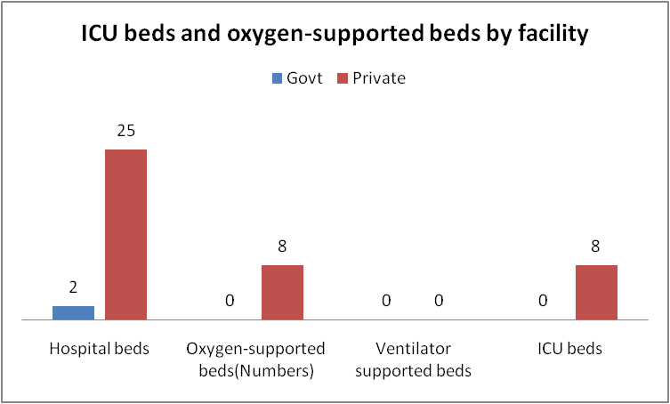

Diagnostics facility mapping at the LSGI level
The diagnostic capacity of Purakkad G.P represents the "intelligence network" of our healthcare system. The speed and accuracy of disease identification depend entirely on the distribution and technical level of these facilities.

Item | Govt | Private | AYUSH | Total
General labs | 7 | 2 | 0 | 9
Microbiology labs | 0 | 0 | 0 | 0
RT-PCR labs | 0 | 0 | 0 | 0
USG units | 0 | 0 | 0 | 0
CT/MRI units | 0 | 0 | 0 | 0
Research labs | 0 | 0 | 0 | 0
Labs of other departments that can be repurposed | 0 | 0 | 0 | 0

Laboratory Identification & Basic Details
Sl. No. | Name of Laboratory | Ownership (Govt / Private / Academic) | Address | Contact No. | 24×7 Services (Yes/No) | NABL / Govt Approved (Yes/No)
1 | PHC THOTTAPPALLY | GOVT | WARD 10 | 8281215764 | N | Y
2 | FHC PURAKKAD | GOVT | WARD  16 | 9447856372 | N | Y
3 | HWC MAIN CENTRE THOTTAPPALLY | GOVT | WARD 10 | 9188783809 | N | Y
4 | HWC KOTTARAVALAVU | GOVT | WARD 8 | 89711956447 | N | Y
5 | HWC ICDS OTTAPPANA | GOVT | WARD 13 | 9847586672 | N | Y
6 | HWC MAINCENTRE PURAKKAD | GOVT | WARD  16 | 9847586672 | N | Y
7 | HWC PURAKKAD | GOVT | WARD  18 | 8943792654 | N | Y
8 | MATHERI MEDICAL MISSION | PVT | WARD 12 | 7034356252 | Y | Y
9 | RELIEF | PVT | WARD 8 | 9895603762 | N | N
10 | ZAINS POLY CLINIC | PVT | WARD 17 | 8089429977 | N | N

Social and Community Infrastructure for surge plan
This table serves as our logistics and shelter inventory. By mapping these locations, quickly we can identify where to house displaced citizens, where to set up temporary medical clinics, and how to manage the deceased with dignity during a crisis.

Category | Total Count | Ward | Est. Capacity (Persons) | Contact details
Educational Institutions
Anganwadis | 33 | WARD  1,2,3,4,5,15,16,18 | 623 | 9633200597
Schools | 9 | WARD 11,14,18,3,  16,17, | 3038 | 9746588235
Colleges | 1 | 4 | 76 | 04772278877
Healthcare Educational Institutions
Medical colleges (Govt/Private) | 0 | 0 | 0 | 0
Nursing colleges (Govt/Private) | 0 | 0 | 0 | 0
Dental colleges (Govt/Private) | 0 | 0 | 0 | 0
Paramedical institutes (Govt/Private) | 1 | WARD4 | 185 | 04772278877
Community Gathering Spaces
Community halls | 11 | WARD 6,8,9.11,12 | 2500
Auditoriums | 6 | WARD 8,9,12,15 | 6000
Religious buildings | 51 | ALL WARD | 3000
Vulnerable Group Support Facility
Destitute homes | 0 | 0 | 0 | 0
Elderly homes | 0 | 0 | 0 | 0
LSGD owned other buildings | 1 | Ward 5 | 200
Mass Fatality Management (MFM) Infrastructure
Mortuary | 0 | 0 | 0 | 0
Crematorium | 0 | 0 | 0 | 0
*refer annexure 1 for contact details

Human resources

This section focuses on the human capital available within the LSGI. In any emergency—be it a pandemic, flood, or industrial accident—infrastructure is only as effective as the people operating it.

Medical & Clinical Personnel
This table tracks the "Frontline" providers responsible for diagnosis, treatment, and clinical management. Narrative sentence: eg., "Total health workforce: 450 personnel, with 60% in government facilities serving as primary surge capacity." A detailed directory with the contact numbers of all workers is maintained (Annexure in 1).

Cadre | Govt (No.) | Private (No.) | Total
Doctors—Modern Medicine | 4 | 8 | 12
Doctors – AYUSH | 1 | 2 | 3
Doctors – Veterinary | 1 | 0 | 1
Doctors – Dental | 0 | 1 | 1
Nursing officers | 4 | 4 | 8
Lab technicians | 3 | 7 | 10
Optometrist | 1 | 0 | 1
Pharmacists | 4 | 3 | 7
Psychologists | 0 | 0 | 0
Counsellors | 0 | 0 | 0

Public Health & Field-Level Workforce
These individuals are the backbone of surveillance, maternal-child health, and decentralized care.

Cadre | Health services | Municipal common services | Total
HS (Health Supervisors) | 1 | 0 | 1
HI (Health Inspectors) | 1 | 0 | 1
LHS (Lady Health Supervisor) | 1 | 0 | 1
LHI (Lady Health Inspectors) | 1 | 0 | 1
JPHN (Jr Public Health Nurses) | 5 | 0 | 5
JHI (Jr Health Inspectors) | 4 | 0 | 4
MLSP (Mid-Level Service Providers) | 4 | 0 | 4
Palliative Nurses | 2 | 0 | 2
RBSK Nurses | 1 | 0 | 1
PRO | 1 | 0 | 1
Epidemiologist | 1 | 0 | 1
Data Manager | 1 | 0 | 1

Community & Support Cadre
This group represents the surge capacity of the LSGI—people who can be called upon for logistics, rescue, and specialized support.

Cadre | Number
ASHA Workers | 30
AWW (Anganwadi Workers) | 33
Emergency Medical Volunteers (Trained) | 88
Kudumbashree | 91
MNREGS | 5317
Purusha Swayam Sahaya Sangham | 4
Ex-Servicemen | 101
Retired Police Officers | 28
NCC/NSS Volunteers | 54
Red Cross volunteers | 0
One Health Community Volunteers | 900
One Health Community Mentors | 120

Community Organizations
This section details the presence of community-based organisations (CBOs), non-governmental organisations (NGOs), faith-based organisations (FBOs), Kudumbashree Self-Help Groups (SHGs), and Ayalkootams within the Local Self-Government Institution (LSGI). These groups enhance grassroots mobilization, resource distribution, and support networks crucial for pandemic response and community resilience.

Category | Total Count
NGOs | 1
Religious based organizations | 3
Foreign based organizations | 8
Sports Club/youth clubs | 0
Kudumbashree SHGs | 189
Ayalkootams | 2
Political organizations | 0
Residential organizations | 0

Administrative & Emergency Services
This section outlines the availability of key non-health emergency support services and infrastructure within the LSGI, which are essential for effective pandemic preparedness and response. These facilities support law enforcement, disaster response, water supply, logistics, mobility, and community-level interventions during public health emergencies.

Category | Total Count | Contact details
Police Stations | 1 | 0477 2296100
Fire & Rescue Stations | 0 | -
Water Pumping Points | 3 | WARD 10
Public Distribution System (PDS) | 7 | WARD 8,9,10,12,13,14,15

Information regarding resources
The availability of essential transport and support resources plays a quiet but critical role in saving lives. Equipment such as ambulances, mobile mortuaries, amphibian ambulances, and motorized boats ensures that patients, samples, and healthcare teams can move swiftly—even in flooded, remote, or difficult terrains. Heavy vehicles like JCBs, cranes, tractors, and torus lorries support logistics, waste management, emergency infrastructure, and rapid conversion of spaces into care or isolation facilities. Taxis, four-wheel-drive vehicles, and trucks help maintain continuity of essential services, reach vulnerable populations, and support home-based care and supply delivery.

Means of transportation | Total Count
JCB | 1
Crane | 0
Heavy Trucks | 1
Tractor | 1
Ambulances | 1
Mobile mortuaries | 0
Boats | 1
Taxi service | 1
Note: For specific details regarding vehicle owners and contact information, please refer to Annexure.

ONE HEALTH & ENVIRONMENTAL SURVEILLANCE
The main risk of zoonotic diseases in Purakkad is concentrated in Ward 6, 7, 12, which is explained by the high density of cattle congregation areas, and poultry units. The stray dog population in market areas, fish landing sites, bus stations continues to be a substantial problem for rabies surveillance and bite prevention. There is a considerable risk of avian influenza introduction and amplification during October–March due to the seasonal presence of migratory and resident water birds near Thottappally , Naluchira and Illichira . Clustered animal shelters vulnerable to flooding further raise the risk of leptospirosis and other zoonoses mediated by the environment, especially during monsoon floods.
Animal & Bird Population
Mapping animal and bird populations at the Panchayat level is essential for identifying and prioritising zoonotic disease hazards like rabies, avian influenza (H5N1), leptospirosis, anthrax, and Nipah-like spillover occurrences. Risk classification, targeted surveillance, vaccination planning, and early epidemic detection made feasible by comprehensive population mapping all enhance One Health-based pandemic preparedness.

Category | Item | Estimated Population | Wards
Animal Population | Livestock (Cattle/Goats/Buffalo) | 260 | all wards
Animal Population | Pet Animals (Dogs/Cats) | 352 | all wards
Animal Population | Stray Dog Population | Approx 400 | all wards
Animal Population | Pig Farms (Number of heads) | 0 | 0
 | Small Units (Sheep / Goats – clustered) | 0 | 0
Bird Population | Poultry Units (Birds) | 0 | nil
Bird Population | Poultry- (FOWL) | 0 | nil
Bird Population | Wild/Migratory Birds (Observed) | Present | ward 6,7
Bird Population | Crow Mortality Events (Reported) | No | nil

The main risk of zoonotic diseases in Illichira,Naluchira,Pallichira is concentrated in Ward which is explained by the high density of pig farms, cattle congregation areas, and poultry units. The stray dog population in market areas, fish landing sites, bus stations continues to be a substantial problem for rabies surveillance and bite prevention. There is a considerable risk of avian influenza introduction and amplification during November - December due to the seasonal presence of migratory and resident water birds near ponds/ canal / river / backwater / paddy field. Clusters of pig farms and animal shelters vulnerable to flooding further raise the risk of leptospirosis and other zoonoses mediated by the environment, especially during monsoon floods.

Veterinary Infrastructure
Veterinary institutions are a core pillar of One Health surveillance, enabling early zoonotic disease detection through vaccination, investigation of unusual animal illness or deaths, sample collection, and timely outbreak reporting. A well-mapped and responsive veterinary network strengthens coordination with human health and LSGI systems, ensuring rapid response during zoonotic events and pandemics.

Facility Type | Name of Facility | Ownership Govt / Pvt | Location(Ward No) | Contact number
Veterinary Dispensary | Government Veterinary Dispensary | Government | 5 | 9495314850
Veterinary Hospital / Polyclinic | nil | nil | nil | nil
Private Veterinary Clinics | nil | nil | nil | nil
Mobile / Emergency Vet Service (incl. night services) | nil | nil | nil | nil
Pet Homes / Animal Shelters | nil | nil | nil | nil
Slaughterhouse-linked Veterinary Inspection Unit | nil | nil | nil | nil

Veterinary Doctors & Workforce
Early detection, diagnosis, reporting, and reaction to animal illness epidemics depend on the availability and accessibility of qualified veterinary specialists. By identifying unusual animal morbidity or mortality promptly, collecting samples promptly, and coordinating efficiently with human health and LSGI systems—especially during zoonotic outbreaks and pandemic-prone situations—a clearly defined veterinary workforce enhances One Health surveillance.

Category | Number Available | Type (Govt/Pvt) | Contact number
Government Veterinary Doctors | 1 | Govt | 9495314850
Private Veterinary Doctors | nil | nil | nil
Livestock Inspectors | nil | nil | nil
Para-veterinary Staff / Attenders | nil | nil | nil
Contract / On-call Veterinary Support (if any) | nil | nil | nil

High-Risk Interface Points (Surveillance Sites)
High-risk interface points for zoonotic disease surveillance in Purakkad Grama Panchayath include wetland–livestock–human contact zones, backyard poultry farms, cattle sheds near water bodies, fish markets, and areas of high human–animal interaction such as community slaughter points and migratory bird congregation sites. These are the primary surveillance sites where zoonotic spillover risks are elevated.

Type of Habitat | Type of High risk interface | Geographical vulnerability wards | Locations
Wetlands & Backwaters | Dengue, Leptospirosis | Ward10 ,6,7,9,13,17 - Thottapally | Thottappally , Naluchira ,Tychira , Illichira,Ottapana
Backyard Poultry Farms | Avian Influenza | Ward 6,7,12 - Thottapally  Ward 5- Purakkad | Illichra , Naluchira, Pallichira,  Appathikarichira
Cattle Sheds near Water Bodies | 0 | nil | nil
Fish & Meat Markets | Leptospirosis | Ward 10 - Thottapally  Ward 16- Purakkad JN | Harbour  Fish market
Community Slaughter Sites | nil | nil | nil
Migratory Bird Congregation Areas | Avian Influenza | ward 6
Rodent-Infested Grain Storage | nil | nil

Category | Total Count | Key Locations (wards)
Poultry Farms | 0 | -
Backyard / Clustered Poultry Units | 5 | Illichira,Naluchira,Pallichira
Duck Rearing Units (open water access) | 2 | Illichira
Slaughterhouses/ Slaughter Points | 9 | Naluchira,Thottappally,Harbour
Meat/Fish Markets | 2 | Harbour
Live Bird Sale Points | 0 | -
Cattle Markets / Weekly Animal Fairs | 0 | -
Pet Shops / Breeders | 0 | -
Animal Shelters / Pet Homes | 0 | -
Waste Disposal Sites near Animal Units | 0 | -

Environmental Risk Mapping
Environmental risk mapping identifies monsoon/flood hotspots for vector-borne (dengue, chikungunya), water-borne (leptospirosis, diarrhoea), and zoonotic diseases in Kerala's wetlands. Systematic surveillance supports early warnings, targeted interventions, and Panchayat pandemic preparedness.
Waterborne exposure: Flood-prone areas and stagnant water bodies facilitate leptospira survival, raising leptospirosis risk.

Traditional practices: Informal slaughter and fish markets lack standardized hygiene, creating spillover opportunities.

Risk Factor | High-Risk Wards | Key Locations | Risk Level (High/Med/Low)
Flood-prone areas | Ward10 ,6,7,9,13,17 - Thottapally | Thottappally , Naluchira , Illichira,Ottapana | High
Water bodies/wetlands | Ward10 ,6,7,9,13,17 - Thottapally | Thottappally , Naluchira ,Tychira , Illichira,Ottapana | Med
Solid waste accumulation | nil | nil | nil
Animal waste disposal issues | nil | nil | nil
Rodent infestation zones | nil | nil | nil
Industrial effluent discharge | nil | nil | nil
Construction sites / abandoned buildings | Ward 6,10 | Tychira , Thottappally | Med
Poor drainage/blocked canals | nil | nil | nil
Drinking water source contamination risk | nil | nil | nil

Disease Seasonality Mapping
- 1, Flooding & waterlogging → amplifies leptospirosis, malaria, diarrheal diseases.
- ·
- Migratory bird influx (Nov–Feb) → avian influenza risk.

- 3, Mosquito breeding cycles → vector-borne disease peaks in monsoon.

- 4, Agricultural practices → close human–animal contact in paddy fields.

Disease | Peak Risk Season | Key Drivers | High-Risk Locations | Surveillance Focus
Avian Influenza | October- march | poultry farms | Thottapally | fever
Leptospirosis | Monsoon | paddy fields, flood | Thottappally , Naluchira , Illichira, Purakkad | fever
Dengue/Chikungunya | Monsoon | mosquito | Purakkad | fever
Acute Diarrheal Diseases | - | fast food | Purakkad | Diarrhea, vomiting
Rabies | - | stray dogs | All Wards | dog bites
Anthrax (rare) | nil | nil | nil | nil

Vulnerability Mapping
Vulnerability mapping pinpoints high-risk populations, occupations, and areas exposed via environment, livelihoods, socio-economics, and poor service access. Paired with environmental/seasonality mapping, it enables risk-based surveillance, targeted actions, and optimal resource use in One Health and pandemic planning.
Vulnerability Factor | High-Risk Wards | Key Groups / Locations | Risk Level
Flood-prone households | Ward 6,7,9,10,13,17,1,4,18,2 | Thottappally , Naluchira ,Tychira , Illichira,Ottapana | High
Wetland-adjacent communities | Ward10 ,6,7,9,13,17,2,3,4 - | Thottappally , Naluchira ,Tychira , Illichira,Ottapana | Med
Backyard poultry / duck rearing households | Ward 6,7,12 | Tychira , Illichira ,Pallichira | High
Livestock-rearing households | ward1,4,3,18 | Karoor west, | Moderate
Slaughterhouse & meat market workers | Nil | Nil | Moderate
Fisherfolk & fish market workers | Ward 9,10 | Harbour | Moderate
Sanitation workers | All Wards | All wards | Moderate
Daily wage / migrant workers | Ward 8,10,6 | Thottappally , Illichira | Moderate
Elderly & chronically ill populations | All Wards | All Wards | Moderate
Pregnant Women | All Wards | All Wards | Moderate
Children (schools, Anganwadi’s) | All Wards | All Wards | Moderate
Limited access to safe water & sanitation | nil | nil | nil

EPIDEMIOLOGICAL TRENDS (2021–2025)

Disease surveillance is the systematic collection, analysis, and interpretation of health data for planning, implementation, and evaluation of public health practice. This section presents the disease surveillance profile of the LSGI based on routine reporting systems and outbreak investigations to identify priority diseases, seasonal patterns, and emerging public health threats.

Disease Burden among human beings(Last 5 Years)
Analysis of disease-wise data for the last five years helps identify persistent public health problems, emerging diseases, and changes in disease burden. This information supports prioritisation of prevention, preparedness, and response activities at the Panchayat level.

Disease | 2021 | 2022 | 2023 | 2024 | 2025 | Trend(Increasing/Stable/Decreasing)
Dengue | 5 | 13 | 12 | 19 | 2 | Decreasing
Leptospirosis | 19 | 14 | 14 | 8 | 6 | Decreasing
Hepatitis A | 0 | 0 | 2 | 2 | 3 | Decreasing
Malaria | 1 | 0 | 0 | 0 | 0 | Decreasing
Scrub Typhus | 0 | 0 | 0 | 0 | 0 | Decreasing
Typhoid | 0 | 0 | 0 | 2 | 0 | Decreasing
H1N1 | 0 | 0 | 4 | 3 | 0 | Decreasing
H3N2 | 0 | 0 | 1 | 0 | 0 | Decreasing
ADD | 15 | 10 | 16 | 23 | 55 | Increasing
Mumps | 0 | 0 | 0 | 0 | 15 | Increasing
Measles | 0 | 0 | 0 | 0 | 0 | stable
Hepatitis B | 0 | 0 | 2 | 3 | 0 | Increasing
Hepatitis C | 0 | 0 | 3 | 0 | 0 | stable
Tuberculosis | 2 | 3 | 2 | 3 | 4 | Increasing
Leprosy | 0 | 0 | 0 | 0 | 0 | stable
COVID-19 | 0 | 0 | 1 | 0 | 1 | stable

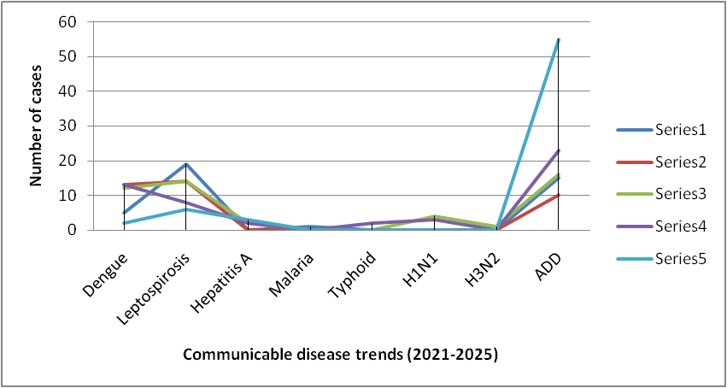

*(use the above table data to create the graph/diagram)

Seasonal Trend Analysis
Seasonal analysis helps anticipate surges (e.g. dengue in monsoon, leptospirosis after floods, influenza in cooler months) and plan pre‑emptive vector control, stockpiling of IV fluids, and awareness campaigns at Panchayat level.

DENGUE
Dengue is a major seasonal vector-borne disease strongly associated with rainfall, water stagnation, and increased mosquito breeding during the monsoon period.

Peak: July–November

Dengue – Ward-wise Yearly Distribution (2021–2025)

Ward | Dengue – Ward-wise Yearly Distribution
Ward | 2021 | 2022 | 2023 | 2024 | 2025 | Total
1 | 1 | 3 | - | - | - | 4
2 | - | - | - | - | - | 0
3 | - | 1 | 1 | - | - | 2
4 | - | - | 4 | - | - | 4
5 | - | - | 2 | 1 | 1 | 4
6 | - | - | - | - | - | -
7 | - | - | 2 | 2 | - | 4
8 | - | - | - | - | - | -
9 | - | - | - | 3 | 1 | 4
10 | - | - | 1 | 1 | 2 | 4
11 | - | - | - | 1 | 1 | 2
12 | - | - | 1 | - | - | 1
13 | - | - | - | - | - | -
14 | - | - | - | - | - | -
15 | - | 1 | 2 | - | - | 3
16 | - | 1 | 1 |  | 1 | 3
17 | - | - | - | - | - | -
18 | - | 1 | 3 | 2 | - | 6

LEPTOSPIROSIS
Leptospirosis cases are closely linked to monsoon rains, flooding, and occupational exposure, particularly in low-lying and waterlogged areas.

Peak: June - August

Leptospirosis – Ward-wise Yearly Distribution (2021–2025)

Ward | Leptospirosis – Ward-wise Yearly Distribution
Ward | 2021 | 2022 | 2023 | 2024 | 2025 | Total
1 | - | - | 2 | - | 2 | 4
2 | - | 1 | - | - | - | 1
3 | 1 | - | - | - | - | 1
4 | - | - | 1 | - | - | 1
5 | 1 | 1 | - | - | 1 | 3
6 | - | - | - | - | - | -
7 | - | - | - | - | - | -
8 | - | - | - | - | 1 | 1
9 | - | - | 2 | - | - | 2
10 | - | - | - | 2 | - | 2
11 | - | - | - | 1 | - | 1
12 | - | - | - | - | - | -
13 | - | - | - | - | - | -
14 | - | - | - | - | - | -
15 | - | - | - | - | - | -
16 | - | - | - | - | - | -
17 | - | - | - | - | - | -
18 | - | - | - | - | 1 | 1

VIRAL HEPATITIS - A
Hepatitis A cases are commonly associated with unsafe drinking water, food contamination, and breakdowns in sanitation, often presenting as clusters or outbreaks.

Peak: October - December

Hepatitis A – Ward-wise Yearly Distribution (2021–2025)

Ward | Hep A – Ward-wise Yearly Distribution
Ward | 2021 | 2022 | 2023 | 2024 | 2025 | Total
1 | - | - | - | - | - | -
2 | - | - | - | - | - | -
3 | - | - | - | - | - | -
4 | - | - | - | - | - | -
5 | - | - | - | - | - | -
6 | - | - | - | - | - | -
7 | - | - | - | - | - | -
8 | - | - | - | 1 | - | 1
9 | - | - | - | - | - | -
10 | - | - | - | 1 | - | 1
11 | - | - | - | - | - | -
12 | - | - | - | - | - | -
13 | - | - | - | - | - | -
14 | - | - | - | - | - | -
15 | - | - | - | - | 1 | 1
16 | - | - | - | - | - | -
17 | - | - | - | - | - | -
18 | - | - | - | 1 | - | 1

Outcome-Based Trend Analysis- 2025

An approach for monitoring and analyzing the disease patterns based on the outcomes or impacts of specific interventions, policies, or public health measures and concerns. It shifts emphasis from merely tracking disease incidence to evaluating the effectiveness of prevention measures implemented for the disease. This type of analysis is crucial for understanding not only the spreadness of diseases but also how well the system is responding to them. This analysis evaluates the impact of various public health measures, determines whether these measures lead to reductions in disease prevalence, morbidity, mortality, or healthcare burden over time and this can be utilized modifying or improving existing health policies, resource allocation, and preparedness plans.

Sl. No. | Type of disease | Age group | Gender |  | Total no. of survival | Total no. of death | No. of cases received treatment
Sl. No. | Type of disease | Age group | No. of Male | No. of Female | Total no. of survival | Total no. of death | No. of cases received treatment
1 | Dengue | under 05 children | 1 | 0 | 1 | 0 | 1
2 | Dengue | 5-19 years | 3 | 0 | 3 | 0 | 3
3 | Dengue | 20-59 years | 4 | 2 | 6 | 0 | 6
4 | Dengue | 60+ (Seniors) | 0 | 0 | 0 | 0 | 0
1 | Lepto | under 05 children | 0 | 0 | 0 | 0 | 0
2 | Lepto | 5-19 years | 0 | 0 | 0 | 0 | 0
3 | Lepto | 20-59 years | 2 | 4 | 5 | 1 | 6
4 | Lepto | 60+ (Seniors) | 0 | 0 | 0 | 0 | 0
1 | VH-A | under 05 children | 0 | 0 | 0 | 0 | 0
2 | VH-A | 5-19 years | 0 | 0 | 0 | 0 | 0
3 | VH-A | 20-59 years | 3 | 0 | 3 | 0 | 3
4 | VH-A | 60+ (Seniors) | 0 | 0 | 0 | 0 | 0

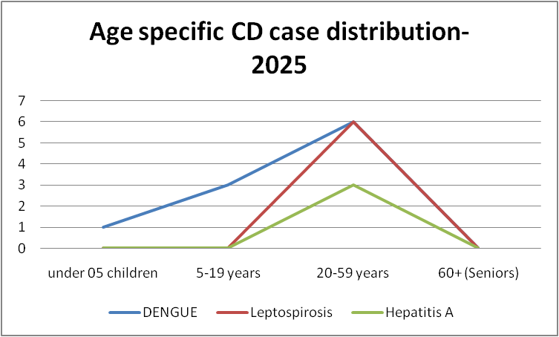

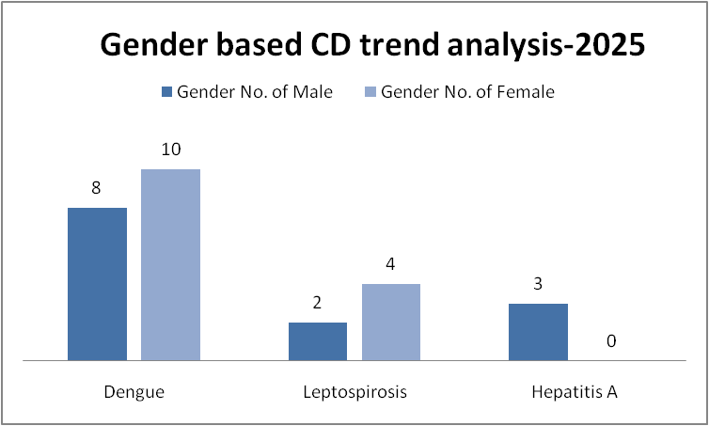

Transmission Trend- 2025
For effective management of public health issues, it is important to track the trend of disease transmission mode. It helps identify the population or place at high risk that can be used to predict outbreaks and implement targeted interventions as quickly as possible. Understanding these kinds of trends enables authorities to allocate resources efficiently and change the strategies adequately based on the trend that follows.

Mode of Transmission | No. of cases | No. of Deaths
Vector Borne Diseases | 10 | 0
Water Borne Diseases | 3 | 1
Air Borne Diseases | 0 | 0
Blood Borne Diseases | 0 | 0
Zoonotic Diseases | 6 | 1

Vector-Borne Disease

Disease | No. of Cases | No. of Deaths
Dengue | 10 | 0
Malaria | 1 | 0
Chikungunya | 0 | 0

Water Borne Disease

Disease | No. of Cases | No. of Deaths
Cholera | 0 | 0
Typhoid | 0 | 0
Hep- A | 3 | 0
Dysentery | 0 | 0
Amoebiasis | 0 | 0
E- Coli infections | 0 | 0

Air Borne Disease

Disease | No. of Cases | No. of Deaths
Influenza | 0 | 0
H1N1 | 0 | 0
TB | 7 | 0
Chickenpox | 15+ | 0
Measles | 0 | 0
Covid-19 | 1 | 0
Pertussis | 0 | 0
Mumps | 15 | 0

Blood-Borne Disease

Disease | No. of Cases | No. of Deaths
AIDS | 0 | 0
Hep- B | 0 | 0
Hep- C | 0 | 0

Zoonotic Disease

Disease | No. of Cases | No. of Deaths
Rabies | 0 | 0
Leptospirosis | 6 | 1
Avian influenza | 0 | 0
West nile | 0 | 0
Anthrax | 0 | 0
Nipah | 0 | 0
Scrub Typhus | 0 | 0

Integrated Disease Hotspot (2021–2025)

Ward No | Dengue Total (2021-25) | Leptospirosis Total (2021-25) | Hepatitis A Total (2021-25) | Mumps (2021-25) | ADD (2021-25) | Total Cases
1 | 1 | 2 | 1 | 2 | 7 | 13
2 | 2 | 0 | 0 | 3 | 6 | 11
3 | 1 | 0 | 0 | 4 | 5 | 10
4 | 2 | 0 | 1 | 4 | 6 | 13
5 | 1 | 2 | 0 | 4 | 8 | 15
6 | - | - | - | - | 5 | 5
7 | 4 | - | - | 1 | 9 | 14
8 | - | 1 | 1 | - | 1 | 3
9 | 4 | 2 | - | - | 3 | 9
10 | 4 | 2 | 1 | - | 10 | 17
11 | 2 | 1 | - | - | 1 | 4
12 | 1 | - | - | 12 | 4 | 17
13 | - | - | - | 8 | 9 | 17
14 | - | - | - | 4 | 6 | 10
15 | 3 | - | 1 | - | - | 4
16 | 3 | 0 | 2 | 6 | 9 | 21
17 | 0 | 0 | 0 | 0 | 0 | 0
18 | 2 | 3 | 2 | 3 | 8 | 18
19 | 0 | 0 | 0 | 0 | 0 | 0

By overlaying five years of data, we have identified ward 13,.18 'Red Zone' Wards. These are wards where at least two different categories of diseases (e.g., Dengue and Lepto) recurred in consecutive years. Ward 4 is categorized as the Highest Priority Hotspot due to its combination of flood vulnerability and high vector density. Future health infrastructure, such as the proposed R.O plants at ward 1 and 2 should be prioritized.

Preparedness and Response Protocol at LSG Level
This section describes the operational framework for the LSGI once a pandemic is declared. It explains how the LSGI and health system will move from routine data collection to active response, using a One Health approach.

Constitution of One Health Committee
The LSGD shall constitute a One Health Committee comprising the LSGI President, Medical Officers (Modern Medicine, AYUSH, and Veterinary), the Health Inspector, and the Veterinary Surgeon.

Objective: The One Health Committee coordinates human, animal, and environmental health to prevent and control pandemics.

Sl No | Name | Designation | Department/Institution | Role in Committee | Contact Number
1 | Smt.Rahmath Hamid | Panchayat President | LSGD | Chairperson | 9746468847
2 | Dr Lekshmi  Dr Shibu | Medical Officer (PHC/CHC) | Health Dept | Member Secretary | 8281215764  9447856372
3 | Dr.Biju | Veterinary Officer | Animal Husbandry | Member | 9495314850
4 | Dr Bhagya lekshmi L | Epidemiologist | Health Dept | Member | 8848186525
5 | Sri.Jinu sudhakar | Health Inspector/PHN | Health Dept | Surveillance | 9961040422
6 | Smt Sandhya | ASHA Supervisor | Health Dept | Community link | 9446874173
7 | Smt.Amitha | ICDS Supervisor | Social Welfare | Vulnerable groups | 9633200597
8 |  | Police Station Officer | Police Dept | Law & order
9 | Smt..Sulekha | Ward Councillor Representative | LSGD | Community coordination | 9746602195
10 | Girija bhasi | Kudumbashree CDO | Kudumbashree | Community mobilisation

Key Responsibilities:
- Review disease surveillance data (human + animal)
- Conduct ward-wise risk assessment and vulnerability mapping
- Approve quarantine/isolation centre locations
- Coordinate with district for resources (PPE, oxygen, ambulances)
- Periodically review health system surge capacity, including beds, oxygen, human resources, and ambulances.
- Approve and monitor risk communication and community engagement strategies, including rumour management.
- Ensure protection and service continuity for vulnerable groups (elderly, persons with disabilities, dialysis patients, coastal populations).
- Conduct quarterly mock drills
- Monitor equity measures for vulnerable groups

Meeting Schedule:
Quarterly (normal times) | Weekly (outbreak alert) | Daily (pandemic phase)

Pandemic Response Workforce
To ensure a coordinated and timely response during a pandemic, a dedicated Pandemic Response Workforce shall be constituted at the LSG level. The workforce will function under the overall supervision of the One Health Committee and in close coordination with the health authorities. Team-based deployment will enable efficient surveillance, case management, quarantine and isolation management, logistics support, and risk communication. Each team shall have a clearly designated team leader, defined roles, and an identified pool of personnel to allow rapid activation, rotation of duties, and continuity of services during prolonged emergencies.

Total Response Workforce Available: 300 persons

Team Name | Composition | Key Responsibilities | Team Leader
Surveillance and Contact Tracing Team | HI, JHI, JPHN, ASHAs and Volunteers | Case detection, contact listing, home visits, reporting | HI
Case Management Team | Doctors, Nurses, MLSP, Palliative Nurses | Patient care & referral | DOCTOR
Quarantine & Isolation Team | LSGD staff, Volunteers | Facility management | JHI
Psychosocial support | LSGD,Social justice dept |  | counsellor
Logistics & supply chain Team | LSGD staff, Storekeepers, Drivers 3 | Supplies & transport [PPE, medicines, oxygen, transport, waste management] | Ward Member
Communication Team | Ward members, Kudumbashree, Youth clubs,  AWW workers and other self help groups | IEC, community meetings, countering misinformation | M.O in charge
Transportation | KSRTC, educational institutional buses | SNM,ASM LPS,LF LPS,Naluchira HS,AES COLLEGE, | Principal,HM
Media Surveillance | UCV NEWS | Programme Reporting | MD
Intersectoral coordination and convergence | LSGD Purakkad | Co ordination | President

All teams shall be activated immediately upon outbreak alert or pandemic declaration and shall report daily to the LSG Incident Commander/Medical Officer, with consolidated reporting to the Block PHC. Duty rosters and alternate personnel shall be maintained to ensure uninterrupted services during staff shortages or prolonged response periods. Team composition and numbers may be revised based on the magnitude of the outbreak and availability of human resources.

Activities and Measures before and during Pandemic

PHASE 1 - Alert / Preparation
Surveillance and Reporting-Enhanced syndromic surveillance:
- Data sources for surveillance:
- Event-based triggers (to be monitored and reported):
- Zoonotic and animal health surveillance
- Logistics and Stock Preparedness
  - Identify and empanel local vendors and define emergency procurement mechanisms in accordance with existing LSGD and Health Department norms.
  - Prepare and maintain an essential logistics checklist covering medical supplies, consumables, and support equipment.
  - Pre-identify secure storage locations for emergency stocks and ensure maintenance of stock registers with regular updating.
  - Finalise emergency transport arrangements, including availability of vehicles and identified drivers for rapid deployment during alerts.
  - Designate a Nodal Officer for Logistics to enable prompt decision-making, coordination, and communication during emergencies.
  - Conduct rapid stock verification and ensure availability of minimum buffer stock, including:
- PPEkits- 10 numbers
- Pulse oximeters – 6 numbers
- Hand sanitizers – 8 litres
- Masks, gloves, disinfectants – adequate quantity
Identify critical gaps in logistics and immediately communicate requirements to the Block and District authorities for timely replenishment and support. Monitor expiry dates and stock rotation.

Identification of Quarantine and Isolation Facilities
  - Identify and list suitable buildings for quarantine and isolation (schools, hostels, community halls, etc.).
  - Categorise cases as per the severity and allocate to appropriate facilities (for instance, severe cases to classrooms, mild cases to an assembly hall in case of a school).
  - Facility readiness checklist needed (beds, toilets, ventilation) etc.
  - Find an alternate site if the primary sites are not available or not in use.
  - Identify facility managers and support staff
  - Prepare basic SOPs for:
    - Admission and discharge
    - Food, water, sanitation
    - Infection prevention and waste disposal
  - Ensure availability of basic amenities: water, sanitation, electricity, ventilation, and waste disposal. Prepare a rapid activation plan for these facilities if case numbers increase.

Risk Communication and Community Preparedness
  - Disseminate early warning messages on symptoms, preventive measures, and reporting mechanisms. Display IEC materials both in English and the local language in public places and ensure ward-level awareness.
  - Sensitize elected representatives and community leaders on preparedness measures.
  - Establish a rumour tracking and misinformation response mechanism to identify, verify, and promptly counter false or misleading information.
  - Engage trusted local persons (ward members, ASHA workers, religious leaders, teachers, community volunteers) to communicate official public health messages and reinforce correct practices.
  - Develop and deploy targeted IEC materials for:
    - Schools and educational institutions
    - Markets and commercial areas
    - Work sites and labour settings
  - Conduct community sensitization meetings at the ward level to promote preventive behaviors, address concerns, and strengthen community participation in preparedness and response.

Protection of Vulnerable Groups
Vulnerable populations require priority protection through targeted line-listing, service continuity, and delivery mechanisms.
- Prepare and regularly update line-lists of vulnerable populations, including:
  - Elderly persons living alone
  - Persons with disabilities
  - Pregnant women
  - Migrant workers
  - Dialysis patients
The detailed line-lists shall be maintained as Annexure ___ and updated periodically.

Clinical Dependency Mapping
Develop ward-wise dependency and vulnerability maps to identify households requiring regular support during emergencies. Ensure continuity of essential health services for vulnerable groups, including
- Dialysis services (facility mapping, transport arrangements, and scheduling)
- Continuity of treatment for TB, HIV, and other chronic conditions requiring uninterrupted medication
- Mental health and psychosocial support services
Establish delivery mechanisms for food, essential commodities, and medicines to vulnerable households through coordinated action involving ASHAs, JPHNs, Kudumbashree, volunteers, and local administration.

PHASE 2 - Active Response

Case Identification and Contact Tracing
Case detection and contact tracing activities will be carried out in coordination with the Health authorities, following disease-specific SOPs and IDSP guidelines.
Field Staff Involved
- Health Inspector (HI)
- Junior Health Inspector (JHI)
- Junior Public Health Nurse (JPHN)
- ASHAs and ASHA Supervisors
- Ward-level volunteers and Kudumbashree members (as required)

Screening Checkpoints
Screening checkpoints at high-traffic locations (transport hubs, markets, religious gatherings) for early detection of symptomatic travellers and crowd screening during outbreaks. Potential locations include bus stands, market entry points, and boat jetties, based on local context and risk assessment.
Screening activities will be carried out by trained personnel such as ASHAs, ward members, and volunteers, with support from Health Department staff. Necessary equipment, including non-contact thermometers and appropriate PPE, shall be ensured prior to activation.
Location | Type (Bus stand/Jetty/Market/Railway) | Staff Deployed (ASHAs/Volunteers) | Screening Method | Reporting authority
Bus stand | Transport hub | One JHI  One ASHA  One health Mentors | 1.Swab Collection.  2. Blood smears collection (RDT)  3.Thermal Scanners | Surveillance Nodal Officer in control room
Market entry | Market | One JHI  One ASHA  Male health volunteers | 1.Swab Collection.  2. Blood smears collection (RDT)  3.Thermal Scanners | Surveillance Nodal Officer in control room
Boat jetty | Water transport | One JHI  One ASHA  Male health volunteers | 1.Swab Collection.  2. Blood smears collection (RDT)  3.Thermal Scanners | Surveillance Nodal Officer in control room

Standard Screening Protocol

The screening protocol shall include temperature screening, observation for visible symptoms, and inquiry regarding recent travel or exposure history. Individuals identified as suspects during screening shall be immediately referred to the nearest PHC/FHC for further evaluation, testing, and appropriate action as per prevailing guidelines.

Pandemic Control Room
The Pandemic Control Room (PCR) serves as the central nerve center for real-time coordination, data aggregation, decision support, and communication during outbreaks. It consolidates information from all LSGD teams, health facilities and community sources to enable rapid response decisions.

Control Room Infrastructure and Location
Primary Location: Purakkad Panchayath Office.
Backup Location: Community Hall in Purakkad G.P.

Health System Control Room Framework
The PCR is organized into seven functional pillars to ensure no aspect of the response is overlooked:

Rapid Response Team (RRT)
  - Provides immediate intervention during emergencies, clusters, and field alerts.​
  - Coordinates urgent actions such as case investigation, contact tracing, isolation, and inter‑facility referrals.

Data Management & Analytics Team
  - Collects, validates, and manages key health system indicators (cases, tests, beds, HR, supplies).​
  - Analyzes data trends, generates projections, and supports evidence‑based decision‑making for local authorities.

Human Resource Deployment Team
  - Allocates healthcare staff efficiently based on workload and need
  - Ensures adequate and equitable workforce distribution across facilities

Laboratory Surveillance Team
  - Oversees diagnostic testing coordination, sample transport, and timely reporting of results.​
  - Monitors lab indicators (testing volume, positivity rate, turnaround time) for early detection of outbreaks

Vaccination Cell (If Required)
  - Plans and executes vaccination campaigns, including micro‑planning and session scheduling.​
  - Tracks coverage, identifies gaps, and coordinates corrective actions with field teams and outreach services.

Infrastructure & Patient Occupancy Team
  - Monitors facility capacity, earmarked beds, oxygen and critical care resources across all linked facilities.​
  - Ensures optimal patient distribution and referral management using updated bed‑status and resource data.
  - BMWM

Communication team
- Logistics and supply chain
- Transportation (interfacility & emergency transport)
- Media surveillance Call centre
- Management of the deceased
- Intersectoral coordination and convergence

Key Control Room Team
The Control Room Team coordinates all pandemic response activities within the LSGD and serves as the single command and communication hub during activation. It integrates information, field actions, logistics, and policy execution across all participating departments and health facilities.

Role | Name | Designation | Contact Number | Responsibility
In-charge/Nodal Officer | Sri Shijimon | Health Supervisor | 9947585928 | Overall coordination, decision-making, and reporting to the District level.
Data Entry Operator | Nikhila Nazharudheen | Data Manager | 7025637493 | Managing the line list, updating dashboards, and tracking testing results.
Communication Officer | Sri. Jinu Sudhakar | Health Inspector | 9961040422 | Handling the public helpline, coordinating ambulance dispatch, and contact tracing calls.
Logistics Coordinator | Smt Bareera Beevi | Junior Health Inspector | 9562816102 | Handling logistics and supply
Technical Support (IT/Data) | Nikhila Nazharudheen | Data Manager | 7025637493 | Data entry and reporting

SOP for alert escalation/trigger point with mapping of responsibilities.

Key Points:
- The Control Room shall be staffed with a designated In-charge, data entry personnel, and communication staff with clearly defined roles and shift arrangements.
- It shall maintain updated records on daily monitoring indicators including new cases, persons under active quarantine, and hospital bed occupancy.
- All reports and situation updates shall be shared daily with the Block and District Surveillance Unit.
- The Control Room shall act as a single point of contact for coordination with response teams, health institutions, and other departments.
- Contact details of the Control Room shall be widely communicated to field staff and stakeholders during activation.

Daily Monitoring Indicators
To ensure timely decision-making and effective response, the following key indicators shall be monitored and updated on a daily basis by the Pandemic Control Room:

Epidemiological Indicators:
New cases reported today, Total active cases, Test Positivity Rate (TPR), Case Fatality Rate (CFR)
- Surveillance Indicators:
Persons under home quarantine, High-risk contacts identified, Fever, ILI, SARI or other symptoms (syndromic surges), Travellers (symptomatic or high-risk arrivals),Animal husbandry surveillance (zoonotic alerts, unusual animal deaths, poultry/bird flu signals), Mortality surveillance (excess deaths, unexplained fatalities, verbal autopsy reports)
- Logistics and Infrastructure Indicators:
Hospital / CFLTC beds occupied, Oxygen cylinders/concentrators available, Ambulances on standby
- Alert Findings
The following table outlines category-specific trigger points (red flags) from surveillance indicators and corresponding immediate actions for the Pandemic Control Room. These enable rapid response to alert findings like testing anomalies, positive cases exceeding thresholds, clusters, and WGS reports.

Category | Trigger Pophint (Red Flag) | Immediate Action
Clusters | Geographical or facility-based: 5+ cases linked to one location (office, school, street). | Declare a micro-containment zone; perimeter control and active case finding.
Testing | Sudden drop in testing volume / delay in reporting / unusual testing trends | Review the sample collection process, address lab bottlenecks, deploy additional testing teams, and notify the District Lab.
Lab | Test Positivity rate increases | Increase testing sites in that ward.
Hospital | >80% Oxygen bed occupancy | Activate backup/CFLTC beds.
Travel | Cluster of cases from a single flight/train or high-risk arrival group. | Trace all passengers in adjacent seats; implement mandatory institutional quarantine.
Animal | Mass poultry/wildlife death or unusual sickness | Notify Animal Husbandry, sample the area, and dispatch RRT for environmental sampling and zoonotic check.
Mortality | Sudden spike in home deaths or brought-in-dead (BID) cases | Audit the deaths and Active Case Search drive
Additional investigations like Whole Genome Sequencing (WGS) | Detection of a Variant of Concern (VOC) or Variant of Interest (VOI) | Implement strict micro-containment; update clinical protocols to match variant severity.

Communication of Public Health Information
A Community Communication Hub shall be established to ensure timely, accurate, and consistent dissemination of information during a pandemic. The Hub will function under the coordination of Nodal officers of the control room and act as the nodal point for public communication, risk messaging, and community engagement. It will support dissemination of official advisories, promote preventive behaviors, address rumors and misinformation, and ensure that messages reach all sections of the population through trusted local channels and leaders.

Key communicators
Channel | Responsible Person | Contact
Ward-level announcements | Rahmath hamid LSGDpresident | 9746468847
Social media | Rajesh UCV News | 9847887385
Local Cable TV/Radio | Ani Asianet | 9947630389

- All messages disseminated through the Hub shall align with advisories issued by the Health Department and District authorities.
- Community leaders shall be sensitized to support behavior change, reduce stigma, and counter misinformation.
- Special efforts shall be made to reach vulnerable and hard-to-reach populations using locally appropriate communication methods.

Rumor Tracking: A designated volunteer will monitor local social media/WhatsApp groups daily to identify misinformation and issue official clarifications via the Communication Hub.

Coordination with District/State Authorities & Other Organisations
Effective coordination with Block, District, and State authorities is essential to ensure timely reporting, technical guidance, and uninterrupted supply of essential resources during a pandemic. The LSG shall establish clear communication channels, designate responsible officers, and adhere to prescribed reporting timelines to support coordinated public health action and efficient resource mobilisation.

Key Details:
- Nodal Officer for Reporting: Dr Shibu S
- Contact Number: 9447856372

Reporting Schedule and Protocols:

To Whom | What to Report | Frequency | Nodal Person
Block PHC | Complete Situation Report (Cases, Quarantine, Beds, Screening, Deaths) | Within 24 hours | Block medical officer
District IDSP Unit | Outbreaks/Clusters/Unusual Events (>5 cases same ward) | Within 48 hours | District surveillance officer
Veterinary Officer | Animal health events/Zoonotic alerts | Within 24 hours | Vetinary surgeon
State Cell | Zoonotic cross-sector events | Within 48 hours | Block level one health coordinator

Supply Chain Coordination
The LSG shall coordinate closely with Block, District, and State authorities (KMSCL) to ensure uninterrupted availability of essential goods, medical supplies, and logistics during a pandemic. Supply requirements shall be assessed regularly based on case load and communicated promptly to the appropriate authorities for timely replenishment.
Key Points:
- Maintain updated contact details of District and Block nodal officers for health logistics, oxygen supply, ambulances, and essential medicines.
- Submit timely indent requests for PPE, testing kits, medicines, oxygen, and other critical supplies through prescribed channels.
- Monitor stock levels at LSGD facilities, quarantine/isolation centres, and field teams through daily stock registers and dispensing logs to prevent shortages.
- Coordinate with District authorities, Karunya/Neethi medical shops, and local purchase committees for funds allocation and emergency procurement.

- Ensure regular monitoring of dispensing registers at all facilities to track usage, expiry, and pilferage—shortages being a perennial issue requiring proactive weekly audits.

- Activate surge procurement protocols during high caseloads, leveraging local purchase powers under LSGD funds alongside state supplies.

Resource Inventory and Contacts
Resource Category | Source  (District/State/Private) | Contact
PPE Kits/Masks/Gloves | KMSCL | 0477 2282302
PPE Kits/Masks/Gloves | Neethi Shops | 6282782491
Oxygen  Cylinders/Concentrators | KMSCL | 0477 2282302
Medicines/Antivirals | KMSCL | 04772282302
Medicines/Antivirals | Neethi Shops | 6282782491
Test Kits (RTPCR/Rapid) | KMSCL | 0477 2282302

Collaboration with NGOs, PPP, and CSR
To augment government efforts during a pandemic, the LSG shall collaborate with NGOs, voluntary organisations, and private sector partners through public–private partnerships and Corporate Social Responsibility (CSR) initiatives, in coordination with District authorities.

Key Points:
- Engage NGOs and community-based organisations for community outreach, awareness, and support to vulnerable populations.
- Leverage CSR support for procurement of medical equipment, PPE, oxygen concentrators, food kits, and sanitation materials, as permitted.
- Ensure all collaborations align with government guidelines and are routed through approved administrative and financial procedures.
- Maintain transparency and documentation for all external support received and utilised.

Interdepartmental Coordination
Coordination among departments during a pandemic shall be ensured through regular review meetings convened by the LSGD President. These meetings will provide a structured platform for sharing situational updates, assessing resource availability, resolving operational gaps, and taking joint decisions to ensure a coordinated and timely response.

Department | Representative | Key Role | Contact
Health (PHC) | Staff Nurse : | Case management | 9539751432
Veterinary | Veterinary Surgeon: | Animal surveillance | 9495314850
ICDS | Supervisor: AMITHA | Nutrition support | 9633200597
Education | Head Teacher: | School coordination | 8281826163
Police | SHO | Containment enforcement | 04772296100
Water Authority | KWA Overseer :JESNA | Water supply | 9188958588
LSGD Engineering | LSGD overseer:JOLLY | Quarantine infrastructure | 9895114869

PHASE 3 - Surge Capacity
Phase 3 is activated when there is a rapid increase in cases, high test positivity rates, or when existing health facilities and quarantine arrangements approach saturation. The focus of this phase is to expand isolation capacity, augment clinical care services, and mobilise additional resources through district and state support mechanisms.

Conversion of Community Facilities
To manage increased case load, the LSGD shall activate additional isolation facilities by repurposing identified community infrastructure such as community halls, auditoriums, schools, hostels, or other suitable buildings.

Name of facility | Facility Type | No. of Buildings | Ward | Surge Capacity (Beds) | Nodal Person
SNMHSS | School | 4 | 5 | 50 | Ambily (HM)
GHS NALUCHIRA | School | 3 | 10 | 50
Vyasa Auditorium | Auditorium | 1 | 13 | 100

Recovery Phase – Purakkad Grama Panchayath Pandemic Preparedness Plan
The recovery phase focuses on restoring normalcy while strengthening systems to withstand future public health emergencies. The following components outline the structured approach for Purakkad Grama Panchayath:

Damage & Impact Assessment
- Rapid assessment of morbidity, mortality, and vulnerable groups affected.
- Evaluation of disruption to essential health services (MCH, NCD, immunization).
- Assessment of economic loss, livelihood impact (especially coastal & daily wage workers).
- Infrastructure damage review (health facilities, water supply, sanitation systems).

Restoration of Health Services
- Gradual reinstatement of routine OP services, immunization, ANC/PNC, and NCD clinics.
- Clearing backlog of elective procedures and follow-up cases.
- Replenishment of essential drugs, vaccines, PPE, and medical supplies.
- Strengthening referral linkages with higher centers.

Rehabilitation of Affected Population
- Special care for post-infection complications and long-term illness.
- Nutritional rehabilitation for children, elderly, and pregnant women.
- Targeted outreach services for bedridden and marginalized populations.

Psychosocial & Mental Health Support

- Community-level counselling camps and mental health screening.
- Support groups for bereaved families and frontline workers.
- School-based mental health awareness programs.
- Helpline support in collaboration with district mental health program.

Disease Surveillance During Recovery Phase
- Continued syndromic surveillance through health workers and ASHAs.
- Monitoring of post-pandemic outbreaks or secondary infections.
- Strengthening data reporting and digital health records.

Environmental Cleanup & Sanitation
- Disinfection of public institutions and community spaces.
- Safe biomedical waste disposal monitoring.
- Water quality testing and vector control measures.
- Community sanitation drives with Kudumbashree and volunteers.

Livelihood Restoration
- Support schemes for affected fishermen, daily wage workers, and small businesses.
- Convergence with social welfare and employment guarantee schemes.
- Skill-building and alternative livelihood initiatives.

Community Engagement & Confidence Building
- Transparent communication regarding recovery progress.
- Public meetings and awareness campaigns to rebuild trust.
- Recognition of frontline workers and volunteers.

Documentation & After-Action Review
- Detailed documentation of response activities, challenges, and outcomes.
- Conducting review meetings with health teams and Panchayath authorities.
- Compilation of data for district-level reporting.

Lessons Learned & Best Practices
- Identification of successful strategies in surveillance, vaccination, and containment.
- Documentation of innovative local interventions.
- Sharing experiences with neighboring Panchayaths.

Health System Strengthening
- Capacity building and periodic emergency drills.
- Infrastructure upgrades (oxygen support, isolation facilities).
- Strengthening supply chain and stockpiling mechanisms.

Policy Revision & Preparedness Enhancement
- Updating local pandemic response guidelines based on experience.
- Revising SOPs for quarantine, containment, and vaccination drives.
- Strengthening interdepartmental coordination mechanisms.

Research
- Encouraging operational research on pandemic impact at local level.
- Data analysis on morbidity, mortality, and service disruption.
- Collaboration with district/state health authorities for evidence-based planning.
The recovery framework of Purakkad Grama Panchayath emphasizes not only restoration but also resilience. By integrating health, social, environmental, and economic strategies, the Panchayath ensures sustainable recovery while strengthening preparedness for future public health emergencies.

CONCLUSION
The Purakkad Grama Panchayath Pandemic Preparedness Plan serves as a comprehensive and proactive framework to ensure timely prevention, early detection, effective response, and rapid recovery during public health emergencies. Through coordinated efforts of health institutions, local self-government, community volunteers, and interdepartmental teams, the Panchayath aims to strengthen surveillance, resource mobilization, risk communication, and essential service continuity.
With strong community participation and systematic preparedness, Purakkad Grama Panchayath is committed to safeguarding public health and minimizing the impact of future pandemics in a resilient and sustainable manner.
The Pandemic Preparedness Plan of Purakkad Grama Panchayath reflects a strong commitment to protecting the health, safety, and livelihoods of its community. As a coastal Panchayath with vulnerable populations including fishermen, daily wage workers, elderly citizens, and socially disadvantaged groups, Purakkad recognizes the need for a well-coordinated, inclusive, and resilient public health system.
This plan emphasizes early warning systems, decentralized response mechanisms, strengthened primary healthcare services, community participation through ASHAs and volunteers, and effective interdepartmental coordination. Special focus is given to continuity of essential health services, mental health support, sanitation, livelihood restoration, and protection of vulnerable groups during and after public health emergencies.
Through systematic documentation, regular review, policy updates, and capacity building, Purakkad Grama Panchayath aims not only to respond effectively to pandemics but also to emerge stronger and better prepared for future challenges. With active community engagement and strong local governance, Purakkad stands committed to building a resilient, responsive, and people-centered health system.

RECOMMENDATIONS

Strengthening Healthcare Infrastructure
- Establish a primary health response unit within the Panchayat with trained staff.
- Ensure availability of basic medical supplies (masks, sanitizers, PPE kits, oxygen cylinders).
- Create tie-ups with nearby hospitals for emergency referral and transport.

2. Community Awareness & Education
- Conduct regular awareness campaigns on hygiene, vaccination, and preventive measures.
- Use local communication channels (community radio, WhatsApp groups, notice boards) to spread verified information.
- Train volunteers to act as health ambassadors in each ward.

3. Emergency Response & Coordination
- Form a Pandemic Preparedness Committee at Panchayat level including health workers, ward members, and NGOs.
- Develop a clear action plan for lockdowns, quarantine, and distribution of essentials.
- Maintain a database of vulnerable groups (elderly, differently-abled, chronically ill) for targeted support.

4. Supply Chain & Food Security
- Identify and support local suppliers and farmers to ensure uninterrupted food supply.
- Create community kitchens during emergencies to serve vulnerable populations.
- Stockpile essential commodities in Panchayat-run outlets for crisis periods.

5. Digital Preparedness
- Promote digital platforms for telemedicine consultations.
- Use Panchayat’s website/social media for real-time updates on health advisories.
- Encourage online grievance redressal to reduce crowding in offices.

6. Training & Capacity Building
- Organize mock drills for pandemic response in schools, offices, and public spaces.
- Train Panchayat staff and volunteers in first aid, infection control, and crowd management.
- Collaborate with NGOs and health departments for capacity-building workshops.

7. Long-Term Resilience
- Integrate pandemic preparedness into the Panchayat Development Plan.
- Allocate a dedicated budget for health emergencies.
- Encourage community participation in planning and monitoring preparedness measures.
MOCKDRILL SCENARIOS
CYCLONE MOCK DRILL DONE AT THOTTAPPALLY FHC
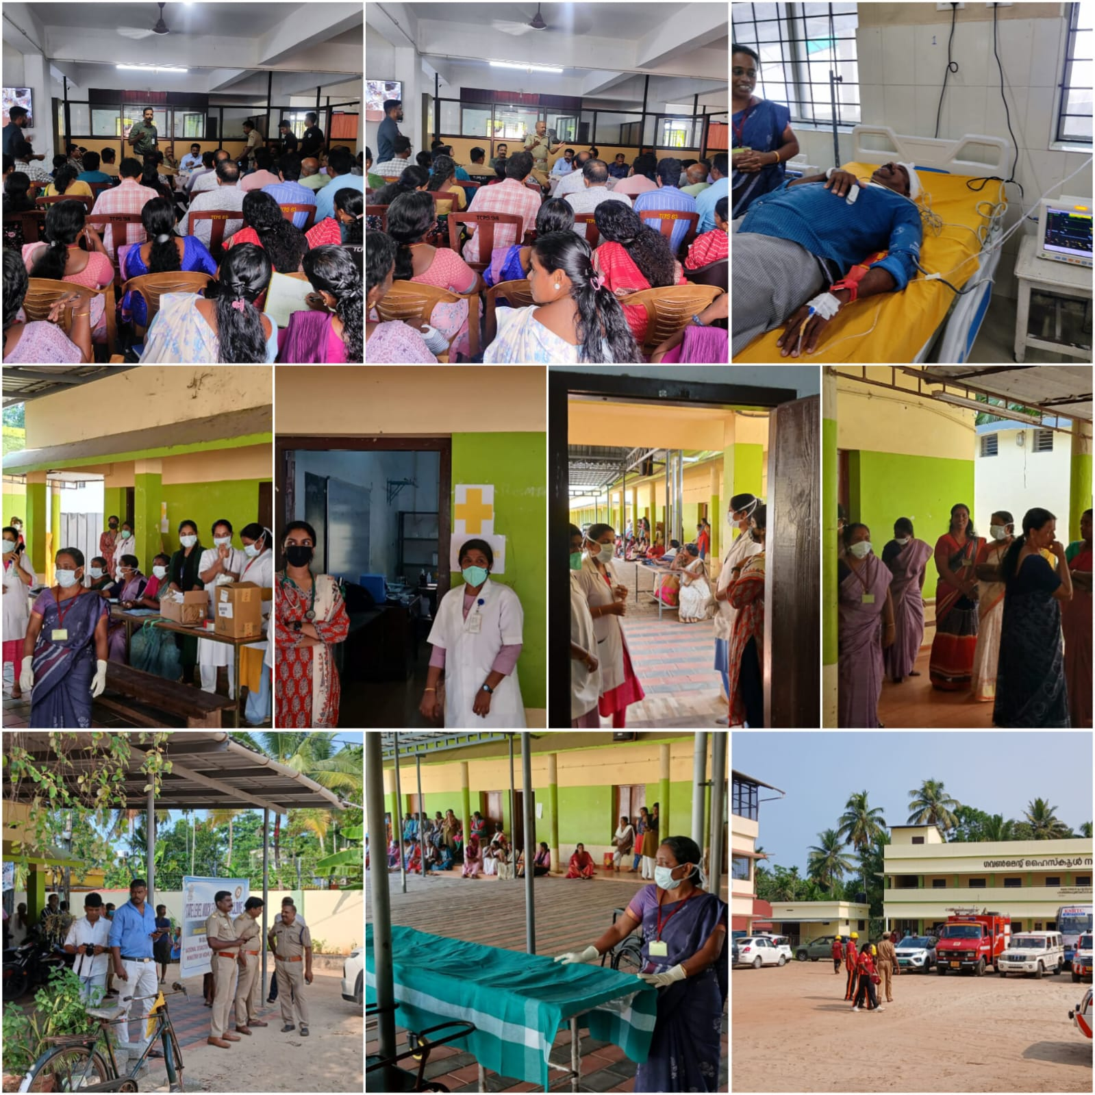

TSUNAMI MOCK DRILL AT FHC THOTTAPPALLY

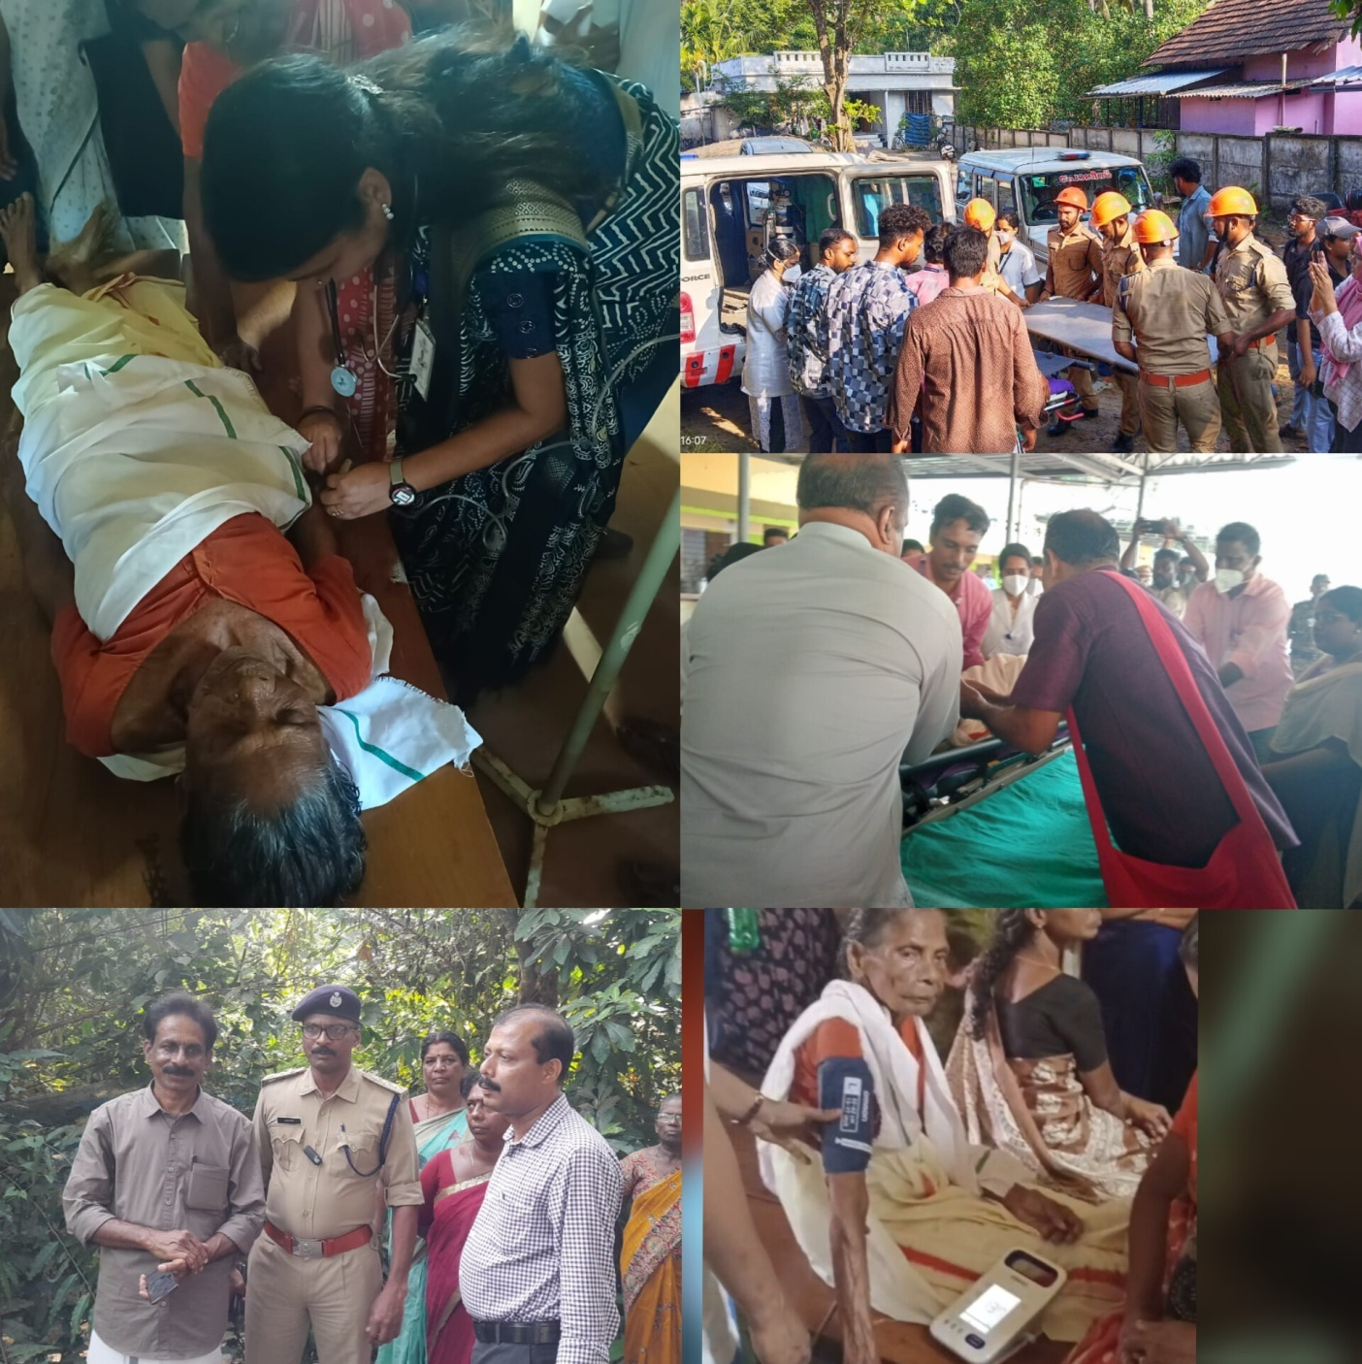

During a Cyclone
Cyclones bring strong winds, heavy rain, and storm surges. Follow updates from the India Meteorological Department and local authorities.
✅ What To Do
- Stay Indoors
- Remain inside a strong building.
- Stay away from windows, glass doors, and weak walls.
- Take shelter in a small interior room (bathroom/store room).
- Switch Off Utilities
- Turn off electricity and gas if flooding begins.
- Unplug appliances.
- Emergency Kit Ready
- Drinking water
- Dry food
- Torch and batteries
- Power bank
- First aid kit and medicines
- Important documents (waterproof cover)
- Keep Mobile Charged
- Use phone only for emergency communication.
- If Evacuation Is Ordered
- Move immediately to a government relief camp or higher ground.
Do not delay.
❌ What Not To Do
- Do not go outside to watch the storm.
- Do not touch fallen electric wires.
- Do not spread rumours.
🌊 During a Flood
✅ What To Do
- Move to Higher Ground Immediately
- Climb to upper floors if water enters the house.
- Avoid Flood Water
- 15–30 cm of moving water can sweep a person away.
- Do not drive through flooded roads.
- Turn Off Electricity
- If safe to do so, switch off main power supply.
- Drink Safe Water
- Boil water before drinking.
- Use bottled or stored water.
- Help Vulnerable People
- Assist children, elderly, and disabled persons.
🚨 Emergency Numbers in India
Police: 100
Ambulance: 108
Disaster Management: 1070 / 1077
National Disaster Response Force (National Disaster Response Force)
🌤️ After Flood/Cyclone
- Return home only after official clearance.
- Watch for snakes, insects, and damaged buildings.
- Clean and disinfect the house.
- Seek medical help if fever, diarrhea, or infection occurs.
Panchayat Level Disaster Management Plan (suitable for floods & cyclones, especially in coastal Kerala areas like Purakkad side).
🏘️ Panchayat Level Disaster Management Plan
1️⃣ Formation of Disaster Management Committee (DMC)
Chairperson: Panchayat President
Members: Ward members, Health workers (ASHA), Police, Fire Force, Volunteers
Coordinate with District Administration and the National Disaster Management Authority (NDMA)
2️⃣ Risk Assessment & Mapping
Identify:
- Flood-prone areas
- Coastal erosion zones
- Weak houses
- Low-lying areas
- Prepare village hazard maps.
- List vulnerable groups (elderly, disabled, pregnant women, children).
3️⃣ Early Warning System
- Monitor alerts from the India Meteorological Department (IMD).
Use:
- WhatsApp groups
- Public announcement systems
- Temple/Mosque/Church speakers
- Inform people quickly about evacuation orders.
- 4️⃣ Evacuation Planning
- Identify safe shelters:
- Schools
- Community halls
- Relief camps
- Arrange transport (boats, tractors, buses).
- Prepare a special evacuation plan for bedridden and elderly people.
5️⃣ Relief Camp Management
Ensure:
- Safe drinking water
- Toilets and sanitation
- Food supply
- Medical aid
- Maintain a register of camp residents.
- Provide separate spaces for women and children.
6️⃣ Emergency Response Team
Local volunteers trained in:
- First aid
- Swimming & rescue
- Basic firefighting
- Coordinate with:
- Fire & Rescue Department
- Police
- National Disaster Response Force (NDRF)
7️⃣ Resource Management
- Prepare and maintain:
- Emergency stock (rice, drinking water, medicines)
- Boats, life jackets, ropes
- Generators and lights
- Earthmovers for clearing debris
8️⃣ Public Awareness & Training
- Conduct mock drills before monsoon season.
- Awareness classes in schools.
- Teach:
- How to prepare emergency kits
- Safe evacuation methods
- Hygiene during floods
9️⃣ Post-Disaster Recovery
- Damage assessment survey.
- Clean and disinfect public areas.
- Restore electricity, water supply, and roads.
- Provide compensation support through government schemes.
Conclusion
A Panchayat-level disaster management plan should focus on:
- Preparedness
- Quick response
- Community participation
- Fast recovery

ANNEXURE

IMPORTANT PHONE NUMBERS

Phone numbers and particulars of persons responsible for providing guidance, assistance, and support for pandemic preparedness operations may be provided here in a manner that allows easy reference at a glance. The information recorded here could be exhibited elsewhere at the time of emergencies. LSG institutions shall give special attention to collect and record the above data of persons and institutions who/which are supposed to give technical and co-ordination support to reduce the impact of pandemic.

1.1. Details of grama panchayat/municipality/corporation wards
Sl.No | Name of the ward | Ward number | Name of the ward  member | Contact number
1 | PAYALKULANGARA | 1 | GOPAKUMAR | 9562957917
2 | PAYALKULANGARA EAST | 2 | SUNITHA.U | 8943528063
3 | KAROOR EAST | 3 | SREEKUMAR | 9847795722
4 | KAROOR | 4 | MAYADEVI | 9746431824
5 | PAZHAYANGADY  EAST | 5 | SUSHEELA | 9605984829
6 | ILLICHIRA | 6 | Sumesh | 9645879518
7 | NALUCHIRA | 7 | Sindhu Baby | 9562090458
8 | THOTTAPPALLY | 8 | Sunil Kumar | 9447344656
9 | THOTTAPPALLY WEST | 9 | MH Vijayan | 9496886413
10 | HARBOUR | 10 | Arya Noju | 9061720655
11 | SPILLWAY EAST | 11 | Raji | 9496722071
12 | CHENNAGARA | 12 | Lekshmi | 9562637332
13 | ANANDESWARAM | 13 | Soumi | 7907218315
14 | OTTAPANA | 14 | Shailamma | 9633157951
15 | PUNTHALA | 15 | Sasikumar | 9447957356
16 | PURAKKAD | 16 | BEENA | 8907864438
17 | PURAKKADJN | 17 | RAHMATH HAMID | 9746468847
18 | PAZHAYANGADI | 18 | SULEKHA | 9746602195
19 | KAROOR WEST | 19 | JAYASREE | 9961288606

1.2. Other important phone numbers of grama panchayat/municipality/corporation area
Sl. No. | Name | Contact number
1. | Panchayat president | 9746468847

1.3. Important offices of grama panchayat/municipality/ corporation
Sl.No | Name of the office | Contact person | Contact number
1. | Village Office | Village Officer | 8547612109
2. | Agriculture Office | Agriculture Officer | 0471-2598211
3. | Animal Husbandry Office | Animal Husbandry Doctor | 0477-2252431
4. | Police Station | Police Officer | 0477 2296100
5. | BSNL Office | Officer | 0477-2252000
6. | Block Office | Officer | 9746468847
7. | KSEB Office | Officer | 0477-2272058
8. | Fisheries Office | Officer | 9072455221
9. | Fire and Rescue | Officer | 04792411101

1.4. Health Services

Sl. No | Name of the hospital/institution | Location | Phone number
1. | Government hospitals/PHC | FHC Thottapally  FHC Purakkad | 8281215764  9447856372
2. | Private hospitals | Mathery Medical Mission  Relief | 7034356252  9895603762
3. | Clinical laboratories
4. | Chemist/pharmacy

1.5. Veterinary Services
Sl.No | Name of the Clinic | Name of the  Surgeon/Doctor | Place/location | Phone  number
1 | Govt.Veterinary Hospital | BIJU | PAZHAYANGADI EAST | 9495314850

1.6. Helpline numbers
Helpline | Phone number
Police | 100
Fire and Rescue | 101
KSEB | 1912

1.7. Public and Private Schools Contact details

S.No | Name of School | Institution type | Phone number
1 | GHS Naluchira | Govt | 9497633552
2 | GLPS THOTTAPPLLY | Govt | 9447501091
3 | SNMHS PURAKKAD | Private | 9400443984
4 | GLPS KAROOR | Govt | 9446170976
5 | SNMHSS PURAKKAD | Private | 8281826163
6 | ASM LPS PURAKKAD | Private | 9288651639
7 | L.F LPS PURAKKAD | Private | 9188638489
8 | GNLPS PURAKKAD | Govt | 9496923288
9 | SVD GUPS | AIDED | 9746588235

1.9. Anganwadi Contact Details

SL No | Anganwadi No: | Phone number
1 | AW NO :124 | 9745648062
2 | AW NO :90 | 8921766990
3 | AW NO :91 | 9048850625
4 | AW NO :96 | 8594011261
5 | AW NO :89 | 7306328838
6 | AW NO :84 | 9207165256

7 | AW NO :103 | 8086036156
8 | AW NO :105 | 8089757560
9 | AW NO :92 | 9037753525
10 | AW NO :93 | 9656582207
11 | AW NO :94 | 9656836561
12 | AW NO :104 | 7025562339
13 | AW NO :95 | 9072965745
14 | AW NO :79 | 8089256481
15 | AW NO :123 | 8157030245
16 | AW NO:81 | 9288900618
17 | AW NO:75 | 9746119147
18 | AW NO:72 | 9388918815
19 | AW NO:87 | 8714213241
20 | AW NO:117 | 879961606508
21 | AW NO:74 | 7902846132
22 | AW NO:77 | 7560818875
23 | AW NO:78 | 7306328838
24 | AW NO:82 | 9746481783
25 | AW NO:80 | 8156809748
26 | AW NO:76 | 8714124012
27 | AW NO:73 | 9037409501
28 | AW NO:102 | 9388462421
29 | AW NO :136 | 8714012009
30 | AW NO 85 | 8943383227
31 | AW NO 127 | 8137844754
32 | AW NO 86 | 9496612570

1.12. Information regarding resources

Means of transportation | Name of Owner | Phone Number
Heavy Trucks | Pradapan | 9447909185
Tractor | Sudheer | 9562262949
Ambulances | Faizal | 9747525177
Boats | Dileep | 9562938031
Taxi service | Anil | 9400796802

LSG Baseline Data Collection Format
A. Baseline data
Sl. No. | Indicator / Field | Baseline Data
1 | Name of LSG | PURAKKAD
2 | District | ALAPPUZHA
3 | Block / Taluk | AMBALAPPUZHA
4 | Type of LSG (Gram Panchayat / Municipality / Corporation) | GRAMAPANCHAYATH
5 | Area (sq. km) | 21.19sqkm
6 | No. of wards | 19
7 | GIS boundary file available | (Yes/No)
8 | Key contact person & phone | JinuSudhakar 9961040422

B. Demography
Indicator / Field | Baseline Data
Total population | 31741
Males | 15234
Females | 16507
Transgender population | 1
No. of households | 7638
Population density (persons/sq.km) | 21.19 sq km
No. of migrant workers | 385
Major occupational groups | fisher man

C. Vulnerable Populations & Social Risks
Sl. No. | Indicator / Field | Baseline Data (Value / Description)
1 | No. of elderly (≥60) | 8855
2 | No. of persons with disability | 206
3 | No. of bedridden persons | 168
4 | No. of chronic disease cases (DM/HTN/COPD/CKD etc.) | 5681
5 | Pregnant women (current estimate) | 115
6 | Children <5 years | 1268
7 | Tribal population (if any) | 0
8 | Fisherfolk / coastal vulnerable groups (if any) | 2468
9 | Urban slums / unnotified settlements (if any) | 0
10 | Homeless population | 0
11 | Orphanages / old age homes (number & capacity) | 0
12 | Hostels / prisons / shelters (number & capacity) | 0
13 | Poverty / BPL estimate | 12185
14 | Food insecurity hotspots | 0
15 | Any history of stigma/discrimination issues (Yes/No) | no

D. Health System & Service Readiness
Sl. No. | Indicator / Field | Baseline Data (Value / Description)
1 | No. of health facilities in LSG (PHC/CHC/TH/DH/Private) | 9
2 | PHC/Family Health Centre details (name, location) | FHC THOTTAPPALLY  FHC PURAKKAD
3 | Subcentres / Health & Wellness Centres (number) | 5
4 | Private clinics / hospitals (number) | 2
5 | Labs available (public/private) | 10
6 | Availability of ambulance services (Yes/No, number) | no
7 | Availability of isolation/quarantine facilities (Yes/No, details) | no
8 | Cold chain facilities (Yes/No, details) | yes
9 | Stockpile space available (Yes/No) | no
10 | PPE / mask / sanitizer availability plan (Yes/No) | yes
11 | Surveillance staff available (JHI/JPHN/ASHA count) | JHI -4  JPHN - 5  ASHA -30
12 | Existing emergency referral pathways (Yes/No) | yes

E. Points of Entry & Mobility
Sl. No. | Indicator / Field | Baseline Data (Value / Description)
1 | Bus stands / depots (number) | 7
2 | Railway stations (number) | 0
3 | Boat jetties / fishing harbours (number) | 1
4 | Ports / airports nearby (specify distance) | 0
5 | Major highways/roads passing through | NH 66
6 | Border crossings (state/district) | nil
7 | Major markets / weekly markets | fish market
8 | Tourism hubs / major event venues | nil
9 | Schools/colleges with hostels (number) | 1
10 | Factories / large workplaces (number) | nil
F. Water, Sanitation & Hygiene (WASH)
Sl. No. | Indicator / Field | Baseline Data (Value / Description)
1 | Major drinking water sources (piped / wells / borewells / springs) | piped
2 | No. of public wells | 727
3 | No. of households with piped water connection | 7638
4 | Water quality testing routine (Yes/No) | yes
5 | Common contamination risks (flooding, salinity, industrial waste) | flooding
6 | Open defecation free status (Yes/No) | yes
7 | Solid waste management system (Yes/No) | yes
8 | Bio-medical waste disposal mechanism (Yes/No) | yes
9 | No. of public toilets | 0
10 | Handwashing stations in public places (Yes/No) | 0
G. Zoonotic Risks & One Health
Sl. No. | Indicator / Field | Baseline Data (Value / Description)
1 | Livestock population (cattle/goats/pigs/poultry) – estimates | 260
2 | No. of dairy farms / poultry farms / pig farms | 2
3 | Slaughterhouses / meat shops (number) | 9
4 | Animal markets (Yes/No, details) | no
5 | Veterinary dispensaries (number) | 1
6 | History of zoonotic outbreaks (rabies, leptospirosis, avian flu etc.) | yes
7 | Stray dog population management measures (Yes/No) | yes
8 | Rodent infestation hotspots (Yes/No) | no
9 | Wetlands / waterlogged areas prone to leptospirosis | yes
10 | Bat roosting areas / caves / fruit orchards (if any) | no
11 | Human-animal interface hotspots (farms near residences) | no
H. Climate & Disaster Risks (Pandemic Amplifiers)
Sl. No. | Indicator / Field | Baseline Data (Value / Description)
1 | Flood-prone wards (list) | 4,5, 6,7,9,13,16,17
2 | Landslide-prone wards (list) | nil
3 | Cyclone/sea surge risk (Yes/No) | yes
4 | Heatwave risk zones (Yes/No) | no
5 | Waterlogging areas (list) | 4,5, 6,7,9,13,16,17
6 | Shelter homes / relief camps (number, capacity) | 3
7 | Past disaster displacement history
8 | Disruption to water supply/transport common (Yes/No) | no
I. Critical Infrastructure & Logistics
Sl. No. | Indicator / Field | Baseline Data (Value / Description)
1 | Schools (number) | 9
2 | Anganwadis (number) | 33
3 | Colleges (number) | 2
4 | Community halls (number) | 11
5 | Places of worship with large gatherings (number) | 12
6 | Large markets / shopping areas (number) | 0
7 | Warehouses / cold storages (number) | 0
8 | Telecom/mobile network coverage gaps (Yes/No) | yes
9 | Power outage frequency (high/medium/low) | medium
10 | Availability of generators in key facilities | yes

J. Risk Communication & Community Networks
Sl. No. | Indicator / Field | Baseline Data (Value / Description)
1 | Ward-level rapid response teams (Yes/No) | yes
2 | Jagratha samithis / committees active (Yes/No) | yes
3 | Kudumbashree presence and strength (number of units) | yes
4 | Volunteer network (number, coverage) | yes
5 | Community-based surveillance mechanisms (Yes/No) | yes
6 | IEC dissemination channels (WhatsApp groups, community radio, PA systems) | yes
7 | Rumour tracking mechanisms (Yes/No) | yes
8 | Languages spoken / literacy considerations | malayalam
9 | Vulnerable groups communication strategy available (Yes/No) | yes

K. Preparedness Planning & Governance
Sl. No. | Indicator / Field | Baseline Data (Value / Description)
1 | LSG emergency plan available (Yes/No) | yes
2 | Pandemic preparedness plan available (Yes/No) | yes
3 | Incident Command System identified (Yes/No) | Yes
4 | Rapid procurement mechanism available (Yes/No) | Yes
5 | Emergency fund available (Yes/No, amount) | yes
6 | Past outbreak response experience (Yes/No, details) | yes
7 | Intersectoral coordination mechanism (Health, Police, LSG, Veterinary, Education) | yes
8 | Mock drills conducted in last 12 months (Yes/No) | yes
9 | Training coverage for staff/volunteers (Yes/No) | yes

L. Surveillance & Data Systems
Sl. No. | Indicator / Field | Baseline Data (Value / Description)
1 | Digital reporting tools used (e.g., DHIS2, portals) | NO
2 | Availability of line-listing format (Yes/No) | NO
3 | Contact tracing team identified (Yes/No) | YES
4 | Mapping of high-risk households available (Yes/No) | YES
5 | Testing sample transport mechanism (Yes/No) | YES
6 | Reporting timeline adherence (good/average/poor) | GOOD
7 | Data sharing between departments (Yes/No) | YES
8 | Availability of dashboard for monitoring (Yes/No) | YES (IDSP)

M. Additional Notes & Observations
Sl. No. | Indicator / Field | Baseline Data (Value / Description) | Source / Remarks
1 | Key challenges perceived by LSG | Lack of information regarding vulnerable population
2 | Top 5 high-risk wards (reason) | 5,4,18,1,6,7 | C.D,FLOOD
3 | Any unique local risks (industrial pollution, refugee camps, etc.) | 0 | 0
4 | Recommendations for preparedness strengthening | Strengthen interdepartmental coordination

