0



PANDEMIC PREPAREDNESS PLAN
Arookutty grama panchayath

CHC AROOKUTTY

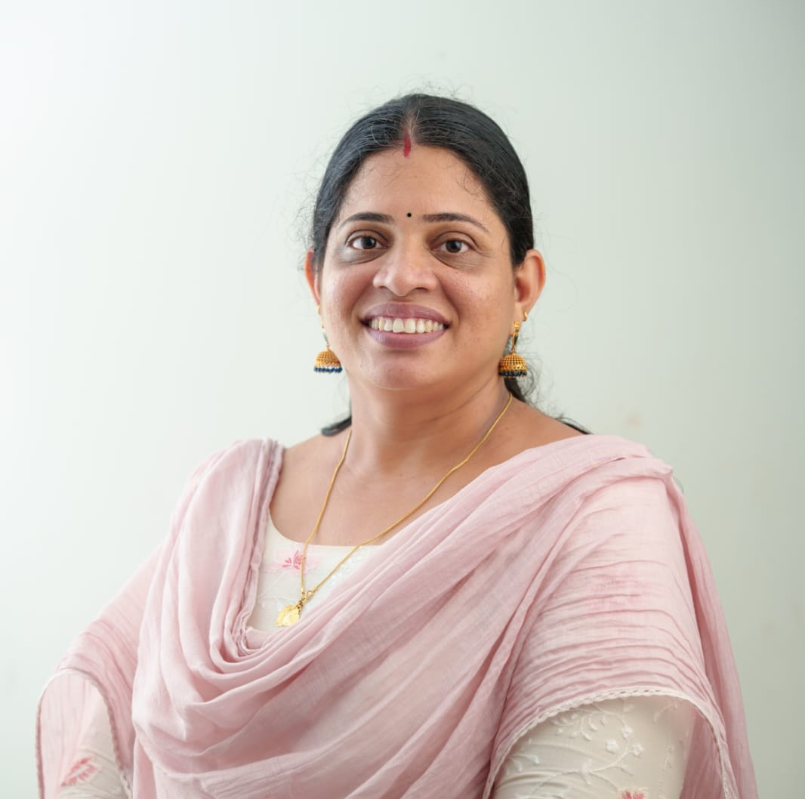
MESSAGE FROM PRESIDENT/CHAIR LSGI

In the present global context, the continuing threat of pandemics and emerging infectious diseases poses significant challenges to public health systems and community well-being. The experiences from recent outbreaks, particularly the COVID-19 pandemic, have clearly demonstrated that preparedness, prevention, and coordinated response are the most effective measures to safeguard lives and maintain essential services.
With this understanding, Arookutty Grama Panchayat has formulated a comprehensive Pandemic Preparedness Plan (PPP) with the primary objective of protecting the health of our people and ensuring timely, efficient, and equitable healthcare services during public health emergencies. This plan is designed to strengthen our local health system so that it can effectively respond to outbreaks while minimising social and economic disruption.
Primary Health Centres, Sub-Centres, ASHA workers, Junior Public Health Nurses, and other frontline health personnel play a crucial role in early response and community-level interventions. Capacity building of healthcare workers, availability of essential medicines and equipment, strict infection prevention and control measures, and institutional emergency preparedness form the backbone of this plan.
As President, I call upon all stakeholders—health professionals, community leaders, voluntary organisations, and every resident—to extend their full cooperation in implementing this plan. Preparedness is a shared responsibility, and only through collective commitment and coordinated action can we build a resilient and healthier Arookutty.
Let us work together to ensure a safe and secure future for our community.



Smt . Binitha Pramod
President
Arookutty Grama Panchayat

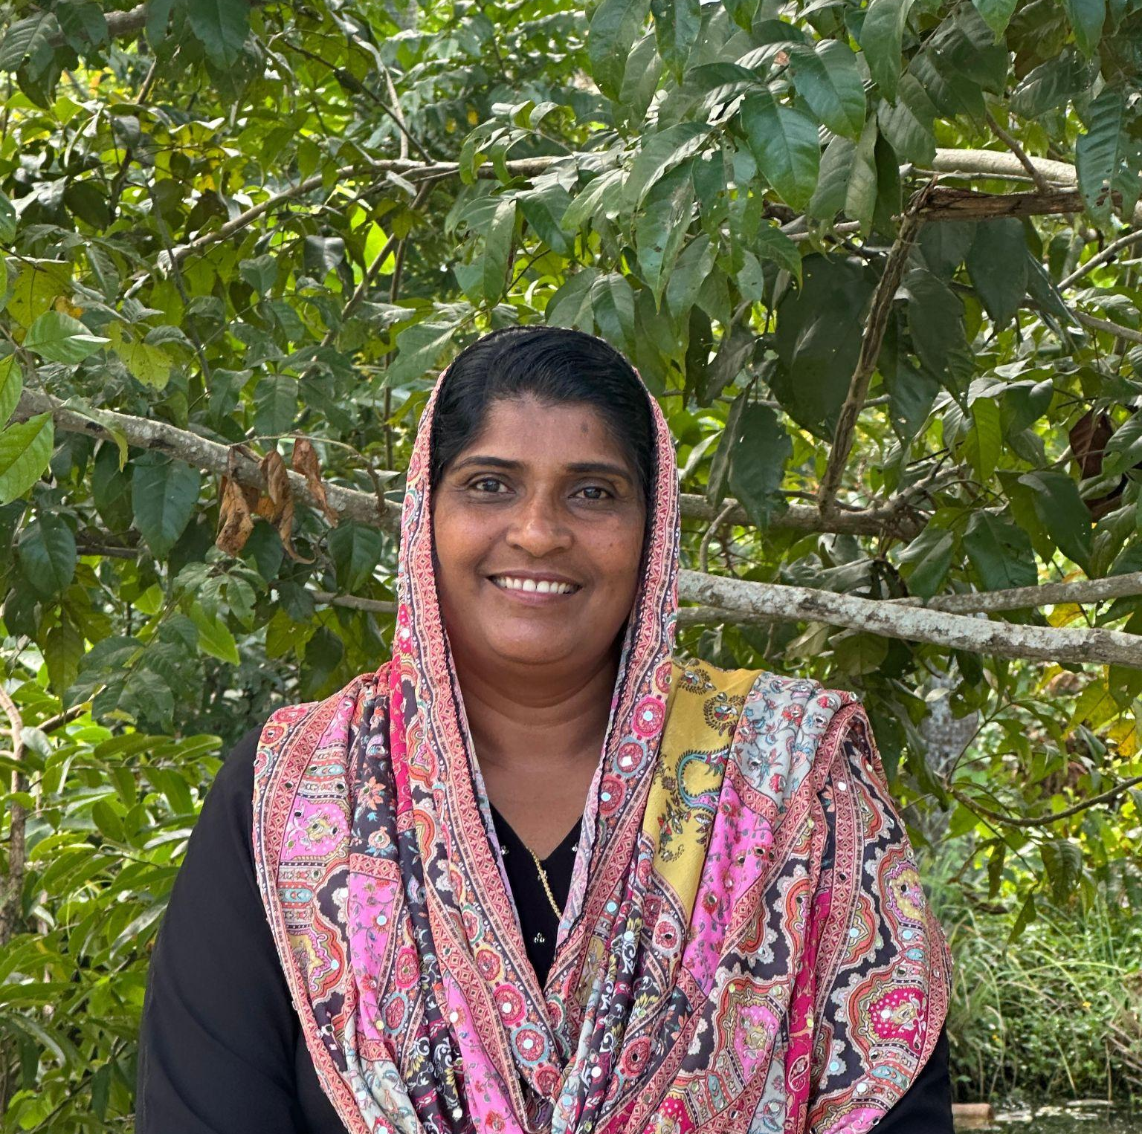
MESSAGE FROM HEALTH STANDING COMMITTEE CHAIR

Dear Citizens and Health Partners of Arookutty,
As the Chairperson of the Health Standing Committee, my foremost responsibility is to ensure that our public health vision is translated into effective action at the grassroots level. Arookutty Grama Panchayat is a vibrant coastal community shaped by its backwaters, fishing activities, agriculture, and close connectivity with nearby urban centres. While these features strengthen our local economy and social fabric, they also expose us to specific public health risks, including vector-borne diseases, waterborne infections, and rapidly spreading communicable diseases during outbreaks.Our healthcare system, supported by frontline workers and community volunteers, forms the backbone of early detection, reporting, and response mechanisms within the Panchayat.
We are fortunate to have a dedicated network of ASHA workers, Anganwadi staff, health inspectors, and community volunteers who serve as the first line of defence in protecting vulnerable groups, including the elderly, persons with chronic illnesses, and bedbound patients. This Pandemic Preparedness Plan is designed to empower and coordinate this network, ensuring uninterrupted essential services, timely referrals, and structured emergency response during any public health crisis. The Health Standing Committee is committed to mobilising necessary resources—from protective equipment to essential medicines—and strengthening interdepartmental coordination. However, the true strength of Arookutty lies in its unity and community spirit. Let us work together with discipline, scientific awareness, and collective commitment to build a resilient and disease-free Arookutty.
With health and solidarity,
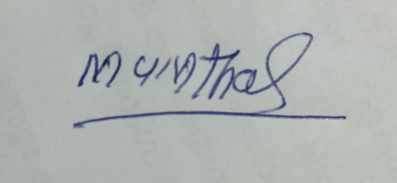
Mumthaas
Chairperson
Health Standing Committee
Arookutty Grama Panchayat

MESSAGE BY MEDICAL OFFICER
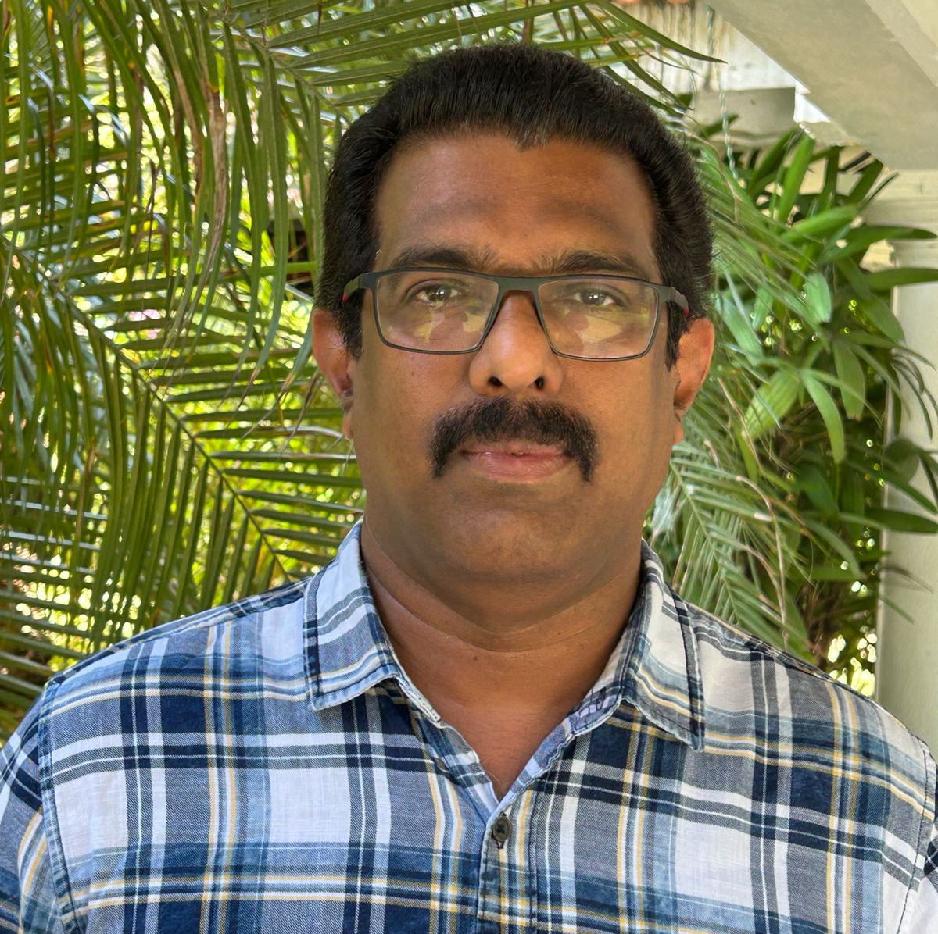

To the Residents, Health Partners and Stakeholders of Arookutty Grama Panchayat:

Public health preparedness is a continuous process rooted in the planning, coordination, and community trust.It is not a response which is activated during crises alone. As the Medical Officer in charge of the Community Health Centre, Arookutty, I consider this as a professional and ethical responsibility of a health institution to ensure that the area under its jurisdiction should remain resilient in the face of potential pandemics and public health emergencies.

The geographic and demographic characteristics of our panchayat like coastal influence, seasonal water stagnation, population mobility, and mixed rural–semi-urban settlement patterns—require a context-specific preparedness approach. These factors increase vulnerability to communicable diseases, particularly vector-borne, water-borne diseases and respiratory infections. risks.After studying all these risks this Pandemic Preparedness Plan has been designed in such a way to strengthen the early warning systems and decentralised response mechanisms.

The CHC Arookutty functions as the central coordinating hub for outbreak preparedness and emergency health response. Through systematic disease surveillance, regular data analysis, and ward-level reporting, we aim to detect unusual health events at the earliest possible stage. Field-level health staff, including ASHA workers, Junior Public Health Nurses,Junior Health Inspectors, Multipurpose health workers and Health Volunteers form the backbone of this system by maintaining continuous community engagement and timely reporting.

Clinical preparedness under this plan focuses on standardized treatment protocols, infection prevention and control practices, and uninterrupted delivery of essential health services. Special emphasis is placed on safeguarding vulnerable groups such as the elderly, persons with chronic non-communicable diseases, pregnant women, and bedridden patients. Continuity of care—including access to life-saving medicines, referral services, and emergency transport—will be ensured even during periods of heightened public health risk.

Effective pandemic management is possible only through coordinated action. Government health facilities, AYUSH institutions, private healthcare providers, laboratories, pharmacies, and local self-government systems must function as a single integrated network. Adherence to reporting mechanisms, clinical guidelines, and public health advisories is critical for protecting both individual patients and the wider community.

Preparedness is a shared responsibility. Through collective vigilance, scientific planning, and community cooperation, Arookutty can respond decisively to public health threats and protect the health and well-being of all its residents.

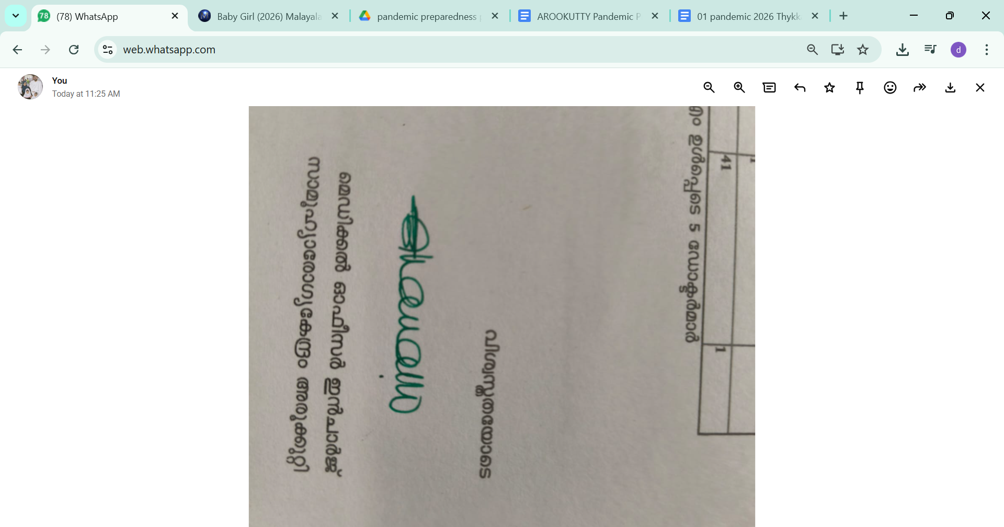
Dr.Ruby. R
Medical Officer In Charge,
Community Health Centre, Arookutty
EXECUTIVE SUMMARY

Primary Health Centre (PHC) functions as the primary public healthcare institution serving the population of Arookutty Grama Panchayath. The PHC plays a pivotal role in delivering comprehensive, accessible, and affordable healthcare services, with a strong focus on preventive, promotive, curative, and rehabilitative care in accordance with national and state health programmes.
The PHC caters to a predominantly rural population, addressing key public health priorities such as public health issues generating problems under control, maternal and child health, communicable and non-communicable disease control, immunization, family welfare, adolescent health, and geriatric care. Regular outpatient services, home-based care through the JAK team, and outreach activities ensure healthcare coverage even in geographically and socially challenging areas. The institution actively implements all national programmes including the National Health Mission (NHM),Integrated Disease control programme, National Tuberculosis Elimination Programme, National Programme for Prevention and Control of Cancer, Diabetes, Cardiovascular Diseases and Stroke (NPCDCS),National Malaria control programme ,National Leprosy eradication programme ,National Iodine deficiency control programme and other disease surveillance initiatives.
CHC AROOKUTTY works in close coordination with the Grama Panchayath, ASHA workers, Anganwadi centres, schools, and community-based organizations to strengthen community participation and improve health awareness. Emphasis is placed on early detection, timely referral, health education, and lifestyle modification to reduce disease burden and improve overall health outcomes.
Despite constraints related to infrastructure, manpower, and increasing service demand, the PHC continues to enhance service delivery through effective planning, data-driven decision-making, and community engagement. Strengthening facilities, upgrading digital health systems, and expanding preventive services remain key focus areas for future development.
Overall, CHC AROOKUTTY stands as a vital institution in safeguarding public health and improving the quality of life of the residents of Arookutty Grama Panchayath

LIST OF ABBREVIATIONS

LSGD/LSGI | Local Self Government Department / Local Self Government Institution
BMO | Block Medical Officer
IDSP | Integrated Disease Surveillance Programme
NDMA | National Disaster Management Authority
PPE | Personal Protective Equipment
ICMR | Indian Council of Medical Research
CD | Communicable Diseases
NCD | NON-COMMUNICABLE Diseases

TABLE OF CONTENTS

3
INTRODUCTION 9
● Background of the PPP 9
LSGD AT A GLANCE 9
INTEGRATED HEALTH INFRASTRUCTURE MAP OF ____________ PANCHAYAT 10
GENERAL PROFILE OF THE LSGI’S 13
Background of the LSGI 13
Demographic and Vulnerable Population 14
Clinical Vulnerability 16
INFRASTRUCTURE & RESOURCE INVENTORY 18
Health Facility Directory & Basic Capacity in the LSGD 18
Private Clinics 19
Healthcare Education & Training Institutions 20
Specialized Services & Emergency Inventory 20
Oxygen & Diagnostic Capacity 21
Diagnostics facility mapping at the LSGI level 22
Laboratory Identification & Basic Details 22
Social and Community Infrastructure for surge plan 22
Human resources 24
Community & Support Cadre 25
Community Organizations 26
Administrative & Emergency Services 27
Information regarding resources 27
ONE HEALTH & ENVIRONMENTAL SURVEILLANCE 28
Animal & Bird Population 28
Veterinary Infrastructure 29
Veterinary Doctors & Workforce 30
High-Risk Interface Points (Surveillance Sites) 30
Environmental Risk Mapping 31
Disease Seasonality Mapping 32
Vulnerability Mapping 33
EPIDEMIOLOGICAL TRENDS (2021–2025) 34
Disease Burden among human beings(Last 5 Years) 34
*(use the above table data to create the graph/diagram) 36
Seasonal Trend Analysis 37
Outcome-Based Trend Analysis- 2025 39
Transmission Trend- 2025 40
Integrated Disease Hotspot Map (2021–2025) 42
Preparedness and Response Protocol at LSG Level 44
Constitution of One Health Committee 44
Pandemic Response Workforce 45
Activities and Measures before and during Pandemic 47
PHASE 1 - Alert / Preparation 47
PHASE 2 - Active Response 50
Standard Screening Protocol 51
PHASE 3 - Surge Capacity 60
Conversion of Community Facilities 60
CONCLUSION 61
RECOMMENDATIONS 62
ANNEXURE 63
1. IMPORTANT PHONE NUMBERS 63

INTRODUCTION

Arookutty Grama Panchayath, located in Alappuzha District of Kerala, is a coastal and semi-urban local self-government institution characterized by a mix of traditional livelihoods, small-scale trade, fisheries, daily wage employment, and regular commuting to nearby towns and industrial centres. Its geographical setting, proximity to backwaters and coastal areas, and strong inter-linkages with neighbouring urban regions shape its public health risk profile. Seasonal rainfall, water stagnation, and high population interaction increase susceptibility to waterborne, vector-borne, and respiratory infections, particularly during public health emergencies and pandemics.

The experiences from recent global and national health crises have underscored the critical importance of preparedness, early detection, rapid response, and coordinated action at the local level. As the closest tier of governance to the community, Arookutty Grama Panchayath plays a pivotal role in safeguarding public health through decentralized planning, community engagement, and inter-departmental coordination. A structured Pandemic Preparedness Plan provides a systematic framework to anticipate risks, strengthen surveillance systems, ensure continuity of essential services, and mobilize resources efficiently during emergencies.

This document outlines the strategies, institutional mechanisms, and operational protocols designed to enhance readiness and resilience within the Panchayath. It emphasizes strengthening primary healthcare systems, improving laboratory and surveillance networks, ensuring adequate human resources and logistics management, and establishing a functional control room mechanism. Special attention is given to vulnerable populations including the elderly, children, persons with disabilities, migrant workers, and economically disadvantaged groups.

Community participation forms the cornerstone of this preparedness strategy. Through awareness campaigns, transparent communication, volunteer engagement, and collaboration with health institutions, educational establishments, and civil society organizations, the Panchayath aims to build a culture of collective responsibility and preparedness. Intersectoral coordination among health, local self-government, police, education, social welfare, and other departments will ensure a unified and timely response.

The Arookutty Grama Panchayath Pandemic Preparedness Plan is therefore a proactive and locally adapted framework intended to minimize health impacts, protect livelihoods, and maintain essential services during public health crises. By adopting evidence-based planning and continuous monitoring, the Panchayath strives to enhance resilience and ensure a structured, efficient, and compassionate response to future pandemics and emergencies.

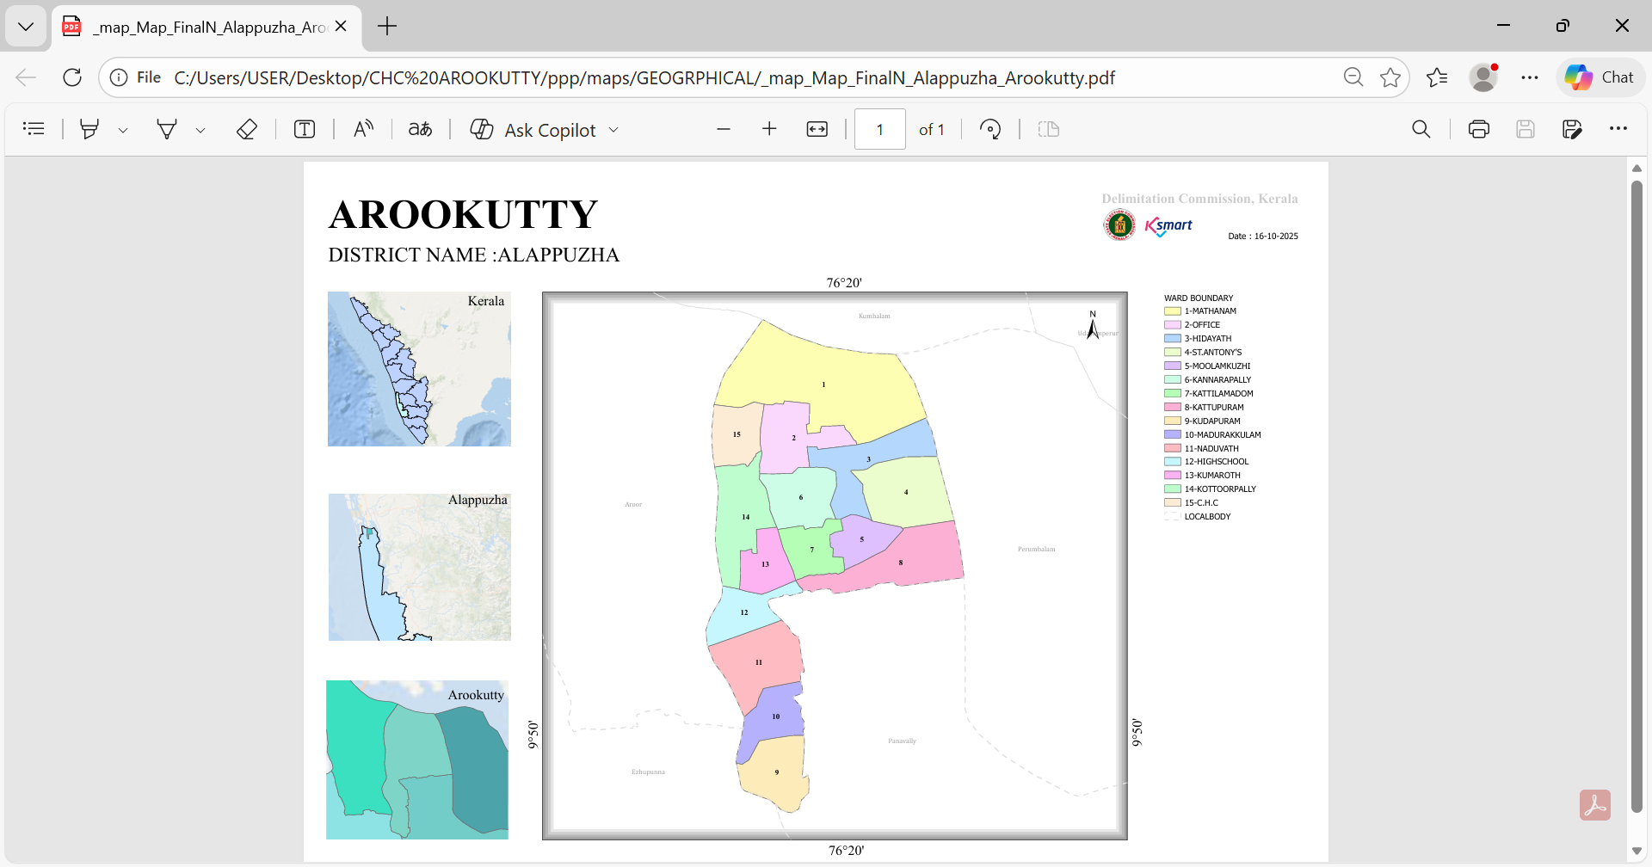

LSGD AT A GLANCE
- Baseline data
- Ward division -
Ward | Houses | Population | Migrants | Wells | Hot  spots | Ed. Institutions | Hosp pvt/govt.
13 | 5522 | 23507 | 147 | 623 | 9 WARDS | 9 | 2/1

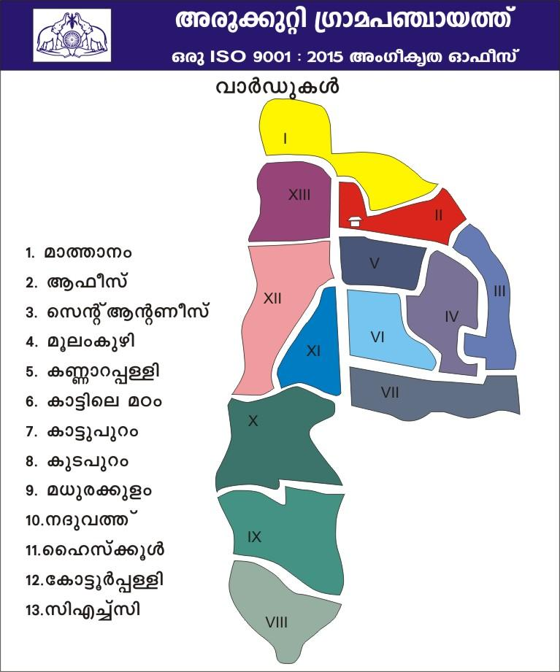

- Risk stratification among wards in the context of Communicable diseases and hazards

Priority Disease Risk (Ward-Level)
- Leptospirosis High-Risk Wards:
15, 11, 8
- Dengue High-Risk Wards:
1, 2, 4, 6, 8, 10
- These wards require intensified surveillance, pre-monsoon preparedness, vector control, and chemoprophylaxis strategies.

Major Roads
- Cherthala – Arookutty roads
- Kombanamury-perumbalam jn road
- Aroor- Arookutty bridge

- Major establishments with geospatial mapping
- C H C Arookutty – Main healthcare institution.
- Arookutty Panchayath Office – Local governance.
- Arookutty Post Office – Postal services.
- Village Office, Arookutty – Revenue/village admin.

- Electricity office – K S E B
- Educational institutions – Government/aided schools across wards.
- Religious & community landmarks – Masjid, temples, churches.
- Periyar Memorial (upcoming) – Cultural/social landmark

- Occupational groups, socio cultural groups, migration & mobility patterns
Arookutty has a mixed livelihood pattern including:
- Fishing & inland fisheries
- Paddy cultivation
- Coir processing
- Daily wage labour
- Migrant-linked service occupations
Frequent exposure to:
- Waterlogged agricultural fields
- Backwaters
- Wetlands
Increases vulnerability to:
- Leptospirosis (monsoon exposure)
- Dengue (vector breeding)
- Water-borne infections
High mobility through road corridors also elevates outbreak spread risk.
- Vulnerability mapping
- Geriatric Population: 4539
- Diabetes Mellitus (DM): 475
- Hypertension (HT): 1945
- Bedridden: 56
- Dialysis Patients: 9

High-Risk Groups:
- Elderly & NCD patients (high complication risk during outbreaks)
- Bedridden & dialysis-dependent individuals
- Pregnant women
- Children in schools & Anganwadis
- Daily wage and migrant workers

- Disaster prone areas (geographic vulnerability)
Flood-Prone Wards:
1, 2, 3, 7, 8, 9, 10, 12, 13

Maps - ward-based

- Geographical boundaries - ward boundaries map

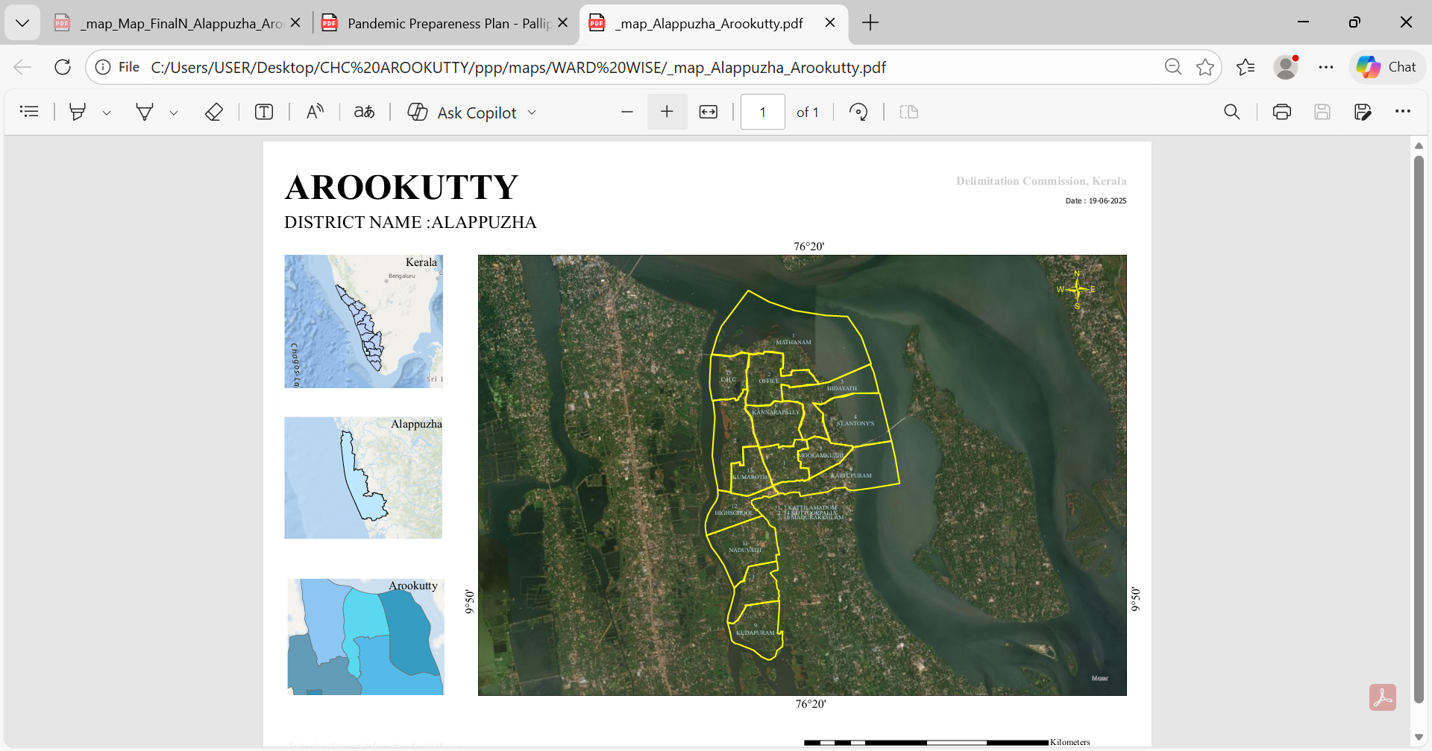

https://wardmap.ksmart.live/files/Alappuzha_Arookutty_01JBBD712V988H7QG8ZCK3D563.html

- Health infrastructure map
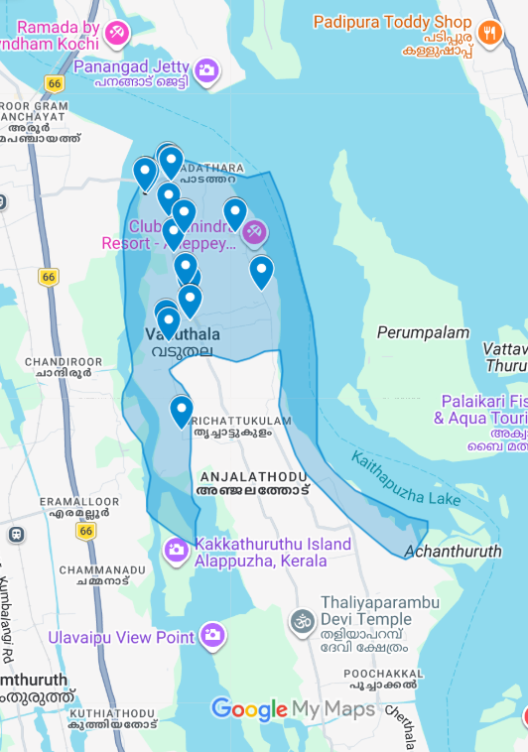
https://www.google.com/maps/d/edit?mid=1Zh4yzX4CJTL5O0vlCqhMgMj7zDVQBFs&ll=9.850437098407305%2C76.34207870134277&z=13

- Roads and rivers map
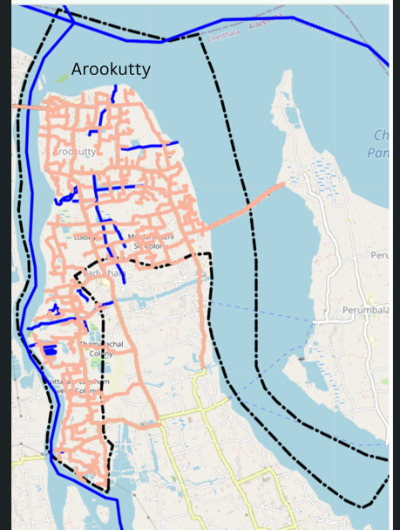
https://map.opendatakerala.org/alappuzha/arookutty-grama-panchayat/?

- Major establishments map
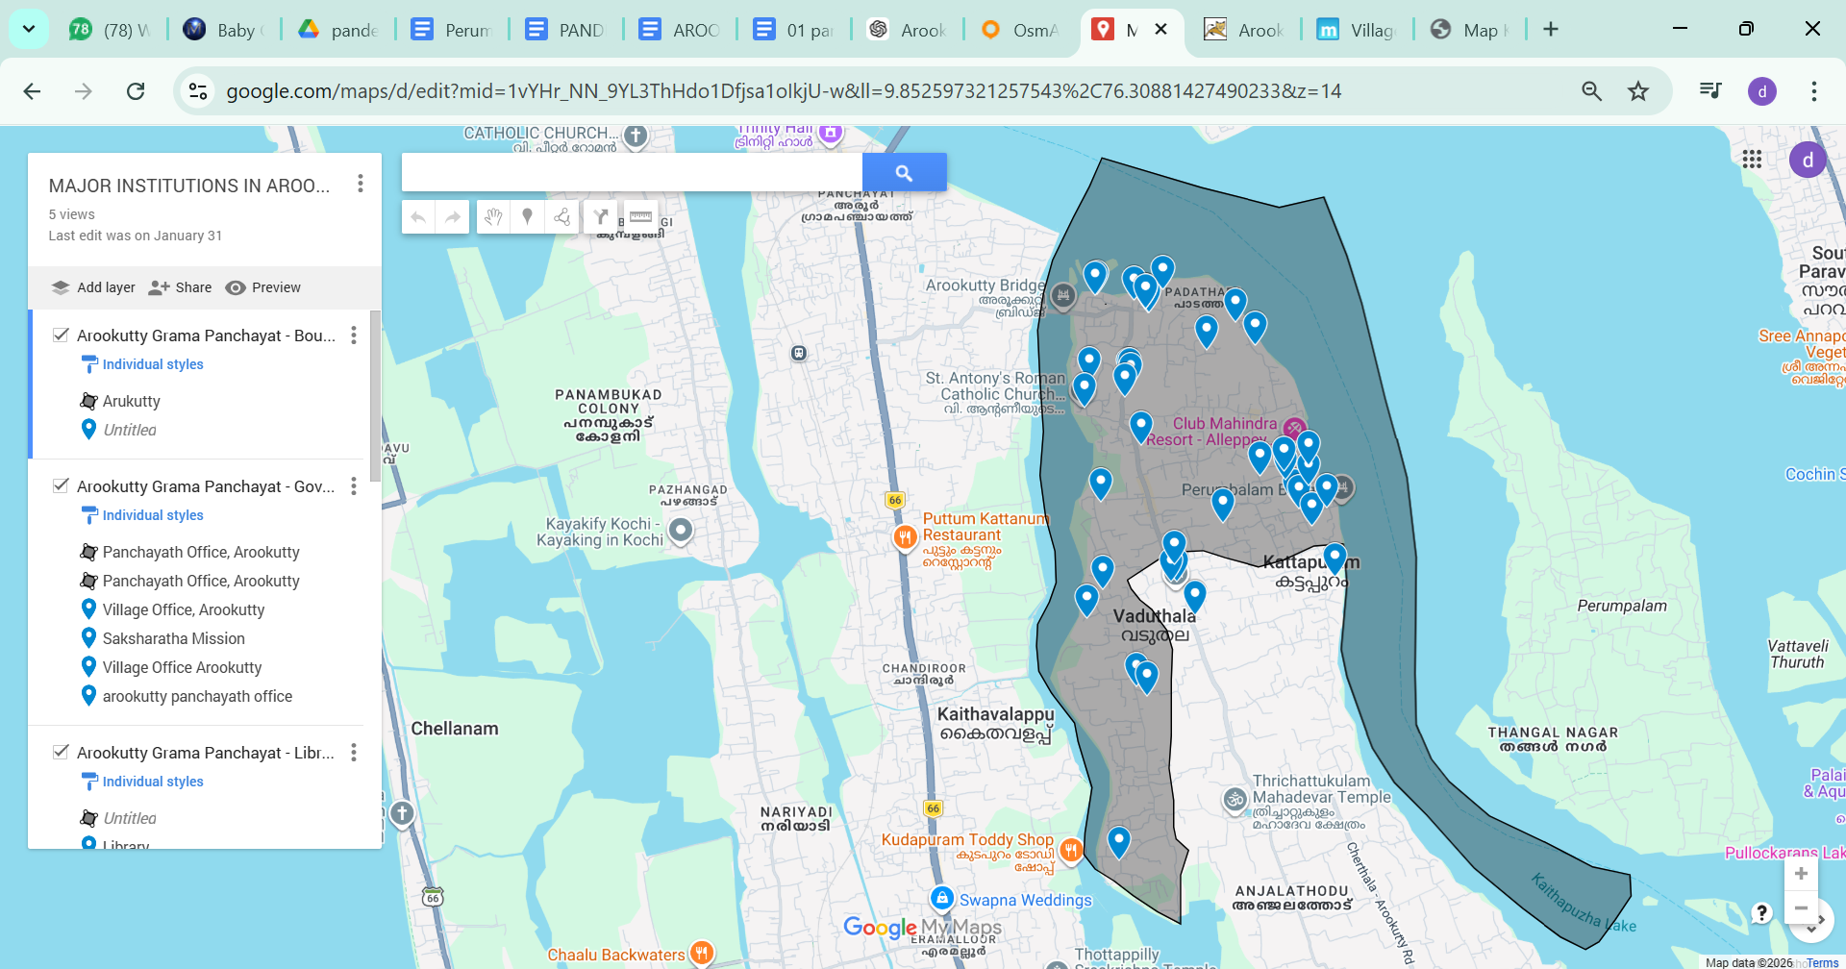
https://www.google.com/maps/d/edit?mid=1vYHr_NN_9YL3ThHdo1Dfjsa1oIkjU-w&ll=9.852597321257543%2C76.30881427490233&z=14

- Disaster-prone areas map
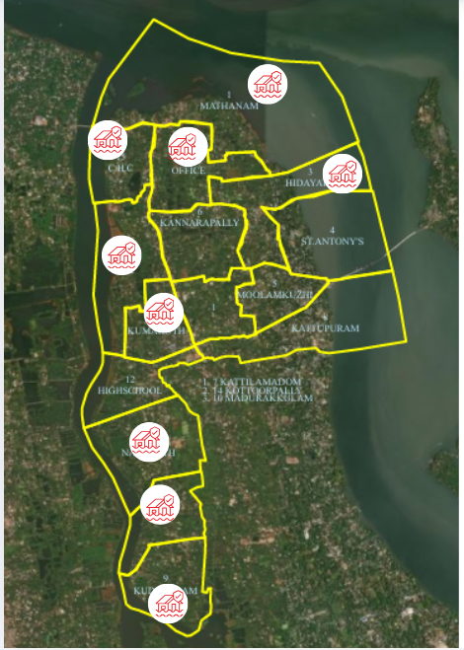

- Hotspot map - CD & disaster

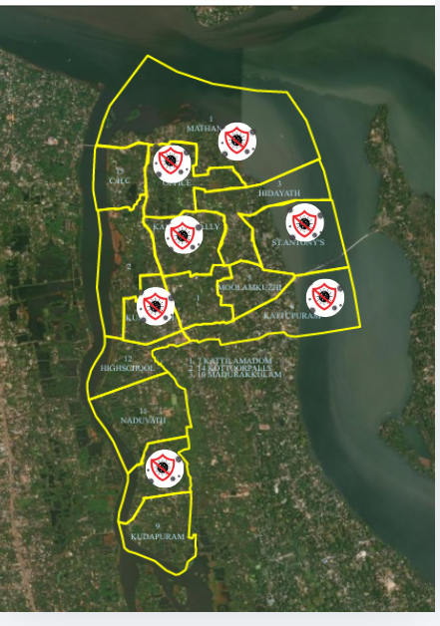

INTEGRATED HEALTH INFRASTRUCTURE

MAP OF _AROOKUTTY GRAMA PANCHAYAT

https://www.google.com/maps/d/edit?mid=1Zh4yzX4CJTL5O0vlCqhMgMj7zDVQBFs&ll=9.84502487509591%2C76.33941795&z=13

Health Infrastructure Map

Background of the LSGI
Arookutty Grama Panchayat is situated in the north end of Alappuzha district, Kerala. The geographical landscape of the Panchayat is predominantly low-lying, characterized by extensive uncultivating old paddy fields now majority of changed to land or land like and a dense network of rivers, canals, and backwaters. This unique terrain plays a significant role in shaping the local microclimate and poses distinct challenges to transportation, emergency response, and service delivery, particularly during monsoon seasons and flood events.
The Panchayat is administratively divided into multiple wards, with a population largely dependent on traditional livelihoods. Agriculture—especially paddy and coconut cultivation—fishing, coir and coconut husk processing, house and small scale industry prawn peeling are the income and backbone of the local economy. In recent years, tourism-related activities and service-sector employment have also shown gradual growth. The area hosts a diverse workforce, including a notable presence of migrant labourers, particularly in construction, agriculture, marine exporting companies and allied sectors.
From a public health and disaster management perspective, Arookutty LSGD has historically been vulnerable to seasonal flooding, waterborne diseases, and vector-borne illnesses such as Dengue and Leptospirosis. The severe floods experienced during recent years, including the 2018 flood disaster, significantly impacted life, livelihoods, and infrastructure within the Panchayat. These recurring emergencies have underscored the importance of strengthening local preparedness, response mechanisms, and inter-departmental coordination.
In this context, the development of a localized, data-driven Auxiliary Infrastructure and Logistical Resource Map is essential to support effective planning, timely emergency response, and sustainable development initiatives. Such mapping enables the Panchayat to identify critical resources, improve accessibility during disasters, and enhance overall resilience of the community.

Table 1: Background of LSGD
Description | Details
Name of LSGI | AROOKUTTY
Type (GP/Municipality / Corporation etc.) | Grama Panchayath
Block | THYKATTUSSERY
District | ALAPPUZHA
Number of wards | 15
Total area (sq. km) | 10.11 SQ KMS
Population(Projected) | 23507
Population density | persons/sq km – 2325
Terrain (coastal/low-lying/backwaters/foothills, etc.) | COASTAL
Number of rivers passing through LSGI | ONE
Number of water bodies in the LSGI | NIL
Number of educational institutions | 9
Factories / small-scale industries | 4/21
Flood-prone wards | 1,2,3,7,8,9,10,12,13
Landslide-prone wards | NIL
Death Management and Disposal Facilities (mortuaries/crematorium, including electric) | 01/01.. AT CHC / UNDER LSGD
Auditoriums/Marriage halls/convention centres/community halls | 5/2/0/4

Demographic and Vulnerable Population
Understanding the demographic composition and vulnerable population groups is essential for pandemic preparedness. Children, elderly, economically deprived families, migrant workers, and socially and economically vulnerable groups are at increased risk during public health emergencies due to higher exposure, limited access to services by nature and terrain conditions, and dependency on public systems..

Description |  | Details (in numbers)
DEMOGRAPHIC PROFILE
Total population |  | 23507
Male |  | 11401
Female |  | 12105
Transgender |  | 1
Children under 5 |  | 1252
Adolescent |  | 2291
Elderly (>60) |  | 3362
SOCIAL/LIVELIHOOD VULNERABILITY
Previous EPEP family |  | 15
BPL family |  | 2714
Tribal communities |  | 0
Migration | Immigrant | 240
Migration | Emigrant
Socio-economically deprived |  | 13
Fisherfolk |  | 720
SC Community |  | 2087
ST Community |  | 10

Graphs: Population pyramid (if possible) for seeing if your LSGI has a high "dependency ratio" (lots of children and elderly compared to working adults).

Clinical Vulnerability
Certain population groups need priority healthcare and are at higher risk of severe illness, complications, and mortality during pandemics may happened. Patients with chronic diseases, those requiring regular medical care, individuals with mobility or functional limitations to routine activity face challenges in accessing timely care during emergencies. Mapping these groups helps in prioritizing continuity of treatment,mental support,family support and medicine stock planning also for oxygen support, referral and transport, and targeted home-based care.
Description | Details in numbers
Pregnant women | 178
Lactating mothers | 161
Bedbound patients | 48
Patients under palliative care other than bedbound | 208
Patients on Haemodialysis | 19
Patients on COPD | 5
Cancer patients (currently on treatment) | 114
Haemophilic patients | 0
Mentally challenged | 31
Differently abled | 125
Diabetic patients | 465
Hypertensive patients | 1607
TB patients | 13

Major Festivals & Events specific to the LSGI
(with the possibility of a public gathering)

Sl. No. | Name of festival | Month detailing the periodicity
1 | PADUVAPURAM CHURCH FSTIVAL | FEBRUARY
2 | MATHANAM KSHETHRAM FESTVAL | MARCH
3 | KATTUPURAM JUMA MASJID | FEBRUARY

INFRASTRUCTURE & RESOURCE INVENTORY

Health Facility Directory & Basic Capacity in the LSGD
This section provides an overview of the healthcare infrastructure available within the LSGD area. It outlines the distribution and basic capacity of health facilities that form the backbone of service delivery during routine times and public health emergencies.

Family Health Centres (FHCs) and Community Health Centres (CHCs) generally function as the first point of contact for the community, providing essential outpatient and inpatient services. General Hospitals (GH) and Medical College Hospitals (MCH), where accessible, serve as the main referral centres for advanced diagnostics, specialist care, and critical services during public health emergencies. This inventory helps identify existing strengths, gaps, and potential surge capacity that can be mobilised during a pandemic or disaster.

Table 5. Health Facility Resource Summary
Sl.no. | Health Facility | Type of Facility (MCH/GH/CHC/FHC/SC etc.) | Contact Number | Total beds | ICU Beds | Oxygen-Supported Beds | No. of Ventilator Support Beds | No. of ambulances
Government Healthcare Facilities
1 | CHC AROOKTTY | CHC | 0478 2872931 | 10 | 0 | 0 | 0 | 1
Private Healthcare Facilities
1 | MEDIZIO POLY CLINIC | CLINIC | 7907335532 | 4 | 0 | 0 | 0 | 1
2 | GENERAL MEDICAL CARE | CLINIC | 974688455 | 12 | 0 | 0 | 0 | 0
AYUSH Healthcare Facilities
1 | GOVT AYURVEDA HOSPITAL | DISPENSARY | 9447347806 | 0 | 0 | 0 | 0 | 0
2 | GOVT HOMEO HOSPITAL | DISPENSARY | 9447550810 | 0 | 0 | 0 | 0 | 0

Private Clinics
Private clinics are an essential part of pandemic preparedness, as they are often the first place people seek care when symptoms begin. In many communities, private clinics manage a significant share of outpatient visits and therefore play a critical role in early case detection, timely referrals, and disease surveillance. Having an up-to-date understanding of where these clinics are located, the services they provide, and how they are linked to the public health system helps ensure that no cases are missed during an outbreak. It also allows health authorities to engage private practitioners more effectively for reporting, risk communication, and coordinated response, strengthening the overall capacity of the health system to manage public health emergencies.

Table 6. Private Clinic Resource Summary
Sl No. | Name of Clinic | Registered (Y/N) | Clinic (General / Speciality) | Speciality (if any) | Address | Contact Number | Diagnostic Facility (Y/N) | Ambulance Linkage (Y/N)
1 | GENERAL MEDICAL CENTRE AROOKUTTY | Y-TEM | CLINIC/LAB/PHRMASY | NIL |  | 994266111
2 | AL SHIFA DENTAL CARE | YES- PERMANANT | CLINIC | DENTAL |  | 8943263899
3 | MEDIZIO POLY CLINIC | YES- TEMP | CLINIC/LAB/PHRMASY | NIL |  | 7907335532
4 | CARE LABS | YES- TEMP | CLINIC/LAB/PHRMASY | GYONEC/ORTHO |  | 9946668545
5 | GREENLS LAB | YES- TEMP | LAB | NIL |  | 9961870190
6 | WE CARE CLINIC | NO | LAB/CLINIC/PHARMASY | NIL |  | 7619185710

Healthcare Education & Training Institutions
This section tracks the educational infrastructure available, which is vital for human resource planning in the health sector.

Category of Institution | Govt | Private | AYUSH | Total
Medical Colleges | 0 | 0 | 0 | 0
Nursing Colleges | 0 | 0 | 0 | 0
Dental Colleges | 0 | 0 | 0 | 0
Para-medical / Allied Health | 0 | 0 | 0 | 0
Pharmacy Colleges | 0 | 0 | 0 | 0

Specialized Services & Emergency Inventory
This section provides a detailed view of the specialized medical resources available to the community, focusing on emergency response and critical care capabilities. This table tracks the vital assets required for managing severe illnesses and emergencies across Government, Private, and AYUSH sectors.

Item | Govt | Private | AYUSH | Total
Hospital beds | 10 | 14 | 0 | 24
Oxygen-generating systems(Y/N) | 0 | 0 | 0 | 0
Oxygen-supported beds(Numbers) | 0 | 0 | 0 | 0
Ventilator-supported beds | 0 | 0 | 0 | 0
ICU beds | 0 | 0 | 0 | 0
Burns units | 0 | 0 | 0 | 0
Blood centres | 0 | 0 | 0 | 0
BLS ambulances | 1 | 3 | 0 | 4
ALS ambulances | 0 | 1 | 0 | 1
Dialysis facilities | 0 | 0 | 0 | 0
Dispensaries | 1 | 3 | 1 | 5
Medical store | 1 | 8 | 1 | 10
Industrial establishments(Medium-scale industries/small-scale industries establishments to whom we can depend in a worst-case scenario) | 0 | 0 | 0 | 0

Oxygen & Diagnostic Capacity
Monitoring oxygen and diagnostic capacity is a critical component of public health preparedness, ensuring that the LSGD can handle both chronic care and sudden surges in respiratory or infectious diseases.
Name of Health Facility | Oxygen-generating System (Y/N) | Backup Oxygen Source (Y/N) | Diagnostic Facilities Available(Y/N)
Name of Health Facility | Oxygen-generating System (Y/N) | Backup Oxygen Source (Y/N) | Lab | USG | X-ray | CT/MRI | RT-PCR
Government Healthcare Facilities
CHC AROOKUTTY | YES | YES | 1 | 0 | 0 | 0 | 1

Diagnostics facility mapping at the LSGI level
The diagnostic capacity of Arookutty represents the "intelligence network" of our healthcare system. The speed and accuracy of disease identification depend entirely on the distribution and technical level of these facilities.

Item | Govt | Private | AYUSH | Total
General labs | 1 | 8 | 0 | 9
Microbiology labs | 0 | 0 | 0 | 0
RT-PCR labs | 0 | 0 | 0 | 0
USG units | 0 | 0 | 0 | 0
CT/MRI units | 0 | 0 | 0 | 0
Research labs | 0 | 0 | 0 | 0
Labs of other departments that can be repurposed | 0 | 0 | 0 | 0

Laboratory Identification & Basic Details
Sl. No. | Name of Laboratory | Ownership (Govt / Private / Academic) | Address | Contact No. (refer pg no 27 | 24×7 Services (Yes/No) | NABL / Govt Approved (Yes/No)
1 | CHC AROOKUTTY | GOVT |  |  | NO | YES
2 | GREEN LABS | PVT |  |  | N0 | YES
3 | GENERAL MEDICAL CARE | PVT |  |  | N0 | YES
4 | WE CARE CLINIC | PVT |  |  | N0
5 | CARE LABS | PVT |  |  | N0 | YES
6 | MEDIZIO POLY CLINIC | PVT |  |  | YES | YES

Social and Community Infrastructure for surge plan
This table serves as our logistics and shelter inventory. By mapping these locations, quickly we can identify where to house displaced citizens, where to set up temporary medical clinics, and how to manage the deceased with dignity during a crisis.

Category | Total Count | Ward | Est cap
Educational Institutions
Anganwadis | 21 | 1-15 | 210
Schools | 8 | 1,4, 8, 13, 10 | 5000
Colleges | 1 | 13 | 500
Healthcare Educational Institutions
Medical colleges (Govt/Private) | 0
Nursing colleges (Govt/Private) | 0
Dental colleges (Govt/Private) | 0
Paramedical institutes (Govt/Private) | 0
Community Gathering Spaces
Community halls | 3 | 13,1, 2, | 3000
Auditoriums | 3 | 8, 4, 13 | 5000
Religious buildings | 4 | 8,2,3,13 | 3500
Vulnerable Group Support Facility
Destitute homes | NIL
Elderly homes | NIL
LSGD owned other buildings
Mass Fatality Management (MFM) Infrastructure
Mortuary | 1
Crematorium | 1
*refer annexure 1 for contact details

Human resources
This section focuses on the human capital available within the LSGI. In any emergency—be it a pandemic, flood, or industrial accident—infrastructure is only as effective as the people operating it.

Medical & Clinical Personnel
This table tracks the "Frontline" providers responsible for diagnosis, treatment, and clinical management. Narrative sentence: eg., "Total health workforce: 450 personnel, with 60% in government facilities serving as primary surge capacity." A detailed directory with the contact numbers of all workers is maintained (Annexure in 1).

Cadre | Govt (No.) | Private (No.) | Total
Doctors—Modern Medicine | 4 | 4 | 8
Doctors – AYUSH | 1 | 2 | 3
Doctors – Veterinary | 1 | 0 | 1
Doctors – Dental | 1 | 3 | 4
Nursing officers | 5 | 5 | 6
Lab technicians | 1 | 5 | 6
Optometrist | 1 | 1 | 2
Pharmacists | 2 | 4 | 7
Psychologists | 0 | 0 | 0
Counsellors | 0 | 0 | 0

Public Health & Field-Level Workforce
These individuals are the backbone of surveillance, maternal-child health, and decentralized care.

Cadre | Health services | Municipal common services | Total
HS (Health Supervisors) | 1 | 0 | 0
HI (Health Inspectors) | 0 | 0 | 0
LHS (Lady Health Supervisor) | 1 | 0 | 0
PHN(PUBLIC HEALTH NURSE )) | 1 | 0 | 0
JPHN (Jr Public Health Nurses) | 3 | 0 | 0
JHI (Jr Health Inspectors) | 3 | 0 | 0
MLSP (Mid-Level Service Providers) | 3 | 0 | 0
Palliative Nurses | 2 | 0 | 0
RBSK Nurses | 1 | 0 | 0
PRO | 1 | 0 | 0
Epidemiologist | 1 | 0 | 0
Data Manager | 1 | 0 | 0

Community & Support Cadre

This group represents the surge capacity of the LSGI—people who can be called upon for logistics, rescue, and specialized support.

Cadre | Number
ASHA Workers | 13
AWW (Anganwadi Workers) | 21
Emergency Medical Volunteers (Trained) | 91
Kudumbashree | 164
MNREGS | 734 FAMILY
Purusha Swayam Sahaya Sangham | 6
Ex-Servicemen | 12
Retired Police Officers | 10
NCC/NSS Volunteers | 35
Red Cross volunteers | 0
One Health Community Volunteers | 91
One Health Community Mentors | 1

Community Organizations
This section details the presence of community-based organisations (CBOs), non-governmental organisations (NGOs), faith-based organisations (FBOs), Kudumbashree Self-Help Groups (SHGs), and Ayalkootams within the Local Self-Government Institution (LSGI). These groups enhance grassroots mobilization, resource distribution, and support networks crucial for pandemic response and community resilience.

Category | Total Count
NGOs | 3
Religious based organizations | 4
Foreign based organizations | 0
Sports Club/youth clubs | 5
Kudumbashree SHGs | 164
Ayalkootams | 34
Political organizations | 7
Residential organizations | 3

Administrative & Emergency Services
This section outlines the availability of key non-health emergency support services and infrastructure within the LSGI, which are essential for effective pandemic preparedness and response. These facilities support law enforcement, disaster response, water supply, logistics, mobility, and community-level interventions during public health emergencies.

Category | Total Count | Contact details
Police Stations | 0
Fire & Rescue Stations | 0
Water Pumping Points | 1
Public Distribution System (PDS) | 0

Information regarding resources
The availability of essential transport and support resources plays a quiet but critical role in saving lives. Equipment such as ambulances, mobile mortuaries, amphibian ambulances, and motorized boats ensures that patients, samples, and healthcare teams can move swiftly—even in flooded, remote, or difficult terrains. Heavy vehicles like JCBs, cranes, tractors, and torus lorries support logistics, waste management, emergency infrastructure, and rapid conversion of spaces into care or isolation facilities. Taxis, four-wheel-drive vehicles, and trucks help maintain continuity of essential services, reach vulnerable populations, and support home-based care and supply delivery.

Means of transportation | Total Count
JCB | 3
Crane
Heavy Trucks | 1
Tractor
Ambulances | 5
Mobile mortuaries | 2
Boats
Taxi service | 11
Note: For specific details regarding vehicle owners and contact information, please refer to Annexure [X].

ONE HEALTH & ENVIRONMENTAL SURVEILLANCE
The One Health method integrates environmental, animal, and human health to enable proactive pandemic preparedness. Panchayat-level surveillance needs to be improved in order to detect and treat zoonotic and environmentally generated diseases early. Surveillance is strengthened through systematic assessment of animal populations, veterinary infrastructure, poultry and slaughter facilities, inter-sectoral coordination, and specialised tools like avian influenza seasonality mapping using GIS in previous outbreaks to enable predictive alerts and ward-specific sampling to support effective pandemic preparedness in high-risk areas.

Animal & Bird Population
Mapping animal and bird populations at the Panchayat level is essential for identifying and prioritising zoonotic disease hazards like rabies, avian influenza (H5N1), leptospirosis, anthrax, and Nipah-like spillover occurrences. Risk classification, targeted surveillance, vaccination planning, and early epidemic detection made feasible by comprehensive population mapping all enhance One Health-based pandemic preparedness.

Category | Item | Estimated Population | Wards
Animal Population | Livestock (Cattle/Goats/Buffalo) | 1236 | 1-15
Animal Population | Pet Animals (Dogs/Cats) | 319 | 1-15
Animal Population | Stray Dog Population | 179 | 1-15
Animal Population | Pig Farms (Number of  heads) | 0
 | Small Units (Sheep / Goats – clustered) | 19 | 0
Bird Population | Poultry Units (Birds) | 2 | 5, 13
Bird Population | Poultry- (FOWL) | 0 | 0
Bird Population | Wild/Migratory Birds (Observed) | 0 | 0
Bird Population | Crow Mortality Events (Reported) | 0 | 0

The main risk of zoonotic diseases in Arookutty is concentrated in Wards1,2,4,5,8,10,13, which is explained by the high density of cattle congregation areas, and poultry units. The stray dog population in meat stall areas,chiken stall areas ,market areas, fish landing sites, bus stations continues to be a substantial problem for rabies surveillance and bite prevention. There is a considerable risk of avian influenza introduction and amplification during November - December due to the seasonal presence of migratory and resident water birds near ponds/ canal / river / backwater / paddy field. Clusters of pig farms and animal shelters vulnerable to flooding further raise the risk of leptospirosis and other zoonoses mediated by the environment, especially during monsoon floods.

Veterinary Infrastructure
Veterinary institutions are a core pillar of One Health surveillance, enabling early zoonotic disease detection through vaccination, investigation of unusual animal illness or deaths, sample collection, and timely outbreak reporting. A well-mapped and responsive veterinary network strengthens coordination with human health and LSGI systems, ensuring rapid response during zoonotic events and pandemics.
Facility Type | Name of Facility | Ownership Govt / Pvt | Location(Ward No) | Contact number
Veterinary Dispensary | VETENARY HOSPITAL | Govt | 5 | 9400442311
Veterinary Hospital / Polyclinic | 0 | 0 | 0 | 0
Private Veterinary Clinics | 0 | 0 | 0 | 0
Mobile / Emergency Vet Service (incl. night services) | 0 | 0 | 0 | 0
Pet Homes / Animal Shelters | 0 | 0 | 0 | 0
Slaughterhouse-linked Veterinary Inspection Unit | 0 | 0 | 0 | 0

Veterinary Doctors & Workforce
Early detection, diagnosis, reporting, and reaction to animal illness epidemics depend on the availability and accessibility of qualified veterinary specialists. By identifying unusual animal morbidity or mortality promptly, collecting samples promptly, and coordinating efficiently with human health and LSGI systems—especially during zoonotic outbreaks and pandemic-prone situations—a clearly defined veterinary workforce enhances One Health surveillance.

Category | Number Available | Type (Govt/Pvt) | Contact number
Government Veterinary Doctors | 1 | Govt | 9400442311
Private Veterinary Doctors
Livestock Inspectors | 1 | govt
Para-veterinary Staff / Attenders | 1 | govt
Contract / On-call Veterinary Support (if any)

High-Risk Interface Points (Surveillance Sites)
High-risk interface points for zoonotic disease surveillance in Arookutty Grama Panchayath include wetland–livestock–human contact zones, backyard poultry farms, cattle sheds near water bodies, fish markets, and areas of high human–animal interaction such as community slaughter points and migratory bird congregation sites. These are the primary surveillance sites where zoonotic spillover risks are elevated.

Type of Habitat | Type of High risk interface | Geographical vulnerability
Wetlands & Backwaters | flood related | 1200 families
Backyard Poultry Farms | cow dung waste related | all most all wards
Cattle Sheds near Water Bodies | cow dung waste related | 1,2,3,7,8,9,10,12,13
Fish & Meat Markets | prawn peeling - house and small scale industry type | waste disposal to small water ways and canals
Community Slaughter Sites | nil
Migratory Bird Congregation Areas | slightly to all wards
Rodent-Infested Grain Storage | nil

Category | Total Count | Key Locations (wards)
Poultry Farms | 3 | 4, 10
Backyard / Clustered Poultry Units | 12 | 1,2,4,6,7,8,9,11,13,14,15
Duck Rearing Units (open water access) | 0
Slaughterhouses/ Slaughter Points | 0
Meat/Fish Markets | 15/12 | 13,4,5,7,8,9,10,13,12,11
Live Bird Sale Points | 1
Cattle Markets / Weekly Animal Fairs | 0/0
Pet Shops / Breeders | 1/0 | 3
Animal Shelters / Pet Homes | 0
Waste Disposal Sites near Animal Units | 0

Environmental Risk Mapping
Environmental risk mapping identifies monsoon/flood hotspots for vector-borne (dengue, chikungunya), water-borne (leptospirosis, diarrhoea), and zoonotic diseases in Kerala's wetlands. Systematic surveillance supports early warnings, targeted interventions, and Panchayat pandemic preparedness.
Waterborne exposure: Flood-prone areas and stagnant water bodies facilitate leptospira survival, raising leptospirosis risk.

Traditional practices: Informal slaughter and fish markets lack standardized hygiene, creating spillover opportunities.

Risk Factor | High-Risk Wards | Key Locations | Risk Level (High/Med/Low)
Flood-prone areas | 1,2,3,7,8,9,10,12,13 | All areas | 8,9,1,10,12,13,7
Water bodies/wetlands | 1,2,3,7,8,9,10,12,13 | All areas | 8,9,1,10,12,13,7
Solid waste accumulation | 3,5
Animal waste disposal issues | 13
Rodent infestation zones | all most all wards
Industrial effluent discharge | Nil
Construction sites / abandoned buildings | 4
Poor drainage/blocked canals | 1,2,3,7,8,9,10,12,13
Drinking water source contamination risk | 8,9,10

Disease Seasonality Mapping
1, Flooding & waterlogging → amplifies leptospirosis,acute jaundice cases and Hepatitis A, diarrheal diseases.
·
2, Migratory bird influx (Nov–Feb) → avian influenza risk.

3, Mosquito breeding cycles → vector-borne disease peaks in monsoon.and post monsoon.

4, Agricultural practices → close human–animal contact in paddy fields.

Disease | Peak Risk Season | Key Drivers | High-Risk Locations
Avian Influenza | NA
Leptospirosis | rainy and post rainy season | fishing,construction labours and other local jobs including cleaning activities | 15, 11, 8
Dengue/Chikungunya
Acute Diarrheal Diseases | not at high risk – normally to all seasons and some increase in rainy season.
Rabies | all seasons- by pet animals bite and strag dog attack
Anthrax (rare) | not reported

Vulnerability Mapping
Vulnerability mapping pinpoints high-risk populations, occupations, and areas exposed via environment, livelihoods, socio-economics, and poor service access. Paired with environmental/seasonality mapping, it enables risk-based surveillance, targeted actions, and optimal resource use in One Health and pandemic planning.
Vulnerability Factor | High-Risk Wards | Key Groups / Locations | Risk Level
Flood-prone households | 1,2,3,7,8,9,10,12,13 | 1,2,3,7,8,9,10,12,13 | low
Wetland-adjacent communities | 1,2,3,7,8,9,10,12,13 | 1,2,3,7,8,9,10,12,13 | moderate
Backyard poultry / duck rearing households | - | - | -
Livestock-rearing households | - | – | -
Slaughterhouse & meat market workers | - | - | -
Fisherfolk & fish market workers | - | - | -
Sanitation workers | - | - | -
Daily wage / migrant workers | - | -
Elderly & chronically ill populations | - | - | -
Pregnant Women | 178
Children (schools, Anganwadis) | all ward |  | low
Limited access to safe water & sanitation

EPIDEMIOLOGICAL TRENDS (2021–2025)

Disease surveillance is the systematic collection, analysis, and interpretation of health data for planning, implementation, and evaluation of public health practice. This section presents the disease surveillance profile of the LSGI based on routine reporting systems and outbreak investigations to identify priority diseases, seasonal patterns, and emerging public health threats.

Disease Burden among human beings (Last 5 Years)
Analysis of disease-wise data for the last five years helps identify persistent public health problems, emerging diseases, and changes in disease burden. This information supports prioritisation of prevention, preparedness, and response activities at the Panchayat level.

Disease | 2021 | 2022 | 2023 | 2024 | 2025 | Trend (Increasing/Stable/Decreasing)
Dengue | 5 | 23 | 27 | 45 | 36 | STABLE
Leptospirosis | 0 | 2 | 0 | 5 | 8 | INCREASING
Hepatitis A | 0 | 0 | 0 | 0 | 3 | STABLE
Malaria | 0 | 0 | 0 | 0 | 0 | STABLE
Scrub Typhus | 0 | 0 | 0 | 0 | 0 | STABLE
Typhoid | 0 | 0 | 0 | 0 | 0 | STABLE
H1N1 | 0 | 0 | 0 | 0 | 0 | STABLE
H3N2 | 0 | 0 | 0 | 0 | 0 | STABLE
ADD | 11 | 30 | 20 | 24 | 30 | STABLE
Mumps | 0 | 18 | 30 | 42 | 40 | INCREASING
Measles | 0 | 0 | 0 | 0 | 1 | STABLE
Hepatitis B | 0 | 0 | 0 | 0 | 0 | STABLE
Hepatitis C | 0 | 0 | 0 | 0 | 0 | STABLE
Tuberculosis | 6 | 8 | 9 | 10 | 8 | STABLE
Leprosy | 0 | 0 | 0 | 1 | 0 | STABLE
COVID-19 | 0 | 0 | 0 | 0 | 0 | NA

Seasonal Trend Analysis
Seasonal analysis helps anticipate surges (e.g., dengue in monsoon, leptospirosis after floods, influenza in cooler months) and plan pre‑emptive vector control, stockpiling of IV fluids, and awareness campaigns at the Panchayat level.

DENGUE
Dengue is a major seasonal vector-borne disease strongly associated with rainfall, water stagnation, and increased mosquito breeding during the monsoon period.

Peak: July–November

Dengue – Ward-wise Yearly Distribution (2021–2025)

Ward | Dengue – Ward-wise Yearly Distribution
Ward | 2021 | 2022 | 2023 | 2024 | 2025 | Total
1 | 0 | 2 | 7 | 7 | 0 | 16
2 | 1 | 7 | 6 | 3 | 1 | 18
3 | 0 | 1 | 1 | 4 | 2 | 8
4 | 0 | 0 | 3 | 5 | 2 | 10
5 | 1 | 2 | 1 | 2 | 1 | 7
6 | 0 | 1 | 1 | 6 | 3 | 11
7 | 1 | 1 | 2 | 1 | 0 | 5
8 | 0 | 2 | 0 | 2 | 15 | 19
9 | 1 | 2 | 0 | 3 | 0 | 6
10 | 0 | 0 | 0 | 2 | 7 | 9
11 | 0 | 0 | 0 | 2 | 4 | 6
12 | 1 | 2 | 0 | 4 | 1 | 8
13 | 0 | 2 | 6 | 4 | 0 | 12
Total | 5 | 23 | 27 | 45 | 36 | 136

LEPTOSPIROSIS

Leptospirosis cases are closely linked to monsoon rains, flooding, and occupational exposure, particularly in low-lying and waterlogged areas.

Peak: June - August

Leptospirosis – Ward-wise Yearly Distribution (2021–2025)

Ward | Leptospirosis – Ward-wise Yearly Distribution
Ward | 2021 | 2022 | 2023 | 2024 | 2025 | Total
1 | 0 | 0 | 2 | 1 | 1 | 4
2 | 0 | 0 | 0 | 1 | 0 | 1
3 | 0 | 0 | 1 | 0 | 1 | 2
4 | 0 | 0 | 0 | 2 | 0 | 2
5 | 0 | 0 | 0 | 0 | 1 | 1
6 | 0 | 1 | 0 | 0 | 1 | 2
7 | 0 | 0 | 0 | 0 | 0 | 0
8 | 0 | 0 | 0 | 0 | 1 | 1
9 | 0 | 0 | 0 | 0 | 1 | 1
10 | 1 | 0 | 0 | 0 | 1 | 2
11 | 0 | 1 | 0 | 0 | 1 | 2
12 | 0 | 0 | 0 | 0 | 0 | 0
13 | 0 | 1 | 0 | 1 | 0 | 2
Total | 1 | 3 | 3 | 5 | 8 | 20

VIRAL HEPATITIS - A
Hepatitis A cases are commonly associated with unsafe drinking water, food contamination, and breakdowns in sanitation, often presenting as clusters or outbreaks.

Peak: October - December

Hepatitis A – Ward-wise Yearly Distribution (2021–2025)

Ward | Hep A – Ward-wise Yearly Distribution
Ward | 2021 | 2022 | 2023 | 2024 | 2025 | Total
1 | 0 | 0 | 0 | 0 | 0 | 0
2 | 0 | 0 | 0 | 0 | 1 | 1
3 | 0 | 0 | 0 | 0 | 0 | 0
4 | 0 | 0 | 0 | 0 | 0 | 0
5 | 0 | 0 | 0 | 0 | 0 | 0
6 | 0 | 0 | 0 | 0 | 0 | 0
7 | 0 | 0 | 0 | 0 | 0 | 0
8 | 0 | 0 | 0 | 0 | 0 | 0
9 | 0 | 0 | 0 | 0 | 0 | 0
10 | 0 | 0 | 0 | 0 | 0 | 0
11 | 0 | 0 | 0 | 0 | 0 | 0
12 | 0 | 0 | 0 | 0 | 0 | 0
13 | 0 | 0 | 0 | 0 | 2 | 2
Total | 0 | 0 | 0 | 0 | 3 | 3

Transmission Trend- 2025
For effective management of public health issues, it is important to track the trend of disease transmission mode. It helps identify the population or place at high risk that can be used to predict outbreaks and implement targeted interventions as quickly as possible. Understanding these kinds of trends enables authorities to allocate resources efficiently and change the strategies adequately based on the trend that follows.

Mode of Transmission | No. of cases | No. of Deaths
Vector Borne Diseases | 08 | 2
Water Borne Diseases | 30 | 0
Air Borne Diseases | 8 | 1
Blood Borne Diseases | 0 | 0
Food Borne Diseases | 0 | 0

Vector-Borne Disease

Disease | No. of Cases | No. of Deaths
Dengue | 36 | 0
Malaria | 0 | 0
Chikungunya | 0 | 0

Water Borne Disease

Disease | No. of Cases | No. of Deaths
Cholera | 0 | 0
Typhoid | 0 | 0
Hep- A | 3 | 0
Dysentery | 0 | 0
Amoebiasis | 0 | 0
E- Coli infections | 0 | 0

Air Borne Disease

Disease | No. of Cases | No. of Deaths
Influenza | 0 | 0
H1N1 | 0 | 0
TB | 8 | 1
Chickenpox | 31 | 0
Measles | 0 | 0
Covid-19 | 0 | 0
Pertussis | 0 | 0
Mumps | 40 | 0

Blood-Borne Disease

Disease | No. of Cases | No. of Deaths
AIDS | 0 | 0
Hep- B | 0 | 0
Hep- C | 0 | 0

Zoonotic Disease

Disease | No. of Cases | No. of Deaths
Rabies
Leptospirosis | 8 | 2
Avian influenza | 0 | 0
West nile
Anthrax
Nipah
Scrub Typhus | 0 | 0

Integrated Disease Hotspot Map (2021–2025)

Ward No | Dengue Total (2021-25) | Leptospirosis Total (2021-25) | Hepatitis A Total (2021-25) | Mumps (2021-25) | Total Cases
1 | 16 | 4 | 0 | 5 | 25
2 | 17 | 1 | 1 | 8 | 27
3 | 8 | 2 | 0 | 6 | 16
4 | 10 | 2 | 0 | 11 | 23
5 | 6 | 1 | 0 | 4 | 11
6 | 11 | 2 | 0 | 15 | 25
7 | 4 | 0 | 0 | 11 | 15
8 | 19 | 1 | 0 | 0 | 20
9 | 5 | 1 | 0 | 2 | 8
10 | 9 | 1 | 0 | 10 | 20
11 | 6 | 2 | 0 | 1 | 9
12 | 7 | 0 | 0 | 7 | 14
13 | 12 | 1 | 2 | 2 | 17

Overlaying five years of data, we have identified 1,2,4,6, 8, 13Red Zone Wards. These are wards in which at least two distinct categories of diseases (e.g., Dengue and Lepto) recurred in consecutive years. Ward 2 is categorized as the Highest Priority Hotspot due to its combination of flood vulnerability and high vector density. Future health infrastructure, such as the proposed R.O plants at 975 Arookutty, should be prioritized.

Preparedness and Response Protocol at LSG Level
This section describes the operational framework for the LSGI once a pandemic is declared. It explains how the LSGI and health system will move from routine data collection to active response, using a One Health approach.

Constitution of One Health Committee
The LSGD shall constitute a One Health Committee comprising the LSGI President, Medical Officers (Modern Medicine, AYUSH, and Veterinary), the Health Inspector, and the Veterinary Surgeon.

Objective: The One Health Committee coordinates human, animal, and environmental health to prevent and control pandemics.

Sl No | Name | Designation | Department/Institution | Role in Committee | Contact Number
1 | Binitha Pramod | Panchayat President | LSGD | Chairperson | 9746350085
2 | Dr Ruby R | Medical Officer (PHC/CHC) | Health Dept | Member Secretary
3 |  | Veterinary Officer | Animal Husbandry | Member | 9400442311
4 | Sri Manoj | Epidemiologist | Health Dept | Member
5 | Dinil Kumar | Health Inspector/PHN | Health Dept | Surveillance
6 | Arun Kumar | ASHA Supervisor | Health Dept | Community link
7 | seena | ICDS Supervisor | Social Welfare | Vulnerable groups | 9072606194
9 | SHANAVAS | Ward Councillor Representative | LSGD | Community coordination | 7012044124
10 | Smt Shameela | Kudumbashree CDO | Kudumbashree | Community mobilisation | 9846462544
11 |  | NGO/Volunteer rep | Civil Society | Support services
12 | KANIV | Line Department representations | PRIVATE | palliative care and support services

Key Responsibilities:
- Review disease surveillance data (human + animal)
- Conduct ward-wise risk assessment and vulnerability mapping
- Approve quarantine/isolation centre locations
- Coordinate with district for resources (PPE, oxygen, ambulances)
- Periodically review health system surge capacity, including beds, oxygen, human resources, and ambulances.
- Approve and monitor risk communication and community engagement strategies, including rumour management.
- Ensure protection and service continuity for vulnerable groups (elderly, persons with disabilities, dialysis patients, coastal populations).
- Conduct quarterly mock drills
- Monitor equity measures for vulnerable groups

Meeting Schedule:
Quarterly (normal times) | Weekly (outbreak alert) | Daily (pandemic phase)

Pandemic Response Workforce
To ensure a coordinated and timely response during a pandemic, a dedicated Pandemic Response Workforce shall be constituted at the LSG level. The workforce will function under the overall supervision of the One Health Committee and in close coordination with the health authorities. Team-based deployment will enable efficient surveillance, case management, quarantine and isolation management, logistics support, and risk communication. Each team shall have a clearly designated team leader, defined roles, and an identified pool of personnel to allow rapid activation, rotation of duties, and continuity of services during prolonged emergencies.

Total Response Workforce Available: 300 persons

Team Name | Composition | Key Responsibilities | Team Leader
Surveillance and Contact Tracing Team | HI, JHI, JPHN, ASHAs and Volunteers | Case detection, contact listing, home visits, reporting | HI
Case Management Team | Doctors, Nurses, MLSP, Palliative Nurses | Patient care & referral | DOCTOR
Quarantine & Isolation Team | LSGD staff, Volunteers | Facility management | JHI
Psychosocial support
Logistics & supply chain Team | LSGD staff, Storekeepers, Drivers 3 | Supplies & transport [PPE, medicines, oxygen, transport, waste management] | Ward Member
Communication Team | Ward members, Kudumbashree, Youth clubs,  AWW workers and other self help groups | IEC, community meetings, countering misinformation | M.O in charge
Transportation | KSRTC, educational institutional buses

All teams shall be activated immediately upon outbreak alert or pandemic declaration and shall report daily to the LSG Incident Commander/Medical Officer, with consolidated reporting to the Block PHC. Duty rosters and alternate personnel shall be maintained to ensure uninterrupted services during staff shortages or prolonged response periods. Team composition and numbers may be revised based on the magnitude of the outbreak and availability of human resources.

Activities and Measures before and during Pandemic

PHASE 1 - Alert / Preparation

1. Surveillance and Reporting
Effective surveillance is essential for early detection and timely response to emerging infectious diseases.

1.1 Enhanced Syndromic Surveillance
Strengthen syndromic surveillance systems to detect unusual increases in symptoms such as fever, respiratory illness, gastrointestinal illness, or other outbreak-prone conditions. Ensure regular reporting from health facilities and field-level workers.

1.2 Data Sources for Surveillance
Surveillance data shall be collected from multiple sources, including:
- Government and private health institutions
- Family Health Centres (FHCs)
- Accredited Social Health Activists (ASHAs)
- Junior Public Health Nurses (JPHNs)
- Laboratories
- Schools and anganwadis
- Veterinary institutions

1.3 Event-Based Triggers (To Be Monitored and Reported)
- Sudden clustering of fever or respiratory illness
- Unusual or unexplained deaths
- Increase in absenteeism in schools or workplaces
- Media or social media reports of outbreaks
- Reports of animal illness or deaths

1.4 Zoonotic and Animal Health Surveillance
Coordinate with the Animal Husbandry Department to monitor unusual morbidity or mortality in livestock, poultry, or companion animals. Strengthen interdepartmental reporting mechanisms to detect potential zoonotic threats at an early stage.

2. Logistics and Stock Preparedness
Timely availability of essential supplies is critical during public health emergencies.

2.1 Vendor Identification and Procurement
Identify and empanel reliable local vendors and establish emergency procurement mechanisms in accordance with existing Local Self Government Department (LSGD) and Health Department norms.

2.2 Essential Logistics Checklist
Prepare and maintain an updated checklist covering:
- Medical supplies
- Personal Protective Equipment (PPE)
- Consumables
- Disinfectants
- Support equipment

2.3 Storage and Stock Management
Pre-identify secure storage locations for emergency stocks. Maintain stock registers with regular updating, monitor expiry dates, and ensure stock rotation to prevent wastage.

2.4 Emergency Transport Arrangements
Finalize arrangements for emergency transport, including identification of vehicles and designated drivers for rapid deployment during alerts.

2.5 Designation of Logistics Nodal Officer
Appoint a Nodal Officer for Logistics to ensure prompt decision-making, coordination, and communication during emergencies.

2.6 Buffer Stock Maintenance
Conduct rapid stock verification and ensure availability of minimum buffer stock, including:
- PPE Kits – ____ numbers
- Pulse Oximeters – ____ numbers
- Hand Sanitizers – ____ litres
- Masks, gloves, disinfectants – Adequate quantity
Identify critical gaps and immediately communicate requirements to Block and District authorities for timely replenishment.

3. Identification of Quarantine and Isolation Facilities
Preparedness requires advance identification and readiness of quarantine and isolation spaces.

3.1 Identification of Suitable Buildings
List suitable facilities such as schools, hostels, community halls, and other public buildings for potential use as quarantine or isolation centres.

3.2 Categorisation and Allocation
Categorise cases based on severity and allocate facilities accordingly (e.g., severe cases to separate rooms/classrooms, mild cases to larger halls with appropriate distancing).

3.3 Facility Readiness Checklist
Ensure readiness in terms of:
- Adequate beds
- Functional toilets
- Safe drinking water
- Proper ventilation
- Electricity supply
- Waste disposal systems

3.4 Alternate Sites
Identify alternate facilities in case primary sites are unavailable.

3.5 Facility Management
Identify and assign facility managers and support staff in advance.

3.6 Standard Operating Procedures (SOPs)
Prepare basic SOPs for:
- Admission and discharge procedures
- Food and water supply
- Sanitation and hygiene
- Infection prevention and control
- Biomedical waste management

3.7 Rapid Activation Plan
Develop a rapid activation plan to operationalize facilities if case numbers increase.

4. Risk Communication and Community Preparedness
Clear communication and community engagement are essential for effective outbreak control.

4.1 Early Warning Communication
Disseminate early warning messages on symptoms, preventive measures, and reporting mechanisms. Display Information, Education, and Communication (IEC) materials in English and the local language at public places and ensure ward-level awareness.

4.2 Sensitization of Leaders
Orient elected representatives and community leaders on preparedness and response measures.

4.3 Rumour Tracking and Misinformation Control
Establish a rumour tracking mechanism to identify, verify, and promptly counter misinformation through official channels.

4.4 Engagement of Trusted Community Members
Engage ward members, ASHAs, religious leaders, teachers, and community volunteers to reinforce accurate public health messages.

4.5 Targeted IEC Deployment
Develop and disseminate targeted IEC materials for:
- Schools and educational institutions
- Markets and commercial establishments
- Work sites and labour camps

4.6 Ward-Level Sensitization Meetings
Conduct community meetings at ward level to promote preventive behaviors, address concerns, and strengthen public participation.

5. Protection of Vulnerable Groups
Priority protection shall be ensured for vulnerable populations through systematic identification and support mechanisms.

5.1 Line-Listing of Vulnerable Populations
Prepare and periodically update ward-wise line-lists of:
- Elderly persons living alone
- Persons with disabilities
- Pregnant women
- Migrant workers
- Dialysis patients
- Persons with chronic illnesses
The detailed line-list shall be maintained as Annexure ___ and updated regularly.

5.2 Clinical Dependency Mapping
Develop ward-wise dependency and vulnerability maps to identify households requiring continuous medical or social support during emergencies.

5.3 Continuity of Essential Health Services
Ensure uninterrupted access to:
- Dialysis services (facility mapping, transport, scheduling)
- TB, HIV, and other chronic disease treatments
- Essential medications
- Maternal health services
- Mental health and psychosocial support

5.4 Delivery of Essential Supplies
Establish mechanisms for delivery of food, medicines, and essential commodities to vulnerable households through coordinated action involving ASHAs, JPHNs, Kudumbashree units, volunteers, and local administration.

PHASE 2 - Active Response

Case Identification and Contact Tracing
Case detection and contact tracing activities will be carried out in coordination with the Health authorities, following disease-specific SOPs and IDSP guidelines.
Field Staff Involved
- Health Inspector (HI)
- Junior Health Inspector (JHI)
- Junior Public Health Nurse (JPHN)
- ASHAs and ASHA Supervisors
- Ward-level volunteers and Kudumbashree members (as required)

Screening Checkpoints
Screening checkpoints at high-traffic locations (transport hubs, markets, religious gatherings) for early detection of symptomatic travellers and crowd screening during outbreaks. Potential locations include bus stands, market entry points, and boat jetties, based on local context and risk assessment.
Screening activities will be carried out by trained personnel such as ASHAs, ward members, and volunteers, with support from Health Department staff. Necessary equipment, including non-contact thermometers and appropriate PPE, shall be ensured prior to activation.

Location | Type (Bus stand/Jetty/Market/Railway) | Staff Deployed (ASHAs/Volunteers) | Screening Method | Reporting authority
Bus stand | Transport hub | One JHI  One ASHA  One health Mentors | 1.Swab Collection.  2. Blood smears collection (RDT)  3.Thermal Scanners | Surveillance Nodal Officer in control room
Market entry | Market | One JHI  One ASHA  Male health volunteers | 1.Swab Collection.  2. Blood smears collection (RDT)  3.Thermal Scanners | Surveillance Nodal Officer in control room
Boat jetty | Water transport | One JHI  One ASHA  Male health volunteers | 1.Swab Collection.  2. Blood smears collection (RDT)  3.Thermal Scanners | Surveillance Nodal Officer in control room

Standard Screening Protocol

The screening protocol shall include temperature screening, observation for visible symptoms, and inquiry regarding recent travel or exposure history. Individuals identified as suspects during screening shall be immediately referred to the nearest PHC/FHC for further evaluation, testing, and appropriate action as per prevailing guidelines.

Pandemic Control Room
The Pandemic Control Room (PCR) serves as the central nerve center for real-time coordination, data aggregation, decision support, and communication during outbreaks. It consolidates information from all LSGD teams, health facilities and community sources to enable rapid response decisions.

Control Room Infrastructure and Location
Primary Location – Arookutty Grama Panchayath Office
The Pandemic Control Room (PCR) of Arookutty Grama Panchayath will function from the Panchayath Office, serving as the central coordination hub during public health emergencies. All response activities including surveillance, monitoring, reporting, and strategic decision-making will be streamlined from this location. The office ensures administrative control, accessibility to the public, and effective linkage with health institutions and field teams. Daily situation assessments and inter-departmental coordination meetings will be convened here to ensure timely and coordinated action.
Backup Location – Community Hall, Arookutty G.P.
The Community Hall within Arookutty Panchayath will function as the alternate control room during surge situations or infrastructure disruption. It offers sufficient space to accommodate expanded teams and emergency operations. Essential communication systems, power backup, and data management facilities will be arranged to ensure uninterrupted functioning. This backup arrangement enhances operational continuity and strengthens overall emergency resilience.

Health System Control Room Framework – Arookutty Grama Panchayath

1. Rapid Response Team (RRT)
The RRT ensures immediate field response to suspected outbreaks and emergency alerts. It conducts case investigation, contact tracing, and containment activities. Isolation, quarantine, and referral coordination are managed promptly. Early intervention limits community transmission and prevents clustering.

2. Data Management & Analytics Team
This team compiles daily data on cases, testing, bed occupancy, workforce, and supplies. It validates and analyzes trends to support evidence-based decisions. Regular dashboards and situation reports are prepared for Panchayath authorities. Accurate analytics guide timely public health actions.

3. Human Resource Deployment Team
The HR team assesses staffing requirements across health facilities. It ensures equitable deployment of doctors, nurses, field workers, and support staff. Surge staffing plans are activated during peak caseloads. Proper allocation maintains uninterrupted essential health services.

4. Laboratory Surveillance Team
This team coordinates sample collection, transport, and reporting of diagnostic results. It monitors testing volume, positivity rate, and turnaround time. Early warning signals are identified through lab trend analysis. Continuous surveillance strengthens outbreak detection.

5. Vaccination Cell (If Required)
The Vaccination Cell plans and implements immunization campaigns with micro-level strategies. Coverage tracking helps identify gaps among vulnerable populations. Coordination with outreach teams ensures equitable access. Effective vaccination reduces severity and hospitalization.

6. Infrastructure & Patient Occupancy Team
This team monitors isolation beds, ICU capacity, oxygen supply, and critical care resources. Real-time bed status updates ensure optimal patient distribution. Referral linkages with higher centers are streamlined. Efficient infrastructure management prevents overcrowding.

7. Biomedical Waste Management (BMWM) Team
The BMWM team ensures proper segregation, collection, transport, and disposal of biomedical waste. Compliance with infection prevention guidelines is regularly monitored. Training is provided to healthcare workers on safe waste handling. Proper management reduces environmental and infection risks.

8. Communication Team
The Communication Team disseminates official advisories and awareness messages. It counters misinformation through verified updates and public engagement. Regular communication builds community trust and cooperation. Transparency enhances public confidence in response measures.

9. Logistics & Supply Chain Team
This team manages procurement and distribution of PPE, medicines, oxygen, and equipment. It monitors stock levels and prevents shortages through advance planning. Coordination with district authorities ensures timely replenishment. Efficient logistics sustain healthcare delivery.

10. Transportation (Inter-facility & Emergency Transport)
The Transportation Unit coordinates ambulance services and patient transfers. It ensures timely referral of critical cases to appropriate facilities. Vehicle readiness and communication systems are maintained. Efficient transport improves survival outcomes.

11. Media Surveillance & Call Centre
This unit monitors media platforms for outbreak alerts and misinformation. The call centre addresses public queries and emergency support needs. It provides guidance on testing, treatment, and vaccination services. Active engagement enhances responsiveness.

12. Management of the Deceased
This team ensures safe and dignified handling of deceased persons as per public health protocols. Documentation, transport, and family support are coordinated sensitively. Infection prevention measures are strictly followed. The process upholds safety and humanitarian values.

13. Intersectoral Coordination & Convergence
This pillar ensures collaboration among health, local self-government, police, education, and social welfare departments. Regular coordination meetings align response strategies. Shared responsibilities enhance efficiency. Integrated action strengthens pandemic preparedness in Arookutty.

Key Control Room Team

The Control Room Team coordinates all pandemic response activities within the LSGD and serves as the single command and communication hub during activation. It integrates information, field actions, logistics, and policy execution across all participating departments and health facilities.

Role | Name | Designation | Contact Number | Responsibility
In-charge/Nodal Officer |  |  |  | Overall coordination, decision-making, and reporting to the District level.
Data Entry Operator |  |  |  | Managing the line list, updating dashboards, and tracking testing results.
Communication Officer |  |  |  | Handling the public helpline, coordinating ambulance dispatch, and contact tracing calls.
Logistics Coordinator
Technical Support (IT/Data)

SOP for alert escalation/trigger point with mapping of responsibilities.
Key Points:
- The Control Room shall be staffed with a designated In-charge, data entry personnel, and communication staff with clearly defined roles and shift arrangements.
- It shall maintain updated records on daily monitoring indicators including new cases, persons under active quarantine, and hospital bed occupancy.
- All reports and situation updates shall be shared daily with the Block and District Surveillance Unit.
- The Control Room shall act as a single point of contact for coordination with response teams, health institutions, and other departments.
- Contact details of the Control Room shall be widely communicated to field staff and stakeholders during activation.

Daily Monitoring Indicators
To ensure timely decision-making and effective response, the following key indicators shall be monitored and updated on a daily basis by the Pandemic Control Room:

Epidemiological Indicators:
New cases reported today, Total active cases, Test Positivity Rate (TPR), Case Fatality Rate (CFR)
- Surveillance Indicators:
Persons under home quarantine, High-risk contacts identified, Fever, ILI, SARI or other symptoms (syndromic surges), Travellers (symptomatic or high-risk arrivals),Animal husbandry surveillance (zoonotic alerts, unusual animal deaths, poultry/bird flu signals), Mortality surveillance (excess deaths, unexplained fatalities, verbal autopsy reports)
- Logistics and Infrastructure Indicators:
Hospital / CFLTC beds occupied, Oxygen cylinders/concentrators available, Ambulances on standby
- Alert Findings
The following table outlines category-specific trigger points (red flags) from surveillance indicators and corresponding immediate actions for the Pandemic Control Room. These enable rapid response to alert findings like testing anomalies, positive cases exceeding thresholds, clusters, and WGS reports.

Category | Trigger Pophint (Red Flag) | Immediate Action
Clusters | Geographical or facility-based: 5+ cases linked to one location (office, school, street). | Declare a micro-containment zone; perimeter control and active case finding.
Testing | Sudden drop in testing volume / delay in reporting / unusual testing trends | Review the sample collection process, address lab bottlenecks, deploy additional testing teams, and notify the District Lab.
Lab | Test Positivity rate increases | Increase testing sites in that ward.
Hospital | >80% Oxygen bed occupancy | Activate backup/CFLTC beds.
Travel | Cluster of cases from a single flight/train or high-risk arrival group. | Trace all passengers in adjacent seats; implement mandatory institutional quarantine.
Animal | Mass poultry/wildlife death or unusual sickness | Notify Animal Husbandry, sample the area, and dispatch RRT for environmental sampling and zoonotic check.
Mortality | Sudden spike in home deaths or brought-in-dead (BID) cases | Audit the deaths and Active Case Search drive
Additional investigations like Whole Genome Sequencing (WGS) | Detection of a Variant of Concern (VOC) or Variant of Interest (VOI) | Implement strict micro-containment; update clinical protocols to match variant severity.

Communication of Public Health Information
A Community Communication Hub shall be established to ensure timely, accurate, and consistent dissemination of information during a pandemic. The Hub will function under the coordination of Nodal officers of the control room and act as the nodal point for public communication, risk messaging, and community engagement. It will support dissemination of official advisories, promote preventive behaviors, address rumors and misinformation, and ensure that messages reach all sections of the population through trusted local channels and leaders.

Key communicators
Channel | Responsible Person | Contact
Ward-level announcements | JHI/JPHN
Social media
Local Cable TV/Radio

- All messages disseminated through the Hub shall align with advisories issued by the Health Department and District authorities.
- Community leaders shall be sensitized to support behavior change, reduce stigma, and counter misinformation.
- Special efforts shall be made to reach vulnerable and hard-to-reach populations using locally appropriate communication methods.

Rumor Tracking: A designated volunteer will monitor local social media/WhatsApp groups daily to identify misinformation and issue official clarifications via the
Communication Hub.

Coordination with District/State Authorities & Other Organisations
Effective coordination with Block, District, and State authorities is essential to ensure
timely reporting, technical guidance, and uninterrupted supply of essential resources during a pandemic. The LSG shall establish clear communication channels, designate responsible officers, and adhere to prescribed reporting timelines to support coordinated public health action and efficient resource mobilisation.

Key Details:
- Nodal Officer for Reporting:
- Contact Number:

Reporting Schedule and Protocols:

To Whom | What to Report | Frequency | Nodal Person
Block PHC | Complete Situation Report (Cases, Quarantine, Beds, Screening, Deaths)
District IDSP Unit | Outbreaks/Clusters/Unusual Events (>5 cases same ward)
Veterinary Officer | Animal health events/Zoonotic alerts
State Cell | Zoonotic cross-sector events

Supply Chain Coordination
The LSG shall coordinate closely with Block, District, and State authorities (KMSCL) to ensure uninterrupted availability of essential goods, medical supplies, and logistics during a pandemic. Supply requirements shall be assessed regularly based on case load and communicated promptly to the appropriate authorities for timely replenishment.
Key Points:
- Maintain updated contact details of District and Block nodal officers for health logistics, oxygen supply, ambulances, and essential medicines.
- Submit timely indent requests for PPE, testing kits, medicines, oxygen, and other critical supplies through prescribed channels.
- Monitor stock levels at LSGD facilities, quarantine/isolation centres, and field teams through daily stock registers and dispensing logs to prevent shortages.
- Coordinate with District authorities, Karunya/Neethi medical shops, and local purchase committees for funds allocation and emergency procurement.

- Ensure regular monitoring of dispensing registers at all facilities to track usage, expiry, and pilferage—shortages being a perennial issue requiring proactive weekly audits.

- Activate surge procurement protocols during high caseloads, leveraging local purchase powers under LSGD funds alongside state supplies.

Resource Inventory and Contacts
Resource Category | Source  (District/State/Private) | Contact
PPE Kits/Masks/Gloves | KMSCL
PPE Kits/Masks/Gloves | Local Vendors
Oxygen  Cylinders/Concentrators | KMSCL
Medicines/Antivirals | KMSCL
Medicines/Antivirals | Neethi Shops
Test Kits (RTPCR/Rapid) | KMSCL

Collaboration with NGOs, PPP, and CSR
To augment government efforts during a pandemic, the LSG shall collaborate with NGOs, voluntary organisations, and private sector partners through public–private partnerships and Corporate Social Responsibility (CSR) initiatives, in coordination with District authorities.

Key Points:
- Engage NGOs and community-based organisations for community outreach, awareness, and support to vulnerable populations.
- Leverage CSR support for procurement of medical equipment, PPE, oxygen concentrators, food kits, and sanitation materials, as permitted.
- Ensure all collaborations align with government guidelines and are routed through approved administrative and financial procedures.
- Maintain transparency and documentation for all external support received and utilised.
Organization | Type | Support Offered | Contact Person
Youth Clubs/Student Unions | CBO

Interdepartmental Coordination
Coordination among departments during a pandemic shall be ensured through regular review meetings convened by the LSGD President. These meetings will provide a structured platform for sharing situational updates, assessing resource availability, resolving operational gaps, and taking joint decisions to ensure a coordinated and timely response.

Department | Representative | Key Role | Contact
Health (PHC) | Staff Nurse : | Case management
Veterinary | Veterinary Surgeon: | Animal surveillance
ICDS | Supervisor: Sindhu | Nutrition support
Education | Head Teacher: | School coordination
Police |  | Containment enforcement | __________
Water Authority | __________ | Water supply | __________
LSGD Engineering | __________ | Quarantine infrastructure | __________

PHASE 3 - Surge Capacity
Phase 3 is activated when there is a rapid increase in cases, high test positivity rates, or when existing health facilities and quarantine arrangements approach saturation. The focus of this phase is to expand isolation capacity, augment clinical care services, and mobilise additional resources through district and state support mechanisms.

Conversion of Community Facilities
To manage the increased caseload, the LSGD shall activate additional isolation facilities by repurposing identified community infrastructure, such as community halls, auditoriums, schools, hostels, or other suitable buildings.

Sl. No. | Type of Facility | Number of Facilities | Ward Numbers Covered | Approximate Capacity | Ownership / Control
1 | Community halls | 3 | 13,1, 2, | 3000 | LSGD
2 | Auditoriums | 3 | 8, 4, 13 | 5000 | LSGD
3 | Religious buildings | 4 | 8,2,3,13 | 3500 | LSGD
4 | Anganwadis | 21 | 1-15 | 210 | LSGD
5 | Schools | 8 | 1,4, 8, 13, 10 | 5000 | LSGD

Recovery and rehabilitation phase

1. Recovery
The recovery phase in Arookutty Grama Panchayat will focus on restoring essential health services, normalizing public service delivery, and revitalizing the local economy. Given its coastal and semi-urban characteristics, priority will be given to strengthening healthcare access, safely reopening educational institutions, and stabilizing small-scale trade and fisheries. Coordinated action among the Panchayat, the Health Department, and community stakeholders will ensure a structured, phased return to pre-pandemic conditions.

2. Damage & Impact Assessment
A comprehensive ward-wise assessment will be conducted to evaluate the pandemic's impact on public health, livelihoods, education, and infrastructure. Household surveys, health facility data, and stakeholder consultations will help identify vulnerable populations, income losses, and service disruptions. The findings will guide targeted interventions and equitable allocation of resources.

3. Restoration of Health Services
Restoration efforts will prioritize emergency care, immunization, maternal and child health services, and management of non-communicable diseases. Coordination with nearby Family Health Centres and referral hospitals in Alappuzha district will ensure continuity of care. Adequate staffing, uninterrupted supply of essential medicines, and strengthening of primary healthcare facilities will be ensured. Outreach medical camps may be organized to address backlog cases.

4. Rehabilitation of Affected Population
Rehabilitation measures will include follow-up healthcare for recovered patients, welfare assistance for affected families, and targeted support for economically weaker sections. Special attention will be given to fisherfolk, daily wage workers, elderly persons, migrant labourers, and persons with disabilities. Convergence with social security schemes and employment programs will help restore socio-economic stability.

5. Psychosocial & Mental Health Support
Community-based counselling programs will be organized in collaboration with trained mental health professionals. Tele-counselling services and ward-level support groups will address stress, anxiety, and trauma resulting from the pandemic. Special sessions will be arranged for children, frontline workers, and bereaved families. Promoting emotional well-being will be integral to comprehensive recovery.

6. Disease Surveillance During Recovery Phase
Active disease surveillance will continue through regular monitoring, testing, and reporting systems. ASHA workers, health inspectors, and Rapid Response Teams will support early detection of new cases. Strengthening coordination with district health authorities will ensure the timely containment of any resurgence. Continuous vigilance will help prevent secondary outbreaks.

7. Environmental Cleanup & Sanitation
Intensive sanitation drives will be conducted in markets, coastal areas, public institutions, and residential localities. Waste management systems will be strengthened with emphasis on biomedical and household waste disposal. Ensuring access to safe drinking water and promoting hygiene awareness will reduce the risk of secondary health issues and waterborne diseases.

8. Livelihood Restoration
Livelihood restoration initiatives will prioritize support to fisherfolk, agricultural workers, small traders, Kudumbashree units, and micro-enterprises. Financial assistance, skill development programs, and linkage to government employment schemes will be facilitated. Encouraging local entrepreneurship and sustainable economic activities will contribute to long-term economic recovery.

9. Community Engagement & Confidence Building
Community participation through Ward Sabhas, self-help groups, and resident associations will be encouraged to support recovery measures. Transparent communication regarding health guidelines and welfare schemes will build trust and confidence. Strengthening volunteer networks and local leadership will foster collective responsibility and social cohesion.

10. Documentation & After-Action Review
Comprehensive documentation of response measures, challenges faced, and corrective actions taken will be prepared. An after-action review involving Panchayat officials, health authorities, and community representatives will identify strengths and gaps. The findings will inform revisions to future preparedness and response plans.

11. Lessons Learned & Best Practices
Effective strategies such as ward-level coordination, community awareness campaigns, and rapid response mechanisms will be documented as best practices. Lessons learned during the pandemic will be integrated into future emergency planning. Sharing experiences with block and district authorities will enhance overall resilience.

12. Health System Strengthening
Efforts will focus on upgrading primary healthcare infrastructure, improving digital health reporting systems, and providing continuous training to frontline health workers. Adequate stockpiling of essential medicines, vaccines, and emergency supplies will be ensured. Strengthening healthcare capacity will improve readiness for future public health emergencies.

13. Policy Revision & Preparedness Enhancement
Local disaster management and public health response plans will be revised based on recovery experiences. Inter-departmental coordination and emergency communication systems will be streamlined. Alignment with updated state and national public health guidelines will enhance preparedness and response efficiency.

14. Research
The Panchayat will encourage data-driven analysis of disease trends, vulnerability patterns, and service delivery gaps. Collaboration with district health authorities and academic institutions will support evidence-based planning. Research findings will inform improved early warning systems and future pandemic preparedness strategies.

CONCLUSION
Arookutty Grama Panchayath has distinct geographical and socio-economic features that influence its public health vulnerabilities. With a mix of coastal livelihoods, small-scale trade, and daily commuting to nearby towns, the Panchayath faces risks of waterborne diseases, vector-borne infections, and the rapid spread of respiratory illnesses during pandemics. Seasonal variations, water stagnation, and close community interactions further increase susceptibility to outbreaks.
The regular movement of workers, traders, students, and migrant labourers strengthens the need for robust surveillance and early detection systems. Close connectivity with neighbouring urban and industrial areas can accelerate disease transmission if preventive measures are not promptly implemented. Strengthening primary healthcare services, referral linkages, and uninterrupted essential health services is therefore critical to minimizing public health impact.
A comprehensive and locally tailored pandemic preparedness plan will play a vital role in protecting the community's health and livelihoods. Through strong community engagement, inter-departmental coordination, and data-driven planning, Arookutty Panchayath can enhance resilience and ensure a timely, structured, and effective response to future public health emergencies.

RECOMMENDATIONS

Strengthening Healthcare Infrastructure
- Establish a primary health response unit within the Panchayat with trained staff.
- Ensure availability of basic medical supplies (masks, sanitizers, PPE kits, oxygen cylinders).
- Create tie-ups with nearby hospitals in ____________ for emergency referral and transport.

2. Community Awareness & Education
- Conduct regular awareness campaigns on hygiene, vaccination, and preventive measures.
- Use local communication channels (community radio, WhatsApp groups, notice boards) to spread verified information.
- Train volunteers to act as health ambassadors in each ward.

3. Emergency Response & Coordination
- Form a Pandemic Preparedness Committee at the Panchayat level, including health workers, ward members, and NGOs.
- Develop a clear action plan for lockdowns, quarantine, and distribution of essentials.
- Maintain a database of vulnerable groups (elderly, differently-abled, chronically ill) for targeted support.

4. Supply Chain & Food Security
- Identify and support local suppliers and farmers to ensure an uninterrupted food supply.
- Create community kitchens during emergencies to serve vulnerable populations.
- Stockpile essential commodities in Panchayat-run outlets for crisis periods.

5. Digital Preparedness
- Promote digital platforms for telemedicine consultations.
- Use the Panchayat’s website/social media for real-time updates on health advisories.
- Encourage online grievance redressal to reduce crowding in offices.

6. Training & Capacity Building
- Organize mock drills for pandemic response in schools, offices, and public spaces.
- Train Panchayat staff and volunteers in first aid, infection control, and crowd management.
- Collaborate with NGOs and health departments for capacity-building workshops.

7. Long-Term Resilience
- Integrate pandemic preparedness into the Panchayat Development Plan.
- Allocate a dedicated budget for health emergencies.
- Encourage community participation in planning and monitoring preparedness measures.

ANNEXURE

IMPORTANT PHONE NUMBERS

Phone numbers and contact details of persons responsible for providing guidance, assistance, and support for pandemic preparedness operations may be provided here for easy reference at a glance. The information recorded here could be displayed elsewhere during emergencies. LSG institutions shall pay special attention to collecting and recording the above data on persons and institutions that are responsible for providing technical and coordination support to reduce the impact of the pandemic.

1.1. Details of grama panchayat/municipality/corporation wards

ward no. | ward name | ward member | Contact Number | Designation
1 | Maathaanam | ULLASAN D | 8129799230 | Member
2 | office | UNNI KRISHNAN R | 9567965343 | Member
3 | Edayath | KABEER K P | 9446711030 | Member
4 | St. Antony’s | BINITHA | 9846447356 | Member
5 | Moolamkuzhy | ANSILA | 9895675508 | Member
6 | kannarapally | MUMTHAS | 8921848528 | Member
7 | kaattilaemadam | BASHEER N M | 9895569707 | Member
8 | kaattupuram | SURUMI | 6282804470 | Member
9 | kudapuram | AKSHAYA RAJ K | 8592080178 | Member
10 | madurakulam | SINDHU S | 9656977811 | Member
11 | naduvath | SHANAVAS | 9495072852 | Member
12 | high school | ZEENATH | 6282618382 | Member
13 | kumaroth | AJAYAKUMAR T M | 9961364777 | Member
14 | kottoor palli | NASEERA E K | 9895954233 | Member
15 | chc | RENJITH E S | 7356375077 | Member

1.2. Other important phone numbers of the grama panchayat/municipality/corporation area

Sl. No. | Name | Contact number
1. | MP: K C Venugopal | 9447016661
2. | MLA: Daleema | 9847698317
3. | Collector | 9447129011
4. | Tahsildar | 9447495004
5. | District Panchayat Secretary | 04772252496
6. | Block Panchayat Secretary | 9496597183
7. | Excise department | 9400069484
8. | KSEB | 89211811488

1.3. Important offices of the grama panchayat/municipality/ corporation

Sl.No | Name of the office | Contact person | Contact number
1. | Village Office | Village Officer
2. | Agriculture Office | Agriculture Officer
3. | Animal Husbandry Office | Animal Husbandry Doctor
4. | Police Station | Police Officer
5. | BSNL Office | Officer
6. | Block Office | Officer
7. | KSEB Office | Officer
8. | Fisheries Office | Officer
9. | Fire and Rescue | Officer

1.4. Health Services

Sl. No | Name of the hospital/institution | Location | Phone number
1. | Government hospitals/PHC/CHC | AROOKUTTY
2. | Private hospitals | NIL
3. | Clinical laboratories | AROOKUTTY, VADUTHALA, KOMBANAMURI
4. | Chemist/pharmacy | AROOKUTTY, VADUTHALA, KOMBANAMURI
5. | Blood donors

1.5. Veterinary Services
Sl.No | Name of the Clinic | Name of the  Surgeon/Doctor | Place/location | Phone  number
1 | Govt.Veterinary Hospital |  | KOMBANAMURI
1.6. Helpline numbers
Helpline | Phone number
Police | 0478 2822249
Fire and Rescue | 0478 2872455
KSEB | 9496008542

1.7. Public and Private Schools Contact Details

S.No | Name of School | Institution type | Phone number
1 | JAMA ATHE HIGH SCHOOL | Aided | 9562951923
2 | JAMA ATHE HIGHER SCHOOL | Aided | 9447597618
3 | JAMA ATH ENGLISH SCHOOL | Private | 8086251131
4 | MATHANAM GOVT UP SCHOOL | Govt
5 | NADVATH ENGLISH SCHOOL | Private | 9022559018
6 | RAZA GARDEN ENGLISH SCHOOL | Private
7 | NADVATH UP SCHOOL | AIDED | 9645082884
9 | GOVT UPS MATTATHILBHAGAM | Govt | 7907500485

1.9. Anganwadi Contact Details

Sl. No | Name of Anganwadi Teachers | Phone number
1 | C. 69. SUNIJA | 7994839281
2 | C. 70 REKHA | 9048548429
3 | C.71 SHEHINI | 9037913015
4 | C.72 SUJA DASAN | 8848470651
5 | C.73 AISHUMMA | 9946037027
6 | C.74 NESRIN | 7736306505

7 | C.75 USHADEVI | 9995576640
8 | C.76 SINDHU | 9846873439
9 | C 77 SHEELA UTHAMAN | 9946950743
10 | C.78 SHINCY | 9539573291
11 | C.79 JANCY NIKSON | 8848726577
12 | C.80 MINIMOL | 9048019496
13 | C.81 JOWHARATHIL NIZA | 9846938019
14 | C.82 AISHA KUMARI | 8086822104
15 | C. 94 JYOTHI | 8943266859
16 | C.100 PRAVADA | 8086965933
17 | C. 103 SAJEEBA | 9847957546
18 | C. 104 LEENA JOHNSON | 9048027547
19 | C. 111 SOUMYA MOL | 9633870639
20 | C.112 JISHA | 7736446415
21 | C. 113 SABEENA | 9074811616

1.12. Information regarding resources

Means of transportation | Name of Owner | Phone Number
Heavy Trucks | IJAS | 9847484967
Tractor | NIL
Ambulances | HAKKIM- SIHAB THANGAL | 7400574893
Boats
Taxi service | RAMESAN | 9048865258

Annexure 1: LSG Baseline Data Collection Format
A. Baseline data
Sl. No. | Indicator / Field | Baseline Data | Source / Remarks
1 | Name of LSG | AROOKUTTY
2 | District | ALAPPUZHA
3 | Block / Taluk | THYKATTUSSERY
4 | Type of LSG (Gram Panchayat / Municipality / Corporation) | GRAMA PANCHAYATH
5 | Area (sq. km) | 11.12
6 | No. of wards | 15
7 | GIS boundary file available | (Yes/No)
8 | Key contact person & phone | BINITHA PRAMOD - 9746350085 | PRESIDENT

B. Demography
Indicator / Field | Baseline Data | Source / Remarks
Total population | 23507
Males | 11401
Females | 12106
Transgender population | 1
Age distribution  (<5, 5–14, 15–59, ≥60) | 1252,2899, 17090,2266
No. of households | 5545
PopulatioN density (persons/sq.km) | 2325/SQ/KMS
No. of migrant workers | 225
Major occupational groups | agricultural, fishing, construction, and private firm employees

C. Vulnerable Populations & Social Risks
Sl. No. | Indicator / Field | Baseline Data (Value / Description) | Source / Remarks
1 | No. of elderly (≥60) | 2266
2 | No. of persons with disability-  PHYSICAL | 94
3 | No. of bedridden persons | 49
4 | No. of chronic disease cases  (DM/HTN/COPD/CKD, etc.) | 465/1607/
5 | Pregnant women (current estimate) | 178
6 | Children <5 years | 1307
7 | Tribal population (if any) | 0
8 | Fisherfolk / coastal vulnerable  groups (if any) | 0
9 | Urban slums / unnotified  settlements (if any) | 0
10 | Homeless population | 0
11 | Orphanages / nursing homes (number & capacity) | 1
12 | Hostels/prisons / shelters (number & capacity) | 1- HOSTEL
13 | Poverty / BPL estimate | 13/2950
14 | Food insecurity hotspots | 0
15 | Any history of stigma/discrimination issues (Yes/No) | 0

D. Health System & Service Readiness
Sl. No. | Indicator / Field | Baseline Data (Value / Description) | Source / Remarks
1 | No. of health facilities in LSG (PHC/CHC/TH/DH/Private) | 01
2 | PHC/Family Health Centre details (name, location) | CHC AROOKUTTY
3 | Subcentres / Health & Wellness Centres (number) | MAIN CENTRE  MATTATHIBHAGAUM  KUDAPURAM
4 | Private clinics/hospitals (number) | MEDIZIO- 7907335532  GENERAL HEALTH CARE- 9946266111
5 | Labs available (public/private) | MEDIZIO- 7907335532  GREEN LAB- 9961870190
6 | Availability of ambulance services (Yes/No, number) | YES/ 4 NOS
7 | Availability of isolation/quarantine facilities (Yes/No, details) | ISOLATION BUILDING UNDER CONSTRUCTION
8 | Cold chain facilities (Yes/No, details) | YES
9 | Stockpile space available (Yes/No) | YES
10 | PPE / mask/sanitizer availability plan (Yes/No) | YES
11 | Surveillance staff available (JHI/JPHN/ASHA count) | YES (3/3/13.. MLSP 3 )
12 | Existing emergency referral pathways (Yes/No) | YES

E. Points of Entry & Mobility
Sl. No. | Indicator / Field | Baseline Data (Value / Description) | Source / Remarks
1 | Bus stands / depots (number) | 2
2 | Railway stations (number) | 0
3 | Boat jetties/fishing harbours (number) | 2
4 | Ports/airports nearby (specify distance) | 0
5 | Major highways/roads passing through | 1
6 | Border crossings (state/district) | 0
7 | Major markets / weekly markets | 0
8 | Tourism hubs / major event venues | 0
9 | Schools/colleges with hostels (number) | 1
10 | Factories / large workplaces (number) | 0
F. Water, Sanitation & Hygiene (WASH)
Sl. No. | Indicator / Field | Baseline Data (Value / Description) | Source / Remarks
1 | Major drinking water sources (piped / wells / borewells / springs) | WATER AUTHORITY PIPE WATER
2 | No. of public wells
3 | No. of households with piped water connection
4 | Water quality testing routine (Yes/No) | YES
5 | Common contamination risks (flooding, salinity, industrial waste) | SALINITY, IRONISED, PEELING COMPANY WASTE TO NARROW STRINGS IN THE PANCHAYATH.
6 | Open defecation free status (Yes/No) | YES
7 | Solid waste management system (Yes/No) | NO
8 | Bio-medical waste disposal mechanism (Yes/No) | CHC AND ALL LABS, CLINICS LINKED WITH IMAGE AND KEL.
9 | No. of public toilets | 0
10 | Handwashing stations in public places (Yes/No) | HAD PROVIDED AT THE TIME OF COVID 19
G. Zoonotic Risks & One Health
Sl. No. | Indicator / Field | Baseline Data (Value / Description) | Source / Remarks
1 | Livestock population (cattle/goats/pigs/poultry) – estimates
2 | No. of dairy farms / poultry farms / pig farms | 0/3/0
3 | Slaughterhouses / meat shops (number) | 10/10
4 | Animal markets (Yes/No, details) | NO
5 | Veterinary dispensaries (number) | 1
6 | History of zoonotic outbreaks (rabies, leptospirosis, avian flu etc.) | 0/8(2025)/0
7 | Stray dog population management measures (Yes/No) | ABC BY VETENARY
8 | Rodent infestation hotspots (Yes/No) | ALMOST ALL WARDS
9 | Wetlands / waterlogged areas prone to leptospirosis | ALL WARDS/1,2,3,4,7,8,9,10,11,13
10 | Bat roosting areas / caves / fruit orchards (if any) | NIL
11 | Human-animal interface hotspots (farms near residences) | 10/WARD- 4,7,11,8,13,
H. Climate & Disaster Risks (Pandemic Amplifiers)
Sl. No. | Indicator / Field | Baseline Data (Value / Description) | Source / Remarks
1 | Flood-prone wards (list) | 1,2,3,,7,8,9,10,11,12,13
2 | Landslide-prone wards (list) | NIL
3 | Cyclone/sea surge risk (Yes/No) | NIL
4 | Heatwave risk zones (Yes/No) | NIL
5 | Waterlogging areas (list) | 1,2,3,,7,8,9,10,11,12,13
6 | Shelter homes / relief camps (number, capacity) | 13 – HALL /AUDITORIUMS
7 | Past disaster displacement history | YES
8 | Disruption to water supply/transport common (Yes/No) | YES
I. Critical Infrastructure & Logistics
Sl. No. | Indicator / Field | Baseline Data (Value / Description) | Source / Remarks
1 | Schools (number) | 8
2 | Anganwadis (number) | 21
3 | Colleges (number) | 1
S4 | Community halls (number) | 13
5 | Places of worship with large gatherings (number) | 1
6 | Large markets / shopping areas (number) | 0
7 | Warehouses / cold storages (number) | 1
8 | Telecom/mobile network coverage gaps (Yes/No) | NO
9 | Power outage frequency (high/medium/low) | MEDIUM
10 | Availability of generators in key facilities | YES

J. Risk Communication & Community Networks
Sl. No. | Indicator / Field | Baseline Data (Value / Description) | Source / Remarks
1 | Ward-level rapid response teams (Yes/No) | YES
2 | Jagratha samithis / committees active (Yes/No) | YES
3 | Kudumbashree presence and strength (number of units) | 164
4 | Volunteer network (number, coverage) | 637
5 | Community-based surveillance mechanisms (Yes/No) | YES
6 | IEC dissemination channels (WhatsApp groups, community radio, PA systems) | YES
7 | Rumour tracking mechanisms (Yes/No) | YES
8 | Languages spoken / literacy considerations | MALAYALAM/ENGLISH
9 | Vulnerable groups communication strategy available (Yes/No) | YES
K. Preparedness Planning & Governance
SL. No. | Indicator / Field | Baseline Data (Value / Description) | Source / Remarks
1 | LSG emergency plan available (Yes/No) | YES
2 | Pandemic preparedness plan available (Yes/No) | YES
3 | Incident Command System identified (Yes/No) | YES
4 | Rapid procurement mechanism available (Yes/No) | YES
5 | Emergency fund available (Yes/No, amount) | YES
6 | Past outbreak response experience (Yes/No, details) | YES
7 | Intersectoral coordination mechanism (Health, Police, LSG, Veterinary, Education) | YES
8 | Mock drills conducted in last 12 months (Yes/No) | NO
9 | Training coverage for staff/volunteers (Yes/No) | YES
L. Surveillance & Data Systems
Sl. No. | Indicator / Field | Baseline Data (Value / Description) | Source / Remarks
1 | Digital reporting tools used (e.g., DHIS2, portals) | YES
2 | Availability of line-listing format (Yes/No) | YES
3 | Contact tracing team identified (Yes/No) | YES
4 | Mapping of high-risk households available (Yes/No) | YES
5 | Testing sample transport mechanism (Yes/No) | YES– HUB AND SPOKE SYSTEM
6 | Reporting timeline adherence (good/average/poor) | AVERAGE
7 | Data sharing between departments (Yes/No) | YES
8 | Availability of dashboard for monitoring (Yes/No) | yes

M. Additional Notes & Observations
Sl. No. | Indicator / Field | Baseline Data (Value / Description) | Source / Remarks
1 | Key challenges perceived by LSG | pealing shed and household pealing work
2 | Top 5 high-risk wards (reason) | 1,2,8,10,14
3 | Any unique local risks (industrial pollution, refugee camps, etc.) | INDUSTRIAL– pealing shed pollution
4 | Recommendations for preparedness strengthening | should provide a well designed area and building for peeling work in required wards with sufficient sanitary arrangements including waste disposal methods.

