[Author name]
[Email address]

PANDEMIC PREPAREDNESS PLAN
FHC PERUMBALAM


MESSAGE FROM PRESIDENT/CHAIR LSGI

Dear All,

The COVID-19 pandemic presented unprecedented challenges worldwide, and our nation was no exception. Through coordinated efforts, strong public participation, and effective interdepartmental collaboration, we were able to mitigate its impact to a considerable extent. Nevertheless, the continuing threat of pandemics, natural disasters, and communicable diseases such as avian influenza, leptospirosis, dengue, and malaria remains a serious concern for our community. These crises have significantly affected the physical health, mental well-being, and economic stability of our people.

Perumbalam Grama Panchayat, with its diverse population comprising farmers, small-scale industrial workers, and migrant labourers from other states, is particularly vulnerable to outbreaks and disaster-related emergencies. The consequences, including loss of life, disruption of livelihoods, and reduced productivity, underscore the need for systematic preparedness and response mechanisms. As a responsible Local Self-Government Institution, it is our duty to proactively manage such risks and minimise their impact.

In this context, the implementation of a comprehensive Pandemic Preparedness Plan is essential. The plan emphasises timely reporting, scientific management of health emergencies, interdepartmental coordination, and active community participation.I call upon all stakeholders—residents, community leaders, health personnel, government departments, and non-governmental organisations—to extend their full cooperation in strengthening this initiative. collective commitment and shared responsibility are crucial to safeguarding the health and well-being of our community.
Let us work together to build a resilient, prepared, and healthier Perumbalam.

C. R GIREESH
PRESIDENT
PERUMBALAM GRAMA PANCHAYAT


MESSAGE FROM HEALTH STANDING COMMITTEE CHAIR

RESPECTED CITIZENS,
Perumbalam Grama Panchayat, with its unique geographic location surrounded by water on all sides, is home to a diverse population. Our community comprises individuals engaged in various sectors, including poultry and dairy farming, agriculture, industry, and migrant workers from within and outside the country. This diverse economic base, while a source of strength, also makes us vulnerable to the spread of infectious diseases, whether local or global.
It is our shared responsibility to prevent loss of life and reduce the physical and mental hardships caused by such diseases. To effectively tackle these challenges, we must develop and implement a scientific, participatory action plan that leverages public-private partnerships and strong interdepartmental coordination.
The Local Self-Government Department (LSGD) is dedicated to promoting public health, but this mission cannot be accomplished alone. It is only through active community involvement and cooperation that we can safeguard the health and well-being of our people.
I call upon all stakeholders—community members, health workers, and local authorities—to come together, just as we have done before, to combat potential epidemics and protect our future health, economic stability, and social welfare.
Let us unite for the greater good of our community.
Best regards,
,
SHAMNAS KAREEM
HEALTH STANDING COMMITTEE CHAIRMAN
PERUMBALAM GRAMA PANCHAYAT

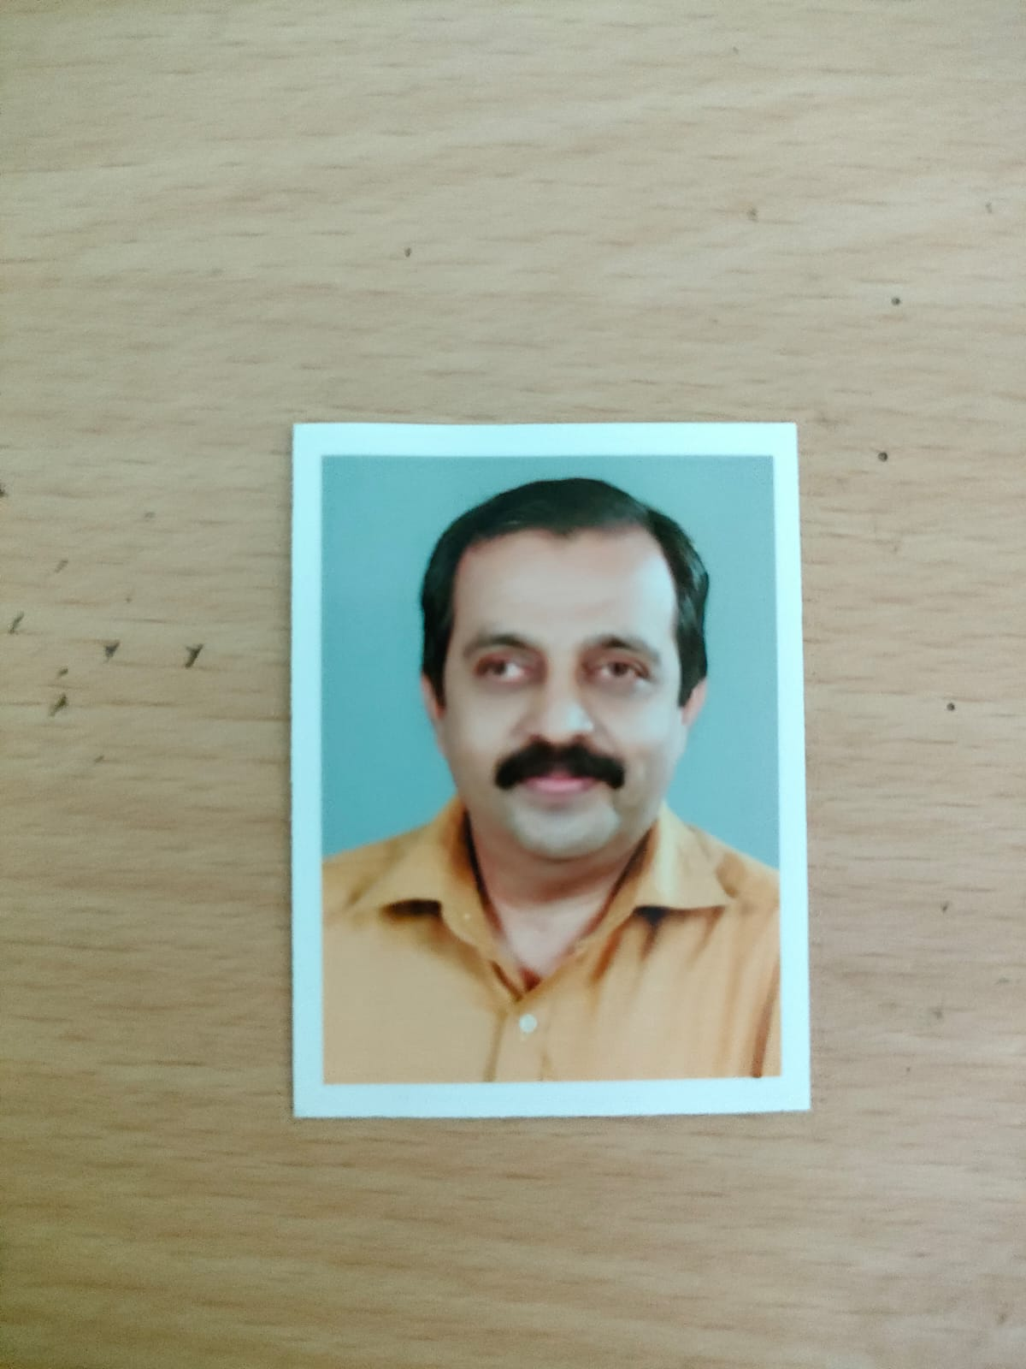
MESSAGE BY MEDICAL OFFICER

Dear Respected Citizens,
As the Medical Officer of the Family Health Centre (FHC), I want to express my deepest concern for the health and well-being of our community, especially amid the ongoing health challenges we face. The COVID-19 pandemic, along with other diseases like leptospirosis, dengue, have deeply impacted our people, causing physical, emotional, and financial hardship.
Our panchayat, with its diverse population, is particularly vulnerable due to its location and the presence of many workers in agriculture and small industry, as well as through migration. In these trying times, the role of healthcare services becomes more crucial than ever. As part of the FHC, I am committed to providing essential healthcare services to everyone in our community, ensuring timely and effective medical care for all.
However, we cannot overcome these challenges alone. The fight against these health crises requires active involvement from each of you. I urge all community members to stay informed, practice preventive measures, and collaborate with health workers and local authorities. Together, through collective action, we can minimize the impact of these diseases and disasters on our people. We will continue to work closely with the Gram Panchayat, local authorities, and other departments to ensure that healthcare resources are available, accessible, and effectively distributed. Let us stand united in the face of these challenges to protect the health and safety of our community.
Thank you for your cooperation and commitment to the health of Perumbalam Grama Panchayat.
Yours sincerely,
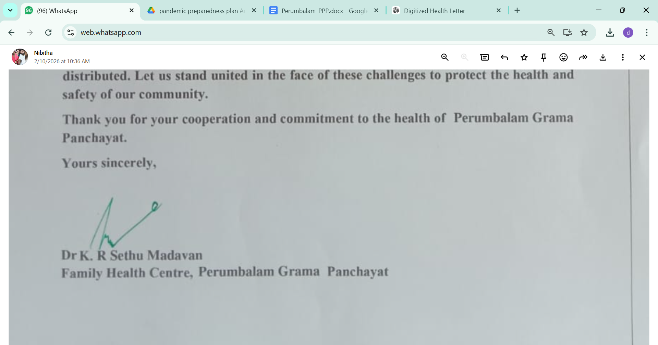
Dr K. R Sethu Madavan
Family Health Centre, Perumbalam Grama Panchayat

EXECUTIVE SUMMARY
Primary Health Centre (PHC) functions as the primary public healthcare institution serving the population of 11678 Grama Panchayath. The PHC plays a pivotal role in delivering comprehensive, accessible, and affordable healthcare services, with a strong focus on preventive, promotive, curative, and rehabilitative care in accordance with national and state health programmes.
The PHC caters to a predominantly rural population, addressing key public health priorities such as maternal and child health, communicable and non-communicable disease control, immunization, family welfare, adolescent health, and geriatric care. Regular outpatient services, home-based care through field health staff, and outreach activities ensure healthcare coverage even in geographically challenging areas. The institution actively implements national health missions, including the National Health Mission (NHM), National Tuberculosis Elimination Programme, National Programme for Prevention and Control of Cancer, Diabetes, Cardiovascular Diseases and Stroke (NPCDCS), and other disease surveillance initiatives.
Perumbalam PHC works in close coordination with the Grama Panchayath, ASHA workers, Anganwadi centres, schools, and community-based organizations to strengthen community participation and improve health awareness. Emphasis is placed on early detection, timely referral, health education, and lifestyle modification to reduce disease burden and improve overall health outcomes.
Despite constraints related to infrastructure, manpower, and increasing service demand, the PHC continues to enhance service delivery through effective planning, data-driven decision-making, and community engagement. Strengthening facilities, upgrading digital health systems, and expanding preventive services remain key focus areas for future development.
Overall, Perumbalam Primary Health Centre stands as a vital institution in safeguarding public health and improving the quality of life of the residents of Perumbalam Grama Panchayath

LIST OF ABBREVIATIONS

LSGD/LSGI | Local Self Government Department / Local Self Government Institution
BMO | Block Medical Officer
IDSP | Integrated Disease Surveillance Programme
NDMA | National Disaster Management Authority
PPE | Personal Protective Equipment
ICMR | Indian Council of Medical Research
CD | Communicable Diseases
NCD | NON-COMMUNICABLE Diseases

TABLE OF CONTENTS

INTRODUCTION 9
Background of the PPP 9
LSGD AT A GLANCE 9
INTEGRATED HEALTH INFRASTRUCTURE MAP OF PANCHAYAT 10
GENERAL PROFILE OF THE LSGI’S 13
Background of the LSGI 13
Demographic and Vulnerable Population 14
Clinical Vulnerability 16
INFRASTRUCTURE & RESOURCE INVENTORY 18
Health Facility Directory & Basic Capacity in the LSGD 18
Private Clinics 19
Healthcare Education & Training Institutions 20
Specialized Services & Emergency Inventory 20
Oxygen & Diagnostic Capacity 21
Diagnostics facility mapping at the LSGI level 22
Laboratory Identification & Basic Details 22
Social and Community Infrastructure for surge plan 22
Human resources 24
Community & Support Cadre 25
Community Organizations 26
Administrative & Emergency Services 27
Information regarding resources 27
ONE HEALTH & ENVIRONMENTAL SURVEILLANCE 28
Animal & Bird Population 28
Veterinary Infrastructure 29
Veterinary Doctors & Workforce 30
High-Risk Interface Points (Surveillance Sites) 30
Environmental Risk Mapping 31
Disease Seasonality Mapping 32
Vulnerability Mapping 33
EPIDEMIOLOGICAL TRENDS (2021–2025) 34
Disease Burden among human beings(Last 5 Years) 34
*(use the above table data to create the graph/diagram) 36
Seasonal Trend Analysis 37
Outcome-Based Trend Analysis- 2025 39
Transmission Trend- 2025 40
Integrated Disease Hotspot Map (2021–2025) 42
Preparedness and Response Protocol at LSG Level 44
Constitution of One Health Committee 44
Pandemic Response Workforce 45
Activities and Measures before and during Pandemic 47
PHASE 1 - Alert / Preparation 47
PHASE 2 - Active Response 50
Standard Screening Protocol 51
PHASE 3 - Surge Capacity 60
Conversion of Community Facilities 60
CONCLUSION 61
RECOMMENDATIONS 62
ANNEXURE 63
1. IMPORTANT PHONE NUMBERS 63

INTRODUCTION

Perumbalam Grama Panchayat is a geographically distinct island Panchayat located in Alappuzha district of Kerala. Surrounded entirely by backwaters and dependent primarily on water transport for connectivity with the mainland, the Panchayat presents a unique administrative and public health setting. Its insular nature fosters strong social cohesion and close community interactions, yet at the same time poses significant logistical and emergency response challenges, particularly during health crises and natural disasters.
The Panchayat comprises 13 wards, covering 2,520 households with a total population of 11,678, including 26 migrant residents engaged in diverse livelihood activities. The community’s occupational profile includes agriculture, fishing, poultry and dairy farming, small-scale industries, and daily wage labour. Regular interaction with mainland markets and movement of migrant workers increase exposure to external disease transmission risks. The clustering of households and shared public spaces further heighten the potential for rapid spread of infectious diseases during outbreaks.
Water security and sanitation are critical public health priorities in Perumbalam. The Panchayat depends heavily on groundwater sources, with 921 wells serving domestic and household needs. During monsoon seasons and periods of flooding, the risk of water contamination, waterborne diseases, and vector breeding increases significantly. Continuous monitoring of water quality, sanitation practices, and waste management systems is therefore essential to prevent outbreaks such as leptospirosis, dengue, and other communicable diseases.
The Panchayat has 7 educational institutions, where a daily congregation of children, teachers, and staff creates environments that require structured infection prevention and control protocols during epidemics. Healthcare infrastructure is limited, with only one hospital (government/private) serving the entire population. Given the geographic isolation and limited in-house healthcare capacity, early detection of cases, functional surveillance systems, clear referral pathways, emergency transport arrangements, and coordination with higher-level health facilities are critical components of preparedness.
In view of these contextual realities, the Pandemic Preparedness Plan (PPP) for Perumbalam Grama Panchayat adopts a proactive, data-driven, and community-centred approach. By integrating scientific planning with local governance mechanisms and community engagement, the PPP seeks to build resilience within the Panchayat, enabling timely, coordinated, and effective responses to future pandemics and public health emergencies while safeguarding the health, livelihoods, and overall well-being of its people.

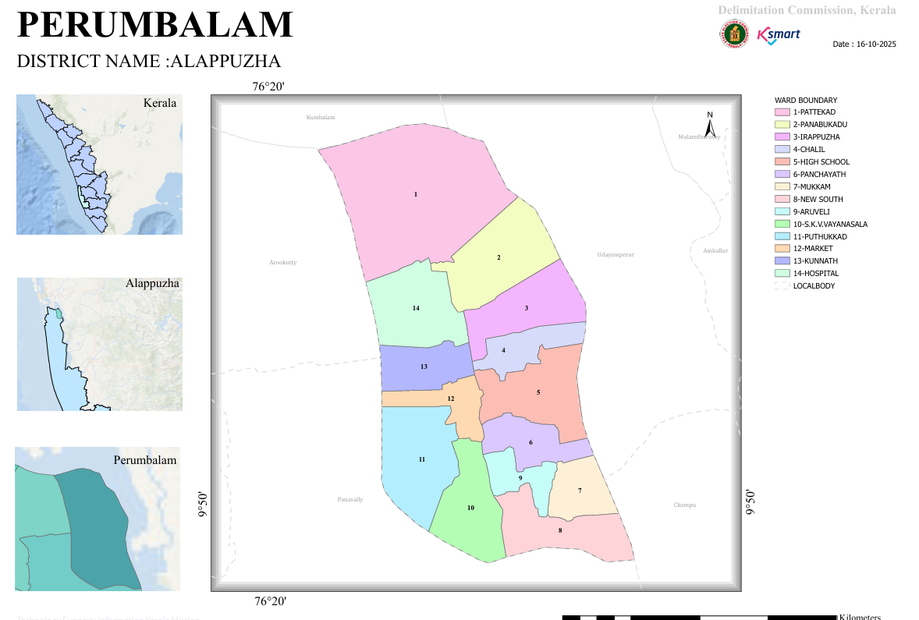

LSGD AT A GLANCE
- Geographical boundaries with political map ( based on latest delimitation)

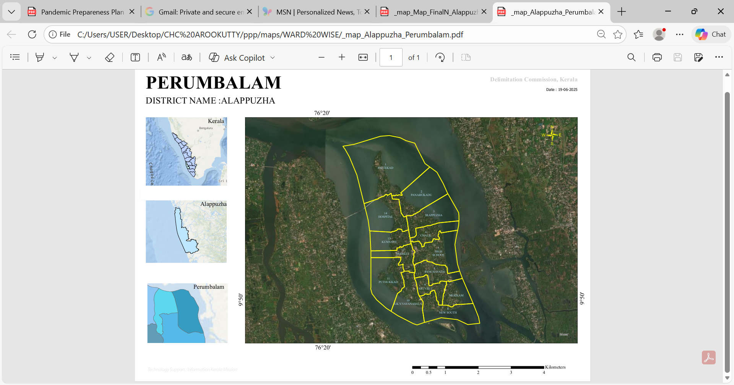

Baseline data
- Ward division -
Ward | Houses | Population | Migrants | Wells | Hot  spots | Ed. Institutions | Hosp pvt/govt.
13 | 2520 | 11678 | 26 | 921 | 0 | 7 | 1

- Risk stratification among wards in the context of Communicable diseases and hazards
Dengue - 4,11,9(wards)
mumps -6,7,8,9(wards)

- Major Roads/rivers
market jetty - vathikad jetty road
hospital -pattekad road
newsouth- panchayath road

- Major establishments with geospatial mapping
FHC Perumbalam ward 13
Fwc south ward 7
Fwc north ward1
Homeo dispensary ward 5
Ayurveda dispensary ward 9
Siddha dispensary ward13
Veterinary dispensary ward11

Occupational Groups, Socio-Cultural Groups, Migration & Mobility Patterns – Perumbalam Grama Panchayat
Occupational Groups:
The population of Perumbalam Grama Panchayat is primarily dependent on traditional livelihoods such as fishing, inland fish farming, agriculture, coir-related work, and daily wage labour. A considerable number of residents are engaged in small-scale trade, transport services, and government or private sector employment in nearby mainland areas such as Cherthala and Arookutty. Women are actively involved in Kudumbashree activities, coir processing, and small household enterprises, contributing to local economic stability.
Socio-Cultural Groups:
Perumbalam has a closely knit island community with strong social cohesion. The population consists mainly of traditional fishing communities, agricultural families, and other rural socio-economic groups. Social institutions such as schools, religious centres, Kudumbashree units, and community-based organizations play an important role in community mobilization and awareness during public health emergencies.
Migration & Mobility Patterns:
Perumbalam experiences regular daily mobility of residents to the mainland for employment, education, healthcare, and essential services. Transport is mainly dependent on ferry services and road connectivity through the Perumbalam Bridge, which increases interaction with outside populations. Seasonal and temporary migration for employment is limited, but routine commuting increases the potential for disease transmission during pandemics.

Vulnerability Mapping – Perumbalam Grama Panchayat
Perumbalam Panchayat has unique vulnerability characteristics due to its island geography and limited access routes. The dependence on ferry services and bridge connectivity can delay emergency response and referral transport during health emergencies. The presence of elderly population, persons with chronic diseases, and economically weaker households increases health-related vulnerability.
The limited number of healthcare institutions within the Panchayat means residents often depend on mainland hospitals for specialized care, which can become challenging during pandemics or transport disruptions. Population clustering in certain wards may increase the risk of rapid disease transmission if outbreaks occur.
However, the Panchayat benefits from strong community networks and manageable population size, which supports effective surveillance and coordinated response.

Disaster-Prone Areas (Geographic Vulnerability) – Perumbalam Grama Panchayat
Perumbalam Grama Panchayat is an island region surrounded by backwaters, but major flood-prone disaster areas have not been reported in recent years. The Panchayat generally remains free from large-scale flooding, making it relatively stable in terms of disaster vulnerability.
However, the Panchayat may experience temporary water level rise, coastal erosion, heavy rainfall impacts, and transport disruption during extreme weather conditions, which can affect mobility and access to health services. Strong winds and monsoon-related disturbances may occasionally affect ferry transport and connectivity with the mainland.
Overall, Perumbalam is considered a low flood-risk Panchayat, but its island nature and limited access routes remain the primary geographic vulnerabilities, especially during public health emergencies and natural calamities.

Maps - ward-based

- Health infrastructure map
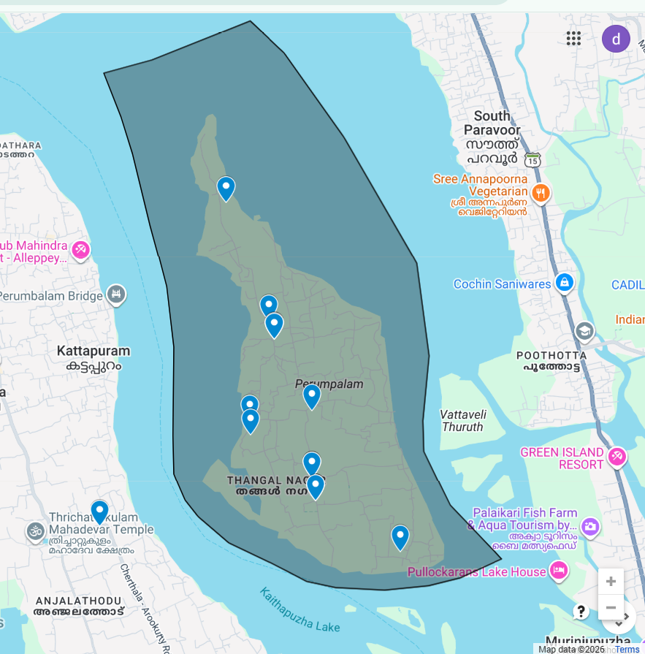

- Roads and rivers map

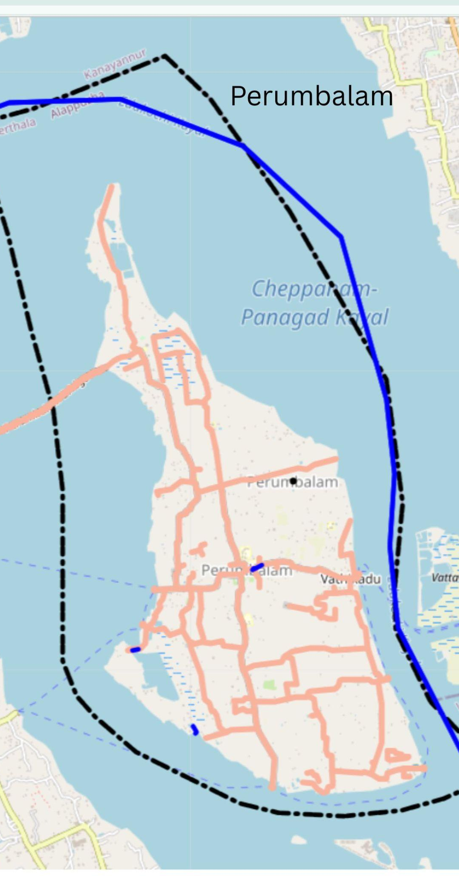

https://map.opendatakerala.org/alappuzha/perumbalam-grama-panchayat/?

- Major establishments map
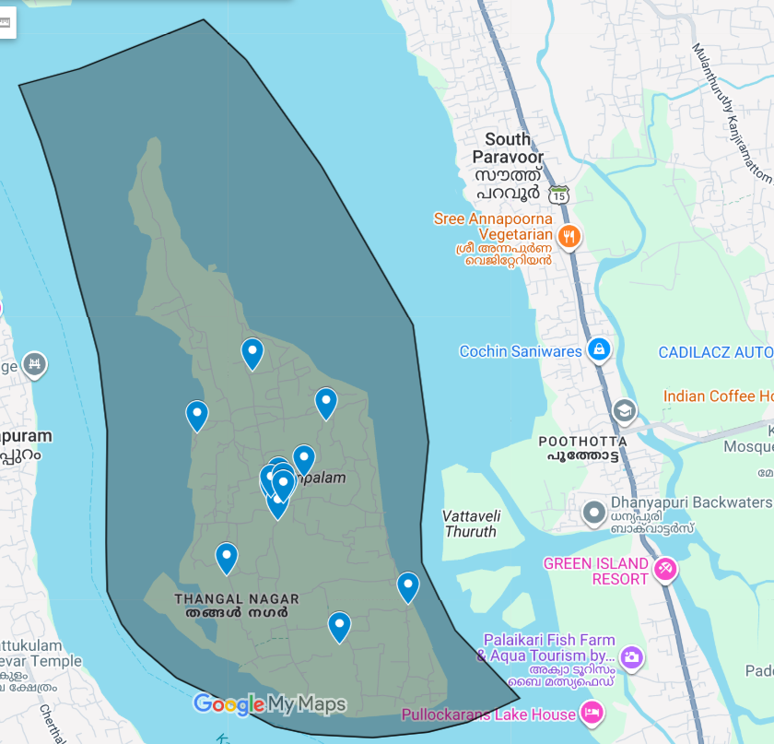

https://www.google.com/maps/d/edit?hl=en&mid=1aa2deSV4uFGsIzOWDa6nbRfmUQz0Fsc&ll=9.858868422095991%2C76.35827888763426&z=14

- Disaster-prone areas map

NIL

- Hotspot map - CD & disasters

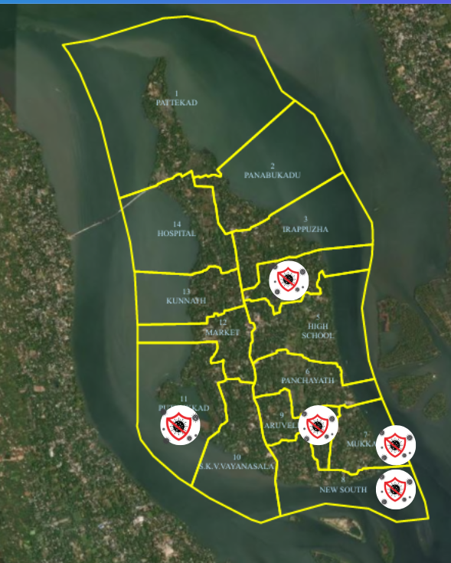

INTEGRATED HEALTH INFRASTRUCTURE MAP OF PERUMBALAM PANCHAYAT
Health Infrastructure Map

GENERAL PROFILE OF THE LSGI’S

Background of the LSGI

Perumbalam Grama Panchayat is situated in the _ of Alappuzha district, Kerala. The geographical landscape of the Panchayat is predominantly low-lying, characterized by extensive paddy fields (Kole lands) and a dense network of rivers, canals, and backwaters. This unique terrain plays a significant role in shaping the local microclimate and poses distinct challenges to transportation, emergency response, and service delivery, particularly during monsoon seasons and flood events.
The Panchayat is administratively divided into multiple wards, with a population largely dependent on traditional livelihoods. Agriculture—especially paddy cultivation—fishing, coir and coconut husk processing, and allied activities form the backbone of the local economy. In recent years, tourism-related activities and service-sector employment have also shown gradual growth. The area hosts a diverse workforce, including a notable presence of migrant labourers, particularly in construction, agriculture, and allied sectors.
From a public health and disaster management perspective, Perumbalam LSGI has historically been vulnerable to seasonal flooding, waterborne diseases, and vector-borne illnesses such as Dengue and Leptospirosis. The severe floods experienced during recent years, including the 2018 flood disaster, significantly impacted life, livelihoods, and infrastructure within the Panchayat. These recurring emergencies have underscored the importance of strengthening local preparedness, response mechanisms, and inter-departmental coordination.
In this context, the development of a localized, data-driven Auxiliary Infrastructure and Logistical Resource Map is essential to support effective planning, timely emergency response, and sustainable development initiatives. Such mapping enables the Panchayat to identify critical resources, improve accessibility during disasters, and enhance overall resilience of the community.

Table 1: Background of LSGD
Description | Details
Name of LSGI | Perumbalam
Type (GP/Municipality / Corporation etc.) | Grama Panchayath
Block | Thykkattussery
District | Alappuzha
Number of wards | 13
Total area (sq. km) | 16.32
Population(Projected) | 11678
Population density | persons/sq km
Terrain (coastal/low-lying/backwaters/foothills, etc.) | coastal
Number of rivers passing through LSGI | 0
Number of water bodies in the LSGI | 921
Number of educational institutions | 7
Factories / small-scale industries | 5
Flood-prone wards | 0
Landslide-prone wards | 0
Death Management and Disposal Facilities (mortuaries/crematorium, including electric) | 0
Auditoriums/Marriage halls/convention centres/community halls | 3

Demographic and Vulnerable Population
Understanding the demographic composition and vulnerable population groups is essential for pandemic preparedness. Children, elderly, economically deprived families, migrant workers, and socially vulnerable groups are at increased risk during public health emergencies due to higher exposure, limited access to services, and dependency on public systems..

Description |  | Details (in numbers)
DEMOGRAPHIC PROFILE
Total population |  | 11678
Male |  | 5791
Female |  | 5887
Transgender |  | 0
Children under 5 |  | 310
Adolescent |  | 638
Elderly (>60) |  | 1628
SOCIAL/LIVELIHOOD VULNERABILITY
Previous EPEP family |  | 20
BPL family |  | 1713
Tribal communities |  | 0
Migration | Immigrant | 13
Migration | Emigrant | 67
Socio-economically deprived |  | 0
Fisherfolk |  | 371
SC Community |  | 614
ST Community |  | 38

Graphs: Population pyramid (if possible) for seeing if your LSGI has a high "dependency ratio" (lots of children and elderly compared to working adults).

Clinical Vulnerability
Certain population groups needs priority healthcare & are at higher risk of severe illness, complications, and mortality during pandemics. Patients with chronic diseases, those requiring regular medical care, and individuals with mobility or functional limitations face challenges in accessing timely care during emergencies. Mapping these groups helps in prioritizing continuity of treatment, medicine stock planning, oxygen support, referral transport, and targeted home-based care.
Description | Details in numbers
Pregnant women | 24
Lactating mothers | 110
Bedbound patients | 48
Patients under palliative care other than bedbound | 88
Patients on Haemodialysis | 6
Patients on CAPD | 1
Cancer patients (currently on treatment) | 42
Haemophilic patients | 0
Mentally challenged | 46
Differently abled | 78
Diabetic patients | 798
Hypertensive patients | 1171
TB patients | 1

Major Festivals & Events specific to the LSGI
(with the possibility of a public gathering)

Sl. No. | Name of festival | Month detailing the periodicity
1 | Arayakulangara, panambu kadu ,pattekadu., pallipattu , sasthangal temple ulsavam | Dec - April

INFRASTRUCTURE & RESOURCE INVENTORY

Health Facility Directory & Basic Capacity in the LSGD
This section provides an overview of the healthcare infrastructure available within the LSGD area. It outlines the distribution and basic capacity of health facilities that form the backbone of service delivery during routine times and public health emergencies.

Family Health Centres (FHCs) and Community Health Centres (CHCs) generally function as the first point of contact for the community, providing essential outpatient and inpatient services. General Hospitals (GH) and Medical College Hospitals (MCH), where accessible, serve as the main referral centres for advanced diagnostics, specialist care, and critical services during public health emergencies. This inventory helps identify existing strengths, gaps, and potential surge capacity that can be mobilised during a pandemic or disaster.

Table 5. Health Facility Resource Summary
Sl.no. | Health Facility | Type of Facility (MCH/GH/CHC/FHC/SC etc.) | Contact Number | Total beds | ICU Beds | Oxygen-Supported Beds | No. of Ventilator Support Beds | No. of ambulances
Government Healthcare Facilities
1 | FHC PERUMBALAM | FHC | Dr. Sethumadhavan  94473 65562 | 29 | 0 | 0 | 0 | 0
Private Healthcare Facilities
 | NIL
AYUSH Healthcare Facilities
1 | AYURVEDA | PHC | Dr. Jijimol  9037538685 | 0 | 0 | 0 | 0 | 0
2 | HOMEO | SC | Dr. Deepak  8113947061 | 0 | 0 | 0 | 0 | 0
3 | SIDDHA | SC | Dr. Adarsh  8129581727 | 0 | 0 | 0 | 0 | 0

Private Clinics
Private clinics are an essential part of pandemic preparedness, as they are often the first place people seek care when symptoms begin. In many communities, private clinics manage a significant share of outpatient visits and therefore play a critical role in early case detection, timely referrals, and disease surveillance. Having an up-to-date understanding of where these clinics are located, the services they provide, and how they are linked to the public health system helps ensure that no cases are missed during an outbreak. It also allows health authorities to engage private practitioners more effectively for reporting, risk communication, and coordinated response, strengthening the overall capacity of the health system to manage public health emergencies.

Table 6. Private Clinic Resource Summary
Sl No. | Name of Clinic | Registered (Y/N) | Clinic (General / Speciality) | Speciality (if any) | Address | Contact Number | Diagnostic Facility (Y/N) | Ambulance Linkage (Y/N)
1 | Science lab family clinic | Y | General | Nil | Science lab Perumbalam | 944 747 5 888 | Y | N

Healthcare Education & Training Institutions
This section tracks the educational infrastructure available, which is vital for human resource planning in the health sector.

Category of Institution | Govt | Private | AYUSH | Total
Medical Colleges | 0 | 0 | 0 | 0
Nursing Colleges | 0 | 0 | 0 | 0
Dental Colleges | 0 | 0 | 0 | 0
Para-medical / Allied Health | 0 | 0 | 0 | 0
Pharmacy Colleges | 0 | 0 | 0 | 0

Specialized Services & Emergency Inventory
This section provides a detailed view of the specialized medical resources available to the community, focusing on emergency response and critical care capabilities. This table tracks the vital assets required for managing severe illnesses and emergencies across Government, Private, and AYUSH sectors.

Item | Govt | Private | AYUSH | Total
Hospital beds | 29 | 0 | 0 | 29
Oxygen-generating systems(Y/N) | 0 | 0 | 0 | 0
Oxygen-supported beds(Numbers) | 0 | 0 | 0 | 0
Ventilator-supported beds | 0 | 0 | 0 | 0
ICU beds | 0 | 0 | 0 | 0
Burns units | 0 | 0 | 0 | 0
Blood centres | 0 | 0 | 0 | 0
BLS ambulances | 0 | 0 | 0 | 0
ALS ambulances | 0 | 0 | 0 | 0
Dialysis facilities | 0 | 0 | 0 | 0
Dispensaries | 3 | 0 | 0 | 0
Medical store | 0 | 3 | 0 | 0
Industrial establishments (Medium-scale industries/small-scale industries establishments to whom we can depend in a worst-case scenario) | 0 | 0 | 0 | 0

Oxygen & Diagnostic Capacity
Monitoring oxygen and diagnostic capacity is a critical component of public health preparedness, ensuring that the LSGD can handle both chronic care and sudden surges in respiratory or infectious diseases.
Name of Health Facility | Oxygen-generating System (Y/N) | Backup Oxygen Source (Y/N) | Diagnostic Facilities Available(Y/N)
Name of Health Facility | Oxygen-generating System (Y/N) | Backup Oxygen Source (Y/N) | Lab | USG | X-ray | CT/MRI | RT-PCR
Government Healthcare Facilities
FHC PERUMBALAM | N | N | Y | N | N | N | N

Diagnostics facility mapping at the LSGI level
The diagnostic capacity of Perumbalam G.P represents the "intelligence network" of our healthcare system. The speed and accuracy of disease identification depend entirely on the distribution and technical level of these facilities.

Item | Govt | Private | AYUSH | Total
General labs | 1 | 3 | 0 | 4
Microbiology labs | 0 | 0 | 0 | 0
RT-PCR labs | 0 | 0 | 0 | 0
USG units | 0 | 0 | 0 | 0
CT/MRI units | 0 | 0 | 0 | 0
Research labs | 0 | 0 | 0 | 0
Labs of other departments that can be repurposed | 0 | 0 | 0 | 0

Laboratory Identification & Basic Details
Sl. No. | Name of Laboratory | Ownership (Govt / Private / Academic) | Address | Contact No. | 24×7 Services (Yes/No) | NABL / Govt Approved (Yes/No)
1 | CARE LAB | PRIVATE | market jetty , perumbalam | 9544577733 | NO | No
2 | SCIENCE LAB | PRIVATE | Arayakulangara, perumbalam | 9447475888 | NO | No
3 | NISA CLINIC | PRIVATE | near FHC , Perumbalam | 9495885238 | NO | No

Social and Community Infrastructure for surge plan
This table serves as our logistics and shelter inventory. By mapping these locations, quickly we can identify where to house displaced citizens, where to set up temporary medical clinics, and how to manage the deceased with dignity during a crisis.

Category | Total Count | Ward | Est. Capacity (Persons) | Contact details
Educational Institutions
Anganwadis | 15 | All wards except ward 6 | 30 | ICDS supervisor - 94479 24411
Schools | 7 | 2,4,6 | 212
Colleges | 0 | 0 | 0 | 0
Healthcare Educational Institutions
Medical colleges (Govt/Private) | 0 | 0 | 0 | 0
Nursing colleges (Govt/Private) | 0 | 0 | 0 | 0
Dental colleges (Govt/Private) | 0 | 0 | 0 | 0
Paramedical institutes (Govt/Private) | 0 | 0 | 0 | 0
Community Gathering Spaces
Community halls | 1 | 2 | 6
Auditoriums | 3 | 5,11 | 30
Religious buildings | 9 | 1,4,5,6,9,12 | 36
Vulnerable Group Support Facility
Destitute homes | 0 | 0 | 0 | 0
Elderly homes | 0 | 0 | 0 | 0
LSGD owned other buildings | 2 | 1,11 | 9
Mass Fatality Management (MFM) Infrastructure
Mortuary | 0 | 0 | 0 | 0
Crematorium | 3 | 1,9,12 | 48
*refer annexure 1 for contact details

Human resources
This section focuses on the human capital available within the LSGI. In any emergency be it a pandemic, flood, or industrial accident—infrastructure is only as effective as the people operating it.

Medical & Clinical Personnel
This table tracks the "Frontline" providers responsible for diagnosis, treatment, and clinical management. Narrative sentence: eg., "Total health workforce: 450 personnel, with 60% in government facilities serving as primary surge capacity." A detailed directory with the contact numbers of all workers is maintained (Annexure in 1).

Cadre | Govt (No.) | Private (No.) | Total
Doctors—Modern Medicine | 6 | 2 | 8
Doctors – AYUSH | 3 | 0 | 3
Doctors – Veterinary | 1 | 0 | 1
Doctors – Dental | 1 | 0 | 1
Nursing officers | 6 | 0 | 6
Lab technicians | 2 | 3 | 5
Optometrist | 1 | 0 | 1
Pharmacists | 1 | 3 | 4
Psychologists | 0 | 0 | 0
Counsellors | 0 | 0 | 0

Public Health & Field-Level Workforce
These individuals are the backbone of surveillance, maternal-child health, and decentralized care.

Cadre | Health services | Municipal common services | Total
HS (Health Supervisors) | 0 | 0 | 0
HI (Health Inspectors) | 1 | 0 | 1
LHS (Lady Health Supervisor) | 0 | 0 | 0
LHI (Lady Health Inspectors) | 0 | 0 | 0
JPHN (Jr Public Health Nurses) | 3 | 0 | 3
JHI (Jr Health Inspectors) | 1 | 0 | 1
MLSP (Mid-Level Service Providers) | 3 | 0 | 3
Palliative Nurses | 1 | 0 | 1
RBSK Nurses | 0 | 0 | 0
PRO | 0 | 0 | 0
Epidemiologist | 0 | 0 | 0
Data Manager | 0 | 0 | 0

Community & Support Cadre
This group represents the surge capacity of the LSGI—people who can be called upon for logistics, rescue, and specialized support.

Cadre | Number
ASHA Workers | 13
AWW (Anganwadi Workers) | 15
Emergency Medical Volunteers (Trained) | 26
Kudumbashree | 139
MNREGS | 1300
Purusha Swayam Sahaya Sangham | 33
Ex-Servicemen | 14
Retired Police Officers | 8
NCC/NSS Volunteers | -
Red Cross volunteers | 0
One Health Community Volunteers | 637
One Health Community Mentors | 91

Community Organizations
This section details the presence of community-based organisations (CBOs), non-governmental organisations (NGOs), faith-based organisations (FBOs), Kudumbashree Self-Help Groups (SHGs), and Ayalkootams within the Local Self-Government Institution (LSGI). These groups enhance grassroots mobilization, resource distribution, and support networks crucial for pandemic response and community resilience.

Category | Total Count
NGOs | 0
Religious based organizations | 9
Foreign based organizations | 0
Sports Club/youth clubs | 16
Kudumbashree SHGs | 26
Ayalkootams | 25
Political organizations | 8
Residential organizations | 0

Administrative & Emergency Services
This section outlines the availability of key non-health emergency support services and infrastructure within the LSGI, which are essential for effective pandemic preparedness and response. These facilities support law enforcement, disaster response, water supply, logistics, mobility, and community-level interventions during public health emergencies.

Category | Total Count | Contact details
Police Stations | 0 | NA
Fire & Rescue Stations | 0 | NA
Water Pumping Points | 0 | NA
Public Distribution System (PDS) | 0 | NA

Information regarding resources
The availability of essential transport and support resources plays a quiet but critical role in saving lives. Equipment such as ambulances, mobile mortuaries, amphibian ambulances, and motorized boats ensures that patients, samples, and healthcare teams can move swiftly—even in flooded, remote, or difficult terrains. Heavy vehicles like JCBs, cranes, tractors, and torus lorries support logistics, waste management, emergency infrastructure, and rapid conversion of spaces into care or isolation facilities. Taxis, four-wheel-drive vehicles, and trucks help maintain continuity of essential services, reach vulnerable populations, and support home-based care and supply delivery.

Means of transportation | Total Count
JCB | 5
Crane | 0
Heavy Trucks | 0
Tractor | 6
Ambulances | 0
Mobile mortuaries | 0
Boats | 5
Taxi service | 6
Note: For specific details regarding vehicle owners and contact information, please refer to Annexure [X].

ONE HEALTH & ENVIRONMENTAL SURVEILLANCE
The One Health method integrates environmental, animal, and human health to enable proactive pandemic preparedness. Panchayat-level surveillance needs to be improved in order to detect and treat zoonotic and environmentally generated diseases early. Surveillance is strengthened through systematic assessment of animal populations, veterinary infrastructure, poultry and slaughter facilities, inter-sectoral coordination, and specialised tools like avian influenza seasonality mapping using GIS in previous outbreaks to enable predictive alerts and ward-specific sampling to support effective pandemic preparedness in high-risk areas.

Animal & Bird Population
Mapping animal and bird populations at the Panchayat level is essential for identifying and prioritising zoonotic disease hazards like rabies, avian influenza (H5N1), leptospirosis, anthrax, and Nipah-like spillover occurrences. Risk classification, targeted surveillance, vaccination planning, and early epidemic detection made feasible by comprehensive population mapping all enhance One Health-based pandemic preparedness.

Category | Item | Estimated Population | Wards
Animal Population | Livestock (Cattle/Goats/Buffalo) | 216 | All wards
Animal Population | Pet Animals (Dogs/Cats) | 1269 | All wards
Animal Population | Stray Dog Population | 468 | All wards
Animal Population | Pig Farms (Number of heads) | 0 | 0
 | Small Units (Sheep / Goats – clustered) | 0 | 0
Bird Population | Poultry Units (Birds) | 78 | All wards
Bird Population | Poultry- (FOWL) | 364 | All wards
Bird Population | Wild/Migratory Birds (Observed) | 160 | 1,3,4,5,6,8,12,13
Bird Population | Crow Mortality Events (Reported) | 3 | 8

The main risk of zoonotic diseases in perumbalam is concentrated in Ward 8 which is explained by the high density of pig farms, cattle congregation areas, and poultry units. The stray dog population in market areas, fish landing sites, bus stations continues to be a substantial problem for rabies surveillance and bite prevention. There is a considerable risk of avian influenza introduction and amplification during November - December due to the seasonal presence of migratory and resident water birds near ponds/ canal / river / backwater / paddy field. Clusters of pig farms and animal shelters vulnerable to flooding further raise the risk of leptospirosis and other zoonoses mediated by the environment, especially during monsoon floods.

Veterinary Infrastructure
Veterinary institutions are a core pillar of One Health surveillance, enabling early zoonotic disease detection through vaccination, investigation of unusual animal illness or deaths, sample collection, and timely outbreak reporting. A well-mapped and responsive veterinary network strengthens coordination with human health and LSGI systems, ensuring rapid response during zoonotic events and pandemics.
Facility Type | Name of Facility | Ownership Govt / Pvt | Location(Ward No) | Contact number
Veterinary Dispensary | 1 | GOVT | 11 | Dr. Tintu  7034079866
Veterinary Hospital / Polyclinic | 0 | 0 | 0 | 0
Private Veterinary Clinics | 0 | 0 | 0 | 0
Mobile / Emergency Vet Service (incl. night services) | 0 | 0 | 0 | 0
Pet Homes / Animal Shelters | 0 | 0 | 0 | 0
Slaughterhouse-linked Veterinary Inspection Unit | 0 | 0 | 0 | 0

Veterinary Doctors & Workforce
Early detection, diagnosis, reporting, and reaction to animal illness epidemics depend on the availability and accessibility of qualified veterinary specialists. By identifying unusual animal morbidity or mortality promptly, collecting samples promptly, and coordinating efficiently with human health and LSGI systems—especially during zoonotic outbreaks and pandemic-prone situations—a clearly defined veterinary workforce enhances One Health surveillance.

Category | Number Available | Type (Govt/Pvt) | Contact number
Government Veterinary Doctors | 1 | GOVT
Private Veterinary Doctors | 0 | 0 | 0
Livestock Inspectors | 0 | 0 | 0
Para-veterinary Staff / Attenders | 0 | 0 | 0
Contract / On-call Veterinary Support (if any) | 0 | 0 | 0

High-Risk Interface Points (Surveillance Sites)
High-risk interface points for zoonotic disease surveillance in perumbalam Grama Panchayath include wetland–livestock–human contact zones, backyard poultry farms, cattle sheds near water bodies, fish markets, and areas of high human–animal interaction such as community slaughter points and migratory bird congregation sites. These are the primary surveillance sites where zoonotic spillover risks are elevated.

Type of Habitat | Type of High risk interface | Geographical vulnerability
Wetlands & Backwaters | 0 | 0
Backyard Poultry Farms | all wards | –
Cattle Sheds near Water Bodies | ward 1, 2,4,5,12,13 | —
Fish & Meat Markets | 0 | 0
Community Slaughter Sites | 0 | 0
Migratory Bird Congregation Areas | ward 1, 3,4,5,6,8,12,13 | —
Rodent-Infested Grain Storage | 0 | 0

Category | Total Count | Key Locations (wards)
Poultry Farms | 0 | 0
Backyard / Clustered Poultry Units | 16 | 1,2,4,5.6,8,9,12,13
Duck Rearing Units (open water access) | 0 | 0
Slaughterhouses/ Slaughter Points | 7 | 3,5,8,9,11,13
Meat/Fish Markets | 0 | 0
Live Bird Sale Points | 0 | 0
Cattle Markets / Weekly Animal Fairs | 0 | 0
Pet Shops / Breeders | 0 | 0
Animal Shelters / Pet Homes | 0 | 0
Waste Disposal Sites near Animal Units | 0 | 0

Environmental Risk Mapping
Environmental risk mapping identifies monsoon/flood hotspots for vector-borne (dengue, chikungunya), water-borne (leptospirosis, diarrhoea), and zoonotic diseases in Kerala's wetlands. Systematic surveillance supports early warnings, targeted interventions, and Panchayat pandemic preparedness.
Waterborne exposure: Flood-prone areas and stagnant water bodies facilitate leptospira survival, raising leptospirosis risk.

Traditional practices: Informal slaughter and fish markets lack standardized hygiene, creating spillover opportunities.

Risk Factor | High-Risk Wards | Key Locations | Risk Level (High/Med/Low)
Flood-prone areas | 0 | 0 | 0
Water bodies/wetlands | 0 | 0 | 0
Solid waste accumulation | 0 | 0 | 0
Animal waste disposal issues | 0 | 0 | 0
Rodent infestation zones | 0 | 0 | 0
Industrial effluent discharge | 0 | 0 | 0
Construction sites / abandoned buildings | 0 | 0 | 0
Poor drainage/blocked canals | 6,4,1 | 1-perumchirakkari area, 4- pallipattu area, 6- thoppuvely area | low
Drinking water source contamination risk | 0 | 0 | 0

Disease Seasonality Mapping
1, Flooding & waterlogging → amplifies leptospirosis, malaria, diarrheal diseases.
2, Migratory bird influx (Nov–Feb) → avian influenza risk.
3, Mosquito breeding cycles → vector-borne disease peaks in monsoon.
4, Agricultural practices → close human–animal contact in paddy fields.

Disease | Peak Risk Season | Key Drivers | High-Risk Locations | Surveillance Focus
Avian Influenza | march-may | crow | 8 | —
Leptospirosis | june-sep | rat | 9,11,10 | rodent surveillance
Dengue/Chikungunya | june - sep | mosquito | all wards | vector surveillance
Acute Diarrheal Diseases | march - may | food source | all wards | —--
Rabies | —-- | —- | —- | —---
Anthrax (rare) | —-- | — | —-- | —--

Vulnerability Mapping
Vulnerability mapping pinpoints high-risk populations, occupations, and areas exposed via environment, livelihoods, socio-economics, and poor service access. Paired with environmental/seasonality mapping, it enables risk-based surveillance, targeted actions, and optimal resource use in One Health and pandemic planning.
Vulnerability Factor | High-Risk Wards | Key Groups / Locations | Risk Level
Flood-prone households | all wards | - | low
Wetland-adjacent communities | all wards except 11,5,6,7,13,12 | - | medium
Backyard poultry / duck rearing households | all wards | - | medium
Livestock-rearing households | all wards | - | low
Slaughterhouse & meat market workers | 3,5,8,9,11,13 | - | low
Fisherfolk & fish market workers | all wards | - | high
Sanitation workers | all wards | - | medium
Daily wage / migrant workers | 5,7,9,11,12 | - | low
Elderly & chronically ill populations | all wards | - | medium
Pregnant Women | all wards | - | low
Children (schools, Anganwadi’s) | all wards | - | low
Limited access to safe water & sanitation | 9,10 | - | low

EPIDEMIOLOGICAL TRENDS (2021–2025)

Disease surveillance is the systematic collection, analysis, and interpretation of health data for planning, implementation, and evaluation of public health practice. This section presents the disease surveillance profile of the LSGI based on routine reporting systems and outbreak investigations to identify priority diseases, seasonal patterns, and emerging public health threats.

Disease Burden among human beings (Last 5 Years)
Analysis of disease-wise data for the last five years helps identify persistent public health problems, emerging diseases, and changes in disease burden. This information supports prioritisation of prevention, preparedness, and response activities at the Panchayat level.

Disease | 2021 | 2022 | 2023 | 2024 | 2025 | Trend (Increasing/Stable/Decreasing)
Dengue | 6 | 12 | 8 | 65 | 15 | DECREASING
Leptospirosis | 1 | 2 | 2 | 0 | 1 | STABLE
Hepatitis A | 0 | 0 | 0 | 0 | 2 | INCREASING
Malaria | 0 | 0 | 0 | 0 | 0 | STABLE
Scrub Typhus | 0 | 0 | 0 | 0 | 0 | STABLE
Typhoid | 0 | 0 | 0 | 1 | 0 | STABLE
H1N1 | 0 | 0 | 0 | 0 | 0 | STABLE
H3N2 | 0 | 0 | 0 | 0 | 0 | STABLE
ADD | 26 | 48 | 64 | 75 | 86 | INCREASING
Mumps | 0 | 0 | 0 | 10 | 24 | INCREASING
Measles | 0 | 0 | 1 | 0 | 0 | DECREASING
Hepatitis B | 0 | 0 | 0 | 0 | 0 | STABLE
Hepatitis C | 0 | 0 | 0 | 0 | 0 | STABLE
Tuberculosis | 5 | 7 | 4 | 4 | 5 | STABLE
Leprosy | 0 | 0 | 0 | 0 | 0 | STABLE

Seasonal Trend Analysis
Seasonal analysis helps anticipate surges (e.g. dengue in monsoon, leptospirosis after floods, influenza in cooler months) and plan pre‑emptive vector control, stockpiling of IV fluids, and awareness campaigns at Panchayat level.

DENGUE
Dengue is a major seasonal vector-borne disease strongly associated with rainfall, water stagnation, and increased mosquito breeding during the monsoon period.

Peak: July–November

Dengue – Ward-wise Yearly Distribution (2021–2025)

Ward | Dengue – Ward-wise Yearly Distribution
Ward | 2021 | 2022 | 2023 | 2024 | 2025 | Total
1 | 1 | 0 | 1 | 4 | 1 | 7
2 | 0 | 1 | 0 | 4 | 1 | 6
3 | 0 | 1 | 1 | 6 | 0 | 8
4 | 0 | 2 | 2 | 8 | 0 | 12
5 | 1 | 1 | 0 | 6 | 2 | 10
6 | 0 | 0 | 0 | 4 | 2 | 6
7 | 0 | 1 | 1 | 5 | 0 | 7
8 | 1 | 0 | 0 | 4 | 0 | 5
9 | 1 | 1 | 1 | 5 | 4 | 12
10 | 1 | 1 | 0 | 4 | 1 | 7
11 | 0 | 2 | 2 | 9 | 0 | 13
12 | 0 | 1 | 0 | 3 | 3 | 7
13 | 1 | 1 | 0 | 3 | 0 | 5

LEPTOSPIROSIS
Leptospirosis cases are closely linked to monsoon rains, flooding, and occupational exposure, particularly in low-lying and waterlogged areas.

Peak: June - August

Leptospirosis – Ward-wise Yearly Distribution (2021–2025)

Ward | Leptospirosis – Ward-wise Yearly Distribution
Ward | 2021 | 2022 | 2023 | 2024 | 2025 | Total
1 | 0 | 0 | 0 | 0 | 0 | 0
2 | 1 | 0 | 0 | 0 | 0 | 1
3 | 0 | 1 | 0 | 0 | 0 | 1
4 | 0 | 0 | 0 | 0 | 0 | 0
5 | 0 | 0 | 0 | 0 | 0 | 0
6 | 0 | 0 | 1 | 0 | 0 | 1
7 | 0 | 0 | 1 | 0 | 0 | 0
8 | 0 | 0 | 0 | 0 | 0 | 0
9 | 0 | 1 | 0 | 0 | 0 | 1
10 | 0 | 0 | 0 | 0 | 1 | 1
11 | 0 | 0 | 0 | 0 | 0 | 0
12 | 0 | 0 | 0 | 0 | 0 | 0
13 | 0 | 0 | 0 | 0 | 0 | 0

VIRAL HEPATITIS - A
Hepatitis A cases are commonly associated with unsafe drinking water, food contamination, and breakdowns in sanitation, often presenting as clusters or outbreaks.

Peak: October - December

Hepatitis A – Ward-wise Yearly Distribution (2021–2025)

Ward | Hep A – Ward-wise Yearly Distribution
Ward | 2021 | 2022 | 2023 | 2024 | 2025 | Total
1 | 0 | 0 | 0 | 0 | 0 | 0
2 | 0 | 0 | 0 | 0 | 0 | 0
3 | 0 | 0 | 0 | 0 | 0 | 0
4 | 0 | 0 | 0 | 0 | 0 | 0
5 | 0 | 0 | 0 | 0 | 0 | 0
6 | 0 | 0 | 0 | 0 | 1 | 1
7 | 0 | 0 | 0 | 0 | 0 | 0
8 | 0 | 0 | 0 | 0 | 0 | 0
9 | 0 | 0 | 0 | 0 | 1 | 1
10 | 0 | 0 | 0 | 0 | 0 | 0
11 | 0 | 0 | 0 | 0 | 0 | 0
12 | 0 | 0 | 0 | 0 | 0 | 0
13 | 0 | 0 | 0 | 0 | 0 | 0

Transmission Trend- 2025
For effective management of public health issues, it is important to track the trend of disease transmission mode. It helps identify the population or place at high risk that can be used to predict outbreaks and implement targeted interventions as quickly as possible. Understanding these kinds of trends enables authorities to allocate resources efficiently and change the strategies adequately based on the trend that follows.

Mode of Transmission | No. of cases | No. of Deaths
Vector Borne Diseases | 15 | 0
Water Borne Diseases | 2 | 0
Air Borne Diseases | 55 | 0
Blood Borne Diseases | 0 | 0
Food Borne Diseases | 0 | 0

Vector-Borne Disease

Disease | No. of Cases | No. of Deaths
Dengue | 15 | 0
Malaria | 0 | 0
Chikungunya | 0 | 0

Water Borne Disease
Disease | No. of Cases | No. of Deaths
Cholera | 0 | 0
Typhoid | 0 | 0
Hep- A | 2 | 0
Dysentery | 0 | 0
Amoebiasis | 0 | 0
E- Coli infections | 0 | 0
Air Borne Disease
Disease | No. of Cases | No. of Deaths
Influenza | 0 | 0
H1N1 | 0 | 0
TB | 5 | 1
Chickenpox | 26 | 0
Measles | 0 | 0
Covid-19 | 0 | 0
Pertussis | 0 | 0
Mumps | 24 | 0

Blood-Borne Disease
Disease | No. of Cases | No. of Deaths
AIDS | 0 | 0
Hep- B | 0 | 0
Hep- C | 0 | 0

Zoonotic Disease
Disease | No. of Cases | No. of Deaths
Rabies | 0 | 0
Leptospirosis | 1 | 0
Avian influenza | 0 | 0
West nile | 0 | 0
Anthrax | 0 | 0
Nipah | 0 | 0
Scrub Typhus | 0 | 0

Integrated Disease Hotspot Map (2021–2025)

Ward No | Dengue Total (2021-25) | Leptospirosis Total (2021-25) | Hepatitis A Total (2021-25) | Mumps (2021-25) | ADD (2021-25) | Total Cases
1 | 7 | 0 | 0 | 3 | 20 | 30
2 | 6 | 1 | 0 | 1 | 25 | 33
3 | 8 | 1 | 0 | 0 | 22 | 31
4 | 12 | 0 | 0 | 2 | 24 | 38
5 | 10 | 0 | 0 | 0 | 25 | 35
6 | 6 | 1 | 1 | 7 | 22 | 37
7 | 7 | 0 | 0 | 8 | 21 | 36
8 | 5 | 0 | 0 | 7 | 22 | 34
9 | 12 | 1 | 1 | 4 | 23 | 41
10 | 7 | 1 | 0 | 1 | 24 | 33
11 | 13 | 0 | 0 | 0 | 26 | 39
12 | 7 | 0 | 0 | 1 | 20 | 28
13 | 5 | 0 | 0 | 0 | 26 | 31

The total number of cases for each ward is also included, with Ward 9 reporting the highest total of 41 cases. Ward 12 has the lowest total, with 28 cases. ADD appears to be the most prevalent disease across all wards, with cases ranging from 20 to 26. Mumps cases are notably higher in some wards, particularly in Ward 7, which has 8 cases. In contrast, Leptospirosis and Hepatitis A have relatively low occurrence across all wards.

Preparedness and Response Protocol at LSG Level
This section describes the operational framework for the LSGI once a pandemic is declared. It explains how the LSGI and health system will move from routine data collection to active response, using a One Health approach.

Constitution of One Health Committee
The LSGD shall constitute a One Health Committee comprising the LSGI President, Medical Officers (Modern Medicine, AYUSH, and Veterinary), the Health Inspector, and the Veterinary Surgeon.

Objective: The One Health Committee coordinates human, animal, and environmental health to prevent and control pandemics.

Sl No | Name | Designation | Department/Institution | Role in Committee | Contact Number
1 | C R Gireesh | Panchayat President | LSGD | Chairperson | 8921157388
2 | Dr. K R Sethumadhavan | Medical Officer (PHC/CHC) | Health Dept | Member Secretary | 9447365562
3 | Dr. Tintu | Veterinary Officer | Animal Husbandry | Member | 7034079866
4 | Manoj | Epidemiologist | Health Dept | Member | 7994189432
5 | Bijith P S | Health Inspector/PHN | Health Dept | Surveillance | 953902451
6 | Indhulekha N | ASHA Supervisor | Health Dept | Community link | 7907737474
7 | Aneesa | ICDS Supervisor | Social Welfare | Vulnerable groups | 9447924411
8 | SHO | Police Station Officer | Police Dept | Law & order | 9497947284
9 | Health standing committee Chairperson | Ward Councillor Representative | LSGD | Community coordination | 9447272568
10 | soya | Kudumbashree CDPO | Kudumbashree | Community mobilisation | 9447506031
11 | —- | NGO/Volunteer rep | Civil Society | Support services | —-
12 | KSEB | Line Department representations | — | —- | 9496011863
13 | Varsha | Agriculture Officer | — | —- | 9961595729
14 | Dr. Deepak | Homeo Doctor | —- | —- | 8113947061
15 | Dr.Jijimol | Ayurveda Doctor | —-- | —--- | 9037538685

Key Responsibilities:
- Review disease surveillance data (human + animal)
- Conduct ward-wise risk assessment and vulnerability mapping
- Approve quarantine/isolation centre locations
- Coordinate with district for resources (PPE, oxygen, ambulances)
- Periodically review health system surge capacity, including beds, oxygen, human resources, and ambulances.
- Approve and monitor risk communication and community engagement strategies, including rumour management.
- Ensure protection and service continuity for vulnerable groups (elderly, persons with disabilities, dialysis patients, coastal populations).
- Conduct quarterly mock drills
- Monitor equity measures for vulnerable groups

Meeting Schedule:
Quarterly (normal times) | Weekly (outbreak alert) | Daily (pandemic phase)

Pandemic Response Workforce
To ensure a coordinated and timely response during a pandemic, a dedicated Pandemic Response Workforce shall be constituted at the LSG level. The workforce will function under the overall supervision of the One Health Committee and in close coordination with the health authorities. Team-based deployment will enable efficient surveillance, case management, quarantine and isolation management, logistics support, and risk communication. Each team shall have a clearly designated team leader, defined roles, and an identified pool of personnel to allow rapid activation, rotation of duties, and continuity of services during prolonged emergencies.

Total Response Workforce Available: 300 persons

Team Name | Composition | Key Responsibilities | Team Leader
Surveillance and Contact Tracing Team | HI, JHI, JPHN, ASHAs and Volunteers | Case detection, contact listing, home visits, reporting | HI
Case Management Team | Doctors, Nurses, MLSP, Palliative Nurses | Patient care & referral | DOCTOR
Quarantine & Isolation Team | LSGD staff, Volunteers | Facility management | JHI
Psychosocial support | NIL | — | —
Logistics & supply chain Team | LSGD staff, Storekeepers, Drivers 3 | Supplies & transport [PPE, medicines, oxygen, transport, waste management] | Ward Member
Communication Team | Ward members, Kudumbashree, Youth clubs,  AWW workers and other self help groups | IEC, community meetings, countering misinformation | M.O in charge
Transportation | KSRTC, educational institutional buses | — | —-
Media Surveillance | —- | —- | —-
Intersectoral coordination and convergence | —- | —- | —--

All teams shall be activated immediately upon outbreak alert or pandemic declaration and shall report daily to the LSG Incident Commander/Medical Officer, with consolidated reporting to the Block PHC. Duty rosters and alternate personnel shall be maintained to ensure uninterrupted services during staff shortages or prolonged response periods. Team composition and numbers may be revised based on the magnitude of the outbreak and availability of human resources.

Activities and Measures before and during Pandemic

PHASE 1 - Alert / Preparation
Surveillance and Reporting-Enhanced syndromic surveillance:
- Data sources for surveillance:
- Event-based triggers (to be monitored and reported):
- Zoonotic and animal health surveillance
- Logistics and Stock Preparedness
  - Identify and empanel local vendors and define emergency procurement mechanisms in accordance with existing LSGD and Health Department norms.
  - Prepare and maintain an essential logistics checklist covering medical supplies, consumables, and support equipment.
  - Pre-identify secure storage locations for emergency stocks and ensure maintenance of stock registers with regular updating.
  - Finalise emergency transport arrangements, including availability of vehicles and identified drivers for rapid deployment during alerts.
  - Designate a Nodal Officer for Logistics to enable prompt decision-making, coordination, and communication during emergencies.
  - Conduct rapid stock verification and ensure availability of minimum buffer stock, including:
- PPE kits – numbers
- Pulse oximeters – ___ numbers
- Hand sanitizers – ___ litres
- Masks, gloves, disinfectants – adequate quantity
Identify critical gaps in logistics and immediately communicate requirements to the Block and District authorities for timely replenishment and support. Monitor expiry dates and stock rotation.

Identification of Quarantine and Isolation Facilities
  - Identify and list suitable buildings for quarantine and isolation (schools, hostels, community halls, etc.).
  - Categorise cases as per the severity and allocate to appropriate facilities (for instance, severe cases to classrooms, mild cases to an assembly hall in case of a school).
  - Facility readiness checklist needed (beds, toilets, ventilation) etc.
  - Find an alternate site if the primary sites are not available or not in use.
  - Identify facility managers and support staff
  - Prepare basic SOPs for:
    - Admission and discharge
    - Food, water, sanitation
    - Infection prevention and waste disposal
  - Ensure availability of basic amenities: water, sanitation, electricity, ventilation, and waste disposal. Prepare a rapid activation plan for these facilities if case numbers increase.

Risk Communication and Community Preparedness
  - Disseminate early warning messages on symptoms, preventive measures, and reporting mechanisms. Display IEC materials both in English and the local language in public places and ensure ward-level awareness.
  - Sensitize elected representatives and community leaders on preparedness measures.
  - Establish a rumour tracking and misinformation response mechanism to identify, verify, and promptly counter false or misleading information.
  - Engage trusted local persons (ward members, ASHA workers, religious leaders, teachers, community volunteers) to communicate official public health messages and reinforce correct practices.
  - Develop and deploy targeted IEC materials for:
    - Schools and educational institutions
    - Markets and commercial areas
    - Work sites and labour settings
  - Conduct community sensitization meetings at the ward level to promote preventive behaviors, address concerns, and strengthen community participation in preparedness and response.

Protection of Vulnerable Groups
Vulnerable populations require priority protection through targeted line-listing, service continuity, and delivery mechanisms.
- Prepare and regularly update line-lists of vulnerable populations, including:
  - Elderly persons living alone
  - Persons with disabilities
  - Pregnant women
  - Migrant workers
  - Dialysis patients
The detailed line-lists shall be maintained as Annexure ___ and updated periodically.

Clinical Dependency Mapping
Develop ward-wise dependency and vulnerability maps to identify households requiring regular support during emergencies. Ensure continuity of essential health services for vulnerable groups, including
- Dialysis services (facility mapping, transport arrangements, and scheduling)
- Continuity of treatment for TB, HIV, and other chronic conditions requiring uninterrupted medication
- Mental health and psychosocial support services
Establish delivery mechanisms for food, essential commodities, and medicines to vulnerable households through coordinated action involving ASHAs, JPHNs, Kudumbashree, volunteers, and local administration.

PHASE 2 - Active Response

Case Identification and Contact Tracing
Case detection and contact tracing activities will be carried out in coordination with the Health authorities, following disease-specific SOPs and IDSP guidelines.
Field Staff Involved
- Health Inspector (HI)
- Junior Health Inspector (JHI)
- Junior Public Health Nurse (JPHN)
- ASHAs and ASHA Supervisors
- Ward-level volunteers and Kudumbashree members (as required)

Screening Checkpoints
Screening checkpoints at high-traffic locations (transport hubs, markets, religious gatherings) for early detection of symptomatic travellers and crowd screening during outbreaks. Potential locations include bus stands, market entry points, and boat jetties, based on local context and risk assessment.
Screening activities will be carried out by trained personnel such as ASHAs, ward members, and volunteers, with support from Health Department staff. Necessary equipment, including non-contact thermometers and appropriate PPE, shall be ensured prior to activation.
Location | Type (Bus stand/Jetty/Market/Railway) | Staff Deployed (ASHAs/Volunteers) | Screening Method | Reporting authority
Bus stand | Transport hub | One JHI  One ASHA  One health Mentors | 1.Swab Collection.  2. Blood smears collection (RDT)  3.Thermal Scanners | Surveillance Nodal Officer in control room
Market entry | Market | One JHI  One ASHA  Male health volunteers | 1.Swab Collection.  2. Blood smears collection (RDT)  3.Thermal Scanners | Surveillance Nodal Officer in control room
Boat jetty | Water transport | One JHI  One ASHA  Male health volunteers | 1.Swab Collection.  2. Blood smears collection (RDT)  3.Thermal Scanners | Surveillance Nodal Officer in control room

Standard Screening Protocol

The screening protocol shall include temperature screening, observation for visible symptoms, and inquiry regarding recent travel or exposure history. Individuals identified as suspects during screening shall be immediately referred to the nearest PHC/FHC for further evaluation, testing, and appropriate action as per prevailing guidelines.

Pandemic Control Room
The Pandemic Control Room (PCR) serves as the central nerve center for real-time coordination, data aggregation, decision support, and communication during outbreaks. It consolidates information from all LSGD teams, health facilities and community sources to enable rapid response decisions.

Control Room Infrastructure and Location
Primary Location – Perumbalam Grama Panchayath Office
The Pandemic Control Room (PCR) of Perumbalam Grama Panchayath will operate from the Panchayath Office as the primary coordination centre during public health emergencies. All response measures including case monitoring, data reporting, and decision-making processes will be coordinated from this site. The office ensures administrative authority, accessibility, and close coordination with healthcare facilities and field-level workers. Regular review meetings and response planning sessions will be conducted here to maintain preparedness and rapid action.
Backup Location – Community Hall, Perumbalam G.P.
The Community Hall in Perumbalam Panchayath will serve as the designated backup control room in the event of increased caseloads or operational challenges at the primary site. It provides adequate space for expanded response teams and emergency coordination activities. Necessary communication equipment and data systems will be arranged to maintain seamless operations. This contingency setup ensures continuity of services and reinforces disaster preparedness capacity.

Health System Control Room Framework – Perumbalam Grama Panchayath

1. Rapid Response Team (RRT)
The RRT provides immediate response to outbreaks and cluster alerts within the Panchayath. It conducts field investigations, contact tracing, and containment actions. Isolation and referral coordination are managed effectively. Rapid response helps prevent large-scale transmission.

2. Data Management & Analytics Team
This team collects and validates daily health indicators including case numbers, testing data, and bed availability. Trend analysis and projections support strategic planning. Situation reports are shared with Panchayath and district authorities. Data-driven decisions enhance preparedness.

3. Human Resource Deployment Team
The HR team ensures balanced distribution of healthcare workers across facilities. Duty rosters and surge staffing plans are prepared during emergencies. Workforce monitoring prevents burnout and service gaps. Efficient deployment ensures continuity of care.

4. Laboratory Surveillance Team
The team oversees diagnostic coordination, sample transport, and timely reporting. Positivity trends and turnaround time are monitored closely. Lab surveillance acts as an early warning system. Continuous monitoring supports quick containment.

5. Vaccination Cell (If Required)
The Vaccination Cell organizes immunization sessions through micro-planning and outreach services. Coverage gaps are identified and corrective actions implemented. Coordination with field workers ensures equitable vaccine access. Vaccination reduces morbidity and mortality.

6. Infrastructure & Patient Occupancy Team
This team tracks isolation beds, oxygen supply, and referral facility capacity. Real-time updates ensure optimal patient distribution. Resource mapping supports efficient utilization. Infrastructure readiness strengthens emergency response.

7. Biomedical Waste Management (BMWM) Team
The BMWM team ensures safe disposal of biomedical waste in compliance with guidelines. Monitoring and supervision are conducted across health facilities. Proper waste handling reduces infection risks. Environmental safety is prioritized.

8. Communication Team
The Communication Team provides timely updates and awareness messages to the public. It prevents misinformation through verified communication channels. Community engagement is strengthened through transparency. Clear messaging supports public cooperation.

9. Logistics & Supply Chain Team
This team manages procurement, storage, and distribution of essential supplies. Stock monitoring prevents shortages during peak demand. Coordination with higher authorities ensures smooth supply flow. Strong logistics systems support sustained response.

10. Transportation (Inter-facility & Emergency Transport)
The unit coordinates ambulance and boat/transport services if required due to geographic needs. Timely referral transport is ensured for critical patients. Vehicles and communication systems are maintained in readiness. Efficient transport reduces delays in care.

11. Media Surveillance & Call Centre
This unit monitors local media and social platforms for outbreak information. The call centre handles public inquiries and emergency assistance requests. Accurate information is provided promptly. Public trust and responsiveness are enhanced.

12. Management of the Deceased
The team ensures dignified and safe management of deceased persons as per protocol. Infection prevention guidelines are strictly followed. Support is extended to bereaved families. Proper procedures maintain safety and respect.

13. Intersectoral Coordination & Convergence
This pillar promotes coordination among health, fisheries, police, education, and social welfare departments. Regular review meetings ensure aligned action. Shared resource utilization improves efficiency. Convergence strengthens overall pandemic preparedness in Perumbalam.

Key Control Room Team
The Control Room Team coordinates all pandemic response activities within the LSGD and serves as the single command and communication hub during activation. It integrates information, field actions, logistics, and policy execution across all participating departments and health facilities.

Role | Name | Designation | Contact Number | Responsibility
In-charge/Nodal Officer | –- | — | — | Overall coordination, decision-making, and reporting to the District level.
Data Entry Operator | Nil | – | – | Managing the line list, updating dashboards, and tracking testing results.
Communication Officer | – | — | – | Handling the public helpline, coordinating ambulance dispatch, and contact tracing calls.
Logistics Coordinator | – | —- | — | —
Technical Support (IT/Data) | —- | —- | – | —-

Key Points:
- The Control Room shall be staffed with a designated In-charge, data entry personnel, and communication staff with clearly defined roles and shift arrangements.
- It shall maintain updated records on daily monitoring indicators including new cases, persons under active quarantine, and hospital bed occupancy.
- All reports and situation updates shall be shared daily with the Block and District Surveillance Unit.
- The Control Room shall act as a single point of contact for coordination with response teams, health institutions, and other departments.
- Contact details of the Control Room shall be widely communicated to field staff and stakeholders during activation.

Daily Monitoring Indicators
To ensure timely decision-making and effective response, the following key indicators shall be monitored and updated on a daily basis by the Pandemic Control Room:

Epidemiological Indicators:
New cases reported today, Total active cases, Test Positivity Rate (TPR), Case Fatality Rate (CFR)
- Surveillance Indicators:
Persons under home quarantine, High-risk contacts identified, Fever, ILI, SARI or other symptoms (syndromic surges), Travellers (symptomatic or high-risk arrivals),Animal husbandry surveillance (zoonotic alerts, unusual animal deaths, poultry/bird flu signals), Mortality surveillance (excess deaths, unexplained fatalities, verbal autopsy reports)
- Logistics and Infrastructure Indicators:
Hospital / CFLTC beds occupied, Oxygen cylinders/concentrators available, Ambulances on standby
- Alert Findings
The following table outlines category-specific trigger points (red flags) from surveillance indicators and corresponding immediate actions for the Pandemic Control Room. These enable rapid response to alert findings like testing anomalies, positive cases exceeding thresholds, clusters, and WGS reports.

Category | Trigger Pophint (Red Flag) | Immediate Action
Clusters | Geographical or facility-based: 5+ cases linked to one location (office, school, street). | Declare a micro-containment zone; perimeter control and active case finding.
Testing | Sudden drop in testing volume / delay in reporting / unusual testing trends | Review the sample collection process, address lab bottlenecks, deploy additional testing teams, and notify the District Lab.
Lab | Test Positivity rate increases | Increase testing sites in that ward.
Hospital | >80% Oxygen bed occupancy | Activate backup/CFLTC beds.
Travel | Cluster of cases from a single flight/train or high-risk arrival group. | Trace all passengers in adjacent seats; implement mandatory institutional quarantine.
Animal | Mass poultry/wildlife death or unusual sickness | Notify Animal Husbandry, sample the area, and dispatch RRT for environmental sampling and zoonotic check.
Mortality | Sudden spike in home deaths or brought-in-dead (BID) cases | Audit the deaths and Active Case Search drive
Additional investigations like Whole Genome Sequencing (WGS) | Detection of a Variant of Concern (VOC) or Variant of Interest (VOI) | Implement strict micro-containment; update clinical protocols to match variant severity.

Communication of Public Health Information
A Community Communication Hub shall be established to ensure timely, accurate, and consistent dissemination of information during a pandemic. The Hub will function under the coordination of Nodal officers of the control room and act as the nodal point for public communication, risk messaging, and community engagement. It will support dissemination of official advisories, promote preventive behaviors, address rumors and misinformation, and ensure that messages reach all sections of the population through trusted local channels and leaders.

Key communicators
Channel | Responsible Person | Contact
Ward-level announcements | — | —
Social media | — | —
Local Cable TV/Radio | — | —

- All messages disseminated through the Hub shall align with advisories issued by the Health Department and District authorities.
- Community leaders shall be sensitized to support behavior change, reduce stigma, and counter misinformation.
- Special efforts shall be made to reach vulnerable and hard-to-reach populations using locally appropriate communication methods.

Rumor Tracking: A designated volunteer will monitor local social media/WhatsApp groups daily to identify misinformation and issue official clarifications via the Communication Hub.

Coordination with District/State Authorities & Other Organisations
Effective coordination with Block, District, and State authorities is essential to ensure timely reporting, technical guidance, and uninterrupted supply of essential resources during a pandemic. The LSG shall establish clear communication channels, designate responsible officers, and adhere to prescribed reporting timelines to support coordinated public health action and efficient resource mobilisation.

Key Details:
- Nodal Officer for Reporting:
- Contact Number:
Reporting Schedule and Protocols:

To Whom | What to Report | Frequency | Nodal Person
Block PHC | Complete Situation Report (Cases, Quarantine, Beds, Screening, Deaths) | —- | –
District IDSP Unit | Outbreaks/Clusters/Unusual Events (>5 cases same ward) | — | —
Veterinary Officer | Animal health events/Zoonotic alerts | —- | —-
State Cell | Zoonotic cross-sector events | —- | —--

Supply Chain Coordination
The LSG shall coordinate closely with Block, District, and State authorities (KMSCL) to ensure uninterrupted availability of essential goods, medical supplies, and logistics during a pandemic. Supply requirements shall be assessed regularly based on case load and communicated promptly to the appropriate authorities for timely replenishment.
Key Points:
- Maintain updated contact details of District and Block nodal officers for health logistics, oxygen supply, ambulances, and essential medicines.
- Submit timely indent requests for PPE, testing kits, medicines, oxygen, and other critical supplies through prescribed channels.
- Monitor stock levels at LSGD facilities, quarantine/isolation centres, and field teams through daily stock registers and dispensing logs to prevent shortages.
- Coordinate with District authorities, Karunya/Neethi medical shops, and local purchase committees for funds allocation and emergency procurement.

- Ensure regular monitoring of dispensing registers at all facilities to track usage, expiry, and pilferage—shortages being a perennial issue requiring proactive weekly audits.

- Activate surge procurement protocols during high caseloads, leveraging local purchase powers under LSGD funds alongside state supplies.

Resource Inventory and Contacts
Resource Category | Source  (District/State/Private) | Contact
PPE Kits/Masks/Gloves | KMSCL | 9895214070/9446184029
PPE Kits/Masks/Gloves | Local Vendors | —
Oxygen  Cylinders/Concentrators | KMSCL | 9895214070/9061011565
Medicines/Antivirals | KMSCL | 9895214070/8921415584/8089452983
Medicines/Antivirals | Neethi Shops | —
Test Kits (RTPCR/Rapid) | KMSCL | 9895214070

Collaboration with NGOs, PPP, and CSR
To augment government efforts during a pandemic, the LSG shall collaborate with NGOs, voluntary organisations, and private sector partners through public–private partnerships and Corporate Social Responsibility (CSR) initiatives, in coordination with District authorities.

Key Points:
- Engage NGOs and community-based organisations for community outreach, awareness, and support to vulnerable populations.
- Leverage CSR support for procurement of medical equipment, PPE, oxygen concentrators, food kits, and sanitation materials, as permitted.
- Ensure all collaborations align with government guidelines and are routed through approved administrative and financial procedures.
- Maintain transparency and documentation for all external support received and utilised.

Interdepartmental Coordination
Coordination among departments during a pandemic shall be ensured through regular review meetings convened by the LSGD President. These meetings will provide a structured platform for sharing situational updates, assessing resource availability, resolving operational gaps, and taking joint decisions to ensure a coordinated and timely response.

Department | Representative | Key Role | Contact
Health (PHC) | Staff Nurse: Antimol | Case management | 9846112030
Veterinary | Veterinary Surgeon: Dr. Tintu | Animal surveillance | 7034079866
ICDS | Supervisor: Aneesa | Nutrition support | 9447924411
Education | Head Teacher: | School coordination
Police |  | Containment enforcement | __________
Water Authority | __________ | Water supply | __________
LSGD Engineering | __________ | Quarantine infrastructure | __________

PHASE 3 - Surge Capacity
Phase 3 is activated when there is a rapid increase in cases, high test positivity rates, or when existing health facilities and quarantine arrangements approach saturation. The focus of this phase is to expand isolation capacity, augment clinical care services, and mobilise additional resources through district and state support mechanisms.

Conversion of Community Facilities
To manage the increased caseload, the LSGD shall activate additional isolation facilities by repurposing identified community infrastructure, such as community halls, auditoriums, schools, hostels, or other suitable buildings.

Facility Type | No. of Buildings | Ward | Surge Capacity (Beds) | Nodal Person
schools | 7 | 2,4,6 | 79 | DEO/AEO
community hall | 1 | 2 | 15 | Panchayat
religious building | 9 | 1,4,5,6,9,12 | 54 | Religious offices
Lsgd owned building | 2 | 1,11 | 12 | Panchayat
auditorium | 3 | 5,11 | 36 | Pvt. owners

Recovery and rehabilitation phase

1. Recovery
The recovery phase in Perumbalam Grama Panchayat will focus on restoring essential health services, rebuilding livelihoods, and normalizing public service delivery in its island setting. Given its geographical isolation, special attention will be given to transport connectivity for medical emergencies and supply chains. Coordinated efforts among the Panchayat, the Health Department, and community institutions will ensure the phased restoration of services and socio-economic stability.

2. Damage & Impact Assessment
A detailed ward-level assessment will be conducted to evaluate the pandemic’s impact on public health, fisheries-based livelihoods, education, and essential services. Data will be collected through household surveys, health records, and stakeholder consultations. The assessment will identify vulnerable households, service disruptions, and economic losses. Findings will guide targeted recovery measures and optimal allocation of resources.

3. Restoration of Health Services
Restoration efforts will prioritize emergency care, immunization, maternal and child health services, and management of chronic diseases. Strengthening coordination with mainland referral hospitals in Alappuzha district will be essential to ensure uninterrupted care. Adequate availability of medicines, medical equipment, and trained health personnel will be ensured. Outreach health camps may be organized to address case backlogs and serve vulnerable populations.

4. Rehabilitation of Affected Population
Rehabilitation initiatives will include medical follow-up for recovered patients, welfare support for affected families, and targeted assistance to economically weaker sections. Special focus will be given to fisherfolk families, elderly residents, and individuals who lost income during the pandemic. Convergence with government social security and relief schemes will help restore community resilience.

5. Psychosocial & Mental Health Support
Community-based mental health awareness and counselling programs will be organized with support from trained professionals. Tele-counselling and local support groups will help individuals cope with stress, anxiety, and bereavement. Special sessions will be arranged for children, frontline workers, and families significantly affected by the pandemic. Promoting emotional well-being will be integral to holistic recovery.

6. Disease Surveillance During Recovery Phase
Continuous disease surveillance will be maintained through regular monitoring, testing, and reporting systems. ASHA workers and health staff will support early detection of new or resurgent cases. Strengthening coordination with district health authorities will ensure a rapid response to any emerging threats. Sustained vigilance will help prevent secondary outbreaks.

7. Environmental Cleanup & Sanitation
Intensive sanitation drives will be conducted across public spaces, coastal areas, markets, and community institutions. Waste management systems will be strengthened, particularly to ensure the safe disposal of biomedical and household waste. Ensuring safe drinking water and promoting hygiene education will reduce the risk of secondary infections and waterborne diseases.

8. Livelihood Restoration
Livelihood restoration will primarily focus on supporting fisheries, small-scale agriculture, coir-related activities, and daily-wage earners. Financial assistance, skill development training, and access to employment schemes will be facilitated. Strengthening local self-help groups and promoting micro-enterprises will contribute to economic recovery and income stability.

9. Community Engagement & Confidence Building
Community participation through Ward Sabhas, Kudumbashree units, and local committees will be encouraged to support recovery initiatives. Transparent communication regarding health measures and welfare schemes will build public confidence. Strengthening community leadership and volunteer networks will foster collective responsibility and social cohesion.

10. Documentation & After-Action Review
Comprehensive documentation of response measures, challenges faced due to geographical isolation, and corrective actions will be prepared. An after-action review involving Panchayat officials, health authorities, and community representatives will identify strengths and gaps. The findings will inform future preparedness and emergency response planning.

11. Lessons Learned & Best Practices
Best practices such as effective community coordination, local volunteer mobilization, and decentralized decision-making will be documented. Lessons learned from managing a pandemic in an island Panchayat will be incorporated into future contingency plans. Sharing these insights with block and district authorities will strengthen regional preparedness.

12. Health System Strengthening
Efforts will focus on improving primary healthcare infrastructure, emergency transport facilities (including boat connectivity), and digital health reporting systems. Continuous training for frontline health workers and the maintenance of buffer stocks of essential medicines and PPE will be prioritized. Strengthening the local health system will enhance resilience against future public health emergencies.

13. Policy Revision & Preparedness Enhancement
Local disaster management and public health response plans will be updated based on recovery experiences. Clear protocols for emergency referral transport, inter-departmental coordination, and supply chain management will be established. Alignment with state and national public health guidelines will ensure improved readiness for future crises.

14. Research
The Panchayat will encourage data collection and analysis related to disease patterns, vulnerability factors, and health service delivery challenges in island communities. Collaboration with district health authorities and academic institutions will support evidence-based planning. Research findings will guide the development of improved preparedness strategies and strengthen long-term resilience.

CONCLUSION
Perumbalam Grama Panchayath possesses unique geographical and socio-economic characteristics that influence its public health risk profile. As an island Panchayath with significant dependence on fishing and water-based livelihoods, the community remains vulnerable to waterborne diseases, vector-borne infections, and climate-related health risks, including flooding and water stagnation. Limited immediate access to mainland tertiary care facilities further emphasizes the importance of strong local preparedness and referral systems during emergencies.
Seasonal mobility for trade, fishing activities, and interaction with mainland markets increases the potential for rapid transmission of infectious diseases during pandemics. The movement of workers, traders, and visitors highlights the need for effective surveillance, early detection, and rapid response mechanisms. Strengthening primary healthcare services, ensuring reliable transport and referral linkages, and maintaining uninterrupted essential services are crucial to minimizing health impacts.
A comprehensive, context-specific pandemic preparedness plan is therefore essential for safeguarding both lives and livelihoods in Perumbalam. Through active community participation, intersectoral coordination, and data-driven decision-making, the Panchayath can enhance resilience and ensure a timely, well-organized, and effective response to future public health emergencies.

RECOMMENDATIONS

Strengthening Healthcare Infrastructure
- Establish a primary health response unit within the Panchayat with trained staff.
- Ensure availability of basic medical supplies (masks, sanitizers, PPE kits, oxygen cylinders).
- Create tie-ups with nearby hospitals in the panchayath for emergency referral and transport.

2. Community Awareness & Education
- Conduct regular awareness campaigns on hygiene, vaccination, and preventive measures.
- Use local communication channels (community radio, WhatsApp groups, notice boards) to spread verified information.
- Train volunteers to act as health ambassadors in each ward.

3. Emergency Response & Coordination
- Form a Pandemic Preparedness Committee at the Panchayat level, including health workers, ward members, and NGOs.
- Develop a clear action plan for lockdowns, quarantine, and distribution of essentials.
- Maintain a database of vulnerable groups (elderly, differently-abled, chronically ill) for targeted support.

4. Supply Chain & Food Security
- Identify and support local suppliers and farmers to ensure an uninterrupted food supply.
- Create community kitchens during emergencies to serve vulnerable populations.
- Stockpile essential commodities in Panchayat-run outlets for crisis periods.

5. Digital Preparedness
- Promote digital platforms for telemedicine consultations.
- Use the Panchayat’s website/social media for real-time updates on health advisories.
- Encourage online grievance redressal to reduce crowding in offices.

6. Training & Capacity Building
- Organize mock drills for pandemic response in schools, offices, and public spaces.
- Train Panchayat staff and volunteers in first aid, infection control, and crowd management.
- Collaborate with NGOs and health departments for capacity-building workshops.

7. Long-Term Resilience
- Integrate pandemic preparedness into the Panchayat Development Plan.
- Allocate a dedicated budget for health emergencies.
- Encourage community participation in planning and monitoring preparedness measures.

ANNEXURE

IMPORTANT PHONE NUMBERS

Phone numbers and contact details of persons responsible for providing guidance, assistance, and support for pandemic preparedness operations may be provided here for easy reference at a glance. The information recorded here could be displayed elsewhere during emergencies. LSG institutions shall pay special attention to collecting and recording the above data on persons and institutions that are supposed to provide technical and coordination support to reduce the impact of the pandemic.

1.1. Details of grama panchayat/municipality/corporation wards
Sl.No | Name of the ward | Ward number | Name of the ward  member | Contact number
1 | PATTEKAD | 1 | ANJU | 8590633594
2 | PANAMBUKAD | 2 | REJANI SUBHASH | 9400297683
3 | IRAPPUZHA | 3 | SIBIN V S | 7907804891
4 | CHALIL | 4 | REJANI | 9074299868
5 | HIGH SCHOOL | 5 | SHYLAJA SASIKUMAR | 9946560153
6 | PANCHAYATH | 6 | RENJINI K P | 8281195658
7 | MUKKAM | 7 | SIJI SINGH | 9495511077
8 | NEWSOUTH | 8 | SHEELA BOSE | 9496653109
9 | ARUVELY | 9 | SHERLY V P | 9497843608
10 | SKV VAYANASALA | 10 | SHAMNAS KAREEM | 9447272568
11 | PUTHUKAD | 11 | ABHILASH | 8078165303
12 | MARKET | 12 | HARIPRIYA | 8943452497
13 | KUNNATH | 13 | JAYAKUMAR | 9446803675
14 | HOSPITAL | 14 | C R GIREESH | 8921157388

1.2. Other important phone numbers of the grama panchayat/municipality/corporation area
Sl. No. | Name | Contact number
1. | M P K C VENUGOPAL | 9447016661
2. | M L A DALEEMA | 9847698317
3. | Collector | 9447129011
4. | Tahsildar | 9447495004
5. | District Panchayat Secretary | 04772252496
6. | Block Panchayat Secretary | 9496597183
7. | Excise department | 9961806072
8. | KSEB | 9496011863

1.3. Important offices of the grama panchayat/municipality/ corporation
Sl.No | Name of the office | Contact person | Contact number
1. | Village Office | Village Officer | 8547612221
2. | Agriculture Office | Agriculture Officer | 9447654087
3. | Animal Husbandry Office | Animal Husbandry Doctor | 9495169708
4. | Police Station | Police Officer | 9497947284
5. | BSNL Office | Officer | 04782512000
6. | Block Office | Officer | 04782523010
7. | KSEB Office | Officer | 9496011863
8. | Fisheries Office | Officer | 8139056498
9. | Fire and Rescue | Officer | 04782512455

1.4. Health Services

Sl. No | Name of the hospital/institution | Location | Phone number
1. | Government hospitals/PHC | ward 13 | 04782512366
2. | Private hospitals | NIL | NA
3. | Clinical laboratories | Care lab | 9544577733
3. | Clinical laboratories | Science lab | 9447475888
3. | Clinical laboratories | Nisa clinic lab | 9495885238
4. | Chemist/pharmacy | nil | nil
5. | Blood donors | C R Gireesh | 8921157388
6. | Other language experts (Bihari, Hindi, Bengali,  Asamees ………) | Devaraja panicker | 9349260524

1.5. Veterinary Services
Sl.No | Name of the Clinic | Name of the  Surgeon/Doctor | Place/location | Phone  number
1 | Govt.Veterinary Hospital | Dr. Tintu | ward11 | 7034079866

1.6. Helpline numbers
Helpline | Phone number
Police | 9497947284
Fire and Rescue | 04782512455
KSEB | 9496011863

1.7. Public and Private Schools Contact Details

S.No | Name of School | Institution type | Phone number
1 | GOVT NORTH LPS PERUMBALAM | GOVT | 9048690508
2 | GOVT SOUTH LPS PERUMBALAM | GOVT | 9846892691
3 | GOVT HSLPS PERUMBALAM | GOVT | 9846032474
4 | GOVT HS PERUMBALAM | GOVT | 8089889517
5 | GOVT HSS PERUBALAM | GOVT | 9446700081
6 | GOVT VHSS PERUMBALAM | GOVT
7 | SNV ENGLISH MEDIUM SCHOOL PALLIPATTU | PRIVATE | 6282851170

1.9. Anganwadi Contact Details

Ward No | Name of Anganwadi Teachers | Phone number
1 | MANJUSHA | 7012540649
1 | SEEMA P V | 9526799751
2 | SHEELA VP | 6282943218
3 | TUNY GILBERT | 8891343728
3 | LIJI | 9562040020
4 | BIJIMOL | 9961447997
5 | MAYA | 8547115274
6 | VINITHA | 9447839297
8 | AJITHA | 9745312697
8 | ARUNDATHI | 9544789742
9 | VIJITHA | 8281701353
10 | SOUMYA | 8943738934
11 | REJIMOL | 9544134741
12 | NISHA | 9496332809
12 | NISHA | 9496332809
13 | INDIRAVATHI | 9388412926

1.12. Information regarding resources

Means of transportation | Name of Owner | Phone Number
Heavy Trucks | 0 | 0
Tractor | SUKUMARAN | 9447804947
Ambulances |  | 108
Boats | BALAKRISHNAN | 9744977916
Taxi service | RAJU

Annexure 1: LSG Baseline Data Collection Format
A. Baseline data
Sl. No. | Indicator / Field | Baseline Data | Source / Remarks
1 | Name of LSG | PERUMBALAM | –
2 | District | ALAPPUZHA | —
3 | Block / Taluk | THYKKATTUSSERY | —
4 | Type of LSG (Gram Panchayat / Municipality / Corporation) | GRAMAPANCHAYAT | —
5 | Area (sq. km) |  | —
6 | No. of wards | 13 | —
7 | GIS boundary file available | (Yes/No) | —
8 | Key contact person & phone | 8921157388 | —

B. Demography
Indicator / Field | Baseline Data | Source / Remarks
Total population | 11678 | —
Males | 5791 | —
Females | 5887 | —
Transgender population | 0 | —
Age distribution  (<5, 5–14, 15–59, ≥60) | 310,638,9103,1628 | —
No. of households | 2640 | —
Population density (persons/sq.km) | 715.56 | —
No. of migrant workers | 27 | —
Major occupational groups | 30-50 age | —

C. Vulnerable Populations & Social Risks
Sl. No. | Indicator / Field | Baseline Data (Value / Description) | Source / Remarks
1 | No. of elderly (≥60) | 1628 | —
2 | No. of persons with disability | 78 | —
3 | No. of bedridden persons | 48 | —
4 | No. of chronic disease cases (DM/HTN/COPD/CKD, etc.) | 1978 | —
5 | Pregnant women (current estimate) | 24 | —
6 | Children <5 years | 310 | —
7 | Tribal population (if any) | 38 | —
8 | Fisherfolk / coastal vulnerable groups (if any) | 371 | —
9 | Urban slums / unnotified settlements (if any) | 0 | —
10 | Homeless population | 0 | —
11 | Orphanages/nursing homes (number & capacity) | 0 | —
12 | Hostels/prisons/shelters (number & capacity) | 0 | —
13 | Poverty / BPL estimate | 1713 | —
14 | Food insecurity hotspots | 0 | —
15 | Any history of stigma/discrimination issues (Yes/No) | 0 | —

D. Health System & Service Readiness
Sl. No. | Indicator / Field | Baseline Data (Value / Description) | Source / Remarks
1 | No. of health facilities in LSG (PHC/CHC/TH/DH/Private) | 1 | —
2 | PHC/Family Health Centre details (name, location) | FHC PERUMBALAM | —
3 | Subcentres / Health & Wellness Centres (number) | 3 | —
4 | Private clinics/hospitals (number) | 1 | —
5 | Labs available (public/private) | 4 | —
6 | Availability of ambulance services (Yes/No, number) | 0 | —
7 | Availability of isolation/quarantine facilities (Yes/No, details) | YES | —
8 | Cold chain facilities (Yes/No, details) | 1 | —
9 | Stockpile space available (Yes/No) | 0 | —-
10 | PPE / mask/sanitizer availability plan (Yes/No) | 0 | —
11 | Surveillance staff available (JHI/JPHN/ASHA count) | 17 | —
12 | Existing emergency referral pathways (Yes/No) | YES | —

E. Points of Entry & Mobility
Sl. No. | Indicator / Field | Baseline Data (Value / Description) | Source / Remarks
1 | Bus stands / depots (number) | 0 | —-
2 | Railway stations (number) | 0 | —
3 | Boat jetties/fishing harbours (number) | 13 | —
4 | Ports/airports nearby (specify distance) | 0 | —
5 | Major highways/roads passing through | 0 | —-
6 | Border crossings (state/district) | 0 | —-
7 | Major markets / weekly markets | 0 | —
8 | Tourism hubs / major event venues | 0 | —-
9 | Schools/colleges with hostels (number) | 0 | —-
10 | Factories / large workplaces (number) | 0 | —-
F. Water, Sanitation & Hygiene (WASH)
Sl. No. | Indicator / Field | Baseline Data (Value / Description) | Source / Remarks
1 | Major drinking water sources (piped / wells / borewells / springs) | Piped | —
2 | No. of public wells | 42 | —
3 | No. of households with piped water connection | 2640 | —-
4 | Water quality testing routine (Yes/No) | yes | —--
5 | Common contamination risks (flooding, salinity, industrial waste) | salinity | —--
6 | Open defecation free status (Yes/No) | yes | —-
7 | Solid waste management system (Yes/No) | yes | —-
8 | Bio-medical waste disposal mechanism (Yes/No) | yes | —
9 | No. of public toilets | 2 | —
10 | Handwashing stations in public places (Yes/No) | 0 | —-
G. Zoonotic Risks & One Health
Sl. No. | Indicator / Field | Baseline Data (Value / Description) | Source / Remarks
1 | Livestock population (cattle/goats/pigs/poultry) – estimates | 216 | —--
2 | No. of dairy farms/poultry farms/pig farms | 0 | —-
3 | Slaughterhouses/meat shops (number) | 7 | —-
4 | Animal markets (Yes/No, details) | 0 | —-
5 | Veterinary dispensaries (number) | 1 | —-
6 | History of zoonotic outbreaks (rabies, leptospirosis, avian flu, etc.) | 0 | —-
7 | Stray dog population management measures (Yes/No) | no | —-
8 | Rodent infestation hotspots (Yes/No) | 0 | —-
9 | Wetlands / waterlogged areas are prone to leptospirosis | 0 | —-
10 | Bat roosting areas/caves / fruit orchards (if any) | 2 | —-
11 | Human-animal interface hotspots (farms near residences) | 0 | —-
H. Climate & Disaster Risks (Pandemic Amplifiers)
Sl. No. | Indicator / Field | Baseline Data (Value / Description) | Source / Remarks
1 | Flood-prone wards (list) | 0 | —-
2 | Landslide-prone wards (list) | 0 | —-
3 | Cyclone/sea surge risk (Yes/No) | 0 | —-
4 | Heatwave risk zones (Yes/No) | 0 | —-
5 | Waterlogging areas (list) | 0 | —-
6 | Shelter homes/relief camps (number, capacity) | 17 | —-
7 | Past disaster displacement history | yes | —-
8 | Disruption to water supply/transport common (Yes/No) | no | —-
I. Critical Infrastructure & Logistics
Sl. No. | Indicator / Field | Baseline Data (Value / Description) | Source / Remarks
1 | Schools (number) | 7 | —
2 | Anganwadis (number) | 15 | –
3 | Colleges (number) | 0 | —
4 | Community halls (number) | 1 | —--
5 | Places of worship with large gatherings (number) | 9 | —
6 | Large markets/shopping areas (number) | 0 | —
7 | Warehouses / cold storages (number) | 0 | —
8 | Telecom/mobile network coverage gaps (Yes/No) | yes | —
9 | Power outage frequency (high/medium/low) | low | —
10 | Availability of generators in key facilities | 1 | —

J. Risk Communication & Community Networks
Sl. No. | Indicator / Field | Baseline Data (Value / Description) | Source / Remarks
1 | Ward-level rapid response teams (Yes/No) | yes | —
2 | Jagratha samithis / committees active (Yes/No) | yes | —-
3 | Kudumbashree presence and strength (number of units) | 139 | —-
4 | Volunteer network (number, coverage) | 68 | —-
5 | Community-based surveillance mechanisms (Yes/No) | yes | —-
6 | IEC dissemination channels (WhatsApp groups, community radio, PA systems) | whatsapp group | —-
7 | Rumour tracking mechanisms (Yes/No) | yes | —--
8 | Languages spoken / literacy considerations | 0 | —-
9 | Vulnerable groups communication strategy available (Yes/No) | no | —-

K. Preparedness Planning & Governance
Sl. No. | Indicator / Field | Baseline Data (Value / Description) | Source / Remarks
1 | LSG emergency plan available (Yes/No) | yes | —--
2 | Pandemic preparedness plan available (Yes/No) | yes | —--
3 | Incident Command System identified (Yes/No) | no | —
4 | Rapid procurement mechanism available (Yes/No) | no | —
5 | Emergency fund available (Yes/No, amount) | no | —-
6 | Past outbreak response experience (Yes/No, details) | yes | —
7 | Intersectoral coordination mechanism (Health, Police, LSG, Veterinary, Education) | yes | —-
8 | Mock drills conducted in last 12 months (Yes/No) | no | —-
9 | Training coverage for staff/volunteers (Yes/No) | yes | —-

L. Surveillance & Data Systems
Sl. No. | Indicator / Field | Baseline Data (Value / Description) | Source / Remarks
1 | Digital reporting tools used (e.g., DHIS2, portals) | portals | —-
2 | Availability of line-listing format (Yes/No) | yes | —-
3 | Contact tracing team identified (Yes/No) | yes | —-
4 | Mapping of high-risk households available (Yes/No) | yes | —-
5 | Testing sample transport mechanism (Yes/No) | yes | —
6 | Reporting timeline adherence (good/average/poor) | average | —
7 | Data sharing between departments (Yes/No) | yes | —
8 | Availability of dashboard for monitoring (Yes/No) | no | —-

M. Additional Notes & Observations
Sl. No. | Indicator / Field | Baseline Data (Value / Description) | Source / Remarks
1 | Key challenges perceived by LSG | 0 | —-
2 | Top 5 high-risk wards (reason) | 0 | —-
3 | Any unique local risks (industrial pollution, refugee camps, etc.) | 0 | —-
4 | Recommendations for preparedness strengthening | 0 | —-

