PANDEMIC PREPAREDNESS PLAN
CHAMPAKULAM GRAMAPANCHAYATH

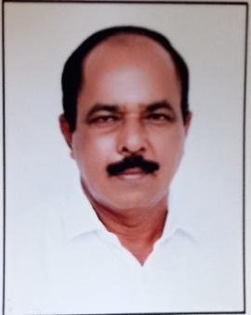

മാത്യു കെ എം
പ്രസിഡന്റ്
ചമ്പക്കുളം ഗ്രാമ പഞ്ചായത്ത്

MESSAGE
നമ്മുടെ ജനങ്ങളുടെ ആരോഗ്യവും പകർച്ചവ്യാധികൾ ഉണ്ടാകാതിരിക്കാനുള്ള മുൻകരുതലും ആണ് ഏറ്റവും പ്രധാനപ്പെട്ട പ്രവർത്തനങ്ങളിൽ ഉൾപ്പെടുത്തിയിരിക്കുന്നത്. അതിനായി തദ്ദേശ സ്വയംഭരണ സ്ഥാപന പ്രതിനിധികളും ഉദ്യോഗസ്ഥരും ആരോഗ്യ പ്രവർത്തകരും പൊതുജനങ്ങളും ചേർന്നുള്ള കൂട്ടായ പ്രവർത്തനങ്ങൾ അനിവാര്യമാണ്. ആരോഗ്യ വിദ്യാഭ്യാസം ജനങ്ങൾക്കിടയിൽ ശക്തിപ്പെടുത്തുന്നതിനും ശുചിത്വ സംവിധാനങ്ങൾ ഉറപ്പാക്കുന്നതിനും, ആശുപത്രി സൗകര്യങ്ങളുടെ ലഭ്യത ഉറപ്പാക്കുന്നതിനും പകർച്ചവ്യാധി സാധ്യത മുൻകൂട്ടി കണ്ടെത്തി പ്രതിരോധ പ്രവർത്തനങ്ങൾ ഏകോപിപ്പിക്കുന്നതിനും ഞാൻ പ്രതിനിധീകരിക്കുന്ന ചമ്പക്കുളം പഞ്ചായത്ത് ഏറെ പ്രാധാന്യം നൽകുന്നു. ആരോഗ്യമുള്ള സമൂഹം ആരോഗ്യമുള്ളവരായിരിക്കുമ്പോൾ നമ്മുടെ ഗ്രാമം കൂടുതൽ ശക്തവും സന്തുഷ്ടവും ഏറ്റവും ഉല്പാദനക്ഷമവുമായിത്തീരുന്നു. നല്ല പൊതുജന ആരോഗ്യ പ്രവർത്തനങ്ങൾ പകർച്ചവ്യാധികൾ തടയുന്നതിനും പകർച്ചേതര വ്യാധികളുടെ തീവ്രത കുറയ്ക്കുന്നതിനും സഹായിക്കുന്നു. കൂട്ടായ പ്രവർത്തനങ്ങൾ ഏവർക്കും നല്ല ആരോഗ്യം പ്രദാനം ചെയ്യുന്ന അന്തരീക്ഷം സൃഷ്ടിക്കുവാൻ സാധിക്കട്ടെ എന്ന് ആശംസിക്കുന്നു.





മെർവിൻ ജോസഫ്
ആരോഗ്യ സ്റ്റാന്റിംഗ് കമ്മിറ്റി ചെയർപേഴ്സൺ
ചമ്പക്കുളം ഗ്രാമ പഞ്ചായത്ത്

MESSAGE
നമ്മുടെ പഞ്ചായത്തിൽ ആരോഗ്യ മേഖല ശക്തിപ്പെടുത്തുന്നതിനും ഭാവിയിൽ ഉണ്ടാകാവുന്ന മഹാമാരികൾ നേരിടുന്നതിനുമായി സമഗ്രമായ Pandemic Preparedness Plan തയ്യാറാക്കുന്നതിൽ ഞങ്ങൾ പ്രതിജ്ഞാബദ്ധരാണ്. കോവിഡ്-19 കാലഘട്ടത്തിൽ നാം അനുഭവിച്ച വെല്ലുവിളികൾ നമ്മെ കൂടുതൽ തയ്യാറെടുപ്പുള്ളവരാക്കേണ്ടതിന്റെ ആവശ്യകത ബോധ്യപ്പെടുത്തി. അതിനാൽ രോഗവ്യാപനം തടയൽ, പ്രതിരോധ പ്രവർത്തനങ്ങൾ ശക്തിപ്പെടുത്തൽ, അവശ്യ ആരോഗ്യ സേവനങ്ങളുടെ തുടർച്ച ഉറപ്പാക്കൽ, സമൂഹ ബോധവൽക്കരണം എന്നിവ ഉൾപ്പെടുത്തി ഈ പദ്ധതി രൂപീകരിച്ചിരിക്കുന്നു.
പഞ്ചായത്ത് ഭരണസമിതി, ആരോഗ്യ വകുപ്പ്, ആശാ പ്രവർത്തകർ, ഹരിതകർമസേന, വിവിധ സന്നദ്ധസംഘടനകൾ എന്നിവരുടെ ഏകോപിത പ്രവർത്തനത്തിലൂടെയാണ് ഈ പദ്ധതി വിജയകരമാകുക.
സമൂഹത്തിന്റെ സഹകരണവും ജാഗ്രതയും ആരോഗ്യരക്ഷയുടെ അടിസ്ഥാനമാണ്. എല്ലാവരും കൈകോർക്കണമെന്ന് അഭ്യർത്ഥിക്കുന്നു.





Dr.Gayathri
Medical Officer
CHC Champakulam
MESSAGE

Pandemic preparedness at the institutional level is strengthened through continuous disease surveillance, early identification of suspected cases, and timely clinical management delivered through structured outpatient services and proactive field engagement.
All individuals presenting with symptoms suggestive of communicable diseases are systematically screened and managed in accordance with established public health protocols. This ensures patient safety, reinforces infection prevention and control practices, and enables early detection of potential outbreaks. Prompt containment measures are implemented to minimize transmission and prevent avoidable complications.
A cornerstone of our preparedness framework is close collaboration with the Local Self Government. Through coordinated planning, community outreach initiatives, awareness campaigns, resource mobilization, and active support for surveillance and field operations, the Local Self Government plays a pivotal role in early warning, rapid response, and ensuring equitable access to testing, treatment, and essential healthcare services—particularly for vulnerable and underserved populations.

Strengthened coordination between healthcare institutions and local governance systems enhances our collective capacity to safeguard lives, sustain essential services, and maintain social and economic stability during public health emergencies.

EXECUTIVE SUMMARY

Primary Health Centre (PHC) functions as the primary public healthcare institution serving the population of Champakulam Grama Panchayath. The PHC plays a pivotal role in delivering comprehensive, accessible, and affordable healthcare services, with a strong focus on preventive, promotive, curative, and rehabilitative care in accordance with national and state health programmes.
The PHC caters to a predominantly rural population, addressing key public health priorities such as maternal and child health, communicable and non-communicable disease control, immunization, family welfare, adolescent health, and geriatric care. Regular outpatient services, home-based care through field health staff, and outreach activities ensure healthcare coverage even in geographically challenging areas. The institution actively implements national health missions, including the National Health Mission (NHM), National Tuberculosis Elimination Programme, National Programme for Prevention and Control of Cancer, Diabetes, Cardiovascular Diseases and Stroke (NPCDCS), and other disease surveillance initiatives.
Champakulam PHC works in close coordination with the Grama Panchayath, ASHA workers, Anganwadi centres, schools, and community-based organizations to strengthen community participation and improve health awareness. Emphasis is placed on early detection, timely referral, health education, and lifestyle modification to reduce disease burden and improve overall health outcomes.
Despite constraints related to infrastructure, manpower, and increasing service demand, the PHC continues to enhance service delivery through effective planning, data-driven decision-making, and community engagement. Strengthening facilities, upgrading digital health systems, and expanding preventive services remain key focus areas for future development.
Overall, Champakulam Primary Health Centre stands as a vital institution in safeguarding public health and improving the quality of life of the residents of Champakulam Grama Panchayath

LIST OF ABBREVIATIONS

LSGD | Local Self Government Department / Local Self Government Institution
BMO | Block Medical Officer
IDSP | Integrated Disease Surveillance Programme
NDMA | National Disaster Management Authority
PPE | Personal Protective Equipment
ICMR | Indian Council of Medical Research
CD | Communicable Diseases
NCD | Non-Communicable Diseases
SOP | Standard Operating Procedure
GP | Grama Panchayath
IPD | In Patient Department
OPD | Outpatient Department
NGO | Non-Governmental Organization
NCDC | National Centre for Disease Control
MO | Medical Officer
HS | Health Supervisor
HI | Health Inspector
JHI | Junior health Inspector
JPHN | Junior Public Health Nurse

TABLE OF CONTENTS | PAGE NO
INTRODUCTION | 10
INTEGRATED HEALTH INFRASTRUCTURE MAP OF PANCHAYAT | 11
GENERAL PROFILE OF THE LSGI’S | 15
Background of the LSGI | 16
Demographic and Vulnerable Population | 17
Clinical Vulnerability | 18
INFRASTRUCTURE & RESOURCE INVENTORY | 20
Health Facility Directory & Basic Capacity in the LSGD | 20
Private Clinics | 21
Healthcare Education & Training Institutions | 21
Specialized Services & Emergency Inventory | 22
Oxygen & Diagnostic Capacity | 23
Diagnostics facility mapping at the LSGI level | 23
Laboratory Identification & Basic Details | 24
Social and Community Infrastructure for surge plan | 24
Human resources | 26
Community & Support Cadre | 25
Community Organizations | 28
Administrative & Emergency Services | 29
Information regarding resources | 30
ONE HEALTH & ENVIRONMENTAL SURVEILLANCE | 31
Animal & Bird Population | 32
Veterinary Infrastructure | 32
Veterinary Doctors & Workforce | 32
High-Risk Interface Points (Surveillance Sites) | 33
Environmental Risk Mapping | 36
Disease Seasonality Mapping | 38
Vulnerability Mapping | 40
EPIDEMIOLOGICAL TRENDS (2021–2025) | 41
Disease Burden among human beings(Last 5 Years) | 41
Seasonal Trend Analysis | 45
Outcome-Based Trend Analysis- 2025 | 51
Transmission Trend- 2025 | 51
Integrated Disease Hotspot Map (2021–2025) | 55
Preparedness and Response Protocol at LSG Level | 58
Constitution of One Health Committee | 58
Pandemic Response Workforce | 59
Activities and Measures before and during Pandemic | 60
PHASE 1 - Alert / Preparation | 60
PHASE 2 - Active Response | 63
Standard Screening Protocol | 64
PHASE 3 - Surge Capacity | 74
Conversion of Community Facilities | 74
CONCLUSION | 77
RECOMMENDATIONS | 78
ANNEXURE 1 | 79
IMPORTANT PHONE NUMBER | 79
ANNEXURE 2 | 82

INTRODUCTION

Background of the PPP
- LSGD at a glancLSGD AT A GLANCE
- Geographical boundaries with political map ( based on latest delimitation)
- Baseline data
- Ward division -
Ward | Houses | Population | Migrants | Wells | Hot  spots | Ed. Institutions | Hosp pvt/govt.
14 | 4594 | 19315 | 67 | 191 | 0 | 26 | 1

- Risk stratification among wards in the context of Communicable diseases and hazards
- Major Roads/rivers
- Major establishments with geospatial mapping
- occupational groups, socio cultural groups, migration & mobility patterns
- Vulnerability mapping
- Disaster prone areas (geographic vulnerability)

Maps - ward-based (Mention source also)

- Geographical boundaries - ward boundaries map
- Health infrastructure map
- roads and rivers map
- major establishments map
- disaster-prone areas map
- hotspot map - CD & disasters

Geographical boundaries - ward boundaries map

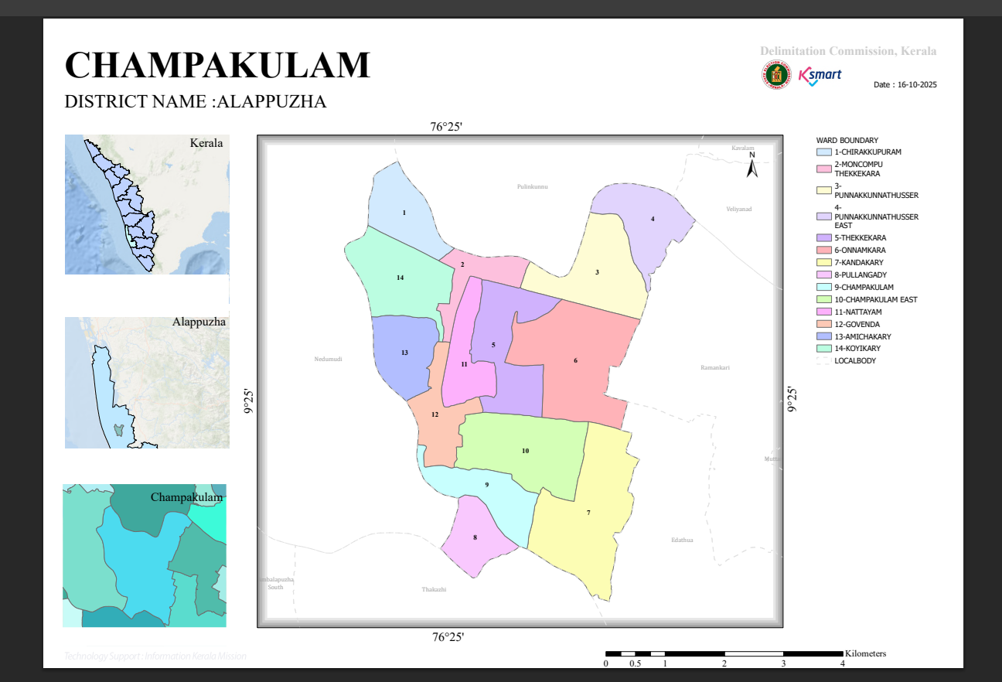

WARD BOUNDARIES

INTEGRATED HEALTH INFRASTRUCTURE MAP OF CHAMPAKULAM PANCHAYAT
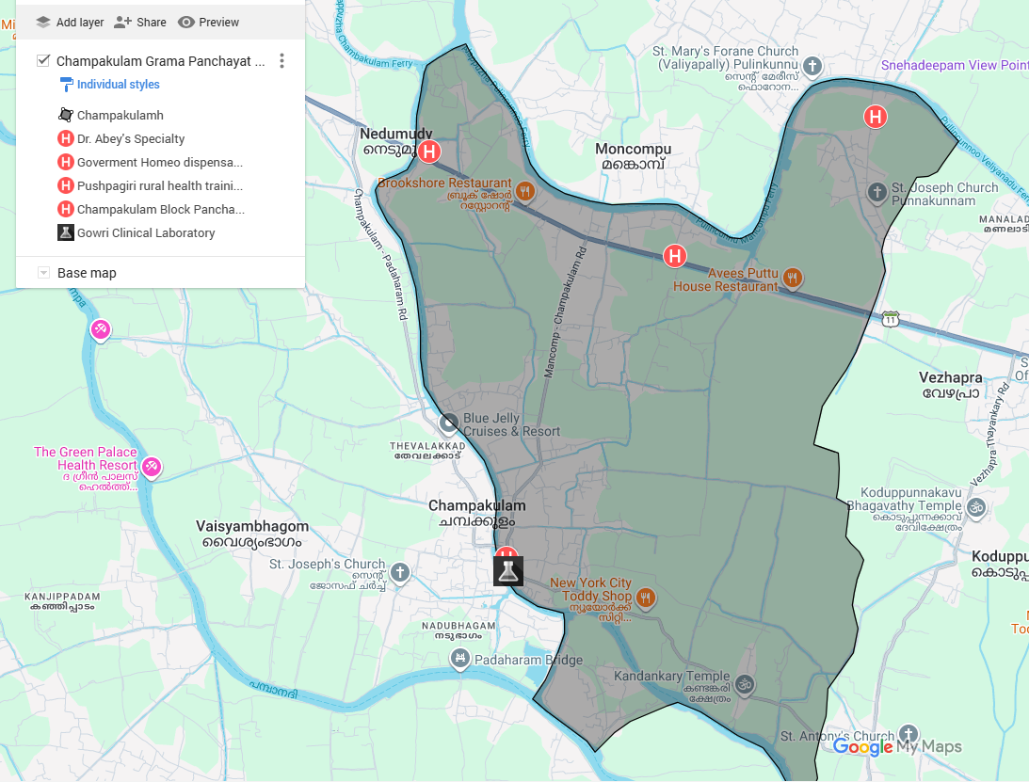

HEALTH INFRASTRUCTURE

ROADS AND RIVERS MAP

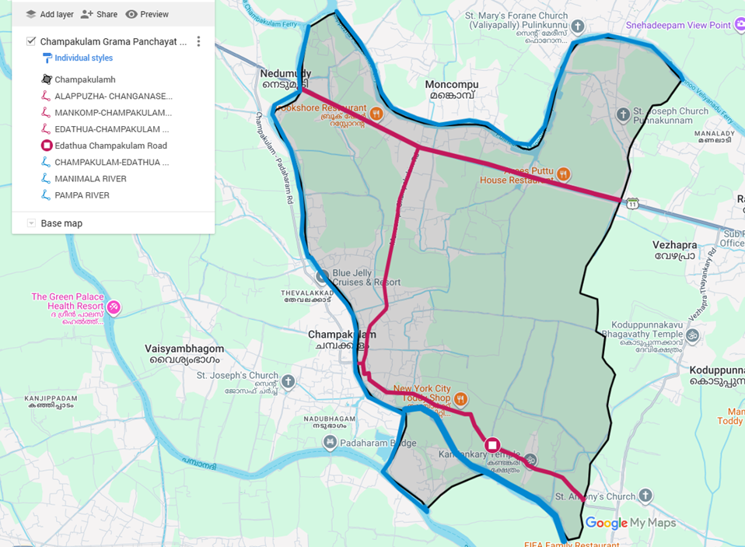
MAJOR ROADS & RIVERS

MAJOR ESTABLISHMENTS MAP
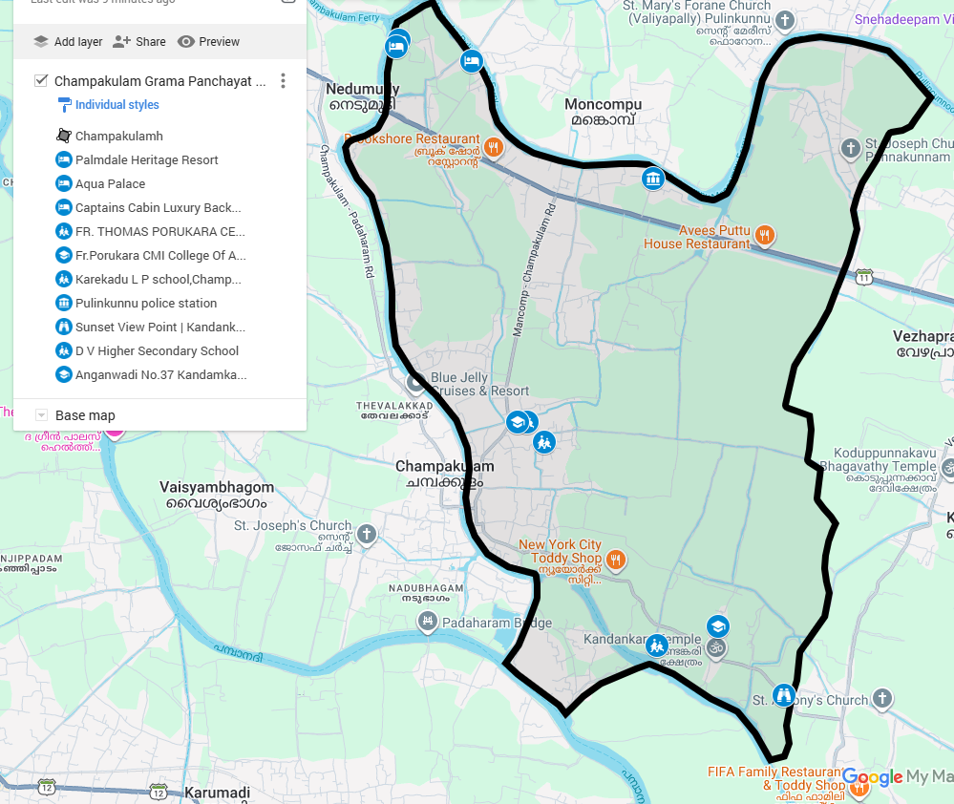
MAJOR ESTABLISHMENTS

DISASTER PRONE AREA

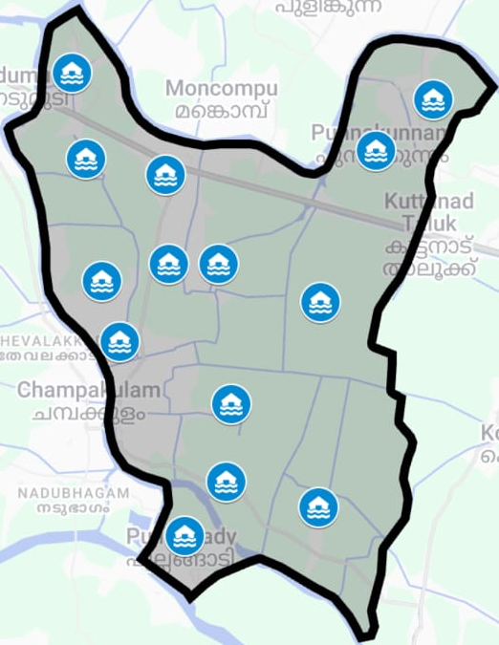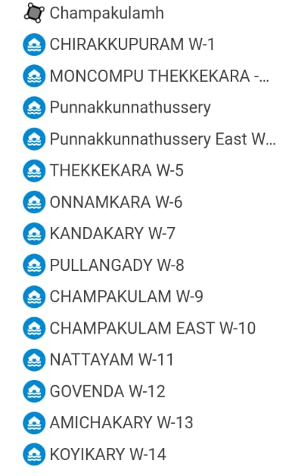

DISASTER PRONE AREA

GENERAL PROFILE OF THE LSGI’S

Background of the LSGI
Champakulam Grama Panchayat is situated in the Kuttanad Taluk of Alappuzha district, Kerala. The geographical landscape of the Panchayat is predominantly low-lying, characterized by extensive paddy fields (Kole lands) and a dense network of rivers, canals, and backwaters. This unique terrain plays a significant role in shaping the local microclimate and poses distinct challenges to transportation, emergency response, and service delivery, particularly during monsoon seasons and flood events.
The Panchayat is administratively divided into multiple wards, with a population largely dependent on traditional livelihoods. Agriculture—especially paddy cultivation—fishing, coir and coconut husk processing, and allied activities form the backbone of the local economy. In recent years, tourism-related activities and service-sector employment have also shown gradual growth. The area hosts a diverse workforce, including a notable presence of migrant labourers, particularly in construction, agriculture, and allied sectors.
From a public health and disaster management perspective, LSGI has historically been vulnerable to seasonal flooding, waterborne diseases, and vector-borne illnesses such as Dengue and Leptospirosis. The severe floods experienced during recent years, including the 2018 flood disaster, significantly impacted life, livelihoods, and infrastructure within the Panchayat. These recurring emergencies have underscored the importance of strengthening local preparedness, response mechanisms, and inter-departmental coordination.
In this context, the development of a localized, data-driven Auxiliary Infrastructure and Logistical Resource Map is essential to support effective planning, timely emergency response, and sustainable development initiatives. Such mapping enables the Panchayat to identify critical resources, improve accessibility during disasters, and enhance overall resilience of the community.

Table 1: Background of LSGD
Description | Details
Name of LSGI | CHAMPAKULAM
Type (GP/Municipality / Corporation etc.) | Grama Panchayath
Block | CHEMPUMPURAM
District | ALAPPUZHA
Number of wards | 14
Total area (sq. km) | 22.97 sq km
Population(Projected) | 1928
Population density | persons/sq km
Terrain (coastal/low-lying/backwaters/foothills, etc.) | backwater
Number of rivers passing through LSGI | 3
Number of water bodies in the LSGI | 12
Number of educational institutions | 26
Factories / small-scale industries | 2
Flood-prone wards | 13
Landslide-prone wards | 0
Death Management and Disposal Facilities (mortuaries/crematorium, including electric) | 7
Auditoriums/Marriage halls/convention centres/community halls | 11

Demographic and Vulnerable Population
Understanding the demographic composition and vulnerable population groups is essential for pandemic preparedness. Children, elderly, economically deprived families, migrant workers, and socially vulnerable groups are at increased risk during public health emergencies due to higher exposure, limited access to services, and dependency on public systems.

Description |  | Details (in numbers)
DEMOGRAPHIC PROFILE
Total population |  | 19315
Male |  | 9218
Female |  | 10097
Transgender |  | 0
Children under 5 |  | 681
Adolescent |  | 1843
Elderly (>60) |  | 3698
SOCIAL/LIVELIHOOD VULNERABILITY
Previous EPEP family |  | 0
BPL family |  | 3015
Tribal communities |  | 0
Migration | Immigrant | 83
Migration | Emigrant | 76
Socio-economically deprived |  | 0
Fisherfolk |  | 62
SC Community |  | 1350
ST Community |  | 0

Graphs: Population pyramid (if possible) for seeing if your LSGI has a high "dependency ratio" (lots of children and elderly compared to working adults).

Clinical Vulnerability
Certain population groups needs priority healthcare & are at higher risk of severe illness, complications, and mortality during pandemics. Patients with chronic diseases, those requiring regular medical care, and individuals with mobility or functional limitations face challenges in accessing timely care during emergencies. Mapping these groups helps in prioritizing continuity of treatment, medicine stock planning, oxygen support, referral transport, and targeted home-based care.
Description | Details in numbers
Pregnant women | 38
Lactating mothers | 66
Bedbound patients | 69
Patients under palliative care other than bedbound | 180
Patients on Haemodialysis | 14
Patients on CAPD | 0
Cancer patients (currently on treatment) | 93
Haemophilic patients | 0
Mentally challenged | 41
Differently abled | 46
Diabetic patients | 158
Hypertensive patients | 1647
TB patients | 3

Major Festivals & Events specific to the LSGI
(with the possibility of a public gathering)

Sl. No.1 | Name of festival | Month detailing the periodicity
1 | Kandankary church | February
2 | Kuttikkattu temple | March

INFRASTRUCTURE & RESOURCE INVENTORY

Health Facility Directory & Basic Capacity in the LSGD
This section provides an overview of the healthcare infrastructure available within the LSGD area. It outlines the distribution and basic capacity of health facilities that form the backbone of service delivery during routine times and public health emergencies.

Family Health Centres (FHCs) and Community Health Centres (CHCs) generally function as the first point of contact for the community, providing essential outpatient and inpatient services. General Hospitals (GH) and Medical College Hospitals (MCH), where accessible, serve as the main referral centres for advanced diagnostics, specialist care, and critical services during public health emergencies. This inventory helps identify existing strengths, gaps, and potential surge capacity that can be mobilised during a pandemic or disaster.

Table 5. Health Facility Resource Summary
Sl.no. | Health Facility | Type of Facility (MCH/GH/CHC/FHC/SC etc.) | Contact Number | Total beds | ICU Beds | Oxygen-Supported Beds | No. of Ventilator Support Beds | No. of ambulances
Government Healthcare Facilities
 | CHC CHAMPAKULAM | CHC | 9495242175 | 51 | 0 | 0 | 0 | 0
Private Healthcare Facilities
1 | Abeys Hospital Nedumudy | PVT | 9947136424 | 3 | 0 | 3 | 0 | 0
AYUSH Healthcare Facilities
1 | Ayush Hospital champakulam | Govt | 9544599460 | 0 | 0 | 0 | 0 | 0

Private Clinics
Private clinics are an essential part of pandemic preparedness, as they are often the first-place people seek care when symptoms begin. In many communities, private clinics manage a significant share of outpatient visits and therefore play a critical role in early case detection, timely referrals, and disease surveillance. Having an up-to-date understanding of where these clinics are located, the services they provide, and how they are linked to the public health system helps ensure that no cases are missed during an outbreak. It also allows health authorities to engage private practitioners more effectively for reporting, risk communication, and coordinated response, strengthening the overall capacity of the health system to manage public health emergencies.

Table 6. Private Clinic Resource Summary
Sl No. | Name of Clinic | Registered (Y/N) | Clinic (General / Speciality) | Speciality (if any) | Address | Contact Number | Diagnostic Facility (Y/N) | Ambulance Linkage (Y/N)
1 | Dr Sarammas clinic | Y | General | 0 | Dr saramma”s clinic,Nedumudy | 9446793349 | Yes | 0
2 | Pushpagiri clinic | Yes | Geneal | 0 | Punnakkunnam,pulincunnu | 04772707770 | Yes | 0

Healthcare Education & Training Institutions
This section tracks the educational infrastructure available, which is vital for human resource planning in the health sector.

Category of Institution | Govt | Private | AYUSH | Total
Medical Colleges | 0 | 0 | 0 | 0
Nursing Colleges | 0 | 0 | 0 | 0
Dental Colleges | 0 | 0 | 0 | 0
Para-medical / Allied Health | 0 | 0 | 0 | 0
Pharmacy Colleges | 0 | 0 | 0 | 0

Specialized Services & Emergency Inventory
This section provides a detailed view of the specialized medical resources available to the community, focusing on emergency response and critical care capabilities. This table tracks the vital assets required for managing severe illnesses and emergencies across Government, Private, and AYUSH sectors.

Item | Govt | Private | AYUSH | Total
Hospital beds | 0 | 0 | 0 | 0
Oxygen-generating systems(Y/N) | 0 | 0 | 0 | 0
Oxygen-supported beds(Numbers) | 0 | 0 | 0 | 0
Ventilator-supported beds | 0 | 0 | 0 | 0
ICU beds | 0 | 0 | 0 | 0
Burns units | 0 | 0 | 0 | 0
Blood centres | 0 | 0 | 0 | 0
BLS ambulances | 0 | 0 | 0 | 0
ALS ambulances | 0 | 0 | 0 | 0
Dialysis facilities | 0 | 0 | 0 | 0
Dispensaries | 0 | 0 | 0 | 0
Medical store | 0 | 6 | 0 | 6
Industrial establishments(Medium-scale industries/small-scale industries establishments to whom we can depend in a worst-case scenario) | 0 | 6 | 0 | 0

Oxygen & Diagnostic Capacity
Monitoring oxygen and diagnostic capacity is a critical component of public health preparedness, ensuring that the LSGD can handle both chronic care and sudden surges in respiratory or infectious diseases.
Name of Health Facility | Oxygen-generating System (Y/N) | Backup Oxygen Source (Y/N) | Diagnostic Facilities Available(Y/N)
Name of Health Facility | Oxygen-generating System (Y/N) | Backup Oxygen Source (Y/N) | Lab | USG | X-ray | CT/MRI | RT-PCR
Government Healthcare Facilities
CHC Champakulam | 0 | Y | Y | 0 | 0 | 0 | 0

Diagnostics facility mapping at the LSGI level
The diagnostic capacity of Champakulam G.P represents the "intelligence network" of our healthcare system. The speed and accuracy of disease identification depend entirely on the distribution and technical level of these facilities.

Item | Govt | Private | AYUSH | Total
General labs | 1 | 5 | 0 | 0
Microbiology labs | 0 | 0 | 0 | 0
RT-PCR labs | 0 | 0 | 0 | 0
USG units | 0 | 0 | 0 | 0
CT/MRI units | 0 | 0 | 0 | 0
Research labs | 0 | 0 | 0 | 0
Labs of other departments that can be repurposed | 1 | 0 | 0 | 0

Laboratory Identification & Basic Details
Sl. No. | Name of Laboratory | Ownership (Govt / Private / Academic) | Address | Contact No. | 24×7 Services (Yes/No) | NABL / Govt Approved (Yes/No)
1 | Gouri Lab | Pvt | Amichakary,champakulam | 9645665443 | No | No
2 | Health Route | Pvt | Nedumudy | 8111891948 | No | No
3 | Royal | Pvt | Amichakary,champakulam | 09526826418 | No | No
4 | Sreenikethan | Pvt | Amichakary,champakulam | 8606841889 | No | No
5 | Abhisanker”s | Pvt | Muncompu |  | No | No

Social and Community Infrastructure for surge plan
This table serves as our logistics and shelter inventory. By mapping these locations, quickly we can identify where to house displaced citizens, where to set up temporary medical clinics, and how to manage the deceased with dignity during a crisis.

Category | Total Count | Ward | Est. Capacity (Persons) | Contact details
Educational Institutions
Anganwadis | 18 | 14 | 180 | 9744765354
Schools | 8 | 5 | 4000 | 6235371634
Colleges | 0 | 0 | 0 | 0
Healthcare Educational Institutions
Medical colleges (Govt/Private) | 0 | 0 | 0 | 0
Nursing colleges (Govt/Private) | 0 | 0 | 0 | 0
Dental colleges (Govt/Private) | 0 | 0 | 0 | 0
Paramedical institutes (Govt/Private) | 0 | 0 | 0 | 0
Community Gathering Spaces
Community halls | 0 | 0 | 0 | 0
Auditoriums | Govt  0 | Pvt  12 | 0 | 0
Religious buildings | 0 | 14 | 1400 | 0
Vulnerable Group Support Facility
Destitute homes | 0 | 0 | 0 | 0
Elderly homes | 0 | 0 | 0 | 0
LSGD owned other buildings | 0 | 0 | 0 | 0
Mass Fatality Management (MFM) Infrastructure
Mortuary | 0 | 0 | 0 | 0
Crematorium | 0 | 7 | 0 | 0
*refer annexure 1 for contact details

Human resources
This section focuses on the human capital available within the LSGI. In any emergency—be it a pandemic, flood, or industrial accident—infrastructure is only as effective as the people operating it.

Medical & Clinical Personnel
This table tracks the "Frontline" providers responsible for diagnosis, treatment, and clinical management. Narrative sentence: eg., "Total health workforce: 450 personnel, with 60% in government facilities serving as primary surge capacity." A detailed directory with the contact numbers of all workers is maintained (Annexure in 1).

Cadre | Govt (No.) | Private (No.) | Total
Doctors—Modern Medicine | 3 | 2 | 5
Doctors – AYUSH | 1 | 0 | 1
Doctors – Veterinary | 2 | 0 | 2
Doctors – Dental | 1 | 3 | 4
Nursing officers | 7 | 5 | 12
Lab technicians | 2 | 4 | 6
Optometrist | 0 | 0 | 0
Pharmacists | 2 | 2 | 4
Psychologists | 0 | 0 | 0
Counsellors | 1 | 0 | 0

Public Health & Field-Level Workforce
These individuals are the backbone of surveillance, maternal-child health, and decentralized care.

Cadre | Health services | Municipal common services | Total
HS (Health Supervisors) | 0 | 0 | 0
HI (Health Inspectors) | 0 | 0 | 0
LHS (Lady Health Supervisor) | 0 | 0 | 0
LHI (Lady Health Inspectors) | 1 | 0 | 1
JPHN (Jr Public Health Nurses) | 7 | 0 | 7
JHI (Jr Health Inspectors) | 2 | 0 | 2
MLSP (Mid-Level Service Providers) | 7 | 0 | 7
Palliative Nurses | 1 | 0 | 1
RBSK Nurses | 1 | 0 | 1
PRO | 0 | 0 | 0
Epidemiologist | 0 | 0 | 0
Data Manager | 0 | 0 | 0

Community & Support Cadre
This group represents the surge capacity of the LSGI—people who can be called upon for logistics, rescue, and specialized support.

Cadre | Number
ASHA Workers | 13
AWW (Anganwadi Workers) | 18
Emergency Medical Volunteers (Trained) | 91
Kudumbashree | 173
MNREGS | 1910
Purusha Swayam Sahaya Sangham | 4
Ex-Servicemen | 22
Retired Police Officers | 26
NCC/NSS Volunteers | 100
Red Cross volunteers | 0
One Health Community Volunteers | 637
One Health Community Mentors | 91

Community Organizations
This section details the presence of community-based organisations (CBOs), non-governmental organisations (NGOs), faith-based organisations (FBOs), Kudumbashree Self-Help Groups (SHGs), and Ayalkootams within the Local Self-Government Institution (LSGI). These groups enhance grassroots mobilization, resource distribution, and support networks crucial for pandemic response and community resilience.

Category | Total Count
NGOs | 126
Religious based organizations | 5
Foreign based organizations | 0
Sports Club/youth clubs | 6
Kudumbashree SHGs | 180
Ayalkootams | 0
Political organizations | 6
Residential organizations | 0

Administrative & Emergency Services
This section outlines the availability of key non-health emergency support services and infrastructure within the LSGI, which are essential for effective pandemic preparedness and response. These facilities support law enforcement, disaster response, water supply, logistics, mobility, and community-level interventions during public health emergencies.

Category | Total Count | Contact details
Police Stations | 1 | 04772702222
Fire & Rescue Stations | 0 | 0
Water Pumping Points | 7 | 8848194056
Public Distribution System (PDS) | 6 | 9446616875

Information regarding resources
The availability of essential transport and support resources plays a quiet but critical role in saving lives. Equipment such as ambulances, mobile mortuaries, amphibian ambulances, and motorized boats ensures that patients, samples, and healthcare teams can move swiftly—even in flooded, remote, or difficult terrains. Heavy vehicles like JCBs, cranes, tractors, and torus lorries support logistics, waste management, emergency infrastructure, and rapid conversion of spaces into care or isolation facilities. Taxis, four-wheel-drive vehicles, and trucks help maintain continuity of essential services, reach vulnerable populations, and support home-based care and supply delivery.

Means of transportation | Total Count
JCB | 6
Crane | 1
Heavy Trucks | 14
Tractor | 8
Ambulances | 2
Mobile mortuaries | 2
Boats | 9
Taxi service | 16
Note: For specific details regarding vehicle owners and contact information, please refer to Annexure [X].

ONE HEALTH & ENVIRONMENTAL SURVEILLANCE
The One Health method integrates environmental, animal, and human health to enable proactive pandemic preparedness. Panchayat-level surveillance needs to be improved in order to detect and treat zoonotic and environmentally generated diseases early. Surveillance is strengthened through systematic assessment of animal populations, veterinary infrastructure, poultry and slaughter facilities, inter-sectoral coordination, and specialised tools like avian influenza seasonality mapping using GIS in previous outbreaks to enable predictive alerts and ward-specific sampling to support effective pandemic preparedness in high-risk areas.

Animal & Bird Population
Mapping animal and bird populations at the Panchayat level is essential for identifying and prioritising zoonotic disease hazards like rabies, avian influenza (H5N1), leptospirosis, anthrax, and Nipah-like spillover occurrences. Risk classification, targeted surveillance, vaccination planning, and early epidemic detection made feasible by comprehensive population mapping all enhance One Health-based pandemic preparedness.

Category | Item | Estimated Population | Wards
Animal Population | Livestock (Cattle/Goats/Buffalo) | 240 | 13
Animal Population | Pet Animals (Dogs/Cats) | 81 | 13
Animal Population | Stray Dog Population | 186 | 13
Animal Population | Pig Farms (Number of heads) | 0 | 0
 | Small Units (Sheep / Goats – clustered) | 5 | 3
Bird Population | Poultry Units (Birds) | 2 | 13
Bird Population | Poultry- (FOWL) | 0 | 0
Bird Population | Wild/Migratory Birds (Observed) | Present | 1,3,11
Bird Population | Crow Mortality Events (Reported) | 0 | 0

The main risk of zoonotic diseases in Champakulam is concentrated in Wards 6 Kandakary which is explained by the high density of pig farms, cattle congregation areas, and poultry units. The stray dog population in market areas, fish landing sites, bus stations continue to be a substantial problem for rabies surveillance and bite prevention. There is a considerable risk of avian influenza introduction and amplification during November - December due to the seasonal presence of migratory and resident water birds near ponds/ canal / river / backwater / paddy field. Clusters of pig farms and animal shelters vulnerable to flooding further raise the risk of leptospirosis and other zoonoses mediated by the environment, especially during monsoon floods.

Veterinary Infrastructure
Veterinary institutions are a core pillar of One Health surveillance, enabling early zoonotic disease detection through vaccination, investigation of unusual animal illness or deaths, sample collection, and timely outbreak reporting. A well-mapped and responsive veterinary network strengthens coordination with human health and LSGI systems, ensuring rapid response during zoonotic events and pandemics.
Facility Type | Name of Facility | Ownership Govt / Pvt | Location(Ward No) | Contact number
Veterinary Dispensary | 1 | GOVT | 6 | 8078772698
Veterinary Hospital / Polyclinic | 1 | Govt | 2 | 8078772698
Private Veterinary Clinics | Nil
Mobile / Emergency Vet Service (incl. night services) | Nil
Pet Homes / Animal Shelters | Nil
Slaughterhouse-linked Veterinary Inspection Unit | Nil

Veterinary Doctors & Workforce
Early detection, diagnosis, reporting, and reaction to animal illness epidemics depend on the availability and accessibility of qualified veterinary specialists. By identifying unusual animal morbidity or mortality promptly, collecting samples promptly, and coordinating efficiently with human health and LSGI systems—especially during zoonotic outbreaks and pandemic-prone situations—a clearly defined veterinary workforce enhances One Health surveillance.

Category | Number Available | Type (Govt/Pvt) | Contact number
Government Veterinary Doctors | 3 | Govt | 9074026951
Private Veterinary Doctors | 0 | 0 | 0
Livestock Inspectors | 2 | Govt | 9745967751
Para-veterinary Staff / Attenders | 5 | Govt | 97454967751
Contract / On-call Veterinary Support (if any) | 0 | 0 | 0

High-Risk Interface Points (Surveillance Sites)
High-risk interface points for zoonotic disease surveillance in ChampakulamGrama Panchayath include wetland–livestock–human contact zones, backyard poultry farms, cattle sheds near water bodies, fish markets, and areas of high human–animal interaction such as community slaughter points and migratory bird congregation sites. These are the primary surveillance sites where zoonotic spillover risks are elevated.

Type of Habitat | Type of High risk interface | Geographical vulnerability
Wetlands & Backwaters | Migratory Birds | Migratory birds spread diseases in to indigenous birds
Backyard Poultry Farms | Migratory birds | spread poultry farms
Cattle Sheds near Water Bodies | possibility to infect leptospirosis | water shed areas
Fish & Meat Markets | possibility to spread waste water in to river or water source | water shed area
Community Slaughter Sites | nil | nil
Migratory Bird Congregation Areas | migratory birds carries germs | involves indigenous birds and other livings
Rodent-Infested Grain Storage | leptospirosis | infect human and other livings

Category | Total Count | Key Locations (wards)
Poultry Farms | 0 | 0
Backyard / Clustered Poultry Units | 18 | ALL OF THE WARDS
Duck Rearing Units (open water access) | 3 | 3,9,12
Slaughterhouses/ Slaughter Points | 0 | 0
Meat/Fish Markets | 9 | 1,2,3,5,9,11,13
Live Bird Sale Points | 0 | 0
Cattle Markets / Weekly Animal Fairs | 0 | 0
Pet Shops / Breeders | 0 | 0
Animal Shelters / Pet Homes | 0 | 0
Waste Disposal Sites near Animal Units | 0 | 0

Environmental Risk Mapping
Environmental risk mapping identifies monsoon/flood hotspots for vector-borne (dengue, chikungunya), water-borne (leptospirosis, diarrhoea), and zoonotic diseases in Kerala's wetlands. Systematic surveillance supports early warnings, targeted interventions, and Panchayat pandemic preparedness.
Waterborne exposure: Flood-prone areas and stagnant water bodies facilitate leptospira survival, raising leptospirosis risk.

Traditional practices: Informal slaughter and fish markets lack standardized hygiene, creating spillover opportunities.

Risk Factor | High-Risk Wards | Key Locations | Risk Level (High/Med/Low)
Flood-prone areas | All of the wards | all of the location | High
Water bodies/wetlands | All of the wards | All of the location | High
Solid waste accumulation | 0 | 0 | 0
Animal waste disposal issues | 0 | 0 | 0
Rodent infestation zones | All of the wards | All | High
Industrial effluent discharge | 0 | 0 | 0
Construction sites / abandoned buildings | 0 | 0 | 0
Poor drainage/blocked canals | 0 | 0 | 0
Drinking water source contamination risk | 0 | 0 | 0

Disease Seasonality Mapping
1, Flooding & waterlogging → amplifies leptospirosis, malaria, diarrheal diseases.
2, Migratory bird influx (Nov–Feb) → avian influenza risk.
3, Mosquito breeding cycles → vector-borne disease peaks in monsoon.
4, Agricultural practices → close human–animal contact in paddy fields.

Disease | Peak Risk Season | Key Drivers | High-Risk Locations | Surveillance Focus
Avian Influenza | April,May,June | Migratory Birds | paddy fields | death of birds
Leptospirosis | June,July,August ,September | Rodents | water shed areas | fever with mayagia,bodyache,headache
Dengue/Chikungunya | may,june,july,august,september ,october,november,december | Mosquitoes | All the wards | fever,headache,mayalgia
Acute Diarrheal Diseases | all the months | water,food | All the wards | diarrhea
Rabies | all the months | dogs etc | pathway,markets etc | symtoms of rabies

Vulnerability Mapping
Vulnerability mapping pinpoints high-risk populations, occupations, and areas exposed via environment, livelihoods, socio-economics, and poor service access. Paired with environmental/seasonality mapping, it enables risk-based surveillance, targeted actions, and optimal resource use in One Health and pandemic planning.
Vulnerability Factor | High-Risk Wards | Key Groups / Locations | Risk Level
Flood-prone households | all of the wards | all locstions | High
Wetland-adjacent communities | nil | nil | nil
Backyard poultry / duck rearing households | all of the wards | all of the locations | high
Livestock-rearing households | all of the wards | all of the locations | Normal
Slaughterhouse & meat market workers | 10,11,13 | nearby households and | Difficult to pedestrious walkers
Fisherfolk & fish market workers | 1,2,4,9,10,11,13 | near backwater side | possibility to flow waste water to river
Sanitation workers | nil | nil | nil
Daily wage / migrant workers | 2,3,5,7,8,10,12,13 | resides in panchayath area | possibility to spread disease to  local generation
Elderly & chronically ill populations | 347 | all of the wards | High
Pregnant Women | 38 | All wards | Average
Children (schools, Anganwadi’s) | 1937 | schools and anganawadies | Low
Limited access to safe water & sanitation | 98% | Schools and anganawadies | Low

EPIDEMIOLOGICAL TRENDS (2021–2025)

Disease surveillance is the systematic collection, analysis, and interpretation of health data for planning, implementation, and evaluation of public health practice. This section presents the disease surveillance profile of the LSGI based on routine reporting systems and outbreak investigations to identify priority diseases, seasonal patterns, and emerging public health threats.

Disease Burden among human beings(Last 5 Years)
Analysis of disease-wise data for the last five years helps identify persistent public health problems, emerging diseases, and changes in disease burden. This information supports prioritisation of prevention, preparedness, and response activities at the Panchayat level.

Disease | 2021 | 2022 | 2023 | 2024 | 2025 | Trend(Increasing/Stable/Decreasing)
Dengue | 0 | 3 | 4 | 2 | 4 | Increasing
Leptospirosis | 3 | 14 | 8 | 4 | 3 | Decreasing
Hepatitis A | 0 | 0 | 0 | 1 | 0 | Decreasing
Malaria | 1 | 2 | 0 | 0 | 1 | Decreasing
Scrub Typhus | 0 | 0 | 0 | 0 | 2 | Increasing
Typhoid | 0 | 0 | 0 | 0 | 0 | Decreasing
H1N1 | 0 | 0 | 2 | 0 | 0 | Decreasing
H3N2 | 0 | 0 | 0 | 0 | 0 | Decreasing
ADD | 0 | 0 | 16 | 47 | 34 | Increasing
Mumps | 0 | 0 | 0 | 2 | 1 | Decreasing
Measles | 0 | 0 | 0 | 0 | 0 | Decreasing
Hepatitis B | 0 | 0 | 0 | 0 | 0 | Decreasing
Hepatitis C | 0 | 0 | 0 | 0 | 0 | Decreasing
Tuberculosis | 2 | 4 | 5 | 2 | 4 | Decreasing
Leprosy | 0 | 0 | 0 | 0 | 0 | Decreasing
COVID-19 | 4 | 2 | 2 | 1 | 0 | Decreasing

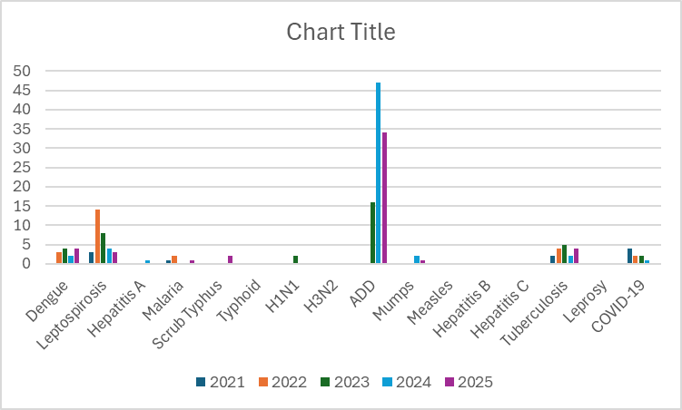

Seasonal Trend Analysis
Seasonal analysis helps anticipate surges (e.g. dengue in monsoon, leptospirosis after floods, influenza in cooler months) and plan pre‑emptive vector control, stockpiling of IV fluids, and awareness campaigns at Panchayat level.

DENGUE
Dengue is a major seasonal vector-borne disease strongly associated with rainfall, water stagnation, and increased mosquito breeding during the monsoon period.

Peak: July–November

Dengue – Ward-wise Yearly Distribution (2021–2025)

Ward | Dengue – Ward-wise Yearly Distribution
Ward | 2021 | 2022 | 2023 | 2024 | 2025 | Total
1 | 0 | 0 | 0 | 0 | 0 | 0
2 | 0 | 0 | 0 | 1 | 0 | 1
3 | 0 | 0 | 0 | 0 | 1 | 1
4 | 0 | 2 | 0 | 0 | 0 | 2
5 | 0 | 0 | 1 | 0 | 0 | 1
6 | 0 | 0 | 0 | 0 | 1 | 1
7 | 0 | 0 | 0 | 0 | 1 | 1
8 | 0 | 1 | 1 | 0 | 0 | 2
9 | 0 | 0 | 1 | 1 | 0 | 2
10 | 0 | 0 | 1 | 0 | 0 | 1
11 | 0 | 0 | 0 | 0 | 0 | 0
12 | 0 | 0 | 0 | 0 | 1 | 1
13 | 0 | 0 | 0 | 0 | 0 | 0

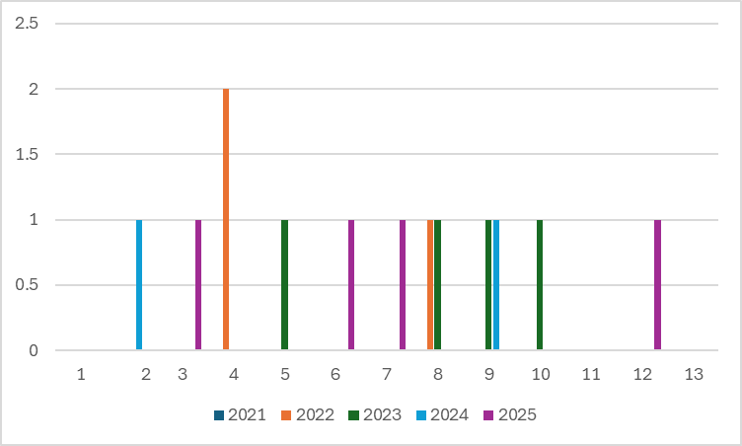

LEPTOSPIROSIS
Leptospirosis cases are closely linked to monsoon rains, flooding, and occupational exposure, particularly in low-lying and waterlogged areas.

Peak: June - August

Leptospirosis – Ward-wise Yearly Distribution (2021–2025)

Ward | Leptospirosis – Ward-wise Yearly Distribution
Ward | 2021 | 2022 | 2023 | 2024 | 2025 | Total
1 | 0 | 0 | 0 | 1 | 1 | 2
2 | 0 | 5 | 0 | 0 | 0 | 5
3 | 0 | 0 | 0 | 0 | 0 | 0
4 | 0 | 1 | 0 | 0 | 0 | 1
5 | 1 | 2 | 1 | 1 | 0 | 5
6 | 1 | 1 | 0 | 1 | 0 | 3
7 | 0 | 0 | 0 | 0 | 1 | 1
8 | 0 | 0 | 2 | 0 | 0 | 2
9 | 0 | 3 | 2 | 1 | 0 | 6
10 | 0 | 0 | 1 | 0 | 0 | 1
11 | 0 | 0 | 0 | 0 | 0 | 0
12 | 0 | 1 | 2 | 0 | 0 | 3
13 | 1 | 1 | 0 | 0 | 1 | 3

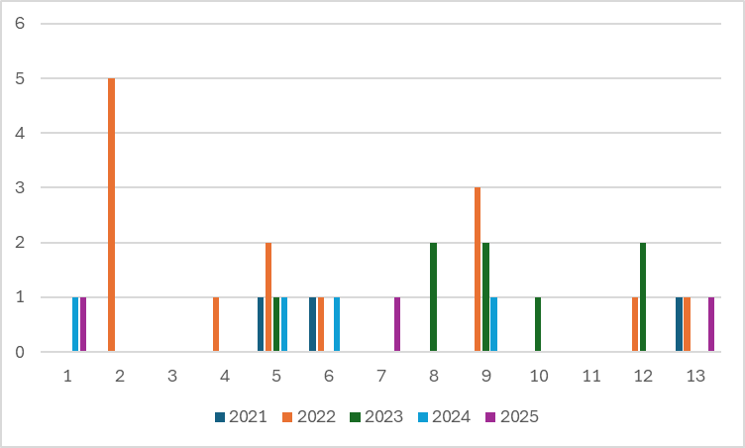

VIRAL HEPATITIS - A
Hepatitis A cases are commonly associated with unsafe drinking water, food contamination, and breakdowns in sanitation, often presenting as clusters or outbreaks.
Peak: October - December

Hepatitis A – Ward-wise Yearly Distribution (2021–2025)

Ward | Hep A – Ward-wise Yearly Distribution
Ward | 2021 | 2022 | 2023 | 2024 | 2025 | Total
1 | 0 | 0 | 0 | 0 | 0 | 0
2 | 0 | 0 | 0 | 0 | 0 | 0
3 | 0 | 0 | 0 | 1 | 0 | 1
4 | 0 | 0 | 0 | 0 | 0 | 0
5 | 0 | 0 | 0 | 0 | 0 | 0
6 | 0 | 0 | 0 | 0 | 0 | 0
7 | 0 | 0 | 0 | 0 | 0 | 0
8 | 0 | 0 | 0 | 0 | 0 | 0
9 | 0 | 0 | 0 | 0 | 0 | 0
10 | 0 | 0 | 0 | 0 | 0 | 0
11 | 0 | 0 | 0 | 0 | 0 | 0
12 | 0 | 0 | 0 | 0 | 0 | 0
13 | 0 | 0 | 0 | 0 | 0 | 0

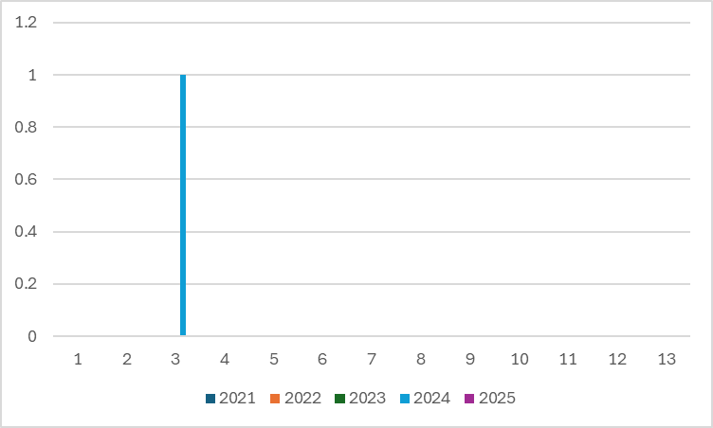

Outcome-Based Trend Analysis- 2025

Transmission Trend- 2025
For effective management of public health issues, it is important to track the trend of disease transmission mode. It helps identify the population or place at high risk that can be used to predict outbreaks and implement targeted interventions as quickly as possible. Understanding these kinds of trends enables authorities to allocate resources efficiently and change the strategies adequately based on the trend that follows.

Mode of Transmission | No. of cases | No. of Deaths
Vector Borne Diseases | 4 | 0
Water Borne Diseases | 34 | 0
Air Borne Diseases | 7 | 0
Zoonotic | 5 | 0
Blood Borne Diseases | 0
Food Borne Diseases | 0 | 0

Vector-Borne Disease

Disease | No. of Cases | No. of Deaths
Dengue | 4 | 0
Malaria | 1 | 0
Chikungunya | 0 | 0

Water Borne Disease

Disease | No. of Cases | No. of Deaths
Cholera | 0 | 0
Typhoid | 0 | 0
Hep- A | 0 | 0
Dysentery | 0 | 0
Amoebiasis | 0 | 0
ADD | 34 | 0
Air Borne Disease

Disease | No. of Cases | No. of Deaths
Influenza | 0 | 0
H1N1 | 0 | 0
TB | 4 | 0
Chickenpox | 2 | 0
Measles | 0 | 0
Covid-19 | 0 | 0
Pertussis | 0 | 0
Mumps | 1 | 0

Blood-Borne Disease

Disease | No. of Cases | No. of Deaths
AIDS | 0 | 0
Hep- B | 0 | 0
Hep- C | 0 | 0

Zoonotic Disease

Disease | No. of Cases | No. of Deaths
Rabies | 0 | 0
Leptospirosis | 3 | 0
Avian influenza | 0 | 0
West nile | 0 | 0
Anthrax | 0 | 0
Nipah | 0 | 0
Scrub Typhus | 2 | 0

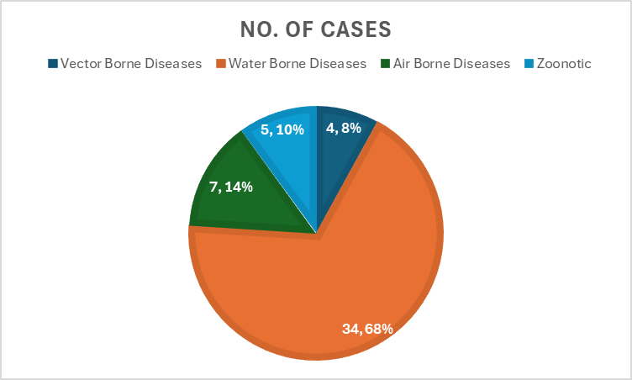

Integrated Disease Hotspot Map (2021–2025)
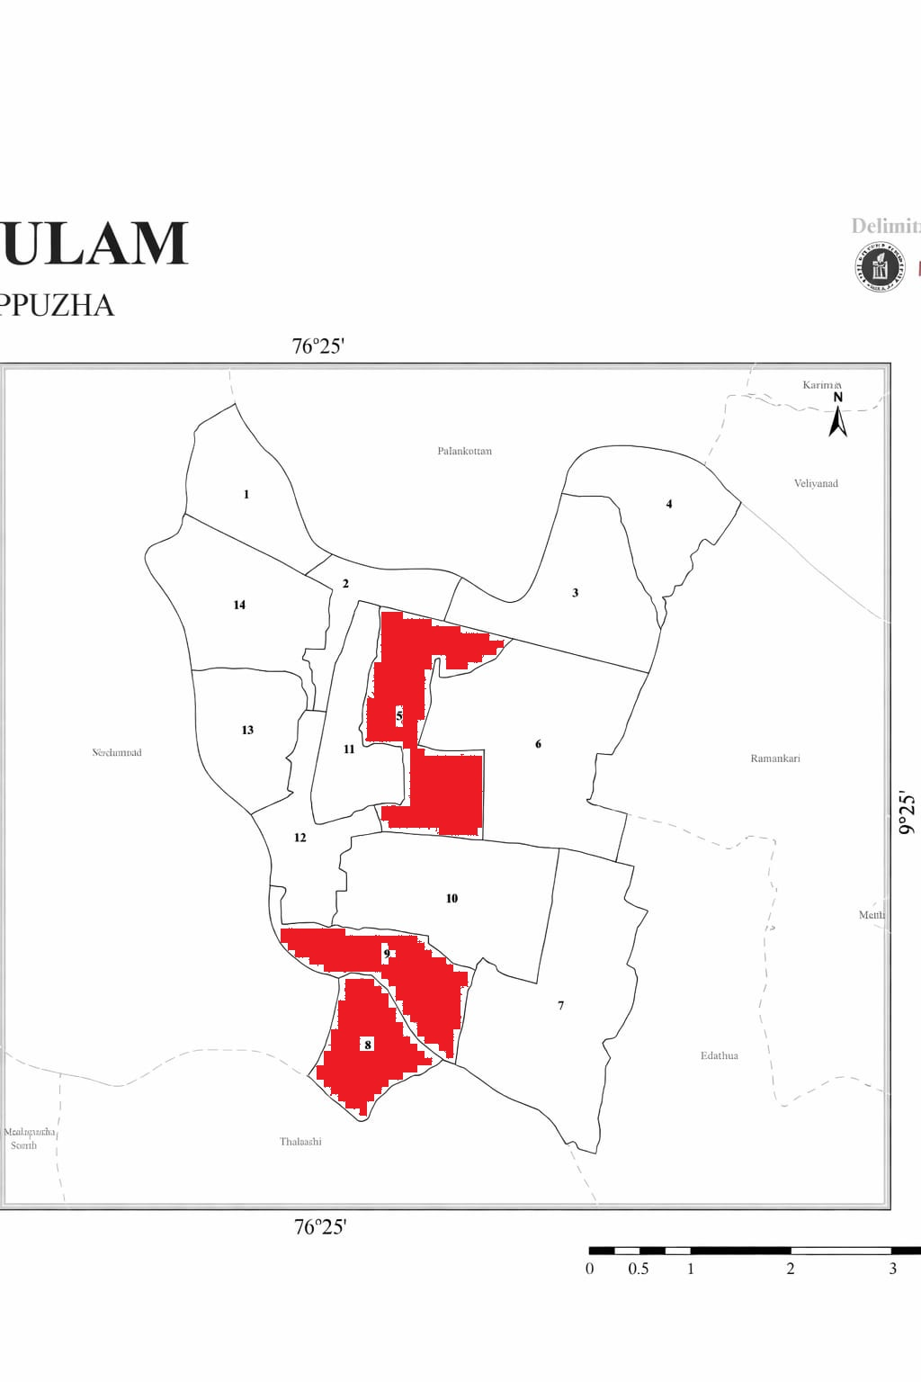

'Red Zone' Wards are ward 5,8 and 9

Ward No | Dengue Total (2021-25) | Leptospirosis Total (2021-25) | Hepatitis A Total (2021-25) | Mumps (2021-25) | ADD (2021-25) | Total Cases
1 | 0 | 2 | 0 | 0 | 18 | 20
2 | 1 | 5 | 0 | 1 | 7 | 14
3 | 1 | 0 | 1 | 0 | 11 | 13
4 | 2 | 1 | 0 | 0 | 9 | 12
5 | 1 | 5 | 0 | 1 | 12 | 19
6 | 1 | 3 | 0 | 0 | 8 | 12
7 | 1 | 1 | 0 | 0 | 6 | 8
8 | 2 | 2 | 0 | 1 | 9 | 14
9 | 2 | 6 | 0 | 0 | 11 | 19
10 | 1 | 1 | 0 | 0 | 8 | 10
11 | 0 | 0 | 0 | 0 | 8 | 8
12 | 1 | 3 | 0 | 0 | 5 | 9
13 | 0 | 3 | 0 | 0 | 12 | 15

By overlaying five years of data, we have identified …………..'Red Zone' Wards. These are wards where at least two different categories of diseases (e.g., Dengue and Lepto) recurred in consecutive years. Ward 4 is categorized as the Highest Priority Hotspot due to its combination of flood vulnerability and high vector density. Future health infrastructure, such as the proposed R.O plants at ………should be prioritized.

Preparedness and Response Protocol at LSG Level
This section describes the operational framework for the LSGI once a pandemic is declared. It explains how the LSGI and health system will move from routine data collection to active response, using a One Health approach.

Constitution of One Health Committee
The LSGD shall constitute a One Health Committee comprising the LSGI President, Medical Officers (Modern Medicine, AYUSH, and Veterinary), the Health Inspector, and the Veterinary Surgeon.

Objective: The One Health Committee coordinates human, animal, and environmental health to prevent and control pandemics.

Sl No | Name | Designation | Department/Institution | Role in Committee | Contact Number
1 | Mathew K M | Panchayat President | LSGD | Chairperson | 9447784465
2 | Dr.Gayathri | Medical Officer (PHC/CHC) | Health Dept | Member Secretary | 9495242175
3 | Sibi | Veterinary Officer | Animal Husbandry | Member | 9074026951
4 | Lijo Peter | Epidemiologist | Health Dept | Member | 9846841916
5 | Das | Health Inspector/PHN | Health Dept | Surveillance | 9495268876
6 | Soumya | ASHA Supervisor | Health Dept | Community link | 9496043658
7 | Suja | ICDS Supervisor | Social Welfare | Vulnerable groups | 9744765354
8 | Anad Babu | Police Station Officer | Police Dept | Law & order | 9497987061
9 | Mervin Joseph | Ward Councillor Representative | LSGD | Community coordination | 9895225965
10 | Sudharmma | Kudumbashree CDO | Kudumbashree | Community mobilisation | 9048982368
11 |  | NGO/Volunteer rep | Civil Society | Support services

Key Responsibilities:
- Review disease surveillance data (human + animal)
- Conduct ward-wise risk assessment and vulnerability mapping
- Approve quarantine/isolation centre locations
- Coordinate with district for resources (PPE, oxygen, ambulances)
- Periodically review health system surge capacity, including beds, oxygen, human resources, and ambulances.
- Approve and monitor risk communication and community engagement strategies, including rumour management.
- Ensure protection and service continuity for vulnerable groups (elderly, persons with disabilities, dialysis patients, coastal populations).
- Conduct quarterly mock drills
- Monitor equity measures for vulnerable groups

Meeting Schedule:
Quarterly (normal times) | Weekly (outbreak alert) | Daily (pandemic phase)

Pandemic Response Workforce
To ensure a coordinated and timely response during a pandemic, a dedicated Pandemic Response Workforce shall be constituted at the LSG level. The workforce will function under the overall supervision of the One Health Committee and in close coordination with the health authorities. Team-based deployment will enable efficient surveillance, case management, quarantine and isolation management, logistics support, and risk communication. Each team shall have a clearly designated team leader, defined roles, and an identified pool of personnel to allow rapid activation, rotation of duties, and continuity of services during prolonged emergencies.

Total Response Workforce Available: 300 persons

Team Name | Composition | Key Responsibilities | Team Leader
Surveillance and Contact Tracing Team | HI, JHI, JPHN, ASHAs and Volunteers | Case detection, contact listing, home visits, reporting | HI
Case Management Team | Doctors, Nurses, MLSP, Palliative Nurses | Patient care & referral | DOCTOR
Quarantine & Isolation Team | LSGD staff, Volunteers | Facility management | JHI
Psychosocial support | HI, JHI, JPHN,MLSP | MO | HI
Logistics & supply chain Team | LSGD staff, Storekeepers, Drivers 3 | Supplies & transport [PPE, medicines, oxygen, transport, waste management] | Ward Member
Communication Team | Ward members, Kudumbashree, Youth clubs,  AWW workers and other self help groups | IEC, community meetings, countering misinformation | M.O in charge
Transportation | KSRTC, educational institutional buses | Panchayath | Secretary
Media Surveillance | All the media | Panchayath | Secretary
Intersectoral coordination and convergence | Panchayat level | President | HS
Collaborative surveillance | Health staff, LSG members | MO | HI

All teams shall be activated immediately upon outbreak alert or pandemic declaration and shall report daily to the LSG Incident Commander/Medical Officer, with consolidated reporting to the Block PHC. Duty rosters and alternate personnel shall be maintained to ensure uninterrupted services during staff shortages or prolonged response periods. Team composition and numbers may be revised based on the magnitude of the outbreak and availability of human resources.

Activities and Measures before and during Pandemic

PHASE 1 - Alert / Preparation
Surveillance and Reporting-Enhanced syndromic surveillance:
- Data sources for surveillance:
- Event-based triggers (to be monitored and reported):
- Zoonotic and animal health surveillance
- Logistics and Stock Preparedness
  - Identify and empanel local vendors and define emergency procurement mechanisms in accordance with existing LSGD and Health Department norms.
  - Prepare and maintain an essential logistics checklist covering medical supplies, consumables, and support equipment.
  - Pre-identify secure storage locations for emergency stocks and ensure maintenance of stock registers with regular updating.
  - Finalise emergency transport arrangements, including availability of vehicles and identified drivers for rapid deployment during alerts.
  - Designate a Nodal Officer for Logistics to enable prompt decision-making, coordination, and communication during emergencies.
  - Conduct rapid stock verification and ensure availability of minimum buffer stock, including:
- PPE kits 3– numbers
- Pulse oximeters – _13__ numbers
- Hand sanitizers – _5__ litres
- Masks, gloves, disinfectants – adequate quantity
Identify critical gaps in logistics and immediately communicate requirements to the Block and District authorities for timely replenishment and support. Monitor expiry dates and stock rotation.

Identification of Quarantine and Isolation Facilities
  - Identify and list suitable buildings for quarantine and isolation (schools, hostels, community halls, etc.).
  - Categorise cases as per the severity and allocate to appropriate facilities (for instance, severe cases to classrooms, mild cases to an assembly hall in case of a school).
  - Facility readiness checklist needed (beds, toilets, ventilation) etc.
  - Find an alternate site if the primary sites are not available or not in use.
  - Identify facility managers and support staff
  - Prepare basic SOPs for:
    - Admission and discharge
    - Food, water, sanitation
    - Infection prevention and waste disposal
  - Ensure availability of basic amenities: water, sanitation, electricity, ventilation, and waste disposal. Prepare a rapid activation plan for these facilities if case numbers increase.

Risk Communication and Community Preparedness
  - Disseminate early warning messages on symptoms, preventive measures, and reporting mechanisms. Display IEC materials both in English and the local language in public places and ensure ward-level awareness.
  - Sensitize elected representatives and community leaders on preparedness measures.
  - Establish a rumour tracking and misinformation response mechanism to identify, verify, and promptly counter false or misleading information.
  - Engage trusted local persons (ward members, ASHA workers, religious leaders, teachers, community volunteers) to communicate official public health messages and reinforce correct practices.
  - Develop and deploy targeted IEC materials for:
    - Schools and educational institutions
    - Markets and commercial areas
    - Work sites and labour settings
  - Conduct community sensitization meetings at the ward level to promote preventive behaviors, address concerns, and strengthen community participation in preparedness and response.

Protection of Vulnerable Groups
Vulnerable populations require priority protection through targeted line-listing, service continuity, and delivery mechanisms.
- Prepare and regularly update line-lists of vulnerable populations, including:
  - Elderly persons living alone
  - Persons with disabilities
  - Pregnant women
  - Migrant workers
  - Dialysis patients
The detailed line-lists shall be maintained as Annexure and updated periodically.

Clinical Dependency Mapping
Develop ward-wise dependency and vulnerability maps to identify households requiring regular support during emergencies. Ensure continuity of essential health services for vulnerable groups, including
- Dialysis services (facility mapping, transport arrangements, and scheduling)
- Continuity of treatment for TB, HIV, and other chronic conditions requiring uninterrupted medication
- Mental health and psychosocial support services
Establish delivery mechanisms for food, essential commodities, and medicines to vulnerable households through coordinated action involving ASHAs, JPHNs, Kudumbashree, volunteers, and local administration.

PHASE 2 - Active Response

Case Identification and Contact Tracing
Case detection and contact tracing activities will be carried out in coordination with the Health authorities, following disease-specific SOPs and IDSP guidelines.
Field Staff Involved
- Health Inspector (HI)
- Junior Health Inspector (JHI)
- Junior Public Health Nurse (JPHN)
- ASHAs and ASHA Supervisors
- Ward-level volunteers and Kudumbashree members (as required)

Screening Checkpoints
Screening checkpoints at high-traffic locations (transport hubs, markets, religious gatherings) for early detection of symptomatic travellers and crowd screening during outbreaks. Potential locations include bus stands, market entry points, and boat jetties, based on local context and risk assessment.
Screening activities will be carried out by trained personnel such as ASHAs, ward members, and volunteers, with support from Health Department staff. Necessary equipment, including non-contact thermometers and appropriate PPE, shall be ensured prior to activation.
Location | Type (Bus stand/Jetty/Market/Railway) | Staff Deployed (ASHAs/Volunteers) | Screening Method | Reporting authority
Bus stand | Transport hub | One JHI  One ASHA  One health Mentors | 1.Swab Collection.  2. Blood smears collection (RDT)  3.Thermal Scanners | Surveillance Nodal Officer in control room
Market entry | Market | One JHI  One ASHA  Male health volunteers | 1.Swab Collection.  2. Blood smears collection (RDT)  3.Thermal Scanners | Surveillance Nodal Officer in control room
Boat jetty | Water transport | One JHI  One ASHA  Male health volunteers | 1.Swab Collection.  2. Blood smears collection (RDT)  3.Thermal Scanners | Surveillance Nodal Officer in control room

Standard Screening Protocol

The screening protocol shall include temperature screening, observation for visible symptoms, and inquiry regarding recent travel or exposure history. Individuals identified as suspects during screening shall be immediately referred to the nearest PHC/FHC for further evaluation, testing, and appropriate action as per prevailing guidelines.

Pandemic Control Room
The Pandemic Control Room (PCR) serves as the central nerve center for real-time coordination, data aggregation, decision support, and communication during outbreaks. It consolidates information from all LSGD teams, health facilities and community sources to enable rapid response decisions.

Control Room Infrastructure and Location
Primary Location: Champakulam Panchayath Office.
Backup Location:C=Community Hall in Champakulam G.P.

Health System Control Room Framework
The PCR is organized into seven functional pillars to ensure no aspect of the response is overlooked:

Rapid Response Team (RRT)
  - Provides immediate intervention during emergencies, clusters, and field alerts.​
  - Coordinates urgent actions such as case investigation, contact tracing, isolation, and inter‑facility referrals.

Data Management & Analytics Team
  - Collects, validates, and manages key health system indicators (cases, tests, beds, HR, supplies).​
  - Analyzes data trends, generates projections, and supports evidence‑based decision‑making for local authorities.

Human Resource Deployment Team
  - Allocates healthcare staff efficiently based on workload and need
  - Ensures adequate and equitable workforce distribution across facilities

Laboratory Surveillance Team
  - Oversees diagnostic testing coordination, sample transport, and timely reporting of results.​
  - Monitors lab indicators (testing volume, positivity rate, turnaround time) for early detection of outbreaks

Vaccination Cell (If Required)
  - Plans and executes vaccination campaigns, including micro‑planning and session scheduling.​
  - Tracks coverage, identifies gaps, and coordinates corrective actions with field teams and outreach services.

Infrastructure & Patient Occupancy Team
  - Monitors facility capacity, earmarked beds, oxygen and critical care resources across all linked facilities.​
  - Ensures optimal patient distribution and referral management using updated bed‑status and resource data.
  - BMWM

Communication team
- Logistics and supply chain
- Transportation (interfacility & emergency transport)
- Media surveillance Call centre
- Management of the deceased
- Intersectoral coordination and convergence

Key Control Room Team
The Control Room Team coordinates all pandemic response activities within the LSGD and serves as the single command and communication hub during activation. It integrates information, field actions, logistics, and policy execution across all participating departments and health facilities.

Role | Name | Designation | Contact Number | Responsibility
In-charge/Nodal Officer | DR.GAYATHRI | MEDICAL OFFICER | 9495242175 | Overall coordination, decision-making, and reporting to the District level.
Data Entry Operator | JOHNSON | CLERK | 9048689797 | Managing the line list, updating dashboards, and tracking testing results.
Communication Officer | V G DAS | JHI | 9495268876 | Handling the public helpline, coordinating ambulance dispatch, and contact tracing calls.
Logistics Coordinator | RUBEENA A | JHI | 8111845398 | Handling transportation
Technical Support (IT/Data) | SEBIN | DATA ENTRY(PANCHAYATH) | 9895092501 | preparedness of data

Key Points:
- The Control Room shall be staffed with a designated In-charge, data entry personnel, and communication staff with clearly defined roles and shift arrangements.
- It shall maintain updated records on daily monitoring indicators including new cases, persons under active quarantine, and hospital bed occupancy.
- All reports and situation updates shall be shared daily with the Block and District Surveillance Unit.
- The Control Room shall act as a single point of contact for coordination with response teams, health institutions, and other departments.
- Contact details of the Control Room shall be widely communicated to field staff and stakeholders during activation.

Daily Monitoring Indicators
To ensure timely decision-making and effective response, the following key indicators shall be monitored and updated on a daily basis by the Pandemic Control Room:

Epidemiological Indicators:
New cases reported today, Total active cases, Test Positivity Rate (TPR), Case Fatality Rate (CFR)
- Surveillance Indicators:
Persons under home quarantine, High-risk contacts identified, Fever, ILI, SARI or other symptoms (syndromic surges), Travellers (symptomatic or high-risk arrivals),Animal husbandry surveillance (zoonotic alerts, unusual animal deaths, poultry/bird flu signals), Mortality surveillance (excess deaths, unexplained fatalities, verbal autopsy reports)
- Logistics and Infrastructure Indicators:
Hospital / CFLTC beds occupied, Oxygen cylinders/concentrators available, Ambulances on standby
- Alert Findings
The following table outlines category-specific trigger points (red flags) from surveillance indicators and corresponding immediate actions for the Pandemic Control Room. These enable rapid response to alert findings like testing anomalies, positive cases exceeding thresholds, clusters, and WGS reports.

Category | Trigger Point (Red Flag) | Immediate Action
Clusters | Geographical or facility-based: 5+ cases linked to one location (office, school, street). | Declare a micro-containment zone; perimeter control and active case finding.
Testing | Sudden drop in testing volume / delay in reporting / unusual testing trends | Review the sample collection process, address lab bottlenecks, deploy additional testing teams, and notify the District Lab.
Lab | Test Positivity rate increases | Increase testing sites in that ward.
Hospital | >80% Oxygen bed occupancy | Activate backup/CFLTC beds.
Travel | Cluster of cases from a single flight/train or high-risk arrival group. | Trace all passengers in adjacent seats; implement mandatory institutional quarantine.
Animal | Mass poultry/wildlife death or unusual sickness | Notify Animal Husbandry, sample the area, and dispatch RRT for environmental sampling and zoonotic check.
Mortality | Sudden spike in home deaths or brought-in-dead (BID) cases | Audit the deaths and Active Case Search drive
Additional investigations like Whole Genome Sequencing (WGS) | Detection of a Variant of Concern (VOC) or Variant of Interest (VOI) | Implement strict micro-containment; update clinical protocols to match variant severity.

Communication of Public Health Information
A Community Communication Hub shall be established to ensure timely, accurate, and consistent dissemination of information during a pandemic. The Hub will function under the coordination of Nodal officers of the control room and act as the nodal point for public communication, risk messaging, and community engagement. It will support dissemination of official advisories, promote preventive behaviors, address rumors and misinformation, and ensure that messages reach all sections of the population through trusted local channels and leaders.

Key communicators
Channel | Responsible Person | Contact
Ward-level announcements | Junior health inspector | 9495268876
Social media | Junior health inspector | 8111845398
Local Cable TV/Radio | KCV Channel | 9020521043

- All messages disseminated through the Hub shall align with advisories issued by the Health Department and District authorities.
- Community leaders shall be sensitized to support behavior change, reduce stigma, and counter misinformation.
- Special efforts shall be made to reach vulnerable and hard-to-reach populations using locally appropriate communication methods.

Rumor Tracking: A designated volunteer will monitor local social media/WhatsApp groups daily to identify misinformation and issue official clarifications via the Communication Hub.

Coordination with District/State Authorities & Other Organisations
Effective coordination with Block, District, and State authorities is essential to ensure timely reporting, technical guidance, and uninterrupted supply of essential resources during a pandemic. The LSG shall establish clear communication channels, designate responsible officers, and adhere to prescribed reporting timelines to support coordinated public health action and efficient resource mobilisation.

Key Details:
- Nodal Officer for Reporting: V G Das ,Junior Health Inspector
- Contact Number: 9494268876
Reporting Schedule and Protocols: According to protocol

To Whom | What to Report | Frequency | Nodal Person
Block PHC | Complete Situation Report (Cases, Quarantine, Beds, Screening, Deaths) | Daily | H S
District IDSP Unit | Outbreaks/Clusters/Unusual Events (>5 cases same ward) | Within 24 hrs | SURVEILLANCE OFFICER
Veterinary Officer | Animal health events/Zoonotic alerts | Daily | VETERINARY MEDICAL OFFICER
State Cell | Zoonotic cross-sector events | Daily | STATE OFFICER

Supply Chain Coordination
The LSG shall coordinate closely with Block, District, and State authorities (KMSCL) to ensure uninterrupted availability of essential goods, medical supplies, and logistics during a pandemic. Supply requirements shall be assessed regularly based on case load and communicated promptly to the appropriate authorities for timely replenishment.
Key Points:
- Maintain updated contact details of District and Block nodal officers for health logistics, oxygen supply, ambulances, and essential medicines.
- Submit timely indent requests for PPE, testing kits, medicines, oxygen, and other critical supplies through prescribed channels.
- Monitor stock levels at LSGD facilities, quarantine/isolation centres, and field teams through daily stock registers and dispensing logs to prevent shortages.
- Coordinate with District authorities, Karunya/Neethi medical shops, and local purchase committees for funds allocation and emergency procurement.

- Ensure regular monitoring of dispensing registers at all facilities to track usage, expiry, and pilferage—shortages being a perennial issue requiring proactive weekly audits.

- Activate surge procurement protocols during high caseloads, leveraging local purchase powers under LSGD funds alongside state supplies.

Resource Inventory and Contacts
Resource Category | Source  (District/State/Private) | Contact
PPE Kits/Masks/Gloves | KMSCL | 9496004700  04772282302
PPE Kits/Masks/Gloves | Local Vendors | 9447467937
Oxygen  Cylinders/Concentrators | KMSCL | 9496004700  04772282302
Medicines/Antivirals | KMSCL | 9496004700
Medicines/Antivirals | Neethi Shops | 9497635516
Test Kits (RTPCR/Rapid) | KMSCL | 9496004700

Collaboration with NGOs, PPP, and CSR
To augment government efforts during a pandemic, the LSG shall collaborate with NGOs, voluntary organisations, and private sector partners through public–private partnerships and Corporate Social Responsibility (CSR) initiatives, in coordination with District authorities.

Key Points:
- Engage NGOs and community-based organisations for community outreach, awareness, and support to vulnerable populations.
- Leverage CSR support for procurement of medical equipment, PPE, oxygen concentrators, food kits, and sanitation materials, as permitted.
- Ensure all collaborations align with government guidelines and are routed through approved administrative and financial procedures.
- Maintain transparency and documentation for all external support received and utilised.
Organization | Type | Support Offered | Contact Person
Youth Clubs/Student Unions | CBO | ROTARY CLUB | AUGUSTINE JOSEPH

Interdepartmental Coordination
Coordination among departments during a pandemic shall be ensured through regular review meetings convened by the LSGD President. These meetings will provide a structured platform for sharing situational updates, assessing resource availability, resolving operational gaps, and taking joint decisions to ensure a coordinated and timely response.

Department | Representative | Key Role | Contact
Health (PHC) | Staff Nurse : | Case management | 8606565105
Veterinary | Veterinary Surgeon: | Animal surveillance | 9074026951
ICDS | Supervisor: Sindhu | Nutrition support | 9744765354
Education | Head Teacher: | School coordination | 9744933447
Police | 04772702222 | Containment enforcement | 04772702222
Water Authority | 8848194056 | Water supply | 9188525730
LSGD Engineering | 9544676515 | Quarantine infrastructure | 9544676515

PHASE 3 - Surge Capacity
Phase 3 is activated when there is a rapid increase in cases, high test positivity rates, or when existing health facilities and quarantine arrangements approach saturation. The focus of this phase is to expand isolation capacity, augment clinical care services, and mobilise additional resources through district and state support mechanisms.

Conversion of Community Facilities
To manage increased case load, the LSGD shall activate additional isolation facilities by repurposing identified community infrastructure such as community halls, auditoriums, schools, hostels, or other suitable buildings.

Name of facility | Facility Type | No. of Buildings | Ward | Surge Capacity (Beds) | Nodal Person
CHC Champakulam | CHC | 2 | 8 | 9 | 9495242175
POROOKARA | SCHOOL | 4 | 12 | 300 | 7025921030
DVHS KANDANKARY | SCHOOL | 2 | 6 | 200 | 9400354596
HS THEKKEKARA | SCHOOL | 2 | 4 | 60 | 9744933447
MARY MATHA | SCHOOL | 2 | 2 | 200 | 9495638530
CHURCH PUNNAKUNNAM | CHURCH | 1 | 3 | 200 | 8547372642
THEKKEKARA CHURCH | CHURCH | 1 | 10 | 150 | 9447566153

Recovery and rehabilitation phase

1. Recovery
 Phased restoration of essential public health services in flood-prone and water-locked wards
 Reactivation of outreach services through ASHA/ward-level micro-planning in island habitations
 Ensuring continuity of NCD, geriatric, palliative and antenatal care services disrupted during pandemic

2. Damage & Impact Assessment
 Health facility functionality assessment (SC/PHC/CHC level)
 Assessment of transport disruption (road & inland waterways)
 Evaluation of impact on elderly population, bedridden patients & chronic disease groups
 Livelihood loss among agriculture-dependent households

3. Restoration of Health Services
 Resumption of routine OPD, immunization and CH services
 Mobile medical units & boat clinics for cut-off wards
 Re-establishment of laboratory surveillance services
 Restocking of essential medicines and emergency supplies

4. Rehabilitation of Affected Population
 Special outreach camps in remote and flood-affected areas
Nutritional and medical support for vulnerable population
Rehabilitation support for COVID/post-pandemic complications

5. Psychosocial & Mental Health Support
 Community-based counselling support through trained health staff
Support for bereaved families and frontline workers
Integration with district mental health programme services

6. Disease Surveillance During Recovery
 Strengthened IDSP reporting from ward level institutions
 Monitoring of post-pandemic outbreaks (water-borne/vector-borne diseases)
 Event-based surveillance through community volunteers

7. Environmental Cleanup & Sanitation
 Disinfection of public spaces, markets and institutions
 Safe drinking water monitoring in pola-affected regions
 Biomedical waste disposal & vector control measures

8. Livelihood Restoration
 Convergence with agriculture & allied departments
 Restoration of paddy cultivation & inland fisheries
 Support for daily wage workers affected by movement restrictions

9. Community Engagement & Confidence Building
 IEC campaigns through LSGD platforms
 Ward-level health awareness meetings
 Engagement of Kudumbashree & local volunteer groups

10. Documentation & After-Action Review
 Panchayat-wise documentation of response activities
 Health system performance analysis
 Stakeholder review meetings at block level

11. Lessons Learned & Best Practices
 Effective use of water transport in service delivery
 Community-led surveillance models
 Integration of local volunteers in emergency response

12. Health System Strengthening
 Infrastructure improvement in sub-centres of remote wards
 Capacity building of healthcare workers
 Strengthening referral linkages with higher centres

13. Policy Revision & Preparedness Enhancement
 Updating block pandemic preparedness SOPs
 Inclusion of flood-pandemic dual hazard planning
 Strengthening inter-departmental coordination mechanisms

14. Research
 Operational research on pandemic response in water-logged terrains
 Study on accessibility barriers in island populations
 Evaluation of post-pandemic health service utilization

CONCLUSION
This Pandemic Preparedness Plan outlines a comprehensive, decentralised, and action-oriented framework for preparedness and response at the LSGD level. By adopting a One Health approach and strengthening coordination between the health system, local self-government institutions, veterinary services, and community networks, the LSGD aims to ensure early detection, rapid response, and effective containment of pandemics and public health emergencies.
The plan emphasises equity, community participation, and evidence-based decision-making to protect vulnerable populations and ensure uninterrupted access to essential services during crises. Regular updating, mock drills, and interdepartmental coordination will be critical to maintaining readiness and resilience.
This document shall serve as a living operational guide, to be activated during alerts and continuously improved based on evolving risks, lessons learnt, and guidance from higher authorities.

"Together for a Healthier and Safer Community."

RECOMMENDATIONS

Strengthening Healthcare Infrastructure
- Establish a primary health response unit within the Panchayat with trained staff.
- Ensure availability of basic medical supplies (masks, sanitizers, PPE kits, oxygen cylinders).
- Create tie-ups with nearby hospitals in MCH Vandanam_ for emergency referral and transport.

2. Community Awareness & Education
- Conduct regular awareness campaigns on hygiene, vaccination, and preventive measures.
- Use local communication channels (community radio, WhatsApp groups, notice boards) to spread verified information.
- Train volunteers to act as health ambassadors in each ward.

3. Emergency Response & Coordination
- Form a Pandemic Preparedness Committee at Panchayat level including health workers, ward members, and NGOs.
- Develop a clear action plan for lockdowns, quarantine, and distribution of essentials.
- Maintain a database of vulnerable groups (elderly, differently-abled, chronically ill) for targeted support.

4. Supply Chain & Food Security
- Identify and support local suppliers and farmers to ensure uninterrupted food supply.
- Create community kitchens during emergencies to serve vulnerable populations.
- Stockpile essential commodities in Panchayat-run outlets for crisis periods.

5. Digital Preparedness
- Promote digital platforms for telemedicine consultations.
- Use Panchayat’s website/social media for real-time updates on health advisories.
- Encourage online grievance redressal to reduce crowding in offices.

6. Training & Capacity Building
- Organize mock drills for pandemic response in schools, offices, and public spaces.
- Train Panchayat staff and volunteers in first aid, infection control, and crowd management.
- Collaborate with NGOs and health departments for capacity-building workshops.

7. Long-Term Resilience
- Integrate pandemic preparedness into the Panchayat Development Plan.
- Allocate a dedicated budget for health emergencies.
- Encourage community participation in planning and monitoring preparedness measures.

ANNEXURE

IMPORTANT PHONE NUMBERS

Phone numbers and particulars of persons responsible for providing guidance, assistance, and support for pandemic preparedness operations may be provided here in a manner that allows easy reference at a glance. The information recorded here could be exhibited elsewhere at the time of emergencies. LSG institutions shall give special attention to collect and record the above data of persons and institutions who/which are supposed to give technical and co-ordination support to reduce the impact of pandemic.

1.1. Details of grama panchayat/municipality/corporation wards
Sl.No | Name of the ward | Ward number | Name of the ward  member | Contact number
1 | Chirakupuram | 1 | Aniyankunju | 9447489950
2 | Moncompu thekkekara | 2 | Athira c r | 9497323572
3 | Punnakkunnathussery | 3 | Joseph | 9539985102
4 | Punnakkunnathussery east | 4 | Soumya Abraham | 9188180682
5 | Thekkekara | 5 | Mary Joseph | 8281078783
6 | Onnamkara | 6 | Omana Sathyan | 7558921972
7 | Kandankary | 7 | Mervin Joseph | 9895225965
8 | Pullangady | 8 | Suja Treesa Baby | 9072155295
9 | Champakulam | 9 | Georgekutty | 9496155797
10 | Champakulam east | 10 | Radhamony | 9444661807
11 | Nattayam | 11 | Manu ThomasDona | 9497221942
12 | Govenda | 12 | Dona Katherine M | 8891727973
13 | Amichakary | 13 | Mathewe K M | 9447784465
14 | Koikkary | 14 | Reji Nanappan | 9947367014

1.2. Other important phone numbers of grama panchayat/municipality/corporation area
Sl. No | Name | Contact number
1. | Kodikkunnil Suresh (MP) | 9447145400
2. | Thomas K Thomas (MLA) | 9539239729
3. | Collector (head of District Disaster Management Authority) | 04772251720
4. | Tahasildar | 04772702221
5. | District Panchayat Secretary | 04772252496
6. | Saju Pathrose | 8281040535
7 | Panchayath President | 9447784465
8. | Excise department | 9562516341
9. | Forest department | 04772252034

1.3. Important offices of grama panchayat/municipality/ corporation
Sl.No | Name of the office | Contact person | Contact number
1. | Village Office | Village Officer | 8547611910
2. | Agriculture Office | Agriculture Officer | 8113896874
3. | Animal Husbandry Office | Animal Husbandry Doctor | 9074026951
4. | Police Station | Police Officer | 9497517585
5. | BSNL Office | Officer | 04772732433
6. | Block Office | Officer | 9656524168
7. | KSEB Office | Officer | 2702288
8. | Fisheries Office | Officer | 7306634020
9. | Fire and Rescue | Officer | 04772230303
10 | Rotary club | 9447596995
11 | Thekkekara Church | Vicar | 9447566153
12 | Petrol pump | Manager | 9446413677
13 | Aryas Hotel | Owner | 9447415162
14 | SNDP | President | 9995068945
15 | NSS | President | 9495159738

1.4. Health Services

Sl. No | Name of the hospital/institution | Location | Phone number
1. | Government hospitals/PHC | Amichakary Champakulam | 9495242175
2. | Private hospitals | Nedumudy | 9544808380
3. | Clinical laboratories | Amichakary | 8606841889
4. | Chemist/pharmacy | amichakary,champakulam | 9447467937
5. | Blood donors | Champakulam | 9746448533
6. | Other language experts (Bihari, Hindi, Bengali,  Asamees ………) | champakulam | 9645665443

1.5. Veterinary Services
Sl.No | Name of the Clinic | Name of the  Surgeon/Doctor | Place/location | Phone  number
1 | Govt.Veterinary Hospital | Dr Siby | Moncompu | 9074026951

1.6. Helpline numbers
Helpline | Phone number
Police | 9497987061
Fire and Rescue | 04772230303
KSEB | 04772702288

1.7. Public and Private Schools Contact details

S.No | Name of School | Institution type | Phone number
1 | DVHS Kandankary | Aided | 9496814882
2 | DVHSS Kandankary | Aided | 9400354596
3 | SH UP School Champakulam | Aided | 9497222083
4 | Marymatha UP School Punnakkunnam | Govt | 9495638530
5 | Fr Thomas Porukarz HSS Champakulam | Private | 7025921030
6 | Govt LP School Champakulam | Govt | 9495439914
7 | Govt HS Thekkekara | Govt | 9744933447
8 | Govt LPS Nedumudy | Govt | 9497635590

1.9. Anganwadi Contact Details

Sl.No. | Ward No | Name of Anganwadi Teachers | Anganwadi No. | Phone number
1 | 1 | Shagimol | 132 | 7559907984
2 | 3 | Sindhu | 47 | 9526575217
3 | 3 | Renu | 48 | 9400352815
4 | 4 | Bhagyasree | 45 | 9946033292
5 | 5 | Sujatha | 46 | 9745626149
6 | 6 | Sindhu R | 37 | 9495496290
7 | 7 | Sabitha | 35 | 9947598537
8 | 7 | Reethamma | 36 | 9747286093
9 | 8 | Ansamma | 38 | 9946897869
10 | 8 | Lousimol | 120 | 8281151218
11 | 9 | Asha | 40 | 9656956459
12 | 10 | Rosamma | 39 | 9995217565
13 | 11 | Geethamma | 44 | 9745163439
14 | 12 | Vidhya | 119 | 6235047449
15 | 12 | Smitha | 112 | 9495758639
16 | 13 | Sruthi | 42 | 8129996061
17 | 13 | Majusha | 43 | 8157983325
18 | 13 | Ashamol | 41 | 8606647615

1.12. Information regarding resources

Means of transportation | Name of Owner | Phone Number
Heavy Trucks | Anilkumar | 9447743943
Tractor | Sharath | 8086050465
Ambulances | Goutham Krishna | 8111891948
Boats | Johnson | 9645072404
Taxi service | Binoy | 9447417927

Annexure 2 : LSG Baseline Data Collection Format
A. Baseline data
Sl. No. | Indicator / Field | Baseline Data | Source / Remarks
1 | Name of LSG | Champakulam | Panchayath
2 | District | Alappuzha | Panchayath
3 | Block / Taluk | Champakulam | Panchayath
4 | Type of LSG (Gram Panchayat / Municipality / Corporation) | Gramapanchayath | Panchayath
5 | Area (sq. km) | 22.97sq km | Panchayath
6 | No. of wards | 14 | Panchayath
7 | GIS boundary file available | (Yes/No) | Panchayath
8 | Key contact person & phone | 9496043659 | Panchayath
B. Demography
Indicator / Field | Baseline Data | Source / Remarks
Total population | 19315 | Panchayath
Males | 8663 | Panchayath
Females | 10652 | Panchayath
Transgender population | 1 | Panchayath
Age distribution  (<5, 5–14, 15–59, ≥60) | <5 _681  5-14 -1843  15-59- 13093  >60- 3698 | Panchayath
No. of households | 4594 | Panchayath
Population density (persons/sq.km) | 19315 | Panchayath
No. of migrant workers | 83 | Panchayath
Major occupational groups | Agriculture Sector | Panchayath

C. Vulnerable Populations & Social Risks
Sl. No. | Indicator / Field | Baseline Data (Value / Description) | Source / Remarks
1 | No. of elderly (≥60) | 3698 | Panchayath
2 | No. of persons with disability | 42 | Panchayath
3 | No. of bedridden persons | 69 | Panchayath
4 | No. of chronic disease cases (DM/HTN/COPD/CKD etc.) | 214 | Panchayath
5 | Pregnant women (current estimate) | 38 | Panchayath
6 | Children <5 years | 681 | Panchayath
7 | Tribal population (if any) | 0 | Panchayath
8 | Fisherfolk / coastal vulnerable groups (if any) | 38 | Panchayath
9 | Urban slums / unnotified settlements (if any) | 0 | Panchayath
10 | Homeless population | 0 | Panchayath
11 | Orphanages / old age homes (number & capacity) | 0 | Panchayath
12 | Hostels / prisons / shelters (number & capacity) | 1 | Panchayath
13 | Poverty / BPL estimate | 3015 | Panchayath
14 | Food insecurity hotspots | 0 | Panchayath
15 | Any history of stigma/discrimination issues (Yes/No) | NO | Panchayath

D. Health System & Service Readiness
Sl. No. | Indicator / Field | Baseline Data (Value / Description) | Source / Remarks
1 | No. of health facilities in LSG (PHC/CHC/TH/DH/Private) | CHC | Panchayath
2 | PHC/Family Health Centre details (name, location) | 0 | Panchayath
3 | Subcentres / Health & Wellness Centres (number) | 7 | Panchayath
4 | Private clinics / hospitals (number) | 2 | Panchayath
5 | Labs available (public/private) | 5 | Panchayath
6 | Availability of ambulance services (Yes/No, number) | 1 | Panchayath
7 | Availability of isolation/quarantine facilities (Yes/No, details) | NO | Panchayath
8 | Cold chain facilities (Yes/No, details) | YES | Panchayath
9 | Stockpile space available (Yes/No) | NO | Panchayath
10 | PPE / mask / sanitizer availability plan (Yes/No) | YES | Panchayath
11 | Surveillance staff available (JHI/JPHN/ASHA count) | YES  JHI 2  JPHN 7  ASHA 13 | Panchayath
12 | Existing emergency referral pathways (Yes/No) | YES | Panchayath

E. Points of Entry & Mobility
Sl. No. | Indicator / Field | Baseline Data (Value / Description) | Source / Remarks
1 | Bus stands / depots (number) | NO | Panchayath
2 | Railway stations (number) | NO | Panchayath
3 | Boat jetties / fishing harbours (number) | YES  NEDUMUDY 7907551431 | Panchayath
4 | Ports / airports nearby (specify distance) | NO | Panchayath
5 | Major highways/roads passing through | AC ROAD | Panchayath
6 | Border crossings (state/district) | NO | Panchayath
7 | Major markets / weekly markets | NO | Panchayath
8 | Tourism hubs / major event venues | NO | Panchayath
9 | Schools/colleges with hostels (number) | SCHOOLS 8  COLLEGE 1  HOSTEL 1 | Panchayath
10 | Factories / large workplaces (number) | 1 | Panchayath
F. Water, Sanitation & Hygiene (WASH)
Sl. No. | Indicator / Field | Baseline Data (Value / Description) | Source / Remarks
1 | Major drinking water sources (piped / wells / borewells / springs) | BORE WELL 6 | Panchayath
2 | No. of public wells | 2 | Panchayath
3 | No. of households with piped water connection | 3217 | Panchayath
4 | Water quality testing routine (Yes/No) | YES | Panchayath
5 | Common contamination risks (flooding, salinity, industrial waste) | FLOODING | Panchayath
6 | Open defecation free status (Yes/No) | YES | Panchayath
7 | Solid waste management system (Yes/No) | NO | Panchayath
8 | Bio-medical waste disposal mechanism (Yes/No) | YES | Panchayath
9 | No. of public toilets | 1 | Panchayath
10 | Handwashing stations in public places (Yes/No) | NO | Panchayath
G. Zoonotic Risks & One Health
Sl. No. | Indicator / Field | Baseline Data (Value / Description) | Source / Remarks
1 | Livestock population (cattle/goats/pigs/poultry) – estimates | 240 | VETERINARY DEPARTMENT
2 | No. of dairy farms / poultry farms / pig farms | 3 | VETERINARY
3 | Slaughterhouses / meat shops (number) | 3 | VETERINARY
4 | Animal markets (Yes/No, details) | NO | VETERINARTY
5 | Veterinary dispensaries (number) | 2 | VETERINARY
6 | History of zoonotic outbreaks (rabies, leptospirosis, avian flu etc.) | 0 | VETERINARY
7 | Stray dog population management measures (Yes/No) | NO | VETERINARY
8 | Rodent infestation hotspots (Yes/No) | NO | CHC
9 | Wetlands / waterlogged areas prone to leptospirosis | 13 | CHC
10 | Bat roosting areas / caves / fruit orchards (if any) | NO | CHC
11 | Human-animal interface hotspots (farms near residences) | NO | Veterinary
H. Climate & Disaster Risks (Pandemic Amplifiers)
Sl. No. | Indicator / Field | Baseline Data (Value / Description) | Source / Remarks
1 | Flood-prone wards (list) | ALL OF THE WARD | Panchayath
2 | Landslide-prone wards (list) | 0 | Panchayath
3 | Cyclone/sea surge risk (Yes/No) | 0 | Panchayath
4 | Heatwave risk zones (Yes/No) | 0 | Panchayath
5 | Waterlogging areas (list) | 13 | Panchayath
6 | Shelter homes / relief camps (number, capacity) | Yes | Panchayath
7 | Past disaster displacement history | YES | Panchayath
8 | Disruption to water supply/transport common (Yes/No) | YES | Water Authority
I. Critical Infrastructure & Logistics
Sl. No. | Indicator / Field | Baseline Data (Value / Description) | Source / Remarks
1 | Schools (number) | 8 | Panchayath
2 | Anganwadis (number) | 18 | Panchayath
3 | Colleges (number) | 1 | Panchayath
4 | Community halls (number) | 6 | Panchayath
5 | Places of worship with large gatherings (number) | 0 | Panchayath
6 | Large markets / shopping areas (number) | 0 | Panchayath
7 | Warehouses / cold storages (number) | 0 | Panchayath
8 | Telecom/mobile network coverage gaps (Yes/No) | NO | Panchayath
9 | Power outage frequency (high/medium/low) | MEDIUM | Panchayath
10 | Availability of generators in key facilities | YES | Panchayath

J. Risk Communication & Community Networks
Sl. No. | Indicator / Field | Baseline Data (Value / Description) | Source / Remarks
1 | Ward-level rapid response teams (Yes/No) | YES | Panchayath
2 | Jagratha samithis / committees active (Yes/No) | YES | Panchayath
3 | Kudumbashree presence and strength (number of units) | YES | Panchayath
4 | Volunteer network (number, coverage) | YES | Panchayath
5 | Community-based surveillance mechanisms (Yes/No) | YES | Panchayath
6 | IEC dissemination channels (WhatsApp groups, community radio, PA systems) | YES | Panchayath
7 | Rumour tracking mechanisms (Yes/No) | YES | Panchayath
8 | Languages spoken / literacy considerations | YES | Panchayath
9 | Vulnerable groups communication strategy available (Yes/No) | YES | Panchayath

K. Preparedness Planning & Governance
Sl. No. | Indicator / Field | Baseline Data (Value / Description) | Source / Remarks
1 | LSG emergency plan available (Yes/No) | YES | Panchayath
2 | Pandemic preparedness plan available (Yes/No) | YES | Panchayath
3 | Incident Command System identified (Yes/No) | YES | Panchayath
4 | Rapid procurement mechanism available (Yes/No) | YES | Panchayath
5 | Emergency fund available (Yes/No, amount) | YES | Panchayath
6 | Past outbreak response experience (Yes/No, details) | YES | Panchayath
7 | Intersectoral coordination mechanism (Health, Police, LSG, Veterinary, Education) | YES | Panchayath
8 | Mock drills conducted in last 12 months (Yes/No) | NO | Panchayath
9 | Training coverage for staff/volunteers (Yes/No) | YES | Panchayath

L. Surveillance & Data Systems
Sl. No. | Indicator / Field | Baseline Data (Value / Description) | Source / Remarks
1 | Digital reporting tools used (e.g., DHIS2, portals) | YES | Panchayath
2 | Availability of line-listing format (Yes/No) | YES | Panchayath
3 | Contact tracing team identified (Yes/No) | YES | Panchayath
4 | Mapping of high-risk households available (Yes/No) | YES | Panchayath
5 | Testing sample transport mechanism (Yes/No) | YES | Panchayath
6 | Reporting timeline adherence (good/average/poor) | GOOD | Panchayath
7 | Data sharing between departments (Yes/No) | YES | Panchayath
8 | Availability of dashboard for monitoring (Yes/No) | YES | Panchayath

M. Additional Notes & Observations
Sl. No. | Indicator / Field | Baseline Data (Value / Description) | Source / Remarks
1 | Key challenges perceived by LSG | FLOOD | Panchayath
2 | Top 5 high-risk wards (reason) | 1, 5,7,9,13  FLOOD AFFECTING AREA | Panchayath
3 | Any unique local risks (industrial pollution, refugee camps, etc.) | NO | Panchayath
4 | Recommendations for preparedness strengthening | CO OPERATE WITH ALL THE DEPATEMENT | Panchayath

