` `

PANDEMIC PREPAREDNESS PLAN
ARYAD GRAMA PANCHAYAT

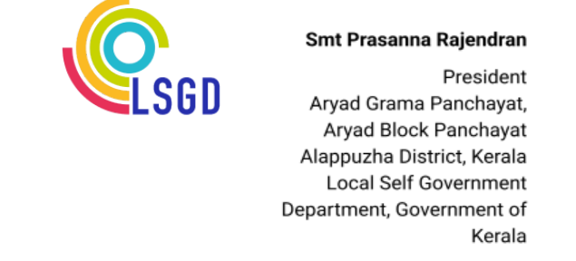
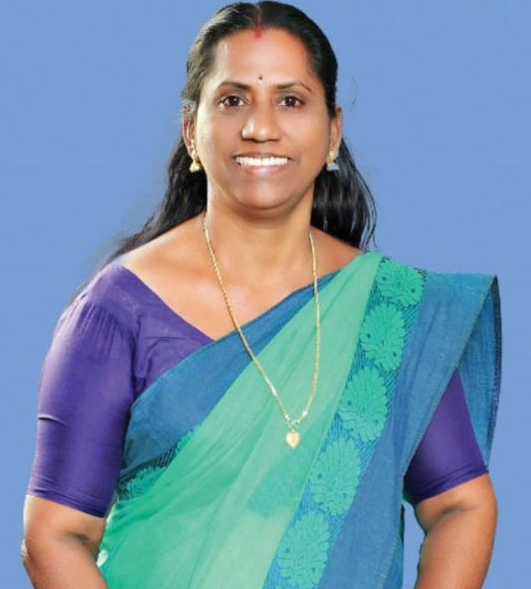
MESSAGE

പ്രിയരേ ,
ആര്യാട് ഗ്രാമപഞ്ചായത് പ്രസിഡന്റ് എന്ന നിലയിൽഎനിക്കും എൻ്റെ ഭരണ സമിതിക്കും വരാൻ പോകുന്ന കാലഘട്ടത്തിൽ പൊതു ജനങ്ങളോട് പൂർണമായും പങ്കാളിത്തത്തോടു കൂടി, കൂടി ആലോചനകളുടെ അടിസ്ഥാനത്തിൽ ആലോചിച്ചു പരിപാടികൾ നടത്തുമെന്ന് ഉറപ്പു നൽകുന്നു. നൂതനമായ പദ്ധതികൾ സങ്കേതികതയുടെ സഹായത്തോടു കൂടി അവതരിപ്പിക്കാൻ ശ്രെമിക്കുകയും അതിൽ ഘടനാപരമായ മാറ്റമില്ലാതെ നടപ്പിലാക്കാൻ ശ്രെമിക്കുമെന്നു ഉറപ്പ് നൽകുന്നു .കോവിഡ് കാലത്തു ആര്യാട് പഞ്ചായത്തിലെ ജനങ്ങൾ എങ്ങനെ പ്രവർത്തിച്ചു എന്ന് നിങ്ങൾ കണ്ടതാണല്ലോ, അതെ മാതൃകയിൽ പൊതു ജനങ്ങളെ ഏകോപിപ്പിച്ചു കൊണ്ട് ഇനിയുള്ള പ്രവർത്തനങ്ങളിൽ ഒരുമിച്ചു നിൽക്കാം എന്ന് ഉറപ്പു നൽകുന്നു

Prasanna Rajendran


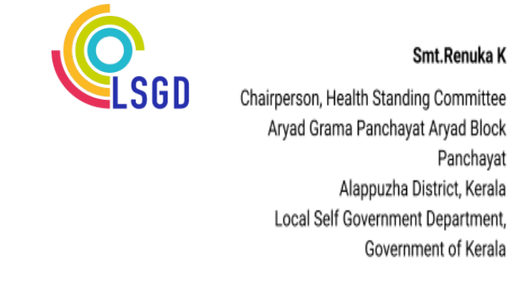

MESSAGE

മാന്യരെ, ,

കോവിഡ് കാലത്തും പ്രളയ കാലത്തുംവിഷയങ്ങളെ ഒരുമയോടെ നേരിട്ടത് എല്ലാവർക്കും അറിവുള്ളതാണല്ലോ .ഒരുമയോടും ഒത്തു ചേർന്നു നിന്നാൽ നമ്മുടെ പഞ്ചായത്തിൻറെ വികസന കാര്യത്തിലും കാര്യ ഗൗരവത്തോടെ ആലോചിച്ചു ആരോഗ്യ രംഗത്തും കൂടുതൽ ഗൗരവത്തോടു കൂടി മുന്നേറാൻ സാധിക്കുമെന്ന് ഉറപ്പ് നൽകുന്നു . ആര്യാട് പഞ്ചായത്തിൻറെ രോഗ പ്രതിരോധ രംഗത്ത് സമഗ്രമായ മാറ്റങ്ങൾ വരുത്തുന്നതിനും ജീവിത ശൈലി രോഗങ്ങൾ നിയന്ത്രിക്കുന്നതിനും പ്രയത്നിക്കുമെന്ന് ജനങ്ങൾക്ക്‌ ഉറപ്പ് നൽകുന്നു


Renuka K
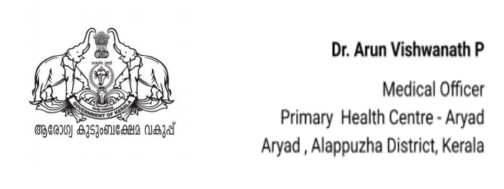


MESSAGE,

കോവിഡ് 19 മഹാമാരി ആധുനിക ലോകം കണ്ടതിൽ വെച്ച് വളരെ ഗുരുതരമായ ഒരു പബ്ലിക് ഹെൽത്ത് അടിയന്തിരാവസ്ഥ ആണ് സൃഷ്ട്ടിച്ചത്. മുൻകാലങ്ങളിൽ സാംക്രമിക രോഗങ്ങൾ, പകർച്ചവ്യാധികൾ എന്നിവ നേരിട്ട ആരോഗ്യ സംവിധാനങ്ങൾ, പക്ഷെ കോവിഡ് പോലെ ഒരു മഹാമാരി നേരിട്ടിട്ടില്ല. ഈ ആശയം ഉൾക്കൊണ്ടാണ് നീതി ആയോഗ് framework for action for future pandemic preparedness and emergency response നു വേണ്ടി ഒരു expert ഗ്രൂപ്പ് നിയോഗിച്ചു.
ഈ ഗ്രൂപ്പിൻറെ മാർഗ്‌നിദേശങ്ങൾ ഉൾക്കൊള്ളിച്ചാണ് ആര്യാട് പി എച് സിയിലും pandemic preparedness പ്ലാൻ തയ്യാറാക്കിയിട്ടുള്ളത്. ആയതിന് പ്രകാരം രോഗലക്ഷണങ്ങൾ ഓ പി യിൽ നിന്നും ഫീൽഡിൽ നിന്നും നേരത്തെ തന്നെ കണ്ടെത്തുകയും ചികിൽസിക്കുകയും, പ്രസ്തുത കേസുകളുടെ നിരീക്ഷണം, സമ്പർക്കം എന്നിവ കൃത്യമായി നോക്കുകയും ചെയ്യുന്നു. ഇതുവഴി രോഗം പകർച്ചവ്യാധി, മഹാമാരി തലങ്ങളിലേക്ക് പോകുന്നത് തടയുവാൻ സാധിക്കുന്നു.


Dr Arun Vishwanath P
EXECUTIVE SUMMARY

The Context of Preparedness
Pandemics represent unpredictable yet recurring threats that profoundly impact human health, local economies, and community resilience worldwide. Advance planning at the local level proves essential to mitigate such crises. In Kerala, public health preparedness has been shaped not only by pandemics but also by climate-related emergencies and recurrent outbreaks. The 2018 floods, followed by subsequent flood events, exposed vulnerabilities related to displacement, disruption of health services, water-borne and zoonotic diseases, and intersectoral coordination. More recently, the COVID-19 pandemic tested health systems at all levels, underscoring the importance of surveillance, surge capacity, continuity of essential services, risk communication, and community participation. These experiences reinforced the need for decentralised preparedness planning that integrates epidemic intelligence, disaster management, and health system resilience. This Pandemic Preparedness and Response Plan for Aryad Grama Panchayat builds on lessons from global and regional events, which highlighted challenges in scaling responses to moderate-severity threats, communicating risks effectively to diverse populations, and adapting surveillance systems rapidly

Geographic and Socio-Economic Profile
Aryad Grama Panchayat is a coastal and backwater-adjacent local self-government institution in Alappuzha district with a total population of 30,989 spread across 20 wards. This LSGI spans diverse terrain—from normal land and dense residential pockets to marshy lowlands, Arabian Sea coastlines, and Vembanad Lake backwaters—shaping livelihoods around fishing, coir-making, agriculture, construction labour, and emerging tourism. These geographic and socio-economic features increase vulnerability to communicable diseases, flooding-related health risks, and rapid disease spread during outbreaks and pandemics. Proximity to densely populated Alappuzha Municipality further amplifies population movement and shared disease burden.

Healthcare Infrastructure and Institutional Strength
In terms of healthcare infrastructure, Aryad Panchayat is supported by one Primary Health Centre (PHC) and multiple Sub-Centres distributed across the Panchayat, ensuring access to routine surveillance, immunisation services, and primary healthcare. One super-specialty private hospital (Providence) with 40 beds, including ICU and ventilator capacity, functioning as the primary referral hub for critical care. AYUSH facilities supplement healthcare delivery through outpatient and supportive care services.

Key Vulnerabilities and Strategic Gaps
Despite these strengths, Aryad Panchayat faces several vulnerabilities that influence pandemic preparedness. These include a high burden of non-communicable diseases, particularly diabetes and hypertension, a considerable elderly and mobility-limited population, and dependence on external facilities for advanced oxygen-supported and critical care services. The Panchayat remains susceptible to recurrent monsoon-associated communicable diseases, with dengue and leptospirosis reported annually, alongside a recent rise in mumps cases, indicating evolving epidemiological challenges.

While overall preparedness can be considered moderate, gaps remain in critical care capacity, ambulance availability, diagnostic access, surge human resources, and structured One Health coordination. Addressing these gaps through intersectoral collaboration, capacity strengthening, and anticipatory planning is essential to enhance pandemic resilience.

LIST OF ABBREVIATIONS

LSGD/LSGI | Local Self Government Department / Local Self Government Institution
BMO | Block Medical Officer
IDSP | Integrated Disease Surveillance Programme
NDMA | National Disaster Management Authority
PPE | Personal Protective Equipment
ICMR | Indian Council of Medical Research
CD | Communicable Diseases
NCD | Non-Communicable Diseases

TABLE OF CONTENTS

INTRODUCTION 11
LSGD AT A GLANCE 12
LSGD AT A GLANCE 13
ADMINISTRATIVE BOUNDARIES OF ARYAD PANCHAYAT 13
INTEGRATED HEALTH INFRASTRUCTURE MAP OF ARYAD PANCHAYAT 14
AUXILIARY INFRASTRUCTURE & LOGISTICAL RESOURCE MAP OF ARYAD PANCHAYATH 15
LSGD ONE HEALTH INFRASTRUCTURE 16
GENERAL PROFILE OF THE LSGI’S 17
Background of the LSGI 17
Demographic and Vulnerable Population 18
Clinical Vulnerability 19
Major Festivals 23
INFRASTRUCTURE & RESOURCE INVENTORY 24
Health Facility Directory & Basic Capacity in the LSGD 24
Health Facility Capacity Summary – Aryad Panchayat 27
Private Clinics 27
Healthcare Education & Training Institutions 29
Specialized Services & Emergency Inventory 29
Oxygen & Diagnostic Capacity 30
Diagnostics Summary 31
Laboratory Identification & Basic Details 33
Social and Community Infrastructure for Emergency Use 33
Human resources 35
Community & Support Cadre 36
Community Organizations 37
Administrative & Emergency Services 37
Information regarding resources 38
ONE HEALTH & ENVIRONMENTAL SURVEILLANCE 39
Animal & Bird Population 39
Veterinary Infrastructure 41
Veterinary Doctors & Workforce 42
High-Risk Interface Points (Surveillance Sites) 43
Environmental Risk Mapping 44
Disease Seasonality Mapping 45
Vulnerability Mapping 46
EPIDEMIOLOGICAL TRENDS (2021–2025) 48
Disease Burden among human beings(Last 5 Years) 48
Seasonal Trend Analysis 50
Leptospirosis – Ward-wise Yearly Distribution (2021–2025) 54
Ward-wise Trend of Hepatitis A Cases in Aryad Panchayat (2021–2025) 56
Outcome Based Trend Analysis- 2025 58
Transmission Trend- 2025 59
Integrated Disease Hotspot Map (2021–2025) 64
Preparedness and Response Protocol at LSG Level 66
Constitution of One Health Committee 66
Pandemic Response Workforce 67
Activities and Measures before and during Pandemic 69
PHASE 1 - Alert / Preparation 69
PHASE 2 - Active Response 74
Standard Screening Protocol 76
PHASE 3 - Surge Capacity 88
Conversion of Community Facilities 89
Recovery and rehabilitation phase 91
CONCLUSION 92
RECOMMENDATIONS 93
ANNEXURE 94
1. IMPORTANT PHONE NUMBERS 94

INTRODUCTION

Pandemics pose significant and recurrent threats to public health, social stability, and essential services, particularly at the community level where early detection, rapid response, and service continuity are critical. Local Self Government Institutions (LSGIs) play a pivotal role in pandemic preparedness and response by translating national and state-level strategies into context-specific actions that address local risks, vulnerabilities, and capacities.

Aryad Grama Panchayat, located along the coastal and backwater belt of Alappuzha district, is characterized by marshland terrain, high population density, seasonal flooding, and frequent mass gatherings. These geographic and socio-economic features, combined with population mobility related to fishing activities, tourism, migrant labour, and religious festivals, increase the Panchayat’s vulnerability to communicable disease outbreaks. Past public health emergencies, including the 2018 floods and recurrent monsoon-related disease surges, have highlighted the need for a structured and anticipatory pandemic preparedness framework at the Panchayat level.

This Pandemic Preparedness Plan has been developed to strengthen Aryad Grama Panchayat’s readiness to prevent, detect, and respond to pandemics and large-scale disease outbreaks. The plan adopts a risk-based and data-driven approach, integrating disease seasonality mapping, clinical vulnerability profiling, health infrastructure assessment, and intersectoral coordination mechanisms. It emphasizes early warning systems, protection of vulnerable populations, continuity of essential health services, and effective coordination between the Health Department, LSGI, line departments, private healthcare providers, and community stakeholders.

By institutionalizing preparedness measures and strengthening local capacity, this plan aims to enhance the resilience of Aryad Grama Panchayat and ensure timely, coordinated, and effective action during future pandemics

LSGD AT A GLANCE

ADMINISTRATIVE BOUNDARIES OF ARYAD PANCHAYAT

NEW MAP (2026)
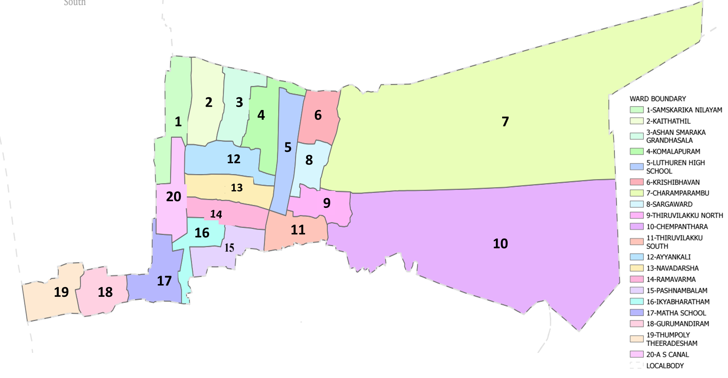

Aryad Grama Panchayat Ward-Wise Map (2026) Data provided by K-SMART (https://wardmap.ksmart.live/FinalN/FinalN_Alappuzha_Aryad.html)

Ward | Houses | Population | Migrants | Wells | Hotspots | Ed. Institution | Hosp pvt/govt
20 | 8913 | 35232 | 198 | 1010 | 0 | 6 | 5

INTEGRATED HEALTH INFRASTRUCTURE MAP OF ARYAD PANCHAYAT

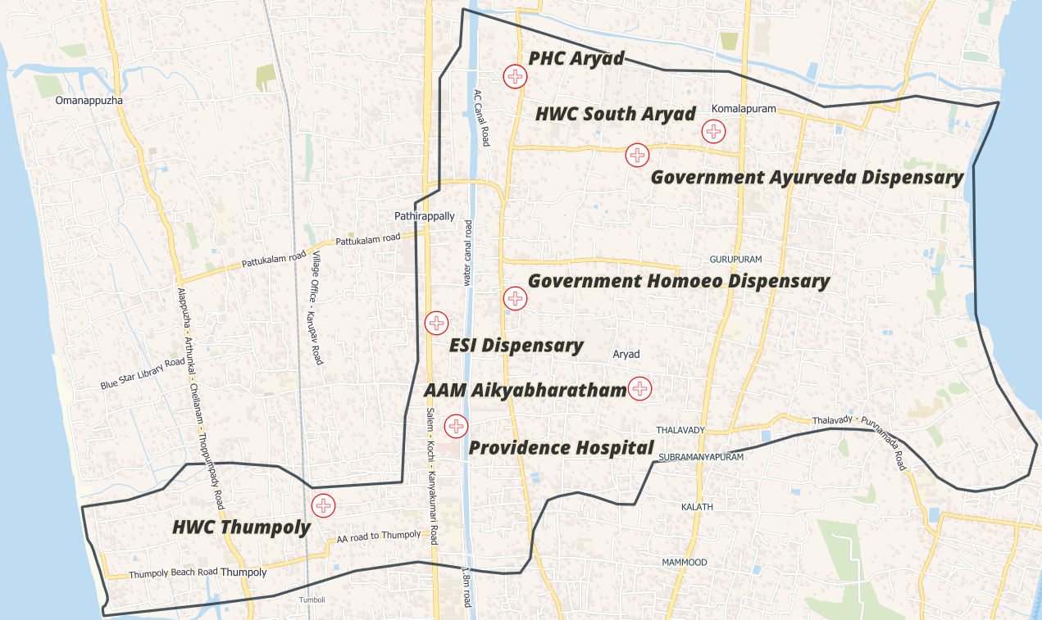

Aryad Grama Panchayat Health Infrastructure Map (2026)
Boundary Data: OpenDataKerala | Map Created with QGIS

AUXILIARY INFRASTRUCTURE & LOGISTICAL RESOURCE MAP OF ARYAD PANCHAYATH

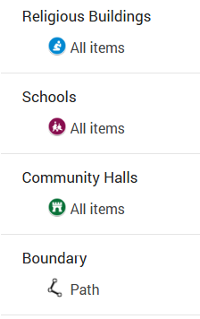
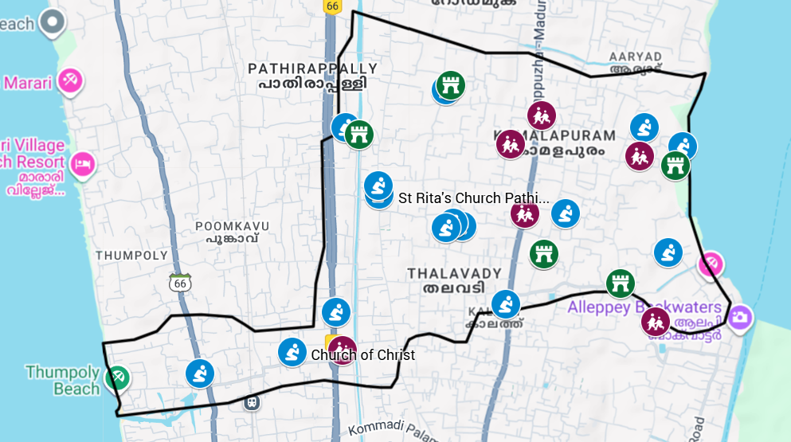

Spatial Mapping of Major Establishments of Aryad Grama Panchayat (2026)
Boundary Data: OpenDataKerala | Map Created with Google My Maps Major Establishment Map

MAJOR ROADWAYS AND WATERWAYS MAP OF ARYAD GRAMA PANCHAYAT

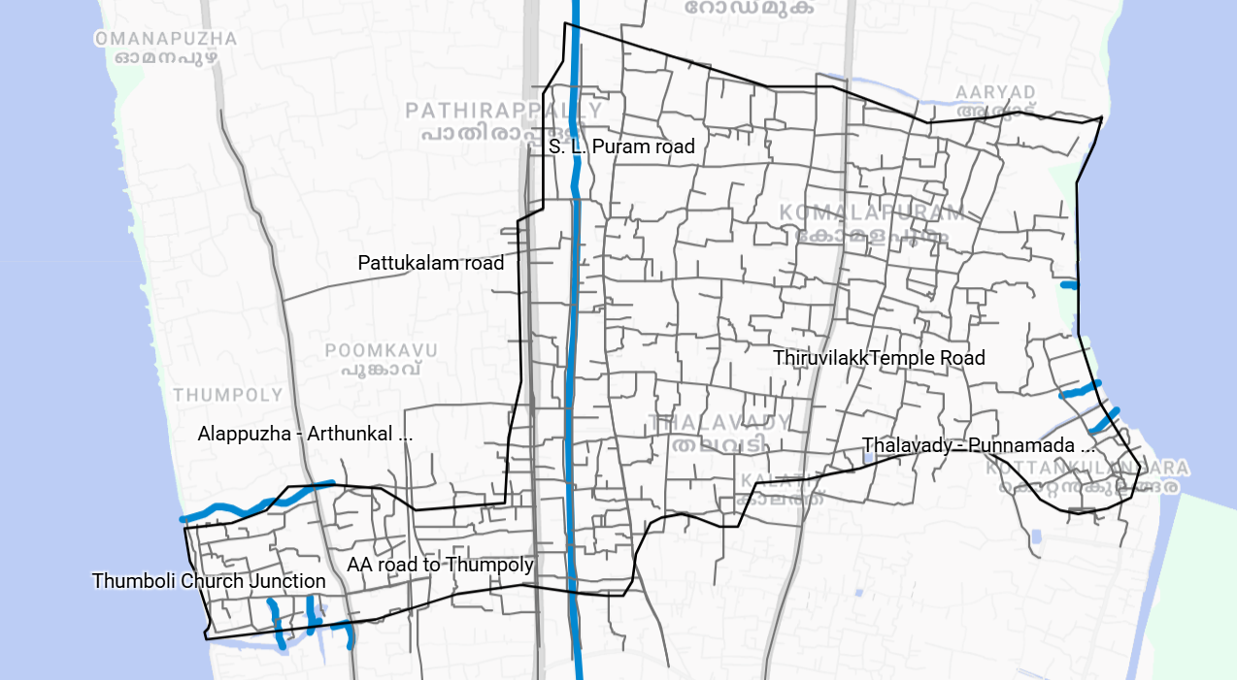
Aryad Grama Panchayat Major Roads and Waterway Map (2026)
Boundary Data: OpenData OpenDataKerala | Map Created with Google My Maps and visualized through Google Earth Roads and Waterways Map

LSGD ONE HEALTH INFRASTRUCTURE

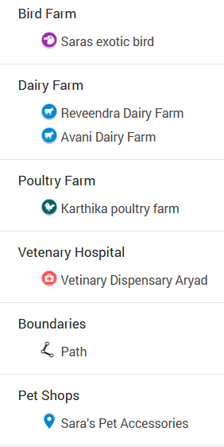
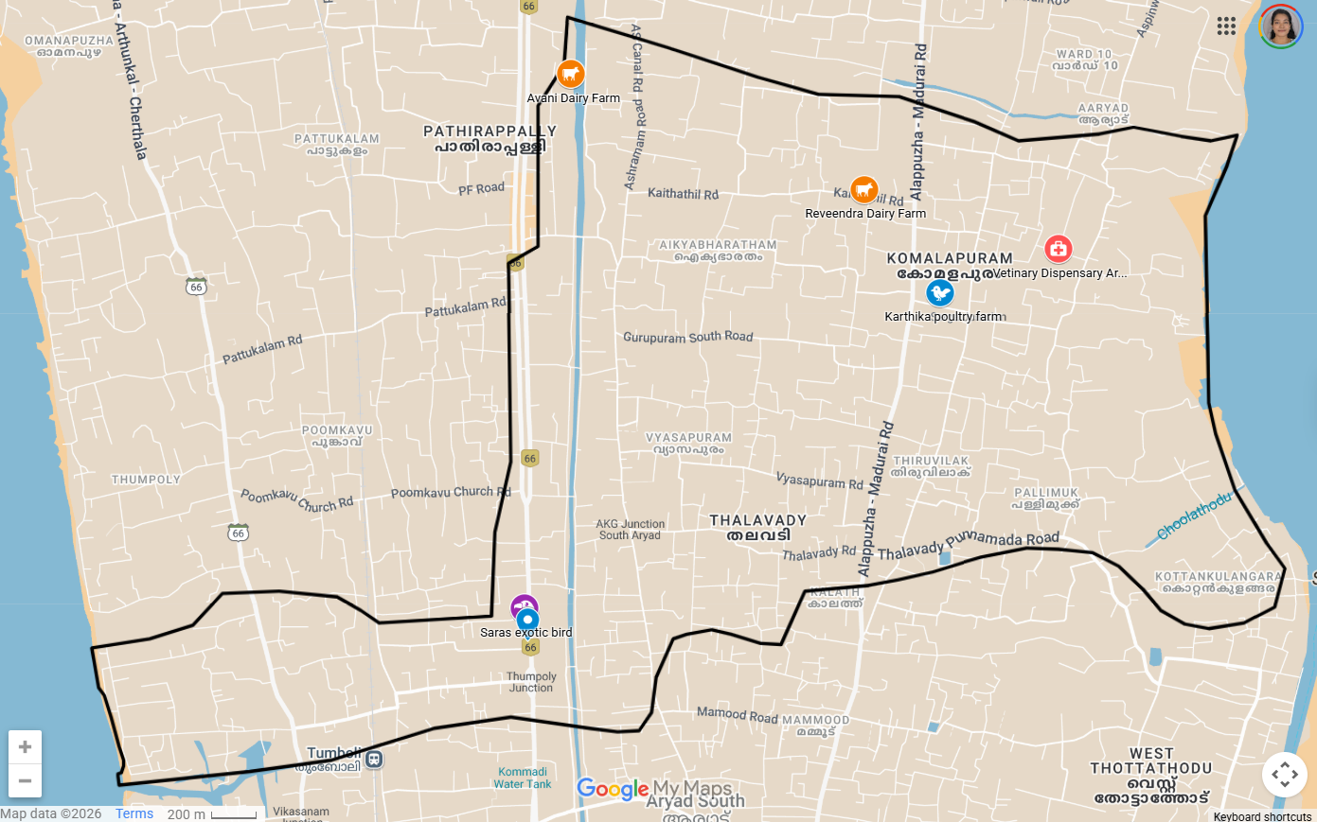
Spatial Inventory of One Health Infrastructure – Aryad Grama Panchayat (2026)
Boundary Data: OpenDataKerala | Map Created with Google My Maps : One Health Map

INTEGRATED HOTSPOT MAP: COMMUNICABLE DISEASES

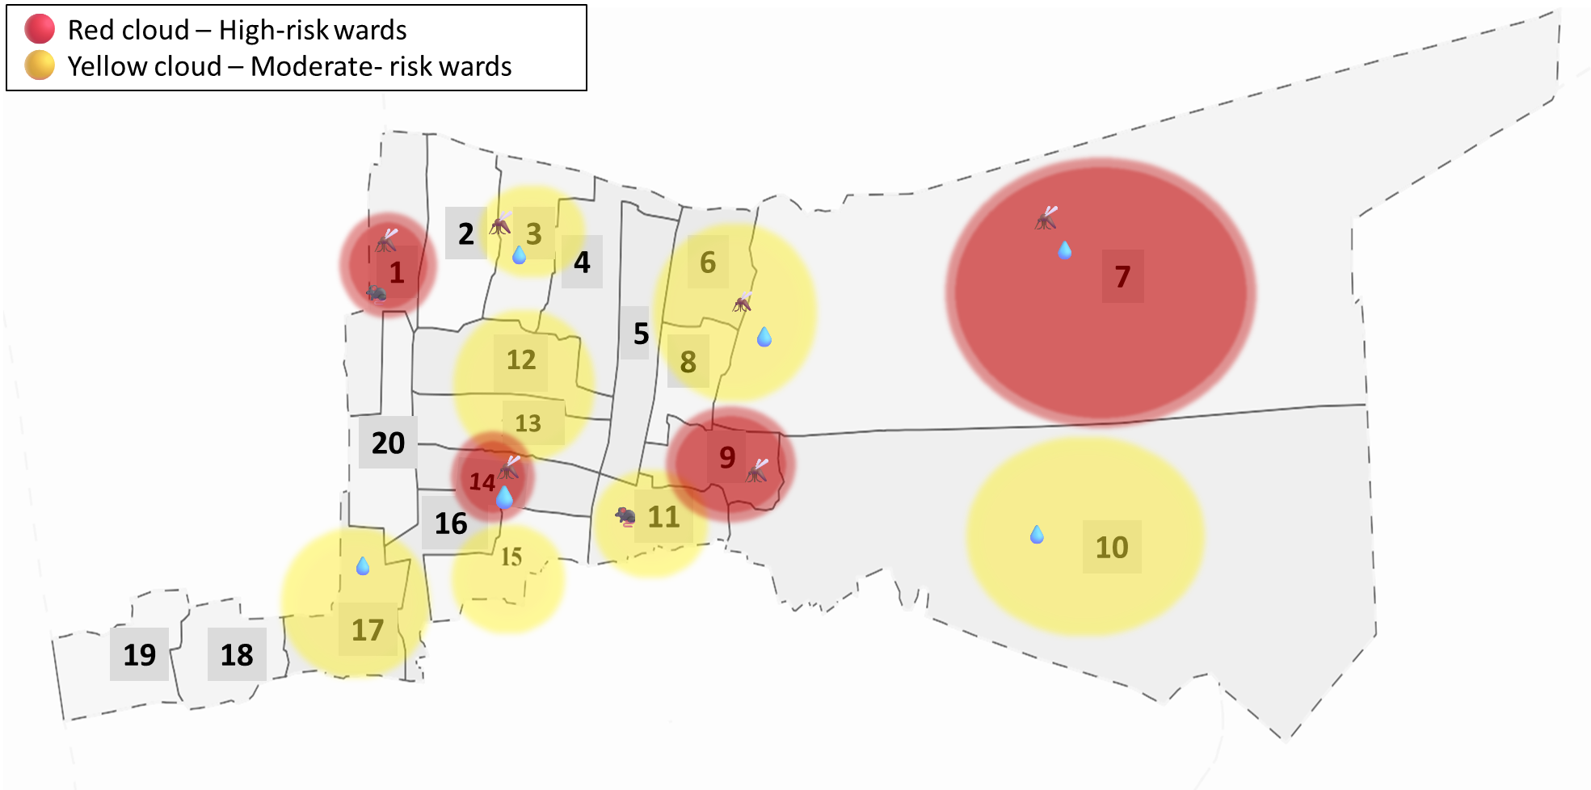
Integrated Health Risk & Disease Hotspot Map: Aryad Panchayat (2021–2025)

INTEGRATED HEATMAP: COMMUNICABLE DISEASES

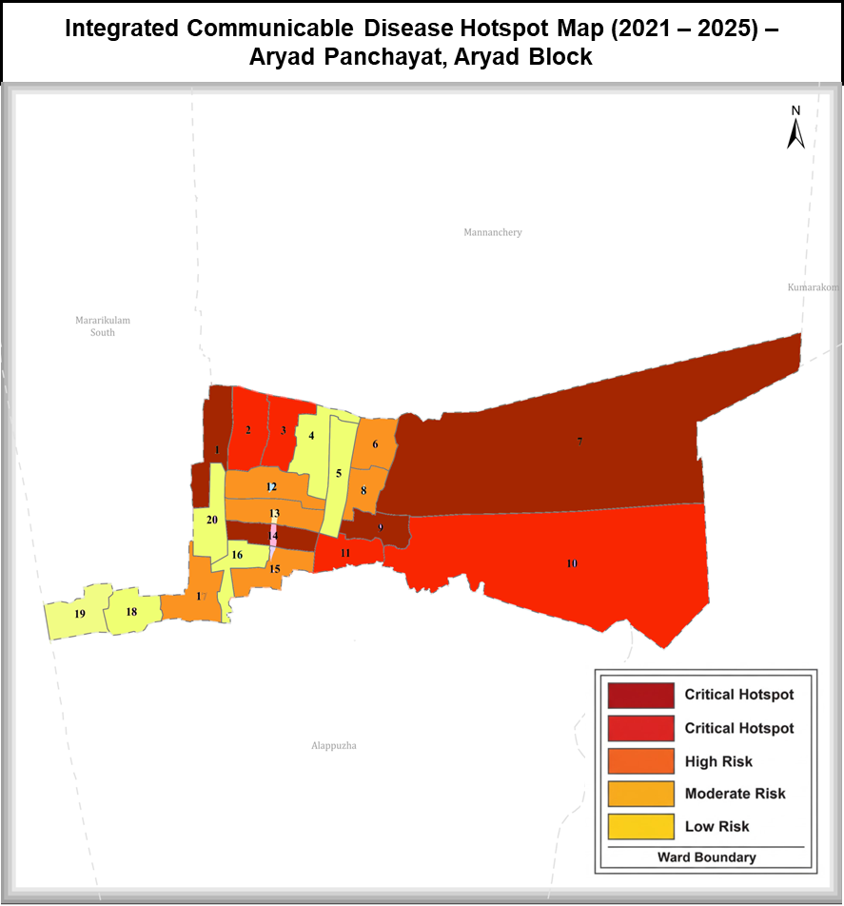



GENERAL PROFILE OF THE LSGI’S

Background of the LSGI
Aryad Grama Panchayat is situated along the coastal and backwater belt. The region’s terrain comprises a mix of normal land and marshland, which plays a crucial role in shaping both the local microclimate and the area’s vulnerability to flooding and water stagnation. With a total population of 35,232 distributed across 20 wards, Aryad serves as an important economic and social hub rooted in traditional occupations such as fishing, coir mat weaving, and small-scale agriculture. In recent years, the area has also witnessed a gradual diversification of income sources through tourism-related activities and a noticeable inflow of migrant labour, especially in the construction and service sectors.

Historically, the LSGI has experienced significant public health and disaster-related challenges, most notably during the 2018 floods, which caused widespread disruption to livelihoods, infrastructure, and essential health services. These events have shaped the community's resilience and highlighted the need for a localized, data-driven disaster management framework.

Table 1: Background of LSGD
Item | Details
Name of LSGI | Aryad
Type (GP/Municipality etc.) | Gram Panchayat
Block | Aryad
District | Alappuzha
Number of wards | 20
Total area (sq. km) | 6.87
Population (latest) | 35232
Population density | 5128 persons/sq km
Terrain (coastal/low-lying/backwaters/foothills, etc.) | Coastal, backwater
Number of rivers passing through LSGI | 0
Number of ponds in the LSGI | 392
Number of wells in LSGI | 1010

Demographic and Vulnerable Population
Understanding the demographic composition and vulnerable population groups is essential for pandemic preparedness. Children, the elderly, economically deprived families, migrant workers, and socially vulnerable groups are at increased risk during public health emergencies due to higher exposure, limited access to services, and dependency on public systems.

Item |  | Details in numbers
DEMOGRAPHIC PROFILE
Total population |  | 35232
Male |  | 17389
Female |  | 17843
Transgender |  | 0
Children under 5 |  | 1446
Adolescent |  | 1693
Elderly (>60) |  | 6961
SOCIAL/LIVELIHOOD VULNERABILITY
EPEP family |  | 57
BPL family |  | 7997
Tribal communities |  | 52
Migration | Immigrant | 198
Migration | Emigrant | 1616
Socio-economically deprived |  | 2495
Fisherfolk |  | 272

Clinical Vulnerability
Certain population groups need priority healthcare & are at higher risk of severe illness, complications, and mortality during pandemics. Patients with chronic diseases, those requiring regular medical care, and individuals with mobility or functional limitations face challenges in accessing timely care during emergencies. Mapping these groups helps in prioritizing continuity of treatment, medicine stock planning, oxygen support, referral transport, and targeted home-based care.
Group | Item | Details (in numbers)
Maternal/Child | Pregnant women | 122
Maternal/Child | Lactating mothers | 356
Maternal/Child | Children under 5 | 1446
Mobility-challenged | Bedbound patients | 149
Mobility-challenged | Patients under palliative care other than bedbound | 256
Mobility-challenged | Mentally challenged | 83
Mobility-challenged | Differently abled | 190
Chronic Illnesses | Patients on Haemodialysis | 27
Chronic Illnesses | Patients on CAPD | 9
Chronic Illnesses | Cancer patients | 218
Chronic Illnesses | Haemophilic patients | 0
Chronic Illnesses | Diabetic patients | 978
Chronic Illnesses | Hypertensive patients | 2168
Chronic Illnesses | TB patients | 9
Total vulnerable individuals: 4,564 (14.7% of Aryad's 35232 population).
The clinical vulnerability profile indicates a substantial burden of chronic non-communicable diseases, particularly hypertension (2,168) and diabetes (978), alongside populations requiring continuous care, such as dialysis patients, palliative care beneficiaries, and bedbound individuals. Maternal groups also represent a significant share, necessitating uninterrupted antenatal, postnatal, and newborn care during public health emergencies. The presence of mobility- and function-limited individuals highlights the need for decentralized service delivery, home-based care, assured medicine supply, oxygen support, and reliable referral transport during pandemics and disasters.
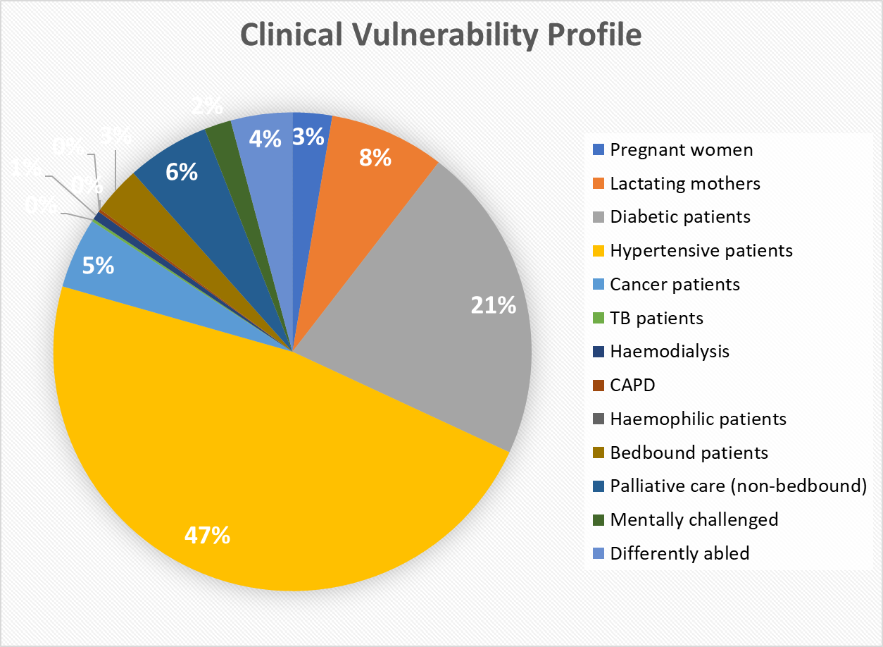
Clinical Vulnerability Profile by Category
Categorization of clinical vulnerability supports prioritized planning for medicine supply, oxygen support, referral transport, and home-based care for high-risk populations during emergencies.

Group | Conditions | Total | Percentage (%)
Maternal | Pregnant women, Lactating mothers, Children under 5 | 1924 | 6.21%
Chronic Illnesses | Diabetes, Hypertension, TB, Cancer, Dialysis, CAPD | 3408 | 11.00%
Mobility / Functional limitation | Bedbound, Palliative (non-bedbound), Mentally challenged, Differently abled | 678 | 2.19%
Overall Total |  | 6010 | 19.4% of 30,989

Chronic illnesses dominate, signaling urgent NCD stockpiling needs amid flood risks; maternal groups require antenatal transport; mobility cases need palliative oxygen and ASHA home visits.

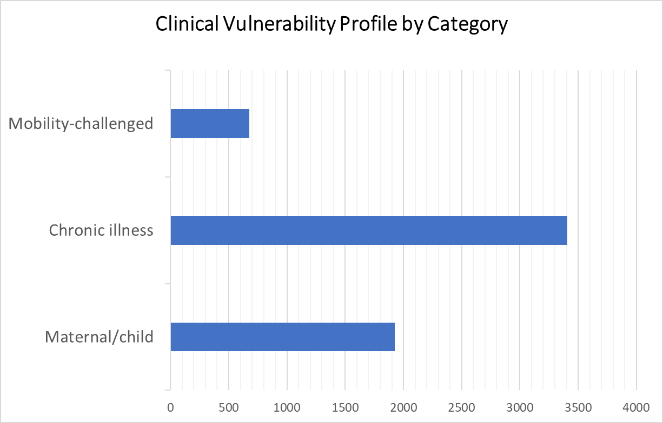

Major Festivals
Major festivals in Aryad Panchayat, such as the Thumpoly Church Festival, amplify communicable disease risks due to local overcrowding, pilgrim influx from nearby areas, and sanitation challenges.

Sl. No. | Name of festivals | Month | Key Risks & Local Impact
1 | Thumpoly Church Festival | December (11-day festival) | Overcrowding in coastal pockets; waste management.
2 | Thalavady Thypooya Mahotsavam | January–February | Food safety; high transit movement.

The Thumpoly Perunnal at St. Thomas Church (Our Lady of Immaculate Conception) spans 11 days in late November–early December and draws thousands of interfaith devotees through flag hoisting, processions with bands and caparisons, fireworks, and the unique women-led Ettamidam. Known locally as "Kappal Karathi Amma" festival, its dense coastal gatherings. The scale and duration of the festival result in prolonged crowd congregation, repeated mass gatherings, and high population density in and around the church premises and adjacent public spaces.



INFRASTRUCTURE & RESOURCE INVENTORY

Health Facility Directory & Basic Capacity in the LSGD
This section presents an inventory of healthcare infrastructure within Aryad Grama Panchayat, detailing the availability, type, and basic service capacity of health facilities supporting routine service delivery and emergency response. The inventory includes government health facilities, private healthcare providers, and AYUSH institutions, offering a comprehensive overview of service points accessible to the Panchayat population during public health emergencies.

Referral Hierarchy:
Primary care: PHC Aryad + 6 sub-centers (Surveillance, OPD)
Secondary referrals: RHTC Chettikad (nearby FHC-level support) (3.9 km)
Tertiary/critical care: Providence Hospital (2.6 km) → GH Alappuzha (10 km) → TDMC Alappuzha 25 km)

Table 5. Health Facility Resource Summary
Sl.no. | Health Facility | Type of Facility | Contact Number | Total beds | ICU Beds | O₂ Beds | Ventilator | Ambulances
Government Healthcare Facilities
1 | PHC Aryad | PHC | 9497340143 | 0 | 0 | 0 | 0 | 0
2 | Main Centre | S/C | 9249236523 | 0 | 0 | 0 | 0 | 0
3 | South Aryad | S/C | 6235723496 | 0 | 0 | 0 | 0 | 0
4 | Chempenthara | S/C | 9567639335 | 0 | 0 | 0 | 0 | 0
5 | Aikyabharatham | S/C | 9744840513 | 0 | 0 | 0 | 0 | 0
6 | Thumpoly | S/C | 9387175999 | 0 | 0 | 0 | 0 | 0
7 | ESI Hospital | Govt | 9446274545 | 0 | 0 | 0 | 0 | 0
Private Healthcare Facilities
1 | Providence Hospital | Super-  Specialty | 8156802151 | 40 | 6 | 0 | 2 | 0
AYUSH Healthcare Facilities
1 | Govt Ayurveda Dispensary | Dispensary | 8547804398 | 0 | 0 | 0 | 0 | 0
2 | Homoeo Hospital | Dispensary | 9496230779 | 0 | 0 | 0 | 0 | 0

Government healthcare facilities in Aryad primarily consist of one Primary Health Centre (PHC Aryad) and six sub-centers, which serve as the first point of contact for preventive, promotive, and basic curative services. However, as reflected in the resource summary, these facilities do not possess inpatient beds, ICU beds, oxygen-supported beds, ventilators, or ambulances, indicating limited on-site critical care and surge capacity at the Panchayat level.

In the absence of critical care infrastructure at government facilities within Aryad Panchayat, patients requiring inpatient care, oxygen support, or intensive care services are dependent on referral to higher-level government institutions or nearby private hospitals. The presence of a private super-specialty hospital provides some degree of critical care support; however, reliance on the private sector may pose challenges related to affordability and accessibility during public health emergencies. This highlights the need for strengthened referral linkages, functional ambulance services, and contingency planning to manage medical surges during outbreaks, disasters, or other health emergencies.
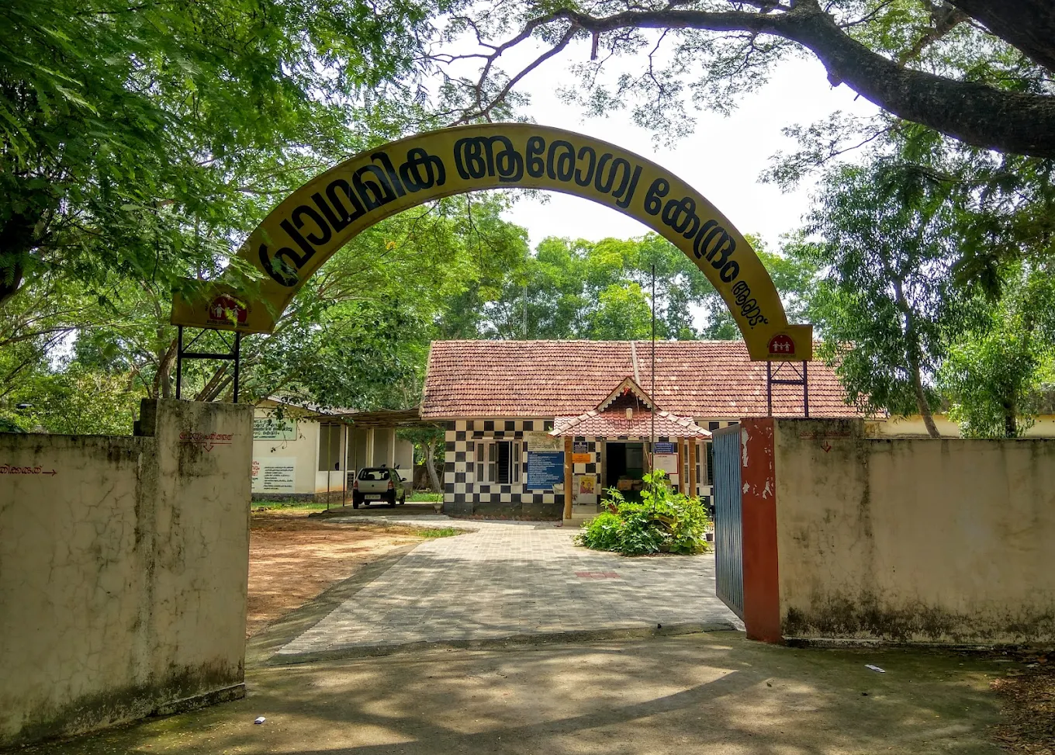
Primary Health Centre Aryad

Private sector capacity within the Panchayat is represented by Providence Hospital, a super-specialty facility with 40 inpatient beds and 6 ICU beds, serving as a key referral point for advanced care. While ventilator availability is limited (2 units) and oxygen-supported beds are not designated separately, the facility provides essential secondary and tertiary care support during emergencies, particularly for severe cases requiring inpatient management.
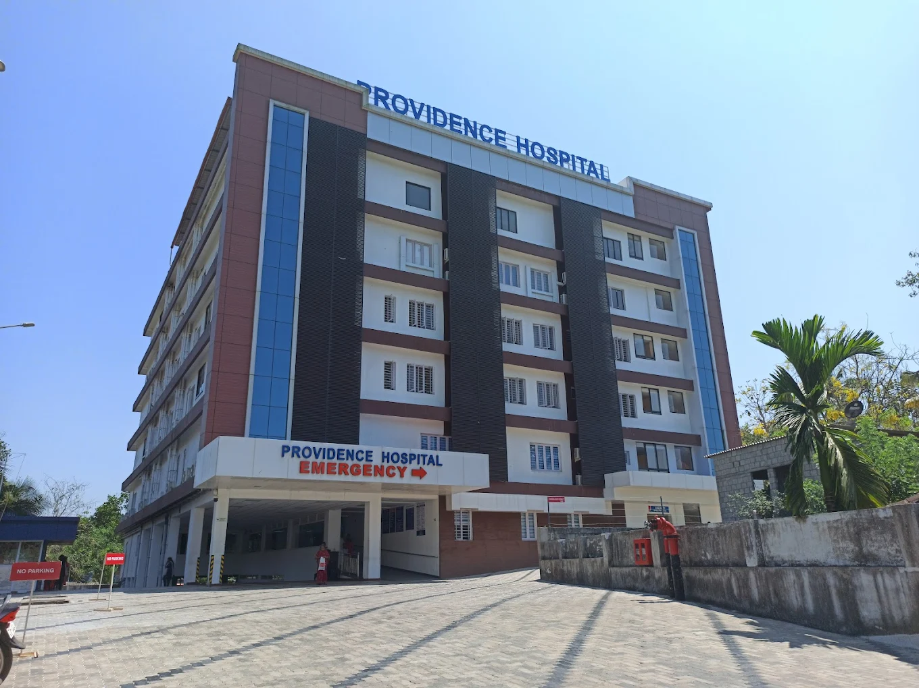
Providence Hospital, Thumpoly

The Panchayat also hosts AYUSH facilities, including a Government Ayurveda Dispensary and a Homoeo Hospital. Although these facilities do not have inpatient or critical care capacity, they contribute to outpatient care, supportive treatment, and continuity of care for chronic conditions, thereby reducing unnecessary burden on allopathic health facilities during emergencies

Health Facility Capacity Summary – Aryad Panchayat

Facility Type | No. of Facilities | Total Beds | ICU Beds | O₂ Beds | Ventilators | Ambulances | Key Contacts
Government (PHC + S/C) | 8 | 0 | 0 | 0 | 0 | 0 | PHC: 9497340143
Private | 1 | 40 | 6 | 0 | 2 | 0 | Providence: 8156802151
AYUSH | 2 | 0 | 0 | 0 | 0 | 0 | Ayurveda: 8547804398
PANCHAYAT TOTALS | 11 | 40 | 6 | 0 | 2 | 0 | —

Private Clinics
Private clinics are an essential part of pandemic preparedness, as they are often the first-place people seek care when symptoms begin. In many communities, private clinics manage a significant share of outpatient visits and therefore play a critical role in early case detection, timely referrals, and disease surveillance. Having an up-to-date understanding of where these clinics are located, the services they provide, and how they are linked to the public health system helps ensure that no cases are missed during an outbreak. It also allows health authorities to engage private practitioners more effectively for reporting, risk communication, and coordinated response, strengthening the overall capacity of the health system to manage public health emergencies.

Table 6. Private Clinic Resource Summary
Sl No. | Name of Clinic | Registered | Clinic | Address | Contact | Diagnostic Facility | Ambulance Linkage
1 | family dental care | N | General and dental | avalookunnu  south aryad ,ward 10 | 9745167391 | N | N
2 | SR Life Care Medical And Dental Family Clinic | N | General and Dental | Ward 4 ,avalookunnu p o | 9747772779 | N | N
3 | Homeo Clinic | N | General | Dr Madanappan  chittuvelikkakam  ward 11 | 9846415346 | N | N
4 | Dr Usha Lal | Y | Homeo | ward 11  avalookunnu p o  south aryad | 9400448200 | N | N
5 | Homeo Clinic | N | General | ward 7  avalookunnu p o | 8129932585 | N | N

Healthcare Education & Training Institutions
This section tracks the educational infrastructure available, which is vital for human resource planning in the health sector.

Category of Institution | Govt | Private | AYUSH | Total
Medical Colleges | 0 | 0 | 0 | 0
Nursing Colleges | 0 | 0 | 0 | 0
Dental Colleges | 0 | 0 | 0 | 0
Para-medical / Allied Health | 0 | 0 | 0 | 0
Pharmacy Colleges | 0 | 0 | 0 | 0

Specialized Services & Emergency Inventory
This section provides a detailed view of the specialized medical resources available to the community, focusing on emergency response and critical care capabilities. This table tracks the vital assets required for managing severe illnesses and emergencies across Government, Private, and AYUSH sectors.

Item | Govt | Private | AYUSH | Total
Hospital beds | 0 | 40 | 0 | 40
Oxygen-generating systems(Y/N) | NO | YES | NO
Oxygen-supported beds(Numbers) | 0 | 0 | 0 | 0
Ventilator supported beds | 0 | 2 | 0 | 2
ICU beds | 0 | 6 | 0 | 6
Burns units | 0 | 0 | 0 | 0
Blood banks | 0 | 0 | 0 | 0
BLS ambulances | 0 | 0 | 0 | 0
ALS ambulances | 0 | 0 | 0 | 0
Dialysis facilities | NO | YES | NO | NO
Dispensaries | 0 | 0 | 3 | 3
Medical store | 0 | 6 | 2 | 8
Industrial establishments (medium-scale industries/small-scale industries establishments to whom we can depend in a worst-case scenario) | 0 | 0 | 0 | 0

The data reveals the distribution of critical care infrastructure within the LSGD. Providence hospital facilities currently hold the largest share of ICU capacity, while the providence hospital sector provides the majority of oxygen-supported beds, which are crucial for pandemic and respiratory emergency preparedness.

Oxygen & Diagnostic Capacity
Monitoring oxygen and diagnostic capacity is a critical component of public health preparedness, ensuring that the LSGD can handle both chronic care and sudden surges in respiratory or infectious diseases.
Name of Health Facility | Oxygen-generating System (Y/N) | Backup Oxygen Source (Y/N) | Diagnostic Facilities Available(Y/N)
Name of Health Facility | Oxygen-generating System (Y/N) | Backup Oxygen Source (Y/N) | Lab | USG | X-ray | CT/MRI | RT-PCR
Government Healthcare Facilities
PHC ARYAD | NO | NO | YES | NO | NO | NO | NO
ESI HOSPITAL | NO | NO | NO | NO | NO | NO | NO
Private Healthcare Facilities
PROVIDANCE HOSPITAL | YES | YES | YES | YES | YES | NO | YES

Diagnostics Summary
The diagnostic capacity of ARYAD PANCHAYATH represents the "intelligence network" of our healthcare system. The speed and accuracy of disease identification depend entirely on the distribution and technical level of these facilities.

Item | Govt | Private | AYUSH | Total
General labs | 1 | 6 | 0 | 7
Microbiology labs | 0 | 0 | 0 | 0
RT-PCR labs | 0 | 0 | 0 | 0
USG units | 0 | 0 | 0 | 0
CT/MRI units | 0 | 0 | 0 | 0

The availability of General and Microbiology labs at the local level is the primary determinant of the Turnaround Time (TAT) for basic disease identification. Currently, the LSGI has 7 labs. Of these, ONE is operated by the Government, while six are Private.

Advanced imaging is vital for trauma management and detecting complications from infectious diseases (such as pneumonia via CT scans). There are currently one USG units and 0 CT/MRI units available. If these units are absent within the LSGI limits, the designated emergency transit route for imaging is to Sankar Lab and GH Alappuzha, which is approximately 6.5 km away.

The presence of RT-PCR labs is a direct indicator of pandemic self-sufficiency. With one RT-PCR units, the LSGI can manage low volumes of gold-standard testing locally. Facilities without RT-PCR capacity must maintain a strict "Sample Collection & Transport" protocol to ensure samples reach the nearest lab within half an hours.

Laboratory Identification & Basic Details
Sl. No. | Name of Laboratory | Ownership | Address | Contact No. | 24×7 Services (Yes/No)
1 | Kanivu Lab | Private | Avalookunnu P.O., South Aryad | 9446549380 | No
2 | Neethi lab | Private | Near post office, Komalapuram | 025416662 | No
3 | sankar lab | Private | Avalookunnu P.O., South Aryad | 9995224488 | No
4 | Nucleus lab | Private | Avalookunnu P.O., South Aryad | 9496919604 | No
5 | Kanivu Lab | Private | Avalookunnu p o, south aryad | 9446549380 | No

Social and Community Infrastructure for Emergency Use
This table serves as your logistics and shelter inventory. By mapping these locations, you can quickly identify where to house displaced citizens, where to set up temporary medical clinics, and how to manage the deceased with dignity during a crisis.
Category | Total Count | Total strength/Capacity
Educational Institutions
Anganwadis | 29 | 358
Schools | 6 | 5350
Colleges | 1 | 100
Healthcare Educational Institutions
Medical colleges (Govt/Private) | 0 | 0
Nursing colleges (Govt/Private) | 0 | 0
Dental colleges (Govt/Private) | 0 | 0
Paramedical institutes (Govt/Private) | 0 | 0
Community Gathering Spaces
Community halls | 1 | 1000
Auditoriums | 3 | 600
Religious buildings | 29 | 1225
Vulnerable Group Support Facility
Destitute homes | 0 | 0
Elderly homes | 0 | 0
LSGD owned other buildings | 1 | 20
Mass Fatality Management (MFM) Infrastructure
Mortuary | 0 | 0
Crematorium | 0 | 0

Human resources
This section focuses on the human capital available within the LSGI. In any emergency—be it a pandemic, flood, or industrial accident—infrastructure is only as effective as the people operating it.

Medical & Clinical Personnel
This table tracks the "Frontline" providers responsible for diagnosis, treatment, and clinical management. Narrative sentence: eg., "Total health workforce: 450 personnel, with 60% in government facilities serving as primary surge capacity." A detailed directory with the contact numbers of all workers is maintained (Annexure 1).

Cadre | Govt (No.) | Private (No.) | Total
Doctors—Modern Medicine | 3 | 39 | 42
Doctors – AYUSH | 1 | 1 | 2
Doctors – Veterinary | 1 | 0 | 1
Doctors – Dental | 0 | 6 | 6
Nursing officers | 2 | 24 | 26
Lab technicians | 1 | 6 | 7
Optometrist | 1 | 2 | 3
Pharmacists | 2 | 4 | 6
Psychologists | 0 | 0 | 0
Counsellors | 0 | 0 | 0

Public Health & Field-Level Workforce
These individuals are the backbone of surveillance, maternal-child health, and decentralized care.

Cadre | Government/Municipal | Total
HS (Health Supervisors) | 0 | 0
HI (Health Inspectors) | 1 | 1
LHS (Lady Health Supervisor) | 0 | 0
LHI (Lady Health Inspectors) | 1 | 1
JPHN (Jr Public Health Nurses) | 5 | 5
JHI (Jr Health Inspectors) | 4 | 4
MLSP (Mid-Level Service Providers) | 5 | 5
Palliative Nurses | 1 | 1
RBSK Nurses | 1 | 1
PRO | 0 | 0

Community & Support Cadre
This group represents the surge capacity of the LSGI—people who can be called upon for logistics, rescue, and specialized support.

Cadre | Number
ASHA Workers | 31
AWW (Anganwadi Workers) | 29
Emergency Medical Volunteers (Trained) | 125
Kudumbashree | 310
Purusha Swayam Sahaya Sangam | 190
Ex-Servicemen | 118
Retired Police Officers | 50
NCC/NSS Volunters | 100
One Health Community Volunteers | 441
One Health Community Mentors | 126

Community Organizations
This section details the presence of community-based organizations (CBOs), non-governmental organizations (NGOs), faith-based organizations (FBOs), Kudumbashree Self-Help Groups (SHGs), and Ayalkootams within the Local Self-Government Institution (LSGI). These groups enhance grassroots mobilization, resource distribution, and support networks crucial for pandemic response and community resilience.

Category | Total Count
NGOs | 6
CBOs (Resident Associations/Libraries) | 14
FBOs | 4
Sports Club | 13
Kudumbashree SHGs | 310
Ayalkootams | 310

Administrative & Emergency Services
This section outlines the availability of key non-health emergency support services and infrastructure within the LSGI, which are essential for effective pandemic preparedness and response. These facilities support law enforcement, disaster response, water supply, logistics, mobility, and community-level interventions during public health emergencies.

Category | Total Count
Police Stations | 0(under Alappuzha North Police Station)
Fire & Rescue Stations | 0
Water Pumping Points | 2
Public Distribution System (PDS) | 9

Information regarding resources
The availability of essential transport and support resources plays a quiet but critical role in saving lives. Equipment such as ambulances, mobile mortuaries, amphibian ambulances, and motorized boats ensures that patients, samples, and healthcare teams can move swiftly—even in flooded, remote, or difficult terrains. Heavy vehicles like JCBs, cranes, tractors, and torus lorries support logistics, waste management, emergency infrastructure, and rapid conversion of spaces into care or isolation facilities. Taxis, four-wheel-drive vehicles, and trucks help maintain continuity of essential services, reach vulnerable populations, and support home-based care and supply delivery.

Means of transportation | Total Count
JCB | 1
Crane | 0
Heavy Trucks | 0
Tractor | 0
Ambulances | 1
Mobile mortuaries | 0
Boats | 48
houseboats | 3
Taxi service | 8

Note: For specific details regarding vehicle owners and contact information, please refer to Annexure 1.10.

ONE HEALTH & ENVIRONMENTAL SURVEILLANCE
The One Health method integrates environmental, animal, and human health to enable proactive pandemic preparedness. Panchayat-level surveillance needs to be improved in order to detect and treat zoonotic and environmentally generated diseases early. Surveillance is strengthened through systematic assessment of animal populations, veterinary infrastructure, poultry and slaughter facilities, inter-sectoral coordination, and specialised tools like avian influenza seasonality mapping using GIS in previous outbreaks to enable predictive alerts and ward-specific sampling to support effective pandemic preparedness in high-risk areas like Alappuzha.

Animal & Bird Population
Mapping animal and bird populations at the Panchayat level is essential for identifying and prioritising zoonotic disease hazards like rabies, avian influenza (H5N1), leptospirosis, anthrax, and Nipah-like spillover occurrences. Risk classification, targeted surveillance, vaccination planning, and early epidemic detection made feasible by comprehensive population mapping all enhance One Health-based pandemic preparedness.

Category | Item | Estimated Population | Wards
Animal Population | Livestock (Cattle/Goats/Buffalo) | 1241 | 3, 4, 14, 18, 20
Animal Population | Pet Animals (Dogs/Cats) | 2081 | All wards
Animal Population | Stray Dog Population | 250 | All wards
Animal Population | Pig Farms (Number of heads) | 0 | 0
Animal Population | Small Units (Sheep / Goats – clustered) | 0 | 0
Bird Population | Poultry Units (Birds) | 474 | 8, 9, 17, 20
Bird Population | Poultry – Backyard / Unorganised | 356 | All wards
Bird Population | Duck Rearing Units | 1 unit | 20
Bird Population | Wild/Migratory Birds (Observed) | Absent | -
Bird Population | Crow Mortality Events (Reported) | Absent | -

The main risk of zoonotic diseases in Aryad Grama Panchayath is concentrated in almost all wards, which is explained by the high density of cattle farms, cattle congregation areas, and poultry units. The stray dog population in Chempenthara continues to be a substantial problem for rabies surveillance and bite prevention. There is a considerable risk of avian influenza introduction and amplification during October-March due to the seasonal presence of migratory and resident water birds near Vembanad Lake. Clustering of cattle farms and animal shelters vulnerable to flooding further raise the risk of leptospirosis and other zoonoses mediated by the environment, especially during monsoon floods.

Veterinary Infrastructure
Facility Type | Name of Facility | Ownership | Ward(s) | Contact number
Veterinary Dispensary | Govt Veterinary Hospital | Govt | 6 | 9496466217
Veterinary Hospital / Polyclinic | 0 | 0 | 0 | 0
Private Veterinary Clinics | Sara's Birds and exotic animal hospital | Private | 16 | 8732985563
Mobile / Emergency Vet Service (incl. night services) | 0 | 0 | 0 | 0
Pet Homes / Animal Shelters | 0 | 0 | 0 | 0
Slaughterhouse-linked Veterinary Inspection Unit | Poomkavu Meat Stall | Private | 20 | 9447659079
Veterinary institutions are a core pillar of One Health surveillance, enabling early zoonotic disease detection through vaccination, investigation of unusual animal illness or deaths, sample collection, and timely outbreak reporting. A well-mapped and responsive veterinary network strengthens coordination with human health and LSGI systems, ensuring rapid response during zoonotic events and pandemics.

The LSGD is served by one Government Veterinary Dispensary(ies) and Hospital(s); however, limited mobile and 24×7 emergency services may delay detection of sudden animal deaths, especially during night hours, monsoon floods, and avian influenza high-risk seasons. To address this gap, one private veterinary facilities have been empanelled for outbreak response and integrated into the One Health rapid reporting system through defined alert mechanisms, SOPs, and designated nodal officers.

Veterinary Doctors & Workforce
Early detection, diagnosis, reporting, and reaction to animal illness epidemics depend on the availability and accessibility of qualified veterinary specialists. Through timely identification of unusual animal morbidity or mortality, timely sample collection, and efficient coordination with human health and LSGI systems—especially during zoonotic outbreaks and pandemic-prone situations—a clearly defined veterinary workforce enhances One Health surveillance.
Category | Number Available | Type (Govt/Pvt) | Contact number
Government Veterinary Doctors | 1 | Govt | 1)Rechan R  9496466217
Private Veterinary Doctors | 1 | Pvt | Dr Sara  8732985563
Livestock Inspectors | 1 | Govt | Subash N  9496229975
Para-veterinary Staff / Attenders | 2 | Govt | Raakhil T M  7907380700,  Raji Saji  9142415568
Contract / On-call Veterinary Support | no | NA | NA

High-Risk Interface Points (Surveillance Sites)
High-risk interface points are places where people, animals, and the environment interact frequently, closely, or without protection, which raises the risk of zoonotic disease amplification and spillover. In order to discover animal-to-human transmission concerns early, particularly during monsoon, flood, and avian influenza high-risk seasons, routine mapping, inspection, and surveillance of these sites are essential components of One Health readiness.
Category | Total Count | Wards | Key Locations
Large Poultry Farms | 0 | 0 | 0
Backyard / Clustered Poultry Units | 0 | 0 | 0
Duck Rearing Units (open water access) | 0 | 0 | 0
Slaughterhouses/ Slaughter Points | 1 | 1 | near Poomkavu
Meat/Fish Markets | 0 | 0 | 0
Live Bird Sale Points | 0 | 0 | 0
Cattle Markets / Weekly Animal Fairs | 0 | 0 | 0
Pet Shops / Breeders | 1 | 1 | near AS canal
Animal Shelters / Pet Homes | 0 | 0 | 0
Waste Disposal Sites near Animal Units | 0 | 0 | 0

Environmental Risk Mapping
Environmental risk mapping identifies monsoon/flood hotspots for vector-borne (dengue, chikungunya), water-borne (leptospirosis, diarrhoea), and zoonotic diseases in Kerala's wetlands. Systematic surveillance supports early warnings, targeted interventions, and Panchayat pandemic preparedness.
Risk Factor | Presence (Yes/No) | High-Risk Wards | Key Locations | Risk Level (High/Med/Low)
Flood-prone areas | yes | 7,9,10,19 | chempenthara,  thumpoly | high
Water bodies/wetlands | yes | 1.2,14,17 | chempenthara,thumpoly | high
Solid waste accumulation | yes | 1 | pathirapally | medium
Animal waste disposal issues | 0 | 0 | 0 | 0
Rodent infestation zones | 0 | 0 | 0 | 0
Industrial effluent discharge | 0 | 0 | 0 | 0
Construction sites / abandoned buildings | 76 | 1,2,3….20 | ALL WARDS | MEDIUM
Poor drainage/blocked canals | 0 | 0 | 0 | 0
Drinking water source contamination risk | 0 | 0 | 0 | 0
Wards 7,9,10, especially those adjacent to backwater are highly vulnerable to seasonal flooding, increasing the risk of leptospirosis, diarrheal diseases, and skin infections. Solid and animal waste accumulation in pathirapally further elevates zoonotic and occupational risks, while wetlands, poor drainage, and construction sites act as mosquito breeding hotspots, necessitating intensified source reduction, larvicidal measures, and targeted fogging during August & September, with active community participation.

Disease Seasonality Mapping
In zoonotic, vector-borne, and water-borne diseases, disease seasonality mapping identifies time- and environment-driven trends for targeted prevention, early warnings, and anticipatory surveillance. Variations in Alappuzha are caused by wetlands, floods, monsoon rains, animal migration, and migrating birds. By incorporating this into Panchayat surveillance, pandemic preparedness and quick reaction are increased.
Disease | Peak Risk Season | Key Drivers | High-Risk Locations | Surveillance Focus
Leptospirosis | Monsoon | Rodent, Flood,Contaminated Water | Chempenthara | Fever Survey, Doxy, Rodent Control
Dengue/  Chikungunya | Monsoon | Mosquitoes, Stagnant Water, Coconut Shell | Aryad Maincentre, Chempenthara | Source Reduction, Fever Survey
Acute Diarrheal Diseases | Monsoon | Contaminated Water | Chempenthara, | Water Quality Testing,Chlorination
Rabies | All Year | Stray Dog | All wards | Mass Dog Vaccination, Public Awareness

Vulnerability Mapping
Vulnerability mapping pinpoints high-risk populations, occupations, and areas exposed via environment, livelihoods, socio-economics, and poor service access. Paired with environmental/seasonality mapping, it enables risk-based surveillance, targeted actions, and optimal resource use in One Health and pandemic planning.
Vulnerability Factor | Presence | High-Risk Wards | Key Groups / Locations | Risk Level
Flood-prone households | Yes | 7.9 | Chempenthara | Medium
Wetland-adjacent communities | Yes | 7.9 | Chempenthara | Medium
Slaughterhouse & meat market workers | Yes | 20 | Near Poomkavu | Medium
Fisherfolk & fish market workers | Yes | 7, 8, 17 | Chempenthara, Thumpoly | Medium
Daily wage / migrant workers | Yes | 2, 7, | Chempenthara, Maincentre | Medium
Elderly & chronically ill populations | Yes | All Wards | All Wards | Medium
Pregnant Women | Yes | All Wards | Aikyabharatham, Chempenthara, South Aryad, Thumpoly, Main Centre | Medium
Children (schools, Anganwadi’s) | Yes | All Wards | All S/C | Medium

EPIDEMIOLOGICAL TRENDS (2021–2025)

Disease surveillance is the systematic collection, analysis, and interpretation of health data for planning, implementation, and evaluation of public health practice. This section presents the disease surveillance profile of the LSGI based on routine reporting systems and outbreak investigations to identify priority diseases, seasonal patterns, and emerging public health threats.

Disease Burden among human beings (Last 5 Years)
Analysis of disease-wise data for the last five years helps identify persistent public health problems, emerging diseases, and changes in disease burden. This information supports prioritization of prevention, preparedness, and response activities at the Panchayat level.

Disease | 2021 | 2022 | 2023 | 2024 | 2025 | 5-Year Total | Trend
Dengue | 3 | 4 | 20 | 25 | 11 | 63 | Increasing
Leptospirosis | 7 | 3 | 10 | 2 | 3 | 25 | Increasing
Hepatitis A | 0 | 0 | 0 | 4 | 1 | 5 | Decreasing
Malaria | 0 | 0 | 0 | 1 | 2 | 3 | Increasing
Scrub Typhus | 0 | 0 | 0 | 0 | 1 | 1 | Increasing
Typhoid | 0 | 0 | 0 | 0 | 1 | 1 | Increasing
H1N1 | 0 | 0 | 0 | 0 | 12 | 12 | Increasing
H3N2 | 0 | 0 | 0 | 0 | 1 | 1 | Increasing
ADD | 59 | 105 | 72 | 87 | 52 | 375 | Decreasing
Mumps | 0 | 0 | 0 | 0 | 34 | 34 | Increasing
Measles | 0 | 0 | 0 | 0 | 0 | 0 | Stable
Hepatitis B | 0 | 0 | 0 | 0 | 0 | 0 | Stable
Hepatitis C | 0 | 0 | 0 | 0 | 0 | 0 | Stable
Tuberculosis | 17 | 16 | 21 | 22 | 19 | 95 | Decreasing
Leprosy | 0 | 0 | 0 | 0 | 0 | 0 | Stable
COVID-19 | 0 | 0 | 0 | 0 | 0 | 0 | Stable

The table records annual disease cases from 2021 to 2025 and their 5‑year totals. Based on the data from the last five years, dengue & tuberculosis remain the most frequent endemic challenge for Aryad panchayath.. Dengue continues to be a significant endemic challenge, with an average of 18 cases reported annually. The majority of cases are recorded during the monsoon and immediate post-monsoon period (June–September), Leptospirosis remains a threat and has 25 cases in total, while hepatitis A, malaria, and scrub typhus each have single‑digit totals.
Based on the data from the last five years, Acute Diarrhoeal Disease (ADD) remains the most frequent endemic public health challenge in Aryad Grama Panchayath. On average, approximately 75 cases are reported annually. The magnitude of cases indicates ongoing vulnerabilities related to drinking water safety, sanitation infrastructure, food handling practices, and monsoon-related contamination. The emergence of hepatitis A cases in recent years further supports the need for sustained WASH interventions, safe water monitoring, and rapid outbreak response mechanisms at the ward level.
Tuberculosis totals 95 cases, which may reflect improved case detection, active case finding, or delayed health-seeking behavior during post-pandemic periods. This trend underscores the importance of integrating TB surveillance and treatment continuity into emergency preparedness planning, ensuring uninterrupted diagnostic and treatment services during public health emergencies. Overall the above data highlights dengue, ADD, and tuberculosis as the major health concerns over the five years.

Seasonal Trend Analysis
Seasonal analysis helps anticipate surges (e.g. dengue in monsoon, leptospirosis after floods, influenza in cooler months) and plan pre‑emptive vector control, stockpiling of IV fluids, and awareness campaigns at Panchayat level.

DENGUE
Dengue is a major seasonal vector-borne disease strongly associated with rainfall, water stagnation, and increased mosquito breeding during the monsoon period.

Peak: July–September
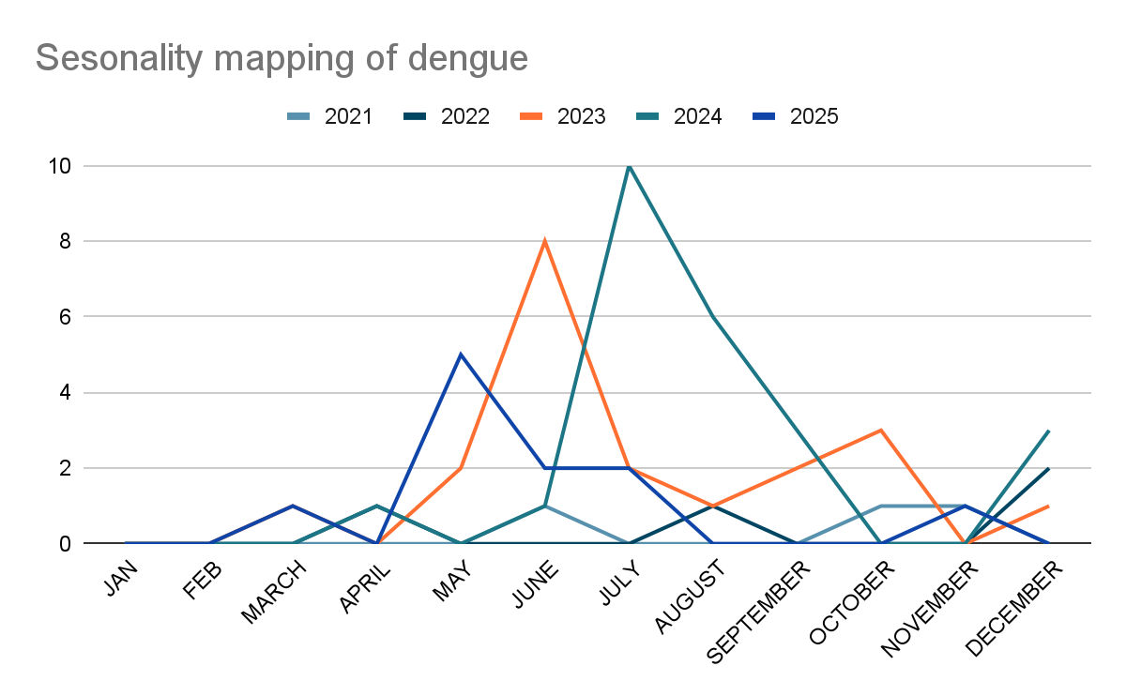

The line graph illustrates a recurrent seasonal surge in dengue cases during the monsoon and immediate post-monsoon months, highlighting the importance of early preparedness and sustained vector control activities.

Dengue – Ward-wise Distribution
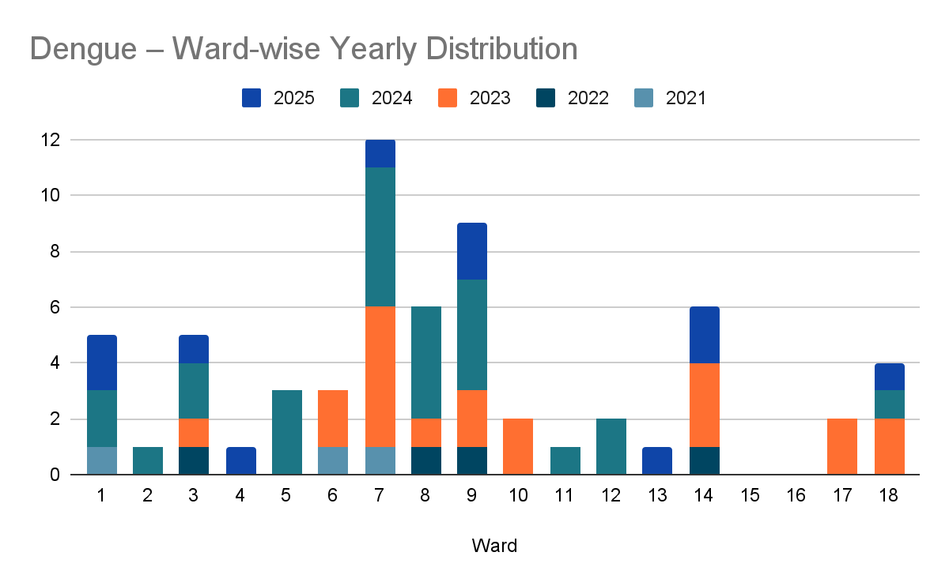

Ward-wise Trend of Dengue Cases in Aryad Panchayat (2021–2025)

The chart shows the ward‑wise yearly distribution of dengue cases from 2021 to 2025. Most wards report 1–2 cases each year, but Ward 7 spikes with 5 cases each in two years, making it the highest incidence. Wards 8 and 9 also see notable cases. Wards 15 and 16 remain dengue‑free throughout the period. The data indicates concentrated outbreaks, suggesting targeted interventions may be needed. Repeated reporting from the same wards across multiple years suggests the presence of persistent environmental risk factors such as water stagnation, dense housing patterns, or inadequate solid waste management. These findings support the need for ward-specific micro-planning, intensified entomological surveillance, and focused behaviour change communication in identified high-risk wards, particularly during the pre-monsoon and monsoon periods.

Dengue – Ward-wise Yearly Distribution (2021–2025)

Ward | Dengue – Ward-wise Yearly Distribution
Ward | 2021 | 2022 | 2023 | 2024 | 2025 | Total
1 | 1 | 0 | 0 | 2 | 2 | 5
2 | 0 | 0 | 0 | 1 | 0 | 1
3 | 0 | 1 | 1 | 2 | 1 | 5
4 | 0 | 0 | 0 | 0 | 1 | 1
5 | 0 | 0 | 0 | 3 | 0 | 3
6 | 1 | 0 | 2 | 0 | 0 | 3
7 | 1 | 0 | 5 | 5 | 1 | 12
8 | 0 | 1 | 1 | 4 | 0 | 6
9 | 0 | 1 | 2 | 4 | 2 | 9
10 | 0 | 0 | 2 | 0 | 0 | 2
11 | 0 | 0 | 0 | 1 | 0 | 1
12 | 0 | 0 | 0 | 2 | 0 | 2
13 | 0 | 0 | 0 | 0 | 1 | 1
14 | 0 | 1 | 3 | 0 | 2 | 6
15 | 0 | 0 | 0 | 0 | 0 | 0
16 | 0 | 0 | 0 | 0 | 0 | 0
17 | 0 | 0 | 2 | 0 | 0 | 2
18 | 0 | 0 | 2 | 1 | 1 | 4

LEPTOSPIROSIS
Leptospirosis cases are closely linked to monsoon rains, flooding, and occupational exposure, particularly in low-lying and waterlogged areas.

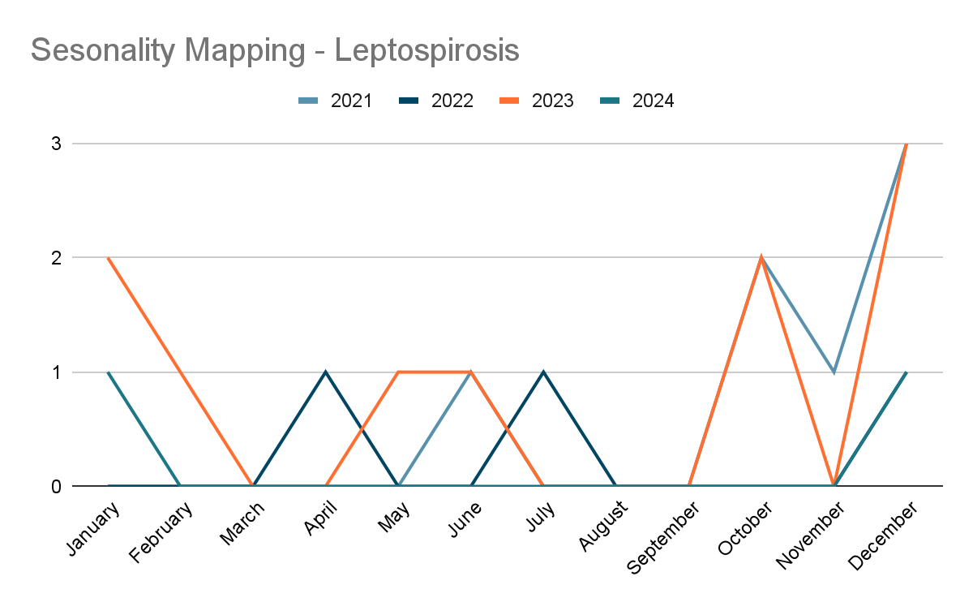
Analysis of reported cases from 2021 to 2025 indicates a clear seasonal clustering during the monsoon and immediate post-monsoon months, with cases reported predominantly between June and November.

Leptospirosis—Ward-wise Distribution

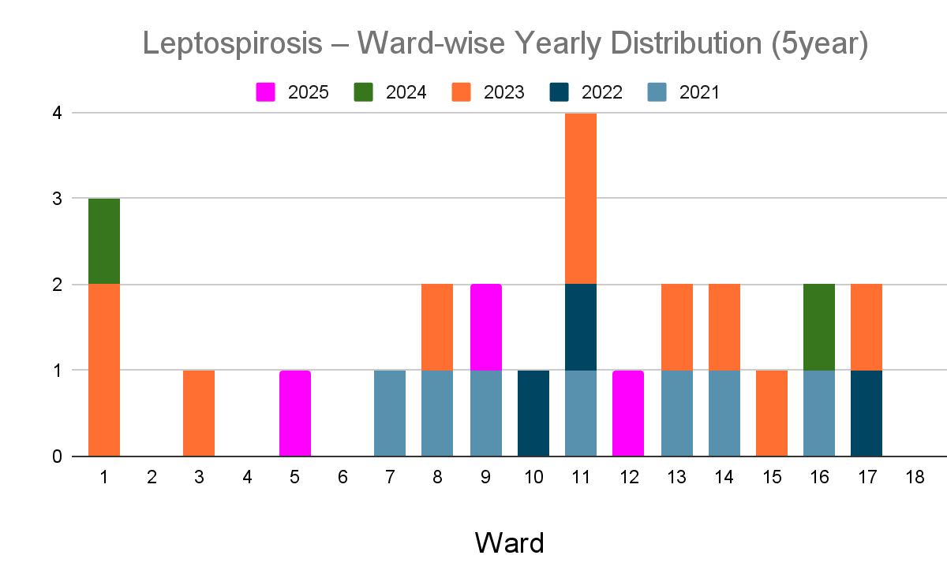

Ward-wise Trend of Leptospirosis Cases in Aryad Panchayat (2021–2025)

The leptospirosis case trend in Aryad from 2021 to 2025 shows a low overall incidence. The disease activity spikes in 2023, which accounts for the largest number of 10 cases. Ward 11 had the highest spike—4 cases total over the last 5 years. The distribution across multiple wards suggests a widespread risk for outdoor workers. Prophylactic coverage must therefore be expanded beyond the FHC staff to include the Haritha Karma Sena, MGNREGS workers, and local farmers residing in these specific wards.

Leptospirosis – Ward-wise Yearly Distribution (2021–2025)
Ward | Leptospirosis – Ward-wise Yearly Distribution
Ward | 2021 | 2022 | 2023 | 2024 | 2025 | Total
1 | 0 | 0 | 2 | 1 | 0 | 3
2 | 0 | 0 | 0 | 0 | 0 | 0
3 | 0 | 0 | 1 | 0 | 0 | 1
4 | 0 | 0 | 0 | 0 | 0 | 0
5 | 0 | 0 | 0 | 0 | 1 | 1
6 | 0 | 0 | 0 | 0 | 0 | 0
7 | 1 | 0 | 0 | 0 | 0 | 1
8 | 1 | 0 | 1 | 0 | 0 | 2
9 | 1 | 0 | 0 | 0 | 1 | 2
10 | 0 | 1 | 0 | 0 | 0 | 1
11 | 1 | 1 | 2 | 0 | 0 | 4
12 | 0 | 0 | 0 | 0 | 1 | 1
13 | 1 | 0 | 1 | 0 | 0 | 2
14 | 1 | 0 | 1 | 0 | 0 | 2
15 | 0 | 0 | 1 | 0 | 0 | 1
16 | 1 | 0 | 0 | 1 | 0 | 2
17 | 0 | 1 | 1 | 0 | 0 | 2
18 | 0 | 0 | 0 | 0 | 0 | 0

VIRAL HEPATITIS - A
Hepatitis A cases are commonly associated with unsafe drinking water, food contamination, and breakdowns in sanitation, often presenting as clusters or outbreaks.
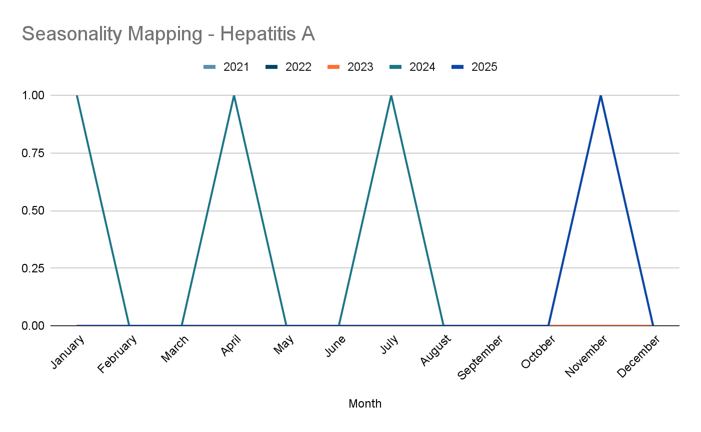

Month-wise Distribution of Hep A Cases in Aryad Grama Panchayat (2021–2025)

Analysis of reported Hepatitis A cases during 2021–2025 indicates sporadic occurrence with low overall case numbers, with cases reported primarily during mid-year and end-of-year months. Although the absolute number of cases remains limited, the temporal clustering suggests seasonal vulnerability related to monsoon-associated water contamination and post-monsoon sanitation challenges.

Hepatitis A – Ward-wise Distribution

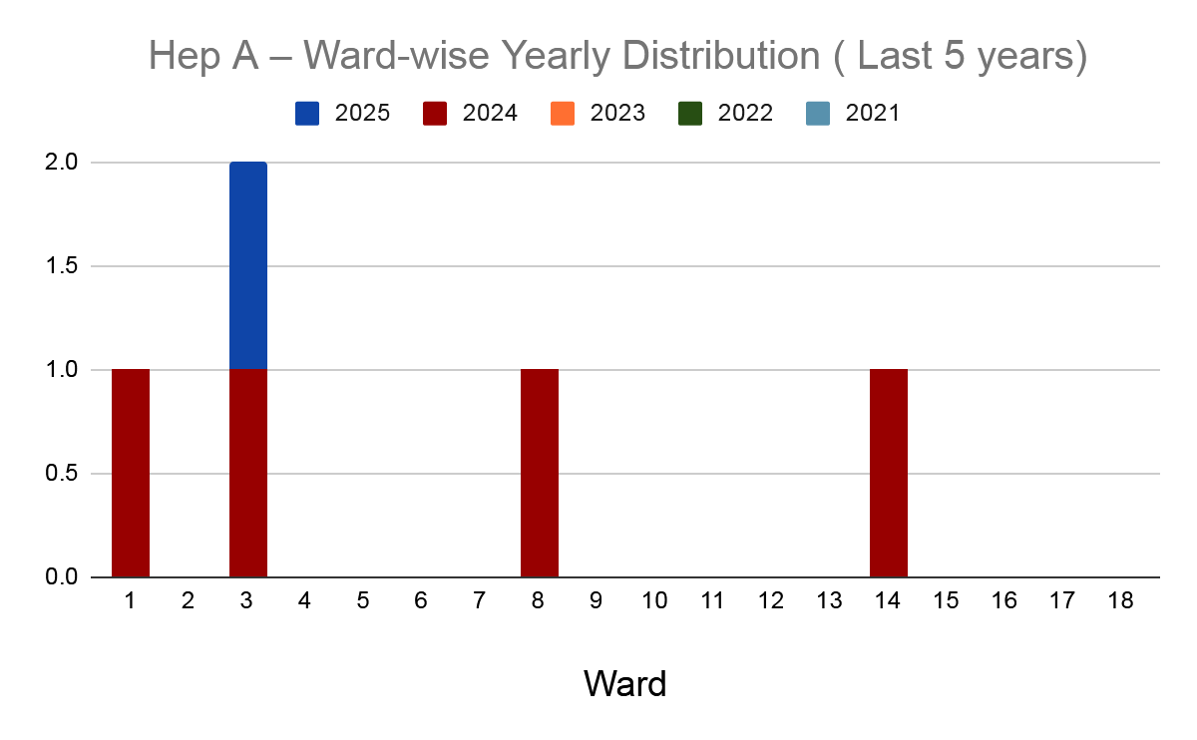

Ward-wise Trend of Hepatitis A Cases in Aryad Panchayat (2021–2025)

Ward-wise analysis of Hepatitis A cases during 2021–2025 indicates limited and sporadic distribution, with cases reported in only a few wards and no ward showing sustained transmission across multiple years. The cases are concentrated in Wards 3, 8 and 14. The presence of cases in Ward 3 across both 2024 and 2025 suggests a persistent environmental or behavioral risk factor.

Hepatitis A – Ward-wise Yearly Distribution (2021–2025)

Ward | Hep A – Ward-wise Yearly Distribution
Ward | 2021 | 2022 | 2023 | 2024 | 2025 | Total
1 | 0 | 0 | 0 | 1 | 0 | 1
2 | 0 | 0 | 0 | 0 | 0 | 0
3 | 0 | 0 | 0 | 1 | 1 | 2
4 | 0 | 0 | 0 | 0 | 0 | 0
5 | 0 | 0 | 0 | 0 | 0 | 0
6 | 0 | 0 | 0 | 0 | 0 | 0
7 | 0 | 0 | 0 | 0 | 0 | 0
8 | 0 | 0 | 0 | 1 | 0 | 1
9 | 0 | 0 | 0 | 0 | 0 | 0
10 | 0 | 0 | 0 | 0 | 0 | 0
11 | 0 | 0 | 0 | 0 | 0 | 0
12 | 0 | 0 | 0 | 0 | 0 | 0
13 | 0 | 0 | 0 | 0 | 0 | 0
14 | 0 | 0 | 0 | 1 | 0 | 1
15 | 0 | 0 | 0 | 0 | 0 | 0
16 | 0 | 0 | 0 | 0 | 0 | 0
17 | 0 | 0 | 0 | 0 | 0 | 0
18 | 0 | 0 | 0 | 0 | 0 | 0

Outcome Based Trend Analysis- 2025
An approach for monitoring and analyzing the disease patterns based on the outcomes or impacts of specific interventions, policies, or public health measures and concerns. It shifts emphasis from merely tracking disease incidence to evaluating the effectiveness of prevention measures implemented for the disease. This type of analysis is crucial for understanding not only the spreadness of diseases but also how well the system is responding to them. This analysis evaluates the impact of various public health measures, determines whether these measures lead to reductions in disease prevalence, morbidity, mortality, or healthcare burden over time and this can be utilized modifying or improving existing health policies, resource allocation, and preparedness plans.

Sl. No. | Type of disease | Age group | Gender |  | Total no. of survival | Total no. of death | No. of cases received treatment
Sl. No. | Type of disease | Age group | No. of Male | No. of Female | Total no. of survival | Total no. of death | No. of cases received treatment
1 | Dengue | under 05 children | 0 | 0 | 0 | 0 | 0
2 | Dengue | 5-19 years | 1 | 2 | 3 | 0 | 3
3 | Dengue | 20-59 years | 4 | 4 | 8 | 0 | 8
4 | Dengue | 60+ (Seniors) | 0 | 0 | 0 | 0 | 0
1 | Lepto | under 05 children | 0 | 0 | 0 | 0 | 0
2 | Lepto | 5-19 years | 0 | 1 | 1 | 0 | 1
3 | Lepto | 20-59 years | 2 | 0 | 2 | 0 | 2
4 | Lepto | 60+ (Seniors) | 0 | 0 | 0 | 0 | 0
1 | VH-A | under 05 children | 0 | 0 | 0 | 0 | 0
2 | VH-A | 5-19 years | 0 | 0 | 0 | 0 | 0
3 | VH-A | 20-59 years | 0 | 1 | 1 | 0 | 1
4 | VH-A | 60+ (Seniors) | 0 | 0 | 0 | 0 | 0

Transmission Trend- 2025
For effective management of public health issues, it is important to track the trend of disease transmission mode. It helps to identify the population or the place under high risk that can be used to predict outbreaks, and implement targeted interventions as fast as possible. Understanding these kind of trends enables authorities to allocate resources efficiently and change the strategies adequately based on the trend that follows.

Mode of Transmission | No. of cases | No. of Deaths
Vector-Borne Diseases | 14 | 0
Water Borne Diseases | 62 | 0
Air Borne Diseases | 101 | 0
Blood Borne Diseases | 0 | 0
Food Borne Diseases | 0 | 0

Vector-Borne Disease (2025 )

Disease | No. of Cases | No. of Deaths
Dengue | 11 | 0
Malaria | 2 | 0
Chickengunea | 0 | 0
Yellow fever | 0 | 0

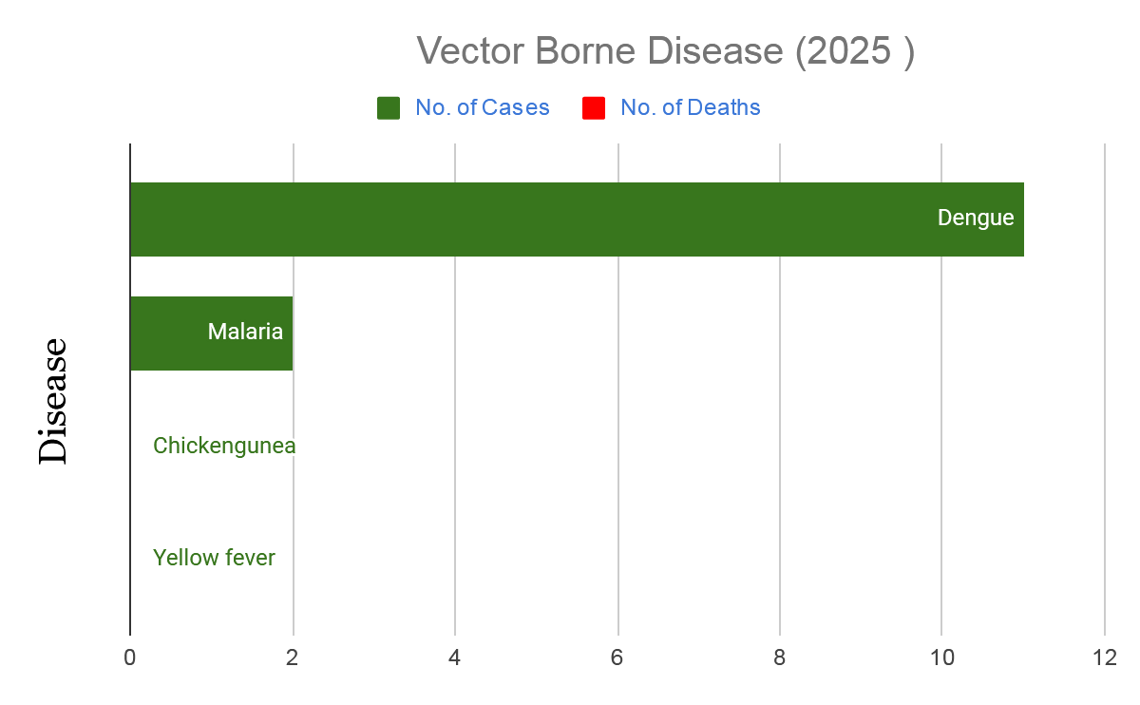

Water Borne Disease (2025 )

Disease | No. of Cases | No. of Deaths
Cholera | 0 | 0
Typhoid | 1 | 0
Hep- A | 1 | 0
Dysentery | 0 | 0
Amoebiasis | 0 | 0
E- Coli infections | 0 | 0

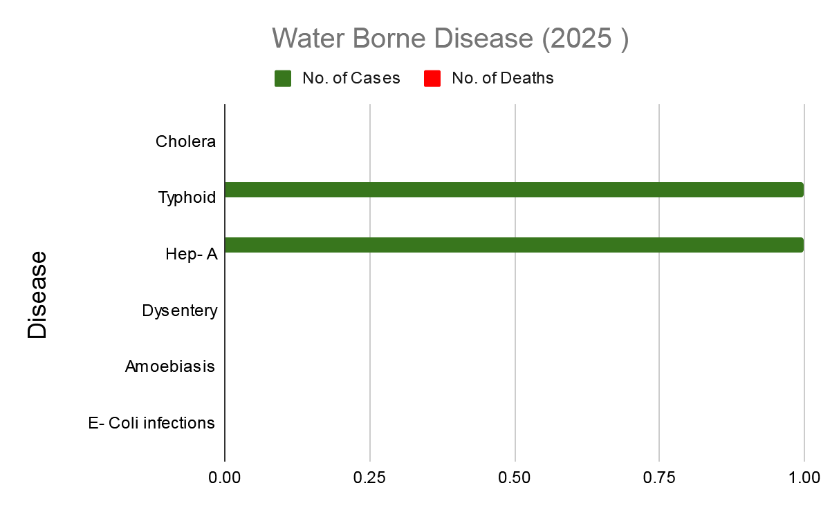

Air Borne Disease (2025)

Disease | No. of Cases | No. of Deaths
Influenza | 0 | 0
H1N1 | 0 | 0
TB | 19 | 1
Chickenpox | 46 | 0
Measles | 0 | 0
Covid-19 | 0 | 0
Pertussis | 0 | 0
Mumps | 36 | 0

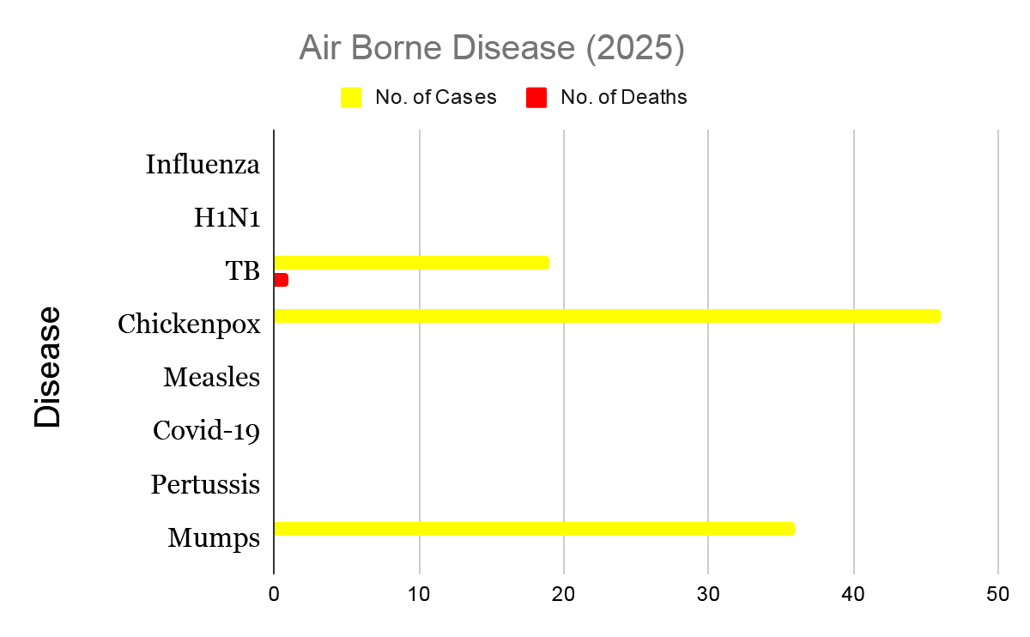

Blood Borne Disease (2025)

Disease | No. of Cases | No. of Deaths
AIDS | 0 | 0
Hep- B | 0 | 0
Hep- C | 0 | 0

Zoonotic Disease (2025)

Disease | No. of Cases | No. of Deaths
Rabies | 0 | 0
Leptospirosis | 3 | 0
Avian influenza | 0 | 0
West nile | 0 | 0
Anthrax | 0 | 0
Nipah | 0 | 0
Scrub Typhus | 1 | 0

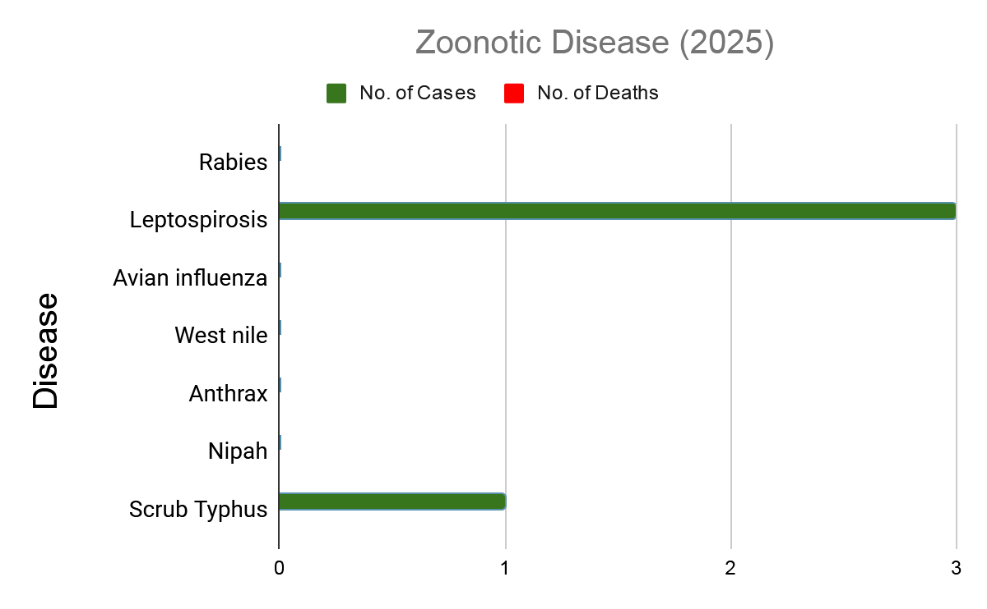

Integrated Disease Hotspot Map (2021–2025)

Integrated Health Risk & Disease Hotspot Map: Aryad Panchayat (2021–2025)

The integrated disease hotspot mapping for the period 2021–2025 reveals a heterogeneous distribution of communicable diseases across wards. Wards 14, 13, 9, and 7 emerged as high-burden areas, reporting the highest total number of cases, driven predominantly by ADD, along with recurrent dengue and leptospirosis cases. Wards 8, 1, and 10 also demonstrated consistently elevated disease occurrence, indicating persistent transmission risk.

In contrast, wards such as 2, 4, 5, and 18 reported comparatively lower cumulative case loads. Among these, Ward 7 is categorised as the highest-priority hotspot due to its combined flood vulnerability and high vector density. The coexistence of multiple diseases in several wards highlights shared environmental and sanitation-related risk factors, underscoring the need for integrated surveillance, targeted vector control, water safety measures, and inter-sectoral coordination in identified hotspot wards.
Ward No | Dengue Total (2021-25) | Leptospirosis Total (2021-25) | Hepatitis A Total (2021-25) | ADD (2021-25) | Total Cases
1 | 5 | 3 | 1 | 18 | 27
2 | 1 | 0 | 0 | 13 | 14
3 | 5 | 1 | 2 | 12 | 20
4 | 1 | 0 | 0 | 12 | 13
5 | 3 | 1 | 0 | 10 | 14
6 | 3 | 0 | 0 | 18 | 21
7 | 12 | 1 | 0 | 21 | 34
8 | 6 | 2 | 1 | 19 | 28
9 | 9 | 2 | 0 | 29 | 40
10 | 2 | 1 | 0 | 29 | 32
11 | 1 | 4 | 0 | 17 | 22
12 | 2 | 1 | 0 | 24 | 27
13 | 1 | 2 | 0 | 38 | 41
14 | 6 | 2 | 1 | 40 | 49
15 | 0 | 1 | 0 | 26 | 27
16 | 0 | 2 | 0 | 15 | 17
17 | 2 | 2 | 0 | 25 | 29
18 | 4 | 0 | 0 | 9 | 13

Preparedness and Response Protocol at LSG Level
This section describes the operational framework for the LSGI once a pandemic is declared. It explains how the LSGI and health system will move from routine data collection to active response, using a One Health approach. The protocol ensures clarity of leadership, defined roles, timely decision-making, and effective coordination between health systems, line departments, and community-based institutions.

Constitution of One Health Committee
The LSGD shall constitute a One Health Committee comprising the LSGI President, Medical Officers (Modern Medicine, AYUSH, and Veterinary), the Health Inspector, and the Veterinary Surgeon. The One Health Committee shall function as the apex decision-making and coordination body for pandemic preparedness and response at the LSGD level. The committee shall be formally notified by the LSGD and shall remain functional throughout all phases of preparedness, response, and recovery.
The committee shall ensure clear command and control, including the designation of nodal officers for surveillance, logistics, risk communication, and inter-departmental coordination. It shall facilitate rapid mobilization of resources, including human resources, essential supplies, and emergency funds, in accordance with prevailing guidelines.
The committee will meet periodically during the preparedness phase and shift to regular or emergency meetings during an outbreak, depending on the evolving situation. Decisions taken by the committee shall be documented and communicated to all implementing agencies for timely action.

Objective: The One Health Committee coordinates human health, animal health, and environmental protection to prevent and control pandemics.

One Health Committee Member

Sl No | Name | Designation | Department/Institution | Role in Committee | Contact Number
1 | Prasanna Rajendran | Panchayat President | LSGD | Chairperson | 7736474239
2 | Dr Arun Vishwanath | Medical Officer (PHC/CHC) | Health Dept | Member Secretary | 9497340143
3 | Dr Rechana | Veterinary Officer | Animal Husbandry | Member | 9496466217
4 | Shweta | Epidemiologist | Health Dept | Member | 8606799186
5 | Santhan P | Health Inspector/PHN | Health Dept | Surveillance | 9947788876
6 | SINDHU | ASHA Supervisor | Health Dept | Community link | 8137065083
7 | Russel bind ali | ICDS Supervisor | Social Welfare | Vulnerable groups | 9048862522
8 | SI | Police Station Officer | Police Dept | Law & order | 9495980298
9 | Jiji mon | Ward Councillor Representative | LSGD | Community coordination | 9495758563
10 | Seema | Kudumbashree CDO | Kudumbashree | Community mobilisation | 9446373157
11 | Adarsh | NGO/Volunteer rep | Civil Society | Support services | 8137092102
12 | subhash | Live Stock Inspector | veterinary | support service | 9496229975

Key Responsibilities:
- Review disease surveillance data (human + animal)
- Conduct ward-wise risk assessment and vulnerability mapping
- Approve quarantine/isolation centre locations
- Coordinate with district for resources (PPE, oxygen, ambulances)
- Periodically review health system surge capacity, including beds, oxygen, human resources, and ambulances.
- Approve and monitor risk communication and community engagement strategies, including rumour management.
- Ensure protection and service continuity for vulnerable groups (elderly, persons with disabilities, dialysis patients, coastal populations).
- Conduct quarterly mock drills
- Monitor equity measures for vulnerable groups

Meeting Schedule:
Quarterly (normal times) | Weekly (outbreak alert) | Daily (pandemic phase)

Decision-Making and Reporting Mechanism
The Medical Officer (Modern Medicine) shall act as the Member Secretary and nodal officer for coordination with higher health authorities. All urgent decisions during an outbreak shall be taken in consultation with the Chairperson and key members, and reported to the Block Medical Officer and District Health authorities without delay. Minutes of meetings, action points, and follow-up responsibilities shall be clearly recorded to ensure accountability and continuity.

Pandemic Response Workforce
To ensure a coordinated and timely response during a pandemic, a dedicated Pandemic Response Workforce shall be constituted at the LSG level. The workforce will function under the overall supervision of the One Health Committee and in close coordination with the health authorities. Team-based deployment will enable efficient surveillance, case management, quarantine and isolation management, logistics support, and risk communication. Each team shall have a clearly designated team leader, defined roles, and an identified pool of personnel to allow rapid activation, rotation of duties, and continuity of services during prolonged emergencies.

Team Name | Composition | Numbers Available | Key Responsibilities | Team Leader
Surveillance and Contact Tracing Team | HI, JHI, JPHN, ASHAs and Volunteers | HI: 1  JHI: 4  JPHN : 5  ASHA: 31  Volunteers: 441 | Case detection, contact listing, home visits, reporting | Santhan P
Case Management Team | Doctors, Nurses, MLSP, Palliative Nurses | Doctors: 3  Nurses: 2  MLSP: 5  Palliative: 1 | Patient care & referral | Dr Arun Vishwanath
Quarantine & Isolation Team | LSGD staff, Volunteers | LSGD staff 14 | Facility management | SEEMA
Psychosocial support | JPHN ,Palliative nurse,counselors,volunteers | jphn -2  palliative -1  volunteers -10  counselor -1 | psychosocial support, counseling, and mental health follow up | JPHN IN CHARGE
Logistics Team | LSGD staff, Storekeepers, Drivers | LSGD staff: 10  Drivers: 1 | Supplies & transport [PPE, medicines, oxygen, transport, waste management] | vineeth john
Communication Team | Ward members, Kudumbashree, Youth clubs,  AWW workers | Ward members: 20  Kudumbashree: 310 | IEC, community meetings, countering misinformation | prasanna rajendran
Media Surveillance | Ward members, volunteers | Ward member- 5  Volunteers -10 | media surveillance,rumor tracking ,reporting mis information | jijimon (ward member)
Intersectoral coordination and convergence | LSGD, Health, Police, Education, Icds | Ward member - 20 | intersectoral coordination,convergence of service | ward member
Collaborative surveillance | health staff ,ward members, volunteers | health staff -15  ward members -20  volunteers -15 | collaborative surveillance | Dr Arun vishwanath

All teams shall be activated immediately upon outbreak alert or pandemic declaration and shall report daily to the LSG Incident Commander/Medical Officer, with consolidated reporting to the Block PHC. Duty rosters and alternate personnel shall be maintained to ensure uninterrupted services during staff shortages or prolonged response periods. Team composition and numbers may be revised based on the magnitude of the outbreak and availability of human resources.

Activities and Measures before and during Pandemic
Guidelines for active containment and monitoring.

PHASE 1 - Alert / Preparation

Activate One Health Committee
  - Immediately activate the One Health Committee at the LSG level. Convene an emergency meeting to review risk assessment, roles, and preparedness. Ensure coordination between Health, Veterinary, Agriculture, Local Self Government, and allied departments.
  - Prepare and circulate a contact directory of all committee members and emergency services.
  - Ensure documentation of decisions and action points with timelines.
  - Escalation hierarchy to be finalised (LSG to Institution to Block to District).

Surveillance and Reporting
Objective: To ensure early detection, timely reporting, and response to potential outbreaks through enhanced facility-, community-, and event-based surveillance
- Enhanced syndromic surveillance:
The LSGD shall initiate enhanced surveillance for priority syndromes and events such as:
  - Fever
  - Influenza-like illness (ILI)
  - Severe acute respiratory infection (SARI)
  - Unusual illness clusters (any unexpected increase in similar symptoms in a defined area or group)
Data sources for surveillance:
- Ward-wise household surveillance (through ASHAs/JPHNs/ward volunteers)
- Outpatient surveillance from all government facilities (PHC, FHC, CHC, GH, etc.)
- Private hospitals, clinics and labs
Event-based triggers (to be monitored and reported):
- School absenteeism above the usual pattern (to be monitored through the headmaster/PTA nodal person)
- Sudden increase in pharmacy sales of fever/cough/cold medicines
- Workplace illness clusters (multiple staff reporting similar symptoms within a short period)
- Zoonotic and animal health surveillance
- LSGD shall review reports of unusual animal deaths or suspected outbreaks in animals in coordination with the Veterinary Officer..

- Any unusual mortality in poultry, pigs, cattle, companion animals, or wild birds/mammals shall be notified within 24 hours to the Veterinary Officer and One Health Committee for joint investigation.

Reporting Mechanism:
All government and private health facilities, laboratories, and clinics within the LSGD shall report suspected and confirmed cases of notifiable diseases. Unusual clusters (schools, workplaces, neighborhoods, events, institutions) shall be reported within 24 hours of detection for verification and field investigation.​

Logistics and Stock Preparedness
  - Identify and empanel local vendors and define emergency procurement mechanisms in accordance with existing LSGD and Health Department norms.

  - Prepare and maintain an essential logistics checklist covering medical supplies, consumables, and support equipment.
  - Pre-identify secure storage locations for emergency stocks and ensure maintenance of stock registers with regular updating.
  - Finalise emergency transport arrangements, including availability of vehicles and identified drivers for rapid deployment during alerts.
  - Designate a Nodal Officer for Logistics to enable prompt decision-making, coordination, and communication during emergencies.
  - Conduct rapid stock verification and ensure availability of minimum buffer stock, including:
Identify critical gaps in logistics and immediately communicate requirements to the Block and District authorities for timely replenishment and support. Monitor expiry dates and stock rotation.

Identification of Quarantine and Isolation Facilities
  - Identify and list suitable buildings for quarantine and isolation (schools, hostels, community halls, etc.).
  - Categorize cases as per the severity and allocate to appropriate facilities (for instance, severe cases to class rooms, mild case to an assembly hall in case of a school).
  - Facility readiness checklist needed (beds, toilets, ventilation) etc.
  - Find alternate site if primary sites not available or not in use condition.
  - Identify facility managers and support staff
  - Prepare basic SOPs for:
    - Admission and discharge
    - Food, water, sanitation
    - Infection prevention and waste disposal
  - Ensure availability of basic amenities: water, sanitation, electricity, ventilation, and waste disposal. Prepare a rapid activation plan for these facilities if case numbers increase.

Risk Communication and Community Preparedness
  - Disseminate early warning messages on symptoms, preventive measures, and reporting mechanisms. Display IEC materials both in English and the local language in public places and ensure ward-level awareness.
  - Sensitize elected representatives and community leaders on preparedness measures.
  - Establish a rumour tracking and misinformation response mechanism to identify, verify, and promptly counter false or misleading information.
  - Engage trusted local persons (ward members, ASHA workers, religious leaders, teachers, community volunteers) to communicate official public health messages and reinforce correct practices.
  - Develop and deploy targeted IEC materials for:
    - Schools and educational institutions
    - Markets and commercial areas
    - Work sites and labour settings

  - Conduct community sensitization meetings at the ward level to promote preventive behaviors, address concerns, and strengthen community participation in preparedness and response.

Protection of Vulnerable Groups
Vulnerable populations require priority protection through targeted line-listing, service continuity, and delivery mechanisms.
- Prepare and regularly update line-lists of vulnerable populations, including:
  - Elderly persons living alone
  - Persons with disabilities
  - Pregnant women
  - Migrant workers
The detailed line-lists shall be maintained as Annexure ___ and updated periodically.

Clinical Dependency Mapping
Develop ward-wise dependency and vulnerability maps to identify households requiring regular support during emergencies. Ensure continuity of essential health services for vulnerable groups, including
- Dialysis services (facility mapping, transport arrangements, and scheduling)
- Continuity of treatment for TB, HIV, and other chronic conditions requiring uninterrupted medication
- Mental health and psychosocial support services
Establish delivery mechanisms for food, essential commodities, and medicines to vulnerable households through coordinated action involving ASHAs, JPHNs, Kudumbashree, volunteers, and local administration.

PHASE 2 - Active Response

Case Identification and Contact Tracing
Case detection and contact tracing activities will be carried out in coordination with the Health authorities, following disease-specific SOPs and IDSP guidelines.
Field Staff Involved
- Health Inspector (HI)
- Junior Health Inspector (JHI)
- Junior Public Health Nurse (JPHN)
- ASHAs and ASHA Supervisors
- Ward-level volunteers and Kudumbashree members (as required)

Screening Checkpoints
Screening checkpoints at high-traffic locations (transport hubs, markets, religious gatherings) for early detection of symptomatic travelers and crowd screening during outbreaks. Potential locations include bus stands, market entry points, and boat jetties, based on local context and risk assessment.
Screening activities will be carried out by trained personnel such as ASHAs, ward members, and volunteers, with support from Health Department staff. Necessary equipment including non-contact thermometers and appropriate PPE shall be ensured prior to activation.
Location | Type | Staff Deployed | Screening Method | Reporting authority
Bus stand | Transport hub | ASHA/Volunteer | Thermal screening ,questionnaire | Transport officer
Market entry | Market | ASHA/Volunteer | Thermal screening, visual screening ,questionnaire | market association
Boat jetty | Water transport | Volunteers | visual screening, thermal screening, questionnaire | Port authority

Standard Screening Protocol

The screening protocol shall include temperature screening, observation for visible symptoms, and inquiry regarding recent travel or exposure history. Individuals identified as suspects during screening shall be immediately referred to the nearest PHC/FHC for further evaluation, testing, and appropriate action as per prevailing guidelines.

Pandemic Control Room
The Pandemic Control Room (PCR) serves as the central nerve center for real-time coordination, data aggregation, decision support, and communication during outbreaks. It consolidates information from all LSGD teams, health facilities and community sources to enable rapid response decisions.

Control Room Infrastructure and Location
Primary Location: LSGD OFFICE
Backup Location: PHC (in case primary unavailable)

Health System Control Room Framework
The PCR is organized into seven functional pillars to ensure no aspect of the response is overlooked:

Rapid Response Team (RRT)
  - Provides immediate intervention during emergencies, clusters, and field alerts.​
  - Coordinates urgent actions such as case investigation, contact tracing, isolation, and inter‑facility referrals.

Data Management & Analytics Team
  - Collects, validates, and manages key health system indicators (cases, tests, beds, HR, supplies).​
  - Analyzes data trends, generates projections, and supports evidence‑based decision‑making for local authorities.

Human Resource Deployment Team
  - Allocates healthcare staff efficiently based on workload and need
  - Ensures adequate and equitable workforce distribution across facilities

Laboratory Surveillance Team
  - Oversees diagnostic testing coordination, sample transport, and timely reporting of results.​
  - Monitors lab indicators (testing volume, positivity rate, turnaround time) for early detection of outbreaks

Vaccination Cell (If Required)
  - Plans and executes vaccination campaigns, including micro‑planning and session scheduling.​
  - Tracks coverage, identifies gaps, and coordinates corrective actions with field teams and outreach services.

Infrastructure & Patient Occupancy Team
  - Monitors facility capacity, earmarked beds, oxygen and critical care resources across all linked facilities.​
  - Ensures optimal patient distribution and referral management using updated bed‑status and resource data.

Policy Execution & Strategy Team
  - Implements health policies, SoPs, and government orders within the LSGD jurisdiction.​
  - Develops local strategies, reviews compliance, and recommends modifications based on field feedback and data.

Key Control Room Team
The Control Room Team coordinates all pandemic response activities within the LSGD and serves as the single command and communication hub during activation. It integrates information, field actions, logistics, and policy execution across all participating departments and health facilities.

Role | Name | Designation | Contact Number | Responsibility
In-charge/Nodal Officer | Dr Arun vishwanath | Medical Officer | 9497340143 | Overall coordination, decision-making, and reporting to the District level.
Data Entry Operator | As per the availability |  |  | Managing the line list, updating dashboards, and tracking testing results.
Communication Officer | Santhan P | Health Inspector | 9947788876 | Handling the public helpline, coordinating ambulance dispatch, and contact tracing calls.
Logistics Coordinator | M G Krishnan | Vyapari Vyavasayi Samithi Secretary | 9495087482 | Monitor stock ,manage storage,oversee order fulfillment and ensure product availability
Technical Support (IT/Data) | Sethu lekshmi | LSGD TA | 8138826162 | Provides technical support

Key Points:
- The Control Room shall be staffed with a designated In-charge, data entry personnel, and communication staff with clearly defined roles and shift arrangements.
- It shall maintain updated records on daily monitoring indicators including new cases, persons under active quarantine, and hospital bed occupancy.
- All reports and situation updates shall be shared daily with the Block and District Surveillance Unit.
- The Control Room shall act as a single point of contact for coordination with response teams, health institutions, and other departments.
- Contact details of the Control Room shall be widely communicated to field staff and stakeholders during activation.

Daily Monitoring Indicators
To ensure timely decision-making and effective response, the following key indicators shall be monitored and updated on a daily basis by the Pandemic Control Room:

Epidemiological Indicators:
New cases reported today, Total active cases, Test Positivity Rate (TPR), Case Fatality Rate (CFR)
- Surveillance Indicators:
Persons under home quarantine, High-risk contacts identified, Fever, ILI, SARI or other symptoms (syndromic surges), Travellers (symptomatic or high-risk arrivals),Animal husbandry surveillance (zoonotic alerts, unusual animal deaths, poultry/bird flu signals), Mortality surveillance (excess deaths, unexplained fatalities, verbal autopsy reports)
- Logistics and Infrastructure Indicators:
Hospital / CFLTC beds occupied, Oxygen cylinders / concentrators available, Ambulances on standby
- Alert Findings
The following table outlines category-specific trigger points (red flags) from surveillance indicators and corresponding immediate actions for the Pandemic Control Room. These enable rapid response to alert findings like testing anomalies, positive cases exceeding thresholds, clusters, and WGS reports.

Category | Trigger Point (Red Flag) | Immediate Action
Clusters | Geographical or facility-based: 5+ cases linked to one location (office, school, street). | Declare a micro-containment zone; perimeter control and active case finding.
Testing | Sudden drop in testing volume / delay in reporting / unusual testing trends | Review the sample collection process, address lab bottlenecks, deploy additional testing teams, and notify the District Lab.
Lab | Test Positivity rate increases | Increase testing sites in that ward.
Hospital | >80% Oxygen bed occupancy | Activate backup/CFLTC beds.
Travel | Cluster of cases from a single flight/train or high-risk arrival group. | Trace all passengers in adjacent seats; implement mandatory institutional quarantine.
Animal | Mass poultry/wildlife death or unusual sickness | Notify Animal Husbandry, sample the area, and dispatch RRT for environmental sampling and zoonotic check.
Mortality | Sudden spike in home deaths or brought-in-dead (BID) cases | Audit the deaths and Active Case Search drive
Whole Genome Sequencing (WGS) | Detection of a Variant of Concern (VOC) or Variant of Interest (VOI) | Implement strict micro-containment; update clinical protocols to match variant severity.

Communication of Public Health Information
A Community Communication Hub shall be established to ensure timely, accurate, and consistent dissemination of information during a pandemic. The Hub will function under the coordination of the president and act as the nodal point for public communication, risk messaging, and community engagement. It will support dissemination of official advisories, promote preventive behaviors, address rumors and misinformation, and ensure that messages reach all sections of the population through trusted local channels and leaders.

Key communicators
Channel | Responsible Person | Contact
Ward-level announcements | Health Inspector | 9947788876
Social media | Arathy S Rajeev | 9249236523
Local Cable TV/Radio | Rajeev | 9447758548

- All messages disseminated through the Hub shall align with advisories issued by the Health Department and District authorities.
- Community leaders shall be sensitized to support behavior change, reduce stigma, and counter misinformation.
- Special efforts shall be made to reach vulnerable and hard-to-reach populations using locally appropriate communication methods.

Rumor Tracking: A designated volunteer will monitor local social media/WhatsApp groups daily to identify misinformation and issue official clarifications via the Communication Hub.

Coordination with District/State Authorities & Other Organisations
Effective coordination with Block, District, and State authorities is essential to ensure timely reporting, technical guidance, and uninterrupted supply of essential resources during a pandemic. The LSG shall establish clear communication channels, designate responsible officers, and adhere to prescribed reporting timelines to support coordinated public health action and efficient resource mobilisation.

Key Details:
- Nodal Officer for Reporting: Dr Arun Viswanath
- Contact Number: 9497340143

Reporting Schedule and Protocols:

To Whom | What to Report | Frequency | Nodal Person
Block PHC | Complete Situation Report (Cases, Quarantine, Beds, Screening, Deaths) | Daily | Health Inspector
District IDSP Unit | Outbreaks/Clusters/Unusual Events (>5 cases same ward) | Within 24 hrs | Health Inspector
Veterinary Officer | Animal health events/Zoonotic alerts | as early as possible | Health Inspector
State Cell | Zoonotic cross-sector events | as early as possible | Health Inspector

Supply Chain Coordination
The LSG shall coordinate closely with Block, District, and State authorities (KMSCL) to ensure uninterrupted availability of essential goods, medical supplies, and logistics during a pandemic. Supply requirements shall be assessed regularly based on case load and communicated promptly to the appropriate authorities for timely replenishment.
Key Points:
- Maintain updated contact details of District and Block nodal officers for health logistics, oxygen supply, ambulances, and essential medicines.
- Submit timely indent requests for PPE, testing kits, medicines, oxygen, and other critical supplies through prescribed channels.
- Monitor stock levels at LSGD facilities, quarantine/isolation centres, and field teams through daily stock registers and dispensing logs to prevent shortages.
- Coordinate with District authorities, Karunya/Neethi medical shops, and local purchase committees for funds allocation and emergency procurement.

- Ensure regular monitoring of dispensing registers at all facilities to track usage, expiry, and pilferage—shortages being a perennial issue requiring proactive weekly audits.

- Activate surge procurement protocols during high caseloads, leveraging local purchase powers under LSGD funds alongside state supplies.

Resource Inventory and Contacts

Resource Category | Source (District/State/Private) | Contact
PPE Kits/Masks/Gloves | KMSCL / District Stores / Local Vendors | 9895214070
Oxygen Cylinders/Concentrators | KMSCL / Private Suppliers / Refill Plants | 9895214070
Medicines/Antivirals | KMSCL / Karunya/Neethi Shops / District | 9895214070
Test Kits (RTPCR/Rapid) | ICMR-KMSCL / District Lab Network | 9895214070
Ambulances (ALS/BLS) | 108 / Private | 860610101
Vaccines (if applicable) | State Cold Chain / District | 9497544598

Collaboration with NGOs, PPP, and CSR
To augment government efforts during a pandemic, the LSG shall collaborate with NGOs, voluntary organisations, and private sector partners through public–private partnerships and Corporate Social Responsibility (CSR) initiatives, in coordination with District authorities.

Key Points:
- Engage NGOs and community-based organisations for community outreach, awareness, and support to vulnerable populations.
- Leverage CSR support for procurement of medical equipment, PPE, oxygen concentrators, food kits, and sanitation materials, as permitted.
- Ensure all collaborations align with government guidelines and are routed through approved administrative and financial procedures.
- Maintain transparency and documentation for all external support received and utilised.
Organization | Type | Support Offered | Contact Person
Rotary Club | CSR | Food,Logistic Support | Babykumaran
providence | Private | Beds | Ponnamma Rose
Kudumbashree NHG | CBO | Logistic Support | Seema
Lion's Club | NGO | Food | Adarsh
[Corporate Name] | CSR | Food, Logistic Support | MAHESH
Church/Mosque/Temple Committees | FBO | Food,Bed | Fr.Jose Thomas Parassery  Muhammad kunju  C, Shaji
Youth Clubs/Student Unions | CBO | Food ,Logistic Support | Danu Mahendran

Interdepartmental Coordination
Coordination among departments during a pandemic shall be ensured through regular review meetings convened by the LSGD President. These meetings will provide a structured platform for sharing situational updates, assessing resource availability, resolving operational gaps, and taking joint decisions to ensure a coordinated and timely response.

Department | Representative | Key Role | Contact
Health (PHC) | Santhan. P | Case management | 9947788876
Veterinary | Dr. Rachana | Animal surveillance | 9496466217
ICDS | Russell | Nutrition support | 9048862522
Education | Elizabeth | School coordination | 7025607325
Police | SI of police | Containment enforcement | 9495980298
Fire/Rescue | Station officer | Disinfection support | 04772230303
Water Authority | AEE | Water supply | 04772245780

PHASE 3 - Surge Capacity
Phase 3 is activated when there is a rapid increase in cases, high test positivity rates, or when existing health facilities and quarantine arrangements approach saturation. The focus of this phase is to expand isolation capacity, augment clinical care services, and mobilise additional resources through district and state support mechanisms.

Conversion of Community Facilities
To manage increased case load, the LSGD shall activate additional isolation facilities by repurposing identified community infrastructure such as community halls, auditoriums, schools, hostels, or other suitable buildings.

Facility Type | No. of Buildings | Ward | Surge Capacity (Beds) | Nodal Person
Community Halls | 1 | Ward 3 | 500 | Ward Member
Schools (Closed) | 6 | Wards 1, 5, and 16 | 2500 | Ward Member
Auditoriums | 3 | Ward 10, 7, 3 | 300 | Ward Member
Religious Halls | 29 | All wards | 600 | Ward Member
Total Surge Capacity | 39 buildings | All wards | 3900 beds | LSGD Engineer

Recovery and rehabilitation phase
The recovery and rehabilitation phase begins once the immediate public health emergency is controlled and transmission is reduced to manageable levels. This phase focuses on restoring essential services, addressing long-term health and socio-economic impacts, and strengthening systems to prevent or better manage future pandemics.
Recovery

Recovery
Recovery refers to the gradual return of communities and systems to normal functioning while continuing public health vigilance. It involves phased withdrawal of emergency measures, reopening of services, and reintegration of disrupted health and social systems. Recovery activities should be evidence-based, inclusive, and aligned with national and state guidelines to ensure sustainability and resilience.

Damage and Impact Assessment
Before long-term rebuilding can happen, the dust must be settled and the immediate risks managed.Damage and impact assessment is a critical step to understand the full extent of the pandemic’s effects on health systems, communities, and livelihoods. This assessment evaluates disruptions to healthcare services, availability of infrastructure and workforce, morbidity and mortality patterns, and socio-economic consequences such as loss of income, education disruption, and food insecurity. The findings inform evidence-based planning, prioritization of interventions, and optimal allocation of resources during the recovery phase.

Restoration of Health Services
Recovery requires moving beyond emergency trauma care. This sub-phase focuses on reopening primary care clinics, restarting routine immunization programs, and ensuring that patients with chronic conditions (like diabetes or hypertension) can once again access life-sustaining medications and check-ups.

Environmental Cleanup and Sanitation
Post-disaster environments are often breeding grounds for secondary health crises. Cleanup efforts focus on removing debris, managing hazardous waste, and restoring water and sewage systems. Ensuring a "clean slate" is biologically necessary to prevent the spread of waterborne and vector-borne diseases.

Rehabilitation
Rehabilitation focuses on addressing the long-term physical, social, and economic impacts of the pandemic on affected individuals and communities. This includes medical rehabilitation for post-infection complications, nutritional support for vulnerable groups, and social assistance for households affected by illness, disability, or loss of livelihood. Rehabilitation efforts should promote reintegration into education, employment, and community life, with special attention to marginalized and high-risk populations.

Physical and Livelihood Rehabilitation
For those left with lasting injuries, rehabilitation involves providing physical therapy and assistive devices. Simultaneously, Livelihood Restoration addresses the economic health of the community; without the ability to earn an income, individuals cannot sustain their own long-term health and nutrition. Support for small businesses, informal workers, self-help groups, and skill development initiatives is essential to promote economic resilience and long-term recovery.

Psychosocial and Mental Health Support
The trauma of a disaster often outlasts the physical damage. Providing psychological first aid and long-term mental health counseling is vital for community cohesion. This support helps individuals process grief and anxiety, reducing the long-term societal burden of PTSD.

Community Engagement and Confidence Building
Recovery fails if the public does not trust the systems being rebuilt. Active communication and involving local leaders in the decision-making process help rebuild social capital. This ensures that the population feels safe returning to schools, workplaces, and hospitals. Active involvement of community leaders, local self-governments, and civil society organizations strengthens community ownership, promotes adherence to public health measures, and enhances preparedness for future emergencies.

Vigilance and Disease Surveillance
Disease surveillance during the recovery phase ensures early detection of resurgence, secondary outbreaks, or emerging variants. Surveillance systems should continue monitoring communicable disease trends, post-pandemic complications, and unusual health events. Strengthening laboratory capacity, sentinel surveillance, and community-based reporting mechanisms enables timely response and supports sustained public health security.

System Strengthening and Future Preparedness
The final stage of recovery is an intellectual exercise in "Building Back Better," turning the tragedy of the past into the safety of the future.

Documentation and After-Action Review (AAR)
Once the immediate pressure has subsided, stakeholders must conduct a formal review of the response. This involves a candid look at what worked, what failed, and where communication broke down. These Lessons Learned are then transformed into Best Practices.

Policy Revision and Health System Strengthening
The ultimate goal of recovery is to ensure the next crisis is less damaging. This involves updating emergency protocols, revising public health laws, and investing in more durable infrastructure. Through Research and data analysis, the health system is "hardened" against future threats, moving the community from a state of vulnerability to a state of permanent readiness.

Research
Research during the recovery phase is essential to generate evidence on the long-term health, social, and economic impacts of pandemics. Operational, clinical, and policy research should examine the effectiveness of response and recovery interventions, community behaviors, and innovations in service delivery and surveillance. Research findings should inform future preparedness strategies and public health decision-making.

Recovery & Rehabilitation Master Checklist

1. Assessment & Infrastructure Restoration
[ ] Conduct Multi-Sectoral Impact Assessment: Complete a full audit of damage to health facilities, equipment, and digital infrastructure.
[ ] Restore Essential Utilities: Verify that hospitals and clinics have stable access to clean water, electricity, and medical gas.
[ ] Re-establish Supply Chains: Transition from emergency "push" systems to routine procurement for medications and consumables.
[ ] Environmental Safety Check: Clear all hazardous debris and certify that sanitation/waste management systems are fully functional.

2. Clinical & Public Health Continuity
[ ] Resume Primary Care: Transition staff from emergency roles back to routine services (Maternal health, NCDs, Immunizations).
[ ] Launch Recovery-Phase Surveillance: Implement enhanced monitoring for infectious diseases common in post-disaster settings.
[ ] Clear Patient Backlogs: Identify and schedule patients whose elective surgeries or treatments were delayed during the crisis.
[ ] Environmental Health Audit: Test local water sources and food supply chains for contamination post-cleanup.

3. Human-Centric Rehabilitation
[ ] Deploy Psychosocial Support: Establish long-term mental health clinics and peer support groups for survivors and first responders.
[ ] Physical Rehab Integration: Provide specialized care, prosthetics, and occupational therapy for those with permanent injuries.
[ ] Livelihood Support Coordination: Partner with NGOs to provide micro-grants or vocational training to displaced healthcare workers or patients.
[ ] Community Feedback Loop: Create a "Town Hall" or digital platform for citizens to report gaps in the recovery process.

4. Administrative & System Strengthening
[ ] Initiate After-Action Review (AAR): Schedule debriefing sessions with all stakeholders to document successes and failures.
[ ] Financial Reconciliation: Audit emergency spending and finalize insurance claims or international aid reports.
[ ] Knowledge Management: Compile a "Lessons Learned" report and share it with regional and national health authorities.
[ ] Update Preparedness Plans: Revise Standard Operating Procedures (SOPs) based on real-world data gathered during the crisis.
[ ] Research & Development: Identify areas where the response was slowed by lack of data and initiate studies to close those gaps.

5. Confidence & Policy
[ ] Launch Public Information Campaign: Use local media to inform the public that services have resumed and are safe to use.
[ ] Legislative Advocacy: Present findings to policymakers to secure funding for "Build Back Better" infrastructure projects.
[ ] Staff Wellness Check: Conduct mandatory mental health screenings for healthcare workers to prevent burnout and PTSD.

Additional Strategic Components for Strengthening Pandemic Governance at LSGD Level

Technical Support & Hazard Mapping
GIS-based mapping enables spatial identification of disease clusters, high-density populations, flood-prone zones, and health infrastructure gaps. According to spatial epidemiology, disease distribution is influenced by geography, environmental exposure, and socio-demographic factors. By adopting GIS tools, the LSGD can systematically map high-density settlements, elderly population clusters, containment zones, flood-prone areas, healthcare facilities, and essential service locations. This spatial intelligence enables early detection of emerging clusters and supports targeted micro-containment strategies. GIS mapping should be institutionalised within the preparedness and surveillance components of pandemic management, ensuring dynamic updating during the response phase. Such an approach enhances precision in resource deployment and prevents indiscriminate allocation of manpower and supplies.

Logistics & Relief-Based Commodities
Maintaining a structured buffer stock of essential commodities such as personal protective equipment (PPE), essential medicines, disinfectants, and sanitation materials is a critical component of supply chain resilience during pandemics. Global health emergencies often disrupt procurement channels, leading to shortages that can delay response efforts and increase exposure risks for frontline workers. The LSGD should adopt a “just-in-case” inventory approach for emergency preparedness, maintaining minimum stock norms sufficient to support initial response operations. A systematic inventory management mechanism with periodic review, stock rotation, and expiry monitoring must be institutionalised. This component should be embedded within the preparedness phase, with rapid activation protocols during early outbreak detection. Ensuring commodity readiness strengthens operational continuity and safeguards both healthcare workers and the community.

Emergency Communication & Power
Effective communication systems are foundational to coordinated pandemic response. However, pandemics may coincide with natural disasters or infrastructural disruptions, resulting in power failures or network collapse. In the event of network or power failure—common during the monsoon floods in these blocks—HAM radio operators will be activated to maintain a link between the One Health Committee and remote ward-level isolation centers. KSEB backup and alternate power sources (generators/solar) are mandated for all high-capacity surge facilities. Integration of HAM operators into mock drills and emergency response planning ensures operational readiness. This mechanism should be positioned within the emergency response and critical infrastructure support components of the pandemic plan to ensure continuity of command, reporting, and coordination during unforeseen disruptions.

KSEB Coordination and Alternate Power Sources for Health Facilities
Health facilities constitute critical infrastructure during pandemics, and uninterrupted power supply is vital for sustaining life-saving equipment, cold chain systems, laboratory services, and data reporting mechanisms. Coordination with the electricity authority for priority restoration and identification of alternate power sources such as generators, inverters, or solar backup systems is therefore essential. The LSGD should maintain a registry of facilities requiring backup power support and ensure periodic testing of alternative systems. Fuel availability and maintenance schedules must be incorporated into preparedness planning. This component aligns with principles of resilience engineering and business continuity planning and should be embedded within the health system strengthening and preparedness framework of the pandemic response strategy.

Human Resource-Specific Responsibility and Defined Role Allocation
Clear delineation of roles and responsibilities among health staff, volunteers, and supporting personnel is fundamental to effective pandemic governance. Role ambiguity often results in duplication of effort, delayed response, and operational inefficiency. The LSGD should adopt a structured human resource allocation framework, clearly defining responsibilities across surveillance, case management, logistics, communication, and coordination functions. An updated contact directory, escalation matrix, and reporting hierarchy must be maintained at the control room level. Regular orientation sessions and mock drills will reinforce clarity and preparedness. This structured human resource governance model should span all phases of pandemic management—preparedness, response, and recovery—ensuring coordinated action and accountability at every level.

CONCLUSION
This Pandemic Preparedness Plan outlines a comprehensive, decentralised, and action-oriented framework for preparedness and response at the LSGD level. By adopting a One Health approach and strengthening coordination between the health system, local self-government institutions, veterinary services, and community networks, the LSGD aims to ensure early detection, rapid response, and effective containment of pandemics and public health emergencies.
The plan emphasises equity, community participation, and evidence-based decision-making to protect vulnerable populations and ensure uninterrupted access to essential services during crises. It reinforces the importance of local leadership, accountability, and inter-sectoral collaboration in translating preparedness plans into timely action on the ground.
Regular updating, mock drills, capacity building of frontline workers, and sustained interdepartmental coordination will be critical to maintaining readiness and resilience. The successful implementation of this plan depends on collective responsibility, continuous monitoring, and adaptive management in response to emerging threats.
This document shall serve as a living operational guide, to be activated during alerts and continuously improved based on evolving risks, lessons learnt, and guidance from higher authorities, thereby strengthening the LSGD’s ability to safeguard public health.
“Together for a Healthier and Safer Community.”

RECOMMENDATIONS
It is recommended that ward-level risk grading be institutionalised using the Hazard Risk Index (HRI) to guide prioritisation of resources and strategic deployment of emergency response teams. Incorporating indicators such as hazard frequency, population density, infrastructure integrity, and environmental vulnerability will ensure a comprehensive and context-sensitive assessment of ward-level risk. This approach will enable early intervention in high-risk zones and help mitigate spillover effects to neighbouring areas through targeted preparedness and response measures.
In high-risk wards, particularly those reporting higher mortality or long-term morbidity, the application of survival analysis is recommended to strengthen risk stratification and guide sustained response planning. By analysing time-to-event outcomes, this method can identify areas requiring prolonged recovery support, facilitate evidence-based allocation of resources, and inform interventions addressing both immediate health impacts and long-term disease burden.
To strengthen forward-looking disaster preparedness, hazard and risk projections should be modelled under the Representative Concentration Pathway (RCP 8.5) climate change scenario. Integrating climate projections will support scenario-based planning by anticipating future changes in hazard frequency and intensity, including extreme weather events, sea-level rise, and shifting disease patterns. Embedding climate-informed risk assessment into planning processes will enable policy-makers to prioritise vulnerable areas, enhance the resilience of critical infrastructure, and implement sustainable, community-centred adaptation strategies, ultimately strengthening long-term disaster resilience and emergency preparedness.

ANNEXURE

IMPORTANT PHONE NUMBERS

Phone numbers and particulars of persons responsible for providing guidance, assistance, and support for pandemic preparedness operations may be provided here in a manner that allows easy reference at a glance. The information recorded here could be exhibited elsewhere at the time of emergencies. LSG institutions shall give special attention to collect and record the above data of persons and institutions who/which are supposed to give technical and co-ordination support to reduce the impact of disasters.

1.1.Details of grama panchayat/municipality/corporation wards
Sl.No | Name of the ward | Ward number | Name of the ward member | Contact number
1 | SAMSKARIKA NILAYAM | 1 | DIVYA | 9526450309
2 | KAITHATHIL | 2 | ARUN S | 9446375419
3 | ASHANSMARAKAM | 3 | P PRASANTH | 9497627713
4 | KOMALAPURAM | 4 | REMYA | 8157833410
5 | LUTHARAN HIGH SCHOOL | 5 | PRASANNA RAJENDRAN | 7736474239
6 | KRISHI BHAVAN | 6 | AJIKUMAR CHITTEZHAM | 8129634439
7 | CHARAMPARAMBU | 7 | ANJANA M | 9037426480
8 | SARGA WARD | 8 | R RAJESH | 9947459612
9 | THIRUVILAKKU NORTH | 9 | FOUSIYA ASHRAF | 9746345505
10 | CHEMPENTHARA | 10 | RENUKA | 9605615651
11 | THIRUVILAKKU SOUTH | 11 | YAMUNA BIJU | 9562871430
12 | AYYANKALI | 12 | SHEEJA PRADEEP | 9745358133
13 | NAVADARSA | 13 | BINU KUMAR P S | 8907475445
14 | RAMAVARMA | 14 | BINDHU MADHUKUMAR | 9496597003
15 | PASHNAMBALAM | 15 | MANJU | 7025833893
16 | IKYABHARATHAM | 16 | DEEPTHI SANTHOSH | 9961114495
17 | MATHA SCHOOL | 17 | VARGHEESE SEBASTIAN | 7025700658
18 | GURUMANDIRAM | 18 | BIJU V P | 9447014570
19 | THUMPOLY THEERADESHAM | 19 | M P SHIBU | 9946507020
20 | A S CANAL | 20 | JIJI MON | 9495758563

1.2.Other important phone numbers of grama panchayat/municipality/corporation area
Sl. No. | Name | Contact number
1. | MP | 09447016661
2. | MLA | 9447480112
3. | Collector | 9447129011
4. | Tahasildar | 9947758885
5. | District Panchayat Secretary | 9446857694
6. | Block Panchayat Secretary | 9447264755
8 | Excise department | 9447324850
9 | Forest department | 04772252034

1.3.Important offices of grama panchayat/municipality/ corporation
Sl.No | Name of the office | Contact person | Contact number
1. | Village Office | SUNIL KUMAR | 8547612108
2. | Agriculture Office | ALAPPUZHA | 04772251403
3. | Animal Husbandry Office | RACHANA | 9496466217
4. | Police Station | MADHU P G | 9497909997
5. | BSNL Office | ALAPPUZHA | 04772999999
6. | Block Office | BDO | 9847533301
7. | KSEB Office | RAJESH | 8943393902
8. | Fisheries Office | Deputy director (alappuzha) | 9496007028
9. | Fire and Rescue | ALAPPUZHA | 04772230303
10. | Money Exchanges | MUTHOOT FINCORP | 9289242870

1.4.Health Services

Sl. No | Name of the hospital/institution | Location | Phone number
1. | Government hospitals/PHC | ARYAD | 9497340143
2. | Private hospitals | ARYAD | 8156802151
3. | Clinical laboratories | ARYAD | 9747772779
4. | Chemist/pharmacy | KOMALAPURAM | 9446856438
5. | Blood donors | ARYAD | 8281932713

1.5.Veterinary Services
Sl.No | Name of the Clinic | Name of the Surgeon/Doctor | Place/location | Phone number
1 | Govt veterinary clinic | Rachana | aryad | 9496466217

1.6. Helpline numbers
Helpline | Phone number
Police | 9497909997
Fire and Rescue | 04772230303
Child Line | 1098
Railway enquiry | 04772253965
Ham Radio Operator | 9497996982
Chemical factories | 04772267834
Blood Banks | 04772234746
Ambulance Service | 860610101

1.7.Public and Private Schools Contact details

S.No | Name of School | Phone number
1 | VVSD LP SCHOOL | 7025607325
2 | LUTHERAN SCHOOL | 8547306352
3 | MATHA SCHOOL | 9188675347
4 | BELIEVER’ S SCHOOL | 9633483600
5 | CREATIVE SCHOOL | 9605565637
6 | MANORAMA KIDS | 9895225457

1.8.Public and Private Colleges Contact details

S.No | Name of college | Phone number
1 | SWATHANTHRA COLLEGE | 9495269299

1.9.Anganwadi Contact Details

S.No | Name of Anganwadi | Phone number
1 | AW NO 1 | 8281715808
2 | AW NO 2 | 7306757805
3 | AW NO 3 | 9645663178
4 | AW NO 4 | 9567135035
5 | AW NO 5 | 8139005051
6 | AW NO 6 | 7403888658
7 | AW NO 7 | 9744520334
8 | AW NO 8 | 9562541450
9 | AW NO 9 | 9144047223
10 | AW NO 12 | 9744905777
11 | AW NO 13 | 8157004607
12 | AW NO 14 | 6235681262
13 | AW NO 15 | 9142488798
14 | AW NO 16 | 9400136856
15 | AW NO 17 | 7034445930
16 | AW NO 18 | 8304977254
17 | AW NO 19 | 9142397906
18 | AW NO 20 | 9895242993
19 | AW NO 21 | 9288029384
20 | AW NO 22 | 9562567905
21 | AW NO 23 | 8138034189
22 | AW NO 24 | 9747002328
23 | AW NO 114 | 8943431288
24 | AW NO 115 | 7558037220
25 | AW NO 127 | 9895769009
26 | AW NO 113 | 6282589392
27 | AW NO 101 | 9656805190
28 | AW NO 11 | 8907650750
29 | AW NO 10 | 9142235803

1.10. Information regarding resources

Means of transportation | Name of Owner | Phone Number
JCB | saneesh | 9142165050
Crane | 0 | 0
Heavy Trucks | 0 | 0
Tractor | 0 | 0
Ambulances | Emmanuel | 8606110101
Mobile mortuaries | 0 | 0
Boats | Shakthi | 9207553693

Annexure 2: LSG Baseline Data Collection Format

A. Baseline data
Sl. No. | Indicator / Field | Baseline Data | Source / Remarks
1 | Name of LSG | Aryad | LSGD
2 | District | Alappuzha | LSGD
3 | Block / Taluk | Aryad/Ambalappuzha | LSGD
4 | Type of LSG | Grama Panchayat | LSGD
5 | Area (sq. km) | 6.87 | LSGD
6 | No. of wards | 20 | LSGD
7 | GIS boundary file available | Yes | Ksmart
8 | Key contact person & phone | Dr Arun Viswanathan  9497340143 | LSGD

B. Demography
Indicator / Field | Baseline Data | Source / Remarks
Total population | 35232 | LSGD
Males | 17389 | LSGD
Females | 17843 | LSGD
Transgender population | 0 | LSGD
Age distribution  (<5, 5–14, 15–59, ≥60) | 1446,2892,23387,6961 | LSGD
No. of households | 8913 | LSGD
Population density (persons/sq.km) | 5128 | LSGD
No. of migrant workers | 198 | LSGD
Major occupational groups | coir works ,fisher man | LSGD

C. Vulnerable Populations & Social Risks
Sl. No. | Indicator / Field | Baseline Data | Source / Remarks
1 | No. of elderly (≥60) | 6961 | LSGD
2 | No. of persons with disability | 190 | LSGD
3 | No. of bedridden persons | 149 | LSGD
4 | No. of chronic disease cases (DM/HTN/COPD/CKD etc.) | 3408 | LSGD
5 | Pregnant women (current estimate) | 122 | LSGD
6 | Children <5 years | 1446 | LSGD
7 | Tribal population (if any) | 52 | LSGD
8 | Fisherfolk / coastal vulnerable groups (if any) | 272 | LSGD
9 | Urban slums / unnotified settlements (if any) | 0 | LSGD
10 | Homeless population | 202 | LSGD
11 | Orphanages / old age homes (number & capacity) | 0 | LSGD
12 | Hostels / prisons / shelters (number & capacity) | 0 | LSGD
13 | Poverty / BPL estimate | 7997 | LSGD
14 | Food insecurity hotspots | 0 | LSGD
15 | Any history of stigma/discrimination issues (Yes/No) | no | LSGD

D. Health System & Service Readiness
Sl. No. | Indicator / Field | Baseline Data | Source / Remarks
1 | No. of health facilities in LSG (PHC/CHC/TH/DH/Private) | 2 | LSGD
2 | PHC/Family Health Centre details (name, location) | ARYAD PHC ,PATHIRAPALLY | LSGD
3 | Subcentres / Health & Wellness Centres (number) | 5 | LSGD
4 | Private clinics / hospitals (number) | 7 | LSGD
5 | Labs available (public/private) | 7 | LSGD
6 | Availability of ambulance services (Yes/No, number) | NO | LSGD
7 | Availability of isolation/quarantine facilities (Yes/No, details) | NO | LSGD
8 | Cold chain facilities (Yes/No, details) | YES | LSGD
9 | Stockpile space available (Yes/No) | yes | LSGD
10 | PPE / mask / sanitizer availability plan (Yes/No) | YES | LSGD
11 | Surveillance staff available (JHI/JPHN/ASHA count) | YES | LSGD
12 | Existing emergency referral pathways (Yes/No) | YES | LSGD

E. Points of Entry & Mobility
Sl. No. | Indicator / Field | Baseline Data (Value / Description) | Source / Remarks
1 | Bus stands / depots (number) | 0 | LSGD
2 | Railway stations (number) | 0 | LSGD
3 | Boat jetties / fishing harbours (number) | 1 | LSGD
4 | Ports / airports nearby (specify distance) | 0 | LSGD
5 | Major highways/roads passing through | MADHURAI -ALAPPUZHA | LSGD
6 | Border crossings (state/district) | NA | LSGD
7 | Major markets / weekly markets | NA | LSGD
8 | Tourism hubs / major event venues | 1 | LSGD
9 | Schools/colleges with hostels (number) | 0 | LSGD
10 | Factories / large workplaces (number) | 0 | LSGD

F. Water, Sanitation & Hygiene (WASH)
Sl. No. | Indicator / Field | Baseline Data (Value / Description) | Source / Remarks
1 | Major drinking water sources (piped / wells / borewells / springs) | 1010 | LSGD
2 | No. of public wells | 16 | LSGD
3 | No. of households with piped water connection | 8218 | LSGD
4 | Water quality testing routine (Yes/No) | YES | LSGD
5 | Common contamination risks (flooding, salinity, industrial waste) | FLOODING | LSGD
6 | Open defecation free status (Yes/No) | YES | LSGD
7 | Solid waste management system (Yes/No) | YES | LSGD
8 | Bio-medical waste disposal mechanism (Yes/No) | YES | LSGD
9 | No. of public toilets | 0 | LSGD
10 | Handwashing stations in public places (Yes/No) | NO | LSGD

G. Zoonotic Risks & One Health
Sl. No. | Indicator / Field | Baseline Data (Value / Description) | Source / Remarks
1 | Livestock population (cattle/goats/pigs/poultry) – estimates | 1715 | LSGD
2 | No. of dairy farms / poultry farms / pig farms | 5 | LSGD
3 | Slaughterhouses / meat shops (number) | 4 | LSGD
4 | Animal markets (Yes/No, details) | NO | LSGD
5 | Veterinary dispensaries (number) | 2 | LSGD
6 | History of zoonotic outbreaks (rabies, leptospirosis, avian flu etc.) | NO | LSGD
7 | Stray dog population management measures (Yes/No) | NO | LSGD
8 | Rodent infestation hotspots (Yes/No) | NO | LSGD
9 | Wetlands / waterlogged areas prone to leptospirosis | WARD 7,9,10,19 | LSGD
10 | Bat roosting areas / caves / fruit orchards (if any) | NO | LSGD
11 | Human-animal interface hotspots (farms near residences) | NO | LSGD

H. Climate & Disaster Risks (Pandemic Amplifiers)
Sl. No. | Indicator / Field | Baseline Data (Value / Description) | Source / Remarks
1 | Flood-prone wards (list) | 7,9,10,19 | LSGD
2 | Landslide-prone wards (list) | NO | LSGD
3 | Cyclone/sea surge risk (Yes/No) | NO | LSGD
4 | Heatwave risk zones (Yes/No) | NO | LSGD
5 | Waterlogging areas (list) | chempenthara,Thumpoly | LSGD
6 | Shelter homes / relief camps (number, capacity) | 0 | LSGD
7 | Past disaster displacement history | NO | LSGD
8 | Disruption to water supply/transport common (Yes/No) | no | LSGD

I. Critical Infrastructure & Logistics
Sl. No. | Indicator / Field | Baseline Data (Value / Description) | Source / Remarks
1 | Schools (number) | 6 | LSGD
2 | Anganwadis (number) | 29 | LSGD
3 | Colleges (number) | 1 | LSGD
4 | Community halls (number) | 1 | LSGD
5 | Places of worship with large gatherings (number) | 0 | LSGD
6 | Large markets / shopping areas (number) | 0 | LSGD
7 | Warehouses / cold storages (number) | 1 | LSGD
8 | Telecom/mobile network coverage gaps (Yes/No) | NO | LSGD
9 | Power outage frequency (high/medium/low) | LOW | LSGD
10 | Availability of generators in key facilities | yes | LSGD

J. Risk Communication & Community Networks
Sl. No. | Indicator / Field | Baseline Data (Value / Description) | Source / Remarks
1 | Ward-level rapid response teams (Yes/No) | YES | LSGD
2 | Jagratha samithis / committees active (Yes/No) | YES | LSGD
3 | Kudumbashree presence and strength (number of units) | YES, 310 | LSGD
4 | Volunteer network (number, coverage) | 667 | LSGD
5 | Community-based surveillance mechanisms (Yes/No) | YES | LSGD
6 | IEC dissemination channels (WhatsApp groups, community radio, PA systems) | YES | LSGD
7 | Rumour tracking mechanisms (Yes/No) | YES | LSGD
8 | Languages spoken / literacy considerations | Malayalam | LSGD
9 | Vulnerable groups communication strategy available (Yes/No) | YES | LSGD

K. Preparedness Planning & Governance
Sl. No. | Indicator / Field | Baseline Data (Value / Description) | Source / Remarks
1 | LSG emergency plan available (Yes/No) | YES | LSGD
2 | Pandemic preparedness plan available (Yes/No) | YES | LSGD
3 | Incident Command System identified (Yes/No) | YES | LSGD
4 | Rapid procurement mechanism available (Yes/No) | YES | LSGD
5 | Emergency fund available (Yes/No, amount) | yes, 180000 | LSGD
6 | Past outbreak response experience (Yes/No, details) | NO | LSGD
7 | Intersectoral coordination mechanism (Health, Police, LSG, Veterinary, Education) | YES | LSGD
8 | Mock drills conducted in last 12 months (Yes/No) | NO | LSGD
9 | Training coverage for staff/volunteers (Yes/No) | YES | LSGD

L. Surveillance & Data Systems
Sl. No. | Indicator / Field | Baseline Data (Value / Description) | Source / Remarks
1 | Digital reporting tools used (e.g., DHIS2, portals) | YES | LSGD
2 | Availability of line-listing format (Yes/No) | YES | LSGD
3 | Contact tracing team identified (Yes/No) | YES | LSGD
4 | Mapping of high-risk households available (Yes/No) | YES | LSGD
5 | Testing sample transport mechanism (Yes/No) | YES | LSGD
6 | Reporting timeline adherence (good/average/poor) | GOOD | LSGD
7 | Data sharing between departments (Yes/No) | YES | LSGD
8 | Availability of dashboard for monitoring (Yes/No) | YES | LSGD

M. Additional Notes & Observations
Sl. No. | Indicator / Field | Baseline Data (Value / Description) | Source / Remarks
1 | Key challenges perceived by LSG | Lack of information,shortage of staff,inadequate infrastructure ,financial constraints | LSGD
2 | Top 5 high-risk wards (reason) | 7,9,10,19(flood) | LSGD
3 | Any unique local risks (industrial pollution, refugee camps, etc.) | NO | LSGD
4 | Recommendations for preparedness strengthening | Yes | PHC, MO, Block PHU

