PANDEMIC PREPAREDNESS PLAN MODEL OF
MARARIKULAM SOUTH GRAMA PANCHAYAT
Preparedness, Surveillance, and Response Framework for Public Health Emergencies.


Prepared by:
Rural Health Training Centre (RHTC), Chettikad
Health Department, Government of Kerala
In collaboration with
Mararikulam South Grama Panchayat

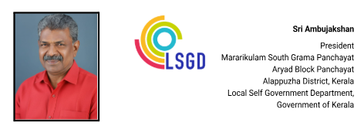
MESSAGE

പ്രിയരേ ,
ആരോഗ്യ സുരക്ഷ ഉറപ്പാക്കുന്നതിന് ശാസ്ത്രീയമായ മുൻകരുതലുകൾ അനിവാര്യമാണെന്ന് നിപ, കോവിഡ് തുടങ്ങിയ പ്രതിസന്ധികൾ നമ്മെ പഠിപ്പിച്ചു. തീരദേശ മേഖലയായ മാരാരിക്കുളം സൗത്ത് ഗ്രാമപഞ്ചായത്തിൽ, പ്രകൃതി ദുരന്തങ്ങളും ആരോഗ്യ ഭീഷണികളും നേരിടാൻ മുൻകൂട്ടി തയ്യാറാക്കിയ കർമ്മപദ്ധതികൾക്ക് വലിയ പ്രാധാന്യമുണ്ട്. തീരദേശ ഗ്രാമപഞ്ചായത്തായ മാരാരികുളം സൗത്ത്, പ്രകൃതി ദുരന്തങ്ങളും ആരോഗ്യ ഭീഷണികളും നേരിടാനുള്ള സാധ്യതയുള്ള പ്രദേശമാണ്. കടൽക്ഷോഭങ്ങൾ ഉൾപ്പെടെയുള്ള ഇത്തരം സാഹചര്യങ്ങളിൽ ജനജീവിതം സംരക്ഷിക്കുന്നതിനും ദുരന്തങ്ങളുടെ ആഘാതം ലഘൂകരിക്കുന്നതിനും മുൻകൂട്ടി തയ്യാറാക്കിയ ആക്ഷൻ പ്ലാനുകൾക്ക് വലിയ പ്രാധാന്യമുണ്ട്.


ഈ പശ്ചാത്തലത്തിൽ, ആർ.എച്ച്.ടി.സി. ചെറ്റിക്കാട് തയ്യാറാക്കിയ ഈ 'പാൻഡമിക് പ്രിപെയർഡ്നസ് ആക്ഷൻ പ്ലാൻ' ഏറെ അഭിനന്ദനാർഹമാണ്. അടിയന്തര ഘട്ടങ്ങളിൽ വിവിധ വകുപ്പുകളെ ഏകോപിപ്പിച്ച് കൃത്യമായ ഇടപെടലുകൾ നടത്താൻ ഈ മാർഗ്ഗരേഖ നമ്മെ സഹായിക്കും. ഇതിനായി പ്രയത്നിച്ച എല്ലാ ആരോഗ്യ പ്രവർത്തകർക്കും അഭിനന്ദനങ്ങൾ നേരുന്നതോടൊപ്പം, പഞ്ചായത്തിന്റെ പൂർണ്ണ പിന്തുണ വാഗ്ദാനം ചെയ്യുന്നു.

(AMBUJAKSHAN)

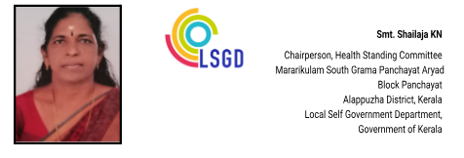
MESSAGE

പ്രിയരേ ,
മാരാരിക്കുളം സൗത്ത് ഗ്രാമപഞ്ചായത്തിന്റെ ആരോഗ്യ സുരക്ഷാ പ്രവർത്തനങ്ങളിൽ സുപ്രധാനമായ ഒരു നാഴികക്കല്ലാണ് ചെട്ടിക്കാട് ആർ.എച്ച്.ടി.സി.യുടെ സാങ്കേതിക സഹായത്തോടെ തയ്യാറാക്കിയ ഈ 'മഹാമാരി പ്രതിരോധ പ്ലാൻ'. മുൻകാലങ്ങളിലുണ്ടായ പകർച്ചവ്യാധി സാഹചര്യങ്ങളെ നാം അതിജീവിച്ചത് കൃത്യമായ ജനകീയ ഇടപെടലുകളിലൂടെയാണ്. ഭാവിയിൽ ഉണ്ടായേക്കാവുന്ന സമാനമായ വെല്ലുവിളികളെ കൂടുതൽ ശാസ്ത്രീയമായും ഏകോപനത്തോടെയും നേരിടാൻ ഈ മാർഗ്ഗരേഖ നമ്മുടെ പഞ്ചായത്തിന് കരുത്തുപകരും.

ആരോഗ്യ പ്രവർത്തകർ, ജനപ്രതിനിധികൾ, സന്നദ്ധ പ്രവർത്തകർ എന്നിവർ ഏത് അടിയന്തര സാഹചര്യത്തിലും എങ്ങനെ പ്രവർത്തിക്കണം എന്നതിനെക്കുറിച്ച് വളരെ ലളിതവും വ്യക്തവുമായ നിർദ്ദേശങ്ങളാണ് ഇതിൽ ഉൾപ്പെടുത്തിയിരിക്കുന്നത്. നമ്മുടെ പഞ്ചായത്തിനെ ഒരു സുരക്ഷിത ആരോഗ്യ കേന്ദ്രമായി നിലനിർത്താൻ ഈ പദ്ധതി ഏറെ സഹായകമാകും. ഇതിനായി പ്രയത്നിച്ച ചെട്ടിക്കാട് ആർ.എച്ച്.ടി.സി.യിലെ ഡോക്ടർമാർക്കും മറ്റ് ആരോഗ്യ പ്രവർത്തകർക്കും ആരോഗ്യ സ്റ്റാൻഡിംഗ് കമ്മിറ്റിയുടെ പേരിൽ ഹൃദയം നിറഞ്ഞ നന്ദി രേഖപ്പെടുത്തുന്നു.

(SHYLAJA KN)

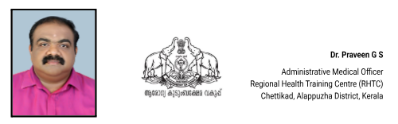

MESSAGE,

മാരാരിക്കുളം സൗത്ത് ഗ്രാമപഞ്ചായത്തിന്റെ ആരോഗ്യ സുരക്ഷയിൽ ഒരു പുതിയ അധ്യായം കുറിച്ചുകൊണ്ട് 'പാൻഡമിക് പ്രിപെയർഡ്നസ് പ്ലാൻ' സമർപ്പിക്കുന്നതിൽ അതിയായ സന്തോഷമുണ്ട്. ഭൂരിഭാഗവും തീരദേശ മേഖലയായ ഈ പഞ്ചായത്തിലെ ജനസംഖ്യയിൽ നല്ലൊരു ശതമാനവും മത്സ്യത്തൊഴിലാളികളും സാമൂഹിക-സാമ്പത്തികമായി പിന്നോക്കം നിൽക്കുന്നവരുമാണ്. ജനസാന്ദ്രതയേറിയ ഈ മേഖലകളിൽ ഒരു പകർച്ചവ്യാധി പടർന്നുപിടിച്ചാൽ അത് ഗുരുതരമായ പ്രത്യാഘാതങ്ങൾ ഉണ്ടാക്കിയേക്കാം എന്ന തിരിച്ചറിവാണ് ഇത്തരമൊരു ശാസ്ത്രീയ കർമ്മപദ്ധതിക്ക് രൂപം നൽകാൻ ഞങ്ങളെ പ്രേരിപ്പിച്ചത്.

ആരോഗ്യ സംവിധാനങ്ങളുടെ പരിമിതികളും ഭൂമിശാസ്ത്രപരമായ പ്രത്യേകതകളും കണക്കിലെടുത്ത്, ഏറ്റവും താഴെത്തട്ടിലുള്ള വ്യക്തിക്കും കൃത്യസമയത്ത് ചികിത്സയും കരുതലും ഉറപ്പാക്കുക എന്നതാണ് ഈ പ്ലാനിന്റെ ലക്ഷ്യം. ദുരന്തമുഖങ്ങളിൽ പതറാതെ പ്രവർത്തിക്കാൻ ആരോഗ്യ പ്രവർത്തകർക്കും സന്നദ്ധ സേവകർക്കും ഈ രേഖ ഒരു വഴികാട്ടിയാകും. ഈ ഉദ്യമത്തിൽ സഹകരിച്ച ജനപ്രതിനിധികൾക്കും ആരോഗ്യ പ്രവർത്തകർക്കും നന്ദി അറിയിക്കുന്നു. ഒരുമിച്ച് നമുക്ക് സുരക്ഷിതമായ ഒരു നാളെയെ കെട്ടിപ്പടുക്കാം.

(DR PRAVEEN G S)
EXECUTIVE SUMMARY
The Rural Health Training Centre (RHTC), Chettikad functions as the primary public healthcare institution serving the population of Mararikulam South Grama Panchayat. As a key pillar of the local health system, the RHTC plays a critical role in delivering comprehensive, accessible, and affordable healthcare services, with a strong emphasis on preventive, promotive, curative, and rehabilitative care, in alignment with national and state health policies and programmes.

The RHTC caters to a predominantly rural and coastal population with diverse health needs. Core service areas include maternal and child health, immunisation, family welfare, adolescent health, geriatric care, communicable and non-communicable disease prevention and control, and palliative care. Through regular outpatient services, field-level outreach, home-based care, and community-based surveillance, the institution ensures continuity of care even in hard-to-reach and environmentally vulnerable areas.
Chettikad RHTC actively implements major public health initiatives such as the National Health Mission (NHM), Integrated Disease Surveillance Programme (IDSP), National Tuberculosis Elimination Programme (NTEP), National Programme for Prevention and Control of Cancer, Diabetes, Cardiovascular Diseases and Stroke (NPCDCS), and other priority disease control and surveillance programmes. These efforts are supported by systematic data collection, routine reporting, and outbreak investigation mechanisms that enable early detection and timely response to public health threats.
The RHTC works in close coordination with the Grama Panchayat, Block Panchayat, ASHA workers, Anganwadi centres, educational institutions, and community-based organisations to strengthen community participation, enhance
health awareness, and improve service utilisation. Special emphasis is placed on risk communication, behaviour change communication, early referral, and lifestyle modification to reduce disease burden and improve long-term health outcomes.
Recognising the increasing vulnerability to pandemics, climate-related health emergencies, and emerging infectious diseases, the RHTC has adopted a proactive and preparedness-oriented approach. Despite existing constraints related to infrastructure, human resources, and rising service demand, the institution continues to strengthen service delivery through effective planning, intersectoral coordination, data-driven decision-making, and community engagement. Upgrading infrastructure, enhancing digital health systems, strengthening surveillance and laboratory linkages, and expanding preventive and emergency response capacities remain key focus areas for future development.
Overall, RHTC Chettikad stands as a vital institution in safeguarding public health, ensuring health system resilience, and improving the quality of life of the residents of Mararikulam South Grama Panchayat, particularly during public health emergencies and pandemics.

LIST OF ABBREVIATIONS

LSGD/LSGI | Local Self Government Department / Local Self Government Institution
BMO | Block Medical Officer
IDSP | Integrated Disease Surveillance Programme
NDMA | National Disaster Management Authority
PPE | Personal Protective Equipment
ICMR | Indian Council of Medical Research
CD | Communicable Diseases
NCD | Non-Communicable Diseases

TABLE OF CONTENTS

INTRODUCTION 9
● Background of the PPP 9
LSGD AT A GLANCE 9
INTEGRATED HEALTH INFRASTRUCTURE MAP OF ____________ PANCHAYAT 10
GENERAL PROFILE OF THE LSGI’S 14
Background of the LSGI 14
Demographic and Vulnerable Population 16
Clinical Vulnerability 17
INFRASTRUCTURE & RESOURCE INVENTORY 19
Health Facility Directory & Basic Capacity in the LSGD 19
Private Clinics 20
Healthcare Education & Training Institutions -NIL 21
Specialized Services & Emergency Inventory–NIL 21
Oxygen & Diagnostic Capacity 22
Diagnostics facility mapping at the LSGI level 23
Laboratory Identification & Basic Details 24
Social and Community Infrastructure for surge plan 24
Human resources 27
Medical & Clinical Personnel 27
Public Health & Field-Level Workforce 27
Community & Support Cadre 29
Community Organizations 30
Administrative & Emergency Services 31
Information regarding resources 31
ONE HEALTH & ENVIRONMENTAL SURVEILLANCE 32
Animal & Bird Population 33
Veterinary Infrastructure 34
Veterinary Doctors & Workforce 35
High-Risk Interface Points (Surveillance Sites) 36
Environmental Risk Mapping 39
Disease Seasonality Mapping 40
Vulnerability Mapping 41
EPIDEMIOLOGICAL TRENDS (2021–2025) 43
Disease Burden among human beings(Last 5 Years) 43
*(use the above table data to create the graph/diagram) 44
Seasonal Trend Analysis 45
DENGUE 45
Dengue – Ward-wise Yearly Distribution (2021–2025) 45
LEPTOSPIROSIS 46
Leptospirosis – Ward-wise Yearly Distribution (2021–2025) 46
VIRAL HEPATITIS - A 47
Hepatitis A – Ward-wise Yearly Distribution (2021–2025) 47
Outcome-Based Trend Analysis- 2025 49
Transmission Trend- 2025 51
Integrated Disease Hotspot Map (2021–2025) 54
Preparedness and Response Protocol at LSG Level 57
Constitution of One Health Committee 57
Key Responsibilities: 58
Meeting Schedule: 58
Pandemic Response Workforce 58
Activities and Measures before and during Pandemic 60
PHASE 1 - Alert / Preparation 60
➢ Identification of Quarantine and Isolation Facilities 61
➢ Risk Communication and Community Preparedness 62
➢ Protection of Vulnerable Groups 62
➢ Clinical Dependency Mapping 63
PHASE 2 - Active Response 63
1. Case Identification and Contact Tracing 63
2. Screening Checkpoints 63
Standard Screening Protocol 65
3. Pandemic Control Room 65
Control Room Infrastructure and Location 65
Health System Control Room Framework 65
1. Rapid Response Team (RRT) 66
2. Data Management & Analytics Team 66
3. Human Resource Deployment Team 66
4. Laboratory Surveillance Team 66
5. Vaccination Cell (If Required) 66
6. Infrastructure & Patient Occupancy Team 66
7. Communication team 66
Key Control Room Team 67
Daily Monitoring Indicators 68
1. Epidemiological Indicators: 68
4. Communication of Public Health Information 70
Key communicators 70
5. Coordination with District/State Authorities & Other Organisations 71
Key Details: 71
Supply Chain Coordination 72
Resource Inventory and Contacts 72
Collaboration with NGOs, PPP, and CSR 73
Interdepartmental Coordination 74
PHASE 3 - Surge Capacity 74
Conversion of Community Facilities 75
CONCLUSION 76
RECOMMENDATIONS 77
1. Strengthening Healthcare Infrastructure 77
2. Community Awareness & Education 77
3. Emergency Response & Coordination 77
4. Supply Chain & Food Security 77
5. Digital Preparedness 77
6. Training & Capacity Building 77
7. Long-Term Resilience 78
ANNEXURE 79
1. IMPORTANT PHONE NUMBERS 79
1.1. Details of grama panchayat/municipality/corporation wards 79
1.2. Other important phone numbers of grama panchayat/municipality/corporation area 80
1.3. Important offices of grama panchayat/municipality/ corporation 81
1.4. Health Services 82
1.5. Veterinary Services 82
1.6. Helpline numbers 83
1.7. Public and Private Schools Contact details 83
1.9. Anganwadi Contact Details 84
1.12. Information regarding resources 85

INTRODUCTION

Pandemics and large-scale infectious disease outbreaks remain persistent threats to public health, social stability, and local governance systems. While such events may emerge beyond local boundaries, their most immediate and severe consequences are felt at the community level. Early detection, rapid coordination, continuity of essential services, and public trust become decisive factors in limiting impact. Although international and national frameworks provide strategic direction, effective preparedness and response are ultimately operationalised through Local Self-Government Institutions (LSGIs), which serve as the frontline of public health action.

In Kerala, LSGIs occupy a central role in the public health architecture, functioning as the crucial link between communities and higher-level health systems. Experiences from recurrent monsoon-related disease outbreaks, coastal flooding, and the COVID-19 pandemic have highlighted the importance of decentralised, locally grounded preparedness planning. These events have demonstrated that pandemic readiness must extend beyond healthcare facilities to include disease surveillance, environmental and waste management, risk communication, social support systems, and intersectoral coordination. Context-specific planning is therefore essential to address local vulnerabilities while ensuring timely and coordinated action during public health emergencies.

Mararikulam South Grama Panchayat, located in Aryad Block of Alappuzha district, represents a densely populated coastal and low-lying region with unique epidemiological and environmental challenges. With a projected population of 59,165 spread across 23 wards and a high population density of over 8,400 persons per square kilometre, the Panchayat faces significant pressure on health services during outbreaks. The terrain, characterised by coastal stretches, water bodies, and flood-prone areas—particularly affecting 17 wards—creates favourable conditions for water-borne, vector-borne, and climate-sensitive diseases, especially during the monsoon season.
The demographic profile of Mararikulam South further underscores the need for structured preparedness. The Panchayat has a substantial population of pregnant and lactating women, elderly individuals, persons with disabilities, bed-bound and palliative-care patients, and individuals living with chronic conditions such as diabetes, hypertension, tuberculosis, cancer, and renal disease requiring dialysis. These groups are particularly vulnerable during pandemics due to increased health risks, care dependency, and potential disruption of routine services.
This Pandemic Preparedness Plan for Mararikulam South Grama Panchayat has been developed to strengthen the Panchayat’s capacity to prevent, detect, and respond effectively to pandemics and large-scale infectious disease outbreaks. It emphasises early warning systems, protection of high-risk populations, continuity of essential health and social services, surge capacity planning, and coordinated action across health, local governance, animal health, environmental, disaster management, and community sectors.
This document serves as a guiding framework to support timely decision-making, efficient resource mobilisation, and coordinated action, ensuring that the Panchayat is better equipped to safeguard lives, livelihoods, and public health during future pandemics and infectious disease emergenci

LSGD AT A GLANCE

ADMINISTRATIVE BOUNDARIES OF MARARIKULAM SOUTH PANCHAYAT
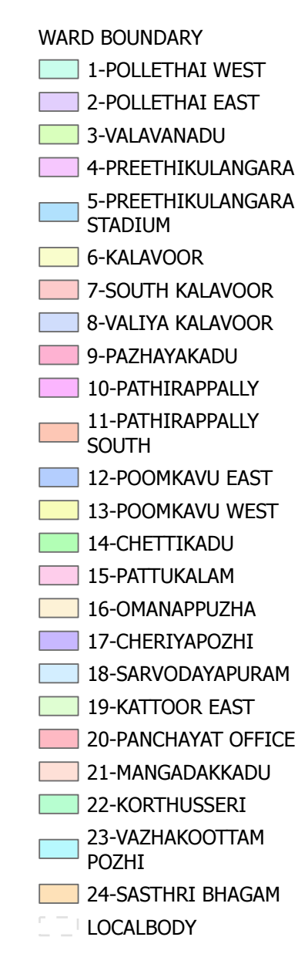
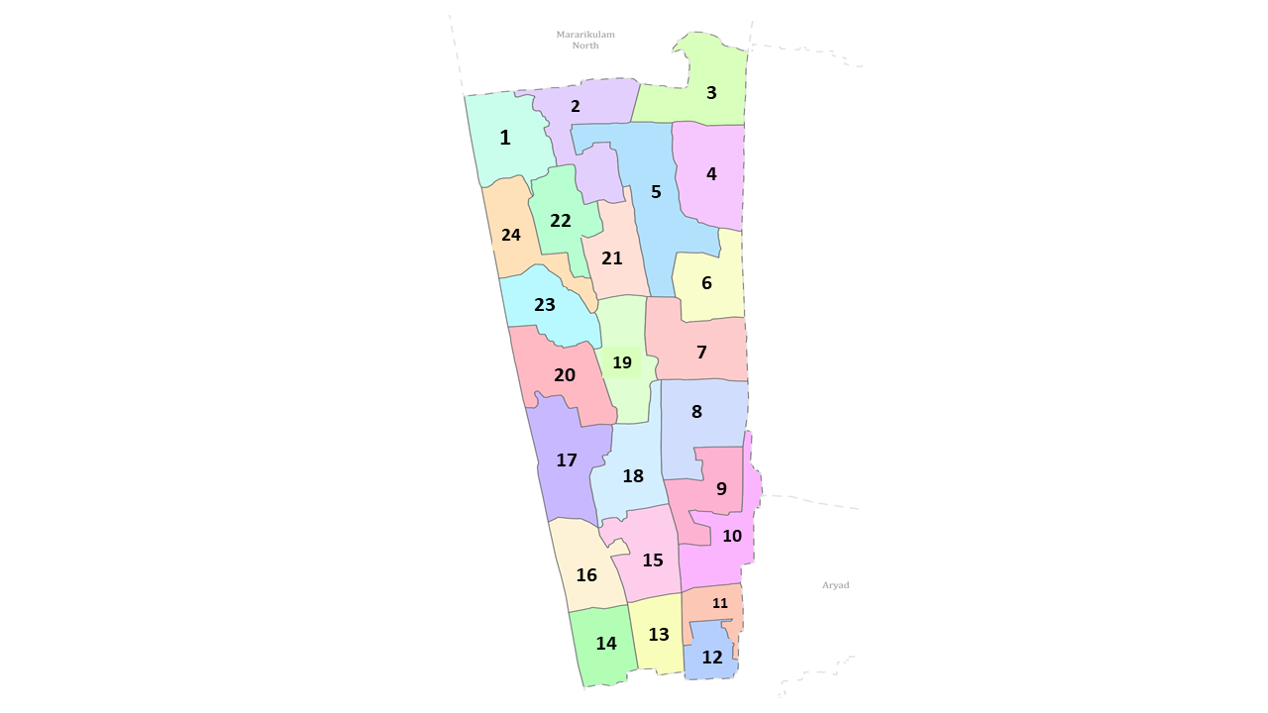
Mararikulam South Grama Panchayat Ward-Wise Map (2026) Data provided by K-SMART (K-SMART Final Notification for Mararikulam South)

Ward | Houses | Population | Migrants | Wells | Ed. Institutions | Hosp pvt/govt.
24 | 14902 | 59165 | 310 | 1726 | 16 | 3

INTEGRATED HEALTH INFRASTRUCTURE MAP OF MARARIKULAM SOUTH PANCHAYAT

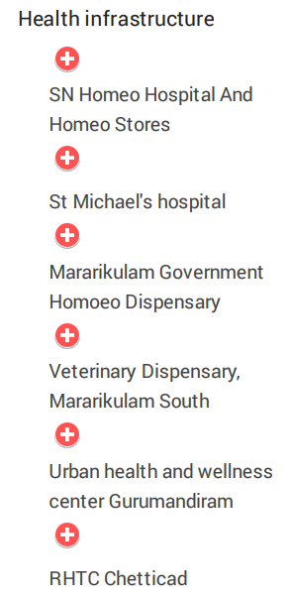
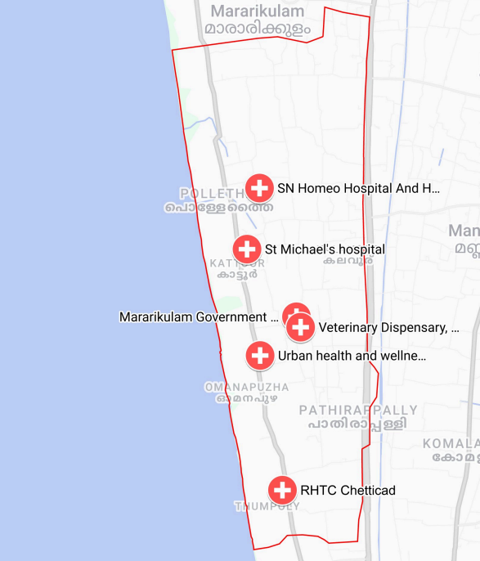

Mararikulam South Grama Panchayat Health Infrastructure Map (2026)
Boundary Data: OpenData K-SMART Final Notification 2026 | Map Created with Google My Maps Major Establishment Map

MAJOR ROADWAYS AND WATERWAYS MAP OF MARARIKULAM SOUTH GRAMA PANCHAYAT

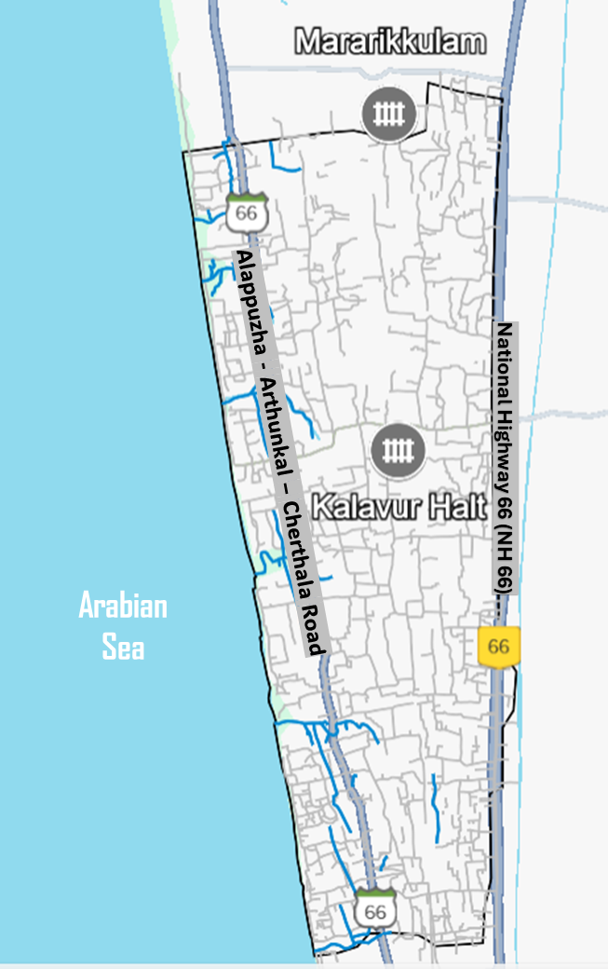
Mararikulam South Grama Panchayat Major Roads and Waterway Map (2026)
Boundary Data: OpenData K-SMART Final Notification 2026 | Map Created with Google My Maps and visualized through Google Earth Roads and Waterways Map

SPATIAL MAPPING OF MAJOR ESTABLISHMENTS – MARARIKULAM SOUTH GRAMA PANCHAYAT (2026)

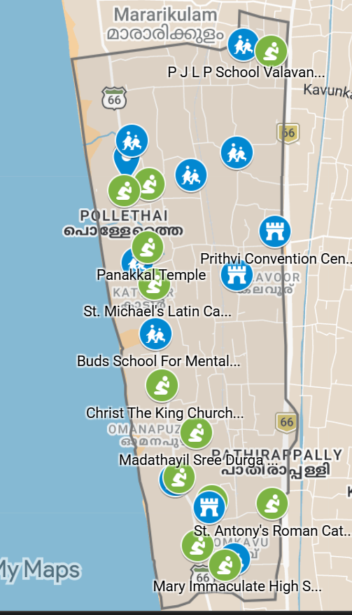
Spatial Mapping of Major Establishments of Mararikulam South Panchayat (2026) Boundary Data: K-SMART Final Notification 2026 | Map Created with Google My Maps: Major Establishment

INTEGRATED DISEASE HOTSPOT MAP (2023–2025)

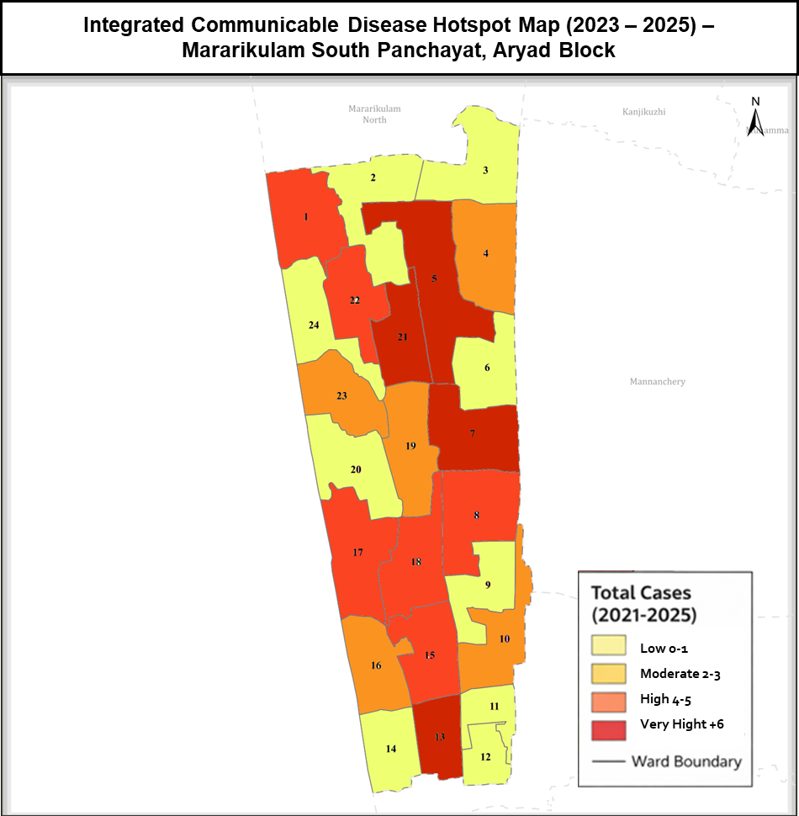
Disease Heat Map: Mararikulam South Panchayat (2023–2025)
Boundary Data: K-SMART Final Notification 2026 | Map Created with GIMP

GENERAL PROFILE OF THE LSGI’S

Background of the LSGI
Mararikulam South Grama Panchayat is a coastal administrative division located in Aryad Block of Alappuzha district, Kerala. The Panchayat is predominantly low-lying, with extensive coastal stretches, backwaters, canals, and interconnected waterways. This terrain influences the local microclimate and creates challenges for transportation, emergency response, and service delivery, particularly during monsoon seasons and flood events.

The Panchayat is administratively divided into 23 wards, with a population largely dependent on traditional livelihoods. Fishing, coir and coconut husk processing, and allied activities form the backbone of the local economy. In recent years, tourism-related activities—leveraging the backwaters and coastline—and service-sector employment have shown gradual growth.

From a public health perspective, the Panchayat has reported a higher burden of communicable diseases, including dengue and tuberculosis, along with vulnerability to seasonal flooding and water-related illnesses. These factors highlight the need for strengthened surveillance, preparedness, and coordinated response. In this context, developing a localized, data-driven auxiliary infrastructure and logistical resource map is essential to support effective planning, ensure timely emergency response, and enhance community resilience.

TABLE 1: BACKGROUND OF LSGD
Description | Details
Name of LSGI | Mararikkulam South Grama Panchayat
Type | Grama Panchayat
Block | Aryadu Block Panchayath
District | Alappuzha
Number of wards | 24
Total area (sq. km- | 19.67 km
Population (Projected) | 59165
Population density- | 3007.88/sq. km
Terrain | coastal/low-lying
Number of rivers passing through LSGI | Nil
Number of water bodies in the LSGI | 38
Number of educational institutions | 15
Factories / small-scale industries | 67
Flood-prone wards | 17
Landslide-prone wards | NIL
Death Management and Disposal Facilities (mortuaries/crematorium, including electric) | NIL
Auditoriums/Marriage halls/convention centres/community halls | 9

The Panchayat has 15 educational institutions, 67 small-scale industries, and 9 community halls and auditoriums, reflecting moderate infrastructure availability. However, the absence of dedicated death management facilities such as mortuaries or crematoriums highlights a critical gap in emergency and disaster preparedness planning.

Demographic and Vulnerable Population
Understanding the demographic composition and vulnerable population groups is essential for pandemic preparedness. Children, the elderly, economically deprived families, migrant workers, and socially vulnerable groups are at increased risk during public health emergencies due to higher exposure, limited access to services, and dependency on public systems.

Description |  | Details (in numbers)
DEMOGRAPHIC PROFILE
Total population |  | 59165
Male |  | 29166
Female |  | 29999
Transgender |  | 0
Children under 5 |  | 2504
Adolescent |  | 5621
Elderly (>60) |  | 6084
SOCIAL/LIVELIHOOD VULNERABILITY
Previous EPEP family |  | 31
BPL family |  | 35499
Tribal communities |  | 152
Migration | Immigrant | 310
Migration | Emigrant | 1326
Socio-economically deprived |  | 1264
Fisherfolk |  | 264
SC Community |  | 2059
ST Community |  | 152

The demographic and social profile of Mararikulam South Grama Panchayat highlights a high-density population of 59,165, with significant pockets of vulnerability that demand a tailored public health approach. With over 60% of the population (35,499 families) living below the poverty line and a substantial elderly cohort of 6,084 individuals, the community faces heightened socio-economic and clinical risks during health emergencies. Furthermore, the presence of 1,264 socio-economically deprived individuals, a mobile population of 1,636 migrants, and specific marginalized groups including SC, ST, and fisherfolk communities, underscores the necessity for an equitable and inclusive disaster management strategy that prioritizes social safety nets alongside medical intervention.

Clinical Vulnerability
Certain population groups need priority healthcare & are at higher risk of severe illness, complications, and mortality during pandemics. Patients with chronic diseases, those requiring regular medical care, and individuals with mobility or functional limitations face challenges in accessing timely care during emergencies. Mapping these groups helps in prioritizing continuity of treatment, medicine stock planning, oxygen support, referral transport, and targeted home-based care.

Group | Item | Details in numbers
Maternal/  Child | Pregnant women | 215
Maternal/  Child | Lactating mothers | 541
Maternal/  Child | Children under 5 | 2504
Mobility-  challenged | Bedbound patients | 164
Mobility-  challenged | Patients under palliative care other than bedbound | 362
Mobility-  challenged | Mentally challenged | 52
Mobility-  challenged | Differently abled | 211
Chronic Illnesses | Patients on Haemodialysis | 22
Chronic Illnesses | Patients on CAPD | 11
Chronic Illnesses | Cancer patients (currently on treatment) | 251
Chronic Illnesses | Haemophilic patients | 0
Chronic Illnesses | Diabetic patients | 1662
Chronic Illnesses | Hypertensive patients | 3451
Chronic Illnesses | TB patients | 25

Total vulnerable individuals: 9,471 (16.0% of Mararikulam South’s 59,165 population).
The vulnerability assessment in Mararikulam South Grama Panchayat identifies 9,471 individuals (16.0% of the total population) requiring priority attention during public health emergencies.
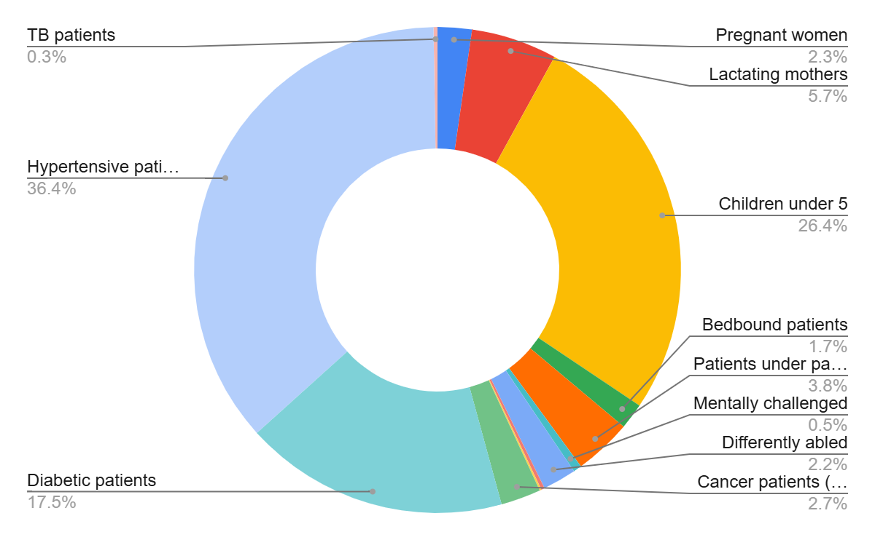
Clinical Vulnerability Profile of Mararikulam South Panchayat
Chronic non-communicable diseases constitute the largest share, particularly hypertension (3,451) and diabetes (1,662), indicating a substantial population dependent on continuous treatment and monitoring. Maternal and child health groups—including 215 pregnant women, 541 lactating mothers, and 2,504 children under five—represent a critical segment requiring uninterrupted essential health services. Additionally, 789 individuals with mobility and functional limitations, along with patients undergoing dialysis, cancer treatment, and TB care, highlight the need for decentralized, home-based care, assured medicine supply, and reliable referral support to ensure continuity of care during emergencies.

Major Festivals & Events specific to the LSGI
Major religious events in Mararikulam South Grama Panchayat, particularly those associated with prominent pilgrimage and temple centers, significantly increase the risk of communicable disease transmission due to large crowd gatherings, increased mobility, and pressure on sanitation and public health systems.

Sl. No. | Name of Festival | Periodicity | Key Risks & Local Impact
1 | Poomkavu Church Perunnal | April (One Week) | Overcrowding; massive transit movement; sanitation pressure.
2 | Omanapuzha Church Festival | December (One Week) | Localized congestion; food safety at stalls; waste management in coastal tracts.
3 | Kattoor Church Festival | April (One Week) | Community-wide gatherings; increased mobility between wards; hygiene monitoring.

The Our Lady of Assumption Church, Poomkavu, established in 1860, is a premier pilgrimage center in Alappuzha. Its Holy Week celebrations (commencing around April 1st) represent the largest annual mass gathering in the Panchayat, attracting over 50,000 devotees. The influx peaks during Palm Sunday, Maundy Thursday, Good Friday, and Easter.

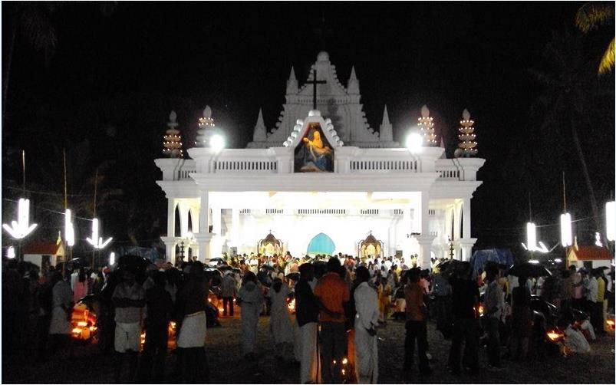
The Our Lady of Assumption Church, Poomkavu
The annual feast at St. Sebastian’s Church, Omanapuzha, held in December, is a significant event for the coastal community. Marked by traditional flag-hoisting and processions, the festival sees a surge in local population density. The Kattoor Church festival is a vibrant community celebration, featuring traditional festivities, social gatherings, and religious observances. Typically featuring church services and cultural events, it draws locals for a time of faith and community connection.


Omanapuzha Church

All the above-mentioned mass gatherings pose significant public health risks, including increased disease transmission, overcrowding, and strain on health services. Preparedness planning should focus on risk assessment, crowd management, disease surveillance, sanitation, safe water, health education, and coordination with health authorities for timely response.

INFRASTRUCTURE & RESOURCE INVENTORY

Health Facility Directory & Basic Capacity in the LSGD
This section provides an overview of the healthcare infrastructure available within the LSGD area. It outlines the distribution and basic capacity of health facilities that form the backbone of service delivery during routine times and public health emergencies.

Family Health Centres (FHCs) and Community Health Centres (CHCs) generally function as the first point of contact for the community, providing essential outpatient and inpatient services. General Hospitals (GH) and Medical College Hospitals (MCH), where accessible, serve as the main referral centres for advanced diagnostics, specialist care, and critical services during public health emergencies. This inventory helps identify existing strengths, gaps, and potential surge capacity that can be mobilised during a pandemic or disaster.

Table 5. Health Facility Resource Summary -NIL
Sl.no. | Health Facility | Type of Facility (MCH/GH/CHC/FHC/SC etc.) | Contact Number | Total beds | ICU Beds | Oxygen-Supported Beds | No. of Ventilator Support Beds | No. of ambulances
Government Healthcare Facilities
1 | RHTC CHETTIKAD | CHC | 04772248668 | 18 | NIL | 2 | NIL | 2
2 | CHETTIKAD | SC | 9048364330 | 1 | NIL | NIL | NIL | NIL
3 | POOMKAV | SC | 8075599491 | 1 | NIL | NIL | NIL | NIL
4 | PATHIRAPALLY | SC | 8547345118 | 1 | NIL | NIL | NIL | NIL
5 | MARARIKULAM SOUTH | SC | 7994574877 | 1 | NIL | NIL | NIL | NIL
6 | CHERIYAPOZHI | SC | 9447706293 | 1 | NIL | NIL | NIL | NIL
7 | KATTOOR | SC | 8086450925 | 1 | NIL | NIL | NIL | NIL
8 | KALAVOOR NEW | SC | 9645572538 | 1 | NIL | NIL | NIL | NIL
9 | KALAVOOR | SC | 9562424471 | 1 | NIL | NIL | NIL | NIL
Private Healthcare Facilities
 | NIL
AYUSH Healthcare Facilities
 | NIL

Private Clinics
Private clinics are an essential part of pandemic preparedness, as they are often the first place people seek care when symptoms begin. In many communities, private clinics manage a significant share of outpatient visits and therefore play a critical role in early case detection, timely referrals, and disease surveillance. Having an up-to-date understanding of where these clinics are located, the services they provide, and how they are linked to the public health system helps ensure that no cases are missed during an outbreak. It also allows health authorities to engage private practitioners more effectively for reporting, risk communication, and coordinated response, strengthening the overall capacity of the health system to manage public health emergencies.

Table 6. Private Clinic Resource Summary
Sl No. | Name of Clinic | Registered (Y/N) | Clinic (General / Speciality) | Speciality (if any) | Address | Contact Number | Diagnostic Facility (Y/N) | Ambulance Linkage (Y/N)
1 | St,micle clinic | y | clinic | Nil | kattoor,kattoor PO | 9048996333 | Nil | y

Healthcare Education & Training Institutions -NIL
This section tracks the educational infrastructure available, which is vital for human resource planning in the health sector.

Category of Institution | Govt | Private | AYUSH | Total
Medical Colleges | 0 | 0 | 0 | 0
Nursing Colleges | 0 | 0 | 0 | 0
Dental Colleges | 0 | 0 | 0 | 0
Para-medical / Allied Health | 0 | 0 | 0 | 0
Pharmacy Colleges | 0 | 0 | 0 | 0

Specialized Services & Emergency Inventory–NIL
This section provides a detailed view of the specialized medical resources available to the community, focusing on emergency response and critical care capabilities. This table tracks the vital assets required for managing severe illnesses and emergencies across Government, Private, and AYUSH sectors.

Item | Govt | Private | AYUSH | Total
Hospital beds | 18 | 0 | 0 | 18
Oxygen-generating systems(Y/N) | N | N | N | N
Oxygen-supported beds(Numbers) | 0 | 0 | 0 | 0
Ventilator-supported beds | 0 | 0 | 0 | 0
ICU beds - | 0 | 0 | 0 | 0
Burns units- | 0 | 0 | 0 | 0
Blood centres- | 0 | 0 | 0 | 00
BLS ambulances- | 0 | 0 | 0 | 0
ALS ambulances - | 2 | 3 | 0 | 0
Dialysis facilities- | 0 | 0 | 0 | 0
Dispensaries- | 1 | 1 | 1 | 3
Medical store- | 1 | 14 | 1 | 16
Industrial establishments(Medium-scale industries/small-scale industries establishments to whom we can depend in a worst-case scenario) | 1 | 0 | 0 | 1

Oxygen & Diagnostic Capacity
Monitoring oxygen and diagnostic capacity is a critical component of public health preparedness, ensuring that the LSGD can handle both chronic care and sudden surges in respiratory or infectious diseases.
Name of Health Facility | Oxygen-generating System (Y/N) | Backup Oxygen Source (Y/N) | Diagnostic Facilities Available(Y/N)
Name of Health Facility | Oxygen-generating System (Y/N) | Backup Oxygen Source (Y/N) | Lab | USG | X-ray | CT/MRI | RT-PCR
Government Healthcare Facilities
NIL

Diagnostics facility mapping at the LSGI level
The diagnostic capacity of Mararikkulam G.P represents the "intelligence network" of our healthcare system. The speed and accuracy of disease identification depend entirely on the distribution and technical level of these facilities.

Item | Govt | Private | AYUSH | Total
General labs1- | 1 | 12 | 0 | 13
Microbiology labs | 0 | 0 | 0 | 0
RT-PCR labs- | 0 | 0 | 0 | 0
USG units- | 0 | 0 | 0 | 0
CT/MRI units- | 0 | 0 | 0 | 0
Research labs- | 0 | 0 | 0 | 0
Labs of other departments that can be repurposed-0 | 0 | 0 | 0 | 0

Laboratory Identification & Basic Details
Sl. No. | Name of Laboratory | Ownership (Govt / Private / Academic) | Address | Contact No. | 24×7 Services (Yes/No) | NABL / Govt Approved (Yes/No)
1 | Janakiya Laboratary | Private | chettikadu,Pathirapally | 960554281 | NO | NO
2 | Janakshema Lab | Private | Pathirapally  ,Pathirapally PO | 8088324457 | No | No
3 | BiometricLab | Private | Kattoor, Kattoor PO | 7306896458 | No | No
4 | St,Micle Lab | Private | Kattoor, Kattoor PO | 9048996333 | No | No
5 | Krishnas Medical lab | Private | lepracy jn,Kalavoor | 9539549766 | No | No
6 | Aiswa Hitech Lab | Private | Marankulangara ,Kalavoor | 9946351432 | No | No
7 | St,Antonys lab | Private | Pathirapally po | 9567168920 | No | No

Social and Community Infrastructure for surge plan
This table serves as our logistics and shelter inventory. By mapping these locations, quickly we can identify where to house displaced citizens, where to set up temporary medical clinics, and how to manage the deceased with dignity during a crisis.

Category | Total Count | Ward | Est. Capacity (Persons) | Contact details
Educational Institutions
Anganwadis | 51 | ALL WARD | 716 | CDPO Aryadu Block Panchayth
Schools | 15 | 19,4,9,12,11,15,20,23,7 | 10700 | AEO Aryadu Block Panchayth
Colleges | 0
Healthcare Educational Institutions
Medical colleges (Govt/Private)- | NIL
Nursing colleges (Govt/Private) | NIL
Dental colleges (Govt/Private) | NIL
Paramedical institutes (Govt/Private) | NIL
Community Gathering Spaces
Community halls- | 0
Auditoriums- | 4 | 8,5 | AVERAGE 50BED CAPACITY | MANAGER
Religious buildings- | 36 | 15,11, 13,5,3, 14,19, 23 | AVERAGE 50BED CAPACITY
Vulnerable Group Support Facility
Destitute homes–
Elderly homes- | 6 | 9,6,18,19 | AVERAGE 30 BED CAPACITY
LSGD owned other buildings- | 6
Mass Fatality Management (MFM) Infrastructure
Mortuary- | NIL
Crematorium- | NIL
*refer annexure 1 for contact details

Human resources
This section focuses on the human capital available within the LSGI. In any emergency—be it a pandemic, flood, or industrial accident—infrastructure is only as effective as the people operating it.

Medical & Clinical Personnel
This table tracks the "Frontline" providers responsible for diagnosis, treatment, and clinical management. Narrative sentence: eg., "Total health workforce: 450 personnel, with 60% in government facilities serving as primary surge capacity." A detailed directory with the contact numbers of all workers is maintained (Annexure in 1).

Cadre | Govt (No.) | Private (No.) | Total
Doctors—Modern Medicine | 13 | 2 | 15
Doctors – AYUSH | 1 | 3 | 4
Doctors – Veterinary | 1 | 0 | 1
Doctors – Dental | 0 | 4 | 4
Nursing officers | 11 | 5 | 16
Lab technicians | 4 | 7 | 11
Optometrist | 2 | 3 | 5
Pharmacists | 4 | 14 | 19
Psychologists | 0 | 0 | 0
Counsellors | 0 | 0 | 0

Public Health & Field-Level Workforce
These individuals are the backbone of surveillance, maternal-child health, and decentralized care.

Cadre | Health services | Municipal common services | Total
HS (Health Supervisors) | 1 | 0 | 1
HI (Health Inspectors) | 1 | 0 | 1
LHS (Lady Health Supervisor) | 1 | 0 | 1
LHI (Lady Health Inspectors) | 1 | 0 | 1
JPHN (Jr Public Health Nurses) | 8 | 0 | 8
JHI (Jr Health Inspectors) | 5 | 0 | 5
MLSP (Mid-Level Service Providers) | 8 | 0 | 8
Palliative Nurses | 2 | 0 | 2
RBSK Nurses | 1 | 0 | 1
PRO | 1 | 0 | 1
Epidemiologist | 1 | 0 | 1
Data Manager | 1 | 0 | 1

Community & Support Cadre
This group represents the surge capacity of the LSGI—people who can be called upon for logistics, rescue, and specialized support.

Cadre | Number
ASHA Workers | 50
AWW (Anganwadi Workers) | 51
Emergency Medical Volunteers (Trained) | 1127
Kudumbashree | 273
MNREGS | 1478
Purusha Swayam Sahaya Sangham | 20
Ex-Servicemen | 134
Retired Police Officers | 76
NCC/NSS Volunteers | 400
Red Cross volunteers | 70
One Health Community Volunteers | 161
One Health Community Mentors | 1127

Community Organizations
This section details the presence of community-based organisations (CBOs), non-governmental organisations (NGOs), faith-based organisations (FBOs), Kudumbashree Self-Help Groups (SHGs), and Ayalkootams within the Local Self-Government Institution (LSGI). These groups enhance grassroots mobilization, resource distribution, and support networks crucial for pandemic response and community resilience.

Category | Total Count
NGOs | 42
Religious based organizations | 9
Foreign based organizations | 0
Sports Club/youth clubs | 6
Kudumbashree SHGs | 273
Ayalkootams | 273
Political organizations | 9
Residential organizations | 6

Administrative & Emergency Services
This section outlines the availability of key non-health emergency support services and infrastructure within the LSGI, which are essential for effective pandemic preparedness and response. These facilities support law enforcement, disaster response, water supply, logistics, mobility, and community-level interventions during public health emergencies.

Category | Total Count | Contact details
Police Stations | 0
Fire & Rescue Stations | 0
Water Pumping Points | 0
Public Distribution System (PDS) | 0

Information regarding resources
The availability of essential transport and support resources plays a quiet but critical role in saving lives. Equipment such as ambulances, mobile mortuaries, amphibian ambulances, and motorized boats ensures that patients, samples, and healthcare teams can move swiftly—even in flooded, remote, or difficult terrains. Heavy vehicles like JCBs, cranes, tractors, and torus lorries support logistics, waste management, emergency infrastructure, and rapid conversion of spaces into care or isolation facilities. Taxis, four-wheel-drive vehicles, and trucks help maintain continuity of essential services, reach vulnerable populations, and support home-based care and supply delivery.

Means of transportation | Total Count
JCB | 12
Crane | 0
Heavy Trucks | 4
Tractor | 5
Ambulances | 6
Mobile mortuaries | 2
Boats | 0
Taxi service | 60
Note: For specific details regarding vehicle owners and contact information, please refer to Annexure [X].

ONE HEALTH & ENVIRONMENTAL SURVEILLANCE
The One Health method integrates environmental, animal, and human health to enable proactive pandemic preparedness. Panchayat-level surveillance needs to be improved in order to detect and treat zoonotic and environmentally generated diseases early. Surveillance is strengthened through systematic assessment of animal populations, veterinary infrastructure, poultry and slaughter facilities, inter-sectoral coordination, and specialised tools like avian influenza seasonality mapping using GIS in previous outbreaks to enable predictive alerts and ward-specific sampling to support effective pandemic preparedness in high-risk areas.

Animal & Bird Population
Mapping animal and bird populations at the Panchayat level is essential for identifying and prioritising zoonotic disease hazards like rabies, avian influenza (H5N1), leptospirosis, anthrax, and Nipah-like spillover occurrences. Risk classification, targeted surveillance, vaccination planning, and early epidemic detection made feasible by comprehensive population mapping all enhance One Health-based pandemic preparedness.

Category | Item | Estimated Population
Animal Population | Livestock (Cattle/Goats/Buffalo) | 174
Animal Population | Pet Animals (Dogs/Cats) | 719
Animal Population | Stray Dog Population | 842
Animal Population | Pig Farms (Number of heads) | 1
 | Small Units (Sheep / Goats – clustered) | 2
Bird Population | Poultry Units (Birds) | 12
Bird Population | Poultry- (FOWL) | 0
Bird Population | Wild/MigratoryBirds (Observed) | 0
Bird Population | Crow Mortality Events (Reported) | 0

The main risk of zoonotic diseases inwhich is explained by the high density of pig farms, cattle congregation areas, and poultry units. The stray dog population in market areas, fish landing sites, bus stations continues to be a substantial problem for rabies surveillance and bite prevention. Animal shelters vulnerable to flooding further raise the risk of leptospirosis and other zoonoses mediated by the environment, especially during monsoon floods.

Veterinary Infrastructure
Veterinary institutions are a core pillar of One Health surveillance, enabling early zoonotic disease detection through vaccination, investigation of unusual animal illness or deaths, sample collection, and timely outbreak reporting. A well-mapped and responsive veterinary network strengthens coordination with human health and LSGI systems, ensuring rapid response during zoonotic events and pandemics.
Facility Type | Name of Facility | Ownership Govt / Pvt | Location(Ward No) | Contact number
Veterinary Dispensary | Govt;Veterinary Dispensary Sarvodayapuram | Govt | 18 | 8590135480

Veterinary Doctors & Workforce
Early detection, diagnosis, reporting, and reaction to animal illness epidemics depend on the availability and accessibility of qualified veterinary specialists. By identifying unusual animal morbidity or mortality promptly, collecting samples promptly, and coordinating efficiently with human health and LSGI systems—especially during zoonotic outbreaks and pandemic-prone situations—a clearly defined veterinary workforce enhances One Health surveillance.

Category | Number Available | Type (Govt/Pvt) | Contact number
Government Veterinary Doctors | 1 | Govt | DR.VISHNU SOMAN- 859013548
Private Veterinary Doctors | 2 | Pvt
Livestock Inspectors | 2 | Govt | JAYALEKSHMI J PILLA  9446441442
Para-veterinary Staff / Attenders | 1 | Govt | AJITHA T K 9947402064
Contract / On-call Veterinary Support (if any) | 0

High-Risk Interface Points (Surveillance Sites)
High-risk interface points for zoonotic disease surveillance in Mararikkulam South Grama Panchayath include wetland–livestock–human contact zones, backyard poultry farms, cattle sheds near water bodies, fish markets, and areas of high human–animal interaction such as community slaughter points and migratory bird congregation sites. These are the primary surveillance sites where zoonotic spillover risks are elevated.

Type of Habitat | Type of High risk interface | Geographical vulnerability
Wetlands & Backwaters | NIL
Backyard Poultry Farms | NIL
Cattle Sheds near Water Bodies | NIL
Fish & Meat Markets | NIL
Community Slaughter Sites | NIL
Migratory Bird Congregation Areas | NIL
Rodent-Infested Grain Storage | NIL
Category | Total Count | Key Locations (wards)
Poultry Farms | 8 | 5,13,18,14
Backyard / Clustered Poultry Units | NIL
Duck Rearing Units (open water access) | NIL
Slaughterhouses/ Slaughter Points | NIL
Meat/Fish Markets | 3 | 11,17,9
Live Bird Sale Points | NIL
Cattle Markets / Weekly Animal Fairs | NIL
Pet Shops / Breeders | 2 | 10,4
Animal Shelters / Pet Homes | 0
Waste Disposal Sites near Animal Units | 0

Environmental Risk Mapping
Environmental risk mapping identifies monsoon/flood hotspots for vector-borne (dengue, chikungunya), water-borne (leptospirosis, diarrhoea), and zoonotic diseases in Kerala's wetlands. Systematic surveillance supports early warnings, targeted interventions, and Panchayat pandemic preparedness.
Waterborne exposure: Flood-prone areas and stagnant water bodies facilitate leptospira survival, raising leptospirosis risk.

Traditional practices: Informal slaughter and fish markets lack standardized hygiene, creating spillover opportunities.
Risk Factor | High-Risk Wards | Key Locations | Risk Level (High/Med/Low)
Flood-prone areas | 1,23,19,16,15, 13,12 | ALL WARDS | LOW
Water bodies/wetlands | NIL
Solid waste accumulation | 7 | SARVODAYAPURAM | HIGH RISK
Animal waste disposal issues | NIL
Rodent infestation zones | NIL
Industrial effluent discharge | NIL
Construction sites / abandoned buildings | NIL
Poor drainage/blocked canals | NIL
Drinking water source contamination risk | NIL

Disease Seasonality Mapping -
1, Flooding & waterlogging → amplifies leptospirosis, malaria, diarrheal diseases.
·
2, Migratory bird influx (Nov–Feb) → avian influenza risk.

3, Mosquito breeding cycles → vector-borne disease peaks in monsoon. JUNE to November

4, Agricultural practices → close human–animal contact in paddy fields. June To November

Disease | Peak Risk Season | Key Drivers | High-Risk Locations | Surveillance Focus
Avian Influenza | August To January | Migratory birds | 18, | Awareness
Leptospirosis | Monsoon | Rodents, Flooding & Poor sanitation | 6,16 | Doxycycline Prophylaxis & Awareness about Leptospirosis
Dengue/Chikungunya | Monsoon | Mosquitoes and Wet containers | 10,15,17, | Source reduction, Vector Survey, Early Diagnosis & Awareness
Acute Diarrheal Diseases | Mostly in monsoon | Lack of access to clean drinking water | Some Wards | Chlorination, Water Testing & Awareness
Rabies | No Season | Stray Dog & Pet Animals | All Wards | Awareness Of First Aid & Preventive measures
Anthrax (rare) | 0 | 0 | 0 | 0

Vulnerability Mapping
Vulnerability mapping pinpoints high-risk populations, occupations, and areas exposed via environment, livelihoods, socio-economics, and poor service access. Paired with environmental/seasonality mapping, it enables risk-based surveillance, targeted actions, and optimal resource use in One Health and pandemic planning.
Vulnerability Factor | High-Risk Wards | Key Groups / Locations | Risk Level
Flood-prone households | 1,23,19,16,15,13,12, | COSTAL AREA | Medium Level
Wetland-adjacent communities | NIL
Backyard poultry / duck rearing households | 18 |  | Medium level
Livestock-rearing households | NIL
Slaughterhouse & meat market workers
Fisherfolk & fish market workers | 1,23,19,16,15,13,12 | Costal area | Medium Level
Limited access to safe water & sanitation | NIL

EPIDEMIOLOGICAL TRENDS (2021–2025)

Disease surveillance is the systematic collection, analysis, and interpretation of health data for planning, implementation, and evaluation of public health practice. This section presents the disease surveillance profile of the LSGI based on routine reporting systems and outbreak investigations to identify priority diseases, seasonal patterns, and emerging public health threats.

Disease Burden among human beings(Last 5 Years)
Analysis of disease-wise data for the last five years helps identify persistent public health problems, emerging diseases, and changes in disease burden. This information supports prioritisation of prevention, preparedness, and response activities at the Panchayat level.

Disease | 2023 | 2024 | 2025 | Trend(Increasing/Stable/Decreasing)
Dengue | 40 | 19 | 10 | Decreasing
Leptospirosis | 17 | 11 | 2 | Decreasing
Hepatitis A | 1 | 1 | 2 | Increasing
Malaria | 0 | 0 | 0 | Stable
Scrub Typhus | 0 | 0 | 0 | Stable
Typhoid | 1 | 0 | 1 | Increasing
H1N1 | 0 | 0 | 0 | Stable
H3N2 | 0 | 0 | 0 | Stable
ADD | 111 | 131 | 118 | Decreasing
Mumps | 3 | 0 | 3 | Increasing
Measles | 0 | 2 | 0 | Decreasing
Hepatitis B | 0 | 1 | 0 | Decreasing
Hepatitis C | 0 | 0 | 0 | Stable
Tuberculosis | 27 | 25 | 25 | Decreasing
Leprosy | 0 | 0 | 0 | Stable
COVID-19 | 5 | 0 | 0 | Decreasing

*(use the above table data to create the graph/diagram)

Seasonal Trend Analysis
Seasonal analysis helps anticipate surges (e.g. dengue in monsoon, leptospirosis after floods, influenza in cooler months) and plan pre‑emptive vector control, stockpiling of IV fluids, and awareness campaigns at Panchayat level.

DENGUE
Dengue is a major seasonal vector-borne disease strongly associated with rainfall, water stagnation, and increased mosquito breeding during the monsoon period.

Peak: July–November

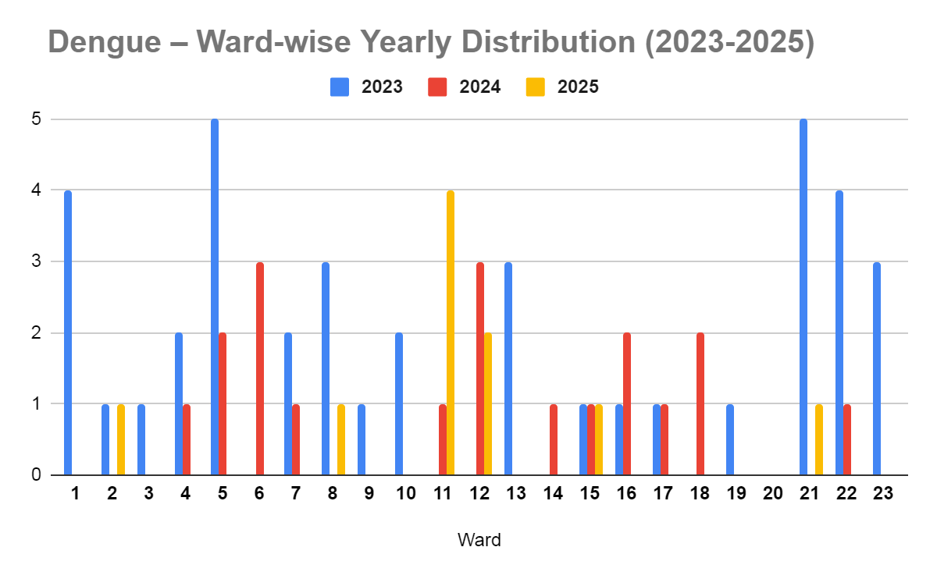

Dengue – Ward-wise Yearly Distribution (2021–2025)

Ward | Dengue – Ward-wise Yearly Distribution
Ward | 2023 | 2024 | 2025 | Total
1 | 4 | 0 | 0 | 4
2 | 1 | 0 | 1 | 2
3 | 1 | 0 | 0 | 1
4 | 2 | 1 | 0 | 3
5 | 5 | 2 | 0 | 7
6 | 0 | 3 | 0 | 3
7 | 2 | 1 | 0 | 3
8 | 3 | 0 | 1 | 4
9 | 1 | 0 | 0 | 1
10 | 2 | 0 | 0 | 2
11 | 0 | 1 | 4 | 5
12 | 0 | 3 | 2 | 5
13 | 3 | 0 | 0 | 3
14 | 0 | 1 | 0 | 1
15 | 1 | 1 | 1 | 3
16 | 1 | 2 | 0 | 3
17 | 1 | 1 | 0 | 2
18 | 0 | 2 | 0 | 2
19 | 1 | 0 | 0 | 1
20 | 0 | 0 | 0 | 0
21 | 5 | 0 | 1 | 6
22 | 4 | 1 | 0 | 5
23 | 3 | 0 | 0 | 3

LEPTOSPIROSIS
Leptospirosis cases are closely linked to monsoon rains, flooding, and occupational exposure, particularly in low-lying and waterlogged areas.
Peak: June - August

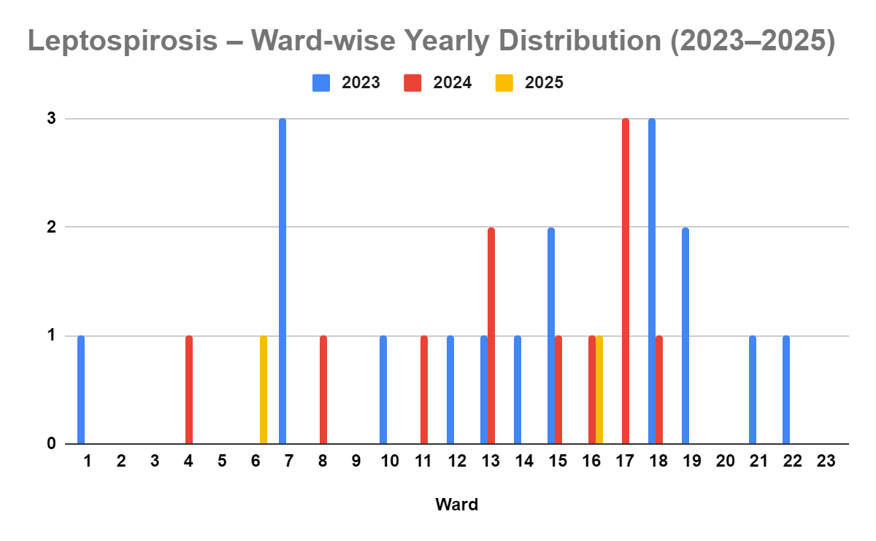

Leptospirosis – Ward-wise Yearly Distribution (2021–2025)

Ward | Leptospirosis – Ward-wise Yearly Distribution
Ward | 2023 | 2024 | 2025 | Total
1 | 1 | 0 | 0 | 1
2 | 0 | 0 | 0 | 0
3 | 0 | 0 | 0 | 0
4 | 0 | 1 | 0 | 1
5 | 0 | 0 | 0 | 0
6 | 0 | 0 | 1 | 1
7 | 3 | 0 | 0 | 3
8 | 0 | 1 | 0 | 1
9 | 0 | 0 | 0 | 0
10 | 1 | 0 | 0 | 1
11 | 0 | 1 | 0 | 1
12 | 1 | 0 | 0 | 1
13 | 1 | 2 | 0 | 3
14 | 1 | 0 | 0 | 1
15 | 2 | 1 | 0 | 3
16 | 0 | 1 | 1 | 2
17 | 0 | 3 | 0 | 3
18 | 3 | 1 | 0 | 4
19 | 2 | 0 | 0 | 2
20 | 0 | 0 | 0 | 0
21 | 1 | 0 | 0 | 1
22 | 1 | 0 | 0 | 1
23 | 0 | 0 | 0 | 0

VIRAL HEPATITIS - A
Hepatitis A cases are commonly associated with unsafe drinking water, food contamination, and breakdowns in sanitation, often presenting as clusters or outbreaks.

Peak: October - December

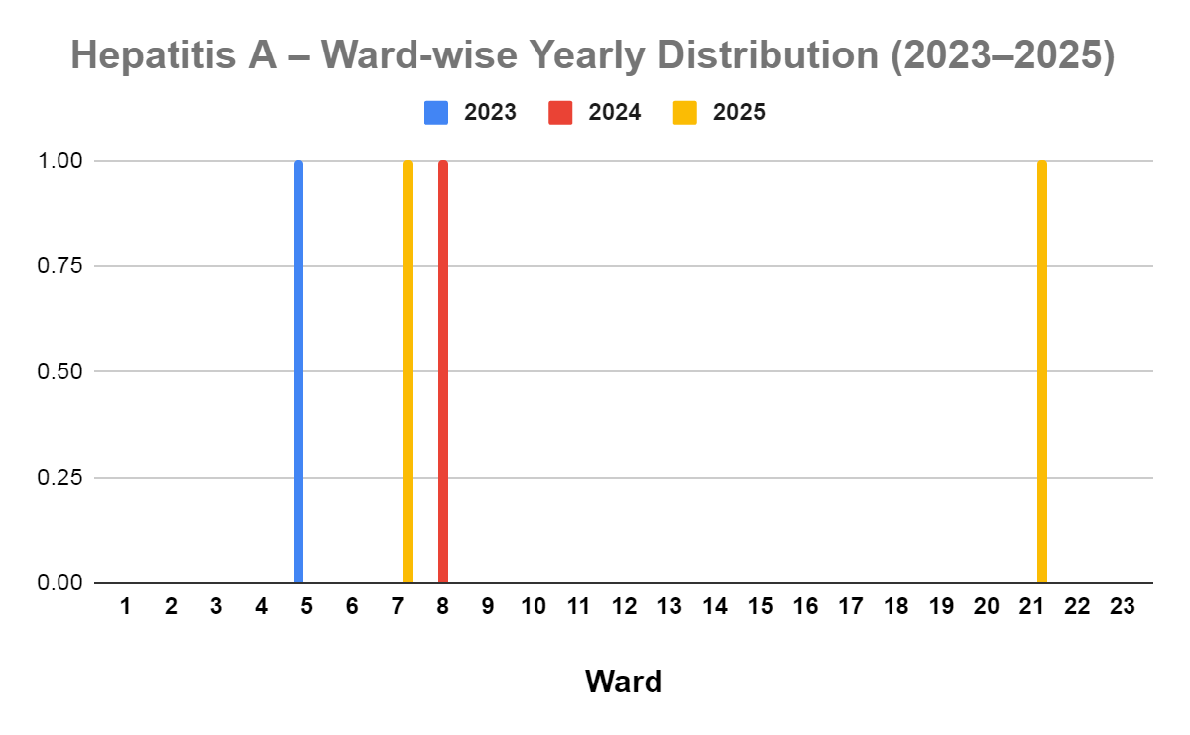

Hepatitis A – Ward-wise Yearly Distribution (2021–2025)

Ward | Hep A – Ward-wise Yearly Distribution
Ward | 2023 | 2024 | 2025 | Total
1 | 0 | 0 | 0 | 0
2 | 0 | 0 | 0 | 0
3 | 0 | 0 | 0 | 0
4 | 0 | 0 | 0 | 0
5 | 1 | 0 | 0 | 1
6 | 0 | 0 | 0 | 0
7 | 0 | 0 | 1 | 1
8 | 0 | 1 | 0 | 1
9 | 0 | 0 | 0 | 0
10 | 0 | 0 | 0 | 0
11 | 0 | 0 | 0 | 0
12 | 0 | 0 | 0 | 0
13 | 0 | 0 | 0 | 0
14 | 0 | 0 | 0 | 0
15 | 0 | 0 | 0 | 0
16 | 0 | 0 | 0 | 0
17 | 0 | 0 | 0 | 0
18 | 0 | 0 | 0 | 0
19 | 0 | 0 | 0 | 0
20 | 0 | 0 | 0 | 0
21 | 0 | 0 | 1 | 1
22 | 0 | 0 | 0 | 0
23 | 0 | 0 | 0 | 0

Outcome-Based Trend Analysis- 2025

An approach for monitoring and analyzing the disease patterns based on the outcomes or impacts of specific interventions, policies, or public health measures and concerns. It shifts emphasis from merely tracking disease incidence to evaluating the effectiveness of prevention measures implemented for the disease. This type of analysis is crucial for understanding not only the spreadness of diseases but also how well the system is responding to them. This analysis evaluates the impact of various public health measures, determines whether these measures lead to reductions in disease prevalence, morbidity, mortality, or healthcare burden over time and this can be utilized modifying or improving existing health policies, resource allocation, and preparedness plans.

Sl. No. | Type of disease | Age group | Gender |  | Total no. of survival | Total no. of death | No. of cases received treatment
Sl. No. | Type of disease | Age group | No. of Male | No. of Female | Total no. of survival | Total no. of death | No. of cases received treatment
1 | Dengue | under 05 children | 1 | 0 | 1 | 0 | 1
2 | Dengue | 5-19 years | 0 | 2 | 2 | 0 | 2
3 | Dengue | 20-59 years | 7 | 2 | 9 | 0 | 9
4 | Dengue | 60+ (Seniors) | 1 | 1 | 2 | 0 | 2
1 | Lepto | under 05 children | 0 | 0 | 0 | 0 | 0
2 | Lepto | 5-19 years | 0 | 0 | 0 | 0 | 0
3 | Lepto | 20-59 years | 1 | 1 | 2 | 0 | 2
4 | Lepto | 60+ (Seniors) | 0 | 1 | 1 | 0 | 1
1 | VH-A | under 05 children | 0 | 0 | 0 | 0 | 0
2 | VH-A | 5-19 years | 0 | 0 | 0 | 0 | 0
3 | VH-A | 20-59 years | 1 | 1 | 2 | 0 | 2
4 | VH-A | 60+ (Seniors) | 0 | 0 | 0 | 0 | 0

Transmission Trend- 2025
For effective management of public health issues, it is important to track the trend of disease transmission mode. It helps identify the population or place at high risk that can be used to predict outbreaks and implement targeted interventions as quickly as possible. Understanding these kinds of trends enables authorities to allocate resources efficiently and change the strategies adequately based on the trend that follows.

Mode of Transmission | No. of cases | No. of Deaths
Vector Borne Diseases | 7 | 0
Water Borne Diseases | 120 | 0
Air Borne Diseases | 24 | 0
Blood Borne Diseases | 0 | 0
Food Borne Diseases | 2 | 0

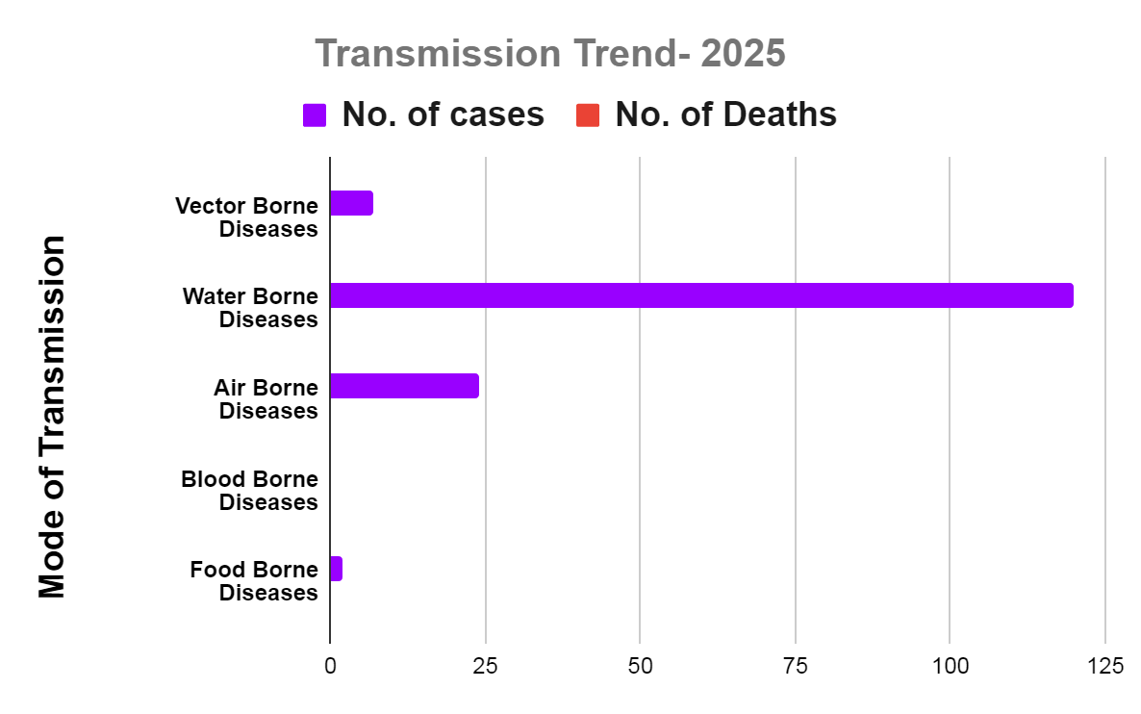

Vector-Borne Disease

Disease | No. of Cases | No. of Deaths
Dengue | 4 | 0
Malaria | 1 | 0
Chikungunya | 0 | 0

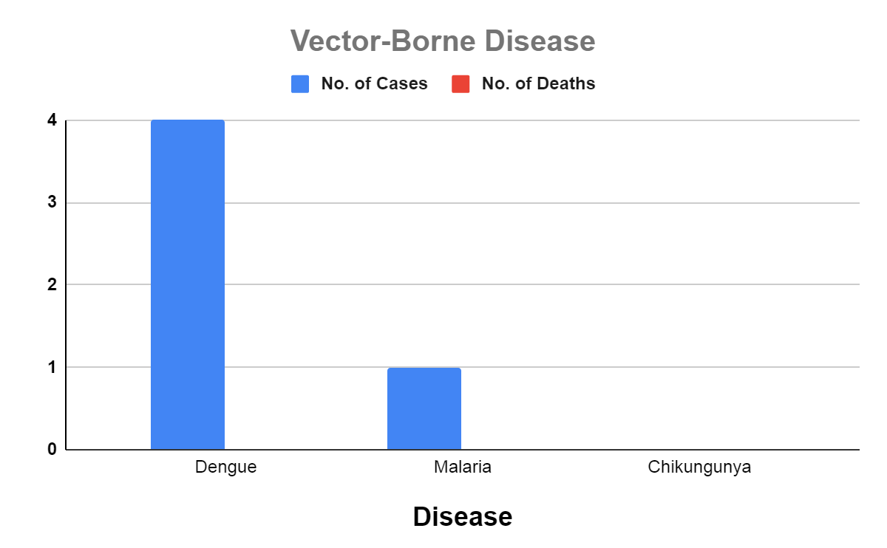
Water Borne Disease

Disease | No. of Cases | No. of Deaths
Cholera | 0 | 0
Typhoid | 1 | 0
Hep- A | 2 | 0
Dysentery | 0 | 0
Amoebiasis | 0 | 0
E- Coli infections | 0 | 0

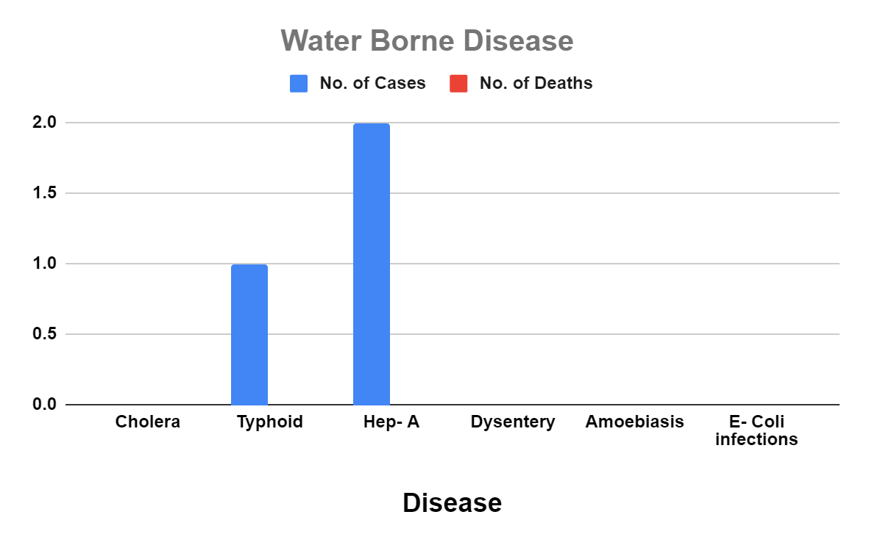

Air Borne Disease

Disease | No. of Cases | No. of Deaths
Influenza | 0 | 0
H1N1 | 0 | 0
TB | 19 | 2
Chickenpox | 36 | 0
Measles | 0 | 0
Covid-19 | 0 | 0
Pertussis | 0 | 0
Mumps | 10 | 0

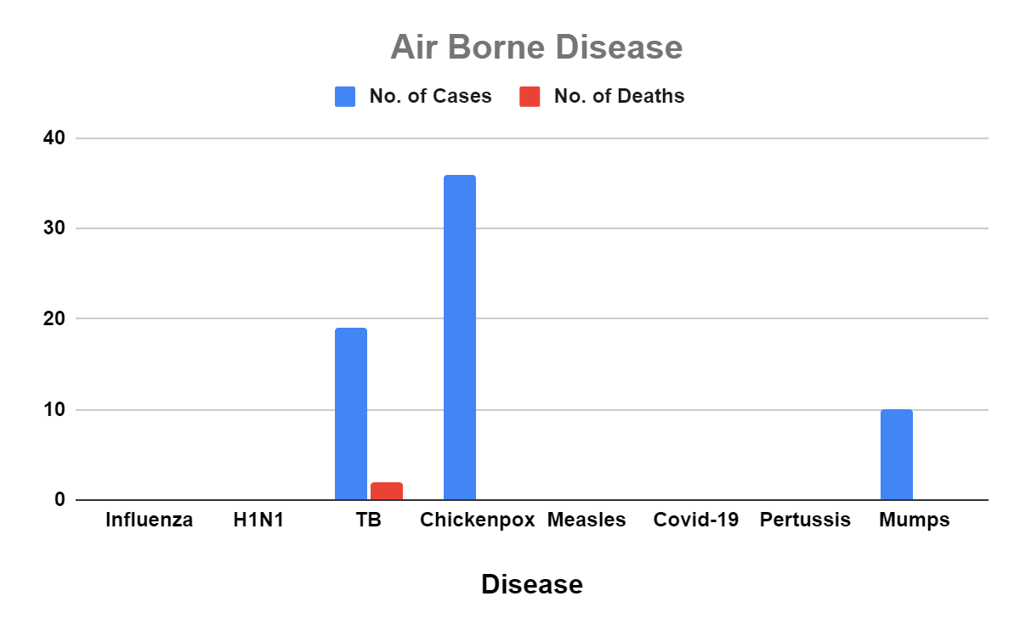

Blood-Borne Disease

Disease | No. of Cases | No. of Deaths
AIDS | 0 | 0
Hep- B | 0 | 0
Hep- C | 0 | 0

Zoonotic Disease
Disease | No. of Cases | No. of Deaths
Rabies | 0 | 0
Leptospirosis | 3 | 0
Avian influenza | 0 | 0
West nile | 0 | 0
Anthrax | 0 | 0
Nipah | 0 | 0
Scrub Typhus | 1 | 0

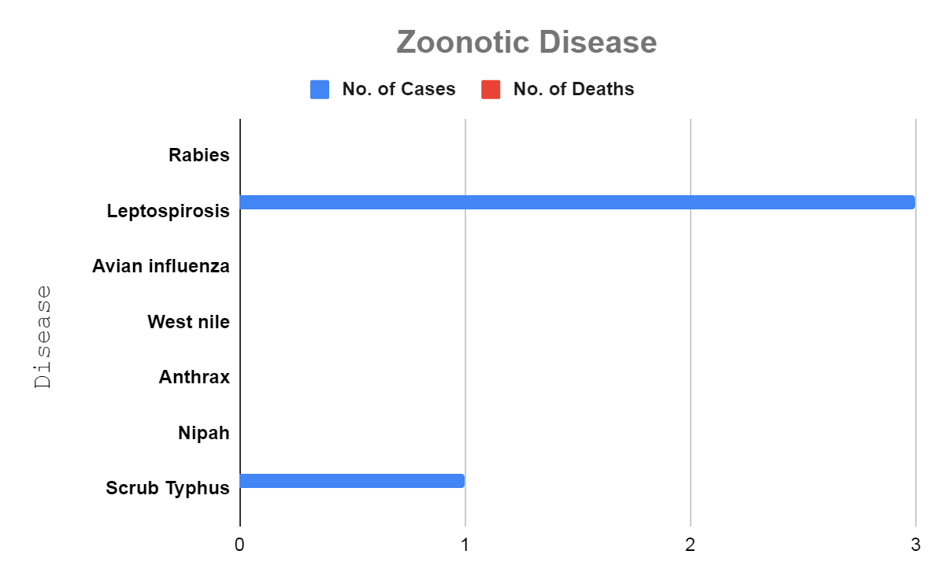

Integrated Disease Hotspot Map (2023–2025)

Between 2023 and 2025, communicable disease incidence shows a relatively moderate distribution across wards, with no extreme clustering. By overlaying this three-year data, we have identified four (4) Primary 'Red Zone' Wards (5, 7, 13, and 21). These are areas where high case counts and disease co-occurrence (multi-pathogen presence) are most significant.Ward 21 reports the highest total (7 cases), followed by Wards 5, 7, and 13 (6 cases each). Dengue remains the predominant contributor in most wards, while leptospirosis shows consistent but lower-level presence across several areas. Hepatitis A cases are minimal and sporadic. Ward 20 reported no cases during this period. Overall, the pattern suggests localized moderate-risk clusters rather than widespread high-intensity transmission, indicating the need for targeted vector control, environmental sanitation, and continued surveillance in identified higher-burden wards.

Ward No | Dengue Total (2023-25) | Leptospirosis Total (2023-25) | Hepatitis A Total (2023-25) | Total Cases
1 | 4 | 1 | 0 | 4
2 | 1 | 0 | 0 | 1
3 | 1 | 0 | 0 | 1
4 | 2 | 1 | 0 | 3
5 | 5 | 0 | 1 | 6
6 | 0 | 1 | 0 | 1
7 | 2 | 3 | 1 | 6
8 | 3 | 1 | 1 | 5
9 | 1 | 0 | 0 | 1
10 | 2 | 1 | 0 | 3
11 | 0 | 1 | 0 | 1
12 | 0 | 1 | 0 | 1
13 | 3 | 3 | 0 | 6
14 | 0 | 1 | 0 | 1
15 | 1 | 3 | 0 | 4
16 | 1 | 2 | 0 | 3
17 | 1 | 3 | 0 | 4
18 | 0 | 4 | 0 | 4
19 | 1 | 2 | 0 | 3
20 | 0 | 0 | 0 | 0
21 | 5 | 1 | 1 | 7
22 | 4 | 1 | 0 | 5
23 | 3 | 0 | 0 | 3

Ward-wise Risk Stratification of Communicable Diseases (2021–2025) Based on Total Reported Cases

Intensity | Risk Level | Total Cases | Wards
Dark Red | Critical Hotspot | 6+ | Ward 21 (7), Ward 5, Ward 7, Ward 13
Orange-Red | High Risk | 4 – 5 | Ward 1, Ward 8, Ward 15, Ward 17, Ward 18, Ward 22
Orange | Moderate Risk | 2 – 3 | Ward 4, Ward 10, Ward 16, Ward 19, Ward 23
Yellow | Low Risk | 0 – 1 | Wards 2, 3, 6, 9, 11, 12, 14, 20

Preparedness and Response Protocol at LSG Level
This section describes the operational framework for the LSGI once a pandemic is declared. It explains how the LSGI and health system will move from routine data collection to active response, using a One Health approach.

Constitution of One Health Committee
The LSGD shall constitute a One Health Committee comprising the LSGI President, Medical Officers (Modern Medicine, AYUSH, and Veterinary), the Health Inspector, and the Veterinary Surgeon.

Objective: The One Health Committee coordinates human, animal, and environmental health to prevent and control pandemics.

Sl No | Name | Designation | Department/Institution | Role in Committee | Contact Number
1 | VD Ambujakshan | Panchayat President | LSGD | Chairperson | 9288550021
2 | Dr. Praveen GS | Medical Officer (PHC/CHC) | Health Dept | Member Secretary | 9400037804
3 | Dr. Vishnu Soman | Veterinary Officer | Animal Husbandry | Member | 8590135480
4 | Swetha | Epidemiologist | Health Dept | Member | 8606799186
5 | Biju KN | Health Inspector/PHN | Health Dept | Surveillance | 9496090270
6 | Sithara | ASHA Supervisor | Health Dept | Community link | 9447706293
7 | Pramada | ICDS Supervisor | Social Welfare | Vulnerable groups | 8281729643
8 |  | Police Station Officer | Police Dept | Law & order | 04772292100
9 | Daniya | Ward Councillor Representative | LSGD | Community coordination | 7012418920
10 | Susheela | Kudumbashree CDO | Kudumbashree | Community mobilisation | 9400140973

Key Responsibilities:
- Review disease surveillance data (human + animal)
- Conduct ward-wise risk assessment and vulnerability mapping
- Approve quarantine/isolation centre locations
- Coordinate with district for resources (PPE, oxygen, ambulances)
- Periodically review health system surge capacity, including beds, oxygen, human resources, and ambulances.
- Approve and monitor risk communication and community engagement strategies, including rumour management.
- Ensure protection and service continuity for vulnerable groups (elderly, persons with disabilities, dialysis patients, coastal populations).
- Conduct quarterly mock drills
- Monitor equity measures for vulnerable groups

Meeting Schedule:
Quarterly (normal times) | Weekly (outbreak alert) | Daily (pandemic phase)

Pandemic Response Workforce
To ensure a coordinated and timely response during a pandemic, a dedicated Pandemic Response Workforce shall be constituted at the LSG level. The workforce will function under the overall supervision of the One Health Committee and in close coordination with the health authorities. Team-based deployment will enable efficient surveillance, case management, quarantine and isolation management, logistics support, and risk communication. Each team shall have a clearly designated team leader, defined roles, and an identified pool of personnel to allow rapid activation, rotation of duties, and continuity of services during prolonged emergencies.

Total Response Workforce Available: 300 persons

Team Name | Composition | Key Responsibilities | Team Leader
Surveillance and Contact Tracing Team | HI, JHI, JPHN, ASHAs and Volunteers | Case detection, contact listing, home visits, reporting | HI
Case Management Team | Doctors, Nurses, MLSP, Palliative Nurses | Patient care & referral | DOCTOR
Quarantine & Isolation Team | LSGD staff, Volunteers | Facility management | JHI
Psychosocial support | Physocogist | psychosocial support, counseling, and mental health follow up | M.O in charge
Logistics & supply chain Team | LSGD staff, Storekeepers, Drivers 3 | Supplies & transport [PPE, medicines, oxygen, transport, waste management] | Ward Member
Communication Team | Ward members, Kudumbashree, Youth clubs,  AWW workers and other self help groups | IEC, community meetings, countering misinformation | M.O in charge
Transportation | KSRTC, educational institutional buses
Media Surveillance | Ward members | media surveillance,rumor tracking ,reporting mis information | Secretary
Intersectoral coordination and convergence | LSGD, Health, Police, Education, Icds | intersectoral coordination,convergence of service | Panchayat President
Collaborative surveillance | health staff ,ward members, volunteers | collaborative surveillance | HI, MO

All teams shall be activated immediately upon outbreak alert or pandemic declaration and shall report daily to the LSG Incident Commander/Medical Officer, with consolidated reporting to the Block PHC. Duty rosters and alternate personnel shall be maintained to ensure uninterrupted services during staff shortages or prolonged response periods. Team composition and numbers may be revised based on the magnitude of the outbreak and availability of human resources.

Activities and Measures before and during Pandemic

PHASE 1 - Alert / Preparation

Activate One Health Committee
  - Immediately activate the One Health Committee at the LSG level. Convene an emergency meeting to review risk assessment, roles, and preparedness. Ensure coordination between Health, Veterinary, Agriculture, Local Self Government, and allied departments.
  - Prepare and circulate a contact directory of all committee members and emergency services.
  - Ensure documentation of decisions and action points with timelines.
  - Escalation hierarchy to be finalised (LSG to Institution to Block to District).

Surveillance and Reporting
Objective: To ensure early detection, timely reporting, and response to potential outbreaks through enhanced facility-, community-, and event-based surveillance
- Enhanced syndromic surveillance:
The LSGD shall initiate enhanced surveillance for priority syndromes and events such as:
  - Fever
  - Influenza-like illness (ILI)
  - Severe acute respiratory infection (SARI)
  - Unusual illness clusters (any unexpected increase in similar symptoms in a defined area or group)
Data sources for surveillance:
- Ward-wise household surveillance (through ASHAs/JPHNs/ward volunteers)
- Outpatient surveillance from all government facilities (PHC, FHC, CHC, GH, etc.)
- Private hospitals, clinics and labs
Event-based triggers (to be monitored and reported):
- School absenteeism above the usual pattern (to be monitored through the headmaster/PTA nodal person)
- Sudden increase in pharmacy sales of fever/cough/cold medicines
- Workplace illness clusters (multiple staff reporting similar symptoms within a short period)
- Zoonotic and animal health surveillance
- LSGD shall review reports of unusual animal deaths or suspected outbreaks in animals in coordination with the Veterinary Officer..

- Any unusual mortality in poultry, pigs, cattle, companion animals, or wild birds/mammals shall be notified within 24 hours to the Veterinary Officer and One Health Committee for joint investigation.

Reporting Mechanism:
All government and private health facilities, laboratories, and clinics within the LSGD shall report suspected and confirmed cases of notifiable diseases. Unusual clusters (schools, workplaces, neighborhoods, events, institutions) shall be reported within 24 hours of detection for verification and field investigation.​

Logistics and Stock Preparedness
  - Identify and empanel local vendors and define emergency procurement mechanisms in accordance with existing LSGD and Health Department norms.

  - Prepare and maintain an essential logistics checklist covering medical supplies, consumables, and support equipment.
  - Pre-identify secure storage locations for emergency stocks and ensure maintenance of stock registers with regular updating.
  - Finalise emergency transport arrangements, including availability of vehicles and identified drivers for rapid deployment during alerts.
  - Designate a Nodal Officer for Logistics to enable prompt decision-making, coordination, and communication during emergencies.
  - Conduct rapid stock verification and ensure availability of minimum buffer stock, including:
Identify critical gaps in logistics and immediately communicate requirements to the Block and District authorities for timely replenishment and support. Monitor expiry dates and stock rotation.

Identification of Quarantine and Isolation Facilities
  - Identify and list suitable buildings for quarantine and isolation (schools, hostels, community halls, etc.).
  - Categorize cases as per the severity and allocate to appropriate facilities (for instance, severe cases to class rooms, mild case to an assembly hall in case of a school).
  - Facility readiness checklist needed (beds, toilets, ventilation) etc.
  - Find alternate site if primary sites not available or not in use condition.
  - Identify facility managers and support staff
  - Prepare basic SOPs for:
    - Admission and discharge
    - Food, water, sanitation
    - Infection prevention and waste disposal
  - Ensure availability of basic amenities: water, sanitation, electricity, ventilation, and waste disposal. Prepare a rapid activation plan for these facilities if case numbers increase.

Risk Communication and Community Preparedness
  - Disseminate early warning messages on symptoms, preventive measures, and reporting mechanisms. Display IEC materials both in English and the local language in public places and ensure ward-level awareness.
  - Sensitize elected representatives and community leaders on preparedness measures.
  - Establish a rumour tracking and misinformation response mechanism to identify, verify, and promptly counter false or misleading information.
  - Engage trusted local persons (ward members, ASHA workers, religious leaders, teachers, community volunteers) to communicate official public health messages and reinforce correct practices.
  - Develop and deploy targeted IEC materials for:
    - Schools and educational institutions
    - Markets and commercial areas
    - Work sites and labour settings

  - Conduct community sensitization meetings at the ward level to promote preventive behaviors, address concerns, and strengthen community participation in preparedness and response.

Protection of Vulnerable Groups
Vulnerable populations require priority protection through targeted line-listing, service continuity, and delivery mechanisms.
- Prepare and regularly update line-lists of vulnerable populations, including:
  - Elderly persons living alone
  - Persons with disabilities
  - Pregnant women
  - Migrant workers
The detailed line-lists shall be maintained as Annexure ___ and updated periodically.

Clinical Dependency Mapping
Develop ward-wise dependency and vulnerability maps to identify households requiring regular support during emergencies. Ensure continuity of essential health services for vulnerable groups, including
- Dialysis services (facility mapping, transport arrangements, and scheduling)
- Continuity of treatment for TB, HIV, and other chronic conditions requiring uninterrupted medication
- Mental health and psychosocial support services
Establish delivery mechanisms for food, essential commodities, and medicines to vulnerable households through coordinated action involving ASHAs, JPHNs, Kudumbashree, volunteers, and local administration.

PHASE 2 - Active Response

Case Identification and Contact Tracing
Case detection and contact tracing activities will be carried out in coordination with the Health authorities, following disease-specific SOPs and IDSP guidelines.
Field Staff Involved
- Health Inspector (HI)
- Junior Health Inspector (JHI)
- Junior Public Health Nurse (JPHN)
- ASHAs and ASHA Supervisors
- Ward-level volunteers and Kudumbashree members (as required)

Screening Checkpoints
Screening checkpoints at high-traffic locations (transport hubs, markets, religious gatherings) for early detection of symptomatic travelers and crowd screening during outbreaks. Potential locations include bus stands, market entry points, and boat jetties, based on local context and risk assessment.
Screening activities will be carried out by trained personnel such as ASHAs, ward members, and volunteers, with support from Health Department staff. Necessary equipment including non-contact thermometers and appropriate PPE shall be ensured prior to activation.

Location | Type (Bus stand/Jetty/Market/Railway) | Staff Deployed (ASHAs/Volunteers) | Screening Method | Reporting authority
Bus stand | Transport hub | One JHI  One ASHA  One health Mentors | 1.Swab Collection.  2. Blood smears collection (RDT)  3.Thermal Scanners | Surveillance Nodal Officer in control room
Market entry | Market | One JHI  One ASHA  Male health volunteers | 1.Swab Collection.  2. Blood smears collection (RDT)  3.Thermal Scanners | Surveillance Nodal Officer in control room
Boat jetty | Water transport | One JHI  One ASHA  Male health volunteers | 1.Swab Collection.  2. Blood smears collection (RDT)  3.Thermal Scanners | Surveillance Nodal Officer in control room

Standard Screening Protocol

The screening protocol shall include temperature screening, observation for visible symptoms, and inquiry regarding recent travel or exposure history. Individuals identified as suspects during screening shall be immediately referred to the nearest PHC/FHC for further evaluation, testing, and appropriate action as per prevailing guidelines.

Pandemic Control Room
The Pandemic Control Room (PCR) serves as the central nerve center for real-time coordination, data aggregation, decision support, and communication during outbreaks. It consolidates information from all LSGD teams, health facilities and community sources to enable rapid response decisions.

Control Room Infrastructure and Location
Primary Location: Mararikkulam South Panchayath Office.
Backup Location: Community Hall in Mararikkulam South G.P.

Health System Control Room Framework
The PCR is organized into seven functional pillars to ensure no aspect of the response is overlooked:

Rapid Response Team (RRT)
  - Provides immediate intervention during emergencies, clusters, and field alerts.​
  - Coordinates urgent actions such as case investigation, contact tracing, isolation, and inter‑facility referrals.

Data Management & Analytics Team
  - Collects, validates, and manages key health system indicators (cases, tests, beds, HR, supplies).​
  - Analyzes data trends, generates projections, and supports evidence‑based decision‑making for local authorities.

Human Resource Deployment Team
  - Allocates healthcare staff efficiently based on workload and need
  - Ensures adequate and equitable workforce distribution across facilities

Laboratory Surveillance Team
  - Oversees diagnostic testing coordination, sample transport, and timely reporting of results.​
  - Monitors lab indicators (testing volume, positivity rate, turnaround time) for early detection of outbreaks

Vaccination Cell (If Required)
  - Plans and executes vaccination campaigns, including micro‑planning and session scheduling.​
  - Tracks coverage, identifies gaps, and coordinates corrective actions with field teams and outreach services.

Infrastructure & Patient Occupancy Team
  - Monitors facility capacity, earmarked beds, oxygen and critical care resources across all linked facilities.​
  - Ensures optimal patient distribution and referral management using updated bed‑status and resource data.

Policy Execution & Strategy Team
  - Implements health policies, SoPs, and government orders within the LSGD jurisdiction.​
  - Develops local strategies, reviews compliance, and recommends modifications based on field feedback and data.

Key Control Room Team
The Control Room Team coordinates all pandemic response activities within the LSGD and serves as the single command and communication hub during activation. It integrates information, field actions, logistics, and policy execution across all participating departments and health facilities.

Role | Name | Designation | Contact Number | Responsibility
In-charge/Nodal Officer | Dr.Praveen G S | AMO | 9400037804 | Overall coordination, decision-making, and reporting to the District level.
Data Entry Operator | Staff from LSGD | As per the availability |  | Managing the line list, updating dashboards, and tracking testing results.
Communication Officer | Biju KN | ,Health Inspector | 9496090270 | Handling the public helpline, coordinating ambulance dispatch, and contact tracing calls.
Logistics Coordinator | Ahammad Riyas | Jr,Health Inspector | 9495758865 | Monitor stock,manage storage
TechnicalSupport (IT/Data) | Prasadkumar R | Jr,Health Inspector | 7012438958 | Provides technical support

Key Points:
- The Control Room shall be staffed with a designated In-charge, data entry personnel, and communication staff with clearly defined roles and shift arrangements.
- It shall maintain updated records on daily monitoring indicators including new cases, persons under active quarantine, and hospital bed occupancy.
- All reports and situation updates shall be shared daily with the Block and District Surveillance Unit.
- The Control Room shall act as a single point of contact for coordination with response teams, health institutions, and other departments.
- Contact details of the Control Room shall be widely communicated to field staff and stakeholders during activation.

Daily Monitoring Indicators
To ensure timely decision-making and effective response, the following key indicators shall be monitored and updated on a daily basis by the Pandemic Control Room:

Epidemiological Indicators:
New cases reported today, Total active cases, Test Positivity Rate (TPR), Case Fatality Rate (CFR)
- Surveillance Indicators:
Persons under home quarantine, High-risk contacts identified, Fever, ILI, SARI or other symptoms (syndromic surges), Travellers (symptomatic or high-risk arrivals),Animal husbandry surveillance (zoonotic alerts, unusual animal deaths, poultry/bird flu signals), Mortality surveillance (excess deaths, unexplained fatalities, verbal autopsy reports)
- Logistics and Infrastructure Indicators:
Hospital / CFLTC beds occupied, Oxygen cylinders / concentrators available, Ambulances on standby
- Alert Findings
The following table outlines category-specific trigger points (red flags) from surveillance indicators and corresponding immediate actions for the Pandemic Control Room. These enable rapid response to alert findings like testing anomalies, positive cases exceeding thresholds, clusters, and WGS reports.

Category | Trigger Pophint (Red Flag) | Immediate Action
Clusters | Geographical or facility-based: 5+ cases linked to one location (office, school, street). | Declare a micro-containment zone; perimeter control and active case finding.
Testing | Sudden drop in testing volume / delay in reporting / unusual testing trends | Review the sample collection process, address lab bottlenecks, deploy additional testing teams, and notify the District Lab.
Lab | Test Positivity rate increases | Increase testing sites in that ward.
Hospital | >80% Oxygen bed occupancy | Activate backup/CFLTC beds.
Travel | Cluster of cases from a single flight/train or high-risk arrival group. | Trace all passengers in adjacent seats; implement mandatory institutional quarantine.
Animal | Mass poultry/wildlife death or unusual sickness | Notify Animal Husbandry, sample the area, and dispatch RRT for environmental sampling and zoonotic check.
Mortality | Sudden spike in home deaths or brought-in-dead (BID) cases | Audit the deaths and Active Case Search drive
Additional investigations like Whole Genome Sequencing (WGS) | Detection of a Variant of Concern (VOC) or Variant of Interest (VOI) | Implement strict micro-containment; update clinical protocols to match variant severity.

Communication of Public Health Information
A Community Communication Hub shall be established to ensure timely, accurate, and consistent dissemination of information during a pandemic. The Hub will function under the coordination of the president and act as the nodal point for public communication, risk messaging, and community engagement. It will support dissemination of official advisories, promote preventive behaviors, address rumors and misinformation, and ensure that messages reach all sections of the population through trusted local channels and leaders.

Key communicators
Channel | Responsible Person | Contact
Ward-level announcements | Ward members | MARY JASMIN PA 8848986362
Social media | Ward members | MARY JASMIN PA 8848986362
LocalCable TV/Radio | Health Inspector | 9496090270

- All messages disseminated through the Hub shall align with advisories issued by the Health Department and District authorities.
- Community leaders shall be sensitized to support behavior change, reduce stigma, and counter misinformation.
- Special efforts shall be made to reach vulnerable and hard-to-reach populations using locally appropriate communication methods.

Rumor Tracking: A designated volunteer will monitor local social media/WhatsApp groups daily to identify misinformation and issue official clarifications via the Communication Hub.

Coordination with District/State Authorities & Other Organisations
Effective coordination with Block, District, and State authorities is essential to ensure timely reporting, technical guidance, and uninterrupted supply of essential resources during a pandemic. The LSG shall establish clear communication channels, designate responsible officers, and adhere to prescribed reporting timelines to support coordinated public health action and efficient resource mobilisation.

Key Details:
- Nodal Officer for Reporting: Dr.Praveen AMO
- Contact Number: 9400037804

Reporting Schedule and Protocols:

To Whom | What to Report | Frequency | Nodal Person
Block PHC | Complete Situation Report (Cases, Quarantine, Beds, Screening, Deaths) | As early Possible | Health Supervisor
District IDSP Unit | Outbreaks/Clusters/Unusual Events (>5 cases same ward) | Within 24 hrs | DMOH
Veterinary Officer | Animal health events/Zoonotic alerts | As early Possible | Veterinary Medical Officer
State Cell | Zoonotic cross-sector events | As early Possible | ADHS

Supply Chain Coordination
The LSG shall coordinate closely with Block, District, and State authorities (KMSCL) to ensure uninterrupted availability of essential goods, medical supplies, and logistics during a pandemic. Supply requirements shall be assessed regularly based on case load and communicated promptly to the appropriate authorities for timely replenishment.
Key Points:
- Maintain updated contact details of District and Block nodal officers for health logistics, oxygen supply, ambulances, and essential medicines.
- Submit timely indent requests for PPE, testing kits, medicines, oxygen, and other critical supplies through prescribed channels.
- Monitor stock levels at LSGD facilities, quarantine/isolation centres, and field teams through daily stock registers and dispensing logs to prevent shortages.
- Coordinate with District authorities, Karunya/Neethi medical shops, and local purchase committees for funds allocation and emergency procurement.

- Ensure regular monitoring of dispensing registers at all facilities to track usage, expiry, and pilferage—shortages being a perennial issue requiring proactive weekly audits.

- Activate surge procurement protocols during high caseloads, leveraging local purchase powers under LSGD funds alongside state supplies.

Resource Inventory and Contacts
Resource Category | Source  (District/State/Private) | Contact
PPE Kits/Masks/Gloves | KMSCL | 9895214070
PPE Kits/Masks/Gloves | KMSCL/Local Vendors | 9895214070
Oxygen  Cylinders/Concentrators | KMSCL | 9895214070
Medicines/Antivirals | KMSCL | 9895214070
Medicines/Antivirals | Neethi Shops | 04782810114
Test Kits (RTPCR/Rapid) | KMSCL | 9895214070

Collaboration with NGOs, PPP, and CSR
To augment government efforts during a pandemic, the LSG shall collaborate with NGOs, voluntary organisations, and private sector partners through public–private partnerships and Corporate Social Responsibility (CSR) initiatives, in coordination with District authorities.

Key Points:
- Engage NGOs and community-based organisations for community outreach, awareness, and support to vulnerable populations.
- Leverage CSR support for procurement of medical equipment, PPE, oxygen concentrators, food kits, and sanitation materials, as permitted.
- Ensure all collaborations align with government guidelines and are routed through approved administrative and financial procedures.
- Maintain transparency and documentation for all external support received and utilised.

Department | Representative | Key Role | Contact
Health (PHC) | Dr.Praveen G S | Case management | 9400037804
Veterinary | Vishnusoman Veterinary Surgeon: | Animal surveillance | 8590135480
ICDS | PravathaPeter CDPO | Nutrition support | 8281729643
Education | AEO | School coordination | 04772251587
Police | SHO | Containment enforcement | 9497975247
Water Authority | Assistant Engineer | Water supply | 04772245780
LSGD Engineering | Assistant Engineer | Quarantine infrastructure | 04772258238

PHASE 3 - Surge Capacity
Phase 3 is activated when there is a rapid increase in cases, high test positivity rates, or when existing health facilities and quarantine arrangements approach saturation. The focus of this phase is to expand isolation capacity, augment clinical care services, and mobilise additional resources through district and state support mechanisms.

Conversion of Community Facilities
To manage increased case load, the LSGD shall activate additional isolation facilities by repurposing identified community infrastructure such as community halls, auditoriums, schools, hostels, or other suitable buildings.
Facility Type | No. of Buildings | Ward | Surge Capacity (Beds) | Nodal Person
Auditoriums | 2 | Ward 5,9 | Average 50 Bed In 1 Hall | Ward Member
Schools | 15 | Ward 4,11,15,12,7,20,19 | 100 Bed Capacity in Each School | School HM
Community Halls | 0 | 0
Religious Hall | 35 | Mostly all Wards | 20 bed Capacity Average In 1 Hall | Ward Member

Recovery and rehabilitation phase
The recovery and rehabilitation phase begins once the immediate public health emergency is controlled and transmission is reduced to manageable levels. This phase focuses on restoring essential services, addressing long-term health and socio-economic impacts, and strengthening systems to prevent or better manage future pandemics.
Recovery

Recovery
Recovery refers to the gradual return of communities and systems to normal functioning while continuing public health vigilance. It involves phased withdrawal of emergency measures, reopening of services, and reintegration of disrupted health and social systems. Recovery activities should be evidence-based, inclusive, and aligned with national and state guidelines to ensure sustainability and resilience.

Damage and Impact Assessment
Before long-term rebuilding can happen, the dust must be settled and the immediate risks managed.Damage and impact assessment is a critical step to understand the full extent of the pandemic’s effects on health systems, communities, and livelihoods. This assessment evaluates disruptions to healthcare services, availability of infrastructure and workforce, morbidity and mortality patterns, and socio-economic consequences such as loss of income, education disruption, and food insecurity. The findings inform evidence-based planning, prioritization of interventions, and optimal allocation of resources during the recovery phase.

Restoration of Health Services
Recovery requires moving beyond emergency trauma care. This sub-phase focuses on reopening primary care clinics, restarting routine immunization programs, and ensuring that patients with chronic conditions (like diabetes or hypertension) can once again access life-sustaining medications and check-ups.

Environmental Cleanup and Sanitation
Post-disaster environments are often breeding grounds for secondary health crises. Cleanup efforts focus on removing debris, managing hazardous waste, and restoring water and sewage systems. Ensuring a "clean slate" is biologically necessary to prevent the spread of waterborne and vector-borne diseases.

Rehabilitation
Rehabilitation focuses on addressing the long-term physical, social, and economic impacts of the pandemic on affected individuals and communities. This includes medical rehabilitation for post-infection complications, nutritional support for vulnerable groups, and social assistance for households affected by illness, disability, or loss of livelihood. Rehabilitation efforts should promote reintegration into education, employment, and community life, with special attention to marginalized and high-risk populations.

Physical and Livelihood Rehabilitation
For those left with lasting injuries, rehabilitation involves providing physical therapy and assistive devices. Simultaneously, Livelihood Restoration addresses the economic health of the community; without the ability to earn an income, individuals cannot sustain their own long-term health and nutrition. Support for small businesses, informal workers, self-help groups, and skill development initiatives is essential to promote economic resilience and long-term recovery.

Psychosocial and Mental Health Support
The trauma of a disaster often outlasts the physical damage. Providing psychological first aid and long-term mental health counseling is vital for community cohesion. This support helps individuals process grief and anxiety, reducing the long-term societal burden of PTSD.

Community Engagement and Confidence Building
Recovery fails if the public does not trust the systems being rebuilt. Active communication and involving local leaders in the decision-making process help rebuild social capital. This ensures that the population feels safe returning to schools, workplaces, and hospitals. Active involvement of community leaders, local self-governments, and civil society organizations strengthens community ownership, promotes adherence to public health measures, and enhances preparedness for future emergencies.

Vigilance and Disease Surveillance
Disease surveillance during the recovery phase ensures early detection of resurgence, secondary outbreaks, or emerging variants. Surveillance systems should continue monitoring communicable disease trends, post-pandemic complications, and unusual health events. Strengthening laboratory capacity, sentinel surveillance, and community-based reporting mechanisms enables timely response and supports sustained public health security.

System Strengthening and Future Preparedness
The final stage of recovery is an intellectual exercise in "Building Back Better," turning the tragedy of the past into the safety of the future.

Documentation and After-Action Review (AAR)
Once the immediate pressure has subsided, stakeholders must conduct a formal review of the response. This involves a candid look at what worked, what failed, and where communication broke down. These Lessons Learned are then transformed into Best Practices.

Policy Revision and Health System Strengthening
The ultimate goal of recovery is to ensure the next crisis is less damaging. This involves updating emergency protocols, revising public health laws, and investing in more durable infrastructure. Through Research and data analysis, the health system is "hardened" against future threats, moving the community from a state of vulnerability to a state of permanent readiness.

Research
Research during the recovery phase is essential to generate evidence on the long-term health, social, and economic impacts of pandemics. Operational, clinical, and policy research should examine the effectiveness of response and recovery interventions, community behaviors, and innovations in service delivery and surveillance. Research findings should inform future preparedness strategies and public health decision-making.

Recovery & Rehabilitation Master Checklist

1. Assessment & Infrastructure Restoration
[ ] Conduct Multi-Sectoral Impact Assessment: Complete a full audit of damage to health facilities, equipment, and digital infrastructure.
[ ] Restore Essential Utilities: Verify that hospitals and clinics have stable access to clean water, electricity, and medical gas.
[ ] Re-establish Supply Chains: Transition from emergency "push" systems to routine procurement for medications and consumables.
[ ] Environmental Safety Check: Clear all hazardous debris and certify that sanitation/waste management systems are fully functional.

2. Clinical & Public Health Continuity
[ ] Resume Primary Care: Transition staff from emergency roles back to routine services (Maternal health, NCDs, Immunizations).
[ ] Launch Recovery-Phase Surveillance: Implement enhanced monitoring for infectious diseases common in post-disaster settings.
[ ] Clear Patient Backlogs: Identify and schedule patients whose elective surgeries or treatments were delayed during the crisis.
[ ] Environmental Health Audit: Test local water sources and food supply chains for contamination post-cleanup.

3. Human-Centric Rehabilitation
[ ] Deploy Psychosocial Support: Establish long-term mental health clinics and peer support groups for survivors and first responders.
[ ] Physical Rehab Integration: Provide specialized care, prosthetics, and occupational therapy for those with permanent injuries.
[ ] Livelihood Support Coordination: Partner with NGOs to provide micro-grants or vocational training to displaced healthcare workers or patients.
[ ] Community Feedback Loop: Create a "Town Hall" or digital platform for citizens to report gaps in the recovery process.

4. Administrative & System Strengthening
[ ] Initiate After-Action Review (AAR): Schedule debriefing sessions with all stakeholders to document successes and failures.
[ ] Financial Reconciliation: Audit emergency spending and finalize insurance claims or international aid reports.
[ ] Knowledge Management: Compile a "Lessons Learned" report and share it with regional and national health authorities.
[ ] Update Preparedness Plans: Revise Standard Operating Procedures (SOPs) based on real-world data gathered during the crisis.
[ ] Research & Development: Identify areas where the response was slowed by lack of data and initiate studies to close those gaps.

5. Confidence & Policy
[ ] Launch Public Information Campaign: Use local media to inform the public that services have resumed and are safe to use.
[ ] Legislative Advocacy: Present findings to policymakers to secure funding for "Build Back Better" infrastructure projects.
[ ] Staff Wellness Check: Conduct mandatory mental health screenings for healthcare workers to prevent burnout and PTSD.

CONCLUSION
This Pandemic Preparedness Plan outlines a comprehensive, decentralised, and action-oriented framework for preparedness and response at the LSGD level. By adopting a One Health approach and strengthening coordination between the health system, local self-government institutions, veterinary services, and community networks, the LSGD aims to ensure early detection, rapid response, and effective containment of pandemics and public health emergencies.
The plan emphasises equity, community participation, and evidence-based decision-making to protect vulnerable populations and ensure uninterrupted access to essential services during crises. It reinforces the importance of local leadership, accountability, and inter-sectoral collaboration in translating preparedness plans into timely action on the ground.
Regular updating, mock drills, capacity building of frontline workers, and sustained interdepartmental coordination will be critical to maintaining readiness and resilience. The successful implementation of this plan depends on collective responsibility, continuous monitoring, and adaptive management in response to emerging threats.
This document shall serve as a living operational guide, to be activated during alerts and continuously improved based on evolving risks, lessons learnt, and guidance from higher authorities, thereby strengthening the LSGD’s ability to safeguard public health.
“Together for a Healthier and Safer Community.”

RECOMMENDATIONS
- It is recommended that ward-level risk grading be institutionalised using the Hazard Risk Index (HRI) to guide prioritisation of resources and strategic deployment of emergency response teams. Incorporating indicators such as hazard frequency, population density, infrastructure integrity, and environmental vulnerability will ensure a comprehensive and context-sensitive assessment of ward-level risk. This approach will enable early intervention in high-risk zones and help mitigate spillover effects to neighbouring areas through targeted preparedness and response measures.
- In high-risk wards, particularly those reporting higher mortality or long-term morbidity, the application of survival analysis is recommended to strengthen risk stratification and guide sustained response planning. By analysing time-to-event outcomes, this method can identify areas requiring prolonged recovery support, facilitate evidence-based allocation of resources, and inform interventions addressing both immediate health impacts and long-term disease burden.
- To strengthen forward-looking disaster preparedness, hazard and risk projections should be modelled under the Representative Concentration Pathway (RCP 8.5) climate change scenario. Integrating climate projections will support scenario-based planning by anticipating future changes in hazard frequency and intensity, including extreme weather events, sea-level rise, and shifting disease patterns.

ANNEXURE

IMPORTANT PHONE NUMBERS
Phone numbers and particulars of persons responsible for providing guidance, assistance, and support for pandemic preparedness operations may be provided here in a manner that allows easy reference at a glance. The information recorded here could be exhibited elsewhere at the time of emergencies. LSG institutions shall give special attention to collect and record the above data of persons and institutions who/which are supposed to give technical and co-ordination support to reduce the impact of pandemic.

1.1. Details of grama panchayat/municipality/corporation wards
Sl.No | Name of the ward | Ward number | Name of the ward  member | Contact number
1 | POLLETHAI WEST | 1 | SHANUPRIYA. P J | 9946717973
2 | POLLETHAI EAST | 2 | V D AMBUJAKSHAN | 9288550021
3 | VALAVANAD | 3 | ADV ASHOKAN.KP | 9446069281
4 | PREETHIKULANGARA | 4 | RESHMI MOHANAN | 8281584227
5 | PREETHIKULANGARA STADIUM | 5 | RESHMI | 8301886109
6 | KALAVOOR | 6 | PRINCY | 9562647770
7 | KALAVOOR SOUTH | 7 | INDIRA THILAKAN | 9249651479
8 | VALIYA KALAVOOR | 8 | SETHUNATH.V | 9847222196
9 | PAZHAYAKAD | 9 | SHAILAJA.K N | 8089447189
10 | PATHIRAPALLY | 10 | VISHWALETHA.VV | 9142503268
11 | PATHIRAPALLY SOUTH | 11 | C A .PEETER | 9446617256
12 | POOMKAV EAST | 12 | THRESSIYA | 9605869123
13 | POOMKAV WEST | 13 | ANTONY | 9447886004
14 | CHETTIKAD | 14 | MARY JASMIN PA | 8848986362
15 | PATTUKALAM | 15 | M S.ARUN | 9496332606
16 | OMANAPUZHA | 16 | SIBIL MARTIN | 9645571322
17 | CHERUYAPOZHI | 17 | SALIMOL | 9142018204
18 | SARVODHAYAPURAM | 18 | T V SAJAN | 9539851887
19 | KATTOOR EAST | 19 | LAIJU A R | 9349927790
20 | PANCHAYATH OFFICE | 20 | RINCY SANTHOSH | 8136897831
21 | MANKADAKAD | 21 | SHARATH MON | 9497128494
22 | KORTHUSHERRY | 22 | CONSTANTAIN ( P V. MANOJ | 8848124792
23 | VAZHAKOOTTAM POZHI | 23 | ROSAMMA SEBASTIAN | 9048370547
24 | SHASTHRI BHAGAM | 24 | SHEELA SURESH | 90611403755

1.2. Other important phone numbers of grama panchayat/municipality/corporation area
Sl. No. | Name | Contact number
1. | V D AMBUJAKSHAN (PANCHAYATH PRSIDENT) | 9288550021
2. | SABU MON ( PANCHAYATH SECRETARY)
3. | RHTC CHETTIKAD | 04772248680
4. | Excise department | 04772230183
5. | Forest department | 0472252034

1.3. Important offices of grama panchayat/municipality/ corporation
Sl.No | Name of the office | Contact person | Contact number
1. | Village Office | Village Officer | 8547612103
2. | Agriculture Office | Agriculture Officer | 9383470608
3. | Animal Husbandry Office | Animal Husbandry Doctor | 8590135480
4. | Police Station | Police Officer | 04772292100
5. | BSNL Office | Officer | 0477-2252000
6. | Block Office | Officer | 04772292425
7. | KSEB Office | Officer | 04772242184
8. | Fisheries Office | Officer | 9497733071
9. | Fire and Rescue | Officer | 04772230303

1.4. Health Services
Sl. No | Name of the hospital/institution | Location | Phone number
1. | Government hospitals/PHC | Chetikadu | 04772248680
2. | Private hospitals | St,micle Kattoor
3. | Clinical laboratories | Chettikadu Pathirapally, Kalavoor,Sarvodayapuram, Poomkavu….
4. | Chemist/pharmacy
5. | Blood donors
6. | Other language experts (Bihari, Hindi, Bengali,  Asamees ………)

1.5. Veterinary Services
Sl.No | Name of the Clinic | Name of the  Surgeon/Doctor | Place/location | Phone  number
1 | Govt.Veterinary Hospital | VISHNUSOMAN | Sarvodayapuram | 8590135480

1.6. Helpline numbers
Helpline | Phone number
Police | 100
Fire and Rescue | 101
KSEB | 1912

1.7. Public and Private Schools Contact details

S.No | Name of School | Institution type | Phone number
1 | SRRLPS PATTUKALAM | Aided | 9446825864
2 | VVSD UPS PATHIRAPALLY | Aided | 8281137193
3 | MARY IMMACULATE UPS PATHIRAPALLY | Private | 9629898609
4 | MARY IMMACULATE HS POOMKAV | Aided | 9495252204
5 | SCMV GUPS POOMKAV | Govt | 7012735192
6 | ST ANTONYS LPS OMANAPUZHA | Aided | 9497674288
7 | TMP LPS KALAVOOR | Govt | 8547944220
8 | ST JOSEPH PUBLIC SCHOOL | Private | 9567217920
9 | GOVT HS POLLETHAI | Govt | 9447460699
10 | HOLLY FAMILY HS KATTOOR | Aided | 8848974298
11 | HOLLY FAMILY VISITATION PUBLIC SCHOOL | Privte | 9846900284
12 | HOLLY FAMILY HSS KATTOOR | Aided | 9895494912
13 | ALPHA GENIUS INTEGRATED SCHOOL | Privte | 9074186741
14 | ST SEBASTIAN PRESENTAION COLLEGE | Private

1.9. Anganwadi Contact Details

Ward No | Name of Anganwadi Teachers | Phone number
6 | Asha  binimol | 9446542254  9846516897
1 | Sudha  Swarna | 9400760115  9846207919
5 | Rema  Chandra | 9645747288  8086442480
4 | Jessy  Reenamol | 8590162373  8075821822
3 | Swapna | 8113051167

Ward No | Anganwadi No and Name of Teacher | Phone number
7 | 77,Ash  76,Rethiyamma | 9496256681  9142421993
8 | 81.Jisha  82,Sajitha | 9656277716  7306877898
11 | Rossamma | 9747083772

Annexure 1: LSG Baseline Data Collection Format
A. Baseline data
Sl. No. | Indicator / Field | Baseline Data | Source / Remarks
1 | Name of LSG | Mararikkulam South Grama Panchayath | LSGD
2 | District | Alappuzha DIstricT Panchayath | LSGD
3 | Block / Taluk | AryadBlock Panchayth | LSGD
4 | Type of LSG (Gram Panchayat / Municipality / Corporation) | Grama Panchayath | LSGD
5 | Area (sq. km) | 6.69KM | LSGD
6 | No. of wards | 23 | LSGD
7 | GIS boundary file available | Yes | Ksmart
8 | Key contact person & phone | Dr. Praveen G S | PHC

B. Demography
Indicator / Field | Baseline Data | Source / Remarks
Total population | 59165 | LSGD
Males | 29165 | LSGD
Females | 29999 | LSGD
Transgender population | 0 | LSGD
Age distribution  (<5, 5–14, 15–59, ≥60) | 2504,5621,17749,6084 | LSGD
No. of households | 14902 | LSGD
Population density (persons/sq.km) | 8452/km | Ksmart
No. of migrant workers | 310 | PHC
Major occupational groups | fisherman,Construction workers | LSGD

C. Vulnerable Populations & Social Risks
Sl. No. | Indicator / Field | Baseline Data (Value / Description) | Source / Remarks
1 | No. of elderly (≥60) | 6084 | PHC
2 | No. of persons with disability | 211 | PHC
3 | No. of bedridden persons | 164 | PHC
4 | No. of chronic disease cases (DM/HTN/COPD/CKD etc.) | 5114 | PHC
5 | Pregnant women (current estimate) | 215 | PHC
6 | Children <5 years | 2504 | PHC
7 | Tribal population (if any) | 622 | LSGD
8 | Fisherfolk / coastal vulnerable groups (if any) | 1264 | LSGD
9 | Urban slums / unnotified settlements (if any) | NIL | LSGD
10 | Homeless population | 20 | LSGD
11 | Orphanages / old age homes (number & capacity) | 3 | LSGD
12 | Hostels / prisons / shelters (number & capacity) | NIL | LSGD
13 | Poverty / BPL estimate | 35499(Populations) | LSGD
14 | Food insecurity hotspots | NIL | LSGD
15 | Any history of stigma/discrimination issues (Yes/No) | NO | LSGD

D. Health System & Service Readiness
Sl. No. | Indicator / Field | Baseline Data (Value / Description) | Source / Remarks
1 | No. of health facilities in LSG (PHC/CHC/TH/DH/Private) | 2(RHTC-1Private CLINIC –1) | LSGD
2 | PHC/Family Health Centre details (name, location) | RHTC Chettikadu | LSGD
3 | Subcentres / Health & Wellness Centres (number) | 8 | PHC
4 | Private clinics / hospitals (number) | 1 | LSGD
5 | Labs available (public/private) | 18 | LSGD
6 | Availability of ambulance services (Yes/No, number) | Yes-2 | Private
7 | Availability of isolation/quarantine facilities (Yes/No, details) | yes, (Schools -15 nos) | PHC
8 | Cold chain facilities (Yes/No, details) | yes (RHTC) | PHC
9 | Stockpile space available (Yes/No) | yes | LSGD
10 | PPE / mask / sanitizer availability plan (Yes/No) | yes | PHC
11 | Surveillance staff available (JHI/JPHN/ASHA count) | 64 | PHC
12 | Existing emergency referral pathways (Yes/No) | yes | PHC

E. Points of Entry & Mobility
Sl. No. | Indicator / Field | Baseline Data (Value / Description) | Source / Remarks
1 | Bus stands / depots (number) | Alappuzha | LSGD
2 | Railway stations (number) | Alappuzha | LSGD
3 | Boat jetties / fishing harbours (number) | Alappuzha- 1 | LSGD
4 | Ports / airports nearby (specify distance) | Ernakulam -60km | LSGD
5 | Major highways/roads passing through | Alappuzha-Kalavoor | LSGD
6 | Border crossings (state/district) | Aroor (Disrtict) | LSGD
7 | Major markets / weekly markets | Alappuzha | LSGD
8 | Tourism hubs / major event venues | Alappuzha | LSGD
9 | Schools/colleges with hostels (number) | 1 | LSGD
10 | Factories / large workplaces (number) | 20 | LSGD
F. Water, Sanitation & Hygiene (WASH)
Sl. No. | Indicator / Field | Baseline Data (Value / Description) | Source / Remarks
1 | Major drinking water sources (piped / wells / borewells / springs) | KWA pipline, Borewell | LSGD
2 | No. of public wells | 20 | LSGD
3 | No. of households with piped water connection | 12000 | LSGD
4 | Water quality testing routine (Yes/No) | yes | PHC
5 | Common contamination risks (flooding, salinity, industrial waste) | flood | LSGD
6 | Open defecation free status (Yes/No) | yes | LSGD
7 | Solid waste management system (Yes/No) | no | LSGD
8 | Bio-medical waste disposal mechanism (Yes/No) | no | LSGD
9 | No. of public toilets | nil | LSGD
10 | Handwashing stations in public places (Yes/No) | nil | LSGD

.G. Zoonotic Risks & One Health
Sl. No. | Indicator / Field | Baseline Data (Value / Description) | Source / Remarks
1 | Livestock population (cattle/goats/pigs/poultry) – estimates | 1715 | LSGD
2 | No. of dairy farms / poultry farms / pig farms | 5 | LSGD
3 | Slaughterhouses / meat shops (number) | 4 | LSGD
4 | Animal markets (Yes/No, details) | NO | LSGD
5 | Veterinary dispensaries (number) | 2 | LSGD
6 | History of zoonotic outbreaks (rabies, leptospirosis, avian flu etc.) | NO | LSGD
7 | Stray dog population management measures (Yes/No) | NO | LSGD
8 | Rodent infestation hotspots (Yes/No) | NO | LSGD
9 | Wetlands / waterlogged areas prone to leptospirosis | WARD 7,9,10,19 | LSGD
10 | Bat roosting areas / caves / fruit orchards (if any) | NO | LSGD
11 | Human-animal interface hotspots (farms near residences) | NO | LSGD

H. Climate & Disaster Risks (Pandemic Amplifiers)
Sl. No. | Indicator / Field | Baseline Data (Value / Description) | Source / Remarks
1 | Flood-prone wards (list) | 7,9,10,19 | LSGD
2 | Landslide-prone wards (list) | NO | LSGD
3 | Cyclone/sea surge risk (Yes/No) | NO | LSGD
4 | Heatwave risk zones (Yes/No) | NO | LSGD
5 | Waterlogging areas (list) | chempenthara,Thumpoly | LSGD
6 | Shelter homes / relief camps (number, capacity) | 0 | LSGD
7 | Past disaster displacement history | NO | LSGD
8 | Disruption to water supply/transport common (Yes/No) | no | LSGD

I. Critical Infrastructure & Logistics
Sl. No. | Indicator / Field | Baseline Data (Value / Description) | Source / Remarks
1 | Schools (number) | 16 | LSGD
2 | Anganwadis (number) | 50 | LSGD
3 | Colleges (number) | 0 | LSGD
4 | Community halls (number) | 8 | LSGD
5 | Places of worship with large gatherings (number) | 5000 | LSGD
6 | Large markets / shopping areas (number) | 0 | LSGD
7 | Warehouses / cold storages (number) | 0 | LSGD
8 | Telecom/mobile network coverage gaps (Yes/No) | yes | LSGD
9 | Power outage frequency (high/medium/low) | medium | LSGD
10 | Availability of generators in key facilities | Yes | LSGD

J. Risk Communication & Community Networks
Sl. No. | Indicator / Field | Baseline Data (Value / Description) | Source / Remarks
1 | Ward-level rapid response teams (Yes/No) | yes | LSGD
2 | Jagratha samithis / committees active (Yes/No) | yes | LSGD
3 | Kudumbashree presence and strength (number of units) | 254 | LSGD
4 | Volunteer network (number, coverage) | 1127 | LSGD
5 | Community-based surveillance mechanisms (Yes/No) | yes | LSGD
6 | IEC dissemination channels (WhatsApp groups, community radio, PA systems) | yes | LSGD
7 | Rumour tracking mechanisms (Yes/No) | yes | LSGD
8 | Languages spoken / literacy considerations | yes | LSGD
9 | Vulnerable groups communication strategy available (Yes/No) | yes | LSGD

K. Preparedness Planning & Governance
Sl. No. | Indicator / Field | Baseline Data (Value / Description) | Source / Remarks
1 | LSG emergency plan available (Yes/No) | yes | LSGD
2 | Pandemic preparedness plan available (Yes/No) | yes | LSGD
3 | Incident Command System identified (Yes/No) | yes | LSGD
4 | Rapid procurement mechanism available (Yes/No) | yes | LSGD
5 | Emergency fund available (Yes/No, amount) | yes | LSGD
6 | Past outbreak response experience (Yes/No, details) | yes | LSGD
7 | Intersectoral coordination mechanism (Health, Police, LSG, Veterinary, Education) | yes | LSGD
8 | Mock drills conducted in last 12 months (Yes/No) | No | PHC
9 | Training coverage for staff/volunteers (Yes/No) | Yes | PHC

L. Surveillance & Data Systems
Sl. No. | Indicator / Field | Baseline Data (Value / Description) | Source / Remarks
1 | Digital reporting tools used (e.g., DHIS2, portals) | Yes | LSGD
2 | Availability of line-listing format (Yes/No) | Yes | LSGD
3 | Contact tracing team identified (Yes/No) | Yes | LSGD
4 | Mapping of high-risk households available (Yes/No) | Yes | LSGD
5 | Testing sample transport mechanism (Yes/No) | Yes | PHC
6 | Reporting timeline adherence (good/average/poor) | Good | LSGD
7 | Data sharing between departments (Yes/No) | Yes | LSGD
8 | Availability of dashboard for monitoring (Yes/No) | Yes | LSGD

M. Additional Notes & Observations
Sl. No. | Indicator / Field | Baseline Data (Value / Description) | Source / Remarks
1 | Key challenges perceived by LSG | Lack of information,shortage of staff,inadequate infrastructure ,financial constraints | LSGD
2 | Top 5 high-risk wards (reason) | 7,9,10,19(flood) | LSGD
3 | Any unique local risks (industrial pollution, refugee camps, etc.) | NO | LSGD
4 | Recommendations for preparedness strengthening | Yes | PHC, MO, Block PHU

