PANDEMIC PREPAREDNESS PLAN MODEL OF
MANNANCHERRY GRAMA PANCHAYAT
Preparedness, Surveillance, and Response Framework for Public Health Emergencies



Prepared by:
Primary Health Centre, Mannancherry
and Family Health Centre, Kalavoor
Health Department, Government of Kerala
In collaboration with
Mannancherry Grama Panchayat

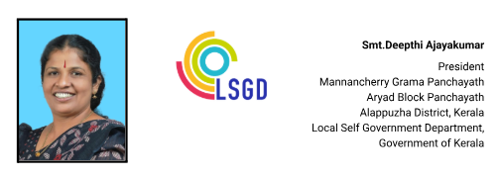
MESSAGE FROM PRESIDENT
പ്രിയരേ ,

മണ്ണഞ്ചേരി ഗ്രാമപഞ്ചായത്തിന്റെ പ്രസിഡൻറ് എന്ന നിലയിൽ, വരാനിരിക്കുന്ന കാലഘട്ടത്തിൽ ജനകീയ പങ്കാളിത്തം ഉറപ്പാക്കി വികസന പ്രവർത്തനങ്ങൾ മുന്നോട്ടുകൊണ്ടുപോകുമെന്ന് ഞാനും എന്റെ ഭരണസമിതിയും ദൃഢമായി ഉറപ്പ് നൽകുന്നു. കോവിഡ് മഹാമാരിപോലുള്ള അത്യന്തം വെല്ലുവിളിപൂർണമായ കാലഘട്ടം നമുക്ക് നിരവധി പാഠങ്ങൾ പഠിപ്പിച്ചു. ഐക്യം, സഹകരണം, ഉത്തരവാദിത്വബോധം എന്നിവയിലൂടെ മാത്രമാണ് ഒരു സമൂഹത്തിന് പ്രതിസന്ധികളെ അതിജീവിക്കാൻ കഴിയുന്നതെന്ന് നാം ഒരുമിച്ച് തെളിയിച്ചു.
കോവിഡ് കാലത്ത് ആരോഗ്യ മേഖലയുടെ പ്രാധാന്യം നമുക്ക് വ്യക്തമായി ബോധ്യപ്പെട്ടു. അതിനാൽ പൊതുജനങ്ങളുടെ നിർദ്ദേശങ്ങളും അഭിപ്രായങ്ങളും ആദരവോടെ ഉൾക്കൊണ്ട്, ശാസ്ത്രീയവും വിശകലനപരവുമായ ആലോചനകളുടെ അടിസ്ഥാനത്തിൽ ആരോഗ്യസുരക്ഷക്കും സാമൂഹികക്ഷേമത്തിനും മുൻഗണന നൽകുന്ന പദ്ധതികൾ ആസൂത്രണം ചെയ്ത് നടപ്പിലാക്കുന്നതാണ് ഞങ്ങളുടെ പ്രവർത്തന ദിശ. ജനങ്ങളുടെ ആരോഗ്യവും ക്ഷേമവും മുൻനിർത്തി, സുരക്ഷിതവും പുരോഗമനപരവുമായ മണ്ണഞ്ചേരി സൃഷ്ടിക്കാൻ എല്ലാവരുടെയും സഹകരണം അഭ്യർത്ഥിക്കുന്നു.


(Deepthi Ajayakumar)

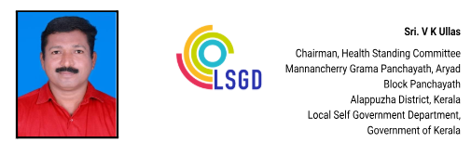

MESSAGE FROM HEALTH STANDING COMMITTEE

പ്രിയരേ ,
കോവിഡ് മഹാമാരിയും പ്രളയവും പോലുള്ള പ്രതിസന്ധി ഘട്ടങ്ങളിൽ നാം ഒരുമയോടെ നിന്നു പ്രശ്നങ്ങളെ അതിജീവിച്ച അനുഭവം എല്ലാവർക്കും സുപരിചിതമാണ്. ആ ഐക്യവും കൂട്ടായ്മയും തന്നെയാണ് നമ്മുടെ ഏറ്റവും വലിയ ശക്തി. അതേ മനോഭാവത്തോടെ പ്രവർത്തിച്ചാൽ പഞ്ചായത്തിന്റെ വികസന പ്രവർത്തനങ്ങൾ കൂടുതൽ കാര്യക്ഷമമായും ഉത്തരവാദിത്വബോധത്തോടെയും മുന്നോട്ട് കൊണ്ടുപോകാൻ സാധിക്കുമെന്ന് ഞാൻ വിശ്വസിക്കുന്നു. പ്രത്യേകിച്ച് ആരോഗ്യ മേഖലയെ മുൻഗണന നൽകി കൂടുതൽ ഗൗരവത്തോടെ ഇടപെടലുകൾ നടത്തുമെന്ന് ഉറപ്പ് നൽകുന്നു.

മണ്ണഞ്ചേരി പഞ്ചായത്തിലെ രോഗപ്രതിരോധ സംവിധാനത്തെ ശക്തിപ്പെടുത്തി സമഗ്രമായ മാറ്റങ്ങൾ കൊണ്ടുവരുന്നതിനും, ജീവിതശൈലി രോഗങ്ങൾ നിയന്ത്രിക്കുന്നതിനും ബോധവൽക്കരണ പ്രവർത്തനങ്ങളും പ്രതിരോധ നടപടികളും ശക്തമാക്കുന്നതിനും ഞങ്ങൾ പ്രതിജ്ഞാബദ്ധരാണ്. ജനങ്ങളുടെ ആരോഗ്യവും സുരക്ഷയും മുൻനിർത്തി ശാസ്ത്രീയവും ദീർഘകാലപരവുമായ പദ്ധതികൾ നടപ്പിലാക്കാൻ എല്ലാ വിഭാഗങ്ങളുടെയും സഹകരണത്തോടെ മുന്നോട്ട് പോകും.

(V. K. Ullas)

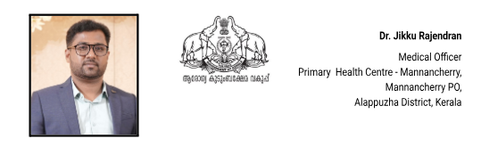
MESSAGE FROM MEDICAL OFFICER
പൊതുജനാരോഗ്യം സംരക്ഷിക്കുക എന്നത് നമ്മുടെ പ്രാഥമികവും പ്രധാനവുമായ ഉത്തരവാദിത്തമാണ്. കോവിഡ്-19 ഉൾപ്പെടെയുള്ള മഹാമാരികൾ നമുക്ക് നൽകിയ ഏറ്റവും വലിയ പാഠം, ആരോഗ്യ അടിയന്തരാവസ്ഥകളെ നേരിടാൻ നാം എപ്പോഴും സുസജ്ജരായിരിക്കണം എന്നതാണ്.
ഗ്രാമീണ ആരോഗ്യസംരക്ഷണത്തിന്റെ അടിത്തറയാണ് പ്രാഥമികാരോഗ്യ കേന്ദ്രങ്ങൾ. അതിനാൽ, ഭാവിയിൽ ഉണ്ടായേക്കാവുന്ന ഏതുതരം പകർച്ചവ്യാധികളെയും ഫലപ്രദമായി പ്രതിരോധിക്കാനും നിയന്ത്രിക്കാനും മണ്ണഞ്ചേരി പ്രാഥമികാരോഗ്യ കേന്ദ്രം തയ്യാറാക്കിയ 'പാൻഡെമിക് പ്രിപ്പയേർഡ്‌നെസ് പ്ലാൻ' (Pandemic Preparedness) ആണിത്.
തദ്ദേശ സ്വയംഭരണ സ്ഥാപനങ്ങൾ, ആരോഗ്യ പ്രവർത്തകർ, ആശാ വർക്കർമാർ, സന്നദ്ധ പ്രവർത്തകർ, പൊതുജനങ്ങൾ എന്നിവരുടെ കൂട്ടായ പ്രവർത്തനത്തിലൂടെ നമ്മുടെ നാടിനെ സുരക്ഷിതമായി നിലനിർത്താൻ ഈ പദ്ധതി സഹായിക്കും എന്ന് ഞങ്ങൾ ഉറച്ചു വിശ്വസിക്കുന്നു.

ഡോ ജിക്കു രാജേന്ദ്രൻ

EXECUTIVE SUMMARY

Primary Health Centre (PHC) Mannancherry serves as the primary public healthcare institution for a population of 29,442 under Mannancherry Grama Panchayath. As the first point of contact within the public health system, the PHC plays a central role in delivering comprehensive, accessible, and affordable healthcare services. The institution is committed to providing preventive, promotive, curative, and rehabilitative care in alignment with national and state health programmes and public health priorities.
The PHC caters predominantly to a rural population and addresses key health needs including maternal and child health services, communicable disease prevention and control, non-communicable disease screening and management, immunization, family welfare services, adolescent health, and geriatric care. Regular outpatient services, systematic home visits by field health staff, and community-based outreach programmes ensure that healthcare services reach all sections of the population, including vulnerable and underserved groups.
PHC Mannancherry actively implements major national health initiatives such as the National Health Mission (NHM), National Tuberculosis Elimination Programme (NTEP), National Programme for Prevention and Control of Cancer, Diabetes, Cardiovascular Diseases and Stroke (NPCDCS), and surveillance activities under the Integrated Disease Surveillance Programme (IDSP). These programmes facilitate early disease detection, timely treatment, effective follow-up, and continuous monitoring of priority health conditions within the community.
The PHC works in close coordination with the Grama Panchayath, ASHA workers, Anganwadi centres, educational institutions, and community-based organizations to strengthen community participation and promote health awareness. Emphasis is placed on preventive healthcare, lifestyle modification, early identification of health conditions, and appropriate referral services to higher healthcare facilities when required.
Despite challenges related to infrastructure constraints, manpower limitations, and increasing service demand, PHC Mannancherry continues to enhance service delivery through strategic planning, data-driven decision-making, and active community engagement. Strengthening infrastructure, upgrading digital health systems, and expanding preventive and promotive healthcare services remain key priorities for sustained improvement.
Overall, Primary Health Centre Mannancherry remains a cornerstone of the local public health system, playing a vital role in safeguarding community health and improving the quality of life of the residents of Mannancherry Grama Panchayath.

LIST OF ABBREVIATIONS

LSGD/LSGI | Local Self Government Department / Local Self Government Institution
BMO | Block Medical Officer
IDSP | Integrated Disease Surveillance Programme
NDMA | National Disaster Management Authority
PPE | Personal Protective Equipment
ICMR | Indian Council of Medical Research
CD | Communicable Diseases
NCD | Non-Communicable Diseases

TABLE OF CONTENTS

INTRODUCTION 9
LSGD AT A GLANCE 10
INTEGRATED HEALTH INFRASTRUCTURE MAP OF MANNANCHERRY GRAMA PANCHAYAT 12
MAJOR ROADWAYS AND WATERWAYS MAP OF MANNANCHERRY GRAMA PANCHAYAT 13
SPATIAL MAPPING OF MAJOR ESTABLISHMENTS 14
GENERAL PROFILE OF THE LSGI’S 15
Background of the LSGI 15
Demographic and Vulnerable Population 17
Clinical Vulnerability 18
INFRASTRUCTURE & RESOURCE INVENTORY 20
Health Facility Directory & Basic Capacity in the LSGD 20
Private Clinics 21
Healthcare Education & Training Institutions 22
Specialized Services & Emergency Inventory 22
Oxygen & Diagnostic Capacity 23
Diagnostics facility mapping at the LSGI level 24
Laboratory Identification & Basic Details 25
Social and Community Infrastructure for surge plan 25
Human resources 28
Medical & Clinical Personnel 28
Public Health & Field-Level Workforce 28
Community & Support Cadre 30
Community Organizations 31
Administrative & Emergency Services 32
Information regarding resources 32
ONE HEALTH & ENVIRONMENTAL SURVEILLANCE 33
Animal & Bird Population 33
Veterinary Infrastructure 34
Veterinary Doctors & Workforce 35
High-Risk Interface Points (Surveillance Sites) 36
Environmental Risk Mapping 39
Disease Seasonality Mapping 40
Vulnerability Mapping 42
EPIDEMIOLOGICAL TRENDS (2021–2025) 43
Disease Burden among human beings(Last 5 Years) 43
*(use the above table data to create the graph/diagram) 44
Seasonal Trend Analysis 45
DENGUE 45
Dengue – Ward-wise Yearly Distribution (2021–2025) 45
LEPTOSPIROSIS 47
Leptospirosis – Ward-wise Yearly Distribution (2021–2025) 47
VIRAL HEPATITIS - A 48
Hepatitis A – Ward-wise Yearly Distribution (2021–2025) 49
Outcome-Based Trend Analysis- 2025 50
Transmission Trend- 2025 51
Integrated Disease Hotspot Map (2021–2025) 56
Preparedness and Response Protocol at LSG Level 59
Constitution of One Health Committee 59
Key Responsibilities: 60
Meeting Schedule: 60
Pandemic Response Workforce 60
Activities and Measures before and during Pandemic 61
PHASE 1 - Alert / Preparation 61
➢ Identification of Quarantine and Isolation Facilities 62
➢ Risk Communication and Community Preparedness 63
➢ Protection of Vulnerable Groups 63
➢ Clinical Dependency Mapping 64
PHASE 2 - Active Response 64
1. Case Identification and Contact Tracing 64
2. Screening Checkpoints 65
Standard Screening Protocol 66
3. Pandemic Control Room 66
Control Room Infrastructure and Location 66
Health System Control Room Framework 66
1. Rapid Response Team (RRT) 66
2. Data Management & Analytics Team 66
3. Human Resource Deployment Team 67
4. Laboratory Surveillance Team 67
5. Vaccination Cell (If Required) 67
6. Infrastructure & Patient Occupancy Team 67
7. Communication team 67
Key Control Room Team 67
Daily Monitoring Indicators 68
1. Epidemiological Indicators: 68
4. Communication of Public Health Information 70
Key communicators 70
5. Coordination with District/State Authorities & Other Organisations 71
Key Details: 71
Supply Chain Coordination 72
Resource Inventory and Contacts 72
Collaboration with NGOs, PPP, and CSR 73
Interdepartmental Coordination 74
PHASE 3 - Surge Capacity 74
Conversion of Community Facilities 75
CONCLUSION 76
RECOMMENDATIONS 77
1. Strengthening Healthcare Infrastructure 77
2. Community Awareness & Education 77
3. Emergency Response & Coordination 77
4. Supply Chain & Food Security 77
5. Digital Preparedness 77
6. Training & Capacity Building 77
7. Long-Term Resilience 77
ANNEXURE 78
1. IMPORTANT PHONE NUMBERS 78
1.1. Details of grama panchayat/municipality/corporation wards 79
1.2. Other important phone numbers of grama panchayat/municipality/corporation area 80
1.3. Important offices of grama panchayat/municipality/ corporation 80
1.4. Health Services 81
1.5. Veterinary Services 82
1.6. Helpline numbers 82
1.7. Public and Private Schools Contact details 83
1.9. Anganwadi Contact Details 83
1.12. Information regarding resources 85

INTRODUCTION
Pandemics and large-scale infectious disease outbreaks remain persistent threats to public health, social stability, and local governance systems. While such events may emerge beyond local boundaries, their most immediate and severe consequences are felt at the community level. Early detection, rapid coordination, continuity of essential services, and public trust become decisive factors in limiting impact. Although international and national frameworks provide strategic direction, effective preparedness and response are ultimately operationalised through Local Self-Government Institutions (LSGIs), which serve as the frontline of public health action.

In Kerala, LSGIs occupy a central role in the public health architecture, functioning as the crucial link between communities and higher-level health systems. Experiences from recurrent monsoon-related disease outbreaks, coastal flooding, and the COVID-19 pandemic have highlighted the importance of decentralised, locally grounded preparedness planning. These events have demonstrated that pandemic readiness must extend beyond healthcare facilities to include disease surveillance, environmental and waste management, risk communication, social support systems, and intersectoral coordination. Context-specific planning is therefore essential to address local vulnerabilities while ensuring timely and coordinated action during public health emergencies.
Mannancherry Grama Panchayath, located in Aryad Block of Alappuzha District, represents a coastal and backwater region with distinct epidemiological and environmental characteristics. The Panchayath comprises 12 wards and spans an area of 17.52 square kilometres, with a projected population of 29,442 and a population density of 1,680 persons per square kilometre. Seasonal flooding and water stagnation create favourable conditions for water-borne and vector-borne diseases, especially during the monsoon period.

The demographic profile of Mannancherry further emphasizes the need for a highly structured and inclusive preparedness plan. The Panchayat is home to a significant number of vulnerable individuals. These groups often face increased risk during public health emergencies due to higher exposure levels and a heavier dependency on public support systems. These demographic and socio-economic characteristics underscore the need to prioritize high-risk populations and those dependent on regular medical treatment are at increased risk during pandemics due to potential service disruptions and heightened exposure risks.
This Pandemic Preparedness Plan for Mannancherry Grama Panchayath has been developed to strengthen the Panchayath’s capacity to prevent, detect, and respond effectively to pandemics and large-scale infectious disease outbreaks. The plan emphasizes early warning systems, protection of vulnerable populations, continuity of essential health and social services, surge capacity planning, environmental health management, and coordinated action across health, local governance, disaster management, animal health, and community sectors.

LSGD AT A GLANCE

ADMINISTRATIVE BOUNDARIES OF MANNANCHERRY PANCHAYAT
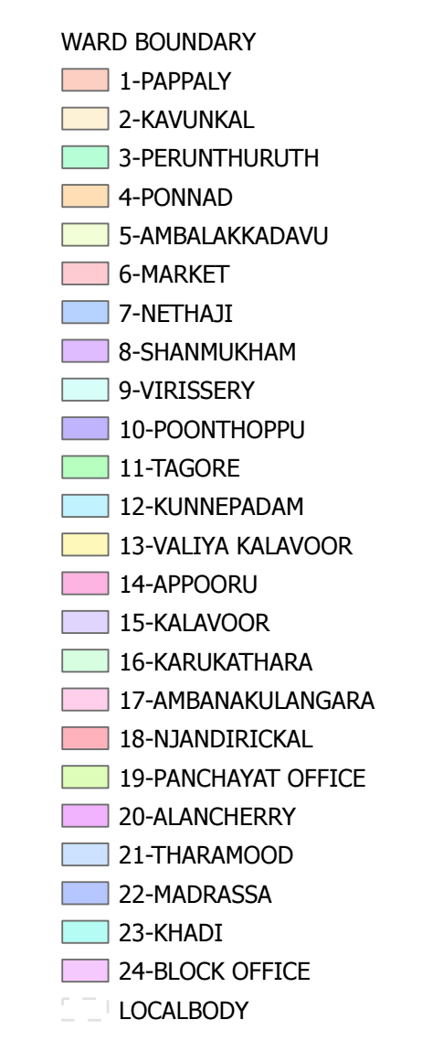
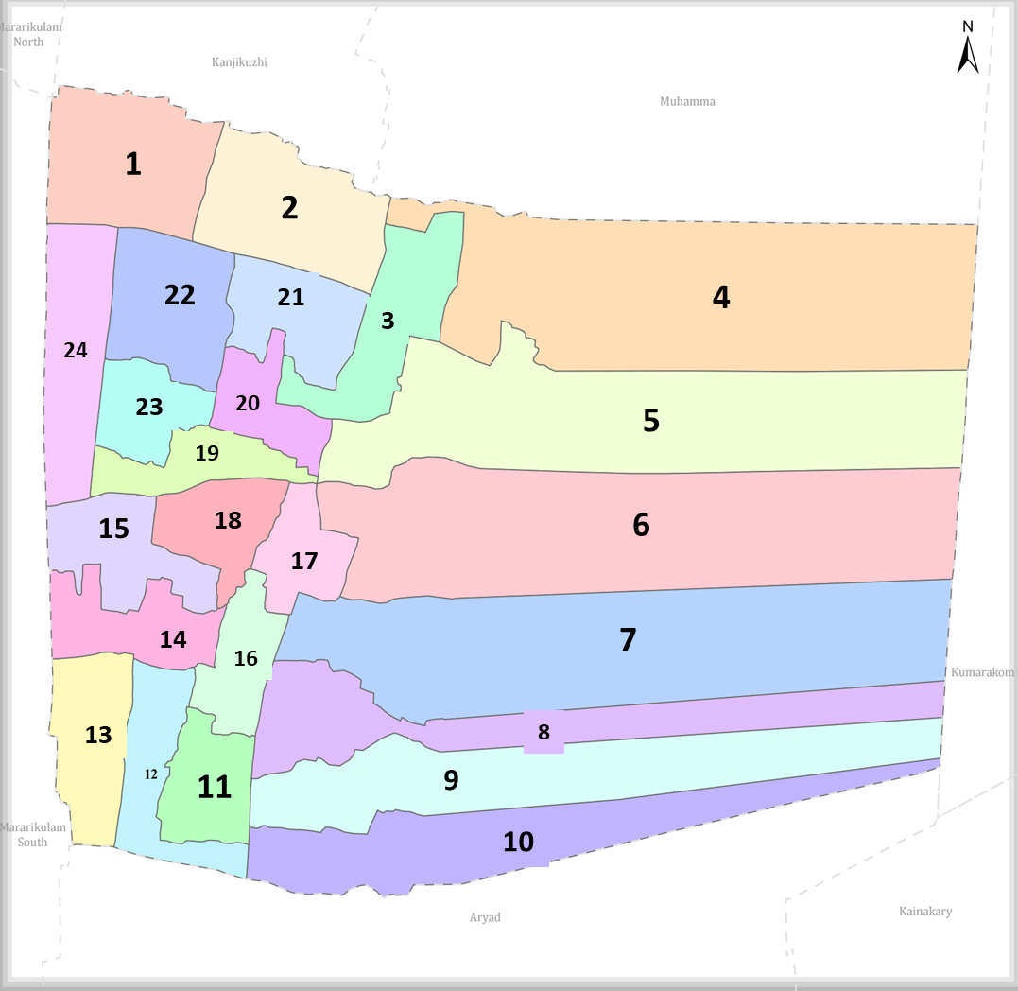
Mannancherry Panchayat Ward-Wise Map (2026) Data provided by K-SMART (OpenData - K-SMART Final Notification (2026))

Ward | Houses | Population | Migrants | Wells | Hot  spots | Ed. Institutions | Hosp pvt/govt.
12 | 8096 | 29442 | 108 | 1461 | 4 | 7 | 4

INTEGRATED HEALTH INFRASTRUCTURE MAP OF MANNANCHERRY PANCHAYAT

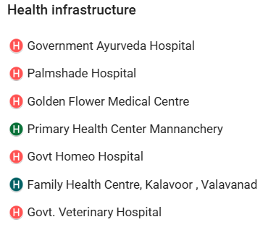
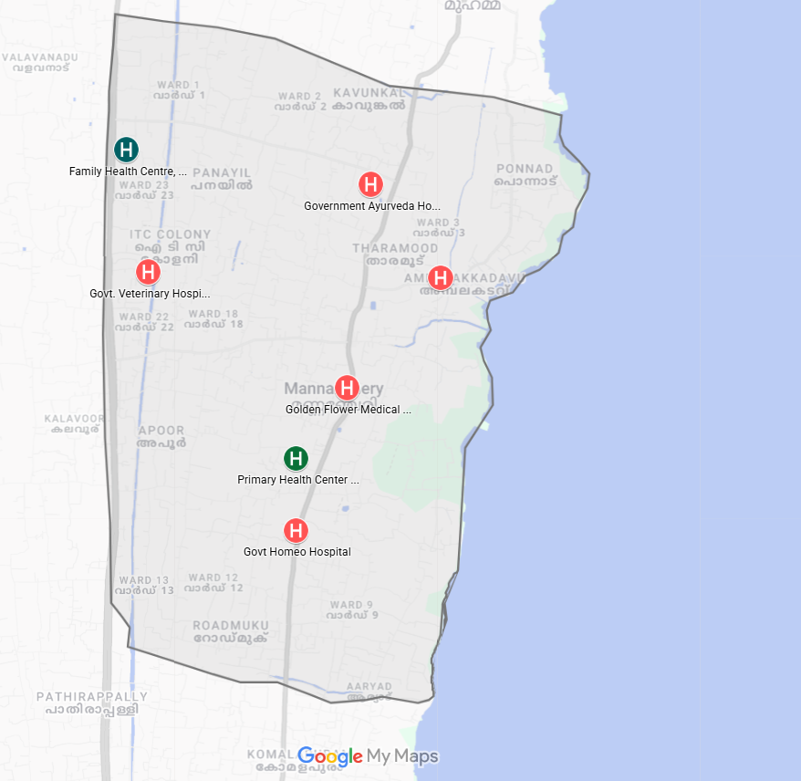
Mannancherry Grama Panchayat Health Infrastructure Map (2026)
Boundary Data: OpenData K-SMART- Mannancherry | Map Created with Google My Maps Major Establishment Map of Mannancherry

MAJOR ROADWAYS AND WATERWAYS MAP OF MANNANCHERRY GRAMA PANCHAYAT
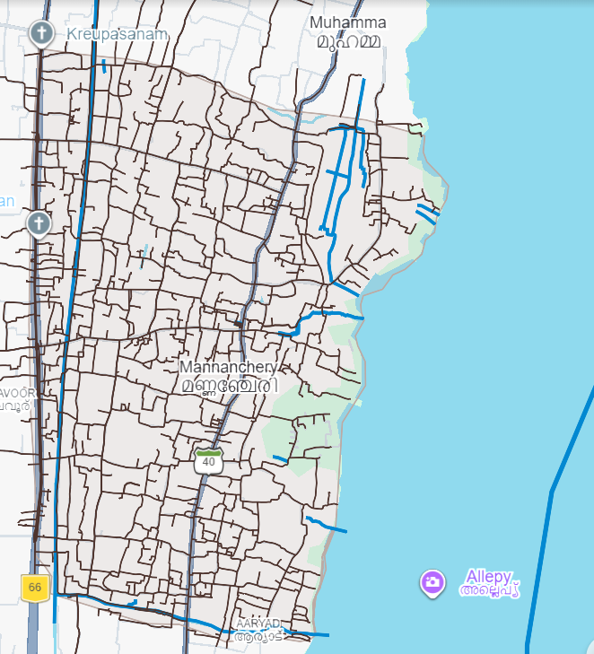

Mannancherry Grama Panchayat Major Roads and Waterway Map (2026)
Boundary Data: OpenData K-SMART- Mannancherry | Map Created with Google My Maps and visualized through Google Earth Roads and Waterways Map - Mannancherry

SPATIAL MAPPING OF MAJOR ESTABLISHMENTS – MANNANCHERRY GRAMA PANCHAYAT (2026)
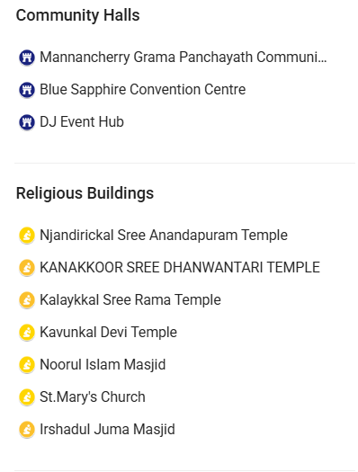
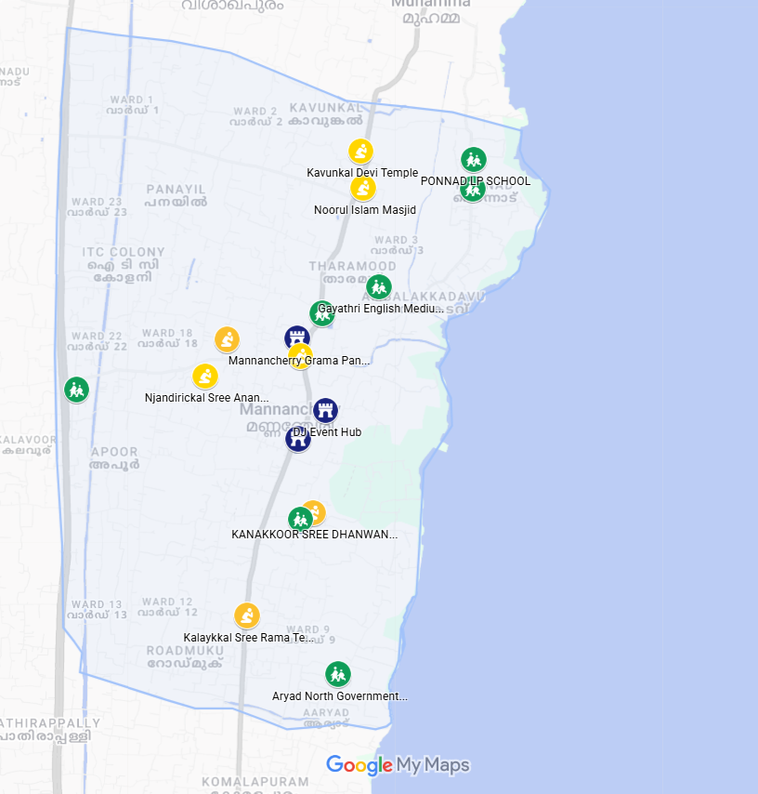

Mannancherry Grama Panchayat Majore Establishments (2026)
Boundary Data: OpenData K-SMART- Mannancherry | Map Created with Google My Maps and visualized through Google Earth Major Establishments Map - Mannancherry

INTEGRATED DISEASE HOTSPOT MAP (2021–2025)
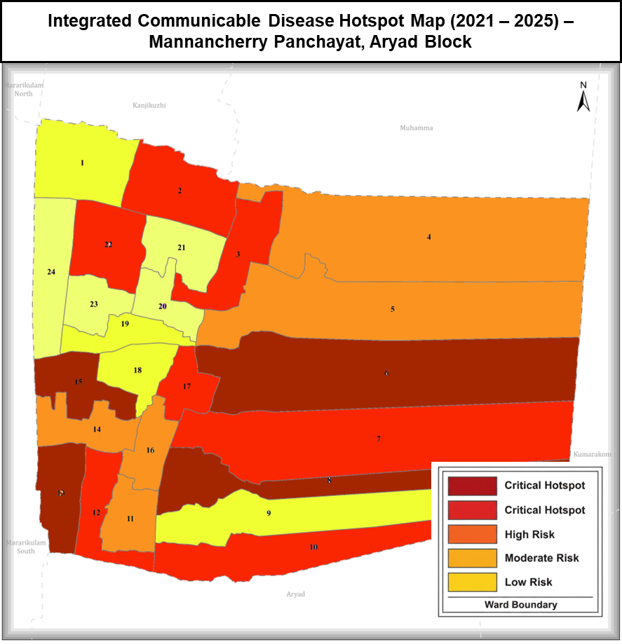
Disease Heat Map: Mannancherry Panchayat (2021–2025)
Boundary Data: K-SMART- Mannancherry | Map Created with GIMP

GENERAL PROFILE OF THE LSGI’S

Background of the LSGI
Mannancherry Grama Panchayat, located in the Aryad Block of Alappuzha, is a strategic administrative hub spanning 17.52 square kilometres. Bordered to the east by the Vembanad Lake, the Panchayat is composed of 12 wards and characterized by a unique landscape of coastal stretches, low-lying lands, and backwater ecosystems which significantly influence local livelihoods, environmental conditions, and vulnerability to flooding and water-borne diseases.

The economy of Mannancherry is closely linked to its unique geographical setting. A substantial proportion of the population depends on the blue economy–related activities, particularly fishing and allied aquaculture, which form a primary source of livelihood. The Panchayat also has a longstanding association with the coir industry, along with the presence of small-scale industries and an expanding service sector that contributes to local economic development and employment. The area hosts a diverse workforce, including a notable presence of migrant labourers, particularly in construction, agriculture, and allied sectors.

From a public health and disaster management perspective, Mannancherry remains vulnerable to vector-borne and water-borne diseases such as dengue and leptospirosis due to environmental conditions favourable for disease transmission. The presence of the Krupasanam Marian Shrine, a major pilgrimage centre attracting large floating populations, further highlights the need for strengthened public health preparedness and surveillance. These factors underscore the importance of a localized, data-driven disaster preparedness and resource mapping framework to enhance emergency response capacity and community resilience.

Table 1: Background of LSGD
Description | Details
Name of LSGI | Mannancherry
Type | Grama Panchayat
Block | Aryad Block
District | Alappuzha
Number of wards | 24
Total area (sq. km) | 35 Sq Km
Population (Projected) | 58265
Population density | 1680 people/sq km
Terrain | Coastal and backwaters
Number of rivers passing through LSGI | 0
Number of water bodies in the LSGI | 1
Number of educational institutions | 17
Factories / small-scale industries | 24
Flood-prone wards | Wards 6, 7, 8, 9, and 10
Landslide-prone wards | 0
Death Management and Disposal Facilities (mortuaries/crematorium, including electric) | 0
Auditoriums/Marriage halls/convention centres/community halls | 6

Demographic and Vulnerable Population
Understanding the demographic composition and vulnerable population groups is essential for pandemic preparedness. Children, elderly, economically deprived families, migrant workers, and socially vulnerable groups are at increased risk during public health emergencies due to higher exposure, limited access to services, and dependency on public systems.

Description |  | Details (in num mo bers)
DEMOGRAPHIC PROFILE |  | PHC Mannancherry | FHC Kalavoor | Total
Total population |  | 29442 | 28823 | 58265
Male |  | 14398 | 12438 | 26836
Female |  | 15044 | 16439 | 31483
Transgender |  | 0 | 0 | 0
Children under 5 |  | 1350 | 1449 | 2799
Adolescent |  | 2945 | 1897 | 4842
Elderly (>60) |  | 5078 | 4458 | 9536
SOCIAL/LIVELIHOOD VULNERABILITY
Previous EPEP family |  | 55 | 98 | 153
BPL family |  | 7360 | 4368 | 11728
Tribal communities |  | 0 | 0 | 0
Migration | Immigrant | 108 | 210 | 318
Migration | Emigrant | 1452 | 728 | 2180
Socio-economically deprived |  | 31 | 2502 | 2533
Fisherfolk |  | 280 | 62 | 342
SC Community |  | Family -355, Members -1310 | 752 families | 1107 families
ST Community |  | Family - 4,  Members - 20 | 21 families | 25 families

The demographic profile of Mannancherry Grama Panchayat reveals a high-density population with significant clinical and social vulnerabilities, notably a substantial elderly cohort and families living below the poverty line. The presence of economically vulnerable families, marginalized communities, migrant populations, and households dependent on traditional livelihoods highlights the need for inclusive, equity-focused public health planning and strengthened social support systems, particularly during public health emergencies and disasters.

Clinical Vulnerability
Certain population groups need priority healthcare & are at higher risk of severe illness, complications, and mortality during pandemics. Patients with chronic diseases, those requiring regular medical care, and individuals with mobility or functional limitations face challenges in accessing timely care during emergencies. Mapping these groups helps in prioritizing continuity of treatment, medicine stock planning, oxygen support, referral transport, and targeted home-based care.

Group | Item | PHC Mannacherry | FHC Kalavoor | Total
Maternal/  Child | Pregnant women | 142 | 194 | 336
Maternal/  Child | Lactating mothers | 361 | 361 | 722
Maternal/  Child | Children under 5 | 1350 | 1449 | 2799
Mobility-  challenged | Bedbound patients | 78 | 78 | 156
Mobility-  challenged | Patients under palliative care other than bedbound | 90 | 65 | 155
Mobility-  challenged | Mentally challenged | 21 | 21 | 42
Mobility-  challenged | Differently abled | 116 | 358 | 474
Chronic Illnesses | Patients on Haemodialysis | 14 | 0 | 14
Chronic Illnesses | Patients on CAPD | 1 | 0 | 1
Chronic Illnesses | Cancer patients (currently on treatment) | 68 | 96 | 164
Chronic Illnesses | Haemophilic patients | 0 | 0 | 0
Chronic Illnesses | Diabetic patients | 1236 | 325 | 1561
Chronic Illnesses | Hypertensive patients | 2154 | 1665 | 3819
Chronic Illnesses | TB patients | 5 | 11 | 16
Total vulnerable individuals: 10,259 (17.6% of Mannancherry’s 58,265 population).
The vulnerability assessment across PHC Mannancherry and FHC Kalavoor identifies 10,259 individuals (17.6% of the total population) requiring prioritized attention during public health emergencies.
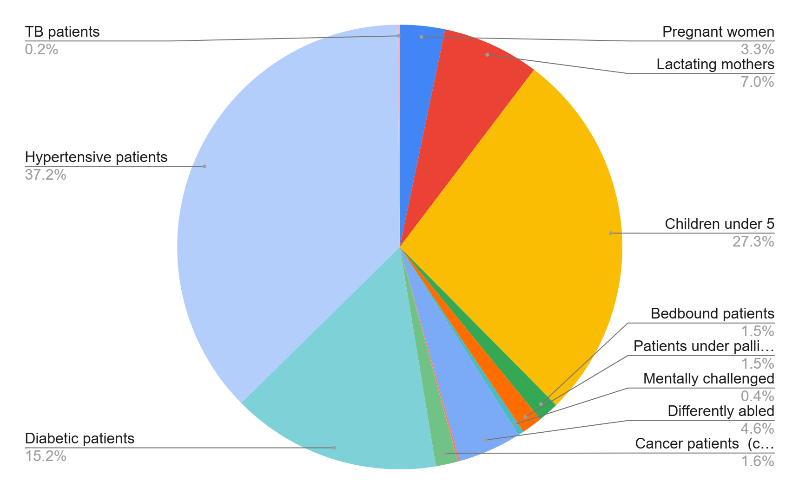
The proportion of vulnerable population is higher in PHC Mannancherry, with 5,636 individuals (19.1%), compared to 4,623 individuals (16.0%) in FHC Kalavoor, indicating a relatively greater vulnerability burden in the Mannancherry PHC area. Chronic non-communicable diseases constitute the largest share, particularly hypertension (3,819) and diabetes (1,561), indicating a substantial population dependent on uninterrupted medication, monitoring, and continuity of care. Maternal and child groups—including pregnant women, lactating mothers, and 2,799 children under five—require continued access to essential health and nutrition services. Additionally, mobility- and function-limited individuals and those requiring dialysis, cancer, and TB care highlight the need for decentralized, home-based care and reliable referral support during public health emergencies.

Major Festivals & Events specific to the LSGI
Major religious events in Mannancherry Grama Panchayat, particularly those associated with prominent pilgrimage and temple centres, significantly increase the risk of communicable disease transmission due to large crowd gatherings, increased mobility, and pressure on sanitation and public health systems.

Sl. No. | Name of Festival | Month / Periodicity | Key Risks & Local Impact
1 | Kripasanam F | Throughout the year (peak during public holidays and feast days) | Large floating population; overcrowding; increased risk of respiratory and contact-based infections; sanitation and waste management burden
2 | Kavunkal Temple Festival | February–March (Annual festival) | Mass gatherings; food safety risks; increased local movement.

The Krupasanam Marian Shrine is an internationally renowned Marian pilgrimage centre that attracts thousands of devotees daily, with significantly higher attendance on Sundays, feast days, and public holidays. Pilgrims travel from across Kerala, other Indian states, and abroad to participate in Holy Mass, retreats, and prayer services. The continuous influx of visitors results in sustained crowd density, increased demand for sanitation facilities, and greater risk of respiratory infections, gastrointestinal illnesses, and other communicable diseases. The presence of a large floating population also necessitates strengthened disease surveillance, emergency medical preparedness, and coordinated public health measures.
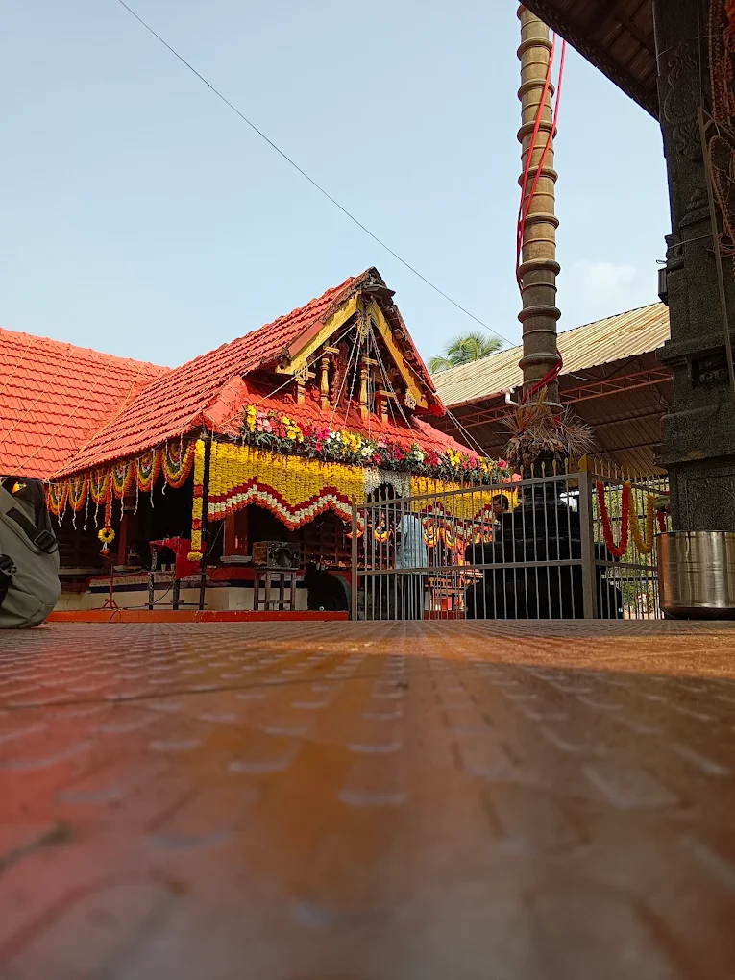
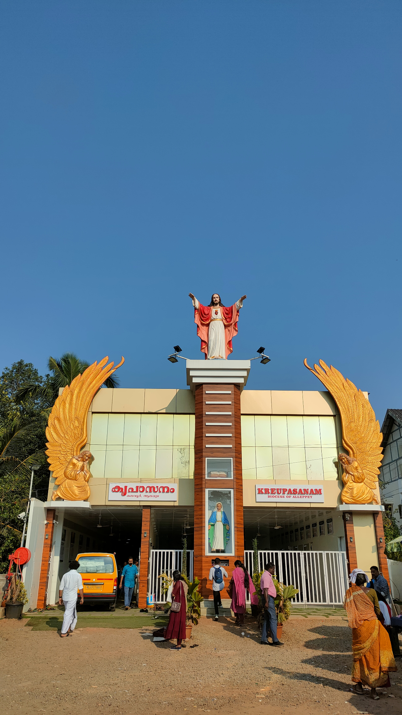

Similarly, the annual festival at Kavunkal Temple is a major cultural and religious event that draws large gatherings of devotees from Mannancherry and neighbouring regions. The festival typically includes rituals, processions, cultural programmes, and community feasts, leading to temporary overcrowding and increased population movement. Such events elevate the risk of communicable disease spread, food-borne illnesses, and sanitation challenges, while also requiring enhanced crowd management, waste disposal, and emergency health response planning.

INFRASTRUCTURE & RESOURCE INVENTORY

Health Facility Directory & Basic Capacity in the LSGD
This section presents an inventory of healthcare infrastructure within Aryad Grama Panchayat, detailing the availability, type, and basic service capacity of health facilities supporting routine service delivery and emergency response. The inventory includes government health facilities, private healthcare providers, and AYUSH institutions, offering a comprehensive overview of service points accessible to the Panchayat population during public health emergencies.

Referral Hierarchy:
Primary care: [FHC Kalavoor + 4 sub-centers] and [PHC Mannancherry + 4 sub-centers] (Surveillance, OPD)
Secondary referrals: RHTC Chettikad (BLOCK), WE ONE hospital (1.5 km)
Tertiary/critical care: Providence Hospital (2.6 km) → GH Alappuzha (10 km) → TDMC Alappuzha (25 km)
Family Health Centres (FHCs) and Community Health Centres (CHCs) generally function as the first point of contact for the community, providing essential outpatient and inpatient services. General Hospitals (GH) and Medical College Hospitals (MCH), where accessible, serve as the main referral centres for advanced diagnostics, specialist care, and critical services during public health emergencies. This inventory helps identify existing strengths, gaps, and potential surge capacity that can be mobilised during a pandemic or disaster

Table 5. Health Facility Resource Summary
Sl.no. | Health Facility | Type of Facility | Contact Number | Total beds | ICU Beds | O2  Supported Beds | Ventilator Support Beds | Ambulances
Government Healthcare Facilities
PHC Mannacherry
1 | PHC MANNANCHERRY | PHC | 9747285951 | 0 | 0 | 0 | 0 | 0
2 | HWC MAIN CENTRE, AMBANAKULANGARA | SC | 9745427865 | 0 | 0 | 0 | 0 | 0
3 | HWC NORTH ARYAD | SC | 8891175373 | 0 | 0 | 0 | 0 | 0
4 | HWC VIRUSSARY | SC | 8891175373 | 0 | 0 | 0 | 0 | 0
5 | HWC MANNANCHERRY | SC | 8589028410 | 0 | 0 | 0 | 0 | 0
FHC Kalavoor
1 | FHC KALAVOOR | FHC | 9495320690 | 12 | 0 | 0 | 0 | 1
2 | SC PONNAD | SC | 9645741697 | 0 | 0 | 0 | 0 | 0
3 | SC KAVUNKAL | SC | 9447503524 | 0 | 0 | 0 | 0 | 0
4 | SC VALAVANAD | SC | 8848577681 | 0 | 0 | 0 | 0 | 0
5 | SC KALAOOR MAIN CENTER | SC | 7025537865 | 0 | 0 | 0 | 0 | 0
Private Healthcare Facilities
1. | WE ONE | PRVT | 04772292913 | 5 | 0 | 0 | 0 | 0
AYUSH Healthcare Facilities
1 | Govt. Sidha Hospital | Sidha | 9497274201 | 0 | 0 | 0 | 0 | 0
2 | Govt Homeo Hospital | Homeo | 9847469153 | 0 | 0 | 0 | 0 | 0

Government healthcare facilities in Mannacherry primarily consist of one Primary Health Centre (PHC Mannacherry) and four sub-centers, as well as one Family Health Centre (FHC Kalavoor) with four sub-centers, which serve as the first point of contact for preventive, promotive, and basic curative services.
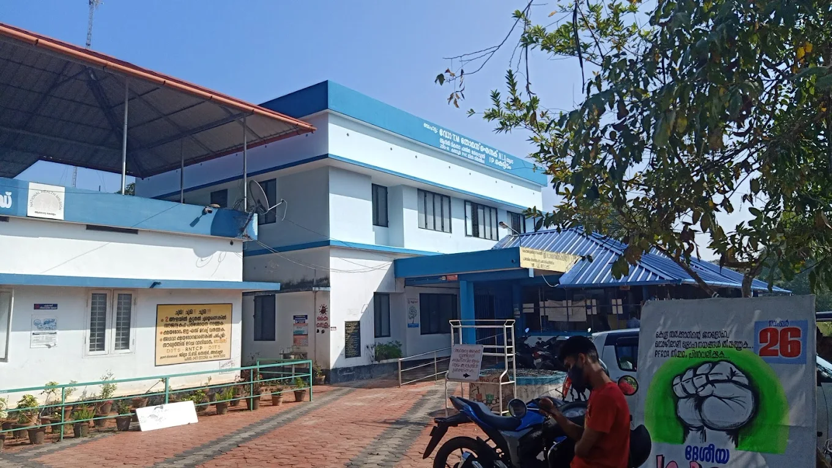
.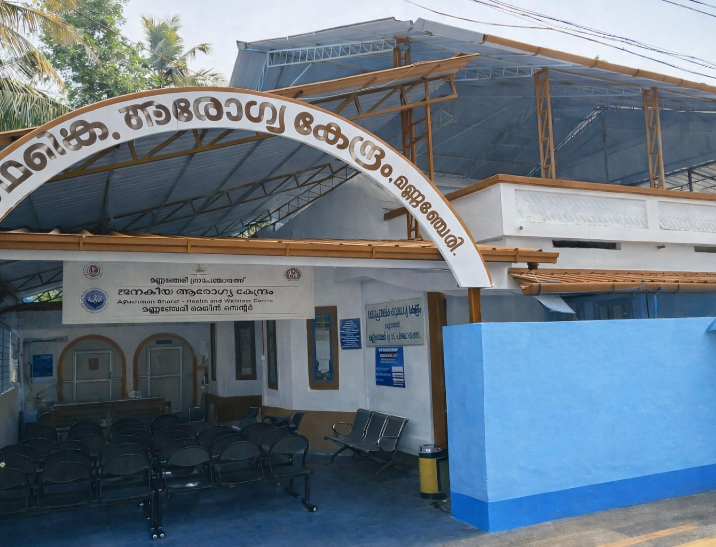
PHC Mannancherry FHC Kalavoor

Private Clinics
Private clinics are an essential part of pandemic preparedness, as they are often the first place people seek care when symptoms begin. In many communities, private clinics manage a significant share of outpatient visits and therefore play a critical role in early case detection, timely referrals, and disease surveillance. Having an up-to-date understanding of where these clinics are located, the services they provide, and how they are linked to the public health system helps ensure that no cases are missed during an outbreak. It also allows health authorities to engage private practitioners more

Table 6. Private Clinic Resource Summary
Name of Clinic | Registered | Clinic | Specialist | Address | Contact Number | Diagnostics | Ambulance Linkage
Golden Flower Medical Centre | NO | General | Ortho, Family Physician | Dr. Vinil, Mannancherry, Alappuzha, 688538 | 9496333374 | Y | N
Karunya | NO | General | N | Mannancherry  Near police station | 0477229027 | Y | N
Palmshade | NO | General & Ayurvedic | N | Mannancherry | 9447166956 | N | N

Healthcare Education & Training Institutions
This section tracks the educational infrastructure available, which is vital for human resource planning in the health sector.

Item | Govt | Private | AYUSH | Total

Category of Institution | Govt | Private | AYUSH | Total
Medical Colleges | 0 | 0 | 0 | 0
Nursing Colleges | 0 | 0 | 0 | 0
Dental Colleges | 0 | 0 | 0 | 0
Para-medical / Allied Health | 0 | 0 | 0 | 0
Pharmacy Colleges | 0 | 0 | 0 | 0

The absence of healthcare education institutions within the local area highlights a critical dependency on external regions for the supply of trained medical and paramedical professionals. Monitoring these categories is essential for long-term health human resource (HHR) planning, as the local workforce's sustainability relies on the output and quality of graduates from regional and state-level training hubs.

Specialized Services & Emergency Inventory
This section provides a detailed view of the specialized medical resources available to the community, focusing on emergency response and critical care capabilities. This table tracks the vital assets required for managing severe illnesses and emergencies across government, private, and AYUSH sectors.

Hospital beds | 12 | 9 | 0 | 21
Oxygen-generating systems (Y/N) | Y | Y | 0 | 0
Oxygen-supported beds (Numbers) | 0 | 0 | 0 | 0
Ventilator-supported beds | 0 | 0 | 0 | 0
ICU beds | 0 | 0 | 0 | 0
Burns units | 0 | 0 | 0 | 0
Blood centres | 0 | 0 | 0 | 0
BLS ambulances | 1 | 1 | 0 | 2
ALS ambulances | 0 | 0 | 0 | 0
Dialysis facilities | 0 | 0 | 0 | 0
Dispensaries | 0 | 0 | 2 | 2
Medical store | 0 | 19 | 2 | 21
Industrial establishments | 3 | 5 | 0 | 8

The data indicates a primary healthcare profile characterized by basic inpatient capacity and a high density of retail pharmacy services, but a critical deficit in specialized life-support infrastructure. While the presence of oxygen-generating systems and basic life support (BLS) ambulances provides a foundational emergency response, the total absence of ventilator-supported beds, ICU facilities, and advanced life support (ALS) units suggests that the region is currently unequipped to manage high-acuity medical emergencies or complex surgical cases. As a result, the local community will depend heavily on major institutions like the Government T.D. Medical College (Vandanam) and the General Hospital, Alappuzha.

Oxygen & Diagnostic Capacity
Monitoring oxygen and diagnostic capacity is a critical component of public health preparedness, ensuring that the LSGD can handle both chronic care and sudden surges in respiratory or infectious diseases.
Name of Health Facility | Oxygen-  generating System | Backup Oxygen Source | Diagnostic Facilities Available (Y/N)
Name of Health Facility | Oxygen-  generating System | Backup Oxygen Source | Lab | USG | X-ray | CT/MRI | RT-PCR
Government Healthcare Facilities
FHC KALAVOOR | N | N | 1 | 0 | 0 | 0 | 0
PHC MANNANCHERRY | N | N | 0 | 0 | 0 | 0 | 0
WEONE HOSPITAL | N | Y | 1 | 1 | 1 | 0 | 0

The Family Health Centre (FHC) Kalavoor and PHC Mannancherry lack both on-site oxygen generation and backup oxygen. In contrast, WEONE Hospital (Private) is the only facility with a backup oxygen source.

Diagnostics Summary
The diagnostic capacity of MANNACHERRY PANCHAYATH represents the "intelligence network" of our healthcare system. The speed and accuracy of disease identification depend entirely on the distribution and technical level of these facilities.

Item | Govt | Private | AYUSH | Total
General labs | 1 | 10 | 0 | 11
Microbiology labs | 0 | 0 | 0 | 0
RT-PCR labs | 0 | 0 | 0 | 0
USG units | 0 | 0 | 0 | 0
CT/MRI units | 0 | 0 | 0 | 0
Research labs | 0 | 0 | 0 | 0
Labs of other departments that can be repurposed | 0 | 0 | 0 | 0

Laboratory Identification & Basic Details
Sl. No. | Name of Lab | Ownership | Address | Contact No. | 24×7 Services | NABL / Govt Approved
1 | Sankers Health Care | Private | Vanchipurakkal building | 8129434488 | No | Yes
2 | S & S Lab | Private | Nethaji | 9633092283 | No | No
3 | Bio Vision Lab | Private | Opp. Panchayat Office | 9037777217 | No | No
4 | Dia Care | Private | Thoppil Building | 9633598413 | No | No
5 | We One Hospital | Private | Mannachery | 04772292913 | Yes | Yes
6 | Karunya Hospital | Private | Mannachery | 04772290277 | Yes | No Clinical Establishment Certificate
7 | Health Value | Private | Near Edaral Bank, Mannanan Cherry |  | No | No Clinical Establishment Certificate
8 | FHC kalavoor | Government | Valavanad | 9495320690 | No | Yes
The laboratory infrastructure within the region is characterized by a high density of private-sector facilities, with the government-operated FHC Kalavoor serving as the primary public diagnostic node. A significant majority of the diagnostic facilities currently operate without NABL or formal Government approval. The heavy reliance on private diagnostics (representing over 85% of the local capacity) emphasizes the need for a formal Public-Private Partnership (PPP) framework.

Social and Community Infrastructure for Emergency Use
This table serves as your logistics and shelter inventory. By mapping these locations, you can quickly identify where to house displaced citizens, where to set up temporary medical clinics, and how to manage the deceased with dignity during a crisis.

Category | Total Count | Ward | Est. Capacity (Persons)
Educational Institutions
Anganwadis | 26 + 23 = 49 | All wards | 480 + 276 = 756 persons
Schools | 7 + 10 = 17 | Wards 11, 8, 10, 15, 4, 5, 18, 23, 22, 24 | 3590 + 3000 = 6590 persons
Colleges | 0 | 0 | 0
Healthcare Educational Institutions
Category | Total Count | Ward | Est. Capacity (Persons)
Medical colleges (Govt/Private) | 0 | 0 | 0
Nursing colleges (Govt/Private) | 0 | 0 | 0
Dental colleges (Govt/Private) | 0 | 0 | 0
Paramedical institutes (Govt/Private) | 0 | 0 | 0
Community Gathering Spaces
Category | Total Count | Ward | Est. Capacity (Persons)
Community halls | 1 | 0 | 0
Auditoriums | 3 | Wards 17, 6, 11, | Average 50-bed facility
Religious buildings | 3 | Wards 17, 11, 16, 9(2), 8, 14, 13, 7 | Average 50-bed facility
Vulnerable Group Support Facility
Destitute homes | 1 | Kalavoor | 25 Persons
Elderly homes | 1 | 16 | 10
LSGD owned other buildings | 1 | Wad 16 | 20 Persons
Mass Fatality Management (MFM) Infrastructure
Mortuary | 0 | 0 | 0
Crematorium | 0 | 0 | 0
*refer annexure 1 for contact details

Human resources
This section focuses on the human capital available within the LSGI. In any emergency—be it a pandemic, flood, or industrial accident—infrastructure is only as effective as the people operating it.

Medical & Clinical Personnel
This table tracks the "Frontline" providers responsible for diagnosis, treatment, and clinical management. Narrative sentence: eg., "Total health workforce: 450 personnel, with 60% in government facilities serving as primary surge capacity." A detailed directory with the contact numbers of all workers is maintained (Annexure 1).

Cadre | Govt (No.) | Private (No.) | Total
Doctors—Modern Medicine | 6 | 12 | 18
Doctors – AYUSH | 4 | 2 | 6
Doctors – Veterinary | 1 | 0 | 1
Doctors – Dental | 0 | 7 | 7
Nursing officers | 12 | 27 | 39
Lab technicians | 2 | 19 | 21
Optometrist | 0 | 1 | 1
Pharmacists | 5 | 9 | 14
Psychologists | 0 | 0 | 0
Counsellors | 0 | 0 | 0

Public Health & Field-Level Workforce
These individuals are the backbone of surveillance, maternal-child health, and decentralized care.

Cadre | PHC Mannancherry | FHC Kalavoor | Total
HS (Health Supervisors) | 0 | 0 | 0
HI (Health Inspectors) | 1- Kalavoor HI inc | 1 | 1
LHS (Lady Health Supervisor) | 0 | 0 | 0
LHI (Lady Health Inspectors) | 1- Kalavoor LHI inc | 1 | 1
JPHN (Jr Public Health Nurses) | 4 | 4 | 8
JHI (Jr Health Inspectors) | 3 | 2 | 5
MLSP (Mid-Level Service Providers) | 4 (1 vacant) | 3 | 7 (1 vacant)
Palliative Nurses | 1 | 1 | 2
RBSK Nurses | 0 | 1 | 1
PRO | 0 | 0 | 0
Epidemiologist | 0 | 0 | 0
Data Manager | 0 | 0 | 0

Community & Support Cadre
This group represents the surge capacity of the LSGI—people who can be called upon for logistics, rescue, and specialized support.

Cadre | PHC Mannancherry | FHC Kalavoor | Total
ASHA Workers | 26 | 20 | 46
AWW (Anganwadi Workers) | 25 | 23 | 48
Emergency Medical Volunteers (Trained) | 55 | 0 | 55
Kudumbashree | 647 | 180 | 827
MNREGS | 1830 | 1966 | 3796
Purusha Swayam Sahaya Sangham | 71 | 5 | 76
Ex-Servicemen | 45 | 22 | 67
Retired Police Officers | 14 | 10 | 24
NCC/NSS Volunteers | 60 SPC 128 | 15 | 203
Red Cross volunteers | 29 | 10 | 39
One Health Community Volunteers | 588 | 588 | 1176
One Health Community Mentors | 84 | 84 | 168

Community Organizations
This section details the presence of community-based organizations (CBOs), non-governmental organizations (NGOs), faith-based organizations (FBOs), Kudumbashree Self-Help Groups (SHGs), and Ayalkootams within the Local Self-Government Institution (LSGI). These groups enhance grassroots mobilization, resource distribution, and support networks crucial for pandemic response and community resilience.

Category | Total Count
NGOs | 6
Religious based organizations | 18
Foreign based organizations | 1
Sports Club/youth clubs | 13
Kudumbashree SHGs | 647
Ayalkootams | 85
Political organizations | 6
Residential organizations | 4

Administrative & Emergency Services
This section outlines the availability of key non-health emergency support services and infrastructure within the LSGI, which are essential for effective pandemic preparedness and response. These facilities support law enforcement, disaster response, water supply, logistics, mobility, and community-level interventions during public health emergencies.

Category | Total Count | Contact details
Police Stations | 1 | 0477-2292100, 9497975247
Fire & Rescue Stations | Station Officer- Alappuzha | 04772230303
Water Pumping Points | 1 | Rajesh - 9447708455  Vishnu-7907651538
Public Distribution System (PDS) | 6 | Bineesh-9847516193

Information regarding resources
The availability of essential transport and support resources plays a quiet but critical role in saving lives. Equipment such as ambulances, mobile mortuaries, amphibian ambulances, and motorized boats ensures that patients, samples, and healthcare teams can move swiftly—even in flooded, remote, or difficult terrains. Heavy vehicles like JCBs, cranes, tractors, and torus lorries support logistics, waste management, emergency infrastructure, and rapid conversion of spaces into care or isolation facilities. Taxis, four-wheel-drive vehicles, and trucks help maintain continuity of essential services, reach vulnerable populations, and support home-based care and supply delivery.

Means of transportation | Mannancherry | Kalavoor | Total
JCB | 5 | 12 | 17
Crane | 0 | 0 | 0
Heavy Trucks | 4 | 8 | 12
Tractor | 1 | 1 | 2
Ambulances | 2 | 2 | 4
Mobile mortuaries | 0 | 0 | 0
Boats | 8 (Capacity 15-20) | 17 (capacity 4-6) | 25
Taxi service | 45 | 12 on taxi | 57
Note: For specific details regarding vehicle owners and contact information, please refer to Annexure [X].

ONE HEALTH & ENVIRONMENTAL SURVEILLANCE
The One Health method integrates environmental, animal, and human health to enable proactive pandemic preparedness. Panchayat-level surveillance needs to be improved in order to detect and treat zoonotic and environmentally generated diseases early. Surveillance is strengthened through systematic assessment of animal populations, veterinary infrastructure, poultry and slaughter facilities, inter-sectoral coordination, and specialised tools like avian influenza seasonality mapping using GIS in previous outbreaks to enable predictive alerts and ward-specific sampling to support effective pandemic preparedness in high-risk areas like ward 6, 18, and 15.
Animal & Bird Population
Mapping animal and bird populations at the Panchayat level is essential for identifying and prioritising zoonotic disease hazards like rabies, avian influenza (H5N1), leptospirosis, anthrax, and Nipah-like spillover occurrences. Risk classification, targeted surveillance, vaccination planning, and early epidemic detection made feasible by comprehensive population mapping all enhance One Health-based pandemic preparedness.
Category | Item | Estimated Population | Wards
Animal Population | Livestock  (Cattle/Goats/Buffalo) | 1242 + 525 = 1767 | 2, 3, 4, 5, 6, 7 , 8, 9, 10, 11, 12, 13, 14, 15, 16, 17, 18, 19, 20, 21, 22, 23, 24
Animal Population | Pet Animals  (Dogs/Cats) | 590 + 48 = 638 | 6, 7 , 8, 9, 10, 11, 12, 13, 14, 15, 16, 17, 18
Animal Population | Stray Dog Population | 280 + 242 = 522 | 6, 7, 8, 9, 10, 11, 12, 13, 14, 15, 16, 17, 18
Animal Population | Pig Farms  (Number of heads) | 0 | NA
Animal Population | Small Units  (Sheep / Goats – clustered) | 0 | NA
Bird Population | Poultry Units (Birds) | 5 units | 6, 8, 9, 14, 15
Bird Population | Poultry- (FOWL) | 0 | NA
Bird Population | Wild/Migratory Birds (Observed) | 0 | NA
Bird Population | Crow Mortality Events (Reported) | 0 | NA

The zoonotic risk profile of the Panchayat is primarily concentrated in Wards 6, 7, 8, 9, and 10, where the convergence of cattle congregation areas, poultry units, and high-density residential zones creates a significant potential for cross-species disease transmission. The stray dog population—estimated at 522, with a high concentration around market areas, fish landing sites, and the bus station—remains a persistent challenge for rabies surveillance and post-exposure prophylaxis (PEP) management. Furthermore, the presence of 1,767 livestock animals across the low-lying wards elevates the risk of Leptospirosis, as animal urine can easily contaminate stagnant water during the monsoon season. Although no migratory bird mortality has been reported, the geographical proximity to the backwaters necessitates heightened vigilance during the November–December period for potential Avian Influenza introduction.

Veterinary Infrastructure
Veterinary institutions are a core pillar of One Health surveillance, enabling early zoonotic disease detection through vaccination, investigation of unusual animal illness or deaths, sample collection, and timely outbreak reporting. A well-mapped and responsive veterinary network strengthens coordination with human health and LSGI systems, ensuring rapid response during zoonotic events and pandemics.
Facility Type | Name of Facility | Ownership | Ward No | Contact number
Veterinary Dispensary | 1 | GOVT | 24 | 9446955212
Veterinary Hospital / Polyclinic | 0 | 0 | 0 | 0
Private Veterinary Clinics | 0 | 0 | 0 | 0
Mobile / Emergency Vet Service (incl. night services) | 0 | 0 | 0 | 0
Pet Homes / Animal Shelters | 0 | 0 | 0 | 0
Slaughterhouse-linked Veterinary Inspection Unit | 0 | 0 | 0 | 0

The Panchayat has one Government Veterinary Dispensary located in Ward 24, which serves as the primary institution for livestock care, vaccination, and basic zoonotic disease surveillance. The absence of veterinary hospitals, private clinics, mobile veterinary services, and animal shelters indicates limited veterinary infrastructure, which may constrain rapid response during animal disease outbreaks. Strengthening veterinary outreach services and intersectoral coordination is essential to enhance early detection, reporting, and control of zoonotic diseases under the One Health framework.

Veterinary Doctors & Workforce
Early detection, diagnosis, reporting, and reaction to animal illness epidemics depend on the availability and accessibility of qualified veterinary specialists. Through timely identification of unusual animal morbidity or mortality, timely sample collection, and efficient coordination with human health and LSGI systems—especially during zoonotic outbreaks and pandemic-prone situations—a clearly defined veterinary workforce enhances One Health surveillance.
Category | Number Available | Type (Govt/Pvt) | Contact number
Government Veterinary Doctors | 1 | Govt | Dr. Sheena joseph - 7907150104
Private Veterinary Doctors | 1 | Pvt | Dr. Rameshan - 8921095365
Livestock Inspectors | 5 | Govt 2 Pvt 3 | Anu - 9446501970 Madhu 9249778104
Para-veterinary Staff / Attenders | 2 | Govt | Anu - 9446501970  Devarajan- 9447488525
Contract / On-call Veterinary Support (if any) | 1 | Retired Doctor | Dr. Rameshan - 8921095365

High-Risk Interface Points (Surveillance Sites)
High-risk interface points are places where people, animals, and the environment interact frequently, closely, or without protection, which raises the risk of zoonotic disease amplification and spillover. In order to discover animal-to-human transmission concerns early, particularly during monsoon, flood, and avian influenza high-risk seasons, routine mapping, inspection, and surveillance of these sites are essential components of One Health readiness.
Type of Habitat | Type of High risk interface | Geographical vulnerability
Wetlands & Backwaters | High-risk area—highly vulnerable to flooding, pollution, habitat loss, and human disturbance due to their ecological sensitivity and close interaction with surrounding activities | Backwaters in wards 6, 7, 8, 9 & 10, the riverbank of Vembanad Lake
Backyard Poultry Farms | Wards 6, 9, 14, 15, and 8—Low Risk | There are that rear houses 5-15 Poultry birds
Cattle Sheds near Water Bodies | 0 | 0
Fish & Meat Markets | 1, Ward 6 | Market
Community Slaughter Sites | 0 | 0
Migratory Bird Congregation Areas | 0 | Wards 6, 7, 8, 9, and 10

The Panchayat’s ecological landscape includes wetlands and backwaters, particularly in Wards 6–10 along the riverbank of Vembanad Lake, which represent a high-risk human–animal–environment interface. These areas are ecologically sensitive and highly vulnerable to flooding, water contamination, habitat disturbance, and increased interaction between humans, livestock, and aquatic ecosystems—thereby elevating the risk of water-borne and zoonotic diseases.

Backyard poultry farming is present in Wards 6, 8, 9, 14, and 15, though at small scale (5–15 birds per household), posing relatively low risk but still requiring periodic surveillance for avian influenza and other poultry-related infections. One fish and meat market in Ward 6 represents a moderate-risk interface due to animal product handling and waste generation. No organized cattle sheds near water bodies or community slaughter sites are reported, and no significant migratory bird congregation areas have been officially identified, although wards adjacent to backwaters warrant seasonal monitoring.

Category | Total Count | Wards | Key Locations (wards)
Poultry Farms | 10 | 6, 8, 9, 14 & 15 | Market, Shanmugham, Valiya Kaavoor, Kalavoor
Backyard / Clustered Poultry Units | 3 | Ward 9, 17 ,8- There are those rear houses with 5-15 ducks | Virusserry, Shanmugham, Ambanakulangara
Duck Rearing Units (open water access) | 0 | 0 | 0
Slaughterhouses/Slaughter Points | 4 | 6, 17, 9 & 15 | Market, Ambanakulangara, Virusserry, Kalavoor
Meat/Fish Markets | 1 | 6 | Market
Live Bird Sale Points | 2 | 7,11 | Ambanakulangara, Roadmukku
Cattle Markets / Weekly Animal Fairs | 0 | 0 | 0
Pet Shops / Breeders | 0 | 0 | 0
Animal Shelters / Pet Homes | 0 | 0 | 0
Waste Disposal Sites near Animal Units | 0 | 0 | 0

Environmental Risk Mapping
Environmental risk mapping identifies monsoon/flood hotspots for vector-borne (dengue, chikungunya), water-borne (leptospirosis, diarrhoea), and zoonotic diseases in Kerala's wetlands. Systematic surveillance supports early warnings, targeted interventions, and Panchayat pandemic preparedness.
Waterborne exposure: Flood-prone areas and stagnant water bodies facilitate leptospira survival, raising leptospirosis risk.

Traditional practices: Informal slaughter and fish markets lack standardized hygiene, creating spillover opportunities.
Risk Factor | Presence | High-Risk Wards | Key Locations | Risk Level (High/M
Flood-prone areas | Yes | 6,7,8,9&10 | Kayichiramadam, Shanmugham,Balichira, madathinkara,Echikkuzhi,Karukathara,Koonampulikkal,Ward 6 East area, Pottayil,Kayippurath,Machinkal,Vattapparambil,Puthenparamb, Valiyanilath,Ponnad | High Risk
Water bodies/wetlands | Yes | 6, 7, 8, 9 & 10 | Shanmugham,Keveli,Shappuchira,Ezhankara,pokkathil,Manappalli,Kayippurath,Machinkal,Vattapparambil,Puthenparamb | High Risk
Solid waste accumulation | NA | NA | NA | NA
Animal waste disposal issues | NA | NA | NA | NA
Rodent infestation zones | Yes | 4.3 | Ponnad | low
Industrial effluent discharge | NA | NA | NA | NA
Construction sites / abandoned buildings | 24 | Mostly All Wards | Mostly All Wards | Low Risk
Poor drainage/blocked canals | Yes | 6, 7, 17 & 14 | Adivaram | Low risk
Drinking water source contamination risk | NA | NA | NA | NA

The environmental risk assessment indicates that flood-prone areas and water bodies/wetlands are the most significant high-risk factors, particularly concentrated in Wards 6–10. These low-lying regions—including Kayichiramadam, Shanmugham, Balichira, Madathinkara, Echikkuzhi, Karukathara, and Ponnad—are highly vulnerable to water stagnation during monsoon seasons, increasing the risk of leptospirosis, dengue, and other water- and vector-borne diseases. Rodent infestation reported in Ward 4.3 (Ponnad) and poor drainage in Wards 6, 7, 14, and 17 represent localized but manageable risks.

Disease Seasonality Mapping
In zoonotic, vector-borne, and water-borne diseases, disease seasonality mapping identifies time- and environment-driven trends for targeted prevention, early warnings, and anticipatory surveillance. Variations in Alappuzha are caused by wetlands, floods, monsoon rains, animal migration, and migrating birds. By incorporating this into Panchayat surveillance, pandemic preparedness and quick reaction are increased.
Disease | Peak Risk Season | Key Drivers | High-Risk Locations | Surveillance Focus
Avian Influenza | August to January | Migratory birds | 6, 7, 8, 10 | Awareness, Regular inspection of poultry, and monitor sudden bird death, reporting mortality above 5% ,sample collection.
Leptospirosis | Monsoon | Rodents, Flooding & Poor sanitation | 3, 4, 6, 7, 8, 15 | Doxycycline Prophylaxis & Awareness about Leptospirosis
Dengue/Chikungunya | Monsoon | Mosquitoes and Wet containers | 6, 7, 8, 17 | Source reduction, Vector Survey, Early Diagnosis & Awareness
Acute Diarrheal Diseases | Mostly in monsoon | Lack of access to clean drinking water and food | Some Wards | Chlorination, Water Testing & Awareness
Rabies | No Season | Stray Dog & Pet Animals | All Wards | Vaccination, Awareness Of First Aid & Preventive measures

Vulnerability Mapping
Vulnerability mapping pinpoints high-risk populations, occupations, and areas exposed via environment, livelihoods, socio-economics, and poor service access. Paired with environmental/seasonality mapping, it enables risk-based surveillance, targeted actions, and optimal resource use in One Health and pandemic planning.
Vulnerability Factor | High-Risk Wards | Key Groups / Locations | Risk Level
Flood-prone households | 3, 4, 6, 7, 8, 9, 10 | Market ward, shanmugham,viruserry,poomthoppu nethaji | High Risk
Wetland-adjacent communities | 3, 4, 6, 7, 8, 9, 10 | Market ward, shanmugham,viruserry,poomthoppu nethaji | High Risk
Backyard poultry / duck rearing households | Wards 6, 8, 9, 14, and 15 | There are that rear houses 5-15 ducks | Low Risk
Livestock-rearing households | Wards 6, 7, 8, 9, 11, 12, 13, and 15 | There are houses that rear 2-3 cattle. | Medium Risk
Slaughterhouse & meat market workers | Wards 6, 8, 9, and 17 | Meat Stall | Low Risk
Fisherfolk & fish market workers | 132 + 160 = 290 (Numbers) | No Fish market in the area | Low Risk
Sanitation workers | 120 + 20 = 140 Number | All wards | Low Risk
Daily wage / migrant workers | 104 | Ward 7,8,10,15,16, 17 | High Risk
Elderly & chronically ill populations | Above 60-9536 | All Wards | High Risk
Pregnant Women | 220 | All Wards | Medium Risk
Children (schools, Anganwadi’s) | 6440 | Anganwadi All wards, School -8,10,11,15 | High Risk
Limited access to safe water & sanitation | Ward 6,8 | market & shanmugham, Valiya kalavoor, Echikkuzhi,Risvala square,Pottayil,Uzhavubhaagam, Thekkeveli, Lenin corner east, madathinkara, Palliveli, Keveli,,Thampakachuvad | High Risk

EPIDEMIOLOGICAL TRENDS (2021–2025)

Disease surveillance is the systematic collection, analysis, and interpretation of health data for planning, implementation, and evaluation of public health practice. This section presents the disease surveillance profile of the LSGI based on routine reporting systems and outbreak investigations to identify priority diseases, seasonal patterns, and emerging public health threats.

Disease Burden among human beings (Last 5 Years)
Analysis of disease-wise data for the last five years helps identify persistent public health problems, emerging diseases, and changes in disease burden. This information supports prioritization of prevention, preparedness, and response activities at the Panchayat level.

Ward-wise Disease Trend – Mannancherry & Kalavoor (2021–2025)

Disease | 2021 (M) | 2021 (K) | 2022 (M) | 2022 (K) | 2023 (M) | 2023 (K) | 2024(M) | 2024 (K) | 2025 (M) | 2025 (K)
Dengue | 3 | 5 | 8 | 12 | 34 | 6 | 19 | 26 | 7 | 2
Leptospirosis | 2 | 2 | 8 | 2 | 3 | 3 | 3 | 3 | 6 | 5
Hepatitis A | 0 | 2 | 1 | 3 | 1 | 0 | 1 | 2 | 6 | 1
Malaria | 0 | 1 | 0 | 3 | 0 | 1 | 1 | 1 | 1 | 4
Scrub Typhus | 0 | 0 | 1 | 1 | 0 | 0 | 0 | 0 | 0 | 0
Typhoid | 0 | 1 | 0 | 0 | 0 | 0 | 0 | 0 | 1 | 0
H1N1 | 0 | 0 | 0 | 0 | 2 | 0 | 0 | 1 | 0 | 0
H3N2 | 0 | 0 | 0 | 0 | 0 | 0 | 0 | 0 | 4 | 1
ADD | 68 | 78 | 111 | 79 | 82 | 122 | 112 | 88 | 80 | 48
Mumps | 0 | 0 | 0 | 0 | 0 | 0 | 3 | 0 | 54 | 22
Measles | 0 | 0 | 1 | 0 | 0 | 0 | 0 | 0 | 0 | 0
Hepatitis B | 0 | 0 | 0 | 0 | 0 | 0 | 0 | 0 | 0 | 0
Hepatitis C | 0 | 0 | 0 | 0 | 1 | 0 | 0 | 0 | 1 | 0
Tuberculosis | 10 | 7 | 19 | 8 | 22 | 3 | 13 | 10 | 12 | 10
Leprosy | 0 | 0 | 0 | 0 | 0 | 0 | 0 | 0 | 0 | 0
COVID-19 | 0 | 4473 | 0 | 0 | 0 | 0 | 0 | 0 | 0 | 0

Panchayat-Level Disease Trend (2021–2025)

Disease | 2021 | 2022 | 2023 | 2024 | 2025 | Overall Trend (Panchayat)
Dengue | 8 | 20 | 40 | 45 | 9 | Peaked in 2023–2024; sharp decline in 2025 (overall fluctuating with recent decrease)
Leptospirosis | 4 | 10 | 6 | 6 | 11 | Gradual increasing trend, highest in 2025
Hepatitis A | 2 | 4 | 1 | 3 | 7 | Increasing in recent years, spike in 2025
Malaria | 1 | 3 | 1 | 2 | 5 | Low numbers but slight increase in 2025
Scrub Typhus | 0 | 2 | 0 | 0 | 0 | Declining; no recent cases
Typhoid | 1 | 0 | 0 | 0 | 1 | Sporadic, very low incidence
H1N1 | 0 | 0 | 2 | 1 | 0 | Sporadic with declining trend
H3N2 | 0 | 0 | 0 | 0 | 5 | Emerging increase in 2025
ADD | 146 | 190 | 204 | 200 | 128 | Persistently high burden; slight decline in 2025
Mumps | 0 | 0 | 0 | 3 | 76 | Significant outbreak in 2025
Measles | 0 | 1 | 0 | 0 | 0 | Isolated case; otherwise controlled
Hepatitis B | 0 | 0 | 0 | 0 | 0 | No cases reported
Hepatitis C | 0 | 0 | 1 | 0 | 1 | Sporadic, stable low incidence
Tuberculosis | 17 | 27 | 25 | 23 | 22 | Relatively stable but consistently present burden
Leprosy | 0 | 0 | 0 | 0 | 0 | No cases reported
COVID-19 | 4473 | 0 | 0 | 0 | 0 | Major outbreak in 2021; no recent cases

At the Panchayat level, dengue and ADD continue to contribute significantly to communicable disease burden, though dengue shows a marked decline in 2025 after peaks in 2023–2024. Leptospirosis and Hepatitis A demonstrate a rising pattern, particularly in 2025.

Tuberculosis remains consistently present, indicating a stable but ongoing burden. A notable surge in mumps cases in 2025 suggests a localized outbreak. Overall, while large-scale epidemics are not evident, periodic spikes in vector-borne and vaccine-preventable diseases highlight the need for sustained surveillance, immunization strengthening, and seasonal preparedness planning.
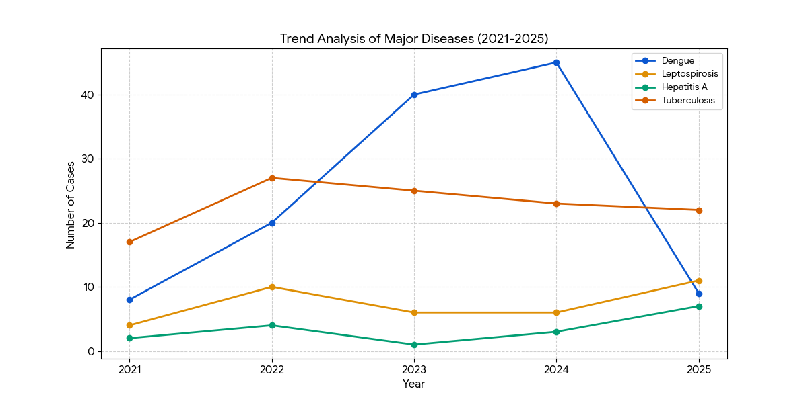
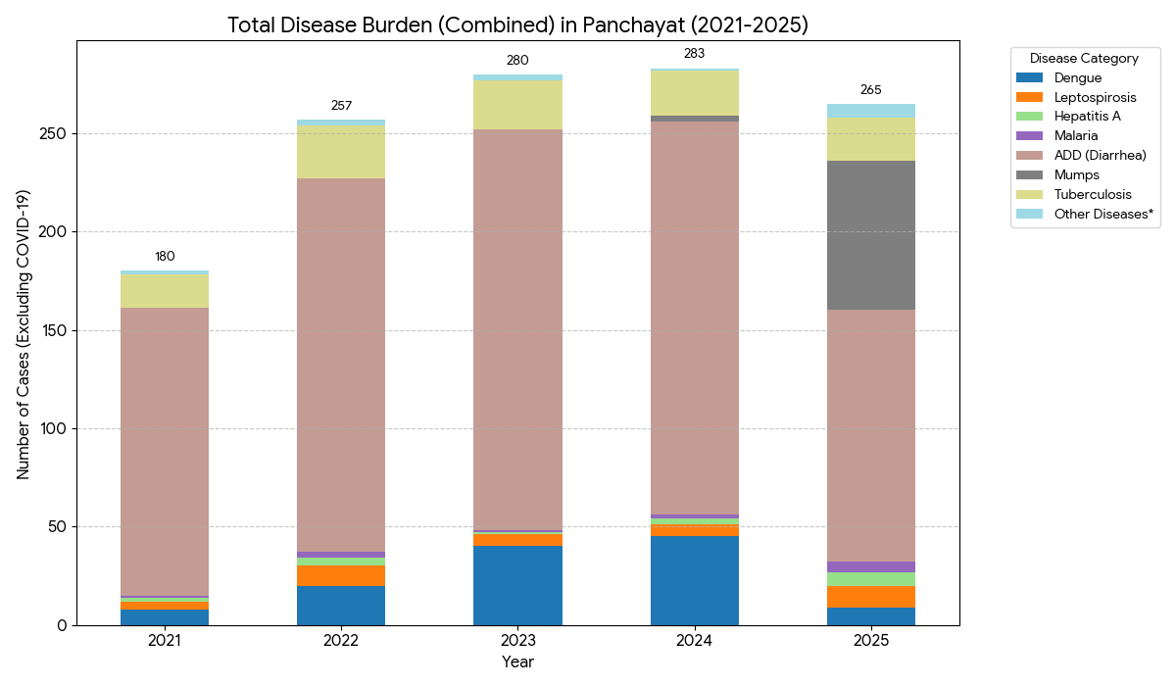
The following stacked bar chart provides a comprehensive view of the total disease burden across the Panchayat from 2021 to 2025. Excluding the COVID-19 outlier of 2021, the highest cumulative disease burden occurred in 2023 and 2024, driven largely by high counts of Acute Diarrheal Diseases (ADD) and Dengue. While the total number of cases decreased in 2025 compared to the previous two years, the composition of the burden changed drastically due to the mumps and the rise in Leptospirosis and Hepatitis A. Tuberculosis maintains a stable segment of the bar each year, reflecting a constant endemic presence that requires steady, uninterrupted public health monitoring.

Seasonal Trend Analysis
Seasonal analysis helps anticipate surges (e.g. dengue in monsoon, leptospirosis after floods, influenza in cooler months) and plan pre‑emptive vector control, stockpiling of IV fluids, and awareness campaigns at Panchayat level.

DENGUE
Dengue is a major seasonal vector-borne disease strongly associated with rainfall, water stagnation, and increased mosquito breeding during the monsoon period.

Dengue—Ward-wise Yearly Distribution (2021–2025)

Ward | Dengue – Ward-wise Yearly Distribution
Ward | 2021 | 2022 | 2023 | 2024 | 2025 | Total
1 | 1 | ,1 | 0 | 3 | 0 | 5
2 | 1 | 0 | 1 | 2 | 1 | 5
3 | 3 | 1 | 0 | 2 | 0 | 6
4 | 0 | 1 | 0 | 2 | 0 | 3
5 | 0 | 0 | 0 | 3 | 0 | 3
6 | 0 | 0 | 0 | 5 | 1 | 6
7 | 0 | 0 | 2 | 3 | 0 | 5
8 | 0 | 0 | 5 | 1 | 0 | 6
9 | 0 | 0 | 3 | 1 | 0 | 4
10 | 2 | 1 | 1 | 2 | 0 | 6
11 | 0 | 2 | 0 | 2 | 0 | 4
12 | 0 | 1 | 1 | 4 | 0 | 6
13 | 1 | 0 | 2 | 5 | 1 | 9
14 | 0 | 0 | 0 | 3 | 0 | 3
15 | 1 | 0 | 1 | 2 | 2 | 6
16 | 0 | 0 | 3 | 2 | 1 | 6
17 | 0 | 0 | 2 | 4 | 1 | 7
18 | 0 | 0 | 1 | 4 | 0 | 5
19 | 0 | 0 | 1 | 2 | 1 | 4
20 | 0 | 0 | 0 | 0 | 0 | 0
21 | 0 | 0 | 1 | 0 | 0 | 1
22 | 0 | 0 | 1 | 8 | 0 | 9

The year 2024 was a critical period for nearly all wards, with widespread transmission. Ward 22 and Ward 13 recorded the highest single-year spikes during this time.Ward 13 and Ward 22 have emerged as the highest-burden areas, both totaling 9 cases. These wards require a detailed investigation into stagnant water sources or construction sites that might be acting as permanent breeding grounds.There is a noticeable "high-intensity cluster" in the Ward 12 through Ward 19 belt. These wards show consistent cases from 2023 onwards, suggesting that once the virus entered this geographic corridor, it successfully established local transmission cycles.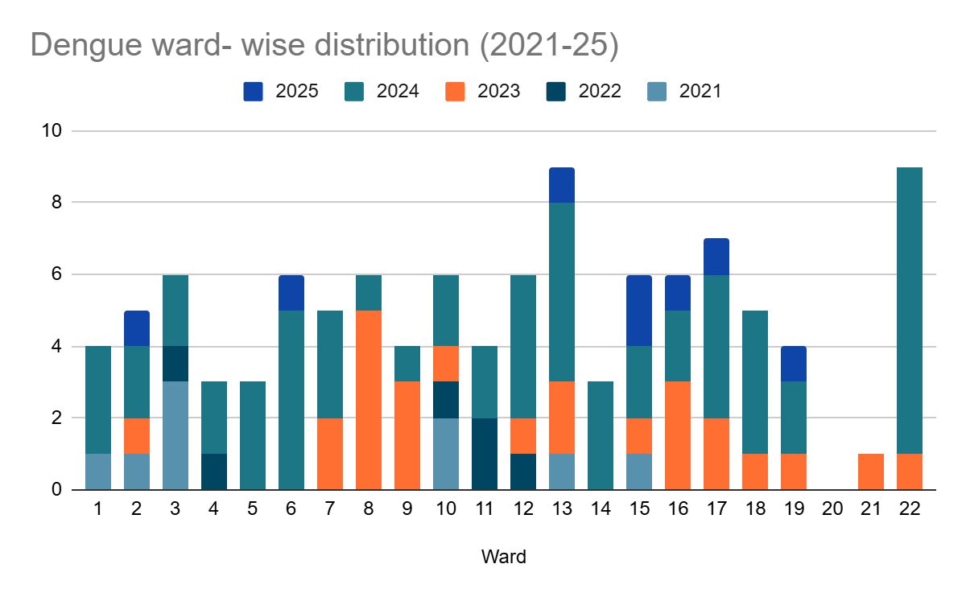
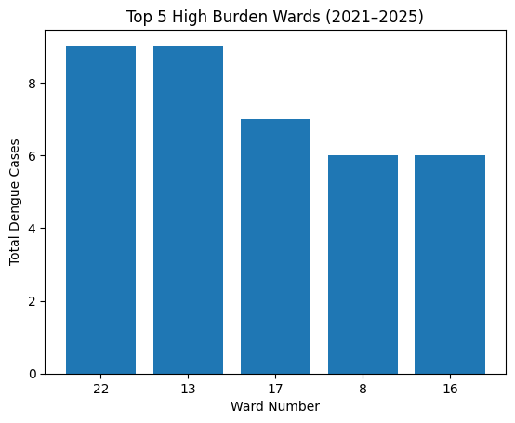

LEPTOSPIROSIS
Leptospirosis cases are closely linked to monsoon rains, flooding, and occupational exposure, particularly in low-lying and waterlogged areas.

Peak: June - August

Leptospirosis – Ward-wise Yearly Distribution (2021–2025)

Ward | Leptospirosis – Ward-wise Yearly Distribution
Ward | 2021 | 2022 | 2023 | 2024 | 2025 | Total
1 | 0 | 1 | 0 | 0 | 0 | 1
2 | 0 | 0 | 1 | 1 | 1 | 3
3 | 1 | 0 | 1 | 0 | 0 | 2
4 | 1 | 0 | 0 | 1 | 0 | 2
5 | 0 | 0 | 0 | 1 | 2 | 3
6 | 0 | 0 | 0 | 0 | 0 | 0
7 | 0 | 2 | 0 | 1 | 0 | 3
8 | 0 | 0 | 0 | 1 | 1 | 2
9 | 1 | 0 | 0 | 0 | 0 | 1
10 | 0 | 0 | 0 | 0 | 0 | 0
11 | 0 | 0 | 0 | 0 | 0 | 0
12 | 1 | 1 | 0 | 0 | 0 | 2
13 | 0 | 1 | 1 | 0 | 0 | 2
14 | 0 | 0 | 0 | 0 | 1 | 1
15 | 0 | 0 | 1 | 0 | 4 | 5
16 | 0 | 1 | 0 | 0 | 0 | 1
17 | 0 | 1 | 0 | 0 | 0 | 1
18 | 0 | 1 | 0 | 0 | 0 | 1
19 | 0 | 0 | 1 | 0 | 0 | 1
20 | 0 | 0 | 0 | 0 | 0 | 0
21 | 0 | 0 | 0 | 0 | 1 | 1
22 | 0 | 0 | 0 | 0 | 0 | 0
23 | 0 | 0 | 0 | 0 | 1 | 1
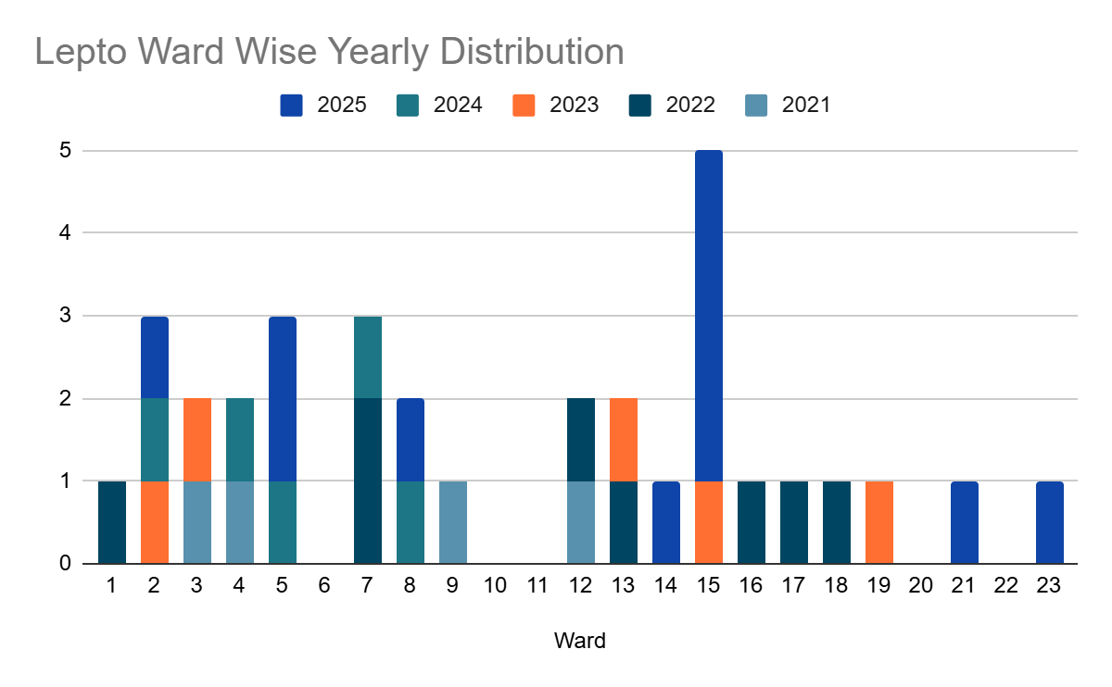
The data shows a significant spike in Ward 15 during 2025, with 4 cases recorded in a single year. This makes Ward 15 the highest cumulative hotspot with 5 total cases. Unlike Dengue, which showed a massive 2024 spike, Leptospirosis appears more sporadically distributed across the years. However, 2025 shows a notable increase in the number of wards affected (Wards 2, 5, 8, 14, 15, 21, and 23), indicating an expanding geographic risk.Wards like Ward 2 and Ward 5 have shown consistent or increasing activity in the last three years, suggesting a need for focused rodent control and sanitation in these specific blocks.

VIRAL HEPATITIS - A
Hepatitis A cases are commonly associated with unsafe drinking water, food contamination, and breakdowns in sanitation, often presenting as clusters or outbreaks.

Hepatitis A – Ward-wise Yearly Distribution (2021–2025)

Ward | Hep A – Ward-wise Yearly Distribution
Ward | 2021 | 2022 | 2023 | 2024 | 2025 | Total
1 | 1 | 0 | 0 | 0 | 0 | 1
2 | 0 | 1 | 0 | 0 | 0 | 1
3 | 0 | 1 | 0 | 0 | 0
4 | 0 | 0 | 0 | 0 | 0 | 0
5 | 0 | 0 | 0 | 0 | 0 | 0
6 | 0 | 1 | 0 | 0 | 1 | 2
7 | 0 | 0 | 1 | 0 | 0 | 1
8 | 0 | 0 | 0 | 0 | 0 | 0
9 | 0 | 0 | 0 | 0 | 0 | 0
10 | 0 | 0 | 0 | 1 | 0 | 1
11 | 0 | 0 | 0 | 0 | 0 | 0
12 | 0 | 0 | 0 | 0 | 1 | 1
13 | 0 | 0 | 0 | 0 | 0 | 0
14 | 0 | 0 | 0 | 0 | 2 | 2
15 | 0 | 0 | 0 | 0 | 1 | 1
16 | 0 | 0 | 0 | 0 | 0 | 0
17 | 0 | 0 | 0 | 0 | 0 | 0
18 | 0 | 0 | 0 | 0 | 0 | 0
19 | 0 | 0 | 0 | 1 | 1 | 2
20 | 0 | 0 | 0 | 1 | 0 | 1
21 | 0 | 0 | 0 | 0 | 0 | 0
22 | 0 | 0 | 0 | 0 | 0 | 0
23 | 1 | 0 | 0 | 0 | 0 | 1
24 | 0 | 0 | 0 | 0 | 0 | 0
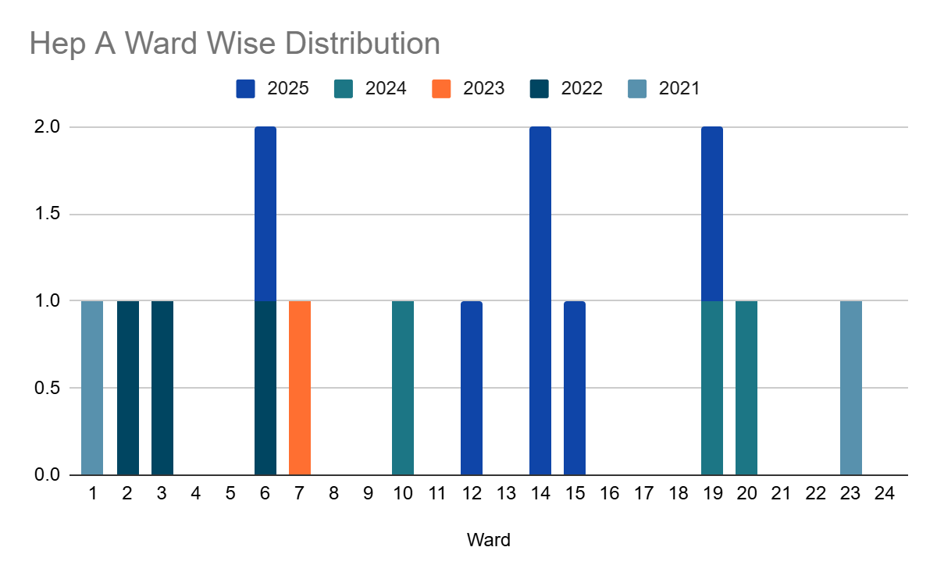The provided data for Hepatitis A across Wards 1 to 24 (2021–2025) reveals a low-volume but sporadic transmission pattern. Unlike the vector-borne spikes seen with Dengue, Hepatitis A trends are often indicative of localized water quality or food hygiene issues.

Outcome Based Trend Analysis- 2025
An approach for monitoring and analyzing the disease patterns based on the outcomes or impacts of specific interventions, policies, or public health measures and concerns. It shifts emphasis from merely tracking disease incidence to evaluating the effectiveness of prevention measures implemented for the disease. This type of analysis is crucial for understanding not only the spreadness of diseases but also how well the system is responding to them. This analysis evaluates the impact of various public health measures, determines whether these measures lead to reductions in disease prevalence, morbidity, mortality, or healthcare burden over time and this can be utilized modifying or improving existing health policies, resource allocation, and preparedness plans.

Sl. No. | Type of disease | Age group | Gender |  | Total no. of survival | Total no. of death | No. of cases received treatment
Sl. No. | Type of disease | Age group | No. of Male | No. of Female | Total no. of survival | Total no. of death | No. of cases received treatment
1 | Dengue | under 05 children | 0 | 0 | 0 | 0 | 0
2 | Dengue | 5-19 years | 1 | 1 | 2 | 0 | 2
3 | Dengue | 20-59 years | 2 | 2 | 4 | 0 | 4
4 | Dengue | 60+ (Seniors) | 0 | 0 | 0 | 0 | 0
1 | Lepto | under 05 children | 0 | 0 | 0 | 0 | 0
2 | Lepto | 5-19 years | 1 | 0 | 1 | 0 | 1
3 | Lepto | 20-59 years | 2 | 0 | 2 | 0 | 2
4 | Lepto | 60+ (Seniors) | 2 | 1 | 3 | 0 | 3
1 | VH-A | under 05 children | 0 | 0 | 0 | 0 | 0
2 | VH-A | 5-19 years | 0 | 0 | 0 | 0 | 0
3 | VH-A | 20-59 years | 2 | 4 | 6 | 0 | 6
4 | VH-A | 60+ (Seniors) | 0 | 0 | 0 | 0 | 0

Transmission Trend- 2025
For effective management of public health issues, it is important to track the trend of disease transmission mode. It helps to identify the population or the place under high risk that can be used to predict outbreaks, and implement targeted interventions as fast as possible. Understanding these kind of trends enables authorities to allocate resources efficiently and change the strategies adequately based on the trend that follows.

Mode of Transmission | No. of cases | No. of Deaths
Vector Borne Diseases | 10 | 0
Water Borne Diseases | 94 | 0
Air Borne Diseases | 84 | 0
Blood Borne Diseases | 1 | 0
Food Borne Diseases | 0 | 0

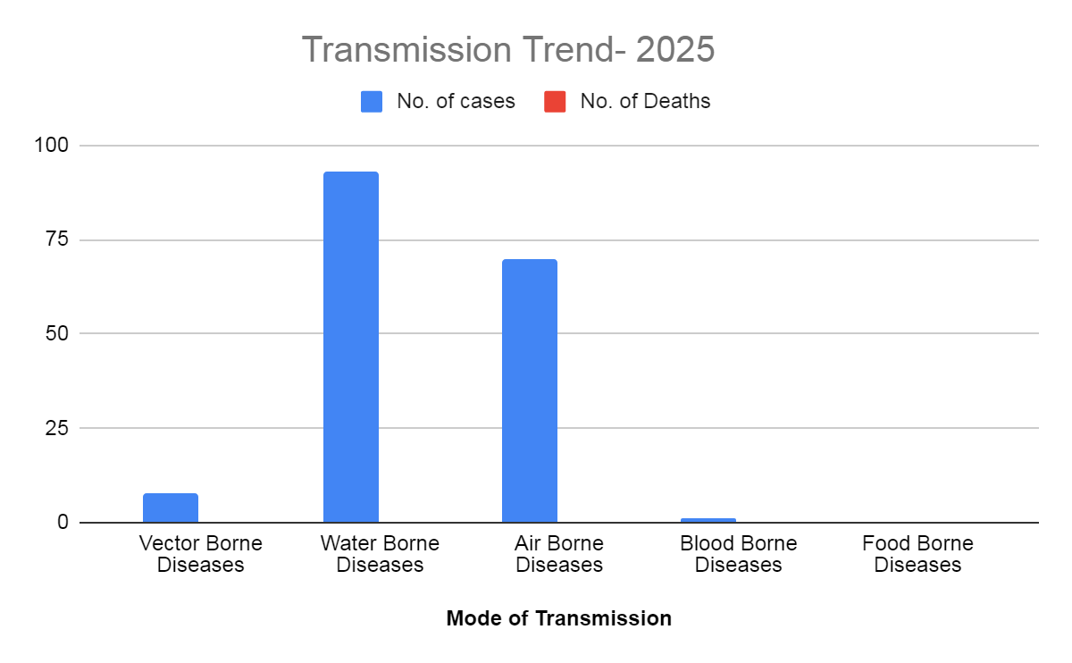

Vector-Borne Disease

Disease | No. of Cases | No. of Deaths
Dengue | 9 | 0
Malaria | 5 | 0
Chikungunya | 0 | 0

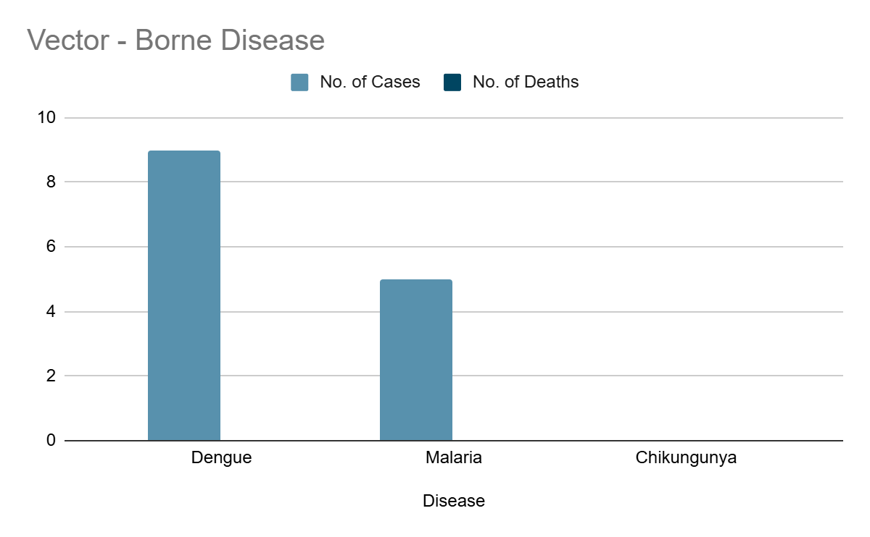

Water Borne Disease

Disease | No. of Cases | No. of Deaths
Cholera | 0 | 0
Typhoid | 1 | 0
Hep- A | 7 | 0
Dysentery | 0 | 0
Amoebiasis | 0 | 0
E- Coli infections | 0 | 0

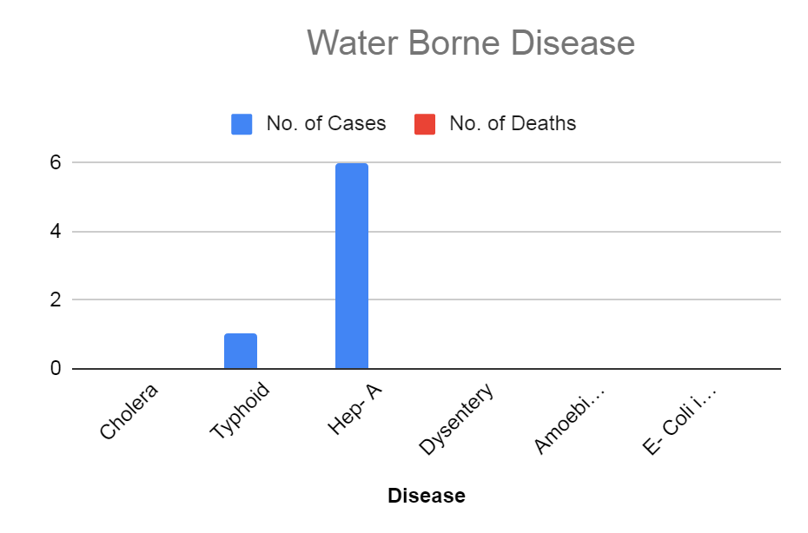

Air Borne Disease

Disease | No. of Cases | No. of Deaths
Influenza | 0 | 0
H1N1 | 1 | 0
TB | 10 | 0
Chickenpox | 14 | 0

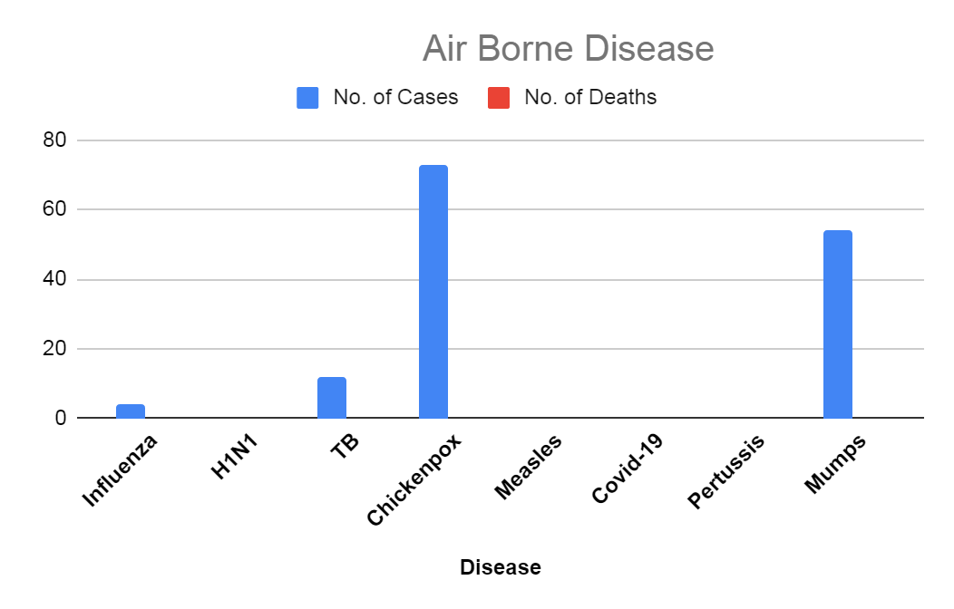

Blood-Borne Disease

Disease | No. of Cases | No. of Deaths
AIDS | 0 | 0
Hep- B | 0 | 0
Hep- C | 1 | 0

Zoonotic Disease

Disease | No. of Cases | No. of Deaths
Rabies | 0 | 0
Leptospirosis | 8 | 1
Avian influenza | 4 | 0
West nile | 0 | 0
Anthrax | 0 | 0
Nipah | 0 | 0
Scrub Typhus | 0 | 0
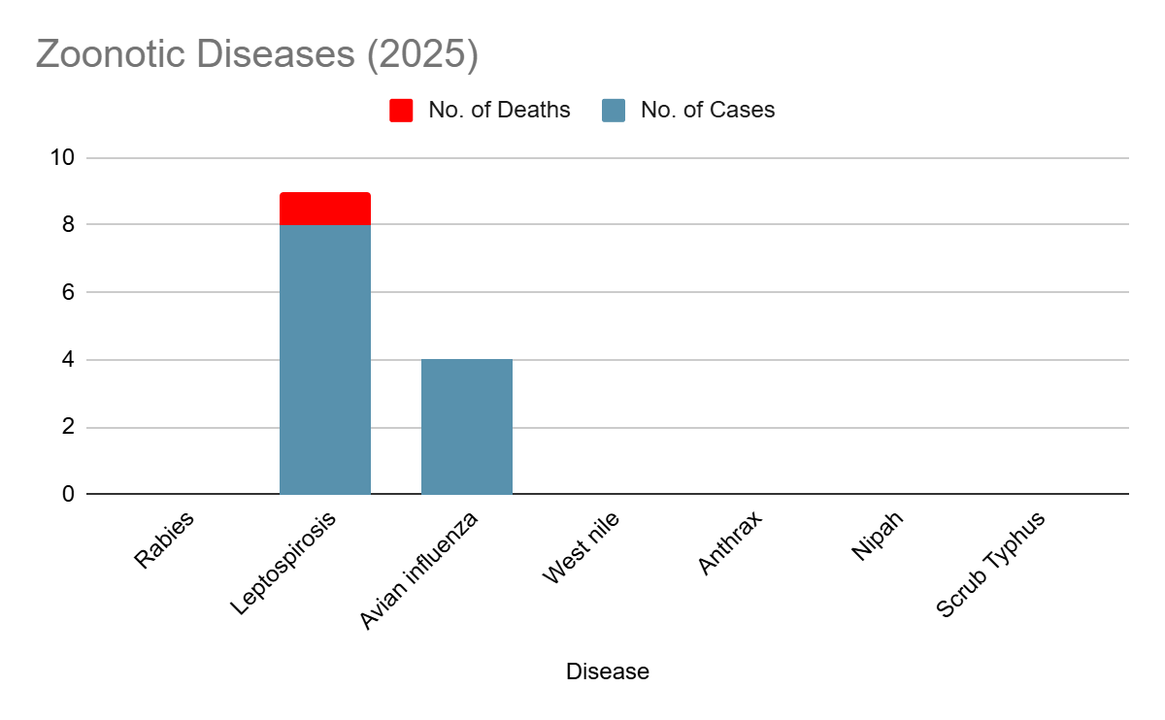

Integrated Disease Hotspot Map (2021–2025)

Ward No | Dengue Total (2021-25) | Leptospirosis Total (2021-25) | Hepatitis A Total (2021-25) | Mumps (2021-25) | ADD (2021-25) | Total Cases
1 | 5 | 1 | 1 | 2 | 15 | 24
2 | 5 | 3 | 1 | 5 | 14 | 28
3 | 6 | 2 | 0 | 6 | 19 | 33
4 | 3 | 2 | 0 | 4 | 30 | 39
5 | 3 | 3 | 0 | 4 | 30 | 40
6 | 6 | 0 | 2 | 5 | 51 | 64
7 | 5 | 3 | 1 | 4 | 40 | 53
8 | 6 | 2 | 0 | 10 | 37 | 55
9 | 4 | 1 | 0 | 5 | 18 | 28
10 | 6 | 0 | 1 | 6 | 36 | 49
11 | 4 | 0 | 0 | 4 | 40 | 48
12 | 7 | 2 | 1 | 3 | 25 | 38
13 | 9 | 2 | 0 | 2 | 44 | 57
14 | 3 | 1 | 2 | 3 | 39 | 48
15 | 5 | 5 | 1 | 5 | 55 | 71
16 | 5 | 1 | 0 | 4 | 30 | 40
17 | 7 | 1 | 1 | 6 | 38 | 53
18 | 5 | 1 | 0 | 4 | 12 | 22
19 | 4 | 1 | 0 | 2 | 13 | 20
20 | 0 | 0 | 0 | 2 | 14 | 16
21 | 1 | 1 | 0 | 4 | 14 | 20
22 | 9 | 0 | 0 | 4 | 20 | 33
23 | 0 | 1 | 0 | 0 | 25 | 26
24 | 0 | 0 | 0 | 0 | 10 | 10

The integrated disease hotspot mapping for the period 2021–2025 reveals a heterogeneous distribution of communicable diseases across wards. Wards 6,8,10,15, and 17 emerged as high-burden areas, reporting the highest total number of cases, driven predominantly by ADD, along with recurrent dengue and leptospirosis cases. Wards 7, 13, and 14 also demonstrated consistently elevated disease occurrence, indicating persistent transmission risk. In contrast, wards such as 9,11,12, and 16 reported comparatively lower cumulative case loads. Among these, Ward 6 & 8 is categorised as the highest-priority hotspot due to its combined flood vulnerability and high vector density. The coexistence of multiple diseases in several wards highlights shared environmental and sanitation-related risk factors, underscoring the need for integrated surveillance, targeted vector control, water safety measures, and inter-sectoral coordination in identified hotspot wards.

Risk Weighting Logic
- Major Diseases (Dengue, Lepto, Hep A): Weight of 4.0 per case.
- Mumps: Weight of 1.5 per case.
- ADD: Weight of 0.5 per case

Intensity | Risk Level | Weighted Score | Wards
Dark Red | Critical Hotspot | 65+ | Ward 15, Ward 13, Ward 8, Ward 6
Bright Red | High Risk | 50 – 64 | Ward 17, Ward 7, Ward 12, Ward 10, Ward 22, Ward 3, Ward 2
Orange | Moderate Risk | 40 – 49 | Ward 14, Ward 5, Ward 16, Ward 11, Ward 4
Yellow | Low Risk | 25 – 39 | Ward 1, Ward 9, Ward 18, Ward 19
Pale Yellow | Minimal Risk | < 25 | Ward 21, Ward 23, Ward 20, Ward 24

Preparedness and Response Protocol at LSG Level
This section describes the operational framework for the LSGI once a pandemic is declared. It explains how the LSGI and health system will move from routine data collection to active response, using a One Health approach. The protocol ensures clarity of leadership, defined roles, timely decision-making, and effective coordination between health systems, line departments, and community-based institutions.

Constitution of One Health Committee
The LSGD shall constitute a One Health Committee comprising the LSGI President, Medical Officers (Modern Medicine, AYUSH, and Veterinary), the Health Inspector, and the Veterinary Surgeon. The One Health Committee shall function as the apex decision-making and coordination body for pandemic preparedness and response at the LSGD level. The committee shall be formally notified by the LSGD and shall remain functional throughout all phases of preparedness, response, and recovery.
The committee shall ensure clear command and control, including the designation of nodal officers for surveillance, logistics, risk communication, and inter-departmental coordination. It shall facilitate rapid mobilization of resources, including human resources, essential supplies, and emergency funds, in accordance with prevailing guidelines.
The committee will meet periodically during the preparedness phase and shift to regular or emergency meetings during an outbreak, depending on the evolving situation. Decisions taken by the committee shall be documented and communicated to all implementing agencies for timely action.

Objective: The One Health Committee coordinates human health, animal health, and environmental protection to prevent and control pandemics.

Sl No | Name | Designation | Department/Institution | Role in Committee | Contact Number
1 | SMT.DEEPTHI | Panchayat President | LSGD | Chairperson | 9895687912
2 | DR.JIKKU RAJENDRAN | Medical Officer (PHC/CHC) | Health Dept | Member Secretary | 9747285951
3 | DR SHEENA JOSEPH | Veterinary Officer | Animal Husbandry | Member | 7907150104
4 | SHEWTA | Epidemiologist | Health Dept | Member | 8306799186
5 | SUMAN JACOB | Health Inspector/PHN | Health Dept | Surveillance | 9745427865
6 | ANIMOL | ASHA Supervisor | Health Dept | Community link | 7356287561
7 | JAYAKALA | ICDS Supervisor | Social Welfare | Vulnerable groups | 8281754545
8 | P G MADHU | Police Station Officer | Police Dept | Law & order | 9497909997
9 | SUDHARMA RAJENDRAN | Ward Councillor Representative | LSGD | Community coordination | 9645194241
10 | AMBILY DAS | Kudumbashree CDO | Kudumbashree | Community mobilisation | 9074524655
11 | NAVAS | President | Malayali Association | Support services | 9526696909

Key Responsibilities:
- Review disease surveillance data (human + animal)
- Conduct ward-wise risk assessment and vulnerability mapping
- Approve quarantine/isolation centre locations
- Coordinate with district for resources (PPE, oxygen, ambulances)
- Periodically review health system surge capacity, including beds, oxygen, human resources, and ambulances.
- Approve and monitor risk communication and community engagement strategies, including rumour management.
- Ensure protection and service continuity for vulnerable groups (elderly, persons with disabilities, dialysis patients, coastal populations).
- Conduct quarterly mock drills
- Monitor equity measures for vulnerable groups

Meeting Schedule:
Quarterly (normal times) | Weekly (outbreak alert) | Daily (pandemic phase)

Decision-Making and Reporting Mechanism
The Medical Officer (Modern Medicine) shall act as the Member Secretary and nodal officer for coordination with higher health authorities. All urgent decisions during an outbreak shall be taken in consultation with the Chairperson and key members, and reported to the Block Medical Officer and District Health authorities without delay. Minutes of meetings, action points, and follow-up responsibilities shall be clearly recorded to ensure accountability and continuity.

Pandemic Response Workforce
To ensure a coordinated and timely response during a pandemic, a dedicated Pandemic Response Workforce shall be constituted at the LSG level. The workforce will function under the overall supervision of the One Health Committee and in close coordination with the health authorities. Team-based deployment will enable efficient surveillance, case management, quarantine and isolation management, logistics support, and risk communication. Each team shall have a clearly designated team leader, defined roles, and an identified pool of personnel to allow rapid activation, rotation of duties, and continuity of services during prolonged emergencies.

Total Response Workforce Available: 300 persons

Team Name | Composition | Key Responsibilities | Team Leader
Surveillance and Contact Tracing Team | HI, JHI, JPHN, ASHAs and Volunteers | Case detection, contact listing, home visits, reporting | HI
Case Management Team | Doctors, Nurses, MLSP, Palliative Nurses | Patient care & referral | DOCTOR
Quarantine & Isolation Team | LSGD staff, Volunteers | Facility management | JHI
Psychosocial support | JPHN,MLSP, Palliative Nurse | Counselling and Mental Support and Patient care | JPHN
Logistics & supply chain Team | LSGD staff, Storekeepers, Drivers 3 | Supplies & transport [PPE, medicines, oxygen, transport, waste management] | Ward Member
Communication Team | Ward members, Kudumbashree, Youth clubs,  AWW workers and other self help groups | IEC, community meetings, countering misinformation | M.O in charge
Transportation | KSRTC, educational institutional buses | Transportation | Usha HM - Govt. UPS Kanakoor And Reshmi HM -Tiny Tots UPS
Media Surveillance | Ward Members & Volunteers | Media surveillance, rumor tracking , IEC s | V K Ullas -Arogya standing committe chaiman
Intersectoral coordination and convergence | LSGD, Health, Police, Education Dept, ICDS | Intersectoral coordination, convergence of service | Soumya rani -Secretary LSGD
Collaborative surveillance | Ward Members and Health Staffs | Collaborative surveillance | Dr.Jikku Rajendran

PHASE 1 - Alert / Preparation

Activate One Health Committee
  - Immediately activate the One Health Committee at the LSG level. Convene an emergency meeting to review risk assessment, roles, and preparedness. Ensure coordination between Health, Veterinary, Agriculture, Local Self Government, and allied departments.
  - Prepare and circulate a contact directory of all committee members and emergency services.
  - Ensure documentation of decisions and action points with timelines.
  - Escalation hierarchy to be finalised (LSG to Institution to Block to District).

Surveillance and Reporting
Objective: To ensure early detection, timely reporting, and response to potential outbreaks through enhanced facility-, community-, and event-based surveillance
- Enhanced syndromic surveillance:
The LSGD shall initiate enhanced surveillance for priority syndromes and events such as:
  - Fever
  - Influenza-like illness (ILI)
  - Severe acute respiratory infection (SARI)
  - Unusual illness clusters (any unexpected increase in similar symptoms in a defined area or group)

Data sources for surveillance:
- Ward-wise household surveillance (through ASHAs/JPHNs/ward volunteers)
- Outpatient surveillance from all government facilities (PHC, FHC, CHC, GH, etc.)
- Private hospitals, clinics and labs
Event-based triggers (to be monitored and reported):
- School absenteeism above the usual pattern (to be monitored through the headmaster/PTA nodal person)
- Sudden increase in pharmacy sales of fever/cough/cold medicines
- Workplace illness clusters (multiple staff reporting similar symptoms within a short period)
- Zoonotic and animal health surveillance
- LSGD shall review reports of unusual animal deaths or suspected outbreaks in animals in coordination with the Veterinary Officer..

- Any unusual mortality in poultry, pigs, cattle, companion animals, or wild birds/mammals shall be notified within 24 hours to the Veterinary Officer and One Health Committee for joint investigation.

Reporting Mechanism:
All government and private health facilities, laboratories, and clinics within the LSGD shall report suspected and confirmed cases of notifiable diseases. Unusual clusters (schools, workplaces, neighborhoods, events, institutions) shall be reported within 24 hours of detection for verification and field investigation.​

Logistics and Stock Preparedness
  - Identify and empanel local vendors and define emergency procurement mechanisms in accordance with existing LSGD and Health Department norms.

  - Prepare and maintain an essential logistics checklist covering medical supplies, consumables, and support equipment.
  - Pre-identify secure storage locations for emergency stocks and ensure maintenance of stock registers with regular updating.
  - Finalise emergency transport arrangements, including availability of vehicles and identified drivers for rapid deployment during alerts.
  - Designate a Nodal Officer for Logistics to enable prompt decision-making, coordination, and communication during emergencies.
  - Conduct rapid stock verification and ensure availability of minimum buffer stock, including:
Identify critical gaps in logistics and immediately communicate requirements to the Block and District authorities for timely replenishment and support. Monitor expiry dates and stock rotation.

Identification of Quarantine and Isolation Facilities
  - Identify and list suitable buildings for quarantine and isolation (schools, hostels, community halls, etc.).
  - Categorize cases as per the severity and allocate to appropriate facilities (for instance, severe cases to class rooms, mild case to an assembly hall in case of a school).
  - Facility readiness checklist needed (beds, toilets, ventilation) etc.
  - Find alternate site if primary sites not available or not in use condition.
  - Identify facility managers and support staff
  - Prepare basic SOPs for:
    - Admission and discharge
    - Food, water, sanitation
    - Infection prevention and waste disposal
  - Ensure availability of basic amenities: water, sanitation, electricity, ventilation, and waste disposal. Prepare a rapid activation plan for these facilities if case numbers increase.

Risk Communication and Community Preparedness
  - Disseminate early warning messages on symptoms, preventive measures, and reporting mechanisms. Display IEC materials both in English and the local language in public places and ensure ward-level awareness.
  - Sensitize elected representatives and community leaders on preparedness measures.
  - Establish a rumour tracking and misinformation response mechanism to identify, verify, and promptly counter false or misleading information.
  - Engage trusted local persons (ward members, ASHA workers, religious leaders, teachers, community volunteers) to communicate official public health messages and reinforce correct practices.
  - Develop and deploy targeted IEC materials for:
    - Schools and educational institutions
    - Markets and commercial areas
    - Work sites and labour settings

  - Conduct community sensitization meetings at the ward level to promote preventive behaviors, address concerns, and strengthen community participation in preparedness and response.

Protection of Vulnerable Groups
Vulnerable populations require priority protection through targeted line-listing, service continuity, and delivery mechanisms.
- Prepare and regularly update line-lists of vulnerable populations, including:
  - Elderly persons living alone
  - Persons with disabilities
  - Pregnant women
  - Migrant workers
The detailed line-lists shall be maintained as Annexure ___ and updated periodically.

Clinical Dependency Mapping
Develop ward-wise dependency and vulnerability maps to identify households requiring regular support during emergencies. Ensure continuity of essential health services for vulnerable groups, including
- Dialysis services (facility mapping, transport arrangements, and scheduling)
- Continuity of treatment for TB, HIV, and other chronic conditions requiring uninterrupted medication
- Mental health and psychosocial support services
Establish delivery mechanisms for food, essential commodities, and medicines to vulnerable households through coordinated action involving ASHAs, JPHNs, Kudumbashree, volunteers, and local administration.

PHASE 2 - Active Response

Case Identification and Contact Tracing
Case detection and contact tracing activities will be carried out in coordination with the Health authorities, following disease-specific SOPs and IDSP guidelines.
Field Staff Involved
- Health Inspector (HI)
- Junior Health Inspector (JHI)
- Junior Public Health Nurse (JPHN)
- ASHAs and ASHA Supervisors
- Ward-level volunteers and Kudumbashree members (as required)

Screening Checkpoints
Screening checkpoints at high-traffic locations (transport hubs, markets, religious gatherings) for early detection of symptomatic travelers and crowd screening during outbreaks. Potential locations include bus stands, market entry points, and boat jetties, based on local context and risk assessment.
Screening activities will be carried out by trained personnel such as ASHAs, ward members, and volunteers, with support from Health Department staff. Necessary equipment including non-contact thermometers and appropriate PPE shall be ensured prior to activation.
Location | Type (Bus stand/Jetty/Market/Railway) | Staff Deployed (ASHAs/Volunteers) | Screening Method | Reporting authority
Bus stand | Transport hub | One JHI  One ASHA  One health Mentors | 1.Swab Collection.  2. Blood smears collection (RDT)  3.Thermal Scanners | Surveillance Nodal Officer in control room
Market entry | Market | One JHI  One ASHA  Male health volunteers | 1.Swab Collection.  2. Blood smears collection (RDT)  3.Thermal Scanners | Surveillance Nodal Officer in control room
Boat jetty | Water transport | One JHI  One ASHA  Male health volunteers | 1.Swab Collection.  2. Blood smears collection (RDT)  3.Thermal Scanners | Surveillance Nodal Officer in control room

Standard Screening Protocol

The screening protocol shall include temperature screening, observation for visible symptoms, and inquiry regarding recent travel or exposure history. Individuals identified as suspects during screening shall be immediately referred to the nearest PHC/FHC for further evaluation, testing, and appropriate action as per prevailing guidelines.

Pandemic Control Room
The Pandemic Control Room (PCR) serves as the central nerve center for real-time coordination, data aggregation, decision support, and communication during outbreaks. It consolidates information from all LSGD teams, health facilities and community sources to enable rapid response decisions.

Control Room Infrastructure and Location
Primary Location: Mannancherry Panchayath Office.
Backup Location: Community Hall in mannancherry G.P.

Health System Control Room Framework
The PCR is organized into seven functional pillars to ensure no aspect of the response is overlooked:

Rapid Response Team (RRT)
  - Provides immediate intervention during emergencies, clusters, and field alerts.​
  - Coordinates urgent actions such as case investigation, contact tracing, isolation, and inter‑facility referrals.

Data Management & Analytics Team
  - Collects, validates, and manages key health system indicators (cases, tests, beds, HR, supplies).​
  - Analyzes data trends, generates projections, and supports evidence‑based decision‑making for local authorities.

Human Resource Deployment Team
  - Allocates healthcare staff efficiently based on workload and need
  - Ensures adequate and equitable workforce distribution across facilities

Laboratory Surveillance Team
  - Oversees diagnostic testing coordination, sample transport, and timely reporting of results.​
  - Monitors lab indicators (testing volume, positivity rate, turnaround time) for early detection of outbreaks

Vaccination Cell (If Required)
  - Plans and executes vaccination campaigns, including micro‑planning and session scheduling.​
  - Tracks coverage, identifies gaps, and coordinates corrective actions with field teams and outreach services.

Infrastructure & Patient Occupancy Team
  - Monitors facility capacity, earmarked beds, oxygen and critical care resources across all linked facilities.​
  - Ensures optimal patient distribution and referral management using updated bed‑status and resource data.

Policy Execution & Strategy Team
  - Implements health policies, SoPs, and government orders within the LSGD jurisdiction.​
  - Develops local strategies, reviews compliance, and recommends modifications based on field feedback and data.

Key Control Room Team
The Control Room Team coordinates all pandemic response activities within the LSGD and serves as the single command and communication hub during activation. It integrates information, field actions, logistics, and policy execution across all participating departments and health facilities.

Role | Name | Designation | Contact Number | Responsibility
In-charge/Nodal Officer | Dr.Jikku Rajendran | Medical officer | 9747285951 | Overall coordination, decision-making, and reporting to the District level.
Data Entry Operator | Nil | Currently No, As per the Availability |  | Managing the line list, updating dashboards, and tracking testing results.
Communication Officer | Saji C | Health Inspector Inc | 9745427865 | Handling the public helpline, coordinating ambulance dispatch, and contact tracing calls.
Logistics Coordinator | Ajayan | Plan Clerk LSGD | 9349576801 | Monitor stock ,manage storage,oversee order fulfillment and ensure product availability
Technical Support (IT/Data) | Smt.Rejimol | Technical Assistant- LSGD | 9809497460 | Provides technical support

Key Points:
- The Control Room shall be staffed with a designated In-charge, data entry personnel, and communication staff with clearly defined roles and shift arrangements.
- It shall maintain updated records on daily monitoring indicators including new cases, persons under active quarantine, and hospital bed occupancy.
- All reports and situation updates shall be shared daily with the Block and District Surveillance Unit.
- The Control Room shall act as a single point of contact for coordination with response teams, health institutions, and other departments.
- Contact details of the Control Room shall be widely communicated to field staff and stakeholders during activation.

Daily Monitoring Indicators
To ensure timely decision-making and effective response, the following key indicators shall be monitored and updated on a daily basis by the Pandemic Control Room:

Epidemiological Indicators:
New cases reported today, Total active cases, Test Positivity Rate (TPR), Case Fatality Rate (CFR)
- Surveillance Indicators:
Persons under home quarantine, High-risk contacts identified, Fever, ILI, SARI or other symptoms (syndromic surges), Travellers (symptomatic or high-risk arrivals),Animal husbandry surveillance (zoonotic alerts, unusual animal deaths, poultry/bird flu signals), Mortality surveillance (excess deaths, unexplained fatalities, verbal autopsy reports)
- Logistics and Infrastructure Indicators:
Hospital / CFLTC beds occupied, Oxygen cylinders / concentrators available, Ambulances on standby
- Alert Findings
The following table outlines category-specific trigger points (red flags) from surveillance indicators and corresponding immediate actions for the Pandemic Control Room. These enable rapid response to alert findings like testing anomalies, positive cases exceeding thresholds, clusters, and WGS reports.

Category | Trigger Pophint (Red Flag) | Immediate Action
Clusters | Geographical or facility-based: 5+ cases linked to one location (office, school, street). | Declare a micro-containment zone; perimeter control and active case finding.
Testing | Sudden drop in testing volume / delay in reporting / unusual testing trends | Review the sample collection process, address lab bottlenecks, deploy additional testing teams, and notify the District Lab.
Lab | Test Positivity rate increases | Increase testing sites in that ward.
Hospital | >80% Oxygen bed occupancy | Activate backup/CFLTC beds.
Travel | Cluster of cases from a single flight/train or high-risk arrival group. | Trace all passengers in adjacent seats; implement mandatory institutional quarantine.
Animal | Mass poultry/wildlife death or unusual sickness | Notify Animal Husbandry, sample the area, and dispatch RRT for environmental sampling and zoonotic check.
Mortality | Sudden spike in home deaths or brought-in-dead (BID) cases | Audit the deaths and Active Case Search drive
Additional investigations like Whole Genome Sequencing (WGS) | Detection of a Variant of Concern (VOC) or Variant of Interest (VOI) | Implement strict micro-containment; update clinical protocols to match variant severity.

Communication of Public Health Information
A Community Communication Hub shall be established to ensure timely, accurate, and consistent dissemination of information during a pandemic. The Hub will function under the coordination of the president and act as the nodal point for public communication, risk messaging, and community engagement. It will support dissemination of official advisories, promote preventive behaviors, address rumors and misinformation, and ensure that messages reach all sections of the population through trusted local channels and leaders.

Key communicators
Channel | Responsible Person | Contact
Ward-level announcements | Saji C (HI inc) | 9745427865
Social media | Sebastian Antony (JHI) | 8891175373
Local Cable TV/Radio | Selvan (local cable tv) | 9287541333

- All messages disseminated through the Hub shall align with advisories issued by the Health Department and District authorities.
- Community leaders shall be sensitized to support behavior change, reduce stigma, and counter misinformation.
- Special efforts shall be made to reach vulnerable and hard-to-reach populations using locally appropriate communication methods.

Rumor Tracking: A designated volunteer will monitor local social media/WhatsApp groups daily to identify misinformation and issue official clarifications via the Communication Hub.

Coordination with District/State Authorities & Other Organisations
Effective coordination with Block, District, and State authorities is essential to ensure timely reporting, technical guidance, and uninterrupted supply of essential resources during a pandemic. The LSG shall establish clear communication channels, designate responsible officers, and adhere to prescribed reporting timelines to support coordinated public health action and efficient resource mobilisation.

Reporting Schedule and Protocols:

To Whom | What to Report | Frequency | Nodal Person
Block PHC | Complete Situation Report (Cases, Quarantine, Beds, Screening, Deaths) | Daily | HI inc
District IDSP Unit | Outbreaks/Clusters/Unusual Events (>5 cases same ward) | Within 24 hrs | HI inc
Veterinary Officer | Animal health events/Zoonotic alerts | as early as possible | HI inc
State Cell | Zoonotic cross-sector events | as early as possible | HI inc

Supply Chain Coordination
The LSG shall coordinate closely with Block, District, and State authorities (KMSCL) to ensure uninterrupted availability of essential goods, medical supplies, and logistics during a pandemic. Supply requirements shall be assessed regularly based on case load and communicated promptly to the appropriate authorities for timely replenishment.
Key Points:
- Maintain updated contact details of District and Block nodal officers for health logistics, oxygen supply, ambulances, and essential medicines.
- Submit timely indent requests for PPE, testing kits, medicines, oxygen, and other critical supplies through prescribed channels.
- Monitor stock levels at LSGD facilities, quarantine/isolation centres, and field teams through daily stock registers and dispensing logs to prevent shortages.
- Coordinate with District authorities, Karunya/Neethi medical shops, and local purchase committees for funds allocation and emergency procurement.

- Ensure regular monitoring of dispensing registers at all facilities to track usage, expiry, and pilferage—shortages being a perennial issue requiring proactive weekly audits.

- Activate surge procurement protocols during high caseloads, leveraging local purchase powers under LSGD funds alongside state supplies.

Resource Inventory and Contacts
Resource Category | Source  (District/State/Private) | Contact
PPE Kits/Masks/Gloves | KMSCL | 9895214070
PPE Kits/Masks/Gloves | KMSCL/Local Vendors | 9895214070
Oxygen  Cylinders/Concentrators | KMSCL | 9895214070
Medicines/Antivirals | KMSCL | 9895214070
Medicines/Antivirals | Neethi Shops | 04782810114
Test Kits (RTPCR/Rapid) | KMSCL | 9895214070

Collaboration with NGOs, PPP, and CSR
To augment government efforts during a pandemic, the LSG shall collaborate with NGOs, voluntary organisations, and private sector partners through public–private partnerships and Corporate Social Responsibility (CSR) initiatives, in coordination with District authorities.

Key Points:
- Engage NGOs and community-based organisations for community outreach, awareness, and support to vulnerable populations.
- Leverage CSR support for procurement of medical equipment, PPE, oxygen concentrators, food kits, and sanitation materials, as permitted.
- Ensure all collaborations align with government guidelines and are routed through approved administrative and financial procedures.
- Maintain transparency and documentation for all external support received and utilised.

Organization | Type | Support Offered | Contact Person
Youth Clubs/Student Unions | Youth Clubs | Yes | Maheen K A- 9995676960  Aravind- 9447400085

Interdepartmental Coordination
Coordination among departments during a pandemic shall be ensured through regular review meetings convened by the LSGD President. These meetings will provide a structured platform for sharing situational updates, assessing resource availability, resolving operational gaps, and taking joint decisions to ensure a coordinated and timely response.

Department | Representative | Key Role | Contact
Health (PHC) | Staff Nurse : | Case management | 9495758458
Veterinary | Veterinary Surgeon: sheens joseph | Animal surveillance | 7907150104
ICDS | Supervisor: jayakala p v | Nutrition support | 8281754545
Education | Head Teacher:  usha kumari | School coordination | 9495268779
Police | Madhu Circle Inspector (SHO) | Containment enforcement | 984692746
Water Authority | Rajesh | Water supply | 9447708455
LSGD Engineering | Sunil Kumar | Quarantine infrastructure | 9961600574

PHASE 3 - Surge Capacity
Phase 3 is activated when there is a rapid increase in cases, high test positivity rates, or when existing health facilities and quarantine arrangements approach saturation. The focus of this phase is to expand isolation capacity, augment clinical care services, and mobilise additional resources through district and state support mechanisms.

Conversion of Community Facilities
To manage increased case load, the LSGD shall activate additional isolation facilities by repurposing identified community infrastructure such as community halls, auditoriums, schools, hostels, or other suitable buildings.

Facility Type | No. of Buildings | Ward | Surge Capacity (Beds) | Nodal Person
Auditoriums | 4 | Ward 6,7,8 | Average 50 Bed In 1 Hall | Ward Member
Schools | 7 | Ward 8,10,11,14 | 100 Bed Capacity in Each School | School HM
Community Halls | 0 | 0
Religious Hall | 22 | Mostly all Wards | 20 bed Capacity Average In 1 Hall | Ward Member

Recovery and rehabilitation phase
The recovery and rehabilitation phase begins once the immediate public health emergency is controlled and transmission is reduced to manageable levels. This phase focuses on restoring essential services, addressing long-term health and socio-economic impacts, and strengthening systems to prevent or better manage future pandemics.
Recovery

Recovery
Recovery refers to the gradual return of communities and systems to normal functioning while continuing public health vigilance. It involves phased withdrawal of emergency measures, reopening of services, and reintegration of disrupted health and social systems. Recovery activities should be evidence-based, inclusive, and aligned with national and state guidelines to ensure sustainability and resilience.

Damage and Impact Assessment
Before long-term rebuilding can happen, the dust must be settled and the immediate risks managed.Damage and impact assessment is a critical step to understand the full extent of the pandemic’s effects on health systems, communities, and livelihoods. This assessment evaluates disruptions to healthcare services, availability of infrastructure and workforce, morbidity and mortality patterns, and socio-economic consequences such as loss of income, education disruption, and food insecurity. The findings inform evidence-based planning, prioritization of interventions, and optimal allocation of resources during the recovery phase.

Restoration of Health Services
Recovery requires moving beyond emergency trauma care. This sub-phase focuses on reopening primary care clinics, restarting routine immunization programs, and ensuring that patients with chronic conditions (like diabetes or hypertension) can once again access life-sustaining medications and check-ups.

Environmental Cleanup and Sanitation
Post-disaster environments are often breeding grounds for secondary health crises. Cleanup efforts focus on removing debris, managing hazardous waste, and restoring water and sewage systems. Ensuring a "clean slate" is biologically necessary to prevent the spread of waterborne and vector-borne diseases.

Rehabilitation
Rehabilitation focuses on addressing the long-term physical, social, and economic impacts of the pandemic on affected individuals and communities. This includes medical rehabilitation for post-infection complications, nutritional support for vulnerable groups, and social assistance for households affected by illness, disability, or loss of livelihood. Rehabilitation efforts should promote reintegration into education, employment, and community life, with special attention to marginalized and high-risk populations.

Physical and Livelihood Rehabilitation
For those left with lasting injuries, rehabilitation involves providing physical therapy and assistive devices. Simultaneously, Livelihood Restoration addresses the economic health of the community; without the ability to earn an income, individuals cannot sustain their own long-term health and nutrition. Support for small businesses, informal workers, self-help groups, and skill development initiatives is essential to promote economic resilience and long-term recovery.

Psychosocial and Mental Health Support
The trauma of a disaster often outlasts the physical damage. Providing psychological first aid and long-term mental health counseling is vital for community cohesion. This support helps individuals process grief and anxiety, reducing the long-term societal burden of PTSD.

Community Engagement and Confidence Building
Recovery fails if the public does not trust the systems being rebuilt. Active communication and involving local leaders in the decision-making process help rebuild social capital. This ensures that the population feels safe returning to schools, workplaces, and hospitals. Active involvement of community leaders, local self-governments, and civil society organizations strengthens community ownership, promotes adherence to public health measures, and enhances preparedness for future emergencies.

Vigilance and Disease Surveillance
Disease surveillance during the recovery phase ensures early detection of resurgence, secondary outbreaks, or emerging variants. Surveillance systems should continue monitoring communicable disease trends, post-pandemic complications, and unusual health events. Strengthening laboratory capacity, sentinel surveillance, and community-based reporting mechanisms enables timely response and supports sustained public health security.

System Strengthening and Future Preparedness
The final stage of recovery is an intellectual exercise in "Building Back Better," turning the tragedy of the past into the safety of the future.

Documentation and After-Action Review (AAR)
Once the immediate pressure has subsided, stakeholders must conduct a formal review of the response. This involves a candid look at what worked, what failed, and where communication broke down. These Lessons Learned are then transformed into Best Practices.

Policy Revision and Health System Strengthening
The ultimate goal of recovery is to ensure the next crisis is less damaging. This involves updating emergency protocols, revising public health laws, and investing in more durable infrastructure. Through Research and data analysis, the health system is "hardened" against future threats, moving the community from a state of vulnerability to a state of permanent readiness.

Research
Research during the recovery phase is essential to generate evidence on the long-term health, social, and economic impacts of pandemics. Operational, clinical, and policy research should examine the effectiveness of response and recovery interventions, community behaviors, and innovations in service delivery and surveillance. Research findings should inform future preparedness strategies and public health decision-making.

Recovery & Rehabilitation Master Checklist

1. Assessment & Infrastructure Restoration
[ ] Conduct Multi-Sectoral Impact Assessment: Complete a full audit of damage to health facilities, equipment, and digital infrastructure.
[ ] Restore Essential Utilities: Verify that hospitals and clinics have stable access to clean water, electricity, and medical gas.
[ ] Re-establish Supply Chains: Transition from emergency "push" systems to routine procurement for medications and consumables.
[ ] Environmental Safety Check: Clear all hazardous debris and certify that sanitation/waste management systems are fully functional.

2. Clinical & Public Health Continuity
[ ] Resume Primary Care: Transition staff from emergency roles back to routine services (Maternal health, NCDs, Immunizations).
[ ] Launch Recovery-Phase Surveillance: Implement enhanced monitoring for infectious diseases common in post-disaster settings.
[ ] Clear Patient Backlogs: Identify and schedule patients whose elective surgeries or treatments were delayed during the crisis.
[ ] Environmental Health Audit: Test local water sources and food supply chains for contamination post-cleanup.

3. Human-Centric Rehabilitation
[ ] Deploy Psychosocial Support: Establish long-term mental health clinics and peer support groups for survivors and first responders.
[ ] Physical Rehab Integration: Provide specialized care, prosthetics, and occupational therapy for those with permanent injuries.
[ ] Livelihood Support Coordination: Partner with NGOs to provide micro-grants or vocational training to displaced healthcare workers or patients.
[ ] Community Feedback Loop: Create a "Town Hall" or digital platform for citizens to report gaps in the recovery process.

4. Administrative & System Strengthening
[ ] Initiate After-Action Review (AAR): Schedule debriefing sessions with all stakeholders to document successes and failures.
[ ] Financial Reconciliation: Audit emergency spending and finalize insurance claims or international aid reports.
[ ] Knowledge Management: Compile a "Lessons Learned" report and share it with regional and national health authorities.
[ ] Update Preparedness Plans: Revise Standard Operating Procedures (SOPs) based on real-world data gathered during the crisis.
[ ] Research & Development: Identify areas where the response was slowed by lack of data and initiate studies to close those gaps.

5. Confidence & Policy
[ ] Launch Public Information Campaign: Use local media to inform the public that services have resumed and are safe to use.
[ ] Legislative Advocacy: Present findings to policymakers to secure funding for "Build Back Better" infrastructure projects.
[ ] Staff Wellness Check: Conduct mandatory mental health screenings for healthcare workers to prevent burnout and PTSD.

CONCLUSION
This Pandemic Preparedness Plan outlines a comprehensive, decentralised, and action-oriented framework for preparedness and response at the LSGD level. By adopting a One Health approach and strengthening coordination between the health system, local self-government institutions, veterinary services, and community networks, the LSGD aims to ensure early detection, rapid response, and effective containment of pandemics and public health emergencies.
The plan emphasises equity, community participation, and evidence-based decision-making to protect vulnerable populations and ensure uninterrupted access to essential services during crises. It reinforces the importance of local leadership, accountability, and inter-sectoral collaboration in translating preparedness plans into timely action on the ground.
Regular updating, mock drills, capacity building of frontline workers, and sustained interdepartmental coordination will be critical to maintaining readiness and resilience. The successful implementation of this plan depends on collective responsibility, continuous monitoring, and adaptive management in response to emerging threats.
This document shall serve as a living operational guide, to be activated during alerts and continuously improved based on evolving risks, lessons learnt, and guidance from higher authorities, thereby strengthening the LSGD’s ability to safeguard public health.
“Together for a Healthier and Safer Community.”

RECOMMENDATIONS
- It is recommended that ward-level risk grading be institutionalised using the Hazard Risk Index (HRI) to guide prioritisation of resources and strategic deployment of emergency response teams. Incorporating indicators such as hazard frequency, population density, infrastructure integrity, and environmental vulnerability will ensure a comprehensive and context-sensitive assessment of ward-level risk. This approach will enable early intervention in high-risk zones and help mitigate spillover effects to neighbouring areas through targeted preparedness and response measures.
- In high-risk wards, particularly those reporting higher mortality or long-term morbidity, the application of survival analysis is recommended to strengthen risk stratification and guide sustained response planning. By analysing time-to-event outcomes, this method can identify areas requiring prolonged recovery support, facilitate evidence-based allocation of resources, and inform interventions addressing both immediate health impacts and long-term disease burden.
- To strengthen forward-looking disaster preparedness, hazard and risk projections should be modelled under the Representative Concentration Pathway (RCP 8.5) climate change scenario. Integrating climate projections will support scenario-based planning by anticipating future changes in hazard frequency and intensity, including extreme weather events, sea-level rise, and shifting disease patterns.

ANNEXURE

IMPORTANT PHONE NUMBERS

Phone numbers and particulars of persons responsible for providing guidance, assistance, and support for pandemic preparedness operations may be provided here in a manner that allows easy reference at a glance. The information recorded here could be exhibited elsewhere at the time of emergencies. LSG institutions shall give special attention to collect and record the above data of persons and institutions who/which are supposed to give technical and co-ordination support to reduce the impact of pandemic.

1.1. Details of grama panchayat/municipality/corporation wards
Sl.No | Name of the ward | Ward number | Name of the ward  member | Contact number
1 | MARKET WARD | 6 | HASHMA NIYAS | 9037665808
2 | NETHAJI | 7 | ANIL C N | 9495890438
3 | SHANMUGHAM | 8 | SABU | 9961575775
4 | VIRUSERRY | 9 | SURESH KUMAR | 9249385488
5 | POONTHOPPU | 10 | SUDHARMA RAJENDRAN | 9645194241
6 | TAGORE | 11 | DEEPTHI AJAYAKUMAR | 9895687912
7 | KUNNEPPADAM | 12 | SANDHYA | 9196116513
8 | VALIYAKALAVOOR | 13 | K P ULLAS | 8289837968
9 | APPOORU | 14 | SINI SURESH | 9747661580
10 | KALAVOOR | 15 | SINDHUKUTTY | 9605799634
11 | KARUKATHARA | 16 | BINDHU SATHEESAN | 9605684265
12 | AMBANAKULANGARA | 17 | NAVAS THURUTHIYIL | 9745543000

1.2. Other important phone numbers of grama panchayat/municipality/corporation area
Sl. No. | Name | Contact number
1. | DEEPTHI AJAYAKUMAR | 9895687912
2. | V K ULLAS | 9645766962
3. | SUDHARMMA RAJENDRAN | 9645194241
4. | SUNIL AE MANNANCHERRY | 9961600574
5. | SOUMYA | 9446047288
6. | AS MNRY | 8891773334
7. | Excise department | 9447324850
8. | Forest department | 04772252034

1.3. Important offices of grama panchayat/municipality/ corporation
Sl.No | Name of the office | Contact person | Contact number
1. | Village Office | Village Officer | 9946020011
2. | Agriculture Office | Agriculture Officer | 9061679277
3. | Animal Husbandry Office | Animal Husbandry Doctor | 9496466217
4. | Police Station | Police Officer | 04772292100 &9497909997
5. | BSNL Office | Officer | 04772292000
6. | Block Office | Officer | 04772292425 &9847533301
7. | KSEB Office | Officer | 04772259192 &9496011785
8. | Fisheries Office | Officer | 9496007028 &9947266889
9. | Fire and Rescue | Officer | 04772230303 & 04772251211

1.4. Health Services

Sl. No | Name of the hospital/institution | Location | Phone number
1. | Government hospitals/PHC | Mannancherry | 9747285951
2. | Private hospitals | Golden Flower Hospital Mannancherry | 9496333374
3. | Clinical laboratories | Sankers Lab, Vanchipurakkal building, Mannancherry | 8129434488
4. | Chemist/pharmacy | PHC Mannancherry | 8714555148
5. | Blood donors | Sarath  Jeevan | 9947473477  9947270716
6. | Other language experts (Bihari, Hindi, Bengali,Asamees….) | Akshay Kumar A | 7012056347

1.5. Veterinary Services
Sl.No | Name of the Clinic | Name of the  Surgeon/Doctor | Place/location | Phone  number
1 | Govt.Veterinary Hospital | Rachana | Aryad block office kalavoor | 9496466217

1.6. Helpline numbers
Helpline | Phone number
Police | 04772292100 &9497909997
Fire and Rescue | 04772230303 & 04772251211
KSEB | 9496007028 &99472668

1.7. Public and Private Schools Contact details

S.No | Name of School | Institution type | Phone number
1 | GOVT U PS THAMPAKACHUVADU | GOVT | 9495268779
2 | GOVT UPS ARYAD NORTH | GOVT | 9809455129
3 | EM SCHOOL KALAVOOR | Private | 04772292307
4 | GOVT HSS KALAVOOR | Govt | 9847164179
5 | TINY TOTS E M SCHOOL | Private | 9747448484
6 | GOVT HS KALAVOOR | Govt | 9061601466
7 | GOVT LPS & UPS KALAVOOR | Govt | 8921448710

1.9. Anganwadi Contact Details

Ward No | Name of Anganwadi Teachers | Phone number
6 | GEETHA | 9288909071
6 | JIJIMOL | 9142674305
17 | REJANI | 9446733214
16 | BEENA | 9846456895
8 | MANIKUTTY | 8921062260
8 | AMELIYA | 9946442416
8 | LEKHA 37 | 9072272274
11 | KALPANA 104 | 7810977987
16 | REJULA 51 | 8089466836
16 | SRUTHY 123 | 859302263
16 | SINDHU 40 | 6235397273
7 | SAVITHA 103 | 9633544051
7 | SANJU 34 | 9446045932
7 | JESSY 35 | 9074038626
9 | MOLLY 39 | 9946263745
10 | SUGADHA 41 | 8547787121
10 | SUSHEELA 42 | 9747558290
12 | SHYMOL 126 | 9544089663
12 | THUSHARA 43 | 9496796274
12 | PADMALATHA 44 | 9497246203
13 | VASANTHA 47 | 8078188428
13 | MANJU 46 | 9745754521
14 | SUSHEELA 45 | 9526372899
15 | SHYLAJA 124 | 9847192558
15 | KUNJUMOL 48 | 8089729594

1.12. Information regarding resources

Means of transportation | Name of Owner | Phone Number
Heavy Trucks | ANSARI | 9400800022
Tractor | SANTHOSH | 9847383259
Ambulances | Ratheesh- FHC Kalavoor | 9497366122
Boats | REJIKUMAR,MUKUNDAN | 7559936224,9496155787
Taxi service | SHAJI DEVASWAMPARAMPIL | 9496829393

Annexure 1: LSG Baseline Data Collection Format
A. Baseline data
Sl. No. | Indicator / Field | Baseline Data | Source / Remarks
1 | Name of LSG | MANNANCHERRY | LSGD
2 | District | ALAPPUZHA | LSGD
3 | Block / Taluk | AMBALAPPUZHA | LSGD
4 | Type of LSG (Gram Panchayat / Municipality / Corporation) | Gramapanchayath | LSGD
5 | Area (sq. km) | 17.5. | LSGD
6 | No. of wards | 12/24 | LSGD
7 | GIS boundary file available | Yes | Ksmart
8 | Key contact person & phone | Dr.Jikku Rajendran | PHC

B. Demography
Indicator / Field | Baseline Data | Source / Remarks
Total population | 29442 | LSGD
Males | 14590 | LSGD
Females | 14852 | LSGD
Transgender population | 0 | LSGD
Age distribution  (<5, 5–14, 15–59, ≥60) | 1350,2945,20069,5078 | LSGD
No. of households | 8096 | PHC
Population density (persons/sq.km) | 1698 sq km | LSGD
No. of migrant workers | 106 | PHC
Major occupational groups | Fishermen & Coir factory | LSGD

C. Vulnerable Populations & Social Risks
Sl. No. | Indicator / Field | Baseline Data (Value / Description) | Source / Remarks
1 | No. of elderly (≥60) | 5078 | PHC
2 | No. of persons with disability | 116 | PHC
3 | No. of bedridden persons | 217 | PHC
4 | No. of chronic disease cases (DM/HTN/COPD/CKD etc.) | DM:1229  HTN:2137  CKD:14 | PHC
5 | Pregnant women (current estimate) | 149 | PHC
6 | Children <5 years | 1350 | PHC
7 | Tribal population (if any) | SC Family-355, Members-1310  ST Family -4, Members-20 | LSGD
8 | Fisherfolk / coastal vulnerable groups (if any) | 280 | LSGD
9 | Urban slums / unnotified settlements (if any) | Colonies- 8 | LSGD
10 | Homeless population | 63 | LSGD
11 | Orphanages / old age homes (number & capacity) | 1- Pakalveedu (working hour-9am to 5pm) | LSGD
12 | Hostels / prisons / shelters (number & capacity) | 0 | LSGD
13 | Poverty / BPL estimate | 7360 | LSGD
14 | Food insecurity hotspots | 0 | LSGD
15 | Any history of stigma/discrimination issues (Yes/No) | 0 | LSGD

D. Health System & Service Readiness
Sl. No. | Indicator / Field | Baseline Data (Value / Description) | Source / Remarks
1 | No. of health facilities in LSG (PHC/CHC/TH/DH/Private) | P H C :1 FHC :1 PVT HOSPITAL 3 | LSGD
2 | PHC/Family Health Centre details (name, location) | PHC Mannancherry FHC KALAVOOR | LSGD
3 | Subcentres / Health & Wellness Centres (number) | 4 | PHC
4 | Private clinics / hospitals (number) | Golden Flower Hospital | LSGD
5 | Labs available (public/private) | 6 | LSGD
6 | Availability of ambulance services (Yes/No, number) | 2 | Private
7 | Availability of isolation/quarantine facilities (Yes/No, details) | No
8 | Cold chain facilities (Yes/No, details) | Yes | PHC
9 | Stockpile space available (Yes/No) | No
10 | PPE / mask / sanitizer availability plan (Yes/No) | Yes | PHC
11 | Surveillance staff available (JHI/JPHN/ASHA count) | JHI -3, JPHN-4, ASHA -26, MLSP-3 | PHC
12 | Existing emergency referral pathways (Yes/No) | Yes | PHC

E. Points of Entry & Mobility
Sl. No. | Indicator / Field | Baseline Data (Value / Description) | Source / Remarks
1 | Bus stands / depots (number) | 1 | LSGD
2 | Railway stations (number) | NIL
3 | Boat jetties / fishing harbours (number) | NIL
4 | Ports / airports nearby (specify distance) | NIL
5 | Major highways/roads passing through | 2 | LSGD
6 | Border crossings (state/district) | NIL
7 | Major markets / weekly markets | MANNANCHERRY | LSGD
8 | Tourism hubs / major event venues | Tourist Resorts- 2 | LSGD
9 | Schools/colleges with hostels (number) | Schools -7 | LSGD
10 | Factories / large workplaces (number) | 4 | LSGD
F. Water, Sanitation & Hygiene (WASH)
Sl. No. | Indicator / Field | Baseline Data (Value / Description) | Source / Remarks
1 | Major drinking water sources (piped / wells / borewells / springs) | Piped well & RO water | LSGD
2 | No. of public wells | 1081 | LSGD
3 | No. of households with piped water connection | 13428 | LSGD
4 | Water quality testing routine (Yes/No) | Yes | PHC
5 | Common contamination risks (flooding, salinity, industrial waste) | Flooding | LSGD
6 | Open defecation free status (Yes/No) | Yes | LSGD
7 | Solid waste management system (Yes/No) | Yes | LSGD
8 | Bio-medical waste disposal mechanism (Yes/No) | Yes | LSGD
9 | No. of public toilets | No | LSGD
10 | Handwashing stations in public places (Yes/No) | No | LSGD
G. Zoonotic Risks & One Health
Sl. No. | Indicator / Field | Baseline Data (Value / Description) | Source / Remarks
1 | Livestock population (cattle/goats/pigs/poultry) – estimates | Ward 6,8,9,14 & 15 | LSGD
2 | No. of dairy farms / poultry farms / pig farms | Poultry-47 | LSGD
3 | Slaughterhouses / meat shops (number) | Meat Shop -4 | LSGD
4 | Animal markets (Yes/No, details) | No | LSGD
5 | Veterinary dispensaries (number) | No | LSGD
6 | History of zoonotic outbreaks (rabies, leptospirosis, avian flu etc.) | No | LSGD
7 | Stray dog population management measures (Yes/No) | Yes | LSGD
8 | Rodent infestation hotspots (Yes/No) | No
9 | Wetlands / waterlogged areas prone to leptospirosis | Wetlands- 15  Water Logged Areas- 25 | LSGD
10 | Bat roosting areas / caves / fruit orchards (if any) | Ward 9- Virusserry | LSGD
11 | Human-animal interface hotspots (farms near residences) | No
H. Climate & Disaster Risks (Pandemic Amplifiers)
Sl. No. | Indicator / Field | Baseline Data (Value / Description) | Source / Remarks
1 | Flood-prone wards (list) | Ward-6,7,8,9,10 | LSGD
2 | Landslide-prone wards (list) | No | LSGD
3 | Cyclone/sea surge risk (Yes/No) | No | LSGD
4 | Heatwave risk zones (Yes/No) | No | LSGD
5 | Waterlogging areas (list) | Ward-6,7,8,9,10,11,12,13,15,16 | LSGD
6 | Shelter homes / relief camps (number, capacity) | Relief Camps-7 (250bed capacity total) | LSGD
7 | Past disaster displacement history | Yes -(Flood) | LSGD
8 | Disruption to water supply/transport common (Yes/No) | Yes (some times) | LSGD
I. Critical Infrastructure & Logistics
Sl. No. | Indicator / Field | Baseline Data (Value / Description) | Source / Remarks
1 | Schools (number) | 7 | LSGD
2 | Anganwadis (number) | 25 | LSGD
3 | Colleges (number) | 0 | LSGD
4 | Community halls (number) | 1 | LSGD
5 | Places of worship with large gatherings (number) | 8 | LSGD
6 | Large markets / shopping areas (number) | 1 | LSGD
7 | Warehouses / cold storages (number) | No | LSGD
8 | Telecom/mobile network coverage gaps (Yes/No) | No | LSGD
9 | Power outage frequency (high/medium/low) | No | LSGD
10 | Availability of generators in key facilities | No (rented Generator available) | LSGD

J. Risk Communication & Community Networks
Sl. No. | Indicator / Field | Baseline Data (Value / Description) | Source / Remarks
1 | Ward-level rapid response teams (Yes/No) | Yes | LSGD
2 | Jagratha samithis / committees active (Yes/No) | Yes | LSGD
3 | Kudumbashree presence and strength (number of units) | Kudumbasree-267  Members- 2429 | LSGD
4 | Volunteer network (number, coverage) | 381 | LSGD
5 | Community-based surveillance mechanisms (Yes/No) | Yes | LSGD
6 | IEC dissemination channels (WhatsApp groups, community radio, PA systems) | Yes | LSGD
7 | Rumour tracking mechanisms (Yes/No) | Yes | LSGD
8 | Languages spoken / literacy considerations | Spoken - Malayalam & Yes | LSGD
9 | Vulnerable groups communication strategy available (Yes/No) | Yes | LSGD

K. Preparedness Planning & Governance
Sl. No. | Indicator / Field | Baseline Data (Value / Description) | Source / Remarks
1 | LSG emergency plan available (Yes/No) | Yes | LSGD
2 | Pandemic preparedness plan available (Yes/No) | Yes | LSGD
3 | Incident Command System identified (Yes/No) | Yes | LSGD
4 | Rapid procurement mechanism available (Yes/No) | Yes | LSGD
5 | Emergency fund available (Yes/No, amount) | Yes | LSGD
6 | Past outbreak response experience (Yes/No, details) | Yes | LSGD
7 | Intersectoral coordination mechanism (Health, Police, LSG, Veterinary, Education) | Yes | LSGD
8 | Mock drills conducted in last 12 months (Yes/No) | Yes -CPR | PHC
9 | Training coverage for staff/volunteers (Yes/No) | Yes | PHC

L. Surveillance & Data Systems
Sl. No. | Indicator / Field | Baseline Data (Value / Description) | Source / Remarks
1 | Digital reporting tools used (e.g., DHIS2, portals) | Yes | LSGD
2 | Availability of line-listing format (Yes/No) | Yes | LSGD
3 | Contact tracing team identified (Yes/No) | Yes | LSGD
4 | Mapping of high-risk households available (Yes/No) | Yes | LSGD
5 | Testing sample transport mechanism (Yes/No) | Yes | PHC
6 | Reporting timeline adherence (good/average/poor) | Good | LSGD
7 | Data sharing between departments (Yes/No) | Yes | LSGD
8 | Availability of dashboard for monitoring (Yes/No) | Yes | LSGD

M. Additional Notes & Observations
Sl. No. | Indicator / Field | Baseline Data (Value / Description) | Source / Remarks
1 | Key challenges perceived by LSG | Infrastructure Gaps, Human Resource,Public Participation, Time Gap Of fund releasing | LSGD
2 | Top 5 high-risk wards (reason) | Ward 6,7,8,9,10,15 &17 (Water catchment area & Lepto Hotspot area) | LSGD
3 | Any unique local risks (industrial pollution, refugee camps, etc.) | No | LSGD
4 | Recommendations for preparedness strengthening | Resolve Staff Shortage, Infrastructure Strengthening | LSGD

