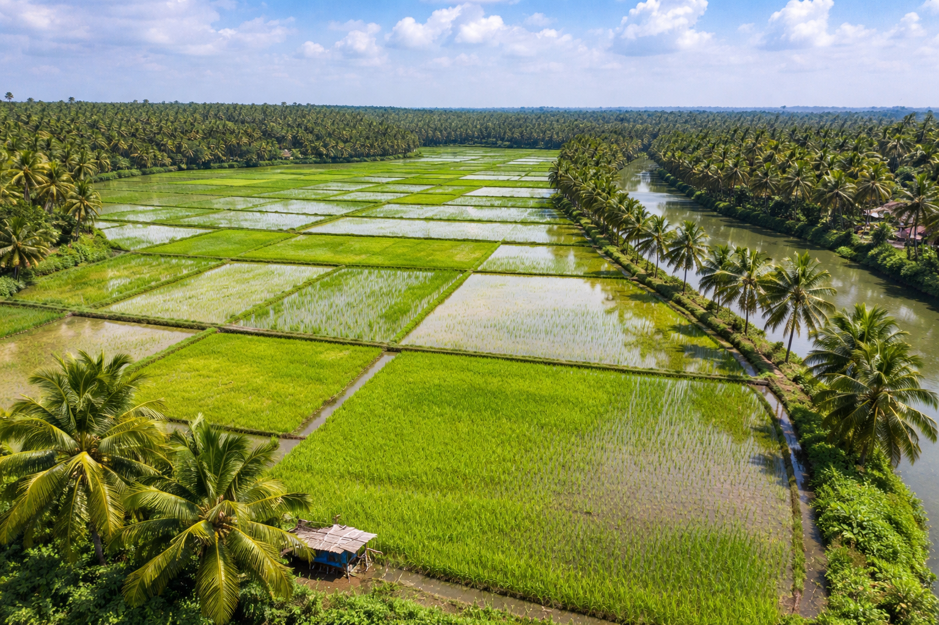

[Author name]
[Email address]

PANDEMIC PREPAREDNESS PLAN CHENNITHALA

MESSAGE FROM PRESIDENT/CHAIR LSGI
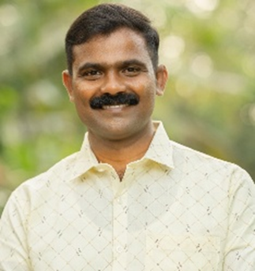
സമീപ വർഷങ്ങളിലെ ആഗോള ആരോഗ്യ പ്രതിസന്ധികൾ ഭരണത്തെക്കുറിച്ചുള്ള നമ്മുടെ ധാരണയെ പുനർനിർവചിച്ചു, മാക്രോ പോളിസിയിൽ നിന്ന് നമ്മുടെ ഗ്രാമത്തിന്റെ സൂക്ഷ്മ യാഥാർത്ഥ്യ ത്തിലേക്ക് ശ്രദ്ധ മാറ്റി. ചെന്നിത്തല ഗ്രാമപഞ്ചായത്തിനെ സംബന്ധി ച്ചിടത്തോളം, വെല്ലുവിളി ഒരിക്കലും കേവലം ക്ലിനിക്കൽ ആയിരുന്നില്ല - അത് ആഴത്തിൽ മാനുഷികമായിരുന്നു. തദ്ദേശ സ്വയംഭരണ സ്ഥാപനത്തിന്റെ പ്രസിഡന്റ് എന്ന നിലയിൽ, പ്രാദേശികവൽക്കരിച്ച തയ്യാറെടുപ്പിന് ജീവൻ രക്ഷിക്കാനും ഉപജീവനമാർഗ്ഗങ്ങൾ നിലനിർത്താനും കഴിയുമെന്നതിന്റെ ആഴത്തിലുള്ള സ്വാധീനം ഞാൻ കണ്ടിട്ടുണ്ട്. പഞ്ചായത്ത് തലത്തിൽ പകർച്ചവ്യാധി തയ്യാറെടുപ്പ് ചെന്നിത്തലയ്ക്കുള്ള ഒരു തന്ത്രപരമായ ചട്ടക്കൂട് എന്ന പേരിലുള്ള ഈ രേഖ ആരോഗ്യകരമായ ഒരു സമൂഹം കെട്ടിപ്പടുക്കുന്നതിനുള്ള ഒരു ഔപചാരിക മാർഗരേഖയായി വർത്തിക്കുന്നു.
ഈ തന്ത്രപരമായ രേഖയുടെ രൂപീകരണത്തിന് സംഭാവന നൽകിയ മെഡിക്കൽ പ്രൊഫഷണലുകൾക്കും, വാർഡ് അംഗങ്ങൾക്കും, നമ്മുടെ പഞ്ചായത്തിലെ സമർപ്പിത സന്നദ്ധപ്രവർത്തകർക്കും എന്റെ ആത്മാർത്ഥമായ നന്ദി അറിയിക്കുന്നു.
ബിനുരാജ്
പ്രസിഡന്റ്
ചെന്നിത്തല - തൃപ്പെരുന്തുറ ഗ്രാമപഞ്ചായത്ത്

MESSAGE FROM HEALTH STANDING COMMITTEE CHAIR

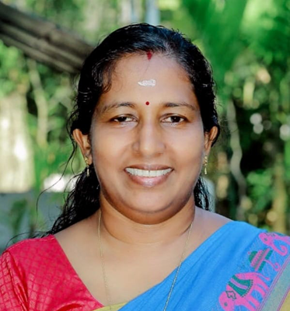

രോഗം വരുന്നത് ഒരു സാധാരണക്കാരന്റെ പോക്കറ്റിൽ നിന്ന് ചെലവഴിക്കുന്ന തുക വർദ്ധിപ്പിക്കുന്നതിനുള്ള ഒരു പ്രധാന സ്രോതസ്സാണ്. ചെന്നിത്തല ഗ്രാമ പഞ്ചായത്ത് ഫണ്ടിന്റെ വലിയൊരു ഭാഗം ആരോഗ്യ സംബന്ധിയായ പ്രവർത്തനങ്ങൾക്കായി ചെലവഴിക്കുന്നു. എന്നിരുന്നാലും മാറിക്കൊണ്ടിരിക്കുന്ന കാലാവസ്ഥയും പുതിയ രോഗങ്ങളുടെ ആവിർ ഭാവവും വലിയ പ്രത്യാഘാതങ്ങൾ സൃഷ്ടിക്കുന്നു. രോഗങ്ങൾ പടരുന്നത് തടയുന്നതിന് നേരത്തെയുള്ള ഇടപെടലുകൾ ആവശ്യമാണ്, അതിനായി എല്ലാ വിഭാഗം ജനങ്ങളുടെയും ഏകോപനം ആവശ്യമാണ്. ഏതൊരു പകർച്ചവ്യാധിയും മനുഷ്യനിലും മൃഗങ്ങളിലും പരിസ്ഥിതിയിലും ചെലു ത്തുന്ന സ്വാധീനം കുറയ്ക്കുക, അതുവഴി ലഭ്യമായ വിഭവങ്ങൾ കൂടുതൽ ഫലപ്രദമായി ഉപയോഗിക്കാൻ നമ്മെ പ്രാപ്തരാക്കുക എന്നതാണ് വൺ ഹെൽത്ത് ഫോർ ഡിസീസ് സർവൈലൻസിന്റെ ദർശനം.
ദീപാ രാജൻ
ആരോഗ്യസ്റ്റാൻഡിങ് കമ്മിറ്റി ചെയർമാൻ
ചെന്നിത്തല-തൃപ്പെരുന്തുറ ഗ്രാമപഞ്ചായത്ത്
MESSAGE BY MEDICAL OFFICER


കോവിഡ്-19 മഹാമാരി നമ്മെ പഠിപ്പിച്ചത് ആരോഗ്യമാണ് നമ്മുടെ ഏറ്റവും വലിയ സമ്പത്ത് എന്നാണ്. ഒരു പ്രശ്നം ആരംഭിക്കുന്നതിന് മുമ്പ് നന്നായി തയ്യാറെടുക്കേണ്ടത് പ്രധാനമാണെന്ന് നമ്മൾ കണ്ടിട്ടുണ്ട്. ഭാവിയിലെ ഏത് ആരോഗ്യ അടിയന്തരാവസ്ഥകളെയും നേരിടാൻ നമ്മുടെ പഞ്ചായത്തും കുടുംബാരോഗ്യ കേന്ദ്രവും എങ്ങനെ സജ്ജമായിരിക്കുമെന്ന് കാണിക്കുന്നതിനുള്ള ഒരു വഴികാട്ടിയാണ് ഈ കൈപ്പുസ്തകം. കാരണം കൂടുതൽ വെള്ളക്കെട്ടുള്ള പ്രദേശമായതിനാൽ എലിപ്പനിക്കും, ജലജന്യ രോഗത്തിനും, ഡെങ്കിപ്പനിക്കും, പക്ഷിപ്പനിക്കും സാധ്യത ഏറിയ ഇടമാണ് നമ്മുടെ നാട്. പ്രായോഗിക നടപടികൾ, കുടുംബാരോഗ്യ കേന്ദ്രത്തിൽ മരുന്നുകൾ നന്നായി സംഭരിക്കുക, ലഭ്യമായ അടിസ്ഥാന സൗകര്യങ്ങളുടെ ശരിയായ ഉപയോഗം, വിവിധ മേഖലകളിൽ നിന്നുള്ള മനുഷ്യവിഭവശേഷി വേഗത്തിൽ പ്രവർത്തിക്കാൻ പരിശീലനം എന്നിവയിലാണ് ഈ പദ്ധതി ശ്രദ്ധ കേന്ദ്രീകരിക്കുന്നത്. ചെന്നിത്തല പഞ്ചായത്തിലെ എല്ലാവർക്കും സുരക്ഷിതവും ആരോഗ്യകരവുമായ ഒരു നാടായി നിലനിർത്താൻ നമ്മൾ പ്രവർത്തിക്കുമ്പോൾ, നമ്മുടെ ആരോഗ്യ സംഘത്തെ പിന്തുണയ്ക്കാൻ ഓരോ പൗരനോടും ഞാൻ അഭ്യർത്ഥിക്കുന്നു.
ഡോ . ദേവിശ്രീ
മെഡിക്കൽ ഓഫീസർ
എഫ്.എച്ച്.സി. ചെന്നിത്തല
EXECUTIVE SUMMARY
Chennithala Primary Health Centre (PHC) functions as the primary public healthcare institution serving the population of Chennithala Grama Panchayath. The PHC plays a pivotal role in delivering comprehensive, accessible, and affordable healthcare services, with a strong focus on preventive, promotive, curative, and rehabilitative care in accordance with national and state health programmes.
The PHC caters to a predominantly rural population, addressing key public health priorities such as maternal and child health, communicable and non-communicable disease control, immunization, family welfare, adolescent health, and geriatric care. Regular outpatient services, home-based care through field health staff, and outreach activities ensure healthcare coverage even in geographically challenging areas. The institution actively implements national health missions, including the National Health Mission (NHM), National Tuberculosis Elimination Programme, National Programme for Prevention and Control of Cancer, Diabetes, Cardiovascular Diseases and Stroke (NPCDCS), and other disease surveillance initiatives.
PHC Chennithala works in close coordination with the Grama Panchayath, ASHA workers, Anganwadi centres, schools, and community-based organizations to strengthen community participation and improve health awareness. Emphasis is placed on early detection, timely referral, health education, and lifestyle modification to reduce disease burden and improve overall health outcomes.
Despite constraints related to infrastructure, manpower, and increasing service demand, the PHC continues to enhance service delivery through effective planning, data-driven decision-making, and community engagement. Strengthening facilities, upgrading digital health systems, and expanding preventive services remain key focus areas for future development.
Overall, PHC Chennithala stands as a vital institution in safeguarding public health and improving the quality of life of the residents of Chennithala Grama Panchayath.

LIST OF ABBREVIATIONS

LSGD/LSGI | Local Self Government Department / Local Self Government Institution
BMO | Block Medical Officer
IDSP | Integrated Disease Surveillance Programme
NDMA | National Disaster Management Authority
PPE | Personal Protective Equipment
ICMR | Indian Council of Medical Research
CD | Communicable Diseases
NCD | NON-COMMUNICABLE Diseases

TABLE OF CONTENTS
INTRODUCTION 9
LSGD AT A GLANCE 10
INTEGRATED HEALTH INFRASTRUCTURE MAP OF CHENNITHALA-THRIPPERUMTHURA GRAMA PANCHAYAT 13
GENERAL PROFILE OF THE LSGI’S 19
Background of the LSGI 19
Demographic and Vulnerable Population 21
Clinical Vulnerability 22
INFRASTRUCTURE & RESOURCE INVENTORY 25
Health Facility Directory & Basic Capacity in the LSGD 25
Private Clinics 26
Healthcare Education & Training Institutions 27
Specialized Services & Emergency Inventory 28
Oxygen & Diagnostic Capacity 29
Diagnostics facility mapping at the LSGI level 30
Laboratory Identification & Basic Details 30
Social and Community Infrastructure for surge plan 31
Human resources 33
Medical & Clinical Personnel 33
Public Health & Field-Level Workforce 34
Community & Support Cadre 35
Community Organizations 36
Administrative & Emergency Services 37
Information regarding resources 38
ONE HEALTH & ENVIRONMENTAL SURVEILLANCE 40
Animal & Bird Population 40
Veterinary Infrastructure 41
Veterinary Doctors & Workforce 42
High-Risk Interface Points (Surveillance Sites) 43
Environmental Risk Mapping 45
Disease Seasonality Mapping 46
Vulnerability Mapping 47
EPIDEMIOLOGICAL TRENDS (2021–2025) 50
Disease Burden among human beings(Last 5 Years) 50
Seasonal Trend Analysis 52
DENGUE 52
Dengue – Ward-wise Yearly Distribution (2021–2025) 53
LEPTOSPIROSIS 55
Leptospirosis – Ward-wise Yearly Distribution (2021–2025) 56
VIRAL HEPATITIS - A 58
Hepatitis A – Ward-wise Yearly Distribution (2021–2025) 59
Outcome-Based Trend Analysis- 2025 61
Transmission Trend- 2025 63
Integrated Disease Hotspot Map (2021–2025) 71
Preparedness and Response Protocol at LSG Level 74
Constitution of One Health Committee 74
Key Responsibilities: 75
Meeting Schedule: 75
Pandemic Response Workforce 76
Activities and Measures before and during Pandemic 77
PHASE 1 - Alert / Preparation 77
PHASE 2 - Active Response 82
Standard Screening Protocol 84
PHASE 3 - Surge Capacity 97
Conversion of Community Facilities 97
CONCLUSION 102
RECOMMENDATIONS 104
ANNEXURE 106
1. IMPORTANT PHONE NUMBERS 106

INTRODUCTION

Chennithala - Thripperumthra Grama Panchayat is situated in the south of Alappuzha district, Kerala. The geographical landscape of the Panchayat is predominantly low-lying, characterized by extensive paddy fields and a dense network of rivers, canals, and backwaters. This unique terrain plays a significant role in shaping the local microclimate and poses distinct challenges to transportation, emergency response, and service delivery, particularly during monsoon seasons and flood events.

The Panchayat is administratively divided into multiple wards, with a population largely dependent on traditional livelihoods. Agriculture, especially paddy cultivation, fishing, coir and coconut husk processing, and allied activities form the backbone of the local economy. In recent years, tourism-related activities and service-sector employment have also shown gradual growth. The area hosts a diverse workforce, including a notable presence of migrant labourers, particularly in construction, agriculture, and allied sectors.

From a public health and disaster management perspective,Chennithala - Thripperumthra LSGI has historically been vulnerable to seasonal flooding, waterborne diseases, and vector-borne illnesses such as Dengue and Leptospirosis. The severe floods experienced during recent years, including the 2018 flood disaster, significantly impacted life, livelihoods, and infrastructure within the Panchayat. These recurring emergencies have underscored the importance of strengthening local preparedness, response mechanisms, and inter-departmental coordination.

In this context, the development of a localized, data-driven Auxiliary Infrastructure and Logistical Resource Map is essential to support effective planning, timely emergency response, and sustainable development initiatives. Such mapping enables the Panchayat to identify critical resources, improve accessibility during disasters, and enhance overall resilience of the community.

LSGD AT A GLANCE

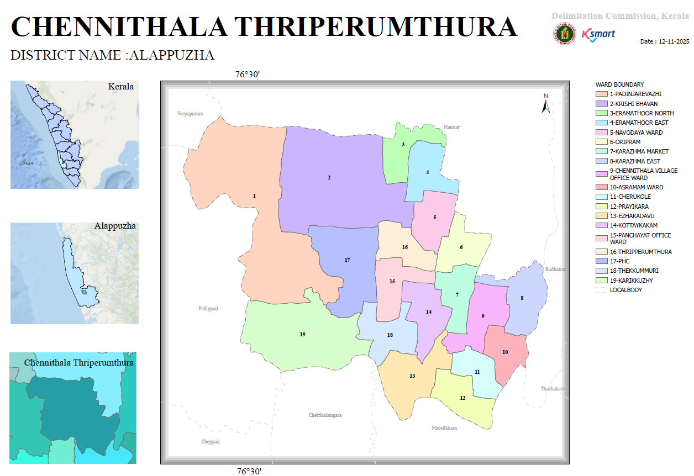

Ward | Houses | Population | Migrants | Wells | Hot  spots | Ed. Institutions | Hosp pvt/govt.
1 | 446 | 1725 | 7 | 293 | 1 | 0 | 0
2 | 465 | 1977 | 12 | 460 | 0 | 2 | 0
3 | 524 | 1996 | 0 | 464 | 0 | 0 | 0
4 | 534 | 1884 | 19 | 515 | 0 | 1 | 0
5 | 619 | 2037 | 40 | 609 | 0 | 0 | 0
6 | 464 | 1906 | 19 | 754 | 0 | 2 | 0
7 | 488 | 1971 | 82 | 495 | 0 | 1 | 0
8 | 436 | 1642 | 24 | 440 | 0 | 1 | 0
9 | 459 | 1779 | 10 | 409 | 0 | 0 | 0
10 | 430 | 1518 | 0 | 443 | 0 | 0 | 0
11 | 460 | 1620 | 46 | 455 | 0 | 1 | 0
12 | 487 | 1760 | 53 | 380 | 1 | 0 | 0
13 | 451 | 1255 | 38 | 450 | 0 | 2 | 0
14 | 508 | 1757 | 27 | 508 | 0 | 1 | 0
15 | 430 | 1561 | 33 | 390 | 0 | 1 | 0
16 | 468 | 1678 | 5 | 362 | 0 | 0 | 1
17 | 410 | 1782 | 30 | 410 | 1 | 2 | 0
18 | 403 | 1800 | 35 | 328 | 1 | 1 | 1

INTEGRATED HEALTH INFRASTRUCTURE MAP OF CHENNITHALA-THRIPPERUMTHURA GRAMA PANCHAYAT
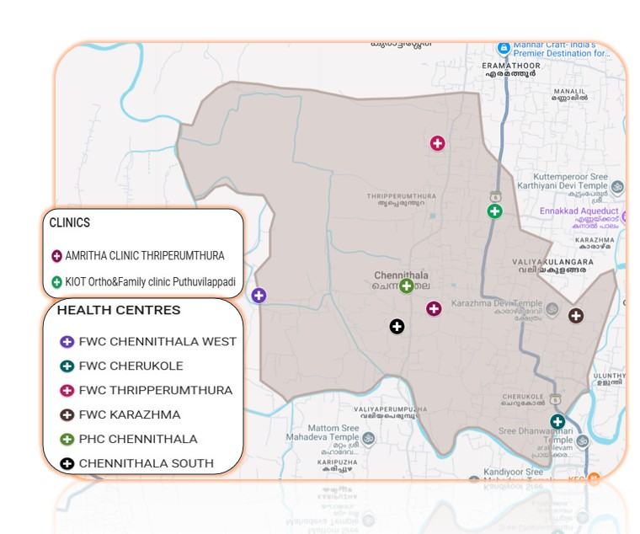

https://www.google.com/maps/d/u/2/viewer?mid=1sDqr_HWt2E2py9SeH1lQqOG6OJkydG0&ll=9.282148954823866%2C76.5193245&z=14

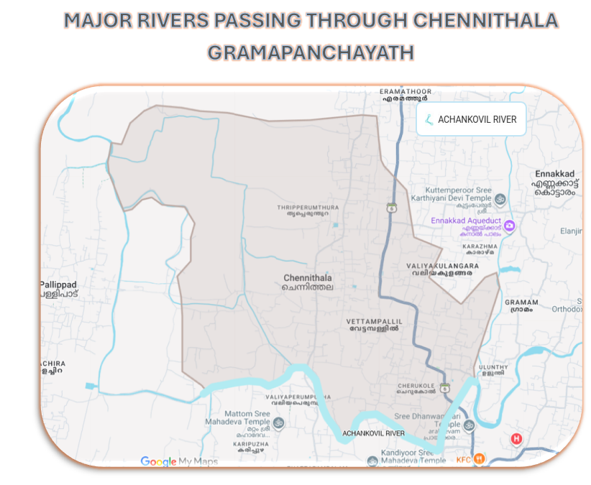
https://www.google.com/maps/d/u/2/viewer?mid=1X5YtQ52e-1STZa6_FGofe3Y4TGJVWBo&ll=9.282028963688413%2C76.5193245&z=14

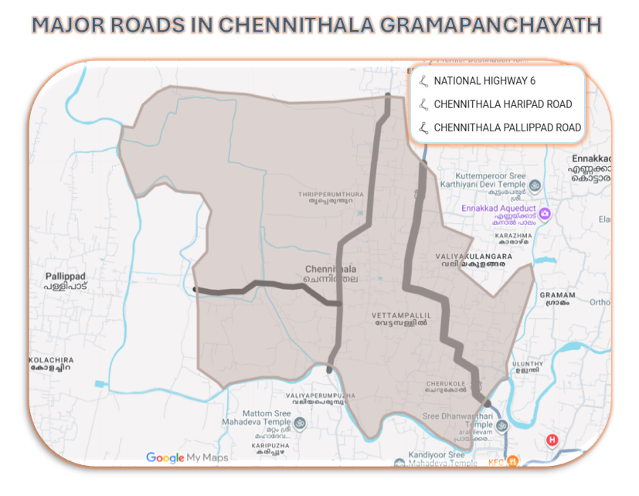
https://www.google.com/maps/d/u/2/viewer?mid=10TXhr9AKaWk9qNOvdUPpMO4bdRr8gII&ll=9.282148954823866%2C76.5193245&z=14

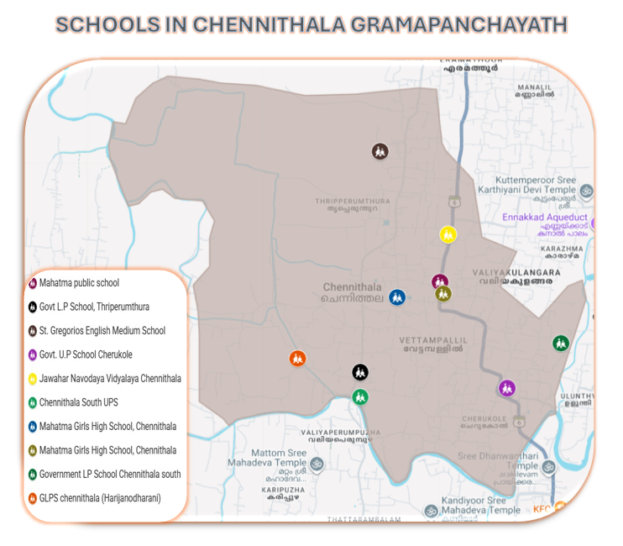
https://www.google.com/maps/d/u/2/viewer?mid=1a3K3frT3cfT3Rc0IsRW5nN1hV0y_CCc&ll=9.282148954823866%2C76.5193245&z=14

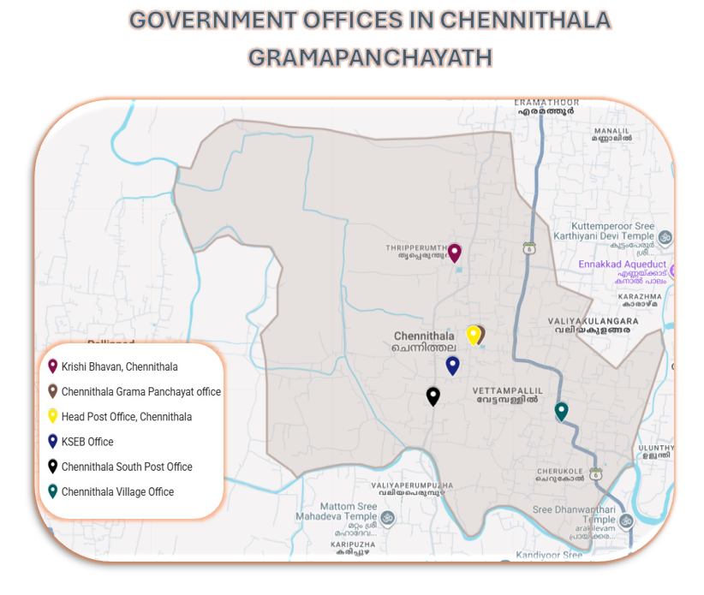
https://www.google.com/maps/d/u/2/viewer?mid=14Bq2WtZQG0MIDxksJPOVcyHVinKjsDE&ll=9.282148954823866%2C76.5193245&z=14

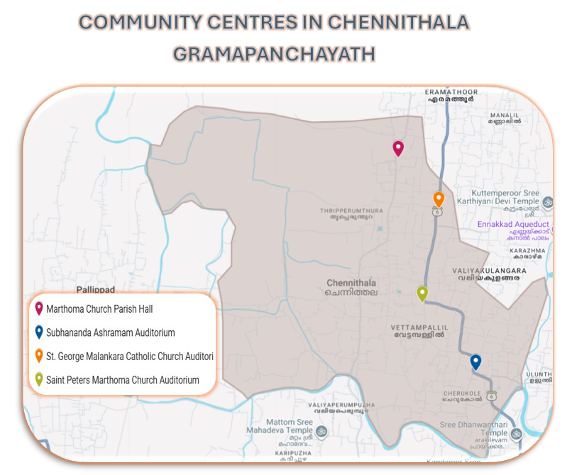
https://www.google.com/maps/d/u/2/viewer?mid=1Hc8Ggz0DPQs67NPcPF3AOtgpSZzw9HM&ll=9.282148954823866%2C76.5193245&z=14

GENERAL PROFILE OF THE LSGI’S

Background of the LSGI
Chennithala Grama Panchayat is situated in the midland, central planes of Alappuzha district, Kerala. The geographical landscape of the Panchayat is predominantly low-lying, characterized by extensive paddy fields (Kole lands) and a dense network of rivers, canals, and backwaters. This unique terrain plays a significant role in shaping the local microclimate and poses distinct challenges to transportation, emergency response, and service delivery, particularly during monsoon seasons and flood events.
The Panchayat is administratively divided into multiple wards, with a population largely dependent on traditional livelihoods. Agriculture—especially paddy cultivation—fishing, coir and coconut husk processing, and allied activities form the backbone of the local economy. In recent years, tourism-related activities and service-sector employment have also shown gradual growth. The area hosts a diverse workforce, including a notable presence of migrant labourers, particularly in construction, agriculture, and allied sectors.
From a public health and disaster management perspective, Chennithala LSGI has historically been vulnerable to seasonal flooding, waterborne diseases, and vector-borne illnesses such as Dengue and Leptospirosis. The severe floods experienced during recent years, including the 2018 flood disaster, significantly impacted life, livelihoods, and infrastructure within the Panchayat. These recurring emergencies have underscored the importance of strengthening local preparedness, response mechanisms, and inter-departmental coordination.
In this context, the development of a localized, data-driven Auxiliary Infrastructure and Logistical Resource Map is essential to support effective planning, timely emergency response, and sustainable development initiatives. Such mapping enables the Panchayat to identify critical resources, improve accessibility during disasters, and enhance overall resilience of the community.

Table 1: Background of LSGD
Description | Details
Name of LSGI | CHENNITHALA THRIPPERUTHURA
Type (GP/Municipality / Corporation etc.) | Grama Panchayath
Block | MAVELIKKARA
District | ALAPPUZHA
Number of wards | 18
Total area (sq. km) | 22.26
Population(Projected) | 31648
Population density | 1409 persons/sq km
Terrain (coastal/low-lying/backwaters/foothills, etc.) | Low lying
Number of rivers passing through LSGI | 1-ACHANKOVIL
Number of water bodies in the LSGI | 6
Number of educational institutions | 15
Factories / small-scale industries | 2
Flood-prone wards | 1, 2, 9, 12, 16, 17, 18
Landslide-prone wards | Nil
Death Management and Disposal Facilities (mortuaries/crematorium, including electric) | NIL
Auditoriums/Marriage halls/convention centres/community halls | 15

Demographic and Vulnerable Population
Understanding the demographic composition and vulnerable population groups is essential for pandemic preparedness. Children, elderly, economically deprived families, migrant workers, and socially vulnerable groups are at increased risk during public health emergencies due to higher exposure, limited access to services, and dependency on public systems..

Description |  | Details (in numbers)
DEMOGRAPHIC PROFILE
Total population |  | 31648
Male |  | 15287
Female |  | 16361
Transgender |  | 0
Children under 5 |  | 862
Adolescent |  | 1680
Elderly (>60) |  | 6862
SOCIAL/LIVELIHOOD VULNERABILITY
Previous EPEP family |  | 40
BPL family |  | 6443
Tribal communities |  | 0
Migration | Immigrant | 581
Migration | Emigrant | 1948
Socio-economically deprived |  | 2
Fisherfolk |  | 280
SC Community |  | 3770
ST Community |  | 2/F

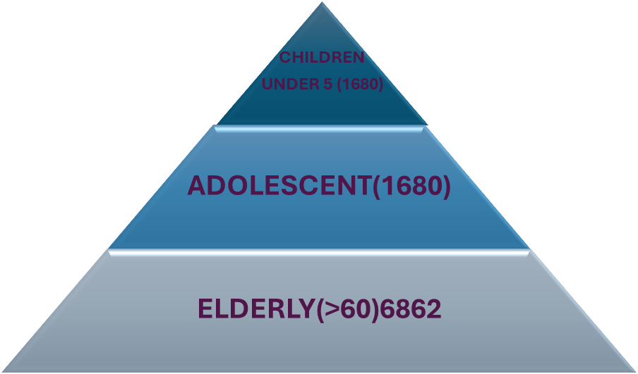

Clinical Vulnerability
Certain population groups needs priority healthcare & are at higher risk of severe illness, complications, and mortality during pandemics. Patients with chronic diseases, those requiring regular medical care, and individuals with mobility or functional limitations face challenges in accessing timely care during emergencies. Mapping these groups helps in prioritizing continuity of treatment, medicine stock planning, oxygen support, referral transport, and targeted home-based care.
Description | Details in numbers
Pregnant women | 94
Lactating mothers | 230
Bedbound patients | 114
Patients under palliative care other than bedbound | 241
Patients on Haemodialysis | 14
Patients on CAPD | 2
Cancer patients (currently on treatment) | 90
Haemophilic patients | 0
Mentally challenged | 101
Differently abled | 105
Diabetic patients | 2801
Hypertensive patients | 3411
TB patients | 1

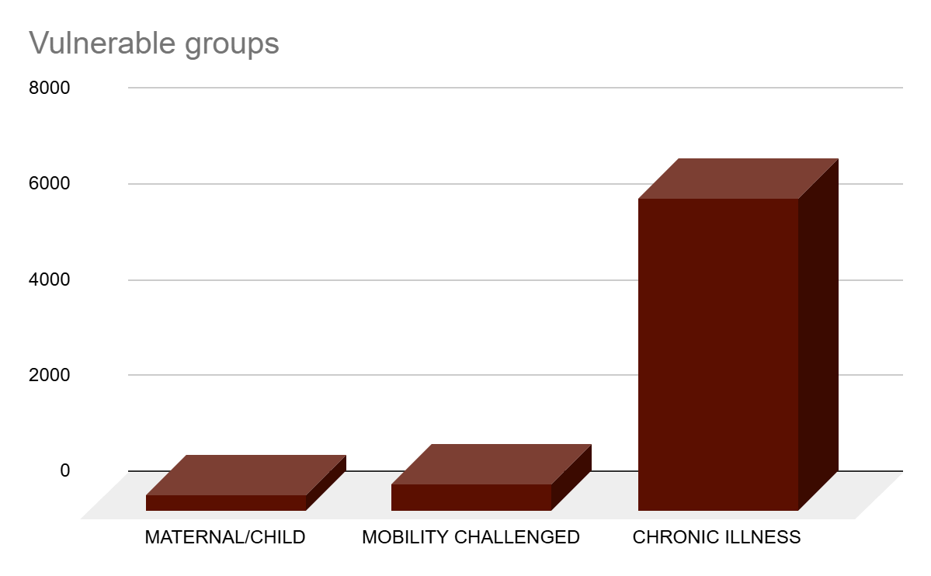
Major Festivals & Events specific to the LSGI
(with the possibility of a public gathering)

Sl. No. | Name of festival | Month detailing the periodicity
1 | Maha Shivarathri | February
2 | Thaipooyam | February
3 | Fathima Matha Devalayam - Padukal Thirunaal | January

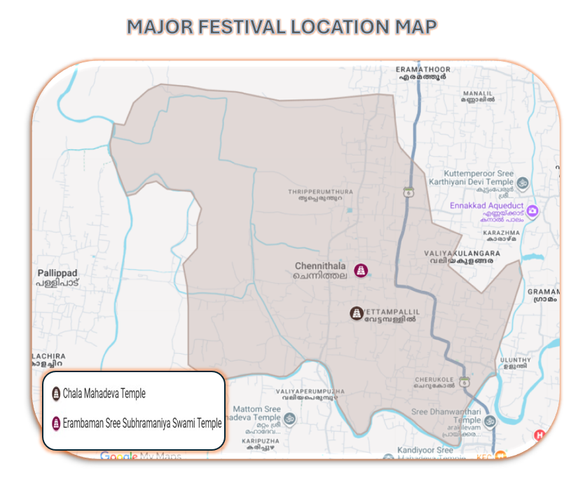
https://www.google.com/maps/d/u/2/viewer?mid=1RRJcP6HYcOazfxBG4bctqJtb5W_HXaI&ll=9.282148954823866%2C76.5193245&z=14

INFRASTRUCTURE & RESOURCE INVENTORY

Health Facility Directory & Basic Capacity in the LSGD
This section provides an overview of the healthcare infrastructure available within the LSGD area. It outlines the distribution and basic capacity of health facilities that form the backbone of service delivery during routine times and public health emergencies.

Family Health Centres (FHCs) and Community Health Centres (CHCs) generally function as the first point of contact for the community, providing essential outpatient and inpatient services. General Hospitals (GH) and Medical College Hospitals (MCH), where accessible, serve as the main referral centres for advanced diagnostics, specialist care, and critical services during public health emergencies. This inventory helps identify existing strengths, gaps, and potential surge capacity that can be mobilised during a pandemic or disaster.

Table 5. Health Facility Resource Summary
Sl.no. | Health Facility | Type of Facility (MCH/GH/CHC/FHC/SC etc.) | Contact Number | Total beds | ICU Beds | Oxygen-Supported Beds | No. of Ventilator Support Beds | No. of ambulances
Government Healthcare Facilities
1 | FHC CHENNITHALA | FHC | 8281216050 | 0 | 0 | 0 | 0 | 0
Private Healthcare Facilities
 | NA
AYUSH Healthcare Facilities
1 | Homeo | Govt Hospital | 9895607839 | 0 | 0 | 0 | 0 | 0
2 | Ayurveda Dispensary | Govt Hospital | 9497221380 | 0 | 0 | 0 | 0 | 0

Private Clinics
Private clinics are an essential part of pandemic preparedness, as they are often the first place people seek care when symptoms begin. In many communities, private clinics manage a significant share of outpatient visits and therefore play a critical role in early case detection, timely referrals, and disease surveillance. Having an up-to-date understanding of where these clinics are located, the services they provide, and how they are linked to the public health system helps ensure that no cases are missed during an outbreak. It also allows health authorities to engage private practitioners more effectively for reporting, risk communication, and coordinated response, strengthening the overall capacity of the health system to manage public health emergencies.

Table 6. Private Clinic Resource Summary
Sl No. | Name of Clinic | Registered (Y/N) | Clinic (General / Speciality) | Speciality (if any) | Address | Contact Number | Diagnostic Facility (Y/N) | Ambulance Linkage (Y/N)
1 | AMRUTHA | Y | General | NA | THRIPPERUMTHURA P O MAVELIKKARA | 9496158328 | N | N
2 | KIOT | N | Speciality | ORTHOPEDIC & TRAMATOLOGY | CHENNITHALA P O PUTHUVILAPADI | 9395241066 | N | N
3 | MEDHUB | Y | General | NA | Haripad Elanjimel Road, Chennithala | 9495521193 | N | N

Healthcare Education & Training Institutions
This section tracks the educational infrastructure available, which is vital for human resource planning in the health sector.

Category of Institution | Govt | Private | AYUSH | Total
Medical Colleges | 0 | 0 | 0 | 0
Nursing Colleges | 0 | 0 | 0 | 0
Dental Colleges | 0 | 0 | 0 | 0
Para-medical / Allied Health | 0 | 0 | 0 | 0
Pharmacy Colleges | 0 | 0 | 0 | 0

Specialized Services & Emergency Inventory
This section provides a detailed view of the specialized medical resources available to the community, focusing on emergency response and critical care capabilities. This table tracks the vital assets required for managing severe illnesses and emergencies across Government, Private, and AYUSH sectors.

Item | Govt | Private | AYUSH | Total
Hospital beds | 0 | 0 | 0 | 0
Oxygen-generating systems(Y/N) | 0 | 0 | 0 | 0
Oxygen-supported beds(Numbers) | 0 | 0 | 0 | 0
Ventilator-supported beds | 0 | 0 | 0 | 0
ICU beds | 0 | 0 | 0 | 0
Burns units | 0 | 0 | 0 | 0
Blood centres | 0 | 0 | 0 | 0
BLS ambulances | 0 | 0 | 0 | 0
ALS ambulances | 0 | 0 | 0 | 0
Dialysis facilities | 0 | 0 | 0 | 0
Dispensaries | 0 | 3 | 2 | 5
Medical store | 0 | 6 | 3 | 9
Industrial establishments(Medium-scale industries/small-scale industries establishments to whom we can depend in a worst-case scenario) | 0 | 2 | 0 | 2

Oxygen & Diagnostic Capacity
Monitoring oxygen and diagnostic capacity is a critical component of public health preparedness, ensuring that the LSGD can handle both chronic care and sudden surges in respiratory or infectious diseases.
Name of Health Facility | Oxygen-generating System (Y/N) | Backup Oxygen Source (Y/N) | Diagnostic Facilities Available(Y/N)
Name of Health Facility | Oxygen-generating System (Y/N) | Backup Oxygen Source (Y/N) | Lab | USG | X-ray | CT/MRI | RT-PCR
Government Healthcare Facilities
PHC Chennithala | 0 | 0 | 0 | 0 | 0 | 0 | 0

Diagnostics facility mapping at the LSGI level
The diagnostic capacity of Chennithala-Thripperumthura G.P represents the "intelligence network" of our healthcare system. The speed and accuracy of disease identification depend entirely on the distribution and technical level of these facilities.

Item | Govt | Private | AYUSH | Total
General labs | 1 | 5 | 0 | 6
Microbiology labs | 0 | 0 | 0 | 0
RT-PCR labs | 0 | 0 | 0 | 0
USG units | 0 | 0 | 0 | 0
CT/MRI units | 0 | 0 | 0 | 0
Research labs | 0 | 0 | 0 | 0
Labs of other departments that can be repurposed | 0 | 0 | 0 | 0

Laboratory Identification & Basic Details
Sl. No. | Name of Laboratory | Ownership (Govt / Private / Academic) | Address | Contact No. | 24×7 Services (Yes/No) | NABL / Govt Approved (Yes/No)
1 | FHC CHENNITHALA | Govt | THRIPPERUMTHURA PO MAVELIKKARA | 8281216050 | NO | YES
2 | AMBADI | Private | THRIPPERUMTHURA PO MAVELIKKARA | 9495087437 | NO | YES
3 | LAB CARE | Private | CHERUKOL PO | 701273621 | NO | YES
4 | PRIYA CLINIC | Private | CHENNITHALA P O MAVELIKKARA | 9447110457 | NO | YES
5 | UNIC CARE | Private | CHENNITHALA P O PUTHUVILAPADI | 8606891996 | NO | YES
6 | PRIYA | Private | THRIPPERUMTHURA PO MAVELIKKARA | 9447110457 | NO | YES

Social and Community Infrastructure for surge plan
This table serves as our logistics and shelter inventory. By mapping these locations, quickly we can identify where to house displaced citizens, where to set up temporary medical clinics, and how to manage the deceased with dignity during a crisis.
 | Category | Total Count | Ward | Est. Capacity (Persons)
 | Educational Institutions
 | Anganwadis | 30 | All 19 wards | 330
 | Schools | 15 | 2,4,6,8,11,13,14,15,17,18 | 1500
 | Colleges | 0 | 0 | 0
 | Healthcare Educational Institutions
 | Medical colleges (Govt/Private) | 0 | 0 | 0
 | Nursing colleges (Govt/Private) | 0 | 0 | 0
 | Dental colleges (Govt/Private) | 0 | 0 | 0
 | Paramedical institutes (Govt/Private) | 0 | 0 | 0
 | Community Gathering Spaces
 | Community halls | 1 | 14 | 200
 | Auditoriums | 0 | 0 | 0
 | Religious buildings | 2 | 8 | 800+800
 | Vulnerable Group Support Facility
 | Destitute homes | 0 | 0 | 0
 | Elderly homes | 1 | 12 | 25
 | LSGD owned other buildings | 0 | 0 | 0
 | Mass Fatality Management (MFM) Infrastructure
 | Mortuary | 0 | 0 | 0
 | Crematorium | 0 | 0 | 0
*refer annexure 1 for contact details

Human resources
This section focuses on the human capital available within the LSGI. In any emergency—be it a pandemic, flood, or industrial accident—infrastructure is only as effective as the people operating it.

Medical & Clinical Personnel
This table tracks the "Frontline" providers responsible for diagnosis, treatment, and clinical management. A detailed directory with the contact numbers of all workers is maintained in Annexure.

Cadre | Govt (No.) | Private (No.) | Total
Doctors—Modern Medicine | 1 | 1 | 2
Doctors – AYUSH | 1 | 2 | 3
Doctors – Veterinary | 1 | 0 | 1
Doctors – Dental | 0 | 3 | 3
Nursing officers | 0 | 0 | 0
Lab technicians | 0 | 0 | 0
Optometrist | 0 | 0 | 0
Pharmacists | 0 | 0 | 0
Psychologists | 0 | 0 | 0
Counsellors | 0 | 0 | 0

Public Health & Field-Level Workforce
These individuals are the backbone of surveillance, maternal-child health, and decentralized care.

Cadre | Health services | Municipal common services | Total
HS (Health Supervisors) | 0 | 0 | 0
HI (Health Inspectors) | 1 | 0 | 1
LHS (Lady Health Supervisor) | 0 | 0 | 0
LHI (Lady Health Inspectors) | 0 | 0 | 0
JPHN (Jr Public Health Nurses) | 5 | 0 | 5
JHI (Jr Health Inspectors) | 4 | 0 | 4
MLSP (Mid-Level Service Providers) | 6 | 0 | 6
Palliative Nurses | 1 | 0 | 1
RBSK Nurses | 1 | 0 | 1
PRO | 0 | 0 | 0
Epidemiologist | 0 | 0 | 0
Data Manager | 0 | 0 | 0

Community & Support Cadre
This group represents the surge capacity of the LSGI—people who can be called upon for logistics, rescue, and specialized support.

Cadre | Number
ASHA Workers | 24
AWW (Anganwadi Workers) | 30
Emergency Medical Volunteers (Trained) | 0
Kudumbashree | 263
MNREGS | 1718
Purusha Swayam Sahaya Sangham | 0
Ex-Servicemen | 288
Retired Police Officers | 23
NCC/NSS Volunteers | 220
Red Cross volunteers | 50
One Health Community Volunteers | 882
One Health Community Mentors | 126

Community Organizations
This section details the presence of community-based organisations (CBOs), non-governmental organisations (NGOs), faith-based organisations (FBOs), Kudumbashree Self-Help Groups (SHGs), and Ayalkootams within the Local Self-Government Institution (LSGI). These groups enhance grassroots mobilization, resource distribution, and support networks crucial for pandemic response and community resilience.

Category | Total Count
NGOs | 1
Religious based organizations | 67
Foreign based organizations | 0
Sports Club/youth clubs | 4
Kudumbashree SHGs | 236
Ayalkootams | 236
Political organizations | 0
Residential organizations | 0

Administrative & Emergency Services
This section outlines the availability of key non-health emergency support services and infrastructure within the LSGI, which are essential for effective pandemic preparedness and response. These facilities support law enforcement, disaster response, water supply, logistics, mobility, and community-level interventions during public health emergencies.

Category | Total Count | Contact details
Police Stations | 0 | 04792312224 (Mannar)
Fire & Rescue Stations | 0 | 04792306264 (Mavelikkara)
Water Pumping Points | 1 | 9446710844
Public Distribution System (PDS) | 20 | 9037386259

Information regarding resources
The availability of essential transport and support resources plays a quiet but critical role in saving lives. Equipment such as ambulances, mobile mortuaries, amphibian ambulances, and motorized boats ensures that patients, samples, and healthcare teams can move swiftly—even in flooded, remote, or difficult terrains. Heavy vehicles like JCBs, cranes, tractors, and torus lorries support logistics, waste management, emergency infrastructure, and rapid conversion of spaces into care or isolation facilities. Taxis, four-wheel-drive vehicles, and trucks help maintain continuity of essential services, reach vulnerable populations, and support home-based care and supply delivery.

Means of transportation | Total Count
JCB | 2
Crane | 0
Heavy Trucks | 2
Tractor | 3
Ambulances | 2
Mobile mortuaries | 1
Boats | 0
Taxi service | 5
Note: For specific details regarding vehicle owners and contact information, please refer to Annexure [X].

ONE HEALTH & ENVIRONMENTAL SURVEILLANCE
The One Health method integrates environmental, animal, and human health to enable proactive pandemic preparedness. Panchayat-level surveillance needs to be improved in order to detect and treat zoonotic and environmentally generated diseases early. Surveillance is strengthened through systematic assessment of animal populations, veterinary infrastructure, poultry and slaughter facilities, inter-sectoral coordination, and specialised tools like avian influenza seasonality mapping using GIS in previous outbreaks to enable predictive alerts and ward-specific sampling to support effective pandemic preparedness in high-risk areas like Cherukole and Padinjarevazhi

Animal & Bird Population
Mapping animal and bird populations at the Panchayat level is essential for identifying and prioritising zoonotic disease hazards like rabies, avian influenza (H5N1), leptospirosis, anthrax, and Nipah-like spillover occurrences. Risk classification, targeted surveillance, vaccination planning, and early epidemic detection made feasible by comprehensive population mapping all enhance One Health-based pandemic preparedness.

Category | Item | Estimated Population | Wards
Animal Population | Livestock (Cattle/Goats/Buffalo) | 779 | ALL
Animal Population | Pet Animals (Dogs/Cats) | 2367 | ALL
Animal Population | Stray Dog Population | 261 | ALL
Animal Population | Pig Farms (Number of heads) | 0 | 0
 | Small Units (Sheep / Goats – clustered) | 76 | ALL
Bird Population | Poultry Units (Birds) | 806 | ALL
Bird Population | Poultry- (FOWL) | 3504 | ALL
Bird Population | Wild/Migratory Birds (Observed) | 0 | 0
Bird Population | Crow Mortality Events (Reported) | 0 | 0

The main risk of zoonotic diseases is concentrated in Ward 1,18, which is explained by the high density of cattle congregation areas, and poultry units. The stray dog population in market areas, fish landing sites, bus stations continues to be a substantial problem for rabies surveillance and bite prevention. There is a considerable risk of avian influenza introduction and amplification during November - December due to the seasonal presence of migratory and resident water birds near ponds/ canal / river / backwater / paddy field. Clusters of pig farms and animal shelters vulnerable to flooding further raise the risk of leptospirosis and other zoonoses mediated by the environment, especially during monsoon floods.

Veterinary Infrastructure
Veterinary institutions are a core pillar of One Health surveillance, enabling early zoonotic disease detection through vaccination, investigation of unusual animal illness or deaths, sample collection, and timely outbreak reporting. A well-mapped and responsive veterinary network strengthens coordination with human health and LSGI systems, ensuring rapid response during zoonotic events and pandemics.
Facility Type | Name of Facility | Ownership Govt / Pvt | Location(Ward No) | Contact number
Veterinary Dispensary | CHENNITHALA | GOVT | 14 | 04792324657
Veterinary Hospital / Polyclinic | 0 | 0 | 0 | 0
Private Veterinary Clinics | 0 | 0 | 0 | 0
Mobile / Emergency Vet Service (incl. night services) | 0 | 0 | 0 | 0
Pet Homes / Animal Shelters | 0 | 0 | 0 | 0
Slaughterhouse-linked Veterinary Inspection Unit | KOTTAMURI | PVT | 16 | 8078920811

Veterinary Doctors & Workforce
Early detection, diagnosis, reporting, and reaction to animal illness epidemics depend on the availability and accessibility of qualified veterinary specialists. By identifying unusual animal morbidity or mortality promptly, collecting samples promptly, and coordinating efficiently with human health and LSGI systems—especially during zoonotic outbreaks and pandemic-prone situations—a clearly defined veterinary workforce enhances One Health surveillance.

Category | Number Available | Type (Govt/Pvt) | Contact number
Government Veterinary Doctors | 1 | GOVT | 04792324657
Private Veterinary Doctors | 0 | 0 | 0
Livestock Inspectors | 1 | GOVT | 7025809253
Para-veterinary Staff / Attenders | 1 | GOVT | 7994968562
Contract / On-call Veterinary Support (if any) | 0 | 0 | 0

High-Risk Interface Points (Surveillance Sites)
High-risk interface points for zoonotic disease surveillance in Chennithala Grama Panchayath include wetland–livestock–human contact zones, backyard poultry farms, cattle sheds near water bodies, fish markets, and areas of high human–animal interaction such as community slaughter points and migratory bird congregation sites. These are the primary surveillance sites where zoonotic spillover risks are elevated.

Type of Habitat | Type of High risk interface | Geographical vulnerability
Wetlands & Backwaters | 0 | 0
Backyard Poultry Farms | Backwater, paddy field - Ward - 1, 18 | Low lying
Cattle Sheds near Water Bodies | 0 | 0
Fish & Meat Markets | 0 | 0
Community Slaughter Sites | 0 | 0
Migratory Bird Congregation Areas | Trees and paddy fields | Low lying
Rodent-Infested Grain Storage | 0 | 0

Category | Total Count | Key Locations (wards)
Poultry Farms | 0 | 0
Backyard / Clustered Poultry Units | 0 | 0
Duck Rearing Units (open water access) | 0 | 0
Slaughterhouses/ Slaughter Points | 0 | 0
Meat/Fish Markets | 2 | 13,8
Live Bird Sale Points | 0 | 0
Cattle Markets / Weekly Animal Fairs | 0 | 0
Pet Shops / Breeders | 1 | 10
Animal Shelters / Pet Homes | 0 | 0
Waste Disposal Sites near Animal Units | 7 | 6,9,10,11,18,19,21

Environmental Risk Mapping
Environmental risk mapping identifies monsoon/flood hotspots for vector-borne (dengue, chikungunya), water-borne (leptospirosis, diarrhoea), and zoonotic diseases in Kerala's wetlands. Systematic surveillance supports early warnings, targeted interventions, and Panchayat pandemic preparedness.
Waterborne exposure: Flood-prone areas and stagnant water bodies facilitate leptospira survival, raising leptospirosis risk.

Traditional practices: Informal slaughter and fish markets lack standardized hygiene, creating spillover opportunities.

Risk Factor | High-Risk Wards | Key Locations | Risk Level (High/Med/Low)
Flood-prone areas | 1, 18, 16 | THREPPERUMTHURA | LOW
Water bodies/wetlands | 0 | 0 | 0
Solid waste accumulation | 0 | 0 | 0
Animal waste disposal issues | 1 | 0 | 0
Rodent infestation zones | 1, 9 | PRAYIKKARA | LOW
Industrial effluent discharge | 0 | 0 | 0
Construction sites / abandoned buildings | 0 | 0 | 0
Poor drainage/blocked canals | 0 | 0 | 0
Drinking water source contamination risk | 0 | 0 | 0

Disease Seasonality Mapping
1, Flooding & waterlogging → amplifies leptospirosis, malaria, diarrheal diseases.
·
2, Migratory bird influx (Nov–Feb) → avian influenza risk.

3, Mosquito breeding cycles → vector-borne disease peaks in monsoon.

4, Agricultural practices → close human–animal contact in paddy fields.
Disease | Peak Risk Season | Key Drivers | High-Risk Locations | Surveillance Focus
Avian Influenza | DECEMBER | PADINJARE VAZHI | LOW | Y
Leptospirosis | JUNE-JULY | PRAYIKKARA, THRIPPERUMTHURA | LOW | Y
Dengue/Chikungunya | MAY | THRIPPERUMTHURA | LOW | Y
Acute Diarrheal Diseases | ALL | CHENNITHALA | LOW | Y
Rabies | ALL | CHENNITHALA | MEDUM | Y1
Anthrax (rare) | 0 | 0 | 0 | 0

Vulnerability Mapping
Vulnerability mapping pinpoints high-risk populations, occupations, and areas exposed via environment, livelihoods, socio-economics, and poor service access. Paired with environmental/seasonality mapping, it enables risk-based surveillance, targeted actions, and optimal resource use in One Health and pandemic planning.

Vulnerability Factor | High-Risk Wards | Key Groups / Locations | Risk Level
Flood-prone households | 1, 9, 18, | parayankeri,prayikkara,karikuzhi | LOW
Wetland-adjacent communities | 0 | 0 | 0
Backyard poultry / duck rearing households | 0 | 0 | 0
Livestock-rearing households | 0 | 0 | 0
Slaughterhouse & meat market workers | 0 | 0 | 0
Fisherfolk & fish market workers | 0 | 0 | 0
Sanitation workers | 0 | 0 | 0
Daily wage / migrant workers | 12 | Migrants ( Puthenkottakkakam) | Moderate
Elderly & chronically ill populations | 0 | 0 | 0
Pregnant Women | 16,11 | Previous LSCS,Thyroid | Moderate
Children (schools, Anganwadi’s) | 0 | 0 | Low
Limited access to safe water & sanitation | 0 | 0 | Low

EPIDEMIOLOGICAL TRENDS (2021–2025)

Disease surveillance is the systematic collection, analysis, and interpretation of health data for planning, implementation, and evaluation of public health practice. This section presents the disease surveillance profile of the LSGI based on routine reporting systems and outbreak investigations to identify priority diseases, seasonal patterns, and emerging public health threats.

Disease Burden among human beings(Last 5 Years)
Analysis of disease-wise data for the last five years helps identify persistent public health problems, emerging diseases, and changes in disease burden. This information supports prioritisation of prevention, preparedness, and response activities at the Panchayat level.

Disease | 2021 | 2022 | 2023 | 2024 | 2025 | Trend(Increasing/Stable/  Decreasing)
Dengue | 2 | 7 | 14 | 20 | 7 | decreasing
Leptospirosis | 3 | 1 | 4 | 1 | 3 | increasing
Hepatitis A | 0 | 0 | 1 | 1 | 1 | stable
Malaria | 0 | 0 | 0 | 1 | 0 | decreasing
Scrub Typhus | 0 | 0 | 0 | 0 | 0 | stable
Typhoid | 0 | 2 | 0 | 0 | 3 | increasing
H1N1 | 0 | 0 | 3 | 0 | 0 | stable
H3N2 | 0 | 0 | 0 | 0 | 0 | stable
ADD | 71 | 107 | 81 | 63 | 89 | increasing
Mumps | 0 | 0 | 0 | 0 | 1 | increasing
Measles | 0 | 0 | 0 | 0 | 0 | stable
Hepatitis B | 0 | 0 | 0 | 0 | 0 | stable
Hepatitis C | 0 | 0 | 0 | 0 | 0 | stable
Tuberculosis | 8 | 16 | 11 | 9 | 9 | stable
Leprosy | 0 | 0 | 0 | 0 | 1 | increasing
COVID-19 | 612 | 186 | 0 | 0 | 0 | stable

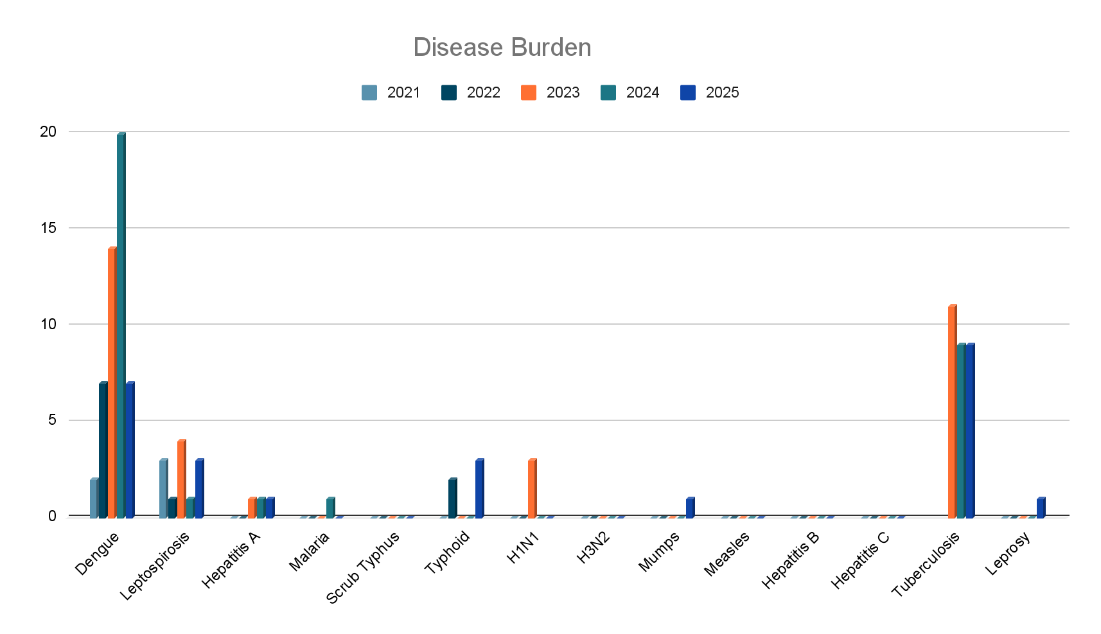

Seasonal Trend Analysis
Seasonal analysis helps anticipate surges (e.g. dengue in monsoon, leptospirosis after floods, influenza in cooler months) and plan pre‑emptive vector control, stockpiling of IV fluids, and awareness campaigns at Panchayat level.

DENGUE
Dengue is a major seasonal vector-borne disease strongly associated with rainfall, water stagnation, and increased mosquito breeding during the monsoon period.

Peak: July–November

MONTH | 2021 | 2022 | 2023 | 2024 | 2025
JAN | 0 | 1 | 3 | 2 | 0
FEB | 0 | 0 | 0 | 0 | 0
MARCH | 0 | 0 | 0 | 0 | 0
APRIL | 1 | 0 | 0 | 0 | 0
MAY | 0 | 0 | 0 | 0 | 1
JUNE | 0 | 2 | 2 | 3 | 1
JULY | 0 | 1 | 2 | 5 | 2
AUGUST | 0 | 0 | 1 | 5 | 0
SEPTEMBER | 0 | 0 | 1 | 1 | 0
OCTOBER | 0 | 1 | 2 | 3 | 1
NOVEMBER | 0 | 2 | 2 | 1 | 1
DECEMBER | 1 | 0 | 1 | 0 | 1

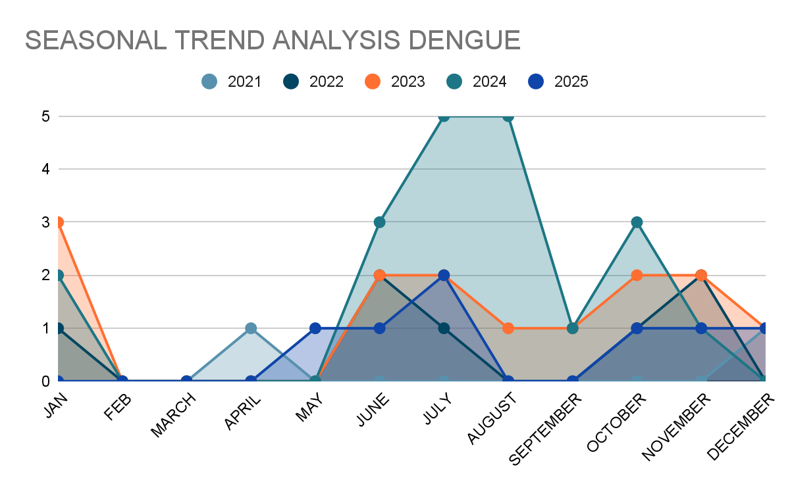

Dengue – Ward-wise Yearly Distribution (2021–2025)

Ward | Dengue – Ward-wise Yearly Distribution
Ward | 2021 | 2022 | 2023 | 2024 | 2025 | Total
1 | 1 | 0 | 0 | 1 | 0 | 2
2 | 0 | 0 | 1 | 1 | 0 | 2
3 | 0 | 0 | 0 | 1 | 0 | 1
4 | 0 | 0 | 1 | 2 | 2 | 5
5 | 0 | 0 | 3 | 1 | 2 | 6
6 | 0 | 1 | 1 | 2 | 1 | 5
7 | 0 | 2 | 1 | 4 | 0 | 7
8 | 0 | 0 | 0 | 1 | 0 | 1
9 | 0 | 1 | 1 | 2 | 0 | 4
10 | 0 | 0 | 0 | 0 | 0 | 0
11 | 0 | 1 | 0 | 0 | 0 | 1
12 | 0 | 0 | 3 | 1 | 0 | 4
13 | 0 | 0 | 0 | 0 | 0 | 0
14 | 0 | 1 | 0 | 2 | 0 | 3
15 | 0 | 0 | 1 | 1 | 0 | 2
16 | 0 | 0 | 2 | 1 | 1 | 4
17 | 0 | 1 | 0 | 0 | 0 | 1
18 | 1 | 0 | 0 | 0 | 1 | 2

LEPTOSPIROSIS
Leptospirosis cases are closely linked to monsoon rains, flooding, and occupational exposure, particularly in low-lying and waterlogged areas.

Peak: June - August

MONTH | 2021 | 2022 | 2023 | 2024 | 2025
JAN | 0 | 0 | 0 | 0 | 0
FEB | 0 | 1 | 0 | 0 | 0
MARCH | 1 | 0 | 0 | 0 | 0
APRIL | 0 | 0 | 0 | 1 | 0
MAY | 0 | 0 | 0 | 0 | 0
JUNE | 1 | 0 | 0 | 0 | 1
JULY | 1 | 0 | 2 | 0 | 0
AUGUST | 0 | 0 | 2 | 0 | 0
SEPTEMBER | 0 | 0 | 0 | 0 | 1
OCTOBER | 0 | 0 | 0 | 0 | 0
NOVEMBER | 0 | 0 | 0 | 0 | 0
DECEMBER | 0 | 0 | 0 | 0 | 1

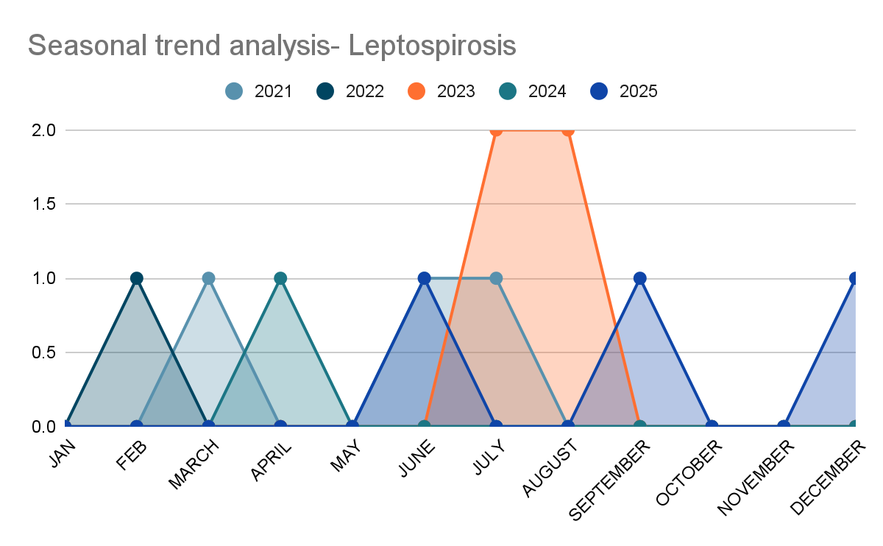

Leptospirosis – Ward-wise Yearly Distribution (2021–2025)

Ward | Leptospirosis – Ward-wise Yearly Distribution
Ward | 2021 | 2022 | 2023 | 2024 | 2025 | Total
1 | 1 | 0 | 3 | 0 | 1 | 5
2 | 0 | 0 | 0 | 0 | 0 | 0
3 | 0 | 0 | 0 | 0 | 0 | 0
4 | 0 | 0 | 0 | 0 | 0 | 0
5 | 0 | 0 | 0 | 0 | 0 | 0
6 | 0 | 0 | 0 | 0 | 0 | 0
7 | 0 | 0 | 0 | 0 | 0 | 0
8 | 0 | 0 | 0 | 0 | 0 | 0
9 | 0 | 0 | 0 | 0 | 1 | 1
10 | 0 | 0 | 0 | 1 | 0 | 1
11 | 0 | 0 | 0 | 0 | 0 | 0
12 | 1 | 1 | 0 | 0 | 1 | 3
13 | 0 | 0 | 0 | 0 | 0 | 0
14 | 0 | 0 | 0 | 0 | 0 | 0
15 | 0 | 0 | 0 | 0 | 0 | 0
16 | 1 | 0 | 0 | 0 | 0 | 1
17 | 0 | 0 | 1 | 0 | 0 | 1
18 | 0 | 0 | 0 | 0 | 0 | 0

VIRAL HEPATITIS - A
Hepatitis A cases are commonly associated with unsafe drinking water, food contamination, and breakdowns in sanitation, often presenting as clusters or outbreaks.

Peak: October - December

MONTH | 2021 | 2022 | 2023 | 2024 | 2025
JAN | 0 | 0 | 0 | 0 | 0
FEB | 0 | 0 | 0 | 1 | 0
MARCH | 0 | 0 | 0 | 0 | 0
APRIL | 0 | 0 | 0 | 0 | 0
MAY | 0 | 0 | 0 | 0 | 0
JUNE | 0 | 0 | 0 | 0 | 0
JULY | 0 | 0 | 0 | 0 | 0
AUGUST | 0 | 0 | 0 | 0 | 0
SEPTEMBER | 0 | 0 | 0 | 0 | 0
OCTOBER | 0 | 0 | 0 | 0 | 0
NOVEMBER | 0 | 0 | 0 | 0 | 0
DECEMBER | 0 | 0 | 1 | 0 | 1

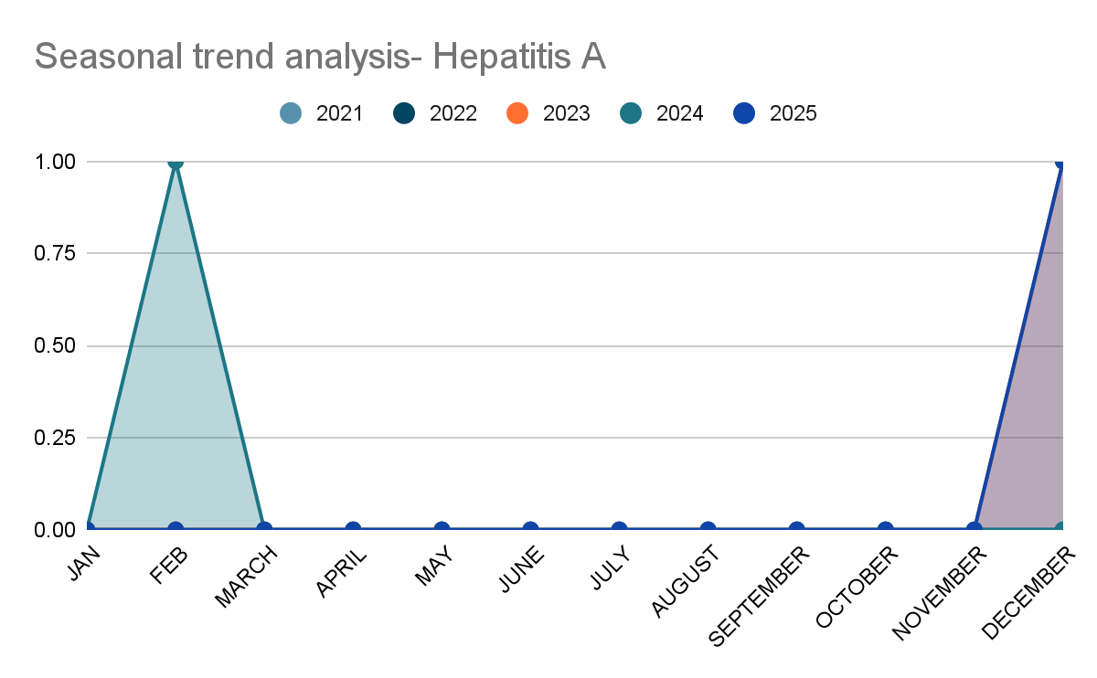

Hepatitis A – Ward-wise Yearly Distribution (2021–2025)

Ward | Hep A – Ward-wise Yearly Distribution
Ward | 2021 | 2022 | 2023 | 2024 | 2025 | Total
1 | 0 | 0 | 0 | 0 | 0 | 0
2 | 0 | 0 | 0 | 0 | 0 | 0
3 | 0 | 0 | 0 | 0 | 0 | 0
4 | 0 | 0 | 0 | 0 | 0 | 0
5 | 0 | 0 | 0 | 0 | 0 | 0
6 | 0 | 0 | 0 | 0 | 0 | 0
7 | 0 | 0 | 0 | 0 | 0 | 0
8 | 0 | 0 | 0 | 0 | 0 | 0
9 | 0 | 0 | 0 | 0 | 1 | 1
10 | 0 | 0 | 0 | 0 | 0 | 0
11 | 0 | 0 | 0 | 0 | 0 | 0
12 | 0 | 0 | 0 | 0 | 0 | 0
13 | 0 | 0 | 0 | 0 | 0 | 0
14 | 0 | 0 | 0 | 0 | 0 | 0
15 | 0 | 0 | 1 | 0 | 0 | 1
16 | 0 | 0 | 0 | 0 | 0 | 0
17 | 0 | 0 | 0 | 1 | 0 | 1
18 | 0 | 0 | 0 | 0 | 0 | 0

Outcome-Based Trend Analysis- 2025
An approach for monitoring and analyzing the disease patterns based on the outcomes or impacts of specific interventions, policies, or public health measures and concerns. It shifts emphasis from merely tracking disease incidence to evaluating the effectiveness of prevention measures implemented for the disease. This type of analysis is crucial for understanding not only the spreadness of diseases but also how well the system is responding to them. This analysis evaluates the impact of various public health measures, determines whether these measures lead to reductions in disease prevalence, morbidity, mortality, or healthcare burden over time and this can be utilized modifying or improving existing health policies, resource allocation, and preparedness plans.

Sl. No. | Type of disease | Age group | Gender |  | Total no. of survival | Total no. of death | No. of cases received treatment
Sl. No. | Type of disease | Age group | No. of Male | No. of Female | Total no. of survival | Total no. of death | No. of cases received treatment
1 | Dengue | under 05 children | 0 | 0 | 0 | 0 | 0
2 | Dengue | 5-19 years | 0 | 0 | 0 | 0 | 0
3 | Dengue | 20-59 years | 2 | `1 | 3 | 0 | 3
4 | Dengue | 60+ (Seniors) | 2 | 2 | 4 | 0 | 4
1 | Lepto | under 05 children | 0 | 0 | 0 | 0 | 0
2 | Lepto | 5-19 years | 0 | 0 | 0 | 0 | 0
3 | Lepto | 20-59 years | 1 | 0 | 1 | 0 | 1
4 | Lepto | 60+ (Seniors) | 1 | 1 | 2 | 0 | 2
1 | VH-A | under 05 children | 0 | 0 | 0 | 0 | 0
2 | VH-A | 5-19 years | 0 | 0 | 0 | 0 | 0
3 | VH-A | 20-59 years | 2 | 0 | 2 | 0 | 2
4 | VH-A | 60+ (Seniors) | 0 | 0 | 0 | 0 | 0
TOTAL |  |  | 8 | 4 | 12 | 0 | 12

Transmission Trend- 2025
For effective management of public health issues, it is important to track the trend of disease transmission mode. It helps identify the population or place at high risk that can be used to predict outbreaks and implement targeted interventions as quickly as possible. Understanding these kinds of trends enables authorities to allocate resources efficiently and change the strategies adequately based on the trend that follows.

Mode of Transmission | No. of cases | No. of Deaths
Vector Borne Diseases | 7 | 0
Water Borne Diseases | 5 | 0
Air Borne Diseases | 37 | 0
Blood Borne Diseases | 0 | 0
Food Borne Diseases | 0 | 0
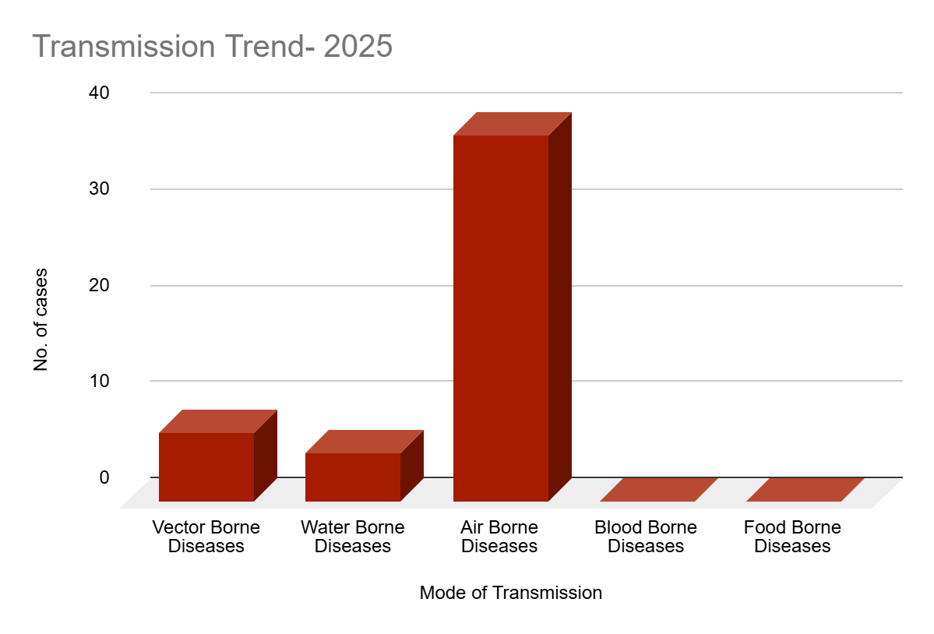
Vector-Borne Disease

Disease | No. of Cases | No. of Deaths
Dengue | 7 | 0
Malaria | 0 | 0
Chikungunya | 0 | 0

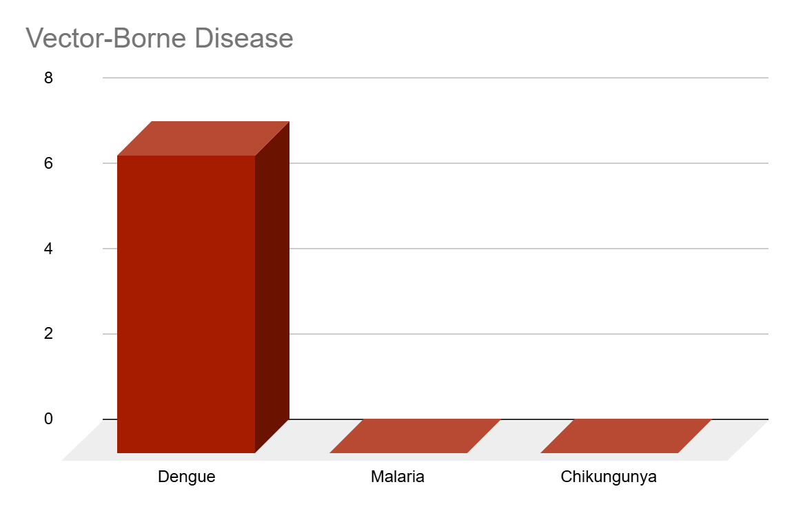

Water Borne Disease

Disease | No. of Cases | No. of Deaths
Cholera | 0 | 0
Typhoid | 3 | 0
Hep- A | 2 | 0
Dysentery | 0 | 0
Amoebiasis | 0 | 0
E- Coli infections | 0 | 0

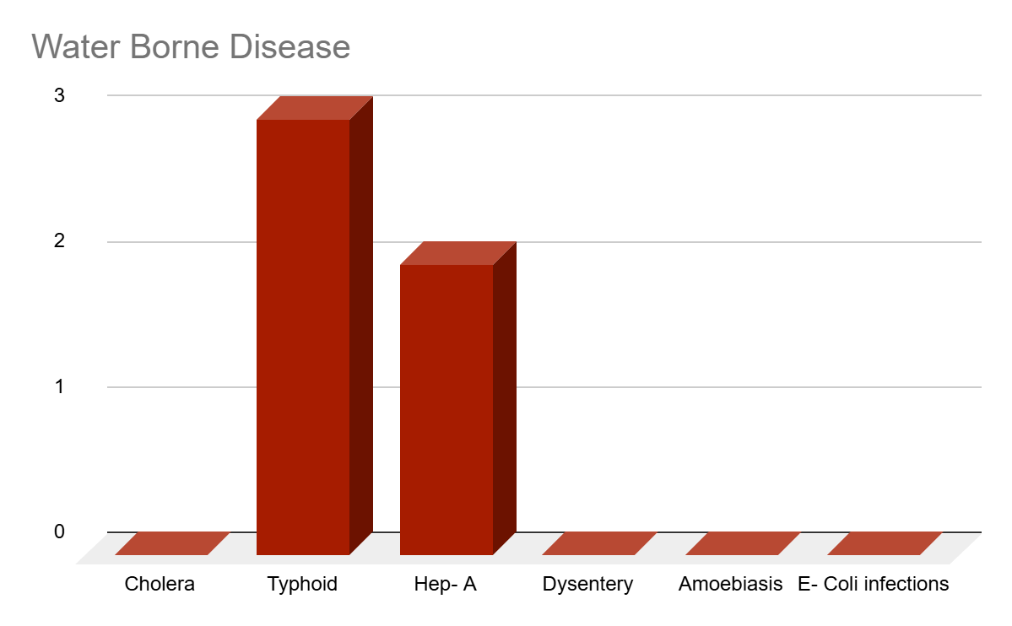

Air Borne Disease

Disease | No. of Cases | No. of Deaths
Influenza | 0 | 0
H1N1 | 0 | 0
TB | 9 | 2
Chickenpox | 27 | 0
Measles | 0 | 0
Covid-19 | 0 | 0
Pertussis | 0 | 0
Mumps | 1 | 0
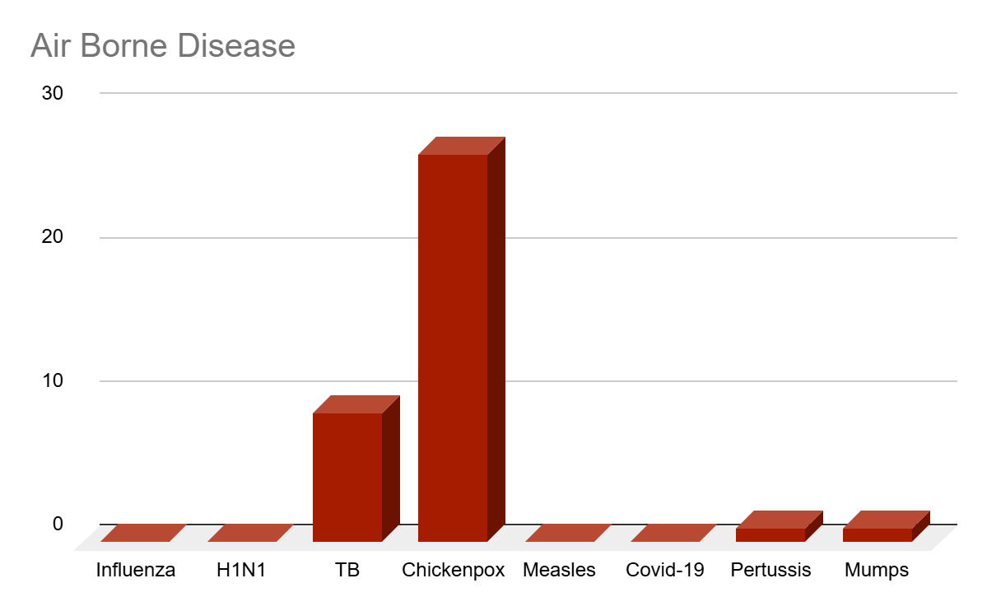

Blood-Borne Disease

Disease | No. of Cases | No. of Deaths
AIDS | 0 | 0
Hep- B | 0 | 0
Hep- C | 0 | 0
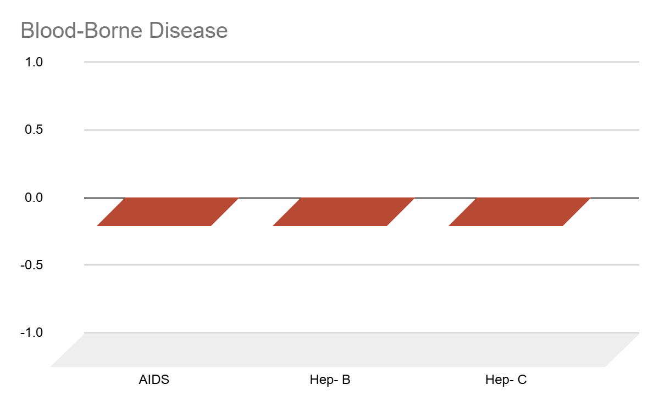

Zoonotic Disease

Disease | No. of Cases | No. of Deaths
Rabies | 0 | 0
Leptospirosis | 3 | 0
Avian influenza | 0 | 0
West nile | 0 | 0
Anthrax | 0 | 0
Nipah | 0 | 0
Scrub Typhus | 0 | 0

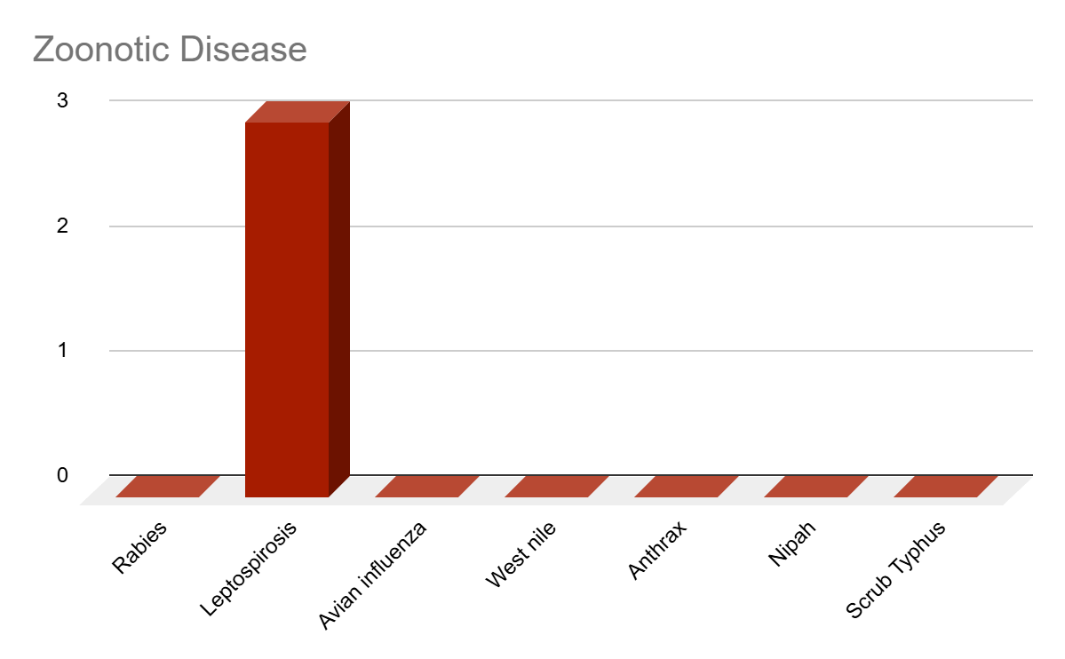

Integrated Disease Hotspot Map (2021–2025)

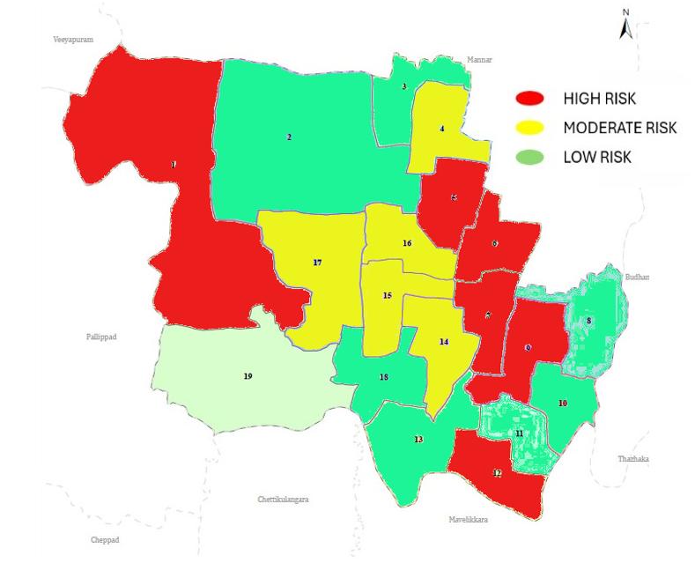
Ward No | Dengue Total (2021-25) | Leptospirosis Total (2021-25) | Hepatitis A Total (2021-25) | Mumps (2021-25) | Total Cases
1 | 2 | 5 | 0 | 0 | 7
2 | 2 | 0 | 0 | 0 | 2
3 | 1 | 0 | 0 | 0 | 1
4 | 5 | 0 | 0 | 0 | 5
5 | 6 | 0 | 0 | 0 | 6
6 | 5 | 0 | 0 | 1 | 6
7 | 7 | 0 | 0 | 0 | 7
8 | 1 | 0 | 0 | 0 | 1
9 | 4 | 1 | 1 | 0 | 6
10 | 0 | 1 | 0 | 0 | 1
11 | 1 | 0 | 0 | 0 | 1
12 | 4 | 3 | 0 | 0 | 7
13 | 0 | 0 | 0 | 0 | 0
14 | 3 | 0 | 0 | 0 | 3
15 | 2 | 0 | 1 | 0 | 3
16 | 4 | 1 | 0 | 0 | 5
17 | 1 | 1 | 1 | 0 | 3
18 | 2 | 0 | 0 | 0 | 2

By overlaying five years of data, we have identified 'Red Zone' Wards. These are wards where at least two different categories of diseases (e.g., Dengue and Lepto) recurred in consecutive years. Ward 1 is categorized as the Highest Priority Hotspot due to its combination of flood vulnerability and high vector density. Future health infrastructure, such as the proposed R.O plants should be prioritized.

Preparedness and Response Protocol at LSG Level
This section describes the operational framework for the LSGI once a pandemic is declared. It explains how the LSGI and health system will move from routine data collection to active response, using a One Health approach.

Constitution of One Health Committee
The LSGD shall constitute a One Health Committee comprising the LSGI President, Medical Officers (Modern Medicine, AYUSH, and Veterinary), the Health Inspector, and the Veterinary Surgeon.

Objective: The One Health Committee coordinates human, animal, and environmental health to prevent and control pandemics.

Sl No | Name | Designation | Department/Institution | Role in Committee | Contact Number
1 | Binuraj | Panchayat President | LSGD | Chairperson | 9747796817
2 | Dr.Devisree | Medical Officer (PHC/CHC) | Health Dept | Member Secretary | 8281216050
3 | Asha Alex | Veterinary Officer | Animal Husbandry | Member | 0479-2324657
4 | Dr.Nandu Nandakumar | Epidemiologist | Health Dept | Member | 9061470521
5 | Ajitha | Health Inspector/PHN | Health Dept | Surveillance | 8921147726
6 | Linu.S | ASHA Supervisor | Health Dept | Community link | 8281174907
7 | Beena | ICDS Supervisor | Social Welfare | Vulnerable groups | 9447245336
8 | CI | Police Station Officer | Police Dept | Law & order | 0479-2312224
9 | Ajitha | Ward Councillor Representative | LSGD | Community coordination | 6282920491
10 | Renjith | Kudumbashree CDO | Kudumbashree | Community mobilisation | 9446192220
11 | Abhilash | NGO/Volunteer rep | Civil Society | Support services | 9496283437
12 | Kavyasree | Agriculture officer | Agriculture | Support services | 9383470658
13 | Madhumohan | Panchayat Secretory | Panchayat | Support services | 9447966899

Key Responsibilities:
- Review disease surveillance data (human + animal)
- Conduct ward-wise risk assessment and vulnerability mapping
- Approve quarantine/isolation centre locations
- Coordinate with district for resources (PPE, oxygen, ambulances)
- Periodically review health system surge capacity, including beds, oxygen, human resources, and ambulances.
- Approve and monitor risk communication and community engagement strategies, including rumour management.
- Ensure protection and service continuity for vulnerable groups (elderly, persons with disabilities, dialysis patients, coastal populations).
- Conduct quarterly mock drills
- Monitor equity measures for vulnerable groups

Meeting Schedule:
Quarterly (normal times) | Weekly (outbreak alert) | Daily (pandemic phase)

Pandemic Response Workforce
To ensure a coordinated and timely response during a pandemic, a dedicated Pandemic Response Workforce shall be constituted at the LSG level. The workforce will function under the overall supervision of the One Health Committee and in close coordination with the health authorities. Team-based deployment will enable efficient surveillance, case management, quarantine and isolation management, logistics support, and risk communication. Each team shall have a clearly designated team leader, defined roles, and an identified pool of personnel to allow rapid activation, rotation of duties, and continuity of services during prolonged emergencies.

Total Response Workforce Available: 300 persons

Team Name | Composition | Key Responsibilities | Team Leader
Surveillance and Contact Tracing Team | HI, JHI, JPHN, ASHAs and Volunteers | Case detection, contact listing, home visits, reporting | HI
Case Management Team | Doctors, Nurses, MLSP, Palliative Nurses | Patient care & referral | DOCTOR
Quarantine & Isolation Team | LSGD staff, Volunteers | Facility management | JHI
Psychosocial support | Counsellor | Psychological support | MO
Logistics & supply chain Team | LSGD staff, Storekeepers, Drivers 3 | Supplies & transport [PPE, medicines, oxygen, transport, waste management] | Ward Member
Communication Team | Ward members, Kudumbashree, Youth clubs,  AWW workers and other self help groups | IEC, community meetings, countering misinformation | M.O in charge
Transportation | KSRTC, educational institutional buses | Provide transport facilities | JHI
Media Surveillance | HI, Clerk | Media coverage | HI
Intersectoral coordination and convergence | HI, JHI | Coordination of other departments | HI
Collaborative surveillance | HI, JHI | Coordination of other departments | HI

All teams shall be activated immediately upon outbreak alert or pandemic declaration and shall report daily to the LSG Incident Commander/Medical Officer, with consolidated reporting to the Block PHC. Duty rosters and alternate personnel shall be maintained to ensure uninterrupted services during staff shortages or prolonged response periods. Team composition and numbers may be revised based on the magnitude of the outbreak and availability of human resources.

Activities and Measures before and during Pandemic

PHASE 1 - Alert / Preparation
Surveillance and Reporting-Enhanced syndromic surveillance:
Objective: To ensure early detection, timely reporting, and response to potential outbreaks through enhanced facility-, community-, and event-based surveillance
- Enhanced syndromic surveillance:
The LSGD shall initiate enhanced surveillance for priority syndromes and events such as:
  - Fever
  - Influenza-like illness (ILI)
  - Severe acute respiratory infection (SARI)
  - Unusual illness clusters (any unexpected increase in similar symptoms in a defined area or group)
- Data sources for surveillance:
- Ward-wise household surveillance (through ASHAs/JPHNs/ward volunteers)
- Outpatient surveillance from all government facilities (PHC, FHC, CHC, GH, etc.)
- Private hospitals, clinics and labs

- Event-based triggers (to be monitored and reported):
- School absenteeism above the usual pattern (to be monitored through the headmaster/PTA nodal person)
- Sudden increase in pharmacy sales of fever/cough/cold medicines
Workplace illness clusters (multiple staff reporting similar symptoms within a short period)

- Zoonotic and animal health surveillance:
- LSGD shall review reports of unusual animal deaths or suspected outbreaks in animals in coordination with the Veterinary Officer..

- Any unusual mortality in poultry, pigs, cattle, companion animals, or wild birds/mammals shall be notified within 24 hours to the Veterinary Officer and One Health Committee for joint investigation.

- Logistics and Stock Preparedness

  - Identify and empanel local vendors and define emergency procurement mechanisms in accordance with existing LSGD and Health Department norms.
  - Prepare and maintain an essential logistics checklist covering medical supplies, consumables, and support equipment.
  - Pre-identify secure storage locations for emergency stocks and ensure maintenance of stock registers with regular updating.
  - Finalise emergency transport arrangements, including availability of vehicles and identified drivers for rapid deployment during alerts.
  - Designate a Nodal Officer for Logistics to enable prompt decision-making, coordination, and communication during emergencies.
  - Conduct rapid stock verification and ensure availability of minimum buffer stock, including:
- PPE kits –Nil numbers
- Pulse oximeters – 2___ numbers
- Hand sanitizers – _2__ litres
- Masks, gloves, disinfectants – adequate quantity
Identify critical gaps in logistics and immediately communicate requirements to the Block and District authorities for timely replenishment and support. Monitor expiry dates and stock rotation.

- Identification of Quarantine and Isolation Facilities
  - Identify and list suitable buildings for quarantine and isolation (schools, hostels, community halls, etc.).
  - Categorise cases as per the severity and allocate to appropriate facilities (for instance, severe cases to classrooms, mild cases to an assembly hall in case of a school).
  - Facility readiness checklist needed (beds, toilets, ventilation) etc.
  - Find an alternate site if the primary sites are not available or not in use.
  - Identify facility managers and support staff
  - Prepare basic SOPs for:
    - Admission and discharge
    - Food, water, sanitation
    - Infection prevention and waste disposal
  - Ensure availability of basic amenities: water, sanitation, electricity, ventilation, and waste disposal. Prepare a rapid activation plan for these facilities if case numbers increase.

- Risk Communication and Community Preparedness
  - Disseminate early warning messages on symptoms, preventive measures, and reporting mechanisms. Display IEC materials both in English and the local language in public places and ensure ward-level awareness.
  - Sensitize elected representatives and community leaders on preparedness measures.
  - Establish a rumour tracking and misinformation response mechanism to identify, verify, and promptly counter false or misleading information.
  - Engage trusted local persons (ward members, ASHA workers, religious leaders, teachers, community volunteers) to communicate official public health messages and reinforce correct practices.
  - Develop and deploy targeted IEC materials for:
    - Schools and educational institutions
    - Markets and commercial areas
    - Work sites and labour settings
  - Conduct community sensitization meetings at the ward level to promote preventive behaviors, address concerns, and strengthen community participation in preparedness and response.

- Protection of Vulnerable Groups
Vulnerable populations require priority protection through targeted line-listing, service continuity, and delivery mechanisms.
- Prepare and regularly update line-lists of vulnerable populations, including:
  - Elderly persons living alone
  - Persons with disabilities
  - Pregnant women
  - Migrant workers
  - Dialysis patients
The detailed line-lists shall be maintained as Annexure ___ and updated periodically.
- Clinical Dependency Mapping
Develop ward-wise dependency and vulnerability maps to identify households requiring regular support during emergencies. Ensure continuity of essential health services for vulnerable groups, including
- Dialysis services (facility mapping, transport arrangements, and scheduling)
- Continuity of treatment for TB, HIV, and other chronic conditions requiring uninterrupted medication
- Mental health and psychosocial support services
Establish delivery mechanisms for food, essential commodities, and medicines to vulnerable households through coordinated action involving ASHAs, JPHNs, Kudumbashree, volunteers, and local administration.

PHASE 2 - Active Response
- Case Identification and Contact Tracing
Case detection and contact tracing activities will be carried out in coordination with the Health authorities, following disease-specific SOPs and IDSP guidelines.
Field Staff Involved
- Health Inspector (HI)
- Junior Health Inspector (JHI)
- Junior Public Health Nurse (JPHN)
- ASHAs and ASHA Supervisors
- Ward-level volunteers and Kudumbashree members (as required)
- Screening Checkpoints
Screening checkpoints at high-traffic locations (transport hubs, markets, religious gatherings) for early detection of symptomatic travellers and crowd screening during outbreaks. Potential locations include bus stands, market entry points, and boat jetties, based on local context and risk assessment.
Screening activities will be carried out by trained personnel such as ASHAs, ward members, and volunteers, with support from Health Department staff. Necessary equipment, including non-contact thermometers and appropriate PPE, shall be ensured prior to activation.

Location | Type (Bus stand/Jetty/Market/Railway) | Staff Deployed (ASHAs/Volunteers) | Screening Method | Reporting authority
Bus stand | Transport hub | One JHI  One ASHA  One health Mentors | 1.Swab Collection.  2. Blood smears collection (RDT)  3.Thermal Scanners | Surveillance Nodal Officer in control room
Market entry | Market | One JHI  One ASHA  Male health volunteers | 1.Swab Collection.  2. Blood smears collection (RDT)  3.Thermal Scanners | Surveillance Nodal Officer in control room
Boat jetty | Water transport | One JHI  One ASHA  Male health volunteers | 1.Swab Collection.  2. Blood smears collection (RDT)  3.Thermal Scanners | Surveillance Nodal Officer in control room

Standard Screening Protocol

The screening protocol shall include temperature screening, observation for visible symptoms, and inquiry regarding recent travel or exposure history. Individuals identified as suspects during screening shall be immediately referred to the nearest PHC/FHC for further evaluation, testing, and appropriate action as per prevailing guidelines.
- Pandemic Control Room
The Pandemic Control Room (PCR) serves as the central nerve center for real-time coordination, data aggregation, decision support, and communication during outbreaks. It consolidates information from all LSGD teams, health facilities and community sources to enable rapid response decisions.
Control Room Infrastructure and Location
Primary Location: Chennithala-thripperumthura Panchayath Office.
Backup Location: Community Hall in Chennithala-thripperumthuraG.P.
Health System Control Room Framework
The PCR is organized into seven functional pillars to ensure no aspect of the response is overlooked:
1.Rapid Response Team (RRT)
  - Provides immediate intervention during emergencies, clusters, and field alerts.​
  - Coordinates urgent actions such as case investigation, contact tracing, isolation, and inter‑facility referrals.

- Data Management & Analytics Team
  - Collects, validates, and manages key health system indicators (cases, tests, beds, HR, supplies).​
  - Analyzes data trends, generates projections, and supports evidence‑based decision‑making for local authorities.
- Human Resource Deployment Team
  - Allocates healthcare staff efficiently based on workload and need
  - Ensures adequate and equitable workforce distribution across facilities
- Laboratory Surveillance Team
  - Oversees diagnostic testing coordination, sample transport, and timely reporting of results.​
  - Monitors lab indicators (testing volume, positivity rate, turnaround time) for early detection of outbreaks
- Vaccination Cell (If Required)
  - Plans and executes vaccination campaigns, including micro‑planning and session scheduling.​
  - Tracks coverage, identifies gaps, and coordinates corrective actions with field teams and outreach services.
- Infrastructure & Patient Occupancy Team
  - Monitors facility capacity, earmarked beds, oxygen and critical care resources across all linked facilities.​
  - Ensures optimal patient distribution and referral management using updated bed‑status and resource data.
  - BMWM

7. Communication Team
- Acts as the single, trusted voice of the health system during a pandemic
- Ensures clear, timely, and accurate information reaches healthcare workers, partner departments, and the public
- Translates technical advisories into simple, locally understandable messages
- Actively counters rumours, misinformation, and stigma
- Builds public trust and confidence through transparent communication

8. Logistics & Supply Chain Management
- Ensures uninterrupted availability of medicines, PPE, vaccines, oxygen, and essential supplies
- Uses real-time stock monitoring to prevent shortages and overstocking
- Prioritises equitable distribution, especially to high-burden and peripheral facilities
- Protects frontline workers by ensuring timely access to safety equipment
- Keeps the response running smoothly even during surge periods

9.Transportation (Inter-facility & Emergency Transport)
- Coordinates safe and timely movement of patients across facilities
- Ensures availability of ambulances, trained drivers, and referral pathways
- Maintains strict infection prevention protocols during patient transport
- Supports critical care transfers and emergency referrals without delay
- Ensures no patient is left behind due to distance or logistics barriers
10. Media Surveillance & Call Centre
- Continuously monitors news and social media for emerging concerns and misinformation
- Functions as the first point of contact for public queries and distress calls
- Provides clear guidance, reassurance, and grievance redressal
- Helps identify early warning signals from community feedback
- Strengthens community confidence by ensuring people feel heard and supported
11. Management of the Deceased
- Ensures safe, respectful, and dignified handling of deceased persons
- Strictly follows public health and infection control protocols
- Provides clear communication and emotional support to bereaved families
12. Inter-sectoral Coordination & Convergence
  - Brings together health, LSGI, disaster management, police, education, transport, and social welfare sectors
  - Enables a whole-of-government and whole-of-society response
  - Prevents duplication of efforts and closes operational gaps
  - Ensures coordinated support for healthcare, food, shelter, sanitation, and livelihoods
  - Strengthens collective responsibility and shared ownership of response

Key Control Room Team
The Control Room Team coordinates all pandemic response activities within the LSGD and serves as the single command and communication hub during activation. It integrates information, field actions, logistics, and policy execution across all participating departments and health facilities.

Role | Name | Designation | Contact Number | Responsibility
In-charge/Nodal Officer | Dr. Devisree | Medical Officer | 8281216050 | Overall coordination, decision-making, and reporting to the District level.
Data Entry Operator | Manoj | JHI | 7907981106 | Managing the line list, updating dashboards, and tracking testing results.
Communication Officer | Ajitha R | Health Inspector | 8921147726 | Handling the public helpline, coordinating ambulance dispatch, and contact tracing calls.
Logistics Coordinator | Reshmi | OA | 9497306957 | Maintain Logistics
Technical Support (IT/Data) | Akhila | Technical Assistant | 7593031957 | Provide technical assistance

SOP for alert escalation/trigger point with mapping of responsibilities.
Key Points:
- The Control Room shall be staffed with a designated In-charge, data entry personnel, and communication staff with clearly defined roles and shift arrangements.
- It shall maintain updated records on daily monitoring indicators including new cases, persons under active quarantine, and hospital bed occupancy.
- All reports and situation updates shall be shared daily with the Block and District Surveillance Unit.
- The Control Room shall act as a single point of contact for coordination with response teams, health institutions, and other departments.
- Contact details of the Control Room shall be widely communicated to field staff and stakeholders during activation.
Daily Monitoring Indicators
To ensure timely decision-making and effective response, the following key indicators shall be monitored and updated on a daily basis by the Pandemic Control Room:
- Epidemiological Indicators:
New cases reported today, Total active cases, Test Positivity Rate (TPR), Case Fatality Rate (CFR)
- Surveillance Indicators:
Persons under home quarantine, High-risk contacts identified, Fever, ILI, SARI or other symptoms (syndromic surges), Travellers (symptomatic or high-risk arrivals),Animal husbandry surveillance (zoonotic alerts, unusual animal deaths, poultry/bird flu signals), Mortality surveillance (excess deaths, unexplained fatalities, verbal autopsy reports)
- Logistics and Infrastructure Indicators:
Hospital / CFLTC beds occupied, Oxygen cylinders/concentrators available, Ambulances on standby
- Alert Findings
The following table outlines category-specific trigger points (red flags) from surveillance indicators and corresponding immediate actions for the Pandemic Control Room. These enable rapid response to alert findings like testing anomalies, positive cases exceeding thresholds, clusters, and WGS reports.

Category | Trigger Point (Red Flag) | Immediate Action
Clusters | Geographical or facility-based: 5+ cases linked to one location (office, school, street). | Declare a micro-containment zone; perimeter control and active case finding.
Testing | Sudden drop in testing volume / delay in reporting / unusual testing trends | Review the sample collection process, address lab bottlenecks, deploy additional testing teams, and notify the District Lab.
Lab | Test Positivity rate increases | Increase testing sites in that ward.
Hospital | >80% Oxygen bed occupancy | Activate backup/CFLTC beds.
Travel | Cluster of cases from a single flight/train or high-risk arrival group. | Trace all passengers in adjacent seats; implement mandatory institutional quarantine.
Animal | Mass poultry/wildlife death or unusual sickness | Notify Animal Husbandry, sample the area, and dispatch RRT for environmental sampling and zoonotic check.
Mortality | Sudden spike in home deaths or brought-in-dead (BID) cases | Audit the deaths and Active Case Search drive
Additional investigations like Whole Genome Sequencing (WGS) | Detection of a Variant of Concern (VOC) or Variant of Interest (VOI) | Implement strict micro-containment; update clinical protocols to match variant severity.
- Communication of Public Health Information
A Community Communication Hub shall be established to ensure timely, accurate, and consistent dissemination of information during a pandemic. The Hub will function under the coordination of Nodal officers of the control room and act as the nodal point for public communication, risk messaging, and community engagement. It will support dissemination of official advisories, promote preventive behaviors, address rumors and misinformation, and ensure that messages reach all sections of the population through trusted local channels and leaders.
Key communicators
Channel | Responsible Person | Contact
Ward-level announcements | JHI | 7907939998
Social media | JHI | 9447620240
Local Cable TV/Radio | JHI | 9447565086

- All messages disseminated through the Hub shall align with advisories issued by the Health Department and District authorities.
- Community leaders shall be sensitized to support behavior change, reduce stigma, and counter misinformation.
- Special efforts shall be made to reach vulnerable and hard-to-reach populations using locally appropriate communication methods.

Rumor Tracking: A designated volunteer will monitor local social media/WhatsApp groups daily to identify misinformation and issue official clarifications via the Communication Hub.
- Coordination with District/State Authorities & Other Organisations
Effective coordination with Block, District, and State authorities is essential to ensure timely reporting, technical guidance, and uninterrupted supply of essential resources during a pandemic. The LSG shall establish clear communication channels, designate responsible officers, and adhere to prescribed reporting timelines to support coordinated public health action and efficient resource mobilisation.

Key Details:
- Nodal Officer for Reporting: Dr. Devisree
- Contact Number: 8281216050
Reporting Schedule and Protocols:

To Whom | What to Report | Frequency | Nodal Person
Block PHC | Complete Situation Report (Cases, Quarantine, Beds, Screening, Deaths) | Daily | Block Medical officer
District IDSP Unit | Outbreaks/Clusters/Unusual Events (>5 cases same ward) | Within 24 hrs | District Surveillance Officer
Veterinary Officer | Animal health events/Zoonotic alerts | Within 24 hrs | Veterinary officer
State Cell | Zoonotic cross-sector events | Within 24 hrs | Officer in charge

Supply Chain Coordination
The LSG shall coordinate closely with Block, District, and State authorities (KMSCL) to ensure uninterrupted availability of essential goods, medical supplies, and logistics during a pandemic. Supply requirements shall be assessed regularly based on case load and communicated promptly to the appropriate authorities for timely replenishment.
Key Points:
- Maintain updated contact details of District and Block nodal officers for health logistics, oxygen supply, ambulances, and essential medicines.
- Submit timely indent requests for PPE, testing kits, medicines, oxygen, and other critical supplies through prescribed channels.
- Monitor stock levels at LSGD facilities, quarantine/isolation centres, and field teams through daily stock registers and dispensing logs to prevent shortages.
- Coordinate with District authorities, Karunya/Neethi medical shops, and local purchase committees for funds allocation and emergency procurement.

- Ensure regular monitoring of dispensing registers at all facilities to track usage, expiry, and pilferage—shortages being a perennial issue requiring proactive weekly audits.

- Activate surge procurement protocols during high caseloads, leveraging local purchase powers under LSGD funds alongside state supplies.

Resource Inventory and Contacts
Resource Category | Source  (District/State/Private) | Contact
PPE Kits/Masks/Gloves | KMSCL | 8281495283
PPE Kits/Masks/Gloves | Local Vendors | 04712945685
Oxygen  Cylinders/Concentrators | KMSCL | 8281495283
Medicines/Antivirals | KMSCL | 8281495283
Medicines/Antivirals | Neethi Shops | 9497268509
Test Kits (RTPCR/Rapid) | KMSCL | 8281495283

Collaboration with NGOs, PPP, and CSR
To augment government efforts during a pandemic, the LSG shall collaborate with NGOs, voluntary organisations, and private sector partners through public–private partnerships and Corporate Social Responsibility (CSR) initiatives, in coordination with District authorities.
Key Points:
- Engage NGOs and community-based organisations for community outreach, awareness, and support to vulnerable populations.
- Leverage CSR support for procurement of medical equipment, PPE, oxygen concentrators, food kits, and sanitation materials, as permitted.
- Ensure all collaborations align with government guidelines and are routed through approved administrative and financial procedures.
- Maintain transparency and documentation for all external support received and utilised.
Organization | Type | Support Offered | Contact Person
Youth Clubs/Student Unions | CBO | Jinu George | 9961011107
Interdepartmental Coordination
Coordination among departments during a pandemic shall be ensured through regular review meetings convened by the LSGD President. These meetings will provide a structured platform for sharing situational updates, assessing resource availability, resolving operational gaps, and taking joint decisions to ensure a coordinated and timely response.

Department | Representative | Key Role | Contact
Health (PHC) | Medical Officer | Case management | 7510216887
Veterinary | Veterinary Surgeon | Animal surveillance | 0479-2324657
ICDS | Supervisor: Beena | Nutrition support | 9447245336
Education | Head Teacher:  Vijalalekshmi | School coordination | 9496967260
Police | CI | Containment enforcement | 0479-2312224
Water Authority | Assistant Engineer | Water supply | 9446048648
LSGD Engineering | Assistant Engineer | Quarantine infrastructure | 9188330403

PHASE 3 - Surge Capacity
Phase 3 is activated when there is a rapid increase in cases, high test positivity rates, or when existing health facilities and quarantine arrangements approach saturation. The focus of this phase is to expand isolation capacity, augment clinical care services, and mobilise additional resources through district and state support mechanisms.

Conversion of Community Facilities
To manage increased case load, the LSGD shall activate additional isolation facilities by repurposing identified community infrastructure such as community halls, auditoriums, schools, hostels, or other suitable buildings.

Name of facility | Facility Type | No. of Buildings | Ward | Surge Capacity (Beds) | Nodal Person
Mahatma H.S.S | School | 3 | 15 | 25 | HM  9496967260
Mahatma B.S.S | School | 3 | 6 | 25 | HM  9847915236
Marthoma Parish hall | Auditorium | 1 | 6 | 25 | Bishop
Subhananda Ashrama hall | Trust | 2 | 6 | 30 | Secretory  8281733335
Govt Model UP School | School | 2 | 8 | 20 | HM
Jawahar Navodhaya Vidhyalayam | School | 2 | 4 | 50 | Principal  0479 2322571

- Recovery and rehabilitation phase

The recovery and rehabilitation phase marks the transition from crisis response to restoration, healing, and long-term strengthening of systems and communities. For a pandemic, recovery is not merely about the decline in cases, but about rebuilding health, livelihoods, trust, and resilience in a way that prepares the community for future public health threats. This phase places people at the centre—acknowledging loss, supporting healing, and restoring normalcy with dignity and care.
1. Damage and Impact Assessment
A systematic assessment of the pandemic’s impact is the foundation of effective recovery. This includes evaluating health outcomes, service disruptions, economic losses, educational interruptions, and social consequences at ward and household levels. Special attention is given to vulnerable groups such as the elderly, children, persons with disabilities, migrant workers, and those with chronic illnesses. Accurate documentation ensures that recovery efforts are equitable, evidence-based, and responsive to real needs.
2. Restoration of Health Services
Restoring routine and essential health services is a priority during recovery. This involves re-establishing outpatient and inpatient care, maternal and child health services, immunization, and management of non-communicable diseases. Health facilities and frontline workers are supported to address service backlogs and burnout, ensuring continuity of care while maintaining infection prevention and control standards.
3. Rehabilitation of the Affected Population
Rehabilitation extends beyond physical recovery. Individuals and families affected by illness, disability, bereavement, or prolonged isolation are supported through coordinated health and social care services. Community-based rehabilitation approaches help reintegrate affected individuals into daily life, work, and social networks, reducing long-term vulnerability.

4. Psychosocial and Mental Health Support
Pandemics leave deep emotional and psychological impacts. Grief, anxiety, fear, and social stigma often persist long after the immediate crisis. Community-level mental health support, counselling services, peer support groups, and referral mechanisms are strengthened to promote emotional healing. Emphasis is placed on normalising mental health care and ensuring access without stigma.

5. Disease Surveillance During the Recovery Phase
Even as case numbers decline, robust disease surveillance remains critical. Continued monitoring helps detect resurgence, emerging health threats, or secondary outbreaks early. Surveillance data guide targeted interventions and inform decisions on scaling down or reintroducing control measures, ensuring that recovery is safe and sustainable.
6. Environmental Cleanup and Sanitation
Environmental hygiene is a cornerstone of post-pandemic recovery. Disinfection of public spaces, safe waste management, water quality monitoring, and sanitation improvements reduce the risk of secondary infections. Community participation in cleanliness drives fosters shared responsibility and long-term behavioural change.
7. Livelihood Restoration
Pandemics disproportionately affect informal workers, farmers, small traders, and migrant labourers. Recovery efforts prioritise restoring livelihoods through employment support, skill-building initiatives, social protection schemes, and access to financial assistance. Reviving local economies is essential not only for economic stability, but also for social well-being and dignity.
8. Community Engagement and Confidence Building
Rebuilding trust and confidence is as important as rebuilding systems. Transparent communication, community consultations, and inclusive decision-making help address fear, misinformation, and stigma. When communities feel heard and involved, recovery becomes a shared journey rather than a top-down process.

9. Documentation and After-Action Review
A structured review of response and recovery activities is conducted to document successes, gaps, and challenges. After-action reviews provide a platform for frontline workers, administrators, and community representatives to reflect on experiences and suggest improvements. This collective learning strengthens future preparedness.
10. Lessons Learned and Best Practices
Lessons identified during recovery are consolidated into practical best practices. These insights inform standard operating procedures, training modules, and community awareness strategies, ensuring that hard-earned experience translates into stronger future responses.
11. Health System Strengthening
Recovery is an opportunity to build back better. Investments in health infrastructure, workforce capacity, supply chains, digital health systems, and inter-sectoral coordination enhance overall health system resilience. Strengthening primary healthcare and public health functions ensures readiness for future emergencies.
12. Policy Revision and Preparedness Enhancement
Based on evidence and experience, existing policies, plans, and protocols are reviewed and updated. Preparedness strategies are refined to address identified gaps, emerging risks, and changing community needs, ensuring that the system remains adaptive and responsive.
13. Research
Research plays a vital role in understanding the long-term health, social, and economic impacts of pandemics. Local studies, operational research, and data analysis inform policy decisions and contribute to broader public health knowledge. Encouraging research also empowers local institutions and professionals to innovate and improve practice.
In essence, the recovery and rehabilitation phase is about healing people, restoring systems, and strengthening the future. By combining compassion with evidence, community participation with institutional support, and learning with action, this phase ensures that recovery is not just a return to normal, but a step towards a safer, healthier, and more resilient society.

CONCLUSION

Chennithala – Thripperumthra Grama Panchayat is a community whose daily life is closely interwoven with water, land, and traditional livelihoods. While its fertile paddy fields, canals, and backwaters sustain agriculture, fishing, and allied occupations, they also expose the Panchayat to recurring risks from floods and climate-sensitive diseases. The experiences of recent years—particularly the floods of 2018—have left lasting lessons, reminding the community that preparedness is not optional, but essential for protecting lives and livelihoods.
This Pandemic Preparedness Plan reflects a collective commitment to learn from those experiences and to act with foresight. By strengthening local systems, improving coordination across departments, and planning for the specific needs of farmers, fisherfolk, coir workers, migrant labourers, and vulnerable households, the Panchayat places people at the heart of preparedness. It recognises that effective response during a pandemic or public health emergency depends as much on trust, communication, and community participation as it does on infrastructure and logistics.The development of a localized, data-driven Auxiliary Infrastructure and Logistical Resource Map marks an important step toward proactive governance. It will help ensure that critical resources are identified in advance, access routes remain functional during emergencies, and support reaches those who need it most, without delay. More importantly, it strengthens the Panchayat’s ability to respond calmly and compassionately in times of crisis.
This plan is not a static document, but a living framework—one that will evolve with changing risks, new knowledge, and community feedback. With shared responsibility, continuous preparedness, and collective resilience, Chennithala – Thripperumthra Grama Panchayat aims to face future pandemics and emergencies with confidence, unity, and care for every member of its community.

Additional points

- Tech support : Support troubleshooting of communication, power backup, and health information systems.

- Relief based commodities : Ensure transparent tracking of stock, distribution, and replenishment.

- Ham reading operators : Integrate HAM radio into emergency communication plans and mock drills, ensure availability during floods, power outages, and disaster-induced connectivity loss.

- Hazard vulnerability mapping : Maps for micro-containment planning, evacuation, and resource deployment, update maps periodically based on seasonal and epidemiological changes.

- Kseb & other power source : Availability of backup power sources, maintain priority restoration protocols during outages and monitor power reliability in flood-prone and remote areas.

- HR specific responsibility : Clearly define role-based responsibilities for all categories of staff during preparedness, response, and recovery phases, maintain updated HR rosters, shift plans, and surge deployment lists and ensure training on infection prevention, emergency protocols, and communication.

RECOMMENDATIONS
1. Strengthening Healthcare Infrastructure
- Establish a primary health response unit within the Panchayat with trained staff.
- Ensure availability of basic medical supplies (masks, sanitizers, PPE kits, oxygen cylinders).
- Create tie-ups with nearby hospitals in Mavelikara for emergency referral and transport.
2. Community Awareness & Education
- Conduct regular awareness campaigns on hygiene, vaccination, and preventive measures.
- Use local communication channels (community radio, WhatsApp groups, notice boards) to spread verified information.
- Train volunteers to act as health ambassadors in each ward.
3. Emergency Response & Coordination
- Form a Pandemic Preparedness Committee at Panchayat level including health workers, ward members, and NGOs.
- Develop a clear action plan for lockdowns, quarantine, and distribution of essentials.
- Maintain a database of vulnerable groups (elderly, differently-abled, chronically ill) for targeted support.
4. Supply Chain & Food Security
- Identify and support local suppliers and farmers to ensure uninterrupted food supply.
- Create community kitchens during emergencies to serve vulnerable populations.
- Stockpile essential commodities in Panchayat-run outlets for crisis periods.
5. Digital Preparedness
- Promote digital platforms for telemedicine consultations.
- Use Panchayat’s website/social media for real-time updates on health advisories.
- Encourage online grievance redressal to reduce crowding in offices.
6. Training & Capacity Building
- Organize mock drills for pandemic response in schools, offices, and public spaces.
- Train Panchayat staff and volunteers in first aid, infection control, and crowd management.
- Collaborate with NGOs and health departments for capacity-building workshops.
7. Long-Term Resilience
- Integrate pandemic preparedness into the Panchayat Development Plan.
- Allocate a dedicated budget for health emergencies.
- Encourage community participation in planning and monitoring preparedness measures.

MOCKDRILL SCENARIOS

ANNEXURE

IMPORTANT PHONE NUMBERS

Phone numbers and particulars of persons responsible for providing guidance, assistance, and support for pandemic preparedness operations may be provided here in a manner that allows easy reference at a glance. The information recorded here could be exhibited elsewhere at the time of emergencies. LSG institutions shall give special attention to collect and record the above data of persons and institutions who/which are supposed to give technical and co-ordination support to reduce the impact of pandemic.
1.1. Details of grama panchayat/municipality/corporation wards
Sl.No | Name of the ward | Ward number | Name of the ward  member | Contact number
1 | PADINJARE VAZHI | 1 | SETHU LEKSHMI | 9061261868
2 | ERAMATHOOR WEST | 2 | BESTY JINU | 9544985668
3 | ERAMATHOOR EAST | 3 | SIBU VARGHESE | 9947486766
4 | NAVODHYA WARD | 4 | SUJITH S | 9744272644
5 | ORIPRAM | 5 | BINU C VARGHEES | 9747228227
6 | KARAZHMA | 6 | MANJU M RENJITH | 8921234972
7 | KARAZHMA EAST | 7 | RATHEESH | 9061725649
8 | ASHRAMAM | 8 | SYALINI | 9744902551
9 | PRAYIKKARA | 9 | DEEPARAJAN | 9744078781
10 | CHERUKOL | 10 | V BINURAJ | 9747796817
11 | CHERUKOL WEST | 11 | XAVIOR KUNNUMPURATHU | 9747908880
12 | KOTTAKKAKAM | 12 | SHIBU | 9544825554
13 | PANCHAYATH OFFICE WARD | 13 | PRADEEP P | 9645098189
14 | THRIPPERUTHURA | 14 | SUKUMARI | 9447360679
15 | CHALAYIL SHATHRAN WARD | 15 | PRIYA MURALI | 7012276883
16 | PHC WARD | 16 | BINIJA | 9496278870
17 | THEKKUMMURI | 17 | AJITHA DEVARAJAN | 6282920491
18 | KARIKKUZHI | 18 | BINDHU PRADEEP | 7034213701

1.2. Other important phone numbers of grama panchayat/municipality/corporation area
Sl. No. | Name | Contact number
1. | MP | 9447016661,  9013180106
2. | MLA | 8547736689
3. | Collector (head of District Disaster Management Authority) | 9447129011
4. | Tahasildar | 9447495008
5. | District Panchayat Secretary | 0477-2253836
6. | Block Panchayat Secretary | 9447473272
7. | Excise department
8. | Forest department

1.3. Important offices of grama panchayat/municipality/ corporation
Sl.No | Name of the office | Contact person | Contact number
1. | Village Office | Village Officer | 8547611705
2. | Agriculture Office | Agriculture Officer | 9446904914
3. | Animal Husbandry Office | Animal Husbandry Doctor | 9747557252
4. | Police Station | Police Officer | 9497987066
5. | BSNL Office | Officer | 18001801503
6. | Block Office | Officer | 9495119009
7. | KSEB Office | Officer | 9496008499
8. | Fisheries Office | Officer
9. | Fire and Rescue | Officer | 04792306264

1.4. Health Services

Sl. No | Name of the hospital/institution | Location | Phone number
1. | Government hospitals/PHC | THATTARAMBALAM MANNAR ROAD IN THRIPPERUTHURA | 8281216050
2. | Private hospitals  Medhub | Vazhakkoottam Kadavu | 9495521193
3. | Clinical laboratories  Ambadi  Labcare Diagnostic Centre  Priya Clinical Lab  Unic Care  Priya Clinical Lab | Near Military Canteen  Karazhma  Kallummoodu  Puthuvilappadi  Near FHC Chennithala | 9495087437  701273621  9447110457  8606891996  9447110457
4. | Chemist/pharmacy | Shibu varghese | 9947899215
5. | Blood donors | Ratheesh kumar Sarath | 9 961183022 9605868833
6. | Other language experts (Bihari, Hindi, Bengali,  Asamees ………)

1.5. Veterinary Services
Sl.No | Name of the Clinic | Name of the  Surgeon/Doctor | Place/location | Phone  number
1 | Govt.Veterinary Hospital | Asha Alex | Near Water Tank | 9445556884

1.6. Helpline numbers
Helpline | Phone number
Police | 0479 231 2224
Fire and Rescue | 101
KSEB | 0479 2325339

1.7. Public and Private Schools Contact details

S.No | Name of School | Institution type | Phone number
1 | MDLPS chennithala | Aided | 9495873473
2 | MTLPS Puthekottackakom | Aided | 9497147019
3 | Mahatma public school | Private | 8086728261
4 | Govt LPS Thripperumthura | Govt | 9496110574
5 | ST Gregorios school | Private | 9400753294
6 | Govt LPS kalarikal | Govt | 9496116891
7 | Govt model U P S chennithala karazhma | Govt | 9446118185
8 | MGHS chennithala | Govt | 9847915236
9 | MBHSS chennithala | Govt | 9496967260
10 | Govt LPS chennithala south | Govt | 9447377963
11 | GLPS karazhma east | Govt | 9847569053
12 | GLPS chennithala (Harijanodharani) | Govt | 9947971131
13 | Chennithala south UPS | Govt | 9656125399
14 | Jawahar Navodhya chennithala | Govt | 7975253262
15 | GLPS Vettathuvilla | Govt | 7356806577

1.9. Anganwadi Contact Details

Ward No | Name of Anganwadi Teachers | Phone number
1 | Remanivikraman | 9747193724
2 | Renathomas | 7909239765
3 | Archanamol | 7306893773
4 | Sreelatha | 9947399266
4 | Ambika | 9961169084
5 | Remya | 9605596797
5 | Sobha | 9544471853
6 | Sreelatha | 7907087504
6 | Anusoloman | 8111976389
7 | Usha | 9847220844
8 | Sujatha | 9526152621
9 | Rekha | 7591961299
9 | Mollamma | 9605524706
10 | Sujathomas | 8592015846
11 | Sumitha | 9747263314
11 | Lethakumari | 9656811296
12 | Nirmala | 9605605362
13 | Anithakumari | 9544021031
13 | Rajalekshmi | 8921004783
14 | Prasanthi | 9605161981
15 | Aswathi | 8921068871
15 | Vijayalekshmi | 8129569965
16 | Vasanthakumari | 9961366830
16 | Omana | 7306496080
17 | Ponnamma | 9961321947
17 | Radhamani | 9747731681
18 | Lekha | 86063543672
18 | Minimol | 8921342407
18 | Ganga | 9526713629
19 | Annath | 9847420483

Ward No | Anganwadi No and Name of Teacher | Phone number
1  2 | 91 | 9747193724
1  2 | 96 | 7909239765
3 | 155 | 7306893773
4 | 95 | 9947399266
4 | 97 | 9961169084
5 | 145 | 9605596797
5 | 146 | 9544471853
6 | 80 | 7907087504
6 | 81 | 8111976389
7 | 149 | 9847220844
8 | 77 | 9526152621
9 | 84 | 7591961299
9 | 76 | 9605524706
10 | 75 | 8592015846
11 | 150 | 9747263314
11 | 86 | 9656811296
12 | 87 | 9605605362
13 | 88 | 9544021031
13 | 147 | 8921004783
14 | 85 | 9605161981
15 | 89 | 8921068871
15 | 90 | 8129569965
16 | 93 | 9961366830
16 | 94 | 7306496080
17 | 92 | 9961321947
17 | 82 | 9747731681
18 | 78 | 86063543672
18 | 79 | 8921342407
18 | 148 | 9526713629
19 | 83 | 9847420483

1.12. Information regarding resources

Means of transportation | Name of Owner | Phone Number
Heavy Trucks | NITHI GEORGE SAM | 7736688955
Tractor | Prasad | 9744632523
Ambulances | Sajan | 9847220708
Boats | 0 | 0
Taxi service | Mohananpilla | 9544473278
Tractor | Sasi | 9846968054
Tractor | SURENDRANATH | 8075384166
Ambulance | Sibuvarghese | 9947486766

Annexure 1: LSG Baseline Data Collection Format
A. Baseline data
Sl. No. | Indicator / Field | Baseline Data | Source / Remarks
1 | Name of LSG | Chennithala | Panchayat
2 | District | Alappuzha | Panchayat
3 | Block / Taluk | Kurathikad | Panchayat
4 | Type of LSG (Gram Panchayat / Municipality / Corporation) | Gramapanchayath | Panchayat
5 | Area (sq. km) | 22 | Panchayat
6 | No. of wards | 19 | Panchayat
7 | GIS boundary file available | (Yes/No) | Panchayat
8 | Key contact person & phone |  | Health Inspector

B. Demography
Indicator / Field | Baseline Data | Source / Remarks
Total population | 31648 | Panchayat
Males | 15287 | Panchayat
Females | 16361 | Panchayat
Transgender population | 0 | Panchayat
Age distribution  (<5, 5–14, 15–59, ≥60) | <5 - 862  Adolescent - 1680  ≥60 - 6862 | Panchayat
No. of households | 8627 | Panchayat
Population density (persons/sq.km) | 1409 | Panchayat
No. of migrant workers | 2529 | Panchayat
Major occupational groups | Farmers | Panchayat

C. Vulnerable Populations & Social Risks
Sl. No. | Indicator / Field | Baseline Data (Value / Description) | Source / Remarks
1 | No. of elderly (≥60) | 6862 | Panchayat
2 | No. of persons with disability | 105 | Panchayat
3 | No. of bedridden persons | 114 | Panchayat
4 | No. of chronic disease cases (DM/HTN/COPD/CKD etc.) | 6351 | Panchayat
5 | Pregnant women (current estimate) | 94 | Panchayat
6 | Children <5 years | 862 | Panchayat
7 | Tribal population (if any) | 2/F | Panchayat
8 | Fisherfolk / coastal vulnerable groups (if any) | 280 | Panchayat
9 | Urban slums / unnotified settlements (if any) | 0 | Panchayat
10 | Homeless population | 0 | Panchayat
11 | Orphanages / old age homes (number & capacity) | 1 | Panchayat
12 | Hostels / prisons / shelters (number & capacity) | 1 | Panchayat
13 | Poverty / BPL estimate | 3687 | Panchayat
14 | Food insecurity hotspots | 0 | Panchayat
15 | Any history of stigma/discrimination issues (Yes/No) | 0 | Panchayat

D. Health System & Service Readiness
Sl. No. | Indicator / Field | Baseline Data (Value / Description) | Source / Remarks
1 | No. of health facilities in LSG (PHC/CHC/TH/DH/Private) | 1 | Health Department
2 | PHC/Family Health Centre details (name, location) | FHC CHENNITHALA | Health Department
3 | Subcentres / Health & Wellness Centres (number) | 6 | Health Department
4 | Private clinics / hospitals (number) | 2 | Health Department
5 | Labs available (public/private) | 5 | Health Department
6 | Availability of ambulance services (Yes/No, number) | YES | Health Department
7 | Availability of isolation/quarantine facilities (Yes/No, details) | YES | Health Department
8 | Cold chain facilities (Yes/No, details) | YES | Health Department
9 | Stockpile space available (Yes/No) | YES | Health Department
10 | PPE / mask / sanitizer availability plan (Yes/No) | YES | Health Department
11 | Surveillance staff available (JHI/JPHN/ASHA count) | JHI-4 JPHN-5 ASHA- 23 | Health Department
12 | Existing emergency referral pathways (Yes/No) | YES | Health Department

E. Points of Entry & Mobility
Sl. No. | Indicator / Field | Baseline Data (Value / Description) | Source / Remarks
1 | Bus stands / depots (number) | NA | Panchayat
2 | Railway stations (number) | NA | Panchayat
3 | Boat jetties / fishing harbours (number) | NA | Panchayat
4 | Ports / airports nearby (specify distance) | NA | Panchayat
5 | Major highways/roads passing through | NA | Panchayat
6 | Border crossings (state/district) | NA | Panchayat
7 | Major markets / weekly markets | NO | Panchayat
8 | Tourism hubs / major event venues | NO | Panchayat
9 | Schools/colleges with hostels (number) | 1 | Panchayat
10 | Factories / large workplaces (number) | 0 | Panchayat
F. Water, Sanitation & Hygiene (WASH)
Sl. No. | Indicator / Field | Baseline Data (Value / Description) | Source / Remarks
1 | Major drinking water sources (piped / wells / borewells / springs) | WELLS/PIPED | Health Department
2 | No. of public wells | 7645 | Health Department
3 | No. of households with piped water connection | 2341 | Health Department
4 | Water quality testing routine (Yes/No) | YES | Health Department
5 | Common contamination risks (flooding, salinity, industrial waste) | NA | Health Department
6 | Open defecation free status (Yes/No) | YES | Health Department
7 | Solid waste management system (Yes/No) | YES | Health Department
8 | Bio-medical waste disposal mechanism (Yes/No) | YES | Health Department
9 | No. of public toilets | 0 | Health Department
10 | Handwashing stations in public places (Yes/No) | 0 | Health Department
G. Zoonotic Risks & One Health
Sl. No. | Indicator / Field | Baseline Data (Value / Description) | Source / Remarks
1 | Livestock population (cattle/goats/pigs/poultry) – estimates | 684 | Health and Veterinary Department
2 | No. of dairy farms / poultry farms / pig farms | 4 | Health and Veterinary Department
3 | Slaughterhouses / meat shops (number) | 2 | Health and Veterinary Department
4 | Animal markets (Yes/No, details) | 0 | Health and Veterinary Department
5 | Veterinary dispensaries (number) | 1 | Health and Veterinary Department
6 | History of zoonotic outbreaks (rabies, leptospirosis, avian flu etc.) | 0 | Health and Veterinary Department
7 | Stray dog population management measures (Yes/No) | YES | Health and Veterinary Department
8 | Rodent infestation hotspots (Yes/No) | NO | Health and Veterinary Department
9 | Wetlands / waterlogged areas prone to leptospirosis | YES | Health and Veterinary Department
10 | Bat roosting areas / caves / fruit orchards (if any) | NO | Health and Veterinary Department
11 | Human-animal interface hotspots (farms near residences) | NO | Health and Veterinary Department
H. Climate & Disaster Risks (Pandemic Amplifiers)
Sl. No. | Indicator / Field | Baseline Data (Value / Description) | Source / Remarks
1 | Flood-prone wards (list) | 1,9,12,16,17,18 | Health Department
2 | Landslide-prone wards (list) | NA | Health Department
3 | Cyclone/sea surge risk (Yes/No) | NA | Health Department
4 | Heatwave risk zones (Yes/No) | NA | Health Department
5 | Waterlogging areas (list) | WARD -1,18,12,2 | Health Department
6 | Shelter homes / relief camps (number, capacity) | 0 | Health Department
7 | Past disaster displacement history | YES (2018 FLOOD) | Health Department
8 | Disruption to water supply/transport common (Yes/No)
I. Critical Infrastructure & Logistics
Sl. No. | Indicator / Field | Baseline Data (Value / Description) | Source / Remarks
1 | Schools (number) | 15 | Panchayat and Health Department
2 | Anganwadis (number) | 30 | Panchayat and Health Department
3 | Colleges (number) | 0 | Panchayat and Health Department
4 | Community halls (number) | 1 | Panchayat and Health Department
5 | Places of worship with large gatherings (number) | 0 | Panchayat and Health Department
6 | Large markets / shopping areas (number) | 0 | Panchayat and Health Department
7 | Warehouses / cold storages (number) | 0 | Panchayat and Health Department
8 | Telecom/mobile network coverage gaps (Yes/No) | NO | Panchayat and Health Department
9 | Power outage frequency (high/medium/low) | MEDIUM | Panchayat and Health Department
10 | Availability of generators in key facilities | NO | Panchayat and Health Department

J. Risk Communication & Community Networks
Sl. No. | Indicator / Field | Baseline Data (Value / Description) | Source / Remarks
1 | Ward-level rapid response teams (Yes/No) | YES | Health Department
2 | Jagratha samithis / committees active (Yes/No) | YES | Health Department
3 | Kudumbashree presence and strength (number of units) | 236 | Health Department
4 | Volunteer network (number, coverage) | 180 | Health Department
5 | Community-based surveillance mechanisms (Yes/No) | NO | Health Department
6 | IEC dissemination channels (WhatsApp groups, community radio, PA systems) | YES | Health Department
7 | Rumour tracking mechanisms (Yes/No) | YES | Health Department
8 | Languages spoken / literacy considerations | YES | Health Department
9 | Vulnerable groups communication strategy available (Yes/No) | YES | Health Department

K. Preparedness Planning & Governance
Sl. No. | Indicator / Field | Baseline Data (Value / Description) | Source / Remarks
1 | LSG emergency plan available (Yes/No) | YES | Panchayat and Health Department
2 | Pandemic preparedness plan available (Yes/No) | YES | Panchayat and Health Department
3 | Incident Command System identified (Yes/No) | YES | Panchayat and Health Department
4 | Rapid procurement mechanism available (Yes/No) |  | Panchayat and Health Department
5 | Emergency fund available (Yes/No, amount) | NO | Panchayat and Health Department
6 | Past outbreak response experience (Yes/No, details) | YES | Panchayat and Health Department
7 | Intersectoral coordination mechanism (Health, Police, LSG, Veterinary, Education) | YES | Panchayat and Health Department
8 | Mock drills conducted in last 12 months (Yes/No) | NO | Panchayat and Health Department
9 | Training coverage for staff/volunteers (Yes/No) | YES | Panchayat and Health Department

L. Surveillance & Data Systems
Sl. No. | Indicator / Field | Baseline Data (Value / Description) | Source / Remarks
1 | Digital reporting tools used (e.g., DHIS2, portals) | YES | Health Department
2 | Availability of line-listing format (Yes/No) | YES | Health Department
3 | Contact tracing team identified (Yes/No) | YES | Health Department
4 | Mapping of high-risk households available (Yes/No) | YES | Health Department
5 | Testing sample transport mechanism (Yes/No) | YES | Health Department
6 | Reporting timeline adherence (good/average/poor) | GOOD | Health Department
7 | Data sharing between departments (Yes/No) | YES
8 | Availability of dashboard for monitoring (Yes/No) | YES

M. Additional Notes & Observations
Sl. No. | Indicator / Field | Baseline Data (Value / Description) | Source / Remarks
1 | Key challenges perceived by LSG |  | Health Department
2 | Top 5 high-risk wards (reason) | 1,2,9,12,17,18 FLOOD | Health Department
3 | Any unique local risks (industrial pollution, refugee camps, etc.) | NO | Health Department
4 | Recommendations for preparedness strengthening | Include all departments in panchayat level for Disaster Management | Health Department

