` `

PANDEMIC PREPAREDNESS PLAN
CHERTHALA SOUTH PANCHAYAT

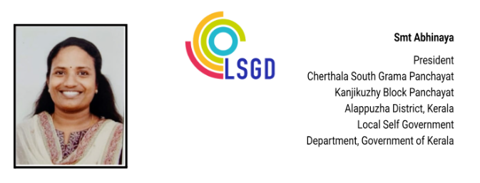
MESSAGE

പ്രിയരേ ,
ആരോഗ്യമേഖലയിൽ കൂട്ടായതും വ്യക്തവുമായ പദ്ധതിയോടൂ കൂടിയ ആരോഗ്യപരിരക്ഷ വേണം എന്നതിൽ തർക്കമില്ല. നിപ ,2018ലെ വെള്ളപ്പൊക്കം, കോവിഡ് 19 തുടങ്ങിയ നിരവധി ദുരന്തങ്ങൾ ഫലപ്രദമായി നാം കൈകാര്യം ചെയ്തിട്ടുണ്ടെ ങ്കിലും വരുംകാലങ്ങളിൽ ഉണ്ടാകാനിടയുള്ള പാൻഡമിക് ഡിസീസുകൾ തടയുന്നതിനും ഫലപ്രദമായി പ്രതിരോധിക്കുന്നതിനും ഇച്ഛാശക്തിയുള്ള ഒരു ഭരണകൂടം ആവശ്യമാണ് . കോവിഡ് 19 പോലുള്ള പകർച്ച വ്യാധിയിൽനിന്നും കര കയറുന്നതിനിടയിൽ പുതിയ അസ്ഥിരത,അനിശ്ചിതത്വം, സങ്കീർണത ഒക്കെ ആഗോളതലത്തിൽ ആരോഗ്യ മേഖല അഭിമുഖീകരിക്കുന്നു.
കടലോര ഗ്രാമമായ നമ്മുടെ ചേർത്തല ഗ്രാമപഞ്ചായത്ത് കടൽക്ഷോഭങ്ങൾ ഉൾപ്പെടെ നിരവധി ആഘാതങ്ങൾ ആഭിമുഖീകരിക്കേണ്ടതായി വന്നേക്കാം അവയെ ഫലപ്രദമായി ചെറുക്കുന്നതിനും ലഘൂകരിക്കുന്നതിനും ആക്ഷൻ പ്ലാനുകൾ അനിവാര്യമാണ്. ഈ അവസരത്തിൽ ചേർത്തല തെക്ക് കുടുംബ ആരോഗ്യ കേന്ദ്രം തയ്യാറാക്കുന്ന പാൻഡമിക് പ്രിപ്പേർഡ്നസ് ആക്ഷൻ പ്ലാന് വളരെ ഏറെ പ്രാധാന്യമുണ്ട്. ഈ പ്രവർത്തനങ്ങളിൽ ഏർപ്പെട്ട മെഡിക്കൽ ഓഫീസർ ഹെൽത്ത് ഇൻസ്പെക്ടർ എപ്പിടമോളജിസ്റ്റ് ജൂനിയർ ഹെൽത്ത് ഇൻസ്പെക്ടർ തുടങ്ങി എല്ലാവർക്കും എൻറെ അഭിനന്ദനങ്ങൾ.
ആരോഗ്യ മേഖലയിൽ ഞങ്ങളിൽ അർപ്പിതമായ പ്രഖ്യാപിതമായ പ്രവർത്തനങ്ങൾ അങ്ങേയറ്റം വിശ്വസ്ഥതയോടെ നിർവ്വഹിക്കുമെന്ന് ഉറപ്പു നൽകുന്നു .

(ABHINEYA)

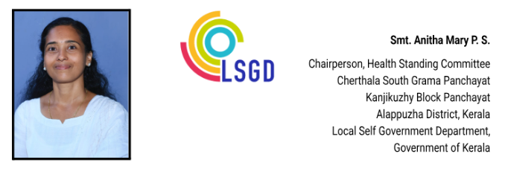

MESSAGE

മാന്യരെ, ,

പകർച്ചവ്യാധികൾ, പകർച്ചേതര രോഗങ്ങൾ, പ്രകൃതി ദുരന്തങ്ങൾ, പാൻഡമിക് ഡിസീസസ് ഒക്കെ ഫലപ്രദമായി ചെറുക്കുകയും ലഘൂകരിക്കുകയും ചെയ്യുന്നതിലൂടെ ആരോഗ്യ രംഗത്ത് വളരെയേറെ സംഭാവനകൾ നൽകാൻ കഴിയുന്ന ഒന്നാണ് pandemic preparedness plan . നമ്മുടെ ചേർത്തല സൗത്ത് പഞ്ചായത്തിലെ ആരോഗ്യ മേഖലയിലെ വിവരശേഖരണങ്ങൾ ഫലപ്രദമായി ഉപയോഗിക്കുകവഴി ആരോഗ്യം മേഖലയിൽ ഉണ്ടാകാവുന്ന ആഘാതങ്ങളുടെ ആക്കം കുറയ്ക്കാൻ കഴിയുന്നു. ഇത്തരത്തിലുള്ള ഒരു പാൻഡമിക് പ്രിപ്രെഡ്നസ് പ്ലാൻ തയ്യാറാക്കുന്നതിന് ശ്രമിച്ച ചേർത്തല തെക്ക് കുടുംബ ആരോഗ്യ കേന്ദ്രത്തിലെ മെഡിക്കൽ ഓഫീസർ അടക്കമുള്ള പബ്ലിക് ഹെൽത്ത് വിഭാഗത്തിലെ എല്ലാവർക്കും അഭിനന്ദനങ്ങള്‍ അറിയിക്കുന്നു.
ഈ പ്ലാൻ ആരോഗ്യ മേഖലയിൽ കൂടുതൽ കരുത്തും കരുതലും നൽകുമെന്നുള്ള പ്രതീക്ഷയോടെ കൂടി, ഞാനും നമ്മുടെ പഞ്ചായത്തും ജനങ്ങളോടൊപ്പം നിന്ന് ആരോഗ്യ മേഖലയിൽ ക്രിയാത്മകമായ ഇടപെടലുകൾ നടത്തുമെന്ന് ഉറപ്പ് നൽകുന്നു.


(ANITHA MARY P.S)

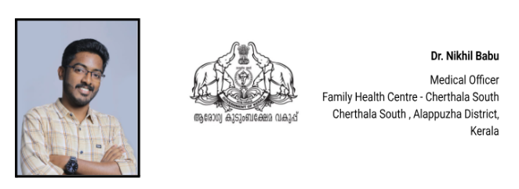

MESSAGE,

രാജ്യാന്തര പകർച്ചവ്യാധികൾ സൃഷ്ടിക്കുന്ന ആരോഗ്യപ്രശ്നങ്ങൾ കഴിഞ്ഞ കാലത്തുണ്ടായ കോവിഡ് 19 ലൂടെ നാം അനുഭവിച്ചറിഞ്ഞതാണല്ലോ. തീരദേശ ഗ്രാമമായ ചേർത്തല തെക്ക് ഗ്രാമപഞ്ചായത്ത് പ്രദേശത്ത് 10579 കുടുംബങ്ങളി ലായി 43,850 ജനങ്ങൾ അധിവസിക്കുന്നു. നിരവധി വിനോദസഞ്ചാരികളും രാജ്യാന്തരങ്ങളിൽ ജോലിചെയ്യുന്ന ഗ്രാമീണരും ഈ പ്രദേശത്തുണ്ട്. ഇത്തരത്തിൽ ലോകത്തിൻറെ ഏതു കോണിൽ പകർച്ച വ്യാധികൾ പൊട്ടിപ്പുറപ്പെട്ടാലും അതിനെതിരെ ശക്തമായ പ്രതിരോധ പ്രവർത്തനങ്ങൾ സ്വീകരിക്കുക അനിവാര്യമാണ്. ഈ പ്രവർത്തനങ്ങൾക്ക് ഏറെ ഉപകാരപ്പെടുന്ന ഒന്നാണ് Pandemic preparedness ആക്ഷൻ പ്ലാൻ. രോഗം പകരുന്ന രീതി, എത്ര പേരെ ഇത് ബാധിക്കുന്നു, രോഗവ്യാപന പ്രദേശം, കാലം തുടങ്ങിയ വിഷയങ്ങൾ ഈ പ്ലാനിൽ ചർച്ച ചെയ്യപ്പെടുന്നു.
കോവിഡ് 19 പോലുള്ള പാൻഡമിക് ഡിസീസുകൾ ദൂരവ്യാപകമായ പ്രത്യാഘാതങ്ങൾ ലോകത്ത് ഉണ്ടാക്കിയിട്ടുണ്ട് ആരോഗ്യരംഗത്തും സാമ്പത്തിക രംഗത്തും വളരെയേറെ ബുദ്ധിമുട്ടുകൾ സൃഷ്ടിച്ചത് നാമെല്ലാം കണ്ടതാണ്. ഇത്തരത്തിലുള്ള ദുരന്തങ്ങളുടെ ആഘാതം ലഘൂകരിക്കുന്നതിനും തടയുന്നതിനും ഉള്ള ഇടപെടലുകൾ ലഭ്യമായ രേഖകളുടെയും, HR ൻ്റേയും, ഇൻഫ്രാസ്ട്രക്ചർ ന്റെയും അടിസ്ഥാനത്തിൽ തയ്യാറാക്കുന്നതിന് പൊതുജന ആരോഗ്യ വിഭാഗത്തിലെ ഞാനും എന്റെ സഹപ്രവർത്തകരും കഴിയുന്നത്ര ശ്രദ്ധിച്ചിട്ടുണ്ട്. ഈ പാഡമിക് preparedness പ്ലാൻ രാജ്യാന്തര പകർച്ചവ്യാധികൾ തടയുന്നതിന് ഏറെ ഉപകാരപ്രദമാകും എന്ന് പ്രത്യാശിക്കുന്നു
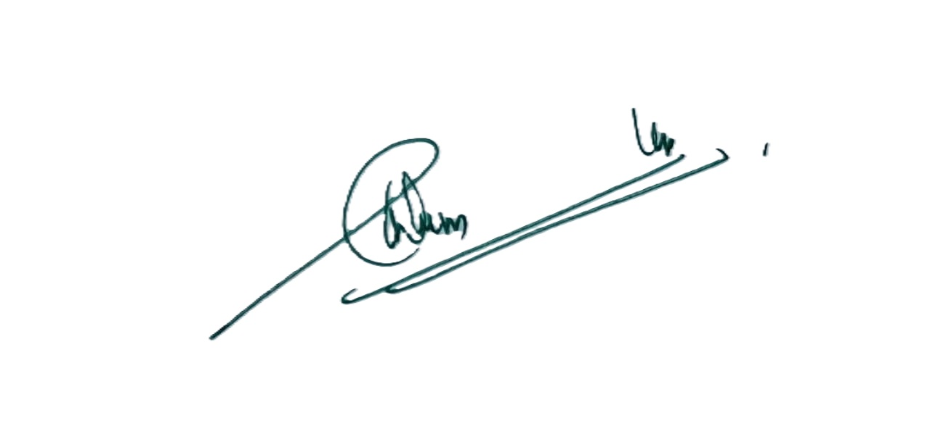
(NIKHIL BABU)

EXECUTIVE SUMMARY
Pandemics are not merely biological events; they are profound social and economic disruptions that test the very fabric of community resilience. In Kerala, public health preparedness has been shaped not only by pandemics but also by climate-related emergencies and endemic disease patterns. The 2018 floods and subsequent monsoon events exposed vulnerabilities related to displacement, interruption of health services, water-borne and zoonotic disease transmission, and the need for strong intersectoral coordination. More recently, the COVID-19 pandemic tested health systems at all levels, highlighting the critical importance of surveillance, surge capacity, continuity of essential services, risk communication, and community engagement.

These experiences underscored the need for decentralised, locally grounded preparedness planning that integrates epidemic intelligence with disaster management and health system resilience. The Pandemic Preparedness Plan for Cherthala South Grama Panchayat draws upon these lessons, recognising the importance of adaptable response strategies, clear role delineation, and the capacity to respond effectively to threats of varying severity and duration.

Geographic and Socio-Economic Profile
Cherthala South Grama Panchayat is a coastal plain LSGI in Alappuzha district under Kanjikuzhy Block, covering an area of 18.34 sq. km and comprising 22 wards. The Panchayat has a total population of 42,179, with a high population density of approximately 2,299 persons per sq. km. The terrain is predominantly low-lying and coastal, with a large number of ponds and wells, creating environmental conditions conducive to water-borne and vector-borne diseases, particularly during the monsoon season.

The Panchayat has a diverse demographic profile, including a significant elderly population, children under five, and adolescents, alongside socio-economically vulnerable groups such as fisherfolk, BPL households, migrant populations, and socially deprived families. Livelihoods are closely linked to fishing, coastal activities, small-scale trade, and employment in nearby urban centres, resulting in frequent population movement. These geographic, environmental, and socio-economic characteristics increase vulnerability to communicable disease transmission, flooding-related health risks, and rapid spread during outbreaks and pandemics.

Healthcare Infrastructure and Institutional Capacity
Healthcare service delivery in Cherthala South Panchayat is anchored by one Family Health Centre and multiple Sub-Centres that provide preventive, promotive, and basic curative services, including disease surveillance, immunisation, and maternal and child health care. While government facilities focus on primary care and surveillance, the St. Sebastian Visitation Hospital serves as a vital private-sector partner, providing a 150-bed capacity, including 5 ICU beds and 15 oxygen-supported beds. The private healthcare sector plays a significant role, with a general hospital providing inpatient care, ICU beds, and oxygen-supported beds, along with several registered private clinics offering general and specialty services. AYUSH institutions further support outpatient care and continuity of treatment for chronic conditions.

Key Vulnerabilities and Strategic Gaps
Despite these strengths, Cherthala South Panchayat faces critical vulnerabilities that influence pandemic preparedness. The Panchayat has a substantial burden of non-communicable diseases, particularly diabetes and hypertension, alongside patients requiring regular medical care such as cancer treatment, dialysis, and palliative services. A considerable proportion of the population consists of elderly persons and individuals with functional or mobility limitations, increasing the need for targeted protection and service continuity during emergencies.

The Panchayat remains vulnerable to recurrent monsoon-associated communicable diseases and outbreak-prone conditions, compounded by high population density, environmental exposure, and mass gatherings during religious festivals. Dependence on limited local critical care infrastructure, absence of dedicated ambulance services at the Panchayat level, and constraints in surge human resources and diagnostics present additional challenges. Coordination across human health, animal health, and environmental sectors requires further strengthening to operationalise a One Health approach.
Overall, while the current level of preparedness in Cherthala South Panchayat can be considered moderate, significant gaps persist in critical care capacity, emergency transport, surge preparedness, and structured intersectoral coordination. Addressing these gaps through systematic planning, capacity strengthening, and collaborative action is essential to enhance pandemic resilience and ensure timely, effective response to future public health emergencies.

LIST OF ABBREVIATIONS

LSGD/LSGI | Local Self Government Department / Local Self Government Institution
BMO | Block Medical Officer
IDSP | Integrated Disease Surveillance Programme
NDMA | National Disaster Management Authority
PPE | Personal Protective Equipment
ICMR | Indian Council of Medical Research
CD | Communicable Diseases
NCD | NON-COMMUNICABLE Diseases

TABLE OF CONTENTS

INTRODUCTION 9
LSGD AT A GLANCE 11
ADMINISTRATIVE BOUNDARIES OF ………………… PANCHAYAT 11
INTEGRATED HEALTH INFRASTRUCTURE MAP OF ………………………… PANCHAYAT 12
AUXILIARY INFRASTRUCTURE & LOGISTICAL RESOURCE MAP OF ………………………… PANCHAYAT 13
LSGD ONE HEALTH INFRASTRUCTURE 14
GENERAL PROFILE OF THE LSGI’S 15
Background of the LSGI 15
Demographic and Vulnerable Population 16
Clinical Vulnerability 17
INFRASTRUCTURE & RESOURCE INVENTORY 20
Health Facility Directory & Basic Capacity in the LSGD 20
Private Clinics 21
Healthcare Education & Training Institutions 22
Specialized Services & Emergency Inventory 22
Oxygen & Diagnostic Capacity 24
Diagnostics Summary 25
Laboratory Identification & Basic Details 26
Social and Community Infrastructure for Emergency Use 26
Human resources 28
Community & Support Cadre 29
Community Organizations 30
Administrative & Emergency Services 30
Information regarding resources 32
ONE HEALTH & ENVIRONMENTAL SURVEILLANCE 33
Animal & Bird Population 33
Veterinary Infrastructure 35
Veterinary Doctors & Workforce 36
High-Risk Interface Points (Surveillance Sites) 37
Environmental Risk Mapping 38
Disease Seasonality Mapping 39
Vulnerability Mapping 40
EPIDEMIOLOGICAL TRENDS (2021–2025) 42
Disease Burden among human beings(Last 5 Years) 42
*(use the above table data to create the graph/diagram) 43
Seasonal Trend Analysis 44
Outcome Based Trend Analysis- 2025 50
Transmission Trend 52
Integrated Disease Hotspot Map (2021–2025) 53
Preparedness and Response Protocol at LSG Level 55
Constitution of One Health Committee 55
Pandemic Response Workforce 56
Activities and Measures before and during Pandemic 58
PHASE 1 - Alert / Preparation 58
PHASE 2 - Active Response 63
Standard Screening Protocol 64
PHASE 3 - Surge Capacity 75
Conversion of Community Facilities 76
CONCLUSION 77
RECOMMENDATIONS 78
ANNEXURE - 1 79
IMPORTANT PHONE NUMBERS 79

INTRODUCTION
Pandemics and large-scale infectious disease outbreaks pose recurring threats to public health systems, livelihoods, and socio-economic stability. While originating remotely, their impacts manifest acutely at the community level, where early detection, coordinated response, and continuity of essential services determine outcomes. International and national frameworks provide overarching guidance; however, effective implementation occurs at the grassroots through Local Self-Government Institutions (LSGIs). In coastal settings like Cherthala South Grama Panchayat, where backwater networks, fishing communities, and festival gatherings shape daily rhythms, local preparedness becomes not just strategic but deeply personal—a commitment to safeguarding families, fisherfolk, and festival-goers from invisible threats that travel faster than tides.

LSGIs in Kerala occupy a unique and critical position within the public health architecture, acting as the interface between communities and higher-level health systems. Experiences from recent decades—including the recurrent monsoon-related outbreaks, the 2018 floods, and the COVID-19 pandemic—have demonstrated that preparedness must extend beyond healthcare facilities alone, encompassing surveillance, environmental management, social protection, risk communication, and intersectoral coordination. These events have reinforced the importance of decentralised, context-specific preparedness planning that reflects local epidemiological, demographic, and environmental realities.

Nestled in the Kanjikuzhy Block of Alappuzha, Cherthala South Grama Panchayat is a vibrant coastal plain characterized by its unique ecological and demographic profile. With a high population density of 2,299 persons per square kilometer, the geography presents both beauty and risk. Cherthala South Panchayat supports a diverse population with varying health needs, including a sizeable elderly population. Individuals living with non-communicable diseases, persons with functional limitations, and women requiring maternal health services. The Panchayat’s healthcare landscape comprises a Family Health Centre, multiple sub-centres, private hospitals, private clinics, and AYUSH facilities, forming a mixed system that supports routine care but depends on coordinated referral and surge planning during emergencies. These characteristics underscore the necessity for a structured preparedness framework that bridges public and private sectors while ensuring equitable access to care during crises.

This Pandemic Preparedness Plan for Cherthala South Grama Panchayat has been developed to enhance local readiness to prevent, detect, and respond to pandemics and large-scale disease outbreaks. The plan adopts a risk-based, data-driven, and anticipatory approach, integrating disease seasonality mapping, vulnerability profiling, health facility capacity assessment, and One Health principles. It emphasises early warning, protection of high-risk groups, continuity of essential health and social services, and coordinated action across health, local governance, animal health, environmental, and disaster management sectors.

By institutionalizing these measures, Cherthala South Grama Panchayat aims to transform from a position of reactive emergency management to one of proactive community resilience. This document is a living guide for our health officials, volunteers, and citizens—a shared promise that in the face of future health threats, no one in Cherthala South will be left behind.

LSGD AT A GLANCE

ADMINISTRATIVE BOUNDARIES OF CHERTHALA SOUTH PANCHAYAT
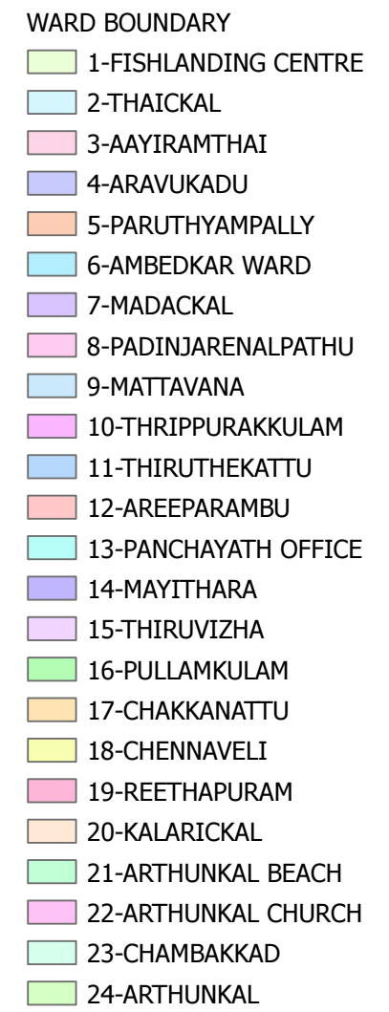
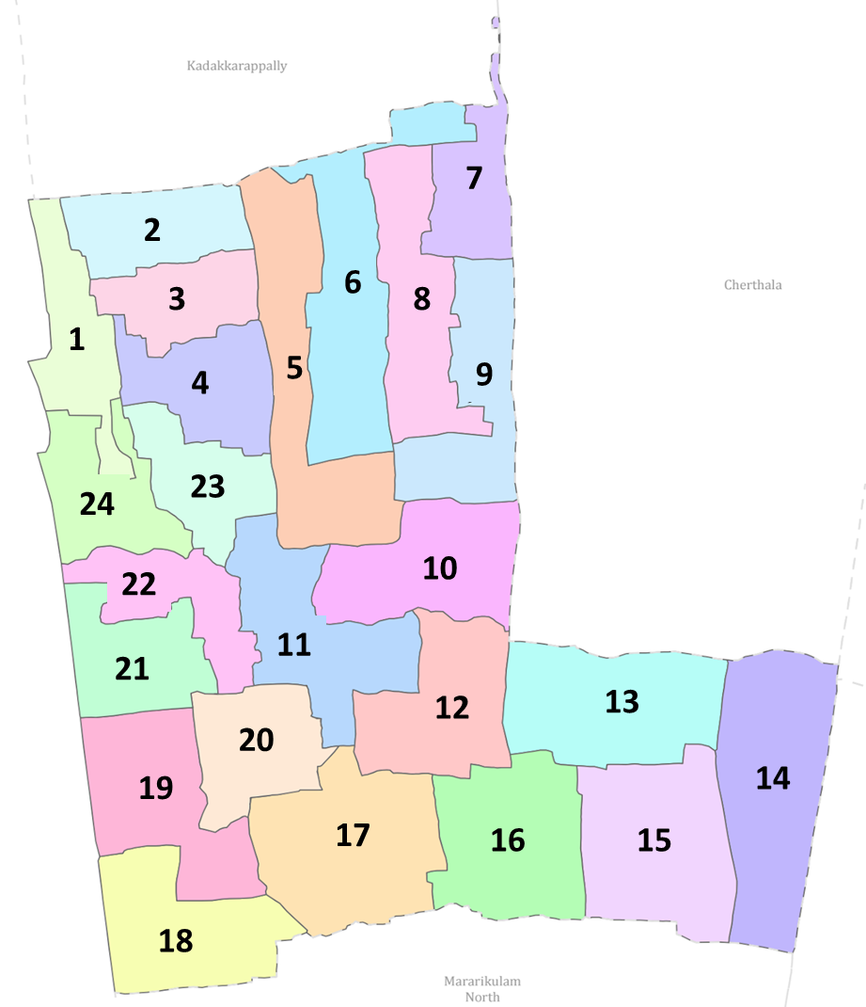
Cherthala South Grama Panchayat Ward-Wise Map

Ward | Houses | Population | Migrants | Wells | Hotspots | Ed. Institution | Hosp pvt/govt
22 | 10579 | 42179 | 136 | 913 | 0 | 15 | 2

INTEGRATED HEALTH INFRASTRUCTURE MAP OF CHERTHALA SOUTH PANCHAYAT

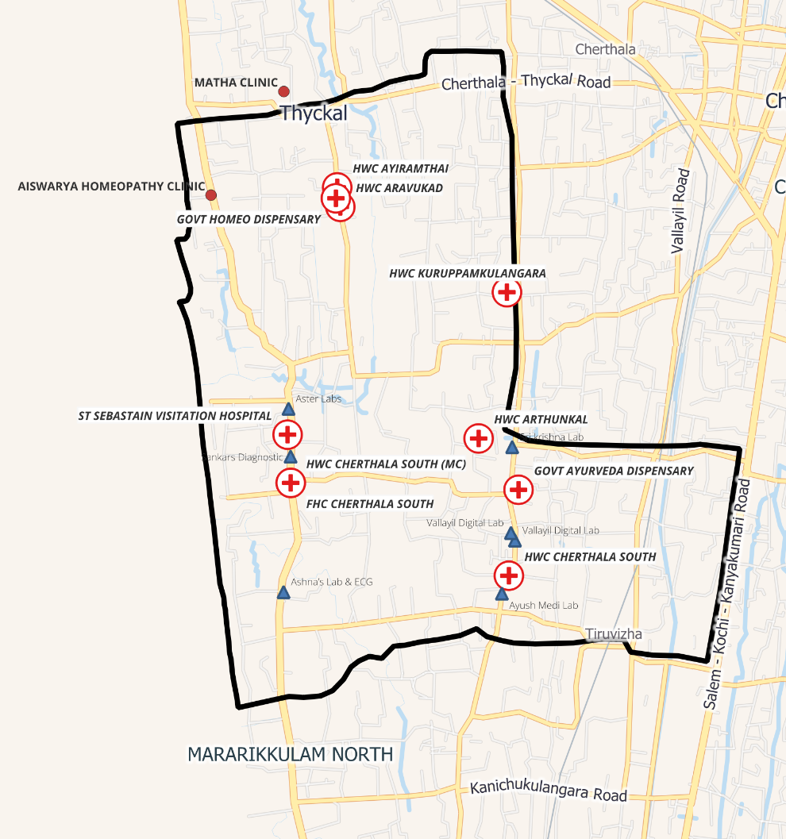
Cherthala South Grama Panchayat Health Infrastructure Map

AUXILIARY INFRASTRUCTURE & LOGISTICAL RESOURCE MAP OF CHERTHALA SOUTH PANCHAYAT

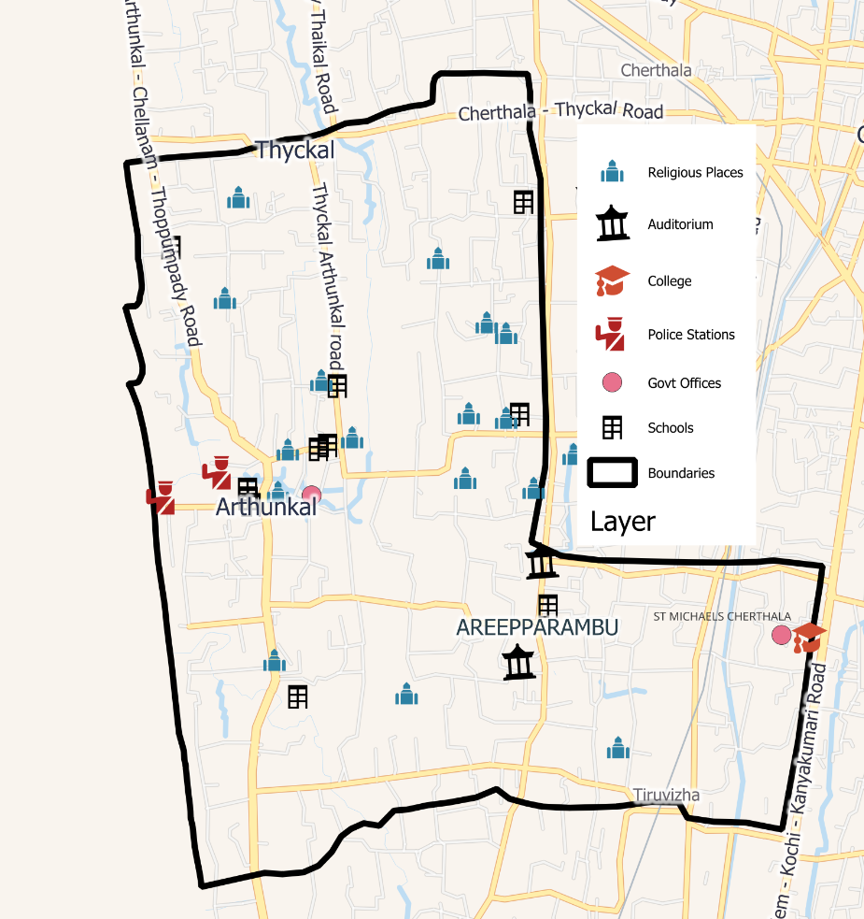
Cherthala South Grama Panchayat Auxiliary and Logistics Infrastructure Map

LSGD ONE HEALTH INFRASTRUCTURE

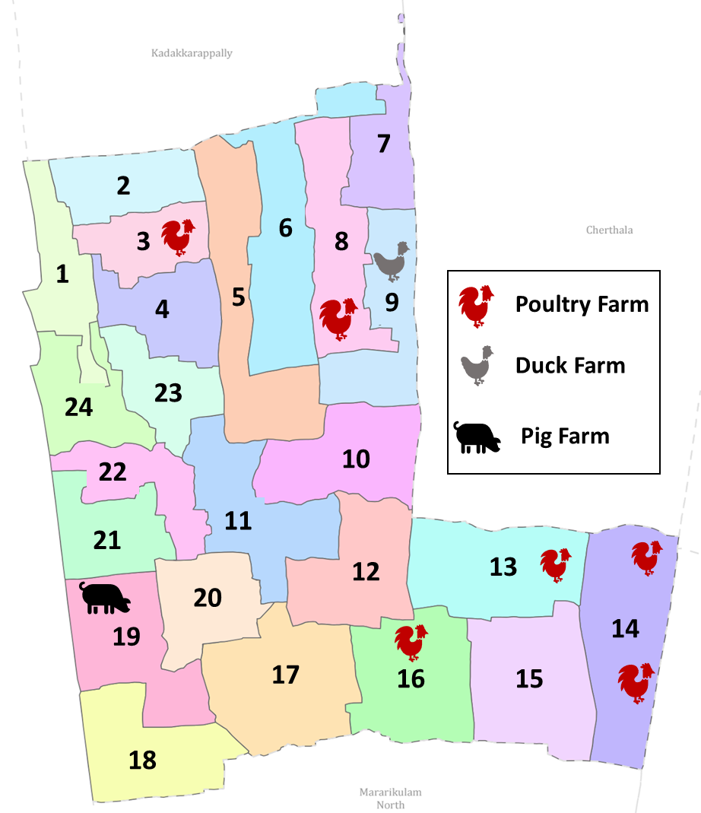
Geographical Distribution of Key Livestock Farms in Cherthala South Panchayat

GENERAL PROFILE OF THE LSGI’S

Background of the LSGI
Cherthala South Grama Panchayat is a vital coastal administrative unit in the Alappuzha district. The Panchayat’s landscape is a complex ecological tapestry of low-lying coastal terrain, canals, backwaters, and proximity to the Arabian Sea. Bordered by the Arabian Sea to the west, the region’s geography is as much a source of livelihood as it is a driver of environmental vulnerability. With a total population of 41,682 spread across 22 wards, the region serves as a vital hub for traditional fishing activities, coir and coconut husk processing, small-scale trade, and allied coastal livelihoods.

Historically, the LSGI has faced significant public health challenges such as recurrent seasonal outbreaks of vector-borne diseases, especially Dengue along with monsoon-related water-borne illnesses, and has been impacted by major climate-induced events, including the Kerala floods of 2018. These experiences have strengthened community resilience while underscoring the importance of a localized, ward-wise, data-driven disaster and pandemic preparedness framework integrated with primary health care systems.

Table 1: Background of LSGD
Item | Details
Name of LSGI | Cherthala South
Type (GP/Municipality etc.) | Grama Panchayat
Block | Kanjikuzhy
District | Alappuzha
Number of wards | 22
Total area (sq. km) | 18.34
Population (latest) | 42179
Population density | 2299 persons/sq km
Terrain (coastal/low-lying/backwaters/foothills, etc.) | Coastal Plain
Number of rivers passing through LSGI | 0
Number of ponds in the LSGI | 257
Number of wells in LSGI | 913
Number of educational institutions | SHOOLS 12,COLLEGE 1 ITI -1,NURSING COLLEGE -1
Factories / small-scale industries | INDUSTRIAL ESTATE -1
Flood-prone wards | WARD-5
Landslide-prone wards | 0
Death Management and Disposal Facilities (mortuaries/crematorium, including electric) | 0
Auditoriums/Marriage halls/convention centres/community halls | 6/1/1

Demographic and Vulnerable Population
Understanding the demographic composition and vulnerable population groups is essential for pandemic preparedness. Children, elderly, economically deprived families, migrant workers, and socially vulnerable groups are at increased risk during public health emergencies due to higher exposure, limited access to services, and dependency on public systems.

Cherthala South Grama Panchayat has a population of 42,179 residing within an area of 18.34 square kilometres, resulting in a relatively high population density of 2,299 persons per square kilometre. The Panchayat comprises 22 wards and is situated in a coastal plain with extensive low-lying areas, canals, backwaters, ponds, and wells, which influence settlement patterns, access to services, and public health risks, particularly during the monsoon season.

Item |  | Details in numbers
DEMOGRAPHIC PROFILE
Total population |  | 42179
Male |  | 20652
Female |  | 21437
Transgender |  | 1
Children under 5 |  | 1621
Adolescent |  | 3586
Elderly (>60) |  | 7677
SOCIAL/LIVELIHOOD VULNERABILITY
Previous EPEP family |  | 85
BPL family |  | 5641
Tribal communities |  | 81
Migration | Immigrant | 147
Migration | Emigrant | 862
Socio-economically deprived |  | 32
Fisherfolk |  | 4116
ST Community |  | 81 FAMILY
SC Community |  | 460

The demographic profile of Cherthala South Grama Panchayat indicates a total population of 42,179, with a near-equal distribution between males (20,652) and females (21,437), and one registered transgender individual. Children under five years of age constitute 1,621 of the population, while adolescents account for 3,586 individuals. The elderly population above 60 years is significant, numbering 7,677, indicating a substantial proportion of age-related vulnerability requiring focused health and social support during public health emergencies.
The socio-economic fabric shows a high degree of vulnerability, with 5,641 BPL (Below Poverty Line) families and 4,116 individuals directly dependent on the fishing sector. These groups often reside in high-density coastal clusters where social distancing is logistically challenging.
Migration patterns show both inward and outward mobility, with 147 immigrants and 862 emigrants, highlighting the potential for population movement–related health risks and the importance of surveillance and follow-up mechanisms. Additionally, 4,116 individuals are engaged in fishing-related livelihoods, reinforcing the coastal character of the Panchayat and the occupational vulnerabilities associated with marine and allied activities. A small but critical group of socio-economically deprived individuals (32) has also been identified, warranting prioritised attention during emergency response and relief planning

Clinical Vulnerability
Certain population groups need priority healthcare & are at higher risk of severe illness, complications, and mortality during pandemics. Patients with chronic diseases, those requiring regular medical care, and individuals with mobility or functional limitations face challenges in accessing timely care during emergencies. Mapping these groups helps in prioritizing continuity of treatment, medicine stock planning, oxygen support, referral transport, and targeted home-based care.
Item | Details in numbers
Pregnant women | 124
Lactating mothers | 453
Bedbound patients | 131
Patients under palliative care other than bedbound | 431
Patients on Haemodialysis | 16
Patients on CAPD | 0
Cancer patients | 176
Haemophilic patients | 0
Mentally challenged | 180
Differently abled | 191
Diabetic patients | 2053
Hypertensive patients | 3530
TB patients | 14
Total vulnerable individuals: 7299 (17.5 % of Cherthala south's population).
The clinical vulnerability profile indicates a substantial burden of chronic non-communicable diseases, particularly hypertension (3530) and diabetes (2053), alongside populations requiring continuous care, such as dialysis patients, palliative care beneficiaries, and bedbound individuals. Maternal groups also represent a significant share, necessitating uninterrupted antenatal, postnatal, and newborn care during public health emergencies. The presence of mobility- and function-limited individuals highlights the need for decentralized service delivery, home-based care, assured medicine supply, oxygen support, and reliable referral transport during pandemics and disasters.
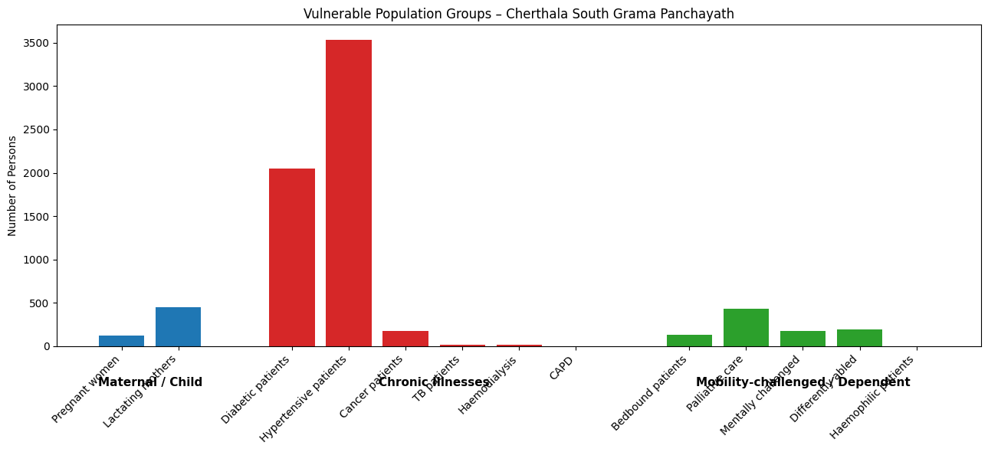

Major Festivals

Major religious and cultural festivals in Cherthala South Grama Panchayath, notably the Arthunkal Basilica Festival, Arthunkal Beach Festival, and Aravukadu Temple Festival, represent high-risk periods for the transmission of communicable diseases due to large-scale crowding, prolonged mass gatherings, and increased population movement from within and outside the district.

Sl. No. | Name of festivals | Month | Key Risks & Local Impact
1 | Arthunkal Basilica Fest | January | Waste management, Overcrowding,
2 | Arthunkal Beach fest | December | Waste management, Overcrowding
3. | Aravukad Temple fest | April | Waste management, Overcrowding

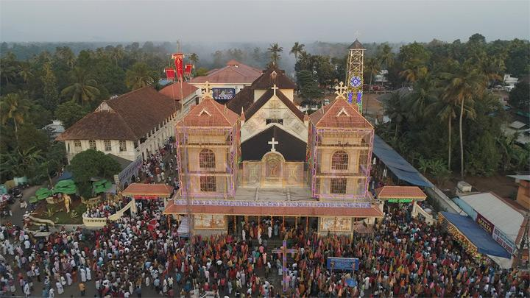
Arthunkal Basilica Fest

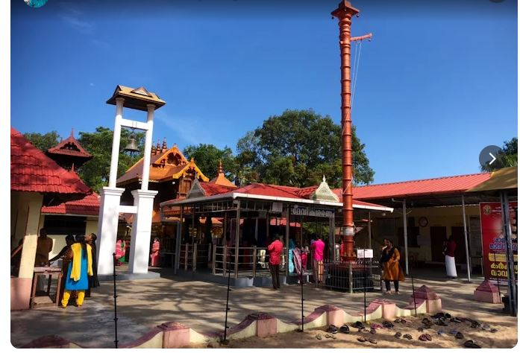
Aravukad Temple fest

INFRASTRUCTURE & RESOURCE INVENTORY

Health Facility Directory & Basic Capacity in the LSGD
FHC Cherthala South functions as the primary government health facility, delivering preventive, promotive, and basic curative services to the Panchayat population. For general secondary-level care, residents also access the Taluk Headquarters Hospital, Cherthala, which caters to a wide range of inpatient and outpatient needs.
In addition, several nearby private hospitals provide multi-specialty and advanced care, including Sanjos Hospital, KVM Super Specialty Hospital, and Sacred Heart General Hospital. For super-speciality and advanced tertiary care services, St. Sebastian’s Super Speciality Hospital, located in the nearby Cherthala Municipality, serves as a key referral institution for the Panchayath, particularly for complex medical and surgical conditions.

Referral Hierarchy:
Primary care: FHC CHERTHALA SOUTH + 6 Sub-centers (Surveillance, OPD)
Secondary referrals: St. Sebastian's Visitation Hospital (450 m)
Tertiary/critical care: →THQH CHERTHALA (7 km)
GH Alappuzha (20 km) → TDMC Alappuzha (30 km)

Table 5. Health Facility Resource Summary
Sl.no. | Health Facility | Type of Facility | Contact Number | Total beds | ICU Beds | Oxygen-Supported Beds | No. of Ventilator Support | No. of ambulances
Government Healthcare Facilities
1 | FHC Cherthala South | FHC | 04782572533 | 0 | 0 | 1 | 0 | 0
2 | Main Centre | SC | 8593064004 | 0 | 0 | 0 | 0 | 0
3 | Kuruppamkulangara | SC | 9562922545 | 0 | 0 | 0 | 0 | 0
4 | Arthunkal | SC | 7025938100 | 0 | 0 | 0 | 0 | 0
5 | Ayiramthai | SC | 8281283752 | 0 | 0 | 0 | 0 | 0
6 | Aravukad | SC |  | 0 | 0 | 0 | 0 | 0
7. | Cherthala South | SC | 9961588731 | 0 | 0 | 0 | 0 | 0
Private Healthcare Facilities
1 | St. Sebastian Visitation Hospital | General | 9446192120 | 150 | 5 | 15 | 0 | 2
AYUSH Healthcare Facilities
1 | Govt Homeo Dispensary | General | 9400320242 | 0 | 0 | 0 | 0 | 0
2 | Govt Ayurveda Dispensary | General | 9447909208 | 0 | 0 | 0 | 0 | 0

Family Health Centre (FHC) Cherthala South, Alappuzha district, Kerala—located near Arthunkal and Kanjikuzhy on the Arthunkal–Chellanam–Thoppumpady Road; a key government health facility, easily accessible by public transport. It serves as an important point for delivery of primary health care services and implementation of public health programs for the surrounding communities.
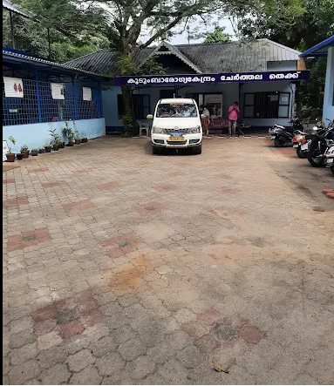
FHC CHERTHALA SOUTH

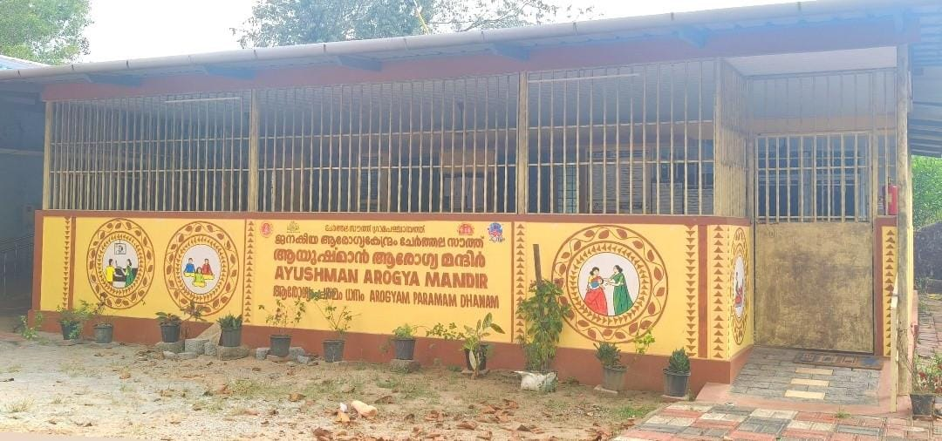
AAM CHERTHALA SOUTH

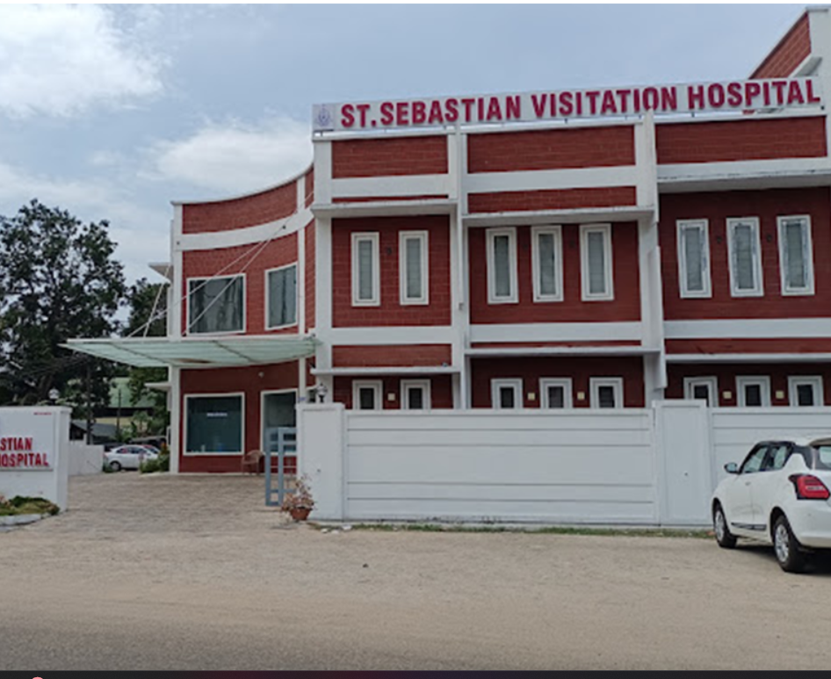
ST.SEBASTIAN VISITATION HOSPITAL ARTHUNKAL ( PRIVATE )

Private Clinics
Private clinics are an essential part of pandemic preparedness, as they are often the first place people seek care when symptoms begin. In many communities, private clinics manage a significant share of outpatient visits and therefore play a critical role in early case detection, timely referrals, and disease surveillance. Having an up-to-date understanding of where these clinics are located, the services they provide, and how they are linked to the public health system helps ensure that no cases are missed during an outbreak. It also allows health authorities to engage private practitioners more effectively for reporting, risk communication, and coordinated response, strengthening the overall capacity of the health system to manage public health emergencies.

Table 6. Private Clinic Resource Summary
Sl No. | Name of Clinic | Name of doctor | Registered (Y/N) | Clinic (General / Specialty) | Specialty (if any) | Address | Contact Number | Diagnostic Facility (Y/N) | Ambulance Linkage (Y/N)
1 | Matha Clinic | Dr Christeen KJ, Dr Lincy Antony, Dr Bincy Antony | Y | General | Nil | Thykal | 807545807 | N | N
3 | Private Pratitioner | Dr John Bosco | Y | General | Nil | Chenathara | 9447293471 | N | N
4 | Aiswarya homeopathy clinic | Dr Nikhil P | Y | AYUSH | - | Ayiramthai |  | N | N
5 | Private Pratitioner | Dr Jose | Y | Speciality | Pediatrician | Areepparambu | 9447564949 | N | N
6 | Private Pratitioner | Dr Kshma Madhavi | Y | Speciality | Pulmonologist | Thiruvizha |  | N | N
7 | Vaidyer's Ayurveda Medical Centre | Dr Rahul |  | AYUSH | nIL | Areeparambu | 7994288907 | N | N

Healthcare Education & Training Institutions
This section tracks the educational infrastructure available, which is vital for human resource planning in the health sector.

Category of Institution | Govt | Private | AYUSH | Total
Medical Colleges | 0 | 0 | 0 | 0
Nursing Colleges | 0 | 1 | 0 | 1
Dental Colleges | 0 | 0 | 0 | 0
Para-medical / Allied Health | 0 | 0 | 0 | 0
Pharmacy Colleges | 0 | 0 | 0 | 0

Specialized Services & Emergency Inventory
This section provides a detailed view of the specialized medical resources available to the community, focusing on emergency response and critical care capabilities. This table tracks the vital assets required for managing severe illnesses and emergencies across Government, Private, and AYUSH sectors.

Item | Govt | Private | AYUSH | Total
Hospital beds | 1 | 150 | 0 | 151
Oxygen-generating systems(Y/N) | 0 | 1 | 0 | 1
Oxygen-supported beds(Numbers) | 0 | 15 | 0 | 15
Ventilator supported beds | 0 | 0 | 0 | 0
ICU beds | 0 | 5 | 0 | 5
Burns units | 0 | 0 | 0 | 0
Blood banks | 0 | 0 | 0 | 0
BLS ambulances | 0 | 1 | 0 | 1
ALS ambulances | 0 | 1 | 0 | 1
Dialysis facilities | 0 | 0 | 0 | 0
Dispensaries | 0 | 1 | 2 | 3
Medical store | 0 | 22 | 2 | 24

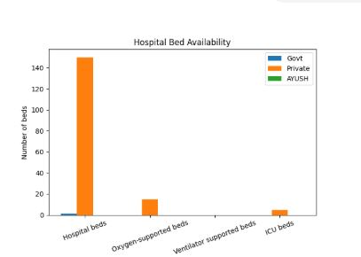

The data reflects the availability of critical care beds within the LSGD, specifically in FHC Cherthala South and St. Sebastian’s Super Speciality Hospital. While FHC Cherthala South provides limited bed capacity for basic inpatient and observation care, St. Sebastian’s Super Speciality Hospital accounts for the major share of critical care and oxygen-supported beds, which are essential for effective preparedness and response during pandemics and respiratory emergencies.

Oxygen & Diagnostic Capacity
Monitoring oxygen and diagnostic capacity is a critical component of public health preparedness, ensuring that the LSGD can handle both chronic care and sudden surges in respiratory or infectious diseases.
Name of Health Facility | Oxygen-generating System (Y/N) | Backup Oxygen Source (Y/N) | Diagnostic Facilities Available(Y/N)
Name of Health Facility | Oxygen-generating System (Y/N) | Backup Oxygen Source (Y/N) | Lab | USG | X-ray | CT/MRI | RT-PCR
Government Healthcare Facilities
FHC Cherthala South | N | Y | Y | N | N | N | N
Private Healthcare Facilities
St Sebastain Visitation Hospital | Y | Y | Y | Y | Y | N | N

Diagnostics Summary
The diagnostic capacity of Cherthala South Panchayat represents the "intelligence network" of our healthcare system. The speed and accuracy of disease identification depend entirely on the distribution and technical level of these facilities.

Item | Govt | Private | AYUSH | Total
General labs | 1 | 7 | 0 | 8
Microbiology labs | 0 | 2 | 0 | 2
RT-PCR labs | 0 | 0 | 0 | 0
USG units | 0 | 1 | 0 | 1
CT/MRI units | 0 | 0 | 0 | 0

The availability of General and Microbiology labs at the local level is the primary determinant of the Turnaround Time (TAT) for basic disease identification. Currently, the LSGI has 8 labs. Of these, 1are operated by the Government, while 7 are Private.

Advanced imaging is vital for trauma management and detecting complications from infectious diseases (such as pneumonia via CT scans). There are currently 1 USG units available. If these units are absent within the LSGI limits, the designated emergency transit route for imaging is to St Sebastian Visitation Hospital, which is approximately 0.5 km away.Facilities without RT-PCR capacity must maintain a strict "Sample Collection & Transport" protocol to ensure samples reach the nearest lab within 6 hours.

Laboratory Identification & Basic Details
Sl. No. | Name of Laboratory | Ownership (Govt / Private / Academic) | Address | Contact No. | 24×7 Services (Yes/No) | NABL / Govt Approved (Yes/No)
1 | Aster Labs | Private | Arthunkal W- | 974455364 | N | Y
2 | Ashna’s Lab & ECG | Private | Thiruvizha | 8921128324 | N | N
3 | Ayush Medi Lab | Private | Thiruvizha Temple Road | 9605041644 | N | N
4 | Sankars | Private | Arthunkal | 04782812268 | N | Y
5 | Vallayil Digital Lab | Private | Areeparambu | 8921140042 | N | N
6 | Sri krishna Lab | Private | Areeparambu | 8532091830 | N | N
7 | Vallayil Digital Lab |  |  | 8921140042 | N | N
8 | HEALTH PLUS | Private | Arthunkal | 7293051641 | N | N

Social and Community Infrastructure for Emergency Use
This table serves as your logistics and shelter inventory. By mapping these locations, you can quickly identify where to house displaced citizens, where to set up temporary medical clinics, and how to manage the deceased with dignity during a crisis.

Category | Total Count | Total strength/Capacity
Educational Institutions
Anganwadis | 47 | 246
Schools | 13 | 5737
Colleges | 1 | 800
Healthcare Educational Institutions
Medical colleges (Govt/Private) | 0 | 0
Nursing colleges (Govt/Private) | 1 | 75
Dental colleges (Govt/Private) | 0 | 0
Paramedical institutes (Govt/Private) | 0 | 0
Community Gathering Spaces
Community halls | 1 | 300
Auditoriums | 6 | 3500
Religious buildings | 14 | 6000
Vulnerable Group Support Facility
Destitute homes | 1 | 40
Elderly homes | 2 | 40
LSGD owned other buildings | 4 | 200
Mass Fatality Management (MFM) Infrastructure
Mortuary | 0
Crematorium | 0

Human resources
This section focuses on the human capital available within the LSGI. In any emergency—be it a pandemic, flood, or industrial accident—infrastructure is only as effective as the people operating it.

Medical & Clinical Personnel
This table tracks the "Frontline" providers responsible for diagnosis, treatment, and clinical management. Narrative sentence: eg., "Total health workforce: 450 personnel, with 60% in government facilities serving as primary surge capacity." A detailed directory with the contact numbers of all workers is maintained (Annexure ……).

Cadre | Govt (No.) | Private (No.) | Qualified Professionals | Total
Doctors—Modern Medicine | 3 | 20 | 6 | 28
Doctors – AYUSH | 2 | 4 | 1 | 7
Doctors – Veterinary | 1 | 0 | 1 | 1
Doctors – Dental | 0 | 5 |  | 5
Nursing officers | 12 | 97 | 13 | 109
Lab technicians | 2 | 10 | 8 | 12
Optometrist | 1 | 0 | 3 | 1
Ophalmologist | 0 | 1 | 0 | 1
Pharmacists | 2 | 6 | 5 | 8
Psychologists | 0 | 1 | 0 | 1
Counsellors | 0 | 0 | 2 | 0

Public Health & Field-Level Workforce
These individuals are the backbone of surveillance, maternal-child health, and decentralized care.

Cadre | Government/Municipal | Total
HS (Health Supervisors) | 0 | 0
HI (Health Inspectors) | 1 | 1
LHS (Lady Health Supervisor) | 0 | 0
LHI (Lady Health Inspectors) | 1 | 1
JPHN (Jr Public Health Nurses) | 6 | 6
JHI (Jr Health Inspectors) | 4 | 4
MLSP (Mid-Level Service Providers) | 6 | 6
Palliative Nurses | 1 | 1
RBSK Nurses | 1 | 1
PRO | 0 | 0

Community & Support Cadre
This group represents the surge capacity of the LSGI—people who can be called upon for logistics, rescue, and specialized support.

Cadre | Number
ASHA Workers | 42
AWW (Anganwadi Workers) | 47
Emergency Medical Volunteers (Trained) | 0
Kudumbashree Unit | 456
Purusha Swayam Sahaya Sangam | 112
Ex-Servicemen | 68
Retired Police Officers | 32
NCC/NSS Volunteers | 170
One Health Community Volunteers | 1078
One Health Community Mentors | 154

Community Organizations
This section details the presence of community-based organizations (CBOs), non-governmental organizations (NGOs), faith-based organizations (FBOs), Kudumbashree Self-Help Groups (SHGs), and Ayalkootams within the Local Self-Government Institution (LSGI). These groups enhance grassroots mobilization, resource distribution, and support networks crucial for pandemic response and community resilience.

Category | Total Count
NGOs | 4
CBOs (Resident Associations/Libraries) | 2
FBOs | 2
Sports Club | 4
Kudumbashree SHGs | 372
Ayalkootams | 50

Administrative & Emergency Services
This section outlines the availability of key non-health emergency support services and infrastructure within the LSGI, which are essential for effective pandemic preparedness and response. These facilities support law enforcement, disaster response, water supply, logistics, mobility, and community-level interventions during public health emergencies.

Category | Total Count | Location
Police Stations | 2 | Arthunkal
Fire & Rescue Stations | 0
Water Pumping Points | 1 | Mayithara
Public Distribution System (PDS) | 21, supplyco - 1

POLICE STATIONS IN CHERTHALA SOUTH PANCHAYATH

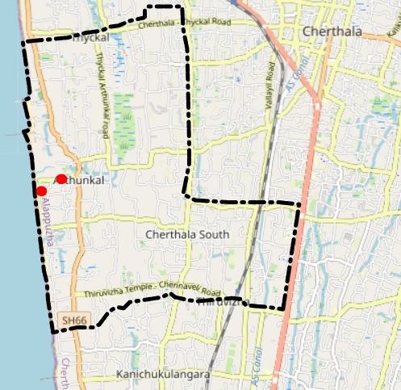

Information regarding resources

The availability of essential transport and support resources plays a quiet but critical role in saving lives. Equipment such as ambulances, mobile mortuaries, amphibian ambulances, and motorized boats ensures that patients, samples, and healthcare teams can move swiftly—even in flooded, remote, or difficult terrains. Heavy vehicles like JCBs, cranes, tractors, and torus lorries support logistics, waste management, emergency infrastructure, and rapid conversion of spaces into care or isolation facilities. Taxis, four-wheel-drive vehicles, and trucks help maintain continuity of essential services, reach vulnerable populations, and support home-based care and supply delivery.

Means of transportation | Total Count
JCB | 1
Crane | 1
Heavy Trucks | 0
Tractor | 2
Ambulances | 2
Mobile mortuaries | 0
Mechanise Boats | 2
Unmechanised Boat | 198
Taxi service | 6

Note: For specific details regarding vehicle owners and contact information, please refer to Annexure [X].

ONE HEALTH & ENVIRONMENTAL SURVEILLANCE
The One Health method integrates environmental, animal, and human health to enable proactive pandemic preparedness. Panchayat-level surveillance needs to be improved in order to detect and treat zoonotic and environmentally generated diseases early. Surveillance is strengthened through systematic assessment of animal populations, veterinary infrastructure, poultry and slaughter facilities, inter-sectoral coordination, and specialised tools like avian influenza seasonality mapping using GIS in previous outbreaks to enable predictive alerts and ward-specific sampling to support effective pandemic preparedness in high-risk areas like Alappuzha.

Animal & Bird Population
Mapping animal and bird populations at the Panchayat level is essential for identifying and prioritising zoonotic disease hazards like rabies, avian influenza (H5N1), leptospirosis, anthrax, and Nipah-like spillover occurrences. Risk classification, targeted surveillance, vaccination planning, and early epidemic detection made feasible by comprehensive population mapping all enhance One Health-based pandemic preparedness.

Category | Item | Estimated Population | Wards
Animal Population | Livestock (Cattle/Goats/Buffalo) | 3103 | All Wards
Animal Population | Pet Animals (Dogs/Cats) | 2102 | All wards
Animal Population | Stray Dog Population | 200 | All ward
Animal Population | Pig Farms (Number of heads) | 5 | 17
 | Small Units (Sheep / Goats – clustered) | 0 | 0
Bird Population | Poultry Units (Birds) | 5 (2500) | 12, 14, 13, 17
Bird Population | Poultry – Backyard / Unorganised | 1 (85) | 12
Bird Population | Duck Rearing Units | 1(80) | 17
Bird Population | Wild/Migratory Birds (Observed) | Present | 5
Bird Population | Crow Mortality Events (Reported) | No | 0

The risk of zoonotic diseases in Cherthala South Grama Panchayat is influenced by the distribution of animal populations, livestock rearing practices, and environmental factors across wards. Livestock, including cattle, goats, and buffaloes (estimated population 3,103), as well as pet animals such as dogs and cats (2,102), are distributed across all wards, contributing to a background level of zoonotic risk throughout the Panchayath. In addition, an estimated stray dog population of around 200, observed across public spaces such as market areas, fish landing centres, and bus routes, poses an ongoing challenge for rabies surveillance and bite prevention.
Ward 17 has particular importance from a zoonotic disease perspective due to the presence of pig farming units (5 heads) and duck rearing units (1 unit with 80 birds), which increases vulnerability to leptospirosis and other environmentally mediated zoonoses, especially during monsoon and flooding periods. Poultry farming activities are noted in Wards 12, 13, 14, and 17, with five organised poultry units housing approximately 2,500 birds and one backyard poultry unit with 85 birds in Ward 12, raising concerns for avian influenza introduction and amplification, particularly during the high-risk season from October to March.

Veterinary Infrastructure
Veterinary institutions are a core pillar of One Health surveillance, enabling early zoonotic disease detection through vaccination, investigation of unusual animal illness or deaths, sample collection, and timely outbreak reporting. A well-mapped and responsive veterinary network strengthens coordination with human health and LSGI systems, ensuring rapid response during zoonotic events and pandemics.

Facility Type | Name of Facility | Ownership Govt / Pvt | Ward(s) | Contact number
Veterinary Dispensary | Government Veterinary Dispensary | Govt | 3 | 9495964609
Pet Shops | Bows N Meow | Pvt | 20 | 9539609420
Pet Shops | Heaven Pet Shop | Pvt | 19 | 9249342326

The LSGD is served by 3 Government Veterinary Dispensaries/Hospitals; however, limitations in mobile services and 24×7 emergency veterinary care may delay the detection and reporting of sudden animal deaths, particularly during night hours, monsoon flooding, and avian influenza high-risk seasons. To address this gap, nearby private veterinary clinics, including facilities in and around the Cherthala area (such as Sree Bhadra Veterinary Clinic, Varanad(10 KM ), and other private veterinary service providers), are proposed to be empanelled for outbreak response and integrated into the One Health rapid reporting and surveillance system through defined alert mechanisms, standard operating procedures (SOPs), and designated nodal officers.

Veterinary Doctors & Workforce
Early detection, diagnosis, reporting, and reaction to animal illness epidemics depend on the availability and accessibility of qualified veterinary specialists. Through timely identification of unusual animal morbidity or mortality, timely sample collection, and efficient coordination with human health and LSGI systems—especially during zoonotic outbreaks and pandemic-prone situations—a clearly defined veterinary workforce enhances One Health surveillance.
Catzgory | Number Available | Type (Govt/Pvt) | Contact number
Government Veterinary Doctors | 1 | Govt | Rajalekshmi Radhakrishnan 9495964609
Private Veterinary Doctors | 0 | 0 | 0
Livestock Inspectors | 2 | Govt | Prakashan 9495443063
Livestock Inspectors | 1 | Pvt | Sumod KS  8129841921
Para-veterinary Staff / Attenders | 2 | Govt | Attender Ponnamma - 9207531586
Contract / On-call Veterinary Support (if any) | 1 | Pvt | Sumod KS  8129841921

High-Risk Interface Points (Surveillance Sites)
High-risk interface points are places where people, animals, and the environment interact frequently, closely, or without protection, which raises the risk of zoonotic disease amplification and spillover. In order to discover animal-to-human transmission concerns early, particularly during monsoon, flood, and avian influenza high-risk seasons, routine mapping, inspection, and surveillance of these sites are essential components of One Health readiness.
Category | Total Count | Wards | Key Locations
Large Poultry Farms | 1 | 11 | Areeparambu
Backyard / Clustered Poultry Units | 1 | 12 | Mayithara
Duck Rearing Units (open water access) | 0 | 0 | 0
Slaughterhouses/ Slaughter Points | 0 | 0 | 0
Meat/Fish Markets | 0 | 0 | 0
Live Bird Sale Points | 0 | 0 | 0
Cattle Markets / Weekly Animal Fairs | 0 | 0 | 0
Pet Shops / Breeders | 2 | 19, 20
Animal Shelters / Pet Homes | 0 | 0 | 0
Waste Disposal Sites near Animal Units | 0 | 0 | 0

Environmental Risk Mapping
Environmental risk mapping identifies monsoon/flood hotspots for vector-borne (dengue, chikungunya), water-borne (leptospirosis, diarrhoea), and zoonotic diseases in Kerala's wetlands. Systematic surveillance supports early warnings, targeted interventions, and Panchayat pandemic preparedness.
Risk Factor | Presence (Yes/No) | High-Risk Wards | Key Locations | Risk Level (High/Med/Low)
Flood-prone areas | Yes | 1, 5, 6, 8, 9 | Kurupankulangara,Ambekar colony, Madakal | Med
Coastal Areas | Yes | 17, 19, 20, 22, 16, 1 | Arthunkal Beach | High
Solid waste accumulation | No
Animal waste disposal issues | No
Rodent infestation zones | Yes | All Ward |  | High
Industrial effluent discharge | No
Construction sites / abandoned buildings | No
Poor drainage/blocked canals | Yes | All ward |  | Med
Drinking water source contamination risk | Yes
Several wards of Cherthala South Grama Panchayath, particularly those adjacent to canals, backwaters, and low-lying coastal areas, are highly vulnerable to seasonal flooding, increasing the risk of leptospirosis, diarrheal diseases, and skin infections, especially during the monsoon period. Flood-prone inland pockets and coastal stretches such as Kurupankulangara, Ambedkar Colony, Madackal, and the Arthunkal coastal belt are of particular concern. Although large-scale solid and animal waste accumulation is not widely reported, localized waste handling and rodent infestation, especially in flood-affected and densely populated areas, elevate zoonotic and occupational health risks.
In addition, wetlands, poor drainage systems, blocked canals, and water stagnation across wards create favourable conditions for mosquito breeding, necessitating intensified source-reduction activities, larvicidal measures, and targeted fogging during the monsoon and post-monsoon months (June–October), with active community participation and intersectoral coordination.

Vulnerability Mapping
Vulnerability mapping pinpoints high-risk populations, occupations, and areas exposed via environment, livelihoods, socio-economics, and poor service access. Paired with environmental/seasonality mapping, it enables risk-based surveillance, targeted actions, and optimal resource use in One Health and pandemic planning.
Vulnerability Factor | Presence (Y/N) | High-Risk Wards | Key Groups / Locations | Risk Level
Flood-prone households | Y | 1, 5, 6, 8, 9 | Kurupankulangara,Ambekar colony, Madakal | Medium
Wetland-adjacent communities | N | - | - | -
Backyard poultry / duck rearing households | Y | 12 | Mayithara | Low
Livestock-rearing households | Y | All ward |  | Medium
Slaughterhouse & meat market workers | No | - | - | -
Fisherfolk | Y | 19, 17, 16, 21 | Arthunkal | Medium
Sanitation workers | Y | All Ward
Daily wage / migrant workers | Y | 12 | Mayithara | Medium
Elderly & chronically ill populations | Y | 12 | Mayithara | Medium
Pregnant Women | Y | 1, 7 | Fishland, Madakkal | Medium
Children (schools, Anganwadi’s) | Y | 20 | Arthunkal | Medium
Limited access to safe water & sanitation | N | - | - | -

EPIDEMIOLOGICAL TRENDS (2023–2025)

Disease surveillance is the systematic collection, analysis, and interpretation of health data for planning, implementation, and evaluation of public health practice. This section presents the disease surveillance profile of the LSGI based on routine reporting systems and outbreak investigations to identify priority diseases, seasonal patterns, and emerging public health threats.

Disease Burden among Human Beings (Last 3 Years)
Analysis of disease-wise data for the last three years helps identify persistent public health problems, emerging diseases, and changes in disease burden. This information supports prioritization of prevention, preparedness, and response activities at the Panchayat level.

Comparative Disease Burden: 3-Year Analysis
Disease | 2023 | 2024 | 2025 | 3-Year Total | Trend
Dengue | 18 | 29 | 5 | 54 | Decreasing
Leptospirosis | 2 | 6 | 2 | 10 | Decreasing
Hepatitis A | 0 | 2 | 2 | 2 | Increasing
Malaria | 0 | 0 | 1 | 1 | Increasing
Scrub Typhus | 1 | 0 | 0 | 1 | Decreasing
Typhoid | 0 | 0 | 0 | 0 | Stable
H1N1 | 0 | 0 | 1 | 1 | Increasing
H3N2 | 0 | 0 | 0 | 0 | Stable
ADD | 82 | 101 | 71 | 254 | Decreasing
Mumps | 0 | 0 | 2 | 2 | Increasing
Measles | 0 | 0 | 1 | 1 | Increasing
Hepatitis B | 0 | 1 | 1 | 2 | Increasing
Hepatitis C | 0 | 0 | 1 | 1 | Increasing
Tuberculosis | 8 | 18 | 12 | 38 | Increasing
Leprosy | 0 | 0 | 0 | 0 | Stable
COVID-19 | 0 | 0 | 0 | 0 | Stable

Dengue continues to be a significant endemic challenge in Cherthala South Grama Panchayath, with an average of 18 cases reported annually. The majority of cases are recorded during the monsoon and immediate post-monsoon period (June–September), Leptospirosis remains a threat, particularly in wards with high livestock density or water-logging. The presence of Scrub Typhus and Malaria (2025) indicates that surveillance must expand to include non-traditional vector threats.

Based on the data from the last five years, Acute Diarrhoeal Disease (ADD) remains the most frequent endemic public health challenge in Cherthala South Grama Panchayath. On average, approximately 85 cases are reported annually.Although a decreasing trend is noted, the magnitude of cases indicates ongoing vulnerabilities related to drinking water safety, sanitation infrastructure, food handling practices, and monsoon-related contamination. The emergence of hepatitis A cases in recent years further supports the need for sustained WASH interventions, safe water monitoring, and rapid outbreak response mechanisms at the ward level.
The sporadic occurrence of measles and mumps suggests generally good immunisation coverage, while also pointing to the need for continued surveillance to identify immunity gaps, especially among school-going children and and hard-to-reach groups. Tuberculosis shows an increasing trend over the observed period, which may reflect improved case detection, active case finding, or delayed health-seeking behaviour during post-pandemic periods. This trend underscores the importance of integrating TB surveillance and treatment continuity into emergency preparedness planning, ensuring uninterrupted diagnostic and treatment services during public health emergencies.

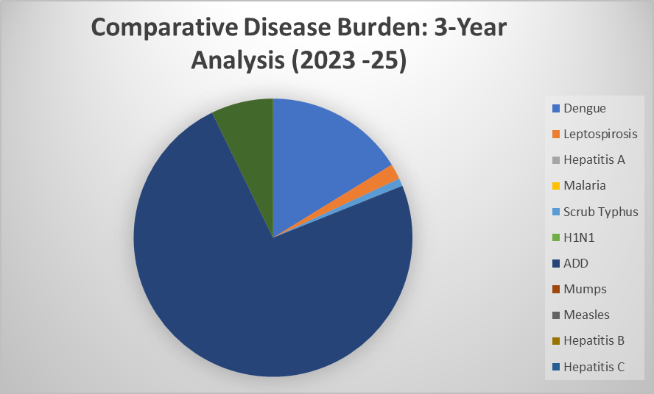

Fig. Distribution of Communicable Diseases in Cherthala South Panchayat (2023–2025)

To facilitate a clearer understanding of overall disease patterns, reported diseases were grouped into major epidemiological categories. A category-wise analysis was undertaken to assess the relative contribution of different disease groups to the total communicable disease burden.

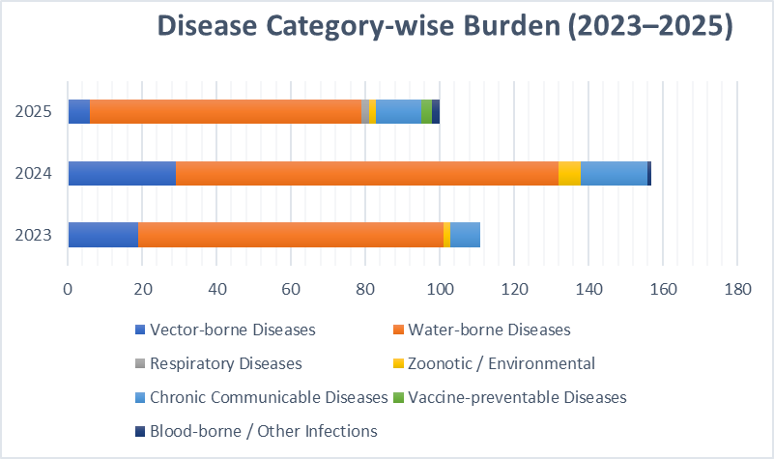

Fig: Category-wise Distribution of Communicable Diseases in Cherthala South Panchayat (2023–2025)

The category-wise analysis demonstrates that water-borne diseases constitute the largest share of the communicable disease burden in Cherthala South Grama Panchayat, accounting for more than two-thirds of reported cases during the period 2023–2025. Vector-borne diseases represent the second major contributor, with a pronounced seasonal pattern linked to monsoon conditions. Chronic communicable diseases, primarily tuberculosis, show a rising contribution, indicating the need for sustained case detection and treatment continuity. Although respiratory and zoonotic diseases currently account for a smaller proportion of cases, their outbreak potential necessitates continued surveillance and preparedness. Detailed category-wise data are provided in Annexure 2.1.

Seasonal Trend Analysis
Seasonal analysis helps anticipate surges (e.g. dengue in monsoon, leptospirosis after floods, influenza in cooler months) and plan pre‑emptive vector control, stockpiling of IV fluids, and awareness campaigns at Panchayat level.

DENGUE
Dengue is a major seasonal vector-borne disease strongly associated with rainfall, water stagnation, and increased mosquito breeding during the monsoon period. Dengue in Cherthala South Grama Panchayat shows a clear seasonal pattern closely linked to monsoon rainfall, water stagnation, and increased vector breeding.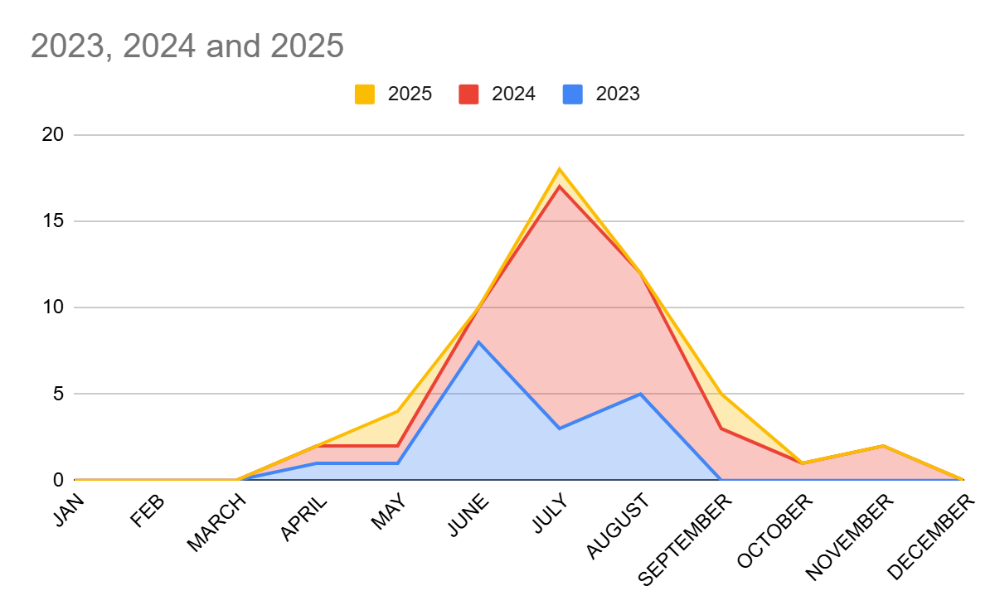

Fig: Month-wise Trend of Dengue Cases in Cherthala South Grama Panchayat (2023–2025)
The line graph illustrates a recurrent seasonal surge in dengue cases during the monsoon and immediate post-monsoon months, highlighting the importance of early preparedness and sustained vector control activities.

Dengue – Ward-wise Yearly Distribution (2023–2025)
Ward-wise analysis of dengue cases over the three-year period reveals clustering in specific wards, indicating localized transmission hotspots. Repeated reporting from the same wards across multiple years suggests the presence of persistent environmental risk factors such as water stagnation, dense housing patterns, or inadequate solid waste management. Detailed ward-wise dengue case distributions for the period 2023–2025 are provided in Annexure 2.2 for reference and operational planning.
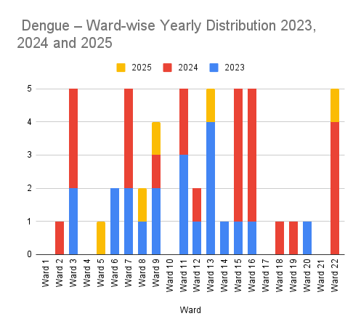

Fig: Ward-wise Trend of Dengue Cases in Cherthala South Panchayat (2023–2025)

Wards 3, 7, 11, 13, 15, 16, and 22 have each reported 5 or more cases over the observed period. Repeated reporting from the same wards across multiple years suggests the presence of persistent environmental risk factors such as water stagnation, dense housing patterns, or inadequate solid waste management. These findings support the need for ward-specific micro-planning, intensified entomological surveillance, and focused behaviour change communication in identified high-risk wards, particularly during the pre-monsoon and monsoon periods.

LEPTOSPIROSIS
Leptospirosis is a seasonal zoonotic disease closely associated with monsoon rainfall, flooding, waterlogging, and occupational exposure to contaminated water and soil. In Cherthala South Grama Panchayat, the disease risk is influenced by low-lying terrain, paddy fields, canals, and frequent water stagnation during the monsoon period
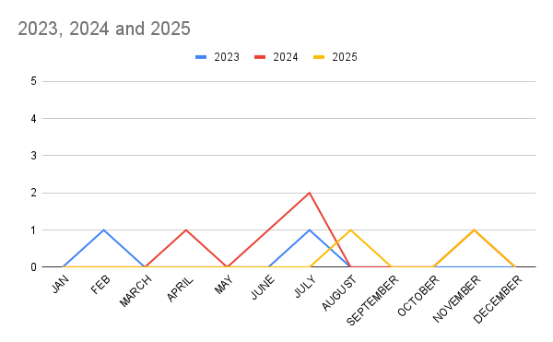

Month-wise Distribution of Leptospirosis Cases in Cherthala South Grama Panchayat (2023–2025)

Analysis of reported cases from 2023 to 2025 indicates a clear seasonal clustering during the monsoon and immediate post-monsoon months, with cases reported predominantly between June and November. The peak occurrence is observed during July and August, coinciding with periods of heavy rainfall and increased exposure to contaminated floodwater.The sporadic cases in February and April suggest non-seasonal, occupational exposure, likely among sanitation workers or those engaged in agricultural activities in low-lying paddy fields. Detailed month-wise distribution of leptospirosis cases for the period 2023–2025 is provided in Annexure 2.4.

Leptospirosis – Ward-wise Yearly Distribution (2023–2025)
Ward-wise analysis of leptospirosis cases during 2023–2025 shows that cases were sporadic and geographically dispersed, with no single ward reporting sustained transmission across all three years. A small number of wards reported isolated cases in different years, indicating localized exposure events rather than widespread community transmission.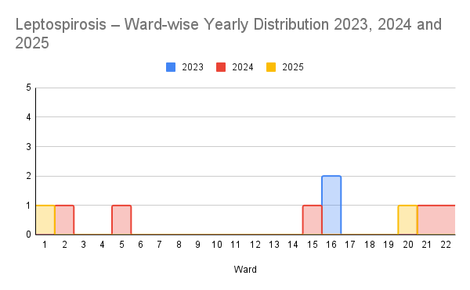
Wards 16, 1, 2, 5, 15, 20, 21, and 22 have recorded cases over the 2023–2025 period. Ward 16, in particular, shows early vulnerability with cases occurring at the start of the observed period, necessitating consistent longitudinal monitoring. The distribution across multiple wards suggests a widespread risk for outdoor workers. Prophylactic coverage must therefore be expanded beyond the FHC staff to include the Haritha Karma Sena, MGNREGS workers, and local farmers residing in these specific wards.

VIRAL HEPATITIS - A
Hepatitis A cases are commonly associated with unsafe drinking water, food contamination, and breakdowns in sanitation, often presenting as clusters or outbreaks. Viral Hepatitis A has emerged as a significant public health concern in Cherthala South, showing a transition from zero cases in 2023 to a consistent presence in 2024 and 2025. Detailed month-wise distribution of leptospirosis cases for the period 2023–2025 is provided in Annexure 2.6.

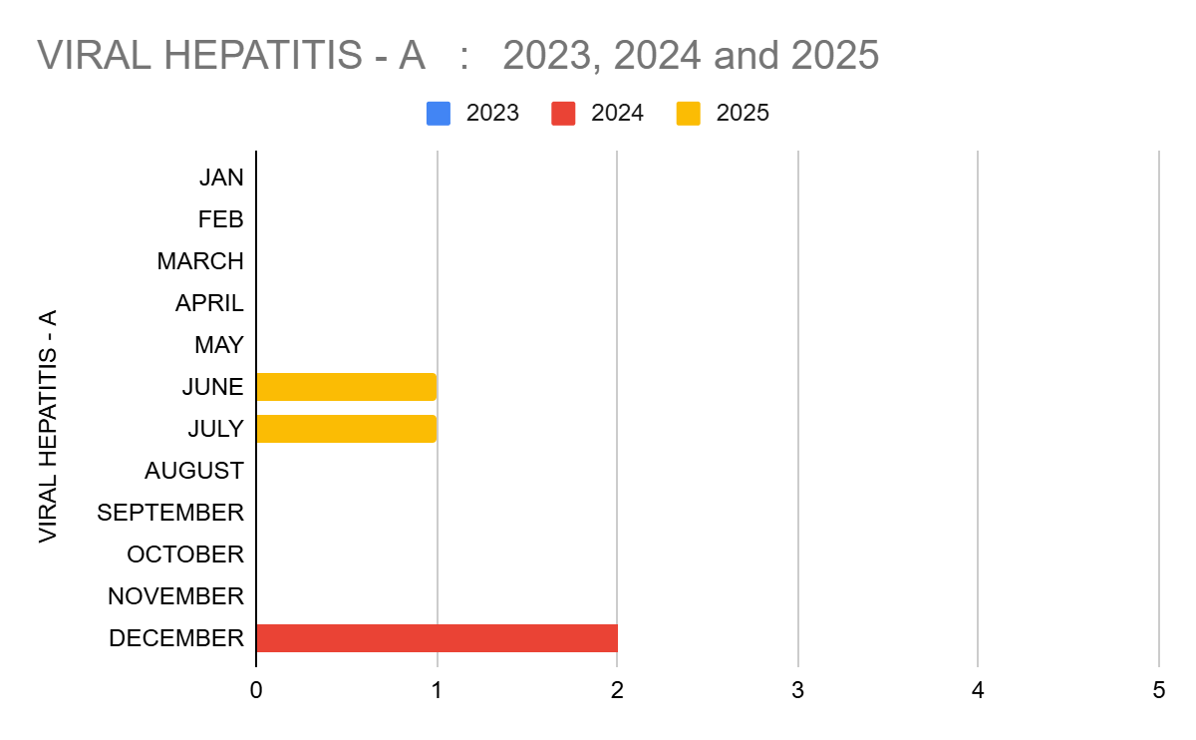

Month-wise Distribution of Hep A Cases in Cherthala South Grama Panchayat (2023–2025)

Analysis of reported Hepatitis A cases during 2023–2025 indicates sporadic occurrence with low overall case numbers, with cases reported primarily during mid-year and end-of-year months. In 2024, cases were recorded in December, while in 2025, cases were reported during June and July. Although the absolute number of cases remains limited, the temporal clustering suggests seasonal vulnerability related to monsoon-associated water contamination and post-monsoon sanitation challenges.

Hepatitis A – Ward-wise Yearly Distribution (2023–2025)

Ward-wise analysis of Hepatitis A cases during 2023–2025 indicates limited and sporadic distribution, with cases reported in only a few wards and no ward showing sustained transmission across multiple years. The cases are concentrated in Wards 3, 10, and 12. The presence of cases in Ward 10 across both 2024 and 2025 suggests a persistent environmental or behavioral risk factor..

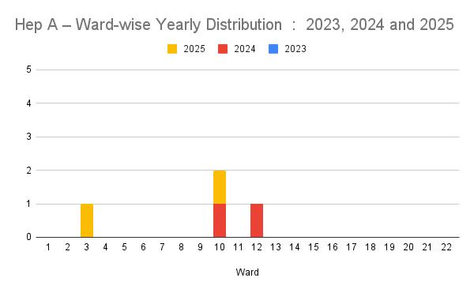Ward-wise Trend of Hepatitis A Cases in Cherthala South Panchayat (2023–2025)

Outcome Based Trend Analysis- 2025
An approach for monitoring and analyzing the disease patterns based on the outcomes or impacts of specific interventions, policies, or public health measures and concerns. It shifts emphasis from merely tracking disease incidence to evaluating the effectiveness of prevention measures implemented for the disease. This type of analysis is crucial for understanding not only the spreadness of diseases but also how well the system is responding to them. This analysis evaluates the impact of various public health measures, determines whether these measures lead to reductions in disease prevalence, morbidity, mortality, or healthcare burden over time and this can be utilized modifying or improving existing health policies, resource allocation, and preparedness plans.

Sl. No. | Type of disease | Age group | Gender |  | Total no. of survival | Total no. of death | No. of cases received treatment
Sl. No. | Type of disease | Age group | No. of Male | No. of Female | Total no. of survival | Total no. of death | No. of cases received treatment
1 | Dengue | under 05 children | 0 | 0 | 0 | 0 | 0
2 | Dengue | 5-19 years | 0 | 0 | 0 | 0 | 0
3 | Dengue | 20-59 years | 2 | 3 | 5 | 0 | 5
4 | Dengue | 60+ (Seniors) | 0 | 1 | 1 | 0 | 1
1 | Lepto | under 05 children | 0 | 0 | 0 | 0 | 0
2 | Lepto | 5-19 years | 0 | 0 | 0 | 0 | 0
3 | Lepto | 20-59 years | 1 | 0 | 1 | 0 | 1
4 | Lepto | 60+ (Seniors) | 1 | 0 | 1 | 0 | 1
1 | VH-A | under 05 children | 0 | 0 | 0 | 0 | 0
2 | VH-A | 5-19 years | 1 | 0 | 1 | 0 | 1
3 | VH-A | 20-59 years | 3 | 1 | 4 | 0 | 4
4 | VH-A | 60+ (Seniors) | 0 | 0 | 0 | 0 | 0

Outcome-based analysis for 2025 indicates 100% treatment coverage and survival for reported cases of dengue, leptospirosis, and viral hepatitis A in Cherthala South Grama Panchayat, with no disease-related mortality recorded during the year. This reflects timely case detection, effective referral mechanisms, and adequate clinical management at the primary and referral care levels.

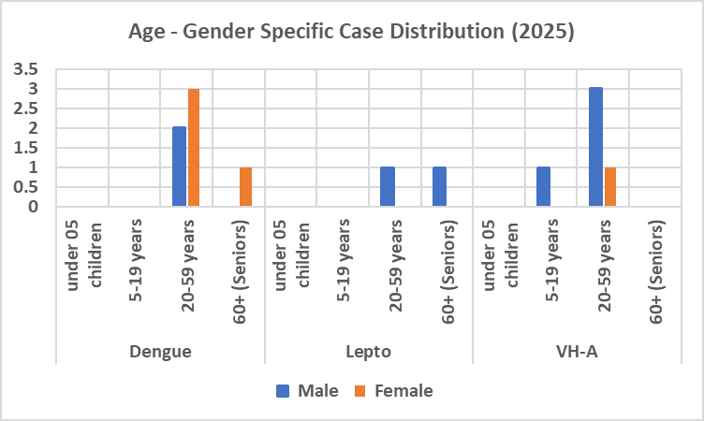

Age- and Gender-wise Case Distribution of Selected Communicable Diseases, 2025
The majority of cases across all three diseases were reported among the 20–59 years age group, representing the economically active population. This pattern suggests occupational and environmental exposure as key risk factors and highlights the importance of workplace-oriented prevention measures and risk communication.
Gender distribution shows a slight male predominance for leptospirosis and hepatitis A, consistent with higher exposure to outdoor and occupational risks, while dengue cases were distributed across both genders. No cases were reported among children under five years.

Overall, the absence of mortality and the high proportion of treated cases demonstrate the strength of the Panchayat’s surveillance, early response, and clinical referral systems. These outcomes support the continued emphasis on early warning systems, seasonal preparedness, and uninterrupted access to care during outbreaks and public health emergencies

Transmission Trend- 2025
For effective management of public health issues, it is important to track the trend of disease transmission mode. It helps to identify the population or the place under high risk that can be used to predict outbreaks, and implement targeted interventions as fast as possible. Understanding these kind of trends enables authorities to allocate resources efficiently and change the strategies adequately based on the trend that follows.

Mode of Transmission | No. of cases | No. of Deaths
Vector Borne Diseases  (Dengue, Malaria, Chikungunya, Zika, JE, Filariasis, Scrub Typhus) | 6 | 0
Water Borne Diseases  (ADD, Viral Hepatitis A & E, Typhoid, Cholera) | 73 | 0
Airborne Diseases  (TB, COVID-19, Influenza (ILI / SARI), Measles , Chickenpox, Diphtheria, Pertussis, Mumps ) | 16 | 0
Blood Borne Diseases  (HIV/AIDS, Hepatitis B ,Hepatitis C , Syphilis) | 2 | 0
Food Borne Diseases  (Food Poisoning) | 0 | 0

Vector Borne Disease

Disease | No. of Cases | No. of Deaths
Dengue | 5 | 0
Malaria | 1 | 0
Chikungunya | 0 | 0
Yellow fever | 0 | 0

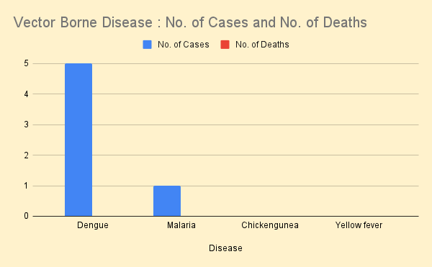

Water Borne Disease

Disease | No. of Cases | No. of Deaths
Cholera | 0 | 0
Typhoid | 0 | 0
Hep- A | 2 | 0
Dysentery | 0 | 0
Amoebiasis | 0 | 0
E- Coli infections | 0 | 0

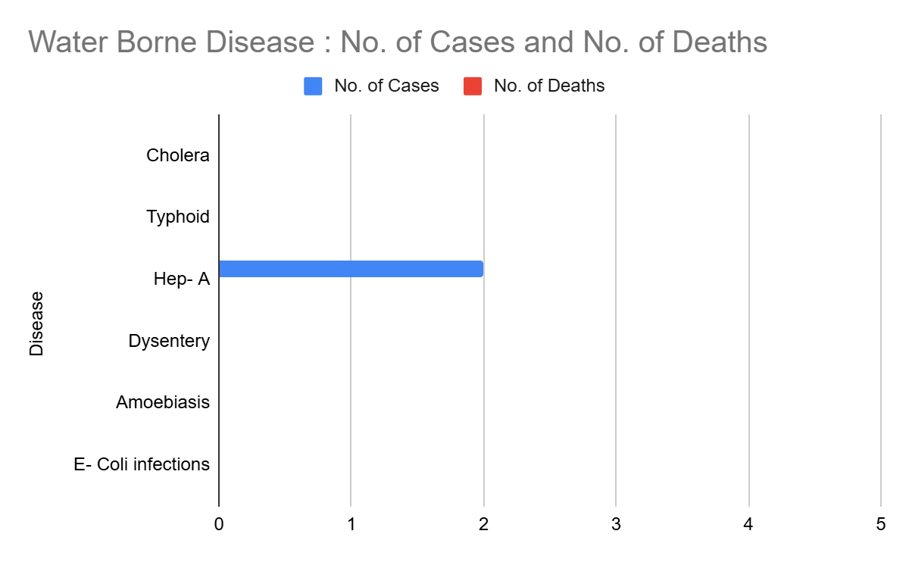

Airborne Disease

Disease | No. of Cases | No. of Deaths
Influenza | 0 | 0
H1N1 | 1 | 0
TB | 12 | 0
Chickenpox | 63 | 0
Measles | 1 | 0
Covid-19 | 0 | 0
Pertussis | 0 | 0
Mumps | 2 | 0

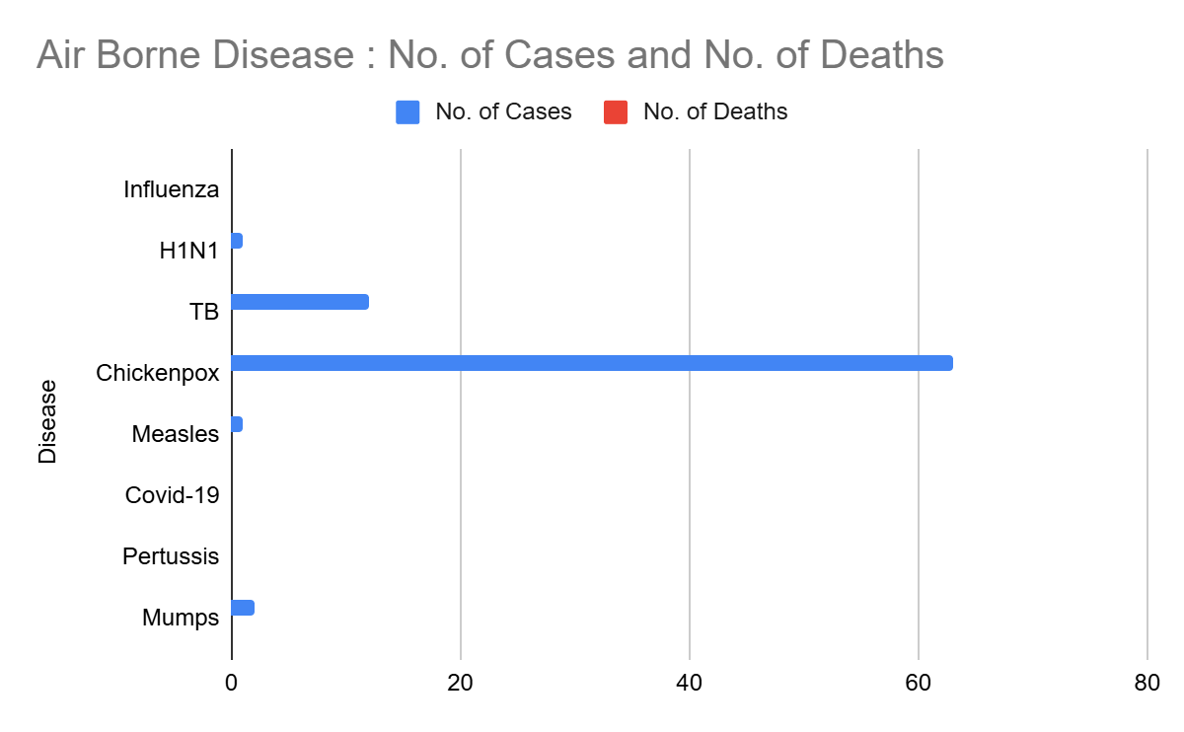

Bloodborne Disease

Disease | No. of Cases | No. of Deaths
AIDS | 0 | 0
Hep- B | 1 | 0
Hep- C | 1 | 0

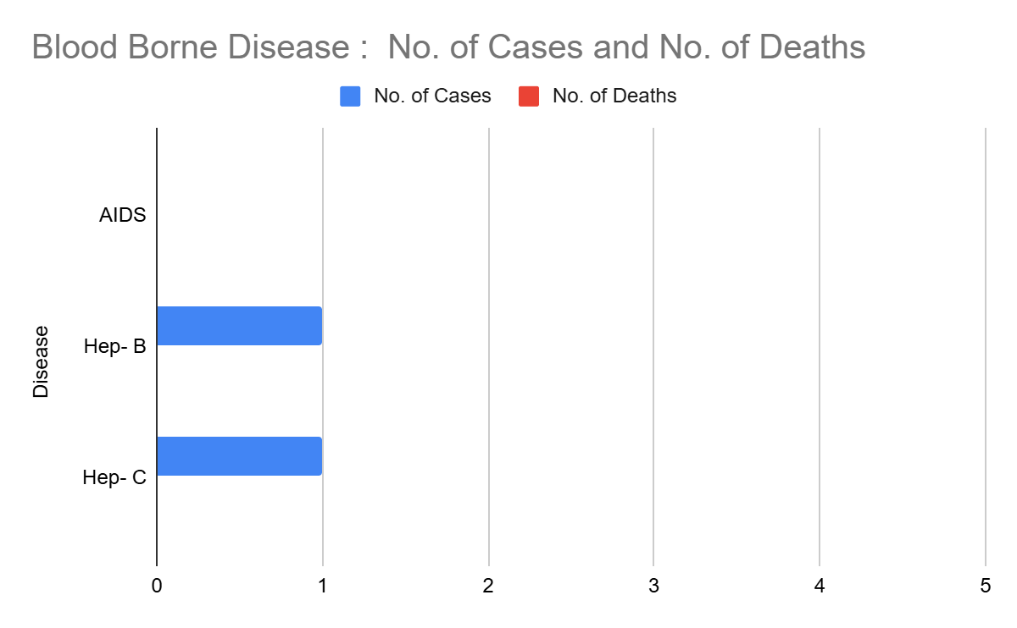

Zoonotic Disease

Disease | No. of Cases | No. of Deaths
Rabies | 0 | 0
Leptospirosis | 2 | 0
Avian influenza | 0 | 0
West nile | 0 | 0
Anthrax | 0 | 00
Nipah | 0 | 0
Scrub Typhus | 0 | 0

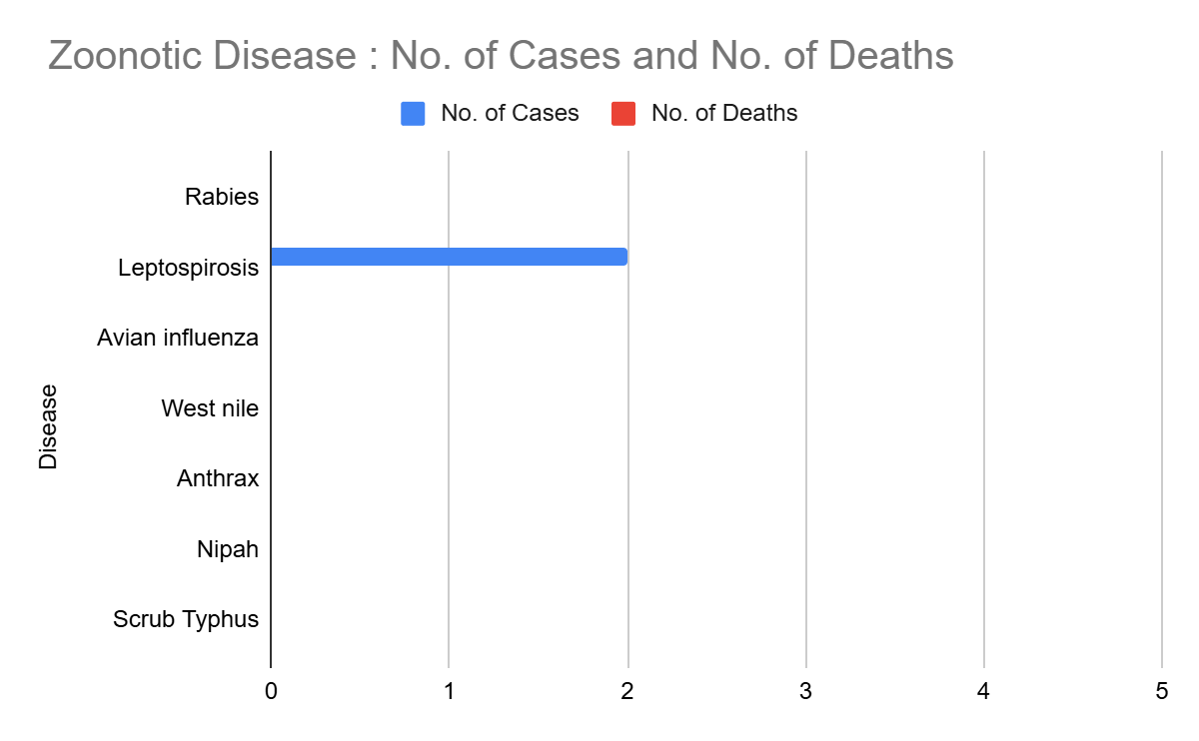

Integrated Disease Hotspot Map (2021–2025)

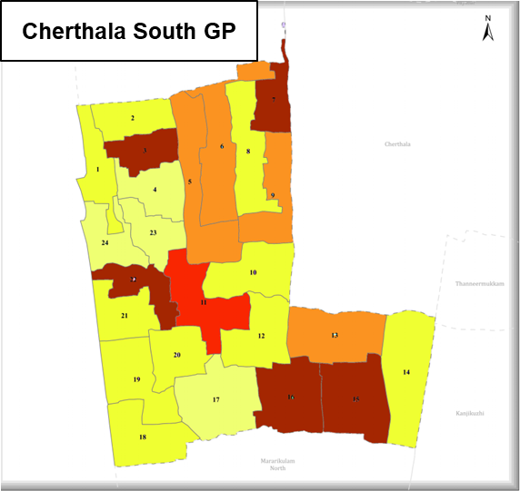

Ward No | Dengue Total (2023-25) | Leptospirosis Total (2023-25) | Hepatitis A Total (2023-25) | Total Cases
1 | 0 | 1 | 0 | 1
2 | 1 | 1 | 0 | 2
3 | 5 | 0 | 1 | 6
4 | 0 | 0 | 0 | 0
5 | 3 | 1 | 0 | 4
6 | 4 | 0 | 0 | 4
7 | 6 | 0 | 0 | 6
8 | 1 | 0 | 0 | 1
9 | 4 | 0 | 0 | 4
10 | 0 | 0 | 1 | 1
11 | 5 | 0 | 0 | 5
12 | 2 | 0 | 0 | 2
13 | 4 | 0 | 0 | 4
14 | 1 | 1 | 0 | 2
15 | 5 | 1 | 0 | 6
16 | 5 | 2 | 0 | 7
17 | 0 | 0 | 0 | 0
18 | 1 | 0 | 0 | 1
19 | 1 | 0 | 0 | 1
20 | 1 | 1 | 0 | 2
21 | 0 | 1 | 0 | 1
22 | 5 | 1 | 0 | 6

By overlaying disease surveillance data from 2023–2025, we have identified 3 high-burden (“Red Zone”) wards where communicable diseases show repeated occurrence. Wards 7 and 16 emerge as the highest priority hotspots, reporting the maximum total case load (7 cases each), indicating increased vulnerability and sustained transmission risk. These wards should be prioritized for strengthened surveillance, vector control activities, and future public health infrastructure interventions such as upgraded clinics, water safety measures, and sanitation facilities.

Preparedness and Response Protocol at LSG Level

This section describes the operational framework for the LSGI once a pandemic is declared. It explains how the LSGI and health system will move from routine data collection to active response, using a One Health approach. The protocol ensures clarity of leadership, defined roles, timely decision-making, and effective coordination between health systems, line departments, and community-based institutions.

Constitution of One Health Committee
The LSGD shall constitute a One Health Committee comprising the LSGI President, Medical Officers (Modern Medicine, AYUSH, and Veterinary), the Health Inspector, and the Veterinary Surgeon. The One Health Committee shall function as the apex decision-making and coordination body for pandemic preparedness and response at the LSGD level. The committee shall be formally notified by the LSGD and shall remain functional throughout all phases of preparedness, response, and recovery.

The committee will meet periodically during the preparedness phase and shift to regular or emergency meetings during an outbreak, depending on the evolving situation. Decisions taken by the committee shall be documented and communicated to all implementing agencies for timely action.

Objective: The One Health Committee coordinates human health, animal health, and environmental protection to prevent and control pandemics.

One Health Committee Member

Sl No | Name | Designation | Department/Institution | Role in Committee | Contact Number
1 | Abhinaya | Panchayat President | LSGD | Chairperson | 9846076564
2 | Dr Nikil Babu | Medical Officer | Health Dept | Member Secretary | 9497050615
3 | Dr Rajalekshmi Radhakrihsnan | Veterinary Officer | Animal Husbandry | Member | 9495964609
4 | Shewta | Epidemiologist | Health Dept | Member | 8606799186
5 | V P Joshy | Health Inspector | Health Dept | Surveillance | 9447265775
6 | Mini MB | ASHA Supervisor | Health Dept | Community link | 9961588731
7 | Dhanya KS | ICDS Supervisor | Social Welfare | Vulnerable groups | 8157978680
8 | Tallson Joseph | SHO | Police Dept | Law & order | 9497910011
9 | Anitha Mary | Standing Committee Chairperson | LSGD | Community coordination | 988867243
10 | Asha | Kudumbashree CDO | Kudumbashree | Community mobilisation | 8075225474
11 | Nelson | NGO/Volunteer rep | Civil Society | Support services | 9249229765

Roles and Responsibilities of the One Health Committee
- Review disease surveillance data (human + animal)
- Conduct ward-wise risk assessment and vulnerability mapping
- Approve quarantine/isolation centre locations
- Coordinate with district for resources (PPE, oxygen, ambulances)
- Periodically review health system surge capacity, including beds, oxygen, human resources, and ambulances.
- Approve and monitor risk communication and community engagement strategies, including rumour management.
- Ensure protection and service continuity for vulnerable groups (elderly, persons with disabilities, dialysis patients, coastal populations).
- Conduct quarterly mock drills
- Monitor equity measures for vulnerable groups

Meeting Schedule:
Quarterly (normal times) | Weekly (outbreak alert) | Daily (pandemic phase)

Decision-Making and Reporting Mechanism
The Medical Officer (Modern Medicine) shall act as the Member Secretary and nodal officer for coordination with higher health authorities. All urgent decisions during an outbreak shall be taken in consultation with the Chairperson and key members, and reported to the Block Medical Officer and District Health authorities without delay. Minutes of meetings, action points, and follow-up responsibilities shall be clearly recorded to ensure accountability and continuity.

Pandemic Response Workforce

To ensure a coordinated and timely response during a pandemic, a dedicated Pandemic Response Workforce shall be constituted at the LSG level. The workforce will function under the overall supervision of the One Health Committee and in close coordination with the health authorities. Team-based deployment will enable efficient surveillance, case management, quarantine and isolation management, logistics support, and risk communication. Each team shall have a clearly designated team leader, defined roles, and an identified pool of personnel to allow rapid activation, rotation of duties, and continuity of services during prolonged emergencies.

Team Name | Composition | Numbers Available | Key Responsibilities | Team Leader
Surveillance and Contact Tracing Team | HI, JHI, JPHN, ASHAs and Volunteers | HI: 1  JHI: 4  JPHN: 6  ASHA: 44  Volunteers: 1078 | Case detection, contact listing, home visits, reporting | VP Joshy
Case Management Team | Doctors, Nurses, MLSP, Palliative Nurses | Doctors: 4  Nurses: 3  MLSP: 6  Palliative: 1 | Patient care & referral | Dr Nikil Babu
Quarantine & Isolation Team | LSGD staff, Volunteers | LSGD staff: 17  Volunteers: 372 | Facility management | Baiju  Secretary
Logistics Team | LSGD staff, Storekeepers, Drivers | LSGD staff: 17  Drivers: 2 | Supplies & transport [PPE, medicines, oxygen, transport, waste management] | Roymon  AS
Communication Team | Ward members, Kudumbashree, Youth clubs,  AWW workers | Ward members: 24  Kudumbashree: 372 | IEC, community meetings, countering misinformation | Asha  CDS Chairperson

All teams shall be activated immediately upon outbreak alert or pandemic declaration and shall report daily to the LSG Incident Commander/Medical Officer, with consolidated reporting to the Block PHC. Duty rosters and alternate personnel shall be maintained to ensure uninterrupted services during staff shortages or prolonged response periods. Team composition and numbers may be revised based on the magnitude of the outbreak and availability of human resources.

Activities and Measures before and during Pandemic
Guidelines for active containment and monitoring.

PHASE 1 - Alert / Preparation

Activate One Health Committee
  - Immediately activate the One Health Committee at the LSG level. Convene an emergency meeting to review risk assessment, roles, and preparedness. Ensure coordination between Health, Veterinary, Agriculture, Local Self Government, and allied departments.
  - Prepare and circulate a contact directory of all committee members and emergency services.
  - Ensure documentation of decisions and action points with timelines.
  - Escalation hierarchy to be finalised (LSG to Institution to Block to District).

Surveillance and Reporting
Objective: To ensure early detection, timely reporting, and response to potential outbreaks through enhanced facility-, community-, and event-based surveillance
- Enhanced syndromic surveillance:
The LSGD shall initiate enhanced surveillance for priority syndromes and events such as:
  - Fever
  - Influenza-like illness (ILI)
  - Severe acute respiratory infection (SARI)
  - Unusual illness clusters (any unexpected increase in similar symptoms in a defined area or group)
Data sources for surveillance:
- Ward-wise household surveillance (through ASHAs/JPHNs/ward volunteers)
- Outpatient surveillance from all government facilities (PHC, FHC, CHC, GH, etc.)
- Private hospitals, clinics and labs
Event-based triggers (to be monitored and reported):
- School absenteeism above the usual pattern (to be monitored through the headmaster/PTA nodal person)
- Sudden increase in pharmacy sales of fever/cough/cold medicines
- Workplace illness clusters (multiple staff reporting similar symptoms within a short period)
- Zoonotic and animal health surveillance
- LSGD shall review reports of unusual animal deaths or suspected outbreaks in animals in coordination with the Veterinary Officer..

- Any unusual mortality in poultry, pigs, cattle, companion animals, or wild birds/mammals shall be notified within 24 hours to the Veterinary Officer and One Health Committee for joint investigation.

Reporting Mechanism:
All government and private health facilities, laboratories, and clinics within the LSGD shall report suspected and confirmed cases of notifiable diseases. Unusual clusters (schools, workplaces, neighborhoods, events, institutions) shall be reported within 24 hours of detection for verification and field investigation.​

Logistics and Stock Preparedness
  - Identify and empanel local vendors and define emergency procurement mechanisms in accordance with existing LSGD and Health Department norms.

  - Prepare and maintain an essential logistics checklist covering medical supplies, consumables, and support equipment.
  - Pre-identify secure storage locations for emergency stocks and ensure maintenance of stock registers with regular updating.
  - Finalise emergency transport arrangements, including availability of vehicles and identified drivers for rapid deployment during alerts.
  - Designate a Nodal Officer for Logistics to enable prompt decision-making, coordination, and communication during emergencies.
  - Conduct rapid stock verification and ensure availability of minimum buffer stock, including:
Identify critical gaps in logistics and immediately communicate requirements to the Block and District authorities for timely replenishment and support. Monitor expiry dates and stock rotation.

Identification of Quarantine and Isolation Facilities
  - Identify and list suitable buildings for quarantine and isolation (schools, hostels, community halls, etc.).
  - Categorize cases as per the severity and allocate to appropriate facilities (for instance, severe cases to class rooms, mild case to an assembly hall in case of a school).
  - Facility readiness checklist needed (beds, toilets, ventilation) etc.
  - Find alternate site if primary sites not available or not in use condition.
  - Identify facility managers and support staff
  - Prepare basic SOPs for:
    - Admission and discharge
    - Food, water, sanitation
    - Infection prevention and waste disposal
  - Ensure availability of basic amenities: water, sanitation, electricity, ventilation, and waste disposal. Prepare a rapid activation plan for these facilities if case numbers increase.

Risk Communication and Community Preparedness
  - Disseminate early warning messages on symptoms, preventive measures, and reporting mechanisms. Display IEC materials both in English and the local language in public places and ensure ward-level awareness.
  - Sensitize elected representatives and community leaders on preparedness measures.
  - Establish a rumour tracking and misinformation response mechanism to identify, verify, and promptly counter false or misleading information.
  - Engage trusted local persons (ward members, ASHA workers, religious leaders, teachers, community volunteers) to communicate official public health messages and reinforce correct practices.
  - Develop and deploy targeted IEC materials for:
    - Schools and educational institutions
    - Markets and commercial areas
    - Work sites and labour settings
  - Conduct community sensitization meetings at the ward level to promote preventive behaviors, address concerns, and strengthen community participation in preparedness and response.

Protection of Vulnerable Groups
Vulnerable populations require priority protection through targeted line-listing, service continuity, and delivery mechanisms.
- Prepare and regularly update line-lists of vulnerable populations, including:
  - Elderly persons living alone
  - Persons with disabilities
  - Pregnant women
  - Migrant workers
The detailed line-lists shall be maintained as Annexure ___ and updated periodically.

Clinical Dependency Mapping
Develop ward-wise dependency and vulnerability maps to identify households requiring regular support during emergencies. Ensure continuity of essential health services for vulnerable groups, including
- Dialysis services (facility mapping, transport arrangements, and scheduling)
- Continuity of treatment for TB, HIV, and other chronic conditions requiring uninterrupted medication
- Mental health and psychosocial support services
Establish delivery mechanisms for food, essential commodities, and medicines to vulnerable households through coordinated action involving ASHAs, JPHNs, Kudumbashree, volunteers, and local administration.

PHASE 2 - Active Response

Case Identification and Contact Tracing
Case detection and contact tracing activities will be carried out in coordination with the Health authorities, following disease-specific SOPs and IDSP guidelines.
Field Staff Involved
- Health Inspector (HI)
- Junior Health Inspector (JHI)
- Junior Public Health Nurse (JPHN)
- ASHAs and ASHA Supervisors
- Ward-level volunteers and Kudumbashree members (as required)

Screening Checkpoints
Screening checkpoints at high-traffic locations (transport hubs, markets, religious gatherings) for early detection of symptomatic travelers and crowd screening during outbreaks. Potential locations include bus stands, market entry points, and boat jetties, based on local context and risk assessment.
Screening activities will be carried out by trained personnel such as ASHAs, ward members, and volunteers, with support from Health Department staff. Necessary equipment including non-contact thermometers and appropriate PPE shall be ensured prior to activation.

Location | Type | Staff Deployed | Reporting authority
Thiruvizha Railway Station | Railway Station | Joby (JHI) | MO
Arthunkal Bus Stand | Bus Stand | Bindhu (JHI) | MO
Thiruvizha Temple | Temple | ASHA | MO
Arthunkal Church | Church | JPHN | MO

Standard Screening Protocol

The screening protocol shall include temperature screening, observation for visible symptoms, and inquiry regarding recent travel or exposure history. Individuals identified as suspects during screening shall be immediately referred to the nearest PHC/FHC for further evaluation, testing, and appropriate action as per prevailing guidelines.

Pandemic Control Room
The Pandemic Control Room (PCR) functions as the central coordination and command unit for managing pandemic and infectious disease emergencies at the LSGD level. It enables real-time monitoring, data aggregation, intersectoral coordination, and timely decision-making during all phases of a pandemic. The Control Room acts as the single point of information flow between the LSGD, health system, line departments, community institutions, and higher authorities.
The PCR consolidates surveillance data from health facilities, field-level health workers, laboratories, and community sources to support rapid assessment of disease trends, case load, resource availability, and response gaps. It also serves as the primary platform for coordinating containment measures, referral services, logistics, and risk communication.

Control Room Infrastructure and Location
Primary Location: LSGD Office
Backup Location: Family Health Centre (FHC), Cherthala South (to be activated if the primary location becomes non-functional or inaccessible)
Both locations shall be equipped to ensure uninterrupted functioning during emergencies, including power supply, communication facilities, and workspace for designated personnel.

Health System Control Room Framework
The PCR is organized into seven functional pillars to ensure no aspect of the response is overlooked:

Rapid Response Team (RRT)
  - Provides immediate intervention during emergencies, clusters, and field alerts.​
  - Coordinates urgent actions such as case investigation, contact tracing, isolation, and inter‑facility referrals.

Data Management & Analytics Team
  - Collects, validates, and manages key health system indicators (cases, tests, beds, HR, supplies).​
  - Analyzes data trends, generates projections, and supports evidence‑based decision‑making for local authorities.

Human Resource Deployment Team
  - Allocates healthcare staff efficiently based on workload and need
  - Ensures adequate and equitable workforce distribution across facilities

Laboratory Surveillance Team
  - Oversees diagnostic testing coordination, sample transport, and timely reporting of results.​
  - Monitors lab indicators (testing volume, positivity rate, turnaround time) for early detection of outbreaks

Vaccination Cell (If Required)
  - Plans and executes vaccination campaigns, including micro‑planning and session scheduling.​
  - Tracks coverage, identifies gaps, and coordinates corrective actions with field teams and outreach services.

Infrastructure & Patient Occupancy Team
  - Monitors facility capacity, earmarked beds, oxygen and critical care resources across all linked facilities.​
  - Ensures optimal patient distribution and referral management using updated bed‑status and resource data.

Policy Execution & Strategy Team
  - Implements health policies, SoPs, and government orders within the LSGD jurisdiction.​
  - Develops local strategies, reviews compliance, and recommends modifications based on field feedback and data.

Key Control Room Team
The Control Room Team coordinates all pandemic response activities within the LSGD and serves as the single command and communication hub during activation. It integrates information, field actions, logistics, and policy execution across all participating departments and health facilities.

Role | Name | Designation | Contact Number | Responsibility
In-charge/Nodal Officer | Shibu | Secretary | 9446370751 | Overall coordination, decision-making, and reporting to the District level.
Data Entry Operator | Staff from LSGD | Staff available at the time of emergency. |  | Managing the line list, updating dashboards, and tracking testing results.
Communication Officer | V P Joshy | Health Inspector | 9447265775 | Handling the public helpline, coordinating ambulance dispatch, and contact tracing calls.
Technical Support (IT/Data) | TA LSGD(Sangeeth) | Technical Assistant | 9567580097 | Provides Technical Support

Key Points:
- The Control Room shall be staffed with a designated In-charge, data entry personnel, and communication staff with clearly defined roles and shift arrangements.
- It shall maintain updated records on daily monitoring indicators including new cases, persons under active quarantine, and hospital bed occupancy.
- All reports and situation updates shall be shared daily with the Block and District Surveillance Unit.
- The Control Room shall act as a single point of contact for coordination with response teams, health institutions, and other departments.
- Contact details of the Control Room shall be widely communicated to field staff and stakeholders during activation.

Daily Monitoring Indicators
To ensure timely decision-making and effective response, the following key indicators shall be monitored and updated on a daily basis by the Pandemic Control Room:

Epidemiological Indicators:
New cases reported today, Total active cases, Test Positivity Rate (TPR), Case Fatality Rate (CFR)
- Surveillance Indicators:
Persons under home quarantine, High-risk contacts identified, Fever, ILI, SARI or other symptoms (syndromic surges), Travellers (symptomatic or high-risk arrivals),Animal husbandry surveillance (zoonotic alerts, unusual animal deaths, poultry/bird flu signals), Mortality surveillance (excess deaths, unexplained fatalities, verbal autopsy reports)
- Logistics and Infrastructure Indicators:
Hospital / CFLTC beds occupied, Oxygen cylinders / concentrators available, Ambulances on standby
- Alert Findings
The following table outlines category-specific trigger points (red flags) from surveillance indicators and corresponding immediate actions for the Pandemic Control Room. These enable rapid response to alert findings like testing anomalies, positive cases exceeding thresholds, clusters, and WGS reports.

Category | Trigger Point (Red Flag) | Immediate Action
Clusters | Geographical or facility-based: 5+ cases linked to one location (office, school, street). | Declare a micro-containment zone; perimeter control and active case finding.
Testing | Sudden drop in testing volume / delay in reporting / unusual testing trends | Review the sample collection process, address lab bottlenecks, deploy additional testing teams, and notify the District Lab.
Lab | Test Positivity rate increases | Increase testing sites in that ward.
Hospital | >80% Oxygen bed occupancy | Activate backup/CFLTC beds.
Travel | Cluster of cases from a single flight/train or high-risk arrival group. | Trace all passengers in adjacent seats; implement mandatory institutional quarantine.
Animal | Mass poultry/wildlife death or unusual sickness | Notify Animal Husbandry, sample the area, and dispatch RRT for environmental sampling and zoonotic check.
Mortality | Sudden spike in home deaths or brought-in-dead (BID) cases | Audit the deaths and Active Case Search drive
Whole Genome Sequencing (WGS) | Detection of a Variant of Concern (VOC) or Variant of Interest (VOI) | Implement strict micro-containment; update clinical protocols to match variant severity.

Communication of Public Health Information
A Community Communication Hub shall be established to ensure timely, accurate, and consistent dissemination of information during a pandemic. The Hub will function under the coordination of the president and act as the nodal point for public communication, risk messaging, and community engagement. It will support dissemination of official advisories, promote preventive behaviors, address rumors and misinformation, and ensure that messages reach all sections of the population through trusted local channels and leaders.

Key communicators
Channel | Responsible Person | Contact
Ward-level announcements | Ward Member | Refer to Annexure
Social media | TA LSGD | 9567580097
Local Cable TV/Radio | HI | 9447265775

All messages disseminated through the Hub shall align with advisories issued by the Health Department and District authorities.
Community leaders shall be sensitized to support behavior change, reduce stigma, and counter misinformation.
Special efforts shall be made to reach vulnerable and hard-to-reach populations using locally appropriate communication methods.

Rumor Tracking: A designated volunteer will monitor local social media/WhatsApp groups daily to identify misinformation and issue official clarifications via the Communication Hub.

Coordination with District/State Authorities & Other Organisations
Effective coordination with Block, District, and State authorities is essential to ensure timely reporting, technical guidance, and uninterrupted supply of essential resources during a pandemic. The LSG shall establish clear communication channels, designate responsible officers, and adhere to prescribed reporting timelines to support coordinated public health action and efficient resource mobilisation.

Key Details:
- Nodal Officer for Reporting: Panchayat Secretary
- Contact Number: 9446370751

Reporting Schedule and Protocols:

To Whom | What to Report | Frequency | Nodal Person
Block PHC | Complete Situation Report (Cases, Quarantine, Beds, Screening, Deaths) | Daily | Health Inspector
District IDSP Unit | Outbreaks/Clusters/Unusual Events (>5 cases same ward) | Within 24 hrs | Health Inspector
Veterinary Officer | Animal health events/Zoonotic alerts | as early as possible | Health Inspector
State Cell | Zoonotic cross-sector events | as early as possible | Health Inspector

Supply Chain Coordination
The LSG shall coordinate closely with Block, District, and State authorities (KMSCL) to ensure uninterrupted availability of essential goods, medical supplies, and logistics during a pandemic. Supply requirements shall be assessed regularly based on case load and communicated promptly to the appropriate authorities for timely replenishment.
Key Points:
- Maintain updated contact details of District and Block nodal officers for health logistics, oxygen supply, ambulances, and essential medicines.
- Submit timely indent requests for PPE, testing kits, medicines, oxygen, and other critical supplies through prescribed channels.
- Monitor stock levels at LSGD facilities, quarantine/isolation centres, and field teams through daily stock registers and dispensing logs to prevent shortages.
- Coordinate with District authorities, Karunya/Neethi medical shops, and local purchase committees for funds allocation and emergency procurement.

- Ensure regular monitoring of dispensing registers at all facilities to track usage, expiry, and pilferage—shortages being a perennial issue requiring proactive weekly audits.

- Activate surge procurement protocols during high caseloads, leveraging local purchase powers under LSGD funds alongside state supplies.

Resource Inventory and Contacts
Resource Category | Source (District/State/Private) | Contact
PPE Kits/Masks/Gloves | KMSCL | 9895214070
Oxygen Cylinders/Concentrators | KMSCL / Private Suppliers | 9895214070
Medicines/Antivirals | KMSCL / Karunya/Neethi Shops / District | 9895214070
Test Kits (RTPCR/Rapid) | ICMR-KMSCL / District Lab Network | 985214070
Ambulances (ALS/BLS) | 108 | 108
Vaccines (if applicable) | State Cold Chain / District | 9497544598

Collaboration with NGOs, PPP, and CSR
To augment government efforts during a pandemic, the LSG shall collaborate with NGOs, voluntary organisations, and private sector partners through public–private partnerships and Corporate Social Responsibility (CSR) initiatives, in coordination with District authorities.
Key Points:
- Engage NGOs and community-based organisations for community outreach, awareness, and support to vulnerable populations.
- Leverage CSR support for procurement of medical equipment, PPE, oxygen concentrators, food kits, and sanitation materials, as permitted.
- Ensure all collaborations align with government guidelines and are routed through approved administrative and financial procedures.
- Maintain transparency and documentation for all external support received and utilised.
Organization | Type | Support Offered | Contact Person
Rotary Club, Cherthala | CSR | Food, Equipment, Voluntary Support | Ajeesh Gopinath  90485 06471
St. Sebastian Visitation Hospital | Private | Treatment support, Daignostic , IP facility | 0478 257 2291
Kudumbashree NHG | CBO | Voluntary support for food and medicine supply, Food preparation | Asha  8075225474
Lion's Club | NGO | Food, Equipment, Voluntary Support | Sheela  9446891054
Cocotuff | Company | Voluntary support- food kit, medicines , space etc | 94951 55555
St Andrews Basilica | FBO | Space, food, Medicine support | 9745197060
Shahul Hameed Memorial Palliative care | CBO | Ambulance, food kit, medicine | 9495772487

Interdepartmental Coordination
Coordination among departments during a pandemic shall be ensured through regular review meetings convened by the LSGD President. These meetings will provide a structured platform for sharing situational updates, assessing resource availability, resolving operational gaps, and taking joint decisions to ensure a coordinated and timely response.

Department | Representative | Key Role | Contact
Health (PHC) | Dr Nikhil Bbau (MO)  V P Joshy (HI) | Case management | 9497050615  9447265775
Veterinary | Dr. Rajalakshmi | Animal surveillance | 9495964609
ICDS | Dhanaya | Nutrition support | 8157978680
Education | Jeeja Bai (Principal)  Meera (HM) | School coordination | 9446637215  9496153157
Police | SHO | Containment enforcement | 9497910011
Fire/Rescue | Station officer | Disinfection support | 0478 2812455
Water Authority | AE | Water supply | 0478 2813012  9446917670

PHASE 3 - Surge Capacity
Phase 3 is activated when there is a rapid increase in cases, high test positivity rates, or when existing health facilities and quarantine arrangements approach saturation. The focus of this phase is to expand isolation capacity, augment clinical care services, and mobilise additional resources through district and state support mechanisms.

Conversion of Community Facilities
To manage increased case load, the LSGD shall activate additional isolation facilities by repurposing identified community infrastructure such as community halls, auditoriums, schools, hostels, or other suitable buildings.

Facility Type | No. of Buildings | Ward | Cumulative Surge Capacity | Nodal Person
Community Halls | 1 | Ward 6 | 60 beds | Ward Member
Schools | 13 | Ward | 5000 beds | Ward Member
Auditoriums | 6 | Ward | 2000 beds | Ward Member
Religious Halls | 14 | Ward | 4000 beds | Ward Member
Hostels/Dormitories |  | Ward | ………..beds | Ward Member
Total Surge Capacity | ___ buildings | All wards | ___ beds | LSGD Engineer

Note: For the specific names, contact numbers, and locations of the 13 schools (e.g., St. Francis HSS, Govt HSS Cherthala South) and other buildings, please refer to the Resource Directory in the Annexure

Trigger for Activation and Massive Surge Capacity
Phase 3 is activated when primary health facilities reach 80% saturation or when localized outbreaks require massive isolation capacity. To manage this, the LSGD implements a rapid conversion strategy, repurposing the 45+ community buildings identified in the Resource Inventory (Section 1.5–1.9). This includes 13 educational institutions (such as St. Francis HSS and Govt HSS Cherthala South), 6 auditoriums, and 14 religious halls. Together, these facilities provide a cumulative surge reservoir of over 15,000 beds, ensuring the Panchayat can accommodate large-scale quarantine or treatment needs within its own geographic boundaries.

Technical Standards and Engineering Readiness
The LSGD Engineer is responsible for the rapid technical modification of these spaces to meet Clinical Safety Standards. This process involves Establishing "Red" and "Green" zones for staff and patients, ensuring separate entry/exit points to prevent cross-contamination. Engineering priorities include optimizing natural ventilation, installing temporary partitions for privacy, and ensuring a minimum of two toilets per ten-bed unit. Coordination with the KSEB and KWA is mandatory to guarantee uninterrupted power and water supply, alongside the deployment of portable oxygen concentrators from the FHC "Oxygen Bank" for patient stabilization.

Recovery and rehabilitation phase
The recovery and rehabilitation phase begins once the immediate public health emergency is controlled and transmission is reduced to manageable levels. This phase focuses on restoring essential services, addressing long-term health and socio-economic impacts, and strengthening systems to prevent or better manage future pandemics.
Recovery

Recovery
Recovery refers to the gradual return of communities and systems to normal functioning while continuing public health vigilance. It involves phased withdrawal of emergency measures, reopening of services, and reintegration of disrupted health and social systems. Recovery activities should be evidence-based, inclusive, and aligned with national and state guidelines to ensure sustainability and resilience.

Damage and Impact Assessment
Before long-term rebuilding can happen, the dust must be settled and the immediate risks managed.Damage and impact assessment is a critical step to understand the full extent of the pandemic’s effects on health systems, communities, and livelihoods. This assessment evaluates disruptions to healthcare services, availability of infrastructure and workforce, morbidity and mortality patterns, and socio-economic consequences such as loss of income, education disruption, and food insecurity. The findings inform evidence-based planning, prioritization of interventions, and optimal allocation of resources during the recovery phase.

Restoration of Health Services
Recovery requires moving beyond emergency trauma care. This sub-phase focuses on reopening primary care clinics, restarting routine immunization programs, and ensuring that patients with chronic conditions (like diabetes or hypertension) can once again access life-sustaining medications and check-ups.

Environmental Cleanup and Sanitation
Post-disaster environments are often breeding grounds for secondary health crises. Cleanup efforts focus on removing debris, managing hazardous waste, and restoring water and sewage systems. Ensuring a "clean slate" is biologically necessary to prevent the spread of waterborne and vector-borne diseases.

Rehabilitation
Rehabilitation focuses on addressing the long-term physical, social, and economic impacts of the pandemic on affected individuals and communities. This includes medical rehabilitation for post-infection complications, nutritional support for vulnerable groups, and social assistance for households affected by illness, disability, or loss of livelihood. Rehabilitation efforts should promote reintegration into education, employment, and community life, with special attention to marginalized and high-risk populations.

Physical and Livelihood Rehabilitation
For those left with lasting injuries, rehabilitation involves providing physical therapy and assistive devices. Simultaneously, Livelihood Restoration addresses the economic health of the community; without the ability to earn an income, individuals cannot sustain their own long-term health and nutrition. Support for small businesses, informal workers, self-help groups, and skill development initiatives is essential to promote economic resilience and long-term recovery.

Psychosocial and Mental Health Support
The trauma of a disaster often outlasts the physical damage. Providing psychological first aid and long-term mental health counseling is vital for community cohesion. This support helps individuals process grief and anxiety, reducing the long-term societal burden of PTSD.

Community Engagement and Confidence Building
Recovery fails if the public does not trust the systems being rebuilt. Active communication and involving local leaders in the decision-making process help rebuild social capital. This ensures that the population feels safe returning to schools, workplaces, and hospitals. Active involvement of community leaders, local self-governments, and civil society organizations strengthens community ownership, promotes adherence to public health measures, and enhances preparedness for future emergencies.

Vigilance and Disease Surveillance
Disease surveillance during the recovery phase ensures early detection of resurgence, secondary outbreaks, or emerging variants. Surveillance systems should continue monitoring communicable disease trends, post-pandemic complications, and unusual health events. Strengthening laboratory capacity, sentinel surveillance, and community-based reporting mechanisms enables timely response and supports sustained public health security.

System Strengthening and Future Preparedness
The final stage of recovery is an intellectual exercise in "Building Back Better," turning the tragedy of the past into the safety of the future.

Documentation and After-Action Review (AAR)
Once the immediate pressure has subsided, stakeholders must conduct a formal review of the response. This involves a candid look at what worked, what failed, and where communication broke down. These Lessons Learned are then transformed into Best Practices.

Policy Revision and Health System Strengthening
The ultimate goal of recovery is to ensure the next crisis is less damaging. This involves updating emergency protocols, revising public health laws, and investing in more durable infrastructure. Through Research and data analysis, the health system is "hardened" against future threats, moving the community from a state of vulnerability to a state of permanent readiness.

Research
Research during the recovery phase is essential to generate evidence on the long-term health, social, and economic impacts of pandemics. Operational, clinical, and policy research should examine the effectiveness of response and recovery interventions, community behaviors, and innovations in service delivery and surveillance. Research findings should inform future preparedness strategies and public health decision-making.

Recovery & Rehabilitation Master Checklist

1. Assessment & Infrastructure Restoration
[ ] Conduct Multi-Sectoral Impact Assessment: Complete a full audit of damage to health facilities, equipment, and digital infrastructure.
[ ] Restore Essential Utilities: Verify that hospitals and clinics have stable access to clean water, electricity, and medical gas.
[ ] Re-establish Supply Chains: Transition from emergency "push" systems to routine procurement for medications and consumables.
[ ] Environmental Safety Check: Clear all hazardous debris and certify that sanitation/waste management systems are fully functional.

2. Clinical & Public Health Continuity
[ ] Resume Primary Care: Transition staff from emergency roles back to routine services (Maternal health, NCDs, Immunizations).
[ ] Launch Recovery-Phase Surveillance: Implement enhanced monitoring for infectious diseases common in post-disaster settings.
[ ] Clear Patient Backlogs: Identify and schedule patients whose elective surgeries or treatments were delayed during the crisis.
[ ] Environmental Health Audit: Test local water sources and food supply chains for contamination post-cleanup.

3. Human-Centric Rehabilitation
[ ] Deploy Psychosocial Support: Establish long-term mental health clinics and peer support groups for survivors and first responders.
[ ] Physical Rehab Integration: Provide specialized care, prosthetics, and occupational therapy for those with permanent injuries.
[ ] Livelihood Support Coordination: Partner with NGOs to provide micro-grants or vocational training to displaced healthcare workers or patients.
[ ] Community Feedback Loop: Create a "Town Hall" or digital platform for citizens to report gaps in the recovery process.

4. Administrative & System Strengthening
[ ] Initiate After-Action Review (AAR): Schedule debriefing sessions with all stakeholders to document successes and failures.
[ ] Financial Reconciliation: Audit emergency spending and finalize insurance claims or international aid reports.
[ ] Knowledge Management: Compile a "Lessons Learned" report and share it with regional and national health authorities.
[ ] Update Preparedness Plans: Revise Standard Operating Procedures (SOPs) based on real-world data gathered during the crisis.
[ ] Research & Development: Identify areas where the response was slowed by lack of data and initiate studies to close those gaps.

5. Confidence & Policy
[ ] Launch Public Information Campaign: Use local media to inform the public that services have resumed and are safe to use.
[ ] Legislative Advocacy: Present findings to policymakers to secure funding for "Build Back Better" infrastructure projects.
[ ] Staff Wellness Check: Conduct mandatory mental health screenings for healthcare workers to prevent burnout and PTSD.

CONCLUSION
This Pandemic Preparedness Plan outlines a comprehensive, decentralised, and action-oriented framework for preparedness and response at the LSGD level. By adopting a One Health approach and strengthening coordination between the health system, local self-government institutions, veterinary services, and community networks, the LSGD aims to ensure early detection, rapid response, and effective containment of pandemics and public health emergencies.
The plan emphasises equity, community participation, and evidence-based decision-making to protect vulnerable populations and ensure uninterrupted access to essential services during crises. It reinforces the importance of local leadership, accountability, and inter-sectoral collaboration in translating preparedness plans into timely action on the ground.
Regular updating, mock drills, capacity building of frontline workers, and sustained interdepartmental coordination will be critical to maintaining readiness and resilience. The successful implementation of this plan depends on collective responsibility, continuous monitoring, and adaptive management in response to emerging threats.
This document shall serve as a living operational guide, to be activated during alerts and continuously improved based on evolving risks, lessons learnt, and guidance from higher authorities, thereby strengthening the LSGD’s ability to safeguard public health.
“Together for a Healthier and Safer Community.”

RECOMMENDATIONS
- It is recommended that ward-level risk grading be institutionalised using the Hazard Risk Index (HRI) to guide prioritisation of resources and strategic deployment of emergency response teams. Incorporating indicators such as hazard frequency, population density, infrastructure integrity, and environmental vulnerability will ensure a comprehensive and context-sensitive assessment of ward-level risk. This approach will enable early intervention in high-risk zones and help mitigate spillover effects to neighbouring areas through targeted preparedness and response measures.
- In high-risk wards, particularly those reporting higher mortality or long-term morbidity, the application of survival analysis is recommended to strengthen risk stratification and guide sustained response planning. By analysing time-to-event outcomes, this method can identify areas requiring prolonged recovery support, facilitate evidence-based allocation of resources, and inform interventions addressing both immediate health impacts and long-term disease burden.
- To strengthen forward-looking disaster preparedness, hazard and risk projections should be modelled under the Representative Concentration Pathway (RCP 8.5) climate change scenario. Integrating climate projections will support scenario-based planning by anticipating future changes in hazard frequency and intensity, including extreme weather events, sea-level rise, and shifting disease patterns.

ANNEXURE

IMPORTANT PHONE NUMBERS

Phone numbers and particulars of persons responsible for providing guidance, assistance, and support for pandemic preparedness operations may be provided here in a manner that allows easy reference at a glance. The information recorded here could be exhibited elsewhere at the time of emergencies. LSG institutions shall give special attention to collect and record the above data of persons and institutions who/which are supposed to give technical and co-ordination support to reduce the impact of disasters.

1.1. Details of grama panchayat
Sl.No | Name of the ward | Ward number | Name of the ward member | Contact number
1 | FISH LANDING CENTRE | 1 | SAJITH ANTONY | 8593037069
2 | THAICKAL | 2 | BABU ANTONY | 9961042652
3 | AAYIRAMTHAI | 3 | SUDHIN N P | 7356408073
4 | ARAVUKAD | 4 | PRINCY | 8157996412
5 | PARUTHYAMPALLY | 5 | VIDHYA V K | 9496372396
6 | AMBEDKAR WARD | 6 | SURESH | 9633607700
7 | MADACKAL | 7 | JAIMON | 9048854937
8 | PADINJARENALPATHU | 8 | MANJU N M | 9142433506
9 | MATTAVANA | 9 | GIREESH R | 9847130758
10 | THRIPPURAKKULAM | 10 | ARJUN T | 8136892774
11 | THRUTHEKATTU | 11 | BINDHU | 6282186640
12 | AREEPARAMBU | 12 | MANJUSHA | 9249110677
13 | PANCHAYATHU OFFICE | 13 | REMADEVI | 8606669690
14 | MAYITHRA | 14 | REJIMOL | 9287666689
15 | THIRUVIZHA | 15 | SAPNA RAJENDRAN | 9287960181
16 | PULLAMKULAM | 16 | JIJIMOL | 8592005955
17 | CHAKKANATTU | 17 | PRASANTH | 9539549808
18 | CHENNAVELI | 18 | MATHEW V M | 9744025136
19 | REETHAPURAM | 19 | MARY LINDA | 9656546993
20 | KALARICKAL | 20 | SHAILAJA | 9645854146
21 | ARTHUNKAL BEACH | 21 | MARKOSE | 9037493932
22 | ARTHUNKAL CHURCH | 22 | ABHINAYA | 9846076564
23 | CHAMBAKAD | 23 | ANITHA MARY | 9188867243
24 | ARTHUNKAL | 24 | BENCY JOHN BRITTO | 9048800905

1.2 Other important phone numbers of grama panchayat

Sl. No. | Name | Contact number
1. | MP | 9013180106
2. | MLA | 9446386719
3. | Collector (head of District Disaster Management Authority) | 9447129011
4. | Tahasildar | 9447495004
5. | District Panchayat Secretary | 04772252496
6. | Block Panchayat Secretary | 04782862373
8 | Excise department | 9400069484
9 | Forest department | 04772252034

1.3. Important offices of grama panchayat
Sl.No | Name of the office | Contact person | Contact number
1. | Village Office | VO | 8547618422
2. | Agriculture Office | AGRICULTURE OFFICER | 9383470595
3. | Animal Husbandry Office | VETERINARY SURGEON | 9495964609
4. | Police Station | SHO | 9497910011
5. | BSNL Office | JTO | 18003451500
6. | Block Office | BDO | 9037249168
7. | KSEB Office | AE | 04782813192
8. | Fisheries Office | FISHERIES OFFICER | 9747747808  9497920085
9. | Fire and Rescue | CHERTHALA | 04782812455
10. | Money Exchanges | MUTHOOT | 9895889293

1.4. Health Services

Sl. No | Name of the hospital/institution | Location | Phone number
1. | Government hospitals/PHC | ITC ARTHUNKAL | 0478-2572533
2. | Private hospitals | ARTHUNKAL | 8943153692
3. | Clinical laboratories | VALLAYIL LABS AREEPPARAMBU | 8921140042
4. | Chemist/pharmacy | THIRUTHEKATTU PHARMACY | 9249870154
5. | Blood donors | ST MICHAELS COLLEGE | 04782822387

1.5. Veterinary Services
Sl.No | Name of the Clinic | Name of the Doctor | Place/location | Phone number
1 | Government Veterinary Dispensary | Dr Rajalekshmi Radhakrihsnan | Ward 3 | 9495964609

1.6. Helpline numbers
S.No | Helpline | Phone number
1 | Police | 0478 2572233
2 | Fire and Rescue | 04782812455 / 9497920085
3 | Child Line | 1098
4 | Railway enquiry | 04782812500

1.7. Public and Private Schools Contact details

S.No | Name of School | Phone number
1 | ST FRANCIS HS ARTHUNKAL | 9745715474
2 | ST FRANCIS HSS ARTHUNKAL | 9446268941
3 | ST FRANCIS LPS | 9846409601
4 | GOVT HSS CHERTHALA SOUTH | 9446637215
5 | GOVT HS CHERTHALA SOUTH | 9496153157
6 | PRESENTATION LPS | 9947011562
7 | GFRTHS ARTHUNKAL | 9446335160
8 | GRFTHSS | 9497787779
9 | ST. SEBASTIAN LPS | 9946280316
10 | ARAVUKAD LPS | 7907041383
11 | LPS CHERTHALA NORTH | 9847121638
12 | SREE SANKARA EMS | 9847119613

1.8. Public and Private Colleges Contact details

S.No | Name of college | Phone number
1 | ST. MICHAELS CHERTHALA | 9895063195

1.9. Anganwadi Contact Details

S.No | Name of Anganwadi | Phone number
1 | KURUPPANKULANGARA | 9744910313
2 | AYIRAMTHAI
3 | PARUTHYAMPALLI | 9074511470
4 | AYIRAMTHAI
5 | POOCHAMUKKU | 9288075284
6 | THAIKAL | 9656610655
7 | ALUNKAL | 79949125197
8 | CHINNANKAVALA | 9142350921
9 | DEEPAM CLUB | 7306768629
10 | ARAVUKAD | 9745598333
11 | V V GRAMAM | 9747547758
12 | KALARIKKAL | 9495684050
13 | AREEPPARAMBU | 9446836154
14 | A S CANAL | 8089261432
15 | KAKKARI | 9288098192
16 | RETHALAYAM | 9142514788
17 | PRRESENTATION | 9847361272
18 | ITC | 85690645856
19 | MUNNUNKAL | 9037285824
20 | ARTHUNKAL | 9249123805
21 | ARTHUNKAL BEACH | 8590226138
22 | ARAVUKAD | 9846662565
23 | CHAMPAKKAD | 9142543259

1.12. Information regarding resources

Means of transportation | Name of Owner | Phone Number
JCB | Sandeep, Veleyamparambu, Ward - 11  JOBIN ARTHUNKAL | 9446743829  9645869957
Crane | BIJU MANIYANTHARA | 9846774363
Heavy Trucks | JOBIN ARTHUNKAL | 9645869957
Tractor | SASEENDRAN PARASSERI AREEPPARAMBU | 9288128573
Ambulances | SHAHUL HAMEED MEMORIAL PALLIATIVE CARE  ANEESH CHERTHALA | 9495772487  7510933024
Mobile mortuaries | ST: SEBASTIAN VISITATION HOSPITAL | 04782572291
Taxi service | THAYIL TRAVELS ARTHUNKAL | 9747512541

Disease wise data of communicable disease

2.1. Disease Category-wise Burden (2023–2025)
Disease Category | Diseases Included | 2023 | 2024 | 2025 | 3-Year Total
Vector-borne Diseases | Dengue, Malaria, Scrub Typhus | 19 | 29 | 6 | 54
Water-borne Diseases | Acute Diarrhoeal Diseases (ADD), Hepatitis A, Typhoid | 82 | 103 | 73 | 258
Respiratory Diseases | H1N1, H3N2, COVID-19 | 0 | 0 | 2 | 2
Zoonotic / Environmental | Leptospirosis | 2 | 6 | 2 | 10
Chronic Communicable Diseases | Tuberculosis, Leprosy | 8 | 18 | 12 | 38
Vaccine-preventable Diseases | Measles, Mumps | 0 | 0 | 3 | 3
Blood-borne / Other Infections | Hepatitis B, Hepatitis C | 0 | 1 | 2 | 3
Total (All Categories) | — | 111 | 157 | 100 | 368

2.2 Month-wise Distribution of Dengue

 | 2023 | 2024 | 2025 | Total
JAN | 0 | 0 | 0 | 0
FEB | 0 | 0 | 0 | 0
MARCH | 0 | 0 | 0 | 0
APRIL | 1 | 1 | 0 | 2
MAY | 1 | 1 | 2 | 4
JUNE | 8 | 2 | 0 | 10
JULY | 3 | 14 | 1 | 18
AUGUST | 5 | 7 | 0 | 12
SEPTEMBER | 0 | 3 | 2 | 5
OCTOBER | 0 | 1 | 0 | 1
NOVEMBER | 0 | 2 | 0 | 2
DECEMBER | 0 | 0 | 0 | 0

2.3 Ward-wise Distribution of Dengue
Ward | Dengue – Ward-wise Yearly Distribution
Ward | 2023 | 2024 | 2025 | Total
1 | 0 | 0 | 0 | 0
2 | 0 | 1 | 0 | 1
3 | 2 | 3 | 0 | 5
4 | 0 | 0 | 0 | 0
5 | 0 | 0 | 1 | 1
6 | 2 | 0 | 0 | 2
7 | 2 | 3 | 0 | 5
8 | 1 | 0 | 1 | 2
9 | 2 | 1 | 1 | 4
10 | 0 | 0 | 0 | 0
11 | 3 | 2 | 0 | 5
12 | 1 | 1 | 0 | 2
13 | 4 | 0 | 1 | 5
14 | 1 | 0 | 0 | 1
15 | 1 | 4 | 0 | 5
16 | 1 | 4 | 0 | 5
17 | 0 | 0 | 0 | 0
18 | 0 | 1 | 0 | 1
19 | 0 | 1 | 0 | 1
20 | 1 | 0 | 0 | 1
21 | 0 | 0 | 0 | 0
22 | 0 | 4 | 1 | 5

2.4 Month-wise Distribution of Leptospirosis

 | 2023 | 2024 | 2025 | Total
JAN | 0 | 0 | 0 | 0
FEB | 1 | 0 | 0 | 1
MARCH | 0 | 0 | 0 | 0
APRIL | 0 | 1 | 0 | 1
MAY | 0 | 0 | 0 | 0
JUNE | 0 | 1 | 0 | 1
JULY | 1 | 2 | 0 | 3
AUGUST | 0 | 0 | 1 | 1
SEPTEMBER | 0 | 0 | 0 | 0
OCTOBER | 0 | 0 | 0 | 0
NOVEMBER | 0 | 1 | 1 | 2
DECEMBER | 0 | 0 | 0 | 0

2.5 Ward-wise Distribution of Leptospirosis

Ward | Leptospirosis – Ward-wise Yearly Distribution
Ward | 2023 | 2024 | 2025 | Total
1 | 0 | 0 | 1 | 1
2 | 0 | 1 | 0 | 1
3 | 0 | 0 | 0 | 0
4 | 0 | 0 | 0 | 0
5 | 0 | 1 | 0 | 1
6 | 0 | 0 | 0 | 0
7 | 0 | 0 | 0 | 0
8 | 0 | 0 | 0 | 0
9 | 0 | 0 | 0 | 0
10 | 0 | 0 | 0 | 0
11 | 0 | 0 | 0 | 0
12 | 0 | 0 | 0 | 0
13 | 0 | 0 | 0 | 0
14 | 0 | 0 | 0 | 0
15 | 0 | 1 | 0 | 1
16 | 2 | 0 | 0 | 2
17 | 0 | 0 | 0 | 0
18 | 0 | 0 | 0 | 0
19 | 0 | 0 | 0 | 0
20 | 0 | 0 | 1 | 1
21 | 0 | 1 | 0 | 1
22 | 0 | 1 | 0 | 1

2.6 Month-wise Distribution of Hep A
 | 2023 | 2024 | 2025 | Total
JAN | 0 | 0 | 0 | 00
FEB | 0 | 0 | 0 | 0
MARCH | 0 | 0 | 0 | 0
APRIL | 0 | 0 | 0 | 0
MAY | 0 | 0 | 0 | 0
JUNE | 0 | 0 | 1 | 1
JULY | 0 | 0 | 1 | 1
AUGUST | 0 | 0 | 0 | 0
SEPTEMBER | 0 | 0 | 0 | 0
OCTOBER | 0 | 0 | 0 | 0
NOVEMBER | 0 | 0 | 0 | 0
DECEMBER | 0 | 2 | 0 | 2
TOTAL | 0 | 2 | 2 | 4

2.7 Ward-wise Distribution of Hep A
Ward | Hep A – Ward-wise Yearly Distribution
Ward | 2023 | 2024 | 2025 | Total
1 | 0 | 0 | 0 | 0
2 | 0 | 0 | 0 | 0
3 | 0 | 0 | 1 | 1
4 | 0 | 0 | 0 | 0
5 | 0 | 0 | 0 | 0
6 | 0 | 0 | 0 | 0
7 | 0 | 0 | 0 | 0
8 | 0 | 0 | 0 | 0
9 | 0 | 0 | 0 | 0
10 | 0 | 1 | 1 | 1
11 | 0 | 0 | 0 | 0
12 | 0 | 1 | 0 | 0
13 | 0 | 0 | 0 | 0
14 | 0 | 0 | 0 | 0
15 | 0 | 0 | 0 | 0
16 | 0 | 0 | 0 | 0
17 | 0 | 0 | 0 | 0
18 | 0 | 0 | 0 | 0
19 | 0 | 0 | 0 | 0
20 | 0 | 0 | 0 | 0
21 | 0 | 0 | 0 | 0
22 | 0 | 0 | 0 | 0

Annexure : LSG Baseline Data Collection Format
A. Baseline data
Sl. No. | Indicator / Field | Baseline Data | Source / Remarks
1 | Name of LSG | Cherthala south
2 | District | Alappuzha
3 | Block / Taluk | Kanjikuzhi/cher
4 | Type of LSG (Gram Panchayat / Municipality / Corporation) | Grama Panchayath
5 | Area (sq. km) | 18.34
6 | No. of wards | 22
7 | GIS boundary file available | no
8 | Key contact person & phone | Medical officer | 9497050615

B. Demography
Indicator / Field | Baseline Data | Source / Remarks
Total population | 42179
Males | 20652
Females | 21437
Transgender population | 0
Age distribution
(<5, 5–14, 15–59, ≥60)
No. of households | 10579
Population density (persons/sq.km) | 2299
No. of migrant workers | 139
Major occupational groups | fishermen

C. Vulnerable Populations & Social Risks
Sl. No. | Indicator / Field | Baseline Data (Value / Description) | Source / Remarks
1 | No. of elderly (≥60) | 7673
2 | No. of persons with disability | 191
3 | No. of bedridden persons | 220
4 | No. of chronic disease cases (DM/HTN/COPD/CKD etc.) | 5583
5 | Pregnant women (current estimate) | 22
6 | Children <5 years | 1621
7 | Tribal population (if any) | 283
8 | Fisherfolk / coastal vulnerable groups (if any) | 4116
9 | Urban slums / unnotified settlements (if any) | 0
10 | Homeless population | 0
11 | Orphanages / old age homes (number & capacity) | 4/160
12 | Hostels / prisons / shelters (number & capacity) | 1/32
13 | Poverty / BPL estimate | EPEP 171/BPL-5641
14 | Food insecurity hotspots | 0
15 | Any history of stigma/discrimination issues (Yes/No) | NO

D. Health System & Service Readiness
Sl. No. | Indicator / Field | Baseline Data (Value / Description) | Source / Remarks
1 | No. of health facilities in LSG (PHC/CHC/TH/DH/Private) | 1
2 | PHC/Family Health Centre details (name, location) | F H C CHERTHALA SOUTH, ITC JUNCTION
3 | Subcentres / Health & Wellness Centres (number) | 6
4 | Private clinics / hospitals (number) | 1
5 | Labs available (public/private) | 6
6 | Availability of ambulance services (Yes/No, number) | Yes
7 | Availability of isolation/quarantine facilities (Yes/No, details) | No
8 | Cold chain facilities (Yes/No, details) | Yes
9 | Stockpile space available (Yes/No) | No
10 | PPE / mask / sanitizer availability plan (Yes/No) | Yes
11 | Surveillance staff available (JHI/JPHN/ASHA count) | 52
12 | Existing emergency referral pathways (Yes/No) | Yes

E. Points of Entry & Mobility
Sl. No. | Indicator / Field | Baseline Data (Value / Description) | Source / Remarks
1 | Bus stands / depots (number) | 0
2 | Railway stations (number) | 1
3 | Boat jetties / fishing harbours (number) | 0
4 | Ports / airports nearby (specify distance) | 0
5 | Major highways/roads passing through | 1
6 | Border crossings (state/district) | 0
7 | Major markets / weekly markets | 0
8 | Tourism hubs / major event venues | 1 Arthunkal Church
9 | Schools/colleges with hostels (number) | 1
10 | Factories / large workplaces (number) | 0
F. Water, Sanitation & Hygiene (WASH)
Sl. No. | Indicator / Field | Baseline Data (Value / Description) | Source / Remarks
1 | Major drinking water sources (piped / wells / borewells / springs) | Piped
2 | No. of public wells | 12
3 | No. of households with piped water connection | 9620
4 | Water quality testing routine (Yes/No) | Yes
5 | Common contamination risks (flooding, salinity, industrial waste) | Flooding
6 | Open defecation free status (Yes/No) | Yes
7 | Solid waste management system (Yes/No) | No
8 | Bio-medical waste disposal mechanism (Yes/No) | Yes
9 | No. of public toilets | 3
10 | Handwashing stations in public places (Yes/No) | No
G. Zoonotic Risks & One Health
Sl. No. | Indicator / Field | Baseline Data (Value / Description) | Source / Remarks
1 | Livestock population (cattle/goats/pigs/poultry) – estimates | 3059
2 | No. of dairy farms / poultry farms / pig farms
3 | Slaughterhouses / meat shops (number)
4 | Animal markets (Yes/No, details)
5 | Veterinary dispensaries (number)
6 | History of zoonotic outbreaks (rabies, leptospirosis, avian flu etc.)
7 | Stray dog population management measures (Yes/No)
8 | Rodent infestation hotspots (Yes/No)
9 | Wetlands / waterlogged areas prone to leptospirosis
10 | Bat roosting areas / caves / fruit orchards (if any)
11 | Human-animal interface hotspots (farms near residences)
H. Climate & Disaster Risks (Pandemic Amplifiers)
Sl. No. | Indicator / Field | Baseline Data (Value / Description) | Source / Remarks
1 | Flood-prone wards (list)
2 | Landslide-prone wards (list)
3 | Cyclone/sea surge risk (Yes/No)
4 | Heatwave risk zones (Yes/No)
5 | Waterlogging areas (list)
6 | Shelter homes / relief camps (number, capacity)
7 | Past disaster displacement history
8 | Disruption to water supply/transport common (Yes/No)
I. Critical Infrastructure & Logistics
Sl. No. | Indicator / Field | Baseline Data (Value / Description) | Source / Remarks
1 | Schools (number)
2 | Anganwadis (number)
3 | Colleges (number)
4 | Community halls (number)
5 | Places of worship with large gatherings (number)
6 | Large markets / shopping areas (number)
7 | Warehouses / cold storages (number)
8 | Telecom/mobile network coverage gaps (Yes/No)
9 | Power outage frequency (high/medium/low)
10 | Availability of generators in key facilities

J. Risk Communication & Community Networks
Sl. No. | Indicator / Field | Baseline Data (Value / Description) | Source / Remarks
1 | Ward-level rapid response teams (Yes/No)
2 | Jagratha samithis / committees active (Yes/No)
3 | Kudumbashree presence and strength (number of units)
4 | Volunteer network (number, coverage)
5 | Community-based surveillance mechanisms (Yes/No)
6 | IEC dissemination channels (WhatsApp groups, community radio, PA systems)
7 | Rumour tracking mechanisms (Yes/No)
8 | Languages spoken / literacy considerations
9 | Vulnerable groups communication strategy available (Yes/No)
I. Critical Infrastructure & Logistics
Sl. No. | Indicator / Field | Baseline Data (Value / Description) | Source / Remarks
1 | Schools (number)
2 | Anganwadis (number)
3 | Colleges (number)
4 | Community halls (number)
5 | Places of worship with large gatherings (number)
6 | Large markets / shopping areas (number)
7 | Warehouses / cold storages (number)
8 | Telecom/mobile network coverage gaps (Yes/No)
9 | Power outage frequency (high/medium/low)
10 | Availability of generators in key facilities

J. Risk Communication & Community Networks
Sl. No. | Indicator / Field | Baseline Data (Value / Description) | Source / Remarks
1 | Ward-level rapid response teams (Yes/No)
2 | Jagratha samithis / committees active (Yes/No)
3 | Kudumbashree presence and strength (number of units)
4 | Volunteer network (number, coverage)
5 | Community-based surveillance mechanisms (Yes/No)
6 | IEC dissemination channels (WhatsApp groups, community radio, PA systems)
7 | Rumour tracking mechanisms (Yes/No)
8 | Languages spoken / literacy considerations
9 | Vulnerable groups communication strategy available (Yes/No)
K. Preparedness Planning & Governance
Sl. No. | Indicator / Field | Baseline Data (Value / Description) | Source / Remarks
1 | LSG emergency plan available (Yes/No)
2 | Pandemic preparedness plan available (Yes/No)
3 | Incident Command System identified (Yes/No)
4 | Rapid procurement mechanism available (Yes/No)
5 | Emergency fund available (Yes/No, amount)
6 | Past outbreak response experience (Yes/No, details)
7 | Intersectoral coordination mechanism (Health, Police, LSG, Veterinary, Education)
8 | Mock drills conducted in last 12 months (Yes/No)
9 | Training coverage for staff/volunteers (Yes/No)

L. Surveillance & Data Systems
Sl. No. | Indicator / Field | Baseline Data (Value / Description) | Source / Remarks
1 | Digital reporting tools used (e.g., DHIS2, portals)
2 | Availability of line-listing format (Yes/No)
3 | Contact tracing team identified (Yes/No)
4 | Mapping of high-risk households available (Yes/No)
5 | Testing sample transport mechanism (Yes/No)
6 | Reporting timeline adherence (good/average/poor)
7 | Data sharing between departments (Yes/No)
8 | Availability of dashboard for monitoring (Yes/No)

M. Additional Notes & Observations

Sl. No. | Indicator / Field | Baseline Data (Value / Description) | Source / Remarks
1 | Key challenges perceived by LSG
2 | Top 5 high-risk wards (reason)
3 | Any unique local risks (industrial pollution, refugee camps, etc.)
4 | Recommendations for preparedness strengthening

