PANDEMIC PREPAREDNESS PLAN MODEL OF
KANJIKUZHY GRAMA PANCHAYAT
Preparedness, Surveillance, and Response Framework for Public Health Emergencies

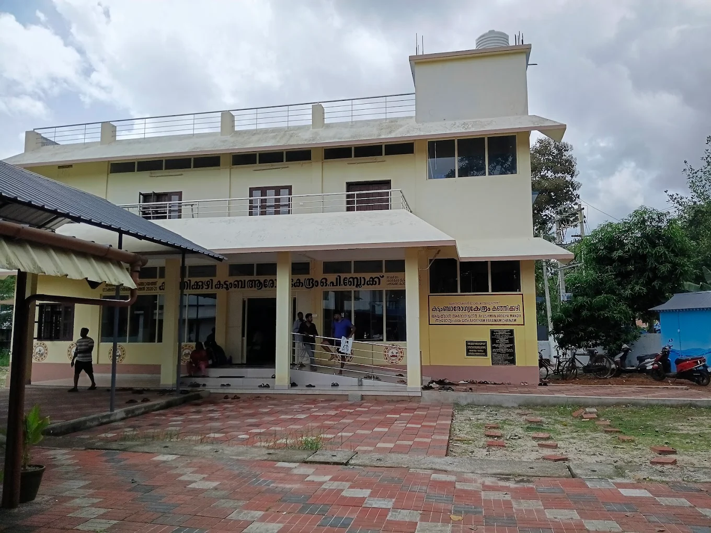

Prepared by:
Family Health Centre, Kanjikuzhy
Health Department, Government of Kerala
In collaboration with
Kanjikuzhy Grama Panchayat

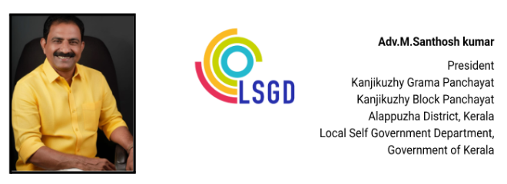നമ്മുടെ കഞ്ഞിക്കുഴി ഗ്രാമപഞ്ചായത്തിന്റെ ആരോഗ്യ മേഖലയിൽ സുപ്രധാനമായ ഒരു ചുവടുവെപ്പാണ് കഞ്ഞിക്കുഴി കുടുംബാരോഗ്യ കേന്ദ്രത്തിന്റെ നേതൃത്വത്തിൽ തയ്യാറാക്കിയ ഈ 'മഹാമാരി പ്രതിരോധ പ്ലാൻ' (Pandemic Preparedness Plan).
കഴിഞ്ഞ കാലങ്ങളിലെ ആരോഗ്യ വെല്ലുവിളികളിൽ നിന്നും പാഠങ്ങൾ ഉൾക്കൊണ്ട്, ഭാവിയിൽ ഉണ്ടായേക്കാവുന്ന സമാനമായ സാഹചര്യങ്ങളെ ശാസ്ത്രീയമായും ആസൂത്രിതമായും നേരിടാൻ ഈ പ്ലാൻ നമ്മെ സഹായിക്കും. ജനകീയ പങ്കാളിത്തത്തോടെ പ്രതിരോധ പ്രവർത്തനങ്ങൾ എങ്ങനെ ഏകോപിപ്പിക്കണം എന്നതിനെക്കുറിച്ച് കൃത്യമായ മാർഗ്ഗരേഖ ഇതിൽ ഉൾക്കൊള്ളിച്ചിട്ടുണ്ട്.

മികച്ചൊരു ആരോഗ്യ സുരക്ഷാ കവചം ഒരുക്കുന്നതിനായി ഈ പദ്ധതി തയ്യാറാക്കിയ മെഡിക്കൽ ഓഫീസർ ഉൾപ്പെടെയുള്ള കഞ്ഞിക്കുഴി കുടുംബാരോഗ്യ കേന്ദ്രത്തിന്റെ ജീവനക്കാരെയും ഇതിന് പിന്നിൽ പ്രവർത്തിച്ച എല്ലാവരെയും അഭിനന്ദിക്കുന്നു. നമ്മുടെ പഞ്ചായത്തിലെ ഓരോ വ്യക്തിയുടെയും സുരക്ഷ ഉറപ്പാക്കാൻ ഈ പ്രവർത്തനങ്ങളിൽ എല്ലാവരുടെയും സഹകരണം ഞാൻ അഭ്യർത്ഥിക്കുന്നു.

(m santosh kumar)

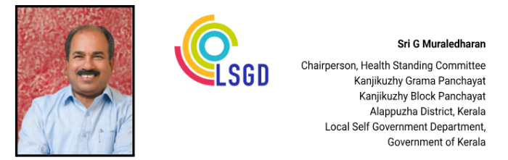
MESSAGE

പ്രിയരേ ,
ആരോഗ്യ പ്രതിസന്ധികൾ ഉണ്ടാകുന്ന ഘട്ടത്തിൽ പരിഭ്രമമില്ലാതെ, കൃത്യമായ മുൻകരുതലുകളോടെയും ഏകോപനത്തോടെയും പ്രവർത്തിക്കാൻ ഈ കർമ്മപദ്ധതി നമുക്ക് കരുത്തേകും. പ്രതിരോധ പ്രവർത്തനങ്ങളിൽ പ്രാദേശിക ഭരണകൂടവും ആരോഗ്യ പ്രവർത്തകരും സന്നദ്ധ പ്രവർത്തകരും കൈകോർക്കേണ്ടതിന്റെ പ്രാധാന്യം ഈ പ്ലാൻ അടിവരയിടുന്നു. നമ്മുടെ പഞ്ചായത്തിലെ ആരോഗ്യ സംവിധാനങ്ങളെ കൂടുതൽ കാര്യക്ഷമമാക്കാനും ജനങ്ങളിലേക്ക് സേവനങ്ങൾ വേഗത്തിൽ എത്തിക്കാനും ഇതിലൂടെ സാധിക്കുമെന്ന് ഞങ്ങൾ വിശ്വസിക്കുന്നു.
ഈ മികച്ച പദ്ധതി ആവിഷ്കരിച്ച എഫ്.എച്ച്.സി മെഡിക്കൽ ഓഫീസർക്കും മറ്റ് ആരോഗ്യ പ്രവർത്തകർക്കും ആരോഗ്യ സ്റ്റാൻഡിംഗ് കമ്മിറ്റിയുടെ പേരിൽ അഭിനന്ദനങ്ങൾ അറിയിക്കുന്നു. പ്ലാനിലെ നിർദ്ദേശങ്ങൾ പ്രായോഗികതലത്തിൽ നടപ്പിലാക്കാൻ എല്ലാവരുടെയും പിന്തുണ പ്രതീക്ഷിക്കുന്നു.


(g muraleedharan)

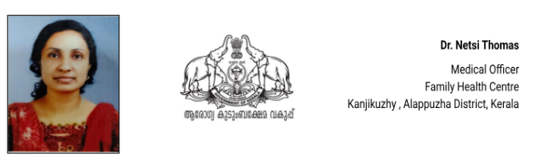

MESSAGE,

കഞ്ഞിക്കുഴി ഗ്രാമപഞ്ചായത്തിന്റെ ആരോഗ്യ മേഖലയിൽ സുപ്രധാനമായ ഒരു നാഴികക്കല്ലായി 'പാൻഡമിക് പ്രിപെയർഡ്നസ് പ്ലാൻ' (Pandemic Preparedness Plan) സമർപ്പിക്കുന്നതിൽ അതിയായ സന്തോഷമുണ്ട്. മുൻകാലങ്ങളിൽ നാം നേരിട്ട നിപ, കോവിഡ് തുടങ്ങിയ മഹാമാരികൾ നൽകിയ പാഠങ്ങൾ ഉൾക്കൊണ്ട്, ഭാവിയിലുണ്ടാകാൻ സാധ്യതയുള്ള സമാനമായ ആരോഗ്യ വെല്ലുവിളികളെ ശാസ്ത്രീയമായി പ്രതിരോധിക്കുക എന്നതാണ് ഈ കർമ്മപദ്ധതിയുടെ ലക്ഷ്യം
.

അടിയന്തര സാഹചര്യങ്ങളിൽ തദ്ദേശസ്വയംഭരണ സ്ഥാപനവും ആരോഗ്യവിഭാഗവും സന്നദ്ധ പ്രവർത്തകരും എങ്ങനെ ഏകോപിതമായി പ്രവർത്തിക്കണമെന്നതിനെക്കുറിച്ച് ഇതിൽ വ്യക്തമായ മാർഗ്ഗനിർദ്ദേശങ്ങളുണ്ട്. കൃത്യമായ പ്ലാനിംഗിലൂടെ പ്രതിരോധ പ്രവർത്തനങ്ങൾ നടപ്പിലാക്കിയാൽ പകർച്ചവ്യാധികളുടെ ആഘാതം വലിയ അളവിൽ കുറയ്ക്കാൻ നമുക്ക് സാധിക്കും.ഈ പ്ലാൻ തയ്യാറാക്കുന്നതിനായി സഹകരിച്ച ഗ്രാമപഞ്ചായത്ത് അധികൃതർക്കും, എന്റെ സഹപ്രവർത്തകർക്കും ഹൃദയം നിറഞ്ഞ നന്ദി അറിയിക്കുന്നു. കഞ്ഞിക്കുഴിയെ ഒരു സുരക്ഷിത ആരോഗ്യ മാതൃകയാക്കി മാറ്റാൻ ഈ പദ്ധതി നമ്മെ സഹായിക്കുമെന്ന് ഞാൻ വിശ്വസിക്കുന്നു.

(DR NETSI THOMAS)

EXECUTIVE SUMMARY

Family Health Centre (FHC) Kanjikuzhy functions as the primary public healthcare institution serving a projected population of 34,833 under Kanjikuzhy Grama Panchayath in Alappuzha District. As an upgraded primary care facility under the state’s Family Health Centre model, the institution plays a pivotal role in delivering comprehensive, accessible, and affordable healthcare services, with a strong focus on preventive, promotive, curative, and rehabilitative care in alignment with national and state health programmes.

FHC Kanjikuzhy caters to a predominantly rural population, addressing key public health priorities including maternal and child health, communicable and non-communicable disease prevention and control, immunization, family welfare, adolescent health, palliative care, and geriatric services. The centre ensures continuity of care through regular outpatient services, structured follow-up of chronic disease patients, home-based care delivered by field-level health staff, and outreach activities that extend services to vulnerable and geographically dispersed communities.

The institution actively implements major public health initiatives under the National Health Mission (NHM), the National Tuberculosis Elimination Programme (NTEP), the National Programme for Prevention and Control of Cancer, Diabetes, Cardiovascular Diseases and Stroke (NPCDCS), and surveillance activities under the Integrated Disease Surveillance Programme (IDSP). These programmes support early detection, timely treatment, referral linkages, and systematic monitoring of priority health conditions. Special emphasis is placed on screening for non-communicable diseases, lifestyle modification counselling, and risk-factor reduction to address the growing burden of chronic illnesses.

FHC Kanjikuzhy works in close coordination with the Grama Panchayath, ASHA workers, Anganwadi centres, educational institutions, and community-based organizations to strengthen community participation and improve public health awareness. Health education campaigns, immunization drives, school health activities, and targeted outreach among high-risk groups enhance preventive care coverage and community resilience.

Despite challenges related to increasing service demand, evolving disease patterns, and resource constraints, the centre continues to strengthen service delivery through systematic planning, data-driven decision-making, digital health record maintenance, and quality improvement initiatives. Upgradation of infrastructure, enhancement of diagnostic services, strengthening of emergency preparedness, and expansion of preventive and outreach services remain key priorities for future development.
Overall, Family Health Centre Kanjikuzhy stands as a cornerstone of primary healthcare delivery, playing a vital role in safeguarding public health and improving the quality of life of the residents of Kanjikuzhy Grama Panchayath

LIST OF ABBREVIATIONS

LSGD/LSGI | Local Self Government Department / Local Self Government Institution
BMO | Block Medical Officer
IDSP | Integrated Disease Surveillance Programme
NDMA | National Disaster Management Authority
PPE | Personal Protective Equipment
ICMR | Indian Council of Medical Research
CD | Communicable Diseases
NCD | NON-COMMUNICABLE Diseases

TABLE OF CONTENTS

EXECUTIVE SUMMARY 5
INTRODUCTION 10
● Background of the PPP 10
LSGD AT A GLANCE 10
ADMINISTRATIVE BOUNDARIES OF KANJIKKUZHY GRAMA PANCHAYAT 12
INTEGRATED HEALTH INFRASTRUCTURE MAP OF KANJIKKUZHY PANCHAYAT 13
INTEGRATED HEALTH INFRASTRUCTURE MAP OF KANJIKKUZHY PANCHAYAT 14
MAJOR ROAD AND WATERWAYS MAP OF KANJIKKUZHY GRAMA PANCHAYAT 15
GENERAL PROFILE OF THE LSGI’S 16
Background of the LSGI 16
Demographic and Vulnerable Population 18
Clinical Vulnerability 19
INFRASTRUCTURE & RESOURCE INVENTORY 21
Health Facility Directory & Basic Capacity in the LSGD 21
Private Clinics 22
Healthcare Education & Training Institutions 23
Specialized Services & Emergency Inventory 24
Oxygen & Diagnostic Capacity 25
Diagnostics facility mapping at the LSGI level 25
Laboratory Identification & Basic Details 26
Social and Community Infrastructure for surge plan 26
Human resources 29
Medical & Clinical Personnel 29
Public Health & Field-Level Workforce 29
Community & Support Cadre 31
Community Organizations 32
Administrative & Emergency Services 33
Information regarding resources 34
ONE HEALTH & ENVIRONMENTAL SURVEILLANCE 35
Animal & Bird Population 35
Veterinary Infrastructure 36
Veterinary Doctors & Workforce 37
High-Risk Interface Points (Surveillance Sites) 38
Environmental Risk Mapping 41
Disease Seasonality Mapping 42
Vulnerability Mapping 43
EPIDEMIOLOGICAL TRENDS (2021–2025) 45
Disease Burden among human beings(Last 3 Years) 45
*(use the above table data to create the graph/diagram) 46
Seasonal Trend Analysis 47
DENGUE 47
Dengue – Ward-wise Yearly Distribution (2021–2025) 47
LEPTOSPIROSIS 50
Leptospirosis – Ward-wise Yearly Distribution (2021–2025) 50
VIRAL HEPATITIS - A 52
Hepatitis A – Ward-wise Yearly Distribution (2021–2025) 52
Outcome-Based Trend Analysis- 2025 55
Transmission Trend- 2025 56
Integrated Disease Hotspot Map (2021–2025) 62
Preparedness and Response Protocol at LSG Level 66
Constitution of One Health Committee 66
Key Responsibilities: 67
Meeting Schedule: 67
Pandemic Response Workforce 67
Activities and Measures before and during Pandemic 69
PHASE 1 - Alert / Preparation 69
➢ Identification of Quarantine and Isolation Facilities 70
➢ Risk Communication and Community Preparedness 71
➢ Protection of Vulnerable Groups 71
➢ Clinical Dependency Mapping 72
PHASE 2 - Active Response 72
1. Case Identification and Contact Tracing 72
2. Screening Checkpoints 73
Standard Screening Protocol 74
3. Pandemic Control Room 74
Control Room Infrastructure and Location 74
Health System Control Room Framework 75
1. Rapid Response Team (RRT) 75
2. Data Management & Analytics Team 75
3. Human Resource Deployment Team 75
4. Laboratory Surveillance Team 75
5. Vaccination Cell (If Required) 75
6. Infrastructure & Patient Occupancy Team 75
7. Communication team 76
Key Control Room Team 76
Daily Monitoring Indicators 77
1. Epidemiological Indicators: 77
4. Communication of Public Health Information 79
Key communicators 79
5. Coordination with District/State Authorities & Other Organisations 80
Key Details: 80
Supply Chain Coordination 81
Resource Inventory and Contacts 82
Collaboration with NGOs, PPP, and CSR 83
Interdepartmental Coordination 83
PHASE 3 - Surge Capacity 84
Conversion of Community Facilities 85
- Recovery and rehabilitation phase 86
- Recovery 86
- Restoration of Health Services 87
- Environmental Cleanup and Sanitation 87
- Rehabilitation 88
- Psychosocial and Mental Health Support 88
- Community Engagement and Confidence Building 89
- Vigilance and Disease Surveillance 89
- System Strengthening and Future Preparedness 89
- Documentation and After-Action Review (AAR) 89
- Policy Revision and Health System Strengthening 90
- Research 90
- Recovery & Rehabilitation Master Checklist 91
- 1. Assessment & Infrastructure Restoration 91
- 2. Clinical & Public Health Continuity 91
- 3. Human-Centric Rehabilitation 92
- 4. Administrative & System Strengthening 92
- 5. Confidence & Policy 93
CONCLUSION 94
RECOMMENDATIONS 95
1. Strengthening Healthcare Infrastructure 95
2. Community Awareness & Education 95
3. Emergency Response & Coordination 95
4. Supply Chain & Food Security 95
5. Digital Preparedness 95
6. Training & Capacity Building 95
7. Long-Term Resilience 96
ANNEXURE 97
1. IMPORTANT PHONE NUMBERS 97
1.1. Details of grama panchayat/municipality/corporation wards 97
1.2. Other important phone numbers of grama panchayat/municipality/corporation area 99
1.3. Important offices of grama panchayat/municipality/ corporation 99
1.4. Health Services 100
1.5. Veterinary Services 101
1.6. Helpline numbers 101
1.7. Public and Private Schools Contact details 102
1.9. Anganwadi Contact Details 102
1.12. Information regarding resources 104

INTRODUCTION
Pandemics pose significant and recurrent threats to public health, social stability, and essential services, particularly at the community level where early detection, rapid response, and continuity of essential services are critical. Local Self Government Institutions (LSGIs) play a pivotal role in pandemic preparedness and response by translating national and state-level strategies into context-specific actions that address local risks, vulnerabilities, and capacities.

Kanjikkuzhy Grama Panchayat is a local self-government institution located in Kanjikkuzhy Block of Alappuzha District, Kerala. Spread over an area of 16.6 square kilometres and comprising 18 wards, the Panchayat supports a projected population of 34,833 residents with a relatively high population density.

The Panchayat also has a significant number of socio-economically vulnerable families, including households belonging to economically disadvantaged and marginalized communities. The presence of migrant populations and individuals from diverse socio-economic backgrounds further underscores the importance of inclusive and equitable preparedness planning to ensure continuity of essential health and social services during pandemics.

This Pandemic Preparedness Plan has been developed to strengthen Kanjikkuzhy Grama Panchayat’s readiness to prevent, detect, and respond effectively to pandemics and large-scale disease outbreaks. The plan adopts a risk-based and data-driven approach, integrating disease surveillance, vulnerability assessment, health system capacity evaluation, and intersectoral coordination mechanisms. It emphasizes early warning systems, protection of high-risk groups, continuity of essential health services, and coordinated action between the Health Department, LSGI, line departments, private healthcare providers, and community stakeholders.

By institutionalizing preparedness measures and strengthening local capacity, this plan aims to enhance the resilience of Kanjikkuzhy Grama Panchayat and ensure timely, coordinated, and effective response to future pandemics and public health emergencies.

LSGD AT A GLANCE

ADMINISTRATIVE BOUNDARIES OF KANJIKUZHY PANCHAYAT

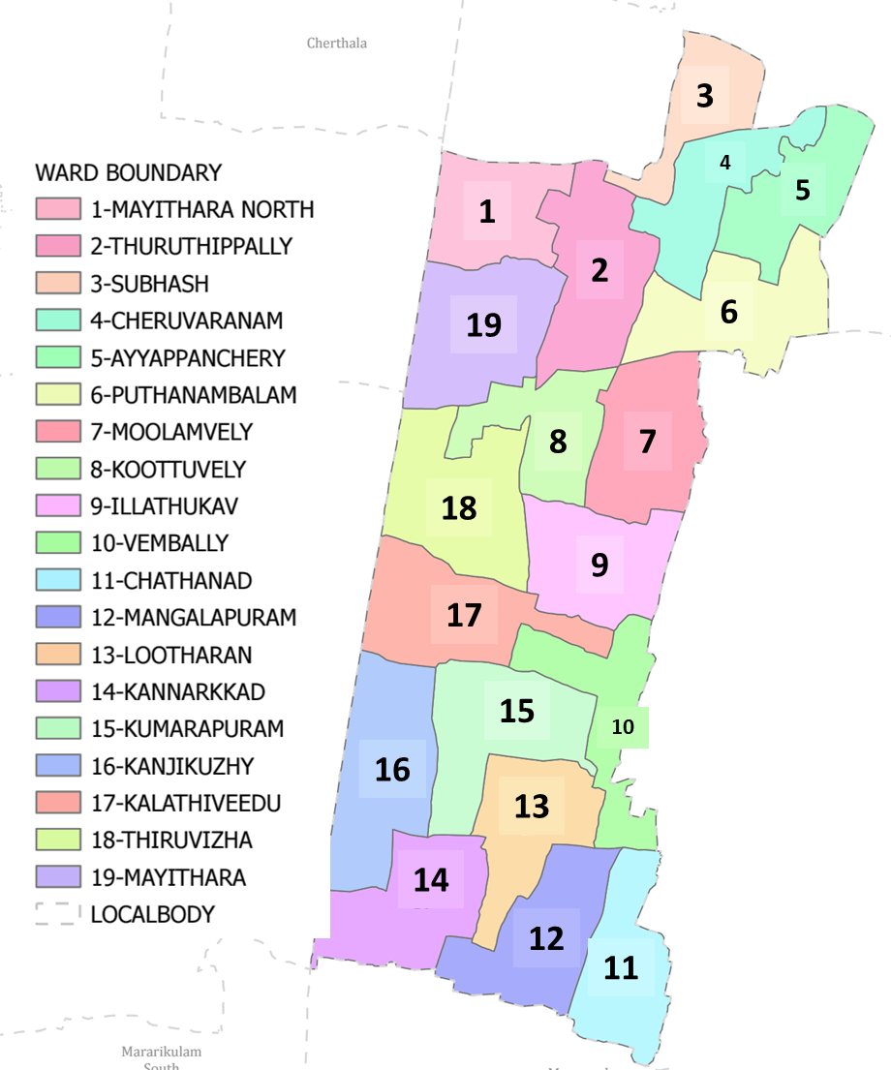
Kanjikkuzhy Grama Panchayat Ward-Wise Map (2026) Data provided by K-SMART
(KSMART Final Notification of Kanjikkuzhy Panchayat)

Ward | Houses | Population | Migrants | Wells | Hotspots | Ed. Institutions | Hosp pvt/govt.
18 | 9368 | 34833 | 87 | 1664 | 0 | 6 | 0/01

INTEGRATED HEALTH INFRASTRUCTURE MAP OF KANJIKKUZHY PANCHAYAT

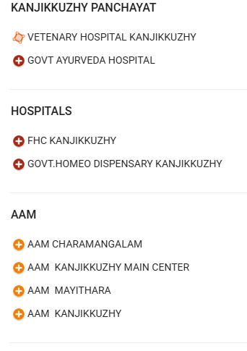
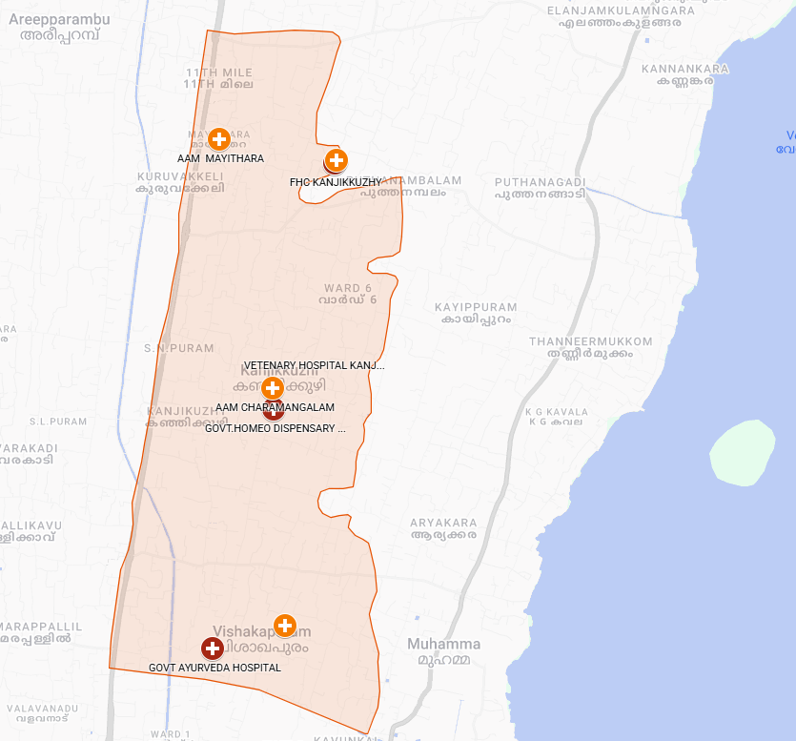
Kanjikkuzhy Grama Panchayat Health Infrastructure Map (2026)
Boundary Data: OpenData K-SMART Final Notification 2026 | Map Created with Google My Maps Major Establishment Map

INTEGRATED HEALTH INFRASTRUCTURE MAP OF KANJIKKUZHY PANCHAYAT
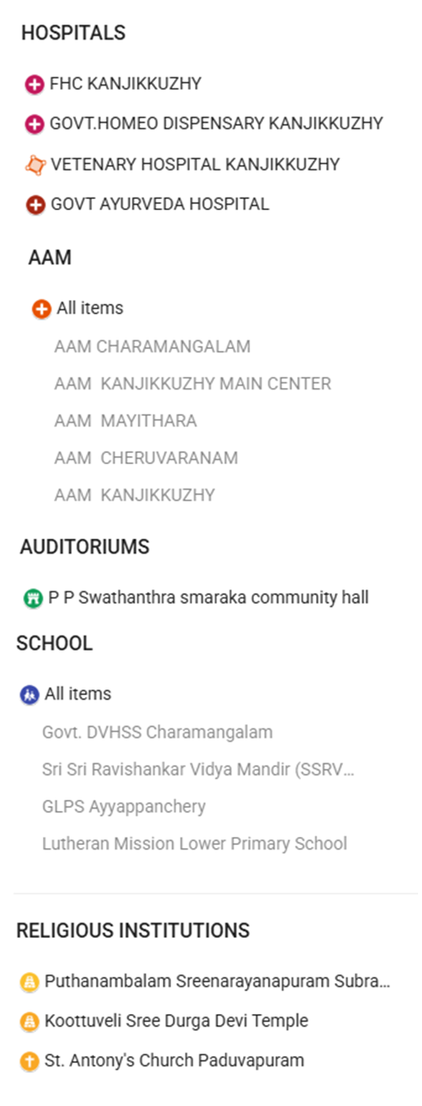
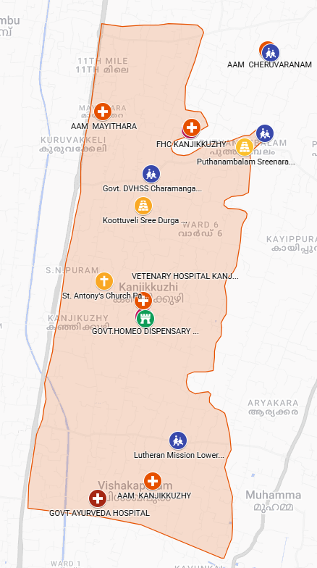

Kanjikkuzhy Grama Panchayat Health Infrastructure Map (2026)
Boundary Data: OpenData K-SMART Final Notification 2026 | Map Created with Google My Maps Major Establishment Map

MAJOR ROAD AND WATERWAYS MAP OF KANJIKKUZHY GRAMA PANCHAYAT

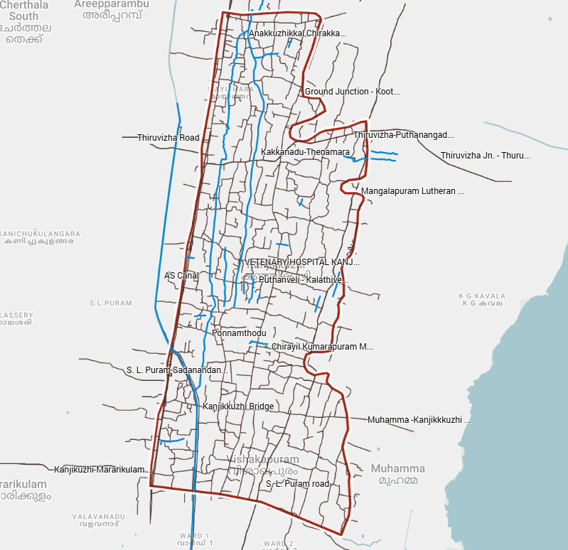
Kanjikkuzhy Grama Panchayat Health Infrastructure Map (2026)
Boundary Data: OpenData K-SMART Final Notification 2026 | Map Created with Google My Maps Kanjikkuzhy Road and Water ways Map

GENERAL PROFILE OF THE LSGI’S

Background of the LSGI
Kanjikkuzhy Grama Panchayat is situated in the Midland/Central plains of Alappuzha district, Kerala. The geographical landscape of the Panchayat is predominantly low-lying, characterized by extensive paddy fields (Kole lands) and a dense network of rivers, canals, and backwaters. This unique terrain plays a significant role in shaping the local microclimate and poses distinct challenges to transportation, emergency response, and service delivery, particularly during monsoon seasons and flood events.
The Panchayat is administratively divided into multiple wards, with a population largely dependent on traditional livelihoods. Agriculture—especially paddy cultivation—fishing, coir and coconut husk processing, and allied activities form the backbone of the local economy. In recent years, tourism-related activities and service-sector employment have also shown gradual growth. The area hosts a diverse workforce, including a notable presence of migrant labourers, particularly in construction, agriculture, and allied sectors.
From a public health and disaster management perspective, Kanjikkuzhy LSGI has historically been vulnerable to seasonal flooding, waterborne diseases, and vector-borne illnesses such as Dengue and Leptospirosis. The severe floods experienced during recent years, including the 2018 flood disaster, significantly impacted life, livelihoods, and infrastructure within the Panchayat. These recurring emergencies have underscored the importance of strengthening local preparedness, response mechanisms, and inter-departmental coordination.
In this context, the development of a localized, data-driven Auxiliary Infrastructure and Logistical Resource Map is essential to support effective planning, timely emergency response, and sustainable development initiatives. Such mapping enables the Panchayat to identify critical resources, improve accessibility during disasters, and enhance overall resilience of the community.

Table 1: Background of LSGD
Description | Details
Name of LSGI | KANJIKKUZHY
Type (GP/Municipality / Corporation etc.) | Grama Panchayath
Block | KANJIKKUZHY
District | ALAPPUZHA
Number of wards | 18
Total area (sq. km) | 16.6
Population(Projected) | 34833
Population density | 1871.67/sq km
Terrain (coastal/low-lying/backwaters/foothills, etc.) | 0
Number of rivers passing through LSGI | AS CANAL
Number of water bodies in the LSGI | 1021
Number of educational institutions | 06
Factories / small-scale industries | 30
Flood-prone wards | 00
Landslide-prone wards | 00
Death Management and Disposal Facilities (mortuaries/crematorium, including electric) | 01
Auditoriums/Marriage halls/convention centres/community halls | 8

Demographic and Vulnerable Population
Understanding the demographic composition and vulnerable population groups is essential for pandemic preparedness. Children, elderly, economically deprived families, migrant workers, and socially vulnerable groups are at increased risk during public health emergencies due to higher exposure, limited access to services, and dependency on public systems..

Description |  | Details (in numbers)
DEMOGRAPHIC PROFILE
Total population |  | 34833
Male |  | 17363
Female |  | 17470
Transgender |  | 0
Children under 5 |  | 1558
Adolescent |  | 3077
Elderly (>60) |  | 5415
SOCIAL/LIVELIHOOD VULNERABILITY
Previous EPEP family |  | 95
BPL family |  | 4757
Tribal communities |  | 154
Migration | Immigrant | 516
Migration | Emigrant | 277
Socio-economically deprived |  | 18246
Fisherfolk |  | 0
SC Community |  | 2070
ST Community |  | 154

Graphs: Population pyramid (if possible) for seeing if your LSGI has a high "dependency ratio" (lots of children and elderly compared to working adults).

Clinical Vulnerability
Certain population groups needs priority healthcare & are at higher risk of severe illness, complications, and mortality during pandemics. Patients with chronic diseases, those requiring regular medical care, and individuals with mobility or functional limitations face challenges in accessing timely care during emergencies. Mapping these groups helps in prioritizing continuity of treatment, medicine stock planning, oxygen support, referral transport, and targeted home-based care.
Description | Details in numbers
Pregnant women | 98
Lactating mothers | 241
Bedbound patients | 62
Patients under palliative care other than bedbound | 196
Patients on Haemodialysis | 12
Patients on CAPD | 97
Cancer patients (currently on treatment) | 156
Haemophilic patients | 0
Mentally challenged | 97
Differently abled | 200
Diabetic patients | 1965
Hypertensive patients | 2616
TB patients | 07

Major Festivals & Events specific to the LSGI
(with the possibility of a public gathering)

Sl. No. | Name of festival | Month detailing the periodicity
1 | PUTHANAMBALAM FEST | JANUARY

INFRASTRUCTURE & RESOURCE INVENTORY

Health Facility Directory & Basic Capacity in the LSGD
This section provides an overview of the healthcare infrastructure available within the LSGD area. It outlines the distribution and basic capacity of health facilities that form the backbone of service delivery during routine times and public health emergencies.

Family Health Centres (FHCs) and Community Health Centres (CHCs) generally function as the first point of contact for the community, providing essential outpatient and inpatient services. General Hospitals (GH) and Medical College Hospitals (MCH), where accessible, serve as the main referral centres for advanced diagnostics, specialist care, and critical services during public health emergencies. This inventory helps identify existing strengths, gaps, and potential surge capacity that can be mobilised during a pandemic or disaster.

Table 5. Health Facility Resource Summary
Sl.no. | Health Facility | Type of Facility (MCH/GH/CHC/FHC/SC etc.) | Contact Number | Total beds | ICU Beds | Oxygen-Supported Beds | No. of Ventilator Support Beds | No. of ambulances
Government Healthcare Facilities
1 | FHC KANJIKKUZY | FHC | 9495535106 | 0 | 0 | 0 | 0 | 0
2 | CHARAMANGALAM | SC | 8593929226 | 0 | 0 | 0 | 0 | 0
3 | MAYITHARA | SC | 9446203198 | 0 | 0 | 0 | 0 | 0
4 | KANJIKUZHY | SC | 9747048642 | 0 | 0 | 0 | 0 | 0
5 | MAIN CENTER | SC | 9946279869 | 0 | 0 | 0 | 0 | 0
AYUSH Healthcare Facilities
1 | AYURVEDA HOSPITAL |  | 9744019103 | 0 | 0 | 0 | 0 | 0

Private Clinics
Private clinics are an essential part of pandemic preparedness, as they are often the first place people seek care when symptoms begin. In many communities, private clinics manage a significant share of outpatient visits and therefore play a critical role in early case detection, timely referrals, and disease surveillance. Having an up-to-date understanding of where these clinics are located, the services they provide, and how they are linked to the public health system helps ensure that no cases are missed during an outbreak. It also allows health authorities to engage private practitioners more effectively for reporting, risk communication, and coordinated response, strengthening the overall capacity of the health system to manage public health emergencies.

Table 6. Private Clinic Resource Summary
Sl No. | Name of Clinic | Registered (Y/N) | Clinic (General / Speciality) | Speciality (if any) | Address | Contact Number | Diagnostic Facility (Y/N) | Ambulance Linkage (Y/N)
1 | KARUNYA CLINIC | Y | GENERAL |  | MUHAMMA .P.O.ROUDIMUKKU | 9539703645 | Y | N
2 | Goutham clinic | y | ENT |  | PUTHANAMBALAM | 9446894142 | N | N

Healthcare Education & Training Institutions
This section tracks the educational infrastructure available, which is vital for human resource planning in the health sector.

Category of Institution | Govt | Private | AYUSH | Total
Medical Colleges | 0 | 0 | 0 | 0
Nursing Colleges | 0 | 0 | 0 | 0
Dental Colleges | 0 | 0 | 0 | 0
Para-medical / Allied Health | 0 | 0 | 0 | 0
Pharmacy Colleges | 0 | 0 | 0 | 0

Specialized Services & Emergency Inventory
This section provides a detailed view of the specialized medical resources available to the community, focusing on emergency response and critical care capabilities. This table tracks the vital assets required for managing severe illnesses and emergencies across Government, Private, and AYUSH sectors.

Item | Govt | Private | AYUSH | Total
Hospital beds | 0 | 0 | 0 | 0
Oxygen-generating systems(Y/N) | 0 | 0 | 0 | 0
Oxygen-supported beds(Numbers) | 2 | 0 | 0 | 0
Ventilator-supported beds | 0 | 0 | 0 | 0
ICU beds | 0 | 0 | 0 | 0
Burns units | 0 | 0 | 0 | 0
Blood centres | 0 | 0 | 0 | 0
BLS ambulances | 0 | 0 | 0 | 0
ALS ambulances | 0 | 0 | 0 | 0
Dialysis facilities | 0 | 0 | 0 | 0
Dispensaries | 2 | 3 | 1 | 6
Medical store | 1 | 13 | 1 | 15
Industrial establishments(Medium-scale industries/small-scale industries establishments to whom we can depend in a worst-case scenario) | 0 | 15 | 0 | 15

Oxygen & Diagnostic Capacity
Monitoring oxygen and diagnostic capacity is a critical component of public health preparedness, ensuring that the LSGD can handle both chronic care and sudden surges in respiratory or infectious diseases.
Name of Health Facility | Oxygen-generating System (Y/N) | Backup Oxygen Source (Y/N) | Diagnostic Facilities Available(Y/N)
Name of Health Facility | Oxygen-generating System (Y/N) | Backup Oxygen Source (Y/N) | Lab | USG | X-ray | CT/MRI | RT-PCR
Government Healthcare Facilities
1 | Y | Y | Y | 0 | 0 | 0 | 0

Diagnostics facility mapping at the LSGI level
The diagnostic capacity of _KANJIKKUZHY_____ G.P represents the "intelligence network" of our healthcare system. The speed and accuracy of disease identification depend entirely on the distribution and technical level of these facilities.

Item | Govt | Private | AYUSH | Total
General labs | 1 | 4 | `0 | 5
Microbiology labs | 0 | 0 | 0 | 0
RT-PCR labs | 0 | 0 | 0 | 0
USG units | 0 | 0 | 0 | 0
CT/MRI units | 0 | 0 | 0 | 0
Research labs | 0 | 0 | 0 | 0
Labs of other departments that can be repurposed | 0 | 0 | 0 | 0

Laboratory Identification & Basic Details
Sl. No. | Name of Laboratory | Ownership (Govt / Private / Academic) | Address | Contact No. | 24×7 Services (Yes/No) | NABL / Govt Approved (Yes/No)
1 | HANA HEALTH LAB | PRIVAT | ASHALATHA.T,S.L.PURAM.P.O. | 8281036563 | N | N
2 | SUNRISE LAB | PRIVATE | SANIJA.O,KALATHIVEEDU,S.L. PURAM P.O., | 8593926439 | N | N
3 | SUNRISE LAB | PRIVATE | KOOTTUVELI,MAYITHARA | 8593926439 | N | N
4 | MEDITRUST LAB | PRIVATE | MANJU,MEDI TRUST,PUTHANAMBALAM |  | N | Y
5

Social and Community Infrastructure for surge plan
This table serves as our logistics and shelter inventory. By mapping these locations, quickly we can identify where to house displaced citizens, where to set up temporary medical clinics, and how to manage the deceased with dignity during a crisis.

Category | Total Count | Ward | Est. Capacity (Persons) | Contact details
Educational Institutions
Anganwadis | 29 | 18 | 527 | 7356577556
Schools | 6 | 7,3,5,15 | 2223 | 9497007473
Colleges | 3 | 13 | 160
Healthcare Educational Institutions
Medical colleges (Govt/Private) | 0
Nursing colleges (Govt/Private) | 0
Dental colleges (Govt/Private) | 0
Paramedical institutes (Govt/Private) | 0
Community Gathering Spaces
Community halls | 9
Auditoriums | 8
Religious buildings | 27
Vulnerable Group Support Facility
Destitute homes | 1
Elderly homes | 1
LSGD owned other buildings | 2
Mass Fatality Management (MFM) Infrastructure
Mortuary | 0
Crematorium | 1
*refer annexure 1 for contact details

Human resources
This section focuses on the human capital available within the LSGI. In any emergency—be it a pandemic, flood, or industrial accident—infrastructure is only as effective as the people operating it.

Medical & Clinical Personnel
This table tracks the "Frontline" providers responsible for diagnosis, treatment, and clinical management. Narrative sentence: eg., "Total health workforce: 450 personnel, with 60% in government facilities serving as primary surge capacity." A detailed directory with the contact numbers of all workers is maintained (Annexure in 1).

Cadre | Govt (No.) | Private (No.) | Total
Doctors—Modern Medicine | 2 | 5 | 7
Doctors – AYUSH | 1 | 2 | 3
Doctors – Veterinary | 1 | 0 | 1
doctors dental | 0 | 2 | 2
Nursing officers | 3 | 0 | 3
Lab technicians | 2 | 4 | 6
Optometrist | 0 | 1 | 1
Pharmacists | 2 | 5 | 7
Psychologists | 0 | 0 | 0
Counsellors | 0 | 1 | 1

Public Health & Field-Level Workforce
These individuals are the backbone of surveillance, maternal-child health, and decentralized care.

Cadre | Health services | Municipal common services | Total
HS (Health Supervisors) | 0 | 0 | 0
HI (Health Inspectors) | 0 | 0 | 0
LHS (Lady Health Supervisor) | 0 | 0 | 0
LHI (Lady Health Inspectors) | 1 | 0 | 0
JPHN (Jr Public Health Nurses) | 5 | 0 | 5
JHI (Jr Health Inspectors) | 3 | 0 | 3
MLSP (Mid-Level Service Providers) | 5 | 0 | 5
Palliative Nurses | 1 | 0 | 1
RBSK Nurses | 1 | 0 | 1
PRO | 1 | 0 | 1
Epidemiologist | 0 | 0 | 0
Data Manager | 0 | 0 | 0

Community & Support Cadre
This group represents the surge capacity of the LSGI—people who can be called upon for logistics, rescue, and specialized support.

Cadre | Number
ASHA Workers | 31
AWW (Anganwadi Workers) | 29
Emergency Medical Volunteers (Trained) | 225
Kudumbashree | 372
MNREGS | 2480
Purusha Swayam Sahaya Sangham | 110
Ex-Servicemen | 115
Retired Police Officers | 214
Red Cross volunteers | 0
One Health Community Volunteers | 882
One Health Community Mentors | 126

Community Organizations
This section details the presence of community-based organisations (CBOs), non-governmental organisations (NGOs), faith-based organisations (FBOs), Kudumbashree Self-Help Groups (SHGs), and Ayalkootams within the Local Self-Government Institution (LSGI). These groups enhance grassroots mobilization, resource distribution, and support networks crucial for pandemic response and community resilience.

Category | Total Count
NGOs | 1
Religious based organizations | 9
Foreign based organizations | 0
Sports Club/youth clubs | 25
Kudumbashree SHGs | 362
Ayalkootams | 82
Political organizations | 3
Residential organizations | 2

Administrative & Emergency Services
This section outlines the availability of key non-health emergency support services and infrastructure within the LSGI, which are essential for effective pandemic preparedness and response. These facilities support law enforcement, disaster response, water supply, logistics, mobility, and community-level interventions during public health emergencies.

Category | Total Count | Contact details
Police Stations | 0
Fire & Rescue Stations | 0
Water Pumping Points | 0
Public Distribution System (PDS) | 12

Information regarding resources
The availability of essential transport and support resources plays a quiet but critical role in saving lives. Equipment such as ambulances, mobile mortuaries, amphibian ambulances, and motorized boats ensures that patients, samples, and healthcare teams can move swiftly—even in flooded, remote, or difficult terrains. Heavy vehicles like JCBs, cranes, tractors, and torus lorries support logistics, waste management, emergency infrastructure, and rapid conversion of spaces into care or isolation facilities. Taxis, four-wheel-drive vehicles, and trucks help maintain continuity of essential services, reach vulnerable populations, and support home-based care and supply delivery.

Means of transportation | Total Count
JCB | 4
Crane | 0
Heavy Trucks | 2
Tractor | 10
Ambulances | 0
Mobile mortuaries | 0
Boats | 0
Taxi service | 5
Note: For specific details regarding vehicle owners and contact information, please refer to Annexure [X].

ONE HEALTH & ENVIRONMENTAL SURVEILLANCE
The One Health method integrates environmental, animal, and human health to enable proactive pandemic preparedness. Panchayat-level surveillance needs to be improved in order to detect and treat zoonotic and environmentally generated diseases early. Surveillance is strengthened through systematic assessment of animal populations, veterinary infrastructure, poultry and slaughter facilities, inter-sectoral coordination, and specialised tools like avian influenza seasonality mapping using GIS in previous outbreaks to enable predictive alerts and ward-specific sampling to support effective pandemic preparedness in high-risk areas like ____________.

Animal & Bird Population
Mapping animal and bird populations at the Panchayat level is essential for identifying and prioritising zoonotic disease hazards like rabies, avian influenza (H5N1), leptospirosis, anthrax, and Nipah-like spillover occurrences. Risk classification, targeted surveillance, vaccination planning, and early epidemic detection made feasible by comprehensive population mapping all enhance One Health-based pandemic preparedness.

Category | Item | Estimated Population | Wards
Animal Population | Livestock (Cattle/Goats/Buffalo) | 1568 | 1 to18
Animal Population | Pet Animals (Dogs/Cats) | 1427 | 1 TO 18
Animal Population | Stray Dog Population | 588 | 1 TO 181 TO
Animal Population | Pig Farms (Number of heads) | 41 | 6,4
 | Small Units (Sheep / Goats – clustered) | 24 | 1 TO 18
Bird Population | Poultry Units (Birds) | 21 | 1 TO 18
Bird Population | Poultry- (FOWL) | 0 | 0
Bird Population | Wild/Migratory Birds (Observed) | 0 | 0
Bird Population | Crow Mortality Events (Reported) | 0 | 0

The main risk of zoonotic diseases in ____________ is concentrated in Wards………………., which is explained by the high density of pig farms, cattle congregation areas, and poultry units. The stray dog population in market areas, fish landing sites, bus stations continues to be a substantial problem for rabies surveillance and bite prevention. There is a considerable risk of avian influenza introduction and amplification during November - December due to the seasonal presence of migratory and resident water birds near ponds/ canal / river / backwater / paddy field. Clusters of pig farms and animal shelters vulnerable to flooding further raise the risk of leptospirosis and other zoonoses mediated by the environment, especially during monsoon floods.

Veterinary Infrastructure
Veterinary institutions are a core pillar of One Health surveillance, enabling early zoonotic disease detection through vaccination, investigation of unusual animal illness or deaths, sample collection, and timely outbreak reporting. A well-mapped and responsive veterinary network strengthens coordination with human health and LSGI systems, ensuring rapid response during zoonotic events and pandemics.
Facility Type | Name of Facility | Ownership Govt / Pvt | Location(Ward No) | Contact number
Veterinary Dispensary | 1 | Govt | 12 | 9605633893
Veterinary Hospital / Polyclinic | 0 | 0 | 0
Private Veterinary Clinics | 0 | 0 | 0
Mobile / Emergency Vet Service (incl. night services) | 0 | 0 | 0
Pet Homes / Animal Shelters | 0 | 0 | 0
Slaughterhouse-linked Veterinary Inspection Unit | 0 | 0 | 0

Veterinary Doctors & Workforce
Early detection, diagnosis, reporting, and reaction to animal illness epidemics depend on the availability and accessibility of qualified veterinary specialists. By identifying unusual animal morbidity or mortality promptly, collecting samples promptly, and coordinating efficiently with human health and LSGI systems—especially during zoonotic outbreaks and pandemic-prone situations—a clearly defined veterinary workforce enhances One Health surveillance.

Category | Number Available | Type (Govt/Pvt) | Contact number
Government Veterinary Doctors | 1 | Govt | 9605633893
Private Veterinary Doctors | 0
Livestock Inspectors | 2 | GOVT | 8281539134
Para-veterinary Staff / Attenders | 2
Contract / On-call Veterinary Support (if any) | 1

High-Risk Interface Points (Surveillance Sites)
High-risk interface points for zoonotic disease surveillance in KanjikkuzhyGrama Panchayath include wetland–livestock–human contact zones, backyard poultry farms, cattle sheds near water bodies, fish markets, and areas of high human–animal interaction such as community slaughter points and migratory bird congregation sites. These are the primary surveillance sites where zoonotic spillover risks are elevated.

Type of Habitat | Type of High risk interface | Geographical vulnerability
Wetlands & Backwaters | 0
Backyard Poultry Farms | 10
Cattle Sheds near Water Bodies | 0
Fish & Meat Markets | 0
Community Slaughter Sites | 0
Migratory Bird Congregation Areas | 0
Rodent-Infested Grain Storage | 0

Category | Total Count | Key Locations (wards)
Poultry Farms | 8 | 1 TO 18
Backyard / Clustered Poultry Units | 12 | 1 TO 18
Duck Rearing Units (open water access) | 2 | 2
Slaughterhouses/ Slaughter Points | 0
Meat/Fish Markets | 0
Live Bird Sale Points | 0
Cattle Markets / Weekly Animal Fairs | 0
Pet Shops / Breeders | 0
Animal Shelters / Pet Homes | 0
Waste Disposal Sites near Animal Units | 0

Environmental Risk Mapping
Environmental risk mapping identifies monsoon/flood hotspots for vector-borne (dengue, chikungunya), water-borne (leptospirosis, diarrhoea), and zoonotic diseases in Kerala's wetlands. Systematic surveillance supports early warnings, targeted interventions, and Panchayat pandemic preparedness.
Waterborne exposure: Flood-prone areas and stagnant water bodies facilitate leptospira survival, raising leptospirosis risk.

Traditional practices: Informal slaughter and fish markets lack standardized hygiene, creating spillover opportunities.

Risk Factor | High-Risk Wards | Key Locations | Risk Level (High/Med/Low)
Flood-prone areas | 0
Water bodies/wetlands | 0
Solid waste accumulation | 0
Animal waste disposal issues | 0
Rodent infestation zones | 0
Industrial effluent discharge | 0
Construction sites / abandoned buildings | 0
Poor drainage/blocked canals | 0
Drinking water source contamination risk | 0

Disease Seasonality Mapping
1, Flooding & waterlogging → amplifies leptospirosis, malaria, diarrheal diseases.
· 2, Migratory bird influx (Nov–Feb) → avian influenza risk.

3, Mosquito breeding cycles → vector-borne disease peaks in monsoon.

4, Agricultural practices → close human–animal contact in paddy fields.

Disease | Peak Risk Season | Key Drivers | High-Risk Locations | Surveillance Focus
Avian Influenza | JANUARY TO JUNE | MIGRATORY BIRDS | 10 | SUDEN DEATH IN
Leptospirosis | september
Dengue/Chikungunya
Acute Diarrheal Diseases
Rabies
Anthrax (rare)

Vulnerability Mapping
Vulnerability mapping pinpoints high-risk populations, occupations, and areas exposed via environment, livelihoods, socio-economics, and poor service access. Paired with environmental/seasonality mapping, it enables risk-based surveillance, targeted actions, and optimal resource use in One Health and pandemic planning.
Vulnerability Factor | High-Risk Wards | Key Groups / Locations | Risk Level
Flood-prone households | 1,17
Wetland-adjacent communities | 0 | 0
Backyard poultry / duck rearing households | 0 | 0
Livestock-rearing households | 0 | 0
Slaughterhouse & meat market workers | 0
Fisherfolk & fish market workers | 2
Sanitation workers | all wards
Daily wage / migrant workers | all wards
Elderly & chronically ill populations | all wards
Pregnant Women | all wards
Children (schools, Anganwadi’s) | all wards
Limited access to safe water & sanitation | nil

EPIDEMIOLOGICAL TRENDS (2021–2025)

Disease surveillance is the systematic collection, analysis, and interpretation of health data for planning, implementation, and evaluation of public health practice. This section presents the disease surveillance profile of the LSGI based on routine reporting systems and outbreak investigations to identify priority diseases, seasonal patterns, and emerging public health threats.

Disease Burden among human beings(Last 3 Years)
Analysis of disease-wise data for the last five years helps identify persistent public health problems, emerging diseases, and changes in disease burden. This information supports prioritisation of prevention, preparedness, and response activities at the Panchayat level.

Disease | 2023 | 2024 | 2025 | Trend(Increasing/Stable/Decreasing)
Dengue | 32 | 91 | 4 | decreasing
Leptospirosis | 2 | 3 | 4 | incresing
Hepatitis A | 0 | 0 | 3 | increasing
Malaria | 1 | 1 | 1 | stable
Scrub Typhus | 4 | 7 | 0 | dicreasing
Typhoid | 0 | 0 | 0 | stable
H1N1 | 0 | 0 | 0 | stable
H3N2 | 0 | 0 | 0 | stable
ADD | 94 | 99 | 59 | dicreasing
Mumps | 0 | 0 | 15 | increasing
Measles | 0 | 0 | 0 | stable
Hepatitis B | 0 | 0 | 0 | stable
Hepatitis C | 0 | 0 | 0 | stable
Tuberculosis | 13 | 20 | 11 | dicreasing
Leprosy | 0 | 0 | 0 | stable
COVID-19 | 0 | 0 | 0 | stable
0

*(use the above table data to create the graph/diagram)

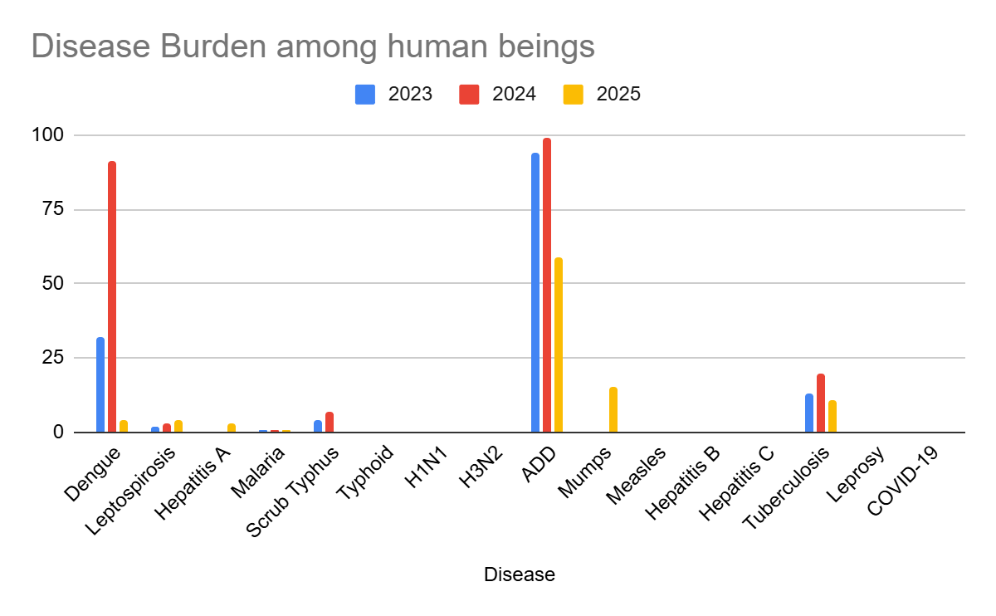

Seasonal Trend Analysis
Seasonal analysis helps anticipate surges (e.g. dengue in monsoon, leptospirosis after floods, influenza in cooler months) and plan pre‑emptive vector control, stockpiling of IV fluids, and awareness campaigns at Panchayat level.

DENGUE
Dengue is a major seasonal vector-borne disease strongly associated with rainfall, water stagnation, and increased mosquito breeding during the monsoon period.

Peak: July–November

Dengue – Ward-wise Yearly Distribution (2021–2025)

Ward | Dengue – Ward-wise Yearly Distribution
Ward | 2023 | 2024 | 2025 | Total
1 | 1 | 2 | 0 | 3
2 | 13 | 8 | 1 | 22
3 | 1 | 18 | 1 | 20
4 | 0 | 4 | 0 | 4
5 | 0 | 10 | 0 | 10
6 | 7 | 9 | 0 | 16
7 | 1 | 3 | 0 | 4
8 | 2 | 1 | 0 | 3
9 | 0 | 2 | 0 | 2
10 | 0 | 4 | 0 | 4
11 | 2 | 2 | 1 | 5
12 | 0 | 4 | 0 | 4
13 | 2 | 2 | 1 | 5
14 | 0 | 4 | 0 | 4
15 | 2 | 6 | 1 | 9
16 | 0 | 9 | 0 | 9
17 | 0 | 4 | 0 | 4
18 | 1 | 2 | 0 | 3

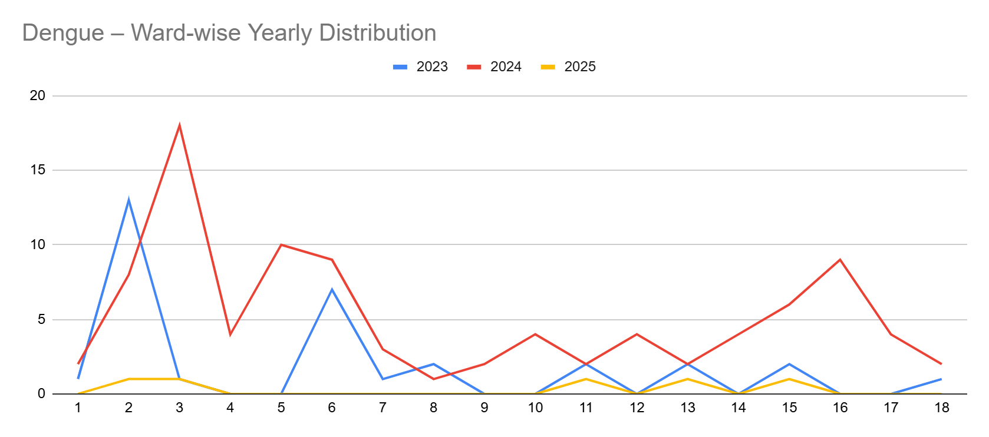

LEPTOSPIROSIS
Leptospirosis cases are closely linked to monsoon rains, flooding, and occupational exposure, particularly in low-lying and waterlogged areas.

Peak: June - August

Leptospirosis – Ward-wise Yearly Distribution (2021–2025)

Ward | Leptospirosis – Ward-wise Yearly Distribution
Ward | 2023 | 2024 | 2025 | Total
1 | 0 | 0 | 0 | 0
2 | 1 | 1 | 0 | 2
3 | 0 | 1 | 1 | 2
4 | 0 | 0 | 0 | 0
5 | 0 | 0 | 0 | 0
6 | 0 | 0 | 1 | 1
7 | 0 | 0 | 0 | 0
8 | 0 | 0 | 0 | 0
9 | 0 | 0 | 0 | 0
10 | 0 | 0 | 0 | 0
11 | 0 | 0 | 1 | 1
12 | 0 | 1 | 0 | 1
13 | 0 | 0 | 0 | 0
14 | 1 | 0 | 0 | 1
15 | 0 | 0 | 0 | 0
16 | 0 | 0 | 0 | 0
17 | 0 | 0 | 1 | 1
18 | 0 | 0 | 0 | 0

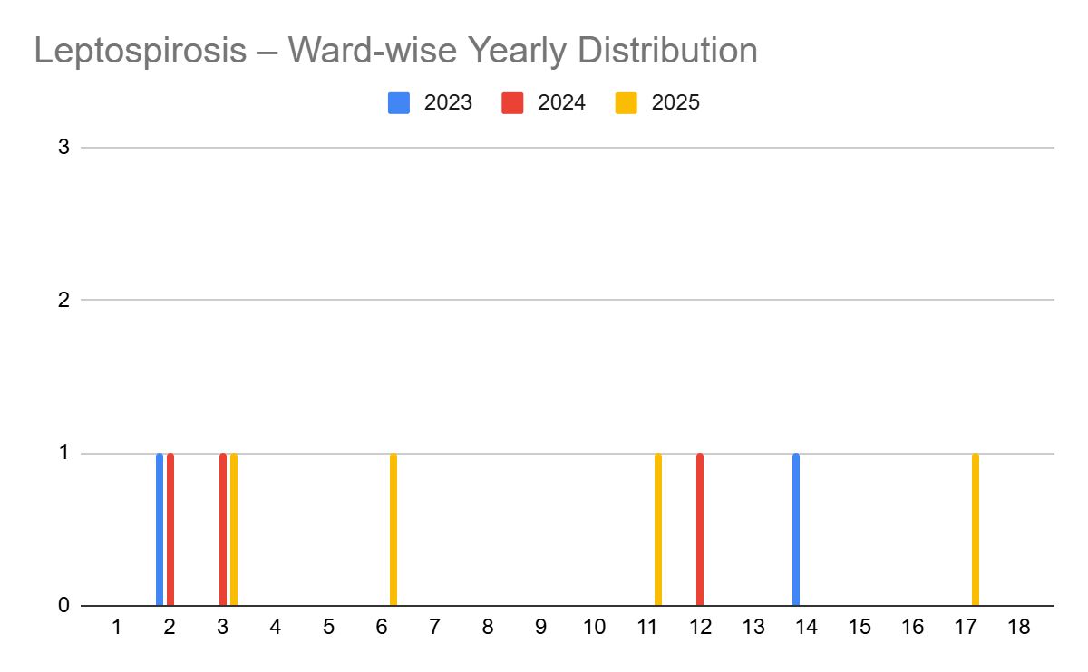

VIRAL HEPATITIS - A
Hepatitis A cases are commonly associated with unsafe drinking water, food contamination, and breakdowns in sanitation, often presenting as clusters or outbreaks.

Peak: October - December

Hepatitis A – Ward-wise Yearly Distribution (2021–2025)

Ward | Hep A – Ward-wise Yearly Distribution
Ward | 2023 | 2024 | 2025 | Total
1 | 0 | 0 | 0 | 0
2 | 0 | 0 | 0 | 0
3 | 0 | 0 | 0 | 0
4 | 0 | 0 | 0 | 0
5 | 0 | 0 | 2 | 2
6 | 0 | 0 | 0 | 0
7 | 0 | 0 | 0 | 0
8 | 0 | 0 | 0 | 0
9 | 0 | 0 | 0 | 0
10 | 0 | 0 | 0 | 0
11 | 0 | 0 | 0 | 0
12 | 0 | 0 | 0 | 0
13 | 0 | 0 | 0 | 0
14 | 0 | 0 | 0 | 0
15 | 0 | 0 | 0 | 0
16 | 0 | 0 | 0 | 0
17 | 0 | 0 | 1 | 1
18 | 0 | 0 | 0 | 0

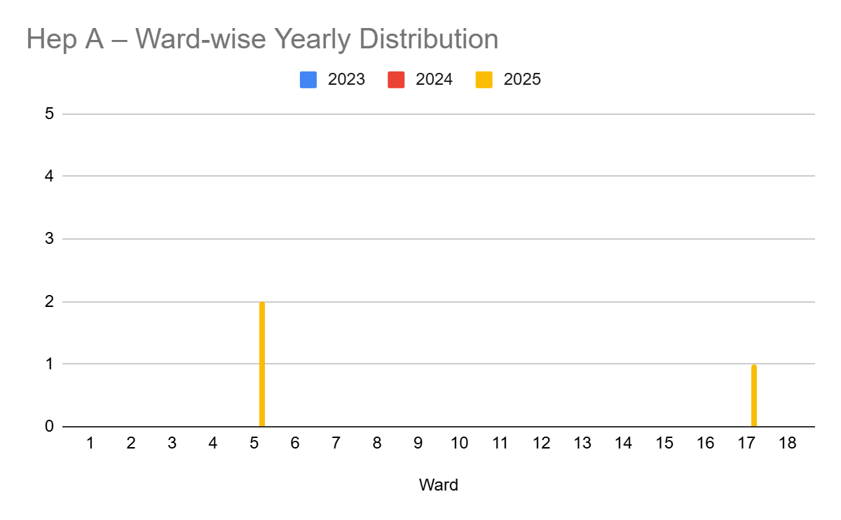

Transmission Trend- 2025
For effective management of public health issues, it is important to track the trend of disease transmission mode. It helps identify the population or place at high risk that can be used to predict outbreaks and implement targeted interventions as quickly as possible. Understanding these kinds of trends enables authorities to allocate resources efficiently and change the strategies adequately based on the trend that follows.

Mode of Transmission | No. of cases | No. of Deaths
Vector Borne Diseases | 9 | 0
Water Borne Diseases | 3 | 1
Air Borne Diseases | 75 | 0
Blood Borne Diseases | 0 | 0
Food Borne Diseases | 15 | 0

Vector-Borne Disease

Disease | No. of Cases | No. of Deaths
Dengue | 4 | 0
Malaria | 1 | 0
Chikungunya | 0 | 0

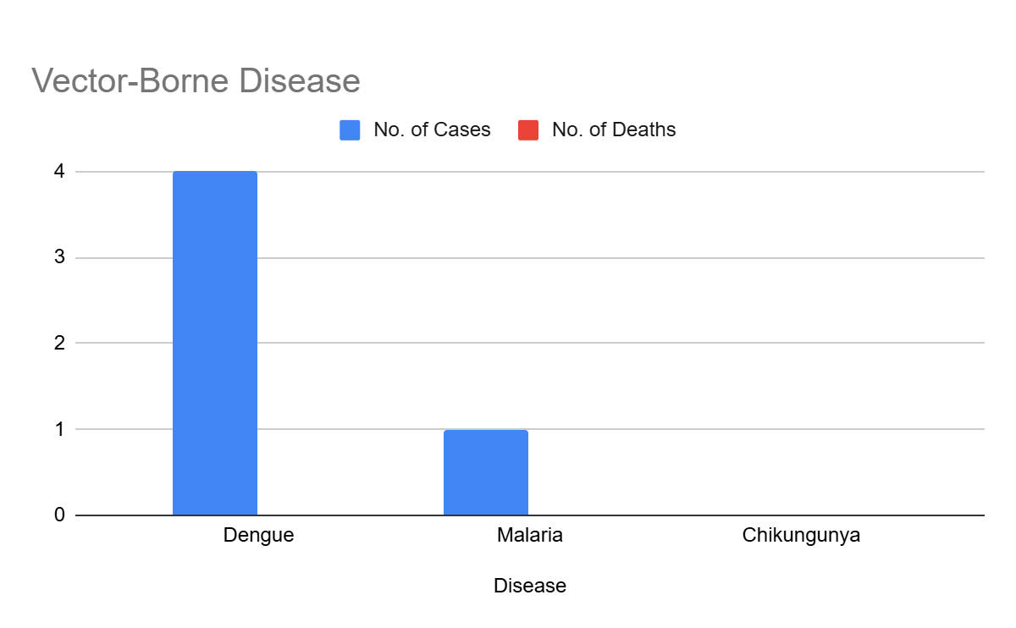

Water Borne Disease

Disease | No. of Cases | No. of Deaths
Cholera | 0 | 0
Typhoid | 0 | 0
Hep- A | 3 | 1
Dysentery | 0 | 0
Amoebiasis | 0 | 0
E- Coli infections | 0 | 0

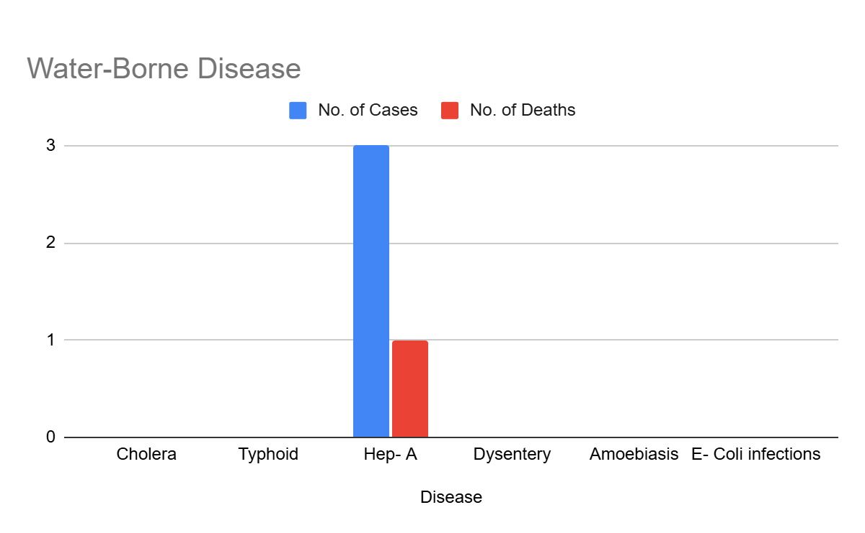

Air Borne Disease

Disease | No. of Cases | No. of Deaths
Influenza | 0 | 0
H1N1 | 0 | 0
TB | 0 | 0
Chickenpox | 48 | 0
Measles | 0 | 0
Covid-19 | 0 | 0
Pertussis | 0 | 0
Mumps | 15 | 15

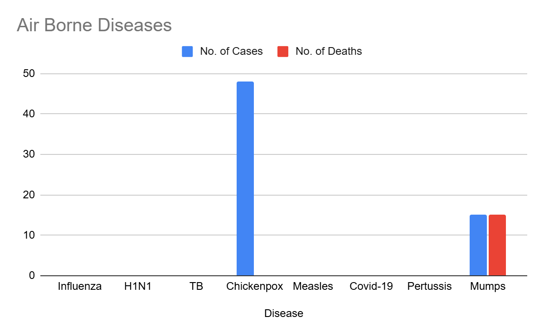

Blood-Borne Disease

Disease | No. of Cases | No. of Deaths
AIDS | 0 | 0
Hep- B | 0 | 0
Hep- C | 0 | 0

Zoonotic Disease

Disease | No. of Cases | No. of Deaths
Rabies | 0 | 0
Leptospirosis | 4 | 0
Avian influenza | 0 | 0
West nile | 0 | 0
Anthrax | 0 | 0
Nipah | 0 | 0
Scrub Typhus | 0 | 0
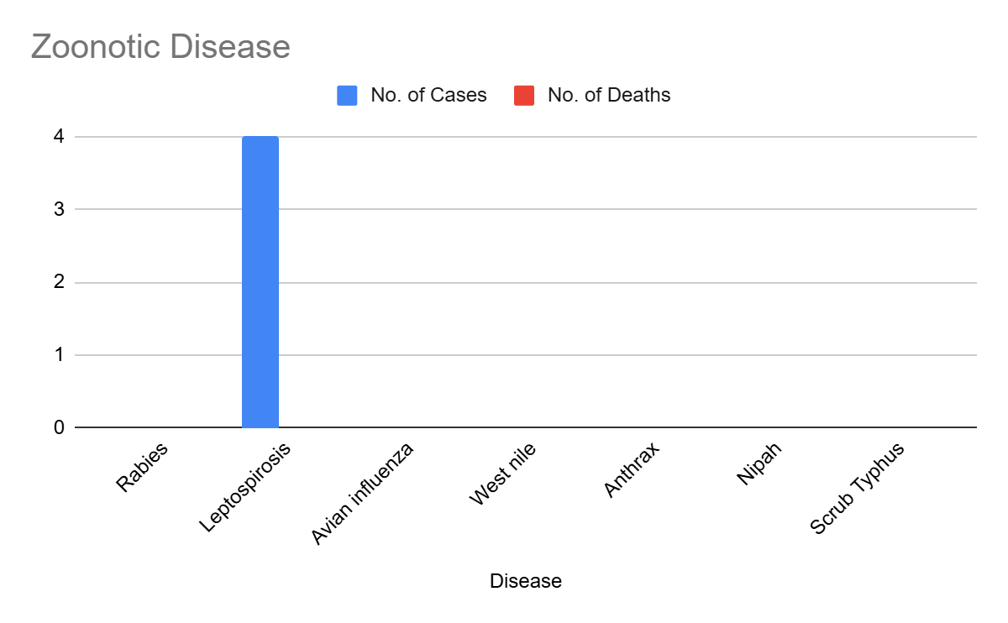

Integrated Disease Hotspot Map (2021–2025)
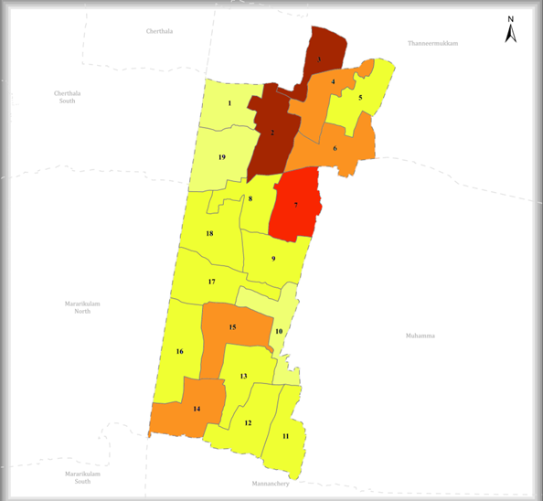

Ward No | Dengue Total (2021-25) | Leptospirosis Total (2021-25) | Hepatitis A Total (2021-25) | Mumps (2021-25) | ADD (2021-25) | Total Cases
1 | 3 | 0 | 0 | 0 | 10
2 | 22 | 2 | 0 | 1 | 13
3 | 20 | 2 | 0 | 1 | 13
4 | 10 | 0 | 0 | 3 | 14
5 | 4 | 0 | 3 | 0 | 14
6 | 10 | 1 | 0 | 4 | 11
7 | 16 | 0 | 0 | 0 | 12
8 | 4 | 0 | 0 | 0 | 12
9 | 3 | 0 | 0 | 5 | 10
10 | 2 | 0 | 0 | 1 | 15
11 | 4 | 1 | 0 | 0 | 15
12 | 5 | 1 | 0 | 0 | 10
13 | 4 | 0 | 0 | 0 | 14
14 | 9 | 1 | 0 | 0 | 17
15 | 9 | 0 | 0 | 0 | 15
16 | 4 | 0 | 0 | 0 | 18
17 | 3 | 1 | 1 | 0 | 18
18 | 5 | 0 | 0 | 0 | 18

By overlaying five years of data, we have identified …………..'Red Zone' Wards. These are wards where at least two different categories of diseases (e.g., Dengue and Lepto) recurred in consecutive years. Ward 4 is categorized as the Highest Priority Hotspot due to its combination of flood vulnerability and high vector density. Future health infrastructure, such as the proposed R.O plants at ………should be prioritized.

Preparedness and Response Protocol at LSG Level
This section describes the operational framework for the LSGI once a pandemic is declared. It explains how the LSGI and health system will move from routine data collection to active response, using a One Health approach.

Constitution of One Health Committee
The LSGD shall constitute a One Health Committee comprising the LSGI President, Medical Officers (Modern Medicine, AYUSH, and Veterinary), the Health Inspector, and the Veterinary Surgeon.

Objective: The One Health Committee coordinates human, animal, and environmental health to prevent and control pandemics.

Sl No | Name | Designation | Department/Institution | Role in Committee | Contact Number
1 | Adv santhosh kumar | Panchayat President | LSGD | Chairperson | 9447463668
2 | Dr Netsi thomas | Medical Officer (PHC/CHC) | Health Dept | Member Secretary | 9495535106
3 |  | Veterinary Officer | Animal Husbandry | Member | 9605633893
4 | Shweta | Epidemiologist | Health Dept | Member | 8606799186
5 | Bindhu | Health Inspector/PHN | Health Dept | Surveillance | 9847108809
6 | netsy | ASHA Supervisor | Health Dept | Community link | 9847108809
7 | anu | ICDS Supervisor | Social Welfare | Vulnerable groups | 7356577556
10 | sunitha sunil | Kudumbashree CDO | Kudumbashree | Community mobilisation | 9061397436
11 | nil | NGO/Volunteer rep | Civil Society | Support services
12 | Rajeev | Line Department representations | Assistant secortary |  | 9061397436

Key Responsibilities:
- Review disease surveillance data (human + animal)
- Conduct ward-wise risk assessment and vulnerability mapping
- Approve quarantine/isolation centre locations
- Coordinate with district for resources (PPE, oxygen, ambulances)
- Periodically review health system surge capacity, including beds, oxygen, human resources, and ambulances.
- Approve and monitor risk communication and community engagement strategies, including rumour management.
- Ensure protection and service continuity for vulnerable groups (elderly, persons with disabilities, dialysis patients, coastal populations).
- Conduct quarterly mock drills
- Monitor equity measures for vulnerable groups

Meeting Schedule:
Quarterly (normal times) | Weekly (outbreak alert) | Daily (pandemic phase)

Pandemic Response Workforce
To ensure a coordinated and timely response during a pandemic, a dedicated Pandemic Response Workforce shall be constituted at the LSG level. The workforce will function under the overall supervision of the One Health Committee and in close coordination with the health authorities. Team-based deployment will enable efficient surveillance, case management, quarantine and isolation management, logistics support, and risk communication. Each team shall have a clearly designated team leader, defined roles, and an identified pool of personnel to allow rapid activation, rotation of duties, and continuity of services during prolonged emergencies.

Total Response Workforce Available: 300 persons

Team Name | Composition | Key Responsibilities | Team Leader
Surveillance and Contact Tracing Team | HI, JHI, JPHN, ASHAs and Volunteers | Case detection, contact listing, home visits, reporting | HI
Case Management Team | Doctors, Nurses, MLSP, Palliative Nurses | Patient care & referral | DOCTOR
Quarantine & Isolation Team | LSGD staff, Volunteers | Facility management | JHI
Logistics & supply chain Team | LSGD staff, Storekeepers, Drivers 3 | Supplies & transport [PPE, medicines, oxygen, transport, waste management] | Ward Member
Communication Team | Ward members, Kudumbashree, Youth clubs,  AWW workers and other self help groups | IEC, community meetings, countering misinformation | M.O in charge

All teams shall be activated immediately upon outbreak alert or pandemic declaration and shall report daily to the LSG Incident Commander/Medical Officer, with consolidated reporting to the Block PHC. Duty rosters and alternate personnel shall be maintained to ensure uninterrupted services during staff shortages or prolonged response periods. Team composition and numbers may be revised based on the magnitude of the outbreak and availability of human resources.

Activities and Measures before and during Pandemic

PHASE 1 - Alert / Preparation
Surveillance and Reporting-Enhanced syndromic surveillance:
- Data sources for surveillance:
- Event-based triggers (to be monitored and reported):
- Zoonotic and animal health surveillance
- Logistics and Stock Preparedness
  - Identify and empanel local vendors and define emergency procurement mechanisms in accordance with existing LSGD and Health Department norms.
  - Prepare and maintain an essential logistics checklist covering medical supplies, consumables, and support equipment.
  - Pre-identify secure storage locations for emergency stocks and ensure maintenance of stock registers with regular updating.
  - Finalise emergency transport arrangements, including availability of vehicles and identified drivers for rapid deployment during alerts.
  - Designate a Nodal Officer for Logistics to enable prompt decision-making, coordination, and communication during emergencies.
  - Conduct rapid stock verification and ensure availability of minimum buffer stock, including:
- PPE kits – numbers
- Pulse oximeters – ___ numbers
- Hand sanitizers – ___ litres
- Masks, gloves, disinfectants – adequate quantity
Identify critical gaps in logistics and immediately communicate requirements to the Block and District authorities for timely replenishment and support. Monitor expiry dates and stock rotation.

Identification of Quarantine and Isolation Facilities
  - Identify and list suitable buildings for quarantine and isolation (schools, hostels, community halls, etc.).
  - Categorise cases as per the severity and allocate to appropriate facilities (for instance, severe cases to classrooms, mild cases to an assembly hall in case of a school).
  - Facility readiness checklist needed (beds, toilets, ventilation) etc.
  - Find an alternate site if the primary sites are not available or not in use.
  - Identify facility managers and support staff
  - Prepare basic SOPs for:
    - Admission and discharge
    - Food, water, sanitation
    - Infection prevention and waste disposal
  - Ensure availability of basic amenities: water, sanitation, electricity, ventilation, and waste disposal. Prepare a rapid activation plan for these facilities if case numbers increase.

Risk Communication and Community Preparedness
  - Disseminate early warning messages on symptoms, preventive measures, and reporting mechanisms. Display IEC materials both in English and the local language in public places and ensure ward-level awareness.
  - Sensitize elected representatives and community leaders on preparedness measures.
  - Establish a rumour tracking and misinformation response mechanism to identify, verify, and promptly counter false or misleading information.
  - Engage trusted local persons (ward members, ASHA workers, religious leaders, teachers, community volunteers) to communicate official public health messages and reinforce correct practices.
  - Develop and deploy targeted IEC materials for:
    - Schools and educational institutions
    - Markets and commercial areas
    - Work sites and labour settings
  - Conduct community sensitization meetings at the ward level to promote preventive behaviors, address concerns, and strengthen community participation in preparedness and response.

Protection of Vulnerable Groups
Vulnerable populations require priority protection through targeted line-listing, service continuity, and delivery mechanisms.
- Prepare and regularly update line-lists of vulnerable populations, including:
  - Elderly persons living alone
  - Persons with disabilities
  - Pregnant women
  - Migrant workers
  - Dialysis patients
The detailed line-lists shall be maintained as Annexure ___ and updated periodically.

Clinical Dependency Mapping
Develop ward-wise dependency and vulnerability maps to identify households requiring regular support during emergencies. Ensure continuity of essential health services for vulnerable groups, including
- Dialysis services (facility mapping, transport arrangements, and scheduling)
- Continuity of treatment for TB, HIV, and other chronic conditions requiring uninterrupted medication
- Mental health and psychosocial support services
Establish delivery mechanisms for food, essential commodities, and medicines to vulnerable households through coordinated action involving ASHAs, JPHNs, Kudumbashree, volunteers, and local administration.

PHASE 2 - Active Response

Case Identification and Contact Tracing
Case detection and contact tracing activities will be carried out in coordination with the Health authorities, following disease-specific SOPs and IDSP guidelines.
Field Staff Involved
- Health Inspector (HI)
- Junior Health Inspector (JHI)
- Junior Public Health Nurse (JPHN)
- ASHAs and ASHA Supervisors
- Ward-level volunteers and Kudumbashree members (as required)

Screening Checkpoints
Screening checkpoints at high-traffic locations (transport hubs, markets, religious gatherings) for early detection of symptomatic travellers and crowd screening during outbreaks. Potential locations include bus stands, market entry points, and boat jetties, based on local context and risk assessment.
Screening activities will be carried out by trained personnel such as ASHAs, ward members, and volunteers, with support from Health Department staff. Necessary equipment, including non-contact thermometers and appropriate PPE, shall be ensured prior to activation.
Location | Type (Bus stand/Jetty/Market/Railway) | Staff Deployed (ASHAs/Volunteers) | Screening Method | Reporting authority
Bus stand | Transport hub | One JHI  One ASHA  One health Mentors | 1.Swab Collection.  2. Blood smears collection (RDT)  3.Thermal Scanners | Surveillance Nodal Officer in control room
Market entry | Market | One JHI  One ASHA  Male health volunteers | 1.Swab Collection.  2. Blood smears collection (RDT)  3.Thermal Scanners | Surveillance Nodal Officer in control room
Boat jetty | Water transport | One JHI  One ASHA  Male health volunteers | 1.Swab Collection.  2. Blood smears collection (RDT)  3.Thermal Scanners | Surveillance Nodal Officer in control room

Standard Screening Protocol

The screening protocol shall include temperature screening, observation for visible symptoms, and inquiry regarding recent travel or exposure history. Individuals identified as suspects during screening shall be immediately referred to the nearest PHC/FHC for further evaluation, testing, and appropriate action as per prevailing guidelines.

Pandemic Control Room
The Pandemic Control Room (PCR) serves as the central nerve center for real-time coordination, data aggregation, decision support, and communication during outbreaks. It consolidates information from all LSGD teams, health facilities and community sources to enable rapid response decisions.

Control Room Infrastructure and Location
Primary Location: ____________ Panchayath Office.
Backup Location: Community Hall in ____________ G.P.

Health System Control Room Framework
The PCR is organized into seven functional pillars to ensure no aspect of the response is overlooked:

Rapid Response Team (RRT)
  - Provides immediate intervention during emergencies, clusters, and field alerts.​
  - Coordinates urgent actions such as case investigation, contact tracing, isolation, and inter‑facility referrals.

Data Management & Analytics Team
  - Collects, validates, and manages key health system indicators (cases, tests, beds, HR, supplies).​
  - Analyzes data trends, generates projections, and supports evidence‑based decision‑making for local authorities.

Human Resource Deployment Team
  - Allocates healthcare staff efficiently based on workload and need
  - Ensures adequate and equitable workforce distribution across facilities

Laboratory Surveillance Team
  - Oversees diagnostic testing coordination, sample transport, and timely reporting of results.​
  - Monitors lab indicators (testing volume, positivity rate, turnaround time) for early detection of outbreaks

Vaccination Cell (If Required)
  - Plans and executes vaccination campaigns, including micro‑planning and session scheduling.​
  - Tracks coverage, identifies gaps, and coordinates corrective actions with field teams and outreach services.

Infrastructure & Patient Occupancy Team
  - Monitors facility capacity, earmarked beds, oxygen and critical care resources across all linked facilities.​
  - Ensures optimal patient distribution and referral management using updated bed‑status and resource data.
  - BMWM

Communication team
- Logistics and supply chain
- Transportation (interfacility & emergency transport)
- Media surveillance Call centre
- Management of the deceased
- Intersectoral coordination and convergence

Key Control Room Team
The Control Room Team coordinates all pandemic response activities within the LSGD and serves as the single command and communication hub during activation. It integrates information, field actions, logistics, and policy execution across all participating departments and health facilities.

Role | Name | Designation | Contact Number | Responsibility
In-charge/Nodal Officer | SEBASTIYAN | SECERETARY | 9061397436 | Overall coordination, decision-making, and reporting to the District level.
Data Entry Operator | REGITHA | TECHENICAL ASSISTANT | 9645966172 | Managing the line list, updating dashboards, and tracking testing results.
Communication Officer | RAJEEV | JHI | 7012983738 | Handling the public helpline, coordinating ambulance dispatch, and contact tracing calls.
Logistics Coordinator | SEBASTIYAN | SECERETARY | 9061397436 | arrangement of logistics services
Technical Support (IT/Data) | REGITHA | TECHENICAL ASSISTANT | 9645966172 | social media awareness

SOP for alert escalation/trigger point with mapping of responsibilities.
Key Points:
- The Control Room shall be staffed with a designated In-charge, data entry personnel, and communication staff with clearly defined roles and shift arrangements.
- It shall maintain updated records on daily monitoring indicators including new cases, persons under active quarantine, and hospital bed occupancy.
- All reports and situation updates shall be shared daily with the Block and District Surveillance Unit.
- The Control Room shall act as a single point of contact for coordination with response teams, health institutions, and other departments.
- Contact details of the Control Room shall be widely communicated to field staff and stakeholders during activation.

Daily Monitoring Indicators
To ensure timely decision-making and effective response, the following key indicators shall be monitored and updated on a daily basis by the Pandemic Control Room:

Epidemiological Indicators:
New cases reported today, Total active cases, Test Positivity Rate (TPR), Case Fatality Rate (CFR)
- Surveillance Indicators:
Persons under home quarantine, High-risk contacts identified, Fever, ILI, SARI or other symptoms (syndromic surges), Travellers (symptomatic or high-risk arrivals),Animal husbandry surveillance (zoonotic alerts, unusual animal deaths, poultry/bird flu signals), Mortality surveillance (excess deaths, unexplained fatalities, verbal autopsy reports)
- Logistics and Infrastructure Indicators:
Hospital / CFLTC beds occupied, Oxygen cylinders/concentrators available, Ambulances on standby
- Alert Findings
The following table outlines category-specific trigger points (red flags) from surveillance indicators and corresponding immediate actions for the Pandemic Control Room. These enable rapid response to alert findings like testing anomalies, positive cases exceeding thresholds, clusters, and WGS reports.

Category | Trigger Pophint (Red Flag) | Immediate Action
Clusters | Geographical or facility-based: 5+ cases linked to one location (office, school, street). | Declare a micro-containment zone; perimeter control and active case finding.
Testing | Sudden drop in testing volume / delay in reporting / unusual testing trends | Review the sample collection process, address lab bottlenecks, deploy additional testing teams, and notify the District Lab.
Lab | Test Positivity rate increases | Increase testing sites in that ward.
Hospital | >80% Oxygen bed occupancy | Activate backup/CFLTC beds.
Travel | Cluster of cases from a single flight/train or high-risk arrival group. | Trace all passengers in adjacent seats; implement mandatory institutional quarantine.
Animal | Mass poultry/wildlife death or unusual sickness | Notify Animal Husbandry, sample the area, and dispatch RRT for environmental sampling and zoonotic check.
Mortality | Sudden spike in home deaths or brought-in-dead (BID) cases | Audit the deaths and Active Case Search drive
Additional investigations like Whole Genome Sequencing (WGS) | Detection of a Variant of Concern (VOC) or Variant of Interest (VOI) | Implement strict micro-containment; update clinical protocols to match variant severity.

Communication of Public Health Information
A Community Communication Hub shall be established to ensure timely, accurate, and consistent dissemination of information during a pandemic. The Hub will function under the coordination of Nodal officers of the control room and act as the nodal point for public communication, risk messaging, and community engagement. It will support dissemination of official advisories, promote preventive behaviors, address rumors and misinformation, and ensure that messages reach all sections of the population through trusted local channels and leaders.

Key communicators

Channel | Responsible Person | Contact
Ward-level announcements | yes
Social media | REGITHA
Local Cable TV/Radio | no

- All messages disseminated through the Hub shall align with advisories issued by the Health Department and District authorities.
- Community leaders shall be sensitized to support behavior change, reduce stigma, and counter misinformation.
- Special efforts shall be made to reach vulnerable and hard-to-reach populations using locally appropriate communication methods.

Rumor Tracking: A designated volunteer will monitor local social media/WhatsApp groups daily to identify misinformation and issue official clarifications via the Communication Hub.

Coordination with District/State Authorities & Other Organisations
Effective coordination with Block, District, and State authorities is essential to ensure timely reporting, technical guidance, and uninterrupted supply of essential resources during a pandemic. The LSG shall establish clear communication channels, designate responsible officers, and adhere to prescribed reporting timelines to support coordinated public health action and efficient resource mobilisation.

Key Details:
- Nodal Officer for Reporting:
- Contact Number:
Reporting Schedule and Protocols:

To Whom | What to Report | Frequency | Nodal Person
Block PHC | Complete Situation Report (Cases, Quarantine, Beds, Screening, Deaths) | Daily | Block Medical Officer
District IDSP Unit | Outbreaks/Clusters/Unusual Events (>5 cases same ward) | Immediately | District Surveillance Officer
Veterinary Officer | Animal health events/Zoonotic alerts | immediate | Veterinary Officer
State Cell | Zoonotic cross-sector events | immediate | Block Medical Officer

Supply Chain Coordination
The LSG shall coordinate closely with Block, District, and State authorities (KMSCL) to ensure uninterrupted availability of essential goods, medical supplies, and logistics during a pandemic. Supply requirements shall be assessed regularly based on case load and communicated promptly to the appropriate authorities for timely replenishment.
Key Points:
- Maintain updated contact details of District and Block nodal officers for health logistics, oxygen supply, ambulances, and essential medicines.
- Submit timely indent requests for PPE, testing kits, medicines, oxygen, and other critical supplies through prescribed channels.
- Monitor stock levels at LSGD facilities, quarantine/isolation centres, and field teams through daily stock registers and dispensing logs to prevent shortages.
- Coordinate with District authorities, Karunya/Neethi medical shops, and local purchase committees for funds allocation and emergency procurement.

- Ensure regular monitoring of dispensing registers at all facilities to track usage, expiry, and pilferage—shortages being a perennial issue requiring proactive weekly audits.

- Activate surge procurement protocols during high caseloads, leveraging local purchase powers under LSGD funds alongside state supplies.

Resource Inventory and Contacts
Resource Category | Source  (District/State/Private) | Contact
PPE Kits/Masks/Gloves | KMSCL | 9895214070
PPE Kits/Masks/Gloves | Local Vendors | 9895214070
Oxygen  Cylinders/Concentrators | KMSCL | 9895214070
Medicines/Antivirals | KMSCL | 9895214070
Medicines/Antivirals | Neethi Shops | 860610101
Test Kits (RTPCR/Rapid) | KMSCL | 9897544598

Collaboration with NGOs, PPP, and CSR
To augment government efforts during a pandemic, the LSG shall collaborate with NGOs, voluntary organisations, and private sector partners through public–private partnerships and Corporate Social Responsibility (CSR) initiatives, in coordination with District authorities.

Key Points:
- Engage NGOs and community-based organisations for community outreach, awareness, and support to vulnerable populations.
- Leverage CSR support for procurement of medical equipment, PPE, oxygen concentrators, food kits, and sanitation materials, as permitted.
- Ensure all collaborations align with government guidelines and are routed through approved administrative and financial procedures.
- Maintain transparency and documentation for all external support received and utilised.
Organization | Type | Support Offered | Contact Person
Youth Clubs/Student Unions | CBO | Greeshma | 9746901565

Interdepartmental Coordination
Coordination among departments during a pandemic shall be ensured through regular review meetings convened by the LSGD President. These meetings will provide a structured platform for sharing situational updates, assessing resource availability, resolving operational gaps, and taking joint decisions to ensure a coordinated and timely response.

Department | Representative | Key Role | Contact
Health (PHC) | Staff Nurse : | Case management
Veterinary | Veterinary Surgeon: | Animal surveillance
ICDS | Supervisor: Sindhu | Nutrition support
Education | Head Teacher: | School coordination
Police |  | Containment enforcement | __________
Water Authority | __________ | Water supply | __________
LSGD Engineering | __________ | Quarantine infrastructure | __________

PHASE 3 - Surge Capacity
Phase 3 is activated when there is a rapid increase in cases, high test positivity rates, or when existing health facilities and quarantine arrangements approach saturation. The focus of this phase is to expand isolation capacity, augment clinical care services, and mobilise additional resources through district and state support mechanisms.

Conversion of Community Facilities
To manage increased case load, the LSGD shall activate additional isolation facilities by repurposing identified community infrastructure such as community halls, auditoriums, schools, hostels, or other suitable buildings.

Name of facility | Facility Type | No. of Buildings | Ward | Surge Capacity (Beds) | Nodal Person
DVHS CHARAMANGALAM | SCHOOL | 6 | 7 | 0 | HM
Ayyappanchery LPS | school | 2 | 3 | 0 | Hm
sree sree Ravishanker vidya mandir | school | 3 | 5 | 0 | hm
sn lps cheruvan  am | School | 2 | 4 | 0 | Hm
Ludherance mission school | school | 3 | 18 | 0 | Hm
ludharance school | school | 3 | 11 | 0 | HM

Recovery and rehabilitation phase
- The recovery and rehabilitation phase begins once the immediate public health emergency is controlled and transmission is reduced to manageable levels. This phase focuses on restoring essential services, addressing long-term health and socio-economic impacts, and strengthening systems to prevent or better manage future pandemics.
- Recovery

Recovery
- Recovery refers to the gradual return of communities and systems to normal functioning while continuing public health vigilance. It involves phased withdrawal of emergency measures, reopening of services, and reintegration of disrupted health and social systems. Recovery activities should be evidence-based, inclusive, and aligned with national and state guidelines to ensure sustainability and resilience.

- Damage and Impact Assessment
- Before long-term rebuilding can happen, the dust must be settled and the immediate risks managed.Damage and impact assessment is a critical step to understand the full extent of the pandemic’s effects on health systems, communities, and livelihoods. This assessment evaluates disruptions to healthcare services, availability of infrastructure and workforce, morbidity and mortality patterns, and socio-economic consequences such as loss of income, education disruption, and food insecurity. The findings inform evidence-based planning, prioritization of interventions, and optimal allocation of resources during the recovery phase.

Restoration of Health Services
- Recovery requires moving beyond emergency trauma care. This sub-phase focuses on reopening primary care clinics, restarting routine immunization programs, and ensuring that patients with chronic conditions (like diabetes or hypertension) can once again access life-sustaining medications and check-ups.

Environmental Cleanup and Sanitation
- Post-disaster environments are often breeding grounds for secondary health crises. Cleanup efforts focus on removing debris, managing hazardous waste, and restoring water and sewage systems. Ensuring a "clean slate" is biologically necessary to prevent the spread of waterborne and vector-borne diseases.

Rehabilitation
- Rehabilitation focuses on addressing the long-term physical, social, and economic impacts of the pandemic on affected individuals and communities. This includes medical rehabilitation for post-infection complications, nutritional support for vulnerable groups, and social assistance for households affected by illness, disability, or loss of livelihood. Rehabilitation efforts should promote reintegration into education, employment, and community life, with special attention to marginalized and high-risk populations.

- Physical and Livelihood Rehabilitation
- For those left with lasting injuries, rehabilitation involves providing physical therapy and assistive devices. Simultaneously, Livelihood Restoration addresses the economic health of the community; without the ability to earn an income, individuals cannot sustain their own long-term health and nutrition. Support for small businesses, informal workers, self-help groups, and skill development initiatives is essential to promote economic resilience and long-term recovery.

Psychosocial and Mental Health Support
- The trauma of a disaster often outlasts the physical damage. Providing psychological first aid and long-term mental health counseling is vital for community cohesion. This support helps individuals process grief and anxiety, reducing the long-term societal burden of PTSD.

Community Engagement and Confidence Building
- Recovery fails if the public does not trust the systems being rebuilt. Active communication and involving local leaders in the decision-making process help rebuild social capital. This ensures that the population feels safe returning to schools, workplaces, and hospitals. Active involvement of community leaders, local self-governments, and civil society organizations strengthens community ownership, promotes adherence to public health measures, and enhances preparedness for future emergencies.

Vigilance and Disease Surveillance
- Disease surveillance during the recovery phase ensures early detection of resurgence, secondary outbreaks, or emerging variants. Surveillance systems should continue monitoring communicable disease trends, post-pandemic complications, and unusual health events. Strengthening laboratory capacity, sentinel surveillance, and community-based reporting mechanisms enables timely response and supports sustained public health security.

System Strengthening and Future Preparedness
- The final stage of recovery is an intellectual exercise in "Building Back Better," turning the tragedy of the past into the safety of the future.

Documentation and After-Action Review (AAR)
- Once the immediate pressure has subsided, stakeholders must conduct a formal review of the response. This involves a candid look at what worked, what failed, and where communication broke down. These Lessons Learned are then transformed into Best Practices.

Policy Revision and Health System Strengthening
- The ultimate goal of recovery is to ensure the next crisis is less damaging. This involves updating emergency protocols, revising public health laws, and investing in more durable infrastructure. Through Research and data analysis, the health system is "hardened" against future threats, moving the community from a state of vulnerability to a state of permanent readiness.

Research
- Research during the recovery phase is essential to generate evidence on the long-term health, social, and economic impacts of pandemics. Operational, clinical, and policy research should examine the effectiveness of response and recovery interventions, community behaviors, and innovations in service delivery and surveillance. Research findings should inform future preparedness strategies and public health decision-making.

Recovery & Rehabilitation Master Checklist

1. Assessment & Infrastructure Restoration
- [ ] Conduct Multi-Sectoral Impact Assessment: Complete a full audit of damage to health facilities, equipment, and digital infrastructure.
- [ ] Restore Essential Utilities: Verify that hospitals and clinics have stable access to clean water, electricity, and medical gas.
- [ ] Re-establish Supply Chains: Transition from emergency "push" systems to routine procurement for medications and consumables.
- [ ] Environmental Safety Check: Clear all hazardous debris and certify that sanitation/waste management systems are fully functional.

2. Clinical & Public Health Continuity
- [ ] Resume Primary Care: Transition staff from emergency roles back to routine services (Maternal health, NCDs, Immunizations).
- [ ] Launch Recovery-Phase Surveillance: Implement enhanced monitoring for infectious diseases common in post-disaster settings.
- [ ] Clear Patient Backlogs: Identify and schedule patients whose elective surgeries or treatments were delayed during the crisis.
- [ ] Environmental Health Audit: Test local water sources and food supply chains for contamination post-cleanup.

3. Human-Centric Rehabilitation
- [ ] Deploy Psychosocial Support: Establish long-term mental health clinics and peer support groups for survivors and first responders.
- [ ] Physical Rehab Integration: Provide specialized care, prosthetics, and occupational therapy for those with permanent injuries.
- [ ] Livelihood Support Coordination: Partner with NGOs to provide micro-grants or vocational training to displaced healthcare workers or patients.
- [ ] Community Feedback Loop: Create a "Town Hall" or digital platform for citizens to report gaps in the recovery process.

4. Administrative & System Strengthening
- [ ] Initiate After-Action Review (AAR): Schedule debriefing sessions with all stakeholders to document successes and failures.
- [ ] Financial Reconciliation: Audit emergency spending and finalize insurance claims or international aid reports.
- [ ] Knowledge Management: Compile a "Lessons Learned" report and share it with regional and national health authorities.
- [ ] Update Preparedness Plans: Revise Standard Operating Procedures (SOPs) based on real-world data gathered during the crisis.
- [ ] Research & Development: Identify areas where the response was slowed by lack of data and initiate studies to close those gaps.

5. Confidence & Policy
- [ ] Launch Public Information Campaign: Use local media to inform the public that services have resumed and are safe to use.
- [ ] Legislative Advocacy: Present findings to policymakers to secure funding for "Build Back Better" infrastructure projects.
- [ ] Staff Wellness Check: Conduct mandatory mental health screenings for healthcare workers to prevent burnout and PTSD.

CONCLUSION
This Pandemic Preparedness Plan outlines a comprehensive, decentralised, and action-oriented framework for preparedness and response at the LSGD level. By adopting a One Health approach and strengthening coordination between the health system, local self-government institutions, veterinary services, and community networks, the LSGD aims to ensure early detection, rapid response, and effective containment of pandemics and public health emergencies.
The plan emphasises equity, community participation, and evidence-based decision-making to protect vulnerable populations and ensure uninterrupted access to essential services during crises. It reinforces the importance of local leadership, accountability, and inter-sectoral collaboration in translating preparedness plans into timely action on the ground.
Regular updating, mock drills, capacity building of frontline workers, and sustained interdepartmental coordination will be critical to maintaining readiness and resilience. The successful implementation of this plan depends on collective responsibility, continuous monitoring, and adaptive management in response to emerging threats.
This document shall serve as a living operational guide, to be activated during alerts and continuously improved based on evolving risks, lessons learnt, and guidance from higher authorities, thereby strengthening the LSGD’s ability to safeguard public health.
“Together for a Healthier and Safer Community.”

RECOMMENDATIONS
- It is recommended that ward-level risk grading be institutionalised using the Hazard Risk Index (HRI) to guide prioritisation of resources and strategic deployment of emergency response teams. Incorporating indicators such as hazard frequency, population density, infrastructure integrity, and environmental vulnerability will ensure a comprehensive and context-sensitive assessment of ward-level risk. This approach will enable early intervention in high-risk zones and help mitigate spillover effects to neighbouring areas through targeted preparedness and response measures.
- In high-risk wards, particularly those reporting higher mortality or long-term morbidity, the application of survival analysis is recommended to strengthen risk stratification and guide sustained response planning. By analysing time-to-event outcomes, this method can identify areas requiring prolonged recovery support, facilitate evidence-based allocation of resources, and inform interventions addressing both immediate health impacts and long-term disease burden.
- To strengthen forward-looking disaster preparedness, hazard and risk projections should be modelled under the Representative Concentration Pathway (RCP 8.5) climate change scenario. Integrating climate projections will support scenario-based planning by anticipating future changes in hazard frequency and intensity, including extreme weather events, sea-level rise, and shifting disease patterns.

ANNEXURE

IMPORTANT PHONE NUMBERS

Phone numbers and particulars of persons responsible for providing guidance, assistance, and support for pandemic preparedness operations may be provided here in a manner that allows easy reference at a glance. The information recorded here could be exhibited elsewhere at the time of emergencies. LSG institutions shall give special attention to collect and record the above data of persons and institutions who/which are supposed to give technical and co-ordination support to reduce the impact of pandemic.

1.1. Details of grama panchayat/municipality/corporation wards
Sl.No | Name of the ward | Ward number | Name of the ward  member | Contact number
1 | MAYITHARA NORTH | 1 | Murali | 9446204999
2 | THURUTHIPALLY | 2 | Soya V | 8089194640
3 | SUBASH | 3 | Aswin R | 9061058000
4 | CHERUVARANAM | 4 | Sumadevi | 8089730691
5 | AYYAPPANCHERY | 5 | Honeymol | 8943469976
6 | PUTHANAMBALAM | 6 | K V Vijayan | 6282816325
7 | MOOLAMVELY | 7 | M K Saji | 8281394498
8 | KOOTTUVELY | 8 | Akbar P | 9847276127
9 | ILLATHUKAV | 9 | Sajitha Baiju | 7356756760
10 | VEMBALLY | 10 | Muralidharan | 9747473597
11 | CHATHANAD | 11 | Rajam | 9605625747
12 | MANGALAPURAM | 12 | Joly Ajithan | 9497351336
13 | LOOTHARAN | 13 | Rejani | 9656838790
14 | KANNARKKAD | 14 | Sasidharan | 9656565124
15 | KUMARAPURAM | 15 | M Santhosh kumar | 9477463668
16 | KANJIKUZHY | 16 | M D Muraleedharan | 9497337479
17 | KALATHIVEEDU | 17 | Lejitha thilakan | 8304928508
18 | THIRUVIZHA | 18 | P C Sreeletha | 9961483389
19 | MAYITHARA | 19 | Satheesan P | 9497339462

1.2. Other important phone numbers of grama panchayat/municipality/corporation area

Sl. No. | Name | Contact number
1. | Panchayat secretary | 9446855902
2. | Panchayath president | 9605633893
3. | Ayush docter | 8078046278
4 | Excise department
5. | Forest department

1.3. Important offices of grama panchayat/municipality/ corporation
Sl.No | Name of the office | Contact person | Contact number
1. | Village Office | Village Officer
2. | Agriculture Office | Agriculture Officer
3. | Animal Husbandry Office | Animal Husbandry Doctor
4. | Police Station | Police Officer
5. | BSNL Office | Officer
6. | Block Office | Officer
7. | KSEB Office | Officer
8. | Fisheries Office | Officer
9. | Fire and Rescue | Officer

1.4. Health Services

Sl. No | Name of the hospital/institution | Location | Phone number
1. | Government hospitals/PHC | THRUTHIPALLY
2. | Private hospitals | RODUIMUKKU
3. | Clinical laboratories
4. | Chemist/pharmacy
5. | Blood donors
6. | Other language experts (Bihari, Hindi, Bengali,  Asamees ………)

1.5. Veterinary Services
Sl.No | Name of the Clinic | Name of the  Surgeon/Doctor | Place/location | Phone  number
1 | Govt.Veterinary Hospital

1.6. Helpline numbers
Helpline | Phone number
Police
Fire and Rescue
KSEB

1.7. Public and Private Schools Contact details

S.No | Name of School | Institution type | Phone number
1 | SSRVM | Aided | 7012451910
2 | DVHSS CHARAMANGALAM | Govt | 9497007473
3 | ayyappancheriLPS | Govt | 9037740252
4 | SN LPS cheruvaranam | Private | 9497245082
7 |  | Private
8 |  | Govt
9 |  | Govt
10

1.9. Anganwadi Contact Details

Ward No | Name of Anganwadi Teachers | Phone number
1 | Rathi | 9074466119
2 | Lathamma | 9745022341
3 | Girjamol MS | 9495194867
4 | shailamma | 8075298799
5 | Girirjakumari | 9656458289
6 | Thankamani KS | 8590094224
7 | Salitha .O | 8590061358

Ward No | Anganwadi No and Name of Teacher | Phone number
8 | - Minimo; K P | 9539176417
9 | SHEELA | 7025607524
10 | Sheela | 70125607524
11 | Surya v . S | 8921834836
12 | JESSY K A | 9496615152
13 | SUBHA | 7306513507
14 | JIJI | 7306173924
15 | ANITHA KUMARY | 9287965229
16 | Prejith | 8592018200
17 | AJI | 9037461209
18 | SAINA | 9287590091
19 | SHEEJA | 9288903999
20 | SUMA | 9249273573
21 | BINDHU | 924991897
22 | ARCHANA | 9744900461
23 | BEENA | 9496766008
24 | BINI | 9249866356

1.12. Information regarding resources

Means of transportation | Name of Owner | Phone Number
Heavy Trucks | 0
Tractor | 5
Ambulances | 0
Boats | 0
Taxi service

Annexure 1: LSG Baseline Data Collection Format
A. Baseline data
Sl. No. | Indicator / Field | Baseline Data | Source / Remarks
1 | Name of LSG | KANJIKUZHY
2 | District | ALAPPUZHA
3 | Block / Taluk | CHERTHALA
4 | Type of LSG (Gram Panchayat / Municipality / Corporation) | GRAMA PANCHAYATH
5 | Area (sq. km)
6 | No. of wards | 19
7 | GIS boundary file available | (Yes/No)
8 | Key contact person & phone

B. Demography
Indicator / Field | Baseline Data | Source / Remarks
Total population | 34833
Males | 17363
Females | 17470
Transgender population | 0
Age distribution
(<5, 5–14, 15–59, ≥60)
No. of households | 34833
Population density (persons/sq.km)
No. of migrant workers | 400
Major occupational groups | AGRICULTURE

C. Vulnerable Populations & Social Risks
Sl. No. | Indicator / Field | Baseline Data (Value / Description) | Source / Remarks
1 | No. of elderly (≥60) | 5413
2 | No. of persons with disability | 432
3 | No. of bedridden persons | 1110
4 | No. of chronic disease cases (DM/HTN/COPD/CKD etc.) | 2574
5 | Pregnant women (current estimate) | 172
6 | Children <5 years | 1558
7 | Tribal population (if any) | 62
8 | Fisherfolk / coastal vulnerable groups (if any) | 0
9 | Urban slums / unnotified settlements (if any) | 0
10 | Homeless population | 0
11 | Orphanages / old age homes (number & capacity) | 3
12 | Hostels / prisons / shelters (number & capacity) | 2
13 | Poverty / BPL estimate | 2816
14 | Food insecurity hotspots | NIL
15 | Any history of stigma/discrimination issues (Yes/No) | NIL

D. Health System & Service Readiness
Sl. No. | Indicator / Field | Baseline Data (Value / Description) | Source / Remarks
1 | No. of health facilities in LSG (PHC/CHC/TH/DH/Private) | 1
2 | PHC/Family Health Centre details (name, location) | FHC KANJIKKUZHY,THURUTHYPPALLY
3 | Subcentres / Health & Wellness Centres (number) | 5
4 | Private clinics / hospitals (number) | 01
5 | Labs available (public/private) | 04
6 | Availability of ambulance services (Yes/No, number) | NIL
7 | Availability of isolation/quarantine facilities (Yes/No, details) | NIL
8 | Cold chain facilities (Yes/No, details) | YES
9 | Stockpile space available (Yes/No) | YES
10 | PPE / mask / sanitizer availability plan (Yes/No) | YES
11 | Surveillance staff available (JHI/JPHN/ASHA count) | YES
12 | Existing emergency referral pathways (Yes/No) | YES

E. Points of Entry & Mobility
Sl. No. | Indicator / Field | Baseline Data (Value / Description) | Source / Remarks
1 | Bus stands / depots (number) | NIL | 06KM
2 | Railway stations (number) | NIL | 03KM
3 | Boat jetties / fishing harbours (number) | NIL | 08KM
4 | Ports / airports nearby (specify distance) | NIL | 60KM
5 | Major highways/roads passing through | YES | 2KM
6 | Border crossings (state/district) | NIL
7 | Major markets / weekly markets | NIL
8 | Tourism hubs / major event venues | NIL
9 | Schools/colleges with hostels (number) | NIL
10 | Factories / large workplaces (number) | NIL
F. Water, Sanitation & Hygiene (WASH)
Sl. No. | Indicator / Field | Baseline Data (Value / Description) | Source / Remarks
1 | Major drinking water sources (piped / wells / borewells / springs) | KWA
2 | No. of public wells | 43
3 | No. of households with piped water connection | 8875
4 | Water quality testing routine (Yes/No) | YES
5 | Common contamination risks (flooding, salinity, industrial waste) | SANITARY
6 | Open defecation free status (Yes/No) | YES
7 | Solid waste management system (Yes/No) | YES
8 | Bio-medical waste disposal mechanism (Yes/No) | YES
9 | No. of public toilets | 10
10 | Handwashing stations in public places (Yes/No) | NIL
G. Zoonotic Risks & One Health
Sl. No. | Indicator / Field | Baseline Data (Value / Description) | Source / Remarks
1 | Livestock population (cattle/goats/pigs/poultry) – estimates | YES
2 | No. of dairy farms / poultry farms / pig farms | YES
3 | Slaughterhouses / meat shops (number) | NO
4 | Animal markets (Yes/No, details) | NO
5 | Veterinary dispensaries (number) | YES
6 | History of zoonotic outbreaks (rabies, leptospirosis, avian flu etc.) | YES
7 | Stray dog population management measures (Yes/No) | NO
8 | Rodent infestation hotspots (Yes/No) | NO
9 | Wetlands / waterlogged areas prone to leptospirosis | NO
10 | Bat roosting areas / caves / fruit orchards (if any) | NO
11 | Human-animal interface hotspots (farms near residences) | NO
H. Climate & Disaster Risks (Pandemic Amplifiers)
Sl. No. | Indicator / Field | Baseline Data (Value / Description) | Source / Remarks
1 | Flood-prone wards (list) | 0
2 | Landslide-prone wards (list) | 0
3 | Cyclone/sea surge risk (Yes/No) | 0
4 | Heatwave risk zones (Yes/No) | 0
5 | Waterlogging areas (list) | 0
6 | Shelter homes / relief camps (number, capacity) | 0
7 | Past disaster displacement history
8 | Disruption to water supply/transport common (Yes/No) | no
I. Critical Infrastructure & Logistics
Sl. No. | Indicator / Field | Baseline Data (Value / Description) | Source / Remarks
1 | Schools (number) | 5
2 | Anganwadis (number) | 21
3 | Colleges (number) | 1
4 | Community halls (number) | 1
5 | Places of worship with large gatherings (number) | 0
6 | Large markets / shopping areas (number) | 0
7 | Warehouses / cold storages (number) | 0
8 | Telecom/mobile network coverage gaps (Yes/No) | No
9 | Power outage frequency (high/medium/low) | MEDIUM
10 | Availability of generators in key facilities | NO

J. Risk Communication & Community Networks
Sl. No. | Indicator / Field | Baseline Data (Value / Description) | Source / Remarks
1 | Ward-level rapid response teams (Yes/No) | Yes
2 | Jagratha samithis / committees active (Yes/No) | YES
3 | Kudumbashree presence and strength (number of units) | YES
4 | Volunteer network (number, coverage) | YES
5 | Community-based surveillance mechanisms (Yes/No) | YES
6 | IEC dissemination channels (WhatsApp groups, community radio, PA systems) | YES
7 | Rumour tracking mechanisms (Yes/No) | YES
8 | Languages spoken / literacy considerations | MALAYALAM
9 | Vulnerable groups communication strategy available (Yes/No) | YES

K. Preparedness Planning & Governance
Sl. No. | Indicator / Field | Baseline Data (Value / Description) | Source / Remarks
1 | LSG emergency plan available (Yes/No) | YES
2 | Pandemic preparedness plan available (Yes/No) | YES
3 | Incident Command System identified (Yes/No) | no
4 | Rapid procurement mechanism available (Yes/No) | NO
5 | Emergency fund available (Yes/No, amount) | NO
6 | Past outbreak response experience (Yes/No, details) | YES
7 | Intersectoral coordination mechanism (Health, Police, LSG, Veterinary, Education) | YES
8 | Mock drills conducted in last 12 months (Yes/No) | YES
9 | Training coverage for staff/volunteers (Yes/No) | YES

L. Surveillance & Data Systems
Sl. No. | Indicator / Field | Baseline Data (Value / Description) | Source / Remarks
1 | Digital reporting tools used (e.g., DHIS2, portals) | YES
2 | Availability of line-listing format (Yes/No) | YES
3 | Contact tracing team identified (Yes/No) | YES
4 | Mapping of high-risk households available (Yes/No) | NO
5 | Testing sample transport mechanism (Yes/No) | YES
6 | Reporting timeline adherence (good/average/poor) | GOOD
7 | Data sharing between departments (Yes/No) | YES
8 | Availability of dashboard for monitoring (Yes/No) | YES

M. Additional Notes & Observations
Sl. No. | Indicator / Field | Baseline Data (Value / Description) | Source / Remarks
1 | Key challenges perceived by LSG | YES
2 | Top 5 high-risk wards (reason) | 0
3 | Any unique local risks (industrial pollution, refugee camps, etc.) | NO
4 | Recommendations for preparedness strengthening | data collections man power team making awareness

