PANDEMIC PREPAREDNESS PLAN MODEL OF
THANNEERMUKKOM GRAMA PANCHAYAT
Preparedness, Surveillance, and Response Framework for Public Health Emergencies

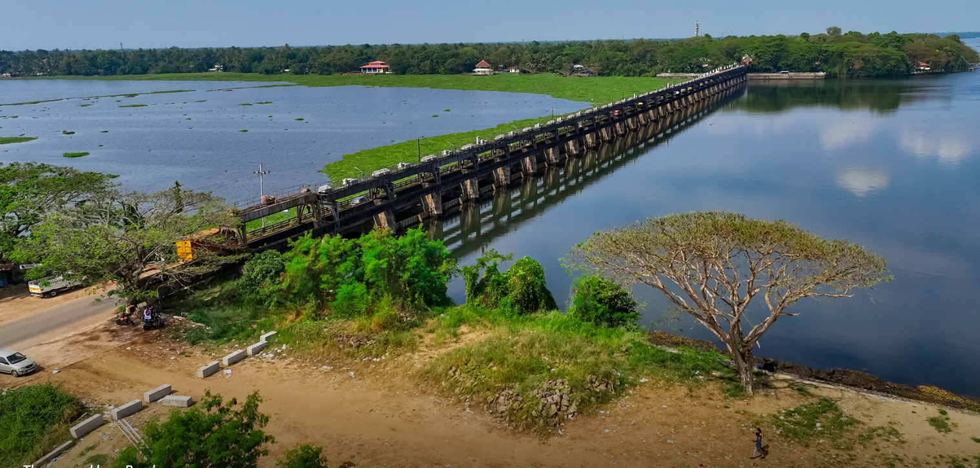

Prepared by:
Community Health Centre, Thanneermukkom
Health Department, Government of Kerala
In collaboration with
Thanneeermukkom Grama Panchayat

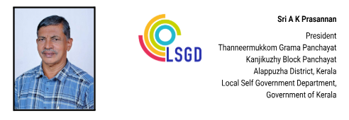
MESSAGE

പ്രിയരേ ,
തണ്ണീർമുക്കം സി.എച്ച്.സി.യുടെ (CHC) നേതൃത്വത്തിൽ തയ്യാറാക്കിയ ഈ 'മഹാമാരി പ്രതിരോധ പ്ലാൻ' (Pandemic Preparedness Plan) നമ്മുടെ പഞ്ചായത്തിന്റെ ആരോഗ്യ സുരക്ഷ ഉറപ്പാക്കുന്നതിൽ സുപ്രധാനമായ ഒരു ചുവടുവെപ്പാണ്. വേമ്പനാട് കായലിനാൽ ചുറ്റപ്പെട്ടതും തണ്ണീർമുക്കം ബണ്ട് സ്ഥിതിചെയ്യുന്നതുമായ നമ്മുടെ സവിശേഷമായ ഭൂമിശാസ്ത്രപരമായ സാഹചര്യങ്ങളിൽ, പകർച്ചവ്യാധി ഭീഷണികളെ ശാസ്ത്രീയമായി നേരിടാൻ ഈ കർമ്മപദ്ധതി നമ്മെ സഹായിക്കും.
മുൻകാലങ്ങളിൽ നാം നേരിട്ട ആരോഗ്യ പ്രതിസന്ധികളിൽ നിന്ന് പഠിച്ച പാഠങ്ങൾ ഉൾക്കൊണ്ട്, ഭാവിയിൽ ഏതു സാഹചര്യത്തെയും നേരിടാൻ സജ്ജമായ ഒരു പ്രതിരോധ സംവിധാനമാണ് ഇതിലൂടെ ലക്ഷ്യമിടുന്നത്. ഈ പദ്ധതി ആവിഷ്കരിച്ച മെഡിക്കൽ ഓഫീസർ ഉൾപ്പെടെയുള്ള എല്ലാ ആരോഗ്യ പ്രവർത്തകരെയും അഭിനന്ദിക്കുന്നു. പഞ്ചായത്തിലെ ഓരോ വ്യക്തിയുടെയും സുരക്ഷ ഉറപ്പാക്കാൻ എല്ലാവരുടെയും ആത്മാർത്ഥമായ സഹകരണം ഞാൻ അഭ്യർത്ഥിക്കുന്നു.

( A K PRASANNAN)

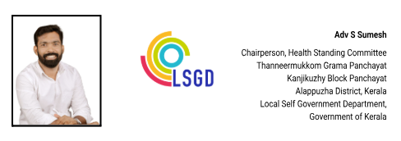
MESSAGE

പ്രിയരേ ,
പകർച്ചവ്യാധികൾ, പ്രകൃതി ദുരന്തങ്ങൾ, മറ്റ് ആരോഗ്യ അടിയന്തരാവസ്ഥകൾ എന്നിവയെ ഫലപ്രദമായി പ്രതിരോധിക്കാനും അവയുടെ ആഘാതം ലഘൂകരിക്കാനും ശാസ്ത്രീയമായ ആസൂത്രണം അനിവാര്യമാണ്. ഈ ലക്ഷ്യത്തോടെ മാരാരിക്കുളം വടക്ക് കുടുംബാരോഗ്യ കേന്ദ്രം തയ്യാറാക്കിയ 'പാൻഡമിക് പ്രിപെയർഡ്നസ് പ്ലാൻ' നമ്മുടെ പഞ്ചായത്തിന്റെ ആരോഗ്യ സുരക്ഷാ പ്രവർത്തനങ്ങളിൽ വലിയൊരു നാഴികക്കല്ലാണ്. നമ്മുടെ പഞ്ചായത്തിലെ ആരോഗ്യ മേഖലയിലെ വിവരശേഖരണങ്ങൾ കൃത്യമായി വിശകലനം ചെയ്ത് തയ്യാറാക്കിയ ഈ കർമ്മപദ്ധതി, ഭാവിയിലുണ്ടാകാവുന്ന ആരോഗ്യ വെല്ലുവിളികളെ നേരിടാൻ നമ്മെ കൂടുതൽ സജ്ജരാക്കും. ഇത്തരമൊരു മാതൃകാപരമായ പ്ലാൻ തയ്യാറാക്കിയ മെഡിക്കൽ ഓഫീസർ ഉൾപ്പെടെയുള്ള പബ്ലിക് ഹെൽത്ത് വിഭാഗത്തിലെ എല്ലാ ജീവനക്കാരെയും ആരോഗ്യ സ്റ്റാൻഡിംഗ് കമ്മിറ്റിക്കു വേണ്ടി അഭിനന്ദിക്കുന്നു. ഈ പ്ലാൻ നമ്മുടെ ആരോഗ്യ മേഖലയ്ക്ക് കൂടുതൽ കരുത്തും കരുതലും നൽകുമെന്ന് ഉറച്ചു വിശ്വസിക്കുന്നു. ജനങ്ങളുടെ ആരോഗ്യ സംരക്ഷണത്തിനായി പഞ്ചായത്ത് ഭരണസമിതിയും ആരോഗ്യ സ്റ്റാൻഡിംഗ് കമ്മിറ്റിയും എന്നും മുൻപന്തിയിലുണ്ടാകുമെന്ന് ഉറപ്പുനൽകുന്നു.

(S SUMESH)
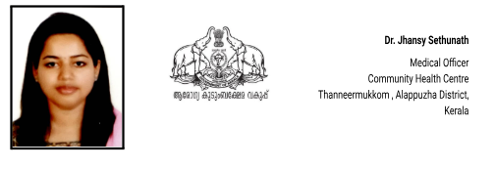

MESSAGE,

രാജ്യാന്തര പകർച്ചവ്യാധികൾ സൃഷ്ടിക്കുന്ന ആരോഗ്യപ്രശ്നങ്ങൾ കഴിഞ്ഞ കാലത്തുണ്ടായ കോവിഡ് 19 ലൂടെ നാം അനുഭവിച്ചറിഞ്ഞതാണല്ലോ. തീരദേശ ഗ്രാമമായ തണ്ണീർമുക്കം ഗ്രാമപഞ്ചായത്ത് പ്രദേശത്ത് 14527 കുടുംബങ്ങളി ലായി 43,654 ജനങ്ങൾ അധിവസിക്കുന്നു. നിരവധി വിനോദസഞ്ചാരികളും രാജ്യാന്തരങ്ങളിൽ ജോലിചെയ്യുന്ന ഗ്രാമീണരും ഈ പ്രദേശത്തുണ്ട്. ഇത്തരത്തിൽ ലോകത്തിൻറെ ഏതു കോണിൽ പകർച്ച വ്യാധികൾ പൊട്ടിപ്പുറപ്പെട്ടാലും അതിനെതിരെ ശക്തമായ പ്രതിരോധ പ്രവർത്തനങ്ങൾ സ്വീകരിക്കുക അനിവാര്യമാണ്. ഈ പ്രവർത്തനങ്ങൾക്ക് ഏറെ ഉപകാരപ്പെടുന്ന ഒന്നാണ് Pandemic preparedness ആക്ഷൻ പ്ലാൻ. രോഗം പകരുന്ന രീതി, എത്ര പേരെ ഇത് ബാധിക്കുന്നു, രോഗവ്യാപന പ്രദേശം, കാലം തുടങ്ങിയ വിഷയങ്ങൾ ഈ പ്ലാനിൽ ചർച്ച ചെയ്യപ്പെടുന്നു.
ഇത്തരത്തിലുള്ള ദുരന്തങ്ങളുടെ ആഘാതം ലഘൂകരിക്കുന്നതിനും തടയുന്നതിനും ഉള്ള ഇടപെടലുകൾ ലഭ്യമായ രേഖകളുടെയും, HR ൻ്റേയും, ഇൻഫ്രാസ്ട്രക്ചർ ന്റെയും അടിസ്ഥാനത്തിൽ തയ്യാറാക്കുന്നതിന് പൊതുജന ആരോഗ്യ വിഭാഗത്തിലെ ഞാനും എന്റെ സഹപ്രവർത്തകരും കഴിയുന്നത്ര ശ്രദ്ധിച്ചിട്ടുണ്ട്. ഈ പാഡമിക് preparedness പ്ലാൻ രാജ്യാന്തര പകർച്ചവ്യാധികൾ തടയുന്നതിന് ഏറെ ഉപകാരപ്രദമാകും എന്ന് പ്രത്യാശിക്കുന്നു

(DR JHANSY SETHUNATH)

EXECUTIVE SUMMARY

Community Health Centre (CHC) Thanneermukkom serves as a key secondary-level public healthcare institution catering to the population of Thanneermukkom Grama Panchayath under Kanjikuzhy Block in Alappuzha District. The Grama Panchayath comprises 24 wards, covers a total geographical area of 31.44 square kilometres, and has a projected population of 43,654, with a population density of 1,309 persons per square kilometre. The terrain is predominantly characterized by backwaters, intersected by rivers and water bodies, making the region environmentally unique and geographically vulnerable to water-related health risks.

CHC Thanneermukkom plays a pivotal role in delivering comprehensive, accessible, and affordable healthcare services to this geographically sensitive and densely populated area. The institution provides preventive, promotive, curative, and rehabilitative services in alignment with national and state health programmes. As a secondary care facility, the CHC offers outpatient and inpatient services, emergency care, maternal and child health services, and referral support to higher-level institutions when required.
The CHC addresses major public health priorities, including communicable disease control, non-communicable disease management, immunization, reproductive and child health services, adolescent health, geriatric care, and disease surveillance. Special attention is given to vector-borne diseases, water-borne illnesses, and seasonal outbreaks that may arise due to the terrain and extensive water bodies.
The institution actively implements major national health initiatives such as the National Health Mission (NHM), National Tuberculosis Elimination Programme (NTEP), National Programme for Prevention and Control of Cancer, Diabetes, Cardiovascular Diseases and Stroke (NPCDCS), Reproductive, Maternal, Newborn, Child and Adolescent Health (RMNCH+A) services, and surveillance activities under the Integrated Disease Surveillance Programme (IDSP). These programmes ensure early detection, effective treatment, and systematic monitoring of priority health conditions.
CHC Thanneermukkom functions in close coordination with the Grama Panchayath, ASHA workers, Anganwadi centres, educational institutions, and community-based organizations to strengthen community participation and health awareness. Given the environmental and geographical characteristics of the Panchayath, emphasis is placed on preventive health education, environmental sanitation, early diagnosis, outbreak preparedness, and timely referral services.
Despite challenges related to terrain, seasonal flooding risks, infrastructure limitations, and increasing service demand, the CHC continues to enhance service delivery through structured planning, data-driven decision-making, and strengthened intersectoral coordination. Future priorities include infrastructure strengthening, digital health system enhancement, emergency preparedness planning, and expansion of preventive and outreach services tailored to the unique backwater ecosystem.
Overall, Community Health Centre Thanneermukkom stands as a critical healthcare institution within Alappuzha District, playing a vital role in safeguarding public health and improving the quality of life of the residents of Thanneermukkom Grama Panchayat

LIST OF ABBREVIATIONS

LSGD/LSGI | Local Self Government Department / Local Self Government Institution
BMO | Block Medical Officer
IDSP | Integrated Disease Surveillance Programme
NDMA | National Disaster Management Authority
PPE | Personal Protective Equipment
ICMR | Indian Council of Medical Research
CD | Communicable Diseases
NCD | NON-COMMUNICABLE Diseases

TABLE OF CONTENTS

EXECUTIVE SUMMARY 5
INTRODUCTION 10
● Background of the PPP 10
LSGD AT A GLANCE 10
INTEGRATED HEALTH INFRASTRUCTURE MAP OF ____________ PANCHAYAT 11
GENERAL PROFILE OF THE LSGI’S 14
Background of the LSGI 14
Demographic and Vulnerable Population 15
Clinical Vulnerability 17
INFRASTRUCTURE & RESOURCE INVENTORY 19
Health Facility Directory & Basic Capacity in the LSGD 19
Private Clinics 21
Healthcare Education & Training Institutions 22
Specialized Services & Emergency Inventory 22
Oxygen & Diagnostic Capacity 23
Diagnostics facility mapping at the LSGI level 24
Laboratory Identification & Basic Details 25
Social and Community Infrastructure for surge plan 26
Human resources 30
Medical & Clinical Personnel 30
Public Health & Field-Level Workforce 30
Community & Support Cadre 32
Community Organizations 33
Administrative & Emergency Services 34
Information regarding resources 34
ONE HEALTH & ENVIRONMENTAL SURVEILLANCE 35
Animal & Bird Population 36
Veterinary Infrastructure 37
Veterinary Doctors & Workforce 38
High-Risk Interface Points (Surveillance Sites) 39
Environmental Risk Mapping 42
Disease Seasonality Mapping 43
Vulnerability Mapping 44
EPIDEMIOLOGICAL TRENDS (2021–2025) 46
Disease Burden among human beings(Last 5 Years) 46
*(use the above table data to create the graph/diagram) 48
Seasonal Trend Analysis 49
DENGUE 49
Dengue – Ward-wise Yearly Distribution (2021–2025) 49
LEPTOSPIROSIS 51
Leptospirosis – Ward-wise Yearly Distribution (2021–2025) 51
VIRAL HEPATITIS - A 53
Hepatitis A – Ward-wise Yearly Distribution (2021–2025) 53
Outcome-Based Trend Analysis- 2025 54
Transmission Trend- 2025 57
Integrated Disease Hotspot Map (2021–2025) 60
Preparedness and Response Protocol at LSG Level 63
Constitution of One Health Committee 63
Key Responsibilities: 64
Meeting Schedule: 64
Pandemic Response Workforce 64
Activities and Measures before and during Pandemic 66
PHASE 1 - Alert / Preparation 66
➢ Identification of Quarantine and Isolation Facilities 67
➢ Risk Communication and Community Preparedness 67
➢ Protection of Vulnerable Groups 68
➢ Clinical Dependency Mapping 68
PHASE 2 - Active Response 69
1. Case Identification and Contact Tracing 69
2. Screening Checkpoints 69
Standard Screening Protocol 70
3. Pandemic Control Room 71
Control Room Infrastructure and Location 71
Health System Control Room Framework 71
1. Rapid Response Team (RRT) 71
2. Data Management & Analytics Team 71
3. Human Resource Deployment Team 71
4. Laboratory Surveillance Team 71
5. Vaccination Cell (If Required) 72
6. Infrastructure & Patient Occupancy Team 72
7. Communication team 72
Key Control Room Team 72
Daily Monitoring Indicators 73
1. Epidemiological Indicators: 73
4. Communication of Public Health Information 75
Key communicators 75
5. Coordination with District/State Authorities & Other Organisations 76
Key Details: 76
Supply Chain Coordination 77
Resource Inventory and Contacts 78
Collaboration with NGOs, PPP, and CSR 78
Interdepartmental Coordination 79
PHASE 3 - Surge Capacity 79
Conversion of Community Facilities 80
CONCLUSION 81
RECOMMENDATIONS 82
1. Strengthening Healthcare Infrastructure 82
2. Community Awareness & Education 82
3. Emergency Response & Coordination 82
4. Supply Chain & Food Security 82
5. Digital Preparedness 82
6. Training & Capacity Building 82
7. Long-Term Resilience 82
ANNEXURE 83
1. IMPORTANT PHONE NUMBERS 83
1.1. Details of grama panchayat/municipality/corporation wards 84
1.2. Other important phone numbers of grama panchayat/municipality/corporation area 85
1.3. Important offices of grama panchayat/municipality/ corporation 85
1.4. Health Services 86
1.5. Veterinary Services 87
1.6. Helpline numbers 87
1.7. Public and Private Schools Contact details 88
1.9. Anganwadi Contact Details 88
1.12. Information regarding resources 91

INTRODUCTION
Pandemics pose significant and recurrent threats to public health, social stability, and essential services, particularly at the community level where early detection, rapid response, and service continuity are critical. Local Self-Government Institutions (LSGIs) play a pivotal role in pandemic preparedness and response by translating national and state-level strategies into context-specific actions that address local risks, vulnerabilities, and capacities.

Thanneermukkom Grama Panchayat, situated in the Kanjikuzhi Block of Alappuzha District, Kerala, is a region of immense ecological and strategic importance. Known globally for the Thanneermukkom Bund—the largest mud regulator in India—the Panchayat is characterized by its extensive backwater terrain along the banks of the Vembanad Lake. Spread over an area of 31.44 square kilometres and comprising 24 wards, the Panchayat supports a projected population of 43,654 residents with a density of 1,309 persons per square kilometre. Its unique geography, dominated by water bodies and low-lying areas, makes the region environmentally sensitive and particularly vulnerable to water-borne diseases and climate-related public health risks.

The demographic and socio-economic profile of Thanneermukkom necessitates a robust and inclusive preparedness framework. The Panchayat is home to a substantial elderly population of 8,258 individuals, as well as 1,606 children under the age of five, both of whom are high-risk groups during respiratory or infectious outbreaks. Social vulnerability is further highlighted by the presence of 6,306 BPL families, 91 EPEP (Extremely Poor Empowerment Process) families, and 624 individuals dependent on the fishing industry for their livelihoods.

This Pandemic Preparedness Plan has been developed to strengthen Thanneermukkom Grama Panchayat’s capacity to prevent, detect, and respond to pandemics and large-scale infectious disease outbreaks. The plan adopts a risk-based and data-driven approach, integrating disease vulnerability mapping, health system capacity assessment, demographic risk profiling, and intersectoral coordination mechanisms. It emphasises early warning systems, protection of high-risk populations, continuity of essential health and social services, surge capacity planning, and effective collaboration between the Health Department, LSGI, line departments, private healthcare providers, and community stakeholders.

By institutionalising preparedness measures and strengthening local capacity, this plan aims to enhance the resilience of Thanneermukkom Grama Panchayat and ensure timely, coordinated, and effective action in the face of future pandemics and large-scale disease emergencies.

LSGD AT A GLANCE

ADMINISTRATIVE BOUNDARIES OF THANNEERMUKKOM PANCHAYAT
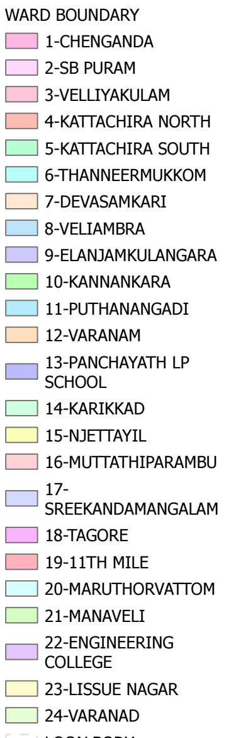
\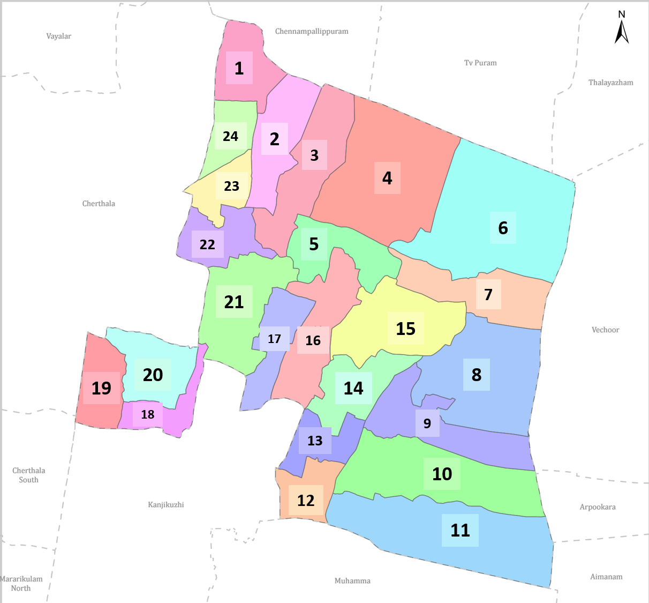
Thanneermukkom Grama Panchayat Ward-Wise Map (2026) Data provided by K-SMART (KSMART Final Notification of Marrikulam North Panchayath)

Ward | Houses | Population | Migrants | Wells | Hot  spots | Ed. Institutions | Hosp pvt/govt.
24 | 14527 | 43654 | 161 | 2335 | 11 | 15 | 3/2

INTEGRATED HEALTH INFRASTRUCTURE MAP OF THANNEERMUKKOM PANCHAYAT
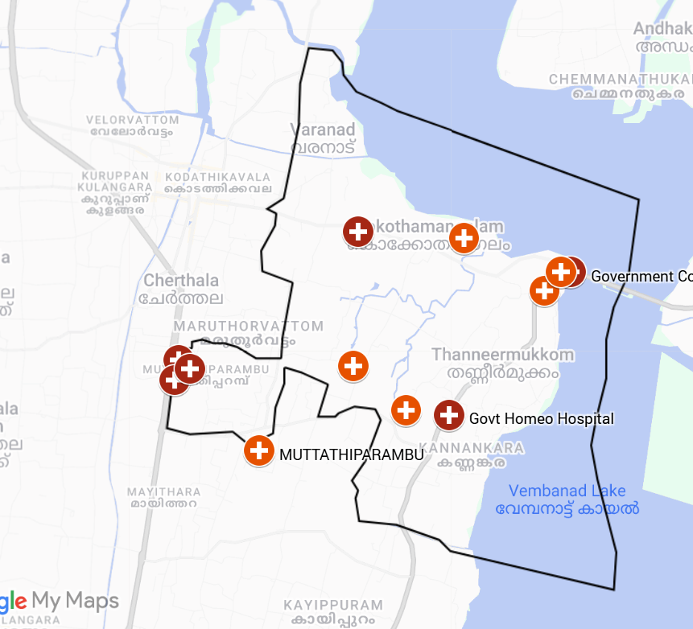
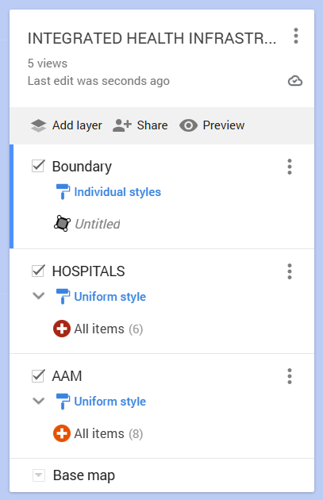

Spatial Mapping of Major Establishments of Muhamma Grama Panchayat (2026)
Boundary Data: OpenDataKerala | Map Created with Google My Maps Thannermukkam Health infrastructure

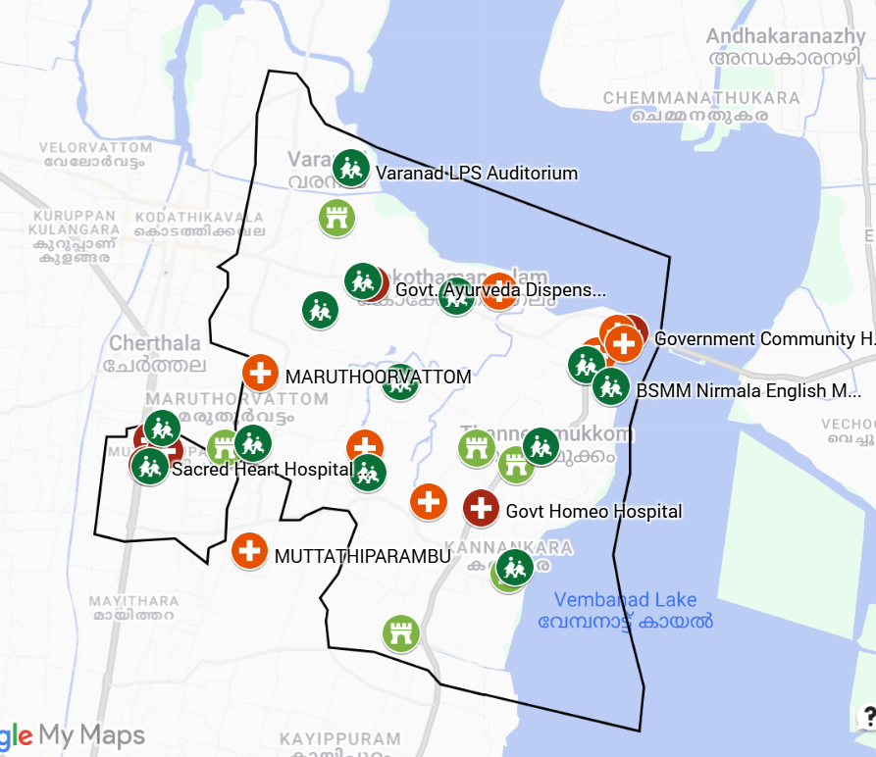
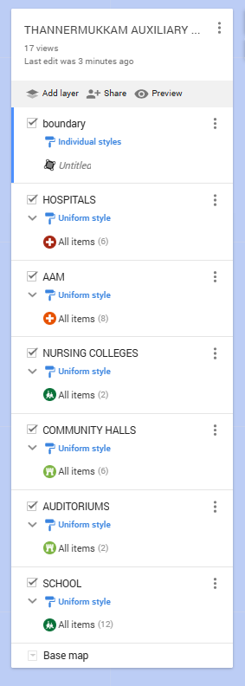
AUXILIARY INFRASTRUCTURE & LOGISTICAL RESOURCE MAP OF THANNERMUKKAM PANCHAYAT

Spatial Mapping of Major Establishments of Muhamma Grama Panchayat (2026)
Boundary Data: OpenDataKerala | Map Created with Google My Maps AUXILIARY INFRASTRUCTURE MAP OF THANNERMUKKAM PANCHAYAT

MAJOR ROADWAYS MAP OF THANNERMUKKAM GRAMA PANCHAYAT
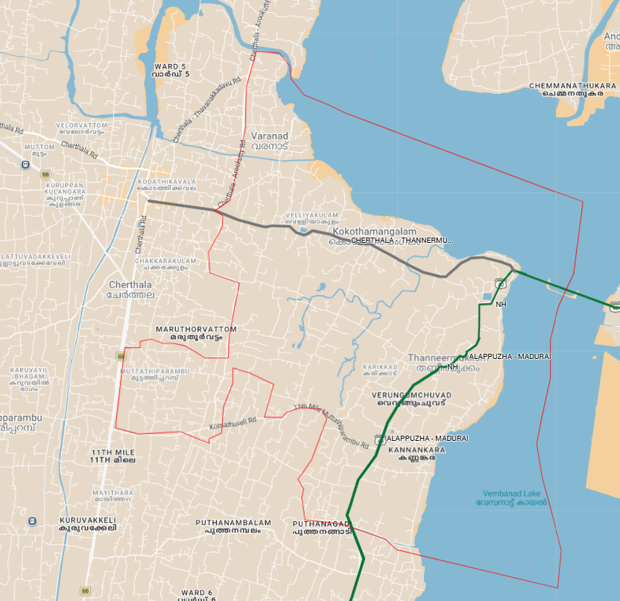

Spatial Mapping of Major Establishments of Thannermukkam Grama Panchayat (2026)
Boundary Data: OpenDataKerala | Map Created with Google My Maps THANNERMUKKAM ROAD MAP

GENERAL PROFILE OF THE LSGI’S

Background of the LSGI
Thanneermukkom Grama Panchayat is situated in Alappuzha district, Kerala. The geographical landscape of the Panchayat is predominantly low-lying, characterized by extensive paddy fields (Kole lands) and a dense network of rivers, canals, and backwaters. This unique terrain plays a significant role in shaping the local microclimate and poses distinct challenges to transportation, emergency response, and service delivery, particularly during monsoon seasons and flood events.
The Panchayat is administratively divided into multiple wards, with a population largely dependent on traditional livelihoods. Agriculture—especially paddy cultivation—fishing, coir and coconut husk processing, and allied activities form the backbone of the local economy. In recent years, tourism-related activities and service-sector employment have also shown gradual growth. The area hosts a diverse workforce, including a notable presence of migrant labourers, particularly in construction, agriculture, and allied sectors.
From a public health and disaster management perspective, LSGI has historically been vulnerable to seasonal flooding, waterborne diseases, and vector-borne illnesses such as Dengue and Leptospirosis. The severe floods experienced during recent years, including the 2018 flood disaster, significantly impacted life, livelihoods, and infrastructure within the Panchayat. These recurring emergencies have underscored the importance of strengthening local preparedness, response mechanisms, and inter-departmental coordination.
In this context, the development of a localized, data-driven Auxiliary Infrastructure and Logistical Resource Map is essential to support effective planning, timely emergency response, and sustainable development initiatives. Such mapping enables the Panchayat to identify critical resources, improve accessibility during disasters, and enhance overall resilience of the community.

Table 1: Background of LSGD
Description | Details
Name of LSGI | Thanneermukkom
Type (GP/Municipality / Corporation etc.) | Grama Panchayath
Block | Kanjikuzhy
District | Alappuzha
Number of wards | 24
Total area (sq. km) | 31.44
Population(Projected) | 43654
Population density | 1309/km
Terrain (coastal/low-lying/backwaters/foothills, etc.) | backwaters
Number of rivers passing through LSGI | 7
Number of water bodies in the LSGI | 1178
Number of educational institutions | 61
Factories / small-scale industries | 04
Flood-prone wards | 1,2,3,4,5,10,14,15,17,21
Landslide-prone wards | 0
Death Management and Disposal Facilities (mortuaries/crematorium, including electric) | 0
Auditoriums/Marriage halls/convention centres/community halls | 03/06/03/06

Demographic and Vulnerable Population
Understanding the demographic composition and vulnerable population groups is essential for pandemic preparedness. Children, elderly, economically deprived families, migrant workers, and socially vulnerable groups are at increased risk during public health emergencies due to higher exposure, limited access to services, and dependency on public systems..

Description |  | Details (in numbers)
DEMOGRAPHIC PROFILE
Total population |  | 43654
Male |  | 21415
Female |  | 22083
Transgender |  | 0
Children under 5 |  | 1606
Adolescent |  | 3606
Elderly (>60) |  | 8258
SOCIAL/LIVELIHOOD VULNERABILITY
Previous EPEP family |  | 91
BPL family |  | 6306
Tribal communities |  | 64
Migration | Immigrant | 161
Migration | Emigrant | 625
Socio-economically deprived |  | 1
Fisherfolk |  | 624
SC Community |  | 4 COLONY, 430 FAMILY & 1400 POPULATION
ST Community |  | 3 COLONY, 98 FAMILY & 260 POPULATION

Graphs: Population pyramid (if possible) for seeing if your LSGI has a high "dependency ratio" (lots of children and elderly compared to working adults).

Clinical Vulnerability
Certain population groups needs priority healthcare & are at higher risk of severe illness, complications, and mortality during pandemics. Patients with chronic diseases, those requiring regular medical care, and individuals with mobility or functional limitations face challenges in accessing timely care during emergencies. Mapping these groups helps in prioritizing continuity of treatment, medicine stock planning, oxygen support, referral transport, and targeted home-based care.
Description | Details in numbers
Pregnant women | 3606
Lactating mothers | 171
Bedbound patients | 129
Patients under palliative care other than bedbound | 356
Patients on Haemodialysis | 19
Patients on CAPD | 77
Cancer patients (currently on treatment) | 213
Haemophilic patients | 9
Mentally challenged | 104
Differently abled | 143
Diabetic patients | 4317
Hypertensive patients | 4980
TB patients | 12

Major Festivals & Events specific to the LSGI
(with the possibility of a public gathering)

Sl. No. | Name of festival | Month detailing the periodicity
1 | Maruthorvattom temple karkidavavau,Varanad temple fest | august,february

INFRASTRUCTURE & RESOURCE INVENTORY

Health Facility Directory & Basic Capacity in the LSGD
This section provides an overview of the healthcare infrastructure available within the LSGD area. It outlines the distribution and basic capacity of health facilities that form the backbone of service delivery during routine times and public health emergencies.

Family Health Centres (FHCs) and Community Health Centres (CHCs) generally function as the first point of contact for the community, providing essential outpatient and inpatient services. General Hospitals (GH) and Medical College Hospitals (MCH), where accessible, serve as the main referral centres for advanced diagnostics, specialist care, and critical services during public health emergencies. This inventory helps identify existing strengths, gaps, and potential surge capacity that can be mobilised during a pandemic or disaster.

Table 5. Health Facility Resource Summary
Sl.no. | Health Facility | Type of Facility (MCH/GH/CHC/FHC/SC etc.) | Contact Number | Total beds | ICU Beds | Oxygen-Supported Beds | No. of Ventilator Support Beds | No. of ambulances
Government Healthcare Facilities
1 | CHC Thannermukkom | CHC | 8921760838 | 24 | 0 | 0 | 0` | 1
2 | AAM  Maincentre | SC | 9495583327 | 1 | 0 | 0 | 0 | 0
3 | AAM Thanneermukkom | SC | 6235037579 | 1 | 0 | 0 | 0 | 0
4 | AAM Maruthorvattom | SC | 7306975608 | 1 | 0 | 0 | 0 | 0
5 | AAM Sreekandamangalam | SC | 884802497 | 1 | 0 | 0 | 0 | 0
6 | AAM Muttathiparambu | SC | 9447056128 | 1 | 0 | 0 | 0 | 0
7 | AAM Thaneermukkom North | SC | 9249976947 | 1 | 0 | 0 | 0 | 0
8 | AAM Kokothamangalam | SC | 9645721631 | 1 | 0 | 0 | 0 | 0
9 | AAM Sasthangal | SC | 8891363478 | 1 | 0 | 0 | 0 | 0
Private Healthcare Facilities
1 | Kinder Fertility Centre | Private | 0478 283 0000 | 100 | 27 | 64 (11 neonatal) | 4 - neonatal, 1- adult | 1
2 | Sacred Heart Hospital | Private | 94974 42337 | 250 | 10 | 10 | 1 | 0
3 | Prathyasa Cancer Care Center | Private | 0478 282 0069 | 0 | 0 | 0 | 0
AYUSH Healthcare Facilities
1 | Govt. Ayurveda Dispensary Thanneermukkom | Govt | 0478 281 0212 | 0 | 0 | 0 | 0 | 0
2 | Govt Homeo Hospital | Govt | 9400705777 | 0 | 0 | 0 | 0 | 0

Private Clinics
Private clinics are an essential part of pandemic preparedness, as they are often the first place people seek care when symptoms begin. In many communities, private clinics manage a significant share of outpatient visits and therefore play a critical role in early case detection, timely referrals, and disease surveillance. Having an up-to-date understanding of where these clinics are located, the services they provide, and how they are linked to the public health system helps ensure that no cases are missed during an outbreak. It also allows health authorities to engage private practitioners more effectively for reporting, risk communication, and coordinated response, strengthening the overall capacity of the health system to manage public health emergencies.

Table 6. Private Clinic Resource Summary
Sl No. | Name of Clinic | Registered (Y/N) | Clinic (General / Speciality) | Speciality (if any) | Address | Contact Number | Diagnostic Facility (Y/N) | Ambulance Linkage (Y/N)
1. | Pan Advanced Speciality Dental Clinic | N | Dental | Nil | 11th Mile | 8921825447 | Y | N
2. | Medicity Family Clinic and Medical Lab | N | General | Nil | Varanad | 8089666580 | Y | N
3 | Our Family Clinic | Y | General | Nil | Puthenangadi | 7085129997 | Y | N

Healthcare Education & Training Institutions
This section tracks the educational infrastructure available, which is vital for human resource planning in the health sector.

Category of Institution | Govt | Private | AYUSH | Total
Medical Colleges | 0 | 0 | 0 | 0
Nursing Colleges | 0 | 2 | 0 | 2
Dental Colleges | 0 | 0 | 0 | 0
Para-medical / Allied Health | 0 | 0 | 0 | 0
Pharmacy Colleges | 0 | 1 | 0 | 0

Specialized Services & Emergency Inventory
This section provides a detailed view of the specialized medical resources available to the community, focusing on emergency response and critical care capabilities. This table tracks the vital assets required for managing severe illnesses and emergencies across Government, Private, and AYUSH sectors.

Item | Govt | Private | AYUSH | Total
Hospital beds | 24 |  | 0
Oxygen-generating systems(Y/N) | 4 | 2 | 0 | 4
Oxygen-supported beds(Numbers) | 0 | 240 | 0 | 120
Ventilator-supported beds | 0 | 2 | 0 | 0
ICU beds | 0 | 15 | 0 | 10
Burns units | 0 | 0 | 0 | 0
Blood centres | 0 | 1 | 0 | 1
BLS ambulances | 1 | 0 | 00 | 3
ALS ambulances | 0 | 0 | 0 | 0
Dialysis facilities | 0 | 0 | 0 | 0
Dispensaries | 1 | 1 | 2 | 15
Medical store | 0 | 15 | 4 | 19
Industrial establishments(Medium-scale industries/small-scale industries establishments to whom we can depend in a worst-case scenario) | 0 | 0 | 0 | 0

Oxygen & Diagnostic Capacity
Monitoring oxygen and diagnostic capacity is a critical component of public health preparedness, ensuring that the LSGD can handle both chronic care and sudden surges in respiratory or infectious diseases.
Name of Health Facility | Oxygen-generating System (Y/N) | Backup Oxygen Source (Y/N) | Diagnostic Facilities Available(Y/N)
Name of Health Facility | Oxygen-generating System (Y/N) | Backup Oxygen Source (Y/N) | Lab | USG | X-ray | CT/MRI | RT-PCR
Government Healthcare Facilities
CHC Thanneermukkom | N | Y | Y | N | N | N | N
Sacred Heart Hospital | N | Y | Y | Y | Y | N | Y
Kinder Hospital | Y | Y | Y | Y | Y | Y | Y
Prathyasa Cancer Care Center1 | Y | Y | Y | Y | Y | Y | Y

Diagnostics facility mapping at the LSGI level
The diagnostic capacity of Thannermukkam G.P represents the "intelligence network" of our healthcare system. The speed and accuracy of disease identification depend entirely on the distribution and technical level of these facilities.

Item | Govt | Private | AYUSH | Total
General labs | 1 | 3 | 0 | 4
Microbiology labs | 0 | 3 | 0 | 3
RT-PCR labs | 0 | 1 | 0 | 1
USG units | 0 | 2 | 0 | 2
CT/MRI units | 0 | 1 | 0 | 0
Research labs | 0 | 0 | 0 | 0
Labs of other departments that can be repurposed | 0 | 0 | 0 | 0

Laboratory Identification & Basic Details
Sl. No. | Name of Laboratory | Ownership (Govt / Private / Academic) | Address | Contact No. | 24×7 Services (Yes/No) | NABL / Govt Approved (Yes/No)
1 | Sacred Heart Hospital | Private | Green Gardens , Cherthala | 04782811337 | Y | N
2 | Hamish Clinical Laboratory | Private | Pallikavala | 9142892134 | N | N
3 | Medicity family clinic and medical lab | Private | Varanad | 8089666580 | N | N
4 | Vallayil Computerized Lab | Private | Pottikavala | 9745488719 | N | Y
5 | CHC Thanneermukkom | Govt | Thanneermukkom |  | N | N
6 | MSGR Jospgh Kandatthil Memorial Cancer Research Centre | Private | Green Gardens | 944748982 | N | N
8 | SV Clinical Laboratory | Private | Thanneermukkom | 9846020973 | N | N
9 | Vishwalekshmi Medical Laboratory | Private | Puthanangadi | 7907592790 | N | Y
10 | AMG Medical Lab | Private | Thnneermukkom | 9995028257 | N | Y
11 | Our Family Clinic | Private | Puthanangadi | 7025129997 | N | Y
12 | Kinder Hospital | Private | Maruthorvattom | 9495133111 | Y | N

Social and Community Infrastructure for surge plan
This table serves as our logistics and shelter inventory. By mapping these locations, quickly we can identify where to house displaced citizens, where to set up temporary medical clinics, and how to mana
ge the deceased with dignity during a crisis.

Category | Total Count | Ward | Est. Capacity (Persons) | Contact details
Educational Institutions
Anganwadis | 44 | 24 | 279 | 9495810668
Schools | 15 | 24 | 1711 | NA
Colleges | 3 | 19,22 |  | NA
Healthcare Educational Institutions
Medical colleges (Govt/Private) | 0 | 0 | 0 | 0
Nursing colleges (Govt/Private) | 2 | 19 | KVM Nursing college - 270 | 9048495222
Nursing colleges (Govt/Private) | 2 | 19 | SH College of Nursing - 158 | 9656919862
Dental colleges (Govt/Private) | 0 | 0 | 0 | 0
ParamedicaL institutes (Govt/Private) | 1 | 21 | KVM Pharmacy- 490 | 9446407345
Community Gathering Spaces
Community hall | 14 | 22 | Varanad Community hall - | 964505080714
Community hall | 14 | 4 | Kopamangalam Parish Hall | 9846330331
Community hall | 14 | 7 | NSS Hall | 9495309926
Community hall | 14 | 8 | Parish Hall Nirmala Church | 4782582815
Community hall | 14 | 12 | Parish Hall Paluthra | 9947065716
Community hall | 14 | 19 | Nammakattu Community Hall - 200 | 9746216076
Community hall | 14 | 21 | Pannatupally Parish Hall | 9847088524
Community hall | 14 | 14 | Parish Hall , Karikadu | 9400234703
Community hall | 14 | 18 | SNDP Hall - 200 | 9746678755
Community hall | 14 | 7 | SNDP Hall | 9188014347
 |  | 2 | Vathyattu Kudumbayogam Hall | 8113006103
 |  | 3 | Veliyakulam NSS Karayogam Hall | 8089940899
 |  | 10 | St Xaviers Church Parish Hall | 9447315300
 |  | 18 | Community Hall, Harijan Colony - 150 | NA
Auditoriums | 3 | 1 | Sreebhdhra Auditorium -250 | 9447013806
Auditoriums | 3 | 2 | Varanad LPS Auditorium- 250 | 9846536561
Auditoriums | 3 | 19 | Maruthorvattom Temple Auditorium - 250 | 9072313355
Religious buildings | 60 | 24 | NA | NA
Vulnerable Group Support Facility
Destitute homes | 0 | 0 | 0 | 0
Elderly homes | 84
LSGD owned other buildings | 0 | 0 | 0 | 0
Mass Fatality Management (MFM) Infrastructure
Mortuary | 0 | 0 | 0 | 0
Crematorium | 0 | 0 | 0 | 0
*refer annexure 1 for contact details

Human resources
This section focuses on the human capital available within the LSGI. In any emergency—be it a pandemic, flood, or industrial accident—infrastructure is only as effective as the people operating it.

Medical & Clinical Personnel
This table tracks the "Frontline" providers responsible for diagnosis, treatment, and clinical management. Narrative sentence: eg., "Total health workforce: 450 personnel, with 60% in government facilities serving as primary surge capacity." A detailed directory with the contact numbers of all workers is maintained (Annexure in 1).

Cadre | Govt (No.) | Private (No.) | Total
Doctors—Modern Medicine | 4 | 6 | 10
Doctors – AYUSH | 1 | 3 | 4
Doctors – Veterinary | 1 | 0 | 1
Doctors – Dental | 0 | 3 | 3
Nursing officers | 4 | 114 | 118
Lab technicians | 1 | 20 | 21
Optometrist | 0 | 1 | 1
Pharmacists | 1 | 20 | 21
Psychologists | 0 | 1 | 1
Counsellors | 0 | 1 | 1

Public Health & Field-Level Workforce
These individuals are the backbone of surveillance, maternal-child health, and decentralized care.

Cadre | Health services | Municipal common services | Total
HS (Health Supervisors) | 0 | 0 | 0
HI (Health Inspectors) | 1 | 0 | 1
LHS (Lady Health Supervisor) | 0 | 0 | 0
LHI (Lady Health Inspectors) | 1 | 0 | 1
JPHN (Jr Public Health Nurses) | 8 | 0 | 8
JHI (Jr Health Inspectors) | 4 | 0 | 4
MLSP (Mid-Level Service Providers) | 7 | 0 | 7
Palliative Nurses | 2 | 0 | 2
RBSK Nurses | 1 | 0 | 1
PRO | 0 | 0 | 0
Epidemiologist | 1 | 0 | 0
Data Manager | 1 | 0 | 0

Community & Support Cadre
This group represents the surge capacity of the LSGI—people who can be called upon for logistics, rescue, and specialized support.

Cadre | Number
ASHA Workers | 35
AWW (Anganwadi Workers) | 44
Emergency Medical Volunteers (Trained) | 0
Kudumbashree | 413
MNREGS | 3509
Purusha Swayam Sahaya Sangham | 68
Ex-Servicemen | 5
Retired Police Officers | 8
Red Cross volunteers | 0
One Health Community Volunteers | 1127
One Health Community Mentors | 161

Community Organizations
This section details the presence of community-based organisations (CBOs), non-governmental organisations (NGOs), faith-based organisations (FBOs), Kudumbashree Self-Help Groups (SHGs), and Ayalkootams within the Local Self-Government Institution (LSGI). These groups enhance grassroots mobilization, resource distribution, and support networks crucial for pandemic response and community resilience.

Category | Total Count
NGOs | 0
Religious based organizations | 24
Foreign based organizations | 0
Sports Club/youth clubs | 6
Kudumbashree SHGs | 413
Ayalkootams | 412
Political organizations | 4

Administrative & Emergency Services
This section outlines the availability of key non-health emergency support services and infrastructure within the LSGI, which are essential for effective pandemic preparedness and response. These facilities support law enforcement, disaster response, water supply, logistics, mobility, and community-level interventions during public health emergencies.

Category | Total Count | Contact details
Police Stations | 0 | 0
Fire & Rescue Stations | 0 | 0
Water Pumping Points | 01 | NA
Public Distribution System (PDS) | 0 | 0

Information regarding resources
The availability of essential transport and support resources plays a quiet but critical role in saving lives. Equipment such as ambulances, mobile mortuaries, amphibian ambulances, and motorized boats ensures that patients, samples, and healthcare teams can move swiftly—even in flooded, remote, or difficult terrains. Heavy vehicles like JCBs, cranes, tractors, and torus lorries support logistics, waste management, emergency infrastructure, and rapid conversion of spaces into care or isolation facilities. Taxis, four-wheel-drive vehicles, and trucks help maintain continuity of essential services, reach vulnerable populations, and support home-based care and supply delivery.

Means of transportation | Total Count
JCB | 5
Crane | 1
Heavy Trucks | 4
Tractor | 1
Ambulances | 1
Mobile mortuaries | 3
Boats | 0
Taxi service | 10
Note: For specific details regarding vehicle owners and contact information, please refer to Annexure [X].

ONE HEALTH & ENVIRONMENTAL SURVEILLANCE
The One Health method integrates environmental, animal, and human health to enable proactive pandemic preparedness. Panchayat-level surveillance needs to be improved in order to detect and treat zoonotic and environmentally generated diseases early. Surveillance is strengthened through systematic assessment of animal populations, veterinary infrastructure, poultry and slaughter facilities, inter-sectoral coordination, and specialised tools like avian influenza seasonality mapping using GIS in previous outbreaks to enable predictive alerts and ward-specific sampling to support effective pandemic preparedness in high-risk areas like ____________.

Animal & Bird Population
Mapping animal and bird populations at the Panchayat level is essential for identifying and prioritising zoonotic disease hazards like rabies, avian influenza (H5N1), leptospirosis, anthrax, and Nipah-like spillover occurrences. Risk classification, targeted surveillance, vaccination planning, and early epidemic detection made feasible by comprehensive population mapping all enhance One Health-based pandemic preparedness.

Category | Item | Estimated Population | Wards
Animal Population | Livestock (Cattle/Goats/Buffalo) | 1173 - cow  556- goat  37- buffallo | All wards
Animal Population | Pet Animals (Dogs/Cats) | 1897 dogs | all wards
Animal Population | Stray Dog Population | 1054 | all wards
Animal Population | Pig Farms (Number of heads) | 15 (5 per farm)
 | Small Units (Sheep / Goats – clustered) | Nil | Nil
Bird Population | Poultry Units (Birds) | 16 | 4,5,8,11,12,13,20,21
Bird Population | Poultry- (FOWL)
Bird Population | Wild/Migratory Birds (Observed) | 1 | 10
Bird Population | Crow Mortality Events (Reported) | 0 | 0

The main risk of zoonotic diseases in ____________ is concentrated in Wards………………., which is explained by the high density of pig farms, cattle congregation areas, and poultry units. The stray dog population in market areas, fish landing sites, bus stations continues to be a substantial problem for rabies surveillance and bite prevention. There is a considerable risk of avian influenza introduction and amplification during November - December due to the seasonal presence of migratory and resident water birds near ponds/ canal / river / backwater / paddy field. Clusters of pig farms and animal shelters vulnerable to flooding further raise the risk of leptospirosis and other zoonoses mediated by the environment, especially during monsoon floods.

Veterinary Infrastructure
Veterinary institutions are a core pillar of One Health surveillance, enabling early zoonotic disease detection through vaccination, investigation of unusual animal illness or deaths, sample collection, and timely outbreak reporting. A well-mapped and responsive veterinary network strengthens coordination with human health and LSGI systems, ensuring rapid response during zoonotic events and pandemics.
Facility Type | Name of Facility | Ownership Govt / Pvt | Location(Ward No) | Contact number
Veterinary Dispensary | 0 | 0 | 0 | 0
Veterinary Hospital / Polyclinic | MUTTATHIPARAMBU, | GOVT | 16 | 9036036070
Private Veterinary Clinics | Sreebhadra Veterinary Clinic | PVT | 2 | 90431 83839
Mobile / Emergency Vet Service (incl. night services) | 0 | 0 | 0 | 0
Pet Homes / Animal Shelters | 0 | 0 | 0 | 0
Slaughterhouse-linked Veterinary Inspection Unit | 0 | 0 | 0 | 0

Veterinary Doctors & Workforce
Early detection, diagnosis, reporting, and reaction to animal illness epidemics depend on the availability and accessibility of qualified veterinary specialists. By identifying unusual animal morbidity or mortality promptly, collecting samples promptly, and coordinating efficiently with human health and LSGI systems—especially during zoonotic outbreaks and pandemic-prone situations—a clearly defined veterinary workforce enhances One Health surveillance.

Category | Number Available | Type (Govt/Pvt) | Contact number
Government Veterinary Doctors | 1 | Govt | 9036036070
Private Veterinary Doctors | 1 | Pvt | 90431 83839
Livestock Inspectors | 1 | Govt | 9847268361
Para-veterinary Staff / Attenders | 1 | Govt | 8891272061
Contract / On-call Veterinary Support (if any) | NA

High-Risk Interface Points (Surveillance Sites)
High-risk interface points for zoonotic disease surveillance in ____________ Grama Panchayath include wetland–livestock–human contact zones, backyard poultry farms, cattle sheds near water bodies, fish markets, and areas of high human–animal interaction such as community slaughter points and migratory bird congregation sites. These are the primary surveillance sites where zoonotic spillover risks are elevated.

Type of Habitat | Type of High risk interface | Geographical vulnerability
Wetlands & Backwaters | 1 | 1
Backyard Poultry Farms | 18 | 18
Cattle Sheds near Water Bodies | 0 | 0
Fish & Meat Markets | 3 | 3
Community Slaughter Sites | 0 | 0
Migratory Bird Congregation Areas | 0 | 0
Rodent-Infested Grain Storage | 0 | 0

Category | Total Count | Key Locations (wards)
Poultry Farms | 21 | 1 - 24
Backyard / Clustered Poultry Units | 09 | 11,14,20,5
Duck Rearing Units (open water access) | 02 | 4&5
Slaughterhouses/ Slaughter Points | 00 | 0
Meat/Fish Markets | 02 | 6&11
Live Bird Sale Points | 00 | 0
Cattle Markets / Weekly Animal Fairs | 00 | 0
Pet Shops / Breeders | 00 | 0
Animal Shelters / Pet Homes
Waste Disposal Sites near Animal Units

Environmental Risk Mapping
Environmental risk mapping identifies monsoon/flood hotspots for vector-borne (dengue, chikungunya), water-borne (leptospirosis, diarrhoea), and zoonotic diseases in Kerala's wetlands. Systematic surveillance supports early warnings, targeted interventions, and Panchayat pandemic preparedness.
Waterborne exposure: Flood-prone areas and stagnant water bodies facilitate leptospira survival, raising leptospirosis risk.

Traditional practices: Informal slaughter and fish markets lack standardized hygiene, creating spillover opportunities.

Risk Factor | High-Risk Wards | Key Locations | Risk Level (High/Med/Low)
Flood-prone areas | 1-24 | chenganda,pappadamukku,othara,mundakkalkari,azhakanthrakkari,puthrakkari,pulikkalchira,thakidiveli,munnummelkari,chettekkari,maruthorvattam,valiyakarichira,kuppakkattu | HIGH
Water bodies/wetlands | 3,4,5,7,8,9,10,11,17 | mundakkalkari,azhakanthrakkari,puthrakkari,pulikkalchira,thakidiveli,munnummelkari,chettekkari,maruthorvattam,valiyakarichira,kuppakkattu | HIGH
Solid waste accumulation | NIL
Animal waste disposal issues | NIL | - | -
Rodent infestation zones | NIL | - | -
Industrial effluent discharge | NIL | - | -
Construction sites / abandoned buildings | NIL | - | -
Poor drainage/blocked canals | NIL | - | -
Drinking water source contamination risk | NIL | - | -

Disease Seasonality Mapping
1, Flooding & waterlogging → amplifies leptospirosis, malaria, diarrheal diseases.
·
2, Migratory bird influx (Nov–Feb) → avian influenza risk.

3, Mosquito breeding cycles → vector-borne disease peaks in monsoon.

4, Agricultural practices → close human–animal contact in paddy fields.

Disease | Peak Risk Season | Key Drivers | High-Risk Locations | Surveillance Focus
Avian Influenza
Leptospirosis | Monsoon | Rodent, Flood,Contaminated Water | Veliyakulam, Sasthangal, KVM Engineering | Fever Survey, Doxy, Rodent Control
Dengue/Chikungunya | Monsoon | Mosquitoes, Stagnant Water, Coconut Shell | Chengada | Source Reduction, Fever Survey
Acute Diarrheal Diseases | Monsoon | Contaminated Water | Sasthangal | Water Quality Testing,Chlorination
Rabies | All Year | Stray Dog | All ward | Mass Dog Vaccination, Public Awareness

Vulnerability Mapping
Vulnerability mapping pinpoints high-risk populations, occupations, and areas exposed via environment, livelihoods, socio-economics, and poor service access. Paired with environmental/seasonality mapping, it enables risk-based surveillance, targeted actions, and optimal resource use in One Health and pandemic planning.
Vulnerability Factor | High-Risk Wards | Key Groups / Locations | Risk Level
Flood-prone households | 4,5,8,9,10,11,17 | - | High During Rainy Season
Wetland-adjacent communities | NIL | - | -
Backyard poultry / duck rearing households | NIL | - | -
Livestock-rearing households | NA | - | -
Slaughterhouse & meat market workers | 6 Ward | All 6 Ward | Low
Fisherfolk & fish market workers | 3 | All 3 Ward | High
Sanitation workers | 24 Ward | All ward | Medium
Daily wage / migrant workers | 24 Ward | All ward | High
Elderly & chronically ill populations | 24 Ward | All ward | low
Pregnant Women | Almost all ward | - | Low
Children (schools, Anganwadi’s) | 24 Ward | All ward | Low
Limited access to safe water & sanitation | Nil | Nil | Nil

EPIDEMIOLOGICAL TRENDS (2021–2025)

Disease surveillance is the systematic collection, analysis, and interpretation of health data for planning, implementation, and evaluation of public health practice. This section presents the disease surveillance profile of the LSGI based on routine reporting systems and outbreak investigations to identify priority diseases, seasonal patterns, and emerging public health threats.

Disease Burden among human beings(Last 5 Years)
Analysis of disease-wise data for the last five years helps identify persistent public health problems, emerging diseases, and changes in disease burden. This information supports prioritisation of prevention, preparedness, and response activities at the Panchayat level.

Disease | 2023 | 2024 | 2025 | Trend(Increasing/Stable/Decreasing)
Dengue | 5 | 46 | 12 | Decreasing
Leptospirosis | 1 | 0 | 1 | Stable
Hepatitis A | 0 | 1 | 2 | Increasing
Malaria | 0 | 0 | 1 | Increasing
Scrub Typhus | 0 | 0 | 0 | Stable
Typhoid | 0 | 0 | 1 | Increasing
H1N1 | 0 | 0 | 2 | Increasing
H3N2 | 1 | 0 | 0 | Stable
ADD | 122 | 124 | 157 | Increasing
Mumps | 0 | 2 | 4 | Increasing
Measles | 0 | 0 | 0 | Stable
Hepatitis B | 0 | 1 | 0 | Decreasing
Hepatitis C | 0 | 0 | 0 | Stable
Tuberculosis | 7 | 14 | 14 | Increasing
Leprosy | 0 | 0 | 0 | Stable
COVID-19 | 0 | 0 | 1 | Increasing

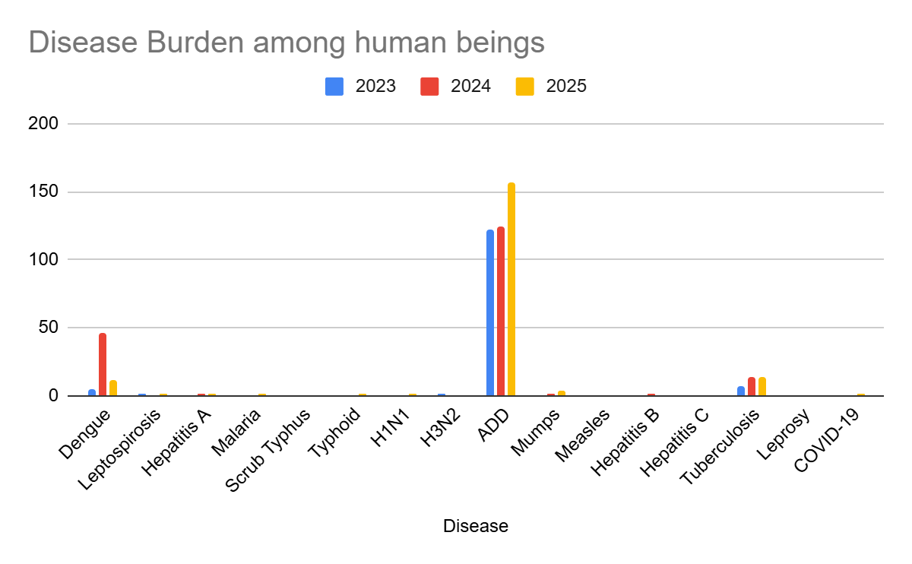

Seasonal Trend Analysis
Seasonal analysis helps anticipate surges (e.g. dengue in monsoon, leptospirosis after floods, influenza in cooler months) and plan pre‑emptive vector control, stockpiling of IV fluids, and awareness campaigns at Panchayat level.

DENGUE
Dengue is a major seasonal vector-borne disease strongly associated with rainfall, water stagnation, and increased mosquito breeding during the monsoon period.

Peak: July–November

Dengue – Ward-wise Yearly Distribution (2021–2025)

Ward | Dengue – Ward-wise Yearly Distribution
Ward | 2023 | 2024 | 2025 | Total
1 | 0 | 1 | 0 | 1
2 | 0 | 3 | 1 | 4
3 | 0 | 10 | 1 | 11
4 | 0 | 0 | 0 | 0
5 | 0 | 1 | 0 | 1
6 | 0 | 2 | 1 | 3
7 | 0 | 1 | 0 | 1
8 | 0 | 0 | 0 | 0
9 | 0 | 0 | 1 | 1
10 | 0 | 1 | 1 | 2
11 | 0 | 1 | 0 | 1
12 | 0 | 0 | 1 | 1
13 | 0 | 2 | 1 | 3
14 | 0 | 1 | 2 | 3
15 | 0 | 1 | 0 | 1
16 | 0 | 1 | 0 | 1
17 | 0 | 6 | 1 | 7
18 | 0 | 5 | 2 | 7
19 | 1 | 1 | 0 | 2
20 | 0 | 3 | 0 | 3
21 | 1 | 2 | 0 | 3
22 | 0 | 1 | 0 | 1
23 | 0 | 0 | 0 | 0

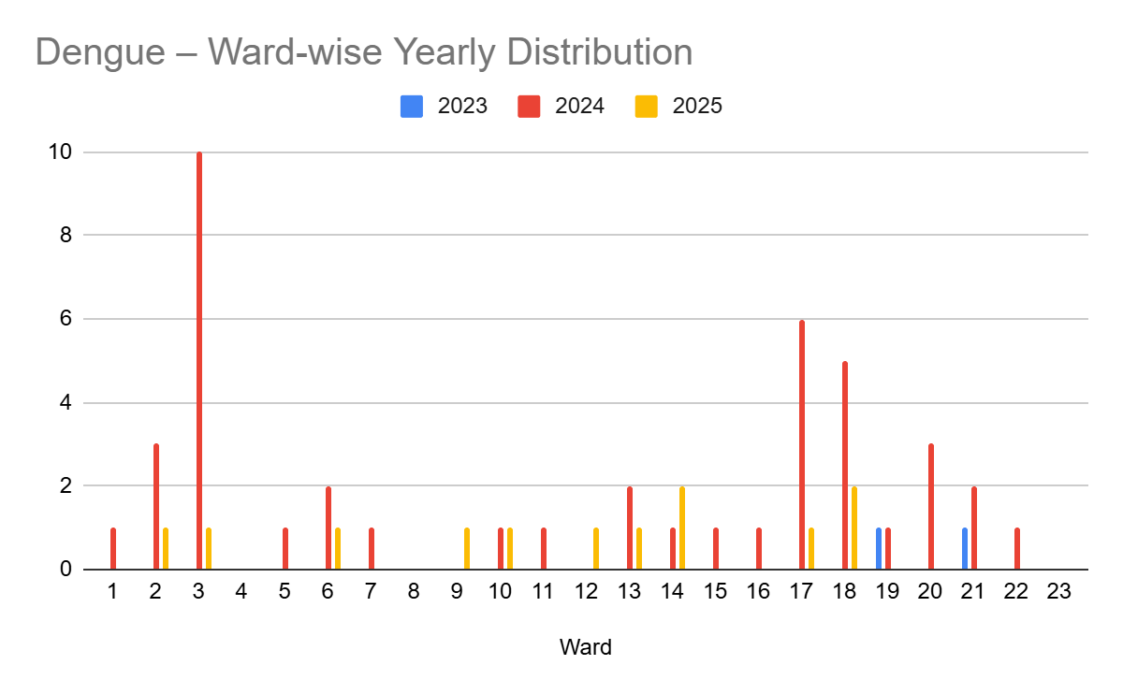

LEPTOSPIROSIS
Leptospirosis cases are closely linked to monsoon rains, flooding, and occupational exposure, particularly in low-lying and waterlogged areas.

Peak: June - August

Leptospirosis – Ward-wise Yearly Distribution (2021–2025)

Ward | Leptospirosis – Ward-wise Yearly Distribution
Ward | 2023 | 2024 | 2025 | Total
1 | 0 | 0 | 0 | 0
2 | 0 | 0 | 0 | 0
3 | 0 | 0 | 0 | 0
4 | 0 | 0 | 0 | 0
5 | 0 | 0 | 0 | 0
6 | 0 | 0 | 0 | 0
7 | 0 | 0 | 0 | 0
8 | 1 | 0 | 0 | 1
9 | 0 | 0 | 0 | 0
10 | 0 | 0 | 0 | 0
11 | 0 | 0 | 0 | 0
12 | 0 | 0 | 0 | 0
13 | 0 | 0 | 0 | 0
141 | 0 | 0 | 0 | 0
15 | 0 | 0 | 0 | 0
16 | 0 | 0 | 0 | 0
17 | 0 | 0 | 0 | 0
18 | 0 | 0 | 1 | 1
19 | 0 | 0 | 0 | 0
20 | 0 | 0 | 0 | 0
21 | 0 | 0 | 1 | 1
22 | 0 | 0 | 0 | 0
23 | 0 | 0 | 0 | 0

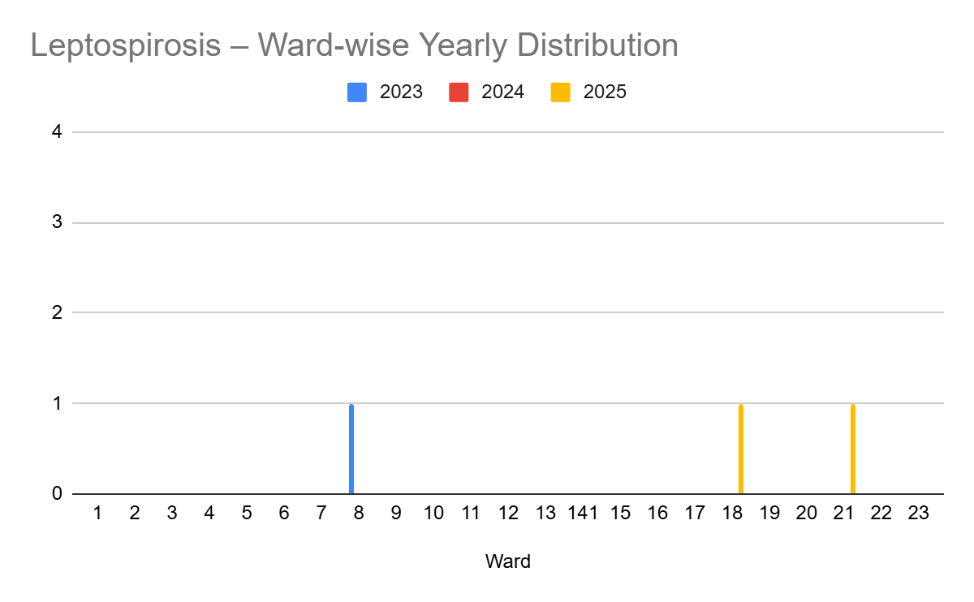

VIRAL HEPATITIS - A
Hepatitis A cases are commonly associated with unsafe drinking water, food contamination, and breakdowns in sanitation, often presenting as clusters or outbreaks.

Peak: October - December

Hepatitis A – Ward-wise Yearly Distribution (2021–2025)

Ward | Hep A – Ward-wise Yearly Distribution
Ward | 2023 | 2024 | 2025 | Total
1 | 0 | 0 | 0 | 0
2 | 0 | 0 | 0 | 0
3 | 0 | 0 | 0 | 0
4 | 0 | 0 | 0 | 0
5 | 0 | 0 | 0 | 0
6 | 0 | 0 | 0 | 0
7 | 0 | 0 | 0 | 0
8 | 0 | 0 | 0 | 0
9 | 0 | 0 | 0 | 0
10 | 0 | 0 | 1 | 1
11 | 0 | 0 | 0 | 0
12 | 0 | 0 | 1 | 1
13 | 0 | 0 | 0 | 0
14 | 0 | 0 | 0 | 0
15 | 0 | 0 | 0 | 0
16 | 0 | 0 | 0 | 0
17 | 0 | 0 | 0 | 0
18 | 0 | 0 | 0 | 0
19 | 0 | 0 | 0 | 0
20 | 0 | 0 | 0 | 0
21 | 0 | 0 | 0 | 0
22 | 0 | 0 | 0 | 0
23 | 0 | 0 | 0 | 0
24 | 0 | 0 | 0 | 0

Outcome-Based Trend Analysis- 2025

An approach for monitoring and analyzing the disease patterns based on the outcomes or impacts of specific interventions, policies, or public health measures and concerns. It shifts emphasis from merely tracking disease incidence to evaluating the effectiveness of prevention measures implemented for the disease. This type of analysis is crucial for understanding not only the spreadness of diseases but also how well the system is responding to them. This analysis evaluates the impact of various public health measures, determines whether these measures lead to reductions in disease prevalence, morbidity, mortality, or healthcare burden over time and this can be utilized modifying or improving existing health policies, resource allocation, and preparedness plans.

Sl. No. | Type of disease | Age group | Gender |  | Total no. of survival | Total no. of death | No. of cases received treatment
Sl. No. | Type of disease | Age group | No. of Male | No. of Female | Total no. of survival | Total no. of death | No. of cases received treatment
1 | Dengue | under 05 children | 0 | 0 | 0 | 0 | 0
2 | Dengue | 5-19 years | 0 | 0 | 0 | 0 | 0
3 | Dengue | 20-59 years | 7 | 3 | 10 | 0 | 10
4 | Dengue | 60+ (Seniors) | 2 | 0 | 2 | 0 | 2
1 | Lepto | under 05 children | 0 | 0 | 0 | 0 | 0
2 | Lepto | 5-19 years | 0 | 0 | 0 | 0 | 0
3 | Lepto | 20-59 years | 1 | 0 | 0 | 0 | 0
4 | Lepto | 60+ (Seniors) | 0 | 0 | 0 | 0 | 0
1 | VH-A | under 05 children | 0 | 0 | 0 | 0 | 0
2 | VH-A | 5-19 years | 0 | 0 | 0 | 0 | 0
3 | VH-A | 20-59 years | 2 | 0 | 0 | 0 | 0
4 | VH-A | 60+ (Seniors) | 0 | 0 | 0 | 0 | 0

Transmission Trend- 2025
For effective management of public health issues, it is important to track the trend of disease transmission mode. It helps identify the population or place at high risk that can be used to predict outbreaks and implement targeted interventions as quickly as possible. Understanding these kinds of trends enables authorities to allocate resources efficiently and change the strategies adequately based on the trend that follows.

Mode of Transmission | No. of cases | No. of Deaths
Vector Borne Diseases | Nil | Nil
Water Borne Diseases | Nil | Nil
Air Borne Diseases | Nil | Nil
Blood Borne Diseases | Nil | Nil
Food Borne Diseases | Nil | Nil

Vector-Borne Disease

Disease | No. of Cases | No. of Deaths
Dengue | Nil | Nil
Malaria | Nil | Nil
Chikungunya | Nil | Nil

Water Borne Disease

Disease | No. of Cases | No. of Deaths
Cholera | Nil | Nil
Typhoid | Nil | Nil
Hep- A | Nil | Nil
Dysentery | Nil | Nil
Amoebiasis | Nil | Nil
E- Coli infections | Nil | Nil
Air Borne Disease

Disease | No. of Cases | No. of Deaths
Influenza | Nil | Nil
H1N1 | Nil | Nil
TB | Nil | Nil
Chickenpox | 164/Y | Nil
Measles | Nil | Nil
Covid-19 | Nil | Nil
Pertussis | Nil | Nil
Mumps | Nil | Nil

Blood-Borne Disease

Disease | No. of Cases | No. of Deaths
AIDS | Nil | Nil
Hep- B | Nil | Nil
Hep- C | Nil | Nil

Zoonotic Disease

Disease | No. of Cases | No. of Deaths
Rabies | 1 | 1
Leptospirosis | 1 | Nil
Avian influenza | Nil | Nil
West nile | Nil | Nil
Anthrax | Nil | Nil
Nipah | Nil | Nil
Scrub Typhus | Nil | Nil

Integrated Disease Hotspot Map (2021–2025)
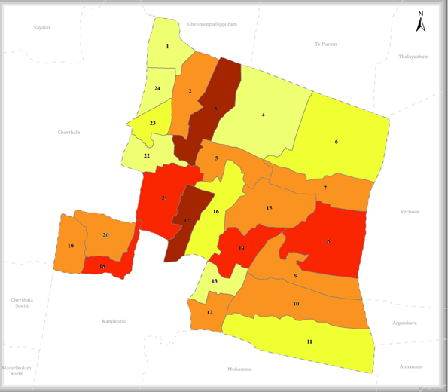

Ward No | Dengue Total (2021-25) | Leptospirosis Total (2021-25) | Hepatitis A Total (2021-25) | Mumps (2021-25) | ADD (2021-25) | Total Cases
1 | 2 | 0 | 0 | 2 | 14 | 18
2 | 5 | 1 | 0 | 6 | 15 | 27
3 | 11 | 1 | 0 | 2 | 34 | 48
4 | 2 | 0 | 0 | 1 | 15 | 18
5 | 2 | 0 | 0 | 0 | 57 | 59
6 | 3 | 0 | 0 | 1 | 28 | 32
7 | 1 | 0 | 0 | 1 | 66 | 68
8 | 0 | 4 | 0 | 2 | 55 | 59
9 | 2 | 1 | 0 | 0 | 49 | 52
10 | 1 | 1 | 0 | 1 | 51 | 54
11 | 1 | 0 | 0 | 2 | 41 | 44
12 | 1 | 0 | 0 | 0 | 69 | 70
13 | 2 | 0 | 0 | 1 | 19 | 22
14 | 3 | 0 | 0 | 1 | 70 | 75
15 | 1 | 0 | 1 | 1 | 44 | 47
16 | 2 | 1 | 0 | 1 | 29 | 33
17 | 8 | 0 | 0 | 1 | 61 | 70
18 | 6 | 0 | 0 | 2 | 46 | 54
19 | 2 | 0 | 0 | 0 | 60 | 62
20 | 3 | 1 | 0 | 0 | 31 | 35
21 | 5 | 2 | 0 | 1 | 35 | 43
22 | 0 | 0 | 0 | 0 | 19 | 19
23 | 2 | 0 | 0 | 0 | 28 | 30
24 | 0 | 0 | 0 | 0 | 32 | 32

By overlaying five years of data, we have identified …………..'Red Zone' Wards. These are wards where at least two different categories of diseases (e.g., Dengue and Lepto) recurred in consecutive years. Ward 4 is categorized as the Highest Priority Hotspot due to its combination of flood vulnerability and high vector density. Future health infrastructure, such as the proposed R.O plants at ………should be prioritized.

Preparedness and Response Protocol at LSG Level
This section describes the operational framework for the LSGI once a pandemic is declared. It explains how the LSGI and health system will move from routine data collection to active response, using a One Health approach.

Constitution of One Health Committee
The LSGD shall constitute a One Health Committee comprising the LSGI President, Medical Officers (Modern Medicine, AYUSH, and Veterinary), the Health Inspector, and the Veterinary Surgeon.

Objective: The One Health Committee coordinates human, animal, and environmental health to prevent and control pandemics.

Sl No | Name | Designation | Department/Institution | Role in Committee | Contact Number
1 | A K PRASANNAN | Panchayat President | LSGD | Chairperson | 9446885959
2 | DR JANCY | Medical Officer (PHC/CHC) | Health Dept | Member Secretary | 8921760838
3 | DR RANI BHARATHAN | Veterinary Officer | Animal Husbandry | Member | 9446192061
4 | SWETHA | Epidemiologist | Health Dept | Member | 8606799186
5 | BEENA CHERIYAN | Health Inspector/PHN | Health Dept | Surveillance | 8921241755
6 | MINI R | ASHA Supervisor | Health Dept | Community link | 9497897776
7 | SUDHARMMA SANTHOSH | ICDS Supervisor | Social Welfare | Vulnerable groups | 9497114124
8 | MUHAMMA | Police Station Officer | Police Dept | Law & order | 9497980293
9 | EMI BENNICHAN | Ward Councillor Representative | LSGD | Community coordination | 8848652830
10 | REENA MANOJ | Kudumbashree CDO | Kudumbashree | Community mobilisation | 9495810668
11 | BEN ROY | NGO/Volunteer rep | Civil Society | Support services | 9895885243
12 | Santhosh | Line Department representations | Village Officer | Support services | 9747647833

Key Responsibilities:
- Review disease surveillance data (human + animal)
- Conduct ward-wise risk assessment and vulnerability mapping
- Approve quarantine/isolation centre locations
- Coordinate with district for resources (PPE, oxygen, ambulances)
- Periodically review health system surge capacity, including beds, oxygen, human resources, and ambulances.
- Approve and monitor risk communication and community engagement strategies, including rumour management.
- Ensure protection and service continuity for vulnerable groups (elderly, persons with disabilities, dialysis patients, coastal populations).
- Conduct quarterly mock drills
- Monitor equity measures for vulnerable groups

Meeting Schedule:
Quarterly (normal times) | Weekly (outbreak alert) | Daily (pandemic phase)

Pandemic Response Workforce
To ensure a coordinated and timely response during a pandemic, a dedicated Pandemic Response Workforce shall be constituted at the LSG level. The workforce will function under the overall supervision of the One Health Committee and in close coordination with the health authorities. Team-based deployment will enable efficient surveillance, case management, quarantine and isolation management, logistics support, and risk communication. Each team shall have a clearly designated team leader, defined roles, and an identified pool of personnel to allow rapid activation, rotation of duties, and continuity of services during prolonged emergencies.

Total Response Workforce Available: 300 persons

Team Name | Composition | Key Responsibilities | Team Leader
Surveillance and Contact Tracing Team | HI, JHI, JPHN, ASHAs and Volunteers | Case detection, contact listing, home visits, reporting | HI
Case Management Team | Doctors, Nurses, MLSP, Palliative Nurses | Patient care & referral | DOCTOR
Quarantine & Isolation Team | LSGD staff, Volunteers | Facility management | JHI
Psychosocial support | LSGD Staff | Counsellor LSGD | 8848652830
Logistics & supply chain Team | LSGD staff, Storekeepers, Drivers 3 | Supplies & transport [PPE, medicines, oxygen, transport, waste management] | Ward Member
Communication Team | Ward members, Kudumbashree, Youth clubs,  AWW workers and other self help groups | IEC, community meetings, countering misinformation | M.O in charge
Media Surveillance | Health-LSGD-Police-Other department | Combined Media Coverage for all Health Care Services | 9846478857
Intersectoral coordination and convergence | Hospital-LSGD-Vetinary-Homeo-Aggriculture-Ayurvedic-Education- | Colabretad Combined Surveillance | MO & Other \0\0h7890departmet heads
Collaborative surveillance | Hospital-LSGD-Vetinary-Homeo-Aggriculture-Ayurvedic-Education- | Colabretad Combined Surveillance | Secratory-MO-Other department

All teams shall be activated immediately upon outbreak alert or pandemic declaration and shall report daily to the LSG Incident Commander/Medical Officer, with consolidated reporting to the Block PHC. Duty rosters and alternate personnel shall be maintained to ensure uninterrupted services during staff shortages or prolonged response periods. Team composition and numbers may be revised based on the magnitude of the outbreak and availability of human resources.

Activities and Measures before and during Pandemic

PHASE 1 - Alert / Preparation
Surveillance and Reporting-Enhanced syndromic surveillance:
- Data sources for surveillance:
- Event-based triggers (to be monitored and reported):
- Zoonotic and animal health surveillance
- Logistics and Stock Preparedness
  - Identify and empanel local vendors and define emergency procurement mechanisms in accordance with existing LSGD and Health Department norms.
  - Prepare and maintain an essential logistics checklist covering medical supplies, consumables, and support equipment.
  - Pre-identify secure storage locations for emergency stocks and ensure maintenance of stock registers with regular updating.
  - Finalise emergency transport arrangements, including availability of vehicles and identified drivers for rapid deployment during alerts.
  - Designate a Nodal Officer for Logistics to enable prompt decision-making, coordination, and communication during emergencies.
  - Conduct rapid stock verification and ensure availability of minimum buffer stock, including:
- PPE kits – numbers
- Pulse oximeters – ___ numbers
- Hand sanitizers – ___ litres
- Masks, gloves, disinfectants – adequate quantity
Identify critical gaps in logistics and immediately communicate requirements to the Block and District authorities for timely replenishment and support. Monitor expiry dates and stock rotation.

Identification of Quarantine and Isolation Facilities
  - Identify and list suitable buildings for quarantine and isolation (schools, hostels, community halls, etc.).
  - Categorise cases as per the severity and allocate to appropriate facilities (for instance, severe cases to classrooms, mild cases to an assembly hall in case of a school).
  - Facility readiness checklist needed (beds, toilets, ventilation) etc.
  - Find an alternate site if the primary sites are not available or not in use.
  - Identify facility managers and support staff
  - Prepare basic SOPs for:
    - Admission and discharge
    - Food, water, sanitation
    - Infection prevention and waste disposal
  - Ensure availability of basic amenities: water, sanitation, electricity, ventilation, and waste disposal. Prepare a rapid activation plan for these facilities if case numbers increase.

Risk Communication and Community Preparedness
  - Disseminate early warning messages on symptoms, preventive measures, and reporting mechanisms. Display IEC materials both in English and the local language in public places and ensure ward-level awareness.
  - Sensitize elected representatives and community leaders on preparedness measures.
  - Establish a rumour tracking and misinformation response mechanism to identify, verify, and promptly counter false or misleading information.
  - Engage trusted local persons (ward members, ASHA workers, religious leaders, teachers, community volunteers) to communicate official public health messages and reinforce correct practices.
  - Develop and deploy targeted IEC materials for:
    - Schools and educational institutions
    - Markets and commercial areas
    - Work sites and labour settings
  - Conduct community sensitization meetings at the ward level to promote preventive behaviors, address concerns, and strengthen community participation in preparedness and response.

Protection of Vulnerable Groups
Vulnerable populations require priority protection through targeted line-listing, service continuity, and delivery mechanisms.
- Prepare and regularly update line-lists of vulnerable populations, including:
  - Elderly persons living alone
  - Persons with disabilities
  - Pregnant women
  - Migrant workers
  - Dialysis patients
The detailed line-lists shall be maintained as Annexure ___ and updated periodically.

Clinical Dependency Mapping
Develop ward-wise dependency and vulnerability maps to identify households requiring regular support during emergencies. Ensure continuity of essential health services for vulnerable groups, including
- Dialysis services (facility mapping, transport arrangements, and scheduling)
- Continuity of treatment for TB, HIV, and other chronic conditions requiring uninterrupted medication
- Mental health and psychosocial support services
Establish delivery mechanisms for food, essential commodities, and medicines to vulnerable households through coordinated action involving ASHAs, JPHNs, Kudumbashree, volunteers, and local administration.

PHASE 2 - Active Response

Case Identification and Contact Tracing
Case detection and contact tracing activities will be carried out in coordination with the Health authorities, following disease-specific SOPs and IDSP guidelines.
Field Staff Involved
- Health Inspector (HI)
- Junior Health Inspector (JHI)
- Junior Public Health Nurse (JPHN)
- ASHAs and ASHA Supervisors
- Ward-level volunteers and Kudumbashree members (as required)

Screening Checkpoints
Screening checkpoints at high-traffic locations (transport hubs, markets, religious gatherings) for early detection of symptomatic travellers and crowd screening during outbreaks. Potential locations include bus stands, market entry points, and boat jetties, based on local context and risk assessment.
Screening activities will be carried out by trained personnel such as ASHAs, ward members, and volunteers, with support from Health Department staff. Necessary equipment, including non-contact thermometers and appropriate PPE, shall be ensured prior to activation.
Location | Type (Bus stand/Jetty/Market/Railway) | Staff Deployed (ASHAs/Volunteers) | Screening Method | Reporting authority
Bus stand | Transport hub | One JHI  One ASHA  One health Mentors | 1.Swab Collection.  2. Blood smears collection (RDT)  3.Thermal Scanners | Surveillance Nodal Officer in control room
Market entry | Market | One JHI  One ASHA  Male health volunteers | 1.Swab Collection.  2. Blood smears collection (RDT)  3.Thermal Scanners | Surveillance Nodal Officer in control room
Boat jetty | Water transport | One JHI  One ASHA  Male health volunteers | 1.Swab Collection.  2. Blood smears collection (RDT)  3.Thermal Scanners | Surveillance Nodal Officer in control room

Standard Screening Protocol

The screening protocol shall include temperature screening, observation for visible symptoms, and inquiry regarding recent travel or exposure history. Individuals identified as suspects during screening shall be immediately referred to the nearest PHC/FHC for further evaluation, testing, and appropriate action as per prevailing guidelines.

Pandemic Control Room
The Pandemic Control Room (PCR) serves as the central nerve center for real-time coordination, data aggregation, decision support, and communication during outbreaks. It consolidates information from all LSGD teams, health facilities and community sources to enable rapid response decisions.

Control Room Infrastructure and Location
Primary Location: THANNEERMUKKOM Panchayath Office.
Backup Location: Community Hall in THANNEERMUKKOM G.P.

Health System Control Room Framework
The PCR is organized into seven functional pillars to ensure no aspect of the response is overlooked:

Rapid Response Team (RRT)
  - Provides immediate intervention during emergencies, clusters, and field alerts.​
  - Coordinates urgent actions such as case investigation, contact tracing, isolation, and inter‑facility referrals.

Data Management & Analytics Team
  - Collects, validates, and manages key health system indicators (cases, tests, beds, HR, supplies).​
  - Analyzes data trends, generates projections, and supports evidence‑based decision‑making for local authorities.

Human Resource Deployment Team
  - Allocates healthcare staff efficiently based on workload and need
  - Ensures adequate and equitable workforce distribution across facilities

Laboratory Surveillance Team
  - Oversees diagnostic testing coordination, sample transport, and timely reporting of results.​
  - Monitors lab indicators (testing volume, positivity rate, turnaround time) for early detection of outbreaks

Vaccination Cell (If Required)
  - Plans and executes vaccination campaigns, including micro‑planning and session scheduling.​
  - Tracks coverage, identifies gaps, and coordinates corrective actions with field teams and outreach services.

Infrastructure & Patient Occupancy Team
  - Monitors facility capacity, earmarked beds, oxygen and critical care resources across all linked facilities.​
  - Ensures optimal patient distribution and referral management using updated bed‑status and resource data.
  - BMWM

Communication team
- Logistics and supply chain
- Transportation (interfacility & emergency transport)
- Media surveillance Call centre
- Management of the deceased
- Intersectoral coordination and convergence

Key Control Room Team
The Control Room Team coordinates all pandemic response activities within the LSGD and serves as the single command and communication hub during activation. It integrates information, field actions, logistics, and policy execution across all participating departments and health facilities.

Role | Name | Designation | Contact Number | Responsibility
In-charge/Nodal Officer | Dr. Jhancy | MO | 8921760838 | Overall coordination, decision-making, and reporting to the District level.
Data Entry Operator | Anju | Data Entry | 7559811406 | Managing the line list, updating dashboards, and tracking testing results.
Communication Officer | Anilkumar | Secretary | 8921485622 | Handling the public helpline, coordinating ambulance dispatch, and contact tracing calls.
Logistics Coordinator | Darshana | Jr. HI Gr.II | 9074033838 | Transportation & Management
Technical Support (IT/Data) | Akash S | Jr. HI Gr.II | 9747577662 | Data Validation & Analysis

SOP for alert escalation/trigger point with mapping of responsibilities.
Key Points:
- The Control Room shall be staffed with a designated In-charge, data entry personnel, and communication staff with clearly defined roles and shift arrangements.
- It shall maintain updated records on daily monitoring indicators including new cases, persons under active quarantine, and hospital bed occupancy.
- All reports and situation updates shall be shared daily with the Block and District Surveillance Unit.
- The Control Room shall act as a single point of contact for coordination with response teams, health institutions, and other departments.
- Contact details of the Control Room shall be widely communicated to field staff and stakeholders during activation.

Daily Monitoring Indicators
To ensure timely decision-making and effective response, the following key indicators shall be monitored and updated on a daily basis by the Pandemic Control Room:

Epidemiological Indicators:
New cases reported today, Total active cases, Test Positivity Rate (TPR), Case Fatality Rate (CFR)
- Surveillance Indicators:
Persons under home quarantine, High-risk contacts identified, Fever, ILI, SARI or other symptoms (syndromic surges), Travellers (symptomatic or high-risk arrivals),Animal husbandry surveillance (zoonotic alerts, unusual animal deaths, poultry/bird flu signals), Mortality surveillance (excess deaths, unexplained fatalities, verbal autopsy reports)
- Logistics and Infrastructure Indicators:
Hospital / CFLTC beds occupied, Oxygen cylinders/concentrators available, Ambulances on standby
- Alert Findings
The following table outlines category-specific trigger points (red flags) from surveillance indicators and corresponding immediate actions for the Pandemic Control Room. These enable rapid response to alert findings like testing anomalies, positive cases exceeding thresholds, clusters, and WGS reports.

Category | Trigger Point (Red Flag) | Immediate Action
Clusters | Geographical or facility-based: 5+ cases linked to one location (office, school, street). | Declare a micro-containment zone; perimeter control and active case finding.
Testing | Sudden drop in testing volume / delay in reporting / unusual testing trends | Review the sample collection process, address lab bottlenecks, deploy additional testing teams, and notify the District Lab.
Lab | Test Positivity rate increases | Increase testing sites in that ward.
Hospital | >80% Oxygen bed occupancy | Activate backup/CFLTC beds.
Travel | Cluster of cases from a single flight/train or high-risk arrival group. | Trace all passengers in adjacent seats; implement mandatory institutional quarantine.
Animal | Mass poultry/wildlife death or unusual sickness | Notify Animal Husbandry, sample the area, and dispatch RRT for environmental sampling and zoonotic check.
Mortality | Sudden spike in home deaths or brought-in-dead (BID) cases | Audit the deaths and Active Case Search drive
Additional investigations like Whole Genome Sequencing (WGS) | Detection of a Variant of Concern (VOC) or Variant of Interest (VOI) | Implement strict micro-containment; update clinical protocols to match variant severity.

Communication of Public Health Information
A Community Communication Hub shall be established to ensure timely, accurate, and consistent dissemination of information during a pandemic. The Hub will function under the coordination of Nodal officers of the control room and act as the nodal point for public communication, risk messaging, and community engagement. It will support dissemination of official advisories, promote preventive behaviors, address rumors and misinformation, and ensure that messages reach all sections of the population through trusted local channels and leaders.

Key communicators
Channel | Responsible Person | Contact
Ward-level announcements | JAK TEAMS | GIVEN ABOVE
Social media | Through LSGD | 8921485622
Local Cable TV/Radio | NA

- All messages disseminated through the Hub shall align with advisories issued by the Health Department and District authorities.
- Community leaders shall be sensitized to support behavior change, reduce stigma, and counter misinformation.
- Special efforts shall be made to reach vulnerable and hard-to-reach populations using locally appropriate communication methods.

Rumor Tracking: A designated volunteer will monitor local social media/WhatsApp groups daily to identify misinformation and issue official clarifications via the Communication Hub.

Coordination with District/State Authorities & Other Organisations
Effective coordination with Block, District, and State authorities is essential to ensure timely reporting, technical guidance, and uninterrupted supply of essential resources during a pandemic. The LSG shall establish clear communication channels, designate responsible officers, and adhere to prescribed reporting timelines to support coordinated public health action and efficient resource mobilisation.

Key Details:
- Nodal Officer for Reporting:
- Contact Number:
Reporting Schedule and Protocols:

To Whom | What to Report | Frequency | Nodal Person
Block PHC | Complete Situation Report (Cases, Quarantine, Beds, Screening, Deaths) | Moderate | BLOCK MO
District IDSP Unit | Outbreaks/Clusters/Unusual Events (>5 cases same ward) | Mild-Moderate | HI
Veterinary Officer | Animal health events/Zoonotic alerts | Moderate | MO
State Cell | Zoonotic cross-sector events | Mild | Secretary

Supply Chain Coordination
The LSG shall coordinate closely with Block, District, and State authorities (KMSCL) to ensure uninterrupted availability of essential goods, medical supplies, and logistics during a pandemic. Supply requirements shall be assessed regularly based on case load and communicated promptly to the appropriate authorities for timely replenishment.
Key Points:
- Maintain updated contact details of District and Block nodal officers for health logistics, oxygen supply, ambulances, and essential medicines.
- Submit timely indent requests for PPE, testing kits, medicines, oxygen, and other critical supplies through prescribed channels.
- Monitor stock levels at LSGD facilities, quarantine/isolation centres, and field teams through daily stock registers and dispensing logs to prevent shortages.
- Coordinate with District authorities, Karunya/Neethi medical shops, and local purchase committees for funds allocation and emergency procurement.

- Ensure regular monitoring of dispensing registers at all facilities to track usage, expiry, and pilferage—shortages being a perennial issue requiring proactive weekly audits.

- Activate surge procurement protocols during high caseloads, leveraging local purchase powers under LSGD funds alongside state supplies.

Resource Inventory and Contacts
Resource Category | Source  (District/State/Private) | Contact
PPE Kits/Masks/Gloves | KMSCL | 4772282302
PPE Kits/Masks/Gloves | KMSCL | 4772282302
Oxygen  Cylinders/Concentrators | KMSCL | 4772282302
Medicines/Antivirals | KMSCL | 4772282302
Medicines/Antivirals | Neethi Shops | 7306222439
Test Kits (RTPCR/Rapid) | KMSCL | 4772282302

Collaboration with NGOs, PPP, and CSR
To augment government efforts during a pandemic, the LSG shall collaborate with NGOs, voluntary organisations, and private sector partners through public–private partnerships and Corporate Social Responsibility (CSR) initiatives, in coordination with District authorities.

Key Points:
- Engage NGOs and community-based organisations for community outreach, awareness, and support to vulnerable populations.
- Leverage CSR support for procurement of medical equipment, PPE, oxygen concentrators, food kits, and sanitation materials, as permitted.
- Ensure all collaborations align with government guidelines and are routed through approved administrative and financial procedures.
- Maintain transparency and documentation for all external support received and utilised.
Organization | Type | Support Offered | Contact Person
Youth Clubs/Student Unions | CBO | Standing Committee Chairman - Health | 9745600820

Interdepartmental Coordination
Coordination among departments during a pandemic shall be ensured through regular review meetings convened by the LSGD President. These meetings will provide a structured platform for sharing situational updates, assessing resource availability, resolving operational gaps, and taking joint decisions to ensure a coordinated and timely response.

Department | Representative | Key Role | Contact
Health (PHC) | Staff Nurse : SINDHU | Case management | 9447960717
Veterinary | Veterinary Surgeon: | Animal surveillance | 9446192061
ICDS | Supervisor: Sindhu | Nutrition support | 9495810668
Education | Head Teacher: | School coordination | 9605985331
Police | Muhamma | Containment enforcement | 9249127216
Water Authority | LSGD | Water supply | 9946359141
LSGD Engineering | LSGD | Quarantine infrastructure | 8547901409

PHASE 3 - Surge Capacity
Phase 3 is activated when there is a rapid increase in cases, high test positivity rates, or when existing health facilities and quarantine arrangements approach saturation. The focus of this phase is to expand isolation capacity, augment clinical care services, and mobilise additional resources through district and state support mechanisms.

Conversion of Community Facilities
To manage increased case load, the LSGD shall activate additional isolation facilities by repurposing identified community infrastructure such as community halls, auditoriums, schools, hostels, or other suitable buildings.

Name of facility | Facility Type | No. of Buildings | Ward | Surge Capacity (Beds) | Nodal Person
Varanad Community hall - | Community hall | 1 | 22 | 30  ( Approximate ) | 9645050714
Kopamangalam Parish Hall | Parish Hall | 1 | 4 | 15  ( Approximate ) | 9846330331
NSS Hall | NSS Hall | 1 | 7 | 10  ( Approximate ) | 9495309926
Parish Hall Nirmala Church | Parish Hal | 1 | 8 | 15  ( Approximate ) | 4782582815
Parish Hall Paluthra | Parish Hall | 1 | 12 | 15  ( Approximate ) | 9947065716
Nammakattu Community Hall - 200 | Community hall | 1 | 19 | 30  ( Approximate ) | 9746216076
Pannatupally Parish Hall | Parish Hall | 1 | 21 | 15  ( Approximate ) | 9847088524
Parish Hall , Karikadu | Parish Hall | 1 | 14 | 15  ( Approximate ) | 9400234703
SNDP Hall - 200 | SNDP Hall | 1 | 18 | 5  ( Approximate ) | 9746678755
SNDP Hall | SNDP Hall | 1 | 7 | 5  ( Approximate ) | 9188014347

Recovery and rehabilitation phase
The recovery and rehabilitation phase begins once the immediate public health emergency is controlled and transmission is reduced to manageable levels. This phase focuses on restoring essential services, addressing long-term health and socio-economic impacts, and strengthening systems to prevent or better manage future pandemics.
Recovery

Recovery
Recovery refers to the gradual return of communities and systems to normal functioning while continuing public health vigilance. It involves phased withdrawal of emergency measures, reopening of services, and reintegration of disrupted health and social systems. Recovery activities should be evidence-based, inclusive, and aligned with national and state guidelines to ensure sustainability and resilience.

Damage and Impact Assessment
Before long-term rebuilding can happen, the dust must be settled and the immediate risks managed.Damage and impact assessment is a critical step to understand the full extent of the pandemic’s effects on health systems, communities, and livelihoods. This assessment evaluates disruptions to healthcare services, availability of infrastructure and workforce, morbidity and mortality patterns, and socio-economic consequences such as loss of income, education disruption, and food insecurity. The findings inform evidence-based planning, prioritization of interventions, and optimal allocation of resources during the recovery phase.

Restoration of Health Services
Recovery requires moving beyond emergency trauma care. This sub-phase focuses on reopening primary care clinics, restarting routine immunization programs, and ensuring that patients with chronic conditions (like diabetes or hypertension) can once again access life-sustaining medications and check-ups.

Environmental Cleanup and Sanitation
Post-disaster environments are often breeding grounds for secondary health crises. Cleanup efforts focus on removing debris, managing hazardous waste, and restoring water and sewage systems. Ensuring a "clean slate" is biologically necessary to prevent the spread of waterborne and vector-borne diseases.

Rehabilitation
Rehabilitation focuses on addressing the long-term physical, social, and economic impacts of the pandemic on affected individuals and communities. This includes medical rehabilitation for post-infection complications, nutritional support for vulnerable groups, and social assistance for households affected by illness, disability, or loss of livelihood. Rehabilitation efforts should promote reintegration into education, employment, and community life, with special attention to marginalized and high-risk populations.

Physical and Livelihood Rehabilitation
For those left with lasting injuries, rehabilitation involves providing physical therapy and assistive devices. Simultaneously, Livelihood Restoration addresses the economic health of the community; without the ability to earn an income, individuals cannot sustain their own long-term health and nutrition. Support for small businesses, informal workers, self-help groups, and skill development initiatives is essential to promote economic resilience and long-term recovery.

Psychosocial and Mental Health Support
The trauma of a disaster often outlasts the physical damage. Providing psychological first aid and long-term mental health counseling is vital for community cohesion. This support helps individuals process grief and anxiety, reducing the long-term societal burden of PTSD.

Community Engagement and Confidence Building
Recovery fails if the public does not trust the systems being rebuilt. Active communication and involving local leaders in the decision-making process help rebuild social capital. This ensures that the population feels safe returning to schools, workplaces, and hospitals. Active involvement of community leaders, local self-governments, and civil society organizations strengthens community ownership, promotes adherence to public health measures, and enhances preparedness for future emergencies.

Vigilance and Disease Surveillance
Disease surveillance during the recovery phase ensures early detection of resurgence, secondary outbreaks, or emerging variants. Surveillance systems should continue monitoring communicable disease trends, post-pandemic complications, and unusual health events. Strengthening laboratory capacity, sentinel surveillance, and community-based reporting mechanisms enables timely response and supports sustained public health security.

System Strengthening and Future Preparedness
The final stage of recovery is an intellectual exercise in "Building Back Better," turning the tragedy of the past into the safety of the future.

Documentation and After-Action Review (AAR)
Once the immediate pressure has subsided, stakeholders must conduct a formal review of the response. This involves a candid look at what worked, what failed, and where communication broke down. These Lessons Learned are then transformed into Best Practices.

Policy Revision and Health System Strengthening
The ultimate goal of recovery is to ensure the next crisis is less damaging. This involves updating emergency protocols, revising public health laws, and investing in more durable infrastructure. Through Research and data analysis, the health system is "hardened" against future threats, moving the community from a state of vulnerability to a state of permanent readiness.

Research
Research during the recovery phase is essential to generate evidence on the long-term health, social, and economic impacts of pandemics. Operational, clinical, and policy research should examine the effectiveness of response and recovery interventions, community behaviors, and innovations in service delivery and surveillance. Research findings should inform future preparedness strategies and public health decision-making.

Recovery & Rehabilitation Master Checklist

1. Assessment & Infrastructure Restoration
[ ] Conduct Multi-Sectoral Impact Assessment: Complete a full audit of damage to health facilities, equipment, and digital infrastructure.
[ ] Restore Essential Utilities: Verify that hospitals and clinics have stable access to clean water, electricity, and medical gas.
[ ] Re-establish Supply Chains: Transition from emergency "push" systems to routine procurement for medications and consumables.
[ ] Environmental Safety Check: Clear all hazardous debris and certify that sanitation/waste management systems are fully functional.

2. Clinical & Public Health Continuity
[ ] Resume Primary Care: Transition staff from emergency roles back to routine services (Maternal health, NCDs, Immunizations).
[ ] Launch Recovery-Phase Surveillance: Implement enhanced monitoring for infectious diseases common in post-disaster settings.
[ ] Clear Patient Backlogs: Identify and schedule patients whose elective surgeries or treatments were delayed during the crisis.
[ ] Environmental Health Audit: Test local water sources and food supply chains for contamination post-cleanup.

3. Human-Centric Rehabilitation
[ ] Deploy Psychosocial Support: Establish long-term mental health clinics and peer support groups for survivors and first responders.
[ ] Physical Rehab Integration: Provide specialized care, prosthetics, and occupational therapy for those with permanent injuries.
[ ] Livelihood Support Coordination: Partner with NGOs to provide micro-grants or vocational training to displaced healthcare workers or patients.
[ ] Community Feedback Loop: Create a "Town Hall" or digital platform for citizens to report gaps in the recovery process.

4. Administrative & System Strengthening
[ ] Initiate After-Action Review (AAR): Schedule debriefing sessions with all stakeholders to document successes and failures.
[ ] Financial Reconciliation: Audit emergency spending and finalize insurance claims or international aid reports.
[ ] Knowledge Management: Compile a "Lessons Learned" report and share it with regional and national health authorities.
[ ] Update Preparedness Plans: Revise Standard Operating Procedures (SOPs) based on real-world data gathered during the crisis.
[ ] Research & Development: Identify areas where the response was slowed by lack of data and initiate studies to close those gaps.

5. Confidence & Policy
[ ] Launch Public Information Campaign: Use local media to inform the public that services have resumed and are safe to use.
[ ] Legislative Advocacy: Present findings to policymakers to secure funding for "Build Back Better" infrastructure projects.
[ ] Staff Wellness Check: Conduct mandatory mental health screenings for healthcare workers to prevent burnout and PTSD.

CONCLUSION
This Pandemic Preparedness Plan outlines a comprehensive, decentralised, and action-oriented framework for preparedness and response at the LSGD level. By adopting a One Health approach and strengthening coordination between the health system, local self-government institutions, veterinary services, and community networks, the LSGD aims to ensure early detection, rapid response, and effective containment of pandemics and public health emergencies.
The plan emphasises equity, community participation, and evidence-based decision-making to protect vulnerable populations and ensure uninterrupted access to essential services during crises. It reinforces the importance of local leadership, accountability, and inter-sectoral collaboration in translating preparedness plans into timely action on the ground.
Regular updating, mock drills, capacity building of frontline workers, and sustained interdepartmental coordination will be critical to maintaining readiness and resilience. The successful implementation of this plan depends on collective responsibility, continuous monitoring, and adaptive management in response to emerging threats.
This document shall serve as a living operational guide, to be activated during alerts and continuously improved based on evolving risks, lessons learnt, and guidance from higher authorities, thereby strengthening the LSGD’s ability to safeguard public health.
“Together for a Healthier and Safer Community.”

RECOMMENDATIONS
- It is recommended that ward-level risk grading be institutionalised using the Hazard Risk Index (HRI) to guide prioritisation of resources and strategic deployment of emergency response teams. Incorporating indicators such as hazard frequency, population density, infrastructure integrity, and environmental vulnerability will ensure a comprehensive and context-sensitive assessment of ward-level risk. This approach will enable early intervention in high-risk zones and help mitigate spillover effects to neighbouring areas through targeted preparedness and response measures.
- In high-risk wards, particularly those reporting higher mortality or long-term morbidity, the application of survival analysis is recommended to strengthen risk stratification and guide sustained response planning. By analysing time-to-event outcomes, this method can identify areas requiring prolonged recovery support, facilitate evidence-based allocation of resources, and inform interventions addressing both immediate health impacts and long-term disease burden.
- To strengthen forward-looking disaster preparedness, hazard and risk projections should be modelled under the Representative Concentration Pathway (RCP 8.5) climate change scenario. Integrating climate projections will support scenario-based planning by anticipating future changes in hazard frequency and intensity, including extreme weather events, sea-level rise, and shifting disease patterns.

ANNEXURE

IMPORTANT PHONE NUMBERS

Phone numbers and particulars of persons responsible for providing guidance, assistance, and support for pandemic preparedness operations may be provided here in a manner that allows easy reference at a glance. The information recorded here could be exhibited elsewhere at the time of emergencies. LSG institutions shall give special attention to collect and record the above data of persons and institutions who/which are supposed to give technical and co-ordination support to reduce the impact of pandemic.

1.1. Details of grama panchayat/municipality/corporation wards
Sl.No | Name of the ward | Ward number | Name of the ward  member | Contact number
1 | CHENGANDA | 1 | JAYESH P | 9249796449
2 | S B PURAM | 2 | BINDHU MOL | 6238671453
3 | VELLIYAKULAM | 3 | ELIZHABATH JOSEPH | 9544549367
4 | KATTACHIRA NORTH | 4 | A K PRASANNAN | 9446885959
5 | KATTACHIRA SOUTH | 5 | VRINDA SUNIL | 9048099437
6 | THANNEERMUKKOM | 6 | BINDHU SADANANDAN | 9809521733
7 | DEVASAMKKARI | 7 | PADMINI | 9142302501
8 | VELIYAMBRA | 8 | GIRIJA ANIRUDHAN | 9048297959
9 | ELANJANKULANGARA | 9 | RESHMA RENJITH | 7025067372
10 | KANNAGARA | 10 | K R YAMUNA | 9747482402
11 | PUTHANANGADI | 11 | T N PRADEEP | 8289957912
12 | VARANAM | 12 | ADV S SUMESH | 9745600820

1.2. Other important phone numbers of grama panchayat/municipality/corporation area
Sl. No. | Name | Contact number
1. | DIARY EXTENSION OFFICER | 9633780351
2. | FOOD SAFETY | 7593873332
3. | WATER AUTHORITY | 857638525
4. | AGRICULTURE OFFICER | 9383470588
5. | ANIMAL HUSBANDARY | 9656262969
6. | FISHERIES | 9400255922
7. | Excise department | NA
8. | Forest department | NA

1.3. Important offices of grama panchayat/municipality/ corporation
Sl.No | Name of the office | Contact person | Contact number
1. | Village Office | Village Officer | 9747647833
2. | Agriculture Office | Agriculture Officer | 9400149761
3. | Animal Husbandry Office | Animal Husbandry Doctor | 9400856220
4. | Police Station | Police Officer | 9496759106
5. | BSNL Office | Officer | 18003451500
6. | Block Office | Officer | 9037249168
7. | KSEB Office | Officer | 0478 2582738
8. | Fisheries Office | Officer | 9747747808
9. | Fire and Rescue | Officer | 8921066590

1.4. Health Services

Sl. No | Name of the hospital/institution | Location | Phone number
1. | Government hospitals/PHC | THANNEERMUKKOM | 0478 2584404
2. | Private hospitals | Cherthala  Mathilakam | 9072779779  8281515153
3. | Clinical laboratories | Kannankara, Puthanangadi, | NA
4. | Chemist/pharmacy | NA | NA
5. | Blood donors | NA | NA
6. | Other language experts (Bihari, Hindi, Bengali,  Asamees ………) | NA | NA

1.5. Veterinary Services
Sl.No | Name of the Clinic | Name of the  Surgeon/Doctor | Place/location | Phone  number
1 | Govt.Veterinary Hospital | Dr. Rani | MUTTATHIPPARAMBU | 9036036070

1.6. Helpline numbers
Helpline | Phone number
Police | 9496759106
Fire and Rescue | 8921066590
KSEB | 8921758628

1.7. Public and Private Schools Contact details

S.No | Name of School | Institution type | Phone number
1 | GLPS MARUTHORVATTOM | GOVT | 9495136672
2 | LPS SREEKANDAMANGALAM | Aided | 9495142982
3 | HS PRATHEEKSHABHAVAN | Private | 9947510714
4 | KVM PUBLIC SCHOOL | PVT | 8547469477
5 | GLPS VARANAD | GOVT | 9497275979
6 | GOVT UPS VELLIYAKULAM | GOVT | 9656556836
7 | NIRMALA SCHOOL | Private | 9495229374
8 | ST,THERESINAS LPS | AIDED | 9633196516
9 | GLSPS THANNEERMUKOM | GOVT | 7907052002
10 | ST. ANTONYS HIGH SCHOOL | AIDED | 8089220215
11 | PANCHAYATH LPS SCHOOL | GOVT | 9447502900
12 | ST.XAVIER | AIDED | 9496059862
13 | HIGH SCHOOL TKM | GOVT | 7510690595
14 | ST MATHEWS HS | AIDED | 9495097281
15 | BUDS SCHOOL | GOVT | 9048354962

1.9. Anganwadi Contact Details

Ward No | Name of Anganwadi Teachers | Phone number
17 | SHYLAJA | 9496230521
17 | GIRIJA | 6282339691
17 | MOHINI | 9946249367
19 | OMANA | 8089336545
19 | USHA | 9995175867
18 | JALAJA | 9249937746
16 | SOBHANA | 9288062027
16 | REJIMOL | 8547885144
20 | JAYASREE | 9744783425
21 | BINDU | 9746407270
7 | ASHA | 9947732979
7 | SINDHU | 9562925501
8 | ANITHA | 7561074821
8 | SHEELA | 9633403270
9 | CLARA JANVY | 8921321813
9 | DHANYA | 9495758844
13 | NISHA | 8943158412
13 | SUDHA | 7306231482
14 | ARUNIMA | 9383407739
14 | PRAMEELA | 9544387134
15 | BINDU | 9526129808
6 | SEEMA | 9656743451
6 | JYOTHY | 9846928510
4 | PRASEENA | 9656564860
4 | SANDHYA | 7025607338
11 | SUJATHA | 9061486241
10 | SINDHU | 9388682898
10 | ANITHA | 9388585233
11 | SHAINA | 9142063615
10 | VIJAYALAKSHMI | 9567679763
12 | CHANDRALEKHA | 9400818839
12 | SUJAMMA | 9656296673
1 | MADHURI | 8921486014
1 | MAYA | 9388472471
1 | SMITHA | 9846082154
2 | SANDHYA | 7025892693
2 | BEENA | 6282971711
24 | VIJAYAKUMARI | 9745055625
24 | SHYLAJA | 8547490620
3 | JAGADAMBIKA | 9142768647
3 | BEENA | 9037314305
5 | SIJI | 7306393815
5 | RAJI | 9142042575
23 | VIJI | 9037362130

1.12. Information regarding resources

Means of transportation | Name of Owner | Phone Number
Heavy Trucks | Sanil | NA
Tractor | Unni | 727041025
Ambulances | CHC THANNEERMUKKOM  ANIL KUMAR & JENSMON | 9961116064  9446616943
Boats | Rameshan | 9497221512
Taxi service | GIREESH ( AUTO ) | 9749728859

Annexure 1: LSG Baseline Data Collection Format
A. Baseline data
Sl. No. | Indicator / Field | Baseline Data | Source / Remarks
1 | Name of LSG | THANNEERMUKKOM | LSGD
2 | District | ALAPPUZHA | LSGD
3 | Block / Taluk | KANJIKKUZHI BLOCK | LSGD
4 | Type of LSG (Gram Panchayat / Municipality / Corporation) | GRAM PANCHAYAT | LSGD
5 | Area (sq. km) | 31.44 | LSGD
6 | No. of wards | 24 | LSGD
7 | GIS boundary file available | YES | LSGD
8 | Key contact person & phone | SECRETARY LSGD | 8921485622

B. Demography
Indicator / Field | Baseline Data | Source / Remarks
Total population | 43654 | LSGD
Males | 21415 | LSGD
Females | 22089 | LSGD
Transgender population | 0 | LSGD
Age distribution  (<5, 5–14, 15–59, ≥60) | <5 - 1678  5-14 - 3606  15-59 - 30112  >60 - 8258 | FIELD STAFF
No. of households | 14527 | LSGD
Population density (persons/sq.km) | 1309/KM | LSGD
No. of migrant workers | 161 | FIELD STAFF
Major occupational groups | NA

C. Vulnerable Populations & Social Risks
Sl. No. | Indicator / Field | Baseline Data (Value / Description) | Source / Remarks
1 | No. of elderly (≥60) | 8258 | LSGD
2 | No. of persons with disability | 552 | LSGD
3 | No. of bedridden persons | 185 | PALLIATIVE
4 | No. of chronic disease cases (DM/HTN/COPD/CKD etc.) | 672/2521/336/251 | FIELD
5 | Pregnant women (current estimate) | 124 | RCH PORTAL
6 | Children <5 years | 1678 | RCH PORTAL
7 | Tribal population (if any) | 0 | 0
8 | Fisherfolk / coastal vulnerable groups (if any) | 23/9 | LSGD
9 | Urban slums / unnotified settlements (if any) | 0
10 | Homeless population | 0
11 | Orphanages / old age homes (number & capacity) | 2 OLD AGE
12 | Hostels / prisons / shelters (number & capacity) | 0
13 | Poverty / BPL estimate | 0
14 | Food insecurity hotspots | 0
15 | Any history of stigma/discrimination issues (Yes/No) | 0

D. Health System & Service Readiness
Sl. No. | Indicator / Field | Baseline Data (Value / Description) | Source / Remarks
1 | No. of health facilities in LSG (PHC/CHC/TH/DH/Private) | 1 - CHC  PVT HOSPITAL - 2
2 | PHC/Family Health Centre details (name, location) | 0
3 | Subcentres / Health & Wellness Centres (number) | 8
4 | Private clinics / hospitals (number) | HOSPITAL - 2  CLINIC - 4
5 | Labs available (public/private) | GOVT LAB - 1  PVT LAB - 3
6 | Availability of ambulance services (Yes/No, number) | YES
7 | Availability of isolation/quarantine facilities (Yes/No, details) | YES
8 | Cold chain facilities (Yes/No, details) | YES
9 | Stockpile space available (Yes/No) | YES
10 | PPE / mask / sanitizer availability plan (Yes/No) | YES
11 | Surveillance staff available (JHI/JPHN/ASHA count) | YES
12 | Existing emergency referral pathways (Yes/No) | YES

E. Points of Entry & Mobility
Sl. No. | Indicator / Field | Baseline Data (Value / Description) | Source / Remarks
1 | Bus stands / depots (number) | 1
2 | Railway stations (number) | 0
3 | Boat jetties / fishing harbours (number) | BOAT JETTY
4 | Ports / airports nearby (specify distance) | 0
5 | Major highways/roads passing through | NH 66
6 | Border crossings (state/district) | THANNEERMUKKOM BUND
7 | Major markets / weekly markets | MAJOR MARKET - 3
8 | Tourism hubs / major event venues | BOAT TERMINAL  THANNEERMUKKOM BUND  KTDC
9 | Schools/colleges with hostels (number) | 0
10 | Factories / large workplaces (number) | 0
F. Water, Sanitation & Hygiene (WASH)
Sl. No. | Indicator / Field | Baseline Data (Value / Description) | Source / Remarks
1 | Major drinking water sources (piped / wells / borewells / springs) | PIPE - 8465  WELL - 164  BOREWELL - 2694  SPRINGS - 0
2 | No. of public wells | 0
3 | No. of households with piped water connection | 8465
4 | Water quality testing routine (Yes/No) | YES
5 | Common contamination risks (flooding, salinity, industrial waste) | NIL
6 | Open defecation free status (Yes/No) | NO
7 | Solid waste management system (Yes/No) | YES
8 | Bio-medical waste disposal mechanism (Yes/No) | YES
9 | No. of public toilets | 4 SITE
10 | Handwashing stations in public places (Yes/No) | YES
G. Zoonotic Risks & One Health
Sl. No. | Indicator / Field | Baseline Data (Value / Description) | Source / Remarks
1 | Livestock population (cattle/goats/pigs/poultry) – estimates | 10/0/0/1500
2 | No. of dairy farms / poultry farms / pig farms | 1/13/0
3 | Slaughterhouses / meat shops (number) | 0/2
4 | Animal markets (Yes/No, details) | 0
5 | Veterinary dispensaries (number) | 1 | GOVT
6 | History of zoonotic outbreaks (rabies, leptospirosis, avian flu etc.) | AVIAN FLU
7 | Stray dog population management measures (Yes/No) | YES
8 | Rodent infestation hotspots (Yes/No) | YES
9 | Wetlands / waterlogged areas prone to leptospirosis | 3,4,5,17,8,9,10,11,12
10 | Bat roosting areas / caves / fruit orchards (if any) | 0
11 | Human-animal interface hotspots (farms near residences) | NA
H. Climate & Disaster Risks (Pandemic Amplifiers)
Sl. No. | Indicator / Field | Baseline Data (Value / Description) | Source / Remarks
1 | Flood-prone wards (list) | 3,4,5,17,8,9,10,11,12 | LSGD
2 | Landslide-prone wards (list) | 0
3 | Cyclone/sea surge risk (Yes/No) | 0
4 | Heatwave risk zones (Yes/No) | 0
5 | Waterlogging areas (list) | 3,4,5,17,8,9,10,11,12 | LSGD
6 | Shelter homes / relief camps (number, capacity) | 0
7 | Past disaster displacement history | FLOOD
8 | Disruption to water supply/transport common (Yes/No) | NO
I. Critical Infrastructure & Logistics
Sl. No. | Indicator / Field | Baseline Data (Value / Description) | Source / Remarks
1 | Schools (number) | 15
2 | Anganwadis (number) | 44 | ICDS
3 | Colleges (number) | 2
4 | Community halls (number) | 18 | LSGD
5 | Places of worship with large gatherings (number) | 1 ( VARANAD TEMPLE DURING FESTIVAL SEASON )
6 | Large markets / shopping areas (number) | 3/0
7 | Warehouses / cold storages (number) | 0
8 | Telecom/mobile network coverage gaps (Yes/No) | YES
9 | Power outage frequency (high/medium/low) | NA
10 | Availability of generators in key facilities | AVAILABLE

J. Risk Communication & Community Networks
Sl. No. | Indicator / Field | Baseline Data (Value / Description) | Source / Remarks
1 | Ward-level rapid response teams (Yes/No) | YES | LSGD
2 | Jagratha samithis / committees active (Yes/No) | YES | LSGD
3 | Kudumbashree presence and strength (number of units) | 413 | LSGD
4 | Volunteer network (number, coverage) | 5800 | LSGD
5 | Community-based surveillance mechanisms (Yes/No) | YES | LSGD & CHC
6 | IEC dissemination channels (WhatsApp groups, community radio, PA systems) | WARD BASE WHATSAPP GROUPS | Passing messages through ward groups
7 | Rumour tracking mechanisms (Yes/No) | YES | HWC wise
8 | Languages spoken / literacy considerations | 0
9 | Vulnerable groups communication strategy available (Yes/No) | YES | FIELD

K. Preparedness Planning & Governance
Sl. No. | Indicator / Field | Baseline Data (Value / Description) | Source / Remarks
1 | LSG emergency plan available (Yes/No) | YES | LSGD
2 | Pandemic preparedness plan available (Yes/No) | YES | LSGD&CHC
3 | Incident Command System identified (Yes/No) | YES | ONE HEALTH
4 | Rapid procurement mechanism available (Yes/No) | YES | LSGD&CHC
5 | Emergency fund available (Yes/No, amount) | YES | LSGD
6 | Past outbreak response experience (Yes/No, details) | YES  Dengue outbreak @ Ward 3 | FIELD
7 | Intersectoral coordination mechanism (Health, Police, LSG, Veterinary, Education) | YES | Intersectoral coordination meetings.
8 | Mock drills conducted in last 12 months (Yes/No) | YES | VARIUS DEPARTMENTS
9 | Training coverage for staff/volunteers (Yes/No) | YES | PHC

L. Surveillance & Data Systems
Sl. No. | Indicator / Field | Baseline Data (Value / Description) | Source / Remarks
1 | Digital reporting tools used (e.g., DHIS2, portals) | NA
2 | Availability of line-listing format (Yes/No) | YES | OFFICE
3 | Contact tracing team identified (Yes/No) | YES | FIELD STAFF
4 | Mapping of high-risk households available (Yes/No) | YES | FIELD STAFF
5 | Testing sample transport mechanism (Yes/No) | YES | LAB
6 | Reporting timeline adherence (good/average/poor) | YES | FIELD
7 | Data sharing between departments (Yes/No) | YES | OFFICE
8 | Availability of dashboard for monitoring (Yes/No) | NA

M. Additional Notes & Observations
Sl. No. | Indicator / Field | Baseline Data (Value / Description) | Source / Remarks
1 | Key challenges perceived by LSG | NIL
2 | Top 5 high-risk wards (reason) | 3,4,5,8,17 | Field
3 | Any unique local risks (industrial pollution, refugee camps, etc.) | NO
4 | Recommendations for preparedness strengthening | NIL

