PANDEMIC PREPAREDNESS PLAN
OF
MUTHUKULAM - LSGI
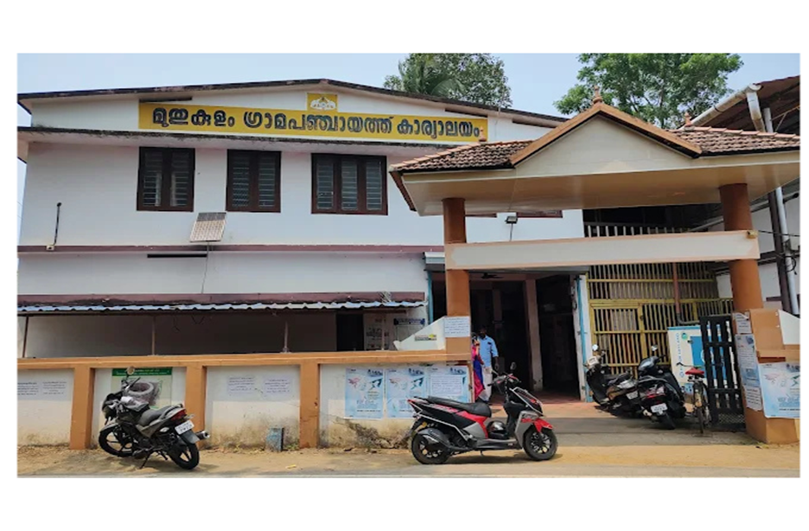
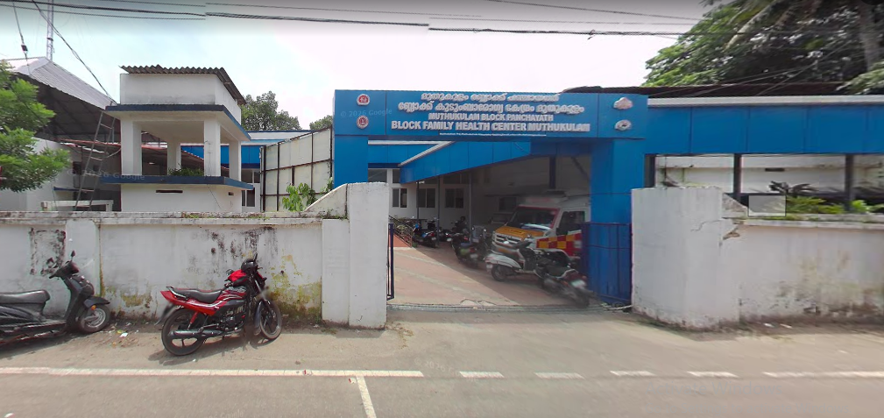

MESSAGE FROM PRESIDENT
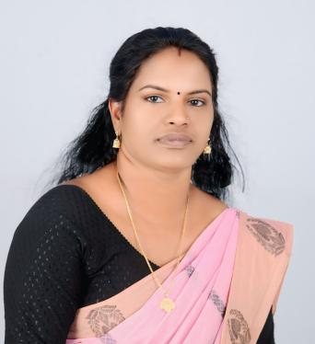
Kerala's health sector has achieved growth on par with developed nations, and activities under the Navakeralam mission are advancing steadily. The state's accomplishments in healthcare have been widely discussed. It is essential to sustain these achievements and remain vigilant in addressing emerging challenges. Natural disasters and climate change have become recurring events, with floods presenting a significant challenge to the population. In recent years, Kerala has faced crises such as the Covid-19 pandemic and severe flooding. Consequently, it is imperative to proactively engage in disaster management and mitigation training and initiatives moving forward.

Smt.Sheeja sunil
Gramapanchayath president
Muthuykulam


MESSAGE FROM HEALTH STANDING COMMITTEE CHAIR

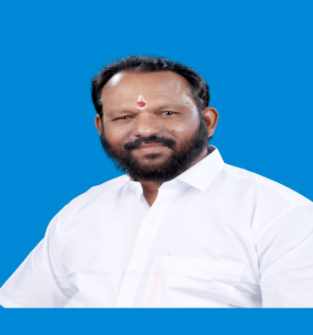

Our state has become increasingly vulnerable to a wide range of disasters. Over time, repeated catastrophes have caused significant loss of life and property. Climate change has led to a rise in cyclones, thunderstorms, droughts, sunstroke, epidemics, and forest fires across the region.
Epidemics occurring worldwide tend to reach Kerala swiftly. To address these challenges, various departments coordinate their preparations. When diseases or conditions that could cause illness are detected, timely interventions and preventive measures can be implemented as quickly as possible.

Mr.Pushpan
Health Standing Committee Chairman
Muthukulam Grama panchayath


MESSAGE FROM MEDICAL OFFICER 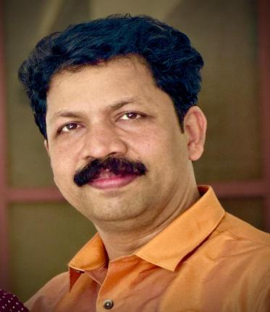
The COVID -19 pandemic has created one of the most serious public health emergencies the modern world has ever seen. Health systems have faced infection diseases and epidemic in the past ,but have never faced a pandemic like COVID. With this in mind NITI Ayog has appointed an expert group for a framework for action for future pandemic preparedness and emergency response. A pandemic preparedness plan has been prepared at Muthukulam CHC based on the guidelines of this group .According to this ,symptoms are detected early from the OP and in the field, and the surveillance and contact tracing of the said cases are done properly .This way , it is possible to prevent the disease from going to the epidemic and pandemic levels.
The COVID-19 pandemic has resulted in one of the most significant public health emergencies experienced by the modern world. Although health systems have previously managed infectious diseases and epidemics, they have not encountered a pandemic at the scale of COVID-19. In response, NITI Ayog established an expert group to develop a framework for future pandemic preparedness and emergency response. In alignment with this group's guidelines, a pandemic preparedness plan has been formulated at Muthukulam CHC. This plan prioritizes early detection of symptoms both in outpatient departments and through field surveillance, alongside comprehensive contact tracing. These measures help prevent the escalation of disease to epidemic or pandemic proportions.
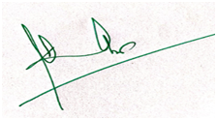
Dr.Sajeev
Block Medical Officer
Community Health Centre -Muthukulam
Muthukulam,Alappuzha District ,Kerala

EXECUTIVE SUMMARY

Community Health Centre (CHC) functions as the Block family healthcare institution serving the population of 25,100GramaPanchayath. The CHC plays a pivotal role in delivering comprehensive, accessible, and affordable healthcare services, with a strong focus on preventive, promotive, curative, and rehabilitative care in accordance with national and state health programmes.
The CHC caters to a predominantly rural population, addressing key public health priorities such as maternal and child health, communicable and non-communicable disease control, immunization, family welfare, adolescent health, and geriatric care. Regular outpatient services, home-based care through field health staff, and outreach activities ensure healthcare coverage even in geographically challenging areas. The institution actively implements national health missions, including the National Health Mission (NHM), National Tuberculosis Elimination Programme, National Programme for Prevention and Control of Cancer, Diabetes, Cardiovascular Diseases and Stroke (NPCDCS), and other disease surveillance initiatives.
Muthukulam CHC works in close coordination with theMuthukulamGramaPanchayath, ASHA workers, Anganwadi centres, schools, and community-based organizations to strengthen community participation and improve health awareness. Emphasis is placed on early detection, timely referral, health education, and lifestyle modification to reduce disease burden and improve overall health outcomes.
Despite constraints related to infrastructure, manpower, and increasing service demand, the CHC continues to enhance service delivery through effective planning, data-driven decision-making, and community engagement. Strengthening facilities, upgrading digital health systems, and expanding preventive services remain key focus areas for future development.
Overall, MuthukulamFamily Health Centre stands as a vital institution in safeguarding public health and improving the quality of life of the residents of MuthukulamGramaPanchayath.

LIST OF ABBREVIATIONS

LSGD/LSGI | Local Self Government Department / Local Self Government Institution
BFHC | Block Family Health Centre
CHC | Community Health Centre
BMO | Block Medical Officer
IDSP | Integrated Disease Surveillance Programme
NDMA | National Disaster Management Authority
PPE | Personal Protective Equipment
ICMR | Indian Council of Medical Research
CD | Communicable Diseases
NCD | NON-COMMUNICABLE Diseases

TABLE OF CONTENTS

INTRODUCTION 9
● Background of the PPP
LSGD AT A GLANCE 11
INTEGRATED HEALTH INFRASTRUCTURE MAP OF PANCHAYAT 11
GENERAL PROFILE OF THE LSGI’S 15
Background of the LSGI 15
Demographic and Vulnerable Population 18
Clinical Vulnerability 19
INFRASTRUCTURE & RESOURCE INVENTORY 22
Health Facility Directory & Basic Capacity in the LSGD 22
Private Clinics 23
Healthcare Education & Training Institutions 24
Specialized Services & Emergency Inventory 24
Oxygen & Diagnostic Capacity 25
Diagnostics facility mapping at the LSGI level 26
Laboratory Identification & Basic Details 26
Social and Community Infrastructure for surge plan 28
Human resources 30
Community & Support Cadre 32
Community Organizations 33
Administrative & Emergency Services 34
Information regarding resources 34
ONE HEALTH & ENVIRONMENTAL SURVEILLANCE 35
Animal & Bird Population 36
Veterinary Infrastructure 37
Veterinary Doctors & Workforce 38
High-Risk Interface Points (Surveillance Sites) 39
Environmental Risk Mapping 40
Disease Seasonality Mapping 41
Vulnerability Mapping 42
EPIDEMIOLOGICAL TRENDS (2021–2025) 43
Disease Burden among human beings(Last 5 Years) 43
*(use the above table data to create the graph/diagram) 43
Seasonal Trend Analysis 44
Outcome-Based Trend Analysis- 2025 51
Transmission Trend- 2025 51
Integrated Disease Hotspot Map (2021–2025) 55
Preparedness and Response Protocol at LSG Level 58
Constitution of One Health Committee 58
Pandemic Response Workforce 60
Activities and Measures before and during Pandemic 61
PHASE 1 - Alert / Preparation 61
PHASE 2 - Active Response 64
Standard Screening Protocol 65
PHASE 3 - Surge Capacity 76
Conversion of Community Facilities 76
CONCLUSION 77
RECOMMENDATIONS 78
ANNEXURE 79
1. IMPORTANT PHONE NUMBERS 80

INTRODUCTION
MuthukulamGrama Panchayat is a scenic, coastal, and backwater village in Karthikapally Taluk of Alappuzha district, Kerala, acting as the headquarters for the Muthukulam Block Panchayath.and is home to the notable Pandavarkavu Devi temple.
Muthukulam is a small backwater village in Central Kerala. It is bordered by the Kanyakumari-Panvel National Highway 66 on the east and the backwaters to the west. A narrow strip of land comprising Aratupuzha village beyond the backwaters separates Muthukulam from the Arabian sea in the West. The nearest major town is Kayamkulam which is well connected by Haripad-Muthukulam-Kayamkulam road. The nearest railway station are Haripad(HAD) and Kayamkulam(KYJ).The primary purpose of this document is to create a clear baseline for rapid mobilisation during health emergencies. By mapping available health facilities, human resources, logistics, community institutions, and support systems, the plan ensures that roles, responsibilities, and communication channels are clearly defined before a crisis occurs. This reduces delays, confusion, and duplication of effort during the early and most critical phase of an outbreak.
Another key objective is to identify gaps in resources and preparedness. The plan systematically reviews existing infrastructure, manpower, supplies, and services, while also identifying high-risk and vulnerable populations such as the elderly, persons with chronic illnesses, pregnant women, children, migrant labourers, and socially disadvantaged groups. Recognising these gaps in advance allows the Panchayat to strengthen preparedness through targeted planning, training, and partnerships rather than relying on reactive measures during emergencies.
Coordinated action across sectors is a central theme of this preparedness framework. Effective pandemic management requires close collaboration between government health services, private healthcare providers, and AYUSH institutions. This document provides a platform for shared planning, standardised referral mechanisms, and coordinated service delivery, ensuring that all available resources within the Panchayat are used efficiently and equitably during health crises.
Recognising that pandemics disrupt more than healthcare, the preparedness plan integrates food and livelihood security into emergency response. Linkages with welfare schemes such as the Public Distribution System, and social support programmes are outlined to prevent hunger and economic distress. Lessons from the COVID-19 response—particularly the role of community kitchens, doorstep delivery of essentials, and support to local farmers and daily wage workers—are incorporated to ensure continuity of essential services.
Special attention is given to the protection of vulnerable populations. The plan ensures continuity of maternal and child health services, regular follow-up of elderly and chronically ill individuals, psychosocial support, and inclusion of migrant labourers and marginalised groups in relief and health services. This focus reflects the Panchayat’s commitment to equity and social justice during emergencies.
This pandemic preparedness plan builds on these experiences to formalise systems, strengthen coordination, and address existing gaps. It aims to ensure that MuthukulamGramaPanchayath is equipped to respond swiftly and compassionately to future public health emergencies, protecting lives while preserving the social and cultural fabric of the community.

LSGD AT A GLANCE
ADMINISTRATIVE BOUNDARIES OF MUTHUKULAM GRAMA PANCHAYAT

Muthukulam is backwater village and census town near Haripad in Alappuzha district in the Indian state of Kerala. It is a major village between Kayamkulam and Haripad and headquarters of the Muthukulam Block Panchayat
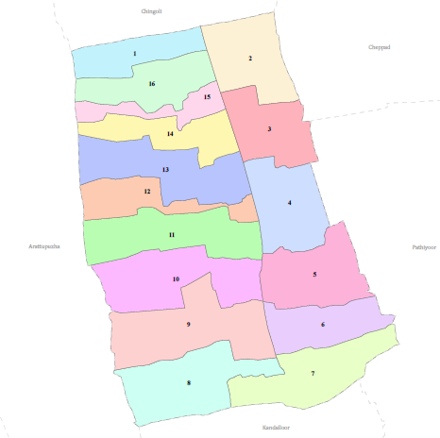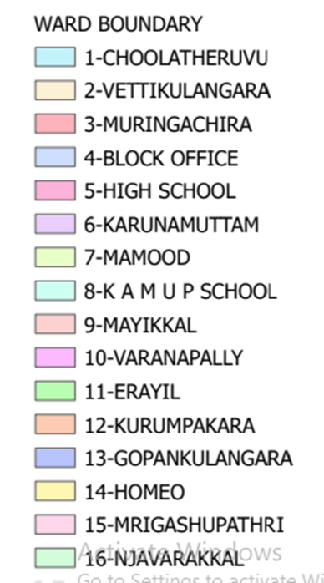

- Ward division -

Ward | Houses | Population | Migrants | wells | Hot Spot | Educational.Institutions | Hospital  Pvt clinic/Govt
16 | 6795 | 25100 | 89 | 1880 | w- 1 | 32 | 3

INTEGRATED HEALTH INFRASTRUCTURE MAP OF MUTHUKULAM-PANCHAYAT

GOVERNMENT ,PRIVATE HOSPITALS AND CLINICS

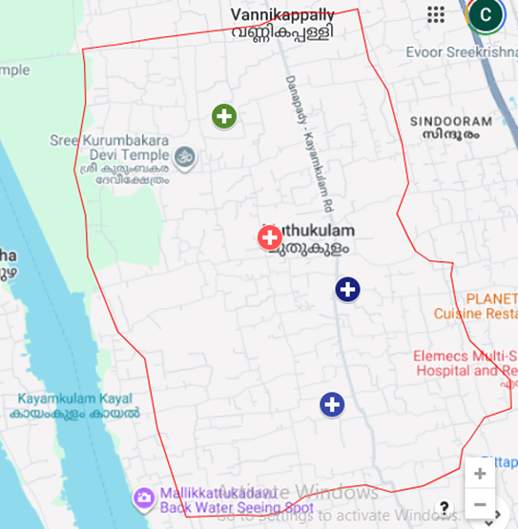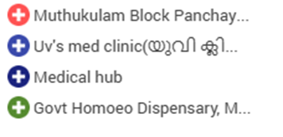
https://www.google.com/maps/d/edit?mid=1wbRc0AWYtgBpDdTq72dU8zmpnCyjujU&ll=9.21404060883863%2C76.41803762244223&z=14
ROADS
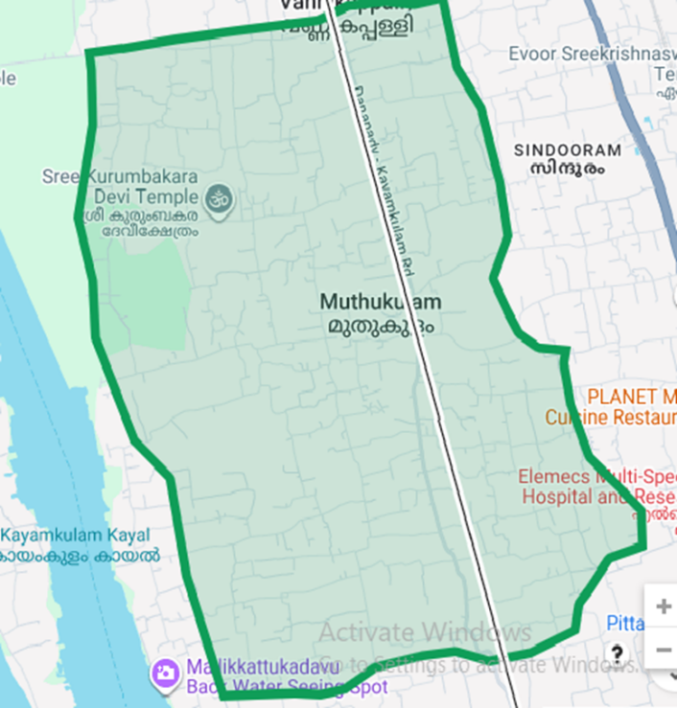
https://www.google.com/maps/d/edit?mid=1DIvmTfVk0V3A3GM2rM-7nLopMmBt6yw&ll=9.216013336448619%2C76.4217574517108&z=14
GOVERNMENT OFFICES IN MUTHUKULAM PANCHAYATH

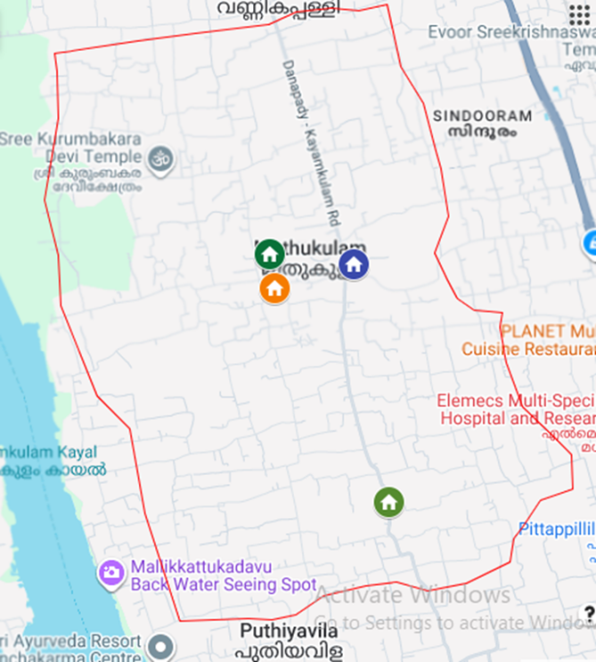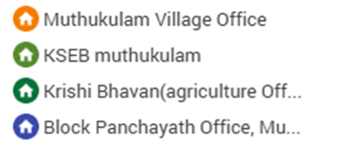https://www.google.com/maps/d/edit?mid=1jwi8reexX8KzTo-Rxe3PrtDOYymhJjs&ll=9.212105787302988%2C76.42594245793785&z=14
COMMUNITY CENTRES
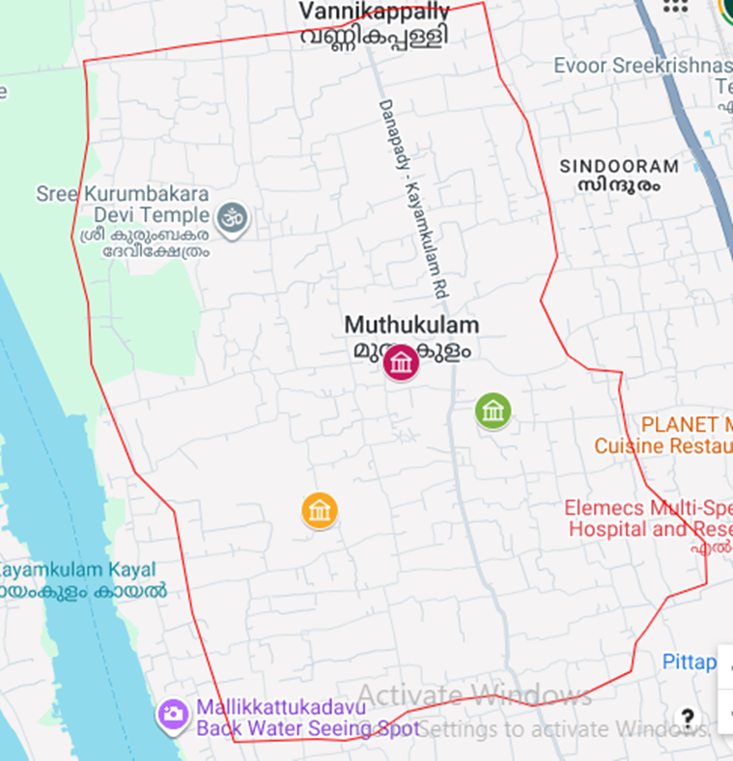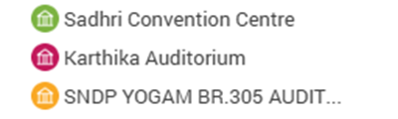
https://www.google.com/maps/d/edit?mid=1L8kEIN7NwlilL7m7RNbN2uofdnScntw&ll=9.214641233574927%2C76.42255235563964&z=14
SCHOOLS

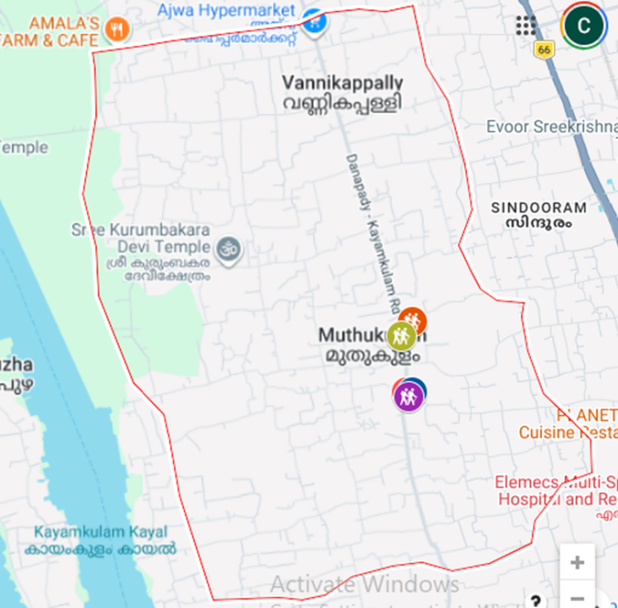
https://www.google.com/maps/d/edit?mid=16kAPj9hePqqobRoIXtO_dH1eo6sr2sY&ll=9.218024992603304%2C76.41838589060933&z=14

GENERAL PROFILE OF THE LSGI’S
GENERAL PROFILE OF THE LSGI’S

Background of the LSGI
Muthukulam is a prominent Grama Panchayat and the headquarters of the Muthukulam Block Panchayat in Alappuzha district, Kerala. As a coastal, agricultural area with significant backwater areas, it operates under the Karthikapally Taluk.
Key Aspects of Muthukulam LSGI:
· Administration: It functions as a Local Self Government Institution (LSGI) managing local development, infrastructure, and welfare programs.
· Block Panchayat Headquarters: It is the hub for a block comprising eight villages: Muthukulam, Chingoli, Arattupuzha, Cheppad, Kandalloor, Pathiyoor, Krishnapuram, and Devikulangara.
· Location & Geography: Situated in Alappuzha district, it is characterized by its coastal and backwater geography.
· Political Landscape: While the Indian National Congress is the largest single party, the governing council is run by the LDF with independent support.

Demographics & Economy: The area has
Table 1: Background of LSGD
Description | Details
Name of LSGI | Muthukulam
Type (GP/Municipality / Corporation etc.) | GramaPanchayath
Block | Muthukulam
District | Alappuzha
Number of wards | 16
Total area (sq. km) | 11.58
Population(Projected) | 25100
Population density | persons/sq km
Terrain (coastal/low-lying/backwaters/foothills, etc.) | 2281
Number of rivers passing through LSGI | 0
Number of water bodies in the LSGI | 16
Number of educational institutions | 32
Factories / small-scale industries | 0
Flood-prone wards | Ward 2,4,13,9,6,7(6)
Landslide-prone wards | 0
Death Management and Disposal Facilities (mortuaries/crematorium, including electric) | 0
Auditoriums/Marriage halls/convention centres/community halls | 5

Demographic and Vulnerable Population
Understanding the demographic composition and vulnerable population groups is essential for pandemic preparedness. Children, elderly, economically deprived families, migrant workers, and socially vulnerable groups are at increased risk during public health emergencies due to higher exposure, limited access to services, and dependency on public systems..
Description |  | Details (in numbers)
DEMOGRAPHIC PROFILE
Total population |  | 25100
Male |  | 11512
Female |  | 13588
Transgender |  | 0
Children under 5 |  | 1101
Adolescent |  | 1856
Elderly (>60) |  | 4600
SOCIAL/LIVELIHOOD VULNERABILITY
Previous EPEP family |  | 8
BPL family |  | 5020
Tribal communities |  | 0
Migration | Immigrant | 121
Migration | Emigrant | 634
Socio-economically deprived |  | 12
Fisherfolk |  | 0
SC Community |  | 1860
ST Community |  | 0

Clinical Vulnerability
Certain population groups needs priority healthcare & are at higher risk of severe illness, complications, and mortality during pandemics. Patients with chronic diseases, those requiring regular medical care, and individuals with mobility or functional limitations face challenges in accessing timely care during emergencies. Mapping these groups helps in prioritizing continuity of treatment, medicine stock planning, oxygen support, referral transport, and targeted home-based care.
Description | Details in numbers
Pregnant women | 180
Lactating mothers | 324
Bedbound patients | 99
Patients under palliative care other than bedbound | 198
Patients on Haemodialysis | 19
Patients on CAPD | 4
Cancer patients (currently on treatment) | 132
Haemophilic patients | 0
Mentally challenged | 25
Differently abled | 182
Diabetic patients | 1256
Hypertensive patients | 2315
TB patients | 3

Major Festivals & Events specific to the LSGI
(with the possibility of a public gathering)

Sl. No. | Name of festival | Month detailing the periodicity
1 | Thiru Uthsavam Pandavarkavu Devi Temple | February-March (Kumbham)(9 days)

INFRASTRUCTURE & RESOURCE INVENTORY

Health Facility Directory & Basic Capacity in the LSGD
This section provides an overview of the healthcare infrastructure available within the LSGD area. It outlines the distribution and basic capacity of health facilities that form the backbone of service delivery during routine times and public health emergencies.

Family Health Centres (FHCs) and Community Health Centres (CHCs) generally function as the first point of contact for the community, providing essential outpatient and inpatient services. General Hospitals (GH) and Medical College Hospitals (MCH), where accessible, serve as the main referral centres for advanced diagnostics, specialist care, and critical services during public health emergencies. This inventory helps identify existing strengths, gaps, and potential surge capacity that can be mobilised during a pandemic or disaster.

Table 5. Health Facility Resource Summary
Sl.no. | Health Facility | Type of Facility (MCH/GH/CHC/FHC/SC etc.) | Contact Number | Total beds | ICU Beds | Oxygen-Supported Beds | No. of Ventilator Support Beds | No. of ambulances
Government Healthcare Facilities
 | CHC Muthukulam | CHC |  |  | 0 | 0 | 0 | 1
 | Main center | SC | 8281470035 | 0 | 0 | 0 | 0 | 0
 | MUTHUKULAM NORTH | SC | 9778048727 | 0 | 0 | 0 | 0 | 0
 | MUTHUKULAM SOUTH | SC | 9048776339 | 0 | 0 | 0 | 0 | 0
 | MURIGACHIRA | SC | 9526191884 | 0 | 0 | 0 | 0 | 0
Private Healthcare Facilities
 | 0 | 0 | 0 | 0 | 0 | 0 | 0 | 0
AYUSH Healthcare Facilities
 | HOMEO DISPENSARY | DISPENSARY | 9846123791 | 0 | 0 | 0 | 0 | 0
 | AYURVEDAM | DISPENSARY | 9744475214 | 0 | 0 | 0 | 0 | 0

Private Clinics
Private clinics are an essential part of pandemic preparedness, as they are often the first place people seek care when symptoms begin. In many communities, private clinics manage a significant share of outpatient visits and therefore play a critical role in early case detection, timely referrals, and disease surveillance. Having an up-to-date understanding of where these clinics are located, the services they provide, and how they are linked to the public health system helps ensure that no cases are missed during an outbreak. It also allows health authorities to engage private practitioners more effectively for reporting, risk communication, and coordinated response, strengthening the overall capacity of the health system to manage public health emergencies.

Table 6. Private Clinic Resource Summary
Sl No. | Name of Clinic | Registered (Y/N) | Clinic (General / Speciality) | Speciality (if any) | Address | Contact Number | Diagnostic Facility (Y/N) | Ambulance Linkage (Y/N)
1 | U V CLINIC | Y | GENERAL | 0 | U V CLINIC Muthukulam | 9400415436 | y | 0

Healthcare Education & Training Institutions
This section tracks the educational infrastructure available, which is vital for human resource planning in the health sector.

Category of Institution | Govt | Private | AYUSH | Total
Medical Colleges | 0 | 0 | 0 | 0
Nursing Colleges | 0 | 0 | 0 | 0
Dental Colleges | 0 | 0 | 0 | 0
Para-medical / Allied Health | 0 | 0 | 0 | 0
Pharmacy Colleges | 0 | 0 | 0 | 0

Specialized Services & Emergency Inventory
This section provides a detailed view of the specialized medical resources available to the community, focusing on emergency response and critical care capabilities. This table tracks the vital assets required for managing severe illnesses and emergencies across Government, Private, and AYUSH sectors.

Item | Govt | Private | AYUSH | Total
Hospital beds | 24 | 0 | 0 | 24
Oxygen-generating systems(Y/N) | 0 | 0 | 0 | 0
Oxygen-supported beds(Numbers) | 0 | 0 | 0 | 0
Ventilator-supported beds | 0 | 0 | 0 | 0
ICU beds | 0 | 0 | 0 | 0
Burns units | 0 | 0 | 0 | 0
Blood centres | 0 | 0 | 0 | 0
BLS ambulances | 1 | 0 | 0 | 0
ALS ambulances | 0 | 0 | 0 | 0
Dialysis facilities | 0 | 0 | 0 | 0
Dispensaries | 2 | 0 | 0 | 2
Medical store | 0 | 9 | 0 | 9
Industrial establishments(Medium-scale industries/small-scale industries establishments to whom we can depend in a worst-case scenario)

Oxygen & Diagnostic Capacity
Monitoring oxygen and diagnostic capacity is a critical component of public health preparedness, ensuring that the LSGD can handle both chronic care and sudden surges in respiratory or infectious diseases.
Name of Health Facility | Oxygen-generating System (Y/N) | Backup Oxygen Source (Y/N) | Diagnostic Facilities Available(Y/N)
Name of Health Facility | Oxygen-generating System (Y/N) | Backup Oxygen Source (Y/N) | Lab | USG | X-ray | CT/MRI | RT-PCR
Government Healthcare Facilities
CHC muthukulam | N | N | Y | N | Y | N | Y

Diagnostics facility mapping at the LSGI level
The diagnostic capacity of G.P represents the "intelligence network" of our healthcare system. The speed and accuracy of disease identification depend entirely on the distribution and technical level of these facilities.

Item | Govt | Private | AYUSH | Total
General labs | 1 | 12 | 0 | 13
Microbiology labs | 0 | 0 | 0 | 0
RT-PCR labs | 0 | 0 | 0 | 0
USG units | 0 | 0 | 0 | 0
CT/MRI units | 0 | 0 | 0 | 0
Research labs | 0 | 0 | 0 | 0
Labs of other departments that can be repurposed | 0 | 0 | 0 | 0

Laboratory Identification & Basic Details

Sl. No. | Name of Laboratory | Ownership (Govt / Private / Academic) |  | Address |  | Contact No. |  | 24×7 Services (Yes/No) |  | NABL / Govt Approved (Yes/No)
1 | NIRNAYA | PVT |  | NEAR UMMAR MUKKU MUTHUKULAM |  | 9249388313 |  | NO |  | YES
2 | SOORYA | PVT |  | NEAR PANCHAYATH MUTHUKULAM |  |  |  | NO |  | YES
3 | SOORYA | PVT |  | KARUNA MUTTOM JUN MUTHUKULAM SOUTH |  | 9656502021 |  | NO |  | YES
4 | KARUNYA MEDILAB | PVT |  | MUTHUKULAM |  | 8113044682 |  | NO |  | YES
5 | HITEC LAB | PVT |  | MUTHUKULAM |  | 8301999715 |  | NO |  | YES
6 | DEVI | PVT |  | NEAR CHC MUTHUKULAM |  |  |  | NO |  | YES
7 | DENBERT | PVT |  | HIGH SCHOOL JUNCTION MUTHUKULAM |  | 7356050994 |  | NO |  | YES
8 | NEW TECH | PVT |  | NEAR PANDAVAR KAVU MUTHUKULAM |  | 9207965265 |  | NO |  | YES
9 | SREE AYYAPPA LAB | PVT |  | HIGH SCHOOL JN.MUTHUKULAM |  | 62823598 |  | NO |  | YES
10 | V.G DENTAL CLINIC | PVT |  | HIGH SCHOOL JUNCTION MUTHUKULAM |  | 8281174010 |  | NO |  | YES
11 | DHARSHANA LAB |  | PVT |  | NEAR PANDAVARKAVU JN MUTHUKULAM |  |  |  | NO |  | YES

Social and Community Infrastructure for surge plan
This table serves as our logistics and shelter inventory. By mapping these locations, quickly we can identify where to house displaced citizens, where to set up temporary medical clinics, and how to manage the deceased with dignity during a crisis.

Category | Total Count | Ward | Est. Capacity (Persons) | Contact details
Educational Institutions
Anganwadis | 20 | 2 to 16 | 200 | 8281878458
Schools | 11 | 7 | 5100 | 0479 2447558
Colleges | 1 | 3 | 500
Healthcare Educational Institutions
Medical colleges (Govt/Private) | 0 | 0 | 0 | 0
Nursing colleges (Govt/Private) | 0 | 0 | 0 | 0
Dental colleges (Govt/Private) | 0 | 0 | 0 | 0
Paramedical institutes (Govt/Private) | 0 | 0 | 0 | 0
Community Gathering Spaces
Community halls | 1 | 12 | 600
Auditoriums | 4 | 15 ,4,12,11 | 1800 | 7034626621
Religious buildings | 0 | 0 | 0 | 0
Vulnerable Group Support Facility
Destitute homes | 0 | 0 | 0 | 0
Elderly homes | 0 | 0 | 0 | 0
LSGD owned other buildings | 2 | 11 | 160 | 0479 2472027
Mass Fatality Management (MFM) Infrastructure
Mortuary | 0 | 0 | 0 | 0
Crematorium | 0 | 0 | 0 | 0
*refer annexure 1 for contact details0
0

Human resources
This section focuses on the human capital available within the LSGI. In any emergency—be it a pandemic, flood, or industrial accident—infrastructure is only as effective as the people operating it.

Medical & Clinical Personnel
This table tracks the "Frontline" providers responsible for diagnosis, treatment, and clinical management. Narrative sentence: eg., "Total health workforce: 450 personnel, with 60% in government facilities serving as primary surge capacity." A detailed directory with the contact numbers of all workers is maintained (Annexure in 1).

Cadre | Govt (No.) | Private (No.) | Total
Doctors—Modern Medicine | 4 | 2 | 6
Doctors – AYUSH | 2 | 3 | 5
Doctors – Veterinary | 1 | 0 | 1
Doctors – Dental | 0 | 5 | 5
Nursing officers | 4 | 0 | 4
Lab technicians | 2 | 12 | 14
Optometrist | 1 | 0 | 1
Pharmacists | 3 | 0 | 3
Psychologists | 0 | 0 | 0
Counsellors | 0 | 0 | 0

Public Health & Field-Level Workforce
These individuals are the backbone of surveillance, maternal-child health, and decentralized care.

Cadre | Health services | Municipal common services | Total
HS (Health Supervisors) | 1 | 0 | 1
HI (Health Inspectors) | 1 | 0 | 1
LHS (Lady Health Supervisor) | 1 | 0 | 1
LHI (Lady Health Inspectors) | 0 | 0 | 0
JPHN (Jr Public Health Nurses) | 4 | 0 | 4
JHI (Jr Health Inspectors) | 3 | 0 | 3
MLSP (Mid-Level Service Providers) | 4 | 0 | 4
Palliative Nurses | 2 | 0 | 2
RBSK Nurses | 1 | 0 | 1
PRO | 1 | 0 | 1
Epidemiologist |  | 1 | 1
Data Manager |  | 1 | 1

Community & Support Cadre
This group represents the surge capacity of the LSGI—people who can be called upon for logistics, rescue, and specialized support.

Cadre | Number
ASHA Workers | 20
AWW (Anganwadi Workers) | 21
Emergency Medical Volunteers (Trained) | 10
Kudumbashree | 196
MNREGS | 680
Purusha Swayam Sahaya Sangham | 13
Ex-Servicemen | 56
Retired Police Officers | 15
NCC/NSS Volunteers | 30
Red Cross volunteers | 25
One Health Community Volunteers | 735
One Health Community Mentors | 105

Community Organizations
This section details the presence of community-based organisations (CBOs), non-governmental organisations (NGOs), faith-based organisations (FBOs), Kudumbashree Self-Help Groups (SHGs), and Ayalkootams within the Local Self-Government Institution (LSGI). These groups enhance grassroots mobilization, resource distribution, and support networks crucial for pandemic response and community resilience.

Category | Total Count
NGOs | 4
Religious based organizations | 12
Foreign based organizations | 1
Sports Club/youth clubs | 12
Kudumbashree SHGs | 15
Ayalkootams | 196
Political organizations | 4
Residential organizations | 4

Administrative & Emergency Services
This section outlines the availability of key non-health emergency support services and infrastructure within the LSGI, which are essential for effective pandemic preparedness and response. These facilities support law enforcement, disaster response, water supply, logistics, mobility, and community-level interventions during public health emergencies.

Category | Total Count | Contact details
Police Stations | 0 | -
Fire & Rescue Stations | 0 | -
Water Pumping Points | 2 | -
Public Distribution System (PDS) | 0 | -

Information regarding resources
The availability of essential transport and support resources plays a quiet but critical role in saving lives. Equipment such as ambulances, mobile mortuaries, amphibian ambulances, and motorized boats ensures that patients, samples, and healthcare teams can move swiftly—even in flooded, remote, or difficult terrains. Heavy vehicles like JCBs, cranes, tractors, and torus lorries support logistics, waste management, emergency infrastructure, and rapid conversion of spaces into care or isolation facilities. Taxis, four-wheel-drive vehicles, and trucks help maintain continuity of essential services, reach vulnerable populations, and support home-based care and supply delivery.

Means of transportation | Total Count
JCB | 3
Crane | 0
Heavy Trucks | 0
Tractor | 0
Ambulances | 1
Mobile mortuaries | 2
Boats | 0
Taxi service | 25
Note: For specific details regarding vehicle owners and contact information, please refer to Annexure [X].

ONE HEALTH & ENVIRONMENTAL SURVEILLANCE
The One Health method integrates environmental, animal, and human health to enable proactive pandemic preparedness. Panchayat-level surveillance needs to be improved in order to detect and treat zoonotic and environmentally generated diseases early. Surveillance is strengthened through systematic assessment of animal populations, veterinary infrastructure, poultry and slaughter facilities, inter-sectoral coordination, and specialised tools like avian influenza seasonality mapping using GIS in previous outbreaks to enable predictive alerts and ward-specific sampling to support effective pandemic preparedness in high-risk areas.

Animal & Bird Population
Mapping animal and bird populations at the Panchayat level is essential for identifying and prioritising zoonotic disease hazards like rabies, avian influenza (H5N1), leptospirosis, anthrax, and Nipah-like spillover occurrences. Risk classification, targeted surveillance, vaccination planning, and early epidemic detection made feasible by comprehensive population mapping all enhance One Health-based pandemic preparedness.

Category | Item | Estimated Population | Wards
Animal Population | Livestock (Cattle/Goats/Buffalo) | 869 | 1 to 16
Animal Population | Pet Animals (Dogs/Cats) | 574 | 1 to 16
Animal Population | Stray Dog Population | 439 | 1 to 16
Animal Population | Pig Farms (Number of heads) | 0 | 0
 | Small Units (Sheep / Goats – clustered) | 0 | 0
Bird Population | Poultry Units (Birds) | 0 | 0
Bird Population | Poultry- (FOWL) | 2745 | 1 to 16
Bird Population | Wild/Migratory Birds (Observed) | 0 | 0
Bird Population | Crow Mortality Events (Reported) | 0 | 0

The main risk of zoonotic diseases in is concentrated in Wards which is explained by the high density of pig farms, cattle congregation areas, and poultry units. The stray dog population in market areas, fish landing sites, bus stations continues to be a substantial problem for rabies surveillance and bite prevention. There is a considerable risk of avian influenza introduction and amplification during November - December due to the seasonal presence of migratory and resident water birds near ponds/ canal / river / backwater / paddy field. Clusters of pig farms and animal shelters vulnerable to flooding further raise the risk of leptospirosis and other zoonoses mediated by the environment, especially during monsoon floods.

Veterinary Infrastructure
Veterinary institutions are a core pillar of One Health surveillance, enabling early zoonotic disease detection through vaccination, investigation of unusual animal illness or deaths, sample collection, and timely outbreak reporting. A well-mapped and responsive veterinary network strengthens coordination with human health and LSGI systems, ensuring rapid response during zoonotic events and pandemics.
Facility Type | Name of Facility | Ownership Govt / Pvt | Location(Ward No) | Contact number
Veterinary Dispensary | 1 | gov | 15 | 9447075699
Veterinary Hospital / Polyclinic | 0 | 0 | 0 | -
Private Veterinary Clinics | 0 | 0 | 0 | -
Mobile / Emergency Vet Service (incl. night services) | 0 | 0 | 0 | -
Pet Homes / Animal Shelters | 0 | 0 | 0 | -
Slaughterhouse-linked Veterinary Inspection Unit | 0 | 0 | 0 | -

Veterinary Doctors & Workforce
Early detection, diagnosis, reporting, and reaction to animal illness epidemics depend on the availability and accessibility of qualified veterinary specialists. By identifying unusual animal morbidity or mortality promptly, collecting samples promptly, and coordinating efficiently with human health and LSGI systems—especially during zoonotic outbreaks and pandemic-prone situations—a clearly defined veterinary workforce enhances One Health surveillance.

Category | Number Available | Type (Govt/Pvt) | Contact number
Government Veterinary Doctors | 1 | gov | 9447075699
Private Veterinary Doctors | 8 | pv | 0
Livestock Inspectors | 1 | gov | 9447075699
Para-veterinary Staff / Attenders | 1 | gov | 9447075699
Contract / On-call Veterinary Support (if any) | 1 | gov | 9447075699

High-Risk Interface Points (Surveillance Sites)
High-risk interface points for zoonotic disease surveillance in Muthukulam Grama Panchayath include wetland–livestock–human contact zones, backyard poultry farms, cattle sheds near water bodies, fish markets, and areas of high human–animal interaction such as community slaughter points and migratory bird congregation sites. These are the primary surveillance sites where zoonotic spillover risks are elevated.

Category | Total Count | Key Locations (wards)
Poultry Farms | 0
Backyard / Clustered Poultry Units | 0
Duck Rearing Units (open water access) | 0
Slaughterhouses/ Slaughter Points | 0
Meat/Fish Markets | 0
Live Bird Sale Points | 0
Cattle Markets / Weekly Animal Fairs | 0
Pet Shops / Breeders | 0
Animal Shelters / Pet Homes | 0
Waste Disposal Sites near Animal Units | 0

Environmental Risk Mapping
Environmental risk mapping identifies monsoon/flood hotspots for vector-borne (dengue, chikungunya), water-borne (leptospirosis, diarrhoea), and zoonotic diseases in Kerala's wetlands. Systematic surveillance supports early warnings, targeted interventions, and Panchayat pandemic preparedness.
Waterborne exposure: Flood-prone areas and stagnant water bodies facilitate leptospira survival, raising leptospirosis risk.

Traditional practices: Informal slaughter and fish markets lack standardized hygiene, creating spillover opportunities.

Risk Factor | High-Risk Wards | Key Locations | Risk Level (High/Med/Low)
Flood-prone areas | 1, 9 , 10, 12 | choolatheruv , varanapally pandavar kav, kurumbakara | med
Water bodies/wetlands | 0 | 0 | 0
Solid waste accumulation | 0 | 0 | 0
Animal waste disposal issues | 0 | 0 | 0
Rodent infestation zones | 0 | 0 | 0
Industrial effluent discharge | 0 | 0 | 0
Construction sites / abandoned buildings | 0 | 0 | 0
Poor drainage/blocked canals | 0 | 0 | 0
Drinking water source contamination risk | 0 | 0 | 0

Disease Seasonality Mapping
1, Flooding & waterlogging → amplifies leptospirosis, malaria, diarrheal diseases.
·
2, Migratory bird influx (Nov–Feb) → avian influenza risk.

3, Mosquito breeding cycles → vector-borne disease peaks in monsoon.

4, Agricultural practices → close human–animal contact in paddy fields.

Disease | Peak Risk Season | Key Drivers | High-Risk Locations | Surveillance Focus
Avian Influenza | 0 | 0 | 0 | 0
Leptospirosis | 0 | 0 | 0 | 0
Dengue/Chikungunya | mansoon | 0 | 0 | 0
Acute Diarrheal Diseases | mansoon | 0 | 0 | 0
Rabies | 0 | 0 | 0 | 0
Anthrax (rare) | 0 | 0 | 0 | 0

Vulnerability Mapping
Vulnerability mapping pinpoints high-risk populations, occupations, and areas exposed via environment, livelihoods, socio-economics, and poor service access. Paired with environmental/seasonality mapping, it enables risk-based surveillance, targeted actions, and optimal resource use in One Health and pandemic planning.
Vulnerability Factor | High-Risk Wards | Key Groups / Locations | Risk Level
Flood-prone households | 0 | 0 | 0
Wetland-adjacent communities | 0 | 0 | 0
Backyard poultry / duck rearing households | 2 | 0 | 0
Livestock-rearing households | 0 | 0 | 0
Slaughterhouse & meat market workers | 0 | 0 | 0
Fisherfolk & fish market workers | 0 | 0 | 0
Sanitation workers | 0
Daily wage / migrant workers | 1 to 16
Elderly & chronically ill populations | 1 to 16
Pregnant Women | 1 to 16
Children (schools, Anganwadi’s) | 1 to 16
Limited access to safe water & sanitation | 0 | 0 | 0

EPIDEMIOLOGICAL TRENDS (2021–2025)

Disease surveillance is the systematic collection, analysis, and interpretation of health data for planning, implementation, and evaluation of public health practice. This section presents the disease surveillance profile of the LSGI based on routine reporting systems and outbreak investigations to identify priority diseases, seasonal patterns, and emerging public health threats.

Disease Burden among human beings(Last 5 Years)
Analysis of disease-wise data for the last five years helps identify persistent public health problems, emerging diseases, and changes in disease burden. This information supports prioritisation of prevention, preparedness, and response activities at the Panchayat level.

Disease | 2021 | 2022 | 2023 | 2024 | 2025 | Trend(Increasing/Stable/Decreasing)
Dengue | 5 | 3 | 26 | 33 | 8 | Stable
Leptospirosis | 0 | 2 | 1 | 3 | 1 | Stable
Hepatitis A | 0 | 1 | 0 | 2 | 0 | Decreasing
Malaria | 0 | 0 | 0 | 2 | 1 | Decreasing
Scrub Typhus | 0 | 0 | 0 | 0 | 0 | Decreasing
Typhoid | 0 | 0 | 1 | 0 | 0 | Decreasing
H1N1 | 0 | 0 | 0 | 1 | 0 | Decreasing
H3N2 | 0 | 0 | 0 | 0 | 0 | Decreasing
ADD | 0 | 25 | 84 | 38 | 31 | Decreasing
Mumps | 0 | 0 | 0 | 0 | 9 | Decreasing
Measles | 0 | 0 | 0 | 0 | 0 | Decreasing
Hepatitis B | 0 | 0 | 0 | 0 | 0 | Decreasing
Hepatitis C | 0 | 0 | 0 | 0 | 0 | Decreasing
Tuberculosis | 0 | 6 | 10 | 4 | 4 | Decreasing
Leprosy | 0 | 0 | 0 | 0 | 0 | Decreasing
COVID-19 | - | - | - | - | -

*(use the above table data to create the graph/diagram)

Seasonal Trend Analysis
Seasonal analysis helps anticipate surges (e.g. dengue in monsoon, leptospirosis after floods, influenza in cooler months) and plan pre‑emptive vector control, stockpiling of IV fluids, and awareness campaigns at Panchayat level.

DENGUE
Dengue is a major seasonal vector-borne disease strongly associated with rainfall, water stagnation, and increased mosquito breeding during the monsoon period.

Peak: July–November

Dengue – Ward-wise Yearly Distribution (2021–2025)

Ward | Dengue – Ward-wise Yearly Distribution
Ward | 2021 | 2022 | 2023 | 2024 | 2025 | Total
1 | 1 | 0 | 11 | 5 | 1 | 18
2 | 0 | 0 | 1 | 1 | 1 | 3
3 | 1 | 0 | 0 | 3 | 1 | 5
4 | 0 | 0 | 2 | 1 | 0 | 3
5 | 0 | 0 | 0 | 5 | 1 | 6
6 | 0 | 0 | 2 | 1 | 1 | 4
7 | 0 | 0 | 0 | 0 | 0 | 0
8 | 0 | 0 | 1 | 1 | 0 | 2
9 | 0 | 0 | 1 | 3 | 0 | 4
10 | 1 | 0 | 2 | 4 | 1 | 8
11 | 1 | 0 | 2 | 4 | 1 | 8
12 | 0 | 0 | 1 | 4 | 2 | 7
13 | 1 | 0 | 0 | 1 | 0 | 2
14 | 0 | 2 | 2 | 0 | 0 | 4
15 | 0 | 1 | 3 | 3 | 0 | 7

LEPTOSPIROSIS
Leptospirosis cases are closely linked to monsoon rains, flooding, and occupational exposure, particularly in low-lying and waterlogged areas.

Peak: June - August

Leptospirosis – Ward-wise Yearly Distribution (2021–2025)

Ward | Leptospirosis – Ward-wise Yearly Distribution
Ward | 2021 | 2022 | 2023 | 2024 | 2025 | Total
1 | - | 0 | 0 | 0 | 0 | 0
2 | - | 1 | 0 | 0 | 0 | 1
3 | - | 1 | 0 | 1 | 0 | 2
4 | - | 0 | 0 | 1 | 0 | 1
5 | - | 0 | 0 | 0 | 0 | 0
6 | - | 0 | 0 | 0 | 0 | 0
7 | - | 0 | 0 | 0 | 0 | 0
8 | - | 0 | 0 | 0 | 0 | 0
9 | - | 0 | 0 | 1 | 0 | 1
10 | - | 0 | 0 | 0 | 0 | 0
11 | - | 0 | 0 | 0 | 0 | 0
12 | - | 0 | 0 | 0 | 0 | 0
13 | - | 0 | 0 | 0 | 0 | 0
14 | - | 0 | 0 | 0 | 0 | 0
15 | - | 0 | 1 | 0 | 1 | 2

VIRAL HEPATITIS - A
Hepatitis A cases are commonly associated with unsafe drinking water, food contamination, and breakdowns in sanitation, often presenting as clusters or outbreaks.

Peak: October - December

Hepatitis A – Ward-wise Yearly Distribution (2021–2025)

Ward | Hep A – Ward-wise Yearly Distribution
Ward | 2021 | 2022 | 2023 | 2024 | 2025 | Total
1 | 0 | 0 | 0 | 0 | 0 | 0
2 | 0 | 0 | 0 | 0 | 0 | 0
3 | 1 | 0 | 0 | 0 | 0 | 0
4 | 0 | 0 | 0 | 1 | 0 | 0
5 | 0 | 0 | 1 | 0 | 0 | 0
6 | 0 | 0 | 0 | 0 | 00 | 0
7 | 0 | 0 | 0 | 0 | 00 | 0
8 | 1 | 0 | 0 | 0 | 0 | 0
9 | 0 | 0 | 0 | 1 | 0 | 0
10 | 0 | 0 | 0 | 0 | 0 | 0
11 | 0 | 0 | 0 | 0 | 0 | 0
12 | 00 | 0 | 0 | 0 | 0 | 0
13 | 0 | 0 | 0 | 0 | 0 | 0
14 | 0 | 1 | 0 | 0 | 0 | 0
15 | 0 | 0 | 0 | 0 | 0 | 0

Outcome-Based Trend Analysis- 2025

Transmission Trend- 2025
For effective management of public health issues, it is important to track the trend of disease transmission mode. It helps identify the population or place at high risk that can be used to predict outbreaks and implement targeted interventions as quickly as possible. Understanding these kinds of trends enables authorities to allocate resources efficiently and change the strategies adequately based on the trend that follows.

Mode of Transmission | No. of cases | No. of Deaths
Vector Borne Diseases | 9 | 0
Water Borne Diseases | 56 | 0
Air Borne Diseases | 32 | 0
Blood Borne Diseases | 0 | 0
Food Borne Diseases | 12 | 0

Vector-Borne Disease

Disease | No. of Cases | No. of Deaths
Dengue | 8 | 0
Malaria | 1 | 0
Chikungunya | 0 | 0

Water Borne Disease

Disease | No. of Cases | No. of Deaths
Cholera | 0 | 0
Typhoid | 1 | 0
Hep- A | 0 | 0
Dysentery | 0 | 0
Amoebiasis | 0 | 0
E- Coli infections | 0 | 0
Air Borne Disease

Disease | No. of Cases | No. of Deaths
Influenza | 0 | 0
H1N1 | 0 | 0
TB | 4 | 0
Chickenpox | 18 | 0
Measles | 0 | 0
Covid-19 | 0 | 0
Pertussis | 0 | 0
Mumps | 10 | 0

Blood-Borne Disease

Disease | No. of Cases | No. of Deaths
AIDS | 0 | 0
Hep- B | 0 | 0
Hep- C | 0 | 0

Zoonotic Disease

Disease | No. of Cases | No. of Deaths
Rabies | 0 | 0
Leptospirosis | 2 | 0
Avian influenza | 0 | 0
West nile | 0 | 0
Anthrax | 0 | 0
Nipah | 0 | 00
Scrub Typhus | 0 | 0

Integrated Disease Hotspot Map (2021–2025)
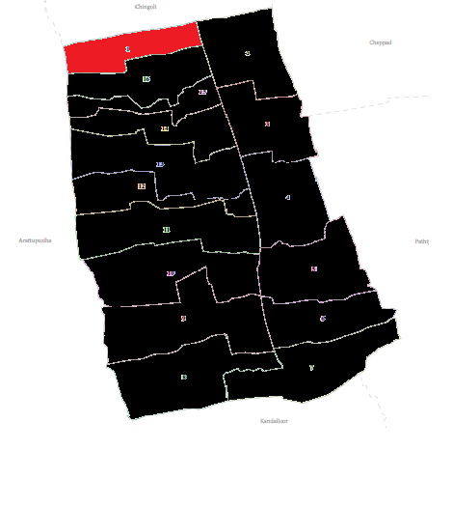HOT SPOT AREA :WARD 1

Ward No | Dengue Total (2021-25) | Leptospirosis Total (2021-25) | Hepatitis A Total (2021-25) | Mumps (2021-25) | ADD (2021-25) | Total Cases
1 | 18 | 0 | 0 | 0 | 28 | 46
2 | 3 | 1 | 0 | 1 | 15 | 20
3 | 5 | 2 | 0 | 0 | 12 | 19
4 | 3 | 1 | 0 | 1 | 21 | 26
5 | 6 | 0 | 0 | 0 | 23 | 29
 |  |  | 0 | 0
6 | 4 | 0 | 0 | 0 | 5 | 9
7 | 0 | 0 | 0 | 3 | 9 | 12
8 | 2 | 0 | 0 | 3 | 10 | 15
9 | 4 | 1 | 0 | 2 | 11 | 18
10 | 8 | 0 | 0 |  | 9 | 17
11 | 8 | 0 | 0 |  | 3 | 11
12 | 7 | 0 | 0 |  | 5 | 12
13 | 2 | 0 | 0 |  | 5 | 7
14 | 4 | 0 | 0 |  | 7 | 11
15 | 7 | 2 |  |  | 7 | 16
2
By overlaying five years of data, we have identified …………..'Red Zone' Wards. These are wards where at least two different categories of diseases (e.g., Dengue and Lepto) recurred in consecutive years. Ward 4 is categorized as the Highest Priority Hotspot due to its combination of flood vulnerability and high vector density. Future health infrastructure, such as the proposed R.O plants at ………should be prioritized.

Preparedness and Response Protocol at LSG Level
This section describes the operational framework for the LSGI once a pandemic is declared. It explains how the LSGI and health system will move from routine data collection to active response, using a One Health approach.

Constitution of One Health Committee
The LSGD shall constitute a One Health Committee comprising the LSGI President, Medical Officers (Modern Medicine, AYUSH, and Veterinary), the Health Inspector, and the Veterinary Surgeon.

Objective: The One Health Committee coordinates human, animal, and environmental health to prevent and control pandemics.

Sl No | Name | Designation | Department/Institution | Role in Committee | Contact Number
1 | sheeja | Panchayat President | LSGD | Chairperson
2 | Dr sajeev | Medical Officer (PHC/CHC) | Health Dept | Member Secretary | 9846014874
3 | Dr sankara narayanan | Veterinary Officer | Animal Husbandry | Member | 9447075691
4 | DR Krishnapriya | Epidemiologist | Health Dept | Member | 8281571060
5 | Lekha | Health Inspector/PHN | Health Dept | Surveillance | 9747777662
6 | geetha | ASHA Supervisor | Health Dept | Community link | 9446192041
7 | sreekala | ICDS Supervisor | Social Welfare | Vulnerable groups | 8281878458
8 |  | Police Station Officer | Police Dept | Law & order
9 |  | Ward Councillor Representative | LSGD | Community coordination
10 | veena lekshmi | Kudumbashree CDO | Kudumbashree | Community mobilisation | 92076255339
11 |  | NGO/Volunteer rep | Civil Society | Support services
12 |  | Line Department representations

Key Responsibilities:
- Review disease surveillance data (human + animal)
- Conduct ward-wise risk assessment and vulnerability mapping
- Approve quarantine/isolation centre locations
- Coordinate with district for resources (PPE, oxygen, ambulances)
- Periodically review health system surge capacity, including beds, oxygen, human resources, and ambulances.
- Approve and monitor risk communication and community engagement strategies, including rumour management.
- Ensure protection and service continuity for vulnerable groups (elderly, persons with disabilities, dialysis patients, coastal populations).
- Conduct quarterly mock drills
- Monitor equity measures for vulnerable groups

Meeting Schedule:
Quarterly (normal times) | Weekly (outbreak alert) | Daily (pandemic phase)

Pandemic Response Workforce
To ensure a coordinated and timely response during a pandemic, a dedicated Pandemic Response Workforce shall be constituted at the LSG level. The workforce will function under the overall supervision of the One Health Committee and in close coordination with the health authorities. Team-based deployment will enable efficient surveillance, case management, quarantine and isolation management, logistics support, and risk communication. Each team shall have a clearly designated team leader, defined roles, and an identified pool of personnel to allow rapid activation, rotation of duties, and continuity of services during prolonged emergencies.

Total Response Workforce Available: 300 persons

Team Name | Composition | Key Responsibilities | Team Leader
Surveillance and Contact Tracing Team | HI, JHI, JPHN, ASHAs and Volunteers | Case detection, contact listing, home visits, reporting | HI
Case Management Team | Doctors, Nurses, MLSP, Palliative Nurses | Patient care & referral | DOCTOR
Quarantine & Isolation Team | LSGD staff, Volunteers | Facility management | JHI
Psychosocial support
Logistics & supply chain Team | LSGD staff, Storekeepers, Drivers 3 | Supplies & transport [PPE, medicines, oxygen, transport, waste management] | Ward Member
Communication Team | Ward members, Kudumbashree, Youth clubs,  AWW workers and other self help groups | IEC, community meetings, countering misinformation | M.O in charge

All teams shall be activated immediately upon outbreak alert or pandemic declaration and shall report daily to the LSG Incident Commander/Medical Officer, with consolidated reporting to the Block PHC. Duty rosters and alternate personnel shall be maintained to ensure uninterrupted services during staff shortages or prolonged response periods. Team composition and numbers may be revised based on the magnitude of the outbreak and availability of human resources.

Activities and Measures before and during Pandemic

PHASE 1 - Alert / Preparation
Surveillance and Reporting-Enhanced syndromic surveillance:
- Data sources for surveillance:
- Event-based triggers (to be monitored and reported):
- Zoonotic and animal health surveillance
- Logistics and Stock Preparedness
  - Identify and empanel local vendors and define emergency procurement mechanisms in accordance with existing LSGD and Health Department norms.
  - Prepare and maintain an essential logistics checklist covering medical supplies, consumables, and support equipment.
  - Pre-identify secure storage locations for emergency stocks and ensure maintenance of stock registers with regular updating.
  - Finalise emergency transport arrangements, including availability of vehicles and identified drivers for rapid deployment during alerts.
  - Designate a Nodal Officer for Logistics to enable prompt decision-making, coordination, and communication during emergencies.
  - Conduct rapid stock verification and ensure availability of minimum buffer stock, including:
- PPE kits – 0
- Mask - 2300
- Hand Sanitiser-5 L
- Black disinfectants-4
- White disinfectants-20
- Chloro xylenol-22
- Pulse oximeters – 30

Identify critical gaps in logistics and immediately communicate requirements to the Block and District authorities for timely replenishment and support. Monitor expiry dates and stock rotation.

Identification of Quarantine and Isolation Facilities
  - Identify and list suitable buildings for quarantine and isolation (schools, hostels, community halls, etc.).
  - Categorise cases as per the severity and allocate to appropriate facilities (for instance, severe cases to classrooms, mild cases to an assembly hall in case of a school).
  - Facility readiness checklist needed (beds, toilets, ventilation) etc.
  - Find an alternate site if the primary sites are not available or not in use.
  - Identify facility managers and support staff
  - Prepare basic SOPs for:
    - Admission and discharge
    - Food, water, sanitation
    - Infection prevention and waste disposal
  - Ensure availability of basic amenities: water, sanitation, electricity, ventilation, and waste disposal. Prepare a rapid activation plan for these facilities if case numbers increase.

Risk Communication and Community Preparedness
  - Disseminate early warning messages on symptoms, preventive measures, and reporting mechanisms. Display IEC materials both in English and the local language in public places and ensure ward-level awareness.
  - Sensitize elected representatives and community leaders on preparedness measures.
  - Establish a rumour tracking and misinformation response mechanism to identify, verify, and promptly counter false or misleading information.
  - Engage trusted local persons (ward members, ASHA workers, religious leaders, teachers, community volunteers) to communicate official public health messages and reinforce correct practices.
  - Develop and deploy targeted IEC materials for:
    - Schools and educational institutions
    - Markets and commercial areas
    - Work sites and labour settings
  - Conduct community sensitization meetings at the ward level to promote preventive behaviors, address concerns, and strengthen community participation in preparedness and response.

Protection of Vulnerable Groups
Vulnerable populations require priority protection through targeted line-listing, service continuity, and delivery mechanisms.
- Prepare and regularly update line-lists of vulnerable populations, including:
  - Elderly persons living alone
  - Persons with disabilities
  - Pregnant women
  - Migrant workers
  - Dialysis patients
The detailed line-lists shall be maintained as Annexure ___ and updated periodically.

Clinical Dependency Mapping
Develop ward-wise dependency and vulnerability maps to identify households requiring regular support during emergencies. Ensure continuity of essential health services for vulnerable groups, including
- Dialysis services (facility mapping, transport arrangements, and scheduling)
- Continuity of treatment for TB, HIV, and other chronic conditions requiring uninterrupted medication
- Mental health and psychosocial support services
Establish delivery mechanisms for food, essential commodities, and medicines to vulnerable households through coordinated action involving ASHAs, JPHNs, Kudumbashree, volunteers, and local administration.

PHASE 2 - Active Response

Case Identification and Contact Tracing
Case detection and contact tracing activities will be carried out in coordination with the Health authorities, following disease-specific SOPs and IDSP guidelines.
Field Staff Involved
- Health Inspector (HI)
- Junior Health Inspector (JHI)
- Junior Public Health Nurse (JPHN)
- ASHAs and ASHA Supervisors
- Ward-level volunteers and Kudumbashree members (as required)

Screening Checkpoints
Screening checkpoints at high-traffic locations (transport hubs, markets, religious gatherings) for early detection of symptomatic travellers and crowd screening during outbreaks. Potential locations include bus stands, market entry points, and boat jetties, based on local context and risk assessment.
Screening activities will be carried out by trained personnel such as ASHAs, ward members, and volunteers, with support from Health Department staff. Necessary equipment, including non-contact thermometers and appropriate PPE, shall be ensured prior to activation.
Location | Type (Bus stand/Jetty/Market/Railway) | Staff Deployed (ASHAs/Volunteers) | Screening Method | Reporting authority
Bus stand | Transport hub | One JHI  One ASHA  One health Mentors | 1.Swab Collection.  2. Blood smears collection (RDT)  3.Thermal Scanners | Surveillance Nodal Officer in control room
Market entry | Market | One JHI  One ASHA  Male health volunteers | 1.Swab Collection.  2. Blood smears collection (RDT)  3.Thermal Scanners | Surveillance Nodal Officer in control room
Boat jetty | Water transport | One JHI  One ASHA  Male health volunteers | 1.Swab Collection.  2. Blood smears collection (RDT)  3.Thermal Scanners | Surveillance Nodal Officer in control room

Standard Screening Protocol

The screening protocol shall include temperature screening, observation for visible symptoms, and inquiry regarding recent travel or exposure history. Individuals identified as suspects during screening shall be immediately referred to the nearest PHC/FHC for further evaluation, testing, and appropriate action as per prevailing guidelines.

Pandemic Control Room
The Pandemic Control Room (PCR) serves as the central nerve center for real-time coordination, data aggregation, decision support, and communication during outbreaks. It consolidates information from all LSGD teams, health facilities and community sources to enable rapid response decisions.

Control Room Infrastructure and Location
Primary Location: muthukulam Panchayath Office.
Backup Location: Community Hall in muthukulam G.P.

Health System Control Room Framework
The PCR is organized into seven functional pillars to ensure no aspect of the response is overlooked:

Rapid Response Team (RRT)
  - Provides immediate intervention during emergencies, clusters, and field alerts.​
  - Coordinates urgent actions such as case investigation, contact tracing, isolation, and inter‑facility referrals.

Data Management & Analytics Team
  - Collects, validates, and manages key health system indicators (cases, tests, beds, HR, supplies).​
  - Analyzes data trends, generates projections, and supports evidence‑based decision‑making for local authorities.

Human Resource Deployment Team
  - Allocates healthcare staff efficiently based on workload and need
  - Ensures adequate and equitable workforce distribution across facilities

Laboratory Surveillance Team
  - Oversees diagnostic testing coordination, sample transport, and timely reporting of results.​
  - Monitors lab indicators (testing volume, positivity rate, turnaround time) for early detection of outbreaks

Vaccination Cell (If Required)
  - Plans and executes vaccination campaigns, including micro‑planning and session scheduling.​
  - Tracks coverage, identifies gaps, and coordinates corrective actions with field teams and outreach services.

Infrastructure & Patient Occupancy Team
  - Monitors facility capacity, earmarked beds, oxygen and critical care resources across all linked facilities.​
  - Ensures optimal patient distribution and referral management using updated bed‑status and resource data.
  - BMWM

Communication team
- Logistics and supply chain
- Transportation (interfacility & emergency transport)
- Media surveillance Call centre
- Management of the deceased
- Intersectoral coordination and convergence

Key Control Room Team
The Control Room Team coordinates all pandemic response activities within the LSGD and serves as the single command and communication hub during activation. It integrates information, field actions, logistics, and policy execution across all participating departments and health facilities.

Role | Name | Designation | Contact Number | Responsibility
In-charge/Nodal Officer | Dr sajeev | MO | 9846014874 | Overall coordination, decision-making, and reporting to the District level.
Data Entry Operator | SHEEJA J | JHIr | -9947115722 | Managing the line list, updating dashboards, and tracking testing results.
Communication Officer | ANIL KUMAR | JHI | 9446524266 | Handling the public helpline, coordinating ambulance dispatch, and contact tracing calls.
Logistics Coordinator | SAVEENA | JHI | 9846976344
Technical Support (IT/Data) | vishnupriya | Data manager | 6282265594 | Data Management

SOP for alert escalation/trigger point with mapping of responsibilities.
Key Points:
- The Control Room shall be staffed with a designated In-charge, data entry personnel, and communication staff with clearly defined roles and shift arrangements.
- It shall maintain updated records on daily monitoring indicators including new cases, persons under active quarantine, and hospital bed occupancy.
- All reports and situation updates shall be shared daily with the Block and District Surveillance Unit.
- The Control Room shall act as a single point of contact for coordination with response teams, health institutions, and other departments.
- Contact details of the Control Room shall be widely communicated to field staff and stakeholders during activation.

Daily Monitoring Indicators
To ensure timely decision-making and effective response, the following key indicators shall be monitored and updated on a daily basis by the Pandemic Control Room:

Epidemiological Indicators:
New cases reported today, Total active cases, Test Positivity Rate (TPR), Case Fatality Rate (CFR)
- Surveillance Indicators:
Persons under home quarantine, High-risk contacts identified, Fever, ILI, SARI or other symptoms (syndromic surges), Travellers (symptomatic or high-risk arrivals),Animal husbandry surveillance (zoonotic alerts, unusual animal deaths, poultry/bird flu signals), Mortality surveillance (excess deaths, unexplained fatalities, verbal autopsy reports)
- Logistics and Infrastructure Indicators:
Hospital / CFLTC beds occupied, Oxygen cylinders/concentrators available, Ambulances on standby
- Alert Findings
The following table outlines category-specific trigger points (red flags) from surveillance indicators and corresponding immediate actions for the Pandemic Control Room. These enable rapid response to alert findings like testing anomalies, positive cases exceeding thresholds, clusters, and WGS reports.

Category | Trigger Pophint (Red Flag) | Immediate Action
Clusters | Geographical or facility-based: 5+ cases linked to one location (office, school, street). | Declare a micro-containment zone; perimeter control and active case finding.
Testing | Sudden drop in testing volume / delay in reporting / unusual testing trends | Review the sample collection process, address lab bottlenecks, deploy additional testing teams, and notify the District Lab.
Lab | Test Positivity rate increases | Increase testing sites in that ward.
Hospital | >80% Oxygen bed occupancy | Activate backup/CFLTC beds.
Travel | Cluster of cases from a single flight/train or high-risk arrival group. | Trace all passengers in adjacent seats; implement mandatory institutional quarantine.
Animal | Mass poultry/wildlife death or unusual sickness | Notify Animal Husbandry, sample the area, and dispatch RRT for environmental sampling and zoonotic check.
Mortality | Sudden spike in home deaths or brought-in-dead (BID) cases | Audit the deaths and Active Case Search drive
Additional investigations like Whole Genome Sequencing (WGS) | Detection of a Variant of Concern (VOC) or Variant of Interest (VOI) | Implement strict micro-containment; update clinical protocols to match variant severity.

Communication of Public Health Information
A Community Communication Hub shall be established to ensure timely, accurate, and consistent dissemination of information during a pandemic. The Hub will function under the coordination of Nodal officers of the control room and act as the nodal point for public communication, risk messaging, and community engagement. It will support dissemination of official advisories, promote preventive behaviors, address rumors and misinformation, and ensure that messages reach all sections of the population through trusted local channels and leaders.

Key communicators
Channel | Responsible Person | Contact
Ward-level announcements | HI | 9747777662
Social media | HI
Local Cable TV/Radio | HI

- All messages disseminated through the Hub shall align with advisories issued by the Health Department and District authorities.
- Community leaders shall be sensitized to support behavior change, reduce stigma, and counter misinformation.
- Special efforts shall be made to reach vulnerable and hard-to-reach populations using locally appropriate communication methods.

Rumor Tracking: A designated volunteer will monitor local social media/WhatsApp groups daily to identify misinformation and issue official clarifications via the Communication Hub.

Coordination with District/State Authorities & Other Organisations
Effective coordination with Block, District, and State authorities is essential to ensure timely reporting, technical guidance, and uninterrupted supply of essential resources during a pandemic. The LSG shall establish clear communication channels, designate responsible officers, and adhere to prescribed reporting timelines to support coordinated public health action and efficient resource mobilisation.

Key Details:
- Nodal Officer for Reporting:
- Contact Number:
Reporting Schedule and Protocols:

To Whom | What to Report | Frequency | Nodal Person
Block PHC | Complete Situation Report (Cases, Quarantine, Beds, Screening, Deaths) | Daily | MO
District IDSP Unit | Outbreaks/Clusters/Unusual Events (>5 cases same ward) | 24 hrs | DSO
Veterinary Officer | Animal health events/Zoonotic alerts | Daily | Vetenery suegon
State Cell | Zoonotic cross-sector events | Daily | HS

Supply Chain Coordination
The LSG shall coordinate closely with Block, District, and State authorities (KMSCL) to ensure uninterrupted availability of essential goods, medical supplies, and logistics during a pandemic. Supply requirements shall be assessed regularly based on case load and communicated promptly to the appropriate authorities for timely replenishment.
Key Points:
- Maintain updated contact details of District and Block nodal officers for health logistics, oxygen supply, ambulances, and essential medicines.
- Submit timely indent requests for PPE, testing kits, medicines, oxygen, and other critical supplies through prescribed channels.
- Monitor stock levels at LSGD facilities, quarantine/isolation centres, and field teams through daily stock registers and dispensing logs to prevent shortages.
- Coordinate with District authorities, Karunya/Neethi medical shops, and local purchase committees for funds allocation and emergency procurement.

- Ensure regular monitoring of dispensing registers at all facilities to track usage, expiry, and pilferage—shortages being a perennial issue requiring proactive weekly audits.

- Activate surge procurement protocols during high caseloads, leveraging local purchase powers under LSGD funds alongside state supplies.

Resource Inventory and Contacts
Resource Category | Source  (District/State/Private) | Contac t
PPE Kits/Masks/Gloves | KMSCL | 9895214070
PPE Kits/Masks/Gloves | Local Vendors | 9895214070
Oxygen  Cylinders/Concentrators | KMSCL | 9895214070  0479-2442806
Medicines/Antivirals | KMSCL | 9895214070
Medicines/Antivirals | Neethi Shops | 9656018108  8606908108
Test Kits (RTPCR/Rapid) | KMSCL | 9495757110

Collaboration with NGOs, PPP, and CSR
To augment government efforts during a pandemic, the LSG shall collaborate with NGOs, voluntary organisations, and private sector partners through public–private partnerships and Corporate Social Responsibility (CSR) initiatives, in coordination with District authorities.

Key Points:
- Engage NGOs and community-based organisations for community outreach, awareness, and support to vulnerable populations.
- Leverage CSR support for procurement of medical equipment, PPE, oxygen concentrators, food kits, and sanitation materials, as permitted.
- Ensure all collaborations align with government guidelines and are routed through approved administrative and financial procedures.
- Maintain transparency and documentation for all external support received and utilised.
Organization | Type | Support Offered | Contact Person
Youth Clubs/Student Unions | CBO

Interdepartmental Coordination
Coordination among departments during a pandemic shall be ensured through regular review meetings convened by the LSGD President. These meetings will provide a structured platform for sharing situational updates, assessing resource availability, resolving operational gaps, and taking joint decisions to ensure a coordinated and timely response.

Department | Representative | Key Role | Contact
Health (PHC) | Staff Nurse | Case management | 9605747427
Veterinary | Veterinary Surgeon | Animal surveillance | 9447075691
ICDS | Supervisor  Sindhu | Nutrition support | 8281878458
Education | Head Teacher | School coordination
Police | SI | Containment enforcement | 04792445929
Water Authority | __________ | Water supply | __________
LSGD Engineering | __________ | Quarantine infrastructure | __________

PHASE 3 - Surge Capacity
Phase 3 is activated when there is a rapid increase in cases, high test positivity rates, or when existing health facilities and quarantine arrangements approach saturation. The focus of this phase is to expand isolation capacity, augment clinical care services, and mobilise additional resources through district and state support mechanisms.

Conversion of Community Facilities
To manage increased case load, the LSGD shall activate additional isolation facilities by repurposing identified community infrastructure such as community halls, auditoriums, schools, hostels, or other suitable buildings.

Name of facility | Facility Type | No. of Buildings | Ward | Surge Capacity (Beds) | Nodal Person
HSS MUTHUKULAM | SCHOOL | 2 | 4 | 170 | JOYTHI
KVM SANSCRIT | SCHOOL | 3 | 11 | 125 | RAGESH
BUDHA CENTRAL | SCHOOL | 2 | 4 | 85 | CHANDRAN

- Recovery and rehabilitation phase
- Recovery
  - Damage & impact assessment
  - Restoration of health services
  - Rehabilitation of affected population
  - Psychosocial & mental health support
  - Disease surveillance during recovery phase
  - Environmental cleanup & sanitation
  - Livelihood restoration
  - Community engagement & confidence building
  - Documentation & after-action review
  - Lessons learned & best practices
  - Health system strengthening
  - Policy revision & preparedness enhancement
  - Research

CONCLUSION

Additional points
- tech support
- relief based commodities
- ham reading operators
- hazard vulnerability mapping
- Kseb & other power source
- HR specific responsibility

RECOMMENDATIONS

Strengthening Healthcare Infrastructure
- Establish a primary health response unit within the Panchayat with trained staff.
- Ensure availability of basic medical supplies (masks, sanitizers, PPE kits, oxygen cylinders).
- Create tie-ups with nearby hospitals in ____________ for emergency referral and transport.

2. Community Awareness & Education
- Conduct regular awareness campaigns on hygiene, vaccination, and preventive measures.
- Use local communication channels (community radio, WhatsApp groups, notice boards) to spread verified information.
- Train volunteers to act as health ambassadors in each ward.

3. Emergency Response & Coordination
- Form a Pandemic Preparedness Committee at Panchayat level including health workers, ward members, and NGOs.
- Develop a clear action plan for lockdowns, quarantine, and distribution of essentials.
- Maintain a database of vulnerable groups (elderly, differently-abled, chronically ill) for targeted support.

4. Supply Chain & Food Security
- Identify and support local suppliers and farmers to ensure uninterrupted food supply.
- Create community kitchens during emergencies to serve vulnerable populations.
- Stockpile essential commodities in Panchayat-run outlets for crisis periods.

5. Digital Preparedness
- Promote digital platforms for telemedicine consultations.
- Use Panchayat’s website/social media for real-time updates on health advisories.
- Encourage online grievance redressal to reduce crowding in offices.

6. Training & Capacity Building
- Organize mock drills for pandemic response in schools, offices, and public spaces.
- Train Panchayat staff and volunteers in first aid, infection control, and crowd management.
- Collaborate with NGOs and health departments for capacity-building workshops.

7. Long-Term Resilience
- Integrate pandemic preparedness into the Panchayat Development Plan.
- Allocate a dedicated budget for health emergencies.
- Encourage community participation in planning and monitoring preparedness measures.

MOCKDRILL SCENARIOS

Fire and safety workshop conducted
First Aid workshop Conducted

ANNEXURE

IMPORTANT PHONE NUMBERS

Phone numbers and particulars of persons responsible for providing guidance, assistance, and support for pandemic preparedness operations may be provided here in a manner that allows easy reference at a glance. The information recorded here could be exhibited elsewhere at the time of emergencies. LSG institutions shall give special attention to collect and record the above data of persons and institutions who/which are supposed to give technical and co-ordination support to reduce the impact of pandemic.

1.1. Details of grama panchayat/municipality/corporation wards
Sl.No |  | Name of the ward | Ward number | Name of the ward  member | Contact number
1 |  | CHOOLATHERUV | 1 | REJEENA | 7561062428
2 |  | GOPALAkulangara | 2 | RESHMI | 9946034405
3 |  | MUTHUKULAM | 3 | SATHEESH KUMAR | 9072846697
4 |  | MURIGACHIRA | 4 | SHEEJA | 7510817805
5 |  | HIGH SCHOOL | 5 | SASIKALA | 9744815604
6 |  | VETTATHUMUKK | 6 | C K RAJAN | 8606742565
7 |  | MAMOOD | 7 | BAIJU | 8921591225
8 |  | MUTTATHUKADAV | 8 | SUJITH LAL | 9447455415
9 |  | MAYIKAL | 9 | PUSHPAN
10 |  | PANDAVARKAV | 10 | AJITH | 9961422521
11 |  | ERAYIL | 11 | SHEEJA | 9745443619
12 |  | KURUMBAKARA | 12 | REHANA | 8281474585
13 |  | GOPANKULANGARA | 13 | SUJATHA | 9961651066
14 |  | HOMEO | 14 | SREELATHA | 9656960082
15 |  | KOLLAKAL | 15 | GIRIJA | 7025633748
16 |  |  | 16 | SUJATHA | 7558010595

1.2. Other important phone numbers of grama panchayat/municipality/corporation area
Sl. No. | Name | Contact number
1. | BLOCK PANCHAYATH | 0479 2472044
2. | K S E B | 04792472796
3.
4.
5.
6.
7. | Excise department
8. | Forest department

1.3. Important offices of grama panchayat/municipality/ corporation
Sl.No | Name of the office | Contact person | Contact number
1. | Village Office | Village Officer | 9446905177
2. | Agriculture Office | Agriculture Officer | 9383470582
3. | Animal Husbandry Office | Animal Husbandry Doctor | 9447075691
4. | Police Station | Police Officer | 04792430629
5. | BSNL Office | Officer | 04792475000
6. | Block Office | Officer | 04792472044
7. | KSEB Office | Officer | 04792472796
8. | Fisheries Office | Officer | 04792297707
9. | Fire and Rescue | Officer | 04792442101

1.4. Health Services

Sl. No | Name of the hospital/institution | Location | Phone number
1. | Government hospitals/PHC | muthukulam | 9846014874
2. | Private hospitals | vettathumukku | 94004115436
3. | Clinical laboratories | muthukulam
4. | Chemist/pharmacy | muthukuilam
5. | Blood donors | muthukulam
6. | Other language experts (Bihari, Hindi, Bengali,  Asamees ………)

1.5. Veterinary Services
Sl.No | Name of the Clinic | Name of the  Surgeon/Doctor | Place/location | Phone  number
1 | Govt.Veterinary Hospital | Dr sankara narayanan | muthukulam | 94470755691

1.6. Helpline numbers
Helpline | Phone number
Police | 04792430629
Fire and Rescue | 04772230303
KSEB | 04792472796

1.7. Public and Private Schools Contact details

S.No | Name of School | Institution type | Phone number
1 | SAMAJAM higher secondary school | AIDED | 9446688984
2 | HSS MUTHUKULAM | AIDED | 9497637471
3 | VHSS MUTHUKULAM | AIDED | 7034389466
4 | SNM MUTHUKULAM | AIDED | 9747200493
5 | BUDDHA SCHOOL MUTHUKULAM | PRIVET | 9447500438
6 | KAM SCHOOL | AIDED | 9496273017
7 | LPS VARANAPALLY | GOV | 8547563971
8 | GLPS MUTHUKULAM | GOV | 9446432662
9 | G K V SANSCRIT MUTHUKULAM | AIDED | 9496230722
10
10 | UPS KURUMBAKARA | AIDED | 6282149874
11 | SNV UPS MUTHUKULAM | AIDED | 9495087519

1.9. Anganwadi Contact Details

Ward No | Name of Anganwadi Teachers | Phone number
2 | SHILPA | 9207121468
2 | KRISHNA KUMARI | 9400667646
2 | ASHA | 9946402408
3 | THAHIRA | 9747745874
4 | SREEJI | 7593073283
5 | DEEPA | 907240826

Ward No | Anganwadio and Name of Teacher | Phone number
6  7 | SUJITHA | 7736586765
6  7 | REKHA | 9744808380
8 | SELMA | 974424387
9  9 | AMBILI | 9747264939
9  9 | SREELATHA | 9745441241
10 | PUSHPA | 8113911524
11 | REVATHI | 7902617448
12 | SUDARSANA | 9746586863
11 | JAYA | 9526488297

1.12. Information regarding resources

Means of transportation | Name of Owner | Phone Number
Heavy Trucks | 0
Tractor | 1
Ambulances | 1
Boats | 0
Taxi service | 25

Annexure 1: LSG Baseline Data Collection Format
A. Baseline data
Sl. No. | Indicator / Field | Baseline Data | Source / Remarks
1 | Name of LSG | muthukulam
2 | District | alapuzha
3 | Block / Taluk | muthukulam
4 | Type of LSG (Gram Panchayat / Municipality / Corporation) | gramapanchayath
5 | Area (sq. km) | 11.2 skm
6 | No. of wards | 16
7 | GIS boundary file available | (Yes
8 | Key contact person & phone | sheeja

B. Demography
Indicator / Field | Baseline Data | Source / Remarks
Total population | 25100
Males | 11512
Females | 13588
Transgender population | 0
Age distribution
(<5, 5–14, 15–59, ≥60)
No. of households
Population density (persons/sq.km)
No. of migrant workers | 130
Major occupational groups

C. Vulnerable Populations & Social Risks
Sl. No. | Indicator / Field | Baseline Data (Value / Description) | Source / Remarks
1 | No. of elderly (≥60) | 2617
2 | No. of persons with disability | 182
3 | No. of bedridden persons | 295
4 | No. of chronic disease cases (DM/HTN/COPD/CKD etc.) | HT 1867 DM 497 CKD 21 COPD 22
5 | Pregnant women (current estimate) | 78
6 | Children <5 years | 933
7 | Tribal population (if any) | 198
8 | Fisherfolk / coastal vulnerable groups (if any) | 0
9 | Urban slums / unnotified settlements (if any) | 0
10 | Homeless population | 0
11 | Orphanages / old age homes (number & capacity) | 0
12 | Hostels / prisons / shelters (number & capacity) | 1
13 | Poverty / BPL estimate | 2340
14 | Food insecurity hotspots | 0
15 | Any history of stigma/discrimination issues (Yes/No) | 0

D. Health System & Service Readiness
Sl. No. | Indicator / Field | Baseline Data (Value / Description) | Source / Remarks
1 | No. of health facilities in LSG (PHC/CHC/TH/DH/Private) | CHC MUTHUKULAM
2 | PHC/Family Health Centre details (name, location) | 1
3 | Subcentres / Health & Wellness Centres (number) | 4
4 | Private clinics / hospitals (number) | 2
5 | Labs available (public/private) | 12
6 | Availability of ambulance services (Yes/No, number) | YES
7 | Availability of isolation/quarantine facilities (Yes/No, details) | YES
8 | Cold chain facilities (Yes/No, details) | YES
9 | Stockpile space available (Yes/No) | NO
10 | PPE / mask / sanitizer availability plan (Yes/No) | YES
11 | Surveillance staff available (JHI/JPHN/ASHA count) | YES
12 | Existing emergency referral pathways (Yes/No) | NO

E. Points of Entry & Mobility
Sl. No. | Indicator / Field | Baseline Data (Value / Description) | Source / Remarks
1 | Bus stands / depots (number) | 0
2 | Railway stations (number) | 0
3 | Boat jetties / fishing harbours (number) | 0
4 | Ports / airports nearby (specify distance) | 0
5 | Major highways/roads passing through | 0
6 | Border crossings (state/district) | 0
7 | Major markets / weekly markets | 0
8 | Tourism hubs / major event venues | 0
9 | Schools/colleges with hostels (number) | 11
10 | Factories / large workplaces (number) | 8
F. Water, Sanitation & Hygiene (WASH)
Sl. No. | Indicator / Field | Baseline Data (Value / Description) | Source / Remarks
1 | Major drinking water sources (piped / wells / borewells / springs) | 0
2 | No. of public wells | 5
3 | No. of households with piped water connection | 3405
4 | Water quality testing routine (Yes/No) | YES
5 | Common contamination risks (flooding, salinity, industrial waste) | NO
6 | Open defecation free status (Yes/No) | NO
7 | Solid waste management system (Yes/No) | YES
8 | Bio-medical waste disposal mechanism (Yes/No) | YES
9 | No. of public toilets | 0
10 | Handwashing stations in public places (Yes/No) | NO
G. Zoonotic Risks & One Health
Sl. No. | Indicator / Field | Baseline Data (Value / Description) | Source / Remarks
1 | Livestock population (cattle/goats/pigs/poultry) – estimates | 170
2 | No. of dairy farms / poultry farms / pig farms | 0
3 | Slaughterhouses / meat shops (number) | 0
4 | Animal markets (Yes/No, details) | 0
5 | Veterinary dispensaries (number) | 1
6 | History of zoonotic outbreaks (rabies, leptospirosis, avian flu etc.) | 0
7 | Stray dog population management measures (Yes/No) | NO
8 | Rodent infestation hotspots (Yes/No) | NO
9 | Wetlands / waterlogged areas prone to leptospirosis
10 | Bat roosting areas / caves / fruit orchards (if any) | NO
11 | Human-animal interface hotspots (farms near residences) | NO
H. Climate & Disaster Risks (Pandemic Amplifiers)
Sl. No. | Indicator / Field | Baseline Data (Value / Description) | Source / Remarks
1 | Flood-prone wards (list) | NO
2 | Landslide-prone wards (list) | NO
3 | Cyclone/sea surge risk (Yes/No) | NO
4 | Heatwave risk zones (Yes/No) | NO
5 | Waterlogging areas (list) | YES
6 | Shelter homes / relief camps (number, capacity) | 0
7 | Past disaster displacement history | YES
8 | Disruption to water supply/transport common (Yes/No) | YES
I. Critical Infrastructure & Logistics
Sl. No. | Indicator / Field | Baseline Data (Value / Description) | Source / Remarks
1 | Schools (number) | 11
2 | Anganwadis (number) | 21
3 | Colleges (number) | 1
4 | Community halls (number) | 2
5 | Places of worship with large gatherings (number) | 4
6 | Large markets / shopping areas (number) | 0
7 | Warehouses / cold storages (number) | 0
8 | Telecom/mobile network coverage gaps (Yes/No) | YES
9 | Power outage frequency (high/medium/low) | MEDIUM
10 | Availability of generators in key facilities | YES

J. Risk Communication & Community Networks
Sl. No. | Indicator / Field | Baseline Data (Value / Description) | Source / Remarks
1 | Ward-level rapid response teams (Yes/No) | YES
2 | Jagratha samithis / committees active (Yes/No) | YES
3 | Kudumbashree presence and strength (number of units) | 196
4 | Volunteer network (number, coverage) | 25
5 | Community-based surveillance mechanisms (Yes/No) | YES
6 | IEC dissemination channels (WhatsApp groups, community radio, PA systems) | YES
7 | Rumour tracking mechanisms (Yes/No) | YES
8 | Languages spoken / literacy considerations | YES
9 | Vulnerable groups communication strategy available (Yes/No) | YES

K. Preparedness Planning & Governance
Sl. No. | Indicator / Field | Baseline Data (Value / Description) | Source / Remarks
1 | LSG emergency plan available (Yes/No) | YES
2 | Pandemic preparedness plan available (Yes/No) | YES
3 | Incident Command System identified (Yes/No) | YES
4 | Rapid procurement mechanism available (Yes/No) | YES
5 | Emergency fund available (Yes/No, amount) | YES
6 | Past outbreak response experience (Yes/No, details) | NO
7 | Intersectoral coordination mechanism (Health, Police, LSG, Veterinary, Education) | YES
8 | Mock drills conducted in last 12 months (Yes/No) | YES
9 | Training coverage for staff/volunteers (Yes/No) | YES

L. Surveillance & Data Systems
Sl. No. | Indicator / Field | Baseline Data (Value / Description) | Source / Remarks
1 | Digital reporting tools used (e.g., DHIS2, portals)
2 | Availability of line-listing format (Yes/No) | YES
3 | Contact tracing team identified (Yes/No) | YES
4 | Mapping of high-risk households available (Yes/No) | YES
5 | Testing sample transport mechanism (Yes/No) | NO
6 | Reporting timeline adherence (good/average/poor) | AVARAGE
7 | Data sharing between departments (Yes/No) | YES
8 | Availability of dashboard for monitoring (Yes/No) | YES

M. Additional Notes & Observations
Sl. No. | Indicator / Field | Baseline Data (Value / Description) | Source / Remarks
1 | Key challenges perceived by LSG
2 | Top 5 high-risk wards (reason) | NO
3 | Any unique local risks (industrial pollution, refugee camps, etc.) | NO
4 | Recommendations for preparedness strengthening | YES

