Dr. Poornima T.A
Medical Officer Charge
Muttar PHC
Pa

Pandemic Preparedness Plan of Muttar LSGD

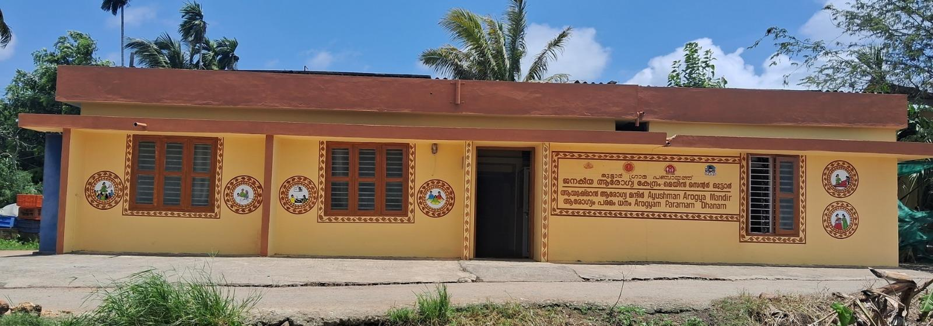

MESSAGE FROM PRESIDENT/CHAIR LSGI

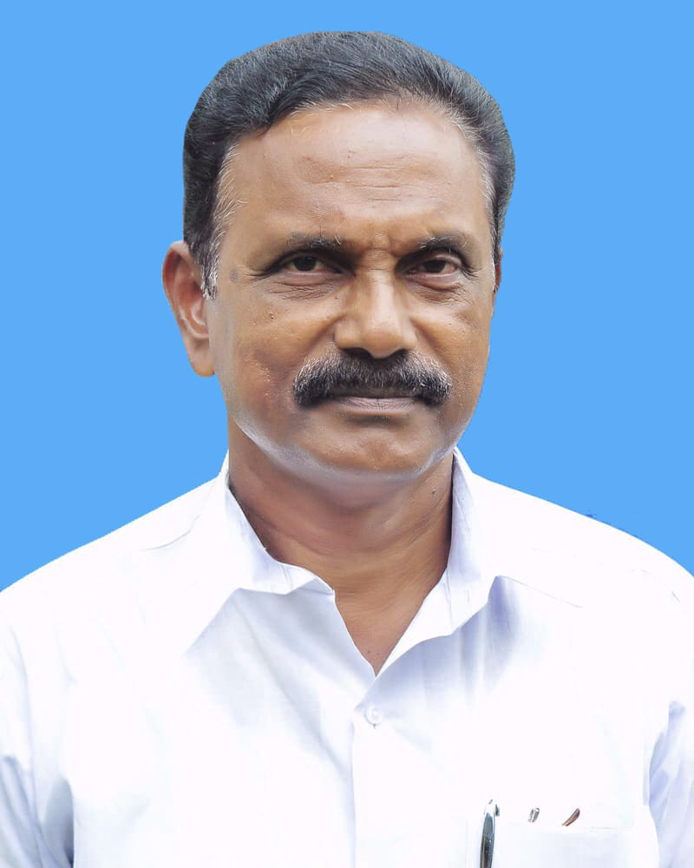
Health and safety have always been our top priorities. While we have faced challenges in the past, our strength lies in our unity and preparedness. To ensure the well-being of every household in our Panchayat, we are strengthening our Pandemic Preparedness Plan.
​Our goal is not to create panic, but to build a resilient community that is ready for any health emergency
​"Prevention is better than cure. Let us work together to keep our Panchayath safe, healthy, and strong."

president
S/D
Muttar

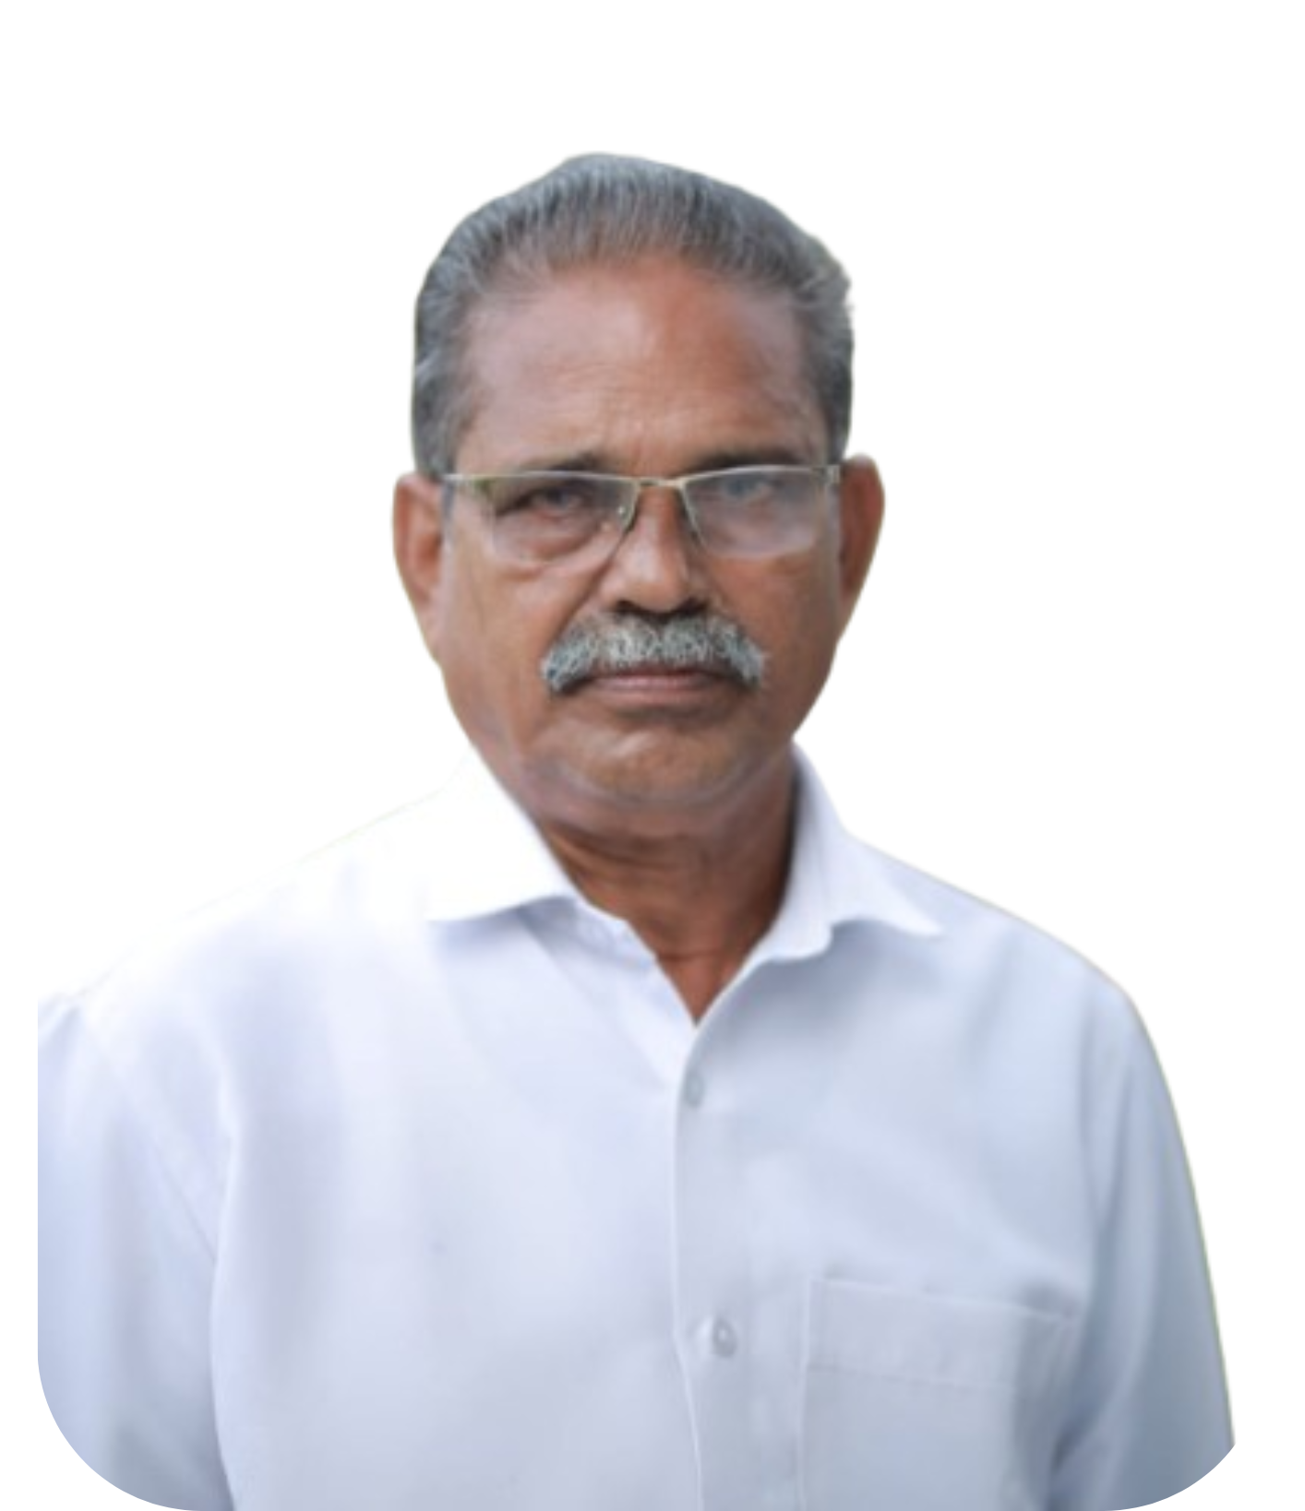
MESSAGE FROM HEALTH STANDING COMMITTEE CHAIR

മുട്ടാർ പഞ്ചായത്തിലുള്ള ജനങ്ങളുടെ സമഗ്ര ആരോഗ്യം പരിരക്ഷിക്കേണ്ടത് പഞ്ചായത്തിന്റെ പ്രഥമ ലക്ഷ്യം തന്നെയാണ്"കോവിഡ്-19യും പകർച്ചവാധിയും പ്രകൃതി ദുരന്തങ്ങളും നമ്മുടെ സമൂഹത്തെ തകർത്തെറിഞ്ഞ ഈ കാലഘട്ടത്തിൽ, അടിയന്തര സാഹചര്യങ്ങളിൽ ആക്ഷൻ എടുക്കാനുള്ള തയ്യാറെടുപ്പിന്റെ പ്രാധാന്യം നമ്മെ പഠിപ്പിച്ചിട്ടുണ്ട്. വിവിധ വകുപ്പുകളുടെ ഏകോപനവും ജനപങ്കാളിത്തവും, ഇത്തരം പ്രശ്നങ്ങളെ നേരിടുവാൻ നമുക്ക് അനിവാര്യമാണ് ഈ പുസ്തകം, പ്രതിസന്ധികളെ നേരിടാനും, ആരോഗ്യ സംരക്ഷണം ഉറപ്പാക്കാനും, സമൂഹത്തെ സംരക്ഷിക്കാനുമുള്ള ഒരു പ്രധാന ഉപകരണമാണ്.

നമ്മുടെ ആരോഗ്യ സംവിധാനം ശക്തിപ്പെടുത്താനും, ദുരന്ത നിവാരണ പ്രവർത്തനങ്ങൾ മെച്ചപ്പെടുത്താനും, പൊതുജനങ്ങളെ അവബോധം വളർത്താനും ഈ പുസ്തകം സഹായിക്കും എന്ന് ഞാൻ വിശ്വസിക്കുന്നു. എല്ലാ ആരോഗ്യ പ്രവർത്തകർക്കും, അധികാരികൾക്കും, പൊതുജനങ്ങൾക്കും ഈ പുസ്തകം ഒരു വിലപ്പെട്ട വിഭവമായിരിക്കും.

ആരോഗ്യവും സുരക്ഷിതത്വവും ഉറപ്പാക്കാൻ നമുക്ക് ഒരുമിച്ച് പ്രവർത്തിക്കാം."

ഹൃദയപൂർവ്വം
S/D
മാത്തുക്കുട്ടി
ആരോഗ്യ സ്റ്റാൻഡിങ് കമ്മറ്റി മെമ്പർ

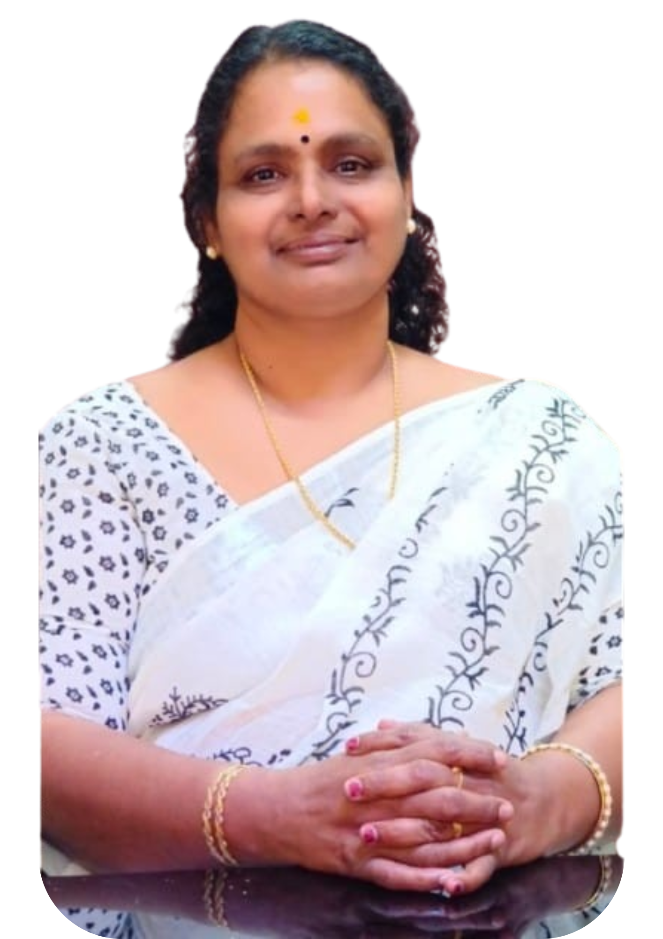
MESSAGE BY MEDICAL OFFICER

Muttar Primary Health Centers serve as the first line of defense at the grassroot level during a pandemic in Muttar . Community participation plays a crucial role in preventing the spread of diseases. Staying informed, and supporting health initiatives we can help protect our families and everyone . PHC prepares to face such challenges through the following safety protocols and steps: Planning and Coordination by Rapid ResponseTeam, Local Collaboration, Early Detection, Surveillance, Reporting,Contact Tracing,Infrastructure and Supplies, Risk Communication( Awareness) ,Vaccination Strategy,The greatest strength of a PHC is the strong relationship between healthcare workers, local body and the local community.and now more than ever, it is important that we work together to face any health challenges that may arise

Medical Officer PHC Muttar
S/D
Dr.Poornima TA

EXECUTIVE SUMMARY

Primary Health Centre (PHC) functions as the primary public healthcare institution serving the population of MUTTAR. Grama Panchayath. The PHC plays a pivotal role in delivering comprehensive, accessible, and affordable healthcare services, with a strong focus on preventive, promotive, curative, and rehabilitative care in accordance with national and state health programmes.
The PHC caters to a predominantly rural population, addressing key public health priorities such as maternal and child health, communicable and non-communicable disease control, immunization, family welfare, adolescent health, and geriatric care. Regular outpatient services, home-based care through field health staff, and outreach activities ensure healthcare coverage even in geographically challenging areas. The institution actively implements national health missions, including the National Health Mission (NHM), National Tuberculosis Elimination Programme, National Programme for Prevention and Control of Cancer, Diabetes, Cardiovascular Diseases and Stroke (NPCDCS), and other disease surveillance initiatives.
MUTTAR PHC works in close coordination with the Grama Panchayath, ASHA workers, Anganwadi centres, schools, and community-based organizations to strengthen community participation and improve health awareness. Emphasis is placed on early detection, timely referral, health education, and lifestyle modification to reduce disease burden and improve overall health outcomes.
Despite constraints related to infrastructure, manpower, and increasing service demand, the PHC continues to enhance service delivery through effective planning, data-driven decision-making, and community engagement. Strengthening facilities, upgrading digital health systems, and expanding preventive services remain key focus areas for future development.
Overall, MUTTAR Primary Health Centre stands as a vital institution in safeguarding public health and improving the quality of life of the residents of MUTTAR Grama Panchayath

LIST OF ABBREVIATIONS

LSGD/LSGI | Local Self Government Department / Local Self Government Institution
BMO | Block Medical Officer
IDSP | Integrated Disease Surveillance Programme
NDMA | National Disaster Management Authority
PPE | Personal Protective Equipment
ICMR | Indian Council of Medical Research
CD | Communicable Diseases
NCD | NON-COMMUNICABLE Diseases

TABLE OF CONTENTS

INTRODUCTION 13
LSGD AT A GLANCE 16
INTEGRATED HEALTH INFRASTRUCTURE MAP OF MUTTAR GRAMA PANCHAYAT 17
GENERAL PROFILE OF THE LSGI’S 18
Demographic and Vulnerable Population 21
Clinical Vulnerability 22
INFRASTRUCTURE & RESOURCE INVENTORY 24
Health Facility Directory & Basic Capacity in the LSGD 24
Private Clinics 25
Healthcare Education & Training Institutions 26
Specialized Services & Emergency Inventory 27
Oxygen & Diagnostic Capacity 28
Diagnostics facility mapping at the LSGI level 28
Laboratory Identification & Basic Details 29
Social and Community Infrastructure for surge plan 29
Human resources 32
Community & Support Cadre 34
Community Organizations 35
Administrative & Emergency Services 36
Information regarding resources 36
ONE HEALTH & ENVIRONMENTAL SURVEILLANCE 38
Animal & Bird Population 38
Veterinary Infrastructure 39
Veterinary Doctors & Workforce 40
High-Risk Interface Points (Surveillance Sites) 41
Environmental Risk Mapping 44
Disease Seasonality Mapping 46
Vulnerability Mapping 47
EPIDEMIOLOGICAL TRENDS (2021–2025) 48
Disease Burden among human beings(Last 5 Years) 48
Seasonal Trend Analysis 50
Outcome-Based Trend Analysis- 2025 54
Transmission Trend- 2025 56
Integrated Disease Hotspot Map (2021–2025) 62
Preparedness and Response Protocol at LSG Level 66
Constitution of One Health Committee 66
Pandemic Response Workforce 67
Activities and Measures before and during Pandemic 69
PHASE 1 - Alert / Preparation 69
PHASE 2 - Active Response 72
Standard Screening Protocol 73
PHASE 3 - Surge Capacity 83
Conversion of Community Facilities 83
RECOMMENDATIONS 86
ANNEXURE 88
1. IMPORTANT PHONE NUMBERS 88

INTRODUCTION

Panchayath’s Role in Preparedness

Panchayats in Kerala—including Muttar—are local self-government bodies empowered under the 73rd Constitutional Amendment to plan and implement community-level development, health, sanitation, and disaster preparedness activities through participatory planning processes like Gram/Ward Sabhas and working groups.

Disaster Management & Preparedness Framework (State Level)

Kerala’s Local Self-Government Department (LSGD) and the Kerala State Disaster Management Authority (KSDMA) have issued guidelines for all Panchayats to prepare local disaster management plans that integrate risk reduction, preparedness, response and mitigation activities. These plans typically include:

Identification of hazards (e.g., floods, health emergencies, pandemics)

Vulnerability assessment of local populations

Formation of Emergency Response Teams (ERTs) and Working Groups

Integration of disaster preparedness activities into annual development plans

Public participation through Grama Sabhas for planning and feedback
This approach encourages each Panchayat, including Muttar, to incorporate health emergencies like pandemics in their local disaster preparedness planning.

Public Health Preparedness (State & Panchayat Linkages)

During health emergencies such as the COVID-19 pandemic and avian influenza outbreaks in the region, Kerala’s Panchayats were expected to coordinate local responses by:

Activating health and sanitation committees

Disseminating public health advisories

Supporting surveillance and community awareness activities

Reactivating One Health committees (linking human, animal, and environmental health surveillance) as directed by state health authorities
These roles are consistent with instructions given to Panchayaths in Alappuzha district during bird flu alerts (e.g., monitoring, bans on poultry sales, control room activation, committee coordination).

Inclusion in Local Planning

Kerala’s planning model encourages integrating disaster and health emergency preparedness into the annual works budgets of Panchayat development plans. This means if a specific pandemic preparedness plan was drafted in Muttar, it would most likely have been:

Prepared in a Gram/Ward Sabha with community inputs

Built into the Panchayat’s annual development projects

Linked to district and state health emergency protocols
Such integration helps ensure resources—such as PPE distribution, awareness drives, isolation/response mechanisms—are budgeted and organized locally.

Regional Public Health Context

The larger Kuttanad region, due to its geography and recurring health threats (like avian influenza), has been under advisories for continual vigilance and public health action. Local bodies across the region—including Muttar—have been asked by state health authorities to remain alert and engage their local health committees.

Key Points for Muttar Grama Panchayath’s Pandemic Preparedness

Since direct access to the Muttar Panchayath’s official pandemic plan document isn’t publicly available in online sources, the background can be summarized as follows:

Legislative & Institutional Basis
Muttar Panchayath, like other local self-government bodies in Kerala, operates under frameworks that require disaster and health emergency planning within the Panchayat’s development plan.

Framework Integration
Pandemic preparedness in this Panchayath would be part of its local disaster management planning, aligned with state guidelines to identify local vulnerabilities and define response teams and actions.

Community Participation
Preparations are (or should be) shaped through Gram/Ward Sabhas, involving local residents and frontline health/sanitation volunteers.

Coordination with Health Authorities
The Panchayath interfaces with district and state health authorities for outbreak alerts, surveillance, and execution of preventive measures during pandemics or other health emergencies.

Operational Activities
Includes awareness campaigns, hygiene and sanitation drives, local monitoring committees, and integration of emergency health measures into its annual work plan.

LSGD AT A GLANCE
- Geographical boundaries with political map ( based on latest delimitation)
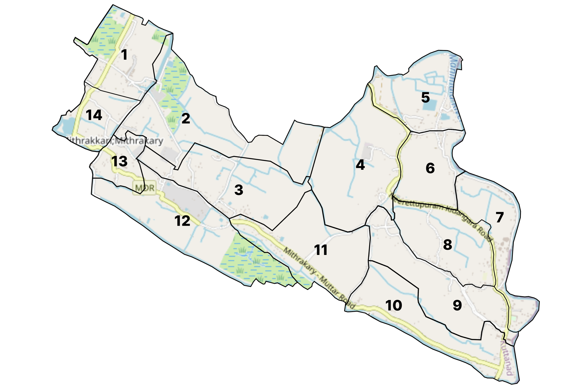

- Baseline data
- Ward division -
Ward | Houses | Population | Migrants | Wells | Hot  spots | Ed. Institutions | Hosp pvt/govt.
14 | 2403 | 11355 | 22 | 709 | 5 | 9 | 1/3

- Risk stratification among wards in the context of Communicable diseases and hazards
- Major Roads/rivers
- Major establishments with geospatial mapping
- occupational groups, socio cultural groups, migration & mobility patterns
- Vulnerability mapping
- Disaster prone areas (geographic vulnerability)

INTEGRATED HEALTH INFRASTRUCTURE MAP OF MUTTAR GRAMA PANCHAYAT
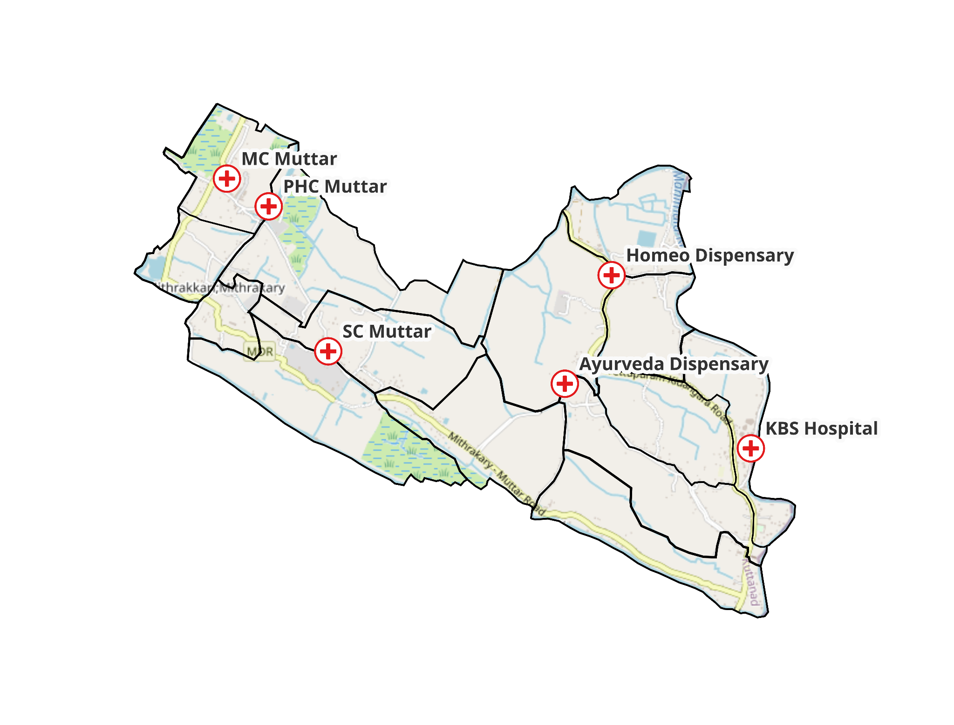

GENERAL PROFILE OF THE LSGI’S

Geographic & Administrative :
Muttar is a rural village situated in the Kuttanad region of Alappuzha district in Kerala. It lies about 10 km west of Thiruvalla town and is surrounded by neighboring villages like Thalavady, Neerattupuram, Kunnamkary and Mithrakary. The Manimala River flows along its eastern side, and the locality is characterized by low-lying paddy fields and backwaters typical of Kuttanad agriculture.
The village falls administratively under the Veliyanad Block Panchayat and Alappuzha Zila Parishad. The Muttar Grama Panchayath is the local self-government institution responsible for planning and implementing development and welfare activities for the village.

Governance Structure :
- Type of body: Village-level Grama Panchayat (local rural governing body) under the Indian Panchayati Raj system, with elected representatives from 13 wards.
- Elected leadership: The Panchayat has around 14 elected members, including a Sarpanch (President) who leads the body and a Panchayat Vice President.
- Staffing: It employs around 19 full-time government officials to manage administration and public services.
- Institutional committees: For local planning and statutory requirements such as biodiversity, the Panchayat also forms committees like the Biodiversity Management Committee, reflecting community participation in governance.
The Panchayat office is located on Kidangara–Chakkulathukavu Road, Muttar (PIN 689574), and conducts administrative, developmental and welfare functions for residents.

Demographics & Society
As per the 2011 Census:
- Population: Approximately 9,200 residents in about 2,264 households.
- Literacy: Very high literacy rate, higher than many rural areas in Kerala.
- Economy: Predominantly agricultural, with rice cultivation (at land levels below sea level), coconut, banana and other crops forming the economic base, supplemented by fishing and allied activities.
Cultural & Community Features
Muttar village reflects the diverse cultural and religious life of Kerala’s rural settings, with temples and churches serving as important community landmarks. Local schools, such as Government UP School and St. George Higher Secondary School, and healthcare services like St Joseph Mission Hospital support the social infrastructure of the Panchayat. It was among the villages that achieved 100 % literacy relatively early in the region, highlighting strong local engagement with education.
Recent Achievements & Development
Muttar Grama Panchayath has been recognized for progressive and innovative local governance:
- It won the Swaraj Trophy at the district level for excellence in implementing people-centric development projects — including sanitation, poverty alleviation, women’s welfare, child and senior citizen programs.
- It also received state-level recognition under schemes like the Mahatma Gandhi National Rural Employment Guarantee Scheme (MGNREGS) for its rural employment efforts.
- These awards reflect the Panchayat’s active role in sustainable community development beyond basic governance.
Muttar Grama Panchayath is a grassroots democratic institution that:
- Administers civic and development functions for Muttar village.
- Ensures public services, infrastructure, welfare and local planning through elected leadership and statutory committees.
- Acts as a vital link between villagers and higher levels of government (block, district, and state authorities).
- Has been consistently recognized for governance excellence in rural development programs.

Table 1: Background of LSGD
Description | Details
Name of LSGI | MUTTAR
Type (GP/Municipality / Corporation etc.) | Grama Panchayath
Block | VELIYANAD
District | ALAPPUZHA
Number of wards | 14
Total area (sq. km) | 20.22sq.km
Population(Projected) | 11355
Population density | 758/sq km
Terrain (coastal/low-lying/backwaters/foothills, etc.) | Low lying, back water
Number of rivers passing through LSGI | 1 Manimal LAKE
Number of water bodies in the LSGI | 2
Number of educational institutions | 9
Factories / small-scale industries | 6
Flood-prone wards | 14
Landslide-prone wards | 0
Death Management and Disposal Facilities (mortuaries/crematorium, including electric) | Ward 8 - public cremation
Auditoriums/Marriage halls/convention centres/community halls | Auditorium 6

Demographic and Vulnerable Population
Understanding the demographic composition and vulnerable population groups is essential for pandemic preparedness. Children, elderly, economically deprived families, migrant workers, and socially vulnerable groups are at increased risk during public health emergencies due to higher exposure, limited access to services, and dependency on public systems..

Description |  | Details (in numbers)
DEMOGRAPHIC PROFILE
Total population |  | 1211
Male |  | 594
Female |  | 617
Transgender |  | 0
Children under 5 |  | 340
Adolescent |  | 721
Elderly (>60) |  | 1879
SOCIAL/LIVELIHOOD VULNERABILITY
Previous EPEP family |  | 1
BPL family |  | 1324
AAY |  | 67
Tribal communities |  | 0
Migration | Immigrant | 22
Migration | Emigrant | 1128
Socio-economically deprived |  | 0
Fisherfolk |  | 13
SC Community |  | 921
ST Community |  | 0

Graphs: Population pyramid (if possible) for seeing if your LSGI has a high "dependency ratio" (lots of children and elderly compared to working adults).

Clinical Vulnerability
Certain population groups needs priority healthcare & are at higher risk of severe illness, complications, and mortality during pandemics. Patients with chronic diseases, those requiring regular medical care, and individuals with mobility or functional limitations face challenges in accessing timely care during emergencies. Mapping these groups helps in prioritizing continuity of treatment, medicine stock planning, oxygen support, referral transport, and targeted home-based care.
Description | Details in numbers
Pregnant women | 27
Lactating mothers | 110
Bedbound patients | 36
Patients under palliative care other than bedbound | 88
Patients on Haemodialysis | 3
Patients on CAPD | 0
Cancer patients (currently on treatment) | 10
Haemophilic patients | 0
Mentally challenged | 15
Differently abled | 34
Diabetic patients | 433
Hypertensive patients | 839
TB patients | 2

Major Festivals & Events specific to the LSGI
(with the possibility of a public gathering)

Sl. No. | Name of festival | Month detailing the periodicity
1 | St. Xaviers church festival, Mitrakary | 3rd,4th and 5th of May
2 | Mahaganpathy temple festival | 9 days, October
3 | Mitrakary devi temple festival | 14th to 25th, April

INFRASTRUCTURE & RESOURCE INVENTORY

Health Facility Directory & Basic Capacity in the LSGD
This section provides an overview of the healthcare infrastructure available within the LSGD area. It outlines the distribution and basic capacity of health facilities that form the backbone of service delivery during routine times and public health emergencies.

Family Health Centres (FHCs) and Community Health Centres (CHCs) generally function as the first point of contact for the community, providing essential outpatient and inpatient services. General Hospitals (GH) and Medical College Hospitals (MCH), where accessible, serve as the main referral centres for advanced diagnostics, specialist care, and critical services during public health emergencies. This inventory helps identify existing strengths, gaps, and potential surge capacity that can be mobilised during a pandemic or disaster.

Table 5. Health Facility Resource Summary
Sl.no. | Health Facility | Type of Facility (MCH/GH/CHC/FHC/SC etc.) | Contact Number | Total beds | ICU Beds | Oxygen-Supported Beds | No. of Ventilator Support Beds | No. of ambulances
Government Healthcare Facilities
 | PHC MUTTAR | PHC | 9447975632 | 0 | 0 | 0 | 0 | 0
 | AAM | MC | 8281004174 | 0 | 0 | 0 | 0 | 0
 | AAM | SC | 9847422511 | 0 | 0 | 0 | 0 | 0
Private Healthcare Facilities
 | KBS HOSPITAL | General Clinic | 8547546943 | 0 | 0 | 0 | 0 | 0
AYUSH Healthcare Facilities
 | AYURVEDA | DISPENSARY | 9446366180 | 0 | 0 | 0 | 0 | 0
 | HOMEO | DISPENSARY | 7012823900 | 0 | 0 | 0 | 0 | 0

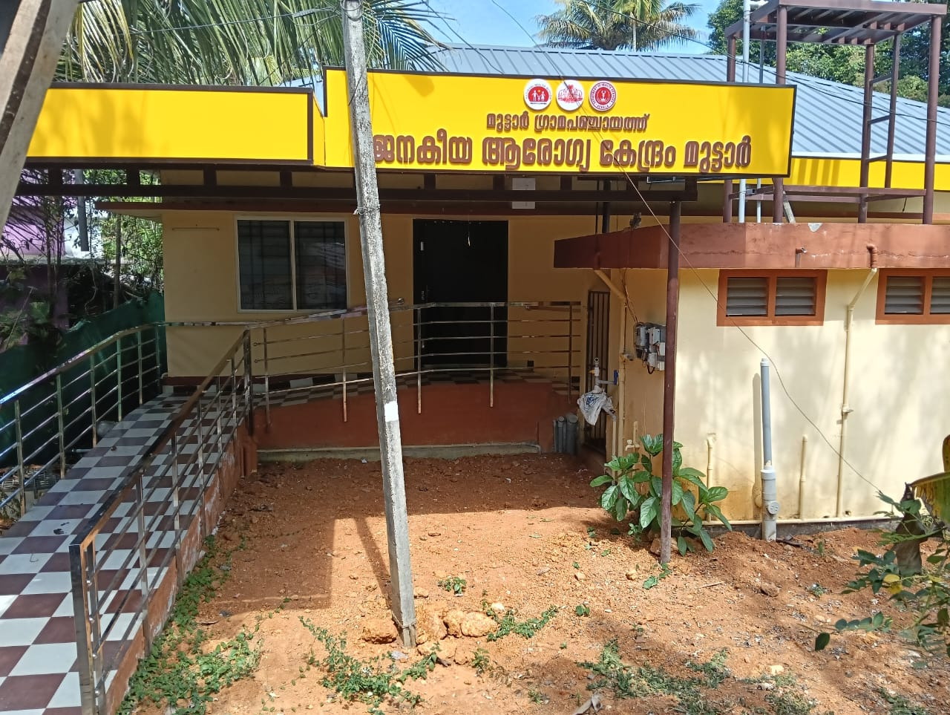

Private Clinics
Private clinics are an essential part of pandemic preparedness, as they are often the first place people seek care when symptoms begin. In many communities, private clinics manage a significant share of outpatient visits and therefore play a critical role in early case detection, timely referrals, and disease surveillance. Having an up-to-date understanding of where these clinics are located, the services they provide, and how they are linked to the public health system helps ensure that no cases are missed during an outbreak. It also allows health authorities to engage private practitioners more effectively for reporting, risk communication, and coordinated response, strengthening the overall capacity of the health system to manage public health emergencies.

Table 6. Private Clinic Resource Summary
Sl No. | Name of Clinic | Registered (Y/N) | Clinic (General / Speciality) | Speciality (if any) | Address | Contact Number | Diagnostic Facility (Y/N) | Ambulance Linkage (Y/N)
1 | KBS HOSPITAL | N | GENARAL | 0 | SH CONVENT , MUTTAR | 8547546943 | Y | N

Healthcare Education & Training Institutions
This section tracks the educational infrastructure available, which is vital for human resource planning in the health sector.

Category of Institution | Govt | Private | AYUSH | Total
Medical Colleges | 0 | 0 | 0 | 0
Nursing Colleges | 0 | 0 | 0 | 0
Dental Colleges | 0 | 0 | 0 | 0
Para-medical / Allied Health | 0 | 0 | 0 | 0
Pharmacy Colleges | 0 | 0 | 0 | 0

Specialized Services & Emergency Inventory
This section provides a detailed view of the specialized medical resources available to the community, focusing on emergency response and critical care capabilities. This table tracks the vital assets required for managing severe illnesses and emergencies across Government, Private, and AYUSH sectors.

Item | Govt | Private | AYUSH | Total
Hospital beds | 1 | 10 | 0 | 11
Oxygen-generating systems(Y/N) | y | y | 0 | 0
Oxygen-supported beds(Numbers) | 0 | 0 | 0 | 0
Ventilator-supported beds | 0 | 0 | 0 | 0
ICU beds | 0 | 0 | 0 | 0
Burns units | 0 | 0 | 0 | 0
Blood centres | 0 | 0 | 0 | 0
BLS ambulances | 0 | 0 | 0 | 0
ALS ambulances | 0 | 0 | 0 | 0
Dialysis facilities | 0 | 0 | 0 | 0
Dispensaries | 0 | 0 | 0 | 0
Medical store | 0 | 0 | 0 | 0
Industrial establishments(Medium-scale industries/small-scale industries establishments to whom we can depend in a worst-case scenario) | 0 | 0 | 0 | 0

Oxygen & Diagnostic Capacity
Monitoring oxygen and diagnostic capacity is a critical component of public health preparedness, ensuring that the LSGD can handle both chronic care and sudden surges in respiratory or infectious diseases.

Name of Health Facility | Oxygen-generating System (Y/N) | Backup Oxygen Source (Y/N) | Diagnostic Facilities Available(Y/N)
Name of Health Facility | Oxygen-generating System (Y/N) | Backup Oxygen Source (Y/N) | Lab | USG | X-ray | CT/MRI | RT-PCR
Government Healthcare Facilities
PHC MUTTAR | Y | Y | N | N | N | N | N
HWC MUTTAR | N | N | N | N | N | N | N

Diagnostics facility mapping at the LSGI level
The diagnostic capacity of Muttar G.P represents the "intelligence network" of our healthcare system. The speed and accuracy of disease identification depend entirely on the distribution and technical level of these facilities.

Item | Govt | Private | AYUSH | Total
General labs | 0 | 2 | 0 | 2
Microbiology labs | 0 | 0 | 0 | 0
RT-PCR labs | 0 | 0 | 0 | 0
USG units | 0 | 0 | 0 | 0
CT/MRI units | 0 | 0 | 0 | 0
Research labs | 0 | 0 | 0 | 0
Labs of other departments that can be repurposed | 0 | 0 | 0 | 0

Laboratory Identification & Basic Details
Sl. No. | Name of Laboratory | Ownership (Govt / Private / Academic) | Address | Contact No. | 24×7 Services (Yes/No) | NABL / Govt Approved (Yes/No)
1 | MEDI LAB | PVT | MUTTAR | 82899294 | NO | NO
2 | KBS HOSPITAL | PVT | SH COR | 8547546943 | Y | NO

Social and Community Infrastructure for surge plan
This table serves as our logistics and shelter inventory. By mapping these locations, quickly we can identify where to house displaced citizens, where to set up temporary medical clinics, and how to manage the deceased with dignity during a crisis.

Category | Total Count | Ward | Est. Capacity (Persons) | Contact details
Educational Institutions
Anganwadis | 11 | 1,2,3,4,6,7,8,9,10,12,  13 | 100 | 9895774093
Schools | 9 | 1.3.14.  7,8,4 | 500 | 9447569629
Colleges | 0 | 0 | 0 | 0
Healthcare Educational Institutions
Medical colleges (Govt/Private) | 0 | 0 | 0 | 0
Nursing colleges (Govt/Private) | 0 | 0 | 0 | 0
Dental colleges (Govt/Private) | 0 | 0 | 0 | 0
Paramedical institutes (Govt/Private) | 0 | 0 | 0 | 0
Community Gathering Spaces
Community halls | 6 | 1,3.4,9,  10,8,4 | 200 | 9645866942
Auditoriums | 7 | 2 | 100 | 9495558734
Religious buildings | 6 | 1,3,10,9,8,4 | 50 | 9496230058
Vulnerable Group Support Facility
Destitute homes | 0 | 0 | 0 | 0
Elderly homes | 0 | 0 | 0 | 0
LSGD owned other buildings | 0 | 0 | 0 | 0
Mass Fatality Management (MFM) Infrastructure
Mortuary | 0 | 0 | 0 | 0
Crematorium | 1 | 0 | 0 | 0
*refer annexure 1 for contact details

Human resources
This section focuses on the human capital available within the LSGI. In any emergency—be it a pandemic, flood, or industrial accident—infrastructure is only as effective as the people operating it.

Medical & Clinical Personnel
This table tracks the "Frontline" providers responsible for diagnosis, treatment, and clinical management. Narrative sentence: eg., "Total health workforce: 450 personnel, with 60% in government facilities serving as primary surge capacity." A detailed directory with the contact numbers of all workers is maintained (Annexure in 1).

Cadre | Govt (No.) | Private (No.) | Total
Doctors—Modern Medicine | 1 | 1 | 2
Doctors – AYUSH | 1 | 0 | 1
Doctors – Veterinary | 1 | 0 | 1
Doctors – Dental | 0 | 0 | 0
Nursing officers | 1 | 0 | 1
Lab technicians | 0 | 2 | 2
Optometrist | 0 | 0 | 0
Pharmacists | 1 | 0 | 1
Psychologists | 0 | 0 | 0
Counsellors | 0 | 0 | 0

Public Health & Field-Level Workforce
These individuals are the backbone of surveillance, maternal-child health, and decentralized care.

Cadre | Health services | Municipal common services | Total
HS (Health Supervisors) | 0 | 0 | 0
HI (Health Inspectors) | I/C | 0 | 0
LHS (Lady Health Supervisor) | 0 | 0 | 0
LHI (Lady Health Inspectors) | I/C | 0 | 1
JPHN (Jr Public Health Nurses) | 2 | 0 | 2
JHI (Jr Health Inspectors) | 2 | 0 | 2
MLSP (Mid-Level Service Providers) | 2 | 0 | 2
Palliative Nurses | `1 | 0 | 1
RBSK Nurses | 1 | 0 | 1
PRO | 0 | 0 | 0
Epidemiologist | 0 | 0 | 0
Data Manager | 0 | 0 | 0

Community & Support Cadre
This group represents the surge capacity of the LSGI—people who can be called upon for logistics, rescue, and specialized support.

Cadre | Number
ASHA Workers | 12
AWW (Anganwadi Workers) | 11
Emergency Medical Volunteers (Trained) | 91
Kudumbashree | 117/1664
MNREGS | 956
Purusha Swayam Sahaya Sangham | 5
Ex-Servicemen | 3- PR Suresh - 8606426880
Retired Police Officers | 2 , 9447070002
NCC/NSS Volunteers | 100
Red Cross volunteers | 34
One Health Community Volunteers | 91
One Health Community Mentors | 13

Community Organizations
This section details the presence of community-based organisations (CBOs), non-governmental organisations (NGOs), faith-based organisations (FBOs), Kudumbashree Self-Help Groups (SHGs), and Ayalkootams within the Local Self-Government Institution (LSGI). These groups enhance grassroots mobilization, resource distribution, and support networks crucial for pandemic response and community resilience.

Category | Total Count
NGOs | 1
Religious based organizations | 10
Foreign based organizations | 0
Sports Club/youth clubs | 3
Kudumbashree SHGs | 164
Ayalkootams | 5
Political organizations | 6
Residential organizations | 0

Administrative & Emergency Services
This section outlines the availability of key non-health emergency support services and infrastructure within the LSGI, which are essential for effective pandemic preparedness and response. These facilities support law enforcement, disaster response, water supply, logistics, mobility, and community-level interventions during public health emergencies.

Category | Total Count | Contact details
Police Stations | 1 | 0477 2762222
Fire & Rescue Stations | 1 | 0477 2275570
Water Pumping Points | 0 | 0477 272022221
Public Distribution System (PDS) | 1

Information regarding resources
The availability of essential transport and support resources plays a quiet but critical role in saving lives. Equipment such as ambulances, mobile mortuaries, amphibian ambulances, and motorized boats ensures that patients, samples, and healthcare teams can move swiftly—even in flooded, remote, or difficult terrains. Heavy vehicles like JCBs, cranes, tractors, and torus lorries support logistics, waste management, emergency infrastructure, and rapid conversion of spaces into care or isolation facilities. Taxis, four-wheel-drive vehicles, and trucks help maintain continuity of essential services, reach vulnerable populations, and support home-based care and supply delivery.

Means of transportation | Total Count
JCB | 1
Crane | 0
Heavy Trucks | 4
Tractor | 0
Ambulances | 0
Mobile mortuaries | 0
Boats | 3
Taxi service | 10
Note: For specific details regarding vehicle owners and contact information, please refer to Annexure [X].

ONE HEALTH & ENVIRONMENTAL SURVEILLANCE
The One Health method integrates environmental, animal, and human health to enable proactive pandemic preparedness. Panchayat-level surveillance needs to be improved in order to detect and treat zoonotic and environmentally generated diseases early. Surveillance is strengthened through systematic assessment of animal populations, veterinary infrastructure, poultry and slaughter facilities, inter-sectoral coordination, and specialised tools like avian influenza seasonality mapping using GIS in previous outbreaks to enable predictive alerts and ward-specific sampling to support effective pandemic preparedness in high-risk wards like ward 1,7,11 and 12.

Animal & Bird Population
Mapping animal and bird populations at the Panchayat level is essential for identifying and prioritising zoonotic disease hazards like rabies, avian influenza (H5N1), leptospirosis, anthrax, and Nipah-like spillover occurrences. Risk classification, targeted surveillance, vaccination planning, and early epidemic detection made feasible by comprehensive population mapping all enhance One Health-based pandemic preparedness.

Category | Item | Estimated Population | Wards
Animal Population | Livestock (Cattle/Goats/Buffalo) | Cattle -256 | 1to 14 ( all wards)
Animal Population | Pet Animals (Dogs/Cats) | 493 | all wards
Animal Population | Stray Dog Population | 18 | 1,2,4,9,13,
Animal Population | Pig Farms (Number of heads) | 0 | 0
 | Small Units (Sheep / Goats – clustered) | 186 | all wards
Bird Population | Poultry Units (Birds) | 5600 | all wards
Bird Population | Poultry- (FOWL) | 0 | 0
Bird Population | Wild/Migratory Birds (Observed) | 100 | 1,2,3,4,5,10
Bird Population | Crow Mortality Events (Reported) | nil | 0

The main risk of zoonotic diseases in Muttar is concentrated in Wards…1 2 4 5 10…., which is explained by the high density of pig farms, cattle congregation areas, and poultry units. The stray dog population in market areas, fish landing sites, bus stations continues to be a substantial problem for rabies surveillance and bite prevention. There is a considerable risk of avian influenza introduction and amplification during November - December due to the seasonal presence of migratory and resident water birds near ponds/ canal / river / backwater / paddy field. Clusters of pig farms and animal shelters vulnerable to flooding further raise the risk of leptospirosis and other zoonoses mediated by the environment, especially during monsoon floods.

Veterinary Infrastructure
Veterinary institutions are a core pillar of One Health surveillance, enabling early zoonotic disease detection through vaccination, investigation of unusual animal illness or deaths, sample collection, and timely outbreak reporting. A well-mapped and responsive veterinary network strengthens coordination with human health and LSGI systems, ensuring rapid response during zoonotic events and pandemics.
Facility Type | Name of Facility | Ownership Govt / Pvt | Location(Ward No) | Contact number
Veterinary Dispensary | Govt.Vetenary | Govt | 9 | 9447404898
Veterinary Hospital / Polyclinic | 0 | 0 | 0 | 0
Private Veterinary Clinics | 0 | 0 | 0 | 0
Mobile / Emergency Vet Service (incl. night services) | 0 | 0 | 0 | 0
Pet Homes / Animal Shelters | 0 | 0 | 0 | 0
Slaughterhouse-linked Veterinary Inspection Unit | 0 | 0 | 0 | 0

Veterinary Doctors & Workforce
Early detection, diagnosis, reporting, and reaction to animal illness epidemics depend on the availability and accessibility of qualified veterinary specialists. By identifying unusual animal morbidity or mortality promptly, collecting samples promptly, and coordinating efficiently with human health and LSGI systems—especially during zoonotic outbreaks and pandemic-prone situations—a clearly defined veterinary workforce enhances One Health surveillance.

Category | Number Available | Type (Govt/Pvt) | Contact number
Government Veterinary Doctors | 1 | Govt. | 9447404898
Private Veterinary Doctors | 0 | 0 | 0
Livestock Inspectors | 1 | govt | 9383476327
Para-veterinary Staff / Attenders | 1 | govt | 7012273583
Contract / On-call Veterinary Support (if any) | 0 | 0 | 0

High-Risk Interface Points (Surveillance Sites)
High-risk interface points for zoonotic disease surveillance in ___Muttar__ Grama Panchayath include wetland–livestock–human contact zones, backyard poultry farms, cattle sheds near water bodies, fish markets, and areas of high human–animal interaction such as community slaughter points and migratory bird congregation sites. These are the primary surveillance sites where zoonotic spillover risks are elevated.

Type of Habitat | Type of High risk interface | Geographical vulnerability
Wetlands & Backwaters | Flood | Near river side
Backyard Poultry Farms | 1 | Near river side
Cattle Sheds near Water Bodies | 25 | Near river side
Fish & Meat Markets | 0 | 0
Community Slaughter Sites | 0 | 0
Migratory Bird Congregation Areas | 35 | Paddy Field
Rodent-Infested Grain Storage | 1 | Paddy Field

Category | Total Count | Key Locations (wards)
Poultry Farms | 8 | 7,9
Backyard / Clustered Poultry Units | 25 | 2,3.4.5.6.7.8.9.
Duck Rearing Units (open water access) | 5000 | 4,5,11
Slaughterhouses/ Slaughter Points | 0 | 0
Meat/Fish Markets | 0 | 0
Live Bird Sale Points | 0 | 0
Cattle Markets / Weekly Animal Fairs | 0 | 0
Pet Shops / Breeders | 0 | 0
Animal Shelters / Pet Homes | 0 | 0
Waste Disposal Sites near Animal Units | 5 | 5,6,7

Environmental Risk Mapping
Environmental risk mapping identifies monsoon/flood hotspots for vector-borne (dengue, chikungunya), water-borne (leptospirosis, diarrhoea), and zoonotic diseases in Kerala's wetlands. Systematic surveillance supports early warnings, targeted interventions, and Panchayat pandemic preparedness.
Waterborne exposure: Flood-prone areas and stagnant water bodies facilitate leptospira survival, raising leptospirosis risk.

Traditional practices: Informal slaughter and fish markets lack standardized hygiene, creating spillover opportunities.
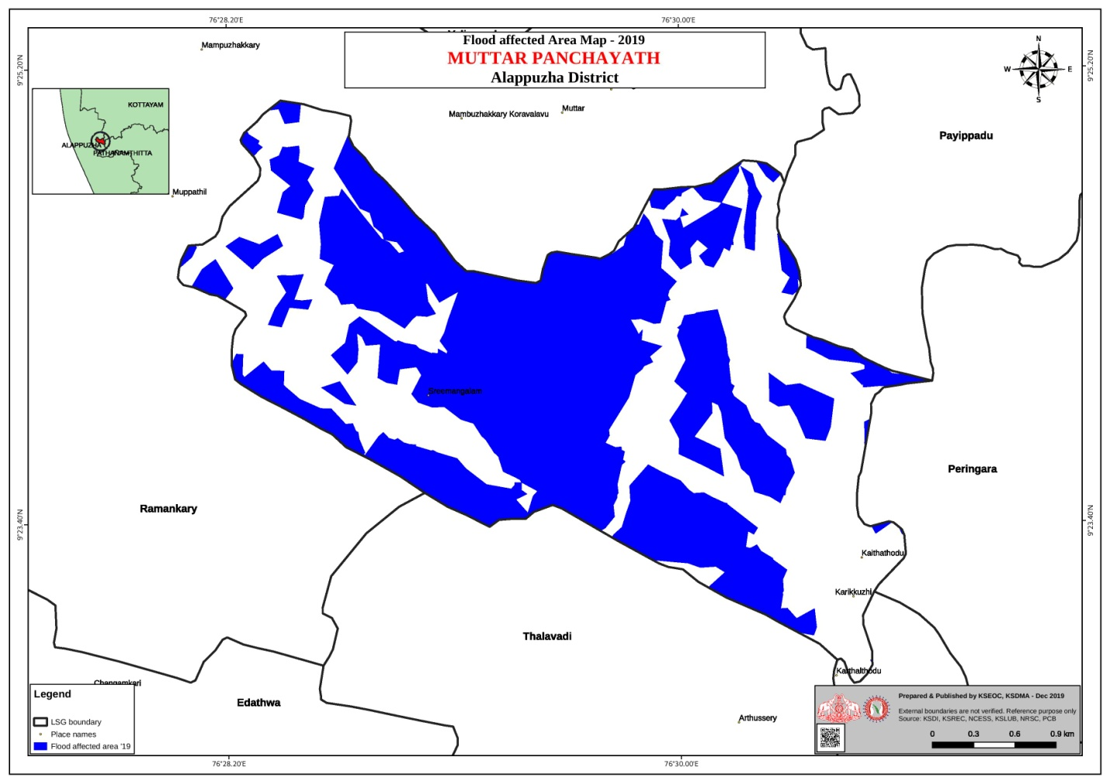

Risk Factor | High-Risk Wards | Key Locations | Risk Level (High/Med/Low)
Flood-prone areas | all wards | Near river, paddy fields | high
Water bodies/wetlands | all wards | paddy field | Med
Solid waste accumulation | 0 | 0 | 0
Animal waste disposal issues | 0 | 0 | 0
Rodent infestation zones | 0 | 0 | 0
Industrial effluent discharge | 0 | 0 | 0
Construction sites / abandoned buildings | 0 | 0 | 0
Poor drainage/blocked canals | 15 | 1,2.3.57,9,10 | LOW
Drinking water source contamination risk | 0 | 0 | 0

Disease Seasonality Mapping
1, Flooding & waterlogging → amplifies leptospirosis, malaria, diarrheal diseases.
·
2, Migratory bird influx (Nov–Feb) → avian influenza risk.

3, Mosquito breeding cycles → vector-borne disease peaks in monsoon.

4, Agricultural practices → close human–animal contact in paddy fields.

Disease | Peak Risk Season | Key Drivers | High-Risk Locations | Surveillance Focus
Avian Influenza | December,January | Not Reported till | Not Reported till | Not Reported till
Leptospirosis | may ,june,july | water logged areas | All Wards | Risk group
Dengue/Chikungunya | may,june, july | water logged areas | nil | Risk Group
Acute Diarrheal Diseases | february , march ,april | water scared areas | nil | Risk Group
Rabies | nil | ni | nil | 0
Anthrax (rare) | nil | nil | nil | 0

Vulnerability Mapping
Vulnerability mapping pinpoints high-risk populations, occupations, and areas exposed via environment, livelihoods, socio-economics, and poor service access. Paired with environmental/seasonality mapping, it enables risk-based surveillance, targeted actions, and optimal resource use in One Health and pandemic planning.
Vulnerability Factor | High-Risk Wards | Key Groups / Locations | Risk Level
Flood-prone households | all wards | all wards | high
Wetland-adjacent communities | all wards | farmers | Med
Backyard poultry / duck rearing households | 7,9 | Farmers | Med
Livestock-rearing households | 0 | 0 | 0
Slaughterhouse & meat market workers | 0 | 0 | 0
Fisherfolk & fish market workers | 13 | sellers | Low
Sanitation workers | 26 |  | low
Daily wage / migrant workers | 22 | farmers ,coolies | Med
Elderly & chronically ill populations | 1666 | all wards | Med
Pregnant Women | 27 | all wards | low
Children (schools, Anganwadi’s) | 340 | all wards | low
Limited access to safe water & sanitation | 960 | all wards | Med

EPIDEMIOLOGICAL TRENDS (2021–2025)

Disease surveillance is the systematic collection, analysis, and interpretation of health data for planning, implementation, and evaluation of public health practice. This section presents the disease surveillance profile of the LSGI based on routine reporting systems and outbreak investigations to identify priority diseases, seasonal patterns, and emerging public health threats.

Disease Burden among human beings(Last 5 Years)
Analysis of disease-wise data for the last five years helps identify persistent public health problems, emerging diseases, and changes in disease burden. This information supports prioritisation of prevention, preparedness, and response activities at the Panchayat level.

Disease | 2021 | 2022 | 2023 | 2024 | 2025 | Trend(Increasing/Stable/Decreasing)
Dengue | 1 | 2 | 3 | 2 | 3 | Stable
Leptospirosis | 0 | 0 | 1 | 1 | 1 | Stable
Hepatitis A | 0 | 0 | 1 | 0 | 0 | Decreasing
Malaria | 0 | 0 | 0 | 0 | 0 | Stable
Scrub Typhus | 0 | 0 | 1 | 1 | 0 | Decreasing
Typhoid | 0 | 0 | 0 | 0 | 0 | Stable
H1N1 | 0 | 1 | 0 | 0 | 0 | Decreasing
H3N2 | 0 | 0 | 0 | 0 | 0 | Stable
ADD | 8 | 6 | 7 | 13 | 17 | Increasing
Mumps | 1 | 0 | 0 | 0 | 0 | Stable
Measles | 0 | 0 | 0 | 0 | 0 | Stable
Hepatitis B | 0 | 0 | 0 | 0 | 0 | Stable
Hepatitis C | 0 | 0 | 0 | 0 | 0 | Stable
Tuberculosis | 1 | 1 | 4 | 1 | 2 | Increasing
Leprosy | 0 | 0 | 0 | 0 | 0 | Stable
COVID-19 | 66 | 16 | 0 | 0 | 1 | Stable

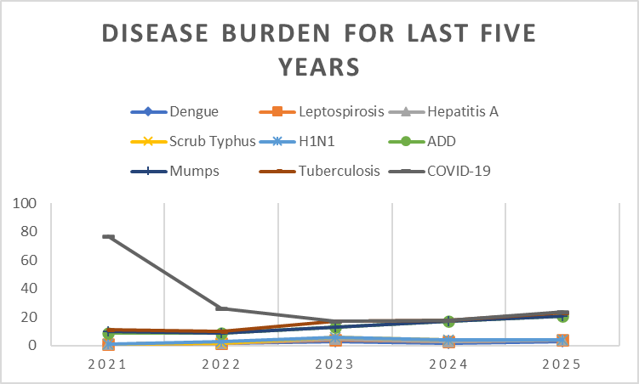

Seasonal Trend Analysis
Seasonal analysis helps anticipate surges (e.g. dengue in monsoon, leptospirosis after floods, influenza in cooler months) and plan pre‑emptive vector control, stockpiling of IV fluids, and awareness campaigns at Panchayat level.

DENGUE
Dengue is a major seasonal vector-borne disease strongly associated with rainfall, water stagnation, and increased mosquito breeding during the monsoon period.

Peak: July–November

Dengue – Ward-wise Yearly Distribution (2021–2025)

Ward | Dengue – Ward-wise Yearly Distribution
Ward | 2021 | 2022 | 2023 | 2024 | 2025 | Total
1 | 0 | 0 | 1 | 0 | 0 | 1
2 | 0 | 0 | 0 | 0 | 0 | 0
3 | 0 | 0 | 0 | 0 | 0 | 0
4 | 0 | 0 | 1 | 0 | 0 | 1
5 | 0 | 0 | 0 | 1 | 0 | 1
6 | 0 | 0 | 0 | 0 | 0 | 0
7 | 0 | 0 | 0 | 1 | 1 | 2
8 | 0 | 0 | 0 | 0 | 0 | 0
9 | 0 | 0 | 0 | 0 | 0 | 0
10 | 0 | 0 | 0 | 0 | 0 | 0
11 | 0 | 0 | 1 | 0 | 0 | 1
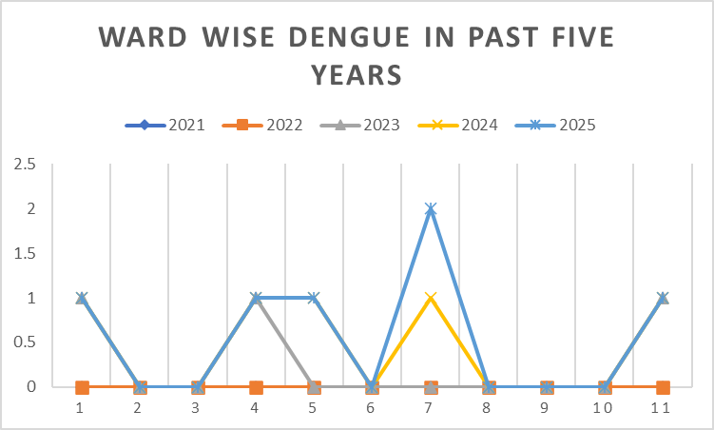

LEPTOSPIROSIS
Leptospirosis cases are closely linked to monsoon rains, flooding, and occupational exposure, particularly in low-lying and waterlogged areas.

Peak: June - August

Leptospirosis – Ward-wise Yearly Distribution (2021–2025)

Ward | Leptospirosis – Ward-wise Yearly Distribution
Ward | 2021 | 2022 | 2023 | 2024 | 2025 | Total
1 | 0 | 0 | 1 | 0 | 0 | 1
2 | 0 | 0 | 0 | 0 | 0 | 0
3 | 0 | 0 | 0 | 0 | 0 | 0
4 | 0 | 0 | 0 | 0 | 0 | 0
5 | 0 | 0 | 0 | 0 | 0 | 0
6 | 0 | 0 | 0 | 0 | 0 | 0
7 | 0 | 0 | 0 | 0 | 0 | 0
8 | 0 | 0 | 0 | 0 | 0 | 0
9 | 0 | 0 | 0 | 0 | 0 | 0
10 | 0 | 0 | 0 | 0 | 0 | 0
11 | 0 | 0 | 0 | 0 | 1 | 1
12 | 0 | 0 | 0 | 1 | 0 | 1
13 | 0 | 0 | 0 | 0 | 0 | 0

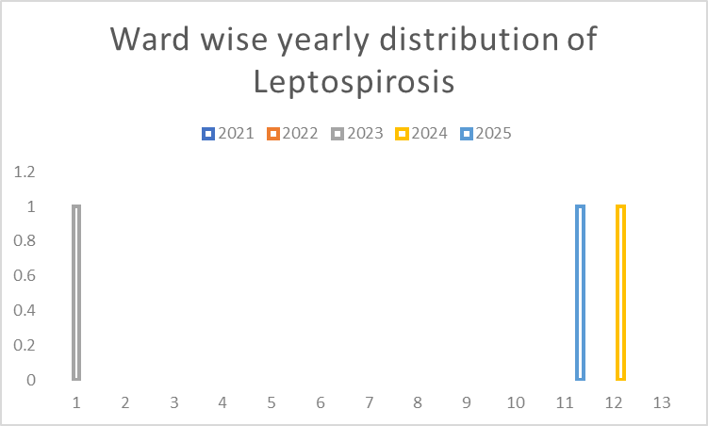

Outcome-Based Trend Analysis- 2025

Sl. No. | Type of disease | Age group | Gender |  | Total no. of survival | Total no. of death | No. of cases received treatment
Sl. No. | Type of disease | Age group | No. of Male | No. of Female | Total no. of survival | Total no. of death | No. of cases received treatment
1 | Dengue | < 20 years | 0 | 0 | 0 | 0 | 0
1 | Dengue | 20 - 59 years | 1 | 3 | 4 | 0 | 4
1 | Dengue | > 60 years
 | Lepto | 20-59 | 1 | 1 | 2 | 0 | 2
2 | VH-A | 5-19 years | 0 | 0 | 0 | 0 | 0
3 | Typhoid | > 60 Years | 0 | 0 | 0 | 0 | 0
4 | Mumps | < 5 Years | 0 | 0 | 0 | 0 | 0
5 | T.B | 20 - 59 Years | 1 | 0 | 1 | 0 | 1
5 | T.B | >60 Years | 0 | 1 | 0 | 1 | 1

Transmission Trend- 2025
For effective management of public health issues, it is important to track the trend of disease transmission mode. It helps identify the population or place at high risk that can be used to predict outbreaks and implement targeted interventions as quickly as possible. Understanding these kinds of trends enables authorities to allocate resources efficiently and change the strategies adequately based on the trend that follows.

Mode of Transmission | No. of cases | No. of Deaths
Vector Borne Diseases | 3 | 0
Water Borne Diseases | 1 | 0
Air Borne Diseases | 2 | 1
Blood Borne Diseases | 0 | 0
Food Borne Diseases | 0 | 0

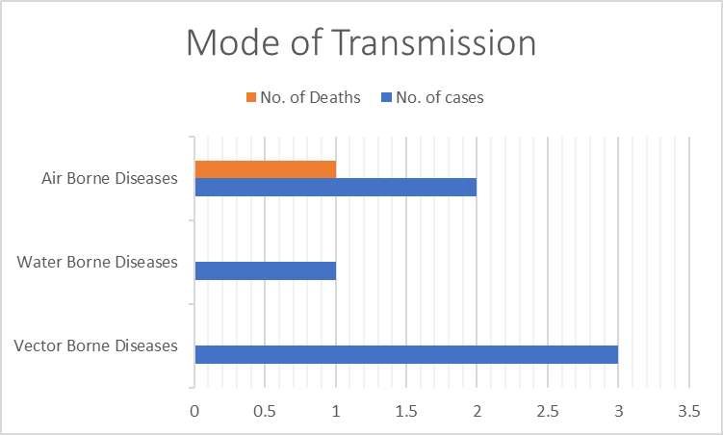

Vector-Borne Disease

Disease | No. of Cases | No. of Deaths
Dengue | 3 | 0
Malaria | 0 | 0
Chikungunya | 0 | 0

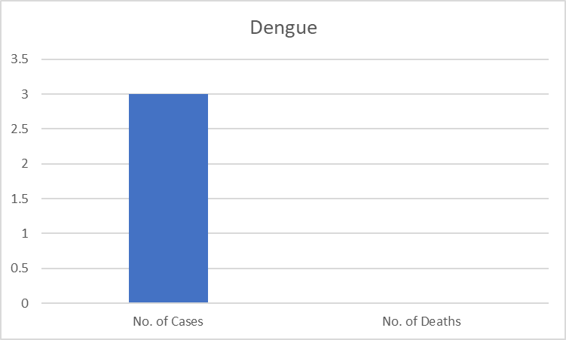
Water Borne Disease

Disease | No. of Cases | No. of Deaths
Cholera | 0 | 0
Typhoid | 1 | 0
Hep- A | 0 | 0
Dysentery | 0 | 0
Amoebiasis | 0 | 0
E- Coli infections | 0 | 0
Air Borne Disease

Disease | No. of Cases | No. of Deaths
Influenza | 9 | 0
H1N1 | 0 | 0
TB | 2 | 1
Chickenpox | 4 | 0
Measles | 0 | 0
Covid-19 | 1 | 0
Pertussis | 0 | 0
Mumps | 0 | 0

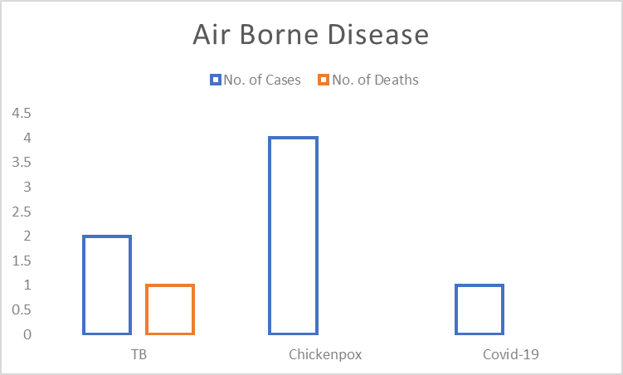
Blood-Borne Disease

Disease | No. of Cases | No. of Deaths
AIDS | 0 | 0
Hep- B | 0 | 0
Hep- C | 0 | 0

Zoonotic Disease

Disease | No. of Cases | No. of Deaths
Rabies | 0 | 0
Leptospirosis | 1 | 0
Avian influenza | 0 | 0
West nile | 0 | 0
Anthrax | 0 | 0
Nipah | 0 | 0
Scrub Typhus | 1 | 0

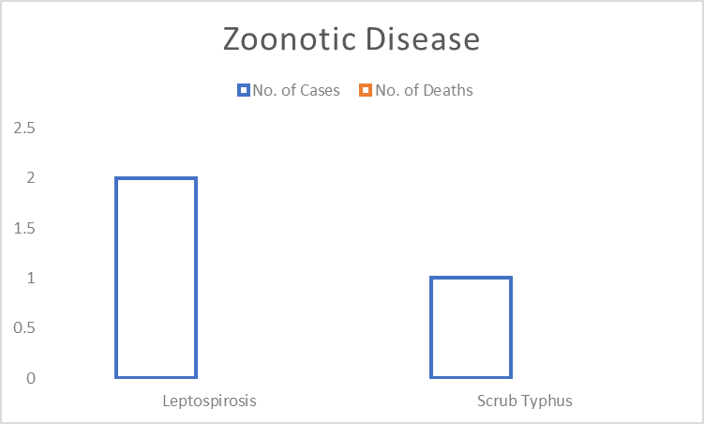

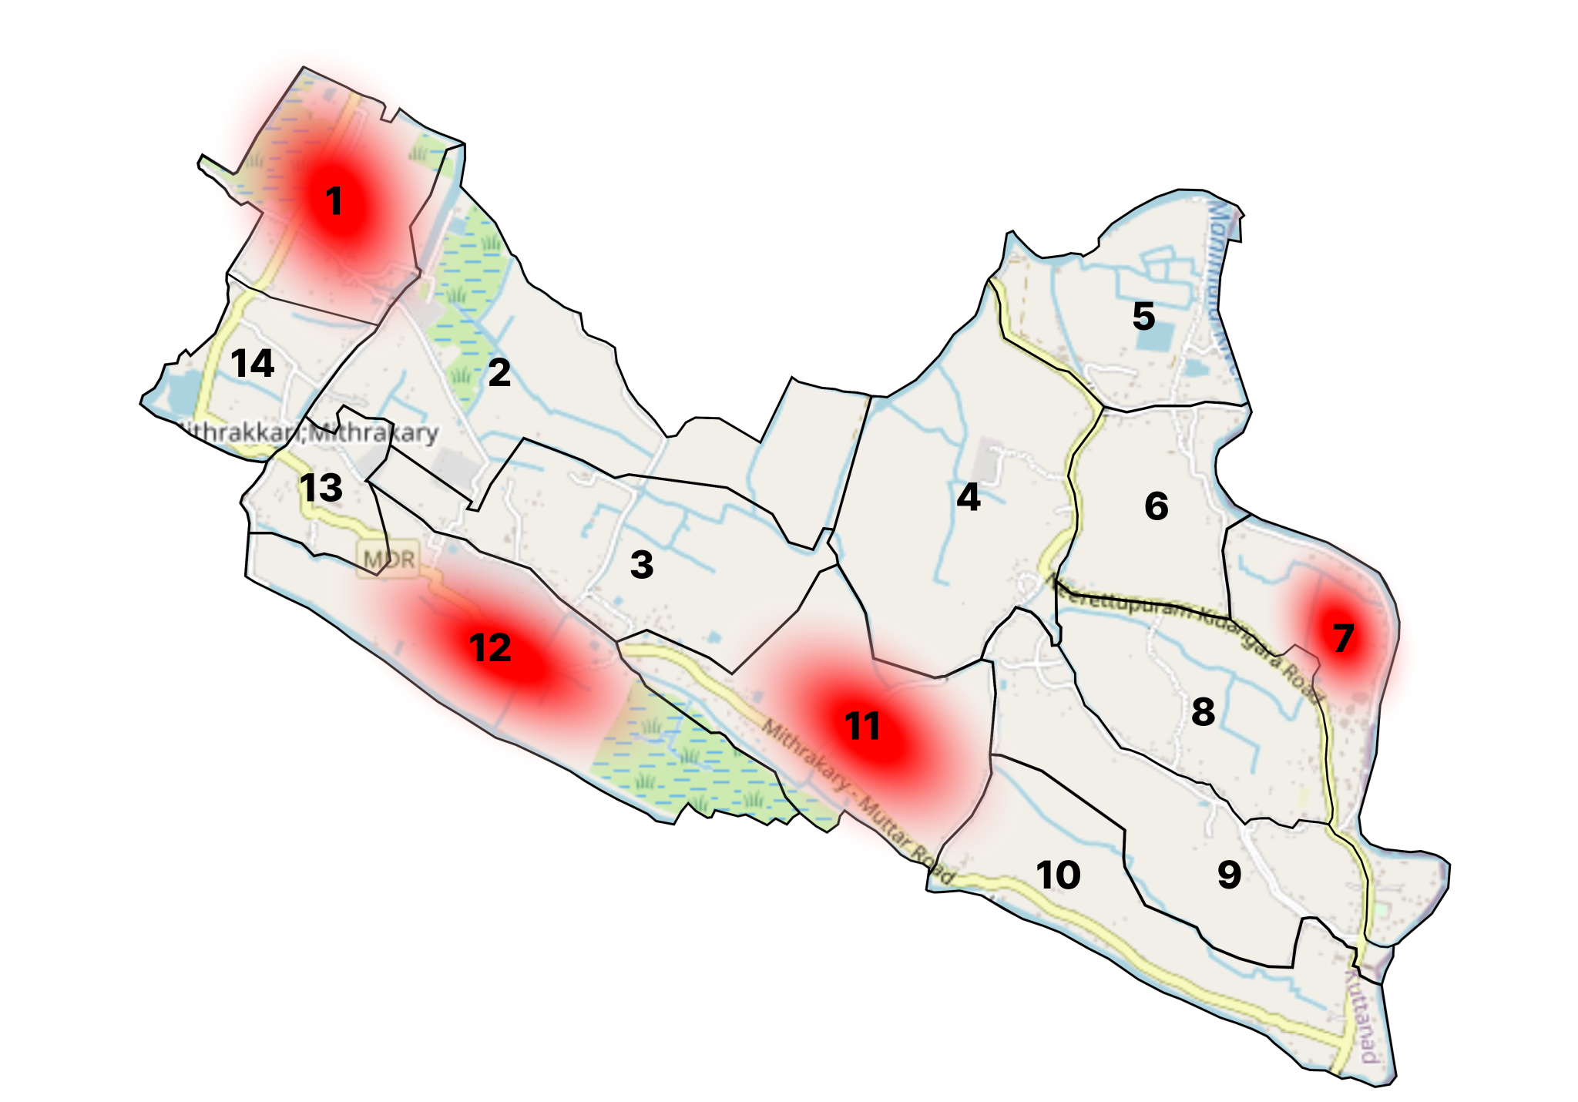
Integrated Disease Hotspot Map (2021–2025)

Ward No | Dengue Total (2021-25) | Leptospirosis Total (2021-25) | Hepatitis A Total (2021-25) | Mumps (2021-25) | ADD (2021-25) | Total Cases
1 | 1 | 1 | 0 | 0 | 5 | 7
2 | 0 | 0 | 0 | 0 | 3 | 3
3 | 0 | 0 | 0 | 1 | 3 | 4
4 | 1 | 0 | 0 | 0 | 5 | 6
5 | 1 | 0 | 0 | 0 | 6 | 7
6 | 2 | 0 | 0 | 0 | 3 | 3
7 | 2 | 0 | 0 | 0 | 3 | 5
8 | 0 | 0 | 0 | 0 | 6 | 6
9 | 1 | 0 | 0 | 0 | 2 | 2
10 | 0 | 0 | 0 | 0 | 5 | 5
11 | 1 | 1 | 0 | 0 | 3 | 5
12 | 0 | 1 | 0 | 0 | 4 | 5
13 | 0 | 0 | 0 | 0 | 3 | 3
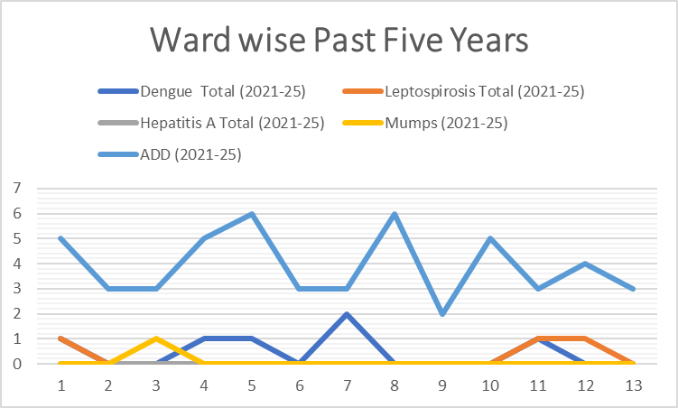

By overlaying five years of disease surveillance data for Ramankary Grama Panchayath, Wards 1 and 11 have been identified as “Red Zone” wards. These wards are characterized by the recurrence of at least two different categories of communicable diseases (such as Dengue and Leptospirosis) over consecutive years. Among them, Ward 11 has been classified as the Highest Priority Hotspot due to its high flood vulnerability combined with elevated vector density. In view of these risk factors, future health infrastructure interventions—such as the proposed installation of Reverse Osmosis (R.O.) plants in Ward 11—should be accorded priority.

Preparedness and Response Protocol at LSG Level
This section describes the operational framework for the LSGI once a pandemic is declared. It explains how the LSGI and health system will move from routine data collection to active response, using a One Health approach.

Constitution of One Health Committee
The LSGD shall constitute a One Health Committee comprising the LSGI President, Medical Officers (Modern Medicine, AYUSH, and Veterinary), the Health Inspector, and the Veterinary Surgeon.

Objective: The One Health Committee coordinates human, animal, and environmental health to prevent and control pandemics.

Sl No | Name | Designation | Department/Institution | Role in Committee | Contact Number
1 | VISWAMBARAN | Panchayat President | LSGD | Chairperson | 9495758662
2 | Dr. POORNIMA.TA | Medical Officer (PHC/CHC) | Health Dept | Member Secretary | 9447975632
3 | Dr.DEEPA JACOB | Veterinary Officer | Animal Husbandry | Member | 9447404898
4 | Dr. ANJALY | Epidemiologist | Health Dept | Member | 9495656702
5 | SUDHEESH | Health Inspector/PHN | Health Dept | Surveillance | 9495706457
6 | BIVI | ASHA Supervisor | Health Dept | Community link | 9747211472
7 | NAJILA | ICDS Supervisor | Social Welfare | Vulnerable groups | 9895774093
8 |  | Police Station Officer | Police Dept | Law & order
9 | ANNAMMA | Ward Councillor Representative | LSGD | Community coordination | 9847532419
10 |  | Kudumbashree CDO | Kudumbashree | Community mobilisation
11 |  | NGO/Volunteer rep | Civil Society | Support services
12 | 0 | Line Department representations | 0 | 0 | 0

Key Responsibilities:
- Review disease surveillance data (human + animal)
- Conduct ward-wise risk assessment and vulnerability mapping
- Approve quarantine/isolation centre locations
- Coordinate with district for resources (PPE, oxygen, ambulances)
- Periodically review health system surge capacity, including beds, oxygen, human resources, and ambulances.
- Approve and monitor risk communication and community engagement strategies, including rumour management.
- Ensure protection and service continuity for vulnerable groups (elderly, persons with disabilities, dialysis patients, coastal populations).
- Conduct quarterly mock drills
- Monitor equity measures for vulnerable groups

Meeting Schedule:
Quarterly (normal times) | Weekly (outbreak alert) | Daily (pandemic phase)

Pandemic Response Workforce
To ensure a coordinated and timely response during a pandemic, a dedicated Pandemic Response Workforce shall be constituted at the LSG level. The workforce will function under the overall supervision of the One Health Committee and in close coordination with the health authorities. Team-based deployment will enable efficient surveillance, case management, quarantine and isolation management, logistics support, and risk communication. Each team shall have a clearly designated team leader, defined roles, and an identified pool of personnel to allow rapid activation, rotation of duties, and continuity of services during prolonged emergencies.

Total Response Workforce Available: 300 persons

Team Name | Composition | Key Responsibilities | Team Leader
Surveillance and Contact Tracing Team | HI, JHI, JPHN, ASHAs and Volunteers | Case detection, contact listing, home visits, reporting | HI
Case Management Team | Doctors, Nurses, MLSP, Palliative Nurses | Patient care & referral | DOCTOR
Quarantine & Isolation Team | LSGD staff, Volunteers | Facility management | JHI
Psychosocial support
Logistics & supply chain Team | LSGD staff, Storekeepers, Drivers 3 | Supplies & transport [PPE, medicines, oxygen, transport, waste management] | Ward Member
Communication Team | Ward members, Kudumbashree, Youth clubs,  AWW workers and other self help groups | IEC, community meetings, countering misinformation | M.O in charge
Transportation | KSRTC, educational institutional buses | Transportation | Station master
Media Surveillance | local channel | IEC | media in charge
Intersectoral coordination and convergence | PHC , LSGD , AYUSH ,VETINARY,FSSI | CORDINATION | MO in charge
Collaborative surveillance | 0 | 0 | 0

All teams shall be activated immediately upon outbreak alert or pandemic declaration and shall report daily to the LSG Incident Commander/Medical Officer, with consolidated reporting to the Block PHC. Duty rosters and alternate personnel shall be maintained to ensure uninterrupted services during staff shortages or prolonged response periods. Team composition and numbers may be revised based on the magnitude of the outbreak and availability of human resources.

Activities and Measures before and during Pandemic

PHASE 1 - Alert / Preparation
Surveillance and Reporting-Enhanced syndromic surveillance:
- Data sources for surveillance:
- Event-based triggers (to be monitored and reported):
- Zoonotic and animal health surveillance
- Logistics and Stock Preparedness
  - Identify and empanel local vendors and define emergency procurement mechanisms in accordance with existing LSGD and Health Department norms.
  - Prepare and maintain an essential logistics checklist covering medical supplies, consumables, and support equipment.
  - Pre-identify secure storage locations for emergency stocks and ensure maintenance of stock registers with regular updating.
  - Finalise emergency transport arrangements, including availability of vehicles and identified drivers for rapid deployment during alerts.
  - Designate a Nodal Officer for Logistics to enable prompt decision-making, coordination, and communication during emergencies.
  - Conduct rapid stock verification and ensure availability of minimum buffer stock, including:
- PPE kits numbers -0
- Pulse oximeters – __0_ numbers
- Hand sanitizers – _0__ litres
- Masks,- 500 gloves-300, disinfectants 6 Cans – adequate quantity
Identify critical gaps in logistics and immediately communicate requirements to the Block and District authorities for timely replenishment and support. Monitor expiry dates and stock rotation.

Identification of Quarantine and Isolation Facilities
  - Identify and list suitable buildings for quarantine and isolation (schools, hostels, community halls, etc.).
  - Categorise cases as per the severity and allocate to appropriate facilities (for instance, severe cases to classrooms, mild cases to an assembly hall in case of a school).
  - Facility readiness checklist needed (beds, toilets, ventilation) etc.
  - Find an alternate site if the primary sites are not available or not in use.
  - Identify facility managers and support staff
  - Prepare basic SOPs for:
    - Admission and discharge
    - Food, water, sanitation
    - Infection prevention and waste disposal
  - Ensure availability of basic amenities: water, sanitation, electricity, ventilation, and waste disposal. Prepare a rapid activation plan for these facilities if case numbers increase.

Risk Communication and Community Preparedness
  - Disseminate early warning messages on symptoms, preventive measures, and reporting mechanisms. Display IEC materials both in English and the local language in public places and ensure ward-level awareness.
  - Sensitize elected representatives and community leaders on preparedness measures.
  - Establish a rumour tracking and misinformation response mechanism to identify, verify, and promptly counter false or misleading information.
  - Engage trusted local persons (ward members, ASHA workers, religious leaders, teachers, community volunteers) to communicate official public health messages and reinforce correct practices.
  - Develop and deploy targeted IEC materials for:
    - Schools and educational institutions
    - Markets and commercial areas
    - Work sites and labour settings
  - Conduct community sensitization meetings at the ward level to promote preventive behaviors, address concerns, and strengthen community participation in preparedness and response.

Protection of Vulnerable Groups
Vulnerable populations require priority protection through targeted line-listing, service continuity, and delivery mechanisms.
- Prepare and regularly update line-lists of vulnerable populations, including:
  - Elderly persons living alone
  - Persons with disabilities
  - Pregnant women
  - Migrant workers
  - Dialysis patients
The detailed line-lists shall be maintained as Annexure ___ and updated periodically.

Clinical Dependency Mapping
Develop ward-wise dependency and vulnerability maps to identify households requiring regular support during emergencies. Ensure continuity of essential health services for vulnerable groups, including
- Dialysis services (facility mapping, transport arrangements, and scheduling)
- Continuity of treatment for TB, HIV, and other chronic conditions requiring uninterrupted medication
- Mental health and psychosocial support services
Establish delivery mechanisms for food, essential commodities, and medicines to vulnerable households through coordinated action involving ASHAs, JPHNs, Kudumbashree, volunteers, and local administration.

PHASE 2 - Active Response

Case Identification and Contact Tracing
Case detection and contact tracing activities will be carried out in coordination with the Health authorities, following disease-specific SOPs and IDSP guidelines.
Field Staff Involved
- Health Inspector (HI)
- Junior Health Inspector (JHI)
- Junior Public Health Nurse (JPHN)
- ASHAs and ASHA Supervisors
- Ward-level volunteers and Kudumbashree members (as required)

Screening Checkpoints
Screening checkpoints at high-traffic locations (transport hubs, markets, religious gatherings) for early detection of symptomatic travellers and crowd screening during outbreaks. Potential locations include bus stands, market entry points, and boat jetties, based on local context and risk assessment.
Screening activities will be carried out by trained personnel such as ASHAs, ward members, and volunteers, with support from Health Department staff. Necessary equipment, including non-contact thermometers and appropriate PPE, shall be ensured prior to activation.
Location | Type (Bus stand/Jetty/Market/Railway) | Staff Deployed (ASHAs/Volunteers) | Screening Method | Reporting authority
Bus stand | Transport hub | One JHI  One ASHA  One health Mentors | 1.Swab Collection.  2. Blood smears collection (RDT)  3.Thermal Scanners | Surveillance Nodal Officer in control room
Market entry | Market | One JHI  One ASHA  Male health volunteers | 1.Swab Collection.  2. Blood smears collection (RDT)  3.Thermal Scanners | Surveillance Nodal Officer in control room
Boat jetty | Water transport | One JHI  One ASHA  Male health volunteers | 1.Swab Collection.  2. Blood smears collection (RDT)  3.Thermal Scanners | Surveillance Nodal Officer in control room

Standard Screening Protocol

The screening protocol shall include temperature screening, observation for visible symptoms, and inquiry regarding recent travel or exposure history. Individuals identified as suspects during screening shall be immediately referred to the nearest PHC/FHC for further evaluation, testing, and appropriate action as per prevailing guidelines.

Pandemic Control Room
The Pandemic Control Room (PCR) serves as the central nerve center for real-time coordination, data aggregation, decision support, and communication during outbreaks. It consolidates information from all LSGD teams, health facilities and community sources to enable rapid response decisions.

Control Room Infrastructure and Location
Primary Location: ___Muttar__ Panchayath Office.
Backup Location: Community Hall in __Muttar____ G.P.

Health System Control Room Framework
The PCR is organized into seven functional pillars to ensure no aspect of the response is overlooked:

Rapid Response Team (RRT)
  - Provides immediate intervention during emergencies, clusters, and field alerts.​
  - Coordinates urgent actions such as case investigation, contact tracing, isolation, and inter‑facility referrals.

Data Management & Analytics Team
  - Collects, validates, and manages key health system indicators (cases, tests, beds, HR, supplies).​
  - Analyzes data trends, generates projections, and supports evidence‑based decision‑making for local authorities.

Human Resource Deployment Team
  - Allocates healthcare staff efficiently based on workload and need
  - Ensures adequate and equitable workforce distribution across facilities

Laboratory Surveillance Team
  - Oversees diagnostic testing coordination, sample transport, and timely reporting of results.​
  - Monitors lab indicators (testing volume, positivity rate, turnaround time) for early detection of outbreaks

Vaccination Cell (If Required)
  - Plans and executes vaccination campaigns, including micro‑planning and session scheduling.​
  - Tracks coverage, identifies gaps, and coordinates corrective actions with field teams and outreach services.

Infrastructure & Patient Occupancy Team
  - Monitors facility capacity, earmarked beds, oxygen and critical care resources across all linked facilities.​
  - Ensures optimal patient distribution and referral management using updated bed‑status and resource data.
  - BMWM

Communication team
- Logistics and supply chain
- Transportation (interfacility & emergency transport)
- Media surveillance Call centre
- Management of the deceased
- Intersectoral coordination and convergence

Key Control Room Team
The Control Room Team coordinates all pandemic response activities within the LSGD and serves as the single command and communication hub during activation. It integrates information, field actions, logistics, and policy execution across all participating departments and health facilities.

Role | Name | Designation | Contact Number | Responsibility
In-charge/Nodal Officer | Dr.Poornima TA | Asst. Surgeon | 9447974632 | Overall coordination, decision-making, and reporting to the District level.
Data Entry Operator | Avani Nandan | Clerk | 9188132022 | Managing the line list, updating dashboards, and tracking testing results.
Communication Officer | Regi Mon.S | JHI | 8281004174 | Handling the public helpline, coordinating ambulance dispatch, and contact tracing calls.
Logistics Coordinator | Shiny Thomas | Nursing Officer | 9446813262
Technical Support (IT/Data) | Jose Praksh | JHI | 9847422511

SOP for alert escalation/trigger point with mapping of responsibilities.
Key Points:
- The Control Room shall be staffed with a designated In-charge, data entry personnel, and communication staff with clearly defined roles and shift arrangements.
- It shall maintain updated records on daily monitoring indicators including new cases, persons under active quarantine, and hospital bed occupancy.
- All reports and situation updates shall be shared daily with the Block and District Surveillance Unit.
- The Control Room shall act as a single point of contact for coordination with response teams, health institutions, and other departments.
- Contact details of the Control Room shall be widely communicated to field staff and stakeholders during activation.

Daily Monitoring Indicators
To ensure timely decision-making and effective response, the following key indicators shall be monitored and updated on a daily basis by the Pandemic Control Room:

Epidemiological Indicators:
New cases reported today, Total active cases, Test Positivity Rate (TPR), Case Fatality Rate (CFR)
- Surveillance Indicators:
Persons under home quarantine, High-risk contacts identified, Fever, ILI, SARI or other symptoms (syndromic surges), Travellers (symptomatic or high-risk arrivals),Animal husbandry surveillance (zoonotic alerts, unusual animal deaths, poultry/bird flu signals), Mortality surveillance (excess deaths, unexplained fatalities, verbal autopsy reports)
- Logistics and Infrastructure Indicators:
Hospital / CFLTC beds occupied, Oxygen cylinders/concentrators available, Ambulances on standby
- Alert Findings
The following table outlines category-specific trigger points (red flags) from surveillance indicators and corresponding immediate actions for the Pandemic Control Room. These enable rapid response to alert findings like testing anomalies, positive cases exceeding thresholds, clusters, and WGS reports.

Category | Trigger Pophint (Red Flag) | Immediate Action
Clusters | Geographical or facility-based: 5+ cases linked to one location (office, school, street). | Declare a micro-containment zone; perimeter control and active case finding.
Testing | Sudden drop in testing volume / delay in reporting / unusual testing trends | Review the sample collection process, address lab bottlenecks, deploy additional testing teams, and notify the District Lab.
Lab | Test Positivity rate increases | Increase testing sites in that ward.
Hospital | >80% Oxygen bed occupancy | Activate backup/CFLTC beds.
Travel | Cluster of cases from a single flight/train or high-risk arrival group. | Trace all passengers in adjacent seats; implement mandatory institutional quarantine.
Animal | Mass poultry/wildlife death or unusual sickness | Notify Animal Husbandry, sample the area, and dispatch RRT for environmental sampling and zoonotic check.
Mortality | Sudden spike in home deaths or brought-in-dead (BID) cases | Audit the deaths and Active Case Search drive
Additional investigations like Whole Genome Sequencing (WGS) | Detection of a Variant of Concern (VOC) or Variant of Interest (VOI) | Implement strict micro-containment; update clinical protocols to match variant severity.

Communication of Public Health Information
A Community Communication Hub shall be established to ensure timely, accurate, and consistent dissemination of information during a pandemic. The Hub will function under the coordination of Nodal officers of the control room and act as the nodal point for public communication, risk messaging, and community engagement. It will support dissemination of official advisories, promote preventive behaviors, address rumors and misinformation, and ensure that messages reach all sections of the population through trusted local channels and leaders.

Key communicators
Channel | Responsible Person | Contact
Ward-level announcements | JOSE PRAKASH (JHI) | 9847422511
Social media | ANU PRAKASH (JPHN) | 9400670199
Local Cable TV/Radio | RAJENDRAN (Local Media) | 9496690552

- All messages disseminated through the Hub shall align with advisories issued by the Health Department and District authorities.
- Community leaders shall be sensitized to support behavior change, reduce stigma, and counter misinformation.
- Special efforts shall be made to reach vulnerable and hard-to-reach populations using locally appropriate communication methods.

Rumor Tracking: A designated volunteer will monitor local social media/WhatsApp groups daily to identify misinformation and issue official clarifications via the Communication Hub.

Coordination with District/State Authorities & Other Organisations
Effective coordination with Block, District, and State authorities is essential to ensure timely reporting, technical guidance, and uninterrupted supply of essential resources during a pandemic. The LSG shall establish clear communication channels, designate responsible officers, and adhere to prescribed reporting timelines to support coordinated public health action and efficient resource mobilisation.

Key Details:
- Nodal Officer for Reporting:
- Contact Number:
Reporting Schedule and Protocols:

To Whom | What to Report | Frequency | Nodal Person
Block PHC | Complete Situation Report (Cases, Quarantine, Beds, Screening, Deaths) | Daily | Head Nurse
District IDSP Unit | Outbreaks/Clusters/Unusual Events (>5 cases same ward) | Real Time basis | MO .in charge
Veterinary Officer | Animal health events/Zoonotic alerts | Whenever Event occurs : Real time | In charge
State Cell | Zoonotic cross-sector events | Real time | Veterinary Surgeon

Supply Chain Coordination
The LSG shall coordinate closely with Block, District, and State authorities (KMSCL) to ensure uninterrupted availability of essential goods, medical supplies, and logistics during a pandemic. Supply requirements shall be assessed regularly based on case load and communicated promptly to the appropriate authorities for timely replenishment.
Key Points:
- Maintain updated contact details of District and Block nodal officers for health logistics, oxygen supply, ambulances, and essential medicines.
- Submit timely indent requests for PPE, testing kits, medicines, oxygen, and other critical supplies through prescribed channels.
- Monitor stock levels at LSGD facilities, quarantine/isolation centres, and field teams through daily stock registers and dispensing logs to prevent shortages.
- Coordinate with District authorities, Karunya/Neethi medical shops, and local purchase committees for funds allocation and emergency procurement.

- Ensure regular monitoring of dispensing registers at all facilities to track usage, expiry, and pilferage—shortages being a perennial issue requiring proactive weekly audits.

- Activate surge procurement protocols during high caseloads, leveraging local purchase powers under LSGD funds alongside state supplies.

Resource Inventory and Contacts
Resource Category | Source  (District/State/Private) | Contact
PPE Kits/Masks/Gloves | KMSCL | 9895214070
PPE Kits/Masks/Gloves | Local Vendors | 9961215230
Oxygen  Cylinders/Concentrators | KMSCL | 9895214070
Medicines/Antivirals | KMSCL | 9895214070
Medicines/Antivirals | Neethi Shops | 9947757360
Test Kits (RTPCR/Rapid) | KMSCL | 9895214070

Collaboration with NGOs, PPP, and CSR
To augment government efforts during a pandemic, the LSG shall collaborate with NGOs, voluntary organisations, and private sector partners through public–private partnerships and Corporate Social Responsibility (CSR) initiatives, in coordination with District authorities.

Key Points:
- Engage NGOs and community-based organisations for community outreach, awareness, and support to vulnerable populations.
- Leverage CSR support for procurement of medical equipment, PPE, oxygen concentrators, food kits, and sanitation materials, as permitted.
- Ensure all collaborations align with government guidelines and are routed through approved administrative and financial procedures.
- Maintain transparency and documentation for all external support received and utilised.

Organization | Type | Support Offered | Contact Person
Youth Clubs/Student Unions | CBO | NCC and Red Cross | 134

Interdepartmental Coordination
Coordination among departments during a pandemic shall be ensured through regular review meetings convened by the LSGD President. These meetings will provide a structured platform for sharing situational updates, assessing resource availability, resolving operational gaps, and taking joint decisions to ensure a coordinated and timely response.

Department | Representative | Key Role | Contact
Health (PHC) | Staff Nurse : | Case management | 9446813268
Veterinary | Veterinary Surgeon: | Animal surveillance | 9447404898
ICDS | Supervisor: Sindhu | Nutrition support | 9895774093
Education | Head Teacher: | School coordination | 9447569629
Police | Police officer | Containment enforcement | _0477 2762222
Water Authority | officer | Water supply | 0477 27202221
LSGD Engineering | ___AE__ | Quarantine infrastructure | 89121848510

PHASE 3 - Surge Capacity
Phase 3 is activated when there is a rapid increase in cases, high test positivity rates, or when existing health facilities and quarantine arrangements approach saturation. The focus of this phase is to expand isolation capacity, augment clinical care services, and mobilise additional resources through district and state support mechanisms.

Conversion of Community Facilities
To manage increased case load, the LSGD shall activate additional isolation facilities by repurposing identified community infrastructure such as community halls, auditoriums, schools, hostels, or other suitable buildings.

Name of facility | Facility Type | No. of Buildings | Ward | Surge Capacity (Beds) | Nodal Person
HWC Muttar | Health Care Facility | 1 | 0 | 0 | HI
M.C Muttar | Health Facility | 1 | 0 | 0 | HI
St. George Higher Secondary School | Schools | 6 | 4,6,8,12 | 75 beds per institutions | H.M
Parish Halls of Church | Community Hall | 3 | 1,8,10 | 20 to 25 Beds per hall | HI

- Recovery and rehabilitation phase
- Recovery
  - Damage & impact assessment
  - Restoration of health services
  - Rehabilitation of affected population
  - Psychosocial & mental health support
  - Disease surveillance during recovery phase
  - Environmental cleanup & sanitation
  - Livelihood restoration
  - Community engagement & confidence building
  - Documentation & after-action review
  - Lessons learned & best practices
  - Health system strengthening
  - Policy revision & preparedness enhancement
  - Research

Conclusion – Pandemic Preparedness Plan of Muttar LSGD
The Pandemic Preparedness Plan of Muttar Local Self Government Department (LSGD) establishes a comprehensive, coordinated, and resilient framework to effectively prevent, respond to, and recover from future public health emergencies. By integrating governance, technology, infrastructure, and community participation, the plan strengthens Muttar’s capacity to manage pandemics while minimizing health, social, and economic impacts.
Technology-enabled support systems form a critical backbone of the preparedness strategy. Digital platforms for disease surveillance, real-time data sharing, telemedicine support, and inter-departmental coordination will enhance early detection, rapid decision-making, and continuity of essential health services. Technical support teams at the LSGD level ensure uninterrupted communication between health institutions, field workers, and district authorities.
The plan emphasizes relief-based commodity management to ensure timely availability and equitable distribution of essential supplies such as food kits, medicines, PPE, disinfectants, drinking water, and sanitation materials. Pre-identified storage facilities, vendor tie-ups, and logistics plans will help avoid shortages and ensure swift relief to vulnerable populations, including the elderly, chronically ill, migrant workers, and economically weaker sections.
Recognizing the importance of communication during emergencies, HAM radio operators are incorporated as a vital alternative communication mechanism. In situations where conventional networks fail due to floods, power outages, or disasters, trained HAM operators will ensure uninterrupted information flow between the LSGD, health facilities, disaster management teams, and district control rooms.
Hazard and vulnerability mapping is a key planning tool used to identify high-risk wards based on disease trends, flood-prone areas, population density, and access to health facilities. This mapping enables prioritization of interventions, targeted surveillance, and efficient deployment of resources. Special coordination with KSEB and other power supply sources ensures uninterrupted electricity to critical infrastructure such as health facilities, isolation centers, water supply schemes, and communication systems, including provisions for backup power sources.
Clearly defined Human Resource–specific roles and responsibilities strengthen operational efficiency. Health staff, ASHA workers, Anganwadi workers, volunteers, sanitation workers, technical personnel, and administrative officials are assigned task-specific duties with clear reporting structures. Regular capacity-building, mock drills, and inter-sectoral coordination enhance readiness and accountability.
In conclusion, the Pandemic Preparedness Plan of Muttar LSGD reflects a proactive, inclusive, and technology-driven approach. By combining technical support, reliable communication systems, assured relief logistics, power continuity planning, hazard vulnerability assessment, and defined human resource responsibilities, Muttar LSGD is better positioned to safeguard public health, maintain essential services, and build long-term resilience against future pandemics

RECOMMENDATIONS

Strengthening Healthcare Infrastructure
- Establish a primary health response unit within the Panchayat with trained staff.
- Ensure availability of basic medical supplies (masks, sanitizers, PPE kits, oxygen cylinders).
- Create tie-ups with nearby hospitals in Muttar for emergency referral and transport.

2. Community Awareness & Education
- Conduct regular awareness campaigns on hygiene, vaccination, and preventive measures.
- Use local communication channels (community radio, WhatsApp groups, notice boards) to spread verified information.
- Train volunteers to act as health ambassadors in each ward.

3. Emergency Response & Coordination
- Form a Pandemic Preparedness Committee at Panchayat level including health workers, ward members, and NGOs.
- Develop a clear action plan for lockdowns, quarantine, and distribution of essentials.
- Maintain a database of vulnerable groups (elderly, differently-abled, chronically ill) for targeted support.

4. Supply Chain & Food Security
- Identify and support local suppliers and farmers to ensure uninterrupted food supply.
- Create community kitchens during emergencies to serve vulnerable populations.
- Stockpile essential commodities in Panchayat-run outlets for crisis periods.

5. Digital Preparedness
- Promote digital platforms for telemedicine consultations.
- Use Panchayat’s website/social media for real-time updates on health advisories.
- Encourage online grievance redressal to reduce crowding in offices.

6. Training & Capacity Building
- Organize mock drills for pandemic response in schools, offices, and public spaces.
- Train Panchayat staff and volunteers in first aid, infection control, and crowd management.
- Collaborate with NGOs and health departments for capacity-building workshops.

7. Long-Term Resilience
- Integrate pandemic preparedness into the Panchayat Development Plan.
- Allocate a dedicated budget for health emergencies.
- Encourage community participation in planning and monitoring preparedness measures.

MOCK DRILLS:
- Local Disease Cluster: Sudden fever cases in a ward → activate surveillance, RRT, and containment.
- PHC Patient Surge: Increased OP cases → triage system and isolation of suspected patients.
- Emergency Transport Delay: Limited ambulance → use local vehicles/boats for referral.
- Essential Supply Shortage: Disruption in medicines/PPE → activate buffer stock and local distribution.
- Quarantine Facility Activation: Prepare and manage institutional quarantine centers.
- Rumor & Panic Situation: Spread of misinformation → strengthen communication and awareness.
- Flood & Power Disruption: (important in Kuttanad region) → ensure backup power and service continuity.
- Staff Shortage: Health workers unavailable → engage volunteers and redistribute duties.
- Water & Sanitation Issue: Risk of secondary outbreaks → chlorination and sanitation drive.
- Community Resistance: Hesitation for isolation/quarantine → counseling and community engagement

ANNEXURE

IMPORTANT PHONE NUMBERS

Phone numbers and particulars of persons responsible for providing guidance, assistance, and support for pandemic preparedness operations may be provided here in a manner that allows easy reference at a glance. The information recorded here could be exhibited elsewhere at the time of emergencies. LSG institutions shall give special attention to collect and record the above data of persons and institutions who/which are supposed to give technical and co-ordination support to reduce the impact of pandemic.

1.1. Details of grama panchayat/municipality/corporation wards
Sl.No | Name of the ward | Ward number | Name of the ward  member | Contact number
1 | MITHRAKARY WEST | 1 | ANNAMMA | 9847532419
2 | MITHRAKARYNORTH | 2 | AMBILY | 7561868733
3 | MITHRAKARY EAST | 3 | JOSE BOBAN | 9567102095
4 | KUMARAMCHIRA | 4 | BAIJU K ARUPARA | 9847010538
5 | NALUTHODU | 5 | MINI | 9645893741
6 | MUTTAR NORTH | 6 | NIJA | 9995567716
7 | MUTTAR EAST | 7 | VINODHEN | 7558036288
8 | MUTTAR CENTRAL | 8 | JOJAN GEORGE | 9947305409
9 | MUTTAR SOUTH | 9 | MATHEW KUTTY | 9947992630
10 | GOVENDA | 10 | ROSSAMMA | 9562343813
11 | CHOORAKUTTY | 11 | JOBIN | 9526998845
12 | MITHRAMADAM | 12 | VISWAMBHARAN | 9495758662
13 | AALAPPURATHUKAD | 13 | PRAVEENA | 9048864168
14 | MITHRAKARY | 14 | RAJI SUNI | 9947831201

1.2. Other important phone numbers of grama panchayat/municipality/corporation area
Sl. No. | Name | Contact number
1. | MEDICAL OFFICER | 9447975632
2. | PANCHAYATH SECRETORY | 9605491086
3. | PANCHAYATH PRESSIDANT | 9495758662
4. | VILLAGE OFFICER | 9544448601
5. | AYURVEDAM | 9446366180
6. | HOMEO | 9477791088
7 | VETERINARY | 9447404898

1.3. Important offices of grama panchayat/municipality/ corporation
Sl.No | Name of the office | Contact person | Contact number
1. | VEO | ARIF | 9496982847
2. | Agriculture Office | Agriculture Officer | 94978537006
3. | Animal Husbandry Office | Dr. DEEPA JACOB | 9447404898
4. | Police Station | Police Officer | 04772762222
5. | BSNL Office | Officer | 0477 2762100
6. | Block Office | Block Development Officer | 9497222048
7. | KSEB Office | Officer | 0477 2702525
8. | Fisheries Office | Officer | 0
9. | Fire and Rescue | Officer | 0477 2275570

1.4. Health Services

Sl. No | Name of the hospital/institution | Location | Phone number
1. | Government hospitals/PHC | MITHRAKARY Ward -1 | 9447975632
2. | Private hospitals | MUTTAR | 8547546943
3. | Clinical laboratories | MUTTAR | 8289929472
4. | Chemist/pharmacy | MITHRAKARY | 9947730120
5. | Blood donors | 0 | 0
6. | Other language experts (Bihari, Hindi, Bengali,  Asamees ………) | 0 | 0

1.5. Veterinary Services
Sl.No | Name of the Clinic | Name of the  Surgeon/Doctor | Place/location | Phone  number
1 | Govt.Veterinary Hospital | Dr.Deepa Jacob | W-9 | 9447404898

1.6. Helpline numbers
Helpline | Phone number
Police | 0744 27602222
Fire and Rescue | 0477 2275570
KSEB | 0477 2702525

1.7. Public and Private Schools Contact details

S.No | Name of School | Institution type | Phone number
1 | St, GEORGE HSS | Aided | 9447569629
2 | ST,GEORGE HS | Aided | 9496157721
3 | St,GEORGE LP | Aided | 9496272895
4 | Govt,LP | Govt | 9447029921
5 | St,Xavier. HS | Aided | 8547785962
6 | Govt.Mithrakary Esat LP | Govt | 9447454889
7 | Govt.Mithrakary West LP | Govt | 9961056880
8 | Sisusadhan Nursury | Private | 9207309283
9 | Amala nursery school | Private | 9605218420

1.9. Anganwadi Contact Details

Ward No | Name of Anganwadi Teachers | Phone number
1 | NO, 53 , USHAKUMARI | 9605319462
2 | N0,54, KANAKAMMA | 9497176759
3 | N0.62 , KRISHNAMMA | 9037685832
4 | NO.57, SINDHU PS | 9526186481
5 | NIL
6 | NO, 59 PUSHPALATHA | 6238510356

Ward No | Anganwadi No and Name of Teacher | Phone number
7 | NO.,60 ASHA RAJAN | 9496157725
8 | NO.61, LISSAMMA VARGHESE | 6238312851
9 | NO.58 ,MINIMOL KB | 8086889945
10 | NO. 56 SUMA | 9745554864
12 | NO. 99 MEENAKUMARI | 94965040348
13 | NO.55 MAYADEVI | 9562540339

1.12. Information regarding resources

Means of transportation | Name of Owner | Phone Number
Heavy Trucks | ANIL KUMAR | 9447743943
Tractor | 0 | 0
Ambulances | Govt. H Champakulam | 0477 2737587
Boats | thomas | 9447051333
Taxi service | BINOY | 9061417996

Annexure 1: LSG Baseline Data Collection Format
A. Baseline data
Sl. No. | Indicator / Field | Baseline Data | Source / Remarks
1 | Name of LSG | MUTTAR GP | Panchayath Data Bank
2 | District | ALAPPUZHA | Panchayath Data Bank
3 | Block / Taluk | KUTTANADU | Panchayath Data Bank
4 | Type of LSG (Gram Panchayat / Municipality / Corporation) | GRAMA PANCHAYATH | Panchayath Data Bank
5 | Area (sq. km) | 20.22 | Panchayath Data Bank
6 | No. of wards | 14 | Panchayath Data Bank
7 | GIS boundary file available | (Yes/No) | Y
8 | Key contact person & phone | MO PHC MUTTAR | 9447974632

B. Demography
Indicator / Field | Baseline Data
Total population | 11355
Males | 5564
Females | 5791
Transgender population | 0
Age distribution  (<5, 5–14, 15–59, ≥60) | <5 -340  5–14,- 2620 15–59-7119  ≥60) 1876
No. of households | 2471
Population density (persons/sq.km) | 758/sq.km
No. of migrant workers | 22
Major occupational groups | Agriculture

C. Vulnerable Populations & Social Risks
Sl. No. | Indicator / Field | Baseline Data (Value / Description) | Source / Remarks
1 | No. of elderly (≥60) | 1879 | Register of HWC
2 | No. of persons with disability | mental-15  Disability-34 | Register of HWC
3 | No. of bedridden persons | 30 | Register of HWC
4 | No. of chronic disease cases (DM/HTN/COPD/CKD etc.) | DM- 433  HTN-1221  COPD-32  CKD-3 | Register of HWC
5 | Pregnant women (current estimate) | 27 | Register of HWC
6 | Children <5 years | 340 | Register of HWC
7 | Tribal population (if any) | 0 | 0
8 | Fisherfolk / coastal vulnerable groups (if any) | Fisherfolk -13 | Register of HWC
9 | Urban slums / unnotified settlements (if any) | 0 | Register of HWC
10 | Homeless population | 0
11 | Orphanages / old age homes (number & capacity) | 0 | 0
12 | Hostels / prisons / shelters (number & capacity) | 0 | 0
13 | Poverty / BPL estimate | BPL–1324 | Register of HWC
14 | Food insecurity hotspots | NIL | Register of HWC
15 | Any history of stigma/discrimination issues (Yes/No) | NO | Register of HWC

D. Health System & Service Readiness
Sl. No. | Indicator / Field | Baseline Data (Value / Description) | Source / Remarks
1 | No. of health facilities in LSG (PHC/CHC/TH/DH/Private) | PHC -1 | Registers of M.C
2 | PHC/Family Health Centre details (name, location) | PHC - MUTTAR  MITHRAKARY WARD -1 | Register of HWC
3 | Subcentres / Health & Wellness Centres (number) | AAM MUTTAR-  MUTTAR, Ward 4  AMM MAIN CENTRE ,MITHRAKARY Ward -1 | Register of HWC
4 | Private clinics / hospitals (number) | 1 | 0
5 | Labs available (public/private) | 2 | 0
6 | Availability of ambulance services (Yes/No, number) | 0 | Panchayath Data Bank
7 | Availability of isolation/quarantine facilities (Yes/No, details) | NO | Panchayath Data Bank
8 | Cold chain facilities (Yes/No, details) | Yes | Panchayath Data Bank
9 | Stockpile space available (Yes/No) | NO | Panchayath Data Bank
10 | PPE / mask / sanitizer availability plan (Yes/No) | Y | Panchayath Data Bank
11 | Surveillance staff available (JHI/JPHN/ASHA count) | JHI -2, JPHN -2  ASHA -12
12 | Existing emergency referral pathways (Yes/No) | Y | Panchayath Data Bank

E. Points of Entry & Mobility
Sl. No. | Indicator / Field | Baseline Data (Value / Description) | Source / Remarks
1 | Bus stands / depots (number) | NO | Panchayath Data Bank
2 | Railway stations (number) | NO | 0
3 | Boat jetties / fishing harbours (number) | YES | Ward 4,5,7
4 | Ports / airports nearby (specify distance) | NO | 0
5 | Major highways/roads passing through | NO | Wards -4,5,6,7,8,9,
6 | Border crossings (state/district) | YES | Kottayayam
7 | Major markets / weekly markets | NO | 0
8 | Tourism hubs / major event venues | NO
9 | Schools/colleges with hostels (number) | NO | 0
10 | Factories / large workplaces (number) | 0 | 0
F. Water, Sanitation & Hygiene (WASH)
Sl. No. | Indicator / Field | Baseline Data (Value / Description) | Source / Remarks
1 | Major drinking water sources (piped / wells / borewells / springs) | PIPED | All Wards
2 | No. of public wells | 9 | 1,3,5,8,9
3 | No. of households with piped water connection | 1525 | All Wards
4 | Water quality testing routine (Yes/No) | Y | outside area
5 | Common contamination risks (flooding, salinity, industrial waste) | Y | all wards
6 | Open defecation free status (Yes/No) | NO | 0
7 | Solid waste management system (Yes/No) | Y | NREG
8 | Bio-medical waste disposal mechanism (Yes/No) | Y | KIEL
9 | No. of public toilets | NO | 0
10 | Handwashing stations in public places (Yes/No) | NO | 0
G. Zoonotic Risks & One Health
Sl. No. | Indicator / Field | Baseline Data (Value / Description) | Source / Remarks
1 | Livestock population (cattle/goats/pigs/poultry) – estimates | Cattle-256, poultry -5600 ,Goat -180
2 | No. of dairy farms / poultry farms / pig farms | Dairy farm -25  Poultry farm -55
3 | Slaughterhouses / meat shops (number) | 0 | 0
4 | Animal markets (Yes/No, details) | NO
5 | Veterinary dispensaries (number) | 1
6 | History of zoonotic outbreaks (rabies, leptospirosis, avian flu etc.) | NO
7 | Stray dog population management measures (Yes/No) | NO
8 | Rodent infestation hotspots (Yes/No) | YES | Panchayath Data Bank
9 | Wetlands / waterlogged areas prone to leptospirosis | YES | Panchayath Data Bank
10 | Bat roosting areas / caves / fruit orchards (if any) | NO
11 | Human-animal interface hotspots (farms near residences) | YES | Panchayath Data Bank
H. Climate & Disaster Risks (Pandemic Amplifiers)
Sl. No. | Indicator / Field | Baseline Data (Value / Description) | Source / Remarks
1 | Flood-prone wards (list) | All wards -14 | Panchayath Data Bank
2 | Landslide-prone wards (list) | NO
3 | Cyclone/sea surge risk (Yes/No) | NO
4 | Heatwave risk zones (Yes/No) | NO
5 | Waterlogging areas (list) | 0 | 0
6 | Shelter homes / relief camps (number, capacity) | NO
7 | Past disaster displacement history | YES | Panchayath Data Bank
8 | Disruption to water supply/transport common (Yes/No) | YES | Panchayath Data Bank
I. Critical Infrastructure & Logistics
Sl. No. | Indicator / Field | Baseline Data (Value / Description) | Source / Remarks
1 | Schools (number) | 9 | Ward 1,3,7,8,9,14
2 | Anganwadis (number) | 11 | 1,2,3,6,7,8,9,10,12,13,
3 | Colleges (number) | 0 | 0
4 | Community halls (number) | 0 | 0
5 | Places of worship with large gatherings (number) | St.thomas Church | Panchayath Data Bank
6 | Large markets / shopping areas (number) | Nil
7 | Warehouses / cold storages (number) | 2 | Panchayath Data Bank
8 | Telecom/mobile network coverage gaps (Yes/No) | yes | Panchayath Data Bank
9 | Power outage frequency (high/medium/low) | high | Panchayath Data Bank
10 | Availability of generators in key facilities | yes | Panchayath Data Bank

J. Risk Communication & Community Networks
Sl. No. | Indicator / Field | Baseline Data (Value / Description) | Source / Remarks
1 | Ward-level rapid response teams (Yes/No) | yer | Panchayath Data Bank
2 | Jagratha samithis / committees active (Yes/No) | yes | Panchayath Data Bank
3 | Kudumbashree presence and strength (number of units) | 117 | Panchayath Data Bank
4 | Volunteer network (number, coverage) | 110 | Panchayath Data Bank
5 | Community-based surveillance mechanisms (Yes/No) | YES | Panchayath Data Bank
6 | IEC dissemination channels (WhatsApp groups, community radio, PA systems) | YES | Panchayath Data Bank
7 | Rumour tracking mechanisms (Yes/No) | YES | Panchayath Data Bank
8 | Languages spoken / literacy considerations | YES | Panchayath Data Bank
9 | Vulnerable groups communication strategy available (Yes/No) | YES | Panchayath Data Bank

K. Preparedness Planning & Governance
Sl. No. | Indicator / Field | Baseline Data (Value / Description) | Source / Remarks
1 | LSG emergency plan available (Yes/No) | YES | Panchayath Data Bank
2 | Pandemic preparedness plan available (Yes/No) | YES | Panchayath Data Bank
3 | Incident Command System identified (Yes/No) | Y | Panchayath Data Bank
4 | Rapid procurement mechanism available (Yes/No) | Y | Panchayath Data Bank
5 | Emergency fund available (Yes/No, amount) | N | Panchayath Data Bank
6 | Past outbreak response experience (Yes/No, details) | YES | Panchayath Data Bank
7 | Intersectoral coordination mechanism (Health, Police, LSG, Veterinary, Education) | YES | Panchayath Data Bank
8 | Mock drills conducted in last 12 months (Yes/No) | YES | Panchayath Data Bank
9 | Training coverage for staff/volunteers (Yes/No) | YES | Panchayath Data Bank

L. Surveillance & Data Systems
Sl. No. | Indicator / Field | Baseline Data (Value / Description) | Source / Remarks
1 | Digital reporting tools used (e.g., DHIS2, portals) | YES | Panchayath Data Bank
2 | Availability of line-listing format (Yes/No) | YES | Panchayath Data Bank
3 | Contact tracing team identified (Yes/No) | YES | Panchayath Data Bank
4 | Mapping of high-risk households available (Yes/No) | YES | Panchayath Data Bank
5 | Testing sample transport mechanism (Yes/No) | YES | Panchayath Data Bank
6 | Reporting timeline adherence (good/average/poor) | Good | Panchayath Data Bank
7 | Data sharing between departments (Yes/No) | yes | Panchayath Data Bank
8 | Availability of dashboard for monitoring (Yes/No) | Y | Panchayath Data Bank

M. Additional Notes & Observations
Sl. No. | Indicator / Field | Baseline Data (Value / Description) | Source / Remarks
1 | Key challenges perceived by LSG | Flood | Panchayath Data Bank
2 | Top 5 high-risk wards (reason) | 2, 5,6,7,8,9- Flood | Panchayath Data Bank
3 | Any unique local risks (industrial pollution, refugee camps, etc.) | Flood | Panchayath Data Bank
4 | Recommendations for preparedness strengthening | yes

