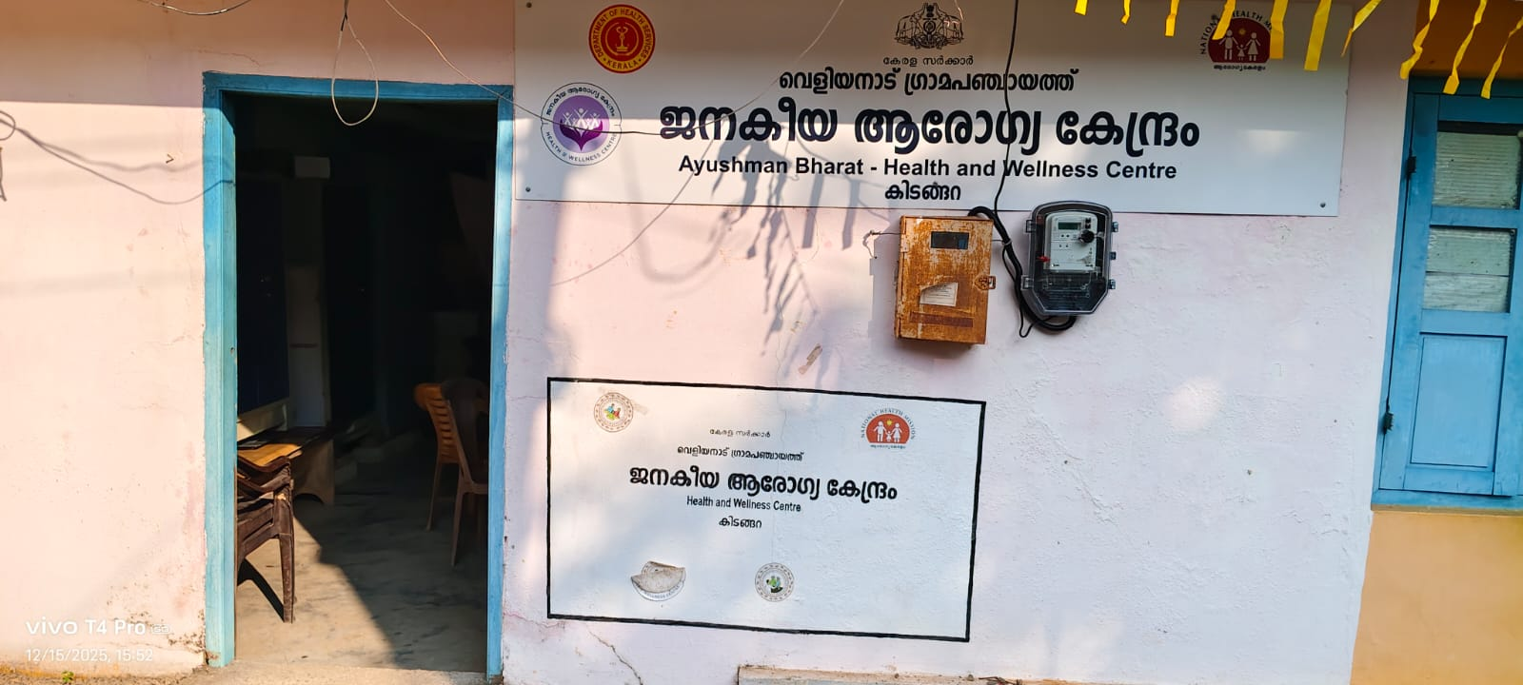

PANDEMIC PREPAREDNESS PLAN OF VELIYANAD G.P

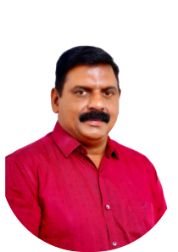
MESSAGE FROM PRESIDENT/CHAIR LSGI

പ്രിയമുള്ള ഗ്രാമ പഞ്ചായത്ത് നിവാസികളേ....
നമ്മുടെ പ്രദേശത്ത് ഉണ്ടായേക്കാവുന്ന പ്രകൃതിദുരന്ത സാധ്യതകളുടെ പശ്ചാത്തലത്തിൽ എല്ലാവരും ജാഗ്രത പാലിക്കുകയും ചെയ്യണമെന്ന് അഭ്യർത്ഥിക്കുന്നു...
ശക്തമായ മഴ, വെള്ളപ്പൊക്കം, കാറ്റ് തുടങ്ങിയ സാഹചര്യങ്ങളിൽ അനാവശ്യ യാത്രകൾ ഒഴിവാക്കുകയും അധികൃതരുടെ നിർദേശങ്ങൾ കർശനമായി പാലിക്കുകയും ചെയ്യണമെന്ന് അറിയിക്കുന്നു.
വീടുകളുടെ സുരക്ഷ ഉറപ്പാക്കുക, വൈദ്യുതി ഉപകരണങ്ങൾ വളരെ ശ്രദ്ധയോടെ ഉപയോഗിക്കുക.അപകട സാധ്യതയുള്ള പ്രദേശങ്ങളിൽ താമസിക്കുന്നവർ മുൻകരുതലുകൾ സ്വീകരിക്കുക. അടിയന്തിര സാഹചര്യം ഉണ്ടായാൽ ഗ്രാമപഞ്ചായത്ത് ഓഫീസുമായും, അതാത് വാർഡിലെ ജനപ്രതിനിധി യുമായോ, അല്ലെങ്കിൽ ബന്ധപ്പെട്ട ദുരന്ത നിവാരണ വിഭാഗങ്ങളുമായി എത്രയും വേഗം ബന്ധപ്പെടുകയും വിവരങ്ങൾ കൈമാറുകയും ചെയ്യണം.
ദുരന്തനിവാരണത്തിനായി പഞ്ചായത്ത് ഭരണസമിതിയും ആരോഗ്യ വിഭാഗം, സന്നദ്ധ പ്രവർത്തകരും സജ്ജരാണെന്ന് അറിയിക്കുന്നു. എല്ലാവരുടെയും സഹകരണത്തോടെ മാത്രമേ ഈ സാഹചര്യം സുരക്ഷിതമായി അതിജീവിക്കാൻ കഴിയൂ.
നമ്മൾ എല്ലാവരും ഒരുമിച്ച് ജാഗ്രതയോടെ നിന്നാൽ ജീവനും സ്വത്തിനും നഷ്ടം ഒഴിവാക്കാൻ കഴിയും എന്ന് വിനയപൂർവ്വം അറിയിക്കുന്നു..

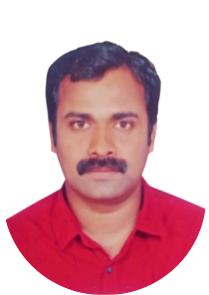
MESSAGE FROM HEALTH STANDING COMMITTEE CHAIR

ഈ സന്ദേശം എല്ലാവർക്കും ആശ്വാസവും പ്രോത്സാഹനവും സുരക്ഷാബോധവും നൽകുന്നതാണ്. നമ്മുടെ സമൂഹത്തിൽ ദുരന്തങ്ങൾ പലപ്പോഴും അപ്രതീക്ഷിതമായി സംഭവിക്കുന്നതിനാൽ, അവബോധവും തയ്യാറെടുപ്പും അത്യന്തം നിർണായകമാണ്.
അടിയന്തര സാഹചര്യങ്ങൾ നേരിടാൻ വ്യക്തിഗതവും സമൂഹാത്മകവുമായ ഒരുക്കങ്ങളോടൊപ്പം, ആരോഗ്യ സംരക്ഷണ സംവിധാനങ്ങൾ ശക്തിപ്പെടുത്തേണ്ടതിന്റെ പ്രാധാന്യം കൂടുതലാണ്. ഈ കാലഘട്ടത്തിൽ എല്ലാവരും സുരക്ഷാ മാനദണ്ഡങ്ങളും ആരോഗ്യ നിർദേശങ്ങളും കൃത്യമായി പാലിക്കണമെന്ന് അഭ്യർത്ഥിക്കുന്നു.
സമൂഹത്തിന്റെ സുരക്ഷയും ക്ഷേമവും ഉറപ്പാക്കാൻ സഹകരണത്തോടെയും ഏകതയോടെയും പ്രവർത്തിക്കാം എന്ന വിശ്വാസത്തോടെ,
ആരോഗ്യ സ്റ്റാൻഡിങ് കമ്മറ്റി ചെയർപേഴ്സൺ


MESSAGE BY MEDICAL OFFICER

Community Health Centre (CHC) Veliyanad serves as the frontline of healthcare delivery at the grassroots level during public health emergencies, including pandemics. Active community participation is vital in preventing the spread of diseases. By staying informed and supporting public health initiatives, we can collectively safeguard our families and the wider community.
CHC Veliyanad is well-prepared to address such challenges through established safety protocols and systematic measures, including planning and coordination by the Rapid Response Team, local inter-sectoral collaboration, early detection, surveillance, reporting, contact tracing, adequate infrastructure and essential supplies, risk communication and awareness activities, and an effective vaccination strategy.
The greatest strength of CHC Veliyanad lies in the strong partnership between healthcare workers, local self-government institutions, and the community. Now, more than ever, it is essential that we work together with unity and commitment to effectively respond to any health challenges that may arise.
Medical Officer
CHC Veliyanad

EXECUTIVE SUMMARY

Veliyanad Community Health Center functions as the secondary public healthcare institution serving the population of Veliyanad Grama Panchayath. The Community Health Center plays a pivotal role in delivering comprehensive, accessible, and affordable healthcare services, with a strong focus on preventive, promotive, curative, and rehabilitative care in accordance with national and state health programmes.
The Community Health Center caters to a predominantly rural population, addressing key public health priorities such as maternal and child health, communicable and non-communicable disease control, immunization, family welfare, adolescent health, and geriatric care. Regular outpatient services, home-based care through field health staff, and outreach activities ensure healthcare coverage even in geographically challenging areas. The institution actively implements national health missions, including the National Health Mission (NHM), National Tuberculosis Elimination Programme, National Programme for Prevention and Control of Cancer, Diabetes, Cardiovascular Diseases and Stroke (NPCDCS), and other disease surveillance initiatives.
Veliyanad Community Health Center (CHC) works in close coordination with the Grama Panchayath, ASHA workers, Anganwadi centres, schools, and community-based organizations to strengthen community participation and improve health awareness. Emphasis is placed on early detection, timely referral, health education, and lifestyle modification to reduce disease burden and improve overall health outcomes.
Despite constraints related to infrastructure, manpower, and increasing service demand, the CHC continues to enhance service delivery through effective planning, data-driven decision-making, and community engagement. Strengthening facilities, upgrading digital health systems, and expanding preventive services remain key focus areas for future development.
Overall, Veliyanad Community Health Centre stands as a vital institution in safeguarding public health and improving the quality of life of the residents of Veliyanad Grama Panchayath.

LIST OF ABBREVIATIONS

LSGD/LSGI | Local Self Government Department / Local Self Government Institution
BMO | Block Medical Officer
IDSP | Integrated Disease Surveillance Programme
NDMA | National Disaster Management Authority
PPE | Personal Protective Equipment
ICMR | Indian Council of Medical Research
CD | Communicable Diseases
NCD | NON-COMMUNICABLE Diseases

TABLE OF CONTENTS

INTRODUCTION 10
LSGD AT A GLANCE 11
INTEGRATED HEALTH INFRASTRUCTURE MAP OF VELIYANAD GRAMA PANCHAYAT 14
GENERAL PROFILE OF THE LSGI’S 15
Background of the LSGI 15
Demographic and Vulnerable Population 17
Clinical Vulnerability 18
INFRASTRUCTURE & RESOURCE INVENTORY 20
Health Facility Directory & Basic Capacity in the LSGD 20
Private Clinics 21
Healthcare Education & Training Institutions 21
Specialized Services & Emergency Inventory 22
Oxygen & Diagnostic Capacity 23
Diagnostics facility mapping at the LSGI level 24
Laboratory Identification & Basic Details 24
Social and Community Infrastructure for surge plan 25
Human resources 27
Community & Support Cadre 29
Community Organizations 30
Administrative & Emergency Services 31
Information regarding resources 31
ONE HEALTH & ENVIRONMENTAL SURVEILLANCE 33
Animal & Bird Population 33
Veterinary Infrastructure 34
Veterinary Doctors & Workforce 35
High-Risk Interface Points (Surveillance Sites) 36
Environmental Risk Mapping 39
Disease Seasonality Mapping 40
Vulnerability Mapping 41
EPIDEMIOLOGICAL TRENDS (2021–2025) 43
Disease Burden among human beings(Last 5 Years) 43
Seasonal Trend Analysis 46
Outcome-Based Trend Analysis- 2025 51
Transmission Trend- 2025 54
Integrated Disease Hotspot Map (2021–2025) 60
Preparedness and Response Protocol at LSG Level 63
Constitution of One Health Committee 63
Pandemic Response Workforce 64
Activities and Measures before and during Pandemic 66
PHASE 1 - Alert / Preparation 66
PHASE 2 - Active Response 69
Standard Screening Protocol 70
PHASE 3 - Surge Capacity 80
Conversion of Community Facilities 80
CONCLUSION 82
RECOMMENDATIONS 83
ANNEXURE 85
1. IMPORTANT PHONE NUMBERS 85

INTRODUCTION

Veliyanad Grama Panchayath, situated under Kuttanad Taluk of Alappuzha District, is a region with unique geographical and socio-environmental characteristics. The low-lying terrain, frequent waterlogging, seasonal flooding, high population density, and dependence on agriculture and inland water systems make the area particularly vulnerable to the rapid spread of communicable diseases. Past public health emergencies, including outbreaks of dengue, leptospirosis, COVID-19, and other vector- and water-borne diseases, have highlighted the need for systematic preparedness and timely response mechanisms at the local level.
A Pandemic Preparedness Plan is essential to ensure early detection of disease outbreaks, effective coordination among health institutions, local self-government departments, and allied sectors, and uninterrupted delivery of essential health and social services during public health emergencies. Preparedness enables Veliyanad Grama Panchayath to strengthen surveillance, improve risk communication, ensure resource readiness, and protect vulnerable populations such as the elderly, children, persons with chronic illnesses, and economically disadvantaged groups.
In view of the increasing frequency of emerging and re-emerging infectious diseases and the lessons learned from recent pandemics, it is imperative for Veliyanad Grama Panchayath to develop a comprehensive, department-wise pandemic preparedness plan. Such a plan will enhance resilience, minimize health and economic impacts, and ensure a coordinated, community-based response to future public health emergencies

LSGD AT A GLANCE
- Geographical boundaries with political map ( based on latest delimitation)
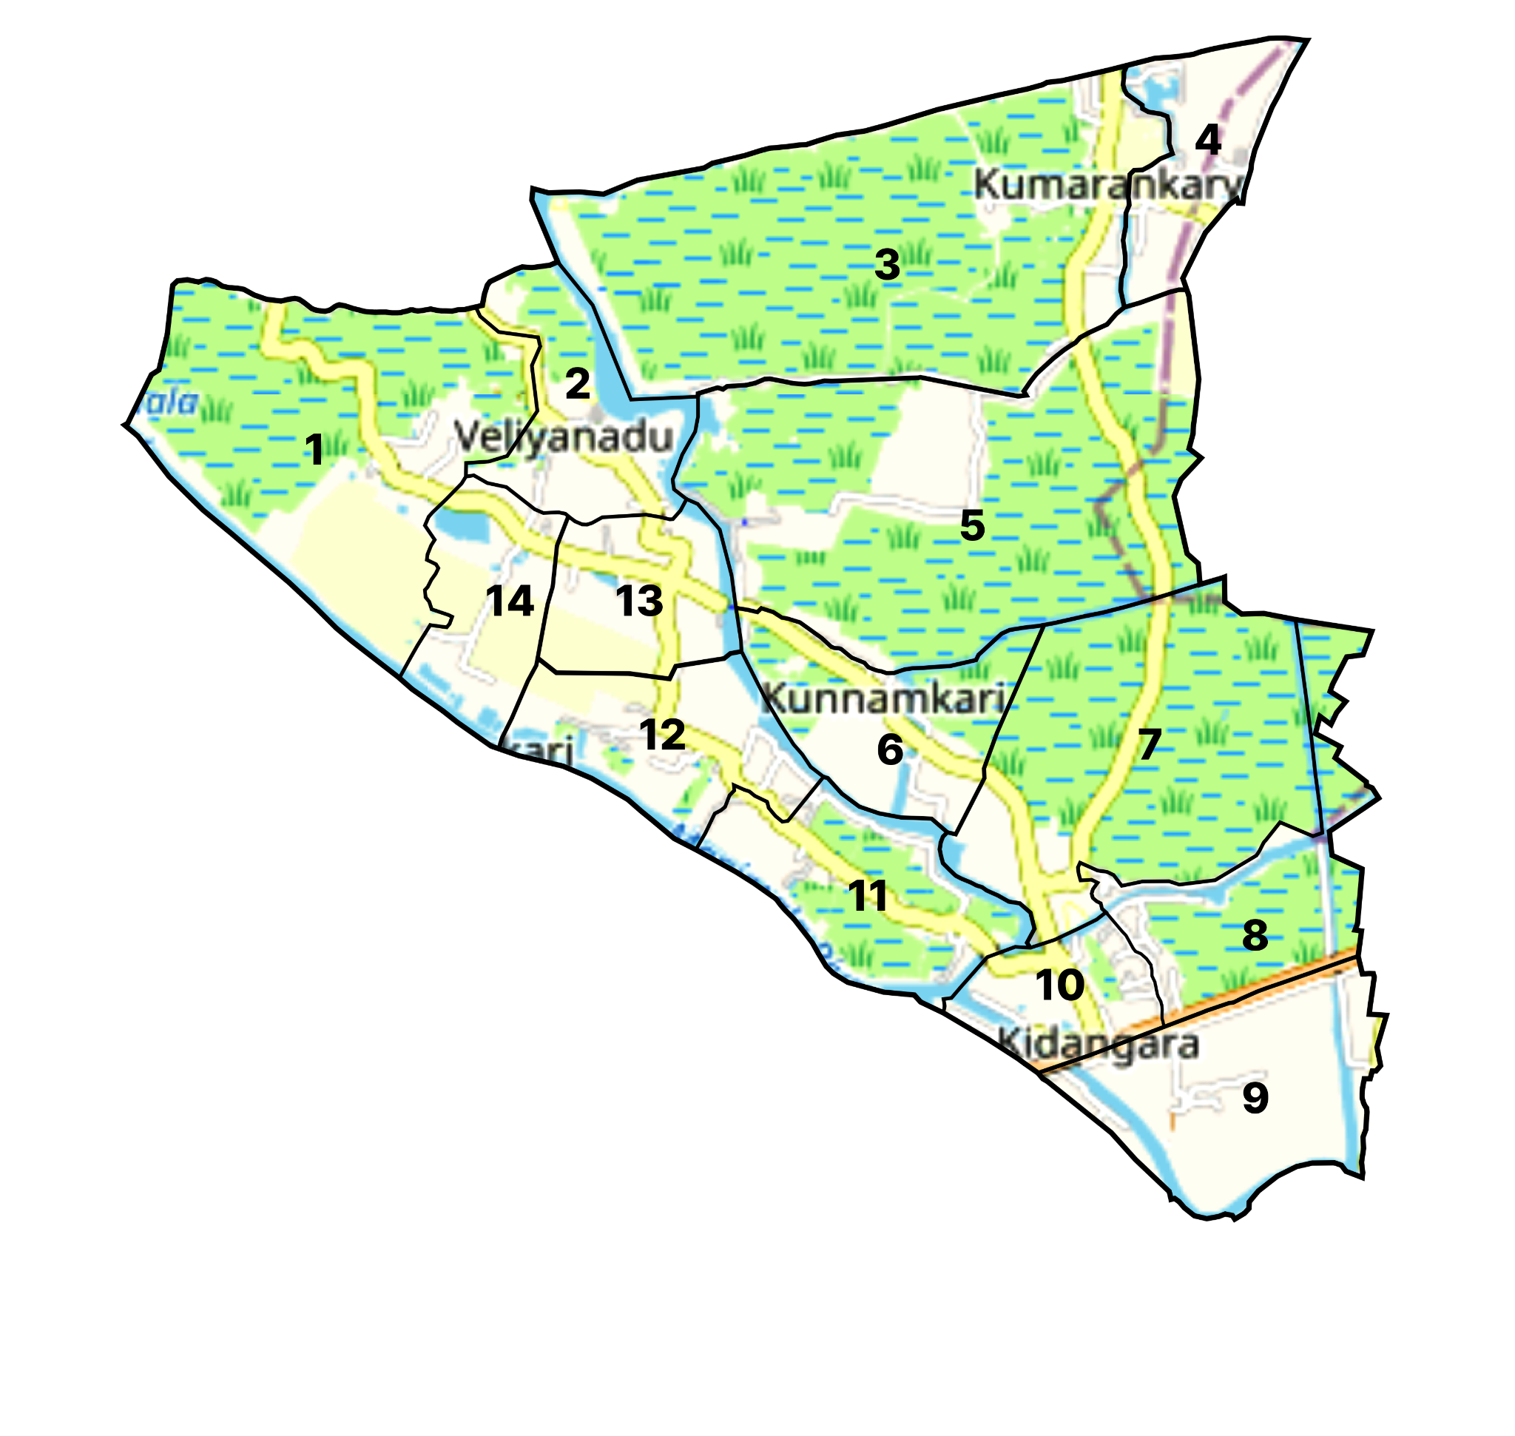
- Baseline data
- Ward division -
Ward | Houses | Population | Migrant Camps | Wells | Hot spots | Ed. Institutions | Hosp pvt/govt.
1 | 190 | 775 | 0 | 52 |  | 1 | 0
2 | 261 | 1072 | 1 | 65 |  | 0 | 0
3 | 164 | 765 | 0 | 67 |  | 0 | 0
4 | 210 | 1010 | 0 | 70 |  | 0 | 0
5 | 210 | 989 | 0 | 22 |  | 2 | 0
6 | 251 | 1010 | 0 | 16 |  | 1 | 0
7 | 280 | 1252 | 4 | 39 | Flood prone area | 2 | 0
8 | 305 | 1237 | 0 | 72 | More c.d reported, Rubber industry with migrants | 0 | 0
9 | 333 | 1361 | 3 | 27 | More c.d reported, poultry farm presented | 0 | 1
10 | 219 | 910 | 1 | 40 |  | 1 | 0
11 | 254 | 1010 | 1 | 15 |  | 0 | 0
12 | 226 | 930 | 4 | 56 |  | 0 | 0
13 | 227 | 1080 | 1 | 35 |  | 0 | 0

Ward level vulnerability groups of Veliyanad:

Ward | Aged >/= 60 | Pregnant | Under 5 years | Dialysis patients | Palliative | TB Patients | D.M/H.T or Both | No. of Adolescents (10 to 19 yrs) | Risk Level
1 | 22.5% | 0.1% | 3.6% | 0.1% | 0.1% | 0.0% | 27.4% | 12.4% | High Risk
2 | 19.3% | 0.4% | 4.1% | 0.0% | 0.4% | 0.0% | 21.9% | 11.4% | Moderate Risk
3 | 37.1% | 0.4% | 4.8% | 0.0% | 0.4% | 0.1% | 24.4% | 4.8% | High Risk
4 | 15.8% | 0.3% | 4.7% | 0.0% | 0.6% | 0.0% | 16.3% | 11.4% | Low Risk
5 | 27.5% | 0.1% | 4.2% | 0.1% | 0.8% | 0.0% | 12.3% | 7.9% | High Risk
6 | 21.6% | 0.5% | 4.2% | 0.2% | 1.0% | 0.1% | 41.6% | 5.3% | High Risk
7 | 16.5% | 0.0% | 4.3% | 0.2% | 1.2% | 0.0% | 20.2% | 13.7% | High Risk
8 | 19.1% | 0.3% | 4.6% | 0.0% | 1.2% | 0.1% | 29.6% | 11.6% | High Risk
9 | 18.5% | 0.1% | 4.6% | 0.0% | 0.4% | 0.0% | 26.2% | 12.6% | High Risk
10 | 21.3% | 0.2% | 5.3% | 0.0% | 0.3% | 0.1% | 28.9% | 11.9% | High Risk
11 | 19.5% | 0.3% | 5.2% | 0.0% | 0.3% | 0.0% | 27.1% | 11.8% | High Risk
12 | 22.4% | 0.3% | 4.6% | 0.0% | 0.4% | 0.0% | 21.1% | 11.9% | Moderate Risk

INTEGRATED HEALTH INFRASTRUCTURE MAP OF VELIYANAD GRAMA PANCHAYAT
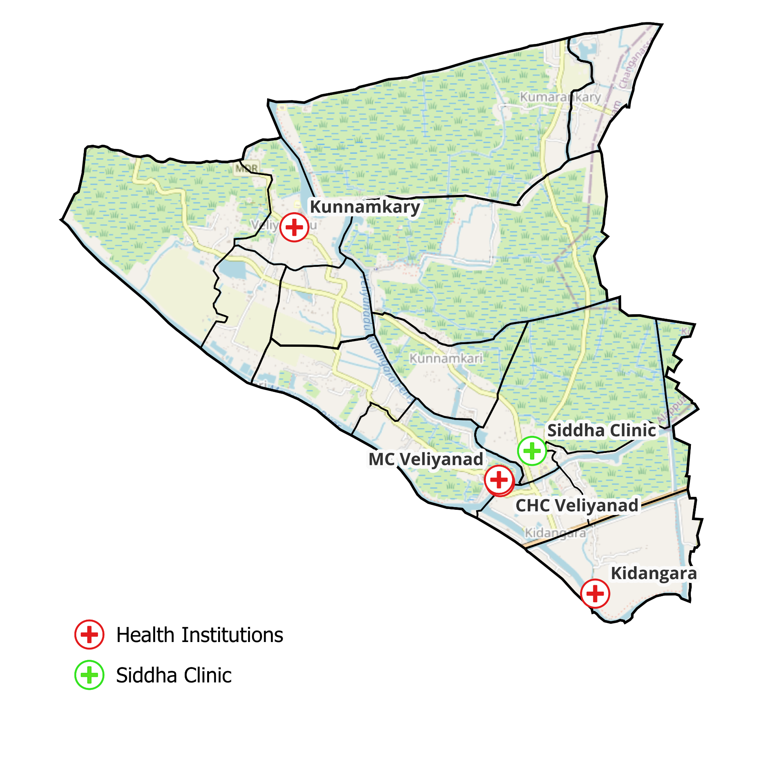

GENERAL PROFILE OF THE LSGI’S

Background of the LSGI
Veliyanad Grama Panchayat is situated in the Kuttanad Taluk of Alappuzha district, Kerala. Veliyanad Gram Panchayath serves as the elected local government body responsible for civic administration, local development, infrastructure, sanitation, welfare schemes, and other community services within its jurisdiction under the supervision of the LSGD.
The Panchayath consists of multiple wards, each represented by an elected member. These members collectively form the council that makes decisions on local issues and development plans.
- According to historical records in Malayalam sources, Veliyanad Grama Panchayath was established on 18 July 1953 as a local body in Alappuzha district. It covers an area of about 19.41 km² and has a population that has grown over decades.
- This formation predates the statewide reorganisation of local governance under the Kerala Panchayat Raj Act, but later was integrated into the modern Panchayat system after the 1990s decentralisation reforms.
- The Panchayath is headed by a President (elected representative) and supported by ward members elected during periodic LSGD elections held every five years.
- It functions under the broader policy, oversight, and administrative framework of the Local Self Government Department (LSGD), which manages all rural and urban local bodies in Kerala.
- Veliyanad Gram Panchayath is part of the Veliyanad Block Panchayath, which in turn falls under the Alappuzha District Panchayath. This nested structure enables coordination from village to district level in planning and implementing development programmes.
- The LSGD facilitates decentralised governance, including financial devolution, service delivery (like sanitation, roads, water supply coordination), and community welfare schemes through these local bodies.
- As the Panchayath of a rural area in Kuttanad, which is known for its backwaters and paddy cultivation, Veliyanad’s local governance includes addressing agricultural issues, village-level infrastructure and public services, and welfare schemes for its residents.
- The Panchayath undertakes annual plans and development projects through funds provided by the state’s decentralisation programme and its internal revenue.

Table 1: Background of LSGD
Description | Details
Name of LSGI | Veliyanad
Type (GP/Municipality / Corporation etc.) | Grama Panchayath
Block | Veliyanad
District | Alappuzha
Number of wards | 13
Total area (sq. km) | 19.41 square kilometers
Population(Projected) | 13,515 people.
Population density | 12,501/19.41 = 644
Terrain (coastal/low-lying/backwaters/foothills, etc.) | Low-Lying area
Number of rivers passing through LSGI | 2
Number of water bodies in the LSGI | 12
Number of educational institutions | 8
Factories / small-scale industries | 1
Flood-prone wards | 1,2,3,4,5,6,7,8,9,10,11,12,13,14
Landslide-prone wards | 0
Death Management and Disposal Facilities (mortuaries/crematorium, including electric) | 2
Auditoriums/Marriage halls/convention centres/community halls | 1

Demographic and Vulnerable Population
Understanding the demographic composition and vulnerable population groups is essential for pandemic preparedness. Children, elderly, economically deprived families, migrant workers, and socially vulnerable groups are at increased risk during public health emergencies due to higher exposure, limited access to services, and dependency on public systems..

Description |  | Details (in numbers)
DEMOGRAPHIC PROFILE
Total population |  | 11692
Male |  | 5765
Female |  | 5926
Transgender |  | 1
Children under 5 |  | 1473
Adolescent |  | 1609
Elderly (>60) |  | 6953
SOCIAL/LIVELIHOOD VULNERABILITY
Previous EPEP family |  | 12
BPL family |  | 1844
Tribal communities |  | 0
Migration | Immigrant | 132
Migration | Emigrant | 812
Socio-economically deprived |  | 97
Fisherfolk |  | 220
SC Community |  | 1651
ST Community |  | 7

Graphs: Population pyramid (if possible) for seeing if your LSGI has a high "dependency ratio" (lots of children and elderly compared to working adults).

Clinical Vulnerability
Certain population groups needs priority healthcare & are at higher risk of severe illness, complications, and mortality during pandemics. Patients with chronic diseases, those requiring regular medical care, and individuals with mobility or functional limitations face challenges in accessing timely care during emergencies. Mapping these groups helps in prioritizing continuity of treatment, medicine stock planning, oxygen support, referral transport, and targeted home-based care.
Description | Details in numbers
Pregnant women | 65
Lactating mothers | 98
Bedbound patients | 60
Patients under palliative care other than bedbound | 165
Patients on Haemodialysis | 6
Patients on CAPD | 8
Cancer patients (currently on treatment) | 29
Haemophilic patients | 0
Mentally challenged | 46
Differently abled | 69
Diabetic patients | 694
Hypertensive patients | 1486
TB patients | 4

Major Festivals & Events specific to the LSGI
(with the possibility of a public gathering)

Sl. No. | Name of festival | Month detailing the periodicity
1 | Kuttanadan Vallam Kali | Last month of November

INFRASTRUCTURE & RESOURCE INVENTORY

Health Facility Directory & Basic Capacity in the LSGD
This section provides an overview of the healthcare infrastructure available within the LSGD area. It outlines the distribution and basic capacity of health facilities that form the backbone of service delivery during routine times and public health emergencies.

Family Health Centres (FHCs) and Community Health Centres (CHCs) generally function as the first point of contact for the community, providing essential outpatient and inpatient services. General Hospitals (GH) and Medical College Hospitals (MCH), where accessible, serve as the main referral centres for advanced diagnostics, specialist care, and critical services during public health emergencies. This inventory helps identify existing strengths, gaps, and potential surge capacity that can be mobilised during a pandemic or disaster.

Table 5. Health Facility Resource Summary
Sl.no. | Health Facility | Type of Facility (MCH/GH/CHC/FHC/SC etc.) | Contact Number | Total beds | ICU Beds | Oxygen-Supported Beds | No. of Ventilator Support Beds | No. of ambulances
Government Healthcare Facilities
1 | CHC Veliyanad | CHC | 9446194099 |  | 0 | 1 | 0 | 1
2 | MC Veliyanad | SC | 9446793927 | 0 | 0 | 0 | 0 | 0
3 | Kidangara | SC | 8921676160 | 0 | 0 | 0 | 0 | 0
4 | Kunnamkary | SC | 8921539097 | 0 | 0 | 0 | 0 | 0

Kidangara Subcenter

Private Clinics
Private clinics are an essential part of pandemic preparedness, as they are often the first place people seek care when symptoms begin. In many communities, private clinics manage a significant share of outpatient visits and therefore play a critical role in early case detection, timely referrals, and disease surveillance. Having an up-to-date understanding of where these clinics are located, the services they provide, and how they are linked to the public health system helps ensure that no cases are missed during an outbreak. It also allows health authorities to engage private practitioners more effectively for reporting, risk communication, and coordinated response, strengthening the overall capacity of the health system to manage public health emergencies.

Table 6. Private Clinic Resource Summary
Sl No. | Name of Clinic | Registered (Y/N) | Clinic (General / Speciality) | Speciality (if any) | Address | Contact Number | Diagnostic Facility (Y/N) | Ambulance Linkage (Y/N)
1 | Asta Dental Clinic | Y | Speciality | Dental | Kidangara |  | Y | N

Healthcare Education & Training Institutions
This section tracks the educational infrastructure available, which is vital for human resource planning in the health sector.

Category of Institution | Govt | Private | AYUSH | Total
Medical Colleges | 0 | 0 | 0 | 0
Nursing Colleges | 0 | 0 | 0 | 0
Dental Colleges | 0 | 0 | 0 | 0
Para-medical / Allied Health | 0 | 0 | 0 | 0
Pharmacy Colleges | 0 | 0 | 0 | 0

Specialized Services & Emergency Inventory
This section provides a detailed view of the specialized medical resources available to the community, focusing on emergency response and critical care capabilities. This table tracks the vital assets required for managing severe illnesses and emergencies across Government, Private, and AYUSH sectors.

Item | Govt | Private | AYUSH | Total
Hospital beds | 0 | 0 | 0 | 0
Oxygen-generating systems(Y/N) | N | N | N | N
Oxygen-supported beds(Numbers) | 1 | 0 | 0 | 1
Ventilator-supported beds | 0 | 0 | 0 | 0
ICU beds | 0 | 0 | 0 | 0
Burns units | 0 | 0 | 0 | 0
Blood centres | 0 | 0 | 0 | 0
BLS ambulances | 1 | 0 | 0 | 1
ALS ambulances | 0 | 0 | 0 | 0
Dialysis facilities | 0 | 0 | 0 | 0
Dispensaries | 0 | 0 | 0 | 0
Medical store | 1 | 0 | 0 | 1
Industrial establishments(Medium-scale industries/small-scale industries establishments to whom we can depend in a worst-case scenario) | 0 | 1 | 0 | 1

Oxygen & Diagnostic Capacity
Monitoring oxygen and diagnostic capacity is a critical component of public health preparedness, ensuring that the LSGD can handle both chronic care and sudden surges in respiratory or infectious diseases.
Name of Health Facility | Oxygen-generating System (Y/N) | Backup Oxygen Source (Y/N) | Diagnostic Facilities Available(Y/N)
Name of Health Facility | Oxygen-generating System (Y/N) | Backup Oxygen Source (Y/N) | Lab | USG | X-ray | CT/MRI | RT-PCR
Government Healthcare Facilities
CHC Veliyanad | N | Y | Y | N | N | N | N
MC Veliyanad | N | N | N | N | N | N | N
Kidangara | N | N | N | N | N | N | N
Kunnamkary | N | N | N | N | N | N | N

Diagnostics facility mapping at the LSGI level
The diagnostic capacity of Veliyanad G.P represents the "intelligence network" of our healthcare system. The speed and accuracy of disease identification depend entirely on the distribution and technical level of these facilities.

Item | Govt | Private | AYUSH | Total
General labs | 1 | 3 | 0 | 4
Microbiology labs | 0 | 0 | 0 | 0
RT-PCR labs | 0 | 0 | 0 | 0
USG units | 0 | 0 | 0 | 0
CT/MRI units | 0 | 0 | 0 | 0
Research labs | 0 | 0 | 0 | 0
Labs of other departments that can be repurposed | 0 | 0 | 0 | 0

Laboratory Identification & Basic Details
Sl. No. | Name of Laboratory | Ownership (Govt / Private / Academic) | Address | Contact No. | 24×7 Services (Yes/No) | NABL / Govt Approved (Yes/No)
1 | CHC Veliyanad | Govt | Kurishumudu, Veliyanadu | 9497780827 | N | Y
2 | Health Care Lab | Private | Kidangara,Kidangara P.O | 8547546943 | N | Y
3 | Amala Lab | Private | Kurishumudu, Veliyanadu | 8289929413 | N | Y
4 | Ponni Lab | Private | Kurishumudu | 9895774093 | N | Y

Social and Community Infrastructure for surge plan
This table serves as our logistics and shelter inventory. By mapping these locations, quickly we can identify where to house displaced citizens, where to set up temporary medical clinics, and how to manage the deceased with dignity during a crisis.

Category | Total Count | Ward | Est. Capacity (Persons) | Contact details
Educational Institutions
Anganwadis | 18 | All | 100 | 9895774093
Schools | 5 | 1,2,8,9 | 300 | 9447569629
Colleges | 0 | 0 | 0 | 0
Healthcare Educational Institutions
Medical colleges (Govt/Private) | 0 | 0 | 0 | 0
Nursing colleges (Govt/Private) | 0 | 0 | 0 | 0
Dental colleges (Govt/Private) | 0 | 0 | 0 | 0
Paramedical institutes (Govt/Private) | 0 | 0 | 0 | 0
Community Gathering Spaces
Community halls | 1 | 9 | 80 | 9495558734
Auditoriums | 1 | 11 | 380 | 9446273670
Religious buildings | 1 | 9 | 45 | 9562835766
Vulnerable Group Support Facility
Destitute homes | 0 | 0 | 0 | 0
Elderly homes | 0 | 0 | 0 | 0
LSGD owned other buildings | 0 | 0 | 0 | 0
Mass Fatality Management (MFM) Infrastructure
Mortuary | 0 | 0 | 0 | 0
Crematorium | 1 | 7 |  | 9400427360
*refer annexure 1 for contact details

Human resources
This section focuses on the human capital available within the LSGI. In any emergency—be it a pandemic, flood, or industrial accident—infrastructure is only as effective as the people operating it.

Medical & Clinical Personnel
This table tracks the "Frontline" providers responsible for diagnosis, treatment, and clinical management. Narrative sentence: eg., "Total health workforce: 450 personnel, with 60% in government facilities serving as primary surge capacity." A detailed directory with the contact numbers of all workers is maintained (Annexure in 1).

Cadre | Govt (No.) | Private (No.) | Total
Doctors—Modern Medicine | 4 | 0 | 4
Doctors – AYUSH | 0 | 0 | 0
Doctors – Veterinary | 1 | 0 | 1
Doctors – Dental | 0 | 2 | 2
Nursing officers | 4 | 0 | 4
Lab technicians | 2 | 2 | 4
Optometrist | 0 | 0 | 0
Pharmacists | 2 | 0 | 2
Psychologists | 0 | 0 | 0
Counsellors | 1 | 0 | 1

Public Health & Field-Level Workforce
These individuals are the backbone of surveillance, maternal-child health, and decentralized care.

Cadre | Health services | Municipal common services | Total
HS (Health Supervisors) | 1 | 0 | 1
HI (Health Inspectors) | 1 | 0 | 1
LHS (Lady Health Supervisor) | 1 | 0 | 1
LHI (Lady Health Inspectors) | 1 | 0 | 1
JPHN (Jr Public Health Nurses) | 7 | 0 | 7
JHI (Jr Health Inspectors) | 5 | 0 | 5
MLSP (Mid-Level Service Providers) | 7 | 0 | 7
Palliative Nurses | 1 | 0 | 1
RBSK Nurses | 0 | 0 | 0
PRO | 1 | 0 | 1
Epidemiologist | 1 | 0 | 0
Data Manager | 1 | 0 | 1

Community & Support Cadre
This group represents the surge capacity of the LSGI—people who can be called upon for logistics, rescue, and specialized support.

Cadre | Number
ASHA Workers | 13
AWW (Anganwadi Workers) | 18
Emergency Medical Volunteers (Trained) | 0
Kudumbashree | 182(2200members)
MNREGS | 39(1600 workers)
Purusha Swayam Sahaya Sangham | 0
Ex-Servicemen | 39
Retired Police Officers | 29
NCC/NSS Volunteers | 69
Red Cross volunteers | 0
One Health Community Volunteers | 637
One Health Community Mentors | 91

Community Organizations
This section details the presence of community-based organisations (CBOs), non-governmental organisations (NGOs), faith-based organisations (FBOs), Kudumbashree Self-Help Groups (SHGs), and Ayalkootams within the Local Self-Government Institution (LSGI). These groups enhance grassroots mobilization, resource distribution, and support networks crucial for pandemic response and community resilience.

Category | Total Count
NGOs | 0
Religious based organizations | 3
Foreign based organizations | 0
Sports Club/youth clubs | 2
Kudumbashree SHGs | 2
Ayalkootams | 182
Political organizations | 4
Residential organizations | 2

Administrative & Emergency Services
This section outlines the availability of key non-health emergency support services and infrastructure within the LSGI, which are essential for effective pandemic preparedness and response. These facilities support law enforcement, disaster response, water supply, logistics, mobility, and community-level interventions during public health emergencies.

Category | Total Count | Contact details
Police Stations | 1 | 0477-2705532
Fire & Rescue Stations | 0
Water Pumping Points | 1 | 9645866942
Public Distribution System (PDS) | 5 | 9496401682

Information regarding resources
The availability of essential transport and support resources plays a quiet but critical role in saving lives. Equipment such as ambulances, mobile mortuaries, amphibian ambulances, and motorized boats ensures that patients, samples, and healthcare teams can move swiftly—even in flooded, remote, or difficult terrains. Heavy vehicles like JCBs, cranes, tractors, and torus lorries support logistics, waste management, emergency infrastructure, and rapid conversion of spaces into care or isolation facilities. Taxis, four-wheel-drive vehicles, and trucks help maintain continuity of essential services, reach vulnerable populations, and support home-based care and supply delivery.

Means of transportation | Total Count
JCB | 0
Crane | 0
Heavy Trucks | 0
Tractor | 2
Ambulances | 1
Mobile mortuaries | 0
Boats | 3
Taxi service | 5
Note: For specific details regarding vehicle owners and contact information, please refer to Annexure [X].

ONE HEALTH & ENVIRONMENTAL SURVEILLANCE
The One Health method integrates environmental, animal, and human health to enable proactive pandemic preparedness. Panchayat-level surveillance needs to be improved in order to detect and treat zoonotic and environmentally generated diseases early. Surveillance is strengthened through systematic assessment of animal populations, veterinary infrastructure, poultry and slaughter facilities, inter-sectoral coordination, and specialised tools like avian influenza seasonality mapping using GIS in previous outbreaks to enable predictive alerts and ward-specific sampling to support effective pandemic preparedness in high-risk wards like 3,5,7,6,10.

Animal & Bird Population
Mapping animal and bird populations at the Panchayat level is essential for identifying and prioritising zoonotic disease hazards like rabies, avian influenza (H5N1), leptospirosis, anthrax, and Nipah-like spillover occurrences. Risk classification, targeted surveillance, vaccination planning, and early epidemic detection made feasible by comprehensive population mapping all enhance One Health-based pandemic preparedness.

Category | Item | Estimated Population | Wards
Animal Population | Livestock (Cattle/Goats/Buffalo) | 126 | 5,8 6
Animal Population | Pet Animals (Dogs/Cats) | 211 | 1,3,7,9,10
Animal Population | Stray Dog Population | 180 | All wards
Animal Population | Pig Farms (Number of heads) | 0 | 4, 10
 | Small Units (Sheep / Goats – clustered) | 1 | 5
Bird Population | Poultry Units (Birds) | 7 | 4,5,7
Bird Population | Poultry- (FOWL) | 0
Bird Population | Wild/Migratory Birds (Observed) | 0
Bird Population | Crow Mortality Events (Reported) | 0

The main risk of zoonotic diseases in Veliyanad is concentrated in Ward 3,5,6,7,10, which is explained by the high density of pig farms, cattle congregation areas, and poultry units. The stray dog population in market areas, fish landing sites, bus stations continues to be a substantial problem for rabies surveillance and bite prevention. There is a considerable risk of avian influenza introduction and amplification during November - December due to the seasonal presence of migratory and resident water birds near ponds/ canal / river / backwater / paddy field. Clusters of pig farms and animal shelters vulnerable to flooding further raise the risk of leptospirosis and other zoonoses mediated by the environment, especially during monsoon floods.

Veterinary Infrastructure
Veterinary institutions are a core pillar of One Health surveillance, enabling early zoonotic disease detection through vaccination, investigation of unusual animal illness or deaths, sample collection, and timely outbreak reporting. A well-mapped and responsive veterinary network strengthens coordination with human health and LSGI systems, ensuring rapid response during zoonotic events and pandemics.
Facility Type | Name of Facility | Ownership Govt / Pvt | Location(Ward No) | Contact number
Veterinary Dispensary | 0 | 0 | 0
Veterinary Hospital / Polyclinic | Vetenery Hospital Kidangara | Govt | 8
Private Veterinary Clinics | 0 | 0 | 0
Mobile / Emergency Vet Service (incl. night services) | 0 | 0 | 0
Pet Homes / Animal Shelters | 0 | 0 | 0
Slaughterhouse-linked Veterinary Inspection Unit | 0 | 0 | 0

Veterinary Doctors & Workforce
Early detection, diagnosis, reporting, and reaction to animal illness epidemics depend on the availability and accessibility of qualified veterinary specialists. By identifying unusual animal morbidity or mortality promptly, collecting samples promptly, and coordinating efficiently with human health and LSGI systems—especially during zoonotic outbreaks and pandemic-prone situations—a clearly defined veterinary workforce enhances One Health surveillance.

Category | Number Available | Type (Govt/Pvt) | Contact number
Government Veterinary Doctors | 1 | Govt | 9746228120
Private Veterinary Doctors | 0 | 0
Livestock Inspectors | 0 | 0
Para-veterinary Staff / Attenders | 0 | 0
Contract / On-call Veterinary Support (if any) | 0 | 0

High-Risk Interface Points (Surveillance Sites)
High-risk interface points for zoonotic disease surveillance in Veliyanad Grama Panchayath include wetland–livestock–human contact zones, backyard poultry farms, cattle sheds near water bodies, fish markets, and areas of high human–animal interaction such as community slaughter points and migratory bird congregation sites. These are the primary surveillance sites where zoonotic spillover risks are elevated.

Type of Habitat | Type of High risk interface | Geographical vulnerability
Wetlands & Backwaters | 0 | 0
Backyard Poultry Farms | 2 | Near waterbody  Rivershore
Cattle Sheds near Water Bodies | 0 | 0
Fish & Meat Markets | 0 | 0
Community Slaughter Sites | 0 | 0
Migratory Bird Congregation Areas | 0 | 0
Rodent-Infested Grain Storage | 0 | 0

Category | Total Count | Key Locations (wards)
Poultry Farms | 0 | 0
Backyard / Clustered Poultry Units | 0 | 0
Duck Rearing Units (open water access) | 0 | 0
Slaughterhouses/ Slaughter Points | 2 | 9
Meat/Fish Markets | 0 | 0
Live Bird Sale Points | 0 | 0
Cattle Markets / Weekly Animal Fairs | 0 | 0
Pet Shops / Breeders | 0 | 0
Animal Shelters / Pet Homes | 0 | 0
Waste Disposal Sites near Animal Units | 0 | 0

Environmental Risk Mapping
Environmental risk mapping identifies monsoon/flood hotspots for vector-borne (dengue, chikungunya), water-borne (leptospirosis, diarrhoea), and zoonotic diseases in Kerala's wetlands. Systematic surveillance supports early warnings, targeted interventions, and Panchayat pandemic preparedness.
Waterborne exposure: Flood-prone areas and stagnant water bodies facilitate leptospira survival, raising leptospirosis risk.

Traditional practices: Informal slaughter and fish markets lack standardized hygiene, creating spillover opportunities.

Risk Factor | High-Risk Wards | Key Locations | Risk Level (High/Med/Low)
Flood-prone areas | 13 | Almost areas | Med
Water bodies/wetlands | 0 | 0 | 0
Solid waste accumulation | 0 | 0 | 0
Animal waste disposal issues | 0 | 0 | 0
Rodent infestation zones | 0 | 0 | 0
Industrial effluent discharge | 0 | 0 | 0
Construction sites / abandoned buildings | 0 | 0 | 0
Poor drainage/blocked canals | 0 | 0 | 0
Drinking water source contamination risk | 0 | 0 | 0

Disease Seasonality Mapping
1, Flooding & waterlogging → amplifies leptospirosis, malaria, diarrheal diseases.
·
2, Migratory bird influx (Nov–Feb) → avian influenza risk.

3, Mosquito breeding cycles → vector-borne disease peaks in monsoon.

4, Agricultural practices → close human–animal contact in paddy fields.

Disease | Peak Risk Season | Key Drivers | High-Risk Locations | Surveillance Focus
Avian Influenza | November-February | 0 | 0 | Migratory birds and local birds
Leptospirosis | June - September | 0 | Whole Panchayat | Farmers,Diary farmers, NREG,
Dengue/Chikungunya | June-December | 0 | 0 | House surrounding especially key containers
Acute Diarrheal Diseases | June- October | 0 | 0
Rabies | March-May | 0
Anthrax (rare) | 0 | 0 | 0 | 0

Vulnerability Mapping
Vulnerability mapping pinpoints high-risk populations, occupations, and areas exposed via environment, livelihoods, socio-economics, and poor service access. Paired with environmental/seasonality mapping, it enables risk-based surveillance, targeted actions, and optimal resource use in One Health and pandemic planning.
Vulnerability Factor | High-Risk Wards | Key Groups / Locations | Risk Level
Flood-prone households | 13 | 70% of Panchayath area | Medium
Wetland-adjacent communities | 0 | 0 | 0
Backyard poultry / duck rearing households | 0 | 0 | 0
Livestock-rearing households | 0 | 0 | 0
Slaughterhouse & meat market workers | 45
Fisherfolk & fish market workers | 80 | sellers | Low
Sanitation workers | 10 |  | low
Daily wage / migrant workers | 98 | farmers ,coolies | Med
Elderly & chronically ill populations | 2420 | all wards | Med
Pregnant Women | 111 | all wards | low
Children (schools, Anganwadi’s) | 490 | all wards | low
Limited access to safe water & sanitation | 11 wards | all wards | Med

EPIDEMIOLOGICAL TRENDS (2021–2025)

Disease surveillance is the systematic collection, analysis, and interpretation of health data for planning, implementation, and evaluation of public health practice. This section presents the disease surveillance profile of the LSGI based on routine reporting systems and outbreak investigations to identify priority diseases, seasonal patterns, and emerging public health threats.

Disease Burden among human beings(Last 5 Years)
Analysis of disease-wise data for the last five years helps identify persistent public health problems, emerging diseases, and changes in disease burden. This information supports prioritisation of prevention, preparedness, and response activities at the Panchayat level.

Disease | 2021 | 2022 | 2023 | 2024 | 2025 | Trend(Increasing/Stable/Decreasing)
Dengue | 3 | 2 | 11 | 9 | 5 | Decreasing
Leptospirosis | 3 | 3 | 6 | 5 | 4 | Decreasing
Hepatitis A |  | 0 | 0 | 1 | 5 | Increasing
Malaria | 0 | 0 | 0 | 0 | 0 | Stable
Scrub Typhus | 0 | 0 | 0 | 0 | 1 | Stable
Typhoid | 0 | 0 | 0 | 0 | 0 | Stable
H1N1 | 0 | 0 | 2 | 0 | 3 | Fluctuating
H3N2 | 0 | 0 | 1 | 0 | 6 | Increasing
ADD | 22 | 25 | 19 | 33 | 50 | Increasing
Mumps | 0 | 0 | 0 | 2 | 10 | Increasing
Chickenpox | 1 | 2 | 5 | 9 | 12 | Increasing
Hepatitis B | 1 | 0 | 1 | 0 | 0 | Stable
Hepatitis C | 0 | 0 | 0 | 0 | 0 | Stable
Tuberculosis | 5 | 11 | 20 | 13 | 10 | Decreasing
Leprosy | 0 | 0 | 0 | 0 | 0 | Stable
COVID-19 | 0 | 0 | 0 | 0 | 0 | Stable

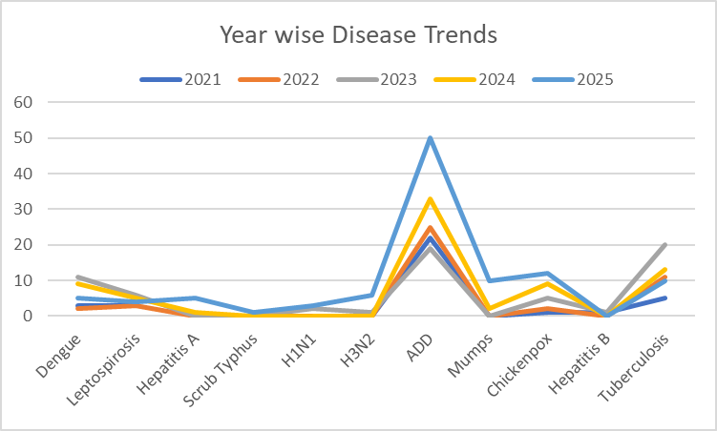

Seasonal Trend Analysis
Seasonal analysis helps anticipate surges (e.g. dengue in monsoon, leptospirosis after floods, influenza in cooler months) and plan pre‑emptive vector control, stockpiling of IV fluids, and awareness campaigns at Panchayat level.

DENGUE
Dengue is a major seasonal vector-borne disease strongly associated with rainfall, water stagnation, and increased mosquito breeding during the monsoon period.

Peak: July–November

Dengue – Ward-wise Yearly Distribution (2021–2025)

Ward | Dengue – Ward-wise Yearly Distribution
Ward | 2021 | 2022 | 2023 | 2024 | 2025 | Total
1 | 0 | 1 | 0 | 1 | 0 | 2
2 | 0 | 0 | 1 | 0 | 0 | 1
3 | 0 | 0 | 1 | 0 | 0 | 1
4 | 0 | 0 | 1 | 1 | 0 | 2
5 | 0 | 0 | 2 | 1 | 0 | 3
6 | 0 | 0 | 1 | 2 | 1 | 4
7 | 0 | 0 | 1 | 1 | 0 | 2
8 | 0 | 0 | 3 | 2 | 3 | 8
9 | 0 | 1 | 0 | 0 | 0 | 1
10 | 1 | 0 | 0 | 0 | 0 | 1
11 | 0 | 0 | 1 | 1 | 1 | 3
12 | 0 | 0 | 0 | 0 | 0 | 0
13 | 0 | 0 | 0 | 0 | 0 | 0

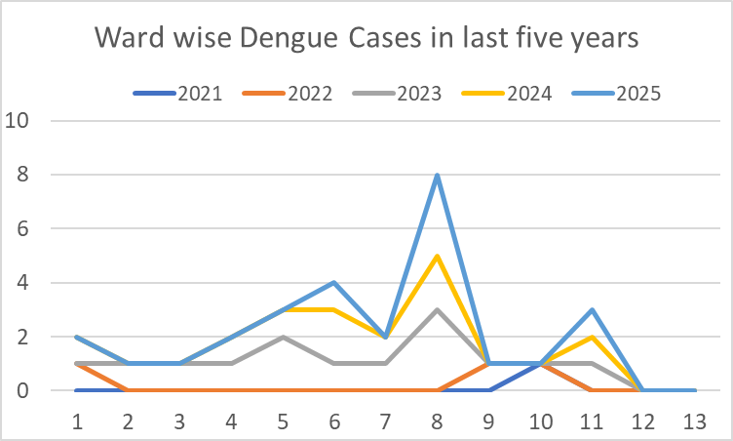

LEPTOSPIROSIS
Leptospirosis cases are closely linked to monsoon rains, flooding, and occupational exposure, particularly in low-lying and waterlogged areas.

Peak: June - August

Leptospirosis – Ward-wise Yearly Distribution (2021–2025)

Ward | Leptospirosis – Ward-wise Yearly Distribution
Ward | 2021 | 2022 | 2023 | 2024 | 2025 | Total
1 | 0 | 0 | 0 | 0 | 0 | 0
2 | 1 | 0 | 0 | 0 | 0 | 1
3 | 0 | 0 | 0 | 1 | 0 | 1
4 | 1 | 0 | 1 | 1 | 1 | 4
5 | 0 | 0 | 1 | 0 | 1 | 2
6 | 0 | 0 | 1 | 1 | 0 | 2
7 | 0 | 2 | 0 | 0 | 0 | 2
8 | 0 | 0 | 1 | 0 | 2 | 3
9 | 1 | 1 | 1 | 0 | 0 | 3
10 | 0 | 0 | 1 | 1 | 0 | 2
11 | 0 | 0 | 0 | 0 | 0 | 0
12 | 0 | 0 | 1 | 1 | 0 | 2
13 | 0 | 0 | 0 | 0 | 0 | 0

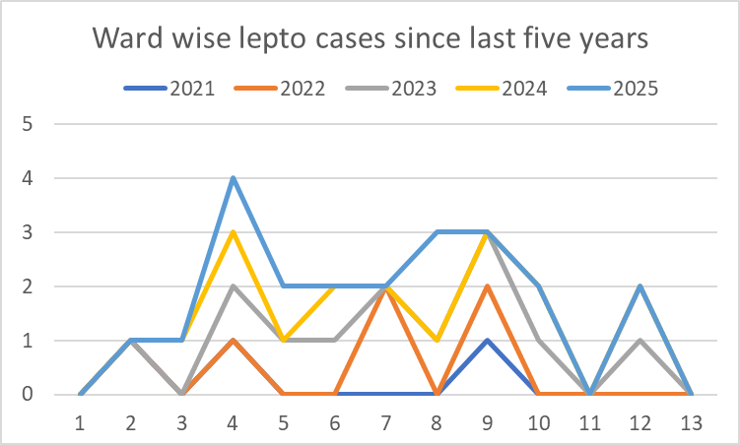

VIRAL HEPATITIS - A
Hepatitis A cases are commonly associated with unsafe drinking water, food contamination, and breakdowns in sanitation, often presenting as clusters or outbreaks.

Peak: October - December

Hepatitis A – Ward-wise Yearly Distribution (2021–2025)

Ward | Hep A – Ward-wise Yearly Distribution
Ward | 2021 | 2022 | 2023 | 2024 | 2025 | Total
1 | 0 | 0 | 0 | 0 | 0 | 0
2 | 0 | 0 | 0 | 0 | 0 | 0
3 | 0 | 0 | 0 | 0 | 0 | 0
4 | 0 | 0 | 0 | 0 | 0 | 0
5 | 0 | 0 | 0 | 0 | 0 | 0
6 | 0 | 0 | 0 | 0 | 0 | 0
7 | 0 | 0 | 0 | 1 | 0 | 1
8 | 0 | 0 | 0 | 0 | 1 | 1
9 | 0 | 0 | 0 | 0 | 0 | 0
10 | 0 | 0 | 0 | 0 | 0 | 0
11 | 0 | 0 | 0 | 0 | 0 | 0
12 | 0 | 0 | 0 | 0 | 0 | 0
13 | 0 | 0 | 0 | 0 | 0 | 0

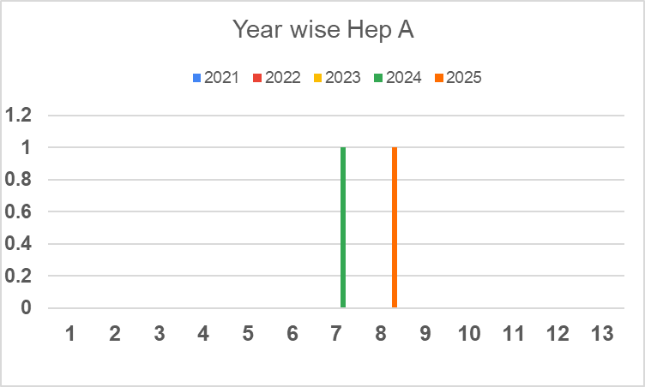

Outcome-Based Trend Analysis- 2025

Sl. No. | Type of disease | Age group | Gender |  | Total no. of survival | Total no. of death | No. of cases received treatment
Sl. No. | Type of disease | Age group | No. of Male | No. of Female | Total no. of survival | Total no. of death | No. of cases received treatment
1 | Dengue | < 20 years | 0 | 1 | 1 | 0 | 1
1 | Dengue | 20 - 59 years | 2 | 1 | 2 | 0 | 3
1 | Dengue | > 60 years | 0 | 0 | 0 | 0 | 0
 | Lepto | <20 | 0 | 0 | 0 | 0 | 0
 | Lepto | 20-59 | 2 | 0 | 2 | 0 | 2
 | Lepto | >60 | 0 | 0 | 0 | 0 | 0
2 | VH-A | 20- 59 years | 1 | 0 | 1 | 0 | 1
3 | Typhoid | > 60 Years | 0 | 0 | 0 | 0 | 0
4 | Mumps | < 5 Years | 1 | 0 | 1 | 0 | 1
4 | Mumps | 5 -19 years | 1 | 0 | 1 | 0 | 1
4 | Mumps | 20 - 59 years | 2 | 1 | 3 | 0 | 3
5 | T.B | 20 - 59 Years | 4 | 1 | 4 | 1 | 5
5 | T.B | >60 Years | 0 | 0 | 0 | 0 | 0

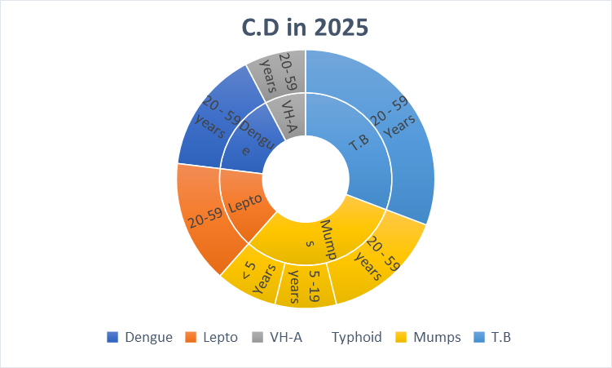
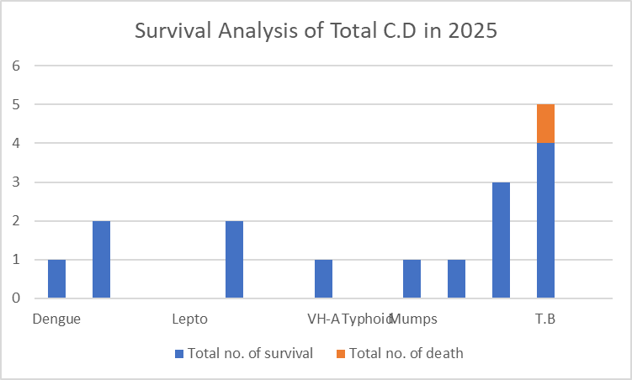

Transmission Trend- 2025
For effective management of public health issues, it is important to track the trend of disease transmission mode. It helps identify the population or place at high risk that can be used to predict outbreaks and implement targeted interventions as quickly as possible. Understanding these kinds of trends enables authorities to allocate resources efficiently and change the strategies adequately based on the trend that follows.

Mode of Transmission | No. of cases | No. of Deaths
Vector Borne Diseases | 4 | 0
Water Borne Diseases | 9 | 0
Air Borne Diseases | 41 | 2
Blood Borne Diseases | 0 | 0
Food Borne Diseases | 0 | 0

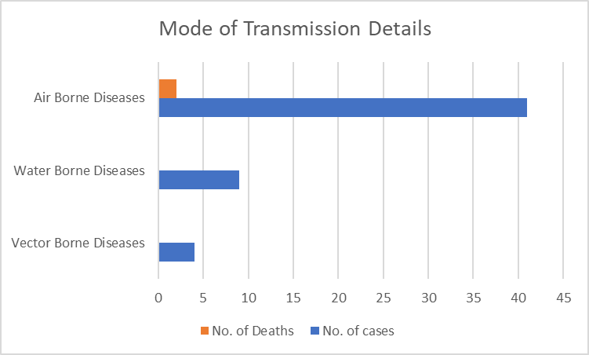

Vector-Borne Disease

Disease | No. of Cases | No. of Deaths
Dengue | 4 | 0
Malaria | 0 | 0
Chikungunya | 0 | 0

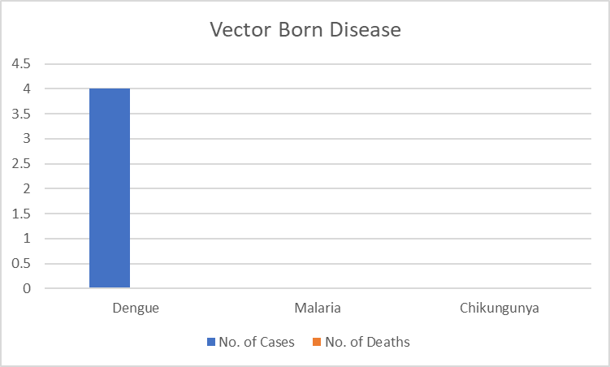

Water Borne Disease

Disease | No. of Cases | No. of Deaths
Cholera | 0 | 0
Typhoid | 0 | 0
Hep- A | 2 | 0
Dysentery | 0 | 0
Amoebiasis | 0 | 0
E- Coli infections | 0 | 0

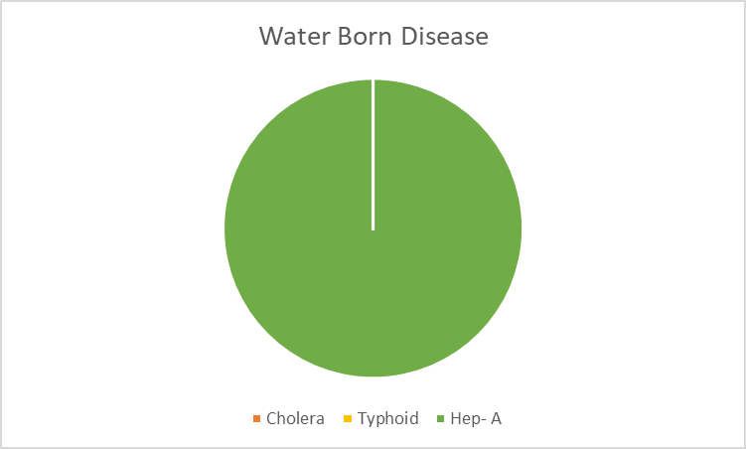

Air Borne Disease

Disease | No. of Cases | No. of Deaths
Influenza | 4 | 0
H1N1 | 3 | 0
TB | 32 | 2
Chickenpox | 25 | 0
Measles | 0 | 0
Covid-19 | 21 | 0
Pertussis | 0 | 0
Mumps | 7 | 0

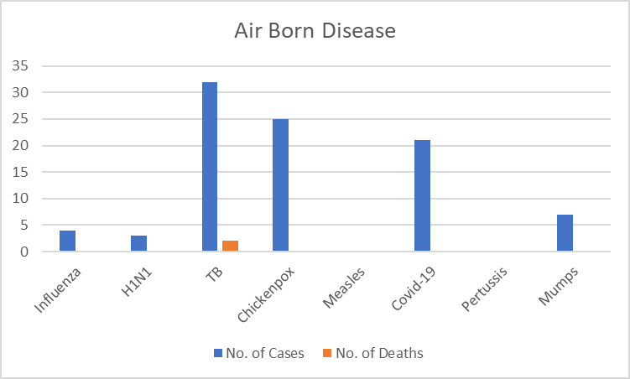
Blood-Borne Disease

Disease | No. of Cases | No. of Deaths
AIDS | 0 | 0
Hep- B | 0 | 0
Hep- C | 0 | 0

Zoonotic Disease

Disease | No. of Cases | No. of Deaths
Rabies | 0 | 0
Leptospirosis | 2 | 0
Avian influenza | 0 | 0
West nile | 0 | 0
Anthrax | 0 | 0
Nipah | 0 | 0
Scrub Typhus | 1 | 0

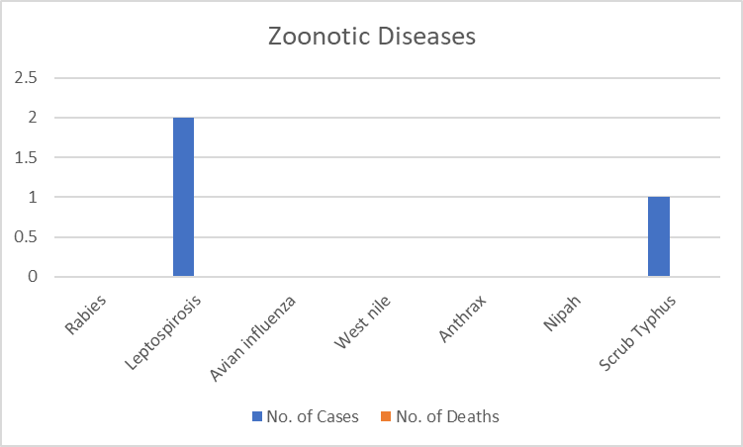

Integrated Disease Hotspot Map (2021–2025)

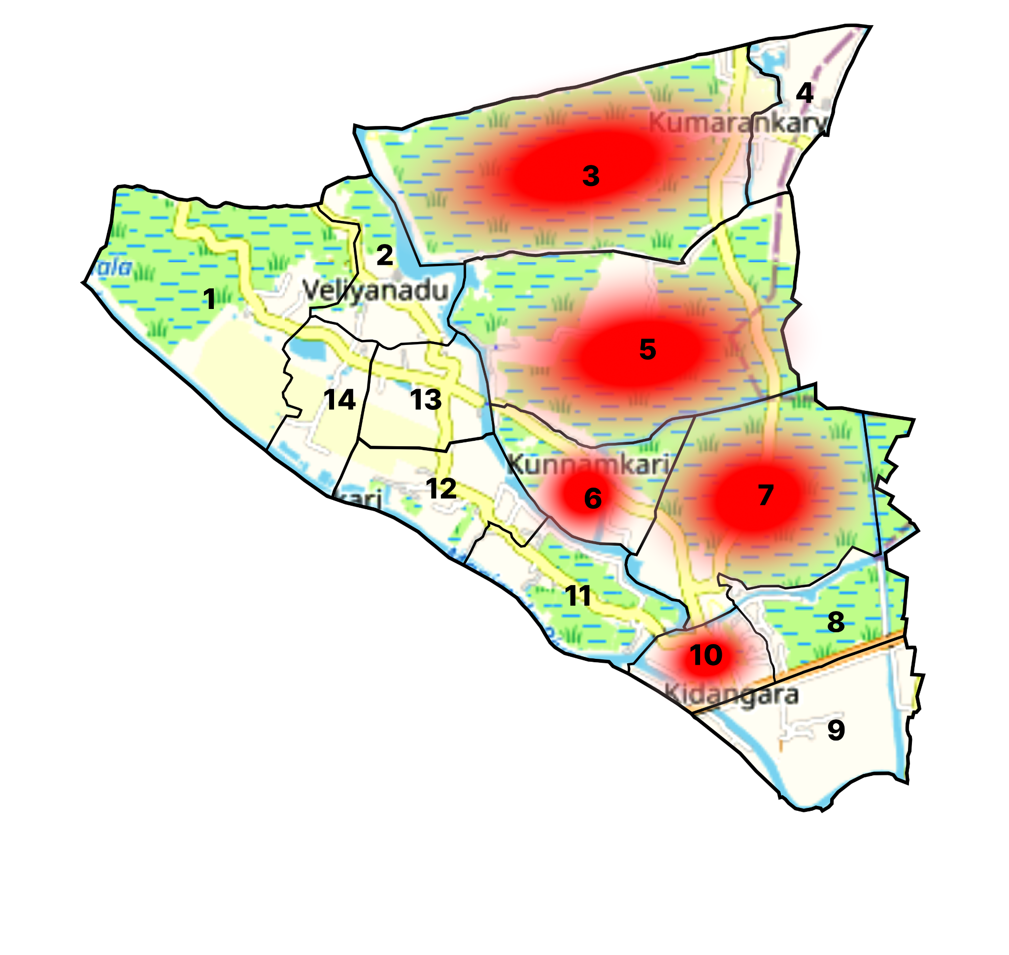

Ward No | Dengue Total (2021-25) | Leptospirosis Total (2021-25) | Hepatitis A Total (2021-25) | Mumps (2021-25) | ADD (2021-25) | Total Cases
1 | 0 | 0 | 0 | 0 | 6 | 6
2 | 0 | 0 | 0 | 0 | 6 | 6
3 | 1 | 0 | 0 | 0 | 6 | 7
4 | 2 | 1 | 0 | 0 | 8 | 11
5 | 2 | 2 | 1 | 0 | 10 | 15
6 | 3 | 0 | 0 | 0 | 18 | 21
7 | 0 | 1 | 1 | 4 | 14 | 20
8 | 0 | 0 | 0 | 0 | 4 | 4
9 | 0 | 1 | 0 | 0 | 12 | 13
10 | 0 | 1 | 0 | 0 | 7 | 8
11 | 0 | 0 | 0 | 0 | 13 | 13
12 | 0 | 0 | 0 | 0 | 3 | 3
13 | 0 | 0 | 0 | 0 | 6 | 6

By overlaying five years of data, we have identified Wards No: 3,5,6,7,10 as 'Red Zone' Wards. These are wards where at least two different categories of diseases (e.g., Dengue and Lepto) recurred in consecutive years. Ward 4 is categorized as the Highest Priority Hotspot due to its combination of flood vulnerability and high vector density. Future health infrastructure, such as the proposed R.O plants at wards 5 and 8 should be prioritized.

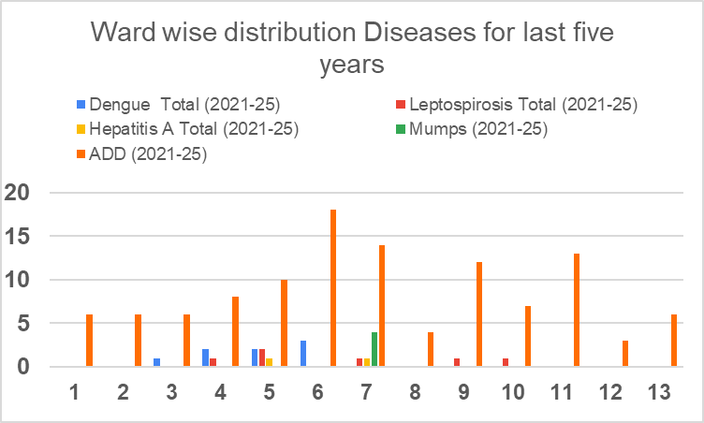

Preparedness and Response Protocol at LSG Level
This section describes the operational framework for the LSGI once a pandemic is declared. It explains how the LSGI and health system will move from routine data collection to active response, using a One Health approach.

Constitution of One Health Committee
The LSGD shall constitute a One Health Committee comprising the LSGI President, Medical Officers (Modern Medicine, AYUSH, and Veterinary), the Health Inspector, and the Veterinary Surgeon.

Objective: The One Health Committee coordinates human, animal, and environmental health to prevent and control pandemics.

Sl No | Name | Designation | Department/Institution | Role in Committee | Contact Number
1 | V M Shine | Panchayat President | LSGD | Chairperson
2 | Dr. Sini C Joseph | Medical Officer (PHC/CHC) | Health Dept | Member Secretary | 9446194099
3 | Ethal Das | Veterinary Officer | Animal Husbandry | Member | 9746228120
4 | Dr.Anjali Annie George | Epidemiologist | Health Dept | Member | 9495656702
5 | Suresh Kumar | Health Inspector/PHN | Health Dept | Surveillance | 8921309021
6 | Gigimol | ASHA Supervisor | Health Dept | Community link | 9496256015
7 | Najila | ICDS Supervisor | Social Welfare | Vulnerable groups | 9895774093
8 | John | Police Station Officer | Police Dept | Law & order | 04772762222
9 | Binoj Kurian | Ward Councillor Representative | LSGD | Community coordination | 8509100100
10 | Remya | Kudumbashree CDO | Kudumbashree | Community mobilisation | 6238077287
11 | 0 | NGO/Volunteer rep | Civil Society | Support services

Key Responsibilities:
- Review disease surveillance data (human + animal)
- Conduct ward-wise risk assessment and vulnerability mapping
- Approve quarantine/isolation centre locations
- Coordinate with district for resources (PPE, oxygen, ambulances)
- Periodically review health system surge capacity, including beds, oxygen, human resources, and ambulances.
- Approve and monitor risk communication and community engagement strategies, including rumour management.
- Ensure protection and service continuity for vulnerable groups (elderly, persons with disabilities, dialysis patients, coastal populations).
- Conduct quarterly mock drills
- Monitor equity measures for vulnerable groups

Meeting Schedule:
Quarterly (normal times) | Weekly (outbreak alert) | Daily (pandemic phase)

Pandemic Response Workforce
To ensure a coordinated and timely response during a pandemic, a dedicated Pandemic Response Workforce shall be constituted at the LSG level. The workforce will function under the overall supervision of the One Health Committee and in close coordination with the health authorities. Team-based deployment will enable efficient surveillance, case management, quarantine and isolation management, logistics support, and risk communication. Each team shall have a clearly designated team leader, defined roles, and an identified pool of personnel to allow rapid activation, rotation of duties, and continuity of services during prolonged emergencies.

Total Response Workforce Available: 300 persons

Team Name | Composition | Key Responsibilities | Team Leader
Surveillance and Contact Tracing Team | HI, JHI, JPHN, ASHAs and Volunteers | Case detection, contact listing, home visits, reporting | HI
Case Management Team | Doctors, Nurses, MLSP, Palliative Nurses | Patient care & referral | DOCTOR
Quarantine & Isolation Team | LSGD staff, Volunteers | Facility management | JHI
Psychosocial support
Logistics & supply chain Team | LSGD staff, Storekeepers, Drivers 3 | Supplies & transport [PPE, medicines, oxygen, transport, waste management] | Ward Member
Communication Team | Ward members, Kudumbashree, Youth clubs,  AWW workers and other self help groups | IEC, community meetings, countering misinformation | M.O in charge
Transportation | KSRTC, educational institutional buses | Transportation | Station master
Media Surveillance | local channel | IEC | media in charge
Intersectoral coordination and convergence | PHC , LSGD , AYUSH ,VETINARY,FSSI | CORDINATION | MO in charge
Collaborative surveillance | 0 | 0 | 0

All teams shall be activated immediately upon outbreak alert or pandemic declaration and shall report daily to the LSG Incident Commander/Medical Officer, with consolidated reporting to the Block PHC. Duty rosters and alternate personnel shall be maintained to ensure uninterrupted services during staff shortages or prolonged response periods. Team composition and numbers may be revised based on the magnitude of the outbreak and availability of human resources.

Activities and Measures before and during Pandemic

PHASE 1 - Alert / Preparation
Surveillance and Reporting-Enhanced syndromic surveillance:
- Data sources for surveillance:
- Event-based triggers (to be monitored and reported):
- Zoonotic and animal health surveillance
- Logistics and Stock Preparedness
  - Identify and empanel local vendors and define emergency procurement mechanisms in accordance with existing LSGD and Health Department norms.
  - Prepare and maintain an essential logistics checklist covering medical supplies, consumables, and support equipment.
  - Pre-identify secure storage locations for emergency stocks and ensure maintenance of stock registers with regular updating.
  - Finalise emergency transport arrangements, including availability of vehicles and identified drivers for rapid deployment during alerts.
  - Designate a Nodal Officer for Logistics to enable prompt decision-making, coordination, and communication during emergencies.
  - Conduct rapid stock verification and ensure availability of minimum buffer stock, including:
- PPE kits 0 numbers
- Pulse oximeters – 0 numbers
- Hand sanitizers – 0 litres
- Masks, gloves, disinfectants – adequate quantity
Identify critical gaps in logistics and immediately communicate requirements to the Block and District authorities for timely replenishment and support. Monitor expiry dates and stock rotation.

Identification of Quarantine and Isolation Facilities
  - Identify and list suitable buildings for quarantine and isolation (schools, hostels, community halls, etc.).
  - Categorise cases as per the severity and allocate to appropriate facilities (for instance, severe cases to classrooms, mild cases to an assembly hall in case of a school).
  - Facility readiness checklist needed (beds, toilets, ventilation) etc.
  - Find an alternate site if the primary sites are not available or not in use.
  - Identify facility managers and support staff
  - Prepare basic SOPs for:
    - Admission and discharge
    - Food, water, sanitation
    - Infection prevention and waste disposal
  - Ensure availability of basic amenities: water, sanitation, electricity, ventilation, and waste disposal. Prepare a rapid activation plan for these facilities if case numbers increase.

Risk Communication and Community Preparedness
  - Disseminate early warning messages on symptoms, preventive measures, and reporting mechanisms. Display IEC materials both in English and the local language in public places and ensure ward-level awareness.
  - Sensitize elected representatives and community leaders on preparedness measures.
  - Establish a rumour tracking and misinformation response mechanism to identify, verify, and promptly counter false or misleading information.
  - Engage trusted local persons (ward members, ASHA workers, religious leaders, teachers, community volunteers) to communicate official public health messages and reinforce correct practices.
  - Develop and deploy targeted IEC materials for:
    - Schools and educational institutions
    - Markets and commercial areas
    - Work sites and labour settings
  - Conduct community sensitization meetings at the ward level to promote preventive behaviors, address concerns, and strengthen community participation in preparedness and response.

Protection of Vulnerable Groups
Vulnerable populations require priority protection through targeted line-listing, service continuity, and delivery mechanisms.
- Prepare and regularly update line-lists of vulnerable populations, including:
  - Elderly persons living alone
  - Persons with disabilities
  - Pregnant women
  - Migrant workers
  - Dialysis patients
The detailed line-lists shall be maintained as Annexure ___ and updated periodically.

Clinical Dependency Mapping
Develop ward-wise dependency and vulnerability maps to identify households requiring regular support during emergencies. Ensure continuity of essential health services for vulnerable groups, including
- Dialysis services (facility mapping, transport arrangements, and scheduling)
- Continuity of treatment for TB, HIV, and other chronic conditions requiring uninterrupted medication
- Mental health and psychosocial support services
Establish delivery mechanisms for food, essential commodities, and medicines to vulnerable households through coordinated action involving ASHAs, JPHNs, Kudumbashree, volunteers, and local administration.

PHASE 2 - Active Response

Case Identification and Contact Tracing
Case detection and contact tracing activities will be carried out in coordination with the Health authorities, following disease-specific SOPs and IDSP guidelines.
Field Staff Involved
- Health Inspector (HI)
- Junior Health Inspector (JHI)
- Junior Public Health Nurse (JPHN)
- ASHAs and ASHA Supervisors
- Ward-level volunteers and Kudumbashree members (as required)

Screening Checkpoints
Screening checkpoints at high-traffic locations (transport hubs, markets, religious gatherings) for early detection of symptomatic travellers and crowd screening during outbreaks. Potential locations include bus stands, market entry points, and boat jetties, based on local context and risk assessment.
Screening activities will be carried out by trained personnel such as ASHAs, ward members, and volunteers, with support from Health Department staff. Necessary equipment, including non-contact thermometers and appropriate PPE, shall be ensured prior to activation.
Location | Type (Bus stand/Jetty/Market/Railway) | Staff Deployed (ASHAs/Volunteers) | Screening Method | Reporting authority
Bus stand | Transport hub | One JHI  One ASHA  One health Mentors | 1.Swab Collection.  2. Blood smears collection (RDT)  3.Thermal Scanners | Surveillance Nodal Officer in control room
Market entry | Market | One JHI  One ASHA  Male health volunteers | 1.Swab Collection.  2. Blood smears collection (RDT)  3.Thermal Scanners | Surveillance Nodal Officer in control room
Boat jetty | Water transport | One JHI  One ASHA  Male health volunteers | 1.Swab Collection.  2. Blood smears collection (RDT)  3.Thermal Scanners | Surveillance Nodal Officer in control room

Standard Screening Protocol

The screening protocol shall include temperature screening, observation for visible symptoms, and inquiry regarding recent travel or exposure history. Individuals identified as suspects during screening shall be immediately referred to the nearest PHC/FHC for further evaluation, testing, and appropriate action as per prevailing guidelines.

Pandemic Control Room
The Pandemic Control Room (PCR) serves as the central nerve center for real-time coordination, data aggregation, decision support, and communication during outbreaks. It consolidates information from all LSGD teams, health facilities and community sources to enable rapid response decisions.

Control Room Infrastructure and Location
Primary Location: Veliyanad Panchayath Office.
Backup Location: Community Hall in Veliyanad G.P.

Health System Control Room Framework
The PCR is organized into seven functional pillars to ensure no aspect of the response is overlooked:

Rapid Response Team (RRT)
  - Provides immediate intervention during emergencies, clusters, and field alerts.​
  - Coordinates urgent actions such as case investigation, contact tracing, isolation, and inter‑facility referrals.

Data Management & Analytics Team
  - Collects, validates, and manages key health system indicators (cases, tests, beds, HR, supplies).​
  - Analyzes data trends, generates projections, and supports evidence‑based decision‑making for local authorities.

Human Resource Deployment Team
  - Allocates healthcare staff efficiently based on workload and need
  - Ensures adequate and equitable workforce distribution across facilities

Laboratory Surveillance Team
  - Oversees diagnostic testing coordination, sample transport, and timely reporting of results.​
  - Monitors lab indicators (testing volume, positivity rate, turnaround time) for early detection of outbreaks

Vaccination Cell (If Required)
  - Plans and executes vaccination campaigns, including micro‑planning and session scheduling.​
  - Tracks coverage, identifies gaps, and coordinates corrective actions with field teams and outreach services.

Infrastructure & Patient Occupancy Team
  - Monitors facility capacity, earmarked beds, oxygen and critical care resources across all linked facilities.​
  - Ensures optimal patient distribution and referral management using updated bed‑status and resource data.
  - BMWM

Communication team
- Logistics and supply chain
- Transportation (interfacility & emergency transport)
- Media surveillance Call centre
- Management of the deceased
- Intersectoral coordination and convergence

Key Control Room Team
The Control Room Team coordinates all pandemic response activities within the LSGD and serves as the single command and communication hub during activation. It integrates information, field actions, logistics, and policy execution across all participating departments and health facilities.

Role | Name | Designation | Contact Number | Responsibility
In-charge/Nodal Officer | Dr Sini C Joseph | Medical Officer | 9446194099 | Overall coordination, decision-making, and reporting to the District level.
Data Entry Operator | Akhila | Clerk | 9747955440 | Managing the line list, updating dashboards, and tracking testing results.
Communication Officer | Saseendran | JHI | 9495189293 | Handling the public helpline, coordinating ambulance dispatch, and contact tracing calls.
Logistics Coordinator | Sr Thankamma | SNO | 8281912139
Technical Support (IT/Data) | Jithin | Data Manager | 7025922378

SOP for alert escalation/trigger point with mapping of responsibilities.
Key Points:
- The Control Room shall be staffed with a designated In-charge, data entry personnel, and communication staff with clearly defined roles and shift arrangements.
- It shall maintain updated records on daily monitoring indicators including new cases, persons under active quarantine, and hospital bed occupancy.
- All reports and situation updates shall be shared daily with the Block and District Surveillance Unit.
- The Control Room shall act as a single point of contact for coordination with response teams, health institutions, and other departments.
- Contact details of the Control Room shall be widely communicated to field staff and stakeholders during activation.

Daily Monitoring Indicators
To ensure timely decision-making and effective response, the following key indicators shall be monitored and updated on a daily basis by the Pandemic Control Room:

Epidemiological Indicators:
New cases reported today, Total active cases, Test Positivity Rate (TPR), Case Fatality Rate (CFR)
- Surveillance Indicators:
Persons under home quarantine, High-risk contacts identified, Fever, ILI, SARI or other symptoms (syndromic surges), Travellers (symptomatic or high-risk arrivals),Animal husbandry surveillance (zoonotic alerts, unusual animal deaths, poultry/bird flu signals), Mortality surveillance (excess deaths, unexplained fatalities, verbal autopsy reports)
- Logistics and Infrastructure Indicators:
Hospital / CFLTC beds occupied, Oxygen cylinders/concentrators available, Ambulances on standby
- Alert Findings
The following table outlines category-specific trigger points (red flags) from surveillance indicators and corresponding immediate actions for the Pandemic Control Room. These enable rapid response to alert findings like testing anomalies, positive cases exceeding thresholds, clusters, and WGS reports.

Category | Trigger Pophint (Red Flag) | Immediate Action
Clusters | Geographical or facility-based: 5+ cases linked to one location (office, school, street). | Declare a micro-containment zone; perimeter control and active case finding.
Testing | Sudden drop in testing volume / delay in reporting / unusual testing trends | Review the sample collection process, address lab bottlenecks, deploy additional testing teams, and notify the District Lab.
Lab | Test Positivity rate increases | Increase testing sites in that ward.
Hospital | >80% Oxygen bed occupancy | Activate backup/CFLTC beds.
Travel | Cluster of cases from a single flight/train or high-risk arrival group. | Trace all passengers in adjacent seats; implement mandatory institutional quarantine.
Animal | Mass poultry/wildlife death or unusual sickness | Notify Animal Husbandry, sample the area, and dispatch RRT for environmental sampling and zoonotic check.
Mortality | Sudden spike in home deaths or brought-in-dead (BID) cases | Audit the deaths and Active Case Search drive
Additional investigations like Whole Genome Sequencing (WGS) | Detection of a Variant of Concern (VOC) or Variant of Interest (VOI) | Implement strict micro-containment; update clinical protocols to match variant severity.

Communication of Public Health Information
A Community Communication Hub shall be established to ensure timely, accurate, and consistent dissemination of information during a pandemic. The Hub will function under the coordination of Nodal officers of the control room and act as the nodal point for public communication, risk messaging, and community engagement. It will support dissemination of official advisories, promote preventive behaviors, address rumors and misinformation, and ensure that messages reach all sections of the population through trusted local channels and leaders.

Key communicators
Channel | Responsible Person | Contact
Ward-level announcements | Saseendran | 9495189293
Social media | Jiji Varghese | 9446793927
Local Cable TV/Radio | RAJENDRAN (Local Media) | 9496690552

- All messages disseminated through the Hub shall align with advisories issued by the Health Department and District authorities.
- Community leaders shall be sensitized to support behavior change, reduce stigma, and counter misinformation.
- Special efforts shall be made to reach vulnerable and hard-to-reach populations using locally appropriate communication methods.

Rumor Tracking: A designated volunteer will monitor local social media/WhatsApp groups daily to identify misinformation and issue official clarifications via the Communication Hub.

Coordination with District/State Authorities & Other Organisations
Effective coordination with Block, District, and State authorities is essential to ensure timely reporting, technical guidance, and uninterrupted supply of essential resources during a pandemic. The LSG shall establish clear communication channels, designate responsible officers, and adhere to prescribed reporting timelines to support coordinated public health action and efficient resource mobilisation.

Key Details:
- Nodal Officer for Reporting:
- Contact Number:
Reporting Schedule and Protocols:

To Whom | What to Report | Frequency | Nodal Person
Block PHC | Complete Situation Report (Cases, Quarantine, Beds, Screening, Deaths) | Daily | MO in charge CHC
District IDSP Unit | Outbreaks/Clusters/Unusual Events (>5 cases same ward) | Within 24 Hrs | DSO
Veterinary Officer | Animal health events/Zoonotic alerts | Real Time | Veterinary Surgeon
State Cell | Zoonotic cross-sector events | Real time | P.H wing

Supply Chain Coordination
The LSG shall coordinate closely with Block, District, and State authorities (KMSCL) to ensure uninterrupted availability of essential goods, medical supplies, and logistics during a pandemic. Supply requirements shall be assessed regularly based on case load and communicated promptly to the appropriate authorities for timely replenishment.
Key Points:
- Maintain updated contact details of District and Block nodal officers for health logistics, oxygen supply, ambulances, and essential medicines.
- Submit timely indent requests for PPE, testing kits, medicines, oxygen, and other critical supplies through prescribed channels.
- Monitor stock levels at LSGD facilities, quarantine/isolation centres, and field teams through daily stock registers and dispensing logs to prevent shortages.
- Coordinate with District authorities, Karunya/Neethi medical shops, and local purchase committees for funds allocation and emergency procurement.

- Ensure regular monitoring of dispensing registers at all facilities to track usage, expiry, and pilferage—shortages being a perennial issue requiring proactive weekly audits.

- Activate surge procurement protocols during high caseloads, leveraging local purchase powers under LSGD funds alongside state supplies.

Resource Inventory and Contacts
Resource Category | Source  (District/State/Private) | Contact
PPE Kits/Masks/Gloves | KMSCL | 9895214070
PPE Kits/Masks/Gloves | Local Vendors | 9961215230
Oxygen  Cylinders/Concentrators | KMSCL | 9895214070
Medicines/Antivirals | KMSCL | 9895214070
Medicines/Antivirals | Neethi Shops | 9947757360
Test Kits (RTPCR/Rapid) | KMSCL | 9895214070

Collaboration with NGOs, PPP, and CSR
To augment government efforts during a pandemic, the LSG shall collaborate with NGOs, voluntary organisations, and private sector partners through public–private partnerships and Corporate Social Responsibility (CSR) initiatives, in coordination with District authorities.

Key Points:
- Engage NGOs and community-based organisations for community outreach, awareness, and support to vulnerable populations.
- Leverage CSR support for procurement of medical equipment, PPE, oxygen concentrators, food kits, and sanitation materials, as permitted.
- Ensure all collaborations align with government guidelines and are routed through approved administrative and financial procedures.
- Maintain transparency and documentation for all external support received and utilised.
Organization | Type | Support Offered | Contact Person
Youth Clubs/Student Unions | CBO | Lions Club | 9446121448

Interdepartmental Coordination
Coordination among departments during a pandemic shall be ensured through regular review meetings convened by the LSGD President. These meetings will provide a structured platform for sharing situational updates, assessing resource availability, resolving operational gaps, and taking joint decisions to ensure a coordinated and timely response.

Department | Representative | Key Role | Contact
Health (CHC) | Staff Nurse : Sr Thankamma | Case management | 8281912139
Veterinary | Veterinary Surgeon: | Animal surveillance | 9895951557
ICDS | Supervisor: Najila | Nutrition support | 9895774093
Education | Head Teacher: | School coordination | 9497219373
Police | John | Containment enforcement | 04772762222
Water Authority | Jyothis | Water supply | 8281597955
LSGD Engineering | Meera | Quarantine infrastructure | 9895866197

PHASE 3 - Surge Capacity
Phase 3 is activated when there is a rapid increase in cases, high test positivity rates, or when existing health facilities and quarantine arrangements approach saturation. The focus of this phase is to expand isolation capacity, augment clinical care services, and mobilise additional resources through district and state support mechanisms.

Conversion of Community Facilities
To manage increased case load, the LSGD shall activate additional isolation facilities by repurposing identified community infrastructure such as community halls, auditoriums, schools, hostels, or other suitable buildings.

Name of facility | Facility Type | No. of Buildings | Ward | Surge Capacity (Beds) | Nodal Person
St Stephen’s Church Parish hall | Parish hall | 1 | 11 | 75 | Ft. Xavier

- Recovery and rehabilitation phase
1. Recovery
- Phased restoration of essential public health services in flood-prone and water-locked wards
- Reactivation of outreach services through ASHA/ward-level micro-planning in island habitations
- Ensuring continuity of NCD, geriatric, palliative and antenatal care services disrupted during pandemic
2. Damage & Impact Assessment
- Health facility functionality assessment (SC/PHC/CHC level)
- Assessment of transport disruption (road & inland waterways)
- Evaluation of impact on elderly population, bedridden patients & chronic disease groups
- Livelihood loss among agriculture-dependent households
3. Restoration of Health Services
- Resumption of routine OPD, immunization and CH services
- Mobile medical units & boat clinics for cut-off wards
- Re-establishment of laboratory surveillance services
- Re-stocking of essential medicines and emergency supplies
4. Rehabilitation of Affected Population
- Special outreach camps in remote and flood-affected areas
- Nutritional and medical support for vulnerable populations
- Rehabilitation support for COVID/post-pandemic complications
5. Psychosocial & Mental Health Support
- Community-based counselling support through trained health staff
- Support for bereaved families and frontline workers
- Integration with district mental health programme services
6. Disease Surveillance During Recovery
- Strengthened IDSP reporting from ward level institutions
- Monitoring of post-pandemic outbreaks (water-borne/vector-borne diseases)
- Event-based surveillance through community volunteers
7. Environmental Cleanup & Sanitation
- Disinfection of public spaces, markets and institutions
- Safe drinking water monitoring in pola-affected regions
- Biomedical waste disposal & vector control measures
8. Livelihood Restoration
- Convergence with agriculture & allied departments
- Restoration of paddy cultivation & inland fisheries
- Support for daily wage workers affected by movement restrictions
9. Community Engagement & Confidence Building
- IEC campaigns through LSGD platforms
- Ward-level health awareness meetings
- Engagement of Kudumbashree & local volunteer groups
10. Documentation & After-Action Review
- Panchayat-wise documentation of response activities
- Health system performance analysis
- Stakeholder review meetings at block level
11. Lessons Learned & Best Practices
- Effective use of water transport in service delivery
- Community-led surveillance models
- Integration of local volunteers in emergency response
12. Health System Strengthening
- Infrastructure improvement in sub-centres of remote wards
- Capacity building of healthcare workers
- Strengthening referral linkages with higher centres
13. Policy Revision & Preparedness Enhancement
- Updating block pandemic preparedness SOPs
- Inclusion of flood-pandemic dual hazard planning
- Strengthening inter-departmental coordination mechanisms
14. Research
- Operational research on pandemic response in water-logged terrains
- Study on accessibility barriers in island populations
- Evaluation of post-pandemic health service utilization

CONCLUSION

The Pandemic Preparedness Plan of Veliyanad Grama Panchayath outlines a proactive and resilient framework to manage present and future public health emergencies. It integrates governance, healthcare systems, infrastructure, and community participation to ensure effective preparedness, response, and recovery. Technology-driven systems such as digital surveillance, real-time reporting, and telemedicine enable early detection and coordinated action. Efficient management of relief commodities ensures timely support to vulnerable populations during crises. HAM radio operators provide reliable communication support during network or power failures. Hazard and vulnerability mapping helps identify high-risk areas and prioritize interventions. Coordination with power agencies and backup systems ensures uninterrupted essential services. Clearly defined roles, regular training, and mock drills strengthen overall preparedness and operational efficiency.

RECOMMENDATIONS

Strengthening Healthcare Infrastructure
- Establish a primary health response unit within the Panchayat with trained staff.
- Ensure availability of basic medical supplies (masks, sanitizers, PPE kits, oxygen cylinders).
- Create tie-ups with nearby hospitals in Veliyanad for emergency referral and transport.

2. Community Awareness & Education
- Conduct regular awareness campaigns on hygiene, vaccination, and preventive measures.
- Use local communication channels (community radio, WhatsApp groups, notice boards) to spread verified information.
- Train volunteers to act as health ambassadors in each ward.

3. Emergency Response & Coordination
- Form a Pandemic Preparedness Committee at Panchayat level including health workers, ward members, and NGOs.
- Develop a clear action plan for lockdowns, quarantine, and distribution of essentials.
- Maintain a database of vulnerable groups (elderly, differently-abled, chronically ill) for targeted support.

4. Supply Chain & Food Security
- Identify and support local suppliers and farmers to ensure uninterrupted food supply.
- Create community kitchens during emergencies to serve vulnerable populations.
- Stockpile essential commodities in Panchayat-run outlets for crisis periods.

5. Digital Preparedness
- Promote digital platforms for telemedicine consultations.
- Use Panchayat’s website/social media for real-time updates on health advisories.
- Encourage online grievance redressal to reduce crowding in offices.

6. Training & Capacity Building
- Organize mock drills for pandemic response in schools, offices, and public spaces.
- Train Panchayat staff and volunteers in first aid, infection control, and crowd management.
- Collaborate with NGOs and health departments for capacity-building workshops.

7. Long-Term Resilience
- Integrate pandemic preparedness into the Panchayat Development Plan.
- Allocate a dedicated budget for health emergencies.
- Encourage community participation in planning and monitoring preparedness measures.

MOCKDRILL SCENARIOS
- Essential Supply Shortage: Disruption in medicines/PPE → activate buffer stock and local distribution.
- Quarantine Facility Activation: Prepare and manage institutional quarantine centers.
- Rumor & Panic Situation: Spread of misinformation → strengthen communication and awareness.
- Flood & Power Disruption: (important in Kuttanad region) → ensure backup power and service continuity.
- Staff Shortage: Health workers unavailable → engage volunteers and redistribute duties.
- Water & Sanitation Issue: Risk of secondary outbreaks → chlorination and sanitation drive.
- Community Resistance: Hesitation for isolation/quarantine → counseling and community engagement

ANNEXURE

IMPORTANT PHONE NUMBERS

Phone numbers and particulars of persons responsible for providing guidance, assistance, and support for pandemic preparedness operations may be provided here in a manner that allows easy reference at a glance. The information recorded here could be exhibited elsewhere at the time of emergencies. LSG institutions shall give special attention to collect and record the above data of persons and institutions who/which are supposed to give technical and co-ordination support to reduce the impact of pandemic.

1.1. Details of grama panchayat/municipality/corporation wards
Sl.No | Name of the ward | Ward number | Name of the ward  member | Contact number
1 | Vellisrakkal | 1 | Jaysree Vijayappan | 9048963460
2 | Veliyanad North | 2 | Sulaja Reni | 8111967316
3 | Mukkodi | 3 | Nirmala Kulangara | 8157994426
4 | Kumaramkary | 4 | Nidheesh Balan | 9745173060
5 | Thachedam | 5 | Pramitha Rajeev | 6282221384
6 | Kunnaamkari | 6 | V M Shine | 9961422511
7 | Kidangara | 7 | M V Manoj | 9447896641
8 | Kidangara Bazar | 8 | Sajitha Subash | 7306989973
9 | Kidangara Bazar South | 9 | Nishamol | 9544005195
10 | Kidangara Junction | 10 | G Suraj | 7907248022
11 | Kurisumoodu | 11 | Binoj Kurian | 8509100100
12 | Veliyanad South | 12 | Santhosh Thomas | 8086953740
13 | Village Office | 13 | Divya Das | 9946855065
14 | Poochal | 14 | James V O | 9447506036

1.2. Other important phone numbers of grama panchayat/municipality/corporation area
Sl. No. | Name | Contact number
1. | MEDICAL OFFICER | 9446194099
2. | PANCHAYATH SECRETORY | 9605491086
3. | BLOCK PRESSIDANT | 9495758662
4. | VILLAGE OFFICER | 9544448601
5. | AYURVEDAM | 9446366180
6. | HOMEO | 9477791088
7 | ETERINARY | 9447404898

1.3. Important offices of grama panchayat/municipality/ corporation
Sl.No | Name of the office | Contact person | Contact number
1. | Village Office | Village Officer | 8547611912
2. | Agriculture Office | Agriculture Officer | 8921295429
3. | Animal Husbandry Office | Animal Husbandry Doctor | 9447404898
4. | Police Station | Police Officer | 04772762222
5. | Block Office | Officer | 0477 2762100
6. | KSEB Office | Officer | 9497222048
8. | Fire and Rescue | Officer | 101

1.4. Health Services

Sl. No | Name of the hospital/institution | Location | Phone number
1. | Government hospitals/PHC | Veliyanad | 9947730120
2. | Private hospitals | 0 | 0
3. | Clinical laboratories | Veliyanad | 8547546943
4. | Chemist/pharmacy | 0 | 0
5. | Blood donors | 0 | 0
6. | Other language experts (Bihari, Hindi, Bengali,  Asamees ………) | 0 | 0

1.5. Veterinary Services
Sl.No | Name of the Clinic | Name of the  Surgeon/Doctor | Place/location | Phone  number
1 | Govt.Veterinary Hospital | Dr.Jacob | 9 | 9447404898

1.6. Helpline numbers
Helpline | Phone number
Police | 100
Fire and Rescue | 101
KSEB | 0477 2702525

1.7. Public and Private Schools Contact details

S.No | Name of School | Institution type | Phone number
1 | NSS HS | Aided | 9497219373
2 | GLPS | Govt | 9495670775
3 | GLPS South | Govt | 9961748589

1.9. Anganwadi Contact Details

Ward No | Name of Anganwadi Teachers | Phone number
1 | Center No: 76, Sudha C V | 9846602114
1 | Center No: 93, Dhannya | 9995517901
2 | Center No: 95, Kairali | 9946259137
2 | Center No: 64, Bincy | 8590789757
3 | Center No: 94,Ambily | 9747858645
3 | Center No: 63,Liji Varghese | 6282110378
4 | Sindhu | 8281266692
5 | Ambily M.R | 857784363
6 | Rachel | 9645798405
7 | Riya | 9747617287
8 | Bindhu | 9539298237
9 | Sindhu | 9656638486
10 | Center No: 72, Yamunabhai | 9544148803
10 | Center No: 69, Sobhana | 8330022115
11 | Bibitha | 9656432327
12 | Anisha | 9048259166
13 | Pushpa | 9495154044

1.12. Information regarding resources

Means of transportation | Name of Owner | Phone Number
Heavy Trucks | ANIL KUMAR | 9447743943
Tractor | 0 | 0
Ambulances | Govt. H Champakulam | 0477 2737587
Boats | thomas | 9447051333
Taxi service | BINOY | 9061417996

Annexure 1: LSG Baseline Data Collection Format
A. Baseline data
Sl. No. | Indicator / Field | Baseline Data | Source / Remarks
1 | Name of LSG | CHC Veliyanad | Panchayath Data Bank
2 | District | Alappuzha | Panchayath Data Bank
3 | Block / Taluk | Veliyanad | Panchayath Data Bank
4 | Type of LSG (Gram Panchayat / Municipality / Corporation) | Grama Panchayat | Panchayath Data Bank
5 | Area (sq. km) | 19.41 | Panchayath Data Bank
6 | No. of wards | 14 | Panchayath Data Bank
7 | GIS boundary file available | (Yes/No) | Yes
8 | Key contact person & phone | Sini C Joseph | 94461 94099

B. Demography
Indicator / Field | Baseline Data | Source / Remarks
Total population | 11692 | Panchayath Data Bank
Males | 5765 | Panchayath Data Bank
Females | 5926 | Panchayath Data Bank
Transgender population | 1 | Panchayath Data Bank
Age distribution  (<5, 5–14, 15–59, ≥60) | <5 = 1473, 5-14 = 1300, 15-59 = 309, >=60 = 6953 | Panchayath Data Bank
No. of households | 377 | Panchayath Data Bank
Population density (persons/sq.km) | 644 | Panchayath Data Bank
No. of migrant workers | 36 | Panchayath Data Bank
Major occupational groups | Agriculture | Panchayath Data Bank

C. Vulnerable Populations & Social Risks
Sl. No. | Indicator / Field | Baseline Data (Value / Description) | Source / Remarks
1 | No. of elderly (≥60) | 6953 | Panchayath Data Bank
2 | No. of persons with disability | 69 | Panchayath Data Bank
3 | No. of bedridden persons | 1473 | Panchayath Data Bank
4 | No. of chronic disease cases (DM/HTN/COPD/CKD etc.) | 1486 | Panchayath Data Bank
5 | Pregnant women (current estimate) | 111 | Panchayath Data Bank
6 | Children <5 years |  | Panchayath Data Bank
7 | Tribal population (if any) | 0 | Panchayath Data Bank
8 | Fisherfolk / coastal vulnerable groups (if any) | 0 | Panchayath Data Bank
9 | Urban slums / unnotified settlements (if any) | 0 | Panchayath Data Bank
10 | Homeless population | 0 | Panchayath Data Bank
11 | Orphanages / old age homes (number & capacity) | 0 | Panchayath Data Bank
12 | Hostels / prisons / shelters (number & capacity) | 0 | Panchayath Data Bank
13 | Poverty / BPL estimate | 1844 | Panchayath Data Bank
14 | Food insecurity hotspots |  | Panchayath Data Bank
15 | Any history of stigma/discrimination issues (Yes/No) | No | Panchayath Data Bank

D. Health System & Service Readiness
Sl. No. | Indicator / Field | Baseline Data (Value / Description) | Source / Remarks
1 | No. of health facilities in LSG (PHC/CHC/TH/DH/Private) | 1 | Panchayath Data Bank
2 | PHC/Family Health Centre details (name, location) | 0 | Panchayath Data Bank
3 | Subcentres / Health & Wellness Centres (number) | 3 | Panchayath Data Bank
4 | Private clinics / hospitals (number) | 0 | Panchayath Data Bank
5 | Labs available (public/private) | 3 | Panchayath Data Bank
6 | Availability of ambulance services (Yes/No, number) | Yes | Panchayath Data Bank
7 | Availability of isolation/quarantine facilities (Yes/No, details) | No | Panchayath Data Bank
8 | Cold chain facilities (Yes/No, details) | Yes | Panchayath Data Bank
9 | Stockpile space available (Yes/No) | No | Panchayath Data Bank
10 | PPE / mask / sanitizer availability plan (Yes/No) | Yes | Panchayath Data Bank
11 | Surveillance staff available (JHI/JPHN/ASHA count) | Yes | Panchayath Data Bank
12 | Existing emergency referral pathways (Yes/No) | Yes | Panchayath Data Bank

E. Points of Entry & Mobility
Sl. No. | Indicator / Field | Baseline Data (Value / Description) | Source / Remarks
1 | Bus stands / depots (number) | NO | Panchayath Data Bank
2 | Railway stations (number) | NO | Panchayath Data Bank
3 | Boat jetties / fishing harbours (number) | YES | Panchayath Data Bank
4 | Ports / airports nearby (specify distance) | NO | Panchayath Data Bank
5 | Major highways/roads passing through | NO | Panchayath Data Bank
6 | Border crossings (state/district) | YES | Panchayath Data Bank
7 | Major markets / weekly markets | NO | Panchayath Data Bank
8 | Tourism hubs / major event venues | NO | Panchayath Data Bank
9 | Schools/colleges with hostels (number) | NO | Panchayath Data Bank
10 | Factories / large workplaces (number) | 0 | Panchayath Data Bank
F. Water, Sanitation & Hygiene (WASH)
Sl. No. | Indicator / Field | Baseline Data (Value / Description) | Source / Remarks
1 | Major drinking water sources (piped / wells / borewells / springs) | Piped | Panchayath Data Bank
2 | No. of public wells | 2 | Panchayath Data Bank
3 | No. of households with piped water connection | 1980 | Panchayath Data Bank
4 | Water quality testing routine (Yes/No) | Yes | Panchayath Data Bank
5 | Common contamination risks (flooding, salinity, industrial waste) | Flooding | Panchayath Data Bank
6 | Open defecation free status (Yes/No) | Yes | Panchayath Data Bank
7 | Solid waste management system (Yes/No) | Yes | Panchayath Data Bank
8 | Bio-medical waste disposal mechanism (Yes/No) | Yes | Panchayath Data Bank
9 | No. of public toilets | 0 | Panchayath Data Bank
10 | Handwashing stations in public places (Yes/No) | No | Panchayath Data Bank
G. Zoonotic Risks & One Health
Sl. No. | Indicator / Field | Baseline Data (Value / Description) | Source / Remarks
1 | Livestock population (cattle/goats/pigs/poultry) – estimates | 1880 | Panchayath Data Bank
2 | No. of dairy farms / poultry farms / pig farms | 36 | Panchayath Data Bank
3 | Slaughterhouses / meat shops (number) | 0 | Panchayath Data Bank
4 | Animal markets (Yes/No, details) | No | Panchayath Data Bank
5 | Veterinary dispensaries (number) | 1 | Panchayath Data Bank
6 | History of zoonotic outbreaks (rabies, leptospirosis, avian flu etc.) | No | Panchayath Data Bank
7 | Stray dog population management measures (Yes/No) | No | Panchayath Data Bank
8 | Rodent infestation hotspots (Yes/No) | Yes | Panchayath Data Bank
9 | Wetlands / waterlogged areas prone to leptospirosis | Yes | Panchayath Data Bank
10 | Bat roosting areas / caves / fruit orchards (if any) | No | Panchayath Data Bank
11 | Human-animal interface hotspots (farms near residences) | Yes | Panchayath Data Bank
H. Climate & Disaster Risks (Pandemic Amplifiers)
Sl. No. | Indicator / Field | Baseline Data (Value / Description) | Source / Remarks
1 | Flood-prone wards (list) | Yes | Panchayath Data Bank
2 | Landslide-prone wards (list) | No | Panchayath Data Bank
3 | Cyclone/sea surge risk (Yes/No) | No | Panchayath Data Bank
4 | Heatwave risk zones (Yes/No) | No | Panchayath Data Bank
5 | Waterlogging areas (list) | 0 | Panchayath Data Bank
6 | Shelter homes / relief camps (number, capacity) | No | Panchayath Data Bank
7 | Past disaster displacement history | Yes | Panchayath Data Bank
8 | Disruption to water supply/transport common (Yes/No) | Yes | Panchayath Data Bank
I. Critical Infrastructure & Logistics
Sl. No. | Indicator / Field | Baseline Data (Value / Description) | Source / Remarks
1 | Schools (number) | 5 | Panchayath Data Bank
2 | Anganwadis (number) | 18 | Panchayath Data Bank
3 | Colleges (number) | 0 | Panchayath Data Bank
4 | Community halls (number) | 1 | Panchayath Data Bank
5 | Places of worship with large gatherings (number) | 1 | Panchayath Data Bank
6 | Large markets / shopping areas (number) | Nil
7 | Warehouses / cold storages (number) | 1 | Panchayath Data Bank
8 | Telecom/mobile network coverage gaps (Yes/No) | Yes | Panchayath Data Bank
9 | Power outage frequency (high/medium/low) | Low | Panchayath Data Bank
10 | Availability of generators in key facilities | Yes | Panchayath Data Bank

J. Risk Communication & Community Networks
Sl. No. | Indicator / Field | Baseline Data (Value / Description) | Source / Remarks
1 | Ward-level rapid response teams (Yes/No) | Yes | Panchayath Data Bank
2 | Jagratha samithis / committees active (Yes/No) | Yes | Panchayath Data Bank
3 | Kudumbashree presence and strength (number of units) | Yes | Panchayath Data Bank
4 | Volunteer network (number, coverage) | Yes | Panchayath Data Bank
5 | Community-based surveillance mechanisms (Yes/No) | Yes | Panchayath Data Bank
6 | IEC dissemination channels (WhatsApp groups, community radio, PA systems) | Yes | Panchayath Data Bank
7 | Rumour tracking mechanisms (Yes/No) | Yes | Panchayath Data Bank
8 | Languages spoken / literacy considerations | Yes | Panchayath Data Bank
9 | Vulnerable groups communication strategy available (Yes/No) | Yes | Panchayath Data Bank

K. Preparedness Planning & Governance
Sl. No. | Indicator / Field | Baseline Data (Value / Description) | Source / Remarks
1 | LSG emergency plan available (Yes/No) | Yes | Panchayath Data Bank
2 | Pandemic preparedness plan available (Yes/No) | Yes | Panchayath Data Bank
3 | Incident Command System identified (Yes/No) | Yes | Panchayath Data Bank
4 | Rapid procurement mechanism available (Yes/No) | Yes | Panchayath Data Bank
5 | Emergency fund available (Yes/No, amount) | No | Panchayath Data Bank
6 | Past outbreak response experience (Yes/No, details) | No | Panchayath Data Bank
7 | Intersectoral coordination mechanism (Health, Police, LSG, Veterinary, Education) | Yes | Panchayath Data Bank
8 | Mock drills conducted in last 12 months (Yes/No) | Yes | Panchayath Data Bank
9 | Training coverage for staff/volunteers (Yes/No) | Yes | Panchayath Data Bank

L. Surveillance & Data Systems
Sl. No. | Indicator / Field | Baseline Data (Value / Description) | Source / Remarks
1 | Digital reporting tools used (e.g., DHIS2, portals) | Yes | Panchayath Data Bank
2 | Availability of line-listing format (Yes/No) | Yes | Panchayath Data Bank
3 | Contact tracing team identified (Yes/No) | Yes | Panchayath Data Bank
4 | Mapping of high-risk households available (Yes/No) | Yes | Panchayath Data Bank
5 | Testing sample transport mechanism (Yes/No) | Yes | Panchayath Data Bank
6 | Reporting timeline adherence (good/average/poor) | Good | Panchayath Data Bank
7 | Data sharing between departments (Yes/No) | Yes | Panchayath Data Bank
8 | Availability of dashboard for monitoring (Yes/No) | Yes | Panchayath Data Bank

M. Additional Notes & Observations
Sl. No. | Indicator / Field | Baseline Data (Value / Description) | Source / Remarks
1 | Key challenges perceived by LSG
2 | Top 5 high-risk wards (reason) | 3,5,7,6,10 | Pandemic Preparedness Plan
3 | Any unique local risks (industrial pollution, refugee camps, etc.) | Flood | Panchayath Data Bank
4 | Recommendations for preparedness strengthening | No

