

HEALTH BLOCK VARAPPUZHA

MESSAGE FROM PRESIDENT/CHAIR LSGI

പ്രിയരേ,
ആരോഗ്യസുരക്ഷയുടെ പുതിയ കാലഘട്ടത്തിൽ വരാപ്പുഴ ഗ്രാമപഞ്ചായത്ത് സജ്ജമാക്കുന്ന പാൻഡമിക് പ്രിപ്പയർഡ്‌നസ് പ്ലാൻ (Pandemic Preparedness Plan) സംബന്ധിച്ച വിവരങ്ങൾ നിങ്ങളുമായി പങ്കുവെക്കുകയാണ്. മുൻകാല അനുഭവങ്ങളിൽ നിന്നും പാഠങ്ങൾ ഉൾക്കൊണ്ട്, ഭാവിയിലുണ്ടാകാവുന്ന പകർച്ചവ്യാധികളെ ശാസ്ത്രീയമായും ഫലപ്രദമായും നേരിടുക എന്നതാണ് ഈ പദ്ധതിയുടെ ലക്ഷ്യം.
പഞ്ചായത്തിന്റെ നേതൃത്വത്തിൽ നടപ്പിലാക്കുന്ന പ്രധാന പ്രവർത്തനങ്ങൾ താഴെ പറയുന്നവയാണ്:
ആരോഗ്യ ജാഗ്രതാ സമിതികളുടെ പ്രവർത്തനം: വാർഡ് തലത്തിൽ ആരോഗ്യ ജാഗ്രതാ സമിതികൾ ശക്തിപ്പെടുത്തുകയും പകർച്ചവ്യാധി ലക്ഷണങ്ങൾ മുൻകൂട്ടി കണ്ടെത്തി റിപ്പോർട്ട് ചെയ്യുകയും ചെയ്യും.
അടിസ്ഥാന സൗകര്യ വികസനം: കുടുംബാരോഗ്യ കേന്ദ്രങ്ങളിലും മറ്റു പൊതുജനാരോഗ്യ കേന്ദ്രങ്ങളിലും ആവശ്യമായ മരുന്നുകൾ, ഓക്സിജൻ സൗകര്യം, ലാബ് സൗകര്യങ്ങൾ എന്നിവ ഉറപ്പാക്കും.
ബോധവൽക്കരണ കാമ്പയിനുകൾ: പകർച്ചവ്യാധികളെ കുറിച്ചുള്ള കൃത്യമായ വിവരങ്ങൾ ജനങ്ങളിൽ എത്തിക്കുന്നതിനായി ആരോഗ്യ പ്രവർത്തകരുടെയും വോളന്റിയർമാരുടെയും നേതൃത്വത്തിൽ വിപുലമായ പ്രചാരണ പരിപാടികൾ നടത്തും.
കമ്മ്യൂണിറ്റി വോളന്റിയർ സേന: അടിയന്തര ഘട്ടങ്ങളിൽ സഹായമെത്തിക്കാൻ സന്നദ്ധസേവകരുടെ ഒരു സ്ഥിരം നിരയെ വാർഡ് അടിസ്ഥാനത്തിൽ സജ്ജമാക്കും.
നമ്മുടെ പഞ്ചായത്തിനെ ഒരു ആരോഗ്യസുരക്ഷിത പഞ്ചായത്തായി മാറ്റാൻ ഏവരുടെയും സഹകരണം പ്രതീക്ഷിക്കുന്നു. എറണാകുളം ജില്ലാ ദുരന്തനിവാരണ അതോറിറ്റിയുടെയും സംസ്ഥാന ആരോഗ്യ വകുപ്പിന്റെയും മാർഗ്ഗനിർദ്ദേശങ്ങൾ പാലിച്ച് നമുക്ക് മുന്നേറാം.
സ്‌നേഹപൂർവ്വം,
പ്രസിഡന്റ്
വരാപ്പുഴ ഗ്രാമപഞ്ചായത്ത്
കൂടുതൽ വിവരങ്ങൾക്കും സഹായങ്ങൾക്കുമായി പഞ്ചായത്ത് ഓഫീസുമായി ബന്ധപ്പെടാവുന്നതാണ്:

MESSAGE FROM HEALTH STANDING COMMITTEE CHAIR

എന്റെ പ്രിയപ്പെട്ട വരാപ്പുഴ നിവാസികളെ,
നമസ്കാരം.
നമ്മുടെ നാടിന്റെ സുരക്ഷയും നിങ്ങളുടെ ഓരോരുത്തരുടെയും ആരോഗ്യവുമാണ് പഞ്ചായത്ത് ഭരണസമിതിയുടെ ഏറ്റവും വലിയ മുൻഗണന. പകർച്ചവ്യാധികൾക്കെതിരെയുള്ള മുൻകരുതൽ എന്ന നിലയിൽ, പഞ്ചായത്ത് ആവിഷ്‌കരിച്ചിട്ടുള്ള 'പാൻഡമിക് പ്രിപ്പയർഡ്‌നസ് പ്ലാൻ' (Pandemic Preparedness Plan) ഔദ്യോഗികമായി അറിയിക്കുകയാണ്.
നമ്മുടെ ജാഗ്രതയാണ് നമ്മുടെ കവചം. ഇതിന്റെ ഭാഗമായി താഴെ പറയുന്ന കാര്യങ്ങളിൽ നിങ്ങളുടെ പൂർണ്ണ സഹകരണം അഭ്യർത്ഥിക്കുന്നു:
വാർഡ് തല പ്രതിരോധം: നമ്മുടെ വാർഡ് മെമ്പർമാരുടെയും ആശാ വർക്കർമാരുടെയും നേതൃത്വത്തിൽ വീടുകൾ കേന്ദ്രീകരിച്ചുള്ള പ്രതിരോധ പ്രവർത്തനങ്ങളിൽ പങ്കാളികളാവുക.
ശുചിത്വ ശീലങ്ങൾ: വീട്ടിലും പരിസരത്തും ശുചിത്വം ഉറപ്പാക്കുന്നതിലൂടെ കൊതുകുജന്യ രോഗങ്ങളെയും മറ്റ് പകർച്ചവ്യാധികളെയും നമുക്ക് പടിയടച്ച് പിണ്ഡം വെക്കാം.
സന്നദ്ധ സേവനം: അടിയന്തര ഘട്ടങ്ങളിൽ സഹായത്തിനെത്താൻ സന്നദ്ധരായ യുവാക്കൾ നമ്മുടെ വോളന്റിയർ ടീമിന്റെ ഭാഗമാകണമെന്ന് അഭ്യർത്ഥിക്കുന്നു.
സഹായം വിരൽത്തുമ്പിൽ: ആരോഗ്യ സംബന്ധമായ എന്ത് അടിയന്തര ആവശ്യങ്ങൾക്കും നമ്മുടെ കുടുംബാരോഗ്യ കേന്ദ്രവുമായും പഞ്ചായത്ത് ഹെൽപ്പ് ഡെസ്കുമായും ബന്ധപ്പെടാവുന്നതാണ്.
വരാപ്പുഴയെ സുരക്ഷിതമായി നിലനിർത്താൻ നമുക്ക് കൈകോർക്കാം. സർക്കാർ നൽകുന്ന നിർദ്ദേശങ്ങൾ പാലിക്കുമെന്നും ആരോഗ്യവകുപ്പിന്റെ പ്രവർത്തനങ്ങളോട് സഹകരിക്കുമെന്നും ഉറപ്പുനൽകാം.

MESSAGE BY MEDICAL OFFICER
To the residents of Varapuzha,
As your Medical Officer, I am reaching out to share our updated Pandemic Preparedness Plan, which align with the latest Kerala State health directives to ensure our community remains resilient against future health emergencies.
Our preparedness strategy focuses on five key pillars:
Grassroots Surveillance: We are strengthening our local monitoring systems, leveraging the Arogya Jagratha Samithis to identify and report health risks early.
Infrastructure & Logistics: Our facilities, including the sub-centre at Chiraikkakam, are being stocked with essential medical supplies, oxygen, and diagnostic tools to handle sudden surges.
One Health Approach: We are collaborating across departments to monitor zoonotic risks and ensure our response is integrated and comprehensive.
Climate Resilience: Recognizing the link between environmental changes and disease, our plan incorporates climate-resilient healthcare practices to protect our most vulnerable citizens.
Community Engagement: We will continue to provide timely advisories and vaccination updates through our Family Health Centers.
Preparedness is a shared responsibility. I urge every household to maintain basic hygiene protocols and stay informed through official Department of Health Services (DHS) channels.
Stay safe, stay prepared.
Medical Officer

Family Health Centre, Varapuzha

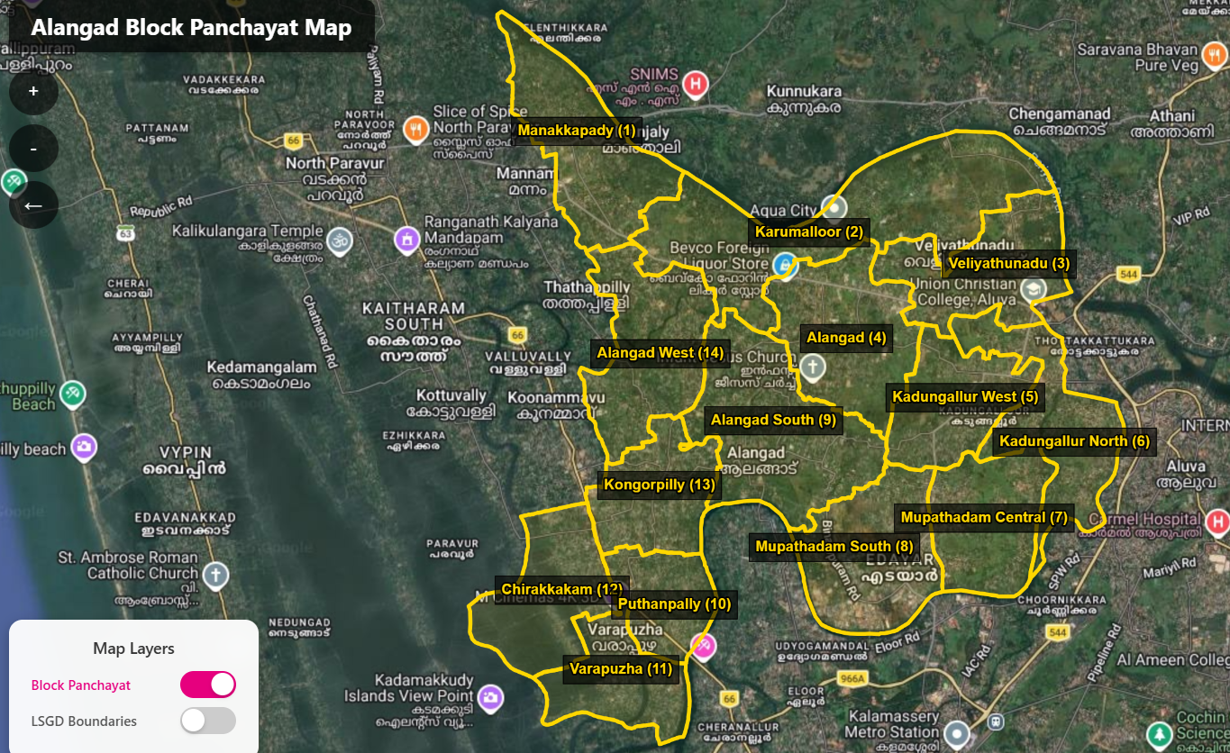
EXECUTIVE SUMMARY

Primary Health Centre (PHC) functions as the primary public healthcare institution serving the population of …Varappuzha….. Grama Panchayath. The PHC plays a pivotal role in delivering comprehensive, accessible, and affordable healthcare services, with a strong focus on preventive, promotive, curative, and rehabilitative care in accordance with national and state health programmes.
The PHC caters to a predominantly rural population, addressing key public health priorities such as maternal and child health, communicable and non-communicable disease control, immunization, family welfare, adolescent health, and geriatric care. Regular outpatient services, home-based care through field health staff, and outreach activities ensure healthcare coverage even in geographically challenging areas. The institution actively implements national health missions, including the National Health Mission (NHM), National Tuberculosis Elimination Programme, National Programme for Prevention and Control of Cancer, Diabetes, Cardiovascular Diseases and Stroke (NPCDCS), and other disease surveillance initiatives.
Varappuzha BFHC works in close coordination with the Grama Panchayath, ASHA workers, Anganwadi centres, schools, and community-based organizations to strengthen community participation and improve health awareness. Emphasis is placed on early detection, timely referral, health education, and lifestyle modification to reduce disease burden and improve overall health outcomes.
Despite constraints related to infrastructure, manpower, and increasing service demand, the PHC continues to enhance service delivery through effective planning, data-driven decision-making, and community engagement. Strengthening facilities, upgrading digital health systems, and expanding preventive services remain key focus areas for future development.
Overall, BFHC VARAPPUZHA stands as a vital institution in safeguarding public health and improving the quality of life of the residents of _VARAPPUZHA Grama Panchayath

LIST OF ABBREVIATIONS

LSGD/LSGI | Local Self Government Department / Local Self Government Institution
BMO | Block Medical Officer
IDSP | Integrated Disease Surveillance Programme
NDMA | National Disaster Management Authority
PPE | Personal Protective Equipment
ICMR | Indian Council of Medical Research
CD | Communicable Diseases
NCD | NON-COMMUNICABLE Diseases

TABLE OF CONTENTS

3
INTRODUCTION 9
● Background of the PPP 9
LSGD AT A GLANCE 9
INTEGRATED HEALTH INFRASTRUCTURE MAP OF ____________ PANCHAYAT 10
GENERAL PROFILE OF THE LSGI’S 13
Background of the LSGI 13
Demographic and Vulnerable Population 14
Clinical Vulnerability 16
INFRASTRUCTURE & RESOURCE INVENTORY 18
Health Facility Directory & Basic Capacity in the LSGD 18
Private Clinics 19
Healthcare Education & Training Institutions 20
Specialized Services & Emergency Inventory 20
Oxygen & Diagnostic Capacity 21
Diagnostics facility mapping at the LSGI level 22
Laboratory Identification & Basic Details 22
Social and Community Infrastructure for surge plan 22
Human resources 24
Community & Support Cadre 25
Community Organizations 26
Administrative & Emergency Services 27
Information regarding resources 27
ONE HEALTH & ENVIRONMENTAL SURVEILLANCE 28
Animal & Bird Population 28
Veterinary Infrastructure 29
Veterinary Doctors & Workforce 30
High-Risk Interface Points (Surveillance Sites) 30
Environmental Risk Mapping 31
Disease Seasonality Mapping 32
Vulnerability Mapping 33
EPIDEMIOLOGICAL TRENDS (2021–2025) 34
Disease Burden among human beings(Last 5 Years) 34
*(use the above table data to create the graph/diagram) 36
Seasonal Trend Analysis 37
Outcome-Based Trend Analysis- 2025 39
Transmission Trend- 2025 40
Integrated Disease Hotspot Map (2021–2025) 42
Preparedness and Response Protocol at LSG Level 44
Constitution of One Health Committee 44
Pandemic Response Workforce 45
Activities and Measures before and during Pandemic 47
PHASE 1 - Alert / Preparation 47
PHASE 2 - Active Response 50
Standard Screening Protocol 51
PHASE 3 - Surge Capacity 60
Conversion of Community Facilities 60
CONCLUSION 61
RECOMMENDATIONS 62
ANNEXURE 63
1. IMPORTANT PHONE NUMBERS 63

INTRODUCTION

LSGD AT A GLANCE
VARAPPUZHA
Ward | Houses | Population | Migrants | Wells | Hot  spots | Ed. Institutions | Hosp pvt/govt.
18 | 8206 | 29206 | 670 | 2568 | 0 | 37 | 5
ALANGAD
Ward | Houses | Population | Migrants | Wells | Hot  spots | Ed. Institutions | Hosp pvt/govt.
24 | 14406 | 52863 | 1184 | 8871 | 21 | 14 | 9
BINANIPURAM
Ward | Houses | Population | Migrants | Wells | Hot  spots | Ed. Institutions | Hosp pvt/govt.
24 | 11819 | 35988 | 1058 | 7255 |  | 10 | 2

ELOOR
Ward | Houses | Population | Migrants | Wells | Hot  spots | Ed. Institutions | Hosp pvt/govt.
32 | 11308 | 40200 | 2388 | 4471 | 7 | 15 | 5

KARUMALOOR
Ward | Houses | Population | Migrants | Wells | Hot  spots | Ed. Institutions | Hosp pvt/govt.
22 | 11305 | 41888 | 460 | 7492 | 10 | 20 | 5

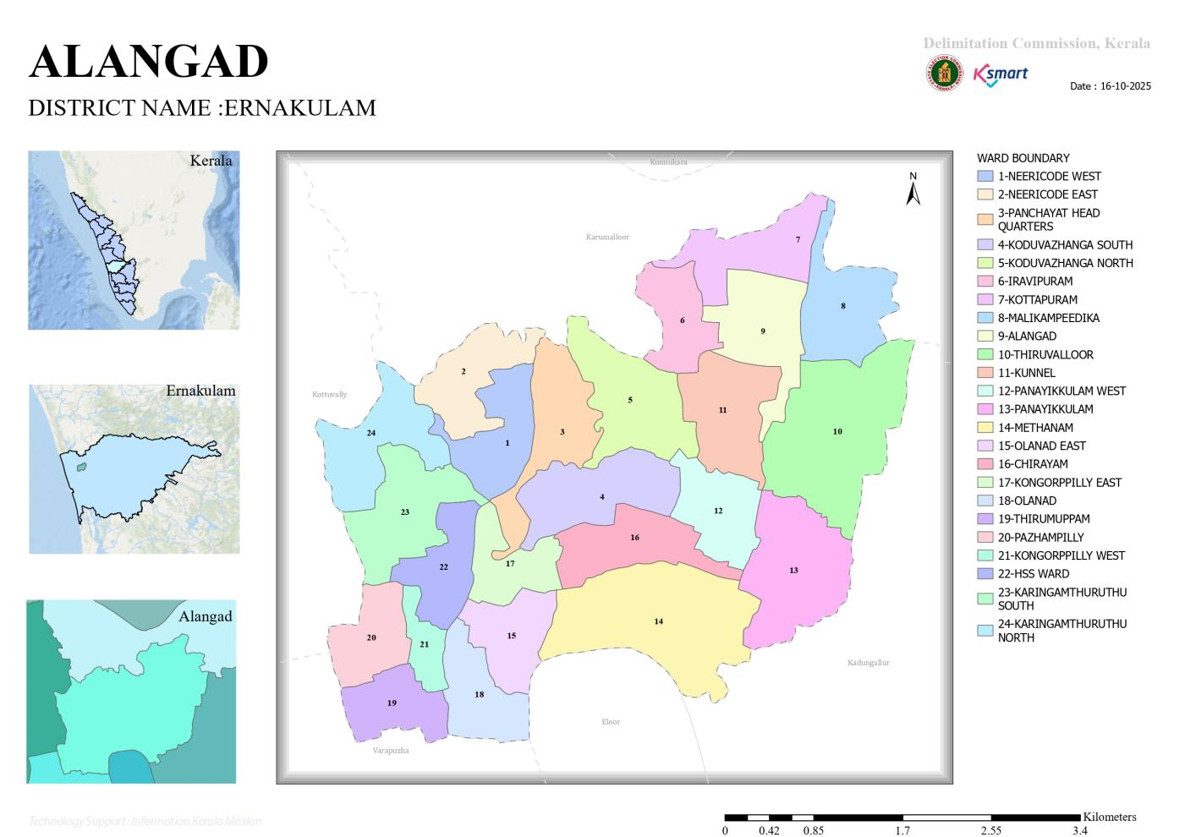

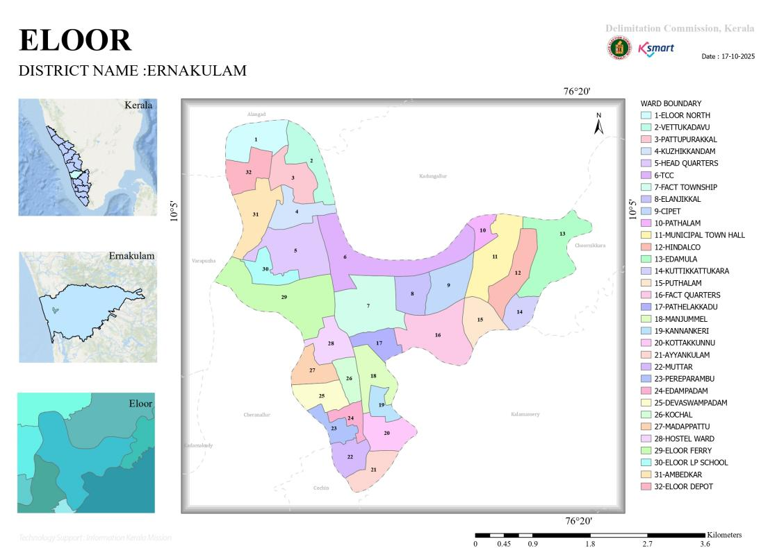
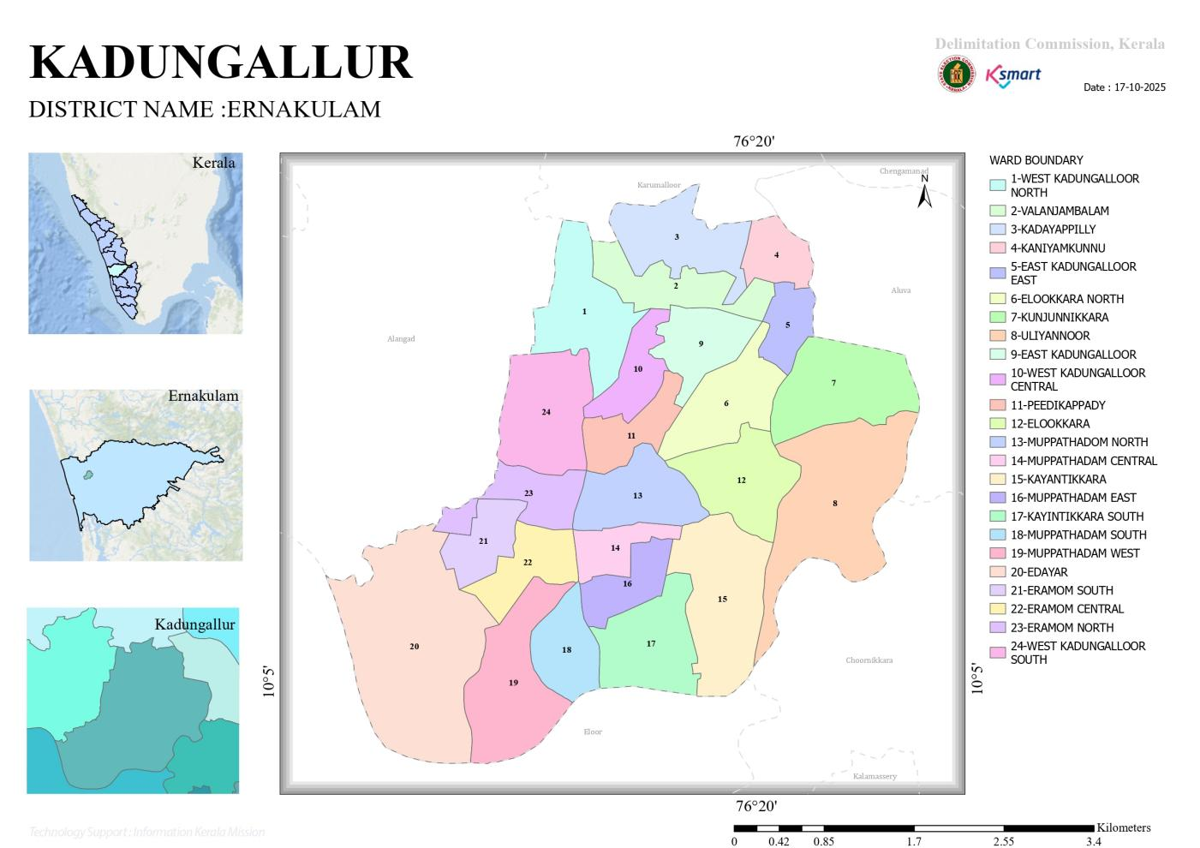
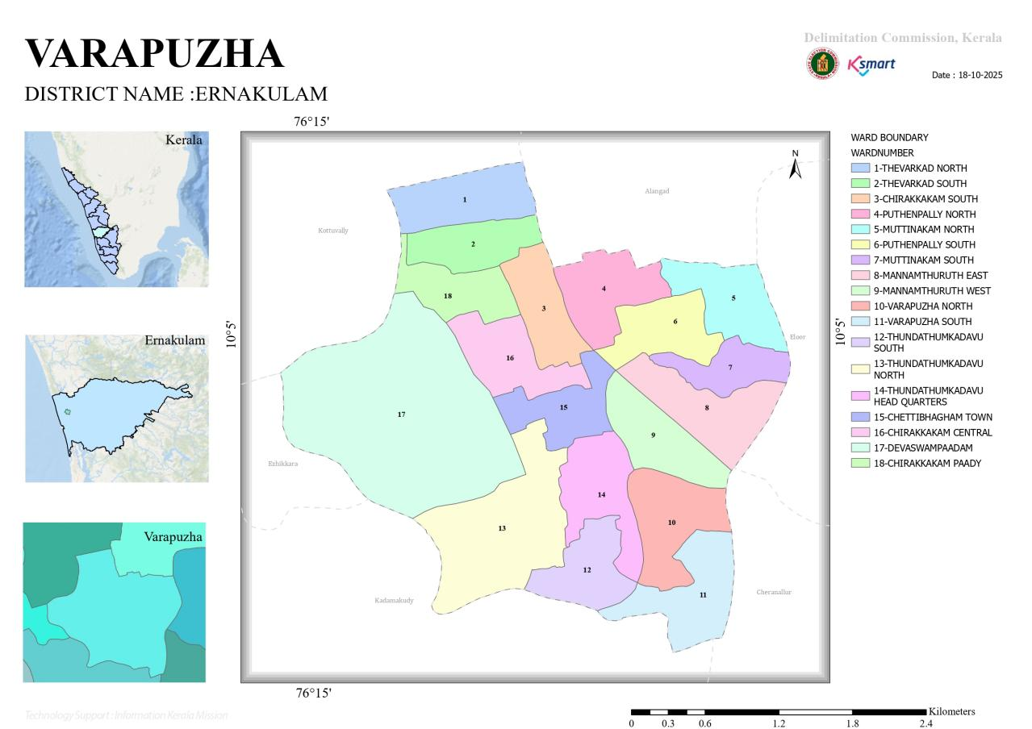

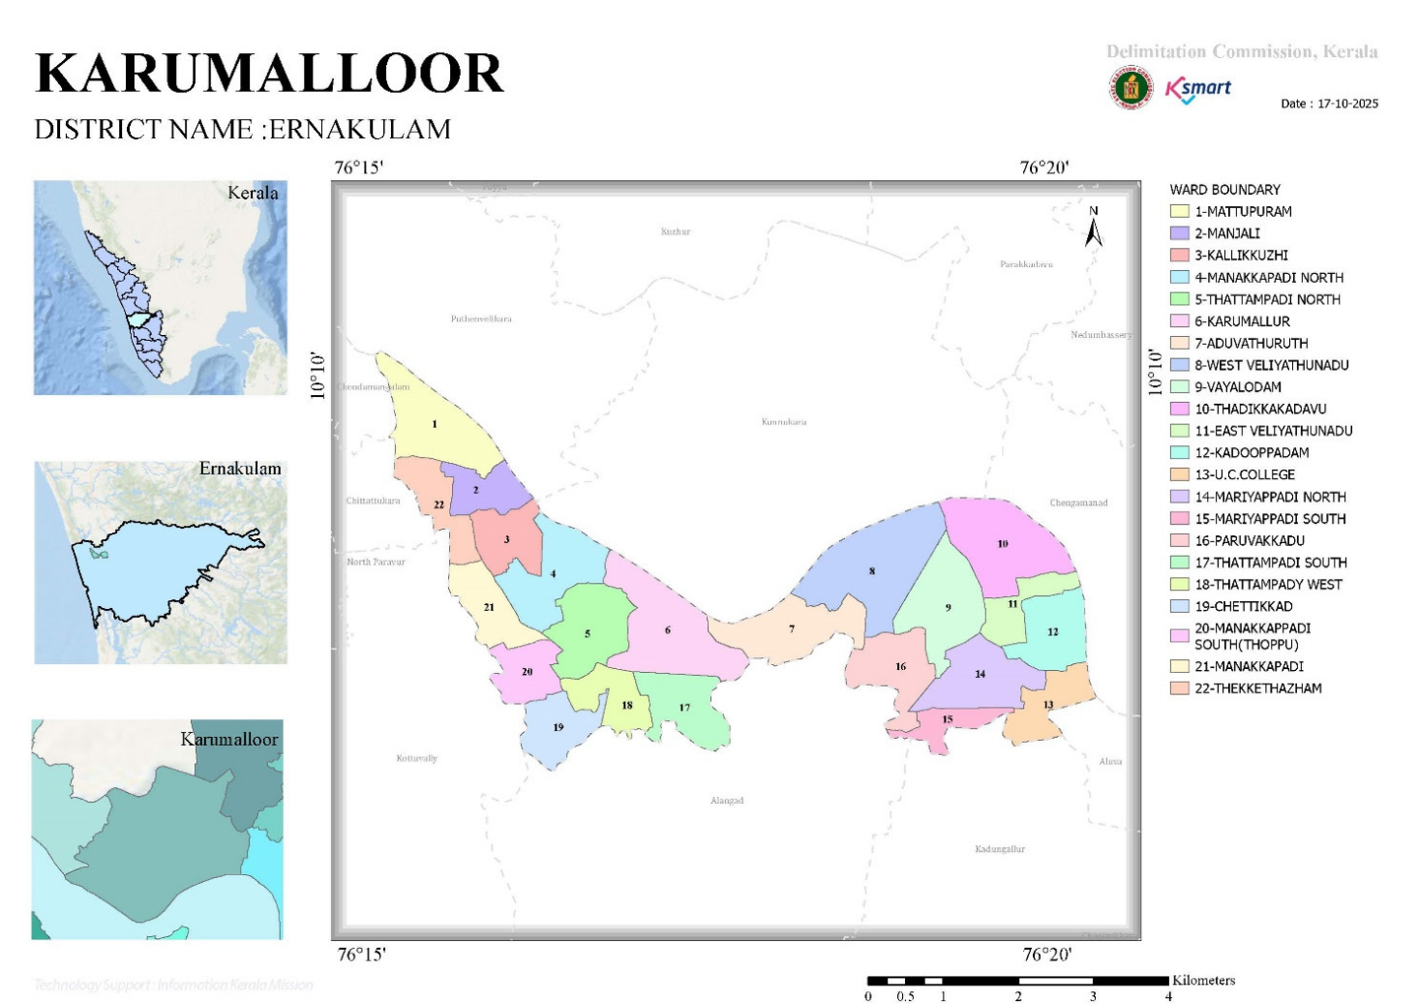

GENERAL PROFILE OF THE BLOCK

Background of the
Alangad Block is situated in the Paravur Taluk of Ernakulam district, Kerala. The geographical landscape of the Panchayat is predominantly low-lying, characterized by the Periyar river, canals, and backwaters. This unique terrain plays a significant role in shaping the local microclimate and poses distinct challenges to transportation, emergency response, and service delivery, particularly during monsoon seasons and flood events.
​The Panchayat is administratively divided into multiple wards, with a population largely dependent on traditional livelihoods. Agriculture—especially paddy cultivation—fishing, coir and coconut husk processing, and allied activities form the backbone of the local economy. In recent years, tourism-related activities and service-sector employment have also shown gradual growth. The area hosts a diverse workforce, including a notable presence of migrant labourers, particularly in construction, agriculture, and allied sectors.
​From a public health and disaster management perspective, Alangad Block LSGI has historically been vulnerable to seasonal flooding, waterborne diseases, and vector-borne illnesses such as Dengue and Leptospirosis. The severe floods experienced during recent years, including the 2018 flood disaster, significantly impacted life, livelihoods, and infrastructure within the Panchayat. These recurring emergencies have underscored the importance of strengthening local preparedness, response mechanisms, and inter-departmental coordination.
​In this context, the development of a localized, data-driven Auxiliary Infrastructure and Logistical Resource Map is essential to support effective planning, timely emergency response, and sustainable development initiatives. Such mapping enables the Panchayat to identify critical resources, improve accessibility during disasters, and enhance overall resilience of the community.
Table 1: Background of Block
Description | Details
Block | ALANGAD
District | ERNAKULAM
Number of Panchayat | 5
Total area (sq. km) | sq.km
Population(Projected)
Population density | persons/sq km
Terrain (coastal/low-lying/backwaters/foothills, etc.) | 12(Eloor)
Number of rivers passing through Block | 1
Number of water bodies in the Block | 49
Number of educational institutions | 98
Factories / small-scale industries | 73/470
Flood-prone Area | 1,9,10,11,17,18(Varappuzha)  1,5,10(Karumaloor)  24(Binanipuram)  25(Eloor)
Landslide-prone Area | NIL
Death Management and Disposal Facilities (mortuaries/crematorium, including electric) | Crematorium-1 (Karumaloor)  Eloor-5  Binnaipuram-4
Auditoriums/Marriage halls/convention centres/community halls | 1.Panchayath community hall(w-4),  2.Vyapara Bhavan Hall-(wd-13,wd-14)  3.CARMEL Hall-(wd-9),  4.Santa maria hall(wd-9),  5.Carmel mini hall(wd-9),  6.Christ nagar church hall(wd-14),  7.SreeDurgahall 8.Marotichuvadu(wd-15),  9.Vana Durga hall(wd-16),  10.Mukundha sree marriage hall (wd-1),  11.StGeorgeparish hall(wd-4)  Cinema Hall-1
Auditoriums/Marriage halls/convention centres/community halls | Alangad-5  Binanipuram-10  Eloor-12  Karumaloor-5  Varappuzha-11

Demographic and Vulnerable Population
Understanding the demographic composition and vulnerable population groups is essential for pandemic preparedness. Children, elderly, economically deprived families, migrant workers, and socially vulnerable groups are at increased risk during public health emergencies due to higher exposure, limited access to services, and dependency on public systems..

Description |  | Details (in numbers)
 |  | Alangad | Binanipuram | Eloor | Karumaloor | Varappuzha
DEMOGRAPHIC PROFILE
Total population |  | 52863 | 53671 | 40200 | 41888 | 29206
Male |  | 25932 | 26114 | 19824 | 21087 | 14147
Female |  | 26931 | 27557 | 20376 | 20801 | 15069
Transgender |  | 0 | 2 | 0 | 0 | 0
Children under 5 |  | 2626 | 2264 | 1805 | 1755 | 1524
Adolescent |  | 4464 | 3366 | 4201 | 3603 | 2503
Elderly (>60) |  | 8009 | 8372 | 5076 | 6137 | 6782
SOCIAL/LIVELIHOOD VULNERABILITY
Previous EPEP family |  | 40 | 24 | 35 | 11 | 1
BPL family |  | 324 | 1835 | 2327 | 3835 | 3190
Tribal communities |  | 14 | 0 | 46 | 0 | 1
Migration | Immigrant | 1284 | 819 | 1956 | 460 | 670
Migration | Emigrant | 2671 | 2600 | 2316 | 270
Socio-economically deprived |  | 40 | 0 | 916 | 0 | AYY -528(YELOW-RC CARD)
Fisherfolk |  | 36 | 0 | 617 | 0 | 500(Ward-9,10,16)
SC Community |  | 4516 | 3638 | 3004 | 5315 | 545(296F+249M)
ST Community |  | 14 | 31 | 193 | 134 | 5(3F+2M)

Clinical Vulnerability
Certain population groups needs priority healthcare & are at higher risk of severe illness, complications, and mortality during pandemics. Patients with chronic diseases, those requiring regular medical care, and individuals with mobility or functional limitations face challenges in accessing timely care during emergencies. Mapping these groups helps in prioritizing continuity of treatment, medicine stock planning, oxygen support, referral transport, and targeted home-based care.

Description | Alangad | Binanipuram | Eloor | Karumaloor | Varappuzha
Pregnant women | 84 | 360 | 225 | 201 | 147
Lactating mothers | 164 | 628 | 144 | 189 | 437
Bedbound patients | 73 | 218 | 127 | 113 | 65
Patients under palliative care other than bedbound | 164 | 35 | 30 | 278 | 80
Patients on Haemodialysis | 19 | 39 | 32 | 43 | 17
Patients on CAPD | 0 | 9 | 0 | 37 | 0
Cancer patients (currently on treatment) | 91 | 126 | 27 | 166 | 44
Haemophilic patients | 0 | 5 | 1 | 2 | 0
Mentally challenged | 36 | 82 | 227 | 23 | 9
Differently abled | 26 | 53 | 310 | 38 | 6
Diabetic patients | 3725 | 3528 | 3168 | 2374 | 272
Hypertensive patients | 4107 | 3259 | 3470 | 1878 | 1878
TB patients | 11 | 15 | 5 | 10 | 3

Major Festivals & Events specific to the LSGI
(with the possibility of a public gathering)

Sl. No. | Name of festival (VARAPPUZHA) | Month detailing the periodicity
1 | St:Joseph Varappuzha church feast | 5DAYS-August
2 | Infant Jesus Church | 5 DAYS-December
3 | Thirumuppam Temple festival | 5 Days
4 | Durga temple festival | 5 DAYS
5 | Vishnu temple festival chirakkakom | 5 DAYS

Sl. No. | Name of festival (ALANGAD) | Month detailing the periodicity
1 | Kunnepalli Alangad Church Festivel, t | January ,
2 | Thiruvaloor Temple Festivel, | March,
3 | Pazhamthodu Fes | December

Sl. No. | Name of festival (BINANIPURAM) | Month detailing the periodicity
1 | Uliyannoor Mahadeva Utsavam | JANUARY
2 | St. Sebastian's Feast | JANUARY
3 | Maha Shivratri Uliyannoor | FEBRUARY
4 | Sree Narasimha Swami Festival | APRIL
5 | Muziris Cultural | DECEMBER
6 | Feast of St. John the Apostle (Muppathadam) | MAY
7 | Feast of Our Lady of Fatima (Binanipuram) | MAY
8 | Holy Angels Church Festival (West Kadungalloor) | OCTOBER

Sl. No. | Name of festival (ELOOR) | Month detailing the periodicity
1 | St.Joseph church festival | march 19

Sl. No. | Name of festival (KARUMALOOR) | Month detailing the periodicity
1 | SABARIMALASEASON | NOV–JAN
2 | MANAKKAPADI TEMPLE ,UTHRA KAVADI | JANUARY
3 | PURAPALLIKAVU TEMPLE | JAN–FEB
4 | STGEORGECHURCH,THATTAMPADY | JAN–FEB
5 | ST THOMAS CHURCH KARAKUNNU | JANUARY
6 | CHERIYATH TEMPLE | MARCH

INFRASTRUCTURE & RESOURCE INVENTORY

Health Facility Directory & Basic Capacity in the LSGD
This section provides an overview of the healthcare infrastructure available within the LSGD area. It outlines the distribution and basic capacity of health facilities that form the backbone of service delivery during routine times and public health emergencies.

Family Health Centres (FHCs) and Community Health Centres (CHCs) generally function as the first point of contact for the community, providing essential outpatient and inpatient services. General Hospitals (GH) and Medical College Hospitals (MCH), where accessible, serve as the main referral centres for advanced diagnostics, specialist care, and critical services during public health emergencies. This inventory helps identify existing strengths, gaps, and potential surge capacity that can be mobilised during a pandemic or disaster.

Table 5. Health Facility Resource Summary
Sl.no. | Health Facility | Type of Facility (MCH/GH/CHC/FHC/SC etc.) | Contact Number | Total beds | ICU Beds | Oxygen-Supported Beds | No. of Ventilator Support Beds | No. of ambulances
Government Healthcare Facilities
1 | CHC VARAPPUZHA | CHC | 04842512520 | 12 | 0 | 0 | 0 | 0
2 | FHC ALANGAD | FHC | 0484-2512711 | 0 | 0 | 0 | 0 | 0
3 | FHC BINANIPURAM | FHC | 0484-2559022 | 4 | 0 | 0 | 0 | 1
4 | FHC ELOOR | FHC | 9895690450 | 0 | 0 | 0 | 0 | 0
5 | FHC KADUNGALOOR | PHC | 0484-2605349 | 0 | 0 | 0 | 0 | 0
6 | FHC KARUMALOOR | FHC | 9539775290 | 2 | 0 | 0 | 0 | 0
7 | ESI HOSPITAL PATHALAM | ESI | 9497444337 | 117 | 12 | 12 | 2 | 1
8 | ESI DIPENSARY PATHALAM | ESI | 8891846880 | 0 | 0 | 0 | 0 | 0
Private Healthcare Facilities
1 | Carmel Medical Centre | Pvt | 8089505019 | 8 | 0 |  | 0 | 0
2 | St: Joseph Hospital Manjummal | PVT | 7994179  361 | 216 | 18 | 18 | 8 | 1
3 | Muppathadam Cooperative Clinic | PVT | 73566121477 | 3 | 0 | 0 | 0 | 0
4 | Rural Medical Centre U C College | PVT | 0484  2606358 | 2 | 0 | 0 | 0 | 0
5 | Thomas Clinic Malikampeedika | PVT | 0484  2670748 | 1 | 0 | 0 | 0 | 0
6 | Dr.Chithras ENT clinic, Mariyapadi | PVT | 9745926  038 | 0 | 0 | 0 | 0 | 0
7 | Mikha homeo clinic manakappady | PVT | 8281447  993 | 1 | 0 | 0 | 0 | 0
AYUSH Healthcare Facilities
1 | AYURVEDA DISPENSARY-Varappuzha | GOV | 04842511991 | 0 | 0 | 0 | 0 | 0
2 | HOMEO DISPENSARY-Varappuzha | GOV | 9388557914 | 0 | 0 | 0 | 0 | 0
3 | GOVT AYURVEDA -Alangad | CLINIC | 9633148232 | 0 | 0 | 0 | 0 | 0
4 | GOVT HOMOEO-Alangad | CLINIC | 7356390550 | 0 | 0 | 0 | 0 | 0
5 | GOVT HOMOEO DISPENSARY-Binanipuarm | Gvt | 8891375515 | 0 | 0 | 0 | 0 | 0
6 | AYURVEDA DISPENSARY-Binanipuram | Gvt | 9542355358 | 0 | 0 | 0 | 0 | 0
7 | HOMEO DIPENSARY-Eloor | Gvt | 9387566  622 | 0 | 0 | 0 | 0 | 0
8 | AYURVEDA  Dispensary-Eloor | Gvt | 999509  2374 | 0 | 0 | 0 | 0 | 0
9 | GovtAyurveda Dispensary, Aduvathuruthu | Gvt | 7012431  658 | 0 | 0 | 0 | 0 | 0
10 | GovtHomeoModel Dispensary, Veliyathunadu | Gvt | 9526917  283 | 0 | 0 | 0 | 0 | 0

Private Clinics
Private clinics are an essential part of pandemic preparedness, as they are often the first place people seek care when symptoms begin. In many communities, private clinics manage a significant share of outpatient visits and therefore play a critical role in early case detection, timely referrals, and disease surveillance. Having an up-to-date understanding of where these clinics are located, the services they provide, and how they are linked to the public health system helps ensure that no cases are missed during an outbreak. It also allows health authorities to engage private practitioners more effectively for reporting, risk communication, and coordinated response, strengthening the overall capacity of the health system to manage public health emergencies.

Table 6. Private Clinic Resource Summary
Sl No. | Name of Clinic | Registered (Y/N) | Clinic (General / Speciality) | Speciality (if any) | Address | Contact Number | Diagnostic Facility (Y/N) | Ambulance Linkage (Y/N)
1 | Thaliyath Dental Clinic | Y | General | Dental | Dr.Paul Thaliyath,Above south indan Bank | 9847084547 | NO | N
2 | ThaliyathDental clinic | Yes | special | Dental | Dr John joseph,Oppo puthenpally ,Varappuzha | 9447327735 | NO | N
3 | UB TRUST HOSPITAL | YES | General |  | Dr.Babu N Jacob Main Road Varappuzha | 9847362233 | NO | N
4 | Willow Medical Centre | No | Genaral |  | Dr.P.J Joseph | 9847177779 | NO | N
5 | Varappuzha Medical Centre | yes | General |  | Mariamma Cheriyan,Puthenpally Market road Varappuzha | 9497683251 | NO | N
6 | Medicare Multy speciality Family clinic | YES | General | NA | Chirayam | 9497028950 | NO | YES
7 | Kongorppilly Medical Centre | NO | General | Na | Kongorppilly | 9207808060 | NO | YES
8 | Neericode Medical Centre | NO | General | NA | Neericode | 8304077297 | NO | YES
9 | Alangad Medical Centre | YES | General | NA | Alangad | 9846062238 | NO | YES
10 | Neo Clinic | NO | General | NA | Malikampediaka | 7510483001 | NO | YES
11 | Our family clinic | N | GEN |  | Muppathda m | 9544448669 | Y | Y
12 | Dental clinic | Yes | GEN | Dental | dental clinic pathalam | 6236425716 | YES | NO
13 | Rural Medical centre UC College | NO | GENERAL |  | UC COLLEGE ALUVA | 0484  2606358 | NO | NO
14 | Thomas clinic  Malikampeedika | NO | GENERAL |  | AHAMAD UNNY ROAD VELIYATH  UNAD | 0484  2670748 | NO | NO

Healthcare Education & Training Institutions
This section tracks the educational infrastructure available, which is vital for human resource planning in the health sector.

Category of Institution | Govt | Private | AYUSH | Total
Medical Colleges | 0 | 0 | 0 | 0
Nursing Colleges | 0 | 1 | 0 | 0
Dental Colleges | 0 | 0 | 0 | 0
Para-medical / Allied Health | 0 | 1 | 0 | 0
Pharmacy Colleges | 0 | 0 | 0 | 0

Specialized Services & Emergency Inventory
This section provides a detailed view of the specialized medical resources available to the community, focusing on emergency response and critical care capabilities. This table tracks the vital assets required for managing severe illnesses and emergencies across Government, Private, and AYUSH sectors.

Item | Govt | Private | AYUSH | Total
Hospital beds | 14  ESI-117 | 57 | 0 | 188
Oxygen-generating systems(Y/N) | Y | Y | 0 | 4
Oxygen-supported beds(Numbers) | 0 | 30 | 0 | 30
Ventilator-supported beds | 2 | 8 | 0 | 10
ICU beds | 12 | 18 | 0 | 30
Burns units | 0 | 0 | 0 | 0
Blood centres | 0 | 1 | 0 | 1
BLS ambulances | 0 | 3 | 0 | 3
ALS ambulances | 0 | 1 | 0 | 1
Dialysis facilities | 0 | 0 | 0 | 0
Dispensaries | 5 | 5 | 1 | 11
Medical store | 2 | 54 | 4 | 60
Industrial establishments(Medium-scale industries/small-scale industries establishments to whom we can depend in a worst-case scenario) | 0 | 11 | 0 | 11

Oxygen & Diagnostic Capacity
Monitoring oxygen and diagnostic capacity is a critical component of public health preparedness, ensuring that the LSGD can handle both chronic care and sudden surges in respiratory or infectious diseases.
Name of Health Facility | Oxygen-generating System (Y/N) | Backup Oxygen Source (Y/N) | Diagnostic Facilities Available(Y/N)
Name of Health Facility | Oxygen-generating System (Y/N) | Backup Oxygen Source (Y/N) | Lab | USG | X-ray | CT/MRI | RT-PCR
Government Healthcare Facilities
CHC VARAPPUZHA | N | N | Y | N | N | N | N
FHC BINANIPURAM | N | N | Y | N | N | N | N
FHC ALANGAD | N | N | Y | N | N | N | N

Diagnostics facility mapping at the LSGI level
The diagnostic capacity of ____ALANGAD BLOCK represents the "intelligence network" of our healthcare system. The speed and accuracy of disease identification depend entirely on the distribution and technical level of these facilities.

Item | Govt | Private | AYUSH | Total
General labs | 5 | 32 | 0 | 37
Microbiology labs | 0 | 7 | 0 | 7
RT-PCR labs | 0 | 4 | 0 | 4
USG units | 0 | 2 | 0 | 3
CT/MRI units | 0 | 1 | 0 | 1
Research labs | 0 | 0 | 0 | 0
Labs of other departments that can be repurposed | 0 | 0 | 0 | 0

Laboratory Identification & Basic Details
Sl. No. | Name of Laboratory | Ownership (Govt / Private / Academic) | Address | Contact No. | 24×7 Services (Yes/No) | NABL / Govt Approved (Yes/No)
1 | CHC VARAPPUZH | Gov | Edampadam,Varappuzha | 04842512520 | NO | YES
2 | Co-operative medical lab | Pvt | Co operative Bank, Varappuzha | 9961349758 | no
3 | St.Antony lab | pvt | Edampadam,Varappuzha | 04842516646 | NO
4 | Aster lab | pvt | Puthenpally,Varappuzha | 8921699760 | YES
5 | Neethi Lab | pvt | Varappuzha | 9567647977 | No
6 | FHC ALANGAD | GOVT | FHC ALANGAD | 7034963007 | 8 | YES
7 | ModiTech Diagnostic centre | PVT | Kongorpilly | 9645912228 | 10 | YES
8 | Kongorppilly sahakarana medical lab | pvt | kongorppilly | 9947671443 | 10 | YES
9 | Sahakarana medical lab panayikulam | pvt | Panayikulam | 9947671443 | 10 | YES
10 | DDIC Scan & diagnostic | Pvt | malikampedika | 9388615143 | 10 | YES
11 | Neericode Medical lab | PVT | Neericode | 9846532152 | 8 | YES
12 | Shakarana medical lab Neericode | PVT | Neericode | 8089112292 | 8 | YES
13 | DDRC, Neericode | PVT | Neericode | 9778424858 | 8 | YES
14 | St.Joseph Manjummal | PVT | Manjummal | 7994179361 | YES | NO
15 | Sree Devi Lab | PVT | Pathalam | 7736382608 | NO | NO
16 | Karunya lab | Private | UC college aluva | 9995529  963 | NO | NO
17 | Aster labs | Private | UC college aluva | 0484  2943658 | NO | NO
18 | KCB LAB | Private | THATTAMPADY KARUMALLOOR | 9995602  352 | NO | NO
19 | MEDIWELL LAB | Private | THEKKETHAZHAM MANJALY | 0484  2340130 | NO | NO
20 | CO OPERATIVE LAB | Private | MILLUPADY KARUMALLOOR | 8589953  030 | NO | NO

Social and Community Infrastructure for surge plan
This table serves as our logistics and shelter inventory. By mapping these locations, quickly we can identify where to house displaced citizens, where to set up temporary medical clinics, and how to manage the deceased with dignity during a crisis.

Category | Total Count | Ward | Est. Capacity (Persons) | Contact details
Educational Institutions
Anganwadis | 99 | 1 to 18 | Max-20,38,50  Min-5 | 8547211556(Varapuzha)  9400237416(Alangad)
Schools | 42 | 2,4,5,7,11,13, 15, | Max-1500,500  Min-46 | 9846861866
Colleges | 0 | 0 | 0 | 0
Healthcare Educational Institutions
Medical colleges (Govt/Private) | 0 | 0 | 0 | 0
Nursing colleges (Govt/Private) | 0 | 0 | 0 | 0
Dental colleges (Govt/Private) | 0 | 0 | 0 | 0
Paramedical institutes (Govt/Private) | 1 | 0 | 0 | 0
Community Gathering Spaces
Community halls | 3 | 14(Varapuzha)  17(Kadungaloor) | 300
Auditoriums | 36 | 1,4,9,14,15,1613,14, | 200,7000 -Binanipuram | 9847415348(Vypara Bhavan)
Religious buildings | 39 | 4,9,12, | - Varappuzha  1500-Binanipuram | 7907792801(Carmel Hall VPZA)
Vulnerable Group Support Facility
Destitute homes | 2 | 13 | 86 | 9847387024(CAPHARANAM)
Elderly homes | 3 | 9,10,11 |  | 7994225243(Nazerath Sr .Sneha)
LSGD owned other buildings | 53 | 14,15 | 100 | 9446192991
Mass Fatality Management (MFM) Infrastructure
Mortuary | 0 | 0
Crematorium | 1 | 0

Human resources
This section focuses on the human capital available within the LSGI. In any emergency—be it a pandemic, flood, or industrial accident—infrastructure is only as effective as the people operating it.

Medical & Clinical Personnel
This table tracks the "Frontline" providers responsible for diagnosis, treatment, and clinical management.

Cadre | Govt (No.) | Private (No.) | Total
Doctors—Modern Medicine | 30 | 46 | 76
Doctors – AYUSH | 6 | 5 | 11
Doctors – Veterinary | 6 | 0 | 6
Doctors – Dental | 2 | 11 | 13
Nursing officers | 28 | 96 | 124
Lab technicians | 10 | 31 | 41
Optometrist | 2 | 2 | 5
Pharmacists | 14 | 19 | 33
Psychologists | 0 | 1 | 1
Counsellors | 1 | 3 | 4

Public Health & Field-Level Workforce
These individuals are the backbone of surveillance, maternal-child health, and decentralized care.

Cadre | Health services | Municipal common services | Total
HS (Health Supervisors) | 1 | 0 | 1
HI (Health Inspectors) | 5 | 0 | 5
LHS (Lady Health Supervisor) | 1 | 0 | 1
LHI (Lady Health Inspectors) | 2 | 0 | 2
JPHN (Jr Public Health Nurses) | 20 | 0 | 20
JHI (Jr Health Inspectors) | 17 | 0 | 17
MLSP (Mid-Level Service Providers) | 22 | 0 | 22
Palliative Nurses | 6 | 0 | 6
RBSK Nurses | 5 | 0 | 5
PRO | 1 | 0 | 1
Epidemiologist | 1 | 0 | 1
Data Manager | 1 | 0 | 1

Community & Support Cadre
This group represents the surge capacity of the LSGI—people who can be called upon for logistics, rescue, and specialized support.

Cadre | Alangad | Binanipuram | Eloor | Karumaloor | Varappuzha | Total
ASHA Workers | 26 | 23 | 31 | 20 | 25
AWW (Anganwadi Workers) | 38 | 32 | 92 | 34 | 27
Emergency Medical Volunteers (Trained) | 32 | 0 | 0 | 0 | 0
Kudumbashree | 24 | 161 | 342 | 242 | 158 UNITS
MNREGS | 24 | 719 | 556 | 617 | 380
Purusha Swayam Sahaya Sangham | 12 | 0 | 161 | 0 | 1
Ex-Servicemen | 8 | 15 | 143 | 6 | 0
Retired Police Officers | 9 | 18 | 37 | 2 | 0
NCC/NSS Volunteers | 12 | 145 | 151 | 120 | 166
Red Cross volunteers | 0 | 153 | 13 | 30 | 98
One Health Community Volunteers | 24 | 0 |  | 637 | 11
One Health Community Mentors | 24 | 0 |  | 91 | 11

Community Organizations
This section details the presence of community-based organisations (CBOs), non-governmental organisations (NGOs), faith-based organisations (FBOs), Kudumbashree Self-Help Groups (SHGs), and Ayalkootams within the Local Self-Government Institution (LSGI). These groups enhance grassroots mobilization, resource distribution, and support networks crucial for pandemic response and community resilience.

Category | Total Count
 | Alangad | Binanipuram | Eloor | Karumaloor | Varappuzha
NGOs | 2 | 23 |  | 0 | 0
Religious based organizations | 3 | 12 |  | 0 | 3
Foreign based organizations | 0 | 2 | 0 | 0 | 0
Sports Club/youth clubs | 3 | 15 | 31 | 2 | 0
Kudumbashree SHGs | 24 | 161 | 342 | 22 | 2
Ayalkootams | 360 | 250 | 342 | 240 | 158
Political organizations | 3 | 8 |  | 0 | 0
Residential organizations | 5 | 43 | 127 | 0 | 0

Administrative & Emergency Services
This section outlines the availability of key non-health emergency support services and infrastructure within the LSGI, which are essential for effective pandemic preparedness and response. These facilities support law enforcement, disaster response, water supply, logistics, mobility, and community-level interventions during public health emergencies.

Category | Total Count | Contact details
Police Stations | 5 | Varappuzha-9497947306  Alangad-04842671101  Binanipuram-  Eloor-  Karumaloor-04842671101
Fire & Rescue Stations | 0 | 04842525500 ELOOR
Water Pumping Points | 3 | 0484 2442340
Public Distribution System (PDS) | ARD 30 (Varapuzha Jn)  ARD 78 (Near Market)  ARD 102 (Puthenpally area)  ARD 115 (Devaswampadam)  ARD 142 (Mannamthuruth)  Supplyco Maveli Store (Near Panchayath Office) | Rationing Inspector, Varapuzha/Paravoor 9188527725  Taluk Supply Officer 9188527378  SupplyCo, Varapuzha 0484 2513003

Information regarding resources
The availability of essential transport and support resources plays a quiet but critical role in saving lives. Equipment such as ambulances, mobile mortuaries, amphibian ambulances, and motorized boats ensures that patients, samples, and healthcare teams can move swiftly—even in flooded, remote, or difficult terrains. Heavy vehicles like JCBs, cranes, tractors, and torus lorries support logistics, waste management, emergency infrastructure, and rapid conversion of spaces into care or isolation facilities. Taxis, four-wheel-drive vehicles, and trucks help maintain continuity of essential services, reach vulnerable populations, and support home-based care and supply delivery.

Means of transportation | Alangad | Binanipuram | Eloor | Karumalor | Varappuzha
JCB | 4 | 3 | 45 | 10
Crane | 1 | 4 | 37 | 0 | 0
Heavy Trucks | 18 | 1 | 45 | 25 | 0
Tractor | 6 | 1 | 13 | 10 | 2
Ambulances | 8 | 3 | 8 | 6 | 3
Mobile mortuaries | 5 | 0 | 3 | 0 | 1
Boats | 3 | 0 | 0 | 0 | 1
Taxi service | 47 | 56 | 21 | 5 | 250

ONE HEALTH & ENVIRONMENTAL SURVEILLANCE
The One Health method integrates environmental, animal, and human health to enable proactive pandemic preparedness. Panchayat-level surveillance needs to be improved in order to detect and treat zoonotic and environmentally generated diseases early. Surveillance is strengthened through systematic assessment of animal populations, veterinary infrastructure, poultry and slaughter facilities, inter-sectoral coordination, and specialised tools like avian influenza seasonality mapping using GIS in previous outbreaks to enable predictive alerts and ward-specific sampling to support effective pandemic preparedness in high-risk areas .

Animal & Bird Population
Mapping animal and bird populations at the Panchayat level is essential for identifying and prioritising zoonotic disease hazards like rabies, avian influenza (H5N1), leptospirosis, anthrax, and Nipah-like spillover occurrences. Risk classification, targeted surveillance, vaccination planning, and early epidemic detection made feasible by comprehensive population mapping all enhance One Health-based pandemic preparedness.

Category | Item | Estimated Population | Wards
 |  | Alangad | Binanipuram | Eloor | Karumaloor | Varappuzha
Animal Population | Livestock (Cattle/Goats/Buffalo) | 820 | 50 | C-225/B-60 | 329 | 923
Animal Population | Pet Animals (Dogs/Cats) | 2100 | 356 | 1256 | 1290 | 1034
Animal Population | Stray Dog Population | 178 | 100 | 250 | 76 | 500
Animal Population | Pig Farms (Number of heads) | 0 | 0 | 0 | 2 | 0
 | Small Units (Sheep / Goats – clustered) | 0 | 1 | 101 | 0 | 0
Bird Population | Poultry Units (Birds) | 3 | 0 | 2132 | 4 | 0
Bird Population | Poultry- (FOWL) | 1 | 0 | 122 | 3250 | 8307
Bird Population | Wild/Migratory Birds (Observed) | 0 | 0 | 0 | 26 | 0
Bird Population | Crow Mortality Events (Reported) | 0 | 0 | 0 | 0 | 0

Veterinary Infrastructure
Veterinary institutions are a core pillar of One Health surveillance, enabling early zoonotic disease detection through vaccination, investigation of unusual animal illness or deaths, sample collection, and timely outbreak reporting. A well-mapped and responsive veterinary network strengthens coordination with human health and LSGI systems, ensuring rapid response during zoonotic events and pandemics.
Facility Type | Name of Facility | Ownership Govt / Pvt | Location(Ward No) | Contact number
Veterinary Dispensary | Gov Veterinary Dispensary | Gov | 4/6/8 | 9847353310-Alangad  9446443181-Binanipuram  9446127986-Karumaloor
Veterinary Hospital / Polyclinic | Veterinary Hospital | Govt | 3/30/5 | 9447290877-Varappuzha  0484254641-Eloor  9387833369-Karumaloor
Private Veterinary Clinics | NIL | NIL | NIL | NIL
Mobile / Emergency Vet Service (incl. night services) | NIL | NIL | NIL | NIL
Pet Homes / Animal Shelters | Nil | Nil | Nil | Nil
Slaughterhouse-linked Veterinary Inspection Unit | NIL | NIL | NIL | NIL

Veterinary Doctors & Workforce
Early detection, diagnosis, reporting, and reaction to animal illness epidemics depend on the availability and accessibility of qualified veterinary specialists. By identifying unusual animal morbidity or mortality promptly, collecting samples promptly, and coordinating efficiently with human health and LSGI systems—especially during zoonotic outbreaks and pandemic-prone situations—a clearly defined veterinary workforce enhances One Health surveillance.

Category | Number Available | Type (Govt/Pvt) | Contact number
Government Veterinary Doctors | 2 | GOV | 9747113580-Varappuzha  9847353310  -Alangad
Private Veterinary Doctors | 1 | GOV
Livestock Inspectors | 9 | GOV | 9847353310-Alangad  9539458276-Binanipuarm  8606525553-Eloor
Para-veterinary Staff / Attenders | 2 | GOV | 9539053110
Contract / On-call Veterinary Support (if any) | 0

High-Risk Interface Points (Surveillance Sites)
High-risk interface points for zoonotic disease surveillance in __Varappuzha__ Grama Panchayath include wetland–livestock–human contact zones, backyard poultry farms, cattle sheds near water bodies, fish markets, and areas of high human–animal interaction such as community slaughter points and migratory bird congregation sites. These are the primary surveillance sites where zoonotic spillover risks are elevated.

Type of Habitat | Type of High risk interface | Geographical vulnerability
Wetlands & Backwaters | Chance of Leptospirosis(contaminated water,animal urine) | Low lying wetland system
Backyard Poultry Farms | 0
Cattle Sheds near Water Bodies | Ward 12-Binanipuarm
Fish & Meat Markets | Improper waste management system | Leading to a range of environmental and public health issues.
Community Slaughter Sites | Nil
Migratory Bird Congregation Areas | Ward 16
Rodent-Infested Grain Storage | Nil

Category | Total Count | Key Locations (wards)
Poultry Farms | 0
Backyard / Clustered Poultry Units | 0
Duck Rearing Units (open water access) | 5 | 1,2,6,7,9-Alangad
Slaughterhouses/ Slaughter Points | 20 | 8,9-Varappuzha  2,,24,22,23-Alangad
Meat/Fish Markets | 6 | - Varappuzha  15,9-Alangad
Live Bird Sale Points | 3 | - Varappuzha  - 2,1,15
Cattle Markets / Weekly Animal Fairs
Pet Shops / Breeders | 6 | 3,8-Varappuzha  3-Alangad
Animal Shelters / Pet Homes | 2 | 5,7
Waste Disposal Sites near Animal Units | 0 | 0

Environmental Risk Mapping
Environmental risk mapping identifies monsoon/flood hotspots for vector-borne (dengue, chikungunya), water-borne (leptospirosis, diarrhoea), and zoonotic diseases in Kerala's wetlands. Systematic surveillance supports early warnings, targeted interventions, and Panchayat pandemic preparedness.
Waterborne exposure: Flood-prone areas and stagnant water bodies facilitate leptospira survival, raising leptospirosis risk.

Traditional practices: Informal slaughter and fish markets lack standardized hygiene,

Risk Factor | High-Risk Area | Key Locations | Risk Level (High/Med/Low)
Flood-prone areas | 1,9,10,11,17,18  1-24 Wards | Varappuzha  Binanipuram | Med  Med
Water bodies/wetlands | 4,2-Wards  1-24- Wards  3-Wards  1,15,18-Wards | Puthenpally,Thevarkad,  Binanipuram,  Manjaly,Manakkapady | Low
Solid waste accumulation | 18,19,20,21,22,23,24 | FACTORIES | HIGH
Animal waste disposal issues | 6 | Uliyanoor | LOW
Rodent infestation zones | Nil
Industrial effluent discharge | 1 | Pathalam | Med
Construction sites / abandoned buildings | 16 |  | Low
Poor drainage/blocked canals | Nil
Drinking water source contamination risk | 1 | Kuttikattukara | Med

Disease Seasonality Mapping
1, Flooding & waterlogging → amplifies leptospirosis, malaria, diarrheal diseases.
·
2, Migratory bird influx (Nov–Feb) → avian influenza risk.

3, Mosquito breeding cycles → vector-borne disease peaks in monsoon.

4, Agricultural practices → close human–animal contact in paddy fields.

Disease | Peak Risk Season | Key Drivers | High-Risk Locations | Surveillance Focus
Avian Influenza
Leptospirosis | June-July | NRG workers, Farmers | Devasampadam | Doxycycline prophylaxis
Dengue/Chikungunya | August,  June-July |  | Devasampadam,Thundathumka,Eloor muncipal are | Source reduction
Acute Diarrheal Diseases | Jan-Dec |  |  | Guiding public health education class,tracking common pathogens
Rabies |  | Stray Dogs
Anthrax (rare) | Nil

Vulnerability Mapping
Vulnerability mapping pinpoints high-risk populations, occupations, and areas exposed via environment, livelihoods, socio-economics, and poor service access. Paired with environmental/seasonality mapping, it enables risk-based surveillance, targeted actions, and optimal resource use in One Health and pandemic planning.

VARAPPUZHA &ELOOR
Vulnerability Factor | High-Risk Wards | Key Groups / Locations | Risk Level
Flood-prone households | 16,13-V  18-E | Devasampadam(Varappuzha)  Kuttikattukara,Pathalam(Eloor) | Low  High
Wetland-adjacent communities | - Varapuzha  5-Eloor | Devasampadam,  Puthiyaroad,Pathalam,Kocheri | low
Backyard poultry / duck rearing households | 16  3 | Eloor Deppo | Low
Livestock-rearing households | Nil | Nil | Nil
Slaughterhouse & meat market workers | 5,7 | Muttinakam | low
Fisherfolk & fish market workers | 16 | Chirakkakam,Devasampadam | Med level
Sanitation workers | 16,13
Daily wage / migrant workers | 1,15,12 | Thundathumkadavu,Devasampadam,Thevarkad
Elderly & chronically ill populations | Nil
Pregnant Women | 16 | Devasamapadam | Low
Children (schools, Anganwadi’s) | 16,13
Limited access to safe water & sanitation | 16,13,14,12 | Devasampadam,Thevarkad | High level

ALANGAD
Vulnerability Factor | High-Risk Wards | Key Groups / Locations | Risk Level
Flood-prone households | 0 | 0 | 0
Wetland-adjacent communities | 0 | 0 | 0
Backyard poultry / duck rearing households | 0 | 0 | 0
Livestock-rearing households | 0 | 0 | 0
Slaughterhouse & meat market workers | 19 | 0 | 0
Fisherfolk & fish market workers | 11 | 0 | 0
Sanitation workers | 24 | 0 | 0
Daily wage / migrant workers | 977 | 0 | 0
Elderly & chronically ill populations | 288 | 0 | 0
Pregnant Women | 63 | 0 | 0
Children (schools, Anganwadi’s) | 7289 | 0 | 0
Limited access to safe water & sanitation | 0 | 0 | 0

BINANIPURAM

Vulnerability Factor | High-Risk Wards | Key Groups / Locations | Risk Level
Flood-prone households | 24 | 1,2,3,4,6,7,8,10,11,12  ,13,14,15,16,17,18,19  ,20,21,22,23,24 | HIGH
Wetland-adjacent communities | 0 | NA | NA
Backyard poultry / duck rearing households | 0 |  | LOW
Livestock-rearing households | 2,3,4,5,6,7,910,11,13,  15,18 |  | MEDIUM
Slaughterhouse & meat market workers | 0 | NA
Fisherfolk & fish market workers | 0 | NA | LOW
Sanitation workers | 19,20 | CLEANING WORKERS | HIGH
Daily wage / migrant workers | WARD 1-24 | KOOLIE WORKERS | HIGH
Elderly & chronically ill populations | WARD 1-24 | ABOVE 60 | HIGH
Pregnant Women | WARD 1-24 | HIGH RISK PREGNANT WOMEN | HIGH
Children (schools, Anganwadi’s) | WARD 1-24 | UNIMMUNIZED CHILDREN | HIGH
Limited access to safe water & sanitation | 0 | NA | NA

Karumaloor
Vulnerability Factor | High-Risk Groups | Key Groups / Locations | Risk Level
Flood-prone households | NIL | NA | NA
Wetland-adjacent communities | NIL | NA | NA
Backyard poultry / duck rearing households | NIL | NA | NA
Livestock-rearing households | NIL | NA | NA
Slaughter house & meat market workers | NIL | NA | NA
Fisherfolk & fish market  workers | NIL | NA | NA
Sanitation workers | YES | Distributed to  All wards | LOW
Daily wage/migrant workers | YES | Distributed to all wards | LOW
Elderly& chronically ill  populations | NIL | NA | NA
Pregnant Women | YES | Distributed to  All wards | LOW
Children(schools, Anganwadis) | YES | stributed to all wards | LOW
Limited access to safe water&  sanitation | YES | Distributed to  All wards | LOW

EPIDEMIOLOGICAL TRENDS (2021–2025)

Disease surveillance is the systematic collection, analysis, and interpretation of health data for planning, implementation, and evaluation of public health practice. This section presents the disease surveillance profile of the LSGI based on routine reporting systems and outbreak investigations to identify priority diseases, seasonal patterns, and emerging public health threats.

Disease Burden among human beings(Last 5 Years)
Analysis of disease-wise data for the last five years helps identify persistent public health problems, emerging diseases, and changes in disease burden. This information supports prioritisation of prevention, preparedness, and response activities at the Panchayat level.
VARAPPUZHA
Disease | 2021 | 2022 | 2023 | 2024 | 2025 | Trend(Increasing/Stable/Decreasing)
Dengue | 10 | 37 | 40 | 41 | 14 | Decreasing
Leptospirosis | 6 | 8 | 0 | 3 | 7 | Increasing
Hepatitis A | 0 | 2 | 0 | 1 | 4 | Increasing
Malaria | 0 | 0 | 0 | 0 | 0 | Stable
Scrub Typhus | 0 | 0 | 0 | 0 | 0 | Stable
Typhoid | 0 | 0 | 0 | 0 | 0 | Stable
H1N1 | 0 | 0 | 0 | 1 | 0 | Stable
H3N2 | 0 | 0 | 0 | 0 | 0 | Stable
ADD | 0 | 0 | 477 | 365 | 122 | Decreasing
Mumps | 0 | 0 | 5 | 11 | 6 | Decreasing
Measles | 0 | 0 | 0 | 0 | 0 | Stable
Hepatitis B | 6 | 0 | 0 | 1 | 0 | Stable
Hepatitis C | 0 | 0 | 0 | 0 | 0 | Stable
Tuberculosis | 21 | 19 | 14 | 20 | 13 | Decreasing
Leprosy | 0 | 0 | 0 | 0 | 0 | Stable
(ALANGAD)  Disease | 2021 | 2022 | 2023 | 2024 | 2025 | Trend(Increasing/Stable/Decreasing)
Dengue | 11 | 43 | 89 | 75 | 41 | Decreasing
Leptospirosis | 3 | 4 | 10 | 3 | 11 | Increasing
Hepatitis A | 0 | 0 | 1 | 13 | 20 | Increasing
Malaria | 1 | 0 | 0 | 0 | 2 | Increasing
Scrub Typhus | 0 | 0 | 0 | 0 | 0 | Stable
Typhoid | 0 | 2 | 1 | 1 | 7 | Increasing
H1N1 | 0 | 0 | 0 | 18 | 6 | Decreasing
H3N2 | 0 | 0 | 0 | 0 | 0 | Stable
ADD | 25 | 125 | 259 | 140 | 121 | Decreasing
Mumps | 0 | 0 | 2 | 21 | 18 | Decreasing
Measles | 0 | 0 | 0 | 1 | 0 | Decreasing
Hepatitis B | 0 | 0 | 4 | 0 | 0 | Stable
Hepatitis C | 0 | 0 | 0 | 0 | 0 | Stable
Tuberculosis | 12 | 24 | 22 | 18 | 17 | Decreasing
Leprosy | 0 | 0 | 0 | 0 | 0 | Stable
COVID-19 | 6940 | 85 | 17 | 0 | 4 | Decreasing

ELOOR
Disease | 2021 | 2022 | 2023 | 2024 | 2025 | Trend(Increasing/Stable/Decreasing)
Leptospirosis | 4 | 2 | 2 | 2 | 0 | DECREASING
Hepatitis A | 15 | 26 | 30 | 37 | 72 | INCREASING
Malaria | 0 | 1 | 2 | 0 | 0 | DECREASING
Scrub Typhus | 0 | 0 | 0 | 0 | 0 | 0
Typhoid | 0 | 2 | 0 | 0 | 43 | INCREASING
H1N1 | 1 | 4 | 3 | 2 | 58 | INCREASING
H3N2 | 0 | 0 | 0 | 0 | 0 | 0
ADD | 9 | 90 | 87 | 91 | 94 | STABLE
Mumps | 0 | 0 | 0 | 0 | 1 | INCREASE
Measles | 0 | 0 | 0 | 1 | 1 | STABLE
Hepatitis B | 0 | 0 | 0 | 1 | 2 | INCREASING
Hepatitis C | 0 | 0 | 0 | 0 | 0 | 0
Tuberculosis | 15 | 19 | 8 | 18 | 12 | DECREASING
Leprosy | 0 | 0 | 0 | 0 | 0
COVID-19 | 6283 | 1083 | 13 | 0 | 3 | DECREASING
Dengue | 20 | 46 | 61 | 57 | 50 | decreasing

KARUMALOOR
 | 2022 | 2023 | 2024 | 2025 | (Increasing/Stable/  Decreasing)
Dengue | 27 | 27 | 69 | 47 | DECREASING
Leptospirosis | 7 | 7 | 7 | 6 | DECREASING
Hepatitis A | 15 | 11 | 7 | 63 | INCREASING
Malaria | 0 | 0 | 0 | 3 | STABLE
Scrub Typhus | 0 | 0 | 0 | 0 | STABLE
Typhoid | 1 | 3 | 0 | 1 | DECREASING
H1N1 | 0 | 0 | 16 | 25 | INCREASING
H3N2 | 0 | 0 | 0 | 0 | STABLE
ADD | 27 | 25 | 61 | 58 | INCREASING
Mumps | 0 | 0 | 0 | 12 | STABLE
Measles | 0 | 0 | 0 | 0 | STABLE
HepatitisB | 1 | 0 | 0 | 1 | STABLE
HepatitisC | 0 | 0 | 1 | 0 | DECREASING
Tuberculosis | 14 | 16 | 8 | 8 | DECREASING
Leprosy | 0 | 0 | 0 | 0 | STABLE
COVID-19 | 157 | 18 | 6 | 6 | STABLE

Seasonal Trend Analysis

DENGUE
Dengue is a major seasonal vector-borne disease strongly associated with rainfall, water stagnation, and increased mosquito breeding during the monsoon period.
Peak: July–November

Dengue – LSGI Yearly Distribution (2021–2025)
 | Dengue – LSGI wise Yearly Distribution
 | 2021 | 2022 | 2023 | 2024 | 2025 | Total
Alangad | 21 | 36 | 85 | 66 | 43 | 251
Binanipuram | 2 | 0 | 21 | 20 | 12 | 55
Eloor | 22 | 44 | 57 | 66 | 55 | 644
Karumaloor | 0 | 22 | 77 | 69 | 46 | 214
Varappuzha | 10 | 20 | 43 | 41 | 11 | 7
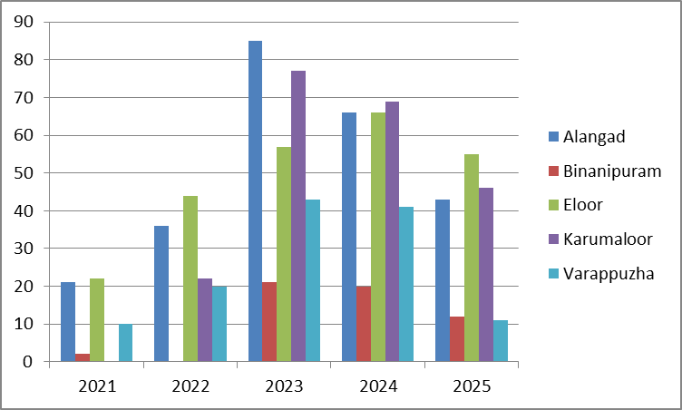

LEPTOSPIROSIS
Leptospirosis cases are closely linked to monsoon rains, flooding, and occupational exposure, particularly in low-lying and waterlogged areas.Peak: June - August

Leptospirosis – LSGI-wise Yearly Distribution (2021–2025)

LSGI | Leptospirosis – LSGI-wise Yearly Distribution
LSGI | 2021 | 2022 | 2023 | 2024 | 2025 | Total
Alangad | 4 | 6 | 9 | 4 | 10 | 33
Binanipuram | 0 | 0 | 2 | 3 | 5 | 10
Eloor | 4 | 2 | 3 | 3 | 0 | 12
Karumaloor | 0 | 7 | 7 | 7 | 6 | 27
Varappuzha | 6 | 7 | 0 | 0 | 7 | 20

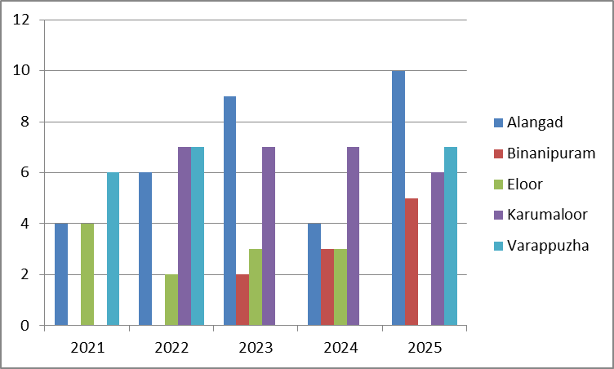

VIRAL HEPATITIS - A
Hepatitis A cases are commonly associated with unsafe drinking water, food contamination, and breakdowns in sanitation, often presenting as clusters or outbreaks.

Peak: October - December

Hepatitis A – LSGI-wise Yearly Distribution (2021–2025)

LSGI | Hep A – Ward-wise Yearly Distribution
LSGI | 2021 | 2022 | 2023 | 2024 | 2025 | Total
Alangad | 3 | 1 | 2 | 15 | 20 | 41
Binanipuram | 0 | 0 | 1 | 13 | 87 | 101
Eloor | 16 | 27 | 31 | 33 | 70 | 177
Karumaloor | 0 | 15 | 11 | 7 | 63 | 96
Varappuzha | 0 | 2 | 0 | 0 | 4 | 6

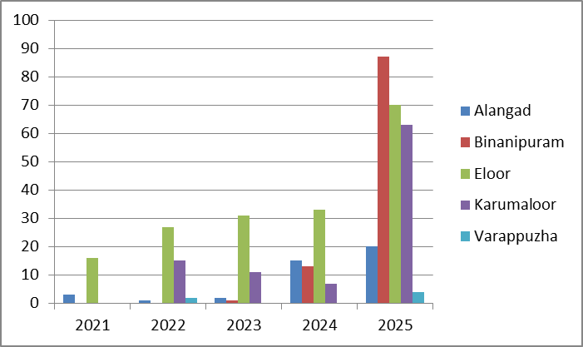

Outcome-Based Trend Analysis- 2025

Transmission Trend- 2025
For effective management of public health issues, it is important to track the trend of disease transmission mode. It helps identify the population or place at high risk that can be used to predict outbreaks and implement targeted interventions as quickly as possible. Understanding these kinds of trends enables authorities to allocate resources efficiently and change the strategies adequately based on the trend that follows.

Mode of Transmission | No. of cases | No. of Deaths
Vector Borne Diseases | 149 | 0
Water Borne Diseases | 352 | 4
Air Borne Diseases | 162 | 0
Blood Borne Diseases | 1 | 0
Food Borne Diseases | 65 | 0

Vector-Borne Disease

Disease | No. of Cases | No. of Deaths
Dengue | 152 | 0
Malaria | 5 | 0
Chikungunya | 0 | 0

Water Borne Disease

Disease | No. of Cases | No. of Deaths
Cholera | 0 | 0
Typhoid | 56 | 0
Hep- A | 177 | 0
Dysentery | 58 | 0
Amoebiasis | 0 | 0
E- Coli infections | 0 | 0
Air Borne Disease

Disease | No. of Cases | No. of Deaths
Influenza | 63 | 0
H1N1 | 65 | 0
TB | 65 | 0
Chickenpox | 194 | 0
Measles | 1 | 0
Covid-19 | 49 | 0
Pertussis | 10 | 0
Mumps | 49 | 0

Blood-Borne Disease

Disease | No. of Cases | No. of Deaths
AIDS | 0 | 0
Hep- B | 1 | 0
Hep- C | 0 | 0

Zoonotic Disease

Disease | No. of Cases | No. of Deaths
Rabies | 0 | 0
Leptospirosis | 29 | 5
Avian influenza | 0 | 0
West nile | 0 | 0
Anthrax | 0 | 0
Nipah | 0 | 0
Scrub Typhus | 0 | 0

Preparedness and Response Protocol at LSG Level
This section describes the operational framework for the LSGI once a pandemic is declared. It explains how the LSGI and health system will move from routine data collection to active response, using a One Health approach.

Constitution of One Health Committee
The LSGD shall constitute a One Health Committee comprising the LSGI President, Medical Officers (Modern Medicine, AYUSH, and Veterinary), the Health Inspector, and the Veterinary Surgeon.

Objective: The One Health Committee coordinates human, animal, and environmental health to prevent and control pandemics.
VARAPPUZHA
Sl No | Name | Designation | Department/Institution | Role in Committee | Contact Number
1 | Viju Chullikad | Panchayat President | LSGD | Chairperson | 9847542830
2 | Dr.Shibu Varghese | Medical Officer (PHC/CHC) | Health Dept | Member Secretary | 8281243386
3 | Dr Indu | Veterinary Officer | Animal Husbandry | Member | 04842514877
4 | Sivaprasad | Epidemiologist | Health Dept | Member | 9747211512
5 | Abdul Jaleel | Health Inspector/PHN | Health Dept | Surveillance | 9446080853
6 | Sajana | ASHA Supervisor | Health Dept | Community link | 9995260433
7 | Lekshmi | ICDS Supervisor | Social Welfare | Vulnerable groups | 9497320009
8 | Sudhisoumishkumar | Police Station Officer | Police Dept | Law & order | 9497947306
9 | Jomon | Ward Councillor Representative | LSGD | Community coordination | 9645195327
10 | Viji | Kudumbashree CDO | Kudumbashree | Community mobilisation | 9744134696
11 |  | NGO/Volunteer rep | Civil Society | Support services

ALANGAD
Sl No | Name | Designation | Department/Institution | Role in Committee | Contact Number
1 | Viji Jolly | Panchayat President | LSGD | Chairperson | 7025756745
2 | Dr victor Joseph | Medical Officer (PHC/CHC) | Health Dept | Member Secretary | 9567057481
3 |  | Veterinary Officer | Animal Husbandry | Member | 9847353310
4 |  | Epidemiologist | Health Dept | Member | 8848184245
5 | Azeem Lebba | Health Inspector/PHN | Health Dept | Surveillance | 9847875847
6 |  | ASHA Supervisor | Health Dept | Community link | 8157986984
7 |  | ICDS Supervisor | Social Welfare | Vulnerable groups | 9400237416
8 |  | Police Station Officer | Police Dept | Law & order | 04842671101
9 |  | Ward Councillor Representative | LSGD | Community coordination | 8606341145
10 |  | Kudumbashree CDO | Kudumbashree | Community mobilisation | 9388178330
11 |  | NGO/Volunteer rep | Civil Society | Support services

BINANIPURAM
Sl No | Name | Designation | Department/Insti tution | Role in Committee | Contact Number
1 | GEETHA | Panchayat President | LSGD | Chairperson
2 | Dr.NAZEER | Medical Officer (PHC/CHC) | Health Dept | Member Secretary
3 | NOUSHAD AK | Health Inspector/PHN | Health Dept | Surveillance
4 |  | Police Station Officer | Police Dept | Law & order | 9497987116
5 | ABDUL NAZAR | Ward Councillor Representative | LSGD | Community coordination | 9249874946
6 | RAMLA THAJUDHEEN | Kudumbashree CDO | Kudumbashree | Community mobilisation | 9895429607
7 | NEW STAR CLUB | NGO/Volunteer rep | Civil Society | Support services | 9895062014

ELOOR
Sl No | Name | Designation | Department/ Institution | Role in  Committee | Contact Number
1 |  | Panchayat President | LSGD | Chairperson | 8137057107
2 |  | Medical Officer (PHC/CHC) | Health Dept | Member Secretary | 9895690450
3 |  | Veterinary Officer | Animal Husbandry | Member | 04842546410
4 |  | Epidemiologist | Health Dept | Member | 848184245
5 |  | Health Inspector/PHN | Health Dept | Surveillance | 9446080853
6 |  | ASHA Supervisor | Health Dept | Community link
7 |  | ICDS Supervisor | Social Welfare | Vulnerable groups | 8547063128
8 |  | Police Station Officer | Police Dept | Law & order | 8884492250
9 |  | Ward Councillor Representative | LSGD | Community coordination | 949650017
10 |  | Kudumbashree CDO | Kudumbashree | Community mobilisation | 9895545904
11 |  | NGO/Volunteer rep | Civil Society | Support | 989554904

KARUMALOOR
Sl No |  |  | epartment/ Institution | Role in Committee | Contact Number
 | Name | Designation | epartment/ Institution | Role in Committee | Contact Number
1 | T A MUJEEB | President | LSGD | Chairperson | 9847025044
2 | Smt. SAJEEVAN | Panchayat Secretary | LSGD | Member Secretary | 9446354972
3 | DR SANDYA DEVI | Medical Officer(Health) | Health Department | Member Secretary | 9656280204
4 | Sri. ANSAR | Health Inspector | Health Department | Member | 9447216535
5 | Sri NASIYA | ETINARY OFFICER | ANIMAL HUSBANDRY | MEMBER | 9387833369
6 | Sri SANGEETHA | ICDS SUPERVISOR | SOCIAL WELFARE | VULNERABLE GROUPS | 8848461339
7 | Sri FRANCIS PANJIKARAN | WARD COUNCILLOR REPRESENTATIVE | LSGD | COMMUNITY COORDINATOR | 9447110993
8 | CI | POLICE STATION OFFICER | POLICE DEPT | LAW AND ORDER | 04842671101

- Review disease surveillance data (human + animal)
- Conduct ward-wise risk assessment and vulnerability mapping
- Approve quarantine/isolation centre locations
- Coordinate with district for resources (PPE, oxygen, ambulances)
- Periodically review health system surge capacity, including beds, oxygen, human resources, and ambulances.
- Approve and monitor risk communication and community engagement strategies, including rumour management.
- Ensure protection and service continuity for vulnerable groups (elderly, persons with disabilities, dialysis patients, coastal populations).
- Conduct quarterly mock drills
- Monitor equity measures for vulnerable groups

Meeting Schedule:
Quarterly (normal times) | Weekly (outbreak alert) | Daily (pandemic phase)

Pandemic Response Workforce
To ensure a coordinated and timely response during a pandemic, a dedicated Pandemic Response Workforce shall be constituted at the LSG level. The workforce will function under the overall supervision of the One Health Committee and in close coordination with the health authorities. Team-based deployment will enable efficient surveillance, case management, quarantine and isolation management, logistics support, and risk communication. Each team shall have a clearly designated team leader, defined roles, and an identified pool of personnel to allow rapid activation, rotation of duties, and continuity of services during prolonged emergencies.

Total Response Workforce Available: 300 persons

Team Name | Composition | Key Responsibilities | Team Leader
Surveillance and Contact Tracing Team | HI, JHI, JPHN, ASHAs and Volunteers | Case detection, contact listing, home visits, reporting | HI
Case Management Team | Doctors, Nurses, MLSP, Palliative Nurses | Patient care & referral | DOCTOR
Quarantine & Isolation Team | LSGD staff, Volunteers | Facility management | JHI
Psychosocial support
Logistics & supply chain Team | LSGD staff, Storekeepers, Drivers 3 | Supplies & transport [PPE, medicines, oxygen, transport, waste management] | Ward Member
Communication Team | Ward members, Kudumbashree, Youth clubs,  AWW workers and other self help groups | IEC, community meetings, countering misinformation | M.O in charge
Transportation | KSRTC, educational institutional buses
Media Surveillance
Intersectoral coordination and convergence
Collaborative surveillance

All teams shall be activated immediately upon outbreak alert or pandemic declaration and shall report daily to the LSG Incident Commander/Medical Officer, with consolidated reporting to the Block PHC. Duty rosters and alternate personnel shall be maintained to ensure uninterrupted services during staff shortages or prolonged response periods. Team composition and numbers may be revised based on the magnitude of the outbreak and availability of human resources.

Activities and Measures before and during Pandemic

PHASE 1 - Alert / Preparation
Surveillance and Reporting-Enhanced syndromic surveillance:
- Data sources for surveillance:
- Event-based triggers (to be monitored and reported):
- Zoonotic and animal health surveillance
- Logistics and Stock Preparedness
  - Identify and empanel local vendors and define emergency procurement mechanisms in accordance with existing LSGD and Health Department norms.
  - Prepare and maintain an essential logistics checklist covering medical supplies, consumables, and support equipment.
  - Pre-identify secure storage locations for emergency stocks and ensure maintenance of stock registers with regular updating.
  - Finalise emergency transport arrangements, including availability of vehicles and identified drivers for rapid deployment during alerts.
  - Designate a Nodal Officer for Logistics to enable prompt decision-making, coordination, and communication during emergencies.
  - Conduct rapid stock verification and ensure availability of minimum buffer stock, including:
- PPE kits – numbers
- Pulse oximeters – ___ numbers
- Hand sanitizers – ___ litres
- Masks, gloves, disinfectants – adequate quantity
Identify critical gaps in logistics and immediately communicate requirements to the Block and District authorities for timely replenishment and support. Monitor expiry dates and stock rotation.

Identification of Quarantine and Isolation Facilities
  - Identify and list suitable buildings for quarantine and isolation (schools, hostels, community halls, etc.).
  - Categorise cases as per the severity and allocate to appropriate facilities (for instance, severe cases to classrooms, mild cases to an assembly hall in case of a school).
  - Facility readiness checklist needed (beds, toilets, ventilation) etc.
  - Find an alternate site if the primary sites are not available or not in use.
  - Identify facility managers and support staff
  - Prepare basic SOPs for:
    - Admission and discharge
    - Food, water, sanitation
    - Infection prevention and waste disposal
  - Ensure availability of basic amenities: water, sanitation, electricity, ventilation, and waste disposal. Prepare a rapid activation plan for these facilities if case numbers increase.

Risk Communication and Community Preparedness
  - Disseminate early warning messages on symptoms, preventive measures, and reporting mechanisms. Display IEC materials both in English and the local language in public places and ensure ward-level awareness.
  - Sensitize elected representatives and community leaders on preparedness measures.
  - Establish a rumour tracking and misinformation response mechanism to identify, verify, and promptly counter false or misleading information.
  - Engage trusted local persons (ward members, ASHA workers, religious leaders, teachers, community volunteers) to communicate official public health messages and reinforce correct practices.
  - Develop and deploy targeted IEC materials for:
    - Schools and educational institutions
    - Markets and commercial areas
    - Work sites and labour settings
  - Conduct community sensitization meetings at the ward level to promote preventive behaviors, address concerns, and strengthen community participation in preparedness and response.

Protection of Vulnerable Groups
Vulnerable populations require priority protection through targeted line-listing, service continuity, and delivery mechanisms.
- Prepare and regularly update line-lists of vulnerable populations, including:
  - Elderly persons living alone
  - Persons with disabilities
  - Pregnant women
  - Migrant workers
  - Dialysis patients
The detailed line-lists shall be maintained as Annexure ___ and updated periodically.

Clinical Dependency Mapping
Develop ward-wise dependency and vulnerability maps to identify households requiring regular support during emergencies. Ensure continuity of essential health services for vulnerable groups, including
- Dialysis services (facility mapping, transport arrangements, and scheduling)
- Continuity of treatment for TB, HIV, and other chronic conditions requiring uninterrupted medication
- Mental health and psychosocial support services
Establish delivery mechanisms for food, essential commodities, and medicines to vulnerable households through coordinated action involving ASHAs, JPHNs, Kudumbashree, volunteers, and local administration.

PHASE 2 - Active Response

Case Identification and Contact Tracing
Case detection and contact tracing activities will be carried out in coordination with the Health authorities, following disease-specific SOPs and IDSP guidelines.
Field Staff Involved
- Health Inspector (HI)
- Junior Health Inspector (JHI)
- Junior Public Health Nurse (JPHN)
- ASHAs and ASHA Supervisors
- Ward-level volunteers and Kudumbashree members (as required)

Screening Checkpoints
Screening checkpoints at high-traffic locations (transport hubs, markets, religious gatherings) for early detection of symptomatic travellers and crowd screening during outbreaks. Potential locations include bus stands, market entry points, and boat jetties, based on local context and risk assessment.
Screening activities will be carried out by trained personnel such as ASHAs, ward members, and volunteers, with support from Health Department staff. Necessary equipment, including non-contact thermometers and appropriate PPE, shall be ensured prior to activation.
Location | Type (Bus stand/Jetty/Market/Railway) | Staff Deployed (ASHAs/Volunteers) | Screening Method | Reporting authority
Bus stand | Transport hub | One JHI  One ASHA  One health Mentors | 1.Swab Collection.  2. Blood smears collection (RDT)  3.Thermal Scanners | Surveillance Nodal Officer in control room
Market entry | Market | One JHI  One ASHA  Male health volunteers | 1.Swab Collection.  2. Blood smears collection (RDT)  3.Thermal Scanners | Surveillance Nodal Officer in control room
Boat jetty | Water transport | One JHI  One ASHA  Male health volunteers | 1.Swab Collection.  2. Blood smears collection (RDT)  3.Thermal Scanners | Surveillance Nodal Officer in control room

Standard Screening Protocol
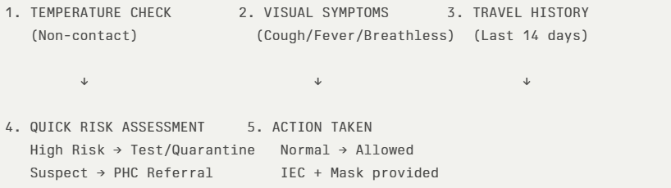
The screening protocol shall include temperature screening, observation for visible symptoms, and inquiry regarding recent travel or exposure history. Individuals identified as suspects during screening shall be immediately referred to the nearest PHC/FHC for further evaluation, testing, and appropriate action as per prevailing guidelines.

Pandemic Control Room
The Pandemic Control Room (PCR) serves as the central nerve center for real-time coordination, data aggregation, decision support, and communication during outbreaks. It consolidates information from all LSGD teams, health facilities and community sources to enable rapid response decisions.

Control Room Infrastructure and Location
Primary Location: ____________ Panchayath Office.
Backup Location: Community Hall in _____Varappuzha_______ G.P.

Health System Control Room Framework
The PCR is organized into seven functional pillars to ensure no aspect of the response is overlooked:

Rapid Response Team (RRT)
  - Provides immediate intervention during emergencies, clusters, and field alerts.​
  - Coordinates urgent actions such as case investigation, contact tracing, isolation, and inter‑facility referrals.

Data Management & Analytics Team
  - Collects, validates, and manages key health system indicators (cases, tests, beds, HR, supplies).​
  - Analyzes data trends, generates projections, and supports evidence‑based decision‑making for local authorities.

Human Resource Deployment Team
  - Allocates healthcare staff efficiently based on workload and need
  - Ensures adequate and equitable workforce distribution across facilities

Laboratory Surveillance Team
  - Oversees diagnostic testing coordination, sample transport, and timely reporting of results.​
  - Monitors lab indicators (testing volume, positivity rate, turnaround time) for early detection of outbreaks

Vaccination Cell (If Required)
  - Plans and executes vaccination campaigns, including micro‑planning and session scheduling.​
  - Tracks coverage, identifies gaps, and coordinates corrective actions with field teams and outreach services.

Infrastructure & Patient Occupancy Team
  - Monitors facility capacity, earmarked beds, oxygen and critical care resources across all linked facilities.​
  - Ensures optimal patient distribution and referral management using updated bed‑status and resource data.
  - BMWM

Communication team
- Logistics and supply chain
- Transportation (interfacility & emergency transport)
- Media surveillance Call centre
- Management of the deceased
- Intersectoral coordination and convergence

Key Control Room Team
The Control Room Team coordinates all pandemic response activities within the LSGD and serves as the single command and communication hub during activation. It integrates information, field actions, logistics, and policy execution across all participating departments and health facilities.

Role-ALANGAD | Name | Designation | Contact Number | Responsibility
In-charge/Nodal Officer | NAVEEN RAJAN | SECRETARY | 8943742314 | Overall coordination, decision-making, and reporting to the District level.
Data Entry Operator | HARI SANKAR | TECH ASST | 9995469633 | Managing the line list, updating dashboards, and tracking testing results.
Communication Officer | AZEEM LEBBA | H I | 9847875847 | Handling the public helpline, coordinating ambulance dispatch, and contact tracing calls.
Logistics Coordinator | DHANYA LEKSHMI | PHARMACIST | 9495462087
Technical Support (IT/Data) | ABIN NAZEER | JHI | 9995258172

Role(ELOOR) | Name | Designation | Contact Number | Responsibility
In-charge/Nodal Officer | DR.SAMITHA | MO IN CHARGE | 9895690450 | Overall coordination, decision-making, and reporting to the District level.
Data Entry Operator | NIL |  |  | Managing the line list, updating dashboards, and tracking testing results.
Communication Officer | AMALESH | CLERK | 9846857176 | Handling the public helpline, coordinating ambulance dispatch, and contact tracing calls.
Logistics Coordinator | ARATHI | PHARAMACIST | 7559876641
Key Points:
- The Control Room shall be staffed with a designated In-charge, data entry personnel, and communication staff with clearly defined roles and shift arrangements.
- It shall maintain updated records on daily monitoring indicators including new cases, persons under active quarantine, and hospital bed occupancy.
- All reports and situation updates shall be shared daily with the Block and District Surveillance Unit.
- The Control Room shall act as a single point of contact for coordination with response teams, health institutions, and other departments.
- Contact details of the Control Room shall be widely communicated to field staff and stakeholders during activation.

Daily Monitoring Indicators
To ensure timely decision-making and effective response, the following key indicators shall be monitored and updated on a daily basis by the Pandemic Control Room:

Epidemiological Indicators:
New cases reported today, Total active cases, Test Positivity Rate (TPR), Case Fatality Rate (CFR)
- Surveillance Indicators:
Persons under home quarantine, High-risk contacts identified, Fever, ILI, SARI or other symptoms (syndromic surges), Travellers (symptomatic or high-risk arrivals),Animal husbandry surveillance (zoonotic alerts, unusual animal deaths, poultry/bird flu signals), Mortality surveillance (excess deaths, unexplained fatalities, verbal autopsy reports)
- Logistics and Infrastructure Indicators:
Hospital / CFLTC beds occupied, Oxygen cylinders/concentrators available, Ambulances on standby
- Alert Findings
The following table outlines category-specific trigger points (red flags) from surveillance indicators and corresponding immediate actions for the Pandemic Control Room. These enable rapid response to alert findings like testing anomalies, positive cases exceeding thresholds, clusters, and WGS reports.

Category | Trigger Pophint (Red Flag) | Immediate Action
Clusters | Geographical or facility-based: 5+ cases linked to one location (office, school, street). | Declare a micro-containment zone; perimeter control and active case finding.
Testing | Sudden drop in testing volume / delay in reporting / unusual testing trends | Review the sample collection process, address lab bottlenecks, deploy additional testing teams, and notify the District Lab.
Lab | Test Positivity rate increases | Increase testing sites in that ward.
Hospital | >80% Oxygen bed occupancy | Activate backup/CFLTC beds.
Travel | Cluster of cases from a single flight/train or high-risk arrival group. | Trace all passengers in adjacent seats; implement mandatory institutional quarantine.
Animal | Mass poultry/wildlife death or unusual sickness | Notify Animal Husbandry, sample the area, and dispatch RRT for environmental sampling and zoonotic check.
Mortality | Sudden spike in home deaths or brought-in-dead (BID) cases | Audit the deaths and Active Case Search drive
Additional investigations like Whole Genome Sequencing (WGS) | Detection of a Variant of Concern (VOC) or Variant of Interest (VOI) | Implement strict micro-containment; update clinical protocols to match variant severity.

Communication of Public Health Information
A Community Communication Hub shall be established to ensure timely, accurate, and consistent dissemination of information during a pandemic. The Hub will function under the coordination of Nodal officers of the control room and act as the nodal point for public communication, risk messaging, and community engagement. It will support dissemination of official advisories, promote preventive behaviors, address rumors and misinformation, and ensure that messages reach all sections of the population through trusted local channels and leaders.

Key communicators
Channel | Responsible Person | Contact
Ward-level announcements | Ward members | 8113065127
Social media | Mercy Johny | 9349262323
Local Cable TV/Radio | Vice president | 9349299733

- All messages disseminated through the Hub shall align with advisories issued by the Health Department and District authorities.
- Community leaders shall be sensitized to support behavior change, reduce stigma, and counter misinformation.
- Special efforts shall be made to reach vulnerable and hard-to-reach populations using locally appropriate communication methods.

Rumor Tracking: A designated volunteer will monitor local social media/WhatsApp groups daily to identify misinformation and issue official clarifications via the Communication Hub.

Coordination with District/State Authorities & Other Organisations
Effective coordination with Block, District, and State authorities is essential to ensure timely reporting, technical guidance, and uninterrupted supply of essential resources during a pandemic. The LSG shall establish clear communication channels, designate responsible officers, and adhere to prescribed reporting timelines to support coordinated public health action and efficient resource mobilisation.

Key Details:
- Nodal Officer for Reporting:
- Contact Number:
Reporting Schedule and Protocols:

To Whom | What to Report | Frequency | Nodal Person
Block PHC | Complete Situation Report (Cases, Quarantine, Beds, Screening, Deaths)
District IDSP Unit | Outbreaks/Clusters/Unusual Events (>5 cases same ward)
Veterinary Officer | Animal health events/Zoonotic alerts
State Cell | Zoonotic cross-sector events

Supply Chain Coordination
The LSG shall coordinate closely with Block, District, and State authorities (KMSCL) to ensure uninterrupted availability of essential goods, medical supplies, and logistics during a pandemic. Supply requirements shall be assessed regularly based on case load and communicated promptly to the appropriate authorities for timely replenishment.
Key Points:
- Maintain updated contact details of District and Block nodal officers for health logistics, oxygen supply, ambulances, and essential medicines.
- Submit timely indent requests for PPE, testing kits, medicines, oxygen, and other critical supplies through prescribed channels.
- Monitor stock levels at LSGD facilities, quarantine/isolation centres, and field teams through daily stock registers and dispensing logs to prevent shortages.
- Coordinate with District authorities, Karunya/Neethi medical shops, and local purchase committees for funds allocation and emergency procurement.

- Ensure regular monitoring of dispensing registers at all facilities to track usage, expiry, and pilferage—shortages being a perennial issue requiring proactive weekly audits.

- Activate surge procurement protocols during high caseloads, leveraging local purchase powers under LSGD funds alongside state supplies.

Resource Inventory and Contacts
Resource Category | Source  (District/State/Private) | Contact
PPE Kits/Masks/Gloves | KMSCL | 7306993299
PPE Kits/Masks/Gloves | Local Vendors | Kochin surgical 9995989688
Oxygen  Cylinders/Concentrators | KMSCL | 7306993299
Medicines/Antivirals | KMSCL | 7306993299
Medicines/Antivirals | Neethi Shops
Test Kits (RTPCR/Rapid) | KMSCL | 7306993299

Collaboration with NGOs, PPP, and CSR
To augment government efforts during a pandemic, the LSG shall collaborate with NGOs, voluntary organisations, and private sector partners through public–private partnerships and Corporate Social Responsibility (CSR) initiatives, in coordination with District authorities.

Key Points:
- Engage NGOs and community-based organisations for community outreach, awareness, and support to vulnerable populations.
- Leverage CSR support for procurement of medical equipment, PPE, oxygen concentrators, food kits, and sanitation materials, as permitted.
- Ensure all collaborations align with government guidelines and are routed through approved administrative and financial procedures.
- Maintain transparency and documentation for all external support received and utilised.
Organization | Type | Support Offered | Contact Person
Youth Clubs/Student Unions | CBO

Interdepartmental Coordination
Coordination among departments during a pandemic shall be ensured through regular review meetings convened by the LSGD President. These meetings will provide a structured platform for sharing situational updates, assessing resource availability, resolving operational gaps, and taking joint decisions to ensure a coordinated and timely response.

Department | Representative | Key Role | Contact
Health (PHC) | Staff Nurse : | Case management | 9847943339
Veterinary | Veterinary Surgeon: | Animal surveillance | 9747113580
ICDS | Supervisor: Sindhu | Nutrition support
Education | Head Teacher: | School coordination | 9745132988
Police | SHO | Containment enforcement | 04842513073________
Water Authority | ___AE_______ | Water supply | ___04842623206_______
LSGD Engineering | __AXE________ | Quarantine infrastructure | _____8301952547_____

PHASE 3 - Surge Capacity
Phase 3 is activated when there is a rapid increase in cases, high test positivity rates, or when existing health facilities and quarantine arrangements approach saturation. The focus of this phase is to expand isolation capacity, augment clinical care services, and mobilise additional resources through district and state support mechanisms.

Conversion of Community Facilities
To manage increased case load, the LSGD shall activate additional isolation facilities by repurposing identified community infrastructure such as community halls, auditoriums, schools, hostels, or other suitable buildings.

Name of facility | Facility Type | No. of Buildings | Ward | Surge Capacity (Beds) | Nodal Person
U.P School Chirakkakom | School | 15 Rooms |  | 200
Isabella school | School | 30Rooms |  | 500
St:George H.S.S | School | 40 Rooms |  | 600
Christ King Parish Hall | community halls | 1 |  | 1000
St. George parish Hall | community halls | 1 |  | 1000
Sacred Heart College | Church | 1 |  | 300
Christ The king Church | Church | 1 |  | 500
St.George Church | Church | 1 |  | 500

- Recovery and rehabilitation phase
- Recovery
  - Damage & impact assessment
  - Restoration of health services
  - Rehabilitation of affected population
  - Psychosocial & mental health support
  - Disease surveillance during recovery phase
  - Environmental cleanup & sanitation
  - Livelihood restoration
  - Community engagement & confidence building
  - Documentation & after-action review
  - Lessons learned & best practices
  - Health system strengthening
  - Policy revision & preparedness enhancement
  - Research

CONCLUSION

Additional points
- tech support
- relief based commodities
- ham reading operators
- hazard vulnerability mapping
- Kseb & other power source
- HR specific responsibility

RECOMMENDATIONS

Strengthening Healthcare Infrastructure
- Establish a primary health response unit within the Panchayat with trained staff.
- Ensure availability of basic medical supplies (masks, sanitizers, PPE kits, oxygen cylinders).
- Create tie-ups with nearby hospitals in ASTER__ for emergency referral and transport.

2. Community Awareness & Education
- Conduct regular awareness campaigns on hygiene, vaccination, and preventive measures.
- Use local communication channels (community radio, WhatsApp groups, notice boards) to spread verified information.
- Train volunteers to act as health ambassadors in each ward.

3. Emergency Response & Coordination
- Form a Pandemic Preparedness Committee at Panchayat level including health workers, ward members, and NGOs.
- Develop a clear action plan for lockdowns, quarantine, and distribution of essentials.
- Maintain a database of vulnerable groups (elderly, differently-abled, chronically ill) for targeted support.

4. Supply Chain & Food Security
- Identify and support local suppliers and farmers to ensure uninterrupted food supply.
- Create community kitchens during emergencies to serve vulnerable populations.
- Stockpile essential commodities in Panchayat-run outlets for crisis periods.

5. Digital Preparedness
- Promote digital platforms for telemedicine consultations.
- Use Panchayat’s website/social media for real-time updates on health advisories.
- Encourage online grievance redressal to reduce crowding in offices.

6. Training & Capacity Building
- Organize mock drills for pandemic response in schools, offices, and public spaces.
- Train Panchayat staff and volunteers in first aid, infection control, and crowd management.
- Collaborate with NGOs and health departments for capacity-building workshops.

7. Long-Term Resilience
- Integrate pandemic preparedness into the Panchayat Development Plan.
- Allocate a dedicated budget for health emergencies.
- Encourage community participation in planning and monitoring preparedness measures.

MOCKDRILL SCENARIOS

ANNEXURE

IMPORTANT PHONE NUMBERS

Phone numbers and particulars of persons responsible for providing guidance, assistance, and support for pandemic preparedness operations may be provided here in a manner that allows easy reference at a glance. The information recorded here could be exhibited elsewhere at the time of emergencies. LSG institutions shall give special attention to collect and record the above data of persons and institutions who/which are supposed to give technical and co-ordination support to reduce the impact of pandemic.

1.1. Details of Varappuzha Grama panchayat
Sl.No | Name of the ward | Ward number | Name of the ward  member | Contact number
1 | THEVARKAD NORTH | 1 | K.P JOSHY | 9847957392
2 | THEVARKAD SOUTH | 2 | MINI JUDESON | 9037672033
3 | CHIRAKKAKOM SOUTH | 3 | VIJU CHULLIKAD | 9847542830
4 | PUTHENPALLY NORTH | 4 | ROJO THOMAS | 9961986415
5 | MUTTINAKAM NORTH | 5 | THRESIA NIMMY K.J | 8592954912
6 | PUTHENPALLY SOUTH | 6 | JOMON T.J | 9645195327
7 | MUTTINAKAM SOUTH | 7 | MERCY JOHNY | 9349262323
8 | MANNAMTHURUTH EAST | 8 | SINDHYA VARGHESE | 8089890501
9 | MANNAMTHURUTH WEST | 9 | T.S SYAM LAL | 9847451951
10 | VARAPPUZHA NORTH | 10 | MARY SHERY | 9301818458
11 | VARAPPUZHA SOUTH | 11 | CINDRELLA ROCHA | 9048327837
12 | THUNDATHUMKADAV SOUTH | 12 | M.D SABU | 9847703811
13 | THUNDATHUM KADAV.NORTH | 13 | T.P POLY | 9947090060
14 | THUNDATHUM KADAV HEAD QUARTERS | 14 | BABY PRIYA | 7736495880
15 | CHETTIBAGAM TOWN | 15 | JITHIN NANDAKUMAR | 8089667883
16 | CHETTIBAGAM CENTRAL | 16 | LISSA A.K | 9747864654
17 | DEVASWM PADAM | 17 | ANILKUMAR M.M | 9526837219
18 | CHIRAKKAKOM PADY | 18 | SINDHU LUCIYA | 9656656491

1.2. Other important phone numbers of Grama panchayat/municipality/corporation area
Sl. No. | Name | Contact number
1. | Excise department | 9400069570
2. | Forest department

1.3. Important offices of grama panchayat/municipality/ corporation
Sl.No | Name of the office | Contact person | Contact number
1. | Village Office | Village Officer | 8547614105
2. | Agriculture Office | Agriculture Officer | 9383470592
3. | Animal Husbandry Office | Animal Husbandry Doctor
4. | Police Station | Police Officer | 04842513073
5. | BSNL Office | Officer | 0484 2514100
6. | Block Office | Officer | 0484 2670486
7. | KSEB Office | Officer | 0484 2513040
8. | Fisheries Office | Officer
9. | Fire and Rescue | Officer | 0484 2545500

Details of Alangad Grama panchayat

Sl.No | Name of the ward | Ward number | Name of the ward  member | Contact number
1 | Neercode west | 1 | P c Jayan | 7025944947
2 | Neercode east | 2 | P k nirmala | 9847216695
3 | Panchayath head quarters | 3 | VB Jabbar | 9846839419
4 | Koduvazhanga south | 4 | Sreebhadra velayudhan | 9495366867
5 | Koduvazhanga north | 5 | Jose gopurathinkal | 9142058430
6 | Iravipuram | 6 | Paul k t | 7034068159
7 | kottappuram | 7 | Maya vinayakumar | 9495012540
8 | Malikampeedika | 8 | Mini piyus | 9349966458
9 | alangad | 9 | Viji jolly | 7025756745
10 | thiruvalloor | 10 | Sunil thiruvalloor | 9349983649
11 | kunnel | 11 | Resmi biju | 6238061822
12 | Panayikkulam west | 12 | P k suresh babu | 9142034001
13 | Panayikkulam | 13 | Ameer ali | 9846947512
14 | methanam | 14 | Afeela sumith | 9526190136
15 | Olanad east | 15 | M A benny | 9847877240
16 | CHIRAYAM | 16 | HASEENA SHIHAB | 9387036363
17 | KONGORPILLY EAST | 17 | XAVIER PEREPPARAMPIL | 9744418853
18 | OLANAD | 18 | SEBASTIAN V J | 9847717154
19 | THIRUMUPPAM | 19 | ANNA ANSLY | 9947920232
20 | PAZHAMPILLY | 20 | ROBIJU | 8111914293
21 | KONGORPILLY WEST | 21 | NIJITHA K S | 9567236243
22 | HSS WARD | 22 | BINNY SIMMICHEN | 9995704691
23 | KARINGAMTHURUTH SOUTH | 23 | RADHAMANI JAYASINGH | 9388178330
24 | KARINGAMTHURUTH NORTH | 24 | NISHAD DEVASSY | 8606341145

Sl. No. | Name | Contact number
1. | NAVEEN RAJ ,SECRETARY | 8943742314
2. | SANJAY HAKKIM  ASST SECRATARY | 9846166766
3. | KAVYA PANCHAYATH H I | 7736455483
7. | Excise department,NEETHU MANOHARAN  INSPECTOR,N.PARAVUR | 0484 2443187
8. | Forest department | 8129666439

Details of Eloor Grama panchayat
Sl.No | Name of the ward | Ward number | Name of the ward member | Contact number
1 | ELOOR NORTH | 1 | P T. SHAJI
2 | VETTUKADAVU | 2 | SUNIL
3 | PATTUPARAKAL | 3 | TISHA
4 | KUZHIKANDAM4 | 4 | SUJIL
5 | HEAD QUARTERS | 5 | MEENA
6 | TCC | 6 | ABOOBACKER
7 | TOWNSHIP | 7 | RAJESH
8 | ILANJIKAL | 8 | JAYASREE
9 | ZIPET | 9 | JINI
10 | PATHALAM | 10 | HARITHA
11 | MUNICPIAL TOWNHALL | 11 | JOSEPH
12 | HINDALCO | 12 | UDHAYAN

Sl.  No. | Name | Contact number
1. | SECRETA | 9188955185
2. | CHAIRPERSON | 8137057107
3. | HEALTH SUPERVISOR | 9995937317

  - Important offices of Eloor

Sl.No | Name of the office | Contact person | Contact number
1. | Village Office | Village Officer | 04842547111
2. | Agriculture Office | Agriculture Officer | 04842739020
3. | Animal Husbandry Office | Animal Husbandry Doctor | 04842546140
4. | Police Station | Police Officer | 9497980401
5. | BSNL Office | Officer | 04842545000
6. | Block Office | Officer | 8547614109
7. | KSEB Office | Officer | 04842545179
9. | Fire and Rescue | Officer | 04842545500

Details of Karumaloor Grama panchayat
Ward No | Ward Name | Name | Designation | Contact number
1 | MATTUPURAM | NISHA SHAMNAD | MEMBER | 7907179747
2 | MANJALY | SHAJITHA NISSAR | MEMBER | 9847576616
3 | KALLIKUZHY | KOCHURANI JOSEPH | VICE PRESIDENT | 93883443338
4 | MANAKKAPADY  NORTH | DHANYA SHARATH | MEMBER | 9072370846
5 | THATTAMPADY  NORTH | REKHA SATHEESHAN | MEMBER | 9495960469
6 | KARUMALLOOR | P R PRAMOD | MEMBER | 9847691600
7 | ADUVATHURUTH | A M ABU | DEVELOPMENT STANDING  COMMITTEE CHAIRMAN | 9447604633
8 | WEST  VELIYATHUNAD | UMAIR | MEMBER | 9747509709
9 | VAYALODAM | SHAMILA SHAMEER | MEMBER | 9349626608
10 | THADIKKAKADVU | MINI MOHAN | MEMBER | 8289864544
11 | EAST  VELIYATHUNAD | SAJEENA NIZAR | MEMBER | 9846062232
12 | KADOOPADAM | MUHAMMED ASHRAF | HEALTH AND EDUCATION  STANDING COMMITTEE CHAIRMAN | 8156972926
13 | UC COLLEGE | SREEDEVI | WELFARE STANDING COMMITTEE CHAIRMAN | 9048779115
14 | MARIYAPPADY  NORTH | ABDUL SALAM | MEMBER | 9207444424
15 | MARIYAPPADY  SOUTH | POULOSE ANTONU | MEMBER | 9074021499
16 | PARUVAKKADU | AYYAPAN | MEMBER | 9995291056
17 | THATTAMPADY  SOUTH | FRANCIS  PANJIKARAN | MEMBER | 9447110993
18 | THATTAMPADY  WEST | GEETHU BABU | MEMBER | 9744415334
19 | CHETTIKAD | G D SHIJU | MEMBER | 9947005835
20 | MANAKKAPADY  SOUTH | T V UDAYAN | MEMBER | 9895645888
21 | MANAKKAPADY | MINI SAJAN | MEMBER | 9809910587
22 | THEKKETHAZHAM | T A MUJEEB | PRESIDENT | 9847025044

SlNo | Name |  |  | Contact number
1. | SHO |  |  | 04842671101
2. | VillageOfficer |  |  | 04842672659
3. | AnimalHusbandryOfficer |  |  | 9387833369
4. | ExciseDepartment |  |  | 04842441280
5. | ForestDepartment |  |  | 8547604222
SlNo |  | Name of the office | Contact person |  | Contact number
1. |  | VillageOffice | VillageOfficer |  | 04842672659
2. |  | AgricultureOffice | AgricultureOfficer |  | 04842671460
3. |  | AnimalHusbandryOffice | AnimalHusbandryDocto  r |  | 9387833369
4. |  | PoliceStation | PoliceOfficer |  | 04842671101
5. |  | BSNLOffice | Officer |  | 18003451500
6. |  | BlockOffice | Officer |  | 04842670486
7. |  | KSEBOffice | Officer |  | 04842604413
8. |  | FisheriesOffice | Officer |  | 9656559781
Sl.No | Name of the ward |  | Ward number |  | Name of the member | Contact number
1 |  | West Kadungalloor North | 1 | Shanavas VK |  | 9846891796
2 |  | Valanjambalam | 2 | Asha Shyam |  | 9526413310
3 |  | Kadepilly | 3 | T K Jayan |  | 8075884148
4 |  | Kaniamkunnu | 4 | M Anilkumar |  | 9446091807
5 |  | East Kadungalloor East | 5 | Sreekumar Mulleppilly |  | 9846006856
6 |  | Elookkara North | 6 | Neeba C H |  | 8547193353
7 |  | Kunjunnikkara | 7 | Mhd. Iqbal |  | 9446069210
8 |  | Uliyannoor | 8 | Seena Mhd |  | 9544084514
9 |  | East Kadungalloor | 9 | R Subrahmania Pillai |  | 9567827400
10 |  | West Kadungalloor Central | 10 | Geetha Salimkumar |  | 7736006448
11 |  | Peedikapadi | 11 | Saraswathi VR |  | 9387368456
12 |  | Elookkara | 12 | Jameela KA |  | 9567516550
13 |  | Muppathadam North | 13 | Ummer Farook MB |  | 9995053756
14 |  | Muppathadam Central | 14 | Rosely Biju |  | 8907544426
15 |  | Kayantikkara | 15 | Amjad Ali |  | 9037493618
17 |  | Kayantikkara South | 17 | Anil SF |  | 9846644066
18 |  | Muppathadam South | 18 | Prajitha R |  | 8281429787
19 |  | Muppathadam West | 19 | Jayasree KR |  | 9633336073
20 |  | Edayar | 20 | Nasar MK |  | 9387286606
21 |  | Eramam South | 21 | Shiji VK |  | 8075404295
22 |  | Eramam Central | 22 | Faseela |  | 9747849094
23 |  | Eramam North | 23 | Abdul Riyas CA |  | 9037487583
24 |  | West Kadungalloor South | 24 | Jyothi Gopakumar |  | 9746646650

Sl.  No. | Name | Contact number
1. | PANCHAYATH SECRETARY | 04842270673
2. | VILLAGE OFFICE | 8547614111
3. | AGRICULTURE OFFICER | 9383471130
4. | VEO
5. | CDS CHAIRPERSON | 9061765760
6. | POLICE STATION (ALUVA) | 04842624006
7. | Excise department | 04842621089
8. | FIRE STATION | 04802802101

Sl.No | Name of the office | Contact person | Contact number
1. | Village Office | Village Officer | 04842609575
2. | Agriculture Office | Agriculture Officer | 04842603505
3. | Animal Husbandry Office | Animal Husbandry Doctor | 0484 2606344
4. | Police Station | Police Officer | 0484 2671101
5. | BSNL Office | Officer | 04842623400
6. | Block Office | Officer | 04842670486
7. | KSEB Office | Officer | 0484 2604218
8. | Fisheries Office | Officer | 04842604179
9. | Fire and Rescue | Officer | 04842623333

1.4. Health Services

Sl. No | Name of the hospital/institution | Eloor | Varappuzha
1. | Government hospitals/PHC | 9895690450 | 04842512520(CHC Varappuzha)
2. | Private hospitals | 8893247123 | 8089505019
3. | Clinical laboratories | 6232725618 | 04842512025(CHC Varappuzha)
4. | Chemist/pharmacy |  | 9400091751
5. | Blood donors |  | 048422212785( Carmel medical centre)

1.5. Veterinary Services
Sl.No | Name of the Clinic | Name of the  Surgeon/Doctor | Place/location | Phone  number
1 | Govt.Veterinary Hospital | Indhu | Varappuzha | 9747113580
 |  | DR.NEENU | Eloor | 04842546410
 |  | Dr Agith | Neericode | 9847353310
 |  | Dr NASIYA | KARUMALLOOR | 9387833369

1.6. Helpline numbers
Helpline | Phone number
Police | 100,8075344619(Alangad),9497980401(Eloor),04842671101 (Karumaloor)
Fire and Rescue | 04842545500(Alangad),04842545500(Kadungaloor),0484 2443101
KSEB | 1912,,04842604413

1.7. Public and Private Schools Contact details

S.No | Name of School( VARAPPUZHA) | Institution type | Phone number
1 | ST:JOSEPH H S VARAPPUZHA | Aided | 9746686518
2 | Holy Infants H.S Varappuzha | Aided | 9847004729
3 | ISEBELLA Chirakkakom | Private | 892188300
4 | Govt. U.P.S. S CHIRAKKAKOM | Govt | 9745132988
5 | ST. GEORGE PUTHENPALLY H.S | Aided | 9947552580
6 | ST. GEORGE PUTHENPALLY H.S.S | Aided | 9846861866
7 | ST.JOSEPH L.P SCHOOL Mannamthuruth | Aided | 8304889171
8 | INFANT JESUS L.P SCHOOL Thundathumkadav | Aided | 9895459548
9 | ST.MARY’S L.P SCHOOL,Muttinakam | Aided | 9633223229
 | ALANGAD
1 | LF LP SCHOOL OLANAD | Aided | 9847582234
2 | LF HSS PANAYIKULAM | Aided | 6238825570
3 | VISWADEEPTI VIDYALAYA, CHIRAYAM | Private | 9947451686
4 | LF LP SCHOOL, PANAYIKULAM | Govt | 9847156407
5 | ALHUDA PUBLIC SCHOOL, PANAYIKULAM | Private | 8943040622
6 | LF LP SCOOL, PANAYIKULAM | Private | 8156984277
 | KADUNGALOOR
1 | Govt.L P School,East Kadungalloor | Govt | 8089212729
2 | The Heritage School,East Kadungalloor | Un Aided | 9789151301
3 | GLPS Uliyannoor | Govt | 04842603828
4 | GHSS West Kadungalloor | Govt | 04842607141
5 | St.Johns School Muppathadam | Un Aided | 04842607255
6 | HM School Kunjunnikkara | Un Aided | 9544251701
7 | GHSS Muppathadm | Govt | 04842559635
8 | GHS Binanipuram | Govt | 04842557
 | KARUMALOOR
1 | GOVT.LPS NORTH KADUNGALLOOR | GOVERNMENT | 9539520835
2 | GOVT.LPS SETTLEMENT ALUVA | GOVERNMENT | 9995217389
3 | GOVT. L P SCHOOL, KARUMALLOOR | GOVERNMENT | 9497679348
4 | GMIUPS VELIYATHUNAD | GOVERNMENT | 9656010424
5 | ST LITTLE TREASAS | AIDED | 9544133176
6 | AISUP SCHOOL MANJALY | AIDED | 9496177495
7 | FMCT HS SCHOOL | AIDED | 9656791816
8 | FMCT HSS SCHOOL | AIDED | 7907533822
9 | JYOTHI NIVAS SCHOOL | PRIVATE | 9846947701
10 | ALANGAD JAMA ATH SCHOOL | PRIVATE | 9495751041
11 | NAVADEEPTHI SCHOOL | PRIVATE | 9544729537
12 | SETTLEMENT HS | PRIVATE | 9995217389

1.9. Anganwadi Contact Details
VARAPPUZHA
Ward No | Name of Anganwadi Teachers(VARAPPUZHA) | Phone number
1 | JENNY | 9961825854
2 | ASHA | 7034238455
3 | SARASA | 9744172708
4 | LIGI | 8129168123
5 | SEENA DEVASI | 9656924398
6 | RENI | 8281405898
7 | VIDHYA | 8590631242
8 | SHIJI | 9895367695
9 | LISSA A X | 9747864654
10 | METTILDA | 9249246637
11 | TENCY JOSEPH | 9744420926
12 | SIJI JOSEPH | 8921776516
13 | SHALI M C | 9747496102
14 | JAYANTHI | 8848090989
15 | NEETHU | 9633182836
16 | ANITHA | 7561052940
17 | PRAVEELA | 7356457837
1 | SHABY T S | 9961816804
2 | GREESHMA | 9744493476
3 | BINDU JOY | 9961027895
4 | BOBY E K | 7736066809
5 | VALSALA K L | 8111840625
6 | BEENA BEEVI | 8714836046
7 | SEEMA M S | 7025963317
8  9 | JUDIT V V | 9388671850
 | LEENA C P | 9946128653
10 | ZEENATH K M | 9605493217
11  12  13 | SUDAMANI M P | 9895658881
 | SREEJA SALIMRAJ | 9847573897
 | JOSEMARY K A | 8590398745
14 | MONEE AL | 9562593291
15 | MARY VILSY C V | 9947176146
16 | REMA C K | 9947209836
17 | AJI V K | 9526159320
18 | LETHA K S | 9188151037
19 | SREEKALA E K | 9048121249
20 | SUMI VARGHESE | 9074267045
21 | STABY VARGHESE | 9946529687
22 | PREETHY T G | 9497793880
23 | GIRIJADEVI M S | 8907929448
24 | SMITHA K M | 9349109197
25 | PREETHA K V | 9645350348
26 | SUBITHA C A | 9497243663
27 | LETHA K C | 9605089757
28 | SEENA M N | 8078193359
29 | SEEMA MOL M R | 9746068819
30 | SHARI A P | 9947367233
31 | ANITHA C A | 8137957478
32 | GIRIJA T V | 9947260667
33 | SOFI | 9048551470
34 | SHYKUTTY E S | 9446055687
35 | DEEPA S | 9745397101
36 | SOSAMMA O A | 9744948989
37 | LALITHA M T | 9747864748
38 | T V SHIJIMOL | 9847494270
 | ELOOR
7 | 1. BEENA K V | 9746383708
 | SHAILJA  2. | 9656123593
8 | MINI | 8289857533
9 | 1. REETHA | 9995163259
6 | ANAR | 9957689321
1 | BEENA | 9446152230
5 | BINDHUMOL | 9497197560
4 | BINDHU P D | 9947167558
2 | RAMLA | 8592991609
3 | SUBAIDA | 9446528561
 | KADUNGALOOR
7 | sobha | 7561801139
2 | Sreeja | 9645990753
3 | Salini | 79028281944
4 | Umadevi | 9447792475
4 | Sreena | 7994625865
5 | Saiby | 7025924545
5 | Mini | 8113846309
6 | Sajitha | 9544137619
6 | Shahana | 9746257313
7 | Remya | 8714195830
8 | Shyla | 9947254276
9 | Umaiba
9 | Jameena | 9567516550
9 | Ayisha Beevi | 6235295590
9 | Shereefa | 8281864175
10 | Ajitha | 98466820014
11 | Thankamani | 9388876524
13 | Sheeba | 7994390508
14 | Sabitha | 8021785020
24 | Yamuna | 8606668533
1 | Deepa | 9447382162
8 | Sajitha | 9447598580
14 | Sabitha | 9495811982
16 | Anjumol | 9645096002
17 | Treesa Molly | 9037191914
18 | Subbamma | 9633501500
19 | Ramla Beevi | 9544253720
15 | Rangamani | 9526398951
15 | Suchithra | 9544081047
22 | Lesitha | 9847100464
20 | Ramlath | 9895106563
20 | Geetha | 9567448933
20 | Jibina | 9895450039
21 | Honey | 8526905159
21 | Arifa | 8129613529
23 | Bindu | 9562385016
23 | Sreeja | 8330008389
23 | Arifa | 8129613529

WARD NO | NAME OF TEACHER | PHONE NO
1 | SANDALA | 9526310357
2 | SANDHYA | 9048340467
20 | VALSALA V T | 9656521077
3 | KOCHURANI | 9388344338
4 | SHEEJA | 7025367414
5 | SANGEETHA | 9744519014
5 | NEETHU | 9656521077
5 | CHANJALA | 9562121463
7 | CHANDRIKA | 9495572156
8 | VAHIDHA | 9387734842
8 | SABITHA | 7034481002
8 | SIJI | 9946351932
10 | ASWATHY | 9846389826
10 | SHAHIDHA | 8547814379
11 | SHERLY | 9846082020
15 | SUNITHA | 9961728640
14 | MINI | 9605450921
16 | MAYADEVI | 9847048016
16 | REMADEVI | 9947350920
18 | PRASEENA | 9744906374
17 | SINI | 9656711984
19 | SUSAN VARGHESE | 8891997059
12 | PRAMEELA | 9947312571
1 | BINDHU E R | 9778321417
4 | JOMI | 9947766617
5 | SHEEBA | 9605846477
6 | SHINY | 7560816369
14 | ROSY | 9633467303
10 | ANNIE | 9895513097
11 | SHIMA | 9795328860
13 | SHEEBA | 9605085776
15 | SHYLA | 7403584447
18 | MOLY | 9847052682
3 | SUNI | 9846128602

1.12. Information regarding resources

Means of transportation | Name of Owner | Phone Number
Heavy Trucks | Praveen,  Madhu, | 9400993977,  9496211493
Tractor
Ambulances |  | 8089505079
Boats
Taxi service | Andrews,Thilakan | 9388625084,9961296045

Annexure 1: LSG Baseline Data Collection Format
A. Baseline data
Sl. No. | Indicator / Field | Baseline Data-Alangad | Baseline Data-Binanipuram | Baseline Data-Eloor | Baseline Data-Karumaloor | Baseline Data-Varappuzha
1 | Name of LSG | Alangad | Binanipuram |  |  | Varappuzha
2 | District | Ernakulam | Ernakulam |  |  | Ernakulam
3 | Block / Taluk | Alangad | Alangad | Alangad | Alangad | Alangad
4 | Type of LSG (Gram Panchayat / Municipality / Corporation) | Gram Panchayath | Gram Panchayath | Municipality | Gram Panchayath | Gram Panchayath
5 | Area (sq. km) | 17.7 SQ KM | 18.06sq.km | 11.21SQ.KM |  | 7.74
6 | No. of wards | 24 |  | 31 |  | 18
7 | GIS boundary file available | (Yes/No) |  | (Yes/No) YES |  | (Yes/No)
8 | Key contact person & phone | 0484-2512267 | President | 25455590484

B. Demography
Indicator / Field | Baseline Data-Alangad | Baseline Data-Binanipuram | Baseline Data-Eloor | Baseline Data-Karumaloor | Baseline Data-Varappuzha
Total population | 52863 | 53671 | 40200 | 41888 | 29206
Males | 25995 | 26114 | 19824 | 21087 | 14147
Females | 26868 | 27557 | 20376 | 20801 | 15059
Transgender population | 0 | 0 |  | 0 | 0
Age distribution  (<5, 5–14, 15–59, ≥60) | 2626,3848, 39456,6933 | <5=1840  ≥60=9675 | 1779,3566, 29779,5066 |  | 20900
No. of households | 42576 | 13057 | 11308 | 10718 | 8106
Population density (persons/sq.km) | 1829 |  | 3556 |  | 3982
No. of migrant workers | 977 | 819 | 2388 | 460 | 731
Major occupational groups | 4 | Industrial,Construction,Trade,Office Jobs,Transport | 27 |  | Fishing

C. Vulnerable Populations & Social Risks
Sl. No. | Indicator / Field | Baseline Data -Alangad | Baseline Data-Binanipuram | Baseline Data-Eloor | Baseline Data-Karumaloor | Baseline Data-Varappuzha
1 | No. of elderly (≥60) | 6933 | 9675 | 5076 |  | 6782
2 | No. of persons with disability | 284 |  | 310 |  | 110
3 | No. of bedridden persons | 73 | 212 | 127 |  | 60
4 | No. of chronic disease cases (DM/HTN/COPD/CKD etc.) | 186 | DM-3528  HTN-3251  CKD-410  CA-125 | 67/52/15/30
5 | Pregnant women (current estimate) | 84 | 152 | 225 |  | 232
6 | Children <5 years | 2626 | 1840 | 1779 |  | 1524
7 | Tribal population (if any) | 0 | 0 | 191 |  | 3
8 | Fisherfolk / coastal vulnerable groups (if any) | 0 | 0 | 610 |  | nil
9 | Urban slums / unnotified settlements (if any) | 0 | 0 | 0 |  | nil
10 | Homeless population | 0 | 0 | 0 |  | 0
11 | Orphanages / old age homes (number & capacity) | 1 | Old age homes-1-50 | 2 |  | 2
12 | Hostels / prisons / shelters (number & capacity) | 0 | Hostel-1-1835 | 2 |  | nil
13 | Poverty / BPL estimate | 3214 | BPL-1835 | 2327 |  | 3190
14 | Food insecurity hotspots | 0 | Nil
15 | Any history of stigma/discrimination issues (Yes/No) | No | No |  |  | No

D. Health System & Service Readiness
Sl. No. | Indicator / Field | Baseline Data -Alangad | Baseline Data -Binanipuram | Baseline Data -Eloor | Baseline Data -Karumaloor | Baseline Data -Varappuzha
1 | No. of health facilities in LSG (PHC/CHC/TH/DH/Private) | 6 | PHC-Kadungaloor | PHC-1  UHWC-2 | 1 | CHC
2 | PHC/Family Health Centre details (name, location) | FHC ALANGAD,  KARINGAMTHURUTH | FHC-Binanipiram | FHC ELOOR | FHC  KARUMALLOO R | BFHC VARAPPUZHA
3 | Subcentres / Health & Wellness Centres (number) |  | 5 | 5 | 5 | 5
4 | Private clinics / hospitals (number) | 5 | 3 | 1 | 2 | Hospital-1  Clinics -3
5 | Labs available (public/private) | 12 | 9 | 13 | 6 | Public-1  Pvt-4
6 | Availability of ambulance services (Yes/No, number) |  | Yes--3 | YES | YES | No
7 | Availability of isolation/quarantine facilities (Yes/No, details) | NO | No | YES | 0 | No
8 | Cold chain facilities (Yes/No, details) | YES | No | YES | YES | Yes
9 | Stockpile space available (Yes/No) | NO | No | NO | YES | Yes
10 | PPE / mask / sanitizer availability plan (Yes/No) | YES | Yes | YES | YES | Yes
11 | Surveillance staff available (JHI/JPHN/ASHA count) | 35 | JHI-4  JPHN-5  ASHA-23 | YES | 29 | 32
12 | Existing emergency referral pathways (Yes/No) | YES | Yes | YES | YES | nil

E. Points of Entry & Mobility
Sl. No. | Indicator / Field | Baseline Data -Alangad | Baseline Data -Binanipuram | Baseline Data-Eloor | Baseline Data -Karumaloor | Baseline Data -Varappuzha
1 | Bus stands / depots (number) | 0 | Nil | 1 | 0 | 1
2 | Railway stations (number) | 0 | Nil | 0 | 0 | NIL
3 | Boat jetties / fishing harbours (number) | 0 | Nil | 1 | 0 | 1
4 | Ports / airports nearby (specify distance) | 15 | Nil | 0 | 0 | NIL
5 | Major highways/roads passing through | NH 66, NH 47 | NH-47 | 1 | NIL | YES
6 | Border crossings (state/district) | 0 | Nil | 0 | NO | YES
7 | Major markets / weekly markets | 0 | Nil | 0 | NIL | YES
8 | Tourism hubs / major event venues | 0 | Nil | 1 | NIL
9 | Schools/colleges with hostels (number) | 0 | Nil | 15 | 12 | Nil
10 | Factories / large workplaces (number) | 0 | 12 | 12 | 2 | Nil
F. Water, Sanitation & Hygiene (WASH)
Sl. No. | Indicator / Field | Baseline Data -Alangad | Baseline Data-Binanipuram | Baseline Data-Eloor | Baseline Data-Karumaloor | Baseline Data-Varappuzha
1 | Major drinking water sources (piped / wells / borewells / springs) | KWA SUPPLY WATER | Wells,KWA |  | 7492 | PIPED
2 | No. of public wells | 51 | 38 | 63 | 92 | 8
3 | No. of households with piped water connection | 12786 |  | 2723 | 7988 | ALMOST ALL PLACES
4 | Water quality testing routine (Yes/No) | YES | Yes | YES | YES | NO
5 | Common contamination risks (flooding, salinity, industrial waste) | NIL | Nil | Salinity, industrial waste | Bacterial Contamination | SALINITY
6 | Open defecation free status (Yes/No) | NO | Yes | YES | NO
7 | Solid waste management system (Yes/No) | YES | Yes | YES | YES | YES
8 | Bio-medical waste disposal mechanism (Yes/No) | YES | Yes | YES | YES | YES
9 | No. of public toilets | 1 | 0 | 5 | 0
10 | Handwashing stations in public places (Yes/No) | YES | 0 | YES | NO | NO
G. Zoonotic Risks & One Health
Sl. No. | Indicator / Field | Baseline Data -Alangad | Baseline Data-Binanipuram | Baseline Data-Eloor | Baseline Data-Karumaloor | Baseline Data-Varappuzha
1 | Livestock population (cattle/goats/pigs/poultry) – estimates | 4700 | Cattle-263  Goats-149  Pigs-0  Poultry-3970 | 2732 | 329 | Cattle-440  Goat-365
2 | No. of dairy farms / poultry farms / pig farms | 3 | 1 | 21 | 6
3 | Slaughterhouses / meat shops (number) | 11 | Meat shops-6 | 0 | 2 | 4
4 | Animal markets (Yes/No, details) | 0 | No | NO | NO | Yes
5 | Veterinary dispensaries (number) | 1 | 1 | 1 | 1 | 0
6 | History of zoonotic outbreaks (rabies, leptospirosis, avian flu etc.) | NIL | Nil | NO | NIL
7 | Stray dog population management measures (Yes/No) | NO | Nil | YES | YES | Yes
8 | Rodent infestation hotspots (Yes/No) | NO | NO | NO | YES | NO
9 | Wetlands / waterlogged areas prone to leptospirosis | NO | NO | NO | YES | NO
10 | Bat roosting areas / caves / fruit orchards (if any) | NO | NO | NO | NO | NO
11 | Human-animal interface hotspots (farms near residences) | NO | NO | NO | NO | NO

H. Climate & Disaster Risks (Pandemic Amplifiers)
Sl. No. | Indicator / Field | Baseline Data -Alangad | Baseline Data-Binanipuram | Baseline Data-Eloor | Baseline Data-Karumaloor | Baseline Data-Varappuzha
1 | Flood-prone wards (list) | NIL |  | 15 | Wards–1,5,18 | 1,9,10,11,17,18
2 | Landslide-prone wards (list) | NIL |  | 5 | NO | 0
3 | Cyclone/sea surge risk (Yes/No) | NIL |  | NO | NO | 0
4 | Heatwave risk zones (Yes/No) | NIL |  | NO | NO | 0
5 | Waterlogging areas (list) | NIL |  | 5 | NO | 0
6 | Shelter homes / relief camps (number, capacity) | 3, 1500 |  | 12 | 0 | 0
7 | Past disaster displacement history | NIL |  | NO | NIL | 0
8 | Disruption to water supply/transport | NO |  | YES | YES
I. Critical Infrastructure & Logistics
Sl. No. | Indicator / Field | Baseline Data -Alangad | Baseline Data-Binanipuram | Baseline Data-Eloor | Baseline Data-Karumaloor | Baseline Data-Varappuzha
1 | Schools (number) | 16 |  | 15 | 12 | 10
2 | Anganwadis (number) | 38 |  | 29 | 34 | 27
3 | Colleges (number) | 0 |  | 0 | 3 | 0
4 | Community halls (number) | 9 |  | 3 | 5 | 1
5 | Places of worship with large gatherings (number) | 10 |  | 26 | 78
6 | Large markets / shopping areas (number) | 0 |  | 0 | 0 | 1
7 | Warehouses / cold storages (number) | 14 |  | 15 | 2 | 0
8 | Telecom/mobile network coverage gaps (Yes/No) | NO |  | NO | NO
9 | Power outage frequency (high/medium/low) | NO |  | MEDIUM | MEDIUM
10 | Availability of generators in key facilities | YES |  | YES | NO

J. Risk Communication & Community Networks
Sl. No. | Indicator / Field | Baseline Data -Alangad | Baseline Data-Binanipuram | Baseline Data-Eloor | Baseline Data-Karumaloor | Baseline Data-Varappuzha
1 | Ward-level rapid response teams (Yes/No) | YES |  | YES | YES | YES
2 | Jagratha samithis / committees active (Yes/No) | YES |  | YES | YES | YES
3 | Kudumbashree presence and strength (number of units) | 28 |  | YES |  | 154
4 | Volunteer network (number, coverage) | 56 |  | 127 | 637 | 4
5 | Community-based surveillance mechanisms (Yes/No) | YES |  | YES | YES | YES
6 | IEC dissemination channels (WhatsApp groups, community radio, PA systems) | YES |  | YES | YES | WHATSAPP GROUP
7 | Rumour tracking mechanisms (Yes/No) | YES |  | YES | YES
8 | Languages spoken / literacy considerations | YES |  | YES | YES
9 | Vulnerable groups communication strategy available (Yes/No) | YES |  | YES | YES

K. Preparedness Planning & Governance
Sl. No. | Indicator / Field | Baseline Data -Alangad | Baseline Data-Binanipuram | Baseline Data-Eloor | Baseline Data-Karumaloor | Baseline Data-Varappuzha
1 | LSG emergency plan available (Yes/No) | YES |  | YES | YES
2 | Pandemic preparedness plan available (Yes/No) | YES |  | YES | YES | YES
3 | Incident Command System identified (Yes/No) | YES |  | YES | YES
4 | Rapid procurement mechanism available (Yes/No) | YES |  | YES | YES
5 | Emergency fund available (Yes/No, amount) | YES |  | YES | NO
6 | Past outbreak response experience (Yes/No, details) | NO |  | YES | YES
7 | Intersectoral coordination mechanism (Health, Police, LSG, Veterinary, Education) |  |  | YES | YES
8 | Mock drills conducted in last 12 months (Yes/No) | YES | FIRE AND SAFETY | YES | YES
9 | Training coverage for staff/volunteers (Yes/No) |  |  | YES | YES

L. Surveillance & Data Systems
Sl. No. | Indicator / Field | Baseline Data -Alangad | Baseline Data-Binanipuram | Baseline Data-Eloor | Baseline Data-Karumaloor | Baseline Data-Varappuzha
1 | Digital reporting tools used (e.g., DHIS2, portals) | YES |  | YES | YES | PORTAL
2 | Availability of line-listing format (Yes/No) | YES |  | YES | YES | YES
3 | Contact tracing team identified (Yes/No) | YES |  | YES | YES
4 | Mapping of high-risk households available (Yes/No) | YES |  | YES | YES
5 | Testing sample transport mechanism (Yes/No) | YES |  | YES | YES | yes
6 | Reporting timeline adherence (good/average/poor) | GOOD |  | Average | GOOD
7 | Data sharing between departments (Yes/No) | YES |  | YES | YES
8 | Availability of dashboard for monitoring (Yes/No) | YES |  | YES | YES

M. Additional Notes & Observations
Sl. No. | Indicator / Field | Baseline Data -Alangad | Baseline Data-Binanipuram | Baseline Data-Eloor | Baseline Data-Karumaloor | Baseline Data-Varappuzha
1 | Key challenges perceived by LSG |  |  |  | NIL
2 | Top 5 high-risk wards (reason) |  |  |  | NIL
3 | Any unique local risks (industrial pollution, refugee camps, etc.) |  |  |  | NIL
4 | Recommendations for preparedness strengthening |  |  |  | StrengthenSurveillance Systems ImproveLaboratory Capacity StrengthenHealth Infrastructure Develop Multi-Sectoral Coordination

