PANDEMIC PREPAREDNESS PLAN
MODEL OF LSG
EDAVETTY PANCHAYAT

MESSAGE FROM PRESIDENT/CHAIR LSGI
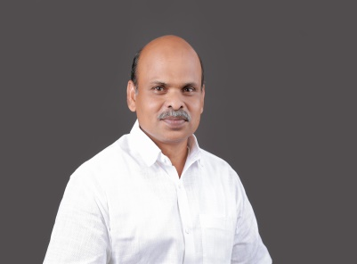
Pandemics pose a serious threat to public health and community well-
being. As a local self-government institution, the Panchayat has a crucial
role in ensuring preparedness, prevention, and coordinated response
during such public health emergencies.
I urge all residents of the Panchayat to cooperate fully with health
authorities and follow the guidelines issued by the Health Department
from time to time. Early reporting of symptoms, adherence to hygiene
practices, use of preventive measures, and avoidance of misinformation
are essential to control the spread of communicable diseases.
The Panchayat, in coordination with the Medical Officer, Health
Department staff, and frontline workers, is committed to strengthening
surveillance, awareness activities, sanitation measures, and community
support systems. Public participation and collective responsibility are
key to ensuring the safety of our community.
Let us work together with discipline, responsibility, and unity to protect

public health and ensure pandemic preparedness in our panchayath

MUHAMMED AMEER
president
edavetty gramapanchyath
MESSAGE FROM HEALTH STANDING COMMITTEE CHAIR
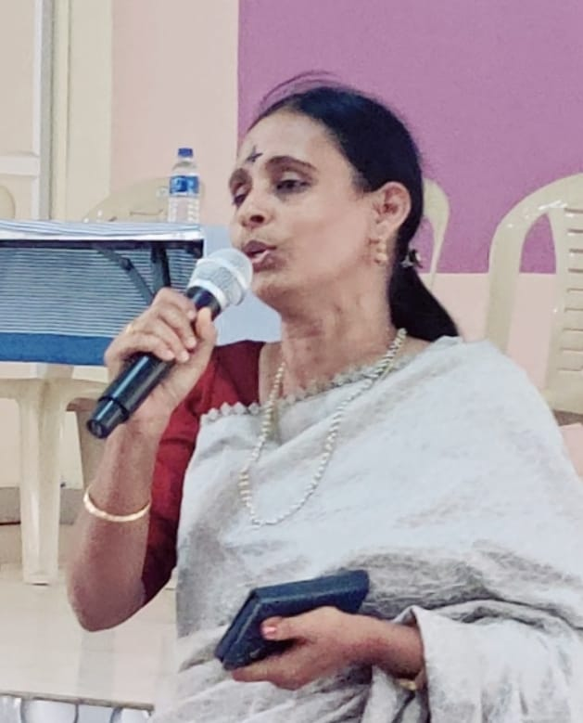

Pandemic preparedness is a shared responsibility that requires coordinated efforts from the Health Department, local self-government institutions, and the community at large. The Health Standing Committee of the Panchayat remains committed to safeguarding public health through timely preparedness and preventive action.
In view of potential pandemic situations, the Committee emphasizes the importance of early detection; prompt reporting of symptoms, strict adherence to health advisories, and cooperation with surveillance and response activities carried out by health officials and frontline workers.
Maintaining personal hygiene, environmental sanitation, and responsible community behaviour are essential to prevent the spread of communicable diseases.
The Health Standing Committee, in coordination with the Medical Officer and health staff, is actively strengthening awareness programmes, sanitation measures, disease surveillance, and community support systems within the Panchayat. Public cooperation and collective vigilance are vital to ensure effective pandemic preparedness and response.
The Committee urges all residents to remain informed through official channels, avoid the spread of misinformation, and support health workers in their efforts to protect the community.
Together, through unity and responsibility, we can ensure the safety and well-being of our Panchayat.

Bincy Martin
Chairperson Health Standing Committee
Edavetty Gramapanchyath
MESSAGE BY MEDICAL OFFICER
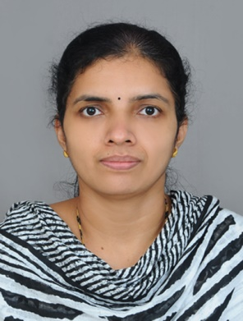
Pandemic preparedness is essential to protect public health from emerging and remerging infectious diseases such as COVID-19, Influenza, Nipah virus infection, other zoonotic and communicable diseases. These diseases highlight the need for early detection, preparedness, and coordinated response.
The Health Department is strengthening surveillance, early reporting, and response activities in line with the One Health approach, which recognizes the interconnection between human health, animal health, and the environment.
Coordinated efforts involving the Health Department, Veterinary services, Local Self Government Institutions, and community stakeholders are vital for effective prevention and control of such diseases.
Members of the public are advised to strictly follow health advisories, maintain personal and respiratory hygiene, ensure timely vaccination where applicable, and report symptoms such as fever, cough, breathlessness, or any unusual illness to the nearest health facility without delay.
Public cooperation with health workers, field staff, and surveillance activities is crucial. Avoidance of misinformation and reliance on official communication will help ensure timely and effective response during public health emergencies. Through collective responsibility, vigilance, and adherence to the One Health approach, we can strengthen pandemic preparedness and safeguard the health of our community


DR.REMYA GEORGE
FHC Edavetty

EXECUTIVE SUMMARY

Primary Health Centre (PHC) functions as the primary public healthcare institution serving the population of Edavetty Grama Panchayath. The PHC plays a pivotal role in delivering comprehensive, accessible, and affordable healthcare services, with a strong focus on preventive, promotive, curative, and rehabilitative care in accordance with national and state health programmes.
The PHC caters to a predominantly rural population, addressing key public health priorities such as maternal and child health, communicable and non-communicable disease control, immunization, family welfare, adolescent health, and geriatric care. Regular outpatient services, home-based care through field health staff, and outreach activities ensure healthcare coverage even in geographically challenging areas. The institution actively implements national health missions, including the National Health Mission (NHM), National Tuberculosis Elimination Programme, National Programme for Prevention and Control of Cancer, Diabetes, Cardiovascular Diseases and Stroke (NPCDCS), and other disease surveillance initiatives.
Edavetty PHC works in close coordination with the Grama Panchayath, ASHA workers, Anganwadi centres, schools, and community-based organizations to strengthen community participation and improve health awareness. Emphasis is placed on early detection, timely referral, health education, and lifestyle modification to reduce disease burden and improve overall health outcomes.
Despite constraints related to infrastructure, manpower, and increasing service demand, the PHC continues to enhance service delivery through effective planning, data-driven decision-making, and community engagement. Strengthening facilities, upgrading digital health systems, and expanding preventive services remain key focus areas for future development.
Overall, Edavetty Primary Health Centre stands as a vital institution in safeguarding public health and improving the quality of life of the residents of Edavetty Grama Panchayath

LIST OF ABBREVIATIONS

LSGD/LSGI | Local Self Government Department / Local Self Government Institution
BMO | Block Medical Officer
IDSP | Integrated Disease Surveillance Programme
NDMA | National Disaster Management Authority
PPE | Personal Protective Equipment
ICMR | Indian Council of Medical Research
CD | Communicable Diseases
NCD | NON-COMMUNICABLE Diseases

TABLE OF CONTENTS

INTRODUCTION 10
● Background of the PPP 10
LSGD AT A GLANCE 10
INTEGRATED HEALTH INFRASTRUCTURE MAP OF EDAVETTY PANCHAYAT 12
Background of the LSGI 14
Demographic and Vulnerable Population 16
Clinical Vulnerability 17
INFRASTRUCTURE & RESOURCE INVENTORY 20
Health Facility Directory & Basic Capacity in the LSGD 20
Private Clinics 21
Healthcare Education & Training Institutions 22
Specialized Services & Emergency Inventory 22
Oxygen & Diagnostic Capacity 23
Diagnostics facility mapping at the LSGI level 24
Laboratory Identification & Basic Details 25
Social and Community Infrastructure for surge plan 25
Human resources 27
Community & Support Cadre 29
Community Organizations 30
Administrative & Emergency Services 31
Information regarding resources 31
ONE HEALTH & ENVIRONMENTAL SURVEILLANCE 32
Animal & Bird Population 33
Veterinary Infrastructure 34
Veterinary Doctors & Workforce 35
High-Risk Interface Points (Surveillance Sites) 35
Environmental Risk Mapping 38
Disease Seasonality Mapping 39
Vulnerability Mapping 40
EPIDEMIOLOGICAL TRENDS (2021–2025) 41
Disease Burden among human beings(Last 5 Years) 42
*(use the above table data to create the graph/diagram) 44
Seasonal Trend Analysis 45
Outcome-Based Trend Analysis- 2025 49
Transmission Trend- 2025 50
Integrated Disease Hotspot Map (2021–2025) 53
Preparedness and Response Protocol at LSG Level 56
Constitution of One Health Committee 56
Pandemic Response Workforce 57
Activities and Measures before and during Pandemic 59
PHASE 1 - Alert / Preparation 59
PHASE 2 - Active Response 63
Standard Screening Protocol 65
PHASE 3 - Surge Capacity 75
Conversion of Community Facilities 76
RECOMMENDATIONS 79
ANNEXURE 81
1. IMPORTANT PHONE NUMBERS 81

INTRODUCTION

Background of the PPP

LSGD AT A GLANCE
- North: Karimannoor Grama Panchayat
South: Velliyamattom Grama Panchayat
East: Udumbannoor Grama Panchayat
West: Kodikulam Grama Panchayat
Edavetty Panchayat is connected through a network of local roads and district roads, linking it to nearby towns and service centers within the Elamdesam Block. The area predominantly consists of agricultural land, rubber plantations, residential settlements, and small commercial centers.
- Baseline data
- Ward division -
Ward | Houses | Population | Migrants | Wells | Hot  spots | Ed. Institutions | Hosp pvt/govt.
14 | 4559 | 18324 | 346 | 2784 | 5 | 7-schools | Govt-1  Pvt-1

- Risk stratification among wards in the context of Communicable diseases and hazards
Highlights a critical public health and environmental concern within Edavatti Grama Panchayat, specifically focusing on Wards 11, 12, and 13, which are the most densely populated areas.
During the summer season, these wards experience significant water scarcity. This shortage forces residents to implement water storage practices for their daily needs, including drinking, cooking, and sanitation.

The practice of storing water, while necessary for the residents, inadvertently creates breeding grounds for mosquitoes. This has led to a noticeable increase in the incidence of dengue, a vector-borne zoonotic disease, in these specific wards. The current water management practices are directly contributing to a public health crisis during the drier months.
Public awareness initiatives are being undertaken to educate individuals on dengue prevention and appropriate response measures in the event of infection. Concurrently, field-level household surveys are being conducted, alongside source reduction activities, to mitigate disease vectors.

- Major Roads/rivers
The integrated road network and river system of Edavetty Grama Panchayath significantly influence its public health preparedness and emergency response capacity. Strengthening road maintenance, ensuring flood-resilient infrastructure, and implementing seasonal risk surveillance will enhance resilience and safeguard community health across all 14 wards. The Panchayath is primarily connected through State Highway SH-43 (Thodupuzha–Moolamattom Road), The Panchayath is influenced by the Thodupuzha River, a tributary of the Periyar River system.
- Major establishments with geospatial mapping
- occupational groups, socio cultural groups, migration & mobility patterns
Edavetty Grama Panchayath – Thodupuzha Block, Idukki District
Edavetty Grama Panchayath exhibits a mixed rural–semi-urban socio-economic structure with agriculture as the traditional backbone and increasing diversification into service and small business sectors. Major occupational groups include small and marginal farmers (rubber, coconut, mixed crops), agricultural labourers, construction workers, small traders, government employees, health and education staff, and self-employed workers. Women actively participate through Kudumbashree and micro-enterprise activities.
The socio-cultural composition reflects Kerala’s pluralistic structure with Hindu, Christian, and Muslim communities co-existing harmoniously. The Panchayath demonstrates high literacy levels, strong community networks, active religious and social institutions, and significant participation in public health and welfare programmes. The population pattern is predominantly nuclear families with a growing elderly segment.
Migration dynamics show moderate out-migration, particularly Gulf migration and inter-state employment of skilled youth. In-migration consists mainly of inter-state migrant labourers engaged in construction and manual sectors. Daily commuting to Thodupuzha town for employment and education is common. These mobility patterns have public health relevance, necessitating periodic migrant screening, communicable disease surveillance, and targeted health awareness interventions.
Overall, Edavetty Panchayath demonstrates stable socio-economic characteristics with manageable migration-related health considerations, supporting effective primary health service delivery and community-based surveillance systems.
- Vulnerability mapping
- Disaster prone areas (geographic vulnerability)

Maps - ward-based (Mention source also)

- Geographical boundaries - ward boundaries map
- Health infrastructure map
- roads and rivers map
- major establishments map
- disaster-prone areas map
- hotspot map - CD & disasters

INTEGRATED HEALTH INFRASTRUCTURE MAP OF EDAVETTY PANCHAYAT

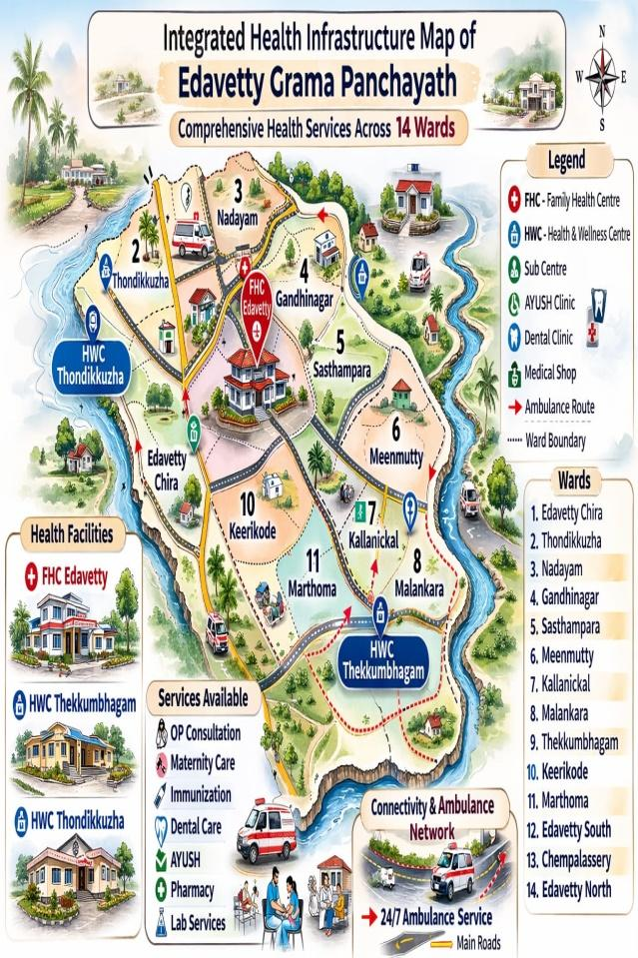

Health Infrastructure Map
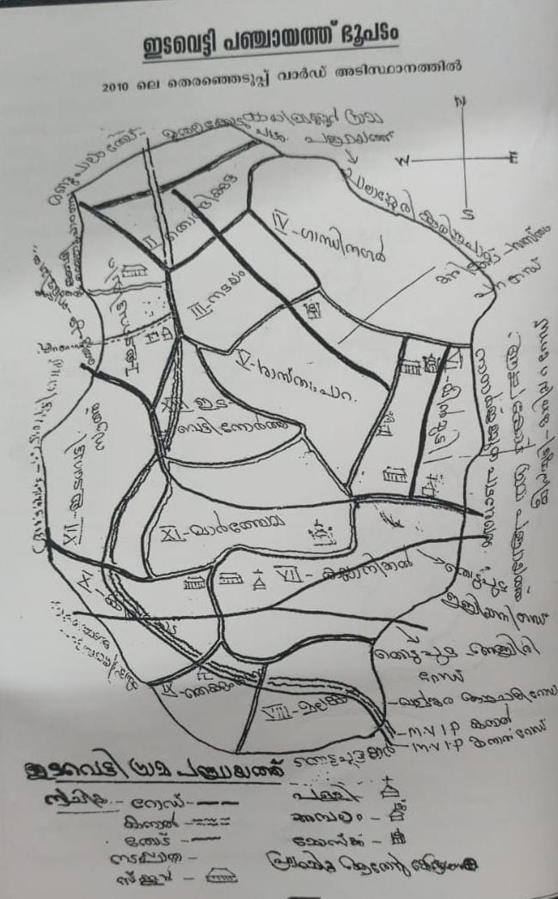
GENERAL PROFILE OF THE LSGI’S

Background of the LSGI
Edavetty Grama Panchayath is a Local Self-Government Institution (LSGI) functioning under the three-tier Panchayat Raj system of Kerala. It falls under the administrative jurisdiction of Thodupuzha Block Panchayath in Idukki District.
The Panchayat is predominantly rural in character, with a mixed agrarian and semi-urban settlement pattern. It comprises 14 wards and functions as the primary grassroots governance unit responsible for local development planning, public service delivery, and community welfare implementation.
The area is geographically influenced by midland terrain typical of central Kerala, with agricultural land use patterns and river-influenced drainage systems. The Panchayath has good road connectivity, particularly through State Highway access linking it to Thodupuzha town, which serves as the nearest urban centre and referral hub.
Edavetty Grama Panchayath lies in the midland belt of Idukki district, characterized by gently undulating terrain. The landscape consists of low hills, gradual slopes, and agricultural plains. The area is influenced by the Thodupuzha River system and seasonal streams. Land use is predominantly plantation-based, especially rubber and mixed crops. The Panchayath experiences a tropical monsoon climate with moderate flood vulnerability in low-lying pockets.
From a public health and disaster management perspective, Edavetty LSGI has historically been vulnerable to seasonal flooding, waterborne diseases, and vector-borne illnesses such as Dengue and Leptospirosis. The severe floods experienced during recent years, including the 2018 flood disaster, significantly impacted life, livelihoods, and infrastructure within the Panchayat. These recurring emergencies have underscored the importance of strengthening local preparedness, response mechanisms, and inter-departmental coordination.
In this context, the development of a localized, data-driven Auxiliary Infrastructure and Logistical Resource Map is essential to support effective planning, timely emergency response, and sustainable development initiatives. Such mapping enables the Panchayat to identify critical resources, improve accessibility during disasters, and enhance overall resilience of the community.

Table 1: Background of LSGD
Description | Details
Name of LSGI | Edavetty
Type (GP/Municipality / Corporation etc.) | Grama Panchayath
Block | Thodupuzha
District | Idukki
Number of wards | 13
Total area (sq. km) | 18.52
Population(Projected) | 18324
Population density | Persons 989/sq km
Terrain (coastal/low-lying/backwaters/foothills, etc.) | 0
Number of rivers passing through LSGI | 0
Number of water bodies in the LSGI | MVIP CANAL
Number of educational institutions | 7-SCHOOL
Factories / small-scale industries | 7
Flood-prone wards | 2
Landslide-prone wards | 0
Death Management and Disposal Facilities (mortuaries/crematorium, including electric) | 0
Auditoriums/Marriage halls/convention centres/community halls | 6

Demographic and Vulnerable Population
Understanding the demographic composition and vulnerable population groups is essential for pandemic preparedness. Children, elderly, economically deprived families, migrant workers, and socially vulnerable groups are at increased risk during public health emergencies due to higher exposure, limited access to services, and dependency on public systems..

Description |  | Details (in numbers)
DEMOGRAPHIC PROFILE
Total population |  | 18324
Male |  | 8966
Female |  | 9358
Transgender |  | 0
Children under 5 |  | 756
Adolescent |  | 965
Elderly (>60) |  | 13549
SOCIAL/LIVELIHOOD VULNERABILITY
Previous EPEP family |  | 45
BPL family |  | 4718
Tribal communities |  | 2
Migration | Immigrant | 346
Migration | Emigrant | 121
Socio-economically deprived |  | 42
Fisherfolk |  | 0
SC Community |  | 1354
ST Community |  | 176

Graphs: Population pyramid (if possible) for seeing if your LSGI has a high "dependency ratio" (lots of children and elderly compared to working adults).

Clinical Vulnerability
Certain population groups needs priority healthcare & are at higher risk of severe illness, complications, and mortality during pandemics. Patients with chronic diseases, those requiring regular medical care, and individuals with mobility or functional limitations face challenges in accessing timely care during emergencies. Mapping these groups helps in prioritizing continuity of treatment, medicine stock planning, oxygen support, referral transport, and targeted home-based care.

Description | Details in numbers
Pregnant women | 89
Lactating mothers | 126
Bedbound patients | 184
Patients under palliative care other than bedbound | 184
Patients on Haemodialysis | 12
Patients on CAPD | 0
Cancer patients (currently on treatment) | 11
Haemophilic patients | 3
Mentally challenged | 19
Differently abled | 32
Diabetic patients | 1524
Hypertensive patients | 1149
TB patients | 1

Major Festivals & Events specific to the LSGI
(with the possibility of a public gathering)

Sl. No. | Name of festival | Month detailing the periodicity
1 | PARISH FESTIVAL | JANUARY
2 | EDAVETTY OUSHADHA SEVA | AUGUST

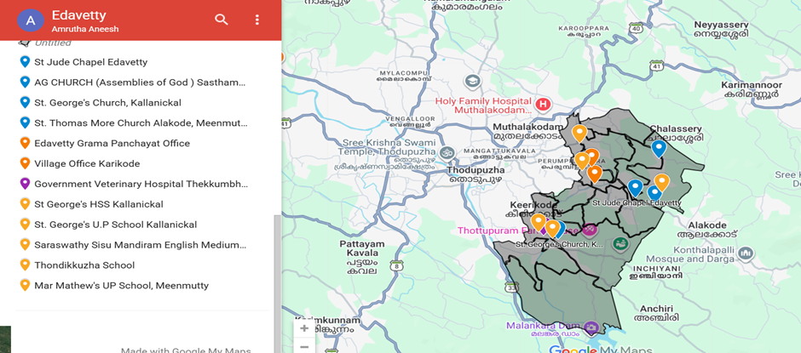

INFRASTRUCTURE & RESOURCE INVENTORY

Health Facility Directory & Basic Capacity in the LSGD
This section provides an overview of the healthcare infrastructure available within the LSGD area. It outlines the distribution and basic capacity of health facilities that form the backbone of service delivery during routine times and public health emergencies.

Family Health Centres (FHCs) and Community Health Centres (CHCs) generally function as the first point of contact for the community, providing essential outpatient and inpatient services. General Hospitals (GH) and Medical College Hospitals (MCH), where accessible, serve as the main referral centres for advanced diagnostics, specialist care, and critical services during public health emergencies. This inventory helps identify existing strengths, gaps, and potential surge capacity that can be mobilised during a pandemic or disaster.

Table 5. Health Facility Resource Summary
Sl.no. | Health Facility | Type of Facility (MCH/GH/CHC/FHC/SC etc.) | Contact Number | Total beds | ICU Beds | Oxygen-Supported Beds |  | No. of Ventilator Support Beds | No. of ambulances
Government Healthcare Facilities
1 | FHC Edavetty | FHC | 04862201076 | 2 | 0 | 0 |  | 0 | 0
2 | HWC Thekkumbhagam | SC | 8921426987 | 0 | 0 | 0 |  | 0 | 0
3 | HWC Thondikuzha | SC | 9947305423 | 0 | 0 | 0 |  | 0 | 0
Private Healthcare Facilities
1 | - | - | - | - | - |  | - | - | -
AYUSH Healthcare Facilities
2 | Homeo dispensary | Govt | 9656068478 | 0 | 0 | 0 |  | 0 | 0
 | Ayurveda Dispensary | Govt | 9495547328 | 0 | 0 | 0 |  | 0 | 0

Private Clinics
Private clinics are an essential part of pandemic preparedness, as they are often the first place people seek care when symptoms begin. In many communities, private clinics manage a significant share of outpatient visits and therefore play a critical role in early case detection, timely referrals, and disease surveillance. Having an up-to-date understanding of where these clinics are located, the services they provide, and how they are linked to the public health system helps ensure that no cases are missed during an outbreak. It also allows health authorities to engage private practitioners more effectively for reporting, risk communication, and coordinated response, strengthening the overall capacity of the health system to manage public health emergencies.

Table 6. Private Clinic Resource Summary
Sl No. | Name of Clinic | Registered (Y/N) | Clinic (General / Speciality) | Speciality (if any) | Address | Contact Number | Diagnostic Facility (Y/N) | Ambulance Linkage (Y/N)
1 | Karuniya Clinic | Yes | General | Nil | Edavetty | 9847702557 | N | N
2 | Smile white Dental Clinic | Yes | General | Nil | Edavetty | 9496181574 | N | N

Healthcare Education & Training Institutions
This section tracks the educational infrastructure available, which is vital for human resource planning in the health sector.

Category of Institution | Govt | Private | AYUSH | Total
Medical Colleges | NIL | NIL | NIL | NIL
Nursing Colleges | NIL | NIL | NIL | NIL
Dental Colleges | NIL | NIL | NIL | NIL
Para-medical / Allied Health | NIL | NIL | NIL | NIL
Pharmacy Colleges | NIL | NIL | NIL | NIL

Specialized Services & Emergency Inventory
This section provides a detailed view of the specialized medical resources available to the community, focusing on emergency response and critical care capabilities. This table tracks the vital assets required for managing severe illnesses and emergencies across Government, Private, and AYUSH sectors.

Item | Govt | Private | AYUSH | Total
Hospital beds | NIL | 0 | 0 | 0
Oxygen-generating systems(Y/N) | NIL | 0 | 0 | 0
Oxygen-supported beds(Numbers) | NIL | 0 | 0 | 0
Ventilator-supported beds | NIL | 0 | 0 | 0
ICU beds | NIL | 0 | 0 | 0
Burns units | NIL | 0 | 0 | 0
Blood centres | NIL | 0 | 0 | 0
BLS ambulances | NIL | 0 | 0 | 0
  0 | 0 | 0
ALS ambulances | NIL | 0 | 0 | 0
Dialysis facilities | NIL | 0 | 0 | 0
Dispensaries | NIL | 0 | 0 | 0
Medical store | NIL | 0 | 0 | 0
Industrial establishments(Medium-scale industries/small-scale industries establishments to whom we can depend in a worst-case scenario) | NIL | 0 | 0 | 0

Oxygen & Diagnostic Capacity
Monitoring oxygen and diagnostic capacity is a critical component of public health preparedness, ensuring that the LSGD can handle both chronic care and sudden surges in respiratory or infectious diseases.
Name of Health Facility | Oxygen-generating System (Y/N) | Backup Oxygen Source (Y/N) | Diagnostic Facilities Available(Y/N)
Name of Health Facility | Oxygen-generating System (Y/N) | Backup Oxygen Source (Y/N) | Lab | USG | X-ray | CT/MRI | RT-PCR
Government Healthcare Facilities
NIL | N | N | NIL | NIL | NIL | NIL | NIL
NIL | N | N | NIL | NIL | NIL | NIL | NIL

Diagnostics facility mapping at the LSGI level
The diagnostic capacity of Edavetty G.P represents the "intelligence network" of our healthcare system. The speed and accuracy of disease identification depend entirely on the distribution and technical level of these facilities.

Item | Govt | Private | AYUSH | Total
General labs | 1 | 1 | 0 | 2
Microbiology labs | 0 | 0 | 0 | 0
RT-PCR labs | 0 | 0 | 0 | 0
USG units | 0 | 0 | 0 | 0
CT/MRI units | 0 | 0 | 0 | 0
Research labs | 0 | 0 | 0 | 0
Labs of other departments that can be repurposed | 0 | 0 | 0 | 0

Laboratory Identification & Basic Details
Sl. No. | Name of Laboratory | Ownership (Govt / Private / Academic) | Address | Contact No. | 24×7 Services (Yes/No) | NABL / Govt Approved (Yes/No)
1 | St.Anns Medical Diagnostics centre | Private | Thekkumbhagam | 8589076889 | NO | No

Social and Community Infrastructure for surge plan
This table serves as our logistics and shelter inventory. By mapping these locations, quickly we can identify where to house displaced citizens, where to set up temporary medical clinics, and how to manage the deceased with dignity during a crisis.

Category | Total Count | Ward | Est. Capacity (Persons) | Contact details
Educational Institutions
Anganwadis | 14 | 13 | 130 | 0
Schools | 7 | 13 | 650 | 0
Colleges | 0 | 0 | 0 | 0
Healthcare Educational Institutions
Medical colleges (Govt/Private) | 0 | 0 | 0 | 0
Nursing colleges (Govt/Private) | 0 | 0 | 0 | 0
Dental colleges (Govt/Private) | 0 | 0 | 0 | 0
Paramedical institutes (Govt/Private) | 0 | 0 | 0 | 0
Community Gathering Spaces
Community halls | 0 | 0 | 0 | 0
Auditoriums | 5 | 5 | 5000 | 0
Religious buildings | 4 | 4 | 2000 | 0
Vulnerable Group Support Facility
Destitute homes | 0 | 0 | 0 | 0
Elderly homes | 0 | 0 | 0 | 0
LSGD owned other buildings | 0 | 0 | 0 | 0
Mass Fatality Management (MFM) Infrastructure
Mortuary | 0 | 0 | 0 | 0
Crematorium | 0 | 0 | 0 | 0
*refer annexure 1 for contact details

Human resources
This section focuses on the human capital available within the LSGI. In any emergency be it a pandemic, flood, or industrial accident infrastructure is only as effective as the people operating it.

Medical & Clinical Personnel
This table tracks the "Frontline" providers responsible for diagnosis, treatment, and clinical management. Narrative sentence: eg., "Total health workforce: 450 personnel, with 60% in government facilities serving as primary surge capacity." A detailed directory with the contact numbers of all workers is maintained (Annexure in 1).

Cadre | Govt (No.) | Private (No.) | Total
Doctors—Modern Medicine | 2 | 1 | 3
Doctors – AYUSH | 1 | 0 | 1
Doctors – Veterinary | 1 | 0 | 1
Doctors – Dental | 0 | 0 | 0
Nursing officers | 1 | 1 | 2
Lab technicians | 1 | 5 | 6
Optometrist | 1 | 0 | 1
Pharmacists | 3 | 2 | 5
Psychologists | 0 | 0 | 0
Counsellors | 0 | 0 | 0

Public Health & Field-Level Workforce
These individuals are the backbone of surveillance, maternal-child health, and decentralized care.

Cadre | Health services | Municipal common services | Total
HS (Health Supervisors) | 0 | 0 | 1
HI (Health Inspectors) | 1 | 0 | 1
LHS (Lady Health Supervisor) | 0 | 0 | 1
LHI (Lady Health Inspectors) | 1 | 0 | 1
JPHN (Jr Public Health Nurses) | 2 | 0 | 2
JHI (Jr Health Inspectors) | 2 | 0 | 2
MLSP (Mid-Level Service Providers) | 2 | 0 | 2
Palliative Nurses | 1 | 0 | 1
RBSK Nurses | 1 | 0 | 1
PRO | 1 | 0 | 1
Epidemiologist | 1 | 0 | 1
Data Manager | 1 | 0 | 1

Community & Support Cadre
This group represents the surge capacity of the LSGI—people who can be called upon for logistics, rescue, and specialized support.

Cadre | Number
ASHA Workers | 13
AWW (Anganwadi Workers) | 14
Emergency Medical Volunteers (Trained) | 13
Kudumbashree | 147
MNREGS | 150
Purusha Swayam Sahaya Sangham | 2
Ex-Servicemen | 26
Retired Police Officers | 34
NCC/NSS Volunteers | 158
Red Cross volunteers | 254
One Health Community Volunteers | 49
One Health Community Mentors | 343

Community Organizations
This section details the presence of community-based organisations (CBOs), non-governmental organisations (NGOs), faith-based organisations (FBOs), Kudumbashree Self-Help Groups (SHGs), and Ayalkootams within the Local Self-Government Institution (LSGI). These groups enhance grassroots mobilization, resource distribution, and support networks crucial for pandemic response and community resilience.

Category | Total Count
NGOs | 5
Religious based organizations | 2
Foreign based organizations | 0
Sports Club/youth clubs | 2
Kudumbashree SHGs | 147
Ayalkootams | 147
Political organizations | 5
Residential organizations | 36

Administrative & Emergency Services
This section outlines the availability of key non-health emergency support services and infrastructure within the LSGI, which are essential for effective pandemic preparedness and response. These facilities support law enforcement, disaster response, water supply, logistics, mobility, and community-level interventions during public health emergencies.

Category | Total Count | Contact details
Police Stations | 0 | 0
Fire & Rescue Stations | 0 | 0
Water Pumping Points | 1 | 0
Public Distribution System (PDS) | 0 | 0

Information regarding resources
The availability of essential transport and support resources plays a quiet but critical role in saving lives. Equipment such as ambulances, mobile mortuaries, amphibian ambulances, and motorized boats ensures that patients, samples, and healthcare teams can move swiftly—even in flooded, remote, or difficult terrains. Heavy vehicles like JCBs, cranes, tractors, and torus lorries support logistics, waste management, emergency infrastructure, and rapid conversion of spaces into care or isolation facilities. Taxis, four-wheel-drive vehicles, and trucks help maintain continuity of essential services, reach vulnerable populations, and support home-based care and supply delivery.

Means of transportation | Total Count
JCB | 1
Crane | 1
Heavy Trucks | 1
Tractor | 1
Ambulances | 1
Mobile mortuaries | 0
Boats | 0
Taxi service | 1
Note: For specific details regarding vehicle owners and contact information, please refer to Annexure [X].

ONE HEALTH & ENVIRONMENTAL SURVEILLANCE
The One Health method integrates environmental, animal, and human health to enable proactive pandemic preparedness. Panchayat-level surveillance needs to be improved in order to detect and treat zoonotic and environmentally generated diseases early. Surveillance is strengthened through systematic assessment of animal populations, veterinary infrastructure, poultry and slaughter facilities, inter-sectoral coordination, and specialised tools like avian influenza seasonality mapping using GIS in previous outbreaks to enable predictive alerts and ward-specific sampling to support effective pandemic preparedness in high-risk areas like Marthoma, Edavetty south and chempalassery

Animal & Bird Population
` Mapping animal and bird populations at the Panchayat level is essential for identifying and prioritising zoonotic disease hazards like rabies, avian influenza (H5N1), leptospirosis, anthrax, and Nipah-like spillover occurrences. Risk classification, targeted surveillance, vaccination planning, and early epidemic detection made feasible by comprehensive population mapping all enhance One Health-based pandemic preparedness.

Category | Item | Estimated Population | Wards
Animal Population | Livestock (Cattle/Goats/Buffalo) | 5000 | 10
Animal Population | Pet Animals (Dogs/Cats) | 1212 | 1,7,8,10
Animal Population | Stray Dog Population | 25 | 8,10
Animal Population | Pig Farms (Number of heads) | 247 | 8
 | Small Units (Sheep / Goats – clustered) | 13 | 9
Bird Population | Poultry Units (Birds) | 0 | 0
Bird Population | Poultry- (FOWL) | 0 | 0
Bird Population | Wild/Migratory Birds (Observed) | 0 | 0
Bird Population | Crow Mortality Events (Reported) | 0 | 0

The main risk of zoonotic diseases in Edavetty is concentrated in Wards 8 which is explained by the high density of pig farms, cattle congregation areas, and poultry units. The stray dog population in market areas, fish landing sites, bus stations continues to be a substantial problem for rabies surveillance and bite prevention. There is a considerable risk of avian influenza introduction and amplification during November - December due to the seasonal presence of migratory and resident water birds near ponds/ canal / river / backwater / paddy field. Clusters of pig farms and animal shelters vulnerable to flooding further raise the risk of leptospirosis and other zoonoses mediated by the environment, especially during monsoon floods.

Veterinary Infrastructure
Veterinary institutions are a core pillar of One Health surveillance, enabling early zoonotic disease detection through vaccination, investigation of unusual animal illness or deaths, sample collection, and timely outbreak reporting. A well-mapped and responsive veterinary network strengthens coordination with human health and LSGI systems, ensuring rapid response during zoonotic events and pandemics.
Facility Type | Name of Facility | Ownership Govt / Pvt | Location(Ward No) | Contact number
Veterinary Dispensary | Animal husbandry | Govt | 8 | 9497279358
Veterinary Hospital / Polyclinic | 0 | 0 | 0 | 0
Private Veterinary Clinics | 0 | 0 | 0 | 0
Mobile / Emergency Vet Service (incl. night services) | 0 | 0 | 0 | 0
Pet Homes / Animal Shelters | 0 | 0 | 0 | 0
Slaughterhouse-linked Veterinary Inspection Unit | 0 | 0 | 0 | 0

Veterinary Doctors & Workforce
Early detection, diagnosis, reporting, and reaction to animal illness epidemics depend on the availability and accessibility of qualified veterinary specialists. By identifying unusual animal morbidity or mortality promptly, collecting samples promptly, and coordinating efficiently with human health and LSGI systems—especially during zoonotic outbreaks and pandemic-prone situations—a clearly defined veterinary workforce enhances One Health surveillance.

Category | Number Available | Type (Govt/Pvt) | Contact number
Government Veterinary Doctors | 1 | Govt | 9497279358
Private Veterinary Doctors | 0 | 0 | 0
Livestock Inspectors | 1 | Govt | 9744137070
Para-veterinary Staff / Attenders | 0 | 0 | 0
Contract / On-call Veterinary Support (if any) | 0 | 0 | 0

High-Risk Interface Points (Surveillance Sites)
High-risk interface points for zoonotic disease surveillance in Edavetty Grama Panchayath include wetland–livestock–human contact zones, backyard poultry farms, cattle sheds near water bodies, fish markets, and areas of high human–animal interaction such as community slaughter points and migratory bird congregation sites. These are the primary surveillance sites where zoonotic spillover risks are elevated.

Type of Habitat | Type of High risk interface | Geographical vulnerability
Wetlands & Backwaters | 0 | 0
Backyard Poultry Farms | 0 | 0
Cattle Sheds near Water Bodies | 0 | 0
Fish & Meat Markets | 0 | 0
Community Slaughter Sites | 0 | 0
Migratory Bird Congregation Areas | 0 | 0
Rodent-Infested Grain Storage | 0 | 0

Category | Total Count | Key Locations (wards)
Poultry Farms | 0 | 0
Backyard / Clustered Poultry Units | 3 | 9
Duck Rearing Units (open water access) | 0 | 0
Slaughterhouses/ Slaughter Points | 0 | 0
Meat/Fish Markets | 0 | 0
Live Bird Sale Points | 0 | 0
Cattle Markets / Weekly Animal Fairs | 0 | 0
Pet Shops / Breeders | 0 | 0
Animal Shelters / Pet Homes | 0 | 0
Waste Disposal Sites near Animal Units | 0 | 0

Environmental Risk Mapping
Edavetty Grama Panchayath environmental risk profile is primarily shaped by monsoon dynamics interacting with the local river system and terrain. Flooding, water quality degradation, and vector proliferation are priority concerns, while landslide risk remains low due to midland topography. Systematic risk mapping, community engagement, and seasonal preparedness strategies will enhance resilience and safeguard both environmental and public health outcomes.

Risk Factor | High-Risk Wards | Key Locations | Risk Level (High/Med/Low)
Flood-prone areas | 0 | 0 | 0
Water bodies/wetlands | 0 | 0 | 0
Solid waste accumulation | 0 | 0 | 0
Animal waste disposal issues | 0 | 0 | 0
Rodent infestation zones | 0 | 0 | 0
Industrial effluent discharge | 0 | 0 | 0
Construction sites / abandoned buildings | 0 | 0 | 0
Poor drainage/blocked canals | 0 | 0 | 0
Drinking water source contamination risk | 0 | 0 | 0

Disease Seasonality Mapping
1, Flooding & waterlogging → amplifies leptospirosis, malaria, diarrheal diseases.
·
2, Migratory bird influx (Nov–Feb) → avian influenza risk.

3, Mosquito breeding cycles → vector-borne disease peaks in monsoon.

4, Agricultural practices → close human–animal contact in paddy fields.

Disease | Peak Risk Season | Key Drivers | High-Risk Locations | Surveillance Focus
Avian Influenza | 0 | 0 | 0 | 0
Leptospirosis | 0 | 0 | 0 | 0
Dengue/Chikungunya | 0 | 0 | 0 | 0
Acute Diarrheal Diseases | 0 | 0 | 0 | 0
Rabies | 0 | 0 | 0 | 0
Anthrax (rare) | 0 | 0 | 0 | 0

Vulnerability Mapping
Vulnerability mapping pinpoints high-risk populations, occupations, and areas exposed via environment, livelihoods, socio-economics, and poor service access. Paired with environmental/seasonality mapping, it enables risk-based surveillance, targeted actions, and optimal resource use in One Health and pandemic planning.
Vulnerability Factor | High-Risk Wards | Key Groups / Locations | Risk Level
Flood-prone households | 0 | 0 | 0
Wetland-adjacent communities | 0 | 0 | 0
Backyard poultry / duck rearing households | 0 | 0 | 0
Livestock-rearing households | 0 | 0 | 0
Slaughterhouse & meat market workers | 0 | 0 | 0
Fisherfolk & fish market workers | 0 | 0 | 0
Sanitation workers | 0 | 0 | 0
Daily wage / migrant workers | 0 | 0 | 0
Elderly & chronically ill populations | 0 | 0 | 0
Pregnant Women | 0 | 0 | 0
Children (schools, Anganwadi’s) | 0 | 0 | 0
Limited access to safe water & sanitation | 0 | 0 | 0

EPIDEMIOLOGICAL TRENDS (2021–2025)

Disease surveillance is the systematic collection, analysis, and interpretation of health data for planning, implementation, and evaluation of public health practice. This section presents the disease surveillance profile of the LSGI based on routine reporting systems and outbreak investigations to identify priority diseases, seasonal patterns, and emerging public health threats.

Disease Burden among human beings(Last 5 Years)

Analysis of disease-wise data for the last five years helps identify persistent public health problems, emerging diseases, and changes in disease burden. This information supports prioritisation of prevention, preparedness, and response activities at the Panchayat level.

Disease | 2021 | 2022 | 2023 | 2024 | 2025 | Trend(Increasing/Stable/Decreasing)
Dengue | 1 | 3 | 9 | 30 | 5 | Decreasing
Leptospirosis | 0 | 3 | 4 | 0 | 2 | Decreasing
Hepatitis A | 0 | 0 | 0 | 0 | 5 | Decreasing
Malaria | 0 | 0 | 1 | 3 | 0 | Decreasing
Scrub Typhus | 0 | 0 | 0 | 0 | 0 | Stable
Typhoid | 1 | 0 | 0 | 2 | 0 | Decreasing
H1N1 | 0 | 0 | 0 | 1 | 0 | Decreasing
H3N2 | 0 | 0 | 0 | 0 | 0 | Stable
ADD | 73 | 62 | 59 | 84 | 73 | Decreasing
Mumps | 0 | 0 | 0 | 2 | 8 | Decreasing
Measles | 0 | 0 | 0 | 0 | 0 | Stable
Hepatitis B | 0 | 0 | 0 | 0 | 0 | Stable
Hepatitis C | 0 | 0 | 0 | 0 | 0 | Stable
Tuberculosis | 2 | 10 | 6 | 9 | 5 | Decreasing
Leprosy | 0 | 0 | 0 | 0 | 0 | Stable
COVID-19 | 4218 | 1242 | 194 | 0 | 0 | Stable

*(use the above table data to create the graph/diagram)

Seasonal Trend Analysis
Seasonal analysis helps anticipate surges (e.g. dengue in monsoon, leptospirosis after floods, influenza in cooler months) and plan pre‑emptive vector control, stockpiling of IV fluids, and awareness campaigns at Panchayat level.

DENGUE
Dengue is a major seasonal vector-borne disease strongly associated with rainfall, water stagnation, and increased mosquito breeding during the monsoon period.

Peak: July–November

Dengue – Ward-wise Yearly Distribution (2021–2025)

Ward | Dengue – Ward-wise Yearly Distribution
Ward | 2021 | 2022 | 2023 | 2024 | 2025 | Total
1 | 1 | 2 | 1 | 1 | 0 | 5
2 | 0 | 1 | 1 | 1 | 1 | 4
3 | 0 | 1 | 2 | 1 | 2 | 6
4 | 0 | 0 | 0 | 2 | 0 | 2
5 | 1 | 3 | 2 | 2 | 2 | 10
6 | 1 | 2 | 0 | 1 | 1 | 5
7 | 1 | 1 | 1 | 1 | 1 | 5
8 | 0 | 1 | 2 | 2 | 2 | 7
9 | 0 | 0 | 0 | 0 | 2 | 2
10 | 0 | 1 | 2 | 1 | 1 | 5
11 | 0 | 2 | 1 | 5 | 6 | 14
12 | 3 | 1 | 4 | 3 | 5 | 16
13 | 2 | 0 | 2 | 3 | 5 | 12

LEPTOSPIROSIS
Leptospirosis cases are closely linked to monsoon rains, flooding, and occupational exposure, particularly in low-lying and waterlogged areas.

Peak: June - August

Leptospirosis – Ward-wise Yearly Distribution (2021–2025)

Ward | Leptospirosis – Ward-wise Yearly Distribution
Ward | 2021 | 2022 | 2023 | 2024 | 2025 | Total
1 | 0 | 0 | 0 | 1 | 0 | 1
2 | 0 | 0 | 0 | 1 | 0 | 1
3 | 0 | 0 | 0 | 1 | 0 | 1
4 | 0 | 0 | 0 | 0 | 0 | 0
5 | 0 | 0 | 0 | 0 | 0 | 0
6 | 0 | 0 | 2 | 0 | 0 | 2
7 | 0 | 0 | 1 | 0 | 0 | 1
8 | 0 | 0 | 2 | 0 | 0 | 2
9 | 0 | 0 | 1 | 0 | 0 | 1
10 | 0 | 0 | 0 | 0 | 0 | 0
11 | 0 | 1 | 0 | 0 | 0 | 1
12 | 0 | 0 | 0 | 0 | 0 | 0
13 | 0 | 0 | 0 | 1 | 0 | 1

VIRAL HEPATITIS - A
Hepatitis A cases are commonly associated with unsafe drinking water, food contamination, and breakdowns in sanitation, often presenting as clusters or outbreaks.

Peak: October - December

Hepatitis A – Ward-wise Yearly Distribution (2021–2025)

Ward | Hep A – Ward-wise Yearly Distribution
Ward | 2021 | 2022 | 2023 | 2024 | 2025 | Total
1 | 0 | 0 | 0 | 0 | 1 | 1
2 | 0 | 0 | 0 | 0 | 0 | 0
3 | 0 | 0 | 0 | 0 | 0 | 0
4 | 0 | 0 | 0 | 0 | 0 | 0
5 | 0 | 0 | 0 | 0 | 0 | 0
6 | 0 | 0 | 0 | 1 | 0 | 1
7 | 0 | 0 | 0 | 0 | 0 | 1
8 | 0 | 0 | 0 | 0 | 0 | 0
9 | 0 | 0 | 0 | 0 | 0 | 0
10 | 0 | 0 | 0 | 0 | 0 | 0
11 | 0 | 0 | 0 | 0 | 1 | 1
12 | 0 | 0 | 0 | 0 | 2 | 2
13 | 0 | 0 | 0 | 0 | 0 | 0

Outcome-Based Trend Analysis- 2025

Majority of diseases show stable or decreasing trends, indicating effective surveillance and control systems. Water-borne diseases ADD require strengthened WASH interventions. Vector-borne diseases (Dengue) improving but need sustained pre-monsoon preparedness. Continuous monitoring of zoonotic and seasonal diseases is essential due to geographical vulnerability.

Transmission Trend- 2025
For effective management of public health issues, it is important to track the trend of disease transmission mode. It helps identify the population or place at high risk that can be used to predict outbreaks and implement targeted interventions as quickly as possible. Understanding these kinds of trends enables authorities to allocate resources efficiently and change the strategies adequately based on the trend that follows.

Mode of Transmission | No. of cases | No. of Deaths
Vector Borne Diseases | 48 | 0
Water Borne Diseases | 5 | 0
Air Borne Diseases | 0 | 0
Blood Borne Diseases | 0 | 0
Food Borne Diseases | 0 | 0

Vector-Borne Disease

Disease | No. of Cases | No. of Deaths
Dengue | 48 | 0
Malaria | 4 | 0
Chikungunya | 0 | 0

Water Borne Disease

Disease | No. of Cases | No. of Deaths
Cholera | 0 | 0
Typhoid | 0 | 0
Hep- A | 5 | 0
Dysentery | 0 | 0
Amoebiasis | 0 | 0
E- Coli infections | 0 | 0
Air Borne Disease

Disease | No. of Cases | No. of Deaths
Influenza | 0 | 0
H1N1 | 1 | 0
TB | 32 | 0
Chickenpox | 39 | 0
Measles | 0 | 0
Covid-19 | 0 | 0
Pertussis | 0 | 0
Mumps | 10 | 0

Blood-Borne Disease

Disease | No. of Cases | No. of Deaths
AIDS | 0 | 0
Hep- B | 0 | 0
Hep- C | 0 | 0

Zoonotic Disease

Disease | No. of Cases | No. of Deaths
Rabies | 21 | 0
Leptospirosis | 9 | 0
Avian influenza | 0 | 0
West nile | 0 | 0
Anthrax | 0 | 0
Nipah | 0 | 0
Scrub Typhus | 0 | 0

Integrated Disease Hotspot Map (2021–2025)

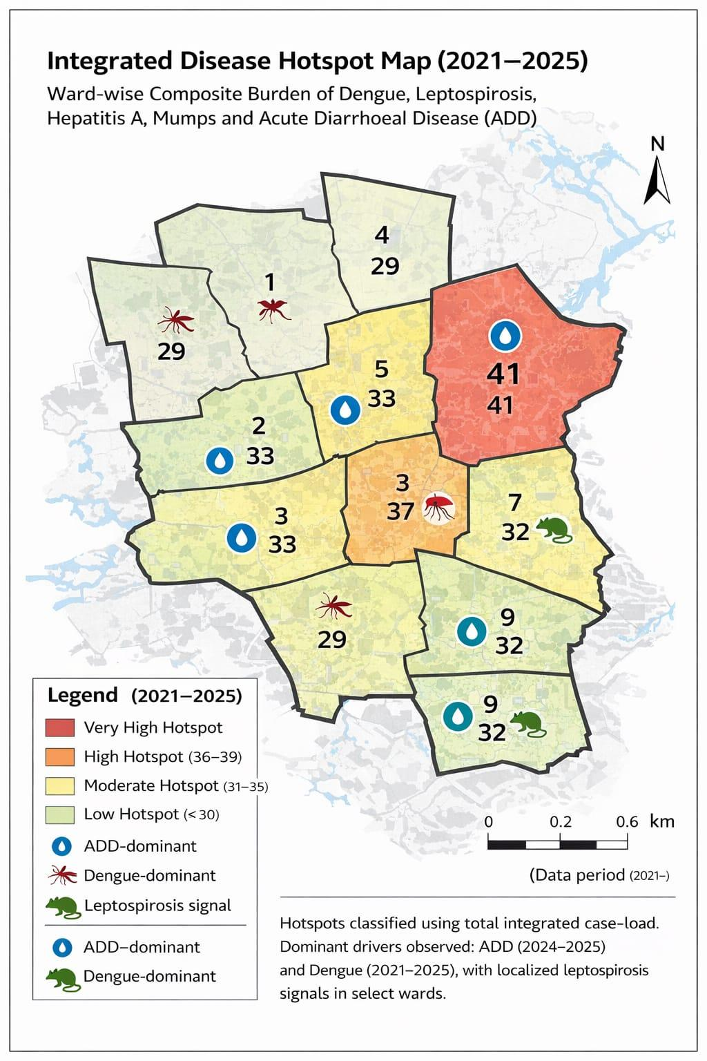

Ward No | Dengue Total (2021-25) | Leptospirosis Total (2021-25) | Hepatitis A Total (2021-25) | Mumps (2021-25) | ADD (2021-25) | Total Cases
1 | 6 | 1 | 1 | 0 | 21 | 29
2 | 4 | 1 | 0 | 0 | 28 | 33
3 | 6 | 1 | 0 | 0 | 30 | 37
4 | 2 | 0 | 0 | 0 | 29 | 31
5 | 10 | 2 | 1 | 0 | 25 | 38
6 | 5 | 2 | 0 | 0 | 25 | 32
7 | 5 | 1 | 0 | 0 | 26 | 32
8 | 7 | 2 | 0 | 0 | 32 | 41
9 | 2 | 1 | 0 | 0 | 29 | 32
10 | 5 | 0 | 0 | 0 | 27 | 32
11 | 18 | 1 | 1 | 0 | 26 | 46
12 | 7 | 0 | 2 | 0 | 23 | 32
13 | 9 | 0 | 0 | 0 | 26 | 35

By overlaying five years of data, we have identified 8 – ADD, 11-Dengue, 'Red Zone' Wards. These are wards where at least two different categories of diseases (e.g., Dengue and ADD) recurred in consecutive years. Ward-8,5,3,2,4,6,7,9,11,10,12,13,1 is categorized as the Highest Priority Hotspot due to its combination of Contaminated drinking water, Food Hygiene Issues and high vector density. Future health infrastructure, such as the proposed R.O plants at nil should be prioritized.

Preparedness and Response Protocol at LSG Level
This section describes the operational framework for the LSGI once a pandemic is declared. It explains how the LSGI and health system will move from routine data collection to active response, using a One Health approach.

Constitution of One Health Committee
The LSGD shall constitute a One Health Committee comprising the LSGI President, Medical Officers (Modern Medicine, AYUSH, and Veterinary), the Health Inspector, and the Veterinary Surgeon.

Objective: The One Health Committee coordinates human, animal, and environmental health to prevent and control pandemics.

Sl No | Name | Designation | Department/Institution | Role in Committee | Contact Number
1 | Edavetty | Panchayat President | LSGD | Chairperson | 9497798843
2 | Dr.Remya George | Medical Officer (PHC/CHC) | Health Dept | Member Secretary | 9447470198
3 | Dst.vet center tdpa | Veterinary Officer | Animal Husbandry | Member | 04862221545
4 | Asha | Epidemiologist | Health Dept | Member | 6235433129
5 | Sumesh | Health Inspector/PHN | Health Dept | Surveillance | 9447805556
6 | Anil | ASHA Supervisor | Health Dept | Community link | 8589043770
7 | Tntu | ICDS Supervisor | Social Welfare | Vulnerable groups | 8086302945
8 | SO | Police Station Officer | Police Dept | Law & order | 04862227472
9 | Muhamed ameer | Ward Councillor Representative | LSGD | Community coordination | 9497798843
10 | Beena | Kudumbashree CDO | Kudumbashree | Community mobilisation | 8111848301
11 | sabu | NGO/Volunteer rep | Civil Society | Support services | 9446193153

Key Responsibilities:
- Review disease surveillance data (human + animal)
- Conduct ward-wise risk assessment and vulnerability mapping
- Approve quarantine/isolation centre locations
- Coordinate with district for resources (PPE, oxygen, ambulances)
- Periodically review health system surge capacity, including beds, oxygen, human resources, and ambulances.
- Approve and monitor risk communication and community engagement strategies, including rumour management.
- Ensure protection and service continuity for vulnerable groups (elderly, persons with disabilities, dialysis patients, coastal populations).
- Conduct quarterly mock drills
- Monitor equity measures for vulnerable groups

Meeting Schedule:
Quarterly (normal times) | Weekly (outbreak alert) | Daily (pandemic phase)

Pandemic Response Workforce
To ensure a coordinated and timely response during a pandemic, a dedicated Pandemic Response Workforce shall be constituted at the LSG level. The workforce will function under the overall supervision of the One Health Committee and in close coordination with the health authorities. Team-based deployment will enable efficient surveillance, case management, quarantine and isolation management, logistics support, and risk communication. Each team shall have a clearly designated team leader, defined roles, and an identified pool of personnel to allow rapid activation, rotation of duties, and continuity of services during prolonged emergencies.

Total Response Workforce Available: 300 persons

Team Name | Composition | Key Responsibilities | Team Leader
Surveillance and Contact Tracing Team | HI, JHI, JPHN, ASHAs and Volunteers | Case detection, contact listing, home visits, reporting | HI
Case Management Team | Doctors, Nurses, MLSP, Palliative Nurses | Patient care & referral | DOCTOR
Quarantine & Isolation Team | LSGD staff, Volunteers | Facility management | JHI
Psychosocial support | HI, JHI, JPHN, ASHAs and Volunteers | Mental Support | HI
Logistics & supply chain Team | LSGD staff, Storekeepers, Drivers 3 | Supplies & transport [PPE, medicines, oxygen, transport, waste management] | Ward Member
Communication Team | Ward members, Kudumbashree, Youth clubs,  AWW workers and other self-help groups | IEC, community meetings, countering misinformation | M.O in charge
Transportation | Educational Institutional Buses, TAXI, Private Vehicle | Supplies & transport [PPE, medicines, oxygen, transport, waste management] | Ward Member
Media Surveillance | Local Channels | Current Situation | MO
Intersectoral coordination and convergence | All Department Staff | Discussion About Current Situation | PANCHAYATH SECRETARY
Collaborative surveillance | All Department | Handle The Current Situation With The Help Of All Departments | PANCHAYATH SECRETARY AND MO

All teams shall be activated immediately upon outbreak alert or pandemic declaration and shall report daily to the LSG Incident Commander/Medical Officer, with consolidated reporting to the Block PHC. Duty rosters and alternate personnel shall be maintained to ensure uninterrupted services during staff shortages or prolonged response periods. Team composition and numbers may be revised based on the magnitude of the outbreak and availability of human resources.

Activities and Measures before and during Pandemic

PHASE 1 - Alert / Preparation
Surveillance and Reporting-Enhanced Syndromic surveillance:
- Data sources for surveillance:
ACTIVE AND PASSIVE SURVEILLANCE, IHIP, LAB REPORTS
- Event-based triggers (to be monitored and reported):
Edavetty Grama Panchayath has operationalized an Event-Based Surveillance (EBS) system to ensure early identification and rapid response to emerging public health threats. The framework integrates epidemiological, environmental, institutional, and community-level triggers to strengthen preparedness and minimize outbreak impact.
Key Triggers Identified
Sudden increase in fever, respiratory illness, or ADD clusters Unusual disease patterns or unexplained severe cases Flooding, water contamination, vector or rodent proliferation School absenteeism spikes or institutional outbreaks, Community alerts, migrant returnee clusters, or rumor signals.
Preparedness Measures (Pre-Pandemic)
Ward-level disease trend monitoring and IDSP integration, Rapid Response Team (RRT) training and mock drills,Stockpiling of PPE, ORS, chlorine, and essential supplies
Strengthening risk communication and IEC activities, Intersectoral coordination with Panchayath, ICDS, Police, and Health Departments.
Response Measures (During Pandemic)
Immediate RRT activation and case isolation, Contact tracing and micro-cluster mapping
Intensified surveillance and daily reporting, Micro-containment strategies where required
Surge capacity planning (beds, oxygen, referral pathways), Community engagement and essential service support
Monitoring Indicators
Time from trigger to response, Weekly case trend analysis, Test positivity and bed occupancy rates, Compliance with WASH and preventive measures.
The structured event-based trigger mechanism enhances early detection, targeted containment, and coordinated response in Edavetty Grama Panchayath. This integrated approach strengthens ward-level preparedness, optimizes resource deployment, and reduces morbidity and mortality during pandemics.
- Zoonotic and animal health surveillance
Edavetty Grama Panchayath has integrated a One Health–based Zoonotic and Animal Health Surveillance System into its Pandemic Preparedness Plan to address risks such as leptospirosis, rabies, brucellosis, avian influenza, and rodent-borne infections. The framework ensures early detection through coordinated reporting between the Health and Veterinary Departments. Ward-level monitoring of unusual animal deaths, livestock morbidity, poultry mortality, and dog bite cases serves as key event-based triggers.
Pre-pandemic measures include anti-rabies vaccination drives, rodent control activities, biosecurity promotion among farmers, and capacity building of frontline workers. During outbreak alerts, a Joint Rapid Response Team is activated within 24 hours for field investigation, human screening, and containment actions. Intersectoral coordination with Panchayath, Agriculture, ICDS, and community groups strengthens response efficiency.
This integrated surveillance approach enhances early warning capacity, prevents cross-species transmission, and improves overall pandemic resilience in Edavetty Grama Panchayath.
- Logistics and Stock Preparedness
  - Identify and empanel local vendors and define emergency procurement mechanisms in accordance with existing LSGD and Health Department norms.
  - Prepare and maintain an essential logistics checklist covering medical supplies, consumables,
  - And support equipment.

  - Pre-identify secure storage locations for emergency stocks and ensure maintenance of stock
Registers with regular updating

  - Finalise emergency transport arrangements, including availability of vehicles and identified
  - Drivers for rapid deployment during alerts.
  - Designate a Nodal Officer for Logistics to enable prompt decision-making, coordination, and communication during emergencies.
  - Conduct rapid stock verification and ensure availability of minimum buffer stock, including:
PPE | kits | 0 | Numbers
Pulse | oximeters | 20 | Numbers
Hand | sanitizers | 3 | Litres
Masks, gloves | disinfections | Adequate | Quanity

Identify critical gaps in logistics and immediately communicate requirements to the Block and District authorities for timely replenishment and support. Monitor expiry dates and stock rotation.

Identification of Quarantine and Isolation Facilities
  - Identify and list suitable buildings for quarantine and isolation (schools, hostels, community halls, etc.).
Most favourable identified schools are St. George UPS Kallanical, St. George HS Kallanickal, Govt. UPS Thondikuzha, Saraswathy school Edavetty.
  - Categorise cases as per the severity and allocate to appropriate facilities (for instance, severe cases to classrooms, mild cases to an assembly hall in case of a school).
  - Facility readiness checklist needed (beds, toilets, ventilation) etc.
  - Find an alternate site if the primary sites are not available or not in use.
  - Identify facility managers and support staff
  - Prepare basic SOPs for:
    - Admission and discharge
    - Food, water, sanitation
    - Infection prevention and waste disposal
  - Ensure availability of basic amenities: water, sanitation, electricity, ventilation, and waste disposal. Prepare a rapid activation plan for these facilities if case numbers increase.

Risk Communication and Community Preparedness
  - Disseminate early warning messages on symptoms, preventive measures, and reporting mechanisms. Display IEC materials both in English and the local language in public places and ensure ward-level awareness.
  - Sensitize elected representatives and community leaders on preparedness measures.
  - Establish a rumour tracking and misinformation response mechanism to identify, verify, and promptly counter false or misleading information.
  - Engage trusted local persons (ward members, ASHA workers, religious leaders, teachers, community volunteers) to communicate official public health messages and reinforce correct practices.
  - Develop and deploy targeted IEC materials for:
    - Schools and educational institutions
    - Markets and commercial areas
    - Work sites and labour settings
  - Conduct community sensitization meetings at the ward level to promote preventive behaviours, address concerns, and strengthen community participation in preparedness and response.

Protection of Vulnerable Groups
Vulnerable populations require priority protection through targeted line-listing, service continuity, and delivery mechanisms.
- Prepare and regularly update line-lists of vulnerable populations, including:
  - Elderly persons living alone
  - Persons with disabilities
  - Pregnant women
  - Migrant workers
  - Dialysis patients
The detailed line-lists shall be maintained as Annexure ___ and updated periodically.

Clinical Dependency Mapping
Develop ward-wise dependency and vulnerability maps to identify households requiring regular support during emergencies. Ensure continuity of essential health services for vulnerable groups, including
- Dialysis services (facility mapping, transport arrangements, and scheduling)
- Continuity of treatment for TB, HIV, and other chronic conditions requiring uninterrupted medication
- Mental health and psychosocial support services
Establish delivery mechanisms for food, essential commodities, and medicines to vulnerable households through coordinated action involving ASHAs, JPHNs, Kudumbashree, volunteers, and local administration.

PHASE 2 - Active Response

Case Identification and Contact Tracing
Case detection and contact tracing activities will be carried out in coordination with the Health authorities, following disease-specific SOPs and IDSP guidelines.
Field Staff Involved
- Health Inspector (HI)
- Junior Health Inspector (JHI)
- Junior Public Health Nurse (JPHN)
- ASHAs and ASHA Supervisors
- Ward-level volunteers and Kudumbashree members (as required)

Screening Checkpoints
Screening checkpoints at high-traffic locations (transport hubs, markets, religious gatherings) for early detection of symptomatic travellers and crowd screening during outbreaks. Potential locations include bus stands, market entry points, and boat jetties, based on local context and risk assessment.
Screening activities will be carried out by trained personnel such as ASHAs, ward members, and volunteers, with support from Health Department staff. Necessary equipment, including non-contact thermometers and appropriate PPE, shall be ensured prior to activation.

Location | Type (Bus stand/Jetty/Market/Railway) | Staff Deployed (ASHAs/Volunteers) | Screening Method | Reporting authority
Bus stand | Transport hub | One JHI  One ASHA  One health Mentors | 1.Swab Collection.  2. Blood smears collection (RDT)  3.Thermal Scanners | Surveillance Nodal Officer in control room
Market entry | Market | One JHI  One ASHA  Male health volunteers | 1.Swab Collection.  2. Blood smears collection (RDT)  3.Thermal Scanners | Surveillance Nodal Officer in control room

Standard Screening Protocol
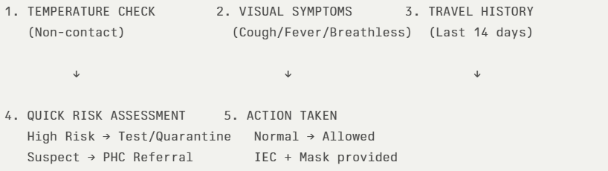
The screening protocol shall include temperature screening, observation for visible symptoms, and inquiry regarding recent travel or exposure history. Individuals identified as suspects during screening shall be immediately referred to the nearest PHC/FHC for further evaluation, testing, and appropriate action as per prevailing guidelines.

Pandemic Control Room
The Pandemic Control Room (PCR) serves as the central nerve center for real-time coordination, data aggregation, decision support, and communication during outbreaks. It consolidates information from all LSGD teams, health facilities and community sources to enable rapid response decisions.

Control Room Infrastructure and Location
Primary Location: Edavetty Panchayath Office.
Backup Location: Community Hall in Edavetty G.P.

Health System Control Room Framework
The PCR is organized into seven functional pillars to ensure no aspect of the response is overlooked:

Rapid Response Team (RRT)
  - Provides immediate intervention during emergencies, clusters, and field alerts.​
  - Coordinates urgent actions such as case investigation, contact tracing, isolation, and inter‑facility referrals.

Data Management & Analytics Team
  - Collects, validates, and manages key health system indicators (cases, tests, beds, HR, supplies).​
  - Analyzes data trends, generates projections, and supports evidence‑based decision‑making for local authorities.

Human Resource Deployment Team
  - Allocates healthcare staff efficiently based on workload and need
  - Ensures adequate and equitable workforce distribution across facilities

Laboratory Surveillance Team
  - Oversees diagnostic testing coordination, sample transport, and timely reporting of results.​
  - Monitors lab indicators (testing volume, positivity rate, turnaround time) for early detection of outbreaks

Vaccination Cell (If Required)
  - Plans and executes vaccination campaigns, including micro‑planning and session scheduling.​
  - Tracks coverage, identifies gaps, and coordinates corrective actions with field teams and outreach services.

Infrastructure & Patient Occupancy Team
  - Monitors facility capacity, earmarked beds, oxygen and critical care resources across all linked facilities.​
  - Ensures optimal patient distribution and referral management using updated bed‑status and resource data.
  - BMWM

Communication team
- Logistics and supply chain
- Transportation (interfacility & emergency transport)
- Media surveillance Call centre
- Management of the deceased
- Intersectoral coordination and convergence

Key Control Room Team
The Control Room Team coordinates all pandemic response activities within the LSGD and serves as the single command and communication hub during activation. It integrates information, field actions, logistics, and policy execution across all participating departments and health facilities.

Role | Name | Designation | Contact Number | Responsibility
In-charge/Nodal Officer | Dr. Ramya George | Medical Officer | 9447470198 | Overall coordination, decision-making, and reporting to the District level.
Data Entry Operator | 0 | 0 | 0 | Managing the line list, updating dashboards, and tracking testing results.
Communication Officer | Tiji M. K | JHI | 9747333567 | Handling the public helpline, coordinating ambulance dispatch, and contact tracing calls.
Logistics Coordinator | Faseela P H | JHI | 8086950316 | MPW
Technical Support (IT/Data) | Tiji M. K | JHI | 9747333567 | MPW

SOP for alert escalation/trigger point with mapping of responsibilities.

Key Points:
- The Control Room shall be staffed with a designated In-charge, data entry personnel, and communication staff with clearly defined roles and shift arrangements.
- It shall maintain updated records on daily monitoring indicators including new cases, persons under active quarantine, and hospital bed occupancy.
- All reports and situation updates shall be shared daily with the Block and District Surveillance Unit.
- The Control Room shall act as a single point of contact for coordination with response teams, health institutions, and other departments.
- Contact details of the Control Room shall be widely communicated to field staff and stakeholders during activation.

Daily Monitoring Indicators
To ensure timely decision-making and effective response, the following key indicators shall be monitored and updated on a daily basis by the Pandemic Control Room:

Epidemiological Indicators:
New cases reported today, Total active cases, Test Positivity Rate (TPR), Case Fatality Rate (CFR)
- Surveillance Indicators:
Persons under home quarantine, High-risk contacts identified, Fever, ILI, SARI or other symptoms (syndromic surges), Travellers (symptomatic or high-risk arrivals),Animal husbandry surveillance (zoonotic alerts, unusual animal deaths, poultry/bird flu signals), Mortality surveillance (excess deaths, unexplained fatalities, verbal autopsy reports)
- Logistics and Infrastructure Indicators:
Hospital / CFLTC beds occupied, Oxygen cylinders/concentrators available, Ambulances on standby
- Alert Findings
The following table outlines category-specific trigger points (red flags) from surveillance indicators and corresponding immediate actions for the Pandemic Control Room. These enable rapid response to alert findings like testing anomalies, positive cases exceeding thresholds, clusters, and WGS reports.

Category | Trigger Pophint (Red Flag) | Immediate Action
Clusters | Geographical or facility-based: 5+ cases linked to one location (office, school, street). | Declare a micro-containment zone; perimeter control and active case finding.
Testing | Sudden drop in testing volume / delay in reporting / unusual testing trends | Review the sample collection process, address lab bottlenecks, deploy additional testing teams, and notify the District Lab.
Lab | Test Positivity rate increases | Increase testing sites in that ward.
Hospital | >80% Oxygen bed occupancy | Activate backup/CFLTC beds.
Travel | Cluster of cases from a single flight/train or high-risk arrival group. | Trace all passengers in adjacent seats; implement mandatory institutional quarantine.
Animal | Mass poultry/wildlife death or unusual sickness | Notify Animal Husbandry, sample the area, and dispatch RRT for environmental sampling and zoonotic check.
Mortality | Sudden spike in home deaths or brought-in-dead (BID) cases | Audit the deaths and Active Case Search drive
Additional investigations like Whole Genome Sequencing (WGS) | Detection of a Variant of Concern (VOC) or Variant of Interest (VOI) | Implement strict micro-containment; update clinical protocols to match variant severity.

Communication of Public Health Information
A Community Communication Hub shall be established to ensure timely, accurate, and consistent dissemination of information during a pandemic. The Hub will function under the coordination of Nodal officers of the control room and act as the nodal point for public communication, risk messaging, and community engagement. It will support dissemination of official advisories, promote preventive behaviours, address rumours and misinformation, and ensure that messages reach all sections of the population through trusted local channels and leaders.

Key communicators
Channel | Responsible Person | Contact
Ward-level announcements | Sheeja Noushad | 9746223038
Social media | 0 | 0
Local Cable TV/Radio | BBC News | 9847141115

- All messages disseminated through the Hub shall align with advisories issued by the Health Department and District authorities.
- Community leaders shall be sensitized to support behavior change, reduce stigma, and counter misinformation.
- Special efforts shall be made to reach vulnerable and hard-to-reach populations using locally appropriate communication methods.

Rumor Tracking: A designated volunteer will monitor local social media/WhatsApp groups daily to identify misinformation and issue official clarifications via the Communication Hub.

Coordination with District/State Authorities & Other Organisations
Effective coordination with Block, District, and State authorities is essential to ensure timely reporting, technical guidance, and uninterrupted supply of essential resources during a pandemic. The LSG shall establish clear communication channels, designate responsible officers, and adhere to prescribed reporting timelines to support coordinated public health action and efficient resource mobilisation.

Key Details:
- Nodal Officer for Reporting:
- Contact Number:
Reporting Schedule and Protocols:

To Whom | What to Report | Frequency | Nodal Person
Block PHC | Complete Situation Report (Cases, Quarantine, Beds, Screening, Deaths) | DAILY | Aji K K  9544046712
District IDSP Unit | Outbreaks/Clusters/Unusual Events (>5 cases same ward) | DAILY | Remya  95444092400
Veterinary Officer | Animal health events/Zoonotic alerts | 0 | 0
State Cell | Zoonotic cross-sector events | 0 | 0

Supply Chain Coordination
The LSG shall coordinate closely with Block, District, and State authorities (KMSCL) to ensure uninterrupted availability of essential goods, medical supplies, and logistics during a pandemic. Supply requirements shall be assessed regularly based on case load and communicated promptly to the appropriate authorities for timely replenishment.
Key Points:
- Maintain updated contact details of District and Block nodal officers for health logistics, oxygen supply, ambulances, and essential medicines.
- Submit timely indent requests for PPE, testing kits, medicines, oxygen, and other critical supplies through prescribed channels.
- Monitor stock levels at LSGD facilities, quarantine/isolation centres, and field teams through daily stock registers and dispensing logs to prevent shortages.
- Coordinate with District authorities, Karunya/Neethi medical shops, and local purchase committees for funds allocation and emergency procurement.

- Ensure regular monitoring of dispensing registers at all facilities to track usage, expiry, and pilferage—shortages being a perennial issue requiring proactive weekly audits.

- Activate surge procurement protocols during high caseloads, leveraging local purchase powers under LSGD funds alongside state supplies.

Resource Inventory and Contacts
Resource Category | Source  (District/State/Private) | Contact
PPE Kits/Masks/Gloves | KMSCL | mgridk.kmsclkerala.gov.in
PPE Kits/Masks/Gloves | Local Vendors | Poaitive Surgicals Thodupuzha  9961682233
Oxygen  Cylinders/Concentrators | KMSCL | mgridk.kmsclkerala.gov.in
Medicines/Antivirals | KMSCL | mgridk.kmsclkerala.gov.in
Medicines/Antivirals | Neethi Shops | 08547850377
Test Kits (RTPCR/Rapid) | KMSCL | mgridk.kmsclkerala.gov.in

Collaboration with NGOs, PPP, and CSR
To augment government efforts during a pandemic, the LSG shall collaborate with NGOs, voluntary organisations, and private sector partners through public–private partnerships and Corporate Social Responsibility (CSR) initiatives, in coordination with District authorities.

Key Points:
- Engage NGOs and community-based organisations for community outreach, awareness, and support to vulnerable populations.
- Leverage CSR support for procurement of medical equipment, PPE, oxygen concentrators, food kits, and sanitation materials, as permitted.
- Ensure all collaborations align with government guidelines and are routed through approved administrative and financial procedures.
- Maintain transparency and documentation for all external support received and utilised.
Organization | Type | Support Offered | Contact Person
Youth Clubs/Student Unions | CBO | 0 | 0

Interdepartmental Coordination
Coordination among departments during a pandemic shall be ensured through regular review meetings convened by the LSGD President. These meetings will provide a structured platform for sharing situational updates, assessing resource availability, resolving operational gaps, and taking joint decisions to ensure a coordinated and timely response.

Department | Representative | Key Role | Contact
Health (PHC) | Staff Nurse : | Case management | 7902781161
Veterinary | Veterinary Surgeon: | Animal surveillance | 9497279358
ICDS | Supervisor: | Nutrition support | 8086302945
Education | Head Teacher:  Shahana | School coordination | 9495373717
Police | SHO | Containment enforcement | 04862 227472
Water Authority | AE | Water supply | 04862297045
LSGD Engineering | secretary_  Sreena Navas | Quarantine infrastructure | 04862223809

PHASE 3 - Surge Capacity
Phase 3 is activated when there is a rapid increase in cases, high test positivity rates, or when existing health facilities and quarantine arrangements approach saturation. The focus of this phase is to expand isolation capacity, augment clinical care services, and mobilise additional resources through district and state support mechanisms.

Conversion of Community Facilities
To manage increased case load, the LSGD shall activate additional isolation facilities by repurposing identified community infrastructure such as community halls, auditoriums, schools, hostels, or other suitable buildings.

Name of facility | Facility Type | No. of Buildings | Ward | Surge Capacity (Beds) | Nodal Person
School | Govt & Govt Aided | 7 | 1,2,6,10,8 | 650 | JHI
Auditorium | Private | 5 | 1,13,2,8 | 1000/Each | JHI

Recovery and rehabilitation phase
The recovery and rehabilitation phase begins once the immediate public health emergency is controlled and transmission is reduced to manageable levels. This phase focuses on restoring essential services, addressing long-term health and socio-economic impacts, and strengthening systems to prevent or better manage future pandemics.

Recovery
Recovery refers to the gradual return of communities and systems to normal functioning while continuing public health vigilance. It involves phased withdrawal of emergency measures, reopening of services, and reintegration of disrupted health and social systems. Recovery activities should be evidence-based, inclusive, and aligned with national and state guidelines to ensure sustainability and resilience.

Damage and Impact Assessment
Before long-term rebuilding can happen, the dust must be settled and the immediate risks managed. Damage and impact assessment is a critical step to understand the full extent of the pandemic’s effects on health systems, communities, and livelihoods. This assessment evaluates disruptions to healthcare services, availability of infrastructure and workforce, morbidity and mortality patterns, and socio-economic consequences such as loss of income, education disruption, and food insecurity. The findings inform evidence-based planning, prioritization of interventions, and optimal allocation of resources during the recovery phase.

Restoration of Health Services
Recovery requires moving beyond emergency trauma care. This sub-phase focuses on reopening primary care clinics, restarting routine immunization programs, and ensuring that patients with chronic conditions (like diabetes or hypertension) can once again access life-sustaining medications and check-ups.

Environmental Cleanup and Sanitation
Post-disaster environments are often breeding grounds for secondary health crises. Cleanup efforts focus on removing debris, managing hazardous waste, and restoring water and sewage systems. Ensuring a "clean slate" is biologically necessary to prevent the spread of waterborne and vector-borne diseases.

Rehabilitation
Rehabilitation focuses on addressing the long-term physical, social, and economic impacts of the pandemic on affected individuals and communities. This includes medical rehabilitation for post-infection complications, nutritional support for vulnerable groups, and social assistance for households affected by illness, disability, or loss of livelihood. Rehabilitation efforts should promote reintegration into education, employment, and community life, with special attention to marginalized and high-risk populations.

Physical and Livelihood Rehabilitation
For those left with lasting injuries, rehabilitation involves providing physical therapy and assistive devices. Simultaneously, Livelihood Restoration addresses the economic health of the community; without the ability to earn an income, individuals cannot sustain their own long-term health and nutrition. Support for small businesses, informal workers, self-help groups, and skill development initiatives is essential to promote economic resilience and long-term recovery.

Psychosocial and Mental Health Support
The trauma of a disaster often outlasts the physical damage. Providing psychological f irst aid and long-term mental health counseling is vital for community cohesion. This support helps individuals process grief and anxiety, reducing the long-term societal burden of PTSD.

Community Engagement and Confidence Building
Recovery fails if the public does not trust the systems being rebuilt. Active communication and involving local leaders in the decision-making process help rebuild social capital. This ensures that the population feels safe returning to schools, workplaces, and hospitals. Active involvement of community leaders, local self-governments, and civil society organizations strengthens community ownership, promotes adherence to public health measures, and enhances preparedness for future emergencies.

Vigilance and Disease Surveillance
Disease surveillance during the recovery phase ensures early detection of resurgence, secondary outbreaks, or emerging variants. Surveillance systems should continue monitoring communicable disease trends, post-pandemic complications, and unusual health events. Strengthening laboratory capacity, sentinel surveillance, and community-based reporting mechanisms enables timely response and supports sustained public health security.

System Strengthening and Future Preparedness
The final stage of recovery is an intellectual exercise in "Building Back Better," turning the tragedy of the past into the safety of the future.

Documentation and After-Action Review (AAR)
Once the immediate pressure has subsided, stakeholders must conduct a formal review of the response. This involves a candid look at what worked, what failed, and where communication broke down. These lessons learned are then transformed into best practices.

Policy Revision and Health System Strengthening
Pandemic Preparedness Plan The ultimate goal of recovery is to ensure the next crisis is less damaging. This involves updating emergency protocols, revising public health laws, and investing in more durable infrastructure. Through Research and data analysis, the health system is "hardened" against future threats, moving the community from a state of vulnerability to a state of permanent readiness.

Research
Research during the recovery phase is essential to generate evidence on the long-term health, social, and economic impacts of pandemics. Operational, clinical, and policy research should examine the effectiveness of response and recovery interventions, community behaviors, and innovations in service delivery and surveillance. Research f indings should inform future preparedness strategies and public health decision-making.

RECOMMENDATIONS
Edavetty Grama Panchayath
- Strengthen Integrated Surveillance:
Implement ward-level Indicator-Based and Event-Based Surveillance systems with real-time reporting and periodic hotspot mapping to ensure early detection of outbreaks.
- Operationalize Rapid Response Mechanism:
Maintain a trained Rapid Response Team (RRT) with 24-hour activation protocol, supported by regular mock drills and adequate outbreak investigation logistics.
- Enhance WASH and Environmental Health Measures:
Ensure routine water quality monitoring, sanitation inspections, and seasonal vector/rodent control interventions to prevent waterborne and vector-borne outbreaks.
- Integrate One Health Approach:
Establish coordinated surveillance between Health and Veterinary Departments, with mandatory reporting of zoonotic risk events including unusual animal deaths and rabies exposures.
- Strengthen Health System Surge Preparedness:
Identify isolation facilities, maintain buffer stock of essential supplies (PPE, ORS, chlorine, medicines), and develop oxygen and referral management plans.
- Institutionalize Risk Communication Strategy:
Develop structured IEC plans, activate rapid communication platforms, and engage community-based organizations to address misinformation and improve compliance.
- Ensure Intersectoral Coordination:
Constitute a Panchayath-level Pandemic Coordination Committee aligned with the District Disaster Management framework for coordinated multi-departmental response.
- Establish Monitoring & Review Mechanism:
Conduct quarterly preparedness reviews focusing on response time, disease trends, resource utilization, and corrective action planning.

MOCKDRILL SCENARIOS
Edavetty Grama Panchayat has aligned its mock drills with the guidelines of the Kerala State Disaster Management Authority to strengthen local Incident Response System (IRS) functionality. Given the hilly terrain of Idukki district, preparedness activities primarily focus on monsoon-related hazards.
Key simulation scenarios include: Landslide risk mitigation, emphasizing rapid evacuation from vulnerable slopes and coordination of rescue operations. Flash flood and riverine flooding response, testing timely relocation to pre-identified relief shelters. Tree fall and structural collapse management, ensuring prompt road clearance for emergency access. School and public building evacuation drills, enhancing awareness of safety protocols and evacuation routes. Participation in state-wide civil defence exercises, including siren and emergency alert testing. These drills aim to enhance Intersectoral coordination, improve response time, validate shelter readiness, and strengthen community awareness, thereby ensuring robust monsoon disaster preparedness at the Panchayat level.

ANNEXURE

IMPORTANT PHONE NUMBERS

Phone numbers and particulars of persons responsible for providing guidance, assistance, and support for pandemic preparedness operations may be provided here in a manner that allows easy reference at a glance. The information recorded here could be exhibited elsewhere at the time of emergencies. LSG institutions shall give special attention to collect and record the above data of persons and institutions who/which are supposed to give technical and co-ordination support to reduce the impact of pandemic.

1.1. Details of grama panchayat/municipality/corporation wards
Sl.No | Name of the ward | Ward number | Name of the ward  member | Contact number
1 | Edavetty chira | 1 | Anoop | 9496461346
2 | Thondikuzha | 2 | Suku | 9745300258
3 | Nadayam | 3 | Jaseela | 9747485630
4 | Gandhinagar | 4 | Mujeeb | 9446022494
5 | Sasthampara | 5 | Muhamed Ameer | 9497794843
6 | Meenmutty | 6 | Bincy martin | 9526800595
7 | kALLANICKAL | 7 | Salmy sidque | 9946593211
8 | Malankara | 8 | Sheela Deepu | 8921332564
9 | Thekkumbhagam | 9 | Rajesh | 9744625880
10 | Keerikode | 10 | Baby thomas | 8606384082
11 | Marthoma | 11 | anisha | 8590607913
12 |  | 12 | Bindhu Kishor | 9072277625
 | Edavetty south

13 Chempalassery Sheeja Noushad 9746223038
14 Edavetty North 13 Beevi Salim 9526984888

1.2. Other important phone numbers of grama panchayat/municipality/corporation area
Sl. No. | Name | Contact number
1. | Edavetty Grama Panchyath | 04862223809
2.
3.
4.
5.
6.
7. | Excise department | 04862223147
8. | Forest department | 04862232505

1.3. Important offices of grama panchayat/municipality/ corporation
Sl.No | Name of the office | Contact person | Contact number
1. | Village Office | Village Officer | 8547612804
2. | Agriculture Office | Agriculture Officer | 9383470968
3. | Animal Husbandry Office | Animal Husbandry Doctor | 04862222894
4. | Police Station | Police Officer | 9497996981
5. | BSNL Office | Officer | 04862200100
6. | Block Office | Officer | 04862275064
7. | KSEB Office | Officer | 9496011102
8. | Fisheries Office | Officer | 04862233226
9. | Fire and Rescue | Officer | 04862222911

1.4. Health Services

Sl. No | Name of the hospital/institution | Location | Phone number
1. | Government hospitals/PHC | Edavetty | 04862221076
2. | Private hospitals | 0 | 0
3. | Clinical laboratories | 0 | 0
4. | Chemist/pharmacy | 0 | 0
5. | Blood donors | 0 | 0
6. | Other language experts (Bihari, Hindi, Bengali,  Asamees ………) | 0 | 0

1.5. Veterinary Services
Sl.No | Name of the Clinic | Name of the  Surgeon/Doctor | Place/location | Phone  number
1 | Govt.Veterinary Hospital |  | thekkumbhagam | 9497279358

1.6. Helpline numbers
Helpline | Phone number
Police | 9497996981
Fire and Rescue | 04862222911
KSEB | 9496011102

1.7. Public and Private Schools Contact details

S.No | Name of School | Institution type | Phone number
1 | St.GeorgeUPS Kallanical | Aided | 9961494340
2 | St.George HS Kallanical | Aided | 9847743335
3 | Saraswathy school Edavetty | Private | 9744032396
4 | Govt.UPS Thondikuzha | Govt | 9947697562
5 | St.George HSSS Kallanical | Aided | 9847223791
6 |  | Private
7 |  | Private
8 | Govt.LPS Sasthampara | Govt | 9847971325
9 | MMUPS Meenmutty | Govt | 9496745808
10

1.9. Anganwadi Contact Details

Ward No | Name of Anganwadi Teachers | Phone number
6 | Seena Ismail | 99619641138
1 | Gisha C.K | 9744463089
5 | Saboora | 9947910852
4 | Subaitha saidumuhamed | 6282774699
2 | Nadeera Nazar | 9074240378
3 | Padmavathi Rekunathu | 9495675990

Ward No | Anganwadi No and Name of Teacher | Phone number
7 | - Minimol Mp | 9744623587
7 | - Mary P J | 9567437412
8
9 | - Sruthy ward-9 | 7510480601
9 | - Sajitha Kumari ward-10 | 9495613867
9 | - Soya ward-11 | 9847328693
13 | Ameena | 8590278298
12 | Omana p | 9947002538

1.12. Information regarding resources

Means of transportation | Name of Owner | Phone Number
Heavy Trucks | 0 | 0
Tractor | 0 | 0
Ambulances | Kujettan | 9446892848
Boats | 0 | 0
Taxi service | 0 | 0

Annexure 1: LSG Baseline Data Collection Format
A. Baseline data
Sl. No. | Indicator / Field | Baseline Data | Source / Remarks
1 | Name of LSG | Edavetty | 0
2 | District | Idukki | 0
3 | Block / Taluk | Elamdesam | 0
4 | Type of LSG (Gram Panchayat / Municipality / Corporation) | Panchyath | 0
5 | Area (sq. km) | 18.52 | 0
6 | No. of wards | 13 | 0
7 | GIS boundary file available | (Yes/No) | 0
8 | Key contact person & phone | 9497794843 | 0

B. Demography
Indicator / Field | Baseline Data | Source / Remarks
Total population | 18324 | 0
Males | 8966 | 0
Females | 9358 | 0
Transgender population | 0 | 0
Age distribution  (<5, 5–14, 15–59, ≥60) | 9457 | 0
No. of households | 4550 | 0
Population density (persons/sq.km) | 989 | 0
No. of migrant workers | 346 | 0
Major occupational groups | shops | 0

C. Vulnerable Populations & Social Risks
Sl. No. | Indicator / Field | Baseline Data (Value / Description) | Source / Remarks
1 | No. of elderly (≥60) | 13549 | 0
2 | No. of persons with disability | 26 | 0
3 | No. of bedridden persons | 28 | 0
4 | No. of chronic disease cases (DM/HTN/COPD/CKD etc.) | 6321 | 00
5 | Pregnant women (current estimate) | 89 | 0
6 | Children <5 years | 756 | 0
7 | Tribal population (if any) | 677 | 0
8 | Fisherfolk / coastal vulnerable groups (if any) | 0 | 0
9 | Urban slums / unnotified settlements (if any) | 0 | 0
10 | Homeless population | 0 | 0
11 | Orphanages / old age homes (number & capacity) | 0 | 0
12 | Hostels / prisons / shelters (number & capacity) | 0 | 0
13 | Poverty / BPL estimate | 0 | 0
14 | Food insecurity hotspots | 0 | 0
15 | Any history of stigma/discrimination issues (Yes/No) | 0 | 0

D. Health System & Service Readiness
Sl. No. | Indicator / Field | Baseline Data (Value / Description) | Source / Remarks
1 | No. of health facilities in LSG (PHC/CHC/TH/DH/Private) | 1 | 0
2 | PHC/Family Health Centre details (name, location) | 1,EDAVETTY | 0
3 | Subcentres / Health & Wellness Centres (number) | 2 | 0
4 | Private clinics / hospitals (number) | 2 | 0
5 | Labs available (public/private) | 5 | 0
6 | Availability of ambulance services (Yes/No, number) | 9446892848 ,YES | 0
7 | Availability of isolation/quarantine facilities (Yes/No, details) | 0 | 0
8 | Cold chain facilities (Yes/No, details) | 0 | 0
9 | Stockpile space available (Yes/No) | 0 | 0
10 | PPE / mask / sanitizer availability plan (Yes/No) | 0 | 0
11 | Surveillance staff available (JHI/JPHN/ASHA count) | 2,2,13 | 0
12 | Existing emergency referral pathways (Yes/No) | YES | 0

E. Points of Entry & Mobility
Sl. No. | Indicator / Field | Baseline Data (Value / Description) | Source / Remarks
1 | Bus stands / depots (number) | 0 | 0
2 | Railway stations (number) | 0 | 0
3 | Boat jetties / fishing harbours (number) | 0 | 0
4 | Ports / airports nearby (specify distance) | 0 | 0
5 | Major highways/roads passing through | 0 | 0
6 | Border crossings (state/district) | 0 | 0
7 | Major markets / weekly markets | 0 | 0
8 | Tourism hubs / major event venues | 0 | 0
9 | Schools/colleges with hostels (number) | 7 | 0
10 | Factories / large workplaces (number) | 5 | 0
F. Water, Sanitation & Hygiene (WASH)
Sl. No. | Indicator / Field | Baseline Data (Value / Description) | Source / Remarks
1 | Major drinking water sources (piped / wells / borewells / springs) | Pipe,well borewell | 0
2 | No. of public wells | 1946 | 0
3 | No. of households with piped water connection | 1245 | 0
4 | Water quality testing routine (Yes/No) | no | 0
5 | Common contamination risks (flooding, salinity, industrial waste) | no | 0
6 | Open defecation free status (Yes/No) | no | 0
7 | Solid waste management system (Yes/No) | yes | 0
8 | Bio-medical waste disposal mechanism (Yes/No) | yes | 0
9 | No. of public toilets | 2 | 0
10 | Handwashing stations in public places (Yes/No) | yes | 0
G. Zoonotic Risks & One Health
Sl. No. | Indicator / Field | Baseline Data (Value / Description) | Source / Remarks
1 | Livestock population (cattle/goats/pigs/poultry) – estimates | 8045 | 0
2 | No. of dairy farms / poultry farms / pig farms | 0 | 0
3 | Slaughterhouses / meat shops (number) | 5 | 0
4 | Animal markets (Yes/No, details) | No | 0
5 | Veterinary dispensaries (number) | 1 | 0
6 | History of zoonotic outbreaks (rabies, leptospirosis, avian flu etc.) | No | 0
7 | Stray dog population management measures (Yes/No) | No | 0
8 | Rodent infestation hotspots (Yes/No) | No | 0
9 | Wetlands / waterlogged areas prone to leptospirosis | No | 0
10 | Bat roosting areas / caves / fruit orchards (if any) | No | 0
11 | Human-animal interface hotspots (farms near residences) | No | 0

H. Climate & Disaster Risks (Pandemic Amplifiers)
Sl. No. | Indicator / Field | Baseline Data (Value / Description) | Source / Remarks
1 | Flood-prone wards (list) | No | 0
2 | Landslide-prone wards (list) | No | 0
3 | Cyclone/sea surge risk (Yes/No) | No | 0
4 | Heatwave risk zones (Yes/No) | No | 0
5 | Waterlogging areas (list) | No | 0
6 | Shelter homes / relief camps (number, capacity) | No | 0
7 | Past disaster displacement history | No | 0
8 | Disruption to water supply/transport common (Yes/No) | Yes | 0
I. Critical Infrastructure & Logistics
Sl. No. | Indicator / Field | Baseline Data (Value / Description) | Source / Remarks
1 | Schools (number) | 7 | 0
2 | Anganwadis (number) | 14 | 0
3 | Colleges (number) | 0 | 0
4 | Community halls (number) | 0 | 0
5 | Places of worship with large gatherings (number) | 0 | 0
6 | Large markets / shopping areas (number) | 0 | 0
7 | Warehouses / cold storages (number) | 0 | 0
8 | Telecom/mobile network coverage gaps (Yes/No) | No | 0
9 | Power outage frequency (high/medium/low) | No | 0
10 | Availability of generators in key facilities | 1 | 0

J. Risk Communication & Community Networks
Sl. No. | Indicator / Field | Baseline Data (Value / Description) | Source / Remarks
1 | Ward-level rapid response teams (Yes/No) | Yes | 0
2 | Jagratha samithis / committees active (Yes/No) | Yes | 0
3 | Kudumbashree presence and strength (number of units) | 147 | 0
4 | Volunteer network (number, coverage) | 735 | 0
5 | Community-based surveillance mechanisms (Yes/No) | Yes | 0
6 | IEC dissemination channels (WhatsApp groups, community radio, PA systems) | Yes | 0
7 | Rumour tracking mechanisms (Yes/No) | Yes | 0
8 | Languages spoken / literacy considerations | Yes | 0
9 | Vulnerable groups communication strategy available (Yes/No) | Yes | 0

K. Preparedness Planning & Governance
Sl. No. | Indicator / Field | Baseline Data (Value / Description) | Source / Remarks
1 | LSG emergency plan available (Yes/No) | Yes | 0
2 | Pandemic preparedness plan available (Yes/No) | Yes | 0
3 | Incident Command System identified (Yes/No) | Yes | 0
4 | Rapid procurement mechanism available (Yes/No) | Yes | 0
5 | Emergency fund available (Yes/No, amount) | Yes | 0
6 | Past outbreak response experience (Yes/No, details) | Yes | 0
7 | Intersectoral coordination mechanism (Health, Police, LSG, Veterinary, Education) | Yes | 0
8 | Mock drills conducted in last 12 months (Yes/No) | Yes | 0
9 | Training coverage for staff/volunteers (Yes/No) | Yes | 0

L. Surveillance & Data Systems
Sl. No. | Indicator / Field | Baseline Data (Value / Description) | Source / Remarks
1 | Digital reporting tools used (e.g., DHIS2, portals) | Yes | 0
2 | Availability of line-listing format (Yes/No) | Yes | 0
3 | Contact tracing team identified (Yes/No) | Yes | 0
4 | Mapping of high-risk households available (Yes/No) | Yes | 0
5 | Testing sample transport mechanism (Yes/No) | Yes | 0
6 | Reporting timeline adherence (good/average/poor)0 | Yes | 0
7 | Data sharing between departments (Yes/No) | Yes | 0
8 | Availability of dashboard for monitoring (Yes/No) | Yes | 0

M. Additional Notes & Observations
Sl. No. | Indicator / Field | Baseline Data (Value / Description) | Source / Remarks
1 | Key challenges perceived by LSG | 0 | 0
2 | Top 5 high-risk wards (reason) | 0 | 0
3 | Any unique local risks (industrial pollution, refugee camps, etc.) | 0 | 0
4 | Recommendations for preparedness strengthening | 0 | 0

Disease | 2021 | 2022 | 2023 | 2024 |  | 2025 |  | Trend(Increasing/Stable/Decreasing)
Dengue | 1 | 3 | 9 | 30 | 5 |  | Decreasing
Leptospirosis | 0 | 3 | 4 | 0 | 2 |  | Decreasing
Hepatitis A | 0 | 0 | 0 | 0 | 5 |  | Decreasing
Malaria | 0 | 0 | 1 | 3 | 0 |  | Decreasing
Scrub Typhus | 0 | 0 | 0 | 0 | 0 |  | Stable
Typhoid | 1 | 0 | 0 | 2 | 0 |  | Decreasing
H1N1 | 0 | 0 | 0 | 1 | 0 |  | Decreasing
H3N2 | 0 | 0 | 0 | 0 | 0 |  | Stable
ADD | 73 | 62 | 59 | 84 | 73 |  | Decreasing
Mumps | 0 | 0 | 0 | 2 | 8 |  | Decreasing
Measles | 0 | 0 | 0 | 0 | 0 |  | Stable
Hepatitis B | 0 | 0 | 0 | 0 | 0 |  | Stable
Hepatitis C | 0 | 0 | 0 | 0 | 0 |  | Stable
Tuberculosis | 2 | 10 | 6 | 9 | 5 |  | Decreasing
Leprosy | 0 | 0 | 0 | 0 | 0 |  | Stable
COVID-19 | 0 | 0 | 0 | 0 | 0 |  | Stable

