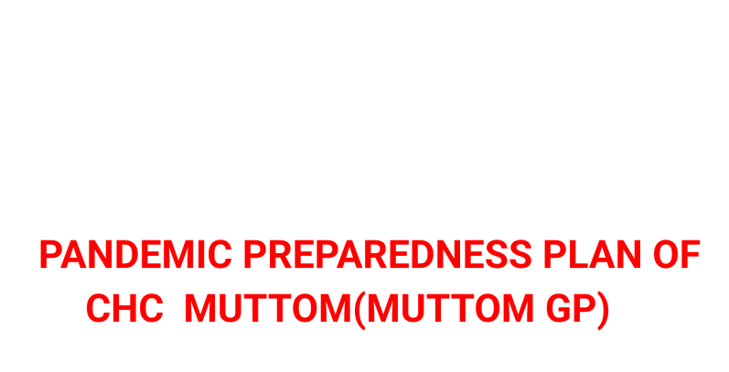
MESSAGE FROM PRESIDENT/CHAIR LSGI
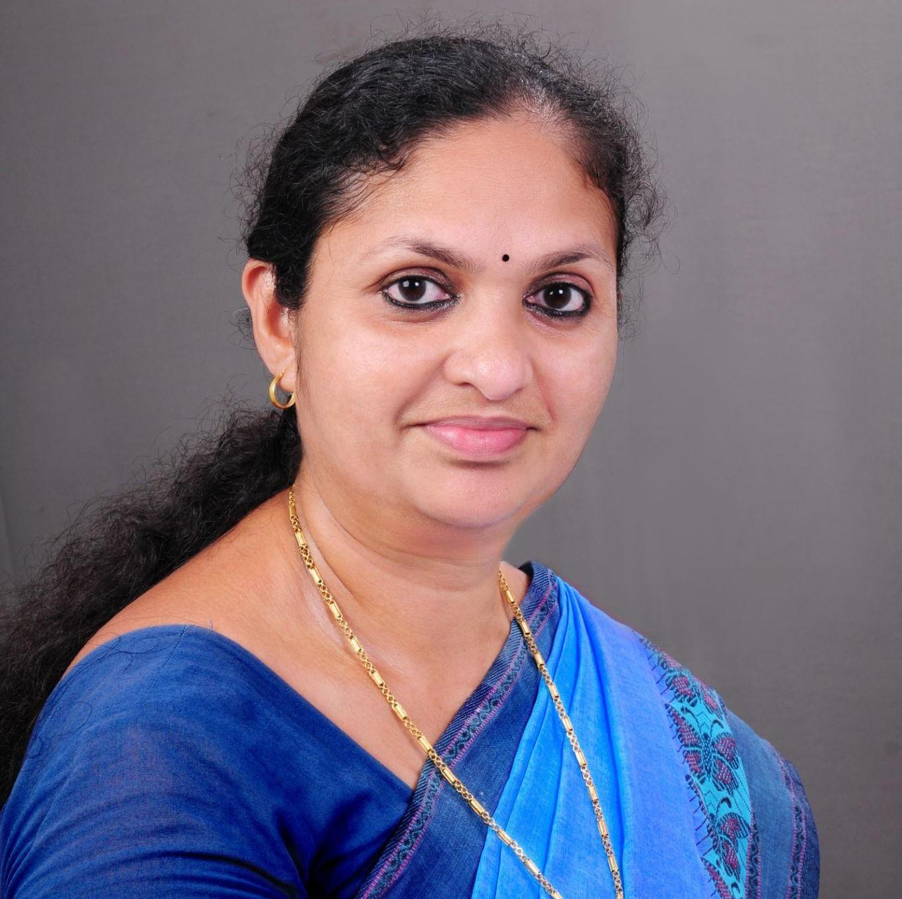
pandemics pose a serious threat to public health and community well-being. As a local self-government institution, the Panchayat has a crucial role in ensuring preparedness, prevention, and coordinated response during such public health emergencies.
I urge all residents of the Panchayat to cooperate fully with health authorities and follow the guidelines issued by the Health Department from time to time. Early reporting of symptoms, adherence to hygiene practices, use of preventive measures, and avoidance of misinformation are essential to control the spread of communicable diseases.
The Panchayat, in coordination with the Medical Officer, Health Department staff, and frontline workers, is committed to strengthening surveillance, awareness activities, sanitation measures, and community support systems. Public participation and collective responsibility are key to ensuring the safety of our community.

Let us work together with discipline, responsibility, and unity to protect public health and ensure pandemic preparedness in our panchayath
TESSY SATHEESH PANCHAYATH PRESIDENT , MUTTOM
MESSAGE FROM HEALTH STANDING COMMITTEE CHAIR

PANDEMIC PREPAREDNESS IS A SHARED RESPONSIBILITY THAT REQUIRES COORDINATED EFFORTS FROM THE HEALTH DEPARTMENT, LOCAL SELF-GOVERNMENT INSTITUTIONS, AND THE COMMUNITY AT LARGE. THE HEALTH STANDING COMMITTEE OF THE PANCHAYAT REMAINS COMMITTED TO SAFEGUARDING PUBLIC HEALTH THROUGH TIMELY PREPAREDNESS AND PREVENTIVE ACTION.
IN VIEW OF POTENTIAL PANDEMIC SITUATIONS, THE COMMITTEE EMPHASIZES THE IMPORTANCE OF EARLY DETECTION, PROMPT REPORTING OF SYMPTOMS, STRICT ADHERENCE TO HEALTH ADVISORIES, AND COOPERATION WITH SURVEILLANCE AND RESPONSE ACTIVITIES CARRIED OUT BY HEALTH OFFICIALS AND FRONTLINE WORKERS. MAINTAINING PERSONAL HYGIENE, ENVIRONMENTAL SANITATION, AND RESPONSIBLE COMMUNITY BEHAVIOR ARE ESSENTIAL TO PREVENT THE SPREAD OF COMMUNICABLE DISEASES.
THE HEALTH STANDING COMMITTEE, IN COORDINATION WITH THE MEDICAL OFFICER AND HEALTH STAFF, IS ACTIVELY STRENGTHENING AWARENESS PROGRAMMES, SANITATION MEASURES, DISEASE SURVEILLANCE, AND COMMUNITY SUPPORT SYSTEMS WITHIN THE PANCHAYAT. PUBLIC COOPERATION AND COLLECTIVE VIGILANCE ARE VITAL TO ENSURE EFFECTIVE PANDEMIC PREPAREDNESS AND RESPONSE.
THE COMMITTEE URGES ALL RESIDENTS TO REMAIN INFORMED THROUGH OFFICIAL CHANNELS, AVOID THE SPREAD OF MISINFORMATION, AND SUPPORT HEALTH WORKERS IN THEIR EFFORTS TO PROTECT THE COMMUNITY.

TOGETHER, THROUGH UNITY AND RESPONSIBILITY, WE CAN ENSURE THE SAFETY AND WELL-BEING OF OUR PANCHAYAT.

RAJEESH V.R
AAROGYA STANDING COMMITTEE CHAIRMAN

MESSAGE BY MEDICAL OFFICER
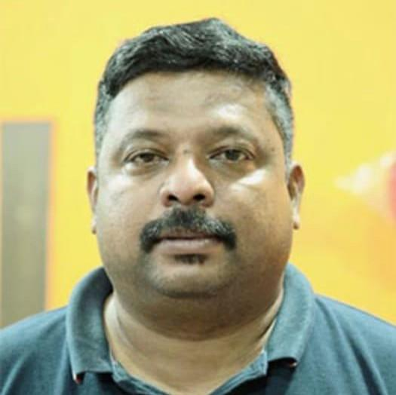

PANDEMIC PREPAREDNESS IS ESSENTIAL TO PROTECT PUBLIC HEALTH FROM EMERGING AND RE-EMERGING INFECTIOUS DISEASES SUCH AS COVID-19, INFLUENZA, NIPAH VIRUS INFECTION, AND OTHER ZOONOTIC AND COMMUNICABLE DISEASES. THESE DISEASES HIGHLIGHT THE NEED FOR EARLY DETECTION, PREPAREDNESS, AND COORDINATED RESPONSE.
THE HEALTH DEPARTMENT IS STRENGTHENING SURVEILLANCE, EARLY REPORTING, AND RESPONSE ACTIVITIES IN LINE WITH THE ONE HEALTH APPROACH, WHICH RECOGNIZES THE INTERCONNECTION BETWEEN HUMAN HEALTH, ANIMAL HEALTH, AND THE ENVIRONMENT. COORDINATED EFFORTS INVOLVING THE HEALTH DEPARTMENT, VETERINARY SERVICES, LOCAL SELF GOVERNMENT INSTITUTIONS, AND COMMUNITY STAKEHOLDERS ARE VITAL FOR EFFECTIVE PREVENTION AND CONTROL OF SUCH DISEASES.
MEMBERS OF THE PUBLIC ARE ADVISED TO STRICTLY FOLLOW HEALTH ADVISORIES, MAINTAIN PERSONAL AND RESPIRATORY HYGIENE, ENSURE TIMELY VACCINATION WHERE APPLICABLE, AND REPORT SYMPTOMS SUCH AS FEVER, COUGH, BREATHLESSNESS, OR ANY UNUSUAL ILLNESS TO THE NEAREST HEALTH FACILITY WITHOUT DELAY.
PUBLIC COOPERATION WITH HEALTH WORKERS, FIELD STAFF, AND SURVEILLANCE ACTIVITIES IS CRUCIAL. AVOIDANCE OF MISINFORMATION AND RELIANCE ON OFFICIAL COMMUNICATION WILL HELP ENSURE TIMELY AND EFFECTIVE RESPONSE DURING PUBLIC HEALTH EMERGENCIES.
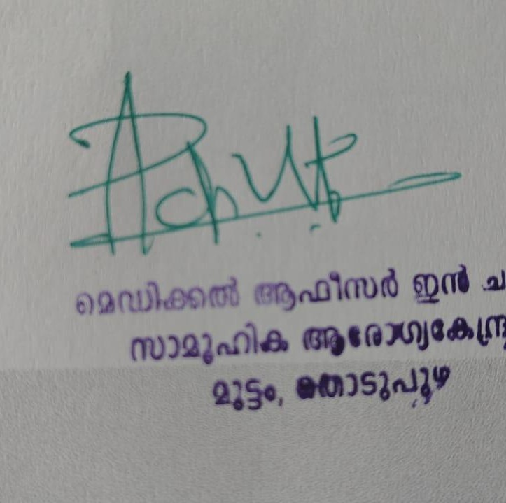

THROUGH COLLECTIVE RESPONSIBILITY, VIGILANCE, AND ADHERENCE TO THE ONE HEALTH APPROACH, WE CAN STRENGTHEN PANDEMIC PREPAREDNESS AND SAFEGUARD THE HEALTH OF OUR COMMUNITY.

DR. PRINCE K MATTOM MEDICAL OFFICER I/C , CHC MUTTOM
EXECUTIVE SUMMARY

Community Health Centre (CHC) functions as the primary public healthcare institution serving the population of Muttom Grama Panchayath. The CHC plays a pivotal role in delivering comprehensive, accessible, and affordable healthcare services, with a strong focus on preventive, promotive, curative, and rehabilitative care in accordance with National and State health programmes.
The CHC caters to a predominantly rural population, addressing key public health priorities such as maternal and child health, communicable and non-communicable disease control, immunization, family welfare, adolescent health, and geriatric care. Regular outpatient services, home-based care through field health staff, and outreach activities ensure healthcare coverage even in geographically challenging areas. The institution actively implements national health missions, including the National Health Mission (NHM), National Tuberculosis Elimination Programme, National Programme for Prevention and Control of Cancer, Diabetes, Cardiovascular Diseases and Stroke (NPCDCS), and other disease surveillance initiatives.
Muttom CHC works in close coordination with the Grama Panchayath, ASHA workers, Anganwadi centres, schools, and community-based organizations to strengthen community participation and improve health awareness. Emphasis is placed on early detection, timely referral, health education, and lifestyle modification to reduce disease burden and improve overall health outcomes.
Despite constraints related to infrastructure, manpower, and increasing service demand, the CHC continues to enhance service delivery through effective planning, data-driven decision-making, and community engagement. Strengthening facilities, upgrading digital health systems, and expanding preventive services remain key focus areas for future development.
Overall, Muttom Community Health Centre stands as a vital institution in safeguarding public health and improving the quality of life of the residents of Muttom Grama Panchayath

LIST OF ABBREVIATIONS

LSGD/LSGI | Local Self Government Department / Local Self Government Institution
BMO | Block Medical Officer
IDSP | Integrated Disease Surveillance Programme
NDMA | NationalDisaster Management Authority
PPE | Personal Protective Equipment
ICMR | IndianCouncil of Medical Research
CD | Communicable Diseases
NCD | NON-COMMUNICABLE DISEASES

TABLE OF CONTENTS

3
INTRODUCTION 9
- Background of the PPP 9
LSGD AT A GLANCE 9
INTEGRATED HEALTH INFRASTRUCTURE MAP OF MUTTOM PANCHAYAT 10
GENERAL PROFILE OF THE LSGI’S 13
Background of the LSGI 13
Demographic and Vulnerable Population 14
Clinical Vulnerability 16
INFRASTRUCTURE & RESOURCE INVENTORY 18
Health Facility Directory & Basic Capacity in the LSGD 18
Private Clinics 19
Healthcare Education & Training Institutions 20
Specialized Services & Emergency Inventory 20
Oxygen & Diagnostic Capacity 21
Diagnostics facility mapping at the LSGI level 22
Laboratory Identification & Basic Details 22
Social and Community Infrastructure for surge plan 22
Human resources 24
Community & Support Cadre 25
Community Organizations 26
Administrative & Emergency Services 27
Information regarding resources 27
ONE HEALTH & ENVIRONMENTAL SURVEILLANCE 28
Animal & Bird Population 28
Veterinary Infrastructure 29
Veterinary Doctors & Workforce 30
High-Risk Interface Points (Surveillance Sites) 30
Environmental Risk Mapping 31
Disease Seasonality Mapping 32
Vulnerability Mapping 33
EPIDEMIOLOGICAL TRENDS (2021–2025) 34
Disease Burden among human beings(Last 5 Years) 34
*(use the above table data to create the graph/diagram) 36
Seasonal Trend Analysis 37
Outcome-Based Trend Analysis- 2025 39
Transmission Trend- 2025 40
Integrated Disease Hotspot Map (2021–2025) 42
Preparedness and Response Protocol at LSG Level 44
Constitution of One Health Committee 44
Pandemic Response Workforce 45
Activities and Measures before and during Pandemic 47
PHASE 1 - Alert / Preparation 47
PHASE 2 - Active Response 50
Standard Screening Protocol 51
PHASE 3 - Surge Capacity 60
Conversion of Community Facilities 60
CONCLUSION 61
RECOMMENDATIONS 62
ANNEXURE 63
- IMPORTANT PHONE NUMBERS 63

INTRODUCTION

Background of the PPP
"The Pandemic Preparedness Plan (PPP) 2026 for Muttom Grama Panchayat is developed in response to the increasing global and local threats of emerging infectious diseases. The experience from past outbreaks, including COVID-19, Nipah, and seasonal surges of Dengue and Leptospirosis, has highlighted the need for a decentralized and proactive health management system.
The background of this plan is rooted in the Integrated Disease Hotspot Map (2021–2025), which provides a data-driven understanding of where and how diseases spread within our 14 wards. By identifying high-risk areas like Ward 1 (high density) and Ward 11 (zoonotic risk), this plan moves away from a 'reactive' approach to a 'preventive' one.
Furthermore, the PPP adopts the 'One Health' approach, acknowledging that human health is deeply connected to animal health and the environment. This document serves as the oﬃcial roadmap for the Panchayat to ensure rapid response, resource availability, and community safety during any future public health emergencies."

LSGD AT A GLANCE
GEOGRAPHICAL BOUNDARIES

EAST: KUDAYATHOOR WEST : KARIMKUNNAM
SOUTH : MELUKAVU & KADANAD NORTH: ALACODE & EDAVETTY

BASE LINE DATA

Ward | Houses | Population | Migrants | Wells | Hot spots | Ed.  Institutions | Hosp  pvt/govt.
14 | 2938 | 10226 | 214 | 1024 | 2 | 15 | 3/1

- Risk stratification among wards in the context of Communicable diseases and hazards
- Ward -1 (Kodathi) –Thickly populated area with schools, colleges,Court,Jail and Industries.High risk for chickenpox and others airborne diseases.Some part of the ward is hazards for transportation also.
- Major portion of Ward 8 (Ellumpuram) is limited with transporting facility which will affect timely access to control of CD.
- Peoples living in Ward 11 (Kanyamala) engaged in cattle rearing activities. So the risk of Scrub Typhus is there.
- Major Roads/rivers

- State Highway 33 (SH-33): Known as the Thodupuzha-Puliyanmala road, this is a key transport artery passing through the area.
- State Highway 44 (SH-44): The Sabarimala–Neriamangalam road also passes through the vicinity, providing connectivity to major regional locations.
- Thodupuzha River: The area is part of the drainage basin of the Thodupuzha Ar, a major tributary of the Muvattupuzha River that originates in the region.
- Local Streams: Various minor, seasonal streams and water bodies, characteristic of the Idukki district, contribute to the local irrigation and water needs.

Major establishments with geospatial mapping
- DISTRICT JAIL – WARD 1
- DISTRICT COURT – WARD 1
- INDUSTRIAL ESTATE – WARD 1
- KINFRA INDUSTRIAL PARK – WARD 9
- MALANKARA DAM – WARD 2

Occupational groups, socio cultural groups, migration & mobility patterns
- Agriculture Is The Main Occupation
- Ward 1, 3, 4, 5 & 13 Is Covered With Small And Medium Sized Business Units
- Rearing Of Cattle , Goat,Pig Etc.
- Working In Construction Sector (Labour)
- Migratory Population Working In Construction & Other Industies

- Vulnerability mapping
- WARD 1 & WARD 9 IS VULNERABLE WITH MIGRATORY POPULATION

Disaster prone areas (geographic vulnerability)

- NO SUCH DISASTER PRONE AREA IN THE PANCHAYATH

Maps - ward-based (Mention source also)
- Geographical boundaries - ward boundaries map
- Health infrastructure map
- roads and rivers map
- major establishments map
- disaster-prone areas map
- hotspot map - CD & disasters

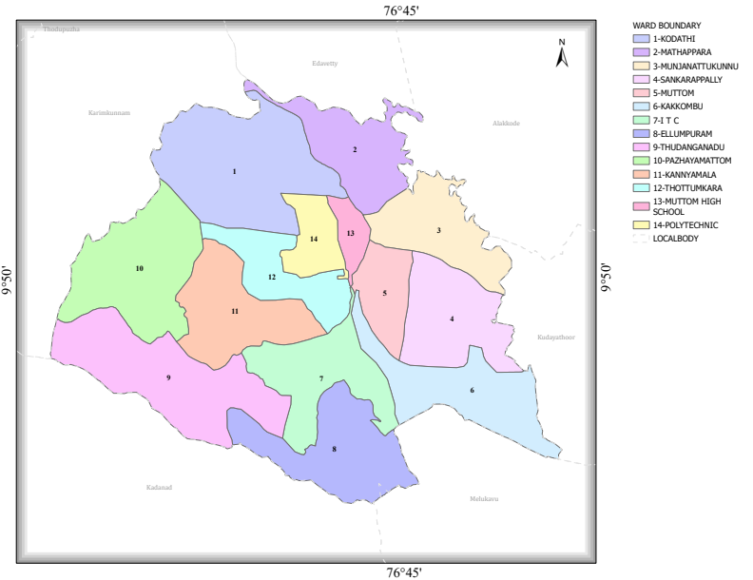
INTEGRATED HEALTH INFRASTRUCTURE MAP OF MUTTOM PANCHAYAT
GENERAL PROFILE OF MUTTOM

Background

Muttom Grama Panchayat is situated in the Thodupuzha Block of Idukki district, Kerala. The geographical landscape of the Panchayat is a hilly landscape characterized by scenic green meadows, rocky terrain, and a 22-meter elevation. The area is part of the mountainous terrain typical of Idukki, with high-elevation points like Pachilamkunnu View Point and Kannadippara View Point. The area experiences a moderate, tropical climate with significant rainfall, as evidenced by the vegetation and proximity to rivers. The village has a well-developed road network, with SH 33 and SH 44 serving as key arteries. Frequent private and public bus services are available, connecting the area to neighboring towns like Thodupuzha. Road transport is the only mode of transportation for both passengers and goods in this region. The landscape is influenced by the Thodupuzha River, a tributary of the Muvattupuzha River.
The Panchayat is administratively divided into 14 wards, with a population largely dependents their income on agriculture and allied activities. Cultivation of crops such as rubber, coconut, nutmeg, banana, and vegetables, along with animal husbandry, plays a significant role in the local economy. In recent years, tourism-related activities and service-sector employment have also shown gradual growth. The area hosts a diverse workforce, including a notable presence of migrant labourers, particularly in Manufacturing industries, construction, hotel industry and allied sectors.
From a public health and disaster management perspective, Muttom LSGI has historically not been so much vulnerable to seasonal flooding, waterborne diseases, and vector-borne illnesses such as Dengue and Leptospirosis. The severe floods experienced during recent years, including the 2018 flood disaster, has not significantly impacted life, livelihoods, and infrastructure within the Panchayat.But by considering the recent trend in waterborne diseases such as Hepatitis A and vector-borne Diseases such as Dengue ,Scrub and Leptospirosis have underscored the importance of strengthening local preparedness, response mechanisms, and inter-departmental coordination.
In this context, the development of a localized, data-driven Auxiliary Infrastructure and Logistical Resource Map is essential to support effective planning, timely emergency response, and sustainable development initiatives. Such mapping enables the Panchayat to identify critical resources, improve accessibility during disasters, and enhance overall resilience of the community.

Health infrastructure map

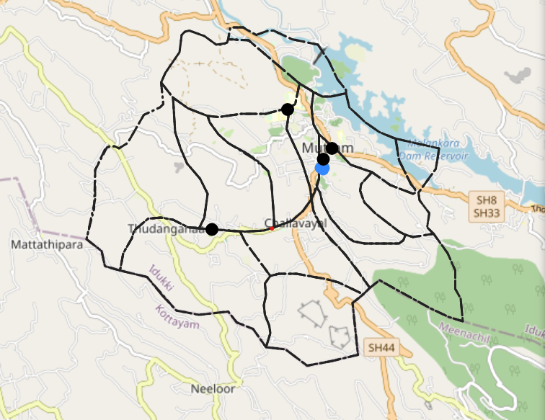

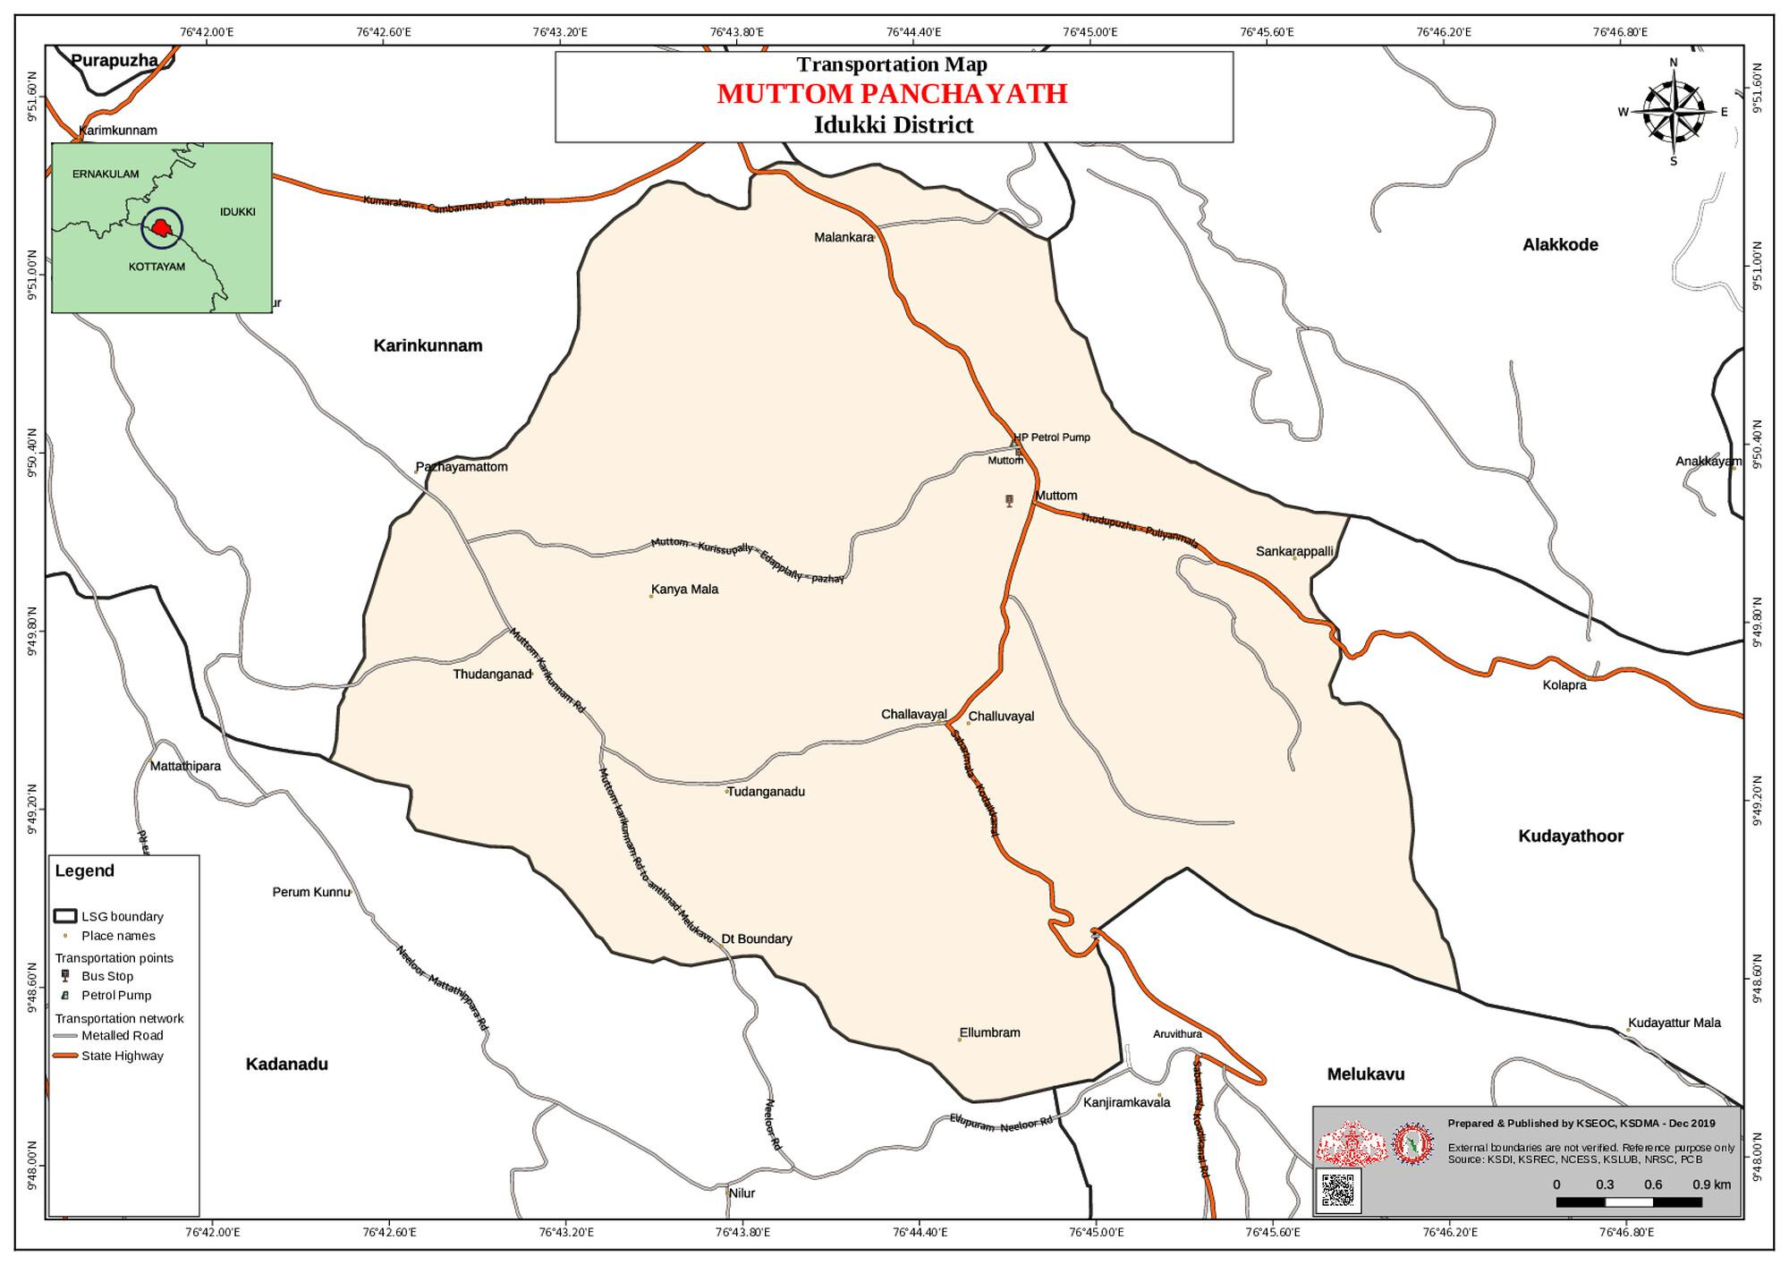
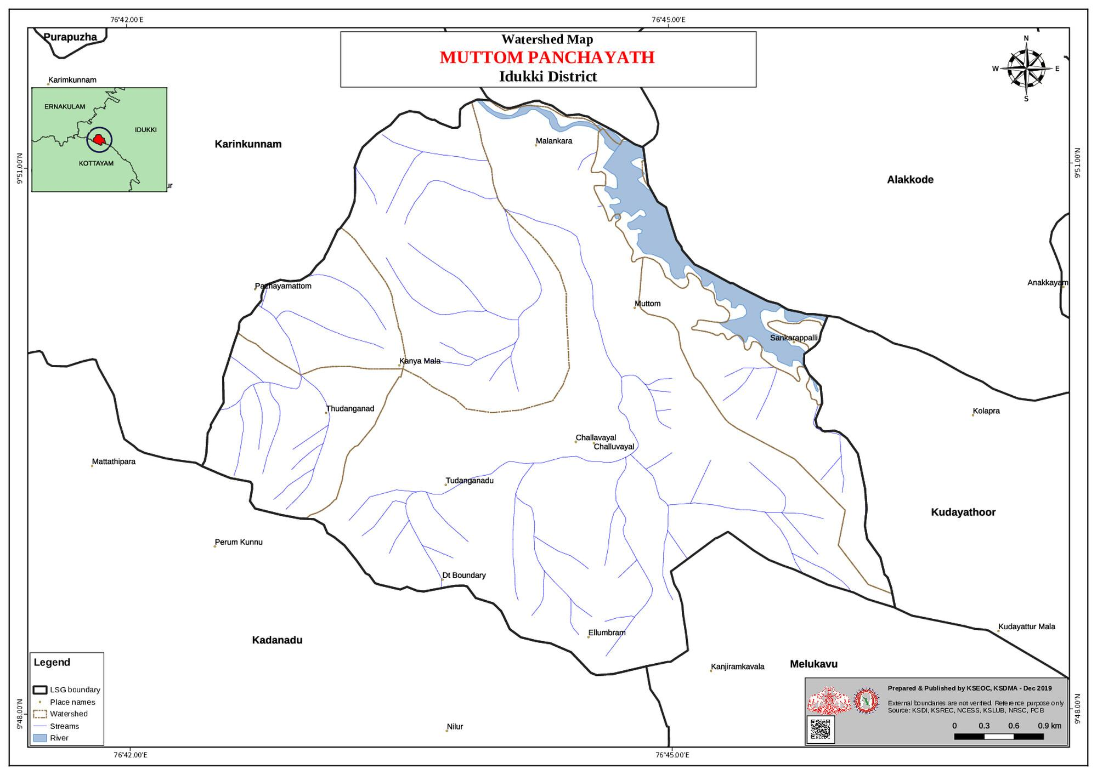

Table 1: Background of LSGD
Description | Details
Name of LSGI | MUTTOM
Type (GP/Municipality / Corporation etc.) | Grama Panchayath
Block | THODUPUZHA
District | IDUKKI
Number of wards | 14
Total area (sq. km) | 25.44
Population(Projected) | 10226
Population density | persons/sq km
Terrain (coastal/low-lying/backwaters/foothills, etc.) | 401.965
Number of rivers passing through LSGI | 1
Number of water bodies in the LSGI | 1
Number of educational institutions | 14
Factories / small-scale industries | 4 / 5
Flood-prone wards | 1
Landslide-prone wards | 1
Death Management and Disposal Facilities (mortuaries/crematorium, including electric) | NO
Auditoriums/Marriage halls/convention centres/community halls | 5 (INCLUDING PARISH HALL)

Demographic and Vulnerable Population
Understanding the demographic composition and vulnerable population groups is essential for pandemic preparedness. Children, elderly, economically deprived families, migrant workers, and socially vulnerable groups are at increased risk during public health emergencies due to higher exposure, limited access to services, and dependency on public systems..

Description |  | Details (in numbers)
DEMOGRAPHIC PROFILE
Total population |  | 10226
Male |  | 4981
Female |  | 5245
Transgender |  | 0
Children under 5 |  | 423
Adolescent |  | 969
Elderly (>60) |  | 2099
SOCIAL/LIVELIHOOD VULNERABILITY
Previous EPEP family |  | 28
BPL family |  | 1240
Tribal communities |  | 844
Migration | Immigrant | 214

Description |  | Details (in numbers)
DEMOGRAPHIC PROFILE
 | Emigrant | 201
Socio-economically deprived |  | 0
Fisherfolk |  | NO
SC Community |  | 807
ST Community |  | 844

Graphs: Population pyramid (if possible) for seeing if your LSGI has a high "dependency ratio" (lots of children and elderly compared to working adults).

Clinical Vulnerability
Certain population groups needs priority healthcare & are at higher risk of severe illness, complications, and mortality during pandemics. Patients with chronic diseases, those requiring regular medical care, and individuals with mobility or functional limitations face challenges in accessing timely care during emergencies. Mapping these groups helps in prioritizing continuity of treatment, medicine stock planning, oxygen support, referral transport, and targeted home-based care.

Description | Details in numbers
Pregnant women | 36
Lactating mothers | 46
Bedbound patients | 19
Patients under palliative care other than bedbound | 123
Patients on Haemodialysis | 11
Patients on CAPD | 173
Cancer patients (currently on treatment) | 64
Haemophilic patients | 0

Description | Details in numbers
Mentally challenged | 56
Differently abled | 112
Diabetic patients | 840
Hypertensive patients | 1539
TB patients | NIL

Major Festivals & Events specific to the LSGI
(with the possibility of a public gathering)

Sl.  No. | Name of festival | Month detailing the periodicity
1 | ST.MARY’S CHURCH -OORUKKUNNU | DECEMBER
2 | ST.SEBASTIAN CHURCH, SANKARAPILLY | JANURARY
3 | ST.MARY’S CHURCH , KAKKOMB | JANUARY
4 | CSI CHURCH KAKKOMB | JANUARY
5 | CSI CHURCH ELLUMPURAM | JANUARY
6 | ST. JOSEPH CHURCH ,EDAPPALLY | JANUARY
7 | ST.THOMAS FERONA CHURCH,THUDANGANAD | JANUARY
8 | THEYYAKKAV BHAGAVATHI TEMPLE | JANUARY
9 | SREEKRISHNA SWAMI TEMPLE, MUTTOM | MARCH
10 | ST. MARY’S ORTHODOX SYRIAN CHURCH, COURT JN. | JANUARY
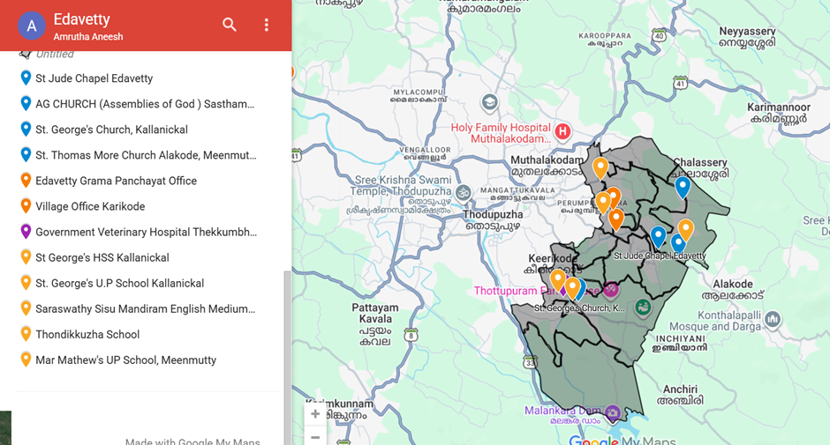

INFRASTRUCTURE & RESOURCE INVENTORY

Health Facility Directory & Basic Capacity in the LSGD
This section provides an overview of the healthcare infrastructure available within the LSGD area. It outlines the distribution and basic capacity of health facilities that form the backbone of service delivery during routine times and public health emergencies.

Family Health Centres (FHCs) and Community Health Centres (CHCs) generally function as the first point of contact for the community, providing essential outpatient and inpatient services. General Hospitals (GH) and Medical College Hospitals (MCH), where accessible, serve as the main referral centres for advanced diagnostics, specialist care, and critical services during public health emergencies. This inventory helps identify existing strengths, gaps, and potential surge capacity that can be mobilised during a pandemic or disaster.

Table 5. Health Facility Resource Summary
Sl. no  . | Health Facility | Type of Facility (MCH/G  H/CHC/ FHC/SC  etc.) |  | Contact Number | Total beds | ICU  Beds | Oxygen- Supported Beds | No. of Ventilator Support Beds | No. of ambulance s
Government Healthcare Facilities
1 | CHC MUTTOM |  | CHC | 04862 255028 | NIL | NIL | NIL | NIL | 1
2 | ELLUMPURAM |  | SC | NIL | NIL | NIL | NIL | NIL | NIL
Private Healthcare Facilities

Table 5. Health Facility Resource Summary
Sl. no  . | Health Facility | Type of Facility (MCH/G  H/CHC/ FHC/SC  etc.) |  | Contact Number | Total beds |  | ICU  Beds |  | Oxygen- Supported Beds |  | No. of Ventilator Support Beds |  | No. of ambulances
 | RANIGIRI HOSPITAL | NIL |  | 9544542185 | 36 |  | 0 |  | 4 |  | 0 |  | 1
AYUSH Healthcare Facilities0
1 | DISTRICT HOMEO HOSPITAL , MUTTOM | DH | 9447206902 |  | 25 |  |  | 1 |  | 0 |  | 0

Private Clinics
Private clinics are an essential part of pandemic preparedness, as they are often the first place people seek care when symptoms begin. In many communities, private clinics manage a significant share of outpatient visits and therefore play a critical role in early case detection, timely referrals, and disease surveillance. Having an up-to-date understanding of where these clinics are located, the services they provide, and how they are linked to the public health system helps ensure that no cases are missed during an outbreak. It also allows health authorities to engage private practitioners more effectively for reporting, risk communication, and coordinated response, strengthening the overall capacity of the health system to manage public health emergencies.

Table 6. Private Clinic Resource Summary
Sl No  . | Name of Clinic | Registered (Y/N) | Clinic (General / Speciality) | Speciality (if any) | Address | Contact Number |  | Diagnostic Facility (Y/N) | Ambulance Linkage (Y/N)
1 | RANIGIRI | Y | GENERAL | NO | THUDAN GANAD | 9544542185 | Y |  | Y
2 | KARUNA | Y | GENERAL | NO | MUTTOM | 9447046899 | Y |  | N

Table 6. Private Clinic Resource Summary
3 | MM HOSPITAL | Y | GENERAL | NO | MUTTOM | 9447165144 | Y | N

Healthcare Education & Training Institutions
This section tracks the educational infrastructure available, which is vital for human resource planning in the health sector.

Category of Institution | Govt | Private | AYUSH | Total
Medical Colleges | NIL | NIL | NIL | NIL
Nursing Colleges | 1 | NIL | NIL | 1
Dental Colleges | NIL | NIL | NIL | NIL
Para-medical / Allied Health | NIL | NIL | NIL | NIL
Pharmacy Colleges | NIL | NIL | NIL | NIL

Specialized Services & Emergency Inventory
This section provides a detailed view of the specialized medical resources available to the community, focusing on emergency response and critical care capabilities. This table tracks the vital assets required for managing severe illnesses and emergencies across Government, Private, and AYUSH sectors.

Item | Govt | Private | AYUSH | Total
Hospital beds | 0 | 30 | 25 | 55

Item | Govt | Private | AYUSH | Total
Oxygen-generating systems(Y/N) | N | N | N | N
Oxygen-supported beds(Numbers) | 2 | 4 | 1 | 7
Ventilator-supported beds | 0 | 0 | 0 | 0
ICU beds | 0 | 0 | 0 | 0
Burns units | 0 | 0 | 0 | 0
Blood centres | 0 | 0 | 0 | 0
BLS ambulances | 1 | 1 | 0 | 2
ALS ambulances | 0 | 0 | 0 | 0
Dialysis facilities | 0 | 0 | 0 | 0
Dispensaries | 0 | 2 | 0 | 2
Medical store | 0 | 5 | 0 | 5
Industrial establishments(Medium-scale industries/small-scale industries establishments to whom we can depend in a worst-case scenario) | NIL | NIL | NIL | NIL

Oxygen & Diagnostic Capacity
Monitoring oxygen and diagnostic capacity is a critical component of public health preparedness, ensuring that the LSGD can handle both chronic care and sudden surges in respiratory or infectious diseases.

Name of Health Facility | Oxygen-gener ating System (Y/N) | Backup Oxygen Source (Y/N) | Diagnostic Facilities Available(Y/N)
Name of Health Facility | Oxygen-gener ating System (Y/N) | Backup Oxygen Source (Y/N) | Lab | USG | X-ray | CT/MRI | RT-PCR
Government Healthcare Facilities
CHC MUTTOM | N | Y | Y | N | N | N | N

Name of Health Facility | Oxygen-gener ating System (Y/N) | Backup Oxygen Source (Y/N) | Diagnostic Facilities Available(Y/N)
Name of Health Facility | Oxygen-gener ating System (Y/N) | Backup Oxygen Source (Y/N) | Lab | USG | X-ray | CT/MRI | RT-PCR

Diagnostics facility mapping at the LSGI level
The diagnostic capacity of Muttom G.P represents the "intelligence network" of our healthcare system. The speed and accuracy of disease identification depend entirely on the distribution and technical level of these facilities.

Item | Govt | Private | AYUSH | Total
General labs | 1 | 2 | 1 | 4
Microbiology labs | NIL | NIL | NIL | NIL
RT-PCR labs | NIL | NIL | NIL | NIL
USG units | NIL | NIL | NIL | NIL
CT/MRI units | NIL | NIL | NIL | NIL
Research labs | NIL | NIL | NIL | NIL
Labs of other departments that can be repurposed | NIL | NIL | NIL | NIL

Laboratory Identification & Basic Details

Sl.  No. | Name of  Laboratory | Ownership  (Govt / Private / Academic) | Address |  | Contact  No. | 24×7  Services (Yes/No) |  | NABL /  Govt  Approved (Yes/No)
1 | IDUKKI DIAGNOSTICS | PRIVATE | MUTTOM |  | 9388860008 | NO |  | NO
2 | PREMIER  DIAGNOSRICS | PRIVATE | MUTTOM | 8606581775 |  | NO | NO

Social and Community Infrastructure for surge plan
This table serves as our logistics and shelter inventory. By mapping these locations, quickly we can identify where to house displaced citizens, where to set up temporary medical clinics, and how to manage the deceased with dignity during a crisis.

Category | Total Count |  | Ward | Est. Capacity (Persons) |  | Contact details
Educational Institutions
Anganwadis | 14 |  | 14 | 101 | NIL
Schools | 9 |  | 1,3,9,10  ,13 | 2022 | NIL
Colleges | 2 |  | 1 | 650 | 9497583011  9539460105
Healthcare Educational Institutions
Medical colleges (Govt/Private) |  | 0 | 0 | 0 | 0
Nursing colleges (Govt/Private) |  | 1 | 5 | 75 | 9400732685
Dental colleges (Govt/Private) |  | 0 | 0 | 0 | NIL
Paramedical institutes (Govt/Private) |  | 0 | 0 | 0 | NIL

Community Gathering Spaces
Community halls | 0 | 0 | 0 | NIL
Auditoriums | 3 | 5,9,13 | 0 | NIL
Religious buildings | 17 | ALL WARDS | 0 | NIL
Vulnerable Group Support Facility
Destitute homes | 0 | 0 | 0 | 0
Elderly homes | 2 | 4, 9 | 70 | 0
LSGD owned other buildings | 0 | 0 | 0 | 0
Mass Fatality Management (MFM) Infrastructure
Mortuary | 0 | 0 | 0 | 0
Crematorium | 0 | 0 | 0 | 0
*refer annexure 1 for contact details

Human resources
This section focuses on the human capital available within the LSGI. In any emergency—be it a pandemic, flood, or industrial accident—infrastructure is only as effective as the people operating it.

Medical & Clinical Personnel
This table tracks the "Frontline" providers responsible for diagnosis, treatment, and clinical management. Narrative sentence: eg., "Total health workforce: 450 personnel, with 60% in government facilities serving as primary surge capacity." A detailed directory with the contact numbers of all workers is maintained (Annexure in 1).

Cadre | Govt (No.) | Private (No.) | Total
Doctors—Modern Medicine | 5 | 5 | 10
Doctors – AYUSH | 3 | 2 | 5
Doctors – Veterinary | 1 | 0 | 1
Doctors – Dental | 0 | 4 | 4
Nursing officers | 5 | 3 | 8
Lab technicians | 1 | 3 | 4
Optometrist | 1 | 0 | 1
Pharmacists | 2 | 5 | 7
Psychologists | 0 | 0 | 0
Counsellors | 1 | 0 | 1

Public Health & Field-Level Workforce
These individuals are the backbone of surveillance, maternal-child health, and decentralized care.

Cadre | Health services | Municipal common services | Total
HS (Health Supervisors) | 1 | 0 | 1
HI (Health Inspectors) | 1 | 0 | 1
LHS (Lady Health Supervisor) | 1 | 0 | 1
LHI (Lady Health Inspectors) | 1 | 0 | 1
JPHN (Jr Public Health Nurses) | 2 | 0 | 2
JHI (Jr Health Inspectors) | 2 | 0 | 2
MLSP (Mid-Level Service Providers) | 2 | 0 | 2
Palliative Nurses | 2 | 0 | 2
RBSK Nurses | 1 | 0 | 1
PRO | 1 | 0 | 1
Epidemiologist | 0 | 0 | 0

Cadre | Health services | Municipal common services | Total
Data Manager | 0 | 0 | 0

Community & Support Cadre
This group represents the surge capacity of the LSGI—people who can be called upon for logistics, rescue, and specialized support.

Cadre | Number
ASHA Workers | 13
AWW (Anganwadi Workers) | 14
Emergency Medical Volunteers (Trained) | 0
Kudumbashree | 86
MNREGS | 307
Purusha Swayam Sahaya Sangham | 1
Ex-Servicemen | 10

Cadre | Number
Retired Police Officers | 3
NCC/NSS Volunteers | 150
Red Cross volunteers | 25
One Health Community Volunteers | 637
One Health Community Mentors | 91

Community Organizations
This section details the presence of community-based organisations (CBOs), non-governmental organisations (NGOs), faith-based organisations (FBOs), Kudumbashree Self-Help Groups (SHGs), and Ayalkootams within the Local Self-Government Institution (LSGI). These groups enhance grassroots mobilization, resource distribution, and support networks crucial for pandemic response and community resilience.

Category | Total Count
NGOs | 15
Religious based organizations | 2
Foreign based organizations | 0

Category | Total Count
Sports Club/youth clubs | 2
Kudumbashree SHGs | 86
Ayalkootams | 86
Political organizations | 3
Residential organizations | 5

Administrative & Emergency Services
This section outlines the availability of key non-health emergency support services and infrastructure within the LSGI, which are essential for effective pandemic preparedness and response. These facilities support law enforcement, disaster response, water supply, logistics, mobility, and community-level interventions during public health emergencies.

Category | Total Count | Contact details
Police Stations | 1 | 04862 257 777
Fire & Rescue Stations | 1 | 914862253101
Water Pumping Points | 3 | 9744353446
Public Distribution System (PDS) | NIL | NIL

Information regarding resources
The availability of essential transport and support resources plays a quiet but critical role in saving lives. Equipment such as ambulances, mobile mortuaries, amphibian ambulances, and motorized boats ensures that patients, samples, and healthcare teams can move swiftly even in flooded, remote, or difficult terrains. Heavy vehicles like JCBs, cranes, tractors, and torus lorries support logistics, waste management, emergency infrastructure, and rapid conversion of spaces into care or isolation facilities. Taxis, four-wheel-drive vehicles, and trucks help maintain continuity of essential services, reach vulnerable populations, and support home-based care and supply delivery.

Means of transportation | Total Count
JCB | 2
Crane | 1
Heavy Trucks | 2
Tractor | 0
Ambulances | 1
Mobile mortuaries | 0
Boats | 0
Taxi service | 5
Note: For specific details regarding vehicle owners and contact information, please refer to
Annexure [X].

ONE HEALTH & ENVIRONMENTAL SURVEILLANCE

The One Health method integrates environmental, animal, and human health to enable proactive pandemic preparedness. Panchayat-level surveillance needs to be improved in order to detect and treat zoonotic and environmentally generated diseases early. Surveillance is strengthened through systematic assessment of animal populations, veterinary infrastructure, poultry and slaughter facilities, inter-sectoral coordination, and specialised tools like avian influenza seasonality mapping using GIS in previous outbreaks to enable predictive alerts and ward-specific sampling to support effective pandemic preparedness in high-risk areas like Thudanganad.

Animal & Bird Population
Mapping animal and bird populations at the Panchayat level is essential for identifying and prioritising zoonotic disease hazards like rabies, avian influenza (H5N1), leptospirosis, anthrax, and Nipah-like spillover occurrences. Risk classification, targeted surveillance, vaccination planning, and early epidemic detection made feasible by comprehensive population mapping all enhance One Health-based pandemic preparedness.

Category | Item | Estimated Population | Wards
Animal Population | Livestock  (Cattle/Goats/Buffalo) | 2100 | ALL WARDS
Animal Population | Pet Animals (Dogs/Cats) | 1480 | ALL WARDS
Animal Population | Stray Dog Population | 38 | ALL WARDS
Animal Population | Pig Farms (Number of heads) | NIL | NIL
 | Small Units (Sheep / Goats – clustered) | NIL | NIL
Bird Population | Poultry Units (Birds) | NIL | NIL
Bird Population | Poultry- (FOWL) | NIL | NIL
Bird Population | Wild/Migratory Birds (Observed) | NO | NIL
Bird Population | Crow Mortality Events (Reported) | NO | NIL

The main risk of zoonotic diseases in Muttom is concentrated in Ward 1, which is explained by the moderate density of cattle congregation areas. The stray dog population in market areas, fish
landing sites, bus stations continues to be a substantial problem for rabies surveillance and bite prevention..

Veterinary Infrastructure
Veterinary institutions are a core pillar of One Health surveillance, enabling early zoonotic disease detection through vaccination, investigation of unusual animal illness or deaths, sample collection, and timely outbreak reporting. A well-mapped and responsive veterinary network strengthens coordination with human health and LSGI systems, ensuring rapid response during zoonotic events and pandemics.

Facility Type | Name of Facility | Ownership Govt  / Pvt | Location  ( Ward No) | Contact number
Veterinary Dispensary | 1 | GOVT | 5 | 9446309992
Veterinary Hospital / Polyclinic | NIL | NIL | NIL | NIL
Private Veterinary Clinics | NIL | NIL | NIL | NIL
Mobile / Emergency Vet Service (incl. night services) | 1 | GOVT (BLOCK) | NIL | NIL
Pet Homes / Animal Shelters | NIL | NIL | NIL | NIL
Slaughterhouse-linked Veterinary Inspection Unit | NIL | NIL | NIL | NIL

Veterinary Doctors & Workforce
Early detection, diagnosis, reporting, and reaction to animal illness epidemics depend on the availability and accessibility of qualified veterinary specialists. By identifying unusual animal morbidity or mortality promptly, collecting samples promptly, and coordinating efficiently with human health and LSGI systems of Muttom especially during zoonotic outbreaks and pandemic-prone situations in Muttom GP a clearly defined veterinary workforce enhances One Health surveillance.

Category | Number Available | Type (Govt/Pvt) | Contact number
Government Veterinary Doctors | 1 | GOVT | 9446309992
Private Veterinary Doctors | NIL | NIL | NIL
Livestock Inspectors | 2 | GOVT | NIL
Para-veterinary Staff / Attenders | 1 | NIL | NIL
Contract / On-call Veterinary Support (if any) | NIL | NIL | NIL

High-Risk Interface Points (Surveillance Sites)
High-risk interface points for zoonotic disease surveillance in Muttom Grama Panchayath include wetland–livestock–human contact zones, backyard poultry farms, cattle sheds near water bodies, fish markets, and areas of high human–animal interaction such as community slaughter points and migratory bird congregation sites are very rare.

Type of Habitat | Type of High risk interface | Geographical vulnerability
Wetlands &Backwaters | NIL | NIL
Backyard Poultry Farms | 1 | NIL

Cattle Sheds near Water Bodies | NIL | NIL
Fish & Meat Markets | NIL | NIL
Community Slaughter Sites | NIL | NIL
Migratory Bird  Congregation Areas | NIL | NIL
Rodent-Infested Grain Storage | NIL | NIL

Category | Total Count | Key Locations (wards)
Poultry Farms | 2 | 6
Backyard / Clustered Poultry Units | NIL | NIL
Duck Rearing Units (open water access) | NIL | NIL
Slaughterhouses/ Slaughter Points | NIL | NIL
Meat/Fish Markets | 8 | 3,4,13
Live Bird Sale Points | NIL | NIL
Cattle Markets / Weekly Animal Fairs | NIL | NIL
Pet Shops / Breeders | NIL | NIL
Animal Shelters / Pet Homes | NIL | NIL
Waste Disposal Sites near Animal Units | NIL | NIL

Environmental Risk Mapping
Environmental risk mapping identifies monsoon/flood hotspots for vector-borne (dengue, chikungunya), water-borne (leptospirosis, diarrhoea), and zoonotic diseases in Kerala's wetlands. Systematic surveillance supports early warnings, targeted interventions, and Panchayat pandemic preparedness.
Waterborne exposure: Flood-prone areas and stagnant water bodies facilitate leptospira survival, raising leptospirosis risk in the Panchayath is comparatively minimum.

Traditional practices: Informal slaughter and fish markets lack standardized hygiene, creating
spillover opportunities.

Risk Factor | High-Risk Wards | Key Locations | Risk Level (High/Med/Low)
Flood-prone areas | NIL | NIL | NIL
Water bodies/wetlands | NIL | NIL | NIL
Solid waste accumulation | NIL | NIL | NIL
Animal waste disposal issues | NIL | NIL | NIL
Rodent infestation zones | NIL | NIL | NIL
Industrial effluent discharge | NIL | NIL | NIL
Construction sites / abandoned buildings | NIL | NIL | NIL
Poor drainage/blocked canals | NIL | NIL | NIL
Drinking water source contamination risk | NIL | NIL | NIL

Disease Seasonality Mapping
1, Flooding & waterlogging → amplifies leptospirosis, malaria, diarrheal diseases.

·

2, Migratory bird influx (Nov–Feb) → avian influenza risk.

3, Mosquito breeding cycles → vector-borne disease peaks in monsoon.

4, Agricultural practices → close human–animal contact in paddy fields.

Disease | Peak Risk Season | Key Drivers | High-Risk Locations | Surveillance Focus
Avian Influenza | NIL | NIL | NIL | NIL
Leptospirosis | JAN,  FEB, MARCH | From Outside | NIL | NIL
Dengue/Chikungunya | JUNE,  JULY,AUG | NIL | NIL | NIL
Acute Diarrheal Diseases | JUNE,  JULY,AUG | NIL | NIL | NIL
Rabies | NIL | NIL | NIL | NIL
Anthrax (rare) | NIL | NIL | NIL | NIL

Vulnerability Mapping
Vulnerability mapping pinpoints high-risk populations, occupations, and areas exposed via environment, livelihoods, socio-economics, and poor service access. Paired with environmental/seasonality mapping, it enables risk-based surveillance, targeted actions, and optimal resource use in One Health and pandemic planning.

Vulnerability Factor | High-Risk Wards | Key Groups / Locations | Risk Level
Flood-prone households | NIL | NIL | NIL
Wetland-adjacent communities | NIL | NIL | NIL
Backyard poultry / duck rearing households | 6 | NIL | moderate
Livestock-rearing households | 800 | NIL | NIL
Slaughterhouse & meat market workers | 25 | NIL | NIL
Fisherfolk & fish market workers | 12 | NIL | NIL
Sanitation workers | NIL | NIL | NIL
Daily wage / migrant workers | 600 | NIL | NIL
Elderly & chronically ill populations | 2099 | NIL | NIL
Pregnant Women | 36 | NIL | NIL
Children (schools, Anganwadi’s) | 101 | NIL | NIL
Limited access to safe water & sanitation | NIL | NIL | NIL

EPIDEMIOLOGICAL TRENDS (2021–2025)
Disease surveillance is the systematic collection, analysis, and interpretation of health data for planning, implementation, and evaluation of public health practice. This section presents the disease surveillance profile of the LSGI based on routine reporting systems and outbreak investigations to identify priority diseases, seasonal patterns, and emerging public health threats.

Disease Burden among human beings(Last 5 Years)
Analysis of disease-wise data for the last five years helps identify persistent public health problems, emerging diseases, and changes in disease burden. This information supports prioritisation of prevention, preparedness, and response activities at the Panchayat level.

Disease | 2021 | 2022 | 2023 | 2024 | 2025 | Trend(Increasing/Stable/Decreasing)
Dengue | 0 | 3 | 40 | 26 | 3 | DECREASING
Leptospirosis | 1 | 2 | 1 | 0 | 3 | STABLE
Hepatitis A | 0 | 0 | 0 | 0 | 8 | STABLE
Malaria | 0 | 0 | 1 | 0 | 0 | DECREASING
Scrub Typhus | 0 | 0 | 0 | 0 | 1 | STABLE
Typhoid | 0 | 2 | 3 | 0 | 0 | DECREASING
H1N1 | 0 | 0 | 0 | 9 | 0 | STABLE
H3N2 | 0 | 0 | 0 | 0 | 0 | STABLE
ADD | 104 | 253 | 178 | 213 | 312 | STABLE

Mumps | 0 | 0 | 12 | 7 | 5 | STABLE
Measles | 0 | 0 | 0 | 0 | 0 | STABLE
Hepatitis B | 1 | 1 | 0 | 6 | 2 | STABLE
Hepatitis C | 0 | 0 | 0 | 0 | 0 | STABLE
Tuberculosis | 1 | 4 | 6 | 9 | 2 | STABLE
Leprosy | 0 | 0 | 0 | 0 | 0 | STABLE
COVID-19 | 657 | 1891 | 3 | 0 | 0 | STABLE

*(use the above table data to create the graph/diagram)

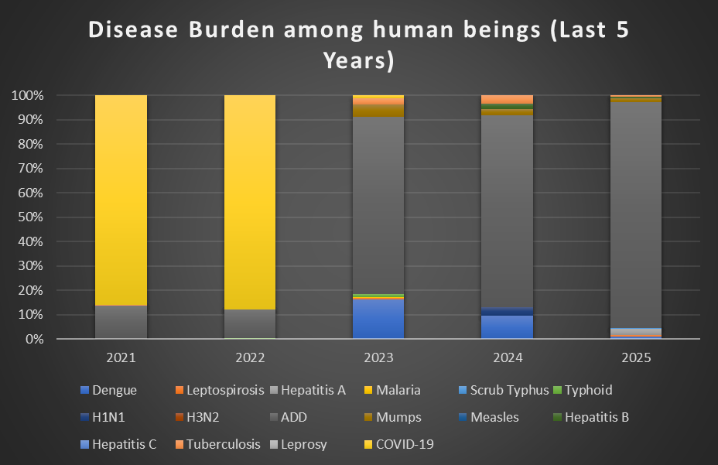

Seasonal Trend Analysis
Seasonal analysis helps anticipate surges (e.g. dengue in monsoon, leptospirosis after floods, influenza in cooler months) and plan pre-emptive vector control, stockpiling of IV fluids, and awareness campaigns at Panchayat level.

DENGUE
Dengue is a major seasonal vector-borne disease strongly associated with rainfall, water stagnation, and increased mosquito breeding during the monsoon period.

Peak: July–November
Dengue – Ward-wise Yearly Distribution (2021–2025)

Ward | Dengue – Ward-wise Yearly Distribution
Ward | 2021 | 2022 | 2023 | 2024 | 2025 | Total
1 | 0 | 0 | 4 | 1 | 0 | 5
2 | 0 | 0 | 2 | 0 | 0 | 2
3 | 0 | 0 | 2 | 1 | 1 | 4
4 | 0 | 0 | 3 | 1 | 0 | 4
5 | 0 | 0 | 3 | 0 | 0 | 3
6 | 0 | 0 | 2 | 4 | 0 | 6
7 | 0 | 1 | 4 | 8 | 0 | 13

8 | 0 | 0 | 0 | 3 | 0 | 3
9 | 0 | 0 | 1 | 1 | 1 | 3
10 | 0 | 0 | 10 | 2 | 0 | 12
11 | 0 | 1 | 2 | 0 | 1 | 4
12 | 0 | 1 | 4 | 1 | 0 | 6
13 | 0 | 0 | 3 | 4 | 0 | 7

LEPTOSPIROSIS
Leptospirosis cases are closely linked to monsoon rains, flooding, and occupational exposure, particularly in low-lying and waterlogged areas.

Peak: June - August
Leptospirosis – Ward-wise Yearly Distribution (2021–2025)

Ward | Leptospirosis – Ward-wise Yearly Distribution
Ward | 2021 | 2022 | 2023 | 2024 | 2025 | Total
1 | 0 | 0 | 0 | 0 | 1 | 1
2 | 0 | 0 | 0 | 0 | 0 | 0

3 | 0 | 0 | 0 | 0 | 0 | 0
4 | 0 | 1 | 0 | 0 | 0 | 0
5 | 0 | 0 | 0 | 0 | 0 | 0
6 | 0 | 0 | 0 | 0 | 0 | 0
7 | 0 | 0 | 0 | 0 | 0 | 0
8 | 0 | 0 | 0 | 0 | 1 | 1
9 | 0 | 1 | 0 | 0 | 1 | 2
10 | 0 | 0 | 1 | 0 | 0 | 1
11 | 1 | 0 | 0 | 0 | 0 | 1
12 | 0 | 0 | 0 | 0 | 0 | 0
13 | 0 | 0 | 0 | 0 | 0 | 0

VIRAL HEPATITIS - A
Hepatitis A cases are commonly associated with unsafe drinking water, food contamination, and breakdowns in sanitation, often presenting as clusters or outbreaks.

Peak: October - December
Hepatitis A – Ward-wise Yearly Distribution (2021–2025)

Ward | Hep A – Ward-wise Yearly Distribution
Ward | 2021 | 2022 | 2023 | 2024 | 2025 | Total
1 | 0 | 0 | 0 | 0 | 0 | 0
2 | 0 | 0 | 0 | 0 | 0 | 0
3 | 0 | 0 | 0 | 0 | 0 | 0
4 | 0 | 0 | 0 | 0 | 2 | 2
5 | 0 | 0 | 0 | 0 | 0 | 0
6 | 0 | 0 | 0 | 0 | 0 | 0
7 | 0 | 0 | 0 | 0 | 0 | 0
8 | 0 | 0 | 0 | 0 | 0 | 0
9 | 0 | 0 | 0 | 0 | 4 | 4
10 | 0 | 0 | 0 | 0 | 1 | 1
11 | 0 | 0 | 0 | 0 | 0 | 0

12 | 0 | 0 | 0 | 0 | 0 | 0
13 | 0 | 0 | 0 | 0 | 1 | 1
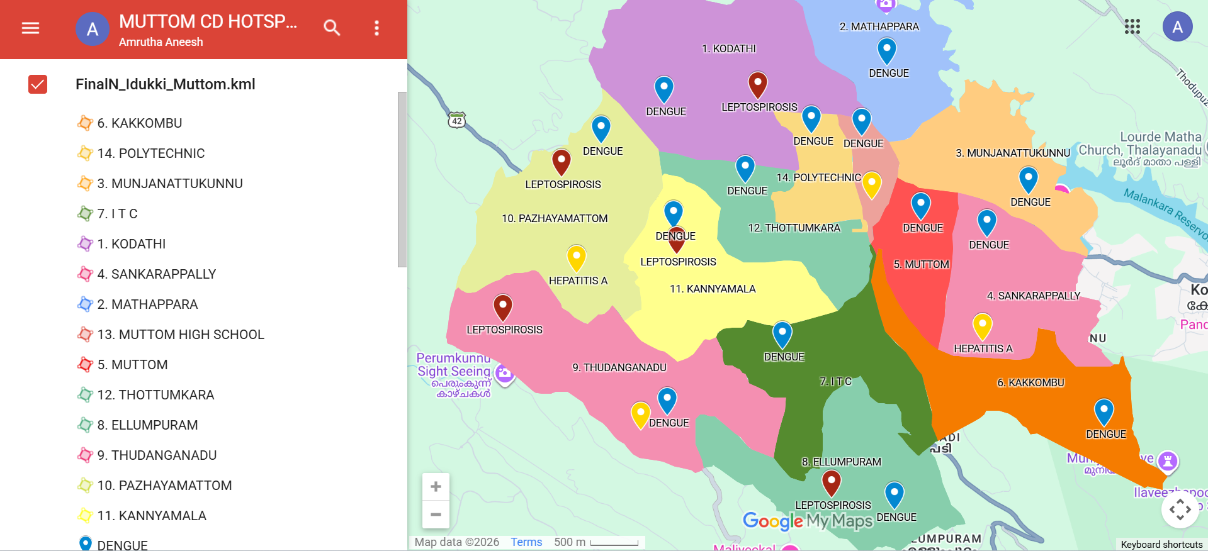

Outcome-Based Trend Analysis- 2025

- Recovery Rate: High recovery observed in viral diseases like Hepatitis A and Chickenpox.
- Fatality Analysis: A critical concern was noted in Leptospirosis (Zoonotic) with 1 reported death out of 3 cases.
- Clinical Focus: The 2026 plan will prioritize early prophylaxis for Leptospirosis in high-risk groups (farmers/dairy workers) to reduce mortality.
- Trend: Overall communicable disease mortality remains low, but zoonotic spillover continues to be a risk factor.
Outcome-Based Trend Analysis (2025)

Disease | Total Cases | Recovered | Deaths | Recovery Rate (%) | Outcome Status
Dengue | 3 | 3 | 0 | 100% | Excellent
Leptospirosis | 3 | 2 | 1 | 66.6% | Critical (Needs Focus)
Hepatitis A | 8 | 8 | 0 | 100% | Good

Chickenpox | 22 | 22 | 0 | 100% | Stable
Total | 36 | 35 | 1 | 97.2% | Action Required

Transmission Trend- 2025
For effective management of public health issues, it is important to track the trend of disease transmission mode. It helps identify the population or place at high risk that can be used to predict outbreaks and implement targeted interventions as quicklyas possible. Understanding these kinds of trends enables authorities to allocate resources efficiently and change the strategies adequately based on the trend that follows.

Mode of Transmission | No. of cases | No. of Deaths
Vector Borne Diseases | 8 | 1
Water Borne Diseases | 8 | 0
Air Borne Diseases | 24 | 0
Blood Borne Diseases | 1 | 0
Food Borne Diseases | 0 | 0

Vector-Borne Disease

Disease | No. of Cases | No. of Deaths
Dengue | 3 | 0
Malaria | 0 | 0
Chikungunya | 0 | 0

Water Borne Disease

Disease | No. of Cases | No. of Deaths
Cholera | 0 | 0
Typhoid | 0 | 0
Hep- A | 8 | 0
Dysentery | 0 | 0
Amoebiasis | 0 | 0
E- Coli infections | 0 | 0

Air Borne Disease

Disease | No. of Cases | No. of Deaths
Influenza | 0 | 0
H1N1 | 0 | 0
TB | 2 | 0
Chickenpox | 22 | 0

Measles | 0 | 0
Covid-19 | 0 | 0
Pertussis | 0 | 0
Mumps | 5 | 0

Blood-Borne Disease

Disease | No. of Cases | No. of Deaths
AIDS | 0 | 0
Hep- B | 1 | 0
Hep- C | 0 | 0

Zoonotic Disease

Disease | No. of Cases | No. of Deaths
Rabies | 0 | 0
Leptospirosis | 3 | 1

Avian influenza | 0 | 0
West nile | 0 | 0
Anthrax | 0 | 0
Nipah | 0 | 0
Scrub Typhus | 1 | 0

Integrated Disease Hotspot Map (2021–2025)

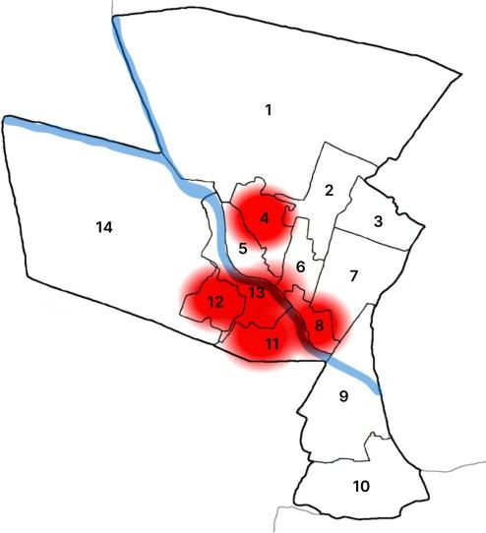

Ward No | Dengue Total (2021-25) | Leptospirosis Total (2021-25) | Hepatitis A Total  (2021-25) | Mumps (2021-25) | ADD  (2021-25) | Total Cases
1 | 5 | 1 | 0 | 12 | 78 | 96

2 | 2 | 0 | 0 | 0 | 82 | 84
3 | 4 | 0 | 0 | 1 | 80 | 85
4 | 4 | 0 | 2 | 0 | 84 | 90
5 | 3 | 0 | 0 | 0 | 84 | 87
6 | 6 | 0 | 0 | 0 | 88 | 94
7 | 13 | 0 | 0 | 0 | 96 | 109
8 | 3 | 1 | 0 | 0 | 74 | 78
9 | 3 | 2 | 4 | 0 | 86 | 95
10 | 12 | 1 | 1 | 00 | 64 | 78
11 | 4 | 1 | 0 | 0 | 68 | 73
12 | 6 | 0 | 0 | 2 | 92 | 100
13 | 7 | 0 | 1 | 1 | 84 | 73

By overlaying five years of data, we have identified the 'Red Zone' Wards. These are wards where at least two different categories of diseases (e.g., Dengue and Lepto) recurred in consecutive years. Ward 9 is categorized as the Highest Priority Hotspot due to moderate vector density.

Action Plan based on Integrated Disease Hotspot Map (2021–2025) for Pandemic Preparedness 2026
The Integrated Disease Hotspot Map (2021–2025) serves as the baseline for the 2026 Pandemic Preparedness Plan. Based on the spatial and temporal data collected over the last five years, the following actions will be implemented:
Identification of High-Risk Zones: Utilizing historical data to categorize areas with recurring outbreaks (Endemic Hotspots) for prioritized intervention.
Pre-emptive Resource Allocation: Deploying medical supplies, diagnostic kits, and rapid response teams to identified hotspots before the peak transmission season.
Trend Analysis & Early Warning: Comparing real-time 2026 data with the 2021–2025 trends to detect unusual spikes or geographical shifts in disease patterns.
Infrastructural Strengthening: Enhancing isolation facilities and laboratory networks in areas marked as "High Intensity" on the 2021–2025 map.

Preparedness and Response Protocol at LSG Level
This section describes the operational framework for the LSGI once a pandemic is declared. It explains how the LSGI and health system will move from routine data collection to active response, using a One Health approach.

Preparedness and Response Protocol at Local Self-Government (LSG) Level
The LSG-level protocol focuses on decentralizing disease management to ensure rapid action at the grassroots level. The key components include:
Ward-Level Monitoring: Strengthening 'Jagratha Samithis' to monitor health trends in every ward. Vulnerability Mapping: Identifying high-risk households (elderly, comorbid, and congested areas) based on the 2021-2025 Hotspot Map.
Rapid Response Teams (RRT): Activating local RRTs comprising Asha workers, volunteers, and health inspectors for immediate field action.
Resource Mobilization: Utilizing LSG funds for sanitation, disinfection, and setting up temporary isolation centers (CFLTCs) if needed.
Community Awareness: Conducting localized awareness campaigns to prevent panic and ensure public cooperation.

Constitution of One Health Committee
The LSGD shall constitute a One Health Committee comprising the LSGI President, Medical Officers (Modern Medicine, AYUSH, and Veterinary), the Health Inspector, and the Veterinary Surgeon.

Objective: The One Health Committee coordinates human, animal, and environmental health to prevent and control pandemics.

Sl No | Name | Designation | Department/Institution | Role in  Committee | Contact Number
1 | Tessy Satheesh | Panchayat President | LSGD | Chairperson | 9544390921
2 | Prince K. Mattam | Medical Officer (PHC/CHC) | Health Dept | Member Secretary | 8848015022
3 | Deepa | Veterinary Officer | Animal Husbandry | Member | 9446309992
4 | Ashamol K. J | Epidemiologist | Health Dept | Member | 6235433129

5 | Tigi Mathew | Health Inspector/PHN | Health Dept | Surveillance | 7736242099
6 | Leelamma | ASHA Supervisor | Health Dept | Community link
7 | Nisha | ICDS Supervisor | Social Welfare | Vulnerable groups | 9656315868
8 | Roy N. S | Police Station Officer | Police Dept | Law &order | 04862 257 777
9 | Soniya Raghu | Ward Councillor Representative | LSGD | Community coordination | 9567763008
10 | Pushpa | Kudumbashree CDO | Kudumbashree | Community mobilisation | 9544764480
11 | George Edattel | NGO/Volunteer rep | Civil Society | Support services
12 |  | Line Department representations |  |  | 9995044010,  8606348753

Key Responsibilities:
- Review disease surveillance data (human + animal)
- Conduct ward-wise risk assessment and vulnerability mapping
- Approve quarantine/isolation centre locations
- Coordinate with district for resources (PPE, oxygen, ambulances)
- Periodically review health system surge capacity, including beds, oxygen, human resources, and ambulances.
- Approve and monitor risk communication and community engagement strategies, including rumour management.
- Ensure protection and service continuity for vulnerable groups (elderly, persons with disabilities, dialysis patients, coastal populations).
- Conduct quarterly mock drills
- Monitor equity measures for vulnerable groups

Meeting Schedule:
Quarterly (normal times) | Weekly (outbreak alert) | Daily (pandemic phase)

Pandemic Response Workforce
To ensure a coordinated and timely response during a pandemic, a dedicated Pandemic Response Workforce shall be constituted at the LSG level. The workforce will function under the overall supervision of the One Health Committee and in close coordination with the health authorities. Team-based deployment will enable efficient surveillance, case management, quarantine and isolation management, logistics support, and risk communication. Each team shall have a clearly designated team leader, defined roles, and an identified pool of personnel to allow rapid activation, rotation of duties, and continuity of services during prolonged emergencies.

Total Response Workforce Available: 300 persons

Team Name | Composition | Key  Responsibilities | Team Leader
Surveillance and Contact Tracing Team | HI, JHI, JPHN, ASHAs and  Volunteers | Case detection,  contact listing, home visits, reporting | HI
Case Management Team | Doctors, Nurses, MLSP, Palliative Nurses | Patient care & referral | DOCTOR
Quarantine & Isolation Team | LSGD staff, Volunteers | Facility management | JHI
Psychosocial support | Nil | Nil | Nil
Logistics & supply chain Team | LSGD staff, Storekeepers, Drivers 3 | Supplies & transport [PPE, medicines, | Ward Member

 |  | oxygen, transport, waste management]
Communication Team | Ward members, Kudumbashree, Youth clubs,  AWW workers and other self help groups | IEC, community meetings, countering misinformation | M.O in charge
Transportation | KSRTC, educational institutional buses | NIL | NIL
Media Surveillance | NEWS PERSON OF PANCHAYATH | NIL | NIL
Intersectoral coordination and convergence | MEDICAL OFFICER | NIL | NIL
Collaborative surveillance | All Department | Handle The Current Situation With The Help Of All Departments | Panchayath secretary and MO

All teams shall be activated immediately upon outbreak alert or pandemic declaration and shall report daily to the LSG Incident Commander/Medical Officer, with consolidated reporting to the Block PHC. Duty rosters and alternate personnel shall be maintained to ensure uninterrupted services during staff shortages or prolonged response periods. Team composition and numbers may be revised based on the magnitude of the outbreak and availability of human resources.

Pandemic Response Workforce (2026 Plan):
A dedicated workforce will be mobilized to manage and mitigate pandemic risks. The strategy involves:
Recruitment & Training: Strengthening the existing pool of healthcare workers and training volunteers for emergency response.
Task Shifting: Empowering community-level workers (ASHA/LSG volunteers) to handle non-clinical surveillance tasks.
Safety Protocols: Ensuring 100% availability of PPE kits, vaccinations, and mental health support for the frontline workers.
Database Management: Maintaining a registry of 'Reserve Personnel' who can be deployed at short notice during an outbreak.

Activities and Measures before and during Pandemic
Pre-Pandemic Measures: Focus on Preparedness through early warning systems (Integrated Hotspot Maps), resource stockpiling, workforce training, and strengthening public health infrastructure.
During-Pandemic Measures: Focus on Mitigation and Response through rigorous contact tracing, establishment of isolation wards, real-time data monitoring via IHIP, and ensuring uninterrupted supply chains for essential medical resources.

PHASE 1 - Alert / Preparation
Surveillance and Reporting-Enhanced syndromic surveillance:

- Data sources for surveillance:
Clinical Data: Monitoring daily OPD/IPD trends from public and private hospitals.
Digital Platforms: Real-time reporting via IHIP (Integrated Health Information Platform).
Laboratory Alerts: Tracking pathogen positivity rates from diagnostic centers.

- Event-based triggers (to be monitored and reported):
Disease Clusters: 5 or more similar cases in a small geographical area.
Unusual Symptoms: Rising cases of severe respiratory distress or unexplained fever.
Mortality Spikes: Any sudden increase in community deaths. Absenteeism: High rate of absence in schools or workplaces.

- Zoonotic and animal health surveillance
Wildlife/Livestock Monitoring: Reporting mass deaths of birds, bats, or domestic animals (One Health approach).
Inter-departmental Coordination: Bi-weekly data sharing between Health and Veterinary departments.

- Logistics and Stock Preparedness
  - Identify and empanel local vendors and define emergency procurement mechanisms in accordance with existing LSGD and Health Department norms.
  - Prepare and maintain an essential logistics checklist covering medical supplies, consumables, and support equipment.

  - Pre-identify secure storage locations for emergency stocks and ensure maintenance of stock registers with regular updating.

  - Finalise emergency transport arrangements, including availability of vehicles and identified drivers for rapid deployment during alerts.

  - Designate a Nodal Officer for Logistics to enable prompt decision-making, coordination, and communication during emergencies.
  - Conduct rapid stock verification and ensure availability of minimum buffer stock, including:
Maintaining a 30-day supply of PPE kits, N95 masks, and essential antivirals/antibiotics.
Diagnostic Kits: Ensuring availability of VTM (Viral Transport Media) and rapid kits.

    - PPE kits Adequate numbers

    - Pulse oximeters Adequate numbers

    - Hand sanitizers Adequate litres

    - Masks, gloves, disinfectants adequate quantity

Identify critical gaps in logistics and immediately communicate requirements to the Block and District authorities for timely replenishment and support. Monitor expiry dates and stock rotation.

Identification of Quarantine and Isolation Facilities
To manage a sudden surge in cases, Muttom Grama Panchayat has pre-identified several community buildings that can be rapidly converted into CFLTCs (Covid/Cluster First Line Treatment Centres) or Quarantine Centres. These facilities are selected based on their accessibility, ventilation, and availability of basic amenities.
Pre-mapping: Identifying community halls, hostels, or vacant buildings to be converted into CFLTCs (Covid/Cluster First Line Treatment Centers).
Infrastructure Audit: Ensuring these facilities have basic water, electricity, and sanitation before an outbreak occurs.

  - Identify and list suitable buildings for quarantine and isolation (schools, hostels, community halls, etc.).
Name of Facility | Type | Ward No. | Estimated  Capacity (Beds) | Nodal Person
Muttom  Govt. HSS & HS | School | 13 | 100 | JHI
St. Thomas HS, Thudanganad | School | 9 | 100 | JHI
St. Thomas LPS, Thudanganad | School | 10 | 50 | JPHN
Govt.  Polytechnic, Muttom | College | 1 | 100 | MLSP

  - Categorise cases as per the severity and allocate to appropriate facilities (for instance, severe cases to classrooms, mild cases to an assembly hall in case of a school).
  - Facility readiness checklist needed (beds, toilets, ventilation) etc.

Before activating these centers, the following minimum requirements will be ensured:
    - Physical Infrastructure: Adequate space for beds with 1-meter distancing, separate toilets for males and females, and proper cross-ventilation.
    - Essential Utilities: 24/7 water supply, electricity with backup (Inverter/Generator), and waste management systems.
    - Communication: High-speed internet/telephone connectivity for the facility manager to report to the Control Room.
    - Infection Control: Designated areas for donning and doffing PPE kits, and scientific disposal of bio-medical waste through IMAGE or local systems.

  - Find an alternate site if the primary sites are not available or not in use.
  - Identify facility managers and support staff

    - Facility Managers: Each center will have a designated Nodal Officer (JHI/JPHN) responsible for admissions and daily reporting.
    - Food & Supplies: The Panchayat, through Kudumbashree or Community Kitchens, will ensure the supply of food and water to the inmates.
    - Medical Oversight: A visiting medical team from CHC Muttom will monitor the health status of those in isolation daily.
  - Prepare basic SOPs for:
    - Admission and discharge
    - Food, water, sanitation
    - Infection prevention and waste disposal
  - Ensure availability of basic amenities: water, sanitation, electricity, ventilation, and waste disposal. Prepare a rapid activation plan for these facilities if case numbers increase.

Risk Communication and Community Preparedness
  - Disseminate early warning messages on symptoms, preventive measures, and reporting mechanisms. Display IEC materials both in English and the local language in public places and ensure ward-level awareness.
  - Sensitize elected representatives and community leaders on preparedness measures.
  - Establish a rumour tracking and misinformation response mechanism to identify, verify, and promptly counter false or misleading information.
  - Engage trusted local persons (ward members, ASHA workers, religious leaders, teachers, community volunteers) to communicate official public health messages and reinforce correct practices.
- Awareness Campaigns: Using social media, FM radio, and loudspeakers to spread accurate info.
  - Combating Misinformation: Setting up a local fact-check or helpdesk to prevent panic.
  - Training: Conducting mock drills for Ward-level RRTs (Rapid Response Teams).

  - Develop and deploy targeted IEC materials for:
    - Schools and educational institutions
    - Markets and commercial areas
    - Work sites and labour settings

  - Conduct community sensitization meetings at the ward level to promote preventive behaviors, address concerns, and strengthen community participation in preparedness and response.

Protection of Vulnerable Groups
Vulnerable populations require priority protection through targeted line-listing, service continuity, and delivery mechanisms.
Listing: Creating a registry of elderly people (above 60), pregnant women, and people with comorbidities (Diabetes, Kidney issues) in each ward.
Priority Care: Planning door-to-door delivery of essential medicines for them during a pandemic.
Social Support: Ensuring palliative care patients and differently-abled individuals are not isolated from medical aid.

- Prepare and regularly update line-lists of vulnerable populations, including:
  - Elderly persons living alone
  - Persons with disabilities
  - Pregnant women
  - Migrant workers
  - Dialysis patients

The detailed line-lists shall be maintained as Annexure and updated periodically.
- Clinical Dependency Mapping

Develop ward-wise dependency and vulnerability maps to identify households requiring regular support during emergencies. Ensure continuity of essential health services for
vulnerable groups, including

- Dialysis services (facility mapping, transport arrangements, and scheduling)
- Continuity of treatment for TB, HIV, and other chronic conditions requiring uninterrupted medication
- Mental health and psychosocial support services

Establish delivery mechanisms for food, essential commodities, and medicines to vulnerable households through coordinated action involving ASHAs, JPHNs, Kudumbashree, volunteers, and local administration.

PHASE 2 - Active Response

Emergency Mobilization: Activation of the District and Local Level Rapid Response Teams (RRTs).
Aggressive Containment: Defining Containment Zones and implementing perimeter control to limit movement.
Trace-Test-Treat Strategy: Systematic contact tracing and expanding testing capacity in identified clusters.
Surge Capacity Activation: Opening First-Line Treatment Centers (CFLTCs) and ensuring bed availability in dedicated hospitals.
Real-time Reporting: Ensuring all new cases are updated hourly/daily on the Integrated Health Information Platform (IHIP).

Case Identification and Contact Tracing
Case detection and contact tracing activities will be carried out in coordination with the Health authorities, following disease-specific SOPs and IDSP guidelines.
Field Staff Involved

  - Health Inspector (HI)
  - Junior Health Inspector (JHI)
  - Junior Public Health Nurse (JPHN)
  - ASHAs and ASHA Supervisors
  - Ward-level volunteers and Kudumbashree members (as required)

Screening Checkpoints

Screening checkpoints at high-traffic locations (transport hubs, markets, religious gatherings) for early detection of symptomatic travellers and crowd screening during outbreaks. Potential locations include bus stands, market entry points, and boat jetties, based on local context and risk assessment.
Screening activities will be carried out by trained personnel such as ASHAs, ward members, and volunteers, with support from Health Department staff. Necessary equipment, including non-contact thermometers and appropriate PPE, shall be ensured prior to activation.

Location | Type (Bus stand/Jetty/M arket/Railway) | Staff Deployed (ASHAs/Volun teers) | Screening Method | Reporting authority
Bus stand | Transport hub | One JHI  One ASHA  One health Mentors | - Swab Collection.  - Blood smears collection (RDT)  - Thermal Scanners | Surveillance Nodal Officer in control room
Market entry | Market | One JHI  One ASHA  Male health volunteers | - Swab Collection.  - Blood smears collection (RDT)  - Thermal Scanners | Surveillance Nodal Officer in control room

Standard Screening Protocol
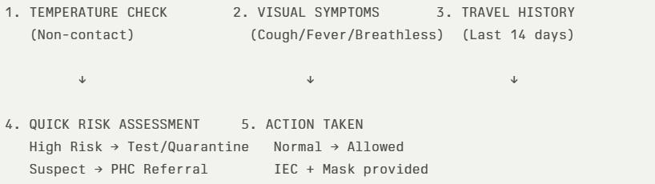

The screening protocol shall include temperature screening, observation for visible symptoms, and inquiry regarding recent travel or exposure history. Individuals identified as suspects during screening shall be immediately referred to the nearest PHC/FHC for further evaluation, testing, and appropriate action as per prevailing guidelines.

Pandemic Control Room
The Pandemic Control Room (PCR) serves as the central nerve center for real-time coordination, data aggregation, decision support, and communication during outbreaks. It consolidates information from all LSGD teams, health facilities and community sources to enable rapid response decisions.

Control Room Infrastructure and Location
Primary Location: MUTTOM GRAMAPANCHAYATH OFFICE
Backup Location: CHC MUTTOM
Health System Control Room Framework
The PCR is organized into seven functional pillars to ensure no aspect of the response is overlooked:
- Rapid Response Team (RRT)
  - Provides immediate intervention during emergencies, clusters, and field alerts.
  - Coordinates urgent actions such as case investigation, contact tracing, isolation, and inter-facility referrals.
- Data Management & Analytics Team
  - Collects, validates, and manages key health system indicators (cases, tests, beds, HR, supplies).
  - Analyzes data trends, generates projections, and supports evidence-based decision-making for local authorities.
- Human Resource Deployment Team
  - Allocates healthcare staff efficiently based on workload and need
  - Ensures adequate and equitable workforce distribution across facilities
- Laboratory Surveillance Team
  - Oversees diagnostic testing coordination, sample transport, and timely reporting of results.
  - Monitors lab indicators (testing volume, positivity rate, turnaround time) for early detection of outbreaks
- Vaccination Cell (If Required)
  - Plans and executes vaccination campaigns, including micro-planning and session scheduling.
  - Tracks coverage, identifies gaps, and coordinates corrective actions with field teams and outreach services.
- Infrastructure & Patient Occupancy Team
  - Monitors facility capacity, earmarked beds, oxygen and critical care resources across all linked facilities.
  - Ensures optimal patient distribution and referral management using updated bed-status and resource data.
  - BMWM
- Communication team
- Logistics and supply chain
- Transportation (interfacility & emergency transport)
- Media surveillance Call centre
- Management of the deceased
- Intersectoral coordination and convergence
Key Control Room Team
The Control Room Team coordinates all pandemic response activities within the LSGD and serves as the single command and communication hub during activation. It integrates information, field actions, logistics, and policy execution across all participating departments and health facilities.

Role | Name | Designation | Contact Number | Responsibility
In-charge/Nodal Officer | AJI K K | HS | 7902395715 | Overall coordination, decision-making, and  reporting to the District level.
Data Entry Operator | AJITH P V | HI | 7736242099 | Managing the line list, updating dashboards, and tracking testing results.
Communication Officer | SHYLA.K. H | STAFF NURSE | 7909165086 | Handling the public helpline, coordinating  ambulance dispatch, and contact tracing calls.
Logistics Coordinator | MANOJKU MAR.M.S | JHI | 9747470092 | NIL
Technical Support(IT/Data) | IT PERSON | E HEALTH | NIL | NIL

SOP for alert escalation/trigger point with mapping of responsibilities.

Key Points:
- The Control Room shall be staffed with a designated In-charge, data entry personnel, and communication staff with clearly defined roles and shift arrangements.

- It shall maintain updated records on daily monitoring indicators including new cases, persons under active quarantine, and hospital bed occupancy.

- All reports and situation updates shall be shared daily with the Block and District Surveillance Unit.

- The Control Room shall act as a single point of contact for coordination with response teams, health institutions, and other departments.

- Contact details of the Control Room shall be widely communicated to field staff and stakeholders during activation.

Daily Monitoring Indicators
To ensure timely decision-making and effective response, the following key indicators shall be monitored and updated on a daily basis by the Pandemic Control Room:

Epidemiological Indicators:
New cases reported today, Total active cases, Test Positivity Rate (TPR), Case Fatality Rate (CFR)

Surveillance Indicators:

Persons under home quarantine, High-risk contacts identified, Fever, ILI, SARI or other symptoms (syndromic surges), Travellers (symptomatic or high-risk arrivals),Animal husbandry surveillance (zoonotic alerts, unusual animal deaths, poultry/bird flu signals), Mortality surveillance (excess deaths, unexplained fatalities, verbal autopsy reports)
- Logistics and Infrastructure Indicators:

Hospital / CFLTC beds occupied, Oxygen cylinders/concentrators available, Ambulances on standby

- Alert Findings
The following table outlines category-specific trigger points (red flags) from surveillance indicators and corresponding immediate actions for the Pandemic
Control Room. These enable rapid response to alert findings like testing anomalies, positive cases exceeding thresholds, clusters, and WGS reports.

Category | Trigger Pophint (Red Flag) | Immediate Action
Clusters | Geographical or facility-based:  5+ cases linked to one location (office, school, street). | Declare a micro-containment zone; perimeter control and active case finding.
Testing | Sudden drop in testing volume / delay in reporting / unusual  testing trends | Review the sample collection process, address lab  bottlenecks, deploy additional testing teams, and notify the District Lab.
Lab | Test Positivity rate increases | Increase testing sites in that ward.
Hospital | >80% Oxygen bed occupancy | Activate backup/CFLTC beds.
Travel | Cluster of cases from a single flight/train or high-risk arrival group. | Trace all passengers in  adjacent seats; implement mandatory institutional  quarantine.
Animal | Mass poultry/wildlife death or unusual sickness | Notify Animal Husbandry,  sample the area, and dispatch RRT for environmental  sampling and zoonotic check.

Mortality | Sudden spike in home deaths or brought-in-dead (BID) cases | Audit the deaths and Active Case Search drive
Additional  investigations like Whole Genome  Sequencing (WGS) | Detection of a Variant of Concern (VOC) or Variant of Interest (VOI) | Implement strict  micro-containment; update clinical protocols to match variant severity.

Communication of Public Health Information
A Community Communication Hub shall be established to ensure timely, accurate, and consistent dissemination of information during a pandemic. The Hub will function under the coordination of Nodal officers of the control room and act as the nodal point for public communication, risk messaging, and community engagement. It will support dissemination of official advisories, promote preventive behaviors, address rumors and misinformation, and ensure that messages reach all sections of the population through trusted local channels and leaders.
Key communicators

Channel | Responsible Person | Contact
Ward-level announcements | WARD  CONVENORS | 9207060143
Social media | HEALTH INSPECTOR | 7736242099
Local Cable TV/Radio | HEALTH SUPERVISOR | 7902395715

  - All messages disseminated through the Hub shall align with advisories issued by the Health Department and District authorities.

  - Community leaders shall be sensitized to support behavior change, reduce stigma, and counter misinformation.
  - Special efforts shall be made to reach vulnerable and hard-to-reach populations using locally appropriate communication methods.

Rumor Tracking: A designated volunteer will monitor local social media/WhatsApp groups daily to identify misinformation and issue official clarifications via the Communication Hub.

Coordination with District/State Authorities & Other Organisations
Effective coordination with Block, District, and State authorities is essential to ensure timely reporting, technical guidance, and uninterrupted supply of essential resources during a pandemic. The LSG shall establish clear communication channels, designate responsible officers, and adhere to prescribed reporting timelines to support coordinated public health action and efficient resource mobilisation.

Key Details:
  - Nodal Officer for Reporting:Dr.Prince K Mattam
  - Contact Number: 8848015022

Reporting Schedule and Protocols:

To Whom | What to Report | Frequency | Nodal Person
Block PHC | Complete Situation  Report (Cases,  Quarantine, Beds, Screening, Deaths) | DAILY | HI
District IDSP Unit | Outbreaks/Clusters/Un usual Events (>5 cases same ward) | DAILY | HS
Veterinary Officer | Animal health events/Zoonotic alerts | DAILY | HI
State Cell | Zoonotic cross-sector events | NIL | NIL

Supply Chain Coordination
The LSG shall coordinate closely with Block, District, and State authorities (KMSCL) to ensure uninterrupted availability of essential goods, medical supplies, and logistics during a pandemic. Supply requirements shall be assessed regularly based on case load and communicated promptly to the appropriate authorities for timely replenishment.
Key Points:

- Maintain updated contact details of District and Block nodal officers for health logistics, oxygen supply, ambulances, and essential medicines.

- Submit timely indent requests for PPE, testing kits, medicines, oxygen, and other critical supplies through prescribed channels.

- Monitor stock levels at LSGD facilities, quarantine/isolation centres, and field teams through daily stock registers and dispensing logs to prevent shortages.

- Coordinate with District authorities, Karunya/Neethi medical shops, and local purchase committees for funds allocation and emergency procurement.

- Ensure regular monitoring of dispensing registers at all facilities to track usage, expiry, and pilferage—shortages being a perennial issue requiring proactive weekly audits.

- Activate surge procurement protocols during high caseloads, leveraging local purchase powers under LSGD funds alongside state supplies.

Resource Inventory and Contacts
Inventory Management: Maintaining a real-time digital registry of medical and non-medical assets, including life-saving drugs, PPE, Oxygen cylinders, and hospital bed availability.
Strategic Stockpiling: Ensuring a minimum 30-day buffer stock of essential items at the block and ward levels.
Contact Directory: A comprehensive database of all frontline responders, nodal oﬃcers, and essential service providers (Ambulance, Food, and Logistics) for immediate mobilization.
Call Center Integration: Linking local contact directories with district-level emergency helpdesks for streamlined communication.

Resource Category | Source (District/State/Private) | Contact
PPE Kits/Masks/Gloves | KMSCL | mgridk.kmsclkerala.gov.in
PPE Kits/Masks/Gloves | Local Vendors | Poaitive Surgicals Thodupuzha 9961682233
Oxygen Cylinders/Concentrators | KMSCL | mgridk.kmsclkerala.gov.in
Medicines/Antivirals | KMSCL | mgridk.kmsclkerala.gov.in
Medicines/Antivirals | Neethi Shops | 08547850377
Test Kits (RTPCR/Rapid) | KMSCL | mgridk.kmsclkerala.gov.in

Collaboration with NGOs, PPP, and CSR
To augment government efforts during a pandemic, the LSG shall collaborate with NGOs, voluntary organisations, and private sector partners through public–private partnerships and Corporate Social Responsibility (CSR) initiatives, in coordination with District authorities.

Key Points:

- Engage NGOs and community-based organisations for community outreach, awareness, and support to vulnerable populations.

- Leverage CSR support for procurement of medical equipment, PPE, oxygen concentrators, food kits, and sanitation materials, as permitted.
- Ensure all collaborations align with government guidelines and are routed through approved administrative and financial procedures.

- Maintain transparency and documentation for all external support received and utilised.

Organization | Type | Support Offered | Contact Person
Youth Clubs/Student Unions | CBO | NIL | NIL

Interdepartmental Coordination
Coordination among departments during a pandemic shall be ensured through regular review meetings convened by the LSGD President. These meetings will provide a structured platform for sharing situational updates, assessing resource availability, resolving operational gaps, and taking joint decisions to ensure a coordinated and timely response.
Effective pandemic management in Muttom Grama Panchayat relies on seamless coordination between various government departments. This integrated approach ensures that resources are shared, information is accurate, and actions are timely.
- Coordination Mechanism
  - Leadership: The LSGD President will lead the coordination meetings, supported by the Medical Officer and Panchayat Secretary.
  - One Health Committee: This committee acts as the common platform where Health, Veterinary, and Environmental sectors share data to prevent zoonotic outbreaks (e.g., Rabies, Nipah).
  - Meeting Schedule: During an alert phase, interdepartmental meetings will be held weekly, and during an active pandemic, they will be held daily.

Department | Representative | Key Role | Contact
Health (PHC) | Staff Nurse : | Case management | 7909165086
Veterinary | Veterinary Surgeon: | Animal surveillance | 9446309992
ICDS | Supervisor: Sindhu | Nutrition support | 9656315868
Education | Head Teacher: | School coordination | 9446068167
Police |  | Containment enforcement | 0486257 777
Water Authority | ASST. ENGINEER | Water supply | 8547638429
LSGD Engineering | ASST. ENGINEER | Quarantine infrastructure | 9995242061

- Role of Key Departments

Department | Key Responsibility
Health (PHC/CHC) | Medical care, testing, contact tracing, and vaccination.
Animal Husbandry | Surveillance of livestock/pets and reporting unusual animal deaths.

Police | Enforcing containment zones, managing crowds, and preventing fake news.
Education | Converting schools into isolation centers and spreading awareness via students.
KSEB & KWA | Ensuring uninterrupted power and safe drinking water supply to hospitals/CFLTCs.
Revenue/Village | Managing relief materials, compensation, and legal documentation.
Kudumbashree | Community kitchen management and support for vulnerable families.

- Information Sharing & Reporting
  - A Unified Communication Channel (Official WhatsApp group/Control Room) will be used to share real-time updates between departments.
  - Joint Field Visits: Health Inspectors and Veterinary Surgeons will conduct joint inspections in high-risk areas like meat markets and farms.
In summary, effective interdepartmental coordination ensures that there is no 'duplication of work' and that every department knows its specific role during a crisis. This unity of command is vital for the swift and efficient management of public health emergencies in Muttom Grama Panchayat.

PHASE 3 - Surge Capacity
Phase 3 is activated when there is a rapid increase in cases, high test positivity rates, or when existing health facilities and quarantine arrangements approach saturation. The focus of this phase is to expand isolation capacity, augment clinical care services, and mobilise additional resources through district and state support mechanisms.

Conversion of Community Facilities
To manage increased case load, the LSGD shall activate additional isolation facilities by repurposing identified community infrastructure such as community halls, auditoriums, schools, hostels, or other suitable buildings.

Name of facility | Facility Type | No. of  Buildings | Ward | Surge Capacity (Beds) | Nodal Person
MUTTOM  GOVT HSS & HS | SCHOOL | 1 | 13 | 100 | JHI
ST. THOMAS HS THUDANGAN AD | SCHOOL | 2 | 9 | 100 | JHI
ST.THOMAS LPS  THUDANGAN AD | SCHOOL | 1 | 10 | 50 | JPHN
GOVT POLY TECHNIQUE MUTTOM | POLY | 2 | 1 | 100 | MLSP

Recovery and rehabilitation phase
The recovery and rehabilitation phase begins once the immediate public health emergency is controlled and transmission is reduced to manageable levels. This phase focuses on restoring essential services, addressing long-term health and socio-economic impacts, and strengthening systems to prevent or better manage future pandemics.

Recovery
Recovery refers to the gradual return of communities and systems to normal functioning while continuing public health vigilance. It involves phased withdrawal of emergency measures, reopening of services, and reintegration of disrupted health and social systems. Recovery activities should be evidence-based, inclusive, and aligned with national and state guidelines to ensure sustainability and resilience.

Damage and Impact Assessment
Before long-term rebuilding can happen, the dust must be settled and the immediate risks managed. Damage and impact assessment is a critical step to understand the full extent of the pandemic’s effects on health systems, communities, and livelihoods. This assessment evaluates disruptions to healthcare services, availability of infrastructure and workforce, morbidity and mortality patterns, and socio-economic consequences such as loss of income, education disruption, and food insecurity. The findings inform evidence-based planning, prioritization of interventions, and optimal allocation of resources during the recovery phase.

Restoration of Health Services
Recovery requires moving beyond emergency trauma care. This sub-phase focuses on reopening primary care clinics, restarting routine immunization programs, and ensuring that patients with chronic conditions (like diabetes or hypertension) can once again access life-sustaining medications and check-ups.

Environmental Cleanup and Sanitation
Post-disaster environments are often breeding grounds for secondary health crises. Cleanup efforts focus on removing debris, managing hazardous waste, and restoring water and sewage systems. Ensuring a "clean slate" is biologically necessary to prevent the spread of waterborne and vector-borne diseases.

Rehabilitation
Rehabilitation focuses on addressing the long-term physical, social, and economic impacts of the pandemic on affected individuals and communities. This includes medical rehabilitation for post-infection complications, nutritional support for vulnerable groups, and social assistance for households affected by illness, disability, or loss of livelihood. Rehabilitation efforts should promote reintegration into education, employment, and community life, with special attention to marginalized and high-risk populations.

Physical and Livelihood Rehabilitation
For those left with lasting injuries, rehabilitation involves providing physical therapy and assistive devices. Simultaneously, Livelihood Restoration addresses the economic health of the community; without the ability to earn an income, individuals cannot sustain their own long-term health and nutrition. Support for small businesses, informal workers, self-help groups, and skill development initiatives is essential to promote economic resilience and long-term recovery.

Psychosocial and Mental Health Support
The trauma of a disaster often outlasts the physical damage. Providing psychological f irst aid and long-term mental health counseling is vital for community cohesion. This support helps individuals process grief and anxiety, reducing the long-term societal burden of PTSD.

Community Engagement and Confidence Building
Recovery fails if the public does not trust the systems being rebuilt. Active communication and involving local leaders in the decision-making process help rebuild social capital. This ensures that the population feels safe returning to schools, workplaces, and hospitals. Active involvement of community leaders, local self-governments, and civil society organizations strengthens community ownership, promotes adherence to public health measures, and enhances preparedness for future emergencies.

Vigilance and Disease Surveillance
Disease surveillance during the recovery phase ensures early detection of resurgence, secondary outbreaks, or emerging variants. Surveillance systems should continue monitoring communicable disease trends, post-pandemic complications, and unusual health events. Strengthening laboratory capacity, sentinel surveillance, and community-based reporting mechanisms enables timely response and supports sustained public health security.

System Strengthening and Future Preparedness
The final stage of recovery is an intellectual exercise in "Building Back Better," turning the tragedy of the past into the safety of the future.

Documentation and After-Action Review (AAR)
Once the immediate pressure has subsided, stakeholders must conduct a formal review of the response. This involves a candid look at what worked, what failed, and where communication broke down. These lessons learned are then transformed into best practices.

Policy Revision and Health System Strengthening
Pandemic Preparedness Plan The ultimate goal of recovery is to ensure the next crisis is less damaging. This involves updating emergency protocols, revising public health laws, and investing in more durable infrastructure. Through Research and data analysis, the health system is "hardened" against future threats, moving the community from a state of vulnerability to a state of permanent readiness.

Research
Research during the recovery phase is essential to generate evidence on the long-term health, social, and economic impacts of pandemics. Operational, clinical, and policy research should examine the effectiveness of response and recovery interventions, community behaviors, and innovations in service delivery and surveillance. Research f indings should inform future preparedness strategies and public health decision-making.

HR specific responsibility

RECOMMENDATIONS
- Strengthening Healthcare Infrastructure
  - Establish a primary health response unit within the Panchayat with trained staff.
  - Ensure availability of basic medical supplies (masks, sanitizers, PPE kits, oxygen cylinders).
  - Create tie-ups with nearby hospitals in case, for emergency referral and transport.

- Community Awareness & Education

  - Conduct regular awareness campaigns on hygiene, vaccination, and preventive measures.
  - Use local communication channels (community radio, What Sapp groups, notice boards) to spread verified information.
  - Train volunteers to act as health ambassadors in each ward.

- Emergency Response & Coordination

  - Form a Pandemic Preparedness Committee at Panchayat level including health workers, ward members, and NGOs.
  - Develop a clear action plan for lockdowns, quarantine, and distribution of essentials.
  - Maintain a database of vulnerable groups (elderly, differently-abled, chronically ill) for targeted support.

- Supply Chain & Food Security

  - Identify and support local suppliers and farmers to ensure uninterrupted food supply.
  - Create community kitchens during emergencies to serve vulnerable populations.
  - Stockpile essential commodities in Panchayat-run outlets for crisis periods.

- Digital Preparedness

  - Promote digital platforms for telemedicine consultations.
  - Use Panchayats website/social media for real-time updates on health advisories.
  - Encourage online grievance redressed to reduce crowding in offices.

- Training & Capacity Building

  - Organize mock drills for pandemic response in schools, offices, and public spaces.
  - Train Panchayat staff and volunteers in first aid, infection control, and crowd management.
  - Collaborate with NGOs and health departments for capacity-building workshops.

- Long-Term Resilience
  - Integrate pandemic preparedness into the Panchayat Development Plan.
  - Allocate a dedicated budget for health emergencies.
  - Encourage community participation in planning and monitoring preparedness measures.

MOCKDRILL SCENARIOS

Mock Drills: Conducting regular simulated exercises based on varied scenarios (e.g., cluster outbreaks, supply chain failures) to ensure the workforce is battle-ready.
Process Improvement: Post-action reviews will be conducted to update the Integrated Disease Hotspot Map and protocols for future challenges.
ANNEXURE

IMPORTANT PHONE NUMBERS

Phone numbers and particulars of persons responsible for providing guidance, assistance, and support for pandemic preparedness operations may be provided here in a manner that allows easy reference at a glance.The information recorded here could be exhibited elsewhere at the time of emergencies. LSG institutions shall give special attention to collect and record the above data of persons and institutions who/which are supposed to give technical and co-ordination support to reduce the impact of pandemic.

  - Details of grama panchayat/municipality/corporation wards

Sl.No | Name of the ward | Ward number | Name of the ward member | Contact number
1 | KODATHI | 1 | SAIMOL.K | 7736874267
2 | MATHAPPARA | 2 | M.A.SHABEER MADATHILPARAMBIL | 9895490976
3 | MUNJANATT KUNNU | 3 | SREEJA SREEJI | 9656916511
4 | SANKARAPILLY | 4 | REJEESH.V.R | 9567763008
5 | MUTTOM | 5 | SULEKHA MADHAVAN | 9605952349
6 | KAKKOMB | 6 | ANU THOMAS KOCHUPARAMBIIL | 9961074934
7 | ITC CHALLAVAYAL | 7 | VISHNU SAJI | 9895098963
8 | ELLUMPURAM | 8 | TESSY SATHEESH | 9544390921
9 | THUDANGANAD | 9 | KUTTIYAMMA MICHEL | 9947946010

10 | PAZHAYAMATTAM | 10 | ISAC GEORGE P | 9446925553
11 | KANYAMALA | 11 | JOBIS JOSE | 9847406350
12 | THOTTUMKARA | 12 | BENNY PLAKKOOTTAM | 9447612593
13 | MUTTOM GOVT.SCHOOL | 13 | REJI GOPI | 9061286375
14 | POLY TECHNIQUE | 14 | ALEENA VARGHEESE | 9947042776

  - Other important phone numbers of grama panchayat/municipality/corporation area

Sl.  No. | Name | Contact number
1. | Dr.GAYATHRI/ Dr.Jyothilekshmi | 9544685054 / 9496745802
2. | Mr.ANTONY | 9496636663
3. | Dr.RAGENDU | 8943346544
4. | Dr.DEEPA | 9446309992
5. | Dr.BIJU | 9633204081
6. | Smt.ANJU | 9526417885

7. | Excise department
8. | Forest department | 9995044010

  - Important offices of grama panchayat/municipality/ corporation

Sl.No | Name of the office | Contact person | Contact number
1. | Village Office | Village Officer | 8547612803
2. | Agriculture Office | Agriculture Officer | 9526417885
3. | Animal Husbandry Office | Animal Husbandry Doctor | 9446309992
4. | Police Station | Police Officer | 04862 257 777
5. | BSNL Office | Officer | 04862-255100
6. | Block Office | Officer | 04862 – 222464
7. | KSEB Office | Officer | 949 600 9348
8. | Fisheries Office | Officer | 9539486468
9. | Fire and Rescue | Officer | NIL
  - Health Services

Sl. No | Name of the hospital/institution | Location | Phone number
1. | Government hospitals/PHC | MUTTOM
 |  |  | 9447046899
2. | Private hospitals | VICHATTU | 9447165144
 |  | KAVALA & | 9544542185
 |  | MUTTOM
3. | Clinical laboratories | MUTTOM | 8606581775
4. | Chemist/pharmacy | MUTTOM | 80759 86554
5. | Blood donors | NIL | NIL
6. | Other language experts (Bihari, Hindi, Bengali,  Asamees ………) | NIL | NIL

  - Veterinary Services

Sl. No | Name of the Clinic | Name of the  Surgeon/Doctor | Place/location | Phone number
1 | Govt.Veterinary Hospital | Dr.DEEPA | Muttom | 9446309992

  - Helpline numbers

Helpline | Phone number
Police | 100

Fire and Rescue | 101
KSEB | 91 471 2555544

  - Public and Private Schools Contact details

S.No | Name of School | Institution type | Phone number
1 | GOVT. HSS MUTTOM ,MUTTOM | Govt | 9446068167
2 | GOVT. TECHNICAL HSS ,MUTTOM | Govt | 9495194188
3 | GOVT. LPS,EDAPPALLY | Govt | 9495373360
4 | St.THOMAS LPS, THUDANGANAD | Aided | 9497015628
5 | St.MARY'S LPS, KAKKOMB | Aided | 9446932339
6 | GOT.HS MUTTOM, MUTTOM | Govt | 9495819062
7 | St.THOMAS HS, THUDANGANAD | Aided | 9497788679
8 | SHANTHAL JYOTHI SCHOOL | Private | 8281450539
9 | LOGOS LITTLE FLOWER LPS , MUTTOM | Private | 9496096554

1.9. Anganwadi Contact Details

Ward No | Name of Anganwadi Teachers | Phone number
1 | SHIRLY THOMAS –C NO. 42 | 9562814015
2 | SREEJA.P – C NO.47 | 7902410221
2 | SHIJINOLE.K.G – C NO.43 | 9747152638
3 | PATHUMMA.K.A – C NO.41 | 9656316442
4 | NABEESATHULMISARI | 9961227499
4 | RAGEENA.M.M | 8281824298
6 | MARY GEORGE.K | 9744142973
7 | ALICE JOHAN | 9847481425
8 | USHA NARAYANAN | 7306408647
9 | USHAKUMARI.P.N | 9656444196
11 | BINDU KUNJAPPAN | 9947716801

11 | SIJI THANKAPPAN (H) | 7561805501
12 | SOOSY ABRAHAM | 9961013818
12 | SHINY.K.O | 9047583306

1.12. Information regarding resources

Means of transportation | Name of Owner | Phone Number
Heavy Trucks | NIL | NIL
Tractor | NIL | NIL
Ambulances | ANEESH.P.H | 9447702395
Boats | NIL | NIL
Taxi service | JOBY | 9544101105

Annexure 1: LSG Baseline Data Collection Format
- Baseline data

Sl.  No. | Indicator / Field | Baseline Data | Source / Remarks
1 | Name of LSG | MUTTOM | NIL
2 | District | IDUKKI | NIL
3 | Block / Taluk | THODUPUZHA | NIL
4 | Type of LSG (Gram Panchayat / Municipality / Corporation) | GRAMA PANCHAYATH | NIL
5 | Area (sq. km) | 25.44 | NIL
6 | No. of wards | 14 | NIL
7 | GIS boundary file available | (Yes/No) | NIL
8 | Key contact person & phone | ANTONY -SEC 9496631663 | NIL

- Demography

Indicator / Field | Baseline Data | Source / Remarks
Total population | 10226 | NIL
Males | 4981 | NIL
Females | 5245 | NIL

Transgender population | 0 | NIL
Age distribution  (<5, 5–14, 15–59, ≥60) | 423, 969,5651 | NIL
No. of households | 2695 | NIL
Population density (persons/sq.km) | 401.965 | NIL
No. of migrant workers | 201 | NIL
Major occupational groups | AGRICULTURE | NIL

- Vulnerable Populations & Social Risks

Sl. No. | Indicator / Field | Baseline Data (Value  / Description) | Source / Remarks
1 | No. of elderly (≥60) | 2099 | NIL
2 | No. of persons with disability | 112 | NIL
3 | No. of bedridden persons | 19 | NIL
4 | No. of chronic disease cases (DM/HTN/COPD/CKD etc.) | DM-840, HTN-1539 COPD-173,  CKD-21 | NIL
5 | Pregnant women (current estimate) | 36 | NIL
6 | Children <5 years | 423 | NIL

7 | Tribal population (if any) | 844 | NIL
8 | Fisherfolk / coastal vulnerable groups (if any) | NIL | NIL
9 | Urban slums / unnotified settlements (if any) | NIL | NIL
10 | Homeless population | NIL | NIL
11 | Orphanages / old age homes (number & capacity) | 2 (48) | NIL
12 | Hostels / prisons / shelters (number & capacity) | HOSTEL -5 (480)  PRISON -1 (180) | NIL
13 | Poverty / BPL estimate | BPL-3532 | NIL
14 | Food insecurity hotspots | NIL | NIL
15 | Any history of  stigma/discrimination issues (Yes/No) | NO | NIL

- Health System & Service Readiness

Sl. No. | Indicator / Field | Baseline Data  (Value /  Description) | Source / Remarks
1 | No. of health facilities in LSG | 4 | NIL

(PHC/CHC/TH/DH/Priva
te)
2 | PHC/Family Health Centre details (name, location) | CHC MUTTOM, MUTTOM | NIL
3 | Subcentres / Health & Wellness Centres (number) | 2 | NIL
4 | Private clinics / hospitals (number) | 3 | NIL
5 | Labs available  (public/private) | 3 | NIL
6 | Availability of ambulance services (Yes/No, number) | YES | NIL
7 | Availability of  isolation/quarantine facilities (Yes/No, details) | NO | NIL
8 | Cold chain facilities (Yes/No, details) | YES | NIL
9 | Stockpile space available (Yes/No) | YES | NIL
10 | PPE / mask / sanitizer availability plan (Yes/No) | YES | NIL
11 | Surveillance staff available (JHI/JPHN/ASHA count) | YES | NIL

12 | Existing emergency referral pathways (Yes/No) | YES | NIL

- Points of Entry & Mobility

Sl. No. | Indicator / Field | Baseline Data (Value  / Description) | Source / Remarks
1 | Bus stands / depots (number) | 1 | NIL
2 | Railwaystations (number) | NO | NIL
3 | Boat jetties / fishing harbours (number) | NO | NIL
4 | Ports / airports nearby(specify distance) | NO | NIL
5 | Major highways/roads passing through | 1 | NIL
6 | Bordercrossings (state/district) | NO | NIL
7 | Major markets / weekly markets | MUTTOM | NIL
8 | Tourism hubs / major event venues | 1 (MINOR) | NIL

9 | Schools/colleges with hostels (number) | 9 SCHOOL, 1 POLY  ,3 COLEGES (1 NURSING  HOSTEL) | NIL
10 | Factories /large workplaces (number) | 2 | NIL
- Water, Sanitation & Hygiene (WASH)

Sl. No. | Indicator / Field | Baseline Data (Value  / Description) | Source / Remarks
1 | Major drinking water sources (piped / wells / borewells / springs) | PIPED & WELL WATER | NIL
2 | No. of public wells | 24 | NIL
3 | No. of households with piped water connection | 840 | NIL
4 | Water quality testing routine (Yes/No) | YES | NIL
5 | Common contamination risks (flooding, salinity, industrial waste) | NO MAJOR SOURCE OF CONTAMINATIO N | NIL
6 | Open defecation free status (Yes/No) | YES | NIL

7 | Solid waste management system (Yes/No) | YES | NIL
8 | Bio-medical waste disposal mechanism (Yes/No) | YES | NIL
9 | No. of public toilets | 1 | NIL
10 | Handwashing stations in public places (Yes/No) | YES | NIL
- Zoonotic Risks & One Health

Sl. No. | Indicator / Field | Baseline Data (Value  / Description) | Source / Remarks
1 | Livestock population (cattle/goats/pigs/poultry) – estimates | 2100 | NIL
2 | No. of dairy farms / poultry farms / pig farms | 2 POULTRY | NIL
3 | Slaughterhouses / meat shops (number) | 8 MEAT STALL | NIL
4 | Animal markets (Yes/No, details) | NO | NIL
5 | Veterinary dispensaries (number) | YES | NIL
6 | History of zoonotic outbreaks (rabies, leptospirosis, avian flu etc.) | NO | NIL

7 | Stray dog population management measures (Yes/No) | 38 | NIL
8 | Rodent infestation hotspots (Yes/No) | NO | NIL
9 | Wetlands / waterlogged areas prone to leptospirosis | NO | NIL
10 | Bat roosting areas / caves / fruit orchards (if any) | NO | NIL
11 | Human-animal interface hotspots (farms near residences) | 1 | NIL
- Climate & Disaster Risks (Pandemic Amplifiers)

Sl. No. | Indicator / Field | Baseline Data (Value  / Description) | Source / Remarks
1 | Flood-prone wards (list) | 7 | NIL
2 | Landslide-prone wards (list) | NO | NIL
3 | Cyclone/sea surge risk (Yes/No) | NO | NIL
4 | Heatwave risk zones (Yes/No) | NO | NIL
5 | Waterlogging areas (list) | NO | NIL
6 | Shelter homes / relief camps (number, capacity) | 2 | NIL
7 | Past disaster displacement history | NIL | NIL

8 | Disruption to water supply/transport common (Yes/No) | NO | NIL
- Critical Infrastructure & Logistics

Sl.  No. | Indicator / Field | Baseline Data (Value  / Description) | Source / Remarks
1 | Schools (number) | 9 | NIL
2 | Anganwadis (number) | 14 | NIL
3 | Colleges (number) | 3 | NIL
4 | Community halls (number) | 3 | NIL
5 | Places of worship with large gatherings (number) | 17 | NIL
6 | Large markets / shopping areas (number) | NIL | NIL
7 | Warehouses /cold storages (number) | NIL | NIL
8 | Telecom/mobile network coverage gaps (Yes/No) | NO | NIL
9 | Power outage frequency (high/medium/low) | LOW | NIL

10 | Availability of generators in key facilities | YES | NIL

- Risk Communication & Community Networks

Sl. No. | Indicator / Field | Baseline Data (Value  / Description) | Source / Remarks
1 | Ward-level rapid response teams (Yes/No) | YES | NIL
2 | Jagratha samithis / committees active (Yes/No) | YES | NIL
3 | Kudumbashree presence and strength (number of units) | YES | NIL
4 | Volunteer network (number, coverage) | NIL | NIL
5 | Community-based surveillance mechanisms (Yes/No) | YES | NIL
6 | IEC dissemination channels (WhatsApp groups, community radio, PA systems) | WHATSAPP | NIL
7 | Rumour tracking mechanisms (Yes/No) | YES | NIL
8 | Languages spoken / literacy considerations | MALAYALAM | NIL

9 | Vulnerable groups communication strategy available (Yes/No) | YES | NIL

- Preparedness Planning & Governance

Sl.  No. | Indicator / Field | Baseline Data (Value  / Description) | Source / Remarks
1 | LSG emergency plan available (Yes/No) | YES | NIL
2 | Pandemic preparedness plan available (Yes/No) | YES | NIL
3 | Incident Command System identified (Yes/No) | YES | NIL
4 | Rapid procurement mechanism available (Yes/No) | YES | NIL
5 | Emergency fund available (Yes/No, amount) | NO | NIL
6 | Past outbreak response experience (Yes/No, details) | NO | NIL
7 | Intersectoral coordination mechanism (Health, Police, LSG, Veterinary, Education) | YES | NIL
8 | Mock drills conducted in last 12 months (Yes/No) | NO | NIL

9 | Training coverage for staff/volunteers (Yes/No) | YES | NIL

- Surveillance & Data Systems

Sl. No. | Indicator / Field | Baseline Data (Value  / Description) | Source / Remarks
1 | Digital reporting tools used (e.g., DHIS2, portals) | PORTALS | NIL
2 | Availability of line-listing format (Yes/No) | YES | NIL
3 | Contact tracing team identified (Yes/No) | YES | NIL
4 | Mapping of high-risk households available (Yes/No) | YES | NIL
5 | Testing sample transport mechanism (Yes/No) | YES | NIL
6 | Reporting timeline adherence (good/average/poor) | GOOD | NIL
7 | Data sharing between departments (Yes/No) | YES | NIL
8 | Availability of dashboard for monitoring (Yes/No) | NO | NIL

- Additional Notes & Observations

Sl.  No. | Indicator / Field | Baseline Data (Value  / Description) | Source / Remarks
1 | Key challenges perceived by LSG | Transportation to some part of the ward (1 , 8, 10 etc) is the key challenge | NIL
2 | Top 5 high-risk wards (reason) | No special risk associated with wards | NIL
3 | Any unique local risks (industrial pollution, refugee camps, etc.) | Nothing | NIL
4 | Recommendations for preparedness strengthening | Make all the Line department ready for timely reporting and responding.. | NIL

