PANDEMIC

PREPAREDNESS PLAN

NARATH PANCHAYATH

PAPPINISSERY HEALTH BLOCK

MESSAGE FROM PRESIDENT/CHAIR LSGI
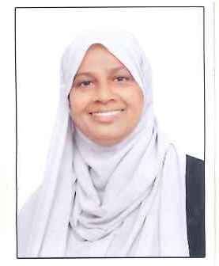
Narath Grama Panchayath
It is with great responsibility that we present the Pandemic Preparedness Plan of Narath Grama Panchayath. This plan reflects our commitment to safeguarding the health and wellbeing of our community through timely preparedness, coordinated response, and strong community participation.
I appreciate the dedicated efforts of the Health Team and all stakeholders who contributed to the development of this plan. Together, we remain committed to ensuring that Narath is well-prepared to respond effectively to any public health emergency.
President
Narath Grama Panchayath

MESSAGE FROM HEALTH STANDING COMMITTEE CHAIR
Narath Grama Panchayath
The Pandemic Preparedness Plan of Narath Grama Panchayath has been developed to strengthen our readiness and response to public health emergencies. As part of our responsibility, the Health Standing Committee remains committed to ensuring effective surveillance, timely action, and uninterrupted essential health services during any crisis.
I sincerely appreciate the dedicated efforts of the Health Team, field staff, and all stakeholders who contributed to the preparation of this plan. Through coordinated action and community support, we aim to protect and promote the health of our people.
Chairperson
Health Standing Committee
Narath Grama Panchayath

MESSAGE BY MEDICAL OFFICER

The Pandemic Preparedness Plan of Narath Grama Panchayath has been developed to ensure systematic preparedness, early detection, and effective response to public health emergencies. This plan outlines clear strategies for surveillance, case management, infection prevention and control, risk communication, and continuity of essential health services.
I sincerely appreciate the coordinated efforts of the Panchayath authorities, health staff, ASHA workers, and all stakeholders who contributed to the preparation of this plan. With strong teamwork and community participation, we are confident in our ability to respond promptly and efficiently to any future health crisis.
Medical Officer
Family Health Centre, Narath

EXECUTIVE SUMMARY

Primary Health Centre (PHC) functions as the primary public healthcare institution serving the population of NARATH Grama Panchayath. The PHC plays a pivotal role in delivering comprehensive, accessible, and affordable healthcare services, with a strong focus on preventive, promotive, curative, and rehabilitative care in accordance with national and state health programmes.
The PHC caters to a predominantly rural population, addressing key public health priorities such as maternal and child health, communicable and non-communicable disease control, immunization, family welfare, adolescent health, and geriatric care. Regular outpatient services, home-based care through field health staff, and outreach activities ensure healthcare coverage even in geographically challenging areas. The institution actively implements national health missions, including the National Health Mission (NHM), National Tuberculosis Elimination Programme, National Programme for Prevention and Control of Cancer, Diabetes, Cardiovascular Diseases and Stroke (NPCDCS), and other disease surveillance initiatives.
NARATH PHC works in close coordination with the Grama Panchayath, ASHA workers, Anganwadi centres, schools, and community-based organizations to strengthen community participation and improve health awareness. Emphasis is placed on early detection, timely referral, health education, and lifestyle modification to reduce disease burden and improve overall health outcomes.
Despite constraints related to infrastructure, manpower, and increasing service demand, the PHC continues to enhance service delivery through effective planning, data-driven decision-making, and community engagement. Strengthening facilities, upgrading digital health systems, and expanding preventive services remain key focus areas for future development.
Overall, NARATH Primary Health Centre stands as a vital institution in safeguarding public health and improving the quality of life of the residents of NARATH Grama Panchayath

LIST OF ABBREVIATIONS

LSGD/LSGI | Local Self Government Department / Local Self Government Institution
BMO | Block Medical Officer
IDSP | Integrated Disease Surveillance Programme
NDMA | National Disaster Management Authority
PPE | Personal Protective Equipment
ICMR | Indian Council of Medical Research
CD | Communicable Diseases
NCD | NON-COMMUNICABLE Diseases

TABLE OF CONTENTS

INTRODUCTION 10
Background of the PPP 10
LSGD AT A GLANCE 11
● Geographical boundaries with political map ( based on latest delimitation) 12
● Baseline data 12
Narath Grama Panchayath – Communicable Diseases & Environmental Hazards 13
1. HEALTHCARE FACILITIES 18
2. EDUCATIONAL INSTITUTIONS 18
3. RELIGIOUS & COMMUNITY GATHERING PLACES 19
4. MARKET & COMMERCIAL AREAS 19
5. ADMINISTRATIVE & EMERGENCY SERVICES 19
6. VULNERABLE SUPPORT FACILITIES 19
ENVIRONMENTAL VULNERABILITY LAYER 23
OCCUPATIONAL VULNERABILITY 23
GENERAL PROFILE OF THE LSGI’S 30
Background of the LSGI 30
Demographic and Vulnerable Population 32
Clinical Vulnerability 33
INFRASTRUCTURE & RESOURCE INVENTORY 36
Health Facility Directory & Basic Capacity in the LSGD 36
Private Clinics 37
Healthcare Education & Training Institutions 38
Specialized Services & Emergency Inventory 39
Oxygen & Diagnostic Capacity 40
Diagnostics facility mapping at the LSGI level 40
Social and Community Infrastructure for surge plan 41
Human resources 45
Public Health & Field-Level Workforce 45
Community & Support Cadre 47
Community Organizations 48
Administrative & Emergency Services 49
Information regarding resources 50
ONE HEALTH & ENVIRONMENTAL SURVEILLANCE 51
Animal & Bird Population 51
Veterinary Infrastructure 53
Veterinary Doctors & Workforce 54
High-Risk Interface Points (Surveillance Sites) 55
Vulnerability Mapping 60
EPIDEMIOLOGICAL TRENDS (2021–2025) 63
Seasonal Trend Analysis 65
Outcome-Based Trend Analysis- 2025 71
Transmission Trend- 2025 72
Integrated Disease Hotspot Map (2021–2025) 76
Preparedness and Response Protocol at LSG Level 80
PHASE 1 - Alert / Preparation 84
PHASE 2 - Active Response 87
Control Room Infrastructure and Location 89
PHASE 3 - Surge Capacity 101
RECOVERY&REHABILITATION PHASE –NARATH PANCHAYAT 101
ADDITIONAL COMPONENTS – NARATH PANCHAYAT 104
RECOMMENDATIONS 106
● Strengthening Healthcare Infrastructure 106
2. Community Awareness & Education 107
3. Emergency Response & Coordination 107
4. Supply Chain & Food Security 107
5. Digital Preparedness 107
6. Training & Capacity Building 107
7. Long-Term Resilience 108
MOCKDRILL SCENARIOS 108
CONCLUSION 110
ANNEXURE 111

INTRODUCTION

Background of the PPP
Narath is a rapidly developing local self-government area situated in Kannur district of Kerala. The region is characterized by a mix of semi-urban settlements and rural habitations, with moderate population density and active community engagement through local self-government institutions. Seasonal monsoon rains, frequent population mobility, and close community interactions increase the vulnerability of the area to communicable disease outbreaks.
The experience of the COVID-19 pandemic highlighted the critical importance of early detection, rapid response, effective surveillance, and coordinated intersectoral action at the primary health care level. As a frontline public health institution, Narath Family Health Centre plays a pivotal role in disease surveillance, outbreak investigation, risk communication, case management, vaccination services, and community awareness activities.
The Pandemic Preparedness Plan has been developed to strengthen the capacity of Narath FHC to prevent, detect, and respond effectively to emerging infectious disease threats. The plan outlines standard operating procedures for surveillance under the Integrated Disease Surveillance Programme (IDSP), laboratory coordination, isolation and referral mechanisms, logistics management, human resource mobilization, infection prevention and control measures, and community engagement strategies.
This plan aims to ensure timely preparedness, minimize morbidity and mortality, maintain continuity of essential health services, and safeguard the health of the community during public health emergencies. It reflects the commitment of Narath FHC to build a resilient health system capable of responding efficiently to future pandemics and large-scale outbreaks.

LSGD AT A GLANCE

Geographical boundaries with political map ( based on latest delimitation)

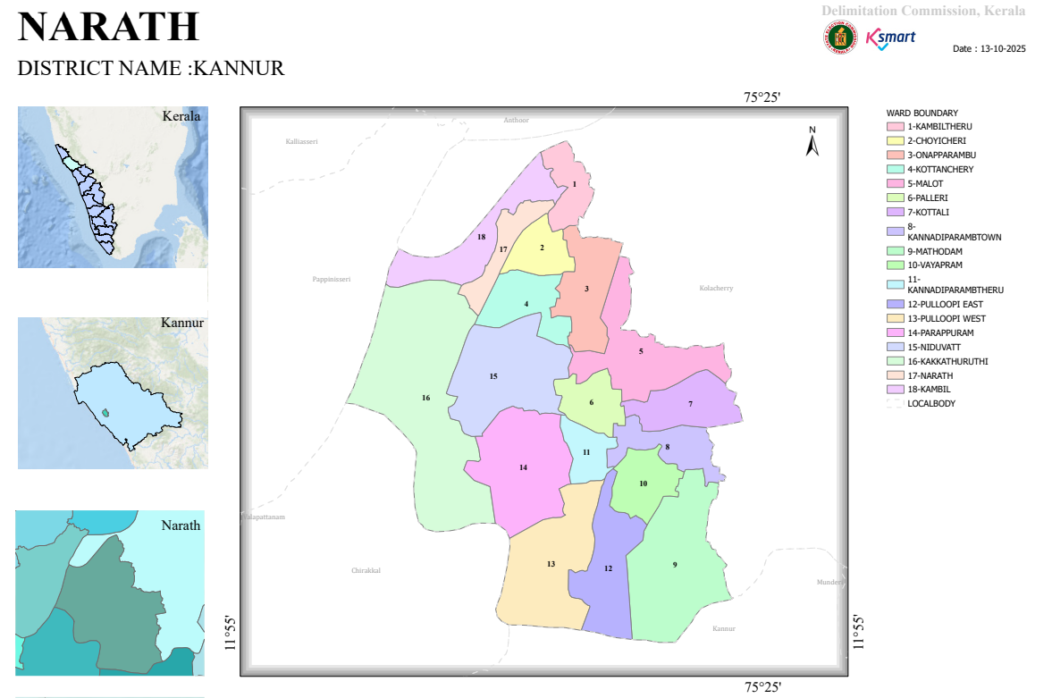

Baseline data
- Ward division -
Ward | Houses | Population | Migrants | Wells | Hot  spots | Ed. Institutions | Hosp pvt/govt.
18 | 6961 | 33063 | 442 | 5408 | 2 | 16 | GOV-1 ,PRIV-2

Risk stratification among wards in the context of Communicable diseases and hazards

Narath Grama Panchayath – Communicable Diseases & Environmental Hazards
Risk classification is based on:
- Epidemiological trends (2021–2025)
- Recent outbreaks / clustering (2024–2025)
- Environmental vulnerability (flooding, wetlands)
- Water, sanitation, and hygiene (WASH) risks
- Occupational and population exposure patterns
🔴 HIGH-RISK WARDS

Wards: 16, 8, 18, 5
- Ward 16
  - Confirmed Leptospirosis case with mortality (2025)
  - Flood-prone, occupational exposure (agriculture, labour)
- Wards 8 & 18
  - Identified as recurrent multi-year hotspots (2021–2025)
  - High population interaction and transmission potential
- Ward 5
  - Cluster of Hepatitis A cases (2025)
  - Suggestive of localized water contamination / sanitation gaps

Risk Profile:
- Zoonotic: Leptospirosis
- Vector-borne: Dengue
- Water-borne: Hepatitis A
- Environmental: Flooding, waterlogging

Public Health Implication:
These wards represent priority intervention zones with active transmission potential and require intensified surveillance and control measures.

🟠 MODERATE-RISK WARDS

Wards: 6, 9, 10, 11, 14, 15
- Moderate disease burden (Dengue, ADD, emerging Hepatitis A cases)
- Proximity to high-risk wards → spillover risk
- Presence of flood-prone and semi-urban settings

Risk Profile:
- Vector-borne diseases (seasonal Dengue)
- Water-borne diseases (Hepatitis A risk)
- Environmental exposure (monsoon-related risks)

Public Health Implication:
These wards require enhanced surveillance and preventive interventions, especially during high-risk seasons.

🟡 LOW-RISK WARDS

Wards: 1, 2, 3, 4, 7, 12, 13, 17
- Low reported disease burden
- No recent clustering or outbreaks
- Relatively stable environmental and sanitation conditions

Risk Profile:
- Sporadic communicable disease occurrence
- Risk of imported infections

Public Health Implication:
Maintain routine surveillance and early warning systems to prevent escalation.

ENVIRONMENTAL & WASH RISK OVERLAY

Key Determinants:
- Flood-prone wards: 5, 12, 14
- Wetland exposure: 3, 4, 5, 15
- Water contamination risk → Hepatitis A outbreaks
Environmental conditions, particularly monsoon-related flooding and unsafe water sources, act as critical drivers for both Leptospirosis and Hepatitis A transmission.

OCCUPATIONAL & SOCIAL RISK OVERLAY
- Agricultural workers → Leptospirosis risk
- Migrant workers → TB and communicable disease spread
- Sanitation workers → Hepatitis risk
- High-density community settings → rapid transmission
Risk Level | Wards | Key Public Health Concerns
🔴 High | 16, 8, 18, 5 | Leptospirosis, Dengue, Hepatitis A clusters
🟠 Moderate | 6, 9, 10, 11, 14, 15 | Seasonal outbreaks, spillover risk
🟡 Low | 1, 2, 3, 4, 7, 12, 13, 17 | Sporadic cases

The risk landscape of Narath Panchayath is shaped by the interaction of environmental vulnerability (flooding and wetlands), occupational exposure, and emerging water-borne disease clusters, particularly Hepatitis A. High-risk wards (16, 8, 18, and 5) require targeted, multi-sectoral interventions under a One Health approach.

Major Roads/rivers

1. National Highway – NH 66 (Primary Corridor)
- Passes through nearby Valapattanam / Kannur region
- Connects:
  - North: Kasaragod, Mangalore
  - South: Kozhikode, Kochi, Thiruvananthapuram
- Serves as the main referral and emergency transport route
It is critical
- Patient referral during pandemics
- Medical supply chain movement

2. Taliparamba – Kannur Road (Major District Road)
- Connects Narath to:
  - Taliparamba (11 km)
  - Kannur town (~20 km)
- High daily movement of people and goods
- Disease transmission (mobility corridor)
- Field surveillance access

3. Local Panchayat & Rural Roads
- Connect all 18 wards internally
- Link to:
  - Schools, Anganwadis
  - Health facilities
  - Markets and community centres
Role in Pandemic:
- Essential for last-mile service delivery
- Critical for home surveillance & contact tracing

Rivers

1. Valapattanam River (Major River System)
- Longest river in Kannur district (~110 km)
- Flows through:
  - Kambil → Narath → Pappinissery → Arabian Sea
Public Health Importance:
- Major source of:
  - Water bodies & wetlands
  - Flooding during monsoon
- Strongly associated with:
  - Leptospirosis outbreaks
  - Vector breeding

2. Local Streams / Tributaries
- Small canals, ponds, and irrigation channels connected to Valapattanam basin
- Present near:
  - Paddy fields
  - Wetland areas
Health Risk:
- Water stagnation → Dengue, Leptospirosis
- Contamination → Hepatitis A outbreaks
- Influence hydrology and flooding patterns in Kannur
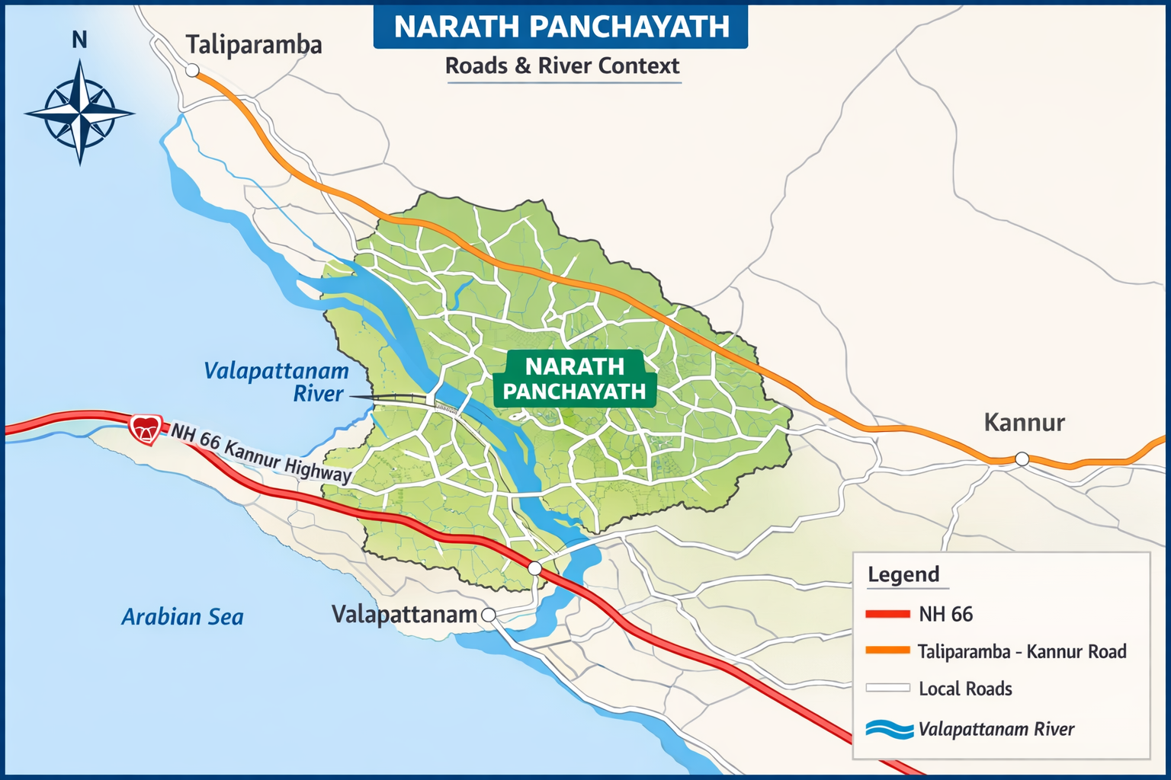

- Major establishments with geospatial mapping

1. HEALTHCARE FACILITIES
- Family Health Centre (FHC), Narath
- Ayurveda Dispensary
- Homeopathy Dispensary
- Private Clinics:
  - Darul Hasanath
  - Afiya Clinic

2. EDUCATIONAL INSTITUTIONS
- 16 Schools
- 24 Anganwadis
- Nursing College (Ward 14)

3. RELIGIOUS & COMMUNITY GATHERING PLACES
- Religious buildings (4)
- Community halls (3)
- Auditoriums (3)

4. MARKET & COMMERCIAL AREAS
- Kannadiparamba town area
- Local markets

5. ADMINISTRATIVE & EMERGENCY SERVICES
- Panchayath Office (Control Room)
- Police Station
- Fire Station
- Veterinary Dispensary

6. VULNERABLE SUPPORT FACILITIES
- Destitute home (Ward 14)
- Anganwadis (nutrition support)

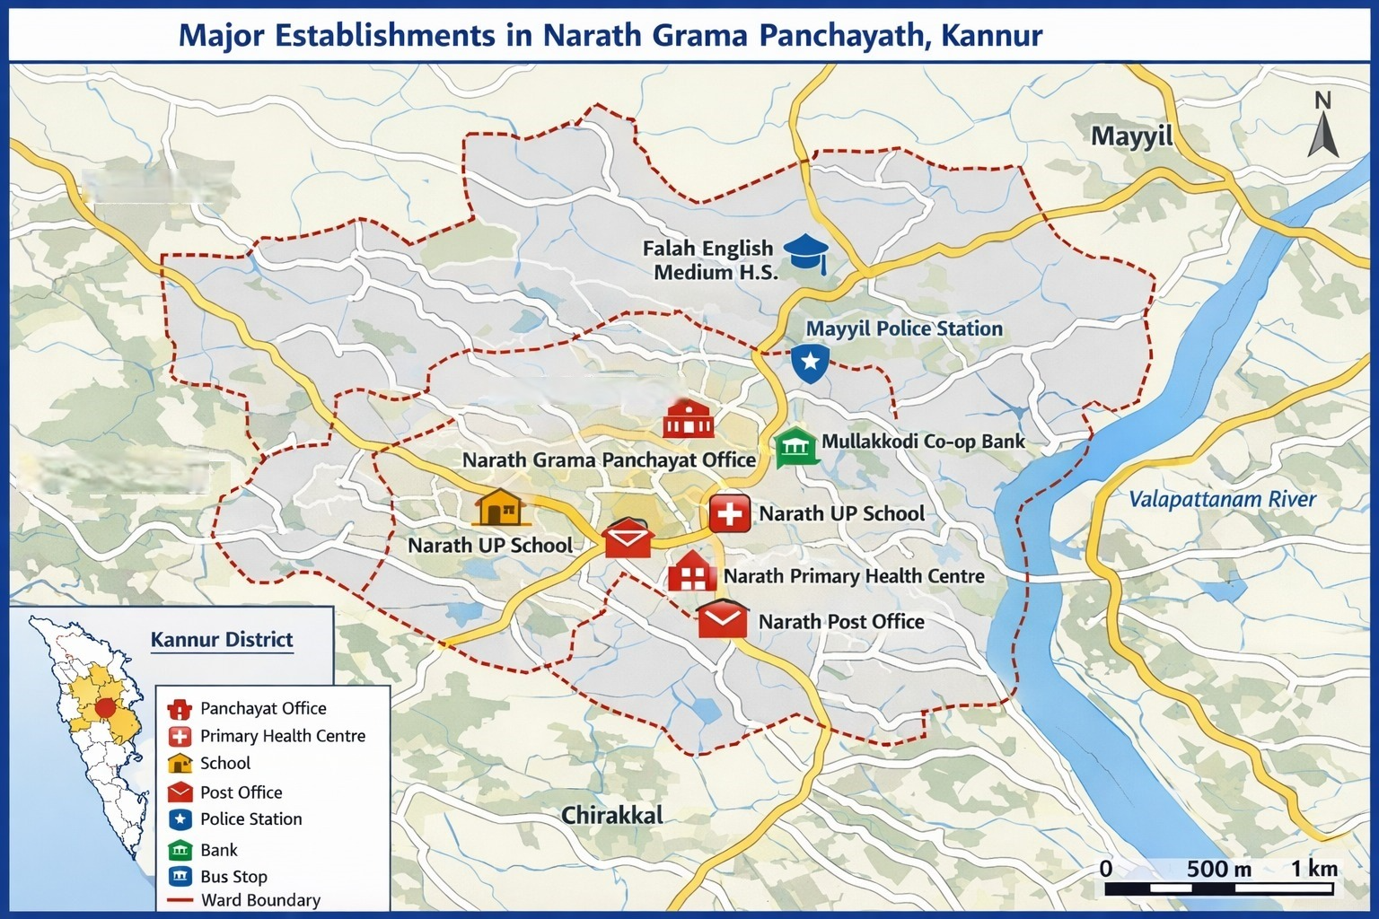

Occupational groups, socio cultural groups, migration & mobility patterns

High Exposure Occupations (Disease & Environmental Risk)
Category | Ward Coverage | Risk Type | Public Health Concern
Daily wage / migrant workers | Wards 1–18 (484 persons) | High mobility | TB, vector-borne diseases
Agricultural workers (wetland areas) | Wards 3, 4, 5, 15 | Water exposure | Leptospirosis
Sanitation workers | All wards | Waste exposure | Hepatitis, Lepto
Fish handling / wet market workers | Local market area | Animal contact | Zoonotic diseases
Construction workers | Growth pockets | Injury + migration | Occupational hazards

- Vulnerability mapping

🔴 HIGH VULNERABILITY ZONES

📍 Wards: 5, 14, 12, 15, 4, 3, 1–18 (specific groups)

1. Environmental Vulnerability
- Flood-prone wards: 5, 14, 12
- Wetland proximity: 15, 4, 3, 5

2. Population-Based Vulnerability
- Elderly: 7028
- Children: 2274 (<5 years)
- Pregnant women: 288

3. Clinical Vulnerability
- Diabetes: 2481
- Hypertension: 2641
- TB patients: 11
- Bedridden: 60

4. Socio-economic Vulnerability
- BPL families: 5547
- Migrant population: 483
- Daily wage workers: high exposure group
These wards and populations are at highest risk of disease occurrence, rapid transmission, and severe outcomes, especially during floods and outbreaks.

🟠 MODERATE VULNERABILITY ZONES

📍 Wards: 6, 9, 10, 11, 8, 16

Characteristics:
- Moderate disease burden
- Near high-risk zones → spillover risk
- Mixed occupational exposure

🟡 LOW VULNERABILITY ZONES

📍 Wards: 2, 7, 13, 17, 18 (comparatively lower exposure pockets)

Characteristics:
- Lower environmental exposure
- Lower clustering of cases

ENVIRONMENTAL VULNERABILITY LAYER (VERY IMPORTANT)
Risk Factor | High-Risk Wards | Disease Link
Flooding | 5, 14, 12 | Leptospirosis
Wetlands | 3, 4, 5, 15 | Dengue, Lepto
Water contamination | 5 | Hepatitis A

OCCUPATIONAL VULNERABILITY
Group | Risk
Agricultural workers | Leptospirosis
Migrant workers | TB, vector diseases
Sanitation workers | Hepatitis
Fish handlers | Zoonotic

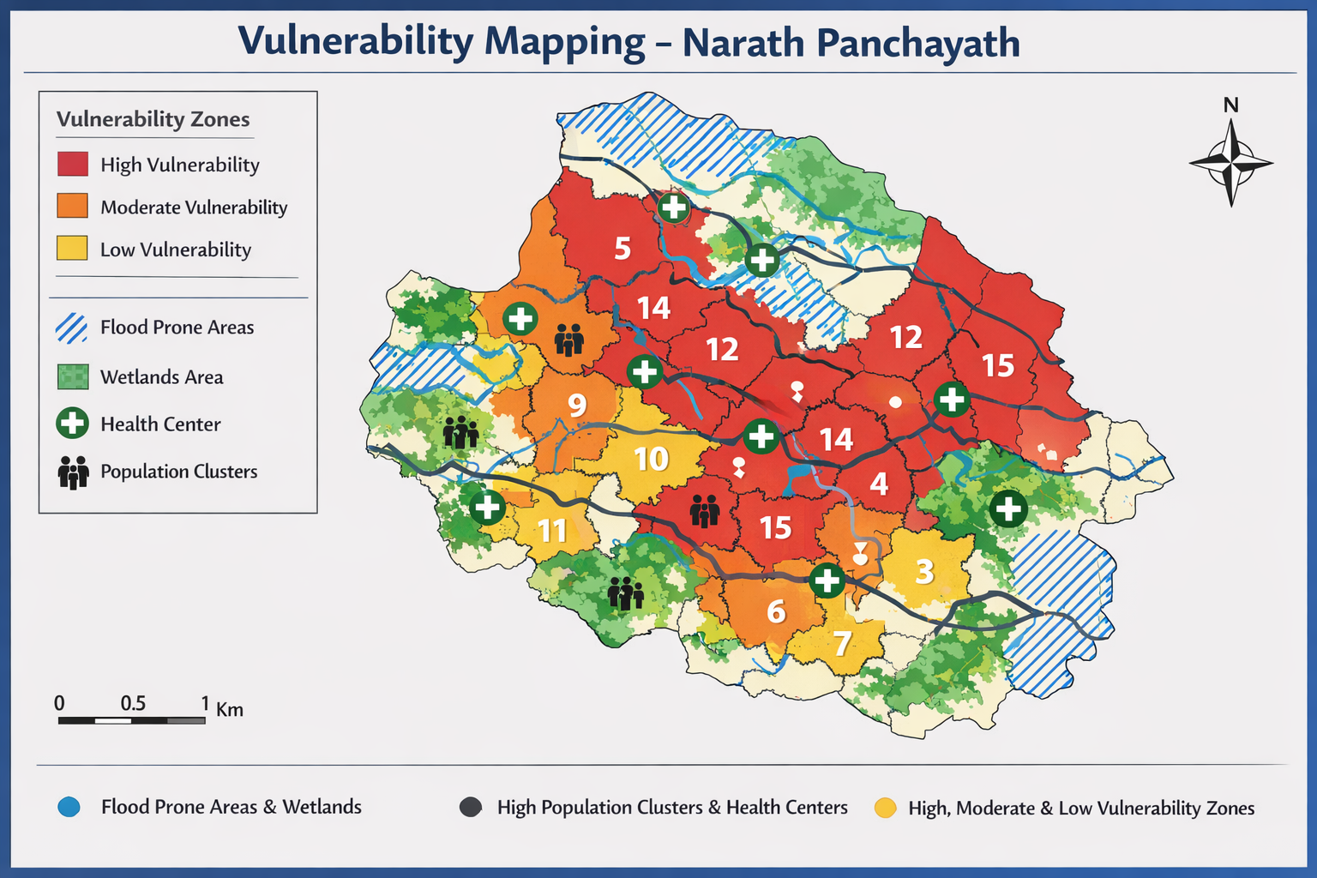

- Disaster prone areas (geographic vulnerability)

FLOOD-PRONE AREAS (PRIMARY HAZARD)

High-Risk Wards:
- Ward 5
- Ward 14
- Ward 12
Characteristics:
- Low-lying terrain
- Poor drainage / water stagnation
- River overflow during monsoon

2. WETLAND & WATERLOGGING ZONES

High-Risk Wards:
- Ward 3, 4, 5, 15

Characteristics:
- Paddy fields
- Standing water
- High mosquito breeding

3. RIVER BASIN VULNERABILITY

Area:
- Along Valapattanam River corridor

📍 Risk Features:
- Seasonal flooding
- Bank erosion (localized)
- Water contamination risk

5. LOW / NO RISK AREAS
- No landslide-prone areas reported
- No major industrial hazard zones
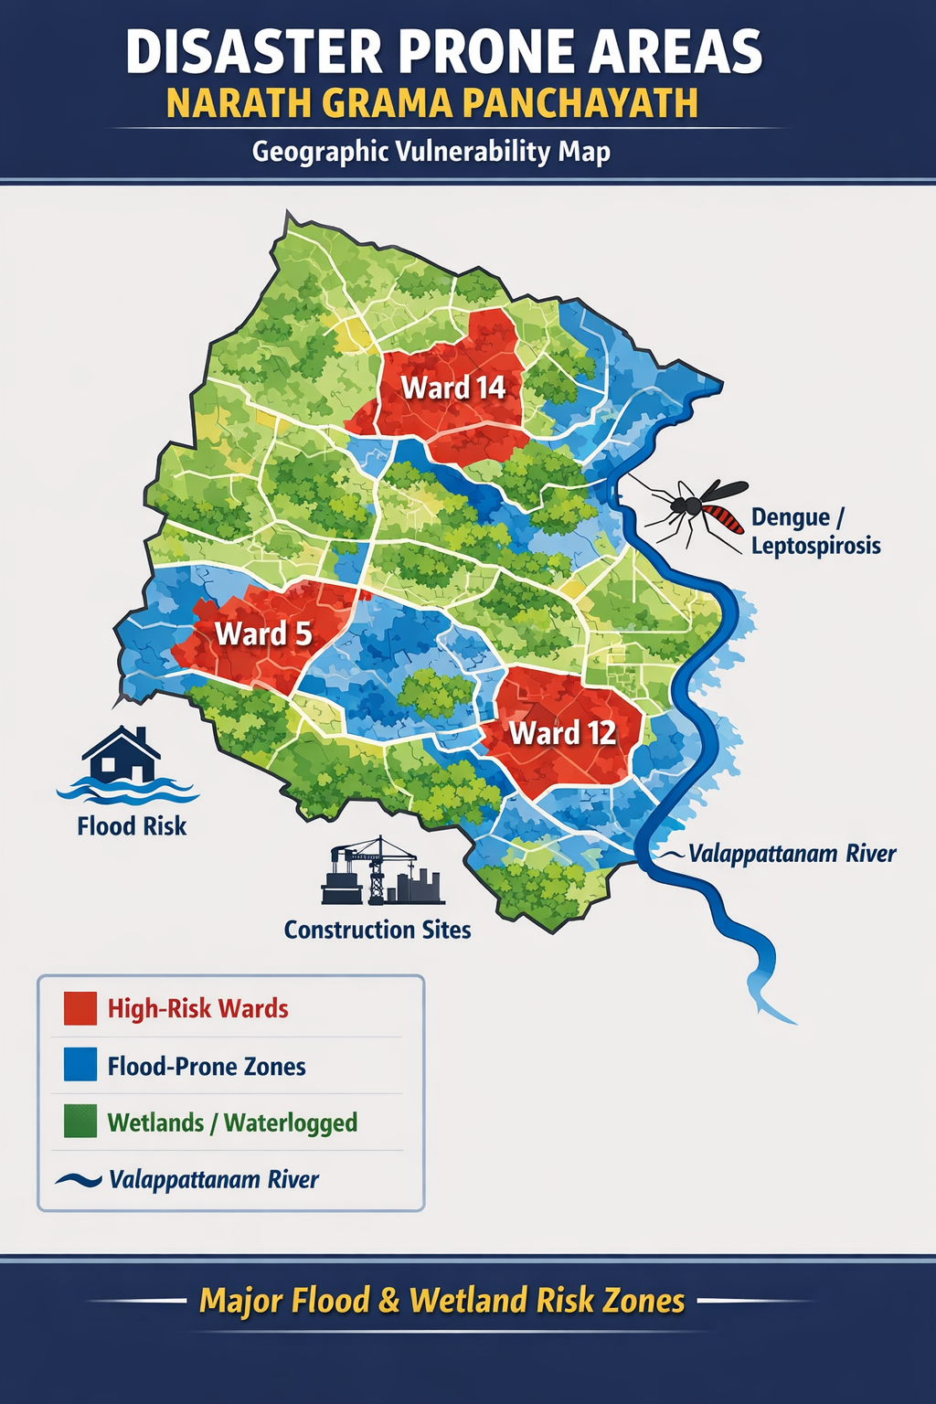

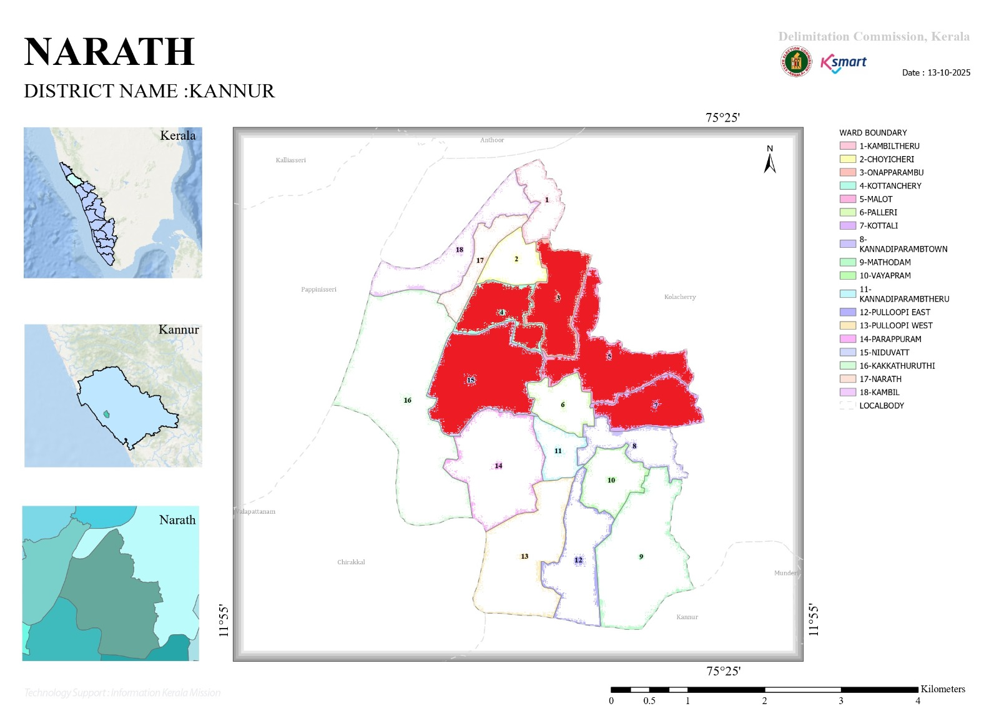

INTEGRATED HEALTH INFRASTRUCTURE MAP OF NARATH PANCHAYAT

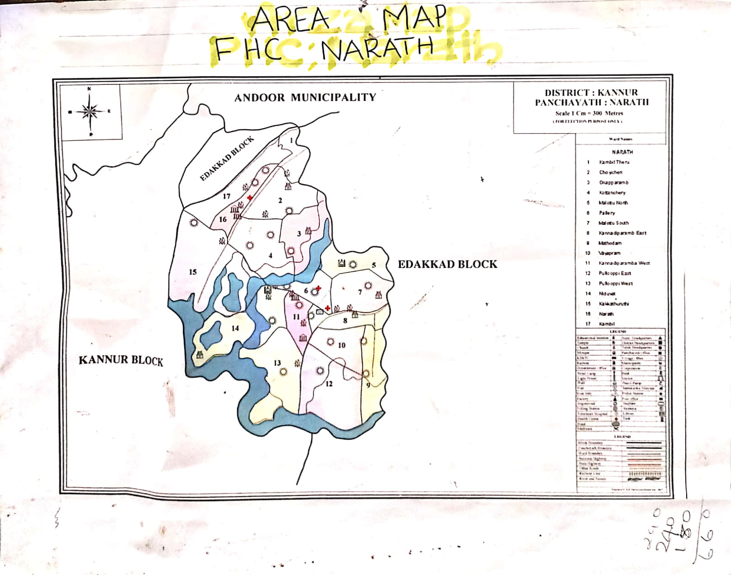

Disease hotspot Map

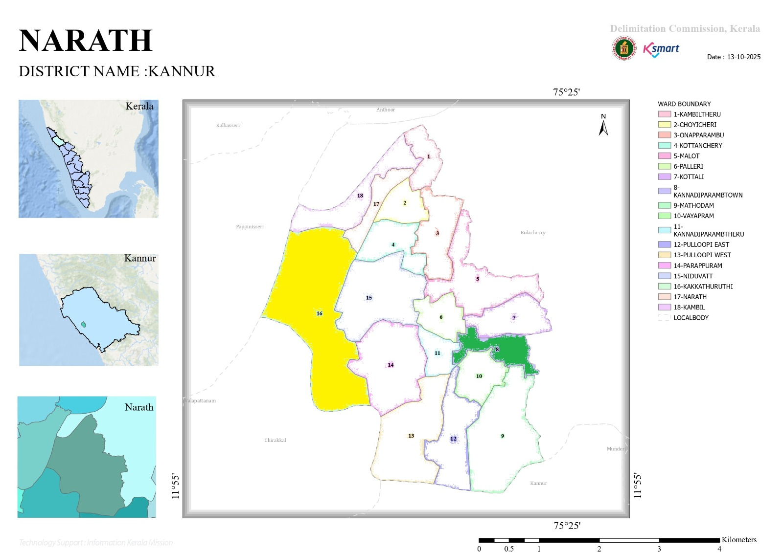

Index- yellow- leptospirosis hotspot , green- scrub typhus hotspot

GENERAL PROFILE OF THE LSGI’S

Background of the LSGI
Narath Grama Panchayat is situated in the Kannur District of Kerala and functions as a Local Self Government Institution (LSGI) under the decentralized governance system of the state. The Panchayat is predominantly rural in character, with a mix of residential settlements, agricultural lands, and small commercial establishments. Paddy cultivation, coconut farming, and other agricultural activities form an important part of the local economy, along with small-scale businesses and service-sector occupations.
Geographically, the Panchayat comprises low-lying areas interspersed with residential clusters and agricultural fields. The region experiences a tropical monsoon climate with heavy rainfall during the monsoon season, which influences agriculture, transportation, and public service delivery. Seasonal variations, especially during monsoon months, may pose challenges related to waterlogging, vector-borne diseases, and accessibility to certain areas.
The Panchayat delivers essential civic services including drinking water supply, sanitation, waste management, primary healthcare support, and implementation of various state and central government welfare schemes. As an LSGI, Narath Grama Panchayat plays a vital role in community development, public health planning, disaster preparedness, and coordination with health institutions such as Family Health Centres and other grassroots-level departments.
With active participation of elected representatives, ward members, and community-based organizations, the Panchayat continues to work towards sustainable development, improved public health outcomes, and enhanced quality of life for its residents.

Table 1: Background of LSGD
Description | Details
Name of LSGI | NARATH
Type (GP/Municipality / Corporation etc.) | Grama Panchayath
Block | KALLIASSERI
District | KANNUR
Number of wards | 18
Total area (sq. km) | sq km
Population(Projected) | 33063
Population density | persons/sq km
Terrain (coastal/low-lying/backwaters/foothills, etc.) | low-lying
Number of rivers passing through LSGI | 1
Number of water bodies in the LSGI | 6
Number of educational institutions | 16
Factories / small-scale industries | 5
Flood-prone wards | 5
Landslide-prone wards | 0
Death Management and Disposal Facilities (mortuaries/crematorium, including electric) | 2
Auditoriums/Marriage halls/convention centres/community halls | 6

Demographic and Vulnerable Population

Understanding the demographic composition and vulnerable population groups is essential for pandemic preparedness. Children, elderly, economically deprived families, migrant workers, and socially vulnerable groups are at increased risk during public health emergencies due to higher exposure, limited access to services, and dependency on public systems..

Description |  | Details (in numbers)
DEMOGRAPHIC PROFILE
Total population |  | 33063
Male |  | 15756
Female |  | 17310
Transgender |  | 0
Children under 5 |  | 2274
Adolescent |  | 6281
Elderly (>60) |  | 7028
SOCIAL/LIVELIHOOD VULNERABILITY
Previous EPEP family |  | 49
BPL family |  | 5547
Tribal communities |  | 0
Migration | Immigrant | 483
Migration | Emigrant | 3417
Socio-economically deprived |  | 42
Fisherfolk |  | 158
SC Community |  | 1654
ST Community |  | 21

Graphs: Population pyramid (if possible) for seeing if your LSGI has a high "dependency ratio" (lots of children and elderly compared to working adults).

Clinical Vulnerability
Certain population groups needs priority healthcare & are at higher risk of severe illness, complications, and mortality during pandemics. Patients with chronic diseases, those requiring regular medical care, and individuals with mobility or functional limitations face challenges in accessing timely care during emergencies. Mapping these groups helps in prioritizing continuity of treatment, medicine stock planning, oxygen support, referral transport, and targeted home-based care.
Description | Details in numbers
Pregnant women | 288
Lactating mothers | 515
Bedbound patients | 60
Patients under palliative care other than bedbound | 98
Patients on Haemodialysis | 22
Patients on CAPD | 4
Cancer patients (currently on treatment) | 17
Haemophilic patients | 0
Mentally challenged | 125
Differently abled | 78
Diabetic patients | 2481
Hypertensive patients | 2641
TB patients | 11

Major Festivals & Events specific to the LSGI
(with the possibility of a public gathering)

Sl. No. | Name of festival | Month detailing the periodicity
1 | valluvan kadavu muthappan temple | january
2 | muchilottukavu temple | january
3 | kannadiparamba siva temple | february
4 | kannadiparamba darma sastha temple | march
5 | kambil mandapam | april
6 | kannadiparamba mandapam | april

INFRASTRUCTURE & RESOURCE INVENTORY

Health Facility Directory & Basic Capacity in the LSGD

This section provides an overview of the healthcare infrastructure available within the LSGD area. It outlines the distribution and basic capacity of health facilities that form the backbone of service delivery during routine times and public health emergencies.

Family Health Centres (FHCs) and Community Health Centres (CHCs) generally function as the first point of contact for the community, providing essential outpatient and inpatient services. General Hospitals (GH) and Medical College Hospitals (MCH), where accessible, serve as the main referral centres for advanced diagnostics, specialist care, and critical services during public health emergencies. This inventory helps identify existing strengths, gaps, and potential surge capacity that can be mobilised during a pandemic or disaster.

Table 5. Health Facility Resource Summary
Sl.no. | Health Facility | Type of Facility (MCH/GH/CHC/FHC/SC etc.) | Contact Number | Total beds | ICU Beds | Oxygen-Supported Beds | No. of Ventilator Support Beds | No. of ambulances
Government Healthcare Facilities
1 | FHC NARATH | FHC | 04602243777 | 2 | 0 | 0 | 0 | 1
AYUSH
1 | AYURVEDA DISPENSARY | DISPENSARY | 04972796111 | 0 | 0 | 0 | 0 | 0
2 | HOMEOPATHY | DISPENSARY | 9387819525 | 0 | 0 | 0 | 0 | 0

Private Clinics
Private clinics are an essential part of pandemic preparedness, as they are often the first place people seek care when symptoms begin. In many communities, private clinics manage a significant share of outpatient visits and therefore play a critical role in early case detection, timely referrals, and disease surveillance. Having an up-to-date understanding of where these clinics are located, the services they provide, and how they are linked to the public health system helps ensure that no cases are missed during an outbreak. It also allows health authorities to engage private practitioners more effectively for reporting, risk communication, and coordinated response, strengthening the overall capacity of the health system to manage public health emergencies.

Table 6. Private Clinic Resource Summary
Sl No. | Name of Clinic | Registered (Y/N) | Clinic (General / Speciality) | Speciality (if any) | Address | Contact Number | Diagnostic Facility (Y/N) | Ambulance Linkage (Y/N)
1 | DARUL HASANATH | YES | GENERAL | NO | KANNADIPARAMBA | 04972797702 | YES | YES
2 | AFIYA | YES | GENERAL | NO | NIDUVATTU ,KANNADIPARAMBA | 09947049204 | YES | YES

Healthcare Education & Training Institutions

This section tracks the educational infrastructure available, which is vital for human resource planning in the health sector.

Category of Institution | Govt | Private | AYUSH | Total
Medical Colleges | 0 | 0 | 0 | 0
Nursing Colleges | 0 | 1 | 0 | 0
Dental Colleges | 0 | 0 | 0 | 0
Para-medical / Allied Health | 0 | 0 | 0 | 0
Pharmacy Colleges | 0 | 0 | 0 | 0

Specialized Services & Emergency Inventory
This section provides a detailed view of the specialized medical resources available to the community, focusing on emergency response and critical care capabilities. This table tracks the vital assets required for managing severe illnesses and emergencies across Government, Private, and AYUSH sectors.

Item | Govt | Private | AYUSH | Total
Hospital beds | 0 | 0 | 0 | 0
Oxygen-generating systems(Y/N) | 0 | 0 | 0 | 0
Oxygen-supported beds(Numbers) | 0 | 0 | 0 | 0
Ventilator-supported beds | 0 | 0 | 0 | 0
ICU beds | 0 | 0 | 0 | 0
Burns units | 0 | 0 | 0 | 0
Blood centres | 0 | 0 | 0 | 0
BLS ambulances | 1 | 1 | 0 | 2
ALS ambulances | 0 | 0 | 0 | 0
Dialysis facilities | 0 | 0 | 0 | 0
Dispensaries | 1 | 2 | 2 | 5
Medical store | 0 | 6 | 0 | 0
Industrial establishments(Medium-scale industries/small-scale industries establishments to whom we can depend in a worst-case scenario) | 0 | 0 | 0 | 0

Oxygen & Diagnostic Capacity
Monitoring oxygen and diagnostic capacity is a critical component of public health preparedness, ensuring that the LSGD can handle both chronic care and sudden surges in respiratory or infectious diseases.
Name of Health Facility | Oxygen-generating System (Y/N) | Backup Oxygen Source (Y/N) | Diagnostic Facilities Available(Y/N)
Name of Health Facility | Oxygen-generating System (Y/N) | Backup Oxygen Source (Y/N) | Lab | USG | X-ray | CT/MRI | RT-PCR
Government Healthcare Facilities
PHC NARATH | 0 | Y | Y | N | N | N | N

Diagnostics facility mapping at the LSGI level

The diagnostic capacity of Narath G.P represents the "intelligence network" of our healthcare system. The speed and accuracy of disease identification depend entirely on the distribution and technical level of these facilities.

Item | Govt | Private | AYUSH | Total
General labs | 1 | 12 | 0 | 13
Microbiology labs | 0 | 0 | 0 | 0
RT-PCR labs | 0 | 0 | 0 | 0
USG units | 0 | 0 | 0 | 0
CT/MRI units | 0 | 0 | 0 | 0
Research labs | 0 | 0 | 0 | 0
Labs of other departments that can be repurposed | 0 | 0 | 0 | 0

Laboratory Identification & Basic Details
Sl. No. | Name of Laboratory | Ownership (Govt / Private / Academic) | Address | Contact No. | 24×7 Services (Yes/No) | NABL / Govt Approved (Yes/No)
1 | fhc narath | gov | FHC narath | 04602243777 | no | yes
2 | neethi lab | priv | narath | 092880 07830 | no | yes
3 | neethi lab | private | kambil | 092880 07830 | no1 | yes
4 | noble | private | narath | 097784 48485 | no | yes
5

Social and Community Infrastructure for surge plan
This table serves as our logistics and shelter inventory. By mapping these locations, quickly we can identify where to house displaced citizens, where to set up temporary medical clinics, and how to manage the deceased with dignity during a crisis.

Category | Total Count | Ward | Est. Capacity (Persons) | Contact details
Educational Institutions
Anganwadis | 24 | 1to 18 | 150 | 9746842481
Schools | 16 | 2,4,15,7,14,13,12,9 | 500 | 9495796127
Colleges | 0 | 0 | 0 | 0
Healthcare Educational Institutions
Medical colleges (Govt/Private) | 0 | 0 | 0 | 0
Nursing colleges (Govt/Private) | 1privet | 14 | 254 | 9447643122
Dental colleges (Govt/Private) | 0 | 0 | 0 | 0
Paramedical institutes (Govt/Private) | 0 | 0 | 0 | 0
Community Gathering Spaces
Community halls | 3 | 12,15, | 700 | 9946461232
Auditoriums | 3 | 8,2,10, | 1500 | 9946461232
Religious buildings | 4 | 9,3, | 1000 | 9946461232
Vulnerable Group Support Facility
Destitute homes | 1 | 14 | 50 | 0
Elderly homes | 0 | 0 | 0 | 0
LSGD owned other buildings | 2 | 6 | 50 | 0497 279 6214
Mass Fatality Management (MFM) Infrastructure
Mortuary | 0 | 0 | 0 | 0
Crematorium | 2 | 9,13 | 20 | 9946461232
*refer annexure 1 for contact details

Human resources
This section focuses on the human capital available within the LSGI. In any emergency—be it a pandemic, flood, or industrial accident—infrastructure is only as effective as the people operating it.
Medical & Clinical Personnel
This table tracks the "Frontline" providers responsible for diagnosis, treatment, and clinical management. Narrative sentence: eg., "Total health workforce: 450 personnel, with 60% in government facilities serving as primary surge capacity." A detailed directory with the contact numbers of all workers is maintained (Annexure in 1).

Cadre | Govt (No.) | Private (No.) | Total
Doctors—Modern Medicine | 1 | 3 | 4
Doctors – AYUSH | 1 | 0 | 1
Doctors – Veterinary | 1 | 0 | 0
Doctors – Dental | 0 | 2 | 2
Nursing officers | 2 | 5 | 7
Lab technicians | 1 | 21 | 22
Optometrist | 0 | 0 | 0
Pharmacists | 2 | 7 | 9
Psychologists | 0 | 0 | 0
Counsellors | 1 | 0 | 0

Public Health & Field-Level Workforce
These individuals are the backbone of surveillance, maternal-child health, and decentralized care.

Cadre | Health services | Municipal common services | Total
HS (Health Supervisors) | 1 | 0 | 1
HI (Health Inspectors) | 0 | 0 | 0
LHS (Lady Health Supervisor) | 0 | 0 | 0
LHI (Lady Health Inspectors) | 0 | 0 | 0
JPHN (Jr Public Health Nurses) | 4 | 0 | 4
JHI (Jr Health Inspectors) | 3 | 0 | 3
MLSP (Mid-Level Service Providers) | 4 | 0 | 4
Palliative Nurses | 1 | 0 | 1
RBSK Nurses | 0 | 0 | 0
PRO | 1 | 0 | 1
Epidemiologist | 1 | 0 | 1
Data Manager | 1 | 0 | 1

Community & Support Cadre

This group represents the surge capacity of the LSGI people who can be called upon for logistics, rescue, and specialized support.

Cadre | Number
ASHA Workers | 20
AWW (Anganwadi Workers) | 48
Emergency Medical Volunteers (Trained) | 0
Kudumbashree | 188
MNREGS | 21
Purusha Swayam Sahaya Sangham | 0
Ex-Servicemen | 4
Retired Police Officers | 4
NCC/NSS Volunteers | 22
Red Cross volunteers | 20
One Health Community Volunteers | 0
One Health Community Mentors | 0

Community Organizations

This section details the presence of community-based organisations (CBOs), non-governmental organisations (NGOs), faith-based organisations (FBOs), Kudumbashree Self-Help Groups (SHGs), and Ayalkootams within the Local Self-Government Institution (LSGI). These groups enhance grassroots mobilization, resource distribution, and support networks crucial for pandemic response and community resilience.

Category | Total Count
NGOs | 4
Religious based organizations | 3
Foreign based organizations | 1
Sports Club/youth clubs | 24
Kudumbashree SHGs | 12
Ayalkootams | 188
Political organizations | 3
Residential organizations | 0

Administrative & Emergency Services
This section outlines the availability of key non-health emergency support services and infrastructure within the LSGI, which are essential for effective pandemic preparedness and response. These facilities support law enforcement, disaster response, water supply, logistics, mobility, and community-level interventions during public health emergencies.

Category | Total Count | Contact details
Police Stations | 1 | 0497 276 3337
Fire & Rescue Stations | 1 | 0497 270 6900
Water Pumping Points | 4 | 0497 270 0141
Public Distribution System (PDS) | 6 | 196714404

Information regarding resources
The availability of essential transport and support resources plays a quiet but critical role in saving lives. Equipment such as ambulances, mobile mortuaries, amphibian ambulances, and motorized boats ensures that patients, samples, and healthcare teams can move swiftly even in flooded, remote, or difficult terrains. Heavy vehicles like JCBs, cranes, tractors, and torus lorries support logistics, waste management, emergency infrastructure, and rapid conversion of spaces into care or isolation facilities. Taxis, four-wheel-drive vehicles, and trucks help maintain continuity of essential services, reach vulnerable populations, and support home-based care and supply delivery.

Means of transportation | Total Count
JCB | 0
Crane | 0
Heavy Trucks | 0
Tractor | 0
Ambulances | 1
Mobile mortuaries | 0
Boats | 0
Taxi service | 0
Note: For specific details regarding vehicle owners and contact information, please refer to Annexure [X].

ONE HEALTH & ENVIRONMENTAL SURVEILLANCE
The One Health method integrates environmental, animal, and human health to enable proactive pandemic preparedness. Panchayat-level surveillance needs to be improved in order to detect and treat zoonotic and environmentally generated diseases early. Surveillance is strengthened through systematic assessment of animal populations, veterinary infrastructure, poultry and slaughter facilities, inter-sectoral coordination, and specialised tools like avian influenza seasonality mapping using GIS in previous outbreaks to enable predictive alerts and ward-specific sampling to support effective pandemic preparedness in high-risk areas like .

Animal & Bird Population
Mapping animal and bird populations at the Panchayat level is essential for identifying and prioritising zoonotic disease hazards like rabies, avian influenza (H5N1), leptospirosis, anthrax, and Nipah-like spillover occurrences. Risk classification, targeted surveillance, vaccination planning, and early epidemic detection made feasible by comprehensive population mapping all enhance One Health-based pandemic preparedness.

Category | Item | Estimated Population | Wards
Animal Population | Livestock (Cattle/Goats/Buffalo) | 54 | 1to18
Animal Population | Pet Animals (Dogs/Cats) | 61 | 1to18
Animal Population | Stray Dog Population | 21 | 1to18
Animal Population | Pig Farms (Number of heads) | 0 | 0
 | Small Units (Sheep / Goats – clustered) | 0 | 0
Bird Population | Poultry Units (Birds) | 0 | 0
Bird Population | Poultry- (FOWL) | 0 | 0
Bird Population | Wild/Migratory Birds (Observed) | 50 | 9,12,3
Bird Population | Crow Mortality Events (Reported) | 2 | 3,2

The main risk of zoonotic diseases in Narath is concentrated in Ward 18., which is explained by the high density of cattle congregation areas and paddy fields. The stray dog population in market areas, fish landing sites, bus stations continues to be a substantial problem for rabies surveillance and bite prevention. There is a considerable risk of avian influenza introduction and amplification during November - December due to the seasonal presence of migratory and resident water birds near ponds/ canal / river / backwater / paddy field. Clusters of pig farms and animal shelters vulnerable to flooding further raise the risk of leptospirosis and other zoonoses mediated by the environment, especially during monsoon floods.

Veterinary Infrastructure
Veterinary institutions are a core pillar of One Health surveillance, enabling early zoonotic disease detection through vaccination, investigation of unusual animal illness or deaths, sample collection, and timely outbreak reporting. A well-mapped and responsive veterinary network strengthens coordination with human health and LSGI systems, ensuring rapid response during zoonotic events and pandemics.
Facility Type | Name of Facility | Ownership Govt / Pvt | Location(Ward No) | Contact number
Veterinary Dispensary | kannadiparamba | gov | 6 | 0497 279 7309
Veterinary Hospital / Polyclinic | 0 | 0 | 0 | 0
Private Veterinary Clinics | 0 | 0 | 0 | 0
Mobile / Emergency Vet Service (incl. night services) | 0 | 0 | 0 | 0
Pet Homes / Animal Shelters | 0 | 0 | 0 | 0
Slaughterhouse-linked Veterinary Inspection Unit | 0 | 0 | 0 | 0

Veterinary Doctors & Workforce
Early detection, diagnosis, reporting, and reaction to animal illness epidemics depend on the availability and accessibility of qualified veterinary specialists. By identifying unusual animal morbidity or mortality promptly, collecting samples promptly, and coordinating efficiently with human health and LSGI systems—especially during zoonotic outbreaks and pandemic-prone situations—a clearly defined veterinary workforce enhances One Health surveillance.

Category | Number Available | Type (Govt/Pvt) | Contact number
Government Veterinary Doctors | 1 | gov | 9400710581
Private Veterinary Doctors | 0 | 0 | 0
Livestock Inspectors | 1 | gov | 9188511634
Para-veterinary Staff / Attenders | 0 | 0 | 0
Contract / On-call Veterinary Support (if any) | 0 | 0 | 0

High-Risk Interface Points (Surveillance Sites)
High-risk interface points for zoonotic disease surveillance in narath Grama Panchayath include wetland–livestock–human contact zones, backyard poultry farms, cattle sheds near water bodies, fish markets, and areas of high human–animal interaction such as community slaughter points and migratory bird congregation sites. These are the primary surveillance sites where zoonotic spillover risks are elevated.

Type of Habitat | Type of High risk interface | Geographical vulnerability
Wetlands & Backwaters | 4 | wetland
Backyard Poultry Farms | 0 | 0
Cattle Sheds near Water Bodies | 4 | 0
Fish & Meat Markets | 0 | 0
Community Slaughter Sites | 0 | 0
Migratory Bird Congregation Areas | 3 | 0
Rodent-Infested Grain Storage | 0 | 0

Category | Total Count | Key Locations (wards)
Poultry Farms | 0 | 0
Backyard / Clustered Poultry Units | 0 | 0
Duck Rearing Units (open water access) | 0 | 0
Slaughterhouses/ Slaughter Points | 0 | 0
Meat/Fish Markets | 0 | 0
Live Bird Sale Points | 1 | 0
Cattle Markets / Weekly Animal Fairs | 0 | 0
Pet Shops / Breeders | 1 | 0
Animal Shelters / Pet Homes | 0 | 0
Waste Disposal Sites near Animal Units | 0 | 0

Environmental Risk Mapping
Environmental risk mapping identifies monsoon/flood hotspots for vector-borne (dengue, chikungunya), water-borne (leptospirosis, diarrhoea), and zoonotic diseases in Kerala's wetlands. Systematic surveillance supports early warnings, targeted interventions, and Panchayat pandemic preparedness.
Waterborne exposure: Flood-prone areas and stagnant water bodies facilitate leptospira survival, raising leptospirosis risk.

Traditional practices: Informal slaughter and fish markets lack standardized hygiene, creating spillover opportunities.

Risk Factor | High-Risk Wards | Key Locations | Risk Level (High/Med/Low)
Flood-prone areas | 5,14,12 | valapattanam river | low
Water bodies/wetlands | 4 | valapattanam river | low
Solid waste accumulation | 0 | 0 | 0
Animal waste disposal issues | 0 | 0 | 0
Rodent infestation zones | 0 | 0 | 0
Industrial effluent discharge | 0 | 0 | 0
Construction sites / abandoned buildings | 2 | narath,kannadiparamba | low
Poor drainage/blocked canals | 0 | 0 | 0
Drinking water source contamination risk | 0 | 0 | 0

Disease Seasonality Mapping
1, Flooding & waterlogging → amplifies leptospirosis, malaria, diarrheal diseases.
2, Migratory bird influx (Nov–Feb) → avian influenza risk.
3, Mosquito breeding cycles → vector-borne disease peaks in monsoon.
4, Agricultural practices → close human–animal contact in paddy fields.

Disease | Peak Risk Season | Key Drivers | High-Risk Locations | Surveillance Focus
Avian Influenza | 0 | 0 | 0 | 0
Leptospirosis | 0 | 0 | 0 | 0
Dengue/Chikungunya | 0 | 0 | 0 | 0
Acute Diarrheal Diseases | 0 | 0 | 0 | 0
Rabies | 0 | 0 | 0 | 0
Anthrax (rare) | 0 | 0 | 0 | 0

Vulnerability Mapping
Vulnerability mapping pinpoints high-risk populations, occupations, and areas exposed via environment, livelihoods, socio-economics, and poor service access. Paired with environmental/seasonality mapping, it enables risk-based surveillance, targeted actions, and optimal resource use in One Health and pandemic planning.
Vulnerability Factor | High-Risk Wards | Key Groups / Locations | Risk Level
Flood-prone households | 2 | 5,14, | high
Wetland-adjacent communities | 4 | 15,4,3,5 | high
Backyard poultry / duck rearing households | 0 | 0 | low
Livestock-rearing households | 0 | 0 | low
Slaughterhouse & meat market workers | 0 | 0 | low
Fisherfolk & fish market workers | 0 | 0 | low
Sanitation workers | 0 | 0 | low
Daily wage / migrant workers | 484 | 1to18 | high
Elderly & chronically ill populations | 6242 | 1to18 | high
Pregnant Women | 228 | 1to18 | high
Children (schools, Anganwadi’s) | 6248 | 1to18 | high
Limited access to safe water & sanitation | 0 | 0 | low

EPIDEMIOLOGICAL TRENDS (2021–2025)

Disease surveillance is the systematic collection, analysis, and interpretation of health data for planning, implementation, and evaluation of public health practice. This section presents the disease surveillance profile of the LSGI based on routine reporting systems and outbreak investigations to identify priority diseases, seasonal patterns, and emerging public health threats.
Disease Burden among human beings(Last 5 Years)
Analysis of disease-wise data for the last five years helps identify persistent public health problems, emerging diseases, and changes in disease burden. This information supports prioritisation of prevention, preparedness, and response activities at the Panchayat level.

Disease | 2021 | 2022 | 2023 | 2024 | 2025 | Trend(Increasing/Stable/Decreasing)
Dengue | 7 | 0 | 1 | 26 | 11 | DECREASING
Leptospirosis | 0 | 0 | 0 | 6 | 3 | DECREASING
Hepatitis A | 0 | 0 | 0 | 2 | 8 | INCREASING
Malaria | 0 | 0 | 0 | 4 | 0 | DECRASING
Scrub Typhus | 0 | 0 | 0 | 0 | 1 | STABLE
Typhoid | 0 | 0 | 0 | 0 | 0 | NO CASE
H1N1 | 0 | 0 | 0 | 0 | 0 | NO CASE
H3N2 | 0 | 0 | 0 | 0 | 0 | NO CASE
ADD | 2 | 1 | 6 | 1 | 2 | DECREASING
Mumps | 12 | 14 | 8 | 4 | 4 | STABLE
Measles | 0 | 0 | 0 | 0 | 0 | NO CASE
Hepatitis B | 0 | 0 | 0 | 0 | 0 | NO CASE
Hepatitis C | 0 | 0 | 0 | 0 | 0 | NO CASE
Tuberculosis | 12 | 10 | 9 | 11 | 14 | INCREASING
Leprosy | 0 | 0 | 0 | 0 | 0 | NO CASE
COVID-19 | 21 | 0 | 0 | 0 | 0 | DECREASING

*(use the above table data to create the graph/diagram)

Seasonal Trend Analysis
Seasonal analysis helps anticipate surges (e.g. dengue in monsoon, leptospirosis after floods, influenza in cooler months) and plan pre‑emptive vector control, stockpiling of IV fluids, and awareness campaigns at Panchayat level.

DENGUE
Dengue is a major seasonal vector-borne disease strongly associated with rainfall, water stagnation, and increased mosquito breeding during the monsoon period.

Peak: July–November
Dengue – Ward-wise Yearly Distribution (2021–2025)

Ward | Dengue – Ward-wise Yearly Distribution
Ward | 2021 | 2022 | 2023 | 2024 | 2025 | Total
1 | 0 | 0 | 0 | 2 | 0 | 0
2 | 1 | 0 | 0 | 3 | 1 | 5
3 | 0 | 0 | 0 | 1 | 0 | 1
4 | 0 | 0 | 0 | 0 | 1 | 1
5 | 1 | 0 | 0 | 1 | 1 | 3
6 | 2 | 0 | 0 | 3 | 1 | 6
7 | 0 | 0 | 0 | 2 | 0 | 2
8 | 1 | 0 | 0 | 1 | 0 | 2
9 | 1 | 0 | 1 | 3 | 3 | 8
10 | 0 | 0 | 0 | 1 | 1 | 2
11 | 0 | 0 | 0 | 2 | 0 | 2
12 | 0 | 0 | 0 | 0 | 0 | 0
13 | 0 | 0 | 0 | 0 | 1 | 1
14 | 0 | 0 | 0 | 1 | 1 | 2
15 | 0 | 0 | 0 | 1 | 0 | 1
16 | 0 | 0 | 0 | 1 | 0 | 1
17 | 0 | 0 | 0 | 0 | 1 | 1
18 | 0 | 0 | 0 | 0 | 0 | 0

LEPTOSPIROSIS

Leptospirosis cases are closely linked to monsoon rains, flooding, and occupational exposure, particularly in low-lying and waterlogged areas.

Peak: June - August
Leptospirosis – Ward-wise Yearly Distribution (2021–2025)

Ward | Leptospirosis – Ward-wise Yearly Distribution
Ward | 2021 | 2022 | 2023 | 2024 | 2025 | Total
1 | 0 | 0 | 0 | 0 | 0 | 0
2 | 0 | 0 | 0 | 0 | 0 | 0
3 | 0 | 0 | 0 | 0 | 0 | 0
4 | 0 | 0 | 0 | 1 | 0 | 0
5 | 0 | 0 | 0 | 0 | 0 | 0
6 | 0 | 0 | 0 | 0 | 0 | 0
7 | 0 | 0 | 0 | 0 | 0 | 0
8 | 0 | 0 | 0 | 1 | 0 | 1
9 | 0 | 0 | 0 | 1 | 0 | 1
10 | 0 | 0 | 0 | 0 | 0 | 0
11 | 0 | 0 | 0 | 0 | 0 | 0
12 | 0 | 0 | 0 | 1 | 0 | 1
13 | 0 | 0 | 0 | 0 | 0 | 0
14 | 0 | 0 | 0 | 0 | 0 | 0
15 | 0 | 0 | 00 | 0 | 0 | 0
16 | 0 | 0 | 0 | 2 | 1 | 3
17 | 0 | 0 | 0 | 0 | 0 | 0
18 | 0 | 0 | 0 | 0 | 0 | 0

VIRAL HEPATITIS - A

Hepatitis A cases are commonly associated with unsafe drinking water, food contamination, and breakdowns in sanitation, often presenting as clusters or outbreaks.

Peak: October - December
Hepatitis A – Ward-wise Yearly Distribution (2021–2025)

Ward | Hep A – Ward-wise Yearly Distribution
Ward | 2021 | 2022 | 2023 | 2024 | 2025 | Total
1 | 0 | 0 | 0 | 0 | 0 | 0
2 | 0 | 0 | 0 | 0 | 0 | 0
3 | 0 | 0 | 0 | 0 | 0 | 0
4 | 0 | 0 | 0 | 0 | 0 | 0
5 | 0 | 0 | 0 | 0 | 5 | 5
6 | 0 | 0 | 0 | 0 | 1 | 1
7 | 0 | 0 | 0 | 0 | 0 | 0
8 | 0 | 0 | 0 | 1 | 0 | 1
9 | 0 | 0 | 0 | 0 | 0 | 0
10 | 0 | 0 | 0 | 0 | 0 | 0
11 | 0 | 0 | 0 | 0 | 0 | 0
12 | 0 | 0 | 0 | 0 | 0 | 0
13 | 0 | 0 | 0 | 0 | 0 | 0
14 | 0 | 0 | 0 | 0 | 0 | 0
15 | 0 | 0 | 0 | 0 | 0 | 0
16 | 0 | 0 | 0 | 0 | 2 | 2
17 | 0 | 0 | 0 | 0 | 0 | 0
18 | 0 | 0 | 0 | 0 | 0 | 0

Outcome-Based Trend Analysis- 2025

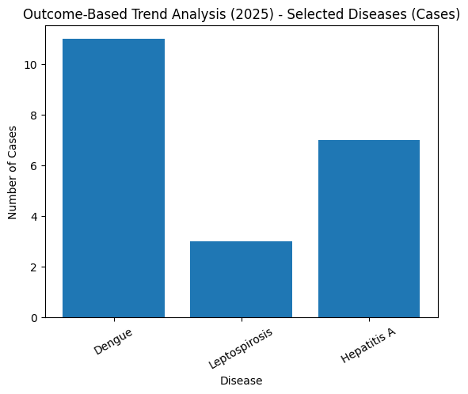

Transmission Trend- 2025

For effective management of public health issues, it is important to track the trend of disease transmission mode. It helps identify the population or place at high risk that can be used to predict outbreaks and implement targeted interventions as quickly as possible. Understanding these kinds of trends enables authorities to allocate resources efficiently and change the strategies adequately based on the trend that follows.

Mode of Transmission | No. of cases | No. of Deaths
Vector Borne Diseases | 11 | 0
Water Borne Diseases | 2 | 0
Air Borne Diseases | 14 | 3
Blood Borne Diseases | 0 | 0
Food Borne Diseases | 0 | 0

Vector-Borne Disease

Disease | No. of Cases | No. of Deaths
Dengue | 11 | 0
Malaria | 0 | 0
Chikungunya | 0 | 0

Water Borne Disease

Disease | No. of Cases | No. of Deaths
Cholera | 0 | 0
Typhoid | 0 | 0
Hep- A | 7 | 0
Dysentery | 0 | 0
Amoebiasis | 0 | 0
E- Coli infections | 0 | 0
Air Borne Disease

Disease | No. of Cases | No. of Deaths
Influenza | 0 | 0
H1N1 | 0 | 0
TB | 14 | 3
Chickenpox | 2 | 0
Measles | 0 | 0
Covid-19 | 0 | 0
Pertussis | 0 | 0
Mumps | 10 | 0

Blood-Borne Disease

Disease | No. of Cases | No. of Deaths
AIDS | 0 | 0
Hep- B | 0 | 0
Hep- C | 0 | 0

Zoonotic Disease

Disease | No. of Cases | No. of Deaths
Rabies | 0 | 0
Leptospirosis | 3 | 1
Avian influenza | 0 | 0
West nile | 0 | 0
Anthrax | 0 | 0
Nipah | 0 | 0
Scrub Typhus | 1 | 0

Integrated Disease Hotspot Map (2021–2025)

Index- yellow- leptospirosis, green- scrub typhus

Ward No | Dengue Total (2021-25) | Leptospirosis Total (2021-25) | Hepatitis A Total (2021-25) | Mumps (2021-25) | ADD (2021-25) | Total Cases
1 | 0 | 0 | 0 | 8 | 0 | 8
2 | 5 | 0 | 0 | 2 | 2 | 9
3 | 1 | 0 | 0 | 4 | 1 | 6
4 | 1 | 0 | 0 | 2 | 02 | 5
5 | 3 | 0 | 5 | 9 | 3 | 20
6 | 6 | 0 | 1 | 4 | 1 | 12
7 | 2 | 0 | 0 | 2 | 2 | 6
8 | 4 | 1 | 1 | 3 | 1 | 10
9 | 8 | 1 | 0 | 4 | 2 | 15
10 | 2 | 0 | 0 | 5 | 4 | 11
11 | 2 | 0 | 0 | 7 | 0 | 9
12 | 0 | 1 | 0 | 2 | 2 | 5
13 | 1 | 0 | 0 | 6 | 0 | 7
14 | 2 | 0 | 0 | 3 | 1 | 6
15 | 1 | 0 | 0 | 4 | 2 | 7
16 | 1 | 3 | 2 | 2 | 3 | 11
17 | 1 | 0 | 0 | 1 | 1 | 3

By overlaying five years of data, we have identified 2 'Red Zone' Wards. These are wards where Lepto recurred in consecutive years. Ward 18 and ward 8 is categorized as the Highest Priority Hotspot due to its combination of flood vulnerability and high vector density. Future health infrastructure, such as the proposed R.O plants at should be prioritized.

Preparedness and Response Protocol at LSG Level
This section describes the operational framework for the LSGI once a pandemic is declared. It explains how the LSGI and health system will move from routine data collection to active response, using a One Health approach.
Constitution of One Health Committee
The LSGD shall constitute a One Health Committee comprising the LSGI President, Medical Officers (Modern Medicine, AYUSH, and Veterinary), the Health Inspector, and the Veterinary Surgeon.

Objective: The One Health Committee coordinates human, animal, and environmental health to prevent and control pandemics.

Sl No | Name | Designation | Department/Institution | Role in Committee | Contact Number
1 | k rahmath | Panchayat President | LSGD | Chairperson | 9946461232
2 | anusree k p | Medical Officer (PHC/CHC) | Health Dept | Member Secretary | 8129656400
3 | rincy | Veterinary Officer | Animal Husbandry | Member | 9400710581
4 | Divya | Epidemiologist | Health Dept | Member | 7994260637
5 | Sreenivasan | Health Inspector/PHN | Health Dept | Surveillance | +9198476 96315
6 | Indhu | ASHA Supervisor | Health Dept | Community link | 94952 14876
7 | udaya | ICDS Supervisor | Social Welfare | Vulnerable groups | 9847318157
8 | Kannur rural circle | Police Station Officer | Police Dept | Law & order | 0497 276 3337
9 |  | Ward Councillor Representative | LSGD | Community coordination
10 | sheeja | Kudumbashree CDO | Kudumbashree | Community mobilisation | 9895406139
11 | Nil | NGO/Volunteer rep | Civil Society | Support services | nil
12 | sheeja | Line Department representations | PHC,AGRICULTURAL OFFICE,VETTINERY,KSEB,POLICE,KUDUMBASREE | Community mobilisation | 9895406139

Key Responsibilities:
- Review disease surveillance data (human + animal)
- Conduct ward-wise risk assessment and vulnerability mapping
- Approve quarantine/isolation centre locations
- Coordinate with district for resources (PPE, oxygen, ambulances)
- Periodically review health system surge capacity, including beds, oxygen, human resources, and ambulances.
- Approve and monitor risk communication and community engagement strategies, including rumour management.
- Ensure protection and service continuity for vulnerable groups (elderly, persons with disabilities, dialysis patients, coastal populations).
- Conduct quarterly mock drills
- Monitor equity measures for vulnerable groups
Meeting Schedule:

Quarterly (normal times) | Weekly (outbreak alert) | Daily (pandemic phase)
Pandemic Response Workforce
To ensure a coordinated and timely response during a pandemic, a dedicated Pandemic Response Workforce shall be constituted at the LSG level. The workforce will function under the overall supervision of the One Health Committee and in close coordination with the health authorities. Team-based deployment will enable efficient surveillance, case management, quarantine and isolation management, logistics support, and risk communication. Each team shall have a clearly designated team leader, defined roles, and an identified pool of personnel to allow rapid activation, rotation of duties, and continuity of services during prolonged emergencies.

Total Response Workforce Available: 300 persons

Team Name | Composition | Key Responsibilities | Team Leader
Surveillance and Contact Tracing Team | HI, JHI, JPHN, ASHAs and Volunteers | Case detection, contact listing, home visits, reporting | HI
Case Management Team | Doctors, Nurses, MLSP, Palliative Nurses | Patient care & referral | DOCTOR
Quarantine & Isolation Team | LSGD staff, Volunteers | Facility management | JHI
Psychosocial support
Logistics & supply chain Team | LSGD staff, Storekeepers, Drivers 3 | Supplies & transport [PPE, medicines, oxygen, transport, waste management] | Ward Member
Communication Team | Ward members, Kudumbashree, Youth clubs,  AWW workers and other self help groups | IEC, community meetings, countering misinformation | M.O in charge
Transportation | KSRTC, educational institutional buses | Transportation | HI
Media Surveillance | Ward members, HI, JHI, JPHN, ASHAs and Volunteers | IEC, community meetings | HI
Intersectoral coordination and convergence | HI, JHI, JPHN, ASHAs and Volunteers | IEC, community meetings, | HI
Collaborative surveillance | HI, JHI, JPHN, ASHAs and Volunteers | case detection | HI

All teams shall be activated immediately upon outbreak alert or pandemic declaration and shall report daily to the LSG Incident Commander/Medical Officer, with consolidated reporting to the Block PHC. Duty rosters and alternate personnel shall be maintained to ensure uninterrupted services during staff shortages or prolonged response periods. Team composition and numbers may be revised based on the magnitude of the outbreak and availability of human resources.

Activities and Measures before and during Pandemic

PHASE 1 - Alert / Preparation
Surveillance and Reporting-Enhanced syndromic surveillance:
- Data sources for surveillance:
- Event-based triggers (to be monitored and reported):
- Zoonotic and animal health surveillance
- Logistics and Stock Preparedness
  - Identify and empanel local vendors and define emergency procurement mechanisms in accordance with existing LSGD and Health Department norms.
  - Prepare and maintain an essential logistics checklist covering medical supplies, consumables, and support equipment.
  - Pre-identify secure storage locations for emergency stocks and ensure maintenance of stock registers with regular updating.
  - Finalise emergency transport arrangements, including availability of vehicles and identified drivers for rapid deployment during alerts.
  - Designate a Nodal Officer for Logistics to enable prompt decision-making, coordination, and communication during emergencies.
  - Conduct rapid stock verification and ensure availability of minimum buffer stock, including:
- PPE kits 200–300 numbers
● Pulse oximeters 20–30 numbers
- Hand sanitizers 50–100 litres litres
- Masks 5000–10000, gloves 20000–30000, disinfectants 25–50 units
- Identify critical gaps in logistics and immediately communicate requirements to the Block and District authorities for timely replenishment and support. Monitor expiry dates and stock rotation.

- Identification of Quarantine and Isolation Facilities
  - Identify and list suitable buildings for quarantine and isolation (schools, hostels, community halls, etc.).
  - Categorise cases as per the severity and allocate to appropriate facilities (for instance, severe cases to classrooms, mild cases to an assembly hall in case of a school).
  - Facility readiness checklist needed (beds, toilets, ventilation) etc.
  - Find an alternate site if the primary sites are not available or not in use.
  - Identify facility managers and support staff
  - Prepare basic SOPs for:
    - Admission and discharge
    - Food, water, sanitation
    - Infection prevention and waste disposal
  - Ensure availability of basic amenities: water, sanitation, electricity, ventilation, and waste disposal. Prepare a rapid activation plan for these facilities if case numbers increase.

- Risk Communication and Community Preparedness
  - Disseminate early warning messages on symptoms, preventive measures, and reporting mechanisms. Display IEC materials both in English and the local language in public places and ensure ward-level awareness.
  - Sensitize elected representatives and community leaders on preparedness measures.
  - Establish a rumour tracking and misinformation response mechanism to identify, verify, and promptly counter false or misleading information.
  - Engage trusted local persons (ward members, ASHA workers, religious leaders, teachers, community volunteers) to communicate official public health messages and reinforce correct practices.
  - Develop and deploy targeted IEC materials for:
    - Schools and educational institutions
    - Markets and commercial areas
    - Work sites and labour settings
  - Conduct community sensitization meetings at the ward level to promote preventive behaviors, address concerns, and strengthen community participation in preparedness and response.
- Protection of Vulnerable Groups
Vulnerable populations require priority protection through targeted line-listing, service continuity, and delivery mechanisms.
- Prepare and regularly update line-lists of vulnerable populations, including:
  - Elderly persons living alone
  - Persons with disabilities
  - Pregnant women
  - Migrant workers
  - Dialysis patients
The detailed line-lists shall be maintained as Annexure 1 and updated periodically.
- Clinical Dependency Mapping
Develop ward-wise dependency and vulnerability maps to identify households requiring regular support during emergencies. Ensure continuity of essential health services for vulnerable groups, including
- Dialysis services (facility mapping, transport arrangements, and scheduling)
- Continuity of treatment for TB, HIV, and other chronic conditions requiring uninterrupted medication
- Mental health and psychosocial support services
Establish delivery mechanisms for food, essential commodities, and medicines to vulnerable households through coordinated action involving ASHAs, JPHNs, Kudumbashree, volunteers, and local administration.

PHASE 2 - Active Response
- Case Identification and Contact Tracing
Case detection and contact tracing activities will be carried out in coordination with the Health authorities, following disease-specific SOPs and IDSP guidelines.
Field Staff Involved
- Health Inspector (HI)
- Junior Health Inspector (JHI)
- Junior Public Health Nurse (JPHN)
- ASHAs and ASHA Supervisors
- Ward-level volunteers and Kudumbashree members (as required)
- Screening Checkpoints
Screening checkpoints at high-traffic locations (transport hubs, markets, religious gatherings) for early detection of symptomatic travellers and crowd screening during outbreaks. Potential locations include bus stands, market entry points, and boat jetties, based on local context and risk assessment.
Screening activities will be carried out by trained personnel such as ASHAs, ward members, and volunteers, with support from Health Department staff. Necessary equipment, including non-contact thermometers and appropriate PPE, shall be ensured prior to activation.
Location | Type (Bus stand/Jetty/Market/Railway) | Staff Deployed (ASHAs/Volunteers) | Screening Method | Reporting authority
Bus stand | Transport hub | One JHI  One ASHA  One health Mentors | 1.Swab Collection.  2. Blood smears collection (RDT)  3.Thermal Scanners | Surveillance Nodal Officer in control room
Market entry | Market | One JHI  One ASHA  Male health volunteers | 1.Swab Collection.  2. Blood smears collection (RDT)  3.Thermal Scanners | Surveillance Nodal Officer in control room
Boat jetty | Water transport | One JHI  One ASHA  Male health volunteers | 1.Swab Collection.  2. Blood smears collection (RDT)  3.Thermal Scanners | Surveillance Nodal Officer in control room
Standard Screening Protocol

The screening protocol shall include temperature screening, observation for visible symptoms, and inquiry regarding recent travel or exposure history. Individuals identified as suspects during screening shall be immediately referred to the nearest PHC/FHC for further evaluation, testing, and appropriate action as per prevailing guidelines.
- Pandemic Control Room
The Pandemic Control Room (PCR) serves as the central nerve center for real-time coordination, data aggregation, decision support, and communication during outbreaks. It consolidates information from all LSGD teams, health facilities and community sources to enable rapid response decisions.

Control Room Infrastructure and Location
Primary Location: KANNADIPARAMBA Panchayath Office.
Backup Location: Community Hall in NARATH G.P.
Health System Control Room Framework
The PCR is organized into seven functional pillars to ensure no aspect of the response is overlooked:
- Rapid Response Team (RRT)
  - Provides immediate intervention during emergencies, clusters, and field alerts.​
  - Coordinates urgent actions such as case investigation, contact tracing, isolation, and inter‑facility referrals.
- Data Management & Analytics Team
  - Collects, validates, and manages key health system indicators (cases, tests, beds, HR, supplies).​
  - Analyzes data trends, generates projections, and supports evidence‑based decision‑making for local authorities.
- Human Resource Deployment Team
  - Allocates healthcare staff efficiently based on workload and need
  - Ensures adequate and equitable workforce distribution across facilities
- Laboratory Surveillance Team
  - Oversees diagnostic testing coordination, sample transport, and timely reporting of results.​
  - Monitors lab indicators (testing volume, positivity rate, turnaround time) for early detection of outbreaks
- Vaccination Cell (If Required)
  - Plans and executes vaccination campaigns, including micro‑planning and session scheduling.​
  - Tracks coverage, identifies gaps, and coordinates corrective actions with field teams and outreach services.
- Infrastructure & Patient Occupancy Team
  - Monitors facility capacity, earmarked beds, oxygen and critical care resources across all linked facilities.​
  - Ensures optimal patient distribution and referral management using updated bed‑status and resource data.
  - BMWM
- Communication team
- Logistics and supply chain
- Transportation (interfacility & emergency transport)
- Media surveillance Call centre
- Management of the deceased
- Intersectoral coordination and convergence
Key Control Room Team
The Control Room Team coordinates all pandemic response activities within the LSGD and serves as the single command and communication hub during activation. It integrates information, field actions, logistics, and policy execution across all participating departments and health facilities.

Role | Name | Designation | Contact Number | Responsibility
In-charge/Nodal Officer | Dr Rajeswari | Medical Officer | +91 98958 32402 | Overall coordination, decision-making, and reporting to the District level.
Data Entry Operator | Nirmala | Data entry | +91 94001 04853 | Managing the line list, updating dashboards, and tracking testing results.
Communication Officer | Arathy | JHI | +91 6282 947 574 | Handling the public helpline, coordinating ambulance dispatch, and contact tracing calls.
Logistics Coordinator | Valsala | JHI | 91 94972 97611 | handling logistics
Technical Support (IT/Data) | Sruthy | Data manager | 8075350904 | handling the IT/ data support

SOP for alert escalation/trigger point with mapping of responsibilities.
Key Points:
- The Control Room shall be staffed with a designated In-charge, data entry personnel, and communication staff with clearly defined roles and shift arrangements.
- It shall maintain updated records on daily monitoring indicators including new cases, persons under active quarantine, and hospital bed occupancy.
- All reports and situation updates shall be shared daily with the Block and District Surveillance Unit.
- The Control Room shall act as a single point of contact for coordination with response teams, health institutions, and other departments.
- Contact details of the Control Room shall be widely communicated to field staff and stakeholders during activation.
Daily Monitoring Indicators
To ensure timely decision-making and effective response, the following key indicators shall be monitored and updated on a daily basis by the Pandemic Control Room:
- Epidemiological Indicators:
New cases reported today, Total active cases, Test Positivity Rate (TPR), Case Fatality Rate (CFR)
- Surveillance Indicators:
Persons under home quarantine, High-risk contacts identified, Fever, ILI, SARI or other symptoms (syndromic surges), Travellers (symptomatic or high-risk arrivals),Animal husbandry surveillance (zoonotic alerts, unusual animal deaths, poultry/bird flu signals), Mortality surveillance (excess deaths, unexplained fatalities, verbal autopsy reports)
- Logistics and Infrastructure Indicators:
Hospital / CFLTC beds occupied, Oxygen cylinders/concentrators available, Ambulances on standby
- Alert Findings
The following table outlines category-specific trigger points (red flags) from surveillance indicators and corresponding immediate actions for the Pandemic Control Room. These enable rapid response to alert findings like testing anomalies, positive cases exceeding thresholds, clusters, and WGS reports.

Category | Trigger Pophint (Red Flag) | Immediate Action
Clusters | Geographical or facility-based: 5+ cases linked to one location (office, school, street). | Declare a micro-containment zone; perimeter control and active case finding.
Testing | Sudden drop in testing volume / delay in reporting / unusual testing trends | Review the sample collection process, address lab bottlenecks, deploy additional testing teams, and notify the District Lab.
Lab | Test Positivity rate increases | Increase testing sites in that ward.
Hospital | >80% Oxygen bed occupancy | Activate backup/CFLTC beds.
Travel | Cluster of cases from a single flight/train or high-risk arrival group. | Trace all passengers in adjacent seats; implement mandatory institutional quarantine.
Animal | Mass poultry/wildlife death or unusual sickness | Notify Animal Husbandry, sample the area, and dispatch RRT for environmental sampling and zoonotic check.
Mortality | Sudden spike in home deaths or brought-in-dead (BID) cases | Audit the deaths and Active Case Search drive
Additional investigations like Whole Genome Sequencing (WGS) | Detection of a Variant of Concern (VOC) or Variant of Interest (VOI) | Implement strict micro-containment; update clinical protocols to match variant severity.
- Communication of Public Health Information
A Community Communication Hub shall be established to ensure timely, accurate, and consistent dissemination of information during a pandemic. The Hub will function under the coordination of Nodal officers of the control room and act as the nodal point for public communication, risk messaging, and community engagement. It will support dissemination of official advisories, promote preventive behaviors, address rumors and misinformation, and ensure that messages reach all sections of the population through trusted local channels and leaders.
Key communicators
Channel | Responsible Person | Contact
Ward-level announcements | sujesh | 7012487995
Social media | valsala | 9497297611
Local Cable TV/Radio | valsala | 9497297611

- All messages disseminated through the Hub shall align with advisories issued by the Health Department and District authorities.
- Community leaders shall be sensitized to support behavior change, reduce stigma, and counter misinformation.
- Special efforts shall be made to reach vulnerable and hard-to-reach populations using locally appropriate communication methods.

Rumor Tracking: A designated volunteer will monitor local social media/WhatsApp groups daily to identify misinformation and issue official clarifications via the Communication Hub.
- Coordination with District/State Authorities & Other Organisations
Effective coordination with Block, District, and State authorities is essential to ensure timely reporting, technical guidance, and uninterrupted supply of essential resources during a pandemic. The LSG shall establish clear communication channels, designate responsible officers, and adhere to prescribed reporting timelines to support coordinated public health action and efficient resource mobilisation.

Key Details:
- Nodal Officer for Reporting:
- Contact Number:
Reporting Schedule and Protocols:

To Whom | What to Report | Frequency | Nodal Person
Block PHC | Complete Situation Report (Cases, Quarantine, Beds, Screening, Deaths) | daily | HI
District IDSP Unit | Outbreaks/Clusters/Unusual Events (>5 cases same ward) | weekly | HI
Veterinary Officer | Animal health events/Zoonotic alerts | as needed | HI
State Cell | Zoonotic cross-sector events | as needed | HI

Supply Chain Coordination

The LSG shall coordinate closely with Block, District, and State authorities (KMSCL) to ensure uninterrupted availability of essential goods, medical supplies, and logistics during a pandemic. Supply requirements shall be assessed regularly based on case load and communicated promptly to the appropriate authorities for timely replenishment.
Key Points:
- Maintain updated contact details of District and Block nodal officers for health logistics, oxygen supply, ambulances, and essential medicines.
- Submit timely indent requests for PPE, testing kits, medicines, oxygen, and other critical supplies through prescribed channels.
- Monitor stock levels at LSGD facilities, quarantine/isolation centres, and field teams through daily stock registers and dispensing logs to prevent shortages.
- Coordinate with District authorities, Karunya/Neethi medical shops, and local purchase committees for funds allocation and emergency procurement.

- Ensure regular monitoring of dispensing registers at all facilities to track usage, expiry, and pilferage—shortages being a perennial issue requiring proactive weekly audits.

- Activate surge procurement protocols during high caseloads, leveraging local purchase powers under LSGD funds alongside state supplies.

Resource Inventory and Contacts

Resource Category | Source  (District/State/Private) | Contact
PPE Kits/Masks/Gloves | KMSCL | 0471 - 2945600
PPE Kits/Masks/Gloves | KMSCL | 0471 - 2945600
Oxygen  Cylinders/Concentrators | KMSCL | 0471 - 2945600
Medicines/Antivirals | KMSCL | 0471 - 2945600
Medicines/Antivirals | Neethi Shops | 0497 270 7322
Test Kits (RTPCR/Rapid) | KMSCL | 0471 - 2945600

Collaboration with NGOs, PPP, and CSR

To augment government efforts during a pandemic, the LSG shall collaborate with NGOs, voluntary organisations, and private sector partners through public–private partnerships and Corporate Social Responsibility (CSR) initiatives, in coordination with District authorities.

Key Points:
- Engage NGOs and community-based organisations for community outreach, awareness, and support to vulnerable populations.
- Leverage CSR support for procurement of medical equipment, PPE, oxygen concentrators, food kits, and sanitation materials, as permitted.
- Ensure all collaborations align with government guidelines and are routed through approved administrative and financial procedures.
- Maintain transparency and documentation for all external support received and utilised.
Organization | Type | Support Offered | Contact Person
Youth Clubs/Student Unions | CBO | 0 | 0
Interdepartmental Coordination
Coordination among departments during a pandemic shall be ensured through regular review meetings convened by the LSGD President. These meetings will provide a structured platform for sharing situational updates, assessing resource availability, resolving operational gaps, and taking joint decisions to ensure a coordinated and timely response.

Department | Representative | Key Role | Contact
Health (PHC) | Staff Nurse : sajitha k m | Case management | 9526011779
Veterinary | Veterinary Surgeon: rincy | Animal surveillance | 9400710581
ICDS | Supervisor: udaya | Nutrition support | 9847318157
Education | Head Teacher: | School coordination | 9495796127
Police | Kannur rural police | Containment enforcement | 0497276 3332
Water Authority | kerala water authority office | Water supply | 085476 38288
LSGD Engineering | LSGD NARATH | Quarantine infrastructure | 0471 2115072

PHASE 3 - Surge Capacity
Phase 3 is activated when there is a rapid increase in cases, high test positivity rates, or when existing health facilities and quarantine arrangements approach saturation. The focus of this phase is to expand isolation capacity, augment clinical care services, and mobilise additional resources through district and state support mechanisms.
Conversion of Community Facilities
To manage increased case load, the LSGD shall activate additional isolation facilities by repurposing identified community infrastructure such as community halls, auditoriums, schools, hostels, or other suitable buildings.

Name of facility | Facility Type | No. of Buildings | Ward | Surge Capacity (Beds) | Nodal Person
Community halls | Community halls | 2 | 12,15, | 700 | 9946461232
Auditoriums | Auditoriums | 3 | 8,2,10, | 1500 | 9946461232
Religious buildings | Religious buildings | 4 | 9,3 | 1000 | 9946461232

RECOVERY&REHABILITATION PHASE –NARATH PANCHAYAT
The recovery and rehabilitation phase focuses on restoring normalcy, rebuilding health
systems, and strengthening resilience following a public health emergency or disaster.
In Narath , this phase prioritizes vulnerable populations, restoration of essential
services, and prevention of secondary outbreaks.

Recovery Phase Components

A. Damage & Impact Assessment

● Rapid and detailed assessment of: Affected population and households, Health
infrastructure damage, Environmental impact (water contamination, vector
breeding)
● Use of ward-level data and field reports for real-time assessment

B. Restoration of Health Services

● Re-establish functioning of: CHC/PHC and sub-centres, Immunization services,
Maternal and child health services
● Ensure continuity of care for: Dialysis patients, Cancer patients, TB and NCD
patients

C. Rehabilitation of Affected Population

● Support displaced and affected families through: Temporary shelter
arrangements, Access to safe drinking water and food
● Special focus on:
○ Elderly (12,337)
○ Bedbound (140)
○ Palliative care patients (37)

D. Psychosocial & Mental Health Support

● Provide counselling services for: Disaster-affected families, Children and elderly
● Mobilize: Health workers, Community volunteers
● Address stress, trauma, and anxiety

E. Disease Surveillance During Recovery

● Strengthen IDSP surveillance
● Monitor for: Dengue, Leptospirosis, Acute Diarrheal Diseases (ADD)
● Early detection of secondary outbreaks

F. Environmental Cleanup & Sanitation

● Disinfection and cleaning of: Flood-affected areas, Wells and water bodies
● Solid waste management and drainage clearance
● Vector control measures (source reduction, larviciding)

3. Rehabilitation Phase Components

A. Livelihood Restoration
● Support affected occupational groups: Fisherfolk, Daily wage workers, Industrial
workers
● Facilitate access to:Government schemes, Financial assistance and employment
programs

B. Community Engagement & Confidence Building
● Conduct awareness campaigns on: Hygiene and sanitation, Disease prevention
● Strengthen community platforms: Kudumbashree, ASHA & Anganwadi networks

C. Documentation & After-Action Review
● Record: Response activities, Challenges faced, Outcomes achieved
● Conduct review meetings at block and ward levels

D. Lessons Learned & Best Practices
● Identify: Successful interventions, Gaps in response
● Integrate findings into future preparedness plans

E. Health System Strengthening
● Improve:Infrastructure resilience, Emergency preparedness systems
● Capacity building of: Health staff, Field workers

F. Policy Revision & Preparedness Enhancement
● Update: Pandemic Preparedness Plan, Disaster management protocols
● Incorporate: Ward-level risk and vulnerability data

G. Research & Evidence Generation
● Conduct studies on: Disease patterns, Effectiveness of interventions
● Use findings for: Policy improvement

ADDITIONAL COMPONENTS – NARATH PANCHAYAT

1. Technical Support Systems

● Strengthening digital surveillance systems (IDSP integration)
● Use of GIS-based mapping for risk and vulnerability tracking
● Telemedicine support for:
○ Remote areas (e.g., Thuruthi)
○ Bedbound and palliative patients
● Data management systems for real-time reporting and decision-making

2. Relief-Based Commodities & Logistics

● Pre-positioning of essential supplies:
○ Medicines and emergency kits
○ ORS, chlorine tablets, PPE kits
○ Food kits and safe drinking water
● Establishment of ward-level storage points
● Efficient supply chain mechanisms during emergencies

3. HAM Radio Operators (Emergency Communication)

● Identification and engagement of licensed HAM radio operators
● Backup communication system during:
○ Power failure
○ Network disruption
● Integration with district disaster management communication network

4. Hazard & Vulnerability Mapping

● Continuous updating of:
○ Flood-prone wards
○ Waterlogging zones
○ High-risk population clusters
● Use of mapping for:
○ Resource allocation
○ Targeted interventions
● Integration with block and district disaster management plans

5. Power Supply & Backup Systems (KSEB & Others)
● Coordination with Kerala State Electricity Board (KSEB)
● Ensuring uninterrupted power supply to:
○ Health facilities
○ Cold chain systems
● Backup arrangements:
○ Generators
○ Solar power (where feasible)
● Rapid restoration mechanisms during disasters

6. Human Resource (HR) – Specific Responsibilities

Medical Officers
● Overall coordination
and clinical management
● Supervision of surveillance and outbreak response

Health Inspectors / JPHNs
● Field-level implementation
● Monitoring sanitation and vector control
ASHA Workers
● Community-level surveillance
● Identification of symptomatic cases
● Awareness generation

Anganwadi Workers
● Support for vulnerable groups:
○ Children
○ Pregnant and lactating women

Volunteers & Community Groups
● Support in:
○ Relief distribution
○ Awareness campaigns
○ Emergency response

RECOMMENDATIONS

Strengthening Healthcare Infrastructure
- Establish a primary health response unit within the Panchayat with trained staff.
- Ensure availability of basic medical supplies (masks, sanitizers, PPE kits, oxygen cylinders).
- Create tie-ups with nearby hospitals in District HeadQuarters Kannur for emergency referral and transport.

2. Community Awareness & Education
- Conduct regular awareness campaigns on hygiene, vaccination, and preventive measures.
- Use local communication channels (community radio, WhatsApp groups, notice boards) to spread verified information.
- Train volunteers to act as health ambassadors in each ward.

3. Emergency Response & Coordination
- Form a Pandemic Preparedness Committee at Panchayat level including health workers, ward members, and NGOs.
- Develop a clear action plan for lockdowns, quarantine, and distribution of essentials.
- Maintain a database of vulnerable groups (elderly, differently-abled, chronically ill) for targeted support.

4. Supply Chain & Food Security
- Identify and support local suppliers and farmers to ensure uninterrupted food supply.
- Create community kitchens during emergencies to serve vulnerable populations.
- Stockpile essential commodities in Panchayat-run outlets for crisis periods.

5. Digital Preparedness
- Promote digital platforms for telemedicine consultations.
- Use Panchayat’s website/social media for real-time updates on health advisories.
- Encourage online grievance redressal to reduce crowding in offices.

6. Training & Capacity Building
- Organize mock drills for pandemic response in schools, offices, and public spaces.
- Train Panchayat staff and volunteers in first aid, infection control, and crowd management.
- Collaborate with NGOs and health departments for capacity-building workshops.

7. Long-Term Resilience
- Integrate pandemic preparedness into the Panchayat Development Plan.
- Allocate a dedicated budget for health emergencies.
- Encourage community participation in planning and monitoring preparedness measures.

MOCKDRILL SCENARIOS

Scenario Title:

Influenza Outbreak in a Hospital Setting (Institutional Cluster)

Context:
During the peak seasonal period, a sudden increase in influenza-like illness (ILI) is reported among patients and healthcare workers at the Primary Health center , Narath, Within 48 hours, multiple staff members develop fever and respiratory symptoms, raising concerns of nosocomial (hospital-acquired) transmission. The situation risks disruption of essential health services and further spread to the
community.

Objectives:
1. Test the early detection and reporting system (IDSP) within the health facility.
2. Evaluate infection prevention and control (IPC) practices, including isolation and PPE use.
3. Assess continuity of essential health services despite staff shortages.
4. Test coordination between hospital team, block health authorities, and rapid
response team (RRT).
5. Evaluate risk communication to patients, attendants, and the community.

Key Actions:
● Identification of ILI cluster by hospital staff and immediate reporting to Medical
Officer
● Activation of Rapid Response Team (RRT)
● Establishment of:
○ Triage area for ILI cases
○ Isolation area within facility
● Implementation of IPC measures:
○ Mask usage
○ Hand hygiene
○ PPE for healthcare workers
● Screening of:
○ Healthcare workers
○ Patients and bystanders
● Temporary restriction of visitors
● Ensuring continuity of:
○ Emergency services
○ Maternal and child health services

Evaluation Indicators:
● Time taken for case detection and reporting
● Adherence to IPC protocols
● Functionality of triage and isolation system
● Impact on health service delivery
● Effectiveness of internal and external communication

Expected Outcomes:
● Early containment of hospital-based outbreak
● Reduced transmission among healthcare workers and patients
● Strengthened infection control preparedness
● Improved coordination and response efficiency

CONCLUSION
The Pandemic Preparedness Plan of Narath Grama Panchayath serves as a comprehensive framework to strengthen local readiness and ensure a timely, coordinated response to public health emergencies. By integrating surveillance, rapid response mechanisms, effective case management, logistics planning, risk communication, and community participation, this plan aims to minimize the impact of any future pandemic on the health and wellbeing of the community.
The successful implementation of this plan depends on continuous monitoring, capacity building, inter-sectoral coordination, and active involvement of the community. With the collective commitment of the Panchayath, Health Department, frontline workers, and the public, Narath Grama Panchayath is well-positioned to respond effectively to emerging health threats and safeguard its population.

ANNEXURE

- IMPORTANT PHONE NUMBERS

Phone numbers and particulars of persons responsible for providing guidance, assistance, and support for pandemic preparedness operations may be provided here in a manner that allows easy reference at a glance. The information recorded here could be exhibited elsewhere at the time of emergencies. LSG institutions shall give special attention to collect and record the above data of persons and institutions who/which are supposed to give technical and co-ordination support to reduce the impact of pandemic.
1.1. Details of grama panchayat/municipality/corporation wards
Sl.No | Name of the ward | Ward number | Name of the ward  member | Contact number
1 | kambiltheru | 1 | T LEELA | 7025976927
2 | choyicheri | 2 | MINI M | 9544234310
3 | onaparambu | 3 | ASHITH ASHOKAN | 9656466723
4 | kottancheri | 4 | P SUDEESH | 8281659460
5 | malot north | 5 | MUHAMMAD M P | 9947674816
6 | palleri | 6 | SABIRA KC K | 9526587996
7 | KOTTALI | 7 | USHA PALLATH | 9544880168
8 | kannadiparamba TOWN | 8 | PURUSHOTHAMAN A | 9746619032
9 | mathodam | 9 | SUJESH R | 7012487995
10 | vayapram | 10 | RAJEEVAN | 9995994220
11 | kannadiparamba THERU | 11 | USHA P | 9746768331
12 | pullupi EAST | 12 | NOWFAL K P | 8157909199
13 | pullupi west | 13 | NAZRIYA | 9747468313
14 | PARAPPURAM | 14 | K RAHMATH | 9946461232
15 | NIDUVATU | 15 | HASEENATH M T | 9061509781
16 | KAKKATHURUTHI | 16 | NAYANA A | 8129490708
17 | NARATH | 17 | P P ASHRAF | 9995994239
18 | KAMBIL | 18 | SAJANA | 9567580778

1.2. Other important phone numbers of grama panchayat/municipality/corporation area
Sl. No. | Name | Contact number
1. | Excise department | 04712722132
2. | Forest department | 04972700357
3. | Police | 9497980888
4. | Fire and Rescue | 04972701092
5. | KSEB | 9496011238

1.3. Important offices of grama panchayat/municipality/ corporation
Sl.No | Name of the office | Contact person | Contact number
1. | Village Office | Village Officer | 8547617032
2. | Agriculture Office | Agriculture Officer | 9383472156
3. | Animal Husbandry Office | Animal Husbandry Doctor | 9400710581
4. | Police Station | Police Officer | 9497980888
5. | BSNL Office | Officer | 04972765400
6. | Block Office | Officer | 04972343500
7. | KSEB Office | Officer | 9496011238
8. | Fisheries Office | Officer | 9496007033
9. | Fire and Rescue | Officer | 04972701092
1.4. Health Services

Sl. No | Name of the hospital/institution | Location | Phone number
1. | Government hospitals/PHC | NARATH | 04602243777
2. | Private hospitals | DARUL HASANATH | 99616926628
3. | Clinical laboratories | NIL | NIL
4. | Chemist/pharmacy | NIL | NIL
5. | Blood donors | NIL | NIL
6. | Other language experts (Bihari, Hindi, Bengali,  Asamees ………) | NIL | NIL

1.5. Veterinary Services
Sl.No | Name of the Clinic | Name of the  Surgeon/Doctor | Place/location | Phone  number
1 | Govt.Veterinary Hospital | RINCY | KANNADIPARAMBA | 9400710581

1.6. Helpline numbers
Helpline | Phone number
Police | 9497980888
Fire and Rescue | 04972701092
KSEB | 9496011238

1.7. Public and Private Schools Contact details

S.No | Name of School | Institution type | Phone number
1 | desaseva up school | Aided | 9747227950
2 | mathodam l p | Aided | 9447881773
3 | dharulhasanath english medium school | Private | 9447646214
4 | hss kannadiparamba | Govt | 9746792288
5 | falah english medium school | Private | 0460 224 3930
6 | pulluppi mapila school | aided | +91 9946393674
7 | hindu lp school | aided | 0497 287 7675
8 | cheruvakkara lp school | Govt | 9495796127
9 | hs kannadiparamba | Govt | 9400579172
10 | kannadiparamba lp school | gov | 085473 70138
11 | narath lp school | aided | 04602240448
12 | varam nursery school | private | 0497 272 2888
13 | narath up school | aided | 974684511
14 | albirr | private | 81292 62637
15 | palleri mapila school | aided | 095265 04151

1.9. Anganwadi Contact Details

Ward No | Name of Anganwadi Teachers | Phone number
1 | KOTTICHAL | 9746842481
2 | PALLERI | 9744497948
3 | MALOT | 9544586255
4 | MALOT SOUTH | 7902252321
5 | MATHODAM | 9526886481
6 | CHAVITTADIPARA | 7902252321

Ward No | Anganwadi No and Name of Teacher | Phone number
11 | - manna | 9746274380
11 | - kannadiparamba theru | 6282947574
8 | - pulluppi | 9526840684
9 | - pallipram | 9744010812
9 | - pulluppi east | 9544676519
9 | - maviladi motta | 9656884912

1.12. Information regarding resources

Means of transportation | Name of Owner | Phone Number
Heavy Trucks | 0 | 0
Tractor | 0 | 0
Ambulances | shaji | 9947302949
Boats | 0 | 0
Taxi service | 0 | 0

Annexure 1: LSG Baseline Data Collection Format
A. Baseline data
Sl. No. | Indicator / Field | Baseline Data | Remarks
1 | Name of LSG | narath | LSGD
2 | District | kannur | LSGD
3 | Block / Taluk | kalliasseri | LSGD
4 | Type of LSG (Gram Panchayat / Municipality / Corporation) | grama panchayath | LSGD
5 | Area (sq. km) | 17.24sq km | LSGD
6 | No. of wards | 18 | LSGD
7 | GIS boundary file available | no | LSGD
8 | Key contact person & phone | 9946461232 | LSGD

B. Demography
Indicator / Field | Baseline Data | Remarks
Total population | 33063 | LSGD
Males | 15756 | LSGD
Females | 17756 | LSGD
Transgender population | 0 | LSGD
Age distribution  (<5, 5–14, 15–59, ≥60) | <5-2274,5-14=6281,>60=7028 | LSGD
No. of households | 6961 | LSGD
Population density (persons/sq.km) | 1580people per sq km | LSGD
No. of migrant workers | 452 | LSGD
Major occupational groups | 24 | LSGD

C. Vulnerable Populations & Social Risks
Sl. No. | Indicator / Field | Baseline Data (Value / Description) | Source / Remarks
1 | No. of elderly (≥60) | 7028 | LSGD
2 | No. of persons with disability | 78 | LSGD
3 | No. of bedridden persons | 60 | LSGD
4 | No. of chronic disease cases (DM/HTN/COPD/CKD etc.) | 4 | LSGD
5 | Pregnant women (current estimate) | 288 | LSGD
6 | Children <5 years | 2274 | LSGD
7 | Tribal population (if any) | 21 | LSGD
8 | Fisherfolk / coastal vulnerable groups (if any) | 158 | LSGD
9 | Urban slums / unnotified settlements (if any) | 0 | LSGD
10 | Homeless population | 0 | LSGD
11 | Orphanages / old age homes (number & capacity) | 0 | LSGD
12 | Hostels / prisons / shelters (number & capacity) | 1-50 | LSGD
13 | Poverty / BPL estimate | 49 | LSGD
14 | Food insecurity hotspots | 0 | LSGD
15 | Any history of stigma/discrimination issues (Yes/No) | 0 | LSGD

D. Health System & Service Readiness
Sl. No. | Indicator / Field | Baseline Data (Value / Description) | Remarks
1 | No. of health facilities in LSG (PHC/CHC/TH/DH/Private) | 1 phc | DHS
2 | PHC/Family Health Centre details (name, location) | fhc narath,narath po narath | DHS
3 | Subcentres / Health & Wellness Centres (number) | 4 | DHS
4 | Private clinics / hospitals (number) | 2 | DHS
5 | Labs available (public/private) | 15 | DHS
6 | Availability of ambulance services (Yes/No, number) | yes | DHS
7 | Availability of isolation/quarantine facilities (Yes/No, details) | yes | DHS
8 | Cold chain facilities (Yes/No, details) | yes | DHS
9 | Stockpile space available (Yes/No) | yes | DHS
10 | PPE / mask / sanitizer availability plan (Yes/No) | yes | DHS
11 | Surveillance staff available (JHI/JPHN/ASHA count) | jhi-3,jphn-4,asha-20 | DHS
12 | Existing emergency referral pathways (Yes/No) | yes | DHS

E. Points of Entry & Mobility
Sl. No. | Indicator / Field | Baseline Data (Value / Description) | Remarks
1 | Bus stands / depots (number) | 0 | LSGD
2 | Railway stations (number) | 0 | LSGD
3 | Boat jetties / fishing harbours (number) | 0 | LSGD
4 | Ports / airports nearby (specify distance) | 0 | LSGD
5 | Major highways/roads passing through | 0 | LSGD
6 | Border crossings (state/district) | 0 | LSGD
7 | Major markets / weekly markets | 0 | LSGD
8 | Tourism hubs / major event venues | 0 | LSGD
9 | Schools/colleges with hostels (number) | school-16,collagr-1,hostel-2 | LSGD
10 | Factories / large workplaces (number) | 2 | LSGD
F. Water, Sanitation & Hygiene (WASH)
Sl. No. | Indicator / Field | Baseline Data (Value / Description) | Remarks
1 | Major drinking water sources (piped / wells / borewells / springs) | 5846 | LSGD
2 | No. of public wells | 32 | LSGD
3 | No. of households with piped water connection | 5401 | LSGD
4 | Water quality testing routine (Yes/No) | yes | LSGD
5 | Common contamination risks (flooding, salinity, industrial waste) | no | LSGD
6 | Open defecation free status (Yes/No) | yes | LSGD
7 | Solid waste management system (Yes/No) | yes | LSGD
8 | Bio-medical waste disposal mechanism (Yes/No) | yes | LSGD
9 | No. of public toilets | 0 | LSGD
10 | Handwashing stations in public places (Yes/No) | yes | LSGD
G. Zoonotic Risks & One Health
Sl. No. | Indicator / Field | Baseline Data (Value / Description) | Remarks
1 | Livestock population (cattle/goats/pigs/poultry) – estimates | 548 | Veterinary Department
2 | No. of dairy farms / poultry farms / pig farms | 0 | Veterinary Department
3 | Slaughterhouses / meat shops (number) | 0 | Veterinary Department
4 | Animal markets (Yes/No, details) | 0 | Veterinary Department
5 | Veterinary dispensaries (number) | 1 | Veterinary Department
6 | History of zoonotic outbreaks (rabies, leptospirosis, avian flu etc.) | 0 | Veterinary Department
7 | Stray dog population management measures (Yes/No) | yes | Veterinary Department
8 | Rodent infestation hotspots (Yes/No) | no | Veterinary Department
9 | Wetlands / waterlogged areas prone to leptospirosis | no | Veterinary Department
10 | Bat roosting areas / caves / fruit orchards (if any) | no | Veterinary Department
11 | Human-animal interface hotspots (farms near residences) | no | Veterinary Department
H. Climate & Disaster Risks (Pandemic Amplifiers)
Sl. No. | Indicator / Field | Baseline Data (Value / Description) | Remarks
1 | Flood-prone wards (list) | 5,14 | LSGD
2 | Landslide-prone wards (list) | 0 | LSGD
3 | Cyclone/sea surge risk (Yes/No) | no | LSGD
4 | Heatwave risk zones (Yes/No) | no | LSGD
5 | Waterlogging areas (list) | no | LSGD
6 | Shelter homes / relief camps (number, capacity) | 8-15000 | LSGD
7 | Past disaster displacement history | no | LSGD
8 | Disruption to water supply/transport common (Yes/No) | no | LSGD
I. Critical Infrastructure & Logistics
Sl. No. | Indicator / Field | Baseline Data (Value / Description) | Remarks
1 | Schools (number) | 16 | LSGD
2 | Anganwadis (number) | 24 | LSGD
3 | Colleges (number) | 1 | LSGD
4 | Community halls (number) | 2 | LSGD
5 | Places of worship with large gatherings (number) | 20000 | LSGD
6 | Large markets / shopping areas (number) | 0 | LSGD
7 | Warehouses / cold storages (number) | 0 | LSGD
8 | Telecom/mobile network coverage gaps (Yes/No) | no | LSGD
9 | Power outage frequency (high/medium/low) | MEDIUM | LSGD
10 | Availability of generators in key facilities | yes | LSGD

J. Risk Communication & Community Networks
Sl. No. | Indicator / Field | Baseline Data (Value / Description) | Remarks
1 | Ward-level rapid response teams (Yes/No) | yes | LSGD
2 | Jagratha samithis / committees active (Yes/No) | yes | LSGD
3 | Kudumbashree presence and strength (number of units) | 188UNITS,3471 STRENGTH | LSGD
4 | Volunteer network (number, coverage) | 100 | LSGD
5 | Community-based surveillance mechanisms (Yes/No) | yes | LSGD
6 | IEC dissemination channels (WhatsApp groups, community radio, PA systems) | YES | LSGD
7 | Rumour tracking mechanisms (Yes/No) | yes | LSGD
8 | Languages spoken / literacy considerations | yes | LSGD
9 | Vulnerable groups communication strategy available (Yes/No) | yes | LSGD

K. Preparedness Planning & Governance
Sl. No. | Indicator / Field | Baseline Data (Value / Description) | Remarks
1 | LSG emergency plan available (Yes/No) | no | LSGD
2 | Pandemic preparedness plan available (Yes/No) | no | LSGD
3 | Incident Command System identified (Yes/No) | no | LSGD
4 | Rapid procurement mechanism available (Yes/No) | no | LSGD
5 | Emergency fund available (Yes/No, amount) | YES | LSGD
6 | Past outbreak response experience (Yes/No, details) | no | LSGD
7 | Intersectoral coordination mechanism (Health, Police, LSG, Veterinary, Education) | yes | LSGD
8 | Mock drills conducted in last 12 months (Yes/No) | no | LSGD
9 | Training coverage for staff/volunteers (Yes/No) | no | LSGD

L. Surveillance & Data Systems
Sl. No. | Indicator / Field | Baseline Data (Value / Description) | Remarks
1 | Digital reporting tools used (e.g., DHIS2, portals) | no | Surveillance
2 | Availability of line-listing format (Yes/No) | yes | Surveillance
3 | Contact tracing team identified (Yes/No) | no | Surveillance
4 | Mapping of high-risk households available (Yes/No) | yes | Surveillance
5 | Testing sample transport mechanism (Yes/No) | yes | Surveillance
6 | Reporting timeline adherence (good/average/poor) | good | Surveillance
7 | Data sharing between departments (Yes/No) | yes | Surveillance
8 | Availability of dashboard for monitoring (Yes/No) | no | Surveillance

M. Additional Notes & Observations
Sl. No. | Indicator / Field | Baseline Data (Value / Description) | Remarks
1 | Key challenges perceived by LSG | no | nil
2 | Top 5 high-risk wards (reason) | no | nil
3 | Any unique local risks (industrial pollution, refugee camps, etc.) | no | nil
4 | Recommendations for preparedness strengthening | no | nil

