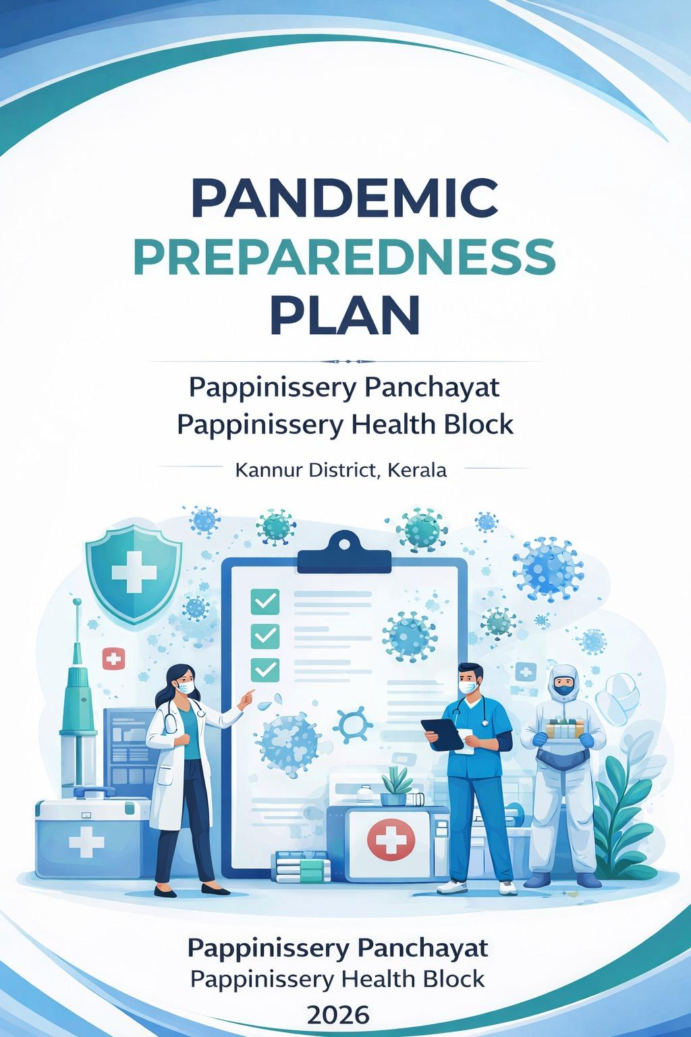

PANDEMIC
PREPAREDNESS PLAN

PAPPINISSERY PANCHAYATH
PAPPINISSERY HEALTH BLOCK

MESSAGE FROM PRESIDENT/CHAIR LSGI

കേരള സംസ്ഥാന ആരോഗ്യ വകുപ്പിന്റെ ആഭിമുഖ്യത്തിൽ 2026 വർഷത്തെ പകർച്ചവ്യാധി പ്രതിരോധദുരന്ത നിവാരണ പ്രവർത്തനങ്ങളെക്കുറിച്ചുള്ള പ്രവർത്തന റിപ്പോർട്ട് / ആക്ഷൻപ്ലാൻ പാപ്പിനിശ്ശേരി സാമൂഹിക ആരോഗ്യ കേന്ദ്രത്തിന്റെ നേതൃത്വത്തിൽ തയ്യാറാക്കപ്പെട്ടിട്ടുണ്ട്. പ്രസ്തുത പ്രവത്തനങ്ങൾക്ക് ഗ്രാമപഞ്ചായത്തിന്റെ എല്ലാ പിന്തുണയും പ്രഖ്യാപിക്കുകയും റിപ്പോർട്ടിന് എല്ലാ ഭാവുകങ്ങളും / ആശംസകളും നേരുകയും ചെയുന്നു.

പ്രസിഡന്റ് ,
പാപ്പിനിശ്ശേരി ഗ്രാമപഞ്ചായത്

MESSAGE FROM HEALTH STANDING COMMITTEE CHAIR

കേരളം സംസ്ഥാന ആരോഗ്യ വകുപ്പിന്റെ ആഭിമുഖ്യത്തിൽ 2026 വർഷത്തെ പകർച്ചവ്യാധി പ്രതിരോധ ദുരന്ത നിവാരണ പ്രവർത്തനങ്ങളിലെ കുറിച്ചുള്ള ആക്ഷൻപ്ലാൻ പാപ്പിനിശ്ശേരി സാമൂഹിക ആരോഗ്യകേന്ദ്രത്തിന്റെ നേതൃത്വത്തിൽ തയ്യാറാക്കപ്പെട്ടിട്ടുണ്ട്. പ്രസ്തുത പ്രവർത്തനങ്ങൾക് സർവാത്മനാ പിന്തുണയും റിപ്പോർട്ടിന് എല്ലാ ആശംസകളും നേരുകയും ചെയുന്നു.

ആരോഗ്യ സ്റ്റാന്റിംഗ് കമ്മറ്റി ചെയർമാൻ
പാപ്പിനിശ്ശേരി ഗ്രാമപഞ്ചായത്

MESSAGE BY MEDICAL OFFICER



പാപ്പിനിശ്ശേരി CHC യുടെ നേതൃത്വത്തിൽ തയ്യാറാക്കിയിട്ടുള്ള പകർച്ചവ്യാധി പ്രതിരോധ പ്രവർത്തന രേഖ (Pandemic Preparedness Plan ) ഭാവിയിൽ പാപ്പിനിശ്ശേരി പഞ്ചായത്തിൽ ഉണ്ടാകാൻ സാധ്യതയുള്ള പകർച്ച വ്യാധികളെ പ്രതിരോധിക്കുവാൻ സഹായിക്കുമെന്ന് വിശ്വാസമുണ്ട്.

മെഡിക്കൽ ഓഫീസർ
CHC പാപ്പിനിശ്ശേരി

EXECUTIVE SUMMARY

Primary Health Centre (PHC) functions as the primary public healthcare institution serving the population of Pappinisseri Grama Panchayath. The PHC plays a pivotal role in delivering comprehensive, accessible, and affordable healthcare services, with a strong focus on preventive, promotive, curative, and rehabilitative care in accordance with national and state health programmes.
The PHC caters to a predominantly rural population, addressing key public health priorities such as maternal and child health, communicable and non-communicable disease control, immunization, family welfare, adolescent health, and geriatric care. Regular outpatient services, home-based care through field health staff, and outreach activities ensure healthcare coverage even in geographically challenging areas. The institution actively implements national health missions, including the National Health Mission (NHM), National Tuberculosis Elimination Programme, National Programme for Prevention and Control of Cancer, Diabetes, Cardiovascular Diseases and Stroke (NPCDCS), and other disease surveillance initiatives
Pappinisseri PHC works in close coordination with the Grama Panchayath, ASHA workers, Anganwadi centres, schools, and community-based organizations to strengthen community participation and improve health awareness. Emphasis is placed on early detection, timely referral, health education, and lifestyle modification to reduce disease burden and improve overall health outcomes.
Despite constraints related to infrastructure, manpower, and increasing service demand, the PHC continues to enhance service delivery through effective planning, data-driven decision-making, and community engagement. Strengthening facilities, upgrading digital health systems, and expanding preventive services remain key focus areas for future development.
Overall, _Pappinisseri Primary Health Centre stands as a vital institution in safeguarding public health and improving the quality of life of the residents of Pappinisseri Grama Panchayath.

LIST OF ABBREVIATIONS

LSGD/LSGI | Local Self Government Department / Local Self Government Institution
BMO | Block Medical Officer
IDSP | Integrated Disease Surveillance Programme
NDMA | National Disaster Management Authority
PPE | Personal Protective Equipment
ICMR | Indian Council of Medical Research
CD | Communicable Diseases
NCD | NON-COMMUNICABLE Diseases

TABLE OF CONTENTS

INTRODUCTION 11
Background of the PPP 11
LSGD AT A GLANCE 12
Geographical boundaries with political map ( based on latest delimitation) 13
Baseline data 13
GENERAL PROFILE OF THE LSGI’S 39
Background of the LSGI 39
Demographic and Vulnerable Population 41
Clinical Vulnerability 42
INFRASTRUCTURE & RESOURCE INVENTORY 44
Health Facility Directory & Basic Capacity in the LSGD 44
Private Clinics 45
Healthcare Education & Training Institutions 47
Specialized Services & Emergency Inventory 47
Oxygen & Diagnostic Capacity 48
Diagnostics facility mapping at the LSGI level 49
Laboratory Identification & Basic Details 49
Social and Community Infrastructure for surge plan 50
Human resources 52
Public Health & Field-Level Workforce 53
Community & Support Cadre 54
Community Organizations 55
Administrative & Emergency Services 56
Information regarding resources 57
ONE HEALTH & ENVIRONMENTAL SURVEILLANCE 58
Animal & Bird Population 58
Veterinary Infrastructure 60
Veterinary Doctors & Workforce 60
High-Risk Interface Points (Surveillance Sites) 61
Environmental Risk Mapping 63
EPIDEMIOLOGICAL TRENDS (2021–2025) 68
Disease Burden among human beings(Last 5 Years) 68
Seasonal Trend Analysis 70
Outcome-Based Trend Analysis- 2021- 2025 76
Transmission Trend- 2025 77
Integrated Disease Hotspot Map (2021–2025) 81
Preparedness and Response Protocol at LSG Level 84
Constitution of One Health Committee 84
Pandemic Response Workforce 86
Activities and Measures before and during Pandemic 87
PHASE 1 - Alert / Preparation 87
PHASE 2 - Active Response 91
HEALTH SYSTEM CONTROL ROOM FRAMEWORK (PCR) – PAPPINISSERY 93
Key Control Room Team 95
PHASE 3 - Surge Capacity 104
RECOVERY&REHABILITATION PHASE –PAPPINISSERY PANCHAYAT 105
CONCLUSION 107
ADDITIONAL COMPONENTS – PAPPINISSERY PANCHAYAT 108
RECOMMENDATIONS 110
MOCKDRILL SCENARIOS 111
ANNEXURE 114
IMPORTANT PHONE NUMBERS 114
Annexure 1: LSG Baseline Data Collection Format 121

INTRODUCTION

Background of the PPP
Pappinissery Block, Kannur District, Kerala
Pandemics pose a serious threat to public health, health systems, and socio-economic stability. The experience of the COVID-19 pandemic highlighted the need for strong surveillance, rapid response mechanisms, coordinated multi-sectoral action, and community engagement at the local level. Health systems across the country were challenged by increased case load, demand for oxygen and critical care, disruption of essential services, and the need for effective risk communication.
In India, the Integrated Disease Surveillance Programme (IDSP) plays a key role in early detection and response to outbreaks. At the block level, strengthening surveillance, reporting systems, outbreak investigation capacity, and emergency preparedness is essential to prevent, detect, and respond to emerging infectious diseases in a timely manner.
Pappinissery Block, under Kannur district, has a dense population and active movement of people due to its proximity to urban and coastal areas. Such demographic and geographic characteristics increase vulnerability to rapid transmission of infectious diseases. The block health system, including Primary Health Centres, Family Health Centres, laboratories, and field-level health workers, plays a critical role in early case detection, contact tracing, isolation, referral, and continuity of essential health services during public health emergencies.
The Pandemic Preparedness Plan for Pappinissery Block is therefore developed to:
- Strengthen surveillance and early warning systems
- Ensure rapid outbreak investigation and respons
- Maintain essential health services during emergencies
- Enhance laboratory preparedness and logistics management
- Strengthen infection prevention and control (IPC) measures
- Improve risk communication and community participation

LSGD AT A GLANCE

Geographical boundaries with political map ( based on latest delimitation)

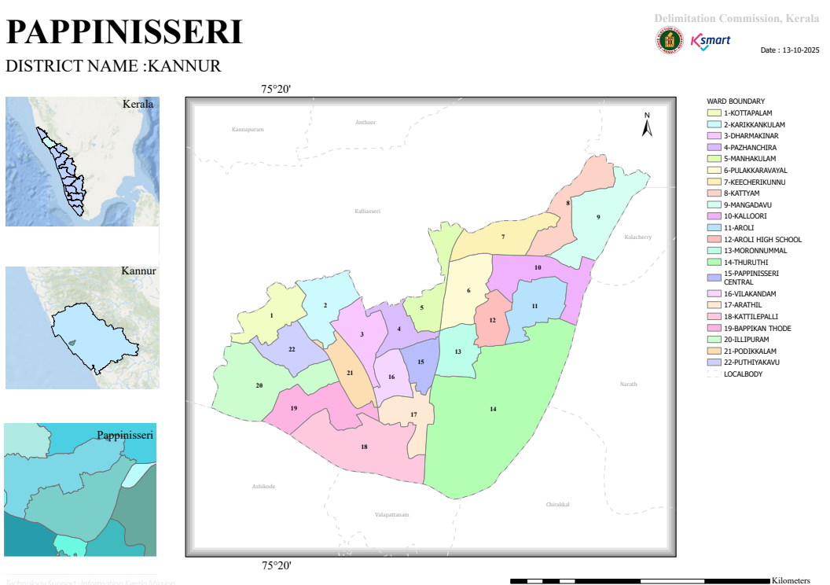

Baseline data

- Ward division -

Ward | Houses | Population | Migrants | Wells | Hot  spots | Ed. Institutions | Hosp pvt/govt.
22 | 9224 | 41125 | 960 | 7184 | 1 (ward 18) | 16 | 2

RISK STRATIFICATION – PAPPINISSERY BLOCK
1. High-Risk Stratification (Priority 1)
Wards in this category require immediate and intensive intervention due to the convergence of environmental hazards, active disease transmission, and highly vulnerable populations.
Vector-Borne Disease Hotspot (Dengue)
- The presence of waterlogging and stagnant water further amplifies mosquito breeding.
- Strategic Actions:
  - Intensive source reduction activities
  - Weekly “Dry Day” campaigns
  - Larviciding and fogging operations
  - Strengthened fever surveillance
Environmental High-Risk Zones (Waterlogging & Backwaters)
- Nearly 20 wards are affected by waterlogging, creating ideal conditions for dengue, leptospirosis, and acute diarrheal diseases (ADD).
- Backwater influence increases contamination risk, especially during monsoon.
- Strategic Actions:
  - Pre-monsoon and post-monsoon sanitation drives
  - Chlorination of water sources
  - Community awareness on safe water practices
High Vulnerability Population Clusters
- 140 bedbound patients and 37 palliative care patients require uninterrupted healthcare access.
- Any outbreak in these wards can lead to severe morbidity and mortality.
- Strategic Actions:
  - Ward-wise vulnerability mappingF
  - Home-based care and emergency referral plans
  - Ensuring medicine and support continuity
2. Moderate-Risk Stratification (Priority 2)
These wards have persistent environmental and social vulnerabilities, but no recent major outbreak.
Flood-Prone & Waterlogged Wards
- Wards experiencing seasonal waterlogging and poor drainage fall under moderate risk.
- Increased likelihood of vector breeding and water contamination.
Socio-Economically Vulnerable Wards
- Presence of 1,970 BPL families increases risk due to:
  - Poor sanitation
  - Limited access to healthcare
  - Overcrowding
Migrant Population Clusters
- 960 migrant population may face barriers in:
  - Accessing health services
  - Awareness of preventive measures
- These wards require targeted outreach and surveillance
Geographically Isolated Area
- Thuruthi Island faces limited accessibility, especially during emergencies.
- Delays in transport and healthcare delivery increase outbreak impact.
Strategic Actions for Moderate Risk Wards:
- Strengthening IDSP surveillance
- Regular field visits by ASHA/health workers
- Targeted IEC campaigns
- Improved sanitation and drainage measures
3. Low-Risk Stratification (Priority 3)
These wards are relatively stable with no recent outbreak history and better infrastructure.
Characteristics
- Good sanitation and drainage systems
- Better healthcare accessibility
- No significant clustering of vulnerable populations
Strategic Focus
- Routine surveillance under IDSP
- Sustaining vector control measures
- Health education and community participation
4. Hazard & Accessibility Risk Mapping
A. Water-Related Hazards (20 Wards with Waterlogging)
- Risk of ADD, Leptospirosis, and Dengue due to stagnant water
- Seasonal flooding worsens contamination
Intervention:
- Chlorination drives
- Drainage improvement
- Monsoon preparedness activities
B. Vector-Related Hazards (Ward 18 + Waterlogged Wards)
- High mosquito breeding potential
- Increased dengue transmission risk
Intervention:
- Source reduction campaigns
- Fogging and larval control
- Community mobilization
C. Accessibility Hazards (Thuruthi Island)
- Delayed emergency response
- Limited healthcare access
Intervention:
- Emergency transport planning
- Mobile health services
- Local volunteer engagement
D. Vulnerability Hazards (Across All Wards)
- Bedbound and palliative patients at highest risk during outbreaks
Intervention:
- Line listing and tracking
- Home-based care systems
- Priority vaccination and prophylaxis
The risk stratification of Pappinissery Block highlights that Ward 18 and waterlogged wards fall under high priority, while socio-economically and geographically vulnerable wards fall under moderate risk. Low-risk wards require continued surveillance.
This classification enables:
- Targeted IDSP surveillance
- Focused vector control strategies
- Prioritized protection of vulnerable populations
- Efficient resource allocation during outbreaks

Ward Category | Wards Included | Primary Sentinel | Frequency of Monitoring
Red Zone (High Risk) | Ward 18 (Dengue hotspot) + Selected highly waterlogged wards | Medical Officer + Health Inspector + Junior Public Health Nurse (JPHN) + Field Staff | Bi-weekly syndromic surveillance (fever, dengue, leptospirosis) + Active case search
Yellow Zone (Moderate Risk) | Waterlogged wards + BPL dominant wards + Migrant clusters + Thuruthi Island | JPHN + ASHA + Field Staff + One Health Volunteers | Weekly surveillance of fever cases, water-borne diseases & risk assessment
Green Zone (Low Risk) | Remaining wards with no outbreak history and better sanitation | ASHA + One Health Volunteers | Routine surveillance (fortnightly reporting & event-based reporting)

MAJOR ROADS & WATERWAYS
Road Network (Transport Connectivity)
Pappinissery Panchayat is well connected by a mix of state highways, arterial roads, and local ward roads, facilitating movement of people, goods, and emergency services.
- The NH 66 (National Highway 66) (old NH 17), one of the most important coastal highways in Kerala, passes close to the panchayat and serves as the primary north–south transport corridor, connecting Kannur and Taliparamba regions.
- The Valapattanam–Taliparamba Road acts as a major internal arterial road, linking Pappinissery with nearby urban centers and healthcare facilities.
- The Pappinissery–Kanhirangad Road provides connectivity to interior wards and plays a key role in local transportation and emergency referrals.
- Several ward-level roads branch from these main corridors, though some remain narrow, partially developed, or prone to waterlogging, affecting accessibility during monsoon.
Waterways & River System
The panchayat is bordered and influenced by the Valapattanam River, one of the major rivers in Kannur district.
- The river and its associated backwaters and distributaries form a natural boundary and significantly influence the ecology and livelihood patterns of the area.
- Low-lying regions and river-adjacent wards experience seasonal flooding and water stagnation, increasing the risk of:
  - Vector-borne diseases (Dengue)
  - Water-borne diseases (Leptospirosis, ADD)
Connectivity Challenges & Gaps
Certain areas, especially low-lying and waterlogged wards, face:Delayed emergency vehicle access, Poor road conditions during heavy rainfall
Thuruthi (island-like area) has limited road connectivity, depending on narrow access routes, which can delay health service delivery.
Internal ward roads are not uniformly developed, affecting last-mile connectivity.
Public Health & Disaster Relevance
- NH 66 and major arterial roads are critical for:
  - Patient referral transport
  - Emergency evacuation during outbreaks/floods
- River and backwater systems act as:
  - Hazard zones (flooding, contamination)
  - Determinants of disease transmission patterns

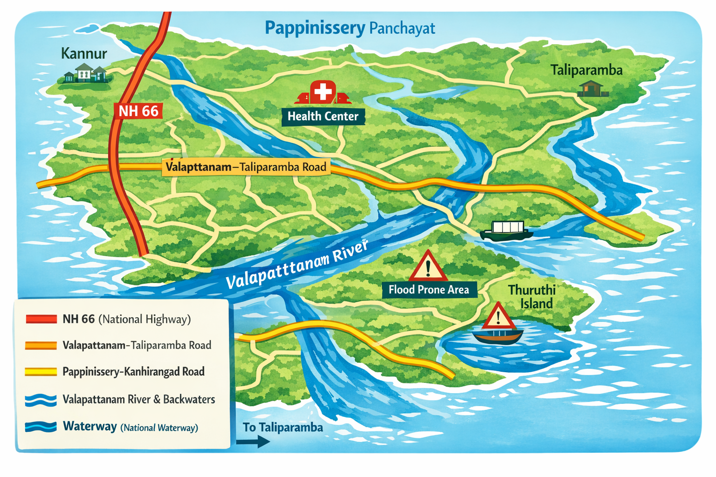

MAJOR ESTABLISHMENT WITH GEOSPATIAL MAPPING
- 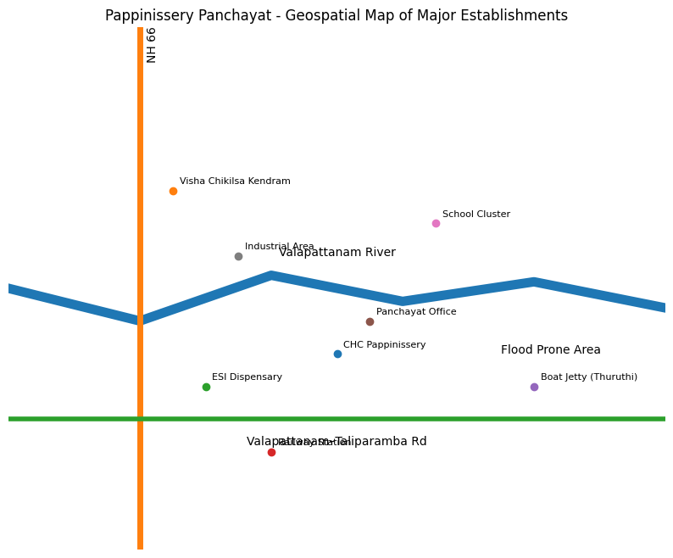
1. Health Institutions
These are strategically located along major roads and central habitations for accessibility.
- Community Health Centre Pappinissery
  - Centrally located – acts as the primary referral unit
  - Provides general medicine, maternal & child health services
- Pappinissery Visha Chikilsa Kendram
  - Located near NH 66
  - Specialized in poison and snakebite management
- ESI Dispensary Pappinissery
  - Located in Chungam area
  - Serves workers and insured population
- Private Clinics & Hospitals Cluster (Chungam area)
  - MM Hospital and private practitioners concentrated along main road
2. Educational Institutions (Community Surveillance Points)
Widely distributed across wards → useful for early outbreak detection & awareness
- Aroli Government Higher Secondary School
- EMS Smaraka Government Higher Secondary School Pappinissery
- Hidayath English Medium School
- Multiple LP & UP schools across wards
3. Administrative & Public Service Institutions
- Pappinissery Grama Panchayat Office
  - Administrative hub for coordination
- Akshaya Centre Pappinissery
  - Digital service & communication support
4. Transport & Logistics Nodes
- Pappinissery Railway Station
  - Key mobility hub
- Boat Jetty Pappinissery
  - Critical for water transport (Thuruthi area)
- NH 66 Corridor (Linear Development Zone)
  - Major transport and emergency evacuation route
5. Industrial & Economic Establishments
- Western India Cottons
- Baliapattam Tile Works
- Plywood, handloom, and small-scale industries
6. Financial & Community Institutions
- Pappinissery Service Cooperative Bank
- Libraries (Vayanasala), religious centers, Anganwadis

Geospatial Risk Interpretation
🔴 High Strategic Zones
- Chungam (health + transport + population cluster)
- Ward 18 (disease hotspot)
- NH 66 corridor
🟡 Moderate Strategic Zones
- School clusters across wards
- Industrial pockets
- BPL-dominant residential areas
🔵 Special Access Zones
- Thuruthi (water-dependent access)
- Backwater / flood-prone wards

Occupational groups, socio cultural groups, migration & mobility patterns
1. Occupational Groups (Economic & Exposure Profile)
Pappinissery Panchayat has a mixed occupational structure, influenced by its coastal–riverine geography and semi-urban setting.
Major Occupational Categories
- Fishing & Allied Activities
  - Concentrated along river/backwater areas
  - High exposure to water-borne diseases (Leptospirosis)
- Daily Wage Labourers (Construction & Manual Work)
  - Includes both local and migrant workers
  - Often live in crowded conditions → higher outbreak risk
- Industrial Workers
  - Employed in plywood, handloom, tile, and small-scale industries
  - Risk of cluster outbreaks in workplaces
- Agricultural & Allied Workers
  - Limited but present in low-lying areas
  - Exposure to contaminated water and soil
- Service Sector & Small Businesses
  - Shops, transport workers, informal sector
  - High mobility → potential disease transmission carriers
2. Socio-Cultural Groups (Community Structure & Vulnerability)
Population Characteristics
- 1,970 BPL families → economically vulnerable
- Presence of elderly, bedbound (140), and palliative patients (37)
- Mixed religious and cultural communities with strong social cohesion
Key Socio-Cultural Features
- Dense family structures & close-knit communities
  - Facilitates rapid disease spread within households
- Religious gatherings & festivals
  - Potential for mass gathering-related outbreaks
- Anganwadi & Kudumbashree networks
  - Strong community platforms for health communication and interventions
Public Health Implication
- High community participation potential
- But also risk of rapid clustering during outbreaks
3. Migration Patterns (Population Movement Dynamics)
Migrant Population
- Approximately 960 migrant workers
- Engaged mainly in:
  - Construction
  - Industrial work
  - Daily wage labour
Characteristics
- Often reside in:
  - Temporary/shared accommodations
  - Areas with limited sanitation facilities
Public Health Risks
- Low health awareness and language barriers
- Delayed healthcare seeking
- Increased risk of disease introduction and spread
Strategic Needs
- Targeted screening and surveillance
- Multilingual IEC materials
- Inclusion in health services
4. Mobility Patterns (Movement & Connectivity)
Internal Mobility
- Movement between wards for:
  - Work
  - Education
  - Health services
- Increased interaction in market and junction areas (e.g., Chungam)
External Mobility
- Strong connectivity via:
  - NH 66 → inter-district travel
  - Railway → long-distance movement
Water-Based Mobility
- Thuruthi and riverine areas depend on:
  - Boat transport
- Can delay emergency response but also act as controlled access zones

5. Public Health Risk Interpretation
🔴 High-Risk Groups
- Fisherfolk and water-exposed workers
- Migrant labourers
- Industrial workers in clusters
🟡 Moderate-Risk Groups
- Daily wage workers
- Service sector population
- Residents in BPL households
🟢 Lower-Risk Groups
- Stable households with better living conditions
6. Strategic Implications for Pandemic Preparedness
- Targeted Surveillance:
Focus on migrant clusters, industrial units, and fishing communities
- Risk Communication:
Use Kudumbashree, ASHA, and Anganwadi networks
- Mobility Control Measures:
Monitoring at transport hubs during outbreaks
- Continuity of Care:
Special attention to bedbound and palliative patients
VULNERABILITY MAPPING – PAPPINISSERY PANCHAYAT
1. Demographic Vulnerability
Population Profile
- Total Population: 41,125 (Projected: 42,000)
- Population Density: 2,756 persons/sq.km → High density risk
Gender Distribution
- Male: 20,019
- Female: 21,106
- Transgender: 0
Age-Based Vulnerability
- Children <5 years: 2,005 → infection-prone group
- Adolescents: 1,560
- Elderly (>60 years): 12,337 → high-risk group (≈30%)
2. Environmental & Geographic Vulnerability
- Terrain: Low-lying, backwater-influenced
- Rivers: 1 (major river system)
- Water Bodies: 20
- Flood-Prone Wards: 20
3. Social & Livelihood Vulnerability
Economic Vulnerability
- BPL Families: 1,970
- Socio-economically deprived: 72 persons
- Previous EPEP families: 33
Community Composition
- SC Population: 3,016
- ST Population: Nil
- Fisherfolk: 5 households
Migration
- Immigrants: 960
- Emigrants: 2,034
4. Health Vulnerability
Maternal & Child Health
- Pregnant Women: 209
- Lactating Mothers: 270
High-Risk Patients
- Bedbound: 140
- Palliative Care: 37
- Haemodialysis: 20
- Cancer Patients: 103
- Haemophilia: 2
Special Groups
- Mentally Challenged: 67
- Differently Abled: 22
NCD Burden
- Diabetics: 867
- Hypertensives: 1,714
Communicable Disease
- TB Patients: 9
5. Institutional & Infrastructure Mapping
- Educational Institutions: 19 → potential surveillance points
- Industries: 5 → potential cluster outbreak zones
6. Socio-Cultural Vulnerability (Mass Gatherings)
Major Events
- Kattile Palli Oroos (January)
- Palott Kavu Festival, Keecheri (April)
7. VULNERABILITY RISK CLASSIFICATION
🔴 High Vulnerability Zones
- Flood-prone wards
- High BPL concentration areas
- Migrant clusters
- Ward with high elderly & bedbound population
🟡 Moderate Vulnerability Zones
- Areas with:
  - NCD clusters
  - Industrial workers
  - Moderate population density
🟢 Low Vulnerability Zones
- Better infrastructure
- Lower density
- Good healthcare access
8. Composite Vulnerability Indicators
- 30% elderly population → very high risk
- 1,970 BPL families → economic vulnerability
- 960 migrants → mobility-related risk
- 140 bedbound + 37 palliative → critical care need
- 20 water bodies + 1 river → environmental hazard
- High density (2,756/km²) → rapid disease spread
9. Strategic Implications for PPP
Priority Actions
- Target high-risk wards for surveillance
- Special tracking of:
  - Elderly
  - Bedbound
  - Migrants
Environmental Control
- Vector control in waterlogged areas
- Water safety interventions
Healthcare Preparedness
- Continuity plans for:
  - Dialysis
  - Cancer care
  - Palliative care
Mass Gathering Control
- Surveillance during festivals
- Temporary health camps
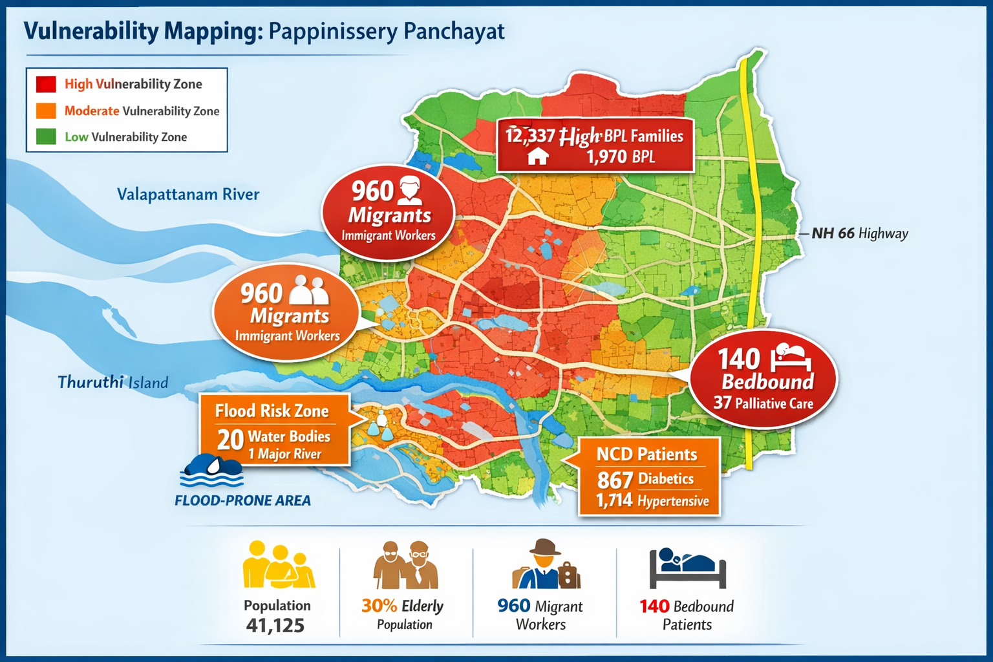

DISASTER-PRONE AREAS (GEOGRAPHIC VULNERABILITY) – PAPPINISSERY PANCHAYAT
Pappinissery Panchayat is characterized by a low-lying, river-influenced terrain with multiple water bodies, making it vulnerable to flooding, water stagnation, and associated public health risks. The presence of 1 major river and 20 water bodies significantly contributes to environmental vulnerability.
Major Disaster-Prone Zones
🔴 A. Flood-Prone Areas (High Risk)
- Flood-prone wards: 2
- Located in low-lying areas adjacent to river/backwaters
- Seasonal flooding during monsoon (June–October)
Risks:
- Water contamination → Acute Diarrheal Diseases (ADD)
- Increased exposure → Leptospirosis
- Displacement and disruption of health services
🔴 B. River & Backwater Influence Zones
- Influenced by Valapattanam River
- Includes areas with water stagnation and poor drainage
Risks:
- Mosquito breeding → Dengue & vector-borne diseases
- Contamination of wells and water sources
- Occupational exposure (fisherfolk, laborers)
🟡 C. Water Body–Dense Areas (Moderate to High Risk)
- 20 water bodies (ponds, canals, stagnant pools)
Risks:
- Persistent vector breeding sites
- Increased leptospirosis risk
- Environmental sanitation challenges
🔴 D. Thuruthi (Geographically Isolated / Special Risk Area)
- Island-like / water-surrounded area
- Limited accessibility during emergencies
Risks:
- Delayed healthcare access
- Difficulty in evacuation during floods
- Isolation during outbreaks
🟡 E. Waterlogging & Poor Drainage Zones
- Several wards experience seasonal water stagnation
Risks:
- Dengue transmission
- Poor sanitation → disease spread
- Infrastructure damage
3. Population at Risk in Disaster-Prone Areas
- Elderly: 12,337
- Bedbound: 140
- Palliative care: 37
- BPL families: 1,970
4. Risk Classification
Risk Level | Area Type | Key Issues
🔴 High | Flood-prone wards, riverbanks, Thuruthi | Flooding, isolation, outbreaks
🟡 Moderate | Waterlogged wards, water body clusters | Vector breeding, contamination
🟢 Low | Well-drained central wards | Minimal environmental risk

5. Strategic Interventions
Flood Preparedness
- Pre-monsoon planning
- Identification of safe shelters & evacuation routes
- Emergency transport arrangements
Water & Sanitation
- Chlorination of wells
- Safe drinking water supply
- Waste management
Vector Control
- Source reduction campaigns
- Larviciding & fogging
- Community awareness
Special Area Focus
- Thuruthi: mobile health units + boat transport

Maps - ward-based
Geographical boundaries - ward boundaries map

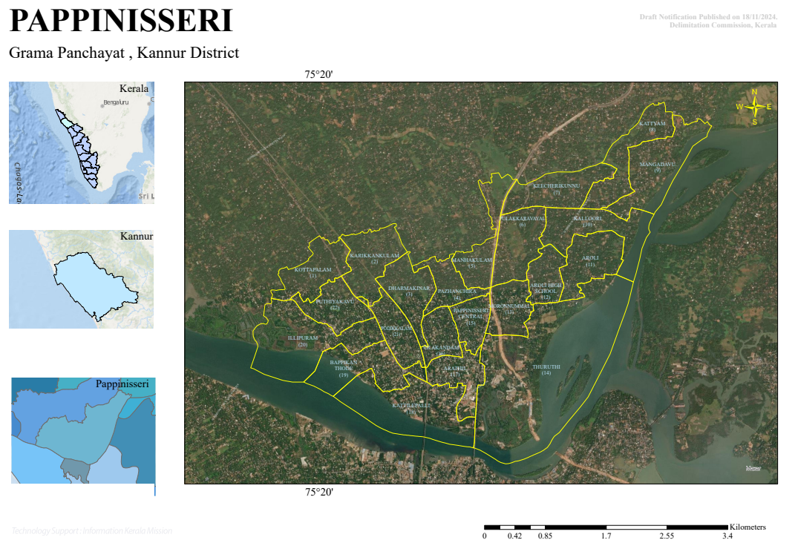

Health infrastructure map

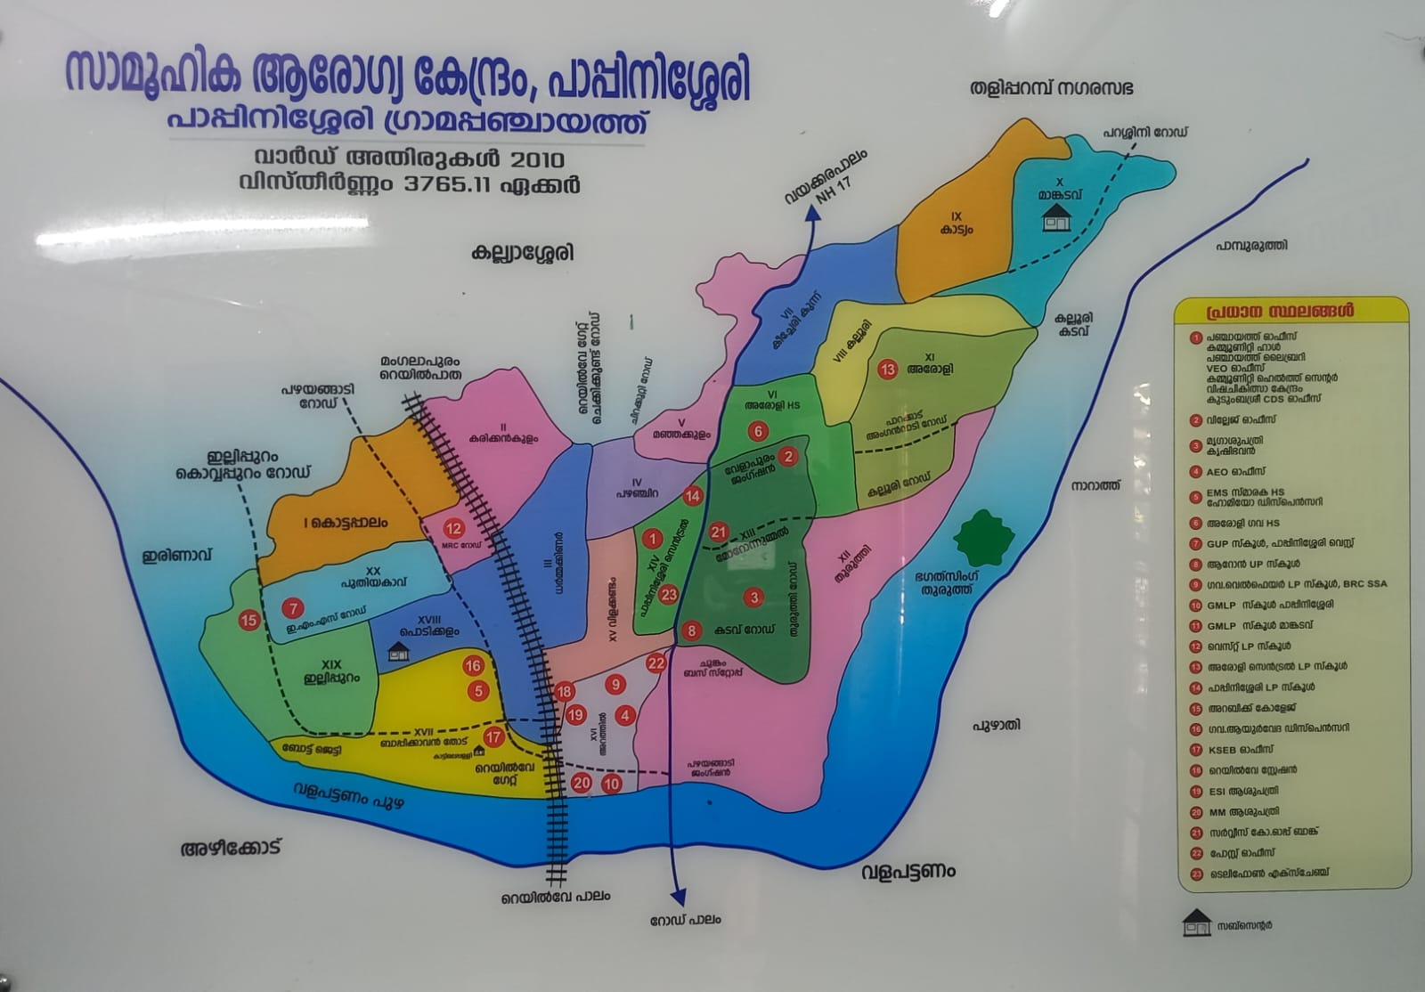

Disaster-prone areas map

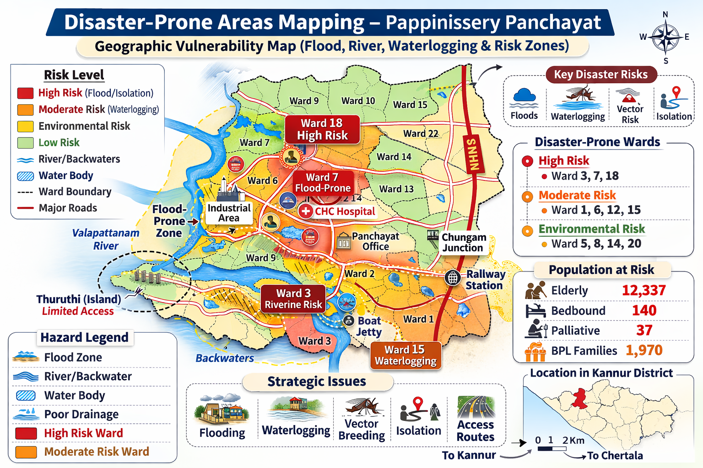

Hotspot map - CD & disasters

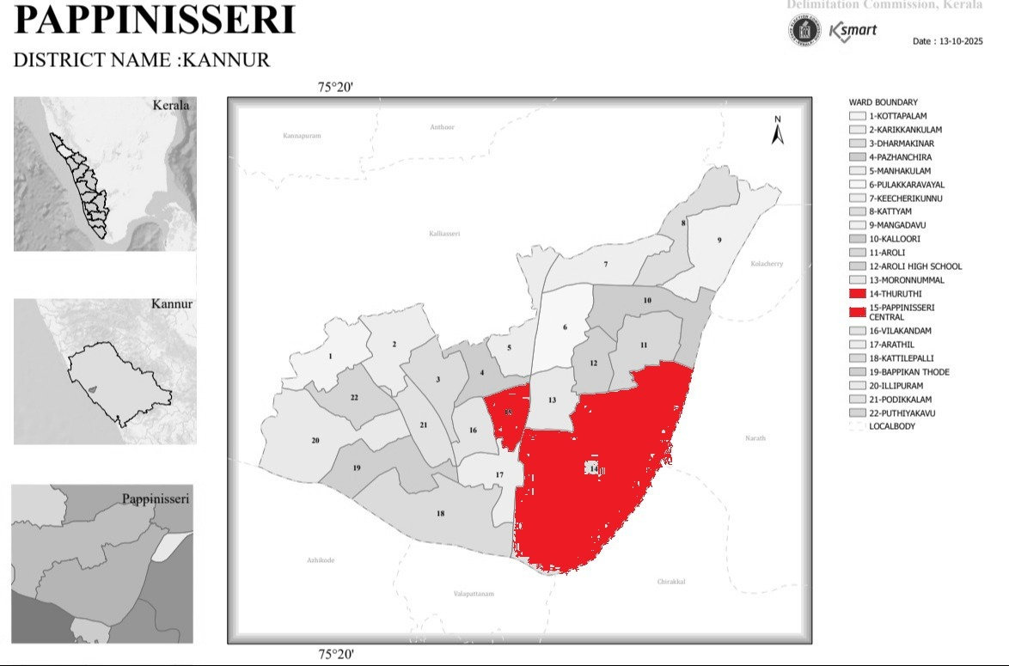

INTEGRATED HEALTH INFRASTRUCTURE MAP OF PAPPINISSERI PANCHAYAT

GENERAL PROFILE OF THE LSGI’S

Background of the LSGI
Pappinissery Grama Panchayat is situated in Kannur District, Kerala. The Panchayat lies along the banks of the Valapattanam River and is characterized by low-lying coastal terrain, backwaters, paddy fields, and canal networks. This unique geographical setting significantly influences the local microclimate and makes several wards vulnerable to waterlogging and seasonal flooding, particularly during the monsoon. The presence of backwater stretches and a small island area (Thuruthi) presents distinct challenges for transportation, emergency evacuation, and timely delivery of essential services during disasters.
Administratively divided into 22 wards, Pappinissery has a population of 41,125, with a considerable number of socio-economically vulnerable households, including 1,970 BPL families and 960 migrant workers engaged mainly in construction, agriculture, fishing, and small-scale industries. Traditional livelihoods such as paddy cultivation, fishing, and coconut-based activities continue to form the economic backbone of the Panchayat, while service-sector employment is gradually increasing. From a public health and disaster management perspective, the Panchayat is vulnerable to seasonal flooding, waterborne diseases, and vector-borne illnesses such as Dengue fever and Leptospirosis, with Ward 18 identified as a dengue hotspot. These environmental and demographic risk factors highlight the need for strengthened local preparedness, surveillance under the Integrated Disease Surveillance Programme (IDSP), and coordinated emergency response planning. In this context, developing a localized, data-driven infrastructure and logistical resource map is essential to enhance disaster resilience, improve emergency response efficiency, and support sustainable development initiatives within the Panchayat.

Table 1: Background of LSGD
Description | Details
Name of LSGI | Pappinisseri
Type (GP/Municipality / Corporation etc.) | Grama Panchayath
Block | Kannur
District | Kannur
Number of wards | 22
Total area (sq. km) | 15.24 sq.km
Population(Projected) | 42000
Population density | 2756 persons/sq km
Terrain (coastal/low-lying/backwaters/foothills, etc.) | nil
Number of rivers passing through LSGI | 1
Number of water bodies in the LSGI | 20
Number of educational institutions | 19
Factories / small-scale industries | 5
Flood-prone wards | 2
Landslide-prone wards | nil
Death Management and Disposal Facilities (mortuaries/crematorium, including electric) | 7
Auditoriums/Marriage halls/convention centres/community halls | 2

Demographic and Vulnerable Population

Understanding the demographic composition and vulnerable population groups is essential for pandemic preparedness. Children, elderly, economically deprived families, migrant workers, and socially vulnerable groups are at increased risk during public health emergencies due to higher exposure, limited access to services, and dependency on public systems..

Description |  | Details (in numbers)
DEMOGRAPHIC PROFILE
Total population |  | 41125
Male |  | 20019
Female |  | 21106
Transgender |  | 0
Children under 5 |  | 2005
Adolescent |  | 1560
Elderly (>60) |  | 12337
SOCIAL/LIVELIHOOD VULNERABILITY
Previous EPEP family |  | 33
BPL family |  | 1970
Tribal communities |  | nil
Migration | Immigrant | 960
Migration | Emigrant | 2034
Socio-economically deprived |  | 72 person
Fisherfolk |  | 5
SC Community |  | 3016
ST Community |  | nil

Graphs: Population pyramid (if possible) for seeing if your LSGI has a high "dependency ratio" (lots of children and elderly compared to working adults).

Clinical Vulnerability
Certain population groups needs priority healthcare & are at higher risk of severe illness, complications, and mortality during pandemics. Patients with chronic diseases, those requiring regular medical care, and individuals with mobility or functional limitations face challenges in accessing timely care during emergencies. Mapping these groups helps in prioritizing continuity of treatment, medicine stock planning, oxygen support, referral transport, and targeted home-based care.
Description | Details in numbers
Pregnant women | 209
Lactating mothers | 270
Bedbound patients | 140
Patients under palliative care other than bedbound | 37
Patients on Haemodialysis | 20
Patients on CAPD | 0
Cancer patients (currently on treatment) | 103
Haemophilic patients | 2
Mentally challenged | 67
Differently abled | 22
Diabetic patients | 867
Hypertensive patients | 1714
TB patients | 9

Major Festivals & Events specific to the LSGI
(with the possibility of a public gathering)

Sl. No. | Name of festival | Month detailing the periodicity
1 | KATTILE PALLI OROOS | JANUVARY
1 | PALOTT KAVU,KEECHERI | APRIL

INFRASTRUCTURE & RESOURCE INVENTORY

Health Facility Directory & Basic Capacity in the LSGD
This section provides an overview of the healthcare infrastructure available within the LSGD area. It outlines the distribution and basic capacity of health facilities that form the backbone of service delivery during routine times and public health emergencies.

Family Health Centres (FHCs) and Community Health Centres (CHCs) generally function as the first point of contact for the community, providing essential outpatient and inpatient services. General Hospitals (GH) and Medical College Hospitals (MCH), where accessible, serve as the main referral centres for advanced diagnostics, specialist care, and critical services during public health emergencies. This inventory helps identify existing strengths, gaps, and potential surge capacity that can be mobilised during a pandemic or disaster.

Table 5. Health Facility Resource Summary
Sl.no. | Health Facility | Type of Facility (MCH/GH/CHC/FHC/SC etc.) | Contact Number | Total beds | ICU Beds | Oxygen-Supported Beds | No. of Ventilator Support Beds | No. of ambulances
Government Healthcare Facilities
1 | CHC Pappinissery | CHC | 04972726270 | 36 | 0 | 2 | 0 | 1
2 | ESI Hospital | GOVT | 8547583204 | 0 | 0 | 0 | 0 | 0
Private Healthcare Facilities
3 | MM HOSPITAL | PVT | 9072777193 | 40 | 8 | 30 | 1 | 0
AYUSH Healthcare Facilities
4 | MVR | PVT/AYURVEDA | 04972786555 | 10 | 0 | 0 | 0 | 0

Private Clinics
Private clinics are an essential part of pandemic preparedness, as they are often the first place people seek care when symptoms begin. In many communities, private clinics manage a significant share of outpatient visits and therefore play a critical role in early case detection, timely referrals, and disease surveillance. Having an up-to-date understanding of where these clinics are located, the services they provide, and how they are linked to the public health system helps ensure that no cases are missed during an outbreak. It also allows health authorities to engage private practitioners more effectively for reporting, risk communication, and coordinated response, strengthening the overall capacity of the health system to manage public health emergencies.

Table 6. Private Clinic Resource Summary
Sl No. | Name of Clinic | Registered (Y/N) | Clinic (General / Speciality) | Speciality (if any) | Address | Contact Number | Diagnostic Facility (Y/N) | Ambulance Linkage (Y/N)
1 | AK DENTAL AND IMPLANT CENTRE | N | SPECIALITY | DENTAL | VNT COMPLEX, HAJI ROAD,PPAPPINISSERY WEST | 9400526268 | YES | NO
2 | PAPPINISSERI DENTAL CLINIC | N | SPECIALIZATION | DENTAL | PAPPINISSERI WEST | 9745138644 | YES | NO
3 | DENTAL CARE | N | SPECIALIZATION | DENTAL | NR.EMS HSS | 9947085478 | YES | NO
4 | SMART MOUTH MULTISPECIALITY | N | SPECIALIZATION | DENTAL | KARIKKANKULAM,PAPPINISSERI WEST | 8089367640 | YES | NO
5 | SS DENTAL CARE | N | SPECIALIZATION | DENTAL | NR.PAPPINISSERI PANCHAYATH | 9544724796 | YES | NO
6 | AYKA DENTAL CARE | N | SPECIALIZATION | DENTAL | KALLAIKKAL AROLI | 8277385872 | YES | NO

Healthcare Education & Training Institutions
This section tracks the educational infrastructure available, which is vital for human resource planning in the health sector.

Category of Institution | Govt | Private | AYUSH | Total
Medical Colleges | 0 | 0 | 0 | 0
Nursing Colleges | 0 | 0 | 0 | 0
Dental Colleges | 0 | 0 | 0 | 0
Para-medical / Allied Health | 0 | 0 | 0 | 0
Pharmacy Colleges | 0 | 0 | 0 | 0

Specialized Services & Emergency Inventory
This section provides a detailed view of the specialized medical resources available to the community, focusing on emergency response and critical care capabilities. This table tracks the vital assets required for managing severe illnesses and emergencies across Government, Private, and AYUSH sectors.

Item | Govt | Private | AYUSH | Total
Hospital beds | 36 | 40 | 0 | 76
Oxygen-generating systems(Y/N) | N | Y | N | N
Oxygen-supported beds(Numbers) | 2 | 30 | 0 | 32
Ventilator-supported beds | 0 | 1 | 0 | 1
ICU beds | 0 | 8 | 0 | 8
Burns units | 0 | 0 | 0 | 0
Blood centres | 0 | 0 | 0 | 0
BLS ambulances | 1 | 0 | 0 | 1
ALS ambulances | 0 | 0 | 0 | 0
Dialysis facilities | no | yes | 0 | 1
Dispensaries | 1 | 1 | 2 | 4
Medical store | 1 | 7 | 1 | 9
Industrial establishments(Medium-scale industries/small-scale industries  establishments to whom we can depend in a worst-case scenario) | 0 | 5 | 0 | 5

Oxygen & Diagnostic Capacity
Monitoring oxygen and diagnostic capacity is a critical component of public health preparedness, ensuring that the LSGD can handle both chronic care and sudden surges in respiratory or infectious diseases.
Name of Health Facility | Oxygen-generating System (Y/N) | Backup Oxygen Source (Y/N) | Diagnostic Facilities Available(Y/N)
Name of Health Facility | Oxygen-generating System (Y/N) | Backup Oxygen Source (Y/N) | Lab | USG | X-ray | CT/MRI | RT-PCR
Government Healthcare Facilities
CHC Pappinissery | N | Y | Y | N | Y | N | N

Diagnostics facility mapping at the LSGI level
The diagnostic capacity of Pappinisssery G.P represents the "intelligence network" of our healthcare system. The speed and accuracy of disease identification depend entirely on the distribution and technical level of these facilities.

Item | Govt | Private | AYUSH | Total
General labs | 1 | 4 | NIL | 5
Microbiology labs | NIL | NIL | NIL | NIL
RT-PCR labs | NIL | NIL | NIL | NIL
USG units | no | 1 | nil | 1
CT/MRI units | no | 1 | NIL | 1
Research labs | NIL | NIL | NIL | NIL
Labs of other departments that can be repurposed | NIL | NIL | NIL | NIL

Laboratory Identification & Basic Details
Sl. No. | Name of Laboratory | Ownership (Govt / Private / Academic) | Address | Contact No. | 24×7 Services (Yes/No) | NABL / Govt Approved (Yes/No)
1 | CHC Pappinissery | Govt | Pappinissery | 049727862870 | No | Govt approved
2 | NOBLE DIAGNOSTIC | PRIVATE | KALLAIKKAL | 9746132100 | NO | NO
3 | GREEN CO LAB | PRIVATE | KARIKKANKULAM | 9847112196 | NO | NO
4 | NOBLE DIAGNOSTIC | PRIVATE | MANGADAV | 9562308485 | NO | YES
5 | NOBLE DIAGNOSTIC | PRIVATE | KUNNUMPURAM | 9562308485 | NO | YES

Social and Community Infrastructure for surge plan
This table serves as our logistics and shelter inventory. By mapping these locations, quickly we can identify where to house displaced citizens, where to set up temporary medical clinics, and how to manage the deceased with dignity during a crisis.

Category | Total Count | Ward | Est. Capacity (Persons) | Contact details
Educational Institutions
Anganwadis | 19 | ALL WARDS | 350 | 9995409292  ICDS OFFISER
Schools | 16 | ALL WADS | 1500 | AEO PAPPINISSERI  9495614965
Colleges | NIL | NIL | NIL | NIL
Healthcare Educational Institutions
Medical colleges (Govt/Private) | 0 | 0 | 0 | 0
Nursing colleges (Govt/Private) | 0 | 0 | 0 | 0
Dental colleges (Govt/Private) | 0 | 0 | 0 | 0
Paramedical institutes (Govt/Private) | 0 | 0 | 0 | 0
Community Gathering Spaces |  |  |  | 7
Community halls | 4 | 12, 1912 | 1500 | 8921572400
Auditoriums | 4 | 12, 1912 | 1500 | 8921572400
Religious buildings | 7 | 16, 5, | 1000 | 9447192481
Vulnerable Group Support Facility
Destitute homes | 0 | 0 | 0 | 0
Elderly homes | 0 | 0 | 0 | 0
LSGD owned other buildings | 0 | 0 | 0 | 0
Mass Fatality Management (MFM) Infrastructure
Mortuary | 0 | 0 | 0 | 0
Crematorium | 8 | 14 | 10 | 7012015339
*refer annexure 1 for contact details

Human resources
This section focuses on the human capital available within the LSGI. In any emergency be it a pandemic, flood, or industrial accident infrastructure is only as effective as the people operating it.
Medical & Clinical Personnel
This table tracks the "Frontline" providers responsible for diagnosis, treatment, and clinical management. Narrative sentence: eg., "Total health workforce: 450 personnel, with 60% in government facilities serving as primary surge capacity." A detailed directory with the contact numbers of all workers is maintained (Annexure in 1).

Cadre | Govt (No.) | Private (No.) | Total
Doctors—Modern Medicine | 8 | 18 | 26
Doctors – AYUSH | 2 | 3 | 5
Doctors – Veterinary | 1 | 0 | 1
Doctors – Dental | 1 | 4 | 5
Nursing officers | 7 | 20 | 27
Lab technicians | 2 | 6 | 8
Optometrist | 1 | 0 | 1
Pharmacists | 4 | 4 | 8
Psychologists | 0 | 0 | 0
Counsellors | 0 | 0 | 0

Public Health & Field-Level Workforce
These individuals are the backbone of surveillance, maternal-child health, and decentralized care.

Cadre | Health services | Municipal common services | Total
HS (Health Supervisors) | 1 | 0 | 1
HI (Health Inspectors) | 1 | 1 | 2
PHNS (Public Health Nursing Supervisor) | 1 | 0 | 1
PHN ( Public Health Nurse) | 1 | 0 | 1
JPHN (Jr Public Health Nurses) | 4 | 0 | 4
JHI (Jr Health Inspectors) | 3 | 0 | 3
MLSP (Mid-Level Service Providers) | 4 | 0 | 4
Palliative Nurses | 2 | 0 | 2
RBSK Nurses | 1 | 0 | 1
PRO | 1 | 0 | 1
Epidemiologist | 1 | 0 | 1
Data Manager | 1 | 0 | 1

Community & Support Cadre
This group represents the surge capacity of the LSGI—people who can be called upon for logistics, rescue, and specialized support.

Cadre | Number
ASHA Workers | 19
AWW (Anganwadi Workers) | 19
Emergency Medical Volunteers (Trained) | 0
Kudumbashree | 246
MNREGS | 350
Purusha Swayam Sahaya Sangham | 0
Ex-Servicemen | 43
Retired Police Officers | 19
NCC/NSS Volunteers | 52
Red Cross volunteers | 5
One Health Community Volunteers | 25
One Health Community Mentors | 0

Community Organizations
This section details the presence of community-based organisations (CBOs), non-governmental organisations (NGOs), faith-based organisations (FBOs), Kudumbashree Self-Help Groups (SHGs), and Ayalkootams within the Local Self-Government Institution (LSGI). These groups enhance grassroots mobilization, resource distribution, and support networks crucial for pandemic response and community resilience.

Category | Total Count
NGOs | NIL
Religious based organizations | 3
Foreign based organizations | 0
Sports Club/youth clubs | 35
Kudumbashree SHGs | 246
Ayalkootams | 246
Political organizations | 0
Residential organizations | 6

Administrative & Emergency Services
This section outlines the availability of key non-health emergency support services and infrastructure within the LSGI, which are essential for effective pandemic preparedness and response. These facilities support law enforcement, disaster response, water supply, logistics, mobility, and community-level interventions during public health emergencies.

Category | Total Count | Contact details
Police Stations | 1 | 9895400636
Fire & Rescue Stations | 0 | nil
Water Pumping Points | 2 | 9288026238
Public Distribution System (PDS) | 9 | 9605173945

Information regarding resources

The availability of essential transport and support resources plays a quiet but critical role in saving lives. Equipment such as ambulances, mobile mortuaries, amphibian ambulances, and motorized boats ensures that patients, samples, and healthcare teams can move swiftly—even in flooded, remote, or difficult terrains. Heavy vehicles like JCBs, cranes, tractors, and torus lorries support logistics, waste management, emergency infrastructure, and rapid conversion of spaces into care or isolation facilities. Taxis, four-wheel-drive vehicles, and trucks help maintain continuity of essential services, reach vulnerable populations, and support home-based care and supply delivery.

Means of transportation | Total Count
JCB | 0
Crane | 0
Heavy Trucks | 0
Tractor | 0
Ambulances | 2
Mobile mortuaries | 0
Boats | 0
Taxi service | 5
Note: For specific details regarding vehicle owners and contact information, please refer to Annexure [X].

ONE HEALTH & ENVIRONMENTAL SURVEILLANCE
The One Health method integrates environmental, animal, and human health to enable proactive pandemic preparedness. Panchayat-level surveillance needs to be improved in order to detect and treat zoonotic and environmentally generated diseases early. Surveillance is strengthened through systematic assessment of animal populations, veterinary infrastructure, poultry and slaughter facilities, inter-sectoral coordination, and specialised tools like avian influenza seasonality mapping using GIS in previous outbreaks to enable predictive alerts and ward-specific sampling to support effective pandemic preparedness in high-risk areas like Thuruthi, Kattilepattli etc.

Animal & Bird Population
Mapping animal and bird populations at the Panchayat level is essential for identifying and prioritising zoonotic disease hazards like rabies, avian influenza (H5N1), leptospirosis, anthrax, and Nipah-like spillover occurrences. Risk classification, targeted surveillance, vaccination planning, and early epidemic detection made feasible by comprehensive population mapping all enhance One Health-based pandemic preparedness.

Category | Item | Estimated Population | Wards
Animal Population | Livestock (Cattle/Goats/Buffalo) | 743 | ALL WARD
Animal Population | Pet Animals (Dogs/Cats) | 283 | ALL WARD
Animal Population | Stray Dog Population | 1870 | ALL WARD
Animal Population | Pig Farms (Number of heads) | 0 | 0
 | Small Units (Sheep / Goats – clustered) | 0 | 0
Bird Population | Poultry Units (Birds) | 12990 | ALL WARD
Bird Population | Poultry- (FOWL) | 0 | 0
Bird Population | Wild/Migratory Birds (Observed) | 10 | 14
Bird Population | Crow Mortality Events (Reported) | 0 | 0
The main risk of zoonotic diseases in leptospirosis is concentrated in Wards 14/15 which is explained by the high density of pig farms, cattle congregation areas, and poultry units. The stray dog population in market areas, fish landing sites, bus stations continues to be a substantial problem for rabies surveillance and bite prevention. There is a considerable risk of avian influenza introduction and amplification during November - December due to the seasonal presence of migratory and resident water birds near ponds/ canal / river / backwater / paddy field. Clusters of pig farms and animal shelters vulnerable to flooding further raise the risk of leptospirosis and other zoonoses mediated by the environment, especially during monsoon floods.

Veterinary Infrastructure
Veterinary institutions are a core pillar of One Health surveillance, enabling early zoonotic disease detection through vaccination, investigation of unusual animal illness or deaths, sample collection, and timely outbreak reporting. A well-mapped and responsive veterinary network strengthens coordination with human health and LSGI systems, ensuring rapid response during zoonotic events and pandemics.
Facility Type | Name of Facility | Ownership Govt / Pvt | Location(Ward No) | Contact number
Veterinary Dispensary | nil | nil | nil | nil
Veterinary Hospital / Polyclinic | Vety hospital | govt | 13 | 04972786140
Private Veterinary Clinics | nil | nil | nil | NIL
Mobile / Emergency Vet Service (incl. night services) | Mobile service | govt | NIL | 1962
Pet Homes / Animal Shelters | NIL | NIL | NIL | NIL
Slaughterhouse-linked Veterinary Inspection Unit | NIL | NIL | NIL | NIL

Veterinary Doctors & Workforce
Early detection, diagnosis, reporting, and reaction to animal illness epidemics depend on the availability and accessibility of qualified veterinary specialists. By identifying unusual animal morbidity or mortality promptly, collecting samples promptly, and coordinating efficiently with human health and LSGI systems especially during zoonotic outbreaks and pandemic-prone situations a clearly defined veterinary workforce enhances One Health surveillance.

Category | Number Available | Type (Govt/Pvt) | Contact number
Government Veterinary Doctors | 1 | Govt | 04972786140
Private Veterinary Doctors | NIL | NIL | NIL
Livestock Inspectors | vacant | nil | nil
Para-veterinary Staff / Attenders | 1 | Govt | 04972786140
Contract / On-call Veterinary Support (if any) | Mobile unit | Govt | 1962

High-Risk Interface Points (Surveillance Sites)
High-risk interface points for zoonotic disease surveillance in Pappinissery Grama Panchayath include wetland–livestock–human contact zones, backyard poultry farms, cattle sheds near water bodies, fish markets, and areas of high human–animal interaction such as community slaughter points and migratory bird congregation sites. These are the primary surveillance sites where zoonotic spillover risks are elevated.

Type of Habitat | Type of High risk interface | Geographical vulnerability
Wetlands & Backwaters | leptospirosis | waterlogged area
Backyard Poultry Farms | NIL | nil
Cattle Sheds near Water Bodies | 10 | water logged area
Fish & Meat Markets | 1 | medium
Community Slaughter Sites | NIL | nil
Migratory Bird Congregation Areas | 1 | medium
Rodent-Infested Grain Storage | NIL | nil

Category | Total Count | Key Locations (wards)
Poultry Farms | 2 | 16/18
Backyard / Clustered Poultry Units | 0 | nil
Duck Rearing Units (open water access) | 0 | nil
Slaughterhouses/ Slaughter Points | 0 | nil
Meat/Fish Markets | 1 | ward 19
Live Bird Sale Points | 1 | ward 16
Cattle Markets / Weekly Animal Fairs | 1 | ward 19
Pet Shops / Breeders | 1 | ward 16
Animal Shelters / Pet Homes | 0 | nil
Waste Disposal Sites near Animal Units | 0 | nil

Environmental Risk Mapping
Environmental risk mapping identifies monsoon/flood hotspots for vector-borne (dengue, chikungunya), water-borne (leptospirosis, diarrhoea), and zoonotic diseases in Kerala's wetlands. Systematic surveillance supports early warnings, targeted interventions, and Panchayat pandemic preparedness.
Waterborne exposure: Flood-prone areas and stagnant water bodies facilitate leptospira survival, raising leptospirosis risk.

Traditional practices: Informal slaughter and fish markets lack standardized hygiene, creating spillover opportunities.

Risk Factor | High-Risk Wards | Key Locations | Risk Level (High/Med/Low)
Flood-prone areas | 3 | 12,14,17 | Med
Water bodies/wetlands | ward 12 | 12 | flood related
Solid waste accumulation | nil | nil | nil
Animal waste disposal issues | nil | nil | nil
Rodent infestation zones | nil | nil | nil
Industrial effluent discharge | 0 | 14 | Med
Construction sites / abandoned buildings | 0 | 14 | Med
Poor drainage/blocked canals | 0 | 15 | Med
Drinking water source contamination risk | 1,2,3,4,5,12,13,14,15,16,17.18,19,20,21,22 | 1,2,3,4,5,12,13,14,15,16,17.18,19,20,21,22 | Med

Disease Seasonality Mapping

1,Flooding & waterlogging → amplifies leptospirosis, malaria, diarrheal diseases.·
2, Migratory bird influx (Nov–Feb) → avian influenza risk.
3, Mosquito breeding cycles → vector-borne disease peaks in monsoon.
4, Agricultural practices → close human–animal contact in paddy fields.

Disease | Peak Risk Season | Key Drivers | High-Risk Locations | Surveillance Focus
Avian Influenza | NIL | NIL | NIL | NIL
Leptospirosis | July-October | Farmers, NREG workers | -ward 14/15 | -ward 14/15-
Dengue/Chikungunya | June-December | Farmers, NREG workers | all wards | -all wards
Acute Diarrheal Diseases | January-May | Under 5 | all wards | -all wards
Rabies | Aug-May | NIL | all wards | -all wards
Anthrax (rare) | NIL | NIL | NIL | NIL
Vulnerability Mapping
Vulnerability mapping pinpoints high-risk populations, occupations, and areas exposed via environment, livelihoods, socio-economics, and poor service access. Paired with environmental/seasonality mapping, it enables risk-based surveillance, targeted actions, and optimal resource use in One Health and pandemic planning.
Vulnerability Factor | High-Risk Wards | Key Groups / Locations | Risk Level
Flood-prone households | 12/14 | thuruthi | low
Wetland-adjacent communities | 16 wards | 1,2,3,4,5,12,13,14,15,16,17.18,19,20,21,22 | low
Backyard poultry / duck rearing households | nil | nil | nil
Livestock-rearing households | nil | nil | nil
Slaughterhouse & meat market workers | nil | nil | nil
Fisherfolk & fish market workers | nil | nil | nil
Sanitation workers | 20 | 20 | low
Daily wage / migrant workers | 4 | 4 | low
Elderly & chronically ill populations | 12337 | ALL WARD | LOW
Pregnant Women | 290 | ALL WARD | LOW
Children (schools, Anganwadi’s) | 6200 | ALL WARD | LOW
Limited access to safe water & sanitation | 0 | 0 | 0

EPIDEMIOLOGICAL TRENDS (2021–2025)

Disease surveillance is the systematic collection, analysis, and interpretation of health data for planning, implementation, and evaluation of public health practice. This section presents the disease surveillance profile of the LSGI based on routine reporting systems and outbreak investigations to identify priority diseases, seasonal patterns, and emerging public health threats.

Disease Burden among human beings(Last 5 Years)
Analysis of disease-wise data for the last five years helps identify persistent public health problems, emerging diseases, and changes in disease burden. This information supports prioritisation of prevention, preparedness, and response activities at the Panchayat level.

Disease | 2021 | 2022 | 2023 | 2024 | 2025 | Trend(Increasing/Stable/Decreasing)
Dengue | 4 | 8 | 19 | 35 | 28 | Decreasing
Leptospirosis | 6 | 2 | 3 | 2 | 3 | Decreasing
Hepatitis A | 2 | 1 | 1 | 12 | 16 | Increasing
Malaria | 1 | 1 | 0 | 1 | 0 | Decreasing
Scrub Typhus | 0 | 0 | 0 | 0 | 0 | Decreasing
Typhoid | 0 | 2 | 1 | 0 | 3 | Stable
H1N1 | 0 | 0 | 0 | 0 | 0 | Decreasing
H3N2 | 0 | 0 | 0 | 0 | 0 | Decreasing
ADD | 12 | 10 | 6 | 9 | 8 | Decreasing
Mumps | 0 | 4 | 6 | 2 | 10 | Incresing
Measles | 0 | 0 | 3 | 10 | 0 | Decreasing
Hepatitis B | 0 | 0 | 0 | 0 | 0 | Decreasing
Hepatitis C | 0 | 0 | 0 | 0 | 0 | Decreasing
Tuberculosis | 22 | 16 | 19 | 18 | 18 | Stable
Leprosy | 0 | 0 | 1 | 2 | 1 | Decreasing
COVID-19 | 356 | 172 | 75 | 0 | 0 | Decreasing

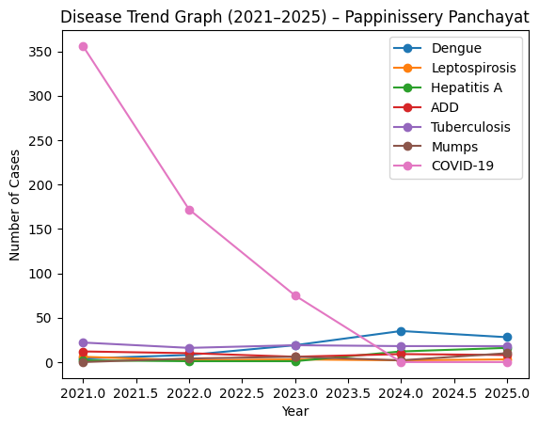

Seasonal Trend Analysis
Seasonal analysis helps anticipate surges (e.g. dengue in monsoon, leptospirosis after floods, influenza in cooler months) and plan pre‑emptive vector control, stockpiling of IV fluids, and awareness campaigns at Panchayat level.

DENGUE
Dengue is a major seasonal vector-borne disease strongly associated with rainfall, water stagnation, and increased mosquito breeding during the monsoon period.

Peak: July–November
Dengue – Ward-wise Yearly Distribution (2021–2025)

Ward | Dengue – Ward-wise Yearly Distribution
Ward | 2021 | 2022 | 2023 | 2024 | 2025 | Total
1 | 0 | 0 | 0 | 2 | 0 | 2
2 | 1 | 0 | 0 | 2 | 0 | 3
3 | 0 | 2 | 2 | 1 | 0 | 5
4 | 1 | 0 | 4 | 1 | 0 | 6
5 | 2 | 2 | 2 | 1 | 3 | 10
6 | 0 | 1 | 2 | 3 | 3 | 9
7 | 0 | 1 | 0 | 1 | 2 | 4
8 | 0 | 1 | 4 | 0 | 3 | 8
9 | 0 | 1 | 3 | 0 | 1 | 5
10 | 0 | 0 | 2 | 0 | 2 | 4
11 | 0 | 0 | 0 | 0 | 1 | 1
12 | 0 | 0 | 0 | 0 | 0 | 0
13 | 0 | 0 | 0 | 0 | 1 | 1
14 | 0 | 0 | 0 | 0 | 3 | 3
15 | 0 | 0 | 0 | 0 | 0 | 0
16 | 0 | 0 | 0 | 0 | 0 | 0
17 | 0 | 0 | 0 | 0 | 4 | 4
18 | 0 | 0 | 0 | 0 | 1 | 1
19 | 0 | 0 | 0 | 0 | 3 | 3
20 | 0 | 0 | 0 | 0 | 4 | 4

LEPTOSPIROSIS
Leptospirosis cases are closely linked to monsoon rains, flooding, and occupational exposure, particularly in low-lying and waterlogged areas.

Peak: June - August
Leptospirosis – Ward-wise Yearly Distribution (2021–2025)

Ward | Leptospirosis – Ward-wise Yearly Distribution
Ward | 2021 | 2022 | 2023 | 2024 | 2025 | Total
1 | 1 | 0 | 0 | 0 | 0 | 1
2 | 0 | 0 | 0 | 0 | 0 | 0
3 | 1 | 0 | 0 | 0 | 1 | 2
4 | 0 | 1 | 0 | 0 | 0 | 1
5 | 0 | 0 | 0 | 0 | 0 | 0
6 | 0 | 0 | 0 | 0 | 0 | 0
7 | 0 | 0 | 0 | 0 | 0 | 0
8 | 0 | 0 | 0 | 0 | 0 | 0
9 | 0 | 0 | 0 | 0 | 1 | 1
10 | 0 | 0 | 0 | 0 | 0 | 0
11 | 0 | 0 | 0 | 1 | 0 | 1
12 | 0 | 1 | 0 | 0 | 0 | 1
13 | 0 | 0 | 0 | 0 | 1 | 1
14 | 1 | 0 | 0 | 0 | 0 | 1
15 | 1 | 0 | 0 | 0 | 1 | 2
16 | 0 | 0 | 0 | 0 | 0 | 0
17 | 0 | 0 | 0 | 0 | 0 | 0
18 | 0 | 0 | 0 | 0 | 0 | 0
19 | 2 | 0 | 0 | 0 | 0 | 2
20 | 0 | 0 | 0 | 0 | 0 | 0

VIRAL HEPATITIS - A
Hepatitis A cases are commonly associated with unsafe drinking water, food contamination, and breakdowns in sanitation, often presenting as clusters or outbreaks.

Peak: October - December
Hepatitis A – Ward-wise Yearly Distribution (2021–2025)

Ward | Hep A – Ward-wise Yearly Distribution
Ward | 2021 | 2022 | 2023 | 2024 | 2025 | Total
1 | 0 | 0 | 0 | 6 | 0 | 6
2 | 0 | 0 | 0 | 0 | 1 | 1
3 | 0 | 0 | 0 | 2 | 1 | 3
4 | 0 | 0 | 0 | 0 | 1 | 1
5 | 0 | 0 | 0 | 2 | 0 | 2
6 | 0 | 0 | 0 | 1 | 2 | 3
7 | 0 | 0 | 0 | 1 | 1 | 2
8 | 0 | 0 | 0 | 1 | 3 | 4
9 | 0 | 0 | 0 | 1 | 2 | 3
10 | 0 | 0 | 0 | 0 | 3 | 3
11 | 0 | 0 | 0 | 1 | 2 | 3
12 | 0 | 0 | 0 | 1 | 0 | 1
13 | 0 | 0 | 0 | 1 | 0 | 1
14 | 0 | 0 | 0 | 0 | 1 | 1
15 | 0 | 0 | 0 | 0 | 2 | 2
16 | 0 | 00 | 00 | 0 | 3 | 3
17 | 0 | 0 | 0 | 0 | 1 | 1
18 | 0 | 0 | 0 | 0 | 0 | 0
19 | 0 | 0 | 1 | 0 |  | 1
20 | 0 | 1 | 0 | 0 | 0 | 1

Outcome-Based Trend Analysis- 2021- 2025

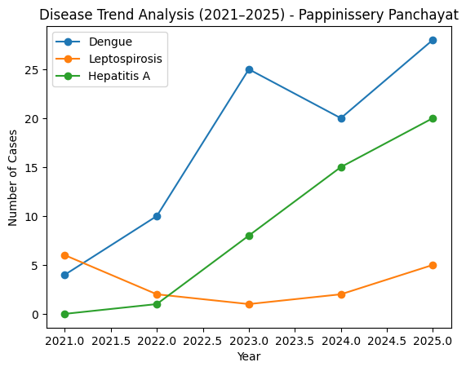

The trend analysis demonstrates a rising burden of dengue and hepatitis A with persistent leptospirosis, highlighting increasing environmental and water-related health risks in Pappinisser

Transmission Trend- 2025
For effective management of public health issues, it is important to track the trend of disease transmission mode. It helps identify the population or place at high risk that can be used to predict outbreaks and implement targeted interventions as quickly as possible. Understanding these kinds of trends enables authorities to allocate resources efficiently and change the strategies adequately based on the trend that follows.

Mode of Transmission | No. of cases | No. of Deaths
Vector Borne Diseases | 28 | NIL
Water Borne Diseases | 19 | NIL
Air Borne Diseases | 7 | NIL
Blood Borne Diseases | NIL | NIL
Food Borne Diseases | NIL | NIL

Vector-Borne Disease

Disease | No. of Cases | No. of Deaths
Dengue | 28 | NIL
Malaria | NIL | NIL
Chikungunya | NIL | NIL

Water Borne Disease

Disease | No. of Cases | No. of Deaths
Cholera | NIL | NIL
Typhoid | 3 | NIL
Hep- A | 16 | NIL
Dysentery | NIL | NIL
Amoebiasis | NIL | NIL
E- Coli infections | NIL | NIL
Air Borne Disease

Disease | No. of Cases | No. of Deaths
Influenza | 0 | 0
H1N1 | 0 | 0
TB | 18 | NIL
Chickenpox | 8 | NIL
Measles | NIL | NIL
Covid-19 | NIL | NIL
Pertussis | NIL | NIL
Mumps | NIL | NIL

Blood-Borne Disease

Disease | No. of Cases | No. of Deaths
AIDS | NIL | NIL
Hep- B | NIL | NIL
Hep- C | NIL | NIL

Zoonotic Disease

Disease | No. of Cases | No. of Deaths
Rabies | NIL | NIL
Leptospirosis | 3 | NIL
Avian influenza | NIL | NIL
West nile | NIL | NIL
Anthrax | NIL | NIL
Nipah | NIL | NIL
Scrub Typhus | NIL | NIL

Integrated Disease Hotspot Map (2021–2025)

Ward No | Dengue Total (2021-25) | Leptospirosis Total (2021-25) | Hepatitis A Total (2021-25) | Mumps (2021-25) | ADD (2021-25) | Total Cases
1 | 2 | 1 | 6 | 0 | 0 | 12
2 | 2 | 0 | 1 | 2 | 2 | 7
3 | 5 | 0 | 0 | 3 | 2 | 10
4 | 4 | 1 | 1 | 2 | 2 | 10
5 | 5 | 0 | 2 | 0 | 2 | 9
6 | 4 | 0 | 3 | 0 | 0 | 7
7 | 2 | 0 | 2 | 0 | 0 | 4
8 | 3 | 0 | 4 | 0 | 0 | 7
9 | 4 | 1 | 3 | 0 | 2 | 10
10 | 4 | 0 | 3 | 0 | 2 | 9
11 | 1 | 1 | 3 | 0 | 2 | 7
12 | 0 | 1 | 1 | 0 | 2 | 4
13 | 1 | 0 | 1 | 0 | 2 | 4
14 | 1 | 1 | 1 | 0 | 2 | 5
15 | 3 | 1 | 1 | 0 | 2 | 7
16 | 0 | 0 | 3 | 0 | 2 | 5
17 | 4 | 0 | 1 | 0 | 2 | 7
18 | 1 | 0 | 0 | 0 | 2 | 3
19 | 3 | 2 | 1 | 0 | 2 | 8
20 | 4 | 0 | 1 | 0 | 2 | 7

By overlaying five years of data, we have identified .'Red Zone' Wards. These are wards where at least two different categories of diseases (e.g., Dengue and Lepto) recurred in consecutive years. Ward 18,14 is categorized as the Highest Priority Hotspot due to its combination of flood vulnerability and high vector density. Future health infrastructure, such as the proposed R.O plants at hould be prioritized.

Preparedness and Response Protocol at LSG Level
This section describes the operational framework for the LSGI once a pandemic is declared. It explains how the LSGI and health system will move from routine data collection to active response, using a One Health approach.

Constitution of One Health Committee
The LSGD shall constitute a One Health Committee comprising the LSGI President, Medical Officers (Modern Medicine, AYUSH, and Veterinary), the Health Inspector, and the Veterinary Surgeon.

Objective: The One Health Committee coordinates human, animal, and environmental health to prevent and control pandemics.

Sl No | Name | Designation | Department/Institution | Role in Committee | Contact Number
1 | K PradeepKumar | Panchayat President | LSGD | Chairperson | 9495695981
2 | Dr.AnishBabu.T | Medical Officer (PHC/CHC) | Health Dept | Member Secretary | 9447372672
3 | Praseena | Veterinary Officer | Animal Husbandry | Member | 9495177474
4 | Divya Suresh | Epidemiologist | Health Dept | Member | 7994260637
5 | Srinivasan K.P | Health Inspector/PHN | Health Dept | Surveillance | 9847696315
6 | Roja E | ASHA Supervisor | Health Dept | Community link | 9446296570
7 | Preetha | ICDS Supervisor | Social Welfare | Vulnerable groups | 9995409292
8 | VIJESH | Police Station Officer | Police Dept | Law & order | 04972778100
9 | K Prameela | Ward Councillor Representative | LSGD | Community coordination | 9526888903
10 | preetha | Kudumbashree CDO | Kudumbashree | Community mobilisation | 995409292
11 | NIL | NGO/Volunteer rep | Civil Society | Support services
12 | ADARSH | AGRICULTURE OFFICER | AGRICULTURE DEPT | Support services | 8618030516

Key Responsibilities:
- Review disease surveillance data (human + animal)
- Conduct ward-wise risk assessment and vulnerability mapping
- Approve quarantine/isolation centre locations
- Coordinate with district for resources (PPE, oxygen, ambulances)
- Periodically review health system surge capacity, including beds, oxygen, human resources, and ambulances.
- Approve and monitor risk communication and community engagement strategies, including rumour management.
- Ensure protection and service continuity for vulnerable groups (elderly, persons with disabilities, dialysis patients, coastal populations).
- Conduct quarterly mock drills
- Monitor equity measures for vulnerable groups
Meeting Schedule:
Quarterly (normal times) | Weekly (outbreak alert) | Daily (pandemic phase)

Pandemic Response Workforce
To ensure a coordinated and timely response during a pandemic, a dedicated Pandemic Response Workforce shall be constituted at the LSG level. The workforce will function under the overall supervision of the One Health Committee and in close coordination with the health authorities. Team-based deployment will enable efficient surveillance, case management, quarantine and isolation management, logistics support, and risk communication. Each team shall have a clearly designated team leader, defined roles, and an identified pool of personnel to allow rapid activation, rotation of duties, and continuity of services during prolonged emergencies.

Total Response Workforce Available: 300 persons

Team Name | Composition | Key Responsibilities | Team Leader
Surveillance and Contact Tracing Team | HI, JHI, JPHN, ASHAs and Volunteers | Case detection, contact listing, home visits, reporting | HI
Case Management Team | Doctors, Nurses, MLSP, Palliative Nurses | Patient care & referral | DOCTOR
Quarantine & Isolation Team | LSGD staff, Volunteers | Facility management | JHI
Psychosocial support | PRO-PAPPINISSERI | Psychosocial support | 8943341418
Logistics & supply chain Team | LSGD staff, Storekeepers, Drivers 3 | Supplies & transport [PPE, medicines, oxygen, transport, waste management] | Ward Member
Communication Team | Ward members, Kudumbashree, Youth clubs,  AWW workers and other self help groups | IEC, community meetings, countering misinformation | M.O in charge
Transportation | KSRTC, educational institutional buses | TRANSPORTATION | LSGD
Media Surveillance | ZEAL NEWS | PUBLICITY& IEC | 9447087751
Intersectoral coordination and convergence | HMC | HMC MEETING | MO IN CHARGE
Collaborative surveillance | PRO/HI | COLLABORATION WITH OTHER DEPTS. | HI IN CHARGE

All teams shall be activated immediately upon outbreak alert or pandemic declaration and shall report daily to the LSG Incident Commander/Medical Officer, with consolidated reporting to the Block PHC. Duty rosters and alternate personnel shall be maintained to ensure uninterrupted services during staff shortages or prolonged response periods. Team composition and numbers may be revised based on the magnitude of the outbreak and availability of human resources.

Activities and Measures before and during Pandemic

PHASE 1 - Alert / Preparation
Surveillance and Reporting-Enhanced syndromic surveillance:
Data sources for surveillance:
- Event-based triggers (to be monitored and reported):
- Zoonotic and animal health surveillance
- Logistics and Stock Preparedness
  - Identify and empanel local vendors and define emergency procurement mechanisms in accordance with existing LSGD and Health Department norms.
  - Prepare and maintain an essential logistics checklist covering medical supplies, consumables, and support equipment.
  - Pre-identify secure storage locations for emergency stocks and ensure maintenance of stock registers with regular updating.
  - Finalise emergency transport arrangements, including availability of vehicles and identified drivers for rapid deployment during alerts.
  - Designate a Nodal Officer for Logistics to enable prompt decision-making, coordination, and communication during emergencies.
  - Conduct rapid stock verification and ensure availability of minimum buffer stock, including:
- PPE kits 200–300 numbers
- Pulse oximeters 20–30 numbers
- Hand sanitizers 50–100 litres litres
- Masks 5000–10000, gloves 20000–30000, disinfectants 25–50 units

Identify critical gaps in logistics and immediately communicate requirements to the Block and District authorities for timely replenishment and support. Monitor expiry dates and stock rotation.

- Identification of Quarantine and Isolation Facilities
  - Identify and list suitable buildings for quarantine and isolation (schools, hostels, community halls, etc.).
  - Categorise cases as per the severity and allocate to appropriate facilities (for instance, severe cases to classrooms, mild cases to an assembly hall in case of a school).
  - Facility readiness checklist needed (beds, toilets, ventilation) etc.
  - Find an alternate site if the primary sites are not available or not in use.
  - Identify facility managers and support staff
  - Prepare basic SOPs for:
    - Admission and discharge
    - Food, water, sanitation
    - Infection prevention and waste disposal
  - Ensure availability of basic amenities: water, sanitation, electricity, ventilation, and waste disposal. Prepare a rapid activation plan for these facilities if case numbers increase.

- Risk Communication and Community Preparedness
  - Disseminate early warning messages on symptoms, preventive measures, and reporting mechanisms. Display IEC materials both in English and the local language in public places and ensure ward-level awareness.
  - Sensitize elected representatives and community leaders on preparedness measures.
  - Establish a rumour tracking and misinformation response mechanism to identify, verify, and promptly counter false or misleading information.
  - Engage trusted local persons (ward members, ASHA workers, religious leaders, teachers, community volunteers) to communicate official public health messages and reinforce correct practices.
  - Develop and deploy targeted IEC materials for:
    - Schools and educational institutions
    - Markets and commercial areas
    - Work sites and labour settings
  - Conduct community sensitization meetings at the ward level to promote preventive behaviors, address concerns, and strengthen community participation in preparedness and response.
- Protection of Vulnerable Groups
Vulnerable populations require priority protection through targeted line-listing, service continuity, and delivery mechanisms.
- Prepare and regularly update line-lists of vulnerable populations, including:
  - Elderly persons living alone
  - Persons with disabilities
  - Pregnant women
  - Migrant workers
  - Dialysis patients
The detailed line-lists shall be maintained as Annexure ___ and updated periodically.
- Clinical Dependency Mapping
Develop ward-wise dependency and vulnerability maps to identify households requiring regular support during emergencies. Ensure continuity of essential health services for vulnerable groups, including
- Dialysis services (facility mapping, transport arrangements, and scheduling)
- Continuity of treatment for TB, HIV, and other chronic conditions requiring uninterrupted medication
- Mental health and psychosocial support services
Establish delivery mechanisms for food, essential commodities, and medicines to vulnerable households through coordinated action involving ASHAs, JPHNs, Kudumbashree, volunteers, and local administration.

PHASE 2 - Active Response
- Case Identification and Contact Tracing
Case detection and contact tracing activities will be carried out in coordination with the Health authorities, following disease-specific SOPs and IDSP guidelines.
Field Staff Involved
- Health Inspector (HI)
- Junior Health Inspector (JHI)
- Junior Public Health Nurse (JPHN)
- ASHAs and ASHA Supervisors
- Ward-level volunteers and Kudumbashree members (as required)
- Screening Checkpoints
Screening checkpoints at high-traffic locations (transport hubs, markets, religious gatherings) for early detection of symptomatic travellers and crowd screening during outbreaks. Potential locations include bus stands, market entry points, and boat jetties, based on local context and risk assessment.
Screening activities will be carried out by trained personnel such as ASHAs, ward members, and volunteers, with support from Health Department staff. Necessary equipment, including non-contact thermometers and appropriate PPE, shall be ensured prior to activation.
Location | Type (Bus stand/Jetty/Market/Railway) | Staff Deployed (ASHAs/Volunteers) | Screening Method | Reporting authority
Bus stand | Transport hub | One JHI  One ASHA  One health Mentors | 1.Swab Collection.  2. Blood smears collection (RDT)  3.Thermal Scanners | Surveillance Nodal Officer in control room
Market entry | Market | One JHI  One ASHA  Male health volunteers | 1.Swab Collection.  2. Blood smears collection (RDT)  3.Thermal Scanners | Surveillance Nodal Officer in control room
Boat jetty | Water transport | One JHI  One ASHA  Male health volunteers | 1.Swab Collection.  2. Blood smears collection (RDT)  3.Thermal Scanners | Surveillance Nodal Officer in control room
Standard Screening Protocol

The screening protocol shall include temperature screening, observation for visible symptoms, and inquiry regarding recent travel or exposure history. Individuals identified as suspects during screening shall be immediately referred to the nearest PHC/FHC for further evaluation, testing, and appropriate action as per prevailing guidelines.
- Pandemic Control Room
The Pandemic Control Room (PCR) serves as the central nerve center for real-time coordination, data aggregation, decision support, and communication during outbreaks. It consolidates information from all LSGD teams, health facilities and community sources to enable rapid response decisions.
Control Room Infrastructure and Location
Primary Location: Paappinisseri Panchayath Office.
Backup Location: Community Hall in PAPPINISSERI G.P.

HEALTH SYSTEM CONTROL ROOM FRAMEWORK (PCR) – PAPPINISSERY
The Public Health Control Room (PCR) is established to ensure real-time coordination, monitoring, and response during public health emergencies. It functions through multi-sectoral teams organized into key operational pillars, ensuring that no aspect of response is overlooked.
Functional Pillars of PCR
1. Rapid Response Team (RRT)
Provides immediate field intervention during: ,Outbreaks, Cluster, Emergency alerts
Key functions: Case investigation, Contact tracing, Isolation and containment, Inter-facility referrals
2. Data Management & Analytics Team
Collects and manages:Cases, testing data, Bed availability, Human resources and supplies
Functions: Trend analysis and projections, Dashboard preparation, Evidence-based decision support
3. Human Resource Deployment Team
Allocates healthcare workers based on: Workload, Facility needs
Ensures: Optimal staffing, Equitable distribution
Manages: Duty rosters, Surge capacity planning
4. Laboratory Surveillance Team
Coordinates: Sample collection and transport, Diagnostic testing
Monitors: Positivity rate, Turnaround time
Supports: Early outbreak detection
5. Vaccination Cell (If Required)
Plans and implements: Vaccination campaigns, Micro-planning and outreach sessions
Tracks: Coverage and dropouts
Coordinates with: Field teams and ASHA workers
6. Infrastructure & Patient Occupancy Team
Monitors: Bed availability, Oxygen supply, ICU and critical care capacity
Ensures:Proper patient referral, Load balancing across facilities
7. Biomedical Waste Management (BMWM)
Ensures safe:Collection, Segregation, Disposal of biomedical waste
Prevents: Secondary infectionn, Environmental contamination
8. Communication & Media Surveillance Team
Handles: Public communication, IEC activities
Monitors:Media reports, Rumors and misinformation
Ensures: Timely and accurate information dissemination
9. Logistics & Supply Chain Team
Manages:Procurement and distribution of supplies, Stock monitoring (PPE, medicines, etc.)
Ensures: Availability of buffer stock
10. Transportation Team (Emergency & Inter-facility)
Coordinates:Ambulances, Patient referrals
Ensures: Timely transport during emergencies, Access to remote areas (e.g., Thuruthi)
11. Call Centre / Helpline Unit
Receives: Public complaints,Health queries
Provides: Guidance and referrals,
Acts as:First point of contact
12. Management of the Deceased
Ensures: Safe and dignified handling of deceased
Follows:Infection control protocols
Coordinates with:Local authorities and families
13. Intersectoral Coordination & Convergence
Coordinates with:Local Self Government (LSGI), Police, KSEB, Water Authority, Disaster Management teams

Key Control Room Team

The Control Room Team coordinates all pandemic response activities within the LSGD and serves as the single command and communication hub during activation. It integrates information, field actions, logistics, and policy execution across all participating departments and health facilities.

Role | Name | Designation | Contact Number | Responsibility
In-charge/Nodal Officer | Sreejaya | Panchayath Secretary | 9746370866 | Overall coordination, decision-making, and reporting to the District level.
Data Entry Operator | 0 | 0 | 0 | 0
Communication Officer | Sreenivasan K.P | Health Inspector | 984769315 | Handling the public helpline, coordinating ambulance dispatch, and contact tracing calls.
Logistics Coordinator | JYOTHI | SENIOR CLARK | 9846740533 | PROCURMENT OF LOGISTICS
Technical Support (IT/Data) | Sruthi | Data Manager | 8075350904 | Managing the line list, updating dashboards, and tracking testing results.

SOP for alert escalation/trigger point with mapping of responsibilities.
Key Points:
- The Control Room shall be staffed with a designated In-charge, data entry personnel, and communication staff with clearly defined roles and shift arrangements.
- It shall maintain updated records on daily monitoring indicators including new cases, persons under active quarantine, and hospital bed occupancy.
- All reports and situation updates shall be shared daily with the Block and District Surveillance Unit.
- The Control Room shall act as a single point of contact for coordination with response teams, health institutions, and other departments.
- Contact details of the Control Room shall be widely communicated to field staff and stakeholders during activation.
Daily Monitoring Indicators
To ensure timely decision-making and effective response, the following key indicators shall be monitored and updated on a daily basis by the Pandemic Control Room:
- Epidemiological Indicators:
New cases reported today, Total active cases, Test Positivity Rate (TPR), Case Fatality Rate (CFR)
- Surveillance Indicators:
Persons under home quarantine, High-risk contacts identified, Fever, ILI, SARI or other symptoms (syndromic surges), Travellers (symptomatic or high-risk arrivals),Animal husbandry surveillance (zoonotic alerts, unusual animal deaths, poultry/bird flu signals), Mortality surveillance (excess deaths, unexplained fatalities, verbal autopsy reports)
- Logistics and Infrastructure Indicators:
Hospital / CFLTC beds occupied, Oxygen cylinders/concentrators available, Ambulances on standby
- Alert Findings
The following table outlines category-specific trigger points (red flags) from surveillance indicators and corresponding immediate actions for the Pandemic Control Room. These enable rapid response to alert findings like testing anomalies, positive cases exceeding thresholds, clusters, and WGS reports.

Category | Trigger Pophint (Red Flag) | Immediate Action
Clusters | Geographical or facility-based: 5+ cases linked to one location (office, school, street). | Declare a micro-containment zone; perimeter control and active case finding.
Testing | Sudden drop in testing volume / delay in reporting / unusual testing trends | Review the sample collection process, address lab bottlenecks, deploy additional testing teams, and notify the District Lab.
Lab | Test Positivity rate increases | Increase testing sites in that ward.
Hospital | >80% Oxygen bed occupancy | Activate backup/CFLTC beds.
Travel | Cluster of cases from a single flight/train or high-risk arrival group. | Trace all passengers in adjacent seats; implement mandatory institutional quarantine.
Animal | Mass poultry/wildlife death or unusual sickness | Notify Animal Husbandry, sample the area, and dispatch RRT for environmental sampling and zoonotic check.
Mortality | Sudden spike in home deaths or brought-in-dead (BID) cases | Audit the deaths and Active Case Search drive
Additional investigations like Whole Genome Sequencing (WGS) | Detection of a Variant of Concern (VOC) or Variant of Interest (VOI) | Implement strict micro-containment; update clinical protocols to match variant severity.
- Communication of Public Health Information
A Community Communication Hub shall be established to ensure timely, accurate, and consistent dissemination of information during a pandemic. The Hub will function under the coordination of Nodal officers of the control room and act as the nodal point for public communication, risk messaging, and community engagement. It will support dissemination of official advisories, promote preventive behaviors, address rumors and misinformation, and ensure that messages reach all sections of the population through trusted local channels and leaders.
Key communicators

Channel | Responsible Person | Contact
Ward-level announcements | SREESHAN | 9995961802
Social media | HI | 9847696315
Local Cable TV/Radio | RADHAKRISHNAN | 9947087751

- All messages disseminated through the Hub shall align with advisories issued by the Health Department and District authorities.
- Community leaders shall be sensitized to support behavior change, reduce stigma, and counter misinformation.
- Special efforts shall be made to reach vulnerable and hard-to-reach populations using locally appropriate communication methods.

Rumor Tracking: A designated volunteer will monitor local social media/WhatsApp groups daily to identify misinformation and issue official clarifications via the Communication Hub.
- Coordination with District/State Authorities & Other Organisations
Effective coordination with Block, District, and State authorities is essential to ensure timely reporting, technical guidance, and uninterrupted supply of essential resources during a pandemic. The LSG shall establish clear communication channels, designate responsible officers, and adhere to prescribed reporting timelines to support coordinated public health action and efficient resource mobilisation.

Key Details:
- Nodal Officer for Reporting: HEALTH INSPECTOR
- Contact Number:
Reporting Schedule and Protocols:

To Whom | What to Report | Frequency | Nodal Person
Block PHC | Complete Situation Report (Cases, Quarantine, Beds, Screening, Deaths) | DAILY | HI
District IDSP Unit | Outbreaks/Clusters/Unusual Events (>5 cases same ward) | WEEKLY | DATA MANAGER
Veterinary Officer | Animal health events/Zoonotic alerts | DAILY | VETENARY
State Cell | Zoonotic cross-sector events | WEEKLY | HI

Supply Chain Coordination
The LSG shall coordinate closely with Block, District, and State authorities (KMSCL) to ensure uninterrupted availability of essential goods, medical supplies, and logistics during a pandemic. Supply requirements shall be assessed regularly based on case load and communicated promptly to the appropriate authorities for timely replenishment.
Key Points:
- Maintain updated contact details of District and Block nodal officers for health logistics, oxygen supply, ambulances, and essential medicines.
- Submit timely indent requests for PPE, testing kits, medicines, oxygen, and other critical supplies through prescribed channels.
- Monitor stock levels at LSGD facilities, quarantine/isolation centres, and field teams through daily stock registers and dispensing logs to prevent shortages.
- Coordinate with District authorities, Karunya/Neethi medical shops, and local purchase committees for funds allocation and emergency procurement.

- Ensure regular monitoring of dispensing registers at all facilities to track usage, expiry, and pilferage—shortages being a perennial issue requiring proactive weekly audits.

- Activate surge procurement protocols during high caseloads, leveraging local purchase powers under LSGD funds alongside state supplies.

Resource Inventory and Contacts
Resource Category | Source  (District/State/Private) | Contact
PPE Kits/Masks/Gloves | KMSCL | 9400052993
PPE Kits/Masks/Gloves | Local Vendors | 9567628584
Oxygen  Cylinders/Concentrators | KMSCL | 9400052993
Medicines/Antivirals | KMSCL | 9400052993
Medicines/Antivirals | JAN OUSHADHI | 9447487441
Test Kits (RTPCR/Rapid) | KMSCL | 9400052993

Collaboration with NGOs, PPP, and CSR

To augment government efforts during a pandemic, the LSG shall collaborate with NGOs, voluntary organisations, and private sector partners through public–private partnerships and Corporate Social Responsibility (CSR) initiatives, in coordination with District authorities.

Key Points:
- Engage NGOs and community-based organisations for community outreach, awareness, and support to vulnerable populations.
- Leverage CSR support for procurement of medical equipment, PPE, oxygen concentrators, food kits, and sanitation materials, as permitted.
- Ensure all collaborations align with government guidelines and are routed through approved administrative and financial procedures.
- Maintain transparency and documentation for all external support received and utilised.
Organization | Type | Support Offered | Contact Person
Youth Clubs/Student Unions | CBO | MANPOWER | 9495695981
Interdepartmental Coordination
Coordination among departments during a pandemic shall be ensured through regular review meetings convened by the LSGD President. These meetings will provide a structured platform for sharing situational updates, assessing resource availability, resolving operational gaps, and taking joint decisions to ensure a coordinated and timely response.

Department | Representative | Key Role | Contact
Health (PHC) | Staff Nurse : | Case management | 9497158280
Veterinary | Veterinary Surgeon: | Animal surveillance | 9495177474
ICDS | Supervisor: Sindhu | Nutrition support | 9995410114
Education | Head Teacher: | School coordination | 949623890
Police | SHO | Containment enforcement | 9497987205
Water Authority | OVERSEAR | Water supply | 7411195921
LSGD Engineering | AE | Quarantine infrastructure | 8606220063

PHASE 3 - Surge Capacity
Phase 3 is activated when there is a rapid increase in cases, high test positivity rates, or when existing health facilities and quarantine arrangements approach saturation. The focus of this phase is to expand isolation capacity, augment clinical care services, and mobilise additional resources through district and state support mechanisms.
Conversion of Community Facilities
To manage increased case load, the LSGD shall activate additional isolation facilities by repurposing identified community infrastructure such as community halls, auditoriums, schools, hostels, or other suitable buildings.

Name of facility | Facility Type | No. of Buildings | Ward | Surge Capacity (Beds) | Nodal Person
PAPPINISSERI  CO-OP BANK | BANK | 1 | 12 | 200 | 9447343167
AROLI GHSS | SCHOOL | 5 | 6 | 500 | 9496242378

RECOVERY&REHABILITATION PHASE –PAPPINISSERY PANCHAYAT
The recovery and rehabilitation phase focuses on restoring normalcy, rebuilding health systems, and strengthening resilience following a public health emergency or disaster. In Pappinissery, this phase prioritizes vulnerable populations, restoration of essential services, and prevention of secondary outbreaks.
Recovery Phase Components
A. Damage & Impact Assessment
- Rapid and detailed assessment of: Affected population and households, Health infrastructure damage, Environmental impact (water contamination, vector breeding)
- Use of ward-level data and field reports for real-time assessment
B. Restoration of Health Services
- Re-establish functioning of: CHC/PHC and sub-centres, Immunization services, Maternal and child health services
- Ensure continuity of care for: Dialysis patients, Cancer patients, TB and NCD patients
C. Rehabilitation of Affected Population
- Support displaced and affected families through: Temporary shelter arrangements, Access to safe drinking water and food
- Special focus on:
  - Elderly (12,337)
  - Bedbound (140)
  - Palliative care patients (37)
D. Psychosocial & Mental Health Support
- Provide counselling services for: Disaster-affected families, Children and elderly
- Mobilize: Health workers, Community volunteers
- Address stress, trauma, and anxiety
E. Disease Surveillance During Recovery
- Strengthen IDSP surveillance
- Monitor for: Dengue, Leptospirosis, Acute Diarrheal Diseases (ADD)
- Early detection of secondary outbreaks
F. Environmental Cleanup & Sanitation
- Disinfection and cleaning of: Flood-affected areas, Wells and water bodies
- Solid waste management and drainage clearance
- Vector control measures (source reduction, larviciding)
3. Rehabilitation Phase Components
A. Livelihood Restoration
- Support affected occupational groups: Fisherfolk, Daily wage workers, Industrial workers
- Facilitate access to:Government schemes, Financial assistance and employment programs
B. Community Engagement & Confidence Building
- Conduct awareness campaigns on: Hygiene and sanitation, Disease prevention
- Strengthen community platforms: Kudumbashree, ASHA & Anganwadi networks
C. Documentation & After-Action Review
- Record: Response activities, Challenges faced, Outcomes achieved
- Conduct review meetings at block and ward levels
D. Lessons Learned & Best Practices
- Identify: Successful interventions, Gaps in response
- Integrate findings into future preparedness plans
E. Health System Strengthening
- Improve:Infrastructure resilience, Emergency preparedness systems
- Capacity building of: Health staff, Field workers
F. Policy Revision & Preparedness Enhancement
- Update: Pandemic Preparedness Plan, Disaster management protocols
- Incorporate: Ward-level risk and vulnerability data
G. Research & Evidence Generation
- Conduct studies on: Disease patterns, Effectiveness of interventions
- Use findings for: Policy improvement

CONCLUSION
The Pandemic Preparedness Plan for Pappinissery Panchayat provides a comprehensive, evidence-based framework to prevent, detect, and respond effectively to public health emergencies. Grounded in detailed assessments of risk stratification, vulnerability mapping, geographic hazards, and health system capacity, the plan emphasizes a proactive and multi-sectoral approach to pandemic management.
The presence of high population density, significant elderly population, environmental vulnerabilities, and socio-economic challenges highlights the need for targeted interventions and prioritized resource allocation. The plan recognizes the importance of early warning systems, strengthened surveillance, and community participation in minimizing the impact of outbreaks.
By integrating health system strengthening, interdepartmental coordination, and community engagement mechanisms, the block is better positioned to ensure continuity of essential services and protection of vulnerable populations, including migrants, bedbound patients, and those with chronic illnesses.
Furthermore, the inclusion of research, capacity building, and continuous monitoring ensures that the plan remains dynamic, adaptive, and responsive to emerging challenges. The recovery and rehabilitation strategies outlined will support resilience building and rapid restoration of normalcy following any public health crisis.
In conclusion, this Pandemic Preparedness Plan serves as a practical roadmap for safeguarding public health in Pappinissery, promoting preparedness, resilience, and coordinated action to effectively manage current and future pandemics.

ADDITIONAL COMPONENTS – PAPPINISSERY PANCHAYAT
1. Technical Support Systems
- Strengthening digital surveillance systems (IDSP integration)
- Use of GIS-based mapping for risk and vulnerability tracking
- Telemedicine support for:
  - Remote areas (e.g., Thuruthi)
  - Bedbound and palliative patients
- Data management systems for real-time reporting and decision-making
2. Relief-Based Commodities & Logistics
- Pre-positioning of essential supplies:
  - Medicines and emergency kits
  - ORS, chlorine tablets, PPE kits
  - Food kits and safe drinking water
- Establishment of ward-level storage points
- Efficient supply chain mechanisms during emergencies
3. HAM Radio Operators (Emergency Communication)
- Identification and engagement of licensed HAM radio operators
- Backup communication system during:
  - Power failure
  - Network disruption
- Integration with district disaster management communication network
4. Hazard & Vulnerability Mapping
- Continuous updating of:
  - Flood-prone wards
  - Waterlogging zones
  - High-risk population clusters
- Use of mapping for:
  - Resource allocation
  - Targeted interventions
- Integration with block and district disaster management plans
5. Power Supply & Backup Systems (KSEB & Others)
- Coordination with Kerala State Electricity Board (KSEB)
- Ensuring uninterrupted power supply to:
  - Health facilities
  - Cold chain systems
- Backup arrangements:
  - Generators
  - Solar power (where feasible)
- Rapid restoration mechanisms during disasters
6. Human Resource (HR) – Specific Responsibilities
Medical Officers
- Overall coordination and clinical management
- Supervision of surveillance and outbreak response
Health Inspectors / JPHNs
- Field-level implementation
- Monitoring sanitation and vector control
ASHA Workers
- Community-level surveillance
- Identification of symptomatic cases
- Awareness generation
Anganwadi Workers
- Support for vulnerable groups:
  - Children
  - Pregnant and lactating women
Volunteers & Community Groups
- Support in:
  - Relief distribution
  - Awareness campaigns
  - Emergency response

RECOMMENDATIONS
1. Strengthening Healthcare Infrastructure
- Establish a primary health response unit within the Panchayat with trained staff.
- Ensure availability of basic medical supplies (masks, sanitizers, PPE kits, oxygen cylinders).
- Create tie-ups with nearby hospitals in Pappinissery for emergency referral and transport.
2. Community Awareness & Education
- Conduct regular awareness campaigns on hygiene, vaccination, and preventive measures.
- Use local communication channels (community radio, WhatsApp groups, notice boards) to spread verified information.
- Train volunteers to act as health ambassadors in each ward.
3. Emergency Response & Coordination
- Form a Pandemic Preparedness Committee at Panchayat level including health workers, ward members, and NGOs.
- Develop a clear action plan for lockdowns, quarantine, and distribution of essentials.
- Maintain a database of vulnerable groups (elderly, differently-abled, chronically ill) for targeted support.
4. Supply Chain & Food Security
- Identify and support local suppliers and farmers to ensure uninterrupted food supply.
- Create community kitchens during emergencies to serve vulnerable populations.
- Stockpile essential commodities in Panchayat-run outlets for crisis periods.
5. Digital Preparedness
- Promote digital platforms for telemedicine consultations.
- Use Panchayat’s website/social media for real-time updates on health advisories.
- Encourage online grievance redressal to reduce crowding in offices.
6. Training & Capacity Building
- Organize mock drills for pandemic response in schools, offices, and public spaces.
- Train Panchayat staff and volunteers in first aid, infection control, and crowd management.
- Collaborate with NGOs and health departments for capacity-building workshops.
7. Long-Term Resilience
- Integrate pandemic preparedness into the Panchayat Development Plan.
- Allocate a dedicated budget for health emergencies.
- Encourage community participation in planning and monitoring preparedness measures.

MOCKDRILL SCENARIOS
Scenario Title:
Influenza Outbreak in a Hospital Setting (Institutional Cluster)
Context:
During the peak seasonal period, a sudden increase in influenza-like illness (ILI) is reported among patients and healthcare workers at the Community Health Centre, Pappinissery. Within 48 hours, multiple staff members develop fever and respiratory symptoms, raising concerns of nosocomial (hospital-acquired) transmission. The situation risks disruption of essential health services and further spread to the community.
Objectives:
- Test the early detection and reporting system (IDSP) within the health facility.
- Evaluate infection prevention and control (IPC) practices, including isolation and PPE use.
- Assess continuity of essential health services despite staff shortages.
- Test coordination between hospital team, block health authorities, and rapid response team (RRT).
- Evaluate risk communication to patients, attendants, and the community.
Key Actions:
- Identification of ILI cluster by hospital staff and immediate reporting to Medical Officer
- Activation of Rapid Response Team (RRT)
- Establishment of:
  - Triage area for ILI cases
  - Isolation area within facility
- Implementation of IPC measures:
  - Mask usage
  - Hand hygiene
  - PPE for healthcare workers
- Screening of:
  - Healthcare workers
  - Patients and bystanders
- Temporary restriction of visitors
- Ensuring continuity of:
  - Emergency services
  - Maternal and child health services
Evaluation Indicators:
- Time taken for case detection and reporting
- Adherence to IPC protocols
- Functionality of triage and isolation system
- Impact on health service delivery
- Effectiveness of internal and external communication
Expected Outcomes:
- Early containment of hospital-based outbreak
- Reduced transmission among healthcare workers and patients
- Strengthened infection control preparedness
- Improved coordination and response efficiency

ANNEXURE

IMPORTANT PHONE NUMBERS

Phone numbers and particulars of persons responsible for providing guidance, assistance, and support for pandemic preparedness operations may be provided here in a manner that allows easy reference at a glance. The information recorded here could be exhibited elsewhere at the time of emergencies. LSG institutions shall give special attention to collect and record the above data of persons and institutions who/which are supposed to give technical and co-ordination support to reduce the impact of pandemic.
1.1. Details of grama panchayat/municipality/corporation wards

Sl.No | Name of the ward | Ward number | Name of the ward  member | Contact number
1 | Kottapalam | 1 | T T Chndramathi | 9809450365
2 | Karinkankulam | 2 | P.K.Sasidharan | 9746131642
3 | Dharmakinar | 3 | K V Ashokan | 9495755644
4 | Pazhanchira | 4 | Pola Raveendraan | 9995384368
5 | Manjakulam | 5 | P V Ajitha | 8547680783
6 | Pulakkaravayal | 6 | M Balakrishnan | 9400587677
7 | Keecherikunnu | 7 | Jithesh Koroth | 9037565148
8 | Kattyam | 8 | Ajayan T | 9947016590
9 | Mankadav | 9 | Maimoona K P | 9995917518
10 | Kaloori | 10 | Raima K | 8129848210
11 | Aroli | 11 | K PradeepKumar | 9495695981
12 | Aroli Highschool | 12 | Sruthi T P | 6235902501
13 | Moronnummal | 13 | Ezhil Raj N.P | 9446388114
14 | Thuruthi | 14 | V Narayani | 9633276020
15 | Pappinissery Central | 15 | K Prameela | 9526888903
16 | Vilakandam | 16 | Pola Rajan | 9447666215
17 | Arathil | 17 | Nadheera P P | 8157801571
18 | Kallilepalli | 18 | Mubseena K V | 8606414341
19 | Bapppikan Thodu | 19 | KunjiMoidheen O K | 9562014486
20 | Illipuram | 20 | Prachitra K V | 9074027900
21 | Podikalam | 21 | Nasreena K N | 9847016229
22 | Puthiyakavu | 22 | Sureshan Panayan | 9847075950

1.2. Other important phone numbers of grama panchayat/municipality/corporation area
Sl. No. | Name | Contact number
1. | SREESHAN-RP,GRAMA PANCHAYATH | 9995961802

1.3. Important offices of grama panchayat/municipality/ corporation

Sl.No | Name of the office | Contact person | Contact number
1. | Village Office | Village Officer | 8547617031
2. | Agriculture Office | Agriculture Officer | 8618030516
3. | Animal Husbandry Office | Animal Husbandry Doctor | 9495177474
4. | Police Station | Police Officer | 0497-2778100
5. | BSNL Office | Officer | 9496773866
6. | Block Office | Officer | 0497-2747822
7. | KSEB Office | Officer | 0497-2787245
8. | Fisheries Office | Officer | NIL
9. | Fire and Rescue | Officer | 9947848978/101

1.4. Health Services

Sl. No | Name of the hospital/institution | Location | Phone number
1. | Government hospitals/PHC | Pappinissery | 04972786270
2. | Private hospitals | PAPPINISSERI | 9072777193
3. | Clinical laboratories | KATTILEPALLI | 9544102777
4. | Chemist/pharmacy | CHERUPUZHA | 9447487441
5. | Blood donors | PAPPINISSERI | 04902341604
6. | Other language experts (Bihari, Hindi, Bengali,  Asamees ………) | DIVYA | 7994260637

1.5. Veterinary Services

Sl.No | Name of the Clinic | Name of the  Surgeon/Doctor | Place/location | Phone  number
1 | Govt.Veterinary Hospital | Raseena | Pappinissery | 9495177474

1.6. Helpline numbers

Helpline | Phone number
Police | 0497-2778100
Fire and Rescue | 100
KSEB | 9496011233

1.7. Public and Private Schools Contact details

S.No | Name of School | Institution type | Phone number
1 | AROLI HSS | GOVT | 9496242378
2 | EMSHSS | Aided | 9497295387
3 | VELAPURAM LPS | AIDED | 9895237744
4 | WELFARE LPS | Govt | 9496238890
5 | ARON UPS | AIDED | 9072930133
6 | GMLPS,MANKADAVU | GOVT | 9400926330
7 | LPS,AROLI | AIDED | 9496162470
8 | PAPPINISSERI WEST LPS | Govt | 7012917096
9 | GOVT.LPS,PAPPINISSERI WEST | Govt | 9446736784
10 | AROLI HSS | AIDED | 9497855097

1.9. Anganwadi Contact Details

Ward No | AW NO. & Name of Anganwadi Teachers | Phone number
6 | ICDS OFFICER | 9995409292
1 | USHA U 167 | 9961953918
2 | DASI K 168 | 8089875155
3 | ROSHNI K 174 | 9746782235
5 | JISHA O 125 | 7902208807

Ward No | Anganwadi No and Name of Teacher | Phone number
6 | SHYMA MV 162 | 9497295278
6 | ANILA PP 163 | 9567920204
8 | SUVARNA BINDHU PV 160 | 9400102271
9 | SUBHA MV 159 | 9847344093
10 | SUMATHI K 157 | 9847197345
10 | SREEJA T 138 | 9656504953
14 | MINI A 164 | 9895231756
16 | JAMSHEERA 173 | 9567540402
17 | ANITHA T 172 | 9947223020
18 | REMANI PP 170 | 6235720277
 | SARITHA PK 171 | 9947657441
20 | SHYNA K 165 | 9526803107
21 | SAVITHRI T 169 | 9744845875
22 | REENA M 166 | 9961504623

1.12. Information regarding resources

Means of transportation | Name of Owner | Phone Number
Heavy Trucks | NISHIL | 9562120455
Tractor | NISHIL | 9562120455
Ambulances | SANAL | 9745784609
Boats | NIL | NIL
Taxi service | JAYARAJAN | 9895830072

Annexure 1: LSG Baseline Data Collection Format
A. Baseline data
Sl. No. | Indicator / Field | Baseline Data | Remarks
1 | Name of LSG | PAPPINISSERI | Nil
2 | District | KANNUR | Nil
3 | Block / Taluk | KANNUR | Nil
4 | Type of LSG (Gram Panchayat / Municipality / Corporation) | GRAMA PANCHAYATH | Nil
5 | Area (sq. km) | 15.4 | FROM LSG
6 | No. of wards | 22 | LSGD
7 | GIS boundary file available | (Yes/No) | YES
8 | Key contact person & phone | SREENIVASAN | 9847696315

B. Demography
Indicator / Field | Baseline Data | Source / Remarks
Total population | 41125 | LSGD
Males | 20019 | LSGD
Females | 21106 | LSGD
Transgender population | 0 | LSGD
Age distribution  (<5, 5–14, 15–59, ≥60) | LESS THAN 5-2015  5-14 6033  15-59-20740  AB0VE 60 -12337 | LSGD
No. of households | 9224 | LSGD
Population density (persons/sq.km) | 2700 | LSGD
No. of migrant workers | 960 | LSGD
Major occupational groups | CONSTRUCTION WORKER | LSGD

C. Vulnerable Populations & Social Risks
Sl. No. | Indicator / Field | Baseline Data (Value / Description) | Source / Remarks
1 | No. of elderly (≥60) | 12337 | LSGD
2 | No. of persons with disability | 140 | LSGD
3 | No. of bedridden persons | 170 | LSGD
4 | No. of chronic disease cases (DM/HTN/COPD/CKD etc.) | 3862 | LSGD
5 | Pregnant women (current estimate) | 209 | LSGD
6 | Children <5 years | 2015 | LSGD
7 | Tribal population (if any) | 0 | LSGD
8 | Fisherfolk / coastal vulnerable groups (if any) | NIL | LSGD
9 | Urban slums / unnotified settlements (if any) | NIL | LSGD
10 | Homeless population | NIL | LSGD
11 | Orphanages / old age homes (number & capacity) | 2/250 | LSGD
12 | Hostels / prisons / shelters (number & capacity) | NIL | LSGD
13 | Poverty / BPL estimate | BPL-1970 | LSGD
14 | Food insecurity hotspots | NIL | LSGD
15 | Any history of stigma/discrimination issues (Yes/No) | NO | LSGD

D. Health System & Service Readiness
Sl. No. | Indicator / Field | Baseline Data (Value / Description) | Source / Remarks
1 | No. of health facilities in LSG (PHC/CHC/TH/DH/Private) | 1 | DHS
2 | PHC/Family Health Centre details (name, location) | 1 | DHS
3 | Subcentres / Health & Wellness Centres (number) | 4 | DHS
4 | Private clinics / hospitals (number) | HOSPITAL-1  PVT. CLINIC-10 | HOSPITAL BASED DATA
5 | Labs available (public/private) | 10 | HOSPITAL BASED DATA
6 | Availability of ambulance services (Yes/No, number) | 2 | HOSPITAL BASED DATA
7 | Availability of isolation/quarantine facilities (Yes/No, details) | YES | HOSPITAL BASED DATA
8 | Cold chain facilities (Yes/No, details) | YES | DHS
9 | Stockpile space available (Yes/No) | YES | HOSPITAL BASED DATA
10 | PPE / mask / sanitizer availability plan (Yes/No) | YES | HOSPITAL BASED DATA
11 | Surveillance staff available (JHI/JPHN/ASHA count) | YES | HOSPITAL BASED DATA
12 | Existing emergency referral pathways (Yes/No) | YES | HOSPITAL BASED DATA

E. Points of Entry & Mobility
Sl. No. | Indicator / Field | Baseline Data (Value / Description) | Source / Remarks
1 | Bus stands / depots (number) | NIL | LSGD
2 | Railway stations (number) | YES | LSGD
3 | Boat jetties / fishing harbours (number) | 2 | LSGD
4 | Ports / airports nearby (specify distance) | NIL | LSGD
5 | Major highways/roads passing through | 1 | LSGD
6 | Border crossings (state/district) | NIL | LSGD
7 | Major markets / weekly markets | 0 | LSGD
8 | Tourism hubs / major event venues | NIL | LSGD
9 | Schools/colleges with hostels (number) | 1 | LSGD
10 | Factories / large workplaces (number) | 5 | LSGD
F. Water, Sanitation & Hygiene (WASH)
Sl. No. | Indicator / Field | Baseline Data (Value / Description) | Source / Remarks
1 | Major drinking water sources (piped / wells / borewells / springs) | WELL-7168 | LSGD
2 | No. of public wells | 97 | LSGD
3 | No. of households with piped water connection | 214 | LSGD
4 | Water quality testing routine (Yes/No) | YES | Routine surveillance
5 | Common contamination risks (flooding, salinity, industrial waste) | NIL | Routine surveillance
6 | Open defecation free status (Yes/No) | YES | LSGD/ODF
7 | Solid waste management system (Yes/No) | YES | LSGD
8 | Bio-medical waste disposal mechanism (Yes/No) | YES | LSGD
9 | No. of public toilets | 4 | LSGD
10 | Handwashing stations in public places (Yes/No) | YES | LSGD
G. Zoonotic Risks & One Health
Sl. No. | Indicator / Field | Baseline Data (Value / Description) | Source / Remarks
1 | Livestock population (cattle/goats/pigs/poultry) – estimates | CATTLE-302  GOAT-344  POULTRY-12990 | VETINARY DEPARTMENT
2 | No. of dairy farms / poultry farms / pig farms | 0 | VETINARY DEPARTMENT
3 | Slaughterhouses / meat shops (number) | MEAT SHOPS-5 | VETINARY DEPARTMENT
4 | Animal markets (Yes/No, details) | NO | VETINARY DEPARTMENT
5 | Veterinary dispensaries (number) | 1 | VETINARY DEPARTMENT
6 | History of zoonotic outbreaks (rabies, leptospirosis, avian flu etc.) | NIL | VETINARY DEPARTMENT
7 | Stray dog population management measures (Yes/No) | YES | VETINARY DEPARTMENT
8 | Rodent infestation hotspots (Yes/No) | NO | VETINARY DEPARTMENT
9 | Wetlands / waterlogged areas prone to leptospirosis | YES | VETINARY DEPARTMENT
10 | Bat roosting areas / caves / fruit orchards (if any) | YES | VETINARY DEPARTMENT
11 | Human-animal interface hotspots (farms near residences) | NIL | VETINARY DEPARTMENT
H. Climate & Disaster Risks (Pandemic Amplifiers)
Sl. No. | Indicator / Field | Baseline Data (Value / Description) | Source / Remarks
1 | Flood-prone wards (list) | 12,17 | LSGD
2 | Landslide-prone wards (list) | NIL | LSGD
3 | Cyclone/sea surge risk (Yes/No) | NO | LSGD
4 | Heatwave risk zones (Yes/No) | NO | LSGD
5 | Waterlogging areas (list) | 12,17 | LSGD
6 | Shelter homes / relief camps (number, capacity) | 4/1000 | LSGD
7 | Past disaster displacement history | YES | LSGD
8 | Disruption to water supply/transport common (Yes/No) | NO | LSGD
I. Critical Infrastructure & Logistics
Sl. No. | Indicator / Field | Baseline Data (Value / Description) | Source / Remarks
1 | Schools (number) | 16 | LSGD
2 | Anganwadis (number) | 19 | LSGD
3 | Colleges (number) | 1 | LSGD
4 | Community halls (number) | 5 | LSGD
5 | Places of worship with large gatherings (number) | 5 | LSGD
6 | Large markets / shopping areas (number) | 0 | LSGD
7 | Warehouses / cold storages (number) | 0 | LSGD
8 | Telecom/mobile network coverage gaps (Yes/No) | YES | LSGD
9 | Power outage frequency (high/medium/low) | MEDIUM | LSGD
10 | Availability of generators in key facilities | YES | LSGD

J. Risk Communication & Community Networks
Sl. No. | Indicator / Field | Baseline Data (Value / Description) | Source / Remarks
1 | Ward-level rapid response teams (Yes/No) | YES | LSGD
2 | Jagratha samithis / committees active (Yes/No) | YES | LSGD
3 | Kudumbashree presence and strength (number of units) | YES | LSGD
4 | Volunteer network (number, coverage) | YES | LSGD
5 | Community-based surveillance mechanisms (Yes/No) | YES | LSGD
6 | IEC dissemination channels (WhatsApp groups, community radio, PA systems) | YES | LSGD
7 | Rumour tracking mechanisms (Yes/No) | YES | LSGD
8 | Languages spoken / literacy considerations | YES | LSGD
9 | Vulnerable groups communication strategy available (Yes/No) | YES | LSGD

K. Preparedness Planning & Governance
Sl. No. | Indicator / Field | Baseline Data (Value / Description) | Source / Remarks
1 | LSG emergency plan available (Yes/No) | NO | LSGD
2 | Pandemic preparedness plan available (Yes/No) | NO | LSGD
3 | Incident Command System identified (Yes/No) | NO | LSGD
4 | Rapid procurement mechanism available (Yes/No) | YES | LSGD
5 | Emergency fund available (Yes/No, amount) | YES | LSGD
6 | Past outbreak response experience (Yes/No, details) | YES | LSGD
7 | Intersectoral coordination mechanism (Health, Police, LSG, Veterinary, Education) | YES | LSGD
8 | Mock drills conducted in last 12 months (Yes/No) | YES | LSGD
9 | Training coverage for staff/volunteers (Yes/No) | YES | LSGD

L. Surveillance & Data Systems
Sl. No. | Indicator / Field | Baseline Data (Value / Description) | Source / Remarks
1 | Digital reporting tools used (e.g., DHIS2, portals) | PORTALS | NIL
2 | Availability of line-listing format (Yes/No) | YES | NIL
3 | Contact tracing team identified (Yes/No) | YES | NIL
4 | Mapping of high-risk households available (Yes/No) | YES | NIL
5 | Testing sample transport mechanism (Yes/No) | YES | NIL
6 | Reporting timeline adherence (good/average/poor) | AVARAGE | NIL
7 | Data sharing between departments (Yes/No) | YES | NIL
8 | Availability of dashboard for monitoring (Yes/No) | YES | NIL

M. Additional Notes & Observations
Sl. No. | Indicator / Field | Baseline Data (Value / Description) | Source / Remarks
1 | Key challenges perceived by LSG | YES | LSGD
2 | Top 5 high-risk wards | 12,13,15,17,19 | LSGD
3 | Any unique local risks (industrial pollution, refugee camps, etc.) | MIGRANT SITE | LSGD
4 | Recommendations for preparedness strengthening | INTERSECTORAL MEETING& TRAINING | LSGD

[Author name]
[Email address]

