0

user

PANDEMIC PREPAREDNESS PLAN
MODEL OF LSG
KARIVELLUR-PERALAM

MESSAGE FROM PRESIDENT/CHAIR LSGI

ആരോഗ്യവകുപ്പ് തയ്യാറാക്കിയ 2026 വർഷത്തെ പകർച്ചവ്യാധി പ്രധിരോധ പ്രവർത്തനങ്ങളുമായി ബന്ധപ്പെട്ടു സാമൂഹികാരോഗ്യകേന്ദ്രംകരിവെള്ളൂർ തയ്യാറാക്കിയ പ്രവർത്തന റിപ്പോർട്ട് /ആക്‌ഷൻ പ്ലാൻ എന്നിവയ്ക്ക് ഗ്രാമപഞ്ചായത് എല്ലാ പിന്തുണയും പ്രഖ്യപിക്കുന്നതോടൊപ്പം എല്ലാ വിധ ആശംസകളും നേരുന്നു


പ്രെസിഡൻറ്
കരിവെള്ളൂർ പെരളം ഗ്രാമപഞ്ചായത്

MESSAGE FROM HEALTH STANDING COMMITTEE CHAIR

ആരോഗ്യവകുപ്പ് തയ്യാറാക്കിയ 2026 വർഷത്തെ പകർച്ചവ്യാധി പ്രധിരോധ പ്രവർത്തനങ്ങളുമായി ബന്ധപ്പെട്ടു സാമൂഹികാരോഗ്യകേന്ദ്രംകരിവെള്ളൂർ തയ്യാറാക്കിയ പ്രവർത്തന റിപ്പോർട്ട് /ആക്‌ഷൻ പ്ലാൻ എന്നിവയ്ക്ക് ഗ്രാമപഞ്ചായത് എല്ലാ പിന്തുണയും പ്രഖ്യപിക്കുന്നതോടൊപ്പം എല്ലാ വിധ ആശംസകളും നേരുന്നു

 ആരോഗ്യ സ്റ്റാൻഡിങ് കമ്മിറ്റി

കരിവെള്ളൂർ പെരളം ഗ്രാമപഞ്ചായത്

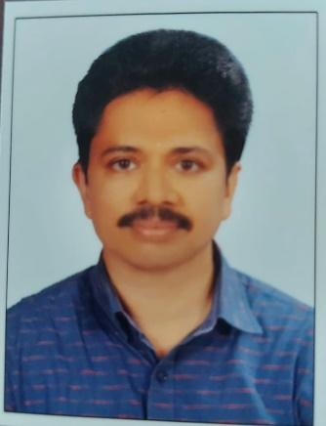
MESSAGE BY MEDICAL OFFICER
ആരോഗ്യ മുള്ള ഒരു സമൂഹത്തിനായി ആരോഗ്യ വിഭാഗം 2026 ലേക്ക് തയ്യാറാക്കിയ സമഗ്രമായ ഒരു മാർഗരേഖ യാണ് ഈ ആക്ഷൻ പ്ലാൻ .വാർഡ് തലത്തിലുള്ള പ്രവർത്തനങ്ങൾ മുതൽ പഞ്ചായത്തിൻറെ മൊത്തത്തിൽ ഉള്ള ഇടപെടലുകൾ വരെ ഇതിൽ ഉൾപ്പെടുത്തിയിട്ടുണ്ട്
ഏതു സാഹചര്യത്തെയും നേരിടാൻ സന്നദ്ധമായ ഒരു ടീം നമുക്ക് ഉണ്ട് .എൻ്റെ എല്ലാ സഹപ്രവർത്തകർക്കും എൻ്റെ ഹൃദയം നിറഞ്ഞ ആശംസകൾ നേരുന്നു .പ്രധിരോധ പ്രവർത്തനങ്ങൾക്ക് പൂർണ പിന്തുണയും സഹകരണവും ഞാൻ വാഗ്ദാനം ചെയ്യുന്നു

മെഡിക്കൽ ഓഫീസർ
സി എച് സി കരിവെള്ളൂർ

EXECUTIVE SUMMARY

Primary Health Centre (PHC) functions as the primary public healthcare institution serving the population of Karivellur Peralam Grama Panchayath. The PHC plays a pivotal role in delivering comprehensive, accessible, and affordable healthcare services, with a strong focus on preventive, promotive, curative, and rehabilitative care in accordance with national and state health programmes.
The PHC caters to a predominantly rural population, addressing key public health priorities such as maternal and child health, communicable and non-communicable disease control, immunization, family welfare, adolescent health, and geriatric care. Regular outpatient services, home-based care through field health staff, and outreach activities ensure healthcare coverage even in geographically challenging areas. The institution actively implements national health missions, including the National Health Mission (NHM), National Tuberculosis Elimination Programme, National Programme for Prevention and Control of Cancer, Diabetes, Cardiovascular Diseases and Stroke (NPCDCS), and other disease surveillance initiatives.
Karivellur CHC works in close coordination with the Grama Panchayath, ASHA workers, Anganwadi centres, schools, and community-based organizations to strengthen community participation and improve health awareness. Emphasis is placed on early detection, timely referral, health education, and lifestyle modification to reduce disease burden and improve overall health outcomes.
Despite constraints related to infrastructure, manpower, and increasing service demand, the PHC continues to enhance service delivery through effective planning, data-driven decision-making, and community engagement. Strengthening facilities, upgrading digital health systems, and expanding preventive services remain key focus areas for future development.
Overall, Karivellur Primary Health Centre stands as a vital institution in safeguarding public health and improving the quality of life of the residents of Karivellur Peralam Grama Panchayath

LIST OF ABBREVIATIONS

LSGD/LSGI | Local Self Government Department / Local Self Government Institution
BMO | Block Medical Officer
IDSP | Integrated Disease Surveillance Programme
NDMA | National Disaster Management Authority
PPE | Personal Protective Equipment
ICMR | Indian Council of Medical Research
CD | Communicable Diseases
NCD | NON- COMMUNICABLE DISEASES

TABLE OF CONTENTS

3
INTRODUCTION 9
● Background of the PPP 9
LSGD AT A GLANCE 9
Integrated Health Infrastructure map of Karivellur Panchayat 10
GENERAL PROFILE OF THE LSGI’S 13
Background of the LSGI 13
Demographic and Vulnerable Population 14
Clinical Vulnerability 16
INFRASTRUCTURE & RESOURCE INVENTORY 17
Health Facility Directory & Basic Capacity in the LSGD 17
Private Clinics 18
Healthcare Education & Training Institutions 18
Specialized Services & Emergency Inventory 18
Oxygen & Diagnostic Capacity 19
Diagnostics facility mapping at the LSGI level 20
Laboratory Identification & Basic Details 20
Social and Community Infrastructure for surge plan 21
Human resources 23
Community & Support Cadre 24
Community Organizations 25
Administrative & Emergency Services 26
Information regarding resources 26
ONE HEALTH & ENVIRONMENTAL SURVEILLANCE 27
Animal & Bird Population 27
Veterinary Infrastructure 28
Veterinary Doctors & Workforce 29
High-Risk Interface Points (Surveillance Sites) 29
Environmental Risk Mapping 30
Disease Seasonality Mapping 31
Vulnerability Mapping 32
EPIDEMIOLOGICAL TRENDS (2021–2025) 33
Disease Burden among human beings(Last 5 Years) 33
*(use the above table data to create the graph/diagram) 34
Seasonal Trend Analysis 35
Outcome-Based Trend Analysis- 2025 37
Transmission Trend- 2025 38
Integrated Disease Hotspot Map (2021–2025) 40
Preparedness and Response Protocol at LSG Level 42
Constitution of One Health Committee 42
Pandemic Response Workforce 43
Activities and Measures before and during Pandemic 45
PHASE 1 - Alert / Preparation 45
PHASE 2 - Active Response 48
Standard Screening Protocol 49
PHASE 3 - Surge Capacity 58
Conversion of Community Facilities 58
CONCLUSION 59
RECOMMENDATIONS 60
ANNEXURE 61
1.IMPORTANT PHONE NUMBERS 61

INTRODUCTION

Background of the PPP
The Pandemic Preparedness Plan of Karivellur LSGD has been developed to strengthen the local health system for effective prevention, early detection, and response to emerging infectious disease threats. Being part of Kannur district in Kerala, the area has high population mobility and strong community interactions, which increase the risk of rapid disease transmission during outbreaks. Hence, structured preparedness is essential to minimize public health impact. A key pillar of this preparedness framework is the role of Karivellur Community Health Centre, which serves as the primary referral and surveillance hub for the locality. The CHC plays a crucial role in case detection, outbreak reporting, clinical management, vaccination support, and coordination with field health staff. Strengthening CHC capacity, logistics, and emergency response mechanisms is vital to ensure timely and effective pandemic management at the grassroots level.
Objectives:
- Early Detection and Surveillance
  - Strengthen disease surveillance systems for early identification of unusual health events.
  - Monitor syndromic, laboratory, and event-based triggers at ward level.
- Rapid Response and Containment
  - Ensure immediate outbreak investigation and response.
  - Activate Rapid Response Teams (RRT) at Panchayath level.
  - Implement containment measures such as isolation, quarantine, and contact tracing.
- Strengthening Healthcare Services
  - Ensure uninterrupted essential health services during pandemics.
  - Improve referral linkages with nearby PHCs, CHCs, and district hospitals.
  - Maintain adequate stock of medicines, PPE, and emergency supplies.
- Capacity Building and Training
  - Train health workers, ASHAs, Anganwadi workers, and volunteers on pandemic protocols.
  - Conduct mock drills and simulation exercises.
- Risk Communication and Community Engagement
  - Promote awareness on preventive measures such as hand hygiene, respiratory etiquette, and vaccination.
  - Counter misinformation through verified communication channels.
  - Engage community leaders, ward members, and NGOs.
- Resource Mobilization and Logistics Management
  - Identify and allocate emergency funds.
  - Map available human resources, vehicles, buildings, and isolation facilities.
- Protection of Vulnerable Populations
  - Prioritize elderly, children, pregnant women, and persons with comorbidities.
  - Ensure support for persons with disabilities and marginalized groups.
- Intersectoral Coordination
  - Coordinate with Health Department, ICDS, Police, Education, Kudumbashree, and local organizations.
  - Establish a clear command and control structure at LSGD level.
- Continuity of Essential Public Services
  - Ensure uninterrupted water supply, sanitation, waste management, and food distribution.
  - Maintain essential administrative services.
- Monitoring, Evaluation, and Documentation
  - Maintain proper data recording and reporting systems.
  - Review response effectiveness and update the preparedness plan periodically.

LSGD AT A GLANCE
- Geographical boundaries with political map (based on latest delimitation)

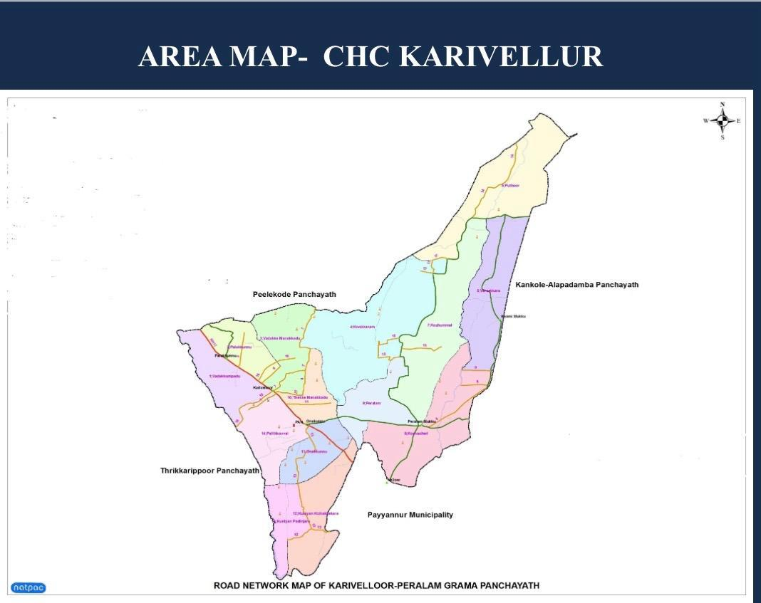

- Baseline data
- Ward division -
Ward | Houses | Population | Migrants | Wells | Hot  spots | Ed. Institutions | Hosp pvt/govt.
16 | 6497 | 23110 | 325 | 5053 | 0 | 14 | 0/3

- Risk stratification among wards in the context of Communicable diseases and hazards
- Major Roads/rivers
Roads:
National Highway (NH-66 / old NH-17 corridor nearby)
The national highway passes through nearby Perumba junction, providing connectivity towards Mangalore/Mumbai (north) and Kochi/Thiruvananthapuram (south).
Karivellur – Paliyeri – Kovval Road (Important local road)
This is a commonly used internal connecting road used by residents travelling between nearby areas like Cheemeni, Kodakkad, Puthoor and Karivellur–Onakkunnu side.
Karivellur – Ayyathra Vayal Service Road (Local access road)
Used for access to local facilities including ration distribution areas and habitations, though maintenance issues have been reported.
River:
Kuniyan River (Kuniyan Stream) – This is the main water body associated with Karivellur. It flows along the Kannur–Kasaragod border and passes through Karivellur–Peralam Panchayath, linking the Tejaswini River and Olavara River before joining the Kavvayi backwaters.

- Major establishments with geospatial mapping
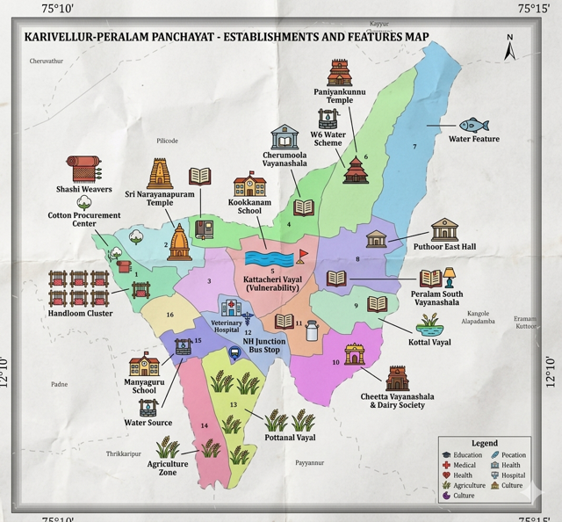
- occupational groups, socio cultural groups, migration & mobility patterns
Fishing Concentrated along river and paddy field ,High exposure to Leptospirosis
Construction and manual workers
Employed in weaving,Tobacco rolling units
- Vulnerability mapping
- Disaster prone areas (geographic vulnerability)
Flood prone wards -2
Seasonal flood during mansoon
Risk Waterborne diseases,dengue,Lepto
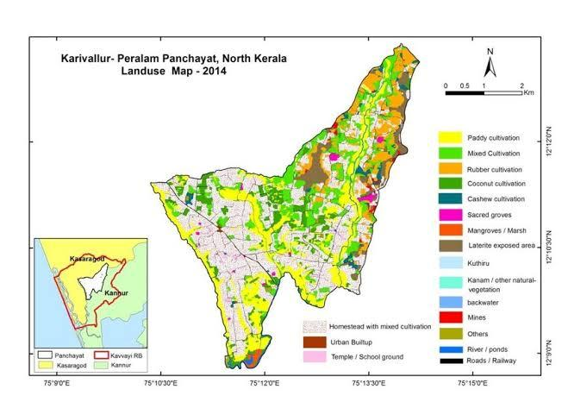

Maps - ward-based (Mention source also)

- Geographical boundaries - ward boundaries map
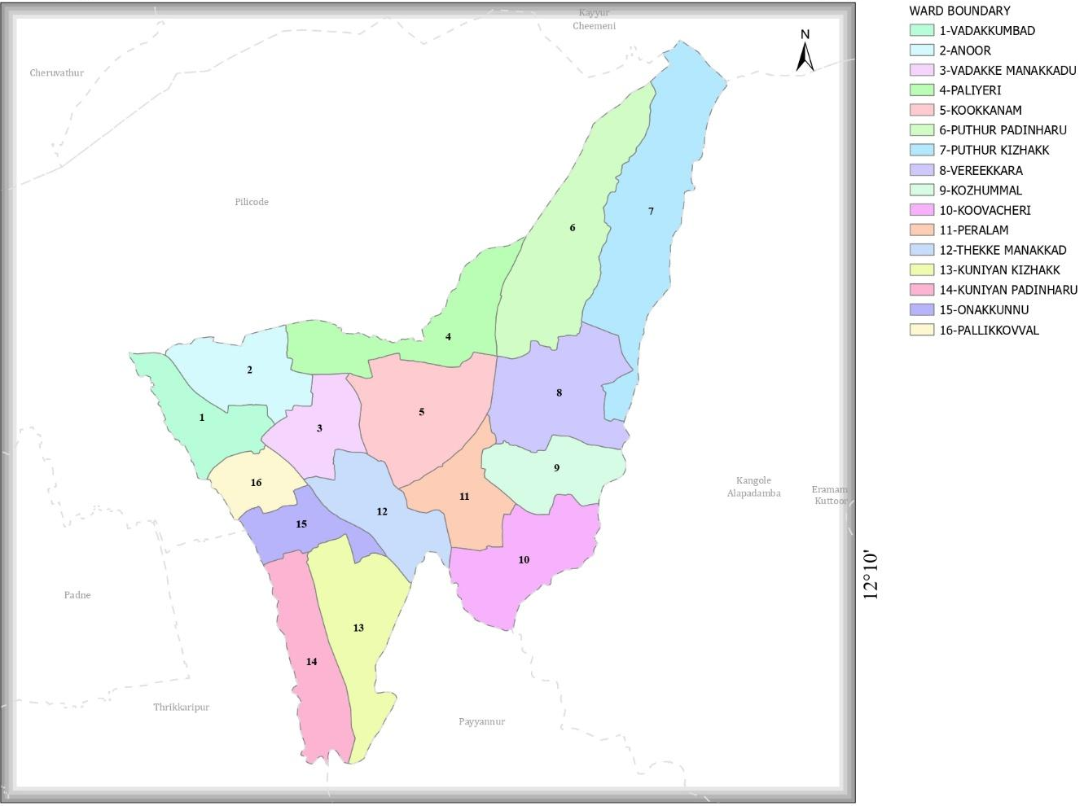

- Health infrastructure map

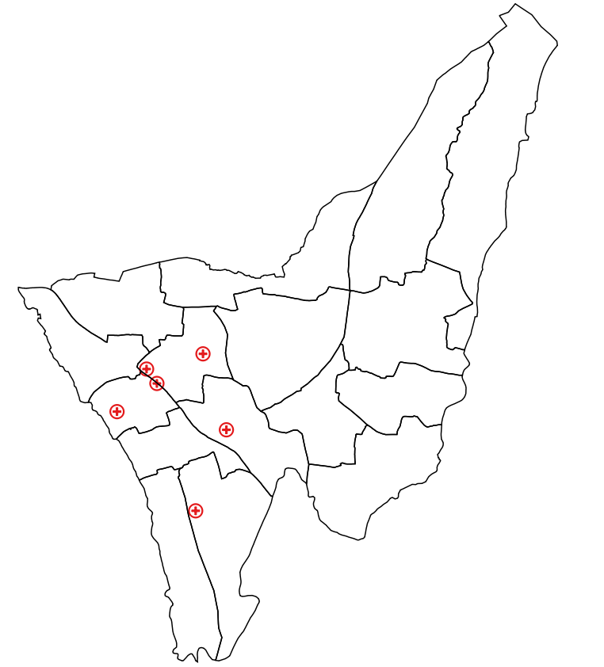

7

6

4

2
8
5
1 3

16 12

15

10

13

14

- Roads and rivers map

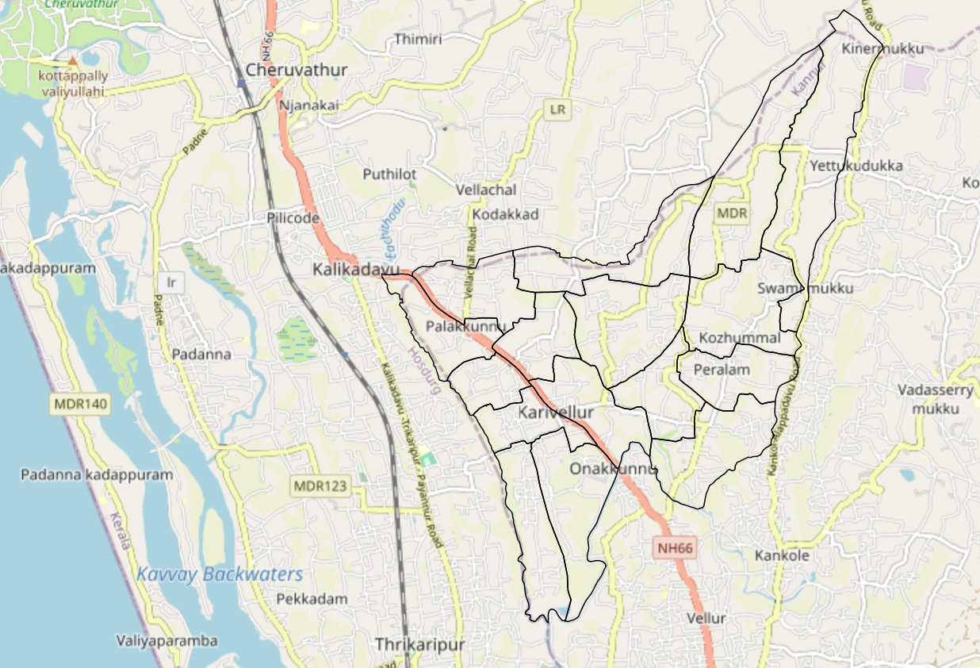

- disaster-prone areas map
- hotspot map - CD & disasters


INTEGRATED HEALTH INFRASTRUCTURE MAP OF KARIVELLUR PANCHAYAT

Health Infrastructure Map

GENERAL PROFILE OF THE LSGI’S

Background of the LSGI
Karivellur–Peralam Grama Panchayat is situated in the northern part of Kannur district in Kerala. It functions as a rural local self-government institution under Payyannur Block Panchayat and Kannur District Panchayat. The Panchayat covers two villages — Karivellur and Peralam and serves as an important administrative and service delivery unit in the region.
The Panchayat is administratively divided into 16 wards, each represented through the local self-government system, ensuring decentralized governance and local participation in development activities.
The geographical landscape of the Panchayat includes low-lying agricultural lands, paddy cultivation areas, and water-influenced ecosystems typical of the coastal Malabar belt. Agriculture, especially paddy cultivation, along with coconut-based activities, fishing-related livelihoods, small-scale trade, and labour-oriented employment form the major economic base of the local population.
The Panchayat has basic social infrastructure including schools and government institutions that support education and public service delivery. The presence of migrant labourers is observed mainly in construction, agriculture, and allied sectors, reflecting local economic transitions.
From a public health and disaster management perspective, the Panchayat, like many coastal and midland regions of Kannur district, is vulnerable to seasonal flooding, water-borne diseases, and vector-borne diseases such as dengue and leptospirosis, especially during monsoon periods. Strengthening local preparedness, surveillance, and coordinated emergency response systems remains a key priority for sustainable community resilience.
In this context, development of a localized Auxiliary Infrastructure and Logistical Resource Map is essential to support evidence-based planning, rapid emergency response, disaster risk reduction, and long-term development initiatives. Such mapping helps identify critical resources, improve accessibility during emergencies, and strengthen overall community preparedness and resilience.

Table 1: Background of LSGD
Description | Details
Name of LSGI | Karivellur-Peralam
Type (GP/Municipality / Corporation etc.) | Grama Panchayath
Block | Payyanur
District | Kannur
Number of wards | 16
Total area (sq. km) | 2223.56 Hectar
Population(Projected) | 23110
Population density | 1150
Terrain (coastal/low-lying/backwaters/foothills, etc.) | Low -lying
Number of rivers passing through LSGI | 1
Number of water bodies in the LSGI | 12
Number of educational institutions | 14
Factories / small-scale industries | 0
Flood-prone wards | 1
Landslide-prone wards | 0
Death Management and Disposal Facilities (mortuaries/crematorium, including electric) | 7
Auditoriums/Marriage halls/convention centres/community halls | 8

Demographic and Vulnerable Population
Understanding the demographic composition and vulnerable population groups is essential for pandemic preparedness. Children, elderly, economically deprived families, migrant workers, and socially vulnerable groups are at increased risk during public health emergencies due to higher exposure, limited access to services, and dependency on public systems..

Description |  | Details (in numbers)
DEMOGRAPHIC PROFILE
Total population |  | 23110
Male |  | 11512
Female |  | 11598
Transgender |  | 0
Children under 5 |  | 949
Adolescent |  | 2351
Elderly (>60) |  | 3242
SOCIAL/LIVELIHOOD VULNERABILITY
Previous EPEP family |  | 29
BPL family |  | 8319
Tribal communities |  | 0
Migration | Immigrant | 325
Migration | Emigrant | 1679
Socio-economically deprived |  | 0
Fisherfolk |  | 0
SC Community |  | 945
ST Community |  | 2

Graphs: Population pyramid (if possible) for seeing if your LSGI has a high "dependency ratio" (lots of children and elderly compared to working adults).

Clinical Vulnerability
Certain population groups need priority healthcare & are at higher risk of severe illness, complications, and mortality during pandemics. Patients with chronic diseases, those requiring regular medical care, and individuals with mobility or functional limitations face challenges in accessing timely care during emergencies. Mapping these groups helps in prioritizing continuity of treatment, medicine stock planning, oxygen support, referral transport, and targeted home-based care.
Description | Details in numbers
Pregnant women | 75
Lactating mothers | 358
Bedbound patients | 102
Patients under palliative care other than bedbound | 88
Patients on Haemodialysis | 19
Patients on CAPD | 1
Cancer patients (currently on treatment) | 116
Haemophilic patients | 0
Mentally challenged | 28
Differently abled | 94
Diabetic patients | 1204
Hypertensive patients | 2075
TB patients | 6

Major Festivals & Events specific to the LSGI
(with the possibility of a public gathering)

Sl. No. | Name of Festival / Event | Month / Periodicity
1 | Karivellur Shiva Temple Annual Festival (Koothu Festival) | Thulam (Oct – Nov) – Annual
2 | Muchilottu Bhagavathi Temple Perumkaliyattam (Theyyam Thira Festival) | Dhanu (Dec – Jan) – Once in ~14 years
3 | Chamundeswari Kavu Theyyam Festival | Makaram (Jan – Feb) – Annual
4 | Niduvappuram Pattua Tharavadu Kaliyattam Theyyam | Medam (Apr – May) – Once in ~5 years
5 | Palathara Neelankai Bhagavathi Thira Kaliyattam | Dhanu (Dec – Jan) – Annual
6 | Ayathravayal Kottam Kaliyattam Theyyam | Vrischikam (Nov – Dec) – Annual
7 | Neyyamruth Kottam Theyyam Festival | Kumbham (Feb – Mar) – Annual
8 | Karivellur Fest (Panchayat Public Event / Exhibition / Cultural Programmes) | Usually April – Periodic

INFRASTRUCTURE & RESOURCE INVENTORY

Health Facility Directory & Basic Capacity in the LSGD
This section provides an overview of the healthcare infrastructure available within the LSGD area. It outlines the distribution and basic capacity of health facilities that form the backbone of service delivery during routine times and public health emergencies.

Family Health Centres (FHCs) and Community Health Centres (CHCs) generally function as the first point of contact for the community, providing essential outpatient and inpatient services. General Hospitals (GH) and Medical College Hospitals (MCH), where accessible, serve as the main referral centres for advanced diagnostics, specialist care, and critical services during public health emergencies. This inventory helps identify existing strengths, gaps, and potential surge capacity that can be mobilised during a pandemic or disaster.

Table 5. Health Facility Resource Summary
Sl.no. | Health Facility | Type of Facility (MCH/GH/CHC/FHC/SC etc.) | Contact Number | Total beds | ICU Beds | Oxygen-Supported Beds | No. of Ventilator Support Beds | No. of ambulances
Government Healthcare Facilities
1 | Govt Ayurveda hospital Puthur | GAD | 9496357738 | 0 | 0 | 0 | 0 | 0
2 | CHC Karivellur | CHC | 9447057592 | 52 | 0 | 4 | 0 | 0
3 | Govt Homeo Dispensary | GH | 9846180398 | 0 | 0 | 0 | 0 | 0
Private Healthcare Facilities
 | 0
AYUSH Healthcare Facilities
 | 0

Private Clinics
Private clinics are an essential part of pandemic preparedness, as they are often the first place people seek care when symptoms begin. In many communities, private clinics manage a significant share of outpatient visits and therefore play a critical role in early case detection, timely referrals, and disease surveillance. Having an up-to-date understanding of where these clinics are located, the services they provide, and how they are linked to the public health system helps ensure that no cases are missed during an outbreak. It also allows health authorities to engage private practitioners more effectively for reporting, risk communication, and coordinated response, strengthening the overall capacity of the health system to manage public health emergencies.

Table 6. Private Clinic Resource Summary
Sl No. | Name of Clinic | Registered (Y/N) | Clinic (General / Speciality) | Speciality (if any) | Address | Contact Number | Diagnostic Facility (Y/N) | Ambulance Linkage (Y/N)

Healthcare Education & Training Institutions
This section tracks the educational infrastructure available, which is vital for human resource planning in the health sector.

Category of Institution | Govt | Private | AYUSH | Total
Medical Colleges | 0 | 0 | 0 | 0
Nursing Colleges | 0 | 00 | 0 | 0
Dental Colleges | 0 | 0 | 0 | 0
Para-medical / Allied Health | 0 | 0 | 0 | 0
Pharmacy Colleges | 0 | 0 | 0 | 0

Specialized Services & Emergency Inventory
This section provides a detailed view of the specialized medical resources available to the community, focusing on emergency response and critical care capabilities. This table tracks the vital assets required for managing severe illnesses and emergencies across Government, Private, and AYUSH sectors.

Item | Govt | Private | AYUSH | Total
Hospital beds | 52 | 0 | 0 | 52
Oxygen-generating systems(Y/N) | 1 | 0 | 0 | 1
Oxygen-supported beds(Numbers) | 4 | 0 | 0 | 4
Ventilator-supported beds | 0 | 0 | 0 | 0
ICU beds | 0 | 0 | 0 | 0
Burns units | 0 | 0 | 0 | 0
Blood centres | 0 | 0 | 0 | 0
BLS ambulances | 0 | 0 | 0 | 0
ALS ambulances | 0 | 0 | 0 | 0
Dialysis facilities | 0 | 0 | 0 | 0
Dispensaries | 0 | 0 | 0 | 0
8ore | 1 | 6 | 1 | 8
Industrial establishments (Medium-scale industries/small-scale industries establishments to whom we can depend in a worst-case scenario) | 0 | 0 | 0 | 0

Oxygen & Diagnostic Capacity
Monitoring oxygen and diagnostic capacity is a critical component of public health preparedness, ensuring that the LSGD can handle both chronic care and sudden surges in respiratory or infectious diseases.
Name of Health Facility | Oxygen-generating System (Y/N) | Backup Oxygen Source (Y/N) | Diagnostic Facilities Available(Y/N)
Name of Health Facility | Oxygen-generating System (Y/N) | Backup Oxygen Source (Y/N) | Lab | USG | X-ray | CT/MRI | RT-PCR
Government Healthcare Facilities
CHC KARIVELLUR | Y | Y | Y | N | N | N | N

Diagnostics facility mapping at the LSGI level
The diagnostic capacity of KARIVELLUR PERALAM G.P represents the "intelligence network" of our healthcare system. The speed and accuracy of disease identification depend entirely on the distribution and technical level of these facilities.

Item | Govt | Private | AYUSH | Total
General labs | 1 | 2 | 0 | 3
Microbiology labs | 0 | 0 | 0 | 0
RT-PCR labs | 0 | 0 | 0 | 0
USG units | 0 | 0 | 0 | 0
CT/MRI units | 0 | 0 | 0 | 0
Research labs | 0 | 0 | 0 | 0
Labs of other departments that can be repurposed | 0 | 0 | 0 | 0

Laboratory Identification & Basic Details
Sl. No. | Name of Laboratory | Ownership (Govt / Private / Academic) | Address | Contact No. | 24×7 Services (Yes/No) | NABL / Govt Approved (Yes/No)
1 | MEDI LAB | PRIVATE | KARIVELLUR | 9972148071 | NO | NO
2 | SM LAB | PRIVATE | KARIVELLUR | 9495560679 | NO | NO

Social and Community Infrastructure for surge plan
This table serves as our logistics and shelter inventory. By mapping these locations, quickly we can identify where to house displaced citizens, where to set up temporary medical clinics, and how to manage the deceased with dignity during a crisis.

Category | Total Count | Ward | Est. Capacity (Persons) | Contact details
Educational Institutions
Anganwadis | 21 | 1 TO 14 | 140 | 8281106150
Schools | 11 | 4,5,7,8,11,14,12,3,1 | 7000 | 9656948675
Colleges | 1 | 4 | 500 | 9447013902
Healthcare Educational Institutions
Medical colleges (Govt/Private) | 0
Nursing colleges (Govt/Private) | 0
Dental colleges (Govt/Private) | 0
Paramedical institutes (Govt/Private) | 0
Community Gathering Spaces
Community halls | 0
Auditoriums | 8 | 7,11,3,14 | 600 | 9961114441
Religious buildings | 1 | 14 | 50 | 9496177110
Vulnerable Group Support Facility
Destitute homes | 0
Elderly homes | 0
LSGD owned other buildings
Mass Fatality Management (MFM) Infrastructure
Mortuary | 0
Crematorium | 7 | 2,3,4,7,8,9,10,11,12,13,14 | 24 | 9562655722
*Refer annexure 1 for contact details

HUMAN RESOURCES
This section focuses on the human capital available within the LSGI. In any emergency—be it a pandemic, flood, or industrial accident—infrastructure is only as effective as the people operating it.

Medical & Clinical Personnel
This table tracks the "Frontline" providers responsible for diagnosis, treatment, and clinical management. Narrative sentence: eg., "Total health workforce: 450 personnel, with 60% in government facilities serving as primary surge capacity." A detailed directory with the contact numbers of all workers is maintained (Annexure in 1).

Cadre | Govt (No.) | Private (No.) | Total
Doctors—Modern Medicine | 5 | 7 | 12
Doctors – AYUSH | 2 | 2 | 4
Doctors – Veterinary | 1 | 0 | 1
Doctors – Dental | 1 | 3 | 3
Nursing officers | 9 | 3 | 9
Lab technicians | 1 | 10 | 11
Optometrist | 0 | 3 | 3
Pharmacists | 3 | 14 | 17
Psychologists | 0 | 0 | 0
Counsellors | 0 | 3 | 3

Public Health & Field-Level Workforce
These individuals are the backbone of surveillance, maternal-child health, and decentralized care.

Cadre | Health services | Municipal common services | Total
HS (Health Supervisors) | 0 | 0 | 0
HI (Health Inspectors) | 1 | 0 | 1
LHS (Lady Health Supervisor) | 0 | 0 | 0
LHI (Lady Health Inspectors) | 1 | 0 | 1
JPHN (Jr Public Health Nurses) | 4 | 0 | 4
JHI (Jr Health Inspectors) | 2 | 0 | 2
MLSP (Mid-Level Service Providers) | 4 | 0 | 4
Palliative Nurses | 2 | 0 | 2
RBSK Nurses | 1 | 0 | 1
PRO | 0 | 0 | 0
Epidemiologist | 0 | 0 | 0
Data Manager | 0 | 0 | 0

Community & Support Cadre
This group represents the surge capacity of the LSGI—people who can be called upon for logistics, rescue, and specialized support.

Cadre | Number
ASHA Workers | 18
AWW (Anganwadi Workers) | 21
Emergency Medical Volunteers (Trained) | 15
Kudumbashree | 165
MNREGS | 615
Purusha Swayam Sahaya Sangham | 12
Ex-Servicemen | 178
Retired Police Officers | 29
NCC/NSS Volunteers | 278
Red Cross volunteers | 70
One Health Community Volunteers | 100
One Health Community Mentors | 15

Community Organizations
This section details the presence of community-based organisations (CBOs), non-governmental organisations (NGOs), faith-based organisations (FBOs), Kudumbashree Self-Help Groups (SHGs), and Ayalkootams within the Local Self-Government Institution (LSGI). These groups enhance grassroots mobilization, resource distribution, and support networks crucial for pandemic response and community resilience.

Category | Total Count
NGOs | 10
Religious based organizations | 3
Foreign based organizations | 2
Sports Club/youth clubs | 38
Kudumbashree SHGs | 120
Ayalkootams | 45
Political organizations | 7
Residential organizations | 2

Administrative & Emergency Services
This section outlines the availability of key non-health emergency support services and infrastructure within the LSGI, which are essential for effective pandemic preparedness and response. These facilities support law enforcement, disaster response, water supply, logistics, mobility, and community-level interventions during public health emergencies.

Category | Total Count | Contact details
Police Stations | 0 | -
Fire & Rescue Stations | 0 | -
Water Pumping Points | 9 | 9020365153
Public Distribution System (PDS) | 4 | 9188679821

Information regarding resources
The availability of essential transport and support resources plays a quiet but critical role in saving lives. Equipment such as ambulances, mobile mortuaries, amphibian ambulances, and motorized boats ensures that patients, samples, and healthcare teams can move swiftly—even in flooded, remote, or difficult terrains. Heavy vehicles like JCBs, cranes, tractors, and torus lorries support logistics, waste management, emergency infrastructure, and rapid conversion of spaces into care or isolation facilities. Taxis, four-wheel-drive vehicles, and trucks help maintain continuity of essential services, reach vulnerable populations, and support home-based care and supply delivery.

Means of transportation | Total Count
JCB | 5
Crane | 0
Heavy Trucks | 2
Tractor | 0
Ambulances | 2
Mobile mortuaries | 0
Boats | 0
Taxi service | 35
Note: For specific details regarding vehicle owners and contact information, please refer to Annexure [X].

ONE HEALTH & ENVIRONMENTAL SURVEILLANCE
The One Health method integrates environmental, animal, and human health to enable proactive pandemic preparedness. Panchayat-level surveillance needs to be improved in order to detect and treat zoonotic and environmentally generated diseases early. Surveillance is strengthened through systematic assessment of animal populations, veterinary infrastructure, poultry and slaughter facilities, inter-sectoral coordination, and specialised tools like avian influenza seasonality mapping using GIS in previous outbreaks to enable predictive alerts and ward-specific sampling to support effective pandemic preparedness in high-risk areas like ____________.

Animal & Bird Population
Mapping animal and bird populations at the Panchayat level is essential for identifying and prioritising zoonotic disease hazards like rabies, avian influenza (H5N1), leptospirosis, anthrax, and Nipah-like spillover occurrences. Risk classification, targeted surveillance, vaccination planning, and early epidemic detection made feasible by comprehensive population mapping all enhance One Health-based pandemic preparedness.

Category | Item | Estimated Population | Wards
Animal Population | Livestock (Cattle/Goats/Buffalo) | 17195 | 1 TO 14
Animal Population | Pet Animals (Dogs/Cats) | 445 | 1 TO 14
Animal Population | Stray Dog Population | 654 | 1 TO 14
Animal Population | Pig Farms (Number of heads) | 0 | 0
 | Small Units (Sheep / Goats – clustered) | 0 | 0
Bird Population | Poultry Units (Birds) | 10 | 3,10,4,9,7,5,11
Bird Population | Poultry- (FOWL) | 0 | 0
Bird Population | Wild/Migratory Birds (Observed) | 1 | 12
Bird Population | Crow Mortality Events (Reported) | 0 | 0

The main risk of zoonotic diseases in Karivellur is is concentrated in Wards 7,12 which is explained by the high density of cattle congregation areas, and poultry units. The stray dog population in market areas, fish landing sites, bus stations continue to be a substantial problem for rabies surveillance and bite prevention. There is a considerable risk of avian influenza introduction and amplification during November - December due to the seasonal presence of migratory and resident water birds near ponds/ canal / river / backwater / paddy field. Clusters of pig farms and animal shelters vulnerable to flooding further raise the risk of leptospirosis and other zoonoses mediated by the environment, especially during monsoon floods.

Veterinary Infrastructure
Veterinary institutions are a core pillar of One Health surveillance, enabling early zoonotic disease detection through vaccination, investigation of unusual animal illness or deaths, sample collection, and timely outbreak reporting. A well-mapped and responsive veterinary network strengthens coordination with human health and LSGI systems, ensuring rapid response during zoonotic events and pandemics.
Facility Type | Name of Facility | Ownership Govt / Pvt | Location(Ward No) | Contact number
Veterinary Dispensary | VETENAERY DISPENSARY ONAKKUNNU | GOVT | 3 | 9744291409
Veterinary Hospital / Polyclinic | 0 | _ | _ | _
Private Veterinary Clinics | 0 | _ | _ | _
Mobile / Emergency Vet Service (incl. night services) | 0 | _ | _ | _
Pet Homes / Animal Shelters | 0 | _ | _ | _
Slaughterhouse-linked Veterinary Inspection Unit | 0 | _ | _ | _

Veterinary Doctors & Workforce
Early detection, diagnosis, reporting, and reaction to animal illness epidemics depend on the availability and accessibility of qualified veterinary specialists. By identifying unusual animal morbidity or mortality promptly, collecting samples promptly, and coordinating efficiently with human health and LSGI systems—especially during zoonotic outbreaks and pandemic-prone situations—a clearly defined veterinary workforce enhances One Health surveillance.

Category | Number Available | Type (Govt/Pvt) | Contact number
Government Veterinary Doctors | 1 | Govt | 9744291409
Private Veterinary Doctors | 3 | Pvt | 7907556818
Livestock Inspectors | 5 | Govt | 9567066756
Para-veterinary Staff / Attenders | 1 | Govt | 9567066756
Contract / On-call Veterinary Support (if any) | 0 | 0 | _

High-Risk Interface Points (Surveillance Sites)
High-risk interface points for zoonotic disease surveillance in Karivellur_Grama Panchayath include wetland–livestock–human contact zones, backyard poultry farms, cattle sheds near water bodies, fish markets, and areas of high human–animal interaction such as community slaughter points and migratory bird congregation sites. These are the primary surveillance sites where zoonotic spillover risks are elevated.

Type of Habitat | Type of High risk interface | Geographical vulnerability
Wetlands & Backwaters | 0 | 0
Backyard Poultry Farms | 0 | 0
Cattle Sheds near Water Bodies | 0 | 0
Fish & Meat Markets | 0 | 1
Community Slaughter Sites | 0 | 0
Migratory Bird Congregation Areas | 1 | 0
Rodent-Infested Grain Storage | 0 | 0

Category | Total Count | Key Locations (wards)
Poultry Farms | 9 | 3,7,9,11,12
Backyard / Clustered Poultry Units | 0 | 0
Duck Rearing Units (open water access) | 0 | 0
Slaughterhouses/ Slaughter Points | 0 | 0
Meat/Fish Markets | 2 | 11,6
Live Bird Sale Points | 0 | 0
Cattle Markets / Weekly Animal Fairs | 0 | 0
Pet Shops / Breeders | 0 | 0
Animal Shelters / Pet Homes | 0 | 0
Waste Disposal Sites near Animal Units | 0 | 0

Environmental Risk Mapping
Environmental risk mapping identifies monsoon/flood hotspots for vector-borne (dengue, chikungunya), water-borne (leptospirosis, diarrhoea), and zoonotic diseases in Kerala's wetlands. Systematic surveillance supports early warnings, targeted interventions, and Panchayat pandemic preparedness.
Waterborne exposure: Flood-prone areas and stagnant water bodies facilitate leptospira survival, raising leptospirosis risk.

Traditional practices: Informal slaughter and fish markets lack standardized hygiene, creating spillover opportunities.

Risk Factor | High-Risk Wards | Key Locations | Risk Level (High/Med/Low)
Flood-prone areas | 1 | Kuniyan | Low
Water bodies/wetlands | 0 | - | -
Solid waste accumulation | 0 | - | -
Animal waste disposal issues | 0 | - | -
Rodent infestation zones | 0 | - | -
Industrial effluent discharge | 0 | - | -
Construction sites / abandoned buildings | 0 | - | -
Poor drainage/blocked canals | 0 | - | -
Drinking water source contamination risk | 0 | - | -

Disease Seasonality Mapping
1. Flooding & waterlogging → amplifies leptospirosis, malaria, diarrheal diseases.
2. Migratory bird influx (Nov–Feb) → avian influenza risk.
3. Mosquito breeding cycles → vector-borne disease peaks in monsoon.
4. Agricultural practices → close human–animal contact in paddy fields.

Disease | Peak Risk Season | Key Drivers | High-Risk Locations | Surveillance Focus
Avian Influenza | Nil
Leptospirosis | January | NREG workers | Kuniyan | DOXY PROFYLAXIS TO NREG
Dengue/Chikungunya | May, June, July | Farmers | Puthur,Kuniyan | Sorce Reduction
Acute Diarrheal Diseases | Nil | - | - | -
Rabies | Nil | - | - | -
Anthrax (rare) | Nil | - | - | -

Vulnerability Mapping
Vulnerability mapping pinpoints high-risk populations, occupations, and areas exposed via environment, livelihoods, socio-economics, and poor service access. Paired with environmental/seasonality mapping, it enables risk-based surveillance, targeted actions, and optimal resource use in One Health and pandemic planning.
Vulnerability Factor | High-Risk Wards | Key Groups / Locations | Risk Level
Flood-prone households | 12 | Kuniyan east | Medium
Wetland-adjacent communities | 0 | - | -
Backyard poultry / duck rearing households | 0 | - | -
Livestock-rearing households | 0 | - | -
Slaughterhouse & meat market workers | 0 | - | -
Fisherfolk & fish market workers | 0 | - | -
Sanitation workers | 0 | - | -
Daily wage / migrant workers | 0 | - | -
Elderly & chronically ill populations | 0 | - | -
Pregnant Women | 0
Children (schools, Anganwadi’s) | 0
Limited access to safe water & sanitation | 0

EPIDEMIOLOGICAL TRENDS (2021–2025)

Disease surveillance is the systematic collection, analysis, and interpretation of health data for planning, implementation, and evaluation of public health practice. This section presents the disease surveillance profile of the LSGI based on routine reporting systems and outbreak investigations to identify priority diseases, seasonal patterns, and emerging public health threats.

Disease Burden among human beings (Last 5 Years)
Analysis of disease-wise data for the last five years helps identify persistent public health problems, emerging diseases, and changes in disease burden. This information supports prioritisation of prevention, preparedness, and response activities at the Panchayat level.

Disease | 2021 | 2022 | 2023 | 2024 | 2025 | Trend(Increasing/Stable/Decreasing)
Dengue | 16 | 15 | 13 | 24 | 16 | Stable
Leptospirosis | 1 | 0 | 0 | 2 | 2 | Stable
Hepatitis A | 0 | 0 | 0 | 6 | 6 | Increasing
Malaria | 0 | 0 | 0 | 0 | 0 | -
Scrub Typhus | 0 | 0 | 0 | 0 | 0 | -
Typhoid | 0 | 0 | 0 | 0 | 0 | -
H1N1 | 0 | 0 | 0 | 0 | 0 | -
H3N2 | 0 | 0 | 0 | 0 | 0 | -
ADD | 46 | 52 | 69 | 62 | 70 | Stable
Mumps | 0 | 0 | 0 | 0 | 18 | Increasing
Measles | 0 | 0 | 0 | 0 | 0 | -
Hepatitis B | 0 | 0 | 0 | 0 | 0 | -
Hepatitis C | 0 | 0 | 0 | 0 | 2 | Increasing
Tuberculosis | 13 | 6 | 11 | 9 | 8 | Increasing
Leprosy | 0 | 0 | 0 | 0 | 1 | Increasing
COVID-19

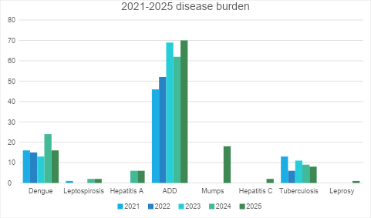

Seasonal Trend Analysis
Seasonal analysis helps anticipate surges (e.g. dengue in monsoon, leptospirosis after floods, influenza in cooler months) and plan pre‑emptive vector control, stockpiling of IV fluids, and awareness campaigns at Panchayat level.

DENGUE
Dengue is a major seasonal vector-borne disease strongly associated with rainfall, water stagnation, and increased mosquito breeding during the monsoon period.

Peak: July–November

Dengue – Ward-wise Yearly Distribution (2021–2025)

Ward | Dengue – Ward-wise Yearly Distribution
Ward | 2021 | 2022 | 2023 | 2024 | 2025 | Total
1 | 0 | 0 | 1 | 0 | 1 | 2
2 | 0 | 3 | 0 | 0 | 1 | 4
3 | 0 | 1 | 1 | 2 | 0 | 4
4 | 2 | 2 | 0 | 2 | 0 | 6
5 | 2 | 3 | 2 | 0 | 1 | 8
6 | 3 | 3 | 0 | 0 | 2 | 8
7 | 2 | 0 | 3 | 8 | 0 | 13
8 | 2 | 0 | 0 | 1 | 5 | 8
9 | 1 | 1 | 2 | 1 | 1 | 6
10 | 0 | 1 | 1 | 3 | 0 | 5
11 | 1 | 0 | 0 | 1 | 0 | 2
12 | 2 | 0 | 0 | 5 | 1 | 8
13 | 0 | 0 | 1 | 0 | 0 | 1
14 | 1 | 1 | 2 | 1 | 3 | 8

LEPTOSPIROSIS
Leptospirosis cases are closely linked to monsoon rains, flooding, and occupational exposure, particularly in low-lying and waterlogged areas.

Peak: June - August

Leptospirosis – Ward-wise Yearly Distribution (2021–2025)

Ward | Leptospirosis – Ward-wise Yearly Distribution
Ward | 2021 | 2022 | 2023 | 2024 | 2025 | Total
1 | 0 | 0 | 0 | 0 | 0 | 0
2 | 0 | 0 | 0 | 0 | 0 | 0
3 | 0 | 0 | 0 | 0 | 0 | 0
4 | 0 | 0 | 0 | 0 | 0 | 0
5 | 0 | 0 | 0 | 0 | 0 | 0
6 | 0 | 0 | 0 | 0 | 0 | 0
7 | 0 | 0 | 0 | 1 | 0 | 1
8 | 0 | 0 | 0 | 0 | 0 | 0
9 | 0 | 0 | 0 | 0 | 0 | 0
10 | 1 | 0 | 0 | 0 | 0 | 1
11 | 0 | 0 | 0 | 0 | 0 | 0
12 | 0 | 0 | 0 | 1 | 0 | 1
13 | 0 | 0 | 0 | 0 | 1 | 1
14 | 0 | 0 | 0 | 0 | 1 | 1

VIRAL HEPATITIS - A
Hepatitis A cases are commonly associated with unsafe drinking water, food contamination, and breakdowns in sanitation, often presenting as clusters or outbreaks.

Peak: October - December

Hepatitis A – Ward-wise Yearly Distribution (2021–2025)

Ward | Hep A – Ward-wise Yearly Distribution
Ward | 2021 | 2022 | 2023 | 2024 | 2025 | Total
1 | 0 | 0 | 0 | 0 | 1 | 1
2 | 0 | 0 | 0 | 0 | 0 | 0
3 | 0 | 0 | 0 | 0 | 0 | 0
4 | 0 | 0 | 0 | 0 | 1 | 1
5 | 0 | 0 | 0 | 0 | 0 | 0
6 | 0 | 0 | 0 | 0 | 0 | 0
7 | 0 | 0 | 0 | 1 | 1 | 2
8 | 0 | 0 | 0 | 1 | 1 | 2
9 | 0 | 0 | 0 | 0 | 0 | 0
10 | 0 | 0 | 0 | 0 | 0 | 0
11 | 0 | 0 | 0 | 1 | 1 | 2
12 | 0 | 0 | 0 | 2 | 0 | 2
13 | 0 | 0 | 0 | 1 | 0 | 1
14 | 0 | 0 | 0 | 0 | 1 | 1

Outcome-Based Trend Analysis- 2025

Transmission Trend- 2025
For effective management of public health issues, it is important to track the trend of disease transmission mode. It helps identify the population or place at high risk that can be used to predict outbreaks and implement targeted interventions as quickly as possible. Understanding these kinds of trends enables authorities to allocate resources efficiently and change the strategies adequately based on the trend that follows.

Mode of Transmission | No. of cases | No. of Deaths
Vector Borne Diseases | 18 | 0
Water Borne Diseases | 76 | 0
Air Borne Diseases | 18 | 0
Blood Borne Diseases | 2 | 0
Food Borne Diseases | 25 | 0

Vector-Borne Disease

Disease | No. of Cases | No. of Deaths
Dengue | 16 | 0
Malaria | 0 | 0
Chikungunya | 0 | 0

Water Borne Disease

Disease | No. of Cases | No. of Deaths
Cholera | 0 | 0
Typhoid | 0 | 0
Hep- A | 6 | 0
Dysentery | 0 | 0
Amoebiasis | 0 | 0
E- Coli infections | 0 | 0
Air Borne Disease

Disease | No. of Cases | No. of Deaths
Influenza | 0 | 0
H1N1 | 0 | 0
TB | 8 | 0
Chickenpox | 26 | 0
Measles | 0 | 0
Covid-19 | 0 | 0
Pertussis | 0 | 0
Mumps | 18 | 0

Blood-Borne Disease

Disease | No. of Cases | No. of Deaths
AIDS | 0 | 0
Hep- B | 1 | 0
Hep- C | 1 | 0

Zoonotic Disease

Disease | No. of Cases | No. of Deaths
Rabies | 0 | 0
Leptospirosis | 2 | 0
Avian influenza | 0 | 0
West nile | 0 | 0
Anthrax | 0 | 0
Nipah | 0 | 0
Scrub Typhus | 0 | 0

Integrated Disease Hotspot Map (2021–2025)
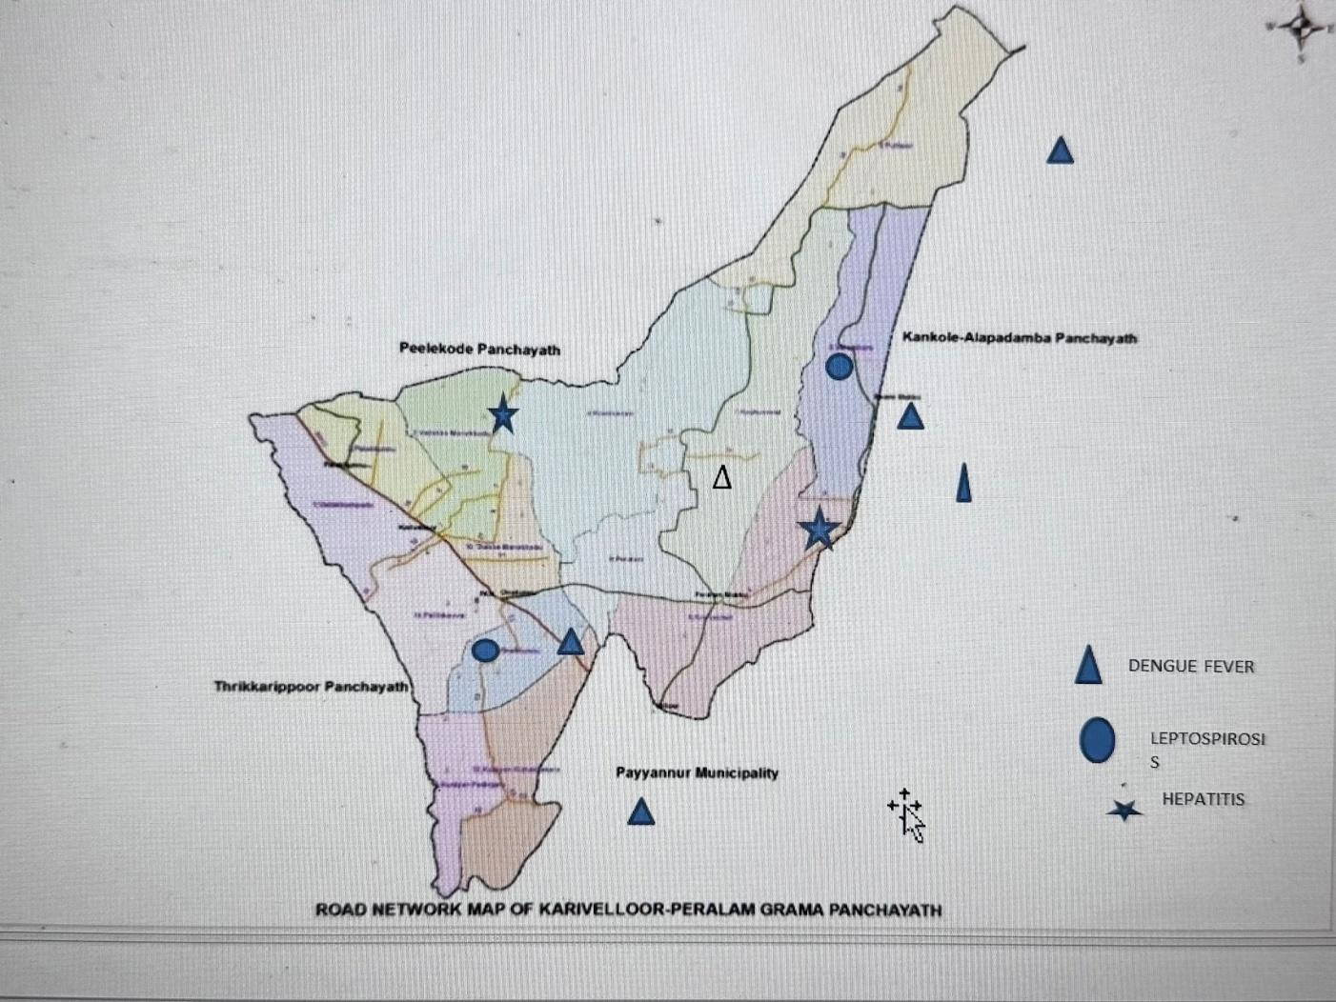

Ward No | Dengue Total (2021-25) | Leptospirosis Total (2021-25) | Hepatitis A Total (2021-25) | Mumps (2021-25) | Total Cases
1 | 2 | 0 | 1 | 1 | 4
2 | 4 | 0 | 0 | 0 | 4
3 | 4 | 0 | 0 | 1 | 5
4 | 6 | 0 | 1 | 2 | 9
5 | 8 | 0 | 0 | 2 | 10
6 | 8 | 0 | 0 | 1 | 9
7 | 13 | 1 | 2 | 0 | 16
8 | 8 | 0 | 2 | 2 | 12
9 | 6 | 0 | 0 | 2 | 8
10 | 5 | 1 | 0 | 3 | 9
11 | 2 | 0 | 2 | 1 | 5
12 | 8 | 1 | 2 | 1 | 12
13 | 1 | 1 | 1 | 1 | 4
14 | 0 | 1 | 1 | 1 | 3

By overlaying five years of data, we have identified zero 'Red Zone' Wards.

Preparedness and Response Protocol at LSG Level
This section describes the operational framework for the LSGI once a pandemic is declared. It explains how the LSGI and health system will move from routine data collection to active response, using a One Health approach.

Constitution of One Health Committee
The LSGD shall constitute a One Health Committee comprising the LSGI President, Medical Officers (Modern Medicine, AYUSH, and Veterinary), the Health Inspector, and the Veterinary Surgeon.

Objective: The One Health Committee coordinates human, animal, and environmental health to prevent and control pandemics.
Sl No | Name | Designation |  | Department/Institution | Role in Committee | Contact Number
1 | RAMESAN | Panchayat President |  | LSGD | Chairperson | 9446983244
2 | DR SAMMUEL JAPHETH | Medical Officer (PHC/CHC) |  | Health Dept | Member Secretary | 9447057592
3 | GAYAHRI | Veterinary Officer |  | Animal Husbandry | Member | 9744291409
4 | Dr Anaswara K | Epidemiologist |  | Health Dept | Member | 8129105379
5 | PANKAJAKSHAN | Health Inspector/PHN |  | Health Dept | Surveillance | 9446668336
6 | BINDU M | ASHA Supervisor |  | Health Dept | Community link | 9446668336
7 | SUJATHA | ICDS Supervisor |  | Social Welfare | Vulnerable groups | 8181106150
8 |  | Police Station Officer |  | Police Dept | Law & order | NIL
9 | VIJAYAKUMAR | Ward Councillor Representative |  | LSGD | Community coordination | 9446983244
10 | NISHA | Kudumbashree CDO | Kudumbashree |  | Community mobilisation | 6285992384
11 | PAVITHRAN | NGO/Volunteer rep | Civil Society |  | Support services | 9447963546
12 |  | Line Department representations

Key Responsibilities:
- Review disease surveillance data (human + animal)
- Conduct ward-wise risk assessment and vulnerability mapping
- Approve quarantine/isolation centre locations
- Coordinate with district for resources (PPE, oxygen, ambulances)
- Periodically review health system surge capacity, including beds, oxygen, human resources, and ambulances.
- Approve and monitor risk communication and community engagement strategies, including rumour management.
- Ensure protection and service continuity for vulnerable groups (elderly, persons with disabilities, dialysis patients, coastal populations).
- Conduct quarterly mock drills
- Monitor equity measures for vulnerable groups

Meeting Schedule:
Quarterly (normal times) | Weekly (outbreak alert) | Daily (pandemic phase)

Pandemic Response Workforce
To ensure a coordinated and timely response during a pandemic, a dedicated Pandemic Response Workforce shall be constituted at the LSG level. The workforce will function under the overall supervision of the One Health Committee and in close coordination with the health authorities. Team-based deployment will enable efficient surveillance, case management, quarantine and isolation management, logistics support, and risk communication. Each team shall have a clearly designated team leader, defined roles, and an identified pool of personnel to allow rapid activation, rotation of duties, and continuity of services during prolonged emergencies.

Total Response Workforce Available: 300 persons

Team Name | Composition | Key Responsibilities | Team Leader
Surveillance and Contact Tracing Team | HI, JHI, JPHN, ASHAs and Volunteers | Case detection, contact listing, home visits, reporting | HI
Case Management Team | Doctors, Nurses, MLSP, Palliative Nurses | Patient care & referral | DOCTOR
Quarantine & Isolation Team | LSGD staff, Volunteers | Facility management | JHI
Psychosocial support
Logistics & supply chain Team | LSGD staff, Storekeepers, Drivers 3 | Supplies & transport [PPE, medicines, oxygen, transport, waste management] | Ward Member
Communication Team | Ward members, Kudumbashree, Youth clubs,  AWW workers and other self-help groups | IEC, community meetings, countering misinformation | M.O in charge
Transportation | KSRTC, educational institutional buses | Transportation | HM
Media Surveillance | PANCHAYATH SECRETARY | MIKING, SOCIAL MEDIA | SECRETARY
Intersectoral coordination and convergence | MEDICAL OFFICER | PLANNING | MEDICAL OFFICER
Collaborative surveillance | LSGD | COLLABORATION | LSG

All teams shall be activated immediately upon outbreak alert or pandemic declaration and shall report daily to the LSG Incident Commander/Medical Officer, with consolidated reporting to the Block PHC. Duty rosters and alternate personnel shall be maintained to ensure uninterrupted services during staff shortages or prolonged response periods. Team composition and numbers may be revised based on the magnitude of the outbreak and availability of human resources.

Activities and Measures before and during Pandemic

PHASE 1 - Alert / Preparation
- Surveillance and Reporting-Enhanced syndromic surveillance:
During the alert phase, the Panchayat will strengthen syndromic surveillance systems to enable early detection of increases in fever cases, respiratory illnesses, diarrhoeal diseases, and other unusual health events. Surveillance of the veterinary population will also be considered essential to detect zoonotic threats at an early stage.
Key Activities
- Strengthen daily reporting of fever and other symptoms from all wards through the network of ASHA workers, JPHNs, and JHIs.
- Ensure prompt reporting of ILI (Influenza-Like Illness), SARI (Severe Acute Respiratory Infection), fever clusters, jaundice cases, and diarrhoeal clusters.
- Conduct weekly ward-wise review of disease trends using information from OPD registers, laboratory reports, and field surveillance data.
- Monitor and identify any unusual rise in disease incidence compared to previous weeks and promptly alert the Control Room for further action.
Data Sources for Surveillance
- OPD registers of PHC Chandanakampara and the Health and Wellness Centres (HWCs).
- Daily field reports submitted by JPHNs, JHIs, and ASHA workers.
- Case reporting from private clinics and diagnostic laboratories.
- School absenteeism reports indicating illness among students.
- Anganwadi-based illness reporting through the IHIP portal.
- Monitoring of pharmacy medicine demand, particularly sudden increases in the sale of fever medicines or ORS.
- Community feedback and reports from ward members.
- Death reports, including home deaths or unusual deaths requiring public health attention.

- Event-based triggers (to be monitored and reported):
Early Warning Indicators
- A sudden increase in fever cases reported within a ward.
- Occurrence of five or more cases of similar illness in a single locality, indicating a possible cluster.
- Sharp rise in diarrhoeal or jaundice cases within a short period.
- Unexpected increase in hospital referrals from the Panchayat area.
- Reports of unusual deaths, including brought-dead cases.
- Higher laboratory positivity rates for suspected infectious diseases.
- Increased school absenteeism attributed to fever or illness.
- Any suspected zoonotic disease event reported from the community or veterinary sector.
Responsible Officers
- Health Inspector – Surveillance Nodal Officer
- Medical Officer, PHC Chandanakampara
- Junior Health Inspector (JHI) / Junior Public Health Nurse (JPHN)
- ASHA Supervisor
- Ward Member and Community Volunteers
Output Indicators
- Preparation of a weekly syndromic surveillance summary report.
- Ward-wise fever line list maintained and regularly updated.
- Early warning alerts generated and communicated promptly to the concerned authorities.

- Zoonotic and animal health surveillance
Key Activities
● Regular monitoring of poultry farms, duck rearing units, and migratory bird sites.
● Reporting of sudden animal illness or deaths (especially poultry deaths).
● Monitoring of stray dog bite incidents and rabies vaccination coverage.
● Coordination with the Veterinary Department for rapid sample collection and reporting.
Event Triggers (Animal & Environment)
- Sudden poultry death cluster
- Increased dog bite cases
- Cattle illness in multiple households
- Rodent infestation complaints
- Flood water exposure complaints (leptospirosis risk)
- Migratory bird congregation and unusual bird deaths
Responsible Officers
- Veterinary Surgeon
- Livestock Inspector
- Health Inspector (Coordination)
- ASHA workers and Ward volunteers
Output Indicators
- Monthly zoonotic surveillance report
- Joint inspection reports for high-risk sites
- Rapid reporting to district if unusual events occur

- Logistics and Stock Preparedness
  - Identify and empanel local vendors and define emergency procurement mechanisms in accordance with existing LSGD and Health Department norms.
  - Prepare and maintain an essential logistics checklist covering medical supplies, consumables, and support equipment.
  - Pre-identify secure storage locations for emergency stocks and ensure maintenance of stock registers with regular updating.
  - Finalise emergency transport arrangements, including availability of vehicles and identified drivers for rapid deployment during alerts.
  - Designate a Nodal Officer for Logistics to enable prompt decision-making, coordination, and communication during emergencies.
  - Conduct rapid stock verification and ensure availability of minimum buffer stock, including:
- PPE kits – 200 numbers
- Pulse oximeters – 2 numbers
- Hand sanitizers – 5 litres
- Masks: 5000, gloves: 2000, disinfectants: 4 litre – adequate quantity
Identify critical gaps in logistics and immediately communicate requirements to the Block and District authorities for timely replenishment and support. Monitor expiry dates and stock rotation.

Identification of Quarantine and Isolation Facilities
  - Identify and list suitable buildings for quarantine and isolation (schools, hostels, community halls, etc.).
  - Categorise cases as per the severity and allocate to appropriate facilities (for instance, severe cases to classrooms, mild cases to an assembly hall in case of a school).
  - Facility readiness checklist needed (beds, toilets, ventilation) etc.
  - Find an alternate site if the primary sites are not available or not in use.
  - Identify facility managers and support staff
  - Prepare basic SOPs for:
    - Admission and discharge
    - Food, water, sanitation
    - Infection prevention and waste disposal
  - Ensure availability of basic amenities: water, sanitation, electricity, ventilation, and waste disposal. Prepare a rapid activation plan for these facilities if case numbers increase.

Risk Communication and Community Preparedness
  - Disseminate early warning messages on symptoms, preventive measures, and reporting mechanisms. Display IEC materials both in English and the local language in public places and ensure ward-level awareness.
  - Sensitize elected representatives and community leaders on preparedness measures.
  - Establish a rumour tracking and misinformation response mechanism to identify, verify, and promptly counter false or misleading information.
  - Engage trusted local persons (ward members, ASHA workers, religious leaders, teachers, community volunteers) to communicate official public health messages and reinforce correct practices.
  - Develop and deploy targeted IEC materials for:
    - Schools and educational institutions
    - Markets and commercial areas
    - Work sites and labour settings
  - Conduct community sensitization meetings at the ward level to promote preventive behaviors, address concerns, and strengthen community participation in preparedness and response.

Protection of Vulnerable Groups
Vulnerable populations require priority protection through targeted line-listing, service continuity, and delivery mechanisms.
- Prepare and regularly update line-lists of vulnerable populations, including:
  - Elderly persons living alone
  - Persons with disabilities
  - Pregnant women
  - Migrant workers
  - Dialysis patients
The detailed line-lists shall be maintained as Annexure ___ and updated periodically.

Clinical Dependency Mapping
Develop ward-wise dependency and vulnerability maps to identify households requiring regular support during emergencies. Ensure continuity of essential health services for vulnerable groups, including
- Dialysis services (facility mapping, transport arrangements, and scheduling)
- Continuity of treatment for TB, HIV, and other chronic conditions requiring uninterrupted medication
- Mental health and psychosocial support services
Establish delivery mechanisms for food, essential commodities, and medicines to vulnerable households through coordinated action involving ASHAs, JPHNs, Kudumbashree, volunteers, and local administration.

PHASE 2 - Active Response

Case Identification and Contact Tracing
Case detection and contact tracing activities will be carried out in coordination with the health authorities, following disease-specific SOPs and IDSP guidelines.
Field Staff Involved
- Health Inspector (HI)
- Junior Health Inspector (JHI)
- Junior Public Health Nurse (JPHN)
- ASHAs and ASHA Supervisors
- Ward-level volunteers and Kudumbashree members (as required)

Screening Checkpoints
Screening checkpoints at high-traffic locations (transport hubs, markets, religious gatherings) for early detection of symptomatic travellers and crowd screening during outbreaks. Potential locations include bus stands, market entry points, and boat jetties, based on local context and risk assessment.
Screening activities will be carried out by trained personnel such as ASHAs, ward members, and volunteers, with support from Health Department staff. Necessary equipment, including non-contact thermometers and appropriate PPE, shall be ensured prior to activation.

Location | Type (Bus stand/Jetty/Market/Railway) | Staff Deployed (ASHAs/Volunteers) | Screening Method | Reporting authority
Bus stand | Transport hub | One JHI  One ASHA  One health Mentors | 1.Swab Collection.  2. Blood smears collection (RDT)  3.Thermal Scanners | Surveillance Nodal Officer in control room
Market entry | Market | One JHI  One ASHA  Male health volunteers | 1.Swab Collection.  2. Blood smears collection (RDT)  3.Thermal Scanners | Surveillance Nodal Officer in control room
Boat jetty | Water transport | One JHI  One ASHA  Male health volunteers | 1.Swab Collection.  2. Blood smears collection (RDT)  3.Thermal Scanners | Surveillance Nodal Officer in control room

Standard Screening Protocol

The screening protocol shall include temperature screening, observation for visible symptoms, and inquiry regarding recent travel or exposure history. Individuals identified as suspects during screening shall be immediately referred to the nearest PHC/FHC for further evaluation, testing, and appropriate action as per prevailing guidelines.

Pandemic Control Room
The Pandemic Control Room (PCR) serves as the central nerve center for real-time coordination, data aggregation, decision support, and communication during outbreaks. It consolidates information from all LSGD teams, health facilities and community sources to enable rapid response decisions.

Control Room Infrastructure and Location
Primary Location: Karivellur Panchayath Office.
Backup Location: Community Hall in Karivellur G.P.

Health System Control Room Framework
The PCR is organized into seven functional pillars to ensure no aspect of the response is overlooked:

Rapid Response Team (RRT)
  - Provides immediate intervention during emergencies, clusters, and field alerts.​
  - Coordinates urgent actions such as case investigation, contact tracing, isolation, and inter‑facility referrals.

Data Management & Analytics Team
  - Collects, validates, and manages key health system indicators (cases, tests, beds, HR, supplies).​
  - Analyzes data trends, generates projections, and supports evidence‑based decision‑making for local authorities.

Human Resource Deployment Team
  - Allocates healthcare staff efficiently based on workload and need
  - Ensures adequate and equitable workforce distribution across facilities

Laboratory Surveillance Team
  - Oversees diagnostic testing coordination, sample transport, and timely reporting of results.​
  - Monitors lab indicators (testing volume, positivity rate, turnaround time) for early detection of outbreaks

Vaccination Cell (If Required)
  - Plans and executes vaccination campaigns, including micro‑planning and session scheduling.​
  - Tracks coverage, identifies gaps, and coordinates corrective actions with field teams and outreach services.

Infrastructure & Patient Occupancy Team
  - Monitors facility capacity, earmarked beds, oxygen and critical care resources across all linked facilities.​
  - Ensures optimal patient distribution and referral management using updated bed‑status and resource data.
  - BMWM

Communication team
- Logistics and supply chain
- Transportation (interfacility & emergency transport)
- Media surveillance Call centre
- Management of the deceased
- Intersectoral coordination and convergence

Key Control Room Team
The Control Room Team coordinates all pandemic response activities within the LSGD and serves as the single command and communication hub during activation. It integrates information, field actions, logistics, and policy execution across all participating departments and health facilities.

Role | Name | Designation | Contact Number | Responsibility
In-charge/Nodal Officer | Dr Sammuel Japheth | Medical Officer | 9447057592 | Overall coordination, decision-making, and reporting to the District level.
Data Entry Operator | - | - | - | Managing the line list, updating dashboards, and tracking testing results.
Communication Officer | SHINI | JHI | 9562435826 | Handling the public helpline, coordinating ambulance dispatch, and contact tracing calls.
Logistics Coordinator | SANDEEP | ASSISTANT SECRETARY | 9496831298 | Collection and support
Technical Support (IT/Data) | PRASEENA | TECHNICAL ASSISTANT GP | 9495511132 | Handling the IT/ Data support

SOP for alert escalation/trigger point with mapping of responsibilities.
Key Points:
- The Control Room shall be staffed with a designated In-charge, data entry personnel, and communication staff with clearly defined roles and shift arrangements.
- It shall maintain updated records on daily monitoring indicators including new cases, persons under active quarantine, and hospital bed occupancy.
- All reports and situation updates shall be shared daily with the Block and District Surveillance Unit.
- The Control Room shall act as a single point of contact for coordination with response teams, health institutions, and other departments.
- Contact details of the Control Room shall be widely communicated to field staff and stakeholders during activation.

Daily Monitoring Indicators
To ensure timely decision-making and effective response, the following key indicators shall be monitored and updated on a daily basis by the Pandemic Control Room:

Epidemiological Indicators:
New cases reported today, Total active cases, Test Positivity Rate (TPR), Case Fatality Rate (CFR)
- Surveillance Indicators:
Persons under home quarantine, High-risk contacts identified, Fever, ILI, SARI or other symptoms (syndromic surges), Travellers (symptomatic or high-risk arrivals),Animal husbandry surveillance (zoonotic alerts, unusual animal deaths, poultry/bird flu signals), Mortality surveillance (excess deaths, unexplained fatalities, verbal autopsy reports)
- Logistics and Infrastructure Indicators:
Hospital / CFLTC beds occupied, Oxygen cylinders/concentrators available, Ambulances on standby
- Alert Findings
The following table outlines category-specific trigger points (red flags) from surveillance indicators and corresponding immediate actions for the Pandemic Control Room. These enable rapid response to alert findings like testing anomalies, positive cases exceeding thresholds, clusters, and WGS reports.

Category | Trigger Pophint (Red Flag) | Immediate Action
Clusters | Geographical or facility-based: 5+ cases linked to one location (office, school, street). | Declare a micro-containment zone; perimeter control and active case finding.
Testing | Sudden drop in testing volume / delay in reporting / unusual testing trends | Review the sample collection process, address lab bottlenecks, deploy additional testing teams, and notify the District Lab.
Lab | Test Positivity rate increases | Increase testing sites in that ward.
Hospital | >80% Oxygen bed occupancy | Activate backup/CFLTC beds.
Travel | Cluster of cases from a single flight/train or high-risk arrival group. | Trace all passengers in adjacent seats; implement mandatory institutional quarantine.
Animal | Mass poultry/wildlife death or unusual sickness | Notify Animal Husbandry, sample the area, and dispatch RRT for environmental sampling and zoonotic check.
Mortality | Sudden spike in home deaths or brought-in-dead (BID) cases | Audit the deaths and Active Case Search drive
Additional investigations like Whole Genome Sequencing (WGS) | Detection of a Variant of Concern (VOC) or Variant of Interest (VOI) | Implement strict micro-containment; update clinical protocols to match variant severity.

Communication of Public Health Information
A Community Communication Hub shall be established to ensure timely, accurate, and consistent dissemination of information during a pandemic. The Hub will function under the coordination of Nodal officers of the control room and act as the nodal point for public communication, risk messaging, and community engagement. It will support dissemination of official advisories, promote preventive behaviors, address rumors and misinformation, and ensure that messages reach all sections of the population through trusted local channels and leaders.

Key communicators
Channel | Responsible Person | Contact
Ward-level announcements | WARD CONVENOR | 9633228302
Social media | WARD CONVENOR | 9633228302
Local Cable TV/Radio | SHIJU | 999834112

- All messages disseminated through the Hub shall align with advisories issued by the Health Department and District authorities.
- Community leaders shall be sensitized to support behavior change, reduce stigma, and counter misinformation.
- Special efforts shall be made to reach vulnerable and hard-to-reach populations using locally appropriate communication methods.

Rumor Tracking: A designated volunteer will monitor local social media/WhatsApp groups daily to identify misinformation and issue official clarifications via the Communication Hub.

Coordination with District/State Authorities & Other Organisations
Effective coordination with Block, District, and State authorities is essential to ensure timely reporting, technical guidance, and uninterrupted supply of essential resources during a pandemic. The LSG shall establish clear communication channels, designate responsible officers, and adhere to prescribed reporting timelines to support coordinated public health action and efficient resource mobilisation.

Key Details:
- Nodal Officer for Reporting: Medical Officer
- Contact Number: 9447057592
Reporting Schedule and Protocols:

To Whom | What to Report | Frequency | Nodal Person
Block PHC | Complete Situation Report (Cases, Quarantine, Beds, Screening, Deaths) | DAILY | Medical Officer
District IDSP Unit | Outbreaks/Clusters/Unusual Events (>5 cases same ward) | DAILY | Health Inspector
Veterinary Officer | Animal health events/Zoonotic alerts | DAILY | Vetenary Doctor
State Cell | Zoonotic cross-sector events | DAILY | Vetenary Doctor

Supply Chain Coordination
The LSG shall coordinate closely with Block, District, and State authorities (KMSCL) to ensure uninterrupted availability of essential goods, medical supplies, and logistics during a pandemic. Supply requirements shall be assessed regularly based on case load and communicated promptly to the appropriate authorities for timely replenishment.
Key Points:
- Maintain updated contact details of District and Block nodal officers for health logistics, oxygen supply, ambulances, and essential medicines.
- Submit timely indent requests for PPE, testing kits, medicines, oxygen, and other critical supplies through prescribed channels.
- Monitor stock levels at LSGD facilities, quarantine/isolation centres, and field teams through daily stock registers and dispensing logs to prevent shortages.
- Coordinate with District authorities, Karunya/Neethi medical shops, and local purchase committees for funds allocation and emergency procurement.

- Ensure regular monitoring of dispensing registers at all facilities to track usage, expiry, and pilferage—shortages being a perennial issue requiring proactive weekly audits.

- Activate surge procurement protocols during high caseloads, leveraging local purchase powers under LSGD funds alongside state supplies.

Resource Inventory and Contacts
Resource Category | Source  (District/State/Private) | Contact
PPE Kits/Masks/Gloves | KMSCL | 04712945600
PPE Kits/Masks/Gloves | Local Vendors | 9847928215
Oxygen  Cylinders/Concentrators | KMSCL | 04712945600
Medicines/Antivirals | KMSCL | 04712945600
Medicines/Antivirals | Neethi Shops | 9495264022
Test Kits (RTPCR/Rapid) | KMSCL | 04712945600

Collaboration with NGOs, PPP, and CSR
To augment government efforts during a pandemic, the LSG shall collaborate with NGOs, voluntary organisations, and private sector partners through public–private partnerships and Corporate Social Responsibility (CSR) initiatives, in coordination with District authorities.

Key Points:
- Engage NGOs and community-based organisations for community outreach, awareness, and support to vulnerable populations.
- Leverage CSR support for procurement of medical equipment, PPE, oxygen concentrators, food kits, and sanitation materials, as permitted.
- Ensure all collaborations align with government guidelines and are routed through approved administrative and financial procedures.
- Maintain transparency and documentation for all external support received and utilised.
Organization | Type | Support Offered | Contact Person
Youth Clubs/Student Unions | CBO | Manpower 200 | NSS NODAL OFFICER

Interdepartmental Coordination
Coordination among departments during a pandemic shall be ensured through regular review meetings convened by the LSGD President. These meetings will provide a structured platform for sharing situational updates, assessing resource availability, resolving operational gaps, and taking joint decisions to ensure a coordinated and timely response.

Department | Representative | Key Role | Contact
Health (PHC) | Staff Nurse | Case management | 9567815574
Veterinary | Veterinary Surgeon: | Animal surveillance | 9744291409
ICDS | Supervisor: Sindhu | Nutrition support | 8281106150
Education | Head Teacher: | School coordination | 9946464505
Police | CI | Containment enforcement | 497987213
Water Authority | __________ | Water supply | __________
LSGD Engineering | Asiistant Engineer | Quarantine infrastructure | 9496011163

PHASE 3 - Surge Capacity
Phase 3 is activated when there is a rapid increase in cases, high test positivity rates, or when existing health facilities and quarantine arrangements approach saturation. The focus of this phase is to expand isolation capacity, augment clinical care services, and mobilise additional resources through district and state support mechanisms.

Conversion of Community Facilities
To manage increased case load, the LSGD shall activate additional isolation facilities by repurposing identified community infrastructure such as community halls, auditoriums, schools, hostels, or other suitable buildings.

Name of facility | Facility Type | No. of Buildings | Ward | Surge Capacity (Beds) | Nodal Person
AVGHSS KARIVELLUR | GOVT | 2 | 14 | 100 | HM
NEST COLLEGE | PRIVATE | 1 | 4 | 100 | PRINCIPAL
GALAXY AUDITORIUM | PRIVATE | 1 | 2 | 50 | OWNER
MANYAGURU SCHOOL | AIDED | 1 | 14 | 50 | HM
GUPS KOOKKANAM | GOVT | 1 | 4 | 30 | HM
DHANYA AUDITORIUM | PRIVATE | 1 | 11 | 40 | OWNER
MAAKKEEL MUNDYA AUDITORIUM | PRIVATE | 1 | 7 | 70 | OWNER
PBKLPS KUNIYAN | AIDED | 1 | 12 | 40 | HM
GUPS PERALAM | GOVT | 1 | 7 | 20 | HM
GLPS PUTHUR | GOVT | 1 | 5 | 20 | HM

- Recovery and rehabilitation phase
- Recovery
  - Damage & impact assessment
  - Restoration of health services
  - Rehabilitation of affected population
  - Psychosocial & mental health support
  - Disease surveillance during recovery phase
  - Environmental cleanup & sanitation
  - Livelihood restoration
  - Community engagement & confidence building
  - Documentation & after-action review
  - Lessons learned & best practices
  - Health system strengthening
  - Policy revision & preparedness enhancement
  - Research

CONCLUSION
The Pandemic Preparedness Plan of Karivellur–Peralam Grama Panchayat serves as a comprehensive framework designed to strengthen local preparedness and ensure a timely and coordinated response to potential public health emergencies. By incorporating key components such as disease surveillance, rapid response mechanisms, effective case management, logistics and resource planning, risk communication, and active community participation, the plan aims to minimize the impact of any future pandemic on the health and wellbeing of the community.
The successful implementation of this plan requires continuous monitoring, periodic capacity building, effective inter-sectoral coordination, and sustained community engagement. Through the collective efforts of the Grama Panchayat, the Health Department, frontline health workers, and the general public, Karivellur–Peralam Grama Panchayat will be better equipped to respond effectively to emerging health threats and ensure the safety and wellbeing of its residents.

Additional points
- tech support
- relief based commodities
- ham reading operators
- hazard vulnerability mapping
- Kseb & other power source
- HR specific responsibility

RECOMMENDATIONS

Strengthening Healthcare Infrastructure
- Establish a primary health response unit within the Panchayat with trained staff.
- Ensure availability of basic medical supplies (masks, sanitizers, PPE kits, oxygen cylinders).
- Create tie-ups with nearby hospitals in Karivellur for emergency referral and transport.

2. Community Awareness & Education
- Conduct regular awareness campaigns on hygiene, vaccination, and preventive measures.
- Use local communication channels (community radio, WhatsApp groups, notice boards) to spread verified information.
- Train volunteers to act as health ambassadors in each ward.

3. Emergency Response & Coordination
- Form a Pandemic Preparedness Committee at Panchayat level including health workers, ward members, and NGOs.
- Develop a clear action plan for lockdowns, quarantine, and distribution of essentials.
- Maintain a database of vulnerable groups (elderly, differently-abled, chronically ill) for targeted support.

4. Supply Chain & Food Security
- Identify and support local suppliers and farmers to ensure uninterrupted food supply.
- Create community kitchens during emergencies to serve vulnerable populations.
- Stockpile essential commodities in Panchayat-run outlets for crisis periods.

5. Digital Preparedness
- Promote digital platforms for telemedicine consultations.
- Use Panchayat’s website/social media for real-time updates on health advisories.
- Encourage online grievance redressal to reduce crowding in offices.

6. Training & Capacity Building
- Organize mock drills for pandemic response in schools, offices, and public spaces.
- Train Panchayat staff and volunteers in first aid, infection control, and crowd management.
- Collaborate with NGOs and health departments for capacity-building workshops.

7. Long-Term Resilience
- Integrate pandemic preparedness into the Panchayat Development Plan.
- Allocate a dedicated budget for health emergencies.
- Encourage community participation in planning and monitoring preparedness measures.

MOCKDRILL SCENARIOS
In a situation where infectious diseases are on the rise

ANNEXURE

IMPORTANT PHONE NUMBERS

Phone numbers and particulars of persons responsible for providing guidance, assistance, and support for pandemic preparedness operations may be provided here in a manner that allows easy reference at a glance. The information recorded here could be exhibited elsewhere at the time of emergencies. LSG institutions shall give special attention to collect and record the above data of persons and institutions who/which are supposed to give technical and co-ordination support to reduce the impact of pandemic.

1.1. Details of grama panchayat/municipality/corporation wards
Sl.No | Name of the ward | Ward number | Name of the ward  member | Contact number
1 | VADAKKUMBAD | 1 | PRADEEPAN V V | 9447646283
2 | ANOOR | 2 | ASOKAN | 9895994394
3 | NORTH, MANAKKAD | 3 | VIJAYAKUMAR | 9447074400
4 | PALIYERI | 4 | Sujatha pu | 8547626306
5 | KOOKKANAM | 5 | P RAMESAN | 9446983244
6 | PUTHUR WEST | 6 | SAJINI K | 9048426867
7 | PUTHUR EAST | 7 | SUNI MOL A K | 9544330865
8 | VAREEKKARA | 8 | JANEESH K | 9995944460
9 | KOZHUMMAL | 9 | P SULOCHANA | 9645457342
10 | KOOVACHERRY | 10 | SUDHAMANI AK | 9497435783
11 | PERALAM | 11 | SHEENA K P | 9656511086
12 | SOUTH MANAKKAD | 12 | VARUN CHANDRA | 9633228302
13 | KUNIYAN EAST | 13 | VENUGOPAL A | 9496184313
14 | KUNIYAN WEST | 14 | PRABHAVATHI E | 8606596597
15 | ONAKKUNNU | 15 | T V CHANDRAMATHI | 9747648747
16 | PALLIKKOVVAL | 16 | K SOBHA | 9746025844

1.2. Other important phone numbers of grama panchayat/municipality/corporation area
Sl. No. | Name | Contact number
1. | SECRETARY | 9496049020
2. | VILLAGE OFFICE | 8606652002
3. | AGRICULURE OFFICE | 8301044355
4. | ASSISTANT ENGINEER | 9496011163
5. | VETENARY | 9633491409
6. | PRESIDENT | 9446983244
7. | Excise department
8. | Forest department

1.3. Important offices of grama panchayat/municipality/ corporation
Sl.No | Name of the office | Contact person | Contact number
1. | Village Office | Village Officer | 8606652002
2. | Agriculture Office | Agriculture Officer | 8301044355
3. | Animal Husbandry Office | Animal Husbandry Doctor | 9633491409
4. | Police Station | Police Officer | 9497980872
5. | BSNL Office | Officer
6. | Block Office | Officer | 8921833903
7. | KSEB Office | Officer | 9496011163
8. | Fisheries Office | Officer
9. | Fire and Rescue | Officer | 04985202901

1.4. Health Services

Sl. No | Name of the hospital/institution | Location | Phone number
1. | Government hospitals/PHC | Karivellur | 04985260506
2. | Private hospitals | 0 | -
3. | Clinical laboratories | Karivellur
4. | Chemist/pharmacy | 0
5. | Blood donors | 0
6. | Other language experts (Bihari, Hindi, Bengali,  Asamees ………) | 0

1.5. Veterinary Services
Sl.No | Name of the Clinic | Name of the Surgeon/Doctor | Place/location | Phone number
1 | Govt.Veterinary Hospital | Dr Gayathri | MANAKKAD | 9744291409

1.6. Helpline numbers
Helpline | Phone number
Police | 9497980872
Fire and Rescue | 04985202901
KSEB | 9496011164

1.7. Public and Private Schools Contact details

S.No | Name of School | Institution type | Phone number
1 | AUPS PERALAM | Aided | 8078094820
2 | LP SCHOOL PERALAM | Aided | 9497046594
3 | MANYAGURU SCHOOL | Aided | 9048818396
4 | GUPS KOOKKANAM | Govt | 9400515869
5 | GLPS KOZHUMMAL | Govt | 9946464505
6 | CENTRAL L P | Aided | 9495341621
7 | PATTIYAMMA AUPS KARIVELLUR | Aided | 9446172300
8 | AVGHSS KARIVELLUR | Govt | 9656948675
9 | GLPS PUTHUR | Govt | 9497609627
10 | NORTH AUPS | Aided | 9995835840
 | PBKLPS KUNIYAN | Aided | 9843887097

1.9. Anganwadi Contact Details

Ward No | Name of Anganwadi Teachers | Phone number
6 | PRANTHAMCHAL | 8547524739
7 | KOZHUMMAL | 8943824739
5 | PUTHUR WEST | 6282399704
5 | PUTHUR EAST | 9746135437
9 | PERALAM WEST | 9400693095
8 | PERALAM | 9496742135

Ward No | Anganwadi No and Name of Teacher | Phone number
4 | CHEETAH | 9496708745
4 | PALIYERI | 9539737527
10 | PALIYERI KOVVAL | 8606422787
13 | KUNIYAN WEST | 9744361795
11 | ONAKKUNNU | 9744204247
10 | THEKKEMANAKKAD | 9605757875
11 | PALATHARA | 9744262059
8 | KOOVACHERI | 8547524739
3 | MANAKKAD | 8157038182
2 | NEDUVAPPURAM | 9744190283
1 | KARIVELLUR | 8129437445
14 | THOTTICHAL | 9747611563
12 | KUNIYAN EAST | 9895725930

1.12. Information regarding resources

Means of transportation | Name of Owner | Phone Number
Heavy Trucks | NISHAD | 9562655722
Tractor | SURENDRAN | 8075346625
Ambulances | NITHIN | 9539736679
Boats | NIL | -
Taxi service | BIJU | 9447854694

Annexure 1: LSG Baseline Data Collection Format
A. Baseline data
Sl. No. | Indicator / Field | Baseline Data | Source / Remarks
1 | Name of LSG | KARIVELLUR PERALAM | From Panchayth
2 | District | KANNUR | From Panchayth
3 | Block / Taluk | PAYYANNUR | From Panchayth
4 | Type of LSG (Gram Panchayat / Municipality / Corporation) | GRAMA PANCHAYATH | From Panchayth
5 | Area (sq. km) | 2223 | From Panchayth
6 | No. of wards | 16 | From Panchayth
7 | GIS boundary file available | (Yes/No) | From Panchayth
8 | Key contact person & phone

B. Demography
Indicator / Field | Baseline Data | Source / Remarks
Total population | 23110 | From family survey
Males | 11512 | From family survey
Females | 11598 | From family survey
Transgender population | 0 | From family survey
Age distribution  (<5, 5–14, 15–59, ≥60) | 949,2351,5056,3242 | From family survey
No. of households | 6497 | From family survey
Population density (persons/sq.km) |  | From family survey
No. of migrant workers | 325 | From family survey
Major occupational groups |  | From family survey

C. Vulnerable Populations & Social Risks
Sl. No. | Indicator / Field | Baseline Data (Value / Description) | Source / Remarks
1 | No. of elderly (≥60) | 3242 | From family survey
2 | No. of persons with disability | 94 | From family survey
3 | No. of bedridden persons | 102 | From family survey
4 | No. of chronic disease cases (DM/HTN/COPD/CKD etc.) | 1204/2075/49/32 | From family survey
5 | Pregnant women (current estimate) | 75 | From family survey
6 | Children <5 years | 949 | From family survey
7 | Tribal population (if any) | 0 | From family survey
8 | Fisherfolk / coastal vulnerable groups (if any) | 0 | From family survey
9 | Urban slums / unnotified settlements (if any) | 0 | From family survey
10 | Homeless population | 0 | From family survey
11 | Orphanages / old age homes (number & capacity) | 0 | From family survey
12 | Hostels / prisons / shelters (number & capacity) | 0 | From family survey
13 | Poverty / BPL estimate | 8319 | From family survey
14 | Food insecurity hotspots | 0 | From family survey
15 | Any history of stigma/discrimination issues (Yes/No) | NO | From family survey

D. Health System & Service Readiness
Sl. No. | Indicator / Field | Baseline Data (Value / Description) | Source / Remarks
1 | No. of health facilities in LSG (PHC/CHC/TH/DH/Private) | 1 | From family survey
2 | PHC/Family Health Centre details (name, location) | CHC KARIVELLUR | From family survey
3 | Subcentres / Health & Wellness Centres (number) | 4 | From family survey
4 | Private clinics / hospitals (number) | 0 | From family survey
5 | Labs available (public/private) | 3 | From family survey
6 | Availability of ambulance services (Yes/No, number) | 1 | From family survey
7 | Availability of isolation/quarantine facilities (Yes/No, details) | YES | From family survey
8 | Cold chain facilities (Yes/No, details) | YES | From family survey
9 | Stockpile space available (Yes/No) | NO | From family survey
10 | PPE / mask / sanitizer availability plan (Yes/No) | NO | From family survey
11 | Surveillance staff available (JHI/JPHN/ASHA count) | 24 | From family survey
12 | Existing emergency referral pathways (Yes/No) | 0 | From family survey

E. Points of Entry & Mobility
Sl. No. | Indicator / Field | Baseline Data (Value / Description) | Source / Remarks
1 | Bus stands / depots (number) | 0 | From family survey
2 | Railway stations (number) | 0 | From family survey
3 | Boat jetties / fishing harbours (number) | 0 | From family survey
4 | Ports / airports nearby (specify distance) | 0 | From family survey
5 | Major highways/roads passing through | 1 | From family survey
6 | Border crossings (state/district) | 1 | From family survey
7 | Major markets / weekly markets | 1 | From family survey
8 | Tourism hubs / major event venues | 1 | From family survey
9 | Schools/colleges with hostels (number) | 0 | From family survey
10 | Factories / large workplaces (number) | 0 | From family survey
F. Water, Sanitation & Hygiene (WASH)
Sl. No. | Indicator / Field | Baseline Data (Value / Description) | Source / Remarks
1 | Major drinking water sources (piped / wells / borewells / springs) | 5053 | From family survey
2 | No. of public wells |  | From family survey
3 | No. of households with piped water connection | 342 | From family survey
4 | Water quality testing routine (Yes/No) | YES | From family survey
5 | Common contamination risks (flooding, salinity, industrial waste) | NO | From family survey
6 | Open defecation free status (Yes/No) | YES | From family survey
7 | Solid waste management system (Yes/No) | YES | From family survey
8 | Bio-medical waste disposal mechanism (Yes/No) | YES | From family survey
9 | No. of public toilets | 2 | From family survey
10 | Handwashing stations in public places (Yes/No) | 2 | From family survey
G. Zoonotic Risks & One Health
Sl. No. | Indicator / Field | Baseline Data (Value / Description) | Source / Remarks
1 | Livestock population (cattle/goats/pigs/poultry) – estimates | 17195
2 | No. of dairy farms / poultry farms / pig farms | 9
3 | Slaughterhouses / meat shops (number) | 0
4 | Animal markets (Yes/No, details) | NO
5 | Veterinary dispensaries (number) | 1
6 | History of zoonotic outbreaks (rabies, leptospirosis, avian flu etc.) | 0
7 | Stray dog population management measures (Yes/No) | YES
8 | Rodent infestation hotspots (Yes/No) | NO
9 | Wetlands / waterlogged areas prone to leptospirosis | NO
10 | Bat roosting areas / caves / fruit orchards (if any) | NO
11 | Human-animal interface hotspots (farms near residences) | O
H. Climate & Disaster Risks (Pandemic Amplifiers)
Sl. No. | Indicator / Field | Baseline Data (Value / Description) | Source / Remarks
1 | Flood-prone wards (list) | 12 | BASELINE DATA
2 | Landslide-prone wards (list) | 0
3 | Cyclone/sea surge risk (Yes/No) | 0
4 | Heatwave risk zones (Yes/No) | 0 | “
5 | Waterlogging areas (list) | 1
6 | Shelter homes / relief camps (number, capacity) | 0
7 | Past disaster displacement history | 0
8 | Disruption to water supply/transport common (Yes/No) | NO
I. Critical Infrastructure & Logistics
Sl. No. | Indicator / Field | Baseline Data (Value / Description) | Source / Remarks
1 | Schools (number) | 12
2 | Anganwadis (number) | 21
3 | Colleges (number) | 1
4 | Community halls (number) | 8
5 | Places of worship with large gatherings (number) | 0
6 | Large markets / shopping areas (number) | 0
7 | Warehouses / cold storages (number) | 0
8 | Telecom/mobile network coverage gaps (Yes/No) | NO
9 | Power outage frequency (high/medium/low) | MEDIUM
10 | Availability of generators in key facilities | 1

J. Risk Communication & Community Networks
Sl. No. | Indicator / Field | Baseline Data (Value / Description) | Source / Remarks
1 | Ward-level rapid response teams (Yes/No) | YES
2 | Jagratha samithis / committees active (Yes/No) | YES
3 | Kudumbashree presence and strength (number of units) | YES/199
4 | Volunteer network (number, coverage) | 18/475
5 | Community-based surveillance mechanisms (Yes/No) | YES
6 | IEC dissemination channels (WhatsApp groups, community radio, PA systems) | YES
7 | Rumour tracking mechanisms (Yes/No) | NO
8 | Languages spoken / literacy considerations
9 | Vulnerable groups communication strategy available (Yes/No) | NO

K. Preparedness Planning & Governance
Sl. No. | Indicator / Field | Baseline Data (Value / Description) | Source / Remarks
1 | LSG emergency plan available (Yes/No) | NO
2 | Pandemic preparedness plan available (Yes/No) | NO
3 | Incident Command System identified (Yes/No) | NO
4 | Rapid procurement mechanism available (Yes/No) | NO
5 | Emergency fund available (Yes/No, amount) | NO
6 | Past outbreak response experience (Yes/No, details) | NO
7 | Intersectoral coordination mechanism (Health, Police, LSG, Veterinary, Education) | YES
8 | Mock drills conducted in last 12 months (Yes/No) | YES
9 | Training coverage for staff/volunteers (Yes/No) | NO

L. Surveillance & Data Systems
Sl. No. | Indicator / Field | Baseline Data (Value / Description) | Source / Remarks
1 | Digital reporting tools used (e.g., DHIS2, portals) | YES
2 | Availability of line-listing format (Yes/No) | YES
3 | Contact tracing team identified (Yes/No) | YES
4 | Mapping of high-risk households available (Yes/No) | NO
5 | Testing sample transport mechanism (Yes/No) | NO
6 | Reporting timeline adherence (good/average/poor) | GOOD
7 | Data sharing between departments (Yes/No) | YES
8 | Availability of dashboard for monitoring (Yes/No) | NO

M. Additional Notes & Observations
Sl. No. | Indicator / Field | Baseline Data (Value / Description) | Source / Remarks
1 | Key challenges perceived by LSG | NA
2 | Top 5 high-risk wards (reason) | NA
3 | Any unique local risks (industrial pollution, refugee camps, etc.) | NA
4 | Recommendations for preparedness strengthening | NA

