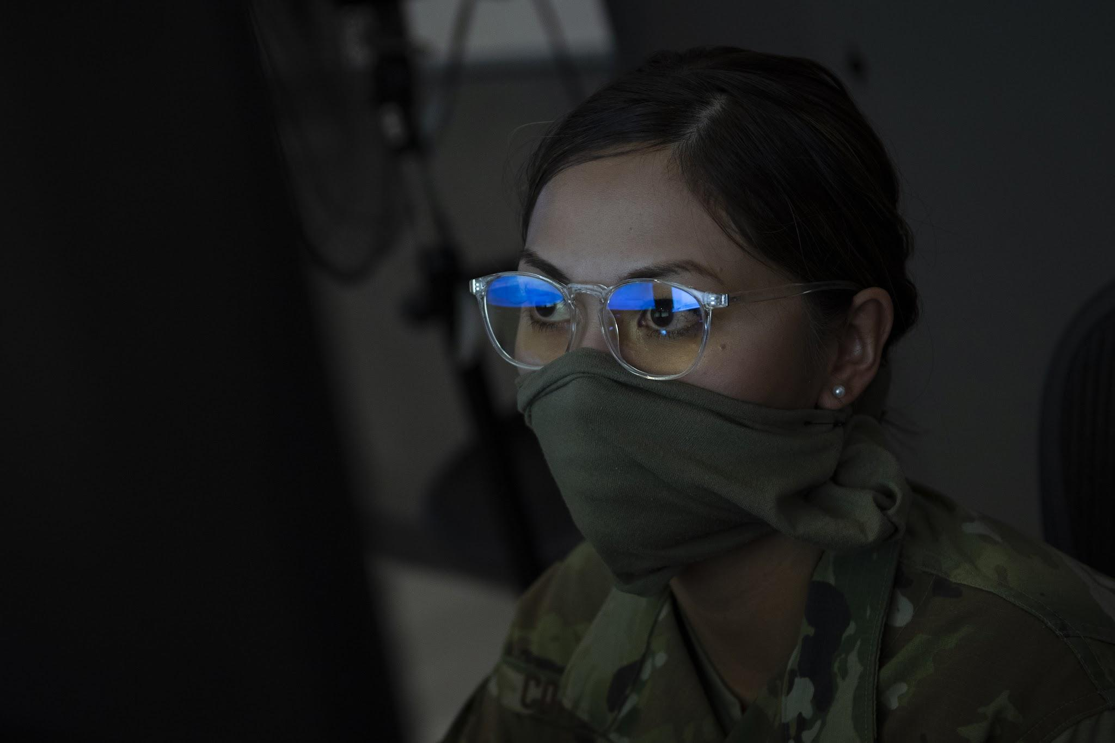
PANDEMIC PREPAREDNESS PLAN
RAMANTHALI GRAMAPACHATH
FHC RAMANTHALI

MESSAGE FROM PRESIDENT OF RAMANTHALI GRAMAPANCHAYATH

കേരള സംസ്ഥാന ആരോഗ്യവ്യകുപ്പിന്റെ ആഭിമുഖ്യത്തിൽ 2026 വർഷത്തെ പകർച്ചവ്യാധി പ്രതിരോധദുരന്ത നിവാരണ പ്രവാര്ത്തനങ്ങളെ കുറിച്ചുള്ള പ്രവർത്തന റിപോർട്ട്/ആക്ഷൻ പ്ലാൻ കുടുംബ ആരോഗ്യ കേന്ദ്രം രാമന്തളിയും ,എട്ടിക്കുളവും സംയോജിച്ച് തയ്യാറാക്കിയിട്ടുണ്ട് പ്രസ്തുത പ്രവര്ത്തനങ്ങള്ക്ക് ഗ്രാമപഞ്ചായത്തിന്റെ എല്ലാ പിന്തുണയും പ്രഖ്യാപിക്കുകയും റിപ്പോർടിന് എല്ലാ ഭാവുകങ്ങളും /ആശംസകളും നേരുകയും ചെയ്യുന്നു
പ്രസിഡൻറ്
രാമന്തളി ഗ്രാമ പഞ്ചായത്ത്

MESSAGE FROM HEALTH STANDING COMMITTEE CHAIRMAN
കേരള സംസ്ഥാന ആരോഗ്യവ്യകുപ്പിന്റെ ആഭിമുഖ്യത്തിൽ 2026 വർഷത്തെ പകർച്ചവ്യാധി പ്രതിരോധദുരന്ത നിവാരണ പ്രവാര്ത്തനങ്ങളെ കുറിച്ചുള്ള പ്രവർത്തന ആക്ഷൻ പ്ലാൻ കുടുംബ ആരോഗ്യ കേന്ദ്രം രാമന്തളിയും ,എട്ടിക്കുളവും സംയോജിച്ച് തയ്യാറാക്കിയിട്ടുണ്ട് . പ്രസ്തുത പ്രവര്ത്തനങ്ങള്ക്ക് ഗ്രാമപഞ്ചായത്തിന്റെ സർവമന പിന്തുണയും പ്രഖ്യാപിക്കുകയും റിപ്പോർടിന് എല്ലാ ഭാവുകങ്ങളും /ആശംസകളും നേരുകയും ചെയ്യുന്നു

ആരോഗ്യ സ്റ്റാഡിങ് കമ്മിറ്റിചെയർമാൻ
രാമന്തളി ഗ്രാമ പഞ്ചായത്ത്

MESSAGE BY MEDICAL OFFICER

കുടുംബ ആരോഗ്യ കേന്ദ്രം രാമന്തളി ,എട്ടികുളം സയുക്തമായി തയ്യാറാക്കിയ പകർച്ചവ്യാധി പ്രതിരോധ പ്രവർത്തന രേഖ (PANDEMIC PREPAREDNESS PLAN) ഭാവിയിൽ രാമന്തളി ഗ്രാമ പഞ്ചായത്തിൽ ഉണ്ടാകാൻ സാധ്യത ഉള്ള പകർച്ച വ്യാധികളെ പരാധിരോധിക്കാൻ സഹായിക്കുമെന്ന് വിശ്വാസമുണ്ട്
മെഡിക്കൽ ഓഫീസർ
കുടുംബ ആരോഗ്യ കേന്ദ്രം രാമന്തളി, എട്ടിക്കുളം

EXECUTIVE SUMMARY

Family Health Centre (FHC) functions as the primary public healthcare institution serving the population of Ramanthali Grama Panchayath. The FHC plays a pivotal role in delivering comprehensive, accessible, and affordable healthcare services, with a strong focus on preventive, promotive, curative, and rehabilitative care in accordance with national and state health programmes.
The FHC caters to a predominantly rural population, addressing key public health priorities such as maternal and child health, communicable and non-communicable disease control, immunization, family welfare, adolescent health, and geriatric care. Regular outpatient services, home-based care through field health staff, and outreach activities ensure healthcare coverage even in geographically challenging areas. The institution actively implements national health missions, including the National Health Mission (NHM), National Tuberculosis Elimination Programme, National Programme for Prevention and Control of Cancer, Diabetes, Cardiovascular Diseases and Stroke (NPCDCS), and other disease surveillance initiatives.
Ramanthali FHC works in close coordination with the Grama Panchayath, ASHA workers, Anganwadi centres, schools, and community-based organizations to strengthen community participation and improve health awareness. Emphasis is placed on early detection, timely referral, health education, and lifestyle modification to reduce disease burden and improve overall health outcomes.
Despite constraints related to infrastructure, manpower, and increasing service demand, the FHC continues to enhance service delivery through effective planning, data-driven decision-making, and community engagement. Strengthening facilities, upgrading digital health systems, and expanding preventive services remain key focus areas for future development.
Overall, Ramanthali Family Health Centre stands as a vital institution in safeguarding public health and improving the quality of life of the residents of Ramanthali Grama Panchayath

LIST OF ABBREVIATIONS

LSGD/LSGI | Local Self Government Department / Local Self Government Institution
BMO | Block Medical Officer
IDSP | Integrated Disease Surveillance Programme
NDMA | NationalDisaster Management Authority
PPE | Personal Protective Equipment
ICMR | IndianCouncil of Medical Research
CD | Communicable Diseases
NCD | NON-COMMUNICABLE DISEASES

TABLE OF CONTENTS

3
INTRODUCTION 9
● Background of the PPP 9
LSGD AT A GLANCE 9
INTEGRATED HEALTH INFRASTRUCTURE MAP OF PANCHAYAT 10
GENERAL PROFILE OF THE LSGI’S 13
Background of the LSGI 13
Demographic and Vulnerable Population 14
Clinical Vulnerability 16
INFRASTRUCTURE & RESOURCE INVENTORY 18
Health Facility Directory & Basic Capacity in the LSGD 18
Private Clinics 19
Healthcare Education & Training Institutions 20
Specialized Services & Emergency Inventory 20
Oxygen & Diagnostic Capacity 21
Diagnostics facility mapping at the LSGI level 22
Laboratory Identification & Basic Details 22
Social and Community Infrastructure for surge plan 22
Human resources 24
Community & Support Cadre 25
Community Organizations 26
Administrative & Emergency Services 27
Information regarding resources 27
ONE HEALTH & ENVIRONMENTAL SURVEILLANCE 28
Animal & Bird Population 28
Veterinary Infrastructure 29
Veterinary Doctors & Workforce 30
High-Risk Interface Points (Surveillance Sites) 30
Environmental Risk Mapping 31
Disease Seasonality Mapping 32
Vulnerability Mapping 33
EPIDEMIOLOGICAL TRENDS (2021–2025) 34
Disease Burden among human beings(Last 5 Years) 34
*(use the above table data to create the graph/diagram) 36
Seasonal Trend Analysis 37
Outcome-Based Trend Analysis- 2025 39
Transmission Trend- 2025 40
Integrated Disease Hotspot Map (2021–2025) 42
Preparedness and Response Protocol at LSG Level 44
Constitution of One Health Committee 44
Pandemic Response Workforce 45
Activities and Measures before and during Pandemic 47
PHASE 1 - Alert / Preparation 47
PHASE 2 - Active Response 50
Standard Screening Protocol 51
PHASE 3 - Surge Capacity 60
Conversion of Community Facilities 60
CONCLUSION 61
RECOMMENDATIONS 62
ANNEXURE 63
1. IMPORTANT PHONE NUMBERS 63

INTRODUCTION

Background of the PPP
Ramanthali Local Self Government Department (LSGD) is a coastal Grama Panchayat located in Payyanur Block of Kannur district, Kerala. Geographically, it lies along the Arabian Sea coast, characterized by a mix of coastal settlements, fishing communities, inland residential areas, and small-scale commercial establishments. Its coastal location significantly influences the socio-economic profile, occupational pattern, and public health dynamics of the area.
A pandemic preparedness plan is essential to ensure early detection, rapid response, coordinated containment, and continuity of essential health services during public health emergencies. Strengthening preparedness at the LSG level is critical because local governments serve as the first administrative and operational units for implementing surveillance, risk communication, quarantine support, and community mobilization. Effective preparedness reduces morbidity, mortality, social disruption, and economic loss.

LSGD AT A GLANCE
- Geographical boundaries with political map (based on latest delimitation)
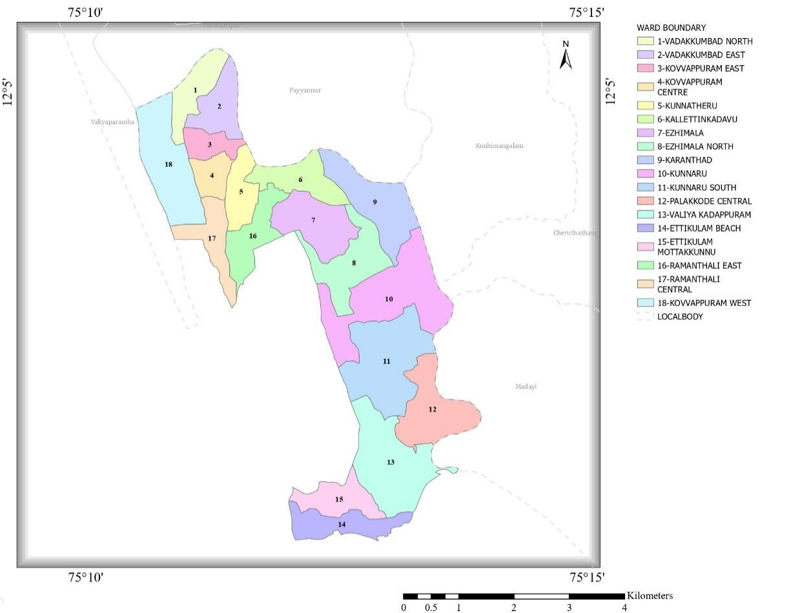

- Baseline data

- Ward division -
Ward | Houses | Population | Migrants | Wells | Hot  spots | Ed. Institutions | Hosp pvt/govt.
18 | 5792 | 28910 | 458 | 4652 | 1 | 13 | 4

- Risk stratification among wards in the context of Communicable diseases and hazards
- Major Roads/rivers
- Major establishments with geospatial mapping
- occupational groups, socio cultural groups, migration & mobility patterns
- Vulnerability mapping
- Disaster prone areas (geographic vulnerability)

Maps - ward-based (Mention source also)

- Geographical boundaries – North: Kavvayi River, East : Puthiya Puzha, West : Eran River , South : INA Ramanthali & FHC Ettikula area
- Health infrastructure map

- Roads and Rivers map

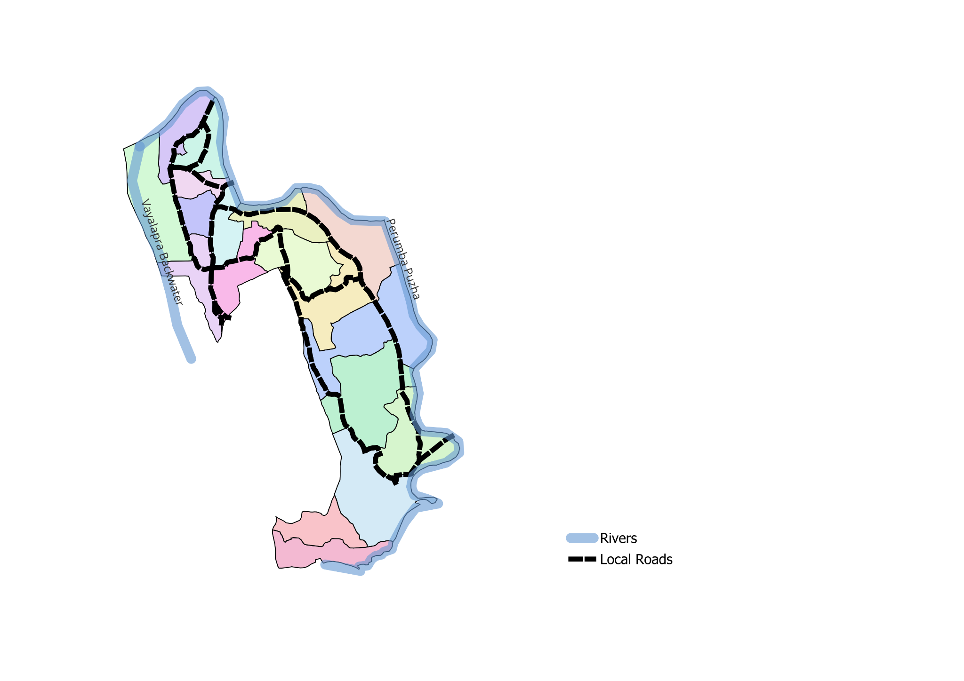

- Major establishments map

- Disaster-prone areas map

- hotspot map - CD & disasters

INTEGRATED HEALTH INFRASTRUCTURE MAP OF RAMANTHALI PANCHAYAT
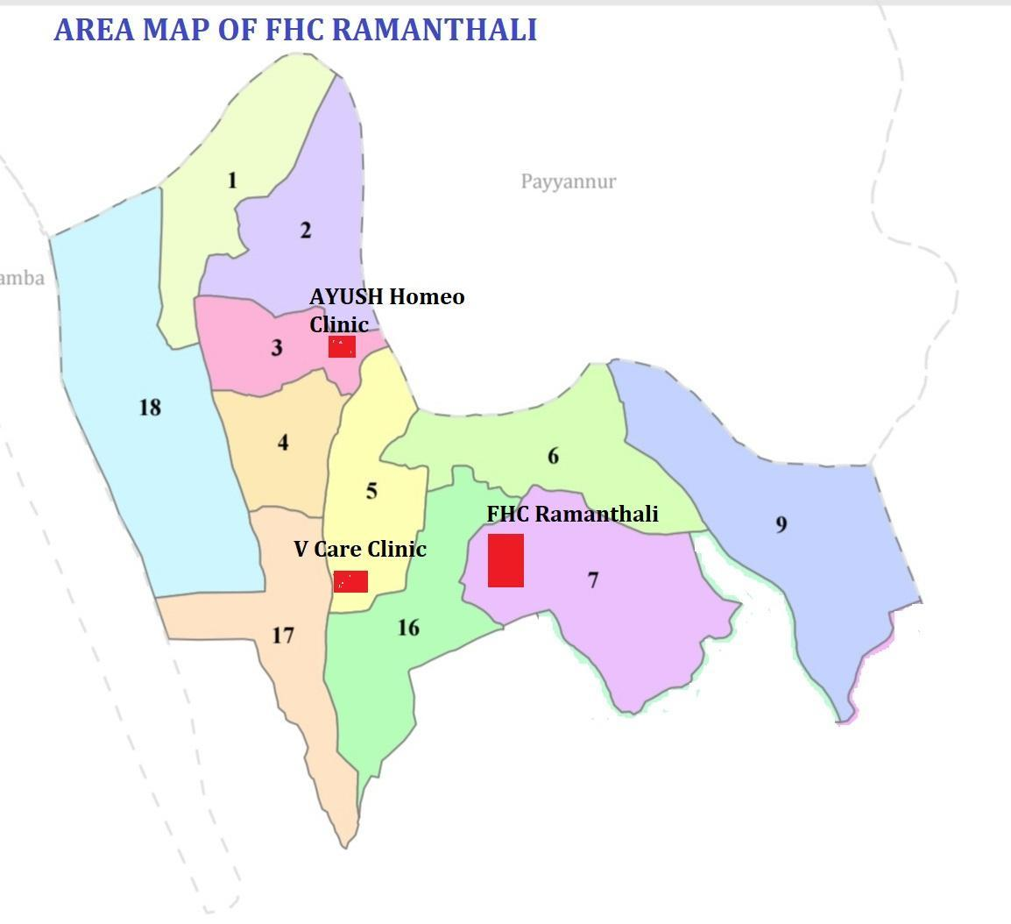

HEALTH IFRASTRUCTURE MAP

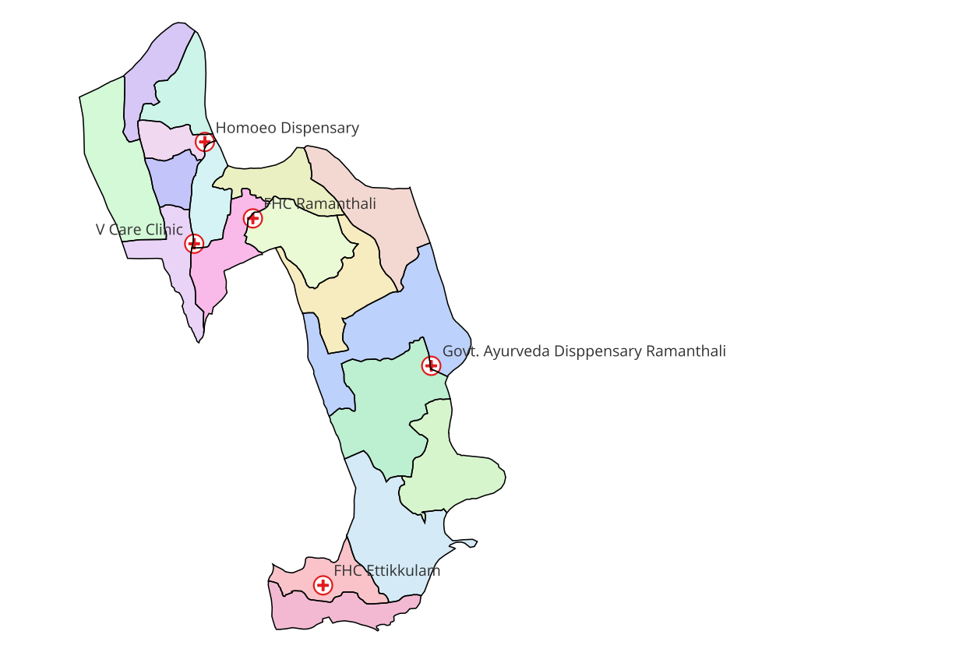

GENERAL PROFILE OF THE LSGI’S

Background of the LSGI
Ramanthali is a developing local self-government area situated in Kannur district of Kerala. The region is characterized by a mix of coastal and rural settlements, with moderate population density and active community participation through local self-government institutions. Seasonal monsoon rains, coastal climatic conditions, population mobility, and close community interactions increase the vulnerability of the area to communicable disease outbreaks.
The experience of the COVID-19 pandemic highlighted the critical importance of early detection, rapid response, effective surveillance, and coordinated intersectoral action at the primary health care level. As a frontline public health institution, Ramanthali Family Health Centre plays a key role in disease surveillance, outbreak investigation, risk communication, case management, vaccination services, and community awareness activities.
The Pandemic Preparedness Plan has been developed to strengthen the capacity of Ramanthali FHC to prevent, detect, and respond effectively to emerging infectious disease threats. The plan outlines standard operating procedures for surveillance under the Integrated Disease Surveillance Programme (IDSP), laboratory coordination, isolation and referral mechanisms, logistics management, human resource mobilization, infection prevention and control measures, and community engagement strategies.
This plan aims to ensure timely preparedness, minimize morbidity and mortality, maintain continuity of essential health services, and safeguard the health of the community during public health emergencies. It reflects the commitment of Ramanthali FHC to build a resilient health system capable of responding effectively to future pandemics and large-scale outbreaks.

Table 1: Background of LSGD
Description | Details
Name of LSGI | Ramanthali
Type (GP/Municipality / Corporation etc.) | Grama Panchayath
Block | Payyanur
District | Kannur
Number of wards | 18
Total area (sq. km) | 31.41
Population(Projected) | 28910
Population density | 860 persons/Sq km
Terrain (coastal/low-lying/backwaters/foothills, etc.) | Coastal, low lying, foothills
Number of rivers passing through LSGI | 3
Number of water bodies in the LSGI | 25
Number of educational institutions | 13
Factories / small-scale industries | 4
Flood-prone wards | I, II, III, VI, IX, XVIII
Landslide-prone wards | I, VII
Death Management and Disposal Facilities (mortuaries/crematorium, including electric) | 6
Auditoriums/Marriage halls/convention centres/community halls | 6

Demographic and Vulnerable Population
Understanding the demographic composition and vulnerable population groups is essential for pandemic preparedness. Children, elderly, economically deprived families, migrant workers, and socially vulnerable groups are at increased risk during public health emergencies due to higher exposure, limited access to services, and dependency on public systems..

Description |  | Details (in numbers)
DEMOGRAPHIC PROFILE
Total population |  | 28910
Male |  | 14190
Female |  | 14720
Transgender |  | 0
Children under 5 |  | 1408
Adolescent |  | 3528
Elderly (>60) |  | 3642
SOCIAL/LIVELIHOOD VULNERABILITY
Previous EPEP family |  | 47
BPL family |  | 1421
Tribal communities |  | 0
Migration | Immigrant | 458
Migration | Emigrant | 580
Socio-economically deprived |  | 60
Fisherfolk |  | 276
SC Community |  | 1081
ST Community |  | 0

Graphs: Population pyramid (if possible) for seeing if your LSGI has a high "dependency ratio" (lots of children and elderly compared to working adults).

Clinical Vulnerability
Certain population groups needs priority healthcare & are at higher risk of severe illness, complications, and mortality during pandemics. Patients with chronic diseases, those requiring regular medical care, and individuals with mobility or functional limitations face challenges in accessing timely care during emergencies. Mapping these groups helps in prioritizing continuity of treatment, medicine stock planning, oxygen support, referral transport, and targeted home-based care.
Description | Details in numbers
Pregnant women | 157
Lactating mothers | 292
Bedbound patients | 250
Patients under palliative care other than bedbound | 199
Patients on Haemodialysis | 11
Patients on COPD | 123
Cancer patients (currently on treatment) | 52
Haemophilic patients | 2
Mentally challenged | 49
Differently abled | 101
Diabetic patients | 2286
Hypertensive patients | 3488
TB patients | 7

Major Festivals & Events specific to the LSGI
(with the possibility of a public gathering)

Sl. No. | Name of festival | Month detailing the periodicity
1 | RAMANTHALI SREE THAVURIYAD KSHETHRAM | DECEMBER 25-29
2 | KUNNARU SREE PRAMANCHERI BHAGHAVATHI KSHETHRAM | FEB 8-11
3 | KUNDORAVAYAL SREE MUTHAPPAN KSHETHRAM RAMANTHALI | FEB
4 | RAMANTHALI SREE SANKARA NARAYANA TEMPLE | FEB 10-17
5 | RAMANTHALI JUMA MAZJID VADAKKUMBAD | APRIL

INFRASTRUCTURE & RESOURCE INVENTORY

Health Facility Directory & Basic Capacity in the LSGD
This section provides an overview of the healthcare infrastructure available within the LSGD area. It outlines the distribution and basic capacity of health facilities that form the backbone of service delivery during routine times and public health emergencies.

Family Health Centres (FHCs) and Community Health Centres (CHCs) generally function as the first point of contact for the community, providing essential outpatient and inpatient services. General Hospitals (GH) and Medical College Hospitals (MCH), where accessible, serve as the main referral centres for advanced diagnostics, specialist care, and critical services during public health emergencies. This inventory helps identify existing strengths, gaps, and potential surge capacity that can be mobilised during a pandemic or disaster.

Table 5. Health Facility Resource Summary
Sl.no. | Health Facility | Type of Facility (MCH/GH/CHC/FHC/SC etc.) | Contact Number | Total beds | ICU Beds | Oxygen-Supported Beds | No. of Ventilator Support Beds | No. of ambulances
Government Healthcare Facilities
1 | FHC Ramanthali | FHC | 04985 222513 | 3 | 0 | 0 | 0 | 0
 | FHC Ettikkulam | FHC | 04985230372 | 2 | 0 | 0 | 0 | 0
Private Healthcare Facilities
1 | V CARE MEDICAL CENTRE RAMANTHALI | CLINIC | 9980185673 | 3 | 0 | 0 | 0 | 0
AYUSH Healthcare Facilities
1 | GOVT HOMEO DISPENSARY RAMANTHALI | CLINIC | 8921344986 | 0 | 0 | 0 | 0 | 0
2 | AYURVEDIC HOSPITAL KUNNARU | GAD | 04985210230 | 0 | 0 | 0 | 0 | 0

Private Clinics
Private clinics are an essential part of pandemic preparedness, as they are often the first-place people seek care when symptoms begin. In many communities, private clinics manage a significant share of outpatient visits and therefore play a critical role in early case detection, timely referrals, and disease surveillance. Having an up-to-date understanding of where these clinics are located, the services they provide, and how they are linked to the public health system helps ensure that no cases are missed during an outbreak. It also allows health authorities to engage private practitioners more effectively for reporting, risk communication, and coordinated response, strengthening the overall capacity of the health system to manage public health emergencies.

Table 6. Private Clinic Resource Summary
Sl No. | Name of Clinic | Registered (Y/N) | Clinic (General / Speciality) | Speciality (if any) | Address | Contact Number | Diagnostic Facility (Y/N) | Ambulance Linkage (Y/N)
1 | V CARE MEDICAL CENTRE RAMANTHALI | Y | GENERAL | NIL | RAMANTHALI CENTRE | 9980185673 | YES | YES
 | D Care dental clinic | n | Dental clinic | NIL | Palakode | 9497378737 | N | NS

Healthcare Education & Training Institutions
This section tracks the educational infrastructure available, which is vital for human resource planning in the health sector.

Category of Institution | Govt | Private | AYUSH | Total
Medical Colleges | 0 | 0 | 0 | 0
Nursing Colleges | 0 | 0 | 0 | 0
Dental Colleges | 0 | 0 | 0 | 0
Para-medical / Allied Health | 0 | 0 | 0 | 0
Pharmacy Colleges | 0 | 0 | 0 | 0

Specialized Services & Emergency Inventory
This section provides a detailed view of the specialized medical resources available to the community, focusing on emergency response and critical care capabilities. This table tracks the vital assets required for managing severe illnesses and emergencies across Government, Private, and AYUSH sectors.

Item | Govt | Private | AYUSH | Total
Hospital beds | 5 | 0 | 0 | 5
Oxygen-generating systems(Y/N) | Y | 0 | 0 | Y
Oxygen-supported beds(Numbers) | 0 | 0 | 0 | 0
Ventilator-supported beds | 0 | 0 | 0 | 0
ICU beds | 0 | 0 | 0 | 0
Burns units | 0 | 0 | 0 | 0
Blood centres | 0 | 0 | 0 | 0
BLS ambulances | 0 | 1 | 0 | 1
ALS ambulances | 0 | 0 | 0 | 0
Dialysis facilities | 0 | 0 | 0 | 0
Dispensaries | 0 | 1 | 1 | 2
Medical store | 1 | 4 | 1 | 6
Industrial establishments(Medium-scale industries/small-scale industries establishments to whom we can depend in a worst-case scenario) | 0 | 0 | 0 | 0

Oxygen & Diagnostic Capacity
Monitoring oxygen and diagnostic capacity is a critical component of public health preparedness, ensuring that the LSGD can handle both chronic care and sudden surges in respiratory or infectious diseases.
Name of Health Facility | Oxygen-generating System (Y/N) | Backup Oxygen Source (Y/N) | Diagnostic Facilities Available(Y/N)
Name of Health Facility | Oxygen-generating System (Y/N) | Backup Oxygen Source (Y/N) | Lab | USG | X-ray | CT/MRI | RT-PCR
Government Healthcare Facilities

FHC Ettikulam | Nil | Nil | 1 | 0 | 0 | 0 | 0

FHC RAMANTHALI | NIL | NO | 1 | 0 | 0 | 0 | 0

Diagnostics facility mapping at the LSGI level
The diagnostic capacity of Ramanthali G.P represents the "intelligence network" of our healthcare system. The speed and accuracy of disease identification depend entirely on the distribution and technical level of these facilities.

Item | Govt | Private | AYUSH | Total
General labs | 2 | 4 | 0 | 6
Microbiology labs | 1 | 1 | 0 | 2
RT-PCR labs | 0 | 0 | 0 | 0
USG units | 0 | 0 | 0 | 0
CT/MRI units | 0 | 0 | 0 | 0
Research labs | 0 | 0 | 0 | 0
Labs of other departments that can be repurposed | 0 | 0 | 0 | 0

Laboratory Identification & Basic Details
Sl. No. | Name of Laboratory | Ownership (Govt / Private / Academic) | Address | Contact No. | 24×7 Services (Yes/No) | NABL / Govt Approved (Yes/No)
1 | FHC Ramanthali | Govt | Ramanthali | 04985 222513 | No | Yes
2 | FHC Ettikkulam | Govt. | Ettikkulam | 04985230322 | No | No
3 | V Care Diagnostics | Private | Ramanthali Centre | 9980185673 | No | Yes
4 | The Result Lab Ramanthali | Private | Punnakkadavu | 9567422177 | No | Yes
5 | Santhwanam Medical Laboratory | Private | Karanthad | 9847902664 | No | Yes
6 | Dua lab | private | palakode | 9895712040 | NO | NO

Social and Community Infrastructure for surge plan
This table serves as our logistics and shelter inventory. By mapping these locations, quickly we can identify where to house displaced citizens, where to set up temporary medical clinics, and how to manage the deceased with dignity during a crisis.

Category | Total Count | Ward | Est. Capacity (Persons) | Contact details
Educational Institutions
Anganwadis | 23 | 1,2,3,4,5,6,7,89,10,11,12,13,14,15,16,17,18 | 130+ Ettikkulam | 9495374994
Schools | 13 | 1,5,9,16,8, 17,18 | 5000+Ettikkulam | 9447914575
Colleges | 0
Healthcare Educational Institutions
Medical colleges (Govt/Private) | 0
Nursing colleges (Govt/Private) | 0
Dental colleges (Govt/Private) | 0
Paramedical institutes (Govt/Private) | 0
Community Gathering Spaces
Community halls | 4 | 1,9,17,18, | 100 | 9961622960
Auditoriums | 2 | 6,7 | 200 | 9605884197
Religious buildings | 7 | 1,2,3,4,5,6,7,89,10,11,12,13,14,15,16,17,18 | 350 | 8547222852  9496523541
Vulnerable Group Support Facility
Destitute homes | 0
Elderly homes | 0
LSGD owned other buildings | 2 |  | 50 | 9961622960
Mass Fatality Management (MFM) Infrastructure
Mortuary | 0
Crematorium | 7 | 6 | 6 | 9495796421
*refer annexure 1 for contact details

Human resources
This section focuses on the human capital available within the LSGI. In any emergency—be it a pandemic, flood, or industrial accident—infrastructure is only as effective as the people operating it.

Medical & Clinical Personnel
This table tracks the "Frontline" providers responsible for diagnosis, treatment, and clinical management. Narrative sentence: eg., "Total health workforce: 450 personnel, with 60% in government facilities serving as primary surge capacity." A detailed directory with the contact numbers of all workers is maintained (Annexure in 1).

Cadre | Govt (No.) | Private (No.) | Total
Doctors—Modern Medicine | 5 | 4 | 7
Doctors – AYUSH | 2 | 1 | 3
Doctors – Veterinary | 1 | 0 | 1
Doctors – Dental | 1 | 4 | 5
Nursing officers | 5 | 2 | 7
Lab technicians | 2 | 7 | 9
Optometrist | 0 | 0 | 0
Pharmacists | 3 | 2 | 5
Psychologists | 0 | 0 | 0
Counsellors | 0 | 0 | 0

Public Health & Field-Level Workforce
These individuals are the backbone of surveillance, maternal-child health, and decentralized care.

Cadre | Health services | Municipal common services | Total
HS (Health Supervisors) | 0 | 0 | 0
HI (Health Inspectors) | 1 | 0 | 1
LHI (Lady Health Inspectors) | 1 | 0 | 1
JPHN (Jr Public Health Nurses) | 4 | 0 | 4
JHI (Jr Health Inspectors) | 3 | 0 | 3
MLSP (Mid-Level Service Providers) | 4 | 0 | 4
Palliative Nurses | 1 | 0 | 1
RBSK Nurses | 1 | 0 | 1
PRO | 0 | 0 | 0
EPIDEMIOLOGIST | 0 | 0 | 0
DATA MANAGER | 0 | 0 | 0

Community & Support Cadre
This group represents the surge capacity of the LSGI—people who can be called upon for logistics, rescue, and specialized support.

Cadre | Number
ASHA Workers | 17
AWW (Anganwadi Workers) | 23
Emergency Medical Volunteers (Trained) | 18
Kudumbashree | 3288
MNREGS | 551
Purusha Swayam Sahaya Sangham | 10
Ex-Servicemen | 70
Retired Police Officers | 38
NCC/NSS Volunteers | 70
Red Cross volunteers | 70
One Health Community Volunteers | 5
One Health Community Mentors | 5

Community Organizations
This section details the presence of community-based organisations (CBOs), non-governmental organisations (NGOs), faith-based organisations (FBOs), Kudumbashree Self-Help Groups (SHGs), and Ayalkootams within the Local Self-Government Institution (LSGI). These groups enhance grassroots mobilization, resource distribution, and support networks crucial for pandemic response and community resilience.

Category | Total Count
NGOs | 11
Religious based organizations | 8
Foreign based organizations | 2
Sports Club/youth clubs | 30
Kudumbashree SHGs | 54
Ayalkootams | 140
Political organizations | 8
Residential organizations | 4

Administrative & Emergency Services
This section outlines the availability of key non-health emergency support services and infrastructure within the LSGI, which are essential for effective pandemic preparedness and response. These facilities support law enforcement, disaster response, water supply, logistics, mobility, and community-level interventions during public health emergencies.

Category | Total Count | Contact details
Police Stations | 1 ( Payyanur) | 04985 203032
Fire & Rescue Stations | 1 (Payyanur) | 04985 202901
Water Pumping Points | 5 | 9961622960
Public Distribution System (PDS) | 14 | 9495960405

Information regarding resources
The availability of essential transport and support resources plays a quiet but critical role in saving lives. Equipment such as ambulances, mobile mortuaries, amphibian ambulances, and motorized boats ensures that patients, samples, and healthcare teams can move swiftly—even in flooded, remote, or difficult terrains. Heavy vehicles like JCBs, cranes, tractors, and torus lorries support logistics, waste management, emergency infrastructure, and rapid conversion of spaces into care or isolation facilities. Taxis, four-wheel-drive vehicles, and trucks help maintain continuity of essential services, reach vulnerable populations, and support home-based care and supply delivery.

Means of transportation | Total Count
JCB | 12
Crane | 0
Heavy Trucks | 2
Tractor | 5
Ambulances | 1
Mobile mortuaries | 0
Boats | 2+35 (Fishing)
Taxi service | 30
Note: For specific details regarding vehicle owners and contact information, please refer to Annexure [X].

ONE HEALTH & ENVIRONMENTAL SURVEILLANCE
The One Health method integrates environmental, animal, and human health to enable proactive pandemic preparedness. Panchayat-level surveillance needs to be improved in order to detect and treat zoonotic and environmentally generated diseases early. Surveillance is strengthened through systematic assessment of animal populations, veterinary infrastructure, poultry and slaughter facilities, inter-sectoral coordination, and specialised tools like avian influenza seasonality mapping using GIS in previous outbreaks to enable predictive alerts and ward-specific sampling to support effective pandemic preparedness in high-risk areas like ____________.

Animal & Bird Population
Mapping animal and bird populations at the Panchayat level is essential for identifying and prioritising zoonotic disease hazards like rabies, avian influenza (H5N1), leptospirosis, anthrax, and Nipah-like spillover occurrences. Risk classification, targeted surveillance, vaccination planning, and early epidemic detection made feasible by comprehensive population mapping all enhance One Health-based pandemic preparedness.

Category | Item | Estimated Population | Wards
Animal Population | Livestock (Cattle/Goats/Buffalo) | 330 | 1, 2, 4, 5, 6, 7, 8, 9, 10, 11, 12, 13, 16, 17, 18
Animal Population | Pet Animals (Dogs/Cats) | 420 | 1, 2, 3, 4, 5, 6, 7, 8, 9, 10,11, 16, 17, 18
Animal Population | Stray Dog Population | 20 | 1, 7, 9
Animal Population | Pig Farms (Number of heads) | 0
 | Small Units (Sheep / Goats – clustered) | 0
Bird Population | Poultry Units (Birds) | 110 | 1, 2, 3, 4, 5, 6, 7, 9, 14, 17, 18
Bird Population | Poultry- (FOWL) | 2169 | 1, 2, 3, 4, 5, 6, 7, 9, 14, 17, 18
Bird Population | Wild/Migratory Birds (Observed) |  | 1, 5, 6, 9, 18
Bird Population | Crow Mortality Events (Reported) | NIL

The main risk of zoonotic diseases in Ramanthali is concentrated in WardsV,VI,IX,X, XVIII which is explained by the high density of cattle congregation areas. The stray dog population in market areas, fish landing sites continues to be a substantial problem for rabies surveillance and bite prevention. There is a considerable risk of avian influenza introduction and amplification during November - December due to the seasonal presence of migratory and resident water birds near ponds/ canal / river / backwater / paddy field. Clusters of animal shelters vulnerable to flooding further raise the risk of leptospirosis and other zoonoses mediated by the environment, especially during monsoon floods.

Veterinary Infrastructure
Veterinary institutions are a core pillar of One Health surveillance, enabling early zoonotic disease detection through vaccination, investigation of unusual animal illness or deaths, sample collection, and timely outbreak reporting. A well-mapped and responsive veterinary network strengthens coordination with human health and LSGI systems, ensuring rapid response during zoonotic events and pandemics.
Facility Type | Name of Facility | Ownership Govt / Pvt | Location(Ward No) | Contact number
Veterinary Dispensary | Govt Veterinary Dispensary Ramanthali | Govt | Kunnatheru Ward 5 | 8547648614
Veterinary Hospital / Polyclinic | 0
Private Veterinary Clinics | 0
Mobile / Emergency Vet Service (incl. night services) | 0
Pet Homes / Animal Shelters | 0
Slaughterhouse-linked Veterinary Inspection Unit | 0

Veterinary Doctors & Workforce
Early detection, diagnosis, reporting, and reaction to animal illness epidemics depend on the availability and accessibility of qualified veterinary specialists. By identifying unusual animal morbidity or mortality promptly, collecting samples promptly, and coordinating efficiently with human health and LSGI systems—especially during zoonotic outbreaks and pandemic-prone situations—a clearly defined veterinary workforce enhances One Health surveillance.

Category | Number Available | Type (Govt/Pvt) | Contact number
Government Veterinary Doctors | 1 | Govt | 8547648614
Private Veterinary Doctors | 0
Livestock Inspectors | 1 | Govt | 7994524795
Para-veterinary Staff / Attenders | 0
Contract / On-call Veterinary Support (if any) | 0

High-Risk Interface Points (Surveillance Sites)
High-risk interface points for zoonotic disease surveillance in Ramanthali Grama Panchayath include wetland–livestock–human contact zones, backyard poultry farms, cattle sheds near water bodies, fish markets, and areas of high human–animal interaction such as community slaughter points and migratory bird congregation sites. These are the primary surveillance sites where zoonotic spillover risks are elevated.

Type of Habitat | Type of High risk interface | Geographical vulnerability
Wetlands & Backwaters | 0
Backyard Poultry Farms | 0
Cattle Sheds near Water Bodies | 11 | Ward VI,IX,XVIII
Fish & Meat Markets | 3 | Ward III, PALAKKODE, ETTIKULAM
Community Slaughter Sites | 0
Migratory Bird Congregation Areas | 0
Rodent-Infested Grain Storage | 0

Category | Total Count | Key Locations (wards)
Poultry Farms | 0
Backyard / Clustered Poultry Units | 0
Duck Rearing Units (open water access) | 0
Slaughterhouses/ Slaughter Points | 1 | 11
Meat/Fish Markets | 3 | Ward 3, 11, 13
Live Bird Sale Points | 0
Cattle Markets / Weekly Animal Fairs | 0
Pet Shops / Breeders | 0
Animal Shelters / Pet Homes | 0
Waste Disposal Sites near Animal Units | 0

Environmental Risk Mapping
Environmental risk mapping identifies monsoon/flood hotspots for vector-borne (dengue, chikungunya), water-borne (leptospirosis, diarrhoea), and zoonotic diseases in Kerala's wetlands. Systematic surveillance supports early warnings, targeted interventions, and Panchayat pandemic preparedness.
Waterborne exposure: Flood-prone areas and stagnant water bodies facilitate leptospira survival, raising leptospirosis risk.

Traditional practices: Informal slaughter and fish markets lack standardized hygiene, creating spillover opportunities.

Risk Factor | High-Risk Wards | Key Locations | Risk Level (High/Med/Low)
Flood-prone areas | I,II,VI,IX,XVIII | Choolakkadavu, Punnakadavu, Kallettinkadavu, Kurumkadavu, Puthiya puzhakkara  Near River side | Low
Water bodies/wetlands | I,II,VI,IIX, IX,XVIII | Choolakkadavu, Punnakadavu, Kallettinkadavu, Kurumkadavu, Puthiya puzhakkara  Near River side  Kunnaru | Medium
Solid waste accumulation | I, IX | Vadakkumbad, Karanthad, Ezhimala Top road | Low
Animal waste disposal issues | 0
Rodent infestation zones | V, VI | Kunnatheru, Kunnaru | Low
Industrial effluent discharge | 0
Construction sites / abandoned buildings | 0
Poor drainage/blocked canals | 0
Drinking water source contamination risk | 8, 11 | KUNNARU, PALAKKODE | MED

Disease Seasonality Mapping
1, Flooding & waterlogging → amplifies leptospirosis, malaria, diarrheal diseases.
·
2, Migratory bird influx (Nov–Feb) → avian influenza risk.

3, Mosquito breeding cycles → vector-borne disease peaks in monsoon.

4, Agricultural practices → close human–animal contact in paddy fields.

Disease | Peak Risk Season | Key Drivers | High-Risk Locations | Surveillance Focus
Avian Influenza | Nil |  | Nil
Leptospirosis | JUNE - SEP | AGRICULTUREL WORK | Ward I,V,VI, IX,XVIII | FEVER SURVEY, HEALTH EDUCATION
Dengue/Chikungunya | MAY - SEP | MANSOON | Ward II,VI,VII,XVI,XVII, XVIII | FEVER SURVEY, HEALTH EDUCATION
Acute Diarrheal Diseases | JUNE - AUG | UN HYGENIC FOOD HANDLING | FILL | FEVER SURVEY, HEALTH EDUCATION
Rabies | Nil
Anthrax (rare) | Nil

Vulnerability Mapping
Vulnerability mapping pinpoints high-risk populations, occupations, and areas exposed via environment, livelihoods, socio-economics, and poor service access. Paired with environmental/seasonality mapping, it enables risk-based surveillance, targeted actions, and optimal resource use in One Health and pandemic planning.
Vulnerability Factor | High-Risk Wards | Key Groups / Locations | Risk Level
Flood-prone households | I,III,VI,IX,XVIII | 510 | LOW
Wetland-adjacent communities | I,III,VI,IX,XVIII | 117 | LOW
Backyard poultry / duck rearing households | 0
Livestock-rearing households | 0
Slaughterhouse & meat market workers | 11. 14 | PALAKKODE | LOW RISK
Fisherfolk & fish market workers | 1, 9, 11, 14, 18 | PALAKKODE, ETTIKKULAM | LOW RISK
Sanitation workers | 0
Daily wage / migrant workers | 1, 16, 17 | 512  VALIYAKADAPPURAM | LOW RISK
Elderly & chronically ill populations | 0
Pregnant Women | 0
Children (schools, Anganwadi’s) | 0
Limited access to safe water & sanitation | 0

EPIDEMIOLOGICAL TRENDS (2021–2025)

Disease surveillance is the systematic collection, analysis, and interpretation of health data for planning, implementation, and evaluation of public health practice. This section presents the disease surveillance profile of the LSGI based on routine reporting systems and outbreak investigations to identify priority diseases, seasonal patterns, and emerging public health threats.

Disease Burden among human beings (Last 5 Years)
Analysis of disease-wise data for the last five years helps identify persistent public health problems, emerging diseases, and changes in disease burden. This information supports prioritisation of prevention, preparedness, and response activities at the Panchayat level.

Disease | 2021 | 2022 | 2023 | 2024 | 2025 | Trend (Increasing/Stable/Decreasing)
Dengue | 3 | 3 | 8 | 12 | 18 | Increasing
Leptospirosis | 2 | 0 | 2 | 2 | 1 | Decreasing
Hepatitis A | 0 | 0 | 2 | 9 | 36 | Increasing
Malaria | 1 | 0 | 1 | 0 | 1 | Stable
Scrub Typhus | 0 | 0 | 0 | 0 | 0
Typhoid | 0 | 0 | 0 | 2 | 0
H1N1 | 0 | 0 | 0 | 0 | 0
H3N2 | 0 | 0 | 0 | 0 | 0
ADD | 48 | 55 | 115 | 159 | 202 | Increasing
Mumps | 0 | 0 | 0 | 38 | 14 | Decreasing
Measles | 0 | 0 | 4 | 0 | 0 | Decreasing
Hepatitis B | 0 | 0 | 0 | 0 | 0
Hepatitis C | 0 | 0 | 0 | 0 | 0
Tuberculosis | 14 | 10 | 15 | 8 | 13 | Stable
Leprosy | 0 | 0 | 0 | 0 | 0
COVID-19 | 0 | 0 | 0 | 0 | 0

*(use the above table data to create the graph/diagram)

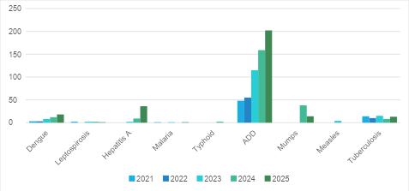

Seasonal Trend Analysis
Seasonal analysis helps anticipate surges (e.g. dengue in monsoon, leptospirosis after floods, influenza in cooler months) and plan pre‑emptive vector control, stockpiling of IV fluids, and awareness campaigns at Panchayat level.

DENGUE
Dengue is a major seasonal vector-borne disease strongly associated with rainfall, water stagnation, and increased mosquito breeding during the monsoon period.

Peak: July–November

Dengue – Ward-wise Yearly Distribution (2021–2025)

Ward | Dengue – Ward-wise Yearly Distribution
Ward | 2021 | 2022 | 2023 | 2024 | 2025 | Total
1 | 0 | 0 | 0 | 2 | 0 | 2
2 | 0 | 0 | 1 | 0 | 1 | 2
3 | 0 | 0 | 0 | 0 | 0 | 0
4 | 0 | 0 | 3 | 2 | 1 | 6
5 | 0 | 0 | 0 | 0 | 2 | 2
6 | 0 | 0 | 0 | 2 | 0 | 2

7 | 1 | 0 | 0 | 0 | 2 | 3
8 | 0 | 0 | 2 | 0 | 3 | 5
9 | 1 | 0 | 0 | 0 | 0 | 1
10 | 1 | 1 | 1 | 1 | 0 | 4
11 | 0 | 0 | 0 | 1 | 1 | 2
12 | 0 | 0 | 0 | 2 | 0 | 2

13 | 0 | 0 | 0 | 1 | 1 | 2
14 | 0 | 2 | 1 | 0 | 1 | 4
15 | 0 | 0 | 0 | 1 | 6 | 7
TOTAL | 0 | 2 | 5 | 8 | 12 | 27

LEPTOSPIROSIS
Leptospirosis cases are closely linked to monsoon rains, flooding, and occupational exposure, particularly in low-lying and waterlogged areas.

Peak: June - August

Leptospirosis – Ward-wise Yearly Distribution (2021–2025)

Ward | Leptospirosis – Ward-wise Yearly Distribution
Ward | 2021 | 2022 | 2023 | 2024 | 2025 | Total
1 | 0 | 0 | 0 | 0 | 0 | 0
2 | 0 | 0 | 0 | 0 | 0 | 0
3 | 0 | 0 | 1 | 0 | 0 | 1
4 | 1 | 0 | 0 | 0 | 0 | 1
5 | 0 | 0 | 0 | 0 | 0 | 0
6 | 0 | 0 | 0 | 1 | 0 | 1

7 | 0 | 0 | 1 | 0 | 0 | 1
8 | 0 | 0 | 0 | 0 | 1 | 1
9 | 0 | 0 | 0 | 0 | 0 | 0
10 | 0 | 0 | 0 | 1 |  | 1
11 | 0 | 0 | 0 | 0 | 0 | 0
12 | 0 | 0 | 0 | 0 | 0 | 0

13 | 0 | 0 | 0 | 0 | 0 | 0
14 | 0 | 0 | 0 | 0 | 0 | 0
15 | 1 | 0 | 0 | 0 | 0 | 1
TOTAL | 2 | 0 | 1 | 1 | 0 | 4

VIRAL HEPATITIS - A
Hepatitis A cases are commonly associated with unsafe drinking water, food contamination, and breakdowns in sanitation, often presenting as clusters or outbreaks.

Peak: October - December

Hepatitis A – Ward-wise Yearly Distribution (2021–2025)

Ward | Hep A – Ward-wise Yearly Distribution
Ward | 2021 | 2022 | 2023 | 2024 | 2025 | Total
1 | 0 | 0 | 0 | 0 | 0 | 0
2 | 0 | 0 | 0 | 0 | 2 | 2
3 | 0 | 0 | 0 | 1 | 0 | 1
4 | 0 | 0 | 0 | 0 | 2 | 2
5 | 0 | 0 | 0 | 0 | 1 | 1
6 | 0 | 0 | 0 | 1 | 1 | 2
7 | 0 | 0 | 1 | 0 | 0 | 1
8 | 0 | 0 | 0 | 1 | 0 | 1
9 | 0 | 0 | 0 | 1 | 1 | 2
10 | 0 | 0 | 1 | 1 | 2 | 4
11 | 0 | 0 | 0 | 0 | 17 | 17
12 | 0 | 0 | 0 | 0 | 9 | 9
13 | 0 | 0 | 0 | 0 | 1 | 1
14 | 0 | 0 | 0 | 2 | 0 | 2
15 | 0 | 0 | 0 | 2 | 0 | 2
TOTAL | 0 | 0 | 0 | 6 | 7 | 13

Outcome-Based Trend Analysis- 2025

NEED TO ADD ETTIKKULAM

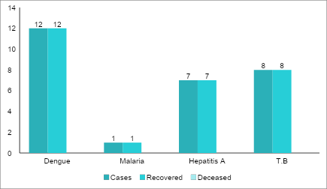

Transmission Trend- 2025
For effective management of public health issues, it is important to track the trend of disease transmission mode. It helps identify the population or place at high risk that can be used to predict outbreaks and implement targeted interventions as quickly as possible. Understanding these kinds of trends enables authorities to allocate resources efficiently and change the strategies adequately based on the trend that follows.

Mode of Transmission | No. of cases | No. of Deaths
Vector Borne Diseases | 19 | 0
Water Borne Diseases | 36 | 0
Air Borne Diseases | 56 | 1
Blood Borne Diseases | 0 | 0
Food Borne Diseases | 56 | 0

Vector-Borne Disease

Disease | No. of Cases | No. of Deaths
Dengue | 18 | 0
Malaria | 1 | 0
Chikungunya | 0 | 0

Water Borne Disease

Disease | No. of Cases | No. of Deaths
Cholera | 0 | 0
Typhoid | 0 | 0
Hep- A | 36 | 0
Dysentery | 0 | 0
Amoebiasis | 0 | 0
E- Coli infections | 0 | 0
Air Borne Disease

Disease | No. of Cases | No. of Deaths
Influenza | 0 | 0
H1N1 | 0 | 0
TB | 13 | 1
Chickenpox | 50 | 0
Measles | 0 | 0
Covid-19 | 0 | 0
Pertussis | 0 | 0
Mumps | 8 | 0

Blood-Borne Disease

Disease | No. of Cases | No. of Deaths
AIDS | 0 | 0
Hep- B | 0 | 0
Hep- C | 0 | 0

Zoonotic Disease

Disease | No. of Cases | No. of Deaths
Rabies | 0 | 0
Leptospirosis | 0 | 0
Avian influenza | 0 | 0
West nile | 0 | 0
Anthrax | 0 | 0
Nipah | 0 | 0
Scrub Typhus | 0 | 0

Integrated Disease Hotspot Map (2021–2025)
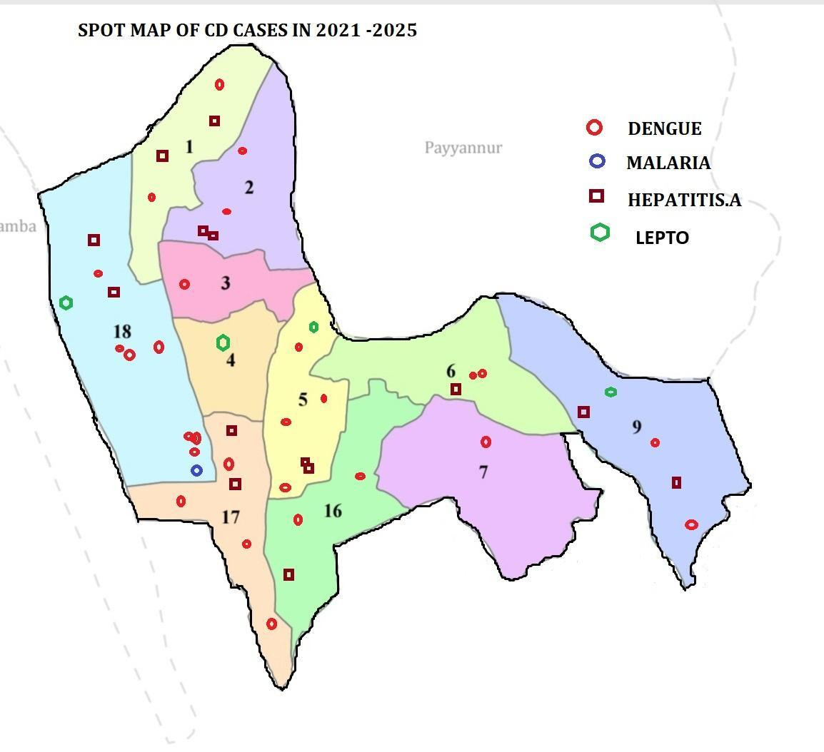

Ward No | Dengue Total (2021-25) | Leptospirosis Total (2021-25) | Hepatitis A Total (2021-25) | Mumps (2021-25) | ADD (2021-25) | Total Cases
1 | 2 | 0 | 0 | 1 | 14 | 17
2 | 2 | 0 | 2 | 1 | 16 | 21
3 | 0 | 1 | 1 | 0 | 17 | 19
4 | 6 | 1 | 2 | 1 | 21 | 31
5 | 2 | 0 | 1 | 1 | 19 | 23
6 | 2 | 1 | 2 | 1 | 13 | 19
7 | 3 | 1 | 1 | 0 | 34 | 39
8 | 5 | 1 | 1 | 0 | 46 | 53
9 | 1 | 0 | 2 | 2 | 82 | 87
10 | 4 | 1 | 4 | 5 | 91 | 105
11 | 2 | 0 | 17 | 22 | 85 | 126
12 | 2 | 0 | 9 | 15 | 74 | 100
13 | 2 | 0 | 1 | 1 | 17 | 21
14 | 4 | 0 | 2 | 1 | 27 | 34
15 | 7 | 1 | 2 | 1 | 23 | 34

By overlaying five years of data, we have identified …………..'Red Zone' Wards. These are wards where at least two different categories of diseases (e.g., Dengue and Lepto) recurred in consecutive years. Ward 4 is categorized as the Highest Priority Hotspot due to its combination of flood vulnerability and high vector density. Future health infrastructure, such as the proposed R.O plants at ………should be prioritized.

Preparedness and Response Protocol at LSG Level
This section describes the operational framework for the LSGI once a pandemic is declared. It explains how the LSGI and health system will move from routine data collection to active response, using a One Health approach.

Constitution of One Health Committee
The LSGD shall constitute a One Health Committee comprising the LSGI President, Medical Officers (Modern Medicine, AYUSH, and Veterinary), the Health Inspector, and the Veterinary Surgeon.

Objective: The One Health Committee coordinates human, animal, and environmental health to prevent and control pandemics.

Sl No | Name | Designation | Department/Institution | Role in Committee | Contact Number
1 | O.K SASI | Panchayat President | LSGD | Chairperson | 9496357320
2 | DR.FATHIMA A | Medical Officer (PHC/CHC) | Health Dept | Member Secretary | 9496357230
3 | Dr..Mohammed Sadiq | Medical Officer (PHC/CHC) | Health Dept | Member Secretary | 9895071012
4 | DR.SABU | Veterinary Officer | Animal Husbandry | Member | 8547764814
5 | DR ANASWARA | Epidemiologist | Health Dept | Member | 8129105379
5 | UMESH P V | Health Inspector/PHN | Health Dept | Surveillance | 7012268439
6 | SAVITHA | ICDS Supervisor | Social Welfare | Vulnerable groups | 9495374994
7 | Saritha JPHN | ASHA Supervisor | Health Dept | Community link | 9497700893
8 | Station house officer,Payyannur | Police Station Officer | Police Dept | Law & order | 04985 203032
9 | K P DINESHAN | Ward Councillor Representative | LSGD | Community coordination | 9497837616
10 | Abdul Azeez | Ward Councillor Representative | LSGD | Community coordination | 9446985758
11 | INDIRA | Kudumbashree CDO | Kudumbashree | Community mobilisation | 8078132699
12 | Adnan N.A.V | NGO(Bismillah Ettikulam) | Civil Society | Support services | 9526106916
13 | MANOJ | THAHSILDAR | Line Department representations |  | 8547617102

Key Responsibilities:
- Review disease surveillance data (human + animal)
- Conduct ward-wise risk assessment and vulnerability mapping
- Approve quarantine/isolation centre locations
- Coordinate with district for resources (PPE, oxygen, ambulances)
- Periodically review health system surge capacity, including beds, oxygen, human resources, and ambulances.
- Approve and monitor risk communication and community engagement strategies, including rumour management.
- Ensure protection and service continuity for vulnerable groups (elderly, persons with disabilities, dialysis patients, coastal populations).
- Conduct quarterly mock drills
- Monitor equity measures for vulnerable groups

Meeting Schedule:
Quarterly (normal times) | Weekly (outbreak alert) | Daily (pandemic phase)

Pandemic Response Workforce
To ensure a coordinated and timely response during a pandemic, a dedicated Pandemic Response Workforce shall be constituted at the LSG level. The workforce will function under the overall supervision of the One Health Committee and in close coordination with the health authorities. Team-based deployment will enable efficient surveillance, case management, quarantine and isolation management, logistics support, and risk communication. Each team shall have a clearly designated team leader, defined roles, and an identified pool of personnel to allow rapid activation, rotation of duties, and continuity of services during prolonged emergencies.

Total Response Workforce Available: 300 persons

Team Name | Composition | Key Responsibilities | Team Leader
Surveillance and Contact Tracing Team | HI, JHI, JPHN, ASHAs and Volunteers | Case detection, contact listing, home visits, reporting | HI
Case Management Team | Doctors, Nurses, MLSP, Palliative Nurses | Patient care & referral | DOCTOR
Quarantine & Isolation Team | LSGD staff, Volunteers | Facility management | JHI
Psychosocial support | NHM | COUNCILLORS | PRO
Logistics & supply chain Team | LSGD staff, Storekeepers, Drivers 3 | Supplies & transport [PPE, medicines, oxygen, transport, waste management] | Ward Member
Communication Team | Ward members, Kudumbashree, Youth clubs,  AWW workers and other self help groups | IEC, community meetings, countering misinformation | M.O in charge
Transportation | KSRTC, educational institutional buses | USE KSRTC EDUCATIONAL BUSES FOR EMERGENCY TRANSPORTATION | TRANSPORT OFFICERPAYYANNUR
Media Surveillance | NEWS PAPER, T V CHANNELS , SOCIAL MEDIA | NONITOR INFORMATION ON DISEASES SPREAD THROUGH NEWS PAPERS , T V ONLINE NEWS AND SOCIAL MEDIA | REPORTER
Intersectoral coordination and convergence | CONDUCT INTER DEPARTMENT CO ORDINATION | CONDUCT DISEASE CONTROLL ACTIVITIES IN CO ORDINATION WITH THE HEALTH DEPARTMENT, LSGD, EDUCATION,AGRICUTURE, VETINARYAND POLICE ,FIREFORCE | MO FHC RAMANTHALI
Collaborative surveillance | WITH ASHA, AWW, KUDUMBASREE HARITHA KARMASENA OTHER NGOs | TO IDENTIFY SYMPTOMS OF DISEASE AND REPORT THEM | PANCHAYATH PRESIDENT

All teams shall be activated immediately upon outbreak alert or pandemic declaration and shall report daily to the LSG Incident Commander/Medical Officer, with consolidated reporting to the Block PHC. Duty rosters and alternate personnel shall be maintained to ensure uninterrupted services during staff shortages or prolonged response periods. Team composition and numbers may be revised based on the magnitude of the outbreak and availability of human resources.

Activities and Measures before and during Pandemic

PHASE 1 - Alert / Preparation
Surveillance and Reporting-Enhanced syndromic surveillance:
- Data sources for surveillance:
- Event-based triggers (to be monitored and reported):
- Zoonotic and animal health surveillance
- Logistics and Stock Preparedness
  - Identify and empanel local vendors and define emergency procurement mechanisms in accordance with existing LSGD and Health Department norms.
  - Prepare and maintain an essential logistics checklist covering medical supplies, consumables, and support equipment.
  - Pre-identify secure storage locations for emergency stocks and ensure maintenance of stock registers with regular updating.
  - Finalise emergency transport arrangements, including availability of vehicles and identified drivers for rapid deployment during alerts.
  - Designate a Nodal Officer for Logistics to enable prompt decision-making, coordination, and communication during emergencies.
  - Conduct rapid stock verification and ensure availability of minimum buffer stock, including:
- PPE kits – 100numbers
- Pulse oximeters – 50numbers
- Hand sanitizers – 10litres
- Masks -1000, gloves -10000, disinfectants 100 Litter, adequate quantity
Identify critical gaps in logistics and immediately communicate requirements to the Block and District authorities for timely replenishment and support. Monitor expiry dates and stock rotation.

Identification of Quarantine and Isolation Facilities
  - Identify and list suitable buildings for quarantine and isolation (schools, hostels, community halls, etc.).
  - Categorise cases as per the severity and allocate to appropriate facilities (for instance, severe cases to classrooms, mild cases to an assembly hall in case of a school).
  - Facility readiness checklist needed (beds, toilets, ventilation) etc.
  - Find an alternate site if the primary sites are not available or not in use.
  - Identify facility managers and support staff
  - Prepare basic SOPs for:
    - Admission and discharge
    - Food, water, sanitation
    - Infection prevention and waste disposal
  - Ensure availability of basic amenities: water, sanitation, electricity, ventilation, and waste disposal. Prepare a rapid activation plan for these facilities if case numbers increase.

Risk Communication and Community Preparedness
  - Disseminate early warning messages on symptoms, preventive measures, and reporting mechanisms. Display IEC materials both in English and the local language in public places and ensure ward-level awareness.
  - Sensitize elected representatives and community leaders on preparedness measures.
  - Establish a rumour tracking and misinformation response mechanism to identify, verify, and promptly counter false or misleading information.
  - Engage trusted local persons (ward members, ASHA workers, religious leaders, teachers, community volunteers) to communicate official public health messages and reinforce correct practices.
  - Develop and deploy targeted IEC materials for:
    - Schools and educational institutions
    - Markets and commercial areas
    - Work sites and labour settings
  - Conduct community sensitization meetings at the ward level to promote preventive behaviors, address concerns, and strengthen community participation in preparedness and response.

Protection of Vulnerable Groups
Vulnerable populations require priority protection through targeted line-listing, service continuity, and delivery mechanisms.
- Prepare and regularly update line-lists of vulnerable populations, including:
  - Elderly persons living alone
  - Persons with disabilities
  - Pregnant women
  - Migrant workers
  - Dialysis patients
The detailed line-lists shall be maintained as Annexure ___ and updated periodically.

Clinical Dependency Mapping
Develop ward-wise dependency and vulnerability maps to identify households requiring regular support during emergencies. Ensure continuity of essential health services for vulnerable groups, including
- Dialysis services (facility mapping, transport arrangements, and scheduling)
- Continuity of treatment for TB, HIV, and other chronic conditions requiring uninterrupted medication
- Mental health and psychosocial support services
Establish delivery mechanisms for food, essential commodities, and medicines to vulnerable households through coordinated action involving ASHAs, JPHNs, Kudumbashree, volunteers, and local administration.

PHASE 2 - Active Response

Case Identification and Contact Tracing
Case detection and contact tracing activities will be carried out in coordination with the Health authorities, following disease-specific SOPs and IDSP guidelines.
Field Staff Involved
- Health Inspector (HI)
- Junior Health Inspector (JHI)
- Junior Public Health Nurse (JPHN)
- ASHAs and ASHA Supervisors
- Ward-level volunteers and Kudumbashree members (as required)

Screening Checkpoints
Screening checkpoints at high-traffic locations (transport hubs, markets, religious gatherings) for early detection of symptomatic travellers and crowd screening during outbreaks. Potential locations include bus stands, market entry points, and boat jetties, based on local context and risk assessment.
Screening activities will be carried out by trained personnel such as ASHAs, ward members, and volunteers, with support from Health Department staff. Necessary equipment, including non-contact thermometers and appropriate PPE, shall be ensured prior to activation.
Location | Type (Bus stand/Jetty/Market/Railway) | Staff Deployed (ASHAs/Volunteers) | Screening Method | Reporting authority
Bus stand | Transport hub | One JHI  One ASHA  One health Mentors | 1.Swab Collection.  2. Blood smears collection (RDT)  3.Thermal Scanners | Surveillance Nodal Officer in control room
Market entry | Market | One JHI  One ASHA  Male health volunteers | 1.Swab Collection.  2. Blood smears collection (RDT)  3.Thermal Scanners | Surveillance Nodal Officer in control room
Boat jetty | Water transport | One JHI  One ASHA  Male health volunteers | 1.Swab Collection.  2. Blood smears collection (RDT)  3.Thermal Scanners | Surveillance Nodal Officer in control room

Standard Screening Protocol

The screening protocol shall include temperature screening, observation for visible symptoms, and inquiry regarding recent travel or exposure history. Individuals identified as suspects during screening shall be immediately referred to the nearest PHC/FHC for further evaluation, testing, and appropriate action as per prevailing guidelines.

Pandemic Control Room
The Pandemic Control Room (PCR) serves as the central nerve center for real-time coordination, data aggregation, decision support, and communication during outbreaks. It consolidates information from all LSGD teams, health facilities and community sources to enable rapid response decisions.

Control Room Infrastructure and Location
Primary Location: RAMANTHALI Panchayath Office.
Backup Location: Community Hall in RAMANTHALI G.P.

Health System Control Room Framework
The PCR is organized into seven functional pillars to ensure no aspect of the response is overlooked:

Rapid Response Team (RRT)
  - Provides immediate intervention during emergencies, clusters, and field alerts.​
  - Coordinates urgent actions such as case investigation, contact tracing, isolation, and inter‑facility referrals.

Data Management & Analytics Team
  - Collects, validates, and manages key health system indicators (cases, tests, beds, HR, supplies).​
  - Analyzes data trends, generates projections, and supports evidence‑based decision‑making for local authorities.

Human Resource Deployment Team
  - Allocates healthcare staff efficiently based on workload and need
  - Ensures adequate and equitable workforce distribution across facilities

Laboratory Surveillance Team
  - Oversees diagnostic testing coordination, sample transport, and timely reporting of results. ​
  - Monitors lab indicators (testing volume, positivity rate, turnaround time) for early detection of outbreaks

Vaccination Cell (If Required)
  - Plans and executes vaccination campaigns, including micro‑planning and session scheduling. ​
  - Tracks coverage, identifies gaps, and coordinates corrective actions with field teams and outreach services.

Infrastructure & Patient Occupancy Team
  - Monitors facility capacity, earmarked beds, oxygen and critical care resources across all linked facilities. ​
  - Ensures optimal patient distribution and referral management using updated bed‑status and resource data.
  - BMWM

Communication team
- Logistics and supply chain
- Transportation (interfacility & emergency transport)
- Media surveillance Call centre
- Management of the deceased
- Intersectoral coordination and convergence

Key Control Room Team
The Control Room Team coordinates all pandemic response activities within the LSGD and serves as the single command and communication hub during activation. It integrates information, field actions, logistics, and policy execution across all participating departments and health facilities.

Role | Name | Designation | Contact Number | Responsibility
In-charge/Nodal Officer | DR.FATHIMA A | Medical Officer | 9496357230 | Overall coordination, decision-making, and reporting to the District level.
Communication Officer | UMESH P V | Health Inspector | 7012268439 | Handling the public helpline, coordinating ambulance dispatch, and contact tracing calls.
Logistics Coordinator | RAJIN | Pharmacist | 9744173527 | MANGING PROCUREMENT AND SUPPLY OF MEDICINES AND OTHER MEDICAL METERIALS
Technical Support(IT/Data) | NIL

SOP for alert escalation/trigger point with mapping of responsibilities.
Key Points:
- The Control Room shall be staffed with a designated In-charge, data entry personnel, and communication staff with clearly defined roles and shift arrangements.
- It shall maintain updated records on daily monitoring indicators including new cases, persons under active quarantine, and hospital bed occupancy.
- All reports and situation updates shall be shared daily with the Block and District Surveillance Unit.
- The Control Room shall act as a single point of contact for coordination with response teams, health institutions, and other departments.
- Contact details of the Control Room shall be widely communicated to field staff and stakeholders during activation.

Daily Monitoring Indicators
To ensure timely decision-making and effective response, the following key indicators shall be monitored and updated on a daily basis by the Pandemic Control Room:

Epidemiological Indicators:
New cases reported today, Total active cases, Test Positivity Rate (TPR), Case Fatality Rate (CFR)
- Surveillance Indicators:
Persons under home quarantine, High-risk contacts identified, Fever, ILI, SARI or other symptoms (syndromic surges), Travellers (symptomatic or high-risk arrivals),Animal husbandry surveillance (zoonotic alerts, unusual animal deaths, poultry/bird flu signals), Mortality surveillance (excess deaths, unexplained fatalities, verbal autopsy reports)
- Logistics and Infrastructure Indicators:
Hospital / CFLTC beds occupied, Oxygen cylinders/concentrators available, Ambulances on standby
- Alert Findings
The following table outlines category-specific trigger points (red flags) from surveillance indicators and corresponding immediate actions for the Pandemic Control Room. These enable rapid response to alert findings like testing anomalies, positive cases exceeding thresholds, clusters, and WGS reports.

Category | Trigger Pophint (Red Flag) | Immediate Action
Clusters | Geographical or facility-based: 5+ cases linked to one location (office, school, street). | Declare a micro-containment zone; perimeter control and active case finding.
Testing | Sudden drop in testing volume / delay in reporting / unusual testing trends | Review the sample collection process, address lab bottlenecks, deploy additional testing teams, and notify the District Lab.
Lab | Test Positivity rate increases | Increase testing sites in that ward.
Hospital | >80% Oxygen bed occupancy | Activate backup/CFLTC beds.
Travel | Cluster of cases from a single flight/train or high-risk arrival group. | Trace all passengers in adjacent seats; implement mandatory institutional quarantine.
Animal | Mass poultry/wildlife death or unusual sickness | Notify Animal Husbandry, sample the area, and dispatch RRT for environmental sampling and zoonotic check.
Mortality | Sudden spike in home deaths or brought-in-dead (BID) cases | Audit the deaths and Active Case Search drive
Additional investigations like Whole Genome Sequencing (WGS) | Detection of a Variant of Concern (VOC) or Variant of Interest (VOI) | Implement strict micro-containment; update clinical protocols to match variant severity.

Communication of Public Health Information
A Community Communication Hub shall be established to ensure timely, accurate, and consistent dissemination of information during a pandemic. The Hub will function under the coordination of Nodal officers of the control room and act as the nodal point for public communication, risk messaging, and community engagement. It will support dissemination of official advisories, promote preventive behaviors, address rumors and misinformation, and ensure that messages reach all sections of the population through trusted local channels and leaders.

Key communicators
Channel | Responsible Person | Contact
Ward-level announcements | ATHIRA S PILLAI  K.K.Kunhimuhammed | 9207023346  9495784756
Social media | SANTHOSH E V | 9947167254
Local Cable TV/Radio | SETHU | 8086997122

- All messages disseminated through the Hub shall align with advisories issued by the Health Department and District authorities.
- Community leaders shall be sensitized to support behavior change, reduce stigma, and counter misinformation.
- Special efforts shall be made to reach vulnerable and hard-to-reach populations using locally appropriate communication methods.

Rumor Tracking: A designated volunteer will monitor local social media/WhatsApp groups daily to identify misinformation and issue official clarifications via the Communication Hub.

Coordination with District/State Authorities & Other Organisations
Effective coordination with Block, District, and State authorities is essential to ensure timely reporting, technical guidance, and uninterrupted supply of essential resources during a pandemic. The LSG shall establish clear communication channels, designate responsible officers, and adhere to prescribed reporting timelines to support coordinated public health action and efficient resource mobilisation.

Key Details:
- Nodal Officer for Reporting: Dr. Fathima A
- Contact Number: 9496357230
Reporting Schedule and Protocols:

To Whom | What to Report | Frequency | Nodal Person
Block PHC | Complete Situation Report (Cases, Quarantine, Beds, Screening, Deaths) | DAILY | MO FHC RAMANTHALI
District IDSP Unit | Outbreaks/Clusters/Unusual Events (>5 cases same ward) | IMMEDIATE | MO FHC RAMANTHALI
Veterinary Officer | Animal health events/Zoonotic alerts | IMMEDIATE | MO FHC RAMANTHALI
State Cell | Zoonotic cross-sector events | IMMEDIATE | MO FHC RAMANTHALI

Supply Chain Coordination
The LSG shall coordinate closely with Block, District, and State authorities (KMSCL) to ensure uninterrupted availability of essential goods, medical supplies, and logistics during a pandemic. Supply requirements shall be assessed regularly based on case load and communicated promptly to the appropriate authorities for timely replenishment.
Key Points:
- Maintain updated contact details of District and Block nodal officers for health logistics, oxygen supply, ambulances, and essential medicines.
- Submit timely indent requests for PPE, testing kits, medicines, oxygen, and other critical supplies through prescribed channels.
- Monitor stock levels at LSGD facilities, quarantine/isolation centres, and field teams through daily stock registers and dispensing logs to prevent shortages.
- Coordinate with District authorities, Karunya/Neethi medical shops, and local purchase committees for funds allocation and emergency procurement.

- Ensure regular monitoring of dispensing registers at all facilities to track usage, expiry, and pilferage—shortages being a perennial issue requiring proactive weekly audits.

- Activate surge procurement protocols during high caseloads, leveraging local purchase powers under LSGD funds alongside state supplies.

Resource Inventory and Contacts
Resource Category | Source  (District/State/Private) | Contact
PPE Kits/Masks/Gloves | KMSCL | 04972705046
PPE Kits/Masks/Gloves | Local Vendors | 9847928215
Oxygen  Cylinders/Concentrators | KMSCL | 04972705046
Medicines/Antivirals | KMSCL | 04972705046
Medicines/Antivirals | Neethi Shops | 9947258886
Test Kits (RTPCR/Rapid) | KMSCL | 04972705046

Collaboration with NGOs, PPP, and CSR
To augment government efforts during a pandemic, the LSG shall collaborate with NGOs, voluntary organisations, and private sector partners through public–private partnerships and Corporate Social Responsibility (CSR) initiatives, in coordination with District authorities.

Key Points:
- Engage NGOs and community-based organisations for community outreach, awareness, and support to vulnerable populations.
- Leverage CSR support for procurement of medical equipment, PPE, oxygen concentrators, food kits, and sanitation materials, as permitted.
- Ensure all collaborations align with government guidelines and are routed through approved administrative and financial procedures.
- Maintain transparency and documentation for all external support received and utilised.
Organization | Type | Support Offered | Contact Person
Youth Clubs/Student Unions | CBO | MANOJ MANCHERY | 9496705452

Interdepartmental Coordination
Coordination among departments during a pandemic shall be ensured through regular review meetings convened by the LSGD President. These meetings will provide a structured platform for sharing situational updates, assessing resource availability, resolving operational gaps, and taking joint decisions to ensure a coordinated and timely response.

Department | Representative | Key Role | Contact
Health (PHC) | Staff Nurse : Sreeja, Kochuthresia | Case management | 7510897918, 9745045739
Veterinary | Veterinary Surgeon: Dr.Sabu | Animal surveillance | 8547648614
ICDS | Supervisor: Savitha | Nutrition support | 9495374994
Education | Head Teacher: Sureshan, Sathyanadhan | School coordination | 9447914575, 8330082100
Police | SHO Payyanur | Containment enforcement | 04985 203032
Water Authority | KWA Payyanur | Water supply | 04985 290734
LSGD Engineering | Vaheeda AE | Quarantine infrastructure | 9995335197

PHASE 3 - Surge Capacity
Phase 3 is activated when there is a rapid increase in cases, high test positivity rates, or when existing health facilities and quarantine arrangements approach saturation. The focus of this phase is to expand isolation capacity, augment clinical care services, and mobilise additional resources through district and state support mechanisms.

Conversion of Community Facilities
To manage increased case load, the LSGD shall activate additional isolation facilities by repurposing identified community infrastructure such as community halls, auditoriums, schools, hostels, or other suitable buildings.

Name of facility | Facility Type | No. of Buildings | Ward | Surge Capacity (Beds) | Nodal Person
Community Hall,Parathikad | Community Hall | 1 | 11 | 5 | Surendran
Tagore Vayanasala | Auditorium | 1 | 10 | 10 | Arunan
MASS HSS,ETTIKULAM | HS SCHOOL | 1 | 12 | 16 | Muhammed Kunhi (Principal)
MASS HS,ETTIKULAM | SCHOOL | 2 | 11 | 16 | Sathyanadhan  (HM)
OLAKAL MADRASSA,PALAKKODE | MADRASSA | 1 | 13 | 5 | 9495863760

- Recovery and rehabilitation phase
- Recovery
  - Damage & impact assessment
  - Restoration of health services
  - Rehabilitation of affected population
  - Psychosocial & mental health support
  - Disease surveillance during recovery phase
  - Environmental cleanup & sanitation
  - Livelihood restoration
  - Community engagement & confidence building
  - Documentation & after-action review
  - Lessons learned & best practices
  - Health system strengthening
  - Policy revision & preparedness enhancement
  - Research

CONCLUSION
The Pandemic Preparedness Plan of Ramanthali Grama Panchayat serves as a comprehensive framework aimed at enhancing local preparedness and ensuring a timely and coordinated response to potential public health emergencies. By integrating essential components such as disease surveillance, rapid response mechanisms, effective case management, logistics and resource planning, risk communication, and active community participation, the plan seeks to reduce the impact of any future pandemic on the health and wellbeing of the community.
The successful implementation of this plan requires continuous monitoring, regular capacity building, strong inter-sectoral coordination, and sustained community engagement. Through the collective efforts of the Grama Panchayat, the Health Department, frontline health workers, and the public, Ramanthali Grama Panchayat will be better equipped to respond effectively to emerging public health threats and to ensure the safety and wellbeing of its residents.

Additional points
- tech support
- relief based commodities
- ham reading operators
- hazard vulnerability mapping
- Kseb & other power source
- HR specific responsibility

RECOMMENDATIONS

Strengthening Healthcare Infrastructure
- Establish a primary health response unit within the Panchayat with trained staff.
- Ensure availability of basic medical supplies (masks, sanitizers, PPE kits, oxygen cylinders).
- Create tie-ups with nearby hospitals in Payyanur for emergency referral and transport.

2. Community Awareness & Education
- Conduct regular awareness campaigns on hygiene, vaccination, and preventive measures.
- Use local communication channels (community radio, WhatsApp groups, notice boards) to spread verified information.
- Train volunteers to act as health ambassadors in each ward.

3. Emergency Response & Coordination
- Form a Pandemic Preparedness Committee at Panchayat level including health workers, ward members, and NGOs.
- Develop a clear action plan for lockdowns, quarantine, and distribution of essentials.
- Maintain a database of vulnerable groups (elderly, differently-abled, chronically ill) for targeted support.

4. Supply Chain & Food Security
- Identify and support local suppliers and farmers to ensure uninterrupted food supply.
- Create community kitchens during emergencies to serve vulnerable populations.
- Stockpile essential commodities in Panchayat-run outlets for crisis periods.

5. Digital Preparedness
- Promote digital platforms for telemedicine consultations.
- Use Panchayat’s website/social media for real-time updates on health advisories.
- Encourage online grievance redressal to reduce crowding in offices.

6. Training & Capacity Building
- Organize mock drills for pandemic response in schools, offices, and public spaces.
- Train Panchayat staff and volunteers in first aid, infection control, and crowd management.
- Collaborate with NGOs and health departments for capacity-building workshops.

7. Long-Term Resilience
- Integrate pandemic preparedness into the Panchayat Development Plan.
- Allocate a dedicated budget for health emergencies.
- Encourage community participation in planning and monitoring preparedness measures.

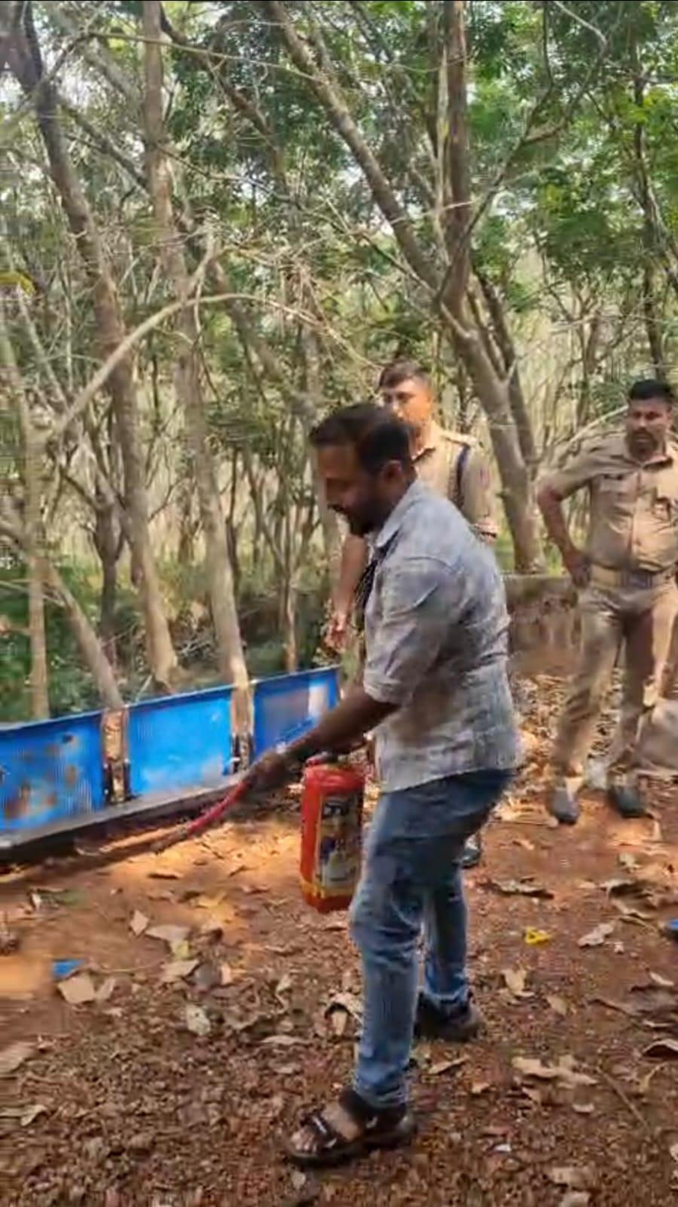MOCKDRILL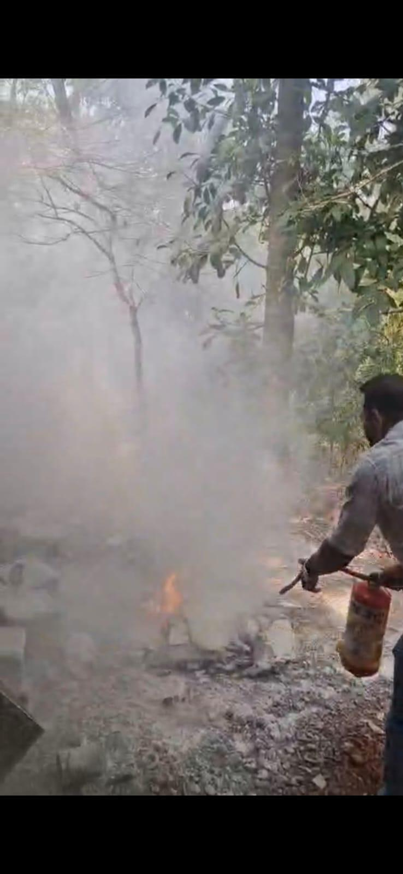 SCENA

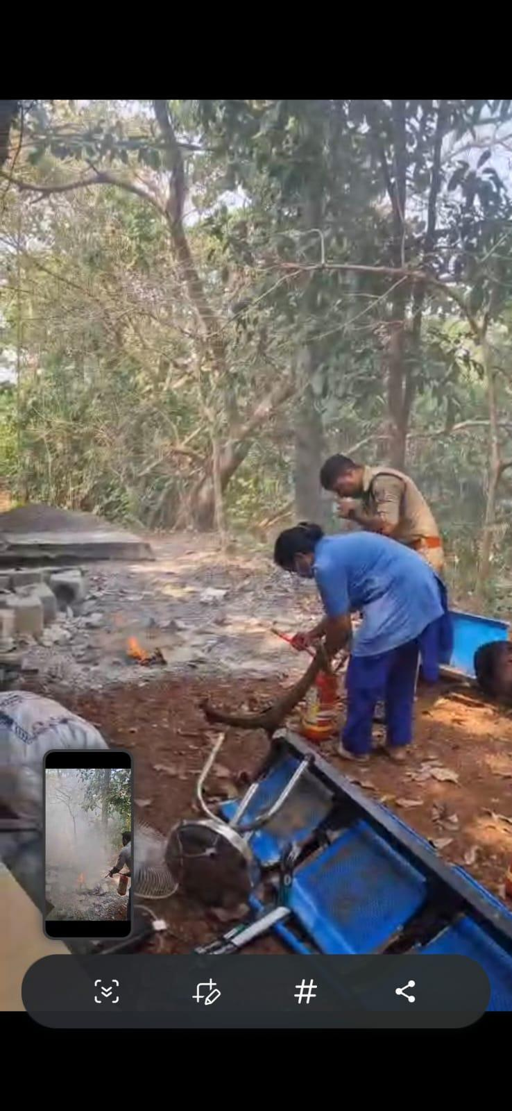

ANNEXURE

IMPORTANT PHONE NUMBERS

Phone numbers and particulars of persons responsible for providing guidance, assistance, and support for pandemic preparedness operations may be provided here in a manner that allows easy reference at a glance.The information recorded here could be exhibited elsewhere at the time of emergencies. LSG institutions shall give special attention to collect and record the above data of persons and institutions who/which are supposed to give technical and co-ordination support to reduce the impact of pandemic.

1.1. Details of grama panchayat/municipality/corporation wards
Sl.No | Name of the ward | Ward Number | Name of the ward  member | Contact number
1 | Vadakkumbad North | 1 | Nusaiba C P | 9544941204
2 | Vadakkumbad East | 2 | Balkis K K | 7907707652
3 | Kovvapuram East | 3 | Abdul Rahiman | 9496523541
4 | Kovvapuram Centre | 4 | K Chandran | 8281337763
5 | Kunnatheru | 5 | E Rajan | 9447737980
6 | Kallettinkadavu | 6 | O K Sasi | 9496357320
7 | Ezhimala | 7 | Dhanya Sukumaran | 9744005994
8 | Karanthad | 9 | Sunil Kunnaru | 9447803317
9 | Ramanthali East | 16 | K P Dineshan | 9497837616
10 | Ramanthali Centre | 17 | Sandhya S | 9946141013
11 | Kovvapuram West | 18 | Shylaja A K V | 9744710368
12 | EAZHIMALA NORTH | 8 | NARAYANAN MASTER | 9495372590
13 | KUNNARU CENTRALGR | 10 | RAMESHAN M | 9633195145
14 | KUNNARU SOUTH | 11 | SUJITHA SUDHEESH | 9400638996
15 | PALAKKODE | 12 | NASEEMA.C | 9744383425
16 | VALIYA KADAPPURAM | 13 | SEENA | 9847384825
17 | ETTIKULAM BEACH | 14 | AMEEFA | 9400284580
18 | ETTIKULAM | 15 | ABDUL ASEES | 9446985758

1.2. Other important phone numbers of grama panchayat/municipality/corporation area
Sl. No. | Name | Contact number
1. | GRAMA PANCHAYAT OFFICE | 04985222025
2.
3.
4.
5.
6.
7. | Excise department | 09400069703
8. | Forest department

1.3. Important offices of grama panchayat/municipality/ corporation
Sl.No | Name of the office | Contact person | Contact number
1. | Village Office | Village Officer | 8547617114
2. | Agriculture Office | Agriculture Officer | 8281200136
3. | Animal Husbandry Office | Animal Husbandry Doctor | 8547648614
4. | Police Station | Police Officer | 04985 203032
5. | BSNL Office | Officer
6. | Block Office | Officer
7. | KSEB Office | Officer | 04985222731
8. | Fisheries Office | Officer | 9946494008
9. | Fire and Rescue | Officer | 04985 202901

1.4. Health Services

Sl. No | Name of the hospital/institution | Location | Phone number
1. | Government hospitals/PHC | Kallettinkadavu | 04985 222513
 |  | FHC ,ETTIKULAM | 04985230372
2. | Private hospitals | SAHAKARANA PAYYANNUR | 04985207373
3. | Clinical laboratories | Punnakkadavu
4. | Chemist/pharmacy
5. | Blood donors | Nil
6. | Other language experts (Bihari, Hindi, Bengali,  Asamees ………)

1.5. Veterinary Services
Sl.No | Name of the Clinic | Name of the  Surgeon/Doctor | Place/location | Phone  number
1 | Govt.Veterinary Hospital | Dr.Sabu | Kunnatheru | 8547648614

1.6. Helpline numbers
Helpline | Phone number
Police | 100 / 04985 203032
Fire and Rescue | 101/ 04985 202901
KSEB | 04985222731

1.7. Public and Private Schools Contact details

S.No | Name of School | Institution type | Phone number
1 | OKKSGHSS Ramanthali | Govt | 8330053284
2 | Kunnaru AUP School | Aided | 9447120366
3 | Chidambaranath UP School | Aided | 6282094491
4 | GMUP School Vadakkumbad | Govt | 9447914575
5 | Ramanthali GLP School | Govt | 9495725410
6 | Panchayath LP School Kunnatheru Ramanthali | Govt | 9746550404
7 | CHMKMHSS Vadakkumbad | Private | 9497088582
8 | MASS HIGH SCHOOL,ETTIKULAM | Govt | 8330082100
9 | MASS HIGHER SEC SCHOOL ,ETTIKULAM | Govt | 9947527313
10 | EMYC ENGLISH SCHOOL ETTIKULAM | Private | 960542044
11 | BADARIYYA ENGLISH SCHOOL, ETTIKULAM | Private | 9847574313
12 | EAZHIMALA ENGLISH SCHOOL,KAKKAMPARA,PALAKKODE | Private | 9605038680
13 | GOVT UP & LP SCHOOL,PALAKKODE | Govt | 9495347753

1.9. Anganwadi Contact Details

Sl No | Ward No | Name of Anganwadi | Anganwadi Teachers | Phone number
1 | 1 | Kuruvanthatta | Nalini | 9288 702 575
2 | 1 | Haji Road | Thambai | 9544 847 742
3 | 2 | Vadakkumbad | Sumathi | 9961 914 908
4 | 3 | Kovval | Yamuna | 7902 203 839
5 | 3 | Punnakkadavu | Ramani | 9633 438 182
6 | 5 | Thavuriyad | Lalitha P | 9495 910 799
7 | 6 | Onaparamba | Susheela P | 9744 968 975
8 | 9 | Kunnaru Second | Sobha M | 9947 196 475
9 | 9 | Karanthad | Sumathi K V | 9947 127 452
10 | 7 | Kurisumukku | Marykutty | 6282 470 923
11 | 7 | Narimada
12 | 16 | Ramanthali | Sindhu M V | 9526 046 518
13 | 18 | Kovvapuram | Minimol | 9048 710 973
14 | 8 | SUMATHI.C ,NEELAKARACHAL | 9567804690 | 8
15 | 10 | LALTHA,KUNNARU | 8281568547 | 10
16 | 11 | SUNITHA ,PARATHIKAD | 9539506453 | 11
17 | 11 | SHYAMAL.AV,KARAMUTTAM | 9526611637 | 11
18 | 12 | LEELA .M,PALAKKODE | 8547597739 | 12
19 | 12 | EAMANI.K.V,CHITTADI | 9562563951 | 12
20 | 13 | SHYNI,VALIYAKADAPPURAM |  | SHYNI,VALIYAKADAPPURAM
21 | 13 | GEETHA.K.V,KAKKAMPARA | 9400822828 | GEETHA.K.V,KAKKAMPARA
22 | 14 | VIMALA.O,MOTTAKUNNU | 9495907950 | VIMALA.O,MOTTAKUNNU
23 | 15 | 1)JAYASREE.C.V,MOTTAKUNNU -2 | 9526241093 | 1)JAYASREE.C.V,MOTTAKUNNU -2
24 | 15 | 2)SAJITHA,AMBALAPARA | 8257801335 | 2)SAJITHA,AMBALAPARA
25 | 15 | 3)AJITHA, POLLA A/W | 8281015109 | 3)AJITHA, POLLA A/W

1.12. Information regarding resources

Means of transportation | Name of Owner | Phone Number
Heavy Trucks | IBRAHIM | 9495102836
Tractor | RANJITH | 9447953359
Ambulances | RURAL BANK | 8547859828
Boats | KALLETTUM KADAVU BAT SERVICE | 9846957999
Taxi service | SHIHAB | 8547142973

Annexure 1: LSG Baseline Data Collection Format
A. Baseline data
Sl. No. | Indicator / Field | Baseline Data | Source / Remarks
1 | Name of LSG | Ramanthali
2 | District | Kannur
3 | Block / Taluk | Payyanur
4 | Type of LSG (Gram Panchayat / Municipality / Corporation) | Grama Panchayath
5 | Area (sq. km) | 31.41
6 | No. of wards | 18
7 | GIS boundary file available | (Yes/No)
8 | Key contact person & phone | OKSASI-9496357320

B. Demography
Indicator / Field | Baseline Data | Source / Remarks
Total population | 28910 | PH SURVEY BY HSD
Males | 14190 | PH SURVEY BY HSD
Females | 14720 | PH SURVEY BY HSD
Transgender population | 0 | PH SURVEY BY HSD
Age distribution  (<5, 5–14, 15–59, ≥60) | <5-794, >60-5830 | PH SURVEY BY HSD
No. of households | 5792 | PH SURVEY BY HSD
Population density (persons/sq.km) | 860 | PH SURVEY BY HSD
No. of migrant workers | 458 | PH SURVEY BY HSD
Major occupational groups |  | PH SURVEY BY HSD

C. Vulnerable Populations & Social Risks
Sl. No. | Indicator / Field | Baseline Data (Value / Description) | Source / Remarks
1 | No. of elderly (≥60) | 3642 | BY HSD
2 | No. of persons with disability | 101 | BY HSD
3 | No. of bedridden persons | 250 | BY HSD
4 | No. of chronic disease cases (DM/HTN/COPD/CKD etc.) | 8278 | BY HSD
5 | Pregnant women (current estimate) | 157 | BY HSD
6 | Children <5 years | 794 | BY HSD
7 | Tribal population (if any) | 0 | BY HSD
8 | Fisherfolk / coastal vulnerable groups (if any) | 276 | BY HSD
9 | Urban slums / unnotified settlements (if any) | 0 | BY HSD
10 | Homeless population | 0 | BY HSD
11 | Orphanages / old age homes (number & capacity) | 0 | BY HSD
12 | Hostels / prisons / shelters (number & capacity) | 0 | BY HSD
13 | Poverty / BPL estimate | 1421 | BY HSD
14 | Food insecurity hotspots | 0 | BY HSD
15 | Any history of stigma/discrimination issues (Yes/No) | NO | BY HSD

D. Health System & Service Readiness
Sl. No. | Indicator / Field | Baseline Data (Value / Description) | Source / REMARKS
1 | No. of health facilities in LSG (PHC/CHC/TH/DH/Private) | 1 | HSD
2 | PHC/Family Health Centre details (name, location) | FHC RAMANTHALI,
3 | Subcentres / Health & Wellness Centres (number) | RAMANTHALI. VADAKKUMBAD
4 | Private clinics / hospitals (number) | V CARE MEDICAL CENTER
5 | Labs available (public/private) | DUA LAB ,SWANTHANAM MEDICAL LABORATARY KARANTHAD
6 | Availability of ambulance services (Yes/No, number) | YES-1
7 | Availability of isolation/quarantine facilities (Yes/No, details) | YES
8 | Cold chain facilities (Yes/No, details) | YES-1
9 | Stockpile space available (Yes/No) | NO
10 | PPE / mask / sanitizer availability plan (Yes/No) | YES
11 | Surveillance staff available (JHI/JPHN/ASHA count) | YES 25
12 | Existing emergency referral pathways (Yes/No) | YES

E. Points of Entry & Mobility
Sl. No. | Indicator / Field | Baseline Data (Value / Description) | Source / Remarks
1 | Bus stands / depots (number) | 0
2 | Railway stations (number) | 0
3 | Boat jetties / fishing harbours (number) | 1
4 | Ports / airports nearby (specify distance) | 0
5 | Major highways/roads passing through | YES
6 | Border crossings (state/district) | NO
7 | Major markets / weekly markets | NO
8 | Tourism hubs / major event venues | YES
9 | Schools/colleges with hostels (number) | 0
10 | Factories / large workplaces (number) | 0
F. Water, Sanitation & Hygiene (WASH)
Sl. No. | Indicator / Field | Baseline Data (Value / Description) | Source / Remarks
1 | Major drinking water sources (piped / wells / borewells / springs) | WELLS-2834
2 | No. of public wells | 14
3 | No. of households with piped water connection | 175
4 | Water quality testing routine (Yes/No) | YES
5 | Common contamination risks (flooding, salinity, industrial waste) | SANITARY
6 | Open defecation free status (Yes/No) | YES
7 | Solid waste management system (Yes/No) | YES
8 | Bio-medical waste disposal mechanism (Yes/No) | YES
9 | No. of public toilets | 1
10 | Handwashing stations in public places (Yes/No) | YES
G. Zoonotic Risks & One Health
Sl. No. | Indicator / Field | Baseline Data (Value / Description) | Source / Remarks
1 | Livestock population (cattle/goats/pigs/poultry) – estimates | 420
2 | No. of dairy farms / poultry farms / pig farms | 110
3 | Slaughterhouses / meat shops (number) | 1
4 | Animal markets (Yes/No, details) | NO
5 | Veterinary dispensaries (number) | 1
6 | History of zoonotic outbreaks (rabies, leptospirosis, avian flu etc.) | 0
7 | Stray dog population management measures (Yes/No) | YES
8 | Rodent infestation hotspots (Yes/No) | NO
9 | Wetlands / waterlogged areas prone to leptospirosis | NO
10 | Bat roosting areas / caves / fruit orchards (if any) | NO
11 | Human-animal interface hotspots (farms near residences) | NO
H. Climate & Disaster Risks (Pandemic Amplifiers)
Sl. No. | Indicator / Field | Baseline Data (Value / Description) | Source / Remarks
1 | Flood-prone wards (list) | 6
2 | Landslide-prone wards (list) | 1
3 | Cyclone/sea surge risk (Yes/No) | No
4 | Heatwave risk zones (Yes/No) | No
5 | Waterlogging areas (list) | 6
6 | Shelter homes / relief camps (number, capacity) | NO
7 | Past disaster displacement history | NO
8 | Disruption to water supply/transport common (Yes/No) | NO
I. Critical Infrastructure & Logistics
Sl. No. | Indicator / Field | Baseline Data (Value / Description) | Source / Remarks
1 | Schools (number) | 7
2 | Anganwadis (number) | 13
3 | Colleges (number) | 0
4 | Community halls (number) | 5
5 | Places of worship with large gatherings (number) | 5
6 | Large markets / shopping areas (number) | 0
7 | Warehouses / cold storages (number) | 0
8 | Telecom/mobile network coverage gaps (Yes/No) | Yes
9 | Power outage frequency (high/medium/low) | NO
10 | Availability of generators in key facilities | YES

J. Risk Communication & Community Networks
Sl. No. | Indicator / Field | Baseline Data (Value / Description) | Source / Remarks
1 | Ward-level rapid response teams (Yes/No) | YES
2 | Jagratha samithis / committees active (Yes/No) | YES
3 | Kudumbashree presence and strength (number of units) | 115
4 | Volunteer network (number, coverage) | 112
5 | Community-based surveillance mechanisms (Yes/No) | YES
6 | IEC dissemination channels (WhatsApp groups, community radio, PA systems) | YES
7 | Rumour tracking mechanisms (Yes/No) | YES
8 | Languages spoken / literacy considerations
9 | Vulnerable groups communication strategy available (Yes/No) | YES

K. Preparedness Planning & Governance
Sl. No. | Indicator / Field | Baseline Data (Value / Description) | Source / Remarks
1 | LSG emergency plan available (Yes/No) | YES | HSD
2 | Pandemic preparedness plan available (Yes/No) | YES | HSD
3 | Incident Command System identified (Yes/No) | YES | HSD
4 | Rapid procurement mechanism available (Yes/No) | YES | HSD
5 | Emergency fund available (Yes/No, amount) | YES | HSD
6 | Past outbreak response experience (Yes/No, details) | YES | HSD
7 | Intersectoral coordination mechanism (Health, Police, LSG, Veterinary, Education) | YES | HSD
8 | Mock drills conducted in last 12 months (Yes/No) | YES | HSD
9 | Training coverage for staff/volunteers (Yes/No) | YES | HSD

L. Surveillance & Data Systems
Sl. No. | Indicator / Field | Baseline Data (Value / Description) | Source / Remarks
1 | Digital reporting tools used (e.g., DHIS2, portals) | YES | HSD
2 | Availability of line-listing format (Yes/No) | YES | HSD
3 | Contact tracing team identified (Yes/No) | YES | HSD
4 | Mapping of high-risk households available (Yes/No) | YES | HSD
5 | Testing sample transport mechanism (Yes/No) | YES | HSD
6 | Reporting timeline adherence (good/average/poor) | GOOD | HSD
7 | Data sharing between departments (Yes/No) | YES | HSD
8 | Availability of dashboard for monitoring (Yes/No) | YES | HSD

M. Additional Notes & Observations
Sl. No. | Indicator / Field | Baseline Data (Value / Description) | Source / Remarks
1 | Key challenges perceived by LSG | Rapid urbanization and poor waste management in Payyanur create fertile breeding grounds for vectors, complicating Dengue containment efforts. Frequent monsoon flooding triggers seasonal spikes in Leptospirosis and Hepatitis by contaminating local water sources and soil. Additionally, public complacency regarding sanitation and delayed clinical testing hinder the effectiveness of early intervention strategies. | HSD
2 | Top 5 high-risk wards (reason) | 14,1,2,5,6 ( FLOOD PRONE AREA)
3 | Any unique local risks (industrial pollution, refugee camps, etc.) | 0 | HSD
4 | Recommendations for preparedness strengthening | Strengthen local surveillance systems by using real-time data tracking to identify and isolate disease clusters before they escalate into outbreaks. Conduct intensive community engagement programs to mandate source reduction at the household level and encourage early clinical reporting for fever cases. | HSD

