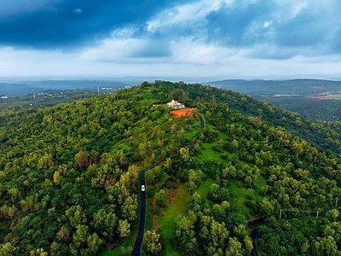

PANDEMIC PREPAREDNESS PLAN
CHERUVATHUR GRAMA PANCHAYATH

BLOCK FAMILY HEALTH CENTER CHERUVATHUR
phcchervathur@gmail.com
MESSAGE FROM PRESIDENT/CHAIR LSGI

Key Message from the President
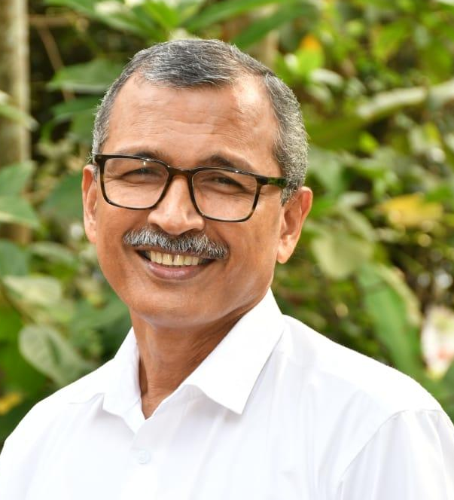
Cheruvathur Grama Panchayat
Greetings,
It gives me great confidence to note the preparation of the Pandemic Preparedness Plan (PPP) for Cheruvathur Grama Panchayat. This initiative reflects our strong commitment to safeguarding the health and wellbeing of our community and strengthening our readiness to respond effectively to future public health emergencies.
Given our limited access to tertiary healthcare facilities and reliance on referral centres outside the Panchayat for specialized treatment, local-level preparedness is critically important. Our geographically dispersed population and the responsibility of maintaining uninterrupted essential services during times of crisis further emphasize the need for a well-structured, coordinated, and practical response framework.
The Panchayat assures its full support and cooperation in the implementation of this plan. We will work in close coordination with the Block Family Health Centre (BFHC), the Health Standing Committee, concerned line departments, and community stakeholders to ensure that the plan remains inclusive, comprehensive, and aligned with local needs.
I extend my sincere appreciation to all officials, healthcare workers, committee members, and volunteers who have contributed to this effort. Through collective responsibility, unity, and proactive planning, we can build a resilient Cheruvathur capable of effectively managing public health challenges and protecting every citizen.
President
Cheruvathur Grama Panchayat

MESSAGE FROM HEALTH STANDING COMMITTEE CHAIR
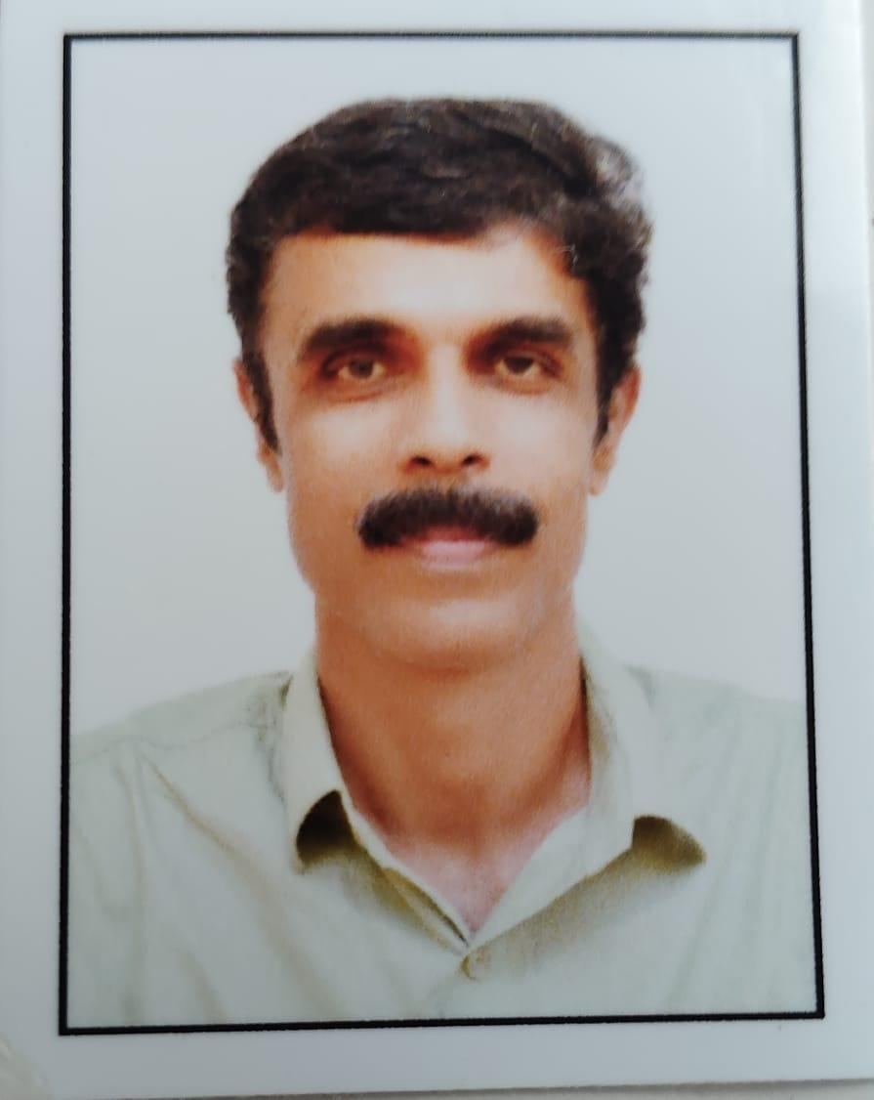
Cheruvathur Grama Panchayat
Greetings,
The preparation of the Pandemic Preparedness Plan (PPP) is a timely and essential initiative to strengthen our Panchayat’s capacity to effectively respond to future public health emergencies. The Health Standing Committee recognizes that pandemics and disease outbreaks can disrupt not only healthcare services but also livelihoods, education, and essential community functions. Therefore, proactive planning and coordinated action are crucial to minimizing risks and safeguarding our population.
This preparedness plan provides a structured framework for disease surveillance, early detection, rapid response, infection prevention and control, and continuity of essential health services. Special attention has been given to protecting vulnerable groups, ensuring adequate medical supplies, strengthening referral systems, and maintaining uninterrupted maternal and child health services, immunization, and management of chronic diseases during crisis situations.
The Health Standing Committee remains fully committed to working closely with the Panchayat, Block Family Health Centre, ICDS, educational institutions, line departments, and community organizations to ensure effective implementation of the plan. Community awareness, participation, and shared responsibility will be key to early identification of risks and timely containment of outbreaks.
I sincerely appreciate the dedicated efforts of healthcare personnel, Panchayat members, officials, and volunteers who have contributed to the development of this plan. Through unity, preparedness, and collective action, we can build a resilient community capable of facing any future public health challenge with confidence.
Chairperson
Health Standing Committee
Cheruvathur Grama Panchayat

MESSAGE BY MEDICAL OFFICER
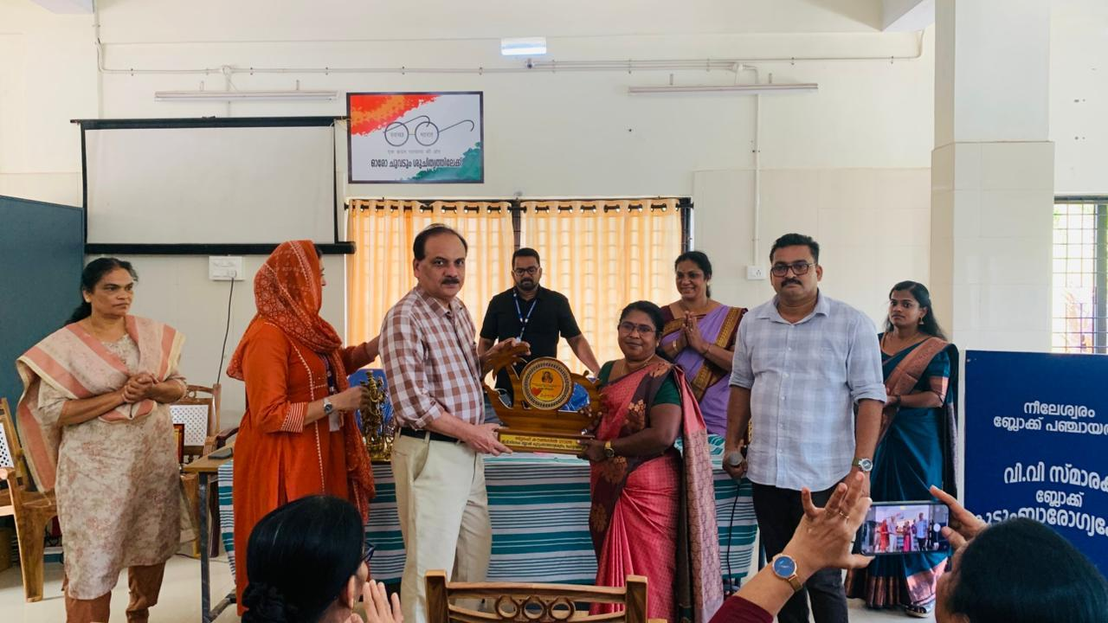
Block Family Health Centre, Cheruvathur
Greetings,
Public health emergencies can manifest in various forms, including respiratory infections, vector-borne and water-borne diseases, as well as emerging and re-emerging infectious threats. Each of these situations requires a carefully designed, disease-specific strategy that includes strengthened surveillance, timely diagnosis, standardized treatment protocols, isolation and infection prevention measures, vaccination preparedness, and clear risk communication. The preparation of the Pandemic Preparedness Plan (PPP) for Cheruvathur Grama Panchayat serves as a vital framework to systematically address such diverse public health challenges.
Cheruvathur Grama Panchayat has its own contextual vulnerabilities, including dispersed habitation patterns, population mobility, seasonal variations in disease occurrence, and dependence on referral centres for advanced medical care. Strengthening early warning systems, rapid response teams, laboratory coordination, availability of essential medicines and personal protective equipment, and efficient referral mechanisms will be key priorities. Simultaneously, uninterrupted delivery of essential health services — including maternal and child healthcare, routine immunization, elderly care, and management of non-communicable diseases — must be ensured even during outbreak situations.
Effective preparedness and response demand close collaboration with the Panchayat, Health Standing Committee, ICDS, educational institutions, the Education Department, Veterinary and Animal Husbandry Department, AYUSH Department, and other line departments, along with active community participation. A coordinated, whole-of-community approach is crucial for early detection of outbreaks, timely containment, and protection of vulnerable groups.
Through this preparedness plan, we aim to enhance our readiness, strengthen response capacity, and minimize preventable morbidity and mortality during any future public health emergency.
With best wishes
Dr.Rajamohan.T.A
Medical Officer
Block Family Health Centre, Cheruvathur
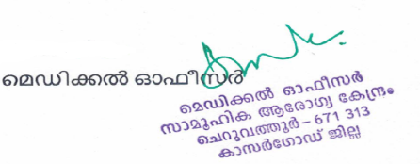
Introduction

Cheruvathur Grama Panchayat is a coastal region through which the Tejaswini River flows and is characterized by the presence of more than six rivers. Covering an area of 18.72 sq. km, the Panchayat has a population of 33,716 residing in over 7,000 households. It shares its boundaries with Kayyur–Cheemeni Grama Panchayat in the east, the Tejaswini River in the west, Nileshwar Municipality in the north, and Pilicode and Padanna Grama Panchayats in the south. A railway line passes through the area, dividing the town and the western regions.
The Panchayat comprises 18 wards spread across Thuruthi and Cheruvathur villages. There are two main towns: Cheruvathur Town, which includes the bus stand, and Madakkara Town. National Highway 66 passes through Cheruvathur Town. The Panchayat has 10 government schools, 6 private schools, and 29 Anganwadis. More than 25 government institutions are also located within this area.
At the heart of Cheruvathur Grama Panchayat lies Cheruvathur Town, where a Block Panchayat Family Health Centre with 24 inpatient (IP) facilities is situated. Additionally, the Thuruthi Family Health Centre is located in the western region at Kari. Under these, AAM sub-centres such as Main Centre, Cheruvathur, Kadankode Thuruthi, and Achamthuruthi are functioning.
More than 400 people are engaged in fishing-related activities, and a fish harbour is operational at Kavumchira. The Panchayat is also home to over 1,800 residents and more than 360 migrant workers who live and work in the area. The majority of the population depends on agriculture for their livelihood.
It is noteworthy that no major disease outbreaks have been reported in the past three years. However, the lack of safe drinking water, increasing waste disposal from growing residential clusters, and the presence of E. coli and coliform bacteria in water sources increase the risk of waterborne diseases. Additionally, water stagnation in the low-lying marshy areas in the western parts of the Panchayat contributes to the risk of mosquito-borne diseases.
Therefore, it is essential to strengthen source reduction activities, chlorination, and larvicidal spraying, along with intensifying awareness programs.

EXECUTIVE SUMMARY
Block Family Health Centre (BFHC), Cheruvathur functions as the primary public healthcare institution serving the population of Cheruvathur Grama Panchayath. The PHC plays a pivotal role in delivering comprehensive, accessible, and affordable healthcare services, with a strong focus on preventive, promotive, curative, and rehabilitative care in accordance with national and state health programmes.
The BFHC caters to a predominantly rural population, addressing key public health priorities such as maternal and child health, communicable and non-communicable disease control, immunization, family welfare, adolescent health, and geriatric care. Regular outpatient services, home-based care through field health staff, and outreach activities ensure healthcare coverage even in geographically challenging areas. The institution actively implements national health missions, including the National Health Mission (NHM), National Tuberculosis Elimination Programme, National Programme for Prevention and Control of Cancer, Diabetes, Cardiovascular Diseases and Stroke (NPCDCS), and other disease surveillance initiatives.
BFHC Cheruvathur works in close coordination with the Grama Panchayath, ASHA workers, Anganwadi centres, schools, and community-based organizations to strengthen community participation and improve health awareness. Emphasis is placed on early detection, timely referral, health education, and lifestyle modification to reduce disease burden and improve overall health outcomes.
Despite constraints related to infrastructure, manpower, and increasing service demand, the PHC continues to enhance service delivery through effective planning, data-driven decision-making, and community engagement. Strengthening facilities, upgrading digital health systems, and expanding preventive services remain key focus areas for future development.
Overall, BFHC Cheruvathur stands as a vital institution in safeguarding public health and improving the quality of life of the residents of Cheruvathur Grama Panchayath

LIST OF ABBREVIATIONS
LSGD/LSGI | Local Self Government Department / Local Self Government Institution
BMO | Block Medical Officer
IDSP | Integrated Disease Surveillance Programme
NDMA | NationalDisaster Management Authority
PPE | Personal Protective Equipment
ICMR | IndianCouncil of Medical Research
CD | Communicable Diseases
NCD | NON-COMMUNICABLE Diseases

TABLE OF CONTENTS
3
INTRODUCTION 9
● Background of the PPP 9
LSGD AT A GLANCE 9
INTEGRATED HEALTH INFRASTRUCTURE MAP OF CHERUVATHUR PANCHAYAT 12
GENERAL PROFILE OF THE LSGI’S 13
Background of the LSGI 13
Demographic and Vulnerable Population 15
Clinical Vulnerability 16
INFRASTRUCTURE & RESOURCE INVENTORY 18
Health Facility Directory & Basic Capacity in the LSGD 18
Private Clinics 19
Healthcare Education & Training Institutions 20
Specialized Services & Emergency Inventory 20
Oxygen & Diagnostic Capacity 21
Diagnostics facility mapping at the LSGI level 22
Laboratory Identification & Basic Details 22
Social and Community Infrastructure for surge plan 23
Human resources 25
Community & Support Cadre 26
Community Organizations 27
Administrative & Emergency Services 28
Information regarding resources 28
ONE HEALTH & ENVIRONMENTAL SURVEILLANCE 29
Animal & Bird Population 29
Veterinary Infrastructure 30
Veterinary Doctors & Workforce 31
High-Risk Interface Points (Surveillance Sites) 32
Environmental Risk Mapping 33
Disease Seasonality Mapping 34
Vulnerability Mapping 34
EPIDEMIOLOGICAL TRENDS (2021–2025) 35
Disease Burden among human beings(Last 5 Years) 35
*(use the above table data to create the graph/diagram) 36
Seasonal Trend Analysis 37
Outcome-Based Trend Analysis- 2025 40
Transmission Trend- 2025 41
Integrated Disease Hotspot Map (2021–2025) 44
Preparedness and Response Protocol at LSG Level 46
Constitution of One Health Committee 46
Pandemic Response Workforce 47
Activities and Measures before and during Pandemic 49
PHASE 1 - Alert / Preparation 49
PHASE 2 - Active Response 52
Standard Screening Protocol 53
PHASE 3 - Surge Capacity 63
Conversion of Community Facilities 63
CONCLUSION 65
RECOMMENDATIONS 66
ANNEXURE 68
1. IMPORTANT PHONE NUMBERS 68

INTRODUCTION
Background of the Pandemic Preparedness Plan (PPP) Cheruvathur Grama Panchayat
Pandemics and other public health emergencies present serious threats to public health, livelihoods, and local governance systems, particularly in regions with environmental and social vulnerabilities. Experiences from recent outbreaks have clearly demonstrated the importance of strengthening preparedness, surveillance, and coordinated response mechanisms at the grassroots level. In this context, the formulation of a localized Pandemic Preparedness Plan (PPP) for Cheruvathur Grama Panchayat is both timely and essential.
Cheruvathur Grama Panchayat observes seasonal variations in communicable diseases. In recent years, vector-borne diseases such as Dengue and water-borne illnesses including Hepatitis A have been reported periodically. Monsoon-related water contamination, unsafe storage practices, and favourable mosquito breeding conditions contribute to seasonal spikes in these diseases. Occasional cases of vaccine-preventable diseases are also reported, and pockets of vaccine hesitancy among certain groups remain a public health concern. These trends highlight the need for strengthened surveillance, sustained risk communication, and proactive community engagement.
The Panchayat also faces environmental and ecological vulnerabilities. With areas characterized by mixed terrain, water bodies, and nearby forest ecosystems, there is potential risk for zoonotic disease transmission linked to animal–human interaction. Therefore, adopting a One Health approach — integrating human, animal, and environmental health systems — is crucial for early identification and prevention of emerging infectious threats.
Cheruvathur has a geographically dispersed population with regular mobility of migrant workers, daily wage earners, students, and traders. Such movement can accelerate disease transmission during outbreaks. The Panchayat primarily depends on primary-level healthcare services, especially the Block Family Health Centre (BFHC) Cheruvathur, while tertiary care facilities are located outside the Panchayat area. Limited access to advanced care within the locality may result in referral delays and increased burden on higher centres during large-scale emergencies.
Seasonal monsoon impacts, including localized flooding, waterlogging, and disruptions in sanitation and transportation, further increase public health risks and may hinder access to healthcare services. These interconnected vulnerabilities underscore the necessity for a structured, context-specific preparedness framework.
Against this backdrop, the Pandemic Preparedness Plan (PPP) for Cheruvathur Grama Panchayat aims to strengthen disease surveillance systems, improve early warning and rapid response mechanisms, enhance community awareness, streamline referral pathways, and ensure continuity of essential health services during emergencies. Through coordinated inter-sectoral collaboration and adoption of a One Health perspective, the Panchayat seeks to build resilience, reduce preventable morbidity and mortality, and protect vulnerable populations from future public health threats.

LSGD AT A GLANCE

- Geographical boundaries with political map ( based on latest delimitation)

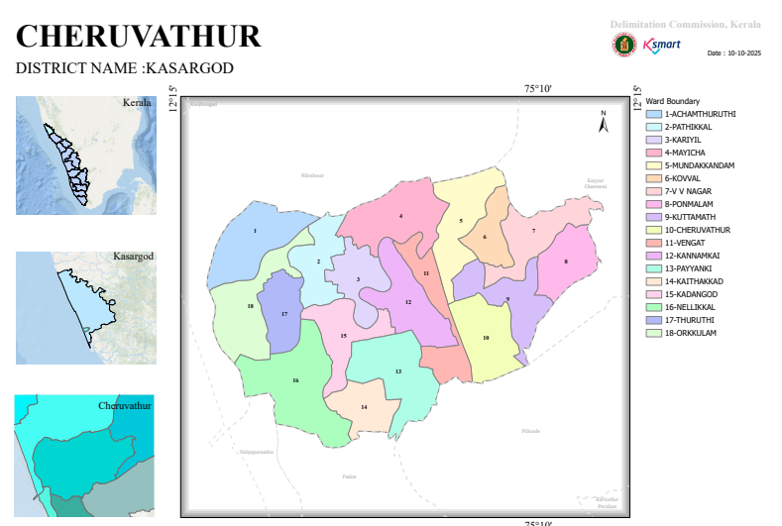

Baseline data

- Ward division -
Ward | Houses | Population | Migrants | Wells | Hot  spots | Ed. Institutions | Hosp pvt/govt.
18 | 7444 | 33714 | 361 | 2230 | - | 18 | 4

- Risk stratification among wards in the context of Communicable diseases and hazards

NOT APPLICABLE

- Major Roads/rivers
Roads
1.NH66,PADNE-CHERUVATHUR ROAD
2.CHERUVATHUR-CHEEMENI
3.CHERUVATHUR- MADAKKARARA-ACHAMTHURUTHI ROAD
4.CHERUVATHUR-RLY STATION –KARIYIL THURUTHI ROAD
5.CHERUVATHUR –KAYYUR ROAD
Rivers
1.THEJASWINI RIVER(KARYAMKODE RIVER AND ITS BRANCHES)

Disaster-prone areas map

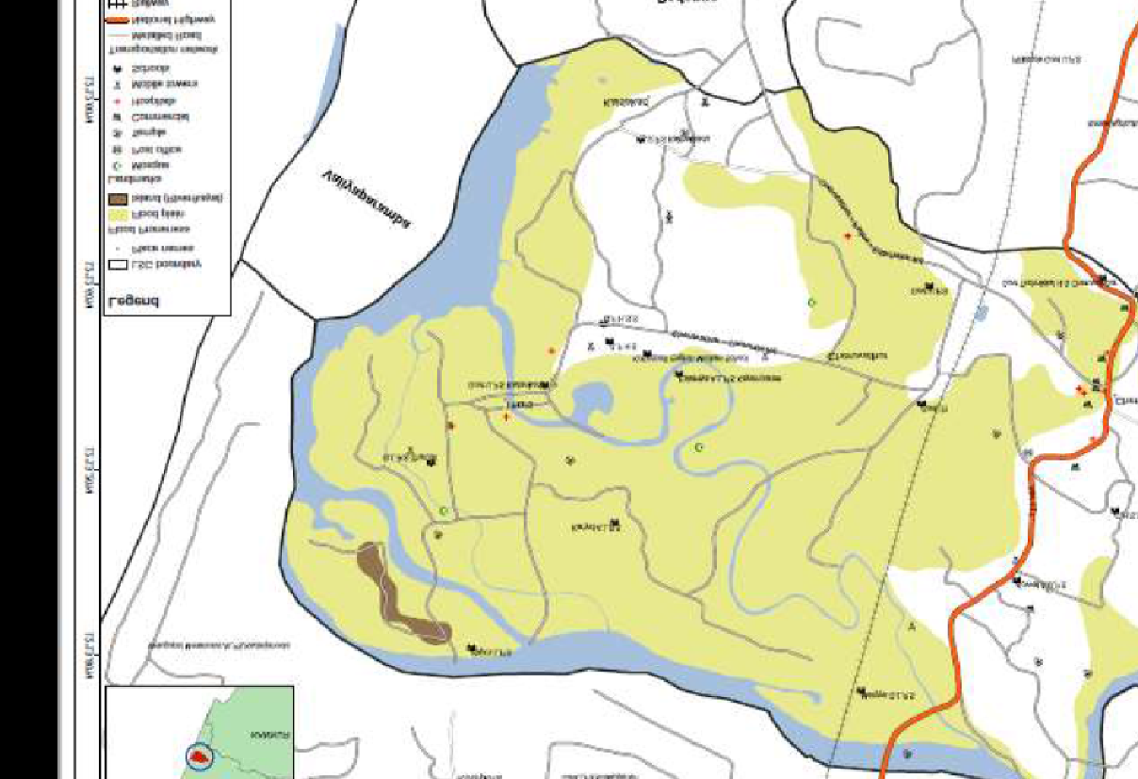

INTEGRATED HEALTH INFRASTRUCTURE MAP OF Cheruvathur PANCHAYAT

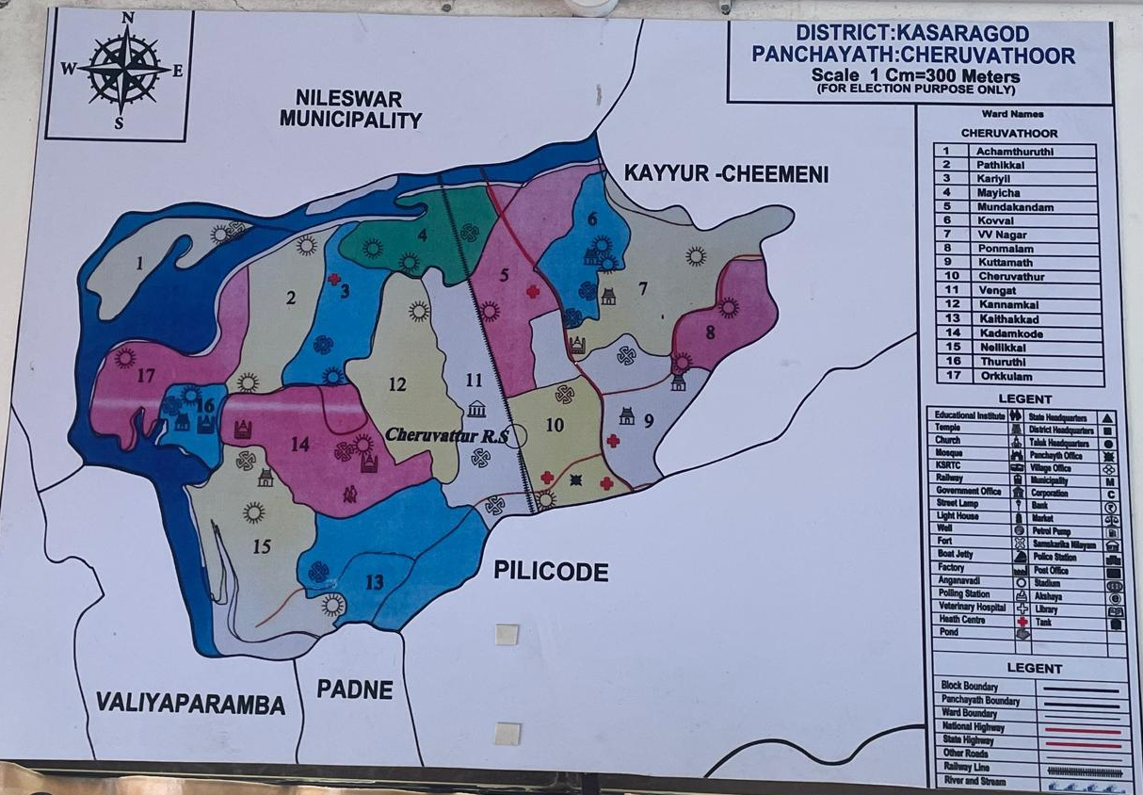

Background of the LSGI
Cheruvathur Grama Panchayat is a coastal region through which the Tejaswini River flows, and it is enriched with more than six rivers and water bodies. The Panchayat covers an area of approximately 18.72 square kilometres and has a population of 33,716 people residing in more than 7,000 households. The Panchayat shares its boundaries with Kayyur-Cheemeni Grama Panchayat on the east, the Tejaswini River on the west, Nileshwar Municipality on the north, and Pilicode Grama Panchayat and Padanna Grama Panchayat on the south. A railway line passes through the Panchayat, dividing the town area from the western regions.
The Panchayat consists of 18 wards spread across Cheruvathur and Thuruthi villages. There are two major town areas within the Panchayat: Cheruvathur Town, which includes the main bus stand, and Madakkara Town. National Highway 66 passes through Cheruvathur Town. The Panchayat has 10 government schools, 6 private schools, and 29 Anganawadis. In addition, more than 25 government institutions are functioning within the Panchayat area.
At the heart of Cheruvathur Town is the Block Panchayat Family Health Centre with 24 inpatient facilities, while the Thuruthi Family Health Centre is situated in the western Kari region. Under these institutions, AAM sub-centres including Main Centre, Cheruvathur, Kadankode Thuruthi, and Achamthuruthi are also functioning.
More than 400 people are engaged in fishing-related occupations in the Panchayat. In addition, a fish harbour is functioning at Kavumchira. The Panchayat also accommodates more than 1,800 residents and over 360 migrant labourers who live and work within the Panchayat limits. The majority of the population primarily depends on agriculture for their livelihood.
It is note worthy that no major disease outbreaks have been reported in the Panchayat during the last three years. However, the lack of safe drinking water, improper waste disposal from the increasing number of labour quarters, and the presence of E. coli and coliform bacteria in drinking water sources increase the risk of waterborne diseases. Furthermore, water stagnation in the marshy lowland areas on the western side of the Panchayat contributes to the risk of mosquito-borne diseases. Therefore, measures such as source reduction, chlorination, larvicidal spraying, and intensified public awareness activities need to be strengthened.

Demographic and Vulnerable Population
Understanding the demographic composition and vulnerable population groups is essential for pandemic preparedness. Children, elderly, economically deprived families, migrant workers, and socially vulnerable groups are at increased risk during public health emergencies due to higher exposure, limited access to services, and dependency on public systems..

Description |  | Details (in numbers)
DEMOGRAPHIC PROFILE
Total population |  | 33714
Male |  | MALE.16674
Female |  | FEMALE 13040
Transgender |  | nill
Children under 5 |  | :1786
Adolescent |  | 4137
Elderly (>60) |  | 4963
SOCIAL/LIVELIHOOD VULNERABILITY
Previous EPEP family |  | 6
BPL family |  | 4953
Tribal communities |  | nill
Migration | Immigrant | 365
Migration | Emigrant | 940
Socio-economically deprived |  | 12
Fisherfolk |  | 381
SC Community |  | 1241(male-604,female-637)
ST Community |  | 0

Graphs: Population pyramid (if possible) for seeing if your LSGI has a high "dependency ratio" (lots of children and elderly compared to working adults).

Clinical Vulnerability
Certain population groups needs priority healthcare & are at higher risk of severe illness, complications, and mortality during pandemics. Patients with chronic diseases, those requiring regular medical care, and individuals with mobility or functional limitations face challenges in accessing timely care during emergencies. Mapping these groups helps in prioritizing continuity of treatment, medicine stock planning, oxygen support, referral transport, and targeted home-based care.
Description | Details in numbers
Pregnant women | 275
Lactating mothers | 603
Bedbound patients | 199
Patients under palliative care other than bedbound | 359
Patients on Haemodialysis | 18
Patients on CAPD | 356
Cancer patients (currently on treatment) | 164
Haemophilic patients | -
Mentally challenged | 12
Differently abled | 206
Diabetic patients | 7584
Hypertensive patients | 7648
TB patients | 10

Major Festivals & Events specific to the LSGI
(with the possibility of a public gathering)

Sl. No. | Name of festival | Month detailing the periodicity
1 | KUTTAMATH BHAGAVATHI TEMPLE | JANUARY
2 | NELLIKKAL THURUTHI KAZHAKAM | NOVEMBER,MARCH
3 | KARIYIL VISHNUMOORTHI KSHETRAM | NOVEMBER
4 | POOMALA B HAGAVATHI TEMPLE | FEBRUARY
5 | PALLIYIL BHAGAVATHI KSHETHRAM | FEBRUARY
6 | KOTTAPPLY MAGHAM URUS | JANUARY
7 | VAYALKARA BHAGAVATHI TEMPLE | DECEMBER

INFRASTRUCTURE & RESOURCE INVENTORY

Health Facility Directory & Basic Capacity in the LSGD
This section provides an overview of the healthcare infrastructure available within the LSGD area. It outlines the distribution and basic capacity of health facilities that form the backbone of service delivery during routine times and public health emergencies.

Family Health Centres (FHCs) and Community Health Centres (CHCs) generally function as the first point of contact for the community, providing essential outpatient and inpatient services. General Hospitals (GH) and Medical College Hospitals (MCH), where accessible, serve as the main referral centres for advanced diagnostics, specialist care, and critical services during public health emergencies. This inventory helps identify existing strengths, gaps, and potential surge capacity that can be mobilised during a pandemic or disaster.

Table 5. Health Facility Resource Summary
Sl.no. | Health Facility | Type of Facility (MCH/GH/CHC/FHC/SC etc.) | Contact Number | Total beds | ICU Beds | Oxygen-Supported Beds | No. of Ventilator Support Beds | No. of ambulances
Government Healthcare Facilities
1 | BFHC CHERUVATHUR | CHC | 0467261270 | 24 | 0 | 0 | 0 | 0
2 | FHC THURUTHI | FHC | 9961855030 | 0 | 0 | 0 | 0 | 0
2.1. | HWC MAINCENTER | SC | 9847723876 | - | - | - | - | -
2.2 | HWC KADAMKODE | SC | 9947988933 | - | - | - | - | -
2.3 | HWC ACHAMTHURUTHI | SC | 9497196995 | - | - | - | - | -
2.4 | HWC CHERUVATHUR | SC | 9495460960 | - | - | - | - | -
Private Healthcare Facilities
1 | KAHM CHERUVATHUR | Pvt.H | 04672260072 | 50 | 3 | 3 | 1 | 1
2 | UNITY HOSPITAL | Pvt.H | 9496138570 | 25 | 1 | 4 | 0 | 0
3 | KKR HOSPITAL CHERUVATHUR(CONSULTAION AND DIAGNOSTIC FACILITY) | Pvt.Clinic | 9447210356 | 0 | 0 | 0 | 0 | 1
4 | THIMIRI CI OPERATIVE HOSPITAL(CONSULTAION AND DIAGNOSTIC FACILITY | Pvt.Clinic | 8714362339 | 0 | 0 | 0 | 0 | 1
5 | MediLab | Pvt.Clinic | 9544475777 | 0 | 0 | 0 | 0 | 0
AYUSH Healthcare Facilities
1 | Gov. Ayurveda Dispensory | GAD | 04672261396 | 0 | 0 | 0 | 0
2 | Gov.Ayush Dispensory

Private Clinics
Private clinics are an essential part of pandemic preparedness, as they are often the first place people seek care when symptoms begin. In many communities, private clinics manage a significant share of outpatient visits and therefore play a critical role in early case detection, timely referrals, and disease surveillance. Having an up-to-date understanding of where these clinics are located, the services they provide, and how they are linked to the public health system helps ensure that no cases are missed during an outbreak. It also allows health authorities to engage private practitioners more effectively for reporting, risk communication, and coordinated response, strengthening the overall capacity of the health system to manage public health emergencies.

Table 6. Private Clinic Resource Summary
Sl No. | Name of Clinic | Registered (Y/N) | Clinic (General / Speciality) | Speciality (if any) | Address | Contact Number | Diagnostic Facility (Y/N) | Ambulance Linkage (Y/N)
1 | CO-OPERATIVE HEALTHCARE | Y | GENERALY | - | CO-OPERATIVE HEALTHCARE,NEAR PETROL PUMP MATLAY,CHERUVATHUR | 9447489439 | Y | Y
2 | KKR | Y | GENERALY | - | KKR CLINIC,NEAR RAILWAY STATION,CHERUVATHUR | 9447210356 | Y | Y
3 | MEDILAB | Y | GENERALY | ORTHO,CARDIOLOGY | MEDILAB,NR. FISHMARKET CHERUVATHUR | 9544475777 | Y | N

Healthcare Education & Training Institutions
This section tracks the educational infrastructure available, which is vital for human resource planning in the health sector.

Category of Institution |  | Govt | Private | AYUSH | Total
Medical Colleges | - | - | - | - | -
Nursing Colleges | - | - | - | - | -
Dental Colleges | - | - | - | - | -
Para-medical / Allied Health | - | - | 1,MLT | - | 1
Pharmacy Colleges | - | - | - | - | -

Specialized Services & Emergency Inventory
This section provides a detailed view of the specialized medical resources available to the community, focusing on emergency response and critical care capabilities. This table tracks the vital assets required for managing severe illnesses and emergencies across Government, Private, and AYUSH sectors.

Item | Govt | Private | AYUSH | Total
Hospital beds | 24 | 75 | - | 99
Oxygen-generating systems(Y/N) | - | 1 | - | 1
Oxygen-supported beds(Numbers) | - | 2 | - | 2
Ventilator-supported beds | - | 1 | - | 1
ICU beds | - | 3 | - | 3
Burns units | - | - | - | -
Blood centres | - | - | - | -
BLS ambulances | - | - | - | -
ALS ambulances | - | 2 | - | 2
Dialysis facilities | - | 1 | - | 1
Dispensaries | - | - | 2-gov | 2
Medical store | 2 | 14 | 5(pvt)1(gov) | 22
Industrial establishments(Medium-scale industries/small-scale industries establishments to whom we can depend in a worst-case scenario) | 1 | 3 | - | 4

Oxygen & Diagnostic Capacity
Monitoring oxygen and diagnostic capacity is a critical component of public health preparedness, ensuring that the LSGD can handle both chronic care and sudden surges in respiratory or infectious diseases.
Name of Health Facility | Oxygen-generating System (Y/N) | Backup Oxygen Source (Y/N) | Diagnostic Facilities Available(Y/N)
Name of Health Facility | Oxygen-generating System (Y/N) | Backup Oxygen Source (Y/N) | Lab | USG | X-ray | CT/MRI | RT-PCR
Government Healthcare Facilities
BFHC Cheruvathur | N | N | Y | N | N | N | N
FHC THURUTHI | N | N | Y | N | N | N | N
Private Healthcare Facilities
KAHM HOSPITAL | N | N | Y | Y | Y | Y | N
UNITY HOSPITAL | N | N | Y | N | Y | N | N
KKR | N | N | Y | N | N | N | N
MEDILAB | N | N | Y | N | Y | N | N

Diagnostics facility mapping at the LSGI level
The diagnostic capacity of Chruvathur G.P represents the "intelligence network" of our healthcare system. The speed and accuracy of disease identification depend entirely on the distribution and technical level of these facilities.

Item | Govt | Private | AYUSH | Total
General labs | 2 | 9 | - | 11
Microbiology labs | - | - | - | -
RT-PCR labs | - | 2 | - | 2
USG units | - | 0 | - | -
CT/MRI units | - | 1 | - | 1
Research labs | - | - | - | -
Labs of other departments that can be repurposed | - | - | - | -

Laboratory Identification & Basic Details
Sl. No. | Name of Laboratory | Ownership (Govt / Private / Academic) | Address | Contact No. | 24×7 Services (Yes/No) | NABL / Govt Approved (Yes/No)
1 | KAHM LAB | PRIVATE | KAHM,CHERUVATHUR | 9445458554-NARAYANAN | YES | YES
2 | UNITY LAB | PRIVATE | UNITY HOSPITAL,CHV | 9496138470-BINI | YES | YES
3 | THIMIRI CI OPERATIVE HOSPITAL(CONSULTAION AND DIAGNOSTIC FACILITY | PRIVATE | THIMIRI CI OPERATIVE HOSPITAL(CONSULTAION AND DIAGNOSTIC FACILITY | 9447789439-SURESH | NO | YES
4 | KKR HOSPITAL CHERUVATHUR(CONSULTAION AND DIAGNOSTIC FACILITY | PRIVATE | KKR HOSPITAL CHERUVATHUR(CONSULTAION AND DIAGNOSTIC FACILITY,CHERUVATHUR,NEAR RAILWAY STATION |  | NO | YES
5 | MDL | PRIVATE | MDL,OPT.BFHC CHERUVATHUR | 9446305424 | NO | YES
6 | BFHC CHERUVATHUR | GOV. | BFHC CHERUVATHUR | 0467220270 | YES | YES
7 | FHC THURUTHI | GOV. | FHC THURUTHI,KARIYIL | 9961855030 | NO | YES
8 | MEDILAB | PRIVATE | MEDILAB,  NR.CHERUVATHUR FISHMARKET | 9544475777 | NO | YES

Social and Community Infrastructure for surge plan
This table serves as our logistics and shelter inventory. By mapping these locations, quickly we can identify where to house displaced citizens, where to set up temporary medical clinics, and how to manage the deceased with dignity during a crisis.

Category | Total Count | Ward | Est. Capacity (Persons) | Contact details
Educational Institutions
Anganwadis | 29 | 18 | - | -
Schools | 16 | 1,3,4,5,6,9  11,13,14,15,  16,17,12 | 6500 | -
Colleges | 1 | 15 | 450 | -
Healthcare Educational Institutions
Medical colleges (Govt/Private) | - | - | - | -
Nursing colleges (Govt/Private) | - | - | - | -
Dental colleges (Govt/Private) | - | - | - | -
Paramedical institutes (Govt/Private) | 1 | 10 | - | -
Community Gathering Spaces
Community halls | 3 | 15,5,14 | 250 | -
Auditoriums | 1 | 11 | 200 | -
Religious buildings | 6 | 9,8,6,4,16,3 | 2000 | -
Vulnerable Group Support Facility
Destitute homes | - | - | - | -
Elderly homes | - | - | - | -
LSGD owned other buildings | 1 | 14 | 100 | -
Mass Fatality Management (MFM) Infrastructure
Mortuary | 4(Freezer facilities Only) | 10,11 |  | -
Crematorium | 16 | 3-18 | - | -
*refer annexure 1 for contact details

Human resources
This section focuses on the human capital available within the LSGI. In any emergency—be it a pandemic, flood, or industrial accident—infrastructure is only as effective as the people operating it.

Medical & Clinical Personnel
This table tracks the "Frontline" providers responsible for diagnosis, treatment, and clinical management. Narrative sentence: eg., "Total health workforce: 450 personnel, with 60% in government facilities serving as primary surge capacity." A detailed directory with the contact numbers of all workers is maintained (Annexure in 1).

Cadre | Govt (No.) | Private (No.) | Total
Doctors—Modern Medicine | 9 | 20 | 29
Doctors – AYUSH | 3 | - | -
Doctors – Veterinary | 1 | - | -
Doctors – Dental | 3 | 6 | 9
Nursing officers | 10 | 40 | 50
Lab technicians | 4 | 20 | 24
Optometrist | 0 | 2 | 2
Pharmacists | 5 | 20 | 25
Psychologists | 0 | 0 | 0
Counsellors | 6 | 0 | 6

Public Health & Field-Level Workforce
These individuals are the backbone of surveillance, maternal-child health, and decentralized care.

Cadre | Health services | Municipal common services | Total
HS (Health Supervisors) | 0 | 0 | 0
HI (Health Inspectors) | 1 | 0 | 1
LHS (Lady Health Supervisor) | 0 | 0 | 0
LHI (Lady Health Inspectors) | 1 | NA | 1
JPHN (Jr Public Health Nurses) | 5 | NA | 5
JHI (Jr Health Inspectors) | 4 | NA | 4
MLSP (Mid-Level Service Providers) | 5 | NA | 5
Palliative Nurses | 2 | NA | 2
RBSK Nurses | 1 | NA | 1
PRO | 1 | NA | 1
Epidemiologist | 1 | NA | 1
Data Manager | 1 | NA | 1

Community & Support Cadre
This group represents the surge capacity of the LSGI—people who can be called upon for logistics, rescue, and specialized support.

Cadre | Number
ASHA Workers | 21
AWW (Anganwadi Workers) | 29
Emergency Medical Volunteers (Trained) | 40
Kudumbashree | 310
MNREGS | 2456
Purusha Swayam Sahaya Sangham | 12
Ex-Servicemen | 96
Retired Police Officers | 15
NCC/NSS Volunteers | 200(NSS)
Red Cross volunteers | 200
One Health Community Volunteers | NIL
One Health Community Mentors | NIL

Community Organizations
This section details the presence of community-based organisations (CBOs), non-governmental organisations (NGOs), faith-based organisations (FBOs), Kudumbashree Self-Help Groups (SHGs), and Ayalkootams within the Local Self-Government Institution (LSGI). These groups enhance grassroots mobilization, resource distribution, and support networks crucial for pandemic response and community resilience.

Category | Total Count
NGOs | 4
Religious based organizations | 1
Foreign based organizations | 1
Sports Club/youth clubs | 50
Kudumbashree SHGs | 324
Ayalkootams | 324
Political organizations | 3
Residential organizations | 0

Administrative & Emergency Services
This section outlines the availability of key non-health emergency support services and infrastructure within the LSGI, which are essential for effective pandemic preparedness and response. These facilities support law enforcement, disaster response, water supply, logistics, mobility, and community-level interventions during public health emergencies.

Category | Total Count | Contact details
Police Stations | 0 | -
Fire & Rescue Stations | 0 | -
Water Pumping Points | 8 | -
Public Distribution System (PDS) | 24 | -

Information regarding resources
The availability of essential transport and support resources plays a quiet but critical role in saving lives. Equipment such as ambulances, mobile mortuaries, amphibian ambulances, and motorized boats ensures that patients, samples, and healthcare teams can move swiftly—even in flooded, remote, or difficult terrains. Heavy vehicles like JCBs, cranes, tractors, and torus lorries support logistics, waste management, emergency infrastructure, and rapid conversion of spaces into care or isolation facilities. Taxis, four-wheel-drive vehicles, and trucks help maintain continuity of essential services, reach vulnerable populations, and support home-based care and supply delivery.

Means of transportation | Total Count
JCB | 2
Crane | 0
Heavy Trucks | 0
Tractor | 0
Ambulances | 5
Mobile mortuaries | 0
Boats | 15
Taxi service | 12
Note: For specific details regarding vehicle owners and contact information, please refer to Annexure [X].

ONE HEALTH & ENVIRONMENTAL SURVEILLANCE
The One Health method integrates environmental, animal, and human health to enable proactive pandemic preparedness. Panchayat-level surveillance needs to be improved in order to detect and treat zoonotic and environmentally generated diseases early. Surveillance is strengthened through systematic assessment of animal populations, veterinary infrastructure, poultry and slaughter facilities, inter-sectoral coordination, and specialised tools like avian influenza seasonality mapping using GIS in previous outbreaks to enable predictive alerts and ward-specific sampling to support effective pandemic preparedness in high-risk areas like

Animal & Bird Population
Mapping animal and bird populations at the Panchayat level is essential for identifying and prioritising zoonotic disease hazards like rabies, avian influenza (H5N1), leptospirosis, anthrax, and Nipah-like spillover occurrences. Risk classification, targeted surveillance, vaccination planning, and early epidemic detection made feasible by comprehensive population mapping all enhance One Health-based pandemic preparedness.

Category | Item | Estimated Population | Wards
Animal Population | Livestock (Cattle/Goats/Buffalo) | 410 | 1-18
Animal Population | Pet Animals (Dogs/Cats) | 150 | 1-18
Animal Population | Stray Dog Population | 25 | -
Animal Population | Pig Farms (Number of heads) | 0 | -
 | Small Units (Sheep / Goats – clustered) | 0 | -
Bird Population | Poultry Units (Birds) | 42 | -
Bird Population | Poultry- (FOWL) | - | -
Bird Population | Wild/Migratory Birds (Observed) | - | -
Bird Population | Crow Mortality Events (Reported) | - | -

The main risk of zoonotic diseases in Cheruvathur is concentrated in Wards, which is explained by the high density of pig farms, cattle congregation areas, and poultry units. The stray dog population in market areas, fish landing sites, bus stations continues to be a substantial problem for rabies surveillance and bite prevention. There is a considerable risk of avian influenza introduction and amplification during November - December due to the seasonal presence of migratory and resident water birds near ponds/ canal / river / backwater / paddy field. Clusters of pig farms and animal shelters vulnerable to flooding further raise the risk of leptospirosis and other zoonoses mediated by the environment, especially during monsoon floods.

Veterinary Infrastructure
Veterinary institutions are a core pillar of One Health surveillance, enabling early zoonotic disease detection through vaccination, investigation of unusual animal illness or deaths, sample collection, and timely outbreak reporting. A well-mapped and responsive veterinary network strengthens coordination with human health and LSGI systems, ensuring rapid response during zoonotic events and pandemics.
Facility Type | Name of Facility | Ownership Govt / Pvt | Location(Ward No) | Contact number
Veterinary Dispensary | Gov.Veterinary | GOVT. | NEAR RAILWAY BRIDGE,CHERUVATHUR,10 | 8138033171-SANGEETHA
Veterinary Hospital / Polyclinic | - | - | - | -
Private Veterinary Clinics | - | - | - | -
Mobile / Emergency Vet Service (incl. night services) | - | - | - | -
Pet Homes / Animal Shelters | - | - | - | -
Slaughterhouse-linked Veterinary Inspection Unit | - | - | - | -

Veterinary Doctors & Workforce
Early detection, diagnosis, reporting, and reaction to animal illness epidemics depend on the availability and accessibility of qualified veterinary specialists. By identifying unusual animal morbidity or mortality promptly, collecting samples promptly, and coordinating efficiently with human health and LSGI systems—especially during zoonotic outbreaks and pandemic-prone situations—a clearly defined veterinary workforce enhances One Health surveillance.

Category | Number Available | Type (Govt/Pvt) | Contact number
Government Veterinary Doctors | 1 | GOVT | 8138033171-SANGEETHA
Private Veterinary Doctors | 0 | - | -
Livestock Inspectors | 3 | GOVT. | Rahul-7907577792  Rathisha-8547229273  Ragi Raj-9495351509
Para-veterinary Staff / Attenders | 1 | GOVT. | Sherly-9847301397
Contract / On-call Veterinary Support (if any) | 1 | GOVT. | Dr.GokulMurali-9605902118

High-Risk Interface Points (Surveillance Sites)
High-risk interface points for zoonotic disease surveillance in CHERUVATHUR Grama Panchayath include wetland–livestock–human contact zones, backyard poultry farms, cattle sheds near water bodies, fish markets, and areas of high human–animal interaction such as community slaughter points and migratory bird congregation sites. These are the primary surveillance sites where zoonotic spillover risks are elevated.

Type of Habitat | Type of High risk interface | Geographical vulnerability
Wetlands & Backwaters | NIL | -
Backyard Poultry Farms | - | -
Cattle Sheds near Water Bodies | - | -
Fish & Meat Markets | FISH MARKET-2 | MADAKKRA  CHERUVATHUR
Community Slaughter Sites | - | -
Migratory Bird Congregation Areas | - | -
Rodent-Infested Grain Storage | - | -

Category | Total Count | Key Locations (wards)
Poultry Farms | 31 | 9
Backyard / Clustered Poultry Units | - | -
Duck Rearing Units (open water access) | - | -
Slaughterhouses/ Slaughter Points | - | -
Meat/Fish Markets | 2 | 10,16
Live Bird Sale Points | 1 | 9
Cattle Markets / Weekly Animal Fairs | - | -
Pet Shops / Breeders | 2 | 9,10
Animal Shelters / Pet Homes | - | -
Waste Disposal Sites near Animal Units | -

Environmental Risk Mapping
Environmental risk mapping identifies monsoon/flood hotspots for vector-borne (dengue, chikungunya), water-borne (leptospirosis, diarrhoea), and zoonotic diseases in Kerala's wetlands. Systematic surveillance supports early warnings, targeted interventions, and Panchayat pandemic preparedness.
Waterborne exposure: Flood-prone areas and stagnant water bodies facilitate leptospira survival, raising leptospirosis risk.

Traditional practices: Informal slaughter and fish markets lack standardized hygiene, creating spillover opportunities.

Risk Factor | High-Risk Wards | Key Locations | Risk Level (High/Med/Low)
Flood-prone areas | 1,2,3,4,5,8,9,11,12,13,16,17 | - | HIGH
Water bodies/wetlands | 17,6,4,2 | - | LOW
Solid waste accumulation | - | - | -
Animal waste disposal issues | - | - | --
Rodent infestation zones | - | - | -
Industrial effluent discharge | - | - | -
Construction sites / abandoned buildings | 6 | - | LOW
Poor drainage/blocked canals | 10 | - | LOW
Drinking water source contamination risk | 10-18 | - | MED

Disease Seasonality Mapping
1, Flooding & waterlogging → amplifies leptospirosis, malaria, diarrheal diseases.

2, Migratory bird influx (Nov–Feb) → avian influenza risk.

3, Mosquito breeding cycles → vector-borne disease peaks in monsoon.

4, Agricultural practices → close human–animal contact in paddy fields.

Disease | Peak Risk Season | Key Drivers | High-Risk Locations | Surveillance Focus
Avian Influenza | - | - | - | -
Leptospirosis | RAINY SEASON | - | - | -
Dengue/Chikungunya | MANSOON | - | - | -
Acute Diarrheal Diseases | MANSOON | - | - | -
Rabies | - | - | - | -
Anthrax (rare) | - | - | - | -

Vulnerability Mapping
Vulnerability mapping pinpoints high-risk populations, occupations, and areas exposed via environment, livelihoods, socio-economics, and poor service access. Paired with environmental/seasonality mapping, it enables risk-based surveillance, targeted actions, and optimal resource use in One Health and pandemic planning.
Vulnerability Factor | High-Risk Wards | Key Groups / Locations | Risk Level
Flood-prone households | - | -- | -
Wetland-adjacent communities | - | - | -
Backyard poultry / duck rearing households | - | - | -
Livestock-rearing households | - | - | -
Slaughterhouse & meat market workers | - | - | -
Fisherfolk & fish market workers | 15,1,2 | MADAKKRA,KAVUMCHIRA,ACHAMTHURUTHI | LOW
Sanitation workers | -
Daily wage / migrant workers | 10,14 | CHERUVATHUR RAILWAY STATION AREA,KAITHAKKAD | LOW
Elderly & chronically ill populations | - | - | -
Pregnant Women | - | - | -
Children (schools, Anganwadi’s) | - | - | -
Limited access to safe water & sanitation | - | - | -

EPIDEMIOLOGICAL TRENDS (2021–2025)

Disease surveillance is the systematic collection, analysis, and interpretation of health data for planning, implementation, and evaluation of public health practice. This section presents the disease surveillance profile of the LSGI based on routine reporting systems and outbreak investigations to identify priority diseases, seasonal patterns, and emerging public health threats.

Disease Burden among human beings(Last 5 Years)
Analysis of disease-wise data for the last five years helps identify persistent public health problems, emerging diseases, and changes in disease burden. This information supports prioritisation of prevention, preparedness, and response activities at the Panchayat level.

Disease | 2021 | 2022 | 2023 | 2024 | 2025 | Trend(Increasing/Stable/Decreasing)
Dengue | 5 | 8 | 18 | 27 | 5 | DECREASING
Leptospirosis | 2 | 2 | 0 | 0 | 3 | INCREASING
Hepatitis A | 0 | 0 | 1 | 13 | 8 | DECREASING
Malaria | 1 | 1 | 0 | 0 | 0 | DECREASING
Scrub Typhus | 0 | 0 | 0 | 0 | 0 | STABLE
Typhoid | 0 | 0 | 1 | 2 | 1 | DECREASING
H1N1 | 0 | 0 | 0 | 0 | 0 | STABLE
H3N2 | 0 | 0 | 0 | 0 | 0 | STABLE
ADD | 179 | 272 | 178 | 260 | 232 | DECREASING
Mumps | 4 | 0 | 2 | 213 | 40 | DECREASING
Measles | 0 | 0 | 3 | 1 | 0 | DECREASING
Hepatitis B | 0 | 0 | 1 | 0 | 0 | DECREASING
Hepatitis C | 0 | 0 | 0 | 0 | 0 | STABLE
Tuberculosis | 11 | 17 | 11 | 14 | 10 | DECREASING
Leprosy | 0 | 0 | 0 | 0 | 0 | STABLE
COVID-19 | 3529 | 0 | 0 | 0 | 0 | DECREASING

*(use the above table data to create the graph/diagram)

Seasonal Trend Analysis
Seasonal analysis helps anticipate surges (e.g. dengue in monsoon, leptospirosis after floods, influenza in cooler months) and plan pre‑emptive vector control, stockpiling of IV fluids, and awareness campaigns at Panchayat level.

DENGUE
Dengue is a major seasonal vector-borne disease strongly associated with rainfall, water stagnation, and increased mosquito breeding during the monsoon period.

Peak: July–November

Dengue – Ward-wise Yearly Distribution (2021–2025)

Ward | Dengue – Ward-wise Yearly Distribution
Ward | 2021 | 2022 | 2023 | 2024 | 2025 | Total
1 | - | 1 | - | - | 1 | 2
2 | - | - | 2 | 1 | - | 3
3 | - | - | - | 2 | - | 2
4 | - | - | 1 | 1 | - | 2
5 | - | - | - | - | - | -
6 | 2 | - | 1 | 3 | - | 6
7 | - | 1 | - | 2 | - | 3
8 | 1 | 3 | 1 | 4 | 1 | 10
9 | - | - | - | - | 1 | 1
10 | - | - | 3 | 1 | - | 4
11 | - | - | 1 | 2 | 1 | 4
12 | - | 1 | 2 | - | - | 3
13 | - | 1 | 1 | 3 | - | 5
14 | - | - | 1 | - | - | 1
15 | - | - | 2 | 4 | 1 | 7
16 | 1 | - | - | 1 | - | 2
17 | 1 | 1 | 3 | 3 | - | 8
18 | - | - | - | - | - | -
TOTAL | 5 | 8 | 18 | 27 | 5 | 63

LEPTOSPIROSIS
Leptospirosis cases are closely linked to monsoon rains, flooding, and occupational exposure, particularly in low-lying and waterlogged areas.

Peak: June - August

Leptospirosis – Ward-wise Yearly Distribution (2021–2025)

Ward | Leptospirosis – Ward-wise Yearly Distribution
Ward | 2021 | 2022 | 2023 | 2024 | 2025 | Total
1 | - | - | - | - | - | -
2 | - | - | - | - | - | -
3 | - | - | - | - | 1 | 1
4 | 1 | 1 | - | - | - | 2
5 | - | - | - | - | - | -
6 | - | - | - | - | - | -
7 | - | - | - | - | 1 | 1
8 | - | - | - | - | - | -
9 | - | - |  | - | - | -
10 | - | - | - | - | - | -
11 | 1 | - | - | - | - | 1
12 | - | - | - | - | - | -
13 | - | - | - | - | - | -
14 | - | - | - | - | - | -
15 | - | 1 | - | - | - | 1
16 | - | - | - | - | - | -
17 | - | - | - | - | 1 | 1
TOTAL | 2 | 2 | 0 | 0 | 3 | 7

VIRAL HEPATITIS - A
Hepatitis A cases are commonly associated with unsafe drinking water, food contamination, and breakdowns in sanitation, often presenting as clusters or outbreaks.

Peak: October - December

Hepatitis A – Ward-wise Yearly Distribution (2021–2025)

Ward | Hep A – Ward-wise Yearly Distribution
Ward | 2021 | 2022 | 2023 | 2024 | 2025 | Total
1 | - | - | - | 1 | - | 1
2 | - | - | - | 2 | - | 2
3 | - | - | - | - | - | -
4 | - | - | - | - | - | -
5 | - | - | - | - | - | -
6 | - | - | - | - | - | -
7 | - | - | - | - | - | -
8 | - | - | - | 2 | - | 2
9 | - | - | - | - | 1 | 1
10 | - | - | - | - | - | -
11 | - | - | - | - | - | -
12 | - | - | - | - | - | -
13 | - | - | - | 3 | - | 3
14 | - | - | 1 | 1 | 3 | 5
15 | - | - | - | 2 | - | 2
16 | - | - | - | 2 | 4 | 6
17 | - | - | - | - | - | -
TOTAL | 0 | 0 | 1 | 13 | 8 | 22

Transmission Trend- 2025
For effective management of public health issues, it is important to track the trend of disease transmission mode. It helps identify the population or place at high risk that can be used to predict outbreaks and implement targeted interventions as quickly as possible. Understanding these kinds of trends enables authorities to allocate resources efficiently and change the strategies adequately based on the trend that follows.

Mode of Transmission | No. of cases | No. of Deaths
Vector Borne Diseases | 27- CASES ON 2024(DENGUE) | 0
Water Borne Diseases | 260 CASES ON 2024(ADD) | 0
Air Borne Diseases | 14 CASES ON 2024(TB)  3529-CASES ON 2021(COVID -19) | 2(TB DEATH)
Blood Borne Diseases | 0 | 0
Food Borne Diseases | 13 CASES ON 2024(Hep-A) | 0

Vector-Borne Disease

Disease | No. of Cases | No. of Deaths
Dengue | 27- CASES ON 2024(DENGUE) | 0
Malaria | 0 | 0
Chikungunya | 0 | 0

Water Borne Disease

Disease | No. of Cases | No. of Deaths
Cholera | 0 | 0
Typhoid | 0 | 0
Hep- A | 13 CASES ON 2024(Hep-A) | 0
Dysentery | 0 | 0
Amoebiasis | 0 | 0
E- Coli infections | 0 | 0
Air Borne Disease

Disease | No. of Cases | No. of Deaths
Influenza | 0 | 0
H1N1 | 0 | 0
TB | 14 CASES ON 2024(TB) | 2
Chickenpox | 0 | 0
Measles | 0 | 0
Covid-19 | 3529-CASES ON 2021(COVID -19) | -
Pertussis | 0 | 0
Mumps | 213-CASES ON 2024 | 0

Blood-Borne Disease

Disease | No. of Cases | No. of Deaths
AIDS | 0 | 0
Hep- B | 0 | 0
Hep- C | 0 | 0

Zoonotic Disease

Disease | No. of Cases | No. of Deaths
Rabies | AROUND 250 IDRV CASES / MONTH | -
Leptospirosis | 7(2021-2025) | -
Avian influenza | - | -
West nile | - | -
Anthrax | - | -
Nipah | - | -
Scrub Typhus | - | -

Integrated Disease Hotspot Map (2021–2025)
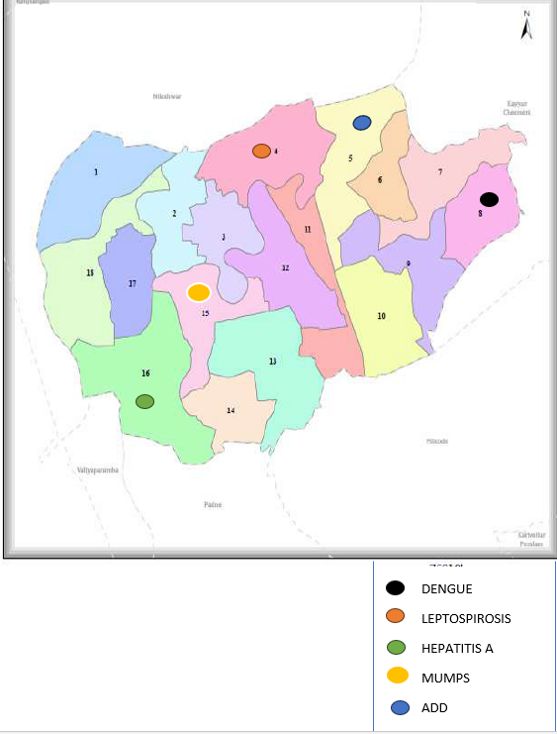

Ward No | Dengue Total (2021-25) | Leptospirosis Total (2021-25) | Hepatitis A Total (2021-25) | Mumps (2021-25) | ADD (2021-25) | Total Cases
1 | 2 | - | 1 | 12 | 68 | 83
2 | 3 | - | 2 | 15 | 77 | 97
3 | 2 | 1 | - | 17 | 85 | 105
4 | 2 | 2 | - | 13 | 74 | 91
5 | - | - | - | 13 | 94 | 107
6 | 6 | - | - | 15 | 34 | 55
7 | 3 | 1 | - | 12 | 35 | 51
8 | 10 | - | 2 | 9 | 35 | 56
9 | 1 | - | 1 | 19 | 84 | 105
10 | 4 | - | - | 15 | 73 | 92
11 | 4 | 1 | - | 15 | 75 | 95
12 | 3 | - | - | 10 | 71 | 84
13 | 5 | - | 3 | 14 | 67 | 89
14 | 1 | - | 5 | 15 | 63 | 84
15 | 7 | 1 | 2 | 35 | 76 | 121
16 | 2 | - | 6 | 15 | 65 | 88
17 | 8 | 1 | - | 15 | 45 | 69
TOTAL | 63 | 7 | 22 | 259 | 1121 | 1472

By overlaying five years of data, we have identified 5 'Red Zone' Wards. These are wards where at least two different categories of diseases (e.g., Dengue and Lepto) recurred in consecutive years. Ward 4 is categorized as the Highest Priority Hotspot due to its combination of flood vulnerability and high vector density.

Preparedness and Response Protocol at LSG Level
This section describes the operational framework for the LSGI once a pandemic is declared. It explains how the LSGI and health system will move from routine data collection to active response, using a One Health approach.

Constitution of One Health Committee
The LSGD shall constitute a One Health Committee comprising the LSGI President, Medical Officers (Modern Medicine, AYUSH, and Veterinary), the Health Inspector, and the Veterinary Surgeon.

Objective: The One Health Committee coordinates human, animal, and environmental health to prevent and control pandemics.

Sl No | Name | Designation | Department/Institution | Role in Committee | Contact Number
1 | T .NARAYANAN | Panchayat President | LSGD | Chairperson | 9400560870
2 | DR.RAJAMOHANAN.T.A | Medical Officer (PHC/CHC) | Health Dept | Member Secretary | 9447934012
3 | DR.SANGEETHA | Veterinary Officer | Animal Husbandry | Member | 8138033171
4 | HARSHAVARDAN .P | Epidemiologist | Health Dept | Member | 8317470180
5 | MADHU P.K | Health Inspector/PHN | Health Dept | Surveillance | 9447872953
6 | SUMA.P(PHN) | ASHA Supervisor | Health Dept | Community link | 9495179038
7 | BIJI | ICDS Supervisor | Social Welfare | Vulnerable groups | 9495029550
8 | PRASANTH.K(SHO-CHANDERA PS) | Police Station Officer | Police Dept | Law & order | 9497947262
9 | SHIJU(WARD 10) | Ward Councillor Representative | LSGD | Community coordination | 9447394094
10 | SREEJA | Kudumbashree CDO | Kudumbashree | Community mobilisation | 9656676760
11 | VIJAYAKUMAR | NGO/Volunteer rep | Civil Society | Support services | 9847123561

Key Responsibilities:
- Review disease surveillance data (human + animal)
- Conduct ward-wise risk assessment and vulnerability mapping
- Approve quarantine/isolation centre locations
- Coordinate with district for resources (PPE, oxygen, ambulances)
- Periodically review health system surge capacity, including beds, oxygen, human resources, and ambulances.
- Approve and monitor risk communication and community engagement strategies, including rumour management.
- Ensure protection and service continuity for vulnerable groups (elderly, persons with disabilities, dialysis patients, coastal populations).
- Conduct quarterly mock drills
- Monitor equity measures for vulnerable groups

Meeting Schedule:
Quarterly (normal times) | Weekly (outbreak alert) | Daily (pandemic phase)

Pandemic Response Workforce
To ensure a coordinated and timely response during a pandemic, a dedicated Pandemic Response Workforce shall be constituted at the LSG level. The workforce will function under the overall supervision of the One Health Committee and in close coordination with the health authorities. Team-based deployment will enable efficient surveillance, case management, quarantine and isolation management, logistics support, and risk communication. Each team shall have a clearly designated team leader, defined roles, and an identified pool of personnel to allow rapid activation, rotation of duties, and continuity of services during prolonged emergencies.

Total Response Workforce Available: 300 persons

Team Name | Composition | Key Responsibilities | Team Leader
Surveillance and Contact Tracing Team | HI, JHI, JPHN, ASHAs and Volunteers | Case detection, contact listing, home visits, reporting | HI
Case Management Team | Doctors, Nurses, MLSP, Palliative Nurses | Patient care & referral | DOCTOR
Quarantine & Isolation Team | LSGD staff, Volunteers | Facility management | JHI
Logistics & supply chain Team | LSGD staff, Storekeepers, Drivers 3 | Supplies & transport [PPE, medicines, oxygen, transport, waste management] | Ward Member
Communication Team | Ward members, Kudumbashree, Youth clubs,  AWW workers and other self help groups | IEC, community meetings, countering misinformation | M.O in charge
Transportation | KSRTC, educational institutional buses

All teams shall be activated immediately upon outbreak alert or pandemic declaration and shall report daily to the LSG Incident Commander/Medical Officer, with consolidated reporting to the Block PHC. Duty rosters and alternate personnel shall be maintained to ensure uninterrupted services during staff shortages or prolonged response periods. Team composition and numbers may be revised based on the magnitude of the outbreak and availability of human resources.

Activities and Measures before and during Pandemic

PHASE 1 - Alert / Preparation
Surveillance and Reporting-Enhanced syndromic surveillance:
- Data sources for surveillance:
- Event-based triggers (to be monitored and reported):
- Zoonotic and animal health surveillance
- Logistics and Stock Preparedness
  - Identify and empanel local vendors and define emergency procurement mechanisms in accordance with existing LSGD and Health Department norms.
  - Prepare and maintain an essential logistics checklist covering medical supplies, consumables, and support equipment.
  - Pre-identify secure storage locations for emergency stocks and ensure maintenance of stock registers with regular updating.
  - Finalise emergency transport arrangements, including availability of vehicles and identified drivers for rapid deployment during alerts.
  - Designate a Nodal Officer for Logistics to enable prompt decision-making, coordination, and communication during emergencies.
  - Conduct rapid stock verification and ensure availability of minimum buffer stock, including:
- PPE kits 150 numbers
Identify critical gaps in logistics and immediately communicate requirements to the Block and District authorities for timely replenishment and support. Monitor expiry dates and stock rotation.

Identification of Quarantine and Isolation Facilities
  - Identify and list suitable buildings for quarantine and isolation (schools, hostels, community halls, etc.).
  - Categorise cases as per the severity and allocate to appropriate facilities (for instance, severe cases to classrooms, mild cases to an assembly hall in case of a school).
  - Facility readiness checklist needed (beds, toilets, ventilation) etc.
  - Find an alternate site if the primary sites are not available or not in use.
  - Identify facility managers and support staff
  - Prepare basic SOPs for:
    - Admission and discharge
    - Food, water, sanitation
    - Infection prevention and waste disposal
  - Ensure availability of basic amenities: water, sanitation, electricity, ventilation, and waste disposal. Prepare a rapid activation plan for these facilities if case numbers increase.

Risk Communication and Community Preparedness
  - Disseminate early warning messages on symptoms, preventive measures, and reporting mechanisms. Display IEC materials both in English and the local language in public places and ensure ward-level awareness.
  - Sensitize elected representatives and community leaders on preparedness measures.
  - Establish a rumour tracking and misinformation response mechanism to identify, verify, and promptly counter false or misleading information.
  - Engage trusted local persons (ward members, ASHA workers, religious leaders, teachers, community volunteers) to communicate official public health messages and reinforce correct practices.
  - Develop and deploy targeted IEC materials for:
    - Schools and educational institutions
    - Markets and commercial areas
    - Work sites and labour settings
  - Conduct community sensitization meetings at the ward level to promote preventive behaviors, address concerns, and strengthen community participation in preparedness and response.

Protection of Vulnerable Groups
Vulnerable populations require priority protection through targeted line-listing, service continuity, and delivery mechanisms.
- Prepare and regularly update line-lists of vulnerable populations, including:
  - Elderly persons living alone
  - Persons with disabilities
  - Pregnant women
  - Migrant workers
  - Dialysis patients

Clinical Dependency Mapping
Develop ward-wise dependency and vulnerability maps to identify households requiring regular support during emergencies. Ensure continuity of essential health services for vulnerable groups, including
- Dialysis services (facility mapping, transport arrangements, and scheduling)
- Continuity of treatment for TB, HIV, and other chronic conditions requiring uninterrupted medication
- Mental health and psychosocial support services
Establish delivery mechanisms for food, essential commodities, and medicines to vulnerable households through coordinated action involving ASHAs, JPHNs, Kudumbashree, volunteers, and local administration.

PHASE 2 - Active Response

Case Identification and Contact Tracing
Case detection and contact tracing activities will be carried out in coordination with the Health authorities, following disease-specific SOPs and IDSP guidelines.
Field Staff Involved
- Health Inspector (HI)
- Junior Health Inspector (JHI)
- Junior Public Health Nurse (JPHN)
- ASHAs and ASHA Supervisors
- Ward-level volunteers and Kudumbashree members (as required)

Screening Checkpoints
Screening checkpoints at high-traffic locations (transport hubs, markets, religious gatherings) for early detection of symptomatic travellers and crowd screening during outbreaks. Potential locations include bus stands, market entry points, and boat jetties, based on local context and risk assessment.
Screening activities will be carried out by trained personnel such as ASHAs, ward members, and volunteers, with support from Health Department staff. Necessary equipment, including non-contact thermometers and appropriate PPE, shall be ensured prior to activation.
Location | Type (Bus stand/Jetty/Market/Railway) | Staff Deployed (ASHAs/Volunteers) | Screening Method | Reporting authority
Bus stand | Transport hub | One JHI  One ASHA  One health Mentors | 1.Swab Collection.  2. Blood smears collection (RDT)  3.Thermal Scanners | Surveillance Nodal Officer in control room
Market entry | Market | One JHI  One ASHA  Male health volunteers | 1.Swab Collection.  2. Blood smears collection (RDT)  3.Thermal Scanners | Surveillance Nodal Officer in control room
Boat jetty | Water transport | One JHI  One ASHA  Male health volunteers | 1.Swab Collection.  2. Blood smears collection (RDT)  3.Thermal Scanners | Surveillance Nodal Officer in control room

Standard Screening Protocol
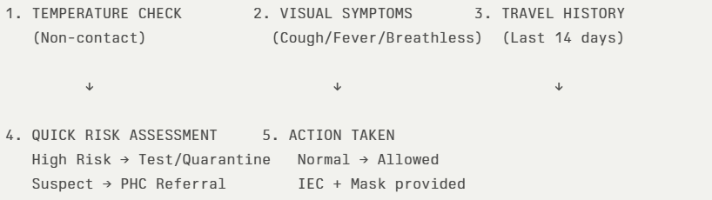
The screening protocol shall include temperature screening, observation for visible symptoms, and inquiry regarding recent travel or exposure history. Individuals identified as suspects during screening shall be immediately referred to the nearest PHC/FHC for further evaluation, testing, and appropriate action as per prevailing guidelines.

Pandemic Control Room
The Pandemic Control Room (PCR) serves as the central nerve center for real-time coordination, data aggregation, decision support, and communication during outbreaks. It consolidates information from all LSGD teams, health facilities and community sources to enable rapid response decisions.

Control Room Infrastructure and Location
Primary Location:Cheruvathur Panchayath Office.
Backup Location: Community Hall in Cheruvathur G.P.

Health System Control Room Framework
The PCR is organized into seven functional pillars to ensure no aspect of the response is overlooked:

Rapid Response Team (RRT)
  - Provides immediate intervention during emergencies, clusters, and field alerts.​
  - Coordinates urgent actions such as case investigation, contact tracing, isolation, and inter‑facility referrals.

Data Management & Analytics Team
  - Collects, validates, and manages key health system indicators (cases, tests, beds, HR, supplies).​
  - Analyzes data trends, generates projections, and supports evidence‑based decision‑making for local authorities.

Human Resource Deployment Team
  - Allocates healthcare staff efficiently based on workload and need
  - Ensures adequate and equitable workforce distribution across facilities

Laboratory Surveillance Team
  - Oversees diagnostic testing coordination, sample transport, and timely reporting of results.​
  - Monitors lab indicators (testing volume, positivity rate, turnaround time) for early detection of outbreaks

Vaccination Cell (If Required)
  - Plans and executes vaccination campaigns, including micro‑planning and session scheduling.​
  - Tracks coverage, identifies gaps, and coordinates corrective actions with field teams and outreach services.

Infrastructure & Patient Occupancy Team
  - Monitors facility capacity, earmarked beds, oxygen and critical care resources across all linked facilities.​
  - Ensures optimal patient distribution and referral management using updated bed‑status and resource data.
  - BMWM

Communication team
- Logistics and supply chain
- Transportation (interfacility & emergency transport)
- Media surveillance Call centre
- Management of the deceased
- Intersectoral coordination and convergence

Key Control Room Team
The Control Room Team coordinates all pandemic response activities within the LSGD and serves as the single command and communication hub during activation. It integrates information, field actions, logistics, and policy execution across all participating departments and health facilities.

Role | Name | Designation | Contact Number | Responsibility
In-charge/Nodal Officer | Arunima | Panchayath Secretary | 9207389386 | Overall coordination, decision-making, and reporting to the District level.
Data Entry Operator | Jinsha | Data Entry Operator | 8129121846 | Managing the line list, updating dashboards, and tracking testing results.
Communication Officer | Madhu P.K | Health inspector | 9447872953 | Handling the public helpline, coordinating ambulance dispatch, and contact tracing calls.
Logistics Coordinator | Vinayaraj | Asst.Panchayth Secretary | 7907344189
Technical Support(IT/Data) | Geethu S Nair | Technical Assistant | 9947317310

SOP for alert escalation/trigger point with mapping of responsibilities.
Key Points:
- The Control Room shall be staffed with a designated In-charge, data entry personnel, and communication staff with clearly defined roles and shift arrangements.
- It shall maintain updated records on daily monitoring indicators including new cases, persons under active quarantine, and hospital bed occupancy.
- All reports and situation updates shall be shared daily with the Block and District Surveillance Unit.
- The Control Room shall act as a single point of contact for coordination with response teams, health institutions, and other departments.
- Contact details of the Control Room shall be widely communicated to field staff and stakeholders during activation.

Daily Monitoring Indicators
To ensure timely decision-making and effective response, the following key indicators shall be monitored and updated on a daily basis by the Pandemic Control Room:

Epidemiological Indicators:
New cases reported today, Total active cases, Test Positivity Rate (TPR), Case Fatality Rate (CFR)
- Surveillance Indicators:
Persons under home quarantine, High-risk contacts identified, Fever, ILI, SARI or other symptoms (syndromic surges), Travellers (symptomatic or high-risk arrivals),Animal husbandry surveillance (zoonotic alerts, unusual animal deaths, poultry/bird flu signals), Mortality surveillance (excess deaths, unexplained fatalities, verbal autopsy reports)
- Logistics and Infrastructure Indicators:
Hospital / CFLTC beds occupied, Oxygen cylinders/concentrators available, Ambulances on standby
- Alert Findings
The following table outlines category-specific trigger points (red flags) from surveillance indicators and corresponding immediate actions for the Pandemic Control Room. These enable rapid response to alert findings like testing anomalies, positive cases exceeding thresholds, clusters, and WGS reports.

Category | Trigger Pophint (Red Flag) | Immediate Action
Clusters | Geographical or facility-based: 5+ cases linked to one location (office, school, street). | Declare a micro-containment zone; perimeter control and active case finding.
Testing | Sudden drop in testing volume / delay in reporting / unusual testing trends | Review the sample collection process, address lab bottlenecks, deploy additional testing teams, and notify the District Lab.
Lab | Test Positivity rate increases | Increase testing sites in that ward.
Hospital | >80% Oxygen bed occupancy | Activate backup/CFLTC beds.
Travel | Cluster of cases from a single flight/train or high-risk arrival group. | Trace all passengers in adjacent seats; implement mandatory institutional quarantine.
Animal | Mass poultry/wildlife death or unusual sickness | Notify Animal Husbandry, sample the area, and dispatch RRT for environmental sampling and zoonotic check.
Mortality | Sudden spike in home deaths or brought-in-dead (BID) cases | Audit the deaths and Active Case Search drive
Additional investigations like Whole Genome Sequencing (WGS) | Detection of a Variant of Concern (VOC) or Variant of Interest (VOI) | Implement strict micro-containment; update clinical protocols to match variant severity.

Communication of Public Health Information
A Community Communication Hub shall be established to ensure timely, accurate, and consistent dissemination of information during a pandemic. The Hub will function under the coordination of Nodal officers of the control room and act as the nodal point for public communication, risk messaging, and community engagement. It will support dissemination of official advisories, promote preventive behaviors, address rumors and misinformation, and ensure that messages reach all sections of the population through trusted local channels and leaders.

Key communicators
Channel | Responsible Person | Contact
Ward-level announcements | WHSC Conviners | 1.RAHULRAJ(W-15,11)  9947988933  2.THOMAS(9,10)  9847723876  3.PRADEEPAN(14,16  9497196995)  .INDUJAI(12,4-7909158929)  5.JPHN THURUTHI(2,3)
Social media | Reshma(LSGD )Technical Assistant | 9074114510
LocalCable TV/Radio | Rahulraj(JHI) | 9947988933

- All messages disseminated through the Hub shall align with advisories issued by the Health Department and District authorities.
- Community leaders shall be sensitized to support behavior change, reduce stigma, and counter misinformation.
- Special efforts shall be made to reach vulnerable and hard-to-reach populations using locally appropriate communication methods.

Rumor Tracking: A designated volunteer will monitor local social media/WhatsApp groups daily to identify misinformation and issue official clarifications via the Communication Hub.

Coordination with District/State Authorities & Other Organisations
Effective coordination with Block, District, and State authorities is essential to ensure timely reporting, technical guidance, and uninterrupted supply of essential resources during a pandemic. The LSG shall establish clear communication channels, designate responsible officers, and adhere to prescribed reporting timelines to support coordinated public health action and efficient resource mobilisation.

Key Details:
- Nodal Officer for Reporting:
- Contact Number:
Reporting Schedule and Protocols:

To Whom | What to Report | Frequency | Nodal Person
Block PHC | Complete Situation Report (Cases, Quarantine, Beds, Screening, Deaths) |  | Dr.RajamohanT.A(Medical Officer)
District IDSP Unit | Outbreaks/Clusters/Unusual Events (>5 cases same ward) |  | Madhu P.K(HI)
Veterinary Officer | Animal health events/Zoonotic alerts |  | -SANGEETHA  8138033171
State Cell | Zoonotic cross-sector events |  | -

Supply Chain Coordination
The LSG shall coordinate closely with Block, District, and State authorities (KMSCL) to ensure uninterrupted availability of essential goods, medical supplies, and logistics during a pandemic. Supply requirements shall be assessed regularly based on case load and communicated promptly to the appropriate authorities for timely replenishment.
Key Points:
- Maintain updated contact details of District and Block nodal officers for health logistics, oxygen supply, ambulances, and essential medicines.
- Submit timely indent requests for PPE, testing kits, medicines, oxygen, and other critical supplies through prescribed channels.
- Monitor stock levels at LSGD facilities, quarantine/isolation centres, and field teams through daily stock registers and dispensing logs to prevent shortages.
- Coordinate with District authorities, Karunya/Neethi medical shops, and local purchase committees for funds allocation and emergency procurement.

- Ensure regular monitoring of dispensing registers at all facilities to track usage, expiry, and pilferage—shortages being a perennial issue requiring proactive weekly audits.

- Activate surge procurement protocols during high caseloads, leveraging local purchase powers under LSGD funds alongside state supplies.

Resource Inventory and Contacts
Resource Category | Source  (District/State/Private) | Contact
PPE Kits/Masks/Gloves | KMSCL | 9496003900
PPE Kits/Masks/Gloves | Neethi MedicalStore(Cheruvathur) | 8547484371
Oxygen  Cylinders/Concentrators | KMSCL | 9496003900
Medicines/Antivirals | KMSCL | 9496003900
Medicines/Antivirals | Neethi Shops | 8547484371
Test Kits (RTPCR/Rapid) | KMSCL | 9496003900

Collaboration with NGOs, PPP, and CSR
To augment government efforts during a pandemic, the LSG shall collaborate with NGOs, voluntary organisations, and private sector partners through public–private partnerships and Corporate Social Responsibility (CSR) initiatives, in coordination with District authorities.

Key Points:
- Engage NGOs and community-based organisations for community outreach, awareness, and support to vulnerable populations.
- Leverage CSR support for procurement of medical equipment, PPE, oxygen concentrators, food kits, and sanitation materials, as permitted.
- Ensure all collaborations align with government guidelines and are routed through approved administrative and financial procedures.
- Maintain transparency and documentation for all external support received and utilised.
Organization | Type | Support Offered | Contact Person
Youth Clubs/Student Unions | CBO | DYFI  YouthCongress  Youth League | Shiju-9447394094  Suraj P(Mayyicha)-9567666872  Riyas-9847137877

Interdepartmental Coordination
Coordination among departments during a pandemic shall be ensured through regular review meetings convened by the LSGD President. These meetings will provide a structured platform for sharing situational updates, assessing resource availability, resolving operational gaps, and taking joint decisions to ensure a coordinated and timely response.

Department | Representative | Key Role | Contact
Health (CHC)  Health (PHC) | Staff Nurse : | Case management | Vimal Rajan-7909227608(CHC)  Sreena-9497008044
Veterinary | Veterinary Surgeon: | Animal surveillance | DR.SANGEETHA  8138033171
ICDS | Supervisor: | Nutrition support | BIJI-9495029550
Education | Head Teacher: | School coordination | GHSS Kuttamath-KRISHNAN(HM)-9400461761  GFVHSS Kadamkode  THSS CHERUVATHUR-PURUSHOTHAMAN(Supt.)-9142196089
Police |  | Containment enforcement | PRASANTH.K(SHO-CHANDERA PS)-9497947262
Water Authority | ENGINEER(KWA) | Water supply | SUNIL KUMAR(8289940564
LSGD Engineering |  | Quarantine infrastructure | SUMESH OV  9037422441

PHASE 3 - Surge Capacity
Phase 3 is activated when there is a rapid increase in cases, high test positivity rates, or when existing health facilities and quarantine arrangements approach saturation. The focus of this phase is to expand isolation capacity, augment clinical care services, and mobilise additional resources through district and state support mechanisms.

Conversion of Community Facilities
To manage increased case load, the LSGD shall activate additional isolation facilities by repurposing identified community infrastructure such as community halls, auditoriums, schools, hostels, or other suitable buildings.

Name of facility | Facility Type | No. of Buildings | Ward | Surge Capacity (Beds) | Nodal Person
GREEN PALACE | AUDITORIUM | 1 | 11 |  | MAHESHKUMAR-9496539539
POOMALA BHAGAVATHI TEMPLE AUDITORIUM | AUDITORIUM | 1 | 10 |  | CHANDRAN-9446863600
PALLIYIL BHAGAVATHI KSHETHRAM | AUDITORIUM | 1 | 10 |  | PT KARUNAKARAN-9495102189
KUTTAMATH BHAGAVATHI TEMPLE | AUDITORIUM | 1 | 10
VAYALKARA BHAGAVATHI TEMPLE | AUDITORIUM | 1 | 4 |  | SUKUMARAN MUNDAKKUNDAM-9961180844
KARIYIL VISHNUMOORTHI KSHETHRAM | AUDITORIUM | 1
THURUTHI NELLIKKALKAZHAKAM | AUDITORIUM | 1 |  |  | 8078710121-KRISHNAN
NELLIKKAL -KADAMKODE | COMMUNITY HALL | 1 | 15 |  | SUNIL TV-9961565746
ANANDHATHEERTHA -VADAKKEVALAP | COMMUNITY HALL | 1 | 5
KAITHAKKAD | COMMUNITY HALL | 1 | 14 |  | BINDU-9847066962
THEKKEVALAP | COMMUNITY HALL | 1
GHSS KUTTAMATH | GOV.SCHOOL |  | 8
THSS CHERUVATHUR | TECHNICAL SCHOOL |  | 10
ALPS KOVVAL | SCHOOL |  | 6
GLPS MAICHA | SCHOOL |  | 4
GWLPS CHERUVATHUR | SCHOOL |  | 11 |  | SINDHU-9846634631
KAITHAKKAD AUPS | SCHOOL |  | 14 |  | ANITHA-9446168544
GFVHSS KADAMKODE | SCHOOL |  |  |  | HEMA-9447851758
GOV.MODEL ITI,CHERUVATHUR | ITI |  | 11
ALPS KARIYIL | SCHOOL
ALPS THURUTI | SCHOOL |  |  |  | SUDHA-  9495671966
RAJAS LPS,ACHAMTHURUTHI | SCHOOL |  | 2 |  | SURESH  9446771847

- Recovery and rehabilitation phase
- Recovery
  - Damage & impact assessment
  - Restoration of health services
  - Rehabilitation of affected population
  - Psychosocial & mental health support
  - Disease surveillance during recovery phase
  - Environmental cleanup & sanitation
  - Livelihood restoration
  - Community engagement & confidence building
  - Documentation & after-action review
  - Lessons learned & best practices
  - Health system strengthening
  - Policy revision & preparedness enhancement
  - Research

CONCLUSION

Additional points
- tech support
- relief based commodities
- ham reading operators
- hazard vulnerability mapping
- Kseb & other power source
- HR specific responsibility

RECOMMENDATIONS

Strengthening Healthcare Infrastructure
- Establish a primary health response unit within the Panchayat with trained staff.
- Ensure availability of basic medical supplies (masks, sanitizers, PPE kits, oxygen cylinders).
- Create tie-ups with nearby hospitals in CHERUVATHUR for emergency referral and transport.

2. Community Awareness & Education
- Conduct regular awareness campaigns on hygiene, vaccination, and preventive measures.
- Use local communication channels (community radio, WhatsApp groups, notice boards) to spread verified information.
- Train volunteers to act as health ambassadors in each ward.

3. Emergency Response & Coordination
- Form a Pandemic Preparedness Committee at Panchayat level including health workers, ward members, and NGOs.
- Develop a clear action plan for lockdowns, quarantine, and distribution of essentials.
- Maintain a database of vulnerable groups (elderly, differently-abled, chronically ill) for targeted support.

4. Supply Chain & Food Security
- Identify and support local suppliers and farmers to ensure uninterrupted food supply.
- Create community kitchens during emergencies to serve vulnerable populations.
- Stockpile essential commodities in Panchayat-run outlets for crisis periods.

5. Digital Preparedness
- Promote digital platforms for telemedicine consultations.
- Use Panchayat’s website/social media for real-time updates on health advisories.
- Encourage online grievance redressal to reduce crowding in offices.

6. Training & Capacity Building
- Organize mock drills for pandemic response in schools, offices, and public spaces.
- Train Panchayat staff and volunteers in first aid, infection control, and crowd management.
- Collaborate with NGOs and health departments for capacity-building workshops.

7. Long-Term Resilience
- Integrate pandemic preparedness into the Panchayat Development Plan.
- Allocate a dedicated budget for health emergencies.
- Encourage community participation in planning and monitoring preparedness measures.

ANNEXURE

IMPORTANT PHONE NUMBERS

Phone numbers and particulars of persons responsible for providing guidance, assistance, and support for pandemic preparedness operations may be provided here in a manner that allows easy reference at a glance.The information recorded here could be exhibited elsewhere at the time of emergencies. LSG institutions shall give special attention to collect and record the above data of persons and institutions who/which are supposed to give technical and co-ordination support to reduce the impact of pandemic.

1.1. Details of grama panchayat/municipality/corporation wards
Sl.No | Name of the ward | Ward number | Name of the ward  member | Contact number
1 | ACHAMTHURUTHI | 1 | K.RAJANI | 7356469822
2 | PATHIKKAL | 2 | RAMACHANDRAN M | 9961503424
3 | KARIYIL | 3 | SHEENA MK | 9048719568
4 | MAICHA | 4 | KM GIREESH | 8547462005
5 | MUNDAKKANDAM | 5 | SHIJU KV | 7907885057
6 | KOVVAL | 6 | SASIDHRAN P | 8281046044
7 | VV NAGAR | 7 | PATHMINI V | 9745215879
8 | PONMALAM | 8 | T NARAYANAN | 9400560870
9 | KUTTAMATH | 9 | SANTHA KANYADIL | 9526146445
10 | CHERUVATHUR | 10 | MV SHIJU | 9447394094
11 | VENGATT | 11 | MINIMOL P | 9847087485
12 | KANNAMKAI | 12 | M SHOBHA | 9446689690
13 | PAYYANKI | 13 | SAMEERA CK | 9656752738
14 | KAITHAKKAD | 14 | FAISAL TK | 9947634421
15 | KADAMKOD | 15 | KARUNAKARAN MUTTATH | 9746728334
16 | NELLIKKAL | 16 | PATHANATH KRISHNAN | 9447488499
17 | THURUTHI | 17 | MUMTHAS CK | 9567669092
18 | OORKKALAM | 18 | REENA VV | 9744364271

1.3. Important offices of grama panchayat/municipality/ corporation
Sl.No | Name of the office | Contact person | Contact number
1. | THURUTHI | Village Officer | 8547631274-SURESH
2. | Agriculture Office | Agriculture Officer | 9496145812
3. | Animal Husbandry Office | Animal Husbandry Doctor | 9447652879
4. | Police Station | Police Officer | 04672210242
5. | BSNL Office | Officer | 04672260500
6. | Block Office | Officer | 04672280328
7. | KSEB Office | Officer | 04672260687
8. | Fisheries Office | Officer | 8075727290
9. | Fire and Rescue | Officer | 04672210201

1.4. Health Services

Sl. No | Name of the hospital/institution | Location | Phone number
1. | Government hospitals/PHC | Cheruvathur
2. | Private hospitals | Cheruvathur
3. | Clinical laboratories | Cheruvathur
4. | Chemist/pharmacy | -
5. | Blood donors | -
6. | Other language experts (Bihari, Hindi, Bengali,  Asamees ………) | - | -

1.5. Veterinary Services
Sl.No | Name of the Clinic | Name of the  Surgeon/Doctor | Place/location | Phone  number
1 | Govt.Veterinary Hospital | DR.SANGEETHA | Near Cheruvathur Railway Station | 8138033171

1.6. Helpline numbers
Helpline | Phone number
Police | 04672210242
Fire and Rescue | 04672210201
KSEB | 04672260687

1.7. Public and Private Schools Contact details

S.No | Name of School | Institution type | Phone number
1 | GHSS KUTTAMATH | GOV.SCHOOL | 04672261015
2 | THSS CHERUVATHUR | TECHNICAL SCHOOL | 09495654488
3 | ALPS KOVVAL | SCHOOL
4 | GLPS MAICHA | GOV.SCHOOL
5 | GWLPS CHERUVATHUR | GOV.SCHOOL | 04672263738
6 | KAITHAKKAD AUPS | AIDED SCHOOL | 04672260417
7 | GFVHSS KADAMKODE | GOV.SCHOOL | 04672261470
8 | GOV.MODEL ITI,CHERUVATHUR | ITI | 04672261425
9 | ALPS KARIYIL | SCHOOL
10 | ALPS THURUTI | SCHOOL
11 | RAJAS LPS,ACHAMTHURUTHI | SCHOOL

1.9. Anganwadi Contact Details

Ward No | Name of Anganwadi Teachers | Phone number
6 | SAROJINI KV | 9656448649
1 | GEETHA T | 8590394996
5 | KANAKAVALLY PV | 9747229501
4 | RAJANI P | 9895048646
2 | BINDHU OK | 9995958139
3 | SREEMATHI KPM | 8547392972

Ward No | Anganwadi No and Name of Teacher | Phone number
7 | MARIYAMBEEVI | 9747541587
7 | BINDU K | 9544631576
8 | REENA PV | 9207326689
9 | VANAJA | 8078858467
9 | LATHA | 9497611850
9 | SUJATHA N | 9497650699
3 | LEELA T | 9744357432
 | GOURI O.V
2 |  | 8547486823
2 | BHANUMATHI | 8086823625
2 | RAMA PK | 9288652267
6 | SREEJA KT | 8086651345
5 | RAMA KV | 9605329090
6 | SUNITHA AV | 8547909809
7 | VIMALAKSHI V | 9447315490
4 | LATHIKA T | 9747870013
4 | PRABHA C | 7510122315
5 | VISHNU PRIYA | 7909102711
7 | SHOBA M | 9497859012
1 | SEEMA P | 9947642129
16 | SUSEELA M | 8606810590
17 | PREJISHA KV | 8113960246
16 | AJITHA VP | 9633295474
17 | SHYAMALA PV | 9947671687

1.12. Information regarding resources

Means of transportation | Name of Owner | Phone Number
Heavy Trucks | - | -
Tractor | - | -
Ambulances | RAJAN(THIMIRI CO-OPERATIVE HOSPITAL)  AKSAR(KKR HOSPITAL)  KAH HOSPITAL | 8281481100  9633013008  9947224103(SUBIN)
Boats | RAMESAN  PRADEEPAN | 9947457150  9539201431
Taxi service | CHANDRAN  RAJEEVAN | 9447540036  9447779188

