phckayyur
phckayyur@gmail.com
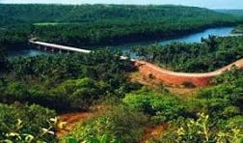
PANDEMIC PREPAREDNESS PLAN-
KAYYUR GRAMAPANCHAYTH

MESSAGE FROM PRESIDENT/CHAIR LSGI
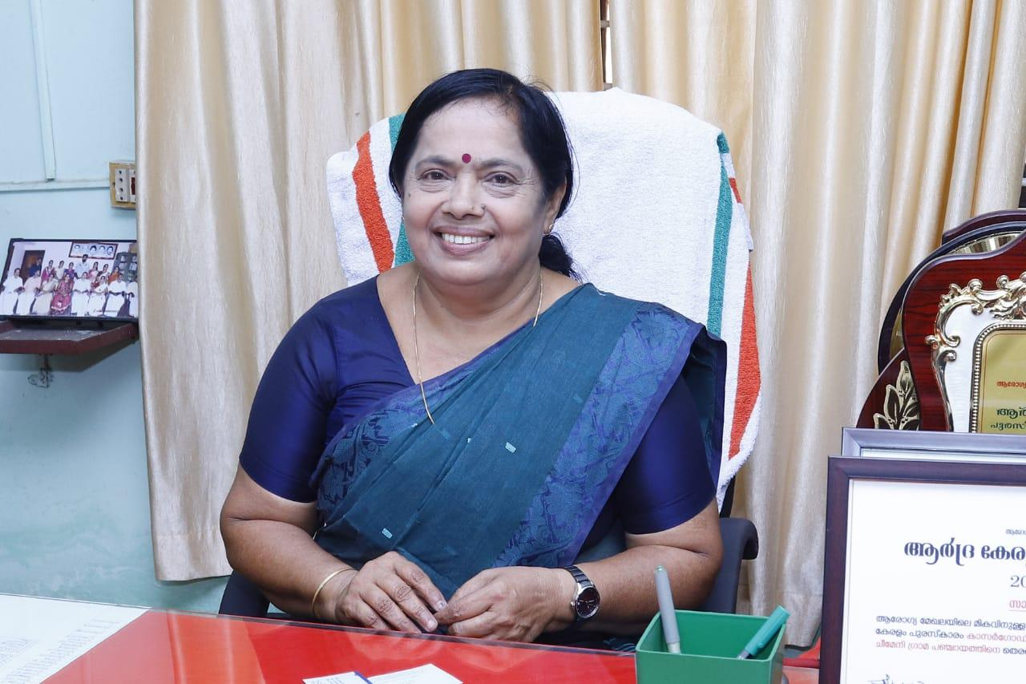

Greetings,
It gives me great confidence to note the preparation of the Pandemic Preparedness Plan (PPP) for Kayyur Cheemeni Grama Panchayat. This initiative reflects our strong commitment to safeguarding the health and wellbeing of our community and strengthening our readiness to respond effectively to future public health emergencies. Given our limited access to tertiary healthcare facilities and reliance on referral centres outside the Panchayat for specialized treatment, local-level preparedness is critically important. Our geographically dispersed population and the responsibility of maintaining uninterrupted essential services during times of crisis further emphasize the need for a well-structured, coordinated, and practical response framework. The Panchayat assures its full support and cooperation in the implementation of this plan. We will work in close coordination with the Family Health Centre KAYYUR, the Health Standing Committee, concerned line departments, and community stakeholders to ensure that the plan remains inclusive, comprehensive, and aligned with local needs.
I extend my sincere appreciation to all officials, healthcare workers, committee members, and volunteers who have contributed to this effort. Through collective responsibility, unity, and proactive planning, we can build a resilient KAYYUR capable of effectively managing public health challenges and protecting every citizen.

President
KAYYUR CHEEMENI Grama Panchayat

MESSAGE FROM HEALTH STANDING COMMITTEE CHAIR
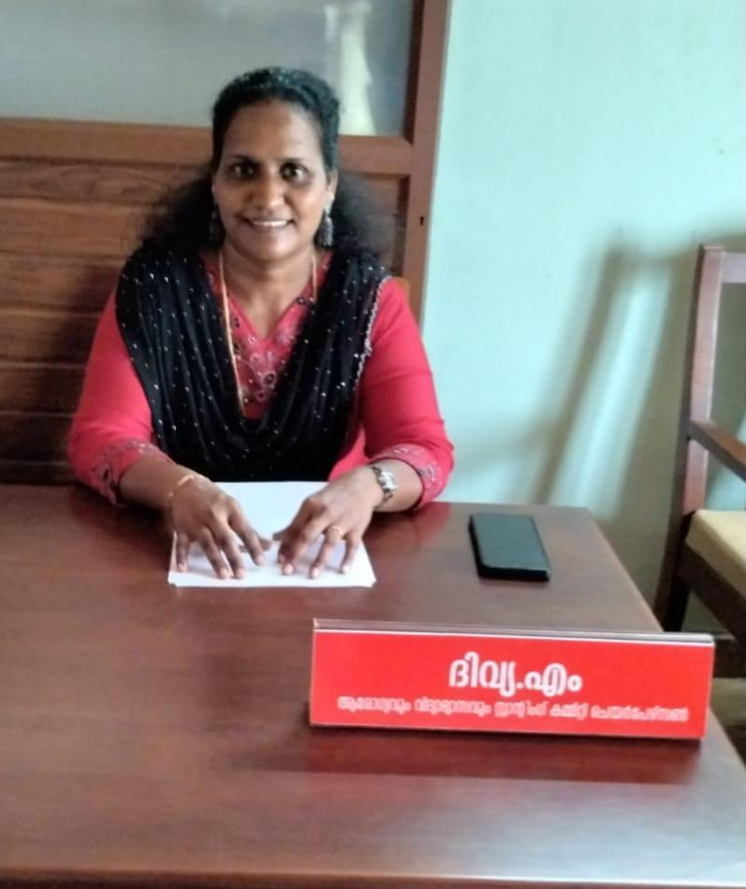
Greetings,
The preparation of the Pandemic Preparedness Plan (PPP) is a timely and essential initiative to strengthen our Panchayat’s capacity to effectively respond to future public health emergencies. The Health Standing Committee recognizes that pandemics and disease outbreaks can disrupt not only healthcare services but also livelihoods, education, and essential community functions. Therefore, proactive planning and coordinated action are crucial to minimizing risks and safeguarding our population.This preparedness plan provides a structured framework for disease surveillance, early detection, rapid response, infection prevention and control, and continuity of essential health services. Special attention has been given to protecting vulnerable groups, ensuring adequate medical supplies, strengthening referral systems, and maintaining uninterrupted maternal and child health services, immunization, and management of chronic diseases during crisis situations. The Health Standing Committee remains fully committed to working closely with the Panchayat, Family Health Centre, ICDS, educational institutions, line departments, and community organizations to ensure effective implementation of the plan. Community awareness, participation, and shared responsibility will be key to early identification of risks and timely containment of outbreaks. I sincerely appreciate the dedicated efforts of healthcare personnel, Panchayat members, officials, and volunteers who have contributed to the development of this plan. Through unity, preparedness, and collective action, we can build a resilient community capable of facing any future public health challenge with confidence.
Chairperson
Health Standing Committee,KAYYUR CHEEMENI GRAMA PANCHAYATH

MESSAGE BY MEDICAL OFFICER

Greetings,
Public health emergencies can manifest in various forms, including respiratory infection, vector-borne and water-borne diseases, as well as emerging and re-emerging infectious threats. Each of these situations requires a carefully designed, disease-specific strategy that includes strengthened surveillance, timely diagnosis, standardized treatment protocols, isolation and infection prevention measures, vaccination preparedness, and clear risk communication. The preparation of the Pandemic Preparedness Plan (PPP) for KAYYUR Grama Panchayat serves as a vital framework to systematically address such diverse public health challenges. Strengthening early warning systems, rapid response teams, laboratory coordination, availability OF essential medicines and personal protective equipment, and efficient referral mechanisms will be key priorities. Simultaneously, uninterrupted delivery of essential health services — including maternal and child healthcare, routine immunization, elderly care, and management of non-communicable diseases — must be ensured even during outbreak situations. Effective preparedness and response demand close collaboration with The Panchayat, Health Standing Committee, ICDS, educational institutions, the Education Department, Veterinary and Animal Husbandry Department, AYUSH Department, and other line departments, along with active community participation. A coordinated, whole-of-community approach is crucial for early detection of outbreaks, timely containment, and protection of vulnerable groups. Through this preparedness plan, we aim tO enhance our readiness, strengthen response capacity, and minimize preventable morbidity and mortality during any future public health emergency
With best wishes
Dr
Medical Officer
Family Health Centre, KAYYUR
EXECUTIVE SUMMARY
Family Health Centre (FHC) functions as the primary public healthcare institution serving the population of Kayyur cheemeni Grama Panchayath. The FHC plays a pivotal role in delivering comprehensive, accessible, and affordable healthcare services, with a strong focus on preventive, promotive, curative, and rehabilitative care in accordance with national and state health programmes.
The FHC caters to a predominantly rural population, addressing key public health priorities such as maternal and child health, communicable and non-communicable disease control, immunization, family welfare, adolescent health, and geriatric care. Regular outpatient services, home-based care through field health staff, and outreach activities ensure healthcare coverage even in geographically challenging areas. The institution actively implements national health missions, including the National Health Mission (NHM), National Tuberculosis Elimination Programme, National Programme for Prevention and Control of Cancer, Diabetes, Cardiovascular Diseases and Stroke (NPCDCS), and other disease surveillance initiatives.
KAYYUR FHC works in close coordination with the Kayyur cheemeni Grama Panchayath, ASHA workers, Anganwadi centres, schools, and community-based organizations to strengthen community participation and improve health awareness. Emphasis is placed on early detection, timely referral, health education, and lifestyle modification to reduce disease burden and improve overall health outcomes.
Despite constraints related to infrastructure, manpower, and increasing service demand, the FHC continues to enhance service delivery through effective planning, data-driven decision-making, and community engagement. Strengthening facilities, upgrading digital health systems, and expanding preventive services remain key focus areas for future development.
Overall, Kayyur cheemeni Primary Health Centre stands as a vital institution in safeguarding public health and improving the quality of life of the residents of Kayyur cheemeni Grama Panchayath

LIST OF ABBREVIATIONS

LSGD/LSGI | Local Self Government Department / Local Self Government Institution
BMO | Block Medical Officer
IDSP | Integrated Disease Surveillance Programme
NDMA | National Disaster Management Authority
PPE | Personal Protective Equipment
ICMR | Indian Council of Medical Research
CD | Communicable Diseases
NCD | NON-COMMUNICABLE Diseases

TABLE OF CONTENTS

3
INTRODUCTION 9
● Background of the PPP 9
LSGD AT A GLANCE 9
INTEGRATED HEALTH INFRASTRUCTURE MAP OF ____________ PANCHAYAT 10
GENERAL PROFILE OF THE LSGI’S 13
Background of the LSGI 13
Demographic and Vulnerable Population 14
Clinical Vulnerability 16
INFRASTRUCTURE & RESOURCE INVENTORY 18
Health Facility Directory & Basic Capacity in the LSGD 18
Private Clinics 19
Healthcare Education & Training Institutions 20
Specialized Services & Emergency Inventory 20
Oxygen & Diagnostic Capacity 21
Diagnostics facility mapping at the LSGI level 22
Laboratory Identification & Basic Details 22
Social and Community Infrastructure for surge plan 22
Human resources 24
Community & Support Cadre 25
Community Organizations 26
Administrative & Emergency Services 27
Information regarding resources 27
ONE HEALTH & ENVIRONMENTAL SURVEILLANCE 28
Animal & Bird Population 28
Veterinary Infrastructure 29
Veterinary Doctors & Workforce 30
High-Risk Interface Points (Surveillance Sites) 30
Environmental Risk Mapping 31
Disease Seasonality Mapping 32
Vulnerability Mapping 33
EPIDEMIOLOGICAL TRENDS (2021–2025) 34
Disease Burden among human beings(Last 5 Years) 34
*(use the above table data to create the graph/diagram) 36
Seasonal Trend Analysis 37
Outcome-Based Trend Analysis- 2025 39
Transmission Trend- 2025 40
Integrated Disease Hotspot Map (2021–2025) 42
Preparedness and Response Protocol at LSG Level 44
Constitution of One Health Committee 44
Pandemic Response Workforce 45
Activities and Measures before and during Pandemic 47
PHASE 1 - Alert / Preparation 47
PHASE 2 - Active Response 50
Standard Screening Protocol 51
PHASE 3 - Surge Capacity 60
Conversion of Community Facilities 60
CONCLUSION 61
RECOMMENDATIONS 62
ANNEXURE 63
1. IMPORTANT PHONE NUMBERS 63

INTRODUCTION

Background of the PPP
Pandemics and other public health emergencies present serious threats to public health, livelihoods, and local governance systems, particularly in regions with environmental and social vulnerabilities. Experiences from recent outbreaks have clearly demonstrated the importance of strengthening preparedness, surveillance, and coordinated response mechanisms at the grassroots level. In this context, the formulation of a localized Pandemic Preparedness Plan (PPP) for Kayyur Cheemeni Grama Panchayat is both timely and essential.
Kayyur Cheemeni Grama Panchayat observes seasonal variations in communicable diseases. In recent years, vector-borne diseases such as Dengue and water-borne illnesses including Hepatitis A have been reported periodically. Monsoon-related water contamination, unsafe storage practices, and favourable mosquito breeding conditions contribute to seasonal spikes in these diseases. Occasional cases of vaccine-preventable diseases are also reported, and pockets of vaccine hesitancy among certain groups remain a public health concern. These trends highlight the need for strengthened surveillance, sustained risk communication, and proactive community engagement.
The Panchayat also faces environmental and ecological vulnerabilities. With areas characterized by mixed terrain, water bodies, and nearby forest ecosystems, there is potential risk for zoonotic disease transmission linked to animal–human interaction. Therefore, adopting a One Health approach — integrating human, animal, and environmental health systems — is crucial for early identification and prevention of emerging infectious threats.
Kayyur Cheemeni has a geographically dispersed population with regular mobility of migrant workers, daily wage earners, students, and traders. Such movement can accelerate disease transmission during outbreaks. The Panchayat primarily depends on primary-level healthcare services, especially the FHC Kayyur, while tertiary care facilities are located outside the Panchayat area. Limited access to advanced care within the locality may result in referral delays and increased burden on higher centres during large-scale emergencies.
Seasonal monsoon impacts, including localized flooding, waterlogging, and disruptions in sanitation and transportation, further increase public health risks and may hinder access to healthcare services. These interconnected vulnerabilities underscore the necessity for a structured, context-specific preparedness framework.
Against this backdrop, the Pandemic Preparedness Plan (PPP) for Kayyur Cheemeni Grama Panchayat aims to strengthen disease surveillance systems, improve early warning and rapid response mechanisms, enhance community awareness, streamline referral pathways, and ensure continuity of essential health services during emergencies. Through coordinated inter-sectoral collaboration and adoption of a One Health perspective, the Panchayat seeks to build resilience, reduce preventable morbidity and mortality, and protect vulnerable populations from future public health threats.

LSGD AT A GLANCE
- Ward division -
Ward | Houses | Population | Migrants | Wells | Hot  spots | Ed. Institutions | Hosp pvt/govt.
17 | 7229 | 27463 | 323 | 4204 | 6 | 14 | 5

Map -ward based

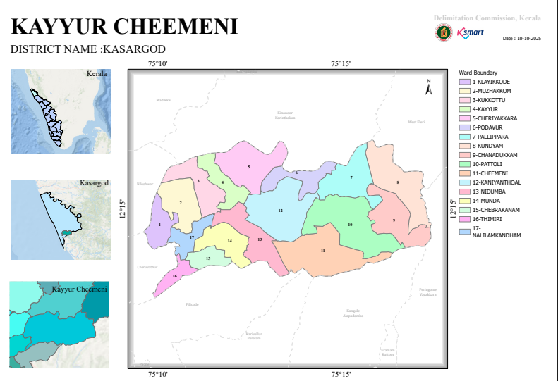

Integrated health infrastructure map

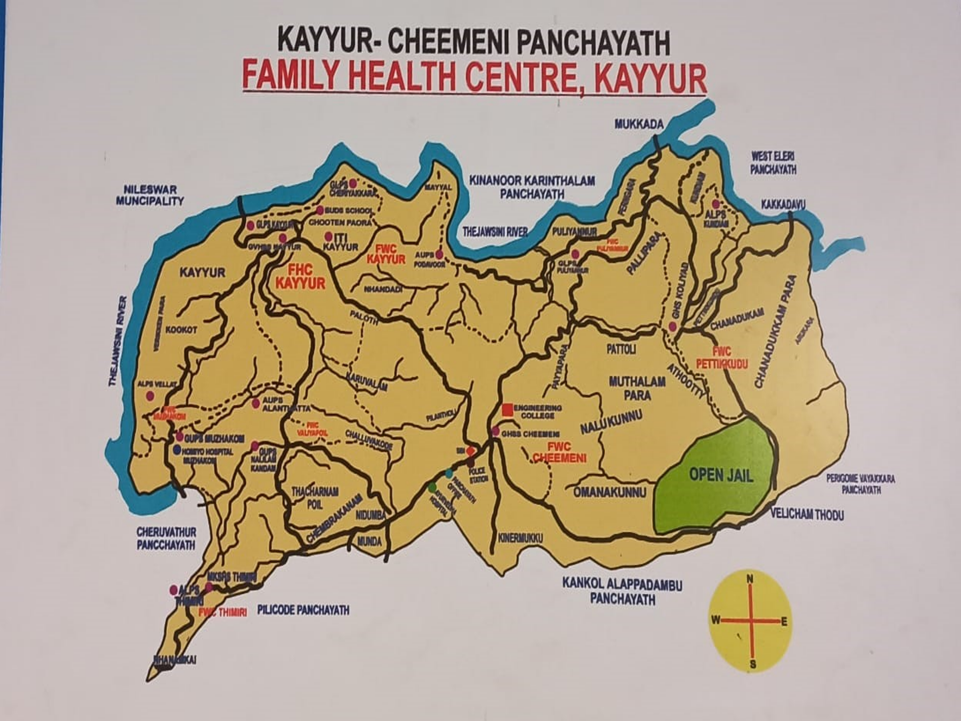

GENERAL PROFILE OF THE LSGI’S

Background of the LSGI
Kayyur is a historic village in the Kasaragod district of Kerala, celebrated as the cradle of Kerala's agrarian revolution. Located near Cheruvathur on the banks of the Thejaswini River, it is famous for the 1941 Kayyur Uprising, a major anti-feudal and anti-imperialist peasant revolt against oppressive landlords and British colonial rule.
Kayyur encompasses a geographical area of roughly 20.55 square kilometers, located near the town of Cheruvathur.
Kayyur–Cheemeni Grama Panchayat is a Gram Panchayat in Kasargod district of Kerala. The gram panchayat, which covers an area of 72.70 km² and is located in the Neeleswaram block of Hosdurg taluk in Kasaragod district. This gram panchayat includes Kayyur, Cheemeni, Thimiri and Klayikode villages. There are 16 wards in this gram panchayat
South - Pilikode Grama Panchayat, Kankol-Alappadamba Grama Panchayat and Karivellur-Peralam Grama Panchayat in Kannur district
North - Kinnaur-Karinthalam and West Eleri panchayats
East - West Eleri and Peringom Vayakara Panchayats in Kannur district
West - Neeleswaram and Cheruvathur panchayats

Table 1: Background of LSGD
Description | Details
Name of LSGI | Kayyur Cheemeni
Type (GP/Municipality / Corporation etc.) | Grama Panchayath
Block | NILESWRAM
District | KASARGOD
Number of wards | 17
Total area (sq. km) | 72.71
Population (Projected) | 27463
Population density | 377 persons/sq km
Terrain (coastal/low-lying/backwaters/foothills, etc.) | foothills
Number of rivers passing through LSGI | 1
Number of water bodies in the LSGI | 4204
Number of educational institutions | 21
Number of anganwadis | 29
Sishu mandiram | 1
Special school | 2
Temples/ church/mosque | 30/4/7
Flood-prone wards | 1,3,4,5,6
Landslide-prone wards | 1
Death Management and Disposal Facilities (mortuaries/crematorium, including electric) | 11
Auditoriums/Marriage halls/convention centres/community halls | 6

Demographic and Vulnerable Population
Understanding the demographic composition and vulnerable population groups is essential for pandemic preparedness. Children, elderly, economically deprived families, migrant workers, and socially vulnerable groups are at increased risk during public health emergencies due to higher exposure, limited access to services, and dependency on public systems..

Description |  | Details (in numbers)
DEMOGRAPHIC PROFILE
Total population |  | 27463
Male |  | 13387
Female |  | 14076
Transgender |  | 0
Children under 5 |  | 1189
Adolescent |  | 2450
Elderly (>60) |  | 5145
Eligible couple |  | 4369
SOCIAL/LIVELIHOOD VULNERABILITY
Previous EPEP family |  | 23
BPL family |  | 3606
Tribal communities |  | 472
Migration | Immigrant | 323
Migration | Emigrant | 176
Fisherfolk |  | 0
SC Community |  | 324
ST Community |  | 117
ST population |  | 472
SC population |  | 954
ST unnathi |  | 7
SC nagar |  | 8
Migrant site |  | 25
Water bodies |  | 4204
Public well |  | 56
Open well |  | 4148
Bore well |  | 2071
Other water sources |  | 27
Drinking water projects |  | 46

Clinical Vulnerability
Certain population groups needs priority healthcare & are at higher risk of severe illness, complications, and mortality during pandemics. Patients with chronic diseases, those requiring regular medical care, and individuals with mobility or functional limitations face challenges in accessing timely care during emergencies. Mapping these groups helps in prioritizing continuity of treatment, medicine stock planning, oxygen support, referral transport, and targeted home-based care.
Description | Details in numbers
Pregnant women | 77
Lactating mothers | 184
Bedbound patients | 223
Patients under palliative care other than bedbound | 512
Patients on Haemodialysis | 12
Patients on CAPD | 0
Cancer patients (currently on treatment) | 145
Haemophilic patients | 0
Mentally challenged | 83
Differently abled | 303
Diabetic patients | 4026
Hypertensive patients | 5354
TB patients | 14

Major Festivals & Events specific to the LSGI

Sl. No. | Name of festival | Month detailing the periodicity
1 | THEYYAM | Oct-may

INFRASTRUCTURE & RESOURCE INVENTORY

Health Facility Directory & Basic Capacity in the LSGD
This section provides an overview of the healthcare infrastructure available within the LSGD area. It outlines the distribution and basic capacity of health facilities that form the backbone of service delivery during routine times and public health emergencies.
Family Health Centres (FHCs) and Community Health Centres (CHCs) generally function as the first point of contact for the community, providing essential outpatient and inpatient services. General Hospitals (GH) and Medical College Hospitals (MCH), where accessible, serve as the main referral centres for advanced diagnostics, specialist care, and critical services during public health emergencies. This inventory helps identify existing strengths, gaps, and potential surge capacity that can be mobilised during a pandemic or disaster.

Table 5. Health Facility Resource Summary
Sl.no. | Health Facility | Type of Facility (MCH/GH/CHC/FHC/SC etc.) | Contact Number | Total beds | ICU Beds | Oxygen-Supported Beds | No. of Ventilator Support Beds | No. of ambulances
Government Healthcare Facilities
 | FHC KAYYUR | FHC | 04672230301 | 5 | 0 | 1 | 0 | 1
 | GOVT AYURVEDIC HOSPITAL | hospital | 0467-2251730 | 10 | 0 | 0 | 0 | 0
 | GOVT HOMEO HOSPITAL | hospital | 0467-230007 | 0 | 0 | 0 | 0 | 0
Private Healthcare Facilities
1 |  | HWC | 04672963488 | 0 | 0 | 0 | 0 | 0
AYUSH Healthcare Facilities
1 | 3 | AYUSH -3 | 9048641865 | 0 | 0 | 0 | 0 | 0

Private Clinics
Private clinics are an essential part of pandemic preparedness, as they are often the first place people seek care when symptoms begin. In many communities, private clinics manage a significant share of outpatient visits and therefore play a critical role in early case detection, timely referrals, and disease surveillance. Having an up-to-date understanding of where these clinics are located, the services they provide, and how they are linked to the public health system helps ensure that no cases are missed during an outbreak. It also allows health authorities to engage private practitioners more effectively for reporting, risk communication, and coordinated response, strengthening the overall capacity of the health system to manage public health emergencies.

Table 6. Private Clinic Resource Summary
Sl No. | Name of Clinic | Registered (Y/N) | Clinic (General / Speciality) | Speciality (if any) | Address | Contact Number | Diagnostic Facility (Y/N) | Ambulance Linkage (Y/N)
1 | Cheemeni speciality clinic | N | GENERAL | PAEDIATRIC | CHEEMENI | 7947117271  8089770280 | Y | Y
2 | MAYO CLINIC | N | GENERAL | PAEDIATRIC,MEDICINE,ORTHO | CHEEMENI | 833009079 | Y | Y

Healthcare Education & Training Institutions

Category of Institution | Govt | Private | AYUSH | Total
Medical Colleges | 0 | 0 | 0 | 0
Nursing Colleges | 0 | 0 | 0 | 0
Dental Colleges | 0 | 0 | 0 | 0
Para-medical / Allied Health | 0 | 0 | 0 | 0
JAK/Hwc | 0 | 0 | 0 | 0

Specialized Services & Emergency Inventory

Item | Govt | Private | AYUSH | Total
Hospital beds | 3 | 0 | 0 | 3
Oxygen-generating systems(Y/N) | 0 | 0 | 0 | 0
Oxygen-supported beds(Numbers) | 1 | 0 | 0 | 1
Ventilator-supported beds | 0 | 0 | 0 | 0
ICU beds | 0 | 0 | 00 | 0
Burns units | 0 | 0 | 0 | 0
Blood centres | 0 | 0 | 0 | 0
BLS ambulances | 0 | 0 | 0 | 0
ALS ambulances | 0 | 0 | 0 | 0
Dialysis facilities | 0 | 0 | 0 | 0
Dispensaries | 0 | 0 | 0 | 0
Medical store | 1 | 7 | 2 | 10
Industrial establishments(Medium-scale industries/small-scale industries establishments to whom we can depend in a worst-case scenario) | 0 | 0 | 0 | 0

Oxygen & Diagnostic Capacity
Monitoring oxygen and diagnostic capacity is a critical component of public health preparedness, ensuring that the LSGD can handle both chronic care and sudden surges in respiratory or infectious diseases.
Name of Health Facility | Oxygen-generating System (Y/N) | Backup Oxygen Source (Y/N) | Diagnostic Facilities Available(Y/N)
Name of Health Facility | Oxygen-generating System (Y/N) | Backup Oxygen Source (Y/N) | Lab | USG | X-ray | CT/MRI | RT-PCR
Government Healthcare Facilities
FHC KAYYUR | N | Y | Y | N | N | N | N

Diagnostics facility mapping at the LSGI level
The diagnostic capacity of Kayyur cheemeni G.P represents the "intelligence network" of our healthcare system. The speed and accuracy of disease identification depend entirely on the distribution and technical level of these facilities.

Item | Govt | Private | AYUSH | Total
General labs | 1 | 6 | 1 | 8
Microbiology labs | 0 | 0 | 0 | 0
RT-PCR labs | 0 | 0 | 0 | 0
USG units | 0 | 0 | 0 | 0
CT/MRI units | 0 | 0 | 0 | 0
Research labs | 0 | 0 | 0 | 0
Labs of other departments that can be repurposed | 0 | 0 | 0 | 0

Laboratory Identification & Basic Details
Sl. No. |  | Name of Laboratory | Ownership (Govt / Private / Academic) | Address |  | Contact No. |  |  | 24×7 Services (Yes/No) |  | NABL / Govt Approved (Yes/No)
1 |  | Cheemeni speciality clinic | pvt | cheemeni |  | 8089770280 |  |  | yes |  | yes
2 |  | Mayo clinic | pvt | cheemeni |  | 8330090793 |  |  | yes |  | yes
3 |  | mediplus | pvt | cheemeni |  | 9188587118 |  |  | no |  | yes
4 |  | Karunya lab | pvt | cheemeni |  | 9847833161 |  |  | no |  | yes
5 |  | Family medicals | pvt | cheemeni |  | 8547722393 |  |  | no |  | yes
6 | DDC lab |  | pvt |  | kayyur |  | 8714846636 | no |  | yes
7 | FHC Kayyur |  | govt |  | kayyur |  | 0467-2230301 | no |  | yes
8 | Govt ayurvedic hospital cheemeni |  | govt |  | cheemeni |  | 0467-2251730 | no |  | yes
9 | Govt homeo hospital cheemeni |  | govt |  | muzhakkom |  |  | no |  | yes

Social and Community Infrastructure for surge plan
This table serves as our logistics and shelter inventory. By mapping these locations, quickly we can identify where to house displaced citizens, where to set up temporary medical clinics, and how to manage the deceased with dignity during a crisis.

Category | Total Count | Ward
Educational Institutions
Anganwadis | 29 | ALL WARDS
Schools | 14 | 1,2,3,4,5,6,7,9,11,15,16,17
Colleges | 3 | 5,10,12
Healthcare Educational Institutions
Medical colleges (Govt/Private) | 0 | 0
Nursing colleges (Govt/Private) | 0 | 0
Dental colleges (Govt/Private) | 0 | 0
Paramedical institutes (Govt/Private) | 0 | 0
Community Gathering Spaces
Community halls | 11 | 5,11,12,13,14,
Auditoriums | 7 | 4,7,11,12,15
Religious buildings | 66 | All wards
Mass Fatality Management (MFM) Infrastructure
Mortuary | 0
Crematorium | 13 | 1,2,3,4,5,10,11,16

Human resources
This section focuses on the human capital available within the LSGI. In any emergency—be it a pandemic, flood, or industrial accident—infrastructure is only as effective as the people operating it.

Medical & Clinical Personnel
This table tracks the "Frontline" providers responsible for diagnosis, treatment, and clinical management. Narrative sentence: eg., "Total health workforce: 450 personnel, with 60% in government facilities serving as primary surge capacity." A detailed directory with the contact numbers of all workers is maintained (Annexure in 1).

Cadre | Govt (No.) | Private (No.) | Total
Doctors—Modern Medicine | 4 | 5 | 9
Doctors – AYUSH | 7 | 6 | 13
Doctors – Veterinary | 1 | 0 | 1
Doctors – Dental | 0 | 3 | 3
Nursing officers | 3 | 0 | 0
Lab technicians | 1 | 5 | 0
Optometrist | 1 | 0 | 0
Pharmacists | 3 | 14 | 17
Psychologists | 0 | 0 | 0
Counsellors | 0 | 0 | 0

Public Health & Field-Level Workforce

Cadre | Health services | Municipal common services | Total
HS (Health Supervisors) | 0 | 0 | 0
HI (Health Inspectors) | 1 | 0 | 1
LHS (Lady Health Supervisor) | 0 | 0 | 0
LHI (Lady Health Inspectors) | 1 | 0 | 1
JPHN (Jr Public Health Nurses) | 8 | 0 | 8
JHI (Jr Health Inspectors) | 5 | 0 | 5
MLSP (Mid-Level Service Providers) | 8 | 0 | 8
Palliative Nurses | 1 | 0 | 1
RBSK Nurses | 1 | 0 | 1
PRO | 0 | 0 | 0
Epidemiologist | 1 | 0 | 1
Data Manager | 1 | 0 | 1

Community & Support Cadre

Cadre | Number
ASHA Workers | 16
AWW (Anganwadi Workers) | 29
Emergency Medical Volunteers (Trained) | 0
Kudumbashree | 336
MNREGS | 1526
Purusha Swayam Sahaya Sangham | 93
Ex-Servicemen | 246
Retired Police Officers | 158
NCC/NSS Volunteers | 326
Red Cross volunteers | 98
One Health Community Volunteers | 0
One Health Community Mentors | 0

Community Organizations
This section details the presence of community-based organisations (CBOs), non-governmental organisations (NGOs), faith-based organisations (FBOs), Kudumbashree Self-Help Groups (SHGs), and Ayalkootams within the Local Self-Government Institution (LSGI). These groups enhance grassroots mobilization, resource distribution, and support networks crucial for pandemic response and community resilience.

Category | Total Count
NGOs | 64
Religious based organizations | 1
Foreign based organizations | 0
Sports Club/youth clubs | 64
Kudumbashree SHGs | 336
Ayalkootams | 356
Political organizations | 1
Residential organizations | 0

Administrative & Emergency Services

Category | Total Count | Contact details
Police Stations | 1 | 04672250220
Fire & Rescue Stations | 1 | 7012326134
Water Pumping Points | 1 | 0
Public Distribution System (PDS) | 10 | 0

Information regarding resources
The availability of essential transport and support resources plays a quiet but critical role in saving lives. Equipment such as ambulances, mobile mortuaries, amphibian ambulances, and motorized boats ensures that patients, samples, and healthcare teams can move swiftly—even in flooded, remote, or difficult terrains. Heavy vehicles like JCBs, cranes, tractors, and torus lorries support logistics, waste management, emergency infrastructure, and rapid conversion of spaces into care or isolation facilities. Taxis, four-wheel-drive vehicles, and trucks help maintain continuity of essential services, reach vulnerable populations, and support home-based care and supply delivery.

Means of transportation | Total Count
JCB | 14
Crane | 6
Heavy Trucks | 0
Tractor | 6
Ambulances | 5
Mobile mortuaries | 0
Boats | 0
Taxi service | 65
Note: For specific details regarding vehicle owners and contact information, please refer to Annexure [X].

ONE HEALTH & ENVIRONMENTAL SURVEILLANCE
The One Health method integrates environmental, animal, and human health to enable proactive pandemic preparedness. Panchayat-level surveillance needs to be improved in order to detect and treat zoonotic and environmentally generated diseases early. Surveillance is strengthened through systematic assessment of animal populations, veterinary infrastructure, poultry and slaughter facilities, inter-sectoral coordination, and specialised tools like avian influenza seasonality mapping using GIS in previous outbreaks to enable predictive alerts and ward-specific sampling to support effective pandemic preparedness in high-risk areas

Animal & Bird Population
Mapping animal and bird populations at the Panchayat level is essential for identifying and prioritising zoonotic disease hazards like rabies, avian influenza (H5N1), leptospirosis, anthrax, and Nipah-like spillover occurrences. Risk classification, targeted surveillance, vaccination planning, and early epidemic detection made feasible by comprehensive population mapping all enhance One Health-based pandemic preparedness.

Category | Item | Estimated Population | Wards
Animal Population | Livestock (Cattle/Goats/Buffalo) | 308 | 16
Animal Population | Pet Animals (Dogs/Cats) | 1421 | 16
Animal Population | Stray Dog Population | 44 | 16
Animal Population | Pig Farms (Number of heads) | 1 | 1
 | Small Units (Sheep / Goats – clustered) | 0 | 0
Bird Population | Poultry Units (Birds) | 8 | 4
Bird Population | Poultry- (FOWL) | 1 | 1
Bird Population | Wild/Migratory Birds (Observed) | 1 | 1
Bird Population | Crow Mortality Events (Reported) | 42 | 9

The stray dog population in market areas, fish landing sites, bus stations continues to be a substantial problem for rabies surveillance and bite prevention. There is a considerable risk of avian influenza introduction and amplification during November - December due to the seasonal presence of migratory and resident water birds near ponds/ canal / river / backwater / paddy field. Clusters of pig farms and animal shelters vulnerable to flooding further raise the risk of leptospirosis and other zoonoses mediated by the environment, especially during monsoon floods.

Veterinary Infrastructure
Veterinary institutions are a core pillar of One Health surveillance, enabling early zoonotic disease detection through vaccination, investigation of unusual animal illness or deaths, sample collection, and timely outbreak reporting. A well-mapped and responsive veterinary network strengthens coordination with human health and LSGI systems, ensuring rapid response during zoonotic events and pandemics.
Facility Type | Name of Facility | Ownership Govt / Pvt | Location(Ward No) | Contact number
Veterinary Dispensary | 1 | govt | 3 | 9495039396
Veterinary Hospital / Polyclinic | 0 | 0 | 0 | 0
Private Veterinary Clinics | 0 | 0 | 0 | 0
Mobile / Emergency Vet Service (incl. night services) | 0 | 0 | 0 | 000
Pet Homes / Animal Shelters | 0 | 0 | 0 | 0
Slaughterhouse-linked Veterinary Inspection Unit | 0 | 0 | 0 | 0
 | 0 | 0 | 0 | 0

Veterinary Doctors & Workforce
Early detection, diagnosis, reporting, and reaction to animal illness epidemics depend on the availability and accessibility of qualified veterinary specialists. By identifying unusual animal morbidity or mortality promptly, collecting samples promptly, and coordinating efficiently with human health and LSGI systems—especially during zoonotic outbreaks and pandemic-prone situations—a clearly defined veterinary workforce enhances One Health surveillance.

Category | Number Available | Type (Govt/Pvt) | Contact number
Government Veterinary Doctors | 1 | govt | 0 | 0
Private Veterinary Doctors | 0 | 0 | 0 | 000
Livestock Inspectors | 1 | govt | 0 | 0
Para-veterinary Staff / Attenders | 0 | 0 | 0 | 0
Contract / On-call Veterinary Support (if any) | 0 | 0 | 0 | 0

High-Risk Interface Points (Surveillance Sites)
High-risk interface points for zoonotic disease surveillance in ____kayyur cheemeni________ Grama Panchayath include wetland–livestock–human contact zones, backyard poultry farms, cattle sheds near water bodies, fish markets, and areas of high human–animal interaction such as community slaughter points and migratory bird congregation sites. These are the primary surveillance sites where zoonotic spillover risks are elevated.

Type of Habitat | Type of High risk interface | Geographical vulnerability
Wetlands & Backwaters | 0 | 0
Backyard Poultry Farms | 0 | 0
Cattle Sheds near Water Bodies | 0 | 0
Fish & Meat Markets | 0 | 0
Community Slaughter Sites | 0 | 0
Migratory Bird Congregation Areas | 0 | 0
Rodent-Infested Grain Storage | 0 | 0

Category | Total Count | Key Locations (wards)
Poultry Farms | 6 | 4
Backyard / Clustered Poultry Units | 10 | 0
Duck Rearing Units (open water access) | 0 | 0
Slaughterhouses/ Slaughter Points | 0 | 0
Meat/Fish Markets | 2 | 12/
Live Bird Sale Points | 1 | 1
Cattle Markets / Weekly Animal Fairs0 | 0 | 0
Pet Shops / Breeders | 0 | 0
Animal Shelters / Pet Homes | 0 | 0
Waste Disposal Sites near Animal Units | 0 | 0

Environmental Risk Mapping
Environmental risk mapping identifies monsoon/flood hotspots for vector-borne (dengue, chikungunya), water-borne (leptospirosis, diarrhoea), and zoonotic diseases in Kerala's wetlands. Systematic surveillance supports early warnings, targeted interventions, and Panchayat pandemic preparedness.
Waterborne exposure: Flood-prone areas and stagnant water bodies facilitate leptospira survival, raising leptospirosis risk.

Traditional practices: Informal slaughter and fish markets lack standardized hygiene, creating spillover opportunities.

Risk Factor | High-Risk Wards | Key Locations | Risk Level (High/Med/Low)
Flood-prone areas | 1,3,4,6,5 | Vellatt,kayyur,puliyannur,,muzhakkom,pothavur,pookott,cheriyakkara | Med risk
Water bodies/wetlands | 0 | 0 | 0
Solid waste accumulation | 0 | 0 | 0
Animal waste disposal issues | 0 | 0 | 0
Rodent infestation zones | 0 | 0 | 0
Industrial effluent discharge | 0 | 00 | 0
Construction sites / abandoned buildings | 11 | 0 | medium
Poor drainage/blocked canals | 0 | 00 | 0
Drinking water source contamination risk | 8 | kakkadav | medium

Disease Seasonality Mapping
1, Flooding & waterlogging → amplifies leptospirosis, malaria, diarrheal diseases.
·
2, Migratory bird influx (Nov–Feb) → avian influenza risk.

3, Mosquito breeding cycles → vector-borne disease peaks in monsoon.

4, Agricultural practices → close human–animal contact in paddy fields.

Disease | Peak Risk Season | Key Drivers | High-Risk Locations | Surveillance Focus
Avian Influenza | 0 | 0 | 0 | 0
Leptospirosis | 0 | 0 | 0 | 0
Dengue/Chikungunya | May-aug | 0 | Pettikund,kayyur | 0
Acute Diarrheal Diseases | May-oct | 0 | 0 | 0
Rabies | 0 | 0 | 0 | 0
Anthrax (rare) | 0 | 0 | 0 | 0

Vulnerability Mapping
Vulnerability mapping pinpoints high-risk populations, occupations, and areas exposed via environment, livelihoods, socio-economics, and poor service access. Paired with environmental/seasonality mapping, it enables risk-based surveillance, targeted actions, and optimal resource use in One Health and pandemic planning.
Vulnerability Factor | High-Risk Wards | Key Groups / Locations | Risk Level
Flood-prone households | 1,2,3,4,5,6 | Vellatt,kayyur,puliyannur,,muzhakkom,pothavur,pookott,cheriyakkara | medium
Wetland-adjacent communities | 0 | 0 | 0
Backyard poultry / duck rearing households | 16 wards | 0 | 0
Livestock-rearing households | 16 wards | 0 | 00
Slaughterhouse & meat market workers | 0 | 00 | 0
Fisherfolk & fish market workers | 12 | cheemeni | medium
Sanitation workers | 0 | 0 | 0
Daily wage / migrant workers | 16 wards | 0 | 0
Elderly & chronically ill populations | 16wards | 0 | 0
Pregnant Women | 16ward | 0 | 0
Children (schools, Anganwadi’s) | 16 ward | 0 | 0
Limited access to safe water & sanitation | 0 | 0 | 0

EPIDEMIOLOGICAL TRENDS (2021–2025)

Disease surveillance is the systematic collection, analysis, and interpretation of health data for planning, implementation, and evaluation of public health practice. This section presents the disease surveillance profile of the LSGI based on routine reporting systems and outbreak investigations to identify priority diseases, seasonal patterns, and emerging public health threats.

Disease Burden among human beings(Last 5 Years)
Analysis of disease-wise data for the last five years helps identify persistent public health problems, emerging diseases, and changes in disease burden. This information supports prioritisation of prevention, preparedness, and response activities at the Panchayat level.

Disease | 2021 | 2022 | 2023 | 2024 | 2025 | Trend(Increasing/Stable/Decreasing)
Dengue | 49 | 29 | 22 | 25 |  | Decreasing
Leptospirosis | 4 | 2 | 2 | 0 | 2 | Decreasng
Hepatitis A | 5 | 0 | 1 | 35 | 28 | Increasing
Malaria | 0 | 0 | 0 | 1 | 1 | Increasing
Scrub Typhus | 0 | 0 | 0 | 0 | 0 | Stable
Typhoid | 0 | 0 | 0 | 0 | 0 | Stable
H1N1 | 00 | 0 | 0 | 0 | 2 | Increasing
H3N2 | 0 | 0 | 0 | 0 | 1 | Increasing
ADD | 59 | 98 | 195 | 253 |  | Increasing
Mumps | 0 | 0 | 0 | 0 | 0 | Stable
Measles | 0 | 0 | 0 | 0 | 0 | Stable
Hepatitis B | 0 | 0 | 0 | 0 | 0 | Stable
Hepatitis C | 0 | 0 | 0 | 0 | 0 | Stable
Tuberculosis |  |  |  | 12 | 14 | Increasing
Leprosy | 0 | 0 | 0 | 0 | 0 | Stable
COVID-19 | 3089 | 15 | 1 | 0 | 0 | Decreasing

Seasonal Trend Analysis
Seasonal analysis helps anticipate surges (e.g. dengue in monsoon, leptospirosis after floods, influenza in cooler months) and plan pre‑emptive vector control, stockpiling of IV fluids, and awareness campaigns at Panchayat level.

DENGUE
Dengue is a major seasonal vector-borne disease strongly associated with rainfall, water stagnation, and increased mosquito breeding during the monsoon period.

Peak: July–November

Dengue – Ward-wise Yearly Distribution (2021–2025)

Ward |  | Dengue – Ward-wise Yearly Distribution
 |  | 2021 | 2022 |  | 2023 | 2024 |  | 2025 | Total
1 |  | 1 | 0 |  | 1 | 1 |  | 0 | 3
2 |  | 2 | 3 |  | 1 | 2 |  | 1 | 9
3 |  | 2 | 2 |  | 3 | 2 |  | 0 | 9
4 |  | 6 | 2 |  | 1 | 12 |  | 1 | 22
5 |  | 5 | 2 |  | 0 | 2 |  | 0 | 9
6 |  | 0 | 2 |  | 0 | 0 |  | 1 | 3
7 |  | 0 | 1 |  | 0 | 0 |  | 0 | 1
8 |  | 0 | 0 |  | 2 | 0 |  | 2 | 4
9 |  | 0 | 0 |  | 2 | 0 |  | 1 | 3
10 |  | 2 | 1 |  | 2 | 1 |  | 0 | 6
11 | 2 |  | 6 | 2 |  | 0 | 2 |  | 12
12 | 6 |  | 4 | 3 |  | 0 | 0 |  | 13
13 | 2 |  | 6 | 2 |  | 1 | 1 |  | 12
14 | 3 |  | 2 | 1 |  | 2 | 1 |  | 9
15 | 2 |  | 2 | 0 |  | 1 | 1 |  | 6
16 | 2 |  | 1 | 0 |  | 0 | 0 |  | 3

LEPTOSPIROSIS

Peak: June - August

Leptospirosis – Ward-wise Yearly Distribution (2021–2025)

Ward | Leptospirosis – Ward-wise Yearly Distribution
Ward | 2021 | 2022 | 2023 | 2024 | 2025 | Total
1 | 0 | 0 | 1 | 0 | 1 | 2
2 | 0 | 0 | 0 | 0 | 0 | 0
3 | 2 | 0 | 0 | 0 | 0 | 2
4 | 0 | 0 | 0 | 0 | 1 | 0
5 | 0 | 0 | 0 | 0 | 0 | 0
6 | 1 | 0 | 0 | 0 | 0 | 1
7 | 0 | 0 | 0 | 0 | 0 | 0
8 | 0 | 0 | 0 | 0 | 0 | 0
9 | 0 | 0 | 1 | 0 | 0 | 1
10 | 0 | 0 | 0 | 0 | 0 | 0
11 | 0 | 1 | 0 | 0 | 0 | 1
12 | 1 | 1 | 1 | 0 | 0 | 3
13 | 4 | 2 | 3 | 0 | 2 | 10

VIRAL HEPATITIS - A

Hepatitis A – Ward-wise Yearly Distribution (2021–2025)
Ward | Hep A – Ward-wise Yearly Distribution
Ward | 2021 |  | 2022 | 2023 | 2024 | 2025 |  | Total
1 | 0 |  | 0 | 0 | 0 | 0 |  | 0
2 | 0 |  | 0 | 0 | 0 | 0 |  | 0
3 | 0 |  | 0 | 0 | 0 | 0 |  | 0
4 | 0 |  | 0 | 0 | 0 | 0 |  | 0
5 | 0 |  | 0 | 0 | 0 | 0 |  | 0
6 | 0 |  | 0 | 0 | 0 | 0 |  | 0
7 | 1 |  | 0 | 0 | 0 | 0 |  | 1
8 | 0 |  | 0 | 0 | 1 | 2 |  | 3
9 | 4 |  | 0 | 5 | 0 | 7 |  | 16
10 | 2 |  | 0 | 0 | 32 | 21 |  | 53
11 | 0 |  | 0 | 0 | 1 | 0 |  | 1
12 | 0 |  | 0 | 0 | 0 | 0 |  | 0
13 | 0 |  | 0 | 0 | 2 | 1 |  | 3
14 | 0 | 0 |  | 0 | 1 | 1 | 2
15 | 0 | 0 |  | 0 | 0 | 0 | 0
16 | 0 | 0 |  | 0 | 0 | 0 | 0

Transmission Trend- 2025

Mode of Transmission | No. of cases | No. of Deaths
Vector Borne Diseases | 12 | 0
Water Borne Diseases | 175 | 0
Air Borne Diseases | 0 | 0
Blood Borne Diseases | 0 | 0
Food Borne Diseases | 0 | 0

Vector-Borne Disease

Disease | No. of Cases | No. of Deaths
Dengue | 10 | 0
Malaria | 2 | 0
Chikungunya | 0 | 0

Water Borne Disease

Disease | No. of Cases | No. of Deaths
Cholera | 0 | 0
Typhoid | 1 | 0
Hep- A | 25 | 0
Dysentery | 0 | 0
Amoebiasis | 0 | 0
E- Coli infections | 0 | 0

Air Borne Disease

Disease | No. of Cases | No. of Deaths
Influenza | 0 | 0
H1N1 | 0 | 0
TB | 15 | 0
Chickenpox | 26 | 0
Measles | 0 | 0
Covid-19 | 0 | 0
Pertussis | 0 | 0
Mumps | 0 | 0

Blood-Borne Disease
Disease | No. of Cases | No. of Deaths
AIDS | 0 | 0
Hep- B | 0 | 0
Hep- C | 0 | 000

Zoonotic Disease

Disease | No. of Cases | No. of Deaths
Rabies | 0 | 0
Leptospirosis | 0 | 0
Avian influenza | 0 | 0
West nile | 0 | 0
Anthrax | 0 | 0
Nipah | 0 | 0
Scrub Typhus | 1 | 0

Integrated Disease Hotspot Map (2021–2025)

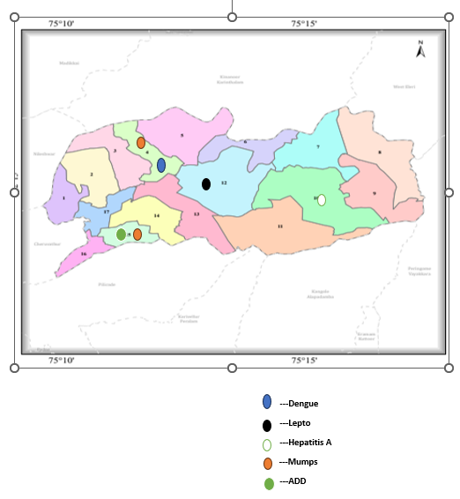

Ward No |  | Dengue Total (2021-25) | Leptospirosis Total (2021-25) |  | Hepatitis A Total (2021-25) | Mumps (2021-25) | ADD (2021-25) | Total Cases
1 |  | 3 | 2 |  | 0 | 0 | 64 | 69
2 |  | 9 | 0 |  | 0 | 1 | 84 | 94
3 |  | 9 | 2 |  | 0 | 0 | 65 | 76
4 |  | 22 | 0 |  | 0 | 2 | 56 | 80
5 |  | 9 | 0 |  | 0 | 0 | 35 | 44
6 |  | 3 | 1 |  | 0 | 1 | 54 | 59
7 |  | 1 | 0 |  | 1 | 1 | 56 | 59
8 |  | 4 | 0 |  | 3 | 0 | 49 | 56
9 |  | 3 | 1 |  | 16 | 0 | 39 | 59
10 |  | 6 | 0 |  | 53 | 1 | 28 | 88
11 |  | 12 | 1 |  | 1 | 1 | 42 | 57
12 |  | 13 | 3 |  | 0 | 0 | 65 | 81
13 |  | 12 | 0 |  | 3 | 01 | 68 | 84
14 | 9 |  | 0 | 2 |  | 1 | 35 | 47
15 | 6 |  | 0 | 0 |  | 2 | 148 | 156
16 | 3 |  | 0 | 0 |  | 4 | 95 | 102

Preparedness and Response Protocol at LSG Level
This section describes the operational framework for the LSGI once a pandemic is declared. It explains how the LSGI and health system will move from routine data collection to active response, using a One Health approach.

Constitution of One Health Committee
The LSGD shall constitute a One Health Committee comprising the LSGI President, Medical Officers (Modern Medicine, AYUSH, and Veterinary), the Health Inspector, and the Veterinary Surgeon.

Objective: The One Health Committee coordinates human, animal, and environmental health to prevent and control pandemics.

Sl No | Name | Designation | Department/Institution | Role in Committee | Contact Number
1 | MPV JANAKI | Panchayat President | LSGD | Chairperson | 8921422280
2 | Dr. LINDA H | Medical Officer (FHC/CHC) | Health Dept | Member Secretary | 9400716363
3 | Dhanusree jineesh | Veterinary Officer | Animal Husbandry | Member | 9495039396
4 | Harshavardhan | Epidemiologist | Health Dept | Member | 8317470180
5 | Rajeevan k | Health Inspector/PHN | Health Dept | Surveillance | 9447816004
6 | Karthyayani | ASHA Supervisor | Health Dept | Community link | 9497607552
7 | Preetha | ICDS Supervisor | Social Welfare | Vulnerable groups | 8086742416
8 | Manuraj G P | Police Station Officer | Police Dept | Law & order
9 | Sobhana v k | Kudumbashree CDO | Kudumbashree | Community mobilisation | 9446418838
10 | Subhash arukara | NGO/Volunteer rep | Civil Society | Support services | 9446696473

Key Responsibilities:
- Review disease surveillance data (human + animal)
- Conduct ward-wise risk assessment and vulnerability mapping
- Approve quarantine/isolation centre locations
- Coordinate with district for resources (PPE, oxygen, ambulances)
- Periodically review health system surge capacity, including beds, oxygen, human resources, and ambulances.
- Approve and monitor risk communication and community engagement strategies, including rumour management.
- Ensure protection and service continuity for vulnerable groups (elderly, persons with disabilities, dialysis patients, coastal populations).
- Conduct quarterly mock drills
- Monitor equity measures for vulnerable groups

Meeting Schedule:
Quarterly (normal times) | Weekly (outbreak alert) | Daily (pandemic phase)

Pandemic Response Workforce
To ensure a coordinated and timely response during a pandemic, a dedicated Pandemic Response Workforce shall be constituted at the LSG level. The workforce will function under the overall supervision of the One Health Committee and in close coordination with the health authorities. Team-based deployment will enable efficient surveillance, case management, quarantine and isolation management, logistics support, and risk communication. Each team shall have a clearly designated team leader, defined roles, and an identified pool of personnel to allow rapid activation, rotation of duties, and continuity of services during prolonged emergencies.

Total Response Workforce Available: 300 persons

Team Name | Composition | Key Responsibilities | Team Leader
Surveillance and Contact Tracing Team | HI, JHI, JPHN, ASHAs and Volunteers | Case detection, contact listing, home visits, reporting | HI
Case Management Team | Doctors, Nurses, MLSP, Palliative Nurses | Patient care & referral | DOCTOR
Quarantine & Isolation Team | LSGD staff, Volunteers | Facility management | JHI
Logistics & supply chain Team | LSGD staff, Storekeepers, Drivers 3 | Supplies & transport [PPE, medicines, oxygen, transport, waste management] | Ward Member
Communication Team | Ward members, Kudumbashree, Youth clubs,  AWW workers and other self help groups | IEC, community meetings, countering misinformation | M.O in charge

Activities and Measures before and during Pandemic

PHASE 1 - Alert / Preparation
PHASE 1 - Alert / Preparation
1.Pre Event Phase

1.Routine Syndrome Surveillance | Weekly Trend Analysis: Monitor data for unusual patterns by Block Public Health Team , DSU  Zoonotic And Animal Health Surveillance – Weekly Aberration/Clustering Check: Identify potential outbreaks if any. If No Event of Concern more with Routine surveillance.
IDSP Data IHIP forms Rumor Registry Media Scanning
Reporting Team | Field Verification: Investigate anomalies on-site.  Preliminary Risk Assessment: Evaluate the severity and potential impact.  Inform Authorities: Notify relevant health officials.  Convene RRT Meeting: Assemble the Rapid Response Team to coordinate actions and add additional members depends on area, event of concern
JHI
JPHN ASHA MLSP WHSN

2.RRT Assessment– by Block RRT in guidance of Public health Officer

1. Outbreak Criteria Check: Determine if an outbreak threshold has been met.
2. Intensify Surveillance: Increase monitoring efforts
3. Activate Field Epidemic Team: deploy a specialized team.
4. Active Case Search: Identify new cases through targeted investigation.
5. Line Listing: Create a detailed list of confirmed cases.
6. Contact Tracing: Identify and monitor individuals who have been in contact with cases.
7. Sample Collection: Gather samples for laboratory confirmation.
8. Public Health Advisory: Issue guidance to the public regarding the outbreak.

3.Logistics and Stock Preparedness

 | Activity | Description | Responsible Authority | Remarks
1 | Identification of Local Vendors | Identify and empanel reliable local vendors for supply of essential items such as PPE kits, masks, sanitizers, disinfectants, medicines, oxygen cylinders and transport services.  Procurement shall follow existing LSGD and Health Department norms. | Municipality Secretary / Medical Officer
2 | Emergency Procurement Mechanism | Establish a rapid procurement mechanism for emergency situations through approved vendors and local purchase committees under LSGD guidelines. | Municipality Secretary / Medical Officer
3 | Essential Logistics Checklist | Prepare and maintain a checklist of essential medical supplies, consumables and support equipment required for pandemic response. The checklist should be updated periodically based on risk assessment. | Medical Officer / Health Inspector
4 | Stock Storage Arrangements | Pre-identify secure storage locations for emergency stock such as hospital medical stores, Municipality storage facilities or isolation centre stores. | Medical Officer / Store Keeper
5 | Stock Register Maintenance | Maintain stock registers for all emergency supplies and update regularly. Conduct periodic | Pharmacist / Health Inspector

 |  | verification of stock levels and monitor expiry dates.
6 | Emergency Transport Arrangements | Identify vehicles for emergency deployment including ambulance services, Municipality vehicles and empanelled private vehicles.  Drivers shall be identified and contact details maintained for rapid mobilization. | Municipality Secretary / Junior Health Inspector
7 | Logistics Nodal Officer | Designate a Logistics Nodal Officer responsible for coordination of procurement, storage, distribution and reporting of logistics during emergencies. | Medical Officer
8 | Rapid Stock Verification | Conduct rapid verification of available stock during outbreak alerts to ensure minimum buffer stock of essential items. | Logistics Nodal Officer / Health Inspector
9 | Buffer Stock Maintenance | Maintain minimum buffer stock of PPE kits, pulse oximeters, sanitizers, masks, gloves and disinfectants to support field teams and health facilities. | Medical Officer / Pharmacist
10 | Reporting Supply Gaps | Identify shortages in essential supplies and communicate requirements immediately to Block and District authorities for replenishment. | Logistics Nodal Officer
11 | Stock Rotation & Expiry Monitoring | Ensure regular monitoring of expiry dates and follow stock rotation practices to prevent wastage and ensure usability of supplies. | Pharmacist / Store Keeper

4. Risk Communication and Community Preparedness
  - Disseminate early warning messages on symptoms, preventive measures, and reporting mechanisms. Display IEC materials both in English and the local language in public places and ensure ward-level awareness.
  - Sensitize elected representatives and community leaders on preparedness measures.
  - Establish a rumour tracking and misinformation response mechanism to identify, verify, and promptly counter false or misleading information.
  - Engage trusted local persons (ward members, ASHA workers, religious leaders, teachers, community volunteers) to communicate official public health messages and reinforce correct practices.
  - Conduct community sensitization meetings at the ward level to promote preventive behaviors, address concerns, and strengthen community participation in preparedness and response.
  - Develop and deploy targeted IEC materials for:
    - Schools and educational institutions
    - Markets and commercial areas
    - Work sites and labour settings
5.Clinical Dependency Mapping
Develop ward-wise dependency and vulnerability maps to identify households requiring regular support during emergencies. Ensure continuity of essential health services for vulnerable groups, including
- Dialysis services (facility mapping, transport arrangements, and scheduling)
- Continuity of treatment for TB, HIV, and other chronic conditions requiring uninterrupted medication
- Mental health and psychosocial support services

Establish delivery mechanisms for food, essential commodities, and medicines to vulnerable households through coordinated action involving ASHAs, JPHNs, Kudumbashree, volunteers, and local administration.

PHASE 2 - Active Response
- Case Identification and Contact Tracing
Case detection and contact tracing activities will be carried out in coordination with the Health authorities, following disease-specific SOPs and IDSP guidelines.
Field Staff Involved
  - Health Inspector (HI)
  - Junior Health Inspector (JHI)
  - Junior Public Health Nurse (JPHN)
  - ASHAs and ASHA Supervisors
  - Ward-level volunteers and Kudumbashree members (as required)
- Screening Checkpoints
Screening checkpoints at high-traffic locations (transport hubs, markets, religious gatherings) for early detection of symptomatic travellers and crowd screening during outbreaks. Potential locations include bus stands, market entry points, and boat jetties, based on local context and risk assessment.
Screening activities will be carried out by trained personnel such as ASHAs, ward members, and volunteers, with support from Health Department staff. Necessary equipment, including non- contact thermometers and appropriate PPE, shall be ensured prior to activation.

Location | Type (Bus stand/Jetty/Mar ket/Railway) | Staff Deployed (ASHAs/Volunt eers) | Screening Method | Reporting authority
Bus stand | Transport hub | One JHI One ASHA One health  Mentors | - Swab Collection.  - Blood smears  collection (RDT)  Thermal Scanners | Surveillance Nodal Officer in  control room
Market entry | Market | One JHI One ASHA Male health  volunteers | 1. Swab Collection. | Surveillance Nodal Officer in  control room

- Blood smears
collection (RDT)
- Thermal Scanners
Boat jetty | Water transport | One JHI One ASHA Male health  volunteers | - Swab Collection.  - Blood smears  collection (RDT)  - Thermal Scanners | Surveillance Nodal Officer in  control room

3.Standard Screening Protocol

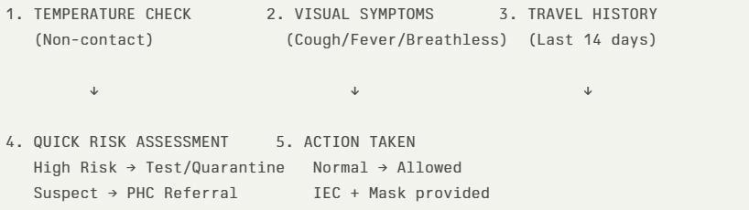
The screening protocol shall include temperature screening, observation for visible symptoms, and inquiry regarding recent travel or exposure history. Individuals identified as suspects during screening shall be immediately referred to the nearest PHC/FHC for further evaluation, testing, and appropriate action as per prevailing guidelines.
4.Event Phase.

Event Phase Activities
Admission Decision: Determine appropriate care settings. | Case Identification: Confirm and document new cases.
Surge Protocol: Implement strategies to manage increased patient volume. | Case Identification: Confirm and document new cases.
Designate Epidemic Care Facility: Establish dedicated facility. DH Kanhanagd can turn to epidemic care facility | Case Identification: Confirm and document new cases.
Shift Routine OP Care: Adjust outpatient  services as needed to nearest W&C and UPHC Kanhangad if there surge capcity not exceeded or upgrade AAMsto OP Care Units | Case Identification: Confirm and document new cases.
 | Triage settings: Assess patients to prioritize care.
 | IP Care Beds: Ensure availability of isolation beds.
Activate Secondary Units: Expand capacity by utilizing additional units. | IP Care Beds: Ensure availability of isolation beds.
 | ICU Escalation: Prepare for increased ICU capacity needs.
Mobilize Staff: Deploy personnel to critical areas. | ICU Escalation: Prepare for increased ICU capacity needs.
Mobilize Staff: Deploy personnel to critical areas. | Staff Training: Provide necessary training to healthcare personnel.
Move Vulnerable Population: Protect at-risk groups.
Move Vulnerable Population: Protect at-risk groups. | Logistics: Manage supplies and resources.
Logistics for Food/Water/Sanitation: Manage essential supplies. | Logistics: Manage supplies and resources.
 | Isolation Facility: Establish dedicated isolation areas.
Severe Case Management: Provide specialized care for severe cases. | Isolation Facility: Establish dedicated isolation areas.
 | Categorization: Classify cases by severity (Mild, Moderate, Severe).
ICU/Ventilator Check: Ensure availability of critical equipment.
Referral Protocol: Establish referral pathways for patients.
Transport to Tertiary Care: Transfer patients to advanced care facilities.

5.Pandemic Control Room
The Pandemic Control Room (PCR) serves as the central nerve center for real-time coordination, data aggregation, decision support, and communication during outbreaks. It consolidates information from all LSGD teams, health facilities and community sources to enable rapid response decisions.

Control Room Infrastructure and Location Primary Location: Municipality hall.
Backup Location: Community Hall in Kanhanagd Municipality
Health System Control Room Framework
The PCR is organized into seven functional pillars to ensure no aspect of the response is overlooked:
- RapidResponseTeam(RRT)
  - Provides immediate intervention during emergencies, clusters, and field alerts.
  - Coordinates urgent actions such as case investigation, contact tracing, isolation, and inter-facility referrals.

- Data Management &Analytics Team
  - Collects, validates, and manages key health system indicators (cases, tests, beds, HR, supplies).
  - Analyzes data trends, generates projections, and supports evidence-based decision-making for local authorities.
- Human Resource Deployment Team
  - Allocates healthcare staff efficiently based on workload and need
  - Ensures adequate and equitable workforce distribution across facilities
- Laboratory surveillanceTeam
  - Oversees diagnostic testing coordination, sample transport, and timely reporting of results.
  - Monitors lab indicators (testing volume, positivity rate, turnaround time) for early detection of outbreaks

- Vaccination cell (if required)
  - Plans and executes vaccination campaigns, including micro-planning and session scheduling.
  - Tracks coverage, identifies gaps, and coordinates corrective actions with field teams and outreach services.
- Infrastructure and patient Occupancy Team
  - Monitors facility capacity, earmarked beds, oxygen and critical care resources across all linked facilities.
  - Ensures optimal patient distribution and referral management using updated bed-status and resource data.
  - BMWM
- Communication team
- Logistics and supply chain
- Transportation (interfacility and emergency transport)
- Media surveillance Call Centre
- Management of the deceased
- Intersectoral coordination and convergence
Key Control Room Team
The Control Room Team coordinates all pandemic response activities within the LSGD and serves as the single command and communication hub during activation. It integrates information, field actions, logistics, and policy execution across all participating departments and health facilities.
Daily Monitoring Indicators
To ensure timely decision-making and effective response, the following key indicators shall be monitored and updated on a daily basis by the Pandemic Control Room:

- Epidemiological Indicators:
New cases reported today, Total active cases, Test Positivity Rate (TPR), Case Fatality Rate (CFR)
- Surveillance Indicators:
Persons under home quarantine, High-risk contacts identified, Fever, ILI, SARI or other symptoms (syndromic surges), Travelers (symptomatic or high-risk arrivals), Animal husbandry surveillance (zoonotic alerts, unusual animal deaths, poultry/bird flu signals), Mortality surveillance (excess deaths, unexplained fatalities, verbal autopsy reports)
- Logistics and Infrastructure Indicators:
Hospital / CFLTC beds occupied, Oxygen cylinders/concentrators available, Ambulances on standby
- Alert Findings
The following table outlines category-specific trigger points (red flags) from surveillance
indicators and corresponding immediate actions for the Pandemic Control Room. These enable rapid response to alert findings like testing anomalies, positive cases exceeding thresholds,
clusters, and WGS reports.

Category | Trigger Pophint (Red Flag) | Immediate Action
Clusters | Geographical or facility- based: 5+ cases linked to one location (office, school, street). | Declare a micro-containment zone; perimeter control and active case finding.
Testing | Sudden drop in testing volume  / delay in reporting / unusual testing trends | Review the sample collection process, address lab bottlenecks, deploy additional testing teams, and notify the District Lab.
Lab | Test Positivity rate increases | Increase testing sites in that ward.
Hospital | >80% Oxygen bed occupancy | Activate backup/CFLTC beds.
Travel | Cluster of cases from a single flight/train or high-risk arrival group. | Trace all passengers in adjacent seats; implement mandatory institutional quarantine.
Animal | Mass poultry/wildlife death or unusual sickness | Notify Animal Husbandry, sample the area, and dispatch RRT for environmental sampling and zoonotic check.
Mortality | Sudden spike in home deaths or brought-in-dead (BID) cases | Audit the deaths and Active Case Search drive

Additional investigations like Whole Genome  Sequencing (WGS) | Detection of a Variant of Concern (VOC) or Variant of Interest (VOI) | Implement strict micro- containment; update clinical protocols to match variant severity.

Key communicators
  - All messages disseminated through the Hub shall align with advisories issued by the Health Department and Districtauthorities.
  - Community leaders shall be sensitized to support behavior change, reduce stigma, and countermisinformation.
  - Special efforts shall be made to reach vulnerable and hard-to-reach populations using locally appropriate communication methods.
Rumor Tracking: A designated volunteer will monitor local social media/WhatsApp groups daily to identify misinformation and issue official clarifications via the Communication Hub.
- Coordination with District/State Authorities & Other Organizations
Effective coordination with Block, District, and State authorities is essential to ensure timely reporting, technical guidance, and uninterrupted supply of essential resources during a pandemic. The LSG shall establish clear communication channels, designate responsible officers, and adhere to prescribed reporting timelines to support coordinated public health action and efficient resource mobilization.

Key Details:
  - Nodal Officer for Reporting:
  - Contact Number: Reporting Schedule and Protocols:

To Whom | What to Report | Frequency | Nodal Person
Block PHC | Complete Situation Report (Cases,  Quarantine, Beds, Screening, Deaths) | Daily | Superintendent W and C
District IDSP Unit | Outbreaks/Clusters/Un usual Events (>5 cases same ward) | Daily | HI
Veterinary Officer | Animalhealth events/Zoonotic alerts | Weekly | Superintendent W and C
State Cell | Zoonotic cross-sector events | Weekly | Superintendent W and C

Supply Chain Coordination
The LSG shall coordinate closely with Block, District, and State authorities (KMSCL) to ensure uninterrupted availability of essential goods, medical supplies, and logistics during a pandemic. Supply requirements shall be assessed regularly based on case load and communicated promptly to the appropriate authorities for timely replenishment.
Key Points:

  - Maintain updated contact details of District and Block nodal officers for health logistics, oxygen supply, ambulances, and essential medicines.
  - Submit timely indent requests for PPE, testing kits, medicines, oxygen, and other critical supplies through prescribed channels.
  - Monitor stock levels at LSGD facilities, quarantine/isolation centres, and field teams through daily stock registers and dispensing logs to prevent shortages.
  - Coordinate with District authorities, Karunya/Neethi medical shops, and local purchase committees for funds allocation and emergency procurement.
  - Ensure regular monitoring of dispensing registers at all facilities to track usage, expiry, and pilferage—shortages being a perennial issue requiring proactive weekly audits.

  - Activate surge procurement protocols during high caseloads, leveraging local purchase powers under LSGD funds alongside state supplies.

Resource Inventory and Contacts

Resource Category | Source (District/State/Private) | Contact
PPE Kits/Masks/Gloves | KMSCL | 9745158939
PPE Kits/Masks/Gloves | Local Vendors | 9037420415
Oxygen Cylinders/Concentrators | KMSCL | 9745158939

Medicines/Antivirals | KMSCL | 9745158939
Medicines/Antivirals | Neethi Shops | 9400524195
Test Kits (RTPCR/Rapid) | KMSCL | 9745158939

REHABILITATION PHASE

Rehabilitation following a pandemic or disaster is a vital responsibility that goes beyond medical treatment and requires strong involvement from Local Self Governments (LSGs) as well as the Government. Comprehensive rehabilitation—including physical recovery, mental health support, disability services, social reintegration, and livelihood assistance— can be effectively carried out only through well-coordinated local efforts. LSGs play a key role in identifying vulnerable households, helping people access welfare schemes, mobilizing community-based rehabilitation services, and ensuring the fair distribution of financial and social support. At the same time, government departments must provide
policy guidance, financial resources, technical support, and coordination among different sectors to ensure long-term and sustainable rehabilitation. Strengthening this partnership helps build community resilience, restores dignity to affected individuals, and supports lasting social and economic recovery.

CONCLUSION
A comprehensive Pandemic Preparedness Plan (PPP) is essential for enabling a timely, coordinated, and effective response during public health emergencies. Incorporating the One Health approach and promoting multi-sectoral coordination enhance the capacity to prevent, detect, and respond to outbreaks by addressing the interconnected risks related to human, animal, and environmental health. The formation of Standing Committees at the LSGI level, along with ward-level sub-committees supported by community-based organizations such as Kudumbashree, CDS, and ICDS, establishes a well-organized framework for surveillance, communication, and rapid response.
Effective pandemic preparedness also depends on active community participation, reliable data management, and the ability to quickly mobilize resources and personnel when needed. By sustaining these systems and strengthening collaboration among different departments and sectors, the LSGI can build a resilient and proactive public health structure capable of efficiently managing current and future public health emergencies.

RECOMMENDATIONS
- Strengthening Healthcare Infrastructure
  - Establish a primary health response unit within the Municipality with trained staff.
  - Ensure availability of basic medical supplies (masks, sanitizers, PPE kits, oxygen cylinders).
  - Create tie-ups with nearby hospitals in for emergency referral and transport.
- Community Awareness & Education
  - Conduct regular awareness campaigns on hygiene, vaccination, and preventive measures.
  - Use local communication channels (community radio, WhatsApp groups, notice boards) to spread verified information.
  - Train volunteers to act as health ambassadors in each ward.
- Emergency Response & Coordination
  - Form a Pandemic Preparedness Committee at Municipality level including health workers, ward members, and NGOs.
  - Develop a clear action plan for lockdowns, quarantine, and distribution of essentials.
  - Maintain a database of vulnerable groups (elderly, differently-abled, chronically ill) for targeted support.

- Supply Chain & Food Security
  - Identify and support local suppliers and farmers to ensure uninterrupted food supply.
  - Create community kitchens during emergencies to serve vulnerable populations.
  - Stockpile essential commodities in Municipality -run outlets for crisis periods.

- Digital Preparedness
  - Promote digital platforms for telemedicine consultations.
  - Use Municipality’swebsite/social media for real-time updates on health advisories.
  - Encourage online grievance redressal to reduce crowding in offices.

- Training & Capacity Building
  - Organize mock drills for pandemic response in schools, offices, and public spaces.
  - Train Municipality staff and volunteers in first aid, infection control, and crowd management.
  - Collaborate with NGOs and health departments for capacity-building workshops.
Long-Term Resilience

- Integrate pandemic preparedness into the Municipality Development Plan.

- Allocate a dedicated budget for health emergencies.
- Encourage community participation in planning and monitoring preparedness measures.

MOCKDRILL SCENARIOS
Scenario 1: Infectious Disease Outbreak
Step 1: Planning and Objective Setting
- Define drill objectives (early detection, triage efficiency, isolation readiness, ICU preparedness).

- Assign Incident Commander and observers.

Step 2: Scenario Trigger
- Simulated patient presents to Emergency with high fever and respiratory symptoms.

- Additional suspected cases reported from nearby areas.

Step 3: Triage and Isolation

- Activate fever triage desk.

- Provide masks and shift patients to isolation wards.

- Initiate infection prevention protocols.

Step 4: Activation of Hospital Incident Command System
- Inform Medical Superintendent.

- Alert Rapid Response Team (RRT).

- Notify District Surveillance Unit.

Step 5: Clinical Management and Sample Collection
- Assess severity and start oxygen/medical management.

- Collect and dispatch samples following biosafety protocol.

Scenario 2: Landslide Disaster

Step 1: Planning and Objective Setting
- Define objectives (mass casualty management, triage, emergency surgery readiness).

- Assign disaster management team and observers.

Step 2: Scenario Trigger

- Information received about landslide in nearby area with multiple casualties.

- Ambulances begin transporting injured patients.

Step 3: Mass Casualty Triage Activation
- Activate disaster triage area outside Emergency.

- Categorize patients (Red – critical, Yellow – moderate, Green – minor).

Step 4: Emergency Response Activation
- Activate Hospital Disaster Management Plan.

- Mobilize surgeons, anesthetists, nurses, blood bank, and OT team.
Step 5: Clinical Management and Stabilization
- Provide emergency resuscitation and trauma care.

- Arrange emergency surgeries and blood transfusion if required.

ANNEXURE

IMPORTANT PHONE NUMBERS

Phone numbers and particulars of persons responsible for providing guidance, assistance, and support for pandemic preparedness operations may be provided here in a manner that allows easy reference at a glance.The information recorded here could be exhibited elsewhere at the time of emergencies. LSG institutions shall give special attention to collect and record the above data of persons and institutions who/which are supposed to give technical and co-ordination support to reduce the impact of pandemic.
SL.NO | WARD NO | NAME OF WARD MEMBER | PH.NO
1 | 1 | RAJITH A K V | 9947674546
2 | 2 | RAVEENDHRAN K | 9495222012
3 | 3 | GEETHA C V | 9846787085
4 | 4 | RAVEENDHRAN P | 9496174446
5 | 5 | MADHU T V | 9496144535
6 | 6 | DHIVAKARAN T K | 9400440424
7 | 7 | PADHMAVADHI M V | 9497438020
8 | 8 | JANARDHANAN V V | 9497138225
9 | 9 | DHANESH K | 9605160981
10 | 10 | NIRMALA A | 9496803425
11 | 11 | LALITHA A V | 9446269724
12 | 12 | DHANESH T P | 9744774524
13 | 13 | LATHA K T | 9605217509
14 | 14 | RAJANI K P | 9744123875
15 | 15 | JANAKI M P V | 8921422280
16 | 16 | KUNHIKANNAN V T | 9496258837
17 | 17 | DHIVYA M | 9496411926

1.2. Other important phone numbers of grama panchayat/municipality/corporation area
Sl. No. | Name | Contact number
1. | RAMESAN K –PANCHAYATH SECRETERY | 9446426872
2. | VINODH C V -PANCHAYATH ASST SECRETERY | 9747914953

1.3. Important offices of grama panchayat/municipality/ corporation
Sl.No | Name of the office | Contact person | Contact number
1. | Village Office | Village Officer | 9544149947-KAYYUR VILLAGE,MANOJ
2. | Agriculture Office | Agriculture Officer | 9947634403
3. | Animal Husbandry Office | Animal Husbandry Doctor | 9495039396
4. | Police Station | Police Officer | 04672250220
5. | BSNL Office | Officer | 18003451500
6. | Block Office | Officer | 04672280328
7. | KSEB Office | Officer | 04672230220
8. | Fisheries Office | Officer | NIL
9. | Fire and Rescue | Officer | 7012326134

1.4. Health Services

Sl. No | Name of the hospital/institution | Location | Phone number
1. | Government hospitals/FHC | KAYYUR | 0467230301
2. | Private hospitals | CHEEMENI
3. | Clinical laboratories | CHEEMENI
4. | Chemist/pharmacy | NIL
5. | Blood donors | NIL
6. | Other language experts (Bihari, Hindi, Bengali,  Asamees ………) | NIL

1.5. Veterinary Services
Sl.No | Name of the Clinic | Name of the  Surgeon/Doctor | Place/location | Phone  number
1 | Govt.Veterinary Hospital |  | KAYYUR | 9495039396

1.6. Helpline numbers
Helpline | Phone number
Police | 04672250220
Fire and Rescue | 7012326134
KSEB | 04672230220
SCHOOL CONTACT DETAILS

SL.NO | NAME OF SCHOOL | INSTITUTION TYPE | CONTACCT NO
1 | GVHSS KAYYUR | GOVT | 9496359667
2 | GHSS CHEEMENI | GOVT | 9447953363
3 | GHS KOOLIYAD | GOVT | 9447363475
4 | MKSHS THIMIRI | AIDED | 8075906867
5 | ITI KAYYUR | GOVT | 9961383636
6 | GLPS KAYYUR | GOVT | 9446276559
7 | GUPS NALILAMKANDAM | GOVT | 9446182357
8 | GUPS MUZHAKKOM | GOVT | 9745750774
9 | GUPS PULIYANNUR | GOVT | 9446696214
10 | GLPS CHERIYAKKARAR | GOVT | 9497601240
11 | ALPS KUNDYAM | AIDED | 9495461126
12 | GLPS VELLATT | GOVT | 9495416633
13 | ALPS THIMIRI | AIDED | 9446165645
14 | AUPS ALANTHATTA | AIDED | 9446203003
15 | AUPS POTHAVOOR | AIDED | 9747069445

1.9. Anganwadi Contact Details

SL No | Name of Anganwadi Teachers |  | Phone number
1 | PREMA M A |  | 9526222420
2 | KARTHYAYANI C V |  | 8930052429
3 | RENJINI V M |  | 9497188068
4 | SREEJA A |  | 8547251766
5 | JAMEELA P P |  | 9656709497
6 | BINDHU K |  | 8547231259
7 | PREMALATHA | 9988645993
8 | RAMANI P | 9809475248
9 | LALITHAKUMARI P V | 9745548611
10 | CHANDHRAMATHI P | 7306888825S
11 | SANTHA T | 90482221802
12 | LIJA K V | 9947361227
13 | SREELATHA K | 8281872795
14 | RAMYA P | 7510875866
15 | LATHIKA K V | 9497438515
16 | INDHIRA M | 9496704521
17 | BINDHURED  GHA V V | 9400431444
18 | RETHI K | 9497297273
19 | RAMANI A | 9747112565
20 SATHIDEVI K V 9605982959

21 | SANITHA K V | 9496704561
22 | MADHAVI | 8943533854
23 | SUDHARMINI V | 9847410542
24 | SAJINA A P | 8086296276
25 | VIJAYASREE K V | 8281275984
26 | VINEETHA K P | 9447803421
27 | SAVITHRI P | 9947477440
28 | PONNAMBILI M V | 9495864318
29 | LALITHA K | 9744123802

1.12. Information regarding resources

Means of transportation | Name of Owner | Phone Number
Heavy Trucks | CHITHRAN | 9447474673
Tractor | 0 | 0
Ambulances | SUBIN | 9947224103
Boats | 0 | 0
Taxi service | NAKULAN  ARUNKUMAR | 9947668694  8943501401

Annexure 1: LSG Baseline Data Collection Format
A. Baseline data
Sl. No. | Indicator / Field | Baseline Data | Source / Remarks
1 | Name of LSG | KAYYUR | Health Records
2 | District | KASARAGOD | Health Records
3 | Block / Taluk | HOSDURG | Health Records
4 | Type of LSG (Gram Panchayat / Municipality / Corporation) | GRAMA PANCHAYATH | Health Records
5 | Area (sq. km) | 72. | Health Records
6 | No. of wards | 17 | Health Records
7 | GIS boundary file available | Yes | Health Records
8 | Key contact person & phone | MPV JANAKI | Health Records

B. Demography
Indicator / Field | Baseline Data | Source / Remarks
Total population | 27463 | Health Records
Males | 13387 | Health Records
Females | 14076 | Health Records
Transgender population | 0 | Health Records
Age distribution  (<5, 5–14, 15–59, ≥60) |  | Health Records
No. of households | 7229 | Health Records
Population density (persons/sq.km) |  | Health Records
No. of migrant workers | 323 | Health Records
Major occupational groups | 1650 | Health Records

C. Vulnerable Populations & Social Risks
Sl. No. | Indicator / Field | Baseline Data (Value / Description) | Source / Remarks
1 | No. of elderly (≥60) | 585 | Health Records
2 | No. of persons with disability | 112 | Health Records
3 | No. of bedridden persons |  | Health Records
4 | No. of chronic disease cases (DM/HTN/COPD/CKD etc.) | 5012 | Health Records
5 | Pregnant women (current estimate) | 205 | Health Records
6 | Children <5 years | 1309 | Health Records
7 | Tribal population (if any) | 118 | Health Records
8 | Fisherfolk / coastal vulnerable groups (if any) | 0 | Health Records
9 | Urban slums / unnotified settlements (if any) | 0 | Health Records
10 | Homeless population | 0 | Health Records
11 | Orphanages / old age homes (number & capacity) | 0 | Health Records
12 | Hostels / prisons / shelters (number & capacity) | 1-PRISON | Health Records
13 | Poverty / BPL estimate | 3 | Health Records
14 | Food insecurity hotspots | 0 | Health Records
15 | Any history of stigma/discrimination issues (Yes/No) | NO | Health Records

D. Health System & Service Readiness
Sl. No. | Indicator / Field | Baseline Data (Value / Description) | Source / Remarks
1 | No. of health facilities in LSG (PHC/CHC/TH/DH/Private) | 2 | Health Records
2 | PHC/Family Health Centre details (name, location) | FHC KAYYUR | Health Records
3 | Subcentres / Health & Wellness Centres (number) | 8 | Health Records
4 | Private clinics / hospitals (number) | 2 | Health Records
5 | Labs available (public/private) | 4 | Health Records
6 | Availability of ambulance services (Yes/No, number) | Y | Health Records
7 | Availability of isolation/quarantine facilities (Yes/No, details) | Y | Health Records
8 | Cold chain facilities (Yes/No, details) | Y | Health Records
9 | Stockpile space available (Yes/No) | Y | Health Records
10 | PPE / mask / sanitizer availability plan (Yes/No) | Y | Health Records
11 | Surveillance staff available (JHI/JPHN/ASHA count) | Y | Health Records
12 | Existing emergency referral pathways (Yes/No) | Y | Health Records

E. Points of Entry & Mobility
Sl. No. | Indicator / Field | Baseline Data (Value / Description) | Source / Remarks
1 | Bus stands / depots (number) | 1 | Health Records
2 | Railway stations (number) | 0 | Health Records
3 | Boat jetties / fishing harbours (number) | 0 | Health Records
4 | Ports / airports nearby (specify distance) | 0 | Health Records
5 | Major highways/roads passing through | 0 | Health Records
6 | Border crossings (state/district) | 0 | Health Records
7 | Major markets / weekly markets | 2 | Health Records
8 | Tourism hubs / major event venues | 2 | Health Records
9 | Schools/colleges with hostels (number) |  | Health Records
10 | Factories / large workplaces (number) | 2 | Health Records
F. Water, Sanitation & Hygiene (WASH)
Sl. No. | Indicator / Field | Baseline Data (Value / Description) | Source / Remarks
1 | Major drinking water sources (piped / wells / borewells / springs) | 4204 | Health Records
2 | No. of public wells | 35 | Health Records
3 | No. of households with piped water connection | 256 | Health Records
4 | Water quality testing routine (Yes/No) | Y | Health Records
5 | Common contamination risks (flooding, salinity, industrial waste) | FLOODING | Health Records
6 | Open defecation free status (Yes/No) | Y | Health Records
7 | Solid waste management system (Yes/No) | Y | Health Records
8 | Bio-medical waste disposal mechanism (Yes/No) | Y | Health Records
9 | No. of public toilets | 3 | Health Records
10 | Handwashing stations in public places (Yes/No) | NO | Health Records
G. Zoonotic Risks & One Health
Sl. No. | Indicator / Field | Baseline Data (Value / Description) | Source / Remarks
1 | Livestock population (cattle/goats/pigs/poultry) – estimates | 1300 | Health Records
2 | No. of dairy farms / poultry farms / pig farms | 9/27/3 | Health Records
3 | Slaughterhouses / meat shops (number) | 13 | Health Records
4 | Animal markets (Yes/No, details) | N | Health Records
5 | Veterinary dispensaries (number) | 2 | Health Records
6 | History of zoonotic outbreaks (rabies, leptospirosis, avian flu etc.) | NIL | Health Records
7 | Stray dog population management measures (Yes/No) | Y | Health Records
8 | Rodent infestation hotspots (Yes/No) | N | Health Records
9 | Wetlands / waterlogged areas prone to leptospirosis | Y | Health Records
10 | Bat roosting areas / caves / fruit orchards (if any) | N | Health Records
11 | Human-animal interface hotspots (farms near residences) | N | Health Records
H. Climate & Disaster Risks (Pandemic Amplifiers)
Sl. No. | Indicator / Field | Baseline Data (Value / Description) | Source / Remarks
1 | Flood-prone wards (list) | 1,2,3,4,5,6 | Health Records
2 | Landslide-prone wards (list) | 8,9,10 | Health Records
3 | Cyclone/sea surge risk (Yes/No) | N | Health Records
4 | Heatwave risk zones (Yes/No) | Y | Health Records
5 | Waterlogging areas (list) | MUZHALLOM,VELLATT | Health Records
6 | Shelter homes / relief camps (number, capacity) | 0 | Health Records
7 | Past disaster displacement history | NIL | Health Records
8 | Disruption to water supply/transport common (Yes/No) | Y | Health Records
I. Critical Infrastructure & Logistics
Sl. No. | Indicator / Field | Baseline Data (Value / Description) | Source / Remarks
1 | Schools (number) | 14 | Health Records
2 | Anganwadis (number) | 29 | Health Records
3 | Colleges (number) | 3 | Health Records
4 | Community halls (number) | 11 | Health Records
5 | Places of worship with large gatherings (number) | 0 | Health Records
6 | Large markets / shopping areas (number) | 1 | Health Records
7 | Warehouses / cold storages (number) | 0 | Health Records
8 | Telecom/mobile network coverage gaps (Yes/No) | NO | Health Records
9 | Power outage frequency (high/medium/low) | MEDIUM | Health Records
10 | Availability of generators in key facilities | Y | Health Records

J. Risk Communication & Community Networks
Sl. No. | Indicator / Field | Baseline Data (Value / Description) | Source / Remarks
1 | Ward-level rapid response teams (Yes/No) | YESYES | Health Records
2 | Jagratha samithis / committees active (Yes/No) | YES | Health Records
3 | Kudumbashree presence and strength (number of units) | YES | Health Records
4 | Volunteer network (number, coverage) | YES | Health Records
5 | Community-based surveillance mechanisms (Yes/No) | YES | Health Records
6 | IEC dissemination channels (WhatsApp groups, community radio, PA systems) | YES | Health Records
7 | Rumour tracking mechanisms (Yes/No) | YES | Health Records
8 | Languages spoken / literacy considerations | 0 | Health Records
9 | Vulnerable groups communication strategy available (Yes/No) | YES | Health Records

K. Preparedness Planning & Governance
Sl. No. | Indicator / Field | Baseline Data (Value / Description) | Source / Remarks
1 | LSG emergency plan available (Yes/No) | Y | Health Records
2 | Pandemic preparedness plan available (Yes/No) | Y | Health Records
3 | Incident Command System identified (Yes/No) | Y | Health Records
4 | Rapid procurement mechanism available (Yes/No) | Y | Health Records
5 | Emergency fund available (Yes/No, amount) | Y | Health Records
6 | Past outbreak response experience (Yes/No, details) | Y | Health Records
7 | Intersectoral coordination mechanism (Health, Police, LSG, Veterinary, Education) | Y | Health Records
8 | Mock drills conducted in last 12 months (Yes/No) | Y | Health Records
9 | Training coverage for staff/volunteers (Yes/No) | 0Y | Health Records

L. Surveillance & Data Systems
Sl. No. | Indicator / Field | Baseline Data (Value / Description) | Source / Remarks
1 | Digital reporting tools used (e.g., DHIS2, portals) | Y | Health Records
2 | Availability of line-listing format (Yes/No) | Y | Health Records
3 | Contact tracing team identified (Yes/No) | Y | Health Records
4 | Mapping of high-risk households available (Yes/No) | Y | Health Records
5 | Testing sample transport mechanism (Yes/No) | Y | Health Records
6 | Reporting timeline adherence (good/average/poor) | GOOD | Health Records
7 | Data sharing between departments (Yes/No) | Y | Health Records
8 | Availability of dashboard for monitoring (Yes/No) | Y | Health Records

M. Additional Notes & Observations
Sl. No. | Indicator / Field | Baseline Data (Value / Description) | Source / Remarks
1 | Key challenges perceived by LSG | FLOOD | Health Records
2 | Top 5 high-risk wards (reason) | 1,2,3,4,5,6-FLOOD | Health Records
3 | Any unique local risks (industrial pollution, refugee camps, etc.) | NIL | Health Records
4 | Recommendations for preparedness strengthening |  | Health Records

