PANDEMIC PREPAREDNESS PLAN
OF MANGALPADY LSG

MESSAGE FROM PRESIDENT/CHAIR LSGI
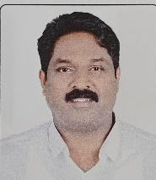
It gives me great pleasure to present the Pandemic Preparedness Plan for Mangalpady Grama Panchayat. Recent public health emergencies have highlighted the importance of strong preparedness and coordinated response at the local level to protect the health and wellbeing of our community.
This preparedness plan has been developed to strengthen the Panchayat’s ability to respond effectively to pandemics and other public health emergencies. The plan focuses on improving disease surveillance, enhancing coordination between different departments, ensuring the availability of essential resources, and promoting community awareness and participation.
Mangalpady Grama Panchayat remains committed to working closely with the Health Department, local institutions, and community members to ensure the effective implementation of this plan. With collective effort and cooperation from all stakeholders, we can build a resilient community that is well prepared to face future health challenges.
I sincerely appreciate the contributions of health officials, Panchayat members, and all those who have supported the preparation of this plan. I am confident that this initiative will strengthen our preparedness and safeguard the health of our people.

President
Mangalpady Grama Panchayat

MESSAGE FROM HEALTH STANDING COMMITTEE CHAIRPERSON

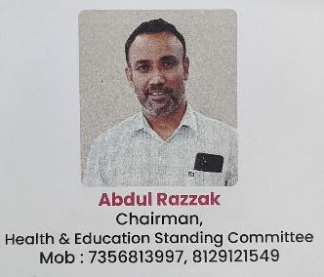
The Health Standing Committee of Mangalpady Grama Panchayat is pleased to present the Pandemic Preparedness Plan developed to strengthen the Panchayat’s readiness to respond to public health emergencies. The recent global health crises have clearly demonstrated the importance of strong local-level planning and coordinated action in protecting the health of the community.
This preparedness plan focuses on strengthening disease surveillance, improving coordination between the Health Department and local self-government institutions, and ensuring the availability of essential resources during emergencies. It also emphasizes the importance of community awareness, sanitation, and timely reporting of illnesses to prevent the spread of infectious diseases.The Health Standing Committee will continue to work closely with health authorities, Panchayat officials, and community members to ensure the effective implementation of this plan. Collective participation and cooperation are essential to build a resilient and healthy community.
I sincerely appreciate the efforts of all officials, health workers, and volunteers who contributed to the preparation of this plan.


Chairman
Health Standing Committee
Mangalpady Grama Panchayat

MESSAGE BY SUPERINTENDENT
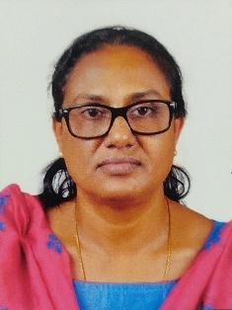
As the Superintendent of Mangalpady THQH, it is my responsibility to provide a technical framework for our collective safety. Our region’s unique coastal geography and high population density present specific epidemiological challenges. Data from recent years indicates a consistent prevalence of water-borne illness and vector-borne diseases, alongside a critical need for rapid response to respiratory outbreaks.
The cornerstone of this preparedness plan is Early Surveillance. In a densely populated area like ours, the window between a single case and a local outbreak is extremely narrow. This plan introduces a “Syndromic Surveillance” model, in which our dedicated ASHA workers and local health volunteers serve as our primary sensors. By identifying clusters of fever or respiratory distress at the ward level, we can initiate containment before our clinical facilities become overwhelmed.
By integrating government hospitals, sub-centres and local clinics into a unified network, we ensure that healthcare – particularly for vulnerable groups and those with chronic conditions – remain mobile and inclusive even during emergencies. We urge all private practitioners to strictly adhere to these official protocols and reporting guidelines, as this coordinated scientific approach is essential to safeguarding our community and saving lives.

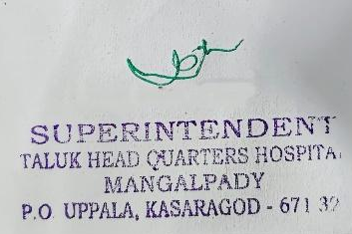
Superintendent
THQH Mangalpady
EXECUTIVE SUMMARY
Taluk Head Quarters Hospital (THQH) functions as the public healthcare institution serving the population of Mangalpady Grama Panchayat. The THQH plays a pivotal role in delivering comprehensive, accessible, and affordable healthcare services, with a strong focus on preventive, promotive, curative, and rehabilitative care in accordance with national and state health programmes.
The THQH caters to a predominantly rural population, addressing key public health priorities such as maternal and child health, communicable and non-communicable disease control, immunization, family welfare, adolescent health, and geriatric care. Regular outpatient services, home-based care through field health staff, and outreach activities ensure healthcare coverage even in geographically challenging areas.
THQH Mangalpady works in close coordination with the Grama Panchayat, ASHA workers, Anganwadi centres, schools, and community-based organizations to strengthen community participation and improve health awareness. Emphasis is placed on early detection, timely referral, health education, and lifestyle modification to reduce disease burden and improve overall health outcomes.
Despite constraints related to infrastructure, manpower, and increasing service demand, the THQH continues to enhance service delivery through effective planning, data-driven decision-making, and community engagement. Strengthening facilities, upgrading digital health systems, and expanding preventive services remain key focus areas for future development.
Overall, Mangalpady THQH stands as a vital institution in safeguarding public health and improving the quality of life of the residents of Mangalpady Grama Panchayat

LIST OF ABBREVIATIONS

LSGD/LSGI | Local Self Government Department / Local Self Government Institution
BMO | Block Medical Officer
IDSP | Integrated Disease Surveillance Programme
NDMA | National Disaster Management Authority
PPE | Personal Protective Equipment
ICMR | Indian Council of Medical Research
CD | Communicable Diseases
NCD | NON-COMMUNICABLE DISEASES

TABLE OF CONTENTS

INTRODUCTION 10
● Background of the PPP 10
LSGD AT A GLANCE 12
INTEGRATED HEALTH INFRASTRUCTURE MAP OF MANGALPADY PANCHAYAT 16
GENERAL PROFILE OF THE LSGI’S 17
Background of the LSGI 17
Demographic and Vulnerable Population 19
Clinical Vulnerability 20
INFRASTRUCTURE & RESOURCE INVENTORY 23
Health Facility Directory & Basic Capacity in the LSGD 23
Private Clinics 26
Healthcare Education & Training Institutions 27
Specialized Services & Emergency Inventory 28
Oxygen & Diagnostic Capacity 29
Diagnostics facility mapping at the LSGI level 30
Laboratory Identification & Basic Details 30
Social and Community Infrastructure for surge plan 31
Human resources 33
Community & Support Cadre 36
Community Organizations 38
Administrative & Emergency Services 39
Information regarding resources 39
ONE HEALTH & ENVIRONMENTAL SURVEILLANCE 41
Animal & Bird Population 41
Veterinary Infrastructure 43
Veterinary Doctors & Workforce 44
High-Risk Interface Points (Surveillance Sites) 45
Environmental Risk Mapping 47
Disease Seasonality Mapping 49
Vulnerability Mapping 51
EPIDEMIOLOGICAL TRENDS (2021–2025) 52
Disease Burden among human beings(Last 5 Years) 52
*(use the above table data to create the graph/diagram) 52
Seasonal Trend Analysis 54
Outcome-Based Trend Analysis- 2025 62
Transmission Trend- 2025 63
Integrated Disease Hotspot Map (2021–2025) 67
Preparedness and Response Protocol at LSG Level 71
Constitution of One Health Committee 71
Pandemic Response Workforce 73
Activities and Measures before and during Pandemic 75
PHASE 1 - Alert / Preparation 75
PHASE 2 - Active Response 78
Standard Screening Protocol 80
PHASE 3 - Surge Capacity 92
Conversion of Community Facilities 92
CONCLUSION 94
RECOMMENDATIONS 95
ANNEXURE 99
1. IMPORTANT PHONE NUMBERS 99

INTRODUCTION

Background of the PPP
Pandemics are large-scale outbreaks of infectious diseases that spread across countries or continents, causing significant morbidity, mortality, and socio-economic disruption. In recent decades, the world has experienced multiple emerging and re-emerging infectious threats such as severe acute respiratory syndrome (SARS), H1N1 influenza, Middle East Respiratory Syndrome (MERS), Ebola virus disease, and most notably COVID-19. These events have highlighted the vulnerability of health systems and the urgent need for structured preparedness and response mechanisms at global, national, and local levels.
Pandemic preparedness refers to the systematic development of policies, plans, capacities, and resources to prevent, detect, respond to, and recover from infectious disease outbreaks with pandemic potential. It encompasses early warning surveillance systems, rapid diagnostic facilities, trained healthcare workforce, stockpiling of essential supplies (PPE, medicines, vaccines), risk communication strategies, and continuity planning for essential services.
At the local level—such as districts, blocks, or panchayats—preparedness planning is crucial because frontline response occurs within communities. Strengthening primary healthcare systems, ensuring functional referral mechanisms, maintaining updated resource inventories, and conducting regular simulation exercises are essential components of preparedness. well-developed pandemic preparedness plan aims to:
- Minimize illness and deaths
- Protect healthcare workers
- Maintain essential health and public services
- Ensure efficient use of available resources
- Reduce social and economic disruption
In conclusion, pandemic preparedness is not a one-time activity but a continuous process of risk assessment, capacity building, and system strengthening. Lessons learned from past pandemics, particularly COVID-19, must inform resilient and adaptive preparedness strategies to safeguard public health in the future.

- LSGD at a glance
Mangalpady Grama Panchayat is a Local Self Government Institution situated in Manjeshwaram Block of Kasaragod district, Kerala. It lies in the northernmost region of the state and shares close proximity with the Kerala–Karnataka interstate border. Uppala, a major commercial town, is located within the Panchayat and functions as an important center for trade, transport, and public services. The Panchayat plays a significant role in implementing development programs, public health initiatives, sanitation activities, and social welfare schemes for the local population.
The Panchayat covers an area of approximately 36.3 square kilometers and has a population of about 48,441 people according to the Census 2011. The population density is around 1,300 persons per square kilometer, reflecting a moderately populated coastal region. Mangalpady Grama Panchayat is administratively divided into 24 wards, each represented by elected ward members under the Kerala Panchayat Raj system. Malayalam, Kannada, Tulu, Beary, and English are commonly spoken in the area, reflecting the cultural and linguistic diversity of the border region.
Boundaries of Mangalpady Grama Panchayat
- North: Karnataka State (Dakshina Kannada district)
- South: Manjeshwar Grama Panchayat
- East: Puthige and Meenja Grama Panchayats
- West: Arabian Sea
The Panchayat’s coastal location, interstate connectivity, and active local governance structure make it an important administrative unit in the northern part of Kasaragod district. The Local Self Government Institution works in coordination with the Health Department, education sector, and other government agencies to improve infrastructure, sanitation, and health services, thereby supporting disease prevention and community development initiatives.

LSGD AT A GLANCE
- Geographical boundaries with political map (based on latest delimitation)
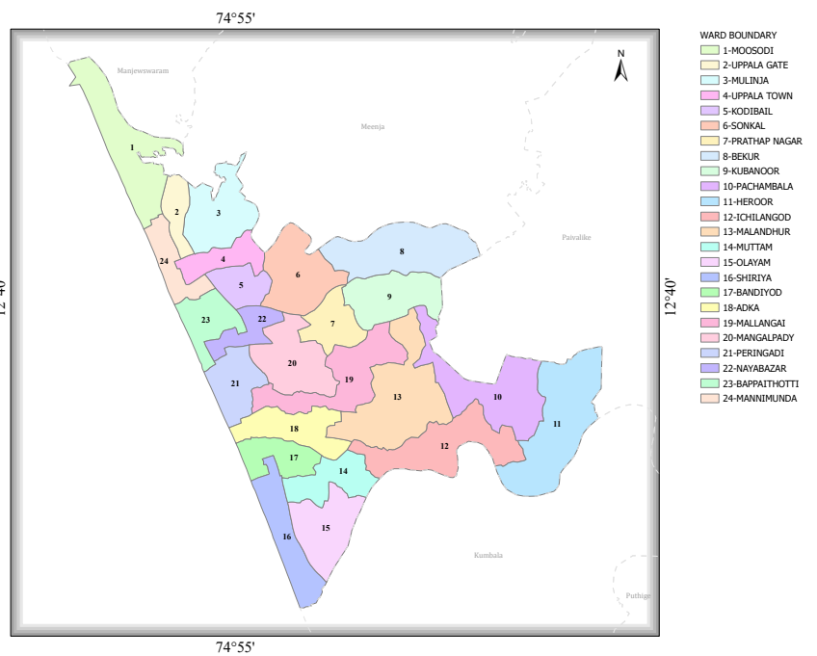
Baseline data
- Ward division -
Ward | Houses | Population | Migrants | Wells | Hot  spots | Ed. Institutions | Hosp pvt/govt.
24 | 12256 | 72741 | 620 | 66 | 0 | 84 | 5

- Major Roads/rivers
Mangalpady Grama Panchayat is well connected by an important road network that facilitates transportation, trade, and access to health and public services.
- National Highway 66 (NH-66) – The most important road passing through Mangalpady via Uppala town. It connects the Panchayat with major cities such as Mangaluru in the north and Kasaragod in the south.
- Uppala–Manjeshwar Road – A key local road linking Mangalpady with Manjeshwar and surrounding villages.
- Uppala–Puthige Road – Connects the Panchayat to interior areas such as Puthige and other rural settlements.
he major river associated with the Panchayat is:
- Shiriya River – A significant river flowing near the northern boundary of Mangalpady. It forms part of the natural boundary between Kerala and Karnataka and eventually drains into the Arabian Sea.
Apart from the Shiriya River, the Panchayat also has small streams, canals, and coastal backwaters

- Occupational groups, socio cultural groups, migration & mobility patterns
The economy of Mangalpady Grama Panchayat is largely supported by a mix of traditional and service-based occupations. A significant portion of the population is engaged in agriculture, particularly cultivation of coconut, paddy, arecanut, and other crops. Fishing and fish-related activities are also common in the coastal areas. Many residents work in small-scale trade and business, especially in and around Uppala town. Other occupational groups include daily wage laborers, construction workers, government and private sector employees, transport workers, and small entrepreneurs. A considerable number of households also depend on overseas employment, particularly in Gulf countries, which contributes to the local economy.
Socio-Cultural Groups:
Mangalpady Panchayat is characterized by cultural and linguistic diversity due to its border location. Major communities include Hindus, Muslims, and Christians, living together with a tradition of communal harmony. Multiple languages such as Malayalam, Kannada, Tulu, Beary, and Konkani are commonly spoken. The Panchayat also has Scheduled Castes and other socially diverse groups, contributing to the multicultural social structure of the region.
- Migration and Mobility Patterns:
Being close to the Kerala–Karnataka border, Mangalpady experiences regular interstate movement of people for work, education, and trade. There is also seasonal in-migration of laborers, particularly for construction and other manual jobs. Additionally, a large number of residents migrate to Gulf countries and other Indian states for employment.
Maps - ward-based (Mention source also)

- Geographical boundaries - ward boundaries map

- roads and rivers map
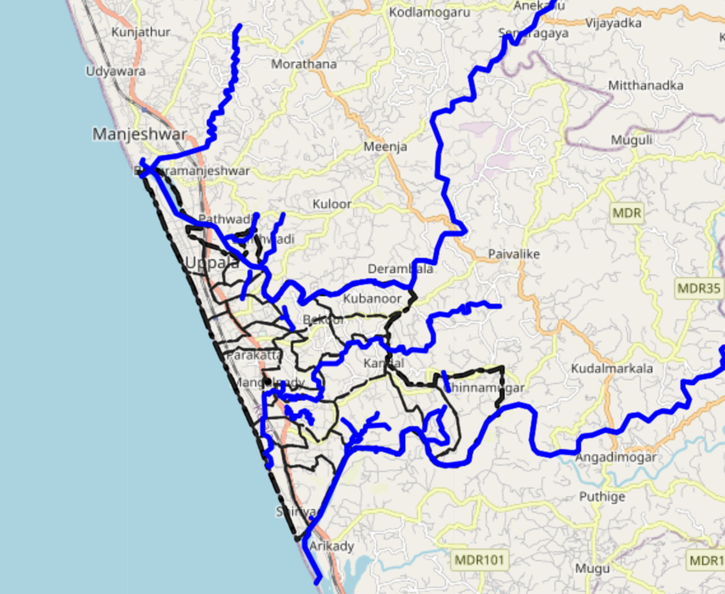
Source:https://map.opendatakerala.org/kasaragod/mangalpady-grama-panchayat/

INTEGRATED HEALTH INFRASTRUCTURE MAP OF MANGALPADY PANCHAYAT
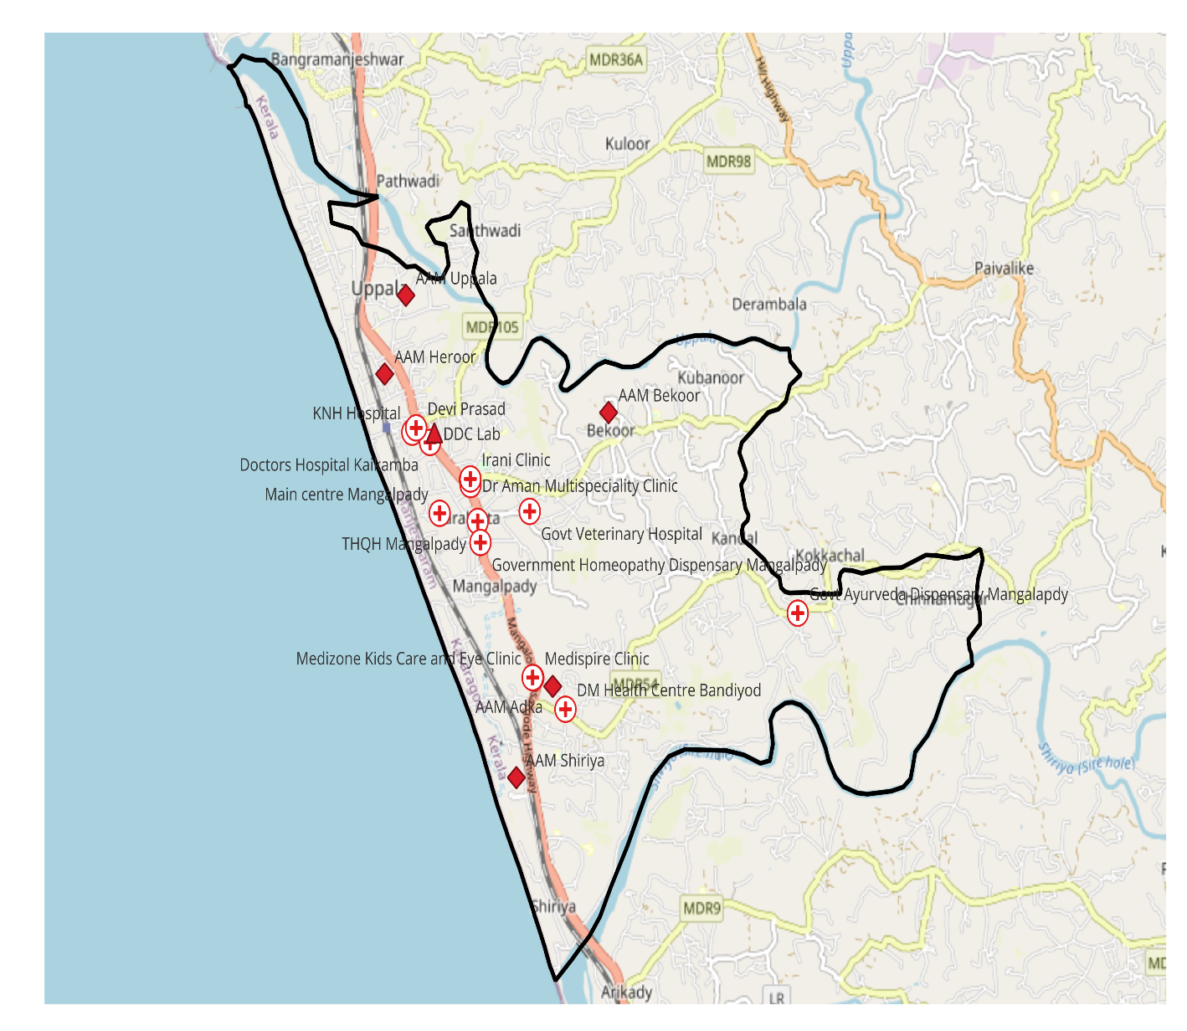
Mangalpady Administrative Boundaries Map
Boundary Data:Open Data Kerala
Map created with QGIS

GENERAL PROFILE OF THE LSGI’S

Background of the LSGI
Mangalpady Grama Panchayat is situated in the northern part of Kasaragod district, Kerala, close to the Kerala–Karnataka interstate border. The geographical landscape of the Panchayat is a combination of coastal plains, low-lying agricultural lands, and gently undulating terrain, with several small streams, canals, and coastal water bodies influencing the local environment. Its proximity to the Arabian Sea and the presence of backwaters and drainage channels contribute to a humid tropical climate and influence the local microclimate. During the monsoon season, heavy rainfall may lead to water stagnation in certain areas, which can affect transportation, sanitation, and service delivery.
The Panchayat is administratively divided into 24 wards, with a population engaged in diverse livelihood activities. Agriculture, particularly coconut and paddy cultivation, small-scale trade, fishing-related activities, and service-sector employment form important components of the local economy. Uppala town within the Panchayat functions as a commercial and service hub for surrounding areas. The Panchayat also hosts a diverse workforce, including migrant labourers engaged in construction, trade, and other service activities, reflecting the dynamic economic interactions of the border region.
From a public health perspective, the Panchayat faces seasonal challenges related to vector-borne and waterborne diseases, particularly during the monsoon period when mosquito breeding and environmental sanitation issues may increase. Continuous surveillance, environmental management, and community awareness programmes are therefore essential to maintain public health and prevent disease outbreaks.
In this context, the development of a localized, data-driven auxiliary infrastructure and logistical resource map is crucial for effective planning, emergency preparedness, and sustainable development. Such mapping helps the Panchayat identify critical facilities, improve coordination during emergencies, and strengthen the overall resilience and preparedness of the community.

Table 1: Background of LSGD
Description | Details
Name of LSGI | Mangalpady
Type (GP/Municipality / Corporation etc.) | Grama panchayat
Block | Manjeshwar
District | Kasaragod
Number of wards | 24
Total area (sq. km) | 36.36sqkm
Population (Projected) | 72741
Population density | 2014persons/sq km
Terrain (coastal/low-lying/backwaters/foothills, etc.) | Coastal, Midland
Number of rivers passing through LSGI | 2
Number of water bodies in the LSGI | 3
Number of educational institutions | 37
Factories / small-scale industries | 8
Flood-prone wards | 0
Landslide-prone wards | 0
Death Management and Disposal Facilities (mortuaries/crematorium, including electric) | 1
Auditoriums/Marriage halls/convention centres/community halls | 5

Demographic and Vulnerable Population
Understanding the demographic composition and vulnerable population groups is essential for pandemic preparedness. Children, elderly, economically deprived families, migrant workers, and socially vulnerable groups are at increased risk during public health emergencies due to higher exposure, limited access to services, and dependency on public systems.

Description |  | Details (in numbers)
DEMOGRAPHIC PROFILE
Total population |  | 72741
Male |  | 36359
Female |  | 36382
Transgender |  | 0
Children under 5 |  | 17219
Adolescent |  | 10539
Elderly (>60) |  | 13999
SOCIAL/LIVELIHOOD VULNERABILITY
Previous EPEP family |  | 283
BPL family |  | 320
Tribal communities |  | 0
Migration | Immigrant | 620
Migration | Emigrant | 0
Socio-economically deprived |  | 0
Fisherfolk |  | 800
SC Community |  | 2958
ST Community |  | 204

Clinical Vulnerability
Certain population groups need priority healthcare & are at higher risk of severe illness, complications, and mortality during pandemics. Patients with chronic diseases, those requiring regular medical care, and individuals with mobility or functional limitations face challenges in accessing timely care during emergencies. Mapping these groups helps in prioritizing continuity of treatment, medicine stock planning, oxygen support, referral transport, and targeted home-based care.

Description | Details in numbers
Pregnant women | 607
Lactating mothers | 860
Bedbound patients | 138
Patients under palliative care other than bedbound | 202
Patients on Haemodialysis | 48
Patients on CAPD | 0
Cancer patients (currently on treatment) | 107
Haemophilic patients | 0
Mentally challenged | 52
Differently abled | 32
Diabetic patients | 601
Hypertensive patients | 1006
TB patients | 19

The table highlights the distribution of vulnerable population groups who may be at increased risk during a pandemic or public health emergency.
A total of 607 pregnant women and 860 lactating mothers indicate a significant proportion of women requiring continuous maternal and child health services. These groups need uninterrupted access to antenatal care, postnatal care, nutrition support, and immunization services.
There are 138 bedbound patients and 202 individuals under palliative care, representing a highly dependent group that requires regular home-based care, medical support, and caregiver assistance. These individuals are particularly vulnerable during emergencies due to mobility limitations and underlying illnesses.
The presence of 48 patients on haemodialysis highlights the need for uninterrupted access to life-saving services, as any disruption in dialysis services can lead to serious health consequences. No patients are reported on CAPD.
There are 107 cancer patients currently undergoing treatment, who are immunocompromised and at higher risk of severe outcomes during infections. Similarly, 19 TB patients require continuous treatment adherence and monitoring to prevent complications and transmission.
The data also shows 52 mentally challenged individuals and 32 differently abled persons, who may face challenges in accessing healthcare services and require additional support during emergencies.
Chronic disease burden is notably high, with 601 diabetic and 1006 hypertensive patients, indicating a large population at risk of complications during infectious disease outbreaks. These individuals require regular medication, monitoring, and follow-up care.
No haemophilic patients are reported in the panchayat.

Major Festivals & Events specific to the LSGI
(with the possibility of a public gathering)

Sl. No. | Name of festival | Month detailing the periodicity
1 | Adka Temple | March
2 | Aila Temple Vishu Festival | April
3 | Ichilangod Masjid Uroos | once in 5 years
4 | Pachilampara masjid Uroos | once in 3 years

INFRASTRUCTURE & RESOURCE INVENTORY

Health Facility Directory & Basic Capacity in the LSGD
This section provides an overview of the healthcare infrastructure available within the LSGD area. It outlines the distribution and basic capacity of health facilities that form the backbone of service delivery during routine times and public health emergencies.

Family Health Centres (FHCs) and Community Health Centres (CHCs) generally function as the first point of contact for the community, providing essential outpatient and inpatient services. General Hospitals (GH) and Medical College Hospitals (MCH), where accessible, serve as the main referral centres for advanced diagnostics, specialist care, and critical services during public health emergencies. This inventory helps identify existing strengths, gaps, and potential surge capacity that can be mobilised during a pandemic or disaster.

Table 5. Health Facility Resource Summary
Sl.no. | Health Facility | Type of Facility (MCH/GH/CHC/FHC/SC etc.) | Contact Number | Total beds | ICU Beds | Oxygen-Supported Beds | No. of Ventilator Support Beds | No. of ambulances
Government Healthcare Facilities
1. | THQH Mangalpady | TH | 8075725238 | 24 | 0 | 0 | 0 | 1
2 | Shiriya | SC | 8075725238 | 0 | 0 | 0 | 0 | 0
3 | Bekoor | SC | 8075725238 | 0 | 0 | 0 | 0 | 0
4 | Heroor | SC | 8075725238 | 0 | 0 | 0 | 0 | 0
5 | Main centre Mangalpady | SC | 8075725238 | 0 | 0 | 0 | 0 | 0
6 | Adka | SC | 8075725238 | 0 | 0 | 0 | 0 | 0
7 | Uppala | SC | 8075725238 | 0 | 0 | 0 | 0 | 0
Private Healthcare Facilities
1 | Society Hospital Bayar |  | 9567502309 | 5 | 0 | 0 | 0 | 0
2 | KNH Hospital |  | 914998240241 | 10 | 1 | 1 | 1 | 0
3 | Doctors Hospital Kaikamba |  | 7947135280 | 5 | 0 | 0 | 0 | 0
4 | DM Health Centre Bandiyod |  | 9400014009 | 10 | 0 | 0 | 0 | 0
5 | Devi Prasad |  | 9846783211 | 2 | 0 | 0 | 0 | 0
AYUSH Healthcare Facilities
1 | Government Homeopathy Dispensary Mangalpady |  | 9744311447 | 0 | 0 | 0 | 0 | 0
2 | Govt Ayurveda Dispensary Mangalapdy |  | 9535361993 | 0 | 0 | 0 | 0 | 0

Private Clinics
Private clinics are an essential part of pandemic preparedness, as they are often the first-place people seek care when symptoms begin. In many communities, private clinics manage a significant share of outpatient visits and therefore play a critical role in early case detection, timely referrals, and disease surveillance. Having an up-to-date understanding of where these clinics are located, the services they provide, and how they are linked to the public health system helps ensure that no cases are missed during an outbreak. It also allows health authorities to engage private practitioners more effectively for reporting, risk communication, and coordinated response, strengthening the overall capacity of the health system to manage public health emergencies.

Table 6. Private Clinic Resource Summary
Sl No. | Name of Clinic | Registered (Y/N) | Clinic (General / Speciality) | Speciality (if any) | Address | Contact Number | Diagnostic Facility (Y/N) | Ambulance Linkage (Y/N)
1 | Medispire Clinic | N | Speciality | Dental | Bandiyod, Mangalpady | 7947129896 | Y | Y
2 | Medizone Kids Care and Eye Clinic | N | General | Eye | Mallagai,Uppala | 8050055162 | Y | Y
3 | Dr Aman Multispeciality Clinic | N | Speciality | Dental | Kaikamba Uppala | 999525359 | Y | Y
4 | Irani Clinic | N | General | 0 | Kaikamba Uppala | 7947150794 | Y | Y

Healthcare Education & Training Institutions
This section tracks the educational infrastructure available, which is vital for human resource planning in the health sector.

Category of Institution | Govt | Private | AYUSH | Total
Medical Colleges | 0 | 0 | 0 | 0
Nursing Colleges | 0 | 0 | 0 | 0
Dental Colleges | 0 | 0 | 0 | 0
Para-medical / Allied Health | 0 | 0 | 0 | 0
Pharmacy Colleges | 0 | 0 | 0 | 0

Specialized Services & Emergency Inventory
This section provides a detailed view of the specialized medical resources available to the community, focusing on emergency response and critical care capabilities. This table tracks the vital assets required for managing severe illnesses and emergencies across Government, Private, and AYUSH sectors.

Item | Govt | Private | AYUSH | Total
Hospital beds | 24 | 85 | 0 | 109
Oxygen-generating systems(Y/N) | 0 | 0 | 0 | 0
Oxygen-supported beds (Numbers) | 2 | 11 | 0 | 13
Ventilator-supported beds | 0 | 0 | 0 | 0
ICU beds | 0 | 0 | 0 | 0
Burns units | 1 | 0 | 0 | 1
Blood centres | 0 | 0 | 0 | 0
BLS ambulances | 1 | 2 | 0 | 3
ALS ambulances | 0 | 1 | 0 | 1
Dialysis facilities | 1 | 0 | 0 | 1
Dispensaries | 0 | 0 | 0 | 0
Medical store | 1 | 6 | 1 | 8
Industrial establishments (Medium-scale industries/small-scale industries establishments to whom we can depend in a worst-case scenario) | 0

Oxygen & Diagnostic Capacity
Monitoring oxygen and diagnostic capacity is a critical component of public health preparedness, ensuring that the LSGD can handle both chronic care and sudden surges in respiratory or infectious diseases.
Name of Health Facility | Oxygen-generating System (Y/N) | Backup Oxygen Source (Y/N) | Diagnostic Facilities Available(Y/N)
Name of Health Facility | Oxygen-generating System (Y/N) | Backup Oxygen Source (Y/N) | Lab | USG | X-ray | CT/MRI | RT-PCR
Government Healthcare Facilities
THQH Mangalpady | Y | Y | Y | N | Y | N | N

Diagnostics facility mapping at the LSGI level
The diagnostic capacity of Mangalpady G.P represents the "intelligence network" of our healthcare system. The speed and accuracy of disease identification depend entirely on the distribution and technical level of these facilities.

Item | Govt | Private | AYUSH | Total
General labs | 1 | 6 | 0 | 7
Microbiology labs | 0 | 0 | 0 | 0
RT-PCR labs | 0 | 0 | 0 | 0
USG units | 0 | 2 | 0 | 0
CT/MRI units | 0 | 0 | 0 | 0
Research labs | 0 | 0 | 0 | 0
Labs of other departments that can be repurposed | 0 | 0 | 0 | 0

Laboratory Identification & Basic Details
Sl. No. | Name of Laboratory | Ownership (Govt / Private / Academic) | Address | Contact No. | 24×7 Services (Yes/No) | NABL / Govt Approved (Yes/No)
1 | THQH Mangalpady | Govt | Mangalpady, Uppala | 04998242098 | NO | NO
2 | DM Health Care | Private | Bandiyod Uppala | 80860 89333 | YES | NO
3 | Doctors Lab | Private | Uppala | 7942694731 | NO | NO
4 | Society Hospital Lab | Private | Uppala | 4998243956 | NO | NO
5 | KNH Lab | Private | Uppala | 7947431696 | YES | NO
6 | DDC Lab | Private | Uppala | 8129702089 | NO | NO

Social and Community Infrastructure for surge plan
This table serves as our logistics and shelter inventory. By mapping these locations, quickly we can identify where to house displaced citizens, where to set up temporary medical clinics, and how to manage the deceased with dignity during a crisis.
Category | Total Count | Ward | Est. Capacity (Persons) | Contact details
Educational Institutions
Anganwadis | 47 | 23 | 1000 | 9947020260
Schools | 37 | 23 | 20000 | 4998241396
Colleges | 0 | 0 | 0 | 0
Healthcare Educational Institutions
Medical colleges (Govt/Private) | 0 | 0 | 0 | 0
Nursing colleges (Govt/Private) | 0 | 0 | 0 | 0
Dental colleges (Govt/Private) | 0 | 0 | 0 | 0
Paramedical institutes (Govt/Private) | 0 | 0 | 0 | 0
Community Gathering Spaces
Community halls | 1 | 18 | 5000
Auditoriums | 4 | 4 | 10000 | 9496049707
Religious buildings | 1 | 1 | 550 | 9446401570
Vulnerable Group Support Facility
Destitute homes | 1 | 1 | 150 | 9496049707
Elderly homes | 0 | 0 | 0 | 0
LSGD owned other buildings | 1 | 1 | 25 | 9496049707
Mass Fatality Management (MFM) Infrastructure
Mortuary | 1 | 1 | 3 | 4998242098
Crematorium | 1 | 1 | 2 | 9496049707
*refer annexure 1 for contact details

Human resources
This section focuses on the human capital available within the LSGI. In any emergency—be it a pandemic, flood, or industrial accident—infrastructure is only as effective as the people operating it.

Medical & Clinical Personnel
This table tracks the "Frontline" providers responsible for diagnosis, treatment, and clinical management. A detailed directory with the contact numbers of all workers is maintained (Annexure in 1).

Cadre | Govt (No.) | Private (No.) | Total
Doctors—Modern Medicine | 9 | 12 | 21
Doctors – AYUSH | 1 | 0 | 1
Doctors – Veterinary | 1 | 0 | 1
Doctors – Dental | 0 | 2 | 2
Nursing officers | 14 | 20 | 34
Lab technicians | 7 | 15 | 22
Optometrist | 1 | 2 | 3
Pharmacists | 4 | 10 | 14
Psychologists | 0 | 0 | 0
Counsellors | 8 | 2 | 2

Public Health & Field-Level Workforce
These individuals are the backbone of surveillance, maternal-child health, and decentralized care.

Cadre | Health services | Municipal common services | Total
HS (Health Supervisors) | 0 | 0 | 0
HI (Health Inspectors) | 1 | 0 | 1
LHS (Lady Health Supervisor) | 0 | 0 | 0
LHI (Lady Health Inspectors) | 1 | 1 | 2
JPHN (Jr Public Health Nurses) | 6 | 0 | 6
JHI (Jr Health Inspectors) | 4 | 0 | 4
MLSP (Mid-Level Service Providers) | 3 | 0 | 3
Palliative Nurses | 2 | 0 | 2
RBSK Nurses | 1 | 0 | 1
PRO | 1 | 0 | 1
Epidemiologist | 1 | 0 | 1
Data Manager | 1 | 0 | 1

Community & Support Cadre
This group represents the surge capacity of the LSGI—people who can be called upon for logistics, rescue, and specialized support.

Cadre | Number
ASHA Workers | 23
AWW (Anganwadi Workers) | 47
Emergency Medical Volunteers (Trained) | 20
Kudumbashree | 3048
MNREGS | 568
Purusha Swayam Sahaya Sangham | 21
Ex-Servicemen | 9
Retired Police Officers | 11
NCC/NSS Volunteers | 320
Red Cross volunteers | 158
One Health Community Volunteers | 10
One Health Community Mentors | 2

Community Organizations
This section details the presence of community-based organisations (CBOs), non-governmental organisations (NGOs), faith-based organisations (FBOs), Kudumbashree Self-Help Groups (SHGs), and Ayalkootams within the Local Self-Government Institution (LSGI). These groups enhance grassroots mobilization, resource distribution, and support networks crucial for pandemic response and community resilience.

Category | Total Count
NGOs | 3
Religious based organizations | 3
Foreign based organizations | 0
Sports Club/youth clubs | 41
Kudumbashree SHGs | 1
Ayalkootams | 254
Political organizations | 4
Residential organizations | 15

Administrative & Emergency Services
This section outlines the availability of key non-health emergency support services and infrastructure within the LSGI, which are essential for effective pandemic preparedness and response. These facilities support law enforcement, disaster response, water supply, logistics, mobility, and community-level interventions during public health emergencies.

Category | Total Count | Contact details
Police Stations | 1 | 9447650810
Fire & Rescue Stations | 1 | 04998241101
Water Pumping Points | 1 | 9496049707
Public Distribution System (PDS) | 11 | 04998230089

Information regarding resources
The availability of essential transport and support resources plays a quiet but critical role in saving lives. Equipment such as ambulances, mobile mortuaries, amphibian ambulances, and motorized boats ensures that patients, samples, and healthcare teams can move swiftly—even in flooded, remote, or difficult terrains. Heavy vehicles like JCBs, cranes, tractors, and torus lorries support logistics, waste management, emergency infrastructure, and rapid conversion of spaces into care or isolation facilities. Taxis, four-wheel-drive vehicles, and trucks help maintain continuity of essential services, reach vulnerable populations, and support home-based care and supply delivery.

Means of transportation | Total Count
JCB | 63
Crane | 8
Heavy Trucks | 131
Tractor | 5
Ambulances | 7
Mobile mortuaries | 0
Boats | 42
Taxi service | 3
Note: For specific details regarding vehicle owners and contact information, please refer to Annexure [X].

ONE HEALTH & ENVIRONMENTAL SURVEILLANCE
The One Health method integrates environmental, animal, and human health to enable proactive pandemic preparedness. Panchayat-level surveillance needs to be improved in order to detect and treat zoonotic and environmentally generated diseases early. Mapping animal and bird populations at the Panchayat level is essential for identifying and prioritising zoonotic disease hazards like rabies, leptospirosis, anthrax, and Nipah-like spillover occurrences. Risk classification, targeted surveillance, vaccination planning, and early epidemic detection made feasible by comprehensive population mapping all enhance One Health-based pandemic preparedness.

Category | Item | Estimated Population | Wards
Animal Population | Livestock (Cattle/Goats/Buffalo) | Cattle-1566, Goat-718, Buffalo-50 | 1-23
Animal Population | Pet Animals (Dogs/Cats) | 1000 | 1-23
Animal Population | Stray Dog Population | 100 | 1-23
Animal Population | Pig Farms (Number of heads) | 0 | 0
 | Small Units (Sheep / Goats – clustered) | 0 | 0
Bird Population | Poultry Units (Birds) | 0 | 0
Bird Population | Poultry- (FOWL) | 26710 | 1-23
Bird Population | Wild/Migratory Birds (Observed) | 0 | 0
Bird Population | Crow Mortality Events (Reported) | 0 | 0

Based on the table, the zoonotic disease risk in Mangalpady Panchayat is relatively low and uniformly distributed across Wards 1–23, as there are no reported pig farms, clustered small livestock units, poultry units, or migratory bird congregation areas. However, the presence of 1,566 cattle, 718 goats, 50 buffaloes, around 1,000 pet animals, and 100 stray dogs indicates ongoing human–animal interaction, which necessitates routine surveillance for zoonotic diseases such as rabies and leptospirosis. Although no crow mortality or avian risk has been reported, the existing livestock and stray animal population across all wards highlights the need for continuous monitoring, vaccination, and preventive measures, especially in areas with higher animal density.

Veterinary Infrastructure
Veterinary institutions are a core pillar of One Health surveillance, enabling early zoonotic disease detection through vaccination, investigation of unusual animal illness or deaths, sample collection, and timely outbreak reporting. A well-mapped and responsive veterinary network strengthens coordination with human health and LSGI systems, ensuring rapid response during zoonotic events and pandemics.
Facility Type | Name of Facility | Ownership Govt / Pvt | Location(Ward No) | Contact number
Veterinary Dispensary | 1 | Govt | 20 | 7902640671
Veterinary Hospital / Polyclinic | 0 | 0 | 0 | 0
Private Veterinary Clinics | 0 | 0 | 0 | 0
Mobile / Emergency Vet Service (incl. night services) | 0 | 0 | 0 | 0
Pet Homes / Animal Shelters | 0 | 0 | 0 | 0
Slaughterhouse-linked Veterinary Inspection Unit | 0 | 0 | 0 | 0

Veterinary Doctors & Workforce
Early detection, diagnosis, reporting, and reaction to animal illness epidemics depend on the availability and accessibility of qualified veterinary specialists. By identifying unusual animal morbidity or mortality promptly, collecting samples promptly, and coordinating efficiently with human health and LSGI systems—especially during zoonotic outbreaks and pandemic-prone situations—a clearly defined veterinary workforce enhances One Health surveillance.

Category | Number Available | Type (Govt/Pvt) | Contact number
Government Veterinary Doctors | 1 | Employment | 8547867018
Private Veterinary Doctors | 0
Livestock Inspectors | 1 | Govt | 7902640617
Para-veterinary Staff / Attenders | 1 | Govt | 8138906100
Contract / On-call Veterinary Support (if any) | 0

High-Risk Interface Points (Surveillance Sites)
High-risk interface points for zoonotic disease surveillance in Mangalpady Grama panchayat include wetland–livestock–human contact zones, cattle sheds near water bodies, fish markets. These are the primary surveillance sites where zoonotic spill over risks are elevated.

Type of Habitat | Type of High risk interface | Geographical vulnerability
Wetlands & Backwaters | 1 | Uppala Lake-Its low lying, coastal geography, intense monsoon flooding and high population density
Backyard Poultry Farms | 0
Cattle Sheds near Water Bodies | 1 | Heroor
Fish & Meat Markets | 1 | Uppala
Community Slaughter Sites | 0
Migratory Bird Congregation Areas | 0
Rodent-Infested Grain Storage | 0

Category | Total Count | Key Locations (wards)
Poultry Farms | 2 | Heroor
Backyard / Clustered Poultry Units | 0 | 0
Duck Rearing Units (open water access) | 0 | 0
Slaughterhouses/ Slaughter Points | 1 | Uppala
Meat/Fish Markets | 1 | Uppala
Live Bird Sale Points | 0 | 0
Cattle Markets / Weekly Animal Fairs | 0 | 0
Pet Shops / Breeders | 1 | Uppala
Animal Shelters / Pet Homes | 0 | 0
Waste Disposal Sites near Animal Units | 0 | 0

Environmental Risk Mapping
Environmental risk mapping identifies monsoon/flood hotspots for vector-borne (dengue, chikungunya), water-borne (leptospirosis, diarrhoea), and zoonotic diseases in Kerala. Systematic surveillance supports early warnings, targeted interventions, and Panchayat pandemic preparedness.
Waterborne exposure: Flood-prone areas and stagnant water bodies facilitate leptospira survival, raising leptospirosis risk.

Traditional practices: Informal slaughter and fish markets lack standardized hygiene, creating spill over opportunities.

Risk Factor | High-Risk Wards | Key Locations | Risk Level (High/Med/Low)
Flood-prone areas | Uppala | Uppala | Medium
Water bodies/wetlands | Uppala | Uppala | Medium
Solid waste accumulation | Kubanoor | Adka | Low
Animal waste disposal issues | 0 | 0 | 0
Rodent infestation zones | 0 | 0 | 0
Industrial effluent discharge | 0 | 0 | 0
Construction sites / abandoned buildings | Uppala | Market | Medium
Poor drainage/blocked canals | 0 | 0 | 0
Drinking water source contamination risk | Mangalpady | G.P | Medium

Disease Seasonality Mapping
1, Flooding & waterlogging → amplifies leptospirosis, malaria, diarrheal diseases.

2, Mosquito breeding cycles → vector-borne disease peaks in monsoon.

3, Agricultural practices → close human–animal contact in paddy fields.

Disease | Peak Risk Season | Key Drivers | High-Risk Locations | Surveillance Focus
Leptospirosis | Monsoon | Poor sanitation, waterlogging | All wards | All wards
Dengue/Chikungunya | Monsoon | Mosquito breeding, stagnant water | All wards | All wards
Acute Diarrheal Diseases | Summer | Contaminated food & water | All wards | 0
Rabies | All seasons | Animal bites (dogs) | 0 | 0

Vulnerability Mapping
Vulnerability mapping pinpoints high-risk populations, occupations, and areas exposed via environment, livelihoods, socio-economics, and poor service access. Paired with environmental/seasonality mapping, it enables risk-based surveillance, targeted actions, and optimal resource use in One Health and pandemic planning.
Vulnerability Factor | High-Risk Wards | Key Groups / Locations | Risk Level
Flood-prone households | 4 | Uppala & Near Coastal Area | Medium
Wetland-adjacent communities | 0 | 0 | 0
Backyard poultry / duck rearing households | 0 | 0 | 0
Livestock-rearing households | 0 | 0 | 0
Slaughterhouse & meat market workers | 2 | Uppala Town | Medium
Fisherfolk & fish market workers | 1 | Uppala Town | Medium
Sanitation workers | 23 | All wards | Low
Daily wage / migrant workers | 5 | Uppala TOwn | High
Elderly & chronically ill populations | 0 | 0 | 0
Pregnant Women | 0 | 0 | 0
Children (schools, Anganwadi’s) | 3 | Shiriya,Uppala | Medium
Limited access to safe water & sanitation | 0 | 0 | 0

EPIDEMIOLOGICAL TRENDS (2021–2025)
Disease surveillance is the systematic collection, analysis, and interpretation of health data for planning, implementation, and evaluation of public health practice. This section presents the disease surveillance profile of the LSGI based on routine reporting systems and outbreak investigations to identify priority diseases, seasonal patterns, and emerging public health threats.

Disease Burden among human beings (Last 5 Years)
Analysis of disease-wise data for the last five years helps identify persistent public health problems, emerging diseases, and changes in disease burden. This information supports prioritisation of prevention, preparedness, and response activities at the Panchayat level.

Disease | 2021 | 2022 | 2023 | 2024 | 2025 | Trend(Increasing/Stable/Decreasing)
Dengue | 78 | 1 | 36 | 61 | 14 | Decreasing
Leptospirosis | 0 | 0 | 0 | 0 | 1 | Stable
Hepatitis A | 17 | 3 | 0 | 6 | 9 | Increasing
Malaria | 7 | 0 | 4 | 6 | 10 | Increasing
Scrub Typhus | 0 | 0 | 0 | 0 | 1 | Increasing
Typhoid | 1 | 2 | 0 | 5 | 3 | Decreasing
H1N1 | 0 | 0 | 0 | 0 | 0 | Stable
H3N2 | 0 | 0 | 0 | 0 | 0 | Stable
ADD | 42 | 37 | 69 | 395 | 455 | Increasing
Mumps | 30 | 25 | 30 | 100 | 30 | Decreasing
Measles | 20 | 10 | 65 | 4 | 0 | Decreasing
Hepatitis B | 0 | 0 | 0 | 0 | 0 | Decreasing
Hepatitis C | 0 | 0 | 0 | 0 | 0 | Decreasing
Tuberculosis | 11 | 21 | 21 | 20 | 42 | Increasing
Leprosy | 0 | 0 | 0 | 0 | 0 | Decreasing
COVID-19 | 3000 | 800 | 0 | 0 | 0 | Decreasing

Seasonal Trend Analysis
Seasonal analysis helps anticipate surges (e.g. dengue in monsoon, leptospirosis after floods, influenza in cooler months) and plan pre‑emptive vector control, stockpiling of IV fluids, and awareness campaigns at Panchayat level.

DENGUE
Dengue is a major seasonal vector-borne disease strongly associated with rainfall, water stagnation, and increased mosquito breeding during the monsoon period.
Peak : July–November

Dengue – Ward-wise Yearly Distribution (2021–2025)

Ward | Dengue – Ward-wise Yearly Distribution
Ward | 2021 | 2022 | 2023 | 2024 | 2025 | Total
1 | 10 | 1 | 5 | 4 | 2 | 22
2 | 6 | 0 | 2 | 5 | 0 | 13
3 | 5 | 0 | 1 | 7 | 0 | 13
4 | 2 | 0 | 7 | 1 | 4 | 14
5 | 5 | 0 | 1 | 1 | 0 | 7
6 | 6 | 0 | 1 | 4 | 0 | 11
7 | 0 | 0 | 0 | 7 | 0 | 7
8 | 7 | 0 | 4 | 8 | 0 | 19
9 | 2 | 0 | 2 | 1 | 0 | 5
10 | 5 | 0 | 4 | 2 | 1 | 12
11 | 6 | 0 | 1 | 2 | 0 | 9
12 | 2 | 0 | 1 | 3 | 0 | 6
13 | 4 | 0 | 2 | 4 | 1 | 11
14 | 1 | 0 | 2 | 1 | 0 | 4
15 | 2 | 0 | 0 | 5 | 1 | 8
16 | 6 | 00 | 2 | 1 | 1 | 10
17 | 3 | 0 | 0 | 1 | 0 | 4
18 | 1 | 0 | 0 | 1 | 1 | 3
19 | 2 | 0 | 0 | 1 | 2 | 5
20 | 0 | 0 | 0 | 1 | 0 | 1
21 | 1 | 0 | 0 | 0 | 0 | 1
22 | 1 | 0 | 0 | 0 | 0 | 1
23 | 1 | 0 | 0 | 0 | 0 | 1

Leptospirosis cases are closely linked to monsoon rains, flooding, and occupational exposure, particularly in low-lying and waterlogged areas.
Peak : June - August

Leptospirosis – Ward-wise Yearly Distribution (2021–2025)

Ward | Leptospirosis – Ward-wise Yearly Distribution
Ward | 2021 | 2022 | 2023 | 2024 | 2025 | Total
1 | 0 | 0 | 0 | 0 | 0 | 0
2 | 0 | 0 | 0 | 0 | 0 | 0
3 | 0 | 0 | 0 | 0 | 0 | 0
4 | 0 | 0 | 0 | 0 | 0 | 0
5 | 0 | 0 | 0 | 0 | 0 | 0
6 | 0 | 0 | 0 | 0 | 0 | 0
7 | 0 | 0 | 0 | 0 | 0 | 0
8 | 0 | 0 | 0 | 0 | 0 | 0
9 | 0 | 0 | 0 | 0 | 0 | 0
10 | 0 | 0 | 0 | 0 | 0 | 0
11 | 0 | 0 | 0 | 0 | 0 | 0
12 | 0 | 0 | 0 | 0 | 0 | 0
13 | 0 | 0 | 0 | 0 | 0 | 0
14 | 0 | 0 | 0 | 0 | 0 | 0
15 | 0 | 0 | 0 | 0 | 0 | 0
16 | 0 | 0 | 0 | 0 | 0 | 0
17 | 0 | 0 | 0 | 0 | 0 | 0
18 | 0 | 0 | 0 | 0 | 1 | 1
19 | 0 | 0 | 0 | 0 | 0 | 0
20 | 0 | 0 | 0 | 0 | 0 | 0
21 | 0 | 0 | 0 | 0 | 0 | 0
22 | 0 | 0 | 0 | 0 | 0 | 0
23 | 0 | 0 | 0 | 0 | 0 | 0

VIRAL HEPATITIS - A
Hepatitis A cases are commonly associated with unsafe drinking water, food contamination, and breakdowns in sanitation, often presenting as clusters or outbreaks.
Peak : October - December

Hepatitis A – Ward-wise Yearly Distribution (2021–2025)

Ward | Hep A – Ward-wise Yearly Distribution
Ward | 2021 | 2022 | 2023 | 2024 | 2025 | Total
1 | 1 | 1 | 0 | 1 | 3 | 6
2 | 1 | 0 | 0 | 0 | 0 | 1
3 | 2 | 1 | 0 | 1 | 1 | 5
4 | 2 | 1 | 0 | 0 | 0 | 3
5 | 1 | 0 | 0 | 1 | 1 | 3
6 | 1 | 0 | 0 | 0 | 0 | 1
7 | 1 | 0 | 0 | 0 | 2 | 3
8 | 0 | 0 | 0 | 0 | 0 | 0
9 | 0 | 0 | 0 | 1 | 0 | 1
10 | 1 | 0 | 0 | 1 | 0 | 2
11 | 2 | 0 | 0 | 0 | 0 | 2
12 | 0 | 0 | 0 | 0 | 0 | 0
13 | 0 | 0 | 0 | 1 | 0 | 1
14 | 0 | 0 | 0 | 0 | 0 | 0
15 | 0 | 0 | 0 | 0 | 0 | 0
16 | 0 | 0 | 0 | 0 | 0 | 0
17 | 0 | 0 | 0 | 0 | 0 | 0
18 | 1 | 0 | 0 | 0 | 0 | 1
19 | 0 | 0 | 0 | 0 | 0 | 0
20 | 0 | 0 | 0 | 0 | 0 | 0
21 | 0 | 0 | 0 | 0 | 1 | 1
22 | 0 | 0 | 0 | 0 | 0 | 0
23 | 0 | 0 | 0 | 0 | 1 | 1

Outcome-Based Trend Analysis- 2025
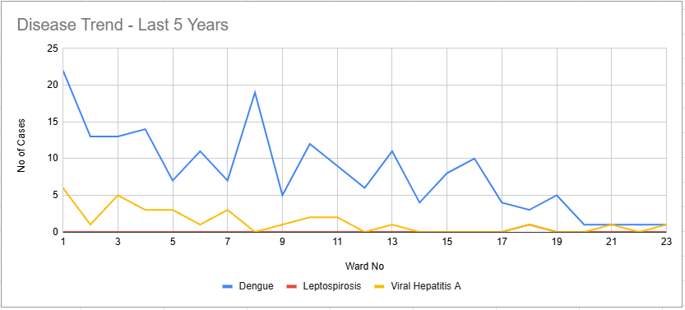

Transmission Trend- 2025
For effective management of public health issues, it is important to track the trend of disease transmission mode. It helps identify the population or place at high risk that can be used to predict outbreaks and implement targeted interventions as quickly as possible. Understanding these kinds of trends enables authorities to allocate resources efficiently and change the strategies adequately based on the trend that follows.

Mode of Transmission | No. of cases | No. of Deaths
Vector Borne Diseases | 24 | 0
Water Borne Diseases | 9 | 0
Air Borne Diseases | 42 | 0
Blood Borne Diseases | 0 | 0
Food Borne Diseases | 0 | 0

Vector-Borne Disease
Disease | No. of Cases | No. of Deaths
Dengue | 14 | 0
Malaria | 10 | 0
Chikungunya | 0 | 0

Water Borne Disease
Disease | No. of Cases | No. of Deaths
Cholera | 0 | 0
Typhoid | 3 | 0
Hep- A | 9 | 0
Dysentery | 0 | 0
Amoebiasis | 0 | 0
E- Coli infections | 0 | 0

Air Borne Disease
Disease | No. of Cases | No. of Deaths
Influenza | 0 | 0
H1N1 | 0 | 0
TB | 42 | 0
Chickenpox | 10 | 0
Measles | 0 | 0
Covid-19 | 0 | 0
Pertussis | 0 | 0
Mumps | 30 | 0

Blood-Borne Disease
Disease | No. of Cases | No. of Deaths
AIDS | 0 | 0
Hep- B | 0 | 0
Hep- C | 0 | 0

Zoonotic Disease
Disease | No. of Cases | No. of Deaths
Rabies | 0 | 0
Leptospirosis | 1 | 1
Avian influenza | 0 | 0
West 0e | 0 | 0
Anthrax | 0 | 0
Nipah | 0 | 0
Scrub Typhus | 1 | 0

Integrated Disease Hotspot Map (2021–2025)

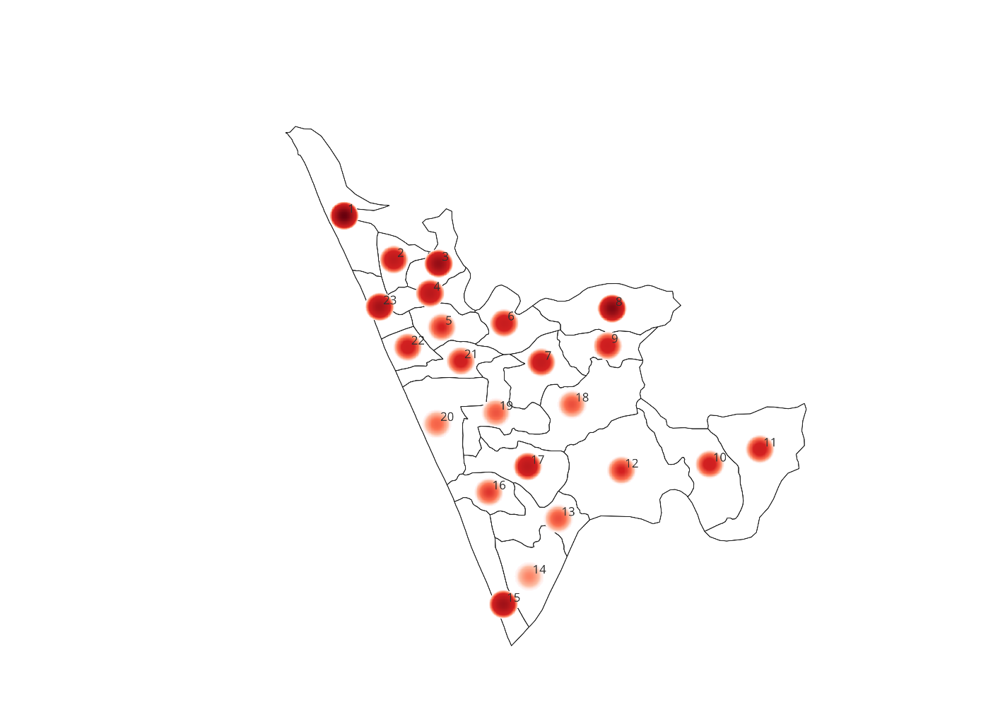

The Integrated Disease Hotspot Map (2021–2025) illustrates the spatial distribution of communicable disease cases across various wards, with red intensity representing higher case concentrations. The map indicates a noticeable clustering of cases in the central and northern wards, where darker red areas reflect a greater disease burden. High-incidence hotspots are specifically observed in wards 1, 3, 6, 7, 15, 17, and 23 identifying them as priority areas for targeted public health interventions. In contrast, the southern and peripheral wards display fewer and less intense hotspots, indicating relatively lower case numbers. Overall, the distribution demonstrates significant spatial variation, with identifiable clusters likely influenced by factors such as population density, sanitation conditions, and access to healthcare services.

Ward No | Dengue Total (2021-25) | Leptospirosis Total (2021-25) | Hepatitis A Total (2021-25) | Mumps (2021-25) | ADD (2021-25) | Total Cases
1 | 22 | 0 | 6 | 10 | 187 | 225
2 | 13 | 0 | 1 | 20 | 30 | 64
3 | 13 | 0 | 5 | 22 | 100 | 140
4 | 14 | 0 | 3 | 10 | 45 | 72
5 | 7 | 0 | 3 | 0 | 15 | 25
6 | 11 | 0 | 1 | 5 | 30 | 47
7 | 7 | 0 | 3 | 2 | 43 | 55
8 | 19 | 0 | 0 | 6 | 150 | 175
9 | 5 | 0 | 1 | 1 | 32 | 39
10 | 12 | 0 | 2 | 10 | 10 | 34
11 | 9 | 0 | 2 | 2 | 23 | 36
12 | 6 | 0 | 0 | 15 | 4 | 25
13 | 10 | 0 | 1 | 2 | 2 | 15
14 | 5 | 0 | 0 | 1 | 1 | 7
15 | 8 | 0 | 0 | 10 | 101 | 119
16 | 10 | 0 | 0 | 5 | 5 | 20
17 | 4 | 0 | 0 | 10 | 54 | 68
18 | 3 | 1 | 1 | 4 | 6 | 15
19 | 5 | 0 | 0 | 8 | 1 | 14
20 | 1 | 0 | 0 | 10 | 0 | 11
21 | 1 | 0 | 1 | 2 | 30 | 34
22 | 1 | 0 | 0 | 15 | 20 | 36
23 | 1 | 0 | 1 | 10 | 100 | 111
By overlaying five years of data, we have identified 1 ,8 as ‘Red Zone' Wards. These are wards where at least two different categories of diseases (e.g., Dengue and Hep A) recurred in consecutive years.

Preparedness and Response Protocol at LSG Level
This section describes the operational framework for the LSGI once a pandemic is declared. It explains how the LSGI and health system will move from routine data collection to active response, using a One Health approach.

Constitution of One Health Committee
The LSGD shall constitute a One Health Committee comprising the LSGI President, Medical Officers (Modern Medicine, AYUSH, and Veterinary), the Health Inspector, and the Veterinary Surgeon.

Objective: The One Health Committee coordinates human, animal, and environmental health to prevent and control pandemics.

Sl No | Name | Designation | Department/Institution | Role in Committee | Contact Number
1 | Golden Abdul Rahman | Panchayat President | LSGD | Chairperson | 9895253033
2 | Dr Indhu | Medical Officer (PHC/CHC) | Health Dept | Member Secretary | 8075725238
3 | Dr Amal Krishna | Veterinary Officer | Animal Husbandry | Member | 7902640671
4 | Dr Anusmitha Mousimi | Epidemiologist | Health Dept | Member | 8281495593
5 | Krishnaja | Health Inspector/PHN | Health Dept | Surveillance | 9947413188
6 | Sanal M | ASHA Supervisor | Health Dept | Community link | 8086010837
7 | Jyothi | ICDS Supervisor | Social Welfare | Vulnerable groups | 9947020260
8 | Manjeshwar | Police Station Officer | Police Dept | Law & order | 4998272640
9 | Ummer Polo | Ward Councillor Representative | LSGD | Community coordination | 7356813997
10 | Rubeena Naufal | Kudumbashree CDO | Kudumbashree | Community mobilisation | 9562840321

Key Responsibilities:
- Review disease surveillance data (human + animal)
- Conduct ward-wise risk assessment and vulnerability mapping
- Approve quarantine/isolation centre locations
- Coordinate with district for resources (PPE, oxygen, ambulances)
- Periodically review health system surge capacity, including beds, oxygen, human resources, and ambulances.
- Approve and monitor risk communication and community engagement strategies, including rumour management.
- Ensure protection and service continuity for vulnerable groups (elderly, persons with disabilities, dialysis patients, coastal populations).
- Conduct quarterly mock drills
- Monitor equity measures for vulnerable groups

Meeting Schedule:
Quarterly (normal times) | Weekly (outbreak alert) | Daily (pandemic phase)

Pandemic Response Workforce
To ensure a coordinated and timely response during a pandemic, a dedicated Pandemic Response Workforce shall be constituted at the LSG level. The workforce will function under the overall supervision of the One Health Committee and in close coordination with the health authorities. Team-based deployment will enable efficient surveillance, case management, quarantine and isolation management, logistics support, and risk communication. Each team shall have a clearly designated team leader, defined roles, and an identified pool of personnel to allow rapid activation, rotation of duties, and continuity of services during prolonged emergencies.

Total Response Workforce Available: 300 persons

Team Name | Composition | Key Responsibilities | Team Leader
Surveillance and Contact Tracing Team | HI, JHI, JPHN, ASHAs and Volunteers | Case detection, contact listing, home visits, reporting | HI
Case Management Team | Doctors, Nurses, MLSP, Palliative Nurses | Patient care & referral | DOCTOR
Quarantine & Isolation Team | LSGD staff, Volunteers | Facility management | JHI
Logistics & supply chain Team | LSGD staff, Storekeepers, Drivers 3 | Supplies & transport [PPE, medicines, oxygen, transport, waste management] | Ward Member
Communication Team | Ward members, Kudumbashree, Youth clubs,  AWW workers and other self help groups | IEC, community meetings, countering misinformation | M.O in charge
Transportation | KSRTC, educational institutional buses

All teams shall be activated immediately upon outbreak alert or pandemic declaration and shall report daily to the LSG Incident Commander/Medical Officer, with consolidated reporting to the Block PHC. Duty rosters and alternate personnel shall be maintained to ensure uninterrupted services during staff shortages or prolonged response periods. Team composition and numbers may be revised based on the magnitude of the outbreak and availability of human resources.

Activities and Measures before and during Pandemic

PHASE 1 - Alert / Preparation
Surveillance and Reporting-Enhanced syndromic surveillance:
- Data sources for surveillance:
- Event-based triggers (to be monitored and reported):
- Zoonotic and animal health surveillance
- Logistics and Stock Preparedness
  - Identify and empanel local vendors and define emergency procurement mechanisms in accordance with existing LSGD and Health Department norms.
  - Prepare and maintain an essential logistics checklist covering medical supplies, consumables, and support equipment.
  - Pre-identify secure storage locations for emergency stocks and ensure maintenance of stock registers with regular updating.
  - Finalise emergency transport arrangements, including availability of vehicles and identified drivers for rapid deployment during alerts.
  - Designate a Nodal Officer for Logistics to enable prompt decision-making, coordination, and communication during emergencies.
  - Conduct rapid stock verification and ensure availability of minimum buffer stock, including:
- PPE kits – 0 numbers
- Pulse oximeters – 20 numbers
- Hand sanitizers – 0 litres
- Masks, gloves, disinfectants – adequate quantity (4500 each)
Identify critical gaps in logistics and immediately communicate requirements to the Block and District authorities for timely replenishment and support. Monitor expiry dates and stock rotation.

Identification of Quarantine and Isolation Facilities
  - Identify and list suitable buildings for quarantine and isolation (schools, hostels, community halls, etc.).
  - Categorise cases as per the severity and allocate to appropriate facilities (for instance, severe cases to classrooms, mild cases to an assembly hall in case of a school).
  - Facility readiness checklist needed (beds, toilets, ventilation) etc.
  - Find an alternate site if the primary sites are not available or not in use.
  - Identify facility managers and support staff
  - Prepare basic SOPs for:
    - Admission and discharge
    - Food, water, sanitation
    - Infection prevention and waste disposal
  - Ensure availability of basic amenities: water, sanitation, electricity, ventilation, and waste disposal. Prepare a rapid activation plan for these facilities if case numbers increase.

Risk Communication and Community Preparedness
  - Disseminate early warning messages on symptoms, preventive measures, and reporting mechanisms. Display IEC materials both in English and the local language in public places and ensure ward-level awareness.
  - Sensitize elected representatives and community leaders on preparedness measures.
  - Establish a rumour tracking and misinformation response mechanism to identify, verify, and promptly counter false or misleading information.
  - Engage trusted local persons (ward members, ASHA workers, religious leaders, teachers, community volunteers) to communicate official public health messages and reinforce correct practices.
  - Develop and deploy targeted IEC materials for:
    - Schools and educational institutions
    - Markets and commercial areas
    - Work sites and labour settings
  - Conduct community sensitization meetings at the ward level to promote preventive behaviors, address concerns, and strengthen community participation in preparedness and response.

Protection of Vulnerable Groups
Vulnerable populations require priority protection through targeted line-listing, service continuity, and delivery mechanisms.
- Prepare and regularly update line-lists of vulnerable populations, including:
  - Elderly persons living alone
  - Persons with disabilities
  - Pregnant women
  - Migrant workers
  - Dialysis patients
The detailed line-lists shall be maintained as and updated periodically.

Clinical Dependency Mapping
Develop ward-wise dependency and vulnerability maps to identify households requiring regular support during emergencies. Ensure continuity of essential health services for vulnerable groups, including
- Dialysis services (facility mapping, transport arrangements, and scheduling)
- Continuity of treatment for TB, HIV, and other chronic conditions requiring uninterrupted medication
- Mental health and psychosocial support services
Establish delivery mechanisms for food, essential commodities, and medicines to vulnerable households through coordinated action involving ASHAs, JPHNs, Kudumbashree, volunteers, and local administration.

PHASE 2 - Active Response

Case Identification and Contact Tracing
Case detection and contact tracing activities will be carried out in coordination with the Health authorities, following disease-specific SOPs and IDSP guidelines.
Field Staff Involved
- Health Inspector (HI)
- Junior Health Inspector (JHI)
- Junior Public Health Nurse (JPHN)
- ASHAs and ASHA Supervisors
- Ward-level volunteers and Kudumbashree members (as required)

Screening Checkpoints
Screening checkpoints at high-traffic locations (transport hubs, markets, religious gatherings) for early detection of symptomatic travellers and crowd screening during outbreaks. Potential locations include bus stands, market entry points, and boat jetties, based on local context and risk assessment.
Screening activities will be carried out by trained personnel such as ASHAs, ward members, and volunteers, with support from Health Department staff. Necessary equipment, including non-contact thermometers and appropriate PPE, shall be ensured prior to activation.
Location | Type (Bus stand/Jetty/Market/Railway) | Staff Deployed (ASHAs/Volunteers) | Screening Method | Reporting authority
Bus stand | Transport hub | One JHI  One ASHA  One health Mentors | 1.Swab Collection.  2. Blood smears collection (RDT)  3.Thermal Scanners | Surveillance Nodal Officer in control room
Market entry | Market | One JHI  One ASHA  Male health volunteers | 1.Swab Collection.  2. Blood smears collection (RDT)  3.Thermal Scanners | Surveillance Nodal Officer in control room

Standard Screening Protocol

The screening protocol shall include temperature screening, observation for visible symptoms, and inquiry regarding recent travel or exposure history. Individuals identified as suspects during screening shall be immediately referred to the nearest PHC/FHC for further evaluation, testing, and appropriate action as per prevailing guidelines.

Pandemic Control Room
The Pandemic Control Room (PCR) serves as the central nerve center for real-time coordination, data aggregation, decision support, and communication during outbreaks. It consolidates information from all LSGD teams, health facilities and community sources to enable rapid response decisions.

Control Room Infrastructure and Location
Primary Location: Mangalpady Panchayath Office.
Backup Location: Community Hall in Mangalpady G.P.

Health System Control Room Framework
The PCR is organized into seven functional pillars to ensure no aspect of the response is overlooked:

Rapid Response Team (RRT)
  - Provides immediate intervention during emergencies, clusters, and field alerts.​
  - Coordinates urgent actions such as case investigation, contact tracing, isolation, and inter‑facility referrals.

Data Management & Analytics Team
  - Collects, validates, and manages key health system indicators (cases, tests, beds, HR, supplies).​
  - Analyzes data trends, generates projections, and supports evidence‑based decision‑making for local authorities.

Human Resource Deployment Team
  - Allocates healthcare staff efficiently based on workload and need
  - Ensures adequate and equitable workforce distribution across facilities

Laboratory Surveillance Team
  - Oversees diagnostic testing coordination, sample transport, and timely reporting of results.​
  - Monitors lab indicators (testing volume, positivity rate, turnaround time) for early detection of outbreaks

Vaccination Cell (If Required)
  - Plans and executes vaccination campaigns, including micro‑planning and session scheduling.​
  - Tracks coverage, identifies gaps, and coordinates corrective actions with field teams and outreach services.

Infrastructure & Patient Occupancy Team
  - Monitors facility capacity, earmarked beds, oxygen and critical care resources across all linked facilities.​
  - Ensures optimal patient distribution and referral management using updated bed‑status and resource data.
  - BMWM

Communication team
- Logistics and supply chain
- Transportation (interfacility & emergency transport)
- Media surveillance Call centre
- Management of the deceased
- Intersectoral coordination and convergence

Key Control Room Team
The Control Room Team coordinates all pandemic response activities within the LSGD and serves as the single command and communication hub during activation. It integrates information, field actions, logistics, and policy execution across all participating departments and health facilities.

Role | Name | Designation | Contact Number | Responsibility
In-charge/Nodal Officer | Dr Indhu | Superintendent | 807525238 | Overall coordination, decision-making, and reporting to the district level.
Data Entry Operator | Rajitha | Data entry operator | 8547516356 | Managing and tracking testing results.
Communication Officer | Krishanaja | HI | 9947413188 | Handling the public helpline, coordinating ambulance dispatch, and contact tracing calls.
Logistics Coordinator | Dhanesh | Clerck | 974612155
Technical Support (IT/Data) | Ashiba B | Data Manager | 623870175 | Managing the line list, updating dashboards, and tracking testing results. ensures data is accurate, secure, and properly organized across systems.
Key Points:
- The Control Room shall be staffed with a designated In-charge, data entry personnel, and communication staff with clearly defined roles and shift arrangements.
- It shall maintain updated records on daily monitoring indicators including new cases, persons under active quarantine, and hospital bed occupancy.
- All reports and situation updates shall be shared daily with the Block and District Surveillance Unit.
- The Control Room shall act as a single point of contact for coordination with response teams, health institutions, and other departments.
- Contact details of the Control Room shall be widely communicated to field staff and stakeholders during activation.

Daily Monitoring Indicators
To ensure timely decision-making and effective response, the following key indicators shall be monitored and updated on a daily basis by the Pandemic Control Room:

Epidemiological Indicators:
New cases reported today, Total active cases, Test Positivity Rate (TPR), Case Fatality Rate (CFR)

- Surveillance Indicators:
Persons under home quarantine, High-risk contacts identified, Fever, ILI, SARI or other symptoms (syndromic surges), Travellers (symptomatic or high-risk arrivals),Animal husbandry surveillance (zoonotic alerts, unusual animal deaths, poultry/bird flu signals), Mortality surveillance (excess deaths, unexplained fatalities, verbal autopsy reports)
- Logistics and Infrastructure Indicators:
Hospital / CFLTC beds occupied, Oxygen cylinders/concentrators available, Ambulances on standby
- Alert Findings
The following table outlines category-specific trigger points (red flags) from surveillance indicators and corresponding immediate actions for the Pandemic Control Room. These enable rapid response to alert findings like testing anomalies, positive cases exceeding thresholds, clusters, and WGS reports.

Category | Trigger Point (Red Flag) | Immediate Action
Clusters | Geographical or facility-based: 5+ cases linked to one location (office, school, street). | Declare a micro-containment zone; perimeter control and active case finding.
Testing | Sudden drop in testing volume / delay in reporting / unusual testing trends | Review the sample collection process, address lab bottlenecks, deploy additional testing teams, and notify the District Lab.
Lab | Test Positivity rate increases | Increase testing sites in that ward.
Hospital | >80% Oxygen bed occupancy | Activate backup/CFLTC beds.
Travel | Cluster of cases from a single flight/train or high-risk arrival group. | Trace all passengers in adjacent seats; implement mandatory institutional quarantine.
Animal | Mass poultry/wildlife death or unusual sickness | Notify Animal Husbandry, sample the area, and dispatch RRT for environmental sampling and zoonotic check.
Mortality | Sudden spike in home deaths or brought-in-dead (BID) cases | Audit the deaths and Active Case Search drive
Additional investigations like Whole Genome Sequencing (WGS) | Detection of a Variant of Concern (VOC) or Variant of Interest (VOI) | Implement strict micro-containment; update clinical protocols to match variant severity.

Communication of Public Health Information
A Community Communication Hub shall be established to ensure timely, accurate, and consistent dissemination of information during a pandemic. The Hub will function under the coordination of Nodal officers of the control room and act as the nodal point for public communication, risk messaging, and community engagement. It will support dissemination of official advisories, promote preventive behaviors, address rumors and misinformation, and ensure that messages reach all sections of the population through trusted local channels and leaders.

Key communicators
Channel | Responsible Person | Contact
Ward-level announcements | HI | 9947413188
Social media | JHI | 9947139154
Local Cable TV/Radio | Mr.Ravi | 989560292

- All messages disseminated through the Hub shall align with advisories issued by the Health Department and District authorities.
- Community leaders shall be sensitized to support behavior change, reduce stigma, and counter misinformation.
- Special efforts shall be made to reach vulnerable and hard-to-reach populations using locally appropriate communication methods.

Rumor Tracking: A designated volunteer will monitor local social media/WhatsApp groups daily to identify misinformation and issue official clarifications via the Communication Hub.

Coordination with District/State Authorities & Other Organisations
Effective coordination with Block, District, and State authorities is essential to ensure timely reporting, technical guidance, and uninterrupted supply of essential resources during a pandemic. The LSG shall establish clear communication channels, designate responsible officers, and adhere to prescribed reporting timelines to support coordinated public health action and efficient resource mobilisation.

Key Details:
- Nodal Officer for Reporting:
- Contact Number:
Reporting Schedule and Protocols:

To Whom | What to Report | Frequency | Nodal Person
Block PHC | Complete Situation Report (Cases, Quarantine, Beds, Screening, Deaths) | Weekly | Block MO
District IDSP Unit | Outbreaks/Clusters/Unusual Events (>5 cases same ward) | Weekly | Epidemiologist
Veterinary Officer | Animal health events/Zoonotic alerts | Weekly | Veterinary Surgeon
State Cell | Zoonotic cross-sector events | Weekly | Epidemiologist

Supply Chain Coordination
The LSG shall coordinate closely with Block, District, and State authorities (KMSCL) to ensure uninterrupted availability of essential goods, medical supplies, and logistics during a pandemic. Supply requirements shall be assessed regularly based on case load and communicated promptly to the appropriate authorities for timely replenishment.

Key Points:
- Maintain updated contact details of District and Block nodal officers for health logistics, oxygen supply, ambulances, and essential medicines.
- Submit timely indent requests for PPE, testing kits, medicines, oxygen, and other critical supplies through prescribed channels.
- Monitor stock levels at LSGD facilities, quarantine/isolation centres, and field teams through daily stock registers and dispensing logs to prevent shortages.
- Coordinate with District authorities, Karunya/Neethi medical shops, and local purchase committees for funds allocation and emergency procurement.

- Ensure regular monitoring of dispensing registers at all facilities to track usage, expiry, and pilferage—shortages being a perennial issue requiring proactive weekly audits.

- Activate surge procurement protocols during high caseloads, leveraging local purchase powers under LSGD funds alongside state supplies.

Resource Inventory and Contacts
Resource Category | Source  (District/State/Private) | Contact
PPE Kits/Masks/Gloves | KMSCL | 9496006900
PPE Kits/Masks/Gloves | Local Vendors | 9037420415
Oxygen  Cylinders/Concentrators | KMSCL | 9496006900
Medicines/Antivirals | KMSCL | 9496006900
Medicines/Antivirals | Neethi Shops | 9037420415
Test Kits (RTPCR/Rapid) | KMSCL | 9496006900

Collaboration with NGOs, PPP, and CSR
To augment government efforts during a pandemic, the LSG shall collaborate with NGOs, voluntary organisations, and private sector partners through public–private partnerships and Corporate Social Responsibility (CSR) initiatives, in coordination with District authorities.
Key Points:
- Engage NGOs and community-based organisations for community outreach, awareness, and support to vulnerable populations.
- Leverage CSR support for procurement of medical equipment, PPE, oxygen concentrators, food kits, and sanitation materials, as permitted.
- Ensure all collaborations align with government guidelines and are routed through approved administrative and financial procedures.
- Maintain transparency and documentation for all external support received and utilised.
Organization | Type | Support Offered | Contact Person
Youth Clubs/Student Unions | CBO | volunteers | 9995712720

Interdepartmental Coordination
Coordination among departments during a pandemic shall be ensured through regular review meetings convened by the LSGD President. These meetings will provide a structured platform for sharing situational updates, assessing resource availability, resolving operational gaps, and taking joint decisions to ensure a coordinated and timely response.

Department | Representative | Key Role | Contact
Health (PHC) | Staff Nurse :Priyendhu | Case management | 9497846163
Veterinary | Veterinary Surgeon | Animal surveillance | 8547867018
ICDS | Supervisor | Nutrition support | 9947020260
Education | Head Teacher: | School coordination | 4998241396
Police | SHO | Containment enforcement | 9447650810
Water Authority |  | Water supply | 9847318046
LSGD Engineering | Engineer | Quarantine infrastructure | 9496049715

PHASE 3 - Surge Capacity
Phase 3 is activated when there is a rapid increase in cases, high test positivity rates, or when existing health facilities and quarantine arrangements approach saturation. The focus of this phase is to expand isolation capacity, augment clinical care services, and mobilise additional resources through district and state support mechanisms.

Conversion of Community Facilities
To manage increased case load, the LSGD shall activate additional isolation facilities by repurposing identified community infrastructure such as community halls, auditoriums, schools, hostels, or other suitable buildings.

Name of facility | Facility Type | No. of Buildings | Surge Capacity (Beds) | Nodal Person
GBLPS Mangalapdy | School | 3 | 100 | 9496836689
GLPS Mulinja | School | 2 | 100 | 9497841501
GBLPS Heroor | School | 3 | 150 | 9497840378
IALPS Ichilangod | School | 1 | 50 | 8547461034
NALPS Kodibail | School | 2 | 200 | 807808264
Billiards International, Pratap Nagar | School | 3 | 100 | 7909209930
Rashadiya School,Muttom | School | 2 | 100 | 7356320403

- Recovery and rehabilitation phase
- Recovery
  - Damage & impact assessment
  - Restoration of health services
  - Rehabilitation of affected population
  - Psychosocial & mental health support
  - Disease surveillance during recovery phase
  - Environmental cleanup & sanitation
  - Livelihood restoration
  - Community engagement & confidence building
  - Documentation & after-action review
  - Lessons learned & best practices
  - Health system strengthening
  - Policy revision & preparedness enhancement
  - Research

CONCLUSION
The success of this Pandemic Preparedness Plan relies on the seamless integration of local governance and the strategic management of healthcare resources. At the grassroots level, the ability of a Grama Panchayat or local administrative body to act as the primary link between public health directives and the community is indispensable. By establishing clear lines of communication and predefined roles for local leaders before a crisis occurs, we ensure that the response is not only rapid but also culturally sensitive and contextually relevant to the specific needs of the population.
Furthermore, the stabilization of the healthcare supply chain and the equitable distribution of medical resources form the backbone of a resilient response. It is not enough to have protocols on paper; there must be a continuous commitment to monitoring local healthcare capacity, from the availability of essential medicines to the mental and physical well-being of frontline workers. Ensuring that local clinics and community health centers are empowered with the necessary tools and data allows for a decentralized response that prevents larger hospital systems from becoming overwhelmed.
Ultimately, this plan serves as a living framework for collective action. True preparedness is found in the strength of our local institutions and their ability to foster public trust through transparency and consistent engagement. By prioritizing local coordination and robust resource management today, we build a foundation that can withstand the uncertainties of tomorrow, ensuring the safety, health, and recovery of every member of the community.

RECOMMENDATIONS

Strengthening Healthcare Infrastructure
- Establish a primary health response unit within the Panchayat with trained staff.
- Ensure availability of basic medical supplies (masks, sanitizers, PPE kits, oxygen cylinders).
- Create tie-ups with nearby hospitals in Taluk / District headquaters for emergency referral and transport.

2. Community Awareness & Education
- Conduct regular awareness campaigns on hygiene, vaccination, and preventive measures.
- Use local communication channels (community radio, WhatsApp groups, notice boards) to spread verified information.
- Train volunteers to act as health ambassadors in each ward.

3. Emergency Response & Coordination
- Form a Pandemic Preparedness Committee at Panchayat level including health workers, ward members, and NGOs.
- Develop a clear action plan for lockdowns, quarantine, and distribution of essentials.
- Maintain a database of vulnerable groups (elderly, differently-abled, chronically ill) for targeted support.

4. Supply Chain & Food Security
- Identify and support local suppliers and farmers to ensure uninterrupted food supply.
- Create community kitchens during emergencies to serve vulnerable populations.
- Stockpile essential commodities in Panchayat-run outlets for crisis periods.

5. Digital Preparedness
- Promote digital platforms for telemedicine consultations.
- Use Panchayat’s website/social media for real-time updates on health advisories.
- Encourage online grievance redressal to reduce crowding in offices.

6. Training & Capacity Building
- Organize mock drills for pandemic response in schools, offices, and public spaces.
- Train Panchayat staff and volunteers in first aid, infection control, and crowd management.
- Collaborate with NGOs and health departments for capacity-building workshops.

7. Long-Term Resilience
- Integrate pandemic preparedness into the Panchayat Development Plan.
- Allocate a dedicated budget for health emergencies.
- Encourage community participation in planning and monitoring preparedness measures.

MOCKDRILL SCENARIOS
Acute Gastrointestinal Disease Outbreak (Suspected Waterborne Disease)
Step 1: Planning and Objective Setting
● Define drill objectives (early outbreak detection, rapid field investigation, case management preparedness, inter-departmental coordination).
● Assign Incident Commander (Medical Superintendent / Medical Officer).
● Identify observers and evaluation team.
● Inform District Health Authorities about scheduled drill (if pre-planned).
Step 2: Scenario Trigger
● Simulated report of 10 cases of acute diarrhea and vomiting from one ward within 24 hours.
● Two patients admitted with signs of dehydration.
● Local ASHA reports clustering of cases near a common drinking water source.
Step 3: Surveillance and Field Response
● Activate Rapid Response Team (RRT).
● Prepare a line list of cases.
● Conduct house-to-house case search.
● Identify common exposure sources (suspected contaminated wells).
● Collect water and stool samples as per protocol.
Step 4: Infection Prevention and Control Measures
● Start chlorination of suspected water sources.
● Distribute ORS and zinc tablets.
● Ensure PPE usage by field staff.
● Initiate sanitation and waste disposal measures.
● Provide health education on boiling water and hand hygiene.
Step 5: Clinical Management and Referral
● Triage patients based on dehydration severity.
● Initiate IV fluids for severe cases.
● Maintain isolation precautions if required.
● Refer complicated cases to higher centers.
Step 6: Communication and Reporting
● Notify the District Surveillance Unit immediately.
● Provide a situation report (SITREP) within 24 hours.
● Public announcement through Panchayat authorities.
● Disseminate IEC messages via WhatsApp and local media.
Step 7: Evaluation and Debriefing
● Assess response time (reporting, RRT activation, control measures).
● Evaluate completeness of line listing and documentation.
● Review IPC compliance and PPE usage.
● Conduct debriefs, meetings and document gaps identified.

ANNEXURE

IMPORTANT PHONE NUMBERS

Phone numbers and particulars of persons responsible for providing guidance, assistance, and support for pandemic preparedness operations may be provided here in a manner that allows easy reference at a glance. The information recorded here could be exhibited elsewhere at the time of emergencies. LSG institutions shall give special attention to collect and record the above data of persons and institutions who/which are supposed to give technical and co-ordination support to reduce the impact of pandemic.

1.1. Details of grama panchayat/municipality/corporation wards
Sl.No | Name Of The Ward | Ward Number | Name Of The Ward  Member | Contact Number
1 | Moosodi | 1 | Sumayya V | 8861192386
2 | Uppala Gate | 2 | Golden Abdul Rahman | 9895253033
3 | Mulinja | 3 | Mohammad Haneef | 9349111110
4 | Uppala Town | 4 | Naziya Abdul Azeez | 8105441684
5 | Kodibail | 5 | Najmunnisa | 9961643440
6 | Sonkal | 6 | Raihana Aboobacklr Talwar | 9995890991
7 | Pratapnagar | 7 | Vasanthkumar Tg | 9743218185
8 | Bekur | 8 | Ravindra Shetty | 9495222368
9 | Kubanoor | 9 | Abdul Hameed Kalpana | 9895272843
10 | Pachambala | 10 | Suhara | 9567959298
11 | Heroor | 11 | Thabseena G | 7902735943
12 | Ichilangod | 12 | Naseera Siraj | 9061238532
13 | Malandhoor | 13 | Beefathima | 9895030943
14 | Muttam | 14 | Appolo Ummer | 9400000110
15 | 0layam | 15 | Saheed Ah | 8129748334
16 | Shiriya | 16 | Aboobacker Sidiqui: | 9995505166
17 | Bandiyod | 17 | Ashoka K | 9747970821
18 | Adka | 18 | Fathimath Suhara | 9895160285
19 | Mallangai | 19 | Sakshi A | 9895543484
20 | Mangalpady | 20 | Samanth Kumar M | 9036650047
21 | Peringady | 21 | Safeena Muneer | 9656574835
22 | Nayabazar | 22 | Abdul Salim Pm | 9995505051
23 | Bapaithotti | 23 | Abdul Razak | 8129121549
24 | Manimunda | 24 | Shameena | 9746083900

1.2. Other important phone numbers of grama panchayat/municipality/corporation area
Sl. No. | Name | Contact number
1. | Excise department | 9400069722
2. | Forest department | 04994 223 171

1.3. Important offices of grama panchayat/municipality/ corporation
Sl.No | Name of the office | Contact person | Contact number
1. | Village Office | Village Officer | 8547617308
2. | Agriculture Office | Agriculture Officer | 9383472292
3. | Animal Husbandry Office | Animal Husbandry Doctor | 8547867018
4. | Police Station | Police Officer | 9497947263
5. | BSNL Office | Officer | 4998232400
6. | Block Office | Officer | 4998272673
7. | KSEB Office | Officer | 4998240693
8. | Fisheries Office | Officer | 8226224555
9. | Fire and Rescue | Officer | 4998241101

1.4. Health Services

Sl. No | Name of the hospital/institution | Location | Phone number
1. | Government hospitals/PHC | Nayabazar, Mangalpady | 4998242098
2. | Private hospitals | Uppala | 999525359
3. | Clinical laboratories | Uppala
4. | Chemist/pharmacy | Uppala
5. | Blood donors
6. | Other language experts (Bihari, Hindi, Bengali,  Asamees ………)

1.5. Veterinary Services
Sl.No | Name of the Clinic | Name of the  Surgeon/Doctor | Place/location | Phone  number
1 | Govt.Veterinary Hospital |  | Ambar | 8547867018

1.6. Helpline numbers
Helpline | Phone number
Police | 100
Fire and Rescue | 04998241101
KSEB | 9496011526

1.7. Public and Private Schools Contact details

S.No | Name of School | Institution type | Phone number
1 | GBLPS Mangalapdy | Govt | 9496836689
2 | GLPS Mulinja | Govt | 9497841501
3 | GBLPS Heroor | Govt | 9497840378
4 | IALPS Ichilangod | Aided | 8547461034
5 | NALPS Kodibail | Aided | 807808264
6 | Billiards International, Pratap Nagar | Private | 7909209930
7 | Rashadiya School,Muttom | Private | 7356320403
8 | GHUPS Kurdipalla | Govt | 8075302385
9 | GHSS Uppala | Govt | 9539367998
10 | GHSS Mangalapdy | Govt | 9847179727
11 | GHSS Shiriya | Govt | 7907043699
12 | GHSS Bekur | Govt | 9964142229

1.8. Anganwadi Contact Details
Ward No | Name of Anganwadi Teachers | Phone number
1 | Chandravathi | 9567108639
2 | Rekha | 9633974004
3 | Prameela | 9745512365
4 | Usha | 9447320514
5 | Shashikala | 9633446019
6 | Zubaida | 8129681468
7 | Bhageerathi | 995894759
8 | Riyana | 7736944332
9 | Sarojini | 8129443720
10 | Pramoda | 8943097740
11 | Ratnavathi | 9746721211
12 | Shakeela | 974637465
13 | Veenakshi | 9747142329
14 | Nalini | 9995397263
15 | Radhamani | 8089197028
16 | Girija | 99474544792
17 | Ravikala | 9633451718
18 | Sreeja | 6360979005
19 | Kusuma | 6361677069
20 | Sumati | 9745151364
21 | Revathi | 9961642097
22 | Shalini | 974696986

1.12. Information regarding resources

Means of transportation | Name of Owner | Phone Number
Heavy Trucks | Mohammed | 9875689489
Tractor | Ashraf | 99956565788
Ambulances | Aslam | 9995809365
Boats | Monu | 9847489262
Taxi service | 1. Ashraf  2. Sukumar  3. Manjunath  4. Abdul Khader | 1. 9995678370  2. 9965478156  3. 9856478213  4. 9865478595

Annexure 1: LSG Baseline Data Collection Format
A. Baseline data
Sl. No. | Indicator / Field | Baseline Data | Source / Remarks
1 | Name of LSG | Mangalpady
2 | District | Kasaragod
3 | Block / Taluk | Manjeshwar
4 | Type of LSG (Gram Panchayat / Municipality / Corporation) | GP
5 | Area (sq. km) | 36.38
6 | No. of wards | 24
7 | GIS boundary file available | (Yes/No)
8 | Key contact person & phone | 9447400940

B. Demography
Indicator / Field | Baseline Data | Source / Remarks
Total population | 73528 | Health Record
Males | 37917 | Health Record
Females | 35611 | Health Record
Transgender population | 0 | Health Record
Age distribution  (<5, 5–14, 15–59, ≥60) | 17219,10539,13999 | Health Record
No. of households | 12256 | Health Record
Population density (persons/sq.km) | 2014 | Health Record
No. of migrant workers | 620 | Health Record
Major occupational groups | Agriculture | Health Record

C. Vulnerable Populations & Social Risks
Sl. No. | Indicator / Field | Baseline Data (Value / Description) | Source / Remarks
1 | No. of elderly (≥60) | 13999 | Health Record
2 | No. of persons with disability | 32 | Health Record
3 | No. of bedridden persons | 138 | Health Record
4 | No. of chronic disease cases (DM/HTN/COPD/CKD etc.) | 1655 | Health Record
5 | Pregnant women (current estimate) | 607 | Health Record
6 | Children <5 years | 17219 | Health Record
7 | Tribal population (if any) | 0 | Health Record
8 | Fisherfolk / coastal vulnerable groups (if any) | 130 | LSGD
9 | Urban slums / unnotified settlements (if any) | 0 | LSGD
10 | Homeless population | 0 | LSGD
11 | Orphanages / old age homes (number & capacity) | 1 | LSGD
12 | Hostels / prisons / shelters (number & capacity) | 0 | LSGD
13 | Poverty / BPL estimate | 320 | LSGD
14 | Food insecurity hotspots | 0 | LSGD
15 | Any history of stigma/discrimination issues (Yes/No) | religiously resistant areas | LSGD

D. Health System & Service Readiness
Sl. No. | Indicator / Field | Baseline Data (Value / Description) | Source / Remarks
1 | No. of health facilities in LSG (PHC/CHC/TH/DH/Private) | 1 | Health Record
2 | PHC/Family Health Centre details (name, location) | THQH MANGALAPDY | Health Record
3 | Subcentres / Health & Wellness Centres (number) | 5 | Health Record
4 | Private clinics / hospitals (number) | 10 | Health Record
5 | Labs available (public/private) | 6 | Health Record
6 | Availability of ambulance services (Yes/No, number) | YES | Health Record
7 | Availability of isolation/quarantine facilities (Yes/No, details) | YES- THQH MANGALPADY | Health Record
8 | Cold chain facilities (Yes/No, details) | NO | Health Record
9 | Stockpile space available (Yes/No) | YES | Health Record
10 | PPE / mask / sanitizer availability plan (Yes/No) | YES | Health Record
11 | Surveillance staff available (JHI/JPHN/ASHA count) | YES | Health Record
12 | Existing emergency referral pathways (Yes/No) | YES | Health Record

E. Points of Entry & Mobility
Sl. No. | Indicator / Field | Baseline Data (Value / Description) | Source / Remarks
1 | Bus stands / depots (number) | 1 | LSGD
2 | Railway stations (number) | 1 | LSGD
3 | Boat jetties / fishing harbours (number) | 0 | LSGD
4 | Ports / airports nearby (specify distance) | MANGALORE (40KM) | LSGD
5 | Major highways/roads passing through | NH 66 | LSGD
6 | Border crossings (state/district) | STATE BORDER - KARANATAKA | LSGD
7 | Major markets / weekly markets | 1 | LSGD
8 | Tourism hubs / major event venues | 2 | LSGD
9 | Schools/colleges with hostels (number) | 1 | LSGD
10 | Factories / large workplaces (number) | 0 | LSGD

F. Water, Sanitation & Hygiene (WASH)
Sl. No. | Indicator / Field | Baseline Data (Value / Description) | Source / Remarks
1 | Major drinking water sources (piped / wells / borewells / springs) | Wells | LSGD
2 | No. of public wells | 66 | LSGD
3 | No. of households with piped water connection | 98 | LSGD
4 | Water quality testing routine (Yes/No) | YES
5 | Common contamination risks (flooding, salinity, industrial waste) | E COLI
6 | Open defecation free status (Yes/No) | YES
7 | Solid waste management system (Yes/No) | YES
8 | Bio-medical waste disposal mechanism (Yes/No) | YES
9 | No. of public toilets | 6
10 | Handwashing stations in public places (Yes/No) | YES

G. Zoonotic Risks & One Health
Sl. No. | Indicator / Field | Baseline Data (Value / Description) | Source / Remarks
1 | Livestock population (cattle/goats/pigs/poultry) – estimates | 2334 | Veterinary Department
2 | No. of dairy farms / poultry farms / pig farms | 29044 | Veterinary Departmen
3 | Slaughterhouses / meat shops (number) | 1 | Veterinary Departmen
4 | Animal markets (Yes/No, details) | 0 | Veterinary Departmen
5 | Veterinary dispensaries (number) | 1 | Veterinary Departmen
6 | History of zoonotic outbreaks (rabies, leptospirosis, avian flu etc.) | 0 | Veterinary Departmen
7 | Stray dog population management measures (Yes/No) | No | Veterinary Departmen
8 | Rodent infestation hotspots (Yes/No) |  | Veterinary Departmen
9 | Wetlands / waterlogged areas prone to leptospirosis | 0 | Veterinary Departmen
10 | Bat roosting areas / caves / fruit orchards (if any) | 0 | Veterinary Departmen
11 | Human-animal interface hotspots (farms near residences) | 0 | Veterinary Departmen
H. Climate & Disaster Risks (Pandemic Amplifiers)
Sl. No. | Indicator / Field | Baseline Data (Value / Description) | Source / Remarks
1 | Flood-prone wards (list) | 1,16,18,19,21,23,24
2 | Landslide-prone wards (list) | 0
3 | Cyclone/sea surge risk (Yes/No) | 0
4 | Heatwave risk zones (Yes/No) | 0
5 | Waterlogging areas (list) | 0
6 | Shelter homes / relief camps (number, capacity) | 1
7 | Past disaster displacement history | 0
8 | Disruption to water supply/transport common (Yes/No) | 0
I. Critical Infrastructure & Logistics
Sl. No. | Indicator / Field | Baseline Data (Value / Description) | Source / Remarks
1 | Schools (number) | 37
2 | Anganwadis (number) | 47
3 | Colleges (number) | 0
4 | Community halls (number) | 1
5 | Places of worship with large gatherings (number) | 2
6 | Large markets / shopping areas (number) | 1
7 | Warehouses / cold storages (number) | 0
8 | Telecom/mobile network coverage gaps (Yes/No) | NO
9 | Power outage frequency (high/medium/low) | MEDIUM
10 | Availability of generators in key facilities | NO

J. Risk Communication & Community Networks
Sl. No. | Indicator / Field | Baseline Data (Value / Description) | Source / Remarks
1 | Ward-level rapid response teams (Yes/No) | Yes
2 | Jagratha samithis / committees active (Yes/No) | Yes
3 | Kudumbashree presence and strength (number of units) | Yes
4 | Volunteer network (number, coverage) | Yes
5 | Community-based surveillance mechanisms (Yes/No) | Yes
6 | IEC dissemination channels (WhatsApp groups, community radio, PA systems) | Yes
7 | Rumour tracking mechanisms (Yes/No) | No
8 | Languages spoken / literacy considerations | KANNADA, TULU
9 | Vulnerable groups communication strategy available (Yes/No) | Yes

K. Preparedness Planning & Governance
Sl. No. | Indicator / Field | Baseline Data (Value / Description) | Source / Remarks
1 | LSG emergency plan available (Yes/No) | Yes
2 | Pandemic preparedness plan available (Yes/No) | Yes
3 | Incident Command System identified (Yes/No) | No
4 | Rapid procurement mechanism available (Yes/No) | No
5 | Emergency fund available (Yes/No, amount) | Yes
6 | Past outbreak response experience (Yes/No, details) | No
7 | Intersectoral coordination mechanism (Health, Police, LSG, Veterinary, Education) | Yes
8 | Mock drills conducted in last 12 months (Yes/No) | Yes
9 | Training coverage for staff/volunteers (Yes/No) | Yes

L. Surveillance & Data Systems
Sl. No. | Indicator / Field | Baseline Data (Value / Description) | Source / Remarks
1 | Digital reporting tools used (e.g., DHIS2, portals) | No
2 | Availability of line-listing format (Yes/No) | No
3 | Contact tracing team identified (Yes/No) | No
4 | Mapping of high-risk households available (Yes/No) | Yes
5 | Testing sample transport mechanism (Yes/No) | Yes
6 | Reporting timeline adherence (good/average/poor) | AVERAGE
7 | Data sharing between departments (Yes/No) | Yes
8 | Availability of dashboard for monitoring (Yes/No) | Yes

M. Additional Notes & Observations
Sl. No. | Indicator / Field | Baseline Data (Value / Description) | Source / Remarks
1 | Key challenges perceived by LSG | Migrant workers
2 | Top 5 high-risk wards (reason) | 0
3 | Any unique local risks (industrial pollution, refugee camps, etc.) | 0
4 | Recommendations for preparedness strengthening | Early warning systems, effective communication, community awareness, regular training, and strong interdepartmental coordination are essential

