PANDEMIC PREPAREDNESS PLAN OF MANJESHWAR GRAMA PANCHAYAT

MESSAGE FROM PRESIDENT/CHAIR LSGI
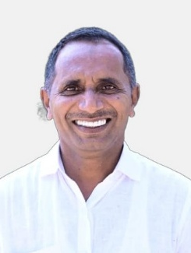
DEAR RESIDENTS OF MANJESHWAR GRAMA PANCHAYAT,
It gives me great pleasure to present the pandemic preparedness plan of our grama panchayat. The recent public health emergencies have reminded us that preparedness, coordination, and community participation are essential to protect the health and well-being of our people.This plan has been prepared to strengthen our readiness to prevent, detect, and respond effectively to any outbreak or pandemic situation. It focuses on early surveillance, rapid response, resource mobilization, public awareness, and inter-departmental coordination.We are committed to ensuring the safety of all residents, especially vulnerable groups such as children, elderly persons, and those with chronic illnesses. With the active support of our health department, frontline workers, volunteers, and the community, we can successfully manage any public health emergency.I request the wholehearted cooperation of all stakeholders in implementing this plan effectively. Together, we can build a safer and healthier panchayat.
President
Manjeshwar grama panchayat

MESSAGE FROM HEALTH STANDING COMMITTEE CHAIR
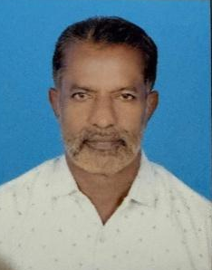

DEAR RESIDENTS OF MANJESHWAR GRAMA PANCHAYAT,
The Health Standing Committee of the Grama Panchayat is pleased to present the Pandemic Preparedness Plan aimed at strengthening our response to public health emergencies. In recent years, we have learned the importance of early detection, proper planning, and coordinated action in managing outbreaks and pandemics. This plan outlines strategies for disease surveillance, rapid response, community awareness, resource management, and protection of vulnerable populations. We are committed to working closely with the Health Department, ASHA workers, Anganwadi workers, volunteers, and other stakeholders to ensure timely and effective action during any public health crisis. Community participation is the key to success. We request the cooperation and support of all residents in implementing preventive measures and adhering to public health guidelines. Together, we can safeguard the health and well-being of our Panchayat.

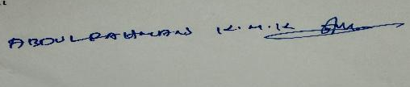

Health Standing Committee
Manjeshwar Grama Panchayat

MESSAGE BY MEDICAL OFFICER
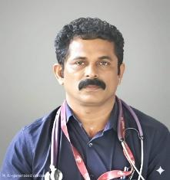
As we navigate the ongoing public health challenges in Manjeshwar Gramapanchayath, it is essential that we remain vigilant and prepared for potential pandemics. Based on our analysis of past years’ disease patterns, pandemic trends, and identified hotspots, our team continues to conduct active and persistent field surveillance. As the Medical Officer of Manjeshwar Gramapanchayath, I am committed to ensuring that our healthcare system is fully prepared to respond promptly and effectively to any public health emergency. We are strengthening our surveillance mechanisms, improving response systems, and staying continuously informed about emerging pandemic risks. Preventive healthcare remains our top priority. Through structured planning, including the implementation of a communicable disease calendar, we are proactively organizing awareness programs, vaccination drives, vector control activities, and community engagement initiatives in accordance with seasonal disease trends. We firmly believe that public health is a shared responsibility. The cooperation and participation of every member of our community play a vital role in safeguarding the health and well-being of all. Together, we remain alert, prepared, and committed to protecting Manjeshwar Gramapanchayath.

Dr. Prabhakar M Rai
Medical Officer
Manjeshwar Gramapanchayath

EXECUTIVE SUMMARY

Block Family Health Centre (BFHC) Manjeshwar functions as the primary public healthcare institution serving the population of Manjeshwar Grama Panchayath. The BFHC plays a pivotal role in delivering comprehensive, accessible, and affordable healthcare services, with a strong focus on preventive, promotive, curative, and rehabilitative care in accordance with national and state health programmes.
The BFHC Manjeshwar caters to a predominantly rural population, addressing key public health priorities such as maternal and child health, communicable and non-communicable disease control, immunization, family welfare, adolescent health, and geriatric care. Regular outpatient services, home-based care through field health staff, and outreach activities ensure healthcare coverage even in geographically challenging areas.
Manjeshwar BFHC works in close coordination with the Grama Panchayath, ASHA workers, Anganwadi centres, schools, and community-based organizations to strengthen community participation and improve health awareness. Emphasis is placed on early detection, timely referral, health education, and lifestyle modification to reduce disease burden and improve overall health outcomes.
Despite constraints related to infrastructure, manpower, and increasing service demand, the PHC continues to enhance service delivery through effective planning, data-driven decision-making, and community engagement. Strengthening facilities, upgrading digital health systems, and expanding preventive services remain key focus areas for future development.
Overall, Manjeshwar Block Family Health Centre stands as a vital institution in safeguarding public health and improving the quality of life of the residents of Manjeshwar Grama Panchayath

LIST OF ABBREVIATIONS

LSGD/LSGI | Local Self Government Department / Local Self Government Institution
BMO | Block Medical Officer
IDSP | Integrated Disease Surveillance Programme
NDMA | National Disaster Management Authority
PPE | Personal Protective Equipment
ICMR | Indian Council of Medical Research
CD | Communicable Diseases
NCD | NON-COMMUNICABLE DISEASES

TABLE OF CONTENTS

INTRODUCTION 9
● Background of the PPP 9
LSGD AT A GLANCE 11
INTEGRATED HEALTH INFRASTRUCTURE MAP OF MANJESHWAR GRAMA PANCHAYAT16
GENERAL PROFILE OF THE LSGI’S 17
Background of the LSGI 17
Demographic and Vulnerable Population 18
Clinical Vulnerability 20
INFRASTRUCTURE & RESOURCE INVENTORY 22
Health Facility Directory & Basic Capacity in the LSGD 22
Private Clinics 24
Healthcare Education & Training Institutions 26
Specialized Services & Emergency Inventory 26
Oxygen & Diagnostic Capacity 28
Diagnostics facility mapping at the LSGI level 28
Laboratory Identification & Basic Details 29
Social and Community Infrastructure for surge plan 29
Human resources 32
Community & Support Cadre 34
Community Organizations 35
Administrative & Emergency Services 37
Information regarding resources 37
ONE HEALTH & ENVIRONMENTAL SURVEILLANCE 38
Animal & Bird Population 38
Veterinary Infrastructure 40
Veterinary Doctors & Workforce 41
High-Risk Interface Points (Surveillance Sites) 42
Environmental Risk Mapping 44
Disease Seasonality Mapping 46
Vulnerability Mapping 47
EPIDEMIOLOGICAL TRENDS (2021–2025) 48
Disease Burden among human beings(Last 5 Years) 48
*(use the above table data to create the graph/diagram) 48
Seasonal Trend Analysis 51
Outcome-Based Trend Analysis- 2025 58
Transmission Trend- 2025 58
Integrated Disease Hotspot Map (2021–2025) 62
Preparedness and Response Protocol at LSG Level 68
Constitution of One Health Committee 68
Pandemic Response Workforce 70
Activities and Measures before and during Pandemic 71
PHASE 1 - Alert / Preparation 71
PHASE 2 - Active Response 74
Standard Screening Protocol 76
PHASE 3 - Surge Capacity 88
Conversion of Community Facilities 88
CONCLUSION 92
RECOMMENDATIONS 93
ANNEXURE 97
1. IMPORTANT PHONE NUMBERS 97

INTRODUCTION

Background of the PPP
Pandemics are large-scale outbreaks of infectious diseases that spread across countries or continents, causing significant morbidity, mortality, and socio-economic disruption. In recent decades, the world has experienced multiple emerging and re-emerging infectious threats such as severe acute respiratory syndrome (SARS), H1N1 influenza, Middle East Respiratory Syndrome (MERS), Ebola virus disease, and most notably COVID-19. These events have highlighted the vulnerability of health systems and the urgent need for structured preparedness and response mechanisms at global, national, and local levels.
Pandemic preparedness refers to the systematic development of policies, plans, capacities, and resources to prevent, detect, respond to, and recover from infectious disease outbreaks with pandemic potential. It encompasses early warning surveillance systems, rapid diagnostic facilities, trained healthcare workforce, stockpiling of essential supplies (PPE, medicines, vaccines), risk communication strategies, and continuity planning for essential services.
At the local level—such as districts, blocks, or panchayats—preparedness planning is crucial because frontline response occurs within communities. Strengthening primary healthcare systems, ensuring functional referral mechanisms, maintaining updated resource inventories, and conducting regular simulation exercises are essential components of preparedness. Integration with national frameworks such as the National Centre for Disease Control guidelines and adherence to International Health Regulations (IHR 2005) further enhance coordinated action.
A well-developed pandemic preparedness plan aims to:
- Minimize illness and deaths
- Protect healthcare workers
- Maintain essential health and public services
- Ensure efficient use of available resources
- Reduce social and economic disruption
In conclusion, pandemic preparedness is not a one-time activity but a continuous process of risk assessment, capacity building, and system strengthening. Lessons learned from past pandemics, particularly COVID-19, must inform resilient and adaptive preparedness strategies to safeguard public health in the future.

- LSGD at a glance
Manjeshwar Grama Panchayat is the northernmost local self-government body in Kerala, located in Kasaragod district at the border of Karnataka near Thalappady, covering an area of approximately 24.40 km² with a population of about 49,680 and a literacy rate of around 92.9%, slightly below the state average. It is linguistically diverse, with Malayalam and Kannada as official languages, while Tulu and Konkani are also widely spoken. Administratively, it falls under Manjeshwaram Taluk and Manjeshwaram Block Panchayat and currently comprises 24 wards following recent delimitation. The Panchayat derives its name from the historic Srimath Anantheshwara Temple and is also known for the ancient Jain Bastis at Bangra Manjeshwar and the memorial of the renowned Kannada Rashtrakavi M. Govinda Pai. Geographically, the Manjeswaram River flows through the region and joins the Arabian Sea at the Manjeshwar estuary, while Kanwatheertha Beach is famous for its natural lagoon-like formation resembling a swimming pool. The local economy is traditionally supported by cashew plantations and fishing activities, particularly centered around the Bengara Manjeshwar fishing village.
Boundaries
- North: Karnataka state line (Talappady checkpost area).
- South: Meenja and Mangalpady panchayats.
- East/West: Inland villages like Kunjathur, Hosabettu, with coastal stretches near Manjeshwar port.

LSGD AT A GLANCE
- Geographical boundaries with political map (based on latest delimitation)
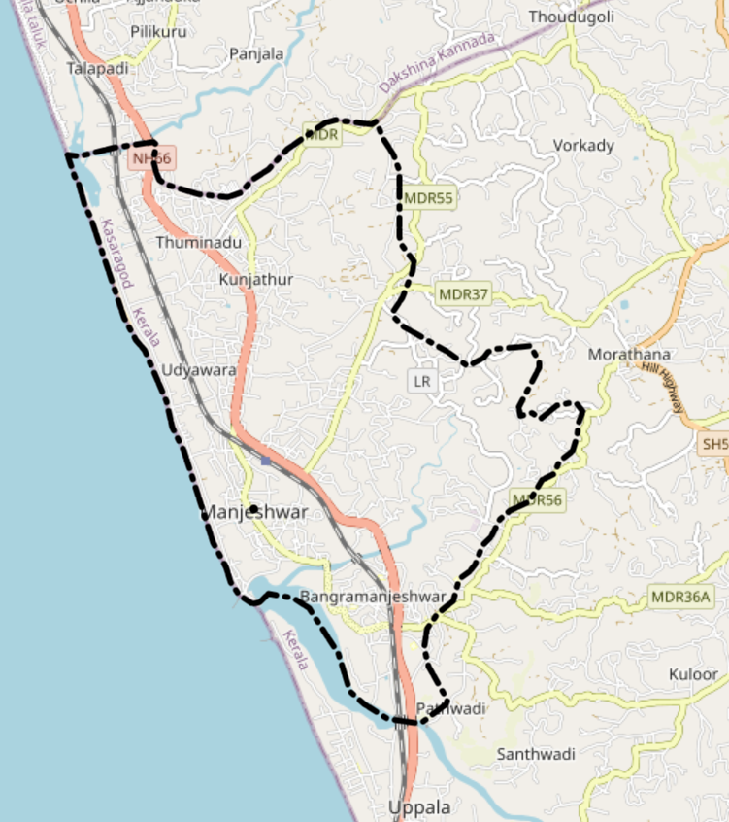

- Ward division -
Ward | Houses | Population | Migrants | Wells | Hot  spots | Ed. Institutions | Hosp pvt/govt.
24 | 10267 | 50233 | 574 | 7164 | 0 | 73 | 6

- Major Roads/rivers
NH-66 (formerly NH-66) runs through Manjeshwar Grama Panchayat, connecting it to the Kerala-Karnataka border at Thalapady, about 9 km north, and serving as a key coastal highway linking Kasaragod and Mangalore. Other notable roads include the Bangara Manjeshwar Kulur road (MDR20, 8 km) and Manjeshwar-Thoudugoli road , supporting local connectivity.
The Manjeswaram River, Kerala's shortest at 16 km, originates from Balappooni hills, flows through the panchayat, and meets the Arabian Sea at the Manjeswaram estuary or Uppala Lake. Nearby rivers like Uppala (5.3 km away) influence the area but do not directly traverse the panchayat.
Major establishments with geospatial Mapping
- Government Facilities:
Block Family Health Centre, Manjeshwar
Government Homoeopathy Dispensary
Government Ayurveda Dispensary
- Private Sector
Dopa Clinic
Dinesh Clinic
Abhinavs Clinic
- Auxillary and Logistical Resource Mapping
Educational Institutions
Anganawadu Centres
Public and Religious Halls
Mosques
Temples
Church
KSEB,Hosabettu
Manjeshwar Police station
Treasury Office
One Health & Zoonotic Mapping
Government Veterinary Dispensary Manjeshwar

Occupational groups, socio cultural groups, migration & mobility patterns

Manjeshwar Grama Panchayat in Kasaragod, Kerala, has a diverse workforce dominated by main workers (70%), Muslims (67%), Hindus (31%), and Christians (2%), with patterns of out-migration for work and education common in northern Kerala.
Around 2,808 workers from a 2011 census town population of 8,742 were employed, with males (2,024) outnumbering females (784); 70% in main work like business, jobs, services, cultivation, and labour, and 30% in marginal work. Agriculture labour, fisheries, and government roles (e.g., medical officers, veterinary surgeons) are prominent, alongside pensions for agriculture labourers, widows, elderly, and disabled indicating reliance on informal sectors.
Northern Kerala districts like Kasaragod show high out-migration for employment and education, with Kerala-wide trends doubling student migrants to 250,000 post-pandemics, rising female emigration, and remittances hitting ₹2.17 lakh crore in 2023. Local return migration has increased due to global disruptions, with youth migrating younger; specific Manjeshwar data aligns with state patterns of Gulf and urban India destinations. In-migration from central Kerala farmers to Malabar occurs in groups, altering local demographics.

Disaster prone areas (geographic vulnerability)
The Manjeswaram area, particularly around Manjeswaram Station on the Manjeswaram River, is under red alert for extreme flooding during high water levels, as seen in recent Kerala-wide alerts.

Maps - ward-based

- Geographical boundaries - ward boundaries map

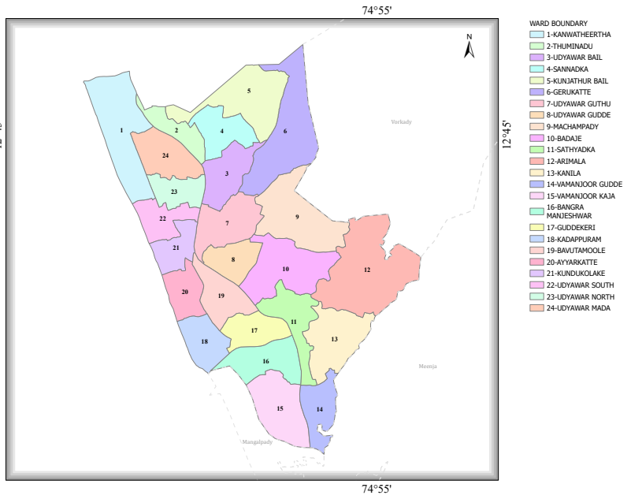

https://wardmap.ksmart.live/FinalN/FinalN_Kasaragod_Manjewswaram.html

- Roads and rivers map

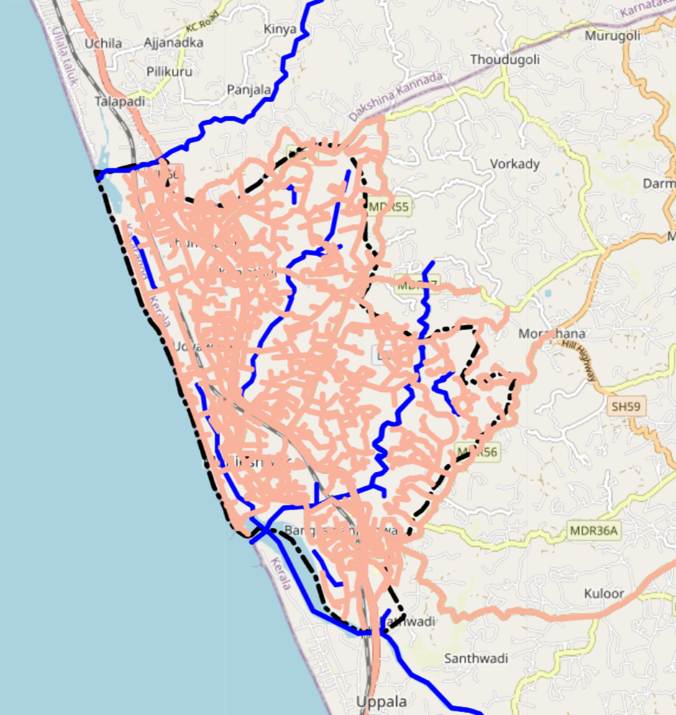

https://map.opendatakerala.org/kasaragod/manjeshwar-grama-panchayat/

INTEGRATED HEALTH INFRASTRUCTURE MAP OF MANJESHWAR PANCHAYAT

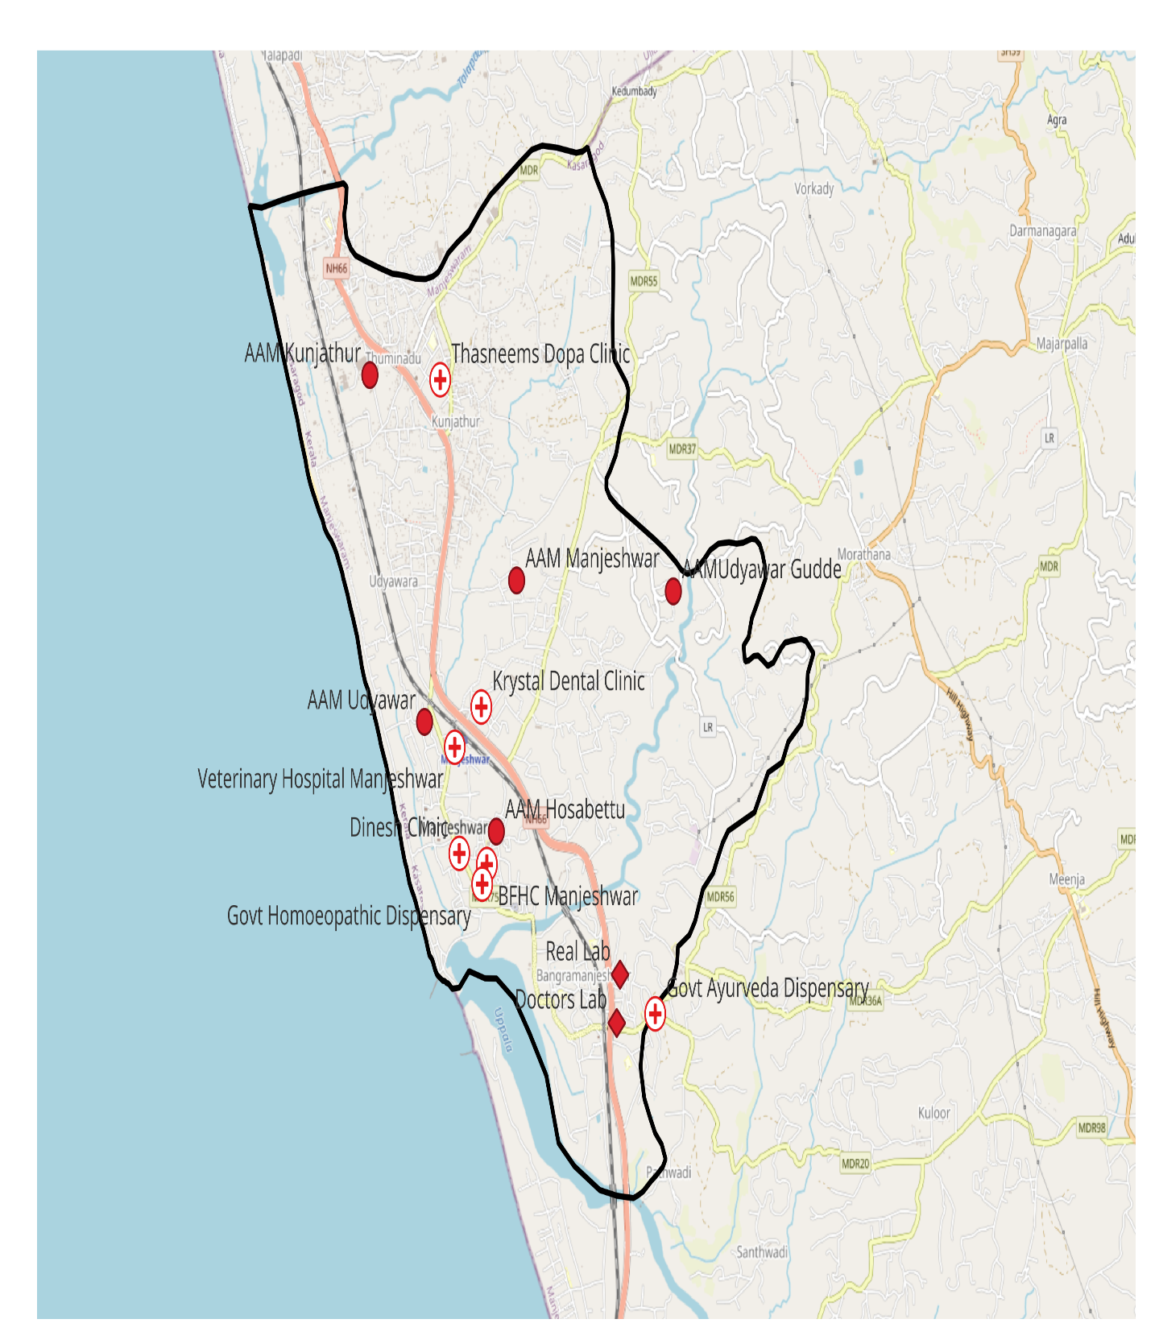

Manjeshwar Administrative Boundaries Map
Boundary Data:Open Data Kerala
Map created with QGIS

GENERAL PROFILE OF THE MANJESHWARA GRAMA PANCHAYAT

Background of the LSGI
Manjeshwar Grama Panchayat is situated in the northern tip of Kasaragod district, Kerala. The geographical landscape of the Panchayat is predominantly coastal and undulating, characterized by cashew plantations, estuaries, and a network of rivers and canals. This unique terrain plays a significant role in shaping the local microclimate and poses distinct challenges to transportation, emergency response, and service delivery, particularly during monsoon seasons and flood events.
The Panchayat is administratively divided into 24 wards, with a population largely dependent on traditional livelihoods. Agriculture—especially cashew and coconut cultivation—fishing, and allied activities form the backbone of the local economy. In recent years, tourism-related activities and service-sector employment have also shown gradual growth. The area hosts a diverse workforce, including a notable presence of migrant labourers, particularly in construction, agriculture, and allied sectors.
From a public health and disaster management perspective, Manjeshwar LSGI has historically been vulnerable to seasonal flooding (near the Manjeshwar river), waterborne diseases, and vector-borne illnesses. The severe floods experienced during recent years significantly impacted life, livelihoods, and infrastructure within the Panchayat. These recurring emergencies have underscored the importance of strengthening local preparedness, response mechanisms, and inter-departmental coordination.

Table 1: Background of LSGD
Description | Details
Name of LSGI | Manjeshwar
Type (GP/Municipality / Corporation etc.) | Grama Panchayath
Block | Manjeshwar
District | Kasaragod
Number of wards | 24
Total area (sq. km) | 24.40
Population (Projected) | 50428
Population density | 2058 persons/sq. km
Terrain (coastal/low-lying/backwaters/foothills, etc.) | Coastal, low lying
Number of rivers passing through LSGI | 1
Number of water bodies in the LSGI | 6
Number of educational institutions | 34,30(Anganwadi’s)
Factories / small-scale industries | 1
Flood-prone wards | 6,13
Landslide-prone wards | 0
Death Management and Disposal Facilities (mortuaries/crematorium, including electric) | 4
Auditoriums/Marriage halls/convention centres/community halls | 20

Demographic and Vulnerable Population
Understanding the demographic composition and vulnerable population groups is essential for pandemic preparedness. Children, elderly, economically deprived families, migrant workers, and socially vulnerable groups are at increased risk during public health emergencies due to higher exposure, limited access to services, and dependency on public systems. For an effective pandemic preparedness plan in Manjeshwar, the Panchayat must leverage its unique demographic and geographic profile—characterized by a high volume of cross-border transit, dense coastal fishing settlements, and linguistic diversity—to implement a strategy that prioritizes ward-wise vulnerability mapping, targeted mobile health outreach, and multi-lingual community communication, thereby ensuring that essential resources and protective measures reach the most marginalized groups to bolster overall community resilience.

Description |  | Details (in numbers)
DEMOGRAPHIC PROFILE
Total population |  | 49680
Male |  | 25211
Female |  | 24469
Transgender |  | 0
Children under 5 |  | 4043
Adolescent |  | 5887
Elderly (>60) |  | 5330
SOCIAL/LIVELIHOOD VULNERABILITY
Previous EPEP family |  | 107
BPL family |  | 45
Tribal communities |  | 4
Migration | Immigrant | 500
Migration | Emigrant | 50
Socio-economically deprived |  | 0
Fisherfolk |  | Fisherman 824, allied-42
SC Community |  | 1602
ST Community |  | 533

Clinical Vulnerability
Certain population groups need priority healthcare & are at higher risk of severe illness, complications, and mortality during pandemics. Patients with chronic diseases, those requiring regular medical care, and individuals with mobility or functional limitations face challenges in accessing timely care during emergencies. Mapping these groups helps in prioritizing continuity of treatment, medicine stock planning, oxygen support, referral transport, and targeted home-based care.
Description | Details in numbers
Pregnant women | 352
Lactating mothers | 684
Bedbound patients | 91
Patients under palliative care other than bedbound | 22
Patients on Haemodialysis | 34
Patients on CAPD | 0
Cancer patients (currently on treatment) | 78
Haemophilic patients | 0
Mentally challenged | 5
Differently abled | 206
Diabetic patients | 379
Hypertensive patients | 940
TB patients | 13

Major Festivals & Events specific to the LSGI
(with the possibility of a public gathering)

Sl. No. | Name of festival | Month detailing the periodicity
1 | Udyawar Masjid Uroos | January
2 | Shanishwara Temple | January
3 | Sashthaveshwara Temple | January
4 | Beach festival | November
5 | Manjeshwar Shashti | November–December
6 | Keertheshwara | March
7 | Kaa Shri Bhagavathi Temple | April
8 | Arasumanjeeshnar Prasanna Temple | May
9 | Mayamaya Temple | November
10 | Madananteshwara Temple | December

INFRASTRUCTURE & RESOURCE INVENTORY

Health Facility Directory & Basic Capacity in the LSGD
This section provides an overview of the healthcare infrastructure available within the LSGD area. It outlines the distribution and basic capacity of health facilities that form the backbone of service delivery during routine times and public health emergencies.
Primary-level institutions such as Family Health Centres (FHCs) and Community Health Centres (CHCs) act as the first point of contact for the community. These facilities play a critical role in early detection, screening, triaging, and initial management of cases during a pandemic. They provide essential outpatient services, basic inpatient care, immunization, maternal and child health services, and public health outreach activities. During a pandemic, these centres can be rapidly adapted for fever clinics, isolation units for mild cases, and community-level surveillance and contact tracing activities.
Secondary-level facilities such as General Hospitals (GHs) serve as important referral centres for cases requiring more advanced medical care. They are equipped to provide inpatient services, oxygen-supported beds, laboratory diagnostics, and limited critical care services. These hospitals play a pivotal role in managing moderate cases and reducing the burden on tertiary care institutions.
Tertiary care facilities, including Medical College Hospitals (MCHs) and other specialized centres (where accessible), function as apex referral institutions. They are equipped with advanced diagnostic capabilities, intensive care units (ICUs), ventilator support, and specialist services. During a pandemic, these facilities are crucial for managing severe and critical cases, supporting case management protocols, and providing technical guidance to lower-level facilities.
In addition to public health institutions, the inventory may include private hospitals, clinics, laboratories, and pharmacies, which can be engaged to augment surge capacity during emergencies. Their inclusion ensures a more comprehensive and coordinated response.
This inventory also captures key parameters such as:
- Number and type of health facilities
- Bed strength (general, oxygen-supported, ICU beds)
- Availability of essential equipment (ventilators, oxygen supply systems, ambulances)
- Human resources (medical officers, nurses, health inspectors, ASHA workers)
- Laboratory capacity and diagnostic facilities
Mapping these resources enables the identification of existing strengths, service gaps, and geographic disparities within the LSGD. It also supports evidence-based planning for resource allocation, capacity building, and emergency preparedness.

Table 5. Health Facility Resource Summary
Sl.no. | Health Facility | Type of Facility (MCH/GH/CHC/FHC/SC etc.) | Contact Number | Total beds | ICU Beds | Oxygen-Supported Beds | No. of Ventilator Support Beds | No. of ambulances
Government Healthcare Facilities
1 | BFHC Manjeshwar | CHC | 04998 273599 | 24 | 0 | 0 | 0 | 0
2 | Manjeshwar | SC | 7012475715 | 0 | 0 | 0 | 0 | 0
3 | Hosabettu | SC | 8075480339 | 0 | 0 | 0 | 0 | 0
4 | Udyawar | SC | 8943901419 | 0 | 0 | 0 | 0 | 0
5 | Udyawar Gudde | SC | 8943901419 | 0 | 0 | 0 | 0 | 0
6 | Kunjathur | SC | 8113072036 | 0 | 0 | 0 | 0 | 0
Private Healthcare Facilities
1 | Dinesh Clinic |  | 7907251055 | 0 | 0 | 0 | 0 | 0
AYUSH Healthcare Facilities
1 | Manjeshwar Government Homoeo Dispensary | Dispensary | 9562653063 | 0 | 0 | 0 | 0 | 0
2 | Ayurveda Dispensary | Dispensary | 8547579220 | 0 | 0 | 0 | 0 | 0

Private Clinics
Private clinics are an essential part of pandemic preparedness, as they are often the first place people seek care when symptoms begin. In many communities, private clinics manage a significant share of outpatient visits and therefore play a critical role in early case detection, timely referrals, and disease surveillance. Having an up-to-date understanding of where these clinics are located, the services they provide, and how they are linked to the public health system helps ensure that no cases are missed during an outbreak. It also allows health authorities to engage private practitioners more effectively for reporting, risk communication, and coordinated response, strengthening the overall capacity of the health system to manage public health emergencies.

Table 6. Private Clinic Resource Summary
Sl No. | Name of Clinic | Registered (Y/N) | Clinic (General / Speciality) | Speciality (if any) | Address | Contact Number | Diagnostic Facility (Y/N) | Ambulance Linkage (Y/N)
1 | Dinesh Clinic | Y | General | 0 | Manjeshwar | 7907251055 | N | N
2 | Dr Thasneems Dopa Clinic | Y | General | 0 | Kunjathur | 07907714342 | N | N
3 | Ganesh Clinic | Y | General | 0 | Hosangadi | 9447348458 | N | N
4 | Abhinav clinic Dr Sudhirs | Y | General | 0 | Hosangadi | 7947149086 | N | N

Healthcare Education & Training Institutions
This section tracks the educational infrastructure available, which is vital for human resource planning in the health sector.

Category of Institution | Govt | Private | AYUSH | Total
Medical Colleges | 0 | 0 | 0 | 0
Nursing Colleges | 0 | 0 | 0 | 0
Dental Colleges | 0 | 0 | 0 | 0
Para-medical / Allied Health | 0 | 0 | 0 | 0
Pharmacy Colleges | 0 | 0 | 0 | 0

Specialized Services & Emergency Inventory
This section provides a detailed view of the specialized medical resources available to the community, focusing on emergency response and critical care capabilities. This table tracks the vital assets required for managing severe illnesses and emergencies across Government, Private, and AYUSH sectors.

Item | Govt | Private | AYUSH | Total
Hospital beds | 24 | 0 | 0 | 24
Oxygen-generating systems(Y/N) | 0 | 0 | 0 | 0
Oxygen-supported beds (Numbers) | 0 | 0 | 0 | 0
Ventilator-supported beds | 0 | 0 | 0 | 0
ICU beds | 0 | 0 | 0 | 0
Burns units | 0 | 0 | 0 | 0
Blood centres | 0 | 0 | 0 | 0
BLS ambulances | 0 | 0 | 0 | 0
ALS ambulances | 0 | 0 | 0 | 0
Dialysis facilities | 0 | 0 | 0 | 0
Dispensaries | 1 | 0 | 2 | 3
Medical store | 1 | 15 | 0 | 16
Industrial establishments (Medium-scale industries/small-scale industries establishments to whom we can depend in a worst-case scenario) | 0

Oxygen & Diagnostic Capacity
Monitoring oxygen and diagnostic capacity is a critical component of public health preparedness, ensuring that the LSGD can handle both chronic care and sudden surges in respiratory or infectious diseases.
Name of Health Facility | Oxygen-generating System (Y/N) | Backup Oxygen Source (Y/N) | Diagnostic Facilities Available(Y/N)
Name of Health Facility | Oxygen-generating System (Y/N) | Backup Oxygen Source (Y/N) | Lab | USG | X-ray | CT/MRI | RT-PCR
Government Healthcare Facilities
CHC Manjeshwar | N | N | Y | N | N | N | N

Diagnostics facility mapping at the LSGI level
The diagnostic capacity of Manjeshwar G.P represents the "intelligence network" of our healthcare system. The speed and accuracy of disease identification depend entirely on the distribution and technical level of these facilities.

Item | Govt | Private | AYUSH | Total
General labs | 1 | 5 | 0 | 6
Microbiology labs | 0 | 0 | 0 | 0
RT-PCR labs | 0 | 0 | 0 | 0
USG units | 0 | 0 | 0 | 0
CT/MRI units | 0 | 0 | 0 | 0
Research labs | 0 | 0 | 0 | 0
Labs of other departments that can be repurposed | 0 | 0 | 0 | 0

Laboratory Identification & Basic Details
Sl. No. | Name of Laboratory | Ownership (Govt / Private / Academic) | Address | Contact No. | 24×7 Services (Yes/No) | NABL / Govt Approved (Yes/No)
1 | BFHC Manjeshwar | Govt | Manjeshwar | 04998 273599 | No | Yes
2 | Index Lab | Pvt | Manjeshwar | 9544727289 | No | No
3 | Real Lab Clinical Laboratory | Pvt | Manjeshwar | 9778773219 | No | No

Social and Community Infrastructure for surge plan
This table serves as our logistics and shelter inventory. By mapping these locations, quickly we can identify where to house displaced citizens, where to set up temporary medical clinics, and how to manage the deceased with dignity during a crisis.

Category | Total Count | Ward | Est. Capacity (Persons) | Contact details
Educational Institutions
Anganwadi’s | 37 | 1-24 | 148 | 9946950300
Schools | 32 | 1-24 | 10,000 | 9632487855
Colleges | 4 | 9-13 | 4000 | 9946715231
Healthcare Educational Institutions
Medical colleges (Govt/Private) | 0
Nursing colleges (Govt/Private) | 0
Dental colleges (Govt/Private) | 0
Paramedical institutes (Govt/Private) | 0
Community Gathering Spaces
Community halls | 4 | 5,8,17,17 | 400
Auditoriums | 5 | 3,5,17,10 | 400
Religious buildings | 22 | 1-21 | 5000
Vulnerable Group Support Facility
Destitute homes | 0
Elderly homes | 1
LSGD owned other buildings | 0
Mass Fatality Management (MFM) Infrastructure
Mortuary | 0
Crematorium | 3 | 20
*refer annexure 1 for contact details

Human resources
This section focuses on the human capital available within the LSGI. In any emergency—be it a pandemic, flood, or industrial accident—infrastructure is only as effective as the people operating it.

Medical & Clinical Personnel
This table tracks the "Frontline" providers responsible for diagnosis, treatment, and clinical management. A detailed directory with the contact numbers of all workers is maintained (Annexure in 1).

Cadre | Govt (No.) | Private (No.) | Total
Doctors—Modern Medicine | 4 | 5 | 9
Doctors – AYUSH | 2 | 3 | 5
Doctors – Veterinary | 3 | 0 | 3
Doctors – Dental | 1 | 5 | 6
Nursing officers | 3 | 2 | 6
Lab technicians | 1 | 5 | 6
Optometrist | 0 | 2 | 2
Pharmacists | 2 | 20 | 22
Psychologists | 0 | 0 | 0
Counsellors | 0 | 0 | 0

Public Health & Field-Level Workforce
These individuals are the backbone of surveillance, maternal-child health, and decentralized care.

Cadre | Health services | Municipal common services | Total
HS (Health Supervisors) | 0 | 0 | 0
HI (Health Inspectors) | 1 | 0 | 1
LHS (Lady Health Supervisor) | 0 | 0 | 0
LHI (Lady Health Inspectors) | 0 | 0 | 0
JPHN (Jr Public Health Nurses) | 4 | 0 | 4
JHI (Jr Health Inspectors) | 4 | 0 | 4
MLSP (Mid-Level Service Providers) | 4 | 0 | 4
Palliative Nurses | 1 | 0 | 1
RBSK Nurses | 1 | 0 | 1
PRO | 1 | 0 | 1
Epidemiologist | 1 | 0 | 1
Data Manager | 1 | 0 | 1

Community & Support Cadre
This group represents the surge capacity of the LSGI—people who can be called upon for logistics, rescue, and specialized support.

Cadre | Number
ASHA Workers | 21
AWW (Anganwadi Workers) | 30
Emergency Medical Volunteers (Trained) | 0
Kudumbashree | 270
MNREGS | 500
Purusha Swayam Sahaya Sangham | 0
Ex-Servicemen | 10
Retired Police Officers | 20
NCC/NSS Volunteers | 100
Red Cross volunteers | 0
One Health Community Volunteers | 0
One Health Community Mentors | 0

Community Organizations
This section details the presence of community-based organisations (CBOs), non-governmental organisations (NGOs), faith-based organisations (FBOs), Kudumbashree Self-Help Groups (SHGs), and Ayalkootams within the Local Self-Government Institution (LSGI). These groups enhance grassroots mobilization, resource distribution, and support networks crucial for pandemic response and community resilience.

Category | Total Count
NGOs | 0
Religious based organizations | 0
Foreign based organizations | 0
Sports Club/youth clubs | 5
Kudumbashree SHGs | 270
Ayalkootams | 225
Political organizations | 0
Residential organizations | 0

Administrative & Emergency Services
This section outlines the availability of key non-health emergency support services and infrastructure within the LSGI, which are essential for effective pandemic preparedness and response. These facilities support law enforcement, disaster response, water supply, logistics, mobility, and community-level interventions during public health emergencies.

Category | Total Count | Contact details
Police Stations | 1 | 04998272660
Fire & Rescue Stations | 1 | 18002125744
Water Pumping Points | 0
Public Distribution System (PDS) | 9

Information regarding resources
The availability of essential transport and support resources plays a quiet but critical role in saving lives. Equipment such as ambulances, mobile mortuaries, amphibian ambulances, and motorized boats ensures that patients, samples, and healthcare teams can move swiftly—even in flooded, remote, or difficult terrains. Heavy vehicles like JCBs, cranes, tractors, and torus lorries support logistics, waste management, emergency infrastructure, and rapid conversion of spaces into care or isolation facilities. Taxis, four-wheel-drive vehicles, and trucks help maintain continuity of essential services, reach vulnerable populations, and support home-based care and supply delivery.

Means of transportation | Total Count
JCB | 4
Crane | 0
Heavy Trucks | 0
Tractor | 5
Ambulances | 4
Mobile mortuaries | 0
Boats | 20
Taxi service | 10
Note: For specific details regarding vehicle owners and contact information, please refer to Annexure [X].

ONE HEALTH & ENVIRONMENTAL SURVEILLANCE
The One Health method integrates environmental, animal, and human health to enable proactive pandemic preparedness. Panchayat-level surveillance needs to be improved in order to detect and treat zoonotic and environmentally generated diseases early. Mapping animal and bird populations at the Panchayat level is essential for identifying and prioritising zoonotic disease hazards like rabies, avian influenza (H5N1), leptospirosis, anthrax, and Nipah-like spillover occurrences. Risk classification, targeted surveillance, vaccination planning, and early epidemic detection made feasible by comprehensive population mapping all enhance One Health-based pandemic preparedness.

Category | Item | Estimated Population | Wards
Animal Population | Livestock (Cattle/Goats/Buffalo) | 889 | 1-24
Animal Population | Pet Animals (Dogs/Cats) | 700 | 1-24
Animal Population | Stray Dog Population | 50 | 1-24
Animal Population | Pig Farms (Number of heads) | 58 | 5,18,20
 | Small Units (Sheep / Goats – clustered) | 123 | 1-24
Bird Population | Poultry Units (Birds) | 1600
Bird Population | Poultry- (FOWL) | 5000 | 1-24
Bird Population | Wild/Migratory Birds (Observed) | 0
Bird Population | Crow Mortality Events (Reported) | 0

The overall risk of zoonotic diseases in Manjeshwar grama Panchayat is very low. The diseases most commonly observed are dengue, hepatitis A infections. and recently. Other zoonotic or infectious diseases in the area show a declining trend, indicating generally low transmission risks.

Veterinary Infrastructure
Veterinary institutions are a core pillar of One Health surveillance, enabling early zoonotic disease detection through vaccination, investigation of unusual animal illness or deaths, sample collection, and timely outbreak reporting. A well-mapped and responsive veterinary network strengthens coordination with human health and LSGI systems, ensuring rapid response during zoonotic events and pandemics.
Facility Type | Name of Facility | Ownership Govt / Pvt | Location (Ward No) | Contact number
Veterinary Dispensary | Veterinary Hospital Manjeswar | Govt | Bangra Manjeshwar | 9446436123
Veterinary Hospital / Polyclinic | 0
Private Veterinary Clinics | 0
Mobile / Emergency Vet Service (incl. night services) | 0
Pet Homes / Animal Shelters | 0
Slaughterhouse-linked Veterinary Inspection Unit | 0

Veterinary Doctors & Workforce
Early detection, diagnosis, reporting, and reaction to animal illness epidemics depend on the availability and accessibility of qualified veterinary specialists. By identifying unusual animal morbidity or mortality promptly, collecting samples promptly, and coordinating efficiently with human health and LSGI systems—especially during zoonotic outbreaks and pandemic-prone situations—a clearly defined veterinary workforce enhances One Health surveillance.

Category | Number Available | Type (Govt/Pvt) | Contact number
Government Veterinary Doctors | 3 | Govt | 9446436123
Private Veterinary Doctors | 0 | 0 | 0
Livestock Inspectors | 2 | Govt | 9846495024
Para-veterinary Staff / Attenders | 1 | Govt
Contract / On-call Veterinary Support (if any) | 0 | 0 | 0

High-Risk Interface Points (Surveillance Sites)
High-risk interface points for zoonotic disease surveillance in Manjeswhar Grama Panchayath include wetland–livestock–human contact zones, backyard poultry farms, cattle sheds near water bodies. These are the primary surveillance sites where zoonotic spillover risks are elevated.

Type of Habitat | Type of High-risk interface | Geographical vulnerability
Wetlands & Backwaters | 0
Backyard Poultry Farms | 4 | Hosabettu
Cattle Sheds near Water Bodies | 1
Fish & Meat Markets | 0
Community Slaughter Sites | 3 | BangraManjeshwar
Migratory Bird Congregation Areas | 0
Rodent-Infested Grain Storage | 0

Category | Total Count | Key Locations (wards)
Poultry Farms | 0
Backyard / Clustered Poultry Units | 0
Duck Rearing Units (open water access) | 0
Slaughterhouses/ Slaughter Points | 11
Meat/Fish Markets | 1 | BangraManjeshwar
Live Bird Sale Points | 0
Cattle Markets / Weekly Animal Fairs | 0
Pet Shops / Breeders | 0
Animal Shelters / Pet Homes | 0
Waste Disposal Sites near Animal Units | 0

Environmental Risk Mapping
Environmental risk mapping identifies monsoon/flood hotspots for vector-borne (dengue, chikungunya), water-borne (leptospirosis, diarrhoea), and zoonotic diseases in Kerala's wetlands. Systematic surveillance supports early warnings, targeted interventions, and Panchayat pandemic preparedness.
Waterborne exposure: Flood-prone areas and stagnant water bodies facilitate leptospira survival, raising leptospirosis risk.

Traditional practices: Informal slaughter and fish markets lack standardized hygiene, creating spillover opportunities.

Risk Factor | High-Risk Wards | Key Locations | Risk Level (High/Med/Low)
Flood-prone areas | 0
Water bodies/wetlands | 0
Solid waste accumulation | 0
Animal waste disposal issues | 0
Rodent infestation zones | 0
Industrial effluent discharge | 0
Construction sites / abandoned buildings | 0
Poor drainage/blocked canals | 0
Drinking water source contamination risk | 0

Disease Seasonality Mapping
1, Flooding & waterlogging → amplifies leptospirosis, malaria, diarrheal diseases.
·
2, Mosquito breeding cycles → vector-borne disease peaks in monsoon.

3, Agricultural practices → close human–animal contact in paddy fields.

Disease | Peak Risk Season | Key Drivers | High-Risk Locations | Surveillance Focus
Leptospirosis | Post Monsoon | Flooding-Contact with contaminated water/soil | 0 | Environmental
Dengue/Chikungunya | Monsoon | Stagnant water | 0 | Environmental
Acute Diarrheal Diseases | Summer |  | 0 | Water Quality
Rabies | All seasons |  | 0 | Animal Surveillance

Vulnerability Mapping
Vulnerability mapping pinpoints high-risk populations, occupations, and areas exposed via environment, livelihoods, socio-economics, and poor service access. Paired with environmental/seasonality mapping, it enables risk-based surveillance, targeted actions, and optimal resource use in One Health and pandemic planning.

Vulnerability Factor | High-Risk Wards | Key Groups / Locations | Risk Level
Flood-prone households | 6 | 0 | Low
Wetland-adjacent communities | 0 | 0 | Low
Backyard poultry / duck rearing households | 0 | 0 | Low
Livestock-rearing households | 0 | 0 | Low
Slaughterhouse & meat market workers | 0 | 0 | Low
Fisherfolk & fish market workers | 10 | 0 | Low
Sanitation workers | 0 | 0 | Low
Daily wage / migrant workers | 0 | 0 | Low
Elderly & chronically ill populations | 0 | 0 | Low
Pregnant Women | 0 | 0 | Low
Children (schools, Anganwadi’s) | 0 | 0 | Low
Limited access to safe water & sanitation | 0 | 0 | Low

EPIDEMIOLOGICAL TRENDS (2021–2025)

Disease surveillance is the systematic collection, analysis, and interpretation of health data for planning, implementation, and evaluation of public health practice. This section presents the disease surveillance profile of the LSGI based on routine reporting systems and outbreak investigations to identify priority diseases, seasonal patterns, and emerging public health threats.

Disease Burden among human beings (Last 5 Years)
Analysis of disease-wise data for the last five years helps identify persistent public health problems, emerging diseases, and changes in disease burden. This information supports prioritisation of prevention, preparedness, and response activities at the Panchayat level.

Disease | 2021 | 2022 | 2023 | 2024 | 2025 | Trend (Increasing/Stable/Decreasing)
Dengue | 0 | 1 | 9 | 17 | 1 | Decreasing
Leptospirosis | 0 | 0 | 4 | 2 | 4 | Increasing
Hepatitis A | 5 | 0 | 3 | 0 | 13 | Increasing
Malaria | 2 | 0 | 3 | 0 | 0 | Decreasing
Scrub Typhus | 0 | 0 | 0 | 0 | 1 | Stable
Typhoid | 0 | 0 | 0 | 0 | 0 | Stable
H1N1 | 0 | 0 | 0 | 4 | 1 | Decreasing
H3N2 | 0 | 0 | 0 | 0 | 1 | Stable
ADD | 40 | 20 | 40 | 59 | 40 | Decreasing
Mumps | 4 | 10 | 14 | 101 | 6 | Decreasing
Measles | 0 | 0 | 5 | 1 | 0 | Decreasing
Hepatitis B | 0 | 0 | 1 | 0 | 0 | Stable
Hepatitis C | 0 | 0 | 0 | 0 | 0 | Stable
Tuberculosis | 17 | 24 | 9 | 15 | 19 | Increasing
Leprosy | 0 | 2 | 0 | 0 | 0 | Deceasing
COVID-19 | 1640 | 852 | 0 | 0 | 0 | Decreasing

Seasonal Trend Analysis
Seasonal analysis helps anticipate surges (e.g. dengue in monsoon, leptospirosis after floods, influenza in cooler months) and plan pre‑emptive vector control, stockpiling of IV fluids, and awareness campaigns at Panchayat level.

DENGUE
Dengue is a major seasonal vector-borne disease strongly associated with rainfall, water stagnation, and increased mosquito breeding during the monsoon period.

Peak: July–November

Dengue – Ward-wise Yearly Distribution (2021–2025)

Ward | Dengue – Ward-wise Yearly Distribution
Ward | 2021 | 2022 | 2023 | 2024 | 2025 | Total
1 | 0 | 0 | 1 | 1 | 1 | 3
2 | 0 | 0 | 0 | 0 | 0 | 0
3 | 0 | 1 | 0 | 0 | 0 | 1
4 | 0 | 0 | 0 | 2 | 0 | 2
5 | 0 | 0 | 0 | 0 | 0 | 0
6 | 0 | 0 | 1 | 0 | 0 | 1
7 | 0 | 0 | 1 | 2 | 0 | 3
8 | 0 | 0 | 0 | 0 | 0 | 0
9 | 0 | 0 | 2 | 1 | 0 | 3
10 | 0 | 0 | 0 | 1 | 0 | 1
11 | 0 | 0 | 1 | 0 | 0 | 1
12 | 0 | 0 | 0 | 1 | 0 | 1
13 | 0 | 0 | 0 | 0 | 0 | 0
14 | 0 | 0 | 1 | 0 | 0 | 1
15 | 0 | 0 | 0 | 2 | 0 | 2
16 | 0 | 0 | 0 | 0 | 0 | 0
17 | 0 | 0 | 0 | 2 | 0 | 2
18 | 0 | 0 | 1 | 1 | 0 | 2
19 | 0 | 0 | 0 | 1 | 0 | 1
20 | 0 | 0 | 1 | 0 | 0 | 1
21 | 0 | 0 | 0 | 0 | 0 | 0
22 | 0 | 0 | 0 | 0 | 0 | 0
23 | 0 | 0 | 0 | 0 | 0 | 00
24 | 0 | 0 | 0 | 0 | 0 | 0

LEPTOSPIROSIS
Leptospirosis cases are closely linked to monsoon rains, flooding, and occupational exposure, particularly in low-lying and waterlogged areas.

Peak: June - August

Leptospirosis – Ward-wise Yearly Distribution (2021–2025)

Ward | Leptospirosis – Ward-wise Yearly Distribution
Ward | 2021 | 2022 | 2023 | 2024 | 2025 | Total
1 | 0 | 0 | 0 | 0 | 0 | 0
2 | 0 | 0 | 0 | 0 | 0 | 0
3 | 0 | 0 | 0 | 0 | 0 | 0
4 | 0 | 0 | 0 | 1 | 0 | 0
5 | 0 | 0 | 0 | 0 | 1 | 1
6 | 0 | 0 | 0 | 0 | 0 | 0
7 | 0 | 0 | 1 | 0 | 0 | 1
8 | 0 | 0 | 1 | 0 | 1 | 2
9 | 0 | 0 | 0 | 0 | 0 | 0
10 | 0 | 0 | 1 | 0 | 0 | 1
11 | 0 | 0 | 0 | 0 | 0 | 0
12 | 0 | 0 | 0 | 0 | 0 | 0
13 | 0 | 0 | 1 | 1 | 0 | 2
14 | 0 | 0 | 0 | 0 | 0 | 0
15 | 0 | 0 | 0 | 0 | 0 | 0
16 | 0 | 0 | 0 | 0 | 1 | 1
17 | 0 | 0 | 0 | 0 | 0 | 0
18 | 0 | 0 | 0 | 0 | 1 | 1
19 | 0 | 0 | 0 | 0 | 0 | 0
20 | 0 | 0 | 0 | 0 | 0 | 0
21 | 0 | 0 | 0 | 0 | 0 | 0

VIRAL HEPATITIS - A
Hepatitis A cases are commonly associated with unsafe drinking water, food contamination, and breakdowns in sanitation, often presenting as clusters or outbreaks.

Peak: October - December

Hepatitis A – Ward-wise Yearly Distribution (2021–2025)

Ward | Hep A – Ward-wise Yearly Distribution
Ward | 2021 | 2022 | 2023 | 2024 | 2025 | Total
1 | 0 | 0 | 0 | 0 | 0 | 0
2 | 0 | 0 | 0 | 0 | 0 | 0
3 | 0 | 0 | 0 | 0 | 1 | 1
4 | 0 | 0 | 0 | 0 | 0 | 0
5 | 1 | 0 | 0 | 0 | 0 | 1
6 | 0 | 0 | 0 | 0 | 0 | 0
7 | 0 | 0 | 0 | 0 | 0 | 0
8 | 1 | 0 | 0 | 0 | 0 | 1
9 | 0 | 0 | 0 | 0 | 0 | 0
10 | 0 | 0 | 1 | 0 | 1 | 2
11 | 0 | 0 | 0 | 0 | 0 | 0
12 | 1 | 0 | 0 | 0 | 1 | 2
13 | 0 | 0 | 0 | 0 | 1 | 1
14 | 1 | 0 | 0 | 0 | 0 | 1
15 | 0 | 0 | 1 | 0 | 1 | 2
16 | 0 | 0 | 1 | 0 | 1 | 2
17 | 1 | 0 | 0 | 0 | 0 | 0
18 | 0 | 0 | 0 | 0 | 0 | 0
19 | 0 | 0 | 0 | 0 | 0 | 0
20 | 0 | 0 | 0 | 0 | 1 | 1
21 | 0 | 0 | 0 | 0 | 0 | 0

Outcome-Based Trend Analysis- 2025

Transmission Trend- 2025
For effective management of public health issues, it is important to track the trend of disease transmission mode. It helps identify the population or place at high risk that can be used to predict outbreaks and implement targeted interventions as quickly as possible. Understanding these kinds of trends enables authorities to allocate resources efficiently and change the strategies adequately based on the trend that follows.

Mode of Transmission | No. of cases | No. of Deaths
Vector Borne Diseases | 11 | 1
Water Borne Diseases | 6 | 0
Air Borne Diseases | 0 | 0
Blood Borne Diseases | 0 | 0
Food Borne Diseases | 0 | 0

Vector-Borne Disease

Disease | No. of Cases | No. of Deaths
Dengue | 11 | 1
Malaria | 1 | 0
Chikungunya | 0 | 0

Water Borne Disease

Disease | No. of Cases | No. of Deaths
Cholera | 0 | 0
Typhoid | 0 | 0
Hep- A | 12 | 0
Dysentery | 0 | 0
Amoebiasis | 0 | 0
E- Coli infections | 0 | 0
Air Borne Disease

Disease | No. of Cases | No. of Deaths
Influenza | 2 | 0
H1N1 | 1 | 0
TB | 13 | 0
Chickenpox | 0 | 0
Measles | 0 | 0
Covid-19 | 0 | 0
Pertussis | 0 | 0
Mumps | 6 | 0

Blood-Borne Disease

Disease | No. of Cases | No. of Deaths
AIDS | 0 | 0
Hep- B | 0 | 0
Hep- C | 0 | 0

Zoonotic Disease

Disease | No. of Cases | No. of Deaths
Rabies | 0 | 0
Leptospirosis | 6 | 0
Avian influenza | 0 | 0
West 0e | 0 | 0
Anthrax | 0 | 0
Nipah | 0 | 0
Scrub Typhus | 2 | 0

Integrated Disease Hotspot Map of Manjeshwar Panchayat (2021–2025)
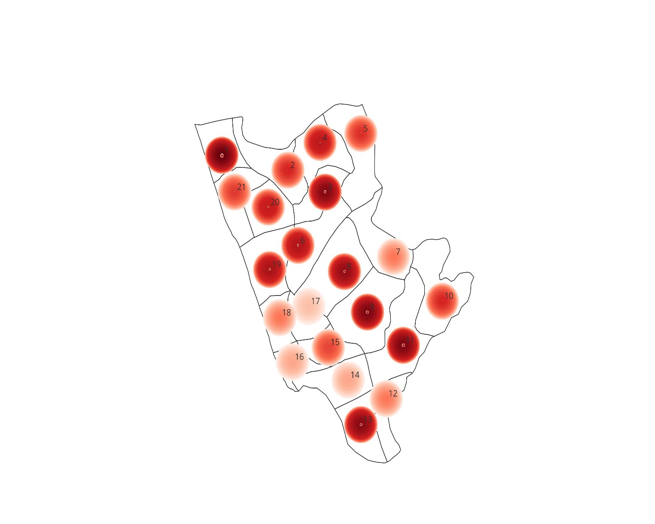

The hotspot map of Manjeshwar Panchayat shows that disease cases are concentrated mainly in central and southern wards especially wards 9,3,13,8 and 10 indicating high-risk clusters, while northern and peripheral wards exhibit moderate to low intensity, suggesting comparatively low transmission

Ward No | Dengue Total (2021-25) | Leptospirosis Total (2021-25) | Hepatitis A Total (2021-25) | Mumps (2021-25) | ADD (2021-25) | Total Cases
1 | 3 | 0 | 0 | 4 | 32 | 39
2 | 0 | 0 | 0 | 5 | 7 | 12
3 | 1 | 0 | 1 | 10 | 20 | 32
4 | 2 | 0 | 0 | 1 | 15 | 18
5 | 0 | 1 | 0 | 0 | 10 | 11
6 | 1 | 0 | 0 | 2 | 18 | 21
7 | 2 | 1 | 01 | 5 | 15 | 5
8 | 0 | 2 | 1 | 5 | 20 | 28
9 | 2 | 0 | 2 | 16 | 14 | 34
10 | 1 | 1 | 2 | 8 | 0 | 12
11 | 1 | 0 | 1 | 22 | 10 | 34
12 | 0 | 0 | 2 | 1 | 2 | 5
13 | 0 | 2 | 1 | 8 | 20 | 31
14 | 1 | 0 | 0 | 16 | 2 | 3
15 | 0 | 0 | 1 | 3 | 6 | 9
16 | 0 | 1 | 1 | 01 | 0 | 3
17 | 0 | 0 | 1 | 01 | 0 | 2
18 | 1 | 1 | 0 | 3 | 0 | 5
19 | 1 | 0 | 0 | 5 | 20 | 23
20 | 1 | 0 | 1 | 2 | 12 | 16
21 | 0 | 0 | 0 | 7 | 10 | 10

Ward No | Dengue Total (2021-25) | Leptospirosis Total (2021-25) | Hepatitis A Total (2021-25) | Mumps (2021-25) | ADD (2021-25) | Total Cases
1 | 3 | 0 | 0 | 4 | 32 | 39
2 | 0 | 0 | 0 | 5 | 7 | 12
3 | 1 | 0 | 1 | 10 | 20 | 32
4 | 2 | 0 | 0 | 1 | 15 | 18
5 | 0 | 1 | 0 | 0 | 10 | 11
6 | 1 | 0 | 0 | 2 | 18 | 21
7 | 2 | 1 | 1 | 5 | 15 | 5
8 | 0 | 2 | 1 | 5 | 20 | 28
9 | 2 | 0 | 2 | 16 | 14 | 34
10 | 1 | 1 | 2 | 8 | 0 | 12
11 | 1 | 0 | 1 | 22 | 10 | 34
12 | 0 | 0 | 2 | 1 | 2 | 5
13 | 0 | 2 | 1 | 8 | 20 | 31
14 | 1 | 0 | 0 | 16 | 2 | 3
15 | 0 | 0 | 1 | 3 | 6 | 9
16 | 0 | 1 | 1 | 1 | 0 | 3
17 | 0 | 0 | 1 | 1 | 0 | 2
18 | 1 | 1 | 0 | 3 | 0 | 5
19 | 1 | 0 | 0 | 5 | 20 | 23
20 | 1 | 0 | 1 | 2 | 12 | 16
21 | 0 | 0 | 0 | 7 | 10 | 10
22 | 0 | 0 | 0 | 0 | 0 | 0
23 | 0 | 0 | 0 | 0 | 0 | 0
24 | 0 | 0 | 0 | 0 | 0 | 0

By overlaying five years of data, we have identified 8 'Red Zone' Wards. These are wards where at least two distinct disease categories (e.g., Dengue and ADD) recurred in consecutive years.

Preparedness and Response Protocol at LSG Level
This section describes the operational framework for the LSGI once a pandemic is declared. It explains how the LSGI and health system will move from routine data collection to active response, using a One Health approach.

Constitution of One Health Committee
The LSGD shall constitute a One Health Committee comprising the LSGI President, Medical Officers (Modern Medicine, AYUSH, and Veterinary), the Health Inspector, and the Veterinary Surgeon.

Objective: The One Health Committee coordinates human, animal, and environmental health to prevent and control pandemics.

Sl No | Name | Designation | Department/Institution | Role in Committee | Contact Number
1 | Basheer | Panchayat President | LSGD | Chairperson | 9895783857
2 | Dr Prabhakar Rai | Medical Officer (PHC/CHC) | Health Dept | Member Secretary | 9448932789
3 | Dr Babitha | Veterinary Officer | Animal Husbandry | Member | 9446436123
4 | Dr Anusmitha Mousimi | Epidemiologist | Health Dept | Member | 8281495593
5 | Vimala | Health Inspector/PHN | Health Dept | Surveillance | 9496401326
6 | Mr Sanal | ASHA Supervisor | Health Dept | Community link | 8086010837
7 | Mrs Sumathi | ICDS Supervisor | Social Welfare | Vulnerable groups | 9946950300
8 | Ajith Kumar P(SHO) | Police Station Officer | Police Dept | Law & order | 9497947264
9 | Abdulla | Ward Councillor Representative | LSGD | Community coordination | 9995408987
10 | Jayanthi | Kudumbashree CDO | Kudumbashree | Community mobilisation | 8921382803

Key Responsibilities:
- Review disease surveillance data (human + animal)
- Conduct ward-wise risk assessment and vulnerability mapping
- Approve quarantine/isolation centre locations
- Coordinate with district for resources (PPE, oxygen, ambulances)
- Periodically review health system surge capacity, including beds, oxygen, human resources, and ambulances.
- Approve and monitor risk communication and community engagement strategies, including rumour management.
- Ensure protection and service continuity for vulnerable groups (elderly, persons with disabilities, dialysis patients, coastal populations).
- Conduct quarterly mock drills
- Monitor equity measures for vulnerable groups

Meeting Schedule:
Quarterly (normal times) | Weekly (outbreak alert) | Daily (pandemic phase)

Pandemic Response Workforce
To ensure a coordinated and timely response during a pandemic, a dedicated Pandemic Response Workforce shall be constituted at the LSG level. The workforce will function under the overall supervision of the One Health Committee and in close coordination with the health authorities. Team-based deployment will enable efficient surveillance, case management, quarantine and isolation management, logistics support, and risk communication. Each team shall have a clearly designated team leader, defined roles, and an identified pool of personnel to allow rapid activation, rotation of duties, and continuity of services during prolonged emergencies.

Total Response Workforce Available: 300 persons

Team Name | Composition | Key Responsibilities | Team Leader
Surveillance and Contact Tracing Team | HI, JHI, JPHN, ASHAs and Volunteers | Case detection, contact listing, home visits, reporting | HI
Case Management Team | Doctors, Nurses, MLSP, Palliative Nurses | Patient care & referral | DOCTOR
Quarantine & Isolation Team | LSGD staff, Volunteers | Facility management | JHI
Psychosocial support | DMHP, Psychologist | Psychological Support | Doctor
Logistics & supply chain Team | LSGD staff, Storekeepers, Drivers 3 | Supplies & transport [PPE, medicines, oxygen, transport, waste management] | Ward Member
Communication Team | Ward members, Kudumbashree, Youth clubs,  AWW workers and other self-help groups | IEC, community meetings, countering misinformation | M.O in charge

All teams shall be activated immediately upon outbreak alert or pandemic declaration and shall report daily to the LSG Incident Commander/Medical Officer, with consolidated reporting to the Block PHC. Duty rosters and alternate personnel shall be maintained to ensure uninterrupted services during staff shortages or prolonged response periods. Team composition and numbers may be revised based on the magnitude of the outbreak and availability of human resources.

Activities and Measures before and during Pandemic

PHASE 1 - Alert / Preparation
Surveillance and Reporting-Enhanced syndromic surveillance:
- Data sources for surveillance: IHIP Data, Field Survey data from ASHA, JHI, JPHN, Rumour Registry
- Event-based triggers (to be monitored and reported):
- Zoonotic and animal health surveillance:
- Monthly Veterinary Health Reporting
- Logistics and Stock Preparedness
  - Identify and empanel local vendors and define emergency procurement mechanisms in accordance with existing LSGD and Health Department norms.
  - Prepare and maintain an essential logistics checklist covering medical supplies, consumables, and support equipment.
  - Pre-identify secure storage locations for emergency stocks and ensure maintenance of stock registers with regular updating.
  - Finalise emergency transport arrangements, including availability of vehicles and identified drivers for rapid deployment during alerts.
  - Designate a Nodal Officer for Logistics to enable prompt decision-making, coordination, and communication during emergencies.
  - Conduct rapid stock verification and ensure availability of minimum buffer stock, including:
- PPEkits 0 numbers
- Pulse oximeters 2 numbers
- Hand sanitizers 5 litres
- Masks, gloves, disinfectants adequate quantity
Identify critical gaps in logistics and immediately communicate requirements to the Block and District authorities for timely replenishment and support. Monitor expiry dates and stock rotation.

Identification of Quarantine and Isolation Facilities
  - Identify and list suitable buildings for quarantine and isolation (schools, hostels, community halls, etc.).
  - Categorise cases as per the severity and allocate to appropriate facilities (for instance, severe cases to classrooms, mild cases to an assembly hall in case of a school).
  - Facility readiness checklist needed (beds, toilets, ventilation) etc.
  - Find an alternate site if the primary sites are not available or not in use.
  - Identify facility managers and support staff
  - Prepare basic SOPs for:
    - Admission and discharge
    - Food, water, sanitation
    - Infection prevention and waste disposal
  - Ensure availability of basic amenities: water, sanitation, electricity, ventilation, and waste disposal. Prepare a rapid activation plan for these facilities if case numbers increase.

Risk Communication and Community Preparedness
  - Disseminate early warning messages on symptoms, preventive measures, and reporting mechanisms. Display IEC materials both in English and the local language in public places and ensure ward-level awareness.
  - Sensitize elected representatives and community leaders on preparedness measures.
  - Establish a rumour tracking and misinformation response mechanism to identify, verify, and promptly counter false or misleading information.
  - Engage trusted local persons (ward members, ASHA workers, religious leaders, teachers, community volunteers) to communicate official public health messages and reinforce correct practices.
  - Develop and deploy targeted IEC materials for:
    - Schools and educational institutions
    - Markets and commercial areas
    - Work sites and labour settings
  - Conduct community sensitization meetings at the ward level to promote preventive behaviours, address concerns, and strengthen community participation in preparedness and response.

Protection of Vulnerable Groups
Vulnerable populations require priority protection through targeted line-listing, service continuity, and delivery mechanisms.
- Prepare and regularly update line-lists of vulnerable populations, including:
  - Elderly persons living alone
  - Persons with disabilities
  - Pregnant women
  - Migrant workers
  - Dialysis patients
The detailed line-lists shall be maintained and updated periodically.

Clinical Dependency Mapping
Develop ward-wise dependency and vulnerability maps to identify households requiring regular support during emergencies. Ensure continuity of essential health services for vulnerable groups, including
- Dialysis services (facility mapping, transport arrangements, and scheduling)
- Continuity of treatment for TB, HIV, and other chronic conditions requiring uninterrupted medication
- Mental health and psychosocial support services
Establish delivery mechanisms for food, essential commodities, and medicines to vulnerable households through coordinated action involving ASHAs, JPHNs, Kudumbashree, volunteers, and local administration.

PHASE 2 - Active Response

Case Identification and Contact Tracing
Case detection and contact tracing activities will be carried out in coordination with the health authorities, following disease-specific SOPs and IDSP guidelines.
Field Staff Involved
- Health Inspector (HI)
- Junior Health Inspector (JHI)
- Junior Public Health Nurse (JPHN)
- ASHAs and ASHA Supervisors
- Ward-level volunteers and Kudumbashree members (as required)

Screening Checkpoints
Screening checkpoints at high-traffic locations (transport hubs, markets, religious gatherings) for early detection of symptomatic travellers and crowd screening during outbreaks. Potential locations include bus stands, market entry points, and boat jetties, based on local context and risk assessment.
Screening activities will be carried out by trained personnel such as ASHAs, ward members, and volunteers, with support from Health Department staff. Necessary equipment, including non-contact thermometers and appropriate PPE, shall be ensured prior to activation.
Location | Type (Bus stand/Jetty/Market/Railway) | Staff Deployed (ASHAs/Volunteers) | Screening Method | Reporting authority
Bus stand | Transport hub | One JHI  One ASHA  One health Mentors | 1.Swab Collection.  2. Blood smears collection (RDT)  3.Thermal Scanners | Surveillance Nodal Officer in control room
Market entry | Market | One JHI  One ASHA  Male health volunteers | 1.Swab Collection.  2. Blood smears collection (RDT)  3.Thermal Scanners | Surveillance Nodal Officer in control room

Standard Screening Protocol

The screening protocol shall include temperature screening, observation for visible symptoms, and inquiry regarding recent travel or exposure history. Individuals identified as suspects during screening shall be immediately referred to the nearest PHC/FHC for further evaluation, testing, and appropriate action as per prevailing guidelines.

Pandemic Control Room
The Pandemic Control Room (PCR) serves as the central nerve center for real-time coordination, data aggregation, decision support, and communication during outbreaks. It consolidates information from all LSGD teams, health facilities and community sources to enable rapid response decisions.

Control Room Infrastructure and Location
Primary Location: Manjeshwar Grama Panchayath Office.
Backup Location: Community Hall in Manjeshwar G.P.

Health System Control Room Framework
The PCR is organized into seven functional pillars to ensure no aspect of the response is overlooked:

Rapid Response Team (RRT)
  - Provides immediate intervention during emergencies, clusters, and field alerts.​
  - Coordinates urgent actions such as case investigation, contact tracing, isolation, and inter‑facility referrals.

Data Management & Analytics Team
  - Collects, validates, and manages key health system indicators (cases, tests, beds, HR, supplies).​
  - Analyzes data trends, generates projections, and supports evidence‑based decision‑making for local authorities.

Human Resource Deployment Team
  - Allocates healthcare staff efficiently based on workload and need
  - Ensures adequate and equitable workforce distribution across facilities

Laboratory Surveillance Team
  - Oversees diagnostic testing coordination, sample transport, and timely reporting of results.​
  - Monitors lab indicators (testing volume, positivity rate, turnaround time) for early detection of outbreaks

Vaccination Cell (If required)
  - Plans and executes vaccination campaigns, including micro‑planning and session scheduling.​
  - Tracks coverage, identifies gaps, and coordinates corrective actions with field teams and outreach services.

Infrastructure & Patient Occupancy Team
  - Monitors facility capacity, earmarked beds, oxygen and critical care resources across all linked facilities.​
  - Ensures optimal patient distribution and referral management using updated bed‑status and resource data.
  - BMWM

Communication team
An effective communication team is essential for ensuring timely, accurate, and transparent dissemination of information during a pandemic. The team should include health officials, IEC (Information, Education, Communication) experts, and designated spokespersons. Their responsibilities include developing risk communication strategies, issuing regular public advisories, countering misinformation, and promoting appropriate health behaviours such as hand hygiene, mask use, and vaccination.
- Logistics and supply chain
A robust logistics and supply chain system is critical to ensure uninterrupted availability of essential supplies during a pandemic. This includes medicines, personal protective equipment (PPE), masks, gloves, sanitizers, oxygen supplies, testing kits, and vaccines.
- Transportation (interfacility & emergency transport)
A well-organized transportation system is necessary for timely referral and transfer of patients during a pandemic. This includes ambulances equipped with oxygen support and trained personnel for safe transport of infectious patients.
- Media surveillance Call centre
Media surveillance and call centre services play a vital role in early detection of public concerns, misinformation, and emerging issues during a pandemic. A dedicated team should monitor news outlets, social media platforms, and community feedback to identify rumours, panic situations, or gaps in communication.
- Management of the deceased
Proper management of deceased individuals during a pandemic is essential to ensure dignity, safety, and cultural sensitivity. Standard protocols should be followed for handling, storage, and disposal of bodies to prevent infection transmission.
- Intersectoral coordination and convergence
Effective pandemic response requires coordinated action across multiple sectors beyond health. This includes departments such as local self-government, police, education, social welfare, transport, water and sanitation, and disaster management authorities.A structured coordination mechanism should be established at the LSGD level, with defined roles and responsibilities for each sector. Regular meetings, joint planning, and information sharing are essential for unified action.

Key Control Room Team
The Control Room Team coordinates all pandemic response activities within the LSGD and serves as the single command and communication hub during activation. It integrates information, field actions, logistics, and policy execution across all participating departments and health facilities.

Role | Name | Designation | Contact Number | Responsibility
In-charge/Nodal Officer | Dr Prabhakar Rai | Medical Officer | 9448932789 | Overall coordination, decision-making, and reporting to the district level.
Data Entry Operator | Vipin C K | JHI | 7012475715 | Managing the line list, updating dashboards, and tracking testing results.
Communication Officer | Vimala | Health Inspector | 9496401326 | Handling the public helpline, coordinating ambulance dispatch, and contact tracing calls.
Logistics Coordinator | Didish | Clerck | 977830918
Technical Support (IT/Data) | Ashiba | Data Manager | 623870175
Key Points:
- The Control Room shall be staffed with a designated In-charge, data entry personnel, and communication staff with clearly defined roles and shift arrangements.
- It shall maintain updated records on daily monitoring indicators including new cases, persons under active quarantine, and hospital bed occupancy.
- All reports and situation updates shall be shared daily with the Block and District Surveillance Unit.
- The Control Room shall act as a single point of contact for coordination with response teams, health institutions, and other departments.
- Contact details of the Control Room shall be widely communicated to field staff and stakeholders during activation.

Daily Monitoring Indicators
To ensure timely decision-making and effective response, the following key indicators shall be monitored and updated on a daily basis by the Pandemic Control Room:

Epidemiological Indicators:
New cases reported today, Total active cases, Test Positivity Rate (TPR), Case Fatality Rate (CFR)
- Surveillance Indicators:
Persons under home quarantine, High-risk contacts identified, Fever, ILI, SARI or other symptoms (syndromic surges), Travellers (symptomatic or high-risk arrivals), Animal husbandry surveillance (zoonotic alerts, unusual animal deaths, poultry/bird flu signals), Mortality surveillance (excess deaths, unexplained fatalities, verbal autopsy reports)

- Logistics and Infrastructure Indicators:
Hospital / CFLTC beds occupied, Oxygen cylinders/concentrators available, Ambulances on standby
- Alert Findings
The following table outlines category-specific trigger points (red flags) from surveillance indicators and corresponding immediate actions for the Pandemic Control Room. These enable rapid response to alert findings like testing anomalies, positive cases exceeding thresholds, clusters, and WGS reports.

Category | Trigger Point (Red Flag) | Immediate Action
Clusters | Geographical or facility-based: 5+ cases linked to one location (office, school, street). | Declare a micro-containment zone; perimeter control and active case finding.
Testing | Sudden drop in testing volume / delay in reporting / unusual testing trends | Review the sample collection process, address lab bottlenecks, deploy additional testing teams, and notify the District Lab.
Lab | Test Positivity rate increases | Increase testing sites in that ward.
Hospital | >80% Oxygen bed occupancy | Activate backup/CFLTC beds.
Travel | Cluster of cases from a single flight/train or high-risk arrival group. | Trace all passengers in adjacent seats; implement mandatory institutional quarantine.
Animal | Mass poultry/wildlife death or unusual sickness | Notify Animal Husbandry, sample the area, and dispatch RRT for environmental sampling and zoonotic check.
Mortality | Sudden spike in home deaths or brought-in-dead (BID) cases | Audit the deaths and Active Case Search drive
Additional investigations like Whole Genome Sequencing (WGS) | Detection of a Variant of Concern (VOC) or Variant of Interest (VOI) | Implement strict micro-containment; update clinical protocols to match variant severity.

Communication of Public Health Information
A Community Communication Hub shall be established to ensure timely, accurate, and consistent dissemination of information during a pandemic. The Hub will function under the coordination of Nodal officers of the control room and act as the nodal point for public communication, risk messaging, and community engagement. It will support dissemination of official advisories, promote preventive behaviors, address rumors and misinformation, and ensure that messages reach all sections of the population through trusted local channels and leaders.

Key communicators
Channel | Responsible Person | Contact
Ward-level announcements | Vimala  Health Inspector | 9496401326
Social media | Vipin C K  Junior Health Inspector | 7012475715
Local Cable TV/Radio | Ravi | 8943901418

- All messages disseminated through the Hub shall align with advisories issued by the Health Department and District authorities.
- Community leaders shall be sensitized to support behaviour change, reduce stigma, and counter misinformation.
- Special efforts shall be made to reach vulnerable and hard-to-reach populations using locally appropriate communication methods.

Rumour Tracking: A designated volunteer will monitor local social media/WhatsApp groups daily to identify misinformation and issue official clarifications via the Communication Hub.

Coordination with District/State Authorities & Other Organisations
Effective coordination with Block, District, and State authorities is essential to ensure timely reporting, technical guidance, and uninterrupted supply of essential resources during a pandemic. The LSG shall establish clear communication channels, designate responsible officers, and adhere to prescribed reporting timelines to support coordinated public health action and efficient resource mobilisation.

Key Details:
- Nodal Officer for Reporting: MO
- Contact Number: 9448932789
Reporting Schedule and Protocols:

To Whom | What to Report | Frequency | Nodal Person
Block PHC | Complete Situation Report (Cases, Quarantine, Beds, Screening, Deaths) | Daily | Block MO
District IDSP Unit | Outbreaks/Clusters/Unusual Events (>5 cases same ward) | Daily | HI
Veterinary Officer | Animal health events/Zoonotic alerts | Weekly | Block MO
State Cell | Zoonotic cross-sector events | Weekly | Block MO

Supply Chain Coordination
The LSG shall coordinate closely with Block, District, and State authorities (KMSCL) to ensure uninterrupted availability of essential goods, medical supplies, and logistics during a pandemic. Supply requirements shall be assessed regularly based on case load and communicated promptly to the appropriate authorities for timely replenishment.
Key Points:
- Maintain updated contact details of District and Block nodal officers for health logistics, oxygen supply, ambulances, and essential medicines.
- Submit timely indent requests for PPE, testing kits, medicines, oxygen, and other critical supplies through prescribed channels.
- Monitor stock levels at LSGD facilities, quarantine/isolation centres, and field teams through daily stock registers and dispensing logs to prevent shortages.
- Coordinate with District authorities, Karunya/Neethi medical shops, and local purchase committees for funds allocation and emergency procurement.

- Ensure regular monitoring of dispensing registers at all facilities to track usage, expiry, and pilferage—shortages being a perennial issue requiring proactive weekly audits.

- Activate surge procurement protocols during high caseloads, leveraging local purchase powers under LSGD funds alongside state supplies.

Resource Inventory and Contacts
Resource Category | Source  (District/State/Private) | Contact
PPE Kits/Masks/Gloves | KMSCL | 974515939
PPE Kits/Masks/Gloves | Local Vendors | 9037420415
Oxygen  Cylinders/Concentrators | KMSCL | 9745158939
Medicines/Antivirals | KMSCL | 9745158939
Medicines/Antivirals | Neethi Shops | 9400524195
Test Kits (RTPCR/Rapid) | KMSCL | 9745158939

Collaboration with NGOs, PPP, and CSR
To augment government efforts during a pandemic, the LSG shall collaborate with NGOs, voluntary organisations, and private sector partners through public–private partnerships and Corporate Social Responsibility (CSR) initiatives, in coordination with District authorities.

Key Points:
- Engage NGOs and community-based organisations for community outreach, awareness, and support to vulnerable populations.
- Leverage CSR support for procurement of medical equipment, PPE, oxygen concentrators, food kits, and sanitation materials, as permitted.
- Ensure all collaborations align with government guidelines and are routed through approved administrative and financial procedures.
- Maintain transparency and documentation for all external support received and utilised.
Organization | Type | Support Offered | Contact Person
Youth Clubs/Student Unions | CBO

Interdepartmental Coordination
Coordination among departments during a pandemic shall be ensured through regular review meetings convened by the LSGD President. These meetings will provide a structured platform for sharing situational updates, assessing resource availability, resolving operational gaps, and taking joint decisions to ensure a coordinated and timely response.

Department | Representative | Key Role | Contact
Health (PHC) | Staff Nurse: Rejilath Shanavas | Case management | 8078298363
Veterinary | Veterinary Surgeon: Babitha A E | Animal surveillance | 9446436123
ICDS | Supervisor: Sumathi | Nutrition support | 9946950300
Education | Head Teacher: Sowmya | School coordination | 9632487855
Police | Ajith Kumar P | Containment enforcement | 9497947264

PHASE 3 - Surge Capacity
Phase 3 is activated when there is a rapid increase in cases, high test positivity rates, or when existing health facilities and quarantine arrangements approach saturation. The focus of this phase is to expand isolation capacity, augment clinical care services, and mobilise additional resources through district and state support mechanisms.

Conversion of Community Facilities
To manage increased case load, the LSGD shall activate additional isolation facilities by repurposing identified community infrastructure such as community halls, auditoriums, schools, hostels, or other suitable buildings.

Name of facility | Facility Type | No. of Buildings | Ward | Surge Capacity (Beds) | Nodal Person
SAT | SCHOOL | 4 | 18 | 500 | Principal
Hindustan Hall | Hall | 1 | 13 | 15 | Owner
Govinda Pai College | College | 1 | 11 | 300 | Principal
Malhar College | College | 2 | 13 | 200 | Principal

Recovery and rehabilitation phase
- Recovery
The recovery phase focuses on restoring normalcy while strengthening systems to better respond to future public health emergencies. It includes both immediate and long-term measures to rebuild health services, support affected populations, and improve resilience.
- Damage & impact assessment
A systematic assessment should be conducted to evaluate the overall impact of the pandemic on health systems and the community.
This includes:
- Assessment of morbidity and mortality patterns
- Evaluation of health system disruption (e.g., reduced OPD services, delayed treatments)
- Impact on vulnerable populations (elderly, children, marginalized groups)
- Economic and social impact at the household and community level
This helps identify priority areas for recovery and resource allocation

  - Restoration of health services
Efforts should be made to resume essential and routine health services that were disrupted.
Key actions:
- Restarting outpatient and inpatient services
- Catch-up activities for immunization, maternal and child health services
- Re-establishing screening and treatment for diseases like TB, NCDs
- Ensuring adequate staffing and supplies
Restoring services prevents secondary health crises.
- Rehabilitation of affected population
Support should be provided to individuals and families affected by illness, loss, or economic hardship.
This includes:
- Medical rehabilitation for post-illness complications (e.g., long COVID)
- Social support for families who lost earning members
- Nutritional support for vulnerable groups
- Assistance for reintegration into normal life

- Psychosocial & mental health support
Pandemics often lead to stress, anxiety, grief, and trauma.
Key measures:
- Providing counselling services at health facilities and community level
- Setting up helplines for mental health support
- Special support for frontline workers and bereaved families
- Awareness programs to reduce stigma

  - Disease surveillance during recovery phase
Continued vigilance is essential to detect resurgence or new outbreaks.
Activities include:
- Strengthening integrated disease surveillance systems (IDSP)
- Monitoring trends of infectious diseases
- Early warning systems for outbreak detection
- Continued testing and reporting mechanisms

Environmental cleanup & sanitation
Improving environmental hygiene is crucial to prevent further disease transmission.
This includes:
- Disinfection of public places, health facilities, and containment zones
- Safe biomedical waste management
- Strengthening water, sanitation, and hygiene (WASH) practices
- Vector control activities where relevant

  - Livelihood restoration
Pandemics significantly impact income and employment.
Key actions:
- Supporting affected individuals through employment schemes (e.g., MGNREGA)
- Assistance to small businesses and informal workers
- Skill development and livelihood programs
- Financial aid and social security measures

  - Community engagement & confidence building
Rebuilding trust and confidence in the health system is essential.
This includes:
- Transparent communication about recovery efforts
- Involving community leaders, ASHA workers, and volunteers
- Addressing stigma and misinformation
- Encouraging community participation in health programs

Documentation & after-action review
A systematic review of the response should be conducted.
Key components:
- Documentation of activities, challenges, and outcomes
- Review meetings with stakeholders
- Evaluation of response effectiveness

  - Lessons learned & best practices
Identifying lessons helps improve future preparedness.
This includes:
- Recognizing successful strategies and innovations
- Identifying gaps and areas needing improvement
- Sharing best practices across regions

  - Health system strengthening
Recovery phase should be used to build a stronger health system.
Focus areas:
- Improving infrastructure and workforce capacity
- Strengthening primary healthcare systems
- Enhancing laboratory and surveillance capacity
- Ensuring emergency preparedness resources

  - Policy revision & preparedness enhancement
Policies and plans should be updated based on experiences.
This includes:
- Revising pandemic preparedness plans
- Updating standard operating procedures (SOPs)
- Strengthening coordination mechanisms
- Incorporating new guidelines and technologies

  - Research
Research plays a key role in improving future responses.
Focus areas:
- Epidemiological studies on disease patterns
- Evaluation of interventions and response strategies
- Operational research to improve service delivery
- Collaboration with academic and research institutions

CONCLUSION
The Pandemic Preparedness Plan serves as a comprehensive and proactive framework to strengthen the capacity of the health system and local self-government institutions to effectively prevent, detect, respond to, and recover from public health emergencies. The COVID-19 pandemic clearly demonstrated the critical importance of early preparedness, intersectoral coordination, surveillance strengthening, and community participation in controlling infectious disease outbreaks.
This plan emphasizes:
- Strengthening disease surveillance and early warning systems
- Ensuring adequate infrastructure, logistics, and human resources
- Enhancing laboratory support and rapid response mechanisms
- Promoting risk communication and community engagement
- Protecting vulnerable populations
- Ensuring continuity of essential health services
At the Panchayat and Block levels, coordinated efforts between the Health Department, Local Self-Government Institutions, ICDS, Police, Education, and community volunteers are essential for an effective response. Regular mock drills, capacity building, resource mapping, and periodic review of preparedness indicators will ensure that the system remains responsive and resilient.
Preparedness is not a one-time activity but a continuous process of planning, training, evaluation, and improvement. By institutionalizing these strategies, the Panchayat/Block can significantly reduce morbidity, mortality, and socio-economic disruption during future pandemics.
Ultimately, a well-prepared community is a resilient community. Strengthened public health systems, informed citizens, and collaborative governance will ensure timely and effective management of any future pandemic threat.

RECOMMENDATIONS

Strengthening Healthcare Infrastructure
- Establish a primary health response unit within the Panchayat with trained staff.
- Ensure availability of basic medical supplies (masks, sanitizers, PPE kits, oxygen cylinders).
- Create tie-ups with nearby hospitals in Kasaragod for emergency referral and transport.

2. Community Awareness & Education
- Conduct regular awareness campaigns on hygiene, vaccination, and preventive measures.
- Use local communication channels (community radio, WhatsApp groups, notice boards) to spread verified information.
- Train volunteers to act as health ambassadors in each ward.

3. Emergency Response & Coordination
- Form a Pandemic Preparedness Committee at Panchayat level including health workers, ward members, and NGOs.
- Develop a clear action plan for lockdowns, quarantine, and distribution of essentials.
- Maintain a database of vulnerable groups (elderly, differently-abled, chronically ill) for targeted support.

4. Supply Chain & Food Security
- Identify and support local suppliers and farmers to ensure uninterrupted food supply.
- Create community kitchens during emergencies to serve vulnerable populations.
- Stockpile essential commodities in Panchayat-run outlets for crisis periods.

5. Digital Preparedness
- Promote digital platforms for telemedicine consultations.
- Use Panchayat’s website/social media for real-time updates on health advisories.
- Encourage online grievance redressal to reduce crowding in offices.

6. Training & Capacity Building
- Organize mock drills for pandemic response in schools, offices, and public spaces.
- Train Panchayat staff and volunteers in first aid, infection control, and crowd management.
- Collaborate with NGOs and health departments for capacity-building workshops.

7. Long-Term Resilience
- Integrate pandemic preparedness into the Panchayat Development Plan.
- Allocate a dedicated budget for health emergencies.
- Encourage community participation in planning and monitoring preparedness measures.

MOCKDRILL SCENARIOS
Acute Gastrointestinal Disease Outbreak (Suspected Waterborne Disease)
Step 1: Planning and Objective Setting
● Define drill objectives (early outbreak detection, rapid field investigation, case management preparedness, inter-departmental coordination).
● Assign Incident Commander (Medical Superintendent / Medical Officer).
● Identify observers and evaluation team.
● Inform District Health Authorities about scheduled drill (if pre-planned).
Step 2: Scenario Trigger
● Simulated report of 10 cases of acute diarrhea and vomiting from one ward within 24 hours.
● Two patients admitted with signs of dehydration.
● Local ASHA reports clustering of cases near a common drinking water source.
Step 3: Surveillance and Field Response
● Activate Rapid Response Team (RRT).
● Prepare line list of cases.
● Conduct house-to-house case search.
● Identify common exposure source (suspected contaminated well).
● Collect water and stool samples as per protocol.
Step 4: Infection Prevention and Control Measures
● Start chlorination of suspected water source.
● Distribute ORS and zinc tablets.
● Ensure PPE usage by field staff.
● Initiate sanitation and waste disposal measures.
● Provide health education on boiling water and hand hygiene.
Step 5: Clinical Management and Referral
● Triage patients based on dehydration severity.
● Initiate IV fluids for severe cases.
● Maintain isolation precautions if required.
● Refer complicated cases to higher center.
Step 6: Communication and Reporting
● Notify the District Surveillance Unit immediately.
● Provide a situation report (SITREP) within 24 hours.
● Public announcement through Panchayat authorities.
● Disseminate IEC messages via WhatsApp and local media.
Step 7: Evaluation and Debriefing
● Assess response time (reporting, RRT activation, control measures).
● Evaluate completeness of line listing and documentation.
● Review IPC compliance and PPE usage.
● Conduct debriefs meeting and document gaps identified.

ANNEXURE

IMPORTANT PHONE NUMBERS

Phone numbers and particulars of persons responsible for providing guidance, assistance, and support for pandemic preparedness operations may be provided here in a manner that allows easy reference at a glance. The information recorded here could be exhibited elsewhere at the time of emergencies. LSG institutions shall give special attention to collect and record the above data of persons and institutions who/which are supposed to give technical and co-ordination support to reduce the impact of pandemic.

Details of grama panchayat/municipality/corporation wards

Sl.No | Name of the ward | Ward number | Name of the ward  member | Contact number
1 | Kanwatheertha | 1 | Bhavesh | 9567416336
2 | Thuminadu | 2 | Eliyas | 9895486465
3 | Udyawar Bail | 3 | Hassina | 9995524402
4 | Sannadka | 4 | Zareena Banu | 9995809170
5 | Kunjathur Bail | 5 | Ashalatha P V | 9847717462
6 | Gerukatte | 6 | Moosa P A | 9446676106
7 | Udyawar Guthu | 7 | Aboobacker Siddique M | 8848182266
8 | Udyawar Gudde | 8 | Fathimath Soura | 9895098319
9 | Machampady | 9 | Mohammed Sherief | 7558904900
10 | Badaje | 10 | Baby K K | 9496248148
11 | Sathyadka | 11 | Fathimath Thamseena | 8139095335
12 | Arimale | 12 | Abdul Rahman | 9895783857
13 | Ka0a | 13 | Shafa S
 |  |  |  | 963344161
14 | Vamanjoor Gudde | 14 | Vanitha K | 8136844518
15 | Vamanjoor Kaje | 15 | Siddique K A | 9895916402
16 | Bangra Manjeshwar | 16 | Rathnakara K | 9746368422
17 | Guddekeri | 17 | Abdulla B | 9995408987
18 | Kadappuram | 18 | Abdul Rahman Kadappura | 9495182954
19 | Bavoottamoole | 19 | Harinakshi | 9633848416
20 | Ayyarkatte | 20 | Prakash | 9744208059
21 | Kundukolake | 21 | Mukthar A | 9447317510
22 | Udyawar South | 22 | Farhanan Abdul Rehman | 9207029940
23 | Udyawar North | 23 | Fathimath Sabeena | 9995177609
24 | Udyawar Mada | 24 | Khadeeja Moosa | 9633952791

1.2. Other important phone numbers of grama panchayat/municipality/corporation area
Sl. No. | Name | Contact number
1. | Panchayat Secretary-Sumesh | 8086812757
2. | Excise Inspector | 9061597143

1.3. Important offices of grama panchayat/municipality/ corporation
Sl. No | Name of the office | Contact person | Contact number
1. | Village Office | Village Officer | 04998272238, 7012366758
2. | Agriculture Office | Agriculture Officer | 04998274447, 9495146593
3. | Animal Husbandry Office | Animal Husbandry Doctor | 9446436123
4. | Police Station | Police Officer | 04998272640
5. | BSNL Office | Officer | 9400655275
6. | Block Office | Officer | 04998272673
7. | KSEB Office | Officer | 04998272400
8. | Fisheries Office | Officer | 7907784120
9. | Fire and Rescue | Officer | 04998241101

1.4. Health Services

Sl. No | Name of the hospital/institution | Location | Phone number
1. | Government hospitals/PHC | Hosabettu | 04998273599
2. | Private hospitals | Dinesh Clinic | 0944987865
3. | Clinical laboratories | Hosabettu
4. | Chemist/pharmacy | Hosabettu
5. | Blood donors | 0
6. | Other language experts (Bihari, Hindi, Bengali,  Asamees ………) | 0

1.5. Veterinary Services
Sl. No | Name of the Clinic | Name of the  Surgeon/Doctor | Place/location | Phone  number
1 | Govt.Veterinary Hospital | Dr Babitha | Manjeshwar | 9446436123

1.6. Helpline numbers
Helpline | Phone number
Police | 100
Fire and rescue | 101
KSEB | 04998272400

1.7. Public and Private Schools Contact details

Sl. No | Name of School | Institution type | Phone number
1 | SAT HSS Manjeshwar | Aided | 9632487855
2 | SAT HS Manjeshwar | Aided | 9448352211
3 | SAT LP School MAnjeshwar | Aided | 8921410970
4 | Infant Jesus School, Manjeshwar | Private | 9074275263
5 | GWLPS, near police station | Govt | 9496144917
6 | GLPS Hosabettu | Govt | 9539615021
7 | Bhagavathi School Ka0a | Private | 9495953396
8 | GLPS Mada | Private | 6282682083
9 | Kunjathur GHSS | Govt | 8867588276
10 | Pease Creative Kunjathur | Private | 8289876412

1.9. Anganwadi Contact Details

Ward No | Name of Anganwadi Teachers | Phone number
1 | Ashalatha K | 9633862656
2 | Minitha C | 9562580106
3 | Vinutha K | 9633941558
4 | Soujanya | 7012231110
5 | Malathi B M | 9567537037
6 | Saraswathi B M | 9567183793
7 | Revathi U | 9895173399
8 | Kushalakshi | 9746727083
9 | Kanakavalli U | 9074256187
10 | Usha K | 7025404107
11 | Baby A | 8138844186
12 | Gangadevi K K | 9495263787
13 | Chandravathi | 9526559037
14 | Vinaya H | 9995147456
15 | Pavana B | 7994806242
16 | Savithri T | 9746540533
17 | Nalinakshi T | 9995412069
18 | Vanitha K | 8129460571
19 | Jayanthi K P | 9845539545
20 | Premalatha M S | 9633951339
21 | Syndu K K | 9567135350
22 | Bharathi B | 9633210617
23 | Prema M K | 8943936826
24 | Bharathi K | 7560902559
25 | Sangeetha M N | 9526401184
26 | Prameela D | 9495694874
27 | Yashoda M | 94956309511
28 | Geetha | 9447007925
29 | Sumangala M N | 9074549655
30 | Vinutha | 9746367748
31 | Suneetha T | 8129489607
32 | Laxmi | 6238506010
33 | Ashwini | 7907741173
34 | NAveenakumari A S | 9995133247
35 | Ashalatha K | 9980082918
36 | Harinakshi | 9633848416
37 | Damayanthi P | 9567143279

1.12. Information regarding resources

Means of transportation | Name of Owner | Phone Number
Heavy Trucks | Mohammed | 9875689489
Tractor | Ashraf | 99956565788
Ambulances | Aslam | 9995809365
Boats | Monu | 9847489262
Taxi service | 1. Ashraf  2. Sukumar  3. Manjunath  4. Abdul Khader | 1. 9995678370  2. 9965478156  3. 9856478213  4. 9865478595

Annexure 1: LSG Baseline Data Collection Format
A. Baseline data
Sl. No. | Indicator / Field | Baseline Data | Source / Remarks
1 | Name of LSG | Manjeshwar grama Panchayat
2 | District | Kasaragod
3 | Block / Taluk | Manjeshwar
4 | Type of LSG (Gram Panchayat / Municipality / Corporation) | Grama Panchayat
5 | Area (sq. km) | 24
6 | No. of wards | 24
7 | GIS boundary file available | Yes
8 | Key contact person & phone | Medical Officer | 9448932789

B. Demography
Indicator / Field | Baseline Data | Source / Remarks
Total population | 49680 | Health Record
Males | 25211 | Health Record
Females | 24469 | Health Record
Transgender population | 0 | Health Record
Age distribution  (<5, 5–14, 15–59, ≥60) | 4043,6081,5330 | Health Record
No. of households | 10267 | Health Record
Population density (persons/sq.km) | 2058 | Health Record
No. of migrant workers | 462 | Health Record
Major occupational groups | Daily wage workers | Health Record

C. Vulnerable Populations & Social Risks
Sl. No. | Indicator / Field | Baseline Data (Value / Description) | Source / Remarks
1 | No. of elderly (≥60) | 5330 | Health Record
2 | No. of persons with disability | 282 | Health Record
3 | No. of bedridden persons | 91 | Health Record
4 | No. of chronic disease cases (DM/HTN/COPD/CKD etc.) | 108 | Health Record
5 | Pregnant women (current estimate) | 352 | Health Record
6 | Children <5 years | 4043 | Health Record
7 | Tribal population (if any) | 2135 | Health Record
8 | Fisherfolk / coastal vulnerable groups (if any) | 824 | Fisheries
9 | Urban slums / unnotified settlements (if any) | 0
10 | Homeless population | 0
11 | Orphanages / old age homes (number & capacity) | 0
12 | Hostels / prisons / shelters (number & capacity) | 1
13 | Poverty / BPL estimate | 43 | LSGD
14 | Food insecurity hotspots | 0
15 | Any history of stigma/discrimination issues (Yes/No) | 0

D. Health System & Service Readiness
Sl. No. | Indicator / Field | Baseline Data (Value / Description) | Source / Remarks
1 | No. of health facilities in LSG (PHC/CHC/TH/DH/Private) | 1
2 | PHC/Family Health Centre details (name, location) | 1
3 | Subcentres / Health & Wellness Centres (number) | 4
4 | Private clinics / hospitals (number) | 3
5 | Labs available (public/private) | 10
6 | Availability of ambulance services (Yes/No, number) | No
7 | Availability of isolation/quarantine facilities (Yes/No, details) | Yes
8 | Cold chain facilities (Yes/No, details) | No
9 | Stockpile space available (Yes/No) | No
10 | PPE / mask / sanitizer availability plan (Yes/No) | Yes
11 | Surveillance staff available (JHI/JPHN/ASHA count) | 7
12 | Existing emergency referral pathways (Yes/No) | Yes

E. Points of Entry & Mobility
Sl. No. | Indicator / Field | Baseline Data (Value / Description) | Source / Remarks
1 | Bus stands / depots (number) | 5 | LSGD
2 | Railway stations (number) | 1 | LSGD
3 | Boat jetties / fishing harbours (number) | 1 | LSGD
4 | Ports / airports nearby (specify distance) | 0 | LSGD
5 | Major highways/roads passing through | 1 | LSGD
6 | Border crossings (state/district) | 1 | LSGD
7 | Major markets / weekly markets | 0 | LSGD
8 | Tourism hubs / major event venues | 0 | LSGD
9 | Schools/colleges with hostels (number) | 74 | LSGD
10 | Factories / large workplaces (number) | 1 | LSGD
F. Water, Sanitation & Hygiene (WASH)
Sl. No. | Indicator / Field | Baseline Data (Value / Description) | Source / Remarks
1 | Major drinking water sources (piped / wells / borewells / springs) | 7164 | LSGD
2 | No. of public wells | 0 | LSGD
3 | No. of households with piped water connection | 3103 | LSGD
4 | Water quality testing routine (Yes/No) | Yes | LSGD
5 | Common contamination risks (flooding, salinity, industrial waste) | 0 | LSGD
6 | Open defecation free status (Yes/No) | Yes | LSGD
7 | Solid waste management system (Yes/No) | No | LSGD
8 | Bio-medical waste disposal mechanism (Yes/No) | Yes | LSGD
9 | No. of public toilets | 3 | LSGD
10 | Handwashing stations in public places (Yes/No) | No

G. Zoonotic Risks & One Health
Sl. No. | Indicator / Field | Baseline Data (Value / Description) | Source / Remarks
1 | Livestock population (cattle/goats/pigs/poultry) – estimates | 1600 | Veterinary Department
2 | No. of dairy farms / poultry farms / pig farms | 0 | Veterinary Department
3 | Slaughterhouses / meat shops (number) | 0 | Veterinary Department
4 | Animal markets (Yes/No, details) | 0 | Veterinary Department
5 | Veterinary dispensaries (number) | 1 | Veterinary Department
6 | History of zoonotic outbreaks (rabies, leptospirosis, avian flu etc.) | 0 | Veterinary Department
7 | Stray dog population management measures (Yes/No) | Yes | Veterinary Department
8 | Rodent infestation hotspots (Yes/No) | 0 | Veterinary Department
9 | Wetlands / waterlogged areas prone to leptospirosis | 0 | Veterinary Department
10 | Bat roosting areas / caves / fruit orchards (if any) | 0 | Veterinary Department
11 | Human-animal interface hotspots (farms near residences) | 0 | Veterinary Department
H. Climate & Disaster Risks (Pandemic Amplifiers)
Sl. No. | Indicator / Field | Baseline Data (Value / Description) | Source / Remarks
1 | Flood-prone wards (list) | 1
2 | Landslide-prone wards (list) | 0
3 | Cyclone/sea surge risk (Yes/No) | 0
4 | Heatwave risk zones (Yes/No) | 0
5 | Waterlogging areas (list) | 0
6 | Shelter homes / relief camps (number, capacity) | 78
7 | Past disaster displacement history | 0
8 | Disruption to water supply/transport common (Yes/No) | 0

I. Critical Infrastructure & Logistics
Sl. No. | Indicator / Field | Baseline Data (Value / Description) | Source / Remarks
1 | Schools (number) | 32 | LSGD
2 | Anganwadis (number) | 37 | LSGD
3 | Colleges (number) | 4 | LSGD
4 | Community halls (number) | 5 | LSGD
5 | Places of worship with large gatherings (number) | 21 | LSGD
6 | Large markets / shopping areas (number) | 2 | LSGD
7 | Warehouses / cold storages (number) | 0 | LSGD
8 | Telecom/mobile network coverage gaps (Yes/No) | No | LSGD
9 | Power outage frequency (high/medium/low) | Low | LSGD
10 | Availability of generators in key facilities | Yes | LSGD

J. Risk Communication & Community Networks
Sl. No. | Indicator / Field | Baseline Data (Value / Description) | Source / Remarks
1 | Ward-level rapid response teams (Yes/No) | Yes
2 | Jagratha samithis / committees active (Yes/No) | Yes
3 | Kudumbashree presence and strength (number of units) | Yes
4 | Volunteer network (number, coverage) | Yes
5 | Community-based surveillance mechanisms (Yes/No) | Yes
6 | IEC dissemination channels (WhatsApp groups, community radio, PA systems) | Yes
7 | Rumour tracking mechanisms (Yes/No) | Yes
8 | Languages spoken / literacy considerations | Yes
9 | Vulnerable groups communication strategy available (Yes/No) | Yes

K. Preparedness Planning & Governance
Sl. No. | Indicator / Field | Baseline Data (Value / Description) | Source / Remarks
1 | LSG emergency plan available (Yes/No) | Yes
2 | Pandemic preparedness plan available (Yes/No) | Yes
3 | Incident Command System identified (Yes/No) | Yes
4 | Rapid procurement mechanism available (Yes/No) | Yes
5 | Emergency fund available (Yes/No, amount) | Yes
6 | Past outbreak response experience (Yes/No, details) | Yes
7 | Intersectoral coordination mechanism (Health, Police, LSG, Veterinary, Education) | Yes
8 | Mock drills conducted in last 12 months (Yes/No) | No
9 | Training coverage for staff/volunteers (Yes/No) | Yes

L. Surveillance & Data Systems
Sl. No. | Indicator / Field | Baseline Data (Value / Description) | Source / Remarks
1 | Digital reporting tools used (e.g., DHIS2, portals) | Yes
2 | Availability of line-listing format (Yes/No) | Yes
3 | Contact tracing team identified (Yes/No) | Yes
4 | Mapping of high-risk households available (Yes/No) | Yes
5 | Testing sample transport mechanism (Yes/No) | Yes
6 | Reporting timeline adherence (good/average/poor) | Yes
7 | Data sharing between departments (Yes/No) | Yes
8 | Availability of dashboard for monitoring (Yes/No) | Yes

M. Additional Notes & Observations
Sl. No. | Indicator / Field | Baseline Data (Value / Description) | Source / Remarks
1 | Key challenges perceived by LSG | Migrant workers
2 | Top 5 high-risk wards (reason) | 0
3 | Any unique local risks (industrial pollution, refugee camps, etc.) | 0
4 | Recommendations for preparedness strengthening | Early warning systems, effective communication, community awareness, regular training, and strong interdepartmental coordination are essential

