PANDEMIC PREPAREDNESS PLAN
OF MEENJA GRAMA PANCHAYAT

MESSAGE FROM PRESIDENT/CHAIR LSGI
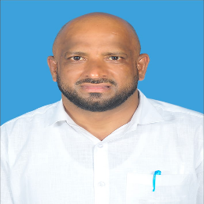

It is with a profound sense of responsibility and dedication to our community that I present the Meenja Grama Panchayat Pandemic Preparedness Plan. Our recent shared experiences have underscored a vital truth: the safety of our families and the resilience of our village depend entirely on our ability to act with foresight, unity, and scientific precision before a crisis arrives.
This comprehensive plan has been developed to fortify our local healthcare infrastructure and enhance our capacity to prevent, identify, and contain public health threats. By prioritizing early-warning surveillance, streamlining our emergency response protocols, and ensuring the strategic mobilization of medical and essential resources, we are creating a safety net that covers every household in Meenja.Our highest priority remains the protection of those most at risk, including our elderly citizens, children, and those with pre-existing health conditions. We are committed to a transparent and coordinated approach, working hand-in-hand with our dedicated frontline health workers, ward members, and volunteers to ensure that no resident is left unsupported during challenging times.The success of this preparedness strategy relies on the collective spirit of our people. I call upon every resident and local stakeholder to join us in this mission of prevention and readiness.
Warm regards,
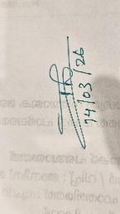
President,
Meenja Grama Panchayat

MESSAGE FROM HEALTH STANDING COMMITTEE CHAIR

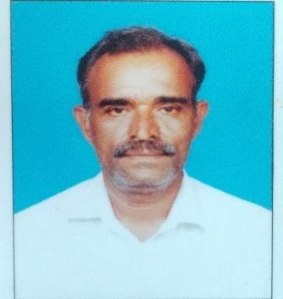

The Health Standing Committee of the Meenja Grama Panchayat is honoured to present our comprehensive Pandemic Preparedness Plan, a vital initiative designed to fortify our collective resilience against future public health emergencies.
In recent years, we have gained a profound understanding of the critical role that early detection, meticulous planning, and unified action play in successfully managing outbreaks and pandemics. This plan serves as a roadmap, detailing our strategies for enhanced disease surveillance, rapid emergency response, active resource management, and the dedicated protection of our most vulnerable neighbours. We remain steadfast in our commitment to working hand-in-hand with the Health Department, our dedicated ASHA workers, Anganwadi staff, and community volunteers. By streamlining our coordination with all local stakeholders, we aim to ensure that every ward receives timely, effective, and compassionate support during any health crisis.The success of this mission rests on the foundation of community participation. We call upon every resident to join us in this effort by staying informed and strictly adhering to public health guidelines. Your cooperation is the most powerful tool we have to safeguard the health and well-being of our entire Panchayat.

Warm regards,
Chairperson, Health Standing Committee Meenja Grama Panchayat

MESSAGE BY MEDICAL OFFICER
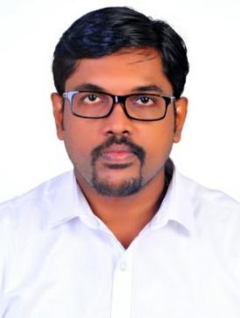
Preparedness is our strongest shield against the unpredictable nature of public health threats. The global health landscape has taught us that the question is not if another public health emergency will occur, but when. As we reflect on our past experiences and the evolving nature of infectious threats—from respiratory viruses to zoonotic outbreaks—it is clear that our strongest defense lies in preparedness, not just response. Based on our analysis of past years’ disease patterns, local pandemic trends, and identified hotspots within our wards, our team continues to conduct active and persistent field surveillance. As the Medical Officer, I am devoted to ensuring that our healthcare infrastructure is fully equipped to provide a swift and efficient response to any emerging public health crisis. The Pandemic Preparedness Plan of Meenja PHC has been developed with a focus on early detection, rapid response, effective surveillance, efficient case management, infection prevention and control, and strong intersectoral coordination. Special emphasis is given to strengthening laboratory linkages, triage systems, isolation facilities, logistics management, risk communication, and community participation. We have also prioritized capacity building of healthcare workers, mock drills, emergency stock maintenance, and coordination with Local Self Government Institutions and private healthcare facilities to ensure a unified and timely response during any public health emergency. Preparedness today ensures safety tomorrow. Through collective responsibility, scientific planning, and community cooperation, we can effectively prevent, contain, and manage future pandemics.


Medical Officer
Meenja Primary Health Centre
EXECUTIVE SUMMARY
Family Health Centre (FHC) functions as the primary public healthcare institution serving the population of Meenja Grama Panchayath. The FHC plays a pivotal role in delivering comprehensive, accessible, and affordable healthcare services, with a strong focus on preventive, promotive, curative, and rehabilitative care in accordance with national and state health programmes.
The PHC caters to a predominantly rural population, addressing key public health priorities such as maternal and child health, communicable and non-communicable disease control, immunization, family welfare, adolescent health, and geriatric care. Regular outpatient services, home-based care through field health staff, and outreach activities ensure healthcare coverage even in geographically challenging areas. Meenja FHC works in close coordination with the Grama Panchayath, ASHA workers, Anganwadi centres, schools, and community-based organizations to strengthen community participation and improve health awareness. Emphasis is placed on early detection, timely referral, health education, and lifestyle modification to reduce disease burden and improve overall health outcomes.
Despite constraints related to infrastructure, manpower, and increasing service demand, the FHC continues to enhance service delivery through effective planning, data-driven decision-making, and community engagement. Strengthening facilities, upgrading digital health systems, and expanding preventive services remain key focus areas for future development.
Overall, Meenja Family Health Centre stands as a vital institution in safeguarding public health and improving the quality of life of the residents of Meenja Grama Panchayath.

LIST OF ABBREVIATIONS

LSGD/LSGI | Local Self Government Department / Local Self Government Institution
BMO | Block Medical Officer
IDSP | Integrated Disease Surveillance Programme
NDMA | National Disaster Management Authority
PPE | Personal Protective Equipment
ICMR | Indian Council of Medical Research
CD | Communicable Diseases
NCD | NON-COMMUNICABLE DISEASES

TABLE OF CONTENTS

INTRODUCTION 9
● Background of the PPP 9
LSGD AT A GLANCE 11
INTEGRATED HEALTH INFRASTRUCTURE MAP OF MEENJA GRAMA PANCHAYAT 15
GENERAL PROFILE OF THE LSGI’S 16
Background of the LSGI 15
Demographic and Vulnerable Population 18
Clinical Vulnerability 19
INFRASTRUCTURE & RESOURCE INVENTORY 21
Health Facility Directory & Basic Capacity in the LSGD 21
Private Clinics 21
Healthcare Education & Training Institutions 22
Specialized Services & Emergency Inventory 24
Oxygen & Diagnostic Capacity 25
Diagnostics facility mapping at the LSGI level 25
Laboratory Identification & Basic Details 26
Social and Community Infrastructure for surge plan 26
Human resources 28
Community & Support Cadre 30
Community Organizations 31
Administrative & Emergency Services 32
Information regarding resources 33
ONE HEALTH & ENVIRONMENTAL SURVEILLANCE 34
Animal & Bird Population 31
Veterinary Infrastructure 35
Veterinary Doctors & Workforce 36
High-Risk Interface Points (Surveillance Sites) 36
Environmental Risk Mapping 39
Disease Seasonality Mapping 41
Vulnerability Mapping 42
EPIDEMIOLOGICAL TRENDS (2021–2025) 43
Disease Burden among human beings(Last 5 Years) 43
*(use the above table data to create the graph/diagram) 43
Seasonal Trend Analysis 45
Outcome-Based Trend Analysis- 2025 50
Transmission Trend- 2025 51
Integrated Disease Hotspot Map (2021–2025) 55
Preparedness and Response Protocol at LSG Level 59
Constitution of One Health Committee 59
Pandemic Response Workforce 60
Activities and Measures before and during Pandemic 62
PHASE 1 - Alert / Preparation 62
PHASE 2 - Active Response 65
Standard Screening Protocol 66
PHASE 3 - Surge Capacity 76
Conversion of Community Facilities 76
CONCLUSION 77
RECOMMENDATIONS 78
ANNEXURE 81
1. IMPORTANT PHONE NUMBERS 81

INTRODUCTION

Background of the PPP
Pandemics are widespread outbreaks of infectious diseases that pose serious threats to public health, economic stability, and social systems. In recent decades, factors such as rapid urbanization, globalization, climate variability, population mobility, and ecological changes have increased the risk of emerging and re-emerging infectious diseases. The COVID-19 pandemic demonstrated how quickly an infectious disease can spread across regions and overwhelm health systems, disrupt livelihoods, and affect essential services. At the local level, Panchayats and Block administrations play a crucial role in the prevention, detection, and response to public health emergencies. Primary Health Centers (PHCs), Sub-centers, community health workers, and local self-government institutions form the frontline of pandemic response. Effective surveillance systems, timely reporting, rapid response mechanisms, and community participation are essential to contain outbreaks at an early stage. Pandemics not only increase morbidity and mortality but also strain healthcare infrastructure, supply chains, and human resources. Vulnerable populations—including the elderly, children, pregnant women, persons with comorbidities, migrant workers, and socio-economically disadvantaged groups—are disproportionately affected. Ensuring equitable access to healthcare services, maintaining essential health services, and protecting frontline workers are critical components of preparedness. A structured Pandemic Preparedness Plan aims to strengthen surveillance and early warning systems, improve laboratory and diagnostic capacity, ensure adequate stockpiling of essential supplies (including PPE, medicines, oxygen, and equipment), establish isolation and referral protocols, and promote risk communication strategies to counter misinformation. Intersectoral coordination among health, local self-government, police, education, ICDS, and community organizations is vital for effective implementation. Preparedness is not a one-time activity but a continuous process involving risk assessment, capacity building, mock drills, periodic review, and plan revision. By institutionalizing preparedness measures at the grassroots level, the Panchayat/Block can enhance resilience, reduce transmission, minimize mortality, and mitigate the social and economic impact of future pandemics. A proactive, coordinated, and community-centered approach is essential to safeguard public health and ensure timely and effective management of any emerging infectious disease threat.

- LSGD at a glance
Administrative Details
- District: Kasaragod district
- Block Panchayat: Manjeshwar Block Panchayat
- State: Kerala
- Type: Rural Local Self Government (Grama Panchayat)
Geographical Features
- Located in the northernmost part of Kerala near the Karnataka border.
- Semi-rural setting with mixed agricultural and residential areas.
- Influenced by monsoon climate, affecting agriculture and public health planning.
Demographic Profile
- Multi-lingual population (Malayalam, Kannada, Tulu).
- Rural households with agriculture, trade, and daily wage employment.
- Border proximity contributes to population mobility.
Health & Public Services
- Primary Health Centre (PHC)
- Sub-centers
- Anganwadi centers (ICDS)
- ASHA workers for community health outreach

LSGD AT A GLANCE
- Geographical boundaries with political map (based on latest delimitation)
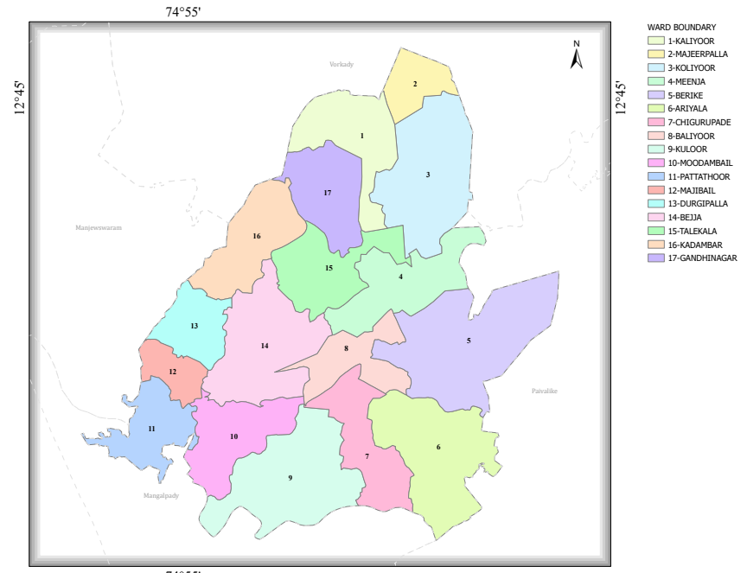
Boundaries
- South - Mangalpady and Paivalike Grama Panchayats
- North - Vorkady Grama Panchayat
- East - Paivalike Grama Panchayat
- West - Manjeswaram and Mangalpady Grama Panchayats

- Baseline data
Ward | Houses | Population | Migrants | Wells | Hot  spots | Ed. Institutions | Hosp pvt/govt.
17 | 6011 | 28325 | 311 | 1671 | 0 | 40 | 3

- Major Roads/rivers
Major Roads
- National Highway 66 (NH 66)
  - Main coastal highway connecting Kasaragod–Mangaluru

- State Highway 57 (SH 57)
  - Connects Kasaragod to Manjeshwar and interior areas.
Major Rivers
- Shiriya River
- Uppala River

- Occupational groups, socio cultural groups, migration & mobility patterns
Occupational Groups
The Panchayat has a predominantly rural economic structure with mixed livelihood patterns:
- Agricultural workers and small farmers – Cultivation of coconut, arecanut, paddy, and other seasonal crops.
- Daily wage laborers – Construction, loading/unloading, small-scale works.
- Small traders and shop owners – Retail shops, local markets, service sector.
- Government and private employees – Teachers, health workers, clerical staff.
- Gulf migrant workers – Significant proportion of households depend on overseas employment (especially Middle East countries).
- Cross-border workers – Daily commuting to nearby areas in Karnataka for employment.
PublicHealth

Socio-Cultural Groups
- Multi-lingual population (Malayalam, Kannada, Tulu).
- Presence of diverse religious communities living in close proximity.

Migration & Mobility Patterns
- International Migration: Significant migration to Gulf countries; seasonal return of expatriates.
- Inter-state Mobility: Regular movement between Kerala and Karnataka due to border proximity.

Maps - ward-based (Mention source also)

- Geographical boundaries - ward boundaries map

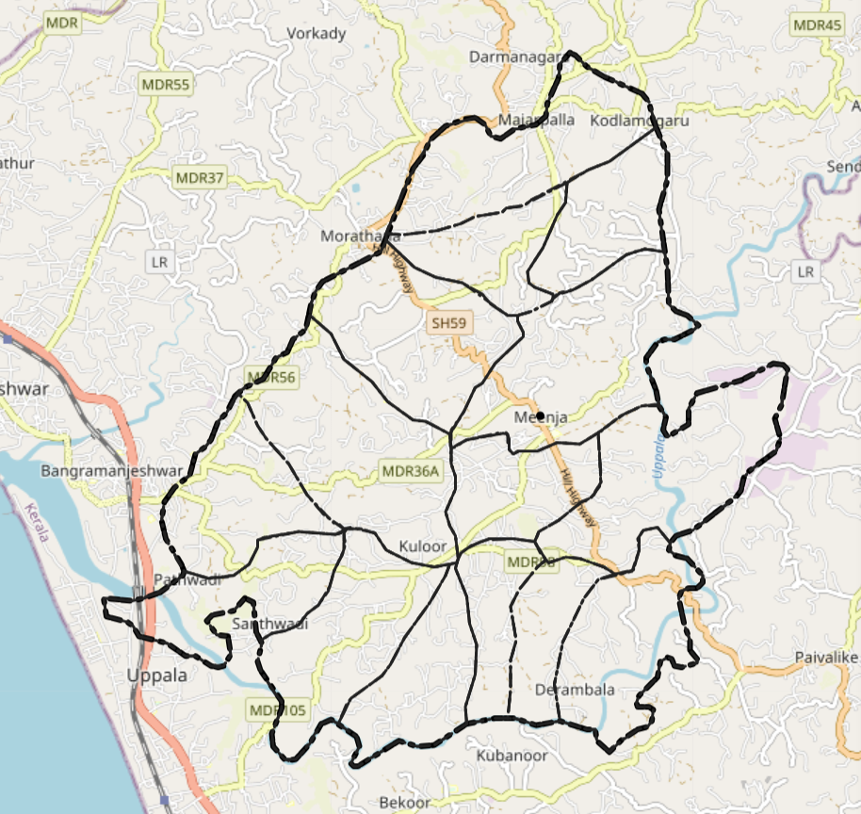
https://map.opendatakerala.org/kasaragod/meenja-grama-panchayat/

- Health infrastructure map
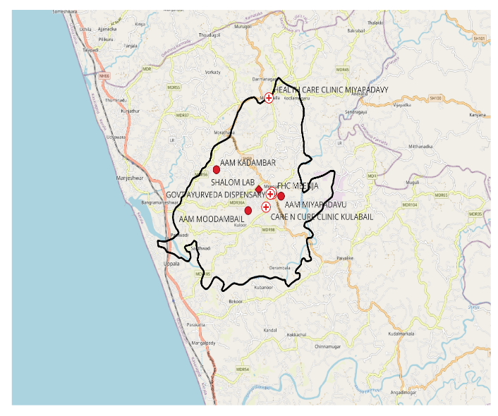

- roads and rivers map
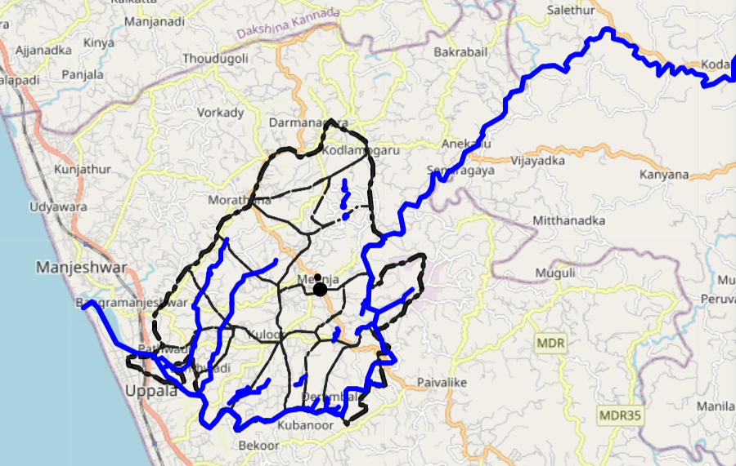

https://map.opendatakerala.org/kasaragod/meenja-grama-panchayat/?

- hotspot map - CD & disasters

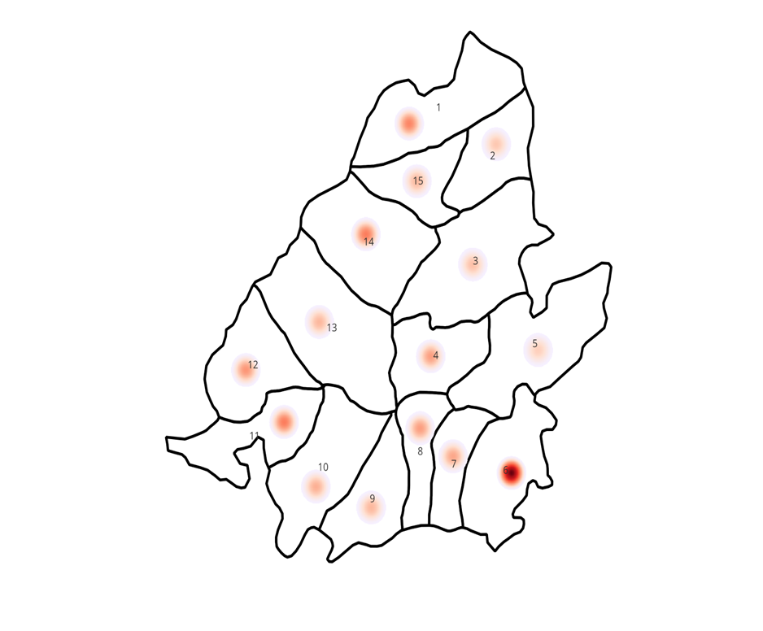

INTEGRATED HEALTH INFRASTRUCTURE MAP OF MEENJA GRAMA PANCHAYAT

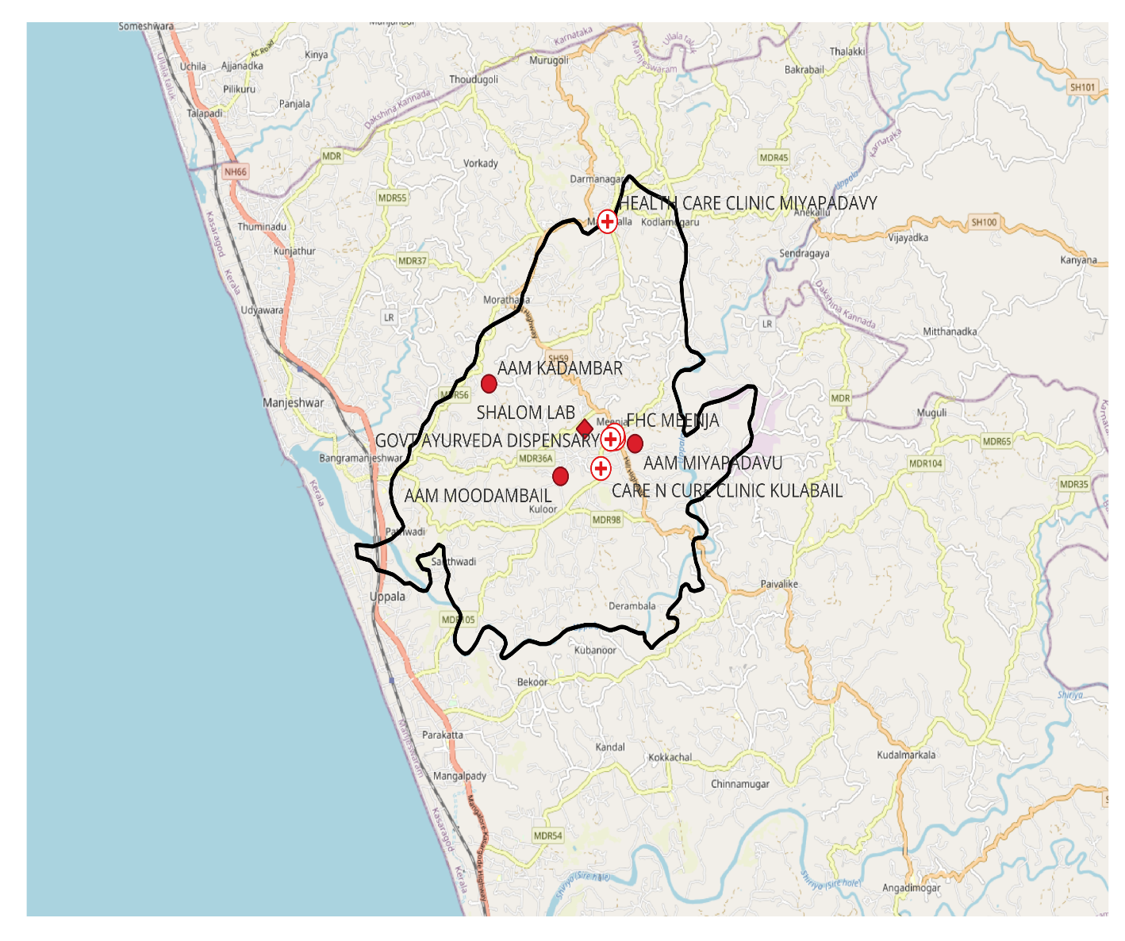

Meenja Administrative Boundaries Map
Boundary Data:Open Data Kerala
Map created with QGIS

GENERAL PROFILE OF THE LSGI’S
Meenja Grama Panchayat is situated in the northern part of Kasaragod district, Kerala, close to the Karnataka state border. The geographical landscape of the Panchayat is predominantly semi-rural, characterized by mixed agricultural lands, residential settlements, laterite terrain, and localized low-lying areas. The region is influenced by heavy monsoon rainfall and is interspersed with small streams and river systems, which significantly shape the local microclimate. While not entirely flood-prone like Kole land regions, certain pockets experience waterlogging during intense monsoon periods, posing challenges to transportation, emergency access, and service delivery.
The Panchayat is administratively divided into multiple wards, with a population largely dependent on traditional and semi-skilled livelihoods. Agriculture—particularly coconut, arecanut, and paddy cultivation—remains an important economic activity. Daily wage labor, small-scale trade, construction work, and cross-border employment opportunities contribute significantly to household income. A considerable proportion of families depend on overseas employment, especially in Gulf countries. The Panchayat also hosts migrant laborers engaged in construction and allied sectors, adding to its socio-economic diversity.
From a public health and disaster management perspective, Meenja LSGI faces seasonal challenges including vector-borne diseases such as Dengue, waterborne diseases during monsoon months, and risks associated with high population mobility due to its border proximity. Interstate movement between Kerala and Karnataka increases the epidemiological vulnerability to communicable diseases. Although the Panchayat has not experienced large-scale flooding comparable to major disaster zones, heavy rainfall events and localized disruptions have highlighted the need for improved preparedness and coordinated response systems.
In this context, the development of a localized, data-driven Auxiliary Infrastructure and Logistical Resource Map is crucial for strengthening preparedness planning. Such mapping will help identify healthcare facilities, critical infrastructure, transportation routes, vulnerable habitations, and emergency resources. A structured preparedness framework will enhance timely response, improve inter-departmental coordination, and build resilience against public health emergencies and other disasters, ensuring sustainable and secure community development within Meenja Grama Panchayat.
Table 1: Background of LSGD
Description | Details
Name of LSGI | Meenja
Type (GP/Municipality / Corporation etc.) | Grama Panchayath
Block | Manjeshwar
District | Kasaragod
Number of wards | 17
Total area (sq. km) | 49.9sqkm
Population (Projected) | 28325
Population density | 567.63persons/sq. km
Terrain (coastal/low-lying/backwaters/foothills, etc.) | low-lying
Number of rivers passing through LSGI | 1
Number of water bodies in the LSGI | 76
Number of educational institutions | 40
Factories / small-scale industries | 9
Flood-prone wards | 2(10,11)
Landslide-prone wards | 0
Death Management and Disposal Facilities (mortuaries/crematorium, including electric) | 2
Auditoriums/Marriage halls/convention centres/community halls | 5

Demographic and Vulnerable Population
Understanding the demographic composition and vulnerable population groups is essential for pandemic preparedness. Children, elderly, economically deprived families, migrant workers, and socially vulnerable groups are at increased risk during public health emergencies due to higher exposure, limited access to services, and dependency on public systems.

Description |  | Details (in numbers)
DEMOGRAPHIC PROFILE
Total population |  | 28325
Male |  | 14293
Female |  | 14032
Transgender |  | 0
Children under 5 |  | 1549
Adolescent |  | 2769
Elderly (>60) |  | 1527
SOCIAL/LIVELIHOOD VULNERABILITY
Previous EPEP family |  | 25
BPL family |  | 2403
Tribal communities |  | Present
Migration | Immigrant | 0
Migration | Emigrant | 0
Socio-economically deprived |  | 0
Fisherfolk |  | 0
SC Community |  | 1030
ST Community |  | 190

Clinical Vulnerability
Certain population groups need priority healthcare & are at higher risk of severe illness, complications, and mortality during pandemics. Patients with chronic diseases, those requiring regular medical care, and individuals with mobility or functional limitations face challenges in accessing timely care during emergencies. Mapping these groups helps in prioritizing continuity of treatment, medicine stock planning, oxygen support, referral transport, and targeted home-based care.
Description | Details in numbers
Pregnant women | 113
Lactating mothers | 291
Bedbound patients | 77
Patients under palliative care other than bedbound | 150
Patients on Haemodialysis | 0
Patients on CAPD | 24
Cancer patients (currently on treatment) | 81
Haemophilic patients | 0
Mentally challenged | 4
Differently abled | 85
Diabetic patients | 259
Hypertensive patients | 952
TB patients | 8

Major Festivals & Events specific to the LSGI
(with the possibility of a public gathering)

Sl. No. | Name of festival | Month detailing the periodicity
1. | ManavattyBeevi Uroos | January
2. | Sankaranarayana Temple, Koliyoor | January (2,3)
3. | Kalootty Devasthana Festival | February
4. | Vishnu Moorthy Temple Festival | February
5. | Arasu Devasthana Festival | February
6. | Padathamogaru Devasathana Festival | March
7. | Ayyappa Bhajana Mandir, Miyapadavu | December

INFRASTRUCTURE & RESOURCE INVENTORY

Health Facility Directory & Basic Capacity in the LSGD
This section provides an overview of the healthcare infrastructure available within the LSGD area. It outlines the distribution and basic capacity of health facilities that form the backbone of service delivery during routine times and public health emergencies.

Family Health Centres (FHCs) and Community Health Centres (CHCs) generally function as the first point of contact for the community, providing essential outpatient and inpatient services. General Hospitals (GH) and Medical College Hospitals (MCH), where accessible, serve as the main referral centres for advanced diagnostics, specialist care, and critical services during public health emergencies. This inventory helps identify existing strengths, gaps, and potential surge capacity that can be mobilised during a pandemic or disaster.

Table 5. Health Facility Resource Summary
Sl.no. | Health Facility | Type of Facility (MCH/GH/CHC/FHC/SC etc.) | Contact Number | Total beds | ICU Beds | Oxygen-Supported Beds | No. of Ventilator Support Beds | No. of ambulances
Government Healthcare Facilities
1 | FHC Meenja | FHC | 8907721877 | 0 | 0 | 0 | 0 | 0
2 | AAM Miyapadav | SC | 9947985239 | 0 | 0 | 0 | 0 | 0
3 | AAM Moodambail | SC | 7356786146 | 0 | 0 | 0 | 0 | 0
4 | AAM Kadambar | SC | 7356786146 | 0 | 0 | 0 | 0 | 0
Private Healthcare Facilities
1 | Health Care Clinic,Majirpalla |  | 9633857967 | 1 | 0 | 0 | 0 | 0
2 | Care and cure clinic, Kulabail |  | 9447914733 | 1 | 0 | 0 | 0 | 0
AYUSH Healthcare Facilities
1 | Govt Homoeopathy Dispensary, Meenja |  | 7012166594 | 0 | 0 | 0 | 0 | 0
2 | Govt Ayurveda Dispensary |  | 9496422597 | 0 | 0 | 0 | 0 | 0

Private Clinics
Private clinics are an essential part of pandemic preparedness, as they are often the first place people seek care when symptoms begin. In many communities, private clinics manage a significant share of outpatient visits and therefore play a critical role in early case detection, timely referrals, and disease surveillance. Having an up-to-date understanding of where these clinics are located, the services they provide, and how they are linked to the public health system helps ensure that no cases are missed during an outbreak. It also allows health authorities to engage private practitioners more effectively for reporting, risk communication, and coordinated response, strengthening the overall capacity of the health system to manage public health emergencies.

Table 6. Private Clinic Resource Summary
Sl No. | Name of Clinic | Registered (Y/N) | Clinic (General / Speciality) | Speciality (if any) | Address | Contact Number | Diagnostic Facility (Y/N) | Ambulance Linkage (Y/N)
1 | Health Care Clinic, Majirpalla | Y | General | 0 | Majirpalla | 9633857967 | Y | N
2 | Care and cure clinic, Kulabail | Y | General | 0 | Kulabail | 9447914733 | Y | N

Healthcare Education & Training Institutions
This section tracks the educational infrastructure available, which is vital for human resource planning in the health sector.

Category of Institution | Govt | Private | AYUSH | Total
Medical Colleges | 0 | 0 | 0 | 0
Nursing Colleges | 0 | 0 | 0 | 0
Dental Colleges | 0 | 0 | 0 | 0
Para-medical / Allied Health | 0 | 0 | 0 | 0
Pharmacy Colleges | 0 | 0 | 0 | 0

Specialized Services & Emergency Inventory
This section provides a detailed view of the specialized medical resources available to the community, focusing on emergency response and critical care capabilities. This table tracks the vital assets required for managing severe illnesses and emergencies across Government, Private, and AYUSH sectors.

Item | Govt | Private | AYUSH | Total
Hospital beds | 0 | 0 | 0 | 0
Oxygen-generating systems(Y/N) | 0 | 0 | 0 | 0
Oxygen-supported beds (Numbers) | 0 | 0 | 0 | 0
Ventilator-supported beds | 0 | 0 | 0 | 0
ICU beds | 0 | 0 | 0 | 0
Burns units | 0 | 0 | 0 | 0
Blood centres | 0 | 0 | 0 | 0
BLS ambulances | 0 | 0 | 0 | 0
ALS ambulances | 0 | 0 | 0 | 0
Dialysis facilities | 0 | 0 | 0 | 0
Dispensaries | 0 | 0 | 1 | 1
Medical store | 1 | 5 | 1 | 1
Industrial establishments (Medium-scale industries/small-scale industries establishments to whom we can depend in a worst-case scenario) | 0 | 0 | 0 | 0

Oxygen & Diagnostic Capacity
Monitoring oxygen and diagnostic capacity is a critical component of public health preparedness, ensuring that the LSGD can handle both chronic care and sudden surges in respiratory or infectious diseases.
Name of Health Facility | Oxygen-generating System (Y/N) | Backup Oxygen Source (Y/N) | Diagnostic Facilities Available(Y/N)
Name of Health Facility | Oxygen-generating System (Y/N) | Backup Oxygen Source (Y/N) | Lab | USG | X-ray | CT/MRI | RT-PCR
Government Healthcare Facilities
FHC Meenja | N | N | Y | N | N | N | N

Diagnostics facility mapping at the LSGI level
The diagnostic capacity of Meenja G.P represents the "intelligence network" of our healthcare system. The speed and accuracy of disease identification depend entirely on the distribution and technical level of these facilities.

Item | Govt | Private | AYUSH | Total
General labs | 1 | 2 | 0 | 0
Microbiology labs | 0 | 0 | 0 | 0
RT-PCR labs | 0 | 0 | 0 | 0
USG units | 0 | 0 | 0 | 0
CT/MRI units | 0 | 0 | 0 | 0
Research labs | 0 | 0 | 0 | 0
Labs of other departments that can be repurposed | 0 | 0 | 0 | 0

Laboratory Identification & Basic Details
Sl. No. | Name of Laboratory | Ownership (Govt / Private / Academic) | Address | Contact No. | 24×7 Services (Yes/No) | NABL / Govt Approved (Yes/No)
1 | FHC Meenja | Govt | Miyapadavu | 8907721877 | No | Yes
2 | Shalom | Private | Majirpalla | 830109577 | No | No
3 | Sri Durga Labs | Private | Miyapadavu | 9740767460 | No | No

Social and Community Infrastructure for surge plan
This table serves as our logistics and shelter inventory. By mapping these locations, quickly we can identify where to house displaced citizens, where to set up temporary medical clinics, and how to manage the deceased with dignity during a crisis.

Category | Total Count | Ward | Est. Capacity (Persons) | Contact details
Educational Institutions
Anganwadi’s | 24 | 1-17 | 300 | 9745458886
Schools | 16 | 1-`17 | 5921 | 9400448888
Colleges | 0 | 0 | 0 | 0
Healthcare Educational Institutions
Medical colleges (Govt/Private) | 0 | 0 | 0 | 0
Nursing colleges (Govt/Private) | 0 | 0 | 0 | 0
Dental colleges (Govt/Private) | 0 | 0 | 0 | 0
Paramedical institutes (Govt/Private) | 0 | 0 | 0 | 0
Community Gathering Spaces
Community halls | 2 |  | 500
Auditoriums | 2 |  | 1000
Religious buildings | 11 |  | 150
Vulnerable Group Support Facility
Destitute homes | 0 | 0 | 0 | 0
Elderly homes | 0 | 0 | 0 | 0
LSGD owned other buildings | 0 | 0 | 0 | 0
Mass Fatality Management (MFM) Infrastructure
Mortuary | 0 | 0 | 0 | 0
Crematorium | 2 | 5,14 | 1 | 04998252262
*Refer annexure 1 for contact details

Human resources
This section focuses on the human capital available within the LSGI. In any emergency—be it a pandemic, flood, or industrial accident—infrastructure is only as effective as the people operating it.

Medical & Clinical Personnel
This table tracks the "Frontline" providers responsible for diagnosis, treatment, and clinical management. Narrative sentence: eg., "Total health workforce: 450 personnel, with 60% in government facilities serving as primary surge capacity." A detailed directory with the contact numbers of all workers is maintained (Annexure in 1).

Cadre | Govt (No.) | Private (No.) | Total
Doctors—Modern Medicine | 1 | 2 | 3
Doctors – AYUSH | 2 | 0 | 2
Doctors – Veterinary | 1 | 0 | 1
Doctors – Dental | 0 | 2 | 2
Nursing officers | 1 | 0 | 1
Lab technicians | 1 | 2 | 3
Optometrist | 0 | 0 | 0
Pharmacists | 1 | 5 | 6
Psychologists | 0 | 0 | 0
Counsellors | 0 | 0 | 0

Public Health & Field-Level Workforce

These individuals are the backbone of surveillance, maternal-child health, and decentralized care.

Cadre | Health services | Municipal common services | Total
HS (Health Supervisors) | 0 | 0 | 0
HI (Health Inspectors) | 1 | 0 | 1
LHS (Lady Health Supervisor) | 0 | 0 | 0
LHI (Lady Health Inspectors) | 0 | 0 | 0
JPHN (Jr Public Health Nurses) | 2 | 2 | 4
JHI (Jr Health Inspectors) | 2 | 2 | 4
MLSP (Mid-Level Service Providers) | 2 | 2 | 4
Palliative Nurses | 1 | 1 | 2
RBSK Nurses | 0 | 0 | 0
PRO | 0 | 0 | 0
Epidemiologist | 0 | 0 | 0
Data Manager | 0 | 0 | 0

Community & Support Cadre
This group represents the surge capacity of the LSGI—people who can be called upon for logistics, rescue, and specialized support.

Cadre | Number
ASHA Workers | 15
AWW (Anganwadi Workers) | 24
Emergency Medical Volunteers (Trained) | 2
Kudumbashree | 223
MNREGS | 785
Purusha Swayam Sahaya Sangham | 0
Ex-Servicemen | 0
Retired Police Officers | 0
NCC/NSS Volunteers | 56
Red Cross volunteers | 60
One Health Community Volunteers | 0
One Health Community Mentors | 0

Community Organizations

This section details the presence of community-based organisations (CBOs), non-governmental organisations (NGOs), faith-based organisations (FBOs), Kudumbashree Self-Help Groups (SHGs), and Ayalkootams within the Local Self-Government Institution (LSGI). These groups enhance grassroots mobilization, resource distribution, and support networks crucial for pandemic response and community resilience.

Category | Total Count
NGOs | 0
Religious based organizations | 0
Foreign based organizations | 0
Sports Club/youth clubs | 4
Kudumbashree SHGs | 223
Ayalkootams | 223
Political organizations | 0
Residential organizations | 0

Administrative & Emergency Services
This section outlines the availability of key non-health emergency support services and infrastructure within the LSGI, which are essential for effective pandemic preparedness and response. These facilities support law enforcement, disaster response, water supply, logistics, mobility, and community-level interventions during public health emergencies.

Category | Total Count | Contact details
Police Stations | 0
Fire & Rescue Stations | 0
Water Pumping Points | 0
Public Distribution System (PDS) | 0

Information regarding resources
The availability of essential transport and support resources plays a quiet but critical role in saving lives. Equipment such as ambulances, mobile mortuaries, amphibian ambulances, and motorized boats ensures that patients, samples, and healthcare teams can move swiftly—even in flooded, remote, or difficult terrains. Heavy vehicles like JCBs, cranes, tractors, and torus lorries support logistics, waste management, emergency infrastructure, and rapid conversion of spaces into care or isolation facilities. Taxis, four-wheel-drive vehicles, and trucks help maintain continuity of essential services, reach vulnerable populations, and support home-based care and supply delivery.

Means of transportation | Total Count
JCB | 3
Crane | 0
Heavy Trucks | 1
Tractor | 0
Ambulances | 0
Mobile mortuaries | 0
Boats | 0
Taxi service | 5
Note: For specific details regarding vehicle owners and contact information, please refer to Annexure [X].

ONE HEALTH & ENVIRONMENTAL SURVEILLANCE
The One Health method integrates environmental, animal, and human health to enable proactive pandemic preparedness. Panchayat-level surveillance needs to be improved in order to detect and treat zoonotic and environmentally generated diseases early. Mapping animal and bird populations at the Panchayat level is essential for identifying and prioritising zoonotic disease hazards like rabies, leptospirosis, and Nipah-like spillover occurrences. Risk classification, targeted surveillance, vaccination planning, and early epidemic detection made feasible by comprehensive population mapping all enhance One Health-based pandemic preparedness.

Category | Item | Estimated Population | Wards
Animal Population | Livestock (Cattle/Goats/Buffalo) | 1640 | 1-17
Animal Population | Pet Animals (Dogs/Cats) | 70/80 | 1-17
Animal Population | Stray Dog Population | 150 | 1-17
Animal Population | Pig Farms (Number of heads) | 1 | 1
 | Small Units (Sheep / Goats – clustered) | 0 | 0
Bird Population | Poultry Units (Birds) | 2800 | 4,12,10
Bird Population | Poultry- (FOWL) | 0 | 0
Bird Population | Wild/Migratory Birds (Observed) | 0 | 0
Bird Population | Crow Mortality Events (Reported) | 0 | 0

The overall risk of zoonotic disease in Meenja Panchayat is very low.The disease most commonly observed are dengue, Hepatitis A infections.The zoonotic or infections disease in the area show a declining trend,indicating generally low transmission risks.

Veterinary Infrastructure
Veterinary institutions are a core pillar of One Health surveillance, enabling early zoonotic disease detection through vaccination, investigation of unusual animal illness or deaths, sample collection, and timely outbreak reporting. A well-mapped and responsive veterinary network strengthens coordination with human health and LSGI systems, ensuring rapid response during zoonotic events and pandemics.
Facility Type | Name of Facility | Ownership Govt / Pvt | Location(Ward No) | Contact number
Veterinary Dispensary | 1 | Govt | 8 | 7907599674
Veterinary Hospital / Polyclinic | 0 | 0 | 0 | 0
Private Veterinary Clinics | 0 | 0 | 0 | 0
Mobile / Emergency Vet Service (incl. night services) | 0 | 0 | 0 | 0
Pet Homes / Animal Shelters | 0 | 0 | 0 | 0
Slaughterhouse-linked Veterinary Inspection Unit | 0 | 0 | 0 | 0

Veterinary Doctors & Workforce
Early detection, diagnosis, reporting, and reaction to animal illness epidemics depend on the availability and accessibility of qualified veterinary specialists. By identifying unusual animal morbidity or mortality promptly, collecting samples promptly, and coordinating efficiently with human health and LSGI systems—especially during zoonotic outbreaks and pandemic-prone situations—a clearly defined veterinary workforce enhances One Health surveillance.

Category | Number Available | Type (Govt/Pvt) | Contact number
Government Veterinary Doctors | 1 | Govt | 7907599674
Private Veterinary Doctors | 0
Livestock Inspectors | 3 | Govt | 9895859040
Para-veterinary Staff / Attenders | 1 | Govt | 9746259081
Contract / On-call Veterinary Support (if any) | 0 | 0 | 0

High-Risk Interface Points (Surveillance Sites)
Zoonotic disease surveillance in Meenja Grama Panchayat indicates minimal high-risk interface points, with only one identified risk at a community slaughter site, while other potential interfaces such as wetlands and backwaters, backyard poultry farms, cattle sheds near water bodies, fish and meat markets, migratory bird congregation areas, and rodent-infested grain storage show no significant risk or geographical vulnerability at present.

Type of Habitat | Type of High-risk interface | Geographical vulnerability
Wetlands & Backwaters | 0 | 0
Backyard Poultry Farms | 0 | 0
Cattle Sheds near Water Bodies | 0 | 0
Fish & Meat Markets | 0 | 0
Community Slaughter Sites | 1 | 0
Migratory Bird Congregation Areas | 0 | 0
Rodent-Infested Grain Storage | 0 | 0

Category | Total Count | Key Locations (wards)
Poultry Farms | 3 | 4,12,10
Backyard / Clustered Poultry Units | 0 | 0
Duck Rearing Units (open water access) | 0 | 0
Slaughterhouses/ Slaughter Points | 1 | 0
Meat/Fish Markets | 0 | 0
Live Bird Sale Points | 0 | 0
Cattle Markets / Weekly Animal Fairs | 0 | 0
Pet Shops / Breeders | 1 | 4
Animal Shelters / Pet Homes | 0 | 0
Waste Disposal Sites near Animal Units | 0 | 0

Environmental Risk Mapping
Environmental risk mapping identifies monsoon/flood hotspots for vector-borne (dengue, chikungunya), water-borne (leptospirosis, diarrhoea), and zoonotic diseases in Kerala's wetlands. Systematic surveillance supports early warnings, targeted interventions, and Panchayat pandemic preparedness.
Waterborne exposure: Flood-prone areas and stagnant water bodies facilitate leptospira survival, raising leptospirosis risk.

Traditional practices: Informal slaughter and fish markets lack standardized hygiene, creating spillover opportunities.

Risk Factor | High-Risk Wards | Key Locations | Risk Level (High/Med/Low)
Flood-prone areas | 0 | 0 | 0
Water bodies/wetlands | 0 | 0 | 0
Solid waste accumulation | 0 | 0 | 0
Animal waste disposal issues | 0 | 0 | 0
Rodent infestation zones | 0 | 0 | 0
Industrial effluent discharge | 0 | 0 | 0
Construction sites / abandoned buildings | 0 | 0 | 0
Poor drainage/blocked canals | 0 | 0 | 0
Drinking water source contamination risk | 0 | 0 | 0

Disease Seasonality Mapping
1, Flooding & waterlogging → amplifies leptospirosis, malaria, diarrheal diseases.
·
2, Migratory bird influx (Nov–Feb) → avian influenza risk.

3, Mosquito breeding cycles → vector-borne disease peaks in monsoon.

4, Agricultural practices → close human–animal contact in paddy fields.

Disease | Peak Risk Season | Key Drivers | High-Risk Locations | Surveillance Focus
Leptospirosis | Post Monsoon |  | 0 | Environmental
Dengue/Chikungunya | Monsoon | Climate | 0 | Environmental
Acute Diarrheal Diseases | Summer |  | 0 | Water Quality
Rabies | No Fixed |  | 0 | Animal Surveillance

Vulnerability Mapping
Vulnerability mapping pinpoints high-risk populations, occupations, and areas exposed via environment, livelihoods, socio-economics, and poor service access. Paired with environmental/seasonality mapping, it enables risk-based surveillance, targeted actions, and optimal resource use in One Health and pandemic planning.
Vulnerability Factor | High-Risk Wards | Key Groups / Locations | Risk Level
Flood-prone households | 0 |  | Low
Wetland-adjacent communities | 0 |  | Low
Backyard poultry / duck rearing households | 0 |  | Low
Livestock-rearing households | 0 |  | Low
Slaughterhouse & meat market workers | 0 |  | Low
Fisherfolk & fish market workers | 0 |  | Low
Sanitation workers | 0 |  | Low
Daily wage / migrant workers | 300 |  | Low
Elderly & chronically ill populations | 1527 |  | Low
Pregnant Women | 113 |  | Low
Children (schools, Anganwadi’s) | 5000 |  | Low
Limited access to safe water & sanitation | 0 |  | Low

EPIDEMIOLOGICAL TRENDS (2021–2025)

Disease surveillance is the systematic collection, analysis, and interpretation of health data for planning, implementation, and evaluation of public health practice. This section presents the disease surveillance profile of the LSGI based on routine reporting systems and outbreak investigations to identify priority diseases, seasonal patterns, and emerging public health threats.

Disease Burden among human beings (Last 5 Years)
Analysis of disease-wise data for the last five years helps identify persistent public health problems, emerging diseases, and changes in disease burden. This information supports prioritisation of prevention, preparedness, and response activities at the Panchayat level.

Disease | 2021 | 2022 | 2023 | 2024 | 2025 | Trend (Increasing/Stable/Decreasing)
Dengue | 0 | 0 | 8 | 13 | 6 | Stable
Leptospirosis | 0 | 0 | 0 | 1 | 2 | Stable
Hepatitis A | 0 | 0 | 27 | 1 | 9 | Decreasing
Malaria | 1 | 0 | 0 | 1 | 2 | Stable
Scrub Typhus | 0 | 0 | 0 | 0 | 0 | Stable
Typhoid | 0 | 0 | 0 | 0 | 0 | Stable
H1N1 | 0 | 0 | 0 | 0 | 1 | Stable
H3N2 | 0 | 0 | 0 | 0 | 0 | Stable
ADD | 10 | 18 | 22 | 16 | 30 | Increasing
Mumps | 6 | 8 | 12 | 2 | 3 | Stable
Measles | 0 | 0 | 0 | 0 | 0 | Stable
Hepatitis B | 0 | 0 | 0 | 0 | 0 | Stable
Hepatitis C | 0 | 0 | 0 | 0 | 0 | Stable
Tuberculosis | 18 | 13 | 14 | 15 | 16 | Increasing
Leprosy | 0 | 0 | 0 | 1 | 0 | Stable
COVID-19 | 608 | 55 | 0 | 0 | 0 | Decreasing

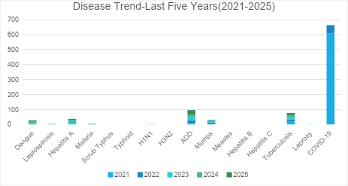

Seasonal Trend Analysis
Seasonal analysis helps anticipate surges (e.g. dengue in monsoon, leptospirosis after floods, influenza in cooler months) and plan pre‑emptive vector control, stockpiling of IV fluids, and awareness campaigns at Panchayat level.

DENGUE
Dengue is a major seasonal vector-borne disease strongly associated with rainfall, water stagnation, and increased mosquito breeding during the monsoon period.

Peak: July–November

Dengue – Ward-wise Yearly Distribution (2021–2025)

Ward | Dengue – Ward-wise Yearly Distribution
Ward | 2021 | 2022 | 2023 | 2024 | 2025 | Total
1 | 1 | 0 | 0 | 1 | 0 | 2
2 | 1 | 0 | 0 | 0 | 0 | 1
3 | 0 | 0 | 0 | 1 | 0 | 1
4 | 2 | 0 | 2 | 1 | 2 | 7
5 | 0 | 0 | 0 | 1 | 0 | 1
6 | 1 | 2 | 1 | 1 | 0 | 5
7 | 1 | 1 | 0 | 0 | 0 | 2
8 | 0 | 1 | 2 | 0 | 1 | 4
9 | 2 | 0 | 0 | 1 | 0 | 3
10 | 0 | 0 | 1 | 1 | 0 | 2
11 | 3 | 1 | 0 | 2 | 0 | 6
12 | 0 | 0 | 0 | 2 | 1 | 3
13 | 0 |  | 2 | 1 | 1 | 4
14 | 6 | 0 | 0 | 1 | 0 | 7
15 | 3 | 1 | 0 | 0 | 1 | 5

LEPTOSPIROSIS
Leptospirosis cases are closely linked to monsoon rains, flooding, and occupational exposure, particularly in low-lying and waterlogged areas.

Peak: June - August

Leptospirosis – Ward-wise Yearly Distribution (2021–2025)

Ward | Leptospirosis – Ward-wise Yearly Distribution
Ward | 2021 | 2022 | 2023 | 2024 | 2025 | Total
1 | 0 | 0 | 0 | 0 | 0 | 0
2 | 0 | 0 | 0 | 0 | 0 | 0
3 | 0 | 0 | 0 | 0 | 0 | 0
4 | 0 | 0 | 0 | 0 | 0 | 0
5 | 0 | 0 | 0 | 0 | 0 | 0
6 | 0 | 0 | 0 | 0 | 0 | 0
7 | 0 | 0 | 0 | 0 | 0 | 0
8 | 0 | 0 | 0 | 0 | 0 | 0
9 | 0 | 0 | 0 | 0 | 0 | 0
10 | 0 | 0 | 0 | 0 | 1 | 1
11 | 0 | 0 | 0 | 0 | 0 | 0
12 | 0 | 0 | 0 | 0 | 1 | 1
13 | 0 | 0 | 0 | 0 | 0 | 0
14 | 0 | 0 | 0 | 1 | 0 | 1

VIRAL HEPATITIS - A
Hepatitis A cases are commonly associated with unsafe drinking water, food contamination, and breakdowns in sanitation, often presenting as clusters or outbreaks.

Peak: October - December

Hepatitis A – Ward-wise Yearly Distribution (2021–2025)

Ward | Hep A – Ward-wise Yearly Distribution
Ward | 2021 | 2022 | 2023 | 2024 | 2025 | Total
1 | 0 | 0 | 0 | 0 | 3 | 3
2 | 0 | 0 | 0 | 0 | 0 | 0
3 | 0 | 0 | 0 | 0 | 0 | 0
4 | 0 | 0 | 0 | 0 | 0 | 0
5 | 0 | 0 | 1 | 0 | 0 | 1
6 | 0 | 0 | 25 | 0 | 1 | 26
7 | 0 | 0 | 1 | 0 | 0 | 1
8 | 0 | 0 | 0 | `1 | 1 | 2
9 | 0 | 0 | 0 | 0 | 0 | 0
10 | 0 | 0 | 0 | 0 | 0 | 0
11 | 0 | 0 | 0 | 0 | 1 | 1
12 | 0 | 0 | 0 | 0 | 0 | 0
13 | 0 | 0 | 0 | 0 | 0 | 0
14 | 0 | 0 | 0 | 0 | 0 | 0
15 | 0 | 0 | 0 | 0 | 3 | 3

Outcome-Based Trend Analysis- 2025

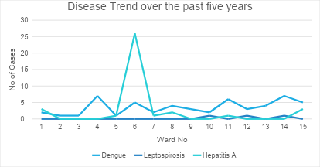

Transmission Trend- 2025
For effective management of public health issues, it is important to track the trend of disease transmission mode. It helps identify the population or place at high risk that can be used to predict outbreaks and implement targeted interventions as quickly as possible. Understanding these kinds of trends enables authorities to allocate resources efficiently and change the strategies adequately based on the trend that follows.

Mode of Transmission | No. of cases | No. of Deaths
Vector Borne Diseases | 8 | 0
Water Borne Diseases | 9 | 0
Air Borne Diseases | 0 | 0
Blood Borne Diseases | 0 | 0
Food Borne Diseases | 0 | 0

Vector-Borne Disease

Disease | No. of Cases | No. of Deaths
Dengue | 6 | 0
Malaria | 2 | 0
Chikungunya | 0 | 0

Water Borne Disease

Disease | No. of Cases | No. of Deaths
Cholera | 0 | 0
Typhoid | 0 | 0
Hep- A | 9 | 0
Dysentery | 0 | 0
Amoebiasis | 0 | 0
E- Coli infections | 0 | 0

Air Borne Disease

Disease | No. of Cases | No. of Deaths
Influenza | 0 | 0
H1N1 | 1 | 0
TB | 16 | 0
Chickenpox | 10 | 0
Measles | 0 | 0
Covid-19 | 0 | 0
Pertussis | 0 | 0
Mumps | 0 | 0

Blood-Borne Disease

Disease | No. of Cases | No. of Deaths
AIDS | 0 | 0
Hep- B | 0 | 0
Hep- C | 0 | 0

Zoonotic Disease

Disease | No. of Cases | No. of Deaths
Rabies | 0 | 0
Leptospirosis | 2 | 1
Avian influenza | 0 | 0
West 0e | 0 | 0
Anthrax | 0 | 0
Nipah | 0 | 0
Scrub Typhus | 0 | 0

Integrated Disease Hotspot Map (2021–2025)
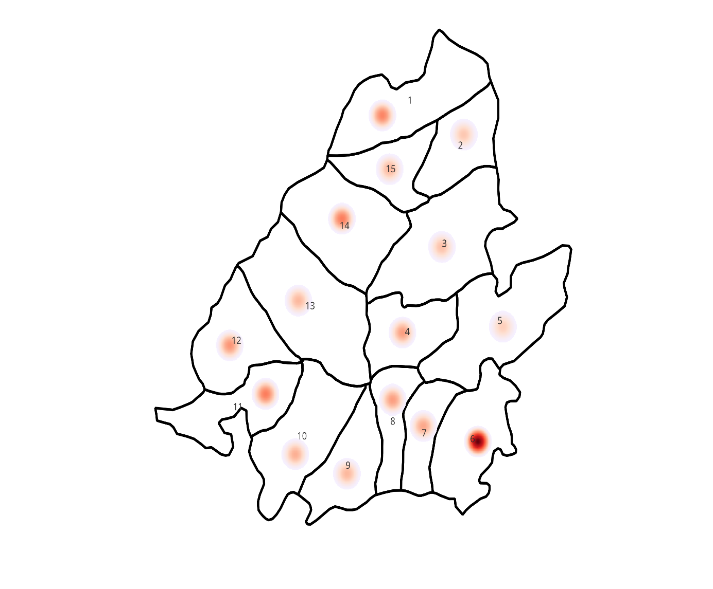

The map shows the spatial distribution of disease cases using hostspot intensity, where darker red indicates higher concentration of cases. The most prominent hotspot is ward 6,showing the highest intensity indicating a cluster of high disease burden in this area. Moderate hostspot are seen in wards 1,2,7,8,10,11,12,13,14 and 15 suggesting scattered but notable case presence across these wards. Lower intensity areas such as wards 3,5,and 9 show minimal or lighter hotspots indicating comparatively low cases. The distribution pattern suggests that the disease is not uniformly spread but rather clustered in specific pockets especially in southern and central parts.

Ward No | Dengue Total (2021-25) | Leptospirosis Total (2021-25) | Hepatitis A Total (2021-25) | Mumps (2021-25) | ADD (2021-25) | Total Cases
1 | 2 | 0 | 3 | 6 | 5 | 16
2 | 1 | 0 | 0 | 4 | 3 | 8
3 | 1 | 0 | 0 | 4 | 4 | 9
4 | 7 | 0 | 0 | 1 | 5 | 13
5 | 1 | 0 | 1 | 1 | 4 | 7
6 | 5 | 0 | 26 | 0 | 6 | 37
7 | 2 | 0 | 1 | 1 | 8 | 12
8 | 4 | 0 | 2 | 2 | 5 | 13
9 | 3 | 0 | 0 | 1 | 6 | 10
10 | 2 | 1 | 0 | 2 | 6 | 11
11 | 6 | 0 | 1 | 3 | 7 | 17
12 | 3 | 1 | 0 | 2 | 8 | 14
13 | 4 | 0 | 0 | 1 | 5 | 10
14 | 7 | 1 | 0 | 2 | 7 | 17
15 | 5 | 0 | 3 | 1 | 1 | 10

Ward No | Dengue Total (2021-25) | Leptospirosis Total (2021-25) | Hepatitis A Total (2021-25) | Mumps (2021-25) | ADD (2021-25) | Total Cases
1 | 2 | 0 | 3 | 6 | 5 | 16
2 | 1 | 0 | 0 | 4 | 3 | 8
3 | 1 | 0 | 0 | 4 | 4 | 9
4 | 7 | 0 | 0 | 1 | 5 | 13
5 | 1 | 0 | 1 | 1 | 4 | 7
6 | 5 | 0 | 26 | 0 | 6 | 37
7 | 2 | 0 | 1 | 1 | 8 | 12
8 | 4 | 0 | 2 | 2 | 5 | 13
9 | 3 | 0 | 0 | 1 | 6 | 10
10 | 2 | 1 | 0 | 2 | 6 | 11
11 | 6 | 0 | 1 | 3 | 7 | 17
12 | 3 | 1 | 0 | 2 | 8 | 14
13 | 4 | 0 | 0 | 1 | 5 | 10
14 | 7 | 1 | 0 | 2 | 7 | 17
15 | 5 | 0 | 3 | 1 | 1 | 10

By overlaying five years of data, we have identified 6 as ‘Red Zone' Ward (Cases above 20). These are wards where at least two different categories of diseases (e.g., Dengue and Hep A) recurred in consecutive years. Ward 6 is categorized as the Highest Priority Hotspot.

Preparedness and Response Protocol at LSG Level
This section describes the operational framework for the LSGI once a pandemic is declared. It explains how the LSGI and health system will move from routine data collection to active response, using a One Health approach.

Constitution of One Health Committee
The LSGD shall constitute a One Health Committee comprising the LSGI President, Medical Officers (Modern Medicine, AYUSH, and Veterinary), the Health Inspector, and the Veterinary Surgeon.

Objective: The One Health Committee coordinates human, animal, and environmental health to prevent and control pandemics.

Sl No | Name | Designation | Department/Institution | Role in Committee | Contact Number
1 | C A Thajuddin | Panchayat President | LSGD | Chairperson | 9995892726
2 | Dr Gautham R B | Medical Officer (PHC/CHC) | Health Dept | Member Secretary | 8907721877
3 | Dr Shilpa K R | Veterinary Officer | Animal Husbandry | Member | 7907599674
4 | Dr Anusmitha Mousimi | Epidemiologist | Health Dept | Member | 8281495593
5 | Vinod P | Health Inspector/PHN | Health Dept | Surveillance | 9446697325
6 | Sanal | ASHA Supervisor | Health Dept | Community link
7 | Bindu | ICDS Supervisor | Social Welfare | Vulnerable groups | 9745458886
8 | Ajith Kumar P(SHO) | Police Station Officer | Police Dept | Law & order | 9497947264
9 |  | Ward Councillor Representative | LSGD | Community coordination
10 | Padmaja | Kudumbashree CDO | Kudumbashree | Community mobilisation | 9895994667
11 | Pushparaj, Talekala | NGO/Volunteer rep | Civil Society | Support services | 9444677451

Key Responsibilities:
- Review disease surveillance data (human + animal)
- Conduct ward-wise risk assessment and vulnerability mapping
- Approve quarantine/isolation centre locations
- Coordinate with district for resources (PPE, oxygen, ambulances)
- Periodically review health system surge capacity, including beds, oxygen, human resources, and ambulances.
- Approve and monitor risk communication and community engagement strategies, including rumour management.
- Ensure protection and service continuity for vulnerable groups (elderly, persons with disabilities, dialysis patients, coastal populations).
- Conduct quarterly mock drills
- Monitor equity measures for vulnerable groups

Meeting Schedule:
Quarterly (normal times) | Weekly (outbreak alert) | Daily (pandemic phase)

Pandemic Response Workforce
To ensure a coordinated and timely response during a pandemic, a dedicated Pandemic Response Workforce shall be constituted at the LSG level. The workforce will function under the overall supervision of the One Health Committee and in close coordination with the health authorities. Team-based deployment will enable efficient surveillance, case management, quarantine and isolation management, logistics support, and risk communication. Each team shall have a clearly designated team leader, defined roles, and an identified pool of personnel to allow rapid activation, rotation of duties, and continuity of services during prolonged emergencies.

Total Response Workforce Available: 300 persons

Team Name | Composition | Key Responsibilities | Team Leader
Surveillance and Contact Tracing Team | HI, JHI, JPHN, ASHAs and Volunteers | Case detection, contact listing, home visits, reporting | HI
Case Management Team | Doctors, Nurses, MLSP, Palliative Nurses | Patient care & referral | DOCTOR
Quarantine & Isolation Team | LSGD staff, Volunteers | Facility management | JHI
Psychosocial support | DMHP
Logistics & supply chain Team | LSGD staff, Storekeepers, Drivers 3 | Supplies & transport [PPE, medicines, oxygen, transport, waste management] | Ward Member
Communication Team | Ward members, Kudumbashree, Youth clubs,  AWW workers and other self help groups | IEC, community meetings, countering misinformation | M.O in charge
Transportation | KSRTC, educational institutional buses
Media Surveillance | HI,JHI
Intersectoral coordination and convergence | Veterinary,Agricultural,Forest and Kudumbasree

All teams shall be activated immediately upon outbreak alert or pandemic declaration and shall report daily to the LSG Incident Commander/Medical Officer, with consolidated reporting to the Block PHC. Duty rosters and alternate personnel shall be maintained to ensure uninterrupted services during staff shortages or prolonged response periods. Team composition and numbers may be revised based on the magnitude of the outbreak and availability of human resources.

Activities and Measures before and during Pandemic

PHASE 1 - Alert / Preparation
Surveillance and Reporting-Enhanced syndromic surveillance:
- 1.Data sources for surveillance: HIP Data, Field Survey data from ASHA, JHI, JPHN, Rumour Registery
- Event-based triggers (to be monitored and reported):
- Zoonotic and animal health surveillance
Monthly Veterinary Health Reporting
- Logistics and Stock Preparedness
  - Identify and empanel local vendors and define emergency procurement mechanisms in accordance with existing LSGD and Health Department norms.
  - Prepare and maintain an essential logistics checklist covering medical supplies, consumables, and support equipment.
  - Pre-identify secure storage locations for emergency stocks and ensure maintenance of stock registers with regular updating.
  - Finalise emergency transport arrangements, including availability of vehicles and identified drivers for rapid deployment during alerts.
  - Designate a Nodal Officer for Logistics to enable prompt decision-making, coordination, and communication during emergencies.
  - Conduct rapid stock verification and ensure availability of minimum buffer stock, including:
- PPEkits
- Pulseoximeters
- Handsanitizerlitres
- Masks,gloves,disinfectantsadequatequantity
Identify critical gaps in logistics and immediately communicate requirements to the Block and District authorities for timely replenishment and support. Monitor expiry dates and stock rotation.

Identification of Quarantine and Isolation Facilities
  - Identify and list suitable buildings for quarantine and isolation (schools, hostels, community halls, etc.).
  - Categorise cases as per the severity and allocate to appropriate facilities (for instance, severe cases to classrooms, mild cases to an assembly hall in case of a school).
  - Facility readiness checklist needed (beds, toilets, ventilation) etc.
  - Find an alternate site if the primary sites are not available or not in use.
  - Identify facility managers and support staff
  - Prepare basic SOPs for:
    - Admission and discharge
    - Food, water, sanitation
    - Infection prevention and waste disposal
  - Ensure availability of basic amenities: water, sanitation, electricity, ventilation, and waste disposal. Prepare a rapid activation plan for these facilities if case numbers increase.

Risk Communication and Community Preparedness
  - Disseminate early warning messages on symptoms, preventive measures, and reporting mechanisms. Display IEC materials both in English and the local language in public places and ensure ward-level awareness.
  - Sensitize elected representatives and community leaders on preparedness measures.
  - Establish a rumour tracking and misinformation response mechanism to identify, verify, and promptly counter false or misleading information.
  - Engage trusted local persons (ward members, ASHA workers, religious leaders, teachers, community volunteers) to communicate official public health messages and reinforce correct practices.
  - Develop and deploy targeted IEC materials for:
    - Schools and educational institutions
    - Markets and commercial areas
    - Work sites and labour settings
  - Conduct community sensitization meetings at the ward level to promote preventive behaviors, address concerns, and strengthen community participation in preparedness and response.

Protection of Vulnerable Groups
Vulnerable populations require priority protection through targeted line-listing, service continuity, and delivery mechanisms.
- Prepare and regularly update line-lists of vulnerable populations, including:
  - Elderly persons living alone
  - Persons with disabilities
  - Pregnant women
  - Migrant workers
  - Dialysis patients
The detailed line-lists shall be maintained as Annexure ___ and updated periodically.

Clinical Dependency Mapping
Develop ward-wise dependency and vulnerability maps to identify households requiring regular support during emergencies. Ensure continuity of essential health services for vulnerable groups, including
- Dialysis services (facility mapping, transport arrangements, and scheduling)
- Continuity of treatment for TB, HIV, and other chronic conditions requiring uninterrupted medication
- Mental health and psychosocial support services
Establish delivery mechanisms for food, essential commodities, and medicines to vulnerable households through coordinated action involving ASHAs, JPHNs, Kudumbashree, volunteers, and local administration.

PHASE 2 - Active Response

Case Identification and Contact Tracing
Case detection and contact tracing activities will be carried out in coordination with the health authorities, following disease-specific SOPs and IDSP guidelines.
Field Staff Involved
- Health Inspector (HI)
- Junior Health Inspector (JHI)
- Junior Public Health Nurse (JPHN)
- ASHAs and ASHA Supervisors
- Ward-level volunteers and Kudumbashree members (as required)

Screening Checkpoints
Screening checkpoints at high-traffic locations (transport hubs, markets, religious gatherings) for early detection of symptomatic travellers and crowd screening during outbreaks. Potential locations include bus stands, market entry points, and boat jetties, based on local context and risk assessment.
Screening activities will be carried out by trained personnel such as ASHAs, ward members, and volunteers, with support from Health Department staff. Necessary equipment, including non-contact thermometers and appropriate PPE, shall be ensured prior to activation.
Location | Type (Bus stand/Jetty/Market/Railway) | Staff Deployed (ASHAs/Volunteers) | Screening Method | Reporting authority
Bus stand | Transport hub | One JHI  One ASHA  One health Mentors | 1.Swab Collection.  2. Blood smears collection (RDT)  3.Thermal Scanners | Surveillance Nodal Officer in control room
Market entry | Market | One JHI  One ASHA  Male health volunteers | 1.Swab Collection.  2. Blood smears collection (RDT)  3.Thermal Scanners | Surveillance Nodal Officer in control room

Standard Screening Protocol

The screening protocol shall include temperature screening, observation for visible symptoms, and inquiry regarding recent travel or exposure history. Individuals identified as suspects during screening shall be immediately referred to the nearest PHC/FHC for further evaluation, testing, and appropriate action as per prevailing guidelines.

Pandemic Control Room
The Pandemic Control Room (PCR) serves as the central nerve center for real-time coordination, data aggregation, decision support, and communication during outbreaks. It consolidates information from all LSGD teams, health facilities and community sources to enable rapid response decisions.

Control Room Infrastructure and Location
Primary Location: Meenja Panchayath Office.
Backup Location: Community Hall in Meenja G.P.

Health System Control Room Framework
The PCR is organized into seven functional pillars to ensure no aspect of the response is overlooked:

Rapid Response Team (RRT)
  - Provides immediate intervention during emergencies, clusters, and field alerts.​
  - Coordinates urgent actions such as case investigation, contact tracing, isolation, and inter‑facility referrals.

Data Management & Analytics Team
  - Collects, validates, and manages key health system indicators (cases, tests, beds, HR, supplies).​
  - Analyzes data trends, generates projections, and supports evidence‑based decision‑making for local authorities.

Human Resource Deployment Team
  - Allocates healthcare staff efficiently based on workload and need
  - Ensures adequate and equitable workforce distribution across facilities

Laboratory Surveillance Team
  - Oversees diagnostic testing coordination, sample transport, and timely reporting of results.​
  - Monitors lab indicators (testing volume, positivity rate, turnaround time) for early detection of outbreaks

Vaccination Cell (If Required)
  - Plans and executes vaccination campaigns, including micro‑planning and session scheduling.​
  - Tracks coverage, identifies gaps, and coordinates corrective actions with field teams and outreach services.

Infrastructure & Patient Occupancy Team
  - Monitors facility capacity, earmarked beds, oxygen and critical care resources across all linked facilities.​
  - Ensures optimal patient distribution and referral management using updated bed‑status and resource data.
  - BMWM

Communication team
- Logistics and supply chain
- Transportation (interfacility & emergency transport)
- Media surveillance Call centre
- Management of the deceased
- Intersectoral coordination and convergence

Key Control Room Team
The Control Room Team coordinates all pandemic response activities within the LSGD and serves as the single command and communication hub during activation. It integrates information, field actions, logistics, and policy execution across all participating departments and health facilities.

Role | Name | Designation | Contact Number | Responsibility
In-charge/Nodal Officer | Dr Gautham | MO | 8907721877 | Overall coordination, decision-making, and reporting to the District level.
Data Entry Operator | Renitha | JHI | 8943905522 | Managing the line list, updating dashboards, and tracking testing results.
Communication Officer | Vinod | HI |  | Handling the public helpline, coordinating ambulance dispatch, and contact tracing calls.
Logistics Coordinator | Saritha P | Clerck | 9791757366
Technical Support (IT/Data) | Ashiba B | Data Manager | 623870175

Key Points:
- The Control Room shall be staffed with a designated In-charge, data entry personnel, and communication staff with clearly defined roles and shift arrangements.
- It shall maintain updated records on daily monitoring indicators including new cases, persons under active quarantine, and hospital bed occupancy.
- All reports and situation updates shall be shared daily with the Block and District Surveillance Unit.
- The Control Room shall act as a single point of contact for coordination with response teams, health institutions, and other departments.
- Contact details of the Control Room shall be widely communicated to field staff and stakeholders during activation.

Daily Monitoring Indicators
To ensure timely decision-making and effective response, the following key indicators shall be monitored and updated on a daily basis by the Pandemic Control Room:

Epidemiological Indicators:
New cases reported today, Total active cases, Test Positivity Rate (TPR), Case Fatality Rate (CFR)
- Surveillance Indicators:
Persons under home quarantine, High-risk contacts identified, Fever, ILI, SARI or other symptoms (syndromic surges), Travellers (symptomatic or high-risk arrivals), Animal husbandry surveillance (zoonotic alerts, unusual animal deaths, poultry/bird flu signals), Mortality surveillance (excess deaths, unexplained fatalities, verbal autopsy reports)
- Logistics and Infrastructure Indicators:
Hospital / CFLTC beds occupied, Oxygen cylinders/concentrators available, Ambulances on standby
- Alert Findings
The following table outlines category-specific trigger points (red flags) from surveillance indicators and corresponding immediate actions for the Pandemic Control Room. These enable rapid response to alert findings like testing anomalies, positive cases exceeding thresholds, clusters, and WGS reports.

Category | Trigger Point (Red Flag) | Immediate Action
Clusters | Geographical or facility-based: 5+ cases linked to one location (office, school, street). | Declare a micro-containment zone; perimeter control and active case finding.
Testing | Sudden drop in testing volume / delay in reporting / unusual testing trends | Review the sample collection process, address lab bottlenecks, deploy additional testing teams, and notify the District Lab.
Lab | Test Positivity rate increases | Increase testing sites in that ward.
Hospital | >80% Oxygen bed occupancy | Activate backup/CFLTC beds.
Travel | Cluster of cases from a single flight/train or high-risk arrival group. | Trace all passengers in adjacent seats; implement mandatory institutional quarantine.
Animal | Mass poultry/wildlife death or unusual sickness | Notify Animal Husbandry, sample the area, and dispatch RRT for environmental sampling and zoonotic check.
Mortality | Sudden spike in home deaths or brought-in-dead (BID) cases | Audit the deaths and Active Case Search drive
Additional investigations like Whole Genome Sequencing (WGS) | Detection of a Variant of Concern (VOC) or Variant of Interest (VOI) | Implement strict micro-containment; update clinical protocols to match variant severity.

Communication of Public Health Information
A Community Communication Hub shall be established to ensure timely, accurate, and consistent dissemination of information during a pandemic. The Hub will function under the coordination of Nodal officers of the control room and act as the nodal point for public communication, risk messaging, and community engagement. It will support dissemination of official advisories, promote preventive behaviors, address rumors and misinformation, and ensure that messages reach all sections of the population through trusted local channels and leaders.

Key communicators
Channel | Responsible Person | Contact
Ward-level announcements | HI | 9446697325
Social media | HI | 9446697325
Local Cable TV/Radio | Ravi | 9895760292

- All messages disseminated through the Hub shall align with advisories issued by the Health Department and District authorities.
- Community leaders shall be sensitized to support behavior change, reduce stigma, and counter misinformation.
- Special efforts shall be made to reach vulnerable and hard-to-reach populations using locally appropriate communication methods.

Rumor Tracking: A designated volunteer will monitor local social media/WhatsApp groups daily to identify misinformation and issue official clarifications via the Communication Hub.

Coordination with District/State Authorities & Other Organisations
Effective coordination with Block, District, and State authorities is essential to ensure timely reporting, technical guidance, and uninterrupted supply of essential resources during a pandemic. The LSG shall establish clear communication channels, designate responsible officers, and adhere to prescribed reporting timelines to support coordinated public health action and efficient resource mobilisation.

Key Details:
- Nodal Officer for Reporting:
- Contact Number:
Reporting Schedule and Protocols:

To Whom | What to Report | Frequency | Nodal Person
Block PHC | Complete Situation Report (Cases, Quarantine, Beds, Screening, Deaths) | Daily | Block MO
District IDSP Unit | Outbreaks/Clusters/Unusual Events (>5 cases same ward) | Daily | HI
Veterinary Officer | Animal health events/Zoonotic alerts | Weekly | Block MO
State Cell | Zoonotic cross-sector events | Weekly | Block MO

Supply Chain Coordination
The LSG shall coordinate closely with Block, District, and State authorities (KMSCL) to ensure uninterrupted availability of essential goods, medical supplies, and logistics during a pandemic. Supply requirements shall be assessed regularly based on case load and communicated promptly to the appropriate authorities for timely replenishment.
Key Points:
- Maintain updated contact details of District and Block nodal officers for health logistics, oxygen supply, ambulances, and essential medicines.
- Submit timely indent requests for PPE, testing kits, medicines, oxygen, and other critical supplies through prescribed channels.
- Monitor stock levels at LSGD facilities, quarantine/isolation centres, and field teams through daily stock registers and dispensing logs to prevent shortages.
- Coordinate with District authorities, Karunya/Neethi medical shops, and local purchase committees for funds allocation and emergency procurement.

- Ensure regular monitoring of dispensing registers at all facilities to track usage, expiry, and pilferage—shortages being a perennial issue requiring proactive weekly audits.

- Activate surge procurement protocols during high caseloads, leveraging local purchase powers under LSGD funds alongside state supplies.

Resource Inventory and Contacts
Resource Category | Source  (District/State/Private) | Contact
PPE Kits/Masks/Gloves | KMSCL | 974515939
PPE Kits/Masks/Gloves | Local Vendors | 9037420415
Oxygen  Cylinders/Concentrators | KMSCL | 9745158939
Medicines/Antivirals | KMSCL | 9745158939
Medicines/Antivirals | Neethi Shops | 9400524195
Test Kits (RTPCR/Rapid) | KMSCL | 9745158939

Collaboration with NGOs, PPP, and CSR
To augment government efforts during a pandemic, the LSG shall collaborate with NGOs, voluntary organisations, and private sector partners through public–private partnerships and Corporate Social Responsibility (CSR) initiatives, in coordination with District authorities.

Key Points:
- Engage NGOs and community-based organisations for community outreach, awareness, and support to vulnerable populations.
- Leverage CSR support for procurement of medical equipment, PPE, oxygen concentrators, food kits, and sanitation materials, as permitted.
- Ensure all collaborations align with government guidelines and are routed through approved administrative and financial procedures.
- Maintain transparency and documentation for all external support received and utilised.
Organization | Type | Support Offered | Contact Person
Youth Clubs/Student Unions | CBO

Interdepartmental Coordination
Coordination among departments during a pandemic shall be ensured through regular review meetings convened by the LSGD President. These meetings will provide a structured platform for sharing situational updates, assessing resource availability, resolving operational gaps, and taking joint decisions to ensure a coordinated and timely response.

Department | Representative | Key Role | Contact
Health (PHC) | Staff Nurse: Shini Abraham | Case management | 9400374690
Veterinary | Veterinary Surgeon:  Dr Shilpa K R | Animal surveillance | 7907599674
ICDS | Supervisor: Bindhu | Nutrition support | 9745458886
Education | Head Teacher: Rameshan | School coordination | 9400448888
Police | SHO | Containment enforcement | 9497947264

PHASE 3 - Surge Capacity
Phase 3 is activated when there is a rapid increase in cases, high test positivity rates, or when existing health facilities and quarantine arrangements approach saturation. The focus of this phase is to expand isolation capacity, augment clinical care services, and mobilise additional resources through district and state support mechanisms.

Conversion of Community Facilities
To manage increased case load, the LSGD shall activate additional isolation facilities by repurposing identified community infrastructure such as community halls, auditoriums, schools, hostels, or other suitable buildings.

Name of facility | Facility Type | No. of Buildings | Ward | Surge Capacity (Beds) | Nodal Person
SVHSS Miyapadavu | School | 5 | 4 | 500 | Principal
Koliyoor | Auditorium | 1 | 2 | 200 | Management
GHS Kadambar | School | 4 | 14 | 500 | Principal
St Marys English medium School | School | 1 | 2 | 500 | Principal
St Joseph School | School | 2 | 2 | 500 | Principal

Recovery and rehabilitation phase
- Recovery
  - Damage & impact assessment
  - Restoration of health services
  - Rehabilitation of affected population
  - Psychosocial & mental health support
  - Disease surveillance during recovery phase
  - Environmental cleanup & sanitation
  - Livelihood restoration
  - Community engagement & confidence building
  - Documentation & after-action review
  - Lessons learned & best practices
  - Health system strengthening
  - Policy revision & preparedness enhancement
  - Research

CONCLUSION
The success of this Pandemic Preparedness Plan relies on the seamless integration of local governance and the strategic management of healthcare resources. At the grassroots level, the ability of a Grama Panchayat or local administrative body to act as the primary link between public health directives and the community is indispensable. By establishing clear lines of communication and predefined roles for local leaders before a crisis occurs, we ensure that the response is not only rapid but also culturally sensitive and contextually relevant to the specific needs of the population.
Furthermore, the stabilization of the healthcare supply chain and the equitable distribution of medical resources form the backbone of a resilient response. It is not enough to have protocols on paper; there must be a continuous commitment to monitoring local healthcare capacity, from the availability of essential medicines to the mental and physical well-being of frontline workers. Ensuring that local clinics and community health centers are empowered with the necessary tools and data allows for a decentralized response that prevents larger hospital systems from becoming overwhelmed.
Ultimately, this plan serves as a living framework for collective action. True preparedness is found in the strength of our local institutions and their ability to foster public trust through transparency and consistent engagement. By prioritizing local coordination and robust resource management today, we build a foundation that can withstand the uncertainties of tomorrow, ensuring the safety, health, and recovery of every member of the community.

RECOMMENDATIONS

Strengthening Healthcare Infrastructure
- Establish a primary health response unit within the Panchayat with trained staff.
- Ensure availability of basic medical supplies (masks, sanitizers, PPE kits, oxygen cylinders).
- Create tie-ups with nearby hospitals in Kasaragod for emergency referral and transport.

2. Community Awareness & Education
- Conduct regular awareness campaigns on hygiene, vaccination, and preventive measures.
- Use local communication channels (community radio, WhatsApp groups, notice boards) to spread verified information.
- Train volunteers to act as health ambassadors in each ward.

3. Emergency Response & Coordination
- Form a Pandemic Preparedness Committee at Panchayat level including health workers, ward members, and NGOs.
- Develop a clear action plan for lockdowns, quarantine, and distribution of essentials.
- Maintain a database of vulnerable groups (elderly, differently-abled, chronically ill) for targeted support.

4. Supply Chain & Food Security
- Identify and support local suppliers and farmers to ensure uninterrupted food supply.
- Create community kitchens during emergencies to serve vulnerable populations.
- Stockpile essential commodities in Panchayat-run outlets for crisis periods.

5. Digital Preparedness
- Promote digital platforms for telemedicine consultations.
- Use Panchayat’s website/social media for real-time updates on health advisories.
- Encourage online grievance redressal to reduce crowding in offices.

6. Training & Capacity Building
- Organize mock drills for pandemic response in schools, offices, and public spaces.
- Train Panchayat staff and volunteers in first aid, infection control, and crowd management.
- Collaborate with NGOs and health departments for capacity-building workshops.

7. Long-Term Resilience
- Integrate pandemic preparedness into the Panchayat Development Plan.
- Allocate a dedicated budget for health emergencies.
- Encourage community participation in planning and monitoring preparedness measures.

MOCKDRILL SCENARIOS
Acute Gastrointestinal Disease Outbreak (Suspected Waterborne Disease)
Step 1: Planning and Objective Setting
● Define drill objectives (early outbreak detection, rapid field investigation, case management preparedness, inter-departmental coordination).
● Assign Incident Commander (Medical Superintendent / Medical Officer).
● Identify observers and evaluation team.
● Inform District Health Authorities about scheduled drill (if pre-planned).
Step 2: Scenario Trigger
● Simulated report of 10 cases of acute diarrhea and vomiting from one ward within 24 hours.
● Two patients admitted with signs of dehydration.
● Local ASHA reports clustering of cases near a common drinking water source.
Step 3: Surveillance and Field Response
● Activate Rapid Response Team (RRT).
● Prepare line list of cases.
● Conduct house-to-house case search.
● Identify common exposure source (suspected contaminated well).
● Collect water and stool samples as per protocol.
Step 4: Infection Prevention and Control Measures
● Start chlorination of suspected water source.
● Distribute ORS and zinc tablets.
● Ensure PPE usage by field staff.
● Initiate sanitation and waste disposal measures.
● Provide health education on boiling water and hand hygiene.
Step 5: Clinical Management and Referral
● Triage patients based on dehydration severity.
● Initiate IV fluids for severe cases.
● Maintain isolation precautions if required.
● Refer complicated cases to higher center.
Step 6: Communication and Reporting
● Notify District Surveillance Unit immediately.
● Provide situation report (SITREP) within 24 hours.
● Public announcement through Panchayat authorities.
● Disseminate IEC messages via WhatsApp and local media.
Step 7: Evaluation and Debriefing
● Assess response time (reporting, RRT activation, control measures).
● Evaluate completeness of line listing and documentation.
● Review IPC compliance and PPE usage.
● Conduct debriefs meeting and document gaps identified.

ANNEXURE

IMPORTANT PHONE NUMBERS

Phone numbers and particulars of persons responsible for providing guidance, assistance, and support for pandemic preparedness operations may be provided here in a manner that allows easy reference at a glance. The information recorded here could be exhibited elsewhere at the time of emergencies. LSG institutions shall give special attention to collect and record the above data of persons and institutions who/which are supposed to give technical and co-ordination support to reduce the impact of pandemic.

1.1. Details of grama panchayat/municipality/corporation wards
Sl.No | Name of the ward | Ward number | Name of the ward  member | Contact number
1 | Kaliyoor | 1 | Sowmya K | 9020651220
2 | Majirpalla | 2 | Salim M A | 9895768844
3 | Koliyoor | 3 | Shantha Kumari B | 9633039692
4 | Meenja | 4 | Siddiqe K M | 9895500461
5 | Berike | 5 | Mohandas Shetty | 9746324254
6 | Ariyala | 6 | Shalini B Shetty | 9496304589
7 | Chigurupade | 7 | Mohammed Sherif C | 9746118205
8 | Baliyoor | 8 | Misiriya M Kunhi | 6238858188
9 | Kuloor | 9 | Sharmila M Shetty | 9400452443
10 | Modambail | 10 | Usha Poonja K | 9539115387
11 | Pattathur | 11 | Ashalatha B M | 9995615583
12 | Majibail | 12 | Lathisha K | 8129003529
13 | Durgipalla | 13 | Krishna K | 9562178549
14 | Bejja | 14 | Sandhya B | 9544491922
15 | Thalekala | 15 | Su0 Kumar M | 9567932918
16 | Kadambar | 16 | C A Thajudheen | 9995892726
17 | Gandinagar | 17 | Beefathima K | 9496555769

1.2. Other important phone numbers of grama panchayat/municipality/corporation area
Sl. No. | Name | Contact number
1. | Anjana-Panchayath Secreatory | 6381384059
2. | Narayana-Assistant Secreatory | 9495344045
3. | Padmaja-Kudumbasree CDS | 9895994667
4. | Vice Chairperson CDS-Rukhiya K | 7907555652
5. | Agriculture Office-Chanchala A | 8547518296

1.3. Important offices of grama panchayat/municipality/ corporation
Sl.No | Name of the office | Contact person | Contact number
1. | Village Office | Village Officer | 8547617305
2. | Agriculture Office | Agriculture Officer | 8547518296
3. | Animal Husbandry Office | Animal Husbandry Doctor
4. | Police Station | Police Officer | 9497947264
5. | BSNL Office | Officer | 0
6. | Block Office | Officer | 04998272673
7. | KSEB Office | Officer | 4998202900
8. | Fisheries Office | Officer | 7907784120
9. | Fire and Rescue | Officer | 04998241101

1.4. Health Services

Sl. No | Name of the hospital/institution | Location | Phone number
1. | Government hospitals/PHC | Miyapadavu | 8907721877
2. | Private hospitals | Majirpalla | 9633857967
3. | Clinical laboratories | Miyapadavu | 9740767460
4. | Chemist/pharmacy | Miyapadavu | 9995144723

1.5. Veterinary Services
Sl.No | Name of the Clinic | Name of the  Surgeon/Doctor | Place/location | Phone  number
1 | Govt.Veterinary Hospital | Dr Shilpa K R | Miyapadavu | 7907599674

1.6. Helpline numbers
Helpline | Phone number
Police | 9497947264
Fire and Rescue
KSEB | 04998-202900

1.7. Public and Private Schools Contact details

S.No | Name of School | Institution type | Phone number
1 | SVHSS Miyapadavu | Aided | 9400448888
2 | Lady Fathima English Medium School | Private | 7353081825
3 | GLPS Thalakala | Govt | 7012876680
4 | GHS Moodambail | Govt | 9895592821
5 | GLPS Kuloor | Govt | 9496190595
6 | VVALPS, Thottathody | Aided | 9497515097
7 | GHS Kadambar | Govt | 7902240928
8 | GLPS Majibail | Govt | 9946579169
9 | Manavatty HSS | Private | 9446226306
10 | Malhar English Medium School | Private | 9495014456
11 | St Joseph | Aided | 9961103011
12 | St Marys English Medium School | Private | 9741206958
13 | Sree Sankaranarayana School | Private | 7406782797
14 | Green Garden School | Private | 8590166866
15 | MS Global | Private | 7760959427

1.9. Anganwadi Contact Details

Ward No | Name of Anganwadi Teachers | Phone number
1 | Thasreena | 7760950575
2 | Susheela | 9746874277
3 | Vishalakshi | 9495358366
4 | Shakeela B | 7407531098
5 | Divya kumari | 9526906077
6 | Bhavani | 7994056132
7 | Jayakala | 8547202285
8 | Shantha | 9495794547
9 | Thulasi kumari | 9539346628
10 | Chandravathi | 9847280958
11 | Sujaya | 9744122262
12 | Vidhya | 8848677129
13 | Dhayavathi | 7356156980
14 | Sudha C N | 8590592277
15 | Vedha | 9544687462
16 | Shakeela K | 7356188174
17 | Arathi | 9947606737
18 | Leelavathi | 9496358634
19 | Bharathi | 9633559359
20 | Shamalakumari | 9567711831

1.12. Information regarding resources

Means of transportation | Name of Owner | Phone Number
Heavy Trucks | Subair | 9447652416
Tractor | 0 | 0
Ambulances | DSF Club | 7034444524
Boats | 0 | 0
Taxi service | Abbas Kulabail | 9846699869

Annexure 1: LSG Baseline Data Collection Format
A. Baseline data
Sl. No. | Indicator / Field | Baseline Data | Source / Remarks
1 | Name of LSG | Meenja | LSGD
2 | District | Kasaragod | LSGD
3 | Block / Taluk | Manjeshwar | LSGD
4 | Type of LSG (Gram Panchayat / Municipality / Corporation) | Gramam Panchayat | LSGD
5 | Area (sq. km) | 44.91 | LSGD
6 | No. of wards | 17 | LSGD
7 | GIS boundary file available | YES | LSGD
8 | Key contact person & phone | Panchayat Secreatory | LSGD

B. Demography
Indicator / Field | Baseline Data | Source / Remarks
Total population | 28325 | Health Record
Males | 14293 | Health Record
Females | 14032 | Health Record
Transgender population | 0 | Health Record
Age distribution  (<5, 5–14, 15–59, ≥60) | 1549,2769,1527 | Health Record
No. of households |  | Health Record
Population density (persons/sq.km) | 567.63 | LSGD
No. of migrant workers | 500 | LSGD
Major occupational groups | Agriculture | LSGD

C. Vulnerable Populations & Social Risks
Sl. No. | Indicator / Field | Baseline Data (Value / Description) | Source / Remarks
1 | No. of elderly (≥60) | 1529 | Health Record
2 | No. of persons with disability | 85 | Health Record
3 | No. of bedridden persons | 77 | Health Record
4 | No. of chronic disease cases (DM/HTN/COPD/CKD etc.) | 1211 | Health Record
5 | Pregnant women (current estimate) | 113 | Health Record
6 | Children <5 years | 5953 | Health Record
7 | Tribal population (if any) | 75 | Health Record
8 | Fisherfolk / coastal vulnerable groups (if any) | 0
9 | Urban slums / unnotified settlements (if any) | 0
10 | Homeless population | 0
11 | Orphanages / old age homes (number & capacity) | 0
12 | Hostels / prisons / shelters (number & capacity) | 0
13 | Poverty / BPL estimate | 25
14 | Food insecurity hotspots | 0
15 | Any history of stigma/discrimination issues (Yes/No) | N

D. Health System & Service Readiness
Sl. No. | Indicator / Field | Baseline Data (Value / Description) | Source / Remarks
1 | No. of health facilities in LSG (PHC/CHC/TH/DH/Private) | 5 | Health Record
2 | PHC/Family Health Centre details (name, location) | FHC Meenja | Health Record
3 | Subcentres / Health & Wellness Centres (number) | 4 | Health Record
4 | Private clinics / hospitals (number) | 2 | Health Record
5 | Labs available (public/private) | 1 | Health Record
6 | Availability of ambulance services (Yes/No, number) | N | Health Record
7 | Availability of isolation/quarantine facilities (Yes/No, details) | Yes | Health Record
8 | Cold chain facilities (Yes/No, details) | Yes | Health Record
9 | Stockpile space available (Yes/No) | Yes | Health Record
10 | PPE / mask / sanitizer availability plan (Yes/No) | No
11 | Surveillance staff available (JHI/JPHN/ASHA count) | 22 | Health Record
12 | Existing emergency referral pathways (Yes/No) | No

E. Points of Entry & Mobility
Sl. No. | Indicator / Field | Baseline Data (Value / Description) | Source / Remarks
1 | Bus stands / depots (number) | 0
2 | Railway stations (number) | 0
3 | Boat jetties / fishing harbours (number) | 0
4 | Ports / airports nearby (specify distance) | 0
5 | Major highways/roads passing through
6 | Border crossings (state/district) | State
7 | Major markets / weekly markets | 0
8 | Tourism hubs / major event venues | 0
9 | Schools/colleges with hostels (number) | 40
10 | Factories / large workplaces (number) | 0

F. Water, Sanitation & Hygiene (WASH)
Sl. No. | Indicator / Field | Baseline Data (Value / Description) | Source / Remarks
1 | Major drinking water sources (piped / wells / borewells / springs) | Wells
2 | No. of public wells | 0
3 | No. of households with piped water connection | 0
4 | Water quality testing routine (Yes/No) | Yes
5 | Common contamination risks (flooding, salinity, industrial waste) | 0
6 | Open defecation free status (Yes/No) | Yes
7 | Solid waste management system (Yes/No) | No
8 | Bio-medical waste disposal mechanism (Yes/No) | Yes
9 | No. of public toilets | 0
10 | Handwashing stations in public places (Yes/No) | No

G. Zoonotic Risks & One Health
Sl. No. | Indicator / Field | Baseline Data (Value / Description) | Source / Remarks
1 | Livestock population (cattle/goats/pigs/poultry) – estimates | 1640/2800 | Veterinary Department
2 | No. of dairy farms / poultry farms / pig farms | 0/3/1 | Veterinary Department
3 | Slaughterhouses / meat shops (number) | 0 | Veterinary Department
4 | Animal markets (Yes/No, details) | No | Veterinary Department
5 | Veterinary dispensaries (number) | 1 | Veterinary Department
6 | History of zoonotic outbreaks (rabies, leptospirosis, avian flu etc.) | Yes | Veterinary Department
7 | Stray dog population management measures (Yes/No) | Yes | Veterinary Department
8 | Rodent infestation hotspots (Yes/No) | 0 | Veterinary Department
9 | Wetlands / waterlogged areas prone to leptospirosis | 0 | Veterinary Department
10 | Bat roosting areas / caves / fruit orchards (if any) | 0 | Veterinary Department
11 | Human-animal interface hotspots (farms near residences) | 0 | Veterinary Department
H. Climate & Disaster Risks (Pandemic Amplifiers)
Sl. No. | Indicator / Field | Baseline Data (Value / Description) | Source / Remarks
1 | Flood-prone wards (list) | 0
2 | Landslide-prone wards (list) | 0
3 | Cyclone/sea surge risk (Yes/No) | 0
4 | Heatwave risk zones (Yes/No) | 0
5 | Waterlogging areas (list) | 0
6 | Shelter homes / relief camps (number, capacity) | 0
7 | Past disaster displacement history | 0
8 | Disruption to water supply/transport common (Yes/No) | 0
I. Critical Infrastructure & Logistics
Sl. No. | Indicator / Field | Baseline Data (Value / Description) | Source / Remarks
1 | Schools (number) | 21 | LSGD
2 | Anganwadis (number) | 19 | LSGD
3 | Colleges (number) | 0 | LSGD
4 | Community halls (number) | 2 | LSGD
5 | Places of worship with large gatherings (number) | 28 | LSGD
6 | Large markets / shopping areas (number) | 0
7 | Warehouses / cold storages (number) | 0
8 | Telecom/mobile network coverage gaps (Yes/No) | Yes
9 | Power outage frequency (high/medium/low) | Medium
10 | Availability of generators in key facilities | No

J. Risk Communication & Community Networks
Sl. No. | Indicator / Field | Baseline Data (Value / Description) | Source / Remarks
1 | Ward-level rapid response teams (Yes/No) | Yes
2 | Jagratha samithis / committees active (Yes/No) | Yes
3 | Kudumbashree presence and strength (number of units) | Yes
4 | Volunteer network (number, coverage) | Yes
5 | Community-based surveillance mechanisms (Yes/No) | Yes
6 | IEC dissemination channels (WhatsApp groups, community radio, PA systems) | Yes
7 | Rumour tracking mechanisms (Yes/No) | Yes
8 | Languages spoken / literacy considerations | Yes
9 | Vulnerable groups communication strategy available (Yes/No) | Yes

K. Preparedness Planning & Governance
Sl. No. | Indicator / Field | Baseline Data (Value / Description) | Source / Remarks
1 | LSG emergency plan available (Yes/No) | Yes | Health Record
2 | Pandemic preparedness plan available (Yes/No) | Yes | Health Record
3 | Incident Command System identified (Yes/No) | Yes | Health Record
4 | Rapid procurement mechanism available (Yes/No) | Yes | Health Record
5 | Emergency fund available (Yes/No, amount) | Yes | Health Record
6 | Past outbreak response experience (Yes/No, details) | Yes,VHA | Health Record
7 | Intersectoral coordination mechanism (Health, Police, LSG, Veterinary, Education) | Yes | Health Record
8 | Mock drills conducted in last 12 months (Yes/No) | Yes | Health Record
9 | Training coverage for staff/volunteers (Yes/No) | Yes | Health Record

L. Surveillance & Data Systems
Sl. No. | Indicator / Field | Baseline Data (Value / Description) | Source / Remarks
1 | Digital reporting tools used (e.g., DHIS2, portals) | Yes | Health Record
2 | Availability of line-listing format (Yes/No) | Yes | Health Record
3 | Contact tracing team identified (Yes/No) | Yes | Health Record
4 | Mapping of high-risk households available (Yes/No) | Yes | Health Record
5 | Testing sample transport mechanism (Yes/No) | Yes | Health Record
6 | Reporting timeline adherence (good/average/poor) | Yes | Health Record
7 | Data sharing between departments (Yes/No) | Yes | Health Record
8 | Availability of dashboard for monitoring (Yes/No) | Yes | Health Record

M. Additional Notes & Observations
Sl. No. | Indicator / Field | Baseline Data (Value / Description) | Source / Remarks
1 | Key challenges perceived by LSG | The institution is constrained by limited resources and inadequate infrastructure
2 | Top 5 high-risk wards (reason) | 0
3 | Any unique local risks (industrial pollution, refugee camps, etc.) | 0
4 | Recommendations for preparedness strengthening | Early warning systems,effective communications,community awareness,regular training and strong interdepartmental coordination are essential

