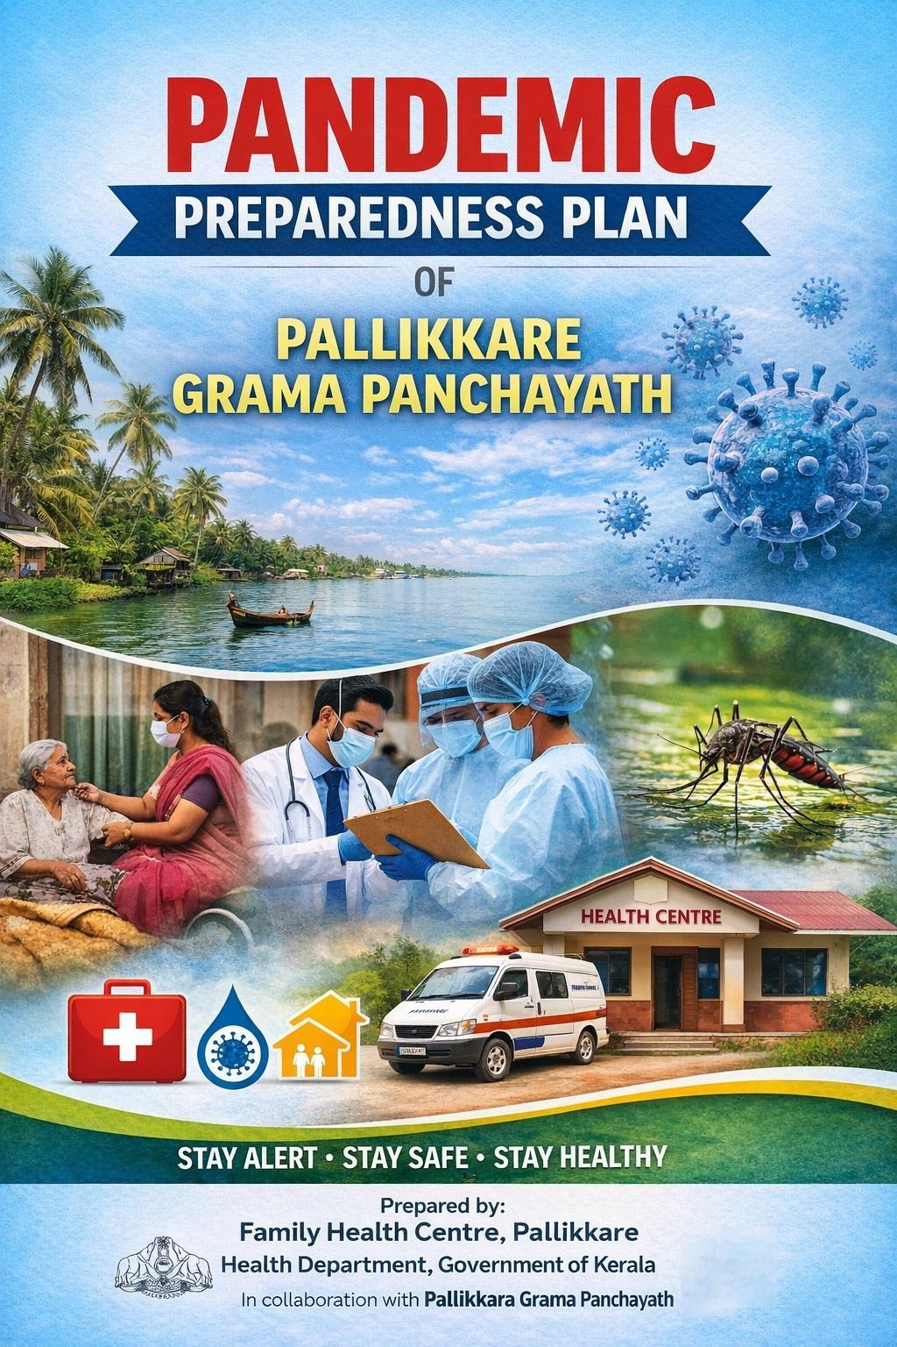

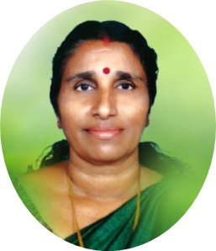
MESSAGE FROM PRESIDENT/CHAIR LSGI

Dear Residents of Pallikkare,
I am pleased to present the Pandemic Preparedness and Response Plan for Pallikkare Grama Panchayat, prepared by Family Health Centre Pallikkare.
Considering our coastal setting, population density, and the occurrence of communicable diseases such as Dengue, Leptospirosis, and Viral Hepatitis A (VHA), it is essential that we remain alert and well-prepared. This plan provides a structured approach to early detection, timely response, and protection of vulnerable groups, including the elderly and high-risk individuals.
While the Health Centre has developed this technical framework, its success depends on the active cooperation of the Panchayat and the community. I urge all residents, health workers, and institutions to strictly follow the guidelines, ensure sanitation, protect drinking water sources, and report symptoms without delay.
Let us work together with unity and responsibility to build a safe, resilient, and “Health-First” Pallikkare.
Warm regards,

Sobhana .t
President
Pallikkare Grama Panchayat


MESSAGE FROM HEALTH STANDING COMMITTEE CHAIR

Dear Citizens and Health Partners of Pallikkare,
As the Chairman of the Health Standing Committee, my priority is to ensure effective public health action at the grassroots level. Pallikkare, with its coastal belt, low-lying areas, and densely populated wards, remains vulnerable to seasonal outbreaks of Dengue, Leptospirosis, Acute Diarrhoeal Diseases (ADD), and Viral Hepatitis A (VHA), especially during the monsoon period.
With the dedicated support of our ASHA workers, Anganwadi staff, and community volunteers, we have a strong local health network to address these challenges. This Pandemic Preparedness and Response Plan is designed to strengthen early detection, improve field-level response, and ensure continuous care for vulnerable groups, including the elderly and bedridden patients.
All residents are advised to follow preventive measures, ensure sanitation, and report symptoms promptly.
Let us work together with responsibility and unity to build a safe, healthy, and resilient Pallikkare.
With health and solidarity,

Chairman
Health Standing Committee
Pallikkare Grama Panchayat

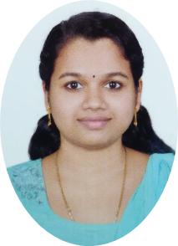
MESSAGE BY MEDICAL OFFICER

To the Stakeholders and Citizens of Pallikkare,
As the Medical Officer of Family Health Centre Pallikkare, I am committed to ensuring a strong technical framework for community health and safety.
Given our coastal and densely populated setting, Pallikkare remains vulnerable to diseases such as Dengue, Leptospirosis, and Acute Diarrhoeal Diseases (ADD). This plan emphasizes early surveillance and syndromic detection, enabling timely identification and control of outbreaks at the ward level through our frontline health workers and volunteers.
Our strategy focuses on early detection, protocol-based treatment, and equitable access to care, with special attention to vulnerable groups including the elderly, bedridden patients, and those with chronic diseases.
All healthcare providers are advised to adhere strictly to government protocols and ensure timely reporting.
Let us remain vigilant and work together to safeguard public health.
Stay Vigilant. Stay Prepared.

Dr. Sreelakshmi
Medical Officer
Family Health Centre Pallikkare
EXECUTIVE SUMMARY

Family Health Centre (FHC) Pallikkare functions as the primary public healthcare institution serving the population of Pallikkere Grama Panchayath. The PHC plays a pivotal role in delivering comprehensive, accessible, and affordable healthcare services, with a strong focus on preventive, promotive, curative, and rehabilitative care in accordance with national and state health programmes.
The FHC caters to a predominantly rural population, addressing key public health priorities such as maternal and child health, communicable and non-communicable disease control, immunization, family welfare, adolescent health, and geriatric care. Regular outpatient services, home-based care through field health staff, and outreach activities ensure healthcare coverage even in geographically challenging areas. The institution actively implements national health missions, including the National Health Mission (NHM), National Tuberculosis Elimination Programme, National Programme for Prevention and Control of Cancer, Diabetes, Cardiovascular Diseases and Stroke (NPCDCS), and other disease surveillance initiatives.
Family Health Centre (FHC) Pallikkare works in close coordination with the Grama Panchayath, ASHA workers, Anganwadi centres, schools, and community-based organizations to strengthen community participation and improve health awareness. Emphasis is placed on early detection, timely referral, health education, and lifestyle modification to reduce disease burden and improve overall health outcomes.
Despite constraints related to infrastructure, manpower, and increasing service demand, the PHC continues to enhance service delivery through effective planning, data-driven decision-making, and community engagement. Strengthening facilities, upgrading digital health systems, and expanding preventive services remain key focus areas for future development.
Overall, Family Health Centre (FHC) Pallikkere stands as a vital institution in safeguarding public health and improving the quality of life of the residents of Pallikkere Grama Panchayath

LIST OF ABBREVIATIONS

LSGD/LSGI | Local Self Government Department / Local Self Government Institution
BMO | Block Medical Officer
IDSP | Integrated Disease Surveillance Programme
NDMA | National Disaster Management Authority
PPE | Personal Protective Equipment
ICMR | Indian Council of Medical Research
CD | Communicable Diseases
NCD | Non-Communicable Diseases
BPHU | Block Public Health Unit

TABLE OF CONTENTS

3
INTRODUCTION 9
Background of the PPP 9
LSGD AT A GLANCE 10
INTEGRATED HEALTH INFRASTRUCTURE MAP OF PALLIKKE PANCHAYAT 14
GENERAL PROFILE OF THE LSGI’S 15
Background of the LSGI 15
Demographic and Vulnerable Population 17
Clinical Vulnerability 19
INFRASTRUCTURE & RESOURCE INVENTORY 21
Health Facility Directory & Basic Capacity in the LSGD 21
Private Clinics 22
Healthcare Education & Training Institutions 23
Specialized Services & Emergency Inventory 23
Oxygen & Diagnostic Capacity 24
Diagnostics facility mapping at the LSGI level 25
Laboratory Identification & Basic Details 25
Social and Community Infrastructure for surge plan 26
Human resources 28
Community & Support Cadre 28
Community Organizations 29
Administrative & Emergency Services 30
Information regarding resources 31
ONE HEALTH & ENVIRONMENTAL SURVEILLANCE 33
Animal & Bird Population 33
Veterinary Infrastructure 34
Veterinary Doctors & Workforce 35
High-Risk Interface Points (Surveillance Sites) 36
Environmental Risk Mapping 37
Disease Seasonality Mapping 39
Vulnerability Mapping 39
EPIDEMIOLOGICAL TRENDS (2021–2025) 41
Disease Burden among human beings(Last 5 Years) 41
*(use the above table data to create the graph/diagram) 41
Seasonal Trend Analysis 43
Outcome-Based Trend Analysis- 2025 47
Transmission Trend- 2025 47
Integrated Disease Hotspot Map (2021–2025) 49
Preparedness and Response Protocol at LSG Level 52
Constitution of One Health Committee 52
Pandemic Response Workforce 53
Activities and Measures before and during Pandemic 55
PHASE 1 - Alert / Preparation 55
PHASE 2 - Active Response 58
Standard Screening Protocol 59
PHASE 3 - Surge Capacity 69
Conversion of Community Facilities 69
CONCLUSION 70
RECOMMENDATIONS 71
ANNEXURE 73
1. IMPORTANT PHONE NUMBERS 73

INTRODUCTION

Background of the PPP

Pandemics pose significant threats to public health, livelihoods, and local governance, particularly in regions with diverse demographic and environmental vulnerabilities. The experience of recent public health emergencies, including COVID-19, highlighted critical gaps in early detection, preparedness, and continuity of essential services at the grassroots level.
Pallikkare Grama Panchayat, located in Kasaragod district, is characterized by a mix of coastal, semi-urban, and low-lying rural landscapes. The Panchayat’s geography includes extensive paddy fields, backwaters, and a network of canals, which influence settlement patterns and accessibility. These features, combined with moderate population density and dispersed habitations, present unique challenges for disease surveillance, timely response, and service delivery during public health emergencies.
The Panchayat experiences continuous movement of people, including migrant workers, traders, students, and daily commuters, increasing the potential for rapid transmission of infectious diseases. This mobility, along with socio-economic diversity, complicates containment measures and requires robust, decentralized surveillance systems. Additionally, seasonal monsoon-related flooding and waterlogging can disrupt transportation, affect drinking water quality, and heighten the risk of communicable diseases, thereby placing additional pressure on the local healthcare system.
Dependence on nearby secondary and tertiary healthcare facilities within Kasaragod district can lead to overcrowding and delays in accessing critical care during large-scale outbreaks. Such constraints underline the importance of strengthening primary healthcare institutions and ensuring preparedness at the Panchayat level.
In this context, Local Self-Government Institutions play a vital role in enhancing community-level resilience through effective surveillance, risk communication, and coordinated response mechanisms. Developing a localized Pandemic Preparedness Plan (PPP) for Pallikkere Grama Panchayat is essential to improve readiness, ensure continuity of essential services, and safeguard vulnerable populations through a comprehensive, context-specific, and disaster-resilient approach.

LSGD AT A GLANCE
Geographical boundaries with political map ( based on latest delimitation)

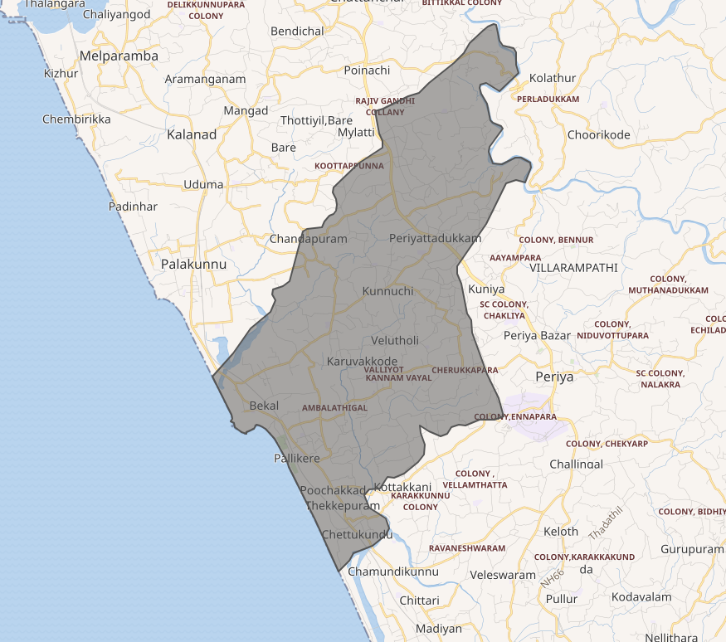

Baseline data

- District : Kasaragod
- Block Panchayath : Kanhangad
- Taluk : Hosdurg
- Grama Panchayaths : Pallikkare
- Number of wards : 24

Ward division -
Wards | Houses | Population | Migrants | Wells | Hot  spots | Ed. Institutions | Hosp pvt/govt.
24 | 12412 | 59176 | 950 | 5645 | 8 | 24 | 2

Major Roads/rivers

National Highway 66 (NH 66)
- The most important road passing near Pallikkere
- Connects:
  - Kasaragod (north)
  - Kanhangad and Kannur (south)

State Highway (SH 57 – Kasaragod–Kanhangad Road)
- Runs parallel to NH66 in parts
- Connects coastal settlements including Bekal
- Important for local and regional transport

Bekal Fort Road
- Connects interior areas to Bekal Fort
- Key tourism and access road
- Used heavily during peak tourist seasons

Local Panchayat Roads
  - Network of small roads connecting:
  - Pallikkara
  - Bekal
  - Nearby wards and coastal hamlets

Major Rivers

Bekal River
- Flows along the northern boundary of Pallikkara area
- A short west-flowing river in Kasaragod district
- Drains into the Arabian Sea near Bekal coast
- Important for:
  - Local irrigation
  - Flooding during monsoon

Chithari River
- Flows along the southern boundary of Pallikkara village
- One of the significant rivers in the Bekal region
- Supports:
  - Agriculture
  - Inland water flow and drainage
- Plays a role in seasonal flooding and waterlogg

Geographical boundaries - ward boundaries map

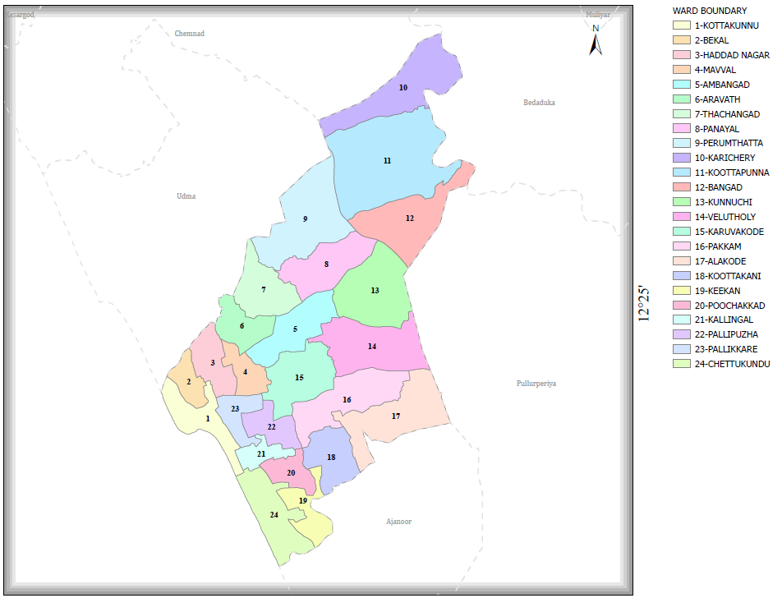

INTEGRATED HEALTH INFRASTRUCTURE MAP OF PALLIKKERE GRAMA PANCHAYAT
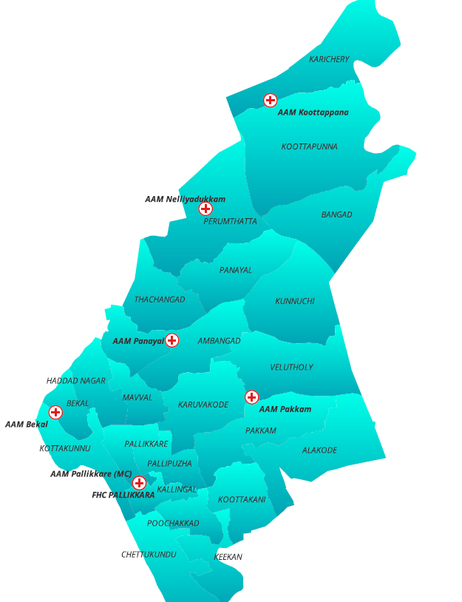

GENERAL PROFILE OF THE LSGI’S

Background of the LSGI
Pallikkere Grama Panchayat is situated in the coastal belt (western part) of Kasaragod district, Kerala. The Panchayat is characterized by low-lying terrain, extensive paddy fields, coastal sandy stretches, and an interconnected network of rivers, canals, and backwaters. This geographical setting significantly influences local climate patterns and increases vulnerability to flooding, waterlogging, and saline water intrusion, particularly during the southwest monsoon.
The Panchayat comprises multiple administrative wards with an estimated population of 35,000–45,000, distributed across coastal and inland habitations. A considerable proportion of the population resides in flood-prone and environmentally sensitive zones, which poses challenges for emergency evacuation, healthcare access, and continuity of essential services during disasters and public health emergencies.
The local economy is primarily dependent on agriculture (paddy cultivation), fishing, and daily wage labour. These livelihood sectors are highly sensitive to climatic variations and disaster events, leading to economic instability and increased vulnerability among households. Additionally, the Panchayat hosts a significant migrant labour population, particularly in construction and allied sectors, necessitating inclusive and multilingual risk communication and health service delivery strategies during pandemics.
From a public health perspective, Pallikkere Grama Panchayat is vulnerable to both communicable disease outbreaks and disaster-induced health risks. Seasonal flooding often results in contamination of drinking water sources such as open wells and borewells, increasing the incidence of waterborne diseases including diarrheal diseases, Hepatitis A, and Typhoid. Furthermore, water stagnation creates breeding grounds for vectors, leading to outbreaks of vector-borne diseases such as Dengue and Leptospirosis.
The experience of recent public health emergencies and seasonal monsoon-related events has highlighted critical gaps in early warning systems, surveillance mechanisms, emergency logistics, and inter-departmental coordination at the local level. Waterlogging and temporary disruption of transportation networks during heavy rainfall periods can hinder timely access to healthcare facilities, thereby affecting disease management and emergency response activities. The Panchayat is supported by a network of primary healthcare institutions including Family Health Centres (FHCs), sub-centres, and nearby secondary and tertiary care hospitals. However, during emergencies, the functional capacity of these facilities may be constrained due to infrastructure limitations, workforce shortages, increased patient load, and accessibility challenges
In this context, the development and implementation of a comprehensive Pandemic Preparedness and Disaster Management Plan is essential to enhance resilience and ensure continuity of essential services. Key components of this plan include:
- Strengthening disease surveillance systems for early detection and rapid response to outbreaks
- Mapping of vulnerable populations and high-risk zones (flood-prone wards, densely populated areas, migrant clusters)
- Inventory and geospatial mapping of critical infrastructure, including health facilities, isolation centres, relief shelters, and supply chains
- Preparedness for emergency logistics, including availability of transport, boats, medical supplies, and trained response teams
- Ensuring safe water, sanitation, and hygiene (WASH) interventions during disasters and pandemics
- Risk communication and community awareness programs, including targeted outreach for vulnerable and migrant populations
- Inter-sectoral coordination mechanisms involving health, local self-government, disaster management authorities, and community-based organizations
This localized, data-driven approach will enable Pallikkere Grama Panchayat to anticipate risks, respond effectively to emergencies, minimize health impacts, and ensure sustainable community resilience in the face of future pandemics and disasters.
Table 1: Background of LSGD
Description | Details
Name of LSGI | Pallikkare
Type (GP/Municipality / Corporation etc.) | Grama Panchayath
Block | Kanhangad
District | Kasaragod
Number of wards | 24
Total area (sq. km) | 34.05
Population(Projected) | 59176
Population density | 1270.36 persons/sq km
Terrain (coastal/low-lying/backwaters/foothills, etc.) | Coastal
Number of rivers passing through LSGI | 3
Number of water bodies in the LSGI | 16
Number of educational institutions | 24
Factories / small-scale industries | 3
Flood-prone wards | 3
Landslide-prone wards | 1
Death Management and Disposal Facilities (mortuaries/crematorium, including electric) | 2
Auditoriums/Marriage halls/convention centres/community halls | 3/1/1/6

Demographic and Vulnerable Population
Understanding the demographic composition and vulnerable population groups is essential for pandemic preparedness. Children, elderly, economically deprived families, migrant workers, and socially vulnerable groups are at increased risk during public health emergencies due to higher exposure, limited access to services, and dependency on public systems..

Description |  | Details (in numbers)
DEMOGRAPHIC PROFILE
Total population |  | 59176
Male |  | 29657
Female |  | 29519
Transgender |  | 1
Children under 5 |  | 3659
Adolescent |  | 6720
Elderly (>60) |  | 14974
SOCIAL/LIVELIHOOD VULNERABILITY
Previous EPEP family |  | 48
BPL family
Tribal communities |  | 224
Migration | Immigrant | 980
Migration | Emigrant | 5140
Socio-economically deprived |  | 151
Fisherfolk |  | 645
SC Community |  | 121
ST Community |  | 224

Graphs: Population pyramid for seeing if your LSGI has a high dependency ratio.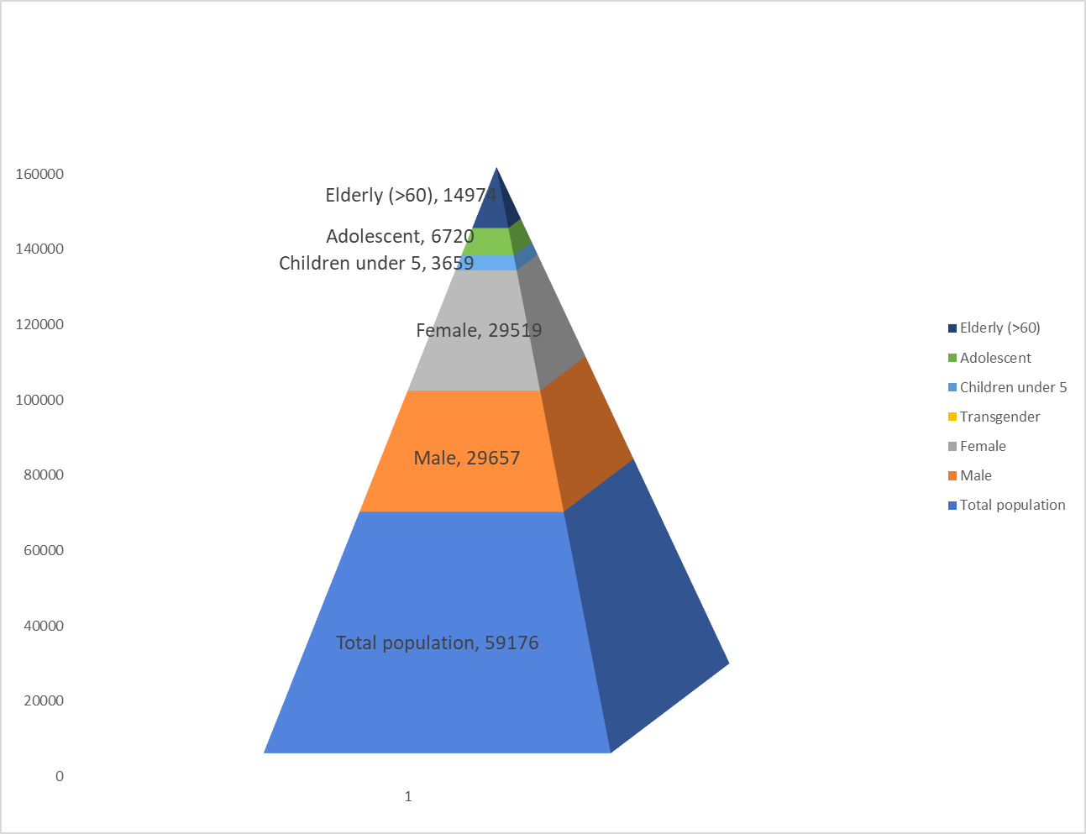

Clinical Vulnerability
Certain population groups need priority healthcare & are at higher risk of severe illness, complications, and mortality during pandemics. Patients with chronic diseases, those requiring regular medical care, and individuals with mobility or functional limitations face challenges in accessing timely care during emergencies. Mapping these groups helps in prioritizing continuity of treatment, medicine stock planning, oxygen support, referral transport, and targeted home-based care.
Description | Details in numbers
Pregnant women | 752
Lactating mothers | 1388
Bedbound patients | 245
Patients under palliative care other than bedbound | 686
Patients on Haemodialysis | 58
Patients on CAPD | 0
Cancer patients (currently on treatment) | 291
Haemophilic patients | 2
Mentally challenged | 40
Differently abled | 752
Diabetic patients | 1441
Hypertensive patients | 2366
TB patients | 12

Major Festivals & Events specific to the LSGI
(with the possibility of a public gathering)

Sl. No. | Name of festival | Month detailing the periodicity
1 | Beach festival | December-10 Days
2 | Teyyam kettu | March -4 days

INFRASTRUCTURE & RESOURCE INVENTORY

Health Facility Directory & Basic Capacity in the LSGD
This section provides an overview of the healthcare infrastructure available within the LSGD area. It outlines the distribution and basic capacity of health facilities that form the backbone of service delivery during routine times and public health emergencies.
Family Health Centres (FHCs) generally function as the first point of contact for the community, providing essential outpatient and limited inpatient services. Nearby referral healthcare institutions support advanced diagnostics, specialist consultation, emergency care, and critical health services during public health emergencies. This inventory helps identify existing strengths, gaps, and potential surge capacity that can be mobilised during a pandemic or disaster situation .
Table 5. Health Facility Resource Summary
Sl.no. | Health Facility | Type of Facility (MCH/GH/CHC/FHC/SC etc.) | Contact Number | Total beds | ICU Beds | Oxygen-Supported Beds | No. of Ventilator Support Beds | No. of9446 ambulances
Government Healthcare Facilities
1 | FHC Pallikkare | FHC | 9400038606 | 0 | 0 | 0 | 0 | 0
2 | FHC Karichery | Mini FHC | 9446760385 | 0 | 0 | 0 | 0 | 0
3 | AAM Bekal | SC |  | 0 | 0 | 0 | 0 | 0
4 | AAM Panayal | SC |  | 0 | 0 | 0 | 0 | 0
5 | AAM Pakkam | SC |  | 0 | 0 | 0 | 0 | 0
6 | AAM Nelliyadukkam | SC |  | 0 | 0 | 0 | 0 | 0
7 | AAM Koottappunna | SC |  | 0 | 0 | 0 | 0 | 0
8 | AAM Pallikkare (MC) | SC |  | 0 | 0 | 0 | 0 | 0
AYUSH Healthcare Facilities
1 | Govt Ayurveda Dispensary Pallikkara Pakkam | Ayurveda |  | 0 | 0 | 0 | 0 | 0
2 | Govt Homoeo Dispensary Pallaikkara | Homeo |  | 0 | 0 | 0 | 0 | 0
3 | NHM Dispensary Pallikkara | Siddha |  | 0 | 0 | 0 | 0 | 0

Private Clinics
Private clinics are an essential part of pandemic preparedness, as they are often the first place people seek care when symptoms begin. In many communities, private clinics manage a significant share of outpatient visits and therefore play a critical role in early case detection, timely referrals, and disease surveillance. Having an up-to-date understanding of where these clinics are located, the services they provide, and how they are linked to the public health system helps ensure that no cases are missed during an outbreak. It also allows health authorities to engage private practitioners more effectively for reporting, risk communication, and coordinated response, strengthening the overall capacity of the health system to manage public health emergencies.

Table 6. Private Clinic Resource Summary
Sl No. | Name of Clinic | Registered (Y/N) | Clinic (General / Speciality) | Speciality (if any) | Address | Contact Number | Diagnostic Facility (Y/N) | Ambulance Linkage (Y/N)
1 | NK Hospital, Bekal | YES | GENERAL | NIL | Bekal, Kottakkunnu | 7907313206 | YES | N
2 | Star Med Bekal | NO | GENERAL | NIL | Bekal Jn | 7592942999 | YES | N
3 | Sajid Clinic Kallingal | NO | GENERAL | NIL | Kallingal | 9562503616 | YES | N

Healthcare Education & Training Institutions
This section tracks the educational infrastructure available, which is vital for human resource planning in the health sector.

Category of Institution | Govt | Private | AYUSH | Total
Medical Colleges | 0 | 0 | 0 | 0
Nursing Colleges | 0 | 0 | 0 | 0
Dental Colleges | 0 | 0 | 0 | 0
Para-medical / Allied Health | 0 | 0 | 0 | 0
Pharmacy Colleges | 0 | 0 | 0 | 0

Specialized Services & Emergency Inventory
This section provides a detailed view of the specialized medical resources available to the community, focusing on emergency response and critical care capabilities. This table tracks the vital assets required for managing severe illnesses and emergencies across Government, Private, and AYUSH sectors.

Item | Govt | Private | AYUSH | Total
Hospital beds | 0 | 0 | 0 | 0
Oxygen-generating systems(Y/N) | 0 | 0 | 0 | 0
Oxygen-supported beds(Numbers) | 0 |  | 0 | 0
Ventilator-supported beds | 0 | 0 | 0 | 0
ICU beds | 0 | 0 | 0 | 0
Burns units | 0 | 0 | 0 | 0
Blood centres | 0 | 0 | 0 | 0
BLS ambulances | 0 | 0 | 0 | 0
ALS ambulances | 0 | 0 | 0 | 0
Dialysis facilities | 0 | 0 | 0 | 0
Dispensaries | 2 | 0 | 1 | 3
Medical store | 1 | 6 | 2 | 9
Industrial establishments(Medium-scale industries/small-scale industries establishments to whom we can depend in a worst-case scenario) | 0 | 3 | 0 | 3

Oxygen & Diagnostic Capacity
Monitoring oxygen and diagnostic capacity is a critical component of public health preparedness, ensuring that the LSGD can handle both chronic care and sudden surges in respiratory or infectious diseases
Name of Health Facility | Oxygen-generating System (Y/N) | Backup Oxygen Source (Y/N) | Diagnostic Facilities Available(Y/N)
Name of Health Facility | Oxygen-generating System (Y/N) | Backup Oxygen Source (Y/N) | Lab | USG | X-ray | CT/MRI | RT-PCR
Government Healthcare Facilities
FHC Pallikkara | N | N | 1 | 0 | 0 | 0 | 0
PHC Karichery | N | N | 1 | 0 | 0 | 0 | 0

Diagnostics facility mapping at the LSGI level
The diagnostic capacity within Pallikkara Grama Panchayat is limited, with scarce laboratory facilities available in nearby health institutions. As a result, timely and accurate disease identification depends on a constrained diagnostic network, which may affect early detection and rapid response during public health emergencies.

Item | Govt | Private | AYUSH | Total
General labs | 2 | 3 | 0 | 5
Microbiology labs | 0 | 0 | 0 | 0
RT-PCR labs | 0 | 0 | 0 | 0
USG units | 0 | 0 | 0 | 0
CT/MRI units | 0 | 0 | 0 | 0
Research labs | 0 | 0 | 0 | 0
Labs of other departments that can be repurposed | 0 | 0 | 0 | 0

Laboratory Identification & Basic Details
Sl. No. | Name of Laboratory | Ownership (Govt / Private / Academic) | Address | Contact No. | 24×7 Services (Yes/No) | NABL / Govt Approved (Yes/No)
1 | FHC Pallikkare | Govt | Pallikkare | 9400038606 | No | Govt
2 | PHC Karchery | Govt | Karichery | 9446760385 | No | Govt
3 | NK Clinic | Private | Bekal, Kottakkunnu | 7907313206 | No
4 | Star Med | Private | Bekal Jn | 7592942999 | No
5 | Dr Sajid | Private | Kallingal | 9562503616 | No

Social and Community Infrastructure for surge plan
This table serves as our logistics and shelter inventory. By mapping these locations, quickly we can identify where to house displaced citizens, where to set up temporary medical clinics, and how to manage the deceased with dignity during a crisis.

Category | Total Count | Ward | Est. Capacity (Persons) | Contact details
Educational Institutions
Anganwadis | 39 | 24 | 25-40
Schools | 23 | 20 | 100-150
Colleges | 1 | 13 | 400
Healthcare Educational Institutions
Medical colleges (Govt/Private) | 0
Nursing colleges (Govt/Private) | 0
Dental colleges (Govt/Private) | 0
Paramedical institutes (Govt/Private) | 0
Community Gathering Spaces
Community halls | 6 | 4,6,10,11,13,15 | 20 | 9645833946
Auditoriums | 2 | 6,23
Religious buildings | 61 | ALL WARDS
Vulnerable Group Support Facility
Destitute homes | 0
Elderly homes | 1
LSGD owned other buildings | 0
Mass Fatality Management (MFM) Infrastructure
Mortuary | 0
Crematorium | 2

Human resources
This section focuses on the human capital available within the LSGI. In any emergency—be it a pandemic, flood, or industrial accident—infrastructure is only as effective as the people operating it.

Medical & Clinical Personnel
This table tracks the Frontline providers responsible for diagnosis, treatment, and clinical management.

Cadre | Govt (No.) | Private (No.) | Total
Doctors—Modern Medicine | 5 | 4 | 9
Doctors – AYUSH | 3 | 13 | 16
Doctors – Veterinary | 1 | 3 | 4
Doctors – Dental | 0 | 3 | 3
Nursing officers | 4 | 14 | 18
Lab technicians | 3 | 12 | 15
Optometrist | 0 | 2 | 2
Pharmacists | 4 | 7 | 11
Psychologists | 0 | 2 | 2
Counsellors | 0 | 1 | 1

Public Health & Field-Level Workforce
These individuals are the backbone of surveillance, maternal-child health, and decentralized care.

Cadre | Health services | Municipal common services | Total
HS (Health Supervisors) | 0 | 0 | 0
HI (Health Inspectors) | 1 | 0 | 1
LHS (Lady Health Supervisor) | 0 | 0 | 0
LHI (Lady Health Inspectors) | 1 | 0 | 1
JPHN (Jr Public Health Nurses) | 5 | 0 | 5
JHI (Jr Health Inspectors) | 5 | 0 | 5
MLSP (Mid-Level Service Providers) | 5 | 0 | 5
Palliative Nurses | 1 | 0 | 1
RBSK Nurses | 1 | 0 | 1
PRO | 1 | 0 | 1
Epidemiologist | 1 | 0 | 1
Data Manager | 1 | 0 | 1

Community & Support Cadre
This group represents the surge capacity of the LSGI—people who can be called upon for logistics, rescue, and specialized support.

Cadre | Number
ASHA Workers | 35
AWW (Anganwadi Workers) | 39
Emergency Medical Volunteers (Trained) | 220
Kudumbashree | 365 / 5400 Members
MNREGS | 2112
Purusha Swayam Sahaya Sangham | 212
Ex-Servicemen | 6
Retired Police Officers | 9
NCC/NSS Volunteers | 190
Red Cross volunteers | 148
One Health Community Volunteers | 0
One Health Community Mentors | 0

Community Organizations
This section details the presence of community-based organisations (CBOs), non-governmental organisations (NGOs), faith-based organisations (FBOs), Kudumbashree Self-Help Groups (SHGs), and Ayalkootams within the Local Self-Government Institution (LSGI). These groups enhance grassroots mobilization, resource distribution, and support networks crucial for pandemic response and community resilience.

Category | Total Count
NGOs | 0
Religious based organizations | 2
Foreign based organizations | 0
Sports Club/youth clubs | 32
Kudumbashree SHGs | 365
Ayalkootams | 365
Political organizations | 5
Residential organizations | 0

Administrative & Emergency Services
This section outlines the availability of key non-health emergency support services and infrastructure within the LSGI, which are essential for effective pandemic preparedness and response. These facilities support law enforcement, disaster response, water supply, logistics, mobility, and community-level interventions during public health emergencies.

Category | Total Count | Contact details
Police Stations | 0 | Area Served by Bekal Police station 9497964323
Fire & Rescue Stations | 0 | Area served by Kanhangad Fire and rescue Service 914672202101
Water Pumping Points | 5
Public Distribution System (PDS) | 13 | 0467-2204044

Information regarding resources
The availability of essential transport and support resources plays a quiet but critical role in saving lives. Equipment such as ambulances, mobile mortuaries, amphibian ambulances, and motorized boats ensures that patients, samples, and healthcare teams can move swiftly—even in flooded, remote, or difficult terrains. Heavy vehicles like JCBs, cranes, tractors, and torus lorries support logistics, waste management, emergency infrastructure, and rapid conversion of spaces into care or isolation facilities. Taxis, four-wheel-drive vehicles, and trucks help maintain continuity of essential services, reach vulnerable populations, and support home-based care and supply delivery.

Means of transportation | Total Count
JCB | 9
Crane | 2
Heavy Trucks | 0
Tractor | 2
Ambulances | 1
Mobile mortuaries | 0
Boats | 25
Taxi service | 6

ONE HEALTH & ENVIRONMENTAL SURVEILLANCE
The One Health method integrates environmental, animal, and human health to enable proactive pandemic preparedness. Panchayat-level surveillance needs to be improved in order to detect and treat zoonotic and environmentally generated diseases early. Surveillance is strengthened through systematic assessment of animal populations, veterinary infrastructure, poultry and slaughter facilities, inter-sectoral coordination, and specialised tools like avian influenza seasonality mapping using GIS in previous outbreaks to enable predictive alerts and ward-specific sampling to support effective pandemic preparedness in high-risk areas .

Animal & Bird Population
Mapping animal and bird populations at the Panchayat level is essential for identifying and prioritising zoonotic disease hazards like rabies, leptospirosis, anthrax, and Nipah-like spillover occurrences. Risk classification, targeted surveillance, vaccination planning, and early epidemic detection made feasible by comprehensive population mapping all enhance One Health-based pandemic preparedness.

Category | Item | Estimated Population | Wards
Animal Population | Livestock (Cattle/Goats/Buffalo) | 2111 (1337+670+104)
Animal Population | Pet Animals (Dogs/Cats) | 294
Animal Population | Stray Dog Population | 612
Animal Population | Pig Farms (Number of heads) | 1
 | Small Units (Sheep / Goats – clustered) | 0
Bird Population | Poultry Units (Birds) | 3
Bird Population | Poultry- (FOWL) | 9529
Bird Population | Wild/Migratory Birds (Observed) | 0
Bird Population | Crow Mortality Events (Reported) | Not yet reported

Veterinary Infrastructure
Veterinary institutions are a core pillar of One Health surveillance, enabling early zoonotic disease detection through vaccination, investigation of unusual animal illness or deaths, sample collection, and timely outbreak reporting. A well-mapped and responsive veterinary network strengthens coordination with human health and LSGI systems, ensuring rapid response during zoonotic events and pandemics.
Facility Type | Name of Facility | Ownership Govt / Pvt | Location | Contact number
Veterinary Dispensary | Pallikkare | Govt | Ambangad ward 6 | 04672274030
Veterinary Hospital / Polyclinic | Nil | 0
Private Veterinary Clinics | Nill
Mobile / Emergency Vet Service (incl. night services) | Nill
Pet Homes / Animal Shelters | Nil
Slaughterhouse-linked Veterinary Inspection Unit | Nil

Veterinary Doctors & Workforce
Early detection, diagnosis, reporting, and response to animal disease outbreaks depend on the availability and accessibility of qualified veterinary personnel. A well-defined veterinary workforce strengthens One Health surveillance by supporting timely identification of unusual animal illness or deaths, facilitating rapid sample collection and reporting, and ensuring effective coordination with human health systems and Local Self Government Institutions (LSGIs), particularly during zoonotic outbreaks and pandemic-prone situations

Category | Number Available | Type (Govt/Pvt) | Contact number
Government Veterinary Doctors | 1 | Govt | Veterinary Subcentre 7510810499
Private Veterinary Doctors | 1 | Pvt | Truvet pet Hospital-90373 80755
Livestock Inspectors | 1 | Govt | 9961146487
Para-veterinary Staff / Attenders | 1 | Govt | Veterinary Subcentre
Contract / On-call Veterinary Support (if any) | 2 | Govt

High-Risk Interface Points (Surveillance Sites)
High-risk interface points for zoonotic disease surveillance in Pallikkara Grama Panchayat are limited but include backyard poultry rearing areas, cattle sheds, fish market environments, and locations with close human–animal interaction. These areas require periodic surveillance and monitoring to support early detection and prevention of potential zoonotic disease transmission

Type of Habitat | Type of High risk interface | Geographical vulnerability
Wetlands & Backwaters | 2 | Low
Backyard Poultry Farms | 1240 | Low
Cattle Sheds near Water Bodies | 0 | NA
Fish & Meat Markets | 1 | Low
Community Slaughter Sites | 0 | NA
Migratory Bird Congregation Areas | 0 | NA
Rodent-Infested Grain Storage | 0 | NA

Category | Total Count | Key Locations (wards)
Poultry Farms | 3
Backyard / Clustered Poultry Units | 24 | Bekal ,
Duck Rearing Units (open water access) | 0
Slaughterhouses/ Slaughter Points | 0
Meat/Fish Markets | 1
Live Bird Sale Points | 0
Cattle Markets / Weekly Animal Fairs | 0
Pet Shops / Breeders | 0
Animal Shelters / Pet Homes | 0
Waste Disposal Sites near Animal Units | 0

Environmental Risk Mapping
Environmental risk mapping identifies monsoon-related waterlogging areas associated with vector-borne diseases such as dengue and chikungunya, water-borne diseases including leptospirosis and diarrhoeal illnesses, and selected zoonotic risks. Systematic surveillance supports early warning systems, targeted interventions, and Panchayat-level pandemic preparedness activities. Waterlogging and stagnant water conditions can facilitate the survival of Leptospira, thereby increasing the risk of leptospirosis in vulnerable areas. Informal slaughter activities and unhygienic conditions in fish market environments may also create potential disease transmission risks if proper sanitation and waste management practices are not consistently maintained.

Risk Factor | High-Risk Wards | Key Locations | Risk Level (High/Med/Low)
Flood-prone areas | 0 |  | Low
Water bodies/wetlands | 2 | Bekal | Low
Solid waste accumulation | 0
Animal waste disposal issues | 0
Rodent infestation zones | 0
Industrial effluent discharge | 0
Construction sites / abandoned buildings | 1
Poor drainage/blocked canals | 0 | Not yet Noticed
Drinking water source contamination risk | 0

Disease Seasonality Mapping
Flooding and waterlogging during monsoon periods can increase the risk of leptospirosis, mosquito-borne diseases, and diarrhoeal illnesses by creating favourable environmental conditions for disease transmission. Increased mosquito breeding during the rainy season contributes to seasonal peaks of vector-borne diseases. In addition, agricultural activities, particularly in paddy field areas, may increase close human–animal and environmental contact, thereby elevating the risk of zoonotic and water-related disease exposure.
Disease / Health Risk | Seasonal Trend / High-Risk Period | Key Risk Factors | Disease / Health Risk
Leptospirosis | June – November | Waterlogging, stagnant water, agricultural exposure | Leptospirosis
Dengue / Chikungunya | June – September | Increased mosquito breeding during monsoon | Dengue / Chikungunya
Acute Diarrhoeal Diseases | All seasons | Unsafe water, poor sanitation, food contamination | Acute Diarrhoeal Diseases
Rabies | All seasons | Animal bites and exposure to infected animals | Rabies

Vulnerability Mapping
Vulnerability mapping pinpoints high-risk populations, occupations, and areas exposed via environment, livelihoods, socio-economics, and poor service access. Paired with environmental/seasonality mapping, it enables risk-based surveillance, targeted actions, and optimal resource use in One Health and pandemic planning.
Vulnerability Factor | High-Risk Wards | Key Groups / Locations | Risk Level
Flood-prone households | 1,2,24,10 | Bekal Beach side
Wetland-adjacent communities | Nil
Slaughterhouse & meat market workers | Nil
Fisherfolk & fish market workers | 645
Daily wage / migrant workers | all wards | Majority 2, 3,6,7
Elderly & chronically ill populations | 14974 | All wards
Pregnant Women | 752 | All wards
Children (schools, Anganwadi’s) | 3659 | All wards
Limited access to safe water & sanitation | Yes

EPIDEMIOLOGICAL TRENDS (2021–2025)

Disease surveillance is the systematic collection, analysis, and interpretation of health data for planning, implementation, and evaluation of public health practice. This section presents the disease surveillance profile of the LSGI based on routine reporting systems and outbreak investigations to identify priority diseases, seasonal patterns, and emerging public health threats.

Disease Burden among human beings(Last 5 Years)
Analysis of disease-wise data for the last five years helps identify persistent public health problems, emerging diseases, and changes in disease burden. This information supports prioritisation of prevention, preparedness, and response activities at the Panchayat level.

Disease | 2021 | 2022 | 2023 | 2024 | 2025 | Trend(Increasing/Stable/Decreasing)
Dengue | 65 | 36 | 31 | 40 | 37 | Decreasing
Leptospirosis | 1 | 0 | 1 | 2 | 4 | Increasing
Hepatitis A | 2 | 1 | 2 | 19 | 158 | Increasing
Malaria | 0 | 0 | 3 | 3 | 0 | Decreasing
Scrub Typhus | 0 | 0 | 0 | 0 | 0
Typhoid | 0 | 1 | 1 | 0 | 0
H1N1 | 0 | 2 | 0 | 2 | 0
H3N2 | 0 | 0 | 0 | 0 | 0
ADD | 0 | 0 | 0 | 0 | 161
Mumps | 0 | 0 | 0 | 0 | 27
Measles | 0 | 0 | 0 | 0 | 0
Hepatitis B | 0 | 0 | 0 | 0 | 0
Hepatitis C | 0 | 0 | 0 | 0 | 0
Tuberculosis | 0 | 0 | 0 | 20 | 12
Leprosy | 0 | 0 | 6 | 0 | 2

Seasonal Trend Analysis
Seasonal analysis helps anticipate surges (e.g. dengue in monsoon, leptospirosis after floods, influenza in cooler months) and plan pre‑emptive vector control, stockpiling of IV fluids, and awareness campaigns at Panchayat level.

DENGUE
Dengue is a major seasonal vector-borne disease strongly associated with rainfall, water stagnation, and increased mosquito breeding during the monsoon period.

Peak: July–November

Dengue – Ward-wise Yearly Distribution (2021–2025)

Ward | Dengue – Ward-wise Yearly Distribution
Ward | 2021 | 2022 | 2023 | 2024 | 2025 | Total
1 | 0 | 0 | 0 | 1 | 0 | 1
2 | 0 | 3 | 0 | 0 | 0 | 3
3 | 1 | 0 | 0 | 0 | 0 | 1
4 | 0 | 0 | 0 | 2 | 0 | 2
5 | 0 | 2 | 2 | 1 | 0 | 5
6 | 1 | 5 | 5 | 4 | 0 | 15
7 | 2 | 2 | 1 | 11 | 0 | 16
8 | 0 | 1 | 2 | 9 | 9 | 21
9 | 1 | 4 | 0 | 18 | 1 | 24
10 | 2 | 1 | 2 | 3 | 2 | 10
11 | 0 | 3 | 0 | 0 | 0 | 3
12 | 0 | 0 | 3 | 1 | 1 | 5
13 | 0 | 1 | 1 | 2 | 0 | 4
14 | 0 | 0 | 0 | 1 | 0 | 1
15 | 0 | 1 | 1 | 0 | 0 | 2
16 | 0 | 2 | 2 | 0 | 0 | 4
17 | 0 | 0 | 2 | 0 | 0 | 2
18 | 2 | 0 | 0 | 0 | 0 | 2
19 | 0 | 0 | 0 | 2 | 1 | 3
20 | 0 | 3 | 0 | 0 | 0 | 3
21 | 0 | 0 | 0 | 0 | 0 | 0
22 | 0 | 3 | 2 | 0 | 0 | 5

LEPTOSPIROSIS
Leptospirosis cases are closely linked to monsoon rains, flooding, and occupational exposure, particularly in low-lying and waterlogged areas.

Peak: June - August

Leptospirosis – Ward-wise Yearly Distribution (2021–2025)

Ward | Leptospirosis – Ward-wise Yearly Distribution
Ward | 2021 | 2022 | 2023 | 2024 | 2025 | Total
1 | 1 | 0 | 0 | 0 | 0 | 1
2 | 0 | 0 | 0 | 0 | 0 | 0
3 | 0 | 0 | 0 | 0 | 0 | 0
4 | 0 | 0 | 0 | 0 | 0 | 0
5 | 0 | 0 | 0 | 0 | 0 | 0
6 | 0 | 0 | 1 | 0 | 0 | 1
7 | 0 | 0 | 0 | 0 | 0 | 0
8 | 0 | 0 | 0 | 1 | 2 | 3
9 | 0 | 0 | 0 | 0 | 0 | 0
10 | 0 | 0 | 0 | 0 | 0 | 0
11 | 0 | 0 | 0 | 0 | 0 | 0
12 | 0 | 0 | 0 | 0 | 0 | 0
13 | 0 | 0 | 0 | 0 | 0 | 0
14 | 0 | 0 | 0 | 0 | 0 | 0
15 | 0 | 0 | 0 | 0 | 0 | 0
16 | 0 | 0 | 0 | 0 | 0 | 0
17 | 0 | 0 | 0 | 0 | 0 | 0
18 | 0 | 0 | 0 | 0 | 0 | 0
19 | 0 | 0 | 0 | 0 | 0 | 0
20 | 0 | 0 | 0 | 0 | 1 | 1
21 | 0 | 0 | 0 | 0 | 0 | 0
22 | 0 | 0 | 0 | 1 | 1 | 2

VIRAL HEPATITIS - A
Hepatitis A cases are commonly associated with unsafe drinking water, food contamination, and breakdowns in sanitation, often presenting as clusters or outbreaks.

Peak: October - December

Hepatitis A – Ward-wise Yearly Distribution (2021–2025)

Ward | Hep A – Ward-wise Yearly Distribution
Ward | 2021 | 2022 | 2023 | 2024 | 2025 | Total
1 | 2 | 0 | 0 | 2 | 41 | 45
2 | 0 | 0 | 0 | 1 | 2 | 3
3 | 0 | 0 | 0 | 0 | 3 | 3
4 | 0 | 0 | 0 | 0 | 3 | 3
5 | 0 | 0 | 0 | 0 | 1 | 1
6 | 0 | 0 | 1 | 3 | 4 | 8
7 | 0 | 1 | 1 | 0 | 0 | 2
8 | 0 | 0 | 0 | 0 | 0 | 0
9 | 0 | 0 | 0 | 0 | 0 | 0
10 | 0 | 0 | 0 | 1 | 3 | 4
11 | 0 | 0 | 0 | 2 | 0 | 2
12 | 0 | 0 | 0 | 0 | 1 | 1
13 | 0 | 0 | 0 | 0 | 0 | 0
14 | 0 | 0 | 0 | 1 | 1 | 2
15 | 0 | 0 | 0 | 0 | 3 | 3
16 | 0 | 0 | 0 | 0 | 1 | 1
17 | 0 | 0 | 0 | 2 | 3 | 5
18 | 0 | 0 | 0 | 3 | 0 | 3
19 | 0 | 0 | 0 | 4 | 43 | 47
20 | 0 | 0 | 0 | 0 | 3 | 3
21 | 0 | 0 | 0 | 0 | 6 | 6
22 | 0 | 0 | 0 | 0 | 9 | 9

Outcome-Based Trend Analysis- 2025

Transmission Trend- 2025
For effective management of public health issues, it is important to track the trend of disease transmission mode. It helps identify the population or place at high risk that can be used to predict outbreaks and implement targeted interventions as quickly as possible. Understanding these kinds of trends enables authorities to allocate resources efficiently and change the strategies adequately based on the trend that follows.

Vector-Borne Disease

Disease | No. of Cases | No. of Deaths
Dengue | 14 | 0
Malaria | 1 | 0
Chikungunya | 0 | 0

Water Borne Disease

Disease | No. of Cases | No. of Deaths
Cholera | 0 | 0
Typhoid | 0 | 0
Hep- A | 158 | 0
Dysentery | 0 | 0
Amoebiasis | 0 | 0
E- Coli infections | 0 | 0
Air Borne Disease

Disease | No. of Cases | No. of Deaths
Influenza | 0 | 0
H1N1 | 0 | 0
TB | 6 | 0
Chickenpox | 58 | 0
Measles | 0
Covid-19 | 0 | 0
Pertussis | 0 | 0
Mumps | 27 | 0

Blood-Borne Disease

Disease | No. of Cases | No. of Deaths
AIDS | 3 | 0
Hep- B | 0 | 0
Hep- C | 0 | 0

Zoonotic Disease

Disease | No. of Cases | No. of Deaths
Rabies | 0 | 0
Leptospirosis | 2 | 1
Avian influenza | 0 | 0
West nile | 0 | 0
Anthrax | 0 | 0
Nipah | 0 | 0
Scrub Typhus | 0 | 3

Preparedness and Response Protocol at LSG Level
This section describes the operational framework for the LSGI once a pandemic is declared. It explains how the LSGI and health system will move from routine data collection to active response, using a One Health approach.

Constitution of One Health Committee
The LSGD shall constitute a One Health Committee comprising the LSGI President, Medical Officers (Modern Medicine, AYUSH, and Veterinary), the Health Inspector, and the Veterinary Surgeon.

Objective: The One Health Committee coordinates human, animal, and environmental health to prevent and control pandemics.

Sl No | Name | Designation | Department/Institution | Role in Committee
1 | Mrs.SHOBHANA T | Panchayat President | LSGD | Chairperson
2 | Dr SREELAKSHMI M | Medical Officer (PHC/CHC) | Health Dept | Member Secretary
3 | Dr NIMNA | Veterinary Officer | Animal Husbandry | Member
4 | Dr.Bhagyalakshmi | Epidemiologist | Health Dept | Member
5 | SAJEEVAN PV | Health Inspector/PHN | Health Dept | Surveillance
6 | PREMA K | ASHA Supervisor | Health Dept | Community link
7 | GREESHMA ,LAVANYA | ICDS Supervisor | Social Welfare | Vulnerable groups
8 | SHO Bekal | Police Station Officer | Police Dept | Law & order
9 | RAJESH PALLIKKARE | Ward Councillor Representative | LSGD | Community coordination
10 | BEENA M | Kudumbashree CDO | Kudumbashree | Community mobilisation
11 | Dr. Anil | NGO/Volunteer rep | Civil Society | Support services

Key Responsibilities:
- Review disease surveillance data (human + animal)
- Conduct ward-wise risk assessment and vulnerability mapping
- Approve quarantine/isolation centre locations
- Coordinate with district for resources (PPE, oxygen, ambulances)
- Periodically review health system surge capacity, including beds, oxygen, human resources, and ambulances.
- Approve and monitor risk communication and community engagement strategies, including rumour management.
- Ensure protection and service continuity for vulnerable groups (elderly, persons with disabilities, dialysis patients, coastal populations).
- Conduct quarterly mock drills
- Monitor equity measures for vulnerable groups

Meeting Schedule:
Quarterly (normal times) | Weekly (outbreak alert) | Daily (pandemic phase)

Pandemic Response Workforce
To ensure a coordinated and timely response during a pandemic, a dedicated Pandemic Response Workforce shall be constituted at the LSG level. The workforce will function under the overall supervision of the One Health Committee and in close coordination with the health authorities. Team-based deployment will enable efficient surveillance, case management, quarantine and isolation management, logistics support, and risk communication. Each team shall have a clearly designated team leader, defined roles, and an identified pool of personnel to allow rapid activation, rotation of duties, and continuity of services during prolonged emergencies.

Team Name | Composition | Key Responsibilities | Team Leader
Surveillance and Contact Tracing Team | HI, JHI, JPHN, ASHAs and Volunteers | Case detection, contact listing, home visits, reporting | HI
Case Management Team | Doctors, Nurses, MLSP, Palliative Nurses | Patient care & referral | DOCTOR
Quarantine & Isolation Team | LSGD staff, Volunteers | Facility management | JHI
Psychosocial support | Aswathi .P | Psychosocial support | DMHP team
Logistics & supply chain Team | LSGD staff, Storekeepers, Drivers 3 | Supplies & transport [PPE, medicines, oxygen, transport, waste management] | Ward Member
Communication Team | Ward members, Kudumbashree, Youth clubs,  AWW workers and other self help groups | IEC, community meetings, countering misinformation | M.O in charge
Transportation | KSRTC, educational institutional buses | Mobilisation
Media Surveillance | Mr.Sajeevan |  | HI
All teams shall be activated immediately upon outbreak alert or pandemic declaration and shall report daily to the LSG Incident Commander/Medical Officer, with consolidated reporting to the Block PHC. Duty rosters and alternate personnel shall be maintained to ensure uninterrupted services during staff shortages or prolonged response periods. Team composition and numbers may be revised based on the magnitude of the outbreak and availability of human resources.

Activities and Measures before and during Pandemic

PHASE 1 - Alert / Preparation
Surveillance and Reporting-Enhanced syndromic surveillance:
- Data sources for surveillance:
- Event-based triggers (to be monitored and reported):
- Zoonotic and animal health surveillance
- Logistics and Stock Preparedness
  - Identify and empanel local vendors and define emergency procurement mechanisms in accordance with existing LSGD and Health Department norms.
  - Prepare and maintain an essential logistics checklist covering medical supplies, consumables, and support equipment.
  - Pre-identify secure storage locations for emergency stocks and ensure maintenance of stock registers with regular updating.
  - Finalise emergency transport arrangements, including availability of vehicles and identified drivers for rapid deployment during alerts.
  - Designate a Nodal Officer for Logistics to enable prompt decision-making, coordination, and communication during emergencies.
  - Conduct rapid stock verification and ensure availability of minimum buffer stock, including:
- PPE kits – numbers
- Pulse oximeters – ___ numbers
- Hand sanitizers – ___ litres
- Masks, gloves, disinfectants – adequate quantity
Identify critical gaps in logistics and immediately communicate requirements to the Block and District authorities for timely replenishment and support. Monitor expiry dates and stock rotation.

Identification of Quarantine and Isolation Facilities
  - Identify and list suitable buildings for quarantine and isolation (schools, hostels, community halls, etc.).
  - Categorise cases as per the severity and allocate to appropriate facilities (for instance, severe cases to classrooms, mild cases to an assembly hall in case of a school).
  - Facility readiness checklist needed (beds, toilets, ventilation) etc.
  - Find an alternate site if the primary sites are not available or not in use.
  - Identify facility managers and support staff
  - Prepare basic SOPs for:
    - Admission and discharge
    - Food, water, sanitation
    - Infection prevention and waste disposal
  - Ensure availability of basic amenities: water, sanitation, electricity, ventilation, and waste disposal. Prepare a rapid activation plan for these facilities if case numbers increase.

Risk Communication and Community Preparedness
  - Disseminate early warning messages on symptoms, preventive measures, and reporting mechanisms. Display IEC materials both in English and the local language in public places and ensure ward-level awareness.
  - Sensitize elected representatives and community leaders on preparedness measures.
  - Establish a rumour tracking and misinformation response mechanism to identify, verify, and promptly counter false or misleading information.
  - Engage trusted local persons (ward members, ASHA workers, religious leaders, teachers, community volunteers) to communicate official public health messages and reinforce correct practices.
  - Develop and deploy targeted IEC materials for:
    - Schools and educational institutions
    - Markets and commercial areas
    - Work sites and labour settings
  - Conduct community sensitization meetings at the ward level to promote preventive behaviors, address concerns, and strengthen community participation in preparedness and response.

Protection of Vulnerable Groups
Vulnerable populations require priority protection through targeted line-listing, service continuity, and delivery mechanisms.
- Prepare and regularly update line-lists of vulnerable populations, including:
  - Elderly persons living alone
  - Persons with disabilities
  - Pregnant women
  - Migrant workers
  - Dialysis patients

Clinical Dependency Mapping
Develop ward-wise dependency and vulnerability maps to identify households requiring regular support during emergencies. Ensure continuity of essential health services for vulnerable groups, including
- Dialysis services (facility mapping, transport arrangements, and scheduling)
- Continuity of treatment for TB, HIV, and other chronic conditions requiring uninterrupted medication
- Mental health and psychosocial support services
Establish delivery mechanisms for food, essential commodities, and medicines to vulnerable households through coordinated action involving ASHAs, JPHNs, Kudumbashree, volunteers, and local administration.

PHASE 2 - Active Response

Case Identification and Contact Tracing
Case detection and contact tracing activities will be carried out in coordination with the Health authorities, following disease-specific SOPs and IDSP guidelines.
Field Staff Involved
- Health Inspector (HI)
- Junior Health Inspector (JHI)
- Junior Public Health Nurse (JPHN)
- ASHAs and ASHA Supervisors
- Ward-level volunteers and Kudumbashree members (as required)

Screening Checkpoints
Screening checkpoints at high-traffic locations (transport hubs, markets, religious gatherings) for early detection of symptomatic travellers and crowd screening during outbreaks. Potential locations include bus stands, market entry points, and boat jetties, based on local context and risk assessment.
Screening activities will be carried out by trained personnel such as ASHAs, ward members, and volunteers, with support from Health Department staff. Necessary equipment, including non-contact thermometers and appropriate PPE, shall be ensured prior to activation.
Location | Type | Staff Deployed (ASHAs/Volunteers) | Screening Method | Reporting authority
Bus stand | Transport hub | One JHI  One ASHA  Onehealth Mentors | 1.Swab Collection.  2. Blood smears collection (RDT)  3.Thermal Scanners | Surveillance Nodal Officer in control room
Bekal Beach | Tourist Spot | One JHI  One ASHA  Male health volunteers | 1.Swab Collection.  2. Blood smears collection (RDT)  3.Thermal Scanners | Surveillance Nodal Officer in control room

Standard Screening Protocol
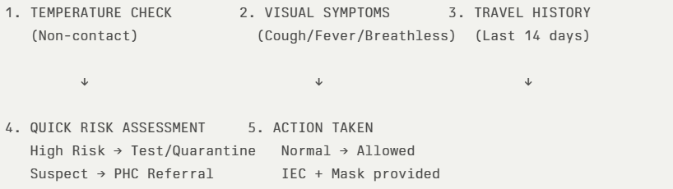
The screening protocol shall include temperature screening, observation for visible symptoms, and inquiry regarding recent travel or exposure history. Individuals identified as suspects during screening shall be immediately referred to the nearest FHC for further evaluation, testing, and appropriate action as per prevailing guidelines.

Pandemic Control Room
The Pandemic Control Room (PCR) serves as the central nerve center for real-time coordination, data aggregation, decision support, and communication during outbreaks. It consolidates information from all LSGD teams, health facilities and community sources to enable rapid response decisions.

Control Room Infrastructure and Location
Primary Location: Pallikkara Panchayath Office.
Backup Location: Community Hall in Pallikkara G.P.

Health System Control Room Framework
The PCR is organized into seven functional pillars to ensure no aspect of the response is overlooked:

Rapid Response Team (RRT)
  - Provides immediate intervention during emergencies, clusters, and field alerts.​
  - Coordinates urgent actions such as case investigation, contact tracing, isolation, and inter‑facility referrals.

Data Management & Analytics Team
  - Collects, validates, and manages key health system indicators (cases, tests, beds, HR, supplies).​
  - Analyzes data trends, generates projections, and supports evidence‑based decision‑making for local authorities.

Human Resource Deployment Team
  - Allocates healthcare staff efficiently based on workload and need
  - Ensures adequate and equitable workforce distribution across facilities

Laboratory Surveillance Team
  - Oversees diagnostic testing coordination, sample transport, and timely reporting of results.​
  - Monitors lab indicators (testing volume, positivity rate, turnaround time) for early detection of outbreaks

Vaccination Cell (If Required)
  - Plans and executes vaccination campaigns, including micro‑planning and session scheduling.​
  - Tracks coverage, identifies gaps, and coordinates corrective actions with field teams and outreach services.

Infrastructure & Patient Occupancy Team
  - Monitors facility capacity, earmarked beds, oxygen and critical care resources across all linked facilities.​
  - Ensures optimal patient distribution and referral management using updated bed‑status and resource data.
  - BMWM

The Pandemic Response Room functions as the central coordination hub for managing public health emergencies by integrating communication, logistics and supply chain management, transportation support for inter-facility and emergency referrals, media surveillance, and call centre operations. It also oversees the management of the deceased in a dignified and systematic manner, while ensuring strong intersectoral coordination and convergence among health services, Local Self Government Institutions, veterinary services, sanitation teams, and other allied departments to enable a timely, coordinated, and effective response during pandemics and other public health emergencies.

Key Control Room Team
The Control Room Team coordinates all pandemic response activities within the LSGD and serves as the single command and communication hub during activation. It integrates information, field actions, logistics, and policy execution across all participating departments and health facilities.

Role | Name | Designation | Contact Number | Responsibility
In-charge/Nodal Officer | Dr.Sreelakshmi  Dr.Venu | Medical officer | 9400038606 | Overall coordination, decision-making, and reporting to the District level.
Logistic Coordinator | Dr.Venu | Medical Officer- Karichery | 9446760385 | Coordination of logistic items and stockpiling
Data Entry and Technical Support | Sreenath M.R | Data Manager | 9995561380 | Managing the line list, updating dashboards, and tracking testing results.
Communication Officer& Logistics Coordinator | Sajeevan.P.V | Health Inspector | 9446041253 | Handling the public helpline, coordinating ambulance dispatch, and contact tracing calls.

Key Points:
- The Control Room shall be staffed with a designated In-charge, data entry personnel, and communication staff with clearly defined roles and shift arrangements.
- It shall maintain updated records on daily monitoring indicators including new cases, persons under active quarantine, and hospital bed occupancy.
- All reports and situation updates shall be shared daily with the Block and District Surveillance Unit.
- The Control Room shall act as a single point of contact for coordination with response teams, health institutions, and other departments.
- Contact details of the Control Room shall be widely communicated to field staff and stakeholders during activation.

Daily Monitoring Indicators
To ensure timely decision-making and effective response, the following key indicators shall be monitored and updated on a daily basis by the Pandemic Control Room:

Epidemiological Indicators:
New cases reported today, Total active cases, Test Positivity Rate (TPR), Case Fatality Rate (CFR)
- Surveillance Indicators:
Persons under home quarantine, High-risk contacts identified, Fever, ILI, SARI or other symptoms (syndromic surges), Travellers (symptomatic or high-risk arrivals),Animal husbandry surveillance (zoonotic alerts, unusual animal deaths, poultry/bird flu signals), Mortality surveillance (excess deaths, unexplained fatalities, verbal autopsy reports)
- Logistics and Infrastructure Indicators:
Hospital / CFLTC beds occupied, Oxygen cylinders/concentrators available, Ambulances on standby
- Alert Findings
The following table outlines category-specific trigger points (red flags) from surveillance indicators and corresponding immediate actions for the Pandemic Control Room. These enable rapid response to alert findings like testing anomalies, positive cases exceeding thresholds, clusters, and WGS reports.

Category | Trigger Point (Red Flag) | Immediate Action
Clusters | Geographical or facility-based: 5+ cases linked to one location (office, school, street). | Declare a micro-containment zone; perimeter control and active case finding.
Testing | Sudden drop in testing volume / delay in reporting / unusual testing trends | Review the sample collection process, address lab bottlenecks, deploy additional testing teams, and notify the District Lab.
Lab | Test Positivity rate increases | Increase testing sites in that ward.
Hospital | >80% Oxygen bed occupancy | Activate backup/CFLTC beds.
Travel | Cluster of cases from a single flight/train or high-risk arrival group. | Trace all passengers in adjacent seats; implement mandatory institutional quarantine.
Animal | Mass poultry/wildlife death or unusual sickness | Notify Animal Husbandry, sample the area, and dispatch RRT for environmental sampling and zoonotic check.
Mortality | Sudden spike in home deaths or brought-in-dead (BID) cases | Audit the deaths and Active Case Search drive

Communication of Public Health Information
A Community Communication Hub shall be established to ensure timely, accurate, and consistent dissemination of information during a pandemic. The Hub will function under the coordination of Nodal officers of the control room and act as the nodal point for public communication, risk messaging, and community engagement. It will support dissemination of official advisories, promote preventive behaviors, address rumors and misinformation, and ensure that messages reach all sections of the population through trusted local channels and leaders.

Key communicators
Channel | Responsible Person | Contact
Ward-level announcements | Mr.Sajeevan Health inspector | 9446041253
Social media | Dr.Venu.Medical Officer FHC Karichery | 9446760385
Local Cable TV/Radio | Mr. Jithin JHI | 8129157511

- All messages disseminated through the Hub shall align with advisories issued by the Health Department and District authorities.
- Community leaders shall be sensitized to support behavior change, reduce stigma, and counter misinformation.
- Special efforts shall be made to reach vulnerable and hard-to-reach populations using locally appropriate communication methods.

Rumor Tracking: A designated volunteer will monitor local social media/WhatsApp groups daily to identify misinformation and issue official clarifications via the Communication Hub.

Coordination with District/State Authorities & Other Organisations
Effective coordination with Block, District, and State authorities is essential to ensure timely reporting, technical guidance, and uninterrupted supply of essential resources during a pandemic. The LSG shall establish clear communication channels, designate responsible officers, and adhere to prescribed reporting timelines to support coordinated public health action and efficient resource mobilisation.

Reporting Schedule and Protocols:

To Whom | What to Report | Frequency | Nodal Person
Block FHC | Complete Situation Report (Cases, Quarantine, Beds, Screening, Deaths) | Daily | Medical officer in charge
District IDSP Unit | Outbreaks/Clusters/Unusual Events (>5 cases same ward) | Daily | Medical officer in charge
Veterinary Officer | Animal health events/Zoonotic alerts | Weekly | Health Inspector -
State Cell | Zoonotic cross-sector events | Weekly | Block Medical Officer

Supply Chain Coordination
The LSG shall coordinate closely with Block, District, and State authorities (KMSCL) to ensure uninterrupted availability of essential goods, medical supplies, and logistics during a pandemic. Supply requirements shall be assessed regularly based on case load and communicated promptly to the appropriate authorities for timely replenishment.
Key Points:
- Maintain updated contact details of District and Block nodal officers for health logistics, oxygen supply, ambulances, and essential medicines.
- Submit timely indent requests for PPE, testing kits, medicines, oxygen, and other critical supplies through prescribed channels.
- Monitor stock levels at LSGD facilities, quarantine/isolation centres, and field teams through daily stock registers and dispensing logs to prevent shortages.
- Coordinate with District authorities, Karunya/Neethi medical shops, and local purchase committees for funds allocation and emergency procurement.

- Ensure regular monitoring of dispensing registers at all facilities to track usage, expiry, and pilferage—shortages being a perennial issue requiring proactive weekly audits.

- Activate surge procurement protocols during high caseloads, leveraging local purchase powers under LSGD funds alongside state supplies.

Resource Inventory and Contacts
Resource Category | Source  (District/State/Private) | Contact
PPE Kits/Masks/Gloves/Test Kits (RTPCR/Rapid) | KMSCL | 0467-2205039
PPE Kits/Masks/Gloves | Local Vendors- Kasargod Surgicals | 0467 2201328
Oxygen Cylinders/Concentrators | KMSCL | 0467-2205039
Medicines/Antivirals | KMSCL | 0467-2205039
Medicines/Antivirals | Neethi Shops - Kanhangad | 07947150091

Collaboration with NGOs, PPP, and CSR
To augment government efforts during a pandemic, the LSG shall collaborate with NGOs, voluntary organisations, and private sector partners through public–private partnerships and Corporate Social Responsibility (CSR) initiatives, in coordination with District authorities.

Key Points:
- Engage NGOs and community-based organisations for community outreach, awareness, and support to vulnerable populations.
- Leverage CSR support for procurement of medical equipment, PPE, oxygen concentrators, food kits, and sanitation materials, as permitted.
- Ensure all collaborations align with government guidelines and are routed through approved administrative and financial procedures.
- Maintain transparency and documentation for all external support received and utilised.

Organization | Type | Support Offered | Contact Person
Youth Clubs/Student Unions- Akkara foundation Bekal | CBO | Psychosocial support Occupational care , Physiotherapy | 6282812703

Interdepartmental Coordination
Coordination among departments during a pandemic shall be ensured through regular review meetings convened by the LSGD President. These meetings will provide a structured platform for sharing situational updates, assessing resource availability, resolving operational gaps, and taking joint decisions to ensure a coordinated and timely response.

Department | Representative | Key Role | Contact
Health (FHC) | Staff Nurse : Deepa | Case management and Proper data communication | 94472 52576
Veterinary | Veterinary Surgeon: Dr.Nimna | Animal Health surveillance | 7510810499
ICDS | Supervisor: Sindhu | Nutrition support | 04672 275755
Education | Head Teacher:Deepa .A.V | School coordination | 04672273200
Police |  | Containment enforcement | __________
Water Authority | __________ | Water supply | __________
LSGD Engineering | __________ | Quarantine infrastructure | __________

PHASE 3 - Surge Capacity
Phase 3 is activated when there is a rapid increase in cases, high test positivity rates, or when existing health facilities and quarantine arrangements approach saturation. The focus of this phase is to expand isolation capacity, augment clinical care services, and mobilise additional resources through district and state support mechanisms.

Conversion of Community Facilities
To manage increased case load, the LSGD shall activate additional isolation facilities by repurposing identified community infrastructure such as community halls, auditoriums, schools, hostels, or other suitable buildings.

Name of facility | Facility Type | No. of Buildings | Ward | Surge Capacity (Beds) | Nodal Person
community Hall

- Recovery and rehabilitation phase
- Recovery
  - Damage & impact assessment
  - Restoration of health services
  - Rehabilitation of affected population
  - Psychosocial & mental health support
  - Disease surveillance during recovery phase
  - Environmental cleanup & sanitation
  - Livelihood restoration
  - Community engagement & confidence building
  - Documentation & after-action review
  - Lessons learned & best practices
  - Health system strengthening
  - Policy revision & preparedness enhancement
  - Research

CONCLUSION

Additional points
- tech support
- relief based commodities
- ham reading operators
- hazard vulnerability mapping
- Kseb & other power source
- HR specific responsibility

RECOMMENDATIONS

Strengthening Healthcare Infrastructure
- Establish a primary health response unit within the Panchayat with trained staff.
- Ensure availability of basic medical supplies (masks, sanitizers, PPE kits, oxygen cylinders).
- Create tie-ups with nearby hospitals in ____________ for emergency referral and transport.

2. Community Awareness & Education
- Conduct regular awareness campaigns on hygiene, vaccination, and preventive measures.
- Use local communication channels (community radio, WhatsApp groups, notice boards) to spread verified information.
- Train volunteers to act as health ambassadors in each ward.

3. Emergency Response & Coordination
- Form a Pandemic Preparedness Committee at Panchayat level including health workers, ward members, and NGOs.
- Develop a clear action plan for lockdowns, quarantine, and distribution of essentials.
- Maintain a database of vulnerable groups (elderly, differently-abled, chronically ill) for targeted support.

4. Supply Chain & Food Security
- Identify and support local suppliers and farmers to ensure uninterrupted food supply.
- Create community kitchens during emergencies to serve vulnerable populations.
- Stockpile essential commodities in Panchayat-run outlets for crisis periods.

5. Digital Preparedness
- Promote digital platforms for telemedicine consultations.
- Use Panchayat’s website/social media for real-time updates on health advisories.
- Encourage online grievance redressal to reduce crowding in offices.

6. Training & Capacity Building
- Organize mock drills for pandemic response in schools, offices, and public spaces.
- Train Panchayat staff and volunteers in first aid, infection control, and crowd management.
- Collaborate with NGOs and health departments for capacity-building workshops.

7. Long-Term Resilience
- Integrate pandemic preparedness into the Panchayat Development Plan.
- Allocate a dedicated budget for health emergencies.
- Encourage community participation in planning and monitoring preparedness measures.

MOCKDRILL SCENARIOS

ANNEXURE

IMPORTANT PHONE NUMBERS

Phone numbers and particulars of persons responsible for providing guidance, assistance, and support for pandemic preparedness operations may be provided here in a manner that allows easy reference at a glance. The information recorded here could be exhibited elsewhere at the time of emergencies. LSG institutions shall give special attention to collect and record the above data of persons and institutions who/which are supposed to give technical and co-ordination support to reduce the impact of pandemic.

1.1. Details of grama panchayat/municipality/corporation wards
Sl.No | Name of the ward | Ward number | Name of the ward  member | Contact number
1 | KOTTAKKUNNU | 1 | SAMEERA TEACHER | 7034187660
2 | BEKAL | 2 | BEEFATHIMA HAMEED | 9847936864
3 | HADDAD NAGAR | 3 | RASHEEDA K | 7902440068
4 | MOUVVAL | 4 | SHAKKEELA BASHEER | 9946189910
5 | AMBENGAD | 5 | MPM SHAFI | 9947138018
6 | ARAVATH | 6 | KANCHANA | 9605175895
7 | THACHANGAD | 7 | SUJATHA K | 9656089442
8 | PANAYAL | 8 | SHOBHANA T | 9946994064
9 | PERUNTHATTA | 9 | JAYALAKSHMI TEACHER | 9645749295
10 | KARICHERI | 10 | RAJAKUSUMAM M | 9847943915
11 | KOOTTAPUNNA | 11 | ASHITHA M | 9544734278
12 | BANGAD | 12 | KUMARAN | 8281433201
13 | KUNNOOCHI | 13 | MADHAVAN T | 9895094833
14 | VELUTHOLI | 14 | A BALAKRISHNAN | 9605378002
15 | KARUVAKKOD | 15 | C MANOHARAN | 9847786383
16 | PAKKAM | 16 | PRABHAKARAN T | 9400673870
17 | ALAKKOD | 17 | P KUNHIRAMAN MASTER | 9446026147
18 | KOOTTAKKANI | 18 | SOUMINI TEACHER | 9497697686
19 | KEEKKAN | 19 | ABBAS P | 9744301076
20 | POOCHAKKAD | 20 | MUNEER THAMANNA | 9995758470
21 | KALLINKAL | 21 | SAMEERA ABBAS | 6235359363
22 | PALLIPUZHA | 22 | ABDUL RADAK | 9847903470
23 | PALLIKKARE | 23 | RAJESH PALLIKKARE | 9447032008
24 | CHETTUKUNDU | 24 | ASURABI RASHID | 8139034131

1.2. Other important phone numbers of grama panchayat/municipality/corporation area
Sl. No. | Name | Contact number
1. | GRAMA PANCHAYATH OFFICE | 04672 272026
2. | AGRICULTURE OFFICE AMBENGAD | 04672 272174
3. | FHC PALLIKKARE | 04672 275500
4. | ICDS OFFICE PALLIKKARE | 04672 275755
5. | BLOCK PANCHAYATH OFFICE | 04672 204048
6. | DMO HEALTH KANHANGAD | 04672 203118
7. | Excise department
8. | Forest department

1.3. Important offices of grama panchayat/municipality/ corporation
Sl.No | Name of the office | Contact person | Contact number
1. | Village Office | Village Officer
2. | Agriculture Office | Agriculture Officer
3. | Animal Husbandry Office | Animal Husbandry Doctor: Dr.Nimna | 7510810499
4. | Police Station | Police Officer | 9497964323
5. | BSNL Office | Officer
6. | Block Office | Officer
7. | KSEB Office | Officer
8. | Fisheries Office | Officer
9. | Fire and Rescue | Officer

1.4. Health Services

Sl. No | Name of the hospital/institution | Location | Phone number
1. | Government hospitals/PHC
2. | Private hospitals
3. | Clinical laboratories
4. | Chemist/pharmacy
5. | Blood donors
6. | Other language experts (Bihari, Hindi, Bengali,  Asamees ………)

1.5. Veterinary Services
Sl.No | Name of the Clinic | Name of the  Surgeon/Doctor | Place/location | Phone  number
1 | Govt.Veterinary Hospital | DR NIMNA | AMBENGAD | 7510810499

1.6. Helpline numbers
Helpline | Phone number
Police | 04672 236224
Fire and Rescue | 04672
KSEB | 04672 267049

1.7. Public and Private Schools Contact details

S.No | Name of School | Institution type | Phone number
1 | GHSS PALLIKKARE | Aided | 9447651655
2 | GHSS PAKKAM | Aided | 9447474676
3 | GHS THACHANGAD | Private | 9495806510
4 | GUPS KARICHERI | Govt | 9495695544
5 | GUPS KOOTTAKKANI | GOVT | 940061610
6 | GUPS AGASAREHOLA | GOVT | 9895162024
7 | GMUPS KALLINKAL | GOVT | 9446655458
8 | RRMGUPS KEEKAN | Govt | 7510397317
9 | GLPS CHERKKAPPARA | Govt | 04672 275707
10 | GLPS PANAYAL | GOVT | 8547027220
11 | GWLPS PALLIKKARE | GOVT | 9495546010
12 | GLPS CHETTUKUND | GOVT | 9446679917
13 | SMAUPS PANAYAL | AIDED | 9645326882
14 | ISLAMIC ENGLISH MEDIUM LP SCHOOL BEKAL | AIDED
15 | RALPS MOUVVAL | AIDED | 8547217398

1.9. Anganwadi Contact Details

Ward No | Name of Anganwadi | Anganwadi No | Name of Anganwadi Teachers | Phone number
1 | Agasarahola | 58 | USHA KUMARI | (0467) 227-3942
2 | Alakode | 32 | USHA KUMARI.K | 9495262289
3 | Aravath | 67 | THANKAMANI KV | 9961659615
4 | Bangad | 41 | KASTHURI | (0953) 949-5991
5 | Battathur | 56 | OMANA T | (0974) 754-1668
6 | Bilal Nagar | 62 | JANAKAMANI C
7 | Charalkadavu | 46 | SUSHEELA P | (0949) 760-9865
8 | Cherkapara | 42 | USHA P | (0994) 730-3260
9 | Cherumba | 52 | BEENA K NAIR | 9947518257
10 | Chettukundu | 37 | VINODINI | (0949) 751-5876
11 | Dawood Mohalla | 38 | GANGA | (0996) 160-4468
12 | Haddad Nagar | 64 | SAKUNDALA | 9048325185
13 | Kalligal | 50 | PADMAVATHI C | (0974) 705-4676
14 | Kannamvayal | 44 | SREELATHA | (0940) 010-9760
15 | Karichery | 53 | VALSALA K | (0964) 532-4840
16 | Karuvakkod | 48 | JYOTHI | (0996) 166-1805
17 | Kattampalli | 33 | PARVATHI PC | 8089456393
18 | Kizhakkekara | 34 | PUSHPAVALLI | 9544088245
19 | kochi Bazar | 59 | PRASEETHA P | (0949) 686-0696
20 | koottappunna | 55 | NANDINI T | (0956) 237-3314
21 | Kunnuchi | 57 | VINEETHA | (0960) 547-2705
22 | Kuthirakode | 69 | KUMARICHANDRA | 9744437676
23 | Madam Colony | 65 | BINDU K | 9946258181
24 | Mavual | 61 | RADHA K | (0854) 737-5871
25 | Nelliyadukkam | 70 | RAJITHA V | 9847872830
26 | Pakkam | 45 | SARANYA | (0974) 466-5958
27 | Pallikara Kadappuram | 66 | DEVAKI | 9847490541
28 | Pallippuzha | 47 | SARASWATHI | (0467) 227-5282
29 | Paramba | 54 | PRIYA V | (0904) 822-0544
30 | parayanganam | 60 | PREMA P
31 | Podippalam | 68 | LAKSHMI P | 9847288631
32 | Poochakkad | 40 | RAJESWARI | 9744672302
33 | Poochakkad Thekkupuram | 36 | VINEETHA K | (0860) 602-0231
34 | Puthiyakadappuram | 63 | DIVYA | (0965) 608-2789
35 | Thekkekkunnu | 49 | PRABODHINI KP | (0974) 451-7157
36 | Thekkupuram | 39 | HEMALATHA P | (0984) 662-9843
37 | Thokkanam | 51 | USHAKUMARI K | (0974) 726-3084
38 | Thotty | 35 | LAKSHMI T | (0984) 759-7147
39 | Velutholi | 43 | VIJAYALAKSHMI | (0965) 634-5616

1.12. Information regarding resources

Means of transportation | Name of Owner | Phone Number
Heavy Trucks | NIL | NIL
Tractor | SURENDRAN | 996155678
Ambulances | SULAIMAN | 8129603436
Boats | YOUSAF | 9995948529
Taxi service | PURUSHOTHAMAN | 9074954344

Annexure 1: LSG Baseline Data Collection Format
A. Baseline data
Sl. No. | Indicator / Field | Baseline Data | Source / Remarks
1 | Name of LSG | Pallikkare
2 | District | Kasaragod
3 | Block / Taluk | Kanhangad
4 | Type of LSG (Gram Panchayat / Municipality / Corporation) | Gram Panchayat
5 | Area (sq. km) | 34.05 Sq kM
6 | No. of wards | 24
7 | GIS boundary file available | (Yes/No)
8 | Key contact person & phone

B. Demography
Indicator / Field | Baseline Data | Source / Remarks
Total population | 59176
Males | 29657
Females | 29519
Transgender population | 1
Age distribution  (<5, 5–14, 15–59, ≥60) | 5-14 7297
No. of households | 12412
Population density (persons/sq.km) | 1729
No. of migrant workers | 950
Major occupational groups | AGRICULTURE, FISHERMEN

C. Vulnerable Populations & Social Risks
Sl. No. | Indicator / Field | Baseline Data (Value / Description) | Source / Remarks
1 | No. of elderly (≥60) | 8876 | BFHC Pallikkara Health records
2 | No. of persons with disability | 752
3 | No. of bedridden persons | 245
5 | Pregnant women (current estimate) | 752
6 | Children <5 years | 4302
7 | Tribal population (if any) | 0
8 | Fisherfolk / coastal vulnerable groups (if any) | 645
9 | Urban slums / unnotified settlements (if any) | NIL
10 | Homeless population | NIL
11 | Orphanages / old age homes (number & capacity) | 1
12 | Hostels / prisons / shelters (number & capacity) | NIL
13 | Poverty / BPL estimate
14 | Food insecurity hotspots
15 | Any history of stigma/discrimination issues (Yes/No)
16 | Patients included in Endosulphan affected list | 164

D. Health System & Service Readiness
Sl. No. | Indicator / Field | Baseline Data (Value / Description) | Source / Remarks
1 | No. of health facilities in LSG (PHC/CHC/TH/DH/Private)
2 | PHC/Family Health Centre details (name, location)
3 | Subcentres / Health & Wellness Centres (number) | 6
4 | Private clinics / hospitals (number) | 3
5 | Labs available (public/private) | 4
6 | Availability of ambulance services (Yes/No, number) | NO
7 | Availability of isolation/quarantine facilities (Yes/No, details)
8 | Cold chain facilities (Yes/No, details)
9 | Stockpile space available (Yes/No)
10 | PPE / mask / sanitizer availability plan (Yes/No)
11 | Surveillance staff available (JHI/JPHN/ASHA count) | 5/6/35
12 | Existing emergency referral pathways (Yes/No)

E. Points of Entry & Mobility
Sl. No. | Indicator / Field | Baseline Data (Value / Description) | Source / Remarks
1 | Bus stands / depots (number) | 0
2 | Railway stations (number) | 1
3 | Boat jetties / fishing harbours (number) | 2
4 | Ports / airports nearby (specify distance) | 0
5 | Major highways/roads passing through
6 | Border crossings (state/district) | 0
7 | Major markets / weekly markets | 0
8 | Tourism hubs / major event venues | Bekal fort
9 | Schools/colleges with hostels (number) | 0
10 | Factories / large workplaces (number) | 0
F. Water, Sanitation & Hygiene (WASH)
Sl. No. | Indicator / Field | Baseline Data (Value / Description) | Source / Remarks
1 | Major drinking water sources (piped / wells / borewells / springs)
2 | No. of public wells | 26
3 | No. of households with piped water connection
4 | Water quality testing routine (Yes/No)
5 | Common contamination risks (flooding, salinity, industrial waste) | SALINITY
6 | Open defecation free status (Yes/No) | YES
7 | Solid waste management system (Yes/No) | YES
8 | Bio-medical waste disposal mechanism (Yes/No) | YES
9 | No. of public toilets
10 | Handwashing stations in public places (Yes/No) | YES
G. Zoonotic Risks & One Health
Sl. No. | Indicator / Field | Baseline Data (Value / Description) | Source / Remarks
1 | Livestock population (cattle/goats/pigs/poultry) – estimates
2 | No. of dairy farms / poultry farms / pig farms
3 | Slaughterhouses / meat shops (number)
4 | Animal markets (Yes/No, details)
5 | Veterinary dispensaries (number)
6 | History of zoonotic outbreaks (rabies, leptospirosis, avian flu etc.)
7 | Stray dog population management measures (Yes/No)
8 | Rodent infestation hotspots (Yes/No)
9 | Wetlands / waterlogged areas prone to leptospirosis
10 | Bat roosting areas / caves / fruit orchards (if any)
11 | Human-animal interface hotspots (farms near residences)

H. Climate & Disaster Risks (Pandemic Amplifiers)
Sl. No. | Indicator / Field | Baseline Data (Value / Description) | Source / Remarks
1 | Flood-prone wards (list)
2 | Landslide-prone wards (list) | Nil
3 | Cyclone/sea surge risk (Yes/No) | Y
4 | Heatwave risk zones (Yes/No) | Y
5 | Waterlogging areas (list)
6 | Shelter homes / relief camps (number, capacity)
7 | Past disaster displacement history
8 | Disruption to water supply/transport common (Yes/No)
I. Critical Infrastructure & Logistics
Sl. No. | Indicator / Field | Baseline Data (Value / Description) | Source / Remarks
1 | Schools (number) | 23
2 | Anganwadis (number) | 39
3 | Colleges (number) | 1
4 | Community halls (number) | 9
5 | Places of worship with large gatherings (number)
6 | Large markets / shopping areas (number) | 0
7 | Warehouses / cold storages (number)
8 | Telecom/mobile network coverage gaps (Yes/No)
9 | Power outage frequency (high/medium/low)
10 | Availability of generators in key facilities

J. Risk Communication & Community Networks
Sl. No. | Indicator / Field | Baseline Data (Value / Description) | Source / Remarks
1 | Ward-level rapid response teams (Yes/No)
2 | Jagratha samithis / committees active (Yes/No)
3 | Kudumbashree presence and strength (number of units)
4 | Volunteer network (number, coverage)
5 | Community-based surveillance mechanisms (Yes/No)
6 | IEC dissemination channels (WhatsApp groups, community radio, PA systems)
7 | Rumour tracking mechanisms (Yes/No)
8 | Languages spoken / literacy considerations
9 | Vulnerable groups communication strategy available (Yes/No)

K. Preparedness Planning & Governance
Sl. No. | Indicator / Field | Baseline Data (Value / Description) | Source / Remarks
1 | LSG emergency plan available (Yes/No) | Yes
2 | Pandemic preparedness plan available (Yes/No) | Yes
3 | Incident Command System identified (Yes/No) | Yes
4 | Rapid procurement mechanism available (Yes/No) | Yes
5 | Emergency fund available (Yes/No, amount) | Yes
6 | Past outbreak response experience (Yes/No, details) | Yes
7 | Intersectoral coordination mechanism (Health, Police, LSG, Veterinary, Education) | Yes
8 | Mock drills conducted in last 12 months (Yes/No) | Yes
9 | Training coverage for staff/volunteers (Yes/No) | Yes

L. Surveillance & Data Systems
Sl. No. | Indicator / Field | Baseline Data (Value / Description) | Source / Remarks
1 | Digital reporting tools used (e.g., DHIS2, portals) | N
2 | Availability of line-listing format (Yes/No) | Y
3 | Contact tracing team identified (Yes/No)
4 | Mapping of high-risk households available (Yes/No)
5 | Testing sample transport mechanism (Yes/No)
6 | Reporting timeline adherence (good/average/poor)
7 | Data sharing between departments (Yes/No)
8 | Availability of dashboard for monitoring (Yes/No)
M. Additional Notes & Observations
Sl. No. | Indicator / Field | Baseline Data (Value / Description) | Source / Remarks
1 | Key challenges perceived by LSG
2 | Top 5 high-risk wards (reason)
3 | Any unique local risks (industrial pollution, refugee camps, etc.)
4 | Recommendations for preparedness strengthening

