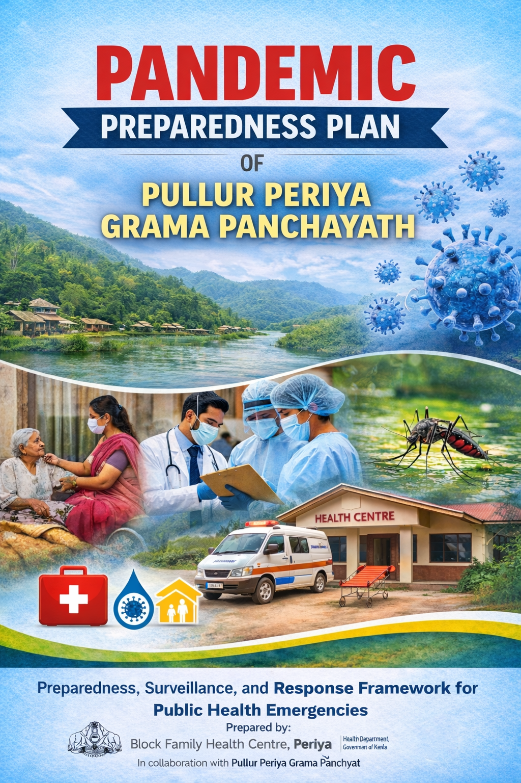

MESSAGE FROM PRESIDENT/CHAIR LSGI

Dear Residents of Pullur Periya,
I am pleased to present the Pandemic Preparedness and Response Plan for Pullur Periya Grama Panchayat, prepared by Family Health Centre Pullur Periya.
Considering our geographic setting, population density, and the occurrence of communicable diseases such as Dengue, Leptospirosis, and Viral Hepatitis A (VHA), it is essential that we remain vigilant and well-prepared. This plan provides a structured framework for early detection, timely response, disease prevention, and protection of vulnerable populations, including the elderly and individuals at high risk.
While the Family Health Centre has developed this technical framework, its successful implementation depends on the active participation and cooperation of the Panchayat, institutions, community organisations, and the public. I urge all residents to strictly follow public health guidelines, maintain environmental sanitation, ensure safe drinking water, eliminate mosquito breeding sources, and promptly report symptoms to health authorities.
Let us work together with unity, responsibility, and commitment to build a safe, resilient, and “Health-First” Pullur Periya.
Warm regards,
Sabitha C.K
President
Pullur Periya Grama Panchayat

MESSAGE FROM HEALTH STANDING COMMITTEE CHAIR
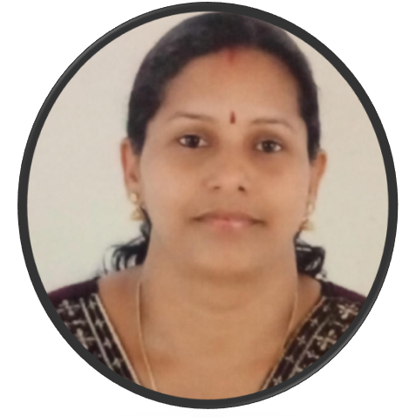
As Chairman of the Health Standing Committee, I am committed to strengthening public health at the grassroots level. Pullur Periya, with its coastal and low-lying areas and dense population, is vulnerable to diseases such as Dengue, Leptospirosis, Acute Diarrhoeal Diseases (ADD), and Viral Hepatitis A (VHA), especially during the monsoon.
With the support of ASHA workers, Anganwadi staff, and community volunteers, and Public Health work force we have a strong Field Health network. This Pandemic Preparedness and Response Plan aims to improve early detection, timely response, and care for vulnerable groups, including the elderly and bedridden.
I request all residents to follow preventive measures, maintain sanitation, and report symptoms without delay.
Let us work together to build a safe, healthy, and resilient Pullur Periya.
With regards,

Chairperson
Mrs.Jayasree
Health Standing Committee
Pullur Periya Grama Panchayat

MESSAGE BY MEDICAL OFFICER
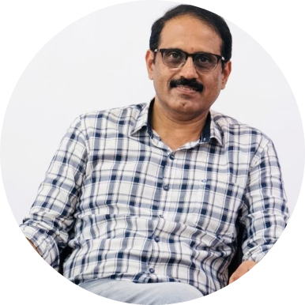
To the Stakeholders and Citizens,
As the Medical Officer of Block Family Health Centre Periya, I am committed to ensuring a strong framework for community health and safety.
Given our coastal and densely populated setting, the area remains vulnerable to diseases such as Dengue, Leptospirosis, and Acute Diarrhoeal Diseases (ADD). This plan focuses on early surveillance and timely detection to control outbreaks at the field level through our frontline health workers and volunteers.
Our approach includes early detection, protocol-based treatment, and equitable access to care, with special attention to vulnerable groups such as the elderly, bedridden patients, and those with chronic illnesses.All healthcare providers are advised to strictly follow government guidelines and ensure timely reporting.
Let us remain vigilant and work together to safeguard public health.
Stay Vigilant. Stay Prepared.

Dr.Ramesh D.G
Medical Officer
Block Family Health Centre Periya
EXECUTIVE SUMMARY

Block Family Health Centre (BFHC), Periya functions as the primary public healthcare institution serving the population of Pullur Periya Grama Panchayath. The FHC plays a pivotal role in delivering comprehensive, accessible, and affordable healthcare services, with a strong focus on preventive, promotive, curative, and rehabilitative care in accordance with national and state health programmes.
The BFHC Periya caters to a predominantly rural population, addressing key public health priorities such as maternal and child health, communicable and non-communicable disease control, immunization, family welfare, adolescent health, and geriatric care. Regular outpatient services, home-based care through field health staff, and outreach activities ensure healthcare coverage even in geographically challenging areas. The institution actively implements national health missions, including the National Health Mission (NHM), National Tuberculosis Elimination Programme, National Programme for Prevention and Control of Cancer, Diabetes, Cardiovascular Diseases and Stroke (NPCDCS), and other disease surveillance initiatives.
Block FHC Periya works in close coordination with the Grama Panchayath, ASHA workers, Anganwadi centres, schools, and community-based organizations to strengthen community participation and improve health awareness. Emphasis is placed on early detection, timely referral, health education, and lifestyle modification to reduce disease burden and improve overall health outcomes.
Despite constraints related to infrastructure, manpower, and increasing service demand, the BFHC continues to enhance service delivery through effective planning, data-driven decision-making, and community engagement. Strengthening facilities, upgrading digital health systems, and expanding preventive services remain key focus areas for future development.
Overall, Block Family Health Centre stands as a vital institution in safeguarding public health and improving the quality of life of the residents of Pullur Periya Grama Panchayath.

LIST OF ABBREVIATIONS

LSGD/LSGI | Local Self Government Department / Local Self Government Institution
BMO | Block Medical Officer
IDSP | Integrated Disease Surveillance Programme
NDMA | National Disaster Management Authority
PPE | Personal Protective Equipment
ICMR | Indian Council of Medical Research
CD | Communicable Diseases
NCD | Non-Communicable Diseases

TABLE OF CONTENTS

INTRODUCTION 9
Background of the PPP 9
LSGD AT A GLANCE 10
INTEGRATED HEALTH INFRASTRUCTURE MAP OF PULLUR PERIYA PANCHAYAT 16
GENERAL PROFILE OF THE LSGI’S 17
Background of the LSGI 17
Demographic and Vulnerable Population 18
Clinical Vulnerability 19
INFRASTRUCTURE & RESOURCE INVENTORY 20
Health Facility Directory & Basic Capacity in the LSGD 20
Private Clinics 22
Healthcare Education & Training Institutions 22
Specialized Services & Emergency Inventory 23
Oxygen & Diagnostic Capacity 24
Diagnostics facility mapping at the LSGI level 24
Laboratory Identification & Basic Details 25
Social and Community Infrastructure for surge plan 25
Human resources 27
Community & Support Cadre 29
Community Organizations 29
Administrative & Emergency Services 30
Information regarding resources 30
ONE HEALTH & ENVIRONMENTAL SURVEILLANCE 31
Animal & Bird Population 32
Veterinary Infrastructure 32
Veterinary Doctors & Workforce 33
High-Risk Interface Points (Surveillance Sites) 33
Environmental Risk Mapping 34
EPIDEMIOLOGICAL TRENDS (2021–2025) 36
Disease Burden among human beings(Last 5 Years) 36
Seasonal Trend Analysis 38
Outcome-Based Trend Analysis- 2025 43
Transmission Trend- 2025 43
Integrated Disease Hotspot Map (2021–2025) 47
Constitution of One Health Committee 49
Pandemic Response Workforce 50
Activities and Measures before and during Pandemic 51
PHASE 1 - Alert / Preparation 51
PHASE 2 - Active Response 54
Standard Screening Protocol 55
PHASE 3 - Surge Capacity 64
Conversion of Community Facilities 65
Recovery and rehabilitation phase 67
CONCLUSION 67
RECOMMENDATIONS 68
Scenario 1: Early Outbreak Detection (Fever Cluster Alert) 69
Scenario 2: Water-Related Disease Outbreak (Post-Monsoon Illness Surge) 69
Scenario 3: Zoonotic Spillover Risk (Animal Death / Unusual Illness) 70
ANNEXURE 71
1. IMPORTANT PHONE NUMBERS 71

INTRODUCTION

Background of the PPP
Pandemics pose significant threats to public health, livelihoods, and local governance, particularly in areas with diverse demographic and environmental vulnerabilities. The experience of recent public health emergencies, including COVID-19, highlighted critical gaps in early detection, preparedness, and continuity of essential services at the grassroots level.
Pullur-Periya Panchayat, located within a region characterized by a mix of rural, semi-urban, and coastal settings, faces unique challenges due to population density, mobility, and socio-economic diversity. The Panchayat experiences regular movement of people including migrant workers, traders, students, and daily commuters, increasing the risk of rapid disease transmission and complicating surveillance and containment measures.
The area is also prone to seasonal flooding and environmental hazards, which can disrupt basic services, affect water quality, and elevate the risk of communicable diseases. These conditions place additional strain on primary healthcare systems and emergency response mechanisms. Furthermore, dependence on nearby secondary and tertiary healthcare facilities, particularly in Kasaragod district, can lead to overcrowding and delayed access to care during large-scale health emergencies.
In this context, Local Self-Government Institutions play a critical role in strengthening community-level preparedness through effective surveillance, risk communication, and coordinated response strategies. Developing a localized Pandemic Preparedness Plan (PPP) for Pullur-Periya Panchayat is essential to enhance resilience, ensure continuity of essential services, and protect vulnerable populations through a comprehensive, context-specific, and disaster-resilient approach.

LSGD AT A GLANCE
Geographical boundaries with political map ( based on latest delimitation)

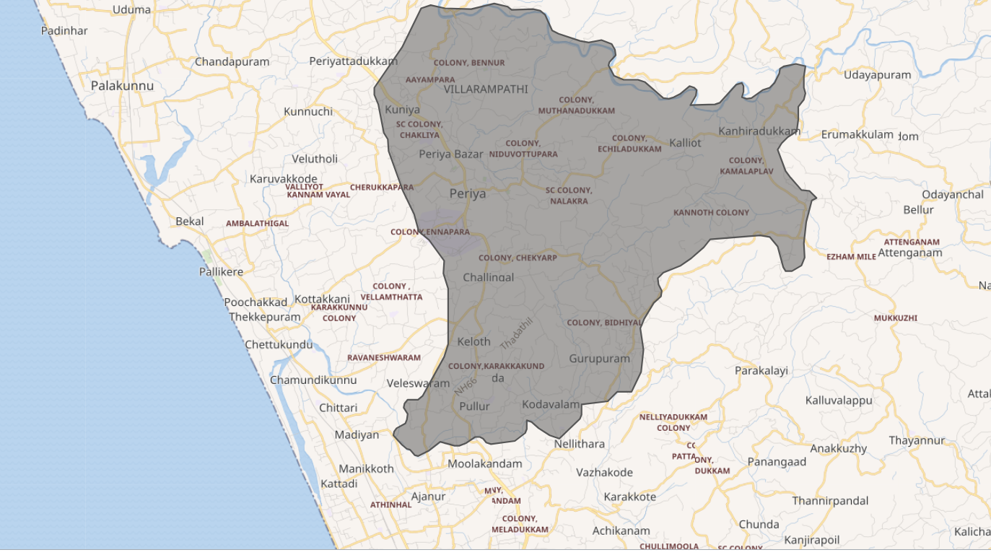

Baseline data
- Block Panchayath : Kanhangad
- Taluk : Hosdurg
- District : Kasaragod
- Grama Panchayaths : Pullur–Periya
- Municipality : Kanhangad Municipality
- Total Population : 37,011
- Total Households : 51,33
- Health Institutions : Govt Hospital 1, Sub centres -6, AYUSH - 3, Private Clinic-2
Ward division -

Ward No. | Houses | Population | Migrants | Wells | Hot  spots | Ed. Institutions | Hosp pvt/govt.
19 | 9395 | 37,011 | 275 | 4739 | 2 | 24 | 0

Risk stratification among wards in the context of Communicable diseases and hazards

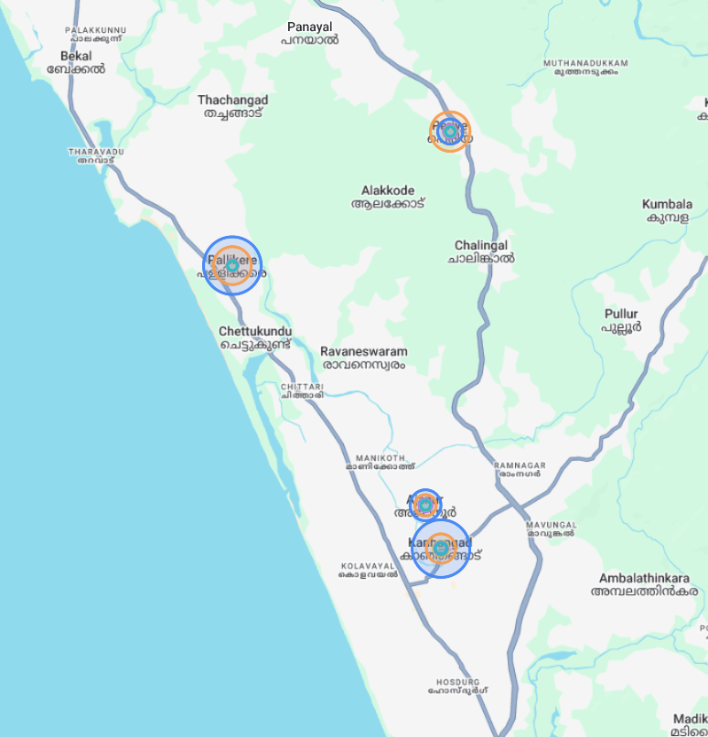.

Major Roads
- National Highway 66 (NH 66): Primary north–south arterial road connecting Kasaragod, Kanhangad, Nileshwaram, and Kannur
- Kanhangad–Panathur Road: Key route linking the coastal region with eastern hilly areas and Karnataka
- Mavungal–Kanhangad Road: Connects Mavungal commercial hub to Kanhangad town
Major District Roads (MDRs): Network connecting coastal, midland, and interior areas of the block

Major Rivers
- Tejaswini River
  - Flows to the southern side of the Panchayat region
  - One of the major west-flowing rivers in Kasaragod district
  - Known locally as Kariangode River
Key importance:
- Supports agriculture and water resources
- Plays a role in seasonal flooding and waterlogging
- Important for maintaining ecological balance

- Chandragiri River
  - The most prominent river in the region
  - Forms part of the northern boundary of Pullur–Periya Panchayat
  - Originates in the Western Ghats and flows westward into the Arabian Sea near Kasaragod
Key importance:
- Major source for drainage and irrigation
- Supports local ecosystems and livelihoods
- Influences flooding during monsoon seasons

Major establishments with geospatial mapping

Educational Institutions
- Central University of Kerala
- Jawahar Navodaya Vidyalaya
- Government Polytechnic College
- Kuniya Group of Institution

Major establishments with geospatial mapping

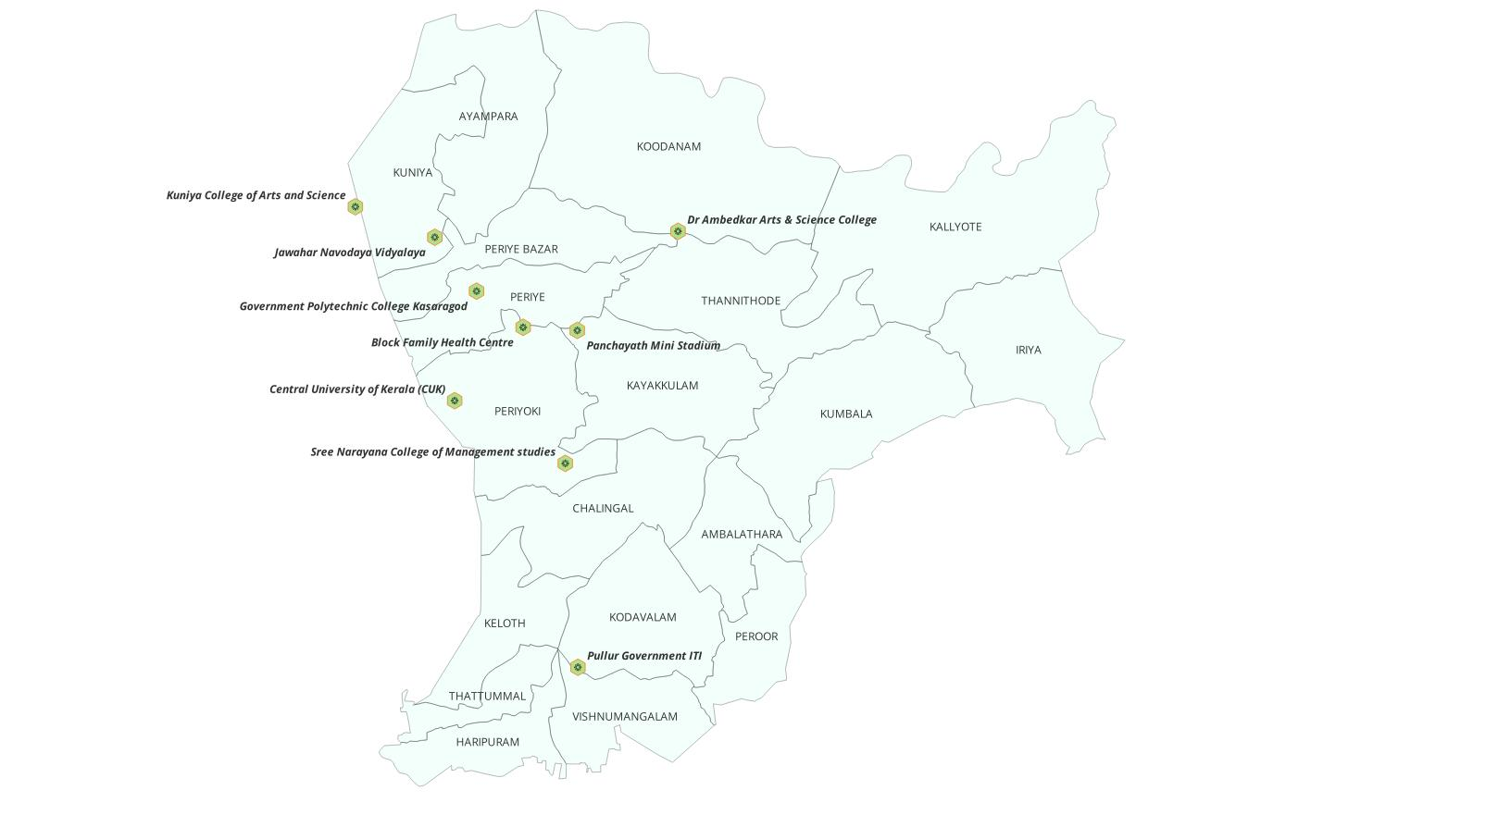

Maps - ward-based (Mention source also)

- Geographical boundaries - ward boundaries map
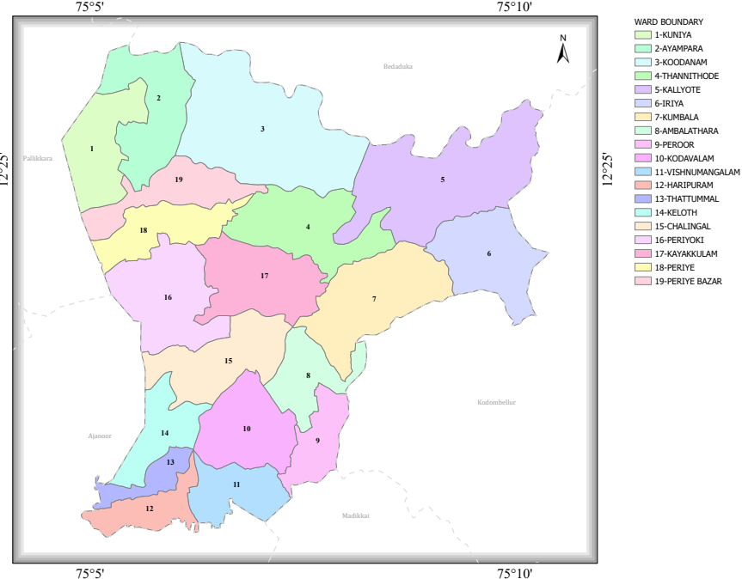

Roads and rivers map

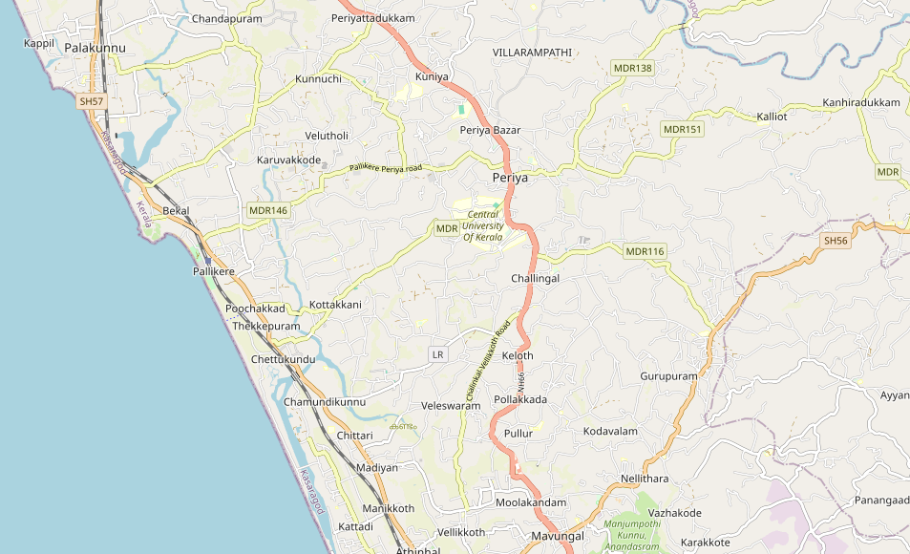

INTEGRATED HEALTH INFRASTRUCTURE MAP OF PULLUR PERIYA PANCHAYAT

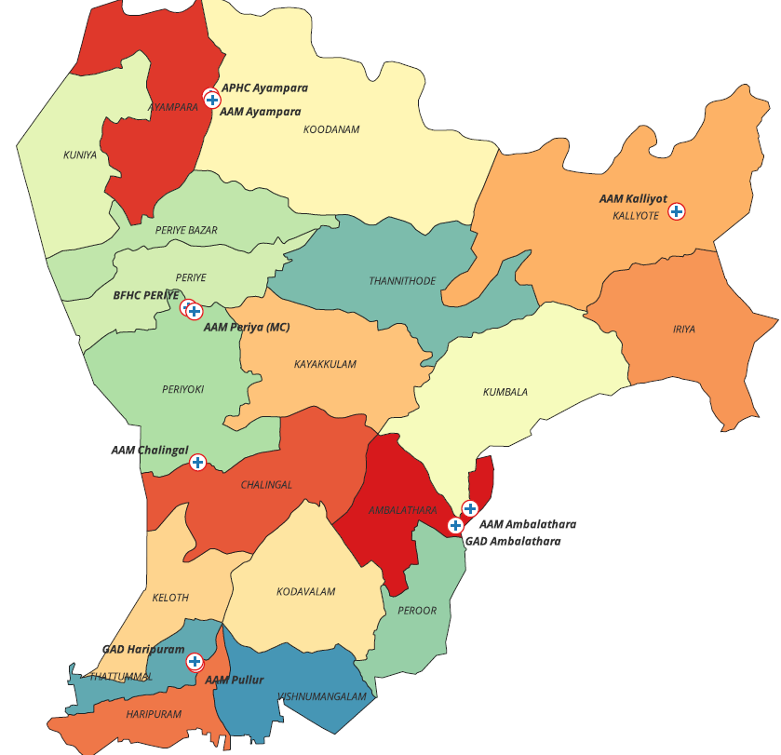

GENERAL PROFILE OF THE LSGI’S

Background of the LSGI
Pullur Periya Grama Panchayat, located in Kasaragod district near Kanhangad, is a geographically and environmentally sensitive region vulnerable to floods, waterlogging, soil erosion, strong winds, and seasonal water scarcity due to heavy monsoon rainfall and changing climate conditions. The presence of low-lying areas, laterite slopes, wetlands, and river systems increases disaster risk within the panchayat.
The Panchayat plays a key role in local disaster management by coordinating with the Kerala State Disaster Management Authority, district administration, health departments, and community volunteer groups for preparedness, emergency response, relief activities, and rehabilitation.
Critical infrastructure such as NH-66, rural roads, bridges, public institutions, water supply systems, and power networks are essential during emergencies. Sustainable environmental management, climate-resilient infrastructure, effective drainage systems, and community participation are important for strengthening disaster resilience and reducing future risks in the region.

Table 1: Background of LSGD
Description | Details
Name of LSGI | Pullur Periya
Type (GP/Municipality / Corporation etc.) | Grama Panchayath
Block | Kanhangad
District | Kasaragod
Number of wards | 19
Total area (sq. km) | 63.25
Population(Projected) | 37011
Population density | 585.15persons/sq km
Terrain (coastal/low-lying/backwaters/foothills, etc.) | 2
Number of rivers passing through LSGI | 0
Number of water bodies in the LSGI | 21
Number of educational institutions | 27
Factories / small-scale industries | 4
Flood-prone wards | 0
Landslide-prone wards | 0
Death Management and Disposal Facilities (mortuaries/crematorium, including electric) | 1
Auditoriums/Marriage halls/convention centres/community halls | 6

Demographic and Vulnerable Population
Understanding the demographic composition and vulnerable population groups is essential for pandemic preparedness. Children, elderly, economically deprived families, migrant workers, and socially vulnerable groups are at increased risk during public health emergencies due to higher exposure, limited access to services, and dependency on public systems..

Description |  | Details (in numbers)
DEMOGRAPHIC PROFILE
Total population |  | 37011
Male |  | 18112
Female |  | 18899
Transgender |  | 0
Children under 5 |  | 1687
Adolescent |  | 3639
Elderly (>60) |  | 6085
SOCIAL/LIVELIHOOD VULNERABILITY
Previous EPEP family |  | 19
Tribal communities |  | 786
Migration | Immigrant | 275
SC Community |  | 95
ST Community |  | 786

Clinical Vulnerability
Certain population groups need priority healthcare & are at higher risk of severe illness, complications, and mortality during pandemics. Patients with chronic diseases, those requiring regular medical care, and individuals with mobility or functional limitations face challenges in accessing timely care during emergencies. Mapping these groups helps in prioritizing continuity of treatment, medicine stock planning, oxygen support, referral transport, and targeted home-based care.
Description | Details in numbers
Pregnant women | 307
Lactating mothers | 281
Bedbound patients | 235
Patients on Haemodialysis | 34
Cancer patients (currently on treatment) | 198
Haemophilic patients | 0
Mentally challenged | 74
Diabetic patients | 2748
Hypertensive patients | 520
TB patients | 11(24&25)

Major Festivals & Events specific to the LSGI
(with the possibility of a public gathering)

Sl. No. | Name of festival | Month detailing the periodicity
1 | Wayanattukulavan Daivam Kettu- Pullur | Jan-Feb-(three to five year interval )

INFRASTRUCTURE & RESOURCE INVENTORY

Health Facility Directory & Basic Capacity in the LSGD
This section provides an overview of the healthcare infrastructure available within the LSGD area. It outlines the distribution and basic capacity of health facilities that form the backbone of service delivery during routine times and public health emergencies.

Block Family Health Centre (BFHC) serves as the primary healthcare institution for the community, providing essential outpatient, inpatient, preventive, and public health services. During outbreaks and public health emergencies, BFHC Periya functions as the first-line response centre for disease surveillance, case management, risk communication, and coordination of field-level interventions.
For advanced diagnostics, specialist consultations, intensive care, and critical emergency services, patients are referred to neighbouring district hospitals and higher referral institutions as required. Assessing the available healthcare infrastructure helps identify existing strengths, service gaps, referral mechanisms, and potential surge capacity that can be mobilised during pandemics, outbreaks, or other disasters. This information supports effective emergency preparedness, timely healthcare delivery, and coordinated response activities within the Panchayat area.

Table 5. Health Facility Resource Summary
Sl.no. | Health Facility | Type of Facility (MCH/GH/CHC/FHC/SC etc.) | Contact Number | Total beds | ICU Beds | Oxygen-Supported Beds | No. of Ventilator Support Beds | No. of ambulances
Government Healthcare Facilities
1 | Block Family Health Centre Periya | BFHC | 8547875617 | 24 | 0 | 0 | 0 | 1
2 | AAM Kalliyot | SC |  | 0 | 0 | 0 | 0 | 0
3 | AAM Ayampara | SC |  | 0 | 0 | 0 | 0 | 0
4 | AAM Chalingal | SC |  | 0 | 0 | 0 | 0 | 0
5 | AAM Pullur | SC |  | 0 | 0 | 0 | 0 | 0
6 | AAM Ambalathara | SC |  | 0 | 0 | 0 | 0 | 0
7 | AAM Periya (MC) | SC |  | 0 | 0 | 0 | 0 | 0
AYUSH Healthcare Facilities
1 | GAD Haripuram | AYUSH | 9495369747 | 0 | 0 | 0 | 0 | 0
2 | GAD Ambalathukara | AYUSH | 9495369747 | 0 | 0 | 0 | 0 | 0
3 | APHC Ayampara-Homoeo | AYUSH | 9495369747 | 0 | 0 | 0 | 0 | 0

Private Clinics
Private clinics are an essential part of pandemic preparedness, as they are often the first place people seek care when symptoms begin. In many communities, private clinics manage a significant share of outpatient visits and therefore play a critical role in early case detection, timely referrals, and disease surveillance. Having an up-to-date understanding of where these clinics are located, the services they provide, and how they are linked to the public health system helps ensure that no cases are missed during an outbreak. It also allows health authorities to engage private practitioners more effectively for reporting, risk communication, and coordinated response, strengthening the overall capacity of the health system to manage public health emergencies.

Table 6. Private Clinic Resource Summary
Sl No. | Name of Clinic | Clinic (General / Speciality) | Address | Diagnostic Facility (Y/N) | Ambulance Linkage (Y/N)
1 | Dr. Bipin Kumar | Pediatrician | Periya | N | N
2 | Dr. Sreekumar | General | Periya | N | N

Healthcare Education & Training Institutions
This section tracks the educational infrastructure available, which is vital for human resource planning in the health sector.

Category of Institution | Govt | Private | AYUSH | Total
Medical Colleges | Nil | Nil | Nil | Nil
Nursing Colleges | 1 | 1 | 0 | 2
Dental Colleges | 0 | 0 | 0 | 0
Para-medical / Allied Health | 0 | 0 | 0 | 0
Pharmacy Colleges | 0 | 0 | 0 | 0

Specialized Services & Emergency Inventory
This section provides a detailed view of the specialized medical resources available to the community, focusing on emergency response and critical care capabilities. This table tracks the vital assets required for managing severe illnesses and emergencies across Government, Private, and AYUSH sectors.

Item | Govt | Private | AYUSH | Total
Hospital beds | 24 | 0 | 0 | 24
Oxygen-generating systems(Y/N) | 0 | 0 | 0 | 0
Oxygen-supported beds(Numbers) | 0 | 0 | 0 | 0
Ventilator-supported beds | 0 | 0 | 0 | 0
ICU beds | 0 | 0 | 0 | 0
Burns units | 0 | 0 | 0 | 0
Blood centres | 0 | 0 | 0 | 0
BLS ambulances | 0 | 0 | 0 | 0
ALS ambulances | 0 | 0 | 0 | 0
Dialysis facilities | 1 | 0 | 0 | 0
Dispensaries | 0 | 0 | 0 | 0
Medical store | 0 | 0 | 0 | 0
Industrial establishments(Medium-scale industries/small-scale industries establishments to whom we can depend in a worst-case scenario) | 0 | 0 | 0 | 0

Oxygen & Diagnostic Capacity
Monitoring oxygen and diagnostic capacity is a critical component of public health preparedness, ensuring that the LSGD can handle both chronic care and sudden surges in respiratory or infectious diseases.
Name of Health Facility | Oxygen-generating System (Y/N) | Backup Oxygen Source (Y/N) | Diagnostic Facilities Available(Y/N)
Name of Health Facility | Oxygen-generating System (Y/N) | Backup Oxygen Source (Y/N) | Lab | USG | X-ray | CT/MRI | RT-PCR
Government Healthcare Facilities
BFHC Periya | N | N | Y | N | Y | N | N
Private Health care
Medicare Laboratory | N | N | Y | N | N | N | N
NeethiLab | N | N | Y | N | N | N | N

Diagnostics facility mapping at the LSGI level
The diagnostic capacity of Pullur Periya Grama Panchayat remains limited, with only a few laboratory facilities available within the local healthcare system. Basic diagnostic services are accessible at the peripheral level, while advanced laboratory investigations and confirmatory testing depend largely on referral laboratories and higher healthcare institutions outside the Panchayat. Strengthening laboratory networking, sample transport mechanisms, and timely reporting systems

Item | Govt | Private | AYUSH | Total
General labs | 1 | 3 | 0 | 4
Microbiology labs | 0 | 0 | 0 | 0
RT-PCR labs | 0 | 0 | 0 | 0
USG units | 0 | 0 | 0 | 0
CT/MRI units | 0 | 0 | 0 | 0
Research labs | 0 | 0 | 0 | 0
Labs of other departments that can be repurposed | 1- Central University Lab | 0 | 0 | 1

Laboratory Identification & Basic Details
Sl. No. | Name of Laboratory | Ownership (Govt / Private / Academic) | Address | Contact No. | 24×7 Services (Yes/No) | NABL / Govt Approved (Yes/No)
1 | BFHC Periye | Govt | Periya | 04672234141 | No | Pvt
2 | Neethi Lab | Private | Periya | 6238544522 | No | Pvt
3 | Medicare Lab | Private | Periya |  | No | Pvt

Social and Community Infrastructure for surge plan
This table serves as our logistics and shelter inventory. By mapping these locations, quickly we can identify where to house displaced citizens, where to set up temporary medical clinics, and how to manage the deceased with dignity during a crisis.

Category | Total Count | Ward | Est. Capacity (Persons) | Contact details
Educational Institutions
Anganwadis | 31 | 1-19 | 300 | 8547251170
Schools | 19 |  | 500 | HM-GHSS Periya 7942695368
Colleges | 2 | 18,19 | 400 | Polytechnic College-04672 234020
Healthcare Educational Institutions
Medical colleges (Govt/Private) | 0 | 0 | 0 | 0
Nursing colleges (Govt/Private) | 2 | Ayampara, Haripuram | 400 | 04672080725 ,9447286597
Dental colleges (Govt/Private) | 0 | 0 | 0 | 0
Paramedical institutes (Govt/Private) | 0 | 0 | 0 | 0
Community Gathering Spaces
Community halls | 7- Tribal development Dept;1 -LSGD | 16,17,19,2,4,5,7,10,14 | 100 | Panchayth community hall Periya  Tribal Promoter-Jeena-8301958137
Auditoriums | 4 | 6.16,18,19. | 800 | 9895669767-Surabhi Auditorium;9447240085 -Sumangali Auditorium
Religious buildings | 14 | Periya,PeriyaBazarKuniya,Periyoki | 200
Vulnerable Group Support Facility
Destitute homes | 0
Elderly homes | 1
LSGD owned other buildings | 1 | Periya Bazar
Mass Fatality Management (MFM) Infrastructure
Mortuary | 0
Crematorium | 1

HUMAN RESOURCES
This section focuses on the human capital available within the LSGI. In any emergency—be it a pandemic, flood, or industrial accident—infrastructure is only as effective as the people operating it.

Medical & Clinical Personnel
This table tracks the “frontline” healthcare providers responsible for diagnosis, treatment, surveillance, and clinical management during public health emergencies.

Cadre | Govt (No.) | Private (No.) | Total
Doctors—Modern Medicine | 8 | 23 | 31
Doctors – AYUSH | 3 | 12 | 15
Doctors – Veterinary | 1 | 2 | 3
Doctors – Dental | 1 | 8 | 9
Nursing officers | 8 | 20 | 28
Lab technicians | 4 | 4 | 8
Optometrist | 1 | 7 | 8
Pharmacists | 5 | 9 | 14
Psychologists | 0 | 2 | 2
Counsellors | 1 | 5 | 6

Public Health & Field-Level Workforce
These individuals are the backbone of surveillance, maternal-child health, and decentralized care.

Cadre | Health services | Municipal common services | Total
HS (Health Supervisors) | 1 | 0 | 1
HI (Health Inspectors) | 1 | 0 | 1
LHS (Lady Health Supervisor) | 1 | 0 | 1
LHI (Lady Health Inspectors) | 1 | 0 | 1
JPHN (Jr Public Health Nurses) | 6 | 00 | 6
JHI (Jr Health Inspectors) | 6 | 0 | 6
MLSP (Mid-Level Service Providers) | 6 | 00 | 6
Palliative Nurses | 2 | 0 | 2
RBSK Nurses | 1 | 0 | 2
PRO | 1 | 0 | 1
Epidemiologist | 1 | 0 | 1
Data Manager | 1 | 0 | 1

Community & Support Cadre
This group represents the surge capacity of the LSGI—people who can be called upon for logistics, rescue, and specialized support.

Cadre | Number
ASHA Workers | 18
AWW (Anganwadi Workers) | 31
Kudumbashree | 388
MNREGS | 19

Community Organizations
This section details the presence of community-based organisations (CBOs), non-governmental organisations (NGOs), faith-based organisations (FBOs), Kudumbashree Self-Help Groups (SHGs), and Ayalkootams within the Local Self-Government Institution (LSGI). These groups enhance grassroots mobilization, resource distribution, and support networks crucial for pandemic response and community resilience.

Category | Total Count
NGOs | 1(Thanal)
Religious based organizations | 3
Foreign based organizations | 0
Sports Club/youth clubs | 72
Kudumbashree SHGs | 50
Ayalkootams | 389
Political organizations | 5
Residential organizations | 5

Administrative & Emergency Services
This section outlines the availability of key non-health emergency support services and infrastructure within the LSGI, which are essential for effective pandemic preparedness and response. These facilities support law enforcement, disaster response, water supply, logistics, mobility, and community-level interventions during public health emergencies.

Category | Total Count | Contact details
Police Stations | 1
Fire & Rescue Stations | 0 | Area Served F&R of Hosdurg
Public Distribution System (PDS) | 2 | Supplyco Civil supplies - Periyttadukkam-0467 2234424

Information regarding resources
The availability of essential transport and support resources plays a quiet but critical role in saving lives. Equipment such as ambulances, mobile mortuaries to ensure the mobilisation that patients, samples, and healthcare teams can move swiftly—even in flooded, remote, or difficult terrains. Heavy vehicles like JCBs, cranes, tractors, and torus lorries support logistics, waste management, emergency infrastructure, and rapid conversion of spaces into care or isolation facilities. Taxis, four-wheel-drive vehicles, and trucks help maintain continuity of essential services, reach vulnerable populations, and support home-based care and supply delivery.

Means of transportation | Total Count
JCB | 5
Crane | 0
Heavy Trucks | 0
Tractor | 2
Ambulances | 1
Mobile mortuaries | 0

ONE HEALTH & ENVIRONMENTAL SURVEILLANCE
The One Health method integrates environmental, animal, and human health to enable proactive pandemic preparedness. Panchayat-level surveillance needs to be strengthened to support the early detection and control of zoonotic and environmentally generated diseases. Surveillance is enhanced through systematic assessment of animal populations, veterinary infrastructure, poultry and slaughter facilities, inter-sectoral coordination, and seasonal disease trend assessment based on previous outbreaks to support predictive alerts and ward-specific sampling for effective pandemic preparedness in high-risk areas.

Animal & Bird Population
Mapping animal and bird populations at the Panchayat level is essential for identifying and prioritising zoonotic disease hazards like rabies, leptospirosis, anthrax, and Nipah-like spillover occurrences. Comprehensive population assessment supports risk classification, targeted surveillance, vaccination planning, and early outbreak detection, thereby strengthening One Health-based pandemic preparedness.

Category | Item | Estimated Population | Wards
Animal Population | Livestock (Cattle/Goats/Buffalo) | 1732/890/60 | 1-19
Animal Population | Pet Animals (Dogs/Cats) | 960/60 | 1-19
Animal Population | Stray Dog Population | 380 | 1-19
Animal Population | Pig Farms (Number of heads) | 300 | 19
Bird Population | Poultry Units (Birds)
Bird Population | Poultry- (FOWL) | 15600 | 19
Bird Population | Wild/Migratory Birds (Observed) | Nil
Bird Population | Crow Mortality Events (Reported) | Not yet noticed

Veterinary Infrastructure
Veterinary institutions are a core pillar of One Health surveillance, enabling early zoonotic disease detection through vaccination, investigation of unusual animal illness or deaths, sample collection, and timely outbreak reporting. A well-mapped and responsive veterinary network strengthens coordination with human health and LSGI systems, ensuring rapid response during zoonotic events and pandemics.
Facility Type | Name of Facility | Ownership Govt / Pvt | Location (Ward No) | Contact number
Veterinary Dispensary | 1 | Govt. | 18 | 9497303255

Veterinary Doctors & Workforce
Early detection, diagnosis, reporting, and reaction to animal illness epidemics depend on the availability and accessibility of qualified veterinary specialists. By identifying unusual animal morbidity or mortality promptly, collecting samples promptly, and coordinating efficiently with human health and LSGI systems—especially during zoonotic outbreaks and pandemic-prone situations—a clearly defined veterinary workforce enhances One Health surveillance.

Category | Number Available | Type (Govt/Pvt) | Contact number
Government Veterinary Doctors | 1 | Govt. | Dr. Vikram Krishnan 9497303255
Livestock Inspectors | 4 | Govt. | Sumiya.H-7736960895
Para-veterinary Staff / Attenders | 1 | Govt | Padmavathi.B-8593992750
Contract / On-call Veterinary Support (if any) | 2 | Govt. | Sarath kumar-9656950709

High-Risk Interface Points (Surveillance Sites)
High-risk interface points for zoonotic disease surveillance in Pullur Periye Grama Panchayath include cattle sheds near water bodies, fish markets, and Coastal Areas.

Type of Habitat | Type of High risk interface | Geographical vulnerability
Wetlands & Backwaters,Backyard Poultry Farms | Nil | No
Cattle Sheds near Water Bodies | Nil
Fish & Meat Markets | Nil
Community Slaughter Sites | Nil
Migratory Bird Congregation Areas | Nil
Rodent-Infested Grain Storage | Nil

Environmental Risk Mapping
Environmental risk assessment identifies monsoon and waterlogging-prone areas associated with vector-borne diseases such as dengue and chikungunya, water-borne diseases such as leptospirosis and diarrhoea, and other zoonotic disease risks. Systematic surveillance supports early warning, targeted interventions, and Panchayat-level pandemic preparedness.
Water-borne exposure: Stagnant water bodies facilitate leptospira survival, increasing the risk of leptospirosis.

Risk Factor | High-Risk Wards | Key Locations | Risk Level (High/Med/Low)
Flood-prone areas | 10 | Vishnumangalam | low

Disease seasonality assessment indicates that flooding and waterlogging can increase the risk of leptospirosis, malaria, and diarrhoeal diseases. Seasonal mosquito breeding cycles contribute to higher transmission of vector-borne diseases during the monsoon period. In addition, agricultural activities in paddy field areas may increase close human–animal contact, thereby elevating the risk of zoonotic disease transmission.

Disease | Peak Risk Season | Key Drivers | High-Risk Locations | Surveillance Focus
Leptospirosis | June to October (Monsoon) | Flooding,contaminated water, rodent density. | Pullur, Chalinkal | Doxy-prophylaxis, rodent control, and jaundice/fever surveys.
Dengue/Chikungunya | May to November (Monsoon/Post-Monsoon) | Stagnant water,coconut shells, high larval breeding sites. | PullurKoodanam,Thannithoide Iriya | Dry Day (Source reduction), larval surveys, and joint pain reporting.
Acute Diarrheal Diseases | March–April (Summer) & June–July (Monsoon) | Contaminated water, roadside eateries, pipe leakages. | No Specific Area | Water quality testing (Super-chlorination), ORS & Zinc stock management
Rabies | Nil | Nil | Nil | Nil
Anthrax (rare) | Nil | Nil | Nil | Nil

EPIDEMIOLOGICAL TRENDS (2021–2025)

Disease surveillance is the systematic collection, analysis, and interpretation of health data for the planning, implementation, and evaluation of public health practice. This section presents the disease surveillance profile of the Local Self Government Institution (LSGI) based on routine reporting systems and outbreak investigations, highlighting priority diseases, seasonal trends, and emerging public health threats relevant to pandemic preparedness.

Disease Burden among human beings(Last 5 Years)
Analysis of disease-wise data for the last five years helps identify persistent public health problems, emerging diseases, and changes in disease burden. This information supports prioritisation of prevention, preparedness, and response activities at the Panchayat level.

Disease | 2021 | 2022 | 2023 | 2024 | 2025 | Trend(Increasing/Stable/Decreasing)
Dengue | 0 | 23 | 18 | 63 | 34 | Decreasing
Leptospirosis | 0 | 1 | 4 | 0 | 2 | Decreasing
Hepatitis A | 0 | 0 | 4 | 0 | 17 | Increasing
Malaria | 0 | 0 | 0 | 0 | 0
Scrub Typhus | 0 | 0 | 0 | 0 | 0
Typhoid | 0 | 0 | 0 | 0 | 0
Hepatitis B | 0 | 0 | 0 | 0 | 0
Hepatitis C | 0 | 0 | 0 | 0 | 0
Tuberculosis | 0 | 0 | 0 | 0 | 0
Leprosy | 0 | 0 | 0 | 0 | 0

Seasonal Trend Analysis
Seasonal analysis helps anticipate surges (e.g. dengue in monsoon, leptospirosis after floods, influenza in cooler months) and plan pre‑emptive vector control, stockpiling of IV fluids, and awareness campaigns at Panchayat level.

DENGUE
Dengue is a major seasonal vector-borne disease strongly associated with rainfall, water stagnation, and increased mosquito breeding during the monsoon period.

Peak: July–November

Dengue – Ward-wise Yearly Distribution (2021–2025)

Ward | Dengue – Ward-wise Yearly Distribution
Ward | 2021 | 2022 | 2023 | 2024 | 2025 | Total
1 | 0 | 0 | 1 | 1 | 0 | 2
2 | 0 | 1 | 0 | 3 | 6 | 10
3 | 0 | 2 | 1 | 1 | 17 | 21
4 | 0 | 2 | 2 | 23 | 0 | 27
5 | 0 | 3 | 1 | 7 | 2 | 13
6 | 0 | 2 | 1 | 8 | 0 | 11
7 | 0 | 0 | 1 | 3 | 0 | 4
8 | 0 | 1 | 0 | 0 | 0 | 1
9 | 0 | 0 | 1 | 2 | 1 | 4
10 | 0 | 0 | 3 | 3 | 0 | 6
11 | 0 | 3 | 1 | 2 | 1 | 7
12 | 0 | 1 | 2 | 0 | 1 | 4
13 | 0 | 3 | 0 | 5 | 1 | 9
14 | 0 | 4 | 1 | 3 | 1 | 9
15 | 0 | 1 | 3 | 1 | 1 | 6
16 | 0 | 0 | 0 | 1 | 2 | 3
17 | 0 | 0 | 0 | 0 | 1 | 1
Total | 0 | 23 | 18 | 63 | 34 | 138

LEPTOSPIROSIS
Leptospirosis cases are closely linked to monsoon rains, flooding, and occupational exposure, particularly in low-lying and waterlogged areas.

Peak: June - August

Leptospirosis – Ward-wise Yearly Distribution (2021–2025)

Ward | Leptospirosis – Ward-wise Yearly Distribution
Ward | 2021 | 2022 | 2023 | 2024 | 2025 | Total
1 | 0 | 0 | 2 | 0 | 1 | 3
2 | 0 | 1 | 0 | 0 | 1 | 2
3 | 0 | 0 | 1 | 0 | 0 | 1
4 | 0 | 0 | 1 | 0 | 0 | 1
5 | 0 | 0 | 0 | 0 | 0 | 0
6 | 0 | 0 | 0 | 0 | 0 | 0
7 | 0 | 0 | 0 | 0 | 0 | 0
8 | 0 | 0 | 0 | 0 | 0 | 0
9 | 0 | 0 | 0 | 0 | 0 | 0
10 | 0 | 0 | 0 | 0 | 0 | 0
11 | 0 | 0 | 0 | 0 | 0 | 0
12 | 0 | 0 | 0 | 0 | 0 | 0
13 | 0 | 0 | 0 | 0 | 0 | 0
14 | 0 | 0 | 0 | 0 | 0 | 0
15 | 0 | 0 | 0 | 0 | 0 | 0
16 | 0 | 0 | 0 | 0 | 0 | 0
17 | 0 | 0 | 0 | 0 | 0 | 0

VIRAL HEPATITIS - A
Hepatitis A cases are commonly associated with unsafe drinking water, food contamination, and breakdowns in sanitation, often presenting as clusters or outbreaks.

Peak: October - December

Hepatitis A – Ward-wise Yearly Distribution (2021–2025)

Ward | Hep A – Ward-wise Yearly Distribution
Ward | 2021 | 2022 | 2023 | 2024 | 2025 | Total
1 | 0 | 0 | 0 | 0 | 2 | 2
2 | 0 | 0 | 1 | 0 | 0 | 1
3 | 0 | 0 | 1 | 0 | 2 | 3
4 | 0 | 0 | 0 | 0 | 0 | 0
5 | 0 | 0 | 0 | 0 | 3 | 3
6 | 0 | 0 | 0 | 0 | 1 | 1
7 | 0 | 0 | 0 | 0 | 0 | 0
8 | 0 | 0 | 0 | 0 | 0 | 0
9 | 0 | 0 | 2 | 0 | 1 | 3
10 | 0 | 0 | 0 | 0 | 0 | 0
11 | 0 | 0 | 0 | 0 | 4 | 4
12 | 0 | 0 | 0 | 0 | 1 | 1
13 | 0 | 0 | 0 | 0 | 1 | 1
14 | 0 | 0 | 0 | 0 | 2 | 2
15 | 0 | 0 | 0 | 0 | 0 | 0
16 | 0 | 0 | 0 | 0 | 0 | 0
17 | 0 | 0 | 0 | 0 | 0 | 0

Outcome-Based Trend Analysis- 2025

Transmission Trend- 2025
For effective management of public health issues, it is important to track the trend of disease transmission mode. It helps identify the population or place at high risk that can be used to predict outbreaks and implement targeted interventions as quickly as possible. Understanding these kinds of trends enables authorities to allocate resources efficiently and change the strategies adequately based on the trend that follows.

Mode of Transmission | No. of cases | No. of Deaths
Vector Borne Diseases | 34 | 0
Water Borne Diseases | 17 | 0
Air Borne Diseases | 21 | 0

Vector-Borne Disease

Disease | No. of Cases | No. of Deaths
Dengue | 34 | 0
Malaria | 0 | 0
Chikungunya | 0 | 0

Water Borne Disease

Disease | No. of Cases | No. of Deaths
Cholera | 0 | 0
Typhoid | 0 | 0
Hep- A | 17 | 0
Dysentery | 0 | 0
Amoebiasis | 0 | 0
E- Coli infections | 0 | 0

Air Borne Disease

Disease | No. of Cases | No. of Deaths
Influenza | 0 | 0
H1N1 | 0 | 0
TB | 0 | 0
Chickenpox | 0 | 0
Measles | 0 | 0
Covid-19 | 0 | 0
Pertussis | 0 | 0
Mumps | 21 | 0

Blood-Borne Disease

Disease | No. of Cases | No. of Deaths
AIDS | 0 | 0
Hep- B | 0 | 0
Hep- C | 0 | 0

Zoonotic Disease

Disease | No. of Cases | No. of Deaths
Rabies | 0 | 0
Leptospirosis | 0 | 0
Avian influenza | 0 | 0
West nile | 0 | 0
Anthrax | 0 | 0
Nipah | 0 | 0
Scrub Typhus | 0 | 0

Integrated Disease Hotspot Map (2021–2025)

Ward No | Dengue Total (2021-25) | Leptospirosis Total (2021-25) | Hepatitis A Total (2021-25) | Mumps (2021-25) | ADD (2021-25) | Total Cases
1 | 2 | 3 | 2 | 0 | 0 | 6
2 | 10 | 2 | 1 | 0 | 0 | 13
3 | 21 | 1 | 3 | 0 | 0 | 25
4 | 27 | 1 | 0 | 0 | 0 | 28
5 | 13 | 0 | 2 | 0 | 0 | 15
6 | 11 | 0 | 1 | 0 | 0 | 12
7 | 4 | 0 | 0 | 0 | 0 | 4
8 | 1 | 0 | 0 | 0 | 0 | 1
9 | 4 | 0 | 3 | 0 | 0 | 7
10 | 6 | 0 | 0 | 0 | 0 | 6
11 | 7 | 0 | 4 | 0 | 0 | 11
12 | 4 | 0 | 1 | 0 | 0 | 5
13 | 9 | 0 | 1 | 0 | 0 | 10
14 | 9 | 0 | 2 | 0 | 0 | 11
15 | 6 | 0 | 0 | 0 | 0 | 6
16 | 3 | 0 | 0 | 0 | 0 | 3
17 | 1 | 0 | 0 | 0 | 0 | 1
Preparedness and Response Protocol at LSG Level
This section describes the operational framework for the LSGI once a pandemic is declared. It explains how the LSGI and health system will move from routine data collection to active response, using a One Health approach.

Constitution of One Health Committee
The LSGD shall constitute a One Health Committee comprising the LSGI President, Medical Officers (Modern Medicine, AYUSH, and Veterinary), the Health Inspector, and the Veterinary Surgeon.

Objective: The One Health Committee coordinates human, animal, and environmental health to prevent and control pandemics.

Sl No | Name | Designation | Department/Institution | Role in Committee | Contact Number
1 | Mrs.Sujatha | Panchayat President | LSGD | Chairperson | 9744258108
2 | Dr Ramesh D G | Medical Officer (BFHC ) | Health Dept | Member Secretary | 8547875617
3 | Dr. Vikram | Veterinary Officer | Animal Husbandry | Member | 9497303255
4 | Dr Bhagyalakshmi C K | Epidemiologist | Health Dept | Member | 9947254749
5 | Mr.Ashokan | Health Inspector/PHN | Health Dept | Surveillance | 9846402027
6 | Mrs.Rudrani | ASHA Supervisor | Health Dept | Community link | 9495790518
7 | Mrs.Lekha | ICDS Supervisor | Social Welfare | Vulnerable groups | 8547251170
8 | SHO | Police Station Officer | Police Dept | Law & order | 0467 223 6050
9 | Mrs.Mini A V | Ward Councillor Representative | LSGD | Community coordination | 9744034028
10 | Mrs.Sunitha | Kudumbashree CDO | Kudumbashree | Community mobilisation | 7025996887
11 | Dr.Gopi | NGO/Volunteer rep | Civil Society | Support services

Key Responsibilities:
- Review disease surveillance data (human + animal)
- Conduct ward-wise risk assessment and vulnerability mapping
- Approve quarantine/isolation centre locations
- Coordinate with district for resources (PPE, oxygen, ambulances)
- Periodically review health system surge capacity, including beds, oxygen, human resources, and ambulances.
- Approve and monitor risk communication and community engagement strategies, including rumour management.
- Ensure protection and service continuity for vulnerable groups (elderly, persons with disabilities, dialysis patients, coastal populations).
- Conduct quarterly mock drills
- Monitor equity measures for vulnerable groups

Meeting Schedule:
Quarterly (normal times) | Weekly (outbreak alert) | Daily (pandemic phase)

Pandemic Response Workforce
To ensure a coordinated and timely response during a pandemic, a dedicated Pandemic Response Workforce shall be constituted at the LSG level. The workforce will function under the overall supervision of the One Health Committee and in close coordination with the health authorities. Team-based deployment will enable efficient surveillance, case management, quarantine and isolation management, logistics support, and risk communication. Each team shall have a clearly designated team leader, defined roles, and an identified pool of personnel to allow rapid activation, rotation of duties, and continuity of services during prolonged emergencies.

Team Name | Composition | Key Responsibilities | Team Leader
Surveillance and Contact Tracing Team | HI, JHI, JPHN, ASHAs and Volunteers | Case detection, contact listing, home visits, reporting | HI
Case Management Team | Doctors, Nurses, MLSP, Palliative Nurses | Patient care & referral | Doctor
Quarantine & Isolation Team | LSGD staff, Volunteers | Facility management | JHI
psychosocial support | DMHP Team, | Psychosocial support | DMHP Counsellor
Logistics & supply chain Team | LSGD staff, Storekeepers, Drivers 3 | Supplies & transport [PPE, medicines, oxygen, transport, waste management] | Ward Member
Communication Team | Ward members, Kudumbashree, Youth clubs,  AWW workers and other self help groups | IEC, community meetings, countering misinformation | M.O in charge
Transportation | KSRTC, educational institutional buses | Mobilisation to Shelter homes | JHI-
Media Surveillance | Rumour tracking |  | JHI

All teams shall be activated immediately upon outbreak alert or pandemic declaration and shall report daily to the LSG Incident Commander/Medical Officer, with consolidated reporting to the Block FHC. Duty rosters and alternate personnel shall be maintained to ensure uninterrupted services during staff shortages or prolonged response periods. Team composition and numbers may be revised based on the magnitude of the outbreak and availability of human resources.

Activities and Measures before and during Pandemic

PHASE 1 - Alert / Preparation
Enhanced syndromic surveillance involves the systematic collection of data from multiple sources, including health facilities, laboratory reports, community-based field reporting, veterinary and animal health systems, school absenteeism patterns, and event-based community alerts. Event-based triggers such as sudden clustering of fever, diarrhoeal or respiratory illnesses, unusual animal deaths, rapid increases in hospital admissions, contamination of water sources, or any atypical community-reported health event are continuously monitored for early outbreak detection. Zoonotic and animal health surveillance is integrated into this system to identify early signals of disease spillover between animals and humans, enabling timely public health response.
Logistics and stock preparedness require the identification and empanelment of local vendors, establishment of emergency procurement mechanisms as per LSGD and Health Department norms, and maintenance of an essential supplies checklist. Secure storage sites for emergency stocks must be pre-identified with updated stock registers, and emergency transport arrangements, including vehicles and drivers, should be finalized for rapid deployment during alerts. A designated Nodal Officer for Logistics is responsible for coordination and decision-making during emergencies. Regular stock verification should ensure the availability of essential items such as PPE kits, pulse oximeters, sanitizers, masks, gloves, and disinfectants, along with monitoring of expiry dates, stock rotation, and timely communication of gaps to Block and District authorities for replenishment.

Identification of Quarantine and Isolation Facilities
  - Identify and list suitable buildings for quarantine and isolation (schools, hostels, community halls, etc.).
  - Categorise cases as per the severity and allocate to appropriate facilities (for instance, severe cases to classrooms, mild cases to an assembly hall in case of a school).
  - Facility readiness checklist needed (beds, toilets, ventilation) etc.
  - Find an alternate site if the primary sites are not available or not in use.
  - Identify facility managers and support staff
  - Prepare basic SOPs for:
    - Admission and discharge
    - Food, water, sanitation
    - Infection prevention and waste disposal
  - Ensure availability of basic amenities: water, sanitation, electricity, ventilation, and waste disposal. Prepare a rapid activation plan for these facilities if case numbers increase.

Risk Communication and Community Preparedness
  - Disseminate early warning messages on symptoms, preventive measures, and reporting mechanisms. Display IEC materials both in English and the local language in public places and ensure ward-level awareness.
  - Sensitize elected representatives and community leaders on preparedness measures.
  - Establish a rumour tracking and misinformation response mechanism to identify, verify, and promptly counter false or misleading information.
  - Engage trusted local persons (ward members, ASHA workers, religious leaders, teachers, community volunteers) to communicate official public health messages and reinforce correct practices.
  - Develop and deploy targeted IEC materials for:
    - Schools and educational institutions
    - Markets and commercial areas
    - Work sites and labour settings
  - Conduct community sensitization meetings at the ward level to promote preventive behaviors, address concerns, and strengthen community participation in preparedness and response.

Protection of Vulnerable Groups
Vulnerable populations require priority protection through targeted line-listing, service continuity, and delivery mechanisms.
- Prepare and regularly update line-lists of vulnerable populations, including:
  - Elderly persons living alone
  - Persons with disabilities
  - Pregnant women
  - Migrant workers
  - Dialysis patients

Clinical Dependency Mapping
Develop ward-wise dependency and vulnerability maps to identify households requiring regular support during emergencies. Ensure continuity of essential health services for vulnerable groups, including
- Dialysis services (facility mapping, transport arrangements, and scheduling)
- Continuity of treatment for TB, HIV, and other chronic conditions requiring uninterrupted medication
- Mental health and psychosocial support services
Establish delivery mechanisms for food, essential commodities, and medicines to vulnerable households through coordinated action involving ASHAs, JPHNs, Kudumbashree, volunteers, and local administration.

PHASE 2 - Active Response

Case Identification and Contact Tracing
Case detection and contact tracing activities will be carried out in coordination with the Health authorities, following disease-specific SOPs and IDSP guidelines.
Field Staff Involved
- Health Inspector (HI)
- Junior Health Inspector (JHI)
- Junior Public Health Nurse (JPHN)
- ASHAs and ASHA Supervisors
- Ward-level volunteers and Kudumbashree members (as required)

Screening Checkpoints
Screening checkpoints at high-traffic locations (transport hubs, markets, religious gatherings) for early detection of symptomatic travellers and crowd screening during outbreaks. Potential locations include bus stands, market entry points, based on local context and risk assessment.
Screening activities will be carried out by trained personnel such as ASHAs, ward members, and volunteers, with support from Health Department staff. Necessary equipment, including non-contact thermometers and appropriate PPE, shall be ensured prior to activation.
Location | Type (Bus stand/Jetty/Market/Railway) | Staff Deployed (ASHAs/Volunteers) | Screening Method | Reporting authority
Bus stand | Transport hub | One JHI  One ASHA  One health Mentors | 1.Swab Collection.  2.Blood smears collection (RDT)  3.Thermal Scanners | Surveillance Nodal Officer in control room
Market entry | Market | One JHI  One ASHA  Male health volunteers | 1.Swab Collection.  2.Blood smears collection (RDT)  3.Thermal Scanners | Surveillance Nodal Officer in control room

Standard Screening Protocol

The screening protocol shall include temperature screening, observation for visible symptoms, and inquiry regarding recent travel or exposure history. Individuals identified as suspects during screening shall be immediately referred to the nearest PHC/FHC for further evaluation, testing, and appropriate action as per prevailing guidelines.

Pandemic Control Room
The Pandemic Control Room (PCR) serves as the central nerve center for real-time coordination, data aggregation, decision support, and communication during outbreaks. It consolidates information from all LSGD teams, health facilities and community sources to enable rapid response decisions.

Control Room Infrastructure and Location
Primary Location: Pullur Periya Panchayath Office.
Backup Location: Community Hall in Pullur Periya G.P.

Health System Control Room Framework
The PCR is organized into seven functional pillars to ensure no aspect of the response is overlooked:

Rapid Response Team (RRT)
  - Provides immediate intervention during emergencies, clusters, and field alerts.​
  - Coordinates urgent actions such as case investigation, contact tracing, isolation, and inter‑facility referrals.

Data Management & Analytics Team
  - Collects, validates, and manages key health system indicators (cases, tests, beds, HR, supplies).​
  - Analyzes data trends, generates projections, and supports evidence‑based decision‑making for local authorities.

Human Resource Deployment Team
  - Allocates healthcare staff efficiently based on workload and need
  - Ensures adequate and equitable workforce distribution across facilities

Laboratory Surveillance Team
  - Oversees diagnostic testing coordination, sample transport, and timely reporting of results.​
  - Monitors lab indicators (testing volume, positivity rate, turnaround time) for early detection of outbreaks

Vaccination Cell (If Required)
  - Plans and executes vaccination campaigns, including micro‑planning and session scheduling.​
  - Tracks coverage, identifies gaps, and coordinates corrective actions with field teams and outreach services.

Infrastructure & Patient Occupancy Team
  - Monitors facility capacity, earmarked beds, oxygen and critical care resources across all linked facilities.​
  - Ensures optimal patient distribution and referral management using updated bed‑status and resource data.
  - BMWM
The pandemic preparedness system is supported by key functional teams, including the Communication Team responsible for risk communication and public information management; the Logistics and Supply Chain team ensuring procurement, storage, and distribution of essential medical supplies; and the Transportation team managing inter-facility referrals and emergency movement of patients and materials. A Media Surveillance Call Centre monitors public reports, rumours, and information signals to support early response and correct misinformation. The Management of the Deceased team ensures dignified and safe handling of mortal remains in accordance with health protocols. Intersectoral coordination and convergence facilitate collaboration between health, local self-government, veterinary, and other departments to ensure a unified and effective pandemic response.

Key Control Room Team
The Control Room Team coordinates all pandemic response activities within the LSGD and serves as the single command and communication hub during activation. It integrates information, field actions, logistics, and policy execution across all participating departments and health facilities.

Role | Name | Designation | Contact Number | Responsibility
In-charge/Nodal Officer | Dr Ramesh D G | Medical Officer | 8547875617 | Overall coordination, decision-making, and reporting to the District level.
Data Entry Operator | Josma A | Data Entry Operator - KASP | 7012721961 | Managing the line list, updating dashboards, and tracking testing results.
Communication Officer | Mr.Ashokan | Health Inspector | 9846402027 | Handling the public helpline, coordinating ambulance dispatch, and contact tracing calls.
Logistics Coordinator | Mr.Surajith | JHI | 8907326925 | Overall coordination of logistic supply
Technical Support (IT/Data) | Sreenath Narayanan K | Data Manager | 9995561380 | Proper data Management and Data communication

Key Points:
- The Control Room shall be staffed with a designated In-charge, data entry personnel, and communication staff with clearly defined roles and shift arrangements.
- It shall maintain updated records on daily monitoring indicators including new cases, persons under active quarantine, and hospital bed occupancy.
- All reports and situation updates shall be shared daily with the Block and District Surveillance Unit.
- The Control Room shall act as a single point of contact for coordination with response teams, health institutions, and other departments.
- Contact details of the Control Room shall be widely communicated to field staff and stakeholders during activation.

Daily Monitoring Indicators
To ensure timely decision-making and effective response, the following key indicators shall be monitored and updated on a daily basis by the Pandemic Control Room:

Epidemiological Indicators:
New cases reported today, Total active cases, Test Positivity Rate (TPR), Case Fatality Rate (CFR)
- Surveillance Indicators:
Persons under home quarantine, High-risk contacts identified, Fever, ILI, SARI or other symptoms (syndromic surges), Travellers (symptomatic or high-risk arrivals),Animal husbandry surveillance (zoonotic alerts, unusual animal deaths, poultry/bird flu signals), Mortality surveillance (excess deaths, unexplained fatalities, verbal autopsy reports)
- Logistics and Infrastructure Indicators:
Hospital / CFLTC beds occupied, Oxygen cylinders/concentrators available, Ambulances on standby
- Alert Findings
The following table outlines category-specific trigger points (red flags) from surveillance indicators and corresponding immediate actions for the Pandemic Control Room. These enable rapid response to alert findings like testing anomalies, positive cases exceeding thresholds, clusters, and WGS reports.

Category | Trigger Point (Red Flag) | Immediate Action
Clusters | Geographical or facility-based: 5+ cases linked to one location (office, school, street). | Declare a micro-containment zone; perimeter control and active case finding.
Testing | Sudden drop in testing volume / delay in reporting / unusual testing trends | Review the sample collection process, address lab bottlenecks, deploy additional testing teams, and notify the District Lab.
Lab | Test Positivity rate increases | Increase testing sites in that ward.
Hospital | >80% Oxygen bed occupancy | Activate backup/CFLTC beds.
Travel | Cluster of cases from a single flight/train or high-risk arrival group. | Trace all passengers in adjacent seats; implement mandatory institutional quarantine.
Animal | Mass poultry/wildlife death or unusual sickness | Notify Animal Husbandry, sample the area, and dispatch RRT for environmental sampling and zoonotic check.
Mortality | Sudden spike in home deaths or brought-in-dead (BID) cases | Audit the deaths and Active Case Search drive

Communication of Public Health Information
A Community Communication Hub shall be established to ensure timely, accurate, and consistent dissemination of information during a pandemic. The Hub will function under the coordination of Nodal officers of the control room and act as the nodal point for public communication, risk messaging, and community engagement. It will support dissemination of official advisories, promote preventive behaviors, address rumors and misinformation, and ensure that messages reach all sections of the population through trusted local channels and leaders.

Key communicators
Channel | Responsible Person | Contact
Ward-level announcements | Health inspector | Mr Ashokan-9846402027
Social media | JHI - Chalinkal | Nidhun Lal-9496368862
Local Cable TV/Radio | JHI- Ayampara | Sreeja.K.N-9895282755

- All messages disseminated through the Hub shall align with advisories issued by the Health Department and District authorities.
- Community leaders shall be sensitized to support behavior change, reduce stigma, and counter misinformation.
- Special efforts shall be made to reach vulnerable and hard-to-reach populations using locally appropriate communication methods.

Rumor Tracking: A designated volunteer will monitor local social media/WhatsApp groups daily to identify misinformation and issue official clarifications via the Communication Hub.

Coordination with District/State Authorities & Other Organisations
Effective coordination with Block, District, and State authorities is essential to ensure timely reporting, technical guidance, and uninterrupted supply of essential resources during a pandemic. The LSG shall establish clear communication channels, designate responsible officers, and adhere to prescribed reporting timelines to support coordinated public health action and efficient resource mobilisation.
Reporting Schedule and Protocols:

To Whom | What to Report | Frequency | Nodal Person
Block PHC | Complete Situation Report (Cases, Quarantine, Beds, Screening, Deaths) | Daily | Medical officer in charge- Clinician
District IDSP Unit | Outbreaks/Clusters/Unusual Events (>5 cases same ward) | Daily | Health Inspector
Veterinary Officer | Animal health events/Zoonotic alerts | weekly | Epidemiologist
State Cell | Zoonotic cross-sector events | Weekly | Block Medical officer

Supply Chain Coordination
The LSG shall coordinate closely with Block, District, and State authorities (KMSCL) to ensure uninterrupted availability of essential goods, medical supplies, and logistics during a pandemic. Supply requirements shall be assessed regularly based on case load and communicated promptly to the appropriate authorities for timely replenishment.
Key Points:
- Maintain updated contact details of District and Block nodal officers for health logistics, oxygen supply, ambulances, and essential medicines.
- Submit timely indent requests for PPE, testing kits, medicines, oxygen, and other critical supplies through prescribed channels.
- Monitor stock levels at LSGD facilities, quarantine/isolation centres, and field teams through daily stock registers and dispensing logs to prevent shortages.
- Coordinate with District authorities, Karunya/Neethi medical shops, and local purchase committees for funds allocation and emergency procurement.

- Ensure regular monitoring of dispensing registers at all facilities to track usage, expiry, and pilferage—shortages being a perennial issue requiring proactive weekly audits.

- Activate surge procurement protocols during high caseloads, leveraging local purchase powers under LSGD funds alongside state supplies.

Resource Inventory and Contacts
Resource Category | Source(District/State/Private) | Contact
PPE Kits/Masks/Gloves/Oxygen  Cylinders/Concentrators/Medicines/Antivirals/Test lits | KMSCL | 0467-2205039
PPE Kits/Masks/Gloves | Local Vendor Kasargod Surgicals | 91 467 2201328
Medicines/Antivirals | Neethi Shops | 0467 297 0662

Collaboration with NGOs, PPP, and CSR
To augment government efforts during a pandemic, the LSG shall collaborate with NGOs, voluntary organisations, and private sector partners through public–private partnerships and Corporate Social Responsibility (CSR) initiatives, in coordination with District authorities.

Key Points:
- Engage NGOs and community-based organisations for community outreach, awareness, and support to vulnerable populations.
- Leverage CSR support for procurement of medical equipment, PPE, oxygen concentrators, food kits, and sanitation materials, as permitted.
- Ensure all collaborations align with government guidelines and are routed through approved administrative and financial procedures.
- Maintain transparency and documentation for all external support received and utilised.
Organization | Type | Support Offered | Contact Person
NGO | CBO-Thanal | Psychosocial support, Rehabilitation | 91 496 251 34 74

Interdepartmental Coordination
Coordination among departments during a pandemic shall be ensured through regular review meetings convened by the LSGD President. These meetings will provide a structured platform for sharing situational updates, assessing resource availability, resolving operational gaps, and taking joint decisions to ensure a coordinated and timely response.

Department | Representative | Key Role | Contact
Health (PHC) | Staff Nurse : Mrs . Geethu | Case management | 9544798606
Veterinary | Veterinary Surgeon: Vikram Krishnan | Animal surveillance | 9497303255
ICDS | Supervisor: Sindhu | Nutrition support | 0467-2217437
Education | Head Teacher: GHS Periya .Mrs Sumathi | School coordination | 8078131837
Police | SHO | Containment enforcement | 0467 223 6050
Water Authority | Project Engineer: Mr.Prakashan | Ensuring safe water and sanitation for sheltered homes and caste centres | 08547638038

PHASE 3 - Surge Capacity
Phase 3 is activated when there is a rapid increase in cases, high test positivity rates, or when existing health facilities and quarantine arrangements approach saturation. The focus of this phase is to expand isolation capacity, augment clinical care services, and mobilise additional resources through district and state support mechanisms.

Conversion of Community Facilities
To manage increased case load, the LSGD shall activate additional isolation facilities by repurposing identified community infrastructure such as community halls, auditoriums, schools, hostels, or other suitable buildings.

Name of facility | Facility Type | No. of Buildings | Ward | Surge Capacity (Beds)
Surabhi Auditorium | Auditorium | 1 | 16 | 300
Sumangali Auditorium | Auditorium | 1 | 16 | 300
Govt. Polytechnic College , Periye | College | 5 | 16 | 1000
CUK,Periye | College | 10 | 16 | 10000
GHSS Periya | School | 4 | 16
GLPS Periya | School | 3 | 16
Ambedkar HSS | School | 2 | 15
De-Gratia English Medium School, Periya | School | 1 | 16
Emin International School | School | 1 | 1
Javahar Navodaya Vidyalaya Periya | School | 4 | 1
GVHSS Kuniya | School | 3 | 1
GUPS Ayampara | School | 2 | 2
Shamsul Ulama Memorial Education Centre Kuniya | School | 1 | 1
GHSS Kalliot | School | 3 | 5
GHS Pullur-Eriya | School | 3 | 7
Urusuline Public School Kanjiradkam | School | 1 | 6
GVHSS Ambalathara | School | 3 | 8
GUPS Pullur | School | 2 | 12
UNHS Pullur | School | 1 | 10
Swami Ramdas Smaraka Saraswathi Vidyamandir Nellithara | School | 1 | 10
Sadguru Public School | School | 1 | 8
GLPS Chalingal | School | 2 | 13
Little Birds English Medium School Makkaramkode | School | 1 | 11

Recovery and rehabilitation phase
The recovery phase focuses on restoring normalcy and strengthening resilience following a public health emergency. It begins with damage and impact assessment to understand disruptions to health services, infrastructure, and community systems, followed by restoration of essential health services to ensure continuity of care. Rehabilitation of affected populations is undertaken through medical follow-up, targeted support, and social assistance, along with psychosocial and mental health services to address trauma and stress.
Ongoing disease surveillance is maintained during the recovery phase to detect any resurgence or secondary outbreaks. Environmental cleanup and sanitation activities are carried out to reduce residual health risks, while livelihood restoration and community engagement initiatives help rebuild economic stability and public confidence. Documentation and after-action reviews are conducted to capture lessons learned and best practices, supporting health system strengthening, policy revision, preparedness enhancement, and future research for improved pandemic response.

CONCLUSION
Effective pandemic preparedness and response at the local level requires an integrated and coordinated approach supported by strong technical systems, resilient infrastructure, and clearly defined human resource roles. Tech support plays a critical role in enabling surveillance systems, data management, communication platforms, and real-time reporting mechanisms that guide timely decision-making. Relief-based commodities, including essential medical supplies, food, and sanitation materials, ensure rapid response during emergencies and reduce community vulnerability.
Wireless communication operators provide crucial support in maintaining communication during disruptions to conventional networks, ensuring continuity of emergency coordination. Hazard and vulnerability mapping helps in identifying high-risk areas and guiding targeted interventions, resource allocation, and preparedness planning. Coordination with KSEB and other power supply agencies is essential to maintain uninterrupted electricity for health facilities, emergency operations, and critical infrastructure. Clearly defined HR-specific responsibilities ensure accountability, efficient task allocation, and smooth functioning of all response components during emergencies.

RECOMMENDATIONS

Strengthening Healthcare Infrastructure
- Establish a primary health response unit within the Panchayat with trained staff.
- Ensure availability of basic medical supplies (masks, sanitizers, PPE kits, oxygen cylinders).
- Create tie-ups with nearby hospitals in Pallikkara for emergency referral and transport.

2. Community Awareness & Education
- Conduct regular awareness campaigns on hygiene, vaccination, and preventive measures.
- Use local communication channels (community radio, WhatsApp groups, notice boards) to spread verified information.
- Train volunteers to act as health ambassadors in each ward.

3. Emergency Response & Coordination
- Form a Pandemic Preparedness Committee at Panchayat level including health workers, ward members, and NGOs.
- Develop a clear action plan for lockdowns, quarantine, and distribution of essentials.
- Maintain a database of vulnerable groups (elderly, differently-abled, chronically ill) for targeted support.

4. Supply Chain & Food Security
- Identify and support local suppliers and farmers to ensure uninterrupted food supply.
- Create community kitchens during emergencies to serve vulnerable populations.
- Stockpile essential commodities in Panchayat-run outlets for crisis periods.

5. Digital Preparedness
- Promote digital platforms for telemedicine consultations.
- Use Panchayat’s website/social media for real-time updates on health advisories.
- Encourage online grievance redressal to reduce crowding in offices.

6. Training & Capacity Building
- Organize mock drills for pandemic response in schools, offices, and public spaces.
- Train Panchayat staff and volunteers in first aid, infection control, and crowd management.
- Collaborate with NGOs and health departments for capacity-building workshops.

7. Long-Term Resilience
- Integrate pandemic preparedness into the Panchayat Development Plan.
- Allocate a dedicated budget for health emergencies.
- Encourage community participation in planning and monitoring preparedness measures.

MOCKDRILL SCENARIOS

Scenario 1: Early Outbreak Detection (Fever Cluster Alert)
A sudden rise in fever cases is reported from one ward through routine surveillance and outpatient records.

Preparations
- Activate Early Warning Surveillance System
- Alert Rapid Response Team (RRT)
- Ensure availability of case investigation forms and lab kits
- Verify PPE stock and isolation facility readiness
- Pre-alert nearby health facilities for triage support

Planned Activities
- Case listing and active fever survey
- House-to-house rapid screening
- Sample collection and laboratory testing
- Establish triage at PHC/CHC level
- Immediate reporting to District Surveillance Unit

Scenario 2: Water-Related Disease Outbreak (Post-Monsoon Illness Surge)
Increased cases of diarrhoea and leptospirosis-like symptoms following heavy rainfall and water stagnation.

Preparations
- Map water stagnation and high-risk areas
- Ensure ORS, antibiotics, and IV fluids availability
- Activate sanitation and water quality monitoring teams
- Pre-position emergency medicines and disinfectants
- Inform local water supply authorities

Planned Activities
- Water source inspection and chlorination
- Community awareness on safe drinking water
- Field-level disease surveillance intensification
- Distribution of ORS and preventive guidance
- Coordination with sanitation workers for cleanup

Scenario 3: Zoonotic Spillover Risk (Animal Death / Unusual Illness)
Unusual illness or death reported among livestock in a locality, raising zoonotic disease concern.

Preparations
- Alert veterinary department and animal health teams
- Prepare sample collection kits for animal testing
- Strengthen human–animal interface surveillance
- Ensure PPE for field teams handling animals
- Activate intersectoral coordination mechanism

Planned Activities
- Veterinary field investigation and sampling
- Human contact tracing in affected households
- Risk communication to local community
- Temporary restriction on animal movement if needed
- Joint review with health and veterinary departments

ANNEXURE

IMPORTANT PHONE NUMBERS

Phone numbers and particulars of persons responsible for providing guidance, assistance, and support for pandemic preparedness operations may be provided here in a manner that allows easy reference at a glance. The information recorded here could be exhibited elsewhere at the time of emergencies. LSG institutions shall give special attention to collect and record the above data of persons and institutions who/which are supposed to give technical and co-ordination support to reduce the impact of pandemic.

1.1. Details of grama panchayat/municipality/corporation wards
Sl.No | Name of the ward | Ward number | Name of the ward  member | Contact number
1 | KUNIYA | 1 | B A SHAFI | 7012399081
2 | AYAMPARA | 2 | GANGADHARAN K | 8921321762
3 | KOODANAM | 3 | KARTHYAYANI A | 9745560308
4 | THANNITHOD | 4 | DEEPA K P | 8547443437
5 | KALLIYOT | 5 | Adv. BABURAJAN | 9447449506
6 | IRIYA | 6 | RATHEESH R | 8086333128
7 | KUMBALA | 7 | SUNITHA K | 9961381882
8 | AMBALATHARA | 8 | SABITHA C K | 8547256134
9 | PEROOR | 9 | KRISHNAKUMAR | 9961498233
10 | KODAVALAM | 10 | REKHA M | 9539771070
11 | VISHNUMANGALAM | 11 | SANTHOSH KUMAR A | 9645683188
12 | HARIPURAM | 12 | K BINDU | 8086851436
13 | THATTUMMAL | 13 | NALINI V K | 9562585659
14 | KELOTH | 14 | A KRISHNAN | 9605692197
15 | CHALINGAL | 15 | LEELA L | 9400533390
16 | PERIYOKI | 16 | MINI A V | 9744034028
17 | KAYAKULAM | 17 | VENU A | 8301061083
18 | PERIYE | 18 | USHA N NAIR | 9497144622
19 | PERIYE BAZAR | 19 | SHOBHANA C | 9847168445

1.2. Other important phone numbers of grama panchayat/municipality/corporation area

1.3. Important offices of grama panchayat/municipality/ corporation
Sl.No | Name of the office | Contact person | Contact number
1. | Village Office | Village Officer | 8547617410
2. | Agriculture Office | Agriculture Officer | 04672233010
3. | Animal Husbandry Office | Animal Husbandry Doctor | 7947105902
4. | Police Station | Police Officer | 0467 223 6050
5. | BSNL Office | Officer
6. | Block Office | Officer | 04672204048
7. | KSEB Office | Officer | 9496012224
8. | Fisheries Office | Officer | 0467 220 2537
9. | Fire and Rescue | Officer | 04994 230 101

1.4. Health Services

Sl. No | Name of the hospital/institution | Location | Phone number
1. | Government hospitals/PHC | Periya | 0467 223 4141
2. | Private hospitals | Nil
3. | Clinical laboratories | Periya
4. | Chemist/pharmacy | Periya | 8971380030
5. | Blood donors | Periya
6. | Other language experts (Hindi,) | Periya | 9667662314

1.5. Veterinary Services
Sl.No | Name of the Clinic | Name of the  Surgeon/Doctor | Place/location | Phone  number
1 | Govt.Veterinary Subcentre | Vikram Krishna | Periya | 9497303255

1.6. Helpline numbers
Helpline | Phone number
Police | 0467 223 6050
Fire and Rescue | 04994 230 101
KSEB | 04672234750

1.7. Public and Private Schools Contact details

S.No | Name of School | Institution type | Phone number
1 | GHSS Periya | Govt | 7942695368
2 | GLPS Periya | Govt | 04672266273
3 | Ambedkar HSS | Private | 04672234340
4 | De-Gratia English Medium School, Periya | Private
5 | Emin International School | Private
6 | Javahar Navodaya Vidyalaya Periya | Govt
7 | GVHSS Kuniya | Govt
8 | GUPS Ayampara | Govt
9 | Shamsul Ulama Memorial Education Centre Kuniya | Private
10 | GHSS Kalliot | Govt
11 | GHS Pullur-Eriya | Govt
12 | Urusuline Public School Kanjiradkam | Private
13 | GVHSS Ambalathara | Govt
14 | GUPS Pullur | Govt
15 | UNHS Pullur | Aided
16 | Swami Ramdas Smaraka Saraswathi Vidyamandir Nellithara | Private
17 | Sadguru Public School | Private
18 | GLPS Chalingal | Govt
19 | Little Birds English Medium School Makkaramkode | Private

1.9. Anganwadi Contact Details

Index | Centre Name | Centre No. | Panchayath | Address | Contact No
1 | AMBALATHARA | 5 | Pullur Periya | AMBALATHARA, PULLUR.P.O | 9544716770
2 | AYAMPARA | 16 | Pullur Periya | .AYAMPARA, PERIYA.P.O | (0808) 603-2063
3 | AYAMPARA AMBALAM | 17 | Pullur Periya | AYAMPARA TEMPLE., PERIYA P.O | (0949) 685-6410
4 | BIDIYALCOLONY | 31 | Pullur Periya | AMBALATHARA, PULLUR.P.O | (0953) 988-4130
5 | CHALINGAL CHEKYARPU | 21 | Pullur Periya | CHEKYARPU, HARIPIRAM.P.O | (0944) 680-6907
6 | CHEERKAPARA | 20 | Pullur Periya | RARAPPANADUKKAM, P.O.PERIYA | (0949) 640-1165
7 | ECHILADKKAM | 10 | Pullur Periya | ECHILADKKAM, PERIYA.P.O
8 | EKKAL | 30 | Pullur Periya | EKKAL, ANANDASHRAM.P.O. | (0808) 635-2426
9 | HARIPURAM | 24 | Pullur Periya | KANNAMKOTU, PULLUR, HARIPURAM.P.O | (0956) 252-9237
10 | IRIYA | 4 | Pullur Periya | IRIYA,P.O.IRIYA | 9544076325
11 | KALIYADUKKAM | 11 | Pullur Periya | KALIYADUKKAM,.PERIYA.P.O
12 | KALLIYOTTU | 9 | Pullur Periya | KALLIYOTTU,KANHIRADKKUM.P.O
13 | KAMALAPLAVU | 3 | Pullur Periya | KAMALAPLAVU, KANHIARADUKKAM,P.O | (0954) 471-2634
14 | KANHIRADUKKAM | 1 | Pullur Periya | KANHIRADUKKAM, POONUR,IRIYA.P.O, | (0974) 491-4746
15 | KANNOTH THATTUMMAL | 2 | Pullur Periya | KANNOTH THATTUMMAL,IRIYA.P.O | 9847764388
16 | KARAKKAKUNDU | 27 | Pullur Periya | KARAKKAKUNDU, HARIPURAM.P.O | (0984) 714-6723
17 | KELOTH | 22 | Pullur Periya | KELOTH, P.O.HARIPURAM | (0974) 400-7127
18 | KODAVALAM | 28 | Pullur Periya | EDAMUNDA, HARIPURAM.P.O | (0854) 706-7175
19 | KODAVALAM | 29 | Pullur Periya | KODAVALAM, PULLUR.P.O | (0984) 634-4371
20 | KUMBALA | 7 | Pullur Periya | KUMBALA, PULLUR.P.O
21 | KUNIYA | 19 | Pullur Periya | KUNIYA, PERIYA.P.O | (0984) 760-2744
22 | KUNIYA KALIYADUKKAM | 18 | Pullur Periya | AYAMPARA ,PERIYA.P.O | (0954) 471-7282
23 | MEENGOTH | 6 | Pullur Periya | MEENGOTH,PULLUR P.O
24 | MUTHANADKKUM | 13 | Pullur Periya | PULIKKAL, PERIYA.P.O | (0974) 410-9916
25 | NEDUVOTTUPARA | 14 | Pullur Periya | NEDUVOTTUPARA, PERIYA.P.O | (0953) 939-0239
26 | PERIYA | 12 | Pullur Periya | PERIYA, P.O.PERIYA | (0974) 750-9821
27 | POLLAKKADA | 23 | Pullur Periya | POLLAKKADA, HARIPURAM | (0984) 796-4407
28 | THANNITHODU | 8 | Pullur Periya | THANNITHODU,KANHIRADKKAM.P.O
29 | THATTUMMAL | 26 | Pullur Periya | THATTUMMAL, HARIPURAM.P. | (0974) 537-8873
30 | THATTUMMAL PERALAM | 25 | Pullur Periya | MADHURAKKAD,PERALA,M, HARIPURAM.P.O | (0984) 723-2258
31 | THAZHATHUPERIYA | 15 | Pullur Periya | PERIYA BAZAR., PO.PERIYA | (0940) 084-0299

1.12. Information regarding resources

Means of transportation | Name of Owner | Phone Number
Heavy Trucks | 0
Tractor | 0
Ambulances | Rasheed | 9656300590
Taxi service | Rajith | 9447854821

Annexure 1: LSG Baseline Data Collection Format
A. Baseline data
Sl. No. | Indicator / Field | Baseline Data | Source / Remarks
1 | Name of LSG | Pullur Periya | LSGD Baseline data
2 | District | Kasaragod
3 | Block / Taluk | Kanhangad/ Hosdurg
4 | Type of LSG (Gram Panchayat / Municipality / Corporation) | Grama Panchayath
5 | Area (sq. km) | 63.25 Sq.kms
6 | No. of wards | 19
7 | GIS boundary file available | (Yes/No)
8 | Key contact person & phone | HI- 9846402027

B. Demography
Indicator / Field | Baseline Data | Source / Remarks
Total population | 37011 | BFHC Baseline data
Males | 18112
Females | 18899
Transgender population | 0
No. of households | 5133
Population density (persons/sq.km) | 585.1
No. of migrant workers
Major occupational groups

C. Vulnerable Populations & Social Risks
Sl. No. | Indicator / Field | Baseline Data (Value / Description) | Source / Remarks
1 | No. of elderly (≥60) | 3114 | BFHC Health data, Palliative Data, RCH
2 | Mentally challenged | 75
3 | No. of bedridden persons | 235
4 | No. of chronic disease cases (DM/HTN) | 3268
5 | Pregnant women (current estimate) | 307
6 | Children <5 years | 1687
7 | Tribal population (if any) | 786
8 | Fisherfolk / coastal vulnerable groups (if any) | yes
9 | Urban slums / unnotified settlements (if any) | Nil
10 | Homeless population | 1
11 | Orphanages / old age homes (number & capacity) | 1
12 | Hostels / prisons / shelters (number & capacity) | 5
14 | Food insecurity hotspots | No
15 | Any history of stigma/discrimination issues (Yes/No) | No

D. Health System & Service Readiness
Sl. No. | Indicator / Field | Baseline Data (Value / Description) | Source / Remarks
1 | No. of health facilities in LSG (PHC/CHC/TH/DH/Private) | 7 | Health records
2 | PHC/Family Health Centre details (name, location) | 1
3 | Subcentres / Health & Wellness Centres (number) | 6
4 | Private clinics / hospitals (number) | 5
5 | Labs available (public/private) | 4
6 | Availability of ambulance services (Yes/No, number) | Yes, 1
7 | Availability of isolation/quarantine facilities (Yes/No, details) | Yes
8 | Cold chain facilities (Yes/No, details) | Yes
9 | Stockpile space available (Yes/No) | Yes
10 | PPE / mask / sanitizer availability plan (Yes/No) | Yes
11 | Surveillance staff available (JHI/JPHN/ASHA count) | Yes
12 | Existing emergency referral pathways (Yes/No) | Yes

E. Points of Entry & Mobility
Sl. No. | Indicator / Field | Baseline Data (Value / Description) | Source / Remarks
1 | Bus stands / depots (number) | 1 | LSGD Data
2 | Railway stations (number) | 0
3 | Boat jetties / fishing harbours (number) | 0
4 | Ports / airports nearby (specify distance) | 0
5 | Major highways/roads passing through | 1 NH47
6 | Border crossings (state/district) | 0
7 | Major markets / weekly markets | 0
8 | Tourism hubs / major event venues | 0
9 | Schools/colleges with hostels (number) | 5
10 | Factories / large workplaces (number) | 0
F. Water, Sanitation & Hygiene (WASH)
Sl. No. | Indicator / Field | Baseline Data (Value / Description) | Source / Remarks
1 | Major drinking water sources (piped / wells / borewells / springs) | 1
2 | No. of public wells | 65
3 | Water quality testing routine (Yes/No) | Yes
4 | Common contamination risks (flooding, salinity, industrial waste)
5 | Open defecation free status (Yes/No) | No
6 | Solid waste management system (Yes/No) | Yes
7 | Bio-medical waste disposal mechanism (Yes/No) | Yes
8 | No. of public toilets | 3
9 | Handwashing stations in public places (Yes/No) | Yes
G. Zoonotic Risks & One Health
Sl. No. | Indicator / Field | Baseline Data (Value / Description) | Source / Remarks
1 | Livestock population (cattle/goats/pigs/poultry) – estimates | 1732/890/60 | veterinary dept Data
3 | Animal markets (Yes/No, details) | No
4 | Veterinary dispensaries (number)
5 | History of zoonotic outbreaks (rabies, leptospirosis, avian flu etc.) | No
6 | Stray dog population management measures (Yes/No) | Yes
7 | Rodent infestation hotspots (Yes/No) | Yes
8 | Wetlands / waterlogged areas prone to leptospirosis | No
9 | Bat roosting areas / caves / fruit orchards (if any) | No
10 | Human-animal interface hotspots (farms near residences) | No
H. Climate & Disaster Risks (Pandemic Amplifiers)
Sl. No. | Indicator / Field | Baseline Data (Value / Description) | Source / Remarks
1 | Flood-prone wards (list) | 10 Vishnumangalam
2 | Landslide-prone wards (list) | 0
3 | Cyclone/sea surge risk (Yes/No) | No
4 | Heatwave risk zones (Yes/No) | No
5 | Waterlogging areas (list) | No
6 | Shelter homes / relief camps (number, capacity) | Panchayat community hall
7 | Disruption to water supply/transport common (Yes/No) | No
I. Critical Infrastructure & Logistics
Sl. No. | Indicator / Field | Baseline Data (Value / Description) | Source / Remarks
1 | Schools (number) | 19
2 | Anganwadis (number) | 31
3 | Colleges (number) | 2
4 | Community halls (number) | 7 TD dept, 1 Panchayth
5 | Places of worship with large gatherings (number) | 14
6 | Large markets / shopping areas (number) | 1
7 | Warehouses / cold storages (number)
8 | Telecom/mobile network coverage gaps (Yes/No) | Yes
9 | Power outage frequency (high/medium/low) | Medium
10 | Availability of generators in key facilities | Yes

J. Risk Communication & Community Networks
Sl. No. | Indicator / Field | Baseline Data (Value / Description) | Source / Remarks
1 | Ward-level rapid response teams (Yes/No) | Yes | Sub centre level data
2 | Jagratha samithis / committees active (Yes/No) | Yes
3 | Kudumbashree presence and strength (number of units) | 388
4 | Volunteer network (number, coverage) | 360
5 | Community-based surveillance mechanisms (Yes/No) | Yes
6 | IEC dissemination channels (WhatsApp groups, community radio, PA systems) | Yes
7 | Rumour tracking mechanisms (Yes/No) | Yes
8 | Languages spoken / literacy considerations
9 | Vulnerable groups communication strategy available (Yes/No) | Yes

K. Preparedness Planning & Governance
Sl. No. | Indicator / Field | Baseline Data (Value / Description) | Source / Remarks
1 | LSG emergency plan available (Yes/No) | Yes
2 | Pandemic preparedness plan available (Yes/No) | Yes
3 | Incident Command System identified (Yes/No) | Yes
4 | Rapid procurement mechanism available (Yes/No) | Yes
5 | Emergency fund available (Yes/No, amount) | Yes
6 | Past outbreak response experience (Yes/No, details) | Yes
7 | Intersectoral coordination mechanism (Health, Police, LSG, Veterinary, Education) | Yes
8 | Mock drills conducted in last 12 months (Yes/No) | Yes
9 | Training coverage for staff/volunteers (Yes/No) | Yes

L. Surveillance & Data Systems
Sl. No. | Indicator / Field | Baseline Data (Value / Description) | Source / Remarks
1 | Digital reporting tools used (e.g., DHIS2, portals) | IDSP
2 | Availability of line-listing format (Yes/No) | Yes
3 | Contact tracing team identified (Yes/No) | Yes
4 | Mapping of high-risk households available (Yes/No) | Yes
5 | Testing sample transport mechanism (Yes/No) | Yes
6 | Reporting timeline adherence (good/average/poor) | Good
7 | Data sharing between departments (Yes/No) | Yes
8 | Availability of dashboard for monitoring (Yes/No) | Yes

M. Additional Notes & Observations
Sl. No. | Indicator / Field | Baseline Data (Value / Description) | Source / Remarks
1 | Key challenges perceived by LSG | Monsoon related waterlogging
2 | Top 5 high-risk wards (reason) | 5,6 | Dengue
3 | Any unique local risks (industrial pollution, refugee camps, etc.) | Pullur-Periya Panchayat is among the areas affected by endosulfan. Institutions like the Central University of Kerala at Periya and Kuniya IAS Institute host domestic and international travelers.

