

PANDEMIC PREPARDNESS PLAN
BALAL GRAMA PANCHAYATH

Block Family Health Centre Vellarikundu &
Family Health centre Konnakad

MESSAGE FROM PRESIDENT/CHAIR LSGI


Pandemic preparedness at the grassroots level is a critical responsibility in ensuring public health security and community resilience. The experience gained from global and regional public health emergencies, including the covid-19 pandemic has unequivocally demonstrated that structured planning, interdepartmental convergence, and adoption of the one health approach are indispensable for effective prevention, early detection, containment, and recovery. In geographically diverse and border regions with vulnerable populations and limited tertiary care access, the importance of coordinated preparedness mechanisms becomes even more pronounced.
Balal grama panchayath formally acknowledges and endorses this pandemic preparedness plan developed through comprehensive intersectoral collaboration. The panchayat assures its full institutional support, administrative facilitation, and coordinated action for the effective implementation of the strategies outlined herein. We remain steadfast in our commitment to strengthening local systems to manage health emergencies and other emerging challenges with efficiency, accountability, and collective responsibility.

Mrs. Latha.A
President
Balal grama panchayath

MESSAGE FROM HEALTH STANDING COMMITTEE CHAIR
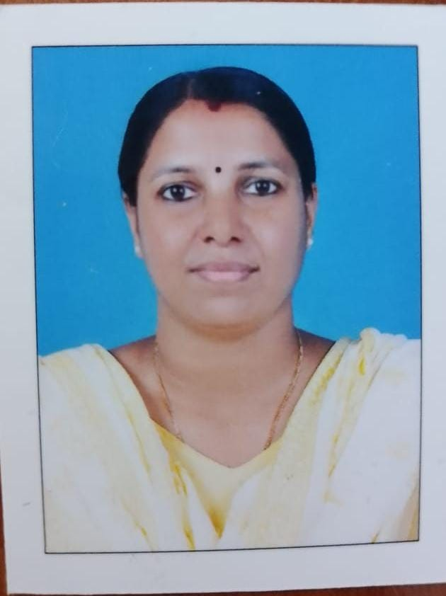

In recent years, our state has faced significant public health emergencies, including the COVID-19 pandemic, outbreaks of Nipah virus infection, and natural disasters such as floods and landslides. These experiences have underscored the critical importance of systematic preparedness, timely response, and coordinated action at all levels of governance. The increasing burden of Non-Communicable Diseases further emphasizes the need to strengthen our health systems and ensure continuity of essential services during emergencies.
The Pandemic Preparedness Plan (PPP) has been developed as a comprehensive framework to guide structured action, capacity building, inter-sectoral coordination, and resilience strengthening at the Panchayath, Block, and Health Facility levels. By promoting preparedness and adopting an integrated approach that recognizes the interconnection between human, animal, and environmental health, this plan aims to enhance our readiness to effectively respond to future public health challenges. On behalf of the Health Standing Committee, Balal Panchayath I formally extend our wholehearted support for the publication and implementation of this Pandemic Preparedness Plan and reaffirm our commitment to safeguarding the health and well-being of our community.

Mrs. Jitha .P.V
Chairman/Chairperson
Health Standing Committee


MESSAGE BY MEDICAL OFFICER

Preparedness is the cornerstone of an effective public health response, enabling institutions to act swiftly, systematically, and confidently during times of crisis. A well-structured Pandemic Preparedness Plan not only safeguards lives but also ensures continuity of essential health services while minimizing disruption to the community. In this context, we are pleased to present the Pandemic Preparedness Plan of Balal Panchayath, the BFHC Vellarikundu serving as a key referral centre in the block.

As the only Block-level government facility in this region, our institution plays a vital role in providing accessible and quality healthcare services to the surrounding communities. This plan has been developed with careful consideration of local needs and available resources, along with the valuable support and cooperation of the Panchayat and other stakeholders. We recognize that healthcare delivery must continue effectively even during periods of limited human resources. Therefore, this plan emphasizes clear protocols, task allocation, cross-training of staff, and optimal resource utilization to ensure uninterrupted services. It is not a static document; rather, it is dynamic and will be regularly reviewed and updated in line with evolving guidelines. Through strict adherence to established protocols, teamwork, and continuous capacity building, we remain committed to maintaining preparedness and safeguarding public health under all circumstances.


Dr.Shinil.V
Medical Officer
BFHC Vellarikundu

MESSAGE BY MEDICAL OFFICER


The preparation of the Pandemic Preparedness Plan for the health institutions serving Balal Grama Panchayath is an important step toward strengthening local capacity to manage public health emergencies. Pandemics and disease outbreaks require timely surveillance, early detection, and coordinated response to minimize their impact on the community.

This plan outlines the available health resources, institutional capacities, and response mechanisms required for effective management of potential health emergencies in the Panchayat area. It also emphasizes strengthening disease surveillance, reporting systems, and coordination among health institutions and local self-government bodies.

I acknowledge the valuable support and cooperation of the Local Self Government Department, Panchayath authorities, health staff, and community health workers who contributed to the preparation of this plan. Their collective efforts will be essential for the effective implementation of the strategies outlined.

It is hoped that this preparedness plan will serve as a practical guide to enhance the readiness of the health system and ensure better protection of the community during public health emergencies.


Dr. Reshma Kalyan
Medical Officer
FHC Konnakad

EXECUTIVE SUMMARY

Family Health Centres (FHC) functions as the primary public healthcare institution serving the population of Balal Grama Panchayath. The FHC plays a pivotal role in delivering comprehensive, accessible, and affordable healthcare services, with a strong focus on preventive, promotive, curative, and rehabilitative care in accordance with national and state health programmes.
The FHC caters to a predominantly rural population, addressing key public health priorities such as maternal and child health, communicable and non-communicable disease control, immunization, family welfare, adolescent health, and geriatric care. Regular outpatient services, home-based care through field health staff, and outreach activities help ensure healthcare access even in geographically challenging areas. The institution actively implements major national health programmes, including the National Health Mission (NHM), National Tuberculosis Elimination Programme (NTEP), National Programme for Prevention and Control of Cancer, Diabetes, Cardiovascular Diseases and Stroke (NPCDCS), and various disease surveillance and public health initiatives.
BFHC Vellarikundu and FHC Konnakkad work in close coordination with the Grama Panchayath, ASHA workers, Anganwadi centres, schools, and community-based organizations to strengthen community participation and improve health awareness. Emphasis is placed on early detection, timely referral, health education, and lifestyle modification to reduce disease burden and improve overall health outcomes.
Despite constraints related to infrastructure, manpower, and increasing service demand, the facilities continues to enhance service delivery through effective planning, data-driven decision-making, and community engagement. Strengthening facilities, upgrading digital health systems, and expanding preventive services remain key focus areas for future development.
Overall, these Family Health Centre stands as a vital institution in safeguarding public health and improving the quality of life of the residents of Parappa block Pancahayath.

LIST OF ABBREVIATIONS

LSGD/LSGI | Local Self Government Department / Local Self Government Institution
BMO | Block Medical Officer
IDSP | Integrated Disease Surveillance Programme
NDMA | National Disaster Management Authority
PPE | Personal Protective Equipment
ICMR | Indian Council of Medical Research
CD | Communicable Diseases
NCD | NON-COMMUNICABLE Diseases

TABLE OF CONTENTS

INTRODUCTION 10
● Background of the PPP 10
LSGD AT A GLANCE 11
INTEGRATED HEALTH INFRASTRUCTURE MAP OF BALAL PANCHAYAT 15
GENERAL PROFILE OF THE LSGI’S 16
Background of the LSGI 16
Demographic and Vulnerable Population 17
Clinical Vulnerability 19
INFRASTRUCTURE & RESOURCE INVENTORY 21
Health Facility Directory & Basic Capacity in the LSGD 21
Private Clinics 22
Healthcare Education & Training Institutions 23
Specialized Services & Emergency Inventory 24
Oxygen & Diagnostic Capacity 24
Diagnostics facility mapping at the LSGI level 25
Laboratory Identification & Basic Details 26
Social and Community Infrastructure for surge plan 26
Human resources 29
Community & Support Cadre 30
Community Organizations 31
Administrative & Emergency Services 31
Information regarding resources 32
ONE HEALTH & ENVIRONMENTAL SURVEILLANCE 33
Animal & Bird Population 33
Veterinary Infrastructure 34
Veterinary Doctors & Workforce 35
High-Risk Interface Points (Surveillance Sites) 35
Environmental Risk Mapping 37
Disease Seasonality Mapping 38
Vulnerability Mapping 39
EPIDEMIOLOGICAL TRENDS (2021–2025) 40
Disease Burden among human beings(Last 5 Years) 40
Seasonal Trend Analysis 41
Outcome-Based Trend Analysis- 2025 45
Transmission Trend- 2025 46
Integrated Disease Hotspot Map (2021–2025) 49
Preparedness and Response Protocol at LSG Level 52
Constitution of One Health Committee 52
Pandemic Response Workforce 53
Activities and Measures before and during Pandemic 55
PHASE 1 - Alert / Preparation 55
PHASE 2 - Active Response 58
Standard Screening Protocol 59
PHASE 3 - Surge Capacity 69
Conversion of Community Facilities 69
CONCLUSION 71
RECOMMENDATIONS 72
ANNEXURE 75
1. IMPORTANT PHONE NUMBERS 75

INTRODUCTION

Background of the PPP
Pandemic Preparedness Plan is essential to ensure a timely, coordinated, and effective response to large-scale infectious disease outbreaks that pose serious threats to public health, social stability, and livelihoods. Pandemics can rapidly overwhelm health systems, disrupt essential services, and disproportionately affect vulnerable populations, particularly in low-resource and rural settings. A well-defined preparedness plan strengthens early detection, surveillance, risk communication, and emergency response mechanisms, enabling local health systems to minimize morbidity, mortality, and socio-economic disruption. By emphasizing proactive planning rather than reactive action, pandemic preparedness enhances community resilience, protects essential services, and ensures continuity of care during public health emergencies.
Balal Panchayath is a rural local self-government unit characterized by hilly terrain, scattered settlements, limited health infrastructure, and socio-economically vulnerable populations, placing it in a low-resource setting. The Panchayath also faces challenges related to difficult accessibility to secondary and tertiary care hospitals due to its geographical conditions. Proximity to forested areas increases exposure to wildlife and human–animal interactions, including occasional wild animal attacks, while the predominance of agricultural activities contributes to occupational and environmental health risks.
Experiences from recent pandemics, particularly COVID-19, revealed critical gaps at the grassroots level, including deficiencies in early case detection, disease surveillance, health workforce capacity, risk communication, emergency transport, and continuity of essential health services. These gaps highlighted the need for structured preparedness planning at the local governance level.
The Pandemic Preparedness Plan for Balal Panchayath is therefore designed to strengthen community-based preparedness and response mechanisms through effective local governance, intersectoral coordination, and community participation. By adopting a decentralized, low-cost, and locally appropriate approach, the plan aims to enhance health system resilience, ensure timely response, and minimize the social and health impacts of future pandemics and other public health emergencies.

LSGD AT A GLANCE
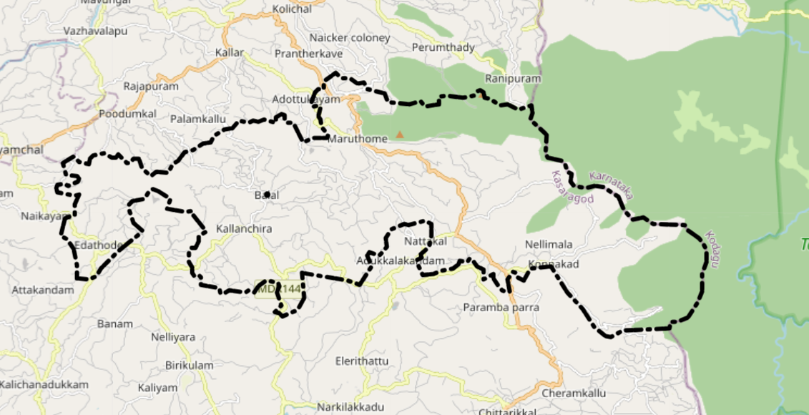
- Geographical boundaries

- North: Kallar Panchayath
- South: West Elery Panchayath
- East : Karnataka forest
- West: Kodom Belur panchayat
Baseline data
- Total Population: 24735
- Males : 12265
- Females : 12470
- No .of House holds : 6081
- Ward division - 17

 | Ward | Houses | Population | Migrants | Wells | Hot  spots | Ed. Institutions | Hosp Pvt/Govt.
1 | Edathode | 450 | 1287 | 53 | 160 | 0 | 1 | 1
2 | Athikadau | 388 | 1337 | 4 | 170 | 0 | 2 | 1
3 | Balal | 396 | 1512 | 5 | 186 | 0 | 5 | 1
4 | Maruthamkulam | 315 | 1510 | 50 | 120 | 0 | 2 | 0
5 | Chulli |  | 1474 | 0 | 241 | 0 | 1 | 0
6 | Darkhas |  | 1383 | 0 | 254 | 0 | 0 | 0
7 | Punja | 345 | 1463 | 0 | 301 | 0 | 1 | 1
8 | Maikayam |  | 1381 | 0 | 211 | 0 | 0 | 0
9 | Konnakad |  | 1359 | 4 | 247 | 0 | 0 | 0
10 | Muttomkadav |  | 1529 | 4 | 219 | 0 | 1 | 2
11 | Malom |  | 1529 | 28 | 315 | 0 | 2 | 1
12 | Karyottuchal |  | 1367 | 0 | 217 | 0 | 0 | 0
13 | Anamanjal | 358 | 1301 | 0 |  | 0 | 1 | 0
14 | Karuvulladukkam | 392 | 1276 | 0 |  | 0 | 2 | 1
15 | Vellarikundu | 485 | 1312 | 0 | 127 | 0 | 6 | 1
16 | Kallanchira |  | 1329 | 0 |  | 0 | 1
17 | Kanakapally | 472 | 1323 | 0 | 132 | 0 | 2 | 0

Major Roads
Balal Panchayath is well connected to both Kerala and Karnataka through important inter-state and regional road networks. SH 59 Nadukani–Parassala (Malayora Highway) passes through the region and serves as a major transportation corridor improving connectivity across the hilly areas of northern Kerala. The Cherupuzha–Sullia interstate road passing through Panathur provides connectivity to Karnataka, enabling easier access to major cities such as Bangalore and Mysore. Within Kerala, the Panchayath is connected through the Balal–Parappa and Adukkam road networks, improving access to nearby towns and service centres. The nearest town is Vellarikundu. The nearest railway station is Kanhangad Railway Station on the Shoranur–Mangalore section under Southern Railway. The nearest airports are Kannur International Airport in the south and Mangalore International Airport in the north.

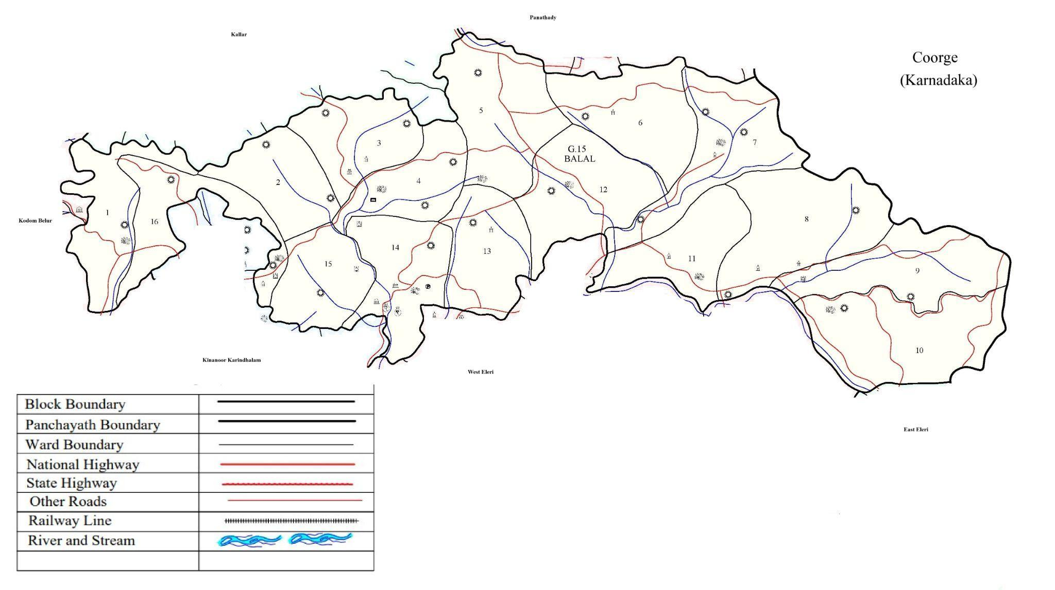

Geographical boundaries - ward boundaries map

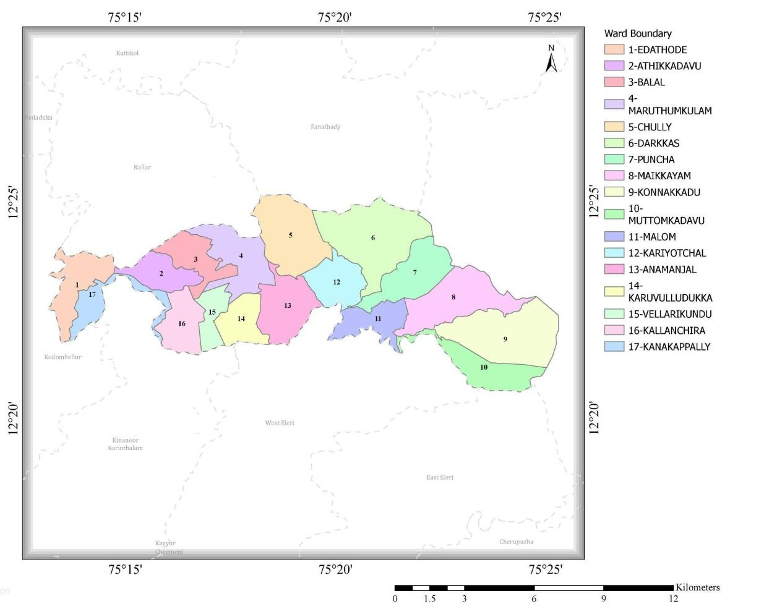

INTEGRATED HEALTH INFRASTRUCTURE MAP OF BALAL PANCHAYAT

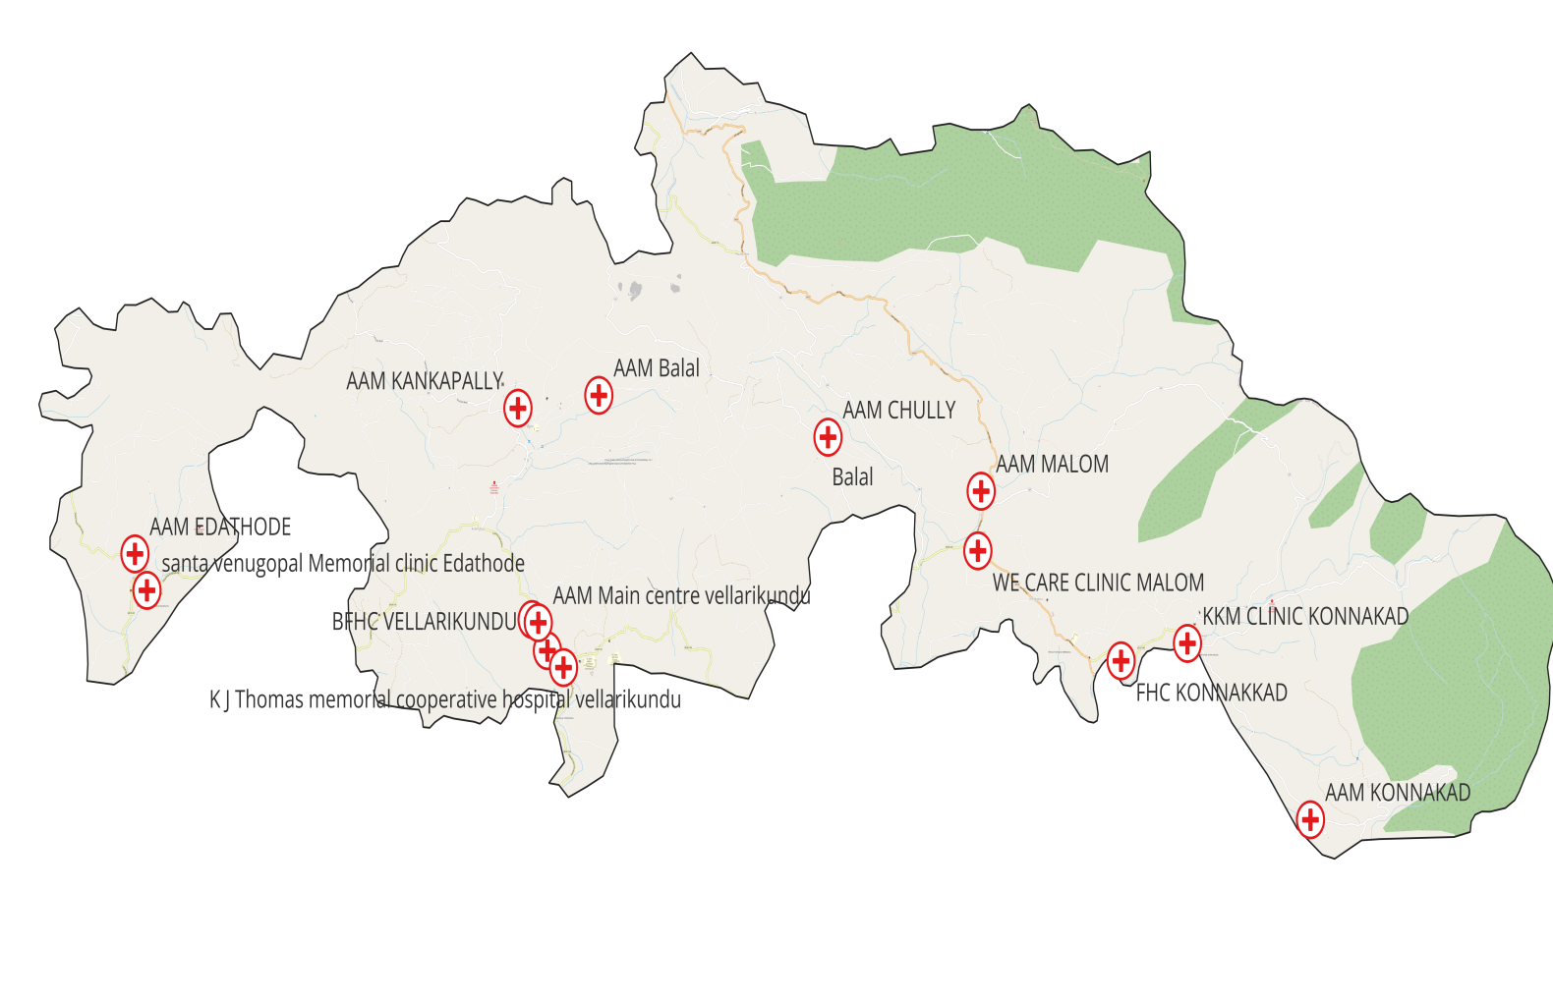

GENERAL PROFILE OF THE LSGI’S

Background of the LSGI
Balal Gram Panchayath is a rural Local Self-Government Institution (LSGI) situated in the southern hilly terrain of the Kasargod district, Kerala. It exercises administrative jurisdiction over a cluster of wards and villages nestled within the Vellarikundu/Parappa region. The region is connected via local networks to neighbouring towns and the major eastern route toward Panathur, which bridges connectivity into Karnataka. While major road upgrades in recent years have vastly improved market accessibility, optimizing last-mile connectivity within interior, elevated wards remains a key infrastructural priority for the LSGI.
The local economy is predominantly agrarian, structurally organized around smallholder farming systems. The primary agricultural landscape is dominated by Cash crops such as rubber and coconut, Paddy cultivation managed in localized lowland patches, integrated mixed food crops and spices.
Agricultural productivity is inherently sensitive to soil variations, high rainfall variability, and constraints stemming from fragmented landholdings. Irrigation remains largely rain-fed, supplemented marginally by local small-scale irrigation projects mapped out in the panchayat’s developmental plans. However, socio-economic vulnerability is acutely felt by landless laborers, marginal farmers, and socially disadvantaged groups who lack substantial asset cushions and face barriers to securing formal institutional credit.
Over the past few decades, Balal Panchayath has transitioned from an isolated, subsistence-heavy agrarian locality into a progressive rural ecosystem. Structural improvements are evidenced by rising literacy rates, near-universal mobile and telecom penetration, and enhanced road connectivity to urban trading centres. The local labour dynamic has shifted away from purely subsistence farming toward cash-crop marketing and non-farm wage labor, significantly elevating the baseline standard of living.
Primary health infrastructure is decentralized at the village and ward levels through local government dispensaries and public health centres. For advanced secondary or tertiary medical interventions, residents travel to well-equipped facilities in the larger nearby towns of Vellarikun du and Kanhangad. The healthcare ecosystem is pluralistic; local residents routinely navigate a mix of public primary care, private practitioners, and traditional Ayurvedic clinics for their day-to-day medical needs. The region faces recurring vulnerabilities to endemic vector-borne diseases (such as dengue, and occasional malaria outbreaks) alongside water-borne illnesses that peak during monsoon seasons. Concurrently, the community reflects broader state-wide trends with a rising incidence of non-communicable diseases (NCDs) like diabetes and hypertension. Health risks are disproportionately higher among the elderly, lower-income households, and pockets lacking reliable access to piped, treated water supply.
Table 1: Background of LSGD
Description | Details
Name of LSGI | Balal
Type (GP/Municipality / Corporation etc.) | Grama Panchayath
Block | Parappa
District | Kasaragod
Number of wards | 17
Total area (sq. km) | 93.4
Population(Projected) | 24735
Population density | 265
Terrain (coastal/low-lying/backwaters/foothills, etc.) | foothills midland-to-highland hilly terrain
Number of rivers passing through LSGI | 1
Number of water bodies in the LSGI | 98
Number of educational institutions | 21
Factories / small-scale industries | 0
Flood-prone wards | 0
Landslide-prone wards | 6
Death Management and Disposal Facilities (mortuaries/crematorium, including electric) | 1
Auditoriums/Marriage halls/convention centres/community halls | 20

Demographic and Vulnerable Population
Understanding the demographic composition and vulnerable population groups is essential for pandemic preparedness. Children, elderly, economically deprived families, migrant workers, and socially vulnerable groups are at increased risk during public health emergencies due to higher exposure, limited access to services, and dependency on public systems.
Description |  | Details (in numbers)
DEMOGRAPHIC PROFILE
Total population |  | 23412
Male |  | 11621
Female |  | 11791
Transgender |  | 0
Children under 5 |  | 1209
Adolescent
Elderly (>60) |  | 3574
SOCIAL/LIVELIHOOD VULNERABILITY
Previous EPEP family |  | 7
BPL family |  | 741
Tribal communities |  | 6567
Migration | Immigrant | 172
Migration | Emigrant | 863
Socio-economically deprived |  | 364
Fisher folk |  | 0
SC Community |  | 57
ST Community |  | 5925

Clinical Vulnerability
Certain population groups needs priority healthcare & are at higher risk of severe illness, complications, and mortality during pandemics. Patients with chronic diseases, those requiring regular medical care, and individuals with mobility or functional limitations face challenges in accessing timely care during emergencies. Mapping these groups helps in prioritizing continuity of treatment, medicine stock planning, oxygen support, referral transport, and targeted home-based care.
Description | Details in numbers
Pregnant women | 120
Lactating mothers | 389
Bedbound patients | 130
Patients under palliative care other than bedbound | 95
Patients on Haemodialysis | 16
Patients on CAPD | 0
Cancer patients (currently on treatment) | 49
Haemophilic patients | 0
Mentally challenged | 115
Differently abled | 129
Diabetic patients | 1843
Hypertensive patients | 2798
TB patients | 12

Major Festivals & Events specific to the LSGI
(With the possibility of a public gathering)

Sl. No. | Name of festival | Month detailing the periodicity
1 | Theyyam- Balal, Neroth, Kakkayam | January- may
2 | Palli thirunnal- Mavunkal | December- February
3 | Uroos-Kallanchira | December- February
4 | Kaliyattam | January- May

INFRASTRUCTURE & RESOURCE INVENTORY

Health Facility Directory & Basic Capacity in the LSGD
This section provides an overview of the healthcare infrastructure available within the LSGD area. It outlines the distribution and basic capacity of health facilities that form the backbone of service delivery during routine times and public health emergencies.

Family Health Centres (FHCs) generally function as the first point of contact for the community, providing essential outpatient and inpatient services. Thaluk Headquarters Hospital Poodamkallu District Hospitals (DHs) where accessible, serve as the main referral centres for advanced diagnostics, specialist care, sophisticated treatment infrastructure, and critical services during public health emergencies. This inventory helps identify existing strengths, service gaps, laboratory and diagnostic capacity, and potential surge resources that can be mobilised during pandemics, disasters, or other emergency situations.
Table5. Health Facility Resource Summary
Sl.no | Health Facility | Type of Facility | Contact Number |  | Total beds |  | ICU Beds | Oxygen-Supported Beds |  | No. of Ventilator Support Beds | No.of ambulances
Government Healthcare Facilities
1 | BFHC Vellarikkund | BFHC |  | 4672242228 |  | 24 | 0 | 0 | 0 |  |  |  | 1
2 | FHC Konnakkad | FHC |  | 4672249663 |  | 0 | 0 | 0 | 0 |  |  |  | 0
3 | Gov.Homeo Hospital Balal | Homoeo Dyspnesary |  | 4672242105 |  | 0 | 0 | 0 | 0 |  |  |  | 0
4 | Gov.Ayurvedha Dispensary Malom | Ayurveda Dyspensary |  |  |  | 0 | 0 | 0 | 0 |  |  |  | 0
5 | AAM Chully | SC |  | 8078125148 |  | 0 | 0 | 0 | 0 |  |  |  | 0
6 | AAM Malom East | SC |  | 8606196995 |  | 0 | 0 | 0 | 0 |  |  |  | 0
7 | AAM Konnakkad | SC |  | 8921495396 |  | 0 | 0 | 0 | 0 |  |  |  | 0
8 | AAM Balal | SC |  | 9744888512 |  | 0 | 0 | 0 | 0 |  |  |  | 0
09 | AAM Edathode | SC |  | 9048503576 |  | 0 | 0 | 0 | 0 |  |  |  | 0
10 | AAM Kanakappally | SC |  | 9497283904 |  | 0 | 0 | 0 | 0 |  |  |  | 0
11 | AAM Vellarikkund Main centre | SC |  | 6282578755 |  | 0 | 0 | 0 | 0 |  |  |  | 0
Private Healthcare Facilities |  |  |  |  |  |  |  |  |  |  |  |  |  |  |  |  |  |  | 0 | 0 | 0 | 0
1 | K M Clinic Konnakad | Private |  | 6235773226 |  | 0 | 0 | 0 |  | 0 |  |  | 0
2 | Homoeo clinic Vellarikundu | Private |  |  |  | 0 | 0 | 0 |  | 0 |  | 0
3 | Health Clinic Malom | Private |  |  |  | 0 | 0 | 0 |  | 0 |  | 0
5 | KJ Thomas memorial co-operative clinic Vellarikkund | Private |  | 9946336552 |  | 0 | 0 | 0 |  | 0 |  | 0
6 | S V M clinic Edathode | Private |  |  |  | 0 | 0 | 0 |  | 0 |  | 0
7 | We care Clinic Malom | Clinic |  | 7306908420 |  | 5 | 0 | 0 |  | 0 |  | 1
AYUSH Healthcare Facilities
1 | Vaidyarathnam Ayurveda Clinic Vellarikkund | Clinic |  | 9495990072 | 0 |  | 0 | 0 |  | 0 |  | 0
2 | JMJ Ayurvedic Clinic Malom | Clinic |  |  | 0 |  | 0 | 0 |  | 0 |  | 0
3 | Rishi Ayurveda Hospital Parappa | Hospital |  | 7942698700 | 0 |  | 0 | 0 |  | 0 |  | 0

Private Clinics
Private clinics are an essential part of pandemic preparedness, as they are often the first place people seek care when symptoms begin. In many communities, private clinics manage a significant share of outpatient visits and therefore play a critical role in early case detection, timely referrals, and disease surveillance. Having an up-to-date understanding of where these clinics are located, the services they provide, and how they are linked to the public health system helps ensure that no cases are missed during an outbreak. It also allows health authorities to engage private practitioners more effectively for reporting, risk communication, and coordinated response, strengthening the overall capacity of the health system to manage public health emergencies.

Table 6. Private Clinic Resource Summary
Sl.No. | Name of Clinic | Registered (Y/N) | Clinic (General / Speciality) | Speciality | Address | Contact Number | Diagnostic Facility (Y/N) | Ambulance Linkage (Y/N)
1 | Medcare Speciality clinic vellarikkund | Y | general | nil | Vellarikundu | 755908877 | Y | Y
2 | K J Thomas memorial co-operative clinic Vellarikkund | Y | general | nil | Vellarikundu | 9946336552 | Y | Y
3 | S V M clinic Edathode | Y | general | nil | Edathode | 9995011192 | N | Y
4 | We Care Malom | Y | general | Nil | Malom | 7306908420 | Y | Y
5 | Kkm Konnakkad | Y | general | Nil | Konnakkad | 6235773226 | Y | N

Healthcare Education & Training Institutions
This section tracks the educational infrastructure available, which is vital for human resource planning in the health sector.
Category of Institution | Govt | Private | AYUSH | Total
Medical Colleges | 0 | 0 | 0 | 0
Nursing Colleges | 0 | 0 | 0 | 0
Dental Colleges | 0 | 0 | 0 | 0
Para-medical / Allied Health | 0 | 0 | 0 | 0
Pharmacy Colleges | 0 | 0 | 0 | 0

Specialized Services & Emergency Inventory
This section provides a detailed view of the specialized medical resources available to the community, focusing on emergency response and critical care capabilities. This table tracks the vital assets required for managing severe illnesses and emergencies across Government, Private, and AYUSH sectors.

Item | Govt | Private | AYUSH | Total
Hospital beds | 24 | 10 | 0 | 34
Oxygen-generating systems(Y/N) | 24 | 5 | 0 | 29
Oxygen-supported beds(Numbers) | N | N | 0 | 0
Ventilator-supported beds | 0 | 0 | 0 | 0
ICU beds | 0 | 0 | 0 | 0
Burns units | 0 | 0 | 0 | 0
Blood centres | 0 | 0 | 0 | 0
BLS ambulances | 0 | 0 | 0 | 0
ALS ambulances | 0 | 0 | 0 | 0
Dialysis facilities | 0 | 0 | 0 | 0
Dispensaries | 0 | 0 | 0 | 0
Medical store | 2 | 0 | 0 | 0
Industrial establishments(Medium-scale industries/small-scale industries establishments to whom we can depend in a worst-case scenario) | 0 | 0 | 0 | 0

Oxygen & Diagnostic Capacity
Monitoring oxygen availability and diagnostic capacity is a critical component of public health preparedness, ensuring that the LSGD can effectively manage routine healthcare needs as well as sudden surges in respiratory illnesses, infectious diseases, and other public health emergencies.
Name of Health Facility | Oxygen-generating System (Y/N) |  | Backup Oxygen Source (Y/N) | Diagnostic Facilities Available(Y/N)
Name of Health Facility |  |  | Backup Oxygen Source (Y/N) | Lab | USG | X-ray | CT/MRI | RT-PCR
Government Healthcare Facilities
BFHC Vellarikund |  | N | N | Y | N | N | N | N
FHC Konnakkad |  | N | N | Y | N | N | N | N
Gov. Homeo Hospital Balal |  | N | N | N | N | N | N | N
Gov.Ayurvedha Dispensary Malom |  | N | N | N | N | N | N | N
AAM Chully |  | N | N | N | N | N | N | N
AAM Malom East |  | N | N | N | N | N | N | N
AAM Konnakkad |  | N | N | N | N | N | N | N
AAM Balal |  | N | N | N | N | N | N | N
AAM Edathode |  | N | N | N | N | N | N | N
AAM Kanakappally |  | N | N | N | N | N | N | N
AAM Vellarikkund Main centre |  | N | N | N | N | N | N | N
private health care facilities
We Care Malom | N |  | Y | Y | N | N | N | Y
KKM Konnakkad | N |  | Y | Y | N | N | N | Y

Diagnostics facility mapping at the LSGI level
The diagnostic capacity of Balal Grama Panchayat is very limited and represents a critical gap in the local healthcare system. The speed and accuracy of disease identification are constrained by the scarce availability, uneven distribution, and limited technical capacity of diagnostic facilities in the area.
Item | Govt | Private | AYUSH | Total
General labs | 3 | 6 | 0 | 9
Microbiology labs | 0 | 0 | 0 | 0
RT-PCR labs | 0 | 0 | 0 | 0
USG units | 0 | 0 | 0 | 0
CT/MRI units | 0 | 0 | 0 | 0
Research labs | 0 | 0 | 0 | 0
Labs of other departments that can be repurposed | 0 | 0 | 0 | 0

Laboratory Identification & Basic Details
Sl. No. | Name of Laboratory | Ownership (Govt / Private / Academic) | Address | Contact No. | 24×7 Services (Yes/No) | NABL / Govt Approved (Yes/No)
1 | New Mariya Lab | Private | Vellarikundu | 6235074110 | No | Yes
2 | Angel Diagnostic Centre | Private | vellarikundu | 9633993344 | No | Yes
3 | FHC Konnakkad | Govt | Konnakkad | 7034123120 | No | Yes
4 | We Care Malom | PVT | Malom | 7306908420 | Yes | No
5 | KKM Lab | PVT | Konnakkad | 6235773226 | No | No

Social and Community Infrastructure for surge plan
This table serves as the logistics and shelter inventory. By mapping these locations, we can quickly identify suitable sites to house displaced citizens, establish temporary medical clinics, and ensure dignified management of the deceased during a crisis situation.
Category | Total Count | Ward |  |  |  | Est. Capacity (Persons) |  | Contact details
Educational Institutions
Anganwadis | 29 | all wards |  |  | 234 |  |  | 9447017054
Schools | 21 | 7,5,16,14 |  |  | 3025 |  |  | 04672247401-Govt School Maloth Kasaba
Colleges | 1 |  |  |  | 200 |  |  | 9495855180
Healthcare Educational Institutions
Medical colleges (Govt/Private) | 0 |  |  | 0 |  | 0 |  | 0
Nursing colleges (Govt/Private) | 0 |  |  | 0 |  | 0 |  | 0
Dental colleges (Govt/Private) | 0 |  |  | 0 |  | 0 |  | 0
Paramedical institutes (Govt/Private) | 0 |  |  | 0 |  | 0 |  | 0
Community Gathering Spaces
Community halls | 14 |  | 1,2,3,4,5,7,8,9,12,15 |  |  |  | 100 | Dhanya- Tribal Promoter
Auditoriums | 2 |  |  |  |  |  | 200 | 0
Religious buildings | 17 |  | 3,2,6,7,4,8 |  |  |  | 100 | 0
Vulnerable Group Support Facility
Destitute homes | 0 |  |  | 0 |  | 0 |  | 0
Elderly homes | 1 |  |  | 16 |  | 50 |  | -
LSGD owned other buildings |  |  |  |  |  |  |  | -
Mass Fatality Management (MFM) Infrastructure
Mortuary | 0 |  |  | - |  | - |  | -
Crematorium | 1 |  |  |  |  |  |  | -

Human resources
This section focuses on the human capital available within the LSGI. In any emergency—be it a pandemic, flood, or industrial accident—infrastructure is only as effective as the people operating it.

Medical & Clinical Personnel
This table tracks the "Frontline" providers responsible for diagnosis, treatment, and clinical management. Narrative sentence:

Cadre | Govt (No.) | Private (No.) | Total
Doctors—Modern Medicine | 4 | 4 | 5
Doctors – AYUSH | 1 | 0 | 1
Doctors – Veterinary | 2 | 0 | 1
Doctors – Dental | 0 | 1 | 1
Nursing officers | 7 | 2 | 4
Lab technicians | 1 | 2 | 3
Optometrist | 1 | 0 | 0
Pharmacists | 2 | 2 | 3
Psychologists | 0 | 0 | 0
Counsellors | 0 | 0 | 0

Public Health & Field-Level Workforce
These individuals are the backbone of surveillance, maternal-child health, and decentralized care.

Cadre | Health services | Municipal common services | Total
HS (Health Supervisors) | 0 | 0 | 0
HI (Health Inspectors) | 2 | 0 | 2
LHS (Lady Health Supervisor) | 0 | 0 | 0
LHI (Lady Health Inspectors) | 2 | 0 | 2
JPHN (Jr Public Health Nurses) | 6 | 0 | 6
JHI (Jr Health Inspectors) | 6 | 0 | 6
MLSP (Mid-Level Service Providers) | 7 | 0 | 7
Palliative Nurses | 1 | 0 | 1
RBSK Nurses | 1 | 0 | 1
PRO | 0 | 0 | 0
Epidemiologist | 1 | 0 | 1
Data Manager | 1 | 0 | 1

Community & Support Cadre
This group represents the surge capacity of the LSGI—people who can be called upon for logistics, rescue, and specialized support.

Cadre | Number
ASHA Workers | 17
AWW (Anganwadi Workers) | 29
Emergency Medical Volunteers (Trained) | 0
Kudumbashree | 162
MNREGS | 508
Purusha Swayam Sahaya Sangham | 25
Ex-Servicemen | 122
Retired Police Officers | 19
NCC/NSS Volunteers | 65
Red Cross volunteers | 0
One Health Community Volunteers | 48
One Health Community Mentors | 0

Community Organizations
This section details the presence of community-based organisations (CBOs), non-governmental organisations (NGOs), faith-based organisations (FBOs), Kudumbashree Self-Help Groups (SHGs), and Ayalkootams within the Local Self-Government Institution (LSGI). These groups enhance grassroots mobilization, resource distribution, and support networks crucial for pandemic response and community resilience.

Category | Total Count
NGOs | 1
Religious based organizations | 4
Foreign based organizations | 0
Sports Club/youth clubs | 9
Kudumbashree SHGs | 98
Ayalkootams | 162
Political organizations | 9
Residential organizations | 0

Administrative & Emergency Services
This section outlines the availability of key non-health emergency support services and infrastructure within the LSGI, which are essential for effective pandemic preparedness and response. These facilities support law enforcement, disaster response, water supply, logistics, mobility, and community-level interventions during public health emergencies.

Category | Total Count | Contact details
Police Stations | 1
Fire & Rescue Stations | 0
Water Pumping Points | 0
Public Distribution System (PDS) | 7

Information regarding resources
The availability of essential transport and support resources plays a critical role in emergency response and saving lives during disasters and public health emergencies. Resources such as ambulances help ensure the rapid movement of patients, medical teams, and essential supplies, particularly in difficult-to-access areas. Heavy vehicles including JCBs, tractors, cranes, and torus lorries support emergency logistics, sanitation activities, waste management, infrastructure clearance, and the rapid setup of temporary care or relief facilities. Taxis, trucks, and four-wheel-drive vehicles help maintain continuity of essential services, facilitate outreach to vulnerable populations, and support home-based care, supply distribution, and emergency transportation during crisis situations.

Means of transportation | Total Count
JCB | 7
Crane | 0
Heavy Trucks | 0
Tractor | 5
Ambulances | 2
Mobile mortuaries | 1
Taxi service | 58
ONE HEALTH & ENVIRONMENTAL SURVEILLANCE
The One Health method integrates environmental, animal, and human health to enable proactive pandemic preparedness. Panchayat-level surveillance needs to be improved in order to detect and treat zoonotic and environmentally generated diseases early. Surveillance is strengthened through systematic assessment of animal populations, veterinary infrastructure, in high-risk areas like Malom & Maruthom, Balal

Animal & Bird Population
The One Health approach integrates environmental, animal, and human health systems to support proactive pandemic preparedness. Strengthening Panchayat-level surveillance is essential for the early detection and management of zoonotic and environmentally associated diseases. Surveillance activities are strengthened through systematic assessment of animal populations, veterinary infrastructure, and environmental risk factors, particularly in higher-risk areas such as Malom and Maruthom in Balal Grama Panchayath, where close interaction between humans, livestock, and the natural environment may increase disease transmission

Category | Item | Estimated Population | Wards
Animal Population | Livestock (Cattle/Goats/Buffalo) | 622 | All Wards
Animal Population | Pet Animals (Dogs/Cats) | 2125
Animal Population | Stray Dog Population | 1230
Animal Population | Pig Farms (Number of heads) | 8 | Malom ,
 | Small Units (Sheep / Goats – clustered) | 1 | Kallanchira
Bird Population | Poultry Units (Birds) | 12
Bird Population | Poultry- (FOWL) | 0
Bird Population | Wild/Migratory Birds (Observed) | 0
Bird Population | Crow Mortality Events (Reported) | Not yet noticed

The main risk of zoonotic diseases in Balal Panchayath is mainly concentrated in Ward 14, where occasional human–animal interaction occurs due to proximity to forest areas and wildlife movement. Stray dog presence in market areas and bus stations remains a key concern for rabies surveillance and bite prevention. Seasonal flooding and water stagnation during monsoon further increase the risk of environmentally mediated diseases such as leptospirosis. Overall, zoonotic risk in the Panchayath is associated more with forest–human interface zones and environmental exposure rather than intensive livestock farming systems

Veterinary Infrastructure
Veterinary institutions are a core pillar of One Health surveillance, enabling early zoonotic disease detection through vaccination, investigation of unusual animal illness or deaths, sample collection, and timely outbreak reporting.
Facility Type | Name of Facility | Ownership Govt / Pvt | Location(Ward No) | Contact number
Veterinary Dispensary | GVD Konnakkad | GOVT | Konnakkad, Malom | 9747750934
Veterinary Hospital / Polyclinic | GVD Konnakkad | GOVT | Konnakkad | 9747750934
Private Veterinary Clinics | 0 | nil | nil | nil
Mobile / Emergency Vet Service (incl. night services) | 0 | nil | nil | nil
Pet Homes / Animal Shelters | 0 | nil | nil | nil
Slaughterhouse-linked Veterinary Inspection Unit | 0 | nil | nil | nil

Veterinary Doctors & Workforce
Early detection, diagnosis, reporting, and reaction to animal illness epidemics depend on the availability and accessibility of qualified veterinary specialists. By identifying unusual animal morbidity or mortality promptly, collecting samples promptly, and coordinating efficiently with human health and LSGI systems—especially during zoonotic outbreaks and pandemic-prone situations—a clearly defined veterinary workforce enhances One Health surveillance.

Category | Number Available | Type (Govt/Pvt) | Contact number
Government Veterinary Doctors | Yes | Govt | 9645068809
Private Veterinary Doctors | Nil
Livestock Inspectors | Nil
Para-veterinary Staff / Attenders | Nil
Contract / On-call Veterinary Support (if any) | Nil

High-Risk Interface Points (Surveillance Sites)
High-risk interface points for zoonotic disease surveillance in Balal Grama Panchayath include livestock–human contact zones, backyard animal rearing areas, and locations where wild animals come into occasional contact with human settlements, particularly forest fringe areas. These sites are considered priority surveillance points due to the potential risk of zoonotic spillover and disease transmission.
The assessment of high-risk zoonotic interface points in Balal Grama Panchayath shows that all major categories currently report Nil or Minimal risk at presence. Overall, there are no identified significant hotspots of human–animal interface that currently indicate elevated zoonotic transmission risk in these listed categories within the panchayath.

Category | Total Count | Key Locations (wards)
Poultry Farms | 12 | Malom ,Vallikkadav
Backyard / Clustered Poultry Units | Nil
Duck Rearing Units (open water access) | Nil
Slaughterhouses/ Slaughter Points | Nil
Meat/Fish Markets | 6 | Konnakkad Malom , Vellarikundu
Live Bird Sale Points | Nil
Cattle Markets / Weekly Animal Fairs | Nil
Pet Shops / Breeders | Nil
Animal Shelters / Pet Homes | Nil
Waste Disposal Sites near Animal Units | Nil

Environmental Risk Mapping
Environmental risk mapping identifies monsoon/flood hotspots for vector-borne (dengue, chikungunya), water-borne (leptospirosis, diarrhoea), and zoonotic diseases. Systematic surveillance supports early warnings, targeted interventions, and Panchayat pandemic preparedness.
Waterborne exposure: Flood-prone areas and stagnant water bodies facilitate leptospira survival, raising leptospirosis risk.

Risk Factor | High-Risk Wards | Key Locations | Risk Level (High/Med/Low)
Flood-prone areas | 5,6,9,10 | Puncha, Darkas, Muttom kadavu | Med
Water bodies/wetlands | Nil
Solid waste accumulation | Poor Drainage in Puncha
Animal waste disposal issues | Nil
Rodent infestation zones | Nil
Industrial effluent discharge | Nil
Construction sites / abandoned buildings | 7 | Valya Puncha | Med
Poor drainage/blocked canals | 5,11 | Malom | High
Drinking water source contamination risk | NIL

Disease Seasonality Mapping
In Balal Grama Panchayath, key environmental and ecological risk factors influencing zoonotic and vector-borne disease transmission include flooding and waterlogging, which can amplify the risk of leptospirosis, malaria, and diarrheal diseases. Seasonal mosquito breeding cycles contribute to predictable increases in vector-borne diseases during the monsoon period. In addition, agricultural activities, particularly in paddy fields, create situations of close human–environment and human–animal interaction, which may increase

Disease | Peak Risk Season | Key Drivers | High-Risk Locations
Leptospirosis | Aug-Nov | WetLand | Muttomkadavu
Dengue/Chikungunya | April-Sept | Rubber Plantation | Karyottuchal
Acute Diarrheal Diseases | All Season
Rabies | All Season
Anthrax (rare) | Nil

Vulnerability Mapping
Vulnerability mapping pinpoints high-risk populations, occupations, and areas exposed via environment, livelihoods, socio-economics, and poor service access. Paired with environmental/seasonality mapping, it enables risk-based surveillance, targeted actions, and optimal resource use in One Health and pandemic planning.
Vulnerability Factor | High-Risk Wards | Key Groups / Locations | Risk Level
Flood-prone households | 5,6,9,10 | Konnakkad ,Puncha | High
Wetland-adjacent communities | Nil
Backyard poultry / duck rearing households | Nil
Livestock-rearing households | 5,6,7,9,10 | Konnakkad Darghas,Chulli | Med
Slaughterhouse & meat market workers | 11,5,12,9 | Muttomkadavau Chulli | Med
Fisherfolk & fish market workers | 12,11,8,9 | Karyottuchal , Malom | Med
Sanitation workers | 5,6,7,8,9,10,11,12 | Karyottuchal ,Chulli Konnakakd | Med
Daily wage / migrant workers | 6,7,9 | Muttomkadavu,Dargjhas | Low
Elderly & chronically ill populations | 5,6,7,8,9,10,11,12 | Konnakkad Darghas,Chulli | Med
Pregnant Women (Current) | 5,6,7,9 | Konnakkad Darghas,Chulli

EPIDEMIOLOGICAL TRENDS (2021–2025)

Disease surveillance is the systematic collection, analysis, and interpretation of health data for planning, implementation, and evaluation of public health practice. This section presents the disease surveillance profile of the LSGI based on routine reporting systems and outbreak investigations to identify priority diseases, seasonal patterns, and emerging public health threats.

Disease Burden among human beings (Last 5 Years)
Analysis of disease-wise data for the last five years helps identify persistent public health problems, emerging diseases, and changes in disease burden. This information supports prioritisation of prevention, preparedness, and response activities at the Panchayat level.

Disease | 2021 | 2022 | 2023 | 2024 | 2025 | Trend(Increasing/Stable/Decreasing)
Dengue | 213 | 32 | 28 | 16 | 54 | decreasing
Leptospirosis | 12 | 5 | 1 | 2 | 4 | decreasing
Hepatitis A | 0 | 0 | 0 | 4 | 4 | increasing
Malaria | 0 | 0 | 0 | 0 | 0 | nil
Scrub Typhus | 0 | 0 | 0 | 0 | 0 | nil
Typhoid | 0 | 0 | 2 | 2 | 0 | increasing
H1N1 | 0 | 0 | 5 | 1 | 1 | decreasing
H3N2 | 0 | 0 | 0 | 0 | 0 | nil
ADD | 416 | 377 | 248 | 198 | 177 | decreasing
Mumps | 0 | 0 | 1 | 1 | 22 | increasing
Measles | 0 | 0 | 0 | 0 | 0 | nil
Hepatitis B | 0 | 0 | 0 | 0 | 0 | nil
Hepatitis C | 0 | 0 | 0 | 0 | 0 | nil
Tuberculosis | 19 | 19 | 15 | 17 | 15 | decreasing
Leprosy | 0 | 0 | 0 | 0 | 0 | nil
COVID-19 | 3664 | 307 | 16 | 0 | 0 | decreasing

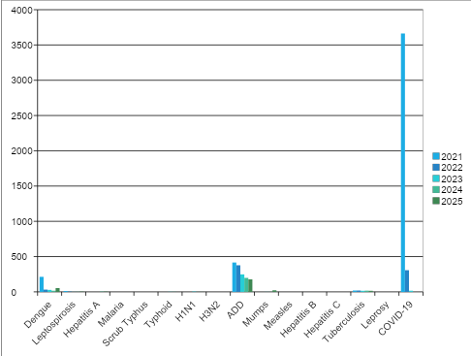

Seasonal Trend Analysis
Seasonal analysis helps anticipate surges (e.g. dengue in monsoon, leptospirosis after floods, influenza in cooler months) and plan pre‑emptive vector control, stockpiling of IV fluids, and awareness campaigns at Panchayath level.

DENGUE
Dengue is a major seasonal vector-borne disease strongly associated with rainfall, water stagnation, and increased mosquito breeding during the monsoon period.

Peak: July–November

Dengue – Ward-wise Yearly Distribution (2021–2025)

Ward | Dengue – Ward-wise Yearly Distribution
Ward | 2021 | 2022 | 2023 | 2024 | 2025 | Total
1 | 22 | 2 | 2 | 1 | 0 | 27
2 | 8 | 4 | 0 | 0 | 1 | 13
3 | 18 | 1 | 3 | 1 | 11 | 34
4 | 19 | 8 | 1 | 1 | 1 | 30
5 | 12 | 0 | 3 | 0 | 4 | 19
6 | 8 | 3 | 2 | 0 | 4 | 17
7 | 6 | 1 | 4 | 2 | 3 | 16
8 | 12 | 1 | 1 | 1 | 3 | 18
9 | 14 | 2 | 2 | 0 | 2 | 20
10 | 15 | 1 | 1 | 2 | 2 | 21
11 | 4 | 1 | 1 | 2 | 4 | 12
12 | 9 | 1 | 2 | 1 | 16 | 29
13 | 15 | 3 | 1 | 2 | 1 | 22
14 | 22 | 3 | 1 | 0 | 1 | 27
15 | 18 | 1 | 1 | 1 | 0 | 21
16 | 11 | 0 | 3 | 2 | 1 | 17
17 | 0 | 0 | 0 | 0 | 0 | 0

LEPTOSPIROSIS
Leptospirosis cases are closely linked to monsoon rains, flooding, and occupational exposure, particularly in low-lying and waterlogged areas.

Peak: June - August

Leptospirosis – Ward-wise Yearly Distribution (2021–2025)

Ward | Leptospirosis – Ward-wise Yearly Distribution
Ward | 2021 | 2022 | 2023 | 2024 | 2025 | Total
1 | 1 | 0 | 1 | 0 | 0 | 2
2 | 0 | 0 | 0 | 0 | 0 | 0
3 | 0 | 0 | 0 | 0 | 0 | 0
4 | 1 | 1 | 0 | 0 | 0 | 2
5 | 2 | 0 | 0 | 0 | 0 | 2
6 | 0 | 1 | 0 | 1 | 1 | 3
7 | 1 | 0 | 0 | 0 | 0 | 1
8 | 2 | 0 | 0 | 0 | 0 | 2
9 | 0 | 1 | 0 | 1 | 0 | 2
10 | 1 | 0 | 0 | 0 | 1 | 2
11 | 2 | 1 | 0 | 0 | 0 | 3
12 | 1 | 0 | 0 | 0 | 1 | 2
13 | 1 | 1 | 0 | 0 | 0 | 2
14 | 0 | 0 | 0 | 0 | 0 | 0
15 | 0 | 0 | 0 | 0 | 0 | 0
16 | 0 | 0 | 0 | 0 | 1 | 1
17 | 0 | 0 | 0 | 0 | 0 | 0

VIRAL HEPATITIS - A
Hepatitis A cases are commonly associated with unsafe drinking water, food contamination, and breakdowns in sanitation, often presenting as clusters or outbreaks.

Peak: October - December

Hepatitis A – Ward-wise Yearly Distribution (2021–2025)

Ward | Hep A – Ward-wise Yearly Distribution
Ward | 2021 | 2022 | 2023 | 2024 | 2025 | Total
1 | 0 | 0 | 0 | 0 | 0 | 0
2 | 0 | 0 | 0 | 0 | 0 | 0
3 | 0 | 0 | 0 | 0 | 1 | 1
4 | 0 | 0 | 0 | 0 | 1 | 1
5 | 0 | 0 | 0 | 1 | 0 | 1
6 | 0 | 0 | 0 | 0 | 0 | 0
7 | 0 | 0 | 0 | 0 | 0 | 0
8 | 0 | 0 | 0 | 1 | 0 | 1
9 | 0 | 0 | 0 | 0 | 1 | 1
10 | 0 | 0 | 0 | 0 | 0 | 0
11 | 0 | 0 | 0 | 0 | 0 | 0
12 | 0 | 0 | 0 | 1 | 1 | 2
13 | 0 | 0 | 0 | 0 | 0 | 0
14 | 0 | 0 | 0 | 0 | 0 | 0
15 | 0 | 0 | 0 | 1 | 0 | 1
16 | 0 | 0 | 0 | 0 | 0 | 0
17 | 0 | 0 | 0 | 0 | 0 | 0

Outcome-Based Trend Analysis- 2025

Transmission Trend- 2025
For effective management of public health issues, it is important to track the trend of disease transmission mode. It helps identify the population or place at high risk that can be used to predict outbreaks and implement targeted interventions as quickly as possible. Understanding these kinds of trends enables authorities to allocate resources efficiently and change the strategies adequately based on the trend that follows.

Mode of Transmission | No. of cases | No. of Deaths
Vector Borne Diseases | 381 | 0
Water Borne Diseases | 10 | 0
Air Borne Diseases | 3753 | 4
Blood Borne Diseases | 0 | 0
Food Borne Diseases | 0 | 0

Vector-Borne Disease

Disease | No. of Cases | No. of Deaths
Dengue | 381 | 0
Malaria | 0 | 0
Chikungunya | 0 | 0

Water Borne Disease

Disease | No. of Cases | No. of Deaths
Cholera | 0 | 0
Typhoid | 3 | 0
Hep- A | 7 | 0
Dysentery | 0 | 0
Amoebiasis | 0 | 0
E- Coli infections | 0 | 0
Air Borne Disease

Disease | No. of Cases | No. of Deaths
Influenza | 0 | 0
H1N1 | 6 | 0
TB | 56 | 4
Chickenpox | 64 | 0
Measles | 0 | 0
Covid-19 | 3603 | 0
Pertussis | 0 | 0
Mumps | 24 | 0

Blood-Borne Disease

Disease | No. of Cases | No. of Deaths
AIDS | 0 | 0
Hep- B | 0 | 0
Hep- C | 0 | 0

Zoonotic Disease

Disease | No. of Cases | No. of Deaths
Rabies | 0 | 0
Leptospirosis | 10 | 1
Avian influenza | 0 | 0
West nile | 0 | 0
Anthrax | 0 | 0
Nipah | 0 | 0
Scrub Typhus | 0 | 0

Integrated Disease Hotspot Map (2021–2025)
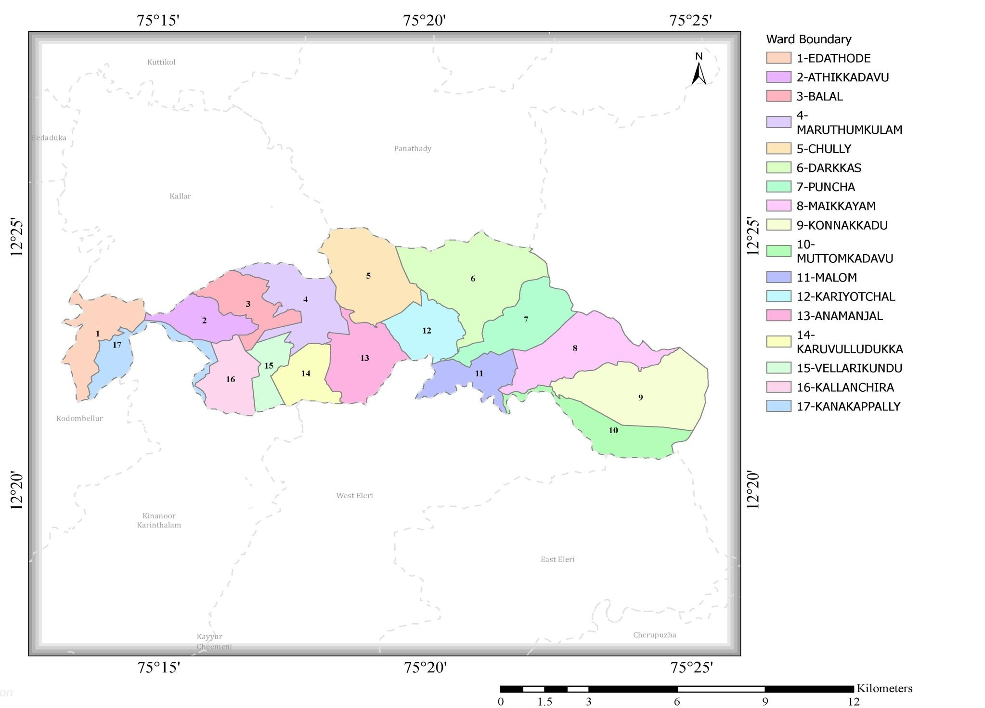

Dengue fever

Leptospirosis

Hepatitis A

Mumps

Ward No | Dengue Total (2021-25) | Leptospirosis Total (2021-25) | Hepatitis A Total (2021-25) | Mumps (2021-25) | ADD (2021-25) | Total Cases
1 | 27 | 2 | 0 | 1 | 65 | 95
2 | 13 | 0 | 0 | 1 | 57 | 71
3 | 34 | 0 | 1 | 2 | 70 | 107
4 | 30 | 2 | 1 | 1 | 67 | 101
5 | 19 | 2 | 1 | 2 | 112 | 136
6 | 17 | 3 | 0 | 1 | 107 | 128
7 | 16 | 1 | 0 | 3 | 106 | 126
8 | 18 | 2 | 1 | 1 | 121 | 143
9 | 20 | 2 | 1 | 1 | 97 | 121
10 | 21 | 2 | 0 | 1 | 119 | 143
11 | 12 | 3 | 0 | 2 | 114 | 131
12 | 29 | 2 | 2 | 4 | 101 | 138
13 | 22 | 2 | 0 | 0 | 69 | 93
14 | 27 | 0 | 0 | 1 | 45 | 73
15 | 21 | 0 | 1 | 1 | 60 | 83
16 | 17 | 1 | 0 | 0 | 61 | 79
17 | 0 | 0 | 0 | 0 | 45 | 45

By overlaying five years of data, we have identified 3,4,5,12'Red Zone' Wards. These are wards where at least two different categories of diseases (e.g., Dengue and Lepto) recurred in consecutive years. Ward 4 is categorized as the Highest Priority Hotspot due to its combination of flood vulnerability and high vector density.

Preparedness and Response Protocol at LSG Level
This section describes the operational framework for the LSGI once a pandemic is declared. It explains how the LSGI and health system will move from routine data collection to active response, using a One Health approach.

Constitution of One Health Committee
The LSGD shall constitute a One Health Committee comprising the LSGI President, Medical Officers (Modern Medicine, AYUSH, and Veterinary), the Health Inspector, and the Veterinary Surgeon.

Objective: The One Health Committee coordinates human, animal, and environmental health to prevent and control pandemics.

Sl No | Name | Designation | Department/Institution | Role in Committee | Contact Number
1 | Latha A | Panchayat President | LSGD | Chairperson | 9496147860
2 | Dr.Shinil V | Medical Officer (PHC/CHC) | Health Dept | Member Secretary | 9400447750
3 | Dr. Reshma Kalyan | Medical Officer (PHC/CHC) | Health Dept | Member Secretary | 7034123120
4 | Dr. Karthikeyan | Veterinary Officer | Animal Husbandry | Member | 9645068809
5 | Dr Bhagyalakshmi C K | Epidemiologist | Health Dept | Member | 9947254749
6 | Anilkumar | Health Inspector/PHN | Health Dept | Surveillance | 9447937230
7 | Saju Sebastian | Health Inspector/PHN | Health Dept | Surveillance | 9400822322
8 | Shyni M A | ASHA Supervisor | Health Dept | Community link | 9497601574
9 | Rabitha | ICDS Supervisor | Social Welfare | Vulnerable groups | 8289853925
10 | Mukundhan | Police Station Officer | Police Dept | Law & order | 4672242300
11 | Shajan Paingot | Ward Councillor Representative | LSGD | Community coordination | 9496139485
12 | Mary Babu | Kudumbashree CDO | Kudumbashree | Community mobilisation | 9846178820
13 | Kunhi krishnan Nair | NGO/Volunteer rep | Civil Society | Support services | 9495780968

Key Responsibilities:
- Review disease surveillance data (human + animal)
- Conduct ward-wise risk assessment and vulnerability mapping
- Approve quarantine/isolation centre locations
- Coordinate with district for resources (PPE, oxygen, ambulances)
- Periodically review health system surge capacity, including beds, oxygen, human resources, and ambulances.
- Approve and monitor risk communication and community engagement strategies, including rumour management.
- Ensure protection and service continuity for vulnerable groups (elderly, persons with disabilities, dialysis patients, coastal populations).
- Conduct quarterly mock drills
- Monitor equity measures for vulnerable groups

Meeting Schedule:
Quarterly (normal times) | Weekly (outbreak alert) | Daily (pandemic phase)

Pandemic Response Workforce
To ensure a coordinated and timely response during a pandemic, a dedicated Pandemic Response Workforce shall be constituted at the LSG level. The workforce will function under the overall supervision of the One Health Committee and in close coordination with the health authorities. Team-based deployment will enable efficient surveillance, case management, quarantine and isolation management, logistics support, and risk communication. Each team shall have a clearly designated team leader, defined roles, and an identified pool of personnel to allow rapid activation, rotation of duties, and continuity of services during prolonged emergencies.

Total Response Workforce Available: 300 persons

Team Name | Composition | Key Responsibilities | Team Leader
Surveillance and Contact Tracing Team | HI, JHI, JPHN, ASHAs and Volunteers | Case detection, contact listing, home visits, reporting | HI
Case Management Team | Doctors, Nurses, MLSP, Palliative Nurses | Patient care & referral | Medical Officer(Clinician)
Quarantine & Isolation Team | LSGD staff, Volunteers | Facility management | JHI
Logistics & supply chain Team | LSGD staff, Storekeepers, Drivers 3 | Supplies & transport [PPE, medicines, oxygen, transport, waste management] | Ward Member
Communication Team | Ward members, Kudumbashree, Youth clubs,  AWW workers and other self help groups | IEC, community meetings, countering misinformation | M.O in charge
Transportation | KSRTC, educational institutional buses | Mobilisation | staff Nurse
All response teams shall be activated immediately upon issuance of an outbreak alert or declaration of a pandemic. Each team shall report daily to the LSG Incident Commander or Medical Officer, with consolidated reporting forwarded to the Block Primary Health Centre (FHC). Duty rosters, along with designated alternate personnel, shall be maintained to ensure continuity of essential services during staff shortages or extended response operations. The composition and size of teams may be modified based on the scale of the outbreak and the availability of human resources.

Activities and Measures before and during Pandemic

PHASE 1 - Alert / Preparation
Surveillance and Reporting-Enhanced syndromic surveillance:
Surveillance data shall be collected from multiple integrated sources, including routine reporting from health facilities, community-based reporting systems, laboratory confirmations, and inputs from veterinary and environmental surveillance units. Event-based triggers such as unusual clustering of fever cases, sudden animal morbidity or mortality, or any atypical health events reported from the field shall be actively monitored and promptly reported through the established notification system for rapid assessment and response.
Zoonotic and animal health surveillance shall be strengthened through continuous coordination with veterinary services and field-level animal health workers to detect early signals of spillover risks. Any abnormal disease patterns in livestock or domestic animals shall be treated as priority alerts. In parallel, logistics and stock preparedness shall be ensured through empanelment of local vendors, defined emergency procurement procedures, pre-identified storage facilities, and maintained stock registers. A designated logistics nodal officer shall oversee rapid stock verification, ensure buffer stock availability of essential supplies such as PPE kits, masks, gloves, sanitizers, and equipment, and coordinate timely replenishment with higher authorities while maintaining stock rotation and expiry monitoring.

Identification of Quarantine and Isolation Facilities
  - Identify and list suitable buildings for quarantine and isolation (schools, hostels, community halls, etc.).
  - Categorise cases as per the severity and allocate to appropriate facilities (for instance, severe cases to classrooms, mild cases to an assembly hall in case of a school).
  - Facility readiness checklist needed (beds, toilets, ventilation) etc.
  - Find an alternate site if the primary sites are not available or not in use.
  - Identify facility managers and support staff
  - Prepare basic SOPs for:
    - Admission and discharge
    - Food, water, sanitation
    - Infection prevention and waste disposal
  - Ensure availability of basic amenities: water, sanitation, electricity, ventilation, and waste disposal. Prepare a rapid activation plan for these facilities if case numbers increase.

Risk Communication and Community Preparedness
  - Disseminate early warning messages on symptoms, preventive measures, and reporting mechanisms. Display IEC materials both in English and the local language in public places and ensure ward-level awareness.
  - Sensitize elected representatives and community leaders on preparedness measures.
  - Establish a rumour tracking and misinformation response mechanism to identify, verify, and promptly counter false or misleading information.
  - Engage trusted local persons (ward members, ASHA workers, religious leaders, teachers, community volunteers) to communicate official public health messages and reinforce correct practices.
  - Develop and deploy targeted IEC materials for:
    - Schools and educational institutions
    - Markets and commercial areas
    - Work sites and labour settings
  - Conduct community sensitization meetings at the ward level to promote preventive behaviors, address concerns, and strengthen community participation in preparedness and response.

Protection of Vulnerable Groups
Vulnerable populations require priority protection through targeted line-listing, service continuity, and delivery mechanisms.
- Prepare and regularly update line-lists of vulnerable populations, including:
  - Elderly persons living alone
  - Persons with disabilities
  - Pregnant women
  - Migrant workers
  - Dialysis patients

Clinical Dependency Mapping
Develop ward-wise dependency and vulnerability maps to identify households requiring regular support during emergencies. Ensure continuity of essential health services for vulnerable groups, including
- Dialysis services (facility mapping, transport arrangements, and scheduling)
- Continuity of treatment for TB, HIV, and other chronic conditions requiring uninterrupted medication
- Mental health and psychosocial support services
Establish delivery mechanisms for food, essential commodities, and medicines to vulnerable households through coordinated action involving ASHAs, JPHNs, Kudumbashree, volunteers, and local administration.

PHASE 2 - Active Response

Case Identification and Contact Tracing
Case detection and contact tracing activities will be carried out in coordination with the Health authorities, following disease-specific SOPs and IDSP guidelines.
Field Staff Involved
- Health Inspector (HI)
- Junior Health Inspector (JHI)
- Junior Public Health Nurse (JPHN)
- ASHAs and ASHA Supervisors
- Ward-level volunteers and Kudumbashree members (as required)

Screening Checkpoints
Screening checkpoints at high-traffic locations (transport hubs, markets, religious gatherings) for early detection of symptomatic travellers and crowd screening during outbreaks. Potential locations include bus stands, market entry points,based on local context and risk assessment.
Screening activities will be carried out by trained personnel such as ASHAs, ward members, and volunteers, with support from Health Department staff. Necessary equipment, including non-contact thermometers and appropriate PPE, shall be ensured prior to activation.
At the bus stand, which serves as a major transport hub, surveillance activities shall be conducted through the deployment of one Junior Health Inspector (JHI), one ASHA worker, and one Health Mentor. The team will carry out frontline screening and monitoring of incoming and outgoing passengers.
Screening methods shall include swab collection where required, blood smear collection for rapid diagnostic testing (RDT), and the use of thermal scanners for fever screening. These measures are aimed at early detection of potential infectious cases and timely referral for further evaluation.
All findings and daily surveillance outputs shall be reported to the Surveillance Nodal Officer stationed in the control room to ensure coordinated monitoring and rapid response actions.
Standard Screening Protocol

The screening protocol shall include temperature screening, observation for visible symptoms, and inquiry regarding recent travel or exposure history. Individuals identified as suspects during screening shall be immediately referred to the nearest PHC/FHC for further evaluation, testing, and appropriate action as per prevailing guidelines.

Pandemic Control Room
The Pandemic Control Room (PCR) serves as the central nerve center for real-time coordination, data aggregation, decision support, and communication during outbreaks. It consolidates information from all LSGD teams, health facilities and community sources to enable rapid response decisions.

Control Room Infrastructure and Location
Primary Location: Balal Panchayath Office.
Backup Location: Community Hall in Balal G.P.

Health System Control Room Framework
The PCR is organized into seven functional pillars to ensure no aspect of the response is overlooked:

Rapid Response Team (RRT)
  - Provides immediate intervention during emergencies, clusters, and field alerts.​
  - Coordinates urgent actions such as case investigation, contact tracing, isolation, and inter‑facility referrals.

Data Management & Analytics Team
  - Collects, validates, and manages key health system indicators (cases, tests, beds, HR, supplies).​
  - Analyzes data trends, generates projections, and supports evidence‑based decision‑making for local authorities.

Human Resource Deployment Team
  - Allocates healthcare staff efficiently based on workload and need
  - Ensures adequate and equitable workforce distribution across facilities

Laboratory Surveillance Team
  - Oversees diagnostic testing coordination, sample transport, and timely reporting of results.​
  - Monitors lab indicators (testing volume, positivity rate, turnaround time) for early detection of outbreaks

Vaccination Cell (If Required)
  - Plans and executes vaccination campaigns, including micro‑planning and session scheduling.​
  - Tracks coverage, identifies gaps, and coordinates corrective actions with field teams and outreach services.

Infrastructure & Patient Occupancy Team
  - Monitors facility capacity, earmarked beds, oxygen and critical care resources across all linked facilities.​
  - Ensures optimal patient distribution and referral management using updated bed‑status and resource data.
  - BMWM
- The outbreak response system shall be organized into key functional teams to ensure efficient coordination and rapid action. The Communication Team will manage risk communication, public messaging, and information dissemination to the community. The Logistics and Supply Chain team will ensure timely procurement, storage, and distribution of essential supplies, including medical equipment and consumables.
- The Transportation team will handle inter-facility patient transfer and emergency transport services, ensuring rapid mobility during critical situations. A Media Surveillance and Call Centre unit will monitor public information channels, manage incoming calls, and address misinformation while supporting early event detection. The Management of the Deceased team will ensure dignified handling of bodies in accordance with health and safety protocols. Finally, the Intersectoral Coordination and Convergence team will facilitate collaboration between health, local self-government, veterinary, and other allied departments for a unified outbreak response.

Key Control Room Team
The Control Room Team coordinates all pandemic response activities within the LSGD and serves as the single command and communication hub during activation. It integrates information, field actions, logistics, and policy execution across all participating departments and health facilities.

Role | Name | Designation | Contact Number | Responsibility
In-charge/Nodal Officer | Dr.Shinil v | Medical officer | 9400447750 | Overall coordination, decision-making, and reporting to the District level.
Communication Officer | Anilkumar | Health inspector | 9447937230 | Handling the public helpline, coordinating ambulance dispatch, and contact tracing calls.
Logistics Coordinator | Bijeesh | Pharmasist | 8590913098
Technical Support(IT/Data) | Ebin P A | Data Manager | 8086105436 | Managing the line list, updating dashboards, and tracking testing results.

Key Points:
- The Control Room shall be staffed with a designated In-charge, data entry personnel, and communication staff with clearly defined roles and shift arrangements.
- It shall maintain updated records on daily monitoring indicators including new cases, persons under active quarantine, and hospital bed occupancy.
- All reports and situation updates shall be shared daily with the Block and District Surveillance Unit.
- The Control Room shall act as a single point of contact for coordination with response teams, health institutions, and other departments.
- Contact details of the Control Room shall be widely communicated to field staff and stakeholders during activation.

Daily Monitoring Indicators
To ensure timely decision-making and effective response, the following key indicators shall be monitored and updated on a daily basis by the Pandemic Control Room:

Epidemiological Indicators:
New cases reported today, Total active cases, Test Positivity Rate (TPR), Case Fatality Rate (CFR)
- Surveillance Indicators:
Persons under home quarantine, High-risk contacts identified, Fever, ILI, SARI or other symptoms (syndromic surges), Travellers (symptomatic or high-risk arrivals),Animal husbandry surveillance (zoonotic alerts, unusual animal deaths, poultry/bird flu signals), Mortality surveillance (excess deaths, unexplained fatalities, verbal autopsy reports)
- Logistics and Infrastructure Indicators:
Hospital / CFLTC beds occupied, Oxygen cylinders/concentrators available, Ambulances on standby
- Alert Findings
The following table outlines category-specific trigger points (red flags) from surveillance indicators and corresponding immediate actions for the Pandemic Control Room. These enable rapid response to alert findings like testing anomalies, positive cases exceeding thresholds, clusters, and WGS reports.

Category | Trigger Point (Red Flag) | Immediate Action
Clusters | Geographical or facility-based: 5+ cases linked to one location (office, school, street). | Declare a micro-containment zone; perimeter control and active case finding.
Testing | Sudden drop in testing volume / delay in reporting / unusual testing trends | Review the sample collection process, address lab bottlenecks, deploy additional testing teams, and notify the District Lab.
Lab | Test Positivity rate increases | Increase testing sites in that ward.
Hospital | >80% Oxygen bed occupancy | Activate backup/CFLTC beds.
Travel | Cluster of cases from a single flight/train or high-risk arrival group. | Trace all passengers in adjacent seats; implement mandatory institutional quarantine.

Communication of Public Health Information
A Community Communication Hub shall be established to ensure timely, accurate, and consistent dissemination of information during a pandemic. The Hub will function under the coordination of Nodal officers of the control room and act as the nodal point for public communication, risk messaging, and community engagement. It will support dissemination of official advisories, promote preventive behaviors, address rumors and misinformation, and ensure that messages reach all sections of the population through trusted local channels and leaders.

Key communicators
Channel | Responsible Person | Contact
Ward-level announcements | Shajan Paingot | 9496139485
Social media | Harikrishnan | 8086399785
Local Cable TV/Radio | City Channel | 9496358939

- All messages disseminated through the Hub shall align with advisories issued by the Health Department and District authorities.
- Community leaders shall be sensitized to support behavior change, reduce stigma, and counter misinformation.
- Special efforts shall be made to reach vulnerable and hard-to-reach populations using locally appropriate communication methods.

Rumor Tracking: A designated volunteer will monitor local social media/WhatsApp groups daily to identify misinformation and issue official clarifications via the Communication Hub.

Coordination with District/State Authorities & Other Organisations
Effective coordination with Block, District, and State authorities is essential to ensure timely reporting, technical guidance, and uninterrupted supply of essential resources during a pandemic. The LSG shall establish clear communication channels, designate responsible officers, and adhere to prescribed reporting timelines to support coordinated public health action and efficient resource mobilisation.

Key Details:
Reporting Schedule and Protocols:

To Whom | What to Report | Frequency | Nodal Person
Block PHC | Complete Situation Report (Cases, Quarantine, Beds, Screening, Deaths) | Weekly | MO
District IDSP Unit | Outbreaks/Clusters/Unusual Events (>5 cases same ward) | weekly | Epidemologist
Veterinary Officer | Animal health events/Zoonotic alerts | weekly | Veterinary Officer

Supply Chain Coordination
The LSG shall coordinate closely with Block, District, and State authorities (KMSCL) to ensure uninterrupted availability of essential goods, medical supplies, and logistics during a pandemic. Supply requirements shall be assessed regularly based on case load and communicated promptly to the appropriate authorities for timely replenishment.
Key Points:
- Maintain updated contact details of District and Block nodal officers for health logistics, oxygen supply, ambulances, and essential medicines.
- Submit timely indent requests for PPE, testing kits, medicines, oxygen, and other critical supplies through prescribed channels.
- Monitor stock levels at LSGD facilities, quarantine/isolation centres, and field teams through daily stock registers and dispensing logs to prevent shortages.
- Coordinate with District authorities, Karunya/Neethi medical shops, and local purchase committees for funds allocation and emergency procurement.

- Ensure regular monitoring of dispensing registers at all facilities to track usage, expiry, and pilferage—shortages being a perennial issue requiring proactive weekly audits.

- Activate surge procurement protocols during high caseloads, leveraging local purchase powers under LSGD funds alongside state supplies.

Resource Inventory and Contacts
Resource Category | Source  (District/State/Private) | Contact
PPE Kits/Masks/Gloves | KMSCL | 9745158939
PPE Kits/Masks/Gloves | Local Vendors | 7902682506
Oxygen  Cylinders/Concentrators | KMSCL | 9745158939
Medicines/Antivirals | KMSCL | 9745158939
Medicines/Antivirals | Neethi Shops | 7902682506
Test Kits (RTPCR/Rapid) | KMSCL | 9745158939

Collaboration with NGOs, PPP, and CSR
To augment government efforts during a pandemic, the LSG shall collaborate with NGOs, voluntary organisations, and private sector partners through public–private partnerships and Corporate Social Responsibility (CSR) initiatives, in coordination with District authorities.

Key Points:
- Engage NGOs and community-based organisations for community outreach, awareness, and support to vulnerable populations.
- Leverage CSR support for procurement of medical equipment, PPE, oxygen concentrators, food kits, and sanitation materials, as permitted.
- Ensure all collaborations align with government guidelines and are routed through approved administrative and financial procedures.
- Maintain transparency and documentation for all external support received and utilised.
Organization | Type | Support Offered | Contact Person
Youth Clubs/Student Unions | CBO | Food Items, shelter Homes | 9446838207 Saji

Interdepartmental Coordination
Coordination among departments during a pandemic shall be ensured through regular review meetings convened by the LSGD President. These meetings will provide a structured platform for sharing situational updates, assessing resource availability, resolving operational gaps, and taking joint decisions to ensure a coordinated and timely response.

Department | Representative | Key Role | Contact
Health (PHC) | Staff Nurse : Haseena Ismail | Case management | 9605231510
Veterinary | Veterinary Surgeon:Dr. Karthikeyan | Animal surveillance | 9645068809
ICDS | Supervisor:Rabitha | Nutrition support | 8289853925
Education | Head Teacher: Jose Kutty | School coordination | 9495647717
Police | SHO Vellarikkund | Containment enforcement | 4672242300
LSGD Engineering | Sijitha | Quarantine infrastructure | 9495129885

PHASE 3 - Surge Capacity
Phase 3 is activated when there is a rapid increase in cases, high test positivity rates, or when existing health facilities and quarantine arrangements approach saturation. The focus of this phase is to expand isolation capacity, augment clinical care services, and mobilise additional resources through district and state support mechanisms.

Conversion of Community Facilities
To manage increased case load, the LSGD shall activate additional isolation facilities by repurposing identified community infrastructure such as community halls, auditoriums, schools, hostels, or other suitable buildings.

Name of facility | Facility Type | No. of Buildings | Ward | Surge Capacity (Beds) | Nodal Person
Payalam community hall | Government (LSGD ) | 1 | 1
Arinkallu community hall | Government | 1 | 2 |  | 9745886054
Balal community hall | Government | 1 | 3
Maruthumulam community hall | Government | 1 | 4
Konnanamkadu community hall | Government | 1 | 4
Maruthom community hall | Government | 1 | 5 |  | 8086268508 (Tomy)
Padi community hall | Government | 1 | 5 |  | 9744775872 (Sathyan)
Poovathummutta | Government) | 1 | 5 |  | 8330801303
Malom cultural centre | Government) | 1 | 7
Vallikochi community hall | Government) | 1 | 8
Konnakad community hall | Government | 1 | 9
Cherumbaakode community hall | Government | 1 | 10
Karyottuchal community hall | Government | 1 | 12
Eramchitta community hall | Government ) | 1 | 15
Recovery and rehabilitation phase
During the recovery phase, systematic activities shall be undertaken to restore normalcy and strengthen resilience. This includes damage and impact assessment to evaluate the extent of health, social, and infrastructural disruption, followed by phased restoration of essential health services. Rehabilitation of the affected population shall be prioritized, along with psychosocial and mental health support to address post-outbreak stress and trauma.
Continuous disease surveillance shall be maintained during the recovery phase to detect any resurgence or secondary outbreaks. Environmental cleanup and sanitation activities shall be undertaken to reduce residual public health risks. Efforts shall also focus on livelihood restoration, community engagement, and confidence-building measures to restore normal community functioning.
In addition, documentation and after-action review shall be conducted to capture lessons learned and best practices. These findings will support health system strengthening, policy revision, and improved preparedness planning. Opportunities for research shall also be encouraged to enhance evidence-based public health response in future outbreaks.

CONCLUSION

The outbreak preparedness and response framework is designed to ensure coordinated, rapid, and effective public health action across all phases of an emergency, from early detection to recovery and system strengthening. It integrates surveillance, logistics, communication, clinical response, and intersectoral coordination to minimize health impacts and ensure continuity of essential services.

Technical support shall be strengthened through dedicated IT systems, digital reporting platforms, and real-time data management tools to ensure timely decision-making. Relief-based commodities, including essential medical supplies, food support, and hygiene materials, shall be pre-identified and mobilized rapidly during emergencies.

Communication support shall include trained operators for handling emergency calls and information dissemination to ensure accurate and timely public messaging. Hazard and vulnerability mapping shall be continuously updated to identify high-risk zones and guide targeted interventions.

Coordination with KSEB and other critical power supply agencies shall be ensured for uninterrupted electricity supply to health facilities, cold chain systems, and emergency response operations. Clearly defined HR-specific responsibilities shall be assigned to all response personnel to ensure accountability, role clarity, and efficient functioning during outbreak situations.

RECOMMENDATIONS

Strengthening Healthcare Infrastructure
- Establish a primary health response unit within the Panchayath with trained staff.
- Ensure availability of basic medical supplies (masks, sanitizers, PPE kits, oxygen cylinders).
- Create tie-ups with nearby hospitals in Vellarikundu and Malom for emergency referral and transport.

2. Community Awareness & Education
- Conduct regular awareness campaigns on hygiene, vaccination, and preventive measures.
- Use local communication channels (community radio, WhatsApp groups, notice boards) to spread verified information.
- Train volunteers to act as health ambassadors in each ward.

3. Emergency Response & Coordination
- Form a Pandemic Preparedness Committee at Panchayat level including health workers, ward members, and NGOs.
- Develop a clear action plan for lockdowns, quarantine, and distribution of essentials.
- Maintain a database of vulnerable groups (elderly, differently-abled, chronically ill) for targeted support.

4. Supply Chain & Food Security
- Identify and support local suppliers and farmers to ensure uninterrupted food supply.
- Create community kitchens during emergencies to serve vulnerable populations.
- Stockpile essential commodities in Panchayat-run outlets for crisis periods.

5. Digital Preparedness
- Promote digital platforms for telemedicine consultations.
- Use Panchayat’s website/social media for real-time updates on health advisories.
- Encourage online grievance redressal to reduce crowding in offices.

6. Training & Capacity Building
- Organize mock drills for pandemic response in schools, offices, and public spaces.
- Train Panchayat staff and volunteers in first aid, infection control, and crowd management.
- Collaborate with NGOs and health departments for capacity-building workshops.

7. Long-Term Resilience
- Integrate pandemic preparedness into the Panchayat Development Plan.
- Allocate a dedicated budget for health emergencies.
- Encourage community participation in planning and monitoring preparedness measures.

MOCKDRILL SCENARIOS
Scenario 1: Infectious Disease Outbreak
Step 1: Planning and Objective Setting
- Define drill objectives (early detection, triage efficiency, isolation readiness, ICU preparedness).
- Assign Incident Commander and observers.
Step 2: Scenario Trigger
- Simulated patient presents to Emergency with high fever and respiratory symptoms.
- Additional suspected cases reported from nearby areas.
Step 3: Triage and Isolation
- Activate fever triage desk.
- Provide masks and shift patients to isolation wards.
- Initiate infection prevention protocols.
Step 4: Activation of Hospital Incident Command System
- Inform Medical Superintendent.
- Alert Rapid Response Team (RRT).
- Notify District Surveillance Unit.
Step 5: Clinical Management and Sample Collection
- Assess severity and start oxygen/medical management.
- Collect and dispatch samples following biosafety protocol.
Scenario 2: Landslide Disaster
Step 1: Planning and Objective Setting
- Define objectives (mass casualty management, triage, emergency surgery readiness).
- Assign disaster management team and observers.
Step 2: Scenario Trigger
- Information received about landslide in nearby area with multiple casualties.
- Ambulances begin transporting injured patients.
Step 3: Mass Casualty Triage Activation
- Activate disaster triage area outside Emergency.
- Categorize patients (Red – critical, Yellow – moderate, Green – minor).
Step 4: Emergency Response Activation
- Activate Hospital Disaster Management Plan.
- Mobilize surgeons, anesthetists, nurses, blood bank, and OT team.
Step 5: Clinical Management and Stabilization
- Provide emergency resuscitation and trauma care.
- Arrange emergency surgeries and blood transfusion if required.

ANNEXURE

IMPORTANT PHONE NUMBERS

Phone numbers and particulars of persons responsible for providing guidance, assistance, and support for pandemic preparedness operations may be provided here in a manner that allows easy reference at a glance.The information recorded here could be exhibited elsewhere at the time of emergencies. LSG institutions shall give special attention to collect and record the above data of persons and institutions who/which are supposed to give technical and co-ordination support to reduce the impact of pandemic.

1.1. Details of grama panchayat/municipality/corporation wards
Sl.No | Name of the ward | Ward number | Name of the ward  member | Contact number
1 | Edathode | 1 | Jitha P V | 9544974440
2 | Athikadau | 2 | Latha A | 9496147860
3 | Balal | 3 | Sreedharan C V | 9747207307
4 | Maruthamkulam | 4 | Chandran T V | 9947990768
5 | Chulli | 5 | Mini Antony | 8547974772
6 | Darkhas | 6 | Dhanya C | 7306226567
7 | Punja | 7 | Lakshmi C K | 6282368091
8 | Maikayam | 8 | Mini Mathew | 9656249639
9 | Konnakad | 9 | Kunjiraman | 9048649891
10 | Muttomkadav | 10 | Sanoj Mathew | 9074263705
11 | Malom | 11 | Roselin Sibi | 9745942026
12 | Karyottuchal | 12 | Raju Kattakayam | 9447649713
13 | Anamanjal | 13 | Jose Mathew | 9961707192
14 | Karuvulladukkam | 14 | Shoby Joseph | 9447864955
15 | Vellarikundu | 15 | Shajan P J | 9496139485
16 | Kallanchira | 16 | Sreeja M | 8281087139
17 | Kanakapally | 17 | shyamala A V | 9747821123

1.2. Other important phone numbers of grama panchayat/municipality/corporation area
Sl. No. | Name | Contact number
1. | Police department | 4672242300
2. | transport department | 4672986042
3. | Excise department
4. | Forest department

1.3. Important offices of grama panchayat/municipality/ corporation
Sl.No | Name of the office | Contact person | Contact number
1. | Village Office maloth | Village Officer | 8547617417
2. | Village Office Balal | Village Officer | 8547617422
3. | Village Office Parappa | Village Officer | 8547617439
4. | Agriculture Office Balal | Agriculture Officer | 0467224255, 9383472351
5. | Animal Husbandry Office | Animal Husbandry Doctor | 9188511242, 9400838007
6. | Police Station Vellarikkundu | Police Officer | 4672242300
7. | BSNL Office | Officer | 9446555411
8. | Block Office Parappa | Officer | 4672255655
9. | KSEB Office | Officer | 9496011456
10 | RTO office | Officer | 4672986042
11 | CDS office Balal | Officer | 9495416869

1.4. Health Services

Sl. No | Name of the hospital/institution | Location | Phone number
1. | Government hospitals/PHC | vellarikundu | 4672242228
2. | Private hospitals | vellarikundu | 9946336552
3. | Clinical laboratories | vellarikundu | 6235074110

1.5. Veterinary Services
Sl.No | Name of the Clinic | Name of the  Surgeon/Doctor | Place/location | Phone  number
1 | Govt.Veterinary Hospital | Dr. Karthikeyan | konnakad | 9645068809

1.6. Helpline numbers
Helpline | Phone number
Police | 4672242300
Fire and Rescue | 4994206100
KSEB | 9496011452

1.7. Public and Private Schools Contact details

S.No | Name of School | Institution type | Phone number
1 | G L P S Puncha | Govt | 9447854654
2 | G L P S Konnakad | Govt | 9446047420
3 | G L P S Edathode | Govt | 8281266513
4 | G L P S Chully | Govt | 8086355469
5 | G L P S Kanakapally | Govt | 9655137728
6 | G H S S Balal | Govt | 9539104486
7 | G H S S Maloth Kasaba | Govt | 9447612547
8 | A L P School Kallamchira | Aided | 9495376182
9 | Nirmalagiri L P School | Aided | 9497837020
10 | St. Josephs U P School Karivulladukkam | Aided | 9400813764
11 | St. Judes H S | Aided | 9495647717
12 | St. Judes H S S | Aided | 9496854911
13 | St. Judes Arts & Science College | Private | 04672242210, 9495855180
14 | Mother Savina Residential School | Private | 80869 05386
15 | St. Rosello Kanakappally | Private | 8088556378

1.9. Anganwadi Contact Details

Ward No | Name of Anganwadi Teachers | Phone number
1 | 28. Saraswathi | 8547686320
1 | 29. Priya | 9446742590
2 | 25. Shylaja | 9497607396
2 | 24. Sushama | 9497607420
3 | 19. Bindu | 9496422286
3 | 20. Mini Joy | 7025178845
3 | 23. Kausalya | 6238887854
4 | 21. Sumithra K | 9497056341
4 | 22. Lilly | 9497604571
13 | 14 Sumithra | 9497056341
13 | 16 Lailamma | 8606491350
17 | 17 Jolly | 9048225818
16 | 18 Mini | 7025178845
16 | 26 Manimol | 9562824579
16 | 27 Leela kumari | 9526043897
5 | 12. Jancy | 9946723930
5 | 13. Bindhu Vinod | 9645604941
6 | 9 Vasanthi | 8075826303
6 | 10 Sreekala | 9074843772
6 | 11 Lalitha | 9495417126
7 | 8 Rosmma P J | 9497728708
8 | 6 Sreeja | 8289808654
9 | 2 Seena | 8606794450
9 | 4 Sindhu | 9847244563
9 | 5 Usha | 9747441413
10 | 1 shima B | 8593948595
10 | 3
11 | 7 Lalitha T P | 9495417126
12 | 15 Sajitha A V | 9526150081

Ward No | Anganwadi No and Name of Teacher | Phone number
1 | 28. Saraswathi | 8547686320
1 | 29. Priya | 9446742590
2 | 25. Shylaja | 9497607396
2 | 24. Sushama | 9497607420
3 | 19. Bindu | 9496422286
3 | 20. Mini Joy | 7025178845
3 | 23. Kausalya | 6238887854
4 | 21. Sumithra K | 9497056341
4 | 22. Lilly | 9497604571
5 | 12. Jancy | 9946723930
5 | 13. Bindhu Vinod | 9645604941
6 | 9 Vasanthi | 8075826303
6 | 10 Sreekala | 9074843772
6 | 11 Lalitha | 9495417126
7 | 8 Rosmma P J | 9497728708
8 | 6 Sreeja | 8289808654
9 | 2 Seena | 8606794450
9 | 4 Sindhu | 9847244563
9 | 5 Usha | 9747441413
10 | 1 shima B | 8593948595
10 | 3
11 | 7 Lalitha T P | 9495417126
12 | 15 Sajitha A V | 9526150081
13 | 14 Sumithra | 9497056341
13 | 16 Lailamma | 8606491350
14 | 17 Jolly | 9048225818
16 | 18 Mini | 7025178845
16 | 26 Manimol | 9562824579
16 | 27 Leela kumara | 9526043897

1.12. Information regarding resources

Means of transportation | Name of Owner | Phone Number
Heavy Trucks | Akhil | 7510918989
Tractor
Ambulances | JEEVAN AMBULANCE | 8606644844
Taxi service | MELBIN (shalom) | 8547078119

Annexure 1: LSG Baseline Data Collection Format
A. Baseline data
Sl. No. | Indicator / Field | Baseline Data | Source / Remarks
1 | Name of LSG | Balal
2 | District | kasaragod
3 | Block / Taluk | parappa block, vellarikundu thaluk
4 | Type of LSG (Gram Panchayat / Municipality / Corporation) | Grama Panchayat
5 | Area (sq. km) | 93.2 | https://dop.lsgkerala.gov.in/en/node/1025
6 | No. of wards | 17
7 | GIS boundary file available | (Yes/No)
8 | Key contact person & phone

B. Demography
Indicator / Field | Baseline Data | Source / Remarks
Total population | 23412 | LSGD
Males | 11621 | LSGD
Females | 11791 | LSGD
Transgender population | 0 | LSGD
Age distribution  (<5, 5–14, 15–59, ≥60) | 1209, ,3574 | LSGD
No. of households | 5786 | LSGD
Population density (persons/sq.km) | 265 | LSGD
No. of migrant workers | 863 | lsgd
Major occupational groups | agriculture | lsgd

C. Vulnerable Populations & Social Risks
Sl. No. | Indicator / Field | Baseline Data (Value / Description) | Source / Remarks
1 | No. of elderly (≥60) | 3574 | LSGD
2 | No. of persons with disability | 354 | LSGD
3 | No. of bedridden persons | 130 | LSGD
4 | No. of chronic disease cases (DM/HTN/COPD/CKD etc.) | 4641 | FHC Medical Records
5 | Pregnant women (current estimate) | 120 | FHC Medical Records
6 | Children <5 years | 1209 | FHC Medical Records
7 | Tribal population (if any) | 5925 | FHC Medical Records
8 | Fisherfolk / coastal vulnerable groups (if any) | 0
9 | Urban slums / unnotified settlements (if any) | 0
10 | Homeless population | 0
11 | Orphanages / old age homes (number & capacity) | 2
12 | Hostels / prisons / shelters (number & capacity) | 0
13 | Poverty / BPL estimate | 741 | lsgd
14 | Food insecurity hotspots | 0
15 | Any history of stigma/discrimination issues (Yes/No) | No

D. Health System & Service Readiness
Sl. No. | Indicator / Field | Baseline Data (Value / Description) | Source / Remarks
1 | No. of health facilities in LSG (PHC/CHC/TH/DH/Private) | 2
2 | PHC/Family Health Centre details (name, location) | Bfhc vellarikkundu  Phc Konnakad
3 | Subcentres / Health & Wellness Centres (number) | 7
4 | Private clinics / hospitals (number) | 5
5 | Labs available (public/private) | 5
6 | Availability of ambulance services (Yes/No, number) | Yes 2
7 | Availability of isolation/quarantine facilities (Yes/No, details) | No
8 | Cold chain facilities (Yes/No, details) | No
9 | Stockpile space available (Yes/No) | No
10 | PPE / mask / sanitizer availability plan (Yes/No) | NO
11 | Surveillance staff available (JHI/JPHN/ASHA count) | 12/14/17
12 | Existing emergency referral pathways (Yes/No) | No

E. Points of Entry & Mobility
Sl. No. | Indicator / Field | Baseline Data (Value / Description) | Source / Remarks
1 | Bus stands / depots (number) | nil
2 | Railway stations (number) | nil
3 | Boat jetties / fishing harbours (number) | nil
4 | Ports / airports nearby (specify distance) | nil
5 | Major highways/roads passing through | Malayora Highway
6 | Border crossings (state/district) | karnataka
7 | Major markets / weekly markets | nil
8 | Tourism hubs / major event venues | Kottanchery
9 | Schools/colleges with hostels (number) | 0
10 | Factories / large workplaces (number) | 0
F. Water, Sanitation & Hygiene (WASH)
Sl. No. | Indicator / Field | Baseline Data (Value / Description) | Source / Remarks
1 | Major drinking water sources (piped / wells / borewells / springs) | Wells & Borewells  2900
2 | No. of public wells | 106 | LSGD
3 | No. of households with piped water connection | 0
4 | Water quality testing routine (Yes/No) | Yes
5 | Common contamination risks (flooding, salinity, industrial waste) | NIL
6 | Open defecation free status (Yes/No) | YES
7 | Solid waste management system (Yes/No) | YES
8 | Bio-medical waste disposal mechanism (Yes/No) | YES
9 | No. of public toilets | 3
10 | Handwashing stations in public places (Yes/No) | yes
G. Zoonotic Risks & One Health
Sl. No. | Indicator / Field | Baseline Data (Value / Description) | Source / Remarks
1 | Livestock population (cattle/goats/pigs/poultry) – estimates | 315
2 | No. of dairy farms / poultry farms / pig farms | 20
3 | Slaughterhouses / meat shops (number) | 0
4 | Animal markets (Yes/No, details) | 0
5 | Veterinary dispensaries (number) | 1
6 | History of zoonotic outbreaks (rabies, leptospirosis, etc.) | nil
7 | Stray dog population management measures (Yes/No) | No
8 | Rodent infestation hotspots (Yes/No) | No
9 | Wetlands / waterlogged areas prone to leptospirosis | Yes
10 | Bat roosting areas / caves / fruit orchards (if any) | Yes
11 | Human-animal interface hotspots (farms near residences) | No
H. Climate & Disaster Risks (Pandemic Amplifiers)
Sl. No. | Indicator / Field | Baseline Data (Value / Description) | Source / Remarks
1 | Flood-prone wards (list)
2 | Landslide-prone wards (list) | 13,6,4,2,1,8
3 | Cyclone/sea surge risk (Yes/No) | 5,6,7,,8,9,10
4 | Heatwave risk zones (Yes/No) | No
5 | Waterlogging areas (list) | No
6 | Shelter homes / relief camps (number, capacity) | 0
7 | Past disaster displacement history | No
8 | Disruption to water supply/transport common (Yes/No) | No
I. Critical Infrastructure & Logistics
Sl. No. | Indicator / Field | Baseline Data (Value / Description) | Source / Remarks
1 | Schools (number) | 18
2 | Anganwadis (number) | 29
3 | Colleges (number) | 1
4 | Community halls (number) | 14
5 | Places of worship with large gatherings (number) | 20
6 | Large markets / shopping areas (number) | 0
7 | Warehouses / cold storages (number) | 0
8 | Telecom/mobile network coverage gaps (Yes/No) | Yes
9 | Power outage frequency (high/medium/low) | low
10 | Availability of generators in key facilities | No

J. Risk Communication & Community Networks
Sl. No. | Indicator / Field | Baseline Data (Value / Description) | Source / Remarks
1 | Ward-level rapid response teams (Yes/No) | Yes
2 | Jagratha samithis / committees active (Yes/No) | Yes
3 | Kudumbashree presence and strength (number of units) | Yes
4 | Volunteer network (number, coverage) | Yes
5 | Community-based surveillance mechanisms (Yes/No) | Yes
6 | IEC dissemination channels (WhatsApp groups, community radio, PA systems) | Yes
7 | Rumour tracking mechanisms (Yes/No) | Yes
8 | Languages spoken / literacy considerations | Yes
9 | Vulnerable groups communication strategy available (Yes/No) | No

K. Preparedness Planning & Governance
Sl. No. | Indicator / Field | Baseline Data (Value / Description) | Source / Remarks
1 | LSG emergency plan available (Yes/No) | YES
2 | Pandemic preparedness plan available (Yes/No) | YES
3 | Incident Command System identified (Yes/No) | YES
4 | Rapid procurement mechanism available (Yes/No) | YES
5 | Emergency fund available (Yes/No, amount) | YES
6 | Past outbreak response experience (Yes/No, details) | YES / 1 /HEPATITIS
7 | Intersectoral coordination mechanism (Health, Police, LSG, Veterinary, Education) | YES | Date : 1/1/26
8 | Mock drills conducted in last 12 months (Yes/No) | YES | Date: 11/04/25
9 | Training coverage for staff/volunteers (Yes/No) | YES

L. Surveillance & Data Systems
Sl. No. | Indicator / Field | Baseline Data (Value / Description) | Source / Remarks
1 | Digital reporting tools used (e.g., DHIS2, portals) | YES
2 | Availability of line-listing format (Yes/No) | YES
3 | Contact tracing team identified (Yes/No) | YES
4 | Mapping of high-risk households available (Yes/No) | YES
5 | Testing sample transport mechanism (Yes/No) | YES
6 | Reporting timeline adherence (good/average/poor) | GOOD
7 | Data sharing between departments (Yes/No) | YES
8 | Availability of dashboard for monitoring (Yes/No) | YES

M. Additional Notes & Observations

Sl. No. | Indicator / Field | Baseline Data (Value / Description) | Source / Remarks
1 | Key challenges perceived by LSG | The institution is constrained by limited resources and inadequate infrastructure
2 | Top 5 high-risk wards (reason) | 8,11 [Landslide prone wards]
3 | Any unique local risks (industrial pollution, refugee camps, etc.) | NIL
4 | Recommendations for preparedness strengthening | Early warning systems, effective communication, community awareness, regular training, and strong interdepartmental coordination are essential

