Pandemic preparedness plan Chavara

MESSAGE FROM BLOCK PANCHAYAT PRESIDENT
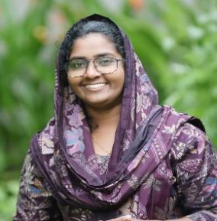
Shamna naushad
BLOCK PANCHAYT PRESIDENT

"The well-being and resilience of our people are the ultimate priorities of the Chavara Block Panchayat. From our bustling coastal fishing villages in Neendakara to our industrial heartlands near KMML and the serene island landscapes of Thekkumbhagom and Thevalkkara, every citizen deserves a robust shield against public health emergencies.
Our experience with recent outbreaks has taught us that preparedness is not just a policy—it is a community-wide commitment. This Pandemic Preparedness Plan is specifically designed to address the unique needs of Chavara, ensuring that our elderly, our hardworking coastal families, and our industrial workers are never left behind.
As a Block Panchayat, we are dedicated to:
- Strengthening our Local Health Infrastructure, from the Chavara Taluk Hospital to every Primary Health Centre.
- Empowering Grassroots Action through our ward-level teams, ASHA workers, and the spirit of community volunteering that defines our land.
- Decentralized Vigilance, ensuring timely fever surveillance and home-based care reach even the most interior parts of our five Grama Panchayats.
Preparedness is an ongoing journey. By combining modern health systems with the collective strength of our people, we are building a safer, more resilient Chavara. Together, we will stand ready to detect, respond to, and overcome any public health challenge that comes our way."

MESSAGE FROM BLOCK HEALTH STANDING COMMITTEE CHAIRPERSON
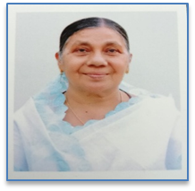
SMT Mary cherian
BLOCK HEALTH STANDING COMMITTEE CHAIRPERSON
Pandemic preparedness is a shared responsibility that requires coordinated planning, strong primary health systems, and active community participation. Our block, with its coastal population, vulnerable groups, and past experience with infectious disease outbreaks, must remain vigilant and ready to respond swiftly to any public health emergency.
This preparedness plan strengthens surveillance, laboratory services, human resource deployment, and protection of high-risk populations, while ensuring close collaboration between government, private sector, and community volunteers. Continuous training, mock drills, and decentralized response mechanisms will be key to timely detection and effective control.
I appreciate the dedicated efforts of our health workforce and local self-government institutions in developing this comprehensive strategy. Together, we reaffirm our commitment to safeguarding the health and resilience of our community.

MESSAGE FROM ADMINISTRATIVE MEDICAL
OFFICER

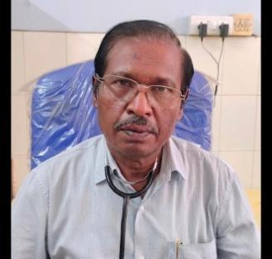
DR Shashi
This Pandemic Preparedness Plan aims to ensure early detection, prompt response, and effective management of any emerging infectious disease threat or natural calamities in Chavara Block. All healthcare facilities and staff shall remain vigilant and strictly adhere to surveillance, reporting, and infection prevention and control protocols.
Adequate preparedness shall be maintained through ensuring the availability of essential supplies, including personal protective equipment, medicines, oxygen, and other critical resources. Functional triage and isolation systems shall be kept ready at all times. Regular training, review meetings, and mock drills shall be conducted to strengthen response capacity.
Community awareness and interdepartmental coordination shall be prioritized to minimize risk and ensure timely action. Through systematic preparedness and coordinated efforts, the health and safety of the community can be effectively safeguarded.

EXECUTIVE SUMMARY

Chavara Block is a coastal block in Kollam district covering 38.93 sq. km with 62 wards and 3 major government health institutions. The block serves a densely populated coastal community of 130,043 people with diverse public health challenges shaped by its geography, livelihoods, and demographic profile. Fisheries, industrial labor (with 26 factories/small-scale industries), and small-scale trade dominate the local economy, while the presence of 19,474 wells and 4 inland water bodies increases vulnerability to water-borne and vector-borne diseases.
The demographic structure reflects a significant elderly population of 7,829 and a high non-communicable disease (NCD) burden across Panmana, Neendakara, and Chavara Panchayats. The block also has vulnerable groups including 766 pregnant women, 5,857 children under five, 139 dialysis patients, 10,147 fisherfolk, and 13,544 BPL families. In addition, substantial poultry and livestock activity—specifically 21,410 birds and 15,085 animals—poses potential zoonotic risks.
Epidemiological trends from 2021–2025 demonstrate recurring seasonal outbreaks of dengue, persistently high acute diarrheal diseases (ADD), ongoing tuberculosis reporting, seasonal leptospirosis, and rising cases of Hepatitis A and Mumps. These trends confirm the block’s vulnerability to vector-borne, water-borne, respiratory, and zoonotic threats, necessitating a structured and surge-ready preparedness framework.
The Pandemic Preparedness Plan adopts the 4S Model—Staff, Stuff, Structure, and Systems—to ensure comprehensive readiness. The block benefits from a strong grassroots workforce comprising 24 government medical officers, 19 nursing officers, 104 ASHAs, 18 JPHNs, 15 Junior Health Inspectors, an epidemiologist, and a Community One Health Volunteer. Diagnostic capacity is strengthened by functional laboratories and established IDSP reporting mechanisms. However, critical care capacity is highly restricted, with 0 government ICU beds and a reliance on 12 private sector ICU beds during severe surges.
The plan outlines phase-wise response activation, oxygen management strategies (leveraging 2 government and 1 private oxygen plants), surge bed expansion, laboratory strengthening, and structured interdepartmental coordination through a Block Pandemic Control Committee. Special emphasis is placed on the protection of vulnerable populations, geriatric-focused care, zoonotic surveillance integration, environmental sanitation, and risk communication mechanisms including daily surveillance reporting and rumor control systems.
A detailed recovery framework ensures systematic restoration of routine services, mental health support for healthcare workers and affected families, logistics replenishment, infrastructure rehabilitation, and structured after-action review. Monitoring indicators—including test positivity rate, bed occupancy, oxygen buffer levels, and vaccination coverage—guide decision-making and escalation.
In conclusion, Chavara Block possesses strong community-based public health foundations and surveillance capacity but must prioritize critical care and ICU strengthening, oxygen redundancy, elderly-focused planning, and climate-resilient disease prevention. Through coordinated governance, data-driven action, and sustained community engagement, the block is positioned to effectively prevent, detect, respond to, and recover from future pandemics and public health emergencies while safeguarding the health and well-being of its population.

Table of Contents

Table of Contents
- MESSAGE FROM BLOCK PANCHAYAT PRESIDENT............................................................... 2 MESSAGE FROM BLOCK HEALTH STANDING COMMITTEE CHAIRPERSON............ 3 MESSAGE FROM ADMINISTRATIVE MEDICAL OFFICER ................................................... 4 EXECUTIVE SUMMARY ..................................................................................................................... 5 LIST OF ABBREVIATIONS................................................................................................................ 11
- INTRODUCTION.......................................................................................................................... 13
- CHAVARA BLOCK AT A GLANCE......................................................................... 15 UHTC Chavara (Community Health Center, Chavara)........................................... 15 Location and Accessibility............................................................................................................ 15
- ADMINISTRATIVE & INSTITUTIONAL COVERAGE.................................................... 18 GEOGRAPHIC PROFILE OF CHAVARA BLOCK .................................................. 18 DEMOGRAPHIC PROFILE OF CHAVARA BLOCK .............................................. 20 Key Strengths & Challenges................................................... Error! Bookmark not defined. HEALTH INFRASTRUCTURE CAPACITY .............................................................................. 21 HUMAN RESOURCE CAPACITY ............................................................................................... 22 Health Workforce Overview......................................................................................................... 22 TIERED HUMAN RESOURCE DEPLOYMENT MODEL......................................................... 26 TIER 1 – COMMUNITY LEVEL (SURVEILLANCE & HOME CARE) ............................ 26 Objectives......................................................................................................................................... 26 Workforce Allocation..................................................................................................................... 26 Key Functions.................................................................................................................................. 26 TIER 2 – PHC/UHTC LEVEL (TRIAGE & PRIMARY CLINICAL CARE)....................... 26 Objectives......................................................................................................................................... 27 Workforce Allocation..................................................................................................................... 27 Key Functions.................................................................................................................................. 27 TIER 3 – BLOCK LEVEL / DEDICATED FACILITIES (ADVANCED CARE & COMMAND)....................................................................................................................................... 27 Objectives......................................................................................................................................... 27 Workforce Allocation..................................................................................................................... 27 Key Functions.................................................................................................................................. 28 SURGE SCALING MODEL ................................................................................................................ 28 SUPPORT SYSTEMS............................................................................................................................ 28 REPORTING FLOW.............................................................................................................................. 28
- RISK ASSESSMENT.................................................................................................................... 29 PANCHAYAT-SPECIFIC HR RISK MAPPING ......................................................................... 29 ANIMALS & BIRDS POPULATION............................................................................................ 30 High-Risk Population Groups .......................................................................................................... 31 HIGH-RISK POPULATION CONTROL PLAN ............................................................................. 31
- Elderly............................................................................................................................................... 31 Prevention & Control Strategies.................................................................................................. 31 Roles & Responsibilities............................................................................................................... 31
- Diabetic Cases................................................................................................................................. 31 Prevention & Control Strategies.................................................................................................. 32 Roles & Responsibilities............................................................................................................... 32
- Hypertensives Cases ...................................................................................................................... 32 Prevention & Control Strategies.................................................................................................. 32 Roles & Responsibilities............................................................................................................... 32
- Dialysis Patients.............................................................................................................................. 32 Prevention & Control Strategies.................................................................................................. 32 Roles & Responsibilities............................................................................................................... 33
- Cancer Patients................................................................................................................................ 33 Prevention & Control Strategies.................................................................................................. 33 Roles & Responsibilities............................................................................................................... 33
- Bedbound Patients.......................................................................................................................... 33 Prevention & Control Strategies.................................................................................................. 33 Roles & Responsibilities............................................................................................................... 34
- Fisherfolk (Special High-Risk Occupational Group).............................................................. 34 Prevention & Control Strategies.................................................................................................. 34 Roles & Responsibilities............................................................................................................... 34 BURDEN AREAS & KEY STRATEGIES........................................................................................ 35 CHALLENGE → SOLUTION MATRIX.......................................................................................... 35 COLOUR-CODED FIELD TRACKING MODEL.......................................................................... 36
- EPIDEMIOLOGICAL TREND ANALYSIS (2023–2025)................................................... 36 Major Communicable Diseases (Cumulative Trends)................................................................. 39
- PANDEMIC PREPAREDNESS STRATEGY ......................................................................... 41 Governance Structure......................................................................................................................... 41 Block Pandemic Control Committee ...................................................................................... 41 Surveillance Strengthening ............................................................................................................... 43 Surveillance Strengthening Mechanism......................................................................................... 43
- Laboratory Preparedness Plan for Pandemic Situations......................................................... 44 Duties and Responsibilities.................................................................................................................... 46
- Laboratory Leadership................................................................................................................... 46
- Laboratory Technical Team.......................................................................................................... 46
- Data and Reporting Unit ............................................................................................................... 46
- Biosafety and Infection Control................................................................................................... 47
- Logistics and Supply Chain.......................................................................................................... 47
- Sample Collection Teams (Field)................................................................................................ 47
- Surge Capacity Plan ....................................................................................................................... 48 Key Performance Indicators.................................................................................................................. 48 Clinical Surge Plan ............................................................................................................................. 48
- INFECTION PREVENTION AND CONTROL (IPC).......................................................... 49
- ONE HEALTH APPROACH....................................................................................................... 49
- LOGISTICS MANAGEMENT................................................................................................ 49 CHAVARA BLOCK SURGE PLAN................................................................................... 50 Based on the 4S MODEL (Staff – Stuff – Structure – Systems)............................................... 50 STAFF (Human Resource Surge Strategy) ........................................................................................ 50 Baseline Government Workforce ................................................................................................ 50 Panchayat-Specific HR Risk Mapping....................................................................................... 50 Phase-wise Staff Mobilization ..................................................................................................... 51 STUFF (Logistics & Essential Supplies)............................................................................................ 51 Existing Critical Resources .......................................................................................................... 51 Minimum Buffer Norms for Block ............................................................................................. 51 Panchayat-Specific Supply Priorities......................................................................................... 52 STRUCTURE (Physical Capacity Expansion).................................................................................. 52 Current Capacity............................................................................................................................. 52 Surge Bed Expansion Plan............................................................................................................ 52 Panchayat-Level Surge Allocation.............................................................................................. 53 SYSTEMS (Surveillance, Governance & Communication)........................................................... 53 Surveillance Intensification............................................................................................................... 53 Risk communication plan.................................................................................................................. 53 Training & mock drills....................................................................................................................... 54 Monitoring indicators......................................................................................................................... 54
- PHASE-WISE RESPONSE FRAMEWORK ....................................................................... 54 VULNERABLE POPULATION STRATEGY (Block-Specific).............................................. 54 INTEGRATED ONE HEALTH RESPONSE ............................................................................... 55 MONITORING DASHBOARD (Block Level)............................................................................ 55 KEY BLOCK-SPECIFIC PRIORITIES ........................................................................................ 55
- RECOVERY PLAN.................................................................................................................... 56 OBJECTIVES OF RECOVERY PHASE ...................................................................................... 56 RESUMPTION OF ROUTINE HEALTH SERVICES............................................................... 56 A. Phased Restoration Strategy ................................................................................................... 56 B. Priority Service Areas (Block-Specific) ............................................................................... 56 MENTAL HEALTH & PSYCHOSOCIAL SUPPORT............................................................... 57 A. Community-Level Mental Health Strategy.......................................................................... 58 B. Healthcare Worker Support..................................................................................................... 58 C. High-Risk Group Focus........................................................................................................... 58 REVIEW, AUDIT & AFTER-ACTION ANALYSIS.................................................................. 58 A. Epidemiological Review.......................................................................................................... 58 B. Clinical Audit ............................................................................................................................. 59 C. Logistics Audit ........................................................................................................................... 59 D. Surveillance System Review .................................................................................................. 59 STOCK REPLENISHMENT & RESOURCE NORMALIZATION ....................................... 59 A. Immediate Replenishment (Within 2 Weeks)...................................................................... 59 B. Oxygen & Critical Equipment ................................................................................................ 59 C. Financial Review....................................................................................................................... 60 INFRASTRUCTURE RESTORATION ........................................................................................ 60 POLICY REVISION & SYSTEM STRENGTHENING ........................................................... 60 COMMUNITY RE-ENGAGEMENT ............................................................................................ 60 MONITORING INDICATORS DURING RECOVERY ........................................................... 61 LONG-TERM RESILIENCE BUILDING.................................................................................... 61
- CONCLUSION ........................................................................................................................... 62
- SWOT ANALYSIS OF CHAVARA BLOCK........................................................ 65
- ANEXTURES.............................................................................................................................. 66 IMPORTANT PHONE NUMBERS................................................................................................ 66
- Chavara Block Health Officials................................................................................... 66
- Important phone numbers of Block Panchayat ..................................................................... 67
- Private and public schools Contact details ………………………………………………68
- Information regarding resources ………………………………………………………69
- Baseline Data …………………………………………………………………72

LIST OF ABBREVIATIONS
LSGD/LSGI | Local Self Government Department / Local Self Government Institution
AMO | Administtrative Medical Officer
IDSP | Integrated Disease Surveillance Programme
PHC | PRIMARY HEALTH CENTRE
NHM | NATIONAL HEALTH MISSION
NDMA | NATIONAL DISASTER MANAGEMENT AUTHORITY
PPE | PERSONAL PROTECTIVE EQUIPMENT
ICMR | INDIAN COUNCIL OF MEDICAL RESEARCH
CD | COMMUNICABLE DISEASES
NCD | NON-COMMUNICABLE DISEASES
ADD | Acute diarrhoeal disease
ASHA | Accredited Social Health Activist
MO | Medical Officer
HS | Health Supervisor
HI | Health Inspector
PHNS | Public Health Nursing Supervisor
PHN | Public Health Nurse

JHI | ^{Junior Health Inspector}
JPHN | Junior Public Health Nurse
MLSP | Mid Level Service Provider
SSU | State Surveillance Unit
DSU | District Surveillance Unit
KMSCL | Kerala Medical Service Corporation Ltd.
AYUSH | Ayurveda, Yoga& Naturopathy, Unani, Siddha& Homoeopathy

1. INTRODUCTION

Chavara Block, located in the coastal belt of Kollam district within Kerala, comprises major public health institutions serving the Panchayats of Panmana, Neendakara, and Chavara. These institutions collectively serve a diverse and densely populated community of 130,043 individuals spread across coastal and semi-urban settlements.

The block is geographically characterized by coastal plains, interconnected inland
water bodies, and environmentally sensitive ecosystems. The presence of 19,474 wells
and 4 water bodies, along with active fisheries and a significant poultry population of
21,410 birdscontribute to the socio-economic vitality of the region while
simultaneously increasing its vulnerability to public health challenges. Historically, the
area has experienced recurring outbreaks of vector-borne, water-borne, respiratory,
and zoonotic diseases, underscoring the need for sustained surveillance and
preparedness.

In this context, the Chavara Block Panchayath remains committed to strengthening its
public health systems through a structured and proactive approach. This Pandemic
Preparedness Plan outlines comprehensive strategies for preparedness, mitigation,
response, and recovery to effectively manage potential future public health
emergencies and safeguard the well-being of the community.

2. CHAVARA BLOCK AT A GLANCE
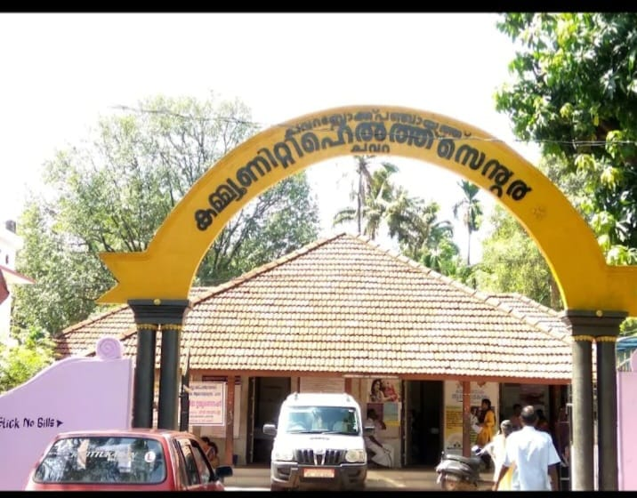
(Community Health Center,chavara)

Location and Accessibility

UHTC Chavara is located near NH-66 in Chavara Panchayat. As a pivotal hospital serving this immediate locality, UHTC plays a critical role in delivering comprehensive and continuous healthcare services to the surrounding population.
Established in 1940, the UHTC carries a distinguished legacy of service spanning over eight decades. Throughout its history, the institution has consistently adapted to the evolving healthcare needs of the community, combining clinical excellence with compassionate patient care for the people of Chavara.
LOCATION | PHONE NUMBER | EMAIL ADDRESS
NH-66, Chavara, | O476 2681500 | chcchavara@gmail.com

BACKGROUND OF LSGDs
 | PANMANA | NEENDAKARA | CHAVARA | CHAVARA BLOCK
Number of wards | 24 | 14 | 24 | 62
Total area (sq. km) | 16.85 sq.km | 10.19sq.km | 11.89 sq.km | 38.93sq.km
Population(Projected) | 64112 | 17321 | 48598 | 130,043
Population density | 3804sq. km | 1699sq.km | 4087/sq km | 3,340sq.km
Terrain (coastal/low lying/backwaters/foothill s, etc.) | Costal & backwaters | coastal | COASTAL | Coastal
Number of rivers passing through LSGI | 0 | 0 | 0 | 0
Number of water bodies in the LSGI | 1 | 2 | 1 | 4
Number of educational institutions | 75 | 5 | 19 | 99
Factories / small-scale industries | 1 | 8 | 17 | 26
Flood-prone wards | 6 | 0 | 4 | 10
Landslide-prone wards | 0 | 0 | 0 | 0
Death Management and Disposal Facilities (mortuaries/crematorium, including electric) | 1 | 0 | 0 | 1
Auditoriums/Marriage halls/convention  centres/community halls | 6 | 13 | 6 | 25

Demographics and Geographic Distribution
The Chavara Block supports a total projected population of 130,043 across an area of 38.93 sq. km, resulting in a high overall population density of 3,340 people per sq. km. All three LSGDs share a coastal terrain, but their demographic profiles differ significantly:
- Panmana (The Most Populous): This is the largest panchayat in both area (16.85 sq. km) and population (64,112), holding nearly half of the block's total residents. It has a high population density of 3,804 per sq. km.
- Chavara (The Most Densely Populated): Despite having a smaller area (11.89 sq. km) than Panmana, Chavara is highly congested. With a population of 48,598, it has the highest population density in the block at 4,087 people per sq. km.
- Neendakara (The Least Populous): This is the smallest panchayat both in size (10.19 sq. km) and population (17,321). Its population density is notably lower at 1,699 per sq. km, less than half that of Panmana or Chavara.
Infrastructure and Economy
The distribution of institutions suggests distinct economic and social roles for each panchayat within the block:
- Educational Hub: Panmana dominates the educational landscape with 75 of the block's 99 educational institutions. Chavara has 19, while Neendakara has only 5.
- Industrial Center: Chavara is the industrial core of the block, housing 17 of the 26 factories and small-scale industries. Neendakara holds 8, while Panmana has only 1, indicating a likely shift toward residential or educational zoning in Panmana versus commercial/industrial zoning in Chavara.
- Community Spaces: Neendakara, despite being the smallest, holds the highest number of auditoriums, marriage halls, and community centers (13 out of 25), suggesting it serves as a central gathering or event location for the broader area.
Environmental Vulnerability and Utilities
Given the coastal nature of the entire block, vulnerability to water-related issues is a key factor:
- Flood Risks: Out of the 62 wards in the block, 10 are flood-prone. Panmana carries the highest risk with 6 flood-prone wards, followed by Chavara with 4. Interestingly, Neendakara reports zero flood-prone wards. There are no landslide-prone wards in the entire block.
- Water Bodies: The block has 4 designated water bodies, with Neendakara having 2, and Panmana and Chavara having 1 each. None of the panchayats report major rivers passing through them.
- Critical Utilities: There is a severe shortage of death management and disposal facilities. The entire block relies on a single facility (mortuary/crematorium) located in Panmana

3. ADMINISTRATIVE & INSTITUTIONAL COVERAGE
GEOGRAPHIC PROFILE OF CHAVARA BLOCK
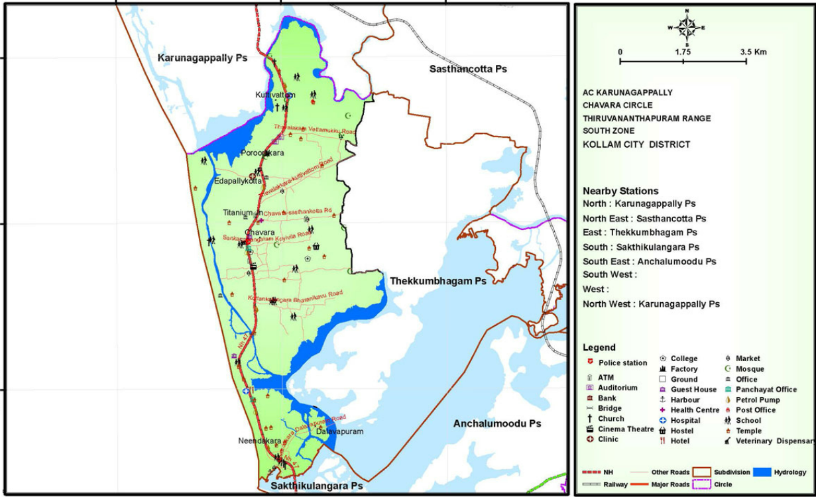

CHAVARA BLOCK OVERVIEW
COMPONENT /  PARAMETER | DETAILS / STATUS
Total PHC/UHTC  Institutions | 3
Health Institutions Covered | 18
Total Wards | 62
Terrain Type | coastal
Major Livelihoods | Fisheries, industrial labor (factories), and small-scale trade.
Total Area | 38.93sq.km
Number of Wells | 19,474
Ponds | 1
Rivers Passing Through | 0
Lakes Passing Through | 0

DEMOGRAPHIC PROFILE OF CHAVARA BLOCK

Demographic and Vulnerable Population
Description |  | PANMANA | NEENDAKARA | CHAVARA | CHAVARA BLOCK TOTAL
DEMOGRAPHIC PROFILE
Total population |  | 64124 | 17321 | 48598 | 130043
Male |  | 33889 | 8519 | 23302 | 65710
Female |  | 30285 | 8802 | 25296 | 64383
Transgender |  | 0 | 0 | 0 | 0
Children under 5 |  | 2835 | 822 | 2200 | 5857
Adolescent |  | 5225 | 1188 | 3942 | 10355
Elderly (>60) |  | 6048 | 2753 | 5076 | 7829
SOCIAL/LIVELIHOOD VULNERABILITY
Previous EPEP family |  | 56 | 7 | 39 | 102
BPL family |  | 8225 | 1041 | 4278 | 13544
Tribal communities |  | 0 | 0 | 0 | 0
Migration | Immigrant | 871 | 669 | 362 | 1902
Migration | Emigrant | 1013 | 245 | 2612 | 3870
Socio-economically deprived |  | 18 | 79 | 2526 | 2623
Fisherfolk |  | 52 | 9279 | 816 | 10147
SC Community |  | 7-798 | 1851 | 797 | 3648
ST Community |  | 0 | 0 | 0 | 0

The Chavara Block has a total population of 130,043. The population is unevenly distributed across the three panchayats:
- Panmana is the most populous, accounting for nearly half of the block's residents with 64,124 people.
- Chavara follows with a substantial population of 48,598.
- Neendakara is the least populated, with 17,321 residents.
Gender Dynamics
Overall, the block has a relatively balanced gender ratio, with males (65,710) slightly outnumbering females (64,383). However, this varies by location:
- Panmana drives the male majority, having notably more males (33,889) than females (30,285).
- Conversely, Neendakara and Chavara both have slightly more females than males, reflecting a different localized demographic structure, potentially influenced by the high emigration rates of males from Chavara.
- There are no transgender individuals recorded in this dataset.
Age Profile
The data outlines the dependent populations (youth and elderly) requiring targeted healthcare and social services:
- Youth: There are 5,857 children under the age of 5 and 10,355 adolescents. As expected, Panmana holds the largest share of both groups due to its overall population size.
- Elderly (>60): Note: There is a mathematical discrepancy in the provided table's total. While the block total is listed as 7,829, adding the individual panchayats (Panmana: 6,048 + Neendakara: 2,753 + Chavara: 5,076) yields an actual total of 13,877. Using the individual numbers, Panmana has the highest absolute number of elderly residents, but Chavara also has a very high concentration relative to its total population.
Social and Livelihood Vulnerabilities
The block exhibits distinct socio-economic challenges that are highly concentrated by geography:
- BPL Families: There are 13,544 Below Poverty Line (BPL) families in the block. Panmana bears the heaviest burden here, hosting 8,225 of these families (over 60% of the block's total).
- Fisherfolk: Neendakara's demographic identity is overwhelmingly defined by its fisherfolk population. Out of the 10,147 fisherfolk in the entire block, 9,279 reside in Neendakara. This means over 53% of Neendakara's total population belongs to this specific occupational group, indicating a massive need for coastal and occupational health interventions there.
- Socio-Economically Deprived: Out of the 2,623 individuals classified as socio-economically deprived, 2,526 (96%) are concentrated entirely within Chavara.
- Marginalised Communities: The Scheduled Caste (SC) community totals 2,648. (Note: The Panmana data entry 798" Neendakara's 1,851 and Chavara's 797 add up exactly to the total of 3,648Migration Trends
The block is characterized by active migration, with emigration (3,870) significantly outpacing immigration (1,902):
- Chavara is the primary source of emigrants, with 2,612 individuals leaving the area (likely for work), which aligns with its slightly female-skewed gender ratio.
- Panmana, while having a high number of emigrants (1,013), is the main destination for immigrants (871), suggesting it serves as a local economic or industrial hub drawing in outside labour.

HEALTH INFRASTRUCTURE CAPACITY
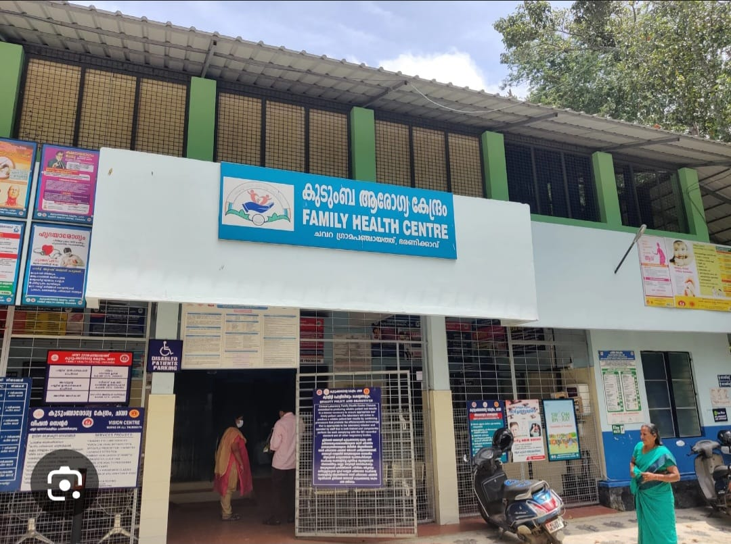
FHC CHVARA OP Block
Health Infrastructure Overview – Chavara Block

FACILITY / RESOURCE | GOVERNMENT | PRIVATE | REMARKS
Hospital Buildings | 3 | 6 | Private sector dominance: The private sector provides the majority of structural capacity. Public-private integration is essential for surge bed expansion.
Sub Centres | 16 | NA | Strong grassroots base: Forms the backbone of Tier 1 community surveillance, home isolation monitoring, and early outbreak detection.
Private Hospitals | NA | 6 | Surge relief: Crucial for providing step-down care and absorbing routine/non-pandemic caseloads during public facility surges.
ICU Beds | 0 | 12 | Critical vulnerability: 100% reliance on the private sector for local intensive care. Requires strict referral protocols to district hospitals and immediate MoUs with private facilities.
Oxygen Plants | 2 | 1 | Good baseline redundancy: Strong asset for supporting moderate oxygen-bed surges. Requires routine maintenance and daily audits during outbreaks.
Blood Bank | 0 | 0 | Zero local capacity: Complete reliance on external district facilities. Requires a dedicated transport linkage for emergency situations.
Dialysis Units | 0 | 0 | High-risk gap: Poses a major risk to the block's 139 dialysis patients. Requires infection-safe transport and coordinated scheduling at district centers.
RTPCR Lab | 0 | 0 | Diagnostic dependency: Relies entirely on district/state labs for molecular confirmation. Mandates highly efficient sample collection and cold-chain transport teams.
Ambulances (ALS) | 0 | 5 | Transfer bottleneck: Government sector lacks Advanced Life Support transport. Must pool private ALS vehicles under the Incident Commander for critical patient transfers.

Summary Assessment:
The data reveals a health system characterized by strong grassroots surveillance (16 Sub Centres) and decent oxygen generation, but severe vulnerabilities in advanced clinical care. The complete absence of government ICU beds, local blood banks, dialysis units, and RTPCR labs means Chavara Block must rely heavily on formal partnerships with its 6 private hospitals and establish highly efficient, rapid referral corridors to the main district hospital during any severe public health emergency.
ssss

HUMAN RESOURCE CAPACITY
Health Workforce Overview
CATEGORY | GOVERNMENT | PRIVATE
Admistrative Medical officer | 1 | 6
Modern Medicine Doctors | 24 | 23
AYUSH Doctors | 3 | 0
Nursing Officers | 19 | 54
Lab Technicians | 4 | 22
Pharmacists | 5 | 34
Health Supervisors | 2 | NA
Public health nursing supervisor | 1 | NA
Epidemiologist | 1 | NA
Data Manager | 1 | NA
JHI | 15 | NA
JPHN | 18 | NA
MLSP | 18 | NA
ASHA | 104 | NA
Community One Health Volunteers | 1 | NA

The available human resources in the Chavara block demonstrate a strong base in government primary care staffing, supplemented by a large private sector clinical workforce and a community-level volunteer network. In a pandemic situation, an integrated resource allocation model should be adopted to optimize triage, surveillance, clinical care, laboratory services, logistics, and community outreach while ensuring continuity of essential health services.
At the command and control level, the Administrative Medical Officer (1), supported by the Epidemiologist (1), Public Health Nursing Supervisor (1), and Health Supervisors (2), should constitute the block pandemic control cell. This team will be responsible for micro-planning, surveillance review, resource mapping, intersectoral coordination, and daily situation analysis. The Data Manager (1) will lead real-time data compilation, dashboard generation, line listing, and reporting to district authorities, enabling rapid decision-making and outbreak detection.
Modern medicine doctors from both government (24) and private (23) sectors should be strategically pooled through a public–private coordination mechanism. Government doctors should prioritize triage, fever clinics, high-risk patient management, and supervision of isolation facilities, while empanelled private practitioners can be assigned to outpatient fever screening, teleconsultation services, and step-down care centers to reduce the load on public facilities. AYUSH doctors (3) can be deployed for screening clinics, home isolation monitoring, and risk communication activities, thereby expanding surge clinical capacity.
Nursing officers (19 government and 54 private) form the backbone of clinical surge capacity. Government nursing staff should be allocated to triage, observation wards, oxygen therapy units, and vaccination sites, while private sector nurses can be mobilized for dedicated care centers, home monitoring teams, and sample collection support. The Public Health Nursing Supervisor will oversee training on infection prevention and control, PPE use, and cohort nursing practices.
Laboratory technicians (4 government and 22 private) should be organized into a hub-and-spoke testing network. Government laboratory staff will manage confirmatory testing, quality control, and biosafety compliance, while private laboratories can be empanelled for sample processing during surge periods. A shift-based duty roster will ensure extended testing hours and rapid turnaround times.
Pharmacists (5 government and 34 private) should manage buffer stock maintenance, drug dispensing for home isolation kits, and supply chain monitoring for essential medicines, PPE, and oxygen-related consumables. They should also support decentralized drug distribution to high-risk groups to minimize facility visits.
Field-level surveillance and containment activities should be led by Junior Health Inspectors (15), Junior Public Health Nurses (18), and Mid-Level Service Providers (18). Their responsibilities will include active case search, contact tracing, containment zone monitoring, vaccination mobilization, and supervision of quarantine compliance. Health Supervisors will additionally coordinate environmental sanitation, disinfection protocols, and vector control where relevant.
ASHA workers (104) and the Community One Health Volunteer (1) represent a critical community interface. ASHAs should be assigned to household-level surveillance, symptom monitoring of home-isolated patients, defaulter tracking for high-risk groups, and risk communication. The Community One Health Volunteer can support door-to-door awareness, reporting of unusual illness clusters, assistance in vaccination campaigns, and dissemination of zoonotic risk alerts, particularly in areas with high animal and bird populations.
A tiered deployment model should be followed, with clear delineation of roles across surveillance, clinical care, logistics, and community engagement. Rotational duty schedules, psychosocial support for staff, and continuous training on IPC and outbreak protocols are essential to maintain workforce resilience. Integration of private sector capacity, digital reporting systems, and community volunteer networks will significantly enhance surge preparedness and ensure a coordinated, multi-sectoral pandemic response at the block level.

Major Festivals & Events specific to the LSGI CHAVARA BLOCK
Sl.  No. | Name of festival | Month detailing the periodicity
PANMANA
1 | KATTIL MEKKATHIL VRISCHIKA MAHOTSAVAM | NOVEMBER

NEENDAKARA
1 | St.Sebastian Thirunnal, T.Joseph Thirunnal, Parimanam temple festival | January, March, February
CHAVARA
1 | KOTTANKULANGARA TEMPLE FEST | MARCH

TIER 1 – COMMUNITY LEVEL (SURVEILLANCE & HOME CARE)
Objectives
- Early case detection
- Home isolation monitoring
- Risk communication
- Protection of high-risk groups
Workforce Allocation
- ASHA (104): Household surveillance, symptom screening, drug delivery
- Community One Health Volunteers (1): Awareness, reporting clusters, zoonotic alerts
- JPHN (18): Line listing, vaccination mobilisation, maternal & elderly follow-up
- JHI (15): Containment zone monitoring, environmental sanitation
Key Functions
- Door-to-door fever survey during surge
- Daily monitoring of home-isolated patients
- High-risk population follow-up (elderly, DM, HTN)
- Support for vaccination drives

TIER 2 – PHC/UHTC LEVEL (TRIAGE & PRIMARY CLINICAL CARE)
Objectives
- Fever screening & triage
- Sample collection
- Mild–moderate case management
- Referral stabilisation
Workforce Allocation
- Medical Officers (24 Govt): Triage supervision, clinical protocols
- AYUSH Doctors (3): Screening clinics, home isolation tele-follow-up
- Staff Nurses (73 total pool: 19 Govt + 54 Private): Triage, observation beds, oxygen support
- Lab Technicians (4 Govt): Sample collection & rapid testing
- Pharmacists (5 Govt): Drug kits, logistics
- MLSP (18): NCD continuity, teleconsult support
Key Functions
- Separate fever clinic & respiratory triage
- Oxygen-supported observation units
- Rapid referral to higher centres
- Continuity of essential NCD services

TIER 3 – BLOCK LEVEL / DEDICATED FACILITIES (ADVANCED CARE & COMMAND)
Objectives
- Moderate–severe case management
- Data surveillance & outbreak analytics
- Resource coordination
- Training & IPC monitoring
Workforce Allocation
- Administrative Medical Officer (1): Incident commander
- Epidemiologist (1): Surveillance analysis, modelling, hotspot mapping
- PH Nursing Supervisor (1): Nursing deployment & IPC training
- Health Supervisors (2): Field operations coordination
- Data Manager (1): Real-time dashboard & reporting
- Private Doctors (23): Step-down care, telemedicine, surge OP
- Private Nurses (54): Dedicated care centres
Key Functions
- Bed management & oxygen allocation
- Daily situation reports
- Rapid response teams for outbreaks
- Training of frontline workers

SURGE SCALING MODEL
SITUATION | ACTION
Early cluster | Intensify Tier 1 surveillance.
Community transmission | Activate fever camps at Tier 2.
Hospital surge | Mobilise private sector (incorporating the 6 private hospitals and their 12 ICU beds) to Tier 3.
Zoonotic alert | Deploy One Health rapid teams, with an immediate focus on high-risk zones like Panmana (due to its high bird population of 17,201).

SUPPORT SYSTEMS
- Logistics: Pharmacists (5 Government, 34 Private) manage PPE, drugs, and the oxygen buffer across the 2 Government and 1 Private oxygen plants.
- Transport: Dedicated referral linkage for severe cases, utilizing the 5 Private ALS Ambulances for critical transfers to district hospitals.
- Telemedicine: Private doctors (23) + MLSP (18) pool mobilized for remote home monitoring and step-down care.
- Staff Rotation: 7–10 day duty cycles with mandatory rest periods to prevent workforce burnout.

REPORTING FLOW
Community (ASHA) → JPHN / JHI / MLSP → PHC Medical Officer → Administrative Medical Officer (AMO) → District Surveillance Officer → District Medical Officer → State Surveillance Officer

4. RISK ASSESSMENT
PANCHAYAT-SPECIFIC HR RISK MAPPING
Panmana, with its high population density, flood-prone wards, and massive bird population, requires measures that reduce transmission in crowded settings alongside a strong One Health-based zoonotic control framework. Control strategies should include decentralised screening points, strict infection prevention and control (IPC) practices, rapid reporting of unusual bird deaths, and temporary containment measures during suspected outbreaks. Prevention efforts must focus on safe poultry handling, community-level risk communication, promotion of respiratory hygiene, and ensuring uninterrupted water, sanitation, and waste management services to prevent the clustering of water-borne and communicable diseases.
Neendakara, characterized by intense coastal clustering and the highest concentration of fisherfolk, needs a strong occupational health focus combined with a fever surveillance and early containment approach. Establishing dedicated evening fever clinics, implementing syndromic surveillance for acute febrile illness, and ensuring prompt testing and isolation are essential control measures. Preventive strategies should include pre-monsoon leptospirosis prophylaxis, household-level vector source reduction, safe drinking water promotion, chlorination monitoring, and targeted health education on hygiene to reduce both vector-borne and water-borne disease transmission in coastal hamlets.
Chavara, with the highest absolute elderly burden, high population density, and significant industrial activity, requires a protection-focused model coupled with workplace interventions. Control strategies should prioritise early identification of high-risk elderly individuals, home-based monitoring, and rapid referral pathways for severe illness. Preventive measures must include the vaccination of eligible elderly populations, continuity of care for chronic diseases, fall prevention, nutritional support, minimising unnecessary facility visits through drug home delivery, and robust factory/workplace awareness programs focusing on sustained vector control and solid waste management.
Across all Panchayats, cross-cutting strategies should include strengthening integrated disease surveillance, maintaining surge staffing plans, ensuring buffer stocks of essential drugs and PPE, and conducting regular outbreak preparedness drills. Risk communication, community engagement, and intersectoral coordination remain central to both prevention and rapid control of communicable disease threats in this coastal block.

ANIMALS & BIRDS POPULATION
 | PANMANA | NEENDAKARA | CHAVARA | CHAVARA  BLOCK TOTAL
Animal | 4922 | 1363 | 8800 | 15085
population Bird | 17201 | 4197 | 12 | 21410
population | 22123 | 5560 | 8812 | 36495

The block has a total animal population of 15,085 and a very high bird population of 21,410, indicating a significant human–animal–avian interface in the coastal area. Chavara and Panmana account for the largest share of livestock, while bird density is particularly high in Panmana and, to a lesser extent, Neendakara. This high avian concentration increases the potential risk for zoonotic and avian influenza transmission , especially in settings with backyard poultry, live bird handling, and wet market exposure. From a pandemic preparedness perspective, these findings necessitate strengthened veterinary–public health coordination, surveillance for unusual bird mortality, promotion of safe poultry handling practices , and community awareness on reporting animal and bird deaths to enable early detection of zoonotic outbreaks
High-Risk Population Groups CATEGORY TOTAL BURDEN
Elderly (>60 years): 9,329; Diabetics: 8,513; Hypertensives: 12,533; Dialysis Patients (Hemodialysis + CAPD): 112. Cancer Patients: 359 Bedbound Patients: 284 Fisherfolk: 10,147

HIGH-RISK POPULATION CONTROL PLAN
1. Elderly (Block Target Population: 7,829) Strategic Note: Requires high-priority focus in Panmana and Chavara panchayats, which hold the highest absolute numbers of elderly residents. Prevention & Control Strategies
- Geriatric risk stratification (high-risk tagging: co-morbidity, living alone)
- Quarterly comprehensive geriatric assessment
- Vaccination (Influenza, COVID booster as per policy)
- Fall prevention and physiotherapy promotion
- Home drug delivery for immobile elderly to minimize facility exposure
Roles & Responsibilities
- Medical Officer (MO): Clinical protocol, high-risk identification
- MLSP: Geriatric clinic, functional assessment
- JPHN: Line listing, follow-up scheduling
- ASHA: Monthly home visits, adherence check
- Physiotherapist: Mobility training

2. Diabetic Cases (Block Target Population: 8,531) Prevention & Control Strategies
- Name-based DM registry with control status
- Quarterly HbA1c for uncontrolled cases
- Annual eye, foot, and renal screening
- Lifestyle counselling (diet, physical activity)
- Defaulter tracking system
Roles & Responsibilities
- MO: Treatment optimisation
- MLSP: Foot exam, RBS monitoring
- JHI/JPHN: Registry maintenance
- Dietician: Lifestyle counseling
- ASHA: Drug adherence & diet follow-up

3. Hypertensive Cases (Block Target Population: 12,533) Prevention & Control Strategies
- BP check for all >30 years at every contact
- Monthly drug refill day
- Salt reduction IEC campaigns
- Home BP monitoring for high-risk patients
Roles & Responsibilities
- MO: Protocol-based treatment
- MLSP: BP triage & counselling
- JHI/JPHN: Community screening camp
- Dietician: Lifestyle counselling
- ASHA: Defaulter tracking

4. Dialysis Patients (Block Target Population: 139) Strategic Note: With zero government or private dialysis units inside the block, safe transport to district centers is a critical priority. Prevention & Control Strategies
- Dialysis patient registry
- Monthly PHC clinical review (BP, Hb, weight)
- AV fistula/CAPD infection prevention education
- Transport and referral linkage to district facilities
- Early CKD screening in DM/HTN patients
Roles & Responsibilities
- MO: Clinical monitoring & referral
- Staff Nurse/MLSP: Access site care education
- JHI/JPHN/MLSP: Appointment tracking
- ASHA: Home follow-up for complications

5. Cancer Patients (Block Target Population: 359) Prevention & Control Strategies
- Treatment continuation tracking
- Pain and palliative care linkage
- Nutrition and infection prevention counselling
- Screening of eligible population (oral, breast, cervical)
Roles & Responsibilities
- MO: Symptom management & referral
- Palliative nurses/MLSP: Palliative care support
- JPHN: Defaulter tracking
- ASHA: Home-based supportive care

6. Bedbound Patients (Block Target Population: 284) Prevention & Control Strategies
- Monthly home care micro-plan
- Pressure sore prevention protocol
- Catheter/Ryle’s tube care training
- Caregiver support and counselling
Roles & Responsibilities
- MO: Clinical review (home/tele)
- Palliative nurses: Wound care training
- JHI/MLSP/JPHN: Visit scheduling
- ASHA: Weekly monitoring checklist

7. Fisherfolk (Special High-Risk Occupational Group: 10,147) Strategic Note: Over 90% of this population resides in Neendakara (9,279 individuals). Interventions must be heavily concentrated in this coastal panchayat. Prevention & Control Strategies
- Evening NCD and fever screening camps tailored to harbor/fishing schedules
- Leptospirosis prophylaxis awareness (pre-monsoon)
- Injury prevention and first aid training
- Tobacco and alcohol cessation IEC
- Vector control in coastal hamlets
Roles & Responsibilities
- MO: Camp planning & clinical services
- HI: Occupational health IEC & vector control
- JHI: Screening records
- ASHA: Community mobilisation & follow-up

CADRE | KEY RESPONSIBILITIES
Medical Officer | Clinical protocols, high-risk stratification, referrals, supervision
MLSP/Staff Nurse | NCD clinic, geriatric assessment, patient education, wound care
JPHN | Line list, registry, reporting, micro-planning
Health Inspector (HI)/JHI | Field IEC, vector control, WASH activities
ASHA | Home visits, adherence tracking, defaulter retrieval
Data Manager | Digital registry, indicator monitoring

BURDEN AREAS & KEY STRATEGIES
BURDEN  AREA | KEY STRATEGY | FIELD ACTION | MONITORING  INDICATOR
NCD (HTN +  DM) | Weekly NCD clinic | Name-based registry, drug refill day | % controlled BP & RBS
Elderly | Geriatric clinic | >70 yrs home visits | Fall cases per month
Bedbound | Home care micro  plan | Pressure sore prevention | Bed sore prevalence
Palliative | Pain & symptom  protocol | Monthly home visits | % patients with pain relief
Cancer | Screening drives | Oral, breast, cervical  screening | Early stage detection rate
Dialysis/CKD | Monthly review | Fistula/CAPD care  education | Infection rate
Fisherfolk | Evening camps | Coastal NCD screening | Screening coverage

CHALLENGE → SOLUTION MATRIX
CHALLENGE SOLUTION RESPONSIBLE TIMELINE
Poor drug adherence ASHA defaulter tracking ASHA Monthly
Missed follow-ups SMS/reminder system JPHN Monthly
High salt diet Ward-level IEC JHI Quarterly
Bed sore risk Caregiver training MLSP/Palliative nurses Monthly
Late cancer detection Screening camps MO Quarterly
Dialysis infection Fistula hygiene education Staff Nurse/ MLSP Monthly
Fisher folk non-attendance Evening clinics JAK Team Monthly

COLOUR-CODED FIELD TRACKING MODEL
COLOUR CATEGORY ACTION
Red Uncontrolled / High risk Monthly review by JAK team
Yellow Defaulter ASHA home visit
Green Controlled Routine follow-up at JAK level

5. EPIDEMIOLOGICAL TREND ANALYSIS (2023–2025)
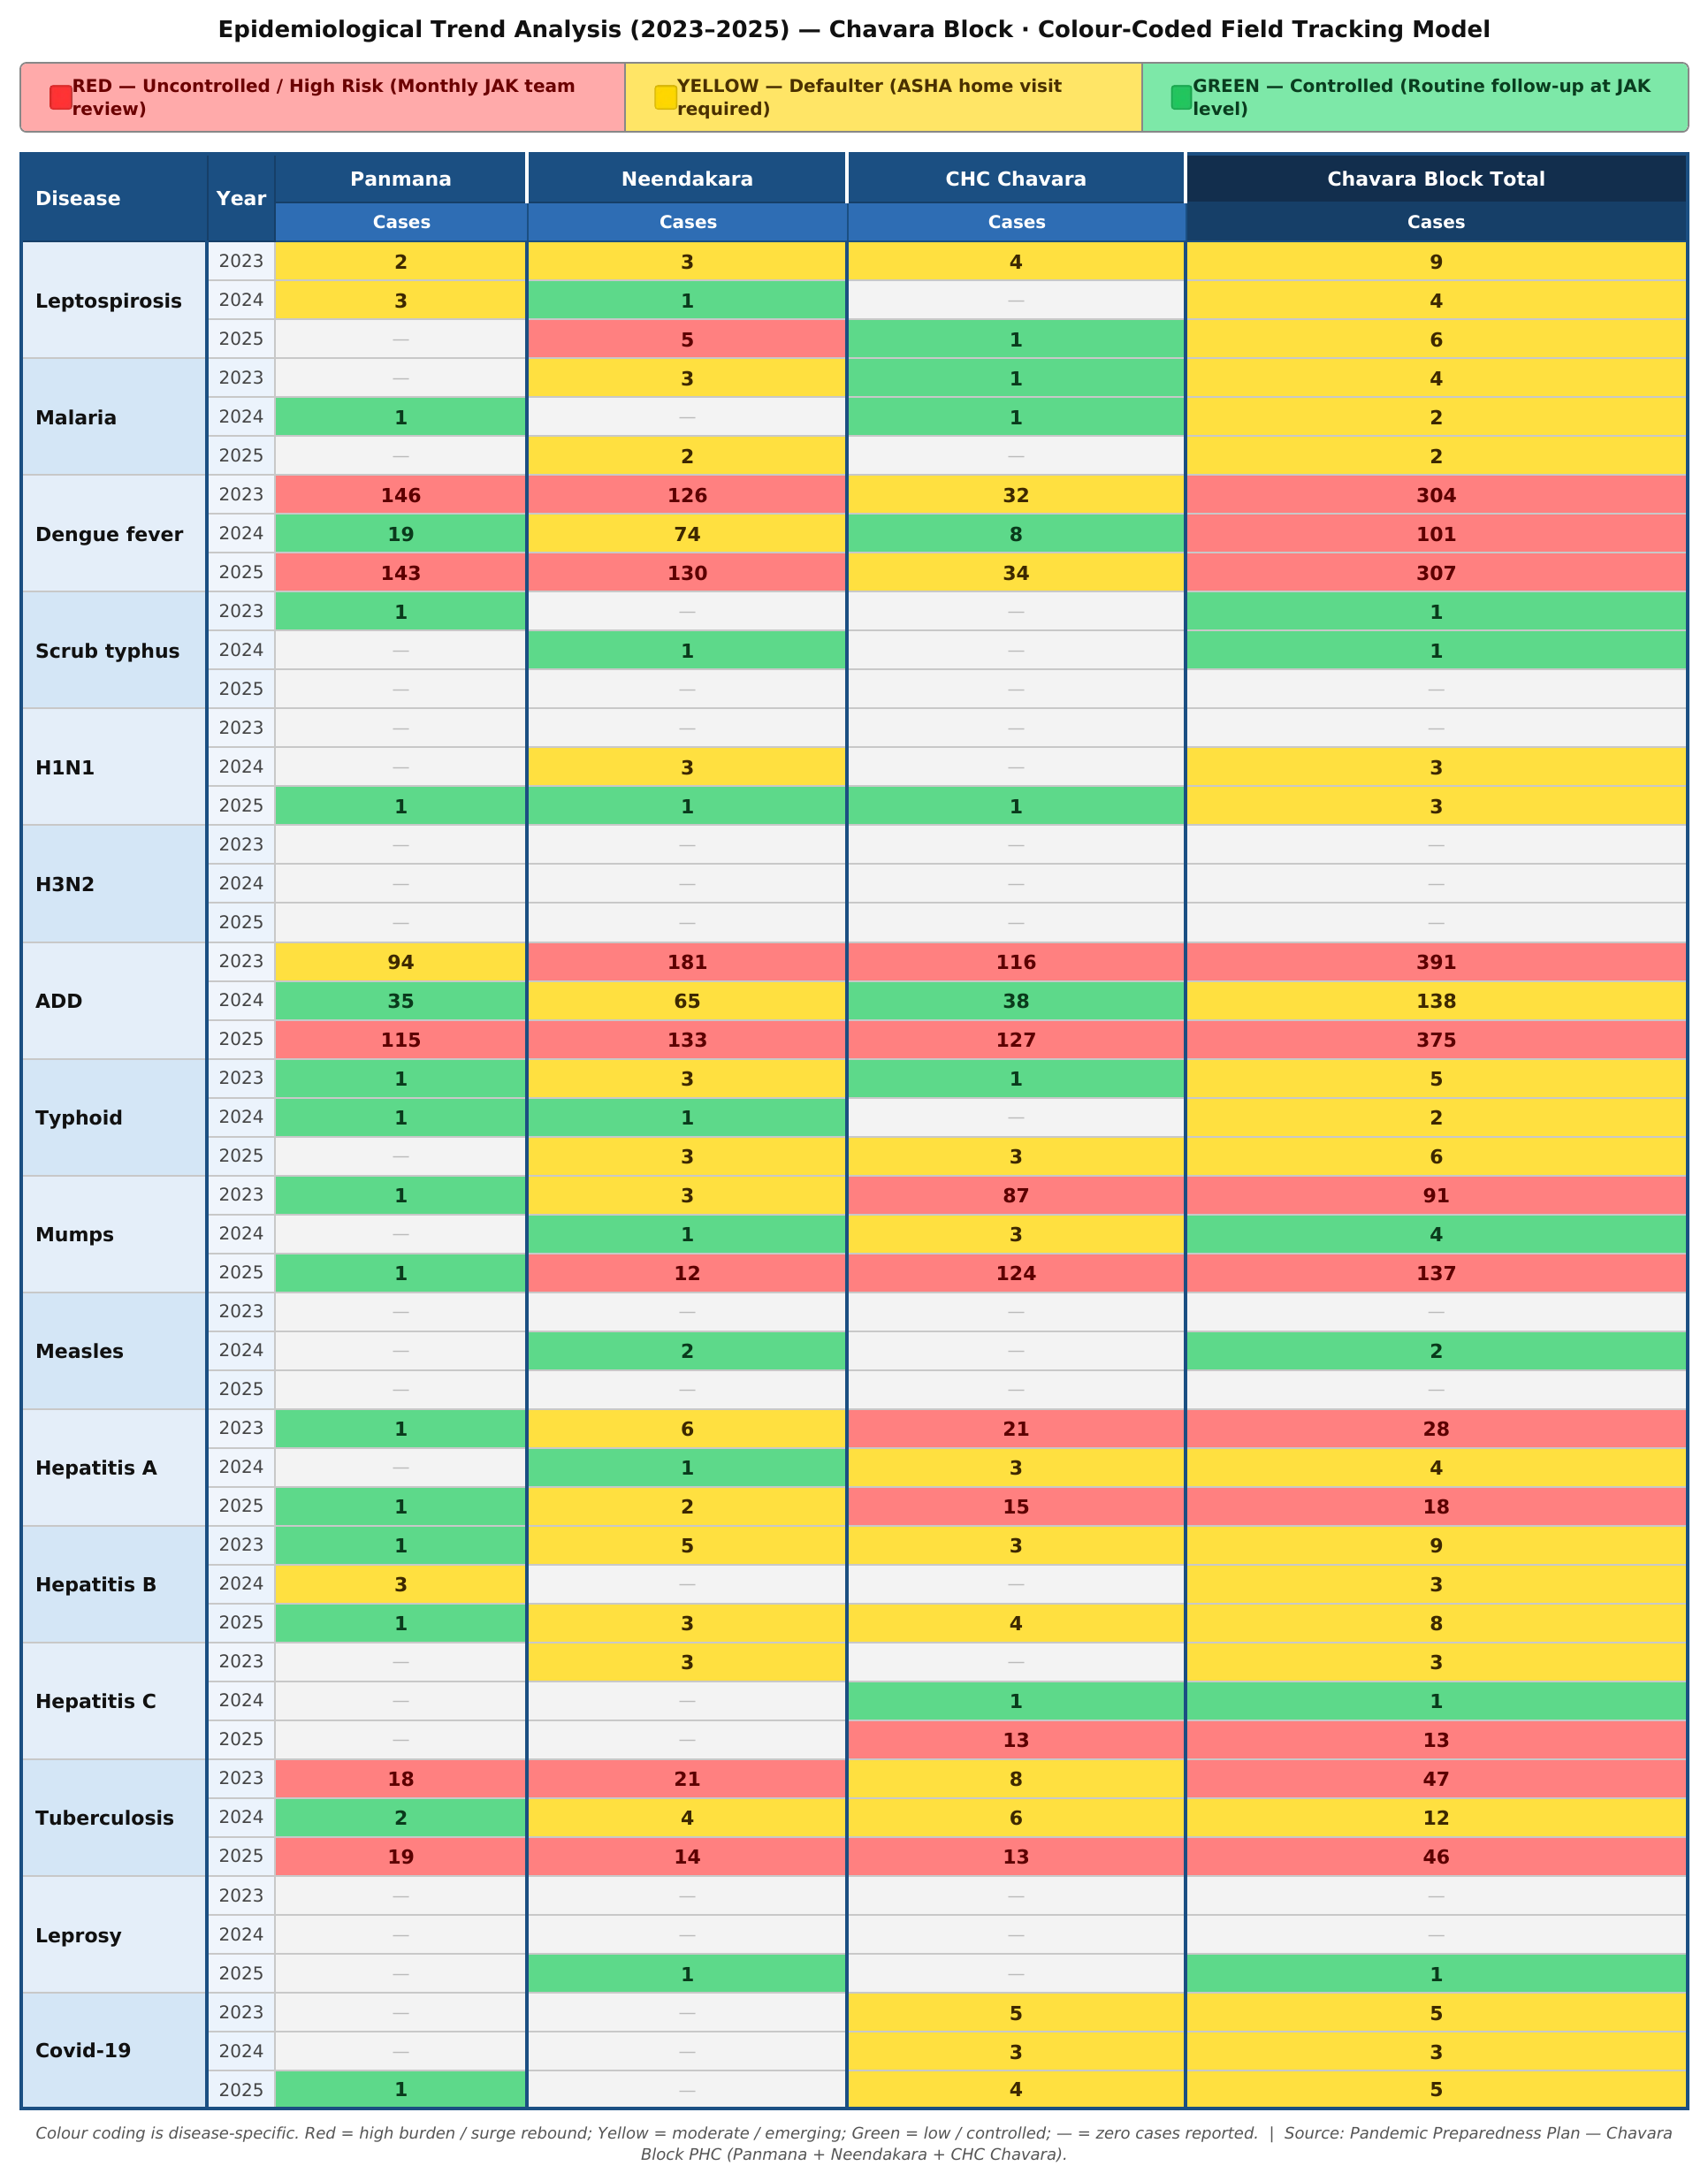
The communicable disease surveillance data from 2023 to 2025 provide critical insights into the epidemic potential, transmission dynamics, and system readiness of Chavara Block. The observed disease patterns indicate a dual burden of water-borne, vector-borne, respiratory, and vaccine-preventable infections, which collectively define the pandemic vulnerability profile of this coastal block.
Acute Diarrhoeal Disease (ADD) emerged as the leading communicable condition throughout the period. After a decline from 391 cases in 2023 to 138 cases in 2024, a sharp resurgence to 375 cases in 2025 signals persistent structural vulnerabilities in water safety, sanitation, and food hygiene across Panmana, Neendakara, and CHC Chavara areas. From a pandemic preparedness perspective, this high and rebounding ADD burden indicates the potential for rapid propagation of enteric pathogens during extreme weather events, mass gatherings, or disruptions in water supply — risks particularly relevant to Chavara's coastal and low-lying geography. Strengthening water quality surveillance, chlorination monitoring, and community-level WASH preparedness is therefore essential.
Dengue fever remains the highest single-disease burden in Chavara Block, with a striking biennial pattern: 304 cases in 2023, dropping to 101 in 2024, and rebounding sharply to 307 in 2025. Neendakara and Panmana consistently account for the largest share of cases. This resurgence confirms endemic transmission and the inadequacy of intermittent control alone. Sustained entomological surveillance, pre-monsoon source reduction, and rapid response mechanisms must be institutionalised, given that vector-borne diseases escalate quickly during the heavy rainfall and flooding events that are common in Chavara's coastal ecosystem.
Mumps represents the most alarming emerging outbreak in 2025, rising from just 4 cases in 2024 to 137 cases — with 124 of those concentrated in the CHC Chavara catchment area alone. This extreme facility-level clustering reveals a critical immunity gap, most likely among school-age children and adolescents. In the context of pandemic preparedness, such rapid institutional clustering demonstrates the block's vulnerability to respiratory pathogen spread. Establishing syndromic surveillance for febrile parotitis, enforcing isolation protocols in schools and institutions, and urgently reviewing immunisation coverage in the CHC Chavara area are priority actions.
Leptospirosis showed a shifting geographic pattern — declining in Panmana (2 to 0 cases) while rising in Neendakara (3 to 5 cases) between 2023 and 2025. This seasonal and occupational exposure risk is consistent with Chavara's coastal and flood-prone geography, particularly among fisherfolk, sanitation workers, and paddy field labourers. Pre-monsoon risk mapping, chemoprophylaxis campaigns for high-risk groups, and rapid diagnostic pathways must be integrated into Chavara's disaster-linked outbreak preparedness planning.
Tuberculosis remains a significant chronic infectious burden, with 47 cases in 2023, an apparent dip to 12 in 2024, and a strong rebound to 46 in 2025 — suggesting reporting gaps rather than true disease control. In pandemic scenarios, disruptions to TB services can accelerate transmission and increase treatment default. Ensuring continuity of TB diagnostic and drug supply chains, maintaining active case finding across all three facilities, and integrating TB screening with respiratory infection surveillance are essential resilience measures for Chavara Block.
Influenza surveillance documented zero H1N1 or H3N2 cases in 2023, the appearance of H1N1 (3 cases) in 2024, and in 2025 both H1N1 (3 cases) and H3N2 remaining absent but with continued H1N1 spread across all three facilities. This confirms ongoing community circulation of respiratory viruses and reinforces the need for strengthened ILI/SARI surveillance, functional triage systems, PPE stockpiling, and facility-level infection prevention and control (IPC) preparedness. The presence of influenza viruses serves as a proxy indicator for Chavara Block's vulnerability to future respiratory pandemics.
Hepatitis A showed a high baseline of 28 cases in 2023 followed by a partial decline to 18 in 2025, with CHC Chavara consistently the most affected facility (21, 3, and 15 cases respectively). This pattern further confirms water and food contamination risks and highlights the potential for common-source outbreaks, particularly in the coastal settlements of the block.
Hepatitis C warrants special attention, with a sudden surge from 1 case in 2024 to 13 cases in 2025, entirely localised to CHC Chavara. This cluster demands immediate investigation for potential healthcare-associated transmission or shared exposure sources.
Sporadic occurrences of malaria, scrub typhus, typhoid, leprosy, measles, and COVID-19 indicate low-level transmission across the block but necessitate sustained surveillance to detect importation events and emerging clusters. The overall disease profile of Chavara Block — marked by high ADD and dengue burden, an explosive mumps cluster, and the rebound of tuberculosis — underscores the urgency of integrated, facility-wise surveillance and preparedness planning.

Major Communicable Diseases (Cumulative Trends)
DISEASE | Chvara block – Yearly Distribution
DISEASE | 2021 | 2022 | 2023 | 2024 | 2025 | Total
DENGUE | 16 | 109 | 308 | 330 | 74 | 837
LEPTO | 0 | 0 | 5 | 9 | 5 | 19
HEP A | 0 | 3 | 2 | 9 | 39 | 53

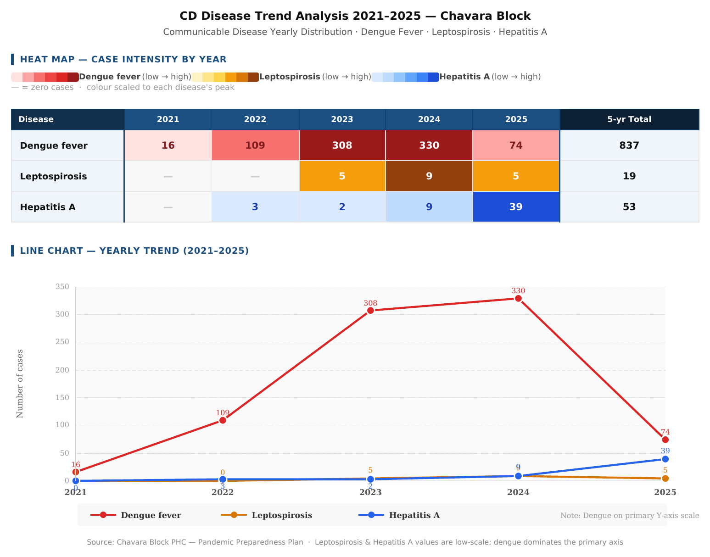

DISEASE | 2023  CASES | 2024  CASES | 2025  CASES | EPIDEMIOLOGICAL TREND
Dengue | 304 | 101 | 307 | Declining trend
Acute  Diarrheal  Disease (ADD) | 391 | 138 | 375 | Rising trend
Mumps | 91 | 4 | 137 | 162 Rising trend
Tuberculosis | 47 | 12 | 46 | 39 Declining trend
Leptospirosis | 0 | 0 | 1 | 32 Stable
Hepatitis A | 28 | 4 | 18 | 33 Rising trend

1. The "2024 Surveillance Anomaly"
The most prominent feature of this dataset is the universal, dramatic decline in cases during 2024. For example, Acute Diarrheal Disease (ADD) dropped by 64%, Dengue by 66%, and Mumps dropped entirely from 91 cases to just 4.
- Insight: In public health surveillance, a sudden, uniform drop across distinct disease categories (vector-borne, water-borne, and respiratory/contact) rarely indicates a spontaneous eradication of pathogens. This "dip" strongly suggests a temporary disruption in the health system. This could be due to under-reporting, a shift in healthcare-seeking behavior, a diversion of health staff to other duties, or an environmental factor (like extreme weather limiting movement).
2. The 2025 "Rebound and Surge"
The 2025 data shows a massive U-turn, with case numbers rebounding to match or exceed the 2023 baseline. This indicates that the underlying transmission risks were never resolved in 2024; they were merely masked.
- Mumps (Active Outbreak): Mumps shows a true rising trend. It not only recovered from the 2024 dip but surged significantly past its 2023 peak (from 91 to 137 cases). This indicates a widening immunity gap in the population, likely spreading through schools or crowded institutions, requiring immediate catch-up vaccination campaigns.
- Dengue (Endemic Resurgence): Despite the "Declining trend" label, the raw numbers show Dengue returning from 101 cases back up to 307 cases (slightly higher than the 304 cases in 2023). This confirms that the vector breeding grounds remain intact and transmission is fully re-established.
- ADD (Persistent High Burden): ADD remains the highest absolute burden, rebounding from 138 back to 375 cases. This persistent volume points to chronic, unresolved vulnerabilities in local water sanitation and hygiene (WASH) infrastructure.
3. Stable but Critical Threats
- Tuberculosis: TB cases rebounded almost perfectly to 2023 levels (47 in 2023 vs. 46 in 2025). TB requires continuous, long-term treatment; the severe drop to 12 cases in 2024 suggests a dangerous lapse in active case finding or contact tracing, which has now resumed in 2025.
- Hepatitis A & Leptospirosis: Hepatitis A is showing a moderate resurgence (up to 18 cases), while Leptospirosis remains very low. Both require continued monitoring of water sources and occupational hazards (like farming or fishing).
Strategic Recommendations
- Investigate 2024: The public health team must audit the 2024 reporting mechanisms to understand why the surveillance system failed to capture the true disease burden that year.
- Prioritize Vector & Water Control: The sheer volume of Dengue and ADD cases demands immediate pre-monsoon source reduction and well-chlorination campaigns.
- Targeted Mumps Intervention: The clear escalation in Mumps requires immediate localized isolation protocols and awareness campaigns in local educational institutions.

6. PANDEMIC PREPAREDNESS STRATEGY
Governance Structure
Block Pandemic Control Committee
ROLE | RESPONSIBILITY
Dr. M. DSasi, Administrative Medical Officer | Incident Commander
PHC Medical Officers of all 6 institutions | Facility Response
Sri Mannan Pillai, Health Supervisor | Public Speaker
Sri Shibu,smt Sredevi, Health Inspectors | Surveillance
Dr Jayasankar, Epidemiologist | Epidemiological trend analysis and  interpretation
Arun, PRO | Interdepartmental Coordination
Sri Maneesh M Purakkad , Block Panchayat President | Local Enforcement
Smt. Arya, Block Health Standing committee chairperson | Local Enforcement
Police, Fire and rescue | Containment Support

Here is the customized Governance and Operational Framework and Surveillance Strengthening section for the Chavara Block.
I have updated the block names, replaced the poultry-dense reference with Panmana (which we identified earlier as having the massive bird population of 17,201), and updated the district laboratory references from Alappuzha to Kollam.
Governance and Operational Framework – Chavara Block
The Block Pandemic Control Committee of Chavara Block serves as the central command and coordination body responsible for planning, activating, and supervising all pandemic preparedness and response activities within the block. The Committee ensures unified leadership, rapid decision-making, interdepartmental convergence, and structured implementation of containment and mitigation strategies across all Panchayats (Panmana, Neendakara, and Chavara) and health institutions.
At the helm of the Committee is the Administrative Medical Officer (AMO), who functions as the Incident Commander. The AMO provides overall strategic leadership, authorizes phase escalation or de-escalation, allocates resources, supervises surge activation, and maintains coordination with district health authorities. The Incident Commander ensures that all actions are data-driven and aligned with state and national public health guidelines.
The PHC Medical Officers are responsible for facility-level response management. They oversee triage systems, isolation ward activation, case management protocols, oxygen utilization, and continuity of essential health services within their respective institutions. During surge phases, they ensure rapid conversion of beds, staff deployment adjustments, and adherence to infection prevention and control (IPC) standards.
The Health Supervisors act as the official Public Communicators and Spokespersons at the block level. This role includes conducting community awareness sessions, coordinating Panchayat meetings, addressing public concerns, and ensuring the dissemination of accurate and timely information to prevent panic and misinformation.
The Health Inspectors (HIs) lead surveillance and field-level containment activities. Their responsibilities include fever surveillance, contact tracing supervision, micro-containment zone monitoring, environmental sanitation oversight, and reporting through the Integrated Disease Surveillance Programme (IDSP).
The Epidemiologist provides technical leadership in epidemiological trend analysis and interpretation. This includes monitoring test positivity rates, outbreak mapping, transmission pattern analysis, and forecasting surge requirements. Evidence-based recommendations from the epidemiologist guide policy decisions, resource allocation, and risk communication strategies.
The Public Relations Officer (PRO) ensures effective interdepartmental coordination, facilitating communication between health, disaster management, education, fisheries, and revenue departments. This coordination is crucial for implementing movement restrictions, community hall activation, supply chain logistics, and welfare measures during containment phases.
Given the zoonotic risk profile of the block—particularly in poultry-dense areas such as Panmana—the Veterinary Officer leads zoonotic surveillance and animal health monitoring. Responsibilities include monitoring unusual animal mortality, coordinating safe disposal protocols, and ensuring rapid cross-reporting between veterinary and human health sectors under the One Health framework.
The Panchayat Authorities play a critical role in local enforcement and community mobilization. They support containment zone notification, sanitation drives, well chlorination campaigns, public announcements, and mobilization of community volunteers. Panchayat leadership ensures local compliance and community participation in response measures.
The Police Department provides containment and regulatory support, assisting in movement control, enforcement of quarantine and isolation orders, crowd regulation, and maintaining public order during high-alert phases.
Together, the Block Pandemic Control Committee functions as an integrated command system that ensures coordinated governance, rapid operational response, and community-centered pandemic management. By clearly defining roles and responsibilities, the committee strengthens accountability, minimizes duplication of efforts, and enhances the overall resilience of Chavara Block in responding to public health emergencies.

Surveillance Strengthening
ACTIVITY | RESPONSIBLE UNIT | FREQUENCY
Daily IDSP Reporting | PHCs | Daily
Private Hospital Reporting | AMO Office | Mandatory
Fever Surveillance | JAK team | Daily
Animal Mortality Surveillance | Veterinary Dept | Immediate
Lab Surveillance | CHC lab / District Labs | Continuous
Surveillance Strengthening Mechanism
In Chavara Block, surveillance strengthening is a core strategic pillar to ensure early outbreak detection, timely containment, and evidence-based decision-making. Considering the block’s history of vector-borne, water-borne, respiratory, and zoonotic diseases, surveillance activities are structured to function on a daily, mandatory, and continuous basis across multiple sectors.
Daily IDSP Reporting by PHCs ensures systematic documentation and transmission of communicable disease data through the Integrated Disease Surveillance Programme. All Primary Health Centres submit daily morbidity and mortality reports, including fever cases, diarrheal diseases, respiratory infections, and other notifiable conditions. This enables real-time trend monitoring, early cluster identification, and rapid epidemiological assessment at the block level.
Mandatory Private Hospital Reporting coordinated through the AMO Office strengthens surveillance completeness. Since the 6 private institutions in the block manage a significant proportion of admissions and critical cases, they are required to report notifiable diseases, severe respiratory infections, and unusual case clusters without delay. The Administrative Medical Officer consolidates and validates this data to ensure integration with government surveillance systems and appropriate escalation when thresholds are crossed.
Daily Fever Surveillance conducted by the JAK Team functions as the frontline early warning mechanism. The JAK team undertakes active field surveillance in wards, particularly in high-risk and densely populated areas like the coastal belts. Door-to-door visits, cluster investigation, and immediate reporting of fever spikes allow prompt initiation of containment measures, testing drives, and environmental interventions.
Immediate Animal Mortality Surveillance by the Veterinary Department is a vital component under the One Health framework. Any unusual or sudden animal deaths—particularly in poultry-dense regions like Panmana—are reported immediately to health authorities. Rapid veterinary investigation, sample collection, and coordinated response reduce the risk of zoonotic spillover and ensure integrated outbreak control.
Continuous Laboratory Surveillance through the CHC Lab, and linked higher centers like the District Public Health Laboratory (DPHL) Kollam and Government Medical College Hospital (MCH) Kollam, provides diagnostic confirmation and trend analysis. The laboratory monitors test volumes, positivity rates, and emerging pathogen patterns. Daily data sharing with the Epidemiologist and AMO supports predictive modeling, surge preparedness activation, and targeted containment strategies.
Collectively, this integrated surveillance system—combining facility-based reporting, private sector inclusion, community-level monitoring, zoonotic vigilance, and laboratory intelligence—ensures that Chavara Block remains proactive, responsive, and data-driven in managing public health threats.

7. Laboratory Preparedness Plan for Pandemic Situations
A well-prepared laboratory system is essential for early detection, confirmation, surveillance, and monitoring during a pandemic. Given that Chavara Block currently lacks internal RT-PCR laboratory capacity, the laboratory network must function in a highly efficient, tiered hub-and-spoke manner. Peripheral laboratories and the 16 Sub Centres will focus exclusively on sample collection, rapid antigen/antibody testing, and safe transport, while all molecular and confirmatory testing must be routed immediately to designated district laboratories (such as DPHL Kollam and MCH Kollam). This strict linkage ensures reduced turnaround time, early isolation of cases, and prompt public health action despite local infrastructure gaps.
All local laboratories must maintain uninterrupted workflow through shift systems to provide 24×7 rapid testing and sample packaging capacity during surge periods. Adequate stock of consumables such as viral transport media (VTM), swabs, rapid extraction kits, reagents, PPE, and disinfectants should be maintained for a minimum buffer period of four weeks. Critical equipment such as biosafety cabinets, centrifuges, and especially deep cold storage units—which are vital for holding samples prior to district transport—must be functional, calibrated, and supported by backup power.
Sample collection should be decentralized through PHCs, fever clinics, mobile teams, and targeted outreach to the block's specific high-risk groups, including the large elderly population, dialysis and cancer patients, the dense fisherfolk clusters in Neendakara, and bedbound individuals. A strict cold-chain system utilizing triple-layer packaging and documented, dedicated transport vehicles must be established to maintain sample integrity during transit to the district centers.
Biosafety remains critical even at the sample-collection level. Laboratories and collection kiosks must implement unidirectional workflow, appropriate zoning, mandatory PPE use, rigorous biomedical waste management, and regular disinfection. Staff health monitoring, vaccination (where applicable), and roster-based deployment are required to prevent the depletion of the block's laboratory workforce.
Real-time data reporting to the surveillance unit must be ensured through the Block Data Manager. Daily reporting of rapid test numbers, positivity rates, and pending sample dispatch logs allows for timely decision-making by the Incident Commander. Quality assurance mechanisms, including external validation of rapid tests and periodic blind sample rechecking in coordination with the district labs, must be institutionalized.
During surge situations, the limited government laboratory workforce (currently comprising only 4 technicians) necessitates the immediate empanelment of the block's 6 private hospitals and their 22 private laboratory technicians. Testing and collection hours should be extended, and this private workforce integrated into the public health response to manage high testing volumes. Pool testing strategies may be initiated at the district level if recommended by national guidelines.
Regular training for both public and private staff on PPE use, biosafety, specialized sample handling for out-of-block transport, and mock drills will ensure readiness and minimize laboratory-acquired infections.
PANDEMIC PREPAREDNESS PLAN Page 45
Duties and Responsibilities
1. Laboratory Leadership
ROLE | DUTIES | RESPONSIBILITIES
Dr SASI M D,  Administrative Medical Officer | Resource allocation and policy decisions | Ensure manpower, logistics, and inter-facility coordination
Dr Jayasankar,  Epidemiologist | Link lab data with  surveillance | Interpret trends, initiate outbreak response

2. Laboratory Technical Team
ROLE | DUTIES | RESPONSIBILITIES
Senior Lab Technician  Lekshmi L | Supervise shift operations | Maintain equipment logs, stock monitoring
MLSP / JPHN (Sample  Collection) | Collect NP/OP samples | Proper labeling, cold-chain  maintenance
Support Staff | Sample transport and waste handling | Triple packaging, biomedical waste disposal

3. Data and Reporting Unit
ROLE | DUTIES | RESPONSIBILITIES
Smt Daniya Joseph, Data Manager | Real-time data  entry | Upload results to portal within stipulated time
Lab Technician | Line listing support | Maintain sample register and tracking
Dr Jayasankar,  Epidemiologist | Data analysis | Daily situational report generation

4. Biosafety and Infection Control
ROLE | DUTIES | RESPONSIBILITIES
All Lab Staff | PPE use and hand hygiene | Follow spill management and exposure protocol
Smt, Nursing Officer, HIC incharge | Supervision of Segregation and disposal | Ensure transport to KEIL and disinfection

5. Logistics and Supply Chain
ROLE | DUTIES | RESPONSIBILITIES
Smt Sindhu, Pharmacist / Store Officer | Maintain stock of  consumables | Buffer stock for 4 weeks, FIFO method
Dr Sasi M D, BMO | Procurement approval | Prevent stock-outs and emergency purchase
Lekshmi L, Senior Lab  Technician (Store link) | Daily stock reporting | Indent preparation and usage  tracking

6. Sample Collection Teams (Field)
TEAM  COMPOSITION | DUTIES | RESPONSIBILITIES
MLSP / JPHN | Sample collection | Follow PPE protocol and proper technique
ASHA | Line listing and community coordination | Mobilize high-risk groups, ensure follow-up
JHI | Transport documentation | Maintain chain of custody and  temperature log

PANDEMIC PREPAREDNESS PLAN Page 47
7. Surge Capacity Plan
TRIGGER | ACTION | RESPONSIBLE
Test positivity rising | Activate 24×7 shifts | Rekha kuttan, Lab Nodal Officer
Increased sample load | Engage private labs | Dr Sreelekshmi G R, AMO
Backlog >24 hours | Deploy additional technicians | District Health Authority
Cluster outbreak | Mobile sample teams | Sri Shijimon, Health Supervisor
Cluster outbreak  Interpretation | Data analysis and Technical assistance | Dr Bhagya Lekshmi L,  Epidemiologist

Key Performance Indicators
INDICATOR TARGET
Turnaround time < 24 hours
Stock-out events Zero
Lab-acquired infections Zero
Real-time reporting 100% compliance
Sample rejection rate < 2%
Clinical Surge Plan
Surge Bed Strategy
PHASE | ACTION
Preparedness | Identify isolation wards
Early Outbreak | Convert wards to isolation
Moderate Surge | Activate community halls
Severe Surge | Engage private hospitals fully
Critical | District-level referral

8. INFECTION PREVENTION AND CONTROL (IPC)
∙ PPE stockpile at each PHC
∙ Mask and sanitizer distribution
∙ Chlorination of wells
∙ Vector control drives
∙ Fogging during dengue outbreaks
∙ Safe poultry disposal protocol
9. ONE HEALTH APPROACH
Due to avian influenza history:
Sector | Action
Health | Human case surveillance
Veterinary | Poultry monitoring
Panchayat | Slaughterhouse regulation
Community | Reporting unusual animal deaths

10. LOGISTICS MANAGEMENT
Maintain buffer stock of:
∙ PPE kits
∙ N95 masks
∙ IV fluids
∙ ORS
∙ Antibiotics
∙ Antivirals (as per Govt policy)
∙ Chlorine tablets
Logistics Nodal Officer appointed at block level.

Here is the Surge Plan fully customized for the Chavara Block, incorporating the specific infrastructure, workforce, and demographic data we established in the previous sections.
11. CHAVARA BLOCK SURGE PLAN
Based on the 4S MODEL (Staff – Stuff – Structure – Systems)
STAFF (Human Resource Surge Strategy)
Baseline Government Workforce
- 24 Modern Medicine Doctors
- 19 Nursing Officers
- 4 Lab Technicians
- 104 ASHA workers
- 18 JPHN
- 15 JHI
- 1 Community One Health Volunteer
- 1 Epidemiologist
- 1 Data Manager

Panchayat-Specific HR Risk Mapping
PANCHAYAT | KEY RISK FACTOR | SURGE HR FOCUS
Panmana | Highest population (64k) & massive bird density | Zoonotic rapid response & massive triage scaling
Neendakara | Coastal cluster & high fisherfolk density | Coastal mobile fever clinics & occupational health teams
Chavara | Highest elderly burden & private hospital hub | Geriatric home-care teams & private sector referral coordination
Phase-wise Staff Mobilization
Phase 1 – Preparedness
- Maintain updated HR roster.
- Train 100% of staff in IPC & oxygen triage.
- Assign ASHA ward-wise high-risk lists (targeting the elderly and BPL families).
Phase 2 – Cluster Detection
- Activate Fever Surveillance Teams (ASHA + JHI).
- Deploy 1 Rapid Response Team per Panchayat.
- Convert OP triage to a dual-entry system to separate infectious cases.
Phase 3 – Community Transmission
- Suspend elective services.
- Initiate 12-hour shift rotation for government staff.
- Engage private doctors (23 available in the block) for step-down and tele-consultation.
- Activate the Community One Health Volunteer for expanded field monitoring.
Phase 4 – Severe Surge
- Pool all block-level doctors (public and private) under the AMO/Incident Commander.
- Engage AYUSH doctors (3 Govt) for screening and home isolation tracking.
- Seek immediate district HR support for ICU and advanced clinical care.

STUFF (Logistics & Essential Supplies)
Existing Critical Resources
- 2 Govt Oxygen Plants, 1 Private Oxygen Plant
- 0 Blood Banks (Requires dedicated district transport linkage)
- 0 RTPCR Labs (Requires strict cold-chain sample transport to district)
- 5 Private ALS Ambulances (0 Govt)
- 12 Private ICU Beds (0 Govt)
Minimum Buffer Norms for Block
ITEM | MINIMUM SURGE BUFFER
PPE Kits | 14-day stock
N95 Masks | 10 per staff per week
Oxygen Cylinders | 7-day backup
ORS | 5,000 sachets
IV Fluids | 2,000 units
Rapid Antigen Kits | 2-week supply
Chlorine Tablets | Enough for 19,474 wells across the block
Panchayat-Specific Supply Priorities
- Chavara: Geriatric medicines, oxygen concentrators, and NCD drug buffers.
- Panmana: PPE + zoonotic outbreak kits (due to bird population), and heavy ORS/IV fluid stock (due to high ADD rates).
- Neendakara: Rapid testing kits for evening coastal camps, ORS + ADD management stock, and pre-monsoon leptospirosis prophylaxis.
STRUCTURE (Physical Capacity Expansion)
Current Capacity
- 3 Government Hospital Buildings & 16 Sub Centres
- 6 Private Hospitals
- Critical Gap: 0 Government ICU beds (100% reliance on the 12 Private ICU beds and district referrals)
- 3 Oxygen Plants (2 Government, 1 Private)
- Community halls and auditoriums available across all three Panchayats for rapid conversion.
Surge Bed Expansion Plan
Phase | Action | Estimated Capacity Gain
Phase 1 | Identify and activate isolation wards across the 3 main government hospital buildings. | +30 beds
Phase 2 | Convert peripheral wards to oxygen-supported beds, leveraging the output of the 3 local oxygen plants. | +40 beds
Phase 3 | Activate major Panchayat community halls and coastal auditoriums. | +100 to +150 beds
Phase 4 | Fully engage the 6 private hospitals to absorb non-pandemic cases and utilize their 12 ICU beds. | +ICU scaling

Panchayat-Level Surge Allocation
Given the distinct demographic and epidemiological risks of the block, physical surge capacity will be allocated as follows:
- Panmana: Zoonotic Containment Zone & High-Volume Isolation. Due to the massive bird population (17,201) and high overall population density, large community halls here will be prioritized for zoonotic observation and large-scale moderate case isolation.
- Neendakara: Coastal Quarantine Hub. Focused on localized isolation facilities near the harbor to serve the dense fisherfolk population (9,279) without requiring them to travel inland.
- Chavara: Critical Care Hub & Geriatric Monitoring. Acting as the clinical anchor of the block, Chavara will host geriatric-specific step-down units and serve as the primary coordination point for Private ICU referral linkages.
Dedicated Transport Corridor: A strict, pre-mapped transport corridor to the District Hospital (MCH Kollam) will be established, pooling the block's 5 Private ALS Ambulances under the Incident Commander to compensate for the lack of government ICU and ALS facilities.
Here are the finalized sections for SYSTEMS, the PHASE-WISE RESPONSE FRAMEWORK, and the comprehensive RECOVERY PLAN, fully customized for the demographic and epidemiological realities of Chavara Block.
SYSTEMS (Surveillance, Governance & Communication)
Surveillance Intensification
Activity | Frequency | Responsible
Daily IDSP | Daily | PHCs
Fever Survey | Daily | JAK team
Animal Mortality Reporting | Immediate | Veterinary Dept
Lab Trend Review | 48 hrs | Epidemiologist
Bed Occupancy Review | Daily | AMO
Risk Communication Plan
CATEGORY | FREQUENCY | PERSON RESPONSIBLE
Daily Case Bulletin | During outbreak | Dr. Sasi M D, AMO
Panchayat Meeting | Weekly | Health Supervisors
SMS Alerts | Emergency | Health Inspectors
Social Media | Regular updates | JHI
Rumor Control Cell | Active during surge | Dr. Sasi M D, AMO
Training & Mock Drills
- Quarterly pandemic drills
- Oxygen failure simulation (testing the 3 local plants)
- Isolation ward activation drill (across the 3 Govt hospital buildings)
- Annual multi-sectoral disaster exercise
Monitoring Indicators
Indicator | Target
Test Positivity Rate | < 5%
Bed Occupancy | < 80%
Oxygen Stock | > 7-day buffer
Case Fatality Rate | Below state average
Vaccination Coverage | > 95% high-risk groups

11. PHASE-WISE RESPONSE FRAMEWORK
Phase | Trigger | Action
Phase 1 | No cases | Preparedness
Phase 2 | Cluster detected | Containment
Phase 3 | Community spread | Surge activation
Phase 4 | Severe outbreak | District escalation

Vulnerable Population Strategy (Block-Specific)
GROUP | TARGETED ACTION
Elderly (High in Chavara & Panmana) | Weekly home monitoring, home drug delivery
Dialysis Patients (Zero local units) | Infection-safe scheduling & dedicated district transport
Pregnant Women | Separate ANC days
Fisherfolk (High in Neendakara) | Harbor health desk, evening screening camps
Poultry Handlers (High in Panmana) | PPE + zoonotic screening
INTEGRATED ONE HEALTH RESPONSE
Monitoring Dashboard (Block Level)
INDICATOR | TARGET
TPR | < 5%
Bed Occupancy | < 80%
Oxygen Buffer | ≥ 7 days
Case Fatality | Below district average
Vaccination Coverage (High-risk) | > 95%
Key Block-Specific Priorities
- Strengthen ICU & District Referral Linkage: Crucial due to the absolute lack of government ICU beds.
- Elderly-Focused Surveillance: Prioritize the 13,877 elderly residents, especially in Chavara and Panmana.
- Zoonotic Preparedness: Active surveillance in Panmana due to the massive bird population (17,201).
- Water-Borne Disease Control: Rigorous monitoring and chlorination of the 19,474 wells to combat the high ADD burden.
- Private Sector Integration: Full empanelment of the 6 private hospitals for surge ICU and step-down care.
With coordinated implementation, Chavara Block can effectively manage future pandemics, respiratory outbreaks, zoonotic threats, and water-borne epidemics while safeguarding its vulnerable populations.

12. RECOVERY PLAN
Chavara Block – Post-Surge Recovery & Health System Restoration Framework
(Applicable to Panmana, Neendakara, and Chavara Panchayats)
Recovery begins once the block transitions from Phase 4/3 (Severe/Community Spread) to Phase 2 (Cluster Control) with a sustained decline in cases for 14 consecutive days and a Test Positivity Rate < 5%.
OBJECTIVES OF RECOVERY PHASE
- Restore essential and routine healthcare services safely.
- Address indirect health impacts of the outbreak.
- Provide psychosocial and mental health support.
- Rebuild supply chain and infrastructure resilience.
- Conduct structured audits and system strengthening.
- Institutionalize lessons learned into policy revision.
RESUMPTION OF ROUTINE HEALTH SERVICES
A. Phased Restoration Strategy
- Phase A (Weeks 1–2): Immunization, ANC, Dialysis transport coordination, NCD clinics.
- Phase B (Weeks 3–4): Elective procedures, School health programs.
- Phase C (Week 5 onward): Full OPD normalization.
B. Priority Service Areas (Block-Specific)
- Maternal & Child Health:
  - Restart routine immunization drives.
  - Special outreach in high BPL pockets (specifically the 8,225 BPL families in Panmana).
  - Catch-up vaccination sessions and growth monitoring for under-5 children.
- NCD Clinics:
  - Focus on high elderly burden areas (Chavara and Panmana).
  - Re-establish monthly diabetes & hypertension clinics.
  - Medication refill camps for defaulters.
- TB & Chronic Disease Continuity:
  - Active tracing of TB treatment defaulters (crucial given the 2025 TB rebound).
  - Home visits by JPHN/JHI and nutritional support linkage.
- Dialysis & Critical Care:
  - Audit infection control compliance.
  - Restore routine out-of-block dialysis scheduling.
- School & Community Health:
  - Mumps catch-up vaccination and screening in Chavara schools.
  - Awareness sessions in coastal fisherfolk communities (Neendakara).
MENTAL HEALTH & PSYCHOSOCIAL SUPPORT
Outbreaks disproportionately affect healthcare workers, bereaved families, the elderly living alone, and fisherfolk affected by livelihood disruption.
A. Community-Level Mental Health Strategy
- Activate Block Mental Health Team.
- Conduct ward-level counseling camps and tele-counselling services.
- ASHA-led stress screening during home visits.
B. Healthcare Worker Support
- Post-surge debrief sessions and burnout assessment surveys.
- Rotational leave planning and peer-support groups.
C. High-Risk Group Focus
GROUP | INTERVENTION
Elderly | Home-based counselling
COVID/Outbreak Survivors | Post-illness screening
Families with deaths | Grief counselling
Frontline workers | Psychological resilience training
REVIEW, AUDIT & AFTER-ACTION ANALYSIS
(Within 30 days of de-escalation)
A. Epidemiological Review: Peak caseload analysis, ward-wise attack rate, and Case Fatality Rate comparison with the district.
B. Clinical Audit: Oxygen utilization review, ICU mortality audit (reviewing private sector performance), and referral efficiency assessment.
C. Logistics Audit: PPE stock adequacy, oxygen plant functionality, and drug consumption patterns.
D. Surveillance System Review: IDSP timeliness, private sector reporting compliance, and laboratory turnaround time.
A formal After-Action Review (AAR) report shall be submitted to District Health Authorities.
STOCK REPLENISHMENT & RESOURCE NORMALIZATION
A. Immediate Replenishment (Within 2 Weeks): PPE kits, N95 masks, Rapid antigen kits, IV fluids & ORS packets (vital for ADD), essential antibiotics, and chlorine tablets.
B. Oxygen & Critical Equipment: Preventive maintenance of the 3 oxygen plants, cylinder refilling, ventilator servicing, and generator inspection.
C. Financial Review: Expenditure audit and emergency fund utilization analysis.
INFRASTRUCTURE RESTORATION
- Decontamination of isolation wards and restoration of converted community halls.
- Biomedical waste audit and repair of overused equipment.
POLICY REVISION & SYSTEM STRENGTHENING
- Update Block Pandemic SOP.
- Revise oxygen surge capacity norms.
- Strengthen ICU referral linkages (formalize private sector integration).
- Enhance zoonotic surveillance (especially in the Panmana bird belt).
- Update ward-level vulnerability mapping.
COMMUNITY RE-ENGAGEMENT
- Public appreciation campaign for volunteers.
- Panchayat-level review meetings and transparency reports to the community.
LONG-TERM RESILIENCE BUILDING
- Establish a permanent Block Emergency Operations Cell.
- Develop a digital real-time surveillance dashboard.
- Conduct biannual pandemic drills.
- Advocate for expanded government ICU and Laboratory capacity within Chavara Block.

13. CONCLUSION
The Pandemic Preparedness Plan of Chavara Block presents a structured, evidence-based, and locally contextualized framework to prevent, detect, respond to, and recover from public health emergencies.
Chavara Block is characterized by:
- A strong grassroots primary healthcare network anchored by 3 main government hospital buildings and 16 Sub Centres.
- An active frontline workforce of 104 ASHA workers and community-level surveillance teams.
- A significant elderly demographic (13,877 residents) and a high NCD burden, including 139 highly vulnerable dialysis patients.
- Severe coastal ecological vulnerability with 19,474 wells driving high water-borne disease trends (ADD), coupled with a massive occupational fisherfolk base (10,147), primarily in Neendakara.
- High zoonotic risk due to a dense bird population (21,410), particularly concentrated in Panmana.
- An absolute lack of government ICU beds, ALS ambulances, and RT-PCR labs, necessitating robust public-private integration with the block's 6 private hospitals and strict referral corridors to district centers.
Given the recurrent and resurging trends of vector-borne diseases (Dengue), water-borne outbreaks (Acute Diarrheal Disease), localized respiratory/contact infections (Mumps), and zoonotic threats, preparedness in this block must remain dynamic, data-driven, and surge-ready at all times.
This document integrates:
- The 4S Model (Staff, Stuff, Structure, Systems) for surge planning.
- Strengthened surveillance and strict cold-chain laboratory coordination with district testing centers.
- Critical care optimization strategies via private sector empanelment and district hospital linkages.
- Targeted protection for vulnerable populations (elderly, dialysis patients, pregnant women, fisherfolk, and industrial workers).
- One Health collaboration between health, veterinary, and local governance sectors.
- Structured recovery and audit mechanisms to ensure system resilience.
The success of this preparedness framework depends on:
- Early detection through robust, multi-tiered surveillance.
- Rapid surge activation with clear role delineation across Panmana, Neendakara, and Chavara panchayats.
- Efficient logistics, oxygen management, and dedicated transport corridors to district hospitals.
- Strong public-private partnerships, especially for intensive care and diagnostics.
- Community engagement and transparent risk communication.
- Continuous monitoring, review, and policy refinement.
With coordinated interdepartmental action, strengthened infrastructure, and sustained community participation, Chavara Block can effectively mitigate the impact of future pandemics and public health emergencies while ensuring the continuity of essential services.
This plan is not a static document but a living framework—subject to periodic review, audit, and strengthening—committed to safeguarding the health, safety, and well-being of every resident of Chavara Block.
BLOCK LEVEL CHALLENGES & STRATEGIES

AREA | CURRENT STATUS | CHALLENGES | STRATEGIES
Surveillance System | Routine reporting from Govt institutions (3 Hospitals, 16 Sub Centres). | Delay in mandatory reporting from the robust private sector. | Integrate a digital real-time reporting system linking all government facilities and the 6 private hospitals.
Data Management | Manual consolidation of data by field staff. | Lack of a centralized, real-time epidemiological dashboard. | Develop a block-level surveillance dashboard managed by the designated Data Manager.
Human Resources | Adequate primary field staff (104 ASHAs, 18 JPHNs). | Zero government ICU capacity; complete reliance on district or private sector for critical care. | Cross-train primary staff for oxygen triage; formalize district referral protocols; conduct emergency training programs.
Private Sector Integration | 23 private modern medicine doctors & 6 private hospitals (with 12 ICU beds). | No formal bed-sharing, reporting, or resource-pooling agreement during surges. | Establish a formal Public-Private Partnership (PPP) agreement for ICU bed pooling and data sharing under the Incident Commander.
One Health Coordination | Veterinary institutions available; high zoonotic risk (21,410 birds, heavily in Panmana). | No structured joint human-animal outbreak protocol specifically for the block. | Develop a joint human-animal outbreak SOP exclusively for Chavara block level, focusing on avian influenza and safe poultry handling.
Risk Communication | IEC materials distributed during localized outbreaks. | No pre-drafted communication strategy tailored to specific local demographics (fisherfolk, industrial laborers). | Prepare standard media & IEC templates customized for coastal communities and industrial workplaces; pre-draft communication strategies.
Vulnerable Population Tracking | NCD, dialysis (139), and elderly (13,877) data available. | No priority registry for pandemic triage, home delivery of drugs, or specialized transport. | Develop a high-risk population registry with ward-level mapping for targeted home care and secure transport to district centers.
Mock Drills | Limited simulation exercises. | No periodic structured drills involving private sector and transport coordination. | Conduct an annual full-scale mock drill that specifically tests oxygen plant failure, private ICU referral, and sample transport to Kollam district labs.
Continuity of Essential Services | Routine services (immunization, NCD clinics) functional. | No documented continuity protocol during a severe surge (Phase 3/4). | Develop an Essential Services Continuity Plan, focusing heavily on out-of-block dialysis transport and uninterrupted NCD medication delivery.

14. SWOT ANALYSIS OF CHAVARA BLOCK
STRENGTHS (Internal Positives)
- Strong Primary Workforce: Robust availability of medical officers with 24 Government Modern Medicine Doctors and 23 Private Doctors.
- Grassroots Surveillance: An active field team of 104 ASHA workers, 18 JPHNs, and 15 JHIs ensuring deep community-level surveillance.
- Private Sector Infrastructure: A strong local private healthcare network comprising 6 hospitals, 12 ICU beds, and 5 ALS Ambulances available for empanelment.
- Oxygen Redundancy: Good baseline oxygen generation capacity with 3 local Oxygen Plants (2 Government, 1 Private).
- Command & Control: Dedicated block-level epidemiological support (1 Epidemiologist and 1 Data Manager) enabling data-driven IDSP reporting.
- Outbreak Experience: Proven experience in managing high-burden vector-borne (Dengue), water-borne (ADD), and localized infectious outbreaks (Mumps).
WEAKNESSES (Internal Negatives)
- Zero Public Critical Care: An absolute lack of Government ICU beds and Advanced Life Support (ALS) ambulances within the block.
- Diagnostic Dependency: Zero Government RT-PCR laboratories and limited government lab staff (only 4 technicians), necessitating 100% reliance on district labs for molecular confirmation.
- No Blood Bank: Zero blood bank facilities across both public and private sectors in the block.
- Dialysis Vulnerability: No local dialysis units, posing a major logistical challenge for the block's 139 dialysis patients during a lockdown or severe surge.
- 100% District/Private Reliance: Total dependence on external referral corridors to District Hospitals (MCH Kollam) or private institutions for any severe or critical cases.
OPPORTUNITIES (External Positives)
- Public-Private Partnerships (PPP): Formalizing agreements with the 6 private hospitals to pool their 12 ICU beds, 54 private nurses, and 5 ALS ambulances under the Incident Commander during surges.
- Targeted Occupational Health: Implementing dedicated evening health desks and fever clinics at the Neendakara harbor to protect the highly concentrated fisherfolk population (9,279 individuals).
- One Health Zoonotic Control: Leveraging veterinary coordination in Panmana to proactively monitor and manage the massive bird population (17,201) against avian influenza risks.
- WASH Interventions: Upgrading environmental surveillance and chlorination drives across the block's massive network of 19,474 wells to drastically cut the persistent ADD burden.
- School-Based Outbreak Prevention: Utilizing the data from the recent Chavara mumps outbreak to launch highly targeted school vaccination and hygiene campaigns.
THREATS (External Negatives)
- Massive Water-Borne Burden: The persistent and rising trend of Acute Diarrheal Disease (375 cases in 2025) threatening to overwhelm primary care during monsoon or flood events.
- Endemic Vector-Borne Resurgence: High and rebounding rates of Dengue fever across Panmana and Neendakara.
- Zoonotic Spillover: The constant ecological threat of avian outbreaks turning into human transmission in high-density poultry/bird areas like Panmana.
- Localized Institutional Outbreaks: The sudden appearance of highly localized infectious spikes, such as the 124 Mumps cases and 13 Hepatitis C cases concentrated entirely in Chavara in 2025.
- Economic Disruption of Vulnerable Groups: Pandemic-related lockdowns or illness clusters disproportionately destroying the livelihoods of the 13,544 BPL families and the massive daily-wage coastal fisherfolk community

15. ANEXTURES
IMPORTANT PHONE NUMBERS
Phone numbers and particulars of persons responsible for providing guidance, assistance, and support for pandemic preparedness operations may be provided here in a manner that allows easy reference at a glance. The information recorded here could be exhibited elsewhere at the time of emergencies. LSG institutions shall give special attention to collect and record the above data of persons and institutions who/which are supposed to give technical and co-ordination support to reduce the impact of pandemic.

1. ChavaraBlock Health Officials
NAME | DESIGNATION | CONTACT NUMBER
Dr SASI MD | Block medical officer (AMO) | 9447052886
Mannanpillai | Health Supervisor | 9496271744
Brinda | Lady Health Supervisor CHC Chavara | 9744009194
Dr Shehna | Medical officer, FHC Chavara | 9544267115
Dr Jayasankar | Epidemiologist | 9738705671
Shibu K | Health Inspector | 9447072661
Sreedevi | Health Inspector | 9496231368

Arun | Public Relation Officer (PRO) | 9020909201
Lekshmi L | Senior Lab technician | 70344229309
Mini Devi | Pharmacist | 9400830486
Nirmala | Senior Clerk | 9446147197s

2. Veterinary Services

Sl.No | Name of the Clinic | Name of the  Surgeon/Doctor | Place/location | Phone  number
1 | Govt.Veterinary Hospital | Dr.Jacob Samuel | Chavara | 9847286825

. Public and Private Schools Contact details chavara Block

S.No | Name of School | Institution type | Phone number
1 | GMLPS, MUKUNDAPURAM | Gov | 9447248655
2 | GLPS PUTHUKKAD | Gov | 9497619371
3 | GLPS KAMANKULANGARA | Gov | 9048726270
4 | Gov Vocational Higher Secondary School, Kottankulangara | Gov | 9497780392
5 | GHSS Kottankulangara | Gov | 9497780392
6 | Gov UPS Mukkuthodu | Gov | 9895997608
7 | St.Augustin LPS Thannimood, Thalamukil | Aided | 9744946543
8 | St.Legonys LPS Kovilthottam | Aided | 8547484221
9 | St.Joseph LPS Karithura | Aided | 9895660934
10 | Khadariya High School, Kottukad | Aided | 8547974343
11 | PSPM UPS Pazhanjikkavu | Aided | 9946917111
12 | Khadariya Central School | Private | 9447305170
13 | SNLPS Thattasherry | Private | 9020886116
14 | Sreebudha Central School, Chavara | Private | 9961892196
15 | Al Ameen public School, Mukundapuram | Private | 8086201059
16 | Mahatma Public School, Bharanikav | Private | 6238311299
17 | Sidhartha Public School, Cherusheribhagom | Private | 9961892196

NEENDAKARA
S.No | Name of School | Institution type | Phone number
1 | St.Agnes High School | Aided | 8547300778
2 | St.Sebastians LP School | Aided | 9847183762
3 | Pretheeksha Special School | Private | 7034743542
4 | Gov. L P School Parimanam | Govt | 9567082661
5 | Arayaseva Samaja Higher Secondary School | Govt | 9495408481

7. Information regarding resources
Means of transportation | Contact Number
JCB | 08907506650
Heavy Trucks | 09539963636
Tractor | Sk tractors  8129211657
Ambulances | 8943341432
Boats | 7034401603
Taxi service | 9207880040

8. Baseline data
Category | PANMANA | NEENDAKARA | CHAVARA | BLOCK TOTAL
Total  population | 64124 | 17321 | 48598 | 1,30,043
Male | 33889 | 8519 | 23303 | 65,711
Female | 30285 | 8808 | 25296 | 64,389
TG | 0 | 0 | 0 | 0
Under 05 | 2835 | 822 | 2206 | 5,863
EPEP | 56 | 7 | 39 | 102

BPL | 8225 | 1041 | 4278 | 13,544
Adolescent  population | 5225 | 1188 | 3942 | 10355
Pregnant  women | 233 | 53 | 480 | 766
Lactating  mothers | 598 | 75 | 380 | 1053
Elderly >60  years | 1500 | 2753 | 5076 | 9329
Bedbound  patients | 65 | 80 | 139 | 284
Palliative care (non-bedbound) | 528 | 90 | 293 | 911
Patients on  haemodialysis | 49 | 10 | 49 | 108
CAPD patients | 2 | 1 | 1 | 4
Cancer patients | 79 | 160 | 120 | 359
Haemophilic  patients | 0 | 0 | 2 | 2
Mentally  challenged | 114 | 39 | 0 | 153
Differently  abled | 162 | 52 | 0 | 214
Diabetic  patients | 5230 | 989 | 2312 | 8531
Hypertensive  patients | 6268 | 1153 | 5112 | 12533
TB patients | 5 | 8 | 13 | 26
Fisherfolks | 52 | 9279 | 816 | 10147
Socio  economically  deprived | 798 | 1851 | 797 | 3453
Tribal  community | 0 | 0 | 0 | 0

