66

Iswarya S
[Email address]

PANDEMIC PREPAREDNESS PLAN KUNDARA

MESSAGE BY PANCHAYAT PRESIDENT
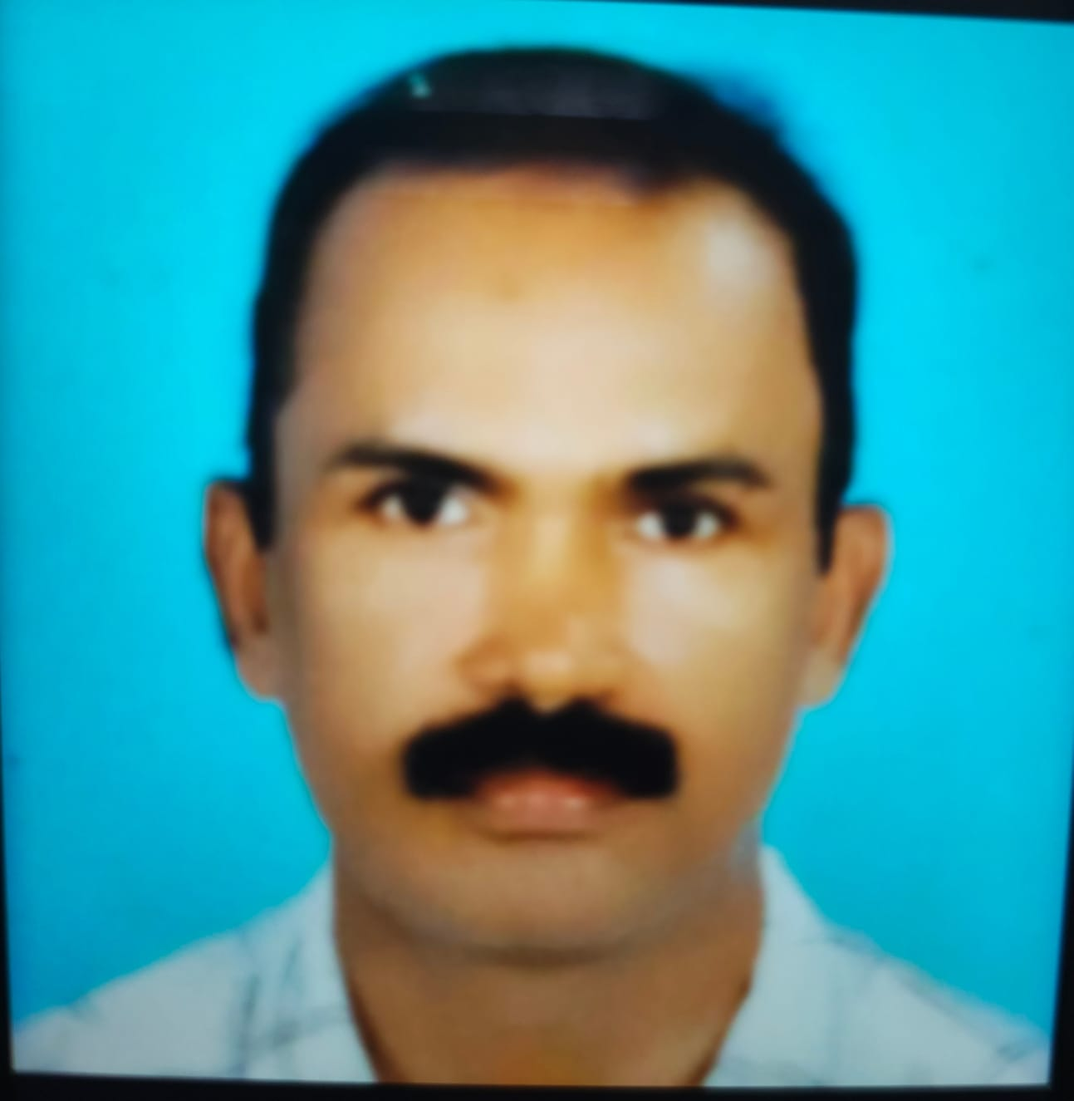
It is with profound gratitude and a deep sense of shared purpose that I introduce the Pandemic Preparedness Plan (PPP) for Kundara Grama Panchayat. As the elected leader of this vibrant community, I acknowledge Kundara's crucial dual role: it is both a collection of residential wards and the vital commercial, transport, and institutional hub of the entire Chittumala Block.
This central position inherently elevates our responsibility for public health. The indelible lessons of the COVID-19 pandemic, alongside the recurring threat of endemic communicable diseases like dengue and leptospirosis, necessitate the proactive defense detailed within these pages. This Plan is a robust strategy, meticulously crafted from a thorough analysis of our unique local risk landscape, spanning from high-density market zones to water-vulnerable peripheral wards. It establishes a practical, ward-level framework for immediate and effective response, supported institutionally by our health network, including the Government Taluk Hospital, Kundara.
The true efficacy of this strategy rests upon our collective unity. I urge every Ward Member, ASHA, health worker, and every resident of Kundara to view this document not merely as an administrative publication, but as a sacred community covenant. By committing to the vigilance and collective action outlined here, we will secure the health and well-being of every family within our Panchayat and the block at large.
Let this Plan serve as our unwavering shield against the next public health emergency.

Panchayat President
Kundara Grama Panchayat

MESSAGE BY MEDICAL OFFICER
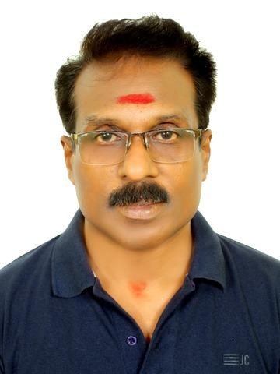
DR G BABULAL
It is with a deep sense of responsibility and institutional commitment that I present the Pandemic Preparedness Plan for Kundara Grama Panchayat. As the Medical Officer of PHC Kundara, I serve a panchayat that occupies a unique and strategically significant position within the Kundara Block — functioning not merely as an administrative unit but as the commercial, transport, and institutional hub of the entire block. This very centrality, however, carries with it a distinctive public health burden. The high population density of Kundara's market zones, the daily convergence of people from surrounding panchayats, the presence of migrant workers, and the volume of inter-district movement through our National Highway corridors all create conditions where communicable diseases can take root rapidly and spread widely if the health system is not adequately prepared.
The COVID-19 pandemic demonstrated this with unmistakable clarity. A hub community like Kundara, with its constant human movement and dense residential pockets, is among the first to register imported infections and among the fastest to amplify local transmission if surveillance and response mechanisms are not firmly in place. Alongside the pandemic experience, the recurring annual burden of dengue, leptospirosis, acute diarrhoeal diseases, and vector-borne illnesses in our wards continues to remind us that preparedness is not a one-time exercise — it is a continuous, evolving institutional commitment.
This preparedness plan is the product of careful analysis of our panchayat's specific risk landscape — its drainage challenges, its rodent density in market areas, its dependence on wells and surface water in peripheral wards, and its vulnerable sub-populations including children under five, the elderly, and the urban poor. It establishes a clear, ward-level framework for disease surveillance, vector control, outbreak containment, and community health communication, with the Government Taluk Hospital, Kundara, serving as the institutional backbone of our emergency response.
I call upon every ASHA, every health inspector, every ward member, and every resident of Kundara to embrace this plan as a shared community covenant. The health of Kundara is the health of the entire block, and the vigilance of each one of us is the strongest safeguard we have against the next public health emergency.
EXECUTIVE SUMMARY

Kundara Primary Health Centre (PHC) functions as the primary public healthcare institution serving the population of Kundara Grama Panchayath. The PHC plays a pivotal role in delivering comprehensive, accessible, and affordable healthcare services, with a strong focus on preventive, promotive, curative, and rehabilitative care in accordance with national and state health programmes.
The Kundara PHC caters to a predominantly rural population, addressing key public health priorities such as maternal and child health, communicable and non-communicable disease control, immunization, family welfare, adolescent health, and geriatric care. Regular outpatient services, home-based care through field health staff, and outreach activities ensure healthcare coverage even in geographically challenging areas. The institution actively implements national health missions, including the National Health Mission (NHM), National Tuberculosis Elimination Programme, National Programme for Prevention and Control of Cancer, Diabetes, Cardiovascular Diseases and Stroke (NPCDCS), and other disease surveillance initiatives.
Kundara PHC works in close coordination with the Grama Panchayath, ASHA workers, Anganwadi centres, schools, and community-based organizations to strengthen community participation and improve health awareness. Emphasis is placed on early detection, timely referral, health education, and lifestyle modification to reduce disease burden and improve overall health outcomes.
Despite constraints related to infrastructure, manpower, and increasing service demand, the PHC continues to enhance service delivery through effective planning, data-driven decision-making, and community engagement. Strengthening facilities, upgrading digital health systems, and expanding preventive services remain key focus areas for future development.
Overall, Kundara Primary Health Centre stands as a vital institution in safeguarding public health and improving the quality of life of the residents of Kundara Grama Panchayath.

LIST OF ABBREVIATIONS

LSGD/LSGI | Local Self Government Department / Local Self Government Institution
BMO | Block Medical Officer
IDSP | Integrated Disease Surveillance Programme
NDMA | National Disaster Management Authority
PPE | Personal Protective Equipment
ICMR | Indian Council of Medical Research
CD | Communicable Diseases
NCD | NON-COMMUNICABLE Diseases

TABLE OF CONTENTS

3
INTRODUCTION 9
● Background of the PPP 9
LSGD AT A GLANCE 9
INTEGRATED HEALTH INFRASTRUCTURE MAP OF ____________ PANCHAYAT 10
GENERAL PROFILE OF THE LSGI’S 13
Background of the LSGI 13
Demographic and Vulnerable Population 14
Clinical Vulnerability 16
INFRASTRUCTURE & RESOURCE INVENTORY 18
Health Facility Directory & Basic Capacity in the LSGD 18
Private Clinics 19
Healthcare Education & Training Institutions 20
Specialized Services & Emergency Inventory 20
Oxygen & Diagnostic Capacity 21
Diagnostics facility mapping at the LSGI level 22
Laboratory Identification & Basic Details 22
Social and Community Infrastructure for surge plan 22
Human resources 24
Community & Support Cadre 25
Community Organizations 26
Administrative & Emergency Services 27
Information regarding resources 27
ONE HEALTH & ENVIRONMENTAL SURVEILLANCE 28
Animal & Bird Population 28
Veterinary Infrastructure 29
Veterinary Doctors & Workforce 30
High-Risk Interface Points (Surveillance Sites) 30
Environmental Risk Mapping 31
Disease Seasonality Mapping 32
Vulnerability Mapping 33
EPIDEMIOLOGICAL TRENDS (2021–2025) 34
Disease Burden among human beings(Last 5 Years) 34
*(use the above table data to create the graph/diagram) 36
Seasonal Trend Analysis 37
Outcome-Based Trend Analysis- 2025 39
Transmission Trend- 2025 40
Integrated Disease Hotspot Map (2021–2025) 42
Preparedness and Response Protocol at LSG Level 44
Constitution of One Health Committee 44
Pandemic Response Workforce 45
Activities and Measures before and during Pandemic 47
PHASE 1 - Alert / Preparation 47
PHASE 2 - Active Response 50
Standard Screening Protocol 51
PHASE 3 - Surge Capacity 60
Conversion of Community Facilities 60
CONCLUSION 61
RECOMMENDATIONS 62
ANNEXURE 63
1. IMPORTANT PHONE NUMBERS 63

INTRODUCTION

Background of the PPP
- LSGD at a glance
- Background Summary of Kundara Grama Panchayat
- Kundara Grama Panchayat is a rural local self-government institution located in Chittumala Block of Kollam district, Kerala. The panchayat covers a total geographical area of 10.06 sq. km and consists of 14 wards, serving a projected population of 19,902 people. The area is characterized by a foothill terrain with a mix of residential and semi-rural landscapes, providing a calm and environmentally rich setting. The presence of the Ashtamudi river flowing through the panchayat and three ponds contributes to the local water resources and supports agriculture and domestic water needs. Kundara Panchayat has 11 educational institutions, which play a key role in improving literacy and human resource development in the area. The presence of five factories and small-scale industries indicates moderate industrial activity, contributing to employment and local economic growth. Overall, Kundara Panchayat represents a semi-rural region with a balanced combination of natural resources, educational facilities, and small-scale industrial development, supporting the socio-economic and environmental well-being of the community.

LSGD AT A GLANCE Kundara
- Geographical boundaries with political map ( based on latest delimitation)
- Baseline data
- Ward division -
Ward | Houses | Population | Migrants | Wells | Hot  spots | Ed. Institutions | Hosp pvt/govt.
14 | 5216 | 19,980 | 30 | 3180 | 7, kakkolil | 11 | 9

- Risk stratification among wards in the context of Communicable diseases and hazards
- Major Roads/rivers
- Major establishments with geospatial mapping
- occupational groups, socio cultural groups, migration & mobility patterns
- Vulnerability mapping
- Disaster prone areas (geographic vulnerability)

Maps - ward-based (Mention source also)

- Geographical boundaries - ward boundaries map

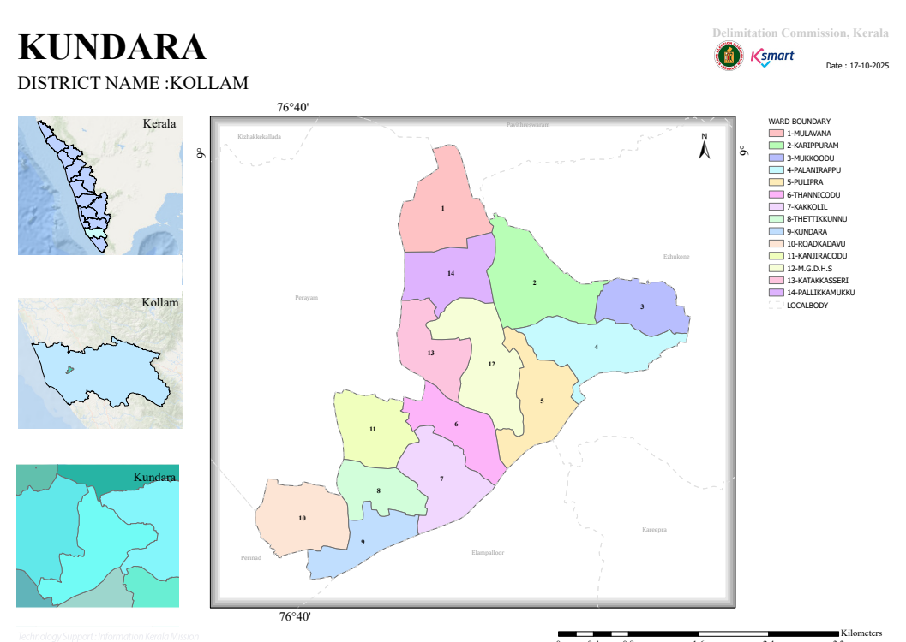

- Health infrastructure map
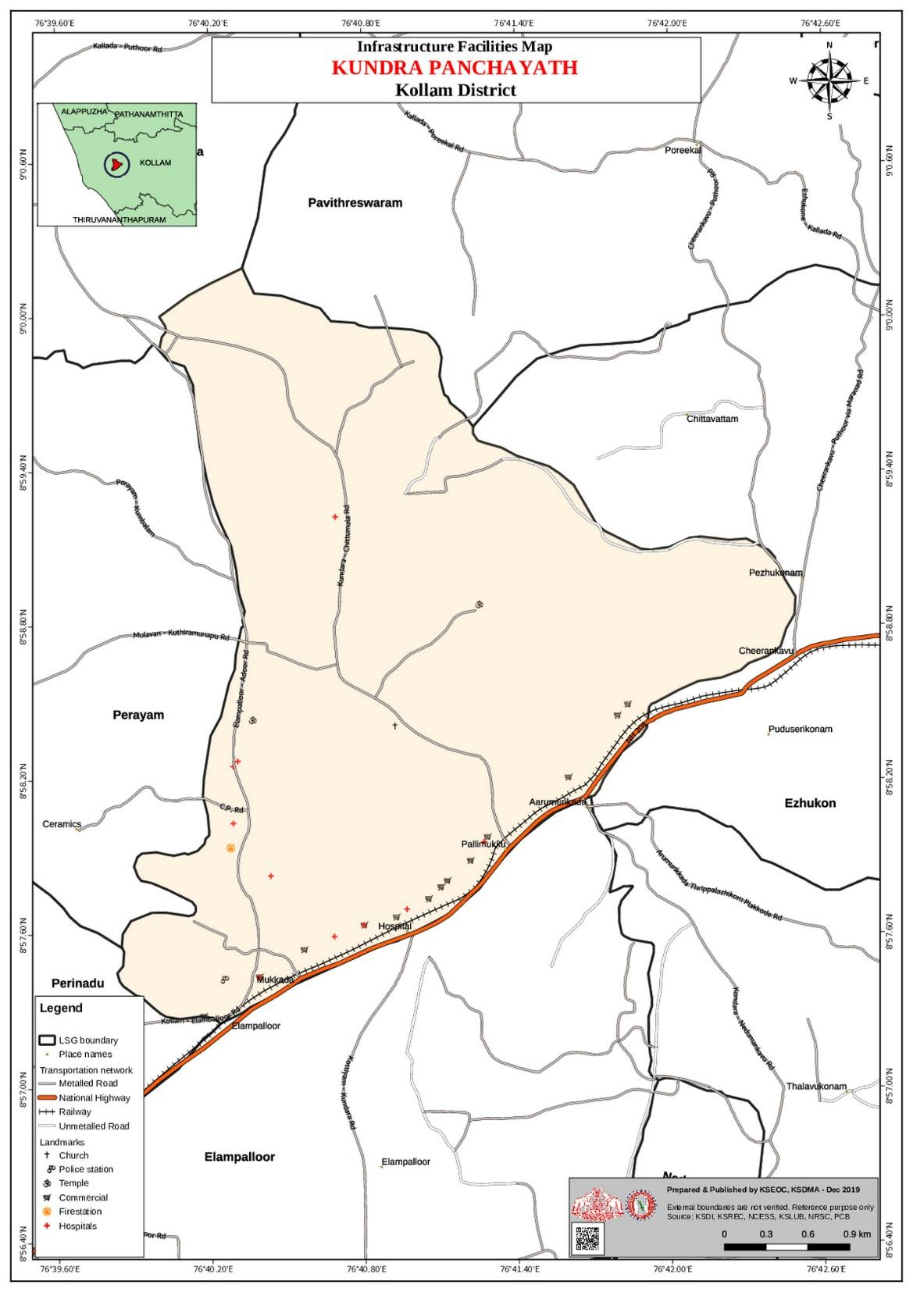

- roads and rivers map

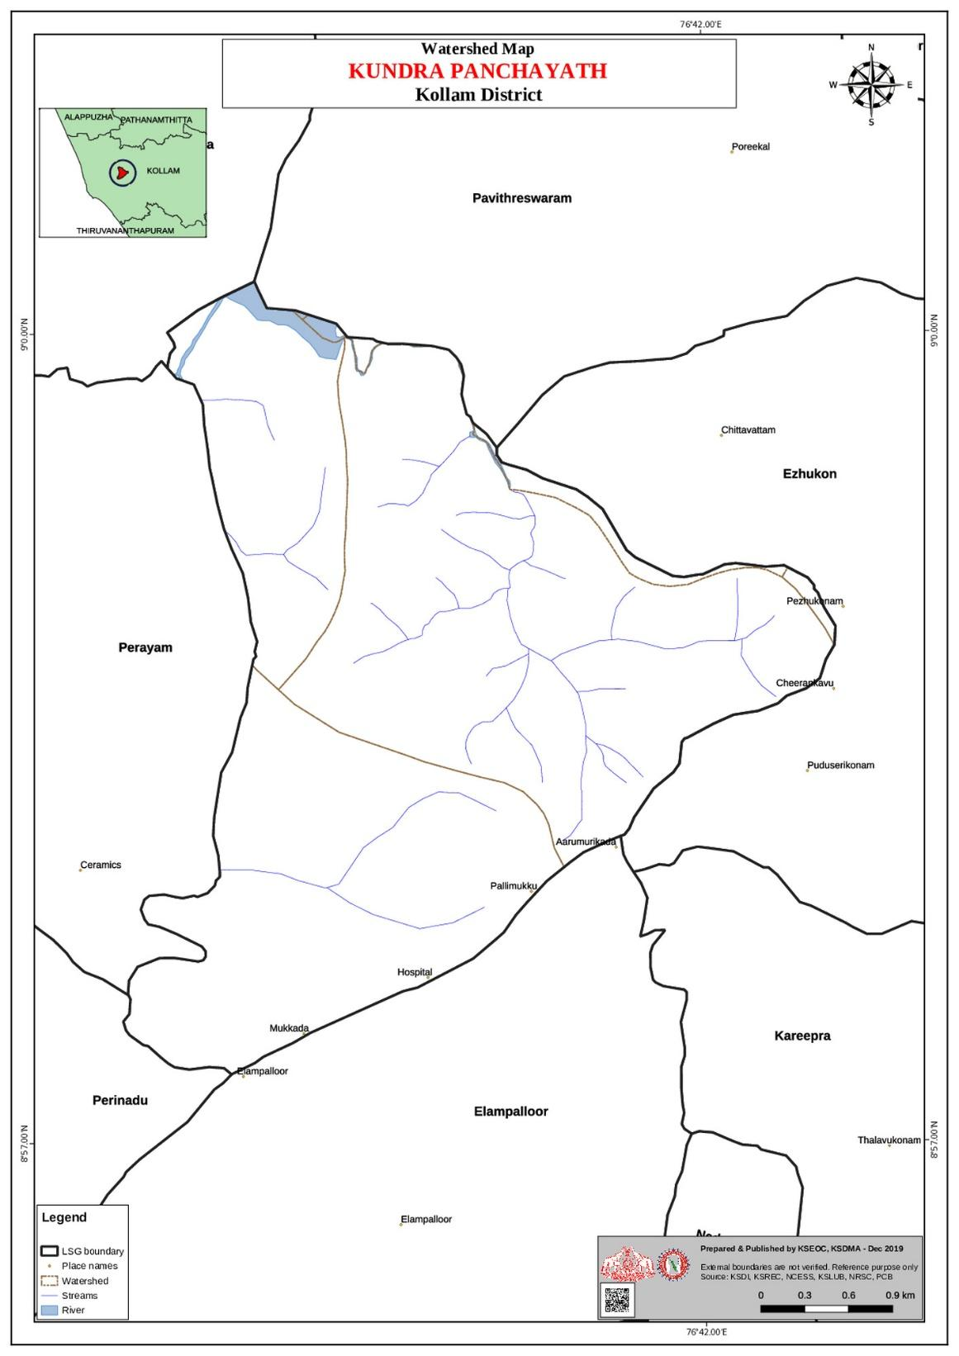

- disaster-prone areas map

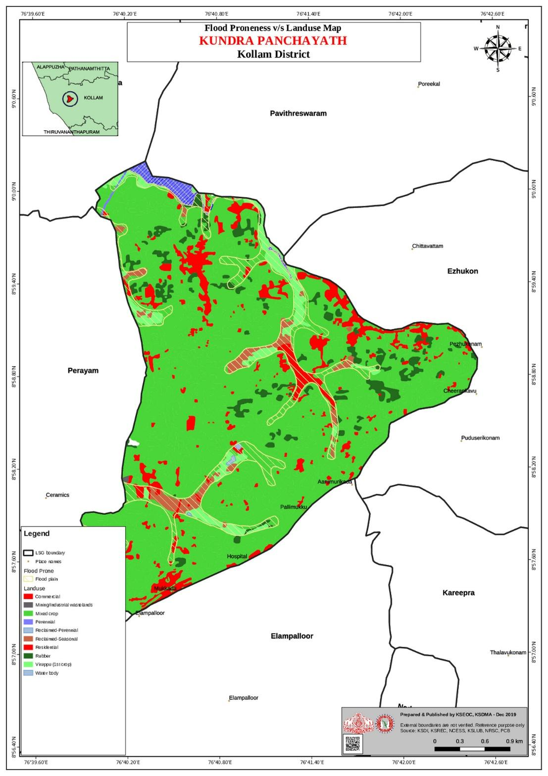

- hotspot map - CD & disasters

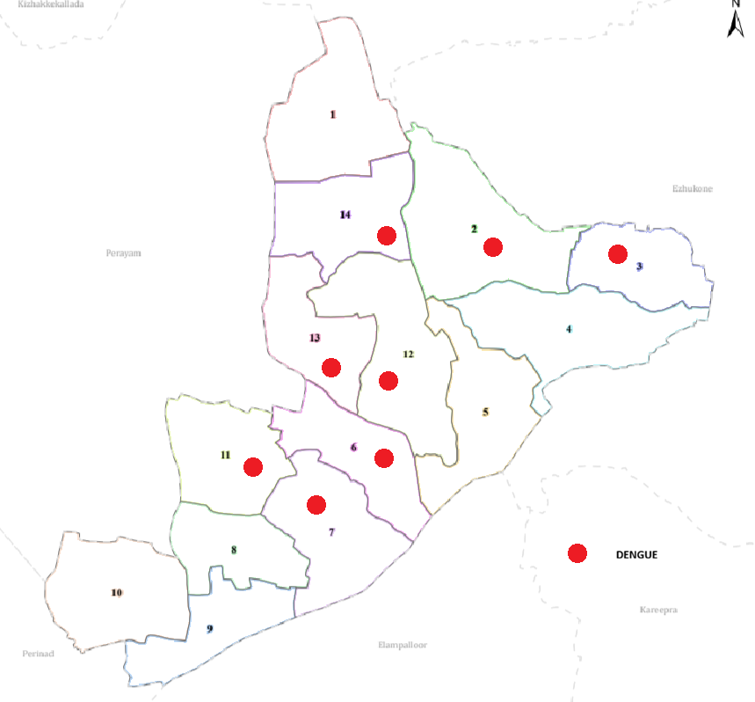

GENERAL PROFILE OF THE LSGI’S

Background of the LSGI
Background Summary of Kundara Grama Panchayat
Kundara Grama Panchayat is a rural local self-government institution located in Chittumala Block of Kollam district, Kerala. The panchayat covers a total geographical area of 10.06 sq. km and consists of 14 wards, serving a projected population of 19,902 people. The area is characterized by a foothill terrain with a mix of residential and semi-rural landscapes, providing a calm and environmentally rich setting. The presence of the Ashtamudi river flowing through the panchayat and three ponds contributes to the local water resources and supports agriculture and domestic water needs. Kundara Panchayat has 11 educational institutions, which play a key role in improving literacy and human resource development in the area. The presence of five factories and small-scale industries indicates moderate industrial activity, contributing to employment and local economic growth. Overall, Kundara Panchayat represents a semi-rural region with a balanced combination of natural resources, educational facilities, and small-scale industrial development, supporting the socio-economic and environmental well-being of the community.

Table 1: Background of LSGD
Description | Details
Name of LSGI | Kundara
Type (GP/Municipality / Corporation etc.) | Grama Panchayath
Block | Chittumala
District | Kollam
Number of wards | 14
Total area (sq. km) | 10.06 sq.km
Population(Projected) | 19902
Population density | 1978 persons/sq km
Terrain (coastal/low-lying/backwaters/foothills, etc.) | foothill
Number of rivers passing through LSGI | 1 ashtamudi
Number of water bodies in the LSGI | 3 ponds
Number of educational institutions | 11
Factories / small-scale industries | 5
Flood-prone wards | 0
Landslide-prone wards | 0
Death Management and Disposal Facilities (mortuaries/crematorium, including electric) | 1
Auditoriums/Marriage halls/convention centres/community halls | 3

Demographic and Vulnerable Population
Understanding the demographic composition and vulnerable population groups is essential for pandemic preparedness. Children, elderly, economically deprived families, migrant workers, and socially vulnerable groups are at increased risk during public health emergencies due to higher exposure, limited access to services, and dependency on public systems..

Description |  | Details (in numbers)
DEMOGRAPHIC PROFILE
Total population |  | 19,902
Male |  | 9962
Female |  | 9940
Transgender |  | -
Children under 5 |  | 981
Adolescent |  | 1264
Elderly (>60) |  | 3566
SOCIAL/LIVELIHOOD VULNERABILITY
Previous EPEP family |  | 32 families
BPL family |  | 1670
Tribal communities |  | -
Migration | Immigrant | 0
Migration | Emigrant | 721
Socio-economically deprived |  | 0
Fisherfolk |  | 22
SC Community |  | 3914
ST Community |  | -

Graphs: Population pyramid (if possible) for seeing if your LSGI has a high "dependency ratio" (lots of children and elderly compared to working adults).

Clinical Vulnerability
Certain population groups needs priority healthcare & are at higher risk of severe illness, complications, and mortality during pandemics. Patients with chronic diseases, those requiring regular medical care, and individuals with mobility or functional limitations face challenges in accessing timely care during emergencies. Mapping these groups helps in prioritizing continuity of treatment, medicine stock planning, oxygen support, referral transport, and targeted home-based care.
Description | Details in numbers
Pregnant women | 97
Lactating mothers | 45
Bedbound patients | 40
Patients under palliative care other than bedbound | 35
Patients on Haemodialysis | 10
Patients on CAPD | 7
Cancer patients (currently on treatment) | 17
Haemophilic patients | -
Mentally challenged | 22
Differently abled | 16
Diabetic patients | 1020
Hypertensive patients | 1814
TB patients | 6

INFRASTRUCTURE & RESOURCE INVENTORY

Health Facility Directory & Basic Capacity in the LSGD
This section provides an overview of the healthcare infrastructure available within the LSGD area. It outlines the distribution and basic capacity of health facilities that form the backbone of service delivery during routine times and public health emergencies.

Family Health Centres (FHCs) and Community Health Centres (CHCs) generally function as the first point of contact for the community, providing essential outpatient and inpatient services. General Hospitals (GH) and Medical College Hospitals (MCH), where accessible, serve as the main referral centres for advanced diagnostics, specialist care, and critical services during public health emergencies. This inventory helps identify existing strengths, gaps, and potential surge capacity that can be mobilised during a pandemic or disaster.

Table 5. Health Facility Resource Summary
Sl.no. | Health Facility | Type of Facility (MCH/GH/CHC/FHC/SC etc.) | Contact Number | Total beds | ICU Beds | Oxygen-Supported Beds | No. of Ventilator Support Beds | No. of ambulances
Government Healthcare Facilities
 | Kundara sc | SC | 8547144869 | - | - | 0 | 0 | 0
 | Mukoodu sc | SC | 7025488705 | - | - | 0 | 0 | 0
 | Main centre | SC | 9961643703 | - | - | 0 | 0 | 0
AYUSH Healthcare Facilities
1 | Aushadi Ayurveda Hospital GOV | GOV | 9846205945 | 0 | 0 | 0 | 0 | 0

Private Clinics
Private clinics are an essential part of pandemic preparedness, as they are often the first place people seek care when symptoms begin. In many communities, private clinics manage a significant share of outpatient visits and therefore play a critical role in early case detection, timely referrals, and disease surveillance. Having an up-to-date understanding of where these clinics are located, the services they provide, and how they are linked to the public health system helps ensure that no cases are missed during an outbreak. It also allows health authorities to engage private practitioners more effectively for reporting, risk communication, and coordinated response, strengthening the overall capacity of the health system to manage public health emergencies.

Table 6. Private Clinic Resource Summary
Sl No. | Name of Clinic | Registered (Y/N) | Clinic (General / Speciality) | Speciality (if any) | Address | Contact Number | Diagnostic Facility (Y/N) | Ambulance Linkage (Y/N)
1 | CAPTAIN MATHEW | YES | GYNEC | Gynecology | Chittumala Road, Mulavana, Kundara-691503 | 04742527415 | LAB | N

Healthcare Education & Training Institutions
This section tracks the educational infrastructure available, which is vital for human resource planning in the health sector.

Category of Institution | Govt | Private | AYUSH | Total
Medical Colleges | 0 | 0 | 0 | 0
Nursing Colleges | 0 | 0 | 0 | 0
Dental Colleges | 0 | 0 | 0 | 0
Para-medical / Allied Health | 0 | 0 | 0 | 0
Pharmacy Colleges | 0 | 0 | 0 | 0

Specialized Services & Emergency Inventory
This section provides a detailed view of the specialized medical resources available to the community, focusing on emergency response and critical care capabilities. This table tracks the vital assets required for managing severe illnesses and emergencies across Government, Private, and AYUSH sectors.

Item | Govt | Private | AYUSH | Total
Hospital beds | 0 | 8 | 0 | 8
Oxygen-generating systems (Y/N) | 0 | 0 | 0 | 0
Oxygen-supported beds (Numbers) | 0 | 1 | 0 | 1
Ventilator-supported beds | 0 | 0 | 0 | 0
ICU beds | 0 | 0 | 0 | 0
Burns units | 0 | 0 | 0 | 0
Blood centres | Yes, 1. | 0 | 0 | 1
BLS ambulances | Yes, 1. | 1 | 0 | 2
ALS ambulances | No | 0 | 0 | 0
Dialysis facilities | Yes, 7 beds | 0 | 0 | 1
Dispensaries | Yes, 1. | 0 | 0 | 1
Medical store | No | 3 | 1 | 4

Oxygen & Diagnostic Capacity
Monitoring oxygen and diagnostic capacity is a critical component of public health preparedness, ensuring that the LSGD can handle both chronic care and sudden surges in respiratory or infectious diseases.
Name of Health Facility | Oxygen-generating System (Y/N) | Backup Oxygen Source (Y/N) | Diagnostic Facilities Available(Y/N)
Name of Health Facility | Oxygen-generating System (Y/N) | Backup Oxygen Source (Y/N) | Lab | USG | X-ray | CT/MRI | RT-PCR
Government Healthcare Facilities
Taluk Hospital Kundara | No | No | Yes | No | Yes | NO | Yes

Diagnostics facility mapping at the LSGI level
The diagnostic capacity of Kundara G.P represents the "intelligence network" of our healthcare system. The speed and accuracy of disease identification depend entirely on the distribution and technical level of these facilities.

Item | Govt | Private | AYUSH | Total
General labs | - | 4 | - | 4
Microbiology labs | - | 2 | - | 2
RT-PCR labs | - | 2 | - | 2
USG units | - | - | - | -
CT/MRI units | - | - | - | -
Research labs | - | - | - | -

Laboratory Identification & Basic Details
Sl. No. | Name of Laboratory | Ownership (Govt / Private / Academic) | Address | Contact No. | 24×7 Services (Yes/No) | NABL / Govt Approved (Yes/No)
1 | DDRC lab | Private (2) | kundara | 7994430861 | N | N
2 | Micro Lab | Private | kundara | 9544037700 | N | N
3 | Captain Mathews hospital Lab | Private | Mulavana , Kundara | 04742527415 | N | N

Social and Community Infrastructure for surge plan
This table serves as our logistics and shelter inventory. By mapping these locations, quickly we can identify where to house displaced citizens, where to set up temporary medical clinics, and how to manage the deceased with dignity during a crisis.

Category | Total Count | Ward | Est. Capacity (Persons) | Contact details
Educational Institutions
Anganwadis | 22 | 1-16 | 440 | ICDS Supervisor: 8078207033
Schools | 11 | 2, 3, 4, 5, 6, 8, 9, 11, 12, 13 | 3300 | Given in Annexure
Colleges | 1 | 8 | 1200 | St. Tresa’s Arts & Science: 9496041787
Healthcare Educational Institutions
Medical colleges (Govt/Private) | 0 | 0 | 0 | -
Nursing colleges (Govt/Private) | 0 | 0 | 0 | -
Dental colleges (Govt/Private) | 0 | 0 | 0 | -
Paramedical institutes (Govt/Private) | 0 | 0 | 0 | -
Community Gathering Spaces
Community halls | - | - | - | -
Auditoriums | 2 | 13,5 | 1000 | 9563362248
Religious buildings | 1 | 5 | 300 | 9746589734
Vulnerable Group Support Facility
Destitute homes | - | - | - | -
Elderly homes | 1, St Luis convent | 1 | 30 | 9546345897
Mass Fatality Management (MFM) Infrastructure
Mortuary | 1 | 5 | 10 | 8282875996
Crematorium | 1 | 6 | 50 | 9895267037
*refer annexure 1 for contact details

Human resources
This section focuses on the human capital available within the LSGI. In any emergency—be it a pandemic, flood, or industrial accident—infrastructure is only as effective as the people operating it.

Medical & Clinical Personnel
This table tracks the "Frontline" providers responsible for diagnosis, treatment, and clinical management. Narrative sentence: eg., "Total health workforce: 450 personnel, with 60% in government facilities serving as primary surge capacity." A detailed directory with the contact numbers of all workers is maintained (Annexure in 1).

Cadre | Govt (No.) | Private (No.) | Total
Doctors—Modern Medicine | 13 | 4 | 17
Doctors – AYUSH | 3 | 2 | 5
Doctors – Veterinary | 2 | - | 2
Doctors – Dental | 3 | 4 | 7
Nursing officers | 1 | 1 | 2
Lab technicians | 4 | 6 | 10
Optometrist | 1 | 1 | 2
Pharmacists | 2 | 10 | 12
Psychologists | - | - | -
Counsellors | 1 | - | 1

Public Health & Field-Level Workforce
These individuals are the backbone of surveillance, maternal-child health, and decentralized care.

Cadre | Health services | Municipal common services | Total
HS (Health Supervisors) | 1 | - | 1
HI (Health Inspectors) | 1 | - | 1
LHS (Lady Health Supervisor) | 1 | - | 1
LHI (Lady Health Inspectors) | 1 | - | 1
JPHN (Jr Public Health Nurses) | 3 | - | 3
JHI (Jr Health Inspectors) | 2 | - | 2
MLSP (Mid-Level Service Providers) | 3 | - | 3
Palliative Nurses | 1 | - | 1
RBSK Nurses | 1 | - | 1
PRO | 2 | - | 2
Epidemiologist | 1 | - | 1
Data Manager | 1 | - | 1

Community & Support Cadre
This group represents the surge capacity of the LSGI—people who can be called upon for logistics, rescue, and specialized support.

Cadre | Number
ASHA Workers | 14
AWW (Anganwadi Workers) | 22
Emergency Medical Volunteers (Trained) | 14
Kudumbashree | 199, 2348 members
MNREGS | 175
Purusha Swayam Sahaya Sangham | 14
Ex-Servicemen | 1
Retired Police Officers | -
NCC/NSS Volunteers | 2
Red Cross volunteers | -
One Health Community Volunteers | 365
One Health Community Mentors | 10

Community Organizations
This section details the presence of community-based organisations (CBOs), non-governmental organisations (NGOs), faith-based organisations (FBOs), Kudumbashree Self-Help Groups (SHGs), and Ayalkootams within the Local Self-Government Institution (LSGI). These groups enhance grassroots mobilization, resource distribution, and support networks crucial for pandemic response and community resilience.

Category | Total Count
NGOs | 9
Religious based organizations | 2
Foreign based organizations | -
Sports Club/youth clubs | 12
Kudumbashree SHGs | 195
Ayalkootams | 36
Political organizations | 6
Residential organizations | 0

Administrative & Emergency Services
This section outlines the availability of key non-health emergency support services and infrastructure within the LSGI, which are essential for effective pandemic preparedness and response. These facilities support law enforcement, disaster response, water supply, logistics, mobility, and community-level interventions during public health emergencies.

Category | Total Count | Contact details
Police Stations | 1 | 0474-2522234 / 9497980221
Fire & Rescue Stations | 1 | 0474-2522101 / 101
Water Pumping Points | 4 | KWA Assistant Engineer (Kundara): 0474-2522409
Public Distribution System (PDS) | 1 | Taluk Supply Office (Kollam): 0474-2746409

Information regarding resources
The availability of essential transport and support resources plays a quiet but critical role in saving lives. Equipment such as ambulances, mobile mortuaries, amphibian ambulances, and motorized boats ensures that patients, samples, and healthcare teams can move swiftly—even in flooded, remote, or difficult terrains. Heavy vehicles like JCBs, cranes, tractors, and torus lorries support logistics, waste management, emergency infrastructure, and rapid conversion of spaces into care or isolation facilities. Taxis, four-wheel-drive vehicles, and trucks help maintain continuity of essential services, reach vulnerable populations, and support home-based care and supply delivery.

Means of transportation | Total Count
JCB | 4
Crane | 0
Heavy Trucks | 3
Tractor | 0
Ambulances | 9
Mobile mortuaries | 0
Boats | 0
Taxi service | 8
Note: For specific details regarding vehicle owners and contact information, please refer to Annexure [X].

ONE HEALTH & ENVIRONMENTAL SURVEILLANCE
The One Health method integrates environmental, animal, and human health to enable proactive pandemic preparedness. Panchayat-level surveillance needs to be improved in order to detect and treat zoonotic and environmentally generated diseases early. Surveillance is strengthened through systematic assessment of animal populations, veterinary infrastructure, poultry and slaughter facilities, inter-sectoral coordination, and specialised tools like avian influenza seasonality mapping using GIS in previous outbreaks to enable predictive alerts and ward-specific sampling to support effective pandemic preparedness in high-risk areas like kundara.

Animal & Bird Population
Mapping animal and bird populations at the Panchayat level is essential for identifying and prioritising zoonotic disease hazards like rabies, avian influenza (H5N1), leptospirosis, anthrax, and Nipah-like spillover occurrences. Risk classification, targeted surveillance, vaccination planning, and early epidemic detection made feasible by comprehensive population mapping all enhance One Health-based pandemic preparedness.

Category | Item | Estimated Population | Wards
Animal Population | Livestock (Cattle/Goats/Buffalo) | 352 | 2, 5, 8, 14 (High grazing areas)
Animal Population | Pet Animals (Dogs/Cats) | 126 | 1, 10, 11 (Residential clusters)
Animal Population | Stray Dog Population | 435 | 11, 12, 13 (Hospital, Junction, and Market areas)
Animal Population | Pig Farms (Number of heads) | 3 | 6, 5, 8 (Isolated units)
 | Small Units (Sheep / Goats – clustered) | 3 | 3, 9, 11
Bird Population | Poultry Units (Birds) | 2 | 4, 12
Bird Population | Poultry- (FOWL) | 0 | Nil
Bird Population | Wild/Migratory Birds (Observed) | 0 | Nil
Bird Population | Crow Mortality Events (Reported) | 0 | Nil

The main risk of zoonotic diseases in Kundara is concentrated in Wards 11, 3/** which is explained by the high density of pig farms, cattle congregation areas, and poultry units. The stray dog population in market areas, fish landing sites, bus stations continues to be a substantial problem for rabies surveillance and bite prevention. There is a considerable risk of avian influenza introduction and amplification during November - December due to the seasonal presence of migratory and resident water birds near ponds/ canal / river / backwater / paddy field. Clusters of pig farms and animal shelters vulnerable to flooding further raise the risk of leptospirosis and other zoonoses mediated by the environment, especially during monsoon floods.

Veterinary Infrastructure
Veterinary institutions are a core pillar of One Health surveillance, enabling early zoonotic disease detection through vaccination, investigation of unusual animal illness or deaths, sample collection, and timely outbreak reporting. A well-mapped and responsive veterinary network strengthens coordination with human health and LSGI systems, ensuring rapid response during zoonotic events and pandemics.
Facility Type | Name of Facility | Ownership Govt / Pvt | Location(Ward No) | Contact number
Veterinary Dispensary | GOV VETINARY | GOVT | 14, Near junction | 0474-2520700
Veterinary Hospital / Polyclinic | Govt Veterinary Hospital | GOVT | 11 (Hospital Rd) | 0474-2522252
Private Veterinary Clinics | Pet Care Clinic | Private | 12 | 9349193132
Mobile / Emergency Vet Service (incl. night services) | District Mobile Vet Unit | Govt | Dist HQ | 0474-2793464
Pet Homes / Animal Shelters | ABC Centre (District) | Govt | Kollam | 0474-2793464
Slaughterhouse-linked Veterinary Inspection Unit | Meat Inspection Unit | Govt | 11 | 0474-2520700

Veterinary Doctors & Workforce
Early detection, diagnosis, reporting, and reaction to animal illness epidemics depend on the availability and accessibility of qualified veterinary specialists. By identifying unusual animal morbidity or mortality promptly, collecting samples promptly, and coordinating efficiently with human health and LSGI systems—especially during zoonotic outbreaks and pandemic-prone situations—a clearly defined veterinary workforce enhances One Health surveillance.

Category | Number Available | Type (Govt/Pvt) | Contact number
Government Veterinary Doctors | 1 | gov | 8606734717 Dr Sreejith
Private Veterinary Doctors | 2 | Pvt | Consultants
Livestock Inspectors | 3 | Govt | Ward 11
Para-veterinary Staff / Attenders | 4 | Govt | Ward 14, 11
Contract / On-call Veterinary Support (if any) | 1 | LSGD | Emergency

High-Risk Interface Points (Surveillance Sites)
High-risk interface points for zoonotic disease surveillance in Kundara Grama Panchayath include wetland–livestock–human contact zones, backyard poultry farms, cattle sheds near water bodies, fish markets, and areas of high human–animal interaction such as community slaughter points and migratory bird congregation sites. These are the primary surveillance sites where zoonotic spillover risks are elevated.

Type of Habitat | Type of High risk interface | Geographical vulnerability
Wetlands & Backwaters | 8 | Proximity to Ashtamudi Estuary; high risk of waterborne pathogens and salinity-driven well contamination.
Backyard Poultry Farms | 12 | Clustered in residential wards; high risk of Avian Flu transmission due to poor biosecurity and open housing.
Cattle Sheds near Water Bodies | 6 | Located along drainage canals/lakefront; high risk of Leptospirosis during monsoon flooding and runoff.
Fish & Meat Markets | 2 | Centralized hubs (Kundara Jn & Marthandapuram); concentration of biological waste attracting rodents/stray dogs.
Community Slaughter Sites | 3 | Unorganized drainage; soil contamination with animal fluids increases risk of parasitic infections.
Migratory Bird Congregation Areas | 3 | Lakefront wards (1, 7, 10); primary entry point.
Rodent-Infested Grain Storage | 5 | Near PDS Godowns and Grain shops

Category | Total Count | Key Locations (wards)
Poultry Farms | 3 | 6, 8, 9
Backyard / Clustered Poultry Units | 14 | 2, 5, 8
Duck Rearing Units (open water access) | 0 | NA
Slaughterhouses/ Slaughter Points | 6 | 11, 12, 8
Meat/Fish Markets | 10 | 11, 12, 8, 14
Live Bird Sale Points | 2 | 11
Cattle Markets / Weekly Animal Fairs | 0 | NA
Pet Shops / Breeders | 2 | 11, 12
Animal Shelters / Pet Homes | 0 | Nil
Waste Disposal Sites near Animal Units | 3 | 11, 8, 12

Environmental Risk Mapping
Environmental risk mapping identifies monsoon/flood hotspots for vector-borne (dengue, chikungunya), water-borne (leptospirosis, diarrhoea), and zoonotic diseases in Kerala's wetlands. Systematic surveillance supports early warnings, targeted interventions, and Panchayat pandemic preparedness.
Waterborne exposure: Flood-prone areas and stagnant water bodies facilitate leptospira survival, raising leptospirosis risk.

Traditional practices: Informal slaughter and fish markets lack standardized hygiene, creating spillover opportunities.

Risk Factor | High-Risk Wards | Key Locations | Risk Level (High/Med/Low)
Flood-prone areas | 0 | Nil | NA
Water bodies/wetlands | 0 | Nil | NA
Solid waste accumulation | 11, 12, 14 | Kundara Junction, Market, & Hospital Road | Medium
Animal waste disposal issues | 8 | Meat stall clusters & backyard cattle sheds | Medium
Rodent infestation zones | 11, 12, 8 | PDS Godowns, Railway Station, & Market | High
Industrial effluent discharge | 12, 13 | Near abandoned industrial units (Ward 12) | Medium
Construction sites / abandoned buildings | 5,12, 13 | Ward 5 projects & old factory quarters | Medium
Poor drainage/blocked canals | 0 | Nil | NA
Drinking water source contamination risk | 0 | nil | NA

Disease Seasonality Mapping
1, Flooding & waterlogging → amplifies leptospirosis, malaria, diarrheal diseases.
·
2, Migratory bird influx (Nov–Feb) → avian influenza risk.

3, Mosquito breeding cycles → vector-borne disease peaks in monsoon.

4, Agricultural practices → close human–animal contact in paddy fields.

Disease | Peak Risk Season | Key Drivers | High-Risk Locations | Surveillance Focus
Avian Influenza | nil | nil | NA | NA
Leptospirosis | Sep-oct | Monsoon flooding; rodent activity in markets. | Wards 11, 12, 14 (Market & Canal zones) | Prophylaxis for sanitation workers & farmers; rodent control.
Dengue/Chikungunya | July, August | Water stagnation in urban junk; high vector density. | Wards 11, 13, 8 (Urban clusters/Scrap yards) | Source reduction; "Dry Day" inspections in central town.
Acute Diarrheal Diseases | June, July, aug | Well contamination due to flooding/seepage. | Wards 1, 7, 10, 14 (Low-lying/Drainage hubs) | Water quality testing (H2S vials); chlorination of open wells.
Rabies | Year round | High stray dog density; poor meat waste disposal. | Wards 11, 12 | Post-exposure prophylaxis (PEP); ABC & vaccination drives.
Anthrax (rare) | Nil | Nil | NA | NA

Vulnerability Mapping
Vulnerability mapping pinpoints high-risk populations, occupations, and areas exposed via environment, livelihoods, socio-economics, and poor service access. Paired with environmental/seasonality mapping, it enables risk-based surveillance, targeted actions, and optimal resource use in One Health and pandemic planning.
Vulnerability Factor | High-Risk Wards | Key Groups / Locations | Risk Level
Flood-prone households | 0 | nil | NA
Wetland-adjacent communities | 1, 7 | Residents near Ashtamudi backwaters | Medium
Backyard poultry / duck rearing households | 2, 5, 14 | Scattered residential clusters | Medium
Livestock-rearing households | 2, 8, 14 | Farmers in the rural-fringe wards | Medium
Slaughterhouse & meat market workers | 11, 12 | Workers at the Kundara Central Market | High
Fisherfolk & fish market workers | 1, 2, 11 | Traditional fishing families | High
Sanitation workers | 11, 14 | Haritha Karma Sena & Drain cleaners | High
Daily wage / migrant workers | 5, 12, 13 | Construction labor & Industrial site workers | Medium
Elderly & chronically ill populations | 12 | Ward 12 has high residential density | Medium
Pregnant Women | 14 | Highest reported count | High
Children (schools, Anganwadi’s) | 14 | High concentration of Anganwadis | High
Limited access to safe water & sanitation | 2, 7 | Wards with high salinity/pit latrine seepage | Medium

EPIDEMIOLOGICAL TRENDS (2021–2025)

Disease surveillance is the systematic collection, analysis, and interpretation of health data for planning, implementation, and evaluation of public health practice. This section presents the disease surveillance profile of the LSGI based on routine reporting systems and outbreak investigations to identify priority diseases, seasonal patterns, and emerging public health threats.

Disease Burden among human beings(Last 5 Years)
Analysis of disease-wise data for the last five years helps identify persistent public health problems, emerging diseases, and changes in disease burden. This information supports prioritisation of prevention, preparedness, and response activities at the Panchayat level.

Disease | 2021 | 2022 | 2023 | 2024 | 2025 | Trend(Increasing/Stable/Decreasing)
Dengue | 13 | 3 | 72 | 74 | 19 | Decreasing
Leptospirosis | 0 | 2 | 1 | 2 | 2 | Stable
Hepatitis A | 0 | 0 | 0 | 2 | 1 | Stable
Malaria | 0 | 0 | 0 | 0 | 0 | Stable
Scrub Typhus | 0 | 0 | 1 | 0 | 0 | Stable
Typhoid | 0 | 0 | 0 | 2 | 0 | Stable
H1N1 | 0 | 2 | 0 | 3 | 2 | Stable
H3N2 | 0 | 0 | 0 | 0 | 0 | Stable
ADD | 12 | 17 | 20 | 23 | 9 | declining
Mumps | 0 | 2 | 1 | 3 | 2 | Stable
Measles | 0 | 0 | 0 | 0 | 0 | -
Hepatitis B | 0 | 0 | 1 | 3 | 1 | -
Hepatitis C | 0 | 0 | 0 | 1 | 0 | -
Tuberculosis | 3 | 4 | 4 | 7 | 9 | -
Leprosy | 0 | 0 | 0 | 0 | 0 | -
COVID-19 | 38 | 12 | 0 | 0 | 0 | Declining

*(use the above table data to create the graph/diagram)

Seasonal Trend Analysis
Seasonal analysis helps anticipate surges (e.g. dengue in monsoon, leptospirosis after floods, influenza in cooler months) and plan pre‑emptive vector control, stockpiling of IV fluids, and awareness campaigns at Panchayat level.

DENGUE
Dengue is a major seasonal vector-borne disease strongly associated with rainfall, water stagnation, and increased mosquito breeding during the monsoon period.

Peak: July–November

Dengue – Ward-wise Yearly Distribution (2021–2025)

Ward | Dengue – Ward-wise Yearly Distribution
Ward | 2021 | 2022 | 2023 | 2024 | 2025 | Total
1 | 0 | 1 | 3 | 1 | 0 | 5
2 | 0 | 0 | 12 | 5 | 0 | 17
3 | 0 | 1 | 7 | 4 | 4 | 16
4 | 0 | 0 | 1 | 0 | 0 | 1
5 | 3 | 0 | 0 | 1 | 1 | 5
6 | 0 | 0 | 8 | 8 | 0 | 16
7 | 1 | 0 | 4 | 20 | 0 | 25
8 | 0 | 0 | 2 | 1 | 0 | 3
9 | 0 | 0 | 1 | 4 | 0 | 5
10 | 3 | 0 | 1 | 2 | 0 | 6
11 | 1 | 1 | 10 | 7 | 12 | 31
12 | 1 | 0 | 11 | 15 | 1 | 28
13 | 4 | 0 | 5 | 9 | 2 | 20
14 | 0 | 0 | 3 | 4 | 6 | 13
total | 13 | 3 | 68 | 81 | 26 | 191

LEPTOSPIROSIS
Leptospirosis cases are closely linked to monsoon rains, flooding, and occupational exposure, particularly in low-lying and waterlogged areas.

Peak: June - August

Leptospirosis – Ward-wise Yearly Distribution (2021–2025)

Ward | Leptospirosis – Ward-wise Yearly Distribution
Ward | 2021 | 2022 | 2023 | 2024 | 2025 | Total
1 | 0 | 0 | 0 | 0 | 0 | 0
2 | 0 | 0 | 0 | 0 | 0 | 0
3 | 0 | 0 | 0 | 1 | 0 | 1
4 | 0 | 0 | 0 | 0 | 0 | 0
5 | 0 | 0 | 0 | 0 | 0 | 0
6 | 0 | 0 | 0 | 1 | 0 | 1
7 | 0 | 0 | 0 | 0 | 0 | 0
8 | 0 | 2 | 0 | 0 | 0 | 2
9 | 0 | 0 | 0 | 0 | 0 | 0
10 | 0 | 0 | 0 | 0 | 0 | 0
11 | 0 | 0 | 0 | 0 | 0 | 0
12 | 0 | 0 | 0 | 0 | 0 | 0
13 | 0 | 0 | 0 | 0 | 0 | 0
14 | 0 | 0 | 0 | 0 | 0 | 0
0

VIRAL HEPATITIS - A
Hepatitis A cases are commonly associated with unsafe drinking water, food contamination, and breakdowns in sanitation, often presenting as clusters or outbreaks.

Peak: October - December

Hepatitis A – Ward-wise Yearly Distribution (2021–2025)

Ward | Hep A – Ward-wise Yearly Distribution
Ward | 2021 | 2022 | 2023 | 2024 | 2025 | Total
1 | 0 | 0 | 0 | 0 | 1 | 1
2 | 0 | 0 | 0 | 0 | 2 | 2
3 | 0 | 0 | 0 | 0 | 0 | 0
4 | 0 | 0 | 0 | 0 | 0 | 0
5 | 0 | 0 | 0 | 0 | 0 | 0
6 | 0 | 0 | 0 | 0 | 0 | 0
7 | 0 | 0 | 0 | 0 | 0 | 0
8 | 0 | 0 | 0 | 0 | 0 | 0
9 | 1 | 0 | 0 | 0 | 0 | 1
10 | 0 | 0 | 0 | 0 | 0 | 0
11 | 0 | 0 | 0 | 2 | 0 | 2
12 | 0 | 0 | 0 | 1 | 0 | 1
13 | 0 | 0 | 0 | 0 | 0 | 0

0

Outcome-Based Trend Analysis- 2025

Transmission Trend- 2025
For effective management of public health issues, it is important to track the trend of disease transmission mode. It helps identify the population or place at high risk that can be used to predict outbreaks and implement targeted interventions as quickly as possible. Understanding these kinds of trends enables authorities to allocate resources efficiently and change the strategies adequately based on the trend that follows.

Mode of Transmission | No. of cases | No. of Deaths
Vector Borne Diseases | 26 | 0
Water Borne Diseases | 2 | 0
Air Borne Diseases | 12 | 1
Blood Borne Diseases | 0 | 0
Food Borne Diseases | 43 | 0

Vector-Borne Disease

Disease | No. of Cases | No. of Deaths
Dengue | 19 | 0
Malaria | 0 | 0
Chikungunya | 0 | 0

Water Borne Disease

Disease | No. of Cases | No. of Deaths
Cholera | 0 | 0
Typhoid | 0 | 0
Hep- A | 2 | 0
Dysentery | 0 | 0
Amoebiasis | 0 | 0
E- Coli infections | 0 | 0
Air Borne Disease

Disease | No. of Cases | No. of Deaths
Influenza | 0 | 0
H1N1 | 0 | 0
TB | 9 | 0
Chickenpox | 13 | 0
Measles | 0 | 0
Covid-19 | 0 | 0
Pertussis | 0 | 0
Mumps | 0 | 0

Blood-Borne Disease

Disease | No. of Cases | No. of Deaths
AIDS | 0 | 0
Hep- B | 1 | 0
Hep- C | 0 | 0

Zoonotic Disease

Disease | No. of Cases | No. of Deaths
Rabies | 0 | 0
Leptospirosis | 2 | 0
Avian influenza | 0 | 0
West nile | 0 | 0
Anthrax | 0 | 0
Nipah | 0 | 0
Scrub Typhus | 0 | 0

Integrated Disease Hotspot Map (2021–2025)

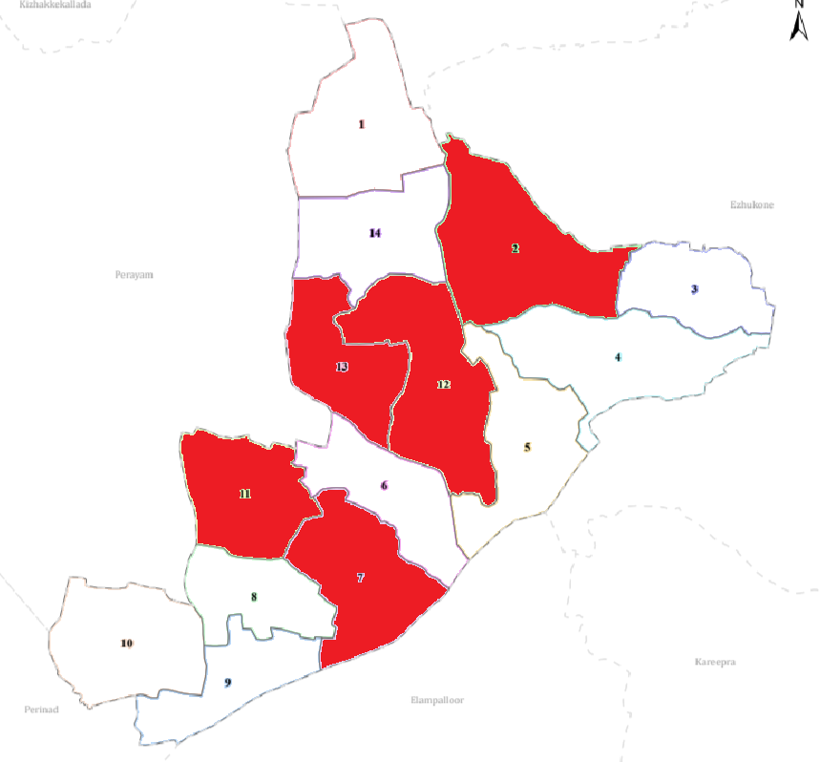

Ward No | Dengue Total (2021-25) | Leptospirosis Total (2021-25) | Hepatitis A Total (2021-25) | Mumps (2021-25) | ADD (2021-25) | Total Cases
1 | 3 | 0 | 1 | 0 | 9 | 13
2 | 17 | 0 | 2 | 0 | 5 | 24
3 | 16 | 1 | 0 | 0 | 0 | 17
4 | 1 | 0 | 0 | 0 | 7 | 8
5 | 5 | 0 | 0 | 0 | 7 | 12
6 | 16 | 1 | 0 | 0 | 9 | 16
7 | 25 | 0 | 0 | 0 | 10 | 30
8 | 3 | 2 | 0 | 0 | 9 | 14
9 | 5 | 0 | 0 | 0 | 10 | 15
10 | 6 | 0 | 0 | 0 | 8 | 14
11 | 31 | 0 | 0 | 0 | 3 | 34
12 | 28 | 0 | 0 | 0 | 4 | 32
13 | 20 | 0 | 0 | 0 | 5 | 25
14 | 13 | 0 | 0 | 0 | 4 | 17

The data reveals that Ward 11 is the most significant public health concern, contributing nearly 10% of the total caseload, primarily driven by an intense concentration of Dengue. This aligns with its status as the central commercial hub (Junction), where high population density and urban water stagnation provide ideal breeding grounds for Aedes mosquitoes.
A secondary, yet equally critical, trend is observed in Wards 7 and 2, which exhibit a dual burden of high Dengue and Acute Diarrheal Diseases (ADD). These wards, located near the backwaters, suffer from geographical vulnerabilities where seasonal flooding likely contributes to both vector proliferation and the contamination of drinking water sources. Interestingly, while Leptospirosis remains low across the board, its presence in Ward 8—coupled with consistent ADD counts—suggests an interface between livestock waste and human habitats that requires specific environmental sanitation. Overall, the transition from rural to urban land use in wards like 11, 12, and 13 has shifted the panchayat's disease profile toward vector-borne outbreaks, necessitating a move from general healthcare to targeted source reduction and water-safety interventions in these specific "Red Zone" wards.

Preparedness and Response Protocol at LSG Level
This section describes the operational framework for the LSGI once a pandemic is declared. It explains how the LSGI and health system will move from routine data collection to active response, using a One Health approach.

Constitution of One Health Committee
The LSGD shall constitute a One Health Committee comprising the LSGI President, Medical Officers (Modern Medicine, AYUSH, and Veterinary), the Health Inspector, and the Veterinary Surgeon.

Objective: The One Health Committee coordinates human, animal, and environmental health to prevent and control pandemics.

Sl No | Name | Designation | Department/Institution | Role in Committee | Contact Number
1 | Vinod kumar | Panchayat President | LSGD | Chairperson | 9497797071
2 | Dr Babulal | Medical Officer (PHC/CHC) | Health Dept | Member Secretary | 8921443300
3 | Dr. Suresh Kumar V | Veterinary Officer | Animal Husbandry | Member | 9447001234
4 | Aiswarya | Epidemiologist | Health Dept | Member | 9526210996
5 | Binu | Health Inspector/PHN | Health Dept | Surveillance | 9447251273
6 | Ajithakumary Amma | ASHA Supervisor | Health Dept | Community link | 9847151675
7 | Deepa Rani | ICDS Supervisor | Social Welfare | Vulnerable groups | 81566868382
8 | Vipin | Police Station Officer | Police Dept | Law & order | 9497003344
9 | Vinod kumar | Ward Councillor Representative | LSGD | Community coordination | 9497797071
10 | Viji | Kudumbashree CDO | Kudumbashree | Community mobilisation | 9895441122
11 | Rajan Pillai | NGO/Volunteer rep | Civil Society | Support services | 9446112233
12 | Raji P (KSEB), Sabu K (KWA) | Line Department representations | KSEB / KWA / PWD | Power & water continuity | 04742-252750

Key Responsibilities:
- Review disease surveillance data (human + animal)
- Conduct ward-wise risk assessment and vulnerability mapping
- Approve quarantine/isolation centre locations
- Coordinate with district for resources (PPE, oxygen, ambulances)
- Periodically review health system surge capacity, including beds, oxygen, human resources, and ambulances.
- Approve and monitor risk communication and community engagement strategies, including rumour management.
- Ensure protection and service continuity for vulnerable groups (elderly, persons with disabilities, dialysis patients, coastal populations).
- Conduct quarterly mock drills
- Monitor equity measures for vulnerable groups

Meeting Schedule:
Quarterly (normal times) | Weekly (outbreak alert) | Daily (pandemic phase)

Pandemic Response Workforce
To ensure a coordinated and timely response during a pandemic, a dedicated Pandemic Response Workforce shall be constituted at the LSG level. The workforce will function under the overall supervision of the One Health Committee and in close coordination with the health authorities. Team-based deployment will enable efficient surveillance, case management, quarantine and isolation management, logistics support, and risk communication. Each team shall have a clearly designated team leader, defined roles, and an identified pool of personnel to allow rapid activation, rotation of duties, and continuity of services during prolonged emergencies.

Total Response Workforce Available: 300 persons

Team Name | Composition | Key Responsibilities | Team Leader
Surveillance and Contact Tracing Team | HI, JHI, JPHN, ASHAs and Volunteers | Case detection, contact listing, home visits, reporting | HI
Case Management Team | Doctors, Nurses, MLSP, Palliative Nurses | Patient care & referral | DOCTOR
Quarantine & Isolation Team | LSGD staff, Volunteers | Facility management | JHI
Psychosocial support | Counsellor, ASHA Supervisors, Kudumbashree members, trained volunteers | Mental health first aid, grief counselling, stigma management, home visits to isolated cases and bereaved families | PHC Counsellor
Logistics & supply chain Team | LSGD staff, Storekeepers, Drivers 3 | Supplies & transport [PPE, medicines, oxygen, transport, waste management] | Ward Member
Communication Team | Ward members, Kudumbashree, Youth clubs,  AWW workers and other self help groups | IEC, community meetings, countering misinformation | M.O in charge
Transportation | KSRTC, educational institutional buses | Patient transport, inter-facility referrals, sample transfer, supply chain movement, staff deployment | LSGD Representative / Ward Member
Media Surveillance | PRO, Social Media Volunteer, ASHA Supervisors | Monitor social and traditional media for misinformation; track rumours; issue timely corrections; coordinate with District PRO for official releases | PRO / Communication Officer
Intersectoral coordination and convergence | LSGD Officers, Block Medical Officer, Veterinary Surgeon, Police, KSEB, KWA, Education Dept representatives | Inter-departmental coordination, resource sharing, joint action on containment, policy execution at ground level, cross-sector reporting | Panchayat President / Medical Officer
Collaborative surveillance | JHI, Veterinary Inspector, ASHA, Anganwadi Workers, field volunteers | Joint human–animal–environment surveillance; early identification of zoonotic signals; co-investigation of clusters; One Health data integration | Health Inspector / Veterinary Officer

All teams shall be activated immediately upon outbreak alert or pandemic declaration and shall report daily to the LSG Incident Commander/Medical Officer, with consolidated reporting to the Block PHC. Duty rosters and alternate personnel shall be maintained to ensure uninterrupted services during staff shortages or prolonged response periods. Team composition and numbers may be revised based on the magnitude of the outbreak and availability of human resources.

Activities and Measures before and during Pandemic

PHASE 1 - Alert / Preparation
Surveillance and Reporting-Enhanced syndromic surveillance:
- Data sources for surveillance:
- Event-based triggers (to be monitored and reported):
- Zoonotic and animal health surveillance
- Logistics and Stock Preparedness
  - Identify and empanel local vendors and define emergency procurement mechanisms in accordance with existing LSGD and Health Department norms.
  - Prepare and maintain an essential logistics checklist covering medical supplies, consumables, and support equipment.
  - Pre-identify secure storage locations for emergency stocks and ensure maintenance of stock registers with regular updating.
  - Finalise emergency transport arrangements, including availability of vehicles and identified drivers for rapid deployment during alerts.
  - Designate a Nodal Officer for Logistics to enable prompt decision-making, coordination, and communication during emergencies.
  - Conduct rapid stock verification and ensure availability of minimum buffer stock, including:
- PPE kits 10 numbers
- Pulse oximeters – 12 numbers
- Hand sanitizers – 15 litres
- Masks, gloves, disinfectants – adequate quantity
Identify critical gaps in logistics and immediately communicate requirements to the Block and District authorities for timely replenishment and support. Monitor expiry dates and stock rotation.

Identification of Quarantine and Isolation Facilities
  - Identify and list suitable buildings for quarantine and isolation (schools, hostels, community halls, etc.).
  - Categorise cases as per the severity and allocate to appropriate facilities (for instance, severe cases to classrooms, mild cases to an assembly hall in case of a school).
  - Facility readiness checklist needed (beds, toilets, ventilation) etc.
  - Find an alternate site if the primary sites are not available or not in use.
  - Identify facility managers and support staff
  - Prepare basic SOPs for:
    - Admission and discharge
    - Food, water, sanitation
    - Infection prevention and waste disposal
  - Ensure availability of basic amenities: water, sanitation, electricity, ventilation, and waste disposal. Prepare a rapid activation plan for these facilities if case numbers increase.

Risk Communication and Community Preparedness
  - Disseminate early warning messages on symptoms, preventive measures, and reporting mechanisms. Display IEC materials both in English and the local language in public places and ensure ward-level awareness.
  - Sensitize elected representatives and community leaders on preparedness measures.
  - Establish a rumour tracking and misinformation response mechanism to identify, verify, and promptly counter false or misleading information.
  - Engage trusted local persons (ward members, ASHA workers, religious leaders, teachers, community volunteers) to communicate official public health messages and reinforce correct practices.
  - Develop and deploy targeted IEC materials for:
    - Schools and educational institutions
    - Markets and commercial areas
    - Work sites and labour settings
  - Conduct community sensitization meetings at the ward level to promote preventive behaviors, address concerns, and strengthen community participation in preparedness and response.

Protection of Vulnerable Groups
Vulnerable populations require priority protection through targeted line-listing, service continuity, and delivery mechanisms.
- Prepare and regularly update line-lists of vulnerable populations, including:
  - Elderly persons living alone
  - Persons with disabilities
  - Pregnant women
  - Migrant workers
  - Dialysis patients
The detailed line-lists shall be maintained as Annexure and updated periodically.

Clinical Dependency Mapping
Develop ward-wise dependency and vulnerability maps to identify households requiring regular support during emergencies. Ensure continuity of essential health services for vulnerable groups, including
- Dialysis services (facility mapping, transport arrangements, and scheduling)
- Continuity of treatment for TB, HIV, and other chronic conditions requiring uninterrupted medication
- Mental health and psychosocial support services
Establish delivery mechanisms for food, essential commodities, and medicines to vulnerable households through coordinated action involving ASHAs, JPHNs, Kudumbashree, volunteers, and local administration.

PHASE 2 - Active Response

Case Identification and Contact Tracing
Case detection and contact tracing activities will be carried out in coordination with the Health authorities, following disease-specific SOPs and IDSP guidelines.
Field Staff Involved
- Health Inspector (HI)
- Junior Health Inspector (JHI)
- Junior Public Health Nurse (JPHN)
- ASHAs and ASHA Supervisors
- Ward-level volunteers and Kudumbashree members (as required)

Screening Checkpoints
Screening checkpoints at high-traffic locations (transport hubs, markets, religious gatherings) for early detection of symptomatic travellers and crowd screening during outbreaks. Potential locations include bus stands, market entry points, and boat jetties, based on local context and risk assessment.
Screening activities will be carried out by trained personnel such as ASHAs, ward members, and volunteers, with support from Health Department staff. Necessary equipment, including non-contact thermometers and appropriate PPE, shall be ensured prior to activation.
Location | Type (Bus stand/Jetty/Market/Railway) | Staff Deployed (ASHAs/Volunteers) | Screening Method | Reporting authority
Bus stand | Transport hub | One JHI  One ASHA  One health Mentors | 1.Swab Collection.  2. Blood smears collection (RDT)  3.Thermal Scanners | Surveillance Nodal Officer in control room
Market entry | Market | One JHI  One ASHA  Male health volunteers | 1.Swab Collection.  2. Blood smears collection (RDT)  3.Thermal Scanners | Surveillance Nodal Officer in control room
Boat jetty | Water transport | One JHI  One ASHA  Male health volunteers | 1.Swab Collection.  2. Blood smears collection (RDT)  3.Thermal Scanners | Surveillance Nodal Officer in control room

Standard Screening Protocol

The screening protocol shall include temperature screening, observation for visible symptoms, and inquiry regarding recent travel or exposure history. Individuals identified as suspects during screening shall be immediately referred to the nearest PHC/FHC for further evaluation, testing, and appropriate action as per prevailing guidelines.

Pandemic Control Room
The Pandemic Control Room (PCR) serves as the central nerve center for real-time coordination, data aggregation, decision support, and communication during outbreaks. It consolidates information from all LSGD teams, health facilities and community sources to enable rapid response decisions.

Control Room Infrastructure and Location
Primary Location: Kundara Panchayath Office.
Backup Location: Community Hall in Kundara G.P.

Health System Control Room Framework
The PCR is organized into seven functional pillars to ensure no aspect of the response is overlooked:

Rapid Response Team (RRT)
  - Provides immediate intervention during emergencies, clusters, and field alerts.​
  - Coordinates urgent actions such as case investigation, contact tracing, isolation, and inter‑facility referrals.

Data Management & Analytics Team
  - Collects, validates, and manages key health system indicators (cases, tests, beds, HR, supplies).​
  - Analyzes data trends, generates projections, and supports evidence‑based decision‑making for local authorities.

Human Resource Deployment Team
  - Allocates healthcare staff efficiently based on workload and need
  - Ensures adequate and equitable workforce distribution across facilities

Laboratory Surveillance Team
  - Oversees diagnostic testing coordination, sample transport, and timely reporting of results.​
  - Monitors lab indicators (testing volume, positivity rate, turnaround time) for early detection of outbreaks

Vaccination Cell (If Required)
  - Plans and executes vaccination campaigns, including micro‑planning and session scheduling.​
  - Tracks coverage, identifies gaps, and coordinates corrective actions with field teams and outreach services.

Infrastructure & Patient Occupancy Team
  - Monitors facility capacity, earmarked beds, oxygen and critical care resources across all linked facilities.​
  - Ensures optimal patient distribution and referral management using updated bed‑status and resource data.
  - BMWM

Communication team
- Logistics and supply chain
- Transportation (interfacility & emergency transport)
- Media surveillance Call centre
- Management of the deceased
- Intersectoral coordination and convergence

Key Control Room Team
The Control Room Team coordinates all pandemic response activities within the LSGD and serves as the single command and communication hub during activation. It integrates information, field actions, logistics, and policy execution across all participating departments and health facilities.

Role | Name | Designation | Contact Number | Responsibility
In-charge/Nodal Officer | Dr Babulal | supertendent | 8921443300 | Overall coordination, decision-making, and reporting to the District level.
Data Entry Operator | Hashim Habi |  | 9605309194 | Managing the line list, updating dashboards, and tracking testing results.
Communication Officer | Shan senani | PRO | 974699297 | Handling the public helpline, coordinating ambulance dispatch, and contact tracing calls.
Logistics Coordinator | Sreekumar P | Panchayat Secretary | 9496558899 | Procurement, storage, and distribution of PPE, medicines, oxygen, and essential supplies; maintaining stock register and coordinating with vendors
Technical Support (IT/Data) | Binu | HI | 9447251273 | IT infrastructure management, dashboard updates, digital tool support, data backup, network coordination between field and control room

SOP for alert escalation/trigger point with mapping of responsibilities.
Key Points:
- The Control Room shall be staffed with a designated In-charge, data entry personnel, and communication staff with clearly defined roles and shift arrangements.
- It shall maintain updated records on daily monitoring indicators including new cases, persons under active quarantine, and hospital bed occupancy.
- All reports and situation updates shall be shared daily with the Block and District Surveillance Unit.
- The Control Room shall act as a single point of contact for coordination with response teams, health institutions, and other departments.
- Contact details of the Control Room shall be widely communicated to field staff and stakeholders during activation.

Daily Monitoring Indicators
To ensure timely decision-making and effective response, the following key indicators shall be monitored and updated on a daily basis by the Pandemic Control Room:

Epidemiological Indicators:
New cases reported today, Total active cases, Test Positivity Rate (TPR), Case Fatality Rate (CFR)
- Surveillance Indicators:
Persons under home quarantine, High-risk contacts identified, Fever, ILI, SARI or other symptoms (syndromic surges), Travellers (symptomatic or high-risk arrivals),Animal husbandry surveillance (zoonotic alerts, unusual animal deaths, poultry/bird flu signals), Mortality surveillance (excess deaths, unexplained fatalities, verbal autopsy reports)
- Logistics and Infrastructure Indicators:
Hospital / CFLTC beds occupied, Oxygen cylinders/concentrators available, Ambulances on standby
- Alert Findings
The following table outlines category-specific trigger points (red flags) from surveillance indicators and corresponding immediate actions for the Pandemic Control Room. These enable rapid response to alert findings like testing anomalies, positive cases exceeding thresholds, clusters, and WGS reports.

Category | Trigger Pophint (Red Flag) | Immediate Action
Clusters | Geographical or facility-based: 5+ cases linked to one location (office, school, street). | Declare a micro-containment zone; perimeter control and active case finding.
Testing | Sudden drop in testing volume / delay in reporting / unusual testing trends | Review the sample collection process, address lab bottlenecks, deploy additional testing teams, and notify the District Lab.
Lab | Test Positivity rate increases | Increase testing sites in that ward.
Hospital | >80% Oxygen bed occupancy | Activate backup/CFLTC beds.
Travel | Cluster of cases from a single flight/train or high-risk arrival group. | Trace all passengers in adjacent seats; implement mandatory institutional quarantine.
Animal | Mass poultry/wildlife death or unusual sickness | Notify Animal Husbandry, sample the area, and dispatch RRT for environmental sampling and zoonotic check.
Mortality | Sudden spike in home deaths or brought-in-dead (BID) cases | Audit the deaths and Active Case Search drive
Additional investigations like Whole Genome Sequencing (WGS) | Detection of a Variant of Concern (VOC) or Variant of Interest (VOI) | Implement strict micro-containment; update clinical protocols to match variant severity.

Communication of Public Health Information
A Community Communication Hub shall be established to ensure timely, accurate, and consistent dissemination of information during a pandemic. The Hub will function under the coordination of Nodal officers of the control room and act as the nodal point for public communication, risk messaging, and community engagement. It will support dissemination of official advisories, promote preventive behaviors, address rumors and misinformation, and ensure that messages reach all sections of the population through trusted local channels and leaders.

Key communicators
Channel | Responsible Person | Contact
Ward-level announcements | Vinod Kumar | 9497797071
Social media | Hashim Habi | 9605309194
Local Cable TV/Radio | Shan Senani (PRO) | 974699297

- All messages disseminated through the Hub shall align with advisories issued by the Health Department and District authorities.
- Community leaders shall be sensitized to support behavior change, reduce stigma, and counter misinformation.
- Special efforts shall be made to reach vulnerable and hard-to-reach populations using locally appropriate communication methods.

Rumor Tracking: A designated volunteer will monitor local social media/WhatsApp groups daily to identify misinformation and issue official clarifications via the Communication Hub.

Coordination with District/State Authorities & Other Organisations
Effective coordination with Block, District, and State authorities is essential to ensure timely reporting, technical guidance, and uninterrupted supply of essential resources during a pandemic. The LSG shall establish clear communication channels, designate responsible officers, and adhere to prescribed reporting timelines to support coordinated public health action and efficient resource mobilisation.

Key Details:
- Nodal Officer for Reporting:
- Contact Number:
Reporting Schedule and Protocols:

To Whom | What to Report | Frequency | Nodal Person
Block PHC | Complete Situation Report (Cases, Quarantine, Beds, Screening, Deaths) | Daily during active outbreak; Weekly during preparedness phase | Dr. Babulal, MO PHC Kundara – 8921443300
District IDSP Unit | Outbreaks/Clusters/Unusual Events (>5 cases same ward) | Immediately on detection of unusual cluster or outbreak event | Binu, HI PHC Kundara – 9447251273
Veterinary Officer | Animal health events/Zoonotic alerts | Immediately on detection of animal disease event / zoonotic signal | Dr. Suresh Kumar V, Veterinary Surgeon – 9447001234
State Cell | Zoonotic cross-sector events | As directed by District Health Officer during cross-sector emergencies | Dr. Babulal, MO PHC Kundara – 8921443300

Supply Chain Coordination
The LSG shall coordinate closely with Block, District, and State authorities (KMSCL) to ensure uninterrupted availability of essential goods, medical supplies, and logistics during a pandemic. Supply requirements shall be assessed regularly based on case load and communicated promptly to the appropriate authorities for timely replenishment.
Key Points:
- Maintain updated contact details of District and Block nodal officers for health logistics, oxygen supply, ambulances, and essential medicines.
- Submit timely indent requests for PPE, testing kits, medicines, oxygen, and other critical supplies through prescribed channels.
- Monitor stock levels at LSGD facilities, quarantine/isolation centres, and field teams through daily stock registers and dispensing logs to prevent shortages.
- Coordinate with District authorities, Karunya/Neethi medical shops, and local purchase committees for funds allocation and emergency procurement.

- Ensure regular monitoring of dispensing registers at all facilities to track usage, expiry, and pilferage—shortages being a perennial issue requiring proactive weekly audits.

- Activate surge procurement protocols during high caseloads, leveraging local purchase powers under LSGD funds alongside state supplies.

Resource Inventory and Contacts
Resource Category | Source  (District/State/Private) | Contact
PPE Kits/Masks/Gloves | KMSCL | 1800-425-1512 (KMSCL Toll-free)
PPE Kits/Masks/Gloves | Local Vendors | Kundara Town Vendor Association – 9446001234
Oxygen  Cylinders/Concentrators | KMSCL | 1800-425-1512 (KMSCL)
Medicines/Antivirals | KMSCL | 1800-425-1512 (KMSCL)
Medicines/Antivirals | Neethi Shops | Neethi Medical, Kundara – 04742-252900
Test Kits (RTPCR/Rapid) | KMSCL | 1800-425-1512 (KMSCL)

Collaboration with NGOs, PPP, and CSR
To augment government efforts during a pandemic, the LSG shall collaborate with NGOs, voluntary organisations, and private sector partners through public–private partnerships and Corporate Social Responsibility (CSR) initiatives, in coordination with District authorities.

Key Points:
- Engage NGOs and community-based organisations for community outreach, awareness, and support to vulnerable populations.
- Leverage CSR support for procurement of medical equipment, PPE, oxygen concentrators, food kits, and sanitation materials, as permitted.
- Ensure all collaborations align with government guidelines and are routed through approved administrative and financial procedures.
- Maintain transparency and documentation for all external support received and utilised.
Organization | Type | Support Offered | Contact Person
Youth Clubs/Student Unions | CBO | Awareness campaigns, volunteer deployment, door-to-door outreach, food distribution to isolated households | Kundara Youth Club – 9447556677

Interdepartmental Coordination
Coordination among departments during a pandemic shall be ensured through regular review meetings convened by the LSGD President. These meetings will provide a structured platform for sharing situational updates, assessing resource availability, resolving operational gaps, and taking joint decisions to ensure a coordinated and timely response.

Department | Representative | Key Role | Contact
Health (PHC) | Staff Nurse : Mini lukose | Case management | 9846241086
Veterinary | Veterinary Surgeon: | Animal surveillance | 9447001234
ICDS | Supervisor: Deepa Rani | Nutrition support | 81566868382
Education | Head Teacher: | School coordination | 04742-252700
Police | SI Vipin Kumar | Containment enforcement | 9497003344
Water Authority | Asst. Engineer, KWA Kundara Section | Water supply | 04742-252280
LSGD Engineering | Asst. Exec. Engineer, LSGD Kundara | Quarantine infrastructure | 04742-252060

PHASE 3 - Surge Capacity
Phase 3 is activated when there is a rapid increase in cases, high test positivity rates, or when existing health facilities and quarantine arrangements approach saturation. The focus of this phase is to expand isolation capacity, augment clinical care services, and mobilise additional resources through district and state support mechanisms.

Conversion of Community Facilities
To manage increased case load, the LSGD shall activate additional isolation facilities by repurposing identified community infrastructure such as community halls, auditoriums, schools, hostels, or other suitable buildings.

Name of facility | Facility Type | No. of Buildings | Ward | Surge Capacity (Beds) | Nodal Person
Kundara Panchayat Auditorium | Auditorium | 1 | Ward 9 | 50 | Panchayat President
Thannicode Community Hall | Community Hall | 1 | Ward 6 | 30 | Ward Member – I Thomas
Kakkolil Convention Centre | Convention Centre | 1 | Ward 7 | 40 | Ward Member – Vijayalekshmi U
Govt. LP School, Kundara | School Building | 1 | Ward 9 | 40 | Head Teacher
Govt. UP School, Mukkoodu | School Building | 1 | Ward 3 | 35 | Head Teacher
Roadukadav Marriage Hall | Marriage Hall | 1 | Ward 10 | 60 | Ward Member – Ajeesh Ramachandran
Kanjiracode Community Hall | Community Hall | 1 | Ward 11 | 25 | Ward Member – Jayalekshmi
MGD Community Centre | Community Hall | 1 | Ward 12 | 25 | Ward Member – Thomas V Panicker
Kattakassery School Building | School Building | 1 | Ward 13 | 30 | Head Teacher
Mulavana Community Hall | Community Hall | 1 | Ward 1 | 20 | Ward Member – Sarini Anil
Nellivila Community Centre | Community Hall | 1 | Ward 14 | 20 | Ward Member – Keerthi Radhakrishnan

- Recovery and rehabilitation phase
- Recovery
  - Damage & impact assessment
  - Restoration of health services
  - Rehabilitation of affected population
  - Psychosocial & mental health support
  - Disease surveillance during recovery phase
  - Environmental cleanup & sanitation
  - Livelihood restoration
  - Community engagement & confidence building
  - Documentation & after-action review
  - Lessons learned & best practices
  - Health system strengthening
  - Policy revision & preparedness enhancement
  - Research

CONCLUSION

Additional points
- tech support
- relief based commodities
- ham reading operators
- hazard vulnerability mapping
- Kseb & other power source
- HR specific responsibility

RECOMMENDATIONS

Strengthening Healthcare Infrastructure
- Establish a primary health response unit within the Panchayat with trained staff.
- Ensure availability of basic medical supplies (masks, sanitizers, PPE kits, oxygen cylinders).
- Create tie-ups with nearby hospitals in ____________ for emergency referral and transport.

2. Community Awareness & Education
- Conduct regular awareness campaigns on hygiene, vaccination, and preventive measures.
- Use local communication channels (community radio, WhatsApp groups, notice boards) to spread verified information.
- Train volunteers to act as health ambassadors in each ward.

3. Emergency Response & Coordination
- Form a Pandemic Preparedness Committee at Panchayat level including health workers, ward members, and NGOs.
- Develop a clear action plan for lockdowns, quarantine, and distribution of essentials.
- Maintain a database of vulnerable groups (elderly, differently-abled, chronically ill) for targeted support.

4. Supply Chain & Food Security
- Identify and support local suppliers and farmers to ensure uninterrupted food supply.
- Create community kitchens during emergencies to serve vulnerable populations.
- Stockpile essential commodities in Panchayat-run outlets for crisis periods.

5. Digital Preparedness
- Promote digital platforms for telemedicine consultations.
- Use Panchayat’s website/social media for real-time updates on health advisories.
- Encourage online grievance redressal to reduce crowding in offices.

6. Training & Capacity Building
- Organize mock drills for pandemic response in schools, offices, and public spaces.
- Train Panchayat staff and volunteers in first aid, infection control, and crowd management.
- Collaborate with NGOs and health departments for capacity-building workshops.

7. Long-Term Resilience
- Integrate pandemic preparedness into the Panchayat Development Plan.
- Allocate a dedicated budget for health emergencies.
- Encourage community participation in planning and monitoring preparedness measures.

ANNEXURE

IMPORTANT PHONE NUMBERS

Phone numbers and particulars of persons responsible for providing guidance, assistance, and support for pandemic preparedness operations may be provided here in a manner that allows easy reference at a glance. The information recorded here could be exhibited elsewhere at the time of emergencies. LSG institutions shall give special attention to collect and record the above data of persons and institutions who/which are supposed to give technical and co-ordination support to reduce the impact of pandemic.

1.1. Details of grama panchayat/municipality/corporation wards
Sl.No | Name of the ward | Ward number | Name of the ward  member | Contact number
1 | MULAVANA | 1 | SARINI ANIL | 9656611142
2 | KARIPPURAM | 2 | SATHEESH KUMAR UNNITHAN S | 9995349505
3 | MUKKOODU | 3 | MAHILA MANI | 9846991604
4 | PALANIRAPP | 4 | SUMANGALA | 8943707093
5 | PULIPRA | 5 | USHA K | 9895892065
6 | THANNICODE | 6 | I THOMAS | 9605653548
7 | KAKKOLIL | 7 | VIJAYALEKSHMI U | 7012708382
8 | THETTIKUNNU | 8 | SUDHA DEVI | 9496150168
9 | KUNDARA | 9 | VINOD KUMAR G | 9497797071
10 | ROADUKADAV | 10 | AJEESH RAMACHANDRAN | 8891573847
11 | KANJIRACODE | 11 | JAYALEKSHMI | 9495267415
12 | MGD | 12 | THOMAS V PANICKER | 9895502195
13 | KATTAKASSERY | 13 | SREEKALA | 99616492434
14 | NELLIVILA | 14 | KEERTHI RADHAKRISHNAN | 9995806945

1.2. Other important phone numbers of grama panchayat/municipality/corporation area
Sl. No. | Name | Contact number
1. | PHC Kundara | 04742-252221
2. | Government Taluk Hospital, Kundara | 04742-252134
3. | Block Panchayat Office, Chittumala | 04742-252001
4. | Kundara Municipal Bus Stand | 04742-252500
5. | Kundara Police Station | 04742-252233
6. | Kundara Grama Panchayat Office | 04742-252050
7. | Excise department | 04742-252456
8. | Forest department | 04742-252678

1.3. Important offices of grama panchayat/municipality/ corporation
Sl.No | Name of the office | Contact person | Contact number
1. | Village Office | Village Officer | 04742-252620
2. | Agriculture Office | Agriculture Officer | 04742-252310
3. | Animal Husbandry Office | Animal Husbandry Doctor | 04742-252450
4. | Police Station | Police Officer | 04742-252233
5. | BSNL Office | Officer | 04742-252180
6. | Block Office | Officer | 04742-252001
7. | KSEB Office | Officer | 04742-252750
8. | Fisheries Office | Officer | 04742-252330
9. | Fire and Rescue | Officer | 101

1.4. Health Services

Sl. No | Name of the hospital/institution | Location | Phone number
1. | Government hospitals/PHC | Kundara, Kollam | 04742-252221
2. | Private hospitals | Kundara Town | 04742-252350
3. | Clinical laboratories | Kundara Town | 04742-253100
4. | Chemist/pharmacy | Kundara Market | 04742-252900
5. | Blood donors | Red Cross, Kundara | 9846241086
6. | Other language experts (Bihari, Hindi, Bengali,  Asamees ………) | Kundara Panchayat | 9895892065

1.5. Veterinary Services
Sl.No | Name of the Clinic | Name of the  Surgeon/Doctor | Place/location | Phone  number
1 | Govt.Veterinary Hospital | Dr. Rajan K | Kundara Town | 04742-252450

1.6. Helpline numbers
Helpline | Phone number
Police | 100
Fire and Rescue | 101
KSEB | 1912

1.7. Public and Private Schools Contact details

S.No | Name of School | Institution type | Phone number
1 | SNDP English Medium School, Kundara | Aided | 04742-252610
2 | St. Mary's LP School, Kundara | Aided | 04742-252620
3 | The New India Public School, Kundara | Private | 04742-253001
4 | Govt. LP School, Kakkolil | Govt | 04742-252800
5 | Little Flower English Medium School | Private | 04742-253050
6 | Holy Grace English School, Kundara | Private | 04742-253100
7 | Springdale English School, Kundara | Private | 04742-253150
8 | Govt. UP School, Mukkoodu | Govt | 04742-252750
9 | Govt. HSS, Kundara | Govt | 04742-252700
10 | SNDP HS, Kundara |  | 04742-252660

1.9. Anganwadi Contact Details

Ward No | Name of Anganwadi Teachers | AW NO | Phone number
1 | USHAJA V | 13 | 7034453229
2 | LINCEY PEARL | 15 | 9605918955
3 | USHA KUMARY P | 14 | 9072192658
3 | REJALA S R | 16 | 9061856341
3 | REJANI S | 20 | 9539245048
4 | SHILNA G S | 17 | 9947398204
4 | SHYLAJA KUMARY R | 18 | 6282557053
5 | ANITHA KUMARY B | 9 | 7356005686
6 | SUDHINA K | 7 | 9995805771
6 | VASANTHA KUMARYAMMA | 5 | 8301873484
6 | SURABHI S | 8 | 7025419350
7 | USHA KUMARY L | 3 | 9846780215
8 | SASIKALA P | 4 | 9562729839
9 | THARA P CHANDRAN | 21 | 9746573905
10 | BIJI THOMAS | 1 | 8606447009
10 | CHITHIRA ASHOK | 2 | 9074199243
11 | SUBHADRA | 6 | 9744333637
12 | DEEPA RANI L | 10 | 6282038102
13 | SHANIFA S | 11 | 9446273246
13 | SASIKALA S | 19 | 9048360511
14 | MARIYAMMA T | 12 | 9526071631

1.12. Information regarding resources

Heavy Trucks | Kollam District Transport / KSRTC | 9400001234
Tractor | Panchayat / Local Farmers Association | 9847001234
Ambulances | 108 Emergency / PHC Kundara | 108 / 9846241086
Boats | Fisheries Dept / NDRF (if required) | 9400009876
Taxi service | Local Taxi Association, Kundara | 9946001234

Annexure 1: LSG Baseline Data Collection Format
A. Baseline data
Sl. No. | Indicator / Field | Baseline Data | Source / Remarks
1 | Name of LSG | Kundara Grama Panchayat | PHC Records / Panchayat Office
2 | District | Kollam | Panchayat Office
3 | Block / Taluk | Chittumala Block / Kundara Taluk | Panchayat Office
4 | Type of LSG (Gram Panchayat / Municipality / Corporation) | Grama Panchayat | Panchayat Office
5 | Area (sq. km) | 10.06 sq. km | Census / Panchayat Office
6 | No. of wards | 14 | Panchayat Office
7 | GIS boundary file available | Yes | Panchayat / LSGD GIS Maps
8 | Key contact person & phone | Dr. G Babulal, Medical Officer, PHC Kundara – 9846241086 | PHC Office

B. Demography
Indicator / Field | Baseline Data | Source / Remarks
Total population | 19,902 | Projected Census 2024
Males | 9,962 | Projected Census 2024
Females | 9,940 | Projected Census 2024
Transgender population | Not recorded | Census / Survey
Age distribution  (<5, 5–14, 15–59, ≥60) | <5 yrs: 981; 5–14 yrs: 1,264; 15–59 yrs: ~14,091; ≥60 yrs: 3,566 | PHC Records / ASHA Survey
No. of households | 5,216 | Ward Data / Panchayat
Population density (persons/sq.km) | 1,978 persons/sq. km | Census Projection
No. of migrant workers | Emigrants: 721; In-migrants: Nil | ASHA Survey 2024
Major occupational groups | Agriculture, trade/commerce, small-scale industries, daily wage labour | ASHA Survey / Panchayat

C. Vulnerable Populations & Social Risks
Sl. No. | Indicator / Field | Baseline Data (Value / Description) | Source / Remarks
1 | No. of elderly (≥60) | 3,566 | ASHA Survey / PHC NCD Register
2 | No. of persons with disability | 16 (officially recorded) | Panchayat / ASHA Survey
3 | No. of bedridden persons | 40 | PHC Palliative Care Register
4 | No. of chronic disease cases (DM/HTN/COPD/CKD etc.) | DM: 1,020; HTN: 1,814; TB: 6; Total: ~2,834+ | PHC NCD Register
5 | Pregnant women (current estimate) | 97 | PHC MCH Register 2024
6 | Children <5 years | 981 | ASHA Survey / Anganwadi
7 | Tribal population (if any) | Nil | Panchayat Records
8 | Fisherfolk / coastal vulnerable groups (if any) | 22 | Panchayat / ASHA Survey
9 | Urban slums / unnotified settlements (if any) | Not applicable (rural panchayat) | Panchayat
10 | Homeless population | Not recorded; periodic survey recommended | Survey
11 | Orphanages / old age homes (number & capacity) | 1 (to be verified) | Panchayat Survey
12 | Hostels / prisons / shelters (number & capacity) | Nil within panchayat limits | Panchayat
13 | Poverty / BPL estimate | 1,670 BPL families; 32 EPEP families | BPL Survey / Panchayat
14 | Food insecurity hotspots | Peripheral wards and market fringe areas (Wards 7, 9, 10) | ASHA Survey
15 | Any history of stigma/discrimination issues (Yes/No) | No | Community Survey

D. Health System & Service Readiness
Sl. No. | Indicator / Field | Baseline Data (Value / Description) | Source / Remarks
1 | No. of health facilities in LSG (PHC/CHC/TH/DH/Private) | PHC: 1; Sub-centres: 3; Private: ~8–10 | PHC / Panchayat
2 | PHC/Family Health Centre details (name, location) | PHC Kundara, Kundara Town – 04742-252221 | PHC Records
3 | Subcentres / Health & Wellness Centres (number) | 3 (Kundara SC, Mukoodu SC, Main Centre) | PHC Records
4 | Private clinics / hospitals (number) | ~8 private clinics/hospitals (to be enumerated) | Field Survey
5 | Labs available (public/private) | 1 govt (PHC); ~3 private labs in town | Field Survey
6 | Availability of ambulance services (Yes/No, number) | Yes; 1 JANAMAITHRI / 108 Emergency available | PHC / District
7 | Availability of isolation/quarantine facilities (Yes/No, details) | Yes; 3 community halls (capacity ~150 beds total) | Panchayat
8 | Cold chain facilities (Yes/No, details) | Yes (PHC cold chain; 1 walk-in cooler) | PHC Immunization Register
9 | Stockpile space available (Yes/No) | Yes (PHC store room) | PHC
10 | PPE / mask / sanitizer availability plan (Yes/No) | Yes (NHM buffer stock at PHC) | PHC Store
11 | Surveillance staff available (JHI/JPHN/ASHA count) | ASHA: 14; JPHN: 4; JHI: 2 | PHC HR Records
12 | Existing emergency referral pathways (Yes/No) | Yes (GTH Kundara, Collector Hospital Kollam) | PHC Protocol

E. Points of Entry & Mobility
Sl. No. | Indicator / Field | Baseline Data (Value / Description) | Source / Remarks
1 | Bus stands / depots (number) | 1 (Kundara Town Bus Stand) | Field Survey
2 | Railway stations (number) | 1 (Kundara Railway Station, NH-66 corridor) | Field Survey
3 | Boat jetties / fishing harbours (number) | Nil within panchayat | Survey
4 | Ports / airports nearby (specify distance) | Thiruvananthapuram Airport (~65 km) | Map Survey
5 | Major highways/roads passing through | NH-66 (Thiruvananthapuram–Mumbai) passes through | PWD / Survey
6 | Border crossings (state/district) | Nil (inter-block boundary only) | Survey
7 | Major markets / weekly markets | 1 major daily market (Kundara Town) | Panchayat
8 | Tourism hubs / major event venues | Nil (no major tourism sites) | Survey
9 | Schools/colleges with hostels (number) | 1 (to be verified) | Survey
10 | Factories / large workplaces (number) | 5 factories / small industries | Panchayat
F. Water, Sanitation & Hygiene (WASH)
Sl. No. | Indicator / Field | Baseline Data (Value / Description) | Source / Remarks
1 | Major drinking water sources (piped / wells / borewells / springs) | KWA piped water (partial coverage); private wells (3,180); ponds | KWA / ASHA Survey
2 | No. of public wells | 3,180 (domestic and public combined) | ASHA Survey
3 | No. of households with piped water connection | ~60% (est. 3,130 households) | KWA / Survey
4 | Water quality testing routine (Yes/No) | Yes (KWA quarterly; PHC JHI periodic testing) | PHC / KWA
5 | Common contamination risks (flooding, salinity, industrial waste) | Seasonal well contamination during monsoon; surface run-off near ponds | PHC / ASHA
6 | Open defecation free status (Yes/No) | Yes (ODF declared) | Panchayat
7 | Solid waste management system (Yes/No) | Yes (panchayat solid waste management system) | Panchayat
8 | Bio-medical waste disposal mechanism (Yes/No) | Yes (colour-coded bins at PHC; licensed BME contractor) | PHC
9 | No. of public toilets | ~12 (at bus stand, market, public institutions) | Panchayat Survey
10 | Handwashing stations in public places (Yes/No) | Yes (post-COVID installations at PHC, bus stand, market) | PHC / Panchayat
G. Zoonotic Risks & One Health
Sl. No. | Indicator / Field | Baseline Data (Value / Description) | Source / Remarks
1 | Livestock population (cattle/goats/pigs/poultry) – estimates | Cattle: ~800; Goats: ~200; Poultry: ~1,500 (estimated) | Veterinary Office
2 | No. of dairy farms / poultry farms / pig farms | Dairy: 5; Poultry: 3; Pig: Nil | Veterinary Office
3 | Slaughterhouses / meat shops (number) | 1 licensed slaughterhouse; ~6 meat shops | Panchayat / Veterinary
4 | Animal markets (Yes/No, details) | Yes (weekly cattle market near Kundara town) | Survey
5 | Veterinary dispensaries (number) | 1 (Govt. Veterinary Hospital, Kundara) | Veterinary Department
6 | History of zoonotic outbreaks (rabies, leptospirosis, avian flu etc.) | Yes – Leptospirosis (annual, monsoon); Rabies (sporadic) | PHC Outbreak Records
7 | Stray dog population management measures (Yes/No) | Yes (vaccination drives; ABC programme) | Panchayat / Veterinary
8 | Rodent infestation hotspots (Yes/No) | Yes (Kundara market zone, Ward 9) | PHC / JHI Survey
9 | Wetlands / waterlogged areas prone to leptospirosis | Yes (3 ponds; Ashtamudi river corridor) | Revenue / PHC
10 | Bat roosting areas / caves / fruit orchards (if any) | Nil recorded | Survey
11 | Human-animal interface hotspots (farms near residences) | Yes (farms near residential areas in Wards 1, 3, 7) | Survey
H. Climate & Disaster Risks (Pandemic Amplifiers)
Sl. No. | Indicator / Field | Baseline Data (Value / Description) | Source / Remarks
1 | Flood-prone wards (list) | Nil (0 flood-prone wards) | Revenue / Panchayat
2 | Landslide-prone wards (list) | Nil (0 landslide-prone wards) | Revenue / Disaster Management
3 | Cyclone/sea surge risk (Yes/No) | No (inland foothill terrain) | Revenue
4 | Heatwave risk zones (Yes/No) | Low (forested foothills; moderate rainfall) | IMD / Revenue
5 | Waterlogging areas (list) | Localised near pond areas and low-lying zones in Wards 3, 6 | PHC / Panchayat
6 | Shelter homes / relief camps (number, capacity) | 3 (community halls); capacity ~150 persons | Panchayat
7 | Past disaster displacement history | Minimal; no major displacement recorded | Revenue / Panchayat
8 | Disruption to water supply/transport common (Yes/No) | Yes (during heavy monsoon; NH-66 flooding risk) | KWA / PWD
I. Critical Infrastructure & Logistics
Sl. No. | Indicator / Field | Baseline Data (Value / Description) | Source / Remarks
1 | Schools (number) | 11 | Panchayat / Education Department
2 | Anganwadis (number) | 21 | ICDS Office / Panchayat
3 | Colleges (number) | Nil within panchayat (Polytechnic College nearby) | Survey
4 | Community halls (number) | 3 (Kundara Auditorium, Thannicode Community Hall, Kakkolil Centre) | Panchayat
5 | Places of worship with large gatherings (number) | ~25 (temples, churches, mosques) across 14 wards | Survey
6 | Large markets / shopping areas (number) | 1 main market (Kundara Town) | Panchayat
7 | Warehouses / cold storages (number) | Nil (commercial cold storage) | Survey
8 | Telecom/mobile network coverage gaps (Yes/No) | No (full 4G coverage across panchayat) | BSNL / Survey
9 | Power outage frequency (high/medium/low) | Medium (monsoon season outages; 1–2 hrs/day typical) | KSEB
10 | Availability of generators in key facilities | Yes (GTH Kundara, PHC have backup generators) | PHC / GTH

J. Risk Communication & Community Networks
Sl. No. | Indicator / Field | Baseline Data (Value / Description) | Source / Remarks
1 | Ward-level rapid response teams (Yes/No) | Yes (14 ward-level teams constituted) | Panchayat / PHC
2 | Jagratha samithis / committees active (Yes/No) | Yes (all 14 wards) | Panchayat
3 | Kudumbashree presence and strength (number of units) | Active; ~280 units across 14 wards | Kudumbashree / Panchayat
4 | Volunteer network (number, coverage) | Yes – ASHA (14), Anganwadi workers (21), NCC/NSS/scouts | PHC / ICDS
5 | Community-based surveillance mechanisms (Yes/No) | Yes (ASHA-based weekly surveillance) | PHC
6 | IEC dissemination channels (WhatsApp groups, community radio, PA systems) | WhatsApp groups (ward-level), PA systems, notice boards, cable TV | PHC / Panchayat
7 | Rumour tracking mechanisms (Yes/No) | Yes (IDSP surveillance; ASHA feedback system) | IDSP / PHC
8 | Languages spoken / literacy considerations | Malayalam (primary); Hindi/Tamil for migrants | Survey
9 | Vulnerable groups communication strategy available (Yes/No) | Yes (home visits by ASHA; Kudumbashree network) | PHC

K. Preparedness Planning & Governance
Sl. No. | Indicator / Field | Baseline Data (Value / Description) | Source / Remarks
1 | LSG emergency plan available (Yes/No) | Yes | Panchayat
2 | Pandemic preparedness plan available (Yes/No) | Yes (this document) | PHC / Panchayat
3 | Incident Command System identified (Yes/No) | Yes (PHC-led; Panchayat President as ICS head) | Panchayat
4 | Rapid procurement mechanism available (Yes/No) | Yes (Kerala State Stores Purchase / NHM protocols) | PHC / NHM
5 | Emergency fund available (Yes/No, amount) | Yes (Panchayat emergency fund; NHM contingency) | Panchayat / NHM
6 | Past outbreak response experience (Yes/No, details) | Yes – COVID-19 (2020–22); Dengue outbreaks; Leptospirosis | PHC Outbreak Records
7 | Intersectoral coordination mechanism (Health, Police, LSG, Veterinary, Education) | Yes (One Health Committee; District Rapid Response Team) | PHC
8 | Mock drills conducted in last 12 months (Yes/No) | Yes (1 mock drill conducted; to be expanded annually) | PHC
9 | Training coverage for staff/volunteers (Yes/No) | Yes (ASHA training; JHI refresher; NHM programmes) | PHC

L. Surveillance & Data Systems
Sl. No. | Indicator / Field | Baseline Data (Value / Description) | Source / Remarks
1 | Digital reporting tools used (e.g., DHIS2, portals) | IHMS (Kerala), IDSP portal, JeevanRekha, RCH portal | PHC IT
2 | Availability of line-listing format (Yes/No) | Yes (IDSP standard format) | IDSP / PHC
3 | Contact tracing team identified (Yes/No) | Yes (ASHA + JHI based team; 14 wards covered) | PHC
4 | Mapping of high-risk households available (Yes/No) | Yes (ASHA household register; CHO mapping) | PHC
5 | Testing sample transport mechanism (Yes/No) | Yes (PHC to Kollam district lab; 108 Ambulance support) | PHC
6 | Reporting timeline adherence (good/average/poor) | Good (weekly S-form reporting maintained) | IDSP / PHC
7 | Data sharing between departments (Yes/No) | Yes (PHC–Panchayat–Veterinary–ICDS coordination) | PHC
8 | Availability of dashboard for monitoring (Yes/No) | Yes (IHMS state dashboard; IDSP early warning system) | PHC / IDSP

M. Additional Notes & Observations
Sl. No. | Indicator / Field | Baseline Data (Value / Description) | Source / Remarks
1 | Key challenges perceived by LSG | Inadequate surge capacity; seasonal disease burden; migrant worker tracking; market-zone surveillance | PHC / Panchayat
2 | Top 5 high-risk wards (reason) | Ward 9 (market density), Ward 7 (Kakkolil hotspot), Ward 6 (Thannicode drainage), Ward 3 (Mukkoodu), Ward 10 (Roadukadav NH corridor) | PHC Outbreak Data
3 | Any unique local risks (industrial pollution, refugee camps, etc.) | NH-66 corridor mobility, dense market zone, seasonal leptospirosis, migrant concentration | PHC
4 | Recommendations for preparedness strengthening | Strengthen surge capacity; equip 3 community halls as FLTCs; expand IEC; enhance vector surveillance in market wards | PHC / Panchayat

