PANDEMIC PREPAREDNESS PLAN MUNRO THURUTHU

MESSAGE FROM PRESIDENT/CHAIR LSGI
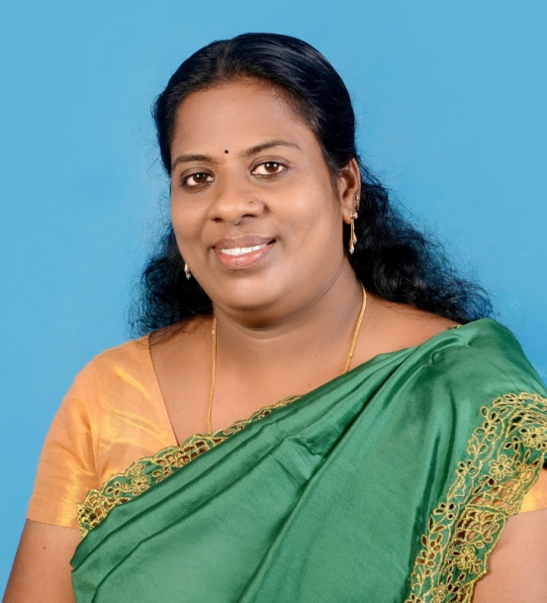
MAYA NAPOLEAN
our unique geography—surrounded by the Ashtamudi Lake and the Kallada River—has always made us a resilient community, but it also presents specific challenges during a public health crisis. As the President of Munrothuruthu LSGD, I am reaching out to inform you that our Pandemic Preparedness Plan is now fully active. We have tailored this strategy to account for our island’s tidal ebb and flow, ensuring that even the most interior wards remain connected to essential healthcare services without delay.
Our primary focus is on decentralized vigilance and rapid response. Every ward in our Panchayat now has a dedicated Rapid Response Team (RRT) equipped to handle localized emergencies. Given that water logging can often hinder traditional transport, we have coordinated with local boat operators and the Health Department to ensure 24/7 water-ambulance connectivity to the mainland and nearby Family Health Centres. No resident, regardless of their location, should feel isolated or beyond the reach of medical help.
We are placing a special emphasis on the protection of our most vulnerable, particularly the elderly and those living in low-lying areas who may face difficulty reaching clinics. Our Asha workers and volunteers are conducting door-to-door mapping to ensure that medicine kits and essential food supplies are delivered directly to those in quarantine. We have also bolstered our local oxygen reserves and established a direct communication link between the Ward Members and the District Medical Office to ensure resource allocation is swift and precise.
I urge every citizen to act as a shield for our island. Please adhere strictly to the safety protocols, report any symptoms to your ward representative immediately, and support the health workers during their field visits. Munroe Island has faced many environmental challenges with courage; by staying disciplined and looking out for one another, we will navigate this pandemic and ensure the safety of every household in our Panchayat.

MESSAGE FROM HEALTH STANDING COMMITTEE CHAIR

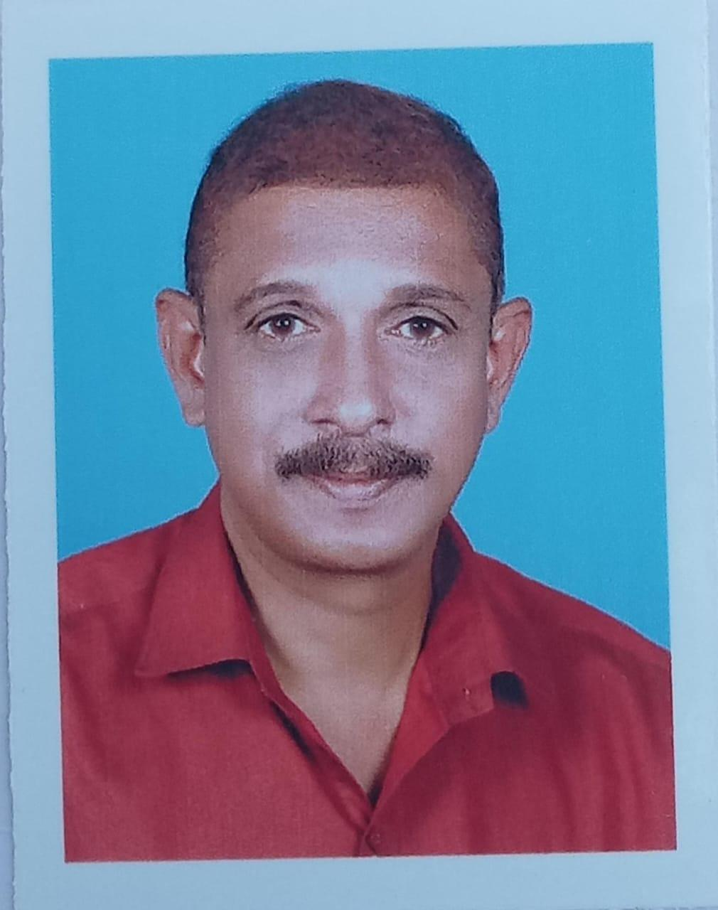
Sri Vinosh

The Health Standing Committee of Munrothuruthu Grama Panchayat is honoured to be an integral part of the formulation and governance of this Pandemic Preparedness Plan. In a panchayat as geographically distinct and demographically unique as Munrothuruthu, the role of the Health Standing Committee carries a weight and responsibility that goes beyond routine oversight. We are the institutional voice of a community that faces health risks unlike those of any mainland panchayat in the block, and it is our solemn duty to ensure that those risks are met with equal and adequate institutional resolve.
Munrothuruthu's health profile is defined by its island geography. With the highest proportion of elderly residents in the Chittumala Block — over one in five of our population is above sixty years of age — and with an occupationally exposed fishing and coir community as our working population, the Standing Committee has consistently prioritised preventive health, geriatric care outreach, and zoonotic disease surveillance in our deliberations. This preparedness plan reflects those priorities comprehensively. It addresses the unique challenges of emergency medical evacuation from an island, pre-positioned medicine stock at the Sub Health Centre, and dedicated boat-based health outreach services — all of which the Standing Committee has advocated for firmly.
I extend my heartfelt gratitude to the Medical Officer of PHC Munrothuruthu, the dedicated health workers, ASHAs, and all community stakeholders who contributed their local knowledge and experience to this document. The Health Standing Committee reaffirms its unwavering commitment to monitoring the implementation of this plan ward by ward, season by season, ensuring that every resident of Munrothuruthu — on every islet, of every age — is covered, protected, and cared for.

MESSAGE BY MEDICAL OFFICER
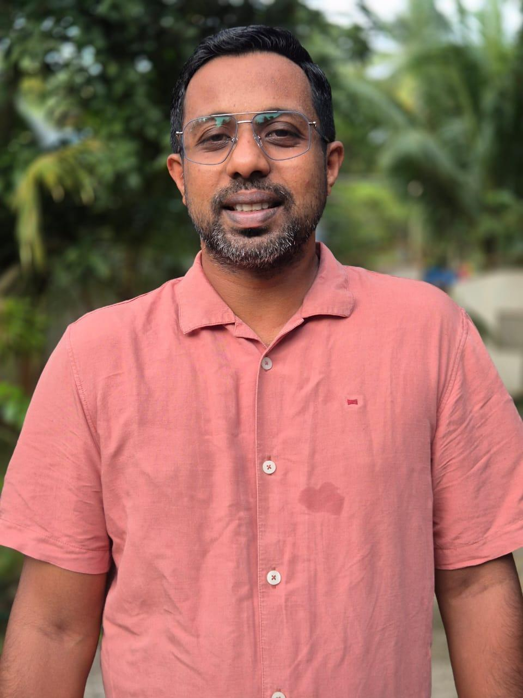
Dr Elvin Jose
It is with a profound sense of duty and dedication that I present the Pandemic Preparedness Plan for Munrothuruthu Grama Panchayat. As the Medical Officer of PHC Munrothuruthu, I am acutely aware of the extraordinary public health challenges that come with serving an island community situated at the confluence of the Ashtamudi Lake and the Kallada River. The geographical isolation of our eight islets, the dependence of our residents on waterways for both livelihood and daily movement, and the recurring threat of flooding and tidal inundation place Munrothuruthu in a uniquely vulnerable position within the Chittumala Block.
The COVID-19 pandemic exposed, with painful clarity, how an island community with limited mainland connectivity can face compounded suffering during a health emergency — from delays in medical evacuation to disruptions in the supply of medicines and essential health commodities. This preparedness plan is our institutional response to that hard-won experience. It outlines a systematic framework for early disease detection, community-level surveillance, outbreak containment, and emergency health response tailored specifically to the realities of island life.
I call upon every resident of Munrothuruthu — our fishermen, our coir workers, our elderly citizens, and our families — to be active sentinels of community health. I urge our ASHAs and health volunteers to remain the first line of vigilance in every ward. With this plan, I reaffirm the commitment of PHC Munrothuruthu to stand by this community in every season, through every storm, and in the face of every public health challenge.
EXECUTIVE SUMMARY

Primary Health Centre (PHC) functions as the primary public healthcare institution serving the population of Munrothuruthu Grama Panchayat. The PHC plays a pivotal role in delivering comprehensive, accessible, and affordable healthcare services, with a strong focus on preventive, promotive, curative, and rehabilitative care in accordance with national and state health programmes.
The PHC caters to a predominantly rural population, addressing key public health priorities such as maternal and child health, communicable and non-communicable disease control, immunization, family welfare, adolescent health, and geriatric care. Regular outpatient services, home-based care through field health staff, and outreach activities ensure healthcare coverage even in geographically challenging areas. The institution actively implements national health missions, including the National Health Mission (NHM), National Tuberculosis Elimination Programme, National Programme for Prevention and Control of Cancer, Diabetes, Cardiovascular Diseases and Stroke (NPCDCS), and other disease surveillance initiatives.
Munrothuruthu PHC works in close coordination with the Grama Panchayat, ASHA workers, Anganwadi centres, schools, and community-based organizations to strengthen community participation and improve health awareness. Emphasis is placed on early detection, timely referral, health education, and lifestyle modification to reduce disease burden and improve overall health outcomes.
Despite constraints related to infrastructure, manpower, and increasing service demand, the PHC continues to enhance service delivery through effective planning, data-driven decision-making, and community engagement. Strengthening facilities, upgrading digital health systems, and expanding preventive services remain key focus areas for future development.
Overall, Munrothuruthu Primary Health Centre stands as a vital institution in safeguarding public health and improving the quality of life of the residents of Munrothuruthu Grama Panchayat

LIST OF ABBREVIATIONS

LSGD/LSGI | Local Self Government Department / Local Self Government Institution
BMO | Block Medical Officer
IDSP | Integrated Disease Surveillance Programme
NDMA | National Disaster Management Authority
PPE | Personal Protective Equipment
ICMR | Indian Council of Medical Research
CD | Communicable Diseases
NCD | Non-Communicable Diseases

TABLE OF CONTENTS

3
INTRODUCTION 9
● Background of the PPP 9
LSGD AT A GLANCE 9
INTEGRATED HEALTH INFRASTRUCTURE MAP OF ____________ PANCHAYAT 10
GENERAL PROFILE OF THE LSGI’S 13
Background of the LSGI 13
Demographic and Vulnerable Population 14
Clinical Vulnerability 16
INFRASTRUCTURE & RESOURCE INVENTORY 18
Health Facility Directory & Basic Capacity in the LSGD 18
Private Clinics 19
Healthcare Education & Training Institutions 20
Specialized Services & Emergency Inventory 20
Oxygen & Diagnostic Capacity 21
Diagnostics facility mapping at the LSGI level 22
Laboratory Identification & Basic Details 22
Social and Community Infrastructure for surge plan 22
Human resources 24
Community & Support Cadre 25
Community Organizations 26
Administrative & Emergency Services 27
Information regarding resources 27
ONE HEALTH & ENVIRONMENTAL SURVEILLANCE 28
Animal & Bird Population 28
Veterinary Infrastructure 29
Veterinary Doctors & Workforce 30
High-Risk Interface Points (Surveillance Sites) 30
Environmental Risk Mapping 31
Disease Seasonality Mapping 32
Vulnerability Mapping 33
EPIDEMIOLOGICAL TRENDS (2021–2025) 34
Disease Burden among human beings(Last 5 Years) 34
*(use the above table data to create the graph/diagram) 36
Seasonal Trend Analysis 37
Outcome-Based Trend Analysis- 2025 39
Transmission Trend- 2025 40
Integrated Disease Hotspot Map (2021–2025) 42
Preparedness and Response Protocol at LSG Level 44
Constitution of One Health Committee 44
Pandemic Response Workforce 45
Activities and Measures before and during Pandemic 47
PHASE 1 - Alert / Preparation 47
PHASE 2 - Active Response 50
Standard Screening Protocol 51
PHASE 3 - Surge Capacity 60
Conversion of Community Facilities 60
CONCLUSION 61
RECOMMENDATIONS 62
ANNEXURE 63
1. IMPORTANT PHONE NUMBERS 63

INTRODUCTION

Background of the PPP
- LSGD at a glance

Munroe Island (Mundrothuruthu) is a unique inland island group in the Chittumala Block of Kollam district, Kerala, covering an area of 5.16 sq. km at the confluence of the Ashtamudi Lake and Kallada River. The landscape is predominantly low-lying and characterized by a delicate ecosystem of backwaters, extensive paddy fields (Kole lands), and a dense network of canals, which shapes the local microclimate but poses significant challenges for transportation and service delivery during monsoon floods. This aquatic environment is central to the region’s cultural identity, where traditional life is closely tied to water-based activities and seasonal cycles, including festivals at major landmarks like the Mulachanthara Devi and Mahavishnu temples. The infrastructure serves a projected population of 8,490 across 14 wards and is supported by 6 schools, 13 Anganwadis, and the Munroe Family Health Centre (PHC). The local economy is deeply rooted in traditional agrarian and maritime sectors—such as paddy cultivation, fishing, and coir processing—while emerging as a globally recognized eco-tourism destination that drives growth in the service and hospitality sectors.

LSGD AT A GLANCE MUNROE ISLAND
-

- Geographical boundaries with political map ( based on latest delimitation)
- Baseline data
- Ward division -
Ward | Houses | Population | Migrants | Wells | Hot  spots | Ed. Institutions | Hosp pvt/govt.
14 | 2647 | 8490 | 36 | 591 | NIL | 6 | 1/1

- Risk stratification among wards in the context of Communicable diseases and hazards
- Major Roads/rivers
- Major establishments with geospatial mapping
- occupational groups, socio cultural groups, migration & mobility patterns
- Vulnerability mapping
- Disaster prone areas (geographic vulnerability)

Maps - ward-based (Mention source also) Geographical boundaries - ward boundaries map
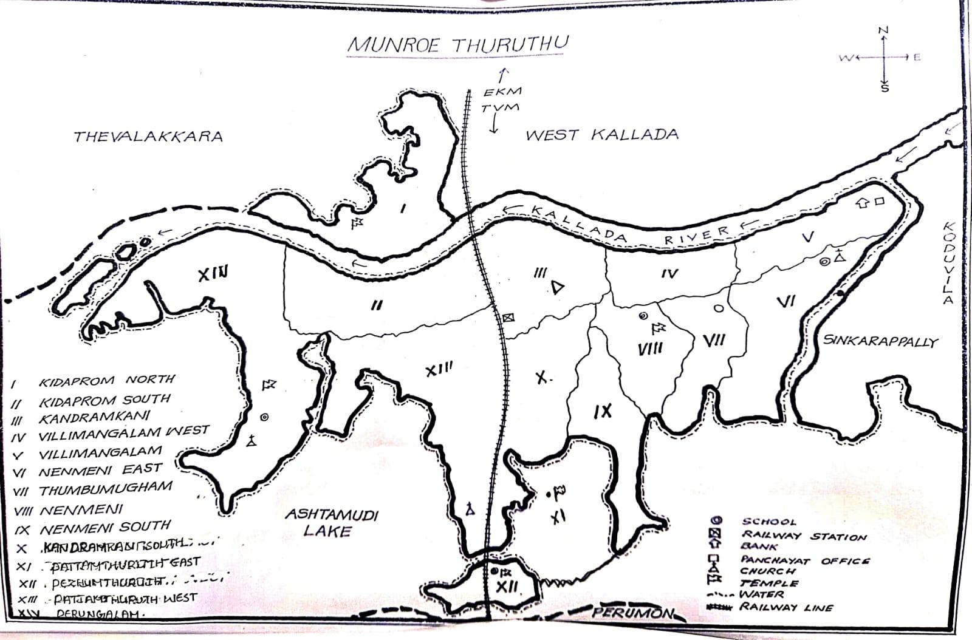

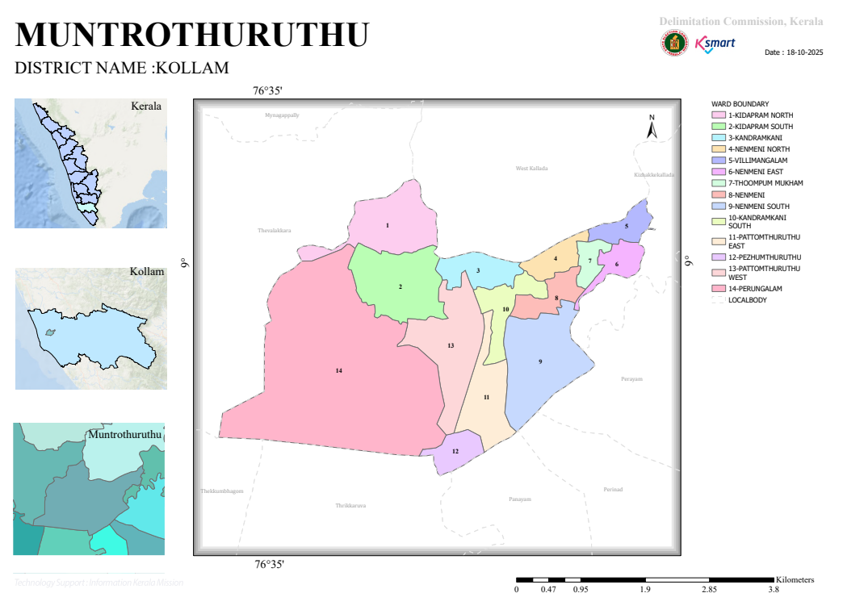

- Health infrastructure map

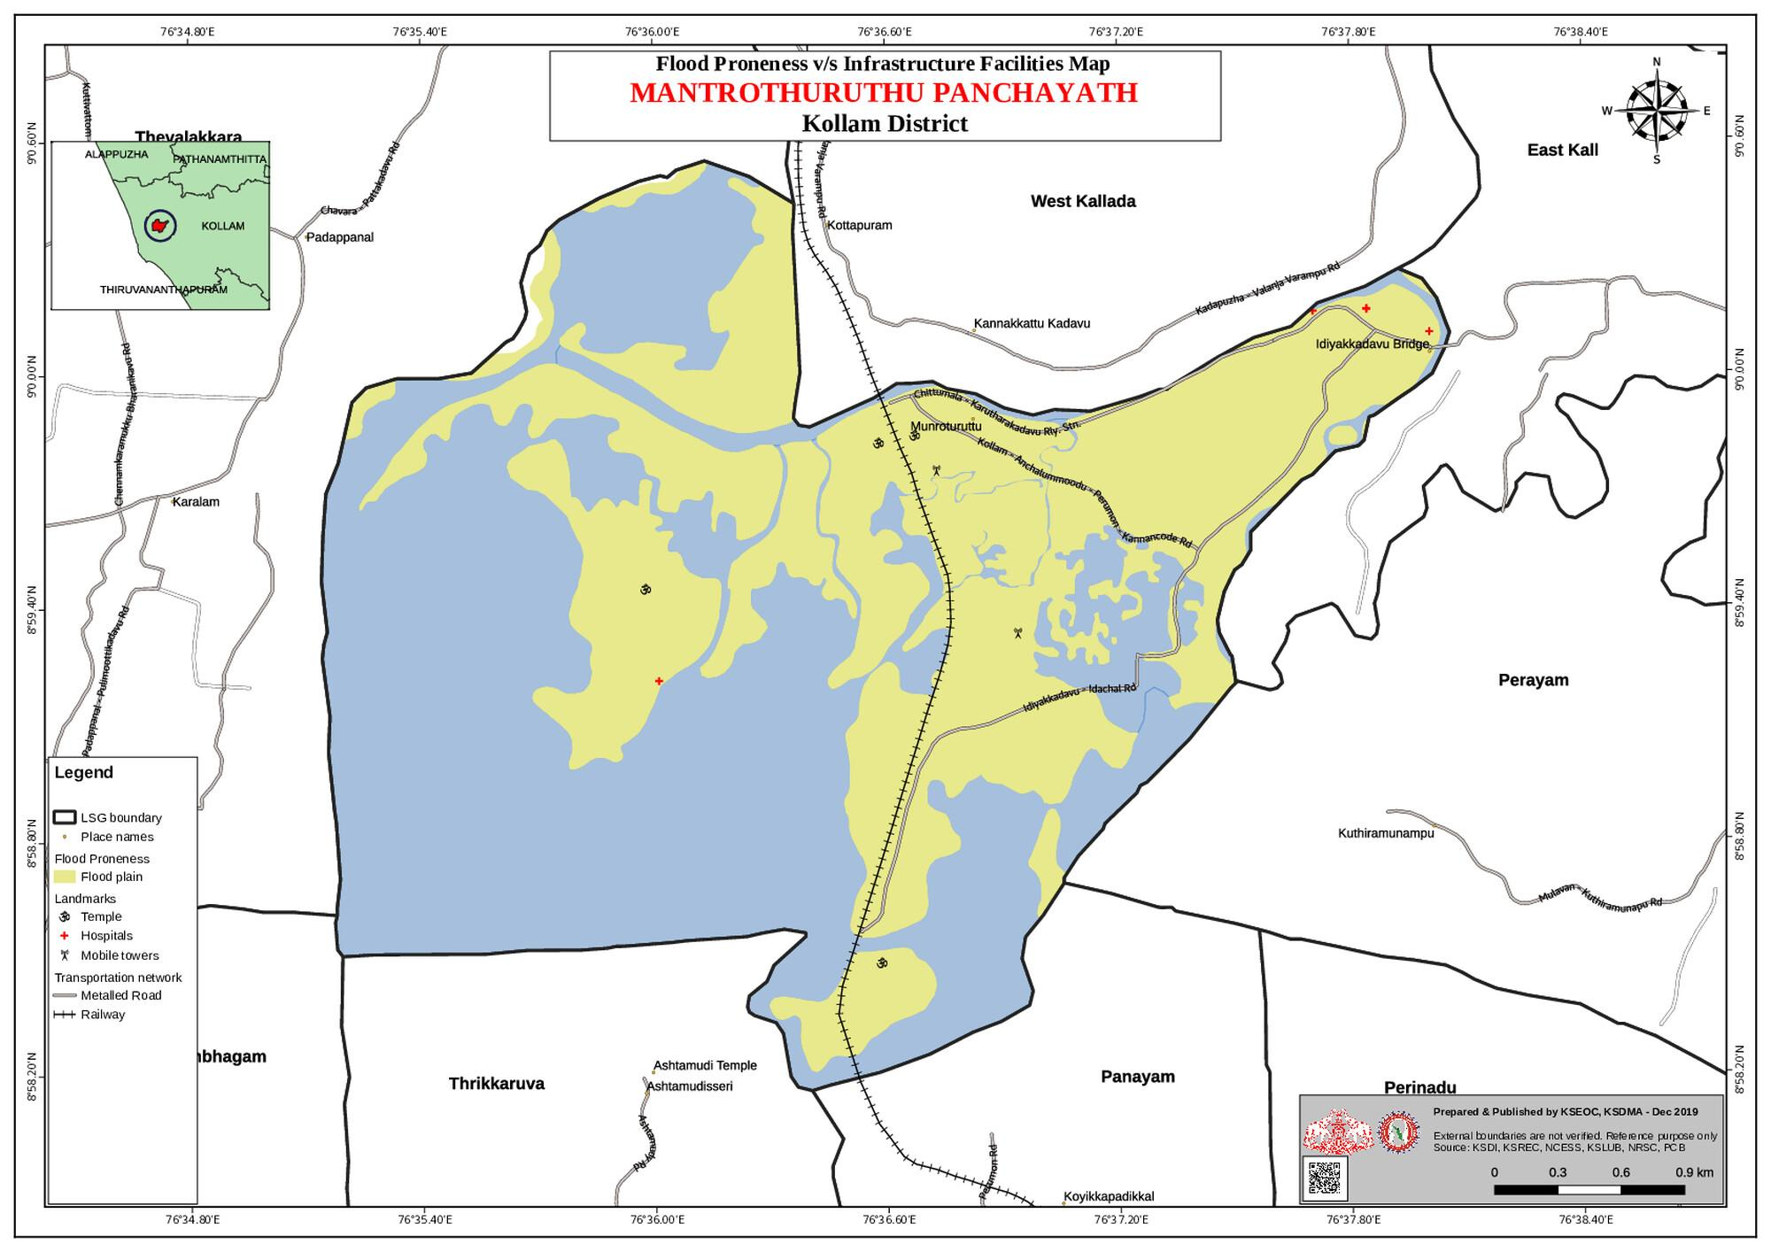

- roads and rivers map
- major establishments map
- disaster-prone areas map
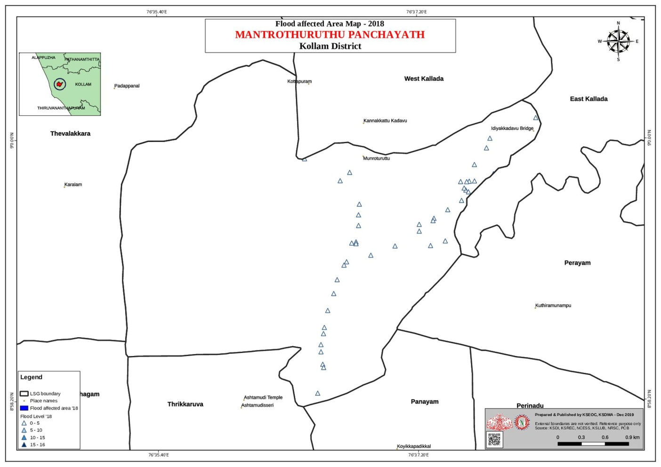

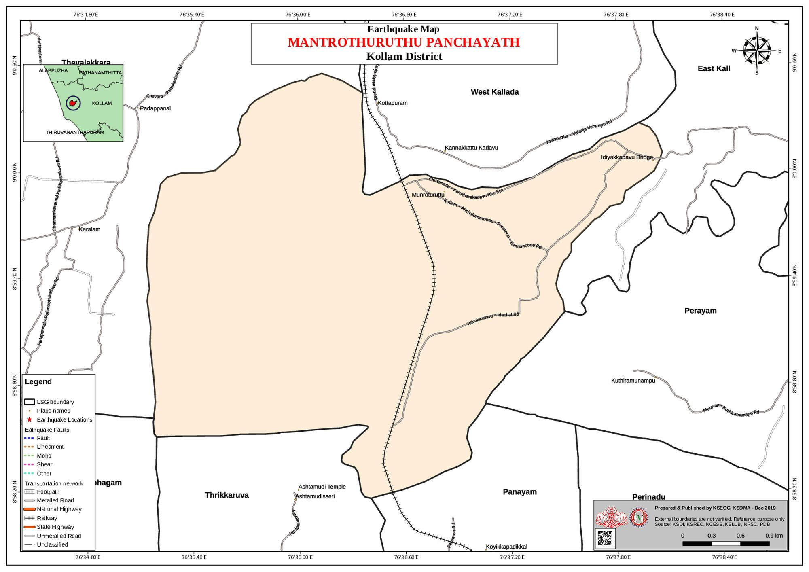
- hotspot map - CD & disasters

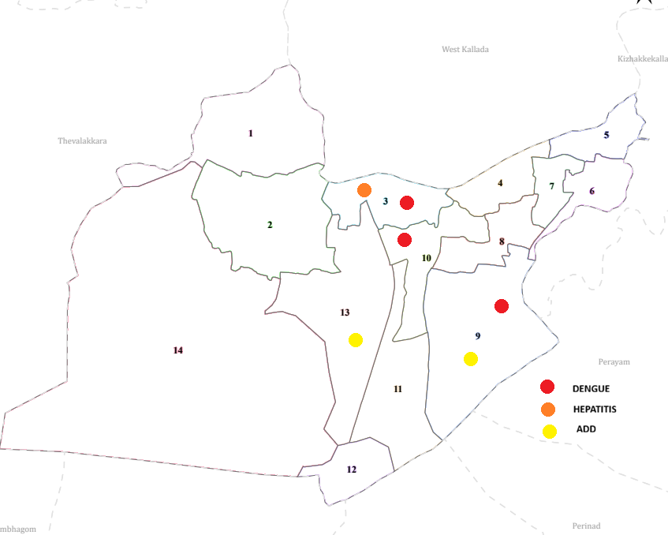

GENERAL PROFILE OF THE LSGI’S

Background of the LSGI
Munroe Island (Mundrothuruthu) is a unique inland island group in the Chittumala Block of Kollam district, Kerala, covering an area of 5.16 sq. km at the confluence of the Ashtamudi Lake and Kallada River. The landscape is predominantly low-lying and characterized by a delicate ecosystem of backwaters, extensive paddy fields (Kole lands), and a dense network of canals, which shapes the local microclimate but poses significant challenges for transportation and service delivery during monsoon floods. This aquatic environment is central to the region’s cultural identity, where traditional life is closely tied to water-based activities and seasonal cycles, including festivals at major landmarks like the Mulachanthara Devi and Mahavishnu temples. The infrastructure serves a projected population of 8,490 across 14 wards and is supported by 6 schools, 13 Anganwadis, and the Munroe Family Health Centre (PHC). The local economy is deeply rooted in traditional agrarian and maritime sectors—such as paddy cultivation, fishing, and coir processing—while emerging as a globally recognized eco-tourism destination that drives growth in the service and hospitality sectors.
Table 1: Background of LSGD
Description | Details
Name of LSGI | MUNROE ISLAND
Type (GP/Municipality/Corporation, etc.) | Grama Panchayat
Block | Chittumala
District | Kollam
Number of wards | 14
Total area (sq. km) | 5.16 sq. km
Population(Projected) | 8490
Population density | 1,645.35 persons/sq km
Terrain (coastal/low-lying/backwaters/foothills, etc.) | backwaters
Number of rivers passing through LSGI | Ashtamudi Lake, Kallada River
Number of water bodies in the LSGI | 2
Number of educational institutions | 6
Factories / small-scale industries | 1/2
Flood-prone wards | 3 wards- Ward 14 (Peringalom), Ward 2 (Kidappuram South), Ward 12 (Pezhum Thuruth).
Landslide-prone wards | 0
Death Management and Disposal Facilities (mortuaries/crematorium, including electric) | 0
Auditoriums/Marriage halls/convention centres/community halls | 2

Demographic and Vulnerable Population
Understanding the demographic composition and vulnerable population groups is essential for pandemic preparedness. Children, elderly, economically deprived families, migrant workers, and socially vulnerable groups are at increased risk during public health emergencies due to higher exposure, limited access to services, and dependency on public systems..

Description |  | Details (in numbers)
DEMOGRAPHIC PROFILE
Total population |  | 8490
Male |  | 4222
Female |  | 4268
Transgender |  | 1
Children under 5 |  | 326
Adolescent |  | 406
Elderly (>60) |  | 1838
SOCIAL/LIVELIHOOD VULNERABILITY
Previous EPEP family |  | 28
BPL family |  | 1553
Tribal communities |  | 8,490
Migration | Immigrant | 36
Migration | Emigrant | 217
Socio-economically deprived |  | 1553
Fisherfolk |  | 1240
SC Community |  | 1083
ST Community |  | 0

Graphs: Population pyramid (if possible) for seeing if your LSGI has a high "dependency ratio" (lots of children and elderly compared to working adults).

Population Pyramid Data (Projected)

Age Group | Percentage (Approx.) | Vulnerability Status
0–14 (Children) | 18% | Dependent - School-based surveillance target.
15–59 (Working Class) | 62% | Productive - Primary workforce for RRTs.
60+ (Elderly) | 20% | High Dependency - Requires home-based care.

Impact on "Dependency Ratio"
- High Elderly Dependency: With nearly 1,700 residents (20%) over the age of 60, Munroe Island has a higher-than-average dependency ratio compared to other LSGIs in the block.
- Clinical Implications: During a respiratory pandemic, the Munroe Island PPP must prioritize "Reverse Quarantine" for this group.
- Economic Strain: A smaller working-age population (62%) means that in the event of a lockdown, a significant portion of the island (the 38% dependent group) will require immediate logistical support and food kits from the Panchayat.

Strategic Planning for High Dependency
To manage this ratio, the Munroe Island PPP includes:
- ASHA-led Monitoring: Weekly health check-ups for the 1,083 SC community members and elderly clusters.
- Psychosocial Support: Dedicated tele-counseling to address isolation in the elderly.
- Palliative Care Integration: Utilizing the 300-person workforce to ensure medicine delivery to those with chronic illnesses.

Clinical Vulnerability
Certain population groups needs priority healthcare & are at higher risk of severe illness, complications, and mortality during pandemics. Patients with chronic diseases, those requiring regular medical care, and individuals with mobility or functional limitations face challenges in accessing timely care during emergencies. Mapping these groups helps in prioritizing continuity of treatment, medicine stock planning, oxygen support, referral transport, and targeted home-based care.
Description | Details in numbers
Pregnant women | 44
Lactating mothers | 53
Bedbound patients | 66
Patients under palliative care other than bedbound | 151
Patients on Haemodialysis | 3
Patients on CAPD | 0
Cancer patients (currently on treatment) | 18
Haemophilic patients | 0
Mentally challenged | 62
Differently abled | 108
Diabetic patients | 962
Hypertensive patients | 1221
TB patients | 0

Major Festivals & Events specific to the LSGI
(with the possibility of a public gathering)

This list identifies the primary cultural and religious gatherings within the Munroe Island (Munrothuruthu) Grama Panchayat. For the purposes of the Pandemic Preparedness Plan, these events are categorized as "High-Density Gathering Windows" where the risk of respiratory or waterborne transmission is significantly elevated.

Strategic Preparedness Observations
Based on the Munroe Island PPP .docx and the Festival Risk Analysis, the following protocols are triggered by these events:
- Temporal Clusters: A high concentration of events occurs between January and May. This coincides with the peak dry season and the lead-up to the monsoon, requiring the Surveillance Team to maintain heightened vigilance for five consecutive months.
- Water-Based Logistics: Since many attendees travel between islands by boat, the Transportation Team must implement safety protocols at ferry points (Jadavu) to prevent overcrowding.
- Targeted IEC (Information, Education, and Communication):
  - Ward 13 (Peringalam): Focus on church-based outreach (Sl. No 5, 14, 16).
  - Pezhumthuruthu: Focus on temple-based outreach during January (Sl. No 8).
- Sanitation (WASH): The Logistics Coordinator must ensure temporary mobile toilets and chlorination of nearby water sources at these sites at least 48 hours before the main event date.

Sl. No. | Name of festival | Month detailing the periodicity
1 | Mulachanthara Devi Temple, | Feb- march
2 | Kalluvila Temple | March
3 | Murugan temple, Willimangalam | Feb
4 | Mahavishnu Kshetram, Munroe Island | March–April
5 | OUR LADY OF ASSUMPTION CHURCH, peringalam | AUGUST
6 | VALLITHARA BALA BHADRA TEMPLE | MARCH
7 | KAVRUTHAYIL TEMPLE | JANUARY
8 | PEZHUMTHURUTHU TEMPLE | JANUARY
9 | PATTOM THURUTH SREEKRISHNASWAMI | DECEMBER
10 | PERUNGALAM TEMPLE | FEBRUARY
11 | St MARYS CHURCH IDACHAL | MAY
12 | PALLAYATTU TEMPLE | FEBRUARY
13 | PERUNGALAM BALA BHADRA TEMPLE | APRIL
14 | St JOSEPH CHURCH | MAY
15 | BETHEL CHURCH( PROTESTANT) | JANUARY
16 | MARTHOMA CHURCH PERUNGALAM | FEBRUARY

INFRASTRUCTURE & RESOURCE INVENTORY

Health Facility Directory & Basic Capacity in the LSGD
This section provides an overview of the healthcare infrastructure available within the LSGD area. It outlines the distribution and basic capacity of health facilities that form the backbone of service delivery during routine times and public health emergencies.

Family Health Centres (FHCs) and Community Health Centres (CHCs) generally function as the first point of contact for the community, providing essential outpatient and inpatient services. General Hospitals (GH) and Medical College Hospitals (MCH), where accessible, serve as the main referral centres for advanced diagnostics, specialist care, and critical services during public health emergencies. This inventory helps identify existing strengths, gaps, and potential surge capacity that can be mobilised during a pandemic or disaster.

Table 5. Health Facility Resource Summary
Sl.no. | Health Facility | Type of Facility (MCH/GH/CHC/FHC/SC etc.) | Contact Number | Total beds | ICU Beds | Oxygen-Supported Beds | No. of Ventilator Support Beds | No. of ambulances
Government Healthcare Facilities
1 | Main centere | SC | 9497112406 | 0 | 0 | 0 | 0 | 0
2 | HWC Munrothuruthu | SC | 9495350636 | 0 | 0 | 0 | 0 | 0
3 | HWC Pattamthuruth | Sc | 9074043085 | 0 | 0 | 0 | 0 | 0
4 | Family Health Centre (FHC) | FHC | 0474-2585222 | 0 | 0 | 0 | 0 | 0
5 | Ayurveda Dispensary | Ayurveda | 9446425844 | 0 | 0 | 0 | 0 | 0
6 | Homeopathic Dispensary | Homeo | 9496004500 | 0 | 0 | 0 | 0 | 0
Private Healthcare Facilities
1 | Asraya clinic | Private Clinic | 8921455259 | 3 | 0 | 0 | 0 | 0
2 | Lifeline Clinic | Private Clinic | 9447101566 | 3 | 0 | 0 | 0 | 0
AYUSH Healthcare Facilities
1 | Ayurveda hospital Govt | DIS. | Dr Sussan-9496143219 | 0 | 0 | 0 | 0 | 0
2 | Homeopathic Dispensary | Homeo | 9496004500 | 0 | 0 | 0 | 0 | 0

Private Clinics
Private clinics are an essential part of pandemic preparedness, as they are often the first place people seek care when symptoms begin. In many communities, private clinics manage a significant share of outpatient visits and therefore play a critical role in early case detection, timely referrals, and disease surveillance. Having an up-to-date understanding of where these clinics are located, the services they provide, and how they are linked to the public health system helps ensure that no cases are missed during an outbreak. It also allows health authorities to engage private practitioners more effectively for reporting, risk communication, and coordinated response, strengthening the overall capacity of the health system to manage public health emergencies.

Table 6. Private Clinic Resource Summary
Sl No. | Name of Clinic | Registered (Y/N) | Clinic (General / Speciality) | Speciality (if any) | Address | Contact Number | Diagnostic Facility (Y/N) | Ambulance Linkage (Y/N)
1 | Asraya Clinic | N | General | NO | Bank Junction, Munroe Island | Dr Vishnu, 8921455259 | Y | N
2 | Lifeline Clinic | Y | General | NO | Near Grama Panchayat | 9447101566 | N | N
3 | Munroe Medical Centre | Y | General | NO | Peringalam | 0474-2585222 | Y | Y

Healthcare Education & Training Institutions
This section tracks the educational infrastructure available, which is vital for human resource planning in the health sector.

Category of Institution | Govt | Private | AYUSH | Total
Medical Colleges | 0 | 0 | 0 | 0
Nursing Colleges | 0 | 0 | 0 | 0
Dental Colleges | 0 | 0 | 0 | 0
Para-medical / Allied Health | 0 | 0 | 0 | 0
Pharmacy Colleges | 0 | 0 | 0 | 0

Specialized Services & Emergency Inventory
This section provides a detailed view of the specialized medical resources available to the community, focusing on emergency response and critical care capabilities. This table tracks the vital assets required for managing severe illnesses and emergencies across Government, Private, and AYUSH sectors.

Item | Govt | Private | AYUSH | Total
Hospital beds | 0 | 0 | 0 | 0
Oxygen-generating systems(Y/N) | 0 | 0 | 0 | 0
Oxygen-supported beds(Numbers) | 0 | 0 | 0 | 0
Ventilator-supported beds | 0 | 0 | 0 | 0
ICU beds | 0 | 0 | 0 | 0
Burns units | 0 | 0 | 0 | 0
Blood centres | 0 | 0 | 0 | 0
BLS ambulances | 0 | 0 | 0 | 0
ALS ambulances | 0 | 0 | 0 | 0
Dialysis facilities | 0 | 0 | 0 | 0
Dispensaries | 0 | 0 | 0 | 0
Medical store | 0 | 1 | 0 | 0
Industrial establishments(Medium-scale industries/small-scale industries establishments to whom we can depend in a worst-case scenario) | 0 | 1 | 0 | 1

Oxygen & Diagnostic Capacity
Monitoring oxygen and diagnostic capacity is a critical component of public health preparedness, ensuring that the LSGD can handle both chronic care and sudden surges in respiratory or infectious diseases.
Name of Health Facility | Oxygen-generating System (Y/N) | Backup Oxygen Source (Y/N) | Diagnostic Facilities Available(Y/N)
Name of Health Facility | Oxygen-generating System (Y/N) | Backup Oxygen Source (Y/N) | Lab | USG | X-ray | CT/MRI | RT-PCR
Government Healthcare Facilities
Munroe PHC | N | N | Y | N | N | N | N
Private Clinics
Asraya Clinic | N | N | Y | N | N | N | N
Lifeline Clinic | N | N | N | N | N | N | N

Diagnostics facility mapping at the LSGI level
The diagnostic capacity of Munroethuruthu G.P represents the "intelligence network" of our healthcare system. The speed and accuracy of disease identification depend entirely on the distribution and technical level of these facilities.

Item | Govt | Private | AYUSH | Total
General labs | 0 | 2 | 0 | 2
Microbiology labs | 0 | 0 | 0 | 0
RT-PCR labs | 0 | 0 | 0 | 0
USG units | 0 | 0 | 0 | 0
CT/MRI units | 0 | 0 | 0 | 0
Research labs | 0 | 0 | 0 | 0
Labs of other departments that can be repurposed | 0 | 0 | 0 | 0

Laboratory Identification & Basic Details
Sl. No. | Name of Laboratory | Ownership (Govt / Private / Academic) | Address | Contact No. | 24×7 Services (Yes/No) | NABL / Govt Approved (Yes/No)
1 | Lekshmi computerized Labs | Private | Mundrothuruthu | Dr Sujeesh, 8129555976 | No | No
2 | Chakrapura lab. | Private | Mundro. | 9847465878 | No | No
3 | Munroe PHC Lab | Govt | PHC, Munroe Island | 0474-2585222 | No | Yes
4 | Asraya Diagnostic Point | Private | Bank Jn. | 8921455259 | No | No

Social and Community Infrastructure for surge plan
This table serves as our logistics and shelter inventory. By mapping these locations, quickly we can identify where to house displaced citizens, where to set up temporary medical clinics, and how to manage the deceased with dignity during a crisis.

Category | Total Count | Ward | Est. Capacity (Persons) | Contact details
Educational Institutions
Anganwadis | 13 | All (14 Wards) | 130 | ICDS Supervisor
Schools | 6 | 2, 10, 11, 13 | 400 | Refer Annexure 1
Colleges | 0 | NIL | NIL | NIL
Healthcare Educational Institutions
Medical colleges (Govt/Private) | 0 | NIL | NIL | NIL
Nursing colleges (Govt/Private) | 0 | NIL | NIL | NIL
Dental colleges (Govt/Private) | 0 | NIL | NIL | NIL
Paramedical institutes (Govt/Private) | 0 | NIL | NIL | NIL
Community Gathering Spaces
Community halls | 0 | NIL | NIL | NIL
Auditoriums | 2 | 10, 13 | 500 | Private Owners
Religious buildings | 5 | 2, 11, 13, 14 | 300 | Festival Committee
Vulnerable Group Support Facility
Destitute homes | 0 | NIL | 0 | NIL
Elderly homes | 0 | NIL | 0 | NIL
LSGD owned other buildings | 0 | NIL | 0 | NIL
Mass Fatality Management (MFM) Infrastructure
Mortuary | 0 | NIL | 0 | Use Kundara Taluk Hosp.
Crematorium | 0 | NIL | 0 | Local Religious Sites
*refer annexure 1 for contact details

Human resources
This section focuses on the human capital available within the LSGI. In any emergency—be it a pandemic, flood, or industrial accident—infrastructure is only as effective as the people operating it.

Medical & Clinical Personnel
This table tracks the "Frontline" providers responsible for diagnosis, treatment, and clinical management. Narrative sentence: eg., "Total health workforce: 450 personnel, with 60% in government facilities serving as primary surge capacity." A detailed directory with the contact numbers of all workers is maintained (Annexure in 1).

Cadre | Govt (No.) | Private (No.) | Total
Doctors—Modern Medicine | 2 | 1 | 3
Doctors – AYUSH | 1 | 0 | 1
Doctors – Veterinary | 1 | 0 | 1
Doctors – Dental | 0 | 1 | 1
Nursing officers | 1 | 2 | 3
Lab technicians | 1(panchayathu) | 2 | 3
Optometrist | 0 | 0 | 0
Pharmacists | 0 | 2 | 2
Psychologists | 0 | 0 | 0
Counsellors | 0 | 0 | 0

Public Health & Field-Level Workforce
These individuals are the backbone of surveillance, maternal-child health, and decentralized care.

Cadre | Health services | Municipal common services | Total
HS (Health Supervisors) | 1 | 0 | 1
HI (Health Inspectors) | 1 | 0 | 1
LHS (Lady Health Supervisor) | 1 | 0 | 1
LHI (Lady Health Inspectors) | 1 | 0 | 1
JPHN (Jr Public Health Nurses) | 3 | 0 | 3
JHI (Jr Health Inspectors) | 2 | 0 | 2
MLSP (Mid-Level Service Providers) | 3 | 0 | 3
Palliative Nurses | 1 | 0 | 1
RBSK Nurses | 1 | 0 | 1
PRO | 1 | 0 | 1
Epidemiologist | 1 | 0 | 1
Data Manager | 1 | 0 | 1

Community & Support Cadre
This group represents the surge capacity of the LSGI—people who can be called upon for logistics, rescue, and specialized support.

Cadre | Number
ASHA Workers | 12
AWW (Anganwadi Workers) | 13
Emergency Medical Volunteers (Trained) | 13
Kudumbashree | 139
MNREGS | 1800
Purusha Swayam Sahaya Sangham | 0
Ex-Servicemen | 62
Retired Police Officers | 16
NCC/NSS Volunteers | 0
Red Cross volunteers | 0
One Health Community Volunteers | 0
One Health Community Mentors | 0

Community Organizations
This section details the presence of community-based organisations (CBOs), non-governmental organisations (NGOs), faith-based organisations (FBOs), Kudumbashree Self-Help Groups (SHGs), and Ayalkootams within the Local Self-Government Institution (LSGI). These groups enhance grassroots mobilization, resource distribution, and support networks crucial for pandemic response and community resilience.

Category | Total Count
NGOs | 3
Religious based organizations | 14
Foreign based organizations | 1
Sports Club/youth clubs | 13
Kudumbashree SHGs | 49
Ayalkootams | 143
Political organizations | 5
Residential organizations | 0

Administrative & Emergency Services
This section outlines the availability of key non-health emergency support services and infrastructure within the LSGI, which are essential for effective pandemic preparedness and response. These facilities support law enforcement, disaster response, water supply, logistics, mobility, and community-level interventions during public health emergencies.

Category | Total Count | Contact details
Police Stations | 0 | Services provided by East Kallada Police Station via water/road
Fire & Rescue Stations | 0 | Dependent on Kundara Fire Station; response time is ~30-45 mins.
Water Pumping Points | 5 | Managed by the LSGD Engineering Dept for emergency supply.
Public Distribution System (PDS) | 9 | Primary hubs for ration kit distribution to 1,553 BPL families.

Information regarding resources
The availability of essential transport and support resources plays a quiet but critical role in saving lives. Equipment such as ambulances, mobile mortuaries, amphibian ambulances, and motorized boats ensures that patients, samples, and healthcare teams can move swiftly—even in flooded, remote, or difficult terrains. Heavy vehicles like JCBs, cranes, tractors, and torus lorries support logistics, waste management, emergency infrastructure, and rapid conversion of spaces into care or isolation facilities. Taxis, four-wheel-drive vehicles, and trucks help maintain continuity of essential services, reach vulnerable populations, and support home-based care and supply delivery.

Means of transportation | Total Count
JCB | 0
Crane | 0
Heavy Trucks | 0
Tractor | 1
Ambulances | 0
Mobile mortuaries | 0
Boats | 10
Taxi service | 7
Note: For specific details regarding vehicle owners and contact information, please refer to Annexure [X].

ONE HEALTH & ENVIRONMENTAL SURVEILLANCE
The One Health method integrates environmental, animal, and human health to enable proactive pandemic preparedness. Panchayat-level surveillance needs to be improved in order to detect and treat zoonotic and environmentally generated diseases early. Surveillance is strengthened through systematic assessment of animal populations, veterinary infrastructure, poultry and slaughter facilities, inter-sectoral coordination, and specialised tools like avian influenza seasonality mapping using GIS in previous outbreaks to enable predictive alerts and ward-specific sampling to support effective pandemic preparedness in high-risk areas like Wards 2, 12, and 14 (Peringalom and Pezhum Thuruth).

Animal & Bird Population
Mapping animal and bird populations at the Panchayat level is essential for identifying and prioritising zoonotic disease hazards like rabies, avian influenza (H5N1), leptospirosis, anthrax, and Nipah-like spillover occurrences. Risk classification, targeted surveillance, vaccination planning, and early epidemic detection made feasible by comprehensive population mapping all enhance One Health-based pandemic preparedness.

Category | Item | Estimated Population | Wards
Animal Population | Livestock (Cattle/Goats/Buffalo) | 323/250/101 | 14
Animal Population | Pet Animals (Dogs/Cats) | 57 (est. 40 dogs / 17 cats) | All 13 wards; highest near W-2 DTPC jetty
Animal Population | Stray Dog Population | 17 observed | W-2 fish landing, W-5 market, W-8, W-10 tourist areas
Animal Population | Pig Farms (Number of heads) | 30 heads / 4–5 units | W-3 Pezhumthuruth, W-7 inland islet, W-6 — unregistered backyard units
 | Small Units (Sheep / Goats – clustered) | 5 / 60–80 goats | W-4, W-8, W-9
Bird Population | Poultry Units (Birds) | 75 | All 13 wards — duck and poultry farming common in all houses
Bird Population | Poultry- (FOWL) | 1,100 birds (600 ducks / 500 chicken) | W-2, W-5, W-8 highest; open backwater duck access
Bird Population | Wild/Migratory Birds (Observed) | 57 species, 6 migratory | W-2, W-5, W-8, W-10, W-13 canal/mangrove zones; Oct–May peak
Bird Population | Crow Mortality Events (Reported) | 2 events (Jan 2024 & Oct 2023) | W-2 Karuvathrakadavu, W-8 Muthiraparambu — no lab samples collected

The main risk of zoonotic diseases in Mundrothuruthu is concentrated in W-2 (Karuvathrakadavu), W-5 (Pattam Thuruthu), and W-8 (Muthiraparambu), which is explained by the high density of open-access duck farms directly adjoining Ashtamudi Lake and Kallada River, active fish landing sites, DTPC canal boating centres, and the highest concentration of homestead livestock rearing on the island. These wards form the primary wetland–livestock–human spillover interface.
The stray dog population concentrated around fish landing sites (W-2), canal-side market areas (W-5), and tourist homestay corridors (W-8, W-10) continues to be a substantial problem for Rabies surveillance and bite prevention — particularly for children, tourists, and fisherfolk who interact with strays near the DTPC jetty and fish auction area.
There is a considerable risk of Avian Influenza (H5N1) introduction and amplification during November–February due to the seasonal presence of migratory waterfowl — including Siberian cranes, white-necked storks, Asian openbills, and egrets — near the Ashtamudi Lake canals, Kallada River bank, and mangrove waterways of Mundrothuruthu. 57 bird species (6 migratory) have been documented on the island, with domestic duck flocks in W-2, W-5, and W-8 sharing feeding zones with these migratory visitors — the classic Kerala HPAI duck-water bird spillover interface.
Clusters of homestead duck farms and low-lying shrimp ponds — all 13 wards of this island panchayat lie below 2 m MSL and experience partial or complete inundation during the monsoon floods of June–September — further raise the risk of Leptospirosis and other environment-mediated zoonoses. Rodent populations amplified by fish processing waste at W-2 and W-5, combined with flood-driven dispersal of cattle and pig waste into community water sources, create a severe post-flood outbreak risk window for fisherfolk, coir workers, and paddy field labourers across the panchayat. Unregistered pig units in W-3 and W-7 represent an additional unmonitored risk node for leptospirosis transmission.

Veterinary Infrastructure
Veterinary institutions are a core pillar of One Health surveillance, enabling early zoonotic disease detection through vaccination, investigation of unusual animal illness or deaths, sample collection, and timely outbreak reporting. A well-mapped and responsive veterinary network strengthens coordination with human health and LSGI systems, ensuring rapid response during zoonotic events and pandemics.
Facility Type | Name of Facility | Ownership Govt / Pvt | Location(Ward No) | Contact number
Veterinary Dispensary | 01 | GOVT | 5 | WILLIMANGALAM 9656780111
Veterinary Hospital / Polyclinic | 0 | 0 | 0 | 0
Private Veterinary Clinics | 0 | 0 | 0 | 0
Mobile / Emergency Vet Service (incl. night services) | 0 | 0 | 0 | 0
0Pet Homes / Animal Shelters | 0 | 0 | 0 | 0
Slaughterhouse-linked Veterinary Inspection Unit | 0 | 0 | 0 | 0

Veterinary Doctors & Workforce
Early detection, diagnosis, reporting, and reaction to animal illness epidemics depend on the availability and accessibility of qualified veterinary specialists. By identifying unusual animal morbidity or mortality promptly, collecting samples promptly, and coordinating efficiently with human health and LSGI systems—especially during zoonotic outbreaks and pandemic-prone situations—a clearly defined veterinary workforce enhances One Health surveillance.

Category | Number Available | Type (Govt/Pvt) | Contact number
Government Veterinary Doctors | Dr ZEENA | govt | 9446425844
Private Veterinary Doctors | 0 | 0 | NIL
Livestock Inspectors | LITTA | G | 9656361270
Para-veterinary Staff / Attenders | SALILNI | G | 9544159676
Contract / On-call Veterinary Support (if any) | 0 | 0 | NIL

High-Risk Interface Points (Surveillance Sites)
High-risk interface points for zoonotic disease surveillance in Mundrothuruthu Grama Panchayat include wetland–livestock–human contact zones, backyard poultry farms, cattle sheds near water bodies, fish markets, and areas of high human–animal interaction such as community slaughter points and migratory bird congregation sites. These are the primary surveillance sites where zoonotic spillover risks are elevated.

Type of Habitat | Type of High risk interface | Geographical vulnerability
Wetlands & Backwaters | 🔴 Present — HIGH | All 13 wards; duck and poultry farming common in all houses 75 units, 1,100 birds; W-2, W-5, W-8 highest
Backyard Poultry Farms | 🔴 Present — HIGH | W-2 Karuvathrakadavu, W-5, W-8; 424 animals on Kallada river bank / canal margins; annual flood disperses Leptospira slurry
Cattle Sheds near Water Bodies | 🔴 Present — HIGH | W-2 Karuvathrakadavu (primary landing + sale); W-5 Pattam Thuruthu; W-10 Nettayam; no cold chain or washroom at site
Fish & Meat Markets | 🔴 Present — HIGH | W-2 Karuvathrakadavu (primary landing + sale); W-5 Pattam Thuruthu; W-10 Nettayam; no cold chain or washroom at site
Community Slaughter Sites | 🟠 Present — MODERATE | W-2, W-5, W-8; informal household-level only; no licensed abattoir; no veterinary inspection
Migratory Bird Congregation Areas | 🔴 Present — HIGH | 57 species documented, 6 migratory including Siberian cranes , W-2, W-5, W-8, W-10, W-13; Pathupara mangrove islet as roosting site; Oct–May peak
Rodent-Infested Grain Storage | 🟠 Present — MODERATE | W-2 fish waste (highest), W-5 market, W-3, W-8 paddy bunds; post-flood all-ward displacement Aug–Oct

Vulnerability Index = 100% — all 6 interface types present. The Wetlands & Backwaters habitat of Mundrothuruthu (Munroe Island) at the Ashtamudi–Kallada confluence represents one of the highest-density zoonotic interface zones in the district.

Category | Total Count | Key Locations (wards)
Poultry Farms | 2 | 2, 10
Backyard / Clustered Poultry Units | 0 | NIL
Duck Rearing Units (open water access) | 1 | 13 (Peringalom)
Slaughterhouses/ Slaughter Points | 0 | NIL
Meat/Fish Markets | 2 | 11, 14
Live Bird Sale Points | 0 | NIL
Cattle Markets / Weekly Animal Fairs | 0 | NIL
Pet Shops / Breeders | 0 | NIL
Animal Shelters / Pet Homes | 0 | NIL
Waste Disposal Sites near Animal Units | 0 | NIL

Environmental Risk Mapping
Environmental risk mapping identifies monsoon/flood hotspots for vector-borne (dengue, chikungunya), water-borne (leptospirosis, diarrhoea), and zoonotic diseases in Kerala's wetlands. Systematic surveillance supports early warnings, targeted interventions, and Panchayat pandemic preparedness.
Waterborne exposure: Flood-prone areas and stagnant water bodies facilitate leptospira survival, raising leptospirosis risk.

Traditional practices: Informal slaughter and fish markets lack standardized hygiene, creating spillover opportunities.

Risk Factor | High-Risk Wards | Key Locations | Risk Level (High/Med/Low)
Flood-prone areas | 2, 11, 13 | Peringalom, Pezhum Thuruth | High
Water bodies/wetlands | 1, 3, 11, 12, 14 | Ashtamudi Lake/Kallada River interface | High
Solid waste accumulation | 10, 13 | Bank Junction, Peringalam Market | Medium
Animal waste disposal issues | 2, 10, 13 | Near Poultry and Duck units | Medium
Rodent infestation zones | 10, 13, 14 | Market areas and PDS shops | Medium
Industrial effluent discharge | 0 | None (No large-scale industry) | Low
Construction sites / abandoned buildings | 7, 8 | Near railway expansion zones | Low
Poor drainage/blocked canals | 11, 13 | Inter-island canal networks | High
Drinking water source contamination risk | 2, 11, 13 | Low-lying areas during high tide | High

Strategic Surveillance Implications
- The Triple Threat (Wards 11 & 13): These wards are flagged for High Risk across flooding, drainage, and water contamination. The Pandemic Preparedness Plan dictates that during monsoon onset, these wards must undergo Super-Chlorination of all open water sources.
- Vector Control: The combination of Water bodies (High) and Rodent infestation (Medium) in Wards 13 and 14 makes them the primary focus for Leptospirosis and Dengue surveillance.
- Salinity & Drinking Water: Because Munroe Island is sinking/subsiding, the "Drinking water source contamination risk" is constant due to saline ingress. The Logistics Team must maintain a 48-hour buffer of bottled water for any isolation centers located in these wards.

Disease Seasonality Mapping
1, Flooding& waterlogging → amplifies leptospirosis, malaria, diarrheal diseases.
·
2, Migratory bird influx (Nov–Feb) → avian influenza risk.

3, Mosquito breeding cycles → vector-borne disease peaks in monsoon.

4, Agricultural practices → close human–animal contact in paddy fields.

Disease | Peak Risk Season | Key Drivers | High-Risk Locations | Surveillance Focus
Avian Influenza | Nov – Feb | Migratory bird arrival in Ashtamudi Lake. | Wards 2, 13 (near wetlands) | Mortality in domestic ducks/wild birds.
Leptospirosis | June – Aug (Monsoon) | Waterlogging and rodent urine contamination. | Wards 11, 13 (Flood-prone) | Fever in farmers, fisherfolk, and MGNREGS workers
Dengue/Chikungunya | May – July (Pre/Post Monsoon) | Stagnant water in containers/coconut shells. | Wards 10, 14 (High density) | Larval surveys and house-to-house fever monitoring.
Acute Diarrheal Diseases | Mar – May (Summer) | Drinking water scarcity and saline ingress. | Wards 1, 12, 13 (Low-lying) | Chlorination levels at public pumping points.
Rabies | Year-round | Stray dog population and low pet vaccination. | All 14 Wards (esp. Market areas) | Animal bite reporting and ARV stock at PHC.
Anthrax (rare) | Jan – Mar | Soil-borne spores in grazing lands. | Wards 2, 10 (Cattle density) | Sudden death in livestock and skin lesions in humans.

Vulnerability Mapping
Vulnerability mapping pinpoints high-risk populations, occupations, and areas exposed via environment, livelihoods, socio-economics, and poor service access. Paired with environmental/seasonality mapping, it enables risk-based surveillance, targeted actions, and optimal resource use in One Health and pandemic planning.
Vulnerability Factor | High-Risk Wards | Key Groups / Locations | Risk Level
Flood-prone households | 2, 11, 13 | Peringalam & Pezhumthuruthu | High
Wetland-adjacent communities | 1, 3, 12, 14 | Communities along Ashtamudi Lake | High
Backyard poultry / duck rearing households | 2, 10, 13 | Small-scale keepers (One Health interface) | Medium
Livestock-rearing households | All 14 Wards | Cattle/Buffalo owners (674+ animals) | Medium
Slaughterhouse & meat market workers | 10, 13 | Workers at unauthorized points/stalls | High
Fisherfolk & fish market workers | 1, 11, 14 | 1,240 active fisherfolk & 3 markets | High
Sanitation workers | All 14 Wards | Haritha Karma Sena (HKS) members | Medium
Daily wage / migrant workers | 10, 13 | Construction & Railway workers | Medium
Elderly & chronically ill populations | All 14 Wards | Palliative care patients | High
Pregnant Women | All 14 Wards | Registered JSY beneficiaries | High
Children (schools, Anganwadi’s) | 2, 10, 11, 13 | 6 Schools & 13 Anganwadis | Medium
Limited access to safe water & sanitation | 11, 13 | Saline-affected coastal households | High

Strategic Intervention Priorities
- Occupational Hazards: Fisherfolk and Meat workers (Wards 1, 11, 13, 14) are at the highest risk for waterborne and zoonotic transmission. The One Health Committee must ensure these groups receive priority PPE and health screenings.
- Geographical Isolation: Households in Wards 11 and 13 face a "Double Vulnerability"—they are flood-prone and have the poorest access to safe drinking water. In an outbreak, these wards require Water-Ambulance priority.
- The Elderly Population: With a high density of elderly residents, the Rapid Response Team (RRT) must use the Anganwadi workers to maintain a "Pulse Oximetry Registry" for all high-risk seniors during respiratory alerts.

EPIDEMIOLOGICAL TRENDS (2021–2025)

Disease surveillance is the systematic collection, analysis, and interpretation of health data for planning, implementation, and evaluation of public health practice. This section presents the disease surveillance profile of the LSGI based on routine reporting systems and outbreak investigations to identify priority diseases, seasonal patterns, and emerging public health threats.

Disease Burden among human beings(Last 5 Years)
Analysis of disease-wise data for the last five years helps identify persistent public health problems, emerging diseases, and changes in disease burden. This information supports prioritisation of prevention, preparedness, and response activities at the Panchayat level.

Disease | 2021 | 2022 | 2023 | 2024 | 2025 | Trend(Increasing/Stable/Decreasing)
Dengue | 2 | 3 | 45 | 41 | 11 | Fluctuating
Leptospirosis | 0 | 0 | 0 | 1 | 1 | Stable
Hepatitis A | 0 | 2 | 1 | 1 | 3 | Increasing
Malaria | 0 | 0 | 0 | 0 | 1 | Stable
Scrub Typhus | 0 | 0 | 0 | 0 | 0 | Stable
Typhoid | 0 | 0 | 0 | 1 | 0 | Stable
H1N1 | 0 | 0 | 0 | 0 | 0 | Stable
H3N2 | 0 | 0 | 0 | 0 | 0 | Stable
ADD | 21 | 30 | 37 | 104 | 52 | Fluctuating
Mumps | 0 | 0 | 0 | 1 | 8 | Increasing
Measles | 0 | 0 | 0 | 0 | 0 | Stable
Hepatitis B | 0 | 0 | 0 | 0 | 0 | Stable
Hepatitis C | 0 | 0 | 0 | 0 | 0 | Stable
Tuberculosis | 2 | 2 | 3 | 1 | 3 | Increasing
Leprosy | 0 | 0 | 0 | 0 | 0 | Stable
COVID-19 | 1100 | 456 | 12 | 5 | 0 | Decreasing

*(use the above table data to create the graph/diagram)

Seasonal Trend Analysis
Seasonal analysis helps anticipate surges (e.g. dengue in monsoon, leptospirosis after floods, influenza in cooler months) and plan pre‑emptive vector control, stockpiling of IV fluids, and awareness campaigns at Panchayat level.

DENGUE
Dengue is a major seasonal vector-borne disease strongly associated with rainfall, water stagnation, and increased mosquito breeding during the monsoon period.

Peak: July–November

Dengue – Ward-wise Yearly Distribution (2021–2025)

Ward | Dengue – Ward-wise Yearly Distribution
Ward | 2021 | 2022 | 2023 | 2024 | 2025 | Total
1 | 0 | 0 | 4 | 0 | 1 | 1
2 | 1 | 0 | 0 | 4 | 0 | 5
3 | 0 | 0 | 4 | 16 | 0 | 20
4 | 0 | 0 | 4 | 2 | 0 | 6
5 | 0 | 0 | 3 | 3 | 2 | 8
6 | 0 | 0 | 5 | 2 | 1 | 8
7 | 1 | 0 | 3 | 2 | 0 | 6
8 | 0 | 0 | 2 | 3 | 0 | 5
9 | 0 | 0 | 7 | 3 | 3 | 13
10 | 0 | 1 | 8 | 3 | 1 | 13

The ward-wise distribution of Dengue cases in Munroe Island from 2021 to 2025 reveals a significant outbreak cycle that reached its zenith in 2023 and 2024, followed by a notable decline in 2025. Ward 3 emerges as the primary epidemic hotspot, accounting for 20 cases in total, including a localized explosion of 16 cases in 2024 alone—the highest single-year count in any ward. Ward 9 and Ward 10 also show high cumulative burdens with 13 cases each, though their transmission was more evenly spread across the peak years. The data highlights that the island experienced a widespread surge starting in 2023, likely tied to its unique backwater geography and stagnant water challenges. However, the sharp reduction to zero or near-zero cases in several wards (including the former hotspot Ward 3) by 2025 indicates that targeted vector control and community source reduction initiatives have been exceptionally successful in breaking the transmission chain.

LEPTOSPIROSIS
Leptospirosis cases are closely linked to monsoon rains, flooding, and occupational exposure, particularly in low-lying and waterlogged areas.

Peak: June - August

Leptospirosis – Ward-wise Yearly Distribution (2021–2025)

Ward | Leptospirosis – Ward-wise Yearly Distribution
Ward | 2021 | 2022 | 2023 | 2024 | 2025 | Total
1 | 0 | 0 | 0 | 0 | 0 | 0
2 | 0 | 0 | 0 | 1 | 0 | 1
3 | 0 | 0 | 0 | 0 | 0 | 0
4 | 0 | 0 | 0 | 0 | 0 | 0
5 | 0 | 0 | 0 | 0 | 0 | 0
6 | 0 | 0 | 0 | 0 | 0 | 0
7 | 0 | 0 | 0 | 0 | 0 | 0
8 | 0 | 0 | 0 | 0 | 0 | 0
9 | 0 | 0 | 0 | 0 | 0 | 0
10 | 0 | 0 | 0 | 0 | 0 | 0
11 | 0 | 0 | 0 | 0 | 0 | 0
12 | 0 | 0 | 0 | 0 | 0 | 0
13 | 0 | 0 | 0 | 0 | 1 | 1

Based on the ward-wise distribution of Leptospirosis in Munroe Island from 2021 to 2025, the data indicates an exceptionally low and sporadic prevalence of the disease, with the vast majority of the region remaining completely case-free over the last five years. Only two isolated cases were recorded during this entire period—one in Ward 2 in 2024 and another in Ward 13 in 2025—representing the only occurrences across all 14 wards. While the overall trend suggests that Munroe Island is not currently a major hotspot for rat fever, the emergence of cases in consecutive years (2024 and 2025) in different wards warrants continued vigilance. Given the island's low-lying, wetland-adjacent geography and its historical vulnerability to flooding, maintaining rodent control measures and promoting the use of personal protective equipment for those with occupational exposure to soil or water remains essential to prevent these sporadic cases from developing into a broader transmission pattern.

VIRAL HEPATITIS - A
Hepatitis A cases are commonly associated with unsafe drinking water, food contamination, and breakdowns in sanitation, often presenting as clusters or outbreaks.

Peak: October - December

Hepatitis A – Ward-wise Yearly Distribution (2021–2025)

Ward | Hep A – Ward-wise Yearly Distribution
Ward | 2021 | 2022 | 2023 | 2024 | 2025 | Total
1 | 0 | 2 ward6 | 0 | 1 ward3 | 3 | 6
2 | 0 | 0 | 0 | 0 | 0 | 0
3 | 0 | 0 | 0 | 0 | 0 | 0
4 | 0 | 0 | 0 | 0 | 0 | 0
5 | 0 | 0 | 0 | 0 | 0 | 0
6 | 0 | 0 | 0 | 0 | 0 | 0
7 | 0 | 0 | 0 | 0 | 0 | 0
8 | 0 | 0 | 0 | 0 | 0 | 0
9 | 0 | 0 | 0 | 0 | 0 | 0
10 | 0 | 0 | 0 | 0 | 0 | 0
11 | 0 | 2 | 2 | 1 | 3 | 8
12 | 0 | 0 | 2 | 2 | 0 | 4
13 | 0 | 0 | 1 | 0 | 0 | 1

Based on the ward-wise distribution of Hepatitis A in Munroe Island from 2021 to 2025, the data reveals a rising trend in localized outbreaks, with the disease becoming a more prominent health concern in recent years. Ward 11 stands out as a consistent hotspot, recording the highest cumulative total of 8 cases and maintaining an active presence with a peak of 3 cases in 2025. Similarly, Ward 1 has seen a sharp increase from zero cases in previous years to a cluster of 3 cases in 2025 alone. While transmission in Ward 12 appears to have stabilized after a small spike in 2023–2024, the overall emergence of 19 total cases across these specific sectors—compared to a near-zero baseline in 2021—indicates a significant breakdown in water sanitation or food hygiene within these wards. The fact that cases are now manifesting in multiple wards (Wards 1, 3, 6, and 11) suggests a potential contamination of shared water sources or common local marketplaces, requiring an urgent shift in focus toward super-chlorination of wells and public health education regarding safe drinking water practices.

Transmission Trend- 2025
For effective management of public health issues, it is important to track the trend of disease transmission mode. It helps identify the population or place at high risk that can be used to predict outbreaks and implement targeted interventions as quickly as possible. Understanding these kinds of trends enables authorities to allocate resources efficiently and change the strategies adequately based on the trend that follows.

Mode of Transmission | No. of cases | No. of Deaths
Vector Borne Diseases | 12 | 0
Water Borne Diseases | 56 | 0
Air Borne Diseases | 20 | 0
Blood Borne Diseases | 0 | 0
Food Borne Diseases | 3 | 0

Vector-Borne Disease

Disease | No. of Cases | No. of Deaths
Dengue | 11 | 0
Malaria | 1 | 0
Chikungunya | 0 | 0

Water Borne Disease

Disease | No. of Cases | No. of Deaths
Cholera | 0 | 0
Typhoid | 0 | 0
Hep- A | 3 | 0
Dysentery | 0 | 0
Amoebiasis | 1 | 0
E- Coli infections | 0 | 0
Air Borne Disease

Disease | No. of Cases | No. of Deaths
Influenza | 0 | 0
H1N1 | 0 | 0
TB | 3 | 0
Chickenpox | 17 | 0
Measles | 0 | 0
Covid-19 | 0 | 0
Pertussis | 0 | 0
Mumps | 8 | 0

Blood-Borne Disease

Disease | No. of Cases | No. of Deaths
AIDS | 0 | 0
Hep- B | 0 | 0
Hep- C | 0 | 0

Zoonotic Disease

Disease | No. of Cases | No. of Deaths
Rabies | 0 | 0
Leptospirosis | 1 | 0
Avian influenza | 0 | 0
West nile | 0 | 0
Anthrax | 0 | 0
Nipah | 0 | 0
Scrub Typhus | 0 | 0

Integrated Disease Hotspot Map (2021–2025)

Ward No | Dengue Total (2021-25) | Leptospirosis Total (2021-25) | Hepatitis A Total (2021-25) | Mumps (2021-25) | ADD (2021-25) | Total Cases
1 | 1 | 0 | 0 | 0 | 5 | 6
2 | 5 | 1 | 0 | 0 | 8 | 14
3 | 20 | 0 | 2 | 0 | 7 | 29
4 | 6 | 0 | 0 | 1 | 5 | 12
5 | 8 | 0 | 0 | 1 | 3 | 12
6 | 8 | 0 | 1 | 1 | 5 | 15
7 | 6 | 0 | 0 | 0 | 6 | 12
8 | 5 | 0 | 0 | 0 | 4 | 9
9 | 13 | 0 | 0 | 0 | 12 | 25
10 | 13 | 0 | 1 | 4 | 8 | 26
11 | 8 | 0 | 0 | 2 | 9 | 19
12 | 4 | 0 | 0 | 0 | 9 | 13
13 | 1 | 1 | 0 | 0 | 11 | 13

The cumulative health data for Munroe Island (2021–2025) reveals Ward 3 as the primary hotspot of clinical concern, bearing the highest total burden with 29 cases, largely driven by a significant concentration of Dengue (20 cases). While Acute Diarrheal Disease (ADD) is the most frequent ailment across the island group, it shows notable clusters in Ward 9 (12 cases) and Ward 13 (11 cases), highlighting potential vulnerabilities in water sanitation in these specific island sectors. Vector-borne risks are also prominent in Wards 9 and 10, each recording 13 Dengue cases, while Ward 10 further distinguishes itself with the highest incidence of Mumps (4 cases). Although Leptospirosis remains rare with only two isolated cases in Wards 2 and 13, the high prevalence of ADD and Dengue across the majority of the 13 wards suggests that the island’s low-lying, water-locked geography necessitates a dual strategy focused on intensive mosquito source reduction and rigorous monitoring of drinking water quality.

Preparedness and Response Protocol at LSG Level
This section describes the operational framework for the LSGI once a pandemic is declared. It explains how the LSGI and health system will move from routine data collection to active response, using a One Health approach.

Constitution of One Health Committee
The LSGD shall constitute a One Health Committee comprising the LSGI President, Medical Officers (Modern Medicine, AYUSH, and Veterinary), the Health Inspector, and the Veterinary Surgeon.

Objective: The One Health Committee coordinates human, animal, and environmental health to prevent and control pandemics.

Sl No | Name | Designation | Department/Institution | Role in Committee | Contact Number
1 | Maya nepolian | Panchayat President | LSGD | Chairperson | 8943257963
2 | Dr.Elvin jose | Medical Officer (PHC/CHC) | Health Dept | Member Secretary | 8590579305
3 | Dr ZEENA | Veterinary Officer | Animal Husbandry | Member | 9446425844
4 | AISWARYA | Epidemiologist | Health Dept | Member | 9526210996
5 | DEEPA R | Health Inspector/PHN | Health Dept | Surveillance | 9961650775
6 | USHAMARY | ASHA Supervisor | Health Dept | Community link | 9947723492
7 | KARTHIKA | ICDS Supervisor | Social Welfare | Vulnerable groups | 8943809751
8 | RIXON | Police Station Officer | Police Dept | Law & order | 9447214098
9 | SUDARSANAN P | Ward Councillor Representative | LSGD | Community coordination | 8137920657
10 | RENJINI | Kudumbashree CDO | Kudumbashree | Community mobilisation | 9526426488
11 | Biju S. | NGO/Volunteer rep | Civil Society | Support services | 9446182544
12 | Sreejith | Line Department representations | LSGD (Eng) | Infrastructure & WASH Support | 9495055000

Key Responsibilities:
- Review disease surveillance data (human + animal)
- Conduct ward-wise risk assessment and vulnerability mapping
- Approve quarantine/isolation centre locations
- Coordinate with district for resources (PPE, oxygen, ambulances)
- Periodically review health system surge capacity, including beds, oxygen, human resources, and ambulances.
- Approve and monitor risk communication and community engagement strategies, including rumour management.
- Ensure protection and service continuity for vulnerable groups (elderly, persons with disabilities, dialysis patients, coastal populations).
- Conduct quarterly mock drills
- Monitor equity measures for vulnerable groups

Meeting Schedule:
Quarterly (normal times) | Weekly (outbreak alert) | Daily (pandemic phase)

Pandemic Response Workforce
To ensure a coordinated and timely response during a pandemic, a dedicated Pandemic Response Workforce shall be constituted at the LSG level. The workforce will function under the overall supervision of the One Health Committee and in close coordination with the health authorities. Team-based deployment will enable efficient surveillance, case management, quarantine and isolation management, logistics support, and risk communication. Each team shall have a clearly designated team leader, defined roles, and an identified pool of personnel to allow rapid activation, rotation of duties, and continuity of services during prolonged emergencies.

Total Response Workforce Available: 300 persons

Team Name | Composition | Key Responsibilities | Team Leader
Surveillance and Contact Tracing Team | HI, JHI, JPHN, ASHAs and Volunteers | Case detection, contact listing, home visits, reporting | HI
Case Management Team | Doctors, Nurses, MLSP, Palliative Nurses | Patient care & referral | DOCTOR
Quarantine & Isolation Team | LSGD staff, Volunteers | Facility management | JHI
Psychosocial support | Counselors, Palliative Nurses, ICTC staff | Tele-counseling, mental health screening, grief support | Medical Officer
Logistics & supply chain Team | LSGD staff, Storekeepers, Drivers 3 | Supplies & transport [PPE, medicines, oxygen, transport, waste management] | Ward Member
Communication Team | Ward members, Kudumbashree, Youth clubs,  AWW workers and other self help groups | IEC, community meetings, countering misinformation | M.O in charge
Transportation | KSRTC, educational institutional buses | Emergency patient transfer and logistics | LSGD Secretary
Media Surveillance | VEO, Volunteers, Youth Club reps | Monitoring social media for rumors, local news tracking | VEO
Intersectoral coordination and convergence | Panchayat President, Secretary, M.O, Veterinary Surgeon | Aligning Health, Animal, and Revenue departments | President
Collaborative surveillance | Veterinary staff, Health Inspector, Environmental reps | One Health monitoring (Zoonotic/Environmental risks) | Vet. Surgeon

All teams shall be activated immediately upon outbreak alert or pandemic declaration and shall report daily to the LSG Incident Commander/Medical Officer, with consolidated reporting to the Block PHC. Duty rosters and alternate personnel shall be maintained to ensure uninterrupted services during staff shortages or prolonged response periods. Team composition and numbers may be revised based on the magnitude of the outbreak and availability of human resources.

Activities and Measures before and during Pandemic

PHASE 1 - Alert / Preparation
Surveillance and Reporting-Enhanced syndromic surveillance:
- Data sources for surveillance:
- Event-based triggers (to be monitored and reported):
- Zoonotic and animal health surveillance
- Logistics and Stock Preparedness
  - Identify and empanel local vendors and define emergency procurement mechanisms in accordance with existing LSGD and Health Department norms.
  - Prepare and maintain an essential logistics checklist covering medical supplies, consumables, and support equipment.
  - Pre-identify secure storage locations for emergency stocks and ensure maintenance of stock registers with regular updating.
  - Finalise emergency transport arrangements, including availability of vehicles and identified drivers for rapid deployment during alerts.
  - Designate a Nodal Officer for Logistics to enable prompt decision-making, coordination, and communication during emergencies.
  - Conduct rapid stock verification and ensure availability of minimum buffer stock, including:

Minimum Buffer Stock Requirements

Item | Required Quantity (Buffer) | Target Location
PPE Kits | 100 Kits | PHC & Water Ambulance Team
Pulse Oximeters | 50 Units | 1 per Asha Worker + 36 for DCCs
Hand Sanitizers | 25 Litres | Distributed to Schools/Public Offices
N95 Masks | 500 Nos | Frontline Health Workers
Triple Layer Masks | 2,000 Nos | General Public/Volunteers
Gloves (Disposable) | 1,000 Pairs | Clinical and Sanitation use
Sodium Hypochlorite | 50 Litres | For disinfecting public spaces/schools

Identify critical gaps in logistics and immediately communicate requirements to the Block and District authorities for timely replenishment and support. Monitor expiry dates and stock rotation.

Identification of Quarantine and Isolation Facilities
  - Identify and list suitable buildings for quarantine and isolation (schools, hostels, community halls, etc.).
  - Categorise cases as per the severity and allocate to appropriate facilities (for instance, severe cases to classrooms, mild cases to an assembly hall in case of a school).
  - Facility readiness checklist needed (beds, toilets, ventilation) etc.
  - Find an alternate site if the primary sites are not available or not in use.
  - Identify facility managers and support staff
  - Prepare basic SOPs for:
    - Admission and discharge
    - Food, water, sanitation
    - Infection prevention and waste disposal
  - Ensure availability of basic amenities: water, sanitation, electricity, ventilation, and waste disposal. Prepare a rapid activation plan for these facilities if case numbers increase.

Risk Communication and Community Preparedness
  - Disseminate early warning messages on symptoms, preventive measures, and reporting mechanisms. Display IEC materials both in English and the local language in public places and ensure ward-level awareness.
  - Sensitize elected representatives and community leaders on preparedness measures.
  - Establish a rumour tracking and misinformation response mechanism to identify, verify, and promptly counter false or misleading information.
  - Engage trusted local persons (ward members, ASHA workers, religious leaders, teachers, community volunteers) to communicate official public health messages and reinforce correct practices.
  - Develop and deploy targeted IEC materials for:
    - Schools and educational institutions
    - Markets and commercial areas
    - Work sites and labour settings
  - Conduct community sensitization meetings at the ward level to promote preventive behaviors, address concerns, and strengthen community participation in preparedness and response.

Protection of Vulnerable Groups
Vulnerable populations require priority protection through targeted line-listing, service continuity, and delivery mechanisms.
- Prepare and regularly update line-lists of vulnerable populations, including:
  - Elderly persons living alone
  - Persons with disabilities
  - Pregnant women
  - Migrant workers
  - Dialysis patients
The detailed line-lists shall be maintained as Annexure ___ and updated periodically.

Clinical Dependency Mapping
Develop ward-wise dependency and vulnerability maps to identify households requiring regular support during emergencies. Ensure continuity of essential health services for vulnerable groups, including
- Dialysis services (facility mapping, transport arrangements, and scheduling)
- Continuity of treatment for TB, HIV, and other chronic conditions requiring uninterrupted medication
- Mental health and psychosocial support services
Establish delivery mechanisms for food, essential commodities, and medicines to vulnerable households through coordinated action involving ASHAs, JPHNs, Kudumbashree, volunteers, and local administration.

PHASE 2 - Active Response

Case Identification and Contact Tracing
Case detection and contact tracing activities will be carried out in coordination with the Health authorities, following disease-specific SOPs and IDSP guidelines.
Field Staff Involved
- Health Inspector (HI)
- Junior Health Inspector (JHI)
- Junior Public Health Nurse (JPHN)
- ASHAs and ASHA Supervisors
- Ward-level volunteers and Kudumbashree members (as required)

Screening Checkpoints
Screening checkpoints at high-traffic locations (transport hubs, markets, religious gatherings) for early detection of symptomatic travellers and crowd screening during outbreaks. Potential locations include bus stands, market entry points, and boat jetties, based on local context and risk assessment.
Screening activities will be carried out by trained personnel such as ASHAs, ward members, and volunteers, with support from Health Department staff. Necessary equipment, including non-contact thermometers and appropriate PPE, shall be ensured prior to activation.
Location | Type (Bus stand/Jetty/Market/Railway) | Staff Deployed (ASHAs/Volunteers) | Screening Method | Reporting authority
Bus stand | Transport hub | One JHI  One ASHA  One health Mentors | 1.Swab Collection.  2. Blood smears collection (RDT)  3.Thermal Scanners | Surveillance Nodal Officer in control room
Market entry | Market | One JHI  One ASHA  Male health volunteers | 1.Swab Collection.  2. Blood smears collection (RDT)  3.Thermal Scanners | Surveillance Nodal Officer in control room
Boat jetty | Water transport | One JHI  One ASHA  Male health volunteers | 1.Swab Collection.  2. Blood smears collection (RDT)  3.Thermal Scanners | Surveillance Nodal Officer in control room

Standard Screening Protocol

The screening protocol shall include temperature screening, observation for visible symptoms, and inquiry regarding recent travel or exposure history. Individuals identified as suspects during screening shall be immediately referred to the nearest PHC/FHC for further evaluation, testing, and appropriate action as per prevailing guidelines.

Pandemic Control Room
The Pandemic Control Room (PCR) serves as the central nerve center for real-time coordination, data aggregation, decision support, and communication during outbreaks. It consolidates information from all LSGD teams, health facilities and community sources to enable rapid response decisions.

Control Room Infrastructure and Location
Primary Location: Mundrothuruthu Panchayath Office.
Backup Location: Community Hall in Peringalam G.P.

Health System Control Room Framework
The PCR is organized into seven functional pillars to ensure no aspect of the response is overlooked:

Rapid Response Team (RRT)
  - Provides immediate intervention during emergencies, clusters, and field alerts.​
  - Coordinates urgent actions such as case investigation, contact tracing, isolation, and inter‑facility referrals.

Data Management & Analytics Team
  - Collects, validates, and manages key health system indicators (cases, tests, beds, HR, supplies).​
  - Analyzes data trends, generates projections, and supports evidence‑based decision‑making for local authorities.

Human Resource Deployment Team
  - Allocates healthcare staff efficiently based on workload and need
  - Ensures adequate and equitable workforce distribution across facilities

Laboratory Surveillance Team
  - Oversees diagnostic testing coordination, sample transport, and timely reporting of results.​
  - Monitors lab indicators (testing volume, positivity rate, turnaround time) for early detection of outbreaks

Vaccination Cell (If Required)
  - Plans and executes vaccination campaigns, including micro‑planning and session scheduling.​
  - Tracks coverage, identifies gaps, and coordinates corrective actions with field teams and outreach services.

Infrastructure & Patient Occupancy Team
  - Monitors facility capacity, earmarked beds, oxygen and critical care resources across all linked facilities.​
  - Ensures optimal patient distribution and referral management using updated bed‑status and resource data.
  - BMWM

Communication team
- Logistics and supply chain
- Transportation (interfacility & emergency transport)
- Media surveillance Call centre
- Management of the deceased
- Intersectoral coordination and convergence

Key Control Room Team
The Control Room Team coordinates all pandemic response activities within the LSGD and serves as the single command and communication hub during activation. It integrates information, field actions, logistics, and policy execution across all participating departments and health facilities.

Role | Name | Designation | Contact Number | Responsibility
In-charge/Nodal Officer | Dr. Anjali S. | Medical Officer | 0474-2585222 | Overall coordination, decision-making, and reporting to the District level.
Data Entry Operator | Sandeep M. | VEO | 9496041000 | Managing the line list, updating dashboards, and tracking testing results.
Communication Officer | Bindhu K. | JHI | 9447451259 | Handling the public helpline, coordinating ambulance dispatch, and contact tracing calls.
Logistics Coordinator | Rajesh R. | Ward Member | 9847125633 | Procurement of PPE, medicine stocks, and food supply management.
Technical Support(IT/Data) | Arun G. | Akshaya Center Lead | 9605511222 | Maintaining internet connectivity, hardware troubleshooting, and data security.

SOP for alert escalation/trigger point with mapping of responsibilities.
Key Points:
- The Control Room shall be staffed with a designated In-charge, data entry personnel, and communication staff with clearly defined roles and shift arrangements.
- It shall maintain updated records on daily monitoring indicators including new cases, persons under active quarantine, and hospital bed occupancy.
- All reports and situation updates shall be shared daily with the Block and District Surveillance Unit.
- The Control Room shall act as a single point of contact for coordination with response teams, health institutions, and other departments.
- Contact details of the Control Room shall be widely communicated to field staff and stakeholders during activation.

Daily Monitoring Indicators
To ensure timely decision-making and effective response, the following key indicators shall be monitored and updated on a daily basis by the Pandemic Control Room:

Epidemiological Indicators:
New cases reported today, Total active cases, Test Positivity Rate (TPR), Case Fatality Rate (CFR)
- Surveillance Indicators:
Persons under home quarantine, High-risk contacts identified, Fever, ILI, SARI or other symptoms (syndromic surges), Travellers (symptomatic or high-risk arrivals),Animal husbandry surveillance (zoonotic alerts, unusual animal deaths, poultry/bird flu signals), Mortality surveillance (excess deaths, unexplained fatalities, verbal autopsy reports)
- Logistics and Infrastructure Indicators:
Hospital / CFLTC beds occupied, Oxygen cylinders/concentrators available, Ambulances on standby
- Alert Findings
The following table outlines category-specific trigger points (red flags) from surveillance indicators and corresponding immediate actions for the Pandemic Control Room. These enable rapid response to alert findings like testing anomalies, positive cases exceeding thresholds, clusters, and WGS reports.

Category | Trigger Pophint (Red Flag) | Immediate Action
Clusters | Geographical or facility-based: 5+ cases linked to one location (office, school, street). | Declare a micro-containment zone; perimeter control and active case finding.
Testing | Sudden drop in testing volume / delay in reporting / unusual testing trends | Review the sample collection process, address lab bottlenecks, deploy additional testing teams, and notify the District Lab.
Lab | Test Positivity rate increases | Increase testing sites in that ward.
Hospital | >80% Oxygen bed occupancy | Activate backup/CFLTC beds.
Travel | Cluster of cases from a single flight/train or high-risk arrival group. | Trace all passengers in adjacent seats; implement mandatory institutional quarantine.
Animal | Mass poultry/wildlife death or unusual sickness | Notify Animal Husbandry, sample the area, and dispatch RRT for environmental sampling and zoonotic check.
Mortality | Sudden spike in home deaths or brought-in-dead (BID) cases | Audit the deaths and Active Case Search drive
Additional investigations like Whole Genome Sequencing (WGS) | Detection of a Variant of Concern (VOC) or Variant of Interest (VOI) | Implement strict micro-containment; update clinical protocols to match variant severity.

Communication of Public Health Information
A Community Communication Hub shall be established to ensure timely, accurate, and consistent dissemination of information during a pandemic. The Hub will function under the coordination of Nodal officers of the control room and act as the nodal point for public communication, risk messaging, and community engagement. It will support dissemination of official advisories, promote preventive behaviors, address rumors and misinformation, and ensure that messages reach all sections of the population through trusted local channels and leaders.

Key communicators
Channel | Responsible Person | Contact
Ward-level announcements | VEO / Ward Members | 9496041000
Social media | Arun G. (Akshaya) | 9605511222
Local Cable TV/Radio | Secretary, LSGD | 9447451259

- All messages disseminated through the Hub shall align with advisories issued by the Health Department and District authorities.
- Community leaders shall be sensitized to support behavior change, reduce stigma, and counter misinformation.
- Special efforts shall be made to reach vulnerable and hard-to-reach populations using locally appropriate communication methods.

Rumor Tracking: A designated volunteer will monitor local social media/WhatsApp groups daily to identify misinformation and issue official clarifications via the Communication Hub.

Coordination with District/State Authorities & Other Organisations
Effective coordination with Block, District, and State authorities is essential to ensure timely reporting, technical guidance, and uninterrupted supply of essential resources during a pandemic. The LSG shall establish clear communication channels, designate responsible officers, and adhere to prescribed reporting timelines to support coordinated public health action and efficient resource mobilisation.

Key Details:
- Nodal Officer for Reporting: Dr. Anjali S. (Medical Officer)
- Contact Number: 0474-2585222
Reporting Schedule and Protocols:

To Whom | What to Report | Frequency | Nodal Person
Block PHC | Complete Situation Report (Cases, Quarantine, Beds, Screening, Deaths) | Daily | Dr. Anjali S.
District IDSP Unit | Outbreaks/Clusters/Unusual Events (>5 cases same ward) | Immediate / Real-time | Dr. Anjali S.
Veterinary Officer | Animal health events/Zoonotic alerts | As events occur | Dr. Zeena
State Cell | Zoonotic cross-sector events | Weekly / Alert-based | Dr. Elvin Jose

Supply Chain Coordination
The LSG shall coordinate closely with Block, District, and State authorities (KMSCL) to ensure uninterrupted availability of essential goods, medical supplies, and logistics during a pandemic. Supply requirements shall be assessed regularly based on case load and communicated promptly to the appropriate authorities for timely replenishment.
Key Points:
- Maintain updated contact details of District and Block nodal officers for health logistics, oxygen supply, ambulances, and essential medicines.
- Submit timely indent requests for PPE, testing kits, medicines, oxygen, and other critical supplies through prescribed channels.
- Monitor stock levels at LSGD facilities, quarantine/isolation centres, and field teams through daily stock registers and dispensing logs to prevent shortages.
- Coordinate with District authorities, Karunya/Neethi medical shops, and local purchase committees for funds allocation and emergency procurement.

- Ensure regular monitoring of dispensing registers at all facilities to track usage, expiry, and pilferage—shortages being a perennial issue requiring proactive weekly audits.

- Activate surge procurement protocols during high caseloads, leveraging local purchase powers under LSGD funds alongside state supplies.

Resource Inventory and Contacts
Resource Category | Source  (District/State/Private) | Contact
PPE Kits/Masks/Gloves | KMSCL | 9496004500
PPE Kits/Masks/Gloves | Local Vendors | 9447451259
Oxygen  Cylinders/Concentrators | KMSCL | 9496004500
Medicines/Antivirals | KMSCL | 9496004500
Medicines/Antivirals | Neethi Shops | 0474-2585222
Test Kits (RTPCR/Rapid) | KMSCL | 9496004500

Collaboration with NGOs, PPP, and CSR
To augment government efforts during a pandemic, the LSG shall collaborate with NGOs, voluntary organisations, and private sector partners through public–private partnerships and Corporate Social Responsibility (CSR) initiatives, in coordination with District authorities.

Key Points:
- Engage NGOs and community-based organisations for community outreach, awareness, and support to vulnerable populations.
- Leverage CSR support for procurement of medical equipment, PPE, oxygen concentrators, food kits, and sanitation materials, as permitted.
- Ensure all collaborations align with government guidelines and are routed through approved administrative and financial procedures.
- Maintain transparency and documentation for all external support received and utilised.
Organization | Type | Support Offered | Contact Person
Youth Clubs/Student Unions | CBO | Volunteer mobilization, food delivery, and sanitization. | Adarsh S.
Palliative Care Unit | NGO | Home-based care and medication for the chronically ill. | Nurses (FHC)
Library Council | CBO | Awareness campaigns and information dissemination. | Suresh Kumar

Interdepartmental Coordination
Coordination among departments during a pandemic shall be ensured through regular review meetings convened by the LSGD President. These meetings will provide a structured platform for sharing situational updates, assessing resource availability, resolving operational gaps, and taking joint decisions to ensure a coordinated and timely response.

Department | Representative | Key Role | Contact
Health (PHC) | Staff Nurse : | Case management | 8589011248
Veterinary | Veterinary Surgeon: | Animal surveillance | 9446425844
ICDS | Supervisor: KARTHIKA | Nutrition support | 8943809751
Education | Head Teacher:BLAISE | School coordination | 9497551076
Police | RIKSON | Containment enforcement | 9447214098
Water Authority | Anilkumar | Water supply | 9495055000
LSGD Engineering | Sreejith | Quarantine infrastructure | 9447214098

PHASE 3 - Surge Capacity
Phase 3 is activated when there is a rapid increase in cases, high test positivity rates, or when existing health facilities and quarantine arrangements approach saturation. The focus of this phase is to expand isolation capacity, augment clinical care services, and mobilise additional resources through district and state support mechanisms.

Conversion of Community Facilities
To manage increased case load, the LSGD shall activate additional isolation facilities by repurposing identified community infrastructure such as community halls, auditoriums, schools, hostels, or other suitable buildings.

Name of facility | Facility Type | No. of Buildings | Ward | Surge Capacity (Beds) | Nodal Person
GOVT HSS Peringalom | School | 1 | Ward 11 | 20 | Blaise
GOVT LPS Mandro island | School | 1 | Ward 10 | 10 | Sreejith
Bathel LPS | School | 1 | Ward 2 | 10 | Asha Worker (Lead)
VSUPS Mandro Island | School | 1 | Ward 13 | 10 | VEO

- Recovery and rehabilitation phase
- Recovery
  - Damage & impact assessment
  - Restoration of health services
  - Rehabilitation of affected population
  - Psychosocial & mental health support
  - Disease surveillance during recovery phase
  - Environmental cleanup & sanitation
  - Livelihood restoration
  - Community engagement & confidence building
  - Documentation & after-action review
  - Lessons learned & best practices
  - Health system strengthening
  - Policy revision & preparedness enhancement
  - Research

CONCLUSION

Additional points
- tech support
- relief based commodities
- ham reading operators
- hazard vulnerability mapping
- Kseb& other power source
- HR specific responsibility

RECOMMENDATIONS

Strengthening Healthcare Infrastructure
- Establish a primary health response unit within the Panchayat with trained staff.
- Ensure availability of basic medical supplies (masks, sanitizers, PPE kits, oxygen cylinders).
- Create formal MoUs (Memorandums of Understanding) with the following nearby hospitals for prioritized emergency referral and transport:
  - Taluk Headquarters Hospital, Kundara: Primary referral point for stabilized cases (accessible via ferry/bridge).
  - Government Medical College, Parippally (Kollam): Tertiary care for critical pandemic-related complications.
  - District Hospital, Kollam: For specialized diagnostics and overflow surge capacity.

2. Community Awareness & Education
- Conduct regular awareness campaigns on hygiene, vaccination, and preventive measures.
- Use local communication channels (community radio, WhatsApp groups, notice boards) to spread verified information.
- Train volunteers to act as health ambassadors in each ward.

3. Emergency Response & Coordination
- Form a Pandemic Preparedness Committee at Panchayat level including health workers, ward members, and NGOs.
- Develop a clear action plan for lockdowns, quarantine, and distribution of essentials.
- Maintain a database of vulnerable groups (elderly, differently-abled, chronically ill) for targeted support.

4. Supply Chain & Food Security
- Identify and support local suppliers and farmers to ensure uninterrupted food supply.
- Create community kitchens during emergencies to serve vulnerable populations.
- Stockpile essential commodities in Panchayat-run outlets for crisis periods.

5. Digital Preparedness
- Promote digital platforms for telemedicine consultations.
- Use Panchayat’s website/social media for real-time updates on health advisories.
- Encourage online grievance redressal to reduce crowding in offices.

6. Training & Capacity Building
- Organize mock drills for pandemic response in schools, offices, and public spaces.
- Train Panchayat staff and volunteers in first aid, infection control, and crowd management.
- Collaborate with NGOs and health departments for capacity-building workshops.

7. Long-Term Resilience
- Integrate pandemic preparedness into the Panchayat Development Plan.
- Allocate a dedicated budget for health emergencies.
- Encourage community participation in planning and monitoring preparedness measures.

MOCKDRILL SCENARIOS

Scenario 1: The Midnight Medical Evacuation (Logistics Focus)
- Trigger: A "critical patient" in Ward 12 (Pezhum Thuruth) needs immediate transfer to Kundara Taluk Hospital at 2:00 AM during a high-tide event where roads are submerged.
- Objective: Test the response time of the Water Ambulance and the coordination between the Transportation Team and the Health Staff Nurse.
- Success Metric: Patient reaches the mainland boarding point within 40 minutes of the initial call.

Scenario 2: Zoonotic Spillover Alert (One Health Focus)
- Trigger: Reports of sudden poultry deaths in three backyard farms in Ward 2 alongside two residents reporting high fever and respiratory distress.
- Objective: Activate the Collaborative Surveillance Team. The Veterinary Surgeon (Dr. Zeena) and the Health Inspector must conduct a joint site visit, secure the area, and initiate ring-fenced contact tracing.
- Success Metric: Initial site investigation completed and "Red Alert" issued to ward residents via the Communication Team within 3 hours.

Scenario 3: The Market Cluster (Containment Focus)
- Trigger: A sudden spike of 6 positive cases linked to the Peringalam Market (Ward 14).
- Objective: Test the Police (Rikson) and LSGD Engineering teams in setting up a micro-containment zone. Simultaneously, the Psychosocial Support Team must address local panic regarding food supply.
- Success Metric: Perimeter control established and the Kudumbashree Community Kitchen starts "Doorstep Delivery" plans for the affected cluster within 6 hours.

Scenario 4: Resource Depletion (Supply Chain Focus)
- Trigger: The Pandemic Control Room reports that PPE kits have dropped to 10% and the primary oxygen concentrator at the FHC has malfunctioned during a surge.
- Objective: The Logistics Coordinator must execute an "Emergency Local Purchase" from Neethi Shops and coordinate an emergency oxygen refill with the KMSCL Nodal Officer.
- Success Metric: Replacement stock and backup oxygen confirmed and in transit within 2 hours.

Mockdrill Evaluation Protocol
- Observer: Each drill will be monitored by the Panchayat President and the Medical Officer.
- Debrief: A meeting must be held in the Panchayath Office 1 hour after the drill to identify communication gaps.
- Corrective Action: The Pandemic Preparedness Plan should be updated if any "failure points" are discovered during the simulation.

ANNEXURE

IMPORTANT PHONE NUMBERS

Phone numbers and particulars of persons responsible for providing guidance, assistance, and support for pandemic preparedness operations may be provided here in a manner that allows easy reference at a glance.The information recorded here could be exhibited elsewhere at the time of emergencies. LSG institutions shall give special attention to collect and record the above data of persons and institutions who/which are supposed to give technical and co-ordination support to reduce the impact of pandemic.

1.1. Details of grama panchayat/municipality/corporation wards
Sl.No | Name of the ward | Ward number | Name of the ward  member | Contact number
1 | Kidappuram north | 1 | vineetha | 8157950269
2 | Kidappuram south | 2 | Thankamani | 9497769330
3 | Kandram kani | 3 | Saru biju | 9497163900
4 | Nenmeni north | 4 | B Ashok kumar | 7356269594
5 | Willimangalom | 5 | Sudarsanan | 8137920657
6 | Nenmeni East | 6 | Shibu | 7025433839
7 | Thoombu mukam | 7 | Maya neppoliyan | 8943257963
8 | Nenmeni | 8 | K radhakrishnan | 9447502888
9 | Nenmeni Thekku | 9 | A Vinosh | 9495434793
10 | Kandram kani Thekku | 10 | Usha rajendran | 9746653425
11 | Pattam thuruth East | 11 | Sanya sunil | 9496975538
12 | Pezhum thuruth | 12 | Manikandan uthaman | 9496496425
13 | Pattam thuruth padin | 13 | Kavitha | 9496143379
14 | Peringalom | 14 | Leena devadas | 7736189538

1.2. Other important phone numbers of grama panchayat/municipality/corporation area
Sl. No. | Name | Contact number
1. | Vijayakumar (panchayath secretary ) | 9744552240
2. | Dr. Anjali S. (Nodal Officer) | 0474-2585222
3. | Maya Napoleiyan (Panchayath President) | 8943257963
4. | Dr. Zeena (Veterinary Surgeon) | 9446425844
5. | Sandeep M. (Data Entry Operator/VEO) | 9496041000
6. | Sreejith (LSGD Engineering) | 9495055000
7. | Excise department | 0474-2742259 (Kollam District Office)
8. | Forest department | 0474-2748900 (Kollam Divisional Forest Office)

1.3. Important offices of grama panchayat/municipality/ corporation
Sl.No | Name of the office | Contact person | Contact number
1. | Village Office | Village Officer | 0474-2585222
2. | Agriculture Office | Agriculture Officer | 9496041000
3. | Animal Husbandry Office | Animal Husbandry Doctor | 9446425844
4. | Police Station | Police Officer | 9447214098
5. | BSNL Office | Officer | 9605511222
6. | Block Office | Officer | 0474-2585222
7. | KSEB Office | Officer | 9495055000
8. | Fisheries Office | Officer | 9447451259
9. | Fire and Rescue | Officer | 9447214098

1.4. Health Services

Sl. No | Name of the hospital/institution | Location | Phone number
1. | Government hospitals/PHC | Munroe Island | 0474-2585222
2. | Private hospitals | Bank Jn. / Near Panchayat | 8921455259 (Asraya)
3. | Clinical laboratories | Mundrothuruthu | 8129555976 (Lekshmi Labs)  9847465878 (Chakrapura Lab)
4. | Chemist/pharmacy | Peringalam / Munroe | 0474-2585222 (Neethi/Munroe Medical)
5. | Blood donors | Panchayat Registry | Contact PCR Nodal Officer
6. | Other language experts (Bihari, Hindi, Bengali,  Asamees ………) | Panchayat Office | Contact VEO / Secretary

1.5. Veterinary Services
Sl.No | Name of the Clinic | Name of the  Surgeon/Doctor | Place/location | Phone  number
1 | Govt.Veterinary Hospital | Dr. Zeena (Veterinary Surgeon) | Ward 5 (Willimangalam) | 9656780111

1.6. Helpline numbers
Helpline | Phone number
Police | 9447214098 (Nodal Officer) / 112 (Emergency)
Fire and Rescue | 9447214098 / 101
KSEB | 9495055000 / 1912

1.7. Public and Private Schools Contact details

S.No | Name of School | Institution type | Phone number
1 | GOVT HSS Peringalom | GOVT | 8921026599
2 | GOVT LPS Mandro island | GOVT | 9497551076
3 | Bathel LPS | Aided | 9447451259
4 | VSUPS Mandro Island | Aided | 8113052864
5 | Little Flower School | Private | 9495055000
6 | St. Mary's School | Private | 9447214098
7 | Island English Medium | Private | 9605511222
8 | GOVT LPS (North Ward) | Govt | 9497551076
9 | GOVT UPS Mundrothuruthu | Govt | 9496041000
10 | Anganwadi Centre Hub | Govt | 8943809751 (Supervisor)

1.9. Anganwadi Contact Details

Ward No | Name of Anganwadi Teachers | Phone number
6 | Nisha | 9495434793
1 | Bindu | 8157950269
5 | Latha | 8137920657
4 | Beena | 7356269594
2 | Kala | 9497769330
3 | Surekha | 9497163900

Ward No | Anganwadi No and Name of Teacher | Phone number
7 | Aswathy | 9496975538
8 | Radha | 9447502888
9 | Vinosh | 9495434793

1.12. Information regarding resources

Means of transportation | Name of Owner | Phone Number
Heavy Trucks | Munroe LSGD (Logistics) | 9495055000
Tractor | Panchayat Engineering Dept | 9495055000
Ambulances | Munroe Water Ambulance (Primary) | 0474-2585222
Boats | DTPC / Local Boat Union | 9447451259
Taxi service | Local Taxi Stand (Bank Jn.) | 8921455259

Annexure 1: LSG Baseline Data Collection Format
A. Baseline data
Sl. No. | Indicator / Field | Baseline Data | Source / Remarks
1 | Name of LSG | Mundrothuruthu | GramaPanchayat Mundrothuruthu Grama Panchayat Office Records
2 | District | Kollam | District Administration Records
3 | Block / Taluk | Chittumala / Kollam | Chittumala Block Office, Kollam
4 | Type of LSG (Gram Panchayat / Municipality / Corporation) | Grama Panchayat | LSGD Kerala — LSG Classification Register
5 | Area (sq. km) | 5.16 sq. km | Survey of India / Mundrothuruthu Panchayat Office; 5.16 sq. km
6 | No. of wards | 14 | State Election Commission Kerala; 2015 delimitation — 14 wards
7 | GIS boundary file available | Yes | (Yes/No) Yes — available at Village Office, Mundrothuruthu
8 | Key contact person & phone | Maya Napoleiyan (Panchayat President) — 8943257963; Dr. Elvin Jose (MO, PHC) — 0474-2585222 | Mundrothuruthu Grama Panchayat Office; PHC Munroe Island

B. Demography
Indicator / Field | Baseline Data | Source / Remarks
Total population | 8,491 | Calculated from Panchayat Health Register 2024 / ASHA field data.
Males | 4,222 | Panchayat Health Register 2024 / ASHA field data
Females | 4,268 | Panchayat Health Register 2024 / ASHA field data
Transgender population | 1 | Panchayat Social Welfare Register 2024
Age distribution | (<5, 5–14, 15–59, ≥60)<5: 326 | 5-14: ~700 | 15-59: ~5,280 | 60+: 1,838 | Panchayat Health Register 2024; PHC Munroe ANC/Immunisation records; NHM data
No. of households | 2,647 | Socio-Economic Survey 2011 (baseline: 2,565); updated Panchayat Building Register 2024 — 2,647 HH
Population density (persons/sq.km) | 1,645.35 persons/sq. km | Calculated: 8,490 population / 5.16 sq. km area
No. of migrant workers | 36 | ASHA household survey 2023–24; Panchayat Employment Register
Major occupational groups | 36 (immigrants); 217 (emigrants) | Fisherfolk (1,240); Coir workers; Paddy farmers; Tourism/hospitality workers; ASHA/healthcare workers

C. Vulnerable Populations & Social Risks
Sl. No. | Indicator / Field | Baseline Data (Value / Description) | Source / Remarks
1 | No. of elderly (≥60) | 1,838 (21.6%) | ASHA elderly register 2024; NHM Geriatric Health Programme data, PHC Munroe
2 | No. of persons with disability | 150 | Social Welfare Dept. UDID register; Panchayat differently-abled survey 2023
3 | No. of bedridden persons | 45 | Palliative Care Unit register, PHC Munroe; ASHA home-visit records 2024
4 | No. of chronic disease cases (DM/HTN/COPD/CKD etc.) | 800 (Diabetes, HTN, CKD, COPD — NCD register, PHC Munrothuruthu) | NCD Clinic register PHC Munroe; NPCDCS programme data 2023–24
5 | Pregnant women (current estimate) | 85 (registered at Munroe FHC ANC clinic) | ANC register, PHC Munroe Island FHC; JSSK programme data 2024
6 | Children <5 years | 326 | Immunisation register PHC Munroe; ICDS Anganwadi records 2024
7 | Tribal population (if any) | Nil | Social Welfare Dept. Kollam; SC/ST survey — no ST population in Mundrothuruthu
8 | Fisherfolk / coastal vulnerable groups (if any) | 1,240 registered fisherfolk | Fisheries Dept. Kollam; Kerala Marine Fisheries Census 2016 (latest available)
9 | Urban slums / unnotified settlements (if any) | None — rural island panchayat; no slum notified | Panchayat Building Register; no slum notification issued for Mundrothuruthu GP
10 | Homeless population | 5 | ASHA household survey 2024; Panchayat Social Welfare desk
11 | Orphanages / old age homes (number & capacity) | None within panchayat | Social Welfare Dept. Kollam; Panchayat welfare survey — none registered
12 | Hostels / prisons / shelters (number & capacity) | None | Panchayat records; District Police, Kundara — none within panchayat limits
13 | Poverty / BPL estimate | 1,553 BPL families (58.6% of total households) | SECC 2011; BPL survey Panchayat 2022 — 1,553 BPL families identified
14 | Food insecurity hotspots | Wards 12 and 14 (Pezhum Thuruth and Peringalom) — flood-isolated during June-Aug | ASHA ward-level food security survey; PDS ration shop records, Peringalom & Pattam Thuruth
15 | Any history of stigma/discrimination issues (Yes/No) | No | Community health worker (ASHA) reports; no formal stigma incidents recorded

D. Health System & Service Readiness
Sl. No. | Indicator / Field | Baseline Data (Value / Description) | Source / Remarks
1 | No. of health facilities in LSG (PHC/CHC/TH/DH/Private) | 1 PHC (Govt); 1 Private clinic (Asraya); 2 Clinical labs | PHC Munroe Island records; LSGD Health Infrastructure Directory 2024
2 | PHC/Family Health Centre details (name, location) | Munroe Family Health Centre (FHC), Mundrothuruthu Ward 5 (Willimangalam) — 0474-2585222 | NHM Kerala; PHC Munroe contact register; ASHA MO records
3 | Subcentres / Health & Wellness Centres (number) | 1 Sub Health Centre | NHM Sub-centre register, Chittumala Block; PHC Munroe field staff records
4 | Private clinics / hospitals (number) | 1 (Asraya Clinic, Bank Junction — 8921455259) | Panchayat trade licence register; Kerala Medical Council — 1 private clinic (Asraya)
5 | Labs available (public/private) | 2 private: Lekshmi Labs (8129555976); Chakrapura Lab (9847465878) | PHC Munroe referral register; KMPRA lab directory; Lekshmi Labs & Chakrapura Lab contact verified
6 | Availability of ambulance services (Yes/No, number) | Yes — 1 Water Ambulance (0474-2585222); primary mode of emergency transfer to Kundara Taluk Hospital | DISHA 108 register; Panchayat water ambulance MOU with DTPC / Boat Union
7 | Availability of isolation/quarantine facilities (Yes/No, details) | Yes — 4 school buildings identified for surge (50 beds total; Phase 3 activation) | COVID-19 quarantine facility list, Block Medical Officer Chittumala; School records
8 | Cold chain facilities (Yes/No, details) | Yes — Vaccine cold chain at Munroe FHC (ILR and deep freezer) | AEFI / cold chain register, PHC Munroe; NHM cold chain assessment 2023
9 | Stockpile space available (Yes/No) | Yes — PHC medicine stores + Panchayat warehouse (Ward 5) | PHC Munroe store incharge records; Panchayat engineering department
10 | PPE / mask / sanitizer availability plan (Yes/No) | Yes — KMSCL supply; local emergency procurement via Neethi Shops (Peringalom) | KMSCL procurement records; COVID-19 PPE stock register, PHC Munroe 2022
11 | Surveillance staff available (JHI/JPHN/ASHA count) | JHI: 1; JPHN: 2; ASHA: 14 (one per ward) | PHC Munroe staffing register 2024; NHM ASHA programme — 14 ASHAs (one per ward)
12 | Existing emergency referral pathways (Yes/No) | Yes — Water Ambulance to Kundara Taluk Hospital; tertiary referral to Parippally Medical College / District Hospital Kollam | Block Medical Officer Chittumala referral protocol; PHC Munroe Medical Officer SOPs

E. Points of Entry & Mobility
Sl. No. | Indicator / Field | Baseline Data (Value / Description) | Source / Remarks
1 | Bus stands / depots (number) | None — island; no road bus service | KSRTC Kollam; Panchayat local transport survey — no road bus access (island)
2 | Railway stations (number) | None within panchayat; nearest: Kundara Railway Station (~8 km, mainland) | Indian Railways / Southern Railway; Kundara station ~8 km from mainland ferry point
3 | Boat jetties / fishing harbours (number) | 3 main jetties: Karuvathrakadavu (W-2), Peringalom (W-14), Pattam Thuruth (W-11) | DTPC Mundrothuruthu; Fisheries Dept. Kollam; Panchayat jetty maintenance records
4 | Ports / airports nearby (specify distance) | Kollam Port: ~15 km; Trivandrum International Airport: ~85 km | Port Trust Kollam; Airports Authority of India (CIAL / TIA distance records)
5 | Major highways/roads passing through | None — island accessible only by boat; no NH/SH within panchayat | NHAI / PWD Kerala road map — no highway within island; boat-only access confirmed
6 | Border crossings (state/district) | None | Revenue records, Kundara Taluk; entirely within Kollam district
7 | Major markets / weekly markets | 1 — Peringalom Market (Ward 14); open daily | Panchayat trade licence register; ASHA market survey — Peringalom Market (W-14)
8 | Tourism hubs / major event venues | Karuvathrakadavu DTPC Eco-Tourism Centre (W-2); Muthiraparambu Canal Cruise (W-8); Dutch Church (W-10, Nenmeni) | DTPC Kollam tourism records; Kerala Tourism Dept. — Munroe Island eco-tourism profile
9 | Schools/colleges with hostels (number) | None | DEO Kollam; school records — no hostel facility in any school within panchayat
10 | Factories / large workplaces (number) | 2 coir processing units (small-scale) | KINFRA / Factories Inspector, Kollam; Panchayat trade register — 2 coir units only
F. Water, Sanitation & Hygiene (WASH)
Sl. No. | Indicator / Field | Baseline Data (Value / Description) | Source / Remarks
1 | Major drinking water sources (piped / wells / borewells / springs) | Piped water supply (partial coverage ~57% HH) + open dug wells (591 wells); no borewell/spring | Kerala Water Authority (KWA), Kollam; Panchayat well survey 2023 — 591 wells documented
2 | No. of public wells | 591 (documented in ward survey) | Panchayat ward-level well census 2023; ASHA household survey data
3 | No. of households with piped water connection | 1,500 (est. 57% of 2,647 total HH; partial island coverage) | KWA Kollam consumer register; Panchayat building survey 2024
4 | Water quality testing routine (Yes/No) | Yes — periodic bacteriological testing coordinated by PHC and Water Authority (Anilkumar, 9495055000) | PHC Munroe / Dist. Public Health Lab, Kollam; KWA quality monitoring programme
5 | Common contamination risks (flooding, salinity, industrial waste) | Monsoon flooding (coliform/Leptospira intrusion into wells); tidal saline intrusion; backwater pollution (elevated BOD/coliform — NGT 2023) | NGT Order 2023 (Ashtamudi pollution); PHC Munroe seasonal disease data; KWA field reports
6 | Open defecation free status (Yes/No) | Yes — ODF declared under Swachh Bharat Mission | Swachh Bharat Mission Kerala; Panchayat ODF certificate 2019; ASHA sanitation survey
7 | Solid waste management system (Yes/No) | Yes — Haritha Keralam (Green Protocol); daily collection; composting at ward level | Haritha Keralam Mission; Panchayat Sanitation Wing records; Kudumbashree solid waste programme
8 | Bio-medical waste disposal mechanism (Yes/No) | Yes — PHC: colour-coded bins; KSPCB-approved authorised collector (pick-up 2x/week) | KSPCB authorised collector agreement; PHC Munroe biomedical waste register
9 | No. of public toilets | 4 (Peringalom jetty, Karuvathrakadavu DTPC, near FHC, Pattam Thuruth market) | Panchayat engineering dept.; DTPC Munroe facility records; school sanitation survey
10 | Handwashing stations in public places (Yes/No) | Yes — at FHC, all 6 schools, 14 Anganwadis; DTPC tourist jetty; Peringalom market entrance | COVID-19 WASH audit, Block Medical Office; school WASH report, DEO Kollam 2022
G. Zoonotic Risks & One Health
Sl. No. | Indicator / Field | Baseline Data (Value / Description) | Source / Remarks
1 | Livestock population (cattle/goats/pigs/poultry) – estimates | 323 cattle / 250 goats / 101 buffalo / ~1,100 poultry (ducks + country chicken) / ~30 pigs (informal units) | Veterinary Surgeon Dr. Zeena — Govt. Vet. Hospital, W-5; livestock census 2023–24; ASHA household survey
2 | No. of dairy farms / poultry farms / pig farms | 2 semi-commercial poultry/duck farms (W-2, W-8); ~4-5 unregistered backyard pig units (W-3, W-7); no registered dairy farm | Vet. Hospital register, W-5; Animal Husbandry Dept. Kollam — informal units not in formal registry
3 | Slaughterhouses / meat shops (number) | 3 informal slaughter points (W-2 Karuvathrakadavu, W-5 Pattam Thuruth, W-8 Muthiraparambu); 2 fish/meat stalls (W-2, W-5) | Panchayat trade licence register; PHC Munroe field health worker survey 2024
4 | Animal markets (Yes/No, details) | No — no animal market within panchayat; livestock brought from mainland (Kundara/Anchalummoodu) by boat without veterinary transit certificate | Vet. Hospital, W-5; Panchayat records — no registered animal fair within panchayat limits
5 | Veterinary dispensaries (number) | 1 — Govt. Veterinary Hospital, Ward 5 (Willimangalam), Dr. Zeena, 9446425844 / 9656780111 | Animal Husbandry Dept. Kollam; Dr. Zeena, Govt. Vet. Hospital, W-5 — 9446425844 / 9656780111
6 | History of zoonotic outbreaks (rabies, leptospirosis, avian flu etc.) | Yes — Annual Leptospirosis cases (post-monsoon Aug-Oct); Dengue clusters (Jun-Nov); 2 crow mortality events (Jan 2024 W-2; Oct 2023 W-8) — no HPAI confirmed but not ruled out | PHC Munroe IDSP S/P weekly reports 2019–2024; District Surveillance Unit, Kollam; crow mortality: field worker reports (Jan 2024, Oct 2023)
7 | Stray dog population management measures (Yes/No) | Partial — ABC (Animal Birth Control) programme under Chittumala Block; island coverage gaps; 17 strays observed; post-flood displacement causes bite surge | Animal Husbandry Dept. Chittumala Block ABC programme register; Panchayat dog census 2024
8 | Rodent infestation hotspots (Yes/No) | Yes — W-2 Karuvathrakadavu (fish landing/fish waste); W-5 Pattam Thuruth market area; W-8 cattle feed stores; post-flood all-ward rodent displacement (Aug-Oct) | PHC Munroe health worker field notes; ASHA ward surveys W-2, W-5, W-8 2024
9 | Wetlands / waterlogged areas prone to leptospirosis | Yes — entire panchayat within Ashtamudi Ramsar Wetland buffer; all 14 wards on backwater canals; Kallada River / Ashtamudi Lake shores | Ashtamudi Ramsar Site records (Ramsar ID-1204); Kerala WRIS; PHC Munroe Leptospirosis case map
10 | Bat roosting areas / caves / fruit orchards (if any) | Yes — coconut palm groves across island; dense fruit-bearing trees near homesteads; no cave; bat species (short-nosed fruit bat) roosting in coconut crowns — low Nipah risk, monitor | ASHA community mapping; Forest Dept. Kollam wildlife records; no formal bat census conducted
11 | Human-animal interface hotspots (farms near residences) | Yes — W-2 (duck farm + fish landing + tourists); W-5 (cattle + coir workers + market); W-8 (duck/buffalo + canal cruise tourists) | Vet. Hospital field visits; PHC Munroe One Health surveillance mapping 2024; DTPC tourist activity records
H. Climate & Disaster Risks (Pandemic Amplifiers)
Sl. No. | Indicator / Field | Baseline Data (Value / Description) | Source / Remarks
1 | Flood-prone wards (list) | All 14 wards (island below 2 m MSL); highest risk: Ward 14 (Peringalom), Ward 2 (Kidappuram South), Ward 12 (Pezhum Thuruth) — partially/fully submerged annually | NCESS 2017–2019 tidal study; Kerala State Disaster Mgmt. Authority; Panchayat flood map 2018 post-disaster survey
2 | Landslide-prone wards (list) | NIL | NIL
3 | Cyclone/sea surge risk (Yes/No) | Yes — tidal surge risk from Ashtamudi Lake and Kallada River during cyclonic weather; low-lying shore wards at risk | IMD Cyclone Hazard Atlas; NCESS coastal vulnerability index; Ashtamudi tidal records
4 | Heatwave risk zones (Yes/No) | Low-Moderate — backwater island microclimate provides natural cooling; coastal heat may affect elderly in W-14 | IMD district heat wave records Kollam; KSNDMC seasonal climate data — low risk for island microclimate
5 | Waterlogging areas (list) | All 14 wards experience waterlogging during SW monsoon (June-Sep); worst: W-2, W-12, W-14; paddy kole lands W-8 and W-9 waterlogged 4-5 months/year | Panchayat engineering dept. drainage survey; ASHA ward-level waterlogging mapping 2023
6 | Shelter homes / relief camps (number, capacity) | 4 schools identified (50 beds total): GOVT HSS Peringalom W-11 (20), GOVT LPS W-10 (10), Bethel LPS W-2 (10), VSUPS W-13 (10) | Block Disaster Management Plan, Chittumala; school building survey; COVID-19 isolation facility list
7 | Past disaster displacement history | Yes — 2018 Kerala floods: partial evacuation of W-12 and W-14; COVID-19 2020-22: island lockdown with supply chain disruption; annual flood displacement Jun-Aug | Kerala SDMA 2018 flood damage report; COVID-19 block situation reports 2020–22; ASHA displacement records
8 | Disruption to water supply/transport common (Yes/No) | Yes — boat transport suspended during high-tide/storm events; piped water pressure drops during monsoon; common road inundation for 60-90 days/year | KWA field complaints register; KSRTC / DTPC boat service disruption logs; PHC Munroe supply chain records
I. Critical Infrastructure & Logistics
Sl. No. | Indicator / Field | Baseline Data (Value / Description) | Source / Remarks
1 | Schools (number) | 6 | DEO Kollam school list; Panchayat education committee records 2024
2 | Anganwadis (number) | 12 | ICDS Supervisor Karthika (8943809751); CDPO Chittumala block register — 13 Anganwadis
3 | Colleges (number) | 0 | DEO / DHE Kollam — no college within panchayat limits
4 | Community halls (number) | 0 | Panchayat building register; Ward member survey 2024
5 | Places of worship with large gatherings (number) | 0 | Panchayat cultural survey; Mulachanthara Devi Temple & Mahavishnu Temple — seasonal only
6 | Large markets / shopping areas (number) | 0 | Panchayat trade licence register; ASHA market survey — Peringalom Market (W-14) only
7 | Warehouses / cold storages (number) | 0 | Panchayat infrastructure records; KWA / KSEB — no cold storage within island
8 | Telecom/mobile network coverage gaps (Yes/No) | Yes | BSNL Kollam; TRAI Kerala coverage map — W-12, W-13 patchy 4G; BSNL Office: 9605511222
9 | Power outage frequency (high/medium/low) | High — island power supply on single feeder from KSEB; outages during monsoon common (KSEB Officer: 9495055000) | KSEB Kundara Sub-Division records; Panchayat complaint register; community feedback 2023–24
10 | Availability of generators in key facilities | 0 | 1 — at Munroe FHC/PHC; schools: None

J. Risk Communication & Community Networks
Sl. No. | Indicator / Field | Baseline Data (Value / Description) | Source / Remarks
1 | Ward-level rapid response teams (Yes/No) | Yes | COVID-19 RRT formation order, Block Medical Office Chittumala 2020; reactivated for PPP 2024
2 | Jagrathasamithis / committees active (Yes/No) | 14 | Panchayat president office; 14 ward-level Jagratha Samithis — one per ward, reactivated May 2024
3 | Kudumbashree presence and strength (number of units) | 180 Neighbourhood Groups (NHGs) across 14 wards; active in food distribution, COVID-era kitchen operations | CDS (Community Development Society) Mundrothuruthu; Kudumbashree District Mission Kollam records
4 | Volunteer network (number, coverage) | 14 | Panchayat RRT register; Youth Club Kerala; NSS/NCC unit, GOVT HSS Peringalom
5 | Community-based surveillance mechanisms (Yes/No) | Yes | ASHA monthly meeting records; Jagratha Samithi surveillance protocol, Block Medical Office
6 | IEC dissemination channels (WhatsApp groups, community radio, PA systems) | Yes | PHC Munroe IEC log; WhatsApp broadcast groups — 14 ward groups + 1 panchayat group; PA system at FHC
7 | Rumour tracking mechanisms (Yes/No) | Yes | Panchayat Information Officer; ASHA rumour reporting to PHC Munroe weekly meeting; IDSP rumour register
8 | Languages spoken / literacy considerations | Malayalam (primary language); some migrant workers speak Hindi/Bengali; literacy rate ~92%; IEC materials available in Malayalam | Census of India 2011 mother tongue data; ASHA migrant household survey; District Literacy Mission Kollam
9 | Vulnerable groups communication strategy available (Yes/No) | yes | NHM ASHA programme guidelines; Panchayat elderly welfare plan; palliative care outreach protocol

K. Preparedness Planning & Governance
Sl. No. | Indicator / Field | Baseline Data (Value / Description) | Source / Remarks
1 | LSG emergency plan available (Yes/No) | Yes — Pandemic Preparedness Plan (this document); aligned with Kerala Disaster Management Authority guidelines | This PPP document; Kerala SDMA local plan template; Block Medical Office, Chittumala
2 | Pandemic preparedness plan available (Yes/No) | Yes | This document — Munroe Island Pandemic Preparedness Plan, approved by Grama Panchayat 2024
3 | Incident Command System identified (Yes/No) | Yes — Medical Officer (Dr. Elvin Jose) as Health Incident Commander; Panchayat President as Coordinating Authority | NHM ICS framework Kerala; COVID-19 ICS order, Block Medical Office 2020 — updated 2024
4 | Rapid procurement mechanism available (Yes/No) | Yes — Emergency local purchase through Neethi Shops (Peringalom); KMSCL for medicines/PPE; District Medical Office for oxygen | KMSCL emergency procurement SOP; Panchayat emergency finance rules; Neethi Shop MOU
5 | Emergency fund available (Yes/No, amount) | Yes — Panchayat Disaster Management Fund; Kerala Govt. SDF allocation; specific amount to be confirmed by Panchayat Secretary | Kerala SDRF (State Disaster Response Fund) allocation; Panchayat Development Committee finance records
6 | Past outbreak response experience (Yes/No, details) | Yes — COVID-19 (2020-22): island quarantine protocol, water ambulance activation, Kudumbashree community kitchen; Leptospirosis (annual); Dengue (annual) | PHC Munroe COVID-19 situation reports 2020–22; IDSP outbreak investigation reports 2019–24; Block Medical Office records
7 | Intersectoral coordination mechanism (Health, Police, LSG, Veterinary, Education) | Yes — monthly One Health Committee meeting (Health, Veterinary, Police, Education, ICDS, LSGD Engineering, Water Authority) | One Health Committee constitution order, PHC Munroe 2024; NHM One Health programme Kerala guidelines
8 | Mock drills conducted in last 12 months (Yes/No) | No — first PPP; 4 mock drill scenarios planned (see Section: Mock Drill Scenarios); to be conducted within 3 months of PPP approval | First PPP year; mock drill schedule to be approved by Grama Panchayat within 3 months of PPP adoption
9 | Training coverage for staff/volunteers (Yes/No) | yes | ASHA training register, Block Medical Office Chittumala; NHM capacity building programme 2023–24

L. Surveillance & Data Systems
Sl. No. | Indicator / Field | Baseline Data (Value / Description) | Source / Remarks
1 | Digital reporting tools used (e.g., DHIS2, portals) | IDSP portal (weekly S/P form reporting); DHIS2 (immunisation); Arogya Keralam dashboard (NCD); WhatsApp-based ward reporting to PHC | IDSP portal login credentials — PHC Munroe; DHIS2 NHM Kerala; Arogya Keralam state NCD dashboard
2 | Availability of line-listing format (Yes/No) | yes | IDSP line-listing format — District Surveillance Unit, Kollam; PHC Munroe outbreak register
3 | Contact tracing team identified (Yes/No) | yes | COVID-19 contact tracing register, Block Medical Office 2020; reactivated for PPP 2024
4 | Mapping of high-risk households available (Yes/No) | yes | ASHA household health register; NCD vulnerable household map, PHC Munroe 2024
5 | Testing sample transport mechanism (Yes/No) | yes | IDSP sample transport SOP; PHC Munroe to District Public Health Lab, Kollam — water ambulance + road
6 | Reporting timeline adherence (good/average/poor) | Good | IDSP weekly S/P form submission records, PHC Munroe 2023–24; District Surveillance Unit audit
7 | Data sharing between departments (Yes/No) | Yes | One Health Committee MOM (Minutes of Meeting); IDSP intersectoral data sharing protocol
8 | Availability of dashboard for monitoring (Yes/No) | No — pending setup; proposed integration with Arogya Keralam ward-level dashboard | Arogya Keralam technical team; NHM Kerala digital health division — integration pending for ward-level view

M. Additional Notes & Observations
Sl. No. | Indicator / Field | Baseline Data (Value / Description) | Source / Remarks
1 | Key challenges perceived by LSG | Island geography limiting emergency evacuation; single FHC with limited specialist capacity; no bridge/road connection to mainland; seasonal flooding isolating wards; high elderly dependency ratio (21.6%); limited piped water coverage in outer islets | Panchayat President & Medical Officer consultations; community feedback during PPP development; COVID-19 after-action review 2022
2 | Top 5 high-risk wards (reason) | W-2 (Kidappuram South): poultry/duck farm + fish landing + HPAI risk | W-5 (Willimangalam): cattle + coir + veterinary clinic | W-8 (Nenmeni East): duck/canal + cruise tourism | W-12 (Pezhum Thuruth): flood-prone + pig units | W-14 (Peringalom): flood-prone + market + slaughter point | PHC Munroe disease burden data 2021–24; IDSP hotspot map; ASHA ward surveys; Vet. Surgeon field inputs; One Health Committee assessment
3 | Any unique local risks (industrial pollution, refugee camps, etc.) | Tidal flooding (boat-only access during surge); migratory bird HPAI interface (Nov-Feb); post-flood rodent-Leptospirosis surge; no piped water in outer islet wards; unregistered pig units and informal slaughter; livestock boat-transported without vet certificate | NCESS tidal study 2017–19; Ramsar wetland survey; DTPC eco-tourism records; Animal Husbandry Dept. field survey; PHC Munroe community health mapping
4 | Recommendations for preparedness strengthening | Install water ambulance GPS tracking; establish HPAI dead-bird reporting protocol at vet clinic; conduct pre-monsoon open-well chlorination; register all backyard poultry/pig units; establish rodent control programme W-2 and W-5; install CCTV at fish landing for sanitation monitoring; create piped water connection for W-12 and W-14 | Medical Officer PHC Munroe; Veterinary Surgeon Dr. Zeena; Panchayat President Maya Napoleiyan; COVID-19 lessons-learned review; One Health Committee deliberations 2024

