PANDEMIC PREPAREDNESS PLAN PERAYAM

Iswarya S
[Email address]

MESSAGE FROM PRESIDENT/CHAIR LSGI

SHYAM
On behalf of the elected members and the hardworking people of Perayam Grama Panchayat, I am honoured to present this Pandemic Preparedness Plan as a firm expression of our panchayat's commitment to the health and wellbeing of every resident we serve.
Perayam is a panchayat shaped by its agricultural character — our paddy fields, rubber groves, and coconut gardens are the pride of our community and the source of our people's livelihoods. But agriculture in a monsoon-prone midland landscape also brings with it real and recurring health risks, particularly for our daily-wage farm labourers who are most exposed and least protected. As a local government institution, it is our duty to ensure that development and health go hand in hand — that the same fields that feed our families do not become sources of preventable illness. The lessons of COVID-19, the annual leptospirosis burden, and the recurring waterborne disease episodes in our wards have made this lesson clear beyond any doubt.
This preparedness plan reflects the priorities of our people and the ground realities of our panchayat. As President, I pledge the full administrative support, local body resources, and community mobilisation machinery of Perayam Grama Panchayat to ensure that this plan moves from paper to practice, in every ward, without exception.

MESSAGE FROM HEALTH STANDING COMMITTEE CHAIR

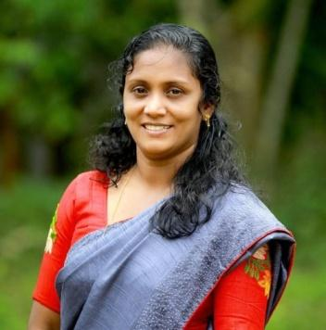
BENSI

The Health Standing Committee of Perayam Grama Panchayat is proud to have played an active and substantive role in the preparation of this Pandemic Preparedness Plan. As a committee entrusted with the health governance of a panchayat with a large agricultural workforce, a significant elderly population, and a landscape marked by seasonal waterlogging and surface water retention, we have always understood that preventive health investment is the most cost-effective and humane form of governance.
Perayam's communicable disease risk is real, seasonal, and well-documented. Leptospirosis among farm labourers, waterborne illnesses linked to well contamination, and vector-borne disease during the post-monsoon period are challenges that this Standing Committee has addressed repeatedly in its deliberations. This preparedness plan institutionalises those efforts into a coherent, time-bound, and accountable action framework. The Standing Committee has specifically championed the inclusion of pre-monsoon prophylaxis drives, safe drinking water access in vulnerable wards, and strengthened ASHA-led surveillance — and we are pleased to see these reflected in the final document.
I thank the Medical Officer, health staff, ASHAs, Kudumbashree networks, and all ward-level contributors for their dedication in building this plan from the ground up. The Standing Committee commits to rigorous monitoring of its implementation and to ensuring that the health of every resident of Perayam remains at the centre of every decision we make.

MESSAGE BY MEDICAL OFFICER

Dr SHEEJA PHILIP
It is with a deep sense of professional commitment and public responsibility that I present the Pandemic Preparedness Plan for Perayam Grama Panchayat. As the Medical Officer of PHC Perayam, I serve a predominantly agrarian community whose daily lives — paddy cultivation, farm labour, and seasonal agricultural work — place them in direct and recurring occupational contact with soil and surface water, making them particularly susceptible to leptospirosis, acute diarrhoeal diseases, and vector-borne illnesses during the monsoon months. The COVID-19 pandemic reinforced for all of us that communicable disease threats do not arrive with advance warning, and that a community unprepared is a community endangered.
This preparedness plan is a systematic, evidence-based framework designed to protect every resident of Perayam — from the youngest child to the eldest farm worker — through early detection, rapid response, and sustained prevention. It places our ASHA workers, health volunteers, and ward-level surveillance networks at the very frontline of disease control. I urge every household, every farmer, and every elected representative of Perayam to own this plan as their own, for the health of our panchayat is ultimately built ward by ward, home by home, and person by person.
EXECUTIVE SUMMARY

Primary Health Centre (PHC) functions as the primary public healthcare institution serving the population of Perayam Grama Panchayath. The PHC plays a pivotal role in delivering comprehensive, accessible, and affordable healthcare services, with a strong focus on preventive, promotive, curative, and rehabilitative care in accordance with national and state health programmes.
The PHC caters to a predominantly rural population, addressing key public health priorities such as maternal and child health, communicable and non-communicable disease control, immunization, family welfare, adolescent health, and geriatric care. Regular outpatient services, home-based care through field health staff, and outreach activities ensure healthcare coverage even in geographically challenging areas. The institution actively implements national health missions, including the National Health Mission (NHM), National Tuberculosis Elimination Programme, National Programme for Prevention and Control of Cancer, Diabetes, Cardiovascular Diseases and Stroke (NPCDCS), and other disease surveillance initiatives.
Perayam PHC works in close coordination with the Grama Panchayath, ASHA workers, Anganwadi centres, schools, and community-based organizations to strengthen community participation and improve health awareness. Emphasis is placed on early detection, timely referral, health education, and lifestyle modification to reduce disease burden and improve overall health outcomes.
Despite constraints related to infrastructure, manpower, and increasing service demand, the PHC continues to enhance service delivery through effective planning, data-driven decision-making, and community engagement. Strengthening facilities, upgrading digital health systems, and expanding preventive services remain key focus areas for future development.
Overall, Perayam Primary Health Centre stands as a vital institution in safeguarding public health and improving the quality of life of the residents of Perayam Grama Panchayath

LIST OF ABBREVIATIONS

LSGD/LSGI | Local Self Government Department / Local Self Government Institution
BMO | Block Medical Officer
IDSP | Integrated Disease Surveillance Programme
NDMA | National Disaster Management Authority
PPE | Personal Protective Equipment
ICMR | Indian Council of Medical Research
CD | Communicable Diseases
NCD | NON-COMMUNICABLE Diseases

TABLE OF CONTENTS

3
INTRODUCTION 9
● Background of the PPP 9
LSGD AT A GLANCE 9
INTEGRATED HEALTH INFRASTRUCTURE MAP OF ____________ PANCHAYAT 10
GENERAL PROFILE OF THE LSGI’S 13
Background of the LSGI 13
Demographic and Vulnerable Population 14
Clinical Vulnerability 16
INFRASTRUCTURE & RESOURCE INVENTORY 18
Health Facility Directory & Basic Capacity in the LSGD 18
Private Clinics 19
Healthcare Education & Training Institutions 20
Specialized Services & Emergency Inventory 20
Oxygen & Diagnostic Capacity 21
Diagnostics facility mapping at the LSGI level 22
Laboratory Identification & Basic Details 22
Social and Community Infrastructure for surge plan 22
Human resources 24
Community & Support Cadre 25
Community Organizations 26
Administrative & Emergency Services 27
Information regarding resources 27
ONE HEALTH & ENVIRONMENTAL SURVEILLANCE 28
Animal & Bird Population 28
Veterinary Infrastructure 29
Veterinary Doctors & Workforce 30
High-Risk Interface Points (Surveillance Sites) 30
Environmental Risk Mapping 31
Disease Seasonality Mapping 32
Vulnerability Mapping 33
EPIDEMIOLOGICAL TRENDS (2021–2025) 34
Disease Burden among human beings(Last 5 Years) 34
*(use the above table data to create the graph/diagram) 36
Seasonal Trend Analysis 37
Outcome-Based Trend Analysis- 2025 39
Transmission Trend- 2025 40
Integrated Disease Hotspot Map (2021–2025) 42
Preparedness and Response Protocol at LSG Level 44
Constitution of One Health Committee 44
Pandemic Response Workforce 45
Activities and Measures before and during Pandemic 47
PHASE 1 - Alert / Preparation 47
PHASE 2 - Active Response 50
Standard Screening Protocol 51
PHASE 3 - Surge Capacity 60
Conversion of Community Facilities 60
CONCLUSION 61
RECOMMENDATIONS 62
ANNEXURE 63
1. IMPORTANT PHONE NUMBERS 63

INTRODUCTION

Background of the PPP
- LSGD at a glance

BACKGROUND OF LSGI — PERAYAM GRAMA PANCHAYAT

Perayam Grama Panchayat is a rural Local Self Government Institution (LSGI) functioning under the three-tier Panchayati Raj system established through the Kerala Panchayat Raj Act, 1994. The panchayat is part of the Chittumala Block Panchayat within Kollam District and falls under the Kundara State Assembly Constituency for legislative representation and the Kollam Lok Sabha Constituency for parliamentary purposes. The panchayat is governed by an elected council headed by a President, supported by ward members and standing committees including the Health Standing Committee, Finance Standing Committee, and Development Standing Committee.
Perayam is situated in the midland interior belt of Kollam district, characterised by a mixed agrarian landscape of paddy fields, rubber and coconut groves, and laterite terrain with seasonal waterlogging. The panchayat's working population is predominantly engaged in paddy cultivation, rubber tapping, and daily-wage agricultural labour, with small trade activities supplementing rural incomes. This agrarian and occupationally exposed demographic profile directly shapes the panchayat's public health priorities, particularly with regard to seasonal and waterborne communicable disease risks.
As an LSGI, Perayam Grama Panchayat plays a constitutionally mandated role in public health governance at the grassroots level. Local governments in Kerala receive formula-based devolution of funds through the General Purpose Fund, Maintenance Fund, and Development Fund, enabling the panchayat to independently plan and implement health programmes, sanitation drives, and vector control initiatives. In partnership with PHC Perayam, ASHA workers, and Kudumbashree networks, the panchayat serves as a critical institutional pillar in the Kundara Block's communicable disease prevention and response framework.

LSGD AT A GLANCE PERAYAM
- Geographical boundaries with political map ( based on latest delimitation)
- Baseline data
- Ward division -
Ward | Houses | Population | Migrants | Wells | Hot  spots | Ed. Institutions | Hosp pvt/govt.
16 | 5915 | 19312 | 48 | 4032 | Ward 2,3,6,13 | 18 | 1

- Risk stratification among wards in the context of Communicable diseases and hazards
- Major Roads/rivers
- Major establishments with geospatial mapping
- occupational groups, socio cultural groups, migration & mobility patterns
- Vulnerability mapping
- Disaster prone areas (geographic vulnerability)

Maps - ward-based (Mention source also)

- Geographical boundaries - ward boundaries map
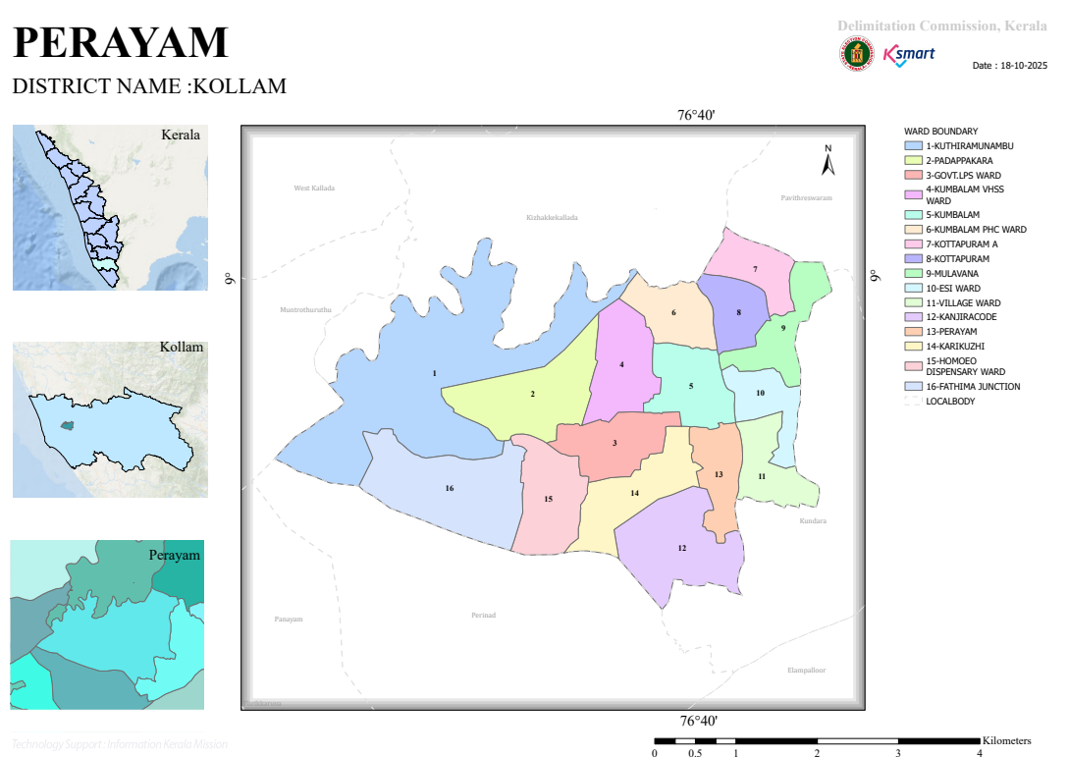

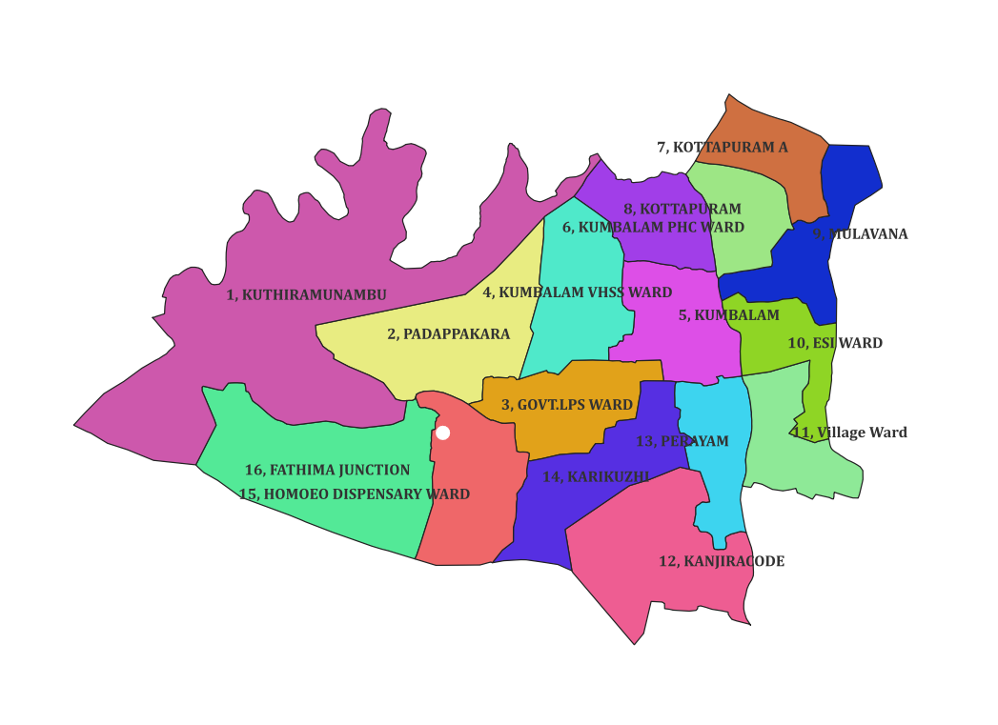

roads and rivers map

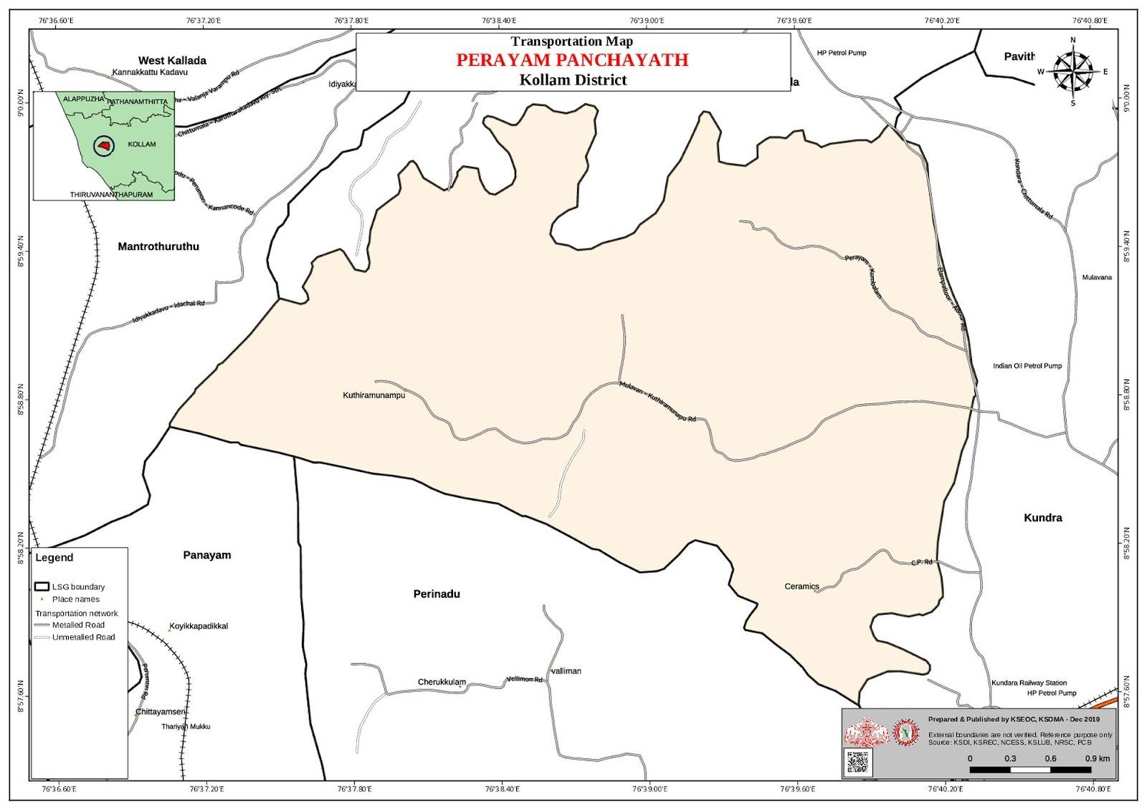

major establishments map

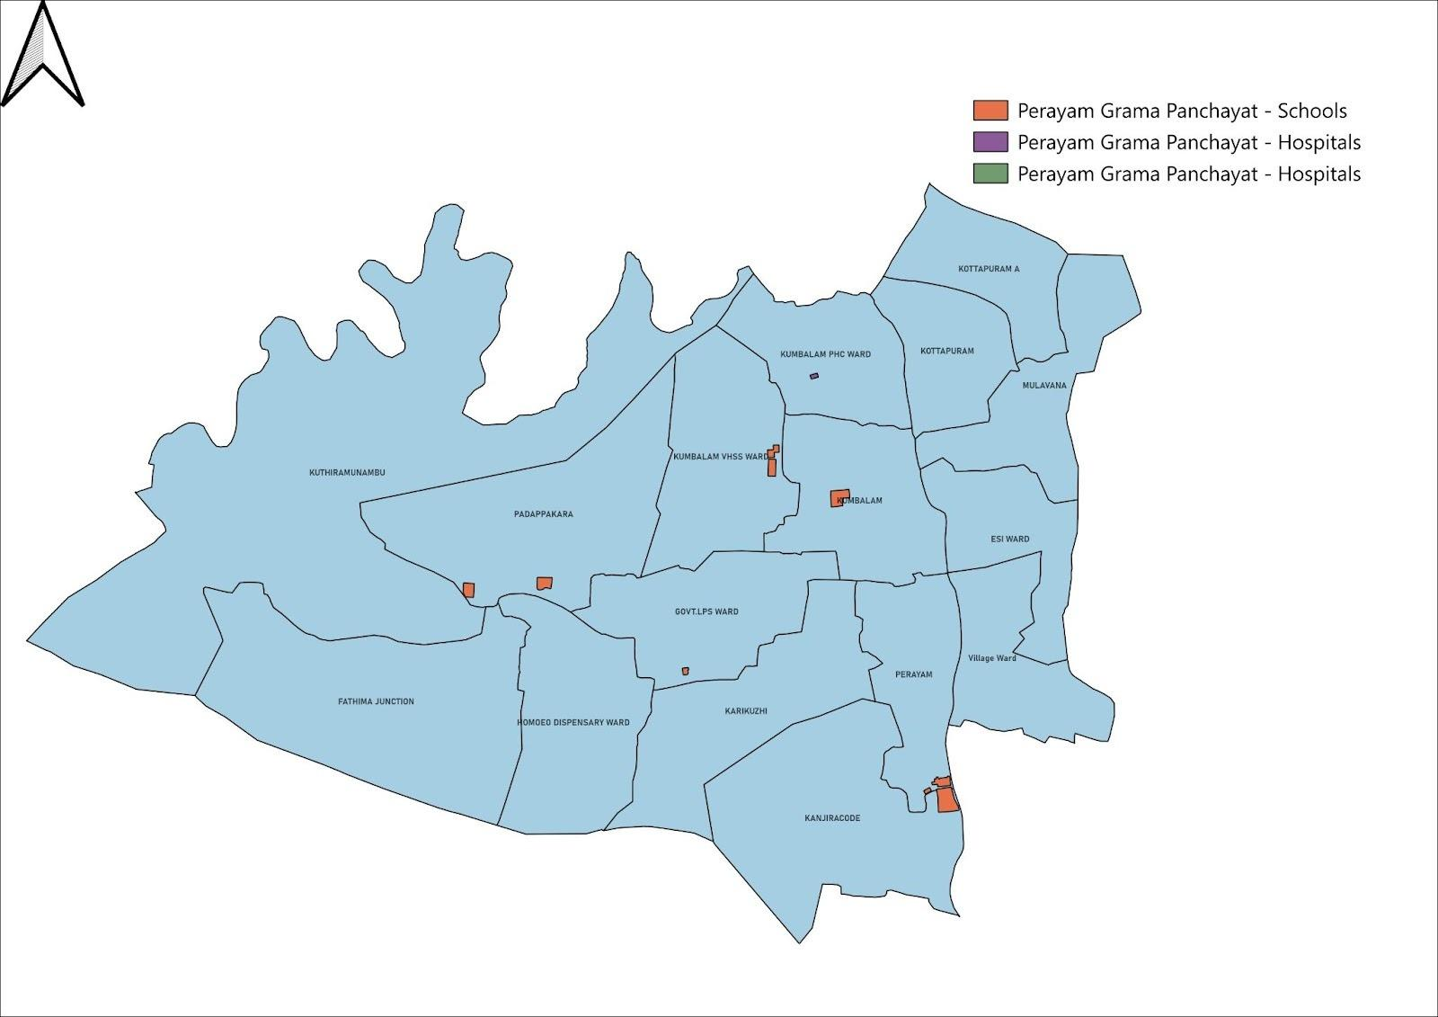

disaster-prone areas map

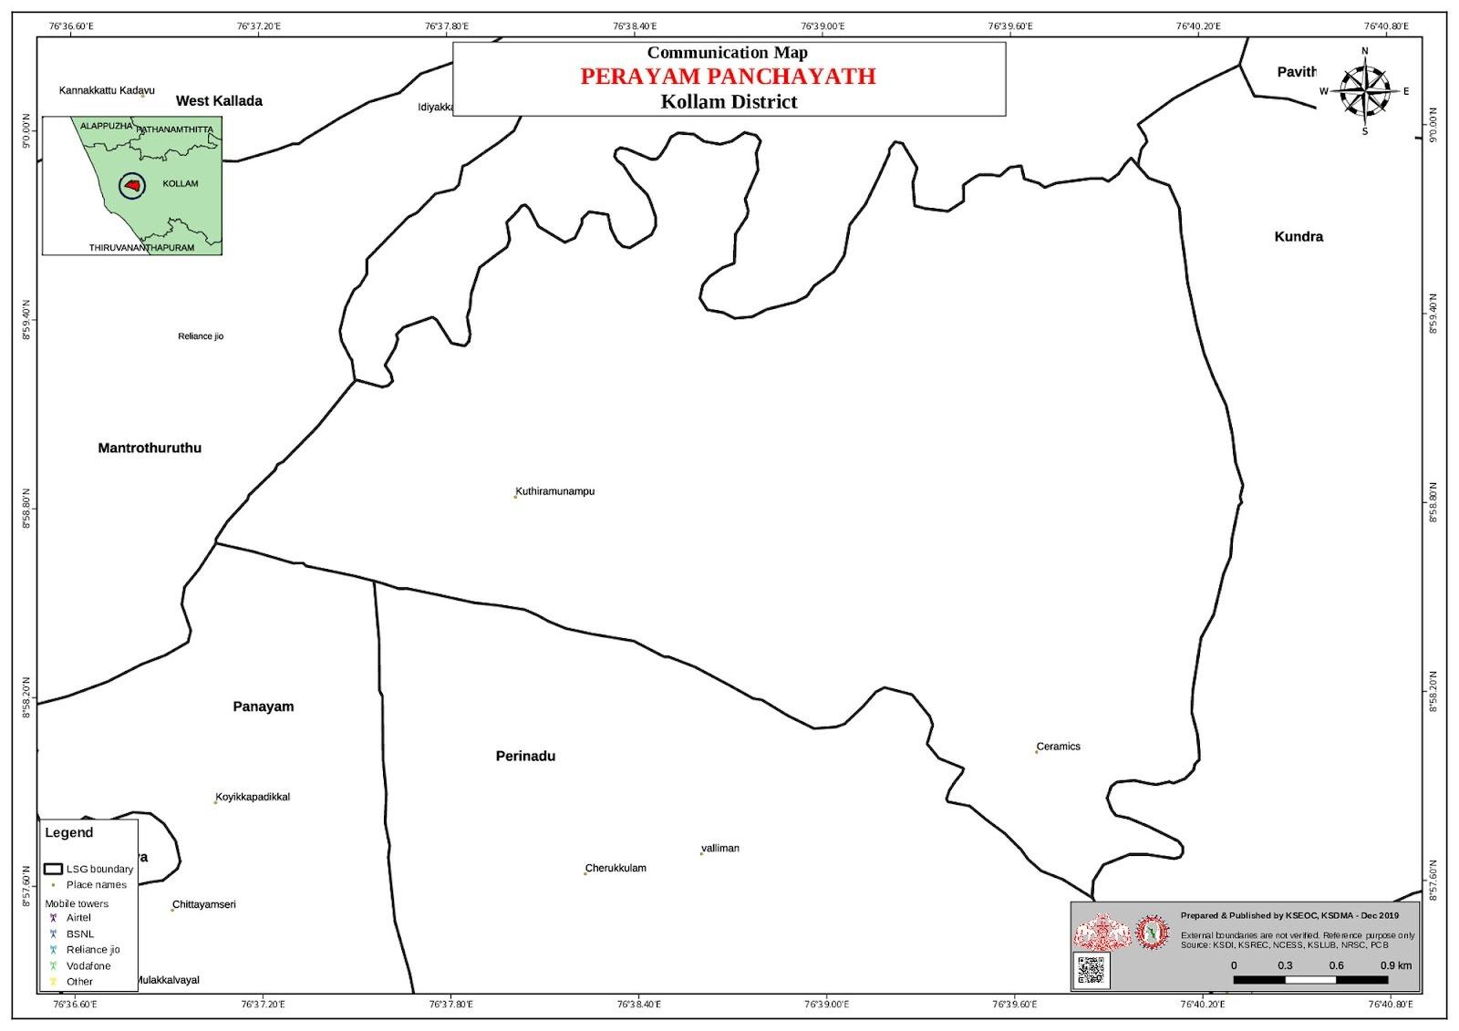

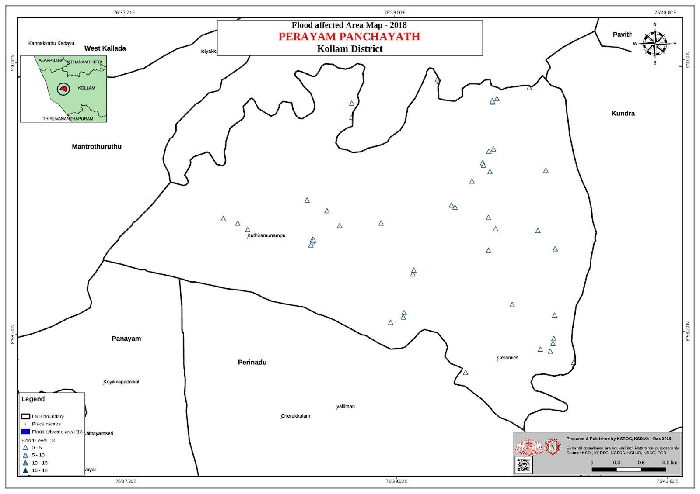

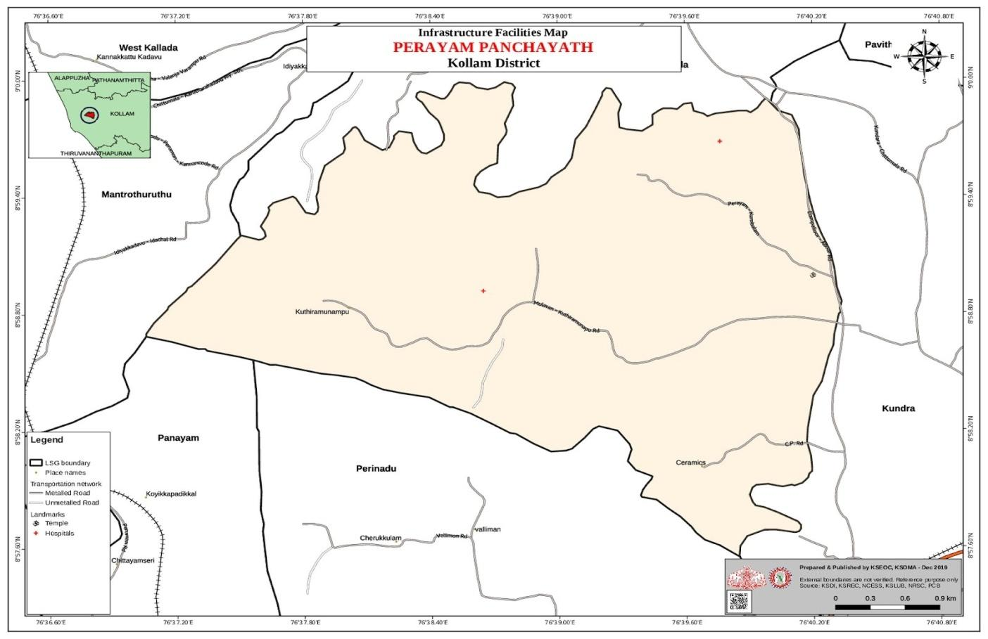

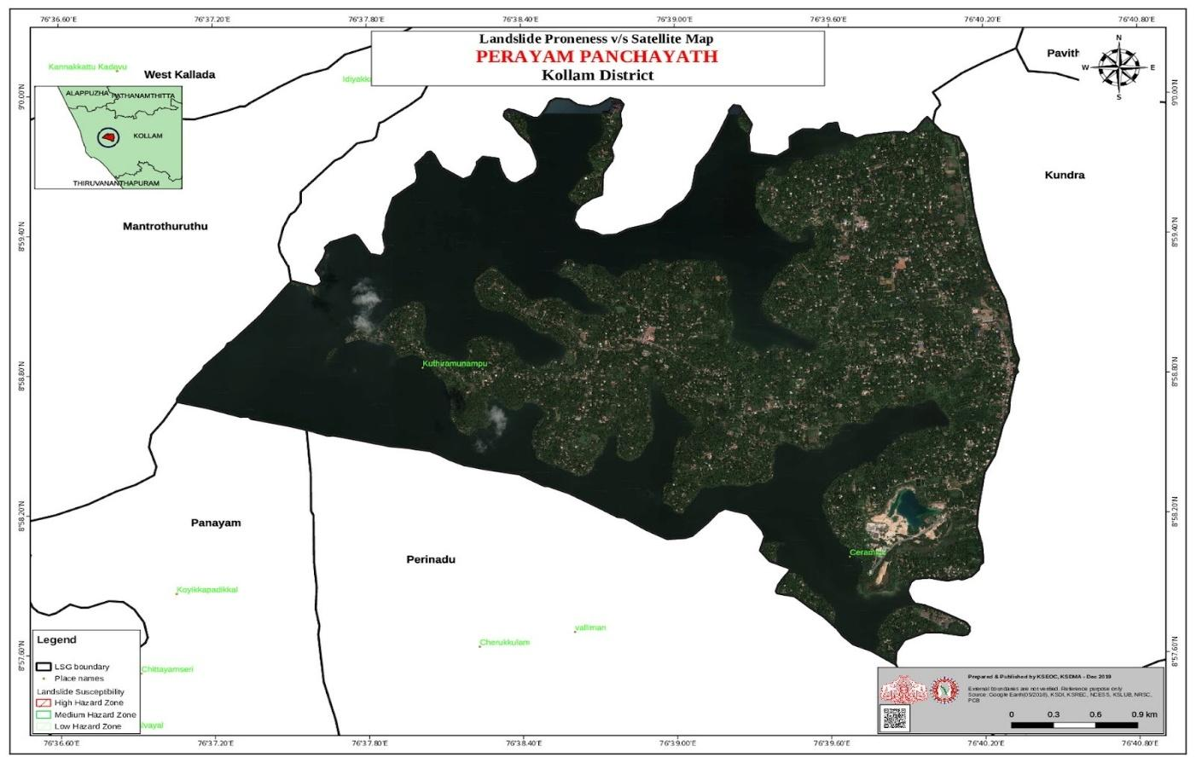

HOTSOPT MAP

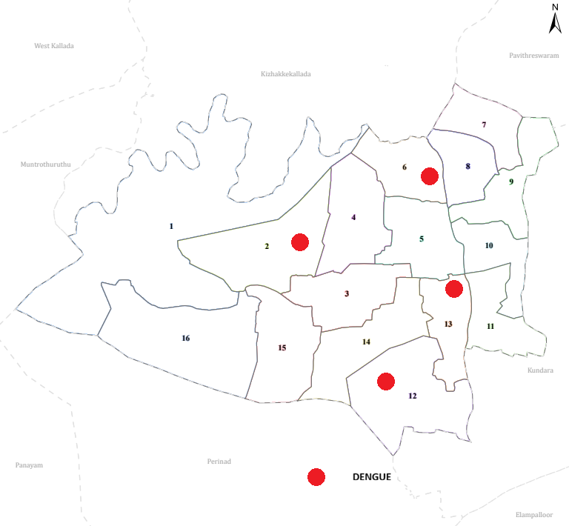

GENERAL PROFILE OF THE LSGI’S

Background of the LSGI

BACKGROUND OF LSGI — PERAYAM GRAMA PANCHAYAT

Perayam Grama Panchayat is a rural Local Self Government Institution (LSGI) functioning under the three-tier Panchayati Raj system established through the Kerala Panchayat Raj Act, 1994. The panchayat is part of the Chittumala Block Panchayat within Kollam District and falls under the Kundara State Assembly Constituency for legislative representation and the Kollam Lok Sabha Constituency for parliamentary purposes. The panchayat is governed by an elected council headed by a President, supported by ward members and standing committees including the Health Standing Committee, Finance Standing Committee, and Development Standing Committee.
Perayam is situated in the midland interior belt of Kollam district, characterised by a mixed agrarian landscape of paddy fields, rubber and coconut groves, and laterite terrain with seasonal waterlogging. The panchayat's working population is predominantly engaged in paddy cultivation, rubber tapping, and daily-wage agricultural labour, with small trade activities supplementing rural incomes. This agrarian and occupationally exposed demographic profile directly shapes the panchayat's public health priorities, particularly with regard to seasonal and waterborne communicable disease risks.
As an LSGI, Perayam Grama Panchayat plays a constitutionally mandated role in public health governance at the grassroots level. Local governments in Kerala receive formula-based devolution of funds through the General Purpose Fund, Maintenance Fund, and Development Fund, enabling the panchayat to independently plan and implement health programmes, sanitation drives, and vector control initiatives. In partnership with PHC Perayam, ASHA workers, and Kudumbashree networks, the panchayat serves as a critical institutional pillar in the Kundara Block's communicable disease prevention and response framework.

Table 1: Background of LSGD
Description | Details
Name of LSGI | Perayam
Type (GP/Municipality / Corporation etc.) | Grama Panchayath
Block | Chittumala
District | Kollam
Number of wards | 16
Total area (sq. km) | 11.05 sq. km
Population(Projected) | 19312
Population density | persons/sq km
Terrain (coastal/low-lying/backwaters/foothills, etc.) | Low-lying
Number of rivers passing through LSGI | 1 ashtamudi
Number of water bodies in the LSGI | 2
Number of educational institutions | 19
Factories / small-scale industries | 1
Flood-prone wards | -
Landslide-prone wards | -
Death Management and Disposal Facilities (mortuaries/crematorium, including electric) | -
Auditoriums/Marriage halls/convention centres/community halls | 2

Demographic and Vulnerable Population
Understanding the demographic composition and vulnerable population groups is essential for pandemic preparedness. Children, elderly, economically deprived families, migrant workers, and socially vulnerable groups are at increased risk during public health emergencies due to higher exposure, limited access to services, and dependency on public systems..

Description |  | Details (in numbers)
DEMOGRAPHIC PROFILE
Total population |  | 19312
Male |  | 9650
Female |  | 9662
Transgender |  | -
Children under 5 |  | 830
Adolescent |  | 1482
Elderly (>60) |  | 2960
SOCIAL/LIVELIHOOD VULNERABILITY
Previous EPEP family |  | 46 members, 20 fAMILY
BPL family |  | 2842
Tribal communities |  | -
Migration 48 | Immigrant | 20
Migration 48 | Emigrant | 986
Socio-economically deprived |  | 28
Fisherfolk |  | 65
SC Community |  | 217 family, 1086 members
ST Community |  | 0

Graphs: Population pyramid (if possible) for seeing if your LSGI has a high "dependency ratio" (lots of children and elderly compared to working adults).

Clinical Vulnerability
Certain population groups needs priority healthcare & are at higher risk of severe illness, complications, and mortality during pandemics. Patients with chronic diseases, those requiring regular medical care, and individuals with mobility or functional limitations face challenges in accessing timely care during emergencies. Mapping these groups helps in prioritizing continuity of treatment, medicine stock planning, oxygen support, referral transport, and targeted home-based care.
Description | Details in numbers
Pregnant women | 45
Lactating mothers | 114
Bedbound patients | 68
Patients under palliative care other than bedbound | 139
Patients on Haemodialysis | 11
Patients on CAPD | -
Cancer patients (currently on treatment) | 12
Haemophilic patients | 5
Mentally challenged | 22
Differently abled | 22
Diabetic patients | 620
Hypertensive patients | 690
TB patients | 12

Major Festivals & Events specific to the LSGI
(with the possibility of a public gathering)

WARD | Name of festival | Month detailing the periodicity
II | StJosephChurch | May 1
III | StSebastiyanChurch | Jan
IV | StSebastiyanChurch | Jan
V | StMichelChurch | Sep
V | PerayamTemple | March
VI | StSebatiyanChurch | Jan
VII | SreeBhadrakaliTemple | Feb
VIII | CristurajChurch | Nov
IX | StGeorge Church | April
XI | StAntonyChurch | Feb
XIII | KarmalRaniChurch | Juli
XV | StAntonyChurch | April
XVI | StJosephChurch | May
IX | ChokkamKuzhy Sri Ammummakavu,Kuzhikkalazhikam | Feb

INFRASTRUCTURE & RESOURCE INVENTORY

Health Facility Directory & Basic Capacity in the LSGD
This section provides an overview of the healthcare infrastructure available within the LSGD area. It outlines the distribution and basic capacity of health facilities that form the backbone of service delivery during routine times and public health emergencies.

Family Health Centres (FHCs) and Community Health Centres (CHCs) generally function as the first point of contact for the community, providing essential outpatient and inpatient services. General Hospitals (GH) and Medical College Hospitals (MCH), where accessible, serve as the main referral centres for advanced diagnostics, specialist care, and critical services during public health emergencies. This inventory helps identify existing strengths, gaps, and potential surge capacity that can be mobilised during a pandemic or disaster.

Table 5. Health Facility Resource Summary
Sl.no. | Health Facility | Type of Facility (MCH/GH/CHC/FHC/SC etc.) | Contact Number | Total beds | ICU Beds | Oxygen-Supported Beds | No. of Ventilator Support Beds | No. of ambulances
Government Healthcare Facilities
 | Main Centre | SC | 9895568254 | -0 | 0 | 0 | 0 | 0
 | Padappakara | SC | 9895568254 | -0 | 0 | 0 | 0 | 0
 | Marthandapuram | SC | 9895568254 | -0 | 0 | 0 | 0 | 0
 | Perayam | SC | 8136821441 | -0 | 0 | 0 | 0 | 0
 | Karikzhi8136821441 | SC | 9895568254 | -0 | 0 | 0 | 0 | 0
Private Healthcare Facilities
AYUSH Healthcare Facilities
1 | Ayurveda hospital 1 gov, MULAVANA | GOVT | 7942698014 | 3 | 0 | 0- | 0- | 0-

Private Clinics
Private clinics are an essential part of pandemic preparedness, as they are often the first place people seek care when symptoms begin. In many communities, private clinics manage a significant share of outpatient visits and therefore play a critical role in early case detection, timely referrals, and disease surveillance. Having an up-to-date understanding of where these clinics are located, the services they provide, and how they are linked to the public health system helps ensure that no cases are missed during an outbreak. It also allows health authorities to engage private practitioners more effectively for reporting, risk communication, and coordinated response, strengthening the overall capacity of the health system to manage public health emergencies.

Table 6. Private Clinic Resource Summary
Sl No. | Name of Clinic | Registered (Y/N) | Clinic (General / Speciality) | Speciality (if any) | Address | Contact Number | Diagnostic Facility (Y/N) | Ambulance Linkage (Y/N)
1 | Vaidyans dental clinic | Y | Dental | DENTAL | Mulavana, kundara | 8606446705 | Y | N
2 | Total care multispeciality dental clinic | Y | Dental | Dental | Kundara, Kerala -691501 | 9745430344 | Y | N

Healthcare Education & Training Institutions
This section tracks the educational infrastructure available, which is vital for human resource planning in the health sector.

Category of Institution | Govt | Private | AYUSH | Total
Medical Colleges | 0 | 0 | 0 | 0
Nursing Colleges | 0 | 0 | 0 | 0
Dental Colleges | 0 | 0 | 0 | 0
Para-medical / Allied Health | 0 | 0 | 0 | 0
Pharmacy Colleges | 0 | 0 | 0 | 0

Specialized Services & Emergency Inventory
This section provides a detailed view of the specialized medical resources available to the community, focusing on emergency response and critical care capabilities. This table tracks the vital assets required for managing severe illnesses and emergencies across Government, Private, and AYUSH sectors.

Item | Govt | Private | AYUSH | Total
Hospital beds | 0 | 0 | 0 | 0
Oxygen-generating systems(Y/N) | 0 | 0 | 0 | 0
Oxygen-supported beds(Numbers) | 0 | 0 | 0 | 0
Ventilator-supported beds | 0 | 0 | 0 | 0
ICU beds | 0 | 0 | 0 | 0
Burns units | 0 | 0 | 0 | 0
Blood centres | 0 | 0 | 0 | 0
BLS ambulances | 0 | 0 | 0 | 0
ALS ambulances | 0 | 0 | 0 | 0
Dialysis facilities | 0 | 0 | 0 | 0
Dispensaries | 0 | 0 | 0 | 0
Medical store | 0 | 2 | 0 | 2
Industrial establishments(Medium-scale industries/small-scale industries establishments to whom we can depend in a worst-case scenario) | 0 | 4 | 0 | 4

Oxygen & Diagnostic Capacity
Monitoring oxygen and diagnostic capacity is a critical component of public health preparedness, ensuring that the LSGD can handle both chronic care and sudden surges in respiratory or infectious diseases.
Name of Health Facility | Oxygen-generating System (Y/N) | Backup Oxygen Source (Y/N) | Diagnostic Facilities Available(Y/N)
Name of Health Facility | Oxygen-generating System (Y/N) | Backup Oxygen Source (Y/N) | Lab | USG | X-ray | CT/MRI | RT-PCR
Government Healthcare Facilities
Fhcperayam | 0 | 0 | 1 | 0 | 0 | 0 | 0

Diagnostics facility mapping at the LSGI level
The diagnostic capacity of G.P represents the "intelligence network" of our healthcare system. The speed and accuracy of disease identification depend entirely on the distribution and technical level of these facilities.

Item | Govt | Private | AYUSH | Total
General labs | 1 | 2 | 1 | 4
Microbiology labs | 0 | 0 | 0 | 0
RT-PCR labs | 0 | 0 | 0 | 0
USG units | 0 | 0 | 0 | 0
CT/MRI units | 0 | 0 | 0 | 0
Research labs | 0 | 0 | 0 | 0

Laboratory Identification & Basic Details
Sl. No. | Name of Laboratory | Ownership (Govt / Private / Academic) | Address | Contact No. | 24×7 Services (Yes/No) | NABL / Govt Approved (Yes/No)
1 | Medicare Lab | Private | mulavana | 9846325115 | NO | YES

Social and Community Infrastructure for surge plan
This table serves as our logistics and shelter inventory. By mapping these locations, quickly we can identify where to house displaced citizens, where to set up temporary medical clinics, and how to manage the deceased with dignity during a crisis.

Category | Total Count | Ward | Est. Capacity (Persons) | Contact details
Educational Institutions
Anganwadis | 22 | 1 TO16 | 440-550 | ICDS Supervisor: 0474-2522423
Schools | 19 | 5,3,4,12,13,8,9, 6, 11, 2 | 2500-3500 | HM ( Govt UPS Perayam) 0474-2528567
Colleges | 1 | 11 | 300 | St Tresa’s Arts & Science : 9496041787
Healthcare Educational Institutions
Medical colleges (Govt/Private) | - | - | - | -
Nursing colleges (Govt/Private) | - | - | - | -
Dental colleges (Govt/Private) | - | - | - | -
Paramedical institutes (Govt/Private) | - | - | - | -
Community Gathering Spaces
Community halls | 3 | 6,10,14 | 450 | Panchayat Secretary-04742522423
Auditoriums | 1 | 8 | 500 | Manager ( Panchayat Hall)
Religious buildings | 5 | 2, 4. 7, 12, 15 | 800-1000 | Temple commiitees
Vulnerable Group Support Facility
Destitute homes | 0 | - | - | -
Elderly homes | 1 | 5 | 25-40 | Manager: 0474-2568793
LSGD owned other buildings | 0 | - | - | NA
Mass Fatality Management (MFM) Infrastructure
Mortuary | 0 | - | - | -
Crematorium | 0 | - | - | -
*refer annexure 1 for contact details

Human resources
This section focuses on the human capital available within the LSGI. In any emergency—be it a pandemic, flood, or industrial accident—infrastructure is only as effective as the people operating it.

Medical & Clinical Personnel
This table tracks the "Frontline" providers responsible for diagnosis, treatment, and clinical management. Narrative sentence: eg., "Total health workforce: 450 personnel, with 60% in government facilities serving as primary surge capacity." A detailed directory with the contact numbers of all workers is maintained (Annexure in 1).

Cadre | Govt (No.) | Private (No.) | Total
Doctors—Modern Medicine | 3 | 2 | 5
Doctors – AYUSH | 2 | 1 | 3
Doctors – Veterinary | 1 | 0 | 1
Doctors – Dental | 0 | 2 | 2
Nursing officers | 1 | 0 | 1
Lab technicians | 1 | 2 | 3
Optometrist | 0 | 0 | 0
Pharmacists | 1 | 3 | 4
Psychologists | 0 | 0 | 0
Counsellors | 0 | 0 | 0

Public Health & Field-Level Workforce
These individuals are the backbone of surveillance, maternal-child health, and decentralized care.

Cadre | Health services | Municipal common services | Total
HS (Health Supervisors) | 0 | 0 | 0
HI (Health Inspectors) | 0 | 0 | 0
LHS (Lady Health Supervisor) | 0 | 0 | 0
LHI (Lady Health Inspectors) | 0 | 0 | 0
JPHN (Jr Public Health Nurses) | 5 | 0 | 5
JHI (Jr Health Inspectors) | 3 | 0 | 3
MLSP (Mid-Level Service Providers) | 5 | 0 | 5
Palliative Nurses | 1 | 0 | 1
RBSK Nurses | 1 | 0 | 1
PRO | 0 | 0 | 0
Epidemiologist | 0 | 0 | 0
Data Manager | 0 | 0 | 0

Community & Support Cadre
This group represents the surge capacity of the LSGI—people who can be called upon for logistics, rescue, and specialized support.

Cadre | Number
ASHA Workers | 16
AWW (Anganwadi Workers) | 22
Emergency Medical Volunteers (Trained) | 14
Kudumbashree | 73
MNREGS | 1050
Purusha Swayam Sahaya Sangham | 9
Ex-Servicemen | 21
Retired Police Officers | 11
NCC/NSS Volunteers | 28
Red Cross volunteers | 0
One Health Community Volunteers | 0
One Health Community Mentors | 0

Community Organizations
This section details the presence of community-based organisations (CBOs), non-governmental organisations (NGOs), faith-based organisations (FBOs), Kudumbashree Self-Help Groups (SHGs), and Ayalkootams within the Local Self-Government Institution (LSGI). These groups enhance grassroots mobilization, resource distribution, and support networks crucial for pandemic response and community resilience.

Category | Total Count
NGOs | 3
Religious based organizations | 2
Foreign based organizations | 0
Sports Club/youth clubs | 4
Kudumbashree SHGs | 15
Ayalkootams | 24
Political organizations | 3
Residential organizations | 1

Administrative & Emergency Services
This section outlines the availability of key non-health emergency support services and infrastructure within the LSGI, which are essential for effective pandemic preparedness and response. These facilities support law enforcement, disaster response, water supply, logistics, mobility, and community-level interventions during public health emergencies.

Category | Total Count | Contact details
Police Stations | 0 | NA
Fire & Rescue Stations | 0 | NA
Water Pumping Points | 2 | KWA Kundara: 0474-2522409
Public Distribution System (PDS) | 1 | Taluk Supply Office: 0474-2746409

Information regarding resources
The availability of essential transport and support resources plays a quiet but critical role in saving lives. Equipment such as ambulances, mobile mortuaries, amphibian ambulances, and motorized boats ensures that patients, samples, and healthcare teams can move swiftly—even in flooded, remote, or difficult terrains. Heavy vehicles like JCBs, cranes, tractors, and torus lorries support logistics, waste management, emergency infrastructure, and rapid conversion of spaces into care or isolation facilities. Taxis, four-wheel-drive vehicles, and trucks help maintain continuity of essential services, reach vulnerable populations, and support home-based care and supply delivery.

Means of transportation | Total Count
JCB | 1
Crane | 0
Heavy Trucks | 2
Tractor | 0
Ambulances | 1
Mobile mortuaries | 0
Boats | 1
Taxi service | 5
Note: For specific details regarding vehicle owners and contact information, please refer to Annexure [X].

ONE HEALTH & ENVIRONMENTAL SURVEILLANCE
The One Health method integrates environmental, animal, and human health to enable proactive pandemic preparedness. Panchayat-level surveillance needs to be improved in order to detect and treat zoonotic and environmentally generated diseases early. Surveillance is strengthened through systematic assessment of animal populations, veterinary infrastructure, poultry and slaughter facilities, inter-sectoral coordination, and specialised tools like avian influenza seasonality mapping using GIS in previous outbreaks to enable predictive alerts and ward-specific sampling to support effective pandemic preparedness in high-risk areas like Mulavana.

Animal & Bird Population
Mapping animal and bird populations at the Panchayat level is essential for identifying and prioritising zoonotic disease hazards like rabies, avian influenza (H5N1), leptospirosis, anthrax, and Nipah-like spillover occurrences. Risk classification, targeted surveillance, vaccination planning, and early epidemic detection made feasible by comprehensive population mapping all enhance One Health-based pandemic preparedness.

Category | Item | Estimated Population | Wards
Animal Population | Livestock (Cattle/Goats/Buffalo) | 45 | All Wards
Animal Population | Pet Animals (Dogs/Cats) | 260 | All Wards
Animal Population | Stray Dog Population | 72 | 1, 5, 8, 11 ( Market areas)
Animal Population | Pig Farms (Number of heads) | 3 | 13,11,6
 | Small Units (Sheep / Goats – clustered) | 2 | 11,15
Bird Population | Poultry Units (Birds) | 4 | 2, 5, 8, 13
Bird Population | Poultry- (FOWL) | 4 | 2, , 5, 8
Bird Population | Wild/Migratory Birds (Observed) | 15 | 7, 10, ( Near ashtamudi lake)
Bird Population | Crow Mortality Events (Reported) | 0 | NA

The main risk of zoonotic diseases in Perayam is concentrated in Wards 3, 5, 12, which is explained by the high density of pig farms, cattle congregation areas, and poultry units. The stray dog population in market areas, fish landing sites, bus stations continues to be a substantial problem for rabies surveillance and bite prevention. There is a considerable risk of avian influenza introduction and amplification during November - December due to the seasonal presence of migratory and resident water birds near ponds/ canal / river / backwater / paddy field. Clusters of pig farms and animal shelters vulnerable to flooding further raise the risk of leptospirosis and other zoonoses mediated by the environment, especially during monsoon floods.

Veterinary Infrastructure
Veterinary institutions are a core pillar of One Health surveillance, enabling early zoonotic disease detection through vaccination, investigation of unusual animal illness or deaths, sample collection, and timely outbreak reporting. A well-mapped and responsive veterinary network strengthens coordination with human health and LSGI systems, ensuring rapid response during zoonotic events and pandemics.
Facility Type | Name of Facility | Ownership Govt / Pvt | Location(Ward No) | Contact number
Veterinary Dispensary | Gov vetinary | gov | Ward 3 | 984645729523
Veterinary Hospital / Polyclinic | nil | nil | nil | nil
Private Veterinary Clinics | nil | nil | nil | nil
Mobile / Emergency Vet Service (incl. night services) | nil | nil | nil | nil
Pet Homes / Animal Shelters | nil | nil | nil | nil
Slaughterhouse-linked Veterinary Inspection Unit | nil | nil | nil | nil

Veterinary Doctors & Workforce
Early detection, diagnosis, reporting, and reaction to animal illness epidemics depend on the availability and accessibility of qualified veterinary specialists. By identifying unusual animal morbidity or mortality promptly, collecting samples promptly, and coordinating efficiently with human health and LSGI systems—especially during zoonotic outbreaks and pandemic-prone situations—a clearly defined veterinary workforce enhances One Health surveillance.

Category | Number Available | Type (Govt/Pvt) | Contact number
Government Veterinary Doctors | 1 | Govt | 989536703
Private Veterinary Doctors | 0 | Nil | Nil
Livestock Inspectors | o | Nil | Nil
Para-veterinary Staff / Attenders | 0 | Nil | Nil
Contract / On-call Veterinary Support (if any) | 0 | Nil | Nil

High-Risk Interface Points (Surveillance Sites)
High-risk interface points for zoonotic disease surveillance in Perayam Grama Panchayath include wetland–livestock–human contact zones, backyard poultry farms, cattle sheds near water bodies, fish markets, and areas of high human–animal interaction such as community slaughter points and migratory bird congregation sites. These are the primary surveillance sites where zoonotic spillover risks are elevated.

Type of Habitat | Type of High risk interface | Geographical vulnerability
Wetlands & Backwaters | Water-Human Contact | Risk of flooding and waterborne diseases. Wards 1, 7, 10, 16
Backyard Poultry Farms | Avian-Human Interface | Moderate: Small-scale informal units in residential areas. All Wards (Dispersed)
Cattle Sheds near Water Bodies | Moderate: Waste runoff into the backwaters. | Wards 3, 4, 12
Fish & Meat Markets | Commercial Interface | marthandapuram Ward 11
Community Slaughter Sites | Unorganized Killing | Low: Minimal reported unofficial sites. Ward 11
Migratory Bird Congregation Areas | Zoonotic Risk | Moderate: Storage in local ration shops/stores. Ward 11 (Perayam Jn)
Rodent-Infested Grain Storage | 0 | NA
0

Category | Total Count | Key Locations (wards)
Poultry Farms | 2 | Ward6,ward8
Backyard / Clustered Poultry Units | 0 | NA
Duck Rearing Units (open water access) | 0 | NA
Slaughterhouses/ Slaughter Points | 2 | Ward 8, 11
Meat/Fish Markets | 1meat stall, 1fish stall | Ward8
Live Bird Sale Points | 0 | NA
Cattle Markets / Weekly Animal Fairs | 0 | NA
Pet Shops / Breeders | 0 | NA
Animal Shelters / Pet Homes | 0 | NA
Waste Disposal Sites near Animal Units | 1 | Ward 8, (Market Vicinity)

Environmental Risk Mapping
Environmental risk mapping identifies monsoon/flood hotspots for vector-borne (dengue, chikungunya), water-borne (leptospirosis, diarrhoea), and zoonotic diseases in Kerala's wetlands. Systematic surveillance supports early warnings, targeted interventions, and Panchayat pandemic preparedness.
Waterborne exposure: Flood-prone areas and stagnant water bodies facilitate leptospira survival, raising leptospirosis risk.

Traditional practices: Informal slaughter and fish markets lack standardized hygiene, creating spillover opportunities.

Risk Factor | High-Risk Wards | Key Locations | Risk Level (High/Med/Low)
Flood-prone areas | 4 | 1, 7, 10, 16 | Medium
Water bodies/wetlands | 2 | 7, 10 | High
Solid waste accumulation | 2 | 11, 8 | Medium
Animal waste disposal issues | 1 | 8 | Medium
Rodent infestation zones | 1 | 11 | Low
Industrial effluent discharge | 0 | - | NA
Construction sites / abandoned buildings | 1 | 5 | Low
Poor drainage/blocked canals | 2 | 11, 14 | Medium
Drinking water source contamination risk | 3 | 1, 7, 16 | High

Disease Seasonality Mapping
1, Flooding& waterlogging → amplifies leptospirosis, malaria, diarrheal diseases.
·
2, Migratory bird influx (Nov–Feb) →

3, Mosquito breeding cycles → vector-borne disease peaks in monsoon.

4, Agricultural practices → close human–animal contact in paddy fields.

Disease | Peak Risk Season | Key Drivers | High-Risk Locations | Surveillance Focus
Avian Influenza | Nil | Nil | NA | NA
Leptospirosis | Sep-oct | Waterlogging; Rodent contact in markets; Agricultural activity. | 1-SINKARAPALLY, 2- PADAPPAKARA, 8-MULAVANA, 7-PALLIYARA | Prophylaxis (Doxycycline) for MGNREGS workers and farmers.
Dengue/Chikungunya | June-july-aug | Stagnant water in scrap/plantations; Construction sites. | , 2-PADAPPAKA, 13-NS NAGAR | Source reduction; Container index monitoring in rubber plantations
Acute Diarrheal Diseases | June, July | Fecal-oral route; Pipe leaks; Contamination of open wells. | 1, 7, 10, 16 (Low-lying areas with high water table) | Water quality testing (H2S vials); Chlorination of public/private wells.
Rabies | All Year (Slight peak in summer) - | Stray dog density near markets and waste dumping sites. | 11 (Perayam Jn), 8 (Marthandapuram) | ABC (Animal Birth Control) and anti-rabies vaccination drives.
Anthrax (rare) | Nil | NA | NA | NA

Vulnerability Mapping
Vulnerability mapping pinpoints high-risk populations, occupations, and areas exposed via environment, livelihoods, socio-economics, and poor service access. Paired with environmental/seasonality mapping, it enables risk-based surveillance, targeted actions, and optimal resource use in One Health and pandemic planning.
Vulnerability Factor | High-Risk Wards | Key Groups / Locations | Risk Level
Flood-prone households | 1, 7, 10, 16 | Coastal residents in Kanjiracode & Perayam | Medium
Wetland-adjacent communities | 7, 10 | Families bordering Ashtamudi Lake | High
Backyard poultry / duck rearing households | 6, 8, 12 | Small-scale subsistence farmers | Medium
Livestock-rearing households | 3, 4, 12 | Cattle/Goat farmers in rural interior | Low
Slaughterhouse & meat market workers | 8 | Marthandapuram (Ward 8) | Medium
Fisherfolk & fish market workers | 1, 7, 11 | Inland fishers | Medium
Sanitation workers | 11, 8 | Haritha Karma Sena (HKS) / Market cleaning | Medium
Daily wage / migrant workers | 2, 5, 13 | Construction sites (Ward 5) | Medium
Elderly & chronically ill populations | All wards | Palliative care patients / Elderly home (Ward 5) | High
Pregnant Women | All wards | Registered with PHC Perayam & Anganwadis | Medium
Children (schools, Anganwadi’s) | 11, 8, 1 | Schools in high-traffic/low-lying areas | Medium
Limited access to safe water & sanitation | 1, 7, 16 | Households reliant on open wells near lake | High

EPIDEMIOLOGICAL TRENDS (2021–2025)

Disease surveillance is the systematic collection, analysis, and interpretation of health data for planning, implementation, and evaluation of public health practice. This section presents the disease surveillance profile of the LSGI based on routine reporting systems and outbreak investigations to identify priority diseases, seasonal patterns, and emerging public health threats.

Disease Burden among human beings(Last 5 Years)
Analysis of disease-wise data for the last five years helps identify persistent public health problems, emerging diseases, and changes in disease burden. This information supports prioritisation of prevention, preparedness, and response activities at the Panchayat level.

Disease | 2021 | 2022 | 2023 | 2024 | 2025 | Trend(Increasing/Stable/Decreasing)
Dengue | 6 | 6 | 105 | 75 | 29 | FLUCTUATING
Leptospirosis | 0 | 0 | 2 | 3 | 2 | STABLE
Hepatitis A | 0 | 0 | 4 | 0 | 3 | -STABLE
Malaria | 2 | 0 | 0 | 0 | 1 | -STABLE
Scrub Typhus | 0 | 0 | 0 | 1 | 0 | -STABLE
Typhoid | 0 | 0 | 0 | 1 | 0 | -STABLE
H1N1 | 0 | 0 | 0 | 4 | 0 | -STABLE
H3N2 | 0 | 0 | 0 | 0 | 0 | -STABLE
ADD | 6 | 14 | 10 | 16 | 15 | INCREASING TREND
Mumps | 0 | 0 | 0 | 0 | 2 | -STABLE
Measles | 0 | 0 | 0 | 0 | 0 | -STABLE
Hepatitis B | 0 | 0 | 0 | 0 | 0 | -STABLE
Hepatitis C | 0 | 0 | 0 | 0 | 0 | -STABLE
Tuberculosis | 10 | 11 | 12 | 14 | 13 | -STABLE
Leprosy | 0 | 0 | 0 | 0 | 0 | -STABLE
COVID-19 | 811 | 82 | 0 | 0 | 0 | DECREASING TREND

*(use the above table data to create the graph/diagram)

Seasonal Trend Analysis
Seasonal analysis helps anticipate surges (e.g. dengue in monsoon, leptospirosis after floods, influenza in cooler months) and plan pre‑emptive vector control, stockpiling of IV fluids, and awareness campaigns at Panchayat level.

DENGUE
Dengue is a major seasonal vector-borne disease strongly associated with rainfall, water stagnation, and increased mosquito breeding during the monsoon period.

Peak: July–November

Dengue – Ward-wise Yearly Distribution (2021–2025)

Ward | Dengue – Ward-wise Yearly Distribution
Ward | 2021 | 2022 | 2023 | 2024 | 2025 | Total
1 | 2 | 0 | 6 | 4 | 1 | 13
2 | 1 | 1 | 19 | 14 | 1 | 36
3 | 0 | 0 | 12 | 2 | 1 | 15
4 | 0 | 0 | 5 | 2 | 3 | 10
5 | 0 | 1 | 1 | 6 | 3 | 11
6 | 0 | 1 | 8 | 10 | 1 | 20
7 | 0 | 0 | 1 | 4 | 4 | 9
8 | 0 | 1 | 6 | 6 | 1 | 14
9 | 2 | 0 | 1 | 3 | 1 | 7
10 | 1 | 0 | 4 | 7 | 2 | 14
11 | 0 | 0 | 5 | 2 | 7 | 14
12 | 0 | 0 | 14 | 3 | 3 | 20
13 | 0 | 0 | 14 | 8 | 0 | 22
14 | 0 | 2 | 7 | 8 | 0 | 17

LEPTOSPIROSIS
Leptospirosis cases are closely linked to monsoon rains, flooding, and occupational exposure, particularly in low-lying and waterlogged areas.

Peak: June - August

Leptospirosis – Ward-wise Yearly Distribution (2021–2025)

Ward | Leptospirosis – Ward-wise Yearly Distribution
Ward | 2021 | 2022 | 2023 | 2024 | 2025 | Total
1 | 0 | 0 | 0 | 1 | 0 | 1
2 | 0 | 0 | 0 | 1 | 0 | 1
3 | 0 | 0 | 0 | 0 | 0 | 0
4 | 0 | 0 | 0 | 0 | 0 | 0
5 | 0 | 0 | 0 | 0 | 0 | 0
6 | 0 | 0 | 0 | 0 | 0 | 0
7 | 0 | 0 | 0 | 0 | 1 | 1
8 | 0 | 0 | 0 | 1 | 0 | 1
9 | 0 | 0 | 0 | 0 | 1 | 1
10 | 0 | 0 | 0 | 0 | 0 | 0
11 | 0 | 0 | 0 | 0 | 0 | 0
12 | 0 | 0 | 0 | 0 | 0 | 0
13 | 0 | 0 | 0 | 0 | 0 | 0
14 | 0 | 0 | 0 | 0 | 0 | 0

VIRAL HEPATITIS - A
Hepatitis A cases are commonly associated with unsafe drinking water, food contamination, and breakdowns in sanitation, often presenting as clusters or outbreaks.

Peak: October - December

Hepatitis A – Ward-wise Yearly Distribution (2021–2025)

Ward | Hep A – Ward-wise Yearly Distribution
Ward | 2021 | 2022 | 2023 | 2024 | 2025 | Tota
1 | 0 | 1 | 0 | 0 | 0 | 1
2 | 0 | 0 | 0 | 1 | 1 | 2
3 | 1 | 1 | 0 | 0 | 1 | 3
4 | 1 | 0 | 0 | 0 | 0 | 1
5 | 0 | 0 | 1 | 0 | 0 | 1
6 | 0 | 1 | 0 | 0 | 0 | 1
7 | 0 | 0 | 1 | 0 | 0 | 1
8 | 0 | 0 | 0 | 1 | 0 | 1
9 | 0 | 0 | 0 | 1 | 0 | 1
10 | 0 | 1 | 0 | 0 | 0 | 1
11 | 0 | 0 | 0 | 1 | 0 | 1
12 | 1 | 0 | 0 | 0 | 1 | 2
13 | 0 | 0 | 1 | 0 | 0 | 1
14 | 1 | 0 | 0 | 1 | 0 | 2

Outcome-Based Trend Analysis- 2025

Transmission Trend- 2025
For effective management of public health issues, it is important to track the trend of disease transmission mode. It helps identify the population or place at high risk that can be used to predict outbreaks and implement targeted interventions as quickly as possible. Understanding these kinds of trends enables authorities to allocate resources efficiently and change the strategies adequately based on the trend that follows.

Mode of Transmission | No. of cases | No. of Deaths
Vector Borne Diseases | 28 | 0
Water Borne Diseases | 6 | 0
Air Borne Diseases | 0 | 0
Blood Borne Diseases | 0 | 0
Food Borne Diseases | 9 | 0

Vector-Borne Disease

Disease | No. of Cases | No. of Deaths
Dengue | 28 | 0
Malaria | 1 | 0
Chikungunya | 0 | 0

Water Borne Disease

Disease | No. of Cases | No. of Deaths
Cholera | 0 | 0
Typhoid | 0 | 0
Hep- A | 3 | 0
Dysentery | 0 | 0
Amoebiasis | 1 | 0
E- Coli infections | 0 | 0
Air Borne Disease

Disease | No. of Cases | No. of Deaths
Influenza | 0 | 0
H1N1 | 0 | 0
TB | 13 | 0
Chickenpox | 7 | 0
Measles | 0 | 0
Covid-19 | 0 | 0
Pertussis | 0 | 0
Mumps | 2 | 0

Blood-Borne Disease

Disease | No. of Cases | No. of Deaths
AIDS | 0 | 0
Hep- B | 0 | 0
Hep- C | 0 | 0

Zoonotic Disease

Disease | No. of Cases | No. of Deaths
Rabies | 0 | 0
Leptospirosis | 2 | 0
Avian influenza | 0 | 0
West nile | 0 | 0
Anthrax | 0 | 0
Nipah | 0 | 0
Scrub Typhus | 0 | 0

Integrated Disease Hotspot Map (2021–2025)

Ward No | Dengue Total (2021-25) | Leptospirosis Total (2021-25) | Hepatitis A Total (2021-25) | Mumps (2021-25) | ADD (2021-25) | Total Cases
1 | 13 | 1 | 1 | 0 | 6 | 21
2 | 36 | 1 | 2 | 0 | 8 | 47
3 | 15 | 0 | 3 | 0 | 7 | 25
4 | 10 | 0 | 1 | 0 | 6 | 17
5 | 11 | 0 | 1 | 0 | 7 | 19
6 | 20 | 0 | 1 | 0 | 7 | 28
7 | 10 | 1 | 1 | 2 | 9 | 23
8 | 14 | 1 | 1 | 0 | 8 | 24
9 | 7 | 1 | 1 | 0 | 7 | 16
10 | 14 | 0 | 1 | 0 | 7 | 22
11 | 14 | 0 | 1 | 0 | 9 | 24
12 | 20 | 0 | 2 | 0 | 8 | 30
13 | 22 | 0 | 1 | 0 | 8 | 31
14 | 17 | 0 | 2 | 0 | 11 | 30

Ward 2 (Padappakkara) is categorized as the Highest Priority Hotspot due to its combination of flood vulnerability and high vector density, having recorded the highest cumulative Dengue cases (36) in the Panchayat.
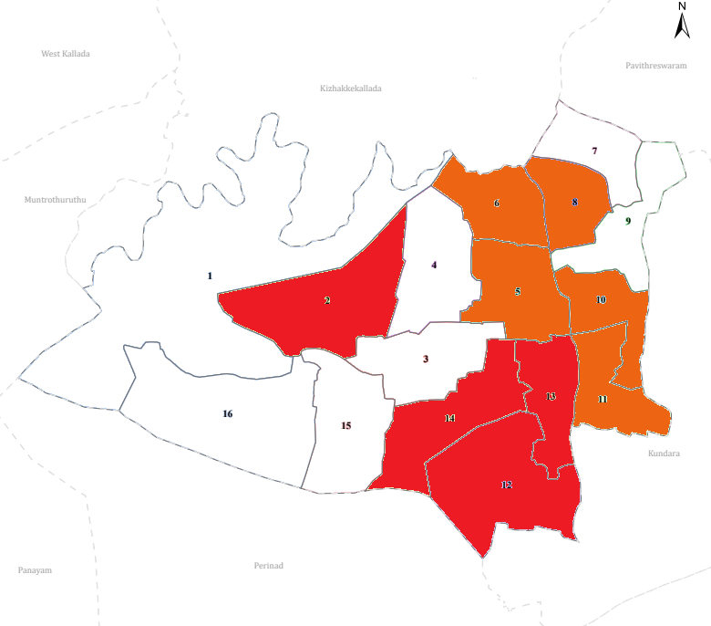

Preparedness and Response Protocol at LSG Level
This section describes the operational framework for the LSGI once a pandemic is declared. It explains how the LSGI and health system will move from routine data collection to active response, using a One Health approach.

Constitution of One Health Committee
The LSGD shall constitute a One Health Committee comprising the LSGI President, Medical Officers (Modern Medicine, AYUSH, and Veterinary), the Health Inspector, and the Veterinary Surgeon.

Objective: The One Health Committee coordinates human, animal, and environmental health to prevent and control pandemics.

Sl No | Name | Designation | Department/Institution | Role in Committee | Contact Number
1 | Shyam | Panchayat President | LSGD | Chairperson | 9745912788
2 | Dr Sheeja Philip | Medical Officer (PHC/CHC) | Health Dept | Member Secretary | 9497621190
3 | Shraddha Krishnan H, Deepa mary | Veterinary Officer | Animal Husbandry | Member | 8606734176, 9846457295
4 | Iswarya S | Epidemiologist | Health Dept | Member | 9526210996
5 | Binu R | Health Inspector/PHN | Health Dept | Surveillance | 9447251273
6 | Jolly | ASHA Supervisor | Health Dept | Community link | 9539392760
7 | Vishwalekshmi | ICDS Supervisor | Social Welfare | Vulnerable groups | 8078207033
8 | Kundara | Police Station Officer | Police Dept | Law & order | 04742547239
9 | Aneesh padappakara | Ward Councillor Representative | LSGD | Community coordination | 9895568254
10 | Moly | Kudumbashree CDO | Kudumbashree | Community mobilisation | 8943003935
11 | Mercy | NGO/Volunteer rep | Civil Society | Support services | 9074165355

Key Responsibilities:
- Review disease surveillance data (human + animal)
- Conduct ward-wise risk assessment and vulnerability mapping
- Approve quarantine/isolation centre locations
- Coordinate with district for resources (PPE, oxygen, ambulances)
- Periodically review health system surge capacity, including beds, oxygen, human resources, and ambulances.
- Approve and monitor risk communication and community engagement strategies, including rumour management.
- Ensure protection and service continuity for vulnerable groups (elderly, persons with disabilities, dialysis patients, coastal populations).
- Conduct quarterly mock drills
- Monitor equity measures for vulnerable groups

Meeting Schedule:
Quarterly (normal times) | Weekly (outbreak alert) | Daily (pandemic phase)

Pandemic Response Workforce
To ensure a coordinated and timely response during a pandemic, a dedicated Pandemic Response Workforce shall be constituted at the LSG level. The workforce will function under the overall supervision of the One Health Committee and in close coordination with the health authorities. Team-based deployment will enable efficient surveillance, case management, quarantine and isolation management, logistics support, and risk communication. Each team shall have a clearly designated team leader, defined roles, and an identified pool of personnel to allow rapid activation, rotation of duties, and continuity of services during prolonged emergencies.

Total Response Workforce Available: 300 persons

Team Name | Composition | Key Responsibilities | Team Leader
Surveillance and Contact Tracing Team | HI, JHI, JPHN, ASHAs and Volunteers | Case detection, contact listing, home visits, reporting | HI
Case Management Team | Doctors, Nurses, MLSP, Palliative Nurses | Patient care & referral | DOCTOR
Quarantine & Isolation Team | LSGD staff, Volunteers | Facility management | JHI
Psychosocial support
Logistics & supply chain Team | LSGD staff, Storekeepers, Drivers 3 | Supplies & transport [PPE, medicines, oxygen, transport, waste management] | Ward Member
Communication Team | Ward members, Kudumbashree, Youth clubs,  AWW workers and other self help groups | IEC, community meetings, countering misinformation | M.O in charge

All teams shall be activated immediately upon outbreak alert or pandemic declaration and shall report daily to the LSG Incident Commander/Medical Officer, with consolidated reporting to the Block PHC. Duty rosters and alternate personnel shall be maintained to ensure uninterrupted services during staff shortages or prolonged response periods. Team composition and numbers may be revised based on the magnitude of the outbreak and availability of human resources.

Activities and Measures before and during Pandemic

PHASE 1 - Alert / Preparation
Surveillance and Reporting-Enhanced syndromic surveillance:
- Data sources for surveillance:
- Event-based triggers (to be monitored and reported):
- Zoonotic and animal health surveillance
- Logistics and Stock Preparedness
  - Identify and empanel local vendors and define emergency procurement mechanisms in accordance with existing LSGD and Health Department norms.
  - Prepare and maintain an essential logistics checklist covering medical supplies, consumables, and support equipment.
  - Pre-identify secure storage locations for emergency stocks and ensure maintenance of stock registers with regular updating.
  - Finalise emergency transport arrangements, including availability of vehicles and identified drivers for rapid deployment during alerts.
  - Designate a Nodal Officer for Logistics to enable prompt decision-making, coordination, and communication during emergencies.
  - Conduct rapid stock verification and ensure availability of minimum buffer stock, including:
- PPE kits -7numbers
- Pulse oximeters – 5numbers
- Hand sanitizers – 10 litres
- Masks, gloves, disinfectants – adequate quantity
Identify critical gaps in logistics and immediately communicate requirements to the Block and District authorities for timely replenishment and support. Monitor expiry dates and stock rotation.

Identification of Quarantine and Isolation Facilities
  - Identify and list suitable buildings for quarantine and isolation (schools, hostels, community halls, etc.).
  - Categorise cases as per the severity and allocate to appropriate facilities (for instance, severe cases to classrooms, mild cases to an assembly hall in case of a school).
  - Facility readiness checklist needed (beds, toilets, ventilation) etc.
  - Find an alternate site if the primary sites are not available or not in use.
  - Identify facility managers and support staff
  - Prepare basic SOPs for:
    - Admission and discharge
    - Food, water, sanitation
    - Infection prevention and waste disposal
  - Ensure availability of basic amenities: water, sanitation, electricity, ventilation, and waste disposal. Prepare a rapid activation plan for these facilities if case numbers increase.

Risk Communication and Community Preparedness
  - Disseminate early warning messages on symptoms, preventive measures, and reporting mechanisms. Display IEC materials both in English and the local language in public places and ensure ward-level awareness.
  - Sensitize elected representatives and community leaders on preparedness measures.
  - Establish a rumour tracking and misinformation response mechanism to identify, verify, and promptly counter false or misleading information.
  - Engage trusted local persons (ward members, ASHA workers, religious leaders, teachers, community volunteers) to communicate official public health messages and reinforce correct practices.
  - Develop and deploy targeted IEC materials for:
    - Schools and educational institutions
    - Markets and commercial areas
    - Work sites and labour settings
  - Conduct community sensitization meetings at the ward level to promote preventive behaviors, address concerns, and strengthen community participation in preparedness and response.

Protection of Vulnerable Groups
Vulnerable populations require priority protection through targeted line-listing, service continuity, and delivery mechanisms.
- Prepare and regularly update line-lists of vulnerable populations, including:
  - Elderly persons living alone
  - Persons with disabilities
  - Pregnant women
  - Migrant workers
  - Dialysis patients
The detailed line-lists shall be maintained as Annexure and updated periodically.

Clinical Dependency Mapping
Develop ward-wise dependency and vulnerability maps to identify households requiring regular support during emergencies. Ensure continuity of essential health services for vulnerable groups, including
- Dialysis services (facility mapping, transport arrangements, and scheduling)
- Continuity of treatment for TB, HIV, and other chronic conditions requiring uninterrupted medication
- Mental health and psychosocial support services
Establish delivery mechanisms for food, essential commodities, and medicines to vulnerable households through coordinated action involving ASHAs, JPHNs, Kudumbashree, volunteers, and local administration.

PHASE 2 - Active Response

Case Identification and Contact Tracing
Case detection and contact tracing activities will be carried out in coordination with the Health authorities, following disease-specific SOPs and IDSP guidelines.
Field Staff Involved
- Health Inspector (HI)
- Junior Health Inspector (JHI)
- Junior Public Health Nurse (JPHN)
- ASHAs and ASHA Supervisors
- Ward-level volunteers and Kudumbashree members (as required)

Screening Checkpoints
Screening checkpoints at high-traffic locations (transport hubs, markets, religious gatherings) for early detection of symptomatic travellers and crowd screening during outbreaks. Potential locations include bus stands, market entry points, and boat jetties, based on local context and risk assessment.
Screening activities will be carried out by trained personnel such as ASHAs, ward members, and volunteers, with support from Health Department staff. Necessary equipment, including non-contact thermometers and appropriate PPE, shall be ensured prior to activation.
Location | Type (Bus stand/Jetty/Market/Railway) | Staff Deployed (ASHAs/Volunteers) | Screening Method | Reporting authority
Bus stand | Transport hub | One JHI  One ASHA  One health Mentors | 1.Swab Collection.  2. Blood smears collection (RDT)  3.Thermal Scanners | Surveillance Nodal Officer in control room
Market entry | Market | One JHI  One ASHA  Male health volunteers | 1.Swab Collection.  2. Blood smears collection (RDT)  3.Thermal Scanners | Surveillance Nodal Officer in control room
Boat jetty | Water transport | One JHI  One ASHA  Male health volunteers | 1.Swab Collection.  2. Blood smears collection (RDT)  3.Thermal Scanners | Surveillance Nodal Officer in control room

Standard Screening Protocol

The screening protocol shall include temperature screening, observation for visible symptoms, and inquiry regarding recent travel or exposure history. Individuals identified as suspects during screening shall be immediately referred to the nearest PHC/FHC for further evaluation, testing, and appropriate action as per prevailing guidelines.

Pandemic Control Room
The Pandemic Control Room (PCR) serves as the central nerve center for real-time coordination, data aggregation, decision support, and communication during outbreaks. It consolidates information from all LSGD teams, health facilities and community sources to enable rapid response decisions.

Control Room Infrastructure and Location
Primary Location: Perayam Panchayath Office.
Backup Location: Community Hall (CSI convention centre mulavana) in perayam G.P.

Health System Control Room Framework
The PCR is organized into seven functional pillars to ensure no aspect of the response is overlooked:

Rapid Response Team (RRT)
  - Provides immediate intervention during emergencies, clusters, and field alerts.​
  - Coordinates urgent actions such as case investigation, contact tracing, isolation, and inter‑facility referrals.

Data Management & Analytics Team
  - Collects, validates, and manages key health system indicators (cases, tests, beds, HR, supplies).​
  - Analyzes data trends, generates projections, and supports evidence‑based decision‑making for local authorities.

Human Resource Deployment Team
  - Allocates healthcare staff efficiently based on workload and need
  - Ensures adequate and equitable workforce distribution across facilities

Laboratory Surveillance Team
  - Oversees diagnostic testing coordination, sample transport, and timely reporting of results.​
  - Monitors lab indicators (testing volume, positivity rate, turnaround time) for early detection of outbreaks

Vaccination Cell (If Required)
  - Plans and executes vaccination campaigns, including micro‑planning and session scheduling.​
  - Tracks coverage, identifies gaps, and coordinates corrective actions with field teams and outreach services.

Infrastructure & Patient Occupancy Team
  - Monitors facility capacity, earmarked beds, oxygen and critical care resources across all linked facilities.​
  - Ensures optimal patient distribution and referral management using updated bed‑status and resource data.
  - BMWM

Communication team
- Logistics and supply chain
- Transportation (interfacility & emergency transport)
- Media surveillance Call centre
- Management of the deceased
- Intersectoral coordination and convergence

Key Control Room Team
The Control Room Team coordinates all pandemic response activities within the LSGD and serves as the single command and communication hub during activation. It integrates information, field actions, logistics, and policy execution across all participating departments and health facilities.

Role | Name | Designation | Contact Number | Responsibility
In-charge/Nodal Officer | Dr Sheeja Philip | Medical officer | 9497621190 | Overall coordination, decision-making, and reporting to the District level.
Data Entry Operator | Hashim | Data Manager | 9605309194 | Managing the line list, updating dashboards, and tracking testing results.
Communication Officer | Iswarya S | Epidemiologist | 9526210996 | Handling the public helpline, coordinating ambulance dispatch, and contact tracing calls.
Logistics Coordinator | Jolly | JPHN | 9539392760 | Handling Logistics
Technical Support(IT/Data) | Hashim | Data Manager | 9605309194 | Data Management

SOP for alert escalation/trigger point with mapping of responsibilities.
Key Points:
- The Control Room shall be staffed with a designated In-charge, data entry personnel, and communication staff with clearly defined roles and shift arrangements.
- It shall maintain updated records on daily monitoring indicators including new cases, persons under active quarantine, and hospital bed occupancy.
- All reports and situation updates shall be shared daily with the Block and District Surveillance Unit.
- The Control Room shall act as a single point of contact for coordination with response teams, health institutions, and other departments.
- Contact details of the Control Room shall be widely communicated to field staff and stakeholders during activation.

Daily Monitoring Indicators
To ensure timely decision-making and effective response, the following key indicators shall be monitored and updated on a daily basis by the Pandemic Control Room:

Epidemiological Indicators:
New cases reported today, Total active cases, Test Positivity Rate (TPR), Case Fatality Rate (CFR)
- Surveillance Indicators:
Persons under home quarantine, High-risk contacts identified, Fever, ILI, SARI or other symptoms (syndromic surges), Travellers (symptomatic or high-risk arrivals),Animal husbandry surveillance (zoonotic alerts, unusual animal deaths, poultry/bird flu signals), Mortality surveillance (excess deaths, unexplained fatalities, verbal autopsy reports)
- Logistics and Infrastructure Indicators:
Hospital / CFLTC beds occupied, Oxygen cylinders/concentrators available, Ambulances on standby
- Alert Findings
The following table outlines category-specific trigger points (red flags) from surveillance indicators and corresponding immediate actions for the Pandemic Control Room. These enable rapid response to alert findings like testing anomalies, positive cases exceeding thresholds, clusters, and WGS reports.

Category | Trigger Pophint (Red Flag) | Immediate Action
Clusters | Geographical or facility-based: 5+ cases linked to one location (office, school, street). | Declare a micro-containment zone; perimeter control and active case finding.
Testing | Sudden drop in testing volume / delay in reporting / unusual testing trends | Review the sample collection process, address lab bottlenecks, deploy additional testing teams, and notify the District Lab.
Lab | Test Positivity rate increases | Increase testing sites in that ward.
Hospital | >80% Oxygen bed occupancy | Activate backup/CFLTC beds.
Travel | Cluster of cases from a single flight/train or high-risk arrival group. | Trace all passengers in adjacent seats; implement mandatory institutional quarantine.
Animal | Mass poultry/wildlife death or unusual sickness | Notify Animal Husbandry, sample the area, and dispatch RRT for environmental sampling and zoonotic check.
Mortality | Sudden spike in home deaths or brought-in-dead (BID) cases | Audit the deaths and Active Case Search drive
Additional investigations like Whole Genome Sequencing (WGS) | Detection of a Variant of Concern (VOC) or Variant of Interest (VOI) | Implement strict micro-containment; update clinical protocols to match variant severity.

Communication of Public Health Information
A Community Communication Hub shall be established to ensure timely, accurate, and consistent dissemination of information during a pandemic. The Hub will function under the coordination of Nodal officers of the control room and act as the nodal point for public communication, risk messaging, and community engagement. It will support dissemination of official advisories, promote preventive behaviors, address rumors and misinformation, and ensure that messages reach all sections of the population through trusted local channels and leaders.

Key communicators
Channel | Responsible Person | Contact
Ward-level announcements | Panchayat President , Shyam | 9745912788
Social media | Hashim | 9605309194
Local Cable TV/Radio | PRO Nahas | 9747700417

- All messages disseminated through the Hub shall align with advisories issued by the Health Department and District authorities.
- Community leaders shall be sensitized to support behavior change, reduce stigma, and counter misinformation.
- Special efforts shall be made to reach vulnerable and hard-to-reach populations using locally appropriate communication methods.

Rumor Tracking: A designated volunteer will monitor local social media/WhatsApp groups daily to identify misinformation and issue official clarifications via the Communication Hub.

Coordination with District/State Authorities & Other Organisations
Effective coordination with Block, District, and State authorities is essential to ensure timely reporting, technical guidance, and uninterrupted supply of essential resources during a pandemic. The LSG shall establish clear communication channels, designate responsible officers, and adhere to prescribed reporting timelines to support coordinated public health action and efficient resource mobilisation.

Key Details:
- Nodal Officer for Reporting:
- Contact Number:
Reporting Schedule and Protocols:

To Whom | What to Report | Frequency | Nodal Person
Block PHC | Complete Situation Report (Cases, Quarantine, Beds, Screening, Deaths) | Daily | MO
District IDSP Unit | Outbreaks/Clusters/Unusual Events (>5 cases same ward) | Daily | Epidemiologist, HI
Veterinary Officer | Animal health events/Zoonotic alerts | Weekly | Veterinery officer
State Cell | Zoonotic cross-sector events | Weekly | District Team

Supply Chain Coordination
The LSG shall coordinate closely with Block, District, and State authorities (KMSCL) to ensure uninterrupted availability of essential goods, medical supplies, and logistics during a pandemic. Supply requirements shall be assessed regularly based on case load and communicated promptly to the appropriate authorities for timely replenishment.
Key Points:
- Maintain updated contact details of District and Block nodal officers for health logistics, oxygen supply, ambulances, and essential medicines.
- Submit timely indent requests for PPE, testing kits, medicines, oxygen, and other critical supplies through prescribed channels.
- Monitor stock levels at LSGD facilities, quarantine/isolation centres, and field teams through daily stock registers and dispensing logs to prevent shortages.
- Coordinate with District authorities, Karunya/Neethi medical shops, and local purchase committees for funds allocation and emergency procurement.

- Ensure regular monitoring of dispensing registers at all facilities to track usage, expiry, and pilferage—shortages being a perennial issue requiring proactive weekly audits.

- Activate surge procurement protocols during high caseloads, leveraging local purchase powers under LSGD funds alongside state supplies.

Resource Inventory and Contacts
Resource Category | Source  (District/State/Private) | Contact
PPE Kits/Masks/Gloves | KMSCL | 9496004500
PPE Kits/Masks/Gloves | Local Vendors | 9496004500
Oxygen  Cylinders/Concentrators | KMSCL | 0471-2945600
Medicines/Antivirals | KMSCL | 0471-2945600
Medicines/Antivirals | Neethi Shops | 989503780
Test Kits (RTPCR/Rapid) | KMSCL | 0471-2945600

Collaboration with NGOs, PPP, and CSR
To augment government efforts during a pandemic, the LSG shall collaborate with NGOs, voluntary organisations, and private sector partners through public–private partnerships and Corporate Social Responsibility (CSR) initiatives, in coordination with District authorities.

Key Points:
- Engage NGOs and community-based organisations for community outreach, awareness, and support to vulnerable populations.
- Leverage CSR support for procurement of medical equipment, PPE, oxygen concentrators, food kits, and sanitation materials, as permitted.
- Ensure all collaborations align with government guidelines and are routed through approved administrative and financial procedures.
- Maintain transparency and documentation for all external support received and utilised.
Organization | Type | Support Offered | Contact Person
Youth Clubs/Student Unions | CBO | Resident Associations | 9562262233

Interdepartmental Coordination
Coordination among departments during a pandemic shall be ensured through regular review meetings convened by the LSGD President. These meetings will provide a structured platform for sharing situational updates, assessing resource availability, resolving operational gaps, and taking joint decisions to ensure a coordinated and timely response.

Department | Representative | Key Role | Contact
Health (PHC) | Staff Nurse :shiny | Case management | 9495327812
Veterinary | Veterinary Surgeon: Dr Deepa | Animal surveillance | 9895306703
ICDS | Supervisor: Vishwalekshmi | Nutrition support | 8078207033
Education | Head Teacher: | School coordination | 9809720224
Police | Containment enforcement & Law & Order | Containment enforcement | 9497980221

PHASE 3 - Surge Capacity
Phase 3 is activated when there is a rapid increase in cases, high test positivity rates, or when existing health facilities and quarantine arrangements approach saturation. The focus of this phase is to expand isolation capacity, augment clinical care services, and mobilise additional resources through district and state support mechanisms.

Conversion of Community Facilities
To manage increased case load, the LSGD shall activate additional isolation facilities by repurposing identified community infrastructure such as community halls, auditoriums, schools, hostels, or other suitable buildings.

Name of facility | Facility Type | No. of Buildings | Ward | Surge Capacity (Beds) | Nodal Person
Govlps padappakara | school | 2 | 3 | 10 | Head Master
JJ AUDITORIUM | AUDITORIUM | 1 | 8 | 15 | Head Master
ST JOSEPH HIGH SCHOOL | SCHOOL | 2 | 2 | 20 | Head Master
STMICHELVHSSKUMBALAM(AIDED) | School | 1 | 4 | 25 | Head Master
STANTONYHSSKANJIRACODE(AIDED) | School | 2 | 5 | 30 | Head Master

- Recovery and rehabilitation phase
- Recovery
  - Damage & impact assessment
  - Restoration of health services
  - Rehabilitation of affected population
  - Psychosocial & mental health support
  - Disease surveillance during recovery phase
  - Environmental cleanup & sanitation
  - Livelihood restoration
  - Community engagement & confidence building
  - Documentation & after-action review
  - Lessons learned & best practices
  - Health system strengthening
  - Policy revision & preparedness enhancement
  - Research

CONCLUSION

Additional points
- tech support
- relief based commodities
- ham reading operators
- hazard vulnerability mapping
- Kseb& other power source
- HR specific responsibility

RECOMMENDATIONS

Strengthening Healthcare Infrastructure
- Establish a primary health response unit within the Panchayat with trained staff.
- Ensure availability of basic medical supplies (masks, sanitizers, PPE kits, oxygen cylinders).
- Create tie-ups with nearby hospitals in Kollam Corporation district Hospital for emergency referral and transport.

2. Community Awareness & Education
- Conduct regular awareness campaigns on hygiene, vaccination, and preventive measures.
- Use local communication channels (community radio, WhatsApp groups, notice boards) to spread verified information.
- Train volunteers to act as health ambassadors in each ward.

3. Emergency Response & Coordination
- Form a Pandemic Preparedness Committee at Panchayat level including health workers, ward members, and NGOs.
- Develop a clear action plan for lockdowns, quarantine, and distribution of essentials.
- Maintain a database of vulnerable groups (elderly, differently-abled, chronically ill) for targeted support.

4. Supply Chain & Food Security
- Identify and support local suppliers and farmers to ensure uninterrupted food supply.
- Create community kitchens during emergencies to serve vulnerable populations.
- Stockpile essential commodities in Panchayat-run outlets for crisis periods.

5. Digital Preparedness
- Promote digital platforms for telemedicine consultations.
- Use Panchayat’s website/social media for real-time updates on health advisories.
- Encourage online grievance redressal to reduce crowding in offices.

6. Training & Capacity Building
- Organize mock drills for pandemic response in schools, offices, and public spaces.
- Train Panchayat staff and volunteers in first aid, infection control, and crowd management.
- Collaborate with NGOs and health departments for capacity-building workshops.

7. Long-Term Resilience
- Integrate pandemic preparedness into the Panchayat Development Plan.
- Allocate a dedicated budget for health emergencies.
- Encourage community participation in planning and monitoring preparedness measures.

ANNEXURE

IMPORTANT PHONE NUMBERS

Phone numbers and particulars of persons responsible for providing guidance, assistance, and support for pandemic preparedness operations may be provided here in a manner that allows easy reference at a glance.The information recorded here could be exhibited elsewhere at the time of emergencies. LSG institutions shall give special attention to collect and record the above data of persons and institutions who/which are supposed to give technical and co-ordination support to reduce the impact of pandemic.

1.1. Details of grama panchayat/municipality/corporation wards
Sl.No | Name of the ward | Ward number | Name of the ward  member | Contact number
1 | Kuthiramunambu | 1 | AneeshPadappakara | 9895568254
2 | PADAPPAKARA | 2 | SheejaSujith | 9447612208
3 | Govt lps ward | 3 | SoosiRanjith | 8547407014
4 | KUMBALAM VHSS | 4 | Alice | 8182167176
5 | KUMBALAM | 5 | Sheelakumari | 8136821441
6 | KUMBALAM PHC WARD | 6 | Jospin | 8181167176
7 | KOTTAPURAM A | 7 | Syam | 9074039419
8 | KOTTAPURAM | 8 | Preeth | 9074039419
9 | MULAVANA | 9 | Bency | 8136821441
10 | ESI WARD | 10 | Rameshan | 8848838407
11 | VILLAGE WARD | 11 | Letha | 8848838407
12 | KANJIRACODE | 12 | Anu Antony | 8136821441
13 | PERAYAM | 13 | Osbon | 8547407014
14 | KARIKUZHI | 14 | Anujamol | 9895458254
15 | Homeo dispensary ward | 15 | sushammajose | 9895458254
16 | FATHIMA JUNCTION | 16 | SunnyLorance | 9447612208

1.2. Important offices of grama panchayat/municipality/ corporation
Sl.No | Name of the office | Contact person | Contact number
1. | Village Office | Village Officer | 8547618439
2. | Agriculture Office | Agriculture Officer | 04742522015
3. | Animal Husbandry Office | Animal Husbandry Doctor | 9495036703
4. | Police Station | Police Officer | 0474-2547239 / 9497987034
5. | BSNL Office | Officer | 0474-2523300
6. | Block Office | Officer | 0474-2522251 / 0474-2585024
7. | KSEB Office | Officer | 0474-2547237 / 9446008316
8. | Fisheries Office | Officer | 0474-2792850 / 9496007027
9. | Fire and Rescue | Officer | 0474-2522101 / 101

1.4. Health Services

Sl. No | Name of the hospital/institution | Location | Phone number
1. | Government hospitals/PHC | Family Health Centre (FHC) Perayam | 0474-2580330
3. | Clinical laboratories | Viswas Fairprice Lab & ECG , Karikuzhi | 96758345789
4. | Chemist/pharmacy | Alappatt Pharmacy , Mulavana | 9580297638
5. | Blood donors | IMA Blood Bank , District Hospital Blood Bank | 0474-2766551 ,  0474-2750206

1.5. Veterinary Services
Sl.No | Name of the Clinic | Name of the  Surgeon/Doctor | Place/location | Phone  number
1 | Govt.Veterinary Hospital | DR DEEPA | Ward 3 | 956865367
PUBLIC AND PRIVATE SCHOOLS
NO OF SCHOOLS | 18 | PHONE NUMBERS
LPS | - GOVTLPSPADAPPAKKARA(GOVT)  - STMARYLPSKUMBALAM(AIDED)  - MTLPSMULAVANA(AIDED)  - STMARGARETLPSCHOOL(AIDED)  - STANTONYLP SCHOOL(AIDED) | 9895437885  9074489414  9961003881  9496738340
UPS | - PKJMUPSCHOOL(AIDED)  - STTHARESA SCHOOL PADAPPAKKARA(UNAIDED) | 8281758419  9608699902
HIGHSCHOOL | - STMICHELHIGHSCHOOL(AIDED)  - NSSHSPERAYAM(AIDED)  - STMARGARETHIGHSCHOOL(AIDED)  - STANTONYHIGHSCHOOL(AIDED)  - STJOSEPHSCHOOLPADAPPAKKARA (AIDED) | 8281814376  8848745701  9847327689  9495351025  9747000271
HIGHERSECONDARY SCHOOL | - STMICHELVHSSKUMBALAM(AIDED)  - STANTONYHSSKANJIRACODE(AIDED) | 9447591091  9895262575

1.6. Helpline numbers
Helpline | Phone number
Police | 112
Fire and Rescue | 1912
KSEB | 0474-2547237 / 9446008316

1.9. Anganwadi Contact Details

Ward No | Name of Anganwadi Teachers | Phone number
1 | Mini Liju | 9207047548
2 | Joji Yesudas | 9567544067
3 | Praveena P | 8075978753
4 | Anupa Oommen | 9746656258
5 | Anandavally Amma | 6238071342
6 | Sindhu P | 9605873415
7 | ANGEL P | 7403264697
8 | BIJI PEREIRA | 9747147723
9 | Girija K | 9946089251
10 | BINU J | 9745700436
11 | Sheeba T | 7012774594
12 | Nima M | 7994602203
13 | Anju S | 7994762296
14 | Rosamma J | 7025697287
15 | Anitha P | 9349996239
116 | Mercy T | 6235867828
17 | Mary Sudha | 7736504038
18 | Nirmala | 7561069336
19 | Diana George | 7356467577
20 | BINDU K | 9544036781
21 | Shylamma Robert Lopez | 9745258674

1.12. Information regarding resources

Means of transportation | Name of Owner | Phone Number
Heavy Trucks | RAJAN | 9847222735
Tractor | SUMESH | 8636895673
Ambulances | NITHIN | 8943570072
Boats | Chandran | 0474-2792850 , 989563750
Taxi service | GODWIN | 8129030281

Annexure 1: LSG Baseline Data Collection Format
A. Baseline data
Sl. No. | Indicator / Field | Baseline Data | Source / Remarks
1 | Name of LSG | Perayam | Baseline
2 | District | KollaM | Baseline
3 | Block / Taluk | Chittumala | Baseline
4 | Type of LSG (Gram Panchayat / Municipality / Corporation) | Perayam | Baseline
5 | Area (sq. km) | 11.05 sq km | Baseline
6 | No. of wards | 16 | Baseline
7 | GIS boundary file available | (Yes/No) Yes | Baseline

B. Demography
Indicator / Field | Baseline Data | Source / Remarks
Total population | 19312 | Baseline data
Males | 9650 | Baseline data
Females | 9662 | Baseline data
Transgender population | 0 | Baseline data
Age distribution  (<5, 5–14, 15–59, ≥60) | 830, 1482, 2960 | Baseline data
No. of households | 4828 | Baseline data
Population density (persons/sq.km) | 1712 | Baseline data
No. of migrant workers | 145 | Baseline data
Major occupational groups | Agriculture, Fishing, Construction | Baseline data

C. Vulnerable Populations & Social Risks
Sl. No. | Indicator / Field | Baseline Data (Value / Description) | Source / Remarks
1 | No. of elderly (≥60) | 2960 | Baseline data
2 | No. of persons with disability | 22 | Baseline data
3 | No. of bedridden persons | 78 | Baseline data
4 | No. of chronic disease cases (DM/HTN/COPD/CKD etc.) | 713,1420,10 | Baseline data
5 | Pregnant women (current estimate) | 69 | Baseline data
6 | Children <5 years | 830 | Baseline data
7 | Tribal population (if any) | 0 | Baseline data
8 | Fisherfolk / coastal vulnerable groups (if any) | 0 | Baseline data
9 | Urban slums / unnotified settlements (if any) | 0 | Baseline data
10 | Homeless population | 0 | Baseline data
11 | Orphanages / old age homes (number & capacity) | 0 | Baseline data
12 | Hostels / prisons / shelters (number & capacity) | 0 | Baseline data
13 | Poverty / BPL estimate | 2842 | NA
14 | Food insecurity hotspots | ward 1, 7, 16 | Primarily low-income coastal/wetland belts
15 | Any history of stigma/discrimination issues (Yes/No) | No | Strong community cohesion reported

D. Health System & Service Readiness
Sl. No. | Indicator / Field | Baseline Data (Value / Description) | Source / Remarks
1 | No. of health facilities in LSG (PHC/CHC/TH/DH/Private) | 6 phc , 1 TH | NA
2 | PHC/Family Health Centre details (name, location) | 6 | -
3 | Subcentres / Health & Wellness Centres (number) | 24 | -
4 | Private clinics / hospitals (number) | 2 | -
5 | Labs available (public/private) | 2 | -
6 | Availability of ambulance services (Yes/No, number) | 1 | -
7 | Availability of isolation/quarantine facilities (Yes/No, details) | 1 | -
8 | Cold chain facilities (Yes/No, details) | Yes | -
9 | Stockpile space available (Yes/No) | Yes | -
10 | PPE / mask / sanitizer availability plan (Yes/No) | Yes | -
11 | Surveillance staff available (JHI/JPHN/ASHA count) | Yes | -
12 | Existing emergency referral pathways (Yes/No) | Yes | -

E. Points of Entry & Mobility
Sl. No. | Indicator / Field | Baseline Data (Value / Description) | Source / Remarks
1 | Bus stands / depots (number) | 6 | Private & KSRTC stops (Kundara/Perayam Jn)
2 | Railway stations (number) | 0 | NA
3 | Boat jetties / fishing harbours (number) | 0 | NA
4 | Ports / airports nearby (specify distance) | 0 | NA
5 | Major highways/roads passing through | 1 | State Highway (SH) connectivity via Kundara
6 | Border crossings (state/district) | 0 | NA
7 | Major markets / weekly markets | 1 | Perayam Junction / Marthandapuram local market
8 | Tourism hubs / major event venues | 0 | NA
9 | Schools/colleges with hostels (number) | 10 | Institutional records from schools/St. Tresa’s
10 | Factories / large workplaces (number) | 4 | Cashew processing units / local small-scale industries
F. Water, Sanitation & Hygiene (WASH)
Sl. No. | Indicator / Field | Baseline Data (Value / Description) | Source / Remarks
1 | Major drinking water sources (piped / wells / borewells / springs) | 4032 | NA
2 | No. of public wells | 4032 | NA
3 | No. of households with piped water connection | 108 | Data from Jal Jeevan Mission (JJM) dashboard
4 | Water quality testing routine (Yes/No) | YES | Conducted by KWA/Health Dept. via H2S vials
5 | Common contamination risks (flooding, salinity, industrial waste) | YES | In the wetland areas
6 | Open defecation free status (Yes/No) | YES | Installation of public toilets, and e- toilets
7 | Solid waste management system (Yes/No) | YES | Collected via IMAGE
8 | Bio-medical waste disposal mechanism (Yes/No) | YES | Collected via IMAGE
9 | No. of public toilets | 1 | Near Bus stand
10 | Handwashing stations in public places (Yes/No) | NO | NA
G. Zoonotic Risks & One Health
Sl. No. | Indicator / Field | Baseline Data (Value / Description) | Source / Remarks
1 | Livestock population (cattle/goats/pigs/poultry) – estimates | 45 | Veterinary Department Livestock Census
2 | No. of dairy farms / poultry farms / pig farms | 1 | LSGD Registered commercial unit data
3 | Slaughterhouses / meat shops (number) | 0 | NA
4 | Animal markets (Yes/No, details) | NIL | NA
5 | Veterinary dispensaries (number) | 1 | Perayam/Mulavana Veterinary Dispensary records
6 | History of zoonotic outbreaks (rabies, leptospirosis, avian flu etc.) | NIL | NA
7 | Stray dog population management measures (Yes/No) | NO | NA
8 | Rodent infestation hotspots (Yes/No) | NIL | NA
9 | Wetlands / waterlogged areas prone to leptospirosis | NIL | NA
10 | Bat roosting areas / caves / fruit orchards (if any) | NIL | NA
11 | Human-animal interface hotspots (farms near residences) | NIL | NA
H. Climate & Disaster Risks (Pandemic Amplifiers)
Sl. No. | Indicator / Field | Baseline Data (Value / Description) | Source / Remarks
1 | Flood-prone wards (list) | NIL | NA
2 | Landslide-prone wards (list) | NIL | NA
3 | Cyclone/sea surge risk (Yes/No) | NIL | NA
4 | Heatwave risk zones (Yes/No) | NIL | NA
5 | Waterlogging areas (list) | NIL | NA
6 | Shelter homes / relief camps (number, capacity) | 3 | In Case of a pandemic or disaster
7 | Past disaster displacement history | NIL | NA
8 | Disruption to water supply/transport common (Yes/No) | NO | NA
I. Critical Infrastructure & Logistics
Sl. No. | Indicator / Field | Baseline Data (Value / Description) | Source / Remarks
1 | Schools (number) | 19 | BAseline Data
2 | Anganwadis (number) | 22 | Baseline data
3 | Colleges (number) | 1 | Baseline data
4 | Community halls (number) | 1 | Baseline data
5 | Places of worship with large gatherings (number) | 16 | Baseline data
6 | Large markets / shopping areas (number) | 1 | Baseline data
7 | Warehouses / cold storages (number) | 0 | Baseline data
8 | Telecom/mobile network coverage gaps (Yes/No) | 0 | NA
9 | Power outage frequency (high/medium/low) | Low | KSEB Section Office (Kundara) reliability reports
10 | Availability of generators in key facilities | NO | Essential equipment list at FHC & Panchayat Office

J. Risk Communication & Community Networks
Sl. No. | Indicator / Field | Baseline Data (Value / Description) | Source / Remarks
1 | Ward-level rapid response teams (Yes/No) | YES | HS, Epidemiologist, Field Team
2 | Jagrathasamithis / committees active (Yes/No) | YES | -
3 | Kudumbashree presence and strength (number of units) | YES | CDS (Community Development Society) records
4 | Volunteer network (number, coverage) | YES | Volunteers in the field
5 | Community-based surveillance mechanisms (Yes/No) | YES | NA
6 | IEC dissemination channels (WhatsApp groups, community radio, PA systems) | YES | Through Field staffs
7 | Rumour tracking mechanisms (Yes/No) | YES | PRO, JHI
8 | Languages spoken / literacy considerations | - | -
9 | Vulnerable groups communication strategy available (Yes/No) | YES | -

K. Preparedness Planning & Governance
Sl. No. | Indicator / Field | Baseline Data (Value / Description) | Source / Remarks
1 | LSG emergency plan available (Yes/No) | YES | Panchayat action level plan
2 | Pandemic preparedness plan available (Yes/No) | YES | LSGD pandemic preparedness plan
3 | Incident Command System identified (Yes/No) | Yes | From the block to the lower levels
4 | Rapid procurement mechanism available (Yes/No) | No | NA
5 | Emergency fund available (Yes/No, amount) | No | NA
6 | Past outbreak response experience (Yes/No, details) | NIL | NA
7 | Intersectoral coordination mechanism (Health, Police, LSG, Veterinary, Education) | YES | Intersectoral committees
8 | Mock drills conducted in last 12 months (Yes/No) | No | NA
9 | Training coverage for staff/volunteers (Yes/No) | YES | In the block and in the district

L. Surveillance & Data Systems
Sl. No. | Indicator / Field | Baseline Data (Value / Description) | Source / Remarks
1 | Digital reporting tools used (e.g., DHIS2, portals) | HMIS, AAM | Registry also maintained
2 | Availability of line-listing format (Yes/No) | YES | IDSP
3 | Contact tracing team identified (Yes/No) | YES | Field level training should be given. Formed by ASHA workers & Health Inspectors
4 | Mapping of high-risk households available (Yes/No) | YES | By field staffs
5 | Testing sample transport mechanism (Yes/No) | YES | Tied to KMSCL/District Lab logistics
6 | Reporting timeline adherence (good/average/poor) | Good | Monitored by District Surveillance Unit (DSU)
7 | Data sharing between departments (Yes/No) | YES | Between health departments
8 | Availability of dashboard for monitoring (Yes/No) | YES | Access via Kerala Health Services Portal

M. Additional Notes & Observations
Sl. No. | Indicator / Field | Baseline Data (Value / Description) | Source / Remarks
1 | Key challenges perceived by LSG | NIL | Maintaining surveillance in high-density pockets
2 | Top 5 high-risk wards (reason) | Wards 2, 8, 11, 14, 1 | From the disease trends
3 | Any unique local risks (industrial pollution, refugee camps, etc.) | nil | NA
4 | Recommendations for preparedness strengthening | 1. Implement R.O. Plants in Wards 1 & 7.  2. Strengthen One Health coordination with Vets.  3. Enhance market sanitation in Ward 11. | NA

