USER
[Email address]

PANDAMIC PREPAREDNESS PLAN

PERINAD GRAMA PANCHAYAT

MESSAGE FROM PRESIDENT/CHAIR LSGI
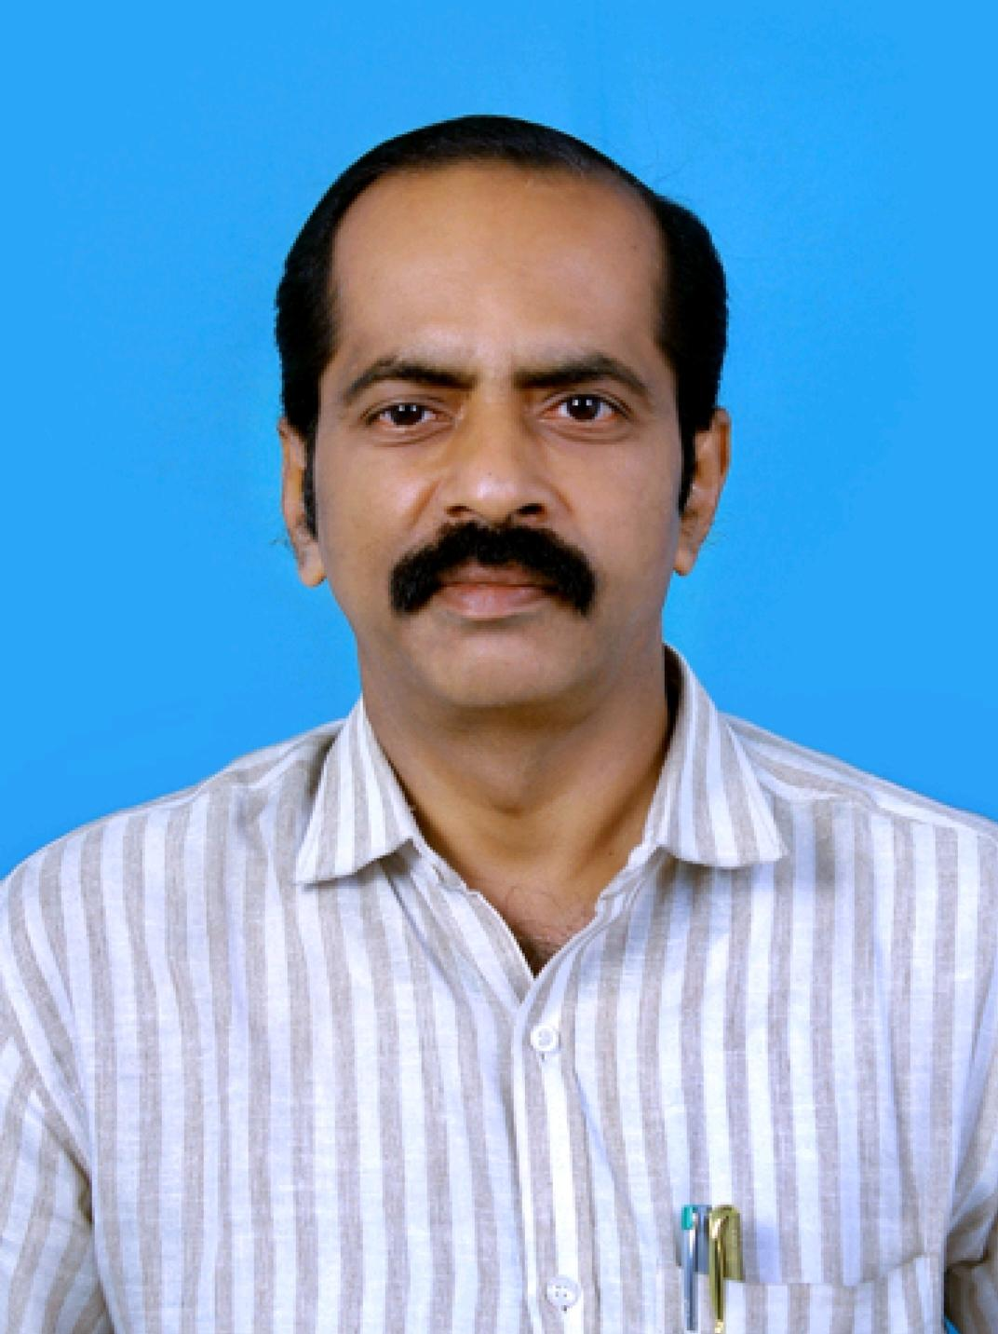
WE CANNOT STOP NATURAL DISASTER BUT WE CAN ARM OURSELVES WITH KNOWLWDGE.
Plan, participate, protect, prepare and practice.
Community Protection – strengthen community preparedness and readiness for health emergency
on other hand, the best preparation for tomorrow is doing your best today

BY V MANOJ (PRESIDENT OF LSGD)

MESSAGE FROM HEALTH STANDING COMMITTEE CHAIR

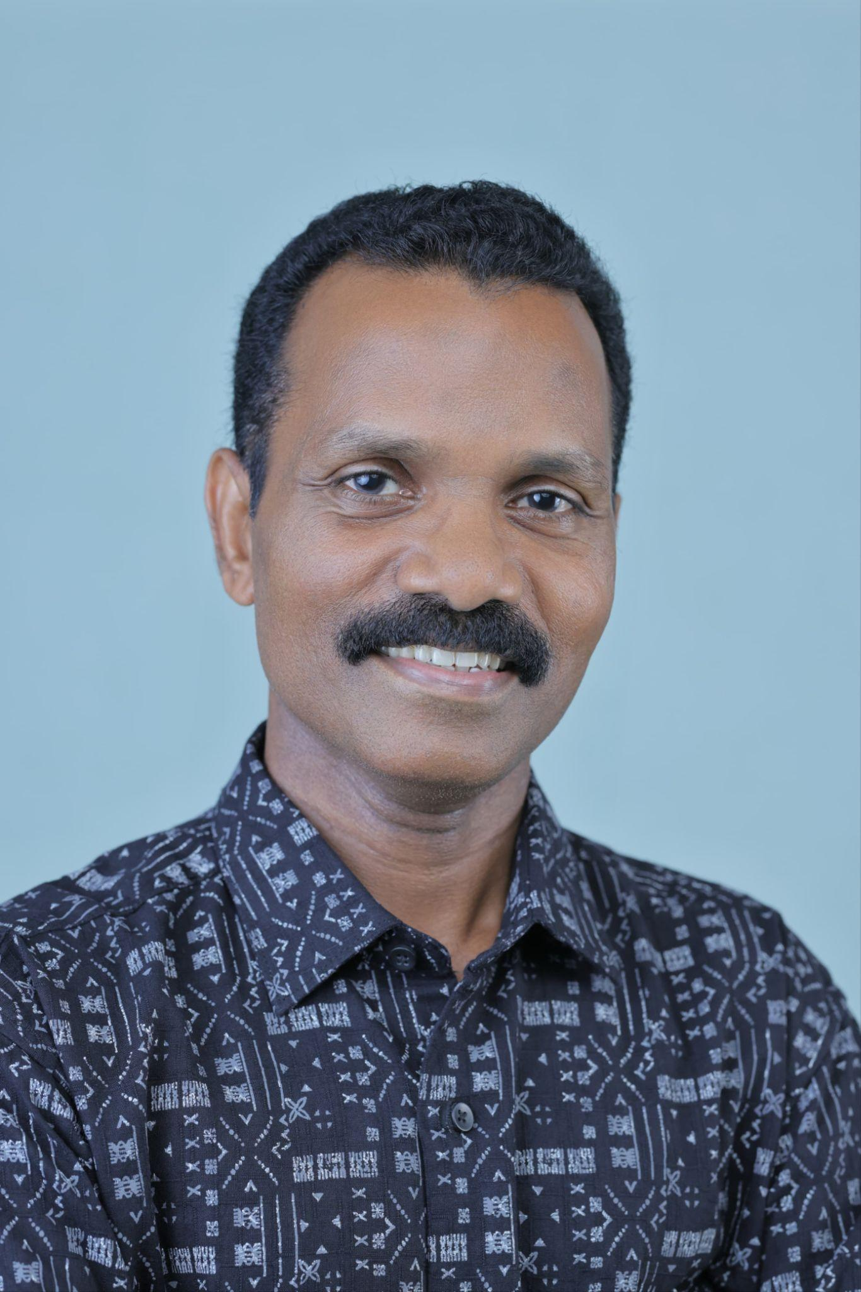
CREATE AN EMERGENCY PLAN SO THAT YOU AND YOUR FAMILY KNOW WHAT TO DO AND WHAT YOU WILL NEED IN CASE AN OUTBREAK HAPPENS

BY
SREEJITH K S
(STANDING COMMITTEE HEALTH AND EDUCATION)

MESSAGE BY MEDICAL OFFICER

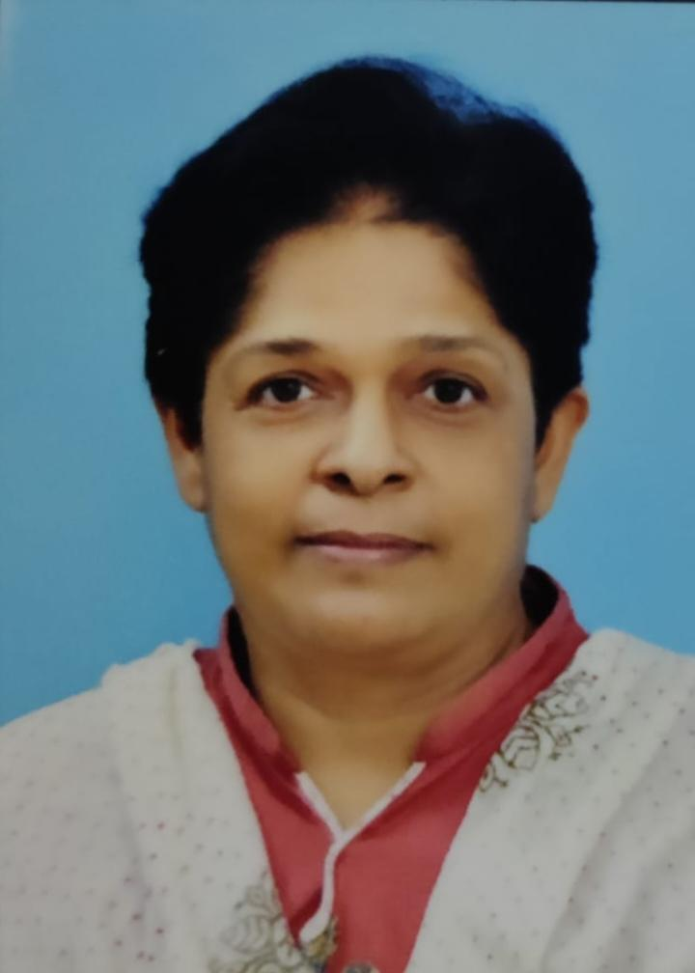
PREPAREDNESS IS AN ONGOING PROCESS IN WHICH INDIVIDUALS, COMMUNITIES, BUSINESSES, AND ORGANIZATIONS CAN PLAN AND TRAIN FOR WHAT THEY’LL DO IN THE EVENT OF A DISASTER

5 STEPS OF PREPAREDNESS

- PREVENTION

- MITIGATION

- PREPAREDNESS

- RESPONSE

- RECOVERY

BY
DR.TRESA LEEN
(Medical Officer FHC Perinad)

EXECUTIVE SUMMARY

Family Health Centre (FHC) functions as the primary public healthcare institution serving the population of Perinad Grama Panchayath. The FHC plays a pivotal role in delivering comprehensive, accessible, and affordable healthcare services, with a strong focus on preventive, promotive, curative, and rehabilitative care in accordance with national and state health programmes.
The FHC caters to a predominantly rural population, addressing key public health priorities such as maternal and child health, communicable and non-communicable disease control, immunization, family welfare, adolescent health, and geriatric care. Regular outpatient services, home-based care through field health staff, and outreach activities ensure healthcare coverage even in geographically challenging areas. The institution actively implements national health missions, including the National Health Mission (NHM), National Tuberculosis Elimination Programme, National Programme for Prevention and Control of Cancer, Diabetes, Cardiovascular Diseases and Stroke (NPCDCS), and other disease surveillance initiatives.
Perinad FHC works in close coordination with the Grama Panchayath, ASHA workers, Anganwadi centres, schools, and community-based organizations to strengthen community participation and improve health awareness. Emphasis is placed on early detection, timely referral, health education, and lifestyle modification to reduce disease burden and improve overall health outcomes.
Despite constraints related to infrastructure, manpower, and increasing service demand, the FHC continues to enhance service delivery through effective planning, data-driven decision-making, and community engagement. Strengthening facilities, upgrading digital health systems, and expanding preventive services remain key focus areas for future development.
Overall, Perinad Family Health Centre stands as a vital institution in safeguarding public health and improving the quality of life of the residents of Perinad Grama Panchayath

LIST OF ABBREVIATIONS

LSGD/LSGI | Local Self Government Department / Local Self Government Institution
BMO | Block Medical Officer
IDSP | Integrated Disease Surveillance Programme
NDMA | National Disaster Management Authority
PPE | Personal Protective Equipment
ICMR | Indian Council of Medical Research
CD | Communicable Diseases
NCD | NON-COMMUNICABLE Diseases

TABLE OF CONTENTS

3
INTRODUCTION 9

LSGD AT A GLANCE 9
INTEGRATED HEALTH INFRASTRUCTURE MAP OF PERINAD PANCHAYAT 10
GENERAL PROFILE OF THE LSGI’S 13
Background of the LSGI 13
Demographic and Vulnerable Population 14
Clinical Vulnerability 16
INFRASTRUCTURE & RESOURCE INVENTORY 18
Health Facility Directory & Basic Capacity in the LSGD 18
Private Clinics 19
Healthcare Education & Training Institutions 20
Specialized Services & Emergency Inventory 20
Oxygen & Diagnostic Capacity 21
Diagnostics facility mapping at the LSGI level 22
Laboratory Identification & Basic Details 22
Social and Community Infrastructure for surge plan 22
Human resources 24
Community & Support Cadre 25
Community Organizations 26
Administrative & Emergency Services 27
Information regarding resources 27
ONE HEALTH & ENVIRONMENTAL SURVEILLANCE 28
Animal & Bird Population 28
Veterinary Infrastructure 29
Veterinary Doctors & Workforce 30
High-Risk Interface Points (Surveillance Sites) 30
Environmental Risk Mapping 31
Disease Seasonality Mapping 32
Vulnerability Mapping 33
EPIDEMIOLOGICAL TRENDS (2021–2025) 34
Disease Burden among human beings(Last 5 Years) 34
*(use the above table data to create the graph/diagram) 36
Seasonal Trend Analysis 37
Outcome-Based Trend Analysis- 2025 39
Transmission Trend- 2025 40
Integrated Disease Hotspot Map (2021–2025) 42
Preparedness and Response Protocol at LSG Level 44
Constitution of One Health Committee 44
Pandemic Response Workforce 45
Activities and Measures before and during Pandemic 47
PHASE 1 - Alert / Preparation 47
PHASE 2 - Active Response 50
Standard Screening Protocol 51
PHASE 3 - Surge Capacity 60
Conversion of Community Facilities 60
CONCLUSION 61
RECOMMENDATIONS 62
ANNEXURE 63

INTRODUCTION

- LSGD at a glance

Perinad is a village in the Kerala state of India, located in the Kollam district. According to the 2011 Census, Perinad had a population of 35,173, comprising 17,046 males and 18,127 females.

Perinad is a fast-growing village situated on the outskirts of Kollam city. National Highway 183 connects the region with Kollam, Kundara, Chengannur, and other nearby towns. The village is located along the scenic shores of Ashtamudi Lake, which adds to its natural beauty and economic importance.

The Perinad Panchayat office is located at Chemmakadu, about 13 km from Kollam city centre. Important towns within the Panchayat include Cherumoodu, Vellimon, and Chemmakadu. Perinad is also notable for hosting the first boxing academy in the state established by a local self-government body.

The Panchayat has been experiencing rapid development with the establishment of several technical and educational institutions. These include the Fashion Technology Institute, Kerala Institute of Management, Techno Lodge Rural IT Park, and the College of Engineering at Perumon, along with various private educational institutions.

Historically, Perinad was an important centre of the coir industry in Kollam, flourishing along the backwaters. The well-known Ashtamudi and Mangad variants of coir originated from this region, contributing significantly to the local economy.

LSGD AT A GLANCE PERINAD
- Geographical boundaries with political map (based on latest delimitation)
- Baseline data
- Ward division -
Ward | Houses | Population | Migrants | Wells | Hot  spots | Ed. Institutions | Hosp pvt/govt.
20 | 10,062 | 38,798 | 335 | 6757 | 2 | 22 | 4

- Risk stratification among wards in the context of Communicable diseases and hazards
- Major Roads/rivers
- Major establishments with geospatial mapping
- occupational groups, socio cultural groups, migration & mobility patterns
- Vulnerability mapping
- Disaster prone areas (geographic vulnerability)

Maps - ward-based (Mention source also)
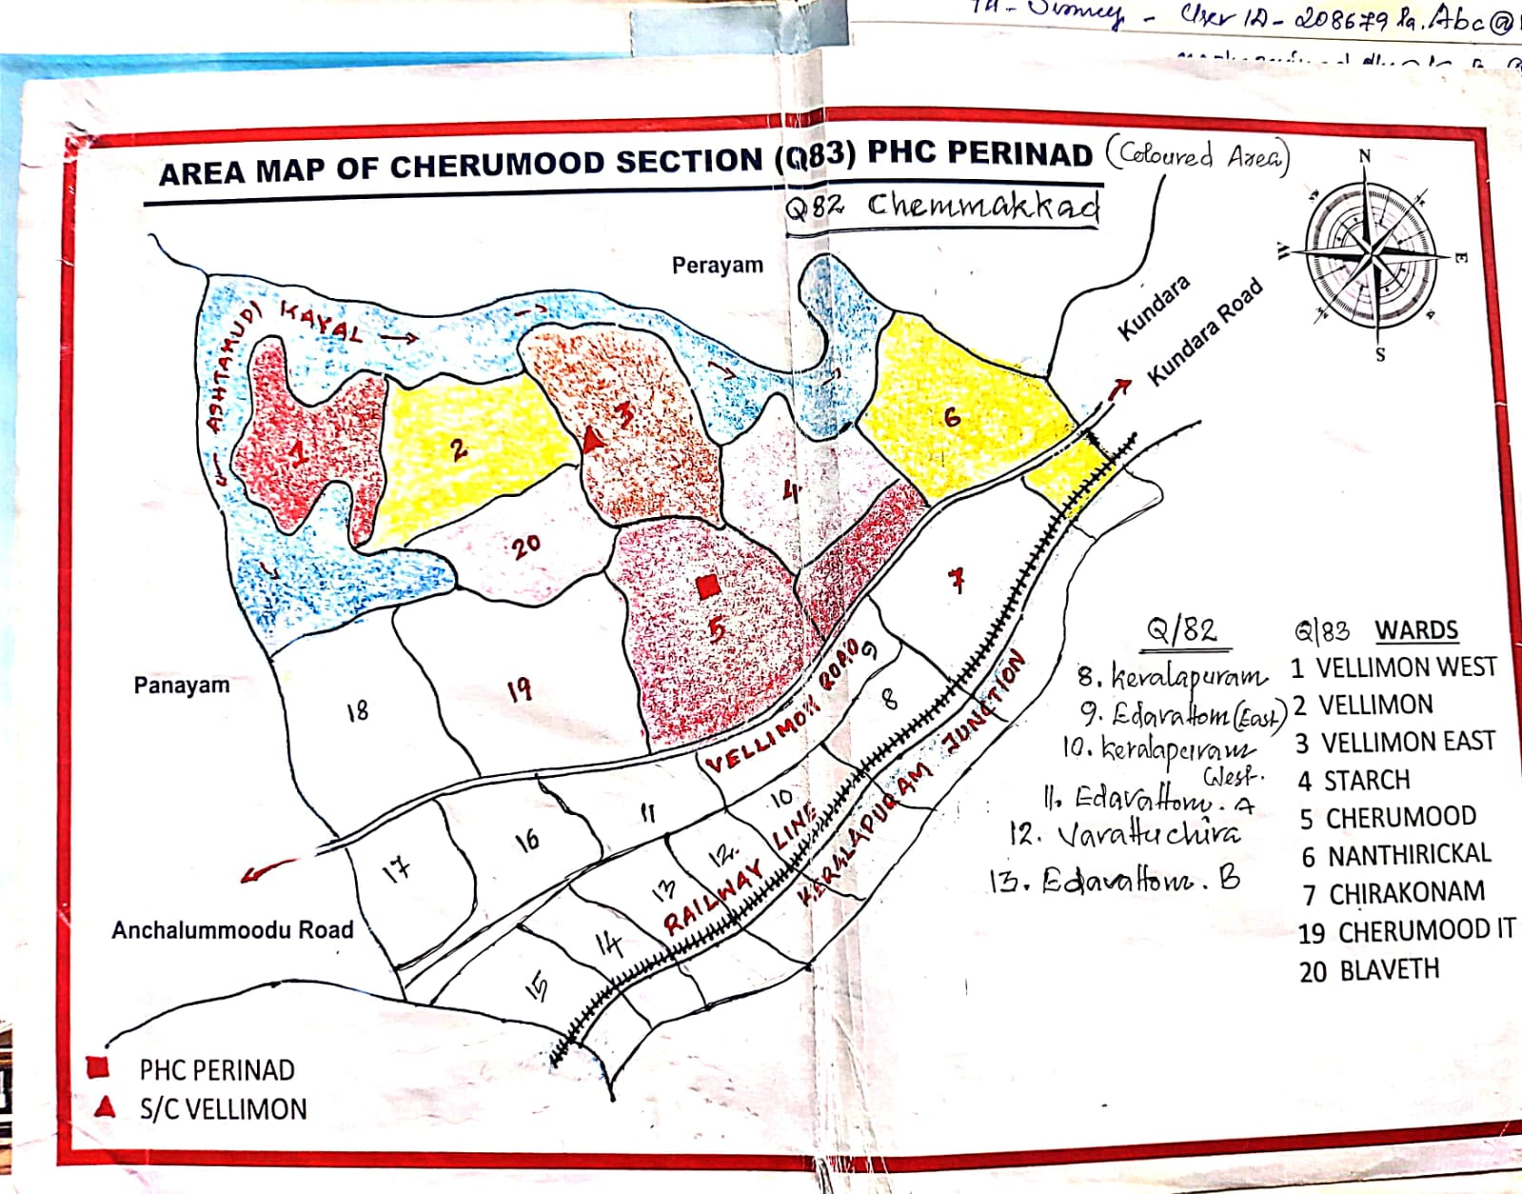

- Geographical boundaries - ward boundaries map

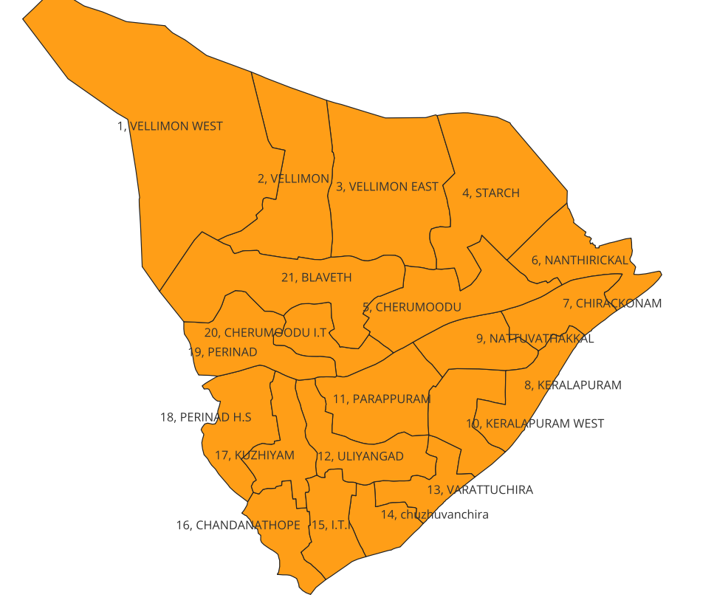

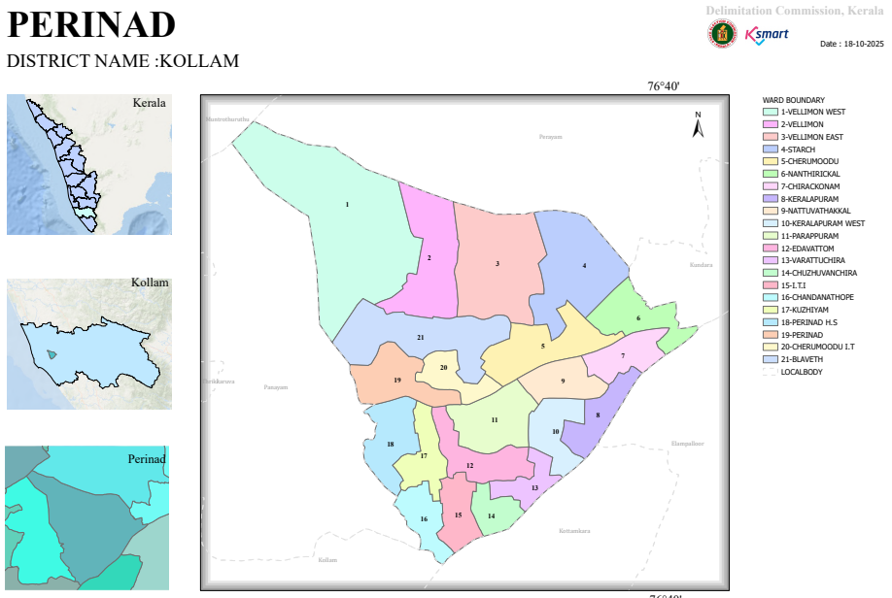

- Health infrastructure map

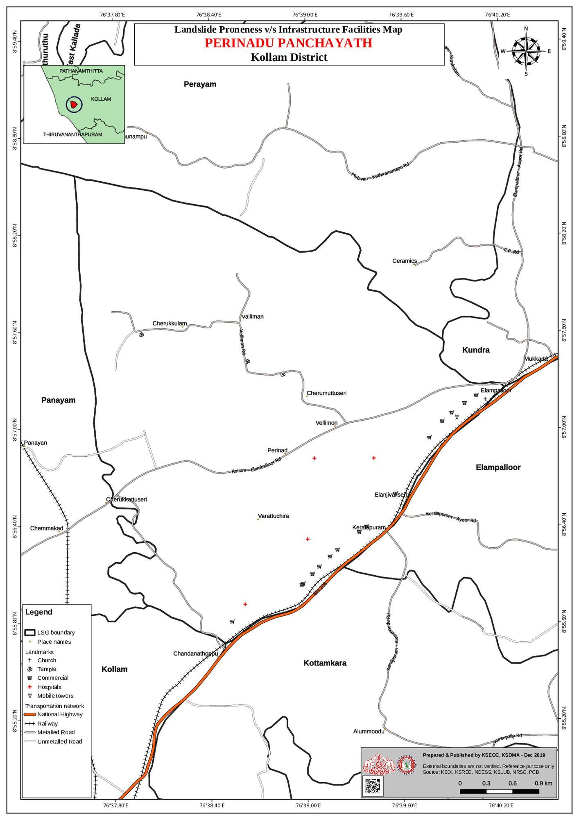

- roads and rivers map

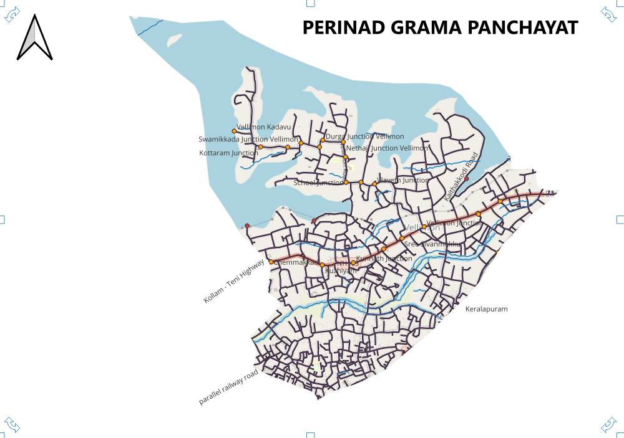
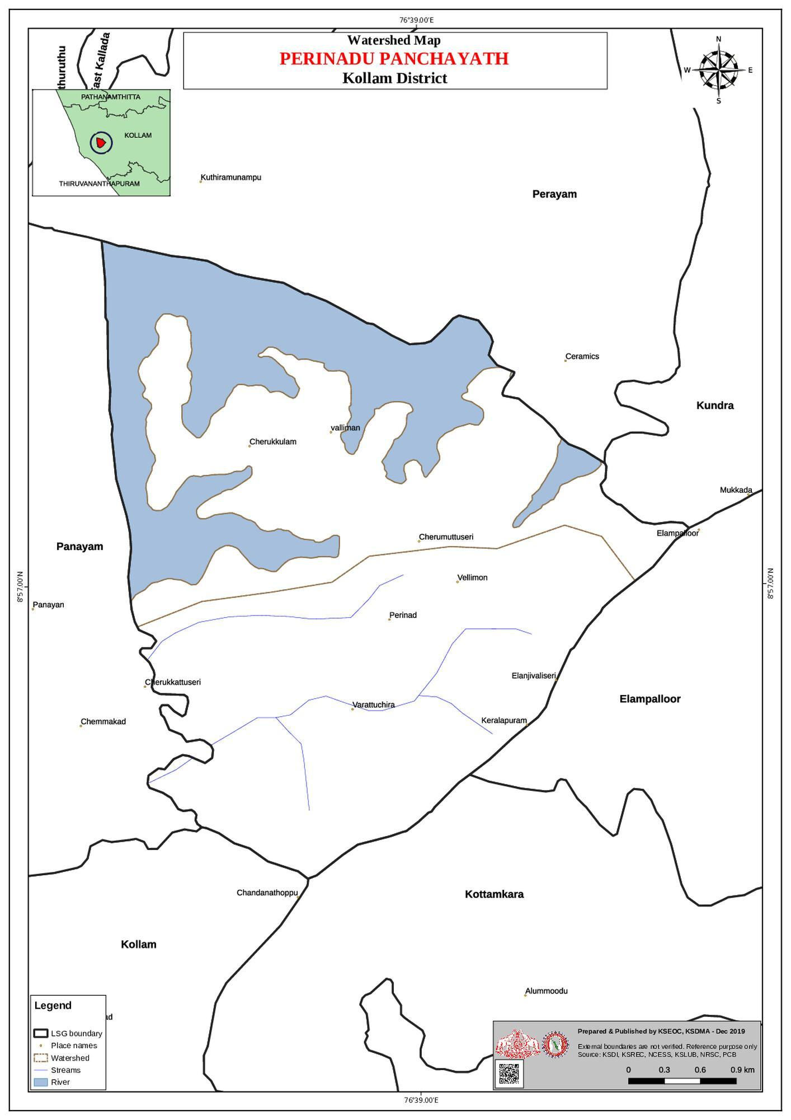

- disaster-prone areas map

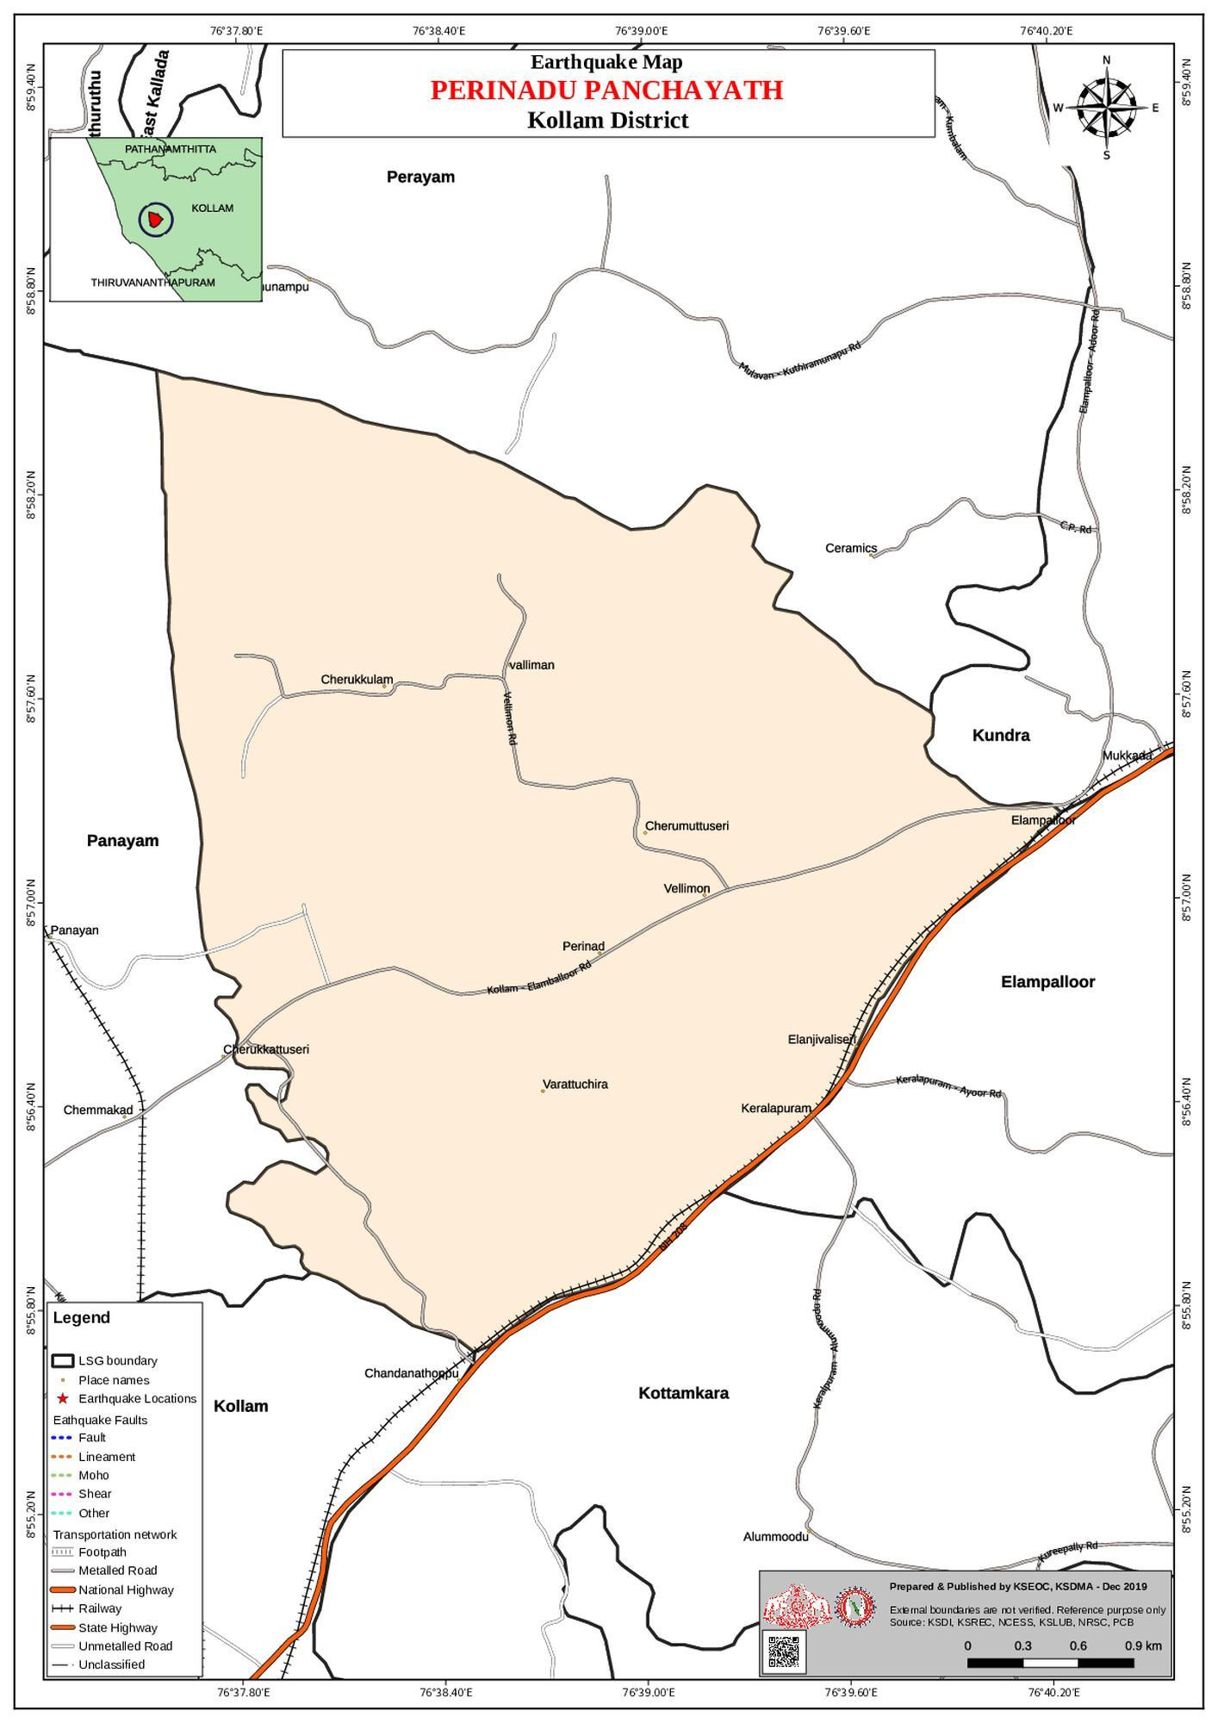

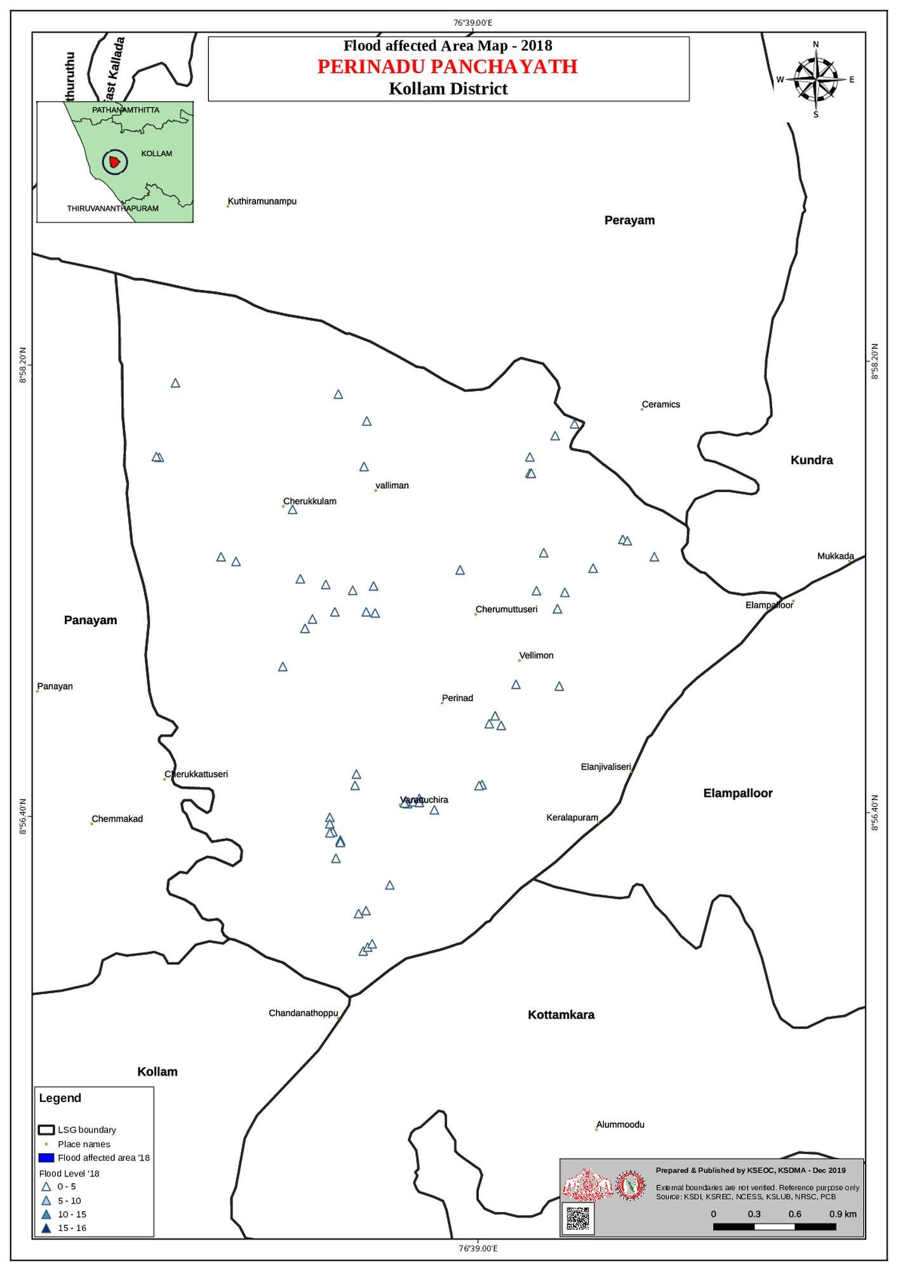

- hotspot map - CD & disasters

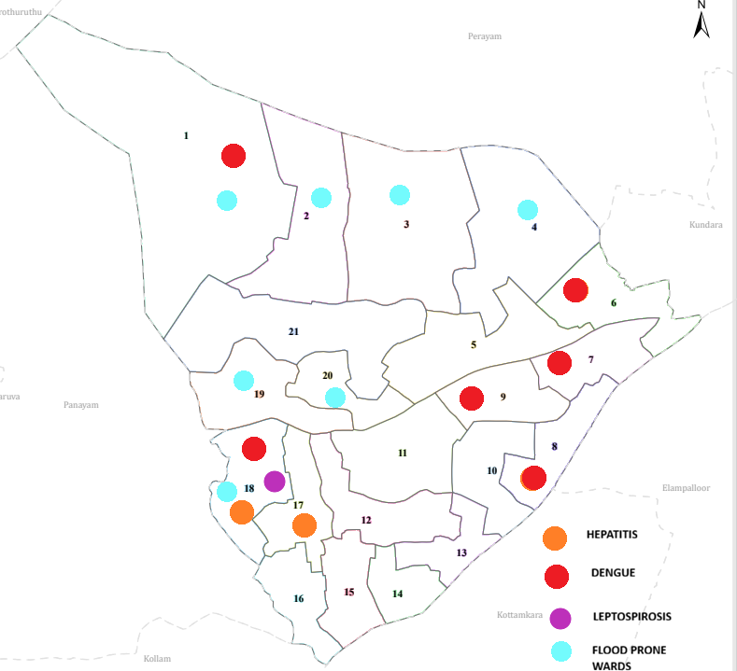

- Transportation Map

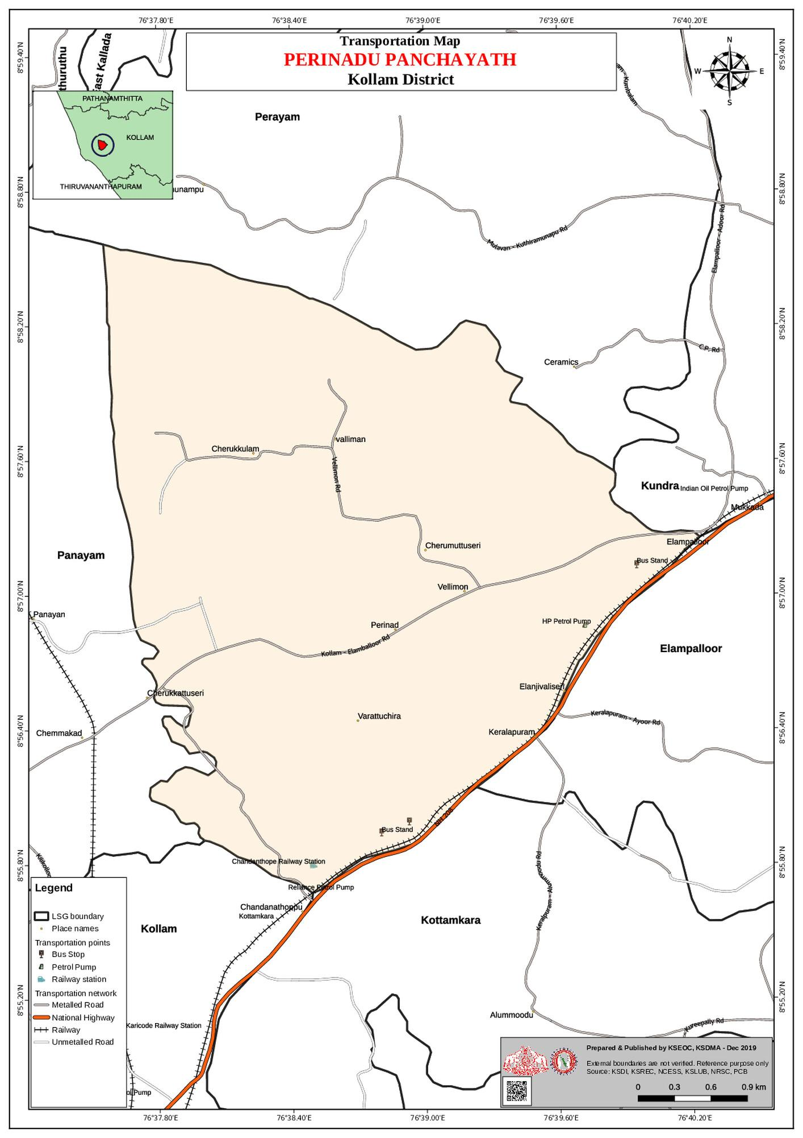

GENERAL PROFILE OF THE LSGI’S

Background of the LSGI

Perinad Grama Panchayat in Kollam district, Kerala, is predominantly a low-lying coastal and backwater region situated along the shores of Ashtamudi Lake. The Panchayat is characterized by extensive paddy fields, wetlands, and a dense network of rivers, canals, and inland waterways. This distinctive geographical setting significantly influences the local microclimate, contributing to high humidity and seasonal waterlogging. While the backwaters enhance the ecological richness and livelihood opportunities of the area, they also create challenges in transportation, emergency mobility, waste management, and public service delivery, particularly during monsoon seasons and flood situations.
Administratively divided into multiple wards, Perinad Grama Panchayat supports a population largely dependent on traditional occupations. Agriculture, especially paddy cultivation in low-lying fields, inland fishing, coir processing, coconut husk retting, and related activities form the backbone of the local economy. Historically, Perinad was an important centre of the coir industry in the Kollam region. In recent years, the Panchayat has witnessed gradual diversification with the growth of educational institutions, small-scale enterprises, tourism-related activities linked to the Ashtamudi backwaters, and service-sector employment. The workforce also includes a significant number of migrant labourers engaged in construction, agriculture, and allied sectors.
From a public health and disaster management perspective, Perinad has demonstrated vulnerability to seasonal flooding, water stagnation, and outbreaks of waterborne and vector-borne diseases such as Dengue and Leptospirosis. The severe floods that affected Kerala in 2018 had a considerable impact on life, livelihoods, housing, and infrastructure within the Panchayat. Recurrent monsoon-related emergencies have highlighted the need for strengthened local preparedness systems, improved drainage and water management strategies, enhanced disease surveillance, and better coordination among health, revenue, irrigation, and local self-government departments.
In this context, the development of a localized, data-driven Auxiliary Infrastructure and Logistical Resource Map is highly relevant for Perinad Grama Panchayat. Such a resource mapping system would enable identification of critical facilities including health institutions, shelters, transportation routes, water sources, vulnerable habitations, and emergency response assets. This would support evidence-based planning, ensure faster and more coordinated emergency response, improve accessibility during disasters, and enhance the long-term resilience and sustainable development of the community.

Table 1: Background of LSGD
Description | Details
Name of LSGI | Perinad
Type (GP/Municipality / Corporation etc.) | Grama Panchayath
Block | Chittumala (revenue) Health- kundara
District | Kollam
Number of wards | 20
Total area (sq. km) | 24.92
Population(Projected) | 38,798
Population density | 1556 persons/sq km
Terrain (coastal/low-lying/backwaters/foothills, etc.) | Coastal
Number of rivers passing through LSGI | 1, Ashtamudi
Number of water bodies in the LSGI | 12 ponds, 1 lake
Number of educational institutions | 22
Factories / small-scale industries | 12
Flood-prone wards | 0
Landslide-prone wards | 0
Death Management and Disposal Facilities (mortuaries/crematorium, including electric) | 1
Auditoriums/Marriage halls/convention centres/community halls | 3

Demographic and Vulnerable Population
Understanding the demographic composition and vulnerable population groups is essential for pandemic preparedness. Children, elderly, economically deprived families, migrant workers, and socially vulnerable groups are at increased risk during public health emergencies due to higher exposure, limited access to services, and dependency on public systems..

Description |  | Details (in numbers)
DEMOGRAPHIC PROFILE
Total population |  | 38798
Male |  | 18751
Female |  | 20047
Transgender |  | 0
Children under 5 |  | 2105
Adolescent |  | 1895
Elderly (>60) |  | 5669
SOCIAL/LIVELIHOOD VULNERABILITY
Previous EPEP family |  | 37
BPL family
Tribal communities |  | 0
Migration | Immigrant | 420
Migration | Emigrant | 325
Socio-economically deprived |  | 76
Fisherfolk |  | 66
SC Community |  | 428
ST Community |  | 1

Graphs: Population pyramid (if possible) for seeing if your LSGI has a high "dependency ratio" (lots of children and elderly compared to working adults).

Clinical Vulnerability
Certain population groups needs priority healthcare & are at higher risk of severe illness, complications, and mortality during pandemics. Patients with chronic diseases, those requiring regular medical care, and individuals with mobility or functional limitations face challenges in accessing timely care during emergencies. Mapping these groups helps in prioritizing continuity of treatment, medicine stock planning, oxygen support, referral transport, and targeted home-based R
Description | Details in numbers
Pregnant women | 240
Lactating mothers | 216
Bedbound patients | 196
Patients under palliative care other than bedbound | 97
Patients on Haemodialysis | 21
Patients on CAPD | 0
Cancer patients (currently on treatment) | 85
Haemophilic patients | 0
Mentally challenged | 6
Differently abled | 58
Diabetic patients | 2875
Hypertensive patients | 2802
TB patients | 9

Major Festivals & Events specific to the LSGI
(with the possibility of a public gathering)

Sl. No. | Name of festival | Month detailing the periodicity
1 | Poojapura Temple | January
2 | Varattuchira Temple | March
3 | Kochu Poojapura | April
5 | Kuzhiyam Devi Temple | February
6 | St. Rithas Reberow Church, Nanthrical | January

INFRASTRUCTURE & RESOURCE INVENTORY

Health Facility Directory & Basic Capacity in the LSGD
This section provides an overview of the healthcare infrastructure available within the LSGD area. It outlines the distribution and basic capacity of health facilities that form the backbone of service delivery during routine times and public health emergencies.

Family Health Centres (FHCs) and Community Health Centres (CHCs) generally function as the first point of contact for the community, providing essential outpatient and inpatient services. General Hospitals (GH) and Medical College Hospitals (MCH), where accessible, serve as the main referral centres for advanced diagnostics, specialist care, and critical services during public health emergencies. This inventory helps identify existing strengths, gaps, and potential surge capacity that can be mobilised during a pandemic or disaster.

Table 5. Health Facility Resource Summary
Sl.no. | Health Facility | Type of Facility (MCH/GH/CHC/FHC/SC etc.) | Contact Number | Total beds | ICU Beds | Oxygen-Supported Beds | No. of Ventilator Support Beds | No. of ambulances
Government Healthcare Facilities
1 | FHC PERINAD | FHC | 0474 2548111 | 2 | 0 | 1 | 0 | 0
Private Healthcare Facilities
1 | KSM HOSPITAL | HOSPITAL | 9037316090 | 4 | 0 | 0 | 0 | 0
YUSH Healthcare Facilities
1 | GOVT.AYURVEDA HOSPITAL | SC | 0474 2704250 | 4 | 0 | 0 | 0 | 0

Private Clinics
Private clinics are an essential part of pandemic preparedness, as they are often the first place people seek care when symptoms begin. In many communities, private clinics manage a significant share of outpatient visits and therefore play a critical role in early case detection, timely referrals, and disease surveillance. Having an up-to-date understanding of where these clinics are located, the services they provide, and how they are linked to the public health system helps ensure that no cases are missed during an outbreak. It also allows health authorities to engage private practitioners more effectively for reporting, risk communication, and coordinated response, strengthening the overall capacity of the health system to manage public health emergencies.

Table 6. Private Clinic Resource Summary
Sl No. | Name of Clinic | Registered (Y/N) | Clinic (General / Speciality) | Speciality (if any) | Address | Contact Number | Diagnostic Facility (Y/N) | Ambulance Linkage (Y/N)
1 | NAS Dentel Clinic | yes | Speciality | Dentel | NAS Speciality Dental Care,Elampalloor | 8281928214 | yes | No
2 | Karthika Nursing Home | No | General | No | Karthika Nursing ,Vellimon | 8281555340 | yes | No

Healthcare Education & Training Institutions
This section tracks the educational infrastructure available, which is vital for human resource planning in the health sector.

Category of Institution | Govt | Private | AYUSH | Total
Medical Colleges | 0 | 0 | 0 | 0
Nursing Colleges | 0 | 0 | 0 | 0
Dental Colleges | 0 | 0 | 0 | 0
Para-medical / Allied Health | 0 | 0 | 0 | 0
Pharmacy Colleges | 0 | 0 | 0 | 0

Specialized Services & Emergency Inventory
This section provides a detailed view of the specialized medical resources available to the community, focusing on emergency response and critical care capabilities. This table tracks the vital assets required for managing severe illnesses and emergencies across Government, Private, and AYUSH sectors.

Item | Govt | Private | AYUSH | Total
Hospital beds | 2 | 4 | 4 | 10
Oxygen-generating systems(Y/N) | yes | 0 | 0 | 1
Oxygen-supported beds(Numbers) | 1 | 0 | 0 | 1
Ventilator-supported beds | 0 | 0 | 0 | 0
ICU beds | 0 | 0 | 0 | 0
Burns units | 0 | 0 | 0 | 0
Blood centres | 0 | 0 | 0 | 0
BLS ambulances | 0 | 0 | 0 | 0
ALS ambulances | 0 | 0 | 0 | 0
Dialysis facilities | 0 | 0 | 0 | 0
Dispensaries | 1 | 1 | 0 | 0
Medical store | 0 | 4 | 0 | 4
Industrial establishments(Medium-scale industries/small-scale industries establishments to whom we can depend in a worst-case scenario) | 0 | 12 | 0 | 12

Oxygen & Diagnostic Capacity
Monitoring oxygen and diagnostic capacity is a critical component of public health preparedness, ensuring that the LSGD can handle both chronic care and sudden surges in respiratory or infectious diseases.
Name of Health Facility | Oxygen-generating System (Y/N) | Backup Oxygen Source (Y/N) | Diagnostic Facilities Available(Y/N)
Name of Health Facility | Oxygen-generating System (Y/N) | Backup Oxygen Source (Y/N) | Lab | USG | X-ray | CT/MRI | RT-PCR
Government Healthcare Facilities
FHC PERINAD | YES | YES | YES | NO | NO | NO | NO
Private Healthcare Facilities
KSM HOSPITAL | YES | No | NO | NO | NO | NO | NO

Diagnostics facility mapping at the LSGI level
The diagnostic capacity of PERINAD G.P represents the "intelligence network" of our healthcare system. The speed and accuracy of disease identification depend entirely on the distribution and technical level of these facilities.

Item | Govt | Private | AYUSH | Total
General labs | 0 | 6 | 0 | 6
Microbiology labs | 0 | 0 | 0 | 0
RT-PCR labs | 0 | 0 | 0 | 0
USG units | 0 | 0 | 0 | 0
CT/MRI units | 0 | 0 | 0 | 0
Research labs | 0 | 0 | 0 | 0
Labs of other departments that can be repurposed | 0 | 0 | 0 | 0

Laboratory Identification & Basic Details
Sl. No. | Name of Laboratory | Ownership (Govt / Private / Academic) | Address | Contact No. | 24×7 Services (Yes/No) | NABL / Govt Approved (Yes/No)
1 | We Care | Private | We Care ,village jn. perinad | 9746209662 | No | No
2 | Life Care | Private | Life Care Vellimon mukku,Perinad | 9539451147 | No | No
3 | Karuna Lab | Private | Karuna Lab,Thundirakkumukku | 9995460617 | No | No

Social and Community Infrastructure for surge plan
This table serves as our logistics and shelter inventory. By mapping these locations, quickly we can identify where to house displaced citizens, where to set up temporary medical clinics, and how to manage the deceased with dignity during a crisis.

Category | Total Count | Ward | Estimated Capacity (Persons) | Contact details
Educational Institutions
Anganwadis | 32 | 21 | 294 | Refer to Annexure 1.9 for all 32 teacher contacts
Schools | 17 | 21 | 4985 | Refer to Annexure 1.7 (Includes GHSS Perinad & VVHS Vellimon)
Colleges | 5 | 21 | 800 | Ward-level coordination via Ward Member (Ward 21)
Healthcare Educational Institutions
Medical colleges (Govt/Private) | 0 | 0 | 0 | NIL
Nursing colleges (Govt/Private) | 0 | 0 | 0 | NIL
Dental colleges (Govt/Private) | 0 | 0 | 0 | NIL
Paramedical institutes (Govt/Private) | 0 | 0 | 0 | NIL
Community Gathering Spaces
Community halls | 1 | 18 | 250 | Ward 18 Member: Dipthi R (6282134470)
Auditoriums | 4 | WARD-6,9,11 | 7500 | Ward 11 Member: Vinod M (9447410553)
Religious buildings | 19 | 21 | 9500 | Coordination via Ward 21 Member: Sreejith K S (9645320038)
Vulnerable Group Support Facility
Destitute homes | 0 | 0 | 0 | NIL
Elderly homes | 1 | 6 | 16 | Ward 6 Member: Babay Agustin (9495351044)
LSGD owned other buildings | 8 | 18 | 40 | Perinad H S (Ward 18)
Mass Fatality Management (MFM) Infrastructure
Mortuary | 0 | 0 | 0 | NIL
Crematorium | 1 | 14 | 65 | Ward 14 Member: Sherina Firoz (9495107462)
*refer annexure 1 for contact details

Human resources
This section focuses on the human capital available within the LSGI. In any emergency—be it a pandemic, flood, or industrial accident—infrastructure is only as effective as the people operating it.

Medical & Clinical Personnel
This table tracks the "Frontline" providers responsible for diagnosis, treatment, and clinical management. Narrative sentence: eg., "Total health workforce: 450 personnel, with 60% in government facilities serving as primary surge capacity." A detailed directory with the contact numbers of all workers is maintained (Annexure in 1).

Cadre | Govt (No.) | Private (No.) | Total
Doctors—Modern Medicine | 3 | 3 | 6
Doctors – AYUSH | 1 | 0 | 1
Doctors – Veterinary | 1 | 0 | 1
Doctors – Dental | 0 | 2 | 2
Nursing officers | 3 | 4 | 7
Lab technicians | 1 | 6 | 7
Optometrist | 0 | 0 | 0
Pharmacists | 2 | 2 | 4
Psychologists | 0 | 0 | 0
Counsellors | 0 | 0 | 0

Public Health & Field-Level Workforce
These individuals are the backbone of surveillance, maternal-child health, and decentralized care.

Cadre | Health services | Municipal common services | Total
HS (Health Supervisors) | 0 | 0 | 0
HI (Health Inspectors) | 1 | 0 | 1
LHS (Lady Health Supervisor) | 0 | 0 | 0
LHI (Lady Health Inspectors) | 0 | 0 | 0
JPHN (Jr Public Health Nurses) | 5 | 0 | 5
JHI (Jr Health Inspectors) | 3 | 0 | 3
MLSP (Mid-Level Service Providers) | 5 | 0 | 5
Palliative Nurses | 1 | 1 | 2
RBSK Nurses | 1 | 0 | 1
PRO | 0 | 0 | 0
Epidemiologist | 0 | 0 | 0
Data Manager | 0 | 0 | 0

Community & Support Cadre
This group represents the surge capacity of the LSGI—people who can be called upon for logistics, rescue, and specialized support.

Cadre | Number
ASHA Workers | 20
AWW (Anganwadi Workers) | 32
Emergency Medical Volunteers (Trained) | 20
Kudumbashree | 243
MNREGS | 900
Purusha Swayam Sahaya Sangham | 2
Ex-Servicemen | 6
Retired Police Officers | 8
NCC/NSS Volunteers | 110
Red Cross volunteers | 60
One Health Community Volunteers | 0
One Health Community Mentors | 0

Community Organizations
This section details the presence of community-based organisations (CBOs), non-governmental organisations (NGOs), faith-based organisations (FBOs), Kudumbashree Self-Help Groups (SHGs), and Ayalkootams within the Local Self-Government Institution (LSGI). These groups enhance grassroots mobilization, resource distribution, and support networks crucial for pandemic response and community resilience.

Category | Total Count
NGOs | 5
Religious based organizations | 20
Foreign based organizations | 1
Sports Club/youth clubs | 14
Kudumbashree SHGs
Ayalkootams | 243
Political organizations | 5
Residential organizations | 0

Administrative & Emergency Services
This section outlines the availability of key non-health emergency support services and infrastructure within the LSGI, which are essential for effective pandemic preparedness and response. These facilities support law enforcement, disaster response, water supply, logistics, mobility, and community-level interventions during public health emergencies.

Category | Total Count | Contact details
Police Stations | 0 | Service provided by Anchalummoodu Police Station: 0474 2707258
Fire & Rescue Stations | 0 | Service provided by Kollam Fire Station: 0474 2742011 or 101
Water Pumping Points | 5 | KWA Pump House Perinad. Contact: 8547638521
Public Distribution System (PDS) | 11 | Coordination via Perinad Rationing Inspector: 0474 2548000

Information regarding resources
The availability of essential transport and support resources plays a quiet but critical role in saving lives. Equipment such as ambulances, mobile mortuaries, amphibian ambulances, and motorized boats ensures that patients, samples, and healthcare teams can move swiftly—even in flooded, remote, or difficult terrains. Heavy vehicles like JCBs, cranes, tractors, and torus lorries support logistics, waste management, emergency infrastructure, and rapid conversion of spaces into care or isolation facilities. Taxis, four-wheel-drive vehicles, and trucks help maintain continuity of essential services, reach vulnerable populations, and support home-based care and supply delivery.

Means of transportation | Total Count
JCB | 5
Crane | 0
Heavy Trucks | 0
Tractor | 2
Ambulances | 4
Mobile mortuaries | 0
Boats | 8
Taxi service | 10
Note: For specific details regarding vehicle owners and contact information, please refer to Annexure [X].

ONE HEALTH & ENVIRONMENTAL SURVEILLANCE
The One Health method integrates environmental, animal, and human health to enable proactive pandemic preparedness. Panchayat-level surveillance needs to be improved in order to detect and treat zoonotic and environmentally generated diseases early. Surveillance is strengthened through systematic assessment of animal populations, veterinary infrastructure, poultry and slaughter facilities, inter-sectoral coordination, and specialised tools like avian influenza seasonality mapping using GIS in previous outbreaks to enable predictive alerts and ward-specific sampling to support effective pandemic preparedness in high-risk areas like Perinad (ward 18)

Animal & Bird Population
Mapping animal and bird populations at the Panchayat level is essential for identifying and prioritising zoonotic disease hazards like rabies, avian influenza (H5N1), leptospirosis, anthrax, and Nipah-like spillover occurrences. Risk classification, targeted surveillance, vaccination planning, and early epidemic detection made feasible by comprehensive population mapping all enhance One Health-based pandemic preparedness.

Category | Item | Estimated Population | Wards
Animal Population | Livestock (Cattle/Goats/Buffalo) | 421/358/205 | 18, 10, 7
Animal Population | Pet Animals (Dogs/Cats) | 101 | All Wards (Residential)
Animal Population | Stray Dog Population | 320 | Markets, Bus Stations, Fish Landing Sites
Animal Population | Pig Farms (Number of heads) | 78 | 10
 | Small Units (Sheep / Goats – clustered) | 12 | 7
Bird Population | Poultry Units (Birds) | 12,450 | 18, 10
Bird Population | Poultry- (FOWL) | 8,200* | 18
Bird Population | Wild/Migratory Birds (Observed) | Observed (Seasonal) | Ponds, Canals, Backwaters
Bird Population | Crow Mortality Events (Reported) | Reported (None Recent) | Monitoring Active

The main risk of zoonotic diseases in Dengue ,Leptospirosis is concentrated in Wards 18 which is explained by the high density of pig farms, cattle congregation areas, and poultry units. The stray dog population in market areas, fish landing sites, bus stations continues to be a substantial problem for rabies surveillance and bite prevention. There is a considerable risk of avian influenza introduction and amplification during November - December due to the seasonal presence of migratory and resident water birds near ponds/ canal / river / backwater / paddy field. Clusters of pig farms and animal shelters vulnerable to flooding further raise the risk of leptospirosis and other zoonoses mediated by the environment, especially during monsoon floods.

Veterinary Infrastructure
Veterinary institutions are a core pillar of One Health surveillance, enabling early zoonotic disease detection through vaccination, investigation of unusual animal illness or deaths, sample collection, and timely outbreak reporting. A well-mapped and responsive veterinary network strengthens coordination with human health and LSGI systems, ensuring rapid response during zoonotic events and pandemics.
Facility Type | Name of Facility | Ownership Govt / Pvt | Location(Ward No) | Contact number
Veterinary Dispensary | Govt.veterinary Hospital,Cherumood | Govt | 5
Veterinary Hospital / Polyclinic | Nill
Private Veterinary Clinics | Nill
Mobile / Emergency Vet Service (incl. night services) | Nill
Pet Homes / Animal Shelters | Nill
Slaughterhouse-linked Veterinary Inspection Unit | Nill

Veterinary Doctors & Workforce
Early detection, diagnosis, reporting, and reaction to animal illness epidemics depend on the availability and accessibility of qualified veterinary specialists. By identifying unusual animal morbidity or mortality promptly, collecting samples promptly, and coordinating efficiently with human health and LSGI systems—especially during zoonotic outbreaks and pandemic-prone situations—a clearly defined veterinary workforce enhances One Health surveillance.

Category | Number Available | Type (Govt/Pvt) | Contact number
Government Veterinary Doctors | 1 | Govt. | 9446346891
Private Veterinary Doctors | Nill
Livestock Inspectors | 1 | Govt.
Para-veterinary Staff / Attenders | 1/1 | Govt.
Contract / On-call Veterinary Support (if any) | Nill

High-Risk Interface Points (Surveillance Sites)
High-risk interface points for zoonotic disease surveillance in Perinad Grama Panchayath include wetland–livestock–human contact zones, backyard poultry farms, cattle sheds near water bodies, fish markets, and areas of high human–animal interaction such as community slaughter points and migratory bird congregation sites. These are the primary surveillance sites where zoonotic spillover risks are elevated.
Type of Habitat | Type of High risk interface | Geographical vulnerability
Wetlands & Backwaters | Ward – 1,2,3,4,18,19,20 | Coastal Area
Backyard Poultry Farms | Nill
Cattle Sheds near Water Bodies | Nill
Fish & Meat Markets | 1 | Ward 19
Community Slaughter Sites | Nill
Migratory Bird Congregation Areas | Nill
Rodent-Infested Grain Storage | Nill

Category | Total Count | Key Locations (wards)
Poultry Farms | 0 | 0
Backyard / Clustered Poultry Units | 10 | Ward -12,8,19,6,5,10
Duck Rearing Units (open water access) | Nill
Slaughterhouses/ Slaughter Points | 1 | Ward -7
Meat/Fish Markets | Nill
Live Bird Sale Points | 2 | Ward -7
Cattle Markets / Weekly Animal Fairs | Nill
Pet Shops / Breeders | 2 | Ward-7
Animal Shelters / Pet Homes | Nill
Waste Disposal Sites near Animal Units | Nill

Environmental Risk Mapping
Environmental risk mapping identifies monsoon/flood hotspots for vector-borne (dengue, chikungunya), water-borne (leptospirosis, diarrhoea), and zoonotic diseases in Kerala's wetlands. Systematic surveillance supports early warnings, targeted interventions, and Panchayat pandemic preparedness.
Waterborne exposure: Flood-prone areas and stagnant water bodies facilitate leptospira survival, raising leptospirosis risk.

Traditional practices: Informal slaughter and fish markets lack standardized hygiene, creating spillover opportunities.

Risk Factor | High-Risk Wards | Key Locations | Risk Level (High/Med/Low)
Flood-prone areas | 1,2,3,4,18,19,20 | Coastal | Med
Water bodies/wetlands | 1,2,3,4,18,19,20 | Coastal | Med
Solid waste accumulation | Nill
Animal waste disposal issues | Nill
Rodent infestation zones | 18,14 | Railway line | Med
Industrial effluent discharge | Nill
Construction sites / abandoned buildings | Nill
Poor drainage/blocked canals | Nill
Drinking water source contamination risk | Nill

Disease Seasonality Mapping
1, Flooding & waterlogging → amplifies leptospirosis, malaria, diarrheal diseases.
·
2, Migratory bird influx (Nov–Feb) → avian influenza risk.

3, Mosquito breeding cycles → vector-borne disease peaks in monsoon.

4, Agricultural practices → close human–animal contact in paddy fields.

Disease | Peak Risk Season | Key Drivers | High-Risk Locations | Surveillance Focus
Avian Influenza | Nill
Leptospirosis | Rainy season | Rodents | Ward 18 | Doxy distribution of high risk people,environmental sanitation,Proper waste management
Dengue/Chikungunya | Rainy season | Mosqueto | Ward 7,18 | Vector study,Source redation,
Acute Diarrheal Diseases | All season | Micro organisms |  | Water &food hygiene
Rabies | All season | Stray dogs | ward 2,4, 14,19 | Stay dog population control measures taken,IDRV Vaccine
Anthrax (rare) | nil

Vulnerability Mapping
Vulnerability mapping pinpoints high-risk populations, occupations, and areas exposed via environment, livelihoods, socio-economics, and poor service access. Paired with environmental/seasonality mapping, it enables risk-based surveillance, targeted actions, and optimal resource use in One Health and pandemic planning.

Vulnerability Factor | High-Risk Wards | Key Groups / Locations | Risk Level
Flood-prone households | nil
Wetland-adjacent communities | nil
Backyard poultry / duck rearing households | 5 | Ward 1,2,3,7,14,10 | Sanitation&hygiene
Livestock-rearing households | nil
Slaughterhouse & meat market workers | nil
Fisherfolk & fish market workers | 26 | Ward 1,2,7,8
Sanitation workers | 1230 | Almost all ward | Sanitation &hygiene,doxcy profilaxis
Daily wage / migrant workers | 313
Elderly & chronically ill populations | 97 | Almost all ward
Pregnant Women | 240
Children (schools, Anganwadi’s) | 3406
Limited access to safe water & sanitation

EPIDEMIOLOGICAL TRENDS (2021–2025)

Disease surveillance is the systematic collection, analysis, and interpretation of health data for planning, implementation, and evaluation of public health practice. This section presents the disease surveillance profile of the LSGI based on routine reporting systems and outbreak investigations to identify priority diseases, seasonal patterns, and emerging public health threats.

Disease Burden among human beings(Last 5 Years)
Analysis of disease-wise data for the last five years helps identify persistent public health problems, emerging diseases, and changes in disease burden. This information supports prioritisation of prevention, preparedness, and response activities at the Panchayat level.

Disease | 2021 | 2022 | 2023 | 2024 | 2025 | Trend(Increasing/Stable/Decreasing)
Dengue | 4 | 17 | 53 | 51 | 23 | Decreasing
Leptospirosis | 2 | 0 | 2 | 1 | 5 | Icreasing
Hepatitis A | 0 | 0 | 1 | 5 | 14 | Increasing
Malaria | 1 | 0 | 0 | 1 | 0 | Decreaseing
Scrub Typhus | 0 | 0 | 0 | 1 | 0 | Decreasing
Typhoid | 0 | 1 | 0 | 3 | 1 | Decreasing
H1N1 | 0 | 0 | 0 | 0 | 0 | -
H3N2 | 0 | 0 | 0 | 0 | 0 | -
ADD | 16 | 86 | 39 | 75 | 39 | Decreasing
Mumps | 0 | 0 | 0 | 1 | 7 | Increasing
Measles | 0 | 0 | 1 | 0 | 0 | Decreasing
Hepatitis B | 0 | 1 | 1 | 5 | 1 | Decreasing
Hepatitis C | 0 | 0 | 0 | 0 | 3 | Increasing
Tuberculosis | 10 | 10 | 14 | 12 | 9 | Decreasing
Leprosy | 1 | 1 | 0 | 0 | 0 | Decreasing
COVID-19 | 0 | 0 | 0 | 0 | 0 | -
The communicable disease profile over the five-year period shows dynamic but largely controllable trends. Dengue cases rose sharply from 2021 to peak in 2023, followed by a steady decline in 2024 and 2025, indicating improved vector control and surveillance measures in recent years. Leptospirosis demonstrates minor fluctuations with a slight rise in 2025, suggesting continued environmental and occupational exposure risks. A notable and consistent increase is seen in Hepatitis A, which escalated significantly by 2025, pointing toward possible sanitation or water quality concerns requiring urgent public health attention. Acute Diarrhoeal Disease (ADD) shows fluctuating but overall declining numbers compared to its 2022 peak, reflecting better awareness and preventive strategies. Emerging increases in Mumps and Hepatitis C in 2025 warrant strengthened immunization review and screening initiatives. Diseases such as Malaria, Scrub Typhus, Measles, Leprosy, and Tuberculosis show an overall decreasing or stable trend, indicating effective control programs. The absence of reported H1N1, H3N2, and COVID-19 cases during this period suggests no active outbreaks locally. Overall, while most vector-borne and communicable diseases are under relative control, the rising trend of Hepatitis A and select infections highlights the need for sustained surveillance, water safety interventions, immunization strengthening, and targeted public health preparedness measures.

*(use the above table data to create the graph/diagram)

Seasonal Trend Analysis
Seasonal analysis helps anticipate surges (e.g. dengue in monsoon, leptospirosis after floods, influenza in cooler months) and plan pre‑emptive vector control, stockpiling of IV fluids, and awareness campaigns at Panchayat level.

DENGUE
Dengue is a major seasonal vector-borne disease strongly associated with rainfall, water stagnation, and increased mosquito breeding during the monsoon period.

Peak: July–November

Dengue – Ward-wise Yearly Distribution (2021–2025)

Ward | Dengue – Ward-wise Yearly Distribution
Ward | 2021 | 2022 | 2023 | 2024 | 2025 | Total
1 | 0 | 1 | 2 | 6 | 1 | 10
2 | 0 | 1 | 0 | 2 | 1 | 4
3 | 0 | 0 | 0 | 1 | 0 | 1
4 | 0 | 0 | 1 | 1 | 0 | 2
5 | 0 | 0 | 1 | 3 | 1 | 5
6 | 0 | 0 | 1 | 4 | 3 | 8
7 | 0 | 1 | 0 | 3 | 4 | 8
8 | 0 | 4 | 1 | 1 | 3 | 9
9 | 0 | 3 | 4 | 8 | 1 | 16
10 | 0 | 0 | 1 | 0 | 0 | 1
11 | 0 | 0 | 0 | 0 | 1 | 1
12 | 0 | 0 | 0 | 2 | 1 | 3
13 | 0 | 0 | 0 | 1 | 1 | 2
14 | 0 | 2 | 0 | 3 | 0 | 3
15 | 0 | 0 | 0 | 3 | 0 | 3
16 | 0 | 0 | 0 | 2 | 0 | 2
17 | 0 | 2 | 1 | 2 | 1 | 6
18 | 0 | 0 | 0 | 4 | 4 | 8
19 | 0 | 1 | 1 | 1 | 1 | 4
20 | 0 | 0 | 0 | 4 | 0 | 4

The ward-wise distribution of Dengue cases over the five-year period shows a clear surge during 2023 and 2024, with minimal or no cases reported in 2021 across all wards. The highest overall burden is observed in Ward 9, reporting the maximum cumulative cases, followed by Wards 1, 8, 6, 7, and 18, indicating clustering of cases in specific pockets of the Panchayat. A marked increase is seen in 2024 across many wards, suggesting either intensified transmission, improved detection, or favorable environmental conditions for vector breeding during that period. In 2025, while several wards show a decline compared to 2024, some areas such as Wards 6, 7, and 18 continue to report relatively higher numbers, indicating persistent vulnerability. Several wards including 3, 10, 11, and 13 have consistently low incidence, suggesting better local control measures or lower exposure risk. Overall, the pattern indicates localized hotspots rather than uniform spread, emphasizing the need for targeted vector control interventions, intensified source reduction activities, and ward-specific surveillance and community awareness programs to sustain the recent declining trend.

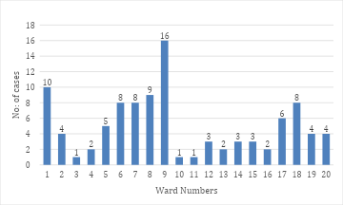

LEPTOSPIROSIS
Leptospirosis cases are closely linked to monsoon rains, flooding, and occupational exposure, particularly in low-lying and waterlogged areas.

Peak: June - August

Leptospirosis – Ward-wise Yearly Distribution (2021–2025)

Ward | Leptospirosis – Ward-wise Yearly Distribution
Ward | 2021 | 2022 | 2023 | 2024 | 2025 | Total
1 | 0 | 0 | 0 | 0 | 0 | 0
2 | 0 | 0 | 0 | 0 | 1 | 1
3 | 0 | 0 | 0 | 0 | 0 | 0
4 | 0 | 0 | 0 | 0 | 0 | 0
5 | 0 | 0 | 0 | 0 | 0 | 0
6 | 0 | 0 | 0 | 0 | 0 | 0
7 | 0 | 0 | 0 | 0 | 0 | 0
8 | 0 | 0 | 0 | 0 | 0 | 0
9 | 0 | 0 | 0 | 0 | 0 | 0
10 | 0 | 0 | 0 | 0 | 0 | 0
11 | 0 | 0 | 0 | 0 | 0 | 0
12 | 0 | 0 | 0 | 0 | 0 | 0
13 | 0 | 0 | 0 | 0 | 0 | 0
14 | 0 | 0 | 0 | 0 | 0 | 0
15 | 0 | 0 | 0 | 0 | 0 | 0
16 | 0 | 0 | 0 | 0 | 1 | 1
17 | 0 | 0 | 0 | 0 | 0 | 0
18 | 0 | 0 | 0 | 0 | 2 | 2
19 | 0 | 0 | 0 | 0 | 1 | 1
20 | 0 | 0 | 0 | 0 | 0 | 0

The ward-wise analysis of Leptospirosis cases over the five-year period indicates an extremely low incidence within the Panchayat, with no reported cases from 2021 to 2024 across all wards. The occurrence of cases is observed only in 2025, and that too in a limited number of wards—specifically Wards 2, 16, 18, and 19. Ward 18 reported the highest number of cases in 2025, while the other affected wards recorded single cases. The absence of cases in the earlier years suggests effective preventive measures, favorable environmental conditions, or low exposure risk during that period. However, the emergence of cases in 2025 may indicate increased occupational exposure, flooding-related risk, or improved surveillance and reporting. Although the overall burden remains minimal and localized, the pattern highlights the need for continued rodent control, public awareness on protective measures during monsoon and agricultural activities, early chemoprophylaxis for high-risk groups, and strengthened surveillance to prevent further spread.

VIRAL HEPATITIS - A
Hepatitis A cases are commonly associated with unsafe drinking water, food contamination, and breakdowns in sanitation, often presenting as clusters or outbreaks.

Peak: October – December
Hepatitis A – Ward-wise Yearly Distribution (2021–2025)

Ward | Hep A – Ward-wise Yearly Distribution
Ward | 2021 | 2022 | 2023 | 2024 | 2025 | TotaPl
1 | 0 | 0 | 0 | 0 | 1 | 1
2 | 0 | 0 | 0 | 1 | 0 | 1
3 | 0 | 0 | 0 | 0 | 0 | 0
4 | 0 | 0 | 0 | 0 | 0 | 0
5 | 0 | 0 | 0 | 0 | 0 | 0
6 | 0 | 0 | 0 | 0 | 0 | 0
7 | 0 | 0 | 0 | 0 | 0 | 0
8 | 0 | 0 | 0 | 0 | 1 | 1
9 | 1 | 0 | 0 | 0 | 0 | 1
10 | 1 | 0 | 0 | 0 | 2 | 3
11 | 0 | 0 | 0 | 0 | 0 | 0
12 | 0 | 0 | 0 | 0 | 0 | 0
13 | 0 | 0 | 0 | 1 | 0 | 1
14 | 0 | 0 | 0 | 0 | 2 | 2
15 | 0 | 0 | 0 | 0 | 0 | 0
16 | 0 | 0 | 0 | 0 | 0 | 0
17 | 0 | 0 | 1 | 0 | 3 | 4
18 | 0 | 0 | 0 | 0 | 4 | 4
19 | 0 | 0 | 0 | 0 | 0 | 0
20 | 0 | 0 | 0 | 0 | 1 | 1

The ward-wise distribution of Hepatitis A over the five-year period shows a clear emerging trend in 2025 after minimal and sporadic cases in earlier years. From 2021 to 2023, only isolated cases were reported in Wards 9, 10, and 17, indicating very low transmission. A slight increase was noted in 2024 in Wards 2 and 13. However, 2025 shows a noticeable rise, with multiple wards reporting cases, particularly Wards 17 and 18, which recorded the highest numbers, followed by Wards 10 and 14. The clustering of cases in specific wards during 2025 suggests possible localized contamination of water sources, sanitation issues, or common-source exposure. Several wards continue to report zero cases, indicating uneven distribution rather than widespread transmission. Overall, the pattern reflects a recent upward trend requiring strengthened water quality surveillance, sanitation measures, food safety monitoring, early case detection, and focused health education interventions in the affected wards to prevent further spread.

Outcome-Based Trend Analysis- 2025

Transmission Trend- 2025
For effective management of public health issues, it is important to track the trend of disease transmission mode. It helps identify the population or place at high risk that can be used to predict outbreaks and implement targeted interventions as quickly as possible. Understanding these kinds of trends enables authorities to allocate resources efficiently and change the strategies adequately based on the trend that follows.

Mode of Transmission | No. of cases | No. of Deaths
Vector Borne Diseases | 24 | 1
Water Borne Diseases | 22 | 2
Air Borne Diseases | 60 | 0
Blood Borne Diseases | 0 | 0
Food Borne Diseases | 39 | 0

Vector-Borne Disease

Disease | No. of Cases | No. of Deaths
Dengue | 23 | 1
Malaria | 1 | 0
Chikungunya | 0 | 0

Water Borne Disease

Disease | No. of Cases | No. of Deaths
Cholera | 0 | 0
Typhoid | 1 | 0
Hep- A | 14 | 0
Dysentery | 0 | 0
Amoebiasis | 0 | 0
E- Coli infections | 0 | 0
Air Borne Disease

Disease | No. of Cases | No. of Deaths
Influenza | 2 | 0
H1N1 | 1 | 0
TB | 9 | 1
Chickenpox | 60 | 0
Measles | 0 | 0
Covid-19 | 0 | 0
Pertussis | 0 | 0
Mumps | 9 | 0

Blood-Borne Disease

Disease | No. of Cases | No. of Deaths
AIDS | 0 | 0
Hep- B | 1 | 0
Hep- C | 1 | 0

Zoonotic Disease

Disease | No. of Cases | No. of Deaths
Rabies | 0 | 0
Leptospirosis | 4 | 1
Avian influenza | 0 | 0
West nile | 0 | 0
Anthrax | 0 | 0
Nipah | 0 | 0
Scrub Typhus | 0 | 0

Integrated Disease Hotspot Map (2021–2025)

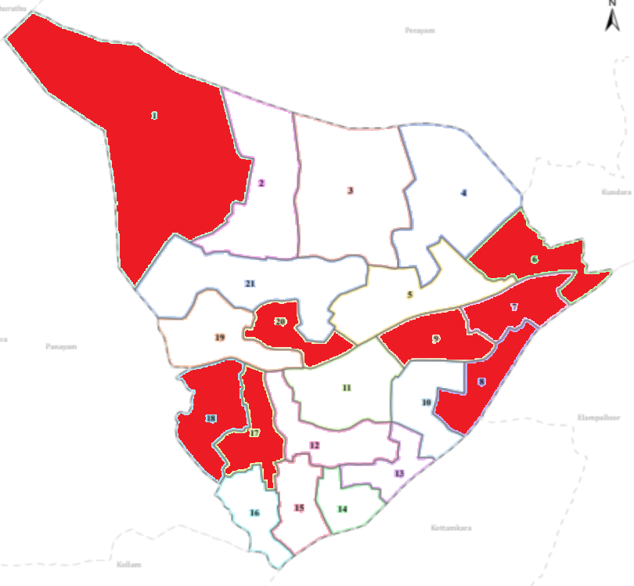

Hotspot wards- 1, 6,7,8,9, 17,18,20

 | Dengue Total (2021-25) | Leptospirosis Total (2021-25) | Hepatitis A Total (2021-25) | Mumps (2021-25) | ADD (2021-25) | Total Cases
1 | 10 | 0 | 1 | 2 | 10 | 23
2 | 4 | 1 | 1 | 0 | 2 | 8
3 | 1 | 0 | 0 | 0 | 1 | 2
4 | 2 | 0 | 0 | 1 | 1 | 4
5 | 5 | 0 | 0 | 1 | 2 | 8
6 | 8 | 0 | 0 | 1 | 3 | 12
7 | 8 | 0 | 0 | 1 | 10 | 19
8 | 9 | 0 | 1 | 0 | 0 | 10
9 | 16 | 0 | 1 | 0 | 0 | 17
10 | 1 | 0 | 3 | 0 | 5 | 9
11 | 1 | 0 | 0 | 0 | 1 | 2
12 | 3 | 0 | 0 | 0 | 1 | 4
13 | 2 | 0 | 1 | 0 | 1 | 4
14 | 3 | 0 | 2 | 0 | 0 | 5
15 | 3 | 0 | 0 | 0 | 1 | 4
16 | 2 | 1 | 0 | 0 | 1 | 4
17 | 6 | 0 | 4 | 0 | 0 | 10
18 | 8 | 2 | 4 | 0 | 2 | 16
19 | 4 | 1 | 0 | 1 | 0 | 6
20 | 4 | 0 | 1 | 1 | 6 | 12

By overlaying five years of communicable disease data, clear spatial clustering and multi-disease vulnerability patterns have emerged within the Panchayat. Wards 1, 2, and 18 can be categorized as “Red Zone” wards, as these areas reported recurring cases from at least two different disease categories over consecutive years. Ward 1 shows a combined burden of Dengue, Hepatitis A, Mumps, and ADD; Ward 2 reflects the presence of Dengue, Leptospirosis, and Hepatitis A; while Ward 18 demonstrates a significant cumulative load including Dengue, Leptospirosis, Hepatitis A, and ADD. The recurrence of both vector-borne and water-borne diseases in these wards indicates environmental vulnerability, possible water stagnation, sanitation gaps, and sustained vector breeding conditions.
Further, Wards 9, 10, 13, 14, 15, 19, and 20 are categorized as “Highest Priority Hotspots.” Ward 9 records the highest cumulative Dengue burden, suggesting persistently high vector density. Ward 10 shows a concentration of Hepatitis A cases along with Dengue and ADD. Wards 13 and 14 reflect repeated water-borne disease occurrence, particularly Hepatitis A. Ward 19 presents a mixed pattern including Dengue, Leptospirosis, and Mumps, while Ward 20 shows combined Dengue, Hepatitis A, Mumps, and a relatively high ADD burden. The consistent reporting of vector-borne and water-borne diseases in these wards suggests the need for intensified entomological surveillance, source reduction, improved drainage systems, and strengthened drinking water quality monitoring.
Overall, the five-year overlay highlights that disease occurrence is not uniformly distributed but concentrated in identifiable clusters. Future public health infrastructure interventions—such as the establishment of R.O. plants, decentralized water purification systems, enhanced waste management units, and strengthened primary health outreach services—should be strategically prioritized in Red Zone and Highest Priority Hotspot wards. Targeted micro-planning, ward-level vector control action plans, continuous water quality testing, and community-based awareness campaigns will be essential to reduce recurrence and improve long-term resilience.

Preparedness and Response Protocol at LSG Level
This section describes the operational framework for the LSGI once a pandemic is declared. It explains how the LSGI and health system will move from routine data collection to active response, using a One Health approach.

Constitution of One Health Committee
The LSGD shall constitute a One Health Committee comprising the LSGI President, Medical Officers (Modern Medicine, AYUSH, and Veterinary), the Health Inspector, and the Veterinary Surgeon.

Objective: The One Health Committee coordinates human, animal, and environmental health to prevent and control pandemics.

Sl No | Name | Designation | Department/Institution | Role in Committee | Contact Number
1 | V Manoj | Panchayat President | LSGD | Chairperson | 9400612960
2 | DR.Treesa leen | Medical Officer (PHC/CHC) | Health Dept | Member Secretary | 9447408462
3 | Dr Zira Rani Kunj | Veterinary Officer | Animal Husbandry | Member | 9446346897
4 | Iswarya | Epidemiologist | Health Dept | Member | 9526210996n
5 | I Abdulsalam | Health Inspector/PHN | Health Dept | Surveillance | 9947817122
6 | Nahas | ASHA Supervisor | Health Dept | Community link | 9747700417
7 | Mary letha | ICDS Supervisor | Social Welfare | Vulnerable groups | 8289963368

Key Responsibilities:
- Review disease surveillance data (human + animal)
- Conduct ward-wise risk assessment and vulnerability mapping
- Approve quarantine/isolation centre locations
- Coordinate with district for resources (PPE, oxygen, ambulances)
- Periodically review health system surge capacity, including beds, oxygen, human resources, and ambulances.
- Approve and monitor risk communication and community engagement strategies, including rumour management.
- Ensure protection and service continuity for vulnerable groups (elderly, persons with disabilities, dialysis patients, coastal populations).
- Conduct quarterly mock drills
- Monitor equity measures for vulnerable groups

Meeting Schedule:
Quarterly (normal times) | Weekly (outbreak alert) | Daily (pandemic phase)

Pandemic Response Workforce
To ensure a coordinated and timely response during a pandemic, a dedicated Pandemic Response Workforce shall be constituted at the LSG level. The workforce will function under the overall supervision of the One Health Committee and in close coordination with the health authorities. Team-based deployment will enable efficient surveillance, case management, quarantine and isolation management, logistics support, and risk communication. Each team shall have a clearly designated team leader, defined roles, and an identified pool of personnel to allow rapid activation, rotation of duties, and continuity of services during prolonged emergencies.

Total Response Workforce Available: 300 persons

Team Name | Composition | Key Responsibilities | Team Leader
Surveillance and Contact Tracing Team | HI, JHI, JPHN, ASHAs and Volunteers | Case detection, contact listing, home visits, reporting | HI
Case Management Team | Doctors, Nurses, MLSP, Palliative Nurses | Patient care & referral | DOCTOR
Quarantine & Isolation Team | LSGD staff, Volunteers | Facility management | JHI
Psychosocial support |  |  | JPHN
  Counsellors, ASHAs, Kudumbashree members
  Mental health support, counselling, stress management
Logistics & supply chain Team | LSGD staff, Storekeepers, Drivers 3 | Supplies & transport [PPE, medicines, oxygen, transport, waste management] | Ward Member
Communication Team | Ward members, Kudumbashree, Youth clubs,  AWW workers and other self help groups | IEC, community meetings, countering misinformation | M.O in charge
Transportation | KSRTC, educational institutional buses | Transport of patients, staff, supplies, emergency mobility | Panchayat Secretary
Media Surveillance | Health Inspectors, IT volunteers, Communication team members | Monitoring news/social media, rumor tracking, reporting misinformation | JHI
Intersectoral coordination and convergence |  | Coordination between departments, resource mobilization, policy implementation | Panchayat President
  Panchayat President, Secretary, Health officials, Police, ICDS, Education dept.
Collaborative surveillance |  | Community-based surveillance, early warning, reporting unusual events | JPHN
  ASHAs, Anganwadi Workers, Teachers, Community volunteers

All teams shall be activated immediately upon outbreak alert or pandemic declaration and shall report daily to the LSG Incident Commander/Medical Officer, with consolidated reporting to the Block PHC. Duty rosters and alternate personnel shall be maintained to ensure uninterrupted services during staff shortages or prolonged response periods. Team composition and numbers may be revised based on the magnitude of the outbreak and availability of human resources.

Activities and Measures before and during Pandemic

PHASE 1 - Alert / Preparation
Surveillance and Reporting-Enhanced syndromic surveillance:
- Data sources for surveillance:
- Event-based triggers (to be monitored and reported):
- Zoonotic and animal health surveillance
- Logistics and Stock Preparedness
  - Identify and empanel local vendors and define emergency procurement mechanisms in accordance with existing LSGD and Health Department norms.
  - Prepare and maintain an essential logistics checklist covering medical supplies, consumables, and support equipment.
  - Pre-identify secure storage locations for emergency stocks and ensure maintenance of stock registers with regular updating.
  - Finalise emergency transport arrangements, including availability of vehicles and identified drivers for rapid deployment during alerts.
  - Designate a Nodal Officer for Logistics to enable prompt decision-making, coordination, and communication during emergencies.
  - Conduct rapid stock verification and ensure availability of minimum buffer stock, including:
- PPE kits –0 numbers
- Pulse oximeters – __0_ numbers
- Hand sanitizers – __0_ litres
- Masks, gloves, disinfectants – not in adequate quantity
Identify critical gaps in logistics and immediately communicate requirements to the Block and District authorities for timely replenishment and support. Monitor expiry dates and stock rotation.

Identification of Quarantine and Isolation Facilities
  - Identify and list suitable buildings for quarantine and isolation (schools, hostels, community halls, etc.).
  - Categorise cases as per the severity and allocate to appropriate facilities (for instance, severe cases to classrooms, mild cases to an assembly hall in case of a school).
  - Facility readiness checklist needed (beds, toilets, ventilation) etc.
  - Find an alternate site if the primary sites are not available or not in use.
  - Identify facility managers and support staff
  - Prepare basic SOPs for:
    - Admission and discharge
    - Food, water, sanitation
    - Infection prevention and waste disposal
  - Ensure availability of basic amenities: water, sanitation, electricity, ventilation, and waste disposal. Prepare a rapid activation plan for these facilities if case numbers increase.

Risk Communication and Community Preparedness
  - Disseminate early warning messages on symptoms, preventive measures, and reporting mechanisms. Display IEC materials both in English and the local language in public places and ensure ward-level awareness.
  - Sensitize elected representatives and community leaders on preparedness measures.
  - Establish a rumour tracking and misinformation response mechanism to identify, verify, and promptly counter false or misleading information.
  - Engage trusted local persons (ward members, ASHA workers, religious leaders, teachers, community volunteers) to communicate official public health messages and reinforce correct practices.
  - Develop and deploy targeted IEC materials for:
    - Schools and educational institutions
    - Markets and commercial areas
    - Work sites and labour settings
  - Conduct community sensitization meetings at the ward level to promote preventive behaviors, address concerns, and strengthen community participation in preparedness and response.

Protection of Vulnerable Groups
Vulnerable populations require priority protection through targeted line-listing, service continuity, and delivery mechanisms.
- Prepare and regularly update line-lists of vulnerable populations, including:
  - Elderly persons living alone
  - Persons with disabilities
  - Pregnant women
  - Migrant workers
  - Dialysis patients
The detailed line-lists shall be maintained as Annexure and updated periodically.

Clinical Dependency Mapping
Develop ward-wise dependency and vulnerability maps to identify households requiring regular support during emergencies. Ensure continuity of essential health services for vulnerable groups, including
- Dialysis services (facility mapping, transport arrangements, and scheduling)
- Continuity of treatment for TB, HIV, and other chronic conditions requiring uninterrupted medication
- Mental health and psychosocial support services
Establish delivery mechanisms for food, essential commodities, and medicines to vulnerable households through coordinated action involving ASHAs, JPHNs, Kudumbashree, volunteers, and local administration.

PHASE 2 - Active Response

Case Identification and Contact Tracing
Case detection and contact tracing activities will be carried out in coordination with the Health authorities, following disease-specific SOPs and IDSP guidelines.
Field Staff Involved
- Health Inspector (HI)
- Junior Health Inspector (JHI)
- Junior Public Health Nurse (JPHN)
- ASHAs and ASHA Supervisors
- Ward-level volunteers and Kudumbashree members (as required)

Screening Checkpoints
Screening checkpoints at high-traffic locations (transport hubs, markets, religious gatherings) for early detection of symptomatic travellers and crowd screening during outbreaks. Potential locations include bus stands, market entry points, and boat jetties, based on local context and risk assessment.
Screening activities will be carried out by trained personnel such as ASHAs, ward members, and volunteers, with support from Health Department staff. Necessary equipment, including non-contact thermometers and appropriate PPE, shall be ensured prior to activation.
Location | Type (Bus stand/Jetty/Market/Railway) | Staff Deployed (ASHAs/Volunteers) | Screening Method | Reporting authority
Bus stand | Transport hub | One JHI  One ASHA  One health Mentors | 1.Swab Collection.  2. Blood smears collection (RDT)  3.Thermal Scanners | Surveillance Nodal Officer in control room
Market entry | Market | One JHI  One ASHA  Male health volunteers | 1.Swab Collection.  2. Blood smears collection (RDT)  3.Thermal Scanners | Surveillance Nodal Officer in control room
Boat jetty | Water transport | One JHI  One ASHA  Male health volunteers | 1.Swab Collection.  2. Blood smears collection (RDT)  3.Thermal Scanners | Surveillance Nodal Officer in control room

Standard Screening Protocol

The screening protocol shall include temperature screening, observation for visible symptoms, and inquiry regarding recent travel or exposure history. Individuals identified as suspects during screening shall be immediately referred to the nearest PHC/FHC for further evaluation, testing, and appropriate action as per prevailing guidelines.

Pandemic Control Room
The Pandemic Control Room (PCR) serves as the central nerve center for real-time coordination, data aggregation, decision support, and communication during outbreaks. It consolidates information from all LSGD teams, health facilities and community sources to enable rapid response decisions.

Control Room Infrastructure and Location
Primary Location: Perinad Panchayath Office.
Backup Location: Community Hall in Perinad G.P.

Health System Control Room Framework
The PCR is organized into seven functional pillars to ensure no aspect of the response is overlooked:

Rapid Response Team (RRT)
  - Provides immediate intervention during emergencies, clusters, and field alerts.​
  - Coordinates urgent actions such as case investigation, contact tracing, isolation, and inter‑facility referrals.

Data Management & Analytics Team
  - Collects, validates, and manages key health system indicators (cases, tests, beds, HR, supplies).​
  - Analyzes data trends, generates projections, and supports evidence‑based decision‑making for local authorities.

Human Resource Deployment Team
  - Allocates healthcare staff efficiently based on workload and need
  - Ensures adequate and equitable workforce distribution across facilities

Laboratory Surveillance Team
  - Oversees diagnostic testing coordination, sample transport, and timely reporting of results.​
  - Monitors lab indicators (testing volume, positivity rate, turnaround time) for early detection of outbreaks

Vaccination Cell (If Required)
  - Plans and executes vaccination campaigns, including micro‑planning and session scheduling.​
  - Tracks coverage, identifies gaps, and coordinates corrective actions with field teams and outreach services.

Infrastructure & Patient Occupancy Team
  - Monitors facility capacity, earmarked beds, oxygen and critical care resources across all linked facilities.​
  - Ensures optimal patient distribution and referral management using updated bed‑status and resource data.
  - BMWM

Communication team
- Logistics and supply chain
- Transportation (interfacility & emergency transport)
- Media surveillance Call centre
- Management of the deceased
- Intersectoral coordination and convergence

Key Control Room Team
The Control Room Team coordinates all pandemic response activities within the LSGD and serves as the single command and communication hub during activation. It integrates information, field actions, logistics, and policy execution across all participating departments and health facilities.

Role | Name | Designation | Contact Number | Responsibility
In-charge/Nodal Officer | Dr Tresa | MO | 9447408462 | Overall coordination, decision-making, and reporting to the District level.
Data Entry Operator | Hashim | Data Manager | 9605309194 | Managing the line list, updating dashboards, and tracking testing results.
Communication Officer | Abdul Salam | HI | 9400553204 | Handling the public helpline, coordinating ambulance dispatch, and contact tracing calls.
Logistics Coordinator | Lissy | LHI | 9447472181 | Logistics management, Buffer Stock

SOP for alert escalation/trigger point with mapping of responsibilities.
Key Points:
- The Control Room shall be staffed with a designated In-charge, data entry personnel, and communication staff with clearly defined roles and shift arrangements.
- It shall maintain updated records on daily monitoring indicators including new cases, persons under active quarantine, and hospital bed occupancy.
- All reports and situation updates shall be shared daily with the Block and District Surveillance Unit.
- The Control Room shall act as a single point of contact for coordination with response teams, health institutions, and other departments.
- Contact details of the Control Room shall be widely communicated to field staff and stakeholders during activation.

Daily Monitoring Indicators
To ensure timely decision-making and effective response, the following key indicators shall be monitored and updated on a daily basis by the Pandemic Control Room:

Epidemiological Indicators:
New cases reported today, Total active cases, Test Positivity Rate (TPR), Case Fatality Rate (CFR)
- Surveillance Indicators:
Persons under home quarantine, High-risk contacts identified, Fever, ILI, SARI or other symptoms (syndromic surges), Travellers (symptomatic or high-risk arrivals),Animal husbandry surveillance (zoonotic alerts, unusual animal deaths, poultry/bird flu signals), Mortality surveillance (excess deaths, unexplained fatalities, verbal autopsy reports)
- Logistics and Infrastructure Indicators:
Hospital / CFLTC beds occupied, Oxygen cylinders/concentrators available, Ambulances on standby
- Alert Findings
The following table outlines category-specific trigger points (red flags) from surveillance indicators and corresponding immediate actions for the Pandemic Control Room. These enable rapid response to alert findings like testing anomalies, positive cases exceeding thresholds, clusters, and WGS reports.

Category | Trigger Pophint (Red Flag) | Immediate Action
Clusters | Geographical or facility-based: 5+ cases linked to one location (office, school, street). | Declare a micro-containment zone; perimeter control and active case finding.
Testing | Sudden drop in testing volume / delay in reporting / unusual testing trends | Review the sample collection process, address lab bottlenecks, deploy additional testing teams, and notify the District Lab.
Lab | Test Positivity rate increases | Increase testing sites in that ward.
Hospital | >80% Oxygen bed occupancy | Activate backup/CFLTC beds.
Travel | Cluster of cases from a single flight/train or high-risk arrival group. | Trace all passengers in adjacent seats; implement mandatory institutional quarantine.
Animal | Mass poultry/wildlife death or unusual sickness | Notify Animal Husbandry, sample the area, and dispatch RRT for environmental sampling and zoonotic check.
Mortality | Sudden spike in home deaths or brought-in-dead (BID) cases | Audit the deaths and Active Case Search drive
Additional investigations like Whole Genome Sequencing (WGS) | Detection of a Variant of Concern (VOC) or Variant of Interest (VOI) | Implement strict micro-containment; update clinical protocols to match variant severity.

Communication of Public Health Information
A Community Communication Hub shall be established to ensure timely, accurate, and consistent dissemination of information during a pandemic. The Hub will function under the coordination of Nodal officers of the control room and act as the nodal point for public communication, risk messaging, and community engagement. It will support dissemination of official advisories, promote preventive behaviors, address rumors and misinformation, and ensure that messages reach all sections of the population through trusted local channels and leaders.

Key communicators
Channel | Responsible Person | Contact
Ward-level announcements | HI | 9400553204
Social media | JHI | 9895364890
Local Cable TV/Radio | JHI, PRO | 9562359829

- All messages disseminated through the Hub shall align with advisories issued by the Health Department and District authorities.
- Community leaders shall be sensitized to support behavior change, reduce stigma, and counter misinformation.
- Special efforts shall be made to reach vulnerable and hard-to-reach populations using locally appropriate communication methods.

Rumor Tracking: A designated volunteer will monitor local social media/WhatsApp groups daily to identify misinformation and issue official clarifications via the Communication Hub.

Coordination with District/State Authorities & Other Organisations
Effective coordination with Block, District, and State authorities is essential to ensure timely reporting, technical guidance, and uninterrupted supply of essential resources during a pandemic. The LSG shall establish clear communication channels, designate responsible officers, and adhere to prescribed reporting timelines to support coordinated public health action and efficient resource mobilisation.

Key Details:
- Nodal Officer for Reporting:
- Contact Number:
Reporting Schedule and Protocols:

To Whom | What to Report | Frequency | Nodal Person
Block PHC | Complete Situation Report (Cases, Quarantine, Beds, Screening, Deaths) | Daily | MO
District IDSP Unit | Outbreaks/Clusters/Unusual Events (>5 cases same ward) | Daily | Epidemiologist, HI
Veterinary Officer | Animal health events/Zoonotic alerts | Weekly | Veterinary staff

Supply Chain Coordination
The LSG shall coordinate closely with Block, District, and State authorities (KMSCL) to ensure uninterrupted availability of essential goods, medical supplies, and logistics during a pandemic. Supply requirements shall be assessed regularly based on case load and communicated promptly to the appropriate authorities for timely replenishment.
Key Points:
- Maintain updated contact details of District and Block nodal officers for health logistics, oxygen supply, ambulances, and essential medicines.
- Submit timely indent requests for PPE, testing kits, medicines, oxygen, and other critical supplies through prescribed channels.
- Monitor stock levels at LSGD facilities, quarantine/isolation centres, and field teams through daily stock registers and dispensing logs to prevent shortages.
- Coordinate with District authorities, Karunya/Neethi medical shops, and local purchase committees for funds allocation and emergency procurement.

- Ensure regular monitoring of dispensing registers at all facilities to track usage, expiry, and pilferage—shortages being a perennial issue requiring proactive weekly audits.

- Activate surge procurement protocols during high caseloads, leveraging local purchase powers under LSGD funds alongside state supplies.

Resource Inventory and Contacts
Resource Category | Source  (District/State/Private) | Contact
PPE Kits/Masks/Gloves | KMSCL | 9496004500
PPE Kits/Masks/Gloves | Local Vendors | 9496004500
Oxygen  Cylinders/Concentrators | KMSCL | 9496004500
Medicines/Antivirals | KMSCL | 9496004500
Medicines/Antivirals | Neethi Shops | 9496004500
Test Kits (RTPCR/Rapid) | KMSCL | 9496004500

Collaboration with NGOs, PPP, and CSR
To augment government efforts during a pandemic, the LSG shall collaborate with NGOs, voluntary organisations, and private sector partners through public–private partnerships and Corporate Social Responsibility (CSR) initiatives, in coordination with District authorities.

Key Points:
- Engage NGOs and community-based organisations for community outreach, awareness, and support to vulnerable populations.
- Leverage CSR support for procurement of medical equipment, PPE, oxygen concentrators, food kits, and sanitation materials, as permitted.
- Ensure all collaborations align with government guidelines and are routed through approved administrative and financial procedures.
- Maintain transparency and documentation for all external support received and utilised.

Interdepartmental Coordination
Coordination among departments during a pandemic shall be ensured through regular review meetings convened by the LSGD President. These meetings will provide a structured platform for sharing situational updates, assessing resource availability, resolving operational gaps, and taking joint decisions to ensure a coordinated and timely response.

Department | Representative | Key Role | Contact
Health (PHC) | Staff Nurse : Anitha | Case management | 8086256146
Veterinary | Veterinary Surgeon: Dr.Zira Rani Kunj | Animal surveillance | 9446346897
ICDS | Supervisor: Mary Latha | Nutrition support | 8289963368
Education | Head Teacher: Sunil Kumar | School coordination | 9495123456
Police | SI: Rajesh Kumar | Containment enforcement | 9495987654
Water Authority | Assistant Engineer: Suresh Babu | Water supply | 9447123456
LSGD Engineering | Overseer: Bindu S | Quarantine infrastructure | 9387456123

PHASE 3 - Surge Capacity
Phase 3 is activated when there is a rapid increase in cases, high test positivity rates, or when existing health facilities and quarantine arrangements approach saturation. The focus of this phase is to expand isolation capacity, augment clinical care services, and mobilise additional resources through district and state support mechanisms.

Conversion of Community Facilities
To manage increased case load, the LSGD shall activate additional isolation facilities by repurposing identified community infrastructure such as community halls, auditoriums, schools, hostels, or other suitable buildings.

Name of facility | Facility Type | No. of Buildings | Ward | Surge Capacity (Beds) | Nodal Person
Perinad Community hall | hall | 1 | 3 | 30 | Head master
UPS Vellimon | School | 1 | 2 | 25 | Head master
VVHS Vellimon | School | 1 | 6 | 20 | Head master
Chinmaya Vidhyalayam | School | 2 | 8 | 30 | Head master
Govt.V V H S S Vellimon | School | 1 | 4 | 20 | Head master
Mount View High School | School | 2 | 5 | 30 | Head master
Peneal Center School | School | 1 | 7 | 20 | Head master
Angel Heart Play School | School | 1 | 5 | 20 | Head master
GHSS Perinad | School | 1 | 3 | 20 | Head master
Govt. L P S Kuzhiyam | School | 1 | 8 | 20 | Head master
Govt. U P S Vellimon | School | 1 | 9 | 20 | Head master
Govt. Welfare L P S Perinad | School | 1 | 10 | 20 | Head master
Infant Jesus | School | 2 | 13 | 25 | Head master
Trinity Lycium | School | 2 | 12 | 25 | Head master

- Recovery and rehabilitation phase
- Recovery
  - Damage & impact assessment
  - Restoration of health services
  - Rehabilitation of affected population
  - Psychosocial & mental health support
  - Disease surveillance during recovery phase
  - Environmental cleanup & sanitation
  - Livelihood restoration
  - Community engagement & confidence building
  - Documentation & after-action review
  - Lessons learned & best practices
  - Health system strengthening
  - Policy revision & preparedness enhancement
  - Research

CONCLUSION

Additional points
- tech support
- relief based commodities
- ham reading operators
- hazard vulnerability mapping
- Kseb & other power source
- HR specific responsibility

RECOMMENDATIONS

Strengthening Healthcare Infrastructure
- Establish a primary health response unit within the Panchayat with trained staff.
- Ensure availability of basic medical supplies (masks, sanitizers, PPE kits, oxygen cylinders).
- Create tie-ups with nearby hospitals in ____Thrikkadavoor________ for emergency referral and transport.

2. Community Awareness & Education
- Conduct regular awareness campaigns on hygiene, vaccination, and preventive measures.
- Use local communication channels (community radio, WhatsApp groups, notice boards) to spread verified information.
- Train volunteers to act as health ambassadors in each ward.

3. Emergency Response & Coordination
- Form a Pandemic Preparedness Committee at Panchayat level including health workers, ward members, and NGOs.
- Develop a clear action plan for lockdowns, quarantine, and distribution of essentials.
- Maintain a database of vulnerable groups (elderly, differently-abled, chronically ill) for targeted support.

4. Supply Chain & Food Security
- Identify and support local suppliers and farmers to ensure uninterrupted food supply.
- Create community kitchens during emergencies to serve vulnerable populations.
- Stockpile essential commodities in Panchayat-run outlets for crisis periods.

5. Digital Preparedness
- Promote digital platforms for telemedicine consultations.
- Use Panchayat’s website/social media for real-time updates on health advisories.
- Encourage online grievance redressal to reduce crowding in offices.

6. Training & Capacity Building
- Organize mock drills for pandemic response in schools, offices, and public spaces.
- Train Panchayat staff and volunteers in first aid, infection control, and crowd management.
- Collaborate with NGOs and health departments for capacity-building workshops.

7. Long-Term Resilience
- Integrate pandemic preparedness into the Panchayat Development Plan.
- Allocate a dedicated budget for health emergencies.
- Encourage community participation in planning and monitoring preparedness measures.

ANNEXURE

IMPORTANT PHONE NUMBERS

Phone numbers and particulars of persons responsible for providing guidance, assistance, and support for pandemic preparedness operations may be provided here in a manner that allows easy reference at a glance. The information recorded here could be exhibited elsewhere at the time of emergencies. LSG institutions shall give special attention to collect and record the above data of persons and institutions who/which are supposed to give technical and co-ordination support to reduce the impact of pandemic.

1.1. Details of grama panchayat/municipality/corporation wards
Sl No. | Name of the Ward | Ward No | Name of the ward Member | Contect No
1 | Vellimon West | 1 | Sunitha Ganardhanan | 9526341659
2 | Vellimon | 2 | Dileep | 9446853883
3 | Vellimon East | 3 | Liji Mol | 9037661905
4 | Starch | 4 | Jancy Antony | 9961490247
5 | Cherumood | 5 | K K Suresh | 9447248334
6 | Nanthrickal | 6 | Babay Agustin | 9495351044
7 | Chirakonam | 7 | Haseena Hisham | 8156903522
8 | Keralapuram | 8 | N Noufiya Nihas | 8891867530
9 | Nattuvathickal | 9 | Jessy Ajayan | 8590189691
10 | Keralapuram West | 10 | V Prasana Kumar | 9895334347
11 | Parapuram | 11 | Vinod M | 9447410553
12 | Edavattom | 12 | Reshmi R | 8606193052
13 | Varattuchira | 13 | Amalendhu | 8593063839
14 | Chuzhuvanchira | 14 | Sherina Firoz | 9495107462
15 | I T I | 15 | V Manoj | 9400612960
16 | Chandanathope | 16 | Radha Sreekumar | 9895332693
17 | Kuzhiyam | 17 | Surendhran pillai | 9847553140
18 | Perinad H S | 18 | Dipthi R | 6282134470
19 | Perinad | 19 | Prasanna Pious | 9747886991
20 | Cherumood I T | 20 | Madathil Suni | 9846709444
21 | Blaveth | 21 | Sreejith K S | 9645320038

1.2. Important offices of grama panchayat/municipality/ corporation
Sl.No | Name of the office | Contact person | Contact number
1. | Village Office | Village Officer | 8547610529
2. | Agriculture Office | Agriculture Officer | 0474 2795082
3. | Animal Husbandry Office | Animal Husbandry Doctor | 9446346897
4. | Police Station | Police Officer | Nill
5. | BSNL Office | Officer | 0474 2552000
6. | Block Office | Officer | 0474 2585024
7. | KSEB Office | Officer | 0474 2702622
8. | Fisheries Office | Officer | Nill
9. | Fire and Rescue | Officer | Nill

1.4. Health Services

Sl. No | Name of the hospital/institution | Location | Phone number
1. | Government hospitals/PHC | FHC Perinad | 0474 2548111
2. | Private hospitals | K S M Hospital Keralapuram | 9037316090
3. | Clinical laboratories | N A S Dental Clinc | 8281928214
4. | Chemist/pharmacy | F H C Perinad | 0474 2548111
5. | Blood donors | Nill
6. | Other language experts (Bihari, Hindi, Bengali,  Asamees ………) | Nill

1.5. Veterinary Services
Sl.No | Name of the Clinic | Name of the  Surgeon/Doctor | Place/location | Phone  number
1 | Govt.Veterinary Hospital | Dr. Zira Rani Kunj | Cherumood | 9446346897

1.6. Helpline numbers
Helpline | Phone number
Police | Nill
Fire and Rescue | Nill
KSEB | 0474 2702622

1.7. Public and Private Schools Contact details

S.No | Name of School | Institution type | Phone number
1 | UPS Vellimon | Aided | 9496297788
2 | VVHS Vellimon | Aided | 9446993594
3 | Chinmaya Vidhyalayam | Private | 8281840836
4 | Govt.V V H S S Vellimon | Govt | 9447334603
5 | Mount View High School | Private | 8281840836
6 | Peneal Center School | Private | 9497537923
7 | Angel Heart Play School | Private | 8139810502
8 | GHSS Perinad | Govt | 8281840836
9 | Govt. L P S Kuzhiyam | Govt | 9447334603
10 | Govt. U P S Vellimon | Govt | 9809349997
11 | Govt. Welfare L P S Perinad | Govt | 8547747538
12 | Infant Jesus | Private | 94977778903
13 | Trinity Lycium | Private | 8547984427
14 | Little Flower LPS Chemmakkad | Aided | 9400472269
15 | LMS LPS Perinad | Govt | 9961359806
16 | Ushas Nursory | Private | 8547747538
17 | Sree Sai Vidhyapeedam | Private | 97442183072

1.9. Anganwadi Contact Details

Ward No | Name of Anganwadi Teachers | AW/No. | Phone number
1 | Rejitha | 14 | 9567026635
2 | Vijaya V | 16 | 9539776010
3 | Prasanna | 12 | 7403673516
3 | Shobha | 10 | 9497620380
3 | Saji Mol | 28 | 8547984427
4 | Leena Kumari | 9 | 9400472269
4 | Seena | 10 | 9961359806
5 | Valsala | 13 | 8547747538
5 | Saraswathi Amma | 5 | 97442183072
20 | Anju Sivan | 26 | 8281840836
18 | Susamma | 19 | 9497537923
11 | VijayaKumari | 6 | 8139810502
16 | Lathika | 25 | 7907818551
12 | Navakumari | 3 | 9495156833
16 | Shalini | 27 | 7736051885
16 | Pushpa | 29 | 9567773485
17 | Shilaja | 18 | 9995518740
17 | Sunitha | 32 | 9895100998
14 | Sreedevi Amma | 20 | 8086608979
13 | Manisha | 21 | 9846903235
13 | Remya Krishnan | 22 | 9895801343
15 | Sreedevi | 24 | 7560949701
6 | kavitha | 8 | 9961780769
19 | Manju | 17 | 9567610784
19 | Sreedevi | 11 | 8129005147
9 | Remadeviamma | 4 | 7994086239
8 | Radhamani | 7 | 8129674271
9 | Sathideviamma | 7 | 8129728688
10 | Libi | 1 | 9645283392
10 | Sajeela | 31 | 9446548932
7 | Nadheera | 30 | 8590722378
7 | Mary Kutty | 2 | 9496847019

1.12. Information regarding resources

Means of transportation | Name of Owner | Phone Number
Heavy Trucks
Tractor
Ambulances
Boats
Taxi service

Annexure 1: LSG Baseline Data Collection Format
A. Baseline data
Sl. No. | Indicator / Field | Baseline Data | Source / Remarks
1 | Name of LSG | Perinad
2 | District | Kollam
3 | Block / Taluk | Kundra
4 | Type of LSG (Gram Panchayat / Municipality / Corporation) | Grama panchayath
5 | Area (sq. km) | 24.92 sq.km
6 | No. of wards | 21
7 | GIS boundary file available | (Yes/No)
8 | Key contact person & phone | Dr.Tresa Leen (9447408562)

B. Demography
Indicator / Field | Baseline Data | Source / Remarks
Total population | 38798 | Baseline
Males | 18751 | Baseline
Females | 20047 | Baseline
Transgender population | 0 | Baseline
Age distribution  (<5, 5–14, 15–59, ≥60) |  | Baseline
No. of households | 9733 | Baseline
Population density (persons/sq.km) | 1556 | Baseline
No. of migrant workers | 313 | Baseline
Major occupational groups | Farmers,Coolie workers, | Baseline

C. Vulnerable Populations & Social Risks
Sl. No. | Indicator / Field | Baseline Data (Value / Description) | Source / Remarks
1 | No. of elderly (≥60) | 5669 | Baseline
2 | No. of persons with disability | 58 | Baseline
3 | No. of bedridden persons | 196 | Baseline
4 | No. of chronic disease cases (DM/HTN/COPD/CKD etc.) | 5698 | Baseline
5 | Pregnant women (current estimate) | 240 | Baseline
6 | Children <5 years | 2105 | Baseline
7 | Tribal population (if any) | 1 | Baseline
8 | Fisherfolk / coastal vulnerable groups (if any) | 66 | Baseline
9 | Urban slums / unnotified settlements (if any) | 0 | Baseline
10 | Homeless population | 0 | Baseline
11 | Orphanages / old age homes (number & capacity) | 0 | Baseline
12 | Hostels / prisons / shelters (number & capacity) | 0 | Baseline
13 | Poverty / BPL estimate |  | Baseline
14 | Food insecurity hotspots | 0 | Baseline
15 | Any history of stigma/discrimination issues (Yes/No) | 0

D. Health System & Service Readiness
Sl. No. | Indicator / Field | Baseline Data (Value / Description) | Source / Remarks
1 | No. of health facilities in LSG (PHC/CHC/TH/DH/Private) | FHC | Baseline
2 | PHC/Family Health Centre details (name, location) | FHC Perinad,Vellimon po Perinad | Baseline
3 | Subcentres / Health & Wellness Centres (number) | 5 | Baseline
4 | Private clinics / hospitals (number) | 1(9037316090) | Baseline
5 | Labs available (public/private) | 6 | Baseline
6 | Availability of ambulance services (Yes/No, number) | 4 | Baseline
7 | Availability of isolation/quarantine facilities (Yes/No, details) | No | Baseline
8 | Cold chain facilities (Yes/No, details) | No | Baseline
9 | Stockpile space available (Yes/No) | Nill | Baseline
10 | PPE / mask / sanitizer availability plan (Yes/No) | No | Baseline
11 | Surveillance staff available (JHI/JPHN/ASHA count) | 28 | Baseline
12 | Existing emergency referral pathways (Yes/No) | No | Baseline

E. Points of Entry & Mobility
Sl. No. | Indicator / Field | Baseline Data (Value / Description) | Source / Remarks
1 | Bus stands / depots (number) | No
2 | Railway stations (number) | No
3 | Boat jetties / fishing harbours (number) | No
4 | Ports / airports nearby (specify distance) | No
5 | Major highways/roads passing through | No
6 | Border crossings (state/district) | No
7 | Major markets / weekly markets | No
8 | Tourism hubs / major event venues | No
9 | Schools/colleges with hostels (number) | No
10 | Factories / large workplaces (number) | No
F. Water, Sanitation & Hygiene (WASH)
Sl. No. | Indicator / Field | Baseline Data (Value / Description) | Source / Remarks
1 | Major drinking water sources (piped / wells / borewells / springs) | Piped,Wells,Bore Wells
2 | No. of public wells | 36
3 | No. of households with piped water connection | 4000
4 | Water quality testing routine (Yes/No) | Yes
5 | Common contamination risks (flooding, salinity, industrial waste) | NA
6 | Open defecation free status (Yes/No) | No
7 | Solid waste management system (Yes/No) | No
8 | Bio-medical waste disposal mechanism (Yes/No) | No
9 | No. of public toilets | No
10 | Handwashing stations in public places (Yes/No) | No
G. Zoonotic Risks & One Health
Sl. No. | Indicator / Field | Baseline Data (Value / Description) | Source / Remarks
1 | Livestock population (cattle/goats/pigs/poultry) – estimates | 236
2 | No. of dairy farms / poultry farms / pig farms | 5
3 | Slaughterhouses / meat shops (number) | 0
4 | Animal markets (Yes/No, details) | No
5 | Veterinary dispensaries (number)
6 | History of zoonotic outbreaks (rabies, leptospirosis, avian flu etc.) | Leptospirosis
7 | Stray dog population management measures (Yes/No) | No
8 | Rodent infestation hotspots (Yes/No) | Yes
9 | Wetlands / waterlogged areas prone to leptospirosis | Yes
10 | Bat roosting areas / caves / fruit orchards (if any) | No
11 | Human-animal interface hotspots (farms near residences) | Yes
H. Climate & Disaster Risks (Pandemic Amplifiers)
Sl. No. | Indicator / Field | Baseline Data (Value / Description) | Source / Remarks
1 | Flood-prone wards (list) | No
2 | Landslide-prone wards (list) | No
3 | Cyclone/sea surge risk (Yes/No) | No
4 | Heatwave risk zones (Yes/No) | No
5 | Waterlogging areas (list) | No
6 | Shelter homes / relief camps (number, capacity) | No
7 | Past disaster displacement history | No
8 | Disruption to water supply/transport common (Yes/No) | No
I. Critical Infrastructure & Logistics
Sl. No. | Indicator / Field | Baseline Data (Value / Description) | Source / Remarks
1 | Schools (number) | 17
2 | Anganwadis (number) | 32
3 | Colleges (number) | 5
4 | Community halls (number) | 1
5 | Places of worship with large gatherings (number) | 0
6 | Large markets / shopping areas (number) | 0
7 | Warehouses / cold storages (number) | 0
8 | Telecom/mobile network coverage gaps (Yes/No) | No
9 | Power outage frequency (high/medium/low) | 0
10 | Availability of generators in key facilities | 0

J. Risk Communication & Community Networks
Sl. No. | Indicator / Field | Baseline Data (Value / Description) | Source / Remarks
1 | Ward-level rapid response teams (Yes/No) | Yes
2 | Jagratha samithis / committees active (Yes/No) | Yes
3 | Kudumbashree presence and strength (number of units) | Yes(20)
4 | Volunteer network (number, coverage) | Yes
5 | Community-based surveillance mechanisms (Yes/No) | Yes
6 | IEC dissemination channels (WhatsApp groups, community radio, PA systems) | Yes
7 | Rumour tracking mechanisms (Yes/No) | No
8 | Languages spoken / literacy considerations | No
9 | Vulnerable groups communication strategy available (Yes/No) | Yes

K. Preparedness Planning & Governance
Sl. No. | Indicator / Field | Baseline Data (Value / Description) | Source / Remarks
1 | LSG emergency plan available (Yes/No) | No
2 | Pandemic preparedness plan available (Yes/No) | Yes
3 | Incident Command System identified (Yes/No) | No
4 | Rapid procurement mechanism available (Yes/No) | No
5 | Emergency fund available (Yes/No, amount) | No
6 | Past outbreak response experience (Yes/No, details) | No
7 | Intersectoral coordination mechanism (Health, Police, LSG, Veterinary, Education) | Yes
8 | Mock drills conducted in last 12 months (Yes/No) | Yes
9 | Training coverage for staff/volunteers (Yes/No) | Yes

L. Surveillance & Data Systems
Sl. No. | Indicator / Field | Baseline Data (Value / Description) | Source / Remarks
1 | Digital reporting tools used (e.g., DHIS2, portals) | Yes
2 | Availability of line-listing format (Yes/No) | Yes
3 | Contact tracing team identified (Yes/No) | No
4 | Mapping of high-risk households available (Yes/No) | Yes
5 | Testing sample transport mechanism (Yes/No) | No
6 | Reporting timeline adherence (good/average/poor) | Average
7 | Data sharing between departments (Yes/No) | No
8 | Availability of dashboard for monitoring (Yes/No) | No

M. Additional Notes & Observations
Sl. No. | Indicator / Field | Baseline Data (Value / Description) | Source / Remarks
1 | Key challenges perceived by LSG | Water Scarcity,Back Water Wetlands,Vector Density.
2 | Top 5 high-risk wards (reason) | 1,2,9,18(water scarcity,vector density
3 | Any unique local risks (industrial pollution, refugee camps, etc.) | No
4 | Recommendations for preparedness strengthening | Health Education,IEC about Sanitation& hygenie

