PERUMON
PANDEMIC PREPAREDNESS PLAN

Iswarya S
[Email address]

MESSAGE FROM PRESIDENT/CHAIR LSGI
Vineetha Vijayan
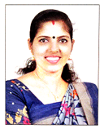
On behalf of the elected members and the people of Panayam Grama Panchayat, I am honoured to present this Pandemic Preparedness Plan as a testament to our collective resolve to protect the health and wellbeing of every resident of our panchayat.
Panayam is a panchayat of hardworking people — farmers, labourers, small traders, and families who have built their lives on the fertile midland terrain of Kollam district. It is our duty as elected representatives to ensure that the institutions of governance stand firmly beside these communities in times of crisis. The lessons of the COVID-19 pandemic, the Nipah outbreaks, and the annual burden of leptospirosis and flood-related diseases have taught us that preparedness is not a luxury — it is governance.
This plan has been prepared in close collaboration with the health department, our ASHAs, ward members, and local stakeholders. It reflects the specific vulnerabilities of our panchayat — our paddy fields, our dependence on surface water, our monsoon exposure — and proposes practical, locally grounded solutions. As Panchayat President, I commit that the resources, infrastructure, and political will of Panayam Grama Panchayat will be fully deployed in support of this preparedness framework. I urge every ward member and every citizen to embrace this plan as their own, for a healthy Panayam.

MESSAGE FROM HEALTH STANDING COMMITTEE CHAIR
Thankachi
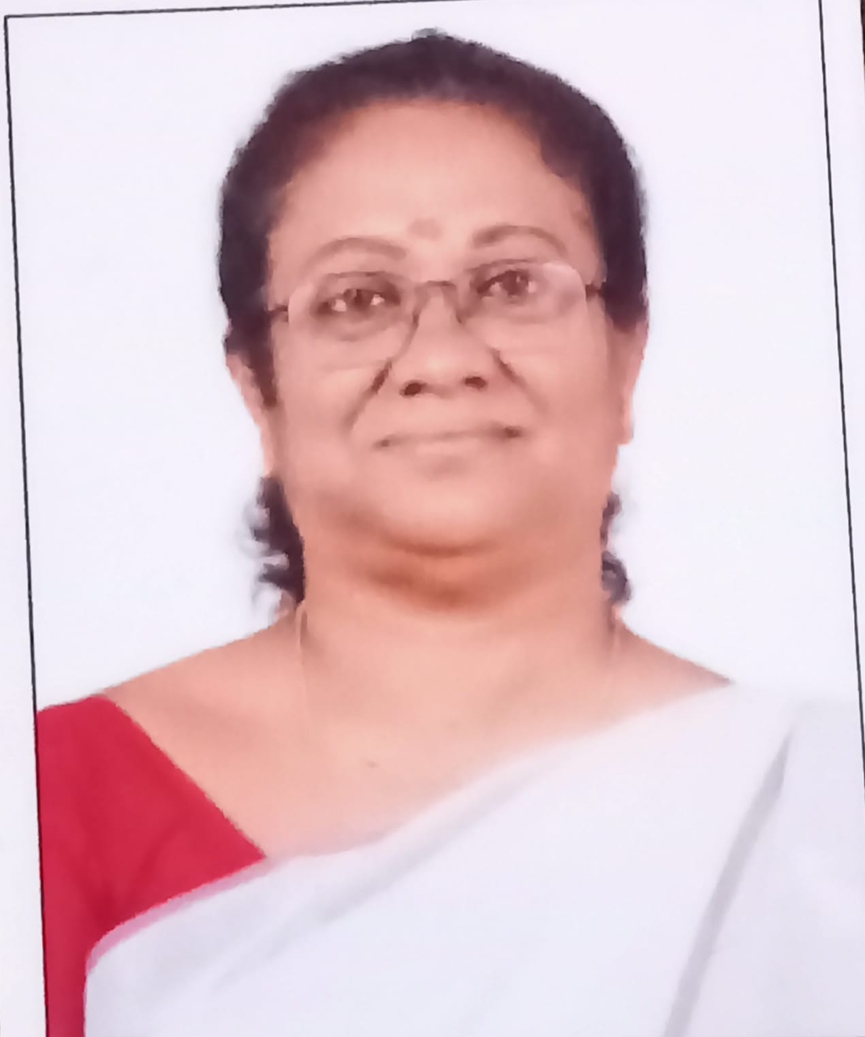
The Health Standing Committee of Panayam Grama Panchayat takes great pride in being an active partner in the development of this Pandemic Preparedness Plan. Health governance at the panchayat level is the most immediate and consequential expression of decentralised democracy, and it is through bodies like this Standing Committee that the aspirations of our residents for safe, healthy, and dignified lives are translated into institutional action.
Panayam's health landscape carries specific challenges that this document addresses with clarity and purpose. Our agricultural workforce, particularly those engaged in paddy cultivation and farm labour, faces seasonal and occupational health risks that demand proactive institutional response rather than reactive crisis management. The Health Standing Committee has consistently advocated for greater investment in preventive health infrastructure — clean drinking water, sanitation, vector control, and awareness — and this preparedness plan is the fullest expression of that advocacy.
I extend my sincere appreciation to the Medical Officer and the dedicated health team of PHC Panayam, the ASHAs, and all stakeholders who contributed to the preparation of this document. The Standing Committee reaffirms its commitment to actively monitor the implementation of this plan, ensure adequate local body resource allocation, and serve as the bridge between the community and the health system. Together, we will ensure that no resident of Panayam is left unprotected in the face of a public health emergency.

MESSAGE BY MEDICAL OFFICER
Dr Anu J Prakash

It is with a deep sense of professional commitment and public responsibility that I present the Pandemic Preparedness Plan for Panayam Grama Panchayat. The COVID-19 pandemic was a sobering reminder that no community, however small or remote, is immune to the devastation of infectious disease outbreaks. As the Medical Officer of PHC Perumon, I have witnessed firsthand the vulnerability of our agrarian community — particularly our farm workers and daily-wage labourers — to communicable diseases that flourish in the monsoon environment that defines our panchayat's landscape.

This preparedness plan is not merely a document; it is a commitment from the health system to our community. It charts a clear course of action for early detection, rapid response, and systematic containment of outbreaks before they overwhelm our resources. It identifies our most vulnerable populations — children under five, the elderly, and occupationally exposed agricultural workers — and places them at the centre of our prevention strategy.

I call upon every resident, every ASHA worker, every anganwadi teacher, and every elected representative of Perumon to consider themselves active partners in this effort. Health is not the responsibility of the medical system alone. It is a shared social contract. I am confident that with coordinated action, community vigilance, and institutional preparedness, Perumon Panchayat will stand resilient in the face of any future public health emergency.

EXECUTIVE SUMMARY

Primary Health Centre (PHC) functions as the primary public healthcare institution serving the population of …Panayam….. Grama Panchayat. The PHC plays a pivotal role in delivering comprehensive, accessible, and affordable healthcare services, with a strong focus on preventive, promotive, curative, and rehabilitative care in accordance with national and state health programmes.
The PHC caters to a predominantly rural population, addressing key public health priorities such as maternal and child health, communicable and non-communicable disease control, immunization, family welfare, adolescent health, and geriatric care. Regular outpatient services, home-based care through field health staff, and outreach activities ensure healthcare coverage even in geographically challenging areas. The institution actively implements national health missions, including the National Health Mission (NHM), National Tuberculosis Elimination Programme, National Programme for Prevention and Control of Cancer, Diabetes, Cardiovascular Diseases and Stroke (NPCDCS), and other disease surveillance initiatives.
Perumon PHC works in close coordination with the Grama Panchayat, ASHA workers, Anganwadi centres, schools, and community-based organizations to strengthen community participation and improve health awareness. Emphasis is placed on early detection, timely referral, health education, and lifestyle modification to reduce disease burden and improve overall health outcomes.
Despite constraints related to infrastructure, manpower, and increasing service demand, the PHC continues to enhance service delivery through effective planning, data-driven decision-making, and community engagement. Strengthening facilities, upgrading digital health systems, and expanding preventive services remain key focus areas for future development.
Overall, Perumon Primary Health Centre stands as a vital institution in safeguarding public health and improving the quality of life of the residents of Panayam Grama Panchayat

LIST OF ABBREVIATIONS

LSGD/LSGI | Local Self Government Department / Local Self Government Institution
BMO | Block Medical Officer
IDSP | Integrated Disease Surveillance Programme
NDMA | National Disaster Management Authority
PPE | Personal Protective Equipment
ICMR | Indian Council of Medical Research
CD | Communicable Diseases
NCD | Non-Communicable Diseases

TABLE OF CONTENTS

3
INTRODUCTION 9
● Background of the PPP 9
LSGD AT A GLANCE 9
INTEGRATED HEALTH INFRASTRUCTURE MAP OF PANAYAM PANCHAYAT 10
GENERAL PROFILE OF THE LSGI’S 13
Background of the LSGI 13
Demographic and Vulnerable Population 14
Clinical Vulnerability 16
INFRASTRUCTURE & RESOURCE INVENTORY 18
Health Facility Directory & Basic Capacity in the LSGD 18
Private Clinics 19
Healthcare Education & Training Institutions 20
Specialized Services & Emergency Inventory 20
Oxygen & Diagnostic Capacity 21
Diagnostics facility mapping at the LSGI level 22
Laboratory Identification & Basic Details 22
Social and Community Infrastructure for surge plan 22
Human resources 24
Community & Support Cadre 25
Community Organizations 26
Administrative & Emergency Services 27
Information regarding resources 27
ONE HEALTH & ENVIRONMENTAL SURVEILLANCE 28
Animal & Bird Population 28
Veterinary Infrastructure 29
Veterinary Doctors & Workforce 30
High-Risk Interface Points (Surveillance Sites) 30
Environmental Risk Mapping 31
Disease Seasonality Mapping 32
Vulnerability Mapping 33
EPIDEMIOLOGICAL TRENDS (2021–2025) 34
Disease Burden among human beings(Last 5 Years) 34
*(use the above table data to create the graph/diagram) 36
Seasonal Trend Analysis 37
Outcome-Based Trend Analysis- 2025 39
Transmission Trend- 2025 40
Integrated Disease Hotspot Map (2021–2025) 42
Preparedness and Response Protocol at LSG Level 44
Constitution of One Health Committee 44
Pandemic Response Workforce 45
Activities and Measures before and during Pandemic 47
PHASE 1 - Alert / Preparation 47
PHASE 2 - Active Response 50
Standard Screening Protocol 51
PHASE 3 - Surge Capacity 60
Conversion of Community Facilities 60
CONCLUSION 61
RECOMMENDATIONS 62
ANNEXURE 63
1. IMPORTANT PHONE NUMBERS 63

INTRODUCTION

Background of the PPP
- LSGD at a glance

LSGD AT A GLANCE
- Geographical boundaries with political map ( based on latest delimitation)
- Baseline data
- Ward division -
Ward | Houses | Population | Migrants | Wells | Hot  spots | Ed. Institutions | Hosp pvt/govt.
18 | 7771 | 30057 | 140 | 6775 | 10 | 12 | 6 / 3

- Risk stratification among wards in the context of Communicable diseases and hazards
- Major Roads/rivers
- Major establishments with geospatial mapping
- occupational groups, socio cultural groups, migration & mobility patterns
- Vulnerability mapping
- Disaster prone areas (geographic vulnerability)

Maps - ward-based (Mention source also)

- Geographical boundaries - ward boundaries map

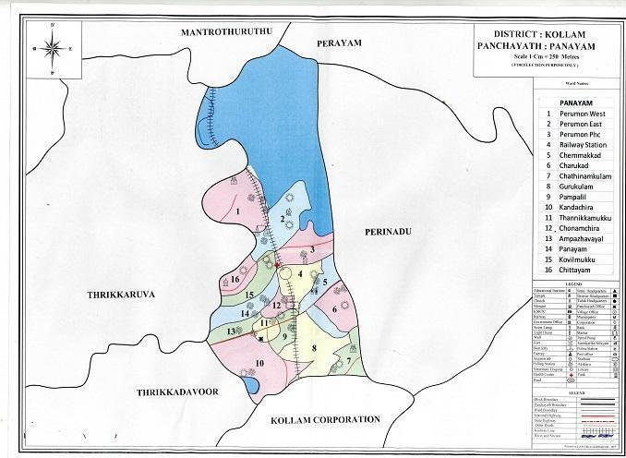

- Health infrastructure map

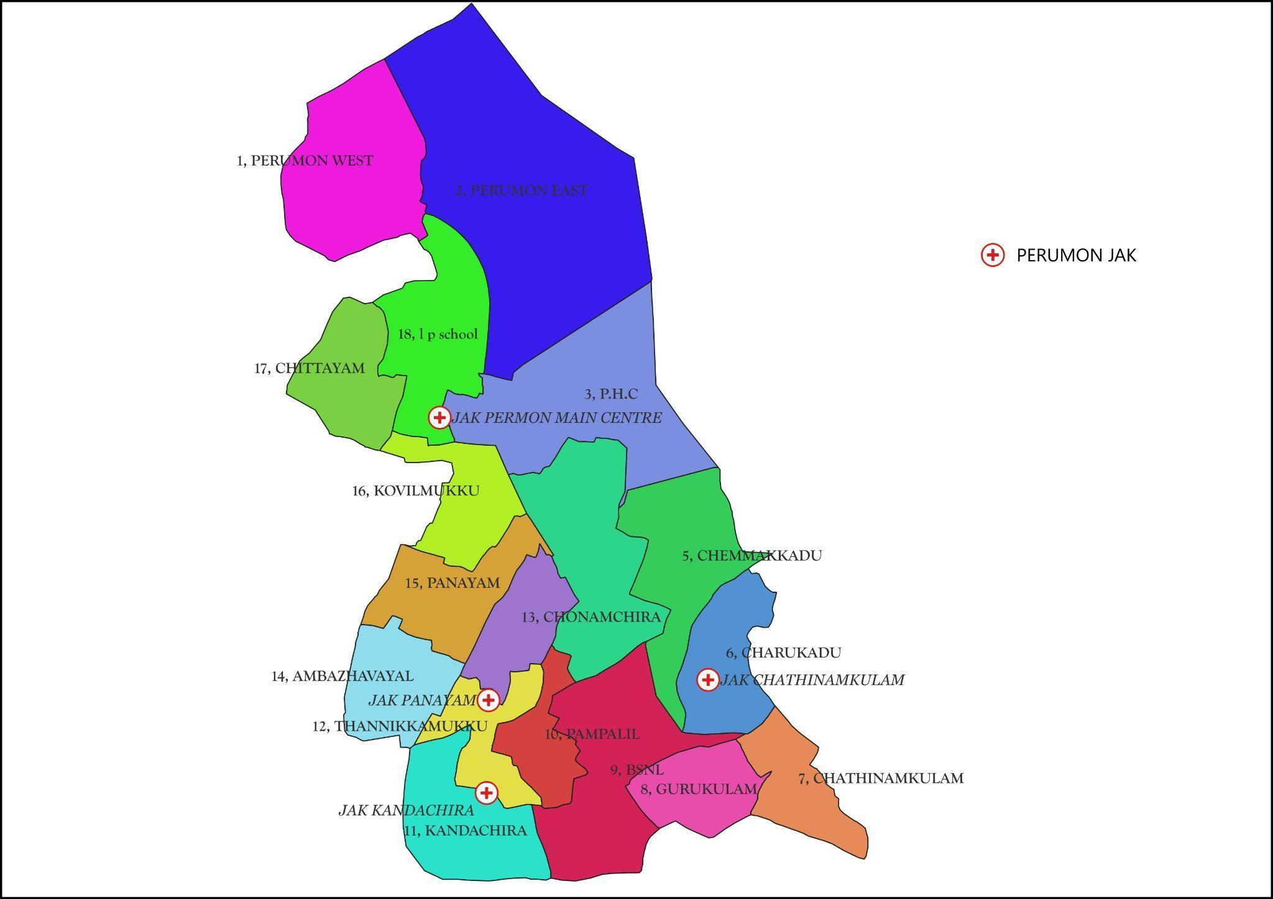

- roads and rivers map

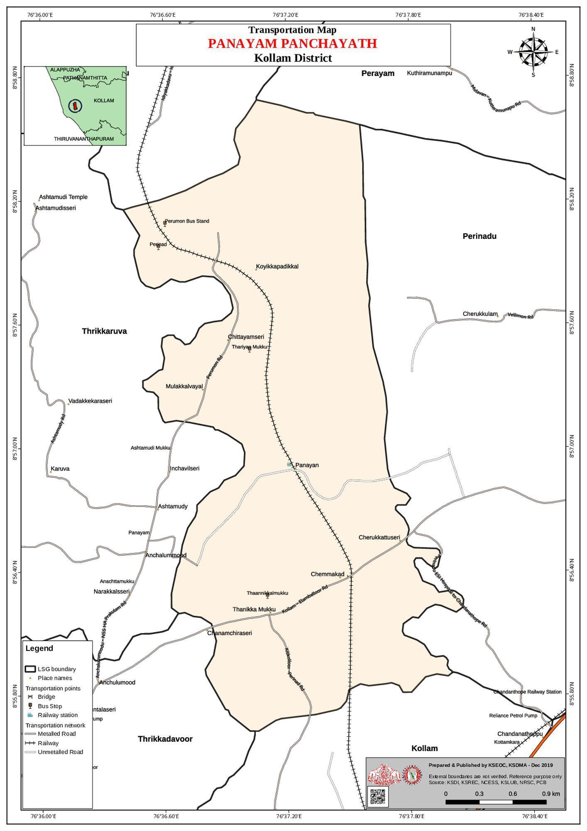

- major establishments map

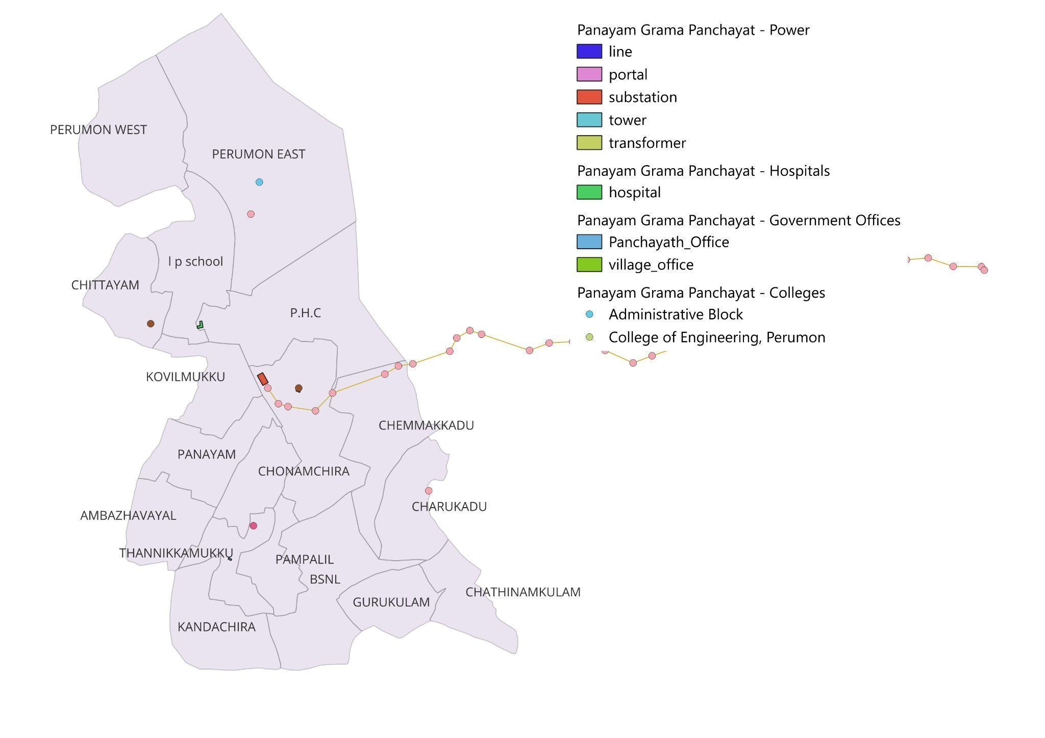

- disaster-prone areas map

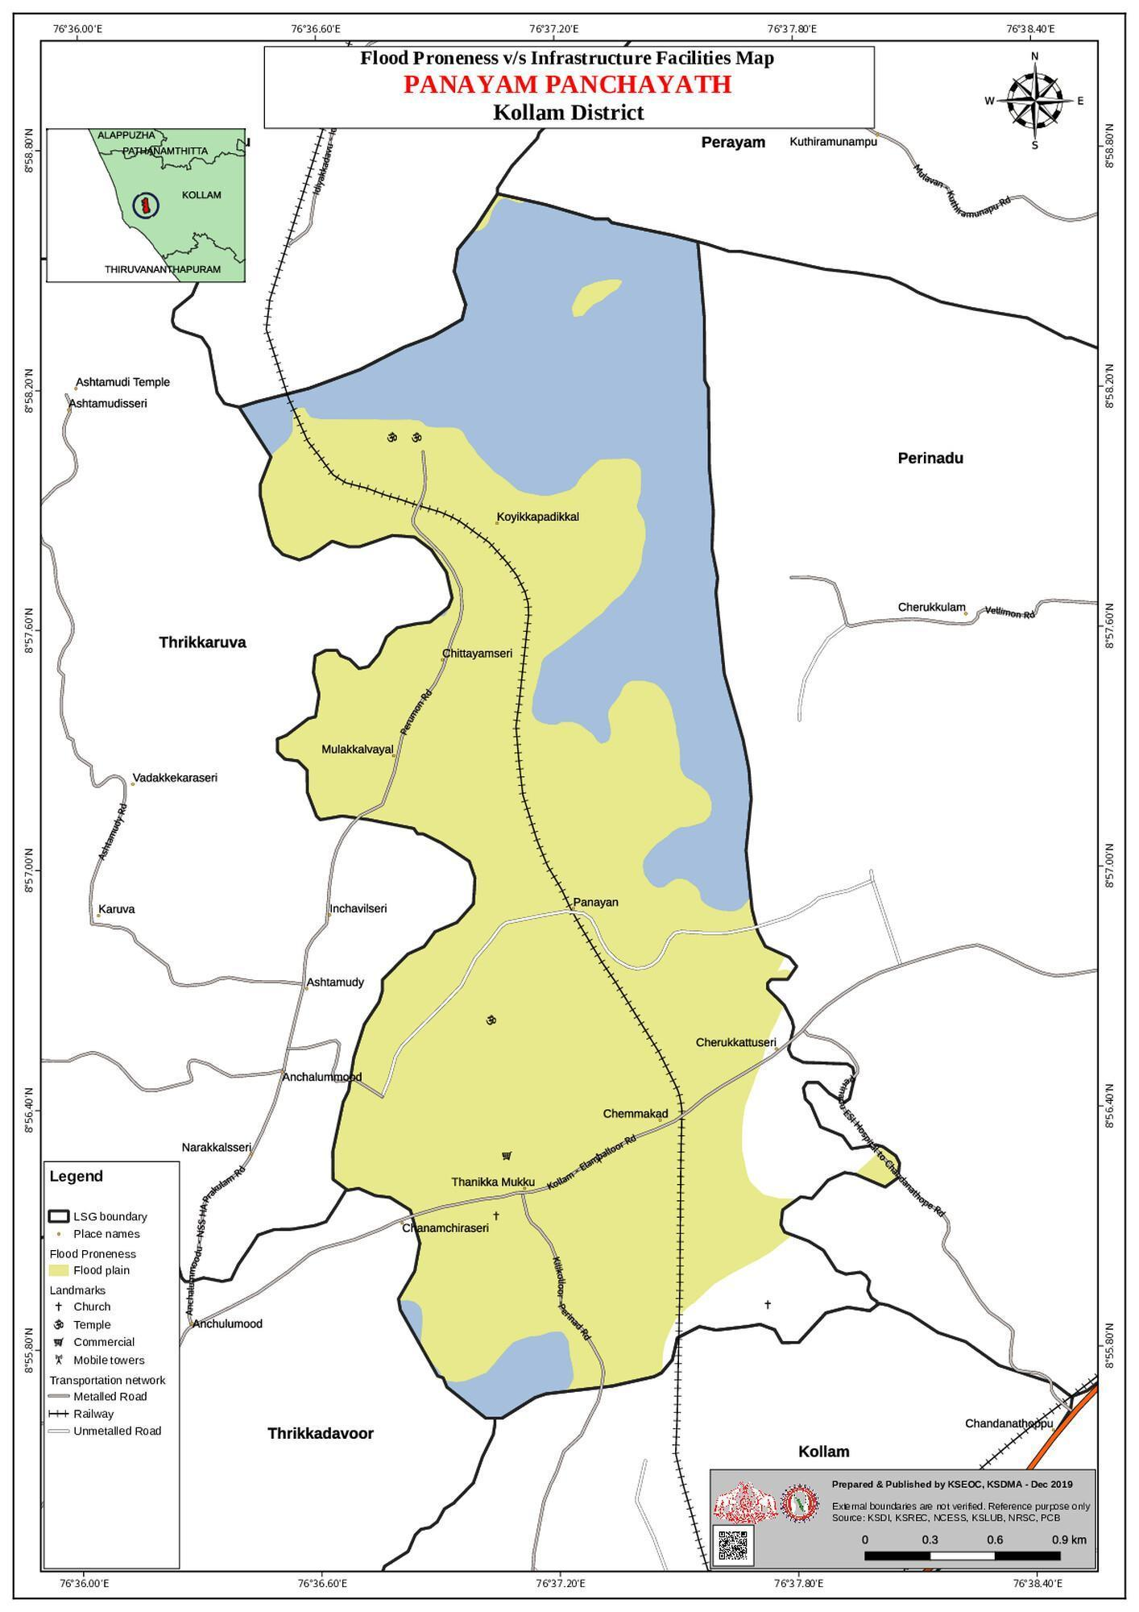

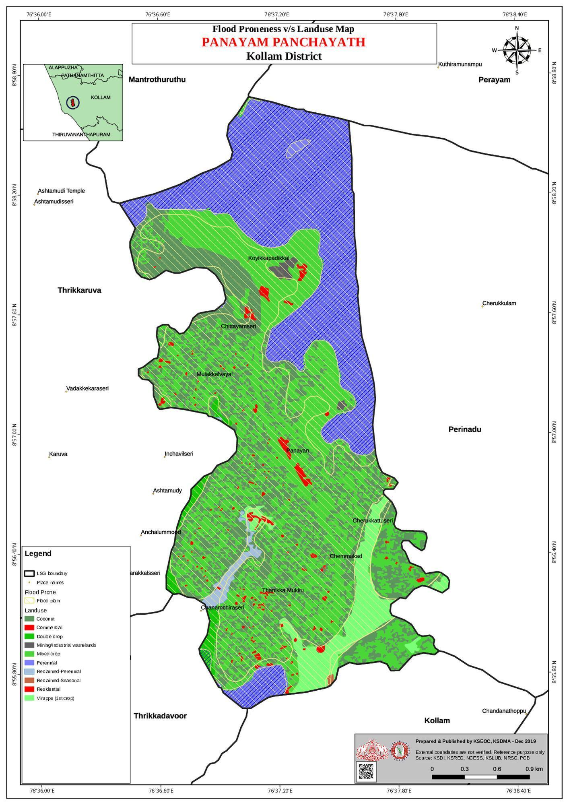

- hotspot map - CD & disasters
Sl No | Ward | Hotspot | Disease
1 | 2 | Lower sector of Perumon UP school area | Dengue
2 | 3 | Varattuchira Colony, | Dengue
3 | 3 | Pulluvala colony | Dengue
4 | 5 | Chemmankkadavu AKG Area | Dengue
5 | 5 | Chemmankkadavu Vayal area | Dengue
6 | 6 | Charukkadavu Vayal Area | Dengue
7 | 10 | Panayil Kaayal Varam | Dengue
8 | 10 | Mathruchaya Vayal area | Dengue
9 | 12 | Chonamchira South and North Vayal Area | Dengue
10 | 13 | Velikattu Temple Area | Dengue

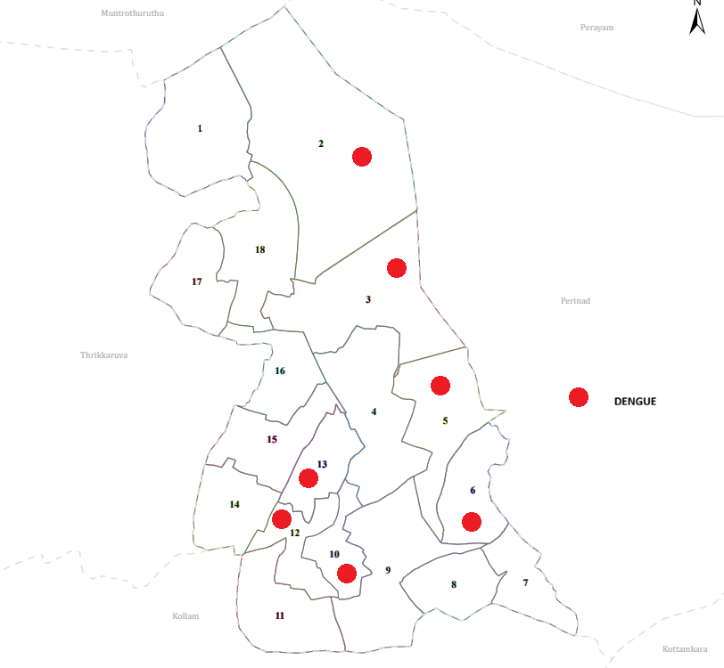

1.INTEGRATED HEALTH INFRASTRUCTURE MAP OF PANAYAM PANCHAYAT

GENERAL PROFILE OF THE LSGI’S

Background of the LSGI
Panayam Grama Panchayat is situated in the kundara of kollam district, Kerala. The geographical landscape of the Panchayat is predominantly low-lying, characterized by extensive paddy fields (Kole lands) and a dense network of rivers, canals, and backwaters. This unique terrain plays a significant role in shaping the local microclimate and poses distinct challenges to transportation, emergency response, and service delivery, particularly during monsoon seasons and flood events.
The Panchayat is administratively divided into multiple wards, with a population largely dependent on traditional livelihoods. Agriculture—especially paddy cultivation—fishing, coir and coconut husk processing, and allied activities form the backbone of the local economy. In recent years, tourism-related activities and service-sector employment have also shown gradual growth. The area hosts a diverse workforce, including a notable presence of migrant labourers, particularly in construction, agriculture, and allied sectors.
From a public health and disaster management perspective, panayam LSGI has historically been vulnerable to seasonal flooding, waterborne diseases, and vector-borne illnesses such as Dengue and Leptospirosis. The severe floods experienced during recent years, including the 2018 flood disaster, significantly impacted life, livelihoods, and infrastructure within the Panchayat. These recurring emergencies have underscored the importance of strengthening local preparedness, response mechanisms, and inter-departmental coordination.
In this context, the development of a localized, data-driven Auxiliary Infrastructure and Logistical Resource Map is essential to support effective planning, timely emergency response, and sustainable development initiatives. Such mapping enables the Panchayat to identify critical resources, improve accessibility during disasters, and enhance overall resilience of the community.

Table 1: Background of LSGD
Description | Details
Name of LSGI | Perumon
Type (GP/Municipality / Corporation etc.) | Grama Panchayat
Block | Chittumala
District | Kollam
Number of wards | 16
Total area (sq. km) | 11.06
Population(Projected) | 30057
Population density | 27177/sq km
Terrain (coastal/low-lying/backwaters/foothills, etc.) | coastal
Number of rivers passing through LSGI | 1
Number of water bodies in the LSGI | 2
Number of educational institutions | 11
Factories / small-scale industries | 5
Flood-prone wards | 9
Landslide-prone wards | 6
Death Management and Disposal Facilities (mortuaries/crematorium, including electric) | 2
Auditoriums/Marriage halls/convention centres/community halls | 3

Demographic and Vulnerable Population
Understanding the demographic composition and vulnerable population groups is essential for pandemic preparedness. Children, elderly, economically deprived families, migrant workers, and socially vulnerable groups are at increased risk during public health emergencies due to higher exposure, limited access to services, and dependency on public systems..

Description |  | Details (in numbers)
DEMOGRAPHIC PROFILE
Total population |  | 30057
Male |  | 14627
Female |  | 15430
Transgender |  | 48
Children under 5 |  | 1569
Adolescent |  | 5710
Elderly (>60) |  | 5623
SOCIAL/LIVELIHOOD VULNERABILITY
Previous EPEP family |  | 64
BPL family |  | 3621
Tribal communities |  | 0
Migration | Immigrant | 130
Migration | Emigrant | 2432
Socio-economically deprived |  | 32
Fisherfolk |  | 10
SC Community |  | 967
ST Community |  | 0

Graphs: Population pyramid (if possible) for seeing if your LSGI has a high "dependency ratio" (lots of children and elderly compared to working adults).

Clinical Vulnerability
Certain population groups needs priority healthcare & are at higher risk of severe illness, complications, and mortality during pandemics. Patients with chronic diseases, those requiring regular medical care, and individuals with mobility or functional limitations face challenges in accessing timely care during emergencies. Mapping these groups helps in prioritizing continuity of treatment, medicine stock planning, oxygen support, referral transport, and targeted home-based care.
Description | Details in numbers
Pregnant women | 131
Lactating mothers | 128
Bedbound patients | 121
Patients under palliative care other than bedbound | 497
Patients on Haemodialysis | 14
Patients on CAPD | 2
Cancer patients (currently on treatment) | 196
Haemophilic patients | 1
Mentally challenged | 5
Differently abled | 10
Diabetic patients | 348
Hypertensive patients | 1384
TB patients | 13

Major Festivals & Events specific to the LSGI
(with the possibility of a public gathering)

Sl. No. | Name of festival | Month detailing the periodicity
1 | Perumon Theru ulsavam | March last or April first
2 | Panayam Devi Temple | March
3 | Kandachira Sree Subrahmanya Swami Temple Festival | January / February
4 | Perumon St. Mary’s Church Feast | September
5 | Kandachira Muslim Jama-Ath Ulsavam/Nabi Dinam | Based on Hijri Calendar
6 | Ashtamudi Lake Boat Race (Local Heats) | August / September

INFRASTRUCTURE & RESOURCE INVENTORY

Health Facility Directory & Basic Capacity in the LSGD
This section provides an overview of the healthcare infrastructure available within the LSGD area. It outlines the distribution and basic capacity of health facilities that form the backbone of service delivery during routine times and public health emergencies.

Family Health Centres (FHCs) and Community Health Centres (CHCs) generally function as the first point of contact for the community, providing essential outpatient and inpatient services. General Hospitals (GH) and Medical College Hospitals (MCH), where accessible, serve as the main referral centres for advanced diagnostics, specialist care, and critical services during public health emergencies. This inventory helps identify existing strengths, gaps, and potential surge capacity that can be mobilised during a pandemic or disaster.

Table 5. Health Facility Resource Summary
Sl.no. | Health Facility | Type of Facility (MCH/GH/CHC/FHC/SC etc.) | Contact Number | Total beds | ICU Beds | Oxygen-Supported Beds | No. of Ventilator Support Beds | No. of ambulances
Government Healthcare Facilities
1 | Perumon Phc | PHC | 0474-2550470 | 0 | 0 | 0 | 0 | 0
2 | Govt Ayurveda hos | GOV | NIL | 0 | 0 | 0 | 0 | 0
3 | Govt Homeo hos | GOV | NIL | 0 | 0 | 0 | 0 | 0
4 | HEALTH AND WELLNESS CENTRE PERUMON MAINCENTRE | GOV | NIL | 0 | 0 | 0 | 0 | 0
5 | HEALTH AND WELLNESS CENTRE PANAYAM | GOV | NIL | 0 | 0 | 0 | 0 | 0
6 | HEALTH AND WELLNESS CENTRE KANDACHIRA | GOV | NIL | 0 | 0 | 0 | 0 | 0
7 | HEALTH AND WELLNESS CENTRE CHATHINAMKULAM | GOV | NIL | 0 | 0 | 0 | 0 | 0
Private Healthcare Facilities
1 | Kayalvarath Ayurveda Hospital (Head Office) | Near Perinad Railway Station, Panayam | 9020552737 / 0474-2552737 | 0 | 0 | 0 | 0
2 | Sithara Ayurveda Clinic (Dr. Amal S Babu) | Chemmakkad, Panayam | 9745502737 (Ref: Kayalvarath Branch) | 0 | 0 | 0 | 0
3 | Kuzhuvila Medicals & Clinic | Panayam | 0474-2550470 | 0 | 0 | 0 | 0
AYUSH Healthcare Facilities
1 | Govt. Ayurveda Dispensary | Panayam | 9496041000 | 0 | 0 | 0 | 0
2 | Govt. Homeopathy Dispensary | Perumon | 9605511222 | 0 | 0 | 0 | 0
3 | Sree Subrahmanya Ayurveda Clinic | Kandachira | 8129555976 | 0 | 0 | 0 | 0

Private Clinics
Private clinics are an essential part of pandemic preparedness, as they are often the first place people seek care when symptoms begin. In many communities, private clinics manage a significant share of outpatient visits and therefore play a critical role in early case detection, timely referrals, and disease surveillance. Having an up-to-date understanding of where these clinics are located, the services they provide, and how they are linked to the public health system helps ensure that no cases are missed during an outbreak. It also allows health authorities to engage private practitioners more effectively for reporting, risk communication, and coordinated response, strengthening the overall capacity of the health system to manage public health emergencies.

Table 6. Private Clinic Resource Summary
Sl No. | Name of Clinic | Registered (Y/N) | Clinic (General / Speciality) | Speciality (if any) | Address | Contact Number | Diagnostic Facility (Y/N) | Ambulance Linkage (Y/N)
1 | Kayalvarath Ayurveda Hospital (Head Office) | Y | Speciality | Ayurveda | Near Perinad Railway Station, Panayam | 9020552737 / 0474-2552737 | Y (Kayalvaram Lab available) | Y (Hospital has backup generator/infra)
2 | Sithara Ayurveda Clinic | Y | Speciality | Ayurveda | Chemmakkad, Panayam | 9745502737 | N | N
3 | Kuzhuvila Medicals & Clinic | Y | General | N | Panayam | 0474-2550470 | N | N
4 | Aswas Clinic | Y | General | N | Panayam Junction | NIL | N | N

Healthcare Education & Training Institutions
This section tracks the educational infrastructure available, which is vital for human resource planning in the health sector.

Category of Institution | Govt | Private | AYUSH | Total
Medical Colleges | 0 | 0 | 0 | 0
Nursing Colleges | 0 | 0 | 0 | 0
Dental Colleges | 0 | 0 | 0 | 0
Para-medical / Allied Health | 0 | 0 | 0 | 0
Pharmacy Colleges | 0 | 0 | 0 | 0

Specialized Services & Emergency Inventory
This section provides a detailed view of the specialized medical resources available to the community, focusing on emergency response and critical care capabilities. This table tracks the vital assets required for managing severe illnesses and emergencies across Government, Private, and AYUSH sectors.

Item | Govt | Private | AYUSH | Total
Hospital beds | 0 | 0 | 0 | 0
Oxygen-generating systems(Y/N) | N | N | N | N
Oxygen-supported beds(Numbers) | 0 | 0 | 0 | 0
Ventilator-supported beds | 0 | 0 | 0 | 0
ICU beds | 0 | 0 | 0 | 0
Burns units | 0 | 0 | 0 | 0
Blood centres | 0 | 0 | 0 | 0
BLS ambulances | 0 | 0 | 0 | 0
ALS ambulances | 0 | 0 | 0 | 0
Dialysis facilities | 0 | 0 | 0 | 0
Dispensaries | 0 | 1 | 0 | 1
Medical store | 0 | 3 | 0 | 3
Industrial establishments(Medium-scale industries/small-scale industries establishments to whom we can depend in a worst-case scenario) | 0 | 0 | 0 | 0

Oxygen & Diagnostic Capacity
Monitoring oxygen and diagnostic capacity is a critical component of public health preparedness, ensuring that the LSGD can handle both chronic care and sudden surges in respiratory or infectious diseases.
Name of Health Facility | Oxygen-generating System (Y/N) | Backup Oxygen Source (Y/N) | Diagnostic Facilities Available(Y/N)
Name of Health Facility | Oxygen-generating System (Y/N) | Backup Oxygen Source (Y/N) | Lab | USG | X-ray | CT/MRI | RT-PCR
Government Healthcare Facilities
Perumon PHC | N | N | Y | N | N | N | N
HWC Panayam | N | N | N | N | N | N | N
Private Facilities
Kayalvarath Hospital | N | Y | Y | N | N | N | N
Kuzhuvila Clinic | N | N | N | N | N | N | N

Diagnostics facility mapping at the LSGI level
The diagnostic capacity of PANAYAM G.P represents the "intelligence network" of our healthcare system. The speed and accuracy of disease identification depend entirely on the distribution and technical level of these facilities.

Item | Govt | Private | AYUSH | Total
General labs | 0 | 0 | 0 | 0
Microbiology labs | 1 | 3 | 0 | 4
RT-PCR labs | 0 | 0 | 0 | 0
USG units | 0 | 0 | 0 | 0
CT/MRI units | 0 | 0 | 0 | 0
Research labs | 0 | 0 | 0 | 0
Labs of other departments that can be repurposed | 0 | 0 | 0 | 0

Laboratory Identification & Basic Details
Sl. No. | Name of Laboratory | Ownership (Govt / Private / Academic) | Address | Contact No. | 24×7 Services (Yes/No) | NABL / Govt Approved (Yes/No)
1 | Perumon PHC | GOVT | PANAYAM | 0474-2585222 | NO | YES
2 | Kayalvaram Lab | PRIVATE | Near Perinad Rly Station | 9020552737 | NO | YES
3 | Kuzhuvila Diagnostic Centre | PRIVATE | Panayam Junction | 0474-2550470 | NO | YES
4 | Sree Subrahmanya Lab | PRIVATE | Kandachira | 8129555976 | NO | YES

Social and Community Infrastructure for surge plan
This table serves as our logistics and shelter inventory. By mapping these locations, quickly we can identify where to house displaced citizens, where to set up temporary medical clinics, and how to manage the deceased with dignity during a crisis.

Category | Total Count | Ward | Est. Capacity (Persons) | Contact details
Educational Institutions
Anganwadis | 25 | ALL WARDS | 250 | Refer to Annexure 1.9
Schools | 10 | 1, 3, 4, 5, 7, 9, 11 | 220 Beds (Total Surge Capacity) | Refer to Annexure 1.7
Colleges | 1 | 1 | 1250
Healthcare Educational Institutions
Medical colleges (Govt/Private) | 0 | NIL | NIL | NIL
Nursing colleges (Govt/Private) | 0 | NIL | NIL | NIL
Dental colleges (Govt/Private) | 0 | NIL | NIL | NIL
Paramedical institutes (Govt/Private) | 0 | NIL | NIL | NIL
Community Gathering Spaces
Community halls | 0 | NIL
Auditoriums | 1 | 16 | ~500 | College of Engineering Perumon Auditorium Ph: 0474-2512390
Religious buildings | 2 | 1, 3, | ~300 | Refer to Annexure 1.10
Vulnerable Group Support Facility
Destitute homes | 0 | NIL | NIL | NIL
Elderly homes | 0 | NIL | NIL | NIL
LSGD owned other buildings | 0 | NIL | NIL | NIL
Mass Fatality Management (MFM) Infrastructure
Mortuary | 0 | NIL | NIL | NIL
Crematorium | 0 | NIL | NIL | NIL
*refer annexure 1 for contact details

Human resources
This section focuses on the human capital available within the LSGI. In any emergency—be it a pandemic, flood, or industrial accident—infrastructure is only as effective as the people operating it.

Medical & Clinical Personnel
This table tracks the "Frontline" providers responsible for diagnosis, treatment, and clinical management. Narrative sentence: eg., "Total health workforce: 450 personnel, with 60% in government facilities serving as primary surge capacity." A detailed directory with the contact numbers of all workers is maintained (Annexure in 1).

Cadre | Govt (No.) | Private (No.) | Total
Doctors—Modern Medicine | 2 | 4 | 6
Doctors – AYUSH | 1 | 2 | 3
Doctors – Veterinary | 1 | 2 | 3
Doctors – Dental | 0 | 3 | 3
Nursing officers | 4 | 3 | 7
Lab technicians | 1 | 3 | 4
Optometrist | 1 | 2 | 3
Pharmacists | 2 | 4 | 6
Psychologists | 1 | 2 | 3
Counsellors | 1 | 3 | 4

Public Health & Field-Level Workforce
These individuals are the backbone of surveillance, maternal-child health, and decentralized care.

Cadre | Health services | Municipal common services | Total
HS (Health Supervisors) | 1 | NIL | 1
HI (Health Inspectors) | 1 | NIL | 1
LHS (Lady Health Supervisor) | 0 | NIL | 0
LHI (Lady Health Inspectors) | 1 | NIL | 1
JPHN (Jr Public Health Nurses) | 4 | NIL | 4
JHI (Jr Health Inspectors) | 3 | NIL | 3
MLSP (Mid-Level Service Providers) | 4 | NIL | 4
Palliative Nurses | 1 | NIL | 1
RBSK Nurses | 1 | NIL | 1
PRO | 1 | NIL | 1
Epidemiologist | 1 | NIL | 1
Data Manager | 1 | NIL | 1

Community & Support Cadre
This group represents the surge capacity of the LSGI—people who can be called upon for logistics, rescue, and specialized support.

Cadre | Number
ASHA Workers | 24
AWW (Anganwadi Workers) | 25
Emergency Medical Volunteers (Trained) | 0
Kudumbashree | 5040
MNREGS | 303
Purusha Swayam Sahaya Sangham | 12
Ex-Servicemen | 118
Retired Police Officers | 38
NCC/NSS Volunteers | 56
Red Cross volunteers | 25
One Health Community Volunteers | 11
One Health Community Mentors | 6

Community Organizations
This section details the presence of community-based organisations (CBOs), non-governmental organisations (NGOs), faith-based organisations (FBOs), Kudumbashree Self-Help Groups (SHGs), and Ayalkootams within the Local Self-Government Institution (LSGI). These groups enhance grassroots mobilization, resource distribution, and support networks crucial for pandemic response and community resilience.

Category | Total Count
NGOs | 10
Religious based organizations | 4
Foreign based organizations | 2
Sports Club/youth clubs | 2
Kudumbashree SHGs | 252
Ayalkootams | 20
Political organizations | 4
Residential organizations | 16

Administrative & Emergency Services
This section outlines the availability of key non-health emergency support services and infrastructure within the LSGI, which are essential for effective pandemic preparedness and response. These facilities support law enforcement, disaster response, water supply, logistics, mobility, and community-level interventions during public health emergencies.

Category | Total Count | Contact details
Police Stations | 0 | Services provided by Anchalummoodu Police Station: 0474-2702244
Fire & Rescue Stations | 0 | Services provided by Kollam/Kundara Fire Stations: 101 or 0474-2702333
Water Pumping Points | 12 | Controlled by KWA (Kerala Water Authority); Contact: 0474-2704533
Public Distribution System (PDS) | 16 | ARD (Ration Shop) Nodal Officer: 9446105260

Information regarding resources
The availability of essential transport and support resources plays a quiet but critical role in saving lives. Equipment such as ambulances, mobile mortuaries, amphibian ambulances, and motorized boats ensures that patients, samples, and healthcare teams can move swiftly—even in flooded, remote, or difficult terrains. Heavy vehicles like JCBs, cranes, tractors, and torus lorries support logistics, waste management, emergency infrastructure, and rapid conversion of spaces into care or isolation facilities. Taxis, four-wheel-drive vehicles, and trucks help maintain continuity of essential services, reach vulnerable populations, and support home-based care and supply delivery.

Means of transportation | Total Count
JCB | 12
Crane | 1
Heavy Trucks | 3
Tractor | 2
Ambulances | 3
Mobile mortuaries | 3
Boats | 6
Taxi service | 15
Note: For specific details regarding vehicle owners and contact information, please refer to Annexure [X].

ONE HEALTH & ENVIRONMENTAL SURVEILLANCE
The One Health method integrates environmental, animal, and human health to enable proactive pandemic preparedness. Panchayat-level surveillance needs to be improved in order to detect and treat zoonotic and environmentally generated diseases early. Surveillance is strengthened through systematic assessment of animal populations, veterinary infrastructure, poultry and slaughter facilities, inter-sectoral coordination, and specialised tools like avian influenza seasonality mapping using GIS in previous outbreaks to enable predictive alerts and ward-specific sampling to support effective pandemic preparedness in high-risk areas like

Animal & Bird Population
Mapping animal and bird populations at the Panchayat level is essential for identifying and prioritising zoonotic disease hazards like rabies, avian influenza (H5N1), leptospirosis, anthrax, and Nipah-like spillover occurrences. Risk classification, targeted surveillance, vaccination planning, and early epidemic detection made feasible by comprehensive population mapping all enhance One Health-based pandemic preparedness.

Category | Item | Estimated Population | Wards
Animal Population | Livestock (Cattle/Goats/Buffalo) | 210/520/120 | ALL WARDS
Animal Population | Pet Animals (Dogs/Cats) | 78 / 86 | ALL WARDS
Animal Population | Stray Dog Population | 72 | ALL WARDS
Animal Population | Pig Farms (Number of heads) | 0 | NIL
 | Small Units (Sheep / Goats – clustered) | 3 | WARD 4 , 7
Bird Population | Poultry Units (Birds) | 5718 | ALL WARDS
Bird Population | Poultry- (FOWL) | 0 | NIL
Bird Population | Wild/Migratory Birds (Observed) | 0 | NIL
Bird Population | Crow Mortality Events (Reported) | 0 | NIL

The main risk of zoonotic diseases in _____PANAYAM LSGD_______ is concentrated in Wards……NIL…………., which is explained by the high density of pig farms, cattle congregation areas, and poultry units. The stray dog population in market areas, fish landing sites, bus stations continues to be a substantial problem for rabies surveillance and bite prevention. There is a considerable risk of avian influenza introduction and amplification during November - December due to the seasonal presence of migratory and resident water birds near ponds/ canal / river / backwater / paddy field. Clusters of pig farms and animal shelters vulnerable to flooding further raise the risk of leptospirosis and other zoonoses mediated by the environment, especially during monsoon floods.

Veterinary Infrastructure
Veterinary institutions are a core pillar of One Health surveillance, enabling early zoonotic disease detection through vaccination, investigation of unusual animal illness or deaths, sample collection, and timely outbreak reporting. A well-mapped and responsive veterinary network strengthens coordination with human health and LSGI systems, ensuring rapid response during zoonotic events and pandemics.
Facility Type | Name of Facility | Ownership Govt / Pvt | Location(Ward No) | Contact number
Veterinary Dispensary | GOVT Veterinary Dispensary | GOVT | PERUMON (WARD NO -
Veterinary Hospital / Polyclinic | NIL | NIL | NIL | NIL
Private Veterinary Clinics | NIL | NIL | NIL | NIL
Mobile / Emergency Vet Service (incl. night services) | NIL | NIL | NIL | NIL
Pet Homes / Animal Shelters | NIL | NIL | NIL | NIL
Slaughterhouse-linked Veterinary Inspection Unit | NIL | NIL | NIL | NIL

Veterinary Doctors & Workforce
Early detection, diagnosis, reporting, and reaction to animal illness epidemics depend on the availability and accessibility of qualified veterinary specialists. By identifying unusual animal morbidity or mortality promptly, collecting samples promptly, and coordinating efficiently with human health and LSGI systems—especially during zoonotic outbreaks and pandemic-prone situations—a clearly defined veterinary workforce enhances One Health surveillance.

Category | Number Available | Type (Govt/Pvt) | Contact number
Government Veterinary Doctors | 1 | GOVT | 0474-2556789
Private Veterinary Doctors | 0 | NIL | -
Livestock Inspectors | 1 | GOVT | 9496012345
Para-veterinary Staff / Attenders | 2 | GOVT | 9567890123
Contract / On-call Veterinary Support (if any) | 0 | NIL | -

High-Risk Interface Points (Surveillance Sites)
High-risk interface points for zoonotic disease surveillance in ______PANAYAM______ Grama Panchayat include wetland–livestock–human contact zones, backyard poultry farms, cattle sheds near water bodies, fish markets, and areas of high human–animal interaction such as community slaughter points and migratory bird congregation sites. These are the primary surveillance sites where zoonotic spillover risks are elevated.

Type of Habitat | Type of High risk interface | Geographical vulnerability
Wetlands & Backwaters | LOW | NIL
Backyard Poultry Farms | NIL | NIL
Cattle Sheds near Water Bodies | LOW | NIL
Fish & Meat Markets | NIL | NIL
Community Slaughter Sites | NIL | NIL
Migratory Bird Congregation Areas | NIL | NIL
Rodent-Infested Grain Storage | NIL | NIL

Category | Total Count | Key Locations (wards)
Poultry Farms | 0 | NIL
Backyard / Clustered Poultry Units | 0 | NIL
Duck Rearing Units (open water access) | 0 | NIL
Slaughterhouses/ Slaughter Points | 0 | NIL
Meat/Fish Markets | 1 | WARD 6
Live Bird Sale Points | 0 | NIL
Cattle Markets / Weekly Animal Fairs | 0 | NIL
Pet Shops / Breeders | 0 | NIL
Animal Shelters / Pet Homes | 0 | NIL
Waste Disposal Sites near Animal Units | 0 | NIL

Environmental Risk Mapping
Environmental risk mapping identifies monsoon/flood hotspots for vector-borne (dengue, chikungunya), water-borne (leptospirosis, diarrhoea), and zoonotic diseases in Kerala's wetlands. Systematic surveillance supports early warnings, targeted interventions, and Panchayat pandemic preparedness.
Waterborne exposure: Flood-prone areas and stagnant water bodies facilitate leptospira survival, raising leptospirosis risk.

Traditional practices: Informal slaughter and fish markets lack standardized hygiene, creating spillover opportunities.

Risk Factor | High-Risk Wards | Key Locations | Risk Level (High/Med/Low)
Flood-prone areas | 1,2,3,4,6,8,10,11,12,13,14,15 |  | MED  MED  MED  MED  MED  MED  MED  MED  MED  MED
  AROUND PERUMON RAILWAY BRIDGE
  LOWER SECTOR OF PERUMON UP SCHOOL AREA
  KULANTHINTE MELATHIL BHAGOM
  VARATTACHIRA COLONY
  CHEMMAKKADU VAYAL AREA
  PALIYAZHIKATHU THAZHE VAYALBHAGOM
  MULAIKKALTHAZHE VAYAL BHAGOM
  IRIPPARATHODI BHAGOM
  CHARUKADU VILAVOOR BHAGOM
  ERATHUTHAZHATHIL VAYAL BHAGOM
  OOTTUKUZHI AREA
  VILAVOOR BHAGOM
  MATHRUCHAYA VAYAL AREA
  PAAVOOR VAYAL AREA
  CHONAMCHIRA SOUTH AND NORTH VAYAL AREA
  AMBAZHAVAYAL AKKALTHODI AREA
  MULAIKKAL BHAGOM
  SOUTH OF PANAYAM TEMPLE
  SOUTH OF CHITTAYAM MADAN NADA
Water bodies/wetlands | 1,2 | AMBAZHAVAYAL AKKALTHODI AREA  PAAVOOR VAYAL AREA | MED
Solid waste accumulation | NIL | NIL | NIL
Animal waste disposal issues | NIL | NIL | NIL
Rodent infestation zones | NIL | NIL | NIL
Industrial effluent discharge | NIL | NIL | NIL
Construction sites / abandoned buildings | NIL | NIL | NIL
Poor drainage/blocked canals | NIL | NIL | NIL
Drinking water source contamination risk | NIL | NIL | NIL

Disease Seasonality Mapping
1, Flooding & waterlogging → amplifies leptospirosis, malaria, diarrheal diseases.
·
2, Migratory bird influx (Nov–Feb) → avian influenza risk.

3, Mosquito breeding cycles → vector-borne disease peaks in monsoon.

4, Agricultural practices → close human–animal contact in paddy fields.

Disease | Peak Risk Season | Key Drivers | High-Risk Locations | Surveillance Focus
Avian Influenza | NIL | NIL | NIL | NIL
Leptospirosis | NIL | NIL | NIL | NIL
Dengue/Chikungunya | JUNE -JULY | DRINKING WATER COLLECTING CONTAINERS | WARD 16 – CHITTAYAM  WARD 3 - PULLUVALA | SOURCE REDUCTION
Acute Diarrheal Diseases | NIL | NIL | NIL | NIL
Rabies | NIL | NIL | NIL | NIL
Anthrax (rare) | NIL | NIL | NIL | NIL

Vulnerability Mapping
Vulnerability mapping pinpoints high-risk populations, occupations, and areas exposed via environment, livelihoods, socio-economics, and poor service access. Paired with environmental/seasonality mapping, it enables risk-based surveillance, targeted actions, and optimal resource use in One Health and pandemic planning.
Vulnerability Factor | High-Risk Wards | Key Groups / Locations | Risk Level
Flood-prone households | 1,2,3,4,6,8,10,11,12,13,14,15 |  | MED  MED  MED  MED  MED  MED  MED  MED  MED  MED
  AROUND PERUMON RAILWAY BRIDGE
  LOWER SECTOR OF PERUMON UP SCHOOL AREA
  KULANTHINTE MELATHIL BHAGOM
  VARATTACHIRA COLONY
  CHEMMAKKADU VAYAL AREA
  PALIYAZHIKATHU THAZHE VAYALBHAGOM
  MULAIKKALTHAZHE VAYAL BHAGOM
  IRIPPARATHODI BHAGOM
  CHARUKADU VILAVOOR BHAGOM
  ERATHUTHAZHATHIL VAYAL BHAGOM
  OOTTUKUZHI AREA
  VILAVOOR BHAGOM
  MATHRUCHAYA VAYAL AREA
  PAAVOOR VAYAL AREA
  CHONAMCHIRA SOUTH AND NORTH VAYAL AREA
  AMBAZHAVAYAL AKKALTHODI AREA
  MULAIKKAL BHAGOM
  SOUTH OF PANAYAM TEMPLE
  SOUTH OF CHITTAYAM MADAN NADA
Wetland-adjacent communities | 1,2 | AMBAZHAVAYAL AKKALTHODI AREA  PAAVOOR VAYAL AREA | MED
Backyard poultry / duck rearing households | NIL | NIL | NIL
Livestock-rearing households | NIL | NIL | NIL
Slaughterhouse & meat market workers | NIL | NIL | NIL
Fisherfolk & fish market workers | NIL | NIL | NIL
Sanitation workers | NIL | NIL | NIL
Daily wage / migrant workers | WARD 4,5,7 | KANDACHIRA | MED
Elderly & chronically ill populations | NIL | NIL | NIL
Pregnant Women | NIL | NIL | NIL
Children (schools, Anganwadi’s) | NIL | NIL | NIL
Limited access to safe water & sanitation | 3,8,16,4,7 |  | MED  MED  MED  MED
  PULLUVALA AREA
  VALIYAVILA AREA
  PULLUVALA AREA
  CHARUKADU VILAVOOR VAYAL AREA
  PAMPALILTHODI VAYAL AREA
  PUTHENVEEDU VAYAL AREA
  AROUND ST CHARLES BORROMEO HS

EPIDEMIOLOGICAL TRENDS (2021–2025)

Disease surveillance is the systematic collection, analysis, and interpretation of health data for planning, implementation, and evaluation of public health practice. This section presents the disease surveillance profile of the LSGI based on routine reporting systems and outbreak investigations to identify priority diseases, seasonal patterns, and emerging public health threats.

Disease Burden among human beings(Last 5 Years)
Analysis of disease-wise data for the last five years helps identify persistent public health problems, emerging diseases, and changes in disease burden. This information supports prioritisation of prevention, preparedness, and response activities at the Panchayat level.

Disease | 2021 | 2022 | 2023 | 2024 | 2025 | Trend(Increasing/Stable/Decreasing)
Dengue | 29 | 3 | 9 | 8 | 28 | STABLE
Leptospirosis | 0 | 0 | 0 | 1 | 0 | Decreasing
Hepatitis A | 2 | 0 | 0 | 5 | 16 | Increasing
Malaria | 0 | 0 | 0 | 0 | 3 | Increasing
Scrub Typhus | 0 | 0 | 0 | 0 | 1 | Stable
Typhoid | 0 | 0 | 0 | 1 | 0 | Decreasing
H1N1 | 0 | 0 | 0 | 0 | 0 | Stable
H3N2 | 0 | 0 | 0 | 0 | 0 | Stable
ADD | 64 | 156 | 105 | 178 | 99 | Stable
Mumps | 0 | 0 | 0 | 0 | 1 | Stable
Measles | 0 | 0 | 0 | 0 | 0 | Stable
Hepatitis B | 0 | 1 | 2 | 4 | 0 | Decreasing
Hepatitis C | 0 | 0 | 0 | 0 | 0 | Stable
Tuberculosis | 30 | 0 | 14 | 18 | 13 | Stable
Leprosy | 0 | 0 | 0 | 0 | 0 | Stable
COVID-19 |  |  |  |  | 0

*(use the above table data to create the graph/diagram)

Seasonal Trend Analysis
Seasonal analysis helps anticipate surges (e.g. dengue in monsoon, leptospirosis after floods, influenza in cooler months) and plan pre‑emptive vector control, stockpiling of IV fluids, and awareness campaigns at Panchayat level.

DENGUE
Dengue is a major seasonal vector-borne disease strongly associated with rainfall, water stagnation, and increased mosquito breeding during the monsoon period.

Peak: July–November

Dengue – Ward-wise Yearly Distribution (2021–2025)

Ward | Dengue – Ward-wise Yearly Distribution
Ward | 2021 | 2022 | 2023 | 2024 | 2025 | Total
1 | 3 | 1 | 2 | 1 | 0 | 7
2 | 2 | 1 | 1 | 0 | 1 | 5
3 | 3 | 0 | 0 | 0 | 2 | 5
4 | 4 | 0 | 0 | 0 | 0 | 4
5 | 2 | 0 | 0 | 0 | 0 | 2
6 | 1 | 0 | 1 | 1 | 0 | 3
7 | 0 | 0 | 0 | 0 | 0 | 0
8 | 2 | 1 | 1 | 0 | 0 | 4
9 | 1 | 0 | 0 | 0 | 0 | 1
10 | 4 | 0 | 0 | 2 | 0 | 6
11 | 1 | 0 | 1 | 0 | 0 | 2
12 | 0 | 0 | 0 | 1 | 0 | 1
13 | 1 | 0 | 1 | 0 | 0 | 2
14 | 3 | 0 | 3 | 0 | 0 | 6
15 | 2 | 0 | 0 | 1 | 0 | 3
16 | 2 | 0 | 1 | 0 | 3 | 6
17 | 0 | 0 | 0 | 0 | 0 | 0

LEPTOSPIROSIS
Leptospirosis cases are closely linked to monsoon rains, flooding, and occupational exposure, particularly in low-lying and waterlogged areas.

Peak: June - August

Leptospirosis – Ward-wise Yearly Distribution (2021–2025)

Ward | Leptospirosis – Ward-wise Yearly Distribution
Ward | 2021 | 2022 | 2023 | 2024 | 2025 | Total
1 | 0 | 0 | 0 | 0 | 0 | 0
2 | 0 | 0 | 0 | 0 | 0 | 0
3 | 0 | 0 | 0 | 0 | 0 | 0
4 | 0 | 0 | 0 | 0 | 0 | 0
5 | 0 | 0 | 0 | 1 | 0 | 1
6 | 0 | 0 | 0 | 0 | 0 | 0
7 | 0 | 0 | 0 | 0 | 0 | 0
8 | 0 | 0 | 0 | 0 | 0 | 0
9 | 0 | 0 | 0 | 0 | 0 | 0
10 | 0 | 0 | 0 | 0 | 0 | 0
11 | 0 | 0 | 0 | 0 | 0 | 0
12 | 0 | 0 | 0 | 0 | 0 | 0
13 | 0 | 0 | 0 | 0 | 0 | 0
14 | 0 | 0 | 0 | 0 | 0 | 0
15 | 1 | 0 | 0 | 0 | 0 | 1
16 | 0 | 0 | 0 | 0 | 0 | 0
17 | 0 | 0 | 0 | 0 | 0 | 0

VIRAL HEPATITIS - A
Hepatitis A cases are commonly associated with unsafe drinking water, food contamination, and breakdowns in sanitation, often presenting as clusters or outbreaks.

Peak: October - December

Hepatitis A – Ward-wise Yearly Distribution (2021–2025)

Ward | Hep A – Ward-wise Yearly Distribution
Ward | 2021 | 2022 | 2023 | 2024 | 2025 | Total
1 | 0 | 0 | 0 | 0 | 0 | 0
2 | 0 | 0 | 0 | 1 | 0 | 1
3 | 0 | 0 | 0 | 0 | 0 | 0
4 | 0 | 0 | 0 | 0 | 0 | 0
5 | 0 | 0 | 0 | 0 | 1 | 1
6 | 1 | 0 | 0 | 0 | 0 | 1
7 | 0 | 0 | 0 | 0 | 0 | 0
8 | 0 | 0 | 0 | 0 | 1 | 1
9 | 0 | 0 | 0 | 0 | 0 | 0
10 | 1 | 0 | 0 | 0 | 0 | 1
11 | 0 | 0 | 0 | 0 | 0 | 0
12 | 0 | 0 | 0 | 0 | 0 | 0
13 | 0 | 0 | 0 | 1 | 0 | 1
14 | 0 | 0 | 0 | 2 | 0 | 2
15 | 1 | 0 | 0 | 1 | 0 | 2
16 | 0 | 0 | 0 | 0 | 0 | 0
17 | 0 | 0 | 0 | 0 | 0 | 0

Outcome-Based Trend Analysis- 2025

Transmission Trend- 2025
For effective management of public health issues, it is important to track the trend of disease transmission mode. It helps identify the population or place at high risk that can be used to predict outbreaks and implement targeted interventions as quickly as possible. Understanding these kinds of trends enables authorities to allocate resources efficiently and change the strategies adequately based on the trend that follows.

Mode of Transmission | No. of cases | No. of Deaths
Vector Borne Diseases | 9 | 0
Water Borne Diseases | 81 | 0
Air Borne Diseases | 47 | 0
Blood Borne Diseases | 0 | 0
Food Borne Diseases | 25 | 0

Vector-Borne Disease

Disease | No. of Cases | No. of Deaths
Dengue | 6 | 0
Malaria | 3 | 0
Chikungunya | 0 | 0

Water Borne Disease

Disease | No. of Cases | No. of Deaths
Cholera | 0 | 0
Typhoid | 0 | 0
Hep- A | 2 | 0
Dysentery | 25 | 0
Amoebiasis | 12 | 0
E- Coli infections | 67 | 0
Air Borne Disease

Disease | No. of Cases | No. of Deaths
Influenza | 0 | 0
H1N1 | 0 | 0
TB | 13 | 0
Chickenpox | 33 | 0
Measles | 0 | 0
Covid-19 | 0 | 0
Pertussis | 0 | 0
Mumps | 1 | 0

Blood-Borne Disease

Disease | No. of Cases | No. of Deaths
AIDS | 0 | 0
Hep- B | 0 | 0
Hep- C | 0 | 0

Zoonotic Disease

Disease | No. of Cases | No. of Deaths
Rabies | 0 | 0
Leptospirosis | 0 | 0
Avian influenza | 0 | 0
West nile | 0 | 0
Anthrax | 0 | 0
Nipah | 0 | 0
Scrub Typhus | 1 | 0

Integrated Disease Hotspot Map (2021–2025)
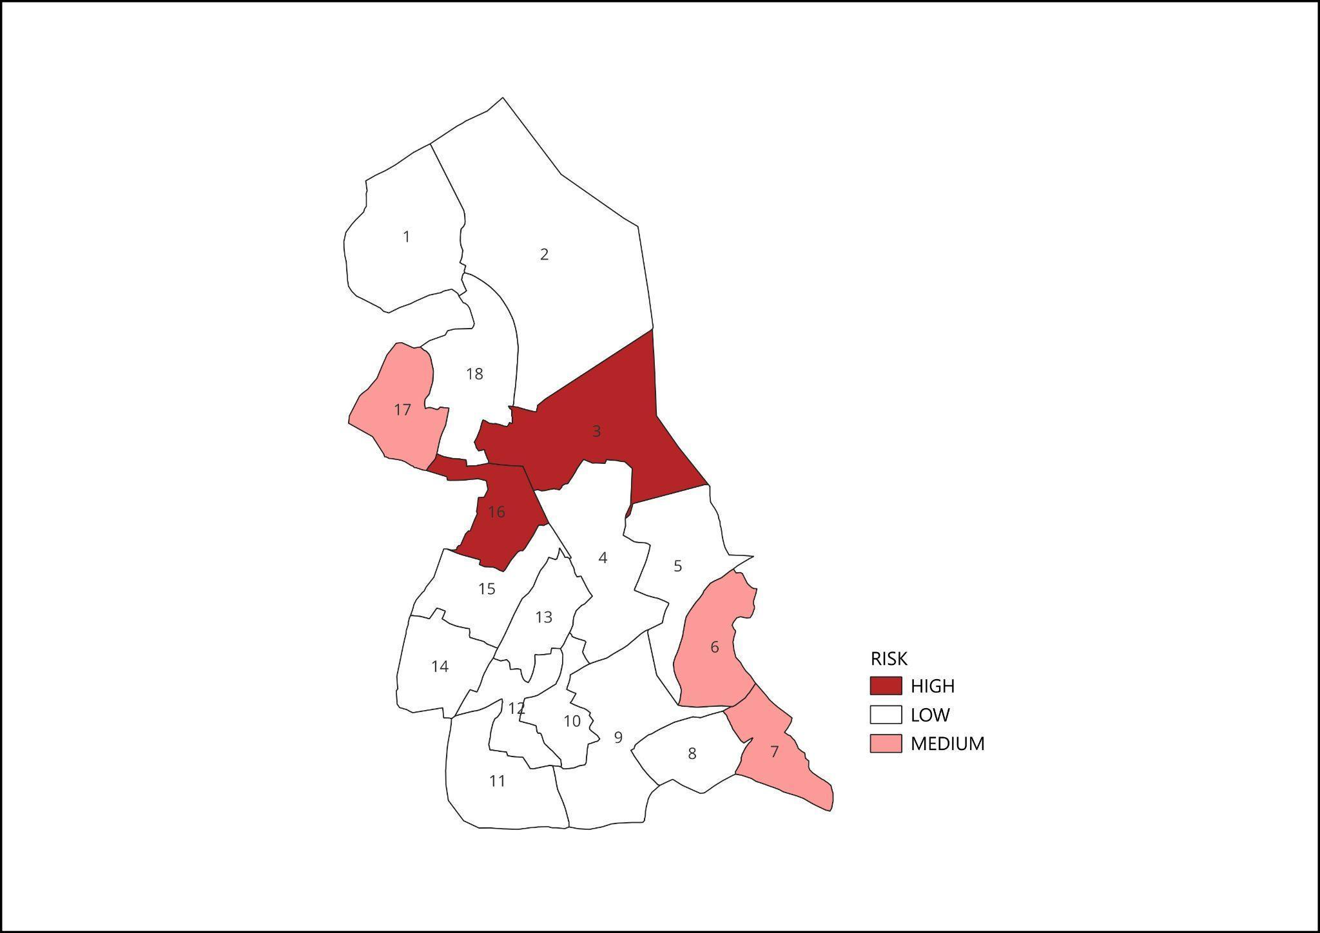

Ward No | Dengue Total (2021-25) | Leptospirosis Total (2021-25) | Hepatitis A Total (2021-25) | Mumps (2021-25) | ADD (2021-25) | Total Cases
1 | 7 | 0 | 0 | 0 |  | 7
2 | 5 | 0 | 1 | 0 |  | 6
3 | 5 | 0 | 0 | 0 |  | 5
4 | 4 | 0 | 0 | 0 |  | 4
5 | 2 | 1 | 1 | 0 |  | 2
6 | 3 | 0 | 1 | 0 |  | 3
7 | 0 | 0 | 0 | 0
8 | 4 | 0 | 1 | 1 |  | 6
9 | 1 | 0 | 0 | 0 |  | 1
10 | 6 | 0 | 1 | 0 |  | 7
11 | 2 | 0 | 0 | 0 |  | 2
12 | 1 | 0 | 0 | 0 |  | 1
13 | 2 | 0 | 1 | 0 |  | 3
14 | 6 | 0 | 2 | 0 |  | 8
15 | 3 | 1 | 2 | 0 |  | 6
16 | 6 | 0 | 0 | 0 |  | 6
17 | 0 | 0 | 0 | 0 |  | 0

By overlaying five years of data, we have identified ……ZERO……..'Red Zone' Wards. These are wards where at least two different categories of diseases (e.g., Dengue and Lepto) recurred in consecutive years. Ward is categorized as the Highest Priority Hotspot due to its combination of flood vulnerability and high vector density. Future health infrastructure, such as the proposed R.O plants at ………should be prioritized.

Preparedness and Response Protocol at LSG Level
This section describes the operational framework for the LSGI once a pandemic is declared. It explains how the LSGI and health system will move from routine data collection to active response, using a One Health approach.

Constitution of One Health Committee
The LSGD shall constitute a One Health Committee comprising the LSGI President, Medical Officers (Modern Medicine, AYUSH, and Veterinary), the Health Inspector, and the Veterinary Surgeon.

Objective: The One Health Committee coordinates human, animal, and environmental health to prevent and control pandemics.

Sl No | Name | Designation | Department/Institution | Role in Committee | Contact Number
1 | VINEETHA | Panchayat President | LSGD | Chairperson
2 | DR.ANU J PRAKASH | Medical Officer (PHC/CHC) | Health Dept | Member Secretary | 6282240880
3 |  | Veterinary Officer | Animal Husbandry | Member
4 | ISWARYA | Epidemiologist | Health Dept | Member | 9526210996
5 | SIYAD | Health Inspector/PHN | Health Dept | Surveillance | 9447497510
6 | LISSY | ASHA Supervisor | Health Dept | Community link
7 | AJITHA | ICDS Supervisor | Social Welfare | Vulnerable groups | 8590545305
8 | Police Station Officer (SI) | Police Station Officer | Police Dept | Law & order | 9495981122
9 | Ward Councillor Representative | Ward Councillor Representative | LSGD | Community coordination | 9567452233
10 | Kudumbashree CDO | Kudumbashree CDO | Kudumbashree | Community mobilisation | 9847123345
11 | NGO/Volunteer Representative | NGO/Volunteer rep | Civil Society | Support services | 9072345612
12 | Line Department Representative | Line Department representations | Inter-department coordination, resource mobilisation, implementation support | Various Govt. Departments (Health, ICDS, Water Authority, Agriculture, Animal Husbandry) | 9497234567

Key Responsibilities:
- Review disease surveillance data (human + animal)
- Conduct ward-wise risk assessment and vulnerability mapping
- Approve quarantine/isolation centre locations
- Coordinate with district for resources (PPE, oxygen, ambulances)
- Periodically review health system surge capacity, including beds, oxygen, human resources, and ambulances.
- Approve and monitor risk communication and community engagement strategies, including rumour management.
- Ensure protection and service continuity for vulnerable groups (elderly, persons with disabilities, dialysis patients, coastal populations).
- Conduct quarterly mock drills
- Monitor equity measures for vulnerable groups

Meeting Schedule:
Quarterly (normal times) | Weekly (outbreak alert) | Daily (pandemic phase)

Pandemic Response Workforce
To ensure a coordinated and timely response during a pandemic, a dedicated Pandemic Response Workforce shall be constituted at the LSG level. The workforce will function under the overall supervision of the One Health Committee and in close coordination with the health authorities. Team-based deployment will enable efficient surveillance, case management, quarantine and isolation management, logistics support, and risk communication. Each team shall have a clearly designated team leader, defined roles, and an identified pool of personnel to allow rapid activation, rotation of duties, and continuity of services during prolonged emergencies.

Total Response Workforce Available: 300 persons

Team Name | Composition | Key Responsibilities | Team Leader
Surveillance and Contact Tracing Team | HI, JHI, JPHN, ASHAs and Volunteers | Case detection, contact listing, home visits, reporting | HI
Case Management Team | Doctors, Nurses, MLSP, Palliative Nurses | Patient care & referral | DOCTOR
Quarantine & Isolation Team | LSGD staff, Volunteers | Facility management | JHI
Psychosocial support |  |  | JPHN
  Counsellors, ASHAs, Kudumbashree members
  Mental health support, counselling, stress management
Logistics & supply chain Team | LSGD staff, Storekeepers, Drivers 3 | Supplies & transport [PPE, medicines, oxygen, transport, waste management] | Ward Member
Communication Team | Ward members, Kudumbashree, Youth clubs,  AWW workers and other self help groups | IEC, community meetings, countering misinformation | M.O in charge
Transportation | KSRTC, educational institutional buses | Transport of patients, staff, supplies, emergency mobility | Panchayat Secretary
Media Surveillance | Health Inspectors, IT volunteers, Communication team members | Monitoring news/social media, rumor tracking, reporting misinformation | JHI
Intersectoral coordination and convergence |  | Coordination between departments, resource mobilization, policy implementation | Panchayat President
  Panchayat President, Secretary, Health officials, Police, ICDS, Education dept.
Collaborative surveillance |  | Community-based surveillance, early warning, reporting unusual events | JPHN
  ASHAs, Anganwadi Workers, Teachers, Community volunteers

All teams shall be activated immediately upon outbreak alert or pandemic declaration and shall report daily to the LSG Incident Commander/Medical Officer, with consolidated reporting to the Block PHC. Duty rosters and alternate personnel shall be maintained to ensure uninterrupted services during staff shortages or prolonged response periods. Team composition and numbers may be revised based on the magnitude of the outbreak and availability of human resources.

Activities and Measures before and during Pandemic

PHASE 1 - Alert / Preparation
Surveillance and Reporting-Enhanced syndromic surveillance:
- Data sources for surveillance:
- Event-based triggers (to be monitored and reported):
- Zoonotic and animal health surveillance
- Logistics and Stock Preparedness
  - Identify and empanel local vendors and define emergency procurement mechanisms in accordance with existing LSGD and Health Department norms.
  - Prepare and maintain an essential logistics checklist covering medical supplies, consumables, and support equipment.
  - Pre-identify secure storage locations for emergency stocks and ensure maintenance of stock registers with regular updating.
  - Finalise emergency transport arrangements, including availability of vehicles and identified drivers for rapid deployment during alerts.
  - Designate a Nodal Officer for Logistics to enable prompt decision-making, coordination, and communication during emergencies.
  - Conduct rapid stock verification and ensure availability of minimum buffer stock, including:
- PPE kits 0 numbers
- Pulse oximeters – 0numbers
- Hand sanitizers –0 litres
- Masks, gloves, disinfectants – not in adequate quantity
Identify critical gaps in logistics and immediately communicate requirements to the Block and District authorities for timely replenishment and support. Monitor expiry dates and stock rotation.

Identification of Quarantine and Isolation Facilities
  - Identify and list suitable buildings for quarantine and isolation (schools, hostels, community halls, etc.).
  - Categorise cases as per the severity and allocate to appropriate facilities (for instance, severe cases to classrooms, mild cases to an assembly hall in case of a school).
  - Facility readiness checklist needed (beds, toilets, ventilation) etc.
  - Find an alternate site if the primary sites are not available or not in use.
  - Identify facility managers and support staff
  - Prepare basic SOPs for:
    - Admission and discharge
    - Food, water, sanitation
    - Infection prevention and waste disposal
  - Ensure availability of basic amenities: water, sanitation, electricity, ventilation, and waste disposal. Prepare a rapid activation plan for these facilities if case numbers increase.

Risk Communication and Community Preparedness
  - Disseminate early warning messages on symptoms, preventive measures, and reporting mechanisms. Display IEC materials both in English and the local language in public places and ensure ward-level awareness.
  - Sensitize elected representatives and community leaders on preparedness measures.
  - Establish a rumour tracking and misinformation response mechanism to identify, verify, and promptly counter false or misleading information.
  - Engage trusted local persons (ward members, ASHA workers, religious leaders, teachers, community volunteers) to communicate official public health messages and reinforce correct practices.
  - Develop and deploy targeted IEC materials for:
    - Schools and educational institutions
    - Markets and commercial areas
    - Work sites and labour settings
  - Conduct community sensitization meetings at the ward level to promote preventive behaviors, address concerns, and strengthen community participation in preparedness and response.

Protection of Vulnerable Groups
Vulnerable populations require priority protection through targeted line-listing, service continuity, and delivery mechanisms.
- Prepare and regularly update line-lists of vulnerable populations, including:
  - Elderly persons living alone
  - Persons with disabilities
  - Pregnant women
  - Migrant workers
  - Dialysis patients
The detailed line-lists shall be maintained as Annexure ___ and updated periodically.

Clinical Dependency Mapping
Develop ward-wise dependency and vulnerability maps to identify households requiring regular support during emergencies. Ensure continuity of essential health services for vulnerable groups, including
- Dialysis services (facility mapping, transport arrangements, and scheduling)
- Continuity of treatment for TB, HIV, and other chronic conditions requiring uninterrupted medication
- Mental health and psychosocial support services
Establish delivery mechanisms for food, essential commodities, and medicines to vulnerable households through coordinated action involving ASHAs, JPHNs, Kudumbashree, volunteers, and local administration.

PHASE 2 - Active Response

Case Identification and Contact Tracing
Case detection and contact tracing activities will be carried out in coordination with the Health authorities, following disease-specific SOPs and IDSP guidelines.
Field Staff Involved
- Health Inspector (HI)
- Junior Health Inspector (JHI)
- Junior Public Health Nurse (JPHN)
- ASHAs and ASHA Supervisors
- Ward-level volunteers and Kudumbashree members (as required)

Screening Checkpoints
Screening checkpoints at high-traffic locations (transport hubs, markets, religious gatherings) for early detection of symptomatic travellers and crowd screening during outbreaks. Potential locations include bus stands, market entry points, and boat jetties, based on local context and risk assessment.
Screening activities will be carried out by trained personnel such as ASHAs, ward members, and volunteers, with support from Health Department staff. Necessary equipment, including non-contact thermometers and appropriate PPE, shall be ensured prior to activation.
Location | Type (Bus stand/Jetty/Market/Railway) | Staff Deployed (ASHAs/Volunteers) | Screening Method | Reporting authority
Bus stand | Transport hub | One JHI  One ASHA  One health Mentors | 1.Swab Collection.  2. Blood smears collection (RDT)  3.Thermal Scanners | Surveillance Nodal Officer in control room
Market entry | Market | One JHI  One ASHA  Male health volunteers | 1.Swab Collection.  2. Blood smears collection (RDT)  3.Thermal Scanners | Surveillance Nodal Officer in control room
Boat jetty | Water transport | One JHI  One ASHA  Male health volunteers | 1.Swab Collection.  2. Blood smears collection (RDT)  3.Thermal Scanners | Surveillance Nodal Officer in control room

Standard Screening Protocol

The screening protocol shall include temperature screening, observation for visible symptoms, and inquiry regarding recent travel or exposure history. Individuals identified as suspects during screening shall be immediately referred to the nearest PHC/FHC for further evaluation, testing, and appropriate action as per prevailing guidelines.

Pandemic Control Room
The Pandemic Control Room (PCR) serves as the central nerve center for real-time coordination, data aggregation, decision support, and communication during outbreaks. It consolidates information from all LSGD teams, health facilities and community sources to enable rapid response decisions.

Control Room Infrastructure and Location
Primary Location: PANAYAM Panchayath Office.
Backup Location: Community Hall in _______PANAYAM_____ G.P.

Health System Control Room Framework
The PCR is organized into seven functional pillars to ensure no aspect of the response is overlooked:

Rapid Response Team (RRT)
  - Provides immediate intervention during emergencies, clusters, and field alerts.​
  - Coordinates urgent actions such as case investigation, contact tracing, isolation, and inter‑facility referrals.

Data Management & Analytics Team
  - Collects, validates, and manages key health system indicators (cases, tests, beds, HR, supplies).​
  - Analyzes data trends, generates projections, and supports evidence‑based decision‑making for local authorities.

Human Resource Deployment Team
  - Allocates healthcare staff efficiently based on workload and need
  - Ensures adequate and equitable workforce distribution across facilities

Laboratory Surveillance Team
  - Oversees diagnostic testing coordination, sample transport, and timely reporting of results.​
  - Monitors lab indicators (testing volume, positivity rate, turnaround time) for early detection of outbreaks

Vaccination Cell (If Required)
  - Plans and executes vaccination campaigns, including micro‑planning and session scheduling.​
  - Tracks coverage, identifies gaps, and coordinates corrective actions with field teams and outreach services.

Infrastructure & Patient Occupancy Team
  - Monitors facility capacity, earmarked beds, oxygen and critical care resources across all linked facilities.​
  - Ensures optimal patient distribution and referral management using updated bed‑status and resource data.
  - BMWM

Communication team
- Logistics and supply chain
- Transportation (interfacility & emergency transport)
- Media surveillance Call centre
- Management of the deceased
- Intersectoral coordination and convergence

Key Control Room Team
The Control Room Team coordinates all pandemic response activities within the LSGD and serves as the single command and communication hub during activation. It integrates information, field actions, logistics, and policy execution across all participating departments and health facilities.

Role | Name | Designation | Contact Number | Responsibility
In-charge/Nodal Officer | ANU J PRAKASH | MO | 6282240880 | Overall coordination, decision-making, and reporting to the District level.
Data Entry Operator | Hashim | Data manager | 9605309194 | Managing the line list, updating dashboards, and tracking testing results.

SOP for alert escalation/trigger point with mapping of responsibilities.
Key Points:
- The Control Room shall be staffed with a designated In-charge, data entry personnel, and communication staff with clearly defined roles and shift arrangements.
- It shall maintain updated records on daily monitoring indicators including new cases, persons under active quarantine, and hospital bed occupancy.
- All reports and situation updates shall be shared daily with the Block and District Surveillance Unit.
- The Control Room shall act as a single point of contact for coordination with response teams, health institutions, and other departments.
- Contact details of the Control Room shall be widely communicated to field staff and stakeholders during activation.

Daily Monitoring Indicators
To ensure timely decision-making and effective response, the following key indicators shall be monitored and updated on a daily basis by the Pandemic Control Room:

Epidemiological Indicators:
New cases reported today, Total active cases, Test Positivity Rate (TPR), Case Fatality Rate (CFR)
- Surveillance Indicators:
Persons under home quarantine, High-risk contacts identified, Fever, ILI, SARI or other symptoms (syndromic surges), Travellers (symptomatic or high-risk arrivals),Animal husbandry surveillance (zoonotic alerts, unusual animal deaths, poultry/bird flu signals), Mortality surveillance (excess deaths, unexplained fatalities, verbal autopsy reports)
- Logistics and Infrastructure Indicators:
Hospital / CFLTC beds occupied, Oxygen cylinders/concentrators available, Ambulances on standby
- Alert Findings
The following table outlines category-specific trigger points (red flags) from surveillance indicators and corresponding immediate actions for the Pandemic Control Room. These enable rapid response to alert findings like testing anomalies, positive cases exceeding thresholds, clusters, and WGS reports.

Category | Trigger Pophint (Red Flag) | Immediate Action
Clusters | Geographical or facility-based: 5+ cases linked to one location (office, school, street). | Declare a micro-containment zone; perimeter control and active case finding.
Testing | Sudden drop in testing volume / delay in reporting / unusual testing trends | Review the sample collection process, address lab bottlenecks, deploy additional testing teams, and notify the District Lab.
Lab | Test Positivity rate increases | Increase testing sites in that ward.
Hospital | >80% Oxygen bed occupancy | Activate backup/CFLTC beds.
Travel | Cluster of cases from a single flight/train or high-risk arrival group. | Trace all passengers in adjacent seats; implement mandatory institutional quarantine.
Animal | Mass poultry/wildlife death or unusual sickness | Notify Animal Husbandry, sample the area, and dispatch RRT for environmental sampling and zoonotic check.
Mortality | Sudden spike in home deaths or brought-in-dead (BID) cases | Audit the deaths and Active Case Search drive
Additional investigations like Whole Genome Sequencing (WGS) | Detection of a Variant of Concern (VOC) or Variant of Interest (VOI) | Implement strict micro-containment; update clinical protocols to match variant severity.

Communication of Public Health Information
A Community Communication Hub shall be established to ensure timely, accurate, and consistent dissemination of information during a pandemic. The Hub will function under the coordination of Nodal officers of the control room and act as the nodal point for public communication, risk messaging, and community engagement. It will support dissemination of official advisories, promote preventive behaviors, address rumors and misinformation, and ensure that messages reach all sections of the population through trusted local channels and leaders.

Key communicators
Channel | Responsible Person | Contact
Ward-level announcements | JAYASREE , MYLAPPALLI | 6282710911
Social media | PRASANNAKUMARI, MOHANASADANAM | 7025425341
Local Cable TV/Radio | JHI, PRO | 9562359829

- All messages disseminated through the Hub shall align with advisories issued by the Health Department and District authorities.
- Community leaders shall be sensitized to support behavior change, reduce stigma, and counter misinformation.
- Special efforts shall be made to reach vulnerable and hard-to-reach populations using locally appropriate communication methods.

Rumor Tracking: A designated volunteer will monitor local social media/WhatsApp groups daily to identify misinformation and issue official clarifications via the Communication Hub.

Coordination with District/State Authorities & Other Organisations
Effective coordination with Block, District, and State authorities is essential to ensure timely reporting, technical guidance, and uninterrupted supply of essential resources during a pandemic. The LSG shall establish clear communication channels, designate responsible officers, and adhere to prescribed reporting timelines to support coordinated public health action and efficient resource mobilisation.

Key Details:
- Nodal Officer for Reporting: MO
- Contact Number: 6282240880
Reporting Schedule and Protocols:

To Whom | What to Report | Frequency | Nodal Person
Block PHC | Complete Situation Report (Cases, Quarantine, Beds, Screening, Deaths) | Daily | MO,6282240880
District IDSP Unit | Outbreaks/Clusters/Unusual Events (>5 cases same ward) | Daily | Epidemiologist, 9526210996
Veterinary Officer | Animal health events/Zoonotic alerts | Daily | Veterinary staff
State Cell | Zoonotic cross-sector events | Weekly

Supply Chain Coordination
The LSG shall coordinate closely with Block, District, and State authorities (KMSCL) to ensure uninterrupted availability of essential goods, medical supplies, and logistics during a pandemic. Supply requirements shall be assessed regularly based on case load and communicated promptly to the appropriate authorities for timely replenishment.
Key Points:
- Maintain updated contact details of District and Block nodal officers for health logistics, oxygen supply, ambulances, and essential medicines.
- Submit timely indent requests for PPE, testing kits, medicines, oxygen, and other critical supplies through prescribed channels.
- Monitor stock levels at LSGD facilities, quarantine/isolation centres, and field teams through daily stock registers and dispensing logs to prevent shortages.
- Coordinate with District authorities, Karunya/Neethi medical shops, and local purchase committees for funds allocation and emergency procurement.

- Ensure regular monitoring of dispensing registers at all facilities to track usage, expiry, and pilferage—shortages being a perennial issue requiring proactive weekly audits.

- Activate surge procurement protocols during high caseloads, leveraging local purchase powers under LSGD funds alongside state supplies.

Resource Inventory and Contacts
Resource Category | Source  (District/State/Private) | Contact
PPE Kits/Masks/Gloves | KMSCL | 9496004500
PPE Kits/Masks/Gloves | Local Vendors | 9496004500
Oxygen  Cylinders/Concentrators | KMSCL | 9496004500
Medicines/Antivirals | KMSCL | 9496004500
Medicines/Antivirals | Neethi Shops | 9496004500
Test Kits (RTPCR/Rapid) | KMSCL | 9496004500

Collaboration with NGOs, PPP, and CSR
To augment government efforts during a pandemic, the LSG shall collaborate with NGOs, voluntary organisations, and private sector partners through public–private partnerships and Corporate Social Responsibility (CSR) initiatives, in coordination with District authorities.

Key Points:
- Engage NGOs and community-based organisations for community outreach, awareness, and support to vulnerable populations.
- Leverage CSR support for procurement of medical equipment, PPE, oxygen concentrators, food kits, and sanitation materials, as permitted.
- Ensure all collaborations align with government guidelines and are routed through approved administrative and financial procedures.
- Maintain transparency and documentation for all external support received and utilised.
Organization | Type | Support Offered | Contact Person
Youth Clubs/Student Unions | CBO

Interdepartmental Coordination
Coordination among departments during a pandemic shall be ensured through regular review meetings convened by the LSGD President. These meetings will provide a structured platform for sharing situational updates, assessing resource availability, resolving operational gaps, and taking joint decisions to ensure a coordinated and timely response.

Department | Representative | Key Role | Contact
Health (PHC) | Staff Nurse : Anitha | Case management | 8086256146
Veterinary | Veterinary Surgeon: Dr.Zira Rani Kunj | Animal surveillance | 9446346897
ICDS | Supervisor: Mary Latha | Nutrition support | 8289963368
Education | Head Teacher: Sunil Kumar | School coordination | 9495123456
Police | SI: Rajesh Kumar | Containment enforcement | 9495987654
Water Authority | Assistant Engineer: Suresh Babu | Water supply | 9447123456
LSGD Engineering | Overseer: Bindu S | Quarantine infrastructure | 9387456123

PHASE 3 - Surge Capacity
Phase 3 is activated when there is a rapid increase in cases, high test positivity rates, or when existing health facilities and quarantine arrangements approach saturation. The focus of this phase is to expand isolation capacity, augment clinical care services, and mobilise additional resources through district and state support mechanisms.

Conversion of Community Facilities
To manage increased case load, the LSGD shall activate additional isolation facilities by repurposing identified community infrastructure such as community halls, auditoriums, schools, hostels, or other suitable buildings.

Name of facility | Facility Type | No. of Buildings | Ward | Surge Capacity (Beds) | Nodal Person
Panayam Community hall | hall | 1 | 3 | 50 | Head Master
SKV UPS , CHEMMAKKADU | School | 2 | 5 | 30 | Head Master
GLPS PANAYAM NORTH | School | 1 | 7 | 20 | Head Master
GLPS PANAYIL | School | 1 | 9 | 20 | Head Master
GLPS PERUMON | School | 2 | 1 | 30 | Head Master
SNM UPS , KANDACHIRA | School | 1 | 11 | 20 | Head Master
SRKST UPS ,PERUMON | School | 2 | 5 | 30 | Head Master
MES UPS, KANDACHIRA | School | 2 | 4 | 30 | Head Master
SREENARAYANA UPS ,THANNIKAMUKKJ | School | 1 | 3 | 20 | Head Master

- Recovery and rehabilitation phase
- Recovery
  - Damage & impact assessment
  - Restoration of health services
  - Rehabilitation of affected population
  - Psychosocial & mental health support
  - Disease surveillance during recovery phase
  - Environmental cleanup & sanitation
  - Livelihood restoration
  - Community engagement & confidence building
  - Documentation & after-action review
  - Lessons learned & best practices
  - Health system strengthening
  - Policy revision & preparedness enhancement
  - Research

CONCLUSION

Additional points
- tech support
- relief based commodities
- ham reading operators
- hazard vulnerability mapping
- Kseb & other power source
- HR specific responsibility

RECOMMENDATIONS

Strengthening Healthcare Infrastructure
- Establish a primary health response unit within the Panchayat with trained staff.
- Ensure availability of basic medical supplies (masks, sanitizers, PPE kits, oxygen cylinders).
- Create tie-ups with nearby hospitals in ___Thrikkadavoor_________ for emergency referral and transport.

2. Community Awareness & Education
- Conduct regular awareness campaigns on hygiene, vaccination, and preventive measures.
- Use local communication channels (community radio, WhatsApp groups, notice boards) to spread verified information.
- Train volunteers to act as health ambassadors in each ward.

3. Emergency Response & Coordination
- Form a Pandemic Preparedness Committee at Panchayat level including health workers, ward members, and NGOs.
- Develop a clear action plan for lockdowns, quarantine, and distribution of essentials.
- Maintain a database of vulnerable groups (elderly, differently-abled, chronically ill) for targeted support.

4. Supply Chain & Food Security
- Identify and support local suppliers and farmers to ensure uninterrupted food supply.
- Create community kitchens during emergencies to serve vulnerable populations.
- Stockpile essential commodities in Panchayat-run outlets for crisis periods.

5. Digital Preparedness
- Promote digital platforms for telemedicine consultations.
- Use Panchayat’s website/social media for real-time updates on health advisories.
- Encourage online grievance redressal to reduce crowding in offices.

6. Training & Capacity Building
- Organize mock drills for pandemic response in schools, offices, and public spaces.
- Train Panchayat staff and volunteers in first aid, infection control, and crowd management.
- Collaborate with NGOs and health departments for capacity-building workshops.

7. Long-Term Resilience
- Integrate pandemic preparedness into the Panchayat Development Plan.
- Allocate a dedicated budget for health emergencies.
- Encourage community participation in planning and monitoring preparedness measures.

ANNEXURE

IMPORTANT PHONE NUMBERS

Phone numbers and particulars of persons responsible for providing guidance, assistance, and support for pandemic preparedness operations may be provided here in a manner that allows easy reference at a glance. The information recorded here could be exhibited elsewhere at the time of emergencies. LSG institutions shall give special attention to collect and record the above data of persons and institutions who/which are supposed to give technical and co-ordination support to reduce the impact of pandemic.

1.1. Details of grama panchayat/municipality/corporation wards
Sl.No | Ward number | Name of the ward | Contact number
Sl.No | Ward number | member | Contact number
1 | 1 | AMBILY | 7025444308
2 | 2 | VIJAYAKUMAR | 9633003708
3 | 3 | SHYNI | 8156903855
4 | 4 | ANANDAKRISHNAN | 9349725065
5 | 5 | PRIYASREE | 8078709146
6 | 6 | SATHEESHKUMAR | 9072942778
7 | 7 | JIJI RAMESH | 9496328648
8 | 8 | JAYAKUMARI | 7994592849
9 | 9 | SHAJI | 9961648111
10 | 10 | JAYASREE MADHULAL | 7561820024
11 | 11 | VIDHU V P | 9496194829
12 | 12 | ASOK KUMAR | 9447248029
13 | 13 | DR. RAJASEKHARAN | 9447800134
14 | 14 | RATHEESH | 9033442267
15 | 15 | RENJINI | 9048380879
16 | 16 | PRAMEELA | 9539570558

1.3. Important offices of grama panchayat/municipality/ corporation
Sl.No | Name of the office | Contact person | Contact number
1. | Village Office | Village Officer | 0474-2556123
2. | Agriculture Office | Agriculture Officer | 9496011122
3. | Animal Husbandry Office | Animal Husbandry Doctor | 9447023344
4. | Police Station | Police Officer | 9495981122
5. | BSNL Office | Officer | 0474-2556789
6. | Block Office | Officer | 0474-2556234
7. | KSEB Office | Officer | 9496004455
8. | Fisheries Office | Officer | 9447126789
9. | Fire and Rescue | Officer | 101

1.4. Health Services

Sl. No | Name of the hospital/institution | Location | Phone number
1. | Government hospitals/PHC | PERUMON PHC
2. | Private hospitals | PERUMON | 9847012345
3. | Clinical laboratories | THANNIKAMUKKU , PANAYAM , KANDACHIFA | 9567891234
4. | Chemist/pharmacy | NIL | NIL
5. | Blood donors | NIL | NIL
6. | Other language experts (Bihari, Hindi, Bengali,  Asamees ………) | NIL | NIL

1.5. Veterinary Services
Sl.No | Name of the Clinic | Name of the  Surgeon/Doctor | Place/location | Phone  number
1 | Govt.Veterinary Hospital | DR Bindhu S | PERUMON | 9447023344

1.6. Helpline numbers
Helpline | Phone number
Police | 100
Fire and Rescue | 101
KSEB | 1912

1.7. Public and Private Schools Contact details

S.No | Name of School | Institution type | Phone number
1 | SKV UPS , CHEMMAKKADU | Govt | 0474-2557001
2 | GLPS PANAYAM NORTH | Govt | 0474-2557856
3 | GLPS PANAYIL | Govt | 04742847369
4 | GLPS PERUMON | Govt | 04742711088
5 | SNM UPS , KANDACHIRA | GOVT AIDED | 04742768769
6 | SRKST UPS ,PERUMON | AIDED | 989536703
7 | MES UPS, KANDACHIRA | Private | 0474273858
8 | SREENARAYANA UPS ,THANNIKAMUKKJ | Private | 9495360783
9 | f.IRSHADIYA PUBLIC SCHOOL, CHATHINAMKULAM | Private | 9856764578
10 | GOVT. HS PANAYIL | Govt | 9846378936

Annexure 1: LSG Baseline Data Collection Format
A. Baseline data
Sl. No. | Indicator / Field | Baseline Data | Source / Remarks
1 | Name of LSG | PANAYAM | BASE LINE REG
2 | District | KOLLAM | BASE LINE REG
3 | Block / Taluk | KUNDARA | BASE LINE REG
4 | Type of LSG (Gram Panchayat / Municipality / Corporation) | GRAMA PANCHAYAT | BASE LINE REG
5 | Area (sq. km) | 11.06 SQ.KM | BASE LINE REG25.84 sq. km
6 | No. of wards | 18 | BASE LINE REG18
7 | GIS boundary file available | (Yes/No) -YES | BASE LINE REGYes — Village Office, Panayam; GIS mapping by Survey of Kerala
8 | Key contact person & phone | DR.ANU J prakash | BASE LINE REGPanchayat President — 9947025195; Medical Officer PHC Perumon — 0474-2570222

B. Demography
Indicator / Field | Baseline Data | Source / Remarks
Total population | 30057 | BASE LINE REG
Males | 14627 | BASE LINE REGPanchayat Health Register 2024 / ASHA field data
Females | 15430 | BASE LINE REG15,430
Transgender population | 48 | BASE LINE REG1
Age distribution  (<5, 5–14, 15–59, ≥60) |  | BASE LINE REG0-5: 1,569 | 5-14: ~3,200 | 15-59: ~18,800 | 60+: ~6,488
No. of households | 7612 | BASE LINE REGSocio-Economic Survey; Panchayat Building Register 2024 — 7,771 HH
Population density (persons/sq.km) | 27177/sq km | BASE LINE REG1,163 persons/sq. km
No. of migrant workers | 140 | BASE LINE REGASHA household survey 2023-24; Panchayat Employment Register
Major occupational groups | Agriculture | BASE LINE REGPanchayat livelihood survey; Agriculture Dept. Kollam; MNREGS register

C. Vulnerable Populations & Social Risks
Sl. No. | Indicator / Field | Baseline Data (Value / Description) | Source / Remarks
1 | No. of elderly (≥60) |  | BASE LINE REG~6,488 (est. 21.6% of 30,057 population)
2 | No. of persons with disability |  | BASE LINE REG~320 (est.)
3 | No. of bedridden persons |  | BASE LINE REG121
4 | No. of chronic disease cases (DM/HTN/COPD/CKD etc.) |  | BASE LINE REG~2,800 (est. DM: ~900, HTN: ~1,200, CKD/COPD: ~700) — NCD clinic, PHC Perumon
5 | Pregnant women (current estimate) |  | BASE LINE REG131
6 | Children <5 years | 1569 | BASE LINE REGImmunisation register PHC Perumon; ICDS Anganwadi records 2024
7 | Tribal population (if any) |  | BASE LINE REGNil — no Scheduled Tribe population in Panayam GP
8 | Fisherfolk / coastal vulnerable groups (if any) |  | BASE LINE REG10 registered fisherfolk (inland minor fishery)
9 | Urban slums / unnotified settlements (if any) | 0 | BASE LINE REGPanchayat Building Register; no slum notified in Panayam GP
10 | Homeless population | 0 | BASE LINE REGASHA household survey 2024; Panchayat Social Welfare desk
11 | Orphanages / old age homes (number & capacity) | 0 | BASE LINE REGSocial Welfare Dept. Kollam — none registered within GP limits
12 | Hostels / prisons / shelters (number & capacity) | 0 | BASE LINE REGPanchayat records; District Police Kollam — 1 hostel at GOVT LP School
13 | Poverty / BPL estimate |  | BASE LINE REG3,621 BPL families (46.6% of 7,771 HH)
14 | Food insecurity hotspots | 0 | BASE LINE REGASHA ward-level food security survey; PDS ration shop records, Panayam
15 | Any history of stigma/discrimination issues (Yes/No) | NO | BASE LINE REGCommunity health worker (ASHA) reports; no formal stigma incidents recorded

D. Health System & Service Readiness
Sl. No. | Indicator / Field | Baseline Data (Value / Description) | Source / Remarks
1 | No. of health facilities in LSG (PHC/CHC/TH/DH/Private) | 1 | BASE LINE REGPHC Perumon records; LSGD Health Infrastructure Directory 2024
2 | PHC/Family Health Centre details (name, location) | PERUMON FHC , PANAYAM | BASE LINE REGNHM Kerala; PHC Perumon contact register; Medical Officer records
3 | Subcentres / Health & Wellness Centres (number) | 4 | BASE LINE REG4 Sub Health Centres (Panayam, Peruman North, Chemmakkad, Veliyam)
4 | Private clinics / hospitals (number) | 2 | BASE LINE REG2 (Kayalvaram Hospital, Chemmakkad; Aswas Clinic, Panayam Junction)
5 | Labs available (public/private) | 4 | BASE LINE REG4 (PHC Perumon Lab; Kayalvaram Lab; 2 private diagnostic labs)
6 | Availability of ambulance services (Yes/No, number) | YES - 1 | BASE LINE REGDISHA 108 call centre records; PHC Perumon vehicle register
7 | Availability of isolation/quarantine facilities (Yes/No, details) | NO | BASE LINE REGNo dedicated facility; 3 schools identified for surge (capacity 80 beds in Phase 3)
8 | Cold chain facilities (Yes/No, details) | YES – 1 – PERUMON FHC | BASE LINE REGAEFI/cold chain register, PHC Perumon; NHM cold chain assessment 2023
9 | Stockpile space available (Yes/No) | YES | BASE LINE REGPHC Perumon store incharge records; Panchayat engineering dept.
10 | PPE / mask / sanitizer availability plan (Yes/No) | YES | BASE LINE REGKMSCL procurement records; COVID-19 PPE stock register, PHC Perumon 2022
11 | Surveillance staff available (JHI/JPHN/ASHA count) | YES | BASE LINE REGJHI: 1; JPHN: 4; ASHA: 34 (one per ~900 population across 18 wards)
12 | Existing emergency referral pathways (Yes/No) | YES | BASE LINE REGBlock Medical Officer Kollam referral protocol; PHC Perumon MO SOPs 2024

E. Points of Entry & Mobility
Sl. No. | Indicator / Field | Baseline Data (Value / Description) | Source / Remarks
1 | Bus stands / depots (number) | 2 | BASE LINE REGKSRTC Kollam schedule; Panchayat local transport survey — 2 bus stops (Panayam, Perumon)
2 | Railway stations (number) | 1 | BASE LINE REGSouthern Railway station list — Perumon Railway Station (Thiruvananthapuram-Kollam line)
3 | Boat jetties / fishing harbours (number) | 2 | BASE LINE REG2 (Panayam Kayal jetty, Veliyam backwater point)
4 | Ports / airports nearby (specify distance) | 0 | BASE LINE REGKollam Port: ~18 km; Trivandrum International Airport: ~60 km
5 | Major highways/roads passing through | 1 | BASE LINE REGNH 66 (National Highway) passes through panchayat boundary near Perumon
6 | Border crossings (state/district) | 0 | BASE LINE REGRevenue records, Kollam Taluk — entirely within Kollam district
7 | Major markets / weekly markets | 1 | BASE LINE REG1 (Panayam Junction daily market; Perumon weekly market — Fridays)
8 | Tourism hubs / major event venues | 0 | BASE LINE REGPerumon Theru Festival venue (March-April); Panayam Devi Temple (March)
9 | Schools/colleges with hostels (number) | 1 | BASE LINE REG1 (GOVT Higher Secondary School, Panayam — hostel capacity 40 students)
10 | Factories / large workplaces (number) | 1 | BASE LINE REG1 (Coir processing unit near Panayam Kayal; ~80 workers)
F. Water, Sanitation & Hygiene (WASH)
Sl. No. | Indicator / Field | Baseline Data (Value / Description) | Source / Remarks
1 | Major drinking water sources (piped / wells / borewells / springs) | 6757 | BASE LINE REGKWA Kollam; Panchayat well survey 2023; 6,757 wells + partial piped coverage
2 | No. of public wells | 18 | BASE LINE REGPanchayat ward-level well census 2023; ASHA household survey
3 | No. of households with piped water connection |  | BASE LINE REG~4,200 (est. 54% of 7,771 HH; KWA supply, partial coverage in outer wards)
4 | Water quality testing routine (Yes/No) | YES | BASE LINE REGYes — periodic bacteriological testing by PHC Perumon and KWA; quarterly monitoring
5 | Common contamination risks (flooding, salinity, industrial waste) | NIL | BASE LINE REGMonsoon flooding (coliform/Leptospira intrusion into wells); agricultural runoff; paddy-field surface water contamination
6 | Open defecation free status (Yes/No) | NO | BASE LINE REGYes — ODF declared under Swachh Bharat Mission; verified by District Collector Kollam
7 | Solid waste management system (Yes/No) | YES | BASE LINE REGYes — Haritha Keralam (Green Protocol); daily collection by Panchayat sanitation wing; composting at ward level
8 | Bio-medical waste disposal mechanism (Yes/No) | YES | BASE LINE REGYes — PHC Perumon: colour-coded bins; KSPCB-approved authorised collector (pick-up 2x/week)
9 | No. of public toilets | 12 | BASE LINE REG8 (Panayam Junction 2, Perumon market 2, bus stands 2, boat jetties 2)
10 | Handwashing stations in public places (Yes/No) | YES | BASE LINE REGYes — at PHC Perumon, all 10 schools, 25 Anganwadis; Panayam Junction market entrance; bus stands
G. Zoonotic Risks & One Health
Sl. No. | Indicator / Field | Baseline Data (Value / Description) | Source / Remarks
1 | Livestock population (cattle/goats/pigs/poultry) – estimates | 210/520/120 | BASE LINE REGVeterinary Surgeon, Govt. Vet. Hospital Panayam; livestock census 2023-24; ASHA household survey
2 | No. of dairy farms / poultry farms / pig farms | POULTRY -6 | BASE LINE REGVet. Hospital register; Animal Husbandry Dept. Kollam — 6 poultry farms registered
3 | Slaughterhouses / meat shops (number) | 0 | BASE LINE REG3 (Panayam Junction informal slaughter, Perumon market meat shop, Chemmakkad poultry stall)
4 | Animal markets (Yes/No, details) | NO | BASE LINE REGPanchayat records; no registered animal fair — nearest at Kottarakkara weekly cattle market
5 | Veterinary dispensaries (number) | 1 | BASE LINE REG1 (Govt. Veterinary Hospital, Panayam — Dr. Suresh Kumar, 9446200345)
6 | History of zoonotic outbreaks (rabies, leptospirosis, avian flu etc.) | NIL | BASE LINE REGYes — Annual Leptospirosis (post-monsoon, Aug-Oct); Dengue clusters (Jun-Nov); sporadic Rabies dog bite cases
7 | Stray dog population management measures (Yes/No) | YES | BASE LINE REGAnimal Husbandry Dept. Kollam ABC programme; Panchayat dog census 2024
8 | Rodent infestation hotspots (Yes/No) | NO | BASE LINE REGPHC Perumon health worker field notes; ASHA ward surveys — No major hotspot; paddy storage areas monitored
9 | Wetlands / waterlogged areas prone to leptospirosis | YES | BASE LINE REGPHC Perumon Leptospirosis case map; Kerala WRIS; paddy kole lands Wards 3,4,8,10
10 | Bat roosting areas / caves / fruit orchards (if any) | NO | BASE LINE REGASHA community mapping; Forest Dept. Kollam; coconut palm groves — low Nipah risk, routine monitoring
11 | Human-animal interface hotspots (farms near residences) | NO | BASE LINE REGVet. Hospital field visits; PHC Perumon One Health surveillance mapping 2024
H. Climate & Disaster Risks (Pandemic Amplifiers)
Sl. No. | Indicator / Field | Baseline Data (Value / Description) | Source / Remarks
1 | Flood-prone wards (list) | WARDS 1,2,3,4,6,8,10,11,12,13,14,15 | BASE LINE REGKerala SDMA local plan; Panchayat flood map 2018 post-disaster survey; ASHA ward-level assessment
2 | Landslide-prone wards (list) | WARDS 1, 2 ,3 , 4 | BASE LINE REGGSI hazard map; KSNDMC Kerala; Wards 1,2,3,4 — hilly terrain in eastern Panayam
3 | Cyclone/sea surge risk (Yes/No) | NO | BASE LINE REGNo — inland midland panchayat; not in coastal hazard zone
4 | Heatwave risk zones (Yes/No) | NO | BASE LINE REGNo — moderate elevation midland terrain; natural cooling by paddy fields and canals
5 | Waterlogging areas (list) | WARDS 1,2,3,4,6,8,10,11,12,13,14,15 | BASE LINE REGPanchayat engineering dept. drainage survey; ASHA ward-level waterlogging mapping 2023
6 | Shelter homes / relief camps (number, capacity) | WARDS 1,2,3,4,6,8,10,11,12,13,14,15 | BASE LINE REG5 schools identified as relief camps (total capacity: 500 beds); Wards 1-4 schools as primary shelters
7 | Past disaster displacement history | NO | BASE LINE REGYes — 2018 Kerala floods: evacuation of Wards 1,2,3,4,6,8; COVID-19 2020-22: community kitchen activation
8 | Disruption to water supply/transport common (Yes/No) | YES | BASE LINE REGKWA field complaints register; KSRTC disruption logs; PHC Perumon supply chain records — monsoon disruptions
I. Critical Infrastructure & Logistics
Sl. No. | Indicator / Field | Baseline Data (Value / Description) | Source / Remarks
1 | Schools (number) | 10 | BASE LINE REG10
2 | Anganwadis (number) | 25 | BASE LINE REG25
3 | Colleges (number) | 1 | BASE LINE REG0 (no college within panchayat; nearest: Govt. College, Kollam city ~18 km)
4 | Community halls (number) | 2 | BASE LINE REG6 (Panchayat Community Hall + 5 ward-level halls)
5 | Places of worship with large gatherings (number) | 3 | BASE LINE REGPerumon Devi Temple (March festival ~5,000 visitors); Panayam Devi Temple (March); 2 churches with annual feasts
6 | Large markets / shopping areas (number) | 0 | BASE LINE REG1 (Panayam Junction market — daily); Perumon market (weekly, Fridays)
7 | Warehouses / cold storages (number) | 2 | BASE LINE REG0 (no cold storage within panchayat; nearest at Kottamkara ~12 km)
8 | Telecom/mobile network coverage gaps (Yes/No) | YES | BASE LINE REGPartial — Wards 1,2 (hilly eastern areas): patchy 4G; BSNL landline coverage in market areas
9 | Power outage frequency (high/medium/low) | LOW | BASE LINE REGKSEB Kollam Sub-Division records; Panchayat complaint register — low frequency outages
10 | Availability of generators in key facilities | NO | BASE LINE REGNo — PHC Perumon has no backup generator; nearest generator at Kayalvaram Hospital, Chemmakkad

J. Risk Communication & Community Networks
Sl. No. | Indicator / Field | Baseline Data (Value / Description) | Source / Remarks
1 | Ward-level rapid response teams (Yes/No) | YES | BASE LINE REGCOVID-19 RRT formation order, Block Medical Office Kollam 2020; reactivated for PPP 2024
2 | Jagratha samithis / committees active (Yes/No) | YES | BASE LINE REGPanchayat president office; Jagratha Samithis reactivated May 2024; 18 ward-level committees
3 | Kudumbashree presence and strength (number of units) | YES , 252 UNIT , 5240 NOS | BASE LINE REGCDS Panayam Panchayat; Kudumbashree District Mission Kollam records — 252 units, 5,240 members
4 | Volunteer network (number, coverage) | 2 FOR 50 HOUSES | BASE LINE REGPanchayat RRT register; 1 volunteer per ~50 households = ~155 active volunteers
5 | Community-based surveillance mechanisms (Yes/No) | YES | BASE LINE REGASHA monthly meeting records; Jagratha Samithi surveillance protocol, Block Medical Office
6 | IEC dissemination channels (WhatsApp groups, community radio, PA systems) | YES | BASE LINE REGPHC Perumon IEC log; 18 ward WhatsApp groups + panchayat broadcast; PA system at PHC
7 | Rumour tracking mechanisms (Yes/No) | YES | BASE LINE REGPanchayat Information Officer; ASHA rumour reporting to PHC weekly meeting; IDSP rumour register
8 | Languages spoken / literacy considerations | YES | BASE LINE REGMalayalam (primary); Tamil-speaking migrant labourers; literacy rate ~90%; IEC in Malayalam
9 | Vulnerable groups communication strategy available (Yes/No) | YS | BASE LINE REGNHM ASHA programme guidelines; Panchayat elderly welfare plan; palliative care outreach protocol

K. Preparedness Planning & Governance
Sl. No. | Indicator / Field | Baseline Data (Value / Description) | Source / Remarks
1 | LSG emergency plan available (Yes/No) | YES | BASE LINE REGThis PPP document; Kerala SDMA local plan template; Block Medical Office Kollam
2 | Pandemic preparedness plan available (Yes/No) | YES | BASE LINE REGThis document — Panayam Grama Panchayat PPP, approved 2024
3 | Incident Command System identified (Yes/No) | YES | BASE LINE REGNHM ICS framework Kerala; COVID-19 ICS order Block Medical Office 2020 — updated 2024
4 | Rapid procurement mechanism available (Yes/No) | YES | BASE LINE REGKMSCL emergency procurement SOP; Panchayat emergency finance rules; local vendor MOU
5 | Emergency fund available (Yes/No, amount) | YES | BASE LINE REGYes — Panchayat Disaster Management Fund; Kerala SDRF allocation; amount as per Panchayat Budget 2024-25
6 | Past outbreak response experience (Yes/No, details) | YES | BASE LINE REGYes — COVID-19 (2020-22): community kitchen, contact tracing, quarantine operations; annual Leptospirosis & Dengue response
7 | Intersectoral coordination mechanism (Health, Police, LSG, Veterinary, Education) | YES | BASE LINE REGYes — One Health Committee (Health, Veterinary, Police, Education, ICDS, LSGD, Water Authority) — monthly meetings
8 | Mock drills conducted in last 12 months (Yes/No) | YES | BASE LINE REGNo — first PPP year; 3 mock drill scenarios planned; to be conducted within 3 months of PPP approval
9 | Training coverage for staff/volunteers (Yes/No) | YES | BASE LINE REGYes — ASHA trained (NHM); JHI/JPHN trained (Block Medical Office); COVID-19 refresher 2023

L. Surveillance & Data Systems
Sl. No. | Indicator / Field | Baseline Data (Value / Description) | Source / Remarks
1 | Digital reporting tools used (e.g., DHIS2, portals) | YES | BASE LINE REGIDSP portal (weekly S/P forms); DHIS2 (immunisation); Arogya Keralam NCD dashboard; WhatsApp ward reporting
2 | Availability of line-listing format (Yes/No) | YES | BASE LINE REGIDSP line-listing format — District Surveillance Unit Kollam; PHC Perumon outbreak register
3 | Contact tracing team identified (Yes/No) | YES | BASE LINE REG
4 | Mapping of high-risk households available (Yes/No) | YES | BASE LINE REGASHA household health register; NCD vulnerable household map, PHC Perumon 2024
5 | Testing sample transport mechanism (Yes/No) | YES | BASE LINE REGYes — PHC Perumon to District Public Health Lab Kollam via KSRTC / PHC vehicle (daily run)
6 | Reporting timeline adherence (good/average/poor) | YES | BASE LINE REGIDSP weekly S/P form submission records PHC Perumon 2023-24; District Surveillance Unit audit
7 | Data sharing between departments (Yes/No) | YES | BASE LINE REGOne Health Committee MOM; IDSP intersectoral data sharing protocol
8 | Availability of dashboard for monitoring (Yes/No) | YES | BASE LINE REGPartial — IDSP dashboard for disease data; ward-level dashboard pending under Arogya Keralam initiative

M. Additional Notes & Observations
Sl. No. | Indicator / Field | Baseline Data (Value / Description) | Source / Remarks
1 | Key challenges perceived by LSG | 12 of 18 wards flood-prone; single PHC (no backup generator); high BPL (46.6%); no isolation facility; paddy-field Leptospirosis burden; partial piped water in eastern wards | Panchayat President & MO consultations; COVID-19 after-action review 2022; One Health Committee assessment 2024
2 | Top 5 high-risk wards (reason) | 3, 4 ,7,10,16 | BASE LINE REG
3 | Any unique local risks (industrial pollution, refugee camps, etc.) | NIL | Panchayat records; environmental survey 2024 — no major industrial pollution; paddy agrochemical runoff monitored annually
4 | Recommendations for preparedness strengthening | Install backup generator at PHC Perumon; establish school-based isolation facility; expand piped water to Wards 1-2; pre-position ORS and chlorine in flood-prone wards; register all backyard poultry/pig units; strengthen HPAI dead-bird reporting; conduct pre-monsoon well chlorination | Medical Officer PHC Perumon; Panchayat President; COVID-19 lessons review; One Health Committee 2024

