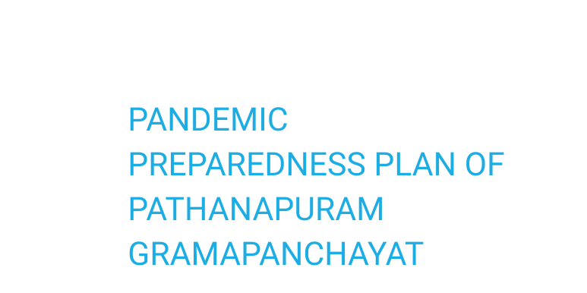



MESSAGE FROM PRESIDENT/CHAIR LSGI



SHEEJA S
PRESIDENT PATHANAPURAM GRAMA PANCHAYAT

Pathanapuram Grama Panchayat, comprising 19 wards, is committed to ensuring the health and well-being of all its residents through robust preparedness and an effective response to public health emergencies. This Pandemic Preparedness Plan has been carefully developed in collaboration with the Health Department, Health Standing Committee, frontline health workers, and community stakeholders to strengthen our capacity to prevent, detect, and respond to infectious disease outbreaks.
The plan focuses on early disease surveillance, prompt reporting through established systems, rapid coordinated action, protection of vulnerable populations, continuity of essential health services, and comprehensive risk communication during any health crisis. It lays out clear roles and responsibilities for health personnel, elected representatives, Panchayat staff, volunteers, and community members to ensure seamless implementation at all levels.
Special emphasis has been placed on safeguarding the elderly, children, pregnant women, persons with chronic illnesses, and ther vulnerable groups. Continuity of essential services such as immunization, maternal and child health care, non-communicable disease management, and emergency medical support will be maintained even during pandemic situations.
Community participation and cooperation are critical to the success of this preparedness strategy. I therefore earnestly request the active involvement of all departments, residents, and stakeholders across all 19 wards of Pathanapuram Grama Panchayat in implementing the activities outlined in this plan. Together, we can build a resilient and health-conscious community capable of responding effectively to any future public health challenge.


MESSAGE FROM HEALTH STANDING COMMITTEE CHAIR

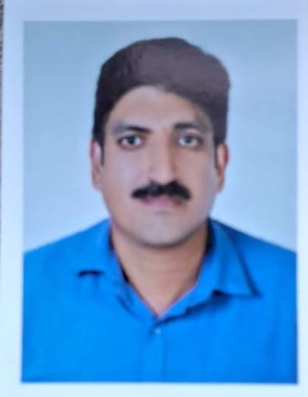

Tenson, Health Standing Committee Chairman

Pathanapuram Grama Panchayat, comprising 19 wards, recognizes the importance of preparedness and coordinated action in managing public health emergencies. This Pandemic Preparedness Plan has been developed to strengthen disease surveillance, early detection, timely reporting, and rapid response during any outbreak or pandemic situation.
The Standing Committee will work in close coordination with the Health Department, elected representatives, frontline workers, and community stakeholders to ensure effective implementation of the activities outlined in this plan. Special attention will be given to the protection of vulnerable groups and the uninterrupted continuation of essential services during emergencies.
I request the cooperation and active participation of all residents and stakeholders across all wards in supporting the successful execution of this preparedness strategy for the safety and well-being of our community.


MESSAGE BY BLOCK MEDICAL OFFICER

Rani Chandran L, Block Medical Officer
Pathanapuram Grama Panchayat, comprising 19 wards, requires strong public health preparedness and coordinated response mechanisms to effectively manage any outbreak or pandemic situation. As the Medical Officer, I am pleased to present this Pandemic Preparedness Plan prepared in collaboration with the Grama Panchayat, Standing Committees, Health Department staff, ASHA workers, Anganwadi workers, and other frontline personnel. This plan focuses on strengthening disease surveillance, early detection of cases, prompt reporting through established surveillance systems, and rapid response to public health emergencies. Clear roles and responsibilities have been defined for health staff, Panchayat authorities, and community volunteers to ensure timely field-level action.
Special emphasis has been placed on protecting vulnerable populations including the elderly, children, pregnant women, and individuals with chronic illnesses. The plan also ensures continuity of essential health services such as immunization, maternal and child health care, management of non-communicable diseases, and emergency medical services even during pandemic periods.
Risk communication, community awareness, promotion of hygiene practices, vaccination activities, and inter-departmental coordination are key components of this preparedness strategy. Active cooperation from the public and stakeholders across all 19 wards will be crucial for effective implementation. I request the wholehearted support and cooperation of all residents, departments, and stakeholders in executing the activities outlined in this plan to safeguard the health of our community.
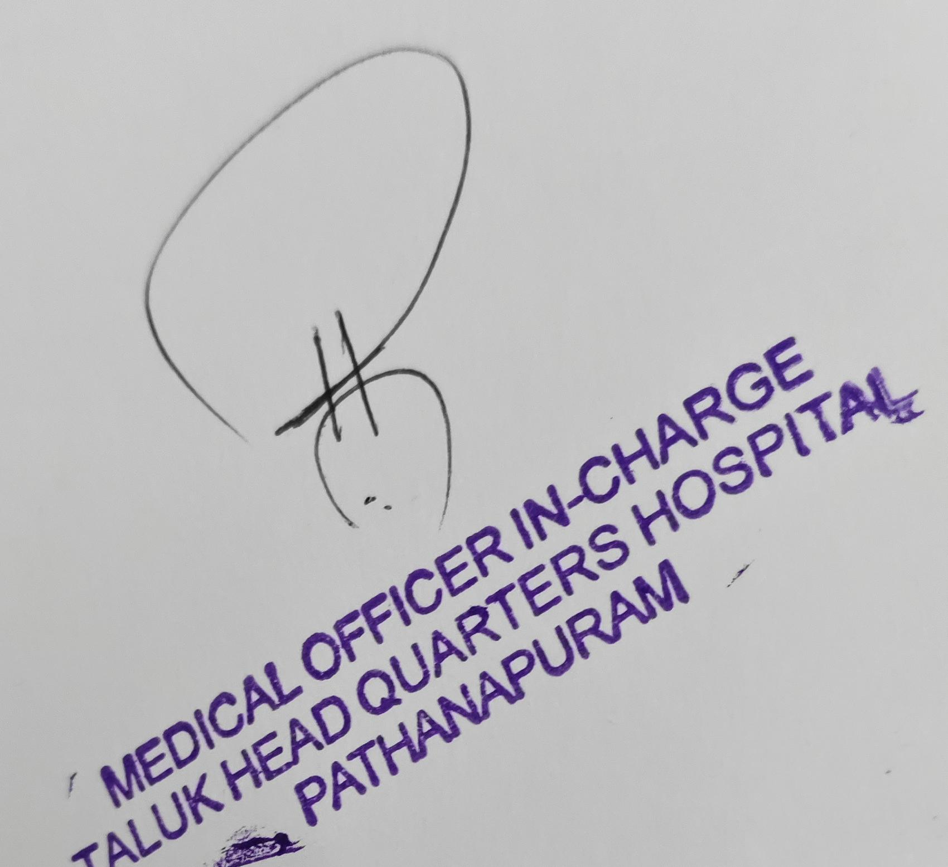

EXECUTIVE SUMMARY

Primary Health Centre (PHC) (mancode) and CHC (Pathanapuram ) functions as the primary public healthcare institution serving the population of Pathanapuram Grama Panchayath. The PHC plays a pivotal role in delivering comprehensive, accessible, and affordable healthcare services, with a strong focus on preventive, promotive, curative, and rehabilitative care in accordance with national and state health programmers.
Both the PHC and CHC caters to a predominantly rural population, addressing key public health priorities such as maternal and child health, communicable and non-communicable disease control, immunization, family welfare, adolescent health, and geriatric care. Regular outpatient services, home-based care through field health staff, and outreach activities ensure healthcare coverage even in geographically challenging areas. The institution actively implements national health missions, including the National Health Mission (NHM), National Tuberculosis Elimination Programme, National Programme for Prevention and Control of Cancer, Diabetes, Cardiovascular Diseases and Stroke (NPCDCS), and other disease surveillance initiatives.
Mancode PHC and CHC Pathanapuram works in close coordination with the Grama Panchayath, ASHA workers, Anganwadi centers, schools, and community-based organizations to strengthen community participation and improve health awareness. Emphasis is placed on early detection, timely referral, health education, and lifestyle modification to reduce disease burden and improve overall health outcomes.
Despite constraints related to infrastructure, manpower, and increasing service demand, the PHC continues to enhance service delivery through effective planning, data-driven decision-making, and community engagement. Strengthening facilities, upgrading digital health systems, and expanding preventive services remain key focus areas for future development.
Overall, _CHC Pathanapuram and Mancode Primary Health Centre stands as a vital institution in safeguarding public health and improving the quality of life of the residents of Pathanapuram_ Grama Panchayath.

LIST OF ABBREVIATIONS

LIST OF ABBREVATIONS

LSGD/LSGI | Local Self Government Department / Local Self Government Institution
BMO | Block Medical Officer
IDSP | Integrated Disease Surveillance Programme
NDMA | National Disaster Management Authority
PPE | Personal Protective Equipment
ICMR | Indian Council of Medical Research
CD | Communicable Diseases
NCD | NON-COMMUNICABLE DISEASES

TABLE OF CONTENTS
3
INTRODUCTION 9
- Background of the PPP 9
LSGD AT A GLANCE 9
INTEGRATED HEALTH INFRASTRUCTURE MAP OF
PANCHAYAT 10
GENERAL PROFILE OF THE LSGI’S 13
Background of the LSGI 13
Demographic and Vulnerable Population 14
Clinical Vulnerability 16
INFRASTRUCTURE & RESOURCE INVENTORY 18
Health Facility Directory & Basic Capacity in the LSGD 18
Private Clinics 19
Healthcare Education & Training Institutions 20
Specialized Services & Emergency Inventory 20
Oxygen & Diagnostic Capacity 21
Diagnostics facility mapping at the LSGI level 22
Laboratory Identification & Basic Details 22
Social and Community Infrastructure for surge plan 22
Human resources 24
Community & Support Cadre 25
Community Organizations 26
Administrative & Emergency Services 27
Information regarding resources 27
ONE HEALTH & ENVIRONMENTAL SURVEILLANCE 28
Animal & Bird Population 28
Veterinary Infrastructure 29
Veterinary Doctors & Workforce 30
High-Risk Interface Points (Surveillance Sites) 30
Environmental Risk Mapping 31
Disease Seasonality Mapping 32
Vulnerability Mapping 33
EPIDEMIOLOGICAL TRENDS (2021–2025) 34
Disease Burden among human beings(Last 5 Years) 34
*(use the above table data to create the graph/diagram) 36
Seasonal Trend Analysis 37
Outcome-Based Trend Analysis- 2025 39
Transmission Trend- 2025 40
Integrated Disease Hotspot Map (2021–2025) 42
Preparedness and Response Protocol at LSG Level 44
Constitution of One Health Committee 44
Pandemic Response Workforce 45
Activities and Measures before and during Pandemic 47
PHASE 1 - Alert / Preparation 47
PHASE 2 - Active Response 50
Standard Screening Protocol 51
PHASE 3 - Surge Capacity 60
Conversion of Community Facilities 60
CONCLUSION 61
RECOMMENDATIONS 62
ANNEXURE 63

INTRODUCTION

Background of the PPP

The repeated emergence of global pandemics such as Severe Acute Respiratory Syndrome (2003), H1N1 inﬂuenza (2009), Ebola (2014), Zika (2015), and COVID-19 (2019) has clearly demonstrated that increased globalization, rapid travel, migration, and population density enable infectious diseases to spread faster than ever before. These events emphasized the critical need for preparedness at every level of governance. In this context, Pathanapuram Block Panchayat in Kollam district, Kerala has developed a structured Pandemic Preparedness Plan aimed at strengthening early disease surveillance, rapid response mechanisms, logistics and stock management, isolation and referral systems, inter-departmental coordination, and community awareness. Considering the block’s mixed rural settlements, population mobility, and
dependence on nearby urban centres, the plan focuses on timely detection, containment,
continuity of essential health services, and protection of vulnerable groups to minimize
morbidity, mortality, and socio-economic disruption during future pandemics.
The Pandemic Preparedness Plan for Pathanapuram Block is developed to Strengthen early warning surveillance systems through PHCs, sub-centres, private facilities, and IDSP reporting.
Establish Rapid Response Teams (RRTs) at block and Panchayat levels.
Ensure adequate logistics and buffer stock of PPE, essential medicines, and emergency supplies.
Identify and prepare isolation and quarantine facilities when required.
Strengthen referral linkages with Taluk/District hospitals.
Enhance risk communication and community engagement through ward-level committees.
Ensure continuity of essential services such as immunization, maternal care, NCD management, and emergency services.
Promote inter-sectoral coordination between Health, LSGD, Police, Revenue, ICDS, Education, and Animal Husbandry Departments

LSGD AT A GLANCE

Pathanapuram Block Panchayat is an intermediate tier Local Self Government Institution functioning under the Local Self Government Department (LSGD) of Kerala. It is located in the eastern part of Kollam district and consists of several Grama Panchayats under its administrative jurisdiction. The block plays a coordinating role in rural development, public health implementation, disaster management, infrastructure development, and welfare scheme execution.
Geographical Boundaries:
North: Punalur Municipality
South: Kulathupuzha Grama Panchayat
East: Forest areas adjoining Aryankavu and Tamil Nadu border
West: Pathanapuram Grama Panchayat and nearby midland Panchayats
Geographical Features:
Midland to highland terrain
Rubber plantations and agricultural lands Forest fringe areas
River and small stream networks
Scattered rural settlements with moderate population density
Administrative & Functional Highlights:
Coordinates Primary Health Centres and Sub Centre

Implements state and centrally sponsored schemes Conducts block-level disaster preparedness planning Supports Panchayats in sanitation, waste management, and disease control
The block’s geographical positioning—between urban centres and forest-border regions—makes it strategically important for surveillance, mobility monitoring, and coordinated response during outbreaks and emergencies.

- Geographical boundaries with political map ( based on latest delimitation)

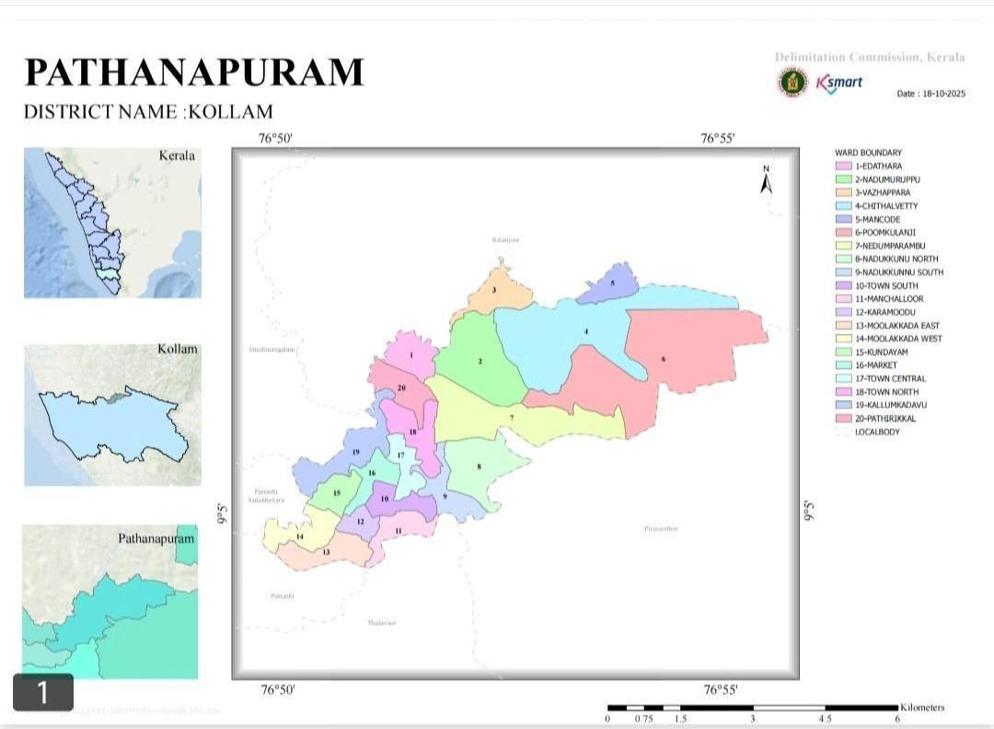

- Baseline data
- Ward division -
Ward | Houses | Populatio n | Migrants | Wells | Hot spots | Ed.  Institutio ns | Hosp  pvt/govt.
19 | 7856 | 30365 | 326 | 7145 | 2 | 19 | 7

- Risk stratification among wards in the context of Communicable diseases and hazards
- Major Roads/rivers
- Major establishments with geospatial mapping
- occupational groups, socio cultural groups, migration & mobility patterns
- Vulnerability mapping
- Disaster prone areas (geographic vulnerability)

Maps - ward-based (Mention source also)

- Health infrastructure map
- Geographical boundaries -ward boundaries map
- Disaster prone areas map
- CD hotspot map
- Rivers and canals map

INTEGRATED HEALTH INFRASTRUCTURE MAP OF
PATHANAPURAM PANCHAYAT

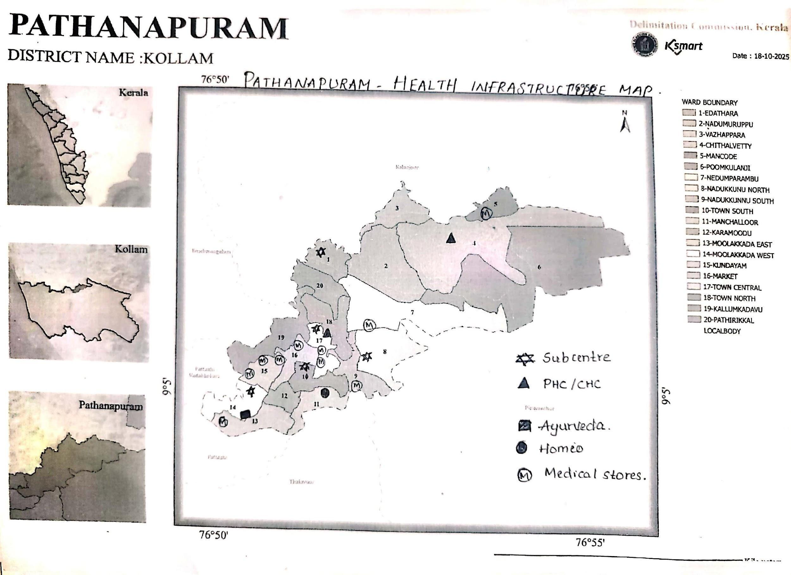

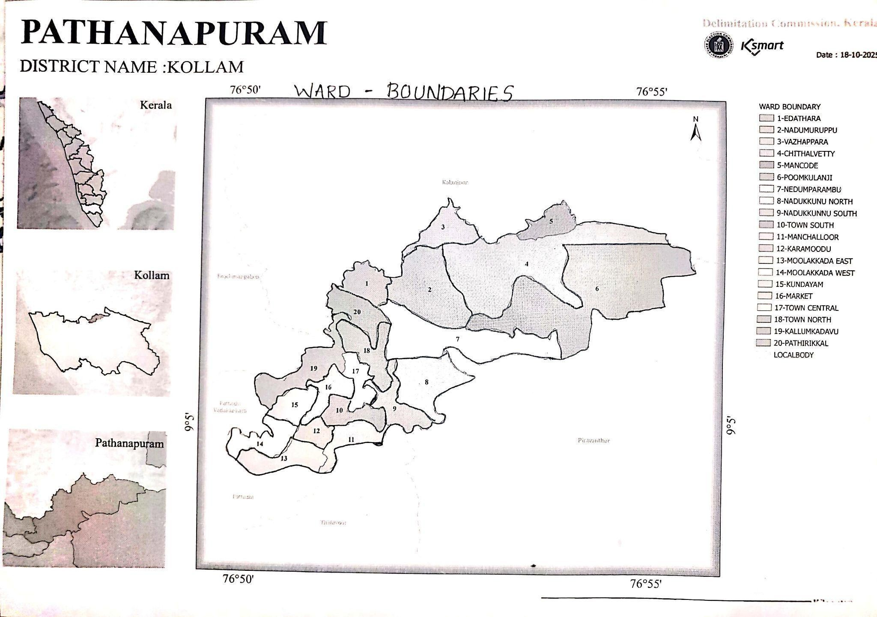

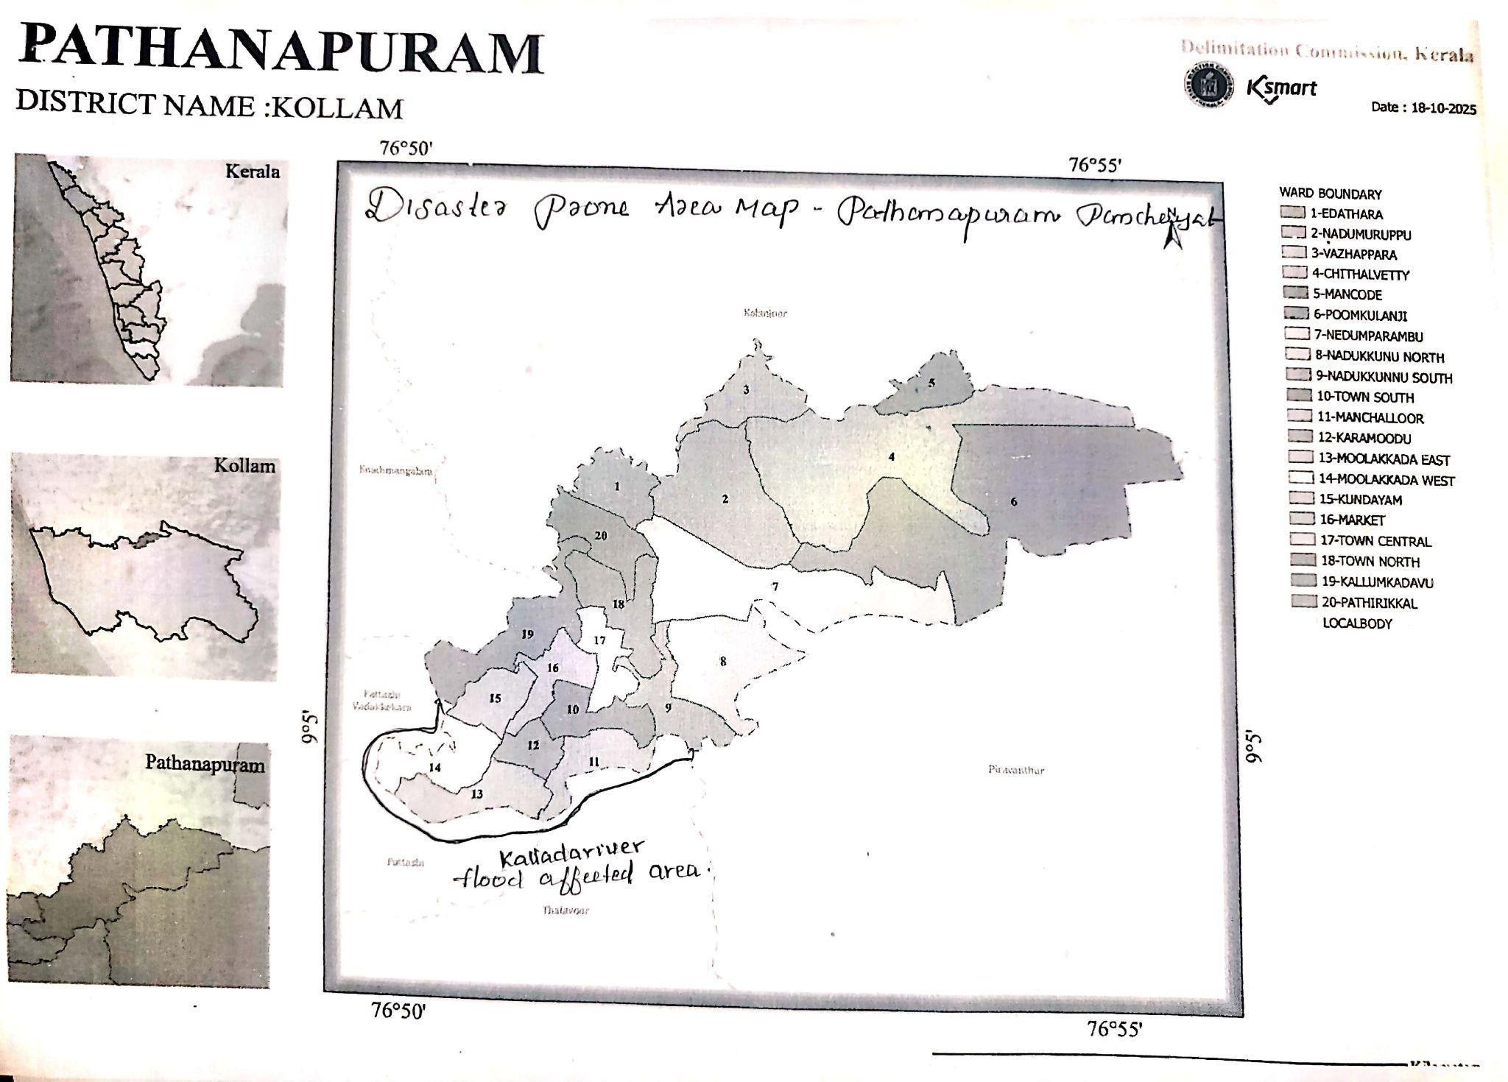

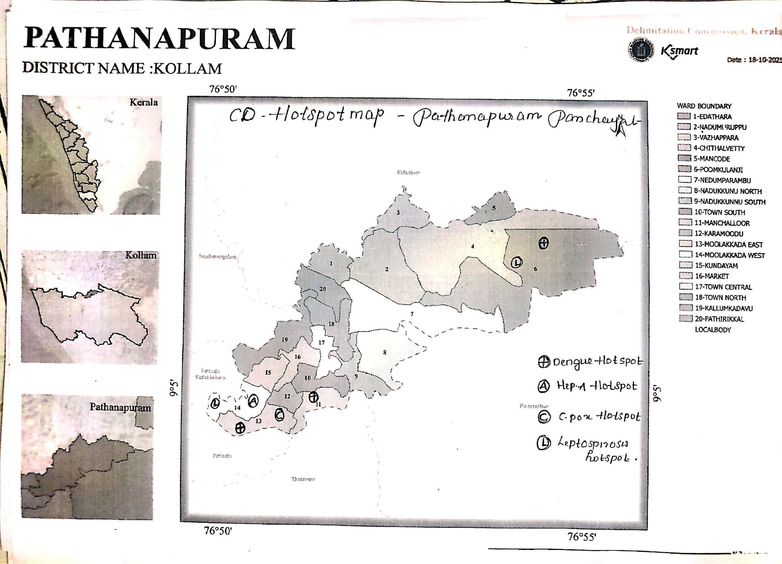

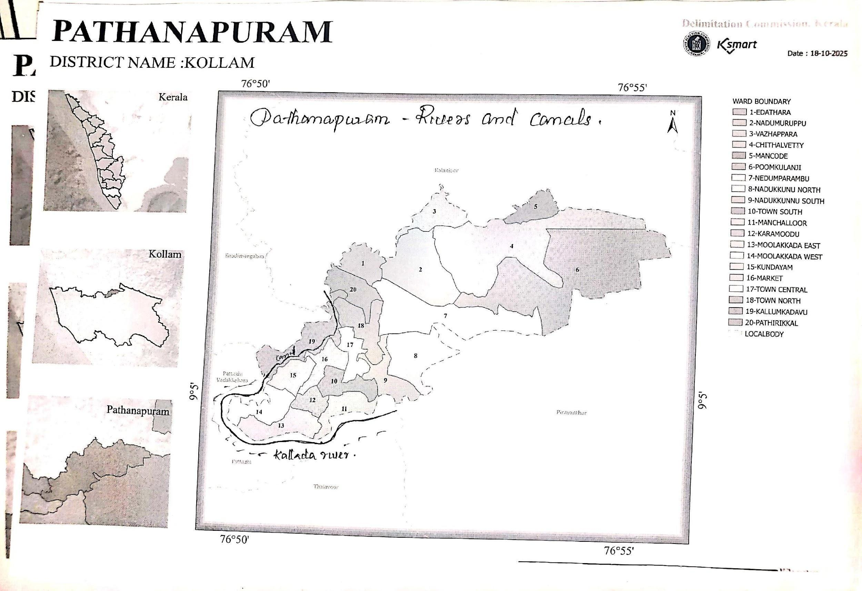

GENERAL PROFILE OF THE LSGI’S
Background of the LSGI
Pathanapuram Grama Panchayat is situated in the eastern part of Kollam District in Kerala. It lies in the foothill region of the Western Ghats and is characterized by a mix of rural and semi-urban settlements. The Panchayat is part of the Pathanapuram Block and functions under the three-tier Panchayati Raj system of Kerala.
The area has a predominantly agrarian economy, with agriculture, rubber cultivation, small-scale trade, and daily wage labour forming the major sources of livelihood. The Panchayat also has a number of small businesses, markets, educational institutions, religious centres, and government offices that serve as hubs of social and economic activity.
Pathanapuram enjoys road connectivity to nearby towns and taluks, facilitating movement of people for education, employment, healthcare, and commerce. The presence of schools, anganwadis, Primary Health Centres, private clinics, and community halls reflects the availability of essential social infrastructure within the Panchayat.
The demographic profile includes a diverse population with children, working-age adults, and elderly residents. Like many rural areas in Kerala, the Panchayat has a significant proportion of elderly individuals, making healthcare services and public health planning particularly important.
The Panchayat administration functions through elected representatives, supported by standing committees and local-level institutions. It plays a vital role in implementing development programmes, sanitation activities, waste management initiatives, and public health measures in coordination with the Health Department.
Due to its geographic location, population mobility, and socio-economic characteristics, Pathanapuram Grama Panchayat requires systematic planning for sustainable development and effective public health management.

Description | Details
Name of LSGI | Pathanapuram
Type (GP/Municipality / Corporation etc.) | Grama Panchayath
Block | Pathanapuram
District | Kollam
Number of wards | 19
Total area (sq. km) | 24.20 km sq
Population(Projected) | 30365

Table 1: Background of LSGD
Description | Details
Population density | 1255 persons/sq km
Terrain (coastal/low-lying/backwaters/foothills, etc.) | foothills
Number of rivers passing through LSGI | 1
Number of water bodies in the LSGI | 6
Number of educational institutions | 21
Factories / small-scale industries | 2
Flood-prone wards | 3
Landslide-prone wards | 0
Death Management and Disposal Facilities (mortuaries/crematorium, including electric) | 0
Auditoriums/Marriage halls/convention centres/community halls | 4
Demographic and Vulnerable Population
Understanding the demographic composition and vulnerable population groups is essential for pandemic preparedness. Children, elderly, economically deprived families, migrant workers, and socially vulnerable groups are at increased risk during public health emergencies due to higher exposure, limited access to services, and dependency on public systems..

Description | Details (in numbers)
DEMOGRAPHIC PROFILE
Total population | 30365
Male | 11526
Female | 18339

Description |  | Details (in numbers)
DEMOGRAPHIC PROFILE
Transgender |  | 0
Children under 5 |  | 1495
Adolescent |  | 1438
Elderly (>60) |  | 3872
SOCIAL/LIVELIHOOD VULNERABILITY
Previous EPEP family |  | 28
BPL family |  | 6548
Tribal communities |  | 0
Migration | Immigrant | 562
Migration | Emigrant | 977
Socio-economically deprived |  | 35
Fisherfolk |  | 0
SC Community |  | 245
ST Community |  | 0

Graphs: Population pyramid (if possible) for seeing if your LSGI has a high "dependency ratio" (lots of children and elderly compared to working adults).

Clinical Vulnerability
Certain population groups needs priority healthcare & are at higher risk of severe illness, complications, and mortality during pandemics. Patients with chronic diseases, those requiring regular medical care, and individuals with mobility or functional limitations face challenges in accessing timely care during emergencies. Mapping these groups helps in prioritizing continuity of treatment, medicine stock planning, oxygen support, referral transport, and targeted home-based care.

Description | Details in numbers
Pregnant women | 276
Lactating mothers | 381
Bedbound patients | 61

Description | Details in numbers
Patients under palliative care other than bedbound | 46
Patients on Haemodialysis | 29
Patients on CAPD | 0
Cancer patients (currently on treatment) | 17
Haemophilic patients | 0
Mentally challenged | 150
Differently abled | 190
Diabetic patients | 10145
Hypertensive patients | 8569
TB patients | 16

Major Festivals & Events specific to the LSGI
(with the possibility of a public gathering)

Sl. No. | Name of festival | Month detailing the periodicity
1 | Sivarathri ulsavam | February
2 | kavala temple | march
3 | mount tabor diara | january
4 | chathanambalam | march
5 | manchalloor | march

INFRASTRUCTURE & RESOURCE INVENTORY
Health Facility Directory & Basic Capacity in the LSGD
This section provides an overview of the healthcare infrastructure available within the LSGD area. It outlines the distribution and basic capacity of health facilities that form the backbone of service delivery during routine times and public health emergencies.

Family Health Centres (FHCs) and Community Health Centres (CHCs) generally function as the first point of contact for the community, providing essential outpatient and inpatient services. General Hospitals (GH) and Medical College Hospitals (MCH), where accessible, serve as the main referral centres for advanced diagnostics, specialist care, and critical services during public health emergencies. This inventory helps identify existing strengths, gaps, and potential surge capacity that can be mobilised during a pandemic or disaster.

Table 5. Health Facility Resource Summary
Sl. no  . | Health Facility | Type of Facility (MCH/G  H/CHC/ FHC/SC  etc.) | Contact Number | Total beds | ICU  Beds | Oxygen- Support ed Beds | No. of Ventilator Support Beds | No. of ambulance s
Government Healthcare Facilities
1 | CHC Pathanapuram | CHC | 9656753870 | 15 | 0 | 0 | 0 | 1
2 | PHC Mancode Pathanapuram | PHC | 8547330010 | 3 | 0 | 0 | 0 | 0
AYUSH Healthcare Facilities

Table 5. Health Facility Resource Summary
Sl. no  . | Health Facility | Type of Facility (MCH/G  H/CHC/ FHC/SC  etc.) | Contact Number | Total beds | ICU  Beds | Oxygen- Support ed Beds | No. of Ventilator Support Beds | No. of ambulance s
1 | AYUSH Ayurveda Hospital | PHC | 9744498938 | 1 | 0 | 0 | 0 | 0
2 | AYUSH Homeo clinic | PHC | 9895519085 | 1 | 0 | 0 | 0 | 0

Private Clinics
Private clinics are an essential part of pandemic preparedness, as they are often the first place people seek care when symptoms begin. In many communities, private clinics manage a significant share of outpatient visits and therefore play a critical role in early case detection, timely referrals, and disease surveillance. Having an up-to-date understanding of where these clinics are located, the services they provide, and how they are linked to the public health system helps ensure that no cases are missed during an outbreak. It also allows health authorities to engage private practitioners more effectively for reporting, risk communication, and coordinated response, strengthening the overall capacity of the health system to manage public health emergencies.

Table 6. Private Clinic Resource Summary
Sl No  . | Name of Clinic | Registered (Y/N) | Clinic (General / Speciality) | Speciality (if any) | Address | Contact Number | Diagnostic Facility (Y/N) | Ambulance Linkage (Y/N)
1 | Path finder | y | general | nil | Dr rajeev  pathanapur am | 8281691596 | y | y
2 | sharon clinic | y | general | nil | dr sherley  pathanapur am | 9847564522 | y | y
Healthcare Education & Training Institutions
This section tracks the educational infrastructure available, which is vital for human resource planning in the health sector.

Category of Institution | Govt | Private | AYUSH | Total
Medical Colleges | 0 | 0 | 0 | 0
Nursing Colleges | 0 | 0 | 0 | 0
Dental Colleges | 0 | 0 | 0 | 0
Para-medical / Allied Health | 0 | 0 | 0 | 0
Pharmacy Colleges | 0 | 0 | 0 | 0

Specialized Services & Emergency Inventory
This section provides a detailed view of the specialized medical resources available to the community, focusing on emergency response and critical care capabilities. This table tracks the vital assets required for managing severe illnesses and emergencies across Government, Private, and AYUSH sectors.

Item | Govt | Private | AYUSH | Total
Hospital beds | 15 | 225 | 0 | 240
Oxygen-generating systems(Y/N) | N | N | N | 0
Oxygen-supported beds(Numbers) | N | N | N | 0
Ventilator-supported beds | N | N | N | 0
ICU beds | 0 | 13 | 0 | 13
Burns units | 0 | 0 | 0 | 0
Blood centres | 0 | 0 | 0 | 0
BLS ambulances | 1 | 5 | 0 | 6
ALS ambulances | 0 | 0 | 0 | 0
Dialysis facilities | 0 | 0 | 0 | 0
Dispensaries | 2 | 14 | 2 | 18

Item | Govt | Private | AYUSH | Total
Medical store | 2 | 22 | 2 | 26
Industrial establishments(Medium-scale industries/small-scale industries establishments to whom we can depend in a worst-case scenario) | 0 | 0 | 0 | 0

Oxygen & Diagnostic Capacity
Monitoring oxygen and diagnostic capacity is a critical component of public health preparedness, ensuring that the LSGD can handle both chronic care and sudden surges in respiratory or infectious diseases.

Name of Health Facility | Oxygen-generati ng System  (Y/N) | Backup Oxygen Source (Y/N) | Diagnostic Facilities Available(Y/N)
Name of Health Facility | Oxygen-generati ng System  (Y/N) | Backup Oxygen Source (Y/N) | Lab | USG | X-ray | CT/MRI | RT-PCR
Government Healthcare Facilities
CHC  Pathanapuram | N | N | Y | N | Y | N | N
Mancode PHC | N | N | Y | N | N | N | N
Diagnostics facility mapping at the LSGI level
The diagnostic capacity of Pathanapuram G.P represents the "intelligence network" of our healthcare system. The speed and accuracy of disease identification depend entirely on the distribution and technical level of these facilities.

Item | Govt | Private | AYUSH | Total
General labs | 2 | 15 | 0 | 17
Microbiology labs | 2 | 15 | 0 | 17
RT-PCR labs | 0 | 4 | 0 | 4
USG units | 0 | 4 | 0 | 4
CT/MRI units | 0 | 0 | 0 | 0

Research labs | 0 | 0 | 0 | 0
Labs of other departments that can be repurposed | 0 | 0 | 0 | 0

Laboratory Identification & Basic Details

Sl.  No. | Name of Laboratory | Ownership  (Govt / Private  / Academic) | Address | Contact No. | 24×7 Services (Yes/No) | NABL / Govt Approved (Yes/No)
1 | Microlab | pvt | near govt hospital pathanapu  ram | 9496924077 | no | no
2 | Optam | pvt | Pallimukk u pathanapu  ram | 8606269977 | no | no
3 | Kairali lab | pvt | pathanapu  ram | 9447505232 | no | no
4 | J S Medi lab | PVT | Pathanapu  ram | 9447076401 | no | no
5 | Govt hospital lab | govt | THQH  Pathanapu ram | 9048524945 | no | no
6 | PHC Lab  mancode pathanapuram | govt | PHC  Mancode Pathanapu ram | 8547330010 | no | no
7 | Aswas lab  mancode pathanapuram | pvt | Mancode  Pathanapu ram | 07034855123 | no | no

Social and Community Infrastructure for surge plan
This table serves as our logistics and shelter inventory. By mapping these locations, quickly we can identify where to house displaced citizens, where to set up temporary medical clinics, and how to manage the deceased with dignity during a crisis.

Category | Total Count | Ward | Est. Capacity (Persons) | Contact details
Educational Institutions
Anganwadis | 32 | 19 | 350 | 047502351551

Schools | 17 | 19 | 8500 | 9764335677
Colleges | 1 | 17 | 300 | 9446993798
Healthcare Educational Institutions
Medical colleges (Govt/Private) | 0 | 0 | 0 | 0
Nursing colleges (Govt/Private) | 0 | 0 | 0 | 0
Dental colleges (Govt/Private) | 0 | 0 | 0 | 0
Paramedical institutes (Govt/Private) | 0 | 0 | 0 | 0
Community Gathering Spaces
Community halls | 2 | 17,12 | 700 | 8606834005
Auditoriums | 3 | 16,15,9 | 3000 | 7025434883  8606834005  7907109001
Religious buildings | 38 | 19 | 4500 | 6282610898
Vulnerable Group Support Facility
Destitute homes | 1 | 13 | 1200 | +91 98471  67422
Elderly homes | 2 | 13 | 1000 | +91 98471  67422
LSGD owned other buildings | 2 | 14,15 | 500 | 04752352346
Mass Fatality Management (MFM) Infrastructure
Mortuary | 0 | 0 | 0 | 0

Crematorium | 0 | 0 | 0 | 0
*refer annexure 1 for contact details

Human resources
This section focuses on the human capital available within the LSGI. In any emergency—be it a pandemic, flood, or industrial accident—infrastructure is only as effective as the people operating it.
Medical & Clinical Personnel
This table tracks the "Frontline" providers responsible for diagnosis, treatment, and clinical management. Narrative sentence: eg., "Total health workforce: 450 personnel, with 60% in government facilities serving as primary surge capacity." A detailed directory with the contact numbers of all workers is maintained (Annexure in 1).

Cadre | Govt (No.) | Private (No.) | Total
Doctors—Modern Medicine | 11 | 18 | 28
Doctors – AYUSH | 4 | 0 | 0
Doctors – Veterinary | 1 | 0 | 0
Doctors – Dental | 2 | 8 | 10
Nursing officers | 11 | 64 | 74
Lab technicians | 3 | 14 | 17
Optometrist | 1 | 3 | 4
Pharmacists | 4 | 14 | 18
Psychologists | 0 | 0 | 0
Counsellors | 0 | 0 | 0

Public Health & Field-Level Workforce
These individuals are the backbone of surveillance, maternal-child health, and decentralized care.

Cadre | Health services | Municipal common services | Total
HS (Health Supervisors) | 1 | 0 | 1
HI (Health Inspectors) | 2 | 0 | 2
LHS (Lady Health Supervisor) | 1 | 0 | 1

Cadre | Health services | Municipal common services | Total
LHI (Lady Health Inspectors) | 2 | 0 | 2
JPHN (Jr Public Health Nurses) | 8 | 0 | 6
JHI (Jr Health Inspectors) | 6 | 0 | 5
MLSP (Mid-Level Service Providers) | 8 | 0 | 6
Palliative Nurses | 2 | 0 | 2
RBSK Nurses | 1 | 0 | 2
PRO | 1 | 0 | 1
Epidemiologist | 1 | 0 | 1
Data Manager | 0 | 0 | 0

Community & Support Cadre
This group represents the surge capacity of the LSGI—people who can be called upon for logistics, rescue, and specialized support.

Cadre | Number
ASHA Workers | 28

Cadre | Number
AWW (Anganwadi Workers) | 32
Emergency Medical Volunteers (Trained) | 0
Kudumbashree | 20
MNREGS | 20
Purusha Swayam Sahaya Sangham | 0
Ex-Servicemen | 45
Retired Police Officers | 21
NCC/NSS Volunteers | 360
Red Cross volunteers | 120
One Health Community Volunteers | 0
One Health Community Mentors | 0

Community Organizations
This section details the presence of community-based organisations (CBOs), non-governmental organisations (NGOs), faith-based organisations (FBOs), Kudumbashree Self-Help Groups (SHGs), and Ayalkootams within the Local Self-Government Institution (LSGI). These groups enhance grassroots mobilization, resource distribution, and support networks crucial for pandemic response and community resilience.

Category | Total Count
NGOs | 1
Religious based organizations | 2
Foreign based organizations | 2
Sports Club/youth clubs | 4
Kudumbashree SHGs | 20
Ayalkootams | 22
Political organizations | 5
Residential organizations | 1

Administrative & Emergency Services
This section outlines the availability of key non-health emergency support services and infrastructure within the LSGI, which are essential for effective pandemic preparedness and response. These facilities support law enforcement, disaster response, water supply, logistics, mobility, and community-level interventions during public health emergencies.

Category | Total Count | Contact details
Police Stations | 1 | 04752352200
Fire & Rescue Stations | 0 | 0
Water Pumping Points | 1 | 9847804023
Public Distribution System (PDS) | 1 | 9188527316
Information regarding resources
The availability of essential transport and support resources plays a quiet but critical role in saving lives. Equipment such as ambulances, mobile mortuaries, amphibian ambulances, and motorized boats ensures that patients, samples, and healthcare teams can move swiftly—even in flooded, remote, or difficult terrains. Heavy vehicles like JCBs, cranes, tractors, and torus lorries support logistics, waste management, emergency infrastructure, and rapid conversion of spaces into care or isolation facilities. Taxis, four-wheel-drive vehicles, and

trucks help maintain continuity of essential services, reach vulnerable populations, and support home-based care and supply delivery.

Means of transportation | Total Count
JCB | 10
Crane | 1
Heavy Trucks | 2
Tractor | 5
Ambulances | 5
Mobile mortuaries | 0
Boats | 0
Taxi service | 30
Note: For specific details regarding vehicle owners and contact information, please refer to Annexure [X].
ONE HEALTH & ENVIRONMENTAL SURVEILLANCE

The One Health method integrates environmental, animal, and human health to enable proactive pandemic preparedness. Panchayat-level surveillance needs to be improved in order to detect and treat zoonotic and environmentally generated diseases early. Surveillance is strengthened through systematic assessment of animal populations, veterinary infrastructure, poultry and slaughter facilities, inter-sectoral coordination, and specialised tools like avian influenza seasonality mapping using GIS in previous outbreaks to enable predictive alerts and ward-specific sampling to support effective pandemic preparedness in high-risk areas.
Animal & Bird Population
Mapping animal and bird populations at the Panchayat level is essential for identifying and prioritising zoonotic disease hazards like rabies, avian influenza (H5N1), leptospirosis, anthrax, and Nipah-like spillover occurrences. Risk classification, targeted surveillance, vaccination planning, and early epidemic detection made feasible by comprehensive population mapping all enhance One Health-based pandemic preparedness.

Category | Item | Estimated Population | Wards
Animal Population | Livestock  (Cattle/Goats/Buffalo) | 5486 | 20
Animal Population | Pet Animals (Dogs/Cats) | 2586 | 20
Animal Population | Stray Dog Population | 523 | 20
Animal Population | Pig Farms (Number of heads) | 10 | 20
 | Small Units (Sheep / Goats – clustered) | 1 | 20
Bird Population | Poultry Units (Birds) | 2 | 20
Bird Population | Poultry- (FOWL) | 2 | 20
Bird Population | Wild/Migratory Birds (Observed) | 0 | 20
Bird Population | Crow Mortality Events (Reported) | 15 | 20

The main risk of zoonotic diseases in PATHANAPURAM PANCHAYAT is concentrated in no Wards which is explained by the high density of pig farms, cattle congregation areas, and poultry units. The stray dog population in market areas, fish landing sites, bus stations continues to be a substantial problem for rabies surveillance and bite prevention. There is a considerable risk of avian influenza introduction and amplification during November - December due to the seasonal presence of migratory and resident water birds near ponds/ canal / river / backwater / paddy field. Clusters of pig farms and animal shelters vulnerable to flooding further raise the risk of leptospirosis and other zoonoses mediated by the environment, especially during monsoon floods.
Veterinary Infrastructure
Veterinary institutions are a core pillar of One Health surveillance, enabling early zoonotic disease detection through vaccination, investigation of unusual animal illness or deaths, sample collection, and timely outbreak reporting. A well-mapped and responsive veterinary network strengthens coordination with human health and LSGI systems, ensuring rapid response during zoonotic events and pandemics.

Facility Type | Name of Facility | Ownership Govt / Pvt | Location(Wa rd No) | Contact number
Veterinary Dispensary | 0 | 0 | 0 | 0
Veterinary Hospital / Polyclinic | 1 | govt | 10 | 9747401797
Private Veterinary Clinics | 0 | 0 | 0 | 0
Mobile / Emergency Vet Service (incl. night  services) | 0 | 0 | 0 | 0
Pet Homes / Animal Shelters | 0 | 0 | 0 | 0
Slaughterhouse-linked Veterinary Inspection Unit | 0 | 0 | 0 | 0

Veterinary Doctors & Workforce
Early detection, diagnosis, reporting, and reaction to animal illness epidemics depend on the availability and accessibility of qualified veterinary specialists. By identifying unusual animal morbidity or mortality promptly, collecting samples promptly, and coordinating efficiently with human health and LSGI systems—especially during zoonotic outbreaks and pandemic-prone situations—a clearly defined veterinary workforce enhances One Health surveillance.

Category | Number Available | Type (Govt/Pvt) | Contact number
Government Veterinary Doctors | 1 | govt | 04752035600
Private Veterinary Doctors | 1 | PVT | 8590309461
Livestock Inspectors | 2 | GOVT | 9747401797
Para-veterinary Staff / Attenders | 5 | PVT | 9526014119
Contract / On-call Veterinary Support (if any) | NIL | NIL | Nil

High-Risk Interface Points (Surveillance Sites)
High-risk interface points for zoonotic disease surveillance in PathanapuramGrama Panchayath include wetland–livestock–human contact zones, backyard poultry farms, cattle sheds near water bodies, fish markets, and areas of high human–animal interaction such as community slaughter points and migratory bird congregation sites. These are the primary surveillance sites where zoonotic spillover risks are elevated.

Type of Habitat | Type of High risk interface | Geographical vulnerability
Wetlands & Backwaters | 0 | 0
Backyard Poultry Farms | 2 | Med
Cattle Sheds near Water Bodies | 0 | 0
Fish & Meat Markets | 1 | Med
Community Slaughter Sites | 0 | 0

Migratory Bird Congregation Areas | nil | nil
Rodent-Infested Grain Storage | nil | nil

Category | Total Count | Key Locations (wards)
Poultry Farms | 2 | 12,10
Backyard / Clustered Poultry Units | 0 | 0
Duck Rearing Units (open water access) | 0 | 0
Slaughterhouses/ Slaughter Points | 0 | 0
Meat/Fish Markets | 1 | 15
Live Bird Sale Points | 0 | 0
Cattle Markets / Weekly Animal Fairs | 0 | 0
Pet Shops / Breeders | 3 | 13,17,9
Animal Shelters / Pet Homes | 0 | 0
Waste Disposal Sites near Animal Units | 0 | 0

Environmental Risk Mapping
Environmental risk mapping identifies monsoon/flood hotspots for vector-borne (dengue, chikungunya), water-borne (leptospirosis, diarrhoea), and zoonotic diseases in Kerala's wetlands. Systematic surveillance supports early warnings, targeted interventions, and Panchayat pandemic preparedness.
Waterborne exposure: Flood-prone areas and stagnant water bodies facilitate leptospira survival, raising leptospirosis risk.

Traditional practices: Informal slaughter and fish markets lack standardized hygiene, creating spillover opportunities.

Risk Factor | High-Risk Wards | Key Locations | Risk Level (High/Med/Low)
Flood-prone areas | ward 15 | jawahar colony kallumkadavu | med
Water bodies/wetlands | ward 19  ward 15  ward 16 | jawaharcolony,man challoor,pathirikal, | med
Solid waste accumulation | ward 16  ward 9  ward 18 | crown area nadukkunnu town | med
Animal waste disposal issues | ward 1 | kattachi kadavu | high
Rodent infestation zones | nil | nil | nil
Industrial effluent discharge | nil | nil | nil
Construction sites / abandoned buildings | ward11 | THQH  Construction site | med
Poor drainage/blocked canals | nil | nil | nil
Drinking water source contamination risk | nil | nil | nil

Disease Seasonality Mapping
1, Flooding & waterlogging → ampliﬁes leptospirosis, malaria, diarrheal diseases.

·

2, Migratory bird influx (Nov–Feb) → avian inﬂuenza risk.

3, Mosquito breeding cycles → vector-borne disease peaks in monsoon.

4, Agricultural practices → close human–animal contact in paddy ﬁelds.

Disease | Peak Risk Season | Key Drivers | High-Risk Locations | Surveillance Focus
Avian Influenza | nil | nil | nil | NIL
Leptospirosis | august-november | nreg | nil | fever survey  vector survey,doxy distribution
Dengue/Chikungunya | june-august | migrants and  plantation workers | manchalloor kundayam | fever survey vector survey
Acute Diarrheal Diseases | june-september | children | nil | well chlorination ORS distribution
Rabies | March - may | Stray dogs | All wards | Coordinate with veterinary department and control the birth
Anthrax (rare) | NIL | nill | nill | nill

Vulnerability Mapping
Vulnerability mapping pinpoints high-risk populations, occupations, and areas exposed via environment, livelihoods, socio-economics, and poor service access. Paired with environmental/seasonality mapping, it enables risk-based surveillance, targeted actions, and optimal resource use in One Health and pandemic planning.

Vulnerability Factor | High-Risk Wards | Key Groups / Locations | Risk Level
Flood-prone households | 15,16,11 | Jawahar colony;kallumkadav u;manchalloor | med
Wetland-adjacent communities | nil | nill | nill
Backyard poultry / duck rearing households | 2 | near veterinary hospital,near sports club10,12 | low
Livestock-rearing households | 0 | 0 | 0
Slaughterhouse & meat market workers | 0 | 0 | 0
Fisherfolk & fish market workers | 3 | 12,13,14kundayam area | med
Sanitation workers | 15 | bus stand area,market area | med
Daily wage / migrant workers | 11 | construction site THQH  Pathanapuram | med
Elderly & chronically ill populations | 3872 | ALL WARDS | Low level immunity status lead to high risk
Pregnant Women | 276 | All wards | critical risk for complication from water born and vector born diseases
Children (schools, Anganwadi’s) | 2495 | All wards | vulnerability to skin conditions and ADD
Limited access to safe water & sanitation | 13 | Attaputhoor | MED

EPIDEMIOLOGICAL TRENDS (2021–2025)

Disease surveillance is the systematic collection, analysis, and interpretation of health data for planning, implementation, and evaluation of public health practice. This section presents the disease surveillance profile of the LSGI based on routine reporting systems and outbreak investigations to identify priority diseases, seasonal patterns, and emerging public health threats.
Disease Burden among human beings(Last 5 Years)
Analysis of disease-wise data for the last five years helps identify persistent public health problems, emerging diseases, and changes in disease burden. This information supports prioritisation of prevention, preparedness, and response activities at the Panchayat level.

Disease | 2021 | 2022 | 2023 | 2024 | 2025 | Trend(Increasing/Stable/Decreasing)
Dengue | 3 | 5 | 27 | 70 | 36 | DECREASING
Leptospirosis | 3 | 2 | 6 | 4 | 4 | STABLE
Hepatitis A | 0 | 0 | 2 | 3 | 11 | INCREASING
Malaria | 1 | 2 | 0 | 0 | 0 | DECREASING
Scrub Typhus | 0 | 0 | 0 | 0 | 1 | INCREASING
Typhoid | 0 | 0 | 0 | 2 | 5 | INCREASING
H1N1 | 0 | 0 | 0 | 4 | 1 | DECREASING
H3N2 | 0 | 0 | 0 | 0 | 0 | STABLE
ADD | 33 | 56 | 82 | 112 | 116 | INCREASING
Mumps | 0 | 0 | 0 | 1 | 65 | INCREASING

Measles | 0 | 0 | 0 | 0 | 0 | STABLE
Hepatitis B | 0 | 0 | 3 | 0 | 3 | STABLE
Hepatitis C | 0 | 0 | 0 | 0 | 0 | STABLE
Tuberculosis | 16 | 14 | 9 | 5 | 10 | INCREASING
Leprosy | 0 | 0 | 0 | 0 | 0 | STABLE
COVID-19 | 283 | 4 | 0 | 0 | 0 | DECREASING

*(use the above table data to create the graph/diagram)

Seasonal Trend Analysis
Seasonal analysis helps anticipate surges (e.g. dengue in monsoon, leptospirosis after floods, influenza in cooler months) and plan pre-emptive vector control, stockpiling of IV fluids, and awareness campaigns at Panchayat level.

DENGUE
Dengue is a major seasonal vector-borne disease strongly associated with rainfall, water stagnation, and increased mosquito breeding during the monsoon period.

Peak: July–November
Dengue – Ward-wise Yearly Distribution (2021–2025)

Ward | Dengue – Ward-wise Yearly Distribution
Ward | 2021 | 2022 | 2023 | 2024 | 2025 | Total
1 | 1 | 1 | 2 | 2 | 1 | 8
2 | 0 | 0 | 0 | 2 | 0 | 2
3 | 0 | 0 | 1 | 3 | 2 | 6
4 | 0 | 0 | 4 | 5 | 0 | 9
5 | 0 | 0 | 1 | 4 | 1 | 6
6 | 0 | 0 | 1 | 6 | 8 | 15
7 | 0 | 1 | 1 | 4 | 3 | 9
8 | 0 | 0 | 2 | 4 | 0 | 6
9 | 0 | 0 | 1 | 5 | 0 | 9

10 | 0 | 0 | 1 | 3 | 0 | 4
11 | 0 | 0 | 1 | 3 | 8 | 12
12 | 0 | 1 | 2 | 2 | 1 | 5
13 | 1 | 0 | 3 | 7 | 4 | 15
14 | 1 | 1 | 2 | 1 | 1 | 6
15 | 0 | 1 | 1 | 10 | 2 | 14
16 | 0 | 0 | 2 | 2 | 0 | 4
17 | 0 | 0 | 1 | 1 | 0 | 2
18 | 0 | 0 | 1 | 2 | 0 | 3
19 | 0 | 0 | 0 | 4 | 2 | 6

LEPTOSPIROSIS
Leptospirosis cases are closely linked to monsoon rains, flooding, and occupational exposure, particularly in low-lying and waterlogged areas.

Peak: June - August
Leptospirosis – Ward-wise Yearly Distribution (2021–2025)

Ward | Leptospirosis – Ward-wise Yearly Distribution

 | 2021 | 2022 | 2023 | 2024 | 2025 | Total
1 | 1 | 0 | 1 | 0 | 1 | 3
2 | 0 | 0 | 0 | 0 | 0 | 0
3 | 0 | 0 | 0 | 0 | 0 | 0
4 | 0 | 0 | 0 | 0 | 0 | 0
5 | 0 | 0 | 0 | 1 | 0 | 1
6 | 0 | 0 | .2 | 0 | 1 | 3
7 | 0 | 0 | 0 | 0 | 0 | 0
8 | 0 | 1 | 0 | 0 | 0 | 1
9 | 0 | 0 | 1 | 0 | 0 | 1
10 | 1 | 0 | 0 | 0 | 0 | 1
11 | 0 | 0 | 1 | 0 | 0 | 1
12 | 0 | 0 | 0 | 0 | 0 | 0
13 | 0 | 0 | 0 | 0 | 0 | 0
14 | 0 | 0 | 1 | 1 | 1 | 3

15 | 0 | 0 | 0 | 1 | 0 | 1
16 | 0 | 1 | 0 | 1 | 0 | 2
17 | 1 | 0 | 0 | 0 | 0 | 1
18 | 0 | 0 | 0 | 0 | 0 | 0
19 | 0 | 0 | 0 | 0 | 0 | 0
20 | 0 | 0 | 0 | 0 | 0 | 0

VIRAL HEPATITIS - A
Hepatitis A cases are commonly associated with unsafe drinking water, food contamination, and breakdowns in sanitation, often presenting as clusters or outbreaks.

Peak: October - December
Hepatitis A – Ward-wise Yearly Distribution (2021–2025)

Ward | Hep A – Ward-wise Yearly Distribution
Ward | 2021 | 2022 | 2023 | 2024 | 2025 | Total
1 | 0 | 0 | 0 | 0 | 0 | 0
2 | 0 | 0 | 0 | 1 | 0 | 1
3 | 0 | 0 | 0 | 0 | 0 | 0
4 | 0 | 0 | 0 | 0 | 1 | 1

5 | 0 | 0 | 0 | 0 | 0 | 0
6 | 0 | 0 | 0 | 0 | 0 | 0
7 | 0 | 0 | 0 | 0 | 0 | 0
8 | 0 | 0 | 0 | 0 | 0 | 0
9 | 0 | 0 | 0 | 0 | 0 | 0
10 | 0 | 0 | 1 | 0 | 0 | 1
11 | 0 | 0 | 0 | 1 | 2 | 3
12 | 0 | 0 | 0 | 0 | 0 | 0
13 | 0 | 0 | 0 | 0 | 0 | 0
14 | 0 | 0 | 1 | 0 | 8 | 10
15 | 0 | 0 | 0 | 0 | 0 | 0
16 | 0 | 0 | 0 | 0 | 0 | 0
17 | 0 | 0 | 0 | 1 | 0 | 1
18 | 0 | 0 | 0 | 0 | 0 | 0

19 | 0 | 0 | 0 | 0 | 0 | 0
20 | 0 | 0 | 0 | 0 | 0 | 0

Outcome-Based Trend Analysis- 2025

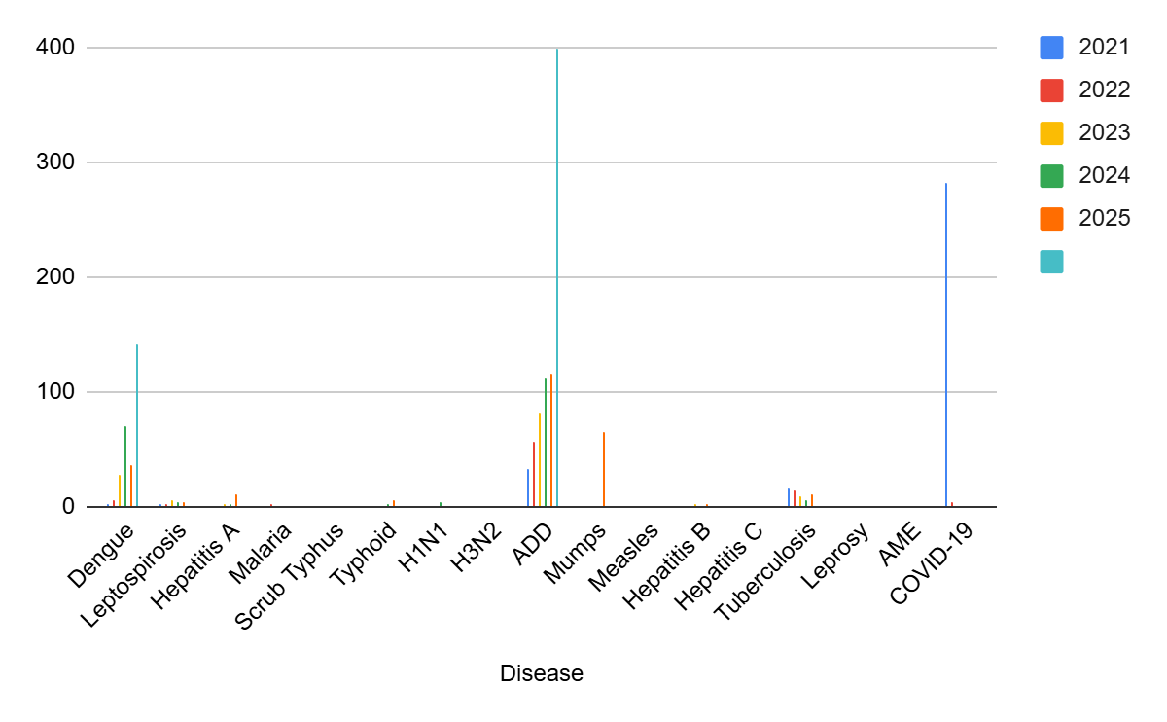

Transmission Trend- 2025
For effective management of public health issues, it is important to track the trend of disease transmission mode. It helps identify the population or place at high risk that can be used to predict outbreaks and implement targeted interventions as quickly as possible. Understanding these kinds of trends enables authorities to allocate resources efficiently and change the strategies adequately based on the trend that follows.

Mode of Transmission | No. of cases | No. of Deaths
Vector Borne Diseases | 25 | 0
Water Borne Diseases | 15 | 0
Air Borne Diseases | 148 | 0
Blood Borne Diseases | 3 | 0
Food Borne Diseases | 5 | 0

Vector-Borne Disease

Disease | No. of Cases | No. of Deaths
Dengue | 25 | 0
Malaria | 0 | 0
Chikungunya | 0 | 0

Water Borne Disease

Disease | No. of Cases | No. of Deaths

Cholera | 0 | 0
Typhoid | 5 | 0
Hep- A | 10 | 0
Dysentery | 0 | 0
Amoebiasis | 0 | 0
E- Coli infections | 0 | 0

Air Borne Disease

Disease | No. of Cases | No. of Deaths
Influenza | 0 | 0
H1N1 | 1 | 0
TB | 10 | 1
Chickenpox | 73 | 0
Measles | 0 | 0
Covid-19 | 0 | 0
Pertussis | 0 | 0

Mumps | 65 | 0

Blood-Borne Disease

Disease | No. of Cases | No. of Deaths
AIDS | 0 | 0
Hep- B | 3 | 0
Hep- C | 0 | 0

Zoonotic Disease

Disease | No. of Cases | No. of Deaths
Rabies | 0 | 0
Leptospirosis | 3 | 1
Avian influenza | 0 | 0
West nile | 0 | 0
Anthrax | 0 | 0
Nipah | 0 | 0

Scrub Typhus | 1 | 0

Integrated Disease Hotspot Map (2021–2025)
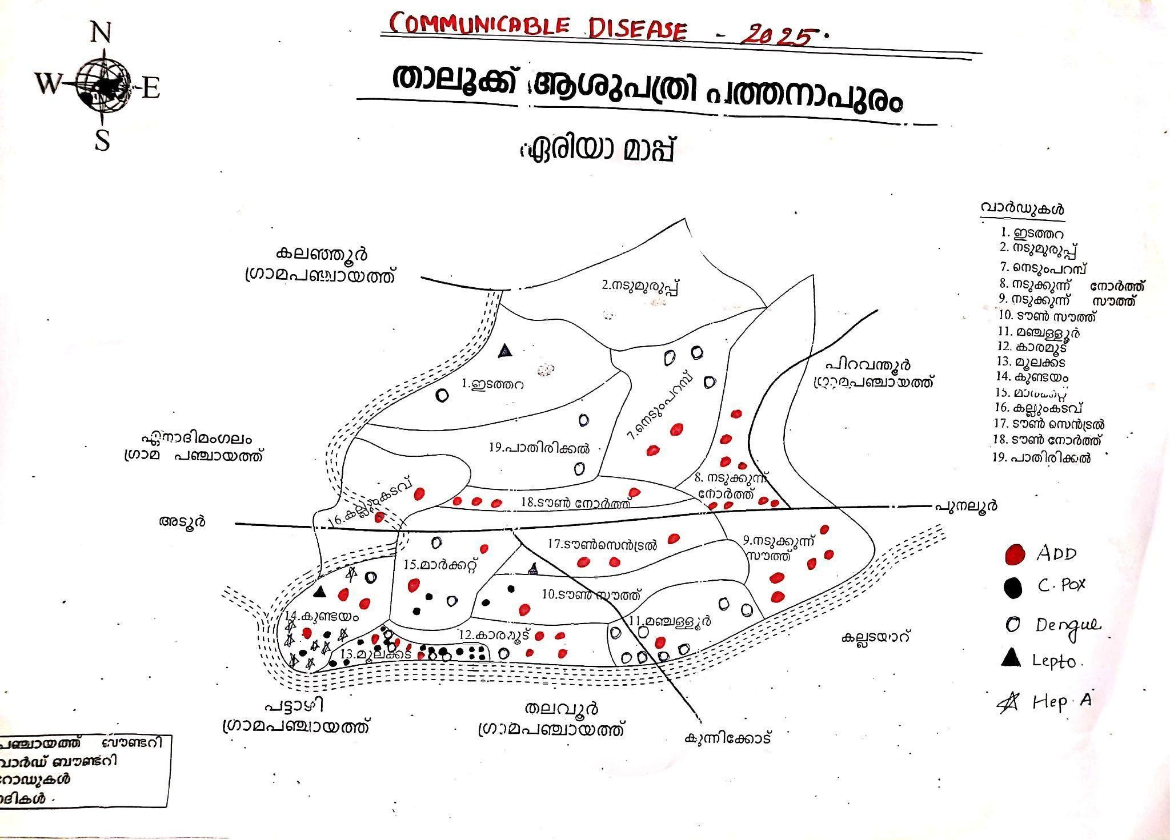

Ward  No | Dengue Total  (2021-25) | Leptospirosis  Total (2021-25) | Hepatitis A  Total (2021-25) | Mumps  (2021-25) | ADD  (2021-25) | Total  Cases
1 | 8 | 3 | 0 | 6 | 20 | 37

2 | 2 | 0 | 1 | 0 | 7 | 10
3 | 6 | 0 | 0 | 0 | 0 | 0
4 | 9 | 0 | 1 | 0 | 0 | 10
5 | 6 | 1 | 0 | 0 | 7 | 14
6 | 15 | 3 | 0 | 0 | 9 | 24
7 | 9 | 0 | 0 | 4 | 15 | 28
8 | 16 | 1 | 0 | 4 | 22 | 33
9 | 9 | 1 | 0 | 6 | 30 | 46
10 | 4 | 1 | 1 | 2 | 38 | 46
11 | 12 | 1 | 3 | 4 | 40 | 60
12 | 5 | 0 | 0 | 10 | 42 | 57

13 | 15 | 0 | 0 | 10 | 35 | 60
14 | 6 | 3 | 10 | 10 | 38 | 67
15 | 14 | 1 | 0 | 2 | 10 | 27
16 | 4 | 2 | 0 | 1 | 16 | 23
17 | 2 | 1 | 1 | 3 | 15 | 22
18 | 3 | 0 | 0 | 3 | 9 | 15
19 | 6 | 0 | 0 | 0 | 5 | 11

By overlaying five years of data, we have identified 11,13,14,6..'Red Zone' Wards. These are wards where at least two different categories of diseases (e.g., Dengue and Lepto) recurred in consecutive years.

Preparedness and Response Protocol at LSG Level
This section describes the operational framework for the LSGI once a pandemic is declared. It explains how the LSGI and health system will move from routine data collection to active response, using a One Health approach.
Constitution of One Health Committee
The LSGD shall constitute a One Health Committee comprising the LSGI President, Medical Officers (Modern Medicine, AYUSH, and Veterinary), the Health Inspector, and the Veterinary Surgeon.

Objective: The One Health Committee coordinates human, animal, and environmental health to prevent and control pandemics.

Sl No | Name | Designation | Department/Inst itution | Role in  Committee | Contact Number
1 | Sheeja shanavas | Panchayat President | LSGD | Chairperson | 94975 32954
2 | Dr.Rani chandra | Medical Officer (PHC/CHC) | Health Dept | Member Secretary | 96567 53870
3 | Shamla | Veterinary Officer | Animal Husbandry | Member | 0475 2035600.
4 | Anjulekshmi | Epidemiologist | Health Dept | Member | 81370 75282
5 | Bindhu | Health Inspector/PHN | Health Dept | Surveillance | 79091 04801
6 | Sheeja s | ASHA Supervisor | Health Dept | Community link | 79072 98664
7 | Rejitha | ICDS Supervisor | Social Welfare | Vulnerable groups | 8593078422
8 | Shanavas | Police Station Officer | Police Dept | Law & order | 04752352200
9 | Rejitha Rajesh | Ward Councillor Representative | LSGD | Community coordination | 7510374018
10 | Haseena | Kudumbashree CDS | Kudumbashree | Community mobilisation | 9847416208
11 | Renjith | NGO/Volunteer rep | Civil Society | Support services | 9745417546
12 | Athulya | Line Department representations | Health department | support | 9544480873

Key Responsibilities:
- Review disease surveillance data (human + animal)
- Conduct ward-wise risk assessment and vulnerability mapping

- Approve quarantine/isolation centre locations
- Coordinate with district for resources (PPE, oxygen, ambulances)
- Periodically review health system surge capacity, including beds, oxygen, human resources, and ambulances.
- Approve and monitor risk communication and community engagement strategies, including rumour management.
- Ensure protection and service continuity for vulnerable groups (elderly, persons with disabilities, dialysis patients, coastal populations).
- Conduct quarterly mock drills
- Monitor equity measures for vulnerable groups

Meeting Schedule:
Quarterly (normal times) | Weekly (outbreak alert) | Daily (pandemic phase)
Pandemic Response Workforce
To ensure a coordinated and timely response during a pandemic, a dedicated Pandemic Response Workforce shall be constituted at the LSG level. The workforce will function under the overall supervision of the One Health Committee and in close coordination with the health authorities. Team-based deployment will enable efficient surveillance, case management, quarantine and isolation management, logistics support, and risk communication. Each team shall have a clearly designated team leader, defined roles, and an identified pool of personnel to allow rapid activation, rotation of duties, and continuity of services during prolonged emergencies.

Total Response Workforce Available: 300 persons

Team Name | Composition | Key Responsibilities | Team Leader
Surveillance and Contact Tracing Team | HI, JHI, JPHN, ASHAs and  Volunteers | Case detection, contact listing, home visits,  reporting | HI
Case Management Team | Doctors, Nurses, MLSP, Palliative Nurses | Patient care & referral | DOCTOR
Quarantine & Isolation Team | LSGD staff, Volunteers | Facility management | JHI
Psychosocial support | MO | Mental health support | MO LSGD
Logistics & supply chain Team | LSGD staff, Storekeepers, Drivers 3 | Supplies & transport [PPE, medicines,  oxygen, transport, waste management] | Ward Member

Communication Team | Ward members, Kudumbashree, Youth clubs,  AWW workers and other self help groups | IEC, community meetings, countering misinformation | M.O in charge
Transportation | KSRTC, educational institutional buses | Transportation to higher facilities | DTO
Media Surveillance | HI, LHI, Epidemiologist | Monitoring news and media | HI
Intersectoral coordination and convergence | JHI, JPHN | Coordination between health, LSGD, police, education and other departments | HI
Collaborative surveillance | MO,HI, LHI, Epidemiologist | Data collection and sharing between departments, timely reporting to higher authorities | MO

All teams shall be activated immediately upon outbreak alert or pandemic declaration and shall report daily to the LSG Incident Commander/Medical Officer, with consolidated reporting to the Block PHC. Duty rosters and alternate personnel shall be maintained to ensure uninterrupted services during staff shortages or prolonged response periods. Team composition and numbers may be revised based on the magnitude of the outbreak and availability of human resources.

Activities and Measures before and during Pandemic PHASE 1 - Alert / Preparation
Surveillance and Reporting – Enhanced Syndromic Surveillance

- Data Sources for Surveillance:

Surveillance data in Pathanapuram LSGI will be collected from multiple formal and informal sources to ensure early detection of outbreaks. The primary data sources include:

Primary Health Centre (PHC) and Sub-centres under the jurisdiction Private hospitals and clinics within and near the Panchayat
Anganwadi centres and ASHA workers
School health records, IDSP weekly surveillance reports

Laboratory reports (public and private)

Field-level reports from Health Inspectors and Junior Public Health Nurses (JPHN) Community-based reporting through ward members and volunteers
Daily/weekly reporting will be consolidated at PHC level and shared with Block and District Health Authorities.

- Event-Based Triggers (to be monitored and reported):

The following unusual events will be treated as early warning signals and must be reported immediately:

Clustering of fever cases in any ward

Sudden increase in Acute Respiratory Infection (ARI)/ILI cases Increase in diarrhoeal diseases or jaundice cases
Any water borne diseases reported immediately after a public function. Mass stray dog bite reported in any area
Unusual deaths (especially with fever or respiratory symptoms) Sudden mass absenteeism in schools
Reports of animal deaths or zoonotic disease suspicion Any emerging infectious disease alerts from District/State
Immediate ﬁeld veriﬁcation and response will be initiated within 24 hours.

- Zoonotic and Animal Health Surveillance:

Considering the rural setting of Pathanapuram Panchayat, coordination will be ensured with: Veterinary Dispensary / Veterinary Oﬃcer
Animal Husbandry Department Dairy farmers and poultry units
Regular monitoring for zoonotic diseases such as Leptospirosis, Rabies, Avian Inﬂuenza, and
other emerging infections will be carried out. Joint inspections and information sharing between Health and Veterinary Departments will be strengthened.

- Logistics and Stock Preparedness:

To ensure preparedness during pandemics and outbreaks, the following measures will be implemented:

Empanelment of local medical suppliers, pharmacies, and essential commodity vendors as per LSGD norms

Maintenance of an updated logistics checklist including medicines, PPE, disinfectants, and emergency equipment

Identiﬁcation of secure storage space within Panchayat/PHC premises Regular updating of stock registers and buffer stock veriﬁcation
Identiﬁcation of emergency transport vehicles and drivers for rapid deployment Appointment of a Nodal Oﬃcer for Logistics (Medical Oﬃcer/Health Inspector) Minimum Buffer Stock (suggested):
PPE Kits – 1000 numbers

N95 Masks – 2000 numbers

Triple layer masks – 5000 numbers

Gloves – 5000 pairs

Pulse Oximeters – 50 numbers Thermal Scanners – 10 numbers ORS packets – Adequate stock
Rapid diagnostic kits (as per disease requirement)

Stock veriﬁcation to be conducted monthly and during outbreak alerts.

- Identify and empanel local vendors and define emergency procurement mechanisms in accordance with existing LSGD and Health Department norms.
- Prepare and maintain an essential logistics checklist covering medical supplies, consumables, and support equipment.

- Pre-identify secure storage locations for emergency stocks and ensure maintenance of stock registers with regular updating.

- Finalise emergency transport arrangements, including availability of vehicles and identified drivers for rapid deployment during alerts.

- Designate a Nodal Officer for Logistics to enable prompt decision-making, coordination, and communication during emergencies.
- Conduct rapid stock verification and ensure availability of minimum buffer stock, including:

  - PPE kits – 0
  - Pulse oximeters 10

  - Hand sanitizers – 10L

  - Masks–,1000 gloves-500, disinfectants – 10L

Identify critical gaps in logistics and immediately communicate requirements to the Block and District authorities for timely replenishment and support. Monitor expiry dates and stock rotation.

- Identification of Quarantine and Isolation Facilities
  - Identify and list suitable buildings for quarantine and isolation (schools, hostels, community halls, etc.).
  - Categorise cases as per the severity and allocate to appropriate facilities (for instance, severe cases to classrooms, mild cases to an assembly hall in case of a school).

  - Facility readiness checklist needed (beds, toilets, ventilation) etc.
  - Find an alternate site if the primary sites are not available or not in use.
  - Identify facility managers and support staff
  - Prepare basic SOPs for:
    - Admission and discharge
    - Food, water, sanitation
    - Infection prevention and waste disposal
  - Ensure availability of basic amenities: water, sanitation, electricity, ventilation, and waste disposal. Prepare a rapid activation plan for these facilities if case numbers increase.

- Risk Communication and Community Preparedness
  - Disseminate early warning messages on symptoms, preventive measures, and reporting mechanisms. Display IEC materials both in English and the local language in public places and ensure ward-level awareness.
  - Sensitize elected representatives and community leaders on preparedness measures.
  - Establish a rumour tracking and misinformation response mechanism to identify, verify, and promptly counter false or misleading information.
  - Engage trusted local persons (ward members, ASHA workers, religious leaders, teachers, community volunteers) to communicate official public health messages and reinforce correct practices.
  - Develop and deploy targeted IEC materials for:
    - Schools and educational institutions
    - Markets and commercial areas
    - Work sites and labour settings

  - Conduct community sensitization meetings at the ward level to promote preventive behaviors, address concerns, and strengthen community participation in preparedness and response.
- Protection of Vulnerable Groups
Vulnerable populations require priority protection through targeted line-listing, service continuity, and delivery mechanisms.

- Prepare and regularly update line-lists of vulnerable populations, including:
  - Elderly persons living alone
  - Persons with disabilities
  - Pregnant women
  - Migrant workers
  - Dialysis patients

The detailed line-lists shall be maintained as Annexure and updated periodically.

- Clinical Dependency Mapping

Develop ward-wise dependency and vulnerability maps to identify households requiring regular support during emergencies. Ensure continuity of essential health services for vulnerable groups, including

- Dialysis services (facility mapping, transport arrangements, and scheduling)
- Continuity of treatment for TB, HIV, and other chronic conditions requiring uninterrupted medication
- Mental health and psychosocial support services

Establish delivery mechanisms for food, essential commodities, and medicines to vulnerable households through coordinated action involving ASHAs, JPHNs, Kudumbashree, volunteers, and local administration.

PHASE 2 - Active Response

- Case Identification and Contact Tracing
Case detection and contact tracing activities will be carried out in coordination with the Health authorities, following disease-specific SOPs and IDSP guidelines.

Field Staff Involved

  - Health Inspector (HI)
  - Junior Health Inspector (JHI)
  - Junior Public Health Nurse (JPHN)
  - ASHAs and ASHA Supervisors
  - Ward-level volunteers and Kudumbashree members (as required)

- Screening Checkpoints

Screening checkpoints at high-traffic locations (transport hubs, markets, religious gatherings) for early detection of symptomatic travellers and crowd screening during outbreaks. Potential locations include bus stands, market entry points, and boat jetties, based on local context and risk assessment.
Screening activities will be carried out by trained personnel such as ASHAs, ward members, and volunteers, with support from Health Department staff. Necessary equipment, including non-contact thermometers and appropriate PPE, shall be ensured prior to activation.

Location | Type (Bus stand/Jetty/Mar ket/Railway) | Staff Deployed  (ASHAs/Volunte ers) | Screening Method | Reporting authority
Bus stand | Transport hub | One JHI  One ASHA  One health Mentors | - Swab Collection.  - Blood smears collection (RDT)  - Thermal Scanners | Surveillance  Nodal Officer in control room
Market entry | Market | One JHI  One ASHA  Male health volunteers | - Swab Collection.  - Blood smears collection (RDT)  - Thermal Scanners | Surveillance  Nodal Officer in control room
Boat jetty | Water transport | One JHI  One ASHA  Male health volunteers | - Swab Collection.  - Blood smears collection (RDT)  - Thermal Scanners | Surveillance  Nodal Officer in control room

Standard Screening Protocol
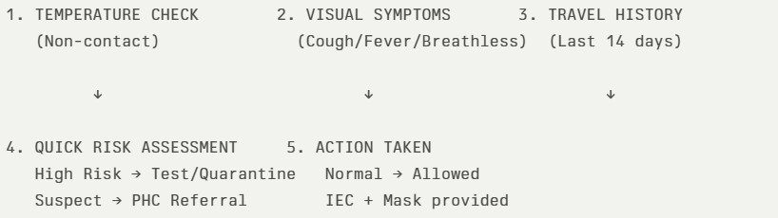

The screening protocol shall include temperature screening, observation for visible symptoms, and inquiry regarding recent travel or exposure history. Individuals identified as suspects during screening shall be immediately referred to the nearest PHC/FHC for further evaluation, testing, and appropriate action as per prevailing guidelines.

- Pandemic Control Room
The Pandemic Control Room (PCR) serves as the central nerve center for real-time coordination, data aggregation, decision support, and communication during outbreaks. It consolidates information from all LSGD teams, health facilities and community sources to enable rapid response decisions.

Control Room Infrastructure and Location
Primary Location: Pathanapuram Panchayath Office.
Backup Location: Community Hall in PathanapuramG.P.
Health System Control Room Framework
The PCR is organized into seven functional pillars to ensure no aspect of the response is overlooked:
- Rapid Response Team (RRT)
  - Provides immediate intervention during emergencies, clusters, and field alerts.
  - Coordinates urgent actions such as case investigation, contact tracing, isolation, and inter-facility referrals.
- Data Management & Analytics Team
  - Collects, validates, and manages key health system indicators (cases, tests, beds, HR, supplies).
  - Analyzes data trends, generates projections, and supports evidence-based decision-making for local authorities.
- Human Resource Deployment Team
  - Allocates healthcare staff efficiently based on workload and need
  - Ensures adequate and equitable workforce distribution across facilities
- Laboratory Surveillance Team
  - Oversees diagnostic testing coordination, sample transport, and timely reporting of results.
  - Monitors lab indicators (testing volume, positivity rate, turnaround time) for early detection of outbreaks
- Vaccination Cell (If Required)
  - Plans and executes vaccination campaigns, including micro-planning and session scheduling.
  - Tracks coverage, identifies gaps, and coordinates corrective actions with field teams and outreach services.
- Infrastructure & Patient Occupancy Team
  - Monitors facility capacity, earmarked beds, oxygen and critical care resources across all linked facilities.
  - Ensures optimal patient distribution and referral management using updated bed-status and resource data.
  - BMWM
- Communication team
- Logistics and supply chain
- Transportation (interfacility & emergency transport)
- Media surveillance Call centre

- Management of the deceased
- Intersectoral coordination and convergence
Key Control Room Team
The Control Room Team coordinates all pandemic response activities within the LSGD and serves as the single command and communication hub during activation. It integrates information, field actions, logistics, and policy execution across all participating departments and health facilities.

Role | Name | Designation | Contact Number | Responsibility
In-charge/Nodal | Dr Rani | MO | +91 96567 | Overall coordination,
Officer | chandran |  | 53870 | decision-making, and
 |  |  |  | reporting to the District
 |  |  |  | level.
Data Entry Operator | Sneha | JHI | +91 94476 | Managing the line list,
 |  |  | 88994 | updating dashboards, and
 |  |  |  | tracking testing results.
Communication | BINDHU | HI | +91 79091 | Handling the public
Officer |  |  | 04801 | helpline, coordinating
 |  |  |  | ambulance dispatch, and
 |  |  |  | contact tracing calls.
Logistics Coordinator | ANJALI | JHI | 9778476531 | Ensures timely procurement , storage and distribution of essential supplies
Technical Support  (IT/Data) | ACHU | JHI | 9605014664 | Provides technical assistance for data management systems, reporting systems

SOP for alert escalation/trigger point with mapping of responsibilities.

Key Points:

- The Control Room shall be staffed with a designated In-charge, data entry personnel, and communication staff with clearly defined roles and shift arrangements.

- It shall maintain updated records on daily monitoring indicators including new cases, persons under active quarantine, and hospital bed occupancy.

- All reports and situation updates shall be shared daily with the Block and District Surveillance Unit.

- The Control Room shall act as a single point of contact for coordination with response teams, health institutions, and other departments.

- Contact details of the Control Room shall be widely communicated to field staff and stakeholders during activation.

Daily Monitoring Indicators
To ensure timely decision-making and effective response, the following key indicators shall be monitored and updated on a daily basis by the Pandemic Control Room:

- Epidemiological Indicators:
New cases reported today, Total active cases, Test Positivity Rate (TPR), Case Fatality Rate (CFR)
- Surveillance Indicators:

Persons under home quarantine, High-risk contacts identified, Fever, ILI, SARI or other symptoms (syndromic surges), Travellers (symptomatic or high-risk arrivals),Animal husbandry surveillance (zoonotic alerts, unusual animal deaths, poultry/bird flu signals), Mortality surveillance (excess deaths, unexplained fatalities, verbal autopsy reports)
- Logistics and Infrastructure Indicators:

Hospital / CFLTC beds occupied, Oxygen cylinders/concentrators available, Ambulances on standby

- Alert Findings
The following table outlines category-specific trigger points (red flags) from surveillance indicators and corresponding immediate actions for the Pandemic Control Room. These enable rapid response to alert findings like testing anomalies, positive cases exceeding thresholds, clusters, and WGS reports.

Category | Trigger Point (Red Flag) | Immediate Action
Clusters | Geographical or facility-based: 5+ cases linked to one location (office,  school, street). | Declare a micro-containment zone; perimeter control and active case finding.
Testing | Sudden drop in testing volume / delay in reporting / unusual testing trends | Review the sample collection process, address lab bottlenecks, deploy additional testing teams, and notify the District Lab.
Lab | Test Positivity rate increases | Increase testing sites in that ward.

Hospital | >80% Oxygen bed occupancy | Activate backup/CFLTC beds.
Travel | Cluster of cases from a single  flight/train or high-risk arrival group. | Trace all passengers in adjacent seats; implement mandatory  institutional quarantine.
Animal | Mass poultry/wildlife death or unusual sickness | Notify Animal Husbandry, sample the area, and dispatch RRT for  environmental sampling and zoonotic check.
Mortality | Sudden spike in home deaths or brought-in-dead (BID) cases | Audit the deaths and Active Case Search drive
Additional  investigations like Whole Genome  Sequencing (WGS) | Detection of a Variant of Concern  (VOC) or Variant of Interest (VOI) | Implement strict  micro-containment; update clinical protocols to match variant severity.

- Communication of Public Health Information
A Community Communication Hub shall be established to ensure timely, accurate, and consistent dissemination of information during a pandemic. The Hub will function under the coordination of Nodal officers of the control room and act as the nodal point for public communication, risk messaging, and community engagement. It will support dissemination of official advisories, promote preventive behaviors, address rumors and misinformation, and ensure that messages reach all sections of the population through trusted local channels and leaders.
Key communicators

Channel | Responsible Person | Contact
Ward-level announcements | Baijudheen kunju | 9447049454
Social media | Riyadh | 9495703179
Local Cable TV/Radio | Aji Thekkadath | 6282449091

  - All messages disseminated through the Hub shall align with advisories issued by the Health Department and District authorities.

  - Community leaders shall be sensitized to support behavior change, reduce stigma, and counter misinformation.

  - Special efforts shall be made to reach vulnerable and hard-to-reach populations using locally appropriate communication methods.

Rumor Tracking: A designated volunteer will monitor local social media/WhatsApp groups daily to identify misinformation and issue official clarifications via the Communication Hub.
- Coordination with District/State Authorities & Other Organisations
Effective coordination with Block, District, and State authorities is essential to ensure timely reporting, technical guidance, and uninterrupted supply of essential resources during a pandemic. The LSG shall establish clear communication channels, designate responsible officers, and adhere to prescribed reporting timelines to support coordinated public health action and efficient resource mobilisation.

Key Details:
  - Nodal Officer for Reporting: Dr.Rani L Chandran
  - Contact Number: 9656753870

Reporting Schedule and Protocols:

To Whom | What to Report | Frequency | Nodal Person
Block PHC | Complete Situation Report (Cases, Quarantine, Beds, Screening, Deaths) | Daily | HS Vinod S
District IDSP Unit | Outbreaks/Clusters/Unusual Events (>5 cases same ward) | Daily | Dr.Prem
Veterinary Officer | Animal health  events/Zoonotic alerts | Daily | Dr.Veena
State Cell | Zoonotic cross-sector events | daily | Dr.Veena

Supply Chain Coordination
The LSG shall coordinate closely with Block, District, and State authorities (KMSCL) to ensure uninterrupted availability of essential goods, medical supplies, and logistics during a pandemic. Supply requirements shall be

assessed regularly based on case load and communicated promptly to the appropriate authorities for timely replenishment.

Key Points:

- Maintain updated contact details of District and Block nodal officers for health logistics, oxygen supply, ambulances, and essential medicines.

- Submit timely indent requests for PPE, testing kits, medicines, oxygen, and other critical supplies through prescribed channels.

- Monitor stock levels at LSGD facilities, quarantine/isolation centres, and field teams through daily stock registers and dispensing logs to prevent shortages.

- Coordinate with District authorities, Karunya/Neethi medical shops, and local purchase committees for funds allocation and emergency procurement.

- Ensure regular monitoring of dispensing registers at all facilities to track usage, expiry, and pilferage—shortages being a perennial issue requiring proactive weekly audits.

- Activate surge procurement protocols during high caseloads, leveraging local purchase powers under LSGD funds alongside state supplies.

Resource Inventory and Contacts

Resource Category | Source (District/State/Private) | Contact
PPE Kits/Masks/Gloves | KMSCL | 0471 - 2945600
PPE Kits/Masks/Gloves | Local Vendors | 04752352655
Oxygen Cylinders/Concentrators | KMSCL | 0471 - 2945600
Medicines/Antivirals | KMSCL | 0471 - 2945600
Medicines/Antivirals | Neethi Shops | +91 9995737285

Test Kits (RTPCR/Rapid) | KMSCL | 0471 - 2945600

Collaboration with NGOs, PPP, and CSR
To augment government efforts during a pandemic, the LSG shall collaborate with NGOs, voluntary organisations, and private sector partners through public–private partnerships and Corporate Social Responsibility (CSR) initiatives, in coordination with District authorities.

Key Points:

- Engage NGOs and community-based organisations for community outreach, awareness, and support to vulnerable populations.

- Leverage CSR support for procurement of medical equipment, PPE, oxygen concentrators, food kits, and sanitation materials, as permitted.

- Ensure all collaborations align with government guidelines and are routed through approved administrative and financial procedures.

- Maintain transparency and documentation for all external support received and utilised.

Organization | Type | Support Offered | Contact Person
Youth Clubs/Student Unions | CBO

Interdepartmental Coordination
Coordination among departments during a pandemic shall be ensured through regular review meetings convened by the LSGD President. These meetings will provide a structured platform for sharing situational updates, assessing resource availability, resolving operational gaps, and taking joint decisions to ensure a coordinated and timely response.

Department | Representative | Key Role | Contact
Health (PHC) | Staff Nurse : | Case management | 9497088192
Veterinary | Veterinary Surgeon: | Animal surveillance | 9747401797
ICDS | Supervisor: Sindhu | Nutrition support | 984692795
Education | Head Teacher: | School coordination | 9447504794
Police | sho | Containment enforcement | 04752352200

Water Authority |  | Water supply | 047124324903
LSGD Engineering | nil | Quarantine infrastructure | nil

PHASE 3 - Surge Capacity
Phase 3 is activated when there is a rapid increase in cases, high test positivity rates, or when existing health facilities and quarantine arrangements approach saturation. The focus of this phase is to expand isolation capacity, augment clinical care services, and mobilise additional resources through district and state support mechanisms.

Conversion of Community Facilities
To manage increased case load, the LSGD shall activate additional isolation facilities by repurposing identified community infrastructure such as community halls, auditoriums, schools, hostels, or other suitable buildings.

Name of facility | Facility Type | No. of  Buildings | Ward | Surge Capacity (Beds) | Nodal Person
crown auditorium | auditorium | 2 | 15 | 150 | 9961031465
saphalyam auditorium | auditorium | 1 | 9 | 100 | 8606834005
mangalya auditorium | auditorium | 1 | 17 | 100 | 7907109001
ymca hall | community hall | 1 | 16 | 20 | 9544715390
sports club | community hall | 1 | 12 | 50 | 9495433621
mount tabor hostel | hostel | 2 | 17 | 80 | 9495710095
mount tabor school | school | 2 | 17 | 100 | 9447870151
st stephens school | school | 5 | 17 | 250 | 9447504794
alameen | school | 1 | 17 | 100 | 9496792775

Recovery and rehabilitation phase
- Recovery

- Damage & impact assessment
- Restoration of health services
- Rehabilitation of affected population
- Psychosocial & mental health support
- Disease surveillance during recovery phase
- Environmental cleanup & sanitation
- Livelihood restoration
- Community engagement & confidence building
- Documentation & after-action review
- Lessons learned & best practices
- Health system strengthening
- Policy revision & preparedness enhancement
- Research

CONCLUSION

Additional points
- tech support
- relief based commodities
- ham reading operators
- hazard vulnerability mapping
- Kseb & other power source
- HR specific responsibility

RECOMMENDATIONS
- Strengthening Healthcare Infrastructure
  - Establish a primary health response unit within the Panchayat with trained staff.
  - Ensure availability of basic medical supplies (masks, sanitizers, PPE kits, oxygen cylinders).
  - Create tie-ups with nearby hospitals in pathanapuram for emergency referral and transport.

- Community Awareness & Education

  - Conduct regular awareness campaigns on hygiene, vaccination, and preventive measures.
  - Use local communication channels (community radio, WhatsApp groups, notice boards) to spread verified information.
  - Train volunteers to act as health ambassadors in each ward.

- Emergency Response & Coordination

  - Form a Pandemic Preparedness Committee at Panchayat level including health workers, ward members, and NGOs.
  - Develop a clear action plan for lockdowns, quarantine, and distribution of essentials.
  - Maintain a database of vulnerable groups (elderly, differently-abled, chronically ill) for targeted support.

- Supply Chain & Food Security

  - Identify and support local suppliers and farmers to ensure uninterrupted food supply.
  - Create community kitchens during emergencies to serve vulnerable populations.
  - Stockpile essential commodities in Panchayat-run outlets for crisis periods.

- Digital Preparedness

  - Promote digital platforms for telemedicine consultations.
  - Use Panchayat’s website/social media for real-time updates on health advisories.
  - Encourage online grievance redressal to reduce crowding in offices.

- Training & Capacity Building

  - Organize mock drills for pandemic response in schools, offices, and public spaces.
  - Train Panchayat staff and volunteers in first aid, infection control, and crowd management.
  - Collaborate with NGOs and health departments for capacity-building workshops.

- Long-Term Resilience

  - Integrate pandemic preparedness into the Panchayat Development Plan.
  - Allocate a dedicated budget for health emergencies.
  - Encourage community participation in planning and monitoring preparedness measures.

MOCKDRILL SCENARIOS

Mock Drill Scenario Pathanapuram Taluk Hospital
Scenario: Suspected Respiratory Pandemic Case Surge Background:
At 10:00 AM on a working day, the casualty department of Pathanapuram Taluk Hospital receives three patients from different wards of Pathanapuram Block Panchayat presenting with high fever, cough, breathlessness, and recent travel history to a neighboring district reporting increased viral respiratory illness cases. Within two hours, two more similar cases arrive.
This triggers activation of the hospital’s Pandemic Preparedness Protocol. Objectives of the Mock Drill
Test early identification and triage system Assess isolation facility readiness
Evaluate PPE usage and infection control practices Test communication and reporting mechanism
Check oxygen supply and emergency logistics
Assess coordination with Block and District Health Authorities Sequence of Events (Drill Flow)
Alert & Triage
Casualty nurse identifies ILI/SARI symptoms Patients directed to separate Flu Clinic/Isolation Area Rapid notification to Medical Superintendent
Activation of Response Team
Hospital Rapid Response Team (RRT) convened Infection Control Nurse ensures PPE compliance Separate entry and exit pathways activated
Isolation & Case Management
Suspected cases shifted to designated isolation ward Oxygen support checked
Sample collection team activated
Biomedical waste disposal protocol enforced Reporting & Communication
Immediate reporting to District Surveillance Unit Intimation to Block Medical Officer
Media communication handled only by authorized officer Logistics Check
PPE stock verification
Oxygen cylinder/central supply pressure check Availability of ventilators and pulse oximeters Ambulance readiness for referral

6 Crowd & Security Management Security restricts bystander entry Separate waiting area arranged
Public announcement regarding precautionary measures Evaluation Parameters
Time taken from identification to isolation PPE donning and doffing procedure adherence Communication flow efficiency

Stock adequacy and equipment functionality Documentation completeness
Expected Outcome
The drill ensures that Pathanapuram Taluk Hospital is prepared for sudden surge of infectious disease cases, minimizes risk of hospital-acquired infection, strengthens coordination with Pathanapuram Block Panchayat authorities, and improves overall pandemic response efficiency

ANNEXURE

IMPORTANT PHONE NUMBERS

Phone numbers and particulars of persons responsible for providing guidance, assistance, and support for
pandemic preparedness operations may be provided here in a manner that allows easy reference at a glance. The information recorded here could be exhibited elsewhere at the time of emergencies. LSG institutions shall give special attention to collect and record the above data of persons and institutions who/which are supposed to
give technical and co-ordination support to reduce the impact of pandemic.

  - Details of grama panchayat/municipality/corporation wards

Sl.No | Name of the ward | Ward number | Name of the ward member | Contact number
1 | Edathara | 1 | Abin | 8075912913
2 | Nadumuruppu | 2 | M abdul Rahman | 9847315267
3 | Vazhappara | 3 | Suni lubies | 9539411374
4 | Chithalvetty | 4 | Shamla shihab | 9645955722
5 | Mancodu | 5 | Kp raju | 9446181336

6 | Poonkulanji | 6 | Geetha suresh | 9961489370
7 | Nedumparambu | 7 | Shafina | 884853707
8 | Nadukkunnu north | 8 | Beena | 9562937356
9 | Nadukkunnu south | 9 | Anas | 8921212566
10 | Town south | 10 | Rejitha Rajedh | 8848650654
11 | Manchalloor | 11 | Anil | 9496107112
12 | Karamood | 12 | Ashraf | 94954 33621
13 | Moolakkda | 13 | Sheeja shanavas | 9497532954
14 | Kundayam | 14 | Raseena | 7306519678
15 | Market | 15 | Farooq Muhammad | 7561014268
16  17  18  19 | Kallumkadavu  Town central  Town north  Pathirickal | 16  17  18  19 | Denson varghese  Rahumath dileep  Saly benny  Rajashekaran nair | 9847039552  9605006429  9895745062  7034461019

  - Other important phone numbers of grama panchayat/municipality/corporation area

Sl.  No. | Name | Contact number
1. | Excise department | 9447178000
2. | Forest department | 8547601087

  - Important offices of grama panchayat/municipality/ corporation

Sl.No | Name of the office | Contact person | Contact number
1. | Village Office | Village Officer | 9497794677
2. | Agriculture Office | Agriculture Officer | 9383470251
3. | Animal Husbandry Office | Animal Husbandry Doctor | 9446597106
4. | Police Station | Police Officer | 100
5. | BSNL Office | Officer | 8003451500
6. | Block Office | Officer | 8593868933
7. | KSEB Office | Officer | 047502352370
8. | Fisheries Office | Officer | nil
9. | Fire and Rescue | Officer | 0475325701

  - Health Services

Sl. No | Name of the hospital/institution | Location | Phone number
1. | Government hospitals/PHC | Pathanapuram | 9656753870
2. | Private hospitals | Pathanapuram | EMS 8078822222
3. | Clinical laboratories | Pathanapuram | 9048524945
4. | Chemist/pharmacy | Pathanapuram | NIL
5. | Blood donors | NIL | NIL
6. | Other language experts (Bihari, Hindi, Bengali, Asamees ………) | NIL

  - Veterinary Services

Sl.N  o | Name of the Clinic | Name of the  Surgeon/Doctor | Place/loca tion | Phone number
1 | Govt.Veterinary Hospital | Dr. Veena | Nadukkunnu | 9447742711

  - Helpline numbers

Helpline | Phone number
Police | 100
Fire and Rescue | 0475325701
KSEB | 047502352370

  - Public and Private Schools Contact details

S.No | Name of School | Institution type | Phone number
1 | KRMMHS, nadukkunnu | Aided | 9074798290
2 | GOVT LPS, nadukkunnu | Govt | 8075014017
3 | St Mary's residential school | Private | 9847528341
4 | Devi matha school | Private | 7025425236
5 | Alfitrah play school | Private | 9633771023
6 | GMLPS Kundayam | govt | +91 90741 28512
7 | Gandhibhavan special school | Private | +91 94974 58564
8 | Navajeevan school | pvt | +91 95448 25431
9 | HBMLPS Nedumparampu | Pvt | 974563595
10 | Nural Hudha Edathara | Pvt | 8547425156
11 | Edathara HSS | Govt | 9946224140
12 | Mount Tabore LPS | AIDED | +91 94471 82429
13 | Mount tabore HSS | Aided | +91 94478 70151
14 | St stephens HSS | AIDED | +91 94475 04794
15 | Mothersoosan LPS | Pvt | +91 99618 42950
16 | Al ameen school | Pvt | 99618 42950

1.9. Anganwadi Contact Details

Ward No | Name of Anganwadi Teachers | Phone number
1 | Naseema | 9946733388

 | Nisha | 9947097821
2 | NABEESATH RADHA | 9605538825  9562748173
3 | PARISHA  BINDHUKUMARI | 9656405360  9605059961
4 | SULEKHA RAHIYANATH | 9048212934  9747994368
4  4 | REMYA BINDHU | 9526908869  9544435224
5  6 | SINDHU USHA LALIKUTTY SREEJA | 9846385053  7510705171  9562408913  9207172492

Ward No | Anganwadi No and Name of Teacher | Phone number
7 | - Sonia  - Anjuraj | 7025508182  9656036681
8 | Latha | 9745862881
9 | - Shahidha | 9526909259
10 | - Sudha | 9605465165

11 | 1. Divya | 9744403675
12 | suja Shailaja Mumthas | +91 87142 40316  +91 94966 95657  +91 95622 65539
13 | Kadeeja | +91 75599 81426
14 | Ruksana Bindhu Letha | +91 94476 19383  +91 94007 54690  +91 94008 54988
15 | Shajila | +91 96455 35815
16 | Asha | +91 80868 11442
17 | Sneha | +91 79022 09649
19 | Anitha Manju | 9526431208  8921294750
18 | Sajitha | +91 92075 37474

1.12. Information regarding resources

Means of transportation | Name of Owner | Phone Number
Heavy Trucks | NA | NA
Tractor | NA | NA
Ambulances | SIJO | 9633065801
Boats | NA | NA
Taxi service | SHYLESH | 9656003170

Annexure 1: LSG Baseline Data Collection Format
- Baseline data

Sl.  No. | Indicator / Field | Baseline Data | Source / Remarks
1 | Name of LSG | Pathanapuram | LSGD
2 | District | Kollam | LSGD
3 | Block / Taluk | Pathanapuram | LSGD
4 | Type of LSG (Gram Panchayat /  Municipality / Corporation) | grama panchayath | LSGD
5 | Area (sq. km) | 24.20kmsq | LSGD
6 | No. of wards | 19 | LSGD
7 | GIS boundary file available | (Yes/No) | LSGD
8 | Key contact person & phone | HI | 7909104801

- Demography

Indicator / Field | Baseline Data | Source / Remarks
Total population | 30365 | Field survey
Males | 11526 | Field survey
Females | 18339 | Field survey
Transgender population | 0 | Field survey
Age distribution  (<5, 5–14, 15–59, ≥60) | 6805 | Field survey
No. of households | 6912 | Field survey
Population density (persons/sq.km) | 24.2 SQKM | Field survey
No. of migrant workers | 220 | Field survey
Major occupational groups |  | Field survey

- Vulnerable Populations & Social Risks

Sl. No. | Indicator / Field | Baseline Data (Value  / Description) | Source / Remarks

1 | No. of elderly (≥60) | 5012 | CHC
2 | No. of persons with disability | 106 | CHC
3 | No. of bedridden persons | 61 | CHC
4 | No. of chronic disease cases (DM/HTN/COPD/CKD etc.) | 10182 | CHC
5 | Pregnant women (current estimate) | 252 | CHC
6 | Children <5 years | 1436 | CHC
7 | Tribal population (if any) | 0 | FIELD
8 | Fisherfolk / coastal vulnerable groups (if any) | 0 | FIELD
9 | Urban slums / unnotified settlements (if any) | 0 | FIELD
10 | Homeless population | 32 | FIELD
11 | Orphanages / old age homes (number & capacity) | 3 | FIELD
12 | Hostels / prisons / shelters (number & capacity) | 2 | FIELD
13 | Poverty / BPL estimate | 0 | FIELD

14 | Food insecurity hotspots | NIL | FIELD
15 | Any history of stigma/discrimination issues (Yes/No) | NO | FIELD

- Health System & Service Readiness

Sl. No. | Indicator / Field | Baseline Data (Value / Description) | Source / Remarks
1 | No. of health facilities in LSG (PHC/CHC/TH/DH/Private) | 2 | PHC
2 | PHC/Family Health Centre details (name, location) | chc ptpmphc mnd | PHC
3 | Subcentres / Health & Wellness Centres (number) | 8 | PHC
4 | Private clinics / hospitals (number) | 34 | PHC
5 | Labs available (public/private) | 16 | PHC
6 | Availability of ambulance services (Yes/No, number) | yes 5 | PRIVATE
7 | Availability of  isolation/quarantine facilities (Yes/No, details) | no | LSGD

8 | Cold chain facilities (Yes/No, details) | yes | CHC
9 | Stockpile space available (Yes/No) | no | CHC
10 | PPE / mask / sanitizer availability plan (Yes/No) | yes | CHC
11 | Surveillance staff available (JHI/JPHN/ASHA count) | jhi 6 john 8 asha 28 | CHC
12 | Existing emergency referral pathways (Yes/No) | yes | CHC

- Points of Entry & Mobility

Sl. No. | Indicator / Field | Baseline Data (Value / Description) | Source / Remarks
1 | Bus stands / depots (number) | 1 | LSGD
2 | Railway stations (number) | 0 | NA
3 | Boat jetties / fishing harbours (number) | 0 | NA
4 | Ports / airports nearby (specify distance) | 0 | NA
5 | Major highways/roads passing through | 0 | NA
6 | Border crossings (state/district) | 0 | NA

7 | Major markets / weekly markets | 0 | NA
8 | Tourism hubs / major event venues | 1 | NA
9 | Schools/colleges with hostels (number) | 17 school 3 hostel1 | NA
10 | Factories / large workplaces (number) | 1 | NA
- Water, Sanitation & Hygiene (WASH)

Sl. No. | Indicator / Field | Baseline Data (Value / Description) | Source / Remarks
1 | Major drinking water sources (piped / wells / borewells / springs) | 7850 | LSG
2 | No. of public wells | 33 | LSG
3 | No. of households with piped water connection | 5150 | LSG
4 | Water quality testing routine (Yes/No) | yes | LSG
5 | Common contamination risks (flooding, salinity, industrial waste) | flooding | NA
6 | Open defecation free status (Yes/No) | yes | LSG

7 | Solid waste management system (Yes/No) | yes | NA
8 | Bio-medical waste disposal mechanism (Yes/No) | yes | IMAGE
9 | No. of public toilets | 2 | LSGD
10 | Handwashing stations in public places (Yes/No) | yes35 | PHC
- Zoonotic Risks & One Health

Sl. No. | Indicator / Field | Baseline Data (Value / Description) | Source / Remarks
1 | Livestock population  (cattle/goats/pigs/poultry) – estimates | 350 | LSGD
2 | No. of dairy farms / poultry farms / pig farms | 1 | LSGD
3 | Slaughterhouses / meat shops (number) | 1 | LSGD
4 | Animal markets (Yes/No, details) | no | LSGD
5 | Veterinary dispensaries (number) | 2 | LSGD
6 | History of zoonotic outbreaks (rabies, leptospirosis, avian flu etc.) | no | LSGD
7 | Stray dog population management measures (Yes/No) | na | LSGD
8 | Rodent infestation hotspots (Yes/No) | no | LSGD

9 | Wetlands / waterlogged areas prone to leptospirosis | no | LSGD
10 | Bat roosting areas / caves / fruit orchards (if any) | no | LSGD
11 | Human-animal interface hotspots (farms near residences) | no | LSGD
- Climate & Disaster Risks (Pandemic Amplifiers)

Sl. No. | Indicator / Field | Baseline Data (Value / Description) | Source / Remarks
1 | Flood-prone wards (list) | 11,15,16 | LSGD
2 | Landslide-prone wards (list) | no | LSGD
3 | Cyclone/sea surge risk (Yes/No) | no | LSGD
4 | Heatwave risk zones (Yes/No) | no | LSGD
5 | Waterlogging areas (list) | 3 | LSGD
6 | Shelter homes / relief camps (number, capacity) | 1/100 | LSGD
7 | Past disaster displacement history | no | LSGD
8 | Disruption to water supply/transport common (Yes/No) | no | LSGD

- Critical Infrastructure & Logistics

Sl. No. | Indicator / Field | Baseline Data (Value / Description) | Source / Remarks
1 | Schools (number) | 17 | CHC
2 | Anganwadis (number) | 35 | CHC
3 | Colleges (number) | 3 | CHC
4 | Community halls (number) | 3 | CHC
5 | Places of worship with large gatherings (number) | 26 | CHC
6 | Large markets / shopping areas (number) | 1 | CHC
7 | Warehouses / cold storages (number) | 0 | CHC
8 | Telecom/mobile network coverage gaps (Yes/No) | yes | CHC
9 | Power outage frequency (high/medium/low) | medium | CHC

10 | Availability of generators in key facilities | yes | CHC

- Risk Communication & Community Networks

Sl. No. | Indicator / Field | Baseline Data (Value / Description) | Source / Remarks
1 | Ward-level rapid response teams (Yes/No) | yes | LSGD
2 | Jagratha samithis / committees active (Yes/No) | yes | CHC
3 | Kudumbashree presence and strength (number of units) | 340 | CHC
4 | Volunteer network (number, coverage) | 60 | CHC
5 | Community-based surveillance mechanisms (Yes/No) | yes | LSGD
6 | IEC dissemination channels (WhatsApp groups, community radio, PA systems) | yes | LSGD
7 | Rumour tracking mechanisms (Yes/No) | NA | LSGD
8 | Languages spoken / literacy considerations | NA | LSGD
9 | Vulnerable groups communication strategy available (Yes/No) | yes | LSGD

- Preparedness Planning & Governance

Sl.  No. | Indicator / Field | Baseline Data (Value / Description) | Source / Remarks
1 | LSG emergency plan available (Yes/No) | yes | LSGD
2 | Pandemic preparedness plan available (Yes/No) | yes | CHC,PHC
3 | Incident Command System identified (Yes/No) | yes | PHC
4 | Rapid procurement mechanism available (Yes/No) | yes | PHC
5 | Emergency fund available (Yes/No, amount) | no | LSGD
6 | Past outbreak response experience (Yes/No, details) | NO | LSGD
7 | Intersectoral coordination mechanism (Health, Police, LSG, Veterinary, Education) | YES | CHC
8 | Mock drills conducted in last 12 months (Yes/No) | NO | CHC
9 | Training coverage for staff/volunteers (Yes/No) | YES | CHC

- Surveillance & Data Systems

Sl. No. | Indicator / Field | Baseline Data (Value / Description) | Source / Remarks
1 | Digital reporting tools used (e.g., DHIS2, portals) | Y | LSGD

2 | Availability of line-listing format (Yes/No) | Y | CHC
3 | Contact tracing team identified (Yes/No) | Y | CHC
s4 | Mapping of high-risk households available (Yes/No) | Y | CHC
5 | Testing sample transport mechanism (Yes/No) | Y | CHC
6 | Reporting timeline adherence (good/average/poor) | Y | CHC
7 | Data sharing between departments (Yes/No) | Y | CHC
8 | Availability of dashboard for monitoring (Yes/No) | Y | CHC

- Additional Notes & Observations

Sl. No. | Indicator / Field | Baseline Data (Value / Description) | Source / Remarks
1 | Key challenges perceived by LSG | Y | LSGD
2 | Top 5 high-risk wards (reason) | N | LSGD
3 | Any unique local risks (industrial pollution, refugee camps, etc.) | N | LSGD
4 | Recommendations for preparedness strengthening | Y | CHC

LINELIST OF VULNERABLE POPULATION

WARD | ELDERLY PERSON L | PERSONS WITH DISABILITY | PREGNANT WOMEN | MIGRANT WORKERS | DIALYSIS PATIENTS
1 | 215 | 7 | 14 | 5 | 0
2 | 211 | 8 | 8 | 14 | 0
3 | 190 | 11 | 11 | 12 | 0
4 | 118 | 10 | 16 | 10 | 4
5 | 156 | 9 | 15 | 19 | 2
6 | 157 | 8 | 20 | 11 | 4
7 | 167 | 9 | 10 | 14 | 3
8 | 213 | 9 | 16 | 14 | 4
9 | 246 | 10 | 19 | 11 | 0
10 | 196 | 12 | 10 | 9 | 1
11 | 183 | 8 | 17 | 81 | 0
12 | 290 | 13 | 22 | 17 | 2
13 | 300 | 11 | 20 | 19 | 2
14 | 254 | 16 | 25 | 12 | 1
15 | 287 | 10 | 12 | 12 | 2
16 | 169 | 12 | 10 | 24 | 0
17 | 111 | 5 | 9 | 30 | 0
18 | 158 | 8 | 10 | 30 | 1
19 | 281 | 14 | 19 | 10 | 3

