f

HP
[Email address]
PANDEMIC PREPAREDNESS PLAN
PIRAVANTHOOR PANCHAYAT

MESSAGE FROM PRESIDENT/CHAIR LSGI
Pandemic Preparedness Message
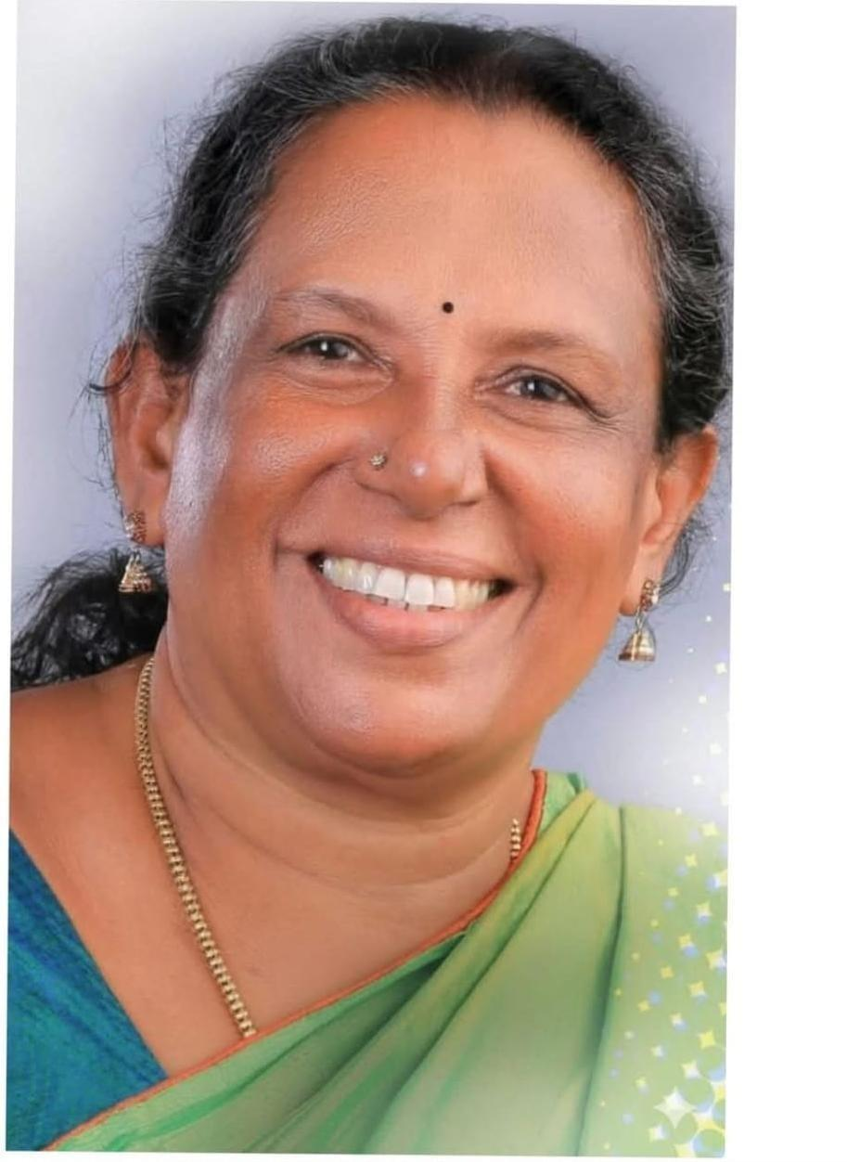

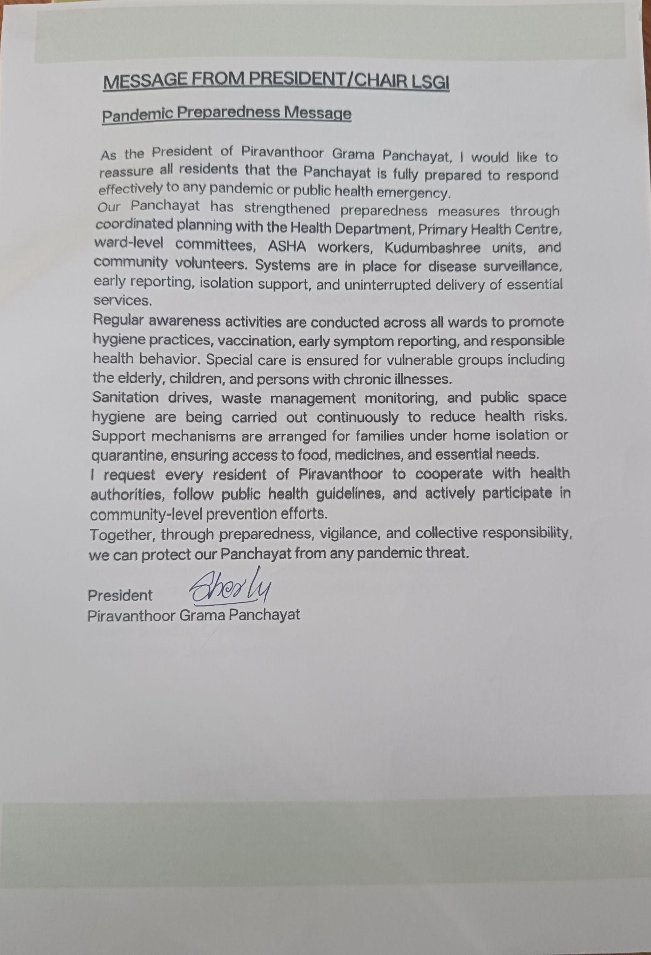

MESSAGE FROM HEALTH STANDING COMMITTEE CHAIR

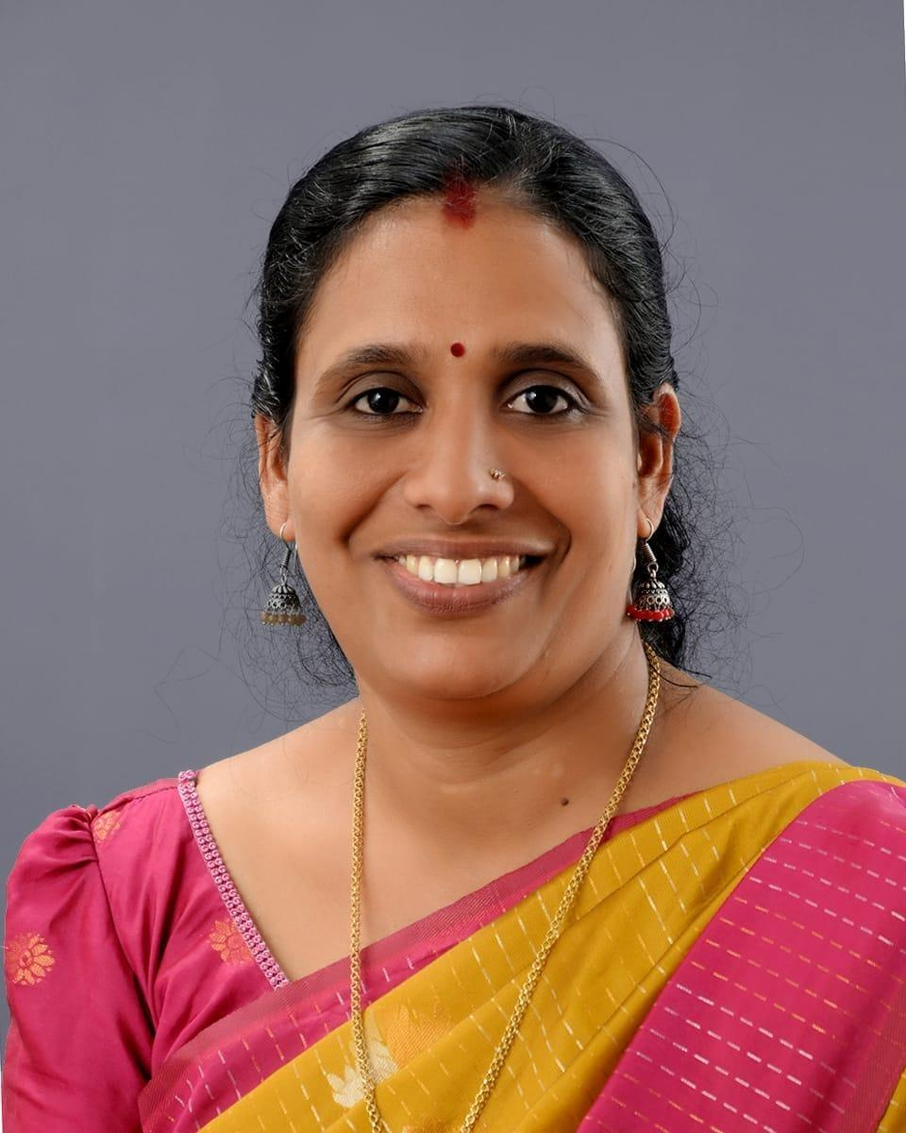
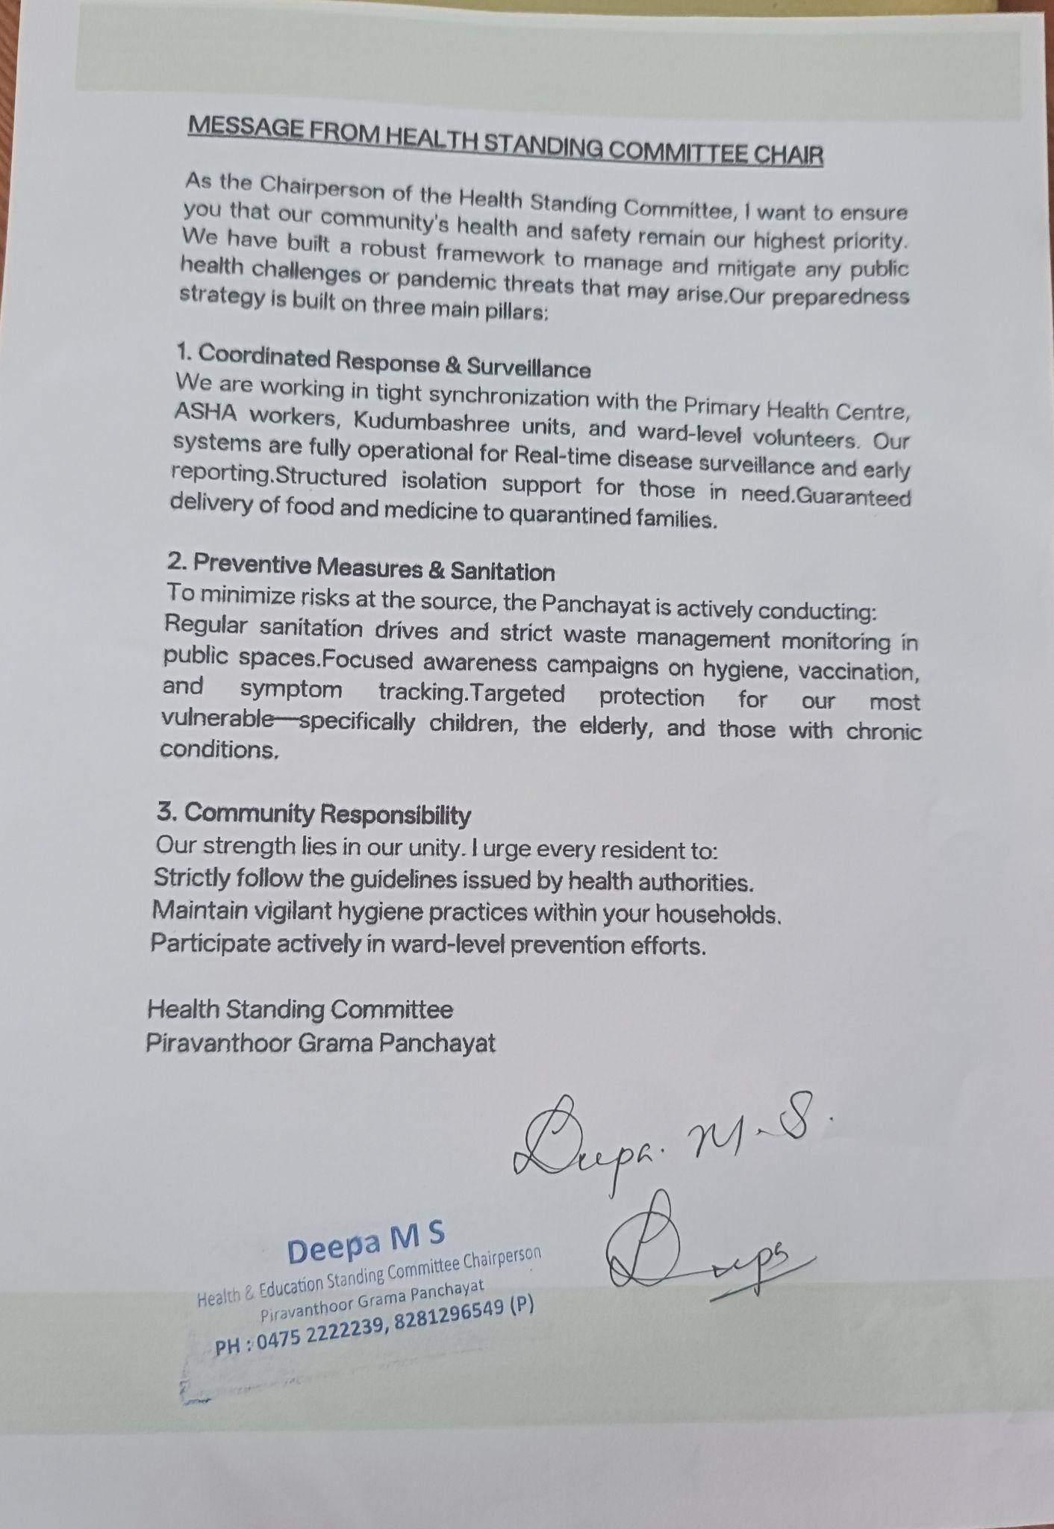

MESSAGE BY MEDICAL OFFICER

Piravanthoor Grama Panchayat, comprising 21 wards, is geographically diverse with rural, forest fringe, and hard-to-reach areas that require strong public health preparedness and coordinated response mechanisms. As the Medical Officer, I am pleased to present this Pandemic Preparedness Plan developed in collaboration with the Grama Panchayat, Health Standing Committee, Health Department staff, ASHA workers, Anganwadi workers, and other frontline personnel.
This plan focuses on strengthening disease surveillance, early detection of infectious diseases, prompt reporting through established surveillance systems, and rapid response to any outbreak or pandemic situation. Clear roles and responsibilities have been defined for health staff, local self-government representatives, and community volunteers to ensure timely action and effective field-level coordination.
Special priority has been given to the protection of vulnerable groups including the elderly, children, pregnant women, and individuals with chronic illnesses. The plan also ensures the uninterrupted continuation of essential health services such as immunization, maternal and child health care, management of non-communicable diseases, palliative care, and emergency medical services during pandemic periods.
Risk communication, public awareness, promotion of hygiene and sanitation practices, vaccination activities, and active community participation are key components of this preparedness strategy. Strengthening coordination between health institutions, local self-government, and the public will be crucial for successful implementation.
I request the wholehearted support and cooperation of all departments, stakeholders, and residents across all 21 wards of Piravanthoor Grama Panchayat in implementing the activities outlined in this plan. Together, we can build a resilient community capable of preventing, detecting, and responding effectively to any future pandemic or public health emergency.

EXECUTIVE SUMMARY

Primary Health Centre (PHC) functions as the primary public healthcare institution serving the population of Piravanthoor Grama Panchayath. The PHC plays a pivotal role in delivering comprehensive, accessible, and affordable healthcare services, with a strong focus on preventive, promotive, curative, and rehabilitative care in accordance with national and state health programmes.
The PHC caters to a predominantly rural population, addressing key public health priorities such as maternal and child health, communicable and non-communicable disease control, immunization, family welfare, adolescent health, and geriatric care. Regular outpatient services, home-based care through field health staff, and outreach activities ensure healthcare coverage even in geographically challenging areas. The institution actively implements national health missions, including the National Health Mission (NHM), National Tuberculosis Elimination Programme, National Programme for Prevention and Control of Cancer, Diabetes, Cardiovascular Diseases and Stroke (NPCDCS), and other disease surveillance initiatives.
Piravanthoor FHC works in close coordination with the Grama Panchayath, ASHA workers, Anganwadi centres, schools, and community-based organizations to strengthen community participation and improve health awareness. Emphasis is placed on early detection, timely referral, health education, and lifestyle modification to reduce disease burden and improve overall health outcomes.
Despite constraints related to infrastructure, manpower, and increasing service demand, the PHC continues to enhance service delivery through effective planning, data-driven decision-making, and community engagement. Strengthening facilities, upgrading digital health systems, and expanding preventive services remain key focus areas for future development.
Overall, Piravanthoor Primary Health Centre stands as a vital institution in safeguarding public health and improving the quality of life of the residents of Piravanthoor Grama Panchayath

LIST OF ABBREVIATIONS

LSGD/LSGI | Local Self Government Department / Local Self Government Institution
BMO | Block Medical Officer
IDSP | Integrated Disease Surveillance Programme
NDMA | National Disaster Management Authority
PPE | Personal Protective Equipment
ICMR | Indian Council of Medical Research
CD | Communicable Diseases
NCD | NON-COMMUNICABLE Diseases

TABLE OF CONTENTS

3
INTRODUCTION 9
● Background of the PPP 9
LSGD AT A GLANCE 9
INTEGRATED HEALTH INFRASTRUCTURE MAP OF ____________ PANCHAYAT 10
GENERAL PROFILE OF THE LSGI’S 13
Background of the LSGI 13
Demographic and Vulnerable Population 14
Clinical Vulnerability 16
INFRASTRUCTURE & RESOURCE INVENTORY 18
Health Facility Directory & Basic Capacity in the LSGD 18
Private Clinics 19
Healthcare Education & Training Institutions 20
Specialized Services & Emergency Inventory 20
Oxygen & Diagnostic Capacity 21
Diagnostics facility mapping at the LSGI level 22
Laboratory Identification & Basic Details 22
Social and Community Infrastructure for surge plan 22
Human resources 24
Community & Support Cadre 25
Community Organizations 26
Administrative & Emergency Services 27
Information regarding resources 27
ONE HEALTH & ENVIRONMENTAL SURVEILLANCE 28
Animal & Bird Population 28
Veterinary Infrastructure 29
Veterinary Doctors & Workforce 30
High-Risk Interface Points (Surveillance Sites) 30
Environmental Risk Mapping 31
Disease Seasonality Mapping 32
Vulnerability Mapping 33
EPIDEMIOLOGICAL TRENDS (2021–2025) 34
Disease Burden among human beings(Last 5 Years) 34
*(use the above table data to create the graph/diagram) 36
Seasonal Trend Analysis 37
Outcome-Based Trend Analysis- 2025 39
Transmission Trend- 2025 40
Integrated Disease Hotspot Map (2021–2025) 42
Preparedness and Response Protocol at LSG Level 44
Constitution of One Health Committee 44
Pandemic Response Workforce 45
Activities and Measures before and during Pandemic 47
PHASE 1 - Alert / Preparation 47
PHASE 2 - Active Response 50
Standard Screening Protocol 51
PHASE 3 - Surge Capacity 60
Conversion of Community Facilities 60
CONCLUSION 61
RECOMMENDATIONS 62
ANNEXURE 63
1. IMPORTANT PHONE NUMBERS 63

INTRODUCTION

Background of the PPP
Pandemics pose significant threats to public health, social stability, and essential services. Effective preparedness at the grassroots level is crucial to minimize the impact of emerging and re-emerging infectious diseases. The Pandemic Preparedness Plan (PPP) is developed by the Health Department as a structured framework to ensure early detection, timely reporting, coordinated response, optimal resource utilization, and community participation during any pandemic situation.
The PPP emphasizes ward-level surveillance, clear roles and responsibilities for stakeholders, inter-departmental coordination, risk communication, protection of vulnerable groups, and continuity of essential services. It serves as a practical guide for Local Self Government Institutions, health institutions, field health workers, and community networks to act promptly and systematically in the event of a pandemic.
Piravanthoor Grama Panchayath is a rural local self-government institution situated in Pathanapuram Block of Kollam District, Kerala. The Panchayath is divided into 21 wards with a population of approximately 35,683 people residing in nearly 8,954 households. The area includes agricultural lands, forest fringes, interior habitations, streams, and scattered settlements, which make organized public health planning and emergency response critically important.
The Panchayath has an active governance system supported by elected ward members, Kudumbashree units, community volunteers, resident associations, and various local committees that actively participate in welfare, sanitation, and health-related activities. Basic civic facilities such as road connectivity to most wards, drinking water supply schemes, anganwadis, schools, community halls, places of worship, ration shops, and public distribution systems are available across the Panchayath. These institutions play a key role in community mobilization and emergency coordination during public health crises.
Piravanthoor is an area that has previously experienced the impact of natural disasters such as heavy monsoon rains, flooding in low-lying areas, landslides in hilly and forest-fringe regions, and seasonal outbreaks of communicable diseases following such events. The geographical nature of the Panchayath, with interior and difficult-to-access areas, makes it vulnerable during emergencies and highlights the need for systematic preparedness and coordinated response mechanisms.
Health services to the population are supported through an established network of field-level health workers including ASHA workers, JPHNs, and other public health staff who are actively involved in disease surveillance, immunization, maternal and child health care, outbreak response, and health awareness activities across all wards.

LSGD at a glance
The Local Self Government Department (LSGD) is the backbone of decentralized governance in Kerala, functioning through a three-tier system comprising District Panchayath, Block Panchayath, and Grama Panchayath in rural areas, and Municipalities and Corporations in urban areas. LSGD ensures that governance, development, welfare activities, and public service delivery reach the grassroots level effectively. Piravanthoor Grama Panchayath functions under the Local Self Government Department (LSGD) as part of the three-tier Panchayath Raj system in Kerala, within Pathanapuram Block Panchayath and Kollam District Panchayath. The Panchayath is administratively divided into 21 wards, each represented by an elected Ward Member, forming a strong grassroots governance structure.

Administrative and Governance Structure
President and Vice President of the Grama Panchayath Standing Committees for Health, Development, Welfare, Finance, and Education 21 Ward Members representing local populations Panchayath Secretary and supporting administrative staff Community and Institutional Network Piravanthoor Panchayath has an active network of: Kudumbashree Neighborhood Groups (NHGs) and ADS/CDS system Anganwadis functioning under ICDS across wards Government and aided schools Community halls and public gathering places Resident associations, youth clubs, and local volunteer groups Ration shops under the Public Distribution System. These institutions play a vital role in public communication, awareness generation, and emergency coordination.

Civic and Public Service Responsibilities LSGD in Piravanthoor ensures:
- Drinking water supply schemes and protection of water sources
- Sanitation activities and waste management initiatives
- Maintenance of Panchayath roads and public infrastructure
- Street lighting and environmental hygiene
- Upkeep of burial and cremation grounds
- Support to vulnerable populations through welfare schemes

Public Health and Welfare Support Piravanthoor LSGD actively supports health-related activities by:
- Assisting field health staff in disease surveillance and reporting
- Supporting immunization programmes, health camps, and awareness activities
- Coordinating maternal and child welfare services through Anganwadis
- Supporting palliative care, elderly care, and social welfare beneficiaries
- Ensuring food security and essential supplies during emergencies

Role in Disaster and Emergency Situations Piravanthoor Panchayat has previously faced challenges such as monsoon-related flooding in low-lying wards, landslide risks in hilly and forest-fringe areas, and communicable disease outbreaks following heavy rains. In such situations, LSGD has been involved in:
- Local resource mapping and identification of vulnerable areas
- Arranging relief support and temporary shelters when required
- Community mobilization and risk communication
- Coordination with Health, Revenue, Police, and other departments
- Role in Pandemic Preparedness Within the Pandemic Preparedness framework, Piravanthoor LSGD contributes through:
- Ward-level coordination for surveillance and rapid reporting
- Mobilization of Kudumbashree, volunteers, and local groups
- Promotion of sanitation, hygiene, and preventive practices
- Support for quarantine, isolation, and containment activities as guided by Health authorities
- Assisting in the distribution of medicines, food, and essential services to affected households
The strong ward-based governance, active community participation, and established civic systems make Piravanthoor Grama Panchayath a key partner in implementing the Pandemic Preparedness Plan effectively at the grassroots level.

LSGD AT A GLANCE
- Geographical boundaries with political map (based on latest delimitation)
- Baseline data
- Ward division -
Ward | Houses | Population | Migrants | Wells | Hot  spots | Ed. Institutions | Hosp pvt/govt.
21 | 11636 | 33914 | 175 | 8514 | 0 | 17 | 1/3

- Risk stratification among wards in the context of Communicable diseases and hazards
- Major Roads/rivers
- Major establishments with geospatial mapping
- occupational groups, socio cultural groups, migration & mobility patterns
- Vulnerability mapping
- Disaster prone areas (geographic vulnerability)

Maps - ward-based (Mention source also)

- Geographical boundaries - ward boundaries map
- Health infrastructure map
- roads and rivers map
- major establishments map
- disaster-prone areas map
- hotspot map - CD & disasters

- GEOGRAPHICAL BOUNDARIES - WARD BOUNDARIES MAP

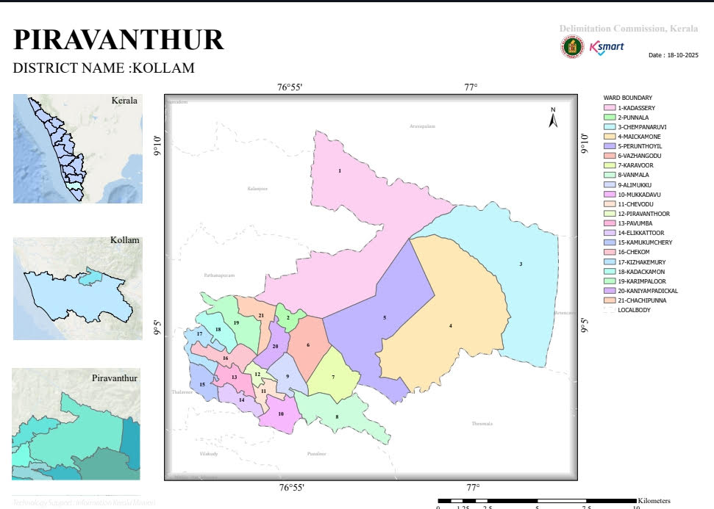

INTEGRATED HEALTH INFRASTRUCTURE MAP PIRAVANTHOOR PANCHAYAT

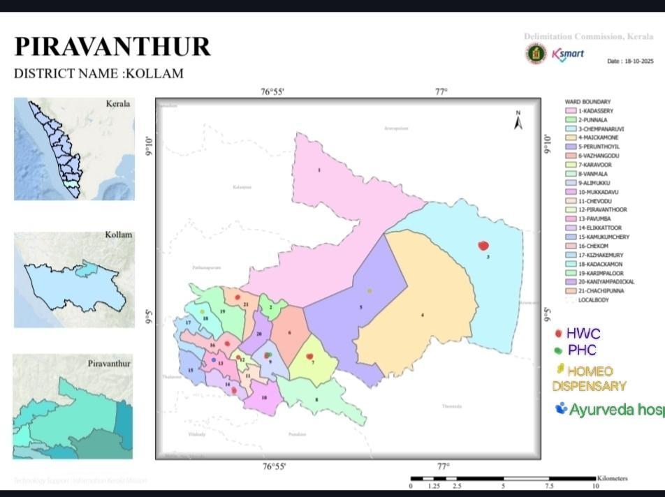

ROADS AND RIVERS MAP

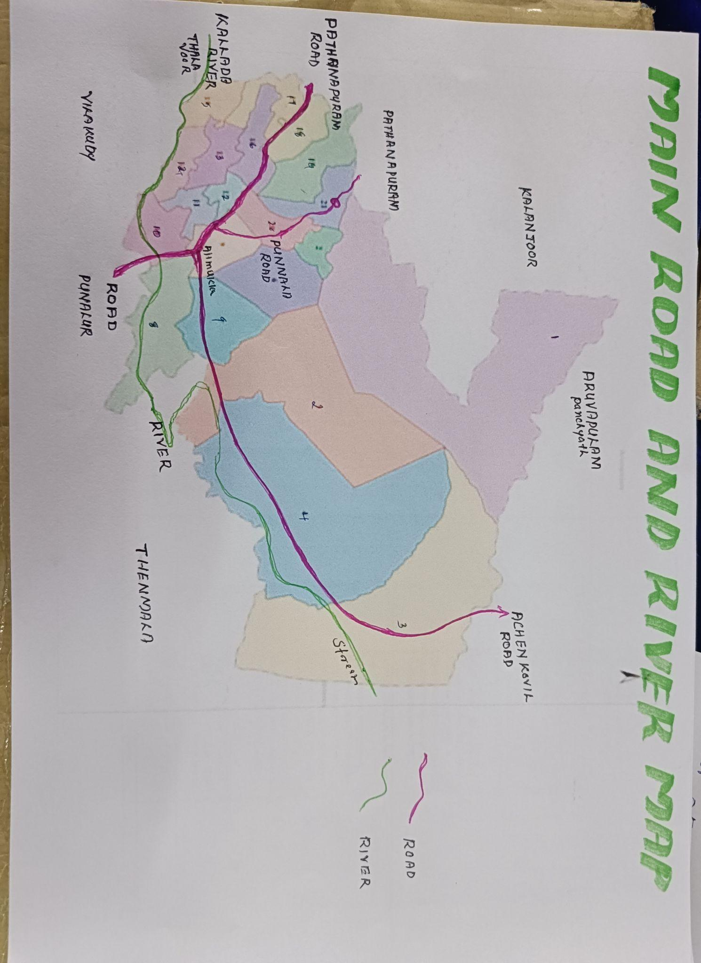

DISASTER PRONE AREAS MAP

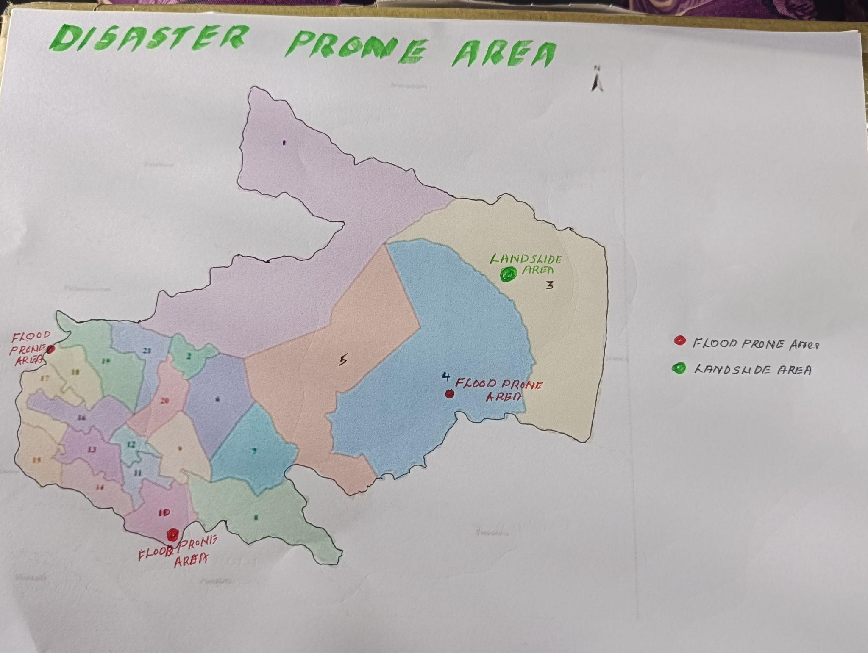

HOTSPOT MAP - COMMUNICABLE DISASTER AND DISASTERS
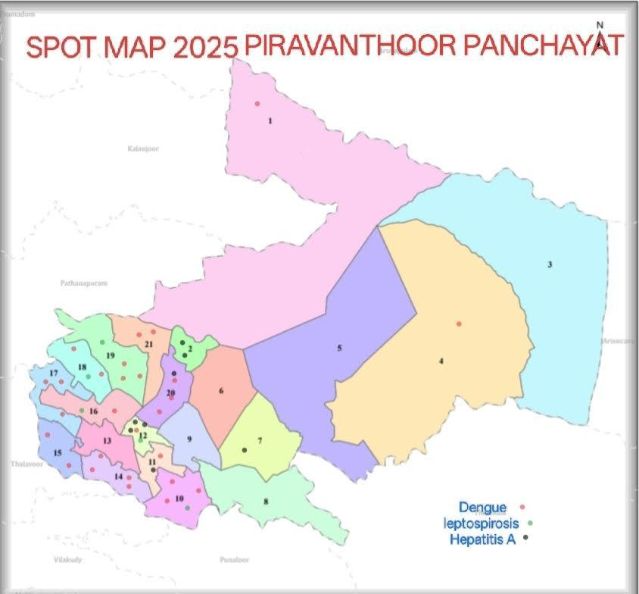

GENERAL PROFILE OF THE LSGI’S

BACKGROUND OF THE LSGI
Piravanthoor Grama Panchayat is situated in the Pathanpuram block of Kollam district, Kerala. The geographical landscape of the Panchayat is predominantly low-lying, characterized by extensive paddy fields (Kole lands) and a dense network of rivers, canals, and backwaters. This unique terrain plays a significant role in shaping the local microclimate and poses distinct challenges to transportation, emergency response, and service delivery, particularly during monsoon seasons and flood events.
The Panchayat is administratively divided into multiple wards, with a population largely dependent on traditional livelihoods. Agriculture—especially paddy cultivation—fishing, coir and coconut husk processing, and allied activities form the backbone of the local economy. In recent years, tourism-related activities and service-sector employment have also shown gradual growth. The area hosts a diverse workforce, including a notable presence of migrant labourers, particularly in construction, agriculture, and allied sectors.
From a public health and disaster management perspective, Piravanthoor LSGI has historically been vulnerable to seasonal flooding, waterborne diseases, and vector-borne illnesses such as Dengue and Leptospirosis. The severe floods experienced during recent years, including the 2018 flood disaster, significantly impacted life, livelihoods, and infrastructure within the Panchayat. These recurring emergencies have underscored the importance of strengthening local preparedness, response mechanisms, and inter-departmental coordination.
In this context, the development of a localized, data-driven Auxiliary Infrastructure and Logistical Resource Map is essential to support effective planning, timely emergency response, and sustainable development initiatives. Such mapping enables the Panchayat to identify critical resources, improve accessibility during disasters, and enhance overall resilience of the community.

Table 1: Background of LSGD
Description | Details
Name of LSGI | Piravanthoor
Type (GP/Municipality / Corporation etc.) | Grama Panchayath
Block | Pathanapuram
District | Kollam
Number of wards | 21
Total area (sq. km) | 129.86sq km
Population(Projected) | 33914
Population density | 261.16persons/sq km
Terrain (coastal/low-lying/backwaters/foothills, etc.) | foothill
Number of rivers passing through LSGI | 1
Number of water bodies in the LSGI | 12
Number of educational institutions | 17
Factories / small-scale industries | 3
Flood-prone wards | 2
Landslide-prone wards | 2
Death Management and Disposal Facilities (mortuaries/crematorium, including electric) | 0
Auditoriums/Marriage halls/convention centres/community halls | 6

Demographic and Vulnerable Population
Understanding the demographic composition and vulnerable population groups is essential for pandemic preparedness. Children, elderly, economically deprived families, migrant workers, and socially vulnerable groups are at increased risk during public health emergencies due to higher exposure, limited access to services, and dependency on public systems..

Description |  | Details (in numbers)
DEMOGRAPHIC PROFILE
Total population |  | 33914
Male |  | 16856
Female |  | 17058
Transgender |  | 0
Children under 5 |  | 909
Adolescent |  | 2025
Elderly (>60) |  | 6095
SOCIAL/LIVELIHOOD VULNERABILITY
Previous EPEP family |  | 46
BPL family |  | 4010
Tribal communities |  | 732
Migration | Immigrant | 175
Migration | Emigrant | 1357
Socio-economically deprived |  | 4010
Fisherfolk |  | 0
SC Community |  | 6397
ST Community |  | 732

Graphs: Population pyramid (if possible) for seeing if your LSGI has a high "dependency ratio" (lots of children and elderly compared to working adults).

Clinical Vulnerability
Certain population groups needs priority healthcare & are at higher risk of severe illness, complications, and mortality during pandemics. Patients with chronic diseases, those requiring regular medical care, and individuals with mobility or functional limitations face challenges in accessing timely care during emergencies. Mapping these groups helps in prioritizing continuity of treatment, medicine stock planning, oxygen support, referral transport, and targeted home-based care.
Description | Details in numbers
Pregnant women | 164
Lactating mother | 132
Bedbound patients | 72
Patients under palliative care other than bedbound | 76
Patients on Haemodialysis | 11
Patients on CAPD | 0
Cancer patients (currently on treatment) | 126
Haemophilic patients | 11
Mentally challenged | 93
Differently abled | 110
Diabetic patients | 2932
Hypertensive patients | 1534
TB patients | 7

Major Festivals & Events specific to the LSGI
(with the possibility of a public gathering)

Sl. No. | Name of festival | Month detailing the periodicity
 | Temple and Church festival | February to April
1 | SHIVAPARVATHY TEMPLE SASTHAMPADIKKAL | MARCH
2 | CHEKOM MAHADEVA TEMPLE | MARCH
3 | AYIRAVALLY TEMPLE ALIMUKK | MARCH
4 | MAHADEVA TEMPLE MAIKAMINE | FEBRUARY
5 | CHERUPPITAKAVU DEVI TEMPLE | MARCH
6 | MAHA DEVA TEMPLE KAMUKUMCHERY | MARCH
7 | DEVI TEMPLE ELIKATTOOR | MARCH
8 | DEVI TEMPLE ANAKULAM | MARCH
9 | DEVI TEMPLE KOTTAKAYAM CHEMPANARUVI | MARCH
10 | PANANGADU MAHAVISHNU TEMPLE CHACHIPUNNA | APRIL
11 | KANNANKARA SIVA TEMPLE KARIMPALOOR | MARCH
12 | ORTHODOX CHURCH CHACHIPUNNA | DECEMBER
13 | ORTHODOX CHURCH KADKKAMON | DECEMBER
14 | ST.MARYS CHURCH VETTITHITTA | DECEMBER
15 | AMMOOMMA KOTTARAM KARAVOOR | FEBRUARY
16 | SREE MAHAVISHNU TEMPLE KADASSERY | FEBRUARY

INFRASTRUCTURE & RESOURCE INVENTORY

Health Facility Directory & Basic Capacity in the LSGD
This section provides an overview of the healthcare infrastructure available within the LSGD area. It outlines the distribution and basic capacity of health facilities that form the backbone of service delivery during routine times and public health emergencies.
Family Health Centres (FHCs) and Community Health Centres (CHCs) generally function as the first point of contact for the community, providing essential outpatient and inpatient services. General Hospitals (GH) and Medical College Hospitals (MCH), where accessible, serve as the main referral centres for advanced diagnostics, specialist care, and critical services during public health emergencies. This inventory helps identify existing strengths, gaps, and potential surge capacity that can be mobilised during a pandemic or disaster.
Table 5. Health Facility Resource Summary
Sl.no. | Health Facility | Type of Facility (MCH/GH/CHC/FHC/SC etc.) | Contact Number | Total beds | ICU Beds | Oxygen-Supported Beds | No. of Ventilator Support Beds | No. of ambulances
Government Healthcare Facilities
 | 1 | FHC | 9567361781 | 5 | 0 | 0 | 0 | 1
 | 5 | SC |  | 0 | 0 | 0 | 0 | 0
Private Healthcare Facilities
 | 1 | AS Health care facility | 9645654777 | 0 | 0 | 0 | 0 | 0
AYUSH Healthcare Facilities
 | 13 | Ayurvedha hospital | 8129793234 | 3 | 0 | 0 | 0 | 0
 | 3 | Homeo dispensary | 9947440958 | 0 | 0 | 0 | 0 | 0
 | 18 | Homeo dispensary | 7034700949 | 0 | 0 | 0 | 0 | 0
 | 19 | Homeo hospital punnla | 9947440958 | 0 | 0 | 0 | 0 | 0

Private Clinics
Private clinics are an essential part of pandemic preparedness, as they are often the first place people seek care when symptoms begin. In many communities, private clinics manage a significant share of outpatient visits and therefore play a critical role in early case detection, timely referrals, and disease surveillance. Having an up-to-date understanding of where these clinics are located, the services they provide, and how they are linked to the public health system helps ensure that no cases are missed during an outbreak. It also allows health authorities to engage private practitioners more effectively for reporting, risk communication, and coordinated response, strengthening the overall capacity of the health system to manage public health emergencies.

Table 6. Private Clinic Resource Summary
Sl No. | Name of Clinic | Registered (Y/N) | Clinic (General / Speciality) | Speciality (if any) | Address | Contact Number | Diagnostic Facility (Y/N) | Ambulance Linkage (Y/N)
1 | AS Health care facility | N | Clinic general | no | Piravanthoor vetithitta p.o | 9645654777 | NO | Yes

Healthcare Education & Training Institutions
This section tracks the educational infrastructure available, which is vital for human resource planning in the health sector.

Category of Institution | Govt | Private | AYUSH | Total
Medical Colleges | 0 | 0 | 0 | 0
Nursing Colleges | 1 | 0 | 0 | 1
Dental Colleges | 0 | 0 | 0 | 0
Para-medical / Allied Health | 0 | 0 | 0 | 0
Pharmacy Colleges | 0 | 0 | 0 | 0

Specialized Services & Emergency Inventory
This section provides a detailed view of the specialized medical resources available to the community, focusing on emergency response and critical care capabilities. This table tracks the vital assets required for managing severe illnesses and emergencies across Government, Private, and AYUSH sectors.

Item | Govt | Private | AYUSH | Total
Hospital beds | 0 | 0 | 0 | 0
Oxygen-generating systems(Y/N) | 0 | 0 | 0 | 0
Oxygen-supported beds(Numbers) | 0 | 0 | 0 | 0
Ventilator-supported beds | 0 | 0 | 0 | 0
ICU beds | 0 | 0 | 0 | 0
Burns units | 0 | 0 | 0 | 0
Blood centres | 0 | 0 | 0 | 0
BLS ambulances | 0 | 0 | 0 | 0
ALS ambulances | 0 | 0 | 0 | 0
Dialysis facilities | 0 | 0 | 0 | 0
Dispensaries | 0 | 1 | 0 | 1
Medical store | 1 | 6 | 3 | 10
Industrial establishments(Medium-scale industries/small-scale industries establishments to whom we can depend in a worst-case scenario) | 1 | 2 | 0 | 3

Oxygen & Diagnostic Capacity
Monitoring oxygen and diagnostic capacity is a critical component of public health preparedness, ensuring that the LSGD can handle both chronic care and sudden surges in respiratory or infectious diseases.
Name of Health Facility | Oxygen-generating System (Y/N) | Backup Oxygen Source (Y/N) | Diagnostic Facilities Available(Y/N)
Name of Health Facility | Oxygen-generating System (Y/N) | Backup Oxygen Source (Y/N) | Lab | USG | X-ray | CT/MRI | RT-PCR
Government Healthcare Facilities
FHC | NO | NO | 1 | 0 | 0 | 0 | 0

Diagnostics facility mapping at the LSGI level
The diagnostic capacity of Piravanthoor G.P represents the "intelligence network" of our healthcare system. The speed and accuracy of disease identification depend entirely on the distribution and technical level of these facilities.

Item | Govt | Private | AYUSH | Total
General labs | 1 | 6 | 0 | 7
Microbiology labs | 0 | 0 | 0 | 0
RT-PCR labs | 0 | 0 | 0 | 0
USG units | 0 | 0 | 0 | 0
CT/MRI units | 0 | 0 | 0 | 0
Research labs | 0 | 0 | 0 | 0
Labs of other departments that can be repurposed | 0 | 0 | 0 | 0

Laboratory Identification & Basic Details
Sl. No. | Name of Laboratory | Ownership (Govt / Private / Academic) | Address | Contact No. | 24×7 Services (Yes/No) | NABL / Govt Approved (Yes/No)
1 | Omega diagnostic centre alimukku | private | alimukku |  | no | yes
2 | Alphalab laboratories and clinics | private | punnala | 09447020737 | no | yes
3 | Optam lab and diagnostics | Private | Alimukku | 08606621111 | no | no
4 | pan india lab collection centre | private | elikattoor |  | no | no
5 | goodwill lab | private | kamukumchery | 9846734656 | no | no
6 | A S Health care lab | private | piravanthoor | 9445923038 | no | no

Social and Community Infrastructure for surge plan
This table serves as our logistics and shelter inventory. By mapping these locations, quickly we can identify where to house displaced citizens, where to set up temporary medical clinics, and how to manage the deceased with dignity during a crisis.

Category | Total Count | Ward | Est. Capacity (Persons) | Contact details
Educational Institutions
Anganwadis | 46 | all wards | 50 | 9846927951
Schools | 17 | 2,21,5,3,7,12,10,8,16,15,14 | 560 | 9495757286
Colleges | 1 | 10 | 150 | 04752022810
Healthcare Educational Institutions
Medical colleges (Govt/Private) | 0 | 0 | 0 | 0
Nursing colleges (Govt/Private) | 1 | 10 | 140 | 9544263366
Dental colleges (Govt/Private) | 0 | 0 | 0 | 0
Paramedical institutes (Govt/Private) | 0 | 0 | 0 | 0
Community Gathering Spaces
Community halls | 4 | 18,9,10,3 | 60 | 9447911572
Auditoriums | 2 | 10,12 | 50 | 9605941121
Religious buildings | 16 | 9(5), 12,13,18,14,15 | 50 | 09447171696
Vulnerable Group Support Facility
Destitute homes | 0 | 0 | 0 | 0
Elderly homes | 1 | 14 | 12 | 9447966287
LSGD owned other buildings | 7 | 10,3,8,18, | 50 | 04752386463
Mass Fatality Management (MFM) Infrastructure
Mortuary | 0 | 0 | 0 | 0
Crematorium | 0 | 0 | 0 | 0
*refer annexure 1 for contact details

Human resources
This section focuses on the human capital available within the LSGI. In any emergency—be it a pandemic, flood, or industrial accident—infrastructure is only as effective as the people operating it.
Medical & Clinical Personnel
This table tracks the "Frontline" providers responsible for diagnosis, treatment, and clinical management. Narrative sentence: eg., "Total health workforce: 450 personnel, with 60% in government facilities serving as primary surge capacity." A detailed directory with the contact numbers of all workers is maintained (Annexure in 1).

Cadre | Govt (No.) | Private (No.) | Total
Doctors—Modern Medicine | 4 | 3 | 7
Doctors – AYUSH | 2 | 1 | 3
Doctors – Veterinary | 1 | 0 | 1
Doctors – Dental | 0 | 1 | 1
Nursing officers | 2 | 2 | 4
Lab technicians | 1 | 6 | 7
Optometrist | 0 | 0 | 0
Pharmacists | 2 | 1 | 3
Psychologists | 0 | 0 | 0
Counsellors | 0 | 0 | 0

Public Health & Field-Level Workforce
These individuals are the backbone of surveillance, maternal-child health, and decentralized care.

Cadre | Health services | Municipal common services | Total
HS (Health Supervisors) | 0 | 0 | 0
HI (Health Inspectors) | 1 | O | 1
LHS (Lady Health Supervisor) | 0 | 0 | 0
LHI (Lady Health Inspectors) | 1 | 0 | 1
JPHN (Jr Public Health Nurses) | 7 | 0 | 7
JHI (Jr Health Inspectors) | 6 | 0 | 6
MLSP (Mid-Level Service Providers) | 7 | 0 | 7
Palliative Nurses | 1 | 0 | 1
RBSK Nurses | 1 | 0 | 1
PRO | 0 | 0 | 0
Epidemiologist | 1 | 0 | 1
Data Manager | 1 | 0 | 1

Community & Support Cadre
This group represents the surge capacity of the LSGI—people who can be called upon for logistics, rescue, and specialized support.

Cadre | Number
ASHA Workers | 27
AWW (Anganwadi Workers) | 41
Emergency Medical Volunteers (Trained) | 0
Kudumbashree | 598
MNREGS | 30units
Purusha Swayam Sahaya Sangham | 4
Ex-Servicemen | 17
Retired Police Officers | 30
NCC/NSS Volunteers | 60
Red Cross volunteers | 0
One Health Community Volunteers | 0
One Health Community Mentors | 0

Community Organizations
This section details the presence of community-based organisations (CBOs), non-governmental organisations (NGOs), faith-based organisations (FBOs), Kudumbashree Self-Help Groups (SHGs), and Ayalkootams within the Local Self-Government Institution (LSGI). These groups enhance grassroots mobilization, resource distribution, and support networks crucial for pandemic response and community resilience.

Category | Total Count
NGOs | 10
Religious based organizations | 0
Foreign based organizations | 0
Sports Club/youth clubs | 10
Kudumbashree SHGs | 560
Ayalkootams | 598
Political organizations | 5
Residential organizations | 0

Administrative & Emergency Services
This section outlines the availability of key non-health emergency support services and infrastructure within the LSGI, which are essential for effective pandemic preparedness and response. These facilities support law enforcement, disaster response, water supply, logistics, mobility, and community-level interventions during public health emergencies.

Category | Total Count | Contact details
Police Stations | 0 | Punalur police station 09497987038
Fire & Rescue Stations | 0 | Punalur  04752222701
Water Pumping Points | 2 | 8289940517
Public Distribution System (PDS) | 16 | 9188527595
Information regarding resources
The availability of essential transport and support resources plays a quiet but critical role in saving lives. Equipment such as ambulances, mobile mortuaries, amphibian ambulances, and motorized boats ensures that patients, samples, and healthcare teams can move swiftly—even in flooded, remote, or difficult terrains. Heavy vehicles like JCBs, cranes, tractors, and torus lorries support logistics, waste management, emergency infrastructure, and rapid conversion of spaces into care or isolation facilities. Taxis, four-wheel-drive vehicles, and trucks help maintain continuity of essential services, reach vulnerable populations, and support home-based care and supply delivery.

Means of transportation | Total Count
JCB | 2
Crane | 0
Heavy Trucks | 0
Tractor | 0
Ambulances | 1
Mobile mortuaries | 0
Boats | 0
Taxi service | 6
Note: For specific details regarding vehicle owners and contact information, please refer to Annexure [X].
ONE HEALTH & ENVIRONMENTAL SURVEILLANCE
The One Health method integrates environmental, animal, and human health to enable proactive pandemic preparedness. Panchayat-level surveillance needs to be improved in order to detect and treat zoonotic and environmentally generated diseases early. Surveillance is strengthened through systematic assessment of animal populations, veterinary infrastructure, poultry and slaughter facilities, inter-sectoral coordination, and specialised tools like avian influenza seasonality mapping using GIS in previous outbreaks to enable predictive alerts and ward-specific sampling to support effective pandemic preparedness in high-risk areas.
Animal & Bird Population
Mapping animal and bird populations at the Panchayat level is essential for identifying and prioritising zoonotic disease hazards like rabies, avian influenza (H5N1), leptospirosis, anthrax, and Nipah-like spillover occurrences. Risk classification, targeted surveillance, vaccination planning, and early epidemic detection made feasible by comprehensive population mapping all enhance One Health-based pandemic preparedness.

Category | Item | Estimated Population | Wards
Animal Population | Livestock (Cattle/Goats/Buffalo) | 568 | all wards
Animal Population | Pet Animals (Dogs/Cats) | 6300 | all wards
Animal Population | Stray Dog Population | 1120 | all wards
Animal Population | Pig Farms (Number of heads) | 1 | 1
 | Small Units (Sheep / Goats – clustered) | 1 | 10
Bird Population | Poultry Units (Birds) | 7 | 5,4,10,8,2
Bird Population | Poultry- (FOWL) | 0 | 0
Bird Population | Wild/Migratory Birds (Observed) | 0 | 0
Bird Population | Crow Mortality Events (Reported) | 0 | 0

The main risk of zoonotic diseases in ward ava is concentrated in Wards 1, & 3 which is explained by the high density of pig farms, cattle congregation areas, and poultry units. The stray dog population in market areas, fish landing sites, bus stations continues to be a substantial problem for rabies surveillance and bite prevention. There is a considerable risk of avian influenza introduction and amplification during November - December due to the seasonal presence of migratory and resident water birds near ponds/ canal / river / backwater / paddy field. Clusters of pig farms and animal shelters vulnerable to flooding further raise the risk of leptospirosis and other zoonoses mediated by the environment, especially during monsoon floods.
Veterinary Infrastructure
Veterinary institutions are a core pillar of One Health surveillance, enabling early zoonotic disease detection through vaccination, investigation of unusual animal illness or deaths, sample collection, and timely outbreak reporting. A well-mapped and responsive veterinary network strengthens coordination with human health and LSGI systems, ensuring rapid response during zoonotic events and pandemics.
Facility Type | Name of Facility | Ownership Govt / Pvt | Location(Ward No) | Contact number
Veterinary Dispensary | 0 | 0 | 0 | 0
Veterinary Hospital / Polyclinic | Veterinary hospital karavoor | govt | 7 | 6282397693
Private Veterinary Clinics | 0 | 0 | 0 | 0
Mobile / Emergency Vet Service (incl. night services) | 0 | 0 | 0 | 0
Pet Homes / Animal Shelters | 0 | 0 | 0 | 0
Slaughterhouse-linked Veterinary Inspection Unit | 0 | 0 | 0 | 0

Veterinary Doctors & Workforce
Early detection, diagnosis, reporting, and reaction to animal illness epidemics depend on the availability and accessibility of qualified veterinary specialists. By identifying unusual animal morbidity or mortality promptly, collecting samples promptly, and coordinating efficiently with human health and LSGI systems—especially during zoonotic outbreaks and pandemic-prone situations—a clearly defined veterinary workforce enhances One Health surveillance.

Category | Number Available | Type (Govt/Pvt) | Contact number
Government Veterinary Doctors | 1 | govt | 6282397693
Private Veterinary Doctors | 0 | 0 | 0
Livestock Inspectors | 2 | govt | Jayakumari-918606042179  Bindhu -9446560050
Para-veterinary Staff / Attenders | 1 | govt | Latha 9497101786
Contract / On-call Veterinary Support (if any) | 0 | 0 | 0

High-Risk Interface Points (Surveillance Sites)
High-risk interface points for zoonotic disease surveillance in Piravanthoor Grama Panchayath include wetland–livestock–human contact zones, backyard poultry farms, cattle sheds near water bodies, fish markets, and areas of high human–animal interaction such as community slaughter points and migratory bird congregation sites. These are the primary surveillance sites where zoonotic spillover risks are elevated.

Type of Habitat | Type of High risk interface | Geographical vulnerability
Wetlands & Backwaters | 0 | 0
Backyard Poultry Farms | 0 | 0
Cattle Sheds near Water Bodies | 0 | 0
Fish & Meat Markets | 0 | 0
Community Slaughter Sites | 4 | Focus on wate to waterway link
Migratory Bird Congregation Areas | 0 | 0
Rodent-Infested Grain Storage | 0 | 0

Category | Total Count | Key Locations (wards)
Poultry Farms | 7 | 2,5,4,10,8
Backyard / Clustered Poultry Units | 112 | all wards
Duck Rearing Units (open water access) | 0 | 0
Slaughterhouses/ Slaughter Points | 0 | 0
Meat/Fish Markets | 0 | 0
Live Bird Sale Points | 0 | 0
Cattle Markets / Weekly Animal Fairs | 0 | 0
Pet Shops / Breeders | 0 | 0
Animal Shelters / Pet Homes | 0 | 0
Waste Disposal Sites near Animal Units | 0 | 0

Environmental Risk Mapping
Environmental risk mapping identifies monsoon/flood hotspots for vector-borne (dengue, chikungunya), water-borne (leptospirosis, diarrhoea), and zoonotic diseases in Kerala's wetlands. Systematic surveillance supports early warnings, targeted interventions, and Panchayat pandemic preparedness.
Waterborne exposure: Flood-prone areas and stagnant water bodies facilitate leptospira survival, raising leptospirosis risk.

Traditional practices: Informal slaughter and fish markets lack standardized hygiene, creating spillover opportunities.
Risk Factor | High-Risk Wards | Key Locations | Risk Level (High/Med/Low)
Flood-prone areas | 2 | Mukkadavu, Karavoor | Low
Water bodies/wetlands | 0 | NA | NA
Solid waste accumulation | 1 | Mukkadavu | Low
Animal waste disposal issues | 0 | NA | NA
Rodent infestation zones | 0 | NA | NA
Industrial effluent discharge | 0 | NA | NA
Construction sites / abandoned buildings | 0 | NA | NA
Poor drainage/blocked canals | 0 | NA | NA
Drinking water source contamination risk | 0 | NA | NA

Disease Seasonality Mapping
1, Flooding & waterlogging → amplifies leptospirosis, malaria, diarrheal diseases.
·
2, Migratory bird influx (Nov–Feb) → avian influenza risk.

3, Mosquito breeding cycles → vector-borne disease peaks in monsoon.

4, Agricultural practices → close human–animal contact in paddy fields.

Disease | Peak Risk Season | Key Drivers | High-Risk Locations | Surveillance Focus
Avian Influenza | NA | NA | NA | focus on migrant birds
Leptospirosis | Monsoon season | NA | 3,18 | high risk due to flooding/ water log
Dengue/Chikungunya | Monsoon season | NA | 18,1 | focus on vector controland stagnant water
Acute Diarrheal Diseases | Mansoon seasob |  | NA | standard surveillance for water quality
Rabies | Summer season , Monsoon season | Stray dogs | Kadassery, chembanaruvy,kadakamon | driven by stray dog and coordinate with veterinary do
Anthrax (rare) | NA | NA | NA | NA

Vulnerability Mapping
Vulnerability mapping pinpoints high-risk populations, occupations, and areas exposed via environment, livelihoods, socio-economics, and poor service access. Paired with environmental/seasonality mapping, it enables risk-based surveillance, targeted actions, and optimal resource use in One Health and pandemic planning.
Vulnerability Factor | High-Risk Wards | Key Groups / Locations | Risk Level
Flood-prone households | 10,4,18,5 | Karavoor kanal area, mukkadav bridge, kadakkamon bridge, mahadevarman | med
Wetland-adjacent communities | 0 | 0 | 0
Backyard poultry / duck rearing households | 0 | 0 | 0
Livestock-rearing households | 0 | 0 | 0
Slaughterhouse & meat market workers | 11 | 0 | 0
Fisherfolk & fish market workers | 5 | 0 | 0
Sanitation workers | 0 | 0 | 0
Daily wage / migrant workers | 0 | 0 | 0
Elderly & chronically ill populations | 6095 | all wards | 0
Pregnant Women | 15 | 2,3,6,11,12,14,9,18,19 ward | 0
Children (schools, Anganwadi’s) | 1705 | 0 | 0
Limited access to safe water & sanitation | 0 | 0 | 0

EPIDEMIOLOGICAL TRENDS (2021–2025)
Disease surveillance is the systematic collection, analysis, and interpretation of health data for planning, implementation, and evaluation of public health practice. This section presents the disease surveillance profile of the LSGI based on routine reporting systems and outbreak investigations to identify priority diseases, seasonal patterns, and emerging public health threats.

Disease Burden among human beings(Last 5 Years)
Analysis of disease-wise data for the last five years helps identify persistent public health problems, emerging diseases, and changes in disease burden. This information supports prioritisation of prevention, preparedness, and response activities at the Panchayat level.

Disease | 2021 | 2022 | 2023 | 2024 | 2025 | Trend(Increasing/Stable/Decreasing)
Dengue | 7 | 7 | 35 | 41 | 27 | decreasing
Leptospirosis | 4 | 0 | 8 | 4 | 4 | stable
Hepatitis A | 0 | 1 | 0 | 3 | 4 | stable
Malaria | 0 | 0 | 0 | 0 | 1 | stable
Scrub Typhus | 0 | 0 | 0 | 0 | 0 | stable
Typhoid | 2 | 1 | 0 | 1 | 3 | stable
H1N1 | 0 | 0 | 0 | 1 | 1 | stable
H3N2 | 0 | 0 | 0 | 0 | 2 | increasing
ADD | 6 | 24 | 38 | 42 | 68 | increasing
Mumps | 0 | 0 | 0 | 2 | 9 | increasing
Measles | 0 | 0 | 0 | 0 | 0 | stable
Hepatitis B | 1 | 1 | 1 | 2 | 4 | increasing
Hepatitis C | 0 | 0 | 0 | 0 | 0 | stable
Tuberculosis | 0 | 0 | 15 | 18 | 7 | decreasing
Leprosy | 0 | 0 | 0 | 0 | 0 | stable
COVID-19 | 0 | 0 | 0 | 2 | 0 | decreasing

*(use the above table data to create the graph/diagram)

Seasonal Trend Analysis
Seasonal analysis helps anticipate surges (e.g. dengue in monsoon, leptospirosis after floods, influenza in cooler months) and plan pre‑emptive vector control, stockpiling of IV fluids, and awareness campaigns at Panchayat level.

DENGUE
Dengue is a major seasonal vector-borne disease strongly associated with rainfall, water stagnation, and increased mosquito breeding during the monsoon period.

Peak: July–November
Dengue – Ward-wise Yearly Distribution (2021–2025)

Ward | Dengue – Ward-wise Yearly Distribution
Ward | 2021 | 2022 | 2023 | 2024 | 2025 | Total
1 | 2 | 0 | 10 | 12 | 1 | 25
2 | 0 | 0 | 2 | 25 | 0 | 27
3 | 0 | 0 | 3 | 3 | 0 | 6
4 | 0 | 2 | 0 | 3 | 1 | 6
5 | 0 | 0 | 0 | 2 | 1 | 3
6 | 0 | 0 | 2 | 1 | 1 | 4
7 | 0 | 0 | 1 | 0 | 0 | 1
8 | 1 | 0 | 1 | 3 | 2 | 6
9 | 0 | 0 | 1 | 1 | 1 | 3
10 | 0 | 0 | 0 | 0 | 0 | 0
11 | 1 | 0 | 0 | 1 | 1 | 3
12 | 1 | 0 | 0 | 0 | 1 | 2
13 | 0 | 0 | 1 | 3 | 0 | 4
14 | 0 | 0 | 1 | 0 | 4 | 5
15 | 0 | 0 | 2 | 3 | 2 | 7
16 | 2 | 0 | 2 | 3 | 2 | 7
17 | 0 | 0 | 1 | 2 | 0 | 3
18 | 0 | 0 | 0 | 4 | 1 | 5
19 | 0 | 0 | 1 | 1 | 3 | 5
20 | 0 | 0 | 0 | 4 | 3 | 7
21 | 0 | 0 | 0 | 5 | 2 | 7

LEPTOSPIROSIS
Leptospirosis cases are closely linked to monsoon rains, flooding, and occupational exposure, particularly in low-lying and waterlogged areas.

Peak: June - August
Leptospirosis – Ward-wise Yearly Distribution (2021–2025)

Ward | Leptospirosis – Ward-wise Yearly Distribution
Ward | 2021 | 2022 | 2023 | 2024 | 2025 | Total
1 | 0 | 0 | 1 | 0 | 0 | 1
2 | 0 | 2 | 1 | 2 | 0 | 5
3 | 0 | 1 | 1 | 0 | 0 | 2
4 | 0 | 0 | 0 | 0 | 0 | 0
5 | 0 | 0 | 0 | 0 | 0 | 0
6 | 0 | 0 | 1 | 1 | 0 | 2
7 | 0 | 0 | 0 | 0 | 0 | 0
8 | 0 | 0 | 1 | 0 | 0 | 1
9 | 0 | 0 | 0 | 0 | 0 | 0
10 | 0 | 0 | 1 |  | 1 | 2
11 | 0 | 0 | 1 | 1 | 1 | 3
12 | 0 | 0 | 0 | 1 | 1 | 2
13 | 0 | 0 | 2 | 1 | 0 | 3
14 | 0 | 0 | 1 | 1 | 0 | 2
15 | 0 | 0 | 0 | 0 | 0 | 0
16 | 0 | 0 | 0 | 0 | 0 | 0
17 | 0 | 0 | 0 | 0 | 0 | 0
18 | 0 | 0 | 2 | 0 | 0 | 2
19 | 0 | 0 | 0 | 0 | 1 | 1
20 | 0 | 0 | 0 | 0 | 0 | 0
21 | 1 | 0 | 0 | 0 | 0 | 1

VIRAL HEPATITIS - A
Hepatitis A cases are commonly associated with unsafe drinking water, food contamination, and breakdowns in sanitation, often presenting as clusters or outbreaks.

Peak: October - December

Hepatitis A – Ward-wise Yearly Distribution (2021–2025)

Ward | Hep A – Ward-wise Yearly Distribution
Ward | 2021 | 2022 | 2023 | 2024 | 2025 | Total
1 | 0 | 0 | 0 | 0 | 0 | 0
2 | 0 | 0 | 0 | 1 | 2 | 3
3 | 0 | 0 | 0 | 0 | 0 | 0
4 | 0 | 0 | 0 | 0 | 0 | 0
5 | 0 | 0 | 0 | 0 | 0 | 0
6 | 0 | 0 | 0 | 0 | 0 | 0
7 | 0 | 0 | 1 | 0 | 1 | 2
8 | 0 | 0 | 0 | 0 | 0 | 0
9 | 0 | 0 | 0 | 1 | 0 | 1
10 | 0 | 0 | 0 | 0 | 0 | 0
11 | 0 | 0 | 0 | 0 | 1 | 1
12 | 0 | 0 | 0 | 0 | 3 | 3
13 | 0 | 0 | 0 | 0 | 0 | 0
14 | 0 | 0 | 0 | 0 | 0 | 0
15 | 0 | 0 | 0 | 0 | 0 | 0
16 | 0 | 0 | 0 | 0 | 0 | 0
17 | 0 | 0 | 0 | 0 | 0 | 0
18 | 0 | 0 | 0 | 0 | 0 | 0
19 | 0 | 0 | 0 | 0 | 0 | 0
20 | 0 | 0 | 0 | 0 | 1 | 1
21 | 0 | 0 | 0 | 0 | 0 | 0

Outcome-Based Trend Analysis- 2025

Transmission Trend- 2025
For effective management of public health issues, it is important to track the trend of disease transmission mode. It helps identify the population or place at high risk that can be used to predict outbreaks and implement targeted interventions as quickly as possible. Understanding these kinds of trends enables authorities to allocate resources efficiently and change the strategies adequately based on the trend that follows.

Mode of Transmission | No. of cases | No. of Deaths
Vector Borne Diseases | 18 | 0
Water Borne Diseases | 4 | 0
Air Borne Diseases | 2 | 0
Blood Borne Diseases | 2 | 0
Food Borne Diseases | 5 | 0

Vector-Borne Disease
Disease | No. of Cases | No. of Deaths
Dengue | 18 | 0
Malaria | 1 | 0
Chikungunya | 0 | 0

Water Borne Disease
Disease | No. of Cases | No. of Deaths
Cholera | 0 | 0
Typhoid | 1 | 0
Hep- A | 4 | 0
Dysentery | 0 | 0
Amoebiasis | 0 | 0
E- Coli infections | 4 | 0
Air Borne Diseases
Disease | No. of Cases | No. of Deaths
Influenza | 0 | 0
H1N1 | 1 | 0
TB | 7 | 0
Chickenpox | 1 | 0
Measles | 0 | 0
Covid-19 | 0 | 0
Pertussis | 0 | 0
Mumps | 2 | 0

Blood-Borne Disease
Disease | No. of Cases | No. of Deaths
AIDS | 2 | 0
Hep- B | 4 | 0
Hep- C | 0 | 0

Zoonotic Disease
Disease | No. of Cases | No. of Deaths
Rabies | 0 | 0
Leptospirosis | 4 | 0
Avian influenza | 0 | 0
West nile | 0 | 0
Anthrax | 0 | 0
Nipah | 0 | 0
Scrub Typhus | 0 | 0

Integrated Disease Hotspot Map (2021–2025)

1 | Dengue Total (2021-25) | Leptospirosis Total (2021-25) | Hepatitis A Total (2021-25) | Mumps (2021-25) | ADD (2021-25) | Total Cases
1 | 23 | 1 | 0 | 0 | 10 | 45
2 | 34 | 0 | 3 | 1 | 10 | 46
3 | 6 | 1 | 0 | 2 | 8 | 17
4 | 4 | 0 | 0 | 1 | 6 | 11
5 | 3 | 0 | 0 | 0 | 7 | 10
6 | 3 | 0 | 0 | 0 | 9 | 12
7 | 0 | 0 | 2 | 0 | 11 | 12
8 | 6 | 1 | 0 | 1 | 5 | 13
9 | 3 | 0 | 1 | 0 | 4 | 8
10 |  | 2 | 0 | 1 | 4 | 7
11 | 2 | 3 | 1 | 0 | 12 | 18
12 | 1 | 2 | 3 | 1 | 14 | 21
13 | 4 | 3 | 0 | 0 | 5 | 12
14 | 5 | 2 | 0 | 2 | 11 | 20
15 | 7 | 0 | 0 | 0 | 14 | 21
16 | 7 | 0 | 0 | 1 | 9 | 17
17 | 3 | 0 | 0 | 0 | 8 | 11
18 | 5 | 2 | 0 | 1 | 9 | 17
19 | 4 | 2 | 0 | 0 | 12 | 18
20 | 7 | 0 | 1 | 1 | 8 | 17
21 | 7 | 1 | 0 | 3 | 13 | 24

By overlaying five years of data, we have identified Kadaseery and Punnala……..'Red Zone' Wards. These are wards where dengue and lepto categories of diseases recurred in consecutive years. Ward 4 is categorized as the Highest Priority Hotspot due to its combination of flood vulnerability and high vector density. Future health infrastructure, such as the proposed R.O plants should be prioritized.

Preparedness and Response Protocol at LSG Level
This section describes the operational framework for the LSGI once a pandemic is declared. It explains how the LSGI and health system will move from routine data collection to active response, using a One Health approach.
Constitution of One Health Committee
The LSGD shall constitute a One Health Committee comprising the LSGI President, Medical Officers (Modern Medicine, AYUSH, and Veterinary), the Health Inspector, and the Veterinary Surgeon.

Objective: The One Health Committee coordinates human, animal, and environmental health to prevent and control pandemics.

Sl No | Name | Designation | Department/Institution | Role in Committee | Contact Number
1 | Mrs Sherly Gopinath | Panchayat President | LSGD | Chairperson | 9562681738
2 | Dr Karthi P Kumar | Medical Officer (PHC/CHC) | Health Dept | Member Secretary | 9567361781
3 | Dr Daniel | Veterinary Officer | Animal Husbandry | Member | 6282397693
4 | Anjulekshmi P | Epidemiologist | Health Dept | Member | 8137075282
5 | MrsChandrika | Health Inspector/PHN | Health Dept | Surveillance | 7592809127
6 | Hajira Beevi LHI | ASHA Supervisor | Health Dept | Community link | 9656873085
7 | Mrs Shobitha | ICDS Supervisor | Social Welfare | Vulnerable groups | 6282397693
9 | Mr Njeeb Khan | Ward Councillor Representative | LSGD | Community coordination | 9495238890
10 | Jalaja | Kudumbashree CDO | Kudumbashree | Community mobilisation | 8075023847
11 | Shafeer | NGO/Volunteer rep | Civil Society | Support services | 9544060786
12 | Bisna | Line Department representations | health | Health department | 8129426976

Key Responsibilities:

- Review disease surveillance data (human + animal)
- Conduct ward-wise risk assessment and vulnerability mapping
- Approve quarantine/isolation centre locations
- Coordinate with district for resources (PPE, oxygen, ambulances)
- Periodically review health system surge capacity, including beds, oxygen, human resources, and ambulances.
- Approve and monitor risk communication and community engagement strategies, including rumour management.
- Ensure protection and service continuity for vulnerable groups (elderly, persons with disabilities, dialysis patients, coastal populations).
- Conduct quarterly mock drills
- Monitor equity measures for vulnerable groups
Meeting Schedule:
Quarterly (normal times) | Weekly (outbreak alert) | Daily (pandemic phase)
Pandemic Response Workforce
To ensure a coordinated and timely response during a pandemic, a dedicated Pandemic Response Workforce shall be constituted at the LSG level. The workforce will function under the overall supervision of the One Health Committee and in close coordination with the health authorities. Team-based deployment will enable efficient surveillance, case management, quarantine and isolation management, logistics support, and risk communication. Each team shall have a clearly designated team leader, defined roles, and an identified pool of personnel to allow rapid activation, rotation of duties, and continuity of services during prolonged emergencies.

Total Response Workforce Available: 300 persons

Team Name | Composition | Key Responsibilities | Team Leader
Surveillance and Contact Tracing Team | HI, JHI, JPHN, ASHAs and Volunteers | Case detection, contact listing, home visits, reporting | HI
Case Management Team | Doctors, Nurses, MLSP, Palliative Nurses | Patient care & referral | DOCTOR
Quarantine & Isolation Team | LSGD staff, Volunteers | Facility management | JHI
Psychosocial support | Hospital staff | Facility management | counsilor
Logistics & supply chain Team | LSGD staff, Storekeepers, Drivers 3 | Supplies & transport [PPE, medicines, oxygen, transport, waste management] | Ward Member
Communication Team | Ward members, Kudumbashree, Youth clubs,  AWW workers and other self help groups | IEC, community meetings, countering misinformation | M.O in charge
Transportation | KSRTC, educational institutional buses | Transportation of patients | MO In charge
Intersectoral coordination and convergence | LSGD | Conduct meeting with all departments | Panchayth President
Collaborative surveillance | LSGD | Conduct meeting ,reviews | Panchayath President

All teams shall be activated immediately upon outbreak alert or pandemic declaration and shall report daily to the LSG Incident Commander/Medical Officer, with consolidated reporting to the Block PHC. Duty rosters and alternate personnel shall be maintained to ensure uninterrupted services during staff shortages or prolonged response periods. Team composition and numbers may be revised based on the magnitude of the outbreak and availability of human resources.

Activities and Measures before and during Pandemic
PHASE 1 - Alert / Preparation
Surveillance and Reporting-Enhanced syndromic surveillance:
- Data sources for surveillance:
- Event-based triggers (to be monitored and reported):
- Zoonotic and animal health surveillance
- Logistics and Stock Preparedness
  - Identify and empanel local vendors and define emergency procurement mechanisms in accordance with existing LSGD and Health Department norms.
  - Prepare and maintain an essential logistics checklist covering medical supplies, consumables, and support equipment.
  - Pre-identify secure storage locations for emergency stocks and ensure maintenance of stock registers with regular updating.
  - Finalise emergency transport arrangements, including availability of vehicles and identified drivers for rapid deployment during alerts.
  - Designate a Nodal Officer for Logistics to enable prompt decision-making, coordination, and communication during emergencies.
  - Conduct rapid stock verification and ensure availability of minimum buffer stock, including:
- PPE kits 0 numbers
- Pulse oximeters 0 numbers
- Hand sanitizers 0 litres
- Masks - 3000nos , gloves - 1000 nos, disinfectants - 40L phenol
Identify critical gaps in logistics and immediately communicate requirements to the Block and District authorities for timely replenishment and support. Monitor expiry dates and stock rotation.

- Identification of Quarantine and Isolation Facilities
  - Identify and list suitable buildings for quarantine and isolation (schools, hostels, community halls, etc.).
  - Categorise cases as per the severity and allocate to appropriate facilities (for instance, severe cases to classrooms, mild cases to an assembly hall in case of a school).
  - Facility readiness checklist needed (beds, toilets, ventilation) etc.
  - Find an alternate site if the primary sites are not available or not in use.
  - Identify facility managers and support staff
  - Prepare basic SOPs for:
    - Admission and discharge
    - Food, water, sanitation
    - Infection prevention and waste disposal
  - Ensure availability of basic amenities: water, sanitation, electricity, ventilation, and waste disposal. Prepare a rapid activation plan for these facilities if case numbers increase.

S.No | Name of School | roms available | estimated bed capacity
1 | GOVT LPS KIZAKKEMURI | 6 | 16
2 | GOVT LPS CHEKOM | 8 | 28
3 | GOVT LPS ELIKATTOOR | 12 | 40
4 | GOVT LPS MUKKADAVU | 2 hall | 10
5 | GOVT UPS PIRAVANTHOOR | 16 | 65
6 | GOVT UPS KIZAKKEMURI | 16 | 65
7 | SN UPS PIRAVANTHOOR | 1 hall | 15
8 | ST Pauls mslps chempanaruvi | 8 | 16
9 | valiyakavu HS | 20 | 100
10 | St.Marys UPS Vettithitta | 2 hall | 12
11 | TINY Tots English medium | 6 | 24
12 | Gurudeva HS Piravanthoor | 10 | 60
13 | GHS Punnala | 25 | 120
14 | PMG Public school | 11 | 45
15 | Salom Marthoma School | 8 | 32
16 | PNKM School Perunthoyil | 6 | 25
17 | GUPS Karavoor | 10 | 42

- Risk Communication and Community Preparedness
  - Disseminate early warning messages on symptoms, preventive measures, and reporting mechanisms. Display IEC materials both in English and the local language in public places and ensure ward-level awareness.
  - Sensitize elected representatives and community leaders on preparedness measures.
  - Establish a rumour tracking and misinformation response mechanism to identify, verify, and promptly counter false or misleading information.
  - Engage trusted local persons (ward members, ASHA workers, religious leaders, teachers, community volunteers) to communicate official public health messages and reinforce correct practices.
  - Develop and deploy targeted IEC materials for:
    - Schools and educational institutions
    - Markets and commercial areas
    - Work sites and labour settings
  - Conduct community sensitization meetings at the ward level to promote preventive behaviors, address concerns, and strengthen community participation in preparedness and response.
- Protection of Vulnerable Groups
Vulnerable populations require priority protection through targeted line-listing, service continuity, and delivery mechanisms.
- Prepare and regularly update line-lists of vulnerable populations, including:
  - Elderly persons living alone
  - Persons with disabilities
  - Pregnant women
  - Migrant workers
  - Dialysis patients
The detailed line-lists shall be maintained as Annexure ___ and updated periodically.
- Clinical Dependency Mapping
Develop ward-wise dependency and vulnerability maps to identify households requiring regular support during emergencies. Ensure continuity of essential health services for vulnerable groups, including
- Dialysis services (facility mapping, transport arrangements, and scheduling)
- Continuity of treatment for TB, HIV, and other chronic conditions requiring uninterrupted medication
- Mental health and psychosocial support services
Establish delivery mechanisms for food, essential commodities, and medicines to vulnerable households through coordinated action involving ASHAs, JPHNs, Kudumbashree, volunteers, and local administration.

PHASE 2 - Active Response
- Case Identification and Contact Tracing
Case detection and contact tracing activities will be carried out in coordination with the Health authorities, following disease-specific SOPs and IDSP guidelines.
Field Staff Involved
- Health Inspector (HI)
- Junior Health Inspector (JHI)
- Junior Public Health Nurse (JPHN)
- ASHAs and ASHA Supervisors
- Ward-level volunteers and Kudumbashree members (as required)
- Screening Checkpoints
Screening checkpoints at high-traffic locations (transport hubs, markets, religious gatherings) for early detection of symptomatic travellers and crowd screening during outbreaks. Potential locations include bus stands, market entry points, and boat jetties, based on local context and risk assessment.
Screening activities will be carried out by trained personnel such as ASHAs, ward members, and volunteers, with support from Health Department staff. Necessary equipment, including non-contact thermometers and appropriate PPE, shall be ensured prior to activation.
Location | Type (Bus stand/Jetty/Market/Railway) | Staff Deployed (ASHAs/Volunteers) | Screening Method | Reporting authority
Bus stand | Transport hub | One JHI  One ASHA  One health Mentors | 1.Swab Collection.  2. Blood smears collection (RDT)  3.Thermal Scanners | Surveillance Nodal Officer in control room
Market entry | Market | One JHI  One ASHA  Male health volunteers | 1.Swab Collection.  2. Blood smears collection (RDT)  3.Thermal Scanners | Surveillance Nodal Officer in control room
Boat jetty | Water transport | One JHI  One ASHA  Male health volunteers | 1.Swab Collection.  2. Blood smears collection (RDT)  3.Thermal Scanners | Surveillance Nodal Officer in control room
Standard Screening Protocol

The screening protocol shall include temperature screening, observation for visible symptoms, and inquiry regarding recent travel or exposure history. Individuals identified as suspects during screening shall be immediately referred to the nearest PHC/FHC for further evaluation, testing, and appropriate action as per prevailing guidelines.
- Pandemic Control Room
The Pandemic Control Room (PCR) serves as the central nerve center for real-time coordination, data aggregation, decision support, and communication during outbreaks. It consolidates information from all LSGD teams, health facilities and community sources to enable rapid response decisions.
Control Room Infrastructure and Location
Primary Location: Piravanthoor Panchayath Office.
Backup Location: Community Hall in Piravanthoor G.P.
Health System Control Room Framework
The PCR is organized into seven functional pillars to ensure no aspect of the response is overlooked:
- Rapid Response Team (RRT)
  - Provides immediate intervention during emergencies, clusters, and field alerts.​
  - Coordinates urgent actions such as case investigation, contact tracing, isolation, and inter‑facility referrals.
- Data Management & Analytics Team
  - Collects, validates, and manages key health system indicators (cases, tests, beds, HR, supplies).​
  - Analyzes data trends, generates projections, and supports evidence‑based decision‑making for local authorities.
- Human Resource Deployment Team
  - Allocates healthcare staff efficiently based on workload and need
  - Ensures adequate and equitable workforce distribution across facilities
- Laboratory Surveillance Team
  - Oversees diagnostic testing coordination, sample transport, and timely reporting of results.​
  - Monitors lab indicators (testing volume, pos
  - turnaround time for early detection of outbreaks
- Vaccination Cell (If Required)
  - Plans and executes vaccination campaigns, including micro‑planning and session scheduling.​
  - Tracks coverage, identifies gaps, and coordinates corrective actions with field teams and outreach services.
- Infrastructure & Patient Occupancy Team
  - Monitors facility capacity, earmarked beds, oxygen and critical care resources across all linked facilities.​
  - Ensures optimal patient distribution and referral management using updated bed‑status and resource data.
  - BMWM
- Communication team
- Logistics and supply chain
- Transportation (interfacility & emergency transport)
- Media surveillance Call centre
- Management of the deceased
- Intersectoral coordination and convergence
Key Control Room Team
The Control Room Team coordinates all pandemic response activities within the LSGD and serves as the single command and communication hub during activation. It integrates information, field actions, logistics, and policy execution across all participating departments and health facilities.

Role | Name | Designation | Contact Number | Responsibility
In-charge/Nodal Officer | Dr Karthi P Kumar | Medical officer | 9567361781 | Overall coordination, decision-making, and reporting to the District level.
Data Entry Operator | Bisna Babu | JHI | 8129426976 | Managing the line list, updating dashboards, and tracking testing results.
Communication Officer | Chandralekha | HI | 7592809127 | Handling the public helpline, coordinating ambulance dispatch, and contact tracing calls.
Logistics Coordinator | Muhammed Shafeer | JHI | 9544060786 | Handling of goods
Technical Support (IT/Data) | Jayaraj | JHI | 8848041235 | Data entry and mobilisation

SOP for alert escalation/trigger point with mapping of responsibilities.
Key Points:
- The Control Room shall be staffed with a designated In-charge, data entry personnel, and communication staff with clearly defined roles and shift arrangements.
- It shall maintain updated records on daily monitoring indicators including new cases, persons under active quarantine, and hospital bed occupancy.
- All reports and situation updates shall be shared daily with the Block and District Surveillance Unit.
- The Control Room shall act as a single point of contact for coordination with response teams, health institutions, and other departments.
- Contact details of the Control Room shall be widely communicated to field staff and stakeholders during activation.
Daily Monitoring Indicators
To ensure timely decision-making and effective response, the following key indicators shall be monitored and updated on a daily basis by the Pandemic Control Room:
- Epidemiological Indicators:
New cases reported today, Total active cases, Test Positivity Rate (TPR), Case Fatality Rate (CFR)
- Surveillance Indicators:
Persons under home quarantine, High-risk contacts identified, Fever, ILI, SARI or other symptoms (syndromic surges), Travellers (symptomatic or high-risk arrivals),Animal husbandry surveillance (zoonotic alerts, unusual animal deaths, poultry/bird flu signals), Mortality surveillance (excess deaths, unexplained fatalities, verbal autopsy reports)
- Logistics and Infrastructure Indicators:
Hospital / CFLTC beds occupied, Oxygen cylinders/concentrators available, Ambulances on standby
- Alert Findings
The following table outlines category-specific trigger points (red flags) from surveillance indicators and corresponding immediate actions for the Pandemic Control Room. These enable rapid response to alert findings like testing anomalies, positive cases exceeding thresholds, clusters, and WGS reports.

Category | Trigger Pophint (Red Flag) | Immediate Action
Clusters | Geographical or facility-based: 5+ cases linked to one location (office, school, street). | Declare a micro-containment zone; perimeter control and active case finding.
Testing | Sudden drop in testing volume / delay in reporting / unusual testing trends | Review the sample collection process, address lab bottlenecks, deploy additional testing teams, and notify the District Lab.
Lab | Test Positivity rate increases | Increase testing sites in that ward.
Hospital | >80% Oxygen bed occupancy | Activate backup/CFLTC beds.
Travel | Cluster of cases from a single flight/train or high-risk arrival group. | Trace all passengers in adjacent seats; implement mandatory institutional quarantine.
Animal | Mass poultry/wildlife death or unusual sickness | Notify Animal Husbandry, sample the area, and dispatch RRT for environmental sampling and zoonotic check.
Mortality | Sudden spike in home deaths or brought-in-dead (BID) cases | Audit the deaths and Active Case Search drive
Additional investigations like Whole Genome Sequencing (WGS) | Detection of a Variant of Concern (VOC) or Variant of Interest (VOI) | Implement strict micro-containment; update clinical protocols to match variant severity.
- Communication of Public Health Information
A Community Communication Hub shall be established to ensure timely, accurate, and consistent dissemination of information during a pandemic. The Hub will function under the coordination of Nodal officers of the control room and act as the nodal point for public communication, risk messaging, and community engagement. It will support dissemination of official advisories, promote preventive behaviors, address rumors and misinformation, and ensure that messages reach all sections of the population through trusted local channels and leaders.
Key communicators
Channel | Responsible Person | Contact
Ward-level announcements | vice president | 9495238890
Social media | health standing chairperson | 8281296549
Local Cable TV/Radio | sunil | 9447429778

- All messages disseminated through the Hub shall align with advisories issued by the Health Department and District authorities.
- Community leaders shall be sensitized to support behavior change, reduce stigma, and counter misinformation.
- Special efforts shall be made to reach vulnerable and hard-to-reach populations using locally appropriate communication methods.

Rumor Tracking: A designated volunteer will monitor local social media/WhatsApp groups daily to identify misinformation and issue official clarifications via the Communication Hub.
- Coordination with District/State Authorities & Other Organisations
Effective coordination with Block, District, and State authorities is essential to ensure timely reporting, technical guidance, and uninterrupted supply of essential resources during a pandemic. The LSG shall establish clear communication channels, designate responsible officers, and adhere to prescribed reporting timelines to support coordinated public health action and efficient resource mobilisation.

Key Details:
- Nodal Officer for Reporting: Dr.Karthi P Kumar
- Contact Number: 9567361781
Reporting Schedule and Protocols:

To Whom | What to Report | Frequency | Nodal Person
Block PHC | Complete Situation Report (Cases, Quarantine, Beds, Screening, Deaths) | continuous | Medical Officer
District IDSP Unit | Outbreaks/Clusters/Unusual Events (>5 cases same ward) | Report | DSO
Veterinary Officer | Animal health events/Zoonotic alerts | Report | Veterinary officer
State Cell | Zoonotic cross-sector events | Report | state officer

Supply Chain Coordination
The LSG shall coordinate closely with Block, District, and State authorities (KMSCL) to ensure uninterrupted availability of essential goods, medical supplies, and logistics during a pandemic. Supply requirements shall be assessed regularly based on case load and communicated promptly to the appropriate authorities for timely replenishment.
Key Points:
- Maintain updated contact details of District and Block nodal officers for health logistics, oxygen supply, ambulances, and essential medicines.
- Submit timely indent requests for PPE, testing kits, medicines, oxygen, and other critical supplies through prescribed channels.
- Monitor stock levels at LSGD facilities, quarantine/isolation centres, and field teams through daily stock registers and dispensing logs to prevent shortages.
- Coordinate with District authorities, Karunya/Neethi medical shops, and local purchase committees for funds allocation and emergency procurement.

- Ensure regular monitoring of dispensing registers at all facilities to track usage, expiry, and pilferage—shortages being a perennial issue requiring proactive weekly audits.

- Activate surge procurement protocols during high caseloads, leveraging local purchase powers under LSGD funds alongside state supplies.

Resource Inventory and Contacts
Resource Category | Source  (District/State/Private) | Contact
PPE Kits/Masks/Gloves | KMSCL | 04712945600
PPE Kits/Masks/Gloves | Local Vendors | 9847103449
Oxygen  Cylinders/Concentrators | KMSCL | 04712945600
Medicines/Antivirals | KMSCL | 04712945600
Medicines/Antivirals | Neethi Shops | 04752323070
Test Kits (RTPCR/Rapid) | KMSCL | 04712945600

Collaboration with NGOs, PPP, and CSR
To augment government efforts during a pandemic, the LSG shall collaborate with NGOs, voluntary organisations, and private sector partners through public–private partnerships and Corporate Social Responsibility (CSR) initiatives, in coordination with District authorities.

Key Points:
- Engage NGOs and community-based organisations for community outreach, awareness, and support to vulnerable populations.
- Leverage CSR support for procurement of medical equipment, PPE, oxygen concentrators, food kits, and sanitation materials, as permitted.
- Ensure all collaborations align with government guidelines and are routed through approved administrative and financial procedures.
- Maintain transparency and documentation for all external support received and utilised.
Organization | Type | Support Offered | Contact Person
Youth Clubs/Student Unions | CBO | volunteer mobilization | 9526321549
Interdepartmental Coordination
Coordination among departments during a pandemic shall be ensured through regular review meetings convened by the LSGD President. These meetings will provide a structured platform for sharing situational updates, assessing resource availability, resolving operational gaps, and taking joint decisions to ensure a coordinated and timely response.

Department | Representative | Key Role | Contact
Health (PHC) | Staff Nurse : | Case management | 9400267625
Veterinary | Veterinary Surgeon: | Animal surveillance | 6282397693
ICDS | Supervisor: sofidha | Nutrition support | 9846927951
Education | Head Teacher: | School coordination | 9495757286
Police | police officer | Containment enforcement | 9496109028
Water Authority | pumping operator | Water supply | _8289940517
LSGD Engineering | AS | Quarantine infrastructure | 9946941797

PHASE 3 - Surge Capacity
Phase 3 is activated when there is a rapid increase in cases, high test positivity rates, or when existing health facilities and quarantine arrangements approach saturation. The focus of this phase is to expand isolation capacity, augment clinical care services, and mobilise additional resources through district and state support mechanisms.
Conversion of Community Facilities
To manage increased case load, the LSGD shall activate additional isolation facilities by repurposing identified community infrastructure such as community halls, auditoriums, schools, hostels, or other suitable buildings.

Name of facility | Facility Type | No. of Buildings | Ward | Surge Capacity (Beds) | Nodal Person
community hall | community hall | 4 | 18,9,3,10 | 50 | LSGD
auditorium | auditorium | 2 | 9,12 | 60 | PRIVATE
hostel | hostel | 1 | 9 | 100 | PVT/GOVT

- Recovery and rehabilitation phase
- Recovery
  - Damage & impact assessment
  - Restoration of health services
  - Rehabilitation of affected population
  - Psychosocial & mental health support
  - Disease surveillance during recovery phase
  - Environmental cleanup & sanitation
  - Livelihood restoration
  - Community engagement & confidence building
  - Documentation & after-action review
  - Lessons learned & best practices
  - Health system strengthening
  - Policy revision & preparedness enhancement
  - Research

CONCLUSION

Additional points
- tech support
- relief based commodities
- ham reading operators
- hazard vulnerability mapping
- Kseb & other power source
- HR specific responsibility

RECOMMENDATIONS
- Strengthening Healthcare Infrastructure
- Establish a primary health response unit within the Panchayat with trained staff.
- Ensure availability of basic medical supplies (masks, sanitizers, PPE kits, oxygen cylinders).
- Create tie-ups with nearby hospitals in THQH Punalur for emergency referral and transport.
2. Community Awareness & Education
- Conduct regular awareness campaigns on hygiene, vaccination, and preventive measures.
- Use local communication channels (community radio, WhatsApp groups, notice boards) to spread verified information.
- Train volunteers to act as health ambassadors in each ward.
3. Emergency Response & Coordination
- Form a Pandemic Preparedness Committee at Panchayat level including health workers, ward members, and NGOs.
- Develop a clear action plan for lockdowns, quarantine, and distribution of essentials.
- Maintain a database of vulnerable groups (elderly, differently-abled, chronically ill) for targeted support.
4. Supply Chain & Food Security
- Identify and support local suppliers and farmers to ensure uninterrupted food supply.
- Create community kitchens during emergencies to serve vulnerable populations.
- Stockpile essential commodities in Panchayat-run outlets for crisis periods.
5. Digital Preparedness
- Promote digital platforms for telemedicine consultations.
- Use Panchayat’s website/social media for real-time updates on health advisories.
- Encourage online grievance redressal to reduce crowding in offices.
6. Training & Capacity Building
- Organize mock drills for pandemic response in schools, offices, and public spaces.
- Train Panchayat staff and volunteers in first aid, infection control, and crowd management.
- Collaborate with NGOs and health departments for capacity-building workshops.
7. Long-Term Resilience
- Integrate pandemic preparedness into the Panchayat Development Plan.
- Allocate a dedicated budget for health emergencies.
- Encourage community participation in planning and monitoring preparedness measures.

ANNEXURE

- IMPORTANT PHONE NUMBERS

Phone numbers and particulars of persons responsible for providing guidance, assistance, and support for pandemic preparedness operations may be provided here in a manner that allows easy reference at a glance. The information recorded here could be exhibited elsewhere at the time of emergencies. LSG institutions shall give special attention to collect and record the above data of persons and institutions who/which are supposed to give technical and co-ordination support to reduce the impact of pandemic.
1.1. Details of grama panchayat/municipality/corporation wards
Sl.No | Name of the ward | Ward number | Name of the ward  member | Contact number
1 | Kadassery | 1 | Suresh Kumar P B | 9946796921
2 | Punnala | 2 | Kumari Ramachandran | 9744352915
3 | Chempanaruvi | 3 | Kavitha | 9400043001
4 | Maikamine | 4 | Deepa M S | 8281296549
5 | Perunthoyil | 5 | Abdul Rahim A | 3400625963
6 | Vazhangodu | 6 | Muth Mahesh | 9072016189
7 | Karavor | 7 | Maya M | 9072046153
8 | Vanmala | 8 | A Najeebkhan | 9495238890
9 | Alimukk | 9 | Rajesh V Rakhavan | 9605073684
10 | Mukkadav | 10 | Ajikumar | 7034348554
11 | cheevod | 11 | Biji | 9447881974
12 | Piravanthoor | 12 | Saiju Arjunan | 9961167131
13 | Pavumba | 13 | Sherly Gopinath | 9562681738
14 | Elikattoor | 14 | Anil S | 9425534089
15 | kamukumchery | 15 | Krishnakumari | 9745871708
16 | Chekom | 16 | Shibu Varghese | 9447332827
17 | Kizakkemuri | 17 | Manju D Nair | 9447585975
18 | Kadakkamon | 18 | Anju | 7356746430
19 | Karimpaloor | 19 | Bini George | 9061419942
20 | Kaniyampadikkal | 20 | Divya T C S | 9846558045
21 | Chachipunna | 21 | Hunaiss P M B Sahib | 9447990024

1.2. Other important phone numbers of grama panchayat/municipality/corporation area
Sl. No. | Name | Contact number
1. | Mrs vanaja, panchayat secretary | 9447911572
2. | Deputy forest office | 9446700704
3. | SFCK ALIMUKK | 8089048671
4. | Agricultural Office Alimukku | 9400427693
5. | Village office Alimukk | 04752222239
6. | ICDS Officer | 9846927951
7. | Excise department | 9447178054
8. | Forest department | 8547600666

1.3. Important offices of grama panchayat/municipality/ corporation
Sl.No | Name of the office | Contact person | Contact number
1. | Village Office | Village Officer | 0475 2222230
2. | Agriculture Office | Agriculture Officer | 9400427693
3. | Animal Husbandry Office | Animal Husbandry Doctor | 6282397693
4. | Police Station | Police Officer | 9496109028
5. | BSNL Office | Officer | 04752385291
6. | Block Office | Officer | 04752352341
7. | KSEB Office | Officer | 04752371010
8. | Fisheries Office | Officer | nill
9. | Fire and Rescue | Officer | 04752222701
1.4. Health Services

Sl. No | Name of the hospital/institution | Location | Phone number
1. | Government hospitals/PHC | alimukku | 7592809127
2. | Private hospitals | nil | nil
3. | Clinical laboratories | Alimukku, piravanthoor | 08606621111
4. | Chemist/pharmacy | alimukku | 096334864111
5. | Blood donors | Alimukku | 8281350712
6. | Other language experts (Bihari, Hindi, Bengali,  Asamees ………) | nil | nil

1.5. Veterinary Services
Sl.No | Name of the Clinic | Name of the  Surgeon/Doctor | Place/location | Phone  number
1 | Govt.Veterinary Hospital | Dr veena | karavoor | 7947431058

1.6. Helpline numbers
Helpline | Phone number
Police | 100
Fire and Rescue | 112
KSEB | 04752371010

1.7. Public and Private Schools Contact details

S.No | Name of School | Institution type | Phone number
1 | GOVT LPS KIZAKKEMURI | GOVT | 9946600152
2 | GOVT LPS CHEKOM | GOVT | 7592809127
3 | GOVT LPS ELIKATTOOR | GOVT | 9446224685
4 | GOVT LPS MUKKADAVU | GOVT | 9946996450
5 | GOVT UPS PIRAVANTHOOR | GOVT | 9495751286
6 | GOVT UPS KIZAKKEMURI | GOVT | 04752371222
7 | SN UPS PIRAVANTHOOR | AIDED | 04752371232
8 | ST Pauls mslps chempanaruvi | aided | 9747558495
9 | valiyakavu HS | govt | 7592809127
10 | St.Marys UPS Vettithitta | aided | 9495433772
11 | TINY Tots English medium | aided | 9961767988
12 | Gurudeva HS Piravanthoor | govt | 04752371222
13 | GHS Punnala | govt | 9496063788
14 | PMG Public school | pvt | 9544848723
15 | Salom Marthoma School | pvt | 9947585834
16 | PNKM School Perunthoyil | pvt | 9446706242
17 | GUPS Karavoor | govt | 9447112220

1.9. Anganwadi Contact Details

Ward No | AW no | Name of Anganwadi Teachers | Phone number
1 |  | sreelatha | 9645382774
3 | 30 | aswathy | 8304062453
3 | 31 | ammini | 9495360397
4 | 29 | sivakumari | 9495487412
4 | 64 | lalithambika | 8078504370
8 | 24 | remakumari | 9526345531
8 | 23 | maya | 8157942572
10 | 33 | sandra | 9048595074
10 | 26 | renjini | 9074425164
9 | 7 | remani | 9526951762
9 | 22 | raseena | 9605418272
18 | 1 | lissy | 9746304146
18 | 2 | lalithambika | 9645790177
11 | 6 | sindhu | 9562780475
11 | 9 | usha | 9567569427
12 | 5 | geethamani | 9846241104
17 | 175 | ajitha | 8590490683
17 | 125 | anithadevi | 9946529500
14 | 8 | leela | 9656832166
15 | 27 | anandavally | 9605774592
15 | 28 | sasikala | 8590460617
19 | 10 | sakunthala | 9961847794
21 | 12 | laila | 9495039591
20 | 13 | shahida | 9645758290
2 | 14 | ambili | 9048088758
20 | 15 | sheeba | 9656470835
2 | 16 | fathima | 8921745451
21 | 123 | latha | 9447066556
19 | 172 | radhamany | 9745773988
20 | 182 | sumayya | 9495432930

1.12. Information regarding resources

Means of transportation | Name of Owner | Phone Number
Heavy Trucks | nil | nil
Tractor | nil | nil
Ambulances | lsgd piravanthoor | 9633381454
Boats | nil | nil
Taxi service | nil | nil

Annexure 1: LSG Baseline Data Collection Format
A. Baseline data
Sl. No. | Indicator / Field | Baseline Data | Source / Remarks
1 | Name of LSG | PIRAVANTHOOR | LSGD
2 | District | KOLLAM | LSGD
3 | Block / Taluk | PATHANAPURAM | LSGD
4 | Type of LSG (Gram Panchayat / Municipality / Corporation) | PIRAVANTHOOR | LSGD
5 | Area (sq. km) | 129.86sq km | LSGD
6 | No. of wards | 21 | LSGD
7 | GIS boundary file available | (Yes/No) | LSGD

B. Demography
Indicator / Field | Baseline Data | Source / Remarks
Total population | 33914 | FIELD SURVEY
Males | 16856 | FIELD SURVEY
Females | 17058 | FIELD SURVEY
Transgender population | 0 | FIELD SURVEY
Age distribution  (<5, 5–14, 15–59, ≥60) | <5 - 909  5-14 - 2025  15-59 - 24885  above 60 - 6095 | FIELD SURVEY
No. of households | 11636 | FIELD SURVEY
Population density (persons/sq.km) | 261.16 | FIELD SURVEY
No. of migrant workers | 273 | FIELD SURVEY
Major occupational groups | farmer, agriculture | FIELD SURVEY

C. Vulnerable Populations & Social Risks
Sl. No. | Indicator / Field | Baseline Data (Value / Description) | Source / Remarks
1 | No. of elderly (≥60) | 6095 | FIELD SURVEY
2 | No. of persons with disability | 110 | FIELD SURVEY
3 | No. of bedridden persons | 72 | FIELD SURVEY
4 | No. of chronic disease cases (DM/HTN/COPD/CKD etc.) | 4938 | FIELD SURVEY
5 | Pregnant women (current estimate) | 164 | FIELD SURVEY
6 | Children <5 years | 909 | FIELD SURVEY
7 | Tribal population (if any) | 732 | FIELD SURVEY
8 | Fisherfolk / coastal vulnerable groups (if any) | 0 | FIELD SURVEY
9 | Urban slums / unnotified settlements (if any) | 0 | FIELD SURVEY
10 | Homeless population | 0 | FIELD SURVEY
11 | Orphanages / old age homes (number & capacity) | 1 | FIELD SURVEY
12 | Hostels / prisons / shelters (number & capacity) | 1 | FIELD SURVEY
13 | Poverty / BPL estimate | 4010 | FIELD SURVEY
14 | Food insecurity hotspots | 0 | FIELD SURVEY
15 | Any history of stigma/discrimination issues (Yes/No) | Nos | FIELD SURVEY

D. Health System & Service Readiness
Sl. No. | Indicator / Field | Baseline Data (Value / Description) | Source / Remarks
1 | No. of health facilities in LSG (PHC/CHC/TH/DH/Private) | phc - 1 | PHC
2 | PHC/Family Health Centre details (name, location) | phc piravanthoor , alimukku | PHC
3 | Subcentres / Health & Wellness Centres (number) | 7 | PHC
4 | Private clinics / hospitals (number) | `1 | PHC
5 | Labs available (public/private) | 6 | PHC
6 | Availability of ambulance services (Yes/No, number) | yes | PHC
7 | Availability of isolation/quarantine facilities (Yes/No, details) | no | PHC
8 | Cold chain facilities (Yes/No, details) | yes | PHC
9 | Stockpile space available (Yes/No) | no | PHC
10 | PPE / mask / sanitizer availability plan (Yes/No) | yes | PHC
11 | Surveillance staff available (JHI/JPHN/ASHA count) | yes(49) | PHC
12 | Existing emergency referral pathways (Yes/No) | yes | PHC

E. Points of Entry & Mobility
Sl. No. | Indicator / Field | Baseline Data (Value / Description) | Source / Remarks
1 | Bus stands / depots (number) | no | NA
2 | Railway stations (number) | no | NA
3 | Boat jetties / fishing harbours (number) | no | NA
4 | Ports / airports nearby (specify distance) | no | NA
5 | Major highways/roads passing through | no | NA
6 | Border crossings (state/district) | yes. pathanamthitta | NA
7 | Major markets / weekly markets | no | NA
8 | Tourism hubs / major event venues | no | NA
9 | Schools/colleges with hostels (number) | 1 | CAPE college
10 | Factories / large workplaces (number) | 2 | kuriyotumala farm, SFCK
F. Water, Sanitation & Hygiene (WASH)
Sl. No. | Indicator / Field | Baseline Data (Value / Description) | Source / Remarks
1 | Major drinking water sources (piped / wells / borewells / springs) | well | LSGD
2 | No. of public wells | 43 | LSGD
3 | No. of households with piped water connection | 1240 | LSGD
4 | Water quality testing routine (Yes/No) | yes | LSGD
5 | Common contamination risks (flooding, salinity, industrial waste) | na | NA
6 | Open defecation free status (Yes/No) | yes | LSGD
7 | Solid waste management system (Yes/No) | yes | HKS
8 | Bio-medical waste disposal mechanism (Yes/No) | yes | IMAGE
9 | No. of public toilets | 1 | LSGD
10 | Handwashing stations in public places (Yes/No) | yes | PHC
G. Zoonotic Risks & One Health
Sl. No. | Indicator / Field | Baseline Data (Value / Description) | Source / Remarks
1 | Livestock population (cattle/goats/pigs/poultry) – estimates | 5518 | LSGD
2 | No. of dairy farms / poultry farms / pig farms | 8 | LSGD
3 | Slaughterhouses / meat shops (number) | 3 | LSGD
4 | Animal markets (Yes/No, details) | no | LSGD
5 | Veterinary dispensaries (number) | 1 | LSGD
6 | History of zoonotic outbreaks (rabies, leptospirosis, avian flu etc.) | nil | LSGD
7 | Stray dog population management measures (Yes/No) | no | NA
8 | Rodent infestation hotspots (Yes/No) | no | LSGD
9 | Wetlands / waterlogged areas prone to leptospirosis | no | LSGD
10 | Bat roosting areas / caves / fruit orchards (if any) | no | LSGD
11 | Human-animal interface hotspots (farms near residences) | 1 (kuriyotumala) | LSGD
H. Climate & Disaster Risks (Pandemic Amplifiers)
Sl. No. | Indicator / Field | Baseline Data (Value / Description) | Source / Remarks
1 | Flood-prone wards (list) | 4,10,18 | LSGD
2 | Landslide-prone wards (list) | 3,10 | LSGD
3 | Cyclone/sea surge risk (Yes/No) | no | LSGD
4 | Heatwave risk zones (Yes/No) | no | LSGD
5 | Waterlogging areas (list) | no | LSGD
6 | Shelter homes / relief camps (number, capacity) | no | LSGD
7 | Past disaster displacement history | no | LSGD
8 | Disruption to water supply/transport common (Yes/No) | no | LSGD
I. Critical Infrastructure & Logistics
Sl. No. | Indicator / Field | Baseline Data (Value / Description) | Source / Remarks
1 | Schools (number) | 17 | PHC
2 | Anganwadis (number) | 32 | PHC
3 | Colleges (number) | 2 | PHC
4 | Community halls (number) | 4 | PHC
5 | Places of worship with large gatherings (number) | nil | PHC
6 | Large markets / shopping areas (number) | nil | PHC
7 | Warehouses / cold storages (number) | nil | PHC
8 | Telecom/mobile network coverage gaps (Yes/No) | yes | PHC
9 | Power outage frequency (high/medium/low) | medium | PHC
10 | Availability of generators in key facilities | nil | PHC

J. Risk Communication & Community Networks
Sl. No. | Indicator / Field | Baseline Data (Value / Description) | Source / Remarks
1 | Ward-level rapid response teams (Yes/No) | yes | LSGD
2 | Jagratha samithis / committees active (Yes/No) | yes | LSGD
3 | Kudumbashree presence and strength (number of units) | 307 (5124) | LSGD
4 | Volunteer network (number, coverage) | 120 | LSGD
5 | Community-based surveillance mechanisms (Yes/No) | yes | LSGD
6 | IEC dissemination channels (WhatsApp groups, community radio, PA systems) | yes | LSGD
7 | Rumour tracking mechanisms (Yes/No) | yes | LSGD
8 | Languages spoken / literacy considerations | malayalam | LSGD
9 | Vulnerable groups communication strategy available (Yes/No) | yes | LSGD

K. Preparedness Planning & Governance
Sl. No. | Indicator / Field | Baseline Data (Value / Description) | Source / Remarks
1 | LSG emergency plan available (Yes/No) | yes | LSGD
2 | Pandemic preparedness plan available (Yes/No) | yes | PHC
3 | Incident Command System identified (Yes/No) | yes | PHC
4 | Rapid procurement mechanism available (Yes/No) | yes | PHC
5 | Emergency fund available (Yes/No, amount) | yes | LSGD
6 | Past outbreak response experience (Yes/No, details) | dengue 2024 | LSGD
7 | Intersectoral coordination mechanism (Health, Police, LSG, Veterinary, Education) | yes | PHC
8 | Mock drills conducted in last 12 months (Yes/No) | no | PHC
9 | Training coverage for staff/volunteers (Yes/No) | yes | PHC

L. Surveillance & Data Systems
Sl. No. | Indicator / Field | Baseline Data (Value / Description) | Source / Remarks
1 | Digital reporting tools used (e.g., DHIS2, portals) | yes | LSGD
2 | Availability of line-listing format (Yes/No) | yes | PHC
3 | Contact tracing team identified (Yes/No) | yes | PHC
4 | Mapping of high-risk households available (Yes/No) | yes | PHC
5 | Testing sample transport mechanism (Yes/No) | yes | PHC
6 | Reporting timeline adherence (good/average/poor) | average | PHC
7 | Data sharing between departments (Yes/No) | yes | PHC
8 | Availability of dashboard for monitoring (Yes/No) | yes | PHC

M. Additional Notes & Observations
Sl. No. | Indicator / Field | Baseline Data (Value / Description) | Source / Remarks
1 | Key challenges perceived by LSG | deep forest area, electricity delay | LSGD
2 | Top 5 high-risk wards (reason) | 1,2,3,4,5 | PHC
3 | Any unique local risks (industrial pollution, refugee camps, etc.) | nil | LSGD

WARD NO | NO OF ELDERLY PERSONS | PERSON WITH DISABILITY | PREGNANT WOMEN HIGH RISK | MIGRANT | DIALYSIS PATIENTS
1 | 284 | 6 | 0 | 3 | 1
2 | 258 | 7 | 1 | 3 | 0
3 | 284 | 5 | 1 | 52 | 0
4 | 258 | 8 | 0 | 43 | 0
5 | 257 | 9 | 0 | 0 | 0
6 | 246 | 5 | 2 | 0 | 0
7 | 305 | 5 | 0 | 0 | 1
8 | 289 | 7 | 0 | 4 | 0
9 | 298 | 8 | 1 | 2 | 0
10 | 314 | 8 | 0 | 11 | 1
11 | 310 | 9 | 1 | 12 | 0
12 | 294 | 5 | 1 | 26 | 1
13 | 295 | 7 | 0 | 0 | 2
14 | 294 | 6 | 1 | 4 | 2
15 | 300 | 6 | 0 | 0 | 1
16 | 288 | 5 | 0 | 14 | 0
17 | 316 | 9 | 0 | 28 | 2
18 | 304 | 8 | 4 | 6 | 1
19 | 298 | 7 | 1 | 41 | 1
20 | 303 | 6 | 0 | 13 | 2
21 | 300 | 6 | 0 | 11 | 1

