15

Lenovo
PANDEMIC PREPAREDNESS PLAN
MODEL OF LSG
VILAKKUDY GP



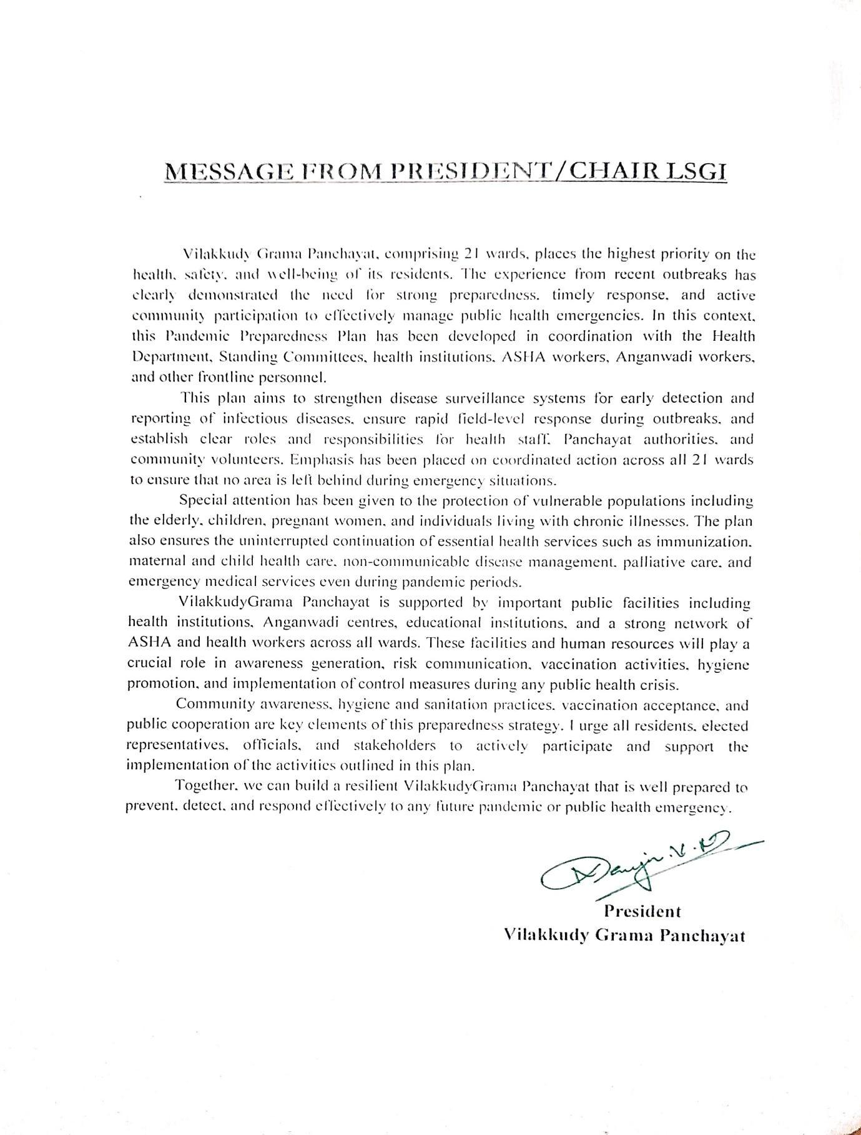

MESSAGE FROM HEALTH STANDING COMMITTEE CHAIR

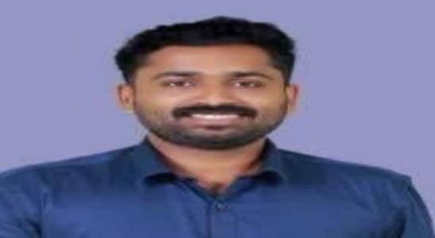

Vilakkudy Grama Panchayat, comprising 21 wards, recognizes the importance of preparedness, planning, and coordinated action in managing public health emergencies. This Pandemic Preparedness Plan has been developed to strengthen disease surveillance, early detection, timely reporting, and rapid response during any outbreak or pandemic situation.
The Standing Committee will work in close coordination with the Health Department, Panchayat authorities, frontline health workers, and community stakeholders to ensure effective implementation of the activities outlined in this plan across all wards.
Special attention will be given to the protection of vulnerable groups and the uninterrupted continuation of essential services during emergencies. Community participation and inter-departmental coordination are essential for the success of this preparedness effort.
I request the cooperation and active involvement of all residents and stakeholders in supporting the implementation of this plan to safeguard the health and well-being of our Panchayath

Standing Committee Chairman
VilakkudyGrama Panchayat



MESSAGE BY MEDICAL OFFICER
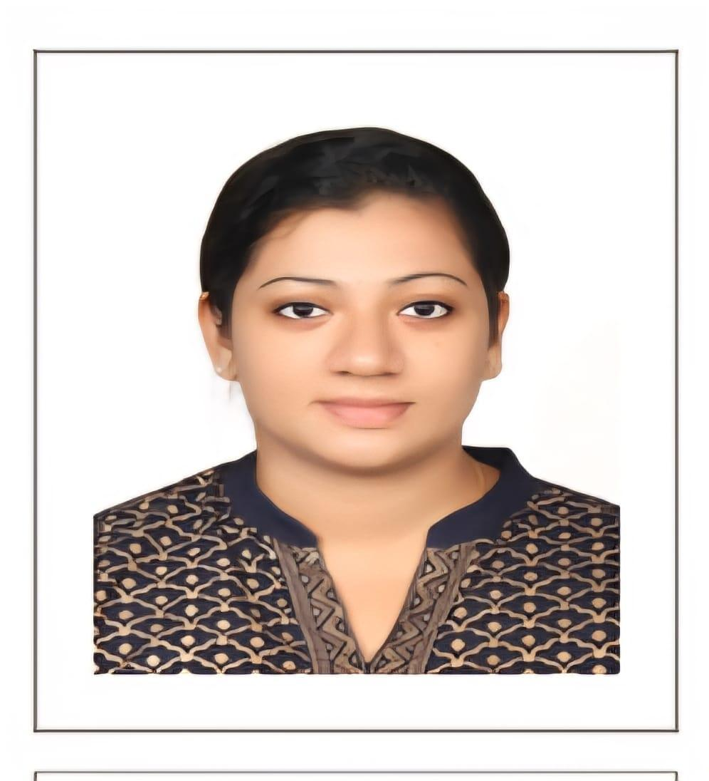
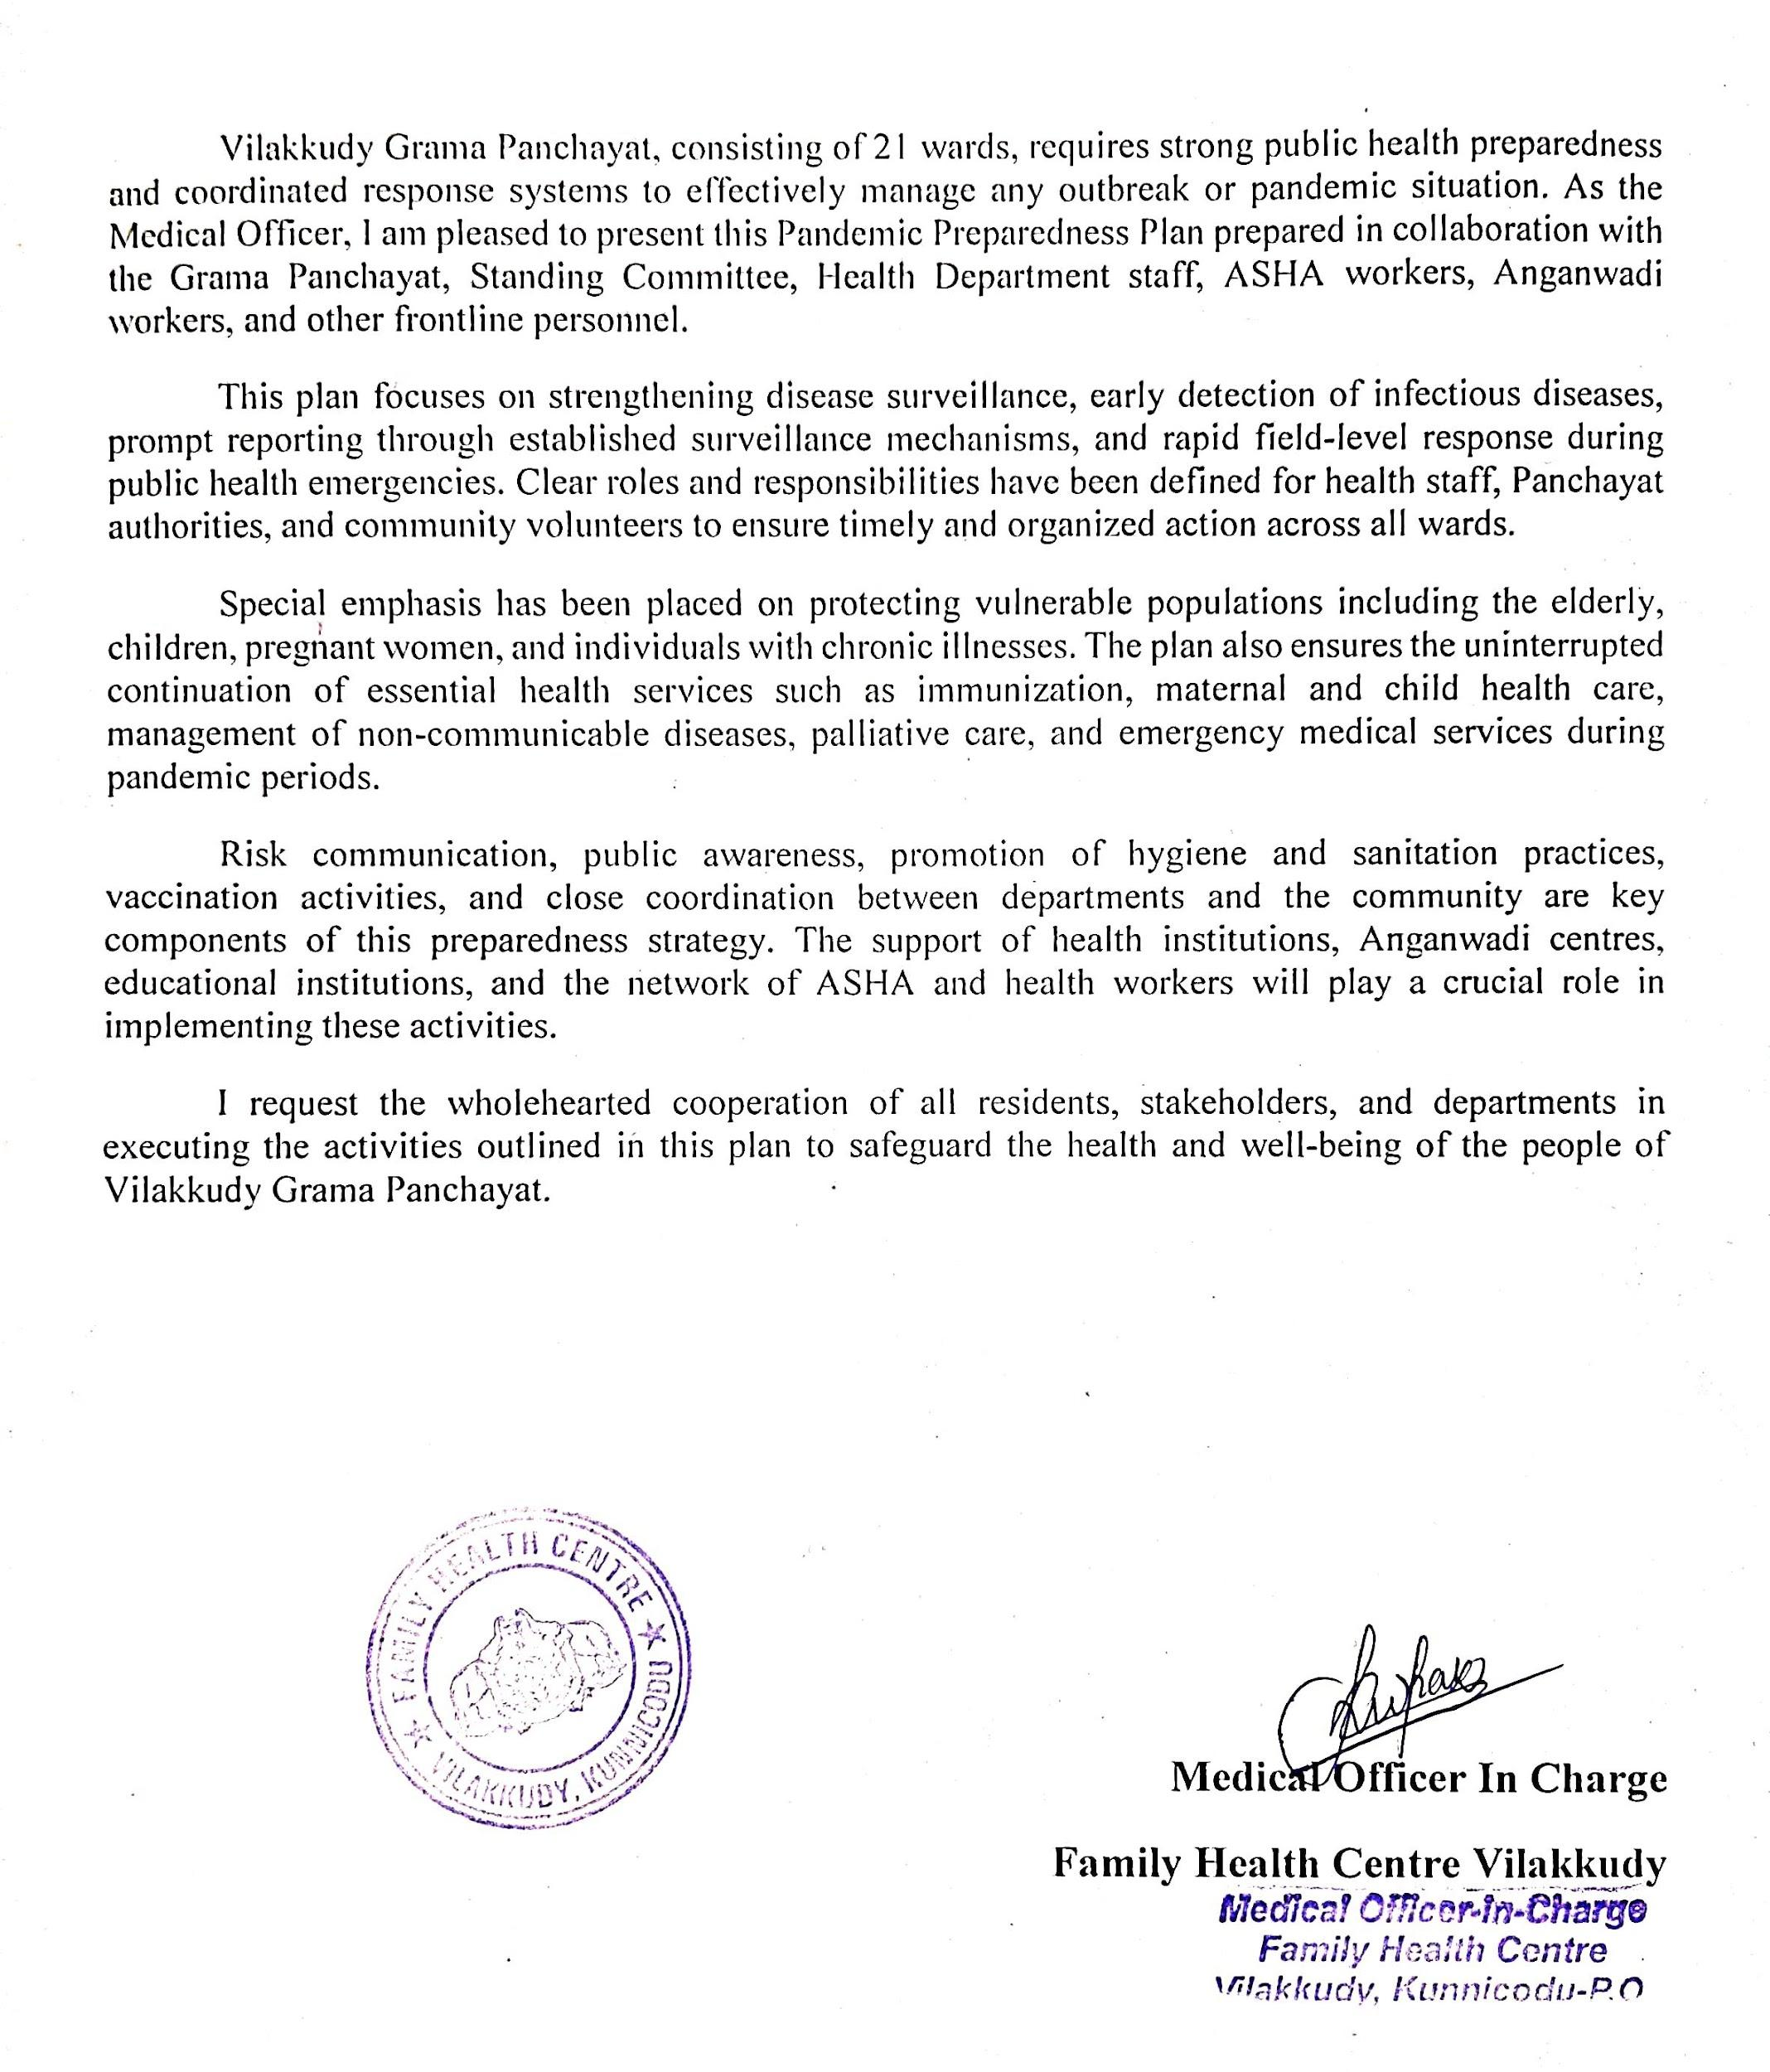

EXECUTIVE SUMMARY

Primary Health Centre (PHC) functions as the primary public healthcare institution serving the population of Vilakkudy Grama Panchayath. The PHC plays a pivotal role in delivering comprehensive, accessible, and affordable healthcare services, with a strong focus on preventive, promotive, curative, and rehabilitative care in accordance with national and state health programmes.
The PHC caters to a predominantly rural population, addressing key public health priorities such as maternal and child health, communicable and non-communicable disease control, immunization, family welfare, adolescent health, and geriatric care. Regular outpatient services, home-based care through field health staff, and outreach activities ensure healthcare coverage even in geographically challenging areas. The institution actively implements national health missions, including the National Health Mission (NHM), National Tuberculosis Elimination Programme, National Programme for Prevention and Control of Cancer, Diabetes, Cardiovascular Diseases and Stroke (NPCDCS), and other disease surveillance initiatives.
Vilakkudy FHC works in close coordination with the Grama Panchayath, ASHA workers, Anganwadi centres, schools, and community-based organizations to strengthen community participation and improve health awareness. Emphasis is placed on early detection, timely referral, health education, and lifestyle modification to reduce disease burden and improve overall health outcomes.
Despite constraints related to infrastructure, manpower, and increasing service demand, the PHC continues to enhance service delivery through effective planning, data-driven decision-making, and community engagement. Strengthening facilities, upgrading digital health systems, and expanding preventive services remain key focus areas for future development.
Overall, Vilakkudy Family Health Centre stands as a vital institution in safeguarding public health and improving the quality of life of the residents of Vilakkudy Grama Panchayath

LIST OF ABBREVIATIONS

LSGD/LSGI | Local Self Government Department / Local Self Government Institution
BMO | Block Medical Officer
IDSP | Integrated Disease Surveillance Programme
NDMA | NationalDisaster Management Authority
PPE | Personal Protective Equipment
ICMR | IndianCouncil of Medical Research
CD | Communicable Diseases
NCD | NON-COMMUNICABLE Diseases

TABLE OF CONTENTS

3
INTRODUCTION 9
● Background of the PPP 9
LSGD AT A GLANCE 9
INTEGRATED HEALTH INFRASTRUCTURE MAP OF VILAKKUDY GRAMAPANCHAYAT 10
GENERAL PROFILE OF THE LSGI’S 13
Background of the LSGI 13
Demographic and Vulnerable Population 14
Clinical Vulnerability 16
INFRASTRUCTURE & RESOURCE INVENTORY 18
Health Facility Directory & Basic Capacity in the LSGD 18
Private Clinics 19
Healthcare Education & Training Institutions 20
Specialized Services & Emergency Inventory 20
Oxygen & Diagnostic Capacity 21
Diagnostics facility mapping at the LSGI level 22
Laboratory Identification & Basic Details 22
Social and Community Infrastructure for surge plan 22
Human resources 24
Community & Support Cadre 25
Community Organizations 26
Administrative & Emergency Services 27
Information regarding resources 27
ONE HEALTH & ENVIRONMENTAL SURVEILLANCE 28
Animal & Bird Population 28
Veterinary Infrastructure 29
Veterinary Doctors & Workforce 30
High-Risk Interface Points (Surveillance Sites) 30
Environmental Risk Mapping 31
Disease Seasonality Mapping 32
Vulnerability Mapping 33
EPIDEMIOLOGICAL TRENDS (2021–2025) 34
Disease Burden among human beings(Last 5 Years) 34
*(use the above table data to create the graph/diagram) 36
Seasonal Trend Analysis 37
Outcome-Based Trend Analysis- 2025 39
Transmission Trend- 2025 40
Integrated Disease Hotspot Map (2021–2025) 42
Preparedness and Response Protocol at LSG Level 44
Constitution of One Health Committee 44
Pandemic Response Workforce 45
Activities and Measures before and during Pandemic 47
PHASE 1 - Alert / Preparation 47
PHASE 2 - Active Response 50
Standard Screening Protocol 51
PHASE 3 - Surge Capacity 60
Conversion of Community Facilities 60
CONCLUSION 61
RECOMMENDATIONS 62
ANNEXURE 63
1. IMPORTANT PHONE NUMBERS 63

LSGD AT A GLANCE
- Geographical boundaries with political map ( based on latest delimitation)
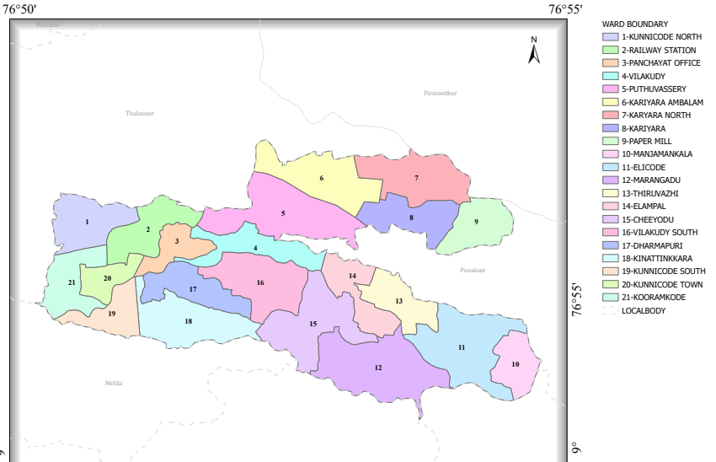

- Baseline data
- Ward division -
Ward | Houses | Population | Migrants | Wells | Hot  spots | Ed. Institutions | Hosp pvt/govt.
21 | 10060 | 39123 | 228 | 8424 | 0 | 21 | 5

- Risk stratification among wards in the context of Communicable diseases and hazards
- Major Roads/rivers
- Major establishments with geospatial mapping
- occupational groups, socio cultural groups, migration & mobility patterns
- Vulnerability mapping
- Disaster prone areas (geographic vulnerability)

Maps - ward-based (Mention source also)

- Geographical boundaries - ward boundaries map
- Health infrastructure map
- roads and rivers map
- major establishments map
- disaster-prone areas map
- hotspot map - CD & disasters

Geographical boundaries - ward boundaries map

INTEGRATED HEALTH INFRASTRUCTURE MAP OF VILAKKUDY GRAMAPANCHAYAT
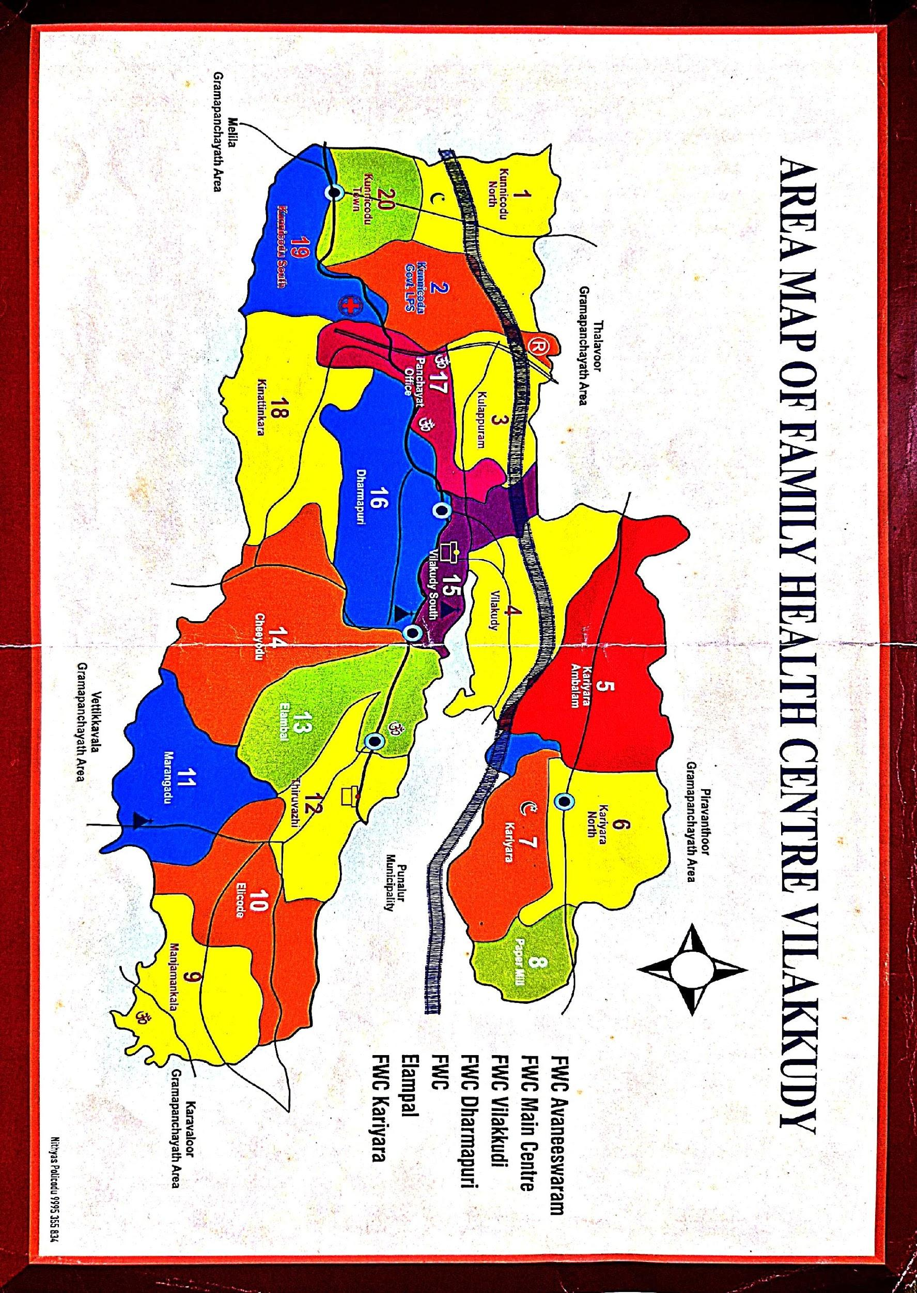
Hotspot Map - CD & Disasters
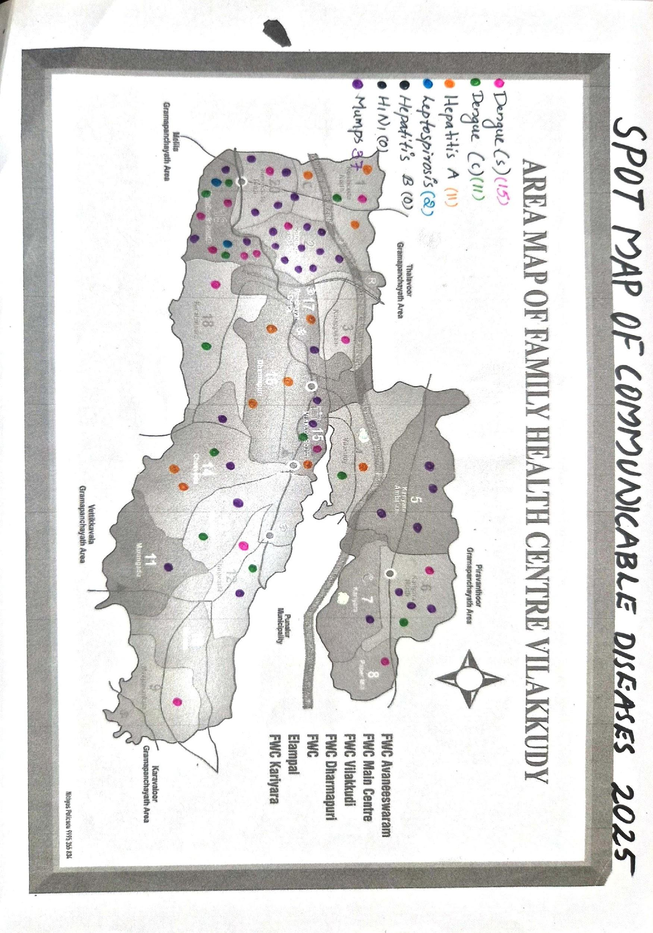

VILAKKUDY GRAMAPANCHAYAT WARD MAP

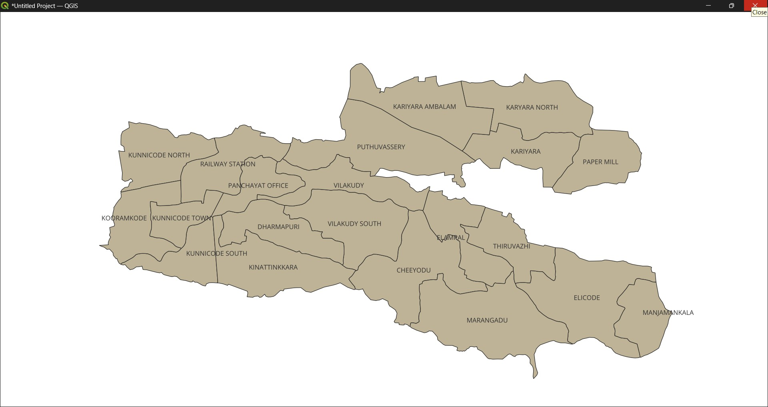

GENERAL PROFILE OF THE LSGI’S

Background of the LSGI
Vilakkudy is a rural Local Self Government Institution (LSGI) located in the eastern part of Kollam district under Pathanapuram Taluk. The panchayat lies in a geographically diverse region characterized by midland and foothill terrain, with several areas bordering the forest ecosystem of the Western Ghats. This topography results in scattered human settlements, including remote and hard-to-reach areas, particularly in forest fringe zones. Seasonal challenges such as heavy rainfall, landslides, and limited transportation infrastructure can affect accessibility and service delivery, especially during emergencies.
The local economy of Vilakkudy is predominantly agrarian, with rubber plantations forming the backbone of household income, along with cultivation of coconut, tapioca, banana, and other seasonal crops. A significant proportion of the population depends on daily wage labour and agriculture-related activities, making them economically vulnerable to market fluctuations and natural disasters. The panchayat also has sections of socially and economically disadvantaged populations, including Scheduled Castes, elderly individuals, and families living below the poverty line.
Administratively, Vilakkudy functions under the decentralized governance framework of the Kerala Panchayati Raj System, which empowers local bodies to plan and implement development activities. The LSGI plays a crucial role in delivering primary healthcare services through sub-centres and coordination with nearby health institutions, implementing sanitation and drinking water programs, and ensuring social welfare schemes reach eligible beneficiaries. Public health activities such as immunization, communicable disease surveillance, and health awareness campaigns are actively carried out with the support of grassroots health workers.
Due to its proximity to forest areas and the presence of scattered settlements, Vilakkudy faces unique public health challenges, including risks of zoonotic diseases, vector-borne illnesses, and occasional cases of conditions like rabies. Accessibility barriers can delay timely healthcare seeking and emergency response. Therefore, strengthening healthcare infrastructure, improving transport connectivity, and enhancing community-based surveillance and preparedness are essential for ensuring effective service delivery and resilience against public health emergencies in the panchayat.
Table 1: Background of LSGD
Description | Details
Name of LSGI | Vilakkudy
Type (GP/Municipality / Corporation etc.) | Grama Panchayath
Block | Pathanapuram
District | Kollam
Thaluk | Pathanapuram
umber of wards | 21
Total area (sq. km) | 21.44/ sqkm
Population(Projected) | 39123
Population density | 1824.76
Terrain (coastal/low-lying/backwaters/foothills, etc.) | midland
Number of rivers passing through LSGI | 1
Number of water bodies in the LSGI | 19
Number of educational institutions | 23
Factories / small-scale industries | 7
Flood-prone wards | 0
Landslide-prone wards | 0
Death Management and Disposal Facilities (mortuaries/crematorium, including electric) | 0
Auditoriums/Marriage halls/convention centres/community halls | 5

Demographic and Vulnerable Population
Understanding the demographic composition and vulnerable population groups is essential for pandemic preparedness. Children, elderly, economically deprived families, migrant workers, and socially vulnerable groups are at increased risk during public health emergencies due to higher exposure, limited access to services, and dependency on public systems..

Description |  | Details (in numbers)
DEMOGRAPHIC PROFILE
Total population |  | 39123
Male |  | 19195
Female |  | 19928
Transgender |  | 2
Children under 5 |  | 1647
Adolescent |  | 2678
Elderly (>60) |  | 5563
SOCIAL/LIVELIHOOD VULNERABILITY
Previous EPEP family |  | 23
BPL family |  | 4962
Tribal communities |  | 0
Migration | Immigrant | 228
Migration | Emigrant | 3460
Socio-economically deprived |  | 360
Fisherfolk |  | 0
SC Community |  | 1138
ST Community |  | 0

Graphs: Population pyramid (if possible) for seeing if your LSGI has a high "dependency ratio" (lots of children and elderly compared to working adults).

Clinical Vulnerability
Certain population groups needs priority healthcare & are at higher risk of severe illness, complications, and mortality during pandemics. Patients with chronic diseases, those requiring regular medical care, and individuals with mobility or functional limitations face challenges in accessing timely care during emergencies. Mapping these groups helps in prioritizing continuity of treatment, medicine stock planning, oxygen support, referral transport, and targeted home-based care.
Description | Details in numbers
Pregnant women | 164
Lactating mothers | 165
Bedbound patients | 96
Patients under palliative care other than bedbound | 112
Patients on Haemodialysis | 26
Patients on CAPD | 0
Cancer patients (currently on treatment) | 72
Haemophilic patients | 2
Mentally challenged | 62
Differently abled | 96
Diabetic patients | 3296
Hypertensive patients | 4246
TB patients | 8

Major Festivals & Events specific to the LSGI
(with the possibility of a public gathering)

Sl. No. | Name of festival | Month detailing the periodicity
1 | KARKKIDAKA VAVU BALI -KADUMANGALAM MAHADEVA TEMPLE AVANEESWARAM | JULY (KARKKIDAKAM)
2 | NAVAHAM FESTIVAL – KARYARA PEEDIKAYIL DEVI TEMPLE | JANUARY
3 | ANNUAL FESTIVAL – KOTTARAM AMBALAM ELAMBAL | FEBRUARY
4 | ANNUAL FESTIVAL – KARUNACODE TEMPLE | APRIL
5 | ANNUAL FESTIVAL – PLATHARA AYIRAVALLI TEMPLE | APRIL
6 | ANNUAL FESTIVAL - SREE MAHADEVA TEMPLE ELAMBAL | FEBRUARY

INFRASTRUCTURE & RESOURCE INVENTORY

Health Facility Directory & Basic Capacity in the LSGD
This section provides an overview of the healthcare infrastructure available within the LSGD area. It outlines the distribution and basic capacity of health facilities that form the backbone of service delivery during routine times and public health emergencies.

Family Health Centres (FHCs) and Community Health Centres (CHCs) generally function as the first point of contact for the community, providing essential outpatient and inpatient services. General Hospitals (GH) and Medical College Hospitals (MCH), where accessible, serve as the main referral centres for advanced diagnostics, specialist care, and critical services during public health emergencies. This inventory helps identify existing strengths, gaps, and potential surge capacity that can be mobilised during a pandemic or disaster.

Table 5. Health Facility Resource Summary
Sl.no. | Health Facility | Type of Facility (MCH/GH/CHC/FHC/SC etc.) | Contact Number | Total beds | ICU Beds | Oxygen-Supported Beds | No. of Ventilator Support Beds | No. of ambulances
Government Healthcare Facilities
1 | FHC VILAKKUDY | FHC | 04752325900 | 5 | 0 | 0 | 0 | 2
2 | HWC MAINCENTRE | SC | 9645411295 | 0 | 0 | 0 | 0 | 0
3 | HWC AVANEESWARAM | SC | 8891371548 | 0 | 0 | 0 | 0 | 0
4 | HWC DHARMAPURY | SC | 8289866300 | 0 | 0 | 0 | 0 | 0
5 | HWC VILAKKUDY | SC | 7736838896 | 0 | 0 | 0 | 0 | 0
6 | HWC ELAMBAL | SC | 9847639166 | 0 | 0 | 0 | 0 | 0
7 | HWC KARIYARA | SC | 9656789399 | 0 | 0 | 0 | 0 | 0
Private Healthcare Facilities
1 | THETTIKKUZHY HOSPITAL,KUNNICODE | PVT HOSP: | 9447464609 | 20 | 0 | 0 | 0 | 1
2 | THOMAS VAIDYAN MEMORIAL HOSPITAL | PVT HOSP: | 04752228978 | 10 | 0 | 0 | 0 | 0
AYUSH Healthcare Facilities
1 | AYURVEDA HOSPITAL ELAMBAL | AYUSH | 9496728960 | 0 | 0 | 0 | 0 | 0
2 | HOMEO DISPENSARY | AYUSH | 9497362033 | 0 | 0 | 0 | 0 | 0

Private Clinics
Private clinics are an essential part of pandemic preparedness, as they are often the first place people seek care when symptoms begin. In many communities, private clinics manage a significant share of outpatient visits and therefore play a critical role in early case detection, timely referrals, and disease surveillance. Having an up-to-date understanding of where these clinics are located, the services they provide, and how they are linked to the public health system helps ensure that no cases are missed during an outbreak. It also allows health authorities to engage private practitioners more effectively for reporting, risk communication, and coordinated response, strengthening the overall capacity of the health system to manage public health emergencies.

Table 6. Private Clinic Resource Summary
Sl No. | Name of Clinic | Registered (Y/N) | Clinic (General / Speciality) | Speciality (if any) | Address | Contact Number | Diagnostic Facility (Y/N) | Ambulance Linkage (Y/N)
1 | TEAM CARE CLINIC | Y | GENERAL | GENERAL | VILAKKUDY .PO | 9188026369 | N | N
2 | AL AIN CLINIC | Y | GENERAL | GENERAL | KUNNICODE.PO | 8157025408 | N | N
3 | V CARE DENTAL CLINIC | Y | DENTAL | DENTAL | KUNNICODE. PO | 8592947367 | N | N
4 | TRINITY DENTAL CLINIC | Y | DENTAL | DENTAL | KUNNICODE.PO | 9447097952 | N | N
5 | FAMILY DENTAL CLINIC | Y | DENTAL | DENTAL | KUNNICODE .PO | 9496468496 | N | N

Healthcare Education & Training Institutions
This section tracks the educational infrastructure available, which is vital for human resource planning in the health sector.

Category of Institution | Govt | Private | AYUSH | Total
Medical Colleges | 0 | 0 | 0 | 0
Nursing Colleges | 0 | 0 | 0 | 0
Dental Colleges | 0 | 0 | 0 | 0
Para-medical / Allied Health | 0 | 0 | 0 | 0
Pharmacy Colleges | 0 | 0 | 0 | 0

Specialized Services & Emergency Inventory
This section provides a detailed view of the specialized medical resources available to the community, focusing on emergency response and critical care capabilities. This table tracks the vital assets required for managing severe illnesses and emergencies across Government, Private, and AYUSH sectors.

Item | Govt | Private | AYUSH | Total
Hospital beds | 2 | 35 | 0 | 0
Oxygen-generating systems(Y/N) | 0 | 0 | 0 | 0
Oxygen-supported beds(Numbers) | 0 | 0 | 0 | 0
Ventilator-supported beds | 0 | 0 | 0 | 0
ICU beds | 0 | 0 | 0 | 0
Burns units | 0 | 0 | 0 | 0
Blood centres | 0 | 0 | 0 | 0
BLS ambulances | 1 | 0 | 0 | 1
ALS ambulances | 0 | 2 | 0 | 2
Dialysis facilities | 0 | 0 | 0 | 0
Dispensaries | 0 | 0 | 0 | 0
Medical store | 0 | 9 | 2 | 11
Industrial establishments(Medium-scale industries/small-scale industries establishments to whom we can depend in a worst-case scenario) | 0 | 0 | 0 | 0

Oxygen & Diagnostic Capacity
Monitoring oxygen and diagnostic capacity is a critical component of public health preparedness, ensuring that the LSGD can handle both chronic care and sudden surges in respiratory or infectious diseases.
Name of Health Facility | Oxygen-generating System (Y/N) | Backup Oxygen Source (Y/N) | Diagnostic Facilities Available(Y/N)
Name of Health Facility | Oxygen-generating System (Y/N) | Backup Oxygen Source (Y/N) | Lab | USG | X-ray | CT/MRI | RT-PCR
Government Healthcare Facilities
Primary Health Centre | 0 | 0 | 1 | 0 | 0 | 0 | 0
Vilakkudy | N | N | 1 | 0 | 0 | 0 | 0

Diagnostics facility mapping at the LSGI level
The diagnostic capacity of Vilakkudy G.P represents the "intelligence network" of our healthcare system. The speed and accuracy of disease identification depend entirely on the distribution and technical level of these facilities.

Item | Govt | Private | AYUSH | Total
General labs | 1 | 5 | 0 | 6
Microbiology labs | 0 | 0 | 0 | 0
RT-PCR labs | 0 | 0 | 0 | 0
USG units | 0 | 0 | 0 | 0
CT/MRI units | 0 | 0 | 0 | 0
Research labs | 0 | 0 | 0 | 0
Labs of other departments that can be repurposed | 0 | 0 | 0 | 0

Laboratory Identification & Basic Details
Sl. No. | Name of Laboratory | Ownership (Govt / Private / Academic) | Address | Contact No. | 24×7 Services (Yes/No) | NABL / Govt Approved (Yes/No)
1 | FHC VILAKKUDY | GOVT | KUNNICODE.PO | 04752325900 | NO | YES
2 | THETTIKKUZHY HOSPITAL | PVT | KUNNICODE.PO | 9633107397 | NO | YES
3 | NEETHI MEDICAL LAB | PVT | KUNNICODE.PO |  | NO | YES
4 | DDRC | PVT | KUNNICODE.PO | 9072570817 | NO | YES
5 | PATHFINDER | PVT | KUNNICODE.PO | 8281691596 | NO | NOs
 | Government | 1 | Vilakkudy phc | 9847117800 | no | no
1

Social and Community Infrastructure for surge plan
This table serves as our logistics and shelter inventory. By mapping these locations, quickly we can identify where to house displaced citizens, where to set up temporary medical clinics, and how to manage the deceased with dignity during a crisis.

Category | Total Count | Ward | Est. Capacity (Persons) | Contact details
Educational Institutions
Anganwadis | 34 | 1-20 | 170 | List attached
Schools | 21 | 2,4,15,19,20,5,13,18. | 1000 | List attached
Colleges | 1 | 15 | 25 | List attached
Others (TTI) | 1 | 5 | 25 | List attached
Healthcare Educational Institutions
Medical colleges (Govt/Private) | 0 | NA | NA | NA
Nursing colleges (Govt/Private) | 0 | NA | NA | NA
Dental colleges (Govt/Private) | 0 | NA | NA | NA
Paramedical institutes (Govt/Private) | 0 | NA | NA | NA
Community Gathering Spaces
Community halls | 0 | NA | NA | NA
Auditoriums | 5 | avaneeshwarm,elambal,vilakkudy | 500 | list attached
Religious buildings | 66 | All wards | 500 | list attached
Vulnerable Group Support Facility
Destitute homes | 2 | vilakkudy, elambal | 18 | 04752322026
Elderly homes | 0 | 0 | 0 | 0
LSGD owned other buildings | 3 | ward 15,1 | 20 | 04752322026
Mass Fatality Management (MFM) Infrastructure
Mortuary | 0 | 0 | 0 | 0
Crematorium | 0 | 0 | 0 | 0
*refer annexure 1 for contact details

Human resources
This section focuses on the human capital available within the LSGI. In any emergency be it a pandemic, flood, or industrial accident—infrastructure is only as effective as the people operating it.

Medical & Clinical Personnel
This table tracks the "Frontline" providers responsible for diagnosis, treatment, and clinical management. Narrative sentence: eg., "Total health workforce: 450 personnel, with 60% in government facilities serving as primary surge capacity." A detailed directory with the contact numbers of all workers is maintained (Annexure in 1).

Cadre | Govt (No.) | Private (No.) | Total
Doctors—Modern Medicine | 4 | 5 | 9
Doctors – AYUSH | 1 | 1 | 2
Doctors – Veterinary | 1 | 0 | 1
Doctors – Dental | 0 | 3 | 3
Nursing officers | 4 | 12 | 16
Lab technicians | 3 | 14 | 17
Optometrist | 1 | 4 | 6
Pharmacists | 3 | 4 | 7
Psychologists | 0 | 0 | 0
Counsellors | 0 | 0 | 0

Public Health & Field-Level Workforce
These individuals are the backbone of surveillance, maternal-child health, and decentralized care.

Cadre | Health services | Municipal common services | Total
HS (Health Supervisors) | 0 | 0 | 0
HI (Health Inspectors) | 1 | 0 | 1
LHS (Lady Health Supervisor) | 0 | 0 | 0
LHI (Lady Health Inspectors) | 1 | 0 | 1
JPHN (Jr Public Health Nurses) | 6 | 0 | 6
JHI (Jr Health Inspectors) | 5 | 0 | 5
MLSP (Mid-Level Service Providers) | 6 | 0 | 6
Palliative Nurses | 1 | 0 | 1
RBSK Nurses | 1 | 0 | 1
PRO | 0 | 0 | 0
Epidemiologist | 1 | 0 | 1
Data Manager | 0 | 0 | 0

Community & Support Cadre
This group represents the surge capacity of the LSGI people who can be called upon for logistics, rescue, and specialized support.

Cadre | Number
ASHA Workers | 24
AWW (Anganwadi Workers) | 34
Emergency Medical Volunteers (Trained) | 0
Kudumbashree | 372
MNREGS | 48
Purusha Swayam SahayaSangham | 28
Ex-Servicemen | 376
Retired Police Officers | 63
NCC/NSS Volunteers | 159
Red Cross volunteers | 0
One Health Community Volunteers | 240
One Health Community Mentors | 0

Community Organizations
This section details the presence of community-based organisations (CBOs), non-governmental organisations (NGOs), faith-based organisations (FBOs), Kudumbashree Self-Help Groups (SHGs), and Ayalkootams within the Local Self-Government Institution (LSGI). These groups enhance grassroots mobilization, resource distribution, and support networks crucial for pandemic response and community resilience.

Category | Total Count
NGOs | 2
Religious based organizations | 2
Foreign based organizations | 0
Sports Club/youth clubs | 12
Kudumbashree SHGs | 372
Ayalkootams | 220
Political organizations | 8
Residential organizations | 21

Administrative & Emergency Services
This section outlines the availability of key non-health emergency support services and infrastructure within the LSGI, which are essential for effective pandemic preparedness and response. These facilities support law enforcement, disaster response, water supply, logistics, mobility, and community-level interventions during public health emergencies.

Category | Total Count | Contact details
Police Stations | 1 | 100
Fire & Rescue Stations | 1 | 101
Water Pumping Points | 1 | 9847804023
Public Distribution System (PDS) | supply outlets21 | 04752322303

Information regarding resources
The availability of essential transport and support resources plays a quiet but critical role in saving lives. Equipment such as ambulances, mobile mortuaries, amphibian ambulances, and motorized boats ensures that patients, samples, and healthcare teams can move swiftly—even in flooded, remote, or difficult terrains. Heavy vehicles like JCBs, cranes, tractors, and torus lorries support logistics, waste management, emergency infrastructure, and rapid conversion of spaces into care or isolation facilities. Taxis, four-wheel-drive vehicles, and trucks help maintain continuity of essential services, reach vulnerable populations, and support home-based care and supply delivery.

Means of transportation | Total Count
JCB | 4
Crane | 0
Heavy Trucks | 0
Tractor | 0
Ambulances | 2
Mobile mortuaries | 0
Boats | 0
Taxi service | 6
Note: For specific details regarding vehicle owners and contact information, please refer to Annexure [X].

ONE HEALTH & ENVIRONMENTAL SURVEILLANCE
The One Health method integrates environmental, animal, and human health to enable proactive pandemic preparedness. Panchayat-level surveillance needs to be improved in order to detect and treat zoonotic and environmentally generated diseases early. Surveillance is strengthened through systematic assessment of animal populations, veterinary infrastructure, poultry and slaughter facilities, inter-sectoral coordination, and specialised tools like avian influenza seasonality mapping using GIS in previous outbreaks to enable predictive alerts and ward-specific sampling to support effective pandemic preparedness in high-risk areas.

Animal & Bird Population
Mapping animal and bird populations at the Panchayat level is essential for identifying and prioritising zoonotic disease hazards like rabies, avian influenza (H5N1), leptospirosis, anthrax, and Nipah-like spillover occurrences. Risk classification, targeted surveillance, vaccination planning, and early epidemic detection made feasible by comprehensive population mapping all enhance One Health-based pandemic preparedness.

Category | Item | Estimated Population | Wards
Animal Population | Livestock (Cattle/Goats/Buffalo) | 1600 | 1-20
Animal Population | Pet Animals (Dogs/Cats) | 636 | 1-20
Animal Population | Stray Dog Population | 150 | 1-20
Animal Population | Pig Farms (Number of heads) | 0 | 0
 | Small Units (Sheep / Goats – clustered) | 4 | 6,9
Bird Population | Poultry Units (Birds) | 1518 | Ward 13, 17
Bird Population | Poultry- (FOWL) | 0 | 0
Bird Population | Wild/Migratory Birds (Observed) | nil | 0
Bird Population | Crow Mortality Events (Reported) | 0 | 0

The main risk of zoonotic diseases in Vilakkudy is concentrated in Wards16,17, which is explained by the high density of pig farms, cattle congregation areas, and poultry units. The stray dog population in market areas, fish landing sites, bus stations continues to be a substantial problem for rabies surveillance and bite prevention. There is a considerable risk of avian influenza introduction and amplification during November - December due to the seasonal presence of migratory and resident water birds near ponds/ canal / river / backwater / paddy field. Clusters of pig farms and animal shelters vulnerable to flooding further raise the risk of leptospirosis and other zoonoses mediated by the environment, especially during monsoon floods.

Veterinary Infrastructure
Veterinary institutions are a core pillar of One Health surveillance, enabling early zoonotic disease detection through vaccination, investigation of unusual animal illness or deaths, sample collection, and timely outbreak reporting. A well-mapped and responsive veterinary network strengthens coordination with human health and LSGI systems, ensuring rapid response during zoonotic events and pandemics.
Facility Type | Name of Facility | Ownership Govt / Pvt | Location(Ward No) | Contact number
Veterinary Dispensary | 1. Vilakkudy  2. Elambal | Govt  Govt | Ward 17  Ward 13 | 9446597106
Veterinary Hospital / Polyclinic | 0 | 0 | 0 | 0
Private Veterinary Clinics | 0 | 0 | 0 | 0
Mobile / Emergency Vet Service (incl. night services) | 0 | 0 | 0 | 0
Pet Homes / Animal Shelters | 0 | 0 | 0 | 0
Slaughterhouse-linked Veterinary Inspection Unit | 0 | 0 | 0 | 0

Veterinary Doctors & Workforce
Early detection, diagnosis, reporting, and reaction to animal illness epidemics depend on the availability and accessibility of qualified veterinary specialists. By identifying unusual animal morbidity or mortality promptly, collecting samples promptly, and coordinating efficiently with human health and LSGI systems—especially during zoonotic outbreaks and pandemic-prone situations—a clearly defined veterinary workforce enhances One Health surveillance.

Category | Number Available | Type (Govt/Pvt) | Contact number
Government Veterinary Doctors | 1 | Govt | 9446597106
Private Veterinary Doctors | nil | 0 | 0
Livestock Inspectors | 3 | Govt | 9446597107
Para-veterinary Staff / Attenders | 1 | govt | 944597107
Contract / On-call Veterinary Support (if any) | nill | 0 | 0

High-Risk Interface Points (Surveillance Sites)
High-risk interface points for zoonotic disease surveillance in Elampal and Kunnikodu Grama Panchayath include wetland–livestock–human contact zones, backyard poultry farms, cattle sheds near water bodies, fish markets, and areas of high human–animal interaction such as community slaughter points and migratory bird congregation sites. These are the primary surveillance sites where zoonotic spillover risks are elevated.

Type of Habitat | Type of High risk interface | Geographical vulnerability
Wetlands & Backwaters | 0 | NA
Backyard Poultry Farms | 0 | NA
Cattle Sheds near Water Bodies | 0 | NA
Fish & Meat Markets | 0 | NA
Community Slaughter Sites | 0 | NA
Migratory Bird Congregation Areas | 0 | NA
Rodent-Infested Grain Storage | 0 | NA

Category | Total Count | Key Locations (wards)
Poultry Farms | 0 | NA
Backyard / Clustered Poultry Units | 0 | NA
Duck Rearing Units (open water access) | 0 | NA
Slaughterhouses/ Slaughter Points | 0 | NA
Meat/Fish Markets | 0 | NA
Live Bird Sale Points | 0 | NA
Cattle Markets / Weekly Animal Fairs | 0 | NA
Pet Shops / Breeders | 1 | Ward 2
Animal Shelters / Pet Homes | 0 | NA
Waste Disposal Sites near Animal Units | 0 | NA

Environmental Risk Mapping
Environmental risk mapping identifies monsoon/flood hotspots for vector-borne (dengue, chikungunya), water-borne (leptospirosis, diarrhoea), and zoonotic diseases in Kerala's wetlands. Systematic surveillance supports early warnings, targeted interventions, and Panchayat pandemic preparedness.
Waterborne exposure: Flood-prone areas and stagnant water bodies facilitate leptospira survival, raising leptospirosis risk.

Traditional practices: Informal slaughter and fish markets lack standardized hygiene, creating spillover opportunities.

Risk Factor | High-Risk Wards | Key Locations | Risk Level (High/Med/Low)
Flood-prone areas | 0 | NA | NA
Water bodies/wetlands | 0 | NA | NA
Solid waste accumulation | 0 | NA | NA
Animal waste disposal issues | 0 | NA | NA
Rodent infestation zones | 0 | NA | NA
Industrial effluent discharge | 0 | NA | NA
Construction sites / abandoned buildings | 0 | NA | NA
Poor drainage/blocked canals | 0 | NA | NA
Drinking water source contamination risk | 0 | NA | NA

Disease Seasonality Mapping
1, Flooding& waterlogging → amplifies leptospirosis, malaria, diarrheal diseases.
·
2, Migratory bird influx (Nov–Feb) → avian influenza risk.

3, Mosquito breeding cycles → vector-borne disease peaks in monsoon.

4, Agricultural practices → close human–animal contact in paddy fields.

Disease | Peak Risk Season | Key Drivers | High-Risk Locations | Surveillance Focus
Avian Influenza | 0 | NA | NA | NA
Leptospirosis | JUNE NOVEMBER | Waterlogging in paddy fields; high density of cattle sheds near water bodies. | kunnikodu, avaneeswaram | Monitoring dairy farmers and agricultural laborers for elderly
Dengue/Chikungunya | June-September | stagnant water in peri-urban junctions and residential clusters | town ward 2 ,1,18 | Vector control : source reduction in plantations
Acute Diarrheal Diseases | Jan-Apr, Jun-Aug | Children | ALL WARDS | ACTIVE
Rabies | May | stray dog common in all wards vilakkudy is high risk | Ward 18 | Active post exposure prophylaxis  Hot spot mapping  Integrated bite case management
Anthrax (rare) | nill | nill | nill | nill

Vulnerability Mapping
Vulnerability mapping pinpoints high-risk populations, occupations, and areas exposed via environment, livelihoods, socio-economics, and poor service access. Paired with environmental/seasonality mapping, it enables risk-based surveillance, targeted actions, and optimal resource use in One Health and pandemic planning.
Vulnerability Factor | High-Risk Wards | Key Groups / Locations | Risk Level
Flood-prone households | 0 | NA | NA
Wetland-adjacent communities | 0 | NA | NA
Backyard poultry / duck rearing households | 0 | NA | NA
Livestock-rearing households | 0 | NA | NA
Slaughterhouse & meat market workers | 0 | NA | NA
Fisherfolk & fish market workers | 0 | NA | NA
Sanitation workers | 54 | panchayat wide | exposure to untreated waste ,contaminated drains
Daily wage / migrant workers | 250 | All wards | high likelihood of living in temporary housing with poor sanitation and limited access to boiled water
Elderly & chronically ill populations | 5563 | all wards | lower physiological immunity
Pregnant Women | 164 | all wards | critical risk for complication from water born and vector born diseases
Children (schools, Anganwadi’s) | 2862 | All wards | vulnerability to skin conditions and ADD
Limited access to safe water & sanitation | 0 | NA | NA

EPIDEMIOLOGICAL TRENDS (2021–2025)

Disease surveillance is the systematic collection, analysis, and interpretation of health data for planning, implementation, and evaluation of public health practice. This section presents the disease surveillance profile of the LSGI based on routine reporting systems and outbreak investigations to identify priority diseases, seasonal patterns, and emerging public health threats.

Disease Burden among human beings(Last 5 Years)
Analysis of disease-wise data for the last five years helps identify persistent public health problems, emerging diseases, and changes in disease burden. This information supports prioritisation of prevention, preparedness, and response activities at the Panchayat level.

Disease | 2021 | 2022 | 2023 | 2024 | 2025 | Trend(Increasing/Stable/  Decreasing)
Dengue | 0 | 8 | 37 | 33 | 26 | stable
Leptospirosis | 0 | 5 | 0 | 4 | 2 | stable
Hepatitis A | 1 | 0 | 1 | 4 | 18 | Increasing
Malaria | 0 | 0 | 0 | 0 | 0 | stable
Scrub Typhus | 0 | 0 | 0 | 0 | 0 | stable
Typhoid | 0 | 0 | 0 | 0 | 1 | stable
H1N1 | 0 | 0 | 0 | 5 | 7 | Increasing
H3N2 | 0 | 0 | 0 | 0 | 3 | increasing
ADD | 18 | 79 | 116 | 115 | 166 | increasing
Mumps | 0 | 0 | 0 | 8 | 46 | increasing
Measles | 0 | 0 | 0 | 0 | 0 | stables
Hepatitis B | 2 | 2 | 2 | 2 | 8 | increasing
Hepatitis C | 0 | 0 | 0 | 0 | 0 | stable
Tuberculosis | 0 | 13 | 20 | 18 | 11 | decreasing
Leprosy | 0 | 0 | 0 | 0 | 0 | stable
AME | 0 | 0 | 0 | 0 | 1 | stable
COVID-19 | 0 | 0 | 0 | 0 | 3 | stable

*(use the above table data to create the graph/diagram)

Seasonal Trend Analysis
Seasonal analysis helps anticipate surges (e.g. dengue in monsoon, leptospirosis after floods, influenza in cooler months) and plan pre‑emptive vector control, stockpiling of IV fluids, and awareness campaigns at Panchayat level.

DENGUE
Dengue is a major seasonal vector-borne disease strongly associated with rainfall, water stagnation, and increased mosquito breeding during the monsoon period.

Peak: July–November

Dengue – Ward-wise Yearly Distribution (2021–2025)

Ward | Dengue – Ward-wise Yearly Distribution
Ward | 2021 | 2022 | 2023 | 2024 | 2025 | Total
1 | 0 | 0 | 3 | 3 | 2 | 8
2 | 0 | 0 | 1 | 6 | 1 | 8
3 | 0 | 0 | 5 | 1 | 1 | 7
4 | 0 | 0 | 0 | 1 | 1 | 2
5 | 0 | 0 | 0 | 1 | 0 | 1
6 | 0 | 0 | 4 | 2 | 2 | 8
7 | 0 | 0 | 0 | 1 | 0 | 1
8 | 0 | 0 | 0 | 0 | 1 | 1
9 | 0 | 0 | 5 | 1 | 1 | 7
10 | 0 | 0 | 0 | 2 | 0 | 2
11 | 0 | 0 | 2 | 0 | 0 | 2
12 | 0 | 0 | 4 | 1 | 2 | 7
13 | 0 | 0 | 6 | 1 | 1 | 8
14 | 0 | 0 | 2 | 1 | 1 | 4
15 | 0 | 0 | 4 | 3 | 2 | 9
16 | 0 | 0 | 7 | 2 | 0 | 9
17 | 0 | 0 | 3 | 3 | 0 | 6
18 | 0 | 0 | 1 | 1 | 2 | 4
19 | 0 | 0 | 1 | 2 | 8 | 11
20 | 0 | 0 | 1 | 1 | 1 | 3

LEPTOSPIROSIS
Leptospirosis cases are closely linked to monsoon rains, flooding, and occupational exposure, particularly in low-lying and waterlogged areas.

Peak: June - August

Leptospirosis – Ward-wise Yearly Distribution (2021–2025)

Ward | Leptospirosis – Ward-wise Yearly Distribution
Ward | 2021 | 2022 | 2023 | 2024 | 2025 | Total
1 | 0 | 0 | 0 | 0 | 0 | 0
2 | 0 | 0 | 0 | 0 | 0 | 0
3 | 0 | 0 | 1 | 0 | 0 | 1
4 | 0 | 1 | 0 | 1 | 0 | 2
5 | 0 | 0 | 0 | 1 | 0 | 1
6 | 0 | 0 | 0 | 0 | 0 | 0
7 | 0 | 1 | 0 | 0 | 0 | 1
8 | 0 | 0 | 0 | 0 | 0 | 0
9 | 0 | 1 | 1 | 0 | 0 | 2
10 | 0 | 0 | 0 | 0 | 0 | 0
11 | 0 | 0 | 0 | 0 | 0 | 0
12 | 0 | 1 | 0 | 0 | 0 | 1
13 | 0 | 0 | 0 | 0 | 0 | 0
14 | 0 | 0 | 0 | 1 | 0 | 1
15 | 0 | 0 | 0 | 1 | 0 | 1
16 | 0 | 1 | 0 | 0 | 0 | 1
17 | 0 | 0 | 0 | 0 | 0 | 0
18 | 0 | 0 | 0 | 0 | 0 | 0
19 | 0 | 0 | 1 | 0 | 2 | 3
20 | 0 | 1 | 0 | 0 | 0 | 1

VIRAL HEPATITIS - A
Hepatitis A cases are commonly associated with unsafe drinking water, food contamination, and breakdowns in sanitation, often presenting as clusters or outbreaks.

Peak: October - December

Hepatitis A – Ward-wise Yearly Distribution (2021–2025)
Ward | Hep A – Ward-wise Yearly Distribution
Ward | 2021 | 2022 | 2023 | 2024 | 2025 | Total
1 | 0 | 0 | 0 | 0 | 3 | 3
2 | 0 | 0 | 0 | 0 | 0 | 0
3 | 0 | 0 | 0 | 2 | 0 | 2
4 | 0 | 0 | 0 | 0 | 1 | 1
5 | 0 | 0 | 0 | 0 | 0 | 0
6 | 0 | 0 | 1 | 0 | 0 | 1
7 | 0 | 0 | 0 | 0 | 0 | 0
8 | 0 | 0 | 0 | 0 | 0 | 0
9 | 0 | 0 | 0 | 2 | 0 | 2
10 | 0 | 0 | 0 | 0 | 0 | 0
11 | 1 | 0 | 0 | 0 | 0 | 1
12 | 0 | 0 | 0 | 0 | 0 | 0
13 | 0 | 0 | 0 | 0 | 0 | 0
14 | 0 | 0 | 0 | 0 | 2 | 2
15 | 0 | 0 | 0 | 0 | 1 | 1
16 | 0 | 0 | 0 | 1 | 3 | 4
17 | 0 | 0 | 0 | 0 | 1 | 1
18 | 0 | 0 | 0 | 0 | 0 | 0
19 | 0 | 0 | 0 | 0 | 0 | 0
20 | 0 | 0 | 0 | 0 | 0 | 0

Outcome-Based Trend Analysis- 2025

Transmission Trend- 2025
For effective management of public health issues, it is important to track the trend of disease transmission mode. It helps identify the population or place at high risk that can be used to predict outbreaks and implement targeted interventions as quickly as possible. Understanding these kinds of trends enables authorities to allocate resources efficiently and change the strategies adequately based on the trend that follows.

Mode of Transmission | No. of cases | No. of Deaths
Vector Borne Diseases | 33 | 0
Water Borne Diseases | 177 | 0
Air Borne Diseases | 11 | 1
Blood Borne Diseases | 2 | 0
Food Borne Diseases | 177 | 0

Vector-Borne Disease

Disease | No. of Cases | No. of Deaths
Dengue | 26 | 0
Malaria | 0 | 0
Chikungunya | 0 | 0

Water Borne Disease

Disease | No. of Cases | No. of Deaths
Cholera | 0 | 0
Typhoid | 1 | 0
Hep- A | 11 | 0
Dysentery | 0 | 0
Amoebiasis | 0 | 0
E- Coli infections | 0 | 0

Air Borne Disease

Disease | No. of Cases | No. of Deaths
Influenza | 5 | 0
H1N1 | 1 | 0
TB | 11 | 1
Chickenpox | 22 | 0
Measles | 0 | 0
Covid-19 | 1 | 1
Pertussis | 0 | 0
Mumps | 46 | 0

Blood-Borne Disease

Disease | No. of Cases | No. of Deaths
AIDS | 0 | 0
Hep- B | 2 | 0
Hep- C | 0 | 0

Zoonotic Disease

Disease | No. of Cases | No. of Deaths
Rabies | 1 | 1
Leptospirosis | 2 | 0
Avian influenza | 0 | 0
West nile | 0 | 0
Anthrax | 0 | 0
Nipah | 0 | 0
Scrub Typhus | 0 | 0

Integrated Disease Hotspot Map (2024–2025) 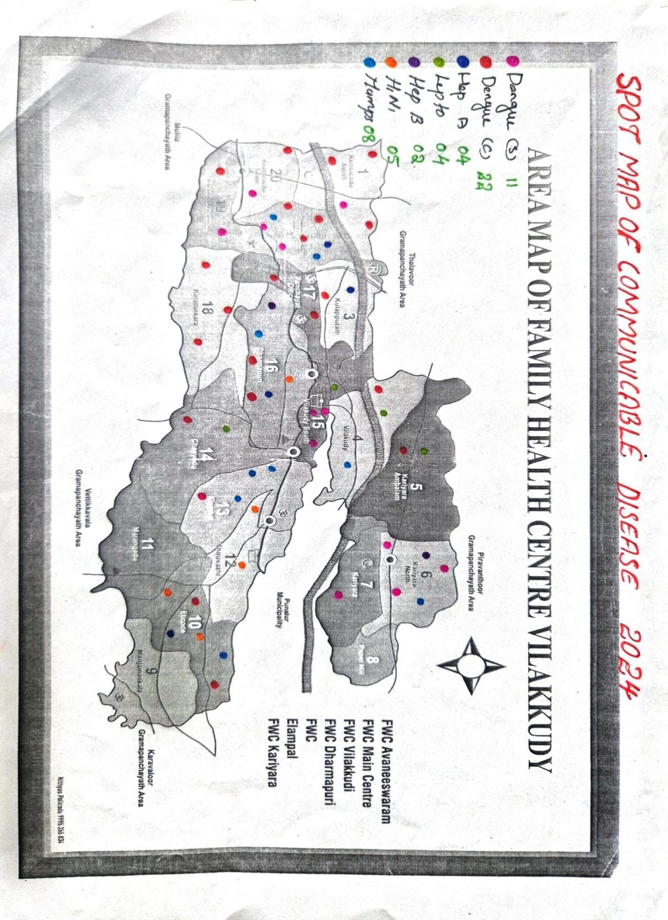

Ward No | Dengue Total (2021-25) | Leptospirosis Total (2021-25) | Hepatitis A Total (2021-25) | Mumps (2021-25) | ADD (2021-25) | Total Cases
1 | 8 | 0 | 3 | 0 | 1 | 12
2 | 8 | 0 | 0 | 10 | 1 | 19
3 | 7 | 1 | 2 | 0 | 6 | 16
4 | 2 | 2 | 1 | 1 | 6 | 12
5 | 1 | 1 | 0 | 4 | 3 | 9
6 | 8 | 0 | 1 | 3 | 14 | 26
7 | 1 | 1 | 0 | 1 | 9 | 12
8 | 1 | 0 | 0 | 0 | 6 | 7
9 | 7 | 2 | 2 | 0 | 4 | 15
10 | 2 | 0 | 0 | 1 | 1 | 4
11 | 2 | 0 | 1 | 1 | 6 | 10
12 | 7 | 1 | 0 | 1 | 10 | 19
13 | 8 | 0 | 0 | 1 | 5 | 14
14 | 4 | 1 | 2 | 2 | 7 | 16
15 | 9 | 1 | 1 | 2 | 8 | 21
16 | 9 | 1 | 4 | 1 | 14 | 29
17 | 6 | 0 | 1 | 1 | 1 | 9
18 | 4 | 0 | 0 | 0 | 0 | 4
19 | 11 | 3 | 0 | 3 | 1 | 18
20 | 3 | 1 | 0 | 5 | 1 | 10

By overlaying five years of data, we have identified 1, 2, 18 'Red Zone' Wards. These are wards where at least two different categories of diseases (e.g., Dengue and Lepto) recurred in consecutive years. Ward 4 is categorized as the Highest Priority Hotspot due to its combination of flood vulnerability and high vector density

Preparedness and Response Protocol at LSG Level
This section describes the operational framework for the LSGI once a pandemic is declared. It explains how the LSGI and health system will move from routine data collection to active response, using a One Health approach.

Constitution of One Health Committee
The LSGD shall constitute a One Health Committee comprising the LSGI President, Medical Officers (Modern Medicine, AYUSH, and Veterinary), the Health Inspector, and the Veterinary Surgeon.

Objective: The One Health Committee coordinates human, animal, and environmental health to prevent and control pandemics.

Sl No | Name | Designation | Department/Institution | Role in Committee | Contact Number
1 | Manju | Panchayat President | LSGD | Chairperson | 9207229173
2 | Kripa Krishnamoorthy | Medical Officer (PHC/CHC) | Health Dept | Member Secretary | 9633621223
3 | Dr.Veena | Veterinary Officer | Animal Husbandry | Member | 9446597106
4 | Anjulekshmi | Epidemiologist | Health Dept | Member | 8137075282
5 | Bindhu | Health Inspector/PHN | Health Dept | Surveillance | 9847117800
6 | Benazeer Begum | ASHA Supervisor | Health Dept | Community link | 9446264367
7 | Sandhya | ICDS Supervisor | Social Welfare | Vulnerable groups | 9633119945
8 | Shajahan | Police Station Officer | Police Dept | Law & order | 04752322095
9 | Ajitha | Ward Councillor Representative | LSGD | Community coordination | 7510374018
10 | Maya | Kudumbashree CDO | Kudumbashree | Community mobilisation | 04752322026
11 | Biju | NGO/Volunteer rep | Civil Society | Support services | 9745417546
12 | Noushad | Line Department representations | health department | Health | 9446854915

Key Responsibilities:
- Review disease surveillance data (human + animal)
- Conduct ward-wise risk assessment and vulnerability mapping
- Approve quarantine/isolation centre locations
- Coordinate with district for resources (PPE, oxygen, ambulances)
- Periodically review health system surge capacity, including beds, oxygen, human resources, and ambulances.
- Approve and monitor risk communication and community engagement strategies, including rumour management.
- Ensure protection and service continuity for vulnerable groups (elderly, persons with disabilities, dialysis patients, coastal populations).
- Conduct quarterly mock drills
- Monitor equity measures for vulnerable groups

Meeting Schedule:
Quarterly (normal times) | Weekly (outbreak alert) | Daily (pandemic phase)

Pandemic Response Workforce
To ensure a coordinated and timely response during a pandemic, a dedicated Pandemic Response Workforce shall be constituted at the LSG level. The workforce will function under the overall supervision of the One Health Committee and in close coordination with the health authorities. Team-based deployment will enable efficient surveillance, case management, quarantine and isolation management, logistics support, and risk communication. Each team shall have a clearly designated team leader, defined roles, and an identified pool of personnel to allow rapid activation, rotation of duties, and continuity of services during prolonged emergencies.

Total Response Workforce Available: 300 persons

Team Name | Composition | Key Responsibilities | Team Leader
Surveillance and Contact Tracing Team | HI, JHI, JPHN, ASHAs and Volunteers | Case detection, contact listing, home visits, reporting | Raju Varghese (HI)
Case Management Team | Doctors, Nurses, MLSP, Palliative Nurses | Patient care & referral | Kripa K Moorthy (Doctor)
Quarantine & Isolation Team | LSGD staff, Volunteers | Facility management | Ajilesh S S (JHI)
Psychosocial support | MO | Mental health and emotional support | MO LSGD
Logistics & supply chain Team | LSGD staff, Storekeepers, Drivers 3 | Supplies & transport [PPE, medicines, oxygen, transport, waste management] | Aneesa Rafeeq (Ward Member)
Communication Team | Ward members, Kudumbashree, Youth clubs,  AWW workers and other self help groups | IEC, community meetings, countering misinformation | Kripa K Moorthy (Doctor)
Transportation | KSRTC, educational institutional buses | Transportation to higher facilities | DTO
Media Surveillance | Kunnicode varthakal | Online Mediya | Riyadh
Intersectoral coordination and convergence | MEDICAL OFFICER | coordinating the departments | MO
Collaborative surveillance | VARIOUS DEPARTMENTS | Data collection, sharing to departments, timely reporting | HI

All teams shall be activated immediately upon outbreak alert or pandemic declaration and shall report daily to the LSG Incident Commander/Medical Officer, with consolidated reporting to the Block PHC. Duty rosters and alternate personnel shall be maintained to ensure uninterrupted services during staff shortages or prolonged response periods. Team composition and numbers may be revised based on the magnitude of the outbreak and availability of human resources.

Activities and Measures before and during Pandemic

PHASE 1 - Alert / Preparation
Surveillance and Reporting-Enhanced syndromic surveillance:
- Data sources for surveillance:
- Event-based triggers (to be monitored and reported):
- Zoonotic and animal health surveillance
- Logistics and Stock Preparedness
  - Identify and empanel local vendors and define emergency procurement mechanisms in accordance with existing LSGD and Health Department norms.
  - Prepare and maintain an essential logistics checklist covering medical supplies, consumables, and support equipment.
  - Pre-identify secure storage locations for emergency stocks and ensure maintenance of stock registers with regular updating.
  - Finalise emergency transport arrangements, including availability of vehicles and identified drivers for rapid deployment during alerts.
  - Designate a Nodal Officer for Logistics to enable prompt decision-making, coordination, and communication during emergencies.
  - Conduct rapid stock verification and ensure availability of minimum buffer stock, including:
- PPE kits –0 numbers
- Pulse oximeters –5 numbers
- Hand sanitizers 100 litres
- Masks, gloves, disinfectants – 200adequate quantity
Identify critical gaps in logistics and immediately communicate requirements to the Block and District authorities for timely replenishment and support. Monitor expiry dates and stock rotation.

Identification of Quarantine and Isolation Facilities
  - Identify and list suitable buildings for quarantine and isolation (schools, hostels, community halls, etc.).
  - Categorise cases as per the severity and allocate to appropriate facilities (for instance, severe cases to classrooms, mild cases to an assembly hall in case of a school).
  - Facility readiness checklist needed (beds, toilets, ventilation) etc.
  - Find an alternate site if the primary sites are not available or not in use.
  - Identify facility managers and support staff
  - Prepare basic SOPs for:
    - Admission and discharge
    - Food, water, sanitation
    - Infection prevention and waste disposal
  - Ensure availability of basic amenities: water, sanitation, electricity, ventilation, and waste disposal. Prepare a rapid activation plan for these facilities if case numbers increase.

Risk Communication and Community Preparedness
  - Disseminate early warning messages on symptoms, preventive measures, and reporting mechanisms. Display IEC materials both in English and the local language in public places and ensure ward-level awareness.
  - Sensitize elected representatives and community leaders on preparedness measures.
  - Establish a rumour tracking and misinformation response mechanism to identify, verify, and promptly counter false or misleading information.
  - Engage trusted local persons (ward members, ASHA workers, religious leaders, teachers, community volunteers) to communicate official public health messages and reinforce correct practices.
  - Develop and deploy targeted IEC materials for:
    - Schools and educational institutions
    - Markets and commercial areas
    - Work sites and labour settings
  - Conduct community sensitization meetings at the ward level to promote preventive behaviors, address concerns, and strengthen community participation in preparedness and response.

Protection of Vulnerable Groups
Vulnerable populations require priority protection through targeted line-listing, service continuity, and delivery mechanisms.
- Prepare and regularly update line-lists of vulnerable populations, including:
  - Elderly persons living alone
  - Persons with disabilities
  - Pregnant women
  - Migrant workers
  - Dialysis patients
The detailed line-lists shall be maintained as Annexure and updated periodically.

Clinical Dependency Mapping
Develop ward-wise dependency and vulnerability maps to identify households requiring regular support during emergencies. Ensure continuity of essential health services for vulnerable groups, including
- Dialysis services (facility mapping, transport arrangements, and scheduling)
- Continuity of treatment for TB, HIV, and other chronic conditions requiring uninterrupted medication
- Mental health and psychosocial support services
Establish delivery mechanisms for food, essential commodities, and medicines to vulnerable households through coordinated action involving ASHAs, JPHNs, Kudumbashree, volunteers, and local administration.

PHASE 2 - Active Response

Case Identification and Contact Tracing
Case detection and contact tracing activities will be carried out in coordination with the Health authorities, following disease-specific SOPs and IDSP guidelines.
Field Staff Involved
- Health Inspector (HI)
- Junior Health Inspector (JHI)
- Junior Public Health Nurse (JPHN)
- ASHAs and ASHA Supervisors
- Ward-level volunteers and Kudumbashree members (as required)

Screening Checkpoints
Screening checkpoints at high-traffic locations (transport hubs, markets, religious gatherings) for early detection of symptomatic travellers and crowd screening during outbreaks. Potential locations include bus stands, market entry points, and boat jetties, based on local context and risk assessment.
Screening activities will be carried out by trained personnel such as ASHAs, ward members, and volunteers, with support from Health Department staff. Necessary equipment, including non-contact thermometers and appropriate PPE, shall be ensured prior to activation.

Location | Type (Bus stand/Jetty/Market/Railway) | Staff Deployed (ASHAs/Volunteers) | Screening Method | Reporting authority
Bus stand | Transport hub | One JHI  One ASHA  One health Mentors | 1.Swab Collection.  2.Blood smears collection (RDT)  3.Thermal Scanners | Surveillance Nodal Officer in control room
Market entry | Market | One JHI  One ASHA  Male health volunteers | 1.Swab Collection.  2. Blood smears collection (RDT)  3.Thermal Scanners | Surveillance Nodal Officer in control room
Boat jetty | Water transport | One JHI  One ASHA  Male health volunteers | 1.Swab Collection.  2. Blood smears collection (RDT)  3.Thermal Scanners | Surveillance Nodal Officer in control room

Standard Screening Protocol

The screening protocol shall include temperature screening, observation for visible symptoms, and inquiry regarding recent travel or exposure history. Individuals identified as suspects during screening shall be immediately referred to the nearest PHC/FHC for further evaluation, testing, and appropriate action as per prevailing guidelines.

Pandemic Control Room
The Pandemic Control Room (PCR) serves as the central nerve center for real-time coordination, data aggregation, decision support, and communication during outbreaks. It consolidates information from all LSGD teams, health facilities and community sources to enable rapid response decisions.

Control Room Infrastructure and Location
Primary Location: Vilakkudy Panchayath Office.
Backup Location: Community Hall in Vilakkudy G.P.

Health System Control Room Framework
The PCR is organized into seven functional pillars to ensure no aspect of the response is overlooked:

Rapid Response Team (RRT)
  - Provides immediate intervention during emergencies, clusters, and field alerts.​
  - Coordinates urgent actions such as case investigation, contact tracing, isolation, and inter‑facility referrals.

Data Management & Analytics Team
  - Collects, validates, and manages key health system indicators (cases, tests, beds, HR, supplies).​
  - Analyzes data trends, generates projections, and supports evidence‑based decision‑making for local authorities.

Human Resource Deployment Team
  - Allocates healthcare staff efficiently based on workload and need
  - Ensures adequate and equitable workforce distribution across facilities

Laboratory Surveillance Team
  - Oversees diagnostic testing coordination, sample transport, and timely reporting of results.​
  - Monitors lab indicators (testing volume, positivity rate, turnaround time) for early detection of outbreaks

Vaccination Cell (If Required)
  - Plans and executes vaccination campaigns, including micro‑planning and session scheduling.​
  - Tracks coverage, identifies gaps, and coordinates corrective actions with field teams and outreach services.

Infrastructure & Patient Occupancy Team
  - Monitors facility capacity, earmarked beds, oxygen and critical care resources across all linked facilities.​
  - Ensures optimal patient distribution and referral management using updated bed‑status and resource data.
  - BMWM

Communication team
- Logistics and supply chain
- Transportation (interfacility & emergency transport)
- Media surveillance Call centre
- Management of the deceased
- Intersectoral coordination and convergence

Key Control Room Team
The Control Room Team coordinates all pandemic response activities within the LSGD and serves as the single command and communication hub during activation. It integrates information, field actions, logistics, and policy execution across all participating departments and health facilities.

Role | Name | Designation | Contact Number | Responsibility
In-charge/Nodal Officer | Dr Kripa K moorthy | MO incharge | 9633621223 | Overall coordination, decision-making, and reporting to the District level.
Data Entry Operator | Anjana devu | Data manager | 8547572394 | Managing the line list, updating dashboards, and tracking testing results.
Communication Officer | Raju Vargheese | Health Inspector | 9847117800 | Handling the public helpline, coordinating ambulance dispatch, and contact tracing calls.
Logistics Coordinator | Mubeena | Pharmacist | 8593020243 | Ensures timely procurement , storage and distribution of essential supplies
Technical Support(IT/Data) | Ajilesh | JHI | 7012157190 | Provides technical assistance for data management systems, reporting systems

SOP for alert escalation/trigger point with mapping of responsibilities.
Key Points:
- The Control Room shall be staffed with a designated In-charge, data entry personnel, and communication staff with clearly defined roles and shift arrangements.
- It shall maintain updated records on daily monitoring indicators including new cases, persons under active quarantine, and hospital bed occupancy.
- All reports and situation updates shall be shared daily with the Block and District Surveillance Unit.
- The Control Room shall act as a single point of contact for coordination with response teams, health institutions, and other departments.
- Contact details of the Control Room shall be widely communicated to field staff and stakeholders during activation.

Daily Monitoring Indicators
To ensure timely decision-making and effective response, the following key indicators shall be monitored and updated on a daily basis by the Pandemic Control Room:

Epidemiological Indicators:
New cases reported today, Total active cases, Test Positivity Rate (TPR), Case Fatality Rate (CFR)
- Surveillance Indicators:
Persons under home quarantine, High-risk contacts identified, Fever, ILI, SARI or other symptoms (syndromic surges), Travellers (symptomatic or high-risk arrivals),Animal husbandry surveillance (zoonotic alerts, unusual animal deaths, poultry/bird flu signals), Mortality surveillance (excess deaths, unexplained fatalities, verbal autopsy reports)
- Logistics and Infrastructure Indicators:
Hospital / CFLTC beds occupied, Oxygen cylinders/concentrators available, Ambulances on standby
- Alert Findings
The following table outlines category-specific trigger points (red flags) from surveillance indicators and corresponding immediate actions for the Pandemic Control Room. These enable rapid response to alert findings like testing anomalies, positive cases exceeding thresholds, clusters, and WGS reports.

Category | Trigger Pophint (Red Flag) | Immediate Action
Clusters | Geographical or facility-based: 5+ cases linked to one location (office, school, street). | Declare a micro-containment zone; perimeter control and active case finding.
Testing | Sudden drop in testing volume / delay in reporting / unusual testing trends | Review the sample collection process, address lab bottlenecks, deploy additional testing teams, and notify the District Lab.
Lab | Test Positivity rate increases | Increase testing sites in that ward.
Hospital | >80% Oxygen bed occupancy | Activate backup/CFLTC beds.
Travel | Cluster of cases from a single flight/train or high-risk arrival group. | Trace all passengers in adjacent seats; implement mandatory institutional quarantine.
Animal | Mass poultry/wildlife death or unusual sickness | Notify Animal Husbandry, sample the area, and dispatch RRT for environmental sampling and zoonotic check.
Mortality | Sudden spike in home deaths or brought-in-dead (BID) cases | Audit the deaths and Active Case Search drive
Additional investigations like Whole Genome Sequencing (WGS) | Detection of a Variant of Concern (VOC) or Variant of Interest (VOI) | Implement strict micro-containment; update clinical protocols to match variant severity.

Communication of Public Health Information
A Community Communication Hub shall be established to ensure timely, accurate, and consistent dissemination of information during a pandemic. The Hub will function under the coordination of Nodal officers of the control room and act as the nodal point for public communication, risk messaging, and community engagement. It will support dissemination of official advisories, promote preventive behaviors, address rumors and misinformation, and ensure that messages reach all sections of the population through trusted local channels and leaders.

Key communicators
Channel | Responsible Person | Contact
Ward-level announcements | Baijudheen Kunj | 9447049454
Social media | Riyadh | 9495703179
Local Cable TV/Radio | Ajeesh Kumar | 8086035791

- All messages disseminated through the Hub shall align with advisories issued by the Health Department and District authorities.
- Community leaders shall be sensitized to support behavior change, reduce stigma, and counter misinformation.
- Special efforts shall be made to reach vulnerable and hard-to-reach populations using locally appropriate communication methods.

Rumor Tracking: A designated volunteer will monitor local social media/WhatsApp groups daily to identify misinformation and issue official clarifications via the Communication Hub.

Coordination with District/State Authorities & Other Organisations
Effective coordination with Block, District, and State authorities is essential to ensure timely reporting, technical guidance, and uninterrupted supply of essential resources during a pandemic. The LSG shall establish clear communication channels, designate responsible officers, and adhere to prescribed reporting timelines to support coordinated public health action and efficient resource mobilisation.

Key Details:
- Nodal Officer for Reporting: Dr.Kripa Krishnamoorthy
- Contact Number :9633621223
Reporting Schedule and Protocols:

To Whom | What to Report | Frequency | Nodal Person
Block PHC | Complete Situation Report (Cases, Quarantine, Beds, Screening, Deaths) | Daily | MO
District IDSP Unit | Outbreaks/Clusters/Unusual Events (>5 cases same ward) | Daily | MO
Veterinary Officer | Animal health events/Zoonotic alerts | Daily | Dr.Veena
State Cell | Zoonotic cross-sector events | Daily | Dr.Veena

Supply Chain Coordination
The LSG shall coordinate closely with Block, District, and State authorities (KMSCL) to ensure uninterrupted availability of essential goods, medical supplies, and logistics during a pandemic. Supply requirements shall be assessed regularly based on case load and communicated promptly to the appropriate authorities for timely replenishment.
Key Points:
- Maintain updated contact details of District and Block nodal officers for health logistics, oxygen supply, ambulances, and essential medicines.
- Submit timely indent requests for PPE, testing kits, medicines, oxygen, and other critical supplies through prescribed channels.
- Monitor stock levels at LSGD facilities, quarantine/isolation centres, and field teams through daily stock registers and dispensing logs to prevent shortages.
- Coordinate with District authorities, Karunya/Neethi medical shops, and local purchase committees for funds allocation and emergency procurement.

- Ensure regular monitoring of dispensing registers at all facilities to track usage, expiry, and pilferage—shortages being a perennial issue requiring proactive weekly audits.

- Activate surge procurement protocols during high caseloads, leveraging local purchase powers under LSGD funds alongside state supplies.

Resource Inventory and Contacts
Resource Category | Source  (District/State/Private) | Contact
PPE Kits/Masks/Gloves | KMSCL | 04712945600
PPE Kits/Masks/Gloves | Local Vendors | 04752323070
Oxygen  Cylinders/Concentrators | KMSCL | 04712945600
Medicines/Antivirals | KMSCL | 04712945600
Medicines/Antivirals | Neethi Shops | 04752323070
Test Kits (RTPCR/Rapid) | KMSCL | 04712945600

Collaboration with NGOs, PPP, and CSR
To augment government efforts during a pandemic, the LSG shall collaborate with NGOs, voluntary organisations, and private sector partners through public–private partnerships and Corporate Social Responsibility (CSR) initiatives, in coordination with District authorities.

Key Points:
- Engage NGOs and community-based organisations for community outreach, awareness, and support to vulnerable populations.
- Leverage CSR support for procurement of medical equipment, PPE, oxygen concentrators, food kits, and sanitation materials, as permitted.
- Ensure all collaborations align with government guidelines and are routed through approved administrative and financial procedures.
- Maintain transparency and documentation for all external support received and utilised.
Organization | Type | Support Offered | Contact Person
Youth Clubs/Student Unions | CBO | Manpower support | 9496786636

Interdepartmental Coordination
Coordination among departments during a pandemic shall be ensured through regular review meetings convened by the LSGD President. These meetings will provide a structured platform for sharing situational updates, assessing resource availability, resolving operational gaps, and taking joint decisions to ensure a coordinated and timely response.

Department | Representative | Key Role | Contact
Health (PHC) | Staff Nurse : Sheena | Case management | 8547957192
Veterinary | Veterinary Surgeon: Dr.Benny | Animal surveillance | 9447112106
ICDS | Supervisor: Jayasree | Nutrition support | 9633119945
Education | School Manager: Padmagireesh | School coordination | 9447122500
Police | SHO: Gopakumar | Containment enforcement | 04752322095
Water Authority | Anoop | Water supply | 9496330186
LSGD Engineering | Joby | Quarantine infrastructure | 8921661774

PHASE 3 - Surge Capacity
Phase 3 is activated when there is a rapid increase in cases, high test positivity rates, or when existing health facilities and quarantine arrangements approach saturation. The focus of this phase is to expand isolation capacity, augment clinical care services, and mobilise additional resources through district and state support mechanisms.

Conversion of Community Facilities
To manage increased case load, the LSGD shall activate additional isolation facilities by repurposing identified community infrastructure such as community halls, auditoriums, schools, hostels, or other suitable buildings.

Name of facility | Facility Type | No. of Buildings | Ward | Surge Capacity (Beds) | Nodal Person
Little Flower | HOSPITAL | 2 | 4 | 100 | Raju Varghese
APPMHSS | SCHOOL | 3 | 19 | 100 | ,,
MAMHSS | SCHOOL | 2 | 15 | 100 | ,,
SUNPALACE | auditorium | 1 | 20 | 50 | ,,
EBENEZER | auditorium | 1 | 12 | 50 | ,,

- Recovery and rehabilitation phase
- Recovery
  - Damage & impact assessment
  - Restoration of health services
  - Rehabilitation of affected population
  - Psychosocial & mental health support
  - Disease surveillance during recovery phase
  - Environmental cleanup & sanitation
  - Livelihood restoration
  - Community engagement & confidence building
  - Documentation & after-action review
  - Lessons learned & best practices
  - Health system strengthening
  - Policy revision & preparedness enhancement
  - Research

Mock drill scenario

Cluster of fever & respiratory illness reported from Vilakkudy ward
One symptomatic patient reports at FHC Vilakkudy
Initial Response Entry screening & triage activated
Patient masked and shifted to designated isolation room
Healthcare workers use PPE
Clinical Management
Assessment by Medical Officer
Sample collection and reporting to higher centre
Start symptomatic treatment
Surveillance & Field Action
Intimation to Rapid Response Team (RRT)
Field visit for contact tracing & active surveillance
Identification of cluster & vulnerable contacts
Containment Measures
Micro-containment of affected ward/area
Health education & restriction of movement if needed
Referral System
Moderate/severe cases referred to CHC Pathanapuram / Taluk Hospital
Safe ambulance transport with infection control
Coordination
ASHA, Anganwadi, Panchayat support
Community awareness and IEC activities
Evaluation
Assess response time, coordination & infection control practices
Identify gaps and corrective actions

CONCLUSION

Additional points
- tech support
- relief based commodities
- ham reading operators
- hazard vulnerability mapping
- Kseb& other power source
- HR specific responsibility

RECOMMENDATIONS

Strengthening Healthcare Infrastructure
- Establish a primary health response unit within the Panchayat with trained staff.
- Ensure availability of basic medical supplies (masks, sanitizers, PPE kits, oxygen cylinders).
- Create tie-ups with nearby hospitals in Tettikuzhy hospital for emergency referral and transport.
Establish a Panchayat Health Response Unit (PHRU):

Set up a dedicated coordination hub at the Vilakkudy Family Health Centre (FHC) with a direct 24/7 link to the Pathanapuram Block RRT.

Maintain a "Monsoon Stockpile" of Doxycycline, ORS, and NS1 Antigen kits, particularly during the peak months of June–September.

Emergency Referral Network:

Tier 1 (Nearby): Establish formal MOUs with Little Flower Mission Hospital (Vilakkudy) and Team Care Medical Centre for immediate stabilization.

Tier 2 (Specialized): Primary referral link should be to Taluk Headquarters Hospital, Punalur (approx. 6–7 km) for secondary care.

Tier 3 (Critical): Direct "Green Channel" protocols to Government Medical College, Parippally for ICU/Ventilator support.

2. Community Awareness & Education
- Conduct regular awareness campaigns on hygiene, vaccination, and preventive measures.
- Use local communication channels (community radio, WhatsApp groups, notice boards) to spread verified information.
- Train volunteers to act as health ambassadors in each ward.
Ward-Level Health Ambassadors:

Train at least 5 youth volunteers per ward (focusing on Ward 18 and river-adjacent areas) as "First Responders" for fever reporting.

Digital Communication Channels:

Create a "Vilakkudy Health Alert" WhatsApp group including ASHA workers, Kudumbashree ADS, and Ward Members for real-time dissemination of water-quality reports and "Dry Day" schedules.

Targeted Hygiene Campaigns:

Conduct specific "Canal Safety" drives for households residing near water bodies to prevent waste-dumping, which is a key driver for Leptospirosis and Diarrheal diseases.

3. Emergency Response & Coordination
- Form a Pandemic Preparedness Committee at Panchayat level including health workers, ward members, and NGOs.
- Develop a clear action plan for lockdowns, quarantine, and distribution of essentials.
- Maintain a database of vulnerable groups (elderly, differently-abled, chronically ill) for targeted support
Map and register all local private ambulances (e.g., Dreams ICU Ambulance or Life Guard Punalur) in a centralized Panchayat directory for rapid dispatch.
Power Back-up (KSEB Coordination):

Ensure the Vilakkudy FHC has a dedicated solar-hybrid inverter system to maintain the Cold Chain for vaccines during frequent monsoon power outages.

4. Supply Chain & Food Security
- Identify and support local suppliers and farmers to ensure uninterrupted food supply.
- Create community kitchens during emergencies to serve vulnerable populations.
- Stockpile essential commodities in Panchayat-run outlets for crisis periods.

5. Digital Preparedness
- Promote digital platforms for telemedicine consultations.
- Use Panchayat’s website/social media for real-time updates on health advisories.
- Encourage online grievance redressal to reduce crowding in offices.

6. Training & Capacity Building
- Organize mock drills for pandemic response in schools, offices, and public spaces.
- Train Panchayat staff and volunteers in first aid, infection control, and crowd management.
- Collaborate with NGOs and health departments for capacity-building workshops.

7. Long-Term Resilience
- Integrate pandemic preparedness into the Panchayat Development Plan.
- Allocate a dedicated budget for health emergencies.
- Encourage community participation in planning and monitoring preparedness measures.
SOP: Communicable Disease Management (Vilakkudy)
Phase 1: Routine Surveillance (Pre-Outbreak)
Weekly Fever Mapping: ASHA workers must report all fever cases from their respective wards to the PHC every Friday.

Vector Control (Dry Day): Sunday must be observed as "Dry Day" in households and Friday in schools/offices to eliminate stagnant water in rubber tapping cups and coconut shells.

Water Quality Monitoring: Monthly chlorination of all public wells and mandatory testing of water samples from households near the Kallada River and local canals.

Phase 2: Early Detection & Trigger Points
Cluster Identification: If 3 or more fever cases are reported from a single ward (e.g., Ward 18) within 7 days, it is treated as a "Potential Cluster."

Rapid Diagnostic Test (RDT): Immediate NS1 Antigen testing for Dengue and IgM/PCR for Leptospirosis for all symptomatic patients in the cluster.

Red Flag Screening: Any patient with fever + jaundice, oliguria (low urine output), or breathlessness must be referred to the Taluk Hospital immediately.

Phase 3: Response Strategy (The "One Health" Action)
Medical Management: * Empiric starting of Doxycycline for suspected Leptospirosis cases (especially for farmers/MGNREGS workers).

Maintenance of a Daily Fever Register at the Vilakkudy PHC.

Environmental Intervention:

Source Reduction: Targeted fogging and indoor residual spraying in the 50-meter radius of a confirmed case.

Waste Management: Strict enforcement against dumping poultry or slaughterhouse waste near canals to prevent Rabies (stray dog gathering) and Water-borne diseases.

Animal Health Coordination:

Veterinary officers to conduct "Ring Vaccination" for livestock if zoonotic spread is suspected in farm-heavy wards.

Phase 4: Administrative Reporting
Daily IDSP Report: The Medical Officer must upload daily case counts to the Integrated Disease Surveillance Programme (IDSP) portal by 4:00 PM.

RRT Activation: If a death occurs or a cluster exceeds 10 cases, the Rapid Response Team (RRT) at the Block level must be notified for a field visit within 24 hours.

MOCKDRILL SCENARIOS

Mock Drill Scenario: "Operation Graze"
The Setting: A busy Monday morning at Vilakkudy FHC.
The Trigger: Within one hour, three patients from Ward 18 arrive with "Category III" bites (deep, bleeding wounds) from an aggressive stray dog near the market.

Phase 1: The FHC Triage (0–30 mins)
The Test: Can the registration desk and nursing staff identify the "Cluster"?

Action: Staff must immediately separate these patients from the regular OP queue.

Checklist: * Is there enough ARS (Anti-Rabies Serum) and IDRV in stock?

Is the wound washing area functional with running water and soap?

Phase 2: Administrative Mobilization (30–60 mins)
The Test: Communication speed between the FHC and Block authorities.

Action: The Medical Officer (MO) must call the Pathanapuram Block Health Supervisor and the Veterinary Surgeon.

Checklist: * Does the MO have the contact number for the Animal Husbandry department saved?

Is the Rapid Response Team (RRT) activated?

Phase 3: The Referral Chain (60–90 mins)
The Test: Handling a "Critical Patient" with limited FHC resources.

Action: Simulate a 4th patient arriving with "Aerophobia/Hydrophobia" (suspected clinical Rabies).

Checklist: * Referral: Does the staff know to refer to the Medical College Hospital (Trivandrum) or District Hospital (Kollam) immediately?

Transport: Is the 108 ambulance or local vehicle available?

Phase 4: Field Surveillance (Simulated)
The Test: ASHA worker response in the affected Ward.

Action: Call an ASHA worker in Ward 18 and ask her to identify 5 households with livestock/poultry for immediate "Bite Mapping."

ANNEXURE

IMPORTANT PHONE NUMBERS

Phone numbers and particulars of persons responsible for providing guidance, assistance, and support for pandemic preparedness operations may be provided here in a manner that allows easy reference at a glance.The information recorded here could be exhibited elsewhere at the time of emergencies. LSG institutions shall give special attention to collect and record the above data of persons and institutions who/which are supposed to give technical and co-ordination support to reduce the impact of pandemic.

1. Details of grama panchayat/municipality/corporation wards

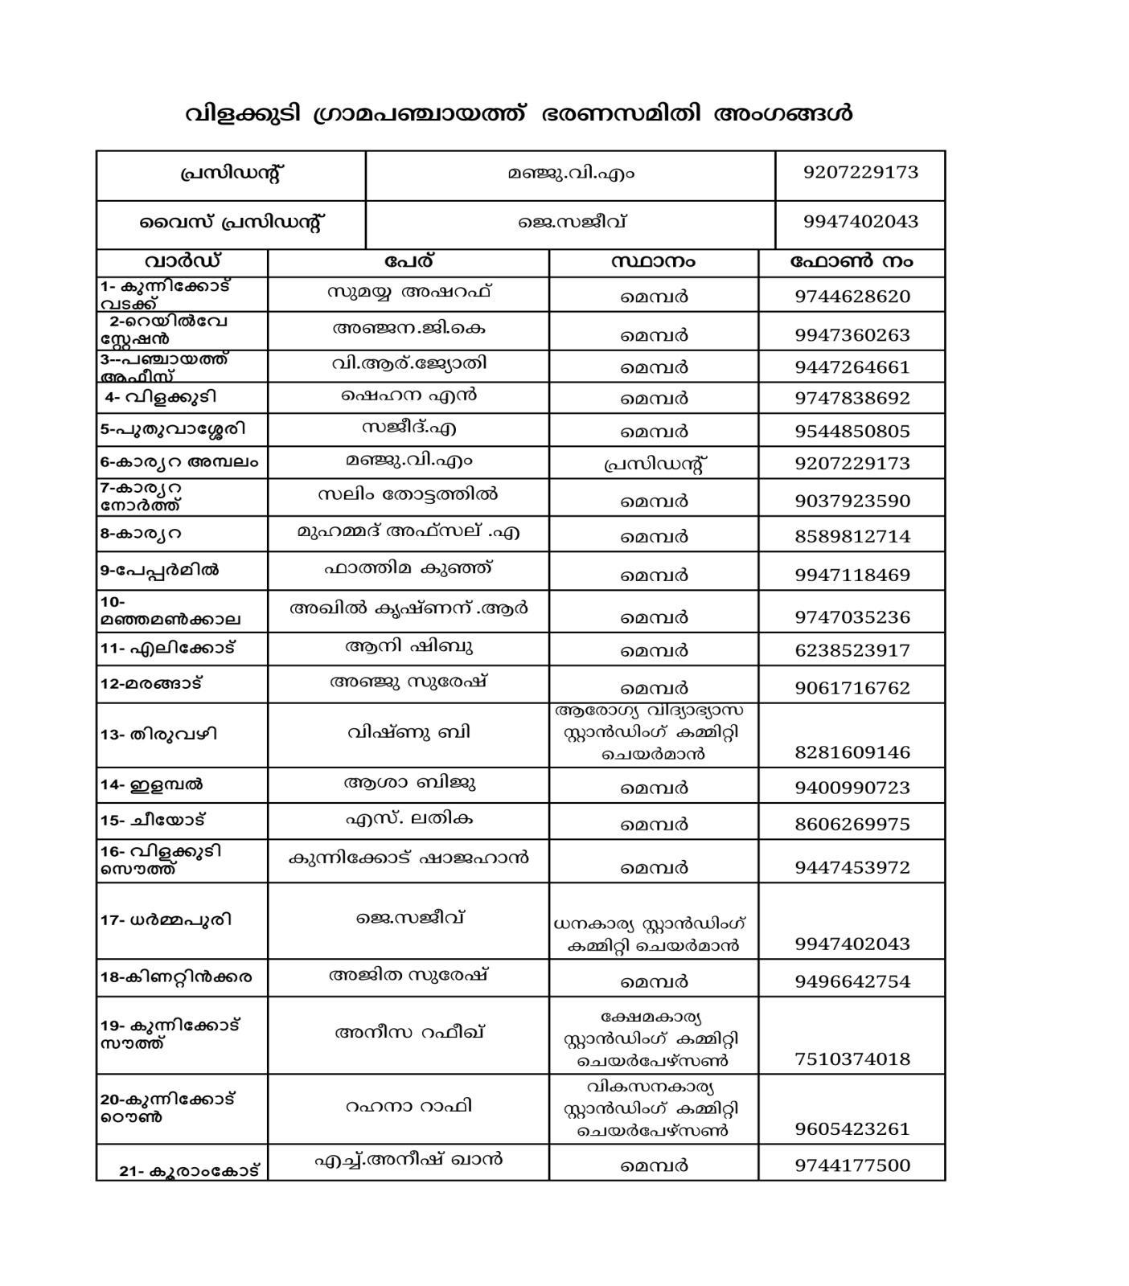

1.2. Other important phone numbers of grama panchayat/municipality/corporation area
Sl. No. | Name | Contact number
1. | Jayakumar, secretary | 8075308917
2. | Anil abraham,accountant | 9188321931
3. | Shahul kunnicode Ex vice president & social worker | 9496786636

1.3. Important offices of grama panchayat/municipality/ corporation
Sl.No | Name of the office | Contact person | Contact number
1. | Village Office | Village Officer | 9446057878
2. | Agriculture Office | Agriculture Officer | 9400620184
3. | Animal Husbandry Office | Animal Husbandry Doctor | 9446597106
4. | Police Station | Police Officer | 04752322095
5. | BSNL Office | Officer | 9496478028
6. | Block Office | Officer | 8593868933
7. | KSEB Office | Officer | 04752322039
8. | Fisheries Office | Officer | nil
9. | Fire and Rescue | Officer | 04752325701

1.4. Health Services

Sl. No | Name of the hospital/institution | Location | Phone number
1. | Government hospitals/PHC | Kunnicode | 04752325900
2. | Private hospitals | Kunnicode | 9447464609
3. | Clinical laboratories | Kunnicode | 7907851996
4. | Chemist/pharmacy | Kunnicode | 9446038952
5. | Blood donors | NA | NA
6. | Other language experts (Bihari, Hindi, Bengali,  Asamees ………) | NA | NA

1.5. Veterinary Services
Sl.No | Name of the Clinic | Name of the  Surgeon/Doctor | Place/location | Phone  number
1 | Govt.Veterinary Hospital | Dr.Veena | Vilakkudy | 04752322026

1.6. Helpline numbers
Helpline | Phone number
Police | 100
Fire and Rescue | 101
KSEB | 04752322039

1.7. Public and Private Schools Contact details

S.No | Name of School | Institution type | Phone number
1 | APPM VHSS Avaneeswaram | Aided | 9446183922
2 | MMHSS Vilakkudy | Aided | 9961751584
3 | GLPS Kunnicode | Govt | 9995956445
4 | GLPS Karyara | Govt | 9539911228
5 | GWLSP Avaneeswaram | Govt | 9562237179
6 | GLPS Vilakkudy | Govt | 8547623874
7 | GWLPS Karyara | Govt | 9447311545
8 | TVTM Kuttikkonam | Aided | 7006049122
9 | GUPS Elambal | Govt | 9495709871
10 | DBUPS Vilakkudy | Aided | 7907187082
11 | SGUPS Kuttikkonam | Aided | 9961752210
12 | RBM UPS Karyara | Aided | 9744969312
13 | St.Benedicts Elambal | Private | 04752227348
14 | IBN Seena Kunnicode | Private | 8078867547
15 | VKR Public School | Private | 7012043127
16 | AL NOOR Public School Karyara | Private | 04752229566
17 | St.Francis Assisi School Kottavattam | Private | 9656793813
18 | Beacon International School Karyara | Private | 8868866263
19 | St.Thomas School Kunnicode | Private | 8606014360
20 | MES Kunnicode | Private | 9497620122
21 | PRNM Public School Avaneeswaram | Private | 9747078280

1.9. Anganwadi Contact Details
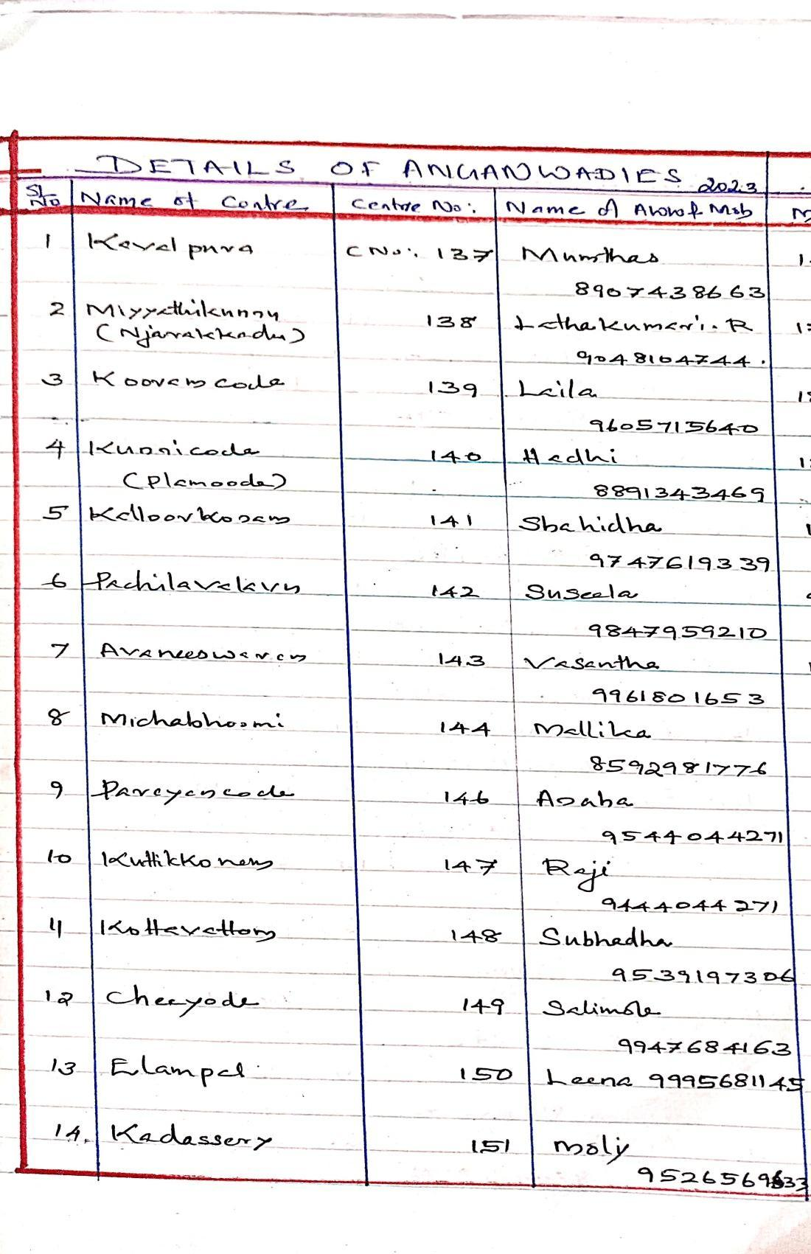
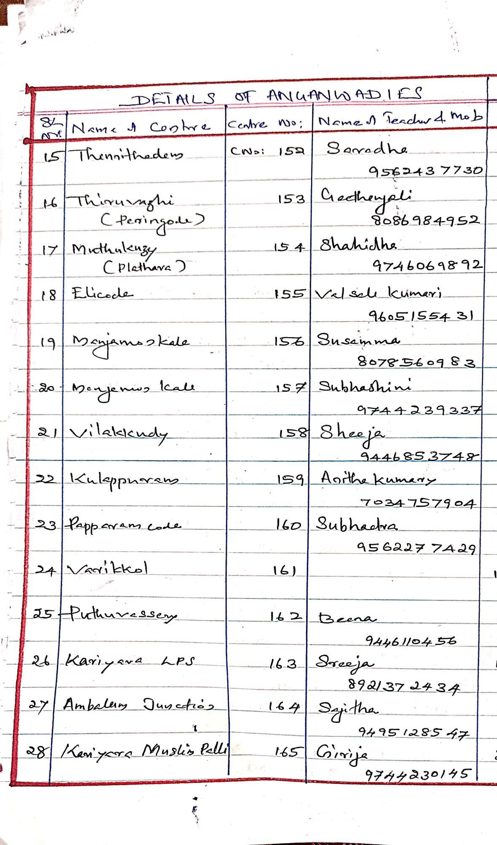
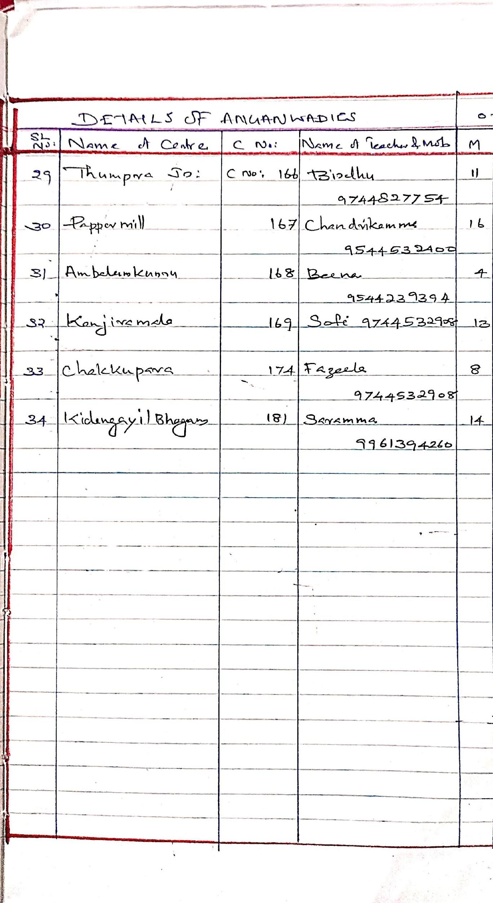

1.12. Information regarding resources

Means of transportation | Name of Owner | Phone Number
Heavy Trucks | nill | Nil
Tractor | nill | Nil
Ambulances | 2 | Shaheem73067 08737
Boats | nil | Nil
Taxi service | Baijudeen | 9447049454

Annexure 1: LSG Baseline Data Collection Format
A. Baseline data
Sl. No. | Indicator / Field | Baseline Data | Source / Remarks
1 | Name of LSG | VILAKKUDY | LSGD
2 | District | KOLLAM | LSGD
3 | Block / Taluk | PATHANAPURAM | LSGD
4 | Type of LSG (Gram Panchayat / Municipality / Corporation) | GRAM PANCHAYATH | LSGD
5 | Area (sq. km) | 21.44 Sq Km | LSGD
6 | No. of wards | 21 | LSGD
7 | GIS boundary file available | (Yes/No) | LSGD
8 | Key contact person & phone | President | 04752322026

B. Demography
Indicator / Field | Baseline Data | Source / Remarks
Total population | 39123 | Field Survey
Males | 19195 | Field Survey
Females | 19928 | Field Survey
Transgender population | 1 | Field Survey
Age distribution  (<5, 5–14, 15–59, ≥60) | 1647,4941,26972,5563 | Field Survey
No. of households | 9978 | Field Survey
Population density (persons/sq.km) | 1824.7 | Field Survey
No. of migrant workers | 228 | Field Survey
Major occupational groups | Construction sites,Hotels | Field Survey

C. Vulnerable Populations & Social Risks
Sl. No. | Indicator / Field | Baseline Data (Value / Description) | Source / Remarks
1 | No. of elderly (≥60) | 5563 | Baseline data
2 | No. of persons with disability | 29 | Baseline data
3 | No. of bedridden persons | 104 | Baseline data
4 | No. of chronic disease cases (DM/HTN/COPD/CKD etc.) |  | Baseline data
5 | Pregnant women (current estimate) | 155 | Baseline data
6 | Children <5 years | 1647 | Baseline data
7 | Tribal population (if any) | nil | Baseline data
8 | Fisherfolk / coastal vulnerable groups (if any) | nil | Baseline data
9 | Urban slums / unnotified settlements (if any) | nil | Baseline data
10 | Homeless population | nil | Baseline data
11 | Orphanages / old age homes (number & capacity) | 2 | Baseline data
12 | Hostels / prisons / shelters (number & capacity) | NIL | Baseline data
13 | Poverty / BPL estimate | 3585 | Baseline data
14 | Any history of stigma/discrimination issues (Yes/No) | NO | Baseline data

D. Health System & Service Readiness
Sl. No. | Indicator / Field | Baseline Data (Value / Description) | Source / Remarks
1 | No. of health facilities in LSG (PHC/CHC/TH/DH/Private) | 10 | LSGD
2 | PHC/Family Health Centre details (name, location) | Family health center vilakkudy | Baseline data
3 | Subcentres / Health & Wellness Centres (number) | 6 | Baseline data
4 | Private clinics / hospitals (number) | 7 | Baseline data
5 | Labs available (public/private) | 12 | Baseline data
6 | Availability of ambulance services (Yes/No, number) | Yes  7306708737 | Baseline data
7 | Availability of isolation/quarantine facilities (Yes/No, details) | YES | Baseline data
8 | Cold chain facilities (Yes/No, details) | YES | Baseline data
9 | Stockpile space available (Yes/No) |  | Baseline data
10 | PPE / mask / sanitizer availability plan (Yes/No) | YES | Baseline data
11 | Surveillance staff available (JHI/JPHN/ASHA count) | 5,6,24 | Baseline data
12 | Existing emergency referral pathways (Yes/No) | YES | Baseline data

E. Points of Entry & Mobility
Sl. No. | Indicator / Field | Baseline Data (Value / Description) | Source / Remarks
1 | Bus stands / depots (number) | NIL | Baseline data
2 | Railway stations (number) | 1 | Baseline data
3 | Boat jetties / fishing harbours (number) | NIL | Baseline data
4 | Ports / airports nearby (specify distance) | NIL | Baseline data
5 | Major highways/roads passing through | NH 744 | Baseline data
6 | Border crossings (state/district) | NIL | Baseline data
7 | Major markets / weekly markets | 2 | Baseline data
8 | Tourism hubs / major event venues | NIL | Baseline data
9 | Schools/colleges with hostels (number) | 23 | Baseline data
10 | Factories / large workplaces (number) | NIL | Baseline data
F. Water, Sanitation & Hygiene (WASH)
Sl. No. | Indicator / Field | Baseline Data (Value / Description) | Source / Remarks
1 | Major drinking water sources (piped / wells / borewells / springs) | WELLS,BOREWELLS | Baseline data
2 | No. of public wells | 8424 | Baseline data
3 | No. of households with piped water connection | 5034 | Baseline data
4 | Water quality testing routine (Yes/No) | YES | LSGD
5 | Common contamination risks (flooding, salinity, industrial waste) | industrial waste | LSGD
6 | Open defecation free status (Yes/No) | YES | LSGD
7 | Solid waste management system (Yes/No) | YES | LSGD
8 | Bio-medical waste disposal mechanism (Yes/No) | YES | LSGD
9 | No. of public toilets | NIL | Baselinedata
10 | Handwashing stations in public places (Yes/No) | NIL | LSGD
G. Zoonotic Risks & One Health
Sl. No. | Indicator / Field | Baseline Data (Value / Description) | Source / Remarks
1 | Livestock population (cattle/goats/pigs/poultry) – estimates | 1600 | Baseline data
2 | No. of dairy farms / poultry farms / pig farms | 0 | Baseline data
3 | Slaughterhouses / meat shops (number) | NIL | Baseline data
4 | Animal markets (Yes/No, details) | NIL | Baseline data
5 | Veterinary dispensaries (number) | 3 | Baseline data
6 | History of zoonotic outbreaks (rabies, leptospirosis, avian flu etc.) | NIL | Baseline data
7 | Stray dog population management measures (Yes/No) | YES | Baseline data
8 | Rodent infestation hotspots (Yes/No) | NIL | Baseline data
9 | Wetlands / waterlogged areas prone to leptospirosis | NIL | Baseline data
10 | Bat roosting areas / caves / fruit orchards (if any) | NIL | Baseline data
11 | Human-animal interface hotspots (farms near residences) | NIL | Baseline data
H. Climate & Disaster Risks (Pandemic Amplifiers)
Sl. No. | Indicator / Field | Baseline Data (Value / Description) | Source / Remarks
1 | Flood-prone wards (list) | WARD 8  WARD 12 | Baseline data
2 | Landslide-prone wards (list) | WARD 11 | Baseline data
3 | Cyclone/sea surge risk (Yes/No) | NIL | Baseline data
4 | Heatwave risk zones (Yes/No) | YES | Baseline data
5 | Waterlogging areas (list) | NA | NA
6 | Shelter homes / relief camps (number, capacity) | NA | NA
7 | Past disaster displacement history | NA | NA
8 | Disruption to water supply/transport common (Yes/No) | NA | NA
I. Critical Infrastructure & Logistics
Sl. No. | Indicator / Field | Baseline Data (Value / Description) | Source / Remarks
1 | Schools (number) | 21 | LSGD
2 | Anganwadis (number) | 33 | LSGD
3 | Colleges (number) | 1 | LSGD
4 | Community halls (number) | 7 | LSGD
5 | Places of worship with large gatherings (number) | 8 | LSGD
6 | Large markets / shopping areas (number) | NIL | LSGD
7 | Warehouses / cold storages (number) | NIL | LSGD
8 | Telecom/mobile network coverage gaps (Yes/No) | YES | LSGD
9 | Power outage frequency (high/medium/low) | MEDIUM | LSGD
10 | Availability of generators in key facilities | NIL | LSGD

J. Risk Communication & Community Networks
Sl. No. | Indicator / Field | Baseline Data (Value / Description) | Source / Remarks
1 | Ward-level rapid response teams (Yes/No) | YES | CHC
2 | Jagrathasamithis / committees active (Yes/No) | YES | LSGD
3 | Kudumbashree presence and strength (number of units) | YES | LSGD
4 | Volunteer network (number, coverage) | 1000 | LSGD
5 | Community-based surveillance mechanisms (Yes/No) | YES | CHC
6 | IEC dissemination channels (WhatsApp groups, community radio, PA systems) | YES | LSGD
7 | Rumour tracking mechanisms (Yes/No) | YES | LSGD
8 | Languages spoken / literacy considerations | MALAYALAM | LSGD
9 | Vulnerable groups communication strategy available (Yes/No) | yes | LSGD

K. Preparedness Planning & Governance
Sl. No. | Indicator / Field | Baseline Data (Value / Description) | Source / Remarks
1 | LSG emergency plan available (Yes/No) | YES | LSGD
2 | Pandemic preparedness plan available (Yes/No) | YES | LSGD
3 | Incident Command System identified (Yes/No) | YES | LSGD
4 | Rapid procurement mechanism available (Yes/No) | YES | LSGD
5 | Emergency fund available (Yes/No, amount) | YES | LSGD
6 | Past outbreak response experience (Yes/No, details) | YES | CHC
7 | Intersectoral coordination mechanism (Health, Police, LSG, Veterinary, Education) | YES | LSGD
8 | Mock drills conducted in last 12 months (Yes/No) | NO | CHC
9 | Training coverage for staff/volunteers (Yes/No) | YES | LSGD

L. Surveillance & Data Systems
Sl. No. | Indicator / Field | Baseline Data (Value / Description) | Source / Remarks
1 | Digital reporting tools used (e.g., DHIS2, portals) | YES | LSGD
2 | Availability of line-listing format (Yes/No) | YES | CHC
3 | Contact tracing team identified (Yes/No) | YES | CHC
4 | Mapping of high-risk households available (Yes/No) | YES | CHC
5 | Testing sample transport mechanism (Yes/No) | YES | CHC
6 | Reporting timeline adherence (good/average/poor) | GOOD | CHC
7 | Data sharing between departments (Yes/No) | YES | CHC
8 | Availability of dashboard for monitoring (Yes/No) | YES | CHC

M. Additional Notes & Observations
Sl. No. | Indicator / Field | Baseline Data (Value / Description) | Source / Remarks
1 | Key challenges perceived by LSG | NIL | LSGD
2 | Top 5 high-risk wards (reason) | 8,11,12,2, (NATURAL CALMITIES) | LSGD
3 | Any unique local risks (industrial pollution, refugee camps, etc.) | NIL | LSGD
4 | Recommendations for preparedness strengthening | NIL | LSGD

