PANDEMIC PREPAREDNESS PLAN
BHARANANGANAM GRAMA PANCHAYATH
COMMUNITY HEALTH CENTRE ULLANADU
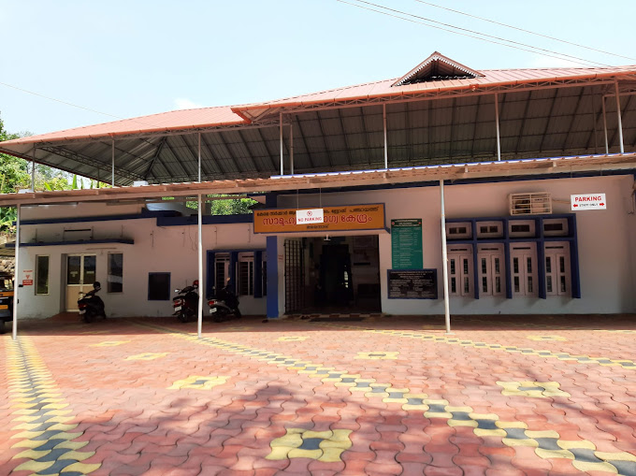

PANDEMIC PREPAREDNESS PLAN
District-

MESSAGE FROM PRESIDENT LSGD


Communicable diseases continue to pose significant challenges to public health and community well-being. In recent years,emerging infectious and global outbreaks have reminded us of the importance of preparedness, timely intervention,and collective responsibility.With this understanding,our Local Self Government Institution has developed a comprehensive Pandemic Preparedness Plan.This initiative is designed to strengthen preventive mechanism,enhance public awareness,and ensure coordinated action during health emergencies.
The success of this plan depends greatly on community participation ,institutional co-operation,and ward level co-ordination.Together,through vigilance and unity,we can build a safer and healthier society.

Smt .SUDHA SHAJI
PRESIDENT ,LSGD BHARANANGANAM

MESSAGE FROM HEALTH STANDING COMMITTEE CHAIR


The increasing occurrence of infectious across the world highlights the urgent need to reinforce our public health systems and promote responsible health practices.The Pandemic Preparedness Plan serves as a practical guide for public representatives,health workers and citizens .It emphasizes prevention,early response,and co-ordinated action among departments.The principle that “Health is a shared responsibility” must guide our daily lives.
With awareness,discipline,and co-operation,we can effectively minimize health risk and protect our community from future outbreaks.Let us work together with commitment and determination.

Sri,C J MARTIN HEALTH STANDING COMMITTEE CHAIRMAN
CHC ULLANADU

MESSAGE FROM MEDICAL OFFICER
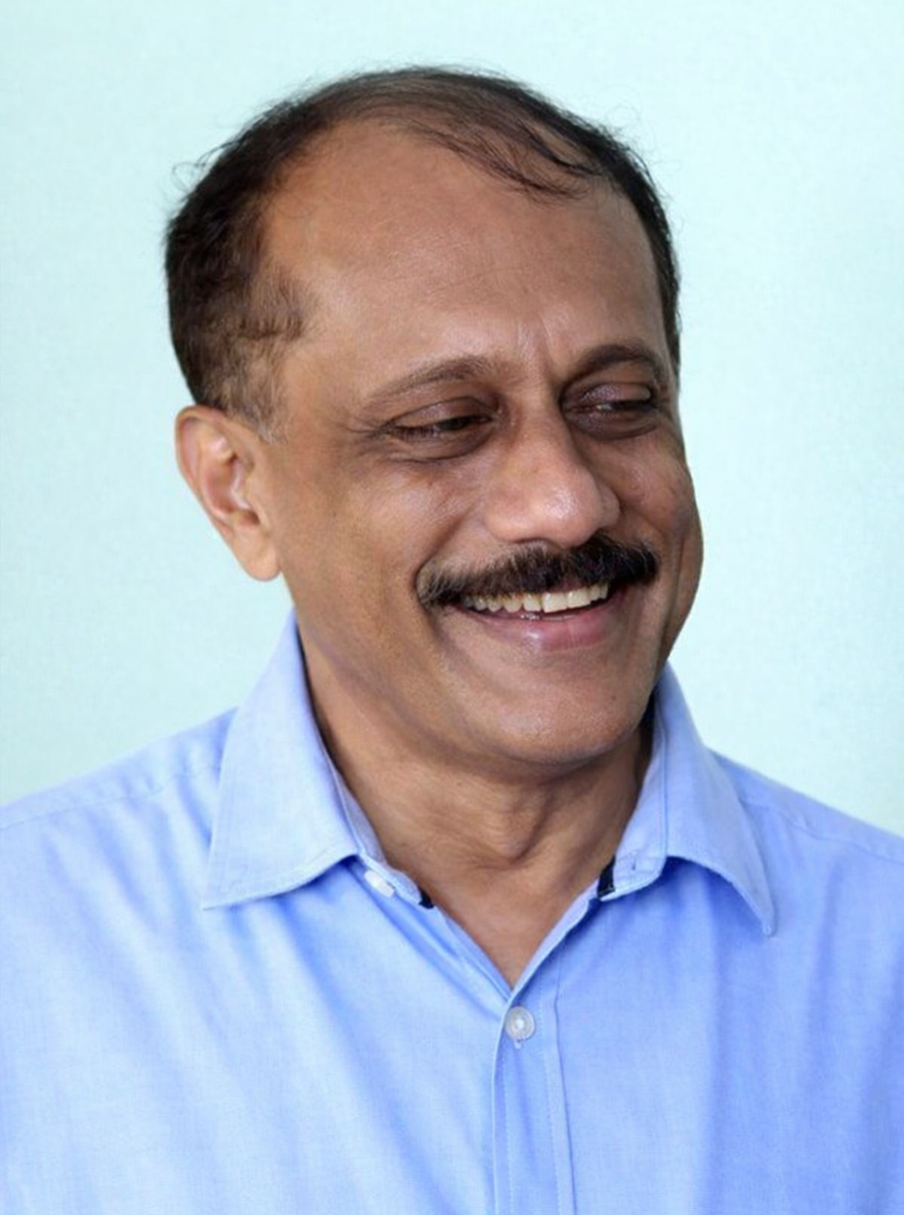

Infectious diseases remain one of the most serious public health concerns globally.Past pandemics have clearly demonstrated that health crises do not affect medical systems alone;they disrupt livelihoods,education,social stability and economic growth.This experiences underline the vital importance of preparedness and scientific planning.The Pandemic Preparedness Plan has been developed as a structured framework to ensure systematic prevention,early identification of outbreaks and timely response during public health emergencies. It focuses on strengthening disease surveillance,improving reporting mechanisms ,ensuring uninterrupted essential health services and maintaining adequate medical supplies.
Capacity building is another key component of this plan.Training health care personnel,improving coordination among departments,enhancing communication strategies and promoting community engagement are essential for an effective response.This initiative is not merely a document,but a commitment to proactive action and resilience.With the active co operation of health workers,local authorities and the public,we can respond confidently and efficiently to any future health emergency.Let us remain vigilant,prepared and united in safeguarding the health of our community for generations to come

Dr.BIJU JOHN
MEDICAL OFFICER
CHC ULLANADU

PANDEMIC PREPAREDNESS PLAN
District-

The template is for reference. All the teams at the districts are suggested to take following actions

- Track 1 – The template already shared for Panchayth level plans. Based on the template Panchayat level plans, the Block level plans to be kept ready.
- The track 2 will be at the district level action to follow up with the respective line department to collect and collate relevant data tables.
- Wherever possible the soft copies also to be collected. Maps in shape files and other data in Excel files.
- The District Disaster Management – all available data shall be collated from them. Wherever there is any issue, bring in the notice of ACS so as to get facilitated . Simultaneously, at the State level all the data available with SDMA hard copy and shape files will be collected.
- The district teams as per the discussions should be preparing the draft plans mainly focusing on the information , data , man power details, past experience related details etc.
6.We will strive to complete the collection of all the information in the first fortnight of FEB
7. Along with the State key resource officers district level meetings are planned to facilitate the preparation of the plans.
EXECUTIVE SUMMARY

Ullanadu Community Health Centre functions as the primary public healthcare institution serving the population of 17057 of Bharananganam Grama Panchayath. The CHC plays a pivotal role in delivering comprehensive, accessible, and affordable healthcare services, with a strong focus on preventive, promotive, curative, and rehabilitative care in accordance with national and state health programmes.
The CHC caters to a predominantly rural population, addressing key public health priorities such as maternal and child health, communicable and non-communicable disease control, immunization, family welfare, adolescent health, and geriatric care. Regular outpatient services, home-based care through field health staff, and outreach activities ensure healthcare coverage even in geographically challenging areas. The institution actively implements national health missions, including the National Health Mission (NHM), National Tuberculosis Elimination Programme,National Programme for Prevention and Control of Non-communicable Diseases (NPNCD), and other disease surveillance initiatives.
Ullanadu CHC works in close coordination with the Grama Panchayath, ASHA workers, Anganwadi centres, schools, and community-based organizations to strengthen community participation and improve health awareness. Emphasis is placed on early detection, timely referral, health education, and lifestyle modification to reduce disease burden and improve overall health outcomes.
Despite constraints related to infrastructure, manpower, and increasing service demand, the FHC continues to enhance service delivery through effective planning, data-driven decision-making, and community engagement. Strengthening facilities, upgrading digital health systems, and expanding preventive services remain key focus areas for future development.
Overall, Ullanadu Community Health Centre stands as a vital institution in safeguarding public health and improving the quality of life of the residents of Bharananganam Grama Panchayath.
LIST OF ABBREVIATIONS

LSGD/LSGI | LOCAL SELF GOVERNMENT DEPARTMENT/LOCAL SELF GOVERNMENT INSTITUTION
NPNCD | NATIONAL PROGRAMME NON COMMUNICABLE DISEASES
IDSP | INTEGRATED DISEASE SURVEILANCE PROGRAMME
NDMA | NATIONAL DISASTER MANAGEMENT AUTHORITY
HMIS | HEALTH MANAGEMENT INFORMATION SYSTEM
LCDC | LEPROSY CASE DETECTION CAMPAIGN
CD | COMMUNICABLE DISEASE
NCD | NON COMMUNICABLE DISEASE

TABLE OF CONTENTS

INTRODUCTION
Background of the PPP 9
District AT A GLANCE 9
Maps - LSG-based (Mention source also) 10
INTEGRATED HEALTH INFRASTRUCTURE MAP OF ____________ District 11
Health Infrastructure Map 12
GENERAL PROFILE OF THE District 15
Background of the District 15
Demographic and Vulnerable Population 16
Clinical Vulnerability 17
INFRASTRUCTURE & RESOURCE INVENTORY 19
Health Facility Directory & Basic Capacity in the DISTRICT 19
Private Clinics 20
Healthcare Education & Training Institutions 20
Specialised Services & Emergency Inventory 21
Oxygen & Diagnostic Capacity 21
Diagnostics facility mapping at the DISTRICT level 22
Laboratory Identification & Basic Details 22
Social and Community Infrastructure for the surge plan 23
Human resources 25
Medical & Clinical Personnel 25
Public Health & Field-Level Workforce 25
Community & Support Cadre 26
Community Organizations 27
Administrative & Emergency Services 28
Information regarding resources 28
ONE HEALTH & ENVIRONMENTAL SURVEILLANCE 29
Animal & Bird Population 29
Veterinary Infrastructure 30
Veterinary Doctors & Workforce 31
High-Risk Interface Points (Surveillance Sites) 32
Environmental Risk Mapping 33
Disease Seasonality Mapping 34
Vulnerability Mapping 35
EPIDEMIOLOGICAL TRENDS (2021–2025) 36
Disease Burden among human beings(Last 5 Years) 36
Seasonal Trend Analysis 38
Outcome-Based Trend Analysis- 2025 40
Transmission Trend- 2025 41
Integrated Disease Hotspot Map (2021–2025) 43
Assessing Core Capacities 46
Mapping of existing plans and committees 46
Assessment of Core capacities 46
Build & Organise critical capacities 47
Governance & Structure 48
Planning Principles & Legal Considerations 48
Plan Development & Approach 49
State Systems & Emergency Coordination 49
Surveillance & Laboratory Systems 49
Community Protection & Communication 50
Clinical Care & Essential Services 50
Access to Countermeasures 51
10. Plan Activation & Operational Triggers 51
Health system surge 51
Supplies and logistics 52
Map and formalize supply chains with contingency routes, framework agreements, and a simple inventory tracking format. 53
Preparedness and Response Protocol at District Level 53
Constitution of One Health Committee 54
Pandemic Response Workforce 56
Activities and Measures before and during Pandemic 58
PHASE 1 - Alert / Preparation 58
Identification of Quarantine and Isolation Facilities 60
Risk Communication and Community Preparedness 60
Protection of Vulnerable Groups 61
Clinical Dependency Mapping 62
PHASE 2 - Active Response 62
Standard Screening Protocol 64
CONTROL ROOM MANDATES 66
PHASE 3 - Surge Capacity 91
Conversion of Community Facilities 91
Recovery and rehabilitation phase 92
CONCLUSION 92
RECOMMENDATIONS 94
MOCKDRILL SCENARIOS 95
Communication 96
Communication strategies 97
Pandemic Preparedness Capacity Building & Training Plan 98
ANNEXURE 102
1. IMPORTANT PHONE NUMBERS 102
Annexure 1: LSG Baseline Data Collection Format 108
A. Baseline data 108
B. Demography 108
C. Vulnerable Populations & Social Risks 109
D. Health System & Service Readiness 109
E. Points of Entry & Mobility 110
F. Water, Sanitation & Hygiene (WASH) 110
G. Zoonotic Risks & One Health 111
H. Climate & Disaster Risks (Pandemic Amplifiers) 111
I. Critical Infrastructure & Logistics 112
J. Risk Communication & Community Networks 112
K. Preparedness Planning & Governance 113
L. Surveillance & Data Systems 114
M. Additional Notes & Observations 114

INTRODUCTION

Background of the PPP
- District at a glance

District AT A GLANCE
- Geographical boundaries with political map ( based on latest delimitation)
- Baseline data
- LSG division -
Ward | Houses | Population | Migrants | Wells | Hot  spots | Ed. Institutions | Hosp pvt/govt.
13 | 4258 | 17057 | 492 | 2676 | 5,6,9,11,10 | 15 | 1+3

- Risk stratification among LSGs in the context of Communicable diseases and hazards
- Major Roads/rivers
- Major establishments with geospatial mapping
- occupational groups, socio-cultural groups, migration & mobility patterns
- Vulnerability mapping
- Disaster-prone areas (geographic vulnerability)

Maps - LSG-based (Mention source also)

- Geographical boundaries - ward boundaries map
- Health infrastructure map
- roads and rivers map
- major establishments map
- disaster-prone areas map
- hotspot map - CD & disasters
Geographical boundaries - ward boundaries map

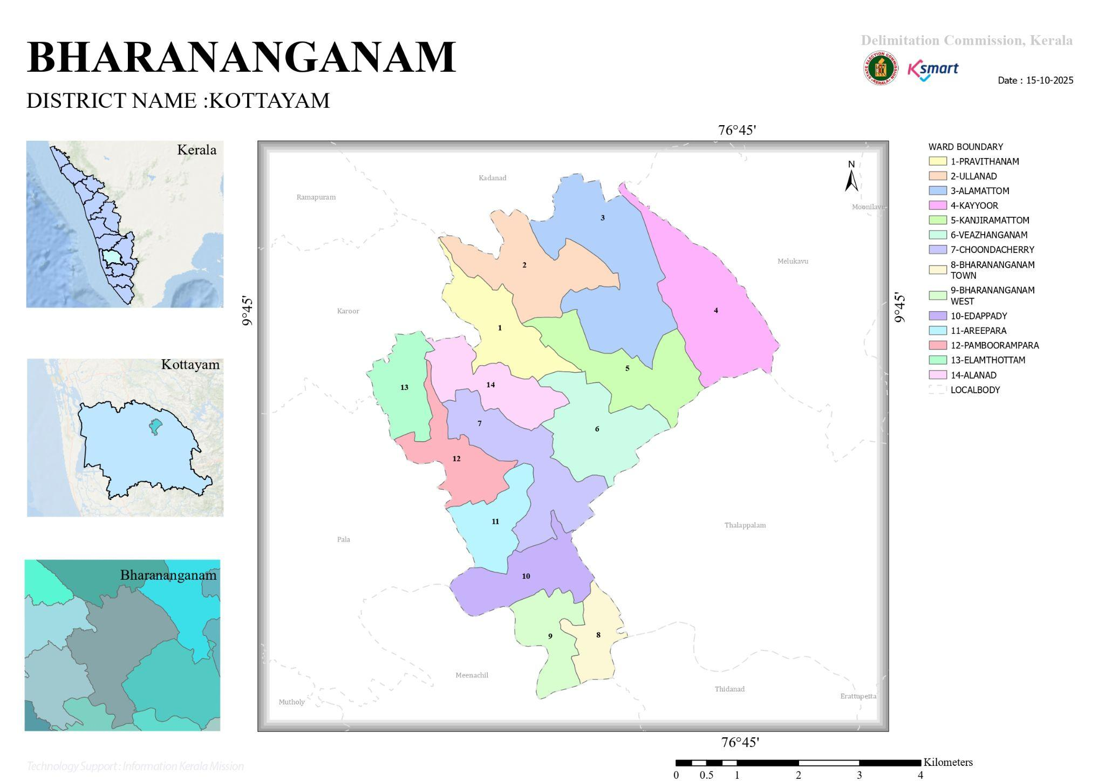

Health Infrastructure Map
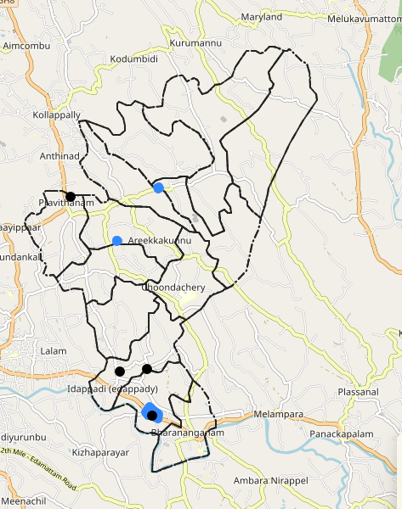

roads & Rivers map
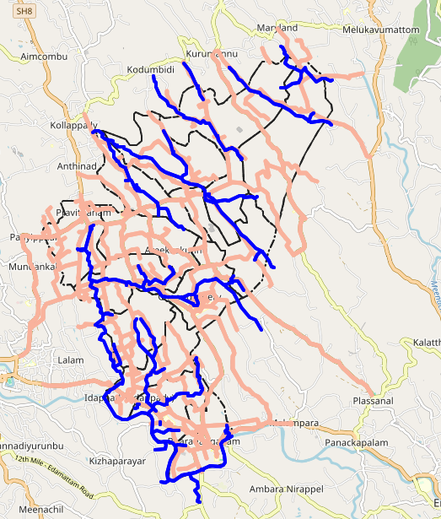

disaster prone area
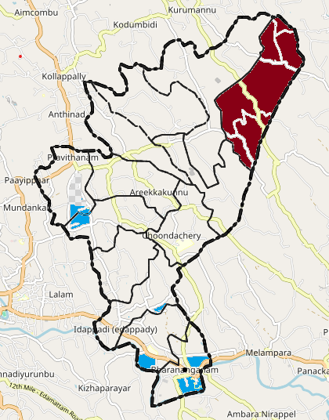

CD - HOTSPOT MAP
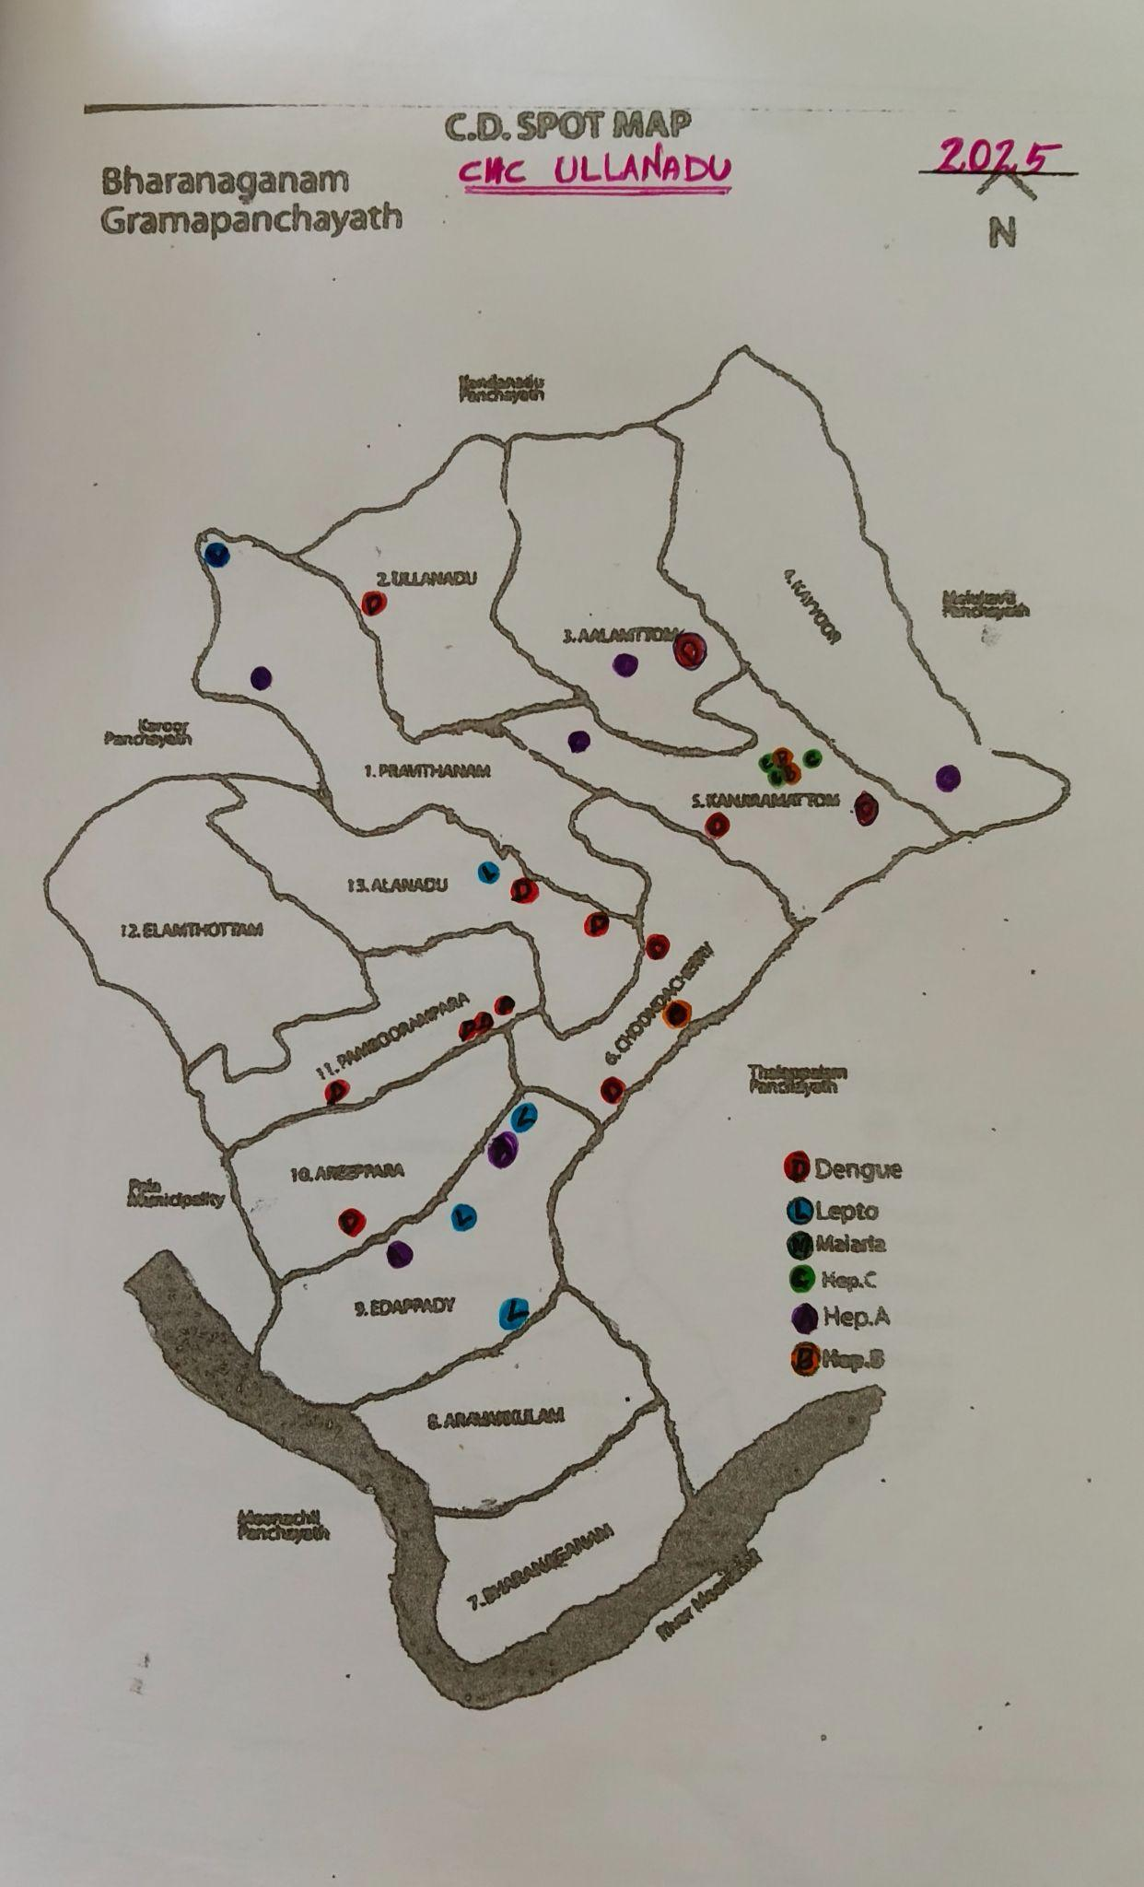
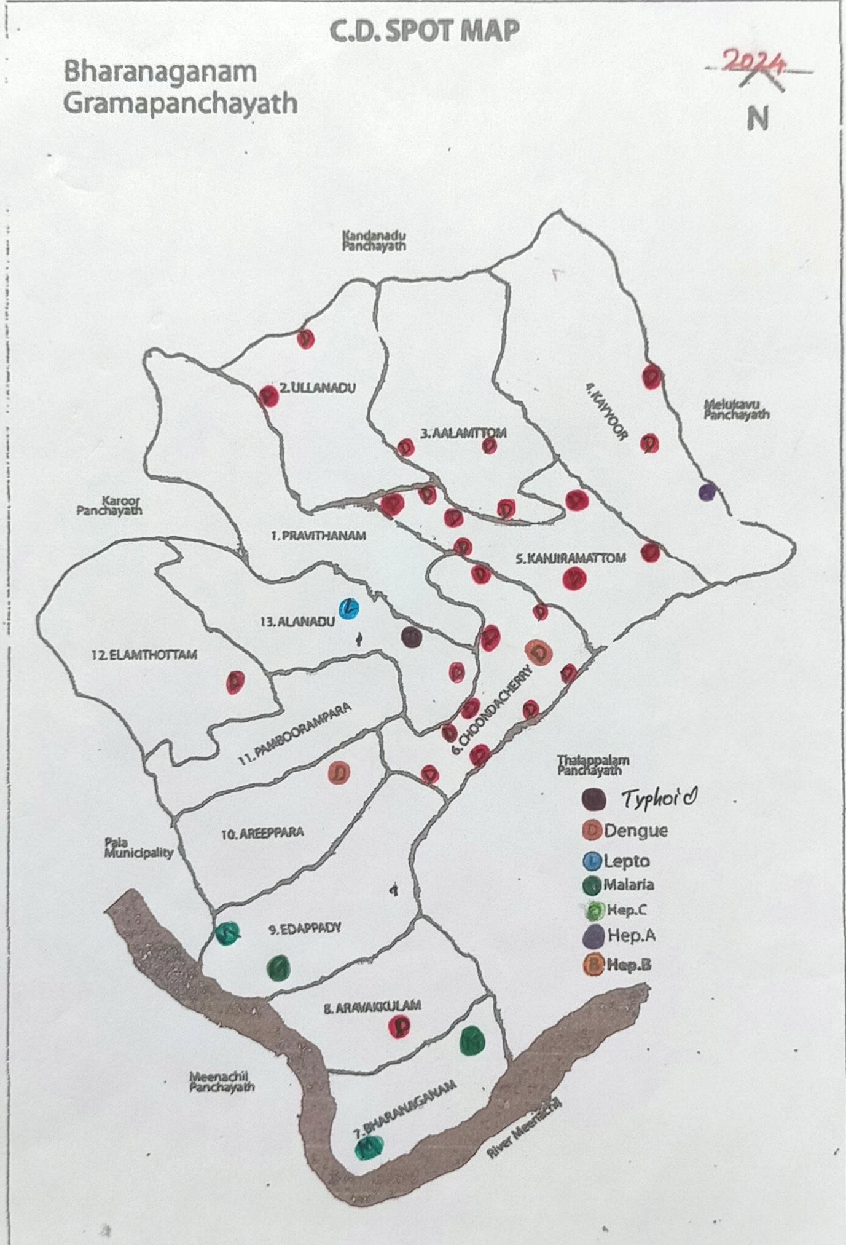
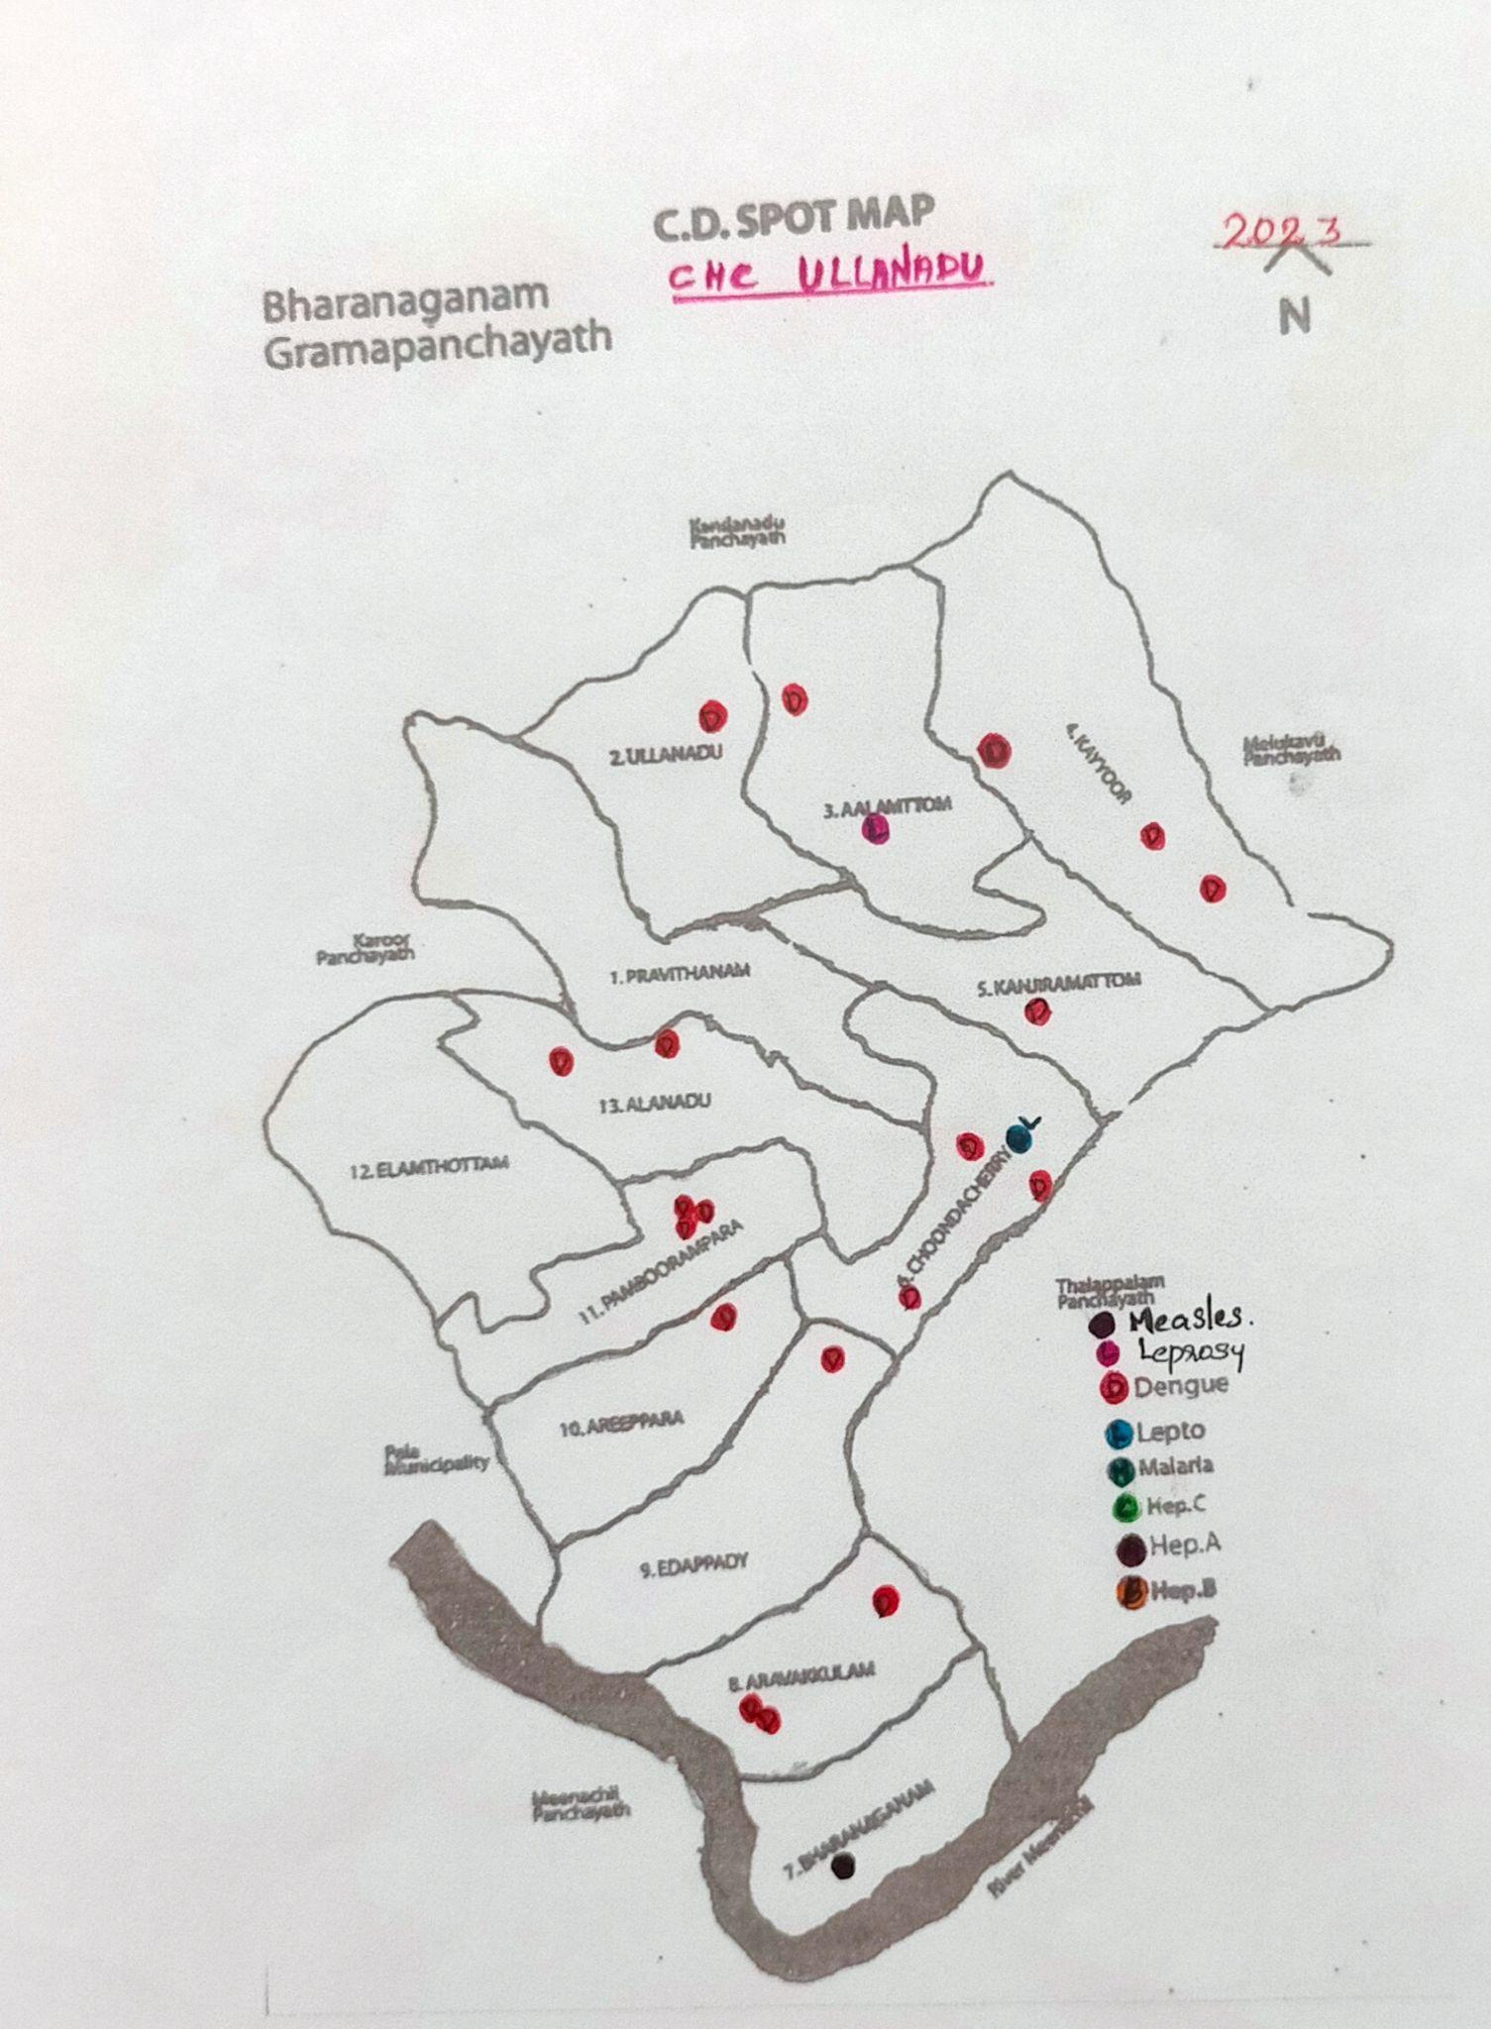

GENERAL PROFILE OF THE District

Background of the District
Table 1: Background of DISTRICT
Description | Details
Name of DISTRICT | KOTTAYAM
Number of LSGs | BHARANANGANAM
Total area (sq. km) | 27.04 sq.km
Population(Projected) | 17057
Population density | 630.80/Sq.Km
Terrain (coastal/low-lying/backwaters/foothills, etc.) | NIL
Number of rivers passing through PANCHAYATH | 1
Number of water bodies in the PANCHAYATH | 4
Number of educational institutions | 13+2
Factories / small-scale industries | 7
Flood-prone wards and LSGs | 7,8,9,11,12
Landslide-prone wards and LSGs | 4
Death Management and Disposal Facilities (mortuaries/crematorium, including electric) | NIL
Auditoriums/Marriage halls/convention centres/community halls | 10

Demographic and Vulnerable Population
Understanding the demographic composition and vulnerable population groups is essential for pandemic preparedness. Children, elderly, economically deprived families, migrant workers, and socially vulnerable groups are at increased risk during public health emergencies due to higher exposure, limited access to services, and dependency on public systems..
Description |  | Details (in numbers)
DEMOGRAPHIC PROFILE
Total population |  | 17057
Male |  | 8453
Female |  | 8603
Transgender |  | 1
Children under 5 |  | 698
Adolescent |  | 2089
Elderly (>60) |  | 2389
SOCIAL/LIVELIHOOD VULNERABILITY
Previous EPEP family |  | 5
BPL family |  | 1457
Tribal communities |  | 63
Migration | Immigrant | 492
Migration | Emigrant | 219
Socio-economically deprived |  | 7
Fisherfolk |  | 0
SC Community |  | 612
ST Community |  | 63
Graphs: Population pyramid (if possible) for seeing if your DISTRICT has a high "dependency ratio" (lots of children and elderly compared to working adults).

Clinical Vulnerability
Certain population groups need priority healthcare & are at higher risk of severe illness, complications, and mortality during pandemics. Patients with chronic diseases, those requiring regular medical care, and individuals with mobility or functional limitations face challenges in accessing timely care during emergencies. Mapping these groups helps in prioritising continuity of treatment, medicine stock planning, oxygen support, referral transport, and targeted home-based care.
Description | Details in numbers
Pregnant women | 82
Lactating mothers | 84
Bedbound patients | 53
Patients under palliative care other than bedbound | 107
Patients on Haemodialysis | 10
Patients on CAPD | 7
Cancer patients (currently on treatment) | 11
Haemophilic patients | 6
Mentally challenged | 32
Differently abled | 77
Diabetic patients | 1676
Hypertensive patients | 2041
TB patients | 6

Major Festivals & Events specific to the DISTRICT
(with the possibility of a public gathering)
Sl. No. | Name of festival | Month detailing the periodicity
1 | ST.Alphonsa Shrine &Pilgrim Centre, Bharananganam | July
2 | Sree Krishna Swami Kshethram, Bharananganam | January
3 | St. Augustine’s Forane Church, Pravithanam | November
4 | Sreedharma Sastha Kshethram ,Ullanadu | February
5 | Christhuraj Church ,Kayyoor | February
6 | Anandhashanmukakshetram, Edappady | January, February
7 | St. Albert Church, Elamthottam | january
8 | St. Joseph Church , Edappady | January
9 | St.MarysChurch , Bharananganam | January

INFRASTRUCTURE & RESOURCE INVENTORY

Health Facility Directory & Basic Capacity in the DISTRICT
This section provides an overview of the healthcare infrastructure available within the DISTRICT area. It outlines the distribution and basic capacity of health facilities that form the backbone of service delivery during routine times and public health emergencies.
Family Health Centres (FHCs) and Community Health Centres (CHCs) generally function as the first point of contact for the community, providing essential outpatient and inpatient services. General Hospitals (GH) and Medical College Hospitals (MCH), where accessible, serve as the main referral centres for advanced diagnostics, specialist care, and critical services during public health emergencies. This inventory helps identify existing strengths, gaps, and potential surge capacity that can be mobilised during a pandemic or disaster.
Table 5. Health Facility Resource Summary
Sl.no. | Health Facility | Type of Facility (MCH/GH/CHC/FHC/SC etc.) | Contact Number | Total beds | ICU Beds | Oxygen-Supported Beds | No. of Ventilator Support Beds | No. of ambulances
Government Healthcare Facilities
1 | CHC ULLANADU | CHC | 6282068449 | 24 | 0 | 0 | 0 | 0
2 | AAM Maincentre | SC | 9446602972 | 0 | 0 | 0 | 0 | 0
3 | AAM Kayyoor | SC | 9745813235 | 0 | 0 | 0 | 0 | 0
4 | AAM Bharananganam | SC | 9074943745 | 0 | 0 | 0 | 0 | 0
5  6 | AAM Edappady  AAM Alanadu | SC | 9961400439  9447674552 | 0 | 0 | 0 | 0 | 0
Private Healthcare Facilities
1 | IMMACULATE HEART OF MARY | HOSPITAL | 9447392639 | 100 | 10 | 5 | 0 | 4
AYUSH Healthcare Facilities
1 | GOV. AYURVEDHA HOSPITAL |  | 9446681983 | 0 | 0 | 0 | 0 | 0
 | GOV. HOMEO HOSPITAL |  | 9447265162 | 0 | 0 | 0 | 0 | 0

Private Clinics
Private clinics are an essential part of pandemic preparedness, as they are often the first place people seek care when symptoms begin. In many communities, private clinics manage a significant share of outpatient visits and therefore play a critical role in early case detection, timely referrals, and disease surveillance. Having an up-to-date understanding of where these clinics are located, the services they provide, and how they are linked to the public health system helps ensure that no cases are missed during an outbreak. It also allows health authorities to engage private practitioners more effectively for reporting, risk communication, and coordinated response, strengthening the overall capacity of the health system to manage public health emergencies.

Table 6. Private Clinic Resource Summary
Sl No. | Name of Clinic | Registered (Y/N) | Clinic (General / Speciality) | Speciality (if any) | Address | Contact Number | Diagnostic Facility (Y/N) | Ambulance Linkage (Y/N)
1 | ALPHONSA HOMEOPATHY CLINIC | N | GENERAL |  | ANTHINADU P O , PRAVITHANAM | 9495189196 | N | N
2 | GD DENTAL CARE & ORTHODONTIC | N | DENTAL | DENTAL | GD DENTAL CARE & | 8547190287 | N | N
3 | NEW LIFE DENTAL CLINIC | N | DENTAL | DENTAL | BHARANANGANAM | 9447737998 | N | N
4 | BLISS DENTAL CARE ORTHODONTIC CENTREDENTAL | N | DENTAL | DENTAL | BHARANANGANAM | 9731353032 | N | N

Healthcare Education & Training Institutions
This section tracks the educational infrastructure available, which is vital for human resource planning in the health sector.

Category of Institution | Govt | Private | AYUSH | Total
Medical Colleges | 0 | 0 | 0 | 0
Nursing Colleges | 0 | 1 | 0 | 1
Dental Colleges | 0 | 0 | 0 | 0
Para-medical / Allied Health | 0 | 1 | 0 | 1
Pharmacy Colleges | 0 | 0 | 0 | 0

Specialised Services & Emergency Inventory
This section provides a detailed view of the specialized medical resources available to the community, focusing on emergency response and critical care capabilities. This table tracks the vital assets required for managing severe illnesses and emergencies across the Government, Private, and AYUSH sectors.

Item | Govt | Private | AYUSH | Total
Hospital beds | 24 | 100 | 0 | 124
Oxygen-generating systems(Y/N) | N | N | 0 | 0
Oxygen-supported beds(Numbers) | 0 | 28 | 0 | 5
Ventilator-supported beds | 0 | 0 | 0 | 0
ICU beds | 0 | 10 | 0 | 10
Burns units | 0 | 1 | 0 | 1
Blood centres | 0 | 1 | 0 | 1
BLS ambulances | 0 | 1 | 0 | 1
ALS ambulances | 0 | 0 | 0 | 0
Dialysis facilities | 0 | 1 | 0 | 1
Dispensaries | 5 | 2 | 3 | 10
Medical store | 1 | 8 | 0 | 9
Industrial establishments(Medium-scale industries/small-scale industries establishments to whom we can depend in a worst-case scenario) | 0 | 7 | 0 | 7

Oxygen & Diagnostic Capacity
Monitoring oxygen and diagnostic capacity is a critical component of public health preparedness, ensuring that the LSGD can handle both chronic care and sudden surges in respiratory or infectious diseases.
Name of Health Facility | Oxygen-generating System (Y/N) | Backup Oxygen Source (Y/N) | Diagnostic Facilities Available(Y/N)
Name of Health Facility | Oxygen-generating System (Y/N) | Backup Oxygen Source (Y/N) | Lab | USG | X-ray | CT/MRI | RT-PCR
Government Healthcare Facilities
0 | 0 | 0 | 0 | 0 | 0 | 0 | 0
0 | 0 | 0 | 0 | 0 | 0 | 0 | 0

Diagnostics facility mapping at the DISTRICT level
The diagnostic capacity of Bharananganam G.P represents the "intelligence network" of our healthcare system. The speed and accuracy of disease identification depend entirely on the distribution and technical level of these facilities.
Item | Govt | Private | AYUSH | Total
General labs | 1 | 4 | 0 | 5
Microbiology labs | 0 | 0 | 0 | 0
RT-PCR labs | 0 | 0 | 0 | 0
USG units | 0 | 1 | 0 | 0
CT/MRI units | 0 | 0 | 0 | 0
Research labs | 0 | 0 | 0 | 0
Labs of other departments that can be repurposed | 0 | 0 | 0 | 0

Laboratory Identification & Basic Details
Sl. No. | Name of Laboratory | Ownership (Govt / Private / Academic) | Address | Contact No. | 24×7 Services (Yes/No) | NABL / Govt Approved (Yes/No)
1 | TWINS CLINICAL LABORATORY | PRIVATE | JESSYMOL THOMAS, BHARARANGANAM | 9496633040 | NO | YES
2 | SMART MEDIPLUS LABOROTARY | PRIVATE | BHARANANGANAM | 9207973701 | NO | NO
3 | HEALTH CARE DIAGNOSTIC CENTRE | PRIVATE | PRAVITHANAM | 9207063468 | NO | NO

Social and Community Infrastructure for the surge plan
This table serves as our logistics and shelter inventory. By mapping these locations, we can quickly identify where to house displaced citizens, where to set up temporary medical clinics, and how to manage the deceased with dignity during a crisis
Category | Total Count | Ward | Est. Capacity (Persons) | Contact details
Educational Institutions
Anganwadis | 20 | 13 | 15 | ICDS Supervisor
Schools | 13 | 4,5,6,7,9,12 | 100 | HM
Colleges | 1 | 6 | 500 | PRINCIPAL
Healthcare Educational Institutions
Medical colleges (Govt/Private) | 0 | 0 | 0 | 0
Nursing colleges (Govt/Private) | 1 | 8 | 30 | PRINCIPAL
0Dental colleges (Govt/Private) | 0 | 0 | 0 | 0
Paramedical institutes (Govt/Private) | 0 | 0 | 0 | 0
Community Gathering Spaces
Community halls | 2 | 11,8 | 20 | WARD MEMBER
Auditoriums | 2 | 7 | 70 | OWNER
Religious buildings | 11 | 1.2,3,4,5,6,7,9,11, 12,13 | 80 | VIKAR,SECRETARY
Vulnerable Group Support Facility
Destitute homes | 1 | 2 | 15 | DIRECTOR SANTHIBHAVAN
Elderly homes | 2 | 8, 7 | 31 | DIRECTOR SNEHABHAVAN AND ASSISI
LSGD owned other buildings | 2 | 1, 7 | 45 | PANCHAYATH SECRETORY
Mass Fatality Management (MFM) Infrastructure
Mortuary | 1 | 8 | 3 | ADMINISTRATOR IHM
Crematorium | NIL
*refer annexure 1 for contact details

Human resources
This section focuses on the human capital available within the DISTRICT. In any emergency—be it a pandemic, flood, or industrial accident—infrastructure is only as effective as the people operating it.

Medical & Clinical Personnel
This table tracks the "Frontline" providers responsible for diagnosis, treatment, and clinical management. Narrative sentence: eg., "Total health workforce: 450 personnel, with 60% in government facilities serving as primary surge capacity." A detailed directory with the contact numbers of all workers is maintained (Annexure in 1).
Cadre | Govt (No.) | Private (No.) | Total
Doctors—Modern Medicine | 5 | 25 | 26
Doctors – AYUSH | 2 | 2 | 4
Doctors – Veterinary | 1 | 0 | 1
Doctors – Dental | 0 | 6 | 6
Nursing officers | 5 | 42 | 47
Lab technicians | 2 | 3 | 5
Optometrist | 1 | 1 | 2
Pharmacists | 2 | 8 | 10
Psychologists | 0 | 4 | 4
Counsellors | 0 | 2 | 2

Public Health & Field-Level Workforce
These individuals are the backbone of surveillance, maternal-child health, and decentralized care.

Cadre | Health services | Municipal common services | Total
HS (Health Supervisors) | 1 | 0 | 1
HI (Health Inspectors) | 1 | 0 | 1
LHS (Lady Health Supervisor) | 1 | 0 | 1
LHI (Lady Health Inspectors) | 1 | 0 | 1
JPHN (Jr Public Health Nurses) | 5 | 0 | 5
JHI (Jr Health Inspectors) | 2 | 0 | 2
MLSP (Mid-Level Service Providers) | 5 | 0 | 5
Palliative Nurses | 2 | 0 | 2
RBSK Nurses | 1 | 0 | 1
PRO | 1 | 0 | 1
Epidemiologist | 1 | 0 | 1
Data Manager | 1 | 0 | 1

Community & Support Cadre
This group represents the surge capacity of the DISTRICT—people who can be called upon for logistics, rescue, and specialized support.
Cadre | Number
ASHA Workers | 13
AWW (Anganwadi Workers) | 20
Emergency Medical Volunteers (Trained) | 12
Kudumbashree | 100
MNREGS | 325
Purusha Swayam Sahaya Sangham | 13
Ex-Servicemen | 7
Retired Police Officers | 5
NCC/NSS Volunteers | 356
Red Cross volunteers | 92
One Health Community Volunteers | 637
One Health Community Mentors | 91

Community Organizations
This section details the presence of community-based organisations (CBOs), non-governmental organisations (NGOs), faith-based organisations (FBOs), Kudumbashree Self-Help Groups (SHGs), and Ayalkootams within the Local Self-Government Institution (DISTRICT). These groups enhance grassroots mobilization, resource distribution, and support networks crucial for pandemic response and community resilience.

Category | Total Count
NGOs | 9
Religious based organizations | 18
Foreign based organizations | 2
Sports Club/youth clubs | 6
Kudumbashree SHGs | 100
Ayalkootams | 35
Political organizations | 4
Residential organizations | 17

Administrative & Emergency Services
\
This section outlines the availability of key non-health emergency support services and infrastructure within the DISTRICT, which are essential for effective pandemic preparedness and response. These facilities support law enforcement, disaster response, water supply, logistics, mobility, and community-level interventions during public health emergencies.

Category | Total Count | Contact details
Police Stations | 0
Fire & Rescue Stations | 0
Water Pumping Points | 7 | JALANIDHI PROJECT OFFICER
Public Distribution System (PDS) | 10

Information regarding resources
The availability of essential transport and support resources plays a quiet but critical role in saving lives. Equipment such as ambulances, mobile mortuaries, amphibian ambulances, and motorized boats ensures that patients, samples, and healthcare teams can move swiftly—even in flooded, remote, or difficult terrains. Heavy vehicles like JCBs, cranes, tractors, and torus lorries support logistics, waste management, emergency infrastructure, and rapid conversion of spaces into care or isolation facilities. Taxis, four-wheel-drive vehicles, and trucks help maintain continuity of essential services, reach vulnerable populations, and support home-based care and supply delivery.
Means of transportation | Total Count
JCB | 4
Crane | 2
Heavy Trucks | 6
Tractor | 2
Ambulances | 1
Mobile mortuaries | 3
Boats | 1
Taxi service | 24
Note: For specific details regarding vehicle owners and contact information, please refer to Annexure [X].

ONE HEALTH & ENVIRONMENTAL SURVEILLANCE
The One Health method integrates environmental, animal, and human health to enable proactive pandemic preparedness. Panchayat-level surveillance needs to be improved to detect and treat zoonotic and environmentally transmitted diseases early. Surveillance is strengthened through systematic assessment of animal populations, veterinary infrastructure, poultry and slaughter facilities, intersectoral coordination, and specialised tools, such as GIS-based avian influenza seasonality mapping from previous outbreaks to enable predictive alerts and ward-specific sampling to support effective pandemic preparedness in high-risk areas like ____________.

Animal & Bird Population
Mapping animal and bird populations at the Panchayat level is essential for identifying and prioritising zoonotic disease hazards such as rabies, avian influenza (H5N1), leptospirosis, anthrax, and Nipah-like spillover events. Risk classification, targeted surveillance, vaccination planning, and early epidemic detection made feasible by comprehensive population mapping all enhance One Health-based pandemic preparedness.

Category | Item | Estimated Population | Wards
Animal Population | Livestock (Cattle/Goats/Buffalo) | 688 | 1,2,,3,4,5,6,7,8,9,10,,,12,11
Animal Population | Pet Animals (Dogs/Cats) | 1005 | All wards
Animal Population | Stray Dog Population | 32 | 7
Animal Population | Pig Farms (Number of heads) | 3 | 4,7,5
 | Small Units (Sheep / Goats – clustered) | 4 | 3,5,7
Bird Population | Poultry Units (Birds) | 8 | 2,8,3,11
Bird Population | Poultry- (FOWL) | 1 | 11
Bird Population | Wild/Migratory Birds (Observed) | YES | HERONS, DARTERS AND EGRETS
Bird Population | Crow Mortality Events (Reported) | NO | -

The main risk of zoonotic diseases in Leptospirosis is concentrated in LSGs BHARANANGANAM , which is explained by the high density of pig farms, cattle congregation areas, and poultry units. The stray dog population in market areas, fish landing sites, and bus stations remains a substantial challenge for rabies surveillance and bite prevention. There is a considerable risk of avian influenza introduction and amplification during November - December due to the seasonal presence of migratory and resident water birds near ponds/canals/rivers/backwaters/paddy fields. Clusters of pig farms and animal shelters vulnerable to flooding further raise the risk of leptospirosis and other zoonoses mediated by the environment, especially during monsoon floods.

Veterinary Infrastructure
Veterinary institutions are a core pillar of One Health surveillance, enabling early detection of zoonotic diseases through vaccination, investigation of unusual animal illnesses or deaths, sample collection, and timely outbreak reporting. A well-mapped and responsive veterinary network strengthens coordination with human health and DISTRICT systems, ensuring rapid response during zoonotic events and pandemics.
Facility Type | Name of Facility | Ownership Govt / Pvt | Location(Ward No) | Contact number
Veterinary Dispensary | Veterinary dispensary choondacherry, bharananganam | Govt | 6,8 | Dr.Riyas 9744662122
Veterinary Hospital / Polyclinic | Govt.Veterinary Hospital, Ullanadu | Govt | 2 | Dr.Riyas 9744662122
Private Veterinary Clinics | 0 | 0 | 0 | 0
Mobile / Emergency Vet Service (incl. night services) | 0 | 0 | 0 | 0
Pet Homes / Animal Shelters | 0 | 0 | 0 | 0
Slaughterhouse-linked Veterinary Inspection Unit | 0 | 0 | 0 | 0

Veterinary Doctors & Workforce
Early detection, diagnosis, reporting, and reaction to animal illness epidemics depend on the availability and accessibility of qualified veterinary specialists. By identifying unusual animal morbidity or mortality promptly, collecting samples promptly, and coordinating efficiently with human health and DISTRICT systems—especially during zoonotic outbreaks and pandemic-prone situations—a clearly defined veterinary workforce enhances One Health surveillance.
Category | Number Available | Type (Govt/Pvt) | Contact number
Government Veterinary Doctors | 1 | Govt | Dr.Riyas 9744662122
Private Veterinary Doctors | 0 | 0 | 0
Livestock Inspectors | 1 | Govt
Para-veterinary Staff / Attenders | 1 | Govt
Contract / On-call Veterinary Support (if any) | 0 | 0 | 0

High-Risk Interface Points (Surveillance Sites)
High-risk interface points for zoonotic disease surveillance in Bharananganam Grama Panchayath include wetland–livestock–human contact zones, backyard poultry farms, cattle sheds near water bodies, fish markets, and areas of high human–animal interaction such as community slaughter points and migratory bird congregation sites. These are the primary surveillance sites where zoonotic spillover risks are elevated.
Type of Habitat | Type of High risk interface | Geographical vulnerability
Wetlands & Backwaters | 0 | 0
Backyard Poultry Farms | 242 | All wards
Cattle Sheds near Water Bodies | 2 | 6,
Fish & Meat Markets | 0 | 0
Community Slaughter Sites | 0 | 0
Migratory Bird Congregation Areas | 0 | 0
Rodent-Infested Grain Storage | 0 | 0

Category | Total Count | Key Locations (LSGs)
Poultry Farms | 8 | 4
Backyard / Clustered Poultry Units | 0 | 0
Duck Rearing Units (open water access) | 0 | 0
Slaughterhouses/ Slaughter Points | 2 | Ullanadu, Bharananganam
Meat/Fish Markets | 0 | 0
Live Bird Sale Points | 0 | 0
Cattle Markets / Weekly Animal Fairs | 0 | 0
Pet Shops / Breeders | 0 | 0
Animal Shelters / Pet Homes | 0 | 0
Waste Disposal Sites near Animal Units | 0 | 0

Environmental Risk Mapping
Environmental risk mapping identifies monsoon- and flood-prone hotspots for vector-borne (dengue, chikungunya) and waterborne (leptospirosis, diarrhoea) diseases, as well as zoonotic diseases, in Kerala's wetlands. Systematic surveillance supports early warnings, targeted interventions, and Panchayat pandemic preparedness.
Waterborne exposure: Flood-prone areas and stagnant water bodies facilitate leptospira survival, raising leptospirosis risk.

Traditional practices: Informal slaughter and fish markets lack standardized hygiene, creating spillover opportunities.

Risk Factor | High-Risk Wards | Key Locations | Risk Level (High/Med/Low)
Flood-prone areas | 7,8,9,11,12 | BHARANANGANAM, EDAPPADY, ALANADU | LOW
Water bodies/wetlands | 3 | ALAMATTOM | LOW
Solid waste accumulation | 1 | Pravithanam market jn | NA
Animal waste disposal issues | 3 | ALAMATTOM | LOW
Rodent infestation zones | ALL WARDS | ALL WARDS | LOW
Industrial effluent discharge | 0 | 0 | NA
Construction sites / abandoned buildings | 3,5 | ALAMATTOM, KANJIRAMATTOM | MEDIUM
Poor drainage/blocked canals | 0 | 0 NA | NA
Drinking water source contamination risk | 3,7, | ALAMATTOM, BHARANANGANAM | PRESENCE OF E COLI

Disease Seasonality Mapping
1, Flooding & waterlogging → amplifies leptospirosis, malaria, diarrheal diseases.
2, Migratory bird influx (Nov–Feb) → avian influenza risk.
3, Mosquito breeding cycles → vector-borne disease peaks in monsoon.
4, Agricultural practices → close human–animal contact in paddy fields.

Disease | Peak Risk Season | Key Drivers | High-Risk Locations | Surveillance Focus
Avian Influenza | NA | - | - | -
Leptospirosis | JUNE, JULY | Agriculture related works | EDAPPADY,PRAVITHANAM | Testing, reporting and risk assessment
Dengue/Chikungunya | JUNE JULY , AUGUST | Rubber plantations | CHOONDACHERY, PAMPOORANPARA | Testing, reporting and risk assessment
Acute Diarrheal Diseases | JULY | Food habits | CHOONDACHERY | Testing, reporting and risk assessment
Rabies | 0 | - | 0 | -
Anthrax (rare) | 0 | - | 0 | -

Vulnerability Mapping
Vulnerability mapping pinpoints high-risk populations, occupations, and areas exposed via environment, livelihoods, socio-economics, and poor service access. Paired with environmental/seasonality mapping, it enables risk-based surveillance, targeted actions, and optimal resource use in One Health and pandemic planning.
Vulnerability Factor | High-Risk | Key Groups / Locations | Risk Level
Flood-prone households | 19 | 7,8,9,11,12 | 0.1% to 1% annual chance of flooding [low]
Wetland-adjacent communities | 0 | - | -
Backyard poultry / duck rearing households | 368 | ALL WARD | Small scale vulnerability
Livestock-rearing households | 0 | - | -
Slaughterhouse & meat market workers | 2/6 | 8,2,7,12 | Proper management of waste maintaining
Fisherfolk & fish market workers | 0 | - | -
Sanitation workers | 1 | 7,12,8,6,9 | Moderate risk [vaccinated]
Daily wage/migrant workers | 462 | 5,7,9,12,1,2,13,8 | High risk
Elderly & chronically ill populations | 2389 | All wards | High risk
Pregnant Women | 82 | All wards | High risk
Children (schools, Anganwadis) | 4585 | All wards | Moderate risk [fully vaccinated]
Limited access to safe water & sanitation | 6 | 11,9 | Moderate risk

EPIDEMIOLOGICAL TRENDS (2021–2025)
Disease surveillance is the systematic collection, analysis, and interpretation of health data for planning, implementation, and evaluation of public health practice. This section presents the disease surveillance profile of the DISTRICT based on routine reporting systems and outbreak investigations to identify priority diseases, seasonal patterns, and emerging public health threats.

Disease Burden among human beings(Last 5 Years)
Analysis of disease-wise data for the last five years helps identify persistent public health problems, emerging diseases, and changes in disease burden. This information supports prioritisation of prevention, preparedness, and response activities at the Panchayat level.

Disease | 2021 | 2022 | 2023 | 2024 | 2025 | Trend(Increasing/Stable/Decreasing)
Dengue | 3 | 11 | 20 | 29 | 12 | Decreasing
Leptospirosis | 0 | 0 | 0 | 1 | 7 | Increasing
Hepatitis A | 0 | 0 | 0 | 1 | 8 | Increasing
Malaria | 0 | 1 | 0 | 4 | 1 | Decreasing
Scrub Typhus | 0 | 1 | 0 | 0 | 0 | Decreasing
Typhoid | 0 | 0 | 0 | 1 | 0 | Decreasing
H1N1 | 0 | 0 | 0 | 0 | 0 | Stable
H3N2 | 0 | 0 | 0 | 0 | 0 | Stable
ADD | 21 | 92 | 112 | 129 | 98 | Decreasing
Mumps | 0 | 0 | 0 | 0 | 0 | Stable
Measles | 0 | 0 | 1 | 0 | 0 | Decreasing
Hepatitis B | 0 | 1 | 0 | 0 | 2 | Increasing
Hepatitis C | 0 | 0 | 0 | 0 | 2 | Increasing
Tuberculosis | 7 | 8 | 11 | 6 | 7 | Decreasing
Leprosy | 0 | 0 | 1 | 0 | 0 | Decreasing
COVID-19 | 0 | 0 | 0 | 0 | 0 | Decreasing

*(use the above table data to create the graph/diagram)

Seasonal Trend Analysis
Seasonal analysis helps anticipate surges (e.g. dengue in monsoon, leptospirosis after floods, influenza in cooler months) and plan pre-emptive vector control, stockpiling of IV fluids, and awareness campaigns at Panchayat level.

DENGUE
Dengue is a major seasonal vector-borne disease strongly associated with rainfall, water stagnation, and increased mosquito breeding during the monsoon period.
Peak: July–November

Dengue – LSG-wise Yearly Distribution (2021–2025)

Ward | Dengue – LSG-wise Yearly Distribution
Ward | 2021 | 2022 | 2023 | 2024 | 2025 | Total
1 | 0 | 0 | 0 | 0 | 0 | 0
2 | 0 | 1 | 2 | 2 | 1 | 6
3 | 1 | 1 | 2 | 3 | 0 | 7
4 | 0 | 0 | 1 | 2 | 0 | 3
5 | 0 | 1 | 2 | 7 | 2 | 12
6 | 1 | 2 | 4 | 10 | 2 | 19
7 | 0 | 0 | 0 | 0 | 0 | 0
8 | 0 | 2 | 3 | 1 | 0 | 6
9 | 0 | 1 | 0 | 0 | 0 | 1
10 | 0 | 1 | 2 | 1 | 1 | 5
11 | 1 | 1 | 3 | 1 | 4 | 10
12 | 0 | 1 | 1 | 1 | 0 | 3
13 | 0 | 0 | 0 | 1 | 2 | 3
 | 3 | 11 | 20 | 29 | 12 | 75

LEPTOSPIROSIS
Leptospirosis cases are closely linked to monsoon rains, flooding, and occupational exposure, particularly in low-lying and waterlogged areas.

Peak: June - August

Leptospirosis – LSG-wise Yearly Distribution (2021–2025)

Ward | Leptospirosis – LSG-wise Yearly Distribution
Ward | 2021 | 2022 | 2023 | 2024 | 2025 | Total
1 | 0 | 0 | 0 | 0 | 1 | 1
2 | 0 | 0 | 0 | 0 | 1 | 1
3 | 0 | 0 | 0 | 0 | 0 | 0
4 | 0 | 0 | 0 | 0 | 0 | 0
5 | 0 | 0 | 0 | 0 | 0 | 0
6 | 0 | 0 | 0 | 0 | 1 | 1
7 | 0 | 0 | 0 | 0 | 0 | 0
8 | 0 | 0 | 0 | 0 | 0 | 0
9 | 0 | 0 | 0 | 0 | 4 | 4
10 | 0 | 0 | 0 | 0 | 0 | 0
11 | 0 | 0 | 0 | 0 | 0 | 0
12 | 0 | 0 | 0 | 0 | 0 | 0
13 | 0 | 0 | 0 | 1 | 1 | 2

VIRAL HEPATITIS - A
Hepatitis A cases are commonly associated with unsafe drinking water, food contamination, and breakdowns in sanitation, often presenting as clusters or outbreaks.

Peak: October - December

Hepatitis A – LSG-wise Yearly Distribution (2021–2025)

LSG | Hep A – LSG-wise Yearly Distribution
LSG | 2021 | 2022 | 2023 | 2024 | 2025 | Total
1 | 0 | 0 | 0 | 0 | 1 | 1
2 | 0 | 0 | 0 | 0 | 0 | 0
3 | 0 | 0 | 0 | 0 | 1 | 1
4 | 0 | 0 | 1 | 1 | 1 | 3
5 | 0 | 0 | 0 | 0 | 1 | 1
6 | 0 | 0 | 0 | 0 | 0 | 0
7 | 0 | 0 | 0 | 0 | 0 | 0
8 | 0 | 0 | 0 | 0 | 0 | 0
9 | 0 | 0 | 0 | 0 | 1 | 1
10 | 0 | 0 | 0 | 0 | 1 | 1
11 | 0 | 0 | 0 | 0 | 0 | 0
12 | 0 | 0 | 0 | 0 | 1 | 0
13 | 0 | 0 | 0 | 0 | 1 | 1
 | 0 | 0 | 1 | 7 | 8 | 16

Outcome-Based Trend Analysis- 2025

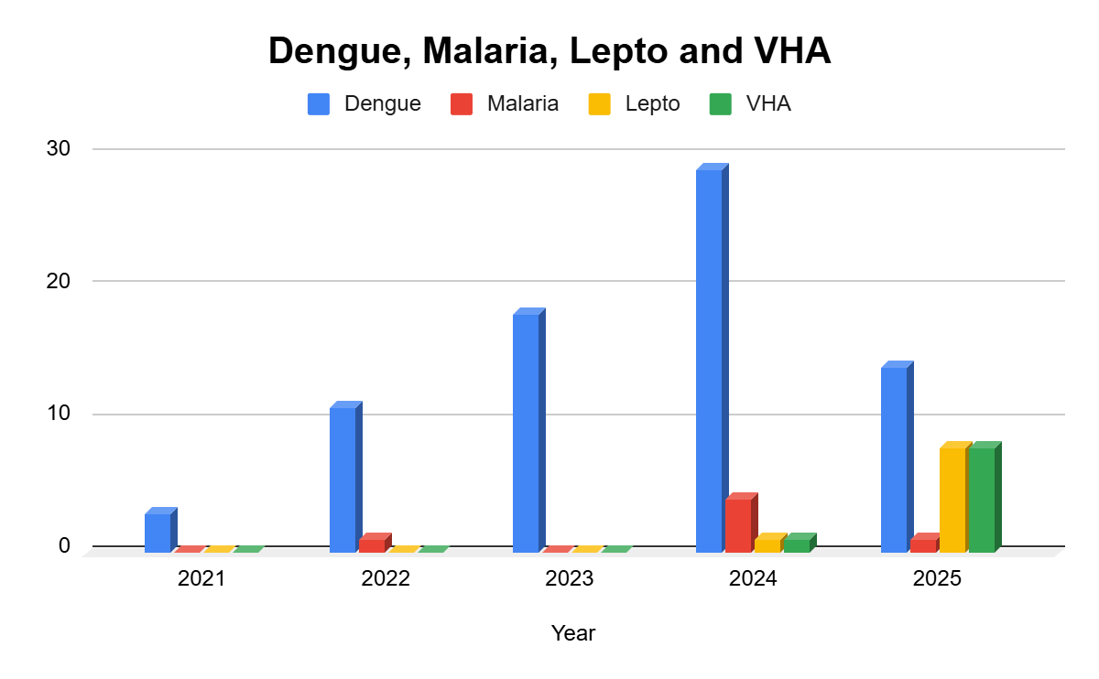

Transmission Trend- 2025
For effective management of public health issues, it is important to track the trend of disease transmission mode. It helps identify the population or place at high risk that can be used to predict outbreaks and implement targeted interventions as quickly as possible. Understanding these kinds of trends enables authorities to allocate resources efficiently and change the strategies adequately based on the trend that follows.
Mode of Transmission | No. of cases | No. of Deaths
Vector Borne Diseases | 13 | 0
Water Borne Diseases | 8 | 0
Air Borne Diseases | 7 | 1
Blood Borne Diseases | 5 | 0
Food Borne Diseases | 26 | 0

Vector-Borne Disease
Disease | No. of Cases | No. of Deaths
Dengue | 12 | 0
Malaria | 1 | 0
Chikungunya | 0 | 0

Water Borne Disease
Disease | No. of Cases | No. of Deaths
Cholera | 0 | 0
Typhoid | 0 | 0
Hep- A | 8 | 0
Dysentery | 0 | 0
Amoebiasis | 0 | 0
E- Coli infections | 0 | 0

Air Borne Disease
Disease | No. of Cases | No. of Deaths
Influenza | 9 | 0
H1N1 | 0 | 0
TB | 7 | 1
Chickenpox | 27 | 0
Measles | 0 | 0
Covid-19 | 0 | 0
Pertussis | 0 | 0
Mumps | 0 | 0

Blood-Borne Disease
Disease | No. of Cases | No. of Deaths
AIDS | 0 | 0
Hep- B | 2 | 2
Hep- C | 2 | 2

Zoonotic Disease
Disease | No. of Cases | No. of Deaths
Rabies | 0 | 0
Leptospirosis | 7 | 1
Avian influenza | 0 | 0
West nile | 0 | 0
Anthrax | 0 | 0
Nipah | 0 | 0
Scrub Typhus | 0 | 0

Integrated Disease Hotspot Map (2021–2025)

LSG Name | Dengue Total (2021-25) | Leptospirosis Total (2021-25) | Hepatitis A Total (2021-25) | Mumps (2021-25) | ADD (2021-25)
BHARANANGANAM | 75 | 8 | 9 | 0 | 452

By overlaying five years of data, we have identified 6,9,10,12,5.'Red Zone' Wards. These are wards where at least two different categories of diseases (e.g., Dengue and Lepto) recurred in consecutive years. Ward 6,9,10,12,5 is categorized as the Highest Priority Hotspot due to its high vector density.

Assessing Core Capacities
Key Points:
- Core Capacities:
  - Surveillance
  - Laboratory access
  - Clinical surge (beds, oxygen, ventilators, triage)
  - Supply chain
  - Risk communication
  - Logistics
  - Social support (volunteers, NGOs, welfare schemes)

Mapping of existing plans and committees
  - Committee Harmonization: A table mapping the members of the LSG Disaster Management Committee (LDMC) to their specific roles in the Pandemic Task Force.
  - HEOC Integration: A clear flow-chart showing how a local signal (at the Ward level) is communicated up to the District Health Emergency Operations Centre.
  - IDSP Liaison: Identification of the specific "Reporting Officer" responsible for sending daily data to the Integrated Disease Surveillance Programme.
  - SOP Adaptation: A list of COVID-19 protocols (e.g., dead body management, quarantine rules) that have been formally adopted and simplified for local language use.
  - Resource Sharing Agreements: Signed MOUs or documented protocols for sharing ambulances or equipment with neighboring LSGs during a surge.

Assessment of Core capacities
  - Clinical Triage Plan: A mapped pathway for how a patient moves from "Home Isolation" to a "Primary Health Centre" to a "District Hospital."
  - Oxygen & Life Support Log: A verified list of local oxygen cylinder suppliers, refilling stations, and the number of oxygen-supported beds available within 10km.
  - Laboratory Logistics: A schedule for sample collection and transport, including the contact details of the nearest designated testing lab and courier.
  - Supply Chain Buffer: A 30-day "Minimum Stock Level" (MSL) defined for essential medicines, masks, and sanitizers.
  - Volunteer Force (Kudumbashree/Arogyasena/NDRF): A registered database of "Trained Volunteers" categorized by skill (e.g., nursing, food preparation, data entry, driving)

Build & Organise critical capacities
  - Surveillance and data
  - Strengthen IDSP and event-based surveillance with clear reporting from PHCs, private facilities, labs, and LSGs.
  - Regular IDSP meetings
  - Monitor routing of IDSP meetings
  - Linelist OF non reporting institutions public and private,labs,LSGD
  - Lab turnover time
  - Define simple ward-level indicators (e.g., ILI clusters, mortality alerts) and SOPs for field verification and response.
  - ILI cluster and mortality alerts
  - Development of SOPs
  - Strengthen IDSP
  - Community-based surveillance
  - Vaccination coverage
  - Cold chain integrity
  - Risk communication
  - Community engagement-RRT, Kudumbhashree, one health
  - Community level meetings-neighbourhood, WHSNC,JAS,MASI .

- Vulnerable Groups:
  - High-density settlements
  - Migrant clusters
  - Major workplaces
  - Institutions
  - High-risk panchayats (based on past outbreaks/hazard mapping)
Visual:
- Use a two-column table or infographic: one side for capacities, one for vulnerable groups.

Governance & Structure
Key Points:
- Defining Roles:
  - From District Collector to ward-level volunteer
  - Use existing disaster management and LSG structures
- District Level:
  - Public Health Emergency & Pandemic Task Force under DDMA
  - Integrates health, revenue, LSG, police, animal husbandry, ICDS, education, transport
  - Incident management: trigger points, activation, reporting lines, decision authority
- Panchayat Level:
  - Formalize health vigilance committees (Arogya Jagratha Samithis)
  - Micro-define responsibilities: home isolation, surveillance, IEC, quarantine, essential services
Visual:
- Hierarchical flowchart showing governance from district to ward level
- Responsibility matrix for panchayat committees.

Planning Principles & Legal Considerations
Key Points:
- Principles:
  - Equity, gender, human rights, inclusiveness, coherence
  - Balancing rights, setting priorities, equitable access to life-saving measures
- Legal/Policy:
  - Legislative frameworks for health emergency preparedness
  - Roles and responsibilities (including technical advisory groups)
  - Compliance with International Health Regulations (2005)
  - Data sharing, research, and innovation policies
Visual:
- List with icons for each principle
- Policy framework diagram.

Plan Development & Approach
Key Points:
- Development Methods:
  - Planning committee terms of reference
  - Multisector/multilevel consultations
  - Analysis of existing systems
- Approach:
  - Needs-based, scalable, integrated, regularly updated
  - Indicators and milestones for preparedness
- Operational Stages:
  - Planning assumptions, funding, national/subnational considerations
Visual:
- Flow diagram of plan development steps
- Timeline or Gantt chart for operational stages.

State Systems & Emergency Coordination
Key Points:
- Emergency Coordination:
  - Integration with other emergency plans
  - Roles at all levels
  - Command-and-control structures
  - Multi-agency coordination
  - Emergency funding triggers and mechanisms
- Exercises & HR Surge:
  - Plans for cross-sector exercises
  - Methods to address skills shortages
  - Use of emergency medical teams
Visual:
- Organizational chart for emergency coordination
- Table for HR surge strategies.

Surveillance & Laboratory Systems
Key Points:
- Collaborative Surveillance:
  - One Health mechanisms, verification, alert teams
  - Data synthesis for action
- Laboratory Access:
  - Networks, specimen transport, biosafety, data integration
- Multi-source Data:
  - Hospital capacity, supply chain, infodemic monitoring, disaster risk data
Visual:
- Process flow for surveillance and lab systems
- Data integration diagram.

Community Protection & Communication
Key Points:
- Protection Mechanisms:
  - Infection prevention, vaccination, PPE, social welfare, essential services
- Communication:
  - Two-way mechanisms, community engagement, media outreach, language adaptation
- Misinformation:
  - Monitoring, resilience, scientific literacy
- Travel & Trade:
  - Risk communication for travellers, screening, quarantine, and essential travel management
Visual:
- Infographic for community protection strategies
- Communication flowchart.

Clinical Care & Essential Services
Key Points:
- Clinical Care:
  - Scaling facilities, diagnostics, case management, telemedicine, safe burials, waste management
- Essential Services:
  - Maintenance, workforce supplementation, monitoring, recovery
- Protection:
  - Infection control, WASH, health worker safety, sectoral roles
Visual:
- Table for clinical care pathways
- Diagram for essential services maintenance.

Access to Countermeasures
Key Points:
- Supplies & Stockpiles:
  - Essential supplies lists, rapid scaling, national/international stockpiles
- Regulatory & Supply Chains:
  - Regulatory frameworks, liability, upstream/downstream supply chains, R\&D environment
Visual:
- Supply chain flowchart
- Checklist for countermeasure access.

10. Plan Activation & Operational Triggers
Key Points:
- Activation:
  - Decision-making bodies, stakeholder roles, communication protocols
- Operational Stages:
  - Prevent & prepare, respond (contain, control, mitigate), recover (scale down, sustain)
Visual:
- Decision tree for plan activation
- Timeline for operational stages.

Health system surge
- Gap analysis for beds, oxygen, critical care, paediatric/obstetric care, and referral transport; pre-plan “expansion beds” using existing infrastructure.

- Specialized Care Audit: Identify the specific number of functional neonatal ventilators, pediatric ICU beds, and labor rooms that can be isolated for infectious obstetric cases.
- Oxygen Autonomy Calculation: Calculate the total "liters-per-minute" (LPM) capacity of local plants/concentrators versus a peak-load projection (e.g., if 5% of active cases need oxygen).
- Secondary Infrastructure Mapping: Create a floor plan for "Expansion Beds" in non-health facilities (hostels, auditoriums), ensuring they have separate entry/exit points for ambulances.
- Referral Transport Matrix: Categorize available vehicles into "Type A" (Basic) and "Type B" (Advanced Life Support/Oxygen), with pre-negotiated fuel-credit lines at local petrol pumps.
- Staff-to-Bed Ratio Analysis: Determine the "Surge Staffing" gap—how many extra nurses and respiratory therapists are needed to manage the expansion beds identified above.

- Standardize triage, cohorting, and IPC practices across levels using concise checklists and on-site mentoring
This ensures that the care provided is safe, standardized, and doesn't lead to "Super-Spreader" events within hospitals.
- Physical Cohorting Zones: Clearly demarcate healthcare facilities into "Green" (Non-COVID/Clean), "Yellow" (Suspected/Triage), and "Red" (Confirmed Infectious) zones.
- Triage "Door-to-Bed" Protocols: A concise 5-point checklist for the "Entry Gate" staff to sort patients by respiratory rate and oxygen saturation ($SpO_2$) within 3 minutes of arrival.
- On-Site Mentoring Roster: A schedule for "Shadow Training," where specialists from the District Hospital visit LSG clinics to provide hands-on training for ventilator use and PPE donning.
- IPC Compliance Checklists: A daily "Safety Walk" tool for supervisors to verify hand-hygiene stations, waste segregation, and environmental surface cleaning.
- Healthcare Worker Prophylaxis: A formal system to monitor the health, vaccination status, and mental well-being of the medical staff to prevent "burnout-induced" IPC lapses.

Supplies and logistics
- Pre-position essential PPE, diagnostics, and medicines based on realistic consumption norms; include local production options where feasible (e.g., masks, sanitizers).
- Consolidated Consumption Norms: Establish a "Per-Patient, Per-Day" consumption rate for PPE, oxygen, and antibiotics to prevent over-stocking or under-stocking.
- Local MSME/Self-Help Group (SHG) Registry: Pre-certify local tailoring units (like Kudumbashree) and chemical units to produce standardized masks and WHO-grade hand sanitizer.
- Diagnostics "Cold-Chain" Audit: Verify the storage capacity (refrigerators/freezers) for diagnostic kits at the LSG level to ensure reagents remain viable.
- Kit-Based Distribution: Create pre-packed "Home-Care Kits" (basic meds, masks, instructions) that can be dispatched immediately to households with positive cases.
- Emergency Procurement Bylaws: Formalize the legal framework that allows the local body to purchase supplies from local vendors during a "State of Emergency" without traditional 30-day tenders.

Map and formalize supply chains with contingency routes, framework agreements, and a simple inventory tracking format.
- Contingency Routing Maps: Identify "Plan B" transport routes for medical supplies in case primary roads are blocked by lockdowns, floods, or protests.
- Framework Agreements (Rate Contracts): Sign pre-fixed price agreements with vendors for the next 12–24 months to prevent "Price Gouging" during the height of a pandemic.
- Simplified Digital Ledger: Implement a "One-Page" inventory tracker (mobile-friendly) where local staff can log incoming and outgoing stock with a single click.
- Buffer Stock Trigger Points: Set "Re-Order Levels" (e.g., when stock hits 25% of capacity) that automatically alert the District Health Emergency Operations Centre.
- Last-Mile Volunteer Network: Identify a "Bicycle/Two-Wheeler Brigade" capable of delivering life-saving medicines to remote or high-density areas where ambulances cannot enter.

Preparedness and Response Protocol at District Level
This section describes the operational framework for the DISTRICT once a pandemic is declared. It explains how the DISTRICT and health system will move from routine data collection to active response, using a One Health approach.

Constitution of One Health Committee
The DISTRICT shall constitute a One Health Committee comprising the DISTRICT collector, Medical Officers (Modern Medicine, AYUSH, and Veterinary), the Health Inspector, and the Veterinary Surgeon.

Objective: The One Health Committee coordinates human, animal, and environmental health to prevent and control pandemics.

Sl No | Name | Designation | Department/Institution | Role in Committee | Contact Number
1 | SUDHA SHAJI | PANCHAYATH PRESIDENT | LSGD | Chairperson | 9496041691
2 | DR. BIJU JOHN | MEDICAL OFFICER(FHC/PHC) | Health Dept | Member Secretary | 6282068449
3 | DR. RIYAS | VETERINARY OFFICER | Animal Husbandry | Member | 9744662122
4 | MANOJ G | HEALTH SUPERVISOR | HEALTH DEPARTMENT | Member | 9605069422
5 | SHYNI MATHEW | HEALTH INSPECTOR/PHN | HEALTH DEPARTMENT | Member | 9495063482
6 | SANITH KUMAR | Fisheries Officer | FISHERIES DEPARTMENT | Member | 9495794505
7 | NA | Forest Officer | NA | Member | NA
8 |  | Food Safety Officer |  | Member | 8943346543
9 | REENA | LSGD SECRETARY | LSGD | Member | 9446627087
10 | MARIYA | ICDS SUPERVISOR | SOCIAL WELFARE | Member | 9946382347
11 | SALINS | Agriculture Officer | AGRICULTURE DEPARTMENT |  | 9447550026

Key Responsibilities:
- Review disease surveillance data (human + animal)
- Conduct ward-wise risk assessment and vulnerability mapping
- Approve quarantine/isolation centre locations
- Coordinate with district for resources (PPE, oxygen, ambulances)
- Periodically review health system surge capacity, including beds, oxygen, human resources, and ambulances.
- Approve and monitor risk communication and community engagement strategies, including rumour management.
- Ensure protection and service continuity for vulnerable groups (elderly, persons with disabilities, dialysis patients, coastal populations).
- Conduct quarterly mock drills
- Monitor equity measures for vulnerable groups

Meeting Schedule:
Quarterly (normal times) | Weekly (outbreak alert) | Daily (pandemic phase)

Pandemic Response Workforce
To ensure a coordinated and timely response during a pandemic, a dedicated Pandemic Response Workforce shall be constituted at the LSG level. The workforce will function under the overall supervision of the One Health Committee and in close coordination with the health authorities. Team-based deployment will enable efficient surveillance, case management, quarantine and isolation management, logistics support, and risk communication. Each team shall have a clearly designated team leader, defined roles, and an identified pool of personnel to allow rapid activation, rotation of duties, and continuity of services during prolonged emergencies.

Total Response Workforce Available: persons
Team Name | Composition | Key Responsibilities | Team Leader
Surveillance and Contact Tracing Team | HI, JHI, JPHN, ASHAs and Volunteers | Case detection, contact listing, home visits, reporting | HI
Case Management Team | Doctors, Nurses, MLSP, Palliative Nurses | Patient care & referral | DOCTOR
Quarantine & Isolation Team | DISTRICT staff, Volunteers | Facility management | JHI
Psychosocial support | DMHP team/School counsellors ICDS | Psychological first aid, Patient care & referral | Multidisciplinary team
Logistics & supply chain Team | DISTRICT staff, Storekeepers, Drivers 3 | Supplies & transport [PPE, medicines, oxygen, transport, waste management] | Ward Member
Communication Team | Ward members, Kudumbashree, Youth clubs,  AWW workers and other self help groups | IEC, community meetings, countering misinformation | M.O in charge
Transportation | KSRTC, educational institutional buses | Transportation | Linkage at the time of emergency
Media Surveillance | Youth club | IEC
Intersectoral coordination and convergence | LSGD | Community meetings,  coordination | Panchayath  President
Collaborative surveillance | LSGD |  | Panchayath  President

All teams shall be activated immediately upon outbreak alert or pandemic declaration and shall report daily to the LSG Incident Commander/Medical Officer, with consolidated reporting to the Block PHC. Duty rosters and alternate personnel shall be maintained to ensure uninterrupted services during staff shortages or prolonged response periods. Team composition and numbers may be revised based on the magnitude of the outbreak and availability of human resources.

Define governance, roles and structure
Clarify who leads what, from the district collector to the ward level volunteer, using existing disaster management and LSG structures.
• District level:
o Notify/strengthen a District Public Health Emergency & Pandemic Task Force under DDMA, integrating health, revenue, LSG, police, animal husbandry, ICDS, education and transport.
o Define incident management: trigger points, activation of HEOC/control room, reporting lines, decision-making authority, and linkages to state IRT/HEOC.
• Panchayat/ULB level:
o Re activate or formalise Arogya Jagratha Samithis/health vigilance committees as the local pandemic committee, chaired by the LSG president, with the MO PHC as convenor.
o Micro define responsibilities: home isolation support, community surveillance, IEC, quarantine support, and essential services continuity.

Activities and Measures before and during Pandemic

PHASE 1 - Alert / Preparation
Surveillance and Reporting-Enhanced syndromic surveillance:
- Data sources for surveillance:
- Event-based triggers (to be monitored and reported):
- Zoonotic and animal health surveillance
- Logistics and Stock Preparedness
  - Identify and empanel local vendors and define emergency procurement mechanisms in accordance with existing DISTRICT and Health Department norms.
  - Prepare and maintain an essential logistics checklist covering medical supplies, consumables, and support equipment.
  - Pre-identify secure storage locations for emergency stocks and ensure maintenance of stock registers with regular updating.
  - Finalise emergency transport arrangements, including availability of vehicles and identified drivers for rapid deployment during alerts.
  - Designate a Nodal Officer for Logistics to enable prompt decision-making, coordination, and communication during emergencies.
  - Conduct rapid stock verification and ensure availability of minimum buffer stock, including:
- PPE kits – numbers
- Pulse oximeters – ___ numbers
- Hand sanitizers – ___ litres
- Masks, gloves, disinfectants – adequate quantity
Identify critical logistics gaps and immediately communicate requirements to the Block and District authorities to ensure timely replenishment and support. Monitor expiry dates and stock rotation.

Identification of Quarantine and Isolation Facilities
  - Identify and list suitable buildings for quarantine and isolation (schools, hostels, community halls, etc.).
  - Categorise cases as per the severity and allocate to appropriate facilities (for instance, severe cases to classrooms, mild cases to an assembly hall in case of a school).
  - Facility readiness checklist needed (beds, toilets, ventilation, etc.
  - Find an alternate site if the primary sites are not available or not in use.
  - Identify facility managers and support staff
  - Prepare basic SOPs for:
    - Admission and discharge
    - Food, water, and sanitation
    - Infection prevention and waste disposal
  - Ensure availability of basic amenities: water, sanitation, electricity, ventilation, and waste disposal. Prepare a rapid activation plan for these facilities if case numbers increase.

Risk Communication and Community Preparedness
  - Disseminate early warning messages on symptoms, preventive measures, and reporting mechanisms. Display IEC materials both in English and the local language in public places and ensure ward-level awareness.
  - Sensitize elected representatives and community leaders on preparedness measures.
  - Establish a rumour tracking and misinformation response mechanism to identify, verify, and promptly counter false or misleading information.
  - Engage trusted local persons (ward members, ASHA workers, religious leaders, teachers, community volunteers) to communicate official public health messages and reinforce correct practices.
  - Develop and deploy targeted IEC materials for:
    - Schools and educational institutions
    - Markets and commercial areas
    - Work sites and labour settings
  - Conduct community sensitisation meetings at the ward level to promote preventive behaviours, address concerns, and strengthen community participation in preparedness and response.

Protection of Vulnerable Groups
Vulnerable populations require priority protection through targeted line-listing, service continuity, and delivery mechanisms.
- Prepare and regularly update line-lists of vulnerable populations, including:
  - Elderly persons living alone
  - Persons with disabilities
  - Pregnant women
  - Migrant workers
  - Dialysis patients
The detailed line-lists shall be maintained as Annexure ___ and updated periodically.

Clinical Dependency Mapping
Develop ward-wise dependency and vulnerability maps to identify households requiring regular support during emergencies. Ensure continuity of essential health services for vulnerable groups, including
- Dialysis services (facility mapping, transport arrangements, and scheduling)
- Continuity of treatment for TB, HIV, and other chronic conditions requiring uninterrupted medication
- Mental health and psychosocial support services
Establish delivery mechanisms for food, essential commodities, and medicines to vulnerable households through coordinated action involving ASHAs, JPHNs, Kudumbashree, volunteers, and local administration.

PHASE 2 - Active Response

Case Identification and Contact Tracing
Case detection and contact tracing activities will be carried out in coordination with the Health authorities, in accordance with disease-specific SOPs and IDSP guidelines.
Field Staff Involved
- Health Inspector (HI)
- Junior Health Inspector (JHI)
- Junior Public Health Nurse (JPHN)
- ASHAs and ASHA Supervisors
- Ward-level volunteers and Kudumbashree members (as required)

Screening Checkpoints
Screening checkpoints at high-traffic locations (transport hubs, markets, religious gatherings) for early detection of symptomatic travellers and crowd screening during outbreaks. Potential locations include bus stands, market entry points, and boat jetties, based on local context and risk assessment.
Screening activities will be carried out by trained personnel such as ASHAs, ward members, and volunteers, with support from Health Department staff. Necessary equipment, including non-contact thermometers and appropriate PPE, shall be ensured prior to activation.
Location | Type (Bus stand/Jetty/Market/Railway) | Staff Deployed (ASHAs/Volunteers) | Screening Method | Reporting authority
Bus stand | Transport hub | One JHI  One ASHA  One health Mentors | 1.Swab Collection.  2. Blood smears collection (RDT)  3.Thermal Scanners | Surveillance Nodal Officer in control room
Market entry | Market | One JHI  One ASHA  Male health volunteers | 1.Swab Collection.  2. Blood smears collection (RDT)  3.Thermal Scanners | Surveillance Nodal Officer in control room
Boat jetty | Water transport | One JHI  One ASHA  Male health volunteers | 1.Swab Collection.  2. Blood smears collection (RDT)  3.Thermal Scanners | Surveillance Nodal Officer in control room

Standard Screening Protocol

The screening protocol shall include temperature screening, observation for visible symptoms, and inquiry regarding recent travel or exposure history. Individuals identified as suspects during screening shall be immediately referred to the nearest PHC/FHC for further evaluation, testing, and appropriate action as per prevailing guidelines.

Pandemic Control Room
The Pandemic Control Room (PCR) serves as the central nerve center for real-time coordination, data aggregation, decision support, and communication during outbreaks. It consolidates information from all DISTRICT teams, health facilities, and community sources to enable rapid decision-making.

Control Room Infrastructure and Location
Primary Location: BHARANANGANAM Panchayath Office.
Backup Location: Community Hall in BHARANANGANAM G.P.

Health System Control Room Framework
The PCR is organised into seven functional pillars to ensure no aspect of the response is overlooked:
Rapid Response Team (RRT)
Provides immediate intervention during emergencies, clusters, and field alerts.​
Coordinates urgent actions such as case investigation, contact tracing, isolation, and inter-facility referrals.
Data Management & Analytics Team
Human Resource Deployment Team
Laboratory Surveillance Team
Vaccination Cell (If Required)
Infrastructure & Patient Occupancy Team
BMWM
Communication team
Logistics and supply chain
Transportation (interfacility & emergency transport)
Media surveillance Call centre
Management of the deceased
Intersectoral coordination and convergence
Surveillance committee
Sample transportation, testing,result management
Contact tracing, line list management
Patient transport management
Materials and logistics management
IEC , media management
Data analysis
Psychological support team
Intersectoral coordination
Field level activity monitoring
Infection control and training
Private hospital coordination
Welfare committee
Animal surveillance
Wildlife surveillance
Telemedicine
IT support

Key Control Room Team
The Control Room Team coordinates all pandemic response activities within the DISTRICT and serves as the single command and communication hub during activation. It integrates information, field actions, logistics, and policy execution across all participating departments and health facilities.

SOP for alert escalation/trigger point with mapping of responsibilities.
- The Control Room shall be staffed with a designated In-Charge, data entry personnel, and communication staff with clearly defined roles and shift arrangements.
- It shall maintain updated records on daily monitoring indicators including new cases, persons under active quarantine, and hospital bed occupancy.
- All reports and situation updates shall be shared daily with the Block and District Surveillance Unit.
- The Control Room shall act as a single point of contact for coordination with response teams, health institutions, and other departments.
- Contact details of the Control Room shall be widely communicated to field staff and stakeholders during activation.

CONTROL ROOM MANDATES
- Control room will be operational 24*7 managed by floor managers in rotation
- Control room access is authorised only to those engaged in control room activities
- Identity proof is mandatory
- In and out movement is written in log logbook
- Food items are not permitted inside the control room
- Team members of different groups have to work in their assigned areas
- Review meetings will be held in the mornings and evenings
- Minimum two members from all groups will participate in review meetings
- Critical appraisal of group activity will be done in the meetings
- The documentation team will record minutes of all meetings
- Decisions taken in the meeting will be communicated to the respective groups
- Implementation status of the decisions taken will be monitored
- Emergency meetings will be informed by phone to the respective teams by the documentation team
- The single window communication system will be operated by the documentation team
- All sub-teams communicate with the control room via their own email ID.
- All communications between the teams were coordinated through the control room.
- All communications are well documented.
- Advances in information technology are well utilised for communication
- Communication to the media will be done only through the media management team
- Health bulletin release at 6 pm
- A departmental coordination meeting at 6 pm
- Press briefing at 7 pm

ACTIVITIES OF VARIOUS TEAMS

Surveillance team

Hospital surveillance
- -The condition of the Symptomatic patients admitted at isolation wards of hospitals will be closely scrutinized, and reports will be updated to surveillance team
- -Analysis of the reports

Field surveillance
- Those patients discharged from hospitals will be monitored by field workers in their corresponding PHC area
- Those asymptomatic travellers/contacts in home isolation will also be monitored for 28 days by field workers, and reports will be sent to the DSO

Lab surveillance
- The DSO and District nodal officers entrusted for sample collection will inform to the lab surveillance team before sample collection
- Sample requisition forms will be scrutinised before sending to National Institute of Virology Pune/Alappuzha/designated labs
- Liaison with districts and sample collection point
- Support and supervise Surveillance activities at district level
- Establishing a support system with SMO (WHO), a mechanism for strengthening the IDSP disease surveillance system.
- Daily LSG-wise monitoring from state level
- Detailed data monitoring at IDSP district unit.
- Identifying areas for inter-sectoral action & steps for the same.

24 X 7 Call Centre management team
- To Set-Up
- A control room call centre should be set up in the state as well as the district. The call centre is set up with 3 laptops and 3 mobile/landline telephone facilities. Each Call Centre Operator is assigned both a telephone and a computer. One outgoing mobile facility is also available for answering pending calls. Two WhatsApp numbers are also available in the disaster control management room. Depending on the configuration of the call center, each workstation has the following items:
- Headset for hands-free answering;
- Reference materials (issued upon activation of call center operations);
- Item to be used to request assistance from the supervisor (Paper and pen/pencil, register etc)
- All phone/computer banks are set up in close proximity to power,telephone, and data sockets/ports.
- Call Center Supervisors are to utilize a sign-in/sign-out sheet to keep track of Call Center Operators.
MANDATES FOR CALL CENTRE
- Maintenance of discipline
- Time management
- Call centre will be operational 24*7
- Documentation of all the activities happening in call centre
- Daily consolidation report at 4.30 pm.
- Establishing call centre with sufficient connectivity
- Linkage with DISHA system
- To answer medical queries, logistics and administrative issues regarding health and health related problems
- Daily maintenance of second and third level call referral.
- Compilation format
Total number of calls till today | No: of calls on the date--/--/2020 | Total | Case follow up till today | Case reported on --/--/2020 | Total fever
- DISHA Calls ………………………………….

HR management
- Human resource management mostly happens at the district level but at any point if district needs any additional support the needs can be communicated to state.
- The team should have a thorough knowledge of all district HR distribution.
- The team should also communicate with the district regarding the optimum redistribution policies according to the needs.
- HR details of the isolation facilities should be managed and timely decisions at state level if necessary should be taken from the control room.
- The HR data of isolation facilities/nodal centres should be compiled on daily basis and ensure there is no shortage in any category.

Training and awareness generation
- The district should train all the necessary cohorts in a timely manner, and the data should be compiled at the state level. State team has the responsibility for preparing the training materials according to the daily needs being discussed in the control room meetings. These training materials should be vetted by a group of experts and should be disseminated via control room mail id to all concerned (districts, agencies, groups,IMA,IAP etc)
- Identify the segments in the Government and Private sectors
- Prepare segment-specific relevant modules
- Preparation of training manuals
- Dissemination of the prepared IEC materials including audiovisual aids/training materials to health workers/volunteers/public/media
- Preparation of FAQ’S and its answers
- Online / Telephonic trainings for district level officers/health workers/volunteers as and when required
- Training to call centre duty staff
- Team of Master trainers
- Conduct of training and demonstration sessions

- DATE:
Sl No | Segment | Subject | Place | Number of persons attended
 | Govt sector
 | Doctors | CPR | LALAM BLOCK PANCHAYATH HALL ,PRAVITHANAM | 16
 | Paramedical staff | CPR, DISASTERMANAGEMENT, ONE HEALTH | LALAM BLOCK PANCHAYATH HALL ,PRAVITHANAM | 80
 | Attendants | CPR, DISASTERMANAGEMENT, ONE HEALTH | LALAM BLOCK PANCHAYATH HALL ,PRAVITHANAM | 15
 | Private sector
 | Doctors
 | Paramedical Staff
 | Attendants
 | Others
 | ASHA | CPR, DISASTERMANAGEMENT, ONE HEALTH | CHC ULLANAD | 13
 | Line departments staff | ONEHEALTH | BHARANANGANAM PANCHAYATH HALL | 6
 | LSGD representatives | DISASTERMANAGEMENT, ONE HEALTH | BHARANANGANAM PANCHAYATH HALL | 15
 | Kudumbashree | DISASTERMANAGEMENT, ONE HEALTH | BHARANANGANAM PANCHAYATH HALL | 97
 | Anganwadi Teachers | DISASTERMANAGEMENT, ONE HEALTH | BHARANANGANAM PANCHAYATH HALL | 20
 | Ambulance Drivers | DISASTERMANAGEMENT, ONE HEALTH | BHARANANGANAM PANCHAYATH HALL | 6

Material management team
- Material management should be done at the institution level using all possible resources under the control of the superintendent; however, there might be a higher degree of needs arising in certain situations. The district and state has a mechanism of supporting these institutions according to the arising needs. The needs and activities should be compiled in the districts and coordinated with the state team/KMSCL. The state team is expected to compile the activities and challenges on a day-to-day basis and present at the control cell meeting, including the following details.
- DATE : INSTITUTION:
Sl No | Items | Opening stock | Distribution | Balance
- The primary responsibilities of the material management team are:
- Prepare the list of items required at the Hospital for providing health care
- Monitor inventory position institution-wise wise
- Ensure the supply chain management of healthcare and other items requirement
Infrastructure (isolation ward and facilities) management team
- Identify an isolation place in each district for at least for 50 patients
- Ensure all the required things in the isolation ward of these facilities
- Set up a dedicated team in each district
- Train the dedicated team and other health functionaries
- Ensure that strict protocol of infection control is followed in each district
- Identify spatially all the field units fever clinics arrangements done in all districts
- Ensure and compile the referral of contacts from field/call centres /DISHA to isolation facilities in the district
- Verify and compile the needs of additional isolation place if the number is increasing in each district
- The data should be collected in the following format at the district level and compiled at the state level
- DATE INSTITUION
Sl No |  | Describe and give data
 | Whether isolation ward identified and all required things are set up | nil
 | Whether the specific teams have been identified and trained  Number of Doctors  Number of Paramedical staff  Number of Attendants | nil
 | Whether stand by team identified and trained  Number of Doctors  Number of Paramedical Staff  Number of Attendants | nil
 | Duty roster prepared | nil
 | Whether all inventory is ensured | nil
 | Number of beds | nil
 | Number of Patients admitted and their details | nil
 | Infection control measures taken  Details | NA
 | Bio medical waste disposal mechanism from Isolation ward | NA
 | Institution requirements details | NIL

Media Surveillance team
- Print, visual and social media surveillance with the support of State and District team.
- Collection of information regarding demand and supply of logistics, Human resources etc. circulated in the media, and addressing the needs by bridging the gaps after validating the information.
- Surveillance of issues regarding 2019-nCoV disease circulating in the media.
- Validating the information collected from the media for negative outcomes and execute timely preventive and control measures.
- Reply queries to the general public regarding health related events and information through phone numbers circulated at the state level.
- District level compilation of media surveillance data should also happen timely
- Reporting format of cyber space monitoring

Sl no : | Description | Details
1 | Whether any misinformation noticed | 0
2 | Misinformation noticed  Give details in brief | 0
3 | Whether reported to take action and case booked | 0
4 | Cases booked today | 0
5 | Total cases Booked till today | 0

SAMPLE TRACING Team
- The team should keep a watch on sample sent to each lab(NIV pune/Alappuzha) from all districts and answer all queries regarding the sending of samples in coordination with the PH lab.
- The team should hand hold the district in transportation of samples, filling formats, collecting reports and intimate the authorities regarding the status of results Monitor sample collection and facilitate
- All sample test results to be reported to the respective Superintendent of MCH, District Collector, DHS, DME and Prl Secretary on daily basis

- DATE

Sl No | Description | Number | Results received | Positive
1 | Total Sample Collected  Blood  Urine  Throat Swab | 3  0  0  1
2 | Samples sent to Alpy NIV  Blood  Urine  Throat swab | 2 stool sample  0  0  0
3 | Samples sent to Manipal Laboratory  Blood  Urine  Throat swab  CSF | 0  0  0  0  0
4 | Samples sent to NIV Pune  Blood  Urine  Throat Swab  CSF | 0  0  0  0  0
IEC/BCC and Media Management team
- Preparation of IEC materials related to the preventive and promotive activities to be done at the field level for the management of 2019-nCov disease spread, decrease the anxiety of the general public and to disseminate factual information regarding the disease
- Dissemination of same in PRD, TV channels , AIR , social media etc
- Timely updating of website with regard to IEC
- Preparation of daily reports for media
- Arrangements of press conferences as per direction
- To act as media spokesperson for DHS
- Review format
Press note | YES
Press brief | YES
Social media dissemination content | YES

Documentation team
- Document all meetings related to 2019-nCov disease management at Minister, Principal Secretary and DHS level
- Ensure proper communication of all decisions to district’s and Public health institutions for implementation of the decisions made in meetings
- Proper communication to various teams of the control room regarding meetings, guidelines, SOPs, etc.
- Communication to the concerned teams for website and social media updates.
- Daily compilation of activity reports by various teams
Private hospital surveillance team
- Team should compile the data regarding the general public visiting private hospitals from all districts and suspect and identify any missed out contacts of contacts reaching the facilities.
- Good rapport should be ensured with the private hospitals/associations
- Reporting format
 | Cumulative
Number of persons visited private hospitals /DAY | 520
Suspected cases/contacts identified from Jan 15 2020 onwards | 1241

Expert study coordination team
- They should work with NHM admin and arrange and facilitate the visits of expert agencies provided they are coming with
- Approval from the head of the institution
- Letter to the principal secretary, health and family welfare for the sanction of the same
- Their own logistical support
- Should be ready to give their input regarding the present scenario and work with the current state and district team
- The team should brief the principal secretary health and family welfare regarding the feasibility, pros and cons of approval in each case after studying their back grounds.

Sl no |  | Details
1 | Expert / Expert Group  Institution  Govt or private
2 | Names:
3 | Activities undertaken

Transportation and ambulance management team
- The teams should compile data on ambulance driver training, availability, and spacing, as well as on vehicles carrying patients from home isolation to hospital isolation facilities and back. It should be ensured that there should be continuous availability of vehicles 24 x 7 in all districts. The data should be compiled in the following format in all districts.All possible challenges at the district should be addressed there itself, and decisions taken at the state level could be compiled and addressed during the control room presentation.
Sl no | Vehicle number | Driver | From | To | Post trip sanitization
1 | KL-35 K 1284

Inter departmental and coordination team
- There should be regular connections with all line departments like LSGD, Animal husbandry, tourism , police, kudumbasree, Suchitwa mission etc

Community level volunteer coordination team
- The field level activity monitoring should be done by this team.
- Grass route level support including food kit management when more people are at quarantine should also be done with the help of kudumbasree , and senior consultant ASHA program in NHM should review these activities and gaps on a daily basis and present it at control room meetings.
- Collect information of Contacts and addresses
- Prepare the food kits to provide to the Contacts in Home Quarantine
- Reporting format
Sl No | Description | Details
1 | Number of Contacts under Home Quarantine | 0
2 | Number of Kits prepared and provided to Homes where contact is quarantine | 0
3 | Kits stock | 0
4 | Kits distribution | 0
5 | Kits balance | 0

Psychological support team
- The team should arrange a district /field team for managing posttraumatic stress-related events and stress during quarantine. The field-level activities should be compiled and presented during daily control room meeting

Data management
- Stat wing should utilise all Google tools to compile all the above data formats and assist the presentation of teams in the daily control room meeting.
- The technical support of MIS manager NHM should be utilized in the same.
- For all these parameters district district-specific sheets with auto-consolidated compilation sheets should be made
- The sheets should be dynamic, and compilation should be given access to all state team leaders, SMD and the principal secretary.
- Districts should be supported for a timely update in the sheet in the specified format

Finance and budgeting team
- The state team for finance should discuss and foresee various areas of fund requirement and pool resources for all possible needs arising from time to time.
- The decision regarding fund expenditure and necessary AS should be prepared timely so as not hinder any processes happening in the state and districts

Sl no | Name of team | Team Leader | Members
 | Over all coordination
1 | Surveillance team | Medical Officer | Public Health Wing
2 | Call Centre management team | PRO | Data Manager
3 | HR management
4 | Training and awareness generation
5 | Material management team
6 | Infrastructure (isolation ward and facilities) management team
7 | Sample Tracing team
8 | Media Surveillance team
9 | IEC/BCC and Media Management team
10 | Documentation team
11 | Private hospital surveillance team
12 | Expert study coordination team
13 | Transportation and ambulance management team
14 | Inter departmental and coordination team
15 | Community level volunteer coordination team
16 | Psychological support team
17 | Data Compilation
18 | Budget and financing

Daily Monitoring Indicators
To ensure timely decision-making and effective response, the following key indicators shall be monitored and updated on a daily basis by the Pandemic Control Room:

Epidemiological Indicators:
New cases reported today, Total active cases, Test Positivity Rate (TPR), Case Fatality Rate (CFR)
- Surveillance Indicators:
Persons under home quarantine, High-risk contacts identified, Fever, ILI, SARI or other symptoms (syndromic surges), Travellers (symptomatic or high-risk arrivals),Animal husbandry surveillance (zoonotic alerts, unusual animal deaths, poultry/bird flu signals), Mortality surveillance (excess deaths, unexplained fatalities, verbal autopsy reports)
- Logistics and Infrastructure Indicators:
Hospital / CFLTC beds occupied, Oxygen cylinders/concentrators available, Ambulances on standby
- Alert Findings
The following table outlines category-specific trigger points (red flags) from surveillance indicators and corresponding immediate actions for the Pandemic Control Room. These enable rapid response to alert findings like testing anomalies, positive cases exceeding thresholds, clusters, and WGS reports.

Category | Trigger Pophint (Red Flag) | Immediate Action
Clusters | Geographical or facility-based: 5+ cases linked to one location (office, school, street). | Declare a micro-containment zone; perimeter control and active case finding.
Testing | Sudden drop in testing volume / delay in reporting / unusual testing trends | Review the sample collection process, address lab bottlenecks, deploy additional testing teams, and notify the District Lab.
Lab | Test Positivity rate increases | Increase testing sites in that ward.
Hospital | >80% Oxygen bed occupancy | Activate backup/CFLTC beds.
Travel | Cluster of cases from a single flight/train or high-risk arrival group. | Trace all passengers in adjacent seats; implement mandatory institutional quarantine.
Animal | Mass poultry/wildlife death or unusual sickness | Notify Animal Husbandry, sample the area, and dispatch RRT for environmental sampling and zoonotic check.
Mortality | Sudden spike in home deaths or brought-in-dead (BID) cases | Audit the deaths and Active Case Search drive
Additional investigations like Whole Genome Sequencing (WGS) | Detection of a Variant of Concern (VOC) or Variant of Interest (VOI) | Implement strict micro-containment; update clinical protocols to match variant severity.

Communication of Public Health Information
A Community Communication Hub shall be established to ensure the timely, accurate, and consistent dissemination of information during a pandemic. The Hub will operate under the coordination of the control room's Nodal officers and serve as the nodal point for public communication, risk messaging, and community engagement. It will support the dissemination of official advisories, promote preventive behaviours, address rumours and misinformation, and ensure that messages reach all sections of the population through trusted local channels and leaders.

Key communicators
Channel | Responsible Person | Contact
LSG-level announcements | HEALTH INSPECTOR | 9495063482
Social media | PRO | 9747211503
Local Cable TV/Radio | PRO | 9747211503

- All messages disseminated through the Hub shall align with advisories issued by the Health Department and District authorities.
- Community leaders shall be sensitized to support behavior change, reduce stigma, and counter misinformation.
- Special efforts shall be made to reach vulnerable and hard-to-reach populations using locally appropriate communication methods.

Rumor Tracking: A designated volunteer will monitor local social media/WhatsApp groups daily to identify misinformation and issue official clarifications via the Communication Hub.

Coordination with District/State Authorities & Other Organisations
Effective coordination with Block, District, and State authorities is essential to ensure timely reporting, technical guidance, and uninterrupted supply of essential resources during a pandemic. The LSG shall establish clear communication channels, designate responsible officers, and adhere to prescribed reporting timelines to support coordinated public health action and efficient resource mobilisation.

Key Details:
- Nodal Officer for Reporting:
- Contact Number:
Reporting Schedule and Protocols:

To Whom | What to Report | Frequency | Nodal Person
Block PHC | Complete Situation Report (Cases, Quarantine, Beds, Screening, Deaths) | DAILY | NURSING OFFICER
District IDSP Unit | Outbreaks/Clusters/Unusual Events (>5 cases same ward)
Veterinary Officer | Animal health events/Zoonotic alerts |  | Veterinary SURGEN
State Cell | Zoonotic cross-sector events

Supply Chain Coordination
The LSG shall coordinate closely with Block, District, and State authorities (KMSCL) to ensure uninterrupted availability of essential goods, medical supplies, and logistics during a pandemic. Supply requirements shall be assessed regularly based on case load and communicated promptly to the appropriate authorities for timely replenishment.

Key Points:
- Maintain updated contact details of District and Block nodal officers for health logistics, oxygen supply, ambulances, and essential medicines.
- Submit timely indent requests for PPE, testing kits, medicines, oxygen, and other critical supplies through prescribed channels.
- Monitor stock levels at DISTRICT facilities, quarantine/isolation centres, and field teams through daily stock registers and dispensing logs to prevent shortages.
- Coordinate with District authorities, Karunya/Neethi medical shops, and local purchase committees for funds allocation and emergency procurement.

- Ensure regular monitoring of dispensing registers at all facilities to track usage, expiry, and pilferage—shortages being a perennial issue requiring proactive weekly audits.

- Activate surge procurement protocols during high caseloads, leveraging local purchase powers under DISTRICT funds alongside state supplies.

Resource Inventory and Contacts
Resource Category | Source  (District/State/Private) | Contact
PPE Kits/Masks/Gloves | KMSCL | 0481- 2562401
PPE Kits/Masks/Gloves | Local Vendors | 9961215230
Oxygen  Cylinders/Concentrators | KMSCL | 9605777271
Medicines/Antivirals | KMSCL | 0481-2562401
Medicines/Antivirals | Karunya, Janaushadhi | 9961215230
Test Kits (RTPCR/Rapid) | KMSCL | 0481-2562401

Collaboration with NGOs, PPP, and CSR
To augment government efforts during a pandemic, the LSG shall collaborate with NGOs, voluntary organisations, and private sector partners through public–private partnerships and Corporate Social Responsibility (CSR) initiatives, in coordination with District authorities.
Key Points:
- Engage NGOs and community-based organisations for community outreach, awareness, and support to vulnerable populations.
- Leverage CSR support for procurement of medical equipment, PPE, oxygen concentrators, food kits, and sanitation materials, as permitted.
- Ensure all collaborations align with government guidelines and are routed through approved administrative and financial procedures.
- Maintain transparency and documentation for all external support received and utilised.
Organization | Type | Support Offered | Contact Person
Youth Clubs/Student Unions | CBO

Interdepartmental Coordination
Coordination among departments during a pandemic shall be ensured through regular review meetings convened by the DISTRICT President. These meetings will provide a structured platform for sharing situational updates, assessing resource availability, resolving operational gaps, and taking joint decisions to ensure a coordinated and timely response.

Department | Representative | Key Role | Contact
Health (PHC) | Staff Nurse : | Case management | 9961395671
Veterinary | Veterinary Surgeon: | Animal surveillance | 9744662122
ICDS | Supervisor: Sindhu | Nutrition support | 9946382347
Education | Head Teacher: | School coordination
Police | Sunil Thomas | Containment enforcement | 9497987080
Water Authority | PALA | Water supply | 9847318046
DISTRICT Engineering |  | Quarantine infrastructure

PHASE 3 - Surge Capacity
Phase 3 is activated when there is a rapid increase in cases, high test positivity rates, or when existing health facilities and quarantine arrangements approach saturation. The focus of this phase is to expand isolation capacity, augment clinical care services, and mobilise additional resources through district and state support mechanisms.

Conversion of Community Facilities
To manage increased case load, the DISTRICT shall activate additional isolation facilities by repurposing identified community infrastructure such as community halls, auditoriums, schools, hostels, or other suitable buildings.

Name of facility | Facility Type | No. of Buildings | Ward | Surge Capacity (Beds) | Nodal Person

Recovery and rehabilitation phase
- Recovery
  - Damage & impact assessment
  - Restoration of health services
  - Rehabilitation of affected population
  - Psychosocial & mental health support
  - Disease surveillance during recovery phase
  - Environmental cleanup & sanitation
  - Livelihood restoration
  - Community engagement & confidence building
  - Documentation & after-action review
  - Lessons learned & best practices
  - Health system strengthening
  - Policy revision & preparedness enhancement
  - Research

CONCLUSION

Additional points
- tech support
- relief based commodities
- ham reading operators
- hazard vulnerability mapping
- Kseb & other power source
- HR specific responsibility

RECOMMENDATIONS

Strengthening Healthcare Infrastructure
- Establish a primary health response unit within the Panchayat with trained staff.
- Ensure availability of basic medical supplies (masks, sanitizers, PPE kits, oxygen cylinders).
- Create tie-ups with nearby hospitals in ____________ for emergency referral and transport.

2. Community Awareness & Education
- Conduct regular awareness campaigns on hygiene, vaccination, and preventive measures.
- Use local communication channels (community radio, WhatsApp groups, notice boards) to spread verified information.
- Train volunteers to act as health ambassadors in each ward.

3. Emergency Response & Coordination
- Form a Pandemic Preparedness Committee at Panchayat level including health workers, ward members, and NGOs.
- Develop a clear action plan for lockdowns, quarantine, and distribution of essentials.
- Maintain a database of vulnerable groups (elderly, differently-abled, chronically ill) for targeted support.

4. Supply Chain & Food Security
- Identify and support local suppliers and farmers to ensure uninterrupted food supply.
- Create community kitchens during emergencies to serve vulnerable populations.
- Stockpile essential commodities in Panchayat-run outlets for crisis periods.

5. Digital Preparedness
- Promote digital platforms for telemedicine consultations.
- Use Panchayat’s website/social media for real-time updates on health advisories.
- Encourage online grievance redressal to reduce crowding in offices.

6. Training & Capacity Building
- Organize mock drills for pandemic response in schools, offices, and public spaces.
- Train Panchayat staff and volunteers in first aid, infection control, and crowd management.
- Collaborate with NGOs and health departments for capacity-building workshops.

7. Long-Term Resilience
- Integrate pandemic preparedness into the Panchayat Development Plan.
- Allocate a dedicated budget for health emergencies.
- Encourage community participation in planning and monitoring preparedness measures.

MOCKDRILL SCENARIOS

Mock Drill Scenario: Leptospirosis Outbreak at CHC Ullanad
A mock drill is conducted at Community Health Centre Ullanad to simulate a sudden increase in Leptospirosis cases following heavy monsoon rainfall and flooding in the surrounding rural areas. Several residents from nearby wards arrive at the casualty department with complaints of high fever, severe muscle pain, headache, and vomiting after exposure to floodwater during agricultural and cleaning activities. Within a short period, the medical officer on duty notices a cluster of suspected leptospirosis cases and activates the outbreak response protocol. The triage team immediately isolates suspected patients, records travel and exposure history, and initiates preliminary management including hydration and empirical antibiotic therapy as per state guidelines.
Simultaneously, the surveillance team alerts the block medical office and the district surveillance unit through the Integrated Disease Surveillance Programme reporting system. Rapid response team members mobilize for field investigation, collecting blood samples for laboratory confirmation and conducting active case search in the affected wards. Health inspectors coordinate with local self-government authorities to identify contaminated water sources, improve drainage, and initiate rodent control measures. Public health nurses begin community awareness activities, educating residents about avoiding contact with stagnant water, wearing protective footwear, and seeking early medical care for fever. The mock drill also tests the availability of essential medicines, personal protective equipment, laboratory sample transport, patient referral systems to higher facilities if complications such as renal failure or pulmonary involvement occur, and the efficiency of interdepartmental communication during the outbreak response.
At the end of the exercise, a debriefing session is conducted with all participating staff to review the response timeline, identify gaps in triage, reporting, logistics, and community outreach, and recommend improvements to strengthen preparedness for a real leptospirosis outbreak in the Ullanad area.

Communication

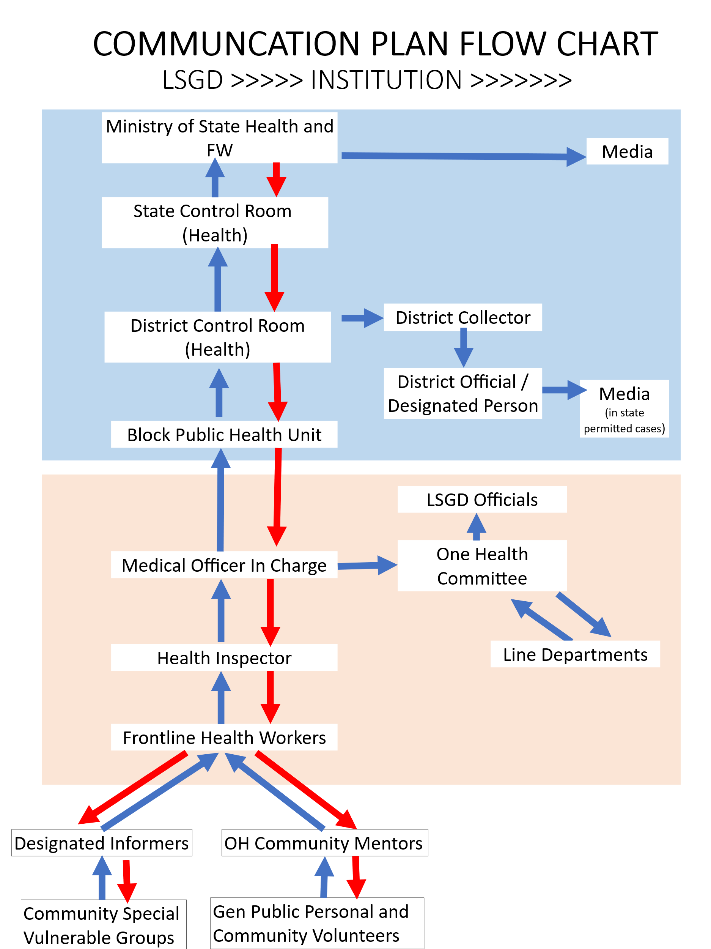

Communication strategies
- Ward level RRTs, Grama sabhas and Vulnerability groups have active participation in preparing and executing the pandemic plan (to identify unique issues, prevention, preparedness, response, recovery).
- Local community leaders involvement
- Special trained informers in Vulnerability groups
- multilingual workers
- NGOs and Resident Associations
- Simple reporting system for public – IHIP or other application – a snap pic reporting, messages
- Home Isolation Monitoring members from the public
- Ward level RRTs, Grama sabhas and Vulnerability groups have active participation in preparing and executing the pandemic plan (to identify unique issues, prevention, preparedness, response, recovery).
- Local community leaders involvement
- Special trained informers in Vulnerability groups
- multilingual workers
- NGOs and Resident Associations
- Simple reporting system for public – IHIP or other application – a snap pic reporting, messages
- Home Isolation Monitoring members from public

Benefits
- Sustainability: Solutions are more likely to last because they are locally owned.Faster
- Response: Local networks provide quicker initial responses.
- Trust & Collaboration: Builds bridges between communities and external agencies.

Pandemic Preparedness Capacity Building & Training Plan

Background & Rationale
- Pandemics pose serious threats to public health, safety, and livelihoods.
- Preparedness requires skilled human resources across sectors.
- Capacity building ensures coordinated, timely, and effective response.
- District-level preparedness is critical for early containment.

Objectives of Capacity Building
- Strengthen readiness of health and allied sectors.
- Improve early detection, reporting, and response.
- Ensure inter-departmental coordination.
- Protect frontline workers and the community.
- Maintain essential services during pandemics.

Target Groups for Training
Health Sector (Government & Private)
- Doctors (all specialties)
- Nurses & paramedical staff
- Laboratory technicians
- Public health staff
- ASHA workers & JPHNs
- Private hospital staff
Police & Emergency Services
- Kerala Police & Traffic Police
- Home Guards
- Fire & Rescue Services
- Ambulance drivers & EMTs
- Roles: crowd control, quarantine enforcement, emergency response

Local Administration & Governance
- District administration
- Municipalities & Panchayats
- Revenue Department
- Public Works Department
- Roles: logistics, containment zones, essential services

Education & Community Groups
- School & college teachers
- Students & NSS/NCC volunteers
- Kudumbashree units
- Community-based organizations
- Religious & community leaders

Modes and Methods of Training
Modes of Training
- Classroom/workshop-based training
- On-site/hands-on training
- Online & virtual training modules
- Simulation exercises & mock drills
- Peer learning & cascade training
- Awareness campaigns
- Online media and social groups

Training Methods
- Lectures & interactive sessions
- Demonstrations & skill stations
- Case studies & role plays
- Table-top exercises
- IEC material & SOP dissemination

Key Training Topics
General Topics
- Disease surveillance & reporting
- Infection prevention & control (IPC)
- Use of personal protective equipment (PPE)
- Sample collection & transport
- Risk communication & community engagement

Advanced & Sector-Specific Topics
- Hospital surge capacity management
- Quarantine & isolation management
- Psychosocial care & stress management
- Waste management during pandemics
- Law & order and ethical issues

Institutional & Resource Support
- District Medical Office
- Kerala Health Services
- State Disaster Management Authority
- Medical colleges & training institutes
- Police Training College

Monitoring & Evaluation
- Pre- and post-training assessment
- Feedback mechanisms
- Periodic refresher trainings
- Mock drill evaluations
- Documentation & reporting

Training Schedule (by Quarter)
 | Jan-Mar | Apr-Jun | Jul-Sept | Oct-Dec
Climate events | Cool | Hot | Rainy, Flood | Cold
Disease events | ILI | HRI, Hep A | Avian, Deng
Training for HCWs
Training for Public
Budgeting
Monitoring & E
- The schedule aligns training and preparedness activities with seasonal climate and disease patterns.
Expected Outcomes
- Improved district-level preparedness
- Skilled and confident workforce
- Effective inter-sectoral coordination
- Reduced morbidity and mortality

13. Conclusion
A comprehensive communication and capacity-building plan is vital for effective pandemic preparedness and response. Community engagement, targeted training, and continuous evaluation ensure resilience and sustainability in managing public health emergencies.

ANNEXURE

IMPORTANT PHONE NUMBERS

Phone numbers and particulars of persons responsible for providing guidance, assistance, and support for pandemic preparedness operations may be provided here in a manner that allows easy reference at a glance. The information recorded here could be exhibited elsewhere at the time of emergencies. LSG institutions shall give special attention to collect and record the above data of persons and institutions who/which are supposed to give technical and co-ordination support to reduce the impact of pandemic.

1.1. Details of LSGs
Sl.No | Name of the LSG | Name of the President | Contact number
1 | BHARANANGANAM | SUDHA SHAJI | 9745585496

1.2. Other important phone numbers of grama panchayat/municipality/corporation area
Sl. No. | Name | Contact number
1. | SECRETARY BHARANANGANAM GRAMAPANCHAYATH | 9446627087

1.3. Important offices of grama panchayat/municipality/ corporation
Sl.No | Name of the office | Contact person | Contact number
1. | Village Office | Village Officer | 8547612615
2. | Agriculture Office | Agriculture Officer | 9447550026
3. | Animal Husbandry Office | Animal Husbandry Doctor | 9744662122
4. | Police Station | Police Officer | 04822-212334
5. | BSNL Office | Officer | 04822-246500
6. | Block Office | Officer | 04822-246980
7. | KSEB Office | Officer | 04822-247000
8. | Fisheries Office | Officer | 9495794505
9. | Fire and Rescue | Officer | 04822-212484

1.4. Health Services
Sl. No | Name of the hospital/institution | Location | Phone number
1. | Government hospitals/PHC | CHC ULLANADU | 04822-247343
2. | Private hospitals | IHM BHARANANGANAM | 9447392639
3. | Clinical laboratories
4. | Chemist/pharmacy
5. | Blood donors | Panchayat
6. | Other language experts (Bihari, Hindi, Bengali,  Asamees ………)
1.5. Veterinary Services
Sl.No | Name of the Clinic | Name of the  Surgeon/Doctor | Place/location | Phone  number
1 | Govt.Veterinary Hospital | DR.RIYAS | ULLANADU | 9744662122

1.6. Helpline numbers
Helpline | Phone number
Police | 100
Fire and Rescue | 101
KSEB | 1912

1.7. Public and Private Schools Contact details
S.No | Name of School | Institution type | Phone number
1 | Glps Edappady | Department Of Education | 9495706503
2 | St. Mary's Hss | Govt Aided | 9447040653
3 | Alphonsa Res School Bharananganam | Private Unaided | 9497547246
4 | Glps Kayyoor | Department Of Education | 8547590692
5 | Slt Lps Bharananganam | Govt Aided | 9562881737
6 | Sh Ups Ullanadu | Govt Aided | 9605844339
7 | Sanjos Public School | Private Unaided | 9447120244
8 | Shghs Bharananganam | Govt Aided | 7907761291
9 | Christhu Jyothi Ems Kayyoor | Private Unaided | 7902459614
10 | Gups Alanadu | Department Of Education | 9496132441
11 | St.josephs Lps Vezhanganam | Govt Aided | 9605261150
12 | St. Mary's Boys Hs Bharananganam | Govt Aided | 9496804175
13 | LITTLE THRESIC ENGLISH MEDIUM BHARANANGANAM | Private Unaided | 9747330553

1.9. Anganwadi Contact Details
Ward No | Name of Anganwadi Teachers | Phone number
1 | GIRIGAMOL | 9495658034
 | MANJUSHA | 9020252492
 | SINDHUMOL P B | 9495617690
2 | INDIRAMMA P S | 9745050682
3 | RATHIKA M P V | 8606136068
3 | SUGUNAMMA V T | 9562126168
4 | BINUMOL K K | 9447674057
4 | ANU K APPU | 9961566924
5 | ANITHA BIJU | 8943661259
6 | JAYAMOL G | 9605829508
6 | SUNIMOL KURUVILA | 9947369233
7 | - REEJA C R | 9747985670
7 | 2. SREEJA E G | 9526577295
8 | MINIMOL C A | 9961603236
9 | - JOLLY SEBASTIAN | 9961307737
10 | MARY MATHEW | 9947031126
11 | SUNI SABU | 7902962442
12 | 1.JYOTHI C NAIR | 8086213080
12 | 2.JINCY THOMAS | 9446822319
13 | ANITHA C R | 6235207480

1.12. Information regarding resources

Means of transportation | Name of Owner | Phone Number
Heavy Trucks | TOMY PORIYATH
Tractor | Nil
Ambulances | IHM HOSPITAL - 9447392639
Boats | NIL
Taxi service | RATHEESH -9947213635

Annexure 1: LSG Baseline Data Collection Format

A. Baseline data

Sl. No. | Indicator / Field | Baseline Data | Source / Remarks
1 | Name of LSG | BHARANANGANAM
2 | District | KOTTAYAM
3 | Block / Taluk | LALAM /MEENACHIL
4 | Type of LSG (Gram Panchayat / Municipality / Corporation) | Gramapanchayath
5 | Area (sq. km) | 27.04 sq.km
6 | No. of wards | 14
7 | GIS boundary file available | (Yes/No)yes
8 | Key contact person & phone | Panchayat Secretary  9446627087

B. Demography

Indicator / Field | Baseline Data | Source / Remarks
Total population | 17057
Males | 8453
Females | 8603
Transgender population | 1
Age distribution  (<5, 5–14, 15–59, ≥60) | 661(<5),(≥60)2389
No. of households | 4258
Population density (persons/sq.km) | 630.80
No. of migrant workers | 492
Major occupational groups | Cooli Workers

C. Vulnerable Populations & Social Risks

Sl. No. | Indicator / Field | Baseline Data (Value / Description) | Source / Remarks
1 | No. of elderly (≥60) | 2389
2 | No. of persons with disability | 16
3 | No. of bedridden persons | 53
4 | No. of chronic disease cases (DM/HTN/COPD/CKD etc.) | 3599
5 | Pregnant women (current estimate) | 56
6 | Children <5 years | 698
7 | Tribal population (if any) | 63
8 | Fisherfolk / coastal vulnerable groups (if any) | Nil
9 | Urban slums / unnotified settlements (if any) | Nil
10 | Homeless population | 4
11 | Orphanages / old age homes (number & capacity) | 2 (35)
12 | Hostels / prisons / shelters (number & capacity) | 4 (300)
13 | Poverty / BPL estimate
14 | Food insecurity hotspots | Nil
15 | Any history of stigma/discrimination issues (Yes/No) | Nil

D. Health System & Service Readiness
Sl. No. | Indicator / Field | Baseline Data (Value / Description) | Source / Remarks
1 | No. of health facilities in LSG (PHC/CHC/TH/DH/Private) | 2
2 | PHC/Family Health Centre details (name, location) | 1 , CHC ULLANADU
3 | Subcentres / Health & Wellness Centres (number) | 5
4 | Private clinics / hospitals (number) | 5
5 | Labs available (public/private) | 4
6 | Availability of ambulance services (Yes/No, number) | YES
7 | Availability of isolation/quarantine facilities (Yes/No, details) | YES
8 | Cold chain facilities (Yes/No, details) | YES
9 | Stockpile space available (Yes/No) | NO
10 | PPE / mask / sanitizer availability plan (Yes/No) | YES
11 | Surveillance staff available (JHI/JPHN/ASHA count) | 20
12 | Existing emergency referral pathways (Yes/No) | YES

E. Points of Entry & Mobility
Sl. No. | Indicator / Field | Baseline Data (Value / Description) | Source / Remarks
1 | Bus stands / depots (number) | 0
2 | Railway stations (number) | 0
3 | Boat jetties / fishing harbours (number) | 0
4 | Ports / airports nearby (specify distance) | 0
5 | Major highways/roads passing through | 2
6 | Border crossings (state/district) | 0
7 | Major markets / weekly markets | 0
8 | Tourism hubs / major event venues | ST. ALPHONSA THOMB, BHARANANGANAM
9 | Schools/colleges with hostels (number) | 2
10 | Factories / large workplaces (number) | 3

F. Water, Sanitation & Hygiene (WASH)
Sl. No. | Indicator / Field | Baseline Data (Value / Description) | Source / Remarks
1 | Major drinking water sources (piped / wells / borewells / springs) | WELLS-2678
2 | No. of public wells | 8
3 | No. of households with piped water connection | 3147
4 | Water quality testing routine (Yes/No) | YES
5 | Common contamination risks (flooding, salinity, industrial waste) | 9,8,11,12
6 | Open defecation free status (Yes/No) | YES
7 | Solid waste management system (Yes/No) | YES
8 | Bio-medical waste disposal mechanism (Yes/No) | YES
9 | No. of public toilets | 2
10 | Handwashing stations in public places (Yes/No) | Yes

G. Zoonotic Risks & One Health
Sl. No. | Indicator / Field | Baseline Data (Value / Description) | Source / Remarks
1 | Livestock population (cattle/goats/pigs/poultry) – estimates | 52004(Including Poultry)
2 | No. of dairy farms / poultry farms / pig farms | 12
3 | Slaughterhouses / meat shops (number) | 2/6
4 | Animal markets (Yes/No, details) | No
5 | Veterinary dispensaries (number) | 3
6 | History of zoonotic outbreaks (rabies, leptospirosis, avian flu etc.) | Nil
7 | Stray dog population management measures (Yes/No) | Yes
8 | Rodent infestation hotspots (Yes/No) | Yes
9 | Wetlands / waterlogged areas prone to leptospirosis | Nil
10 | Bat roosting areas / caves / fruit orchards (if any) | Yes
11 | Human-animal interface hotspots (farms near residences) | Yes

H. Climate & Disaster Risks (Pandemic Amplifiers)
Sl. No. | Indicator / Field | Baseline Data (Value / Description) | Source / Remarks
1 | Flood-prone wards (list) | 7,8,9,11,12
2 | Landslide-prone wards (list) | 4,
3 | Cyclone/sea surge risk (Yes/No) | NO
4 | Heatwave risk zones (Yes/No) | NO
5 | Waterlogging areas (list) | NO
6 | Shelter homes / relief camps (number, capacity) | 0 | SCHOOLS& COMMUNITY HALLS
7 | Past disaster displacement history | YES , KAYYOOR WARD 4
8 | Disruption to water supply/transport common (Yes/No) | YES

I. Critical Infrastructure & Logistics
Sl. No. | Indicator / Field | Baseline Data (Value / Description) | Source / Remarks
1 | Schools (number) | 13
2 | Anganwadis (number) | 20
3 | Colleges (number) | 1
4 | Community halls (number) | 2
5 | Places of worship with large gatherings (number) | 1
6 | Large markets / shopping areas (number) | 0
7 | Warehouses / cold storages (number) | 2
8 | Telecom/mobile network coverage gaps (Yes/No) | NO
9 | Power outage frequency (high/medium/low) | MEDIUM
10 | Availability of generators in key facilities | YES

J. Risk Communication & Community Networks
Sl. No. | Indicator / Field | Baseline Data (Value / Description) | Source / Remarks
1 | Ward-level rapid response teams (Yes/No) | YES
2 | Jagratha samithis / committees active (Yes/No) | YES
3 | Kudumbashree presence and strength (number of units) | YES/ 100
4 | Volunteer network (number, coverage) | 631
5 | Community-based surveillance mechanisms (Yes/No) | YES
6 | IEC dissemination channels (WhatsApp groups, community radio, PA systems) | YES
7 | Rumour tracking mechanisms (Yes/No) | YES
8 | Languages spoken / literacy considerations | YES
9 | Vulnerable groups communication strategy available (Yes/No) | YES

K. Preparedness Planning & Governance
Sl. No. | Indicator / Field | Baseline Data (Value / Description) | Source / Remarks
1 | LSG emergency plan available (Yes/No) | YES
2 | Pandemic preparedness plan available (Yes/No) | YES
3 | Incident Command System identified (Yes/No) | YES
4 | Rapid procurement mechanism available (Yes/No) | YES
5 | Emergency fund available (Yes/No, amount) | NO
6 | Past outbreak response experience (Yes/No, details) | YES,
7 | Intersectoral coordination mechanism (Health, Police, LSG, Veterinary, Education) | YES
8 | Mock drills conducted in last 12 months (Yes/No) | YES
9 | Training coverage for staff/volunteers (Yes/No) | YES

L. Surveillance & Data Systems
Sl. No. | Indicator / Field | Baseline Data (Value / Description) | Source / Remarks
1 | Digital reporting tools used (e.g., DHIS2, portals) | YES
2 | Availability of line-listing format (Yes/No) | YES
3 | Contact tracing team identified (Yes/No) | YES
4 | Mapping of high-risk households available (Yes/No) | YES
5 | Testing sample transport mechanism (Yes/No) | YES
6 | Reporting timeline adherence (good/average/poor) | GOOD
7 | Data sharing between departments (Yes/No) | YES
8 | Availability of dashboard for monitoring (Yes/No) | YES

M. Additional Notes & Observations
Sl. No. | Indicator / Field | Baseline Data (Value / Description) | Source / Remarks
1 | Key challenges perceived by LSG
2 | Top 5 high-risk wards (reason) | 5,6,11,9,4(Rubber Plantation areas,Disaster prone area)
3 | Any unique local risks (industrial pollution, refugee camps, etc.) | Industrial Pollution
4 | Recommendations for preparedness strengthening

