BLO

PANDEMIC PREPAREDNESS PLAN
BALUSSERY (7 PANCHAYAT)
[BPHU -ULLIYERI]

PUBLIC HEALTH TEAM (HS,HI,JHI)
( BPHU TEAM : Dr. SHRINGA SIVANAND S J & SREEJITHA T P)
epidemiologistbalussery@gmail.com,sreejithadatamanager@gmail.com
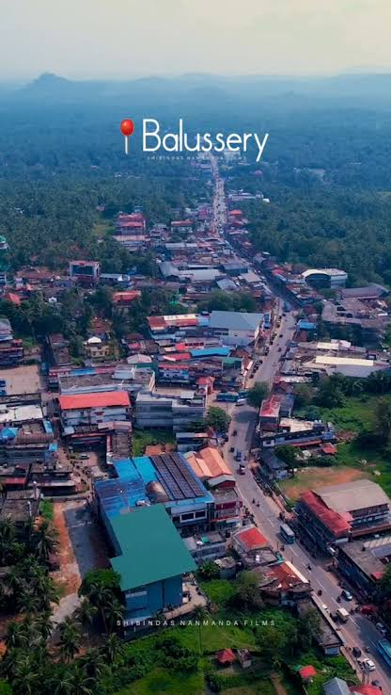
Healthcare Infrastructure in Balussery Block

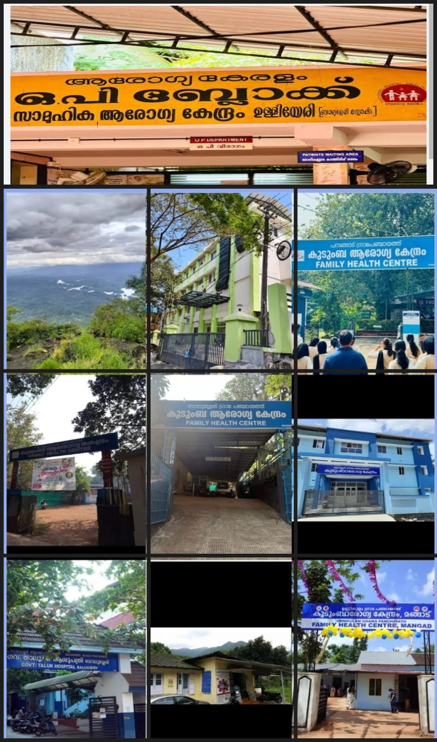

REGIONAL CONTEXT AND CHARACTERISTICS

The Balussery Block is a culturally rich and geographically diverse administrative region located in the northeastern part of Kozhikode district. Surrounded by lush greenery, rolling hills, and fertile agricultural lands, this block serves as a transitional zone between the coastal plains of Kozhikode and the elevated terrains of the Western Ghats. It includes important panchayats such as Balussery, Panangad,Unnikulam, Koorachundu, Ulliyeri, Kottur, and Naduvannur, each contributing to its unique identity. Historically, the region reflects a blend of agrarian traditions, temple-centered culture, and gradual development influenced by migration and local governance. Today, Balussery Block is known not only for its historical roots but also for its emerging eco-tourism destinations like Vayalada and Kakkayam, making it an important area that connects heritage, nature, and rural development within Kozhikode district.The Balussery Block region shows a significant social composition shaped by indigenous tribal presence. The eastern parts of the block ,especially forest fringe areas near Kakkayam and Koorachundu have the presence of Adivasi (tribal) populations, though in smaller numbers compared to districts like Wayanad. These include groups traditionally dependent on forest resources, living close to the Western Ghats. In the wider Kozhikode–Malabar region, primitive tribal groups such as the Cholanaikkans are known to inhabit forest interiors, reflecting the deep-rooted indigenous culture of the region. Culturally, Balussery Block is rich in temple festivals and traditional rituals, which reflect both tribal influences and classical Hindu traditions of North Kerala. The most prominent festival is held at the Balussery Kotta Vettakkorumakan Temple, an ancient temple located within the ruins of a historic fort. This temple, believed to be over 1000 years old, celebrates a unique ritual called “Pantheerayiram Thengayeru”, where around 12,000 coconuts are ceremonially broken as an offering, symbolizing devotion and prosperity. Other major temple festivals across the block include Pooram festivals, Theyyam performances, Kalamezhuthu Pattu, and Bhagavathy temple festivals, especially in panchayats like Ulliyeri, Naduvannur, and Panangad. Altogether, the Balussery Block represents a unique cultural landscape where migration history, tribal heritage, and temple-centered traditions coexist and shape the identity of the region. In recent years, the Balussery Block has witnessed a noticeable increase in interstate migrant workers, especially from North and East Indian states such as Bihar, Jharkhand, Uttar Pradesh, West Bengal, and Odisha. This trend is part of a larger pattern across Kerala, where migrant labourers form a major portion of the workforce in sectors like construction, quarrying, small-scale industries, and agriculture, with nearly 60% engaged in construction-related work.
In the Balussery region, these workers are mainly concentrated in semi-urban and work-centered areas such as Balussery town, Ekarool, Ulliyeri junction areas, and along road corridors connecting to Koorachundu and Kakkayam, where construction activities and small industries are active.
As a whole, Balussery Block plays a vital role in connecting the highland and lowland regions while preserving the cultural richness of Kozhikode.

MESSAGE FROM PRESIDENT/CHAIR Block Panchayath
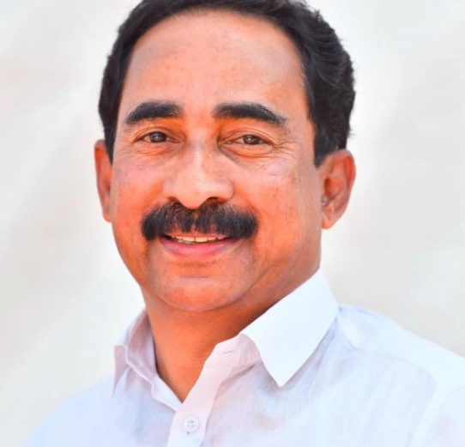
സന്ദേശം
പകർച്ചവ്യാധി പ്രതിരോധത്തിനും നിയന്ത്രണത്തിനുമായി നമ്മുടെ സംസ്ഥാനത്ത് നടപ്പിലാക്കിവരുന്ന ആരോഗ്യ ജാഗ്രതപരിപാടിയിലൂടെ പകർച്ചവ്യാധികളുടെ ഫലപ്രദമായ പ്രതിരോധവും നിയന്ത്രണവും നമ്മുടെ പഞ്ചായത്തിലും സാധ്യമായിട്ടുണ്ട്.
ശക്തമായ രോഗനിരീക്ഷണം ,സമയബന്ധിതമായഇടപെടലുകൾ വിവിധവകുപ്പുകളുടെയും ഏജൻസികളുടെയുംഏകോപനം,പൊതുജന പങ്കാളിത്തം തുടങ്ങിയവയിലൂടെയാണ് ആരോഗ്യ ജാഗ്രത പ്രവർത്തനങ്ങൾ ലക്ഷ്യം കൈവരിക്കുനത് .പ്രാഥമികാരോഗ്യ കേന്ദ്രങ്ങളെ രോഗി സൗഹൃദകേന്ദ്രങ്ങളാക്കി മാറ്റുന്നതിനുള്ള കേരളത്തിന്റെ ആർദ്രം മിഷനുമായും ദേശീയ ആരോഗ്യ ദൗത്യവുമായുംബന്ധപ്പെട്ടുനിൽക്കുന്നു. ഗ്രാമപഞ്ചായത്തിന്റെയും ആരോഗ്യസ്ഥാപനത്തിന്റയെയും കൂട്ടായ പ്രവർത്തനത്തിന്റെ ഫലമായി ബാലുശ്ശേരി ഗ്രാമപഞ്ചായത്തിൽ ആരോഗ്യ മേഖലയിൽ മികച്ച നേട്ടംകൈവരിക്കാൻ സാധിച്ചിട്ടുണ്ട്. പുതിയ മാരക രോഗങ്ങളും പകർച്ചവ്യാധികളുംവരുമ്പോൾ മുൻകാലങ്ങളിൽ പോലെ തന്നെ എല്ലാ ഇതര ഡിപാർട്മെൻറ്കളുടെയും സഹകരണത്തോടെ മികച്ച രീതിയിൽതന്നെ അവയെ പ്രതിരോധിക്കാൻ കഴിയേണ്ടതുണ്ട് .

ഇസ്മായിൽ കുറുമ്പൊയിൽ
ബാലുശ്ശേരി ബ്ലോക്ക് പഞ്ചായത്ത് പ്രസിഡണ്ട്
MESSAGE FROM HEALTH STANDING COMMITTEE CHAIR- BLOCK
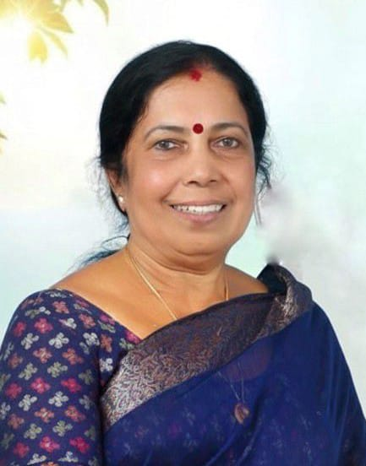
സന്ദേശം
നമ്മുടെ നാടിൻ്റെ ആരോഗ്യ സുരക്ഷ നമ്മൾ ഓരോരുത്തരുടെയും ഉത്തരവാദിത്വമാണ്. മഹാമാരികൾ വന്നപ്പോൾ ഭയപ്പെടുന്നതിന് പകരം, മുൻകരുതലുകളും ജാഗ്രതയും പാലിക്കുകയെന്നതാണ് ഏറ്റവും നല്ല പ്രതിരോധം. ദിവസേന കൈകൾ ശുചിയായി കഴുകുക, ചുമ, പനി പോലുള്ള ലക്ഷണങ്ങൾ ഉണ്ടെങ്കിൽ മറ്റുള്ളവരുമായി അടുത്തിടപഴകൽ ഒഴിവാക്കുക, ഡോക്‌ടർമാരും ആരോഗ്യ പ്രവർത്തകരും നൽകുന്ന നിർദേശങ്ങൾ കൃത്യമായി പാലിക്കുക ഇവയെല്ലാം നമ്മുടെ വീടുകളിൽ നിന്ന് തന്നെ തുടങ്ങേണ്ട കാര്യങ്ങളാണ് വാക്‌സിനേഷൻ ക്യാമ്പുകൾ സംഘടിപ്പിക്കുമ്പോൾ എല്ലാവരും പങ്കെടുത്ത് സ്വന്തം ആരോഗ്യവും കുടുംബത്തിൻ്റെ സുരക്ഷയും ഉറപ്പാക്കണം. ആശാവർക്കർമാർ, ജൂനിയർ ഹെൽത്ത് ഇൻസ്പെക്‌ടർമാർ, നഴ്സുമാർ തുടങ്ങിയ ആരോഗ്യ പ്രവർത്തകർ വീടുകളിലെത്തുമ്പോൾ അവരോട് സഹകരിക്കുക. രോഗലക്ഷണങ്ങൾ ഉണ്ടെങ്കിൽ മറച്ചുവെക്കാതെ ഉടൻ അടുത്ത ആരോഗ്യകേന്ദ്രത്തെ സമീപിക്കണം തെറ്റായ വാർത്തകളും അനാവശ്യ ഭീതിയും പരത്തുന്ന സന്ദേശങ്ങൾ ഒഴിവാക്കി, ആരോഗ്യവകുപ്പ് നൽകുന്ന ഔദ്യോഗിക അറിയിപ്പുകൾ പിന്തുടരണമെന്ന് എല്ലാവരോടും അഭ്യർത്ഥിക്കുന്നു.
പഞ്ചായത്തിന്റെ നേതൃത്വത്തിൽ ആരോഗ്യവകുപ്പുമായി ചേർന്ന് ബോധവത്കരണ പ്രവർത്തനങ്ങളും മുൻകരുതൽ സംവിധാനങ്ങളും ശക്തി പ്പെടുത്തുന്നുണ്ട്. എന്നാൽ ഈ പ്രവർത്തനങ്ങൾ ഫലപ്രദമാകുന്നത് ഓരോ കുടുംബവും ജാഗ്രത പാലിക്കുമ്പോഴാണ്.

പുഷ്പ ടീച്ചർ

ആരോഗ്യ സ്റ്റാന്റിംഗ് ചെയർപേഴ്സൺ

ബാലുശ്ശേരി ബ്ലോക്ക് പഞ്ചായത്ത്

MESSAGE BY BLOCK MEDICAL OFFICER
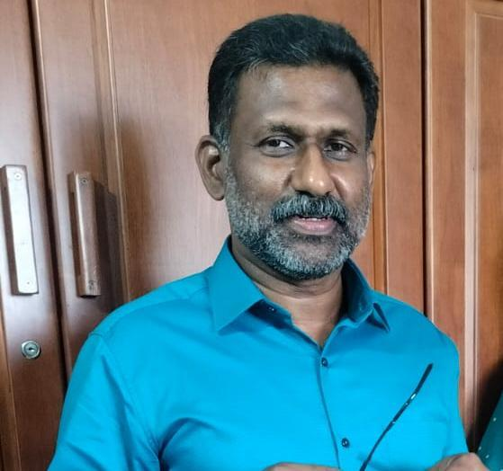
സന്ദേശം

മഹാമാരികൾ നമ്മുടെ ആരോഗ്യ സംവിധാനത്തിനും സമൂഹത്തിനും വലിയ വെല്ലുവിളികളാണ്. എന്നാൽ സമയബന്ധിതമായ മുൻകരുതലുകളും ശാസ്ത്രീയമായ ആരോഗ്യശീലങ്ങളും പാലിച്ചാൽ ഇത്തരം പ്രതിസന്ധികളെ ഫലപ്രദമായി നേരിടാൻ കഴിയും.
Pandemic Preparedness എന്നത് രോഗം പടരുന്നതിന് മുമ്പ് തന്നെ ജാഗ്രത പുലർത്തുകയും, രോഗവ്യാപനം നിയന്ത്രിക്കുന്നതിനുള്ള നടപടികൾ കൃത്യമായി നടപ്പിലാക്കുകയും ചെയ്യുന്നതാണ് കൈകളുടെ ശുചിത്വം പാലിക്കുക, ചുമയ്ക്കുമ്പോഴും തുമ്മുമ്പോഴും സുരക്ഷാ മാനദണ്ഡങ്ങൾ പിന്തുടരുക, ആവശ്യമുള്ള വാക്‌സിനേഷനുകൾ സമയബന്ധിതമായി സ്വീകരിക്കുക, രോഗലക്ഷണങ്ങൾ ഉണ്ടെങ്കിൽ സ്വയം മറച്ചുവെക്കാതെ ഉടൻ ആരോഗ്യ കേന്ദ്രങ്ങളെ സമീപിക്കുക ഇവ എല്ലാം അത്യന്താപേക്ഷിതമാണ്. അനാവശ്യ ഭയം പരത്തുന്ന വ്യാജവാർത്തകൾ ഒഴിവാക്കി, ആരോഗ്യവകുപ്പ് നൽകുന്ന നിർദേശങ്ങൾ അഭ്യർത്ഥിക്കുന്നു. പിന്തുടരണമെന്ന് ആരോഗ്യപ്രവർത്തകരോടുള്ള രോഗനിയന്ത്രണത്തിൻ്റെ പ്രധാന ഘടകമാണ്. എല്ലാവരോടും സഹകരണം ആരോഗ്യവകുപ്പും പഞ്ചായത്ത് ഭരണകൂടവും കൈകോർത്ത്, സമൂഹത്തിന്റെ സുരക്ഷയ്ക്കായി സദാ ജാഗ്രതയോടെ പ്രവർത്തിക്കുന്നതാണ്.

മെഡിക്കൽ ഓഫീസർ
വിൻസെൻറ് ജോർജ്
CHC ഉള്ളിയേരി

EXECUTIVE SUMMARY
The PHC/FHC/CHC etc under Ulliyeri Block Public Health Unit (BPHU) functions as the primary public healthcare institution serving the population of 215732 revenue block. The BPHU plays a pivotal role in delivering comprehensive, accessible, and affordable healthcare services, with a strong focus on preventive, promotive, curative, and rehabilitative care in accordance with national and state health programmes.
The BPHU caters to a predominantly rural population, addressing key public health priorities such as maternal and child health, communicable and non-communicable disease control, immunization, family welfare, adolescent health, and geriatric care. Regular outpatient services, home-based care through field health staff, and outreach activities ensure healthcare coverage even in geographically challenging areas. The institution actively implements national health missions, including the National Health Mission (NHM), National Tuberculosis Elimination Programme, National Programme for Prevention and Control of Cancer, Diabetes, Cardiovascular Diseases and Stroke (NPCDCS), and other disease surveillance initiatives.
Ulliyeri BPHU works in close coordination with the Block Panchayath, ASHA workers, Anganwadi centres, schools, and community-based organizations to strengthen community participation and improve health awareness. Emphasis is placed on early detection, timely referral, health education, and lifestyle modification to reduce disease burden and improve overall health outcomes.
Despite constraints related to infrastructure, manpower, and increasing service demand, the BPHU continues to enhance service delivery through effective planning, data-driven decision-making, and community engagement. Strengthening facilities, upgrading digital health systems, and expanding preventive services remain key focus areas for future development.
Overall, Ulliyeri BPHU stands as a vital institution in safeguarding public health and improving the quality of life of the residents of Ulliyeri revenue block.

LIST OF ABBREVIATIONS

BPHU | Block Public Health Unit
LSGD/LSGI | Local Self Government Department / Local Self Government Institution
BMO | Block Medical Officer
IDSP | Integrated Disease Surveillance Programme
NDMA | National Disaster Management Authority
PPE | Personal Protective Equipment
ICMR | Indian Council of Medical Research
CD | Communicable Diseases
NCD | NON-COMMUNICABLE Diseases

TABLE OF CONTENTS

INTRODUCTION 9
● Background of the PPP 9
REVENUE BLOCK AT A GLANCE 9
INTEGRATED HEALTH INFRASTRUCTURE MAP OF __BALUSSERY ULLIYERI REVENUE BLOCK 10
GENERAL PROFILE OF THE LSGI’S 11
Background of the revenue block 11
Demographic and Vulnerable Population 12
Clinical Vulnerability 13
INFRASTRUCTURE & RESOURCE INVENTORY 17
Health Facility Directory & Basic Capacity in the revenue block 17
Private Clinics 23
Healthcare Education & Training Institutions 25
Specialized Services & Emergency Inventory 26
Oxygen & Diagnostic Capacity 26
Diagnostics facility mapping at the revenue block level 28
Laboratory Identification & Basic Details 29
Social and Community Infrastructure for surge plan 32
Human resources 34
Community & Support Cadre 42
Community Organizations 43
Administrative & Emergency Services 44
Information regarding resources 45
ONE HEALTH & ENVIRONMENTAL SURVEILLANCE 45
Animal & Bird Population 46
Veterinary Infrastructure 48
Veterinary Doctors & Workforce 49
High-Risk Interface Points (Surveillance Sites) 50
Environmental Risk Mapping 52
Disease Seasonality Mapping – Revenue block 54
Vulnerability Mapping 56
EPIDEMIOLOGICAL TRENDS (2021–2025) 57
Disease Burden among human beings(Last 5 Years) 57
At a glance across all panchayaths: ADD/Diarrhoea dominates everywhere (thick red line), Hepatitis A is the second biggest concern, and diseases like Scrub Typhus, Malaria & Typhoid are near-flat at the bottom. 68
Seasonal Trend Analysis 68
Outcome-Based Trend Analysis- 2025-2026 73
Transmission Trend- 2025 75
Integrated Disease Hotspot Map (2021–2025) 78
Preparedness and Response Protocol at revenue block Level 82
Constitution of One Health Committee 82
Pandemic Response Workforce 87
Activities and Measures before and during Pandemic 88
PHASE 1 - Alert / Preparation 88
PHASE 2 - Active Response 91
Standard Screening Protocol 92
PHASE 3 - Surge Capacity 109
Conversion of Community Facilities 109
CONCLUSION 114
RECOMMENDATIONS 116
ANNEXURE 118
1. IMPORTANT PHONE NUMBERS 118

INTRODUCTION

Background of the PPP
- Revenue block at a glance

REVENUE BLOCK AT A GLANCE
- Geographical boundaries with political map (based on latest delimitation)
- Baseline data
- Ward division -
Name of LSGI | Ward | Houses | Population | Migrants | Wells | Hot  spots | Ed. Institutions | Hosp pvt/govt.
NADUVANNUR | 18 | 8003 | 30881 | 204 | 5333 | 0 | 15 | 5
KOTTUR | 19 | 8581 | 34461 | 69 | 6376 | 2 | 17 | 2
ULLIYERI | 21 | 9304 | 36359 | 162 | 6395 | 0 | 16 | 1
PANANGAD | 21 | 4400 | 9400 | 1506 | 6137 | 5 | 18 | 5
BALUSSERY | 18 | 8356 | 29370 | 142 | 5655 | 0 | 22 | 7
UNNIKULAM | 24 | 14218 | 61660 | 347 | 10317 | 3 | 32 | 3
KOORACHUNDU | 14 | 3260 | 13601 | 91 | 2843 | 6 | 10 | 1
Total | 135 | 56122 | 215732 | 2521 | 43056 | 16 | 130 | 24

- Risk stratification among revenue block in the context of Communicable diseases and hazards
- Major Roads/rivers
- Major establishments with geospatial mapping
- occupational groups, socio cultural groups, migration & mobility patterns
- Vulnerability mapping
- Disaster prone areas (geographic vulnerability)

Maps – revenue block based (Mention source also)

- Geographical boundaries - LSGI boundaries map
- Health infrastructure map
- roads and rivers map
- major establishments map
- disaster-prone areas map
- hotspot map - CD & disasters

INTEGRATED HEALTH INFRASTRUCTURE MAP OF __BALUSSERY ULLIYERI REVENUE BLOCK

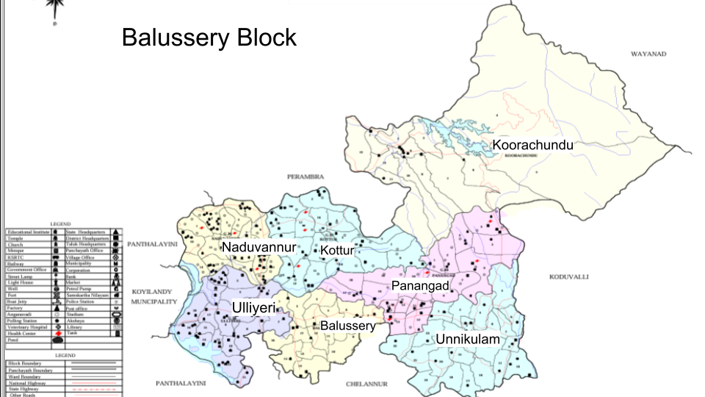

GENERAL PROFILE OF THE LSGI’S

Background of the revenue block
Ulliyeri revenue block is situated in the northeast of Kozhikode district, Kerala. The geographical landscape of the revenue block is predominantly low-lying, characterized by extensive paddy fields (Kole lands) and a dense network of rivers, canals, and backwaters. This unique terrain plays a significant role in shaping the local microclimate and poses distinct challenges to transportation, emergency response, and service delivery, particularly during monsoon seasons and flood events.
The revenue block is administratively divided into multiple panchayaths/municipalities, with a population largely dependent on traditional livelihoods. Agriculture—especially paddy cultivation—fishing, coir and coconut husk processing, and allied activities form the backbone of the local economy. In recent years, tourism-related activities and service-sector employment have also shown gradual growth. The area hosts a diverse workforce, including a notable presence of migrant labourers, particularly in construction, agriculture, and allied sectors.
From a public health and disaster management perspective, Ulliyeri revenue block has historically been vulnerable to seasonal flooding, waterborne diseases, and vector-borne illnesses such as Dengue and Leptospirosis. The severe floods experienced during recent years, including the 2018 flood disaster, significantly impacted life, livelihoods, and infrastructure within the Panchayat. These recurring emergencies have underscored the importance of strengthening local preparedness, response mechanisms, and inter-departmental coordination.
In this context, the development of a localized, data-driven Auxiliary Infrastructure and Logistical Resource Map is essential to support effective planning, timely emergency response, and sustainable development initiatives. Such mapping enables the Panchayat to identify critical resources, improve accessibility during disasters, and enhance overall resilience of the community.

Table 1: Background of revenue block
Description | Details
Name of revenue block | Ulliyeri
Number of LSGI’s (GP/Municipality / Corporation etc.) | 7 GP
District | KOZHIKODE
Number of wards | 122
Total area (sq. km) | 25.8Sqkm
Population(Projected) | 215732
Population density | Persons/sq km
Terrain (coastal/low-lying/backwaters/foothills, etc.) | LOW LIENG AND HILL AREAS
Number of rivers passing through revenue block | 7
Number of water bodies in the revenue block | 78
Number of educational institutions | 115
Factories / small-scale industries | 45
Flood-prone wards | 36
Landslide-prone wards | 18
Death Management and Disposal Facilities (mortuaries/crematorium, including electric) | 2
Auditoriums/Marriage halls/convention centres/community halls | 12

Demographic and Vulnerable Population
Understanding the demographic composition and vulnerable population groups is essential for pandemic preparedness. Children, elderly, economically deprived families, migrant workers, and socially vulnerable groups are at increased risk during public health emergencies due to higher exposure, limited access to services, and dependency on public systems..

Description |  | Details (in numbers)
DEMOGRAPHIC PROFILE OF THE REVENUE BLOCK
Total population |  | 215732
Male |  | 123015
Female |  | 127082
Transgender |  | 1
Children under 5 |  | 13744
Adolescent |  | 36915
Elderly (>60) |  | 49374
SOCIAL/LIVELIHOOD VULNERABILITY
Previous EPEP family |  | 679
BPL family |  | 26829
Tribal communities |  | 329
Migration | Immigrant | 2395
Migration | Emigrant | 5309
Socio-economically deprived |  | 2977
Fisherfolk |  | 6
SC Community |  | 10006
ST Community |  | 389

Graphs: Population pyramid (if possible) for seeing if your revenue block has a high "dependency ratio" (lots of children and elderly compared to working adults).

Clinical Vulnerability
Certain population groups need priority healthcare & are at higher risk of severe illness, complications, and mortality during pandemics. Patients with chronic diseases, those requiring regular medical care, and individuals with mobility or functional limitations face challenges in accessing timely care during emergencies. Mapping these groups helps in prioritizing continuity of treatment, medicine stock planning, oxygen support, referral transport, and targeted home-based care.
Description | Details in numbers
Pregnant women | 1494
Lactating mothers | 2805
Bedbound patients | 890
Patients under palliative care other than bedbound | 6658
Patients on Haemodialysis | 236
Patients on CAPD | 2
Cancer patients (currently on treatment) | 330
Haemophilic patients | 47
Mentally challenged | 511
Differently abled | 1460
Diabetic patients | 19448
Hypertensive patients | 24933
TB patients | 46

Major Festivals & Events specific to the revenue block
(with the possibility of a public gathering)

Sl. No. | Name of LSGI | Name of festival | Month detailing the periodicity
1 | Balussery | Iratta kulangara temple festival | February
 | Balussery | Chirakal Kavu temple | February 2026
 | Balussery | Bajana Madam | ,,
2 | Panangad | chindramangalam | February
 | Panangad | balussery kotta | February
 | Panangad | kavilum avilampadi | February
 | Panangad | pachakkil | February
 | Panangad | chetiyankandy | march
3 | Koorachundu | ardanareeshwari temple, kakkayam | april
 | Koorachundu | koorachundu ST . Thomaschurch | December
 | Koorachundu | Poovathumchola bhagavathi temple | December
 | Koorachundu | Sensebastiam church, Kakkayam | January
 | Koorachundu | Sreeparadevavatha temple , kakayam | April
 | Koorachundu | Senjoseph church, karuyathanpara | december
 | Koorachundu | Kst.marys church | december
4 | Ulliyeri | Modakkalur sri durga devi temple | February
 | Ulliyeri | Sri kaiprakunnumal | February
 | Ulliyeri | Vengilot | February
 | Ulliyeri | padinjarapalliyil bhagavathi temple | February
5 | Mangad | Avelam makkam uroos | march
 | Mangad | Kariyathan kavu | march
 | Mangad | Muppathtakara | march
 | Mangad | Karumala vishnu temple | march
 | Mangad | Karumala sivakhethram | march
 | Mangad | Mangad kovilakam | march
 | Mangad | Madapattil | march
 | Mangad | Tharipayil temple | February
 | Mangad | Kizhakedath | march
 | Mangad | Othayothumpadikkal baghwati temple | march
 | Mangad | Lakshmi narayana | march
6 | Naduvannur | chettiyur bagavathy temple | march
 | Naduvannur | vilayatiri temple | march
 | Naduvannur | meyasseri devi temple | february
 | Naduvannur | thanippetta gurukaranava temple | march
7 | Kottur | nerroth sree maha vishnu temple | march
 | Kottur | kottur maha shiva temple | march
 | Kottur | chundali shiva temple | march
 | Kottur | thrikkuttissery mada deva temple | march

INFRASTRUCTURE & RESOURCE INVENTORY

Health Facility Directory & Basic Capacity in the revenue block
This section provides an overview of the healthcare infrastructure available within the revenue block area. It outlines the distribution and basic capacity of health facilities that form the backbone of service delivery during routine times and public health emergencies.

Family Health Centres (FHCs) and Community Health Centres (CHCs) generally function as the first point of contact for the community, providing essential outpatient and inpatient services. General Hospitals (GH) and Medical College Hospitals (MCH), where accessible, serve as the main referral centres for advanced diagnostics, specialist care, and critical services during public health emergencies. This inventory helps identify existing strengths, gaps, and potential surge capacity that can be mobilised during a pandemic or disaster.

Table 5. Health Facility Resource Summary
Sl.no. | Name of LSGI | Health Facility | Type of Facility (MCH/GH/CHC/FHC/SC etc.) | Contact Number | Total beds | ICU Beds | Oxygen-Supported Beds | No. of Ventilator Support Beds | No. of ambulances
Government Healthcare Facilities
1 | NADUVANNUR | FHC ,NADUVANNUR | FHC | 04962930870 | 1 | 0 | 0 | 0 | 0
 |  | HWC Karuvannur | SC | 8301898121 | 0 | 0 | 0 | 0 | 0
 |  | HWC Kavumthara | SC | 6238417721 | 0 | 0 | 0 | 0 | 0
 |  | HWC Mannamkavu | SC | 9495862453 | 0 | 0 | 0 | 0 | 0
 |  | HWC Naduvannur | SC | 9846533238 | 0 | 0 | 0 | 0 | 0
 |  | HWC Naduvannur Main Centre | SC | 9495862453 | 0 | 0 | 0 | 0 | 0
2 | KOTTUR | FHC KOTTUR | FHC | 9207634044 | 0 | 0 | 0 | 0 | 0
2 |  | HWC POONATH | SC | 8301046055 | 0 | 0 | 0 | 0 | 0
2 |  | HWC MOOLAD S | S SC | 9605954651 | 0 | 0 | 0 | 0 | 0
2 |  | HWC VAKAYAD | S SC | 8606826858 | 0 | 0 | 0 | 0 | 0
 |  | HWC THRIKUTTYSSERY | S SC | 9 207364694 | 0 | 0 | 0 | 0 | 0
3 | ULLIYERI | CHC ULLIYERI | CHC | 04962654226 | 12 | 0 | 0 | 0 | 0
 |  | HWC KAKKANCHERRY | SC | 04962211696 | 0 | 0 | 0 | 0 | 0
 |  | HWC KUNNATHARA | SC | 04962237400 | 0 | 0 | 0 | 0 | 0
 |  | HWC PUTHENCHERRY | SC | 0496223409 | 0 | 0 | 0 | 0 | 0
 |  | HWC ULLIYERI MAIN CENTRE | SC | 04962215787 | 0 | 0 | 0 | 0 | 0
 |  | HWC ORAVIL | SC | 04962963650 | 0 | 0 | 0 | 0 | 0
4 | PANANGAD | Family Health Centre Panangad | FHC | 9846247824 | 1 | 0 | 0 | 0 | 0
 |  | HWC KINALOOR | SC | 8113861869 | 0 | 0 | 0 | 0 | 0
 |  | HWC NIRMALLOOR | SC | 8592040657 | 0 | 0 | 0 | 0 | 0
 |  | HWC PANANGAD | SC | 9446731767 | 0 | 0 | 0 | 0 | 0
 |  | HWC MAIN CENTRE PANANGAD | SC | 8086938068 | 0 | 0 | 0 | 0 | 0
 |  | HWC KURUMPOIL | SC | 9497871079 | 0 | 0 | 0 | 0
 |  | Family Health Centre Vayalada | FHC | 9847401317 | 0 | 0 | 0 | 0 | 0
 |  | HWC VAYALADA | SC | 6235003112 | 0 | 0 | 0 | 0 | 0
 |  | TH Balussery | TH | 4962963650 | 22 | 0 | 0 | 0 | 1
5 | BALUSSERY | FHC Eramangalam | FHC | 8075120499 | 0 | 0 | 0 | 0 | 0
 |  | Panayi | SC | 8086722963 | 0 | 0 | 0 | 0 | 0
 |  | Kokkallur | SC | 9539661715 | 0 | 0 | 0 | 0 | 0
 |  | Mannampoyil | SC | 9946417503 | 0 | 0 | 0 | 0 | 0
 |  | Puthoorvattom | SC | 9847943632 | 0 | 0 | 0 | 0 | 0
6 | UNNIKULAM | MANGAD | FHC | 04962647565 | 2 | 0 | 0 | 0 | 1
 |  | HWC KARUMALA | SC | 0 | 0 | 0 | 0 | 0 | 0
 |  | FHC KARYATHANKAVU | SC | 0 | 0 | 0 | 0 | 0 | 0
 |  | HWC EKAROOL MMMARAMBA | SC | 0 | 0 | 0 | 0 | 0 | 0
 |  | HWC KANTHAPURAM | SC | 0 | 0 | 0 | 0 | 0 | 0
 |  | HWC UNNIKULAM | SC | 0 | 0 | 0 | 0 | 0 | 0
 |  | HWC MADATHAMPOYIL | SC | 0 | 0 | 0 | 0 | 0 | 0
 |  | HWC IYYAD | SC | 0 | 0 | 0 | 0 | 0 | 0
 | KOORACHUNDU | CHC Koorachund | CHC | 04962661939 | 0 | 0 | 0 | 0 | 0
7 |  | PHC Kakkayam | PHC | 04962698191 | 0 | 0 | 0 | 0 | 0
7 |  | H&FW Koorachund | SC | 04962661939 | 0 | 0 | 0 | 0 | 0
7 |  | H&FW Kelothvayal | SC | 7510873967 | 0 | 0 | 0 | 0 | 0
7 |  | H&FW Erappanthod | SC | 9744199700 | 0 | 0 | 0 | 0 | 0
 | TOTAL | 24
Private Healthcare Facilities
1 | BALUSSERY | MEDIMS CLINIC VATTOLI | CLINIC | 8881710700 | 0 | 0 | 0 | 0 | 0
1 |  | AYISHA CLINIC | CLNIC | 9947914148 | 0 | 0 | 0 | 0 | 0
2 | PANNAGAD | IZRA HOSPITAL | CLINIC | 9061522061 | 0 | 0 | 0 | 0 | 0
3 | UNNIKULAM | RIVER SHORE |  | 7594883300 | 28 | 0 | 15 | 0 | 1
 | UNNIKULAM | ROYAL HOSPITAL |  | 9847671410 | 6 | 1 | 0 | 0 | 1
 | Total |  | 5
AYUSH Healthcare Facilities
1 | PANNAGAD | HOMEO HOSPITAL | 0 | 9496808292 | 0 | 0 | 0 | 0 | 0
1 | PANNAGAD | HOMEO CLINIC KURUMPOYIL | CLINIC | 8330054581 | 0 | 0 | 0 | 0 | 0
2 | BALUSSERY | GOVT AYURVEDA HOSPITAL | Balussery | 2646342 | 0 | 0 | 0 | 0 | 0
2 | BALUSSERY | Govt. Ayurveda Hospital Panayi | GH | 96568898 | 10 | 0 | 0 | 0 | 0
2 | BALUSSERY | Homeo Hospital Parambinmukal | GH | 9048441375 | 0 | 0 | 0 | 0 | 0
3 | KOORACHUNDU | Govt Ayurveda Hospital Koorachundu | GH | 9496430526 | 0 | 0 | 0 | 0 | 0
3 | KOORACHUNDU | Govt. Homeo Dispensary Koorachundu | GH | 9400308542 | 0 | 0 | 0 | 0 | 0
 | Total |  | 7

Private Clinics
Private clinics are an essential part of pandemic preparedness, as they are often the first place people seek care when symptoms begin. In many communities, private clinics manage a significant share of outpatient visits and therefore play a critical role in early case detection, timely referrals, and disease surveillance. Having an up-to-date understanding of where these clinics are located, the services they provide, and how they are linked to the public health system helps ensure that no cases are missed during an outbreak. It also allows health authorities to engage private practitioners more effectively for reporting, risk communication, and coordinated response, strengthening the overall capacity of the health system to manage public health emergencies.

Table 6. Private Clinic Resource Summary
Sl No. | Name of LSGI | Name of Clinic | Registered (Y/N) | Clinic (General / Speciality) | Speciality (if any) | Address | Contact Number | Diagnostic Facility (Y/N) | Ambulance Linkage (Y/N)
1.PANANAGAD |  | MEDIMS CLINIC VATTOLI | Y | CLINIC | 0 | PANANGAD | 0 | 0 | 0
 |  | AYISHA CLINIC | Y | CLINIC | 0 | PANANGAD | 0 | 0 | 0
 |  | IZRA HOSPITAL | Y | CLINIC | 0 | PANANGAD | 0 | 0 | 0
2. | Koorachund | AJ Clinic | No | Yes | No | Koorachund | 9400560256 | No | Yes
2. | Koorachund | Family Health Care | Y | Yes | Yes | kallanod | 04962200446 | Yes | Yes
2. | Koorachund | Amala dental Clinic | Y | Yes | Dental | Kallanod | 9495134146 | No | Yes
2. | Koorachund | Health Care Laboratory | Y | No | No | Kallanod | 9495772735 | Yes | Yes
3. | Naduvannur | CARE AND CURE PVT CLINIC | Y | GENERAL | nil | KARUMBAPOYIL, NADUVANNUR | 9497881188 | YES | YES
 |  | METRO HOSPITAL | Y | GENERAL | NIL | NADUVANNUR | 8086525222 | YES | YES
4.KOTTUR |  | KRIPA CLINIC | Y | GENERAL | NIL | KOOTTALIDA | 9956347865 | yes | no
5.UNNIKULAM |  | Bharath | Y | general | YES | ekarool | 984575956 | y
6.BALUSSERY |  | SmartHospital, Kokkalur | Y | General | No | Kokkalur, Balussery | 04962705183 | Y | Y
 |  |  | Y | General | No | Block road Balussery | 9846926124 | Y | Y
 |  | Sreedhar nursing home | Y | General | YES | Balussery town | 9846781235 | Y | Nil
7.ULLIYERI |  | Nalanda hospital | yes | general |  | ulliyeri | 9037691804 | y | y
 |  | Cinco poly clinic | yes | general |  | ulliyeri | 8956347865 | y | y
 |  | We care poly clinic | yes | general |  | ulliyeri | 6937832549 | y | y

Healthcare Education & Training Institutions
This section tracks the educational infrastructure available, which is vital for human resource planning in the health sector.

Category of Institution | Name of LSGI | Govt | Private | AYUSH | Total
Medical Colleges | ULLIYERI | 0 | 0 | 0 | 0
Nursing Colleges | ULLIYERI | 0 | 0 | 0 | 0
Dental Colleges | ULLIYERI | 0 | 0 | 0 | 0
Para-medical / Allied Health |  | 0 | 0 | 0 | 0
Pharmacy Colleges |  | 0 | 0 | 0 | 0

Specialized Services & Emergency Inventory
This section provides a detailed view of the specialized medical resources available to the community, focusing on emergency response and critical care capabilities. This table tracks the vital assets required for managing severe illnesses and emergencies across Government, Private, and AYUSH sectors.
Item | Name of LSGI | Govt | Private | AYUSH | Total
Hospital beds | Total 7 panchayats | 56 | 130 | 25 | 211
Oxygen-generating systems(Y/N) | Total 7 panchayats | 2 | 0 | 0 | 2
Oxygen-supported beds(Numbers) | Total 7 panchayats | 17 | 3 | 0 | 20
Ventilator-supported beds | Total 7 panchayats | 0 | 0 | 0 | 0
ICU beds | Total 7 panchayats | 0 | 0 | 0 | 0
Burns units | Total 7 panchayats | 0 | 0 | 0 | 0
Blood centres | Total 7 panchayats | 0 | 0 | 0 | 0
BLS ambulances | Total 7 panchayats | 1 | 0 | 0 | 1
ALS ambulances | Total 7 panchayats | 0 | 0 | 0 | 0
Dialysis facilities | Total 7 panchayats | 0 | 4 | 0 | 4
Dispensaries | Total 7 panchayats | 1 | 8 | 2 | 11
Medical store | Total 7 panchayats | 2 | 0 | 0 | 2
Industrial establishments(Medium-scale industries/small-scale industries establishments to whom we can depend in a worst-case scenario) | naduvannur & panangad | 0 | 10 | 0 | 10

Oxygen & Diagnostic Capacity
Monitoring oxygen and diagnostic capacity is a critical component of public health preparedness, ensuring that the revenue block can handle both chronic care and sudden surges in respiratory or infectious diseases.
 | Name of LSGI | Name of Health Facility | Oxygen-generating System (Y/N) | Backup Oxygen Source (Y/N) | Diagnostic Facilities Available(Y/N)
 |  |  |  |  | Lab | USG | X-ray | CT/MRI | RT-PCR
 | Government Healthcare Facilities
1 | ULLIYERI | CHC ULLIYERI | Y | Y | Y | N | N | N | N
 | ULLIYERI | NALANDA HOSPITAL | Y | Y | Y | N | Y | N | N
 | ULLIYERI | CINCO CLINIC | Y | Y | Y | N | Y | N | N
 | ULLIYERI | WE CARE POLY CLINIC | Y | Y | Y | N | Y | N | N
2 | NADUVANNUR | 0 | 0 | 0 | N | N | N | N | N
3 | KOTTUR | NIL | Y | Y | Y | N | N | N
4 | PANNAGAD | TH BALUSSRY | N | N | Y | N | Y | N | Y
4 | PANNAGAD | FHC VAYALADA | N | N | Y | N | N | N | Y
4 | PANNAGAD | FHC  PANANAGAD | N | N | Y | N | Y | N | Y
5 | BALUSSRY | NIL | Y | Y | Y | N | N | N | N
6 | UNNIKULAM | NIL | Y | Y | Y | N | N | N | N
7 | KOORACHUNDU | CHC Koorachund | No | C | Yes | No | No | No | No

Diagnostics facility mapping at the revenue block level
The diagnostic capacity of the ULLIYERI revenue block represents the "intelligence network" of our healthcare system. The speed and accuracy of disease identification depend entirely on the distribution and technical level of these facilities.

Item | Name of LSGI | Govt | Private | AYUSH | Total
General labs | ULLIYERI | 8 | 24 | 0 | 32
Microbiology labs | ULLIYERI | 0 | 1 | 0 | 1
RT-PCR labs | ULLIYERI | 1 | 1 | 1 | 3
USG units | ULLIYERI | 4 | 2 | 0 | 0
CT/MRI units | ULLIYERI | 0 | 0 | 0 | 0
Research labs | ULLIYERI | 0 | 0 | 0 | 0
Labs of other departments that can be repurposed | ULLIYERI | 0 | 0 | 0 | 0

Laboratory Identification & Basic Details
Sl. No. | Name of LSGI | Name of Laboratory | Ownership (Govt / Private / Academic) | Address | Contact No. | 24×7 Services (Yes/No) | NABL / Govt Approved (Yes/No)
1 | ULLIYERI | CHC ULLIYERI | GOVT | MAMBOYIL ULLIYERI | 04962964225 | NO | YES
1 | ULLIYERI | CINCO MEDICAL CENTRE | PVT | ULLIYERI | 9483697686 | YES | YES
1 | ULLIYERI | AJAYS CAREC | PVT | ULIYERI | 8089511307 | YES | YES
2 | NADUVANNUR | Medicare lab | PRIVATE | Karumbapoyil | 8589963818 | NO | NO
2 | NADUVANNUR | Evercare pharma | PRIVATE | NADUVANNUR | 7736462010 | NO | NO
2 | NADUVANNUR | Medicare lab | PRIVATE | Near gp naduvannur | 8589963818 | NO | NO
2 | NADUVANNUR | Apollo clinical | PRIVATE | NADUVANNUR | 9847395042 | NO | NO
2 | NADUVANNUR | Clinical laboratory | PRIVATE | NADUVANNUR | 9645027293 | NO | NO
2 | NADUVANNUR | Karunya medical lab | PRIVATE | NADUVANNUR | 9562623702 | NO | NO
2 | NADUVANNUR | Neo medical lab | PRIVATE | Karuvannur | 9946241068 | NO | NO
2 | NADUVANNUR | Ideal lab | PRIVATE | Palliyathkuni | 9947174645 | NO | NO
3 | KOTTUTR | NEETHI LAB | PRIVATE | NAHAD  AVITANALLUR | 9846842639 | NO | NO
3 | KOTTUTR | JAS LAB | PRIVATE | KOYA  AVITANALLUR | 9645445530 | NO | NO
3 | KOTTUTR | KRIPA | PRIVATE | AVITANALLUR | 8113099373 | NO | NO
3 | KOTTUTR | CROWN | PRIVATE | AVITANALLUR | 7034336363 | NO | NO
3 | KOTTUTR | LIFE CARE | PRIVATE | AVITANALLUR | 9847279106 | NO | NO
4 | PANANGAD | NALANDA HOSPITAL | PRIVATE | ULLIYERI | 9947774363 | YES | YES
4 | PANANGAD | WE CARE POLY CLINIC | PRIVATE | ULLIYERI | 9645273300 | YES | YES
4 | PANANGAD | FHC VAYALADA | GOVT | FHC VAYALADA, VAYALADA | 9893626779 | NO | YES
4 | PANANGAD | MEDIMS CLINIC VATTOLI | PRIVATE | MEDIMS , VATTOLI BAZAR | 9948622808 | NO | NO
4 | PANANGAD | AYISHA CLINIC | PRIVATE | AYISHA CLINIC VATTOLI BAZAR | 97477359829 | YES | NO
5 | UNNIKULAM | Poonoor diagnostic center | PRIVATE | Poonoor unnikulam | 9895226779 | no | no
5 | UNNIKULAM | SMILEZ | PRIVATE | POONOOR KOZHIKODE | 9946222808 | NO | NO
5 | UNNIKULAM | SURABHI | PRIVATE | EKAROOL | 9747789829 | NO
5 | UNNIKULAM | ORYX CLINIC | PRIVATE | EKROOL UNNIKULAM | 8089300600 | NO
5 | UNNIKULAM | MALABAR MEDICAL LABORATORY | PRIVATE | UNNIKLAM | 8129163661 | NO
6 | KOORACHUNDU | KarunaPoly Clinic Korachund | PRIVATE | Koorachund | 04962620988 | No
6 | KOORACHUNDU | Micro Health Lab | PRIVATE | Koorachund | 8075210010 | No
6 | KOORACHUNDU | St.Antony’s Lab | PRIVATE | Koorachund | 9946137635 | No
6 | KOORACHUNDU | St.Thomas Lab | PRIVATE | Koorachund | 9847524077 | No
6 | KOORACHUNDU | AJ Clinic | PRIVATE | Koorachund | 9400560256 | No
6 | KOORACHUNDU | Family Health Care | PRIVATE | Kallanod | 04962200446 | No
6 | KOORACHUNDU | Health Care Laboratory | PRIVATE | Kallanode | 9495772735 | No
7 | BALUSSERY | Doctors lab | Private | Balussery | 9885226779 | Yes
7 | BALUSSERY | Jaya lab | Private | Balussery | 9946422808 | No
7 | BALUSSERY | Sreedhar | Private | Balussery | 97967789829 | No

Social and Community Infrastructure for surge plan
This table serves as our logistics and shelter inventory. By mapping these locations, quickly we can identify where to house displaced citizens, where to set up temporary medical clinics, and how to manage the deceased with dignity during a crisis.

Category | Name of LSGI | Total Count | Ward | Est. Capacity (Persons) | Contact details
Educational Institutions
Anganwadis | ULLIYERI | 210 | 122 | 1616 | 9539872120
Schools |  | 130 | 75 | 1200 | 9961887691
Colleges |  | 14 | 12 | 1532 | 04962643164
Healthcare Educational Institutions
Medical colleges (Govt/Private) |  | 0 | 0 | 0 | 9895226779
Nursing colleges (Govt/Private) |  | 0 | 0 |  | 9946992808
Dental colleges (Govt/Private) |  | 0 | 0 |  | 9747619829
Paramedical institutes (Govt/Private) |  | 0 | 0 |  | 8089360600
Community Gathering Spaces
Community halls |  | 4 | 4 | 200 | 9188895777
Auditoriums |  | 14 | 12 | 1000 | 07594933386
Religious buildings |  | 171 | 29 | 300 | 8086653920
Vulnerable Group Support Facility
Destitute homes |  | 0 | 0 |  | 9896326779
Elderly homes |  | 2 | 2 | 60 | 9949622808
LSGD owned other buildings |  |  |  |  | 9747762829
Mass Fatality Management (MFM) Infrastructure
Mortuary |  | 1 |  |  | 6589232168
Crematorium |  | 1 | 1 |  | 8281528235
*refer annexure 1 for contact details

Human resources
This section focuses on the human capital available within the revenue block. In any emergency—be it a pandemic, flood, or industrial accident—infrastructure is only as effective as the people operating it.

Medical & Clinical Personnel
This table tracks the "Frontline" providers responsible for diagnosis, treatment, and clinical management. Narrative sentence: eg., "Total health workforce: 450 personnel, with 60% in government facilities serving as primary surge capacity." A detailed directory with the contact numbers of all workers is maintained (Annexure in 1).

Cadre | Name of LSGI | Govt (No.) | Private (No.) | Total
Doctors—Modern Medicine | NADUVANNUR | Cadre | Govt (No.) | Private (No.) | Total
Doctors – AYUSH | NADUVANNUR | Doctors—Modern Medicine | 3 | 13 | 16
Doctors – Veterinary | NADUVANNUR | Doctors – AYUSH | 2 | 0 | 2
Doctors – Dental | NADUVANNUR | Doctors – Veterinary | 1 | 0 | 1
Nursing officers | NADUVANNUR | Doctors – Dental | 0 | 8 | 8
Lab technicians | NADUVANNUR | Nursing officers | 2 | 6 | 8
Optometrist | NADUVANNUR | Lab technicians | 1 | 8 | 9
Pharmacists |  | Optometrist | 0 | 1 | 1
Psychologists |  | Pharmacists | 2 | 9 | 11
Counsellors |  | Psychologists | 0 | 0 | 0
 |  | Counsellors | 0 | 0 | 0

Cadre | Name of LSGI | Govt (No.) | Private (No.) | Total
Doctors—Modern Medicine | KOTTUR | 3 | 3 | 6
Doctors – AYUSH | KOTTUR | 2 | 0 | 2
Doctors – Veterinary | KOTTUR | 1 | 0 | 1
Doctors – Dental | KOTTUR | 0 | 3 | 3
Nursing officers | KOTTUR | 2 | 1 | 3
Lab technicians | KOTTUR | 2 | 14 | 16
Optometrist |  | 1 | 1 | 2
Pharmacists |  | 3 | 8 | 11
Psychologists |  | 0 | 0 | 0
Counsellors |  | 00 | 0 | 0

Cadre | Name of LSGI | Govt (No.) | Private (No.) | Total
Doctors—Modern Medicine | ULLIYERI | 3 | 5 | 8
Doctors – AYUSH | ULLIYERI | 2 | 2 | 4
Doctors – Veterinary | ULLIYERI | 1 | 0 | 1
Doctors – Dental | ULLIYERI | 0 | 4 | 4
Nursing officers | ULLIYERI | 1 | 4 | 5
Lab technicians | ULLIYERI | 1 | 3 | 4
Optometrist | ULLIYERI | 1 | 1 | 2
Pharmacists |  | 1 | 10 | 11
Psychologists |  | 0 | 0 | 0
Counsellors |  | 1 | 0 | 1

Cadre | Name of LSGI | Govt (No.) | Private (No.) | Total
Doctors—Modern Medicine | UNNIKULAM | 3 | 23 | 26
Doctors – AYUSH | UNNIKULAM | 1 | 1 | 2
Doctors – Veterinary | UNNIKULAM | 1 | 0 | 1
Doctors – Dental | UNNIKULAM | 0 | 7 | 7
Nursing officers | UNNIKULAM | 2 |  | 2
Lab technicians | UNNIKULAM | 1 |  | 1
Optometrist | UNNIKULAM | 0
Pharmacists | UNNIKULAM | 2 |  | 2
Psychologists | UNNIKULAM | 0
Counsellors |  | 0

Cadre | Name of LSGI | Govt (No.) | Private (No.) | Total
Doctors—Modern Medicine | BALUSSERY | 1 | 10 | 11
Doctors – AYUSH | BALUSSERY | 1 | 2 | 3
Doctors – Veterinary | BALUSSERY | 1 | 0 | 1
Doctors – Dental | BALUSSERY | 0 | 4 | 4
Nursing officers | BALUSSERY | 2 | 8 | 10
Lab technicians |  | 1 | 7 | 8
Optometrist |  | 0 | 5 | 5
Pharmacists |  | 2 | 12 | 14
Psychologists |  | 0 | 0 | 0
Counsellors |  | 0 | 0 | 0

Cadre | Name of LSGI | Govt (No.) | Private (No.) | Total
Doctors—Modern Medicine | PANANGAD | 21 | 8 | 29
Doctors – AYUSH | PANANGAD | 2 | 0 | 2
Doctors – Veterinary | PANANGAD | 1 | 0 | 1
Doctors – Dental | PANANGAD | 1 | 0 | 1
Nursing officers | PANANGAD | 18 | 10 | 16
Lab technicians |  | 10 | 8 | 18
Optometrist |  | 1 | 0 | 1
Pharmacists |  | 6 | 8 | 14
Psychologists |  | 0 | 0 | 0
Counsellors |  | 0 | 0 | 0

Cadre | Name of LSGI | Govt (No.) | Private (No.) | Total
Doctors—Modern Medicine | KOORACHUNDU | 3 | 4 | 7
Doctors – AYUSH | KOORACHUNDU | 2 | 0 | 2
Doctors – Veterinary | KOORACHUNDU | 1 | 0 | 1
Doctors – Dental | KOORACHUNDU | 0 | 4 | 4
Nursing officers | KOORACHUNDU | 1 | 8 | 9
Lab technicians | KOORACHUNDU | 1 | 7 | 8
Optometrist | KOORACHUNDU | 0 | 0 | 0
Pharmacists | KOORACHUNDU | 1 | 7 | 8
Psychologists | KOORACHUNDU | 0 | 0 | 0
Counsellors | KOORACHUNDU | 0 | 0 | 0

Public Health & Field-Level Workforce
These individuals are the backbone of surveillance, maternal-child health, and decentralized care.

Cadre | Name of LSGI | Health services | Municipal common services |  | Total
HS (Health Supervisors) | Balussery | 1 |  | 0 | 1
HI (Health Inspectors) | Ulliyeri,Naduvannur , Kottur,balussery, Panangad,Vayalada& Koorachundu | 7 |  | 6 | 13
LHS (Lady Health Supervisor) | Balussery & Ulliyeri | 2 |  | 0 | 2
LHI (Lady Health Inspectors) | Ulliyeri, naduvannur,kottur, eramangalam, mangad, panangad, koorachundu | 7 |  | 0 | 7
JPHN (Jr Public Health Nurses) | Under health block balussery :16 Ulliyeri : | 16+15 |  | 0 | 31
JHI (Jr Health Inspectors) | 17+10 | 27 |  | 0 | 27
MLSP (Mid-Level Service Providers) | 25+15 |  |  | 0 | 40
Palliative Nurses | 13 |  |  | 0 | 13
RBSK Nurses | 4+5 |  |  | 0 | 9
PRO | 2 |  |  | 0 | 2
Epidemiologist | 1 |  |  | 0 | 1
Data Manager | 1 |  |  | 0 | 1

Community & Support Cadre
This group represents the surge capacity of the REVENUE BLOCK—people who can be called upon for logistics, rescue, and specialized support.

Cadre | Name of LSGI | Number
ASHA Workers | total 7 panchayats | 155
AWW (Anganwadi Workers) | total 7 panchayats | 210
Emergency Medical Volunteers (Trained) | total 7 panchayats | 854
Kudumbashree | total 7 panchayats | 6006
MNREGS | total 7 panchayats | 8746
Purusha Swayam Sahaya Sangham | total 7 panchayats | 106
Ex-Servicemen | total 7 panchayats | 478
Retired Police Officers | Total 7 panchayats | 491
NCC/NSS Volunteers | Total 7 panchayats | 518
Red Cross volunteers | Total 7 panchayats | 111
One Health Community Volunteers | Total 7 panchayats | 381
One Health Community Men3tors | Total 7 panchayats | 29

Community Organizations
This section details the presence of community-based organisations (CBOs), non-governmental organisations (NGOs), faith-based organisations (FBOs), Kudumbashree Self-Help Groups (SHGs), and Ayalkootams within the Local Self-Government Institution (REVENUE BLOCK). These groups enhance grassroots mobilization, resource distribution, and support networks crucial for pandemic response and community resilience.

Category | Name of LSGI | Total Count
NGOs | Total 7 panchayats | 33
Religious based organizations | Total 7 panchayats | 171
Foreign based organizations | Total 7 panchayats | 4
Sports Club/youth clubs | Total 7 panchayats | 102
Kudumbashree SHGs | Total 7 panchayats | 1961
Ayalkootams | Total 7 panchayats | 1429
Political organizations | Total 7 panchayats | 40
Residential organizations | Total 7 panchayats | 73

Administrative & Emergency Services
This section outlines the availability of key non-health emergency support services and infrastructure within the REVENUE BLOCK, which are essential for effective pandemic preparedness and response. These facilities support law enforcement, disaster response, water supply, logistics, mobility, and community-level interventions during public health emergencies.

Category | Name of LSGI | Total Count | Contact details
Police Stations | Total 7 panchayats | 2 | 9896326779
Fire & Rescue Stations | Total 7 panchayats | 0 | 9946222896
Water Pumping Points | Total 7 panchayats | 131 | 97477898866
Public Distribution System (PDS) | Total 7 panchayats | 23 | 8089300655

Information regarding resources
The availability of essential transport and support resources plays a quiet but critical role in saving lives. Equipment such as ambulances, mobile mortuaries, amphibian ambulances, and motorized boats ensures that patients, samples, and healthcare teams can move swiftly—even in flooded, remote, or difficult terrains. Heavy vehicles like JCBs, cranes, tractors, and torus lorries support logistics, waste management, emergency infrastructure, and rapid conversion of spaces into care or isolation facilities. Taxis, four-wheel-drive vehicles, and trucks help maintain continuity of essential services, reach vulnerable populations, and support home-based care and supply delivery.

Means of transportation | Name of LSGI | Total Count
JCB | total 7 panchayats | 47
Crane | total 7 panchayats | 11
Heavy Trucks | total 7 panchayats | 16
Tractor | total 7 panchayats | 21
Ambulances | total 7 panchayats | 17
Mobile mortuaries | total 7 panchayats | 1
Boats | total 7 panchayats | 3
Taxi service | total 7 panchayats | 151
Note: For specific details regarding vehicle owners and contact information, please refer to Annexure [X].

ONE HEALTH & ENVIRONMENTAL SURVEILLANCE
The One Health method integrates environmental, animal, and human health to enable proactive pandemic preparedness. Panchayat-level surveillance needs to be improved in order to detect and treat zoonotic and environmentally generated diseases early. Surveillance is strengthened through systematic assessment of animal populations, veterinary infrastructure, poultry and slaughter facilities, inter-sectoral coordination, and specialised tools like avian influenza seasonality mapping using GIS in previous outbreaks to enable predictive alerts and ward-specific sampling to support effective pandemic preparedness in high-risk areas like Unnikulam, Naduvannur& Panangad.

Animal & Bird Population
Mapping animal and bird populations at the Panchayat level is essential for identifying and prioritising zoonotic disease hazards like rabies, avian influenza (H5N1), leptospirosis, anthrax, and Nipah-like spillover occurrences. Risk classification, targeted surveillance, vaccination planning, and early epidemic detection made feasible by comprehensive population mapping all enhance One Health-based pandemic preparedness.

Category | Item | Estimated Population | Name of LSGI | Wards
Animal Population | Livestock (Cattle/Goats/Buffalo) | 8747 | total 7 panchayats | 18,6,5(unnikulam major population seen)
Animal Population | Pet Animals (Dogs/Cats) | 2836 | total 7 panchayats | 5.6,812,13,4(Unnikulam ,major population seen)
Animal Population | Stray Dog Population | 508 | total 7 panchayats | all wards
Animal Population | Pig Farms (Number of heads) | 112 | total 7 panchayats | naduvannur, mangad, panangad, koorachundu
 | Small Units (Sheep / Goats – clustered) | 575 | total 7 panchayats | koorachundu, kottur&mangad
Bird Population | Poultry Units (Birds) | 309 |  | koorachundu, mangad, panangad, naduvannur& balussery
Bird Population | Poultry- (FOWL) | 24659
Bird Population | Wild/Migratory Birds (Observed) | 282 | total 7 panchayats | 5.6,12,16,18(first two in mangad, then naduvannur)
Bird Population | Crow Mortality Events (Reported) | 0

The main risk of zoonotic diseases is concentrated in ……………... .panchayaths/municipalities of this revenue block which is explained by the high density of pig farms, cattle congregation areas, and poultry units. The stray dog population in market areas, fish landing sites, bus stations continues to be a substantial problem for rabies surveillance and bite prevention. There is a considerable risk of avian influenza introduction and amplification during November - December due to the seasonal presence of migratory and resident water birds near ponds/ canal / river / backwater / paddy field. Clusters of pig farms and animal shelters vulnerable to flooding further raise the risk of leptospirosis and other zoonoses mediated by the environment, especially during monsoon floods.

Veterinary Infrastructure
Facility Type | Name of Facility | Ownership Govt / Pvt | Name of LSGI | Location  (Ward No) | Contact number
Veterinary Dispensary | GOVT VD ULLIYERI  GOVT VD NADUVANNUR  GOVT VD KOTTUR  GOVT VD Panangad  GOVT VD  Koorachundu  GOVT VD UNNIKULAM  GOVT VD BALUSSERY | GOVT  GOVT  GOVT  GOVT  GOVT  GOVT  GOVT | ULLIYERI  NADUNNUR  KOTTUR  PANANGAD  KOORCHUNDU  UNNIKULAM  UNNIKULAM  BALUSSERY | 9  7  5  13  12  3  4 | 7907355276  NIL  9745434443  9446731767  9446941413  9447336498  NIL
Veterinary Hospital / Polyclinic | GOVT VHP NADUVANNUR | GOVT | NADUVANNUR | 7 | 0
Private Veterinary Clinics | 0 | 0 | 0 | 0 | 0
Mobile / Emergency Vet Service (incl. night services) | 0 | 0 | 0 | 0 | 0
Pet Homes / Animal Shelters | ANIMAL SHELTER KOTTUR  ANIMAL SHELTER | PVT | KOTTUR  BALUSSERY | 4  5,7,9 | 0  0
Slaughterhouse-linked Veterinary Inspection Unit | 0 | 0 | 0 | 0
Veterinary institutions are a core pillar of One Health surveillance, enabling early zoonotic disease detection through vaccination, investigation of unusual animal illness or deaths, sample collection, and timely outbreak reporting. A well-mapped and responsive veterinary network strengthens coordination with human health and revenue block systems, ensuring rapid response during zoonotic events and pandemics.

Veterinary Doctors & Workforce
Early detection, diagnosis, reporting, and reaction to animal illness epidemics depend on the availability and accessibility of qualified veterinary specialists. By identifying unusual animal morbidity or mortality promptly, collecting samples promptly, and coordinating efficiently with human health and revenue block systems—especially during zoonotic outbreaks and pandemic-prone situations—a clearly defined veterinary workforce enhances One Health surveillance.

Category | Name of LSGI | Number Available | Type (Govt/Pvt) | Contact number
Government Veterinary Doctors | Total 7 Panchayat | 7 | GOVT | 04962287520
Private Veterinary Doctors | Total 7 Panchayat | 0 | 0 | 0
Livestock Inspectors | Total 7 Panchayat | 6 | GOVT | 9846243200  946243100
Para-veterinary Staff / Attenders | Total 7 Panchayat | 6 | GOVT | 9446941413
Contract / On-call Veterinary Support (if any) | Total 7 Panchayat | 2 | GOVT

High-Risk Interface Points (Surveillance Sites)
High-risk interface points for zoonotic disease surveillance in ____________ revenue block include wetland–livestock–human contact zones, backyard poultry farms, cattle sheds near water bodies, fish markets, and areas of high human–animal interaction such as community slaughter points and migratory bird congregation sites. These are the primary surveillance sites where zoonotic spillover risks are elevated.

Naduvannur

Type of Habitat | Type of High risk interface | Geographical vulnerability | 0
Wetlands & Backwaters | Wetlands & Backwaters | karuvannur&thuruthimukk | 8
Backyard Poultry Farms | Backyard Poultry Farms | 0 | 0
Cattle Sheds near Water Bodies | Cattle Sheds near Water Bodies | 0 | 0
Fish & Meat Markets | Fish & Meat Markets | Naduvannur | 7
Community Slaughter Sites | Community Slaughter Sites | 0 | 0
Migratory Bird Congregation Areas | Migratory Bird Congregation Areas | 0 | 0
Rodent-Infested Grain Storage | Rodent-Infested Grain Storage | 0 | 0

Category | Total Count | Name of LSGI | Key Locations (wards)
Poultry Farms | 129 | Total 7 Panchayat | 5,6,8
Backyard / Clustered Poultry Units | 164 | Total 7 Panchayat | 6-12
Duck Rearing Units (open water access) | 0 | Total 7 Panchayat | 0
Slaughterhouses/ Slaughter Points | 4 | Total 7 Panchayat | 1,2
Meat/Fish Markets | 16 | Total 7 Panchayat | 54
Live Bird Sale Points | 6 | Total 7 Panchayat | 5-9
Cattle Markets / Weekly Animal Fairs | 1 | Total 7 Panchayat | 5
Pet Shops / Breeders | 5 | Total 7 Panchayat | 6,3,10
Animal Shelters / Pet Homes | 1 | Total 7 Panchayat | 5
Waste Disposal Sites near Animal Units | 0 | Total 7 Panchayat | 0

Environmental Risk Mapping
Environmental risk mapping identifies monsoon/flood hotspots for vector-borne (dengue, chikungunya), water-borne (leptospirosis, diarrhoea), and zoonotic diseases in Kerala's wetlands. Systematic surveillance supports early warnings, targeted interventions, and Panchayat pandemic preparedness.
Waterborne exposure: Flood-prone areas and stagnant water bodies facilitate leptospira survival, raising leptospirosis risk.

Traditional practices: Informal slaughter and fish markets lack standardized hygiene, creating spillover opportunities.

Risk Factor | Name of LSGI | High-Risk Wards | Key Locations | Risk Level (High/Med/Low)
Flood-prone areas | NADUVANNUR  KOTTUR  PANANAGAD  BALUSSERY  UNNIKULAM  KOORACHUNDU  ULLIYERI |  | 17  12  7-21  2  5,6,9,10  1,2  1-3,10,12,15,16,21 | HIGH  MED  HIGH  MED  LOW  MED  MED
Water bodies/wetlands | NADUVANNUR  KOTTUR  PANANAGAD  BALUSSERY  UNNIKULAM  KOORACHUNDU  ULLIYERI |  | 9  0  12,13,17-19  3,7  6,7,9  5  1-3,10,12,15,16,21 | HIGH  0  HIGH  MED  LOW  MED  MED
Solid waste accumulation | NIL |  | NIL | NIL
Animal waste disposal issues | NIL |  | NIL | NIL
Rodent infestation zones | PANANAGAD  KOORACHUNDU |  | 21  14 | HIGH  MED
Industrial effluent discharge | NIL |  | NIL | NIL
Construction sites / abandoned buildings | NADUVANNUR  PANANGAD  BALUSSERY  KOORACHUNDU |  | 1  21  1,18  4 | HIGH
Poor drainage/blocked canals | NIL |  | NIL | NIL
Drinking water source contamination risk | PANANGAD  BALUSSERY  KOORACHUNDU |  | 21  6  14 | LOW

Disease Seasonality Mapping – Revenue block
1, Flooding & waterlogging → amplifies leptospirosis, malaria, diarrheal diseases.
·
2, Migratory bird influx (Nov–Feb) → avian influenza risk.

3, Mosquito breeding cycles → vector-borne disease peaks in monsoon.

4, Agricultural practices → close human–animal contact in paddy fields.

Disease | Peak Risk Season | Key Drivers | Name of LSGI | High-Risk Locations | Surveillance Focus
Avian Influenza |  |  | BALUSSERY | ERAMANGALAM,VEGARAMTHERU
Leptospirosis |  |  | NADUVANNUR  KOTTUR  PANANAGAD  BALUSSERY  UNNIKULAM  KOORACHUNDU  ULLIYERI | ANJOLIMUKKU  MOOLAD  FLOOD/AGRILAND  6,7  KARIYATHANKAVU  14  KOYAKKAD
Dengue/Chikungunya |  |  | NADUVANNUR  KOTTUR  PANANAGAD  BALUSSERY  UNNIKULAM  KOORACHUNDU  ULLIYERI | KAVUMTHARA  VAKAYAD  RUBBER,PLANTATION  4,6,10,14,18  IYYAD  RUBBER PLANTATION  ULLIYERI
Acute Diarrheal Diseases |  |  | PANANAGAD COOLBAR  BALUSSERY 13,16 WARDS  KOORACHUNDU EATERIES,FAIRS  ULLIYERI WELLS
Rabies |  |  | KOORACHUNDU 14 WARDS STRAY DOGS
Anthrax (rare) | NOT REPORTED

Vulnerability Mapping
Vulnerability mapping pinpoints high-risk populations, occupations, and areas exposed via environment, livelihoods, socio-economics, and poor service access. Paired with environmental/seasonality mapping, it enables risk-based surveillance, targeted actions, and optimal resource use in One Health and pandemic planning.

Factor / Category | Naduvannur | Kottur | Panangad | Balussery | Unnikulam | Koorachund | Ulliyeri
Flood-prone Households | Wd 17 – LOW (Ayanikkad) | Wds 12,1 – MILD (Vakayad, Moolad) | Wds 7-21 – HIGH (River shores, Low-lying) | Wds 1-6 – MEDIUM (Farmers) | Wds 10,9 (Kanthapuram, Choimadam) | Wds 1,2 – MEDIUM (Low-lying) | Wds 1,2 – LOW (Koyakkad, Kakkancheri)
Wetland-adjacent Communities | Wd 5 – LOW (Thuruthimukk) | — (MILD) | Wds 17-19,12,13 – HIGH | Wds 2,3 | Wds 10,9 | — (NIL) | — (NIL)
Backyard Poultry/Duck Rearing HHs | — (NIL) | — (NIL) | All Wards – HIGH (Poultry Farmers) | Wds 18,16,14 (Parambinte Mugal) | Wds 18,9 (Iyyad, Ponoor) | All Wards – MEDIUM | — (NIL)
Livestock-rearing Households | Wd 8 (Kavumthara East) | — (NIL) | All Wards – MEDIUM (Farmers) | — (NIL) | Wds 15,9,21,23,14,7 (Ponoor, Iyyad, Kapparam) | Wds 6,7,11,13 – MEDIUM | — (NIL)
Slaughterhouse & Meat Market Workers | Wds 7,9,10 – LOW | — (NIL) | All Wards – MEDIUM | — (NIL) | Wd 9 (Ponoor) | Wds 6,9,12 – MEDIUM | — (NIL)
Fisherfolk & Fish Market Workers | Wd 10 (Naduvannur) | — (NIL) | All Wards – MEDIUM | Wd 7 (Balussery) | Wd 9 (Ponoor) | Wds 9,12 – MEDIUM | — (NIL)
Sanitation Workers | Wd 5 (Karuvannur) | — (NIL) | All Wards – MEDIUM | Wds 7,8 | Wds 16,15 (Narooth, Valliyoth) | All Wards – MEDIUM | Wds 1,7,12 – LOW (Ulliyeri)
Daily Wage / Migrant Workers | Wds 7,10 – LOW | Wds 8,1 – MODERATE (Neroth) | All Wards – MEDIUM | Wd 18 (Parambinte Mughal) | Wds 9,10,11 (Ponoor, Choimadam) | All Wards – MEDIUM | All Wards – LOW
Elderly & Chronically Ill Populations | Wds 4,5,7 – LOW (Karuvannur) | Wd 6 – MILD (Amayattuvayal) | All Wards – MEDIUM | Wd 17 (Koonanchery) | Wds 1,12,3,5 (Thenakuzhi, Irumbothkuzhi) | All Wards – MEDIUM | All Wards – LOW
Pregnant Women | Wds 9,10 – LOW | Wd 15 – MODERATE (Paloli) | All Wards – MEDIUM | Wds 16,17 (Eramangalam, Koonanchery) | Wds 9,6,11 (Ponoor, Madathampoyil) | All Wards – MEDIUM | All Wards – LOW
Children (Schools / Anganwadis) | Wd 16 – LOW | Wd 3 – MILD (Kolikkadav) | All Wards – MEDIUM (Schools/Anganwadis) | Wd 7 (Balussery North) | Wds 9,10,3,15,22,23 (Ponoor, Choimadam) | All Wards – MEDIUM | All Wards – LOW
Limited Access to Safe Water & Sanitation | Wd 7 – LOW | — (NIL) | — (NIL) | Wds 7,8,10 (Balussery North/South, Mannapoyil) | Wds 23,15,7 (Kappuram, Valliyoth, Karinkali) | — (NIL) | — (NIL)

EPIDEMIOLOGICAL TRENDS (2021–2025)

Disease surveillance is the systematic collection, analysis, and interpretation of health data for planning, implementation, and evaluation of public health practice. This section presents the disease surveillance profile of the revenue block based on routine reporting systems and outbreak investigations to identify priority diseases, seasonal patterns, and emerging public health threats.

Disease Burden among human beings(Last 5 Years)
Analysis of disease-wise data for the last five years helps identify persistent public health problems, emerging diseases, and changes in disease burden. This information supports prioritisation of prevention, preparedness, and response activities at the Panchayat level.

EPIDEMIOLOGICAL TRENDS 2021–2025
ℹ ADD = Acute Diarrhoeal Disease. Hepatitis A shows a sharp block-wide surge from 2023 onwards (Balussery highest: 466 cases). Dengue peaked in 2024 (Block total: 207 cases). Mumps outbreak in 2024 across all panchayaths. Tuberculosis rising in Ulliyeri (20 cases in 2025).
Disease | Panchayath | 2021 | 2022 | 2023 | 2024 | 2025 | 5-Yr Total
Dengue | Naduvannur | 7 | 4 | 16 | 63 | 42 | 132
 | Kottur | 9 | 11 | 14 | 25 | 63 | 122
 | Panangad | 6 | 2 | 43 | 29 | 12 | 92
 | Balussery | 2 | — | 7 | 9 | 7 | 25
 | Unnikulam | 2 | 6 | 35 | 52 | 35 | 130
 | Koorachund | 11 | 5 | 26 | 29 | 6 | 77
 | Ulliyeri | 19 | 5 | 13 | 24 | 39 | 100
 | BLOCK TOTAL | 56 | 33 | 154 | 231 | 204 | 678
Leptospirosis | Naduvannur | — | 4 | 10 | 4 | 3 | 21
 | Kottur | 1 | 2 | 1 | 2 | 1 | 7
 | Panangad | 4 | 1 | 1 | 4 | 5 | 15
 | Balussery | 1 | 2 | 4 | 3 | 4 | 14
 | Unnikulam | 2 | 15 | 8 | 7 | 8 | 40
 | Koorachund | 5 | 2 | 3 | 1 | 1 | 12
 | Ulliyeri | 4 | 1 | 7 | 3 | 9 | 24
 | BLOCK TOTAL | 17 | 27 | 34 | 24 | 31 | 133
Hepatitis A | Naduvannur | 2 | — | 8 | 106 | 77 | 193
 | Kottur | 26 | 31 | 33 | 106 | 41 | 237
 | Panangad | — | 2 | 96 | 95 | 84 | 277
 | Balussery | 55 | 73 | 77 | 131 | 130 | 466
 | Unnikulam | 3 | 2 | 31 | 124 | 158 | 318
 | Koorachund | — | — | 3 | 13 | 12 | 28
 | Ulliyeri | — | 1 | 4 | 64 | 47 | 116
 | BLOCK TOTAL | 86 | 109 | 252 | 639 | 549 | 1635
Malaria | Naduvannur | — | — | — | — | — | —
 | Kottur | — | — | — | — | 1 | 1
 | Panangad | — | — | — | — | — | —
 | Balussery | — | — | — | — | — | —
 | Unnikulam | 1 | — | 2 | — | 2 | 5
 | Koorachund | — | — | — | — | — | —
 | Ulliyeri | — | 1 | 1 | 2 | 1 | 5
 | BLOCK TOTAL | 1 | 1 | 3 | 2 | 4 | 11
Scrub Typhus | Naduvannur | — | — | — | — | — | —
 | Kottur | — | — | — | — | — | —
 | Panangad | — | — | — | — | 1 | 1
 | Balussery | — | — | — | — | — | —
 | Unnikulam | — | — | 1 | — | 1 | 2
 | Koorachund | — | — | — | — | — | —
 | Ulliyeri | — | — | — | — | — | —
 | BLOCK TOTAL | — | — | 1 | — | 2 | 3
Typhoid | Naduvannur | — | — | — | — | — | —
 | Kottur | — | — | — | — | — | —
 | Panangad | — | — | — | — | — | —
 | Balussery | — | — | — | — | — | —
 | Unnikulam | — | — | — | — | 3 | 3
 | Koorachund | 1 | 1 | 1 | — | — | 3
 | Ulliyeri | — | — | 1 | — | — | 1
 | BLOCK TOTAL | 1 | 1 | 2 | — | 3 | 7
ADD (Diarrhoea) | Naduvannur | 52 | 229 | 248 | 474 | 202 | 1205
 | Kottur | 60 | 54 | 49 | 45 | 49 | 257
 | Panangad | 231 | 63 | 38 | 100 | 62 | 494
 | Balussery | 20 | 107 | 328 | 365 | 275 | 1095
 | Unnikulam | 85 | 1033 | 58 | 56 | 68 | 1300
 | Koorachund | 28 | 20 | 13 | 27 | 55 | 143
 | Ulliyeri | 65 | 126 | 255 | 292 | 83 | 821
 | BLOCK TOTAL | 541 | 1632 | 989 | 1359 | 794 | 5315
Mumps | Naduvannur | — | 2 | 4 | 5 | 15 | 26
 | Kottur | 3 | 2 | 10 | 45 | 12 | 72
 | Panangad | — | — | — | 53 | 13 | 66
 | Balussery | — | — | — | 59 | 22 | 81
 | Unnikulam | — | — | — | 48 | 24 | 72
 | Koorachund | — | — | — | 13 | — | 13
 | Ulliyeri | — | — | — | 163 | 18 | 181
 | BLOCK TOTAL | 3 | 4 | 14 | 386 | 104 | 511
Tuberculosis | Naduvannur | 1 | 3 | 1 | 7 | 7 | 19
 | Kottur | 6 | 7 | 8 | 8 | 10 | 39
 | Panangad | 1 | 14 | 15 | 17 | 8 | 55
 | Balussery | — | — | — | — | — | —
 | Unnikulam | 12 | 15 | 34 | 11 | 14 | 86
 | Koorachund | 4 | 1 | — | 1 | 1 | 7
 | Ulliyeri | 2 | 2 | 4 | 16 | 20 | 44
 | BLOCK TOTAL | 26 | 42 | 62 | 60 | 60 | 250

Disease Burden Summary — Block Totals (2021–2025)
Disease | 5-Yr Total | Trend Summary
ADD (Diarrhoea) | 5,315 | Highest burden disease (5,315 cases). Unnikulam recorded a massive spike of 1,033 cases in 2022. Naduvannur and Balussery show persistently high levels. Requires sustained water/sanitation interventions.
Hepatitis A | 1,635 | Rapidly rising trend — block total jumped from 86 (2021) to 639 (2024). Balussery is the worst-affected (466 cases). Indicates ongoing contamination of water sources. Vaccination and WASH programmes are critical.
Dengue | 678 | Cyclical outbreaks peaking in 2023–2024. Kottur and Naduvannur saw surges in 2025. Seasonal vector control and community awareness are essential.
Mumps | 511 | Near-zero until 2024 when a sudden outbreak occurred (386 cases block-wide). Ulliyeri bore the highest burden (163 cases). Likely reflects an immunisation gap in the adolescent population.
Tuberculosis |  | Gradual steady trend (250 total). Unnikulam consistently reports the highest cases. Balussery reports zero — possible underreporting. DOTS adherence monitoring required.
Leptospirosis | 133 | Low but persistent (133 total). Unnikulam leads (40 cases). Linked to monsoon flooding and agricultural/occupational exposure. Peaks correlate with wet season.
Malaria | 11 | Near-eliminated status (11 total). Only Unnikulam (5) and Ulliyeri (5) report sporadic cases. Vigilance needed to prevent re-emergence.
Typhoid | 7 | Very rare (7 total). Isolated cases only in Unnikulam, Koorachund, and Ulliyeri. Continued safe water access should maintain low levels.
Scrub Typhus | 3 | Lowest burden (3 total). Extremely sporadic — only 2 cases in Unnikulam and 1 in Panangad. Surveillance should continue especially in scrub/forest-fringe areas.

Panchayath-Wise Total Case Load (All Diseases, 2021–2025)

Rank | Unnikulam | Balussery | Naduvannur | Ulliyeri | Panangad | Kottur | Koorachund
Total | 1,956 | 1,681 | 1,596 | 1,292 | 1,000 | 735 | 283
Note: Red = highest burden (Unnikulam). Green = lowest burden (Koorachund)

Disease Trend Graphs — All 7 Panchayaths
Each graph shows all 9 diseases per panchayath. Lines are thicker for higher-burden diseases. Case counts are labelled on each data point.
Naduvannur
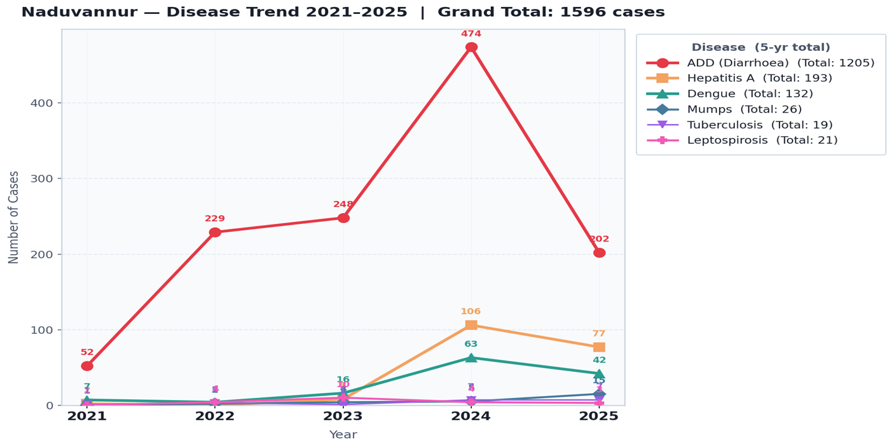
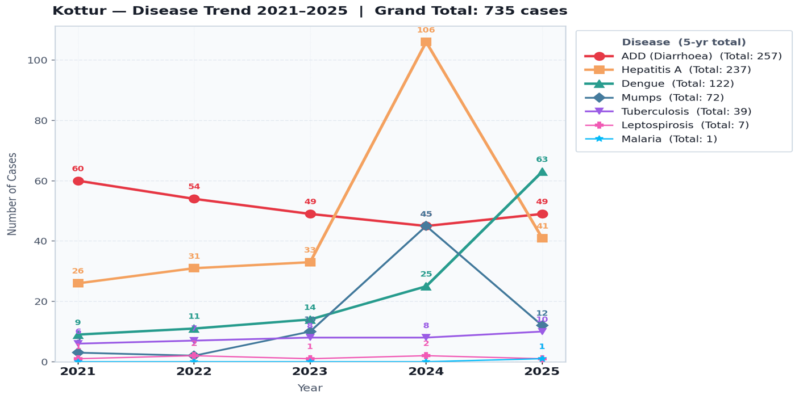

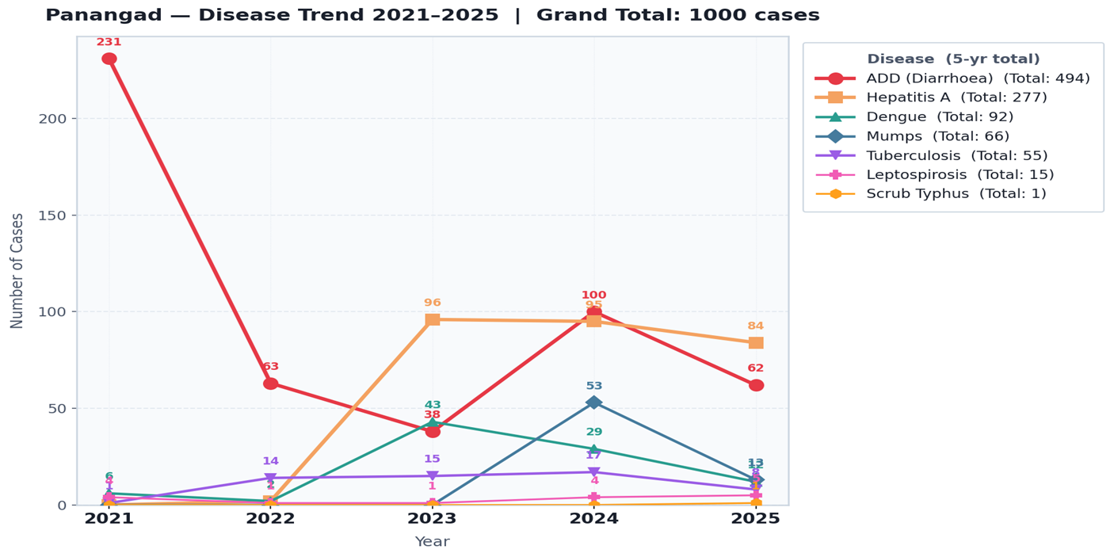

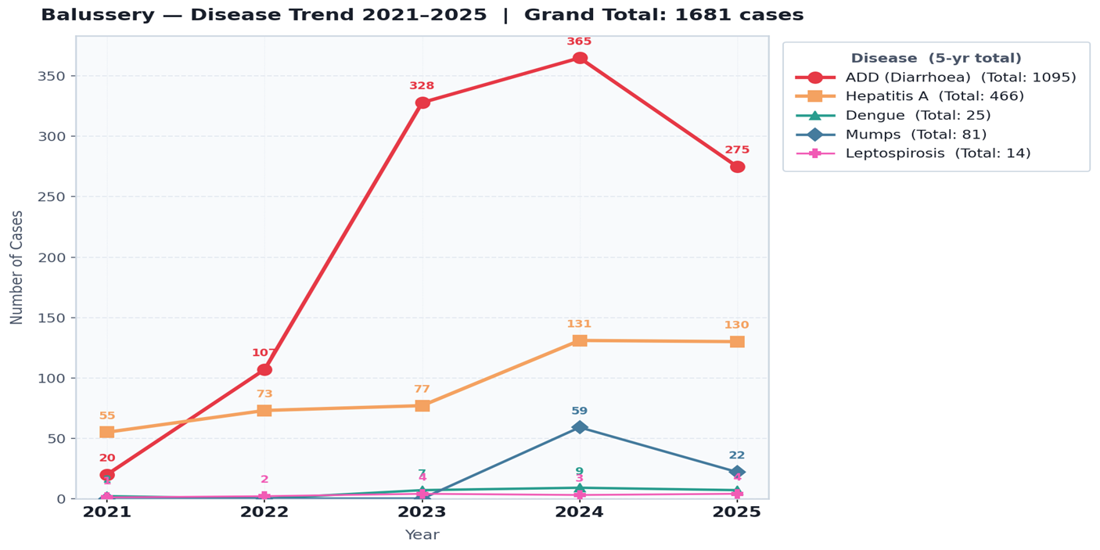

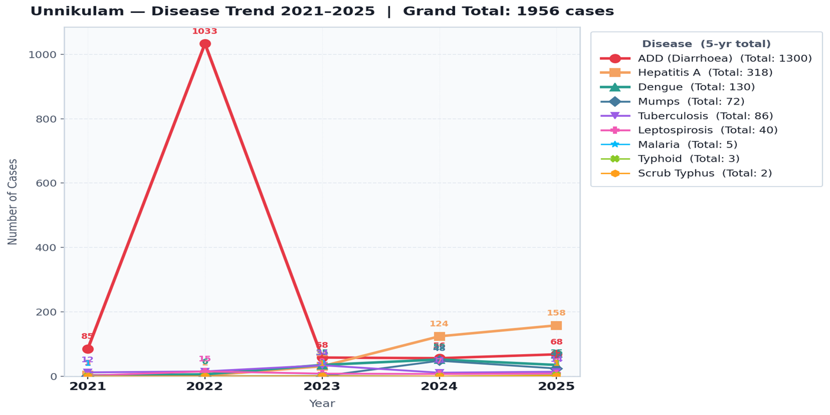
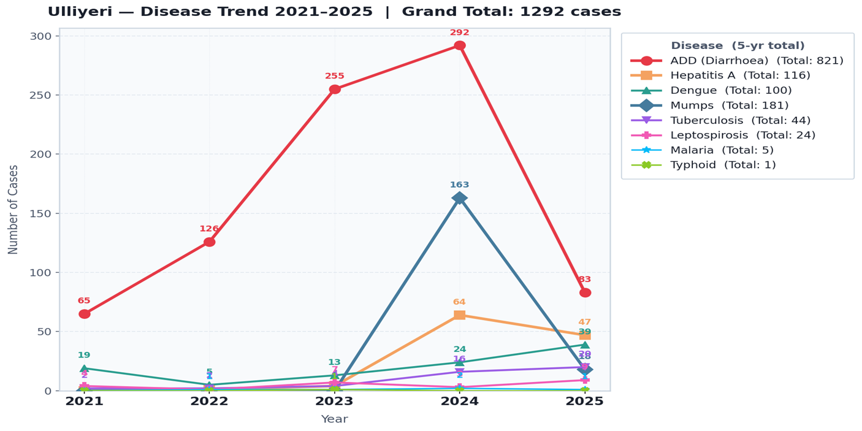

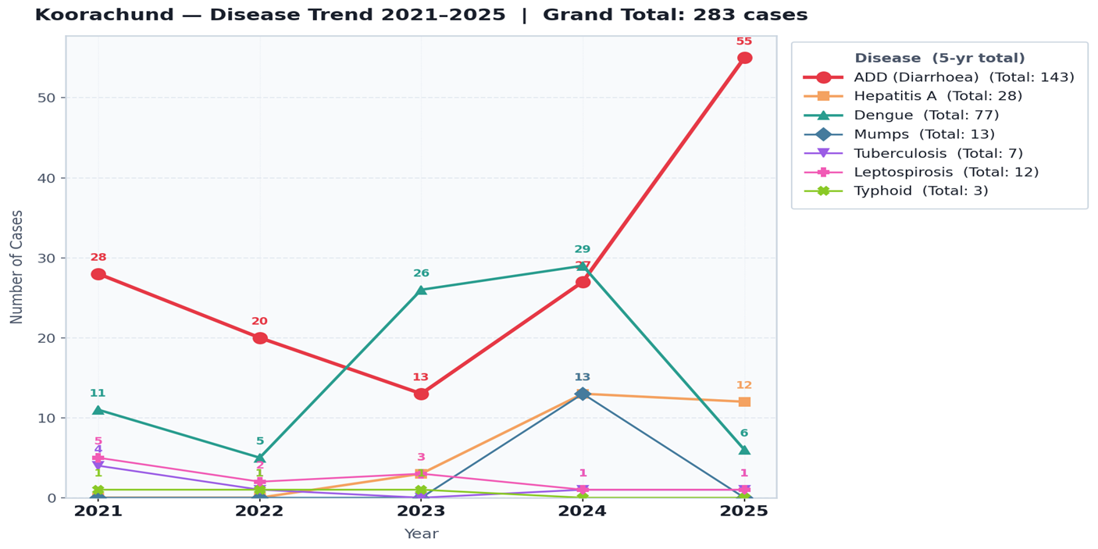

At a glance across all panchayaths: ADD/Diarrhoea dominates everywhere (thick red line), Hepatitis A is the second biggest concern, and diseases like Scrub Typhus, Malaria & Typhoid are near-flat at the bottom.

Seasonal Trend Analysis
Seasonal analysis helps anticipate surges (e.g. dengue in monsoon, leptospirosis after floods, influenza in cooler months) and plan pre‑emptive vector control, stockpiling of IV fluids, and awareness campaigns at Panchayat level.

DENGUE
Dengue is a major seasonal vector-borne disease strongly associated with rainfall, water stagnation, and increased mosquito breeding during the monsoon period.

Peak: July–November

Dengue – LSGI-wise Yearly Distribution (2021–2025)

Name of LSGI | Dengue – LSGI-wise Yearly Distribution
Name of LSGI | 2021 | 2022 | 2023 | 2024 | 2025 | Total
Naduvannur | 7 | 4 | 16 | 63 | 42 | 132
Kottur | 9 | 11 | 14 | 25 | 63 | 122
Panangad | 6 | 2 | 43 | 29 | 12 | 92
Balussery | 2 | --- | 7 | 9 | 7 | 25
Unnikulam | 2 | 6 | 35 | 52 | 35 | 130
Koorachund | 11 | 5 | 26 | 29 | 6 | 77
Ulliyeri | 19 | 5 | 13 | 24 | 39 | 100
Block Total | 56 | 33 | 154 | 231 | 204 | 678

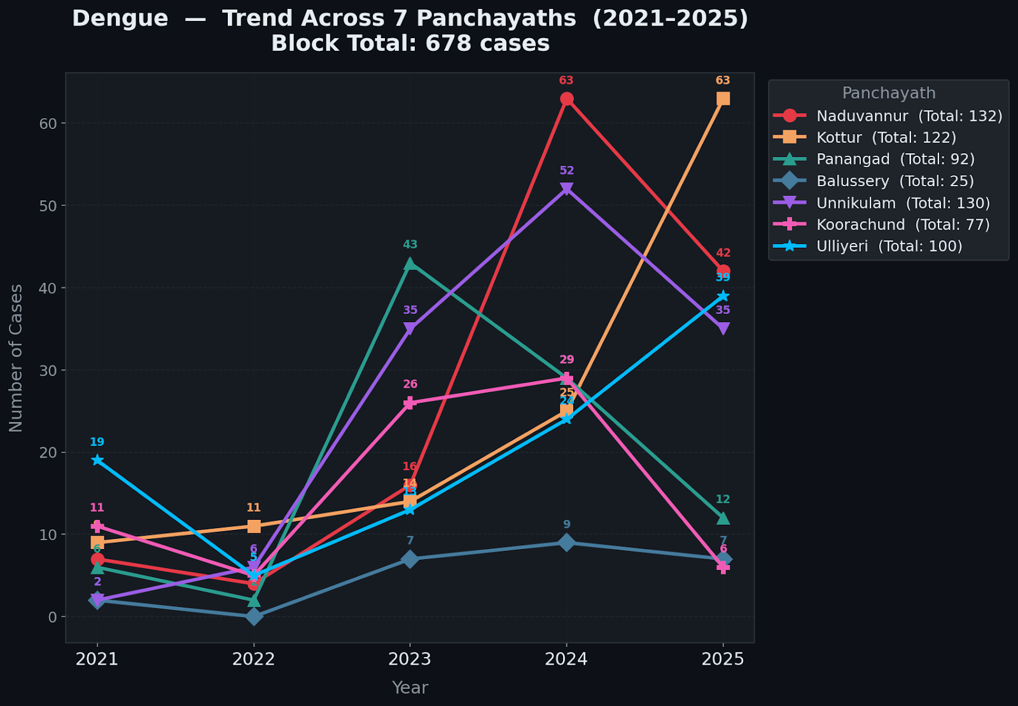

LEPTOSPIROSIS
Leptospirosis cases are closely linked to monsoon rains, flooding, and occupational exposure, particularly in low-lying and waterlogged areas.

Peak: June - August

Leptospirosis – LSGI-wise Yearly Distribution (2021–2025)

Name of LSGI | Leptospirosis – LSGI wise Yearly Distribution
Name of LSGI | 2021 | 2022 | 2023 | 2024 | 2025 | Total
Naduvannur | --- | 4 | 10 | 4 | 3 | 21
Kottur | 1 | 2 | 1 | 2 | 1 | 7
Panangad | 4 | 1 | 1 | 4 | 5 | 15
Balussery | 1 | 2 | 4 | 3 | 4 | 14
Unnikulam | 2 | 15 | 8 | 7 | 8 | 40
Koorachund | 5 | 2 | 3 | 1 | 1 | 12
Ulliyeri | 4 | 1 | 7 | 3 | 9 | 24
Block Total | 17 | 27 | 34 | 24 | 31 | 133

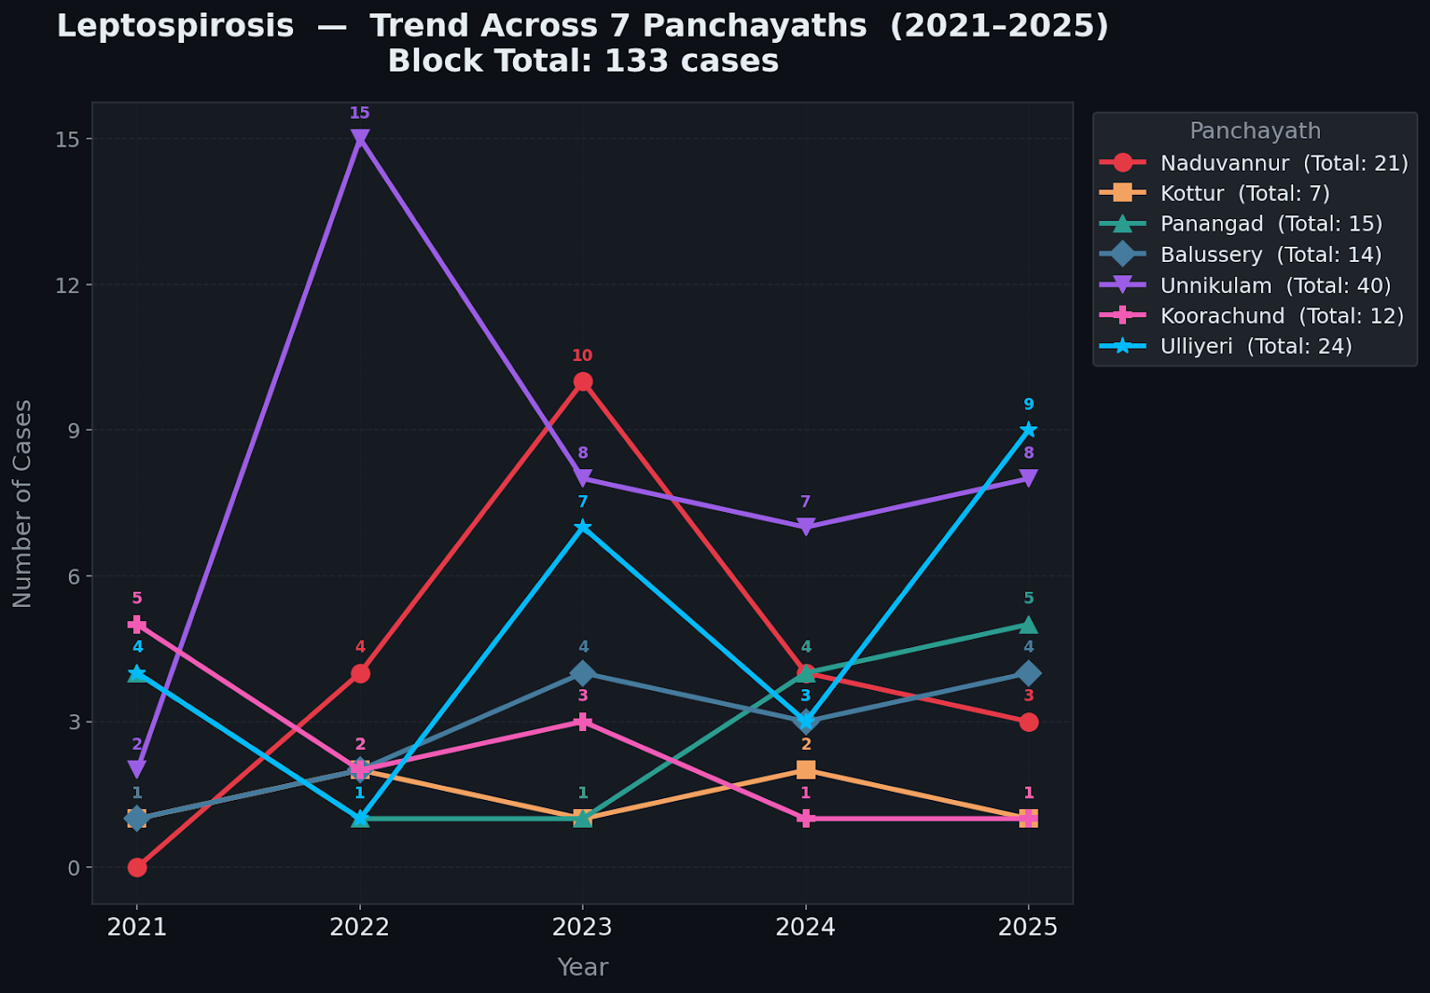

VIRAL HEPATITIS - A
Hepatitis A cases are commonly associated with unsafe drinking water, food contamination, and breakdowns in sanitation, often presenting as clusters or outbreaks.

Peak: October - December

Hepatitis A – LSGI-wise Yearly Distribution (2021–2025)

Name of LSGI | Hep A – LSGI-wise Yearly Distribution
Name of LSGI | 2021 | 2022 | 2023 | 2024 | 2025 | Total
Naduvannur | 2 | - | 8 | 106 | 77 | 193
Kottur | 26 | 31 | 33 | 106 | 41 | 237
Panangad | 1 | 2 | 96 | 95 | 84 | 277
Balussery | 55 | 73 | 77 | 131 | 130 | 466
Unnikulam | 3 | 2 | 31 | 124 | 158 | 318
Koorachund | --- | --- | 3 | 13 | 12 | 28
Ulliyeri | --- | 1 | 4 | 64 | 47 | 116
Block Total | 86 | 109 | 252 | 639 | 549 | 1635

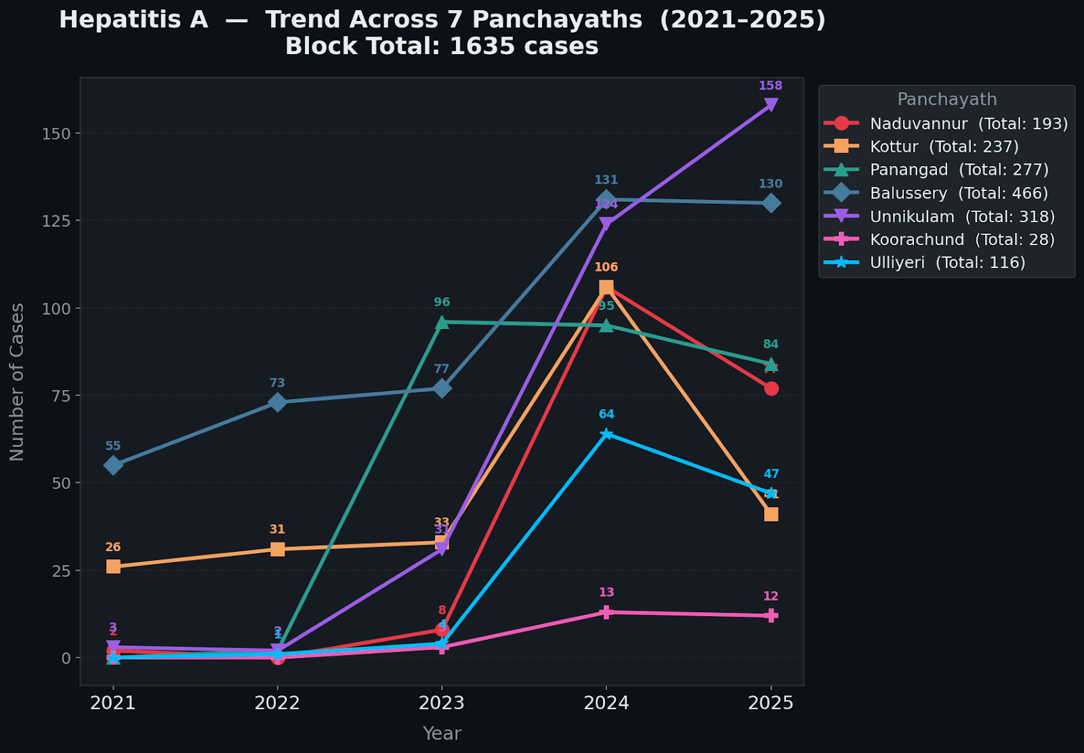

Outcome-Based Trend Analysis- 2025-2026

Key Findings
Overall Disease Burden: Combined hospitalisations for Dengue, Leptospirosis, and Hepatitis A peaked during the monsoon months (July–September 2025), with August 2025 recording the highest block-wide hospitalisations (105 cases across all three diseases).
Dengue: Peak hospitalisation in August 2025 (52 cases). A total of 5 deaths were recorded across the year, all during the monsoon period (June–September). Recovery rates remained high at 94%.
Leptospirosis: Monsoon-driven spike with 18 hospitalisations in August 2025. Three deaths reported (June–August). The disease shows a clear single-peak seasonal pattern with rapid decline post-monsoon.
Hepatitis A: Unlike vector-borne diseases, Hepatitis A showed a broader, prolonged peak from July to October 2025, reflecting waterborne transmission that persists beyond the monsoon. A total of 4 deaths were recorded. Hospitalisation rates remained elevated through November–December 2025, indicating post-monsoon water contamination.
Recovery Rate: Overall block recovery rate across all three diseases stands at 95.8% for 2025–2026, indicating adequate clinical management. However, the 12 deaths (5 Dengue, 3 Leptospirosis, 4 Hepatitis A) signal the need for strengthened early case detection and referral pathways.
Recommendations: (1) Pre-monsoon vector control drives in Kottur and Naduvannur for Dengue.
(2) Protective equipment distribution and chemoprophylaxis for agricultural workers in Unnikulam before June.
(3) Emergency water quality surveillance and Hepatitis A vaccination in Balussery, Panangad, and Unnikulam.
(4) Establish rapid referral protocols for all three diseases in all 7 panchayaths before the onset of monsoon 2026.

Transmission Trend- 2025
For effective management of public health issues, it is important to track the trend of disease transmission mode. It helps identify the population or place at high risk that can be used to predict outbreaks and implement targeted interventions as quickly as possible. Understanding these kinds of trends enables authorities to allocate resources efficiently and change the strategies adequately based on the trend that follows.

Mode of Transmission | Name of LSGI | No. of cases | No. of Deaths
Vector Borne Diseases | Unnikulam, Kottur, Naduvannur, Ulliyeri | 208 | Nil
Water Borne Diseases | Balussery, Unnikulam, Naduvannur, Panangad | 1490 | Nil
Air Borne Diseases | Unnikulam, Ulliyeri, Kottur | 315 | Nil
Blood Borne Diseases | Unnikulam, Kottur | 19 | Nil
Food Borne Diseases | Unnikulam, Ulliyeri, Panangad | 35 | Nil

Vector-Borne Disease

Disease | Name of LSGI | No. of Cases | No. of Deaths
Dengue | Kottur (63), Naduvannur (42), Ulliyeri (39) | 204 | Nil
Malaria | Unnikulam (2), Kottur (1), Ulliyeri (1) | 4 | Nil
Chikungunya | — | — | Nil

Water Borne Disease

Disease | Name of LSGI | No. of Cases | No. of Deaths
Cholera | Unnikulam (158), Balussery (130), Panangad (84) | 549 | Nil
Typhoid | Balussery (275), Naduvannur (202), Ulliyeri (83) | 794 | Nil
Hep- A | Unnikulam (3) | 3 | Nil
Dysentery | Unnikulam (18), Balussery (15), Naduvannur (12) | 77 | Nil
Amoebiasis | Unnikulam (10), Balussery (8), Naduvannur (6) | 41 | Nil
E- Coli infections | Unnikulam (7), Balussery (6), Panangad (4) | 26 | Nil
Air Borne Disease

Disease | Name of LSGI | No. of Cases | No. of Deaths
Influenza | Ulliyeri (20), Unnikulam (14), Kottur (10) | 60 | Nil
H1N1 | Unnikulam (24), Balussery (22), Ulliyeri (18) | 104 | Nil
TB | Unnikulam (16), Balussery (14), Kottur (12) | 70 | Nil
Chickenpox | Unnikulam (11), Balussery (9), Kottur (8) | 49 | Nil
Measles | — | — | Nil
Covid-19 | — | — | Nil
Pertussis | Unnikulam (7), Balussery (6), Ulliyeri (5) | 32 | Nil
Mumps | — | — | Nil

Blood-Borne Disease

Disease | Name of LSGI | No. of Cases | No. of Deaths
AIDS | Unnikulam (1), Kottur (1) | 2 | Nil
Hep- B | Unnikulam (3), Kottur (3), Ulliyeri (2) | 14 | Nil
Hep- C | Unnikulam (1), Kottur (1), Ulliyeri (1) | 3 | Nil

Zoonotic Disease

Disease | Name of LSGI | No. of Cases | No. of Deaths
Rabies | Unnikulam (1), Ulliyeri (1) | 2 | Nil
Leptospirosis | Ulliyeri (9), Unnikulam (8), Panangad (5) | 31 | Nil
Avian influenza | — | — | Nil
West nile | — | — | Nil
Anthrax | — | — | Nil
Nipah | — | — | Nil
Scrub Typhus | Unnikulam (1), Panangad (1) | 2 | Nil

Integrated Disease Hotspot Map (2021–2025)

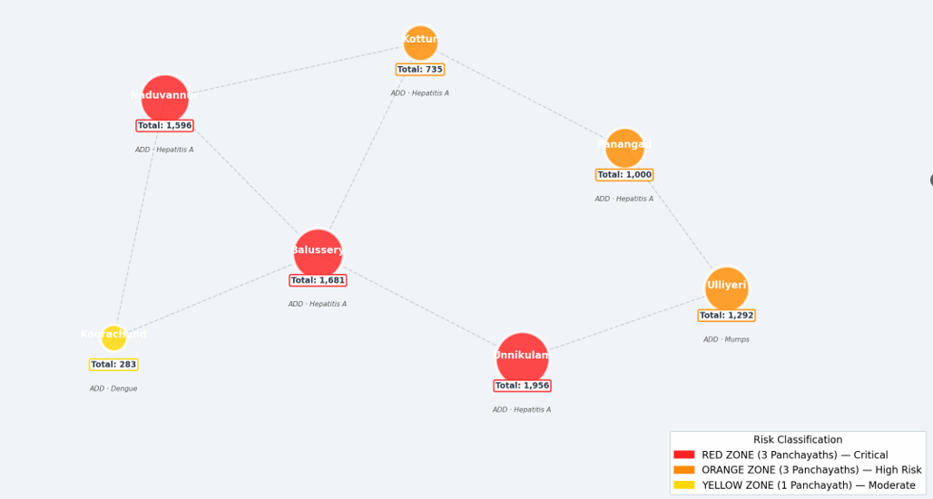
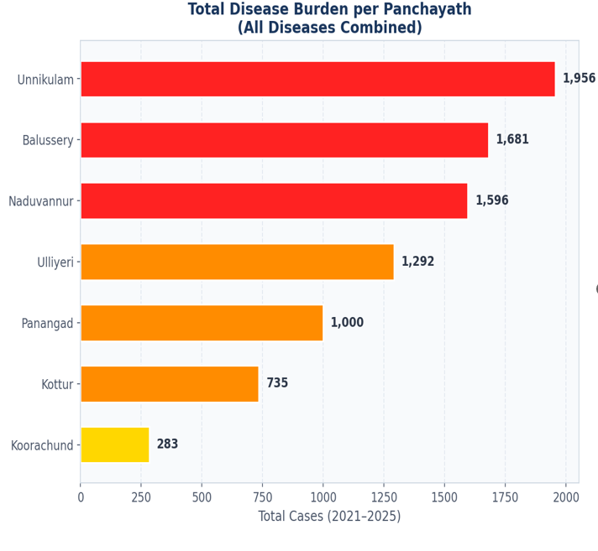

Name of LSGI | Dengue Total (2021-25) | Leptospirosis Total (2021-25) | Hepatitis A Total (2021-25) | Mumps (2021-25) | ADD (2021-25) | Total Cases
Unnikulam [RED] | 130 | 40 | 318 | 72 | 1300 | 1860
Balussery [RED] | 25 | 14 | 466 | 81 | 1095 | 1681
Naduvannur [RED] | 132 | 21 | 193 | 26 | 1205 | 1577
Ulliyeri [ORANGE] | 100 | 24 | 116 | 181 | 821 | 1242
Panangad [ORANGE] | 92 | 15 | 277 | 66 | 494 | 944
Kottur [ORANGE] | 122 | 7 | 237 | 72 | 257 | 695
Koorachund [YELLOW] | 77 | 12 | 28 | 13 | 143 | 273
BLOCK TOTAL | 678 | 133 | 1635 | 511 | 5315 | 8272

Identified 'Red Zone' LSGI. In each Red Zone LSGI’s, there are a number of ‘ Red Zone Wards’,Highest Priority Hotspot& RO proposed.
LSGI | Zone | 5-Yr Total | Red Zone Wards | Reason for Classification | Proposed RO/Infrastructure
Unnikulam | RED | 1956 | Wards 3, 4, 8 | Flood-prone riverside location; | Ward 3 and Ward 4 RO Plants (Proposed)
Balussery | RED | 1681 | Wards 1, 5, 7 | Highest Hepatitis A and ADD burden in block; contaminated well water in Ward 5; dense population in Wards 1 & 7 | Ward 5 RO Plant (Proposed)
Naduvannur | RED | 1596 | Wards 2, 4, 6 | Consistent Dengue and Hepatitis A recurrence across 5 years; Wards 2 & 4 identified as vector hotspots | Ward 4 Infrastructure Upgrade

Preparedness and Response Protocol at revenue block Level
This section describes the operational framework for the revenue block once a pandemic is declared. It explains how the revenue block and health system will move from routine data collection to active response, using a One Health approach.

Constitution of One Health Committee
Each LSGD shall constitute a One Health Committee comprising the LSGD President, Medical Officers (Modern Medicine, AYUSH, and Veterinary), the Health Inspector, and the Veterinary Surgeon.

Objective: The One Health Committee coordinates human, animal, and environmental health to prevent and control pandemics.

One health committee 1- …ULLIYERI……………. (name of LSGI)
Sl No | Name | Designation | Department/Institution | Role in Committee | Contact Number
1 | Nazar | Panchayat President | LSGD | Chairperson | 9745657306
2 | MO : Dr. Vincent | Medical Officer (PHC/CHC) | Health Dept | Member Secretary | 9447203581
3 | MO : Nazar | Veterinary Officer | Animal Husbandry | Member | 7907355276
4 | Dr.Shringa | Epidemiologist | Health Dept | Member | 8838602377
5 | Suresh Kumar | Health Inspector/PHN | Health Dept | Surveillance | 95539382697
6 | Shynu | ASHA Supervisor | Health Dept | Community link | 965803612
7 | Sheena | ICDS Supervisor | Social Welfare | Vulnerable groups | 04962707177
8 | Shinu | Police Station Officer | Police Dept | Law & order | 04962672233
9 | Kamalakshee | Ward Councillor Representative | LSGD | Community coordination | 9048058846
10 | Bindu | Kudumbashree CDO | Kudumbashree | Community mobilisation | 9686798885
11 | Hema | NGO/Volunteer rep | Civil Society | Support services | 10 groups

One health committee 2- …………NADUVANNUR…………………. (name of LSGI)

Sl No | Name | Designation | Department/  Institution | Role in Committee | Contact Number
1 | Shyja Murali | Panchayat President | LSGD | Chairperson
2 | Dr.Chitra m Mukundan | Medical Officer (PHC/CHC) | Health Dept | Member Secretary | 9048634646
3 | Dr..Jithu K S | Veterinary Officer | Animal Husbandry | Member | 9707355276
4 | Dr.Shringa | Epidemiologist | Health Dept | Member | 8838602377
5 | Jithesh N T | Health Inspector/PHN | Health Dept | Surveillance | 9446483486
6 | Reena | ASHA Supervisor | Health Dept | Community link | 9387440367
7 | Deepa | ICDS Supervisor | Social Welfare | Vulnerable groups | 04962707177
8 | SI | Police Station Officer | Police Dept | Law & order | 04962652247
9 | Rajitha | Ward Councillor Representative | LSGD | Community coordination | 0495 2721967
10 | beena | Kudumbashree CDO | Kudumbashree | Community mobilisation | 9747716729
11 | Rajitha | NGO/Volunteer rep | Civil Society | Support services | 9686798885

One health committee 3…………KOTTUR…………………. (name of LSGI)

Sl No | Name | Designation | Department/Institution | Role in Committee | Contact Number
1 | Sujatha teacher | Panchayat President | LSGD | Chairperson | 9947414206
2 | Dr.Mahesh | Medical Officer (PHC/CHC) | Health Dept | Member Secretary | 9048634646
3 | Dr.nazar | Veterinary Officer | Animal Husbandry | Member | 9707355276
4 | Dr.Shringa | Epidemiologist | Health Dept | Member | 8838602377
5 | HI | Health Inspector/PHN | Health Dept | Surveillance | 9207634044

One health committee 4………PANANAGAD………………. (name of LSGI)
Sl No | Name | Designation | Department/Institution | Role in Committee | Contact Number
1 | VM Kamalakshi | Panchayat President | LSGD | Chairperson | 9048058846
2 | Dr.Sajana P P | Medical Officer (PHC/CHC) | Health Dept | Member Secretary | 9048634646
3 | MO | Veterinary Officer | Animal Husbandry | Member | 04962642059
4 | Dr.Shringa | Epidemiologist | Health Dept | Member | 8838602377
5 | Binu | Health Inspector/PHN | Health Dept | Surveillance | 9846247824

One health committee 5 …………UNNIKULAM…………………. (name of LSGI)
Sl No | Name | Designation | Department/Institution | Role in Committee | Contact Number
1 | Abdulla | Panchayat President | LSGD | Chairperson | 0496-2647065
2 | Dr.Abdurahhiman | Medical Officer (PHC/CHC) | Health Dept | Member Secretary | 9048634646
3 | Dr.Naseer | Veterinary Officer | Animal Husbandry | Member | 04962645170
4 | Dr.Shringa | Epidemiologist | Health Dept | Member | 8838602377
5 | Latha | Health Inspector/PHN | Health Dept | Surveillance | 9446156602

One health committee 6 …BALUSSERY…………………………. (name of LSGI)

Sl No | Name | Designation | Department/Institution | Role in Committee | Contact Number
1 | Ismail kurumpoyil | Panchayat President | LSGD | Chairperson | 04962642087
2 | Dr.Umesh | Medical Officer (PHC/CHC) | Health Dept | Member Secretary | 9048634646
3 | Dr.Naseer | Veterinary Officer | Animal Husbandry | Member | 9897226779
4 | Dr.Shringa | Epidemiologist | Health Dept | Member | 9945222808
5 | Binu p Balan | Health Inspector/PHN | Health Dept | Surveillance | 97368789829

One health committee 7…………KOORACHUND………………. (name of LSGI)

Sl No | Name | Designation | Department/Institution | Role in Committee | Contact Number
1 | Sini Jino | Panchayat President | LSGD | Chairperson | 952361765
2 | Dr.Aslam Farooq Z A | Medical Officer (PHC/CHC) | Health Dept | Member Secretary | 9048634646
3 | Dr.Karthika | Veterinary Officer | Animal Husbandry | Member | 9895255779
4 | Dr.Shringa | Epidemiologist | Health Dept | Member | 99462226708
5 | Aravind | Health Inspector/PHN | Health Dept | Surveillance | 8086127178
6 | Jini.K K | ASHA Supervisor | Health Dept | Community link | 9496134622
7 | Udaya | ICDS Supervisor | Social Welfare | Vulnerable groups | 9846999188
8 | Sooraj | Police Station Officer | Police Dept | Law & order | 9946909940
9 | Darly Ebraham | Ward Councillor Representative | LSGD | Community coordination | 9497868095
10 | Karthika.P | Kudumbashree CDO | Kudumbashree | Community mobilisation | 9496726850
11 | Shymol | NGO/Volunteer rep | Civil Society | S Support services | 9188023153
12 | Dr.Anu C Mathew | Line Department representations | Govt.Ayurveda Hospital | S Support services | 9496430526
13 | Dr.Zainaba | Medical officer | Govt.Homoeo Hospital | S Support services | 9400308542
14 | Raji | Agricultural Officer | Agricultural department | S Support services | 9745342454
15 | Dr.Karthika | Veterinary medical | Vet.Hospital | Su Support services | 9446941413

Key Responsibilities:
- Review disease surveillance data (human + animal)
- Conduct ward-wise risk assessment and vulnerability mapping
- Approve quarantine/isolation centre locations
- Coordinate with district for resources (PPE, oxygen, ambulances)
- Periodically review health system surge capacity, including beds, oxygen, human resources, and ambulances.
- Approve and monitor risk communication and community engagement strategies, including rumour management.
- Ensure protection and service continuity for vulnerable groups (elderly, persons with disabilities, dialysis patients, coastal populations).
- Conduct quarterly mock drills
- Monitor equity measures for vulnerable groups

Meeting Schedule:
Quarterly (normal times) | Weekly (outbreak alert) | Daily (pandemic phase)

Pandemic Response Workforce
To ensure a coordinated and timely response during a pandemic, a dedicated Pandemic Response Workforce shall be constituted at the revenue block level. The workforce will function under the overall supervision of the One Health Committee and in close coordination with the health authorities. Team-based deployment will enable efficient surveillance, case management, quarantine and isolation management, logistics support, and risk communication. Each team shall have a clearly designated team leader, defined roles, and an identified pool of personnel to allow rapid activation, rotation of duties, and continuity of services during prolonged emergencies.

Total Response Workforce Available

Team Name | Composition | Key Responsibilities | Team Leader
Surveillance and Contact Tracing Team | HS, HI, JHI, block epidemiologist, block data manager, JPHN, ASHAs and Volunteers | Case detection, contact listing, home visits, reporting | HS
Case Management Team | Doctors, Nurses, MLSP, Palliative Nurses | Patient care & referral | BLOCK MO
Quarantine & Isolation Team | LSGD staff, Volunteers | Facility management | HI
Psychosocial support | JHI,MLSP | STRENGTHENING TEM | JHI
Logistics & supply chain Team | LSGD staff, Storekeepers, Drivers 3 | Supplies & transport [PPE, medicines, oxygen, transport, waste management] | Ward Member
Communication Team | Ward members, Kudumbashree, Youth clubs,  AWW workers and other self help groups | IEC, community meetings, countering misinformation | BLOCK MO
Transportation | KSRTC, educational institutional buses | TRAVEL | HS,JHI,HI
Media Surveillance | JHI | INFORMATION | HI
Intersectoral coordination and convergence | MO & BLOCK LEVEL TEAM | FAST RESPONSE PROPER INFORMATION | MO
Collaborative surveillance | BPHU unit and Institution | SYSTEM STRENGHTHENING | MO

All teams shall be activated immediately upon outbreak alert or pandemic declaration and shall report daily to the revenue block Incident Commander/Block Medical Officer, with consolidated reporting to the Block PHU. Duty rosters and alternate personnel shall be maintained to ensure uninterrupted services during staff shortages or prolonged response periods. Team composition and numbers may be revised based on the magnitude of the outbreak and availability of human resources.

Activities and Measures before and during Pandemic

PHASE 1 - Alert / Preparation
Surveillance and Reporting-Enhanced syndromic surveillance:
- Data sources for surveillance:
- Event-based triggers (to be monitored and reported):
- Zoonotic and animal health surveillance
- Logistics and Stock Preparedness
  - Identify and empanel local vendors and define emergency procurement mechanisms in accordance with existing LSGD and Health Department norms.
  - Prepare and maintain an essential logistics checklist covering medical supplies, consumables, and support equipment.
  - Pre-identify secure storage locations for emergency stocks and ensure maintenance of stock registers with regular updating.
  - Finalise emergency transport arrangements, including availability of vehicles and identified drivers for rapid deployment during alerts.
  - Designate a Nodal Officer for Logistics to enable prompt decision-making, coordination, and communication during emergencies.
  - Conduct rapid stock verification and ensure availability of minimum buffer stock, including:
- PPE kits 90 numbers
- Pulse oximeters _40__ numbers
- Hand sanitizers – 510 available litres
- Masks, gloves, disinfectants in adequate quantity
Identify critical gaps in logistics and immediately communicate requirements to the Block and District authorities for timely replenishment and support. Monitor expiry dates and stock rotation.

Identification of Quarantine and Isolation Facilities
  - Identify and list suitable buildings for quarantine and isolation (schools, hostels, community halls, etc.).
  - Categorise cases as per the severity and allocate to appropriate facilities (for instance, severe cases to classrooms, mild cases to an assembly hall in case of a school).
  - Facility readiness checklist needed (beds, toilets, ventilation) etc.
  - Find an alternate site if the primary sites are not available or not in use.
  - Identify facility managers and support staff
  - Prepare basic SOPs for:
    - Admission and discharge
    - Food, water, sanitation
    - Infection prevention and waste disposal
  - Ensure availability of basic amenities: water, sanitation, electricity, ventilation, and waste disposal. Prepare a rapid activation plan for these facilities if case numbers increase.

Risk Communication and Community Preparedness
  - Disseminate early warning messages on symptoms, preventive measures, and reporting mechanisms. Display IEC materials both in English and the local language in public places and ensure ward-level awareness.
  - Sensitize elected representatives and community leaders on preparedness measures.
  - Establish a rumour tracking and misinformation response mechanism to identify, verify, and promptly counter false or misleading information.
  - Engage trusted local persons (ward members, ASHA workers, religious leaders, teachers, community volunteers) to communicate official public health messages and reinforce correct practices.
  - Develop and deploy targeted IEC materials for:
    - Schools and educational institutions
    - Markets and commercial areas
    - Work sites and labour settings
  - Conduct community sensitization meetings at the ward level to promote preventive behaviors, address concerns, and strengthen community participation in preparedness and response.

Protection of Vulnerable Groups
Vulnerable populations require priority protection through targeted line-listing, service continuity, and delivery mechanisms.
- Prepare and regularly update line-lists of vulnerable populations, including:
  - Elderly persons living alone
  - Persons with disabilities
  - Pregnant women
  - Migrant workers
  - Dialysis patients
The detailed line-lists shall be maintained as Annexure _ and updated periodically.

Clinical Dependency Mapping
Develop ward-wise dependency and vulnerability maps to identify households requiring regular support during emergencies. Ensure continuity of essential health services for vulnerable groups, including
- Dialysis services (facility mapping, transport arrangements, and scheduling)
- Continuity of treatment for TB, HIV, and other chronic conditions requiring uninterrupted medication
- Mental health and psychosocial support services
Establish delivery mechanisms for food, essential commodities, and medicines to vulnerable households through coordinated action involving ASHAs, JPHNs, Kudumbashree, volunteers, and local administration.

PHASE 2 - Active Response

Case Identification and Contact Tracing
Case detection and contact tracing activities will be carried out in coordination with the Health authorities, following disease-specific SOPs and IDSP guidelines.
Field Staff Involved
- Health Supervisor (HS)
- Health Inspector (HI)
- Block epidemiologist
- Block data manger
- Junior Health Inspector (JHI)
- Junior Public Health Nurse (JPHN)
- ASHAs and ASHA Supervisors
- Ward-level volunteers and Kudumbashree members (as required)

Screening Checkpoints
Screening checkpoints at high-traffic locations (transport hubs, markets, religious gatherings) for early detection of symptomatic travellers and crowd screening during outbreaks. Potential locations include bus stands, market entry points, and boat jetties, based on local context and risk assessment.
Screening activities will be carried out by trained personnel such as ASHAs, ward members, and volunteers, with support from Health Department staff. Necessary equipment, including non-contact thermometers and appropriate PPE, shall be ensured prior to activation.
Location | Type (Bus stand/Jetty/Market/Railway) | Staff Deployed (ASHAs/Volunteers) | Screening Method | Reporting authority
Bus stand | Transport hub | One JHI  One ASHA  One health Mentors | 1.Swab Collection.  2. Blood smears collection (RDT)  3.Thermal Scanners | Surveillance Nodal Officer in control room
Market entry | Market | One JHI  One ASHA  Male health volunteers | 1.Swab Collection.  2. Blood smears collection (RDT)  3.Thermal Scanners | Surveillance Nodal Officer in control room
Boat jetty | Water transport | One JHI  One ASHA  Male health volunteers | 1.Swab Collection.  2. Blood smears collection (RDT)  3.Thermal Scanners | Surveillance Nodal Officer in control room

Standard Screening Protocol

The screening protocol shall include temperature screening, observation for visible symptoms, and inquiry regarding recent travel or exposure history. Individuals identified as suspects during screening shall be immediately referred to the nearest PHC/FHC for further evaluation, testing, and appropriate action as per prevailing guidelines.

Pandemic Control Room
The Pandemic Control Room (PCR) serves as the central nerve center for real-time coordination, data aggregation, decision support, and communication during outbreaks. It consolidates information from all LSGD teams, health facilities and community sources to enable rapid response decisions.

Control Room Infrastructure and Location
Primary Location: __ULLIYERI revenue block Office.
Backup Location: Community Hall in __ULLIYERIrevenue block.

Health System Control Room Framework
The PCR is organized into seven functional pillars to ensure no aspect of the response is overlooked:

Rapid Response Team (RRT)
  - Provides immediate intervention during emergencies, clusters, and field alerts.​
  - Coordinates urgent actions such as case investigation, contact tracing, isolation, and inter‑facility referrals.

Data Management & Analytics Team
  - Collects, validates, and manages key health system indicators (cases, tests, beds, HR, supplies).​
  - Analyzes data trends, generates projections, and supports evidence‑based decision‑making for local authorities.

Human Resource Deployment Team
  - Allocates healthcare staff efficiently based on workload and need
  - Ensures adequate and equitable workforce distribution across facilities

Laboratory Surveillance Team
  - Oversees diagnostic testing coordination, sample transport, and timely reporting of results.​
  - Monitors lab indicators (testing volume, positivity rate, turnaround time) for early detection of outbreaks

Vaccination Cell (If Required)
  - Plans and executes vaccination campaigns, including micro‑planning and session scheduling.​
  - Tracks coverage, identifies gaps, and coordinates corrective actions with field teams and outreach services.

Infrastructure & Patient Occupancy Team
  - Monitors facility capacity, earmarked beds, oxygen and critical care resources across all linked facilities.​
  - Ensures optimal patient distribution and referral management using updated bed‑status and resource data.
  - BMWM

Communication team
- Logistics and supply chain
- Transportation (interfacility & emergency transport)
- Media surveillance Call centre
- Management of the deceased
- Intersectoral coordination and convergence

Key Control Room Team
The Control Room Team coordinates all pandemic response activities within the LSGD and serves as the single command and communication hub during activation. It integrates information, field actions, logistics, and policy execution across all participating departments and health facilities.

Role | Name | Designation | Contact Number | Responsibility
In-charge/Nodal Officer | Dr .Vincent George | MEDICAL OFFICER | 9745657306 | Overall coordination, decision-making, and reporting to the District level.
Block epidemiologist | Dr.Shringa Sivanand S J | EPIDEMIOOLOGIST | 8838602377 | Technical lead for surveillance, data interpretation, and outbreak investigation within the block
Block data manager | Sreejitha T P | DATA MANAGER | 8907272745 | Ensure timely collection, compilation, and entry of data (S, P, L forms) &Data Quality Assurance
Data Entry Operator |  |  |  | Managing the line list, updating dashboards, and tracking testing results.
Communication Officer | SURESH  RIBIN | HI,JHI | 8086127178 | Handling the public helpline, coordinating ambulance dispatch, and contact tracing calls.
Logistics Coordinator | RIBIN | JHI |  | coordination
Technical Support (IT/Data) | Data manager | Sreejitha | 8907272745 | Data consolidation,reporting,monitoring portals

SOP for alert escalation/trigger point with mapping of responsibilities.
Key Points:
- The Control Room shall be staffed with a designated In-charge, data entry personnel, and communication staff with clearly defined roles and shift arrangements.
- It shall maintain updated records on daily monitoring indicators including new cases, persons under active quarantine, and hospital bed occupancy.
- All reports and situation updates shall be shared daily with the Block and District Surveillance Unit.
- The Control Room shall act as a single point of contact for coordination with response teams, health institutions, and other departments.
- Contact details of the Control Room shall be widely communicated to field staff and stakeholders during activation.

Daily Monitoring Indicators
To ensure timely decision-making and effective response, the following key indicators shall be monitored and updated on a daily basis by the Pandemic Control Room:

Epidemiological Indicators:
New cases reported today, Total active cases, Test Positivity Rate (TPR), Case Fatality Rate (CFR)
- Surveillance Indicators:
Persons under home quarantine, High-risk contacts identified, Fever, ILI, SARI or other symptoms (syndromic surges), Travellers (symptomatic or high-risk arrivals),Animal husbandry surveillance (zoonotic alerts, unusual animal deaths, poultry/bird flu signals), Mortality surveillance (excess deaths, unexplained fatalities, verbal autopsy reports)
- Logistics and Infrastructure Indicators:
Hospital / CFLTC beds occupied, Oxygen cylinders/concentrators available, Ambulances on standby
- Alert Findings
The following table outlines category-specific trigger points (red flags) from surveillance indicators and corresponding immediate actions for the Pandemic Control Room. These enable rapid response to alert findings like testing anomalies, positive cases exceeding thresholds, clusters, and WGS reports.

Category | Trigger Point (Red Flag) | Immediate Action
Clusters | Geographical or facility-based: 5+ cases linked to one location (office, school, street). | Declare a micro-containment zone; perimeter control and active case finding.
Testing | Sudden drop in testing volume / delay in reporting / unusual testing trends | Review the sample collection process, address lab bottlenecks, deploy additional testing teams, and notify the District Lab.
Lab | Test Positivity rate increases | Increase testing sites in that ward.
Hospital | >80% Oxygen bed occupancy | Activate backup/CFLTC beds.
Travel | Cluster of cases from a single flight/train or high-risk arrival group. | Trace all passengers in adjacent seats; implement mandatory institutional quarantine.
Animal | Mass poultry/wildlife death or unusual sickness | Notify Animal Husbandry, sample the area, and dispatch RRT for environmental sampling and zoonotic check.
Mortality | Sudden spike in home deaths or brought-in-dead (BID) cases | Audit the deaths and Active Case Search drive
Additional investigations like Whole Genome Sequencing (WGS) | Detection of a Variant of Concern (VOC) or Variant of Interest (VOI) | Implement strict micro-containment; update clinical protocols to match variant severity.

Communication of Public Health Information
A Community Communication Hub shall be established to ensure timely, accurate, and consistent dissemination of information during a pandemic. The Hub will function under the coordination of Nodal officers of the control room and act as the nodal point for public communication, risk messaging, and community engagement. It will support dissemination of official advisories, promote preventive behaviors, address rumors and misinformation, and ensure that messages reach all sections of the population through trusted local channels and leaders.

Key communicators
Channel | Name of LSGI | Responsible Person | Contact
Ward-level announcements | NADUVANNUR | JHI | 916238417721
Social media | NADUVANNUR | HI | 9446483486
Local Cable TV/Radio | NADUVANNUR | LOCAL VISION

Channel | Name of LSGI | Responsible Person | Contact
Ward-level announcements | Kottur | BIJU | 8075430953
Social media | Kottur | UNNIKRISHNAN | 9207634044
Local Cable TV/Radio | Kottur | TRUEVISION | BABU 9495760315

Channel | Name of LSGI | Responsible Person | Contact
Ward-level announcements | Ulliyeri | GP SECRETARY | 9496560211
Social media | Ulliyeri | GP SECRETARY | 9496560211
Local Cable TV/Radio | Ulliyeri | GP SECRETARY | 9496560211

Channel | Name of LSGI | Responsible Person | Contact
Ward-level announcements | PANANAGAD | WARD MEMBER | 9895744692
Social media | PANANAGAD | DATA ENTRY OPERATOR | 04842703535
Local Cable TV/Radio | PANANAGAD | WARD MEMBER | 9895744692

Channel | Name of LSGI | Responsible Person | Contact
Ward-level announcements | UNNIKULAM | RANJITH | 9847888328
Social media | UNNIKULAM | SHAFNA | 9048399449
Local Cable TV/Radio | UNNIKULAM | BHASKARAN | 9446783576

Channel | Name of LSGI | Responsible Person | Contact
Ward-level announcements | BALUSSERY | Musthafa | 9847102109
Social media | BALUSSERY | JHI | 9744134383
Local Cable TV/Radio | BALUSSERY | Prasanth | 9744881400

Channel | Name of LSGI | Responsible Person | Contact
Ward-level announcements | KOORACHUNDU | HI | 8086127178
Social media | KOORACHUNDU | JHI | 8592040657
Local Cable TV/Radio | KOORACHUNDU | KOORACHUND NEWS | 9846910345

- All messages disseminated through the Hub shall align with advisories issued by the Health Department and District authorities.
- Community leaders shall be sensitized to support behavior change, reduce stigma, and counter misinformation.
- Special efforts shall be made to reach vulnerable and hard-to-reach populations using locally appropriate communication methods.

Rumor Tracking: A designated volunteer will monitor local social media/WhatsApp groups daily to identify misinformation and issue official clarifications via the Communication Hub.

Coordination with District/State Authorities & Other Organisations
Effective coordination with Block, District, and State authorities is essential to ensure timely reporting, technical guidance, and uninterrupted supply of essential resources during a pandemic. The LSG shall establish clear communication channels, designate responsible officers, and adhere to prescribed reporting timelines to support coordinated public health action and efficient resource mobilisation.

Key Details:
- Nodal Officer for Reporting:
- Contact Number:
Reporting Schedule and Protocols:

To Whom | What to Report | Frequency | Nodal Person
District IDSP Unit | Outbreaks/Clusters/Unusual Events (>5 cases same ward) | DAILY Complete Situation Report (Cases, Quarantine, Beds, Screening, Deaths) | MO
Veterinary Officer | Animal health events/Zoonotic alerts | DAILY Outbreaks/Clusters/Unusual Events (>5 cases same ward) | DSO

Supply Chain Coordination
The revenue block shall coordinate closely with District, and State authorities (KMSCL) to ensure uninterrupted availability of essential goods, medical supplies, and logistics during a pandemic. Supply requirements shall be assessed regularly based on case load and communicated promptly to the appropriate authorities for timely replenishment.
Key Points:
- Maintain updated contact details of District and Block nodal officers for health logistics, oxygen supply, ambulances, and essential medicines.
- Submit timely indent requests for PPE, testing kits, medicines, oxygen, and other critical supplies through prescribed channels.
- Monitor stock levels at LSGD facilities, quarantine/isolation centres, and field teams through daily stock registers and dispensing logs to prevent shortages.
- Coordinate with District authorities, Karunya/Neethi medical shops, and local purchase committees for funds allocation and emergency procurement.

- Ensure regular monitoring of dispensing registers at all facilities to track usage, expiry, and pilferage—shortages being a perennial issue requiring proactive weekly audits.

- Activate surge procurement protocols during high caseloads, leveraging local purchase powers under LSGD funds alongside state supplies.

Resource Inventory and Contacts
Resource Category | Source  (District/State/Private) | Contact
PPE Kits/Masks/Gloves | KMSCL | 0471294600
PPE Kits/Masks/Gloves | Local Vendors | 9947255621
Oxygen  Cylinders/Concentrators | KMSCL | 0471294600
Medicines/Antivirals | KMSCL | 0471294600
Medicines/Antivirals | Neethi Shops | 9947255621
Test Kits (RTPCR/Rapid) | KMSCL | 0471294600

Collaboration with NGOs, PPP, and CSR
To augment government efforts during a pandemic, the revenue block shall collaborate with NGOs, voluntary organisations, and private sector partners through public–private partnerships and Corporate Social Responsibility (CSR) initiatives, in coordination with District authorities.

Key Points:
- Engage NGOs and community-based organisations for community outreach, awareness, and support to vulnerable populations.
- Leverage CSR support for procurement of medical equipment, PPE, oxygen concentrators, food kits, and sanitation materials, as permitted.
- Ensure all collaborations align with government guidelines and are routed through approved administrative and financial procedures.
- Maintain transparency and documentation for all external support received and utilised.
Organization | Type | Name of LSGI | Support Offered | Contact Person
Youth Clubs/Student Unions | CBO  CBO  CBO  CBO  CBO  CBO  CBO | UNNIKULAM  PANNAGAD  KOORACHUNDU  BALUSSERY  NADUVANNUR  KOTTUR  ULLIYERI | Ekarool group | Ajith  HR

Interdepartmental Coordination
Coordination among departments during a pandemic shall be ensured through regular review meetings convened by the revenue block President. These meetings will provide a structured platform for sharing situational updates, assessing resource availability, resolving operational gaps, and taking joint decisions to ensure a coordinated and timely response.

Department | Representative | Key Role | Name of LSGI | Contact
Health (PHC) | Staff Nurse : Liji | Case management | NADUVANNUR | 9495129326
Veterinary | Veterinary Surgeon: Jithu K S | Animal surveillance | NADUVANNUR | 7012447853
ICDS | Supervisor: Sabira | Nutrition support | NADUVANNUR | 9567433108
Education | Head Teacher: Nishid | School coordination | NADUVANNUR | 9539380671
Police | SHO Naduvannur | Containment enforcement |  | 9497987190
Water Authority |  | Water supply
LSGD Engineering | Gloria | Quarantine infrastructure |  | 9633969341

Department | Representative | Key Role | Name of LSGI | Contact
Health (PHC) | Staff Nurse : | Case management | KOTTUR | 9745012553
Veterinary | Veterinary Surgeon: | Animal surveillance | KOTTUR | 9645634161
ICDS | Supervisor: Sindhu | Nutrition support | KOTTUR | 0
Education | Head Teacher: | School coordination | KOTTUR | 0
Police | Sub inspector | Containment enforcement | KOTTUR | 04962642040
Water Authority | CE | Water supply | KOTTUR | 9496306030
LSGD Engineering | AE | Quarantine infrastructure |  | 984658987

Department | Representative | Key Role | Name of LSGI | Contact
Health (PHC) | Staff Nurse : | Case management | ULLIYERI | 9961685936
Veterinary | Veterinary Surgeon: | Animal surveillance | ULLIYERI | 9707355276
ICDS | Supervisor: Sindhu | Nutrition support | ULLIYERI | 9495761680
Education | Head Teacher: | School coordination | ULLIYERI | 9497208931
Police | Sub inspector | Containment enforcement | ULLIYERI | 9961685936
Water Authority | ___CE_______ | Water supply | ULLIYERI | 04962672233
LSGD Engineering | ___AE_______ | Quarantine infrastructure |  | 9539493981

Department | Representative | Key Role | Name of LSGI | Contact
Health (PHC) | Staff Nurse : Bindu Mol | Case management | BALUSSERY | 9526597128
Veterinary | Veterinary Surgeon: Dr Nisar | Animal surveillance | BALUSSERY | 9447336498
ICDS | Supervisor: Seena | Nutrition support | BALUSSERY
Education | Head Teacher:Sreeja | School coordination | BALUSSERY | 9946934968
Police | SHO | Containment enforcement | BALUSSERY | 9447362104
Water Authority | Sunitha | Water supply | BALUSSERY | 9496306030
LSGD Engineering | Renju | Quarantine infrastructure |  | 9744170536

Department | Representative | Key Role | Name of LSGI | Contact
Health (PHC) | Staff Nurse : | Case management | UNNIKULAM | 04962645170
Veterinary | Veterinary Surgeon: | Animal surveillance | UNNIKULAM | 7594994787
ICDS | Supervisor: Sindhu | Nutrition support | UNNIKULAM | 8086287006
Education | Head Teacher: | School coordination | UNNIKULAM | 04962260233
Police | Sub inspector | Containment enforcement | UNNIKULAM | 04952376008
Water Authority | Chief engineer | Water supply | UNNIKULAM | 0495 2365040
LSGD Engineering | AE | Quarantine infrastructure

Department | Representative | Key Role | Name of LSGI | Contact
Health (PHC) | Staff Nurse : Bindu Mol | Case management | KOORACHUNDU | 9539356419
Veterinary | Veterinary Surgeon: Dr Nisar | Animal surveillance | KOORACHUNDU | 9446941413
ICDS | Supervisor: Seena | Nutrition support | KOORACHUNDU | 9846999188
Education | Head Teacher:Sreeja | School coordination | KOORACHUNDU | 9447846222
Police | SHO | Containment enforcement | KOORACHUNDU | 9946909947
Water Authority | Sunitha | Water supply | KOORACHUNDU | 8943064136
LSGD Engineering | Renju | Quarantine infrastructure |  | 8943064136

PHASE 3 - Surge Capacity
Phase 3 is activated when there is a rapid increase in cases, high test positivity rates, or when existing health facilities and quarantine arrangements approach saturation. The focus of this phase is to expand isolation capacity, augment clinical care services, and mobilise additional resources through district and state support mechanisms.

Conversion of Community Facilities

Name of LSGI | Name of facility | Facility Type | No. of Buildings | Ward | Surge Capacity (Beds) | Nodal Person
NADUVANNUR | Green Paraiso | Auditorium | 1 | 11 | 25 | Saseendran  9495785518
NADUVANNUR | GHSS Naduvannur | School | 2 | 11 | 60 | 04962652351
NADUVANNUR | AMUP NADUVANNUR SOUTH | School | 1 | 16 | 60 | 09995072192
NADUVANNUR | AUPS KAVUMTHARA | School | 1 | 16 | 55 | 7947105199

Name of LSGI | Name of facility | Facility Type | No. of Buildings | Ward | Surge Capacity (Beds) | Nodal Person
KOTTUR | GLPS NEROTH | GOVT | 1 | 8 | 25 | MO
KOTTUR | AUPS KOTTUR | AIDED | 1 | 18 | 45 | MO
KOTTUR | HSS VAKAYAD | AIDED | 2 | 15 | 250 | MO
KOTTUR | GHSS AVITANALLUR | GOVT | 1 | 16 | 100 | MO
KOTTUR | AUPS POONATH | AIDED | 1 | 7 | 25 | MO
KOTTUR | AMLP MOOLAD | AIDED | 1 | 1 | 25 | MO
KOTTUR | ALPS AVITANALLUR | AIDED | 1 | 5 | 30 | MO

Name of LSGI | Name of facility | Facility Type | No. of Buildings | Ward | Surge Capacity (Beds) | Nodal Person
ULLIYERI | COMMUNITY HALL | HALL | 1 | 7 | 10 | GP SECRETARY
ULLIYERI | SAMANWAYA HALL | AUDITORIUM | 1 | 7 | 20 | GP SECRETARY

To manage increased case load, the revenue block shall activate additional isolation facilities by repurposing identified community infrastructure such as community halls, auditoriums, schools, hostels, or other suitable buildings.

Name of LSGI | Name of facility | Facility Type | No. of Buildings | Ward | Surge Capacity (Beds) | Nodal Person
KOORACHUNDU | CHC KOORACHUND | CHC | 1 | 12 | 10 | MO CHC
KOORACHUNDU | PARISH HALL KOORACHUND | PRIVATE | 1 | 9 | 50 | MO CHC
KOORACHUNDU | ST.JOSEPH HS KOORACHUND | AIDED | 1 | 12 | 50 | MO CHC
KOORACHUNDU | ST,JOSEPH UP KOORACHUND | AIDED | 1 | 9 | 200 | MO CHC
KOORACHUNDU | ST,JOSEPH HSS KOORACHUND | AIDED | 1 | 9 | 100 | MO CHC
KOORACHUNDU | HIBAS AUDITORIUM KOORACHUND | PRIVATE | 1 | 9 | 50 | MO CHC
KOORACHUNDU | ST MARIES HS | AIDED | 1 | 6 | 250 | MO CHC
KOORACHUNDU | ST MARIES HSS | AIDED | 1 | 6 | 250 | MO CHC
KOORACHUNDU | ST MARIES LP | AIDED | 1 | 6 | 50 | MO CHC

Name of LSGI | Name of facility | Facility Type | No. of Buildings | Ward | Surge Capacity (Beds) | Nodal Person
UNNIKULAM | UNNIKULAM PANCHAYATH COMMUNITY HALL | PANCHAYATH | 1 | 3 | 100 | PANCHAYATH PRESIDENT
UNNIKULAM | VYPARA BHAVAN | PRIVATE | 1 | 9 | 50 | SAJITH AW/M
UNNIKULAM | GHSS POONOOR | GOVT | 1 | 15 | 100 | MOHANAN H.M
UNNIKULAM | GHSS SIVAPURAM | GOVT | 1 | 22 | 100 | SHEEBA HM
UNNIKULAM | GHS SIVAPURAM | GOVT | 1 | 22 | 100 | HM
UNNIKULAM | GHS POONOOR | GOVT | 1 | 15 | 100 | MAHESWAR HM

Name of LSGI | Name of facility | Facility Type | No.of Buildings | Ward | Surge Capacity (Beds) | Nodal Person
BALUSSERY | Smart Hospital | Hospital |  | 2 | 80 | MO
BALUSSERY | Community hall prajiis smarakam |  |  | 5 | 50 | MO

Name of LSGI | Name.of facility | Facility Type | No.of Buildings | Ward | Surge Capacity (Beds) | Nodal Person
PANANAGAD | VANITHA HOSTEL | HOSTEL | 1 | 6 | 60 | WARDEN
PANANAGAD | PAKAL VEEDU | HALL | 1 | 18 | 5 | PANCHAYATH SECRETARY
PANANAGAD | MARINA AUDITORIUM | HALL | 1 | 14 | 0 | AZEEZ
 | ANJOOM AUDITORIUM | CONVENTION HALL | 1 | 13 | 0 | SOMAN
 | POOVAMBAI HS | SCHOOL | 1 | 9 | 0 | MURALI

- Recovery and rehabilitation phase
- Recovery
  - Damage & impact assessment
  - Restoration of health services
  - Rehabilitation of affected population
  - Psychosocial & mental health support
  - Disease surveillance during recovery phase
  - Environmental cleanup & sanitation
  - Livelihood restoration
  - Community engagement & confidence building
  - Documentation & after-action review
  - Lessons learned & best practices
  - Health system strengthening
  - Policy revision & preparedness enhancement
  - Research

CONCLUSION

Additional points
- tech support
- relief based commodities
- ham reading operators
- hazard vulnerability mapping
- Kseb & other power source
- HR specific responsibility

RECOMMENDATIONS

Strengthening Healthcare Infrastructure
- Establish a primary health response unit within the Panchayat with trained staff.
- Ensure availability of basic medical supplies (masks, sanitizers, PPE kits, oxygen cylinders).
- Create tie-ups with nearby hospitals in __Taluk hospital balussery for emergency referral and transport.

2. Community Awareness & Education
- Conduct regular awareness campaigns on hygiene, vaccination, and preventive measures.
- Use local communication channels (community radio, WhatsApp groups, notice boards) to spread verified information.
- Train volunteers to act as health ambassadors in each ward.

3. Emergency Response & Coordination
- Form a Pandemic Preparedness Committee at Panchayat level including health workers, ward members, and NGOs.
- Develop a clear action plan for lockdowns, quarantine, and distribution of essentials.
- Maintain a database of vulnerable groups (elderly, differently-abled, chronically ill) for targeted support.

4. Supply Chain & Food Security
- Identify and support local suppliers and farmers to ensure uninterrupted food supply.
- Create community kitchens during emergencies to serve vulnerable populations.
- Stockpile essential commodities in Panchayat-run outlets for crisis periods.

5. Digital Preparedness
- Promote digital platforms for telemedicine consultations.
- Use Panchayat’s website/social media for real-time updates on health advisories.
- Encourage online grievance redressal to reduce crowding in offices.

6. Training & Capacity Building
- Organize mock drills for pandemic response in schools, offices, and public spaces.
- Train Panchayat staff and volunteers in first aid, infection control, and crowd management.
- Collaborate with NGOs and health departments for capacity-building workshops.

7. Long-Term Resilience
- Integrate pandemic preparedness into the Panchayat Development Plan.
- Allocate a dedicated budget for health emergencies.
- Encourage community participation in planning and monitoring preparedness measures.

MOCKDRILL SCENARIOS
- PANANGAD Completed ( MAY 2024)
- BALUSSERY Completed
- UNNIKULAM Completed(July 2025)
- KOORACHUNDU Completed.
- NADUVANNUR Completed in August 2025
- KOTTUR Completed in August 2025
- Completed

ANNEXURE

IMPORTANT PHONE NUMBERS

Phone numbers and particulars of persons responsible for providing guidance, assistance, and support for pandemic preparedness operations may be provided here in a manner that allows easy reference at a glance. The information recorded here could be exhibited elsewhere at the time of emergencies. LSG institutions shall give special attention to collect and record the above data of persons and institutions who/which are supposed to give technical and co-ordination support to reduce the impact of pandemic.

Details of grama panchayat/municipality/corporation wards under revenue block

Name of LSGI -1 KOTTUR
Sl.No | Name of the ward | Ward number | Name of the ward  member | Contact number
1 | MOOLAD | 1 | SAVINA | 9539164817
2 | NARAYAM KULAM | 2 | LINEESH | 9846505842
3 | KOLIKKADAV | 3 | SAJITH | 9846868941
4 | CHEDIKKULAM | 4 | MINI | 9645653642
5 | AVITANALLUR | 5 | USHA | 9539762070
6 | AMAYATTUVAYAL | 6 | SHEENA | 9747395840
7 | POONATH | 7 | ABITHA | 8943452006
8 | NEROTH | 8 | SHEEBA | 8086109776
9 | PAVUKKANDY | 9 | SHAJI | 6235237141
10 | TRIKUTTYSSERY | 10 | VIJINA | 8086050518
11 | IDINGAKADAV | 11 | RENEESH | 9526658034
12 | PATHINONNUKANDY | 12 | MAMMUKKUTTY | 9946467878
13 | VAKAYAD | 13 | SHABANA SASI | 9946171893
14 | THIRUVOD | 14 | SUJATHA TEACHER | 9947414206
15 | PALOLI | 15 | SAJIRA | 8590959904
16 | KOOTTA;LIDA | 16 | SUJETHA | 9497216061
17 | PADIYAKKANDY | 17 | ABEESH | 9745818718
18 | KOTTUR | 18 | RAGAVAN | 9745148417
19 | KUNNARAMVALLI | 19 | SINI | 9745935640

Name of LSGI -1 NADUVANNUR
SL  .No | Name of the ward | Ward number | Name of the ward  Member | Contact number
1 | PUTHIYEDATHKUNI | 1 | HAMEED NATTIPAROL | 9946275971
2 | KAVIL | 2 | C K BALAKRISHNAN MASTER | 9048131423
3 | KARUVANNUR | 3 | BINDU MADACHERY | 8157874381
4 | KAVUMTHARA | 4 | ASHOK KUMAR THUYYATH | 9747998701
5 | PAPPADAKUNNU | 5 | GREESHMA PRASOON | 9745697517
6 | UDUMBRAMALA | 6 | K P PRASANTH | 9846592805
7 | PUTHUSSERYTHAZHE | 7 | KRISHNA DAS CHEEDATHIL | 9745893040
8 | PUTHIYAPURAM | 8 | SNEHA R G | 8086345026
9 | VALLORAMALA | 9 | A P SHAJI MASTER | 9946512251
10 | NADUVANNUR | 10 | LEELA BAGAVATHIKANDI | 8943252697
11 | NADUVANNUR TOWN | 11 | SHYJA MURALI | 9048634646
12 | ANKAKALARI | 12 | BINDU KUTTIKANDY | 9946816371
13 | KARUMBAPOYIL | 13 | SOUDA K K | 9895189882
14 | CHENGOTTUPARA | 14 | MUHAMMADALI CHATHOTH | 9562100992
15 | PALAYATT | 15 | SAJIRA ANAS | 8943585448
16 | MANNAMKAVU | 16 | DILSHA MAKKATT | 9048689494
17 | THURUTHIMUKK | 17 | SUJA P | 9539321464
18 | ELANKAMAL | 18 | JASEERA MAVOLI | 9048682028

Name of LSGI -ULLIYERI

WARD  NO. | NAME OF WARD | NAME OF MEMBER | CONTACT NO.
1 | KAKKANCHERY | PT IMBICHI MOIDY | 9645252873
2 | KOYAKKAD WEST | PRAVITHA | 9645383544
3 | THERUVATH KADAVU | RAMLA GAFOOR | 9048213036
4 | ULLIYERI WEST | BINDU THANIKKAL | 9349887756
5 | ORAVIL | C K CHANDRAN | 9400652391
6 | ULLIYERI NORTH | RAHMATH EKKALAYULLATHIL | 9946023750
7 | MAMBOYIL | ANJU KRISHNAN | 9778216352
8 | ULLIYERI SOUTH | AJEESH KUMAR | 9745063820
9 | MUNDOTH | EM BASHEER | 9745619360
10 | NARATH WEST | RAJULA HANEEFA | 7025380575
11 | NARATH | SUGAMA HARIDAS | 9645336984
12 | KUNNATHARA | PRIYA PUNATHIL | 9207311394
13 | PUTHANCHERY | VALSAN EDAKKATHIL | 9539683017
14 | PUTHOORVATTOM | BABITHA SHAJI | 8086165503
15 | OLLUR | SAJITHA T K | 9745609872
16 | OLLUR NORTH | NASAR P | 9745657306
17 | KANAYANKOD | SATHEESH KANNURE | 9048852639
18 | ANAVATHIL | KRISHNANA KOOVIL | 7306170097
19 | KANNOOR | SHAJU CHERUKKAVIL | 9947255621
20 | MANAD | BINDU KOYILOTH | 9048846841
21 | MANAD WEST | NISHA SRAVANAM | 8086363310

Name of LSGI -KOORACHUNDU

Sl.No | Name of the ward | Ward number | Name of the ward  member | Contact number
1 | ONJI | 1 | Sini jino | 9656634390
2 | SHANKARAVAYAL | 2 | Ansamma | 9961984191
3 | PANOMVAYAL | 3 | Cheriyan | 9446444693
4 | KALANGALI | 4 | Haseena | 9495281620
5 | OTTAPALAM | 5 | Prabeesh | 9847399882
6 | KAKKAYAM | 6 | Darly Ebraham | 9497868095
7 | KARIYATHUMPARA | 7 | Jose Veliyath | 9446783121
8 | THONIKADAVU | 8 | Bindumol | 9446939812
9 | KALLANODE | 9 | Sunny Joseph | 9447287507
10 | CHALIDAM | 10 | Biju Kadalassery | 9495859747
11 | POOVATHUMCHOLA | 11 | Raseena Yosuf | 7025382727
12 | VATTACHIRA | 12 | Jaleel | 9447757050
13 | KOORACHUND | 13 | Kunjammd | 9526194545
14 | KATTULLAMALA | 14 | Bindhu | 9605367383

Name of LSGI -BALUSSERY

SLNo  l. | Name of the ward | Ward number | Name of the ward  member | Contact number
1 | Kanjikav | 1 | Batheesh Kalathedath | 9400219580
2 | Thuruthyad | 2 | Reeja Padikkal | 9605738226
3 | Mullolithara | 3 | Shebi Parakkal | 9526137211
4 | Thathambath | 4 | UK Siraj | 9946209608
5 | Puthurvattam | 5 | Anu Sajith | 8606776390
6 | Balussery west | 6 | Athulya Mangalassery | 8606392134
7 | Balussery north | 7 | Reeja | 9745565119
8 | Balussery south | 8 | Suma Vellachalil | 8089617060
9 | Panayi | 9 | Beena | 9048316996
10 | Mannampoyil | 10 | Satheesh Chandran | 9539184950
11 | Panayi west | 11 | Mangala Dasan Thriveni | 9495339191
12 | Muduvath | 12 | Rajeevan CK | 8594008541
13 | Eramangalam north | 13 | Sameera Kuvvakattummal | 9745906172
14 | Eramangalam south | 14 | Shanmugan | 6282190712
15 | Eramangalam | 15 | Shyja Poolakuzhi | 8086036039
16 | Kunnakodi | 16 | Rishana | 8086352887
17 | Koonanchery | 17 | AbdulAseesMaster | 9539184008
18 | Parambinde mukal | 18 | ™ Preman | 9539282650

Name of LSGI -PANANAGAD
Sl.No | Name of the ward | Ward number | Name of the ward  member | Contact number
1 | KANNADIPOYIL | 1 | BINDU MM | 9048031189
2 | KURUMPOYIL | 2 | PG DEVANAND MASTER | 9847527030
3 | VAYALADA | 3 | SUNOJ MOHANAN | 9539252398
4 | THALAYAD | 4 | HABEEBA SHAMEER | 8606488696
5 | THAZHE THALAYAD | 5 | ABU NDAUKKANDI | 9447621278
6 | PADIKKAL VAYAL | 6 | TK MUHAMMED ALI | 9495084414
7 | MANKAYAM | 7 | HRIDYA S CHANDRAN | 7902742974
8 | EZHUKANDY | 8 | NASAR PK | 8086466479

Name of LSGI -UNNIKULAM
Sl.No | Name of the ward | Ward number | Name of the ward  member | Contact number
1 | THENAKUZHI | 1 | VALSALA | 9496421312
2 | PANAYAMKANDY | 2 | C K JISHA | 9645052464
3 | EKAROOL | 3 | SAFIYA | 9605680852
4 | MUPPATTAMMAL | 4 | REENA T K | 8547045259
5 | MM PARAMB | 5 | ABDUL GAFOOR TK | 9048902340
6 | MADATHUMPOYIL | 6 | FASEELA ASLAH | 9539778332
7 | KARINKALI | 7 | RANJITH BHASKARAN | 9447400488
8 | ESTATEMUKK | 8 | PRABEESH BALAN | 9447778713
9 | POONOOR | 9 | P SAJITHA | 9645852350
10 | CHOYIMADAM | 10 | ATHIRA BALAN | 7907842144
11 | KANTHAPURAM | 11 | ABDULLA | 8075309575
12 | IRUMBOTTUPOYIL | 12 | LATHIKA KAITHERIPOYIL | 8943704352
13 | UNNIKULAM | 13 | SHABAREESHAN V T | 7356143240
14 | KARUMALA | 14 | NIJIL RAJ | 9847930578
15 | VALLIYOTH | 15 | ABDUL RASHEED | 8606368473
16 | NEROTH | 16 | M HAMZA MASTER | 996058105
17 | MANGAD | 17 | AJITH KUMAR ERADI | 9645426633
18 | NEETORA | 18 | SHAMEER MOOLAKANDY | 9974835851
19 | IYYAD | 19 | SHABNA ARIPPANKANDY | 9048490225
20 | VEERYABRAM | 20 | NITHEESH KUMAR THANIYADATH | 9562271368
21 | KONANKODE | 21 | SANITHA VM | 8592827927
22 | KARIYATHANKAVU | 22 | R K IBRAHIM MASTER | 9400564111
23 | SIVAPURAM | 23 | REETHA RAMACHANDRAN | 9496296808
24 | KAPPURAM | 24 | NALINI MUCHILOTT | 7025214345

Other important phone numbers of grama panchayat/municipality/corporation wards under revenue block
Sl. No. | LSGI | Name of LSGI :NADUVANNUR | Contact number
1. | PRESIDENT | SHAIJA MURALI | 0496 2652247
2 | VICE PRESIDENT | P.ACHUTHAN | 04962651369
3. | SECRETARY | SOORYAJITH | 8089597160
4. | ASST. SECRETARY | ANJANA | 7293884723

Sl. No. | LSGI | Name of LSGI :KOTTUR | Contact number
1. | PRESIDENT | SUJATHA TEACHER | 04962651369
2. | VISE PRESIDENT | SHAJI THACHAIL | 7560902596
3 | SECRETORY | NIKHIL | 6235237141
4 | S ASST SECRETORY | SHIBIN | 9495085042

Sl. No. | LSGI | Name of LSGI :ULLIYERI | Contact number
1 | PRESIDENT | NASAR | 9745657306
2 | VICE PRESIDENT | PRIYA PUNATHIL | 9207311394
3 | SECRETORY | SUNIL DAVID | 94965602
4 | ASST SECRETORY | SOFIYA | 8281528236
5 | VILLAGE OFFICE | VILLAGE OFFICER | 8547616230
6 | AGRICULTURE OFFICE | AGRICULTURE OFFICER | 8606428190
7 | ANIMAL HUSBANDARY | ANIMAL HUSBANDARY DOCTOR | 7907355276
8 | POLICE STATION | POLICE OFFICER | 04962672233
9 | BSNL OFFICE | OFFICER | 7947112652

Sl. No. | LSGI | Name of LSGI : PANANGAD | Contact number
1. | PRESIDENT | KAMALAKSHI | 9645058494
2. | VICE PRESIDENT | SHINY RAJESH | 8129220912
3. | SECRETARY | JAISON | 8606700062
4 | ASST SECRETARY | SAJITH | 9946815038
5 | POLICE | PK MURALI | 8086576157

Sl. No. | LSGI | Name of LSGI :UNNIKULAM | Contact number
1. | PRESIDENT | ABDULLA MASTER | 9656634390
2. | VICE PRESIDENT | SAFIYA | 9605680852
3 | SECRETARY | PRIYESH K P | 9946702670
4. | ASSISTANT SECRETARY | PRIYESH KP | 9946702670
5 | POLICE | SHIJU | 9946909947

Sl. No. | LSGI | Name of LSGI :KOORACHUNDU | Contact number
1. | PRESIDENT | SINI JINU | 9656634390
2. | VICE PRESIDENT | BIJU KADALASHEERY | 04962661072
3 | SECRETARY | MANIL KUMAR | 9947378381
4. | ASSISTANT SECRETARY | MANIL KUMAR | 9947378381

OTHER CONTACT DETAILS OF KOORACHUNDU
Sl. No. | Name | Name of LSGI KOORACHUNDU | Contact number
1. | Village Office | Village Officer | 8547616230
2. | Agriculture Office | Agriculture Officer | 8606428190
3. | Police station | Police Officer | 04962672233
4. | BSNL | BSNL Officer | 7947112652
5. | KSEB | KSEB Officer | 04962653535

Sl. No. | LSGI | Name | Name of LSGI BALUSSERY: CONTACT
1. | PRESIDENT | MANGALDAS | 9495339191
2. | VICE PRESIDENT | SAMEERA TEACHER | 9745906172
3. | SECRETARY | BIJU | 9846807951
4. | AST. SECRETARY | SAJNA | 9495759375

Important offices of grama panchayat/municipality/ corporation under revenue block

Name of LSGI -BALUSSERY

Sl.No | Name of the office | Contact person | Contact number
1. | Village Office | Village Officer | 8547616232
2. | Agriculture Office | Agriculture Officer | 8086828299
3. | Animal Husbandry Office | Animal Husbandry Doctor
4. | Police Station | Police Officer | 0496262040
5. | BSNL Office | Officer | 04962642200
6. | Block Office | Officer | 04962642087
7. | KSEB Office | Officer | 09496010708
8. | Fisheries Office | Officer
9. | Fire and Rescue | Officer

Name of LSGI -UNNIKULAM

Sl.No | Name of the office | Contact person | Contact number
1. | Village Office | Village Officer | 9562324497
2. | Agriculture Office | Agriculture Officer | 9847569842
3. | Animal Husbandry Office | Animal Husbandry Doctor | 7306040314
4. | Police Station | Police Officer | 04962260233
5. | BSNL Office | Officer | 18003451500
6. | Block Office | Officer | 04962647065
7. | KSEB Office | Officer | 04962646057
8. | Fisheries Office | Officer | 8921031800
9. | Fire and Rescue | Officer | 04952365333

Name of LSGI -2 KOORACHUNDU

Sl.No | Name of the office | Contact person | Contact number
1. | Village Office | Village Officer | 8547616237
2. | Agriculture Office | Agriculture Officer | 9745342454
3. | Animal Husbandry Office | Animal Husbandry Doctor | 9446941413
4. | Police Station | Police Officer | 04962660222
5. | BSNL Office | Officer | 04962660200
6. | Block Office | Officer | 04962642087
7. | KSEB Office | Officer | 04962661700
8. | Fisheries Office | Officer | NA
9. | Fire and Rescue | Officer | 04962610201

Name of LSGI -PANANGAD
Sl.No | Name of the office | Contact person | Contact number
1. | Village Office | Village Officer | 8547616235
2. | Agriculture Office | Agriculture Officer | 9400644055
3. | Animal Husbandry Office | Animal Husbandry Doctor | dr. sahiya , 9446429980
4. | Police Station | Police Officer | 04962642040
5. | BSNL Office | Officer | 04962642200
6. | Block Office | Officer | 04962642087, 4645
7. | KSEB Office | Officer | 04962642023
8. | Fisheries Office | Officer | 8921031800
9. | Fire and Rescue | Officer | 049502244800

Name of LSGI -NADUVANNUR

Sl.No | Name of the office | Contact person | Contact number
1. | Village Office | Village Officer | 8547616229
2. | Agriculture Office | Agriculture Officer | 8086707522
3. | Animal Husbandry Office | Animal Husbandry Doctor | 7012447853
4. | Police Station | Police Officer | 9497987190
5. | BSNL Office | Officer | 9446466122
6. | Block Office | Officer
7. | KSEB Office | Officer | 9496010899
8. | Fisheries Office | Officer
9. | Fire and Rescue | Officer | 8075732952

Name of LSGI -KOTTUR

Sl.No | Name of the office | Contact person | Contact number
1. | Village Office | Village Officer | 8086636771
2. | Agriculture Office | Agriculture Officer | 0
3. | Animal Husbandry Office | Animal Husbandry Doctor | 0
4. | Police Station | Police Officer | 04962642040
5. | BSNL Office | Officer | 04962610000
6. | Block Office | Officer | 9496364962
7. | KSEB Office | Officer | 04962658585
8. | Fisheries Office | Officer | 8921031800
9. | Fire and Rescue | Officer | 04962610201

Name of LSGI -ULLIYERI

Sl.No | Name of the office | Contact person | Contact number
1. | Village Office | Village Officer | 8547616230
2. | Agriculture Office | Agriculture Officer | 8606428190
3. | Animal Husbandry Office | Animal Husbandry Doctor | 7907355276
4. | Police Station | Police Officer | 04962672233
5. | BSNL Office | Officer | 7947112652
6. | Block Office | Officer | 8547616230
7. | KSEB Office | Officer | 04962653535
8. | Fisheries Office | Officer | 8921031800
9. | Fire and Rescue | Officer | 04962620101

1.4. Health Services
Name of LSGI -1 NADUVANNUR

Sl. No | Name of the hospital/institution | Location | Phone number
1. | Government hospitals/PHC | Kavumthara | 7947112010
2. | Private hospitals | Naduvannur, Karumbapoyil | 07561052236
3. | Clinical laboratories | , FHC NADUVANNUR Naduvannur | 09946241065
4. | Chemist/pharmacy | FHC Naduvannur | 7947112010
5. | Blood donors |  | 9562823982
6. | Other language experts (Bihari, Hindi, Bengali,  Asamees ………) | -

Name of LSGI 2 ULLIYERI

Sl. No | Name of the hospital/institution | Location | Phone number
1. | Government hospitals/PHC | ULLIYERI | 04962964225
2. | Private hospitals | ULLIYERI | 9037691804
3. | Clinical laboratories | CHC ULLIYERI | 9048214399
4. | Chemist/pharmacy | CHC ULLIYERI | 96056822605
5. | Blood donors | ULLIYERI | 7907612632
6. | Other language experts (Bihari, Hindi, Bengali,  Asamees ………) | ULLIYERI | 9747211587

Name of LSGI 3 KOTTUR

Sl. No | Name of the hospital/institution | Location | Phone number
1. | Government hospitals/PHC | FHC KOTTUR | 04962656675
2. | Private hospitals | CROWN | 7034336363
3. | Clinical laboratories | AVITANALLUR | 9745725627
4. | Chemist/pharmacy | FHC KOTTUR | 9539097188
5. | Blood donors | 0 | 0
6. | Other language experts (Bihari, Hindi, Bengali,  Asamees ………) | 0 | 0

Name of LSGI 4 PANANGAD

Sl. No | Name of the hospital/institution | Location | Phone number
1. | Government hospitals/PHC | Taluk hospital balussery,  FHC PANANGAD,  FHC VAYALADA | 04962998764
2. | Private hospitals | MEDIMS CLINIC VATTOLI,AYISHA CLINIC,IZRA HOSPITAL | 8848710700
3. | Clinical laboratories | FHC PANANGAD , private: 9680396803 | NA
4. | Chemist/pharmacy | FHC PANANGAD , private : available | NA
5. | Blood donors | NA | NA
6. | Other language experts (Bihari, Hindi, Bengali,  Asamees ………) | NA | NA

Name of LSGI 5 UNNIKULAM

Sl. No | Name of the hospital/institution | Location | Phone number
1. | Government hospitals/PHC | Mangad | 04962647565
2. | Private hospitals | ponoor | 9567851537
3. | Clinical laboratories | FHC MANGAD | 04962647565
4. | Chemist/pharmacy | FHC MANGAD | 04962647565
5. | Blood donors | FHC MANGAD ,Subadra | 9847027047
6. | Other language experts (Bihari, Hindi, Bengali,  Asamees ………)

Name of LSGI 6 KOORACHUNDU

Sl. No | Name of the hospital/institution | Location | Phone number
1. | Government hospitals/PHC | CHC KOORACHUNHDU | 04962661939
2. | Private hospitals | KALLANODE | 7592946004
3. | Clinical laboratories | KOORACHUND | 9074618515
4. | Chemist/pharmacy | CHC KOORACHUND | 9847367199
5. | Blood donors | NA | NA
6. | Other language experts (Bihari, Hindi, Bengali,  Asamees ………) | NA | NA

Name of LSGI 7 BALUSSERY
Sl. No | Name of the hospital/institution | Location | Phone number
1. | Government hospitals/PHC | ward 15 | 8075120499
2. | Private hospitals | Smart Kokkallur | 04962705183
3. | Clinical laboratories | FHC ERAMANGALAM , Rahul R | 8075120499
4. | Chemist/pharmacy | FHC ERAMANGALAM, reji | 9562346021
5. | Blood donors | Ragini | 9656234138
6. | Other language experts (Bihari, Hindi, Bengali,  Asamees ………) | Sujan | 6282666861

Veterinary Services
Sl.No | Name of the Clinic | Name of LSGI | Name of the  Surgeon/Doctor | Place/location | Phone  number
1 | Govt.Veterinary Hospital | NADUVANNUR | Dr. Jithu | NADUVANNUR | 7947131286
2 | Govt.Veterinary Hospital | ULLIYERI | SUDHEESH | ULLIYERI | 7907355276
3 | Govt.Veterinary Hospital | KOTTUR | SUDHA | AVITANALLUR | 9645634161
4 | Govt.Veterinary Hospital | PANNAGAD | Dr sakia | Vattoli Bazar | 9446429980
5 | Govt.Veterinary Hospital | BALUSSERY | Dr Nasar | Panayi | 9447336498
6 | Govt.Veterinary Hospital | UNNIKULM | Dr.Nasir | Unnikulam | 7306040314
7 | Govt.Veterinary Hospital | KOORCHUNDU | Dr.Karthika | KOORACHUNDU | 9446941413

1.6. Helpline numbers
Helpline | Name of LSGI | Phone number
Police | UNNIKULAM | 8547883009
Fire and Rescue | UNNIKULAM | 04952244800
KSEB | UNNIKULAM | 04962646057

Helpline | Name of LSGI | Phone number
Police | PANANGAD | 04962642040
Fire and Rescue | PANANGAD | 04962610201
KSEB | PANANGAD | 04962658585

Helpline | Name of LSGI | Phone number
Police | KOORACHUNDU | 04962660222
Fire and Rescue | KOORACHUNDU | 04962610201
KSEB | KOORACHUNDU | 04962661700

Helpline | Name of LSGI | Phone number
Police | BALUSSERY | 04962642040
Fire and Rescue | BALUSSERY | No
KSEB | BALUSSERY | 9496010708

Helpline | Name of LSGI | Phone number
Police | ULLIYERI | 04962672233
Fire and Rescue | ULLIYERI | 04962620101
KSEB | ULLIYERI | 04962653535

Helpline | Name of LSGI | Phone number
Police | KOTTUR | 04962642040
Fire and Rescue | KOTTUR | 04962620101
KSEB | KOTTUR | 04962658585

Helpline | Name of LSGI | Phone number
Police | NADUVANNUR | 100
Fire and Rescue | NADUVANNUR | 102
KSEB | NADUVANNUR | 04962653535

1.7. Public and Private Schools Contact details

S.No | Name of LSGI NADUVANNUR
 | Name of School |  | Institution type | Phone number
1 | AUPS KAVUMTHARA |  | Aided | 9446019962
2 | AMLP KAVIL |  | Aided | 8606087525
3 | ALPS MANNAMKAVU |  | Private | 9645500377
4 | GHSS NADUVANNUR |  | Govt | 9539380671
5 | VIRTUE PUBLIC SCHOOL |  | Private | 9946956086
6 | NOORUL HUDA |  | Private | 9746459183
7 | AMLPS ELANKAMAL |  | Aided | 9544841417
8 | KARUVANNUR GUPS |  | Govt | 9847612633
9 | GWLPS KAVUMTHARA |  | Govt | 9446521394
10 | AMUPS NADUVANNUR |  | Aided | 9846422056
11 | GMLPS NADUVANNUR |  | Govt | 9072589271

Name of LSGI KOTTUR

S.No | Name of School | Institution type | Phone number
1 | AMLP MOOLAD | Aided | 9946054351
2 | HINDHU LPS MOOLAD | Aided | 9544833459
3 | GLPS PERAVACHERY | govt | 9495862210
4 | ALPS THIRUVOD | Aided | 9946915785
5 | AMLPS PALOLI | Aided | 6235403373
6 | GLPS VAKAYAD | Govt | 6238500612
7 | ALPS AVITANALLUR | Aided | 9497218942
8 | GLPS NEEROTH | Govt | 9349960634
9 | MCLP KOLIKKADAV | Aided | 9946815045
10 | AUPS KOTTUR | Aided | 9846612232
11 | GUPS THRIKUTTISSERY | Govt | 9400544179
12 | AUPS VAKAYAD | Aided | 9846487095
13 | AUPS POONATH | Aided | 9896808919
14 | AUPS NARAYANKULAM | Aided | 9846345801
15 | VAKAYAD HS  VAKAYAD HSS | Aided | 9745322636  9645713366
16 | NNKHGHSS  NNKSGHS | Govt | 9645883197  9633270727

Name of LSGI ULLIYERI

S.No | Name of School | Institution type | Phone number
1 | GUPS KAKKANCHERI | Govt | 9400757594
2 | GLPS KAKKANCHERI | Govt | 9744394856
3 | ALPS KAKKANCHERI | AIDED | 8547192382
4 | GLPS ORAVIL | Govt | 9946346304
5 | AUPS ULLIYERI | AIDED | 8943297351
6 | GLPS ULLIYERI | Govt | 8606667969
7 | GLPS MUNDOTH | Govt | 9847804831
8 | AMLP ULLIYERI | AIDED | 96566188898
9 | MARKAZ PUBLIC SCHOOL MUNDOTH | PVT | 8547910731
10 | BHARATIYA VIDHYA BHAVAN ULLIYERI | PVT | 9495905540
11 | AUPS NARATH | AIDED | 8547282353
12 | GLPS PUTHANCHERI | GOVT. | 8086472029
13 | AMLPS KUNNATHARA | AIDED | 8129646133
14 | PALORA HSS | AIDED | 9946319115
14 | GUPS KANNURE | GOV. | 8111919460
15 | GUPS OLLUR | GOV. | 9497212003
16 | INDIAN PUBLIC SCHOOL KANNURE | PVT | 8590698471

SL.  .No | Name of LSGI PANANAGAD
 | Name of School | Institution type | Phone number
1 | AUPS Panangad North | Aided | 9946227307
2 | PANANGAD SOUTH AUPS | Aided | 7907653943
3 | NIRMALLUR EAST ALPS | Aided | 9747357358
4 | LOHYA MEMORIAL ALPS | Aided | 9846267882
5 | KURUMPOYIL DESASEVA SCHOOL | Aided | 04972797050
6 | GUPS KINALUR | Govt | 9961887691
7 | AMHSS POOVAMBAI | Aided | 9895270053
8 | AUPS MUNDAKKARA | Aided | 9446694472
9 | GLPS VALALLNUR | Govt | 7306704536
10 | GOOD HOPE SCHOOL | Private | 7510391918
11 | BUSTHAN UL HUDA | Private | 9745318510

Name of LSGI BALUSSERY

S.No | Name of School | Institution type | Phone number
1 | GGHS BALUSSERY | GOVT | 04963797050
2 | GVHS BALUSSERY | GOVT | 9965287691
3 | GLPS BALUSSERY | GOVT | 9635270053
4 | MARKAS PUBLIC SCHOOL | pvt | 9472694472
5 | AMLPS BALUSSERY | AIDED | 7343704536
6 | AUPS BALUSSERY | AIDED | 7556391918
7 | GLPS PANAYI | GOVT | 9755318510
8 | GLPS MANNAMPOYIL | Govt | 04931797050
9 | ALPS PUTHOORVATTAM | Govt | 99614387691
10 | NEW ALPS PUTHOORVATTOM | AIDED | 04971297050
11 | KANHIKAV LPS | AIDED | 9966587691
12 | KOONANCHERY LPS | AIDED | 949570056
13 | GLPS ERAMANGALM | GOVT | 9443694472
14 | AUPS ERAMANGALAM | AIDED | 8306704536
15 | KCLPS ERAMANGALAM | AIDED | 04972797050
16 | GREENVALLY PUBLIC SCHOOL | Pvt | 9961887691
17 | PAZHASSI RAJA PUBLIC SCHOOL | Pvt | 9895270053
18 | GHSS KOKKALLUR | GOVT | 944394472
19 | AMLPS BALUSSEY | AIDED | 7306704536
20 | JAYRANI PUBLIC SCHOOL | Pvt | 9331039153
21 | ALPHONSA ENGLISH MEDIUM | Pvt | 9745318510
22 | ARABIC COLLEGE KOONANCERY | Pvt | 8639476321

Name of LSGI UNNIKULAM

S.No | Name of School | Institution type | Phone number
1 | AMLPS KANTHAPURAM | Aided | 04972797050
2 | GLPS KANTHAPURAM | Aided | 9961887691
3 | GMLPS KANTHAPURAM | Aided | 9863270053
4 | NEWALPS MANTHYAD | Govt | 92346694472
5 | AMLPS KARUMALA | Aided | 7736704536
6 | DAWN E.M.S KAPPURAM | Private | 04722797050
7 | HOLYLAND EMS EKAROOL | Private | 9361887691
8 | GMLPS POONOOR | Aided | 9895270053
9 | GLPS MADATHUMPOYIL | Aided | 6346694472
10 | GLPS UNNIKULAM | Aided | 7306704536
11 | GLPS PALLIYOTH | Aided | 04972797050
12 | AMLPS VALLIYOTH | Aided | 9961887691
13 | CRESCENT PUBLIC SCHOOL | Private | 9895270053
14 | ALPS PANANGAD WEST | Aided | 96346694472
15 | AGLOBAL PUBLIC SCHOOL IYYAD | Private | 74206704536
16 | DARUL ULOOM POONOOR | Private | 04972797050
17 | GLPS KELOTH | Aided | 9961887691
18 | ORKID MM PARAMBA | Private | 9862270053
19 | CC UPS IYYAD | Private | 9446694472
20 | MI UPS IYYAD | Aided | 2306704536
21 | AUPS MANGAD | Aided | 7563391918
22 | SMMA UPS SIVAPURAM | Aided | 8362475925
23 | GUPS UNNIKULAM | Aided | 96343694472
24 | GUPS POONOOR | Aided | 74273704536
25 | PTM UPS PALLIYOTH | Aided | 04272797050
26 | INDUS SCHOOL KARUMALA | Private | 9963887691
27 | GHSS SIVAPURAM | Aided | 9862270053
28 | GHSS POONOOR | Aided | 9446694472
29 | GATHA PUBLIC SCHOOL | Private | 2372704536
30 | GHS POONOOR | Aided | 7563391918
31 | GHS SIVAPURAM | Aided | 8343475925
32 | ISHAYATH PUBLIC SCHOOL | Private | 8362547563

Name of LSGI KOORCHUNDU
SL.No | Name of School | Institution type | Phone number
1 | ST.THOMAS UP | Aided | 9539661525
2 | ST.THOMAS HS | Aided | 9447909644
3 | ST.THOMAS HSS | Aided | 7652348635
4 | KHELP GLPS KAKKAYAM | Govt | 7012682829
5 | ST.MARYS LP | Aided | 949597071
6 | ST.MARYS HS | Aided | 9447846222
7 | ST.MARYS HSS | Aided | 7034490082

1.9. Anganawadi Contact Details
Name of LSGI NADUVANNUR

Ward No | Name of Anganwadi Teachers | Phone number
1 | RAMA | 9048251578
1 | AJANYA | 9072863269
1 | SHYNI | 7994792911
2 | SUNANDA | 8086802833
2 | SOBHA | 8590413819
2 | RAMLA | 7510152890
5 | SHYAMALA | 9747242125
5 | AJITHA | 8593822658
7 | ANANDAVALLI | 9562099768
11 | SMITHA | 9544941428
6 | SHEEBA | 9745521629
8 | SUSMITHA | 9946815165
9 | RAJALAKSHMI | 9745649879

Name of LSGI KOTTUR
Ward No | Name of Anganwadi Teachers | Phone number
1 | AJITHA | 9048801097
2 | GEETHA | 9048756577
3 | W RADAMANI | 9539936449
4 | SARANYA | 9656232611
5 | SUSHAMA | 8943633651
6 | USHADEVI | 9526132866

Name of LSGI ULLIYERI

Ward No | Name | phone number
1 | MINI K | 8086812148
18 | PADMAJA K | 9447991437
5 | RESMI SOMAN | 6282597504
6 | RITHA M | 9946554587
1 | SOBHA K | 9745343081
3 | USHAKUMARI M K | 8086775054
18 | SHONIYA N C | 8137968685
2 | NALINI P | 8086594388
1 | RAJANI K K | 9645965034
19 | LATHA B K | 9745430103
12 | VIJAYALAKSHMI N | 9074689435
7 | SHIJILA | 7510762184
3 | VIMALA A | 9946785984
11 | SATHYAVATHI K K | 9746609337
5 | SHYLAJA K | 9544886617
14 | BEENA P | 9539286150
12 | SOBHANA M | 8593889639
17 | JAMEELA V M | 9656906135
17 | ANAGHA V | 8594041207
9 | THANKAM M | 9539098157
4 | USHAKUMARI .V | 9645209441
3 | JAGATHA K G | 9717902631
11 | AJITHA E | 9745498451
14 | GEETHA M P | 8590040358
15 | NISHA M M | 9539456421
12 | BEENA P K | 9745419482
18 | SHIJA V | 9497693933
8 | REENA A M | 8086298748
12 | SHANI N K | 9400677517
13 | GANGADEVI T | 9539404862

Name of LSGI UNNIKULAM

Ward No | Name of Anganwadi Teachers | Phone number
1 | REENA | 8943579651
2 | AJITHAKUMARI | 9946604445
3 | SAFIYA | 9605680852
14 | VALSALA | 9605251448
19 | PADMA | 9544243668
22 | SREEJISHA | 6282821995
22 | RADHAMANI | 974748978
23 | YAMUNA | 9645207315
21 | PUSHPALATHA | 9961372223
21 | RAJITHA | 9947434109
10 | SHEEBA | 9645710665
9 | SHERLY | 9745632970
12 | PUSHPA | 87461721
6 | REEJA | 9846990644
9 | SUBAIDHA | 984715594
13 | SHAILA | 8943038931
1 | ANITHA | 9539661693
10 | BINDU | 9745933691
1 | MINI | 7736978393
10 | REEJA KUMARI | 9946872495
14 | SATHI | 9446089413
16 | RUKHIYA | 9544792393
11 | SOUJATH | 9645613438
12 | SARADHA | 9605645473
11 | INDIRA | 9497210945
16 | KADEEJA | 9497651911
20 | PADMINI | 9745478869
18 | BABY SUDHA | 9946763454
17 | VASANTHA | 9645438941
16 | SULOCHANA | 9605758997
19 | SINOOJA | 9496356810
20 | DHARMAJA | 9048832750
21 | SREEJA | 9048484387
19 | VIJI | 8943071344
5 | MUNEERA | 8547069276
5 | VANAJA | 9048197311
8 | MAIMOONA | 9847554832
7 | PREMALATHA | 9645802440
15 | AFSA | 8129960600
7 | SANTHA | 9846513648
15 | MEENA | 8086498781
15 | SAVITHRI | 9645367696
3 | SREEJA | 9491083570

Name of LSGI BALUSSERY
Ward No | Name of Anganwadi Teachers | Phone number
1 | ANJU | 7593801976
2 | MINI | 9446682945
3 | RASHEGA | 9526654130
4 | GIRIJA | 808629182
5 | BINDU | 9690579831
3 | NISHA | 9745251390
2 | SREEJA | 9745251390
5 | MULLOLITHARA SHIJI | 9745251398
6 | MALIKA | 9846028206
7 | JISHA | 9961150074
8 | PADMAJA | 9539282646
8 | SHYAMALA | 9846424566
6 | MALIKA | 9539565929
11 | PRAVITHA ,LEKHA | 8281102298
12 | SHANI | 9349848911
10 | PUSHPA | 8156837769
10 | VALSALA | 9539089219
10 | SAVITHRI | 9744669565
16 | GEETHA | 8086442239
17 | NISHA | 9539565929
10 | SUMATHI | 9048215666
11 | AMINA | 9605415083
15 | SHYLAJA | 9496782936
17 | GEETHA | 7510305355
16 | JILSHA | 9846956695
13 | SAJINI | 828982495
15 | RAMA | 7592035209
13 | PREMA | 6992395209
12 | VIJILA | 7592035209

Name of LSGI KOORACHUNDU
Ward No | Name of Anganwadi Teachers | Phone number
12 | REENA | 9567208605
8 | JAMEELA | 9656568545
5 | GRACY | 9539631234
5 | SHAKEENA | 9496729890
7 | THANKAMANI | 8281331780

Name of LSGI PANANGAD

Ward No | Name of Anganwadi Teachers | Phone number
1 | REENA | 8943579651
2 | AJITHAKUMARI | 9946604445
3 | SAFIYA | 9605680852
14 | VALSALA | 9605251448
19 | PADMA | 9544243668
22 | SREEJISHA | 6282821995
22 | RADHAMANI | 974748978
23 | YAMUNA | 9645207315
21 | PUSHPALATHA | 9961372223
21 | RAJITHA | 9947434109
10 | SHEEBA | 9645710665
9 | SHERLY | 9745632970
12 | PUSHPA | 87461721
6 | REEJA | 9846990644
9 | SUBAIDHA | 984715594
13 | SHAILA | 8943038931
1 | ANITHA | 9539661693
10 | BINDU | 9745933691
1 | MINI | 7736978393
10 | REEJA KUMARI | 9946872495
14 | SATHI | 9446089413
16 | RUKHIYA | 9544792393
11 | SOUJATH | 9645613438
12 | SARADHA | 9605645473
11 | INDIRA | 9497210945
16 | KADEEJA | 9497651911
20 | PADMINI | 9745478869
18 | BABY SUDHA | 9946763454
17 | VASANTHA | 9645438941
16 | SULOCHANA | 9605758997
19 | SINOOJA | 9496356810
20 | DHARMAJA | 9048832750
 | SREEJA | 9048484387
19 | VIJI | 8943071344
5 | MUNEERA | 8547069276
5 | VANAJA | 9048197311
8 | MAIMOONA | 9847554832
7 | PREMALATHA | 9645802440
15 | AFSA | 8129960600
7 | SANTHA | 9846513648
15 | MEENA | 8086498781
15 | SAVITHRI | 9645367696
3 | SREEJA | 9491083570

1.12. Information regarding resources
Name of LSGI NADUVANUR

Means of transportation | Name of Owner | Phone Number
Heavy Trucks | VERMA LOCATORS | 7415170002
Tractor | NIL | NIL
Ambulances | KANIV | 7561052236
Boats | 0 | NIL
Taxi service | KALKI | 9846935942

Name of LSGI KOTTUR

Means of transportation | Name of Owner | Phone Number
Heavy Trucks | AQUA TRUCKS | 8943119933
Tractor | 0 | 0
Ambulances | MED CAB | 18008908208
Boats | 0 | 0
Taxi service | SMART TAXI | 0985053565

Name of LSGI ULLIYERI
Means of transportation | Name of Owner | Phone Number
Heavy Trucks | TATA MOTORS | 7909262000
Tractor | NIL | NIL
Ambulances | SAMARPPANAM | 7510110106
Boats | NIL | NIL
Taxi service | JINAN | 8089852057

Name of LSGI UNNIKULAM
Means of transportation | Name of Owner | Phone Number
Heavy Trucks | subeer | 9745478731
Tractor | 0 | 0
Ambulances | HARIF | 9656402916
Boats | 0 | 0

Name of LSGI BALUSSERY  Means of transportation | Name of Owner | Phone Number
Heavy Trucks | Musthafa | 8156889866
Tractor | 0 | 0
Ambulances | Anoop | 9539066107
Boats | 0 | 0
Taxi service | ZOOMCABS | 7012155061

Name of LSGI PANANGAD  Means of transportation | Name of Owner | Phone Number
Heavy Trucks | Musthafa | 8156889866
Tractor | 0 | 0
Ambulances | Anoop | 9539066107
Boats | 0 | 0
Taxi service | Noufal | 8606640467

Name.ofLSGI KOORACHUNDU  Means of transportation | Name of Owner | Phone Number
Heavy Trucks | SMART | 8880848447
Tractor | NA
Ambulances | ACUTE CARE | 9074063268
Boats | NA
Taxi service | C. TAXI | 9048029601

Annexure 1: LSG Baseline Data Collection Format
A. Baseline data
Sl. No. | Indicator / Field | Baseline Data | Source / Remarks
1 | Name of LSG | ULLIYERI | LSG
2 | District | KOZHIKODE | LSG
3 | Block / Taluk | KOYILANDY | LSG
4 | Type of LSG (Gram Panchayat / Municipality / Corporation) | GP | LSG
5 | Area (sq. km) | 25.8 | LSG
6 | No. of wards | 21 | LSG
7 | GIS boundary file available | No | LSG
8 | Key contact person & phone | SURESH KUMAR P | 8606187276

B. Demography
Indicator / Field | Baseline Data | Source / Remarks
Total population | 36855 | FIELD SURVEY
Males | 17956 | FIELD SURVEY
Females | 18899 | FIELD SURVEY
Transgender population | 0 | FIELD SURVEY
Age distribution  (<5, 5–14, 15–59, ≥60) | <5-1704, 5-14- 5118 , 15-59 – 24369, >60-5664 | FIELD SURVEY
No. of households | 9304 | FIELD SURVEY
Population density (persons/sq.km) | 1428 | FIELD SURVEY
No. of migrant workers | 151 | FIELD SURVEY
Major occupational groups | AGRICULTURE | FIELD SURVEY

C. Vulnerable Populations & Social Risks
Sl. No. | Indicator / Field | Baseline Data (Value / Description) | Source / Remarks
1 | No. of elderly (≥60) | 5664 | FIELD SURVEY
2 | No. of persons with disability | 105 | FIELD SURVEY
3 | No. of bedridden persons | 85 | FIELD SURVEY
4 | No. of chronic disease cases (DM/HTN/COPD/CKD etc.) | 65 | FIELD SURVEY
5 | Pregnant women (current estimate) | 187 | FIELD SURVEY
6 | Children <5 years | 2988 | FIELD SURVEY
7 | Tribal population (if any) | 0 | FIELD SURVEY
8 | Fisherfolk / coastal vulnerable groups (if any) | 0 | FIELD SURVEY
9 | Urban slums / unnotified settlements (if any) | 0 | FIELD SURVEY
10 | Homeless population | 0 | FIELD SURVEY
11 | Orphanages / old age homes (number & capacity) | 0 | FIELD SURVEY
12 | Hostels / prisons / shelters (number & capacity) | 3 | FIELD SURVEY
13 | Poverty / BPL estimate |  | FIELD SURVEY
14 | Food insecurity hotspots | 0 | FIELD SURVEY
15 | Any history of stigma/discrimination issues (Yes/No) | 0 | FIELD SURVEY

D. Health System & Service Readiness
Sl. No. | Indicator / Field | Baseline Data (Value / Description) | Source / Remarks
1 | No. of health facilities in LSG (PHC/CHC/TH/DH/Private) | 4 | FIELD SURVEY
2 | PHC/Family Health Centre details (name, location) | 1 | FIELD SURVEY
3 | Subcentres / Health & Wellness Centres (number) | 6 | FIELD SURVEY
4 | Private clinics / hospitals (number) | 3 | FIELD SURVEY
5 | Labs available (public/private) | 4 | FIELD SURVEY
6 | Availability of ambulance services (Yes/No, number) | 2 | FIELD SURVEY
7 | Availability of isolation/quarantine facilities (Yes/No, details) | YES | FIELD SURVEY
8 | Cold chain facilities (Yes/No, details) | YES | FIELD SURVEY
9 | Stockpile space available (Yes/No) | YES | FIELD SURVEY
10 | PPE / mask / sanitizer availability plan (Yes/No) | YES | FIELD SURVEY
11 | Surveillance staff available (JHI/JPHN/ASHA count) | JHI -4 , JPHN – 5 , ASHA - 23 | FIELD SURVEY
12 | Existing emergency referral pathways (Yes/No) | YES | FIELD SURVEY

E. Points of Entry & Mobility
Sl. No. | Indicator / Field | Baseline Data (Value / Description) | Source / Remarks
1 | Bus stands / depots (number) | 1 | LSGD
2 | Railway stations (number) | 0 | NA
3 | Boat jetties / fishing harbours (number) | 0 | NA
4 | Ports / airports nearby (specify distance) | 0 | NA
5 | Major highways/roads passing through | 0 | NA
6 | Border crossings (state/district) | 0 | NA
7 | Major markets / weekly markets | 0 | NA
8 | Tourism hubs / major event venues | 0 | NA
9 | Schools/colleges with hostels (number) | 0 | NA
10 | Factories / large workplaces (number) | 0 | NA
F. Water, Sanitation & Hygiene (WASH)
Sl. No. | Indicator / Field | Baseline Data (Value / Description) | Source / Remarks
1 | Major drinking water sources (piped / wells / borewells / springs) | 4 | FIELD SURVEY
2 | No. of public wells | 32 | FIELD SURVEY
3 | No. of households with piped water connection | 2658 | FIELD SURVEY
4 | Water quality testing routine (Yes/No) | YES | CHC
5 | Common contamination risks (flooding, salinity, industrial waste) | NIL | NIL
6 | Open defecation free status (Yes/No) | NA | LSGD
7 | Solid waste management system (Yes/No) | YES | LSGD
8 | Bio-medical waste disposal mechanism (Yes/No) | YES | IMAGE
9 | No. of public toilets | 4 | LSGD
10 | Handwashing stations in public places (Yes/No) | YES | LSGD
G. Zoonotic Risks & One Health
Sl. No. | Indicator / Field | Baseline Data (Value / Description) | Source / Remarks
1 | Livestock population (cattle/goats/pigs/poultry) – estimates | 359 | FIELD SURVEY
2 | No. of dairy farms / poultry farms / pig farms | 0 | 0
3 | Slaughterhouses / meat shops (number) | 0 | 0
4 | Animal markets (Yes/No, details) | NO | 0
5 | Veterinary dispensaries (number) | 1 | LSGD
6 | History of zoonotic outbreaks (rabies, leptospirosis, avian flu etc.) | NO | 0
7 | Stray dog population management measures (Yes/No) | YES | LSGD
8 | Rodent infestation hotspots (Yes/No) | NO | NIL
9 | Wetlands / waterlogged areas prone to leptospirosis | YES | CD DATA
10 | Bat roosting areas / caves / fruit orchards (if any) | NO | NIL
11 | Human-animal interface hotspots (farms near residences) | NO | NIL

H. Climate & Disaster Risks (Pandemic Amplifiers)
Sl. No. | Indicator / Field | Baseline Data (Value / Description) | Source / Remarks
1 | Flood-prone wards (list) | 4 | FIELD SURVEY
2 | Landslide-prone wards (list) | NIL | NIL
3 | Cyclone/sea surge risk (Yes/No) | NO | NIL
4 | Heatwave risk zones (Yes/No) | NO | NIL
5 | Waterlogging areas (list) | NO | NIL
6 | Shelter homes / relief camps (number, capacity) | NO | NIL
7 | Past disaster displacement history | NO | NIL
8 | Disruption to water supply/transport common (Yes/No) | YES | NIL

I. Critical Infrastructure & Logistics
Sl. No. | Indicator / Field | Baseline Data (Value / Description) | Source / Remarks
1 | Schools (number) | 17 | FIELD SURVEY
2 | Anganwadis (number) | 30 | FIELD SURVEY
3 | Colleges (number) | 2 | FIELD SURVEY
4 | Community halls (number) | 2 | FIELD SURVEY
5 | Places of worship with large gatherings (number) | 0 | FIELD SURVEY
6 | Large markets / shopping areas (number) | 0 | FIELD SURVEY
7 | Warehouses / cold storages (number) | 0 | FIELD SURVEY
8 | Telecom/mobile network coverage gaps (Yes/No) | 0 | FIELD SURVEY
9 | Power outage frequency (high/medium/low) | 0 | FIELD SURVEY
10 | Availability of generators in key facilities | YES | FIELD SURVEY

J. Risk Communication & Community Networks
Sl. No. | Indicator / Field | Baseline Data (Value / Description) | Source / Remarks
1 | Ward-level rapid response teams (Yes/No) | YES | RECORDS
2 | Jagratha samithis / committees active (Yes/No) | YES | RECORDS
3 | Kudumbashree presence and strength (number of units) | YES | RECORDS
4 | Volunteer network (number, coverage) | YES | RECORDS
5 | Community-based surveillance mechanisms (Yes/No) | YES | FIELD SURVEY
6 | IEC dissemination channels (WhatsApp groups, community radio, PA systems) | YES | LSGD
7 | Rumour tracking mechanisms (Yes/No) | YES | BY INFLUENSER
8 | Languages spoken / literacy considerations | YES | LSGD
9 | Vulnerable groups communication strategy available (Yes/No) | YES | LSGD

K. Preparedness Planning & Governance
Sl. No. | Indicator / Field | Baseline Data (Value / Description) | Source / Remarks
1 | LSG emergency plan available (Yes/No) | YES | LSGD
2 | Pandemic preparedness plan available (Yes/No) | YES | CHC ULLIYERI
3 | Incident Command System identified (Yes/No) | YES | CHC ULLIYERI
4 | Rapid procurement mechanism available (Yes/No) | YES | CHC ULLIYERI
5 | Emergency fund available (Yes/No, amount) | YES | LSGD
6 | Past outbreak response experience (Yes/No, details) | YES | CHC ULLIYERI
7 | Intersectoral coordination mechanism (Health, Police, LSG, Veterinary, Education) | YES | LSGD
8 | Mock drills conducted in last 12 months (Yes/No) | YES | CHC ULLIYERI
9 | Training coverage for staff/volunteers (Yes/No) | YES | CHC ULLIYERI

L. Surveillance & Data Systems
Sl. No. | Indicator / Field | Baseline Data (Value / Description) | Source / Remarks
1 | Digital reporting tools used (e.g., DHIS2, portals) | YES | CHC ULLIYERI
2 | Availability of line-listing format (Yes/No) | YES | CHC ULLIYERI
3 | Contact tracing team identified (Yes/No) | YES | CHC ULLIYERI
4 | Mapping of high-risk households available (Yes/No) | YES | CHC ULLIYERI
5 | Testing sample transport mechanism (Yes/No) | YES | CHC ULLIYERI
6 | Reporting timeline adherence (good/average/poor) | GOOD | CHC ULLIYERI
7 | Data sharing between departments (Yes/No) | YES | CHC ULLIYERI
8 | Availability of dashboard for monitoring (Yes/No) | YES | CHC ULLIYERI

M. Additional Notes & Observations
Sl. No. | Indicator / Field | Baseline Data (Value / Description) | Source / Remarks
1 | Key challenges perceived by LSG | WASTE MANAGEMENT | LSGD
2 | Top 5 high-risk wards (reason) | NIL | 0
3 | Any unique local risks (industrial pollution, refugee camps, etc.) | NIL | 0
4 | Recommendations for preparedness strengthening | FUND AND HR AVAILABILITY | LSGD

Annexure 1: LSG Baseline Data Collection Format
A. Baseline data
Sl. No. | Indicator / Field | Baseline Data | Source / Remarks
1 | Name of LSG | KOTTUR | 9207634044
2 | District | KOZHIKODE | 9207634044
3 | Block / Taluk | KOYILANDY | 9207634044
4 | Type of LSG (Gram Panchayat / Municipality / Corporation) | GRAMA PANCHAYAT | 9207634044
5 | Area (sq. km) | 29.8 | 9207634044
6 | No. of wards | 19 | 9207634044
7 | GIS boundary file available | (Yes/No) YES | 9207634044
8 | Key contact person & phone | UNNIKRISHNAN | 9207634044

B. Demography
Indicator / Field | Baseline Data | Source / Remarks
Total population | 34461 | LSGD
Males | 17436 | LSGD
Females | 17025 | LSGD
Transgender population | 0 | LSGD
Age distribution  (<5, 5–14, 15–59, ≥60) | 1592, 2180, 6682 | LSGD
No. of households | 34461 | LSGD
Population density (persons/sq.km) | 1188.3 | LSGD
No. of migrant workers | 47 | LSGD
Major occupational groups | FARMER | LSGD

C. Vulnerable Populations & Social Risks
Sl. No. | Indicator / Field | Baseline Data (Value / Description) | Source / Remarks
1 | No. of elderly (≥60) | 6682 | LSGD
2 | No. of persons with disability | 135 | LSGD
3 | No. of bedridden persons | 105 | LSGD
4 | No. of chronic disease cases (DM/HTN/COPD/CKD etc.) | 2654 | LSGD
5 | Pregnant women (current estimate) | 123 | LSGD
6 | Children <5 years | 1592 | LSGD
7 | Tribal population (if any) | 231 | LSGD
8 | Fisherfolk / coastal vulnerable groups (if any) | 0 | LSGD
9 | Urban slums / unnotified settlements (if any) | 0 | LSGD
10 | Homeless population | 0 | LSGD
11 | Orphanages / old age homes (number & capacity) | 0 | LSGD
12 | Hostels / prisons / shelters (number & capacity) | 1 | LSGD
13 | Poverty / BPL estimate | 5565 | LSGD
14 | Food insecurity hotspots | 0 | LSGD
15 | Any history of stigma/discrimination issues (Yes/No) | 0 | LSGD

D. Health System & Service Readiness
Sl. No. | Indicator / Field | Baseline Data (Value / Description) | Source / Remarks
1 | No. of health facilities in LSG (PHC/CHC/TH/DH/Private) | FHC -1  PVT-1 | LSGD
2 | PHC/Family Health Centre details (name, location) | FHC KOTTUR  AVITTANALLUR | LSGD
3 | Subcentres / Health & Wellness Centres (number) | 5 | LSGD
4 | Private clinics / hospitals (number) | 1 | LSGD
5 | Labs available (public/private) | 5 | LSGD
6 | Availability of ambulance services (Yes/No, number) | YES/1 | LSGD
7 | Availability of isolation/quarantine facilities (Yes/No, details) | YES | LSGD
8 | Cold chain facilities (Yes/No, details) | YES | LSGD
9 | Stockpile space available (Yes/No) | N | LSGD
10 | PPE / mask / sanitizer availability plan (Yes/No) | YES | LSGD
11 | Surveillance staff available (JHI/JPHN/ASHA count) | YES | LSGD
12 | Existing emergency referral pathways (Yes/No) | YES | LSGD

E. Points of Entry & Mobility
Sl. No. | Indicator / Field | Baseline Data (Value / Description) | Source / Remarks
1 | Bus stands / depots (number) | YES | LSGD
2 | Railway stations (number) | NO | LSGD
3 | Boat jetties / fishing harbours (number) | NO | LSGD
4 | Ports / airports nearby (specify distance) | NO | LSGD
5 | Major highways/roads passing through | NO | LSGD
6 | Border crossings (state/district) | NO | LSGD
7 | Major markets / weekly markets | NO | LSGD
8 | Tourism hubs / major event venues | NO | LSGD
9 | Schools/colleges with hostels (number) | YES/1 | LSGD
10 | Factories / large workplaces (number) | NO | LSGD
F. Water, Sanitation & Hygiene (WASH)
Sl. No. | Indicator / Field | Baseline Data (Value / Description) | Source / Remarks
1 | Major drinking water sources (piped / wells / borewells / springs) | WELL | LSGD
2 | No. of public wells | 61 | LSGD
3 | No. of households with piped water connection | 350 | LSGD
4 | Water quality testing routine (Yes/No) | YES | LSGD
5 | Common contamination risks (flooding, salinity, industrial waste) | NO | LSGD
6 | Open defecation free status (Yes/No) | NO | LSGD
7 | Solid waste management system (Yes/No) | YES | LSGD
8 | Bio-medical waste disposal mechanism (Yes/No) | YES | LSGD
9 | No. of public toilets | YES/18 | LSGD
10 | Handwashing stations in public places (Yes/No) | YES | LSGD
G. Zoonotic Risks & One Health
Sl. No. | Indicator / Field | Baseline Data (Value / Description) | Source / Remarks
1 | Livestock population (cattle/goats/pigs/poultry) – estimates | 0 | LIVESTOCK DEPT
2 | No. of dairy farms / poultry farms / pig farms | 3 | LIVESTOCK DEPT
3 | Slaughterhouses / meat shops (number) | NO | LIVESTOCK DEPT
4 | Animal markets (Yes/No, details) | NO | LIVESTOCK DEPT
5 | Veterinary dispensaries (number) | YES/1 | LIVESTOCK DEPT
6 | History of zoonotic outbreaks (rabies, leptospirosis, avian flu etc.) | NO | LIVESTOCK DEPT
7 | Stray dog population management measures (Yes/No) | YES | LIVESTOCK DEPT
8 | Rodent infestation hotspots (Yes/No) | NO | LIVESTOCK DEPT
9 | Wetlands / waterlogged areas prone to leptospirosis | NO | LIVESTOCK DEPT
10 | Bat roosting areas / caves / fruit orchards (if any) | NO | LIVESTOCK DEPT
11 | Human-animal interface hotspots (farms near residences) | NO | LIVESTOCK DEPT
H. Climate & Disaster Risks (Pandemic Amplifiers)
Sl. No. | Indicator / Field | Baseline Data (Value / Description) | Source / Remarks
1 | Flood-prone wards (list) | VAKAYAD  MOOLAD | LSG
2 | Landslide-prone wards (list) | THURUTHAMALA | LSG
3 | Cyclone/sea surge risk (Yes/No) | NO | LSG
4 | Heatwave risk zones (Yes/No) | NO | LSG
5 | Waterlogging areas (list) | moolad,vakayad,poonath, | LSG
6 | Shelter homes / relief camps (number, capacity) | 5/500 | LSG
7 | Past disaster displacement history | NO | LSG
8 | Disruption to water supply/transport common (Yes/No) | YES | LSG
I. Critical Infrastructure & Logistics
Sl. No. | Indicator / Field | Baseline Data (Value / Description) | Source / Remarks
1 | Schools (number) | 16 | LSG
2 | Anganwadis (number) | 32 | LSG
3 | Colleges (number) | 1 | LSG
4 | Community halls (number) | 2 | LSG
5 | Places of worship with large gatherings (number) | 1 | LSG
6 | Large markets / shopping areas (number) | 0 | LSG
7 | Warehouses / cold storages (number) | 0 | LSG
8 | Telecom/mobile network coverage gaps (Yes/No) | 0 | LSG
9 | Power outage frequency (high/medium/low) | 0 | LSG
10 | Availability of generators in key facilities | 0 | LSG

J. Risk Communication & Community Networks
Sl. No. | Indicator / Field | Baseline Data (Value / Description) | Source / Remarks
1 | Ward-level rapid response teams (Yes/No) | YES | LSG
2 | Jagratha samithis / committees active (Yes/No) | YES | LSG
3 | Kudumbashree presence and strength (number of units) | 352 | LSG
4 | Volunteer network (number, coverage) | 534 | LSG
5 | Community-based surveillance mechanisms (Yes/No) | YES | LSG
6 | IEC dissemination channels (WhatsApp groups, community radio, PA systems) | YES | LSG
7 | Rumour tracking mechanisms (Yes/No) | YES | LSG
8 | Languages spoken / literacy considerations | YES | LSG
9 | Vulnerable groups communication strategy available (Yes/No) | YES | LSG

K. Preparedness Planning & Governance
Sl.  NO | Indicator / Field | Baseline Data (Value / Description) | Source / Remarks
1 | LSG emergency plan available (Yes/No) | YES | LSG
2 | Pandemic preparedness plan available (Yes/No) | YES | LSG
3 | Incident Command System identified (Yes/No) | YES | LSG
4 | Rapid procurement mechanism available (Yes/No) | YES | LSG
5 | Emergency fund available (Yes/No, amount) | YES | LSG
6 | Past outbreak response experience (Yes/No, details) | NO | LSG
7 | Intersectoral coordination mechanism (Health, Police, LSG, Veterinary, Education) | YES | LSG
8 | Mock drills conducted in last 12 months (Yes/No) | YES | LSG
9 | Training coverage for staff/volunteers (Yes/No) | YES | LSG

L. Surveillance & Data Systems
Sl. No. | Indicator / Field | Baseline Data (Value / Description) | Source / Remarks
1 | Digital reporting tools used (e.g., DHIS2, portals) | YES | LSG
2 | Availability of line-listing format (Yes/No) | YES | LSG
3 | Contact tracing team identified (Yes/No) | YES | LSG
4 | Mapping of high-risk households available (Yes/No) | YES | LSG
5 | Testing sample transport mechanism (Yes/No) | YES | LSG
6 | Reporting timeline adherence (good/average/poor) | GOOD | LSG
7 | Data sharing between departments (Yes/No) | YES | LSG
8 | Availability of dashboard for monitoring (Yes/No) | YES | LSG

M. Additional Notes & Observations
Sl. No. | Indicator / Field | Baseline Data (Value / Description) | Source / Remarks
1 | Key challenges perceived by LSG | YES | LSG
2 | Top 5 high-risk wards (reason) | YES | LSG
3 | Any unique local risks (industrial pollution, refugee camps, etc.) | YES | LSG
4 | Recommendations for preparedness strengthening | YES | LSG

Annexure 1: LSG Baseline Data Collection Format
A. Baseline data
Sl. No. | Indicator / Field | Baseline Data | Source / Remarks
1 | Name of LSG | NADUVANNUR | LSG
2 | District | KOZHIKODE | LSG
3 | Block / Taluk |  | LSG
4 | Type of LSG (Gram Panchayat / Municipality / Corporation) | GRAMA PANCHAYATH | LSG
5 | Area (sq. km) | 22.2 | LSG
6 | No. of wards | 18 | LSG
7 | GIS boundary file available | (Yes/No)  YES | LSG
8 | Key contact person & phone | HI | LSG

B. Demography
Indicator / Field | Baseline Data | Source / Remarks
Total population | 30881 | LSG
Males | 14873 | LSG
Females | 16008 | LSG
Transgender population | 1 | LSG
Age distribution  (<5, 5–14, 15–59, ≥60) | 1619, 3512, 3856,6476 | LSG
No. of households |  | LSG
Population density (persons/sq.km) | 1391 | LSG
No. of migrant workers | 150 | LSG
Major occupational groups | Skilled trade &labour | LSG

C. Vulnerable Populations & Social Risks
Sl. No. | Indicator / Field | Baseline Data (Value / Description) | Source / Remarks
1 | No. of elderly (≥60) | 6682 | LSG
2 | No. of persons with disability | 203 | LSG
3 | No. of bedridden persons | 130 | LSG
4 | No. of chronic disease cases (DM/HTN/COPD/CKD etc.) | 1561 | LSG
5 | Pregnant women (current estimate) | 257 | LSG
6 | Children <5 years | 1592 | LSG
7 | Tribal population (if any) | 231 | LSG
8 | Fisherfolk / coastal vulnerable groups (if any) | 0 | LSG
9 | Urban slums / unnotified settlements (if any) | 0 | LSG
10 | Homeless population | 0 | LSG
11 | Orphanages / old age homes (number & capacity) | 0 | LSG
12 | Hostels / prisons / shelters (number & capacity) | 2 | LSG
13 | Poverty / BPL estimate | 5565 | LSG
14 | Food insecurity hotspots | 0 | LSG
15 | Any history of stigma/discrimination issues (Yes/No) | No | LSG

D. Health System & Service Readiness
Sl. No. | Indicator / Field | Baseline Data (Value / Description) | Source / Remarks
1 | No. of health facilities in LSG (PHC/CHC/TH/DH/Private) | PHC | LSG
2 | PHC/Family Health Centre details (name, location) | Family health centre | LSG
3 | Subcentres / Health & Wellness Centres (number) | 5 | LSG
4 | Private clinics / hospitals (number) | 4 | LSG
5 | Labs available (public/private) | 8 | LSG
6 | Availability of ambulance services (Yes/No, number) | YES | LSG
7 | Availability of isolation/quarantine facilities (Yes/No, details) | YES | LSG
8 | Cold chain facilities (Yes/No, details) | YES | LSG
9 | Stockpile space available (Yes/No) | YES | LSG
10 | PPE / mask / sanitizer availability plan (Yes/No) | YES | LSG
11 | Surveillance staff available (JHI/JPHN/ASHA count) | 3,5, 20 | LSG
12 | Existing emergency referral pathways (Yes/No) | YES | LSG

E. Points of Entry & Mobility
Sl. No. | Indicator / Field | Baseline Data (Value / Description) | Source / Remarks
1 | Bus stands / depots (number) | 1 | LSG
2 | Railway stations (number) | 0 | LSG
3 | Boat jetties / fishing harbours (number) | 0 | LSG
4 | Ports / airports nearby (specify distance) | 0 | LSG
5 | Major highways/roads passing through | 0 | LSG
6 | Border crossings (state/district) | SH 38 | LSG
7 | Major markets / weekly markets | 0 | LSG
8 | Tourism hubs / major event venues | 0 | LSG
9 | Schools/colleges with hostels (number) | 2 | LSG
10 | Factories / large workplaces (number) | 1 | LSG
F. Water, Sanitation & Hygiene (WASH)
Sl. No. | Indicator / Field | Baseline Data (Value / Description) | Source / Remarks
1 | Major drinking water sources (piped / wells / borewells / springs) |  | LSG
2 | No. of public wells |  | LSG
3 | No. of households with piped water connection |  | LSG
4 | Water quality testing routine (Yes/No) | YES | LSG
5 | Common contamination risks (flooding, salinity, industrial waste) |  | LSG
6 | Open defecation free status (Yes/No) | NO | LSG
7 | Solid waste management system (Yes/No) | YES | LSG
8 | Bio-medical waste disposal mechanism (Yes/No) | YES | LSG
9 | No. of public toilets | 5 | LSG
10 | Handwashing stations in public places (Yes/No) | YES | LSG
G. Zoonotic Risks & One Health
Sl. No. | Indicator / Field | Baseline Data (Value / Description) | Source / Remarks
1 | Livestock population (cattle/goats/pigs/poultry) – estimates | 15 | LSG
2 | No. of dairy farms / poultry farms / pig farms | 1 | LSG
3 | Slaughterhouses / meat shops (number) | 1 | LSG
4 | Animal markets (Yes/No, details) | No | LSG
5 | Veterinary dispensaries (number) | 1 | LSG
6 | History of zoonotic outbreaks (rabies, leptospirosis, avian flu etc.) | 0 | LSG
7 | Stray dog population management measures (Yes/No) | NO | LSG
8 | Rodent infestation hotspots (Yes/No) | No | LSG
9 | Wetlands / waterlogged areas prone to leptospirosis | 2 areas | LSG
10 | Bat roosting areas / caves / fruit orchards (if any) | No | LSG
11 | Human-animal interface hotspots (farms near residences) | 1 | LSG
H. Climate & Disaster Risks (Pandemic Amplifiers)
Sl. No. | Indicator / Field | Baseline Data (Value / Description) | Source / Remarks
1 | Flood-prone wards (list) | 2 | LSG
2 | Landslide-prone wards (list) | 0 | LSG
3 | Cyclone/sea surge risk (Yes/No) | 0 | LSG
4 | Heatwave risk zones (Yes/No) | No | LSG
5 | Waterlogging areas (list) | 4 areas | LSG
6 | Shelter homes / relief camps (number, capacity) | 3 | LSG
7 | Past disaster displacement history | 0 | LSG
8 | Disruption to water supply/transport common (Yes/No) | No | LSG
I. Critical Infrastructure & Logistics
Sl. No. | Indicator / Field | Baseline Data (Value / Description) | Source / Remarks
1 | Schools (number) | 11 | LSG
2 | Anganwadis (number) | 25 | LSG
3 | Colleges (number) | 0 | LSG
4 | Community halls (number) | 1 | LSG
5 | Places of worship with large gatherings (number) | 4 | LSG
6 | Large markets / shopping areas (number) | 4 | LSG
7 | Warehouses / cold storages (number) | 0 | LSG
8 | Telecom/mobile network coverage gaps (Yes/No) | No | LSG
9 | Power outage frequency (high/medium/low) | 0 | LSG
10 | Availability of generators in key facilities | 3 | LSG

J. Risk Communication & Community Networks
Sl. No. | Indicator / Field | Baseline Data (Value / Description) | Source / Remarks
1 | Ward-level rapid response teams (Yes/No) | Yes | LSG
2 | Jagratha samithis / committees active (Yes/No) | Yes | LSG
3 | Kudumbashree presence and strength (number of units) | 353 | LSG
4 | Volunteer network (number, coverage) | 4 | LSG
5 | Community-based surveillance mechanisms (Yes/No) | Yes | LSG
6 | IEC dissemination channels (WhatsApp groups, community radio, PA systems) | Yes ,Whatsapp groups | LSG
7 | Rumour tracking mechanisms (Yes/No) | Yes | LSG
8 | Languages spoken / literacy considerations | 0 | LSG
9 | Vulnerable groups communication strategy available (Yes/No) | Yes | LSG

K. Preparedness Planning & Governance
Sl. No. | Indicator / Field | Baseline Data (Value / Description) | Source / Remarks
1 | LSG emergency plan available (Yes/No) | YES | LSG
2 | Pandemic preparedness plan available (Yes/No) | YES | LSG
3 | Incident Command System identified (Yes/No) | 0 | LSG
4 | Rapid procurement mechanism available (Yes/No) | YES | LSG
5 | Emergency fund available (Yes/No, amount) | YES | LSG
6 | Past outbreak response experience (Yes/No, details) | NO | LSG
7 | Intersectoral coordination mechanism (Health, Police, LSG, Veterinary, Education) | YES | LSG
8 | Mock drills conducted in last 12 months (Yes/No) | YES | LSG
9 | Training coverage for staff/volunteers (Yes/No) | YES | LSG

L. Surveillance & Data Systems
Sl. No. | Indicator / Field | Baseline Data (Value / Description) | Source / Remarks
1 | Digital reporting tools used (e.g., DHIS2, portals) | Yes | LSG
2 | Availability of line-listing format (Yes/No) | Yes | LSG
3 | Contact tracing team identified (Yes/No) | Yes | LSG
4 | Mapping of high-risk households available (Yes/No) | Yes | LSG
5 | Testing sample transport mechanism (Yes/No) | Yes | LSG
6 | Reporting timeline adherence (good/average/poor) | Yes | LSG
7 | Data sharing between departments (Yes/No) | Yes | LSG
8 | Availability of dashboard for monitoring (Yes/No) | Yes | LSG

M. Additional Notes & Observations
Sl. No. | Indicator / Field | Baseline Data (Value / Description) | Source / Remarks
1 | Key challenges perceived by LSG | 0 | LSG
2 | Top 5 high-risk wards (reason) | Ward 5,7, 16 | LSG
3 | Any unique local risks (industrial pollution, refugee camps, etc.) | NO | LSG
4 | Recommendations for preparedness strengthening | INTERSECTORAL COMMITEE | LSG
Annexure 1: LSG Baseline Data Collection Format
A. Baseline data
Sl. No. | Indicator / Field | Baseline Data | Source / Remarks
1 | Name of LSG | UNNIKULAM PANCHAYATH | LSGI
2 | District | KOZHIKODE | LSG
3 | Block / Taluk | THAMARASSERY | LSG
4 | Type of LSG (Gram Panchayat / Municipality / Corporation) | GRAMAPANCHAYATH | LSG
5 | Area (sq. km) | 38.26 SQ.KM. | LSG
6 | No. of wards | 24 | LSG
7 | GIS boundary file available | YES | LSG
8 | Key contact person & phone | ABDULLA (PA. PRASIDANT) | 8075309575

B. Demography
Indicator / Field | Baseline Data | Source / Remarks
Total population | 61660 | LSGI
Males | 30484 | LSG
Females | 31176 | LSG
Transgender population | 0 | LSG
Age distribution  (<5, 5–14, 15–59, ≥60) | 3558,11962, 28642,17498 | LSG
No. of households | 14232 | LSG
Population density (persons/sq.km) | 1610 | LSG
No. of migrant workers | 347 | LSGI
Major occupational groups | 0 | LSGI

C. Vulnerable Populations & Social Risks
Sl. No. | Indicator / Field | Baseline Data (Value / Description) | Source / Remarks
1 | No. of elderly (≥60) | 17498 | LSGI
2 | No. of persons with disability | 76 | LSGI
3 | No. of bedridden persons | 125 | LSGI
4 | No. of chronic disease cases (DM/HTN/COPD/CKD etc.) | 218 | LSGI
5 | Pregnant women (current estimate) | 690 | LSGI
6 | Children <5 years | 3610
7 | Tribal population (if any) | 233 | LSGI
8 | Fisherfolk / coastal vulnerable groups (if any) | 0 | LSGI
9 | Urban slums / unnotified settlements (if any) | 0 | LSGI
10 | Homeless population | 0 | LSGI
11 | Orphanages / old age homes (number & capacity) | 0 | LSGI
12 | Hostels / prisons / shelters (number & capacity) | 0 | LSGI
13 | Poverty / BPL estimate | 350 | LSGI
14 | Food insecurity hotspots | 0 | LSGI
15 | Any history of stigma/discrimination issues (Yes/No) | 0 | LSGI

D. Health System & Service Readiness
Sl. No. | Indicator / Field | Baseline Data (Value / Description) | Source / Remarks
1 | No. of health facilities in LSG (PHC/CHC/TH/DH/Private) | 1 | LSGI
2 | PHC/Family Health Centre details (name, location) | MANGAD FHC | LSGI
3 | Subcentres / Health & Wellness Centres (number) | 8 | LSGI
4 | Private clinics / hospitals (number) | 40 | LSGI
5 | Labs available (public/private) | Yes (3) | LSGI
6 | Availability of ambulance services (Yes/No, number) | YES | YES
7 | Availability of isolation/quarantine facilities (Yes/No, details) | YES | LSGI
8 | Cold chain facilities (Yes/No, details) | YES | LSGI
9 | Stockpile space available (Yes/No) | Yes | LSGI
10 | PPE / mask / sanitizer availability plan (Yes/No) | YES | LSGI
11 | Surveillance staff available (JHI/JPHN/ASHA count) | YES | LSGI
12 | Existing emergency referral pathways (Yes/No) | YES | LSGI

E. Points of Entry & Mobility
Sl. No. | Indicator / Field | Baseline Data (Value / Description) | Source / Remarks
1 | Bus stands / depots (number) | NO | LSGI
2 | Railway stations (number) | NO | LSGI
3 | Boat jetties / fishing harbours (number) | NO | LSGI
4 | Ports / airports nearby (specify distance) | NO | LSGI
5 | Major highways/roads passing through | YES | LSGI
6 | Border crossings (state/district) | NO | LSGI
7 | Major markets / weekly markets | NO | LSGI
8 | Tourism hubs / major event venues | NO | LSGI
9 | Schools/colleges with hostels (number) | YES | LSGI
10 | Factories / large workplaces (number) | NO | LSGI

F. Water, Sanitation & Hygiene (WASH)
Sl. No. | Indicator / Field | Baseline Data (Value / Description) | Source / Remarks
1 | Major drinking water sources (piped / wells / borewells / springs) | WELLS | LSGI
2 | No. of public wells | 65 | LSGI
3 | No. of households with piped water connection | 250 | LSGI
4 | Water quality testing routine (Yes/No) | YES | LSGI
5 | Common contamination risks (flooding, salinity, industrial waste) | NO | LSGI
6 | Open defecation free status (Yes/No) | NO | LSGI
7 | Solid waste management system (Yes/No) | YES | LSGI
8 | Bio-medical waste disposal mechanism (Yes/No) | YES | LSGI
9 | No. of public toilets | 2 | LSGI
10 | Handwashing stations in public places (Yes/No) | YES | LSGI
G. Zoonotic Risks & One Health
Sl. No. | Indicator / Field | Baseline Data (Value / Description) | Source / Remarks
1 | Livestock population (cattle/goats/pigs/poultry) – estimates | 2345 | LSGI
2 | No. of dairy farms / poultry farms / pig farms | 5 | LSGI
3 | Slaughterhouses / meat shops (number) | 0/22 | LSGI
4 | Animal markets (Yes/No, details) | NO | LSGI
5 | Veterinary dispensaries (number) | 1 | LSGI
6 | History of zoonotic outbreaks (rabies, leptospirosis, avian flu etc.) | NO | LSGI
7 | Stray dog population management measures (Yes/No) | NOYES | LSGI
8 | Rodent infestation hotspots (Yes/No) | NO | LSGI
9 | Wetlands / waterlogged areas prone to leptospirosisNO | NO | LSGI
10 | Bat roosting areaNOs / caves / fruit orchards (if any) | NO | LSGI
11 | Human-animal interface hotspots (farms near residences) | NO | LSGI
H. Climate & Disaster Risks (Pandemic Amplifiers)
Sl. No. | Indicator / Field | Baseline Data (Value / Description) | Source / Remarks
1 | Flood-prone wards (list) | 3,6,8,10 | LSGI
2 | Landslide-prone wards (list) | 1 | LSGI
3 | Cyclone/sea surge risk (Yes/No) | 0 | LSGI
4 | Heatwave risk zones (Yes/No) | 0 | LSGI
5 | Waterlogging areas (list) | 0 | LSGI
6 | Shelter homes / relief camps (number, capacity) | 0 | LSGI
7 | Past disaster displacement history | NO | LSGI
8 | Disruption to water supply/transport common (Yes/No) | YES | LSGI
I. Critical Infrastructure & Logistics
Sl. No. | Indicator / Field | Baseline Data (Value / Description) | Source / Remarks
1 | Schools (number) | 32 | LSGI
2 | Anganwadis (number) | 47 | LSGI
3 | Colleges (number) | 0 | LSGI
4 | Community halls (number) | 1 | LSGI
5 | Places of worship with large gatherings (number) | NO | LSGI
6 | Large markets / shopping areas (number) | NO | LSGI
7 | Warehouses / cold storages (number) | NO | LSGI
8 | Telecom/mobile network coverage gaps (Yes/No) | YES | LSGI
9 | Power outage frequency (high/medium/low) | 0 | LSGI
10 | Availability of generators in key facilities | YES | LSGI

J. Risk Communication & Community Networks
Sl. No. | Indicator / Field | Baseline Data (Value / Description) | Source / Remarks
1 | Ward-level rapid response teams (Yes/No) | YES | LSGI
2 | Jagratha samithis / committees active (Yes/No) | YES | LSGI
3 | Kudumbashree presence and strength (number of units) | 454 | LSGI
4 | Volunteer network (number, coverage) | 510 | LSGI
5 | Community-based surveillance mechanisms (Yes/No) | YES | LSGI
6 | IEC dissemination channels (WhatsApp groups, community radio, PA systems) | YES | LSGI
7 | Rumour tracking mechanisms (Yes/No) | YES | LSGI
8 | Languages spoken / literacy considerations | YES | LSGI
9 | Vulnerable groups communication strategy available (Yes/No) | YES | LSGI

K. Preparedness Planning & Governance
Sl. No. | Indicator / Field | Baseline Data (Value / Description) | Source / Remarks
1 | LSG emergency plan available (Yes/No) | YES | LSGI
2 | Pandemic preparedness plan available (Yes/No) | YES | LSGI
3 | Incident Command System identified (Yes/No) | YES | LSGI
4 | Rapid procurement mechanism available (Yes/No) | YES | LSGI
5 | Emergency fund available (Yes/No, amount) | YES | LSGI
6 | Past outbreak response experience (Yes/No, details) | YES | LSGI
7 | Intersectoral coordination mechanism (Health, Police, LSG, Veterinary, Education) | YES | LSGI
8 | Mock drills conducted in last 12 months (Yes/No) | YES | LSGI
9 | Training coverage for staff/volunteers (Yes/No) | YES | LSGI

L. Surveillance & Data Systems
Sl. No. | Indicator / Field | Baseline Data (Value / Description) | Source / Remarks
1 | Digital reporting tools used (e.g., DHIS2, portals) | YES | REGISTER
2 | Availability of line-listing format (Yes/No) | YES | LSGI
3 | Contact tracing team identified (Yes/No) | YES | LSGI
4 | Mapping of high-risk households available (Yes/No) | YES | LSGI
5 | Testing sample transport mechanism (Yes/No) | YES | LSGI
6 | Reporting timeline adherence (good/average/poor) | GOOD | LSGI
7 | Data sharing between departments (Yes/No) | YES | LSGI
8 | Availability of dashboard for monitoring (Yes/No) | YES | LSGI

M. Additional Notes & Observations
Sl. No. | Indicator / Field | Baseline Data (Value / Description) | Source / Remarks
1 | Key challenges perceived by LSG | NO | LSGI
2 | Top 5 high-risk wards (reason) | 3, 6,8,9,10,17, | FLOOD EFFECTED AREANO
3 | Any unique local risks (industrial pollution, refugee camps, etc.) | NO | LSGI
4 | Recommendations for preparedness strengthening | Intersectoral coordination | LSGI

Annexure 1: LSG Baseline Data Collection Format
A. Baseline data
Sl. No. | Indicator / Field | Baseline Data | Source / Remarks
1 | Name of LSG | PANANGAD | Lsgd database
2 | District | KOZHIKODE | Lsgd database
3 | Block / Taluk | BALUSSERY | Lsgd database
4 | Type of LSG (Gram Panchayat / Municipality / Corporation) | GRAMA PANCHAYATH | Lsgd database
5 | Area (sq. km) | 46.9 | Lsgd database
6 | No. of wards | 21 | Lsgd database
7 | GIS boundary file available | (Yes/No) | Lsgd database
8 | Key contact person & phone | YES | Lsgd database

B. Demography
Indicator / Field | Baseline Data | Source / Remarks
Total population | 37393 | Field Survey
Males | 18486 | Field Survey
Females | 18907 | Field Survey
Transgender population | 0 | Field Survey
Age distribution  (<5, 5–14, 15–59, ≥60) | 3225,5608,7478 | Field Survey
No. of households | 9400 | Field Survey
Population density (persons/sq.km) | 797 | Field Survey
No. of migrant workers | 1506 | Field Survey
Major occupational groups | 8 | Field Survey

C. Vulnerable Populations & Social Risks
Sl. No. | Indicator / Field | Baseline Data (Value / Description) | Source / Remarks
1 | No. of elderly (≥60) | 7478 | Field Survey
2 | No. of persons with disability | 797 | Field Survey
3 | No. of bedridden persons | 207 | Field Survey
4 | No. of chronic disease cases (DM/HTN/COPD/CKD etc.) | 5414 | Field Survey
5 | Pregnant women (current estimate) | 327 | Field Survey
6 | Children <5 years | 3225 | Field Survey
7 | Tribal population (if any) | 456 | Field Survey
8 | Fisherfolk / coastal vulnerable groups (if any) | 0 | Field Survey
9 | Urban slums / unnotified settlements (if any) | 0 | Field Survey
10 | Homeless population | 0 | Field Survey
11 | Orphanages / old age homes (number & capacity) | 1 | Field Survey
12 | Hostels / prisons / shelters (number & capacity) | 2 | Field Survey
13 | Poverty / BPL estimate | 3592 | Field Survey
14 | Food insecurity hotspots | 0 | Field Survey
15 | Any history of stigma/discrimination issues (Yes/No) | No | Field Survey

D. Health System & Service Readiness
Sl. No. | Indicator / Field | Baseline Data (Value / Description) | Source / Remarks
1 | No. of health facilities in LSG (PHC/CHC/TH/DH/Private) | 11 | Lsgd databse
2 | PHC/Family Health Centre details (name, location) | 2 | Lsgd databse
3 | Subcentres / Health & Wellness Centres (number) | 7 | Lsgd databse
4 | Private clinics / hospitals (number) | 6 | Lsgddatabse
5 | Labs available (public/private) | 6 | Lsgd databse
6 | Availability of ambulance services (Yes/No, number) | Yes | lsgd databse
7 | Availability of isolation/quarantine facilities (Yes/No, details) | Yes | Lsgd database
8 | Cold chain facilities (Yes/No, details) | Yes | Lsgd database
9 | Stockpile space available (Yes/No) |  | Lsgd database
10 | PPE / mask / sanitizer availability plan (Yes/No) | Yes | HEALTH databse
11 | Surveillance staff available (JHI/JPHN/ASHA count) | 29 | Health databse
12 | Existing emergency referral pathways (Yes/No) | Yes | lsgd databse

E. Points of Entry & Mobility
Sl. No. | Indicator / Field | Baseline Data (Value / Description) | Source / Remarks
1 | Bus stands / depots (number) | 0 | Lsgd data base
2 | Railway stations (number) | 0 | Lsgd database
3 | Boat jetties / fishing harbours (number) | 0 | Lsgd database
4 | Ports / airports nearby (specify distance) | 0 | Lsgd database
5 | Major highways/roads passing through | 1 | Lsgd database
6 | Border crossings (state/district) | 0 | Lsgd database
7 | Major markets / weekly markets | 2 | Lsgd database
8 | Tourism hubs / major event venues | 1 | Lsgd database
9 | Schools/colleges with hostels (number) | 1 | Lsgd database
10 | Factories / large workplaces (number) | 25 | Lsgd database

F. Water, Sanitation & Hygiene (WASH)
Sl. No. | Indicator / Field | Baseline Data (Value / Description) | Source / Remarks
1 | Major drinking water sources (piped / wells / borewells / springs) | 6137 | Field Survey
2 | No. of public wells | 40 | Field Survey
3 | No. of households with piped water connection | 728 | Field Survey
4 | Water quality testing routine (Yes/No) | Yes | Field Survey
5 | Common contamination risks (flooding, salinity, industrial waste) | Flooding | Field Survey
6 | Open defecation free status (Yes/No) | No | Field Survey
7 | Solid waste management system (Yes/No) | Yes | Field Survey
8 | Bio-medical waste disposal mechanism (Yes/No) | Yes | Field Survey
9 | No. of public toilets | 2 | Field Survey
10 | Handwashing stations in public places (Yes/No) | Yes | Field Survey
G. Zoonotic Risks & One Health
Sl. No. | Indicator / Field | Baseline Data (Value / Description) | Source / Remarks
1 | Livestock population (cattle/goats/pigs/poultry) – estimates | 3611 | Field Survey
2 | No. of dairy farms / poultry farms / pig farms | 117 | Field Survey
3 | Slaughterhouses / meat shops (number) | 45 | Field Survey
4 | Animal markets (Yes/No, details) | Yes | Field Survey
5 | Veterinary dispensaries (number) | 1 | Field Survey
6 | History of zoonotic outbreaks (rabies, leptospirosis, avian flu etc.) | 0 | Field Survey
7 | Stray dog population management measures (Yes/No) | Yes | Field Survey
8 | Rodent infestation hotspots (Yes/No) | Yes | Field Survey
9 | Wetlands / waterlogged areas prone to leptospirosis | Yes | Field Survey
10 | Bat roosting areas / caves / fruit orchards (if any) | Yes | Field Survey
11 | Human-animal interface hotspots (farms near residences) | Yes | Field Survey
H. Climate & Disaster Risks (Pandemic Amplifiers)
Sl. No. | Indicator / Field | Baseline Data (Value / Description) | Source / Remarks
1 | Flood-prone wards (list) | 7,8,9,10,11,12,13,14, 16,17,18,19,20,21 | Field Survey
2 | Landslide-prone wards (list) | 1,2,3,4,5,6,17,18,19, 20,21 | Field Survey
3 | Cyclone/sea surge risk (Yes/No) | No | Field Survey
4 | Heatwave risk zones (Yes/No) | No | Field Survey
5 | Waterlogging areas (list) | Yes | Field Survey
6 | Shelter homes / relief camps (number, capacity) | 20 | Field Survey
7 | Past disaster displacement history | No | Field Survey
8 | Disruption to water supply/transport common (Yes/No) | No | Field Survey
I. Critical Infrastructure & Logistics
Sl. No. | Indicator / Field | Baseline Data (Value / Description) | Source / Remarks
1 | Schools (number) | 17 | Field Survey
2 | Anganwadis (number) | 37 | Field Survey
3 | Colleges (number) | 1 | Field Survey
4 | Community halls (number) | 5 | Field Survey
5 | Places of worship with large gatherings (number) | 12 | Field Survey
6 | Large markets / shopping areas (number) | 2 | Field Survey
7 | Warehouses / cold storages (number) | 0 | Field Survey
8 | Telecom/mobile network coverage gaps (Yes/No) | Yes | Field Survey
9 | Power outage frequency (high/medium/low) | Medium | Field Survey
10 | Availability of generators in key facilities | Yes | Field Survey

J. Risk Communication & Community Networks
Sl. No. | Indicator / Field | Baseline Data (Value / Description) | Source / Remarks
1 | Ward-level rapid response teams (Yes/No) | Yes | LSGD database
2 | Jagratha samithis / committees active (Yes/No) | Yes | LSGD database
3 | Kudumbashree presence and strength (number of units) | 241 | LSGD database
4 | Volunteer network (number, coverage) | 1000 | LSGD database
5 | Community-based surveillance mechanisms (Yes/No) | Yes | LSGD database
6 | IEC dissemination channels (WhatsApp groups, community radio, PA systems) | Yes | LSGD database
7 | Rumour tracking mechanisms (Yes/No) | Yes | LSGD database
8 | Languages spoken / literacy considerations | Yes | LSGD database
9 | Vulnerable groups communication strategy available (Yes/No) | Yes | LSGD database

K. Preparedness Planning & Governance
Sl. No. | Indicator / Field | Baseline Data (Value / Description) | Source / Remarks
1 | LSG emergency plan available (Yes/No) | Yes | Field Survey
2 | Pandemic preparedness plan available (Yes/No) | Yes | Field Survey
3 | Incident Command System identified (Yes/No) | Yes | Field Survey
4 | Rapid procurement mechanism available (Yes/No) | Yes | Field Survey
5 | Emergency fund available (Yes/No, amount) | Yes | Field Survey
6 | Past outbreak response experience (Yes/No, details) | No | Field Survey
7 | Intersectoral coordination mechanism (Health, Police, LSG, Veterinary, Education) | Yes | Field Survey
8 | Mock drills conducted in last 12 months (Yes/No) | No | Field Survey
9 | Training coverage for staff/volunteers (Yes/No) | Yes | Field Survey

L. Surveillance & Data Systems
Sl. No. | Indicator / Field | Baseline Data (Value / Description) | Source / Remarks
1 | Digital reporting tools used (e.g., DHIS2, portals) | Portals | Online
2 | Availability of line-listing format (Yes/No) | Yes | Field Survey
3 | Contact tracing team identified (Yes/No) | Yes | Field Survey
4 | Mapping of high-risk households available (Yes/No) | Yes | Field Survey
5 | Testing sample transport mechanism (Yes/No) | Yes | Field Survey
6 | Reporting timeline adherence (good/average/poor) | Good | Field Survey
7 | Data sharing between departments (Yes/No) | Yes | Field Survey
8 | Availability of dashboard for monitoring (Yes/No) | Yes | Field Survey

M. Additional Notes & Observations
Sl. No. | Indicator / Field | Baseline Data (Value / Description) | Source / Remarks
1 | Key challenges perceived by LSG |  | Field Survey
2 | Top 5 high-risk wards (reason) | Migrants populated wards, Hilly Area | Field Survey
3 | Any unique local risks (industrial pollution, refugee camps, etc.) | Kinalur Industrial area | Field Survey
4 | Recommendations for preparedness strengthening |  | Field Survey

Annexure 1: LSG Baseline Data Collection Format
A. Baseline data
Sl. No. | Indicator / Field | Baseline Data | Source / Remarks
1 | Name of LSG | KOORACHUNDU | LSGD DATABASE
2 | District | KOZHIKODE | LSGD DATABASE
3 | Block / Taluk | BALUSSERY | LSGD DATABASE
4 | Type of LSG (Gram Panchayat / Municipality / Corporation) | Gram Panchayat | LSGD DATABASE
5 | Area (sq. km) | 88.98 | LSGD DATABASE
6 | No. of wards | 14 | LSGD DATABASE
7 | GIS boundary file available | (Yes/No) | LSGD DATABASE
8 | Key contact person & phone | AS | 9947378381

B. Demography
Indicator / Field | Baseline Data | Source / Remarks
Total population | 18512 | FIELD SURVEY
Males | 9379 | FIELD SURVEY
Females | 9133 | FIELD SURVEY
Transgender population | 0 | FIELD SURVEY
Age distribution  (<5, 5–14, 15–59, ≥60) | 735(<5)  ,3063Adolescent  ,3566(,>60) | FIELD SURVEY
No. of households | 4560 | FIELD SURVEY
Population density (persons/sq.km) | 208 | FIELD SURVEY
No. of migrant workers | 167 | FIELD SURVEY
Major occupational groups | 46 | FIELD SURVEY

C. Vulnerable Populations & Social Risks
Sl. No. | Indicator / Field | Baseline Data (Value / Description) | Source / Remarks
1 | No. of elderly (≥60) | 3566 | FIELD SURVEY
2 | No. of persons with disability | 227 | FIELD SURVEY
3 | No. of bedridden persons | 97 | FIELD SURVEY
4 | No. of chronic disease cases (DM/HTN/COPD/CKD etc.) | 110021 | FIELD SURVEY
5 | Pregnant women (current estimate) | 68 | FIELD SURVEY
6 | Children <5 years | 735 | FIELD SURVEY
7 | Tribal population (if any) | 88 | FIELD SURVEY
8 | Fisherfolk / coastal vulnerable groups (if any) | 0 | FIELD SURVEY
9 | Urban slums / un notified settlements (if any) | 0 | FIELD SURVEY
10 | Homeless population | 0 | FIELD SURVEY
11 | Orphanages / old age homes (number & capacity) | 1 | FIELD SURVEY
12 | Hostels / prisons / shelters (number & capacity) | 0 | FIELD SURVEY
13 | Poverty / BPL estimate | 2228 | FIELD SURVEY
14 | Food insecurity hotspots | 0 | FIELD SURVEY
15 | Any history of stigma/discrimination issues (Yes/No) | 0 | FIELD SURVEY

D. Health System & Service Readiness
Sl. No. | Indicator / Field | Baseline Data (Value / Description) | Source / Remarks
1 | No. of health facilities in LSG (PHC/CHC/TH/DH/Private) | 2 | FIELD SURVEY
2 | PHC/Family Health Centre details (name, location) | PHC KAKKAYAM | FIELD SURVEY
3 | Subcentres / Health & Wellness Centres (number) | 6 | FIELD SURVEY
4 | Private clinics / hospitals (number) | 2 | FIELD SURVEY
5 | Labs available (public/private) | 7 | FIELD SURVEY
6 | Availability of ambulance services (Yes/No, number) | 2 | FIELD SURVEY
7 | Availability of isolation/quarantine facilities (Yes/No, details) | 0 | FIELD SURVEY
8 | Cold chain facilities (Yes/No, details) | Yes | FIELD SURVEY
9 | Stockpile space available (Yes/No) | NA | FIELD SURVEY
10 | PPE / mask / sanitizer availability plan (Yes/No) | No | FIELD SURVEY
11 | Surveillance staff available (JHI/JPHN/ASHA count) | YES | FIELD SURVEY
12 | Existing emergency referral pathways (Yes/No) | YES | FIELD SURVEY

E. Points of Entry & Mobility
Sl. No. | Indicator / Field | Baseline Data (Value / Description) | Source / Remarks
1 | Bus stands / depots (number) | 1 | LSGD DATABASE
2 | Railway stations (number) | 0 | LSGD DATABASE
3 | Boat jetties / fishing harbours (number) | 0 | LSGD DATABASE
4 | Ports / airports nearby (specify distance) | 0 | LSGD DATABASE
5 | Major highways/roads passing through | 0 | LSGD DATABASE
6 | Border crossings (state/district) | 0 | LSGD DATABASE
7 | Major markets / weekly markets | 0 | LSGD DATABASE
8 | Tourism hubs / major event venues | 1 | LSGD DATABASE
9 | Schools/colleges with hostels (number) | 10 | LSGD DATABASE
10 | Factories / large workplaces (number) | 0 | LSGD DATABASE
F. Water, Sanitation & Hygiene (WASH)
Sl. No. | Indicator / Field | Baseline Data (Value / Description) | Source / Remarks
1 | Major drinking water sources (piped / wells / borewells / springs) | Wells | FIELD SURVEY
2 | No. of public wells | 28 | FIELD SURVEY
3 | No. of households with piped water connection | 164 | LSGD DATABASE
4 | Water quality testing routine (Yes/No) | Yes | PUBLICHEALTH
5 | Common contamination risks (flooding, salinity, industrial waste) | Flood | FIELD SURVEY
6 | Open defecation free status (Yes/No) | Yes | LSGD DATABASE
7 | Solid waste management system (Yes/No) | Yes | LSGD DATABASE
8 | Bio-medical waste disposal mechanism (Yes/No) | Yes | LSGD DATABASE
9 | No. of public toilets | 12 | LSGD DATABASE
10 | Handwashing stations in public places (Yes/No) | No | LSGD DATABASE
G. Zoonotic Risks & One Health
Sl. No. | Indicator / Field | Baseline Data (Value / Description) | Source / Remarks
1 | Livestock population (cattle/goats/pigs/poultry) – estimates | 1766/729/706/24393 | VETENARY DATABASE
2 | No. of dairy farms / poultry farms / pig farms | 3/2/11 | VETENARY DATABASE
3 | Slaughterhouses / meat shops (number) | 0/5 | VETENARY DATABASE
4 | Animal markets (Yes/No, details) | NO | VETENARY DATABASE
5 | Veterinary dispensaries (number) | 1 | VETENARY DATABASE
6 | History of zoonotic outbreaks (rabies, leptospirosis, avian flu etc.) | NIL | VETENARY DATABASE
7 | Stray dog population management measures (Yes/No) | YES | VETENARY DATABASE
8 | Rodent infestation hotspots (Yes/No) | NO | VETENARY DATABASE
9 | Wetlands / waterlogged areas prone to leptospirosis | NO | VETENARY DATABASE
10 | Bat roosting areas / caves / fruit orchards (if any) | CAVES | VETENARY DATABASE
11 | Human-animal interface hotspots (farms near residences) | YES | VETENARY DATABASE
H. Climate & Disaster Risks (Pandemic Amplifiers)
Sl. No. | Indicator / Field | Baseline Data (Value / Description) | Source / Remarks
1 | Flood-prone wards (list) | 2 | Field Survey
2 | Landslide-prone wards (list) | 2 | Field Survey
3 | Cyclone/sea surge risk (Yes/No) | 0 | Field Survey
4 | Heatwave risk zones (Yes/No) | 0 | Field Survey
5 | Waterlogging areas (list) | 1 | Field Survey
6 | Shelter homes / relief camps (number, capacity) | 10/1000 | Field Survey
7 | Past disaster displacement history | NIL | Field Survey
8 | Disruption to water supply/transport common (Yes/No) | NO | Field Survey
I. Critical Infrastructure & Logistics
Sl. No. | Indicator / Field | Baseline Data (Value / Description) | Source / Remarks
1 | Schools (number) | 10 | Field Survey
2 | Anganwadis (number) | 18 | Field Survey
3 | Colleges (number) | 0 | Field Survey
4 | Community halls (number) | 3 | Field Survey
5 | Places of worship with large gatherings (number) | 0 | Field Survey
6 | Large markets / shopping areas (number) | 0 | Field Survey
7 | Warehouses / cold storages (number) | 0 | Field Survey
8 | Telecom/mobile network coverage gaps (Yes/No) | 0 | Field Survey
9 | Power outage frequency (high/medium/low) | 0 | Field Survey
10 | Availability of generators in key facilities | 0 | Field Survey

J. Risk Communication & Community Networks
Sl. No. | Indicator / Field | Baseline Data (Value / Description) | Source / Remarks
1 | Ward-level rapid response teams (Yes/No) | Yes | Field Survey
2 | Jagratha samithis / committees active (Yes/No) | Yes | Field Survey
3 | Kudumbashree presence and strength (number of units) | 200 | Field Survey
4 | Volunteer network (number, coverage) | 3/10000 | Field Survey
5 | Community-based surveillance mechanisms (Yes/No) | Yes | Field Survey
6 | IEC dissemination channels (WhatsApp groups, community radio, PA systems) | WhatsApp groups | Field Survey
7 | Rumour tracking mechanisms (Yes/No) | Yes | Field Survey
8 | Languages spoken / literacy considerations | NA | Field Survey
9 | Vulnerable groups communication strategy available (Yes/No) | Yes | Field Survey

K. Preparedness Planning & Governance
Sl. No. | Indicator / Field | Baseline Data (Value / Description) | Source / Remarks
1 | LSG emergency plan available (Yes/No) | Yes | Field Survey
2 | Pandemic preparedness plan available (Yes/No) | Yes | Field Survey
3 | Incident Command System identified (Yes/No) | Yes | Field Survey
4 | Rapid procurement mechanism available (Yes/No) | Yes | Field Survey
5 | Emergency fund available (Yes/No, amount) | Yes | Field Survey
6 | Past outbreak response experience (Yes/No, details) | Yes | Field Survey
7 | Intersectoral coordination mechanism (Health, Police, LSG, Veterinary, Education) | Yes | Field Survey
8 | Mock drills conducted in last 12 months (Yes/No) | Yes | Field Survey
9 | Training coverage for staff/volunteers (Yes/No) | Yes | Field Survey

L. Surveillance & Data Systems
Sl. No. | Indicator / Field | Baseline Data (Value / Description) | Source / Remarks
1 | Digital reporting tools used (e.g., DHIS2, portals) | Portals | LSGD DATABASE
2 | Availability of line-listing format (Yes/No) | Yes | LSGD DATABASE
3 | Contact tracing team identified (Yes/No) | Yes | LSGD DATABASE
4 | Mapping of high-risk households available (Yes/No) | Yes | LSGD DATABASE
5 | Testing sample transport mechanism (Yes/No) | Yes | LSGD DATABASE
6 | Reporting timeline adherence (good/average/poor) | Average | LSGD DATABASE
7 | Data sharing between departments (Yes/No) | Yes | LSGD DATABASE
8 | Availability of dashboard for monitoring (Yes/No) | Yes | LSGD DATABASE

M. Additional Notes & Observations
Sl. No. | Indicator / Field | Baseline Data (Value / Description) | Source / Remarks
1 | Key challenges perceived by LSG | Data duplications | LSGD DATABASE
2 | Top 5 high-risk wards (reason) | 5,7,8 | FIELD SURVEY
3 | Any unique local risks (industrial pollution, refugee camps, etc.) | Nil | LSGD DATABASE
4 | Recommendations for preparedness strengthening | Inersectoral cordination | PUBLIC

Annexure 1: LSG Baseline Data Collection Format
A. Baseline data
Sl. No. | Indicator / Field | Baseline Data | Source / Remarks
1 | Name of LSG | Balussery | LSGI
2 | District | Kozhikode | LSGI
3 | Block / Taluk | Balussery | LSGI
4 | Type of LSG (Gram Panchayat / Municipality / Corporation) | GP | LSGI
5 | Area (sq. km) | 22.4 | LSGI
6 | No. of wards | 18 | LSGI
7 | GIS boundary file available | (Yes/No) | LSGI
8 | Key contact person & phone |  | LSGI

B. Demography
Indicator / Field | Baseline Data | Source / Remarks
Total population | 29370 | LSG  LSGI
Males | 14715 | LSG  LSGI
Females | 14655 | LSG  LSGI
Transgender population | 0 | LSG  LSGI
Age distribution  (<5, 5–14, 15–59, ≥60) | 1311, 5472,20577,2010 | LSG  LSGI
No. of households | 8356 | LSG  LSGI
Population density (persons/sq.km) | 1311 | LSG  LSGI
No. of migrant workers | 142 | LSG  LSGI
Major occupational groups | construction workers | LSG  LSGI

C. Vulnerable Populations & Social Risks
Sl. No. | Indicator / Field | Baseline Data (Value / Description) | Source / Remarks
1 | No. of elderly (≥60) | 2010 | LSG
2 | No. of persons with disability | 390 | LSG
3 | No. of bedridden persons | 140 | LSG
4 | No. of chronic disease cases (DM/HTN/COPD/CKD etc.) | 2600 | LSGI
5 | Pregnant women (current estimate) | 188 | LSGI
6 | Children <5 years | 1311 | LSG
7 | Tribal population (if any) | 124 | LSG
8 | Fisherfolk / coastal vulnerable groups (if any) | 0 | LSG
9 | Urban slums / unnotified settlements (if any) | 0 | LSG
10 | Homeless population | 0 | LSG
11 | Orphanages / old age homes (number & capacity) | 0 | LSG
12 | Hostels / prisons / shelters (number & capacity) | 0 | LSG
13 | Poverty / BPL estimate | 2925 | LSG
14 | Food insecurity hotspots | 0 | LSG
15 | Any history of stigma/discrimination issues (Yes/No) | 0 | LSG

D. Health System & Service Readiness
Sl. No. | Indicator / Field | Baseline Data (Value / Description) | Source / Remarks
1 | No. of health facilities in LSG (PHC/CHC/TH/DH/Private) | 4 | HC
2 | PHC/Family Health Centre details (name, location) | FHC Eramangalam  Ward 15 Karatupara | LSGI
3 | Subcentres / Health & Wellness Centres (number) | HWC Panayi, HWC Kokkallur, HWC Mannampoyil, HWC Puthoorvattam | LSGI
4 | Private clinics / hospitals (number) | Smart Hospital Kokkalur, Dr’s United Balussery, Sreedhar nursing home Balussery | LSGI
5 | Labs available (public/private) | FHC,HiTech Kokkallur, Asraya Lab and Jaya lab Balussery | LSGI
6 | Availability of ambulance services (Yes/No, number) | YES | LSGI
7 | Availability of isolation/quarantine facilities (Yes/No, details) | No | LSGI
8 | Cold chain facilities (Yes/No, details) | Y , ILR and DF | LSGI
9 | Stockpile space available (Yes/No) | No | LSGI
10 | PPE / mask / sanitizer availability plan (Yes/No) | YES | LSGI
11 | Surveillance staff available (JHI/JPHN/ASHA count) | 3+3+4 | LSGI
12 | Existing emergency referral pathways (Yes/No) | YES | LSGI

E. Points of Entry & Mobility
Sl. No. | Indicator / Field | Baseline Data (Value / Description) | Source / Remarks
1 | Bus stands / depots (number) | 1 | LSGI
2 | Railway stations (number) | 0 | LSGI
3 | Boat jetties / fishing harbours (number) | 0 | LSGI
4 | Ports / airports nearby (specify distance) | 0 | LSGI
5 | Major highways/roads passing through | Koyilandy Thamarassery SH | LSGI
6 | Border crossings (state/district) | No | LSGI
7 | Major markets / weekly markets | 1 | LSGI
8 | Tourism hubs / major event venues | 0 | LSGI
9 | Schools/colleges with hostels (number) | 0 | LSGI
10 | Factories / large workplaces (number) | 0 | LSGI
F. Water, Sanitation & Hygiene (WASH)
Sl. No. | Indicator / Field | Baseline Data (Value / Description) | Source / Remarks
1 | Major drinking water sources (piped / wells / borewells / springs) | Wells | LSG
2 | No. of public wells | 25 | LSGI
3 | No. of households with piped water connection |  | LSGI
4 | Water quality testing routine (Yes/No) | 360 | LSGI
5 | Common contamination risks (flooding, salinity, industrial waste) | 0 | LSGI
6 | Open defecation free status (Yes/No) | Yes | LSGI
7 | Solid waste management system (Yes/No) | yes | LSGI
8 | Bio-medical waste disposal mechanism (Yes/No) | Yes | LSGI
9 | No. of public toilets | 1 | LSGI
10 | Handwashing stations in public places (Yes/No) | 2 | LSGI
G. Zoonotic Risks & One Health
Sl. No. | Indicator / Field | Baseline Data (Value / Description) | Source / Remarks
1 | Livestock population (cattle/goats/pigs/poultry) – estimates | 50 | LIVESTOCK
2 | No. of dairy farms / poultry farms / pig farms | 0 | LIVESTOCK
3 | Slaughterhouses / meat shops (number) | 0 | LIVESTOCK
4 | Animal markets (Yes/No, details) | N | LIVESTOCK
5 | Veterinary dispensaries (number) | 0 | LIVESTOCK
6 | History of zoonotic outbreaks (rabies, leptospirosis, avian flu etc.) | 0 | LIVESTOCK
7 | Stray dog population management measures (Yes/No) | n | LIVESTOCK
8 | Rodent infestation hotspots (Yes/No) | n | LIVESTOCK
9 | Wetlands / waterlogged areas prone to leptospirosis | n | LIVESTOCK
10 | Bat roosting areas / caves / fruit orchards (if any) | N | LIVESTOCK
11 | Human-animal interface hotspots (farms near residences) | N | LIVESTOCK
H. Climate & Disaster Risks (Pandemic Amplifiers)
Sl. No. | Indicator / Field | Baseline Data (Value / Description) | Source / Remarks
1 | Flood-prone wards (list) | 1,2,3,4,5,6 | Panchayath & block
2 | Landslide-prone wards (list) | 11,13 | Panchayath & block
3 | Cyclone/sea surge risk (Yes/No) | NO | Panchayath & block
4 | Heatwave risk zones (Yes/No) | NO | Panchayath & block
5 | Waterlogging areas (list) | NO | Panchayath & block
6 | Shelter homes / relief camps (number, capacity) | NO | Panchayath & block
7 | Past disaster displacement history | YES | Panchayath & block
8 | Disruption to water supply/transport common (Yes/No) | YES | Panchayath & block
I. Critical Infrastructure & Logistics
Sl. No. | Indicator / Field | Baseline Data (Value / Description) | Source / Remarks
1 | Schools (number) | 22 | EDUCATION
2 | Anganwadis (number) | 29 | Panchayath & block
3 | Colleges (number) | 3 | Panchayath & block
4 | Community halls (number) | 1 | Panchayath & block
5 | Places of worship with large gatherings (number) | 3 | Panchayath & block
6 | Large markets / shopping areas (number) | 1 | Panchayath & block
7 | Warehouses / cold storages (number) | 0 | Panchayath & block
8 | Telecom/mobile network coverage gaps (Yes/No) | NO | Panchayath & block
9 | Power outage frequency (high/medium/low) | M | Panchayath & block
10 | Availability of generators in key facilities | N | Panchayath & block

J. Risk Communication & Community Networks
Sl. No. | Indicator / Field | Baseline Data (Value / Description) | Source / Remarks
1 | Ward-level rapid response teams (Yes/No) | Y | LSG ,HEALTH
2 | Jagratha samithis / committees active (Yes/No) | Y | LSG ,HEALTH
3 | Kudumbashree presence and strength (number of units) | 214 | LSG ,HEALTH
4 | Volunteer network (number, coverage) | Y | LSG ,HEALTH
5 | Community-based surveillance mechanisms (Yes/No) | Y | LSG ,HEALTH
6 | IEC dissemination channels (WhatsApp groups, community radio, PA systems) | WHATSAPP | LSG ,HEALTH
7 | Rumour tracking mechanisms (Yes/No) | Y | LSG ,HEALTH
8 | Languages spoken / literacy considerations | Y | LSG ,HEALTH
9 | Vulnerable groups communication strategy available (Yes/No) | Y | LSG ,HEALTH

K. Preparedness Planning & Governance
Sl. No. | Indicator / Field | Baseline Data (Value / Description) | Source / Remarks
1 | LSG emergency plan available (Yes/No) | Y | LSG
2 | Pandemic preparedness plan available (Yes/No) | Y | LSG
3 | Incident Command System identified (Yes/No) | Y | LSG
4 | Rapid procurement mechanism available (Yes/No) | Y | LSG
5 | Emergency fund available (Yes/No, amount) | Y | LSG
6 | Past outbreak response experience (Yes/No, details) | Y | LSG
7 | Intersectoral coordination mechanism (Health, Police, LSG, Veterinary, Education) | Y | LSG
8 | Mock drills conducted in last 12 months (Yes/No) | NO | LSG
9 | Training coverage for staff/volunteers (Yes/No) | Y | LSG

L. Surveillance & Data Systems
Sl. No. | Indicator / Field | Baseline Data (Value / Description) | Source / Remarks
1 | Digital reporting tools used (e.g., DHIS2, portals) | Y | LSG
2 | Availability of line-listing format (Yes/No) | Y | LSG
3 | Contact tracing team identified (Yes/No) | Y | LSG
4 | Mapping of high-risk households available (Yes/No) | Y | LSG
5 | Testing sample transport mechanism (Yes/No) | Y | LSG
6 | Reporting timeline adherence (good/average/poor) | Y | LSG
7 | Data sharing between departments (Yes/No) | Y | LSG
8 | Availability of dashboard for monitoring (Yes/No) | Y | LSG

M. Additional Notes & Observations
Sl. No. | Indicator / Field | Baseline Data (Value / Description) | Source / Remarks
1 | Key challenges perceived by LSG | Financial dependence & coordination | LSG
2 | Top 5 high-risk wards (reason) | 5&6 | LSG
3 | Any unique local risks (industrial pollution, refugee camps, etc.) | 0 | LSG
4 | Recommendations for preparedness strengthening | GP level awareness and meeting | LSG

