PANTHALAYANI REVENUE BLOCK
PANDEMIC PREPAREDNESS PLAN

MESSAGE FROM PRESIDENT/CHAIR BLOCK PANCHAYATH
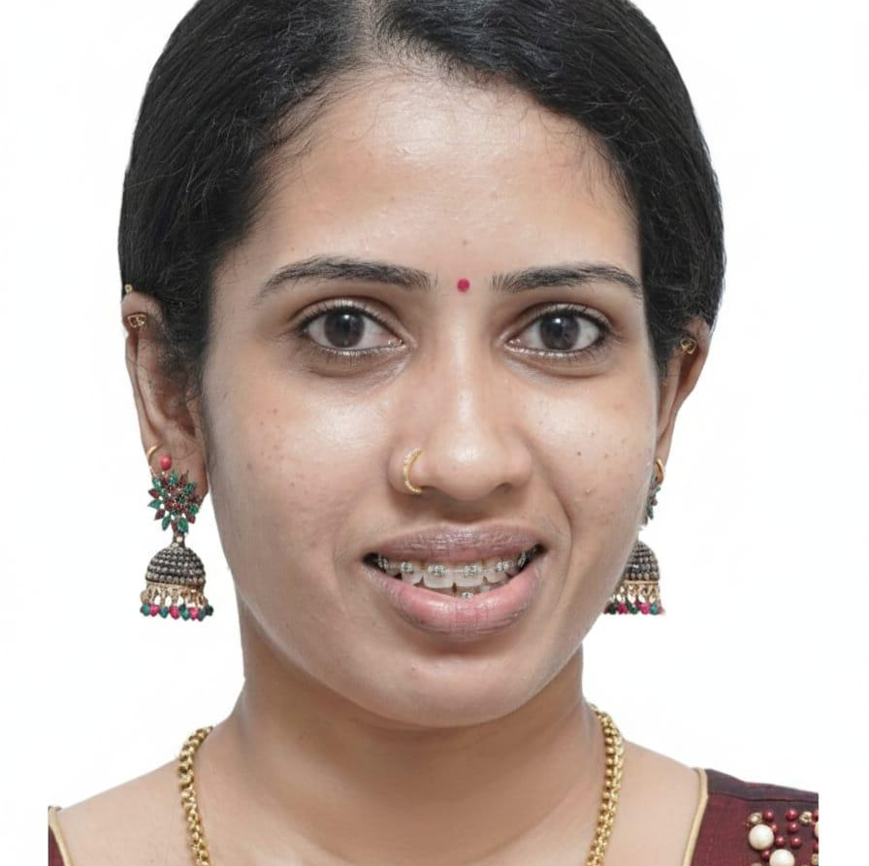

ഗ്രാമപഞ്ചായത് തലത്തിൽ മഹാമാരികളെ ഫലപ്രദമായി പ്രതിരോധിക്കുകയും ആരോഗ്യ സുരക്ഷ ഉറപ്പാക്കുകയും ചെയ്യുന്നതിനായി തയ്യാറാക്കിയിരിക്കുന്ന ഈ PANDEMIC PREPAREDNESS PLAN പുറത്തിറക്കുന്നത് എനിക്ക് അതിയായ സന്തോഷമുണ്ട്. ഇതിന്റെ രൂപീകരണത്തിൽ സഹകരിച്ച എല്ലാ ഉദ്യോഗസ്ഥർക്കും ആരോഗ്യ പ്രവർത്തകർക്കും മറ്റ് ബന്ധപ്പെട്ട വിഭാഗങ്ങൾക്കും ഹൃദയം നിറഞ്ഞ അഭിന്ദനങ്ങൾ അറിയിക്കുന്നു.
നമ്മുടെ പഞ്ചായത്തിലെ പൊതുജനാരോഗ്യ സംരക്ഷണത്തിന് ദുരന്ത നിവാരണ സജ്ജത ശക്തിപ്പെടുത്തുന്നതിന് ഈ രേഖ പ്രായോഗിക മാർഗരേഖയായി മാറട്ടെ എന്ന് ആശംസിക്കുന്നു.

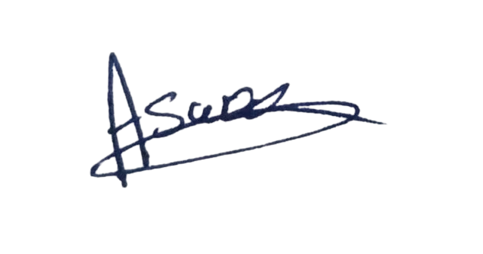
അശ്വതി ഷിനിലേഷ്
പ്രസിഡന്റ്
പന്തലായനി ബ്ലോക്ക്

MESSAGE FROM HEALTH STANDING COMMITTEE CHAIR- BLOCK

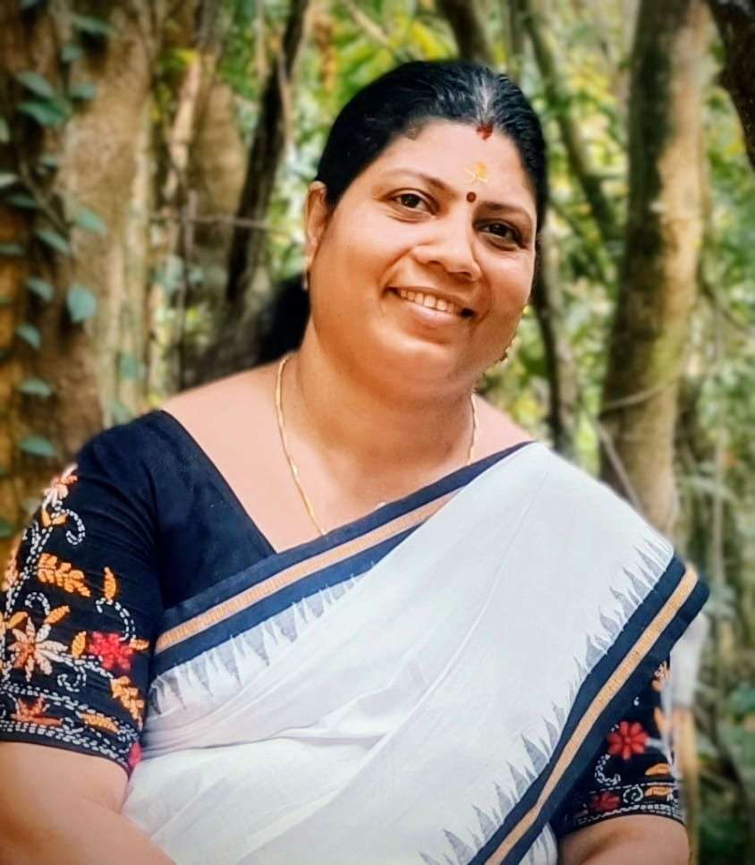

മഹാമാരികളെ മുൻകൂട്ടി തിരിച്ചറിഞ്ഞ് ഫലപ്രദമായി നേരിടുന്നതിനുള്ള ഒരുക്കങ്ങൾ ശക്തിപ്പെടുത്തുക എന്ന ലക്ഷ്യത്തോടെ തയ്യാറാക്കിയിരിക്കുന്ന PANDEMIC PREPAREDNESS PLAN പ്രവർത്തനത്തിൽ ആത്മാർത്ഥമായി പങ്കെടുത്ത എല്ലാ ആരോഗ്യ പ്രവർത്തകർക്കും ബന്ധപ്പെട്ട വിഭാഗത്തിലെ ഉദ്യോഗസ്ഥർക്കും അഭിനന്ദനങ്ങൾ രേഖപെടുത്തുന്നു.
ആരോഗ്യ രംഗത്ത് കൂടുതൽ ഏകോപിതവും സമയബന്ധിതവുമായ പ്രവർത്തനങ്ങൾക്ക് ഈ രേഖ വഴികാട്ടി ആവുകയും പൊതുജനാരോഗ്യ സുരക്ഷ ഉറപ്പാക്കുന്നതിനും ദുരന്ത നിവാരണ സംവിടാനാണ് ശക്തിപ്പെടുത്തുന്നതിനും ഈ പ്ലാൻ സഹായകരമാവട്ടെ എന്ന് ആശംസിക്കുന്നു.

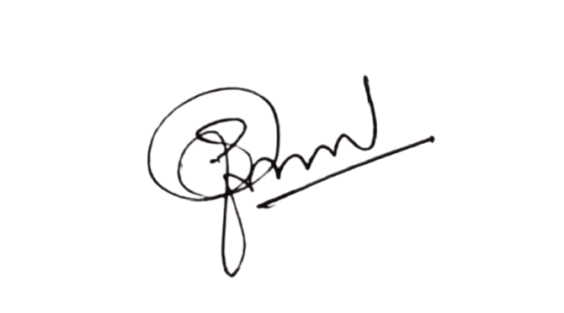
ഷാനി പി വി
ആരോഗ്യ സ്ഥിരം സമിതി ചെയർപേഴ്സൺ

MESSAGE BY BLOCK MEDICAL OFFICER
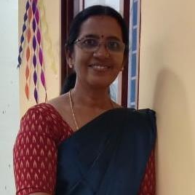

The formulation of a comprehensive Pandemic Preparedness Plan for our Block Panchayat marks a significant milestone in strengthening our local public health system against emerging infectious diseases, environmental hazards, and future public health emergencies. Recent experiences with outbreaks and disasters have clearly demonstrated the need for structured preparedness, coordinated action, and data-driven decision-making at the local level.

At present, the foundation of our health system rests on the dedicated efforts of our frontline workforce—medical officers, field staff, supervisors, ASHAs, and volunteers—who continue to ensure uninterrupted routine immunization, vector control activities, disease surveillance, and intensive Information, Education and Communication (IEC) initiatives. These sustained efforts have built community trust and awareness, which are essential pillars for effective outbreak response and crisis management.

Though the existing system allows rapid deployment of public health teams to verify sudden health threats, this plan addresses the current gaps in surveillance and monitoring. By strengthening surveillance mechanisms and resolving logistical challenges, the plan aims to move the block from a reactive approach to a proactive state of preparedness, ensuring that surveillance data leads to timely and effective containment measures.

I sincerely hope that this plan serves as a practical and resilient framework for preparedness and response, empowering all stakeholders—from health institutions and local self-government bodies to community organizations and citizens. With collective commitment, regular review, and effective implementation, this roadmap will help safeguard our community and ensure a safer, healthier, and better-prepared future for the entire Block Panchayat.

Dr. Sheeba K.J
Medical Officer
EXECUTIVE SUMMARY

Block Family Health Centre (BFHC) functions as the primary public healthcare institution serving the population of Panthalayani block. The PHC plays a pivotal role in delivering comprehensive, accessible, and affordable healthcare services, with a strong focus on preventive, promotive, curative, and rehabilitative care in accordance with national and state health programmes.
The BFHC caters to a predominantly rural population, addressing key public health priorities such as maternal and child health, communicable and non-communicable disease control, immunization, family welfare, adolescent health, and geriatric care. Regular outpatient services, home-based care through field health staff, and outreach activities ensure healthcare coverage even in geographically challenging areas. The institution actively implements national health missions, including the National Health Mission (NHM), National Tuberculosis Elimination Programme, National Programme for Prevention and Control of Cancer, Diabetes, Cardiovascular Diseases and Stroke (NPCDCS), and other disease surveillance initiatives.
Thiruvangoor BFHC works in close coordination with the Panthalayani revenue block, ASHA workers, Anganwadi centres, schools, and community-based organizations to strengthen community participation and improve health awareness. Emphasis is placed on early detection, timely referral, health education, and lifestyle modification to reduce disease burden and improve overall health outcomes.
Despite constraints related to infrastructure, manpower, and increasing service demand, the PHC continues to enhance service delivery through effective planning, data-driven decision-making, and community engagement. Strengthening facilities, upgrading digital health systems, and expanding preventive services remain key focus areas for future development.
Overall, Thiruvangoor BFHC stands as a vital institution in safeguarding public health and improving the quality of life of the residents of Panthalayani Revenue Block.

LIST OF ABBREVIATIONS

BPHU | Block Public Health Unit
LSGD/LSGI | Local Self Government Department / Local Self Government Institution
BMO | Block Medical Officer
IDSP | Integrated Disease Surveillance Programme
NDMA | National Disaster Management Authority
PPE | Personal Protective Equipment
ICMR | Indian Council of Medical Research
CD | Communicable Diseases
NCD | NON-COMMUNICABLE Diseases

TABLE OF CONTENTS

INTRODUCTION 9
● Background of the PPP 9
REVENUE BLOCK AT A GLANCE 9
GENERAL PROFILE OF THE LSGI’S 12
Background of the revenue block 12
Demographic and Vulnerable Population 14
Clinical Vulnerability 15
INFRASTRUCTURE & RESOURCE INVENTORY 20
Health Facility Directory & Basic Capacity in the revenue block 20
Private Clinics 26
Healthcare Education & Training Institutions 28
Specialized Services & Emergency Inventory 29
Oxygen & Diagnostic Capacity 31
Diagnostics facility mapping at the revenue block level 32
Laboratory Identification & Basic Details 33
Social and Community Infrastructure for surge plan 34
Human resources 39
Community & Support Cadre 45
Community Organizations 51
Administrative & Emergency Services 54
Information regarding resources 55
ONE HEALTH & ENVIRONMENTAL SURVEILLANCE 56
Veterinary Infrastructure 61
Veterinary Doctors & Workforce 63
High-Risk Interface Points (Surveillance Sites) 64
Environmental Risk Mapping 67
Disease Seasonality Mapping – Revenue block 68
Vulnerability Mapping 71
EPIDEMIOLOGICAL TRENDS (2021–2025) 73
Disease Burden among human beings(Last 5 Years) 73
Seasonal Trend Analysis 77
Outcome-Based Trend Analysis- 2025 80
Transmission Trend- 2025 82
Integrated Disease Hotspot Map (2021–2025) 90
Preparedness and Response Protocol at revenue block Level 92
Constitution of One Health Committee 92
Pandemic Response Workforce 97
Activities and Measures before and during Pandemic 99
PHASE 1 - Alert / Preparation 99
PHASE 2 - Active Response 103
Standard Screening Protocol 104
PHASE 3 - Surge Capacity 117
Conversion of Community Facilities 118
CONCLUSION 120
ANNEXURE 1 Chemanchery LSGD 124
● IMPORTANT PHONE NUMBERS 124
ANNEXURE 2: Chengottukavu 133
7. IMPORTANT PHONE NUMBERS 133
ANNEXURE 3: Moodadi LSGD 139
● IMPORTANT PHONE NUMBERS 139
ANNEXURE 4 ATHOLI 146
1. IMPORTANT PHONE NUMBERS 146
ANNEXURE 5: ARIKKULAM LSGD 153
5. IMPORTANT PHONE NUMBERS 153
ANNEXURE 6: KOYILANDY MUNICIPALITY 159
● IMPORTANT PHONE NUMBERS 159

INTRODUCTION

Background of the PPP
- Pandemics pose a significant threat to public health, livelihoods, and the overall functioning of society. The emergence of global outbreaks such as COVID-19 has highlighted the urgent need for structured preparedness, rapid response mechanisms, and resilient health systems at all levels. The experience gained during the COVID-19 pandemic emphasized the importance of early detection, coordinated action, effective surveillance, risk communication, and community participation in minimizing morbidity and mortality.
- At the block level, preparedness is crucial as it serves as the first point of contact between the health system and the community. A well-developed Pandemic Preparedness Plan ensures systematic planning for surveillance, case management, laboratory coordination, logistics management, human resource allocation, infection prevention and control measures, and intersectoral coordination. It also strengthens mechanisms for emergency response, including outbreak investigation, isolation facilities, referral systems, and public health communication.
- This plan is developed to enhance readiness to prevent, detect, and respond effectively to any emerging or re-emerging infectious disease threat. It aims to minimize health impacts, maintain essential health services, ensure optimal resource utilization, and protect vulnerable populations. The plan will be periodically reviewed and updated based on evolving epidemiological situations and guidelines from higher authorities to ensure continued relevance and effectiveness.

- Revenue block at a glance

REVENUE BLOCK AT A GLANCE
- Geographical boundaries with political map (based on latest delimitation)
- Baseline data
- Ward division -
Name of LSGI | Ward | Houses | Population | Migrants | Wells | Hot  spots | Ed. Institutions | Hosp pvt/govt.
Chemanchery | 20 | 9545 | 41877 | 197 | 7825 | 9 | 21 | 7
FHC Chengotukavu | 18 | 7809 | 33134 | 171 | 5230 | 1 | 13 | 1
FHC Arikulam | 15 | 5592 | 24986 | 60 | 4623 | 7 | 10 | 4
FHC Moodadi | 20 | 8359 | 35273 | 327 | 5986 | 1 | 15 | 2
FHC Atholi | 19 | 8672 | 33291 | 356 | 6028 | 0 | 19 | 7
Koyilandy Muncipality | 44 | 19057 | 80893 | 592 | 13633 | Koyilandy-18  Kollam-8,10,12,15 | 45 | 10
Total | 136 | 59034 | 249454 | 1703 | 43325 | - | 123 | 31

- Risk stratification among revenue block in the context of Communicable diseases and hazards
- Major Roads/rivers
- Major establishments with geospatial mapping
- occupational groups, socio cultural groups, migration & mobility patterns
- Vulnerability mapping
- Disaster prone areas (geographic vulnerability)

Maps – revenue block based
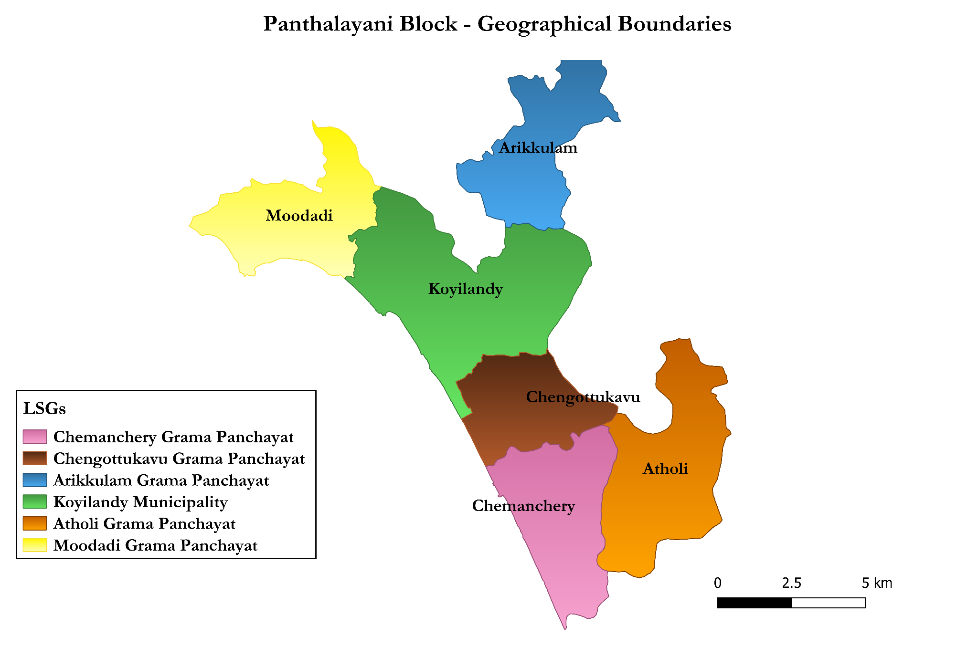

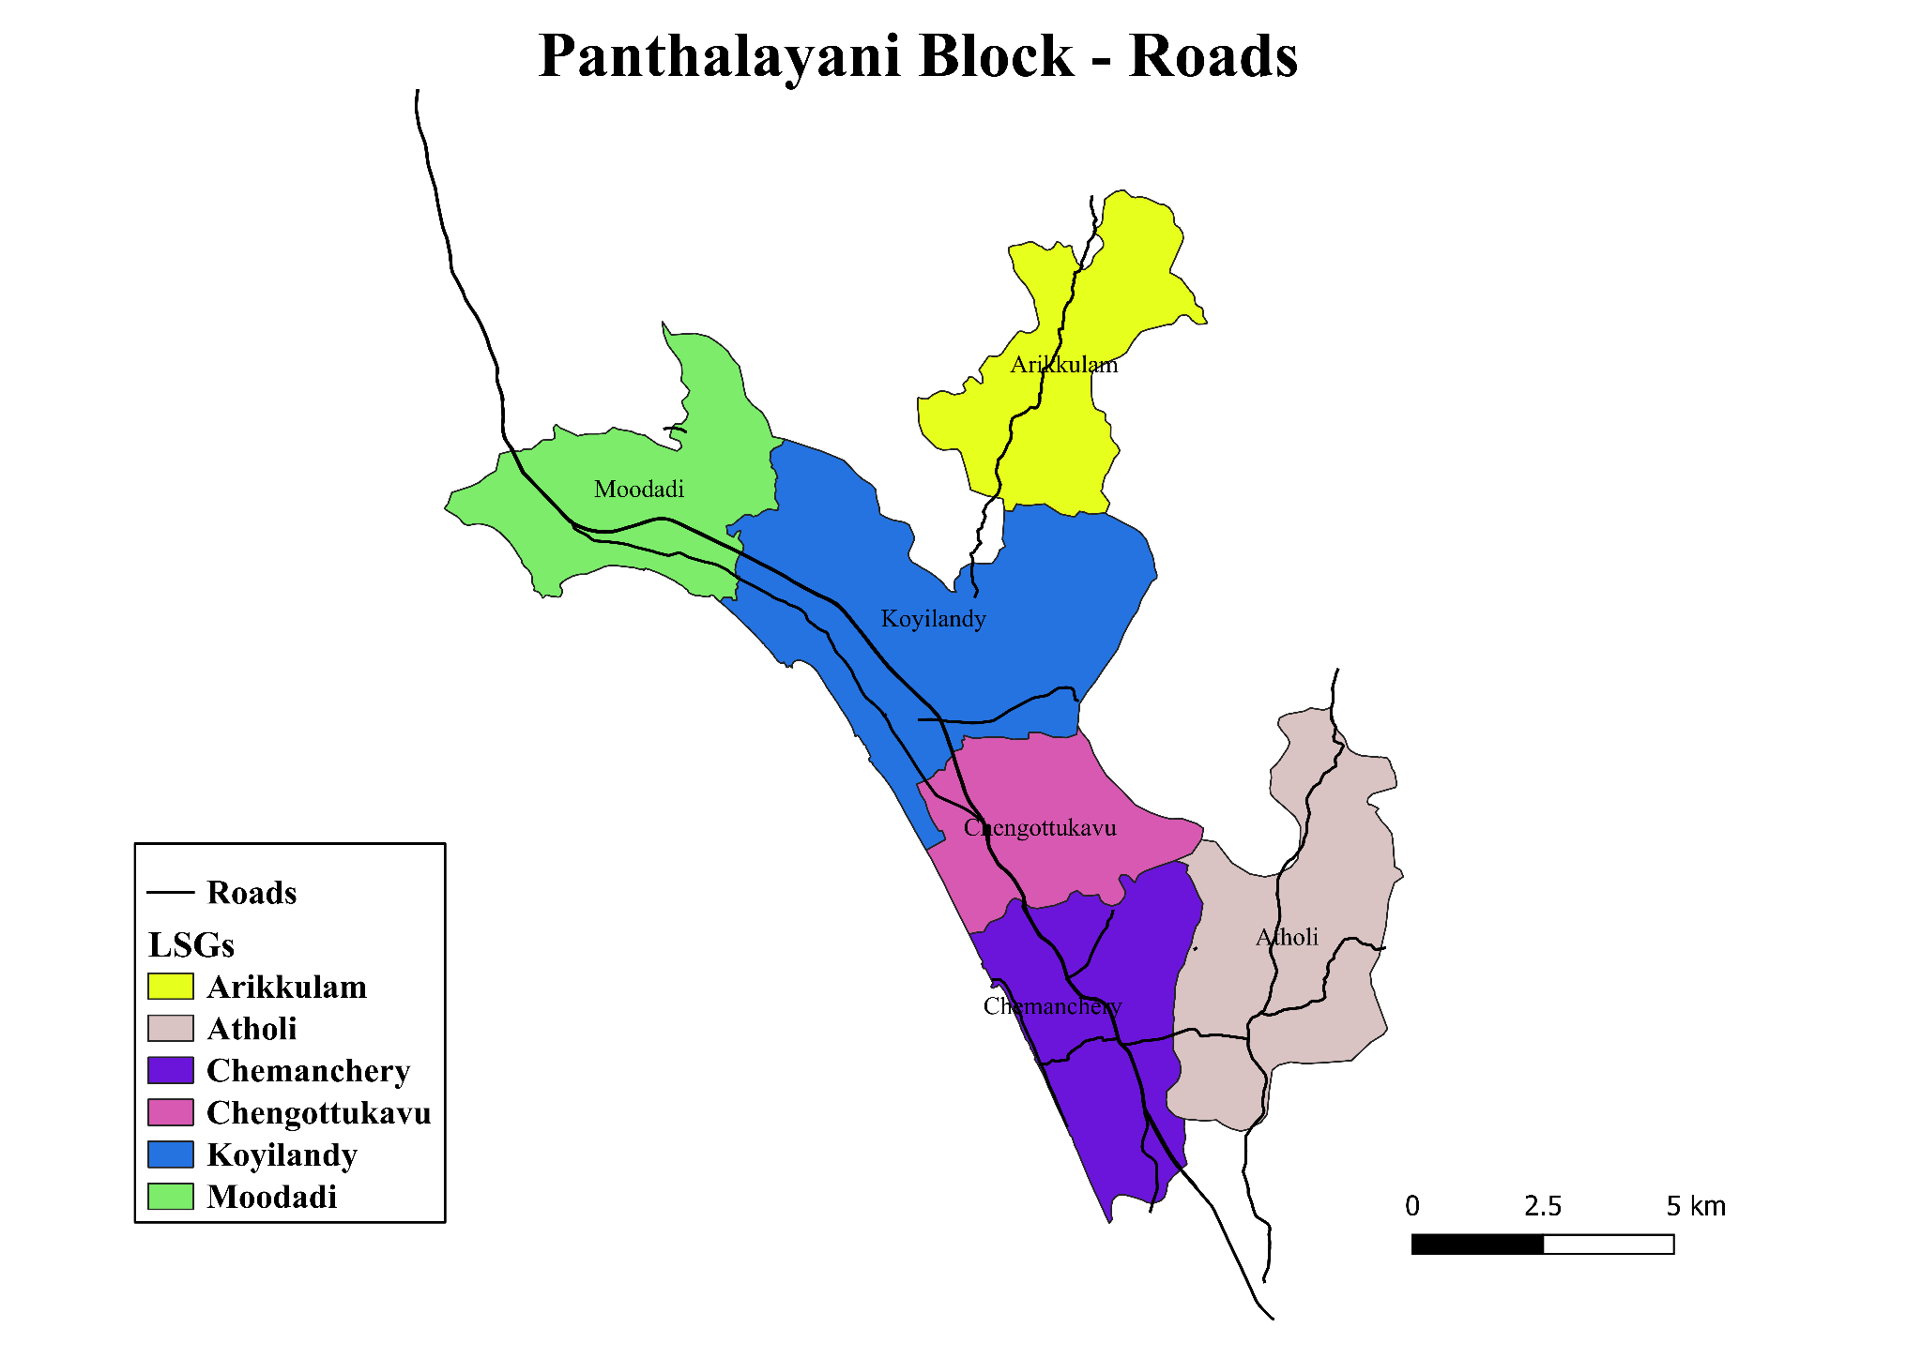

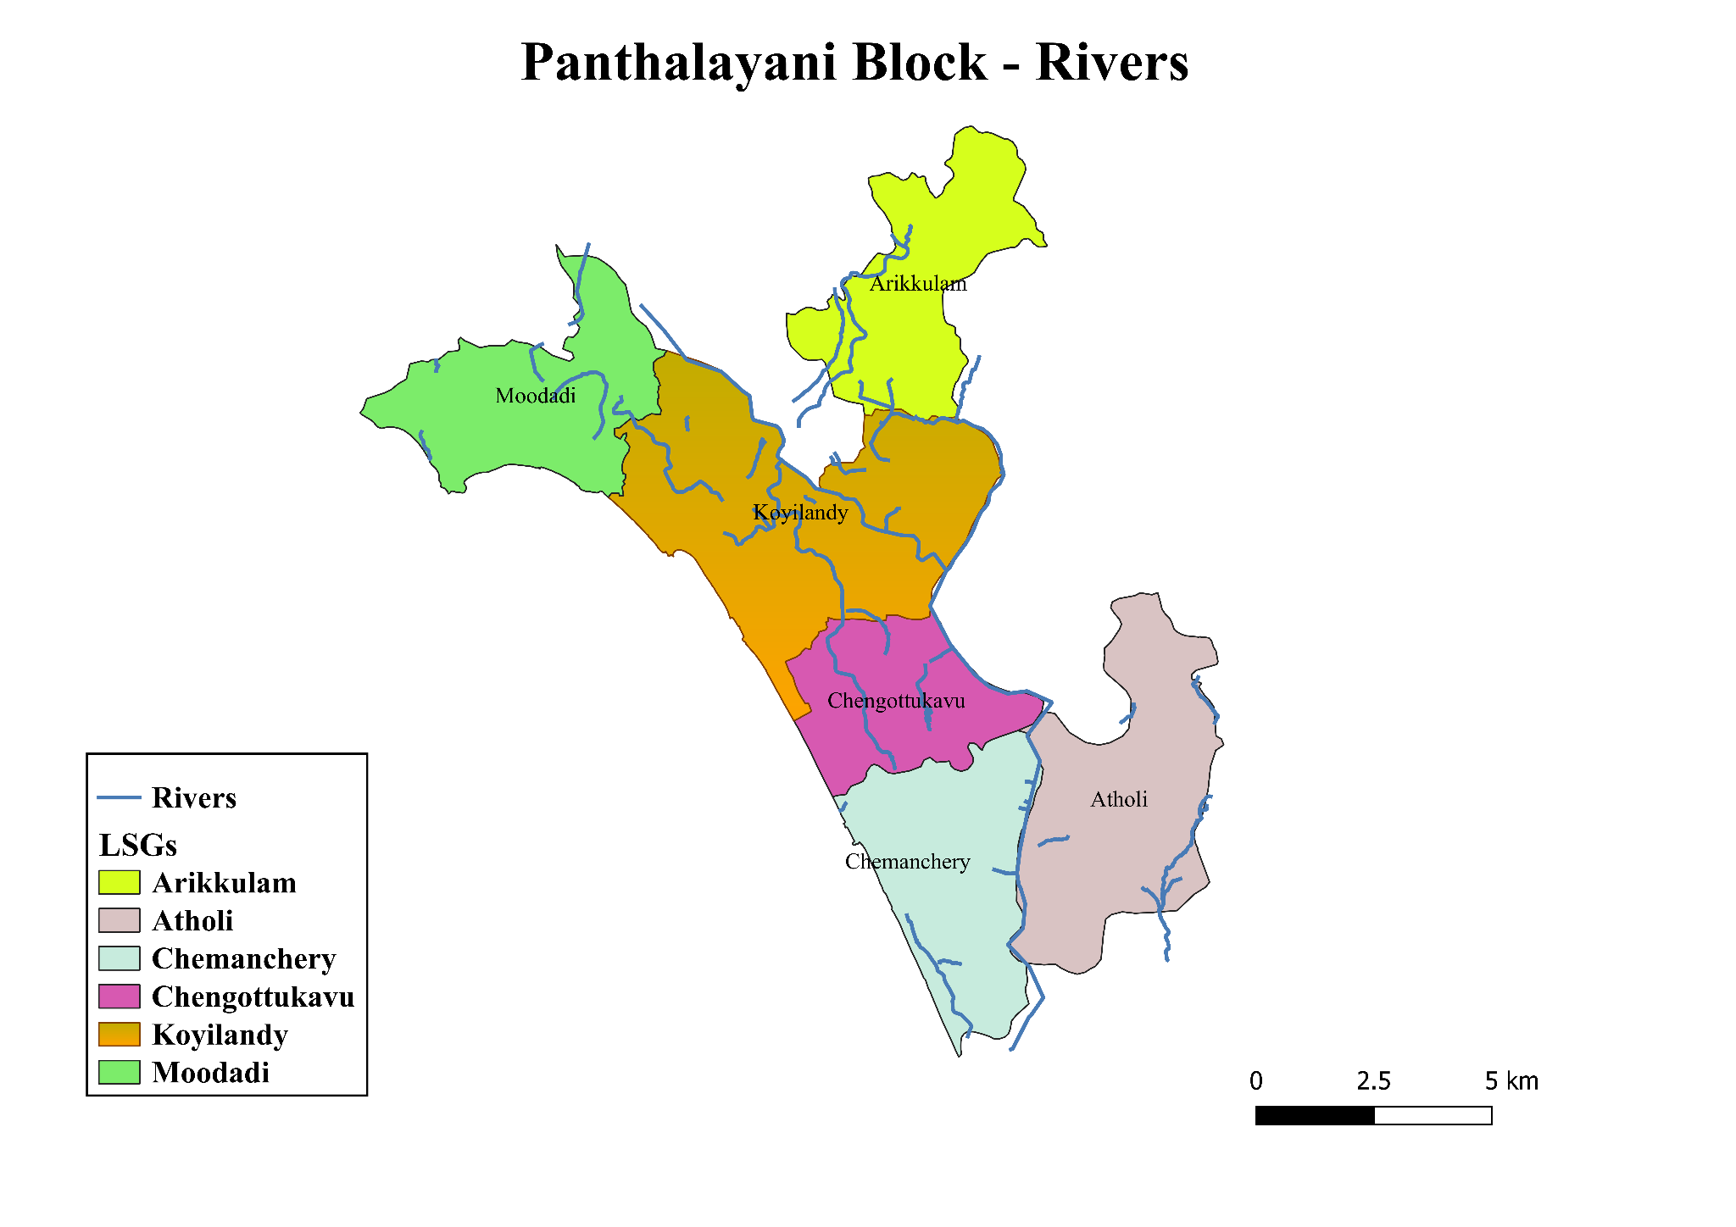
INTEGRATED HEALTH INFRASTRUCTURE MAP OF PANTHALAYANI REVENUE BLOCK
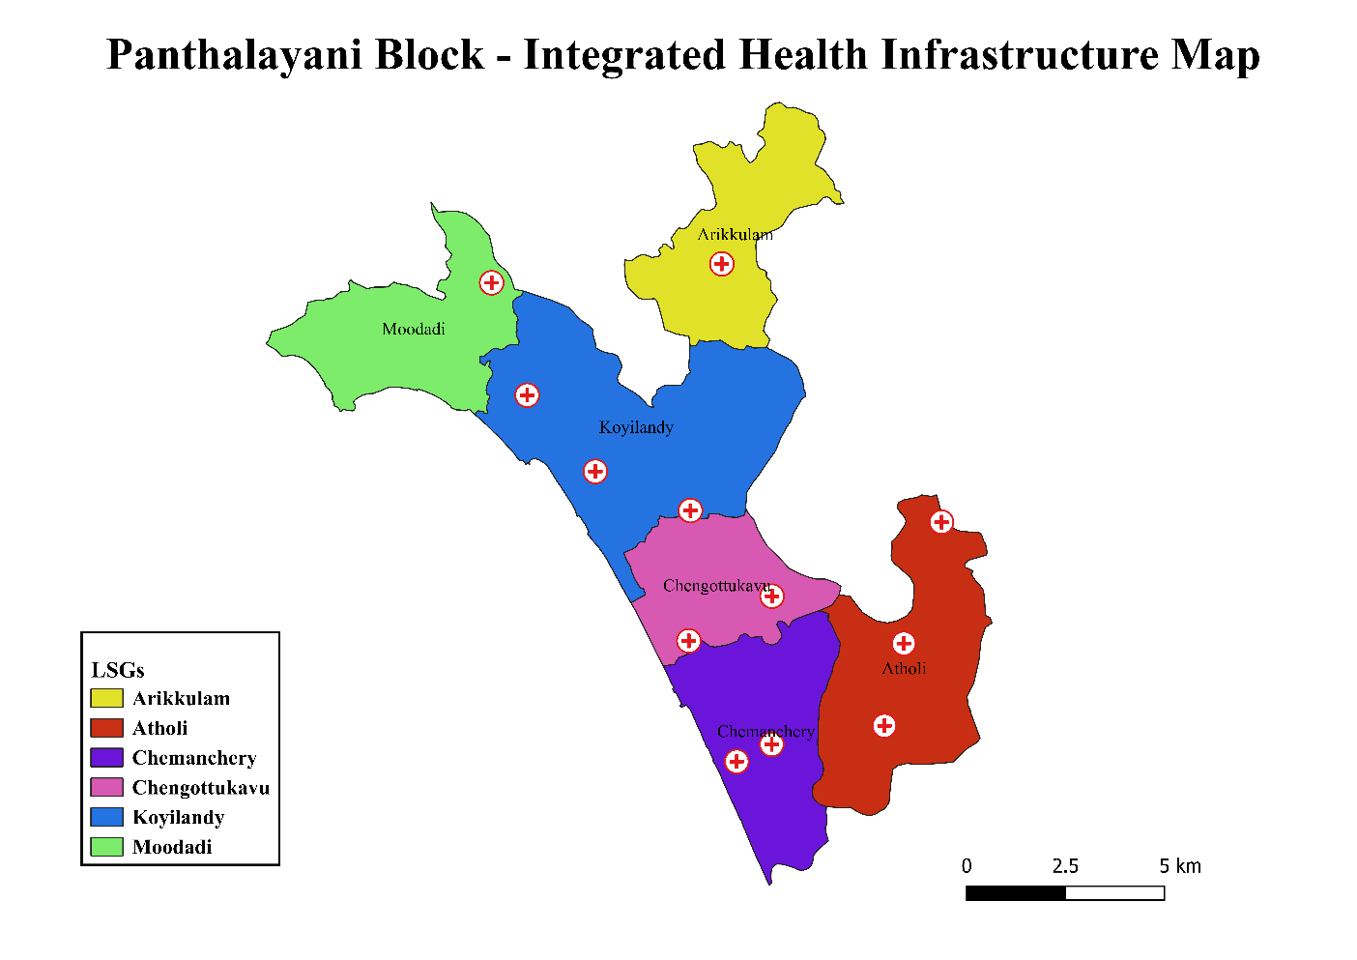

GENERAL PROFILE OF THE LSGI’S

Background of the revenue block
Panthalayani Revenue Block is situated in the northern part of Kozhikode district, Kerala. The block covers a total area of 53.84 sq. km and has a projected population of 2,49,454, with a high population density. The block comprises five Grama Panchayaths—Chemanchery, Chengottukavu, Atholi, Moodadi, and Arikkulam—and one Municipality, Koyilandy. The region includes both rural and urban populations, contributing to diverse demographic and environmental characteristics.
Administratively, the block is divided into 136 wards, and the geographical terrain is largely coastal and low-lying, which significantly influences the environmental and climatic conditions of the region. The block also contains 5 rivers and around 226 water bodies, contributing to a dense hydrological network that affects drainage, flooding patterns, and local livelihoods.
The block has a strong institutional presence, including multiple educational institutions, small-scale industries, and health facilities, which contribute to socioeconomic development. However, industrial activities and population concentration in certain pockets necessitate continuous monitoring of environmental health and public health risks.
From a public health and disaster management perspective, Panthalayani Revenue block is vulnerable to seasonal flooding and other environmental hazards due to its coastal and low-lying terrain. Several wards are identified as flood-prone, including wards 13, 17, 18, 20, and 1 in Chemancherry, wards 2, 3, and 6 in Chengotukavu, and wards 1, 3, 5, 8, 9, 14, and 15 in Arikulam. Additionally, landslide-prone areas have been identified in ward 4 of Chemancherry, ward 8 of Chengotukavu, and ward 1 of Koyilandy. The combination of dense population, multiple water bodies, and vulnerable terrain increases the risk of water-borne and vector-borne diseases, especially during the monsoon season.
In this context, the development of a localized, data-driven Auxiliary Infrastructure and Logistical Resource Map is essential to support effective disaster preparedness, timely emergency response, and efficient public health interventions. Such mapping will help identify critical resources, improve accessibility during emergencies, and strengthen coordination among departments, thereby enhancing the overall resilience and preparedness of the block

Table 1: Background of revenue block
Description | Details
Name of revenue block | Panthalayani
Number of LSGI’s (GP/Municipality / Corporation etc.) | 6
District | Kozhikode
Number of wards | 136
Total area (sq. km) | 53.84 Sq Km
Population(Projected) | 249454
Population density | persons/sq km
Terrain (coastal/low-lying/backwaters/foothills, etc.) | 16(coastal/low-lying)
Number of rivers passing through revenue block | 5
Number of water bodies in the revenue block | 226
Number of educational institutions | 123
Factories / small-scale industries | 44
Flood-prone wards | Chemancherry-ward 13,17,18,20,1  Chengotukavu-Ward 2,3,6  Arikulam-1,3,5,8,9,14,15
Landslide-prone wards | Chemancherry-4,Chengotukavu-8,Koyilandy-1
Death Management and Disposal Facilities (mortuaries/crematorium, including electric) | 3
Auditoriums/Marriage halls/convention centres/community halls | 13

Demographic and Vulnerable Population
Understanding the demographic composition and vulnerable population groups is essential for pandemic preparedness. Children, elderly, economically deprived families, migrant workers, and socially vulnerable groups are at increased risk during public health emergencies due to higher exposure, limited access to services, and dependency on public systems..

Description |  | Details (in numbers)
DEMOGRAPHIC PROFILE OF THE REVENUE BLOCK
Total population |  | 249454
Male |  | 119808
Female |  | 129124
Transgender |  | 0
Children under 5 |  | 11887
Adolescent |  | 31220
Elderly (>60) |  | 47544
SOCIAL/LIVELIHOOD VULNERABILITY
Previous EPEP family |  | 276
BPL family |  | 27547
Tribal communities |  | 14
Migration | Immigrant | 1987
Migration | Emigrant | 8863
Socio-economically deprived |  | 96
Fisherfolk |  | 4951
SC Community |  | 8004
ST Community |  | 23

Graphs: Population pyramid (if possible) for seeing if your revenue block has a high "dependency ratio" (lots of children and elderly compared to working adults).

Clinical Vulnerability
Certain population groups need priority healthcare & are at higher risk of severe illness, complications, and mortality during pandemics. Patients with chronic diseases, those requiring regular medical care, and individuals with mobility or functional limitations face challenges in accessing timely care during emergencies. Mapping these groups helps in prioritizing continuity of treatment, medicine stock planning, oxygen support, referral transport, and targeted home-based care.
Description | Details in numbers
Pregnant women | 1201
Lactating mothers | 3060
Bedbound patients | 749
Patients under palliative care other than bedbound | 1042
Patients on Haemodialysis | 221
Patients on CAPD | 11
Cancer patients (currently on treatment) | 333
Haemophilic patients | 14
Mentally challenged | 248
Differently abled | 734
Diabetic patients | 14008
Hypertensive patients | 20512
TB patients | 62

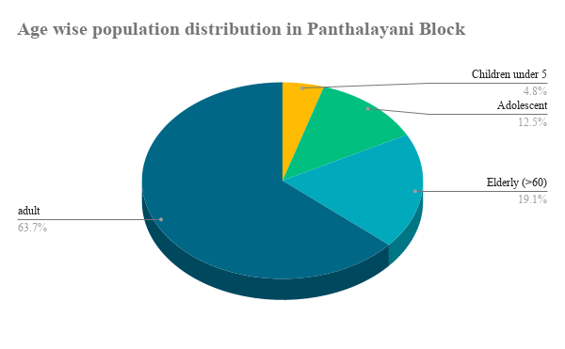

Major Festivals & Events specific to the revenue block
(with the possibility of a public gathering)

Sl. No. | Name of LSGI | Name of festival | Month detailing the periodicity
1 | Chemanchery | Choyyeakkatt Temple, Ward 7 | April
2 | Chemanchery | Illath Temple, Ward 7 | January
3 | Chemanchery | Kshethraalan Kotta Temple, Ward 8 | November
4 | Chemanchery | Sree Narasimha Parthasaradhi Temple, Ward 8 | February
5 | Chemanchery | Kizhakke Mukavurakandy Temple, W 9 | February
6 | Chemanchery | Thiruvangoor Ganapathi Temple, W 9 | February
7 | Chemanchery | Thiruvangoor Bhagavathi Temple,W 9 | March
8 | Chemanchery | Vengalam Kizhakke Vattarambath Bhagavathi Temple, W 10 | January
9 | Chemanchery | Kavilkotta Temple, W 11 | February
10 | Chemanchery | Kuniyil Bhagavathi Temple | February
11 | Chemanchery | Araykkal Bhagavathi Temple | February
12 | Chemanchery | Vengalath Bhagavathi Temple | May
13 | Chengotukavu | Edavanatemplecheliya | January
14 | Chengotukavu | Alangattemplecheliya | January
15 | Chengotukavu | Koolatham Veedu | January
16 | Chengotukavu | Koloortemple | February
17 | Chengotukavu | Muthukoottil Paradevatha Temple | February
18 | Chengotukavu | Plachery Temple | March
19 | Chengotukavu | Moothedath Temple | March
20 | Chengotukavu | Kanniyadath Temple | March
21 | Chengotukavu | Poyikavu Sree Durga Devi Temple | March
22 | Chengotukavu | Thekkayil Bhagavathi Temple | March
23 | Chengotukavu | Anthatta Paradevatha Temple | March
24 | Chengotukavu | Punathum Padikkal Temple | March
25 | Chengotukavu | Manayadath Parambil Temple | March
26 | Chengotukavu | Kondam Vally Ayyappa Temple | April
27 | Chengotukavu | Melur Siva Temple | April
28 | Chengotukavu | Cheenam Kandy Temple | April
29 | Chengotukavu | Meethale Punathil Temple | April
30 | Atholi | Temple Festivals | January, February, March, May
31 | Atholi | Masjid Related Gathering | March
32 | Moodadi | Kongannur | Jaanuary
33 | Moodadi | Kotta-Kovilakam | March
34 | Moodadi | Urupunyakavu | August
35 | Arikulam | Arikkunnath | March
36 | Arikulam | Mannankavu | January
37 | Arikulam | Moolath | February
38 | Arikulam | Vakamoli | January
39 | Arikulam | Edavana Kulangara | December
40 | Arikulam | Utteri | February
41 | Arikulam | Kannambath | January
42 | Arikulam | Vakamoli Vishnu | January
43 | Arikulam | Urallur | January
44 | Arikulam | Uravingal | March
45 | Koyilandy | Sakthankulangara Devi Temple | March
46 | Koyilandy | Deivathumkavu Temple | January
47 | Koyilandy | Viyyur Temple | March
48 | Koyilandy | Maraloor Temple | March
49 | Koyilandy | Kurooli Temple | March
50 | Koyilandy | Areekandy Bhagavathy Temple | March
51 | Koyilandy | Kaliyambath Bhagavathi Temple | February
52 | Koyilandy | Vazhavalappil Nagamullakandy Kavu Temple | February
53 | Koyilandy | Kanavangott Bhagavathi Temple | April
54 | Koyilandy | Puthalath Sree Durgadevi Temple | February
55 | Koyilandy | Aghora Siva Temple,Panthalayani Temple | Shivarathi
56 | Koyilandy | Cheriya Chalora Chamundeswari Temple | January
57 | Koyilandy | Valiya Chalora Temple | March
58 | Koyilandy | Aclari Paradevatha Temple | February
59 | Koyilandy | Chooralkavu Bhaghavathi Temple | February
60 | Koyilandy | Cheriyapurath Perillathon Temple | March
61 | Koyilandy | Cheriyamangad Sreedurga Bagavathi Temple | March
62 | Koyilandy | Kothamangalam Ayyappa Temple | December
63 | Koyilandy | Puthiyakav Temple | December
64 | Koyilandy | Manakulangara Temple | February
65 | Koyilandy | Kothamangalam Mahavishnu Temple | January
66 | Koyilandy | Payattuvalappil Sreedevi Temple | January
67 | Koyilandy | Korayangad Ganapathi Temple | February
68 | Koyilandy | Arayankav Temple Festival | March

INFRASTRUCTURE & RESOURCE INVENTORY

Health Facility Directory & Basic Capacity in the revenue block
This section provides an overview of the healthcare infrastructure available within the revenue block area. It outlines the distribution and basic capacity of health facilities that form the backbone of service delivery during routine times and public health emergencies.

Family Health Centres (FHCs) and Community Health Centres (CHCs) generally function as the first point of contact for the community, providing essential outpatient and inpatient services. General Hospitals (GH) and Medical College Hospitals (MCH), where accessible, serve as the main referral centres for advanced diagnostics, specialist care, and critical services during public health emergencies. This inventory helps identify existing strengths, gaps, and potential surge capacity that can be mobilised during a pandemic or disaster.

Table 5. Health Facility Resource Summary
Sl.no. | Name of LSGI | Health Facility | Type of Facility (MCH/GH/CHC/FHC/SC etc.) | Contact Number | Total beds | ICU Beds | Oxygen-Supported Beds | No. of Ventilator Support Beds | No. of ambulances
Government Healthcare Facilities
1 | Chemanchery | Chc Thiruvangoor | CHC | 8547782509 | 0 | 0 | 0 | 0 | 1
 | Chemanchery | Main Centre Thiruvangoor | SC | 9495639993 | 0 | 0 | 0 | 0 | 0
 | Chemanchery | Hwc Kolakkad | SC | 9495581772 | 0 | 0 | 0 | 0 | 2
 | Chemanchery | Hwc Kappad | SC | 7025366829 | 0 | 0 | 0 | 0 | 3
 | Chemanchery | Hwc Chemanchery | SC | 7025366829 | 0 | 0 | 0 | 0 | 0
 | Chemanchery | Hwc Vengalam | SC | 9656621309 | 0 | 0 | 0 | 0 | 1
2 | Chengotukavu | Chengottukavu | FHC | 04962 960564 | 3 | 0 | 1 | 0 | 0
 | Chengotukavu | Edakkulam | HWC | 9061276469 | 0 | 0 | 0 | 0 | 0
 | Chengotukavu | Cheliya | HWC | 9447195337 | 0 | 0 | 0 | 0 | 0
 | Chengotukavu | Poyilkavu | HWC | 9495612244 | 0 | 0 | 0 | 0 | 0
3 | Moodadi | Fhc Moodadi | FHC | 04962966150 | 2 | 0 | 0 | 0 | 0
4 | Atholi | Fhc Atholi | FHC | 0496 2934898 | 0 | 0 | 0 | 0 | 1
 | Atholi | Hwc M/C | SC | 9400211771 | 0 | 0 | 0 | 0 | 0
 | Atholi | Hwc Kodassery | SC | 9645693485 | 0 | 0 | 0 | 0 | 0
 | Atholi | Hwc Modakkallur | SC | 8921721369 | 0 | 0 | 0 | 0 | 0
 | Atholi | Hwc Pullillamala | SC | 9745864594 | 0 | 0 | 0 | 0 | 0
 | Atholi | Govt . Ayurvedha Dispensory |  | 9847310638 | 0 | 0 | 0 | 0 | 0
 | Atholi | Govt. Homeo Dispensory |  | 9447274596 | 0 | 0 | 0 | 0 | 0
5 | Arikulam | Fhc Arikkulam | FHC | 9497658545 | 0 | 0 | 0 | 0 | 0
 | Arikulam | Hwc Arikkulam | SC | 9946132594 | 0 | 0 | 0 | 0 | 0
 | Arikulam | Hwc Karayad | SC | 9778204730 | 0 | 0 | 0 | 0 | 0
 | Arikulam | Hwc Urallur | SC | 8943516730 | 0 | 0 | 0 | 0 | 0
6 | Koyilandy | Taluk Head Quarters Hospital Koyilandy | SDH | 04962960241 | 159 | 5 | 60 | 3 | 4
 | Koyilandy | Hwc Kollam | SC | 0 | 0 | 0 | 0 | 0 | 0
 | Koyilandy | Hwc Panthalayani | SC | 0 | 0 | 0 | 0 | 0 | 0
 | Koyilandy | Hwc Puliyanchery | SC | 0 | 0 | 0 | 0 | 0 | 0
 | Koyilandy | Uhwc Peruvattoor | UHWC | 0 | 0 | 0 | 0 | 0 | 0
 | Koyilandy | Hwc Kuruvangad | SC | 0 | 0 | 0 | 0 | 0 | 0
 | Koyilandy | Hwc Kothamangalam | SC | 0 | 0 | 0 | 0 | 0 | 0
 | Koyilandy | Hwc Kovilkandy | SC | 0 | 0 | 0 | 0 | 0 | 0
 | Total |  |  | 0 | 0 | 0 | 0 | 0 | 0
Private Healthcare Facilities
1 | Chemanchery | Dr. Kripal Health care Clinic Thiruvangoor (Pvt) | Pvt | 8301077240 | 2 | 0 | 0 | 0 | 0
 | Chemanchery | S-Care Clinic and Lab Pookkad | Pvt | 04962686210 | 0 | 0 | 0 | 0 | 0
 | Chemanchery | Carewell Clinic, Kattilpeedika | Pvt | 9656250428 | 0 | 0 | 0 | 0 | 0
 | Chemanchery | cinco clinic kappad | pvt | 9995898986 | 0 | 0 | 0 | 0 | 1
2 | Moodadi | Sahani Hospital,Nandi | Hospital | 04962690994 | 30 | 6 | 36 | 1 | 1
3 | Atholi | Malabar Medical Collage, Modakkallur, Atholi | PVT | 9895381025 | 890 | 13 | 12 | 10 | 5
 | Atholi | Co- Operative Hospital , Atholi | PVT | 8281738659 | 350 | 6 | 8 | 4 | 2
 | Atholi | Family medical Centre, Atholi | PVT | 9447424552 | 0 | 0 | 0 | 0 | 0
 | Atholi | Chaithanya Clinic , Atholi | PVT | 9072558247 | 0 | 0 | 0 | 0 | 0
4 | Arikulam | Cinco Hospital | Pvt | 7356699887 | 10 | 0 | 3 | 0 | 0
 | Arikulam | Raibow Clinic | Pvt | 8113011140 | 0 | 0 | 0 | 0 | 0
5 | Koyilandy | Aswini Hospital , Kollam | Pvt | 7947139787 | 5 | 0 | 0 | 0 | 0
 | Koyilandy | Co -Op Hospital Koyilandy | Pvt | 9847560226 | 20 | 2 | 3 | 0 | 2
 | Koyilandy | Mm Hospital Koyilandy | Pvt | 04962620371 | 5 | 0 | 0 | 0 | 0
 | Total |  |  |  | 1280 | 27 | 62 | 15 | 11
AYUSH Healthcare Facilities
1 | Chemanchery | Ayush N.H.M. Phc Homoeopathi, Chemanchery Panchayath | Govt. | Dr. Babinesh 9847476442 | 0 | 0 | 0 | 0 | 0
 | Chemanchery | Ayush Nhm Ayurvedic Clinic Thiruvangoor | Pvt | Dr. Shimi 9446360014 | 0 | 0 | 0 | 0 | 0
2 | Chengotukavu | Homeo Dispensary | Govt | - | 0 | 0 | 0 | 0 | 0
3 | Moodadi | Ayurvedha Dispensory | PHC | - | 0 | 0 | 0 | 0 | 0
4 | Arikulam | Ism Hospital | Govt | 9497304593 | 0 | 0 | 0 | 0 | 0
 | Arikulam | Homeo Hospital | Govt | 8547168201 | 0 | 0 | 0 | 0 | 0
 | Total |  |  |  | 0 | 0 | 0 | 0 | 0

Private Clinics
Private clinics are an essential part of pandemic preparedness, as they are often the first place people seek care when symptoms begin. In many communities, private clinics manage a significant share of outpatient visits and therefore play a critical role in early case detection, timely referrals, and disease surveillance. Having an up-to-date understanding of where these clinics are located, the services they provide, and how they are linked to the public health system helps ensure that no cases are missed during an outbreak. It also allows health authorities to engage private practitioners more effectively for reporting, risk communication, and coordinated response, strengthening the overall capacity of the health system to manage public health emergencies.
Table 6. Private Clinic Resource Summary
Sl No. | Name of LSGI | Name of Clinic | Registered (Y/N) | Clinic (General / Speciality) | Speciality (if any) | Address | Contact Number | Diagnostic Facility (Y/N) | Ambulance Linkage (Y/N)
1 | Chemanchery | Dr. Kripal Health Care Clinic Thiruvangoor (Pvt) | Y | Y | N | Chemanchery | 8301077240 | Y | Y
 | Chemanchery | S-Care Clinic And Lab Pookkad | Y | Y | N |  | 04962686210 | Y | Y
 | Chemanchery | Carewell Clinic, Kattilpeedika | N | Y | N |  | 9656250428 | Y | Y
 | Chemanchery | Cinco Clinic Kappad | N | Y | N |  | 9995898986 | Y | Y
2 | Chengotukavu | Ravi S Clinic | No | General |  | Chengoyyukavu | 7034860134 | Y | N
3 | Moodadi | Ig Clinic | Y | General |  | Moodadi | 04962966695 | Y | N
 | Moodadi | Santhi Clinic | Y | General |  | Muchukunnu | 04962083278 | Y | N
4 | Atholi | Malabar Medical Collage, Modakkallur, Atholi | Y | General | Nil | Mmc, Modakkallur, Ulliyeri (Po) | 9895381025 | Y | Y
 | Atholi | Co- Operative Hospital , Atholi | N | General | Nil | Atholi Co-Operative Hospital , Atholi | 8281738659 | Y | Y
 | Atholi | Chaithanya Clinic , Atholi | N | General | Nil | Chaithanya Clinic , Kodakkal , Atholi | 9072558247 | Y | Y
 | Atholi | Family Medical Centre, Atholi |  |  | Nil | Family Medical Centre, Atholi | 9447424552 | Y | N
 | Atholi |  | N | General
5 | Arikulam | Cinco | N | Speciality | Cardiology, Ortho ,Ent,Peadiatrics,Generalmedicine,Skin | Arikkulam Po | 7356699887 | Y | Y
 | Arikulam | Rainbow Clinic | 0 | 0 | General | 0 | 0 | 0 | 0
6 | Koyilandy | We Trust Hospital | Yes | Special | Eye | Sbi Road Koyilandy | 7902666635 | Y | Y
 | Koyilandy | City Med | Yes | General | Genereal | Sbi Road Koyilandy | 9447157722 | Y | Y
 | Koyilandy | Speciality Polyclinic Koyilandy |  | General |  | Koyilandy | 9745063800 | Y | Y
 | Koyilandy | Medis Health Care |  | General |  | Koyilandy | 8086754507 | Y | Y
 | Koyilandy | Muthambi Clinic &Lab | Yes | General |  | Muthambi,  Koyilandy | 9188252522 | Y | Y

Healthcare Education & Training Institutions
This section tracks the educational infrastructure available, which is vital for human resource planning in the health sector.

Category of Institution | Name of LSGI | Govt | Private | AYUSH | Total
Medical Colleges | Atholi | 0 | 1 | 0 | 1
Nursing Colleges | Atholi | 0 | 1 | 0 | 1
Dental Colleges | Atholi | 0 | 1 | 0 | 1
Para-medical / Allied Health | Atholi | 0 | 1 | 0 | 1
Pharmacy Colleges | Atholi | 0 | 1 | 0 | 1

Specialized Services & Emergency Inventory
This section provides a detailed view of the specialized medical resources available to the community, focusing on emergency response and critical care capabilities. This table tracks the vital assets required for managing severe illnesses and emergencies across Government, Private, and AYUSH sectors.
Item | Name of LSGI | Govt | Private | AYUSH | Total
Hospital beds | Chemanchery | 12 | 4 | 0 | 16
Hospital beds | Atholi | 6 | 1159 | 0 | 1165
Hospital beds | Arikulam | 0 | 10 | 0 | 10
Hospital beds | Koyilandy | 159 | 20 | 0 | 179
Hospital beds | Moodadi | 2 | 30 | 0 | 32
Oxygen-generating systems(Y/N) | Atholi | 0 | Yes | 0 | 1
Oxygen-generating systems(Y/N) | Koyilandy | 1 | 0 | 0 | 1
Oxygen-supported beds(Numbers) | Atholi | 0 | 100 | 0 | 100
Oxygen-supported beds(Numbers) | Moodadi | 0 | 36 | 0 | 36
Oxygen-supported beds(Numbers) | Koyilandy | 60 | 0 | 0 | 60
Ventilator-supported beds | Atholi | 0 | 215 | 0 | 215
Ventilator-supported beds | Moodadi | 0 | 1 | 0 | 1
Ventilator-supported beds | Koyilandy | 3 | 0 | 0 | 3
ICU beds | Atholi | 0 | 150 | 0 | 150
 | Moodadi | 0 | 6 | 0 | 6
 | Koyilandy | 5 PICU | 0 | 0 | 5
Burns units | No | 0 | 0 | 0 | 0
Blood centres | Atholi | 0 | 1 | 0 | 1
Blood centres | Koyilandy | 1 | 0 | 0 | 1
BLS ambulances | Atholi | 1 | 5 | 0 | 6
BLS ambulances | Koyilandy | 2 | 0 | 0 | 2
ALS ambulances | Atholi | 0 | 1 | 0 | 1
Dialysis facilities | Atholi | 0 | 1 | 0 | 1
Dialysis facilities | Koyilandy | 1 | 1 | 0 | 2
Dispensaries | Chengotukavu | 0 | 0 | 1 | 1
Dispensaries | Moodadi | 1 | 1 | 0 | 2
Medical store | Chemancherry | 1 | 4 | 1 | 6
Medical store | Arikulam | 4 | 5 | 0 | 0
Medical store | Atholi | 3 | 0 | 0 | 3
Medical store | Moodadi | 1 | 1 | 0 | 2
Medical store | Koyilandy | 1 | 10 | 0 | 11
Medical store | Arikulam | 4 | 5 | 0 | 0
Industrial establishments(Med-scale industries/small-scale industries establishments to whom we can depend in a worst-case scenario) |  | 0 | 0 | 0 | 0

Oxygen & Diagnostic Capacity
Monitoring oxygen and diagnostic capacity is a critical component of public health preparedness, ensuring that the revenue block can handle both chronic care and sudden surges in respiratory or infectious diseases.
Name of LSGI | Name of Health Facility | Oxygen-generating System (Y/N) | Backup Oxygen Source (Y/N) | Diagnostic Facilities Available(Y/N)
 |  |  |  | Lab | USG | X-ray | CT/MRI | RT-PCR
Government Healthcare Facilities
Chemancherry | CHC Thiruvangoor | N | N | Y | N | N | N | N
Moodadi | Fhc moodadi | N | N | Y | N | N | N | N
Atholi | MMC Y |  | Y | Y | Y(6) | Y | Y | Y
Chengotukavu | CHC Chengotukavu | Y | N | Y | N | N | N | N
Koyilandy | Taluk Head Quarter Hospital Koyilandy | Y | Y | Y (1) | Y (1) | Y (1) | Y (1) | 0
Private Healthcare Facilities
Koyilandy | Aswini Hospital Kollam | N | N | Y | N | N | N | Y
Koyilandy | Ayurveda Dispensory , Puliyanchery | N | N | N | N | N | N | N

Diagnostics facility mapping at the revenue block level
The diagnostic capacity of Panthalayani revenue block represents the "intelligence network" of our healthcare system. The speed and accuracy of disease identification depend entirely on the distribution and technical level of these facilities.

Item | Name of LSGI | Govt | Private | AYUSH | Total
General labs | Chemancherry | 1 | 6 | 0 | 8
General labs | Atholi | 1 | 16 | 0 | 17
General labs | Arikulam | 1 | 5 | 0 | 6
General labs | Koyilandy | 1 | 15 | 0 | 16
General labs | Moodadi | 1 | 4 | 0 | 5
General labs | Chengotukavu | 1 | 3 | 0 | 4
Microbiology labs | Chemancherry | 0 | 0 | 0 | 0
Microbiology labs | Atholi | 0 | 1 | 0 | 1
RT-PCR labs | Atholi | 0 | 1 | 0 | 1
USG units | Atholi | 0 | 6 | 0 | 6
USG units | Chemancherry | 0 | 1 | 0 | 1
USG units | Moodadi | 0 | 1 | 0 | 1
CT/MRI units | Moodadi | 0 | 1 | 0 | 1
CT/MRI units | Atholi | 0 | 1 | 0 | 1
Research labs | Atholi | 0 | 1 | 0 | 1
Labs of other departments that can be repurposed |  | 0 | 0 | 0 | 0

Laboratory Identification & Basic Details
Sl. No. | Name of LSGI | Name of Laboratory | Ownership (Govt / Private / Academic) | Address | Contact No. | 24×7 Services (Yes/No) | NABL / Govt Approved (Yes/No)
1 | Chemancherry | Diya Lab | Private | Kattilepeedika | 9745083468 | No | No
1 | Chemancherry | Life Care | Private | Kattilepeedika | 9745608226 | No | No
1 | Chemancherry | Hitech Lab | Private | Kappad | 8075818433 | No | No
1 | Chemancherry | Royal | Pvt | Pookkad |  | No | No
1 | Chemancherry | To Health | Pvt | Thiruvangoor | 9995561174 | No | No
1 | Chemancherry | Arogya Medical Lab, Thiruvangoor | Pvt | Thiruvangoor | 9400160085 | No | No
2 | Chengotukavu | Royal Lab Cheliya | Private | Cheliya | - | No | No
2 | Chengotukavu | Royal Lab Poyilkavu | Private | Poyilkavu | - | No | No
3 | Moodadi | Fhc Moodadi | Govt | Hillbazar Moodadi | 04962966150 | N | Y
3 | Moodadi | Ayush | Prvt | Muchukunnu | - | N | N
3 | Moodadi | Docters Lab | Prvt | Moodadi | 9847640729 | N | N
4 | Atholi | Neo Scan And Laboratory | Private | Neo Scan Atholi, Atholi (Po) | 9447147546 | No | No
4 | Atholi | Med Lab | P | Athani , Atholi | 9188289941 | N | N
4 | Atholi | Appolo Lab | P | Kuniyil Kadav , Atholi | 9846084280 | N | N
4 | Atholi | Chethana ( Akbs) | P | Atholi | 9048823937 | N | N
4 | Atholi | Aims Laboratory | P | Athani Atholi | 8921057353 | N | N
4 | Atholi | Aster Labs | P | Atholi | 9020158441 | N | N
4 | Atholi | Adriyel Lab | P | Kodassery, Atholi | 9746479618 | N | N
4 | Atholi | Atholi Clinical Lab | Private | Atholi | 7025635263 | No | No
5 | Arikulam | Fhc Arikkulam | Govt | Arikkulam Po | 9497658545 | No | No
5 | Arikulam | Cinco | Pvt | Arikkulam | 9746317372 | Y | No
5 | Arikulam | Rainbow | Pvt | Arikkulam | 8113011140 | N | No
5 | Arikulam | Jeevan Lab | Pvt | Arikkulam Po | 9946016724 | N | N
5 | Arikulam | Akshay Lab | Pvt | Arikkulam | 9947340430 | N | N
6 | Koyilandy | Micro Lab | Private | Beach Road Qld | 9072158777 | No | No
6 | Koyilandy | Apolo | Private | Beach Road Qld | 7558817036 | No | Yes
6 | Koyilandy | Karunya | Private | Beach Road Qld | 8848189755 | No | No
6 | Koyilandy | Aswini Lab | Private | Kollam | 7947139787 | No | No
6 | Koyilandy | Alfa Lab | Private | Kollam | 9495955194 | No | No
6 | Koyilandy | Mythri Lab | Private | Kollam | 6238445951 | No | No

Social and Community Infrastructure for surge plan
This table serves as our logistics and shelter inventory. By mapping these locations, quickly we can identify where to house displaced citizens, where to set up temporary medical clinics, and how to manage the deceased with dignity during a crisis.

Category | Name of LSGI | Total Count | Ward | Est. Capacity (Persons) | Contact details
Educational Institutions
Anganwadis | Chemancherry | 33 | 1-20 | 150-250 | ICDS Supervisor- 9567050847
Anganwadis | Atholi | 31 | 19 | 628 | refer annexure
Anganwadis | Arikulam | 19 | 1 2 3 5 6 7 4 13 10 11 12 | 1114 | 9048722846
Anganwadis | Koyilandy | 70 | 4 | 95 | 9496312828
Anganwadis | Moodadi | 32 | 18 | 325
Anganwadis | Chengotukavu | 27
Schools | Chemancherry | 22 | 1-20
Schools | Atholi | 19 | 10 | 2240
Schools | Arikulam | 10 | 1 2 5 6 4 7 9 11 | 3462 | 9946703939
Schools | Koyilandy | 38 | 4 | 3092 | 7907103438
Schools | Moodadi | 13 | 11 | 4993
Schools | Chengotukavu | 12
Colleges | Chemancherry | 0 | 0 | 0
Colleges | Atholi | 0 | 0 | 0
Colleges | Arikulam | 0 | 0 | 0
Colleges | Koyilandy | 4 | 4 | 266 | 9846056638
Colleges | Moodadi | 2 | 2 | 1550
Colleges | Chengotukavu | 1
Healthcare Educational Institutions
Medical colleges (Govt/Private) | Atholi | 1
Nursing colleges (Govt/Private) | Atholi | 1
Dental colleges (Govt/Private) | Atholi | 1
Paramedical institutes (Govt/Private) | Atholi | 1
Community Gathering Spaces
Community halls | 2
F.F. Hall, Chemanchery, Panchayath | 1 | 07 |  | G.P. Office Chemanchery
ICDS Hall, Pookkad, | 1 | 07 |  | G.P. Office Chemanchery
Auditoriums | 1 | 07 |  | Grama Panchayath Office, Chemanchery
Shadi Mahal | 1 | 16 |  | Kappad Rd, Thiruvangoor
Religious buildings | 65 | 1-20 |  | Chemanchery
LSGD owned other buildings | NO
Mass Fatality Management (MFM) Infrastructure
Mortuary | NO
Crematorium | NO
*refer annexure 1 for contact details

Human resources
This section focuses on the human capital available within the revenue block. In any emergency—be it a pandemic, flood, or industrial accident—infrastructure is only as effective as the people operating it.

Medical & Clinical Personnel
This table tracks the "Frontline" providers responsible for diagnosis, treatment, and clinical management. Narrative sentence: eg., "Total health workforce: 450 personnel, with 60% in government facilities serving as primary surge capacity." A detailed directory with the contact numbers of all workers is maintained (Annexure in 1).

Cadre | Name of LSGI | Govt (No.) | Private (No.) | Total
Doctors—Modern Medicine | Chemanchery | 4 | 7 | 11
Doctors—Modern Medicine | Chengotukavu | 2 | 1 | 3
Doctors—Modern Medicine | Moodadi | 2 | 12 | 14
Doctors—Modern Medicine | Atholi | 2 | 499 | 501
Doctors—Modern Medicine | Arikulam | 3 | 4 | 7
Doctors—Modern Medicine | Koyilandy | 23 | 16 | 39
Doctors – AYUSH | Chemanchery | 1 | 1 | 2
Doctors – AYUSH | Moodadi | 1 | 3 | 4
Doctors – AYUSH | Chengotukavu | 2 | 1 | 3
Doctors – AYUSH | Atholi | 1 | 0 | 1
Doctors – AYUSH | Arikulam | 1 | 1 | 2
Doctors – AYUSH | Koyilandy | 4 | 6 | 10
Doctors – Veterinary | Chemanchery | 1 | 0 | 1
Doctors – Veterinary | Moodadi | 1 | 0 | 1
Doctors – Veterinary | Chengotukavu | 1 | 0 | 1
Doctors – Veterinary | Atholi | 1 | 0 | 1
Doctors – Dental | Chemanchery | 0 | 3 | 3
Doctors – Dental | Moodadi | 0 | 6 | 6
Doctors – Dental | Chengotukavu | 0 | 2 | 2
Doctors – Dental | Atholi | 0 | 8 | 8
Doctors – Dental | Koyilandy | 1 | 6 | 7
Nursing officers | Chemanchery | 3 | 12 | 15
Nursing officers | Moodadi | 2 | 24 | 26
Nursing officers | Chengotukavu | 2 | 0 | 2
Nursing officers | Atholi | 4 | 588 | 592
Nursing officers | Arikulam | 3 | 6 | 9
Nursing officers | Koyilandy | 36 | 20 | 56
Lab technicians | Chemanchery | 2 | 13 | 15
Lab technicians | Moodadi | 1 | 9 | 10
Lab technicians | Chengotukavu | 2 | 2 | 4
Lab technicians | Atholi | 2 | 61 | 63
Lab technicians | Arikulam | 2 | 5 | 7
Lab technicians | Koyilandy | 8 | 26 | 34
Optometrist | Chemanchery | 1 | 0 | 1
Optometrist | Moodadi | 0 | 1 | 1
Optometrist | Atholi | 0 | 6 | 6
Optometrist | Arikulam | 0 | 1 | 1
Optometrist | Koyilandy | 1 | 2 | 3
Pharmacists | Chemanchery | 3 | 7 | 10
Pharmacists | Chengotukavu | 2 | 1 | 3
Pharmacists | Moodadi | 2 | 9 | 11
Pharmacists | Atholi | 4 | 55 | 59
Pharmacists | Arikulam | 3 | 9 | 12
Pharmacists | Koyilandy | 6 | 20 | 26
Psychologists | Chemanchery | 0 | 0 | 0
Psychologists | Atholi | 0 | 4 | 4
Psychologists | Arikulam | 0 | 1 | 1
Counsellors | Chemanchery | 0 | 1 | 1
Counsellors | Moodadi | 1 | 1 | 2
Counsellors | Atholi | 0 | 4 | 4
Counsellors | Arikulam | 0 | 1 | 1
Counsellors | Koyilandy | 1 | 4 | 5

Public Health & Field-Level Workforce
These individuals are the backbone of surveillance, maternal-child health, and decentralized care.

Cadre | Name of LSGI | Health services | Municipal common services | Total
HS (Health Supervisors) | Panthalayani Revenue Block | 1 | 1 | 2
HI (Health Inspectors) | Chemanchery | 1 | 0 | 1
HI (Health Inspectors) | Chengotukavu | 1 | 1 | 2
HI (Health Inspectors) | Moodadi | 1 | 0 | 1
HI (Health Inspectors) | Atholi | 1 | 0 | 1
HI (Health Inspectors) | Arikulam | 1 | 1 | 2
 | Koyilandy | 2 | 2 | 4
LHS (Lady Health Supervisor) | Panthalayani Revenue Block | 1 | 0 | 1
LHI (Lady Health Inspectors) | Chemanchery | 1 | 0 | 1
LHI (Lady Health Inspectors) | Chengotukavu | 1 | 0 | 1
LHI (Lady Health Inspectors) | Moodadi | 1 | 0 | 1
LHI (Lady Health Inspectors) | Atholi | 1 | 0 | 1
LHI (Lady Health Inspectors) | Arikulam | 1 | 0 | 1
LHI (Lady Health Inspectors) | Koyilandy | 2 | 0 | 2
JPHN (Jr Public Health Nurses) | Chemanchery | 5 | 0 | 5
JPHN (Jr Public Health Nurses) | Chengotukavu | 2 | 0 | 2
JPHN (Jr Public Health Nurses) | Moodadi | 3 | 0 | 3
JPHN (Jr Public Health Nurses) | Atholi | 3+1 VACANT | 0 | 4
JPHN (Jr Public Health Nurses) | Arikulam | 4 | 0 | 4
JPHN (Jr Public Health Nurses) | Koyilandy | 6 | 0 | 6
JHI (Jr Health Inspectors) | Chemanchery | 4 | 0 | 4
JHI (Jr Health Inspectors) | Chengotukavu | 3 | 0 | 3
JHI (Jr Health Inspectors) | Moodadi | 3 | 0 | 3
JHI (Jr Health Inspectors) | Atholi | 3 | 0 | 3
JHI (Jr Health Inspectors) | Arikulam | 3 | 0 | 3
JHI (Jr Health Inspectors) | Koyilandy | 7 | 4 | 11
MLSP (Mid-Level Service Providers) | Chemanchery | 5 | 0 | 5
MLSP (Mid-Level Service Providers) | Chengotukavu | 3 | 0 | 3
MLSP (Mid-Level Service Providers) | Moodadi | 5 | 0 | 5
MLSP (Mid-Level Service Providers) | Atholi | 4 | 0 | 4
MLSP (Mid-Level Service Providers) | Arikulam | 5 | 0 | 5
MLSP (Mid-Level Service Providers) | Koyilandy | 6 | 0 | 6
Palliative Nurses | Chemanchery | 2 | 0 | 2
Palliative Nurses | Chengotukavu | 1 | 0 | 1
Palliative Nurses | Moodadi | 1 | 0 | 1
Palliative Nurses | Atholi | 1 | 0 | 1
Palliative Nurses | Arikulam | 1 | 0 | 1
Palliative Nurses | Koyilandy | 3 | 0 | 3
RBSK Nurses | Chemanchery | 1 | 0 | 1
RBSK Nurses | Chengotukavu | 1 | 0 | 1
RBSK Nurses | Moodadi | 1 | 0 | 1
RBSK Nurses | Atholi | 1 | 0 | 1
RBSK Nurses | Arikulam | 1 | 0 | 1
RBSK Nurses | Koyilandy | 2 | 0 | 2
PRO | Panthalayani Revenue Block | 1 | 0 | 1
Epidemiologist | Panthalayani Revenue Block | 1 | 0 | 1
Data Manager | Panthalayani Revenue Block | 1 | 0 | 1

Community & Support Cadre
This group represents the surge capacity of the REVENUE BLOCK—people who can be called upon for logistics, rescue, and specialized support.

Cadre | Name of LSGI | Number
ASHA Workers | Chemanchery | 20
ASHA Workers | Chengotukavu | 17
ASHA Workers | Moodadi | 19
ASHA Workers | Atholi | 19
ASHA Workers | Arikulam | 15
ASHA Workers | Koyilandy | 44
AWW (Anganwadi Workers) | Chemanchery | 44
AWW (Anganwadi Workers) | Chengotukavu | 27
AWW (Anganwadi Workers) | Moodadi | 32
AWW (Anganwadi Workers) | Atholi | 31
AWW (Anganwadi Workers) | Arikulam | 19
AWW (Anganwadi Workers) | Koyilandy | 80
Emergency Medical Volunteers (Trained) | Chemanchery | 43
Emergency Medical Volunteers (Trained) | Chengotukavu | 0
Emergency Medical Volunteers (Trained) | Moodadi | 15
Emergency Medical Volunteers (Trained) | Atholi | 0
Emergency Medical Volunteers (Trained) | Arikulam | 14
Emergency Medical Volunteers (Trained) | Koyilandy | 10
Kudumbashree | Chemanchery | 245
Kudumbashree | Chengotukavu | 4113
Kudumbashree | Moodadi | 295
Kudumbashree | Atholi | 341
Kudumbashree | Arikulam | 213
Kudumbashree | Koyilandy | 1970
MNREGS | Chemanchery | 1354
MNREGS | Chengotukavu | 1300
MNREGS | Moodadi | 2105
MNREGS | Atholi | 54
MNREGS | Arikulam | 4176
MNREGS | Koyilandy | 1143
Purusha Swayam Sahaya Sangham | Chemanchery | 3
Purusha Swayam Sahaya Sangham | Chengotukavu | 12
Purusha Swayam Sahaya Sangham | Moodadi | 11
Purusha Swayam Sahaya Sangham | Atholi | 73
Purusha Swayam Sahaya Sangham | Arikulam | 68
Purusha Swayam Sahaya Sangham | Koyilandy | 39
Ex-Servicemen | Chemanchery | 12
Ex-Servicemen | Chengotukavu | 52
Ex-Servicemen | Moodadi | 40
Ex-Servicemen | Atholi | 62
Ex-Servicemen | Arikulam | 12
Ex-Servicemen | Koyilandy | 136
Retired Police Officers | Chemanchery | 5
Retired Police Officers | Chengotukavu | 12
Retired Police Officers | Moodadi | 24
Retired Police Officers | Atholi | 121
Retired Police Officers | Arikulam | 16
Retired Police Officers | Koyilandy | 157
NCC/NSS Volunteers | Chemanchery | 242
NCC/NSS Volunteers | Chengotukavu | 42
NCC/NSS Volunteers | Moodadi | 99
NCC/NSS Volunteers | Atholi | 150
NCC/NSS Volunteers | Arikulam | 100
NCC/NSS Volunteers | Koyilandy | 260
Red Cross volunteers | Chemanchery | 10
Red Cross volunteers | Chengotukavu | 25
Red Cross volunteers | Moodadi | 0
Red Cross volunteers | Atholi | 0
Red Cross volunteers | Arikulam | 87
Red Cross volunteers | Koyilandy | 90
One Health Community Volunteers | Chemanchery | 0
One Health Community Volunteers | Chengotukavu | 150
One Health Community Mentors | Chemanchery | 0
One Health Community Mentors | Chengotukavu | 17

Community Organizations
This section details the presence of community-based organisations (CBOs), non-governmental organisations (NGOs), faith-based organisations (FBOs), Kudumbashree Self-Help Groups (SHGs), and Ayalkootams within the Local Self-Government Institution (REVENUE BLOCK). These groups enhance grassroots mobilization, resource distribution, and support networks crucial for pandemic response and community resilience.

Category | Name of LSGI | Total Count
NGOs | Chemanchery | 3
NGOs | Chengotukavu | 1
NGOs | Moodadi | 5
NGOs | Atholi | 3
NGOs | Arikulam | 1
NGOs | Koyilandy | 13
Religious based organizations | Chemanchery | 5
Religious based organizations | Chengotukavu | 1
Religious based organizations | Moodadi | 8
Religious based organizations | Atholi | 3
Religious based organizations | Arikulam | 1
 | Koyilandy | 15
Foreign based organizations | Chemanchery | 5
Foreign based organizations | Chengotukavu | 0
Foreign based organizations | Moodadi | 0
Foreign based organizations | Atholi | 4
Foreign based organizations | Arikulam | 2
Foreign based organizations | Koyilandy | 4
Sports Club/youth clubs | Chemanchery | 17
Sports Club/youth clubs | Chengotukavu | 17
Sports Club/youth clubs | Moodadi | 10
Sports Club/youth clubs | Atholi | 45
Sports Club/youth clubs | Arikulam | 19
Sports Club/youth clubs | Koyilandy | 40
Kudumbashree SHGs | Chemanchery | 245
Kudumbashree SHGs | Chengotukavu | 288
Kudumbashree SHGs | Moodadi | 36
Kudumbashree SHGs | Atholi | 341
Kudumbashree SHGs | Arikulam | 6
Kudumbashree SHGs | Koyilandy | 446
Ayalkootams | Chemanchery | 288
Ayalkootams | Chengotukavu | 134
Ayalkootams | Moodadi | 285
Ayalkootams | Atholi | 341
Ayalkootams | Arikulam | 25
Ayalkootams | Koyilandy | 313
Political organizations | Chemanchery | 8
Political organizations | Chengotukavu | 0
Political organizations | Moodadi | 6
Political organizations | Atholi | 8
Political organizations | Arikulam | 8
Political organizations | Koyilandy | 11
Residential organizations | Chemanchery | 20
Residential organizations | Chengotukavu | 37
Residential organizations | Moodadi | 12
Residential organizations | Atholi | 25
Residential organizations | Arikulam | 6
Residential organizations | Koyilandy | 44

Administrative & Emergency Services
This section outlines the availability of key non-health emergency support services and infrastructure within the REVENUE BLOCK, which are essential for effective pandemic preparedness and response. These facilities support law enforcement, disaster response, water supply, logistics, mobility, and community-level interventions during public health emergencies.

Category | Name of LSGI | Total Count | Contact details
Police Stations | Chemanchery | 1, Coastal police station | Jubin- 9895218930
Police Stations | Moodadi | 1 | 04962620236
Police Stations | Atholi | 1 | 0496-2672233
Police Stations | Arikulam | 1 | 9497947238
Police Stations | Koyilandy | 2 | 04962620236
Fire & Rescue Stations | Koyilandy | 2 | 04962620101
Fire & Rescue Stations | Moodadi | 1 | 04962620101
Fire & Rescue Stations | Arikulam | 1 | 04962620101
Water Pumping Points | Chemanchery | 38 | NA
Water Pumping Points | Chengotukavu | 29 | NA
Water Pumping Points | Moodadi | 11 | NA
Water Pumping Points | Atholi | 27 | NA
Water Pumping Points | Arikulam | 8 | 9544787062
Water Pumping Points | Koyilandy | 17 | 9744014972
Public Distribution System (PDS) | Chemanchery | 4 | NA
Public Distribution System (PDS) | Atholi | 10 | NA
Public Distribution System (PDS) | Arikulam | 10 | 9446649187
Public Distribution System (PDS) | Koyilandy | 20 | 9526613323

Information regarding resources
The availability of essential transport and support resources plays a quiet but critical role in saving lives. Equipment such as ambulances, mobile mortuaries, amphibian ambulances, and motorized boats ensures that patients, samples, and healthcare teams can move swiftly—even in flooded, remote, or difficult terrains. Heavy vehicles like JCBs, cranes, tractors, and torus lorries support logistics, waste management, emergency infrastructure, and rapid conversion of spaces into care or isolation facilities. Taxis, four-wheel-drive vehicles, and trucks help maintain continuity of essential services, reach vulnerable populations, and support home-based care and supply delivery.

Means of transportation | Name of LSGI | Total Count
JCB | Chemanchery | 2
JCB | Chengotukavu | 2
JCB | Moodadi | 3
JCB | Atholi | 13
JCB | Arikulam | 1
JCB | Koyilandy | 4
Crane | Chemanchery | 1
Crane | Atholi | 5
Heavy Trucks | Arikulam | 3
Heavy Trucks | Koyilandy | 6
Tractor | Atholi | 2
Tractor | Arikulam | 2
Ambulances | Chemanchery | 7
Ambulances | Chengotukavu | 1
Ambulances | Moodadi | 2
Ambulances | Atholi | 7
Ambulances | Arikulam | 2
Ambulances | Koyilandy | 12
Mobile mortuaries | - | 0
Boats | Moodadi | 14
Boats | Koyilandy | 40
Taxi service | Chemanchery | 4
Taxi service | Chengotukavu | 3
Taxi service | Moodadi | 7
Taxi service | Atholi | 13
Taxi service | Arikulam | 15
Taxi service | Koyilandy | 25
Note: For specific details regarding vehicle owners and contact information, please refer to Annexure.

ONE HEALTH & ENVIRONMENTAL SURVEILLANCE
The One Health method integrates environmental, animal, and human health to enable proactive pandemic preparedness. Panchayat-level surveillance needs to be improved in order to detect and treat zoonotic and environmentally generated diseases early. Surveillance is strengthened through systematic assessment of animal populations, veterinary infrastructure, poultry and slaughter facilities, inter-sectoral coordination, and specialised tools like avian influenza seasonality mapping using GIS in previous outbreaks to enable predictive alerts and ward-specific sampling to support effective pandemic preparedness in high-risk areas.
Animal & Bird Population
Mapping animal and bird populations at the Panchayat level is essential for identifying and prioritising zoonotic disease hazards like rabies, avian influenza (H5N1), leptospirosis, anthrax, and Nipah-like spillover occurrences. Risk classification, targeted surveillance, vaccination planning, and early epidemic detection made feasible by comprehensive population mapping all enhance One Health-based pandemic preparedness.
Category | Item | Estimated Population | Name of LSGI | Wards
Animal Population | Livestock (Cattle/Goats/Buffalo) | 744 | Chemanchery | 1,2,3,4,5,6,7,8,9,10,11,12,13,14,15,16,17,18,19,20
Animal Population | Pet Animals (Dogs/Cats) | 694 | Chemanchery | 1,2,3,4,5,6,7,8,9,10,11,12,13,14,15,16,17,18,19,20
Animal Population | Stray Dog Population | 601 | Chemanchery | 1,2,3,4,5,6,7,8,9,10,11,12,13,14,15,16,17,18,19,20
Animal Population | Pig Farms (Number of heads) | 0 | Chemanchery | -
 | Small Units (Sheep / Goats – clustered) | 0 | Chemanchery | -
Animal Population | Livestock (Cattle/Goats/Buffalo) | 162 | Chengottukavu  -  -  - | 13,12
Animal Population | Pet Animals (Dogs/Cats) | 210 | Chengottukavu  -  -  - | 13,12,14
Animal Population | Stray Dog Population | 45 | Chengottukavu  -  -  -
Animal Population | Pig Farms (Number of heads) | 0 | Chengottukavu  -  -  -
 | Small Units (Sheep / Goats – clustered) | 0 | Chengottukavu  -  -  -
Animal Population | Livestock (Cattle/Goats/Buffalo) | 953 | Moodadi | 20
Animal Population | Pet Animals (Dogs/Cats) | 125 | Moodadi | 20
Animal Population | Stray Dog Population | 305 | Moodadi | 20
Animal Population | Pig Farms (Number of heads) | 0 | Moodadi | 0
 | Small Units (Sheep / Goats – clustered) | 1 | Moodadi | 1
Animal Population | Livestock (Cattle/Goats/Buffalo) | 285 | Atholi | All wards
Animal Population | Pet Animals (Dogs/Cats) | 2138 | Atholi | All wards
Animal Population | Stray Dog Population | 61 | Atholi | All wards
Animal Population | Pig Farms (Number of heads) | 0 | Atholi
 | Small Units (Sheep / Goats – clustered) | 0 | Atholi
Animal Population | Livestock (Cattle/Goats/Buffalo) | cattle 920 Goat 310 Baffalo 40 | Arikulam | All wards
Animal Population | Pet Animals (Dogs/Cats) | Dogs 170 |  | All wards
Animal Population | Stray Dog Population | 200 |  | All wards
Animal Population | Pig Farms (Number of heads) | 0 |  | 0
 | Small Units (Sheep / Goats – clustered) | 0 |  | 0
Animal Population | Livestock (Cattle/Goats/Buffalo) | 524/81/20 | Koyilandy  - | 4
Animal Population | Pet Animals (Dogs/Cats) | 248/145 | Koyilandy  - | 4
Animal Population | Stray Dog Population | 80 | Koyilandy  - | 4
Animal Population | Pig Farms (Number of heads) | 0 | Koyilandy  - | 0
 | Small Units (Sheep / Goats – clustered) | 0 | Koyilandy  - | 0
Bird Population | Poultry Units (Birds) | 3 | Koyilandy  - | 9,10
Bird Population | Poultry- (FOWL) | 0 | Koyilandy  -
Bird Population | Wild/Migratory Birds (Observed) | 15 | Koyilandy  - | 17,18
Bird Population | Crow Mortality Events (Reported) | 0 | Koyilandy  - | 17,18
Bird Population | Poultry Units (Birds) | 1 | Chengottukavu
Bird Population | Poultry- (FOWL) | 75 | Chengottukavu
Bird Population | Wild/Migratory Birds (Observed) | 12 | Chengottukavu | 14
Bird Population | Crow Mortality Events (Reported) | NO | Chengottukavu | -
Bird Population | Poultry Units (Birds) | 0 | Moodadi | 0
Bird Population | Poultry- (FOWL) | 3750 | Moodadi | 20
Bird Population | Wild/Migratory Birds (Observed) | 15-20 | Moodadi | 1
Bird Population | Crow Mortality Events (Reported) | 0 | Moodadi | 0
Bird Population | Poultry Units (Birds) | 2 | Atholi
Bird Population | Poultry- (FOWL) | 95 | Atholi | All wards
Bird Population | Wild/Migratory Birds (Observed) | 0 | Atholi
Bird Population | Crow Mortality Events (Reported) | 0 | Atholi
Bird Population | Poultry Units (Birds) | 0 | Arikkulam | 0
Bird Population | Poultry- (FOWL) | 4000 | Arikkulam | 5
Bird Population | Wild/Migratory Birds (Observed) | 0 | Arikkulam | 0
Bird Population | Crow Mortality Events (Reported) | 0 | Arikkulam | 0
Bird Population | Poultry Units (Birds) | 0 | Koyilandy | 0
Bird Population | Poultry- (FOWL) | 2 | Koyilandy | 0
Bird Population | Wild/Migratory Birds (Observed) | 23 | Koyilandy | 0
Bird Population | Crow Mortality Events (Reported) | 6 | Koyilandy | 0

The main risk of zoonotic diseases is concentrated in Chemanchery, Chengottukavu panchayaths/municipalities of this revenue block which is explained by the high density of pig farms, cattle congregation areas, and poultry units. The stray dog population in market areas, fish landing sites, bus stations continues to be a substantial problem for rabies surveillance and bite prevention. There is a considerable risk of avian influenza introduction and amplification during November - December due to the seasonal presence of migratory and resident water birds near ponds/ canal / river / backwater / paddy field. Clusters of pig farms and animal shelters vulnerable to flooding further raise the risk of leptospirosis and other zoonoses mediated by the environment, especially during monsoon floods.

Veterinary Infrastructure
Veterinary institutions are a core pillar of One Health surveillance, enabling early zoonotic disease detection through vaccination, investigation of unusual animal illness or deaths, sample collection, and timely outbreak reporting. A well-mapped and responsive veterinary network strengthens coordination with human health and revenue block systems, ensuring rapid response during zoonotic events and pandemics.
Facility Type | Name of Facility | Ownership Govt / Pvt | Name of LSGI | Location(Ward No) | Contact number
Veterinary Dispensary | Vetinary Hospital, Chemachery | Govt. | Chemanchery | Vettilappara, Ward 8 | Dr.Gopika 9072838779
Veterinary Dispensary | Vetinary Hospital, Elathur | Govt. | Chemancherry | Elathur.-673303 | 9447076886 Kozhikode
Veterinary Dispensary |  |  | Chemancherry | Thiruvangoor.673318 | 9447033540 0495/2688992
Veterinary Dispensary | Chengottukavu | Govt | Chengotukavu | 12 | 8848267240
Veterinary Dispensary | Moodadi | Govt | Moodadi | 16
Veterinary Dispensary | Atholi Govt Veterinary Dispensary | Govt | Atholi | 15 | 9048211077
Veterinary Dispensary | Govt.Vetenery Hospital | Govt. | Arikulam | Ward 5 | 8281495348
Veterinary Hospital / Polyclinic | 0 | 0 | 0 | 0 | 0
Private Veterinary Clinics | 0 | 0 | 0 | 0 | 0
Mobile / Emergency Vet Service (incl. night services) | 0 | 0 | 0 | 0 | 0
Pet Homes / Animal Shelters | 1 | Pvt | Chemancherry | ward 7 Pookkad | Pandora  Pookkad
Slaughterhouse-linked Veterinary Inspection Unit | 0 | 0 | 0 | 0 | 0

Veterinary Doctors & Workforce
Early detection, diagnosis, reporting, and reaction to animal illness epidemics depend on the availability and accessibility of qualified veterinary specialists. By identifying unusual animal morbidity or mortality promptly, collecting samples promptly, and coordinating efficiently with human health and revenue block systems—especially during zoonotic outbreaks and pandemic-prone situations a clearly defined veterinary workforce enhances One Health surveillance.
Category | Name of LSGI | Number Available | Type (Govt/Pvt) | Contact number
Government Veterinary Doctors | Chemancherry | 1 | Govt. | Dr.Gopika 9072838779
Private Veterinary Doctors | Chemancherry | Nil | Nil | Nil
Livestock Inspectors | Chemancherry | 1 | Govt | Athira 9745941052
Para-Veterinary Staff / Attenders | Chemancherry | 1 | Govt | 9745941052
Contract / On-Call Veterinary Support (If Any) | Chemancherry | Nil | Nil | Nil
Government Veterinary Doctors | Chengotukavu | 1 | Govt | 8848267240
Private Veterinary Doctors | Chengotukavu | 0 | 0 | 0
Livestock Inspectors | Chengotukavu | 1 | Govt. | 9745941052
Para-Veterinary Staff / Attenders | Chengotukavu | - | - | -
Contract / On-Call Veterinary Support (If Any) | Chengotukavu | - | - | -
Government Veterinary Doctors | Moodadi | 1 | Gvt | 04962693194
Private Veterinary Doctors | Moodadi | 1 | Pvt | 9447339141
Livestock Inspectors | Moodadi | 3 | Gvt | 9400221180
Para-Veterinary Staff / Attenders | Moodadi | 1 | Gvt | 7907060313
Contract / On-Call Veterinary Support (If Any) | Moodadi
Government Veterinary Doctors | Atholi | 1 | Govt | 9048211077
Private Veterinary Doctors | Atholi | 0
Livestock Inspectors | Atholi | 1
Para-Veterinary Staff / Attenders | Atholi | 1
Contract / On-Call Veterinary Support (If Any) | Atholi | 0
Government Veterinary Doctors | Arikulam | 1 | Govt | 8281495348
Private Veterinary Doctors | Arikulam | 0 | 0 | 0
Livestock Inspectors | Arikulam | 2 | Govt. | 9947830537
Para-Veterinary Staff / Attenders | Arikulam | 0 | 0 | 0
Contract / On-Call Veterinary Support (If Any) | Arikulam | 0 | 0 | 8281495348

High-Risk Interface Points (Surveillance Sites)
High-risk interface points for zoonotic disease surveillance in Pantalayani revenue block include wetland–livestock–human contact zones, backyard poultry farms, cattle sheds near water bodies, fish markets, and areas of high human–animal interaction such as community slaughter points and migratory bird congregation sites. These are the primary surveillance sites where zoonotic spillover risks are elevated.

Type of Habitat | Type of High risk interface | Geographical vulnerability
Wetlands & Backwaters | Marshy areas ward no: 15,16  Waterlogged areas ward no: 1,17,18,20,12,3,14,15,16,11,8  Coastal areas: ward 1,13, 17,18,20  Arikulam-5 | Marshy areas prone for :Leptospirosis  water logged areas  coastal area prone for Tsunami
Backyard Poultry Farms | Arikulam-3 | -
Cattle Sheds near Water Bodies | no | -
Fish & Meat Markets | Chemancherry-2  Moodadi-2  Koyilandy-2 | Human interaction
Community Slaughter Sites | 0 | -
Migratory Bird Congregation Areas | Chemanchery-1, near Kappad beach side  Koyilandy-2 | Coastal area
Rodent-Infested Grain Storage | 0 | -

Category | Total Count | Name of LSGI | Key Locations (wards)
Poultry Farms | 2 | Chemancherry | 10,18
Backyard / Clustered Poultry Units | nil | Chemancherry | -
Duck Rearing Units (open water access) | nil | Chemancherry | -
Slaughterhouses/ Slaughter Points | nil | Chemancherry | -
Meat/Fish Markets | 2 | Chemancherry | 7,9
Live Bird Sale Points | 1 | Chemancherry | 8
Cattle Markets / Weekly Animal Fairs | nil | Chemancherry | -
Pet Shops / Breeders | 1 | Chemancherry | 8
Animal Shelters / Pet Homes | 1 | Chemancherry | Ward no 8
Waste Disposal Sites near Animal Units | nil | Chemancherry | -
Meat/Fish Markets | 2 | Moodadi | 3,16
Live Bird Sale Points | 2 | Moodadi | 15,12
Poultry Farms | 2 | Atholi | 2
Poultry Farms | 2 | Arikulam | 5
Backyard / Clustered Poultry Units | 1012 | Arikulam | All wards
Duck Rearing Units (open water access) | 6 | Arikulam | 8
Slaughterhouses/ Slaughter Points | 0 | Arikulam | 0
Meat/Fish Markets | 0 | Arikulam | 0
Live Bird Sale Points | 1 | Arikulam | 8
Cattle Markets / Weekly Animal Fairs | 0 | Arikulam | 0
Pet Shops / Breeders | 1 | Arikulam | 8
Animal Shelters / Pet Homes | 0 | Arikulam | 0
Waste Disposal Sites near Animal Units | 0 | Arikulam | 0
Backyard / Clustered Poultry Units | 1 | Koyilandy | 0
Duck Rearing Units (open water access) | 0 | Koyilandy | 0
Slaughterhouses/ Slaughter Points | 0 | Koyilandy | 0
Meat/Fish Markets | 2 | Koyilandy | 0

Environmental Risk Mapping
Environmental risk mapping identifies monsoon/flood hotspots for vector-borne (dengue, chikungunya), water-borne (leptospirosis, diarrhoea), and zoonotic diseases in Kerala's wetlands. Systematic surveillance supports early warnings, targeted interventions, and Panchayat pandemic preparedness.
Waterborne exposure: Flood-prone areas and stagnant water bodies facilitate leptospira survival, raising leptospirosis risk.

Traditional practices: Informal slaughter and fish markets lack standardized hygiene, creating spillover opportunities.
Risk Factor | Name of LSGI | High-Risk Wards | Key Locations | Risk Level (High/Med/Low)
Flood-Prone Areas | Chemancherry | 12,13,15,16,1,17,18,20 | Vengalam Area, Kappad Area | Low
Flood-Prone Areas | Chengotukavu | 2,3,6 | Melur,Pavara Vayal, Keeranthode | Med
Flood-Prone Areas | Moodadi | 1 | Kodikkal | Low
Flood-Prone Areas | Arikulam | 1 3 5 8 9 14 15 |  | Med
Flood-Prone Areas | Koyilandy | Kollam-16,8,13,3,10, | Nellyadi River Side,Poothakuttikuni,Peruvattoor,Valiyavayalkuni | Low
Water Bodies/Wetlands | Chemancherry | 12,13,1,17,18,20 | Vengalam Area, Kappad Area | Med
Water Bodies/Wetlands | Moodadi | 4 | Kodikkal | Med
Water Bodies/Wetlands | Arikulam | 1 3 5 8 9 14 15 |  | Med
Solid Waste Accumulation | Chengotukavu | 7 | Kakkatte Kunne | Med
Animal Waste Disposal Issues |  | Nil | - | -
Rodent Infestation Zones | Koyilandy | 2 | 1 | Low
Industrial Effluent Discharge |  | Nil | - | -
Construction Sites / Abandoned Buildings |  | Nil | - | -
Poor Drainage/Blocked Canals | Chemancherry | 10, 20 | Vengalam Area, Kappad Area | Med
Drinking Water Source Contamination Risk | Chemancherry | 1-20 | Almost All wards Coliforms Are Found White Testing The Water. Chlorination Is Done Frequently By Field Staffs | Med

Disease Seasonality Mapping – Revenue block
1, Flooding & waterlogging → amplifies leptospirosis, malaria, diarrheal diseases.
·
2, Migratory bird influx (Nov–Feb) → avian influenza risk.

3, Mosquito breeding cycles → vector-borne disease peaks in monsoon.

4, Agricultural practices → close human–animal contact in paddy fields.

Disease | Peak Risk Season | Key Drivers | Name of LSGI | High-Risk Locations | Surveillance Focus
Avian Influenza | October-March |  | Chemanchery
Avian Influenza | January,February | Environmental, Bird Migration | Moodadi | Chaakara | Early Detection
Leptospirosis | July, September - February | Poor Drainage, Waste Disposal, And Environmental Sanitation, Rodent Reservoirs, Occupational Risk, Delayed Treatment | Chemanchery | Ward 16,10,15,19,20,4 | Early Case Detection, Risk-Area Identification, Animal And Environmental Surveillance, Preventive Interventions Monitoring,Reporting And Rapid Response
Leptospirosis | July, September - February | Poor Drainage, Waste Disposal, And Environmental Sanitation, Rodent Reservoirs, Occupational Risk, Delayed Treatment | Chengotukavu | Ward 5’6’8;1,2,3,10
Leptospirosis | August,September | Poor sanitation | Moodadi | Koyilothumpadi | Early detection
Leptospirosis | June To November | 0 | Arikulam | Ward 10 | 0
Dengue/Chikungunya | April-September | Water Stagnation, High Aedes Density, Monsoon And Post-Monsoon Season Increasing Breeding Sites | Chemanchery | Ward 1,9,15,18,19,14,12 | Early Case Detection, Risk-Area Identification, Animal And Environmental Surveillance, Preventive Interventions Monitoring,Reporting And Rapid Response
Dengue/Chikungunya | April-September | Water Stagnation, High Aedes Density, Monsoon And Post-Monsoon Season Increasing Breeding Sites | Chengotukavu | Ward 8,6,9,1,3,5
Dengue/Chikungunya | June To November | Rainy Season | Moodadi | Moodadi | Early Detection
Dengue/Chikungunya | May To Nov | 0 | Arikulam | Ward 11 ,4 3.8,9 ,6 | 0
Acute Diarrheal Diseases | March-May | Poor Sanitation And Hygiene, Food Contamination | Chemanchery | Ward 13,14,15,16 | Early Case Detection, Water Quality Surveillance, Case Management Monitoring, Health Education And Behaviour Surveillance, Reporting And Outbreak Response
Acute Diarrheal Diseases | March-May | Poor Sanitation And Hygiene, Food Contamination | Chengotukavu | Ward 1,3,6,11,12,15 | Early Case Detection, Water Quality Surveillance, Case Management Monitoring, Health Education And Behaviour Surveillance, Reporting And Outbreak Response
Acute Diarrheal Diseases | June | Rainy Season | Moodadi | Moodadi | Early Detection
Acute Diarrheal Diseases | May To Nov | 0 | Arikulam | 0 | 0
Rabies | January To March | Summer | Moodadi | Moodadi | Early Detection
Anthrax (Rare) | January To March | Summer | Moodadi | Nil | Early Detection

Vulnerability Mapping
Vulnerability mapping pinpoints high-risk populations, occupations, and areas exposed via environment, livelihoods, socio-economics, and poor service access. Paired with environmental/seasonality mapping, it enables risk-based surveillance, targeted actions, and optimal resource use in One Health and pandemic planning.
Vulnerability Factor | Name of LSGI | High-Risk Wards | Key Groups / Locations | Risk Level
Flood-Prone Households | Chemanchery | 12,13,15,16,1,17,18,20 | Vengalam Area, Kappad Area | Low
Flood-Prone Households | Chengotukavu | 2,3,6 | Melur,Pavara Vayal Keeranthode | Med
Flood-Prone Households | Moodadi | 1 | Kodikkal | Low
Flood-Prone Households | Atholi | 0 | 0 | 0
Flood-Prone Households | Arikulam | 1 3 5 8 9 14 15 | 0 | Med
Flood-Prone Households | Koyilandy | 6,8,15,3,14,11 | 0 | 0
Wetland-Adjacent Communities | Chemanchery | 12,13,1,17,18,20 | Vengalam Area, Kappad Area | Med
Wetland-Adjacent Communities | Arikulam | 1 3 5 8 9 14 15 | 0 | Med
Backyard poultry / duck rearing households | Chemanchery | 10,18 | Thiruvangoor and kappad area | Low
Backyard poultry / duck rearing households | Arikulam | 105 | 0 | Med
Backyard poultry / duck rearing households | Arikulam | 315 | 0 | Med
Backyard poultry / duck rearing households | Arikulam | 5 | 0 | Med
Backyard poultry / duck rearing households | Koyilandy | 7 | 0 | 0
Fisherfolk & fish market workers | Chemanchery | 7,9 | thiruvangoor area | Low
Fisherfolk & fish market workers | Chengotukavu | 15,16,17 | poyilkavu | Low
Fisherfolk & fish market workers | Moodadi | 1 | Kodikkal | Low
Fisherfolk & fish market workers | Atholi
Fisherfolk & fish market workers | Arikulam | 31 | 0 | Med
Fisherfolk & fish market workers | Koyilandy | 46,45,43 | 0 | 0
Fisherfolk & fish market workers | Arikulam | 11 | 0 | Med
Fisherfolk & fish market workers | Koyilandy | All wards | 0 | 0
Daily wage / migrant workers | Chemanchery | 192 | - | Med
Daily wage / migrant workers | Arikulam | 60 | 0 | Med
Daily wage / migrant workers | Koyilandy | 6,10,46,45 | 0 | 0
Elderly & chronically ill populations | Chemanchery | 7525 | Chemanchery | Low
Elderly & chronically ill populations | Arikulam | 2328 | 0 | Med
Elderly & chronically ill populations | Koyilandy | 13,7,43 | 0 | 0
Pregnant Women | Chemanchery | 99 | Chemanchery | Low
Pregnant Women | Arikulam | 141 | 0 | Med
Pregnant Women | Koyilandy | 43,44,45, | 0 | 0
Children (schools, Anganwadi’s) | Chemanchery | 1778 | Chemanchery | Low
Children (schools, Anganwadi’s) | Arikulam | 3941 | 0 | Med
Children (schools, Anganwadi’s) | Koyilandy | 43,44,45 | 0 | 0
Limited access to safe water & sanitation | Koyilandy | 8,11,13,16,14,12,15 | 0 | 0

EPIDEMIOLOGICAL TRENDS (2021–2025)

Disease surveillance is the systematic collection, analysis, and interpretation of health data for planning, implementation, and evaluation of public health practice. This section presents the disease surveillance profile of the revenue block based on routine reporting systems and outbreak investigations to identify priority diseases, seasonal patterns, and emerging public health threats.

Disease Burden among human beings(Last 5 Years)
Analysis of disease-wise data for the last five years helps identify persistent public health problems, emerging diseases, and changes in disease burden. This information supports prioritisation of prevention, preparedness, and response activities at the Panchayat level.

Disease | 2021 | 2022 | 2023 | 2024 | 2025 | Trend(Increasing/Stable/Decreasing)
Dengue | 253 | 35 | 144 | 158 | 165 | Decreasing (fluctuating)
Leptospirosis | 30 | 39 | 39 | 34 | 30 | Stable
Hepatitis A | 7 | 11 | 26 | 237 | 260 | Increasing
Malaria | 0 | 1 | 2 | 2 | 3 | Increasing (Low numbers)
Scrub Typhus | 6 | 9 | 8 | 6 | 4 | Decreasing
Typhoid | 1 | 12 | 11 | 10 | 4 | Decreasing
H1N1 | 1 | 12 | 15 | 20 | 13 | Increasing (then slight decrease in 2025)
H3N2 | 0 | 0 | 0 | 0 | 0 | Stable (no cases reported)
ADD | 397 | 642 | 1155 | 1114 | 1035 | Increasing (peaked in 2023, slightly declining later)
Mumps | 8 | 11 | 14 | 168 | 205 | Increasing (sharp rise in 2024–2025)
Measles | 0 | 0 | 1 | 3 | 3 | Increasing (very low numbers)
Hepatitis B | 0 | 4 | 2 | 1 | 0 | Decreasing
Hepatitis C | 0 | 0 | 0 | 0 | 0 | Stable (no cases)
Tuberculosis | 70 | 71 | 116 | 105 | 78 | Increasing overall (fluctuating)
Leprosy | 0 | 2 | 1 | 1 | 3 | Increasing (very low numbers)
COVID-19 | 12480 | 3598 | 3 | 0 | 0 | Sharp Decreasing

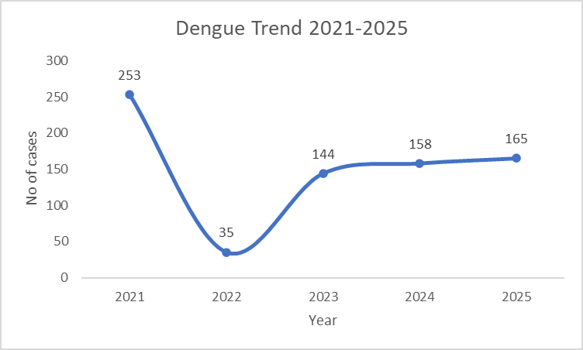
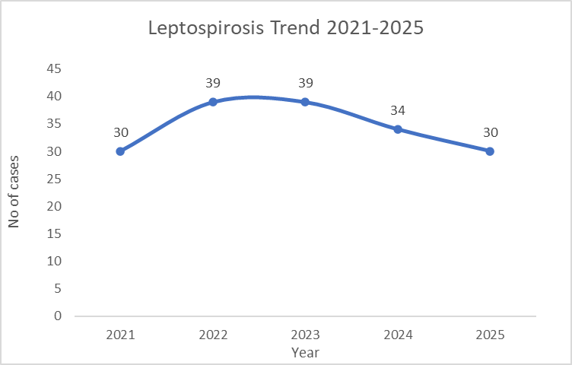

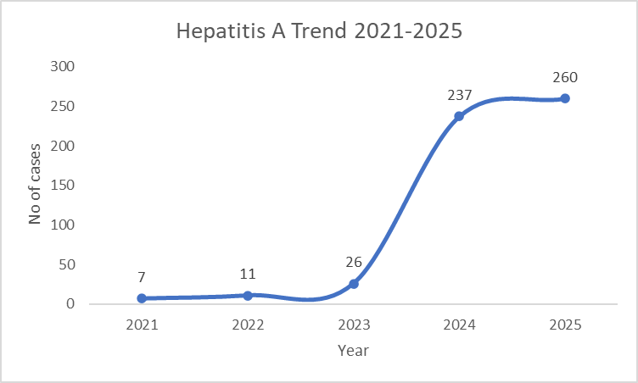

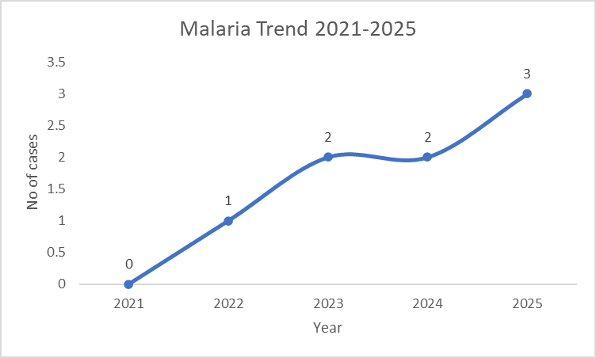

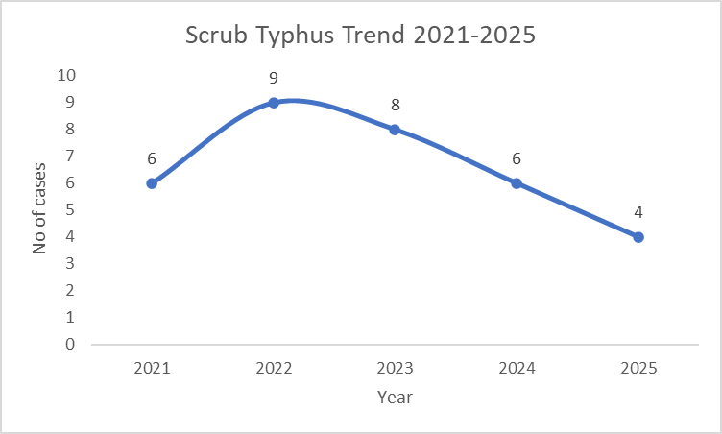

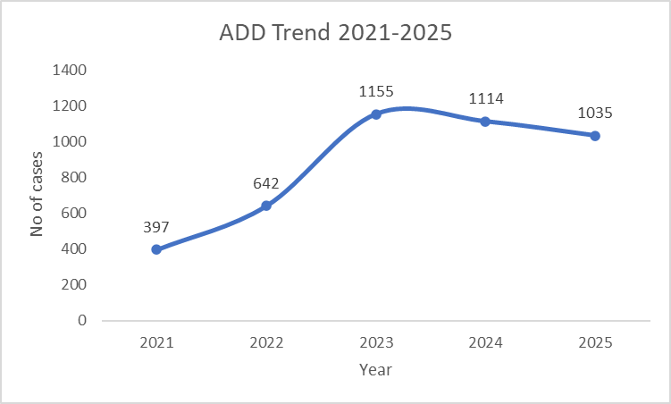

Seasonal Trend Analysis
Seasonal analysis helps anticipate surges (e.g. dengue in monsoon, leptospirosis after floods, influenza in cooler months) and plan pre‑emptive vector control, stockpiling of IV fluids, and awareness campaigns at Panchayat level.

DENGUE
Dengue is a major seasonal vector-borne disease strongly associated with rainfall, water stagnation, and increased mosquito breeding during the monsoon period.

Peak: July–November

Dengue – LSGI-wise Yearly Distribution (2021–2025)

Name of LSGI | Dengue – LSGI-wise Yearly Distribution
Name of LSGI | 2021 | 2022 | 2023 | 2024 | 2025 | Total
Chemanchery | 8 | 4 | 28 | 33 | 30 | 103
Chengottukavu | 14 | 7 | 36 | 30 | 12 | 99
Moodadi | 23 | 5 | 12 | 9 | 21 | 70
Atholi | 77 | 8 | 17 | 28 | 16 | 146
Arikkulam | 27 | 04 | 15 | 27 | 15 | 88
Koyilandy Municipality | 104 | 7 | 36 | 31 | 71 | 249

LEPTOSPIROSIS
Leptospirosis cases are closely linked to monsoon rains, flooding, and occupational exposure, particularly in low-lying and waterlogged areas.

Peak: June - August

Leptospirosis – LSGI-wise Yearly Distribution (2021–2025)

Name of LSGI | Leptospirosis – LSGI wise Yearly Distribution
Name of LSGI | 2021 | 2022 | 2023 | 2024 | 2025 | Total
Chemanchery | 10 | 4 | 12 | 10 | 7 | 43
Chengottukavu | 1 | 7 | 5 | 2 | 6 | 21
Moodadi | 6 | 4 | 4 | 3 | 2 | 19
Atholi | 2 | 11 | 5 | 7 | 8 | 33
Arikkulam | 04 | 05 | 04 | 06 | 02 | 21
Koyilandy Municipality | 7 | 8 | 9 | 6 | 5 | 35

VIRAL HEPATITIS - A
Hepatitis A cases are commonly associated with unsafe drinking water, food contamination, and breakdowns in sanitation, often presenting as clusters or outbreaks.

Peak: October - December

Hepatitis A – LSGI-wise Yearly Distribution (2021–2025)

Name of LSGI | Hep A – LSGI-wise Yearly Distribution
Name of LSGI | 2021 | 2022 | 2023 | 2024 | 2025 | Total
Chemanchery | 1 | 4 | 5 | 46 | 21 | 77
Chengottukavu | 0 | 1 | 5 | 14 | 3 | 23
Moodadi | 1 | 0 | 2 | 36 | 42 | 81
Atholi | 0 | 1 | 5 | 71 | 49 | 126
Arikkulam | 0 | 02 | 03 | 44 | 77 | 126
Koyilandy Municipality | 5 | 3 | 6 | 26 | 68 | 108

Outcome-Based Trend Analysis- 2025
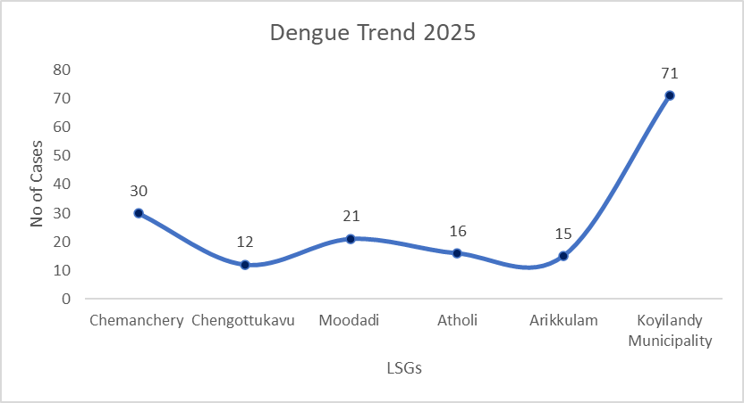

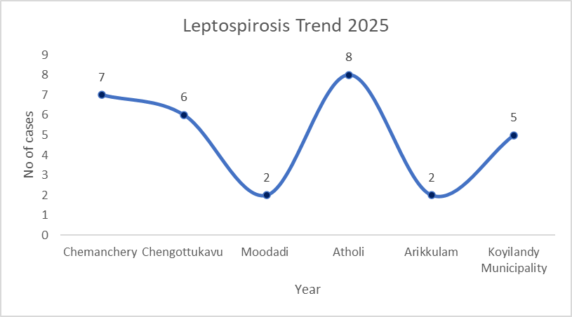

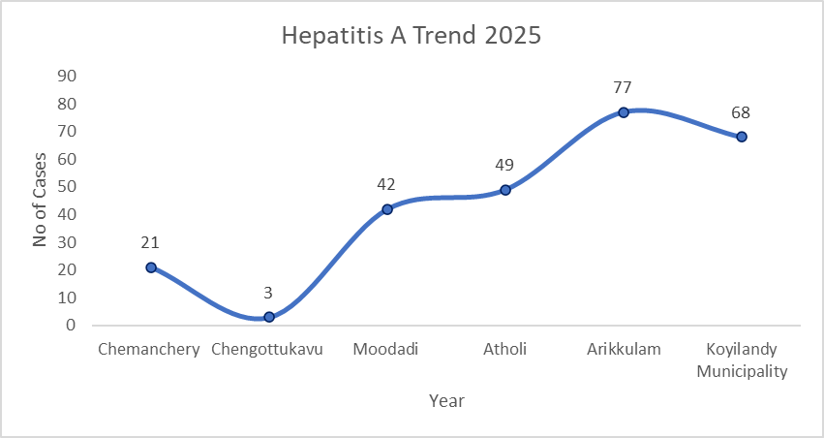

Transmission Trend- 2025
For effective management of public health issues, it is important to track the trend of disease transmission mode. It helps identify the population or place at high risk that can be used to predict outbreaks and implement targeted interventions as quickly as possible. Understanding these kinds of trends enables authorities to allocate resources efficiently and change the strategies adequately based on the trend that follows.

Mode of Transmission | Name of LSGI | No. of cases | No. of Deaths
Vector Borne Diseases | Chemanchery | 30 | 0
Vector Borne Diseases | Chengottukavu | 13 | 0
Vector Borne Diseases | Moodadi | 21 | 0
Vector Borne Diseases | Atholi | 17 | 0
Vector Borne Diseases | Arikkulam | 15 | 0
Vector Borne Diseases | Koyilandy Municipality | 64 | 0
Water Borne Diseases | Chemanchery | 22 | 0
Water Borne Diseases | Chengottukavu | 30 | 0
Water Borne Diseases | Moodadi | 164 | 0
Water Borne Diseases | Atholi | 67 | 0
 | Arikkulam | 77 | 1
 | Koyilandy Municipality | 64 | 0
Air Borne Diseases | Chemanchery | 106 | 1
Air Borne Diseases | Chengottukavu | 23 | 0
Air Borne Diseases | Moodadi | 47 | 1
Air Borne Diseases | Atholi | 114 | 1 (TB)
Air Borne Diseases | Arikkulam | 8 TB | 01
Air Borne Diseases | Koyilandy Municipality | 142 | 0
Blood Borne Diseases | Chemanchery | 0 | 0
Blood Borne Diseases | Chengottukavu | 0 | 0
Blood Borne Diseases | Moodadi | 0 | 0
Blood Borne Diseases | Atholi | 0 | 0
Blood Borne Diseases | Arikkulam | 0 | 0
Blood Borne Diseases | Koyilandy Municipality | 0 | 0
Food Borne Diseases | Chemanchery | 1 | 0
Food Borne Diseases | Chengottukavu | 0 | 0
Food Borne Diseases | Moodadi | 1 | 0
Food Borne Diseases | Atholi | 0 | 0
Food Borne Diseases | Arikkulam | 1 | 0
Food Borne Diseases | Koyilandy Municipality | 0 | 0

Vector-Borne Disease

Disease | Name of LSGI | No. of Cases | No. of Deaths
Dengue | Chemanchery | 30 | 0
Dengue | Chengottukavu | 12 | 0
Dengue | Moodadi | 20 | 0
Dengue | Atholi | 17 | 0
Dengue | Arikkulam | 15 | 0
Dengue | Koyilandy Municipality | 64 | 0
Malaria | Chemanchery | 0 | 0
Malaria | Chengottukavu | 1 | 0
Malaria | Moodadi | 0 | 0
Malaria | Atholi | 0 | 0
Malaria | Arikkulam | 0 | 0
Malaria | Koyilandy Municipality | 0 | 0
Chikungunya | Chemanchery | 0 | 0
Chikungunya | Chengottukavu | 0 | 0
Chikungunya | Moodadi | 0 | 0
Chikungunya | Atholi | 0 | 0
Chikungunya | Arikkulam | 0 | 0
Chikungunya | Koyilandy Municipality | 0 | 0

Water Borne Disease

Disease | Name of LSGI | No. of Cases | No. of Deaths
Cholera | Chemanchery | 0 | 0
Typhoid | Chemanchery | 1 | 0
Hep- A | Chemanchery | 21 | 0
Dysentery | Chemanchery | 0 | 0
Amoebiasis | Chemanchery | 0 | 0
E- Coli infections | Chemanchery | 0 | 0
Cholera | Chengottukavu | 0 | 0
Typhoid | Chengottukavu | 0 | 0
Hep- A | Chengottukavu | 3 | 0
Dysentery | Chengottukavu | 0 | 0
Amoebiasis | Chengottukavu | 1 | 1
E- Coli infections | Chengottukavu | 0 | 0
Cholera | Moodadi | 0 | 0
Typhoid | Moodadi | 0 | 0
Hep- A | Moodadi | 35 | 0
Dysentery | Moodadi | 0 | 0
Amoebiasis | Moodadi | 0 | 0
E- Coli infections | Moodadi | 0 | 0
Cholera | Atholi | 0 | 0
Typhoid | Atholi | 0 | 0
Hep- A | Atholi | 59 | 0
Dysentery | Atholi | 0 | 0
Amoebiasis | Atholi | 0 | 0
E- Coli infections | Atholi | 0 | 0
Cholera | Arikkulam | 0 | 0
Typhoid | Arikkulam | 0 | 0
Hep- A | Arikkulam | 77 | 1
Dysentery | Arikkulam | 0 | 0
Amoebiasis | Arikkulam | 0 | 0
E- Coli infections | Arikkulam | 0 | 0
Cholera | Koyilandy Municipality | 0 | 0
Typhoid | Koyilandy Municipality | 1 | 0
Hep- A | Koyilandy Municipality | 63 | 0
Dysentery | Koyilandy Municipality | 13 | 0
Amoebiasis | Koyilandy Municipality | 13 | 0
E- Coli infections | Koyilandy Municipality | 13 | 0

Air Borne Disease

Disease | Name of LSGI | No. of Cases | No. of Deaths
Influenza | Chemanchery | 0 | 0
H1N1 | Chemanchery | 6 | 0
TB | Chemanchery | 19
Chickenpox | Chemanchery | 78 | 0
Measles | Chemanchery | 2 | 0
Covid-19 | Chemanchery | 1 | 1
Pertussis | Chemanchery | 0 | 0
Mumps | Chemanchery | 0 | 0
Influenza | Chengottukavu | 0 | 0
H1N1 | Chengottukavu | 2 | 0
TB | Chengottukavu | 8 | 0
Chickenpox | Chengottukavu | 8 | 0
Measles | Chengottukavu | 0 | 0
Covid-19 | Chengottukavu | 0 | 0
Pertussis | Chengottukavu | 0 | 0
Mumps | Chengottukavu | 5 | 0
Influenza | Moodadi | 0 | 0
H1N1 | Moodadi | 0 | 0
TB | Moodadi | 11 | 1
Chickenpox | Moodadi | 15 | 0
Measles | Moodadi | 0 | 0
Covid-19 | Moodadi | 0 | 0
Pertussis | Moodadi | 0 | 0
Mumps | Moodadi | 21 | 0
Influenza | Atholi | 0 | 0
H1N1 | Atholi | 0 | 0
TB | Atholi | 19 | 0
Chickenpox | Atholi | 40 | 0
Measles | Atholi | 0 | 0
Covid-19 | Atholi | 0 | 0
Pertussis | Atholi | 0 | 0
Mumps | Atholi | 55 | 0
Influenza | Arikkulam | 0 | 0
H1N1 | Arikkulam | 0 | 0
TB | Arikkulam | 8 | 01
Chickenpox | Arikkulam | 36 | 0
Measles | Arikkulam | 01 | 0
Covid-19 | Arikkulam | 0 | 0
Pertussis | Arikkulam | 0 | 0
Mumps | Arikkulam | 21 | 0
Influenza | Koyilandy Municipality | 0 | 0
H1N1 | Koyilandy Municipality | 6 | 0
TB | Koyilandy Municipality | 21 | 0
Chickenpox | Koyilandy Municipality | 79 | 0
Measles | Koyilandy Municipality | 0 | 0
Covid-19 | Koyilandy Municipality | 0 | 0
Pertussis | Koyilandy Municipality | 0 | 0
Mumps | Koyilandy Municipality | 37 | 0

Blood-Borne Disease

Disease | Name of LSGI | No. of Cases | No. of Deaths
AIDS | Chemanchery, Chengottukavu, Atholi, Arikkulam, Koyilandy Municipality | 0 | 0
Hep- B |  | 0 | 0
Hep- C |  | 0 | 0
AIDS | Moodadi | 0 | 0
Hep- B | Moodadi | 1 | 0
Hep- C | Moodadi | 0 | 0

Zoonotic Disease

Disease | Name of LSGI | No. of Cases | No. of Deaths
Rabies | Chemanchery | 0 | 0
Leptospirosis | Chemanchery | 7 | 2
Avian influenza | Chemanchery | 0 | 0
West nile | Chemanchery | 0 | 0
Anthrax | Chemanchery | 0 | 0
Nipah | Chemanchery | 0 | 0
Scrub Typhus | Chemanchery | 0 | 0
Rabies | Chengottukavu | 0 | 0
Leptospirosis | Chengottukavu | 6 | 1
Avian influenza | Chengottukavu | 0 | 0
West nile | Chengottukavu | 0 | 0
Anthrax | Chengottukavu | 0 | 0
Nipah | Chengottukavu | 0 | 0
Scrub Typhus | Chengottukavu | 0 | 0
Rabies | Moodadi | 0 | 0
Leptospirosis | Moodadi | 2 | 0
Avian influenza | Moodadi | 0 | 0
West nile | Moodadi | 0 | 0
Anthrax | Moodadi | 0 | 0
Nipah | Moodadi | 0 | 0
Scrub Typhus | Moodadi | 0 | 0
Rabies | Atholi | 0 | 0
Leptospirosis | Atholi | 8 | 0
Avian influenza | Atholi | 0 | 0
West nile | Atholi | 0 | 0
Anthrax | Atholi | 0 | 0
Nipah | Atholi | 0 | 0
Scrub Typhus | Atholi | 0 | 0
Rabies | Arikkulam | 0 | 0
Leptospirosis | Arikkulam | 2 | 1
Avian influenza | Arikkulam | 0 | 0
West nile | Arikkulam | 0 | 0
Anthrax | Arikkulam | 0 | 0
Nipah | Arikkulam | 0 | 0
Scrub Typhus | Arikkulam | 0 | 0
Rabies | Koyilandy Municipality | 0 | 0
Leptospirosis | Koyilandy Municipality | 4 | 1
Avian influenza | Koyilandy Municipality | 0 | 0
West nile | Koyilandy Municipality | 1 | 0
Anthrax | Koyilandy Municipality | 0 | 0
Nipah | Koyilandy Municipality | 0 | 0
Scrub Typhus | Koyilandy Municipality | 3 | 0

Integrated Disease Hotspot Map (2021–2025)
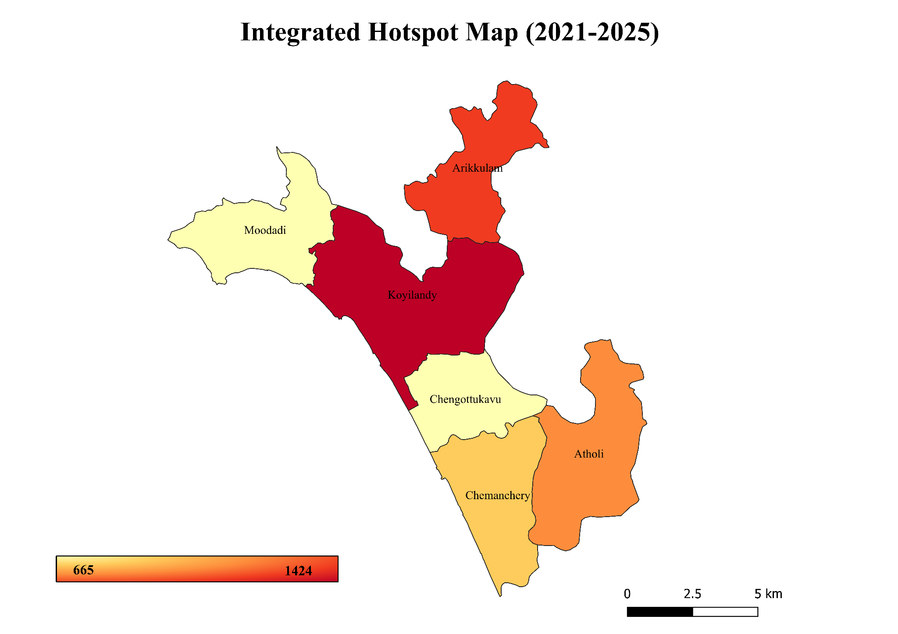

Name of LSGI | Dengue Total (2021-25) | Leptospirosis Total (2021-25) | Hepatitis A Total (2021-25) | Mumps (2021-25) | ADD (2021-25) | Total Cases
Chemanchery | 103 | 43 | 77 | 38 | 705 | 966
Chengottukavu | 99 | 21 | 23 | 39 | 483 | 665
Moodadi | 70 | 19 | 81 | 58 | 443 | 671
Atholi | 146 | 33 | 126 | 65 | 659 | 1029
Arikkulam | 88 | 21 | 126 | 74 | 833 | 1142
Koyilandy Municipality | 249 | 35 | 108 | 132 | 900 | 1424
By overlaying five years of data, we have identified four ‘Red Zone’ LSGIs. These include Koyilandy Municipality, Arikkulam, Chemanchery and Atholi, which reported the highest cumulative number of communicable disease cases during 2021–2025. In each Red Zone LSGI, there are multiple Red Zone wards where at least two different categories of diseases (e.g., Dengue and Leptospirosis) recurred in consecutive years. Wards in Arikkulam, LSGI is categorized as the Highest Priority Hotspot due to its combination of flood vulnerability and high vector density. Future health infrastructure, such as the proposed R.O. plants in Arikkulam Atholi and chemanchery , should be prioritized to reduce the risk of water-borne disease transmission.

Preparedness and Response Protocol at revenue block Level
This section describes the operational framework for the revenue block once a pandemic is declared. It explains how the revenue block and health system will move from routine data collection to active response, using a One Health approach.

Constitution of One Health Committee
Each LSGD shall constitute a One Health Committee comprising the LSGD President, Medical Officers (Modern Medicine, AYUSH, and Veterinary), the Health Inspector, and the Veterinary Surgeon.

Objective: The One Health Committee coordinates human, animal, and environmental health to prevent and control pandemics.

One health committee - CHEMANCHERY
Sl No | Name | Designation | Department/Institution | Role in Committee | Contact Number
1 | Ajay bos | Panchayat President | LSGD | Chairperson | 9539391069
2 | Dr. Sheeba K.J | Medical Officer (PHC/CHC) | Health Dept | Member Secretary | 8547782509
3 | Dr Gopika | Veterinary Officer | Animal Husbandry | Member | 9072838779
4 | Anima Raj | Epidemiologist | Health Dept | Member | 9074844808
5 | Sajeesh | Health Inspector/PHN | Health Dept | Surveillance | 9495339248
6 | Preetha | ASHA Supervisor | Health Dept | Community link | 9562445114
7 | Anitha | ICDS Supervisor | Social Welfare | Vulnerable groups | 9446150775
8 | Station office | Police Station Officer | Police Dept | Law & order | 0496-2620236 (Koyilandy police station is the nearby station)
9 | Nalini | Ward Councillor Representative | LSGD | Community coordination | 9497170308
10 | Valsala | Kudumbashree CDO | Kudumbashree | Community mobilisation | 986908925
11 | Sairy Granthashala Raghunath K | NGO/Volunteer rep | Civil Society | Support services | 9567341045.
12 | Food Safety Officer | Line Department representations | Food Safety Department | Support services | 8086312383

One health committee - CHENGOTUKAVU

Sl No | Name | Designation | Department/Institution | Role in Committee | Contact Number
1 | Bhaskaran K N | Panchayat President | Lsgd | Chairperson | 9048201287
2 | Dr Josmy | Medical Officer (Phc/Chc) | Health Dept | Member Secretary | 8281525429
3 | Dr Ranjith | Veterinary Officer | Animal Husbandry | Member | 8848267240
4 | Anima Raj | Epidemiologist | Health Dept | Member | 904844808
5 | Rajan | Health Inspector | Health Dept | Surveillance | 9447218855
6 | Sheeba | Asha Supervisor | Health Dept | Community Link | 9447635970
7 | Shabila | Icds Supervisor | Social Welfare | Vulnerable Groups | 9846473794
8 | Station office | Police Station Officer | Police Dept | Law & order | 0496-2620236
9 | Babina | Ward Councillor Representative | Lsgd | Community Coordination | 7012005527
10 | Praneetha | Kudumbashree Cdo | Kudumbashree | Community Mobilisation | 9446561521
11 | Sreedharan | Ngo/Volunteer Rep | Civil Society | Support Services | 7025463396
12 | Food Safety Officer | Line Department representations | Food Safety Department | Support services | 8086312383

One health committee - MOODADI

Sl No | Name | Designation | Department/Institution | Role in Committee | Contact Number
1 | Akhila | Panchayat President | LSGD | Chairperson | 9074925714
2 | Dr Ragima N Mohan | Medical Officer (PHC/CHC) | Health Dept | Member Secretary | 9995882125
3 | Dr Praseena poulose | Veterinary Officer | Animal Husbandry | Member | 04962693194
4 | Anima Raj | Epidemiologist | Health Dept | Member | 9074844808
5 | Jasheena.O | Health Inspector/PHN | Health Dept | Surveillance | 7593981972
6 | Lissy Thomas | ASHA Supervisor | Health Dept | Community link | 9847925993
7 | Rajalakshmi | ICDS Supervisor | Social Welfare | Vulnerable groups | 8089773875
8 | station office | Police Station Officer | Police Dept | Law & order | 04962620236
9 | Sunitha | Ward Councillor Representative | LSGD | Community coordination | 9447011564
10 | Sheeja | Kudumbashree CDO | Kudumbashree | Community mobilisation | 8086037932
11 | Rajeesh | NGO/Volunteer rep | Civil Society | Support services | 9495592057
12 | Food Safety Officer | Line Department representations | Food Safety Department | Support services | 8086312383

One health committee - ATHOLI

Sl No | Name | Designation | Department/Institution | Role in Committee | Contact Number
1 | Jayakrishnan | Panchayat President | LSGD | Chairperson | 9495244656
2 | Dr. Madhava sarma Binoy B | Medical Officer (PHC/CHC) | Health Dept | Member Secretary | 9447165158
3 | Dr. Hiba | Veterinary Officer | Animal Husbandry | Member | 9048211077
4 | Anima Raj | Epidemiologist | Health Dept | Member | 9074844808
5 | KK Rathish | Health Inspector/PHN | Health Dept | Surveillance | 9847594633
6 | Bindhu | ASHA Supervisor | Health Dept | Community link | 940021771
7 | Anjali | ICDS Supervisor | Social Welfare | Vulnerable groups | 9400665693
8 | Station office | Police Station Officer | Police Dept | Law & order | 0496 267 2233
9 | Rajan | Ward Councillor Representative | LSGD | Community coordination | 9446306051
10 | Vijila | Kudumbashree CDO | Kudumbashree | Community mobilisation | 9846982092
11 | T Muraleedharan | NGO/Volunteer rep | Civil Society | Support services | 9446890082
12 | Food Safety Officer | Line Department representations | Food Safety Department | Support services | 8086312383

One health committee - ARIKKULAM

Sl No | Name | Designation | Department/Institution | Role in Committee | Contact Number
1 | Pp . Ramani | Panchayat President | LSGD | Chairperson | 7356869284
2 | Dr. .Fincy | Medical Officer (PHC/CHC) | Health Dept | Member Secretary | 9497658545
3 | Dr.Krishna Sooraj | Veterinary Officer | Animal Husbandry | Member | 8281495348
4 | Anima Raj | Epidemiologist | Health Dept | Member | 9074844808
5 | Abdulnasar | Health Inspector/PHN | Health Dept | Surveillance | 9496417238
6 | Radha Phn | ASHA Supervisor | Health Dept | Community link | 9497651658
7 | Jyothi M | ICDS Supervisor | Social Welfare | Vulnerable groups | 90487228446
8 | Sumith Ci | Police Station Officer | Police Dept | Law & order | 9495021102
9 | Anujith | Ward Councillor Representative | LSGD | Community coordination | 7907559934
10 | Bijila | Kudumbashree CDO | Kudumbashree | Community mobilisation | 9645255236
11 | RRT | NGO/Volunteer rep | Civil Society | Support services | 9446038329
12 | Pamchayath | Line Department representations |  |  | 9961730327
13 | Food Safety Officer | Line Department representations | Food Safety Department | Support services | 8086312383

One health committee - KOYILANDY MUNICIPALITY

Sl No | Name | Designation | Department/Institution | Role in Committee | Contact Number
1 | UK chandran | Panchayat President | LSGD | Chairperson | 9447679111
2 | Dr.Sunitha | Medical Officer (PHC/CHC) | Health Dept | Member Secretary | 9495151537
3 | Dr. Sunilkumar M | Veterinary Officer | Animal Husbandry | Member | 9048630897
4 | Anima Raj | Epidemiologist | Health Dept | Member | 9074844808
5 | Shaju | Health Inspector/PHN | Health Dept | Surveillance | 9496470642
6 | priya | ASHA Supervisor | Health Dept | Community link | 7356351066
7 | monisha | ICDS Supervisor | Social Welfare | Vulnerable groups | 9539809378
8 | HSO | Police Station Officer | Police Dept | Law & order | 9495021102
9 | Jaslu | Ward Councillor Representative | LSGD | Community coordination | 9746650130
10 | Shamseera | Kudumbashree CDO | Kudumbashree | Community mobilisation | 9048791272
11 | Santhosh | NGO/Volunteer rep | Civil Society | Support services | 72932 67113
12 | Food Safety Officer | Line Department representations | Food Safety Department | Support services | 8086312383

Key Responsibilities:
- Review disease surveillance data (human + animal)
- Conduct ward-wise risk assessment and vulnerability mapping
- Approve quarantine/isolation centre locations
- Coordinate with district for resources (PPE, oxygen, ambulances)
- Periodically review health system surge capacity, including beds, oxygen, human resources, and ambulances.
- Approve and monitor risk communication and community engagement strategies, including rumour management.
- Ensure protection and service continuity for vulnerable groups (elderly, persons with disabilities, dialysis patients, coastal populations).
- Conduct quarterly mock drills
- Monitor equity measures for vulnerable groups

Meeting Schedule:
Quarterly (normal times) | Weekly (outbreak alert) | Daily (pandemic phase)

Pandemic Response Workforce
To ensure a coordinated and timely response during a pandemic, a dedicated Pandemic Response Workforce shall be constituted at the revenue block level. The workforce will function under the overall supervision of the One Health Committee and in close coordination with the health authorities. Team-based deployment will enable efficient surveillance, case management, quarantine and isolation management, logistics support, and risk communication. Each team shall have a clearly designated team leader, defined roles, and an identified pool of personnel to allow rapid activation, rotation of duties, and continuity of services during prolonged emergencies.

Total Response Workforce Available

Team Name | Composition | Key Responsibilities | Team Leader
Surveillance and Contact Tracing Team | HS, HI, JHI, block epidemiologist, block data manager, JPHN, ASHAs and Volunteers | Case detection, contact listing, home visits, reporting | HS
Case Management Team | Doctors, Nurses, MLSP, Palliative Nurses | Patient care & referral | Block MO
Quarantine & Isolation Team | LSGD staff, Volunteers | Facility management | HI
Psychosocial support | DMHP | Community Awareness and Communication | Psychiatrist
Logistics & supply chain Team | LSGD staff, Storekeepers, Drivers 3 | Supplies & transport [PPE, medicines, oxygen, transport, waste management] | Ward Member
Communication Team | Ward members, Kudumbashree, Youth clubs,  AWW workers and other self help groups | IEC, community meetings, countering misinformation | Block MO
Transportation | KSRTC, educational institutional buses | Patient transport, sample transport, logistic movement, emergency referral coordintion | HI
Media Surveillance | HI, LSG TEAM, ICDS SUPERVISOR, ASHA SUPERVISOR, IEC Officers, | Verification and Fact-Checking, Coordination with Health Authoritie | Block President
Intersectoral coordination and convergence | MO, HI, LHI, ASHA LEADER, ICDS SUPERVISOR, CDS SUPERVISOR, OTHER LINE DEPARTMENT REPRESENTATIVES, WARD MEMBERS | Joint planning and preparedness, Clear role allocation, Coordinated rescue, evacuation, and transport, Maintenance of law and order and crowd control by police authorities. | Block President, Block MO
Collaborative surveillance | MO, HI, LHI, Block Epidemiologist, ASHA Leader, ICDS Supervisor, CDS Supervisor, LSGD representatives, Police, Education Department representatives, Veterinary Department, Water Authority officials, and other line department representatives. | Support resource mobilization and logistics during emergency situations.  Conduct regular review meetings and data sharing for monitoring the situation. | Block MO

All teams shall be activated immediately upon outbreak alert or pandemic declaration and shall report daily to the revenue block Incident Commander/Block Medical Officer, with consolidated reporting to the Block PHU. Duty rosters and alternate personnel shall be maintained to ensure uninterrupted services during staff shortages or prolonged response periods. Team composition and numbers may be revised based on the magnitude of the outbreak and availability of human resources.

Activities and Measures before and during Pandemic

PHASE 1 - Alert / Preparation
Surveillance and Reporting-Enhanced syndromic surveillance:
- Data sources for surveillance:
- Event-based triggers (to be monitored and reported):
- Zoonotic and animal health surveillance
- Logistics and Stock Preparedness
  - Identify and empanel local vendors and define emergency procurement mechanisms in accordance with existing LSGD and Health Department norms.
  - Prepare and maintain an essential logistics checklist covering medical supplies, consumables, and support equipment.
  - Pre-identify secure storage locations for emergency stocks and ensure maintenance of stock registers with regular updating.
  - Finalise emergency transport arrangements, including availability of vehicles and identified drivers for rapid deployment during alerts.
  - Designate a Nodal Officer for Logistics to enable prompt decision-making, coordination, and communication during emergencies.
  - Conduct rapid stock verification and ensure availability of minimum buffer stock, including:
- Chemanchery LSGD
- PPE kits currently no stock
- Pulse oximeters 2 numbers
- Hand sanitizers 10 litres
- Masks: 3500, gloves: 12200, disinfectants 5 bottled (1 litres each) adequate quantity
- Chengottukavu LSGD
- PPE kits 100 numbers
- Pulse oximeters 50 numbers
- Hand sanitizers 10 litres
- Masks,500 gloves,1000 disinfectants adequate quantity

- Moodadi LSGD
- PPE kits 3numbers
- Pulse oximeters 2 numbers
- Hand sanitizers 10 litres
- Masks100, gloves100, disinfectants 2 BOTTLES – adequate quantity

- Atholi LSGD
- PPE kits 10 numbers
- Pulse oximeters – 19 numbers
- Hand sanitizers – 10 litres
- Masks 100 , gloves 200, disinfectants 2 bottles– adequate quantity

- Arikkulam LSGD
- PPE kits 10 numbers
- Pulse oximeters 10numbers
- Hand sanitizers 10 litres
- Masks 200, gloves,500 disinfectants 10 LITRE adequate quantity

- Koyilandy Municipality
- PPE kits 12 numbers
- Pulse oximeters 6 numbers
- Hand sanitizers 40 litres
- Masks, 600 gloves, 500 disinfectants – 6 bottles adequate quantity
Identify critical gaps in logistics and immediately communicate requirements to the Block and District authorities for timely replenishment and support. Monitor expiry dates and stock rotation.

Identification of Quarantine and Isolation Facilities
  - Identify and list suitable buildings for quarantine and isolation (schools, hostels, community halls, etc.).
  - Categorise cases as per the severity and allocate to appropriate facilities (for instance, severe cases to classrooms, mild cases to an assembly hall in case of a school).
  - Facility readiness checklist needed (beds, toilets, ventilation) etc.
  - Find an alternate site if the primary sites are not available or not in use.
  - Identify facility managers and support staff
  - Prepare basic SOPs for:
    - Admission and discharge
    - Food, water, sanitation
    - Infection prevention and waste disposal
  - Ensure availability of basic amenities: water, sanitation, electricity, ventilation, and waste disposal. Prepare a rapid activation plan for these facilities if case numbers increase.

Risk Communication and Community Preparedness
  - Disseminate early warning messages on symptoms, preventive measures, and reporting mechanisms. Display IEC materials both in English and the local language in public places and ensure ward-level awareness.
  - Sensitize elected representatives and community leaders on preparedness measures.
  - Establish a rumour tracking and misinformation response mechanism to identify, verify, and promptly counter false or misleading information.
  - Engage trusted local persons (ward members, ASHA workers, religious leaders, teachers, community volunteers) to communicate official public health messages and reinforce correct practices.
  - Develop and deploy targeted IEC materials for:
    - Schools and educational institutions
    - Markets and commercial areas
    - Work sites and labour settings
  - Conduct community sensitization meetings at the ward level to promote preventive behaviors, address concerns, and strengthen community participation in preparedness and response.

Protection of Vulnerable Groups
Vulnerable populations require priority protection through targeted line-listing, service continuity, and delivery mechanisms.
- Prepare and regularly update line-lists of vulnerable populations, including:
  - Elderly persons living alone
  - Persons with disabilities
  - Pregnant women
  - Migrant workers
  - Dialysis patients
The detailed line-lists shall be maintained as Annexure and updated periodically.

Clinical Dependency Mapping
Develop ward-wise dependency and vulnerability maps to identify households requiring regular support during emergencies. Ensure continuity of essential health services for vulnerable groups, including
- Dialysis services (facility mapping, transport arrangements, and scheduling)
- Continuity of treatment for TB, HIV, and other chronic conditions requiring uninterrupted medication
- Mental health and psychosocial support services
Establish delivery mechanisms for food, essential commodities, and medicines to vulnerable households through coordinated action involving ASHAs, JPHNs, Kudumbashree, volunteers, and local administration.

PHASE 2 - Active Response

Case Identification and Contact Tracing
Case detection and contact tracing activities will be carried out in coordination with the Health authorities, following disease-specific SOPs and IDSP guidelines.
Field Staff Involved
- Health Supervisor (HS)
- Health Inspector (HI)
- Block epidemiologist
- Block data manger
- Junior Health Inspector (JHI)
- Junior Public Health Nurse (JPHN)
- ASHAs and ASHA Supervisors
- Ward-level volunteers and Kudumbashree members (as required)

Screening Checkpoints
Screening checkpoints at high-traffic locations (transport hubs, markets, religious gatherings) for early detection of symptomatic travellers and crowd screening during outbreaks. Potential locations include bus stands, market entry points, and boat jetties, based on local context and risk assessment.
Screening activities will be carried out by trained personnel such as ASHAs, ward members, and volunteers, with support from Health Department staff. Necessary equipment, including non-contact thermometers and appropriate PPE, shall be ensured prior to activation.

Location | Type (Bus stand/Jetty/Market/Railway) | Staff Deployed (ASHAs/Volunteers) | Screening Method | Reporting authority
Bus stand | Transport hub | One JHI  One ASHA  One health Mentors | 1.Swab Collection.  2. Blood smears collection (RDT)  3.Thermal Scanners | Surveillance Nodal Officer in control room
Market entry | Market | One JHI  One ASHA  Male health volunteers | 1.Swab Collection.  2. Blood smears collection (RDT)  3.Thermal Scanners | Surveillance Nodal Officer in control room
Boat jetty | Water transport | One JHI  One ASHA  Male health volunteers | 1.Swab Collection.  2. Blood smears collection (RDT)  3.Thermal Scanners | Surveillance Nodal Officer in control room

Standard Screening Protocol

The screening protocol shall include temperature screening, observation for visible symptoms, and inquiry regarding recent travel or exposure history. Individuals identified as suspects during screening shall be immediately referred to the nearest PHC/FHC for further evaluation, testing, and appropriate action as per prevailing guidelines.

Pandemic Control Room
The Pandemic Control Room (PCR) serves as the central nerve center for real-time coordination, data aggregation, decision support, and communication during outbreaks. It consolidates information from all LSGD teams, health facilities and community sources to enable rapid response decisions.

Control Room Infrastructure and Location
Primary Location: Panthalayani revenue block Office.
Backup Location: Community Hall in Panthalayani revenue block.

Health System Control Room Framework
The PCR is organized into seven functional pillars to ensure no aspect of the response is overlooked:

Rapid Response Team (RRT)
  - Provides immediate intervention during emergencies, clusters, and field alerts.​
  - Coordinates urgent actions such as case investigation, contact tracing, isolation, and inter‑facility referrals.

Data Management & Analytics Team
  - Collects, validates, and manages key health system indicators (cases, tests, beds, HR, supplies).​
  - Analyzes data trends, generates projections, and supports evidence‑based decision‑making for local authorities.

Human Resource Deployment Team
  - Allocates healthcare staff efficiently based on workload and need
  - Ensures adequate and equitable workforce distribution across facilities

Laboratory Surveillance Team
  - Oversees diagnostic testing coordination, sample transport, and timely reporting of results.​
  - Monitors lab indicators (testing volume, positivity rate, turnaround time) for early detection of outbreaks

Vaccination Cell (If Required)
  - Plans and executes vaccination campaigns, including micro‑planning and session scheduling.​
  - Tracks coverage, identifies gaps, and coordinates corrective actions with field teams and outreach services.

Infrastructure & Patient Occupancy Team
  - Monitors facility capacity, earmarked beds, oxygen and critical care resources across all linked facilities.​
  - Ensures optimal patient distribution and referral management using updated bed‑status and resource data.
  - BMWM

Communication team
- Logistics and supply chain
- Transportation (interfacility & emergency transport)
- Media surveillance Call centre
- Management of the deceased
- Intersectoral coordination and convergence

Key Control Room Team
The Control Room Team coordinates all pandemic response activities within the LSGD and serves as the single command and communication hub during activation. It integrates information, field actions, logistics, and policy execution across all participating departments and health facilities.

Role | Name | Designation | Contact Number | Responsibility
In-charge/Nodal Officer | Dr Sheeba K.J  Vinod | Medical Officer  Health Supervisor | 8547782509 | Overall coordination, decision-making, and reporting to the District level.
Block Epidemiologist | Anima Raj | Block Epidemiologist | 9074844808 | Responsible for disease surveillance, early detection of outbreaks, epidemiological investigation, and risk assessment. Ensures timely reporting to the district, monitors disease trends.
Block Data Manager | Amrutha Ullas | Block Data Manager | 9048441271 | Responsible for management and validation of surveillance data, maintaining pandemic-related databases, compiling daily/weekly reports, and supporting data analysis.
Data Entry Operator | Shinila | Data entry operator | 9061895294 | Managing the line list, updating dashboards, and tracking testing results.
Communication Officer | Sajeesh | Health Inspector | 9495339248 | Handling the public helpline, coordinating ambulance dispatch, and contact tracing calls.
Logistics Coordinator | Rasna | Pharmasist | 9745979428 | Stock management
Technical Support (IT/Data) | Ramachandran | JHI | 9961284687 | Managing the line list, updating dashboards, and tracking testing results.

SOP for alert escalation/trigger point with mapping of responsibilities.

Key Points:
- The Control Room shall be staffed with a designated In-charge, data entry personnel, and communication staff with clearly defined roles and shift arrangements.
- It shall maintain updated records on daily monitoring indicators including new cases, persons under active quarantine, and hospital bed occupancy.
- All reports and situation updates shall be shared daily with the Block and District Surveillance Unit.
- The Control Room shall act as a single point of contact for coordination with response teams, health institutions, and other departments.
- Contact details of the Control Room shall be widely communicated to field staff and stakeholders during activation.

Daily Monitoring Indicators
To ensure timely decision-making and effective response, the following key indicators shall be monitored and updated on a daily basis by the Pandemic Control Room:

Epidemiological Indicators:
New cases reported today, Total active cases, Test Positivity Rate (TPR), Case Fatality Rate (CFR)
- Surveillance Indicators:
Persons under home quarantine, High-risk contacts identified, Fever, ILI, SARI or other symptoms (syndromic surges), Travellers (symptomatic or high-risk arrivals),Animal husbandry surveillance (zoonotic alerts, unusual animal deaths, poultry/bird flu signals), Mortality surveillance (excess deaths, unexplained fatalities, verbal autopsy reports)
- Logistics and Infrastructure Indicators:
Hospital / CFLTC beds occupied, Oxygen cylinders/concentrators available, Ambulances on standby
- Alert Findings
The following table outlines category-specific trigger points (red flags) from surveillance indicators and corresponding immediate actions for the Pandemic Control Room. These enable rapid response to alert findings like testing anomalies, positive cases exceeding thresholds, clusters, and WGS reports.

Category | Trigger Pophint (Red Flag) | Immediate Action
Clusters | Geographical or facility-based: 5+ cases linked to one location (office, school, street). | Declare a micro-containment zone; perimeter control and active case finding.
Testing | Sudden drop in testing volume / delay in reporting / unusual testing trends | Review the sample collection process, address lab bottlenecks, deploy additional testing teams, and notify the District Lab.
Lab | Test Positivity rate increases | Increase testing sites in that ward.
Hospital | >80% Oxygen bed occupancy | Activate backup/CFLTC beds.
Travel | Cluster of cases from a single flight/train or high-risk arrival group. | Trace all passengers in adjacent seats; implement mandatory institutional quarantine.
Animal | Mass poultry/wildlife death or unusual sickness | Notify Animal Husbandry, sample the area, and dispatch RRT for environmental sampling and zoonotic check.
Mortality | Sudden spike in home deaths or brought-in-dead (BID) cases | Audit the deaths and Active Case Search drive
Additional investigations like Whole Genome Sequencing (WGS) | Detection of a Variant of Concern (VOC) or Variant of Interest (VOI) | Implement strict micro-containment; update clinical protocols to match variant severity.

Communication of Public Health Information
A Community Communication Hub shall be established to ensure timely, accurate, and consistent dissemination of information during a pandemic. The Hub will function under the coordination of Nodal officers of the control room and act as the nodal point for public communication, risk messaging, and community engagement. It will support dissemination of official advisories, promote preventive behaviors, address rumors and misinformation, and ensure that messages reach all sections of the population through trusted local channels and leaders.

Key communicators
Channel | Name of LSGI | Responsible Person | Contact
Ward-level announcements | Chemanchery | Sreeja Kandyil | 9946031409
Social media | Chemanchery | Panchayath President | 9539391069
Local Cable TV/Radio | Chemanchery | Panchayath President | 9539391069
Ward-level announcements | Chengottukavu | Ward member | 9048201287
Social media | Chengottukavu | Panchayath President | 9048201287
Local Cable TV/Radio | Chengottukavu | Panchayath President | 9048201287
Ward-level announcements | Moodadi | Sathyan.KV | 8281890646
Social media | Moodadi | Dilna | 9745389358
Local Cable TV/Radio | Moodadi | Sreeraj | 9778746886
Ward-level announcements | Atholi | HI/JHI | 9847594633
Social media | Atholi | Panchayat president | 9495244656
Local Cable TV/Radio | Atholi | Panchayat president | 9495244656
Ward-level announcements | Arikkulam | Dileep | 9495176934
Social media | Arikkulam | Biju | 9446038329
Local Cable TV/Radio | Arikkulam | SREELAL | 7194020686
Ward-level announcements | Koyilandy Municipality | shanod | 9846178938
Social media | Koyilandy Municipality | jithin | 9048505805
Local Cable TV/Radio | Koyilandy Municipality | Riyas | 9645353531

- All messages disseminated through the Hub shall align with advisories issued by the Health Department and District authorities.
- Community leaders shall be sensitized to support behavior change, reduce stigma, and counter misinformation.
- Special efforts shall be made to reach vulnerable and hard-to-reach populations using locally appropriate communication methods.

Rumor Tracking: A designated volunteer will monitor local social media/WhatsApp groups daily to identify misinformation and issue official clarifications via the Communication Hub.

Coordination with District/State Authorities & Other Organisations
Effective coordination with Block, District, and State authorities is essential to ensure timely reporting, technical guidance, and uninterrupted supply of essential resources during a pandemic. The LSG shall establish clear communication channels, designate responsible officers, and adhere to prescribed reporting timelines to support coordinated public health action and efficient resource mobilisation.

Key Details:
- Nodal Officer for Reporting:
- Contact Number:
Reporting Schedule and Protocols:

To Whom | What to Report | Frequency | Nodal Person
District IDSP Unit | Outbreaks/Clusters/Unusual Events (>5 cases same ward) | Daily | Dr Manoj  DSO
Veterinary Officer | Animal health events/Zoonotic alerts | Daily | Dr Gopika  Chemanchery, Dr. Renjith Chengottukavu, Dr.praseena, Moodadi, Dr. Hiba, 9048211077, Atholi

Supply Chain Coordination
The revenue block shall coordinate closely with District, and State authorities (KMSCL) to ensure uninterrupted availability of essential goods, medical supplies, and logistics during a pandemic. Supply requirements shall be assessed regularly based on case load and communicated promptly to the appropriate authorities for timely replenishment.
Key Points:
- Maintain updated contact details of District and Block nodal officers for health logistics, oxygen supply, ambulances, and essential medicines.
- Submit timely indent requests for PPE, testing kits, medicines, oxygen, and other critical supplies through prescribed channels.
- Monitor stock levels at LSGD facilities, quarantine/isolation centres, and field teams through daily stock registers and dispensing logs to prevent shortages.
- Coordinate with District authorities, Karunya/Neethi medical shops, and local purchase committees for funds allocation and emergency procurement.

- Ensure regular monitoring of dispensing registers at all facilities to track usage, expiry, and pilferage—shortages being a perennial issue requiring proactive weekly audits.

- Activate surge procurement protocols during high caseloads, leveraging local purchase powers under LSGD funds alongside state supplies

Resource Inventory and Contacts
Resource Category | Source  (District/State/Private) | Contact
PPE Kits/Masks/Gloves | KMSCL | 04962653930
PPE Kits/Masks/Gloves | Local Vendors | 9349846307
Oxygen  Cylinders/Concentrators | KMSCL | 04962653930
Medicines/Antivirals | KMSCL | 04962653930
Medicines/Antivirals | Neethi Shops | 9447311490
Test Kits (RTPCR/Rapid) | KMSCL | 04962653930

Collaboration with NGOs, PPP, and CSR
To augment government efforts during a pandemic, the revenue block shall collaborate with NGOs, voluntary organisations, and private sector partners through public–private partnerships and Corporate Social Responsibility (CSR) initiatives, in coordination with District authorities.

Key Points:
- Engage NGOs and community-based organisations for community outreach, awareness, and support to vulnerable populations.
- Leverage CSR support for procurement of medical equipment, PPE, oxygen concentrators, food kits, and sanitation materials, as permitted.
- Ensure all collaborations align with government guidelines and are routed through approved administrative and financial procedures.
- Maintain transparency and documentation for all external support received and utilised.
Organization | Type | Name of LSGI | Support Offered | Contact Person
Youth Clubs/Student Unions | CBO | Chemanchery | Support During Outbreaks | Sairy Granthashala Raghunath K , 9567341045.
Youth Clubs/Student Unions | CBO | Chengottukavu | NA | NA
Youth Clubs/Student Unions | CBO | Moodadi | Voluntary support | Yuvabhavana Gireesh 9947202360
Youth Clubs/Student Unions | CBO | Atholi | Mobility support | Sivanandan  9846727311
Youth Clubs/Student Unions | CBO | Arikkulam | Voluntary support | Anujith  7907559934
Youth Clubs/Student Unions | CBO | Koyilamdy Municipality | Young Tigers Club | 72932 67113

Interdepartmental Coordination
Coordination among departments during a pandemic shall be ensured through regular review meetings convened by the revenue block President. These meetings will provide a structured platform for sharing situational updates, assessing resource availability, resolving operational gaps, and taking joint decisions to ensure a coordinated and timely response.

Department | Representative | Key Role | Name of LSGI | Contact
Health (PHC) | Staff Nurse : | Case management | Chemanchery | 9847339090
Veterinary | Veterinary Surgeon: | Animal surveillance | Chemanchery | 9072838779
ICDS | Supervisor: Sindhu | Nutrition support | Chemanchery | 9446150775
Education | Head Teacher: | School coordination | Chemanchery | 9496286664  (Thiruvangoor school HM
Police | Station office | Containment enforcement | Chemanchery | 0496-2620236
Water Authority | Sunitha Deputy Quality Manager | Water supply | Chemanchery | 9496306030
LSGD Engineering | AE | Quarantine infrastructure | Chemanchery | 9048637209
Health (PHC) | Staff Nurse : | Case management | Chengottukavu | 8921372705
Veterinary | Veterinary Surgeon: | Animal surveillance | Chengottukavu | 8848267240
ICDS | Supervisor: Shabila | Nutrition support | Chengottukavu | 9846473794
Education | Head Teacher: | School coordination | Chengottukavu | 9495215936
Police | Station office | Containment enforcement | Chengottukavu | 0496-2620236
Water Authority | Sunitha Deputy Quality Manager TH koyilandy | Water supply | Chengottukavu | 9496306030
LSGD Engineering | NA | Quarantine infrastructure | Chengottukavu | NA
Health (PHC) | Staff Nurse : | Case management | Moodadi | 9495150094
Veterinary | Veterinary Surgeon: | Animal surveillance | Moodadi | 9895080007
ICDS | Supervisor: | Nutrition support | Moodadi | 8089773875
Education | Head Teacher: | School coordination | Moodadi | 9645177405
Police | Station office | Containment enforcement | Moodadi | 0496-2620236
Water Authority | Sunitha Deputy Quality Manager TH koyilandy | Water supply | Moodadi | 9496306030
LSGD Engineering |  | Quarantine infrastructure | Moodadi | NA
Health (PHC) | Staff Nurse : | Case management | Atholi | 9961712412
Veterinary | Veterinary Surgeon: | Animal surveillance | Atholi | 9048211077
ICDS | Supervisor: | Nutrition support | Atholi | 9400665693
Education | Head Teacher: | School coordination | Atholi | 8086196300
Police | Station office | Containment enforcement | Atholi | 0496 2672233
Water Authority | Quality Manager TH koyilandy | Water supply | Atholi | 9496306030
LSGD Engineering | AE | Quarantine infrastructure | Atholi | 8086816220
Health (PHC) | Staff Nurse : | Case management | Arikkulam | 9539751747
Veterinary | Veterinary Surgeon: | Animal surveillance | Arikkulam | 8281495348
ICDS | Supervisor: Sindhu | Nutrition support | Arikkulam | 9048722846
Education | Head Teacher: | School coordination | Arikkulam | 974585860
Police | C I KOYILANDI | Containment enforcement | Arikkulam | 9495021102
Water Authority | ANOOJITH B | Water supply | Arikkulam | 9526190645
LSGD Engineering | A E | Quarantine infrastructure | Arikkulam | 9446342352
Health (PHC) | Staff Nurse : | Case management | Koyilandy Municipality | 9846624947
Veterinary | Veterinary Surgeon: | Animal surveillance | Koyilandy Municipality
ICDS | Supervisor: Sindhu | Nutrition support | Koyilandy Municipality | 9539809378
Education | Head Teacher: | School coordination | Koyilandy Municipality | 7907103438
Police | station officer | Containment enforcement | Koyilandy Municipality | 0496-2620236
Water Authority | Sunitha Deputy Quality Manager | Water supply | Koyilandy Municipality | 9496306030
LSGD Engineering | NA | Quarantine infrastructure | Koyilandy Municipality | NA

PHASE 3 - Surge Capacity
Phase 3 is activated when there is a rapid increase in cases, high test positivity rates, or when existing health facilities and quarantine arrangements approach saturation. The focus of this phase is to expand isolation capacity, augment clinical care services, and mobilise additional resources through district and state support mechanisms.

Conversion of Community Facilities
To manage increased case load, the revenue block shall activate additional isolation facilities by repurposing identified community infrastructure such as community halls, auditoriums, schools, hostels, or other suitable buildings.

Name of LSGI | Name of facility | Facility Type | No. of Buildings | Ward | Surge Capacity (Beds) | Nodal Person
Chemanchery | Kappad Madrasa | Private | 1 | 18 | 40 | Medical Officer, Panchayat President, Ward Member
Chengottukavu | Sayam Prabha Melur | Pakalveedu | 1 | 4 | 0 | Rajan Hi
Moodadi | Sarbtm Govt.College Muchukunnu | College | 2 | 10 | 30 | Prof.Shaji,  9495410051
Moodadi | Malabar College Of Arts &Science,Moodadi | College | 2 | 14 | 30 | Nazeer K M,  9188496121
Moodadi | Ckg Hss ,Chingapuram | School | 2 | 3 | 40 | Shyamala,  8547680149
Moodadi | Ghs Vanmugham,Kadaloor | School | 3 | 17 | 30 | Rajan  9645177405
Moodadi | Edu Village ,Moodadi | Arabic College | 1 | 6 | 30 | Shakeer Haithami,  9847642004
Moodadi | Dr.Jp’s | Training College | 1 | 14 | 20 | Subeesh  7025947741
Atholi | Gireesh Puthanchery Memorial Library Hall , Koomulli, Atholi | Library Hall | 1 | 1 | 12 | Sabitha  9048407148
Arikkulam | Alpschool | School | 3 | 1 | 50 | Amrutha Jhi
Arikkulam | East Lp School | School | 2 | 2 | 50 | Aparna Mlsp
Arikkulam | Aups Karayad | School | 1 | 4 | 50 | Megha Mlsp
Arikkulam | Amlp Karayad | School | 2 | 4 | 5o | Amrutha Jhi
Arikkulam | Kpm Hs | School | 2 | 5 | 300 | Archana Mlsp
Arikkulam | Vakamoli Alps | School | 2 | 5 | 50 | Arya Jhi
Arikkulam | Utteri Alp | School | 2 | 6 | 10 | Hajara Jphn
Arikkulam | Mups Urallur | School | 3 | 7 | 150 | Sreelesh Jhi
Arikkulam | Alps Arikkulam | School | 1 | 9 | 20 | Amrutha Mlsp
Arikkulam | Ups Arikkulam | School | 2 | 9 | 30 | Sheeba Jphn
Arikkulam | Madrassa | Madarassa | 1 | 7 | 50 | Swetha Mlsp
Koyilandy Municipality | Sooraj Auditorium | Auditorium | 1 | 39 | 100 | Shanod
Koyilandy Municipality | Ila Event House | Auditorium | 1 | 39 | 60 | Shanod
Koyilandy Municipality | Ems Memmorial Town Hall | Hall | 1 | 32 |  | 9188955270
Koyilandy Municipality | Block Vipanana Hall | Hall | 1 | 33 |  | 04962620305
Koyilandy Municipality | Durga Auditorium | Hall | 1 | 35 |  | 9544554710
Koyilandy Municipality | Kairali Auditorium | Hall | 1 | 33 |  | 9447931262

- Recovery and rehabilitation phase
- Recovery
  - Damage & impact assessment
  - Restoration of health services
  - Rehabilitation of affected population
  - Psychosocial & mental health support
  - Disease surveillance during recovery phase
  - Environmental cleanup & sanitation
  - Livelihood restoration
  - Community engagement & confidence building
  - Documentation & after-action review
  - Lessons learned & best practices
  - Health system strengthening
  - Policy revision & preparedness enhancement
  - Research

CONCLUSION
All relevant data and essential components have been incorporated into this Pandemic Preparedness Plan to ensure systematic readiness and coordinated response. The plan will be reviewed and updated periodically based on evolving guidelines, emerging health threats, and field-level experiences. Necessary revisions and additional measures will be incorporated as required to strengthen preparedness and response capacity.
This plan serves as a living document and a practical guide for ensuring effective public health action and safeguarding the community during emergencies.

Additional points

Technical Support: Ensure communication systems are functional, including backup internet and emergency communication channels. Technical teams should support surveillance, reporting, and coordination systems.
Relief-Based Commodities: Maintain essential emergency supplies such as drinking water, dry ration kits, blankets, first aid materials, emergency medicines, and sanitation supplies.
Ham Radio Operators: Engage licensed ham radio operators as alternative communication support in case of network or mobile failure during disasters.
Hazard Vulnerability Mapping: Identify and map high-risk zones, vulnerable populations, critical infrastructure, and potential hazard areas to prioritize response and resource allocation.
KSEB & Alternate Power Sources: Coordinate with the electricity board for emergency restoration. Ensure availability of generator backup, inverter systems, and fuel stock for uninterrupted power supply.
Human Resource (HR) Specific Responsibilities: Clearly define roles and responsibilities of medical officers, nurses, health inspectors, ASHAs, administrative staff, and support staff during emergencies to ensure smooth coordination and accountability.

- RECOMMENDATIONS

Strengthening Healthcare Infrastructure
- Establish a primary health response unit within the Panchayat with trained staff.
- Ensure availability of basic medical supplies (masks, sanitizers, PPE kits, oxygen cylinders).
- Create tie-ups with nearby hospitals in Panthalayani Revenue Block for emergency referral and transport.

2. Community Awareness & Education
- Conduct regular awareness campaigns on hygiene, vaccination, and preventive measures.
- Use local communication channels (community radio, WhatsApp groups, notice boards) to spread verified information.
- Train volunteers to act as health ambassadors in each ward.

3. Emergency Response & Coordination
- Form a Pandemic Preparedness Committee at Panchayat level including health workers, ward members, and NGOs.
- Develop a clear action plan for lockdowns, quarantine, and distribution of essentials.
- Maintain a database of vulnerable groups (elderly, differently-abled, chronically ill) for targeted support.

4. Supply Chain & Food Security
- Identify and support local suppliers and farmers to ensure uninterrupted food supply.
- Create community kitchens during emergencies to serve vulnerable populations.
- Stockpile essential commodities in Panchayat-run outlets for crisis periods.

5. Digital Preparedness
- Promote digital platforms for telemedicine consultations.
- Use Panchayat’s website/social media for real-time updates on health advisories.
- Encourage online grievance redressal to reduce crowding in offices.

6. Training & Capacity Building
- Organize mock drills for pandemic response in schools, offices, and public spaces.
- Train Panchayat staff and volunteers in first aid, infection control, and crowd management.
- Collaborate with NGOs and health departments for capacity-building workshops.

7. Long-Term Resilience
- Integrate pandemic preparedness into the Panchayat Development Plan.
- Allocate a dedicated budget for health emergencies.
- Encourage community participation in planning and monitoring preparedness measures.

MOCKDRILL SCENARIOS
A mock drill on tsunami preparedness was conducted at the Community Health Centre, Chemanchery, to assess emergency response, coordination, and patient management during a coastal disaster scenario. A siren alarm was activated to simulate the tsunami warning and initiate the emergency response mechanism. Two safe assembly and response areas were arranged—one at Shadi Mahal, Kappad, and another near Kappad Beach.
Ambulance services were positioned in advance to ensure rapid transportation of affected individuals. Triage and black (deceased management) areas were properly organized according to disaster management protocols. Severely ill and emergency patients identified during triage were immediately shifted to the hospital for further treatment and stabilization.
Health staff were assigned specific roles and responsibilities, and first-aid services were kept ready for prompt response. The drill also ensured active participation and coordination from other line departments, including the police, fire force, Local Self-Government Department (LSGD), and health professionals.
Overall, the mock drill helped evaluate preparedness, interdepartmental coordination, and the effectiveness of emergency medical response in a simulated tsunami situation, while also identifying areas for improvement in disaster management planning at the CHC level.
For the rest of the LSGD’s a district-level mock drill was conducted to assess emergency preparedness in the context of a potential bomb blast scenario during the India–Pakistan conflict earlier this year. As part of the drill, a siren alarm was activated to signal the emergency. All lights were switched off immediately, and staff, patients, and attendants were instructed to remain inside the building and follow safety protocols.
The exercise was carried out to evaluate coordination, response time, communication systems, and adherence to safety guidelines during a simulated emergency. The mock drill helped in identifying areas for improvement and strengthening overall disaster preparedness.
Also, A mock drill on pandemic response will be conducted as and when guidelines are issued by the concerned authorities. The exercise will be organized in coordination with all relevant departments to assess preparedness, response mechanisms, intersectoral coordination, and emergency management capacity.

ANNEXURE

IMPORTANT PHONE NUMBERS

Phone numbers and particulars of persons responsible for providing guidance, assistance, and support for pandemic preparedness operations may be provided here in a manner that allows easy reference at a glance. The information recorded here could be exhibited elsewhere at the time of emergencies. LSG institutions shall give special attention to collect and record the above data of persons and institutions who/which are supposed to give technical and co-ordination support to reduce the impact of pandemic.

1.1. Details of grama panchayat/municipality/corporation wards
Sl.No | Name of LSGI | Name of the ward | Ward number | Name of the ward  member | Contact number
1 | Chemancherry | Pookkad | 07 | Sareesh K | 9745240039
2 | Chemancherry | Vettilappara | 08 | Nalini | 9497170308
3 | Chemancherry | Thiruvangoor | 09 | Nirmala Cp | 8547963734
4 | Chemancherry | Vengalam | 10 | Joshini | 9539047036
5 | Chemancherry | Korappuzha | 11 | Kv Surendran | 9846844496
6 | Chemancherry | Vikas Nagar | 16 | Sasi | 9946788452
7 | Chemancherry | Kannakadavu | 13 | Thalha | 8086777293
8 | Chemancherry | Kattilepeedika | 12 | Sreeja Kandiyil | 9946031409
9 | Chemancherry | Cheenacheri | 15 | Subaidha Kabeer | 9946124485
10 | Chemancherry | Vengalam West | 14 | Bindhu Illath | 9567834888
11 | Chemancherry | Chemanchery | 1 | Sathyan | 9446693441
12 | Chemancherry | Kappad | 17 | Shyja Sadique | 9946001367
13 | Chemancherry | Kappad North | 18 | Balkees Musthafa | 9539728072
14 | Chemancherry | Pookad West | 19 | Hafsa Manaf | 8714371160
15 | Chemancherry | Thuvvapara | 20 | Sreeja | 9497082939
16 | Chemancherry | Chemanchery | 2 | Geetha | 9497865462
17 | Chemancherry | Kanjilasery | 3 | Sreeni | 947767700
18 | Chemancherry | Thuvvakode | 4 | Ajayboss | 9539391069
19 | Chemancherry | Kolakkad | 5 | Prabeesh | 9539047057
20 | Chemancherry | Pookkad | 6 | Haris | 9495176148
21 | Chengotukavu | Arangadath | 1 | Babina | 7012005527
22 | Chengotukavu | Anthatta | 2 | Sudha | 9946178967
23 | Chengotukavu | Melurwest | 3 | Arun | 8086599040
24 | Chengotukavu | Melur East | 4 | Pushpavalli | 8943923645
25 | Chengotukavu | Elattery North | 5 | Sasi | 9745081840
26 | Chengotukavu | Elattery East | 6 | Bhaskaran | 9048201287
27 | Chengotukavu | Cheliya West | 8 | Jijila | 8592819853
28 | Chengotukavu | Cheliya South | 9 | Suchithra | 9645088068
29 | Chengotukavu | Kalopoyil | 10 | Sasikumar | 7012156325
30 | Chengotukavu | Nhanam Poyil | 11 | Rejilesh | 9846104476
31 | Chengotukavu | Edakkulam Center | 12 | Sheeja | 9633443804
32 | Chengotukavu | Chengottukavu | 13 | Thasleena | 8086015604
33 | Chengotukavu | Poyilkavu | 14 | Midhun | 9539391330
34 | Chengotukavu | Mangad | 15 | Ajitha | 9074110992
35 | Chengotukavu | Kavalad | 16 | Latheef | 9946992332
36 | Chengotukavu | Edakkulam West | 17 | Sreeja | 9496050259
37 | Chengotukavu | Madakkara | 18 | Ali | 8086644226
38 | Moodadi | Kodikkal | 1 | Kp Kareem | 9061055945
39 | Moodadi | Nandi | 2 | Anas Ayadathil | 9072226973
40 | Moodadi | Elambilad North | 3 | Usna.Av | 9995075039
41 | Moodadi | Elambilad South | 4 | Anas Anyatt | 9605127921
42 | Moodadi | Veeravanchery South | 5 | Mini | 9947890262
43 | Moodadi | Veeravanchery North | 6 | Bhavani | 9656700112
44 | Moodadi | Chingapuram | 7 | Roopesh Koodathil | 9961958903
45 | Moodadi | Valiyamala | 8 | Sunitha | 9562112285
46 | Moodadi | Niravath | 9 | Ck Sreekumar | 9447634234
47 | Moodadi | Muchukunnu North | 10 | Leela.Pk | 9048484221
48 | Moodadi | Muchukunnu Centre | 11 | O.Raghunath | 7558962023
49 | Moodadi | Muchukunnu South | 12 | Mp Akhila | 9645041991
50 | Moodadi | Gopalpuram | 13 | Manjula.Kk | 9497651808
51 | Moodadi | Hillbazar | 14 | Ramya Surjith | 9961036323
52 | Moodadi | Moodadi Centre | 15 | Beena Giressh | 9846505525
53 | Moodadi | Palakulam | 16 | K.Sathyan | 9961689551
54 | Moodadi | Moodadi | 17 | Pappan Moodadi | 9745392363
55 | Moodadi | Veemangalam | 18 | Savitha.K.K | 9656490441
56 | Moodadi | Kadaloor | 19 | Rausy Basher | 9745452832
57 | Moodadi | Avikkal | 20 | Sajna Pirishathil | 7559951551
58 | Atholi | Modakkallur | 1 | Geetha Mappurath | 9400392244
59 | Atholi | Koomulli | 2 | Sabitha | 9539859017
60 | Atholi | Kothangal | 3 | Bindu | 9605491780
61 | Atholi | Aduvatt | 4 | Radhika | 8714131018
62 | Atholi | Kannippoyil | 5 | Sheeja shibu | 9048160385
63 | Atholi | Kodassery | 6 | Ramesh | 7591968492
64 | Atholi | Pookkode | 7 | Sugathakumari | 9645041801
65 | Atholi | Kolakkad | 8 | Jayakrishnan | 9495244656
66 | Atholi | Atholikave | 9 | Bineesh | 8921209551
67 | Atholi | Athani | 10 | Anil | 9961772832
68 | Atholi | Kongannur East | 11 | Thafana Rijas | 8086550225
69 | Atholi | Pullillamala | 12 | Saritha | 8943313646
70 | Atholi | Kongannur | 13 | Anil kumar | 6238989513
71 | Atholi | Kuniyil Kadave | 14 | Shameer | 9645965555
72 | Atholi | Atholi | 15 | Jinsha | 9048018855
73 | Atholi | Kudakkalllu | 16 | Rajan | 9446306051
74 | Atholi | Velur West | 17 | Jayachandran | 9846098900
75 | Atholi | Velur | 18 | Sheeba | 8593929953
76 | Atholi | Thorayi | 19 | Kunjayin kutty | 9995605064
77 | Arikulam | Thiruvangayur | 1 | Ac Balakrishnan | 9447759884
78 | Arikulam | Karayad | 2 | Ok Babu | 9539754495
79 | Arikulam | Karayad South | 3 | Seenath | 8589896109
80 | Arikulam | Ekkattur | 4 | Pp Ramani | 7356869284
81 | Arikulam | Tharammal | 5 | Kk Kamala | 9961159836
82 | Arikulam | Vakamoli | 6 | Stija Aneesh | 7510169154
83 | Arikulam | Utteri | 7 | Shima Kt | 9539989013
84 | Arikulam | Vakamoli | 8 | Jaseena Pm | 9946414683
85 | Arikulam | Urallur West | 9 | Padmini Teacher | 9946414683
86 | Arikulam | Arikkulam East | 10 | Raveendran | 9446649638
87 | Arikulam | Arikkulam | 11 | Narayani Km | 7510890542
88 | Arikulam | Arikkulam North | 12 | V V M Basheer | 9544272537
89 | Arikulam | Arikkulam North | 13 | Anujith S | 8606829043
90 | Arikulam | Kannambath | 14 | Bindu Np | 8086472023
91 | Arikulam | Kurudi Veedu | 15 | Sajitha Elambilatt | 9747931775
92 | Koyilandy | Peruvattur South | 17 | Mythili Soman | 8606694594
93 | Koyilandy | Aruvayal | 18 | Abdulkhader | 9847206668
94 | Koyilandy | Kuruvangad Central | 19 | Sreejarani | 9544033488
95 | Koyilandy | Anela Kuruvangad | 26 | Pt Surendran | 9407082433
96 | Koyilandy | Kanayamkode | 27 | Binila K | 9846372168
97 | Koyilandy | Varakunnu | 28 | Beena Tp | 8086063549
98 | Koyilandy | Kuruvangad | 29 | A Sudhakaran | 8547132654
99 | Koyilandy | Manamal | 30 | Ramyamanoj | 9746935344
100 | Koyilandy | Komathkara | 31 | K K Damodaran | 9847692341
101 | Koyilandy | Kothamangalam | 32 | Drisya | 8606832036
102 | Koyilandy | Nadelakandy | 33 | Jayadavan Ck | 9846907940
103 | Koyilandy | Korayangad | 34 | Nisha Anand | 8943716601
104 | Koyilandy | Chalilparambu | 35 | Mahesh Mk | 9567084382
105 | Koyilandy | Cheriyamangad | 36 | Nimisha Beljin | 7907598324
106 | Koyilandy | Virunnukandy | 37 | Priyanka Aneeshkumar | 9745979395
107 | Koyilandy | Koyilandy South | 38 | Usaiba Assainar C P | 9544273039
108 | Koyilandy | Pathirikkad | 1 | Shaji.P.C.K | 9961036959
109 | Koyilandy | Maraloor | 2 | Bindu C T | 9605334379
110 | Koyilandy | kodakkattumuri | 3 | Sreenivasan | 8593844192
111 | Koyilandy | Perumkuni | 4 | Ramya Thiruvalath | 9048341196
112 | Koyilandy | Puliyanchery | 5 | Balakrishnan Valiyattil | 7306931145
113 | Koyilandy | Attavayal | 6 | Ramya..P | 9539038186
114 | Koyilandy | Puliyanchery East | 7 | V. Ramesan | 9605505845
115 | Koyilandy | kalathinkadavu | 8 | P. K Shaiju | 9656787822
116 | Koyilandy | viyyoor | 9 | Umendran P T | 9387509764
117 | Koyilandy | Pavuvayal | 10 | Abhina Narayanan | 9048701070
118 | Koyilandy | Panthalayani North | 11 | shajith.K | 9846533185
119 | Koyilandy | puthalathukunnu | 12 | Biju.P.M | 8086439115
120 | Koyilandy | Peruvattoor | 13 | Rameshan.A.K | 9846377955
121 | Koyilandy | Panthalayani central | 14 | U.K Chandran | 9447679111
122 | Koyilandy | Panthalayani south | 15 | Rekha.V.K | 9947261758
123 | Koyilandy | Peruvattoor central | 16 | Dinesh Kumar.P | 7736564939
124 | Koyilandy | civil | 43 | Najeeb.K.M | 9495692777
125 | Koyilandy | Ooramkunnu | 44 | Shadiya | 9544601334
126 | Koyilandy | Kaniyankunnu | 46 | Sudheesh AP | 8921691586
127 | Koyilandy | Kollam West | 45 | Thasniya.M.K | 9745606333
128 | Koyilandy | thazhe angadi | 38 | shamim | 9846534444
129 | Koyilandy | koyilamdy town | 39 | jaslu | 9746650130
130 | Koyilandy | gurukulam | 40 | aysha jasmin | 9072060367
131 | Koyilandy | civil station | 41 | suresh | 9745219909
132 | Koyilandy | anela | 20 | Rashid | 9747840588
134 | Koyilandy | muthambi | 21 | vijayalakshmi | 9645461913
135 | Koyilandy | thettikkunnu | 22 | bhavana | 9846800476
136 | Koyilandy | kavumvattom | 23 | hayrunisa | 9048077127
137 | Koyilandy | mozhikkimeethal | 24 | lalisha | 8086619461

1.2. Other important phone numbers of grama panchayat/municipality/corporation area
Sl. No. | LSGI | Name | Contact number
1. | Chemanchery | Chemanchey Grama Panchayat | 9744817373
2 | Chengotukavu | Chengottukavu grama Panchayat office | 9048201287
3 | Moodadi | Moodadi Gramma Panchayath | 04962690200
4 | Moodadi | Village Office Moodadi | 04962691367
5 | Moodadi | KSEB Moodadi | 04962692899
6 | Moodadi | Bsnl Moodadi | 9495197213
7 | Moodadi | Police Station Koyilandy | 04962620236
8 | Moodadi | Fire And Rescue | 04962620101
9 | Moodadi | Excise Department | 04962641830
10 | Moodadi | Forest Department | 9925367459
11 | Atholi | Anil kumar ( Secretory Atholi LSGD ) | 9846527431
12 | Atholi | Manoj ( AS Atholi LSGD) | 9495760323
13 | Atholi | Rekha ( TA , LSGD) | 9747098620
14 | Atholi | Jahith Lal (LSGD PHI Gr.2 ) | 9846624290
15 | Atholi | Rejisha( AE Atholi LSGD) | 9544034844
16 | Atholi | VEO
17 | Atholi | Excise department
18 | Atholi | Forest department
19 | Arikulam | Jaya Palliative nurse | 9745408069
20 | Arikulam | President Arikkulam | 7907559934
21 | Arikulam | Vice president Arikkulam | 9447759884
22 | Arikulam | Sajitha Elambilatt | 9747931775
23 | Arikulam | Secretery Arikkulam Garama panchayath | 9961730327
24 | Arikulam | Agricultuaral officer | 9383471833
25 | Arikulam | Excise department | 9447178000
26 | Arikulam | Forest department | 9925367459
27 | Koyilandy | Panthalayani Block Office | 04962620305
28 | Koyilandy | Excise department | 04962624101
29 | Koyilandy | Agricultuaral officer | 9383471833
30 | Koyilandy | President Arikkulam | 7907559934
31 | Koyilandy | Vice president Arikkulam | 9447759884
32 | Koyilandy | Sajitha Elambilatt | 9747931775
33 | Koyilandy | Secretery Arikkulam Garama panchayath | 9961730327
34 | Koyilandy | Jaya Palliative nurse | 9745408069
35 | Koyilandy | Anil kumar ( Secretory Atholi LSGD ) | 9846527431
36 | Koyilandy | Manoj ( AS Atholi LSGD) | 9495760323
37 | Koyilandy | Rekha ( TA , LSGD) | 9747098620
38 | Koyilandy | Jahith Lal (LSGD PHI Gr.2 ) | 9846624290
39 | Koyilandy | Rejisha( AE Atholi LSGD) | 9544034844
40 | Koyilandy | Village office Moodadi | 04962691367
41 | Koyilandy | Moodadi Gramma panchayath | 04962690200
42 | Koyilandy | KSEB Moodadi | 04962692899
43 | Koyilandy | BSNL Moodadi | 9495197213
44 | Koyilandy | Forest department | 9925367459

1.3. Important offices of grama panchayat/municipality/ corporation
Sl.No | lsgi | Name of the office | Contact person | Contact number
1. | Chemanchery | Village Office | Village Officer | 9645010532
2. | Chemanchery | Agriculture Office | Agriculture Officer | -
3. | Chemanchery | Animal Husbandry Office | Animal Husbandry Doctor | 9072838779
4. | Chemanchery | Police Station | Police Officer | 0496-2620236 (Koyilandy)
5. | Chemanchery | BSNL Office | Officer | 0496-2620440
6. | Chemanchery | Block Office | Officer | 9744817373
7. | Chemanchery | KSEB Office | Officer | 0496-2687010
8. | Chemanchery | Fisheries Office | Officer | -
9. | Chemanchery | Fire and Rescue | Officer | -914962620101
10 | Chengotukavu | Village Office | Village Officer | 8547616203
11 | Chengotukavu | Agriculture Office | Agriculture Officer | 9495064831
12 | Chengotukavu | Animal Husbandry Office | Animal Husbandry Doctor | 8848267240
13 | Chengotukavu | Police Station | Police Officer | NIL
14 | Chengotukavu | BSNL Office | Officer | NIL
15 | Chengotukavu | Block Office | Officer | NIL
16 | Chengotukavu | KSEB Office | Officer | NIL
17 | Chengotukavu | Fisheries Office | Officer | NIL
18 | Chengotukavu | Fire and Rescue | Officer | NIL
19 | Moodadi | Village Office | Village Officer | 04962691367
20 | Moodadi | Agriculture Office | Agriculture Officer | 04962693220
21 | Moodadi | Animal Husbandry Office | Animal Husbandry Doctor | 989508007
22 | Moodadi | Police Station | Police Officer | 04962620236
23 | Moodadi | BSNL Office | Officer | 9495197213
24 | Moodadi | Block Office | Officer | 04962620305
25 | Moodadi | KSEB Office | Officer | 04962692899
26 | Moodadi | Fisheries Office | Officer | 9747538708
27 | Moodadi | Fire and Rescue | Officer | 04962620101
28 | Atholi | Village Office | Village Officer | 8547616231
29 | Atholi | Agriculture Office | Agriculture Officer | 9526632203
30 | Atholi | Animal Husbandry Office | Animal Husbandry Doctor | 9048211077
31 | Atholi | Police Station | Police Officer | 04962672233
32 | Atholi | BSNL Office | Officer | 04962673000
33 | Atholi | Block Office | Officer | 04962620305
34 | Atholi | KSEB Office | Officer | 04962672272
35 | Atholi | Fisheries Office | Officer | -
36 | Atholi | Fire and Rescue | Officer | 04962620101
37 | Arikulam | Village Office | Village Officer | 8547616211
38 | Arikulam | Agriculture Office | Agriculture Officer | 9383471833
39 | Arikulam | Animal Husbandry Office | Animal Husbandry Doctor | 8281495348
40 | Arikulam | Police Station | Police Officer | 9495021102
41 | Arikulam | BSNL Office | Officer | 09495680995
42 | Arikulam | Block Office | Officer | 7736555500
43 | Arikulam | KSEB Office | Officer | 04962695100
44 | Arikulam | Fisheries Office | Officer | 04712305042
45 | Arikulam | Fire and Rescue | Officer | 04962620101
46 | Koyilandy | Village Office | Village Officer | 8547616205
47 | Koyilandy | Agriculture Office | Agriculture Officer | 04962631691
48 | Koyilandy | Animal Husbandry Office | Animal Husbandry Doctor | NIL
49 | Koyilandy | Police Station | Police Officer | 04962620236
50 | Koyilandy | BSNL Office | Officer | Nil
51 | Koyilandy | Block Office | Officer | Nil
52 | Koyilandy | KSEB Office | Officer | Nil
53 | Koyilandy | Fisheries Office | Officer | 9745321680
54 | Koyilandy | Fire and Rescue | Officer | 9961619619

1.4. Health Services
Sl. No | LSGI | Name of the hospital/institution | Location | Phone number
1. | Chemanchery | Government Hospitals/Phc | Thiruvangoor | 8547782509
1. | Chemanchery | Private Hospitals | Nil | -
1. | Chemanchery | Clinical Laboratories | Chemanchery | 9995233986
1. | Chemanchery | Chemist/Pharmacy | Thiruvangoor | 9745979428
1. | Chemanchery | Blood donors | - | -
1. | Chemanchery | Other language experts (Bihari, Hindi, Bengali,  Asamees ………) | - | -
2 | Chengotukavu | Government hospitals/PHC | Edakkulam | 9447218855
2 | Chengotukavu | Private hospitals | Nil | -
2 | Chengotukavu | Clinical laboratories | Cheliya,Poyilkavu | 9745069769
2 | Chengotukavu | Chemist/pharmacy | Chengottukavu | 8592098480
2 | Chengotukavu | Blood donors | - | -
2 | Chengotukavu | Other language experts (Bihari, Hindi, Bengali,  Asamees ………) | -
3 | Moodadi | Government hospitals/PHC | Hillbazar | 04962966150
3 | Moodadi | Private hospitals | Nandi | 04962690994
3 | Moodadi | Clinical laboratories | Nandi | 04962690994
3 | Moodadi | Chemist/pharmacy | Nandi | 04962690994
3 | Moodadi | Blood donors | Nandi | 9947202360
3 | Moodadi | Other language experts (Bihari, Hindi, Bengali,  Asamees ………)
4 | Atholi | Government hospitals/PHC | Atholi | 0496 2934898
4 | Atholi | Private hospitals | Modakkalur | 9895381025
4 | Atholi | Clinical laboratories | kodakkal , atholi | 9072558247
4 | Atholi | Chemist/pharmacy | Atholi | 7034402505
4 | Atholi | Blood donors | -
4 | Atholi | Other language experts (Bihari, Hindi, Bengali,  Asamees ………) | -
5 | Arikulam | Government hospitals/PHC |  | 04962696731
5 | Arikulam | Private hospitals |  | 7356699887
5 | Arikulam | Clinical laboratories |  | 9745086038
5 | Arikulam | Chemist/pharmacy |  | 7736250708
5 | Arikulam | Blood donors |  | 9446038329
5 | Arikulam | Other language experts (Bihari, Hindi, Bengali,  Asamees ………) |  | 9946875905
6 | Koyilandy | Government hospitals/PHC | Thiruvangoor | 04962634260
6 | Koyilandy | Private hospitals | Aswini Hospital | 7947139787
6 | Koyilandy | Chemist/pharmacy |  | 8281360752
6 | Koyilandy | Blood donors |  | 9946202363
6 | Koyilandy | Other language experts (Bihari, Hindi, Bengali,  Asamees ………) |  | 9544332600

1.5. Veterinary Services
Sl.No | LSGI | Name of the Clinic | Name of the  Surgeon/Doctor | Place/location | Phone  number
1 | Chemancherry | Govt.Veterinary Hospital | Dr Gopika | Chemachery | 9072838779
2 | Chengotukavu | Govt.Veterinary Hospital | Dr Renjith | chengottukavu | 8848267240
3 | Moodadi | Govt.Veterinary Hospital | Dr.Praseena | Moodadi | 9895080007
4 | Atholi | Govt.Veterinary Hospital | Hiba | Atholi | 9048211077
5 | Arikulam | Govt.Veterinary Hospital | Dr.Krishna sooraj | 5 | 8281495348

1.6. Helpline numbers
LSGI | Helpline | Phone number
Chemanchery | Police | 0496-2620236
Chemanchery | Fire and Rescue | 914962620101
Chemanchery | KSEB | 0496-2687010
Chengotukavu | Police | 0496-2620236
Chengotukavu | Fire and Rescue | 914962620101
Chengotukavu | KSEB | 0496-2687010
Moodadi | Police | 04962620236
Moodadi | Fire and Rescue | 04962620101
Moodadi | KSEB | 04962692899
Atholi | Police | 0496-2672233
Atholi | Fire and Rescue | 04962620101
Atholi | KSEB | 04962672272
arikulam | Police | 04962620236
arikulam | Fire and Rescue | 04962620101
arikulam | KSEB | 04962695100
Koyilandy | Police | 04962620236
Koyilandy | Fire and Rescue | 9745070761
Koyilandy | KSEB | 04962620230

1.7. Public and Private Schools Contact details

S.No | LSGI | Name of School | Institution type | Phone number
1 | Chemanchery | Govt. Fisheries U.P. School Korappuzha | Government | Mini HM 8547374110
2 | Chemanchery | Vengalam U.P. School, Vengalam | Aided | Bijulal HM 9895575766
3 | Chemanchery | Thiruvangoor HSS, Thiruvangoor | Aided | Principal 9446841626
4 | Chemanchery | Thiruvangoor HS, Thiruvangoor | Aided | Vijitha 9496286664
5 | Chemanchery | Thiruvangoor UP School, Pookkad | Aided | Shameer  949640122
6 | Chemanchery | Vivekanada LP School | Private | Usha-8547123590
7 | Chemanchery | MSS Public School | Private | Prajitha-8547223653
8 | Chemanchery | GLPS Thiruvangoor West | Government | Lasitha-9495574754
9 | Chemanchery | GFLPS, Kannankadavu | Government | George-9847333864
10 | Chemanchery | Early Birds School Pre school | Private | Hamna- 9846218036
11 | Chemanchery | GMUPS Kappad | Government | Satheesh-9846994324
12 | Chemanchery | Thibiyan Pre School | Private | Shibina-9847852367
13 | Chemanchery | Al-Alif Pre School | Private | Safiya-97455849344
14 | Chemanchery | Alfithra Pre School | Private | Mashada-9037536150
15 | Chemanchery | Dreams Pre School | Aided | Seema-9207806469
16 | Chemanchery | Chemanchey UPS | Aided | Sajida-9497209760
17 | Chemanchery | Ilahiya HSS | Aided | Shyni-9447278362
18 | Chemanchery | Ainul-Huda Cultural establishments | Aided | Ajmal-8089474559
19 | Chemanchery | CNM school | Private | Susmitha- 8848229840
20 | Chemanchery | Kolakkad ups | Aided | Reena: 7907685525
21 | Chemanchery | Markaz public school | Aided | Bijula 9539411837
22 | Chemanchery | Thuvakkode lps | Aided | Shahida 9495788313
23 | Chemanchery | East chemancheri ups | Government | Nithara 830104677
24 | Chemanchery | Abhayam special school | Aided | Bitha 9745609316
25 | Chengotukavu | Anthatta Gups | Aided | 9495215936
26 | Chengotukavu | Melur Lps | Aided | 9633642961
27 | Chengotukavu | Chengottukavu Ups | Aided | 8086351542
28 | Chengotukavu | Sreeramananda English School | Private | 7025784854
29 | Chengotukavu | Vidyatharamgini Lps | Aided | 9446428121
30 | Chengotukavu | Poyilkavu Hss | Aided | 9961446100
31 | Chengotukavu | Madakkara Lps | Aided | 9446889813
32 | Chengotukavu | Ezhukudikkal Lps | Govt | 9745296861
33 | Chengotukavu | Sreeguruji | Private | 9446780125
34 | Chengotukavu | Cheliya Ups | Aided | 8075969775
35 | Chengotukavu | Kk Kidavu Ups | Aided | 9946069396
36 | Chengotukavu | Elattery Lps | Aided | 9496712682
37 | Moodadi | Ckghss | Aided | 04962691274
38 | Moodadi | Muchukunnu Ups | Aided | 8606209040
39 | Moodadi | Sri Sathyasai Vidhya Peed | Private | 7012215473
40 | Moodadi | Ghs Kadaloor | Govt | 9645177405
41 | Moodadi | Glps Purakkal Parakkad | Govt | 9497865746
42 | Moodadi | Moodadi South Lps | Aided | 9447631701
43 | Moodadi | Muchukunnu North Ups | Aided | 9497304633
44 | Moodadi | Veemangalam Ups | Aided | 8547820875
45 | Moodadi | Haji Pk Lps | Aided | 8606421451
46 | Moodadi | Gokale Ups | Aided | 9633154963
47 | Moodadi | Vanmugham Elambilad Lps | Aided | 9495242717
48 | Moodadi | Veeravanchery Lps | Aided | 9496134134
49 | Moodadi | Vanmugham Kodikkal Ups | Aided | 7510965751
50 | Moodadi | Albeer Scholl Nandi | Private | 8943476708
51 | Atholi | Modakkalur AUPS | Aided | 9745664686
52 | Atholi | Thorayi ALPS | Aided | 9497080479
53 | Atholi | Promise International | Private | 8129995736
54 | Atholi | GLPS Atholi | Govt | 9400643871
55 | Atholi | St. Mary’s Public School | Private | 8547084566
56 | Atholi | Krishnavilasam ALPS | Private | 7034901112
57 | Atholi | Ilahiya English school | Private | 9447425594
58 | Atholi | GMUPS Velur | Govt | 9447425594
59 | Atholi | GVHS Atholi | Govt | 9745187454
60 | Atholi | GHSS Atholi | Govt | 8590738226
61 | Arikulam | E Alps Karayad | Aided | 9496384464
62 | Arikulam | Amlps Karayad | Aided | 9645656560
63 | Arikulam | Alps Karayad | Aided | 9645656464
64 | Arikulam | Lps Arikkulam | Aided | 9645656667
65 | Arikulam | Lps Vakamoli | Aided | 9497659727
66 | Arikulam | Lps Utteri | Aided | 9048508214
67 | Arikulam | Ups Urallur | Aided | 9645999786
68 | Arikulam | Ups Karayad | Aided | 9946708363
69 | Arikulam | Ups Arikkulam | Aided | 9495892849
70 | Arikulam | Kpms Parakkulangara | Aided | 9745856860
71 | Koyilandy | Peruvattoor LPS | Aided | 9496266822
72 | Koyilandy | viyyur LPS | Aided | 9495411358
73 | Koyilandy | Amrutha vidhyalayam,Koyilandy | Private | 04962621460
74 | Koyilandy | Panthalayani HS | Govt | 9446451501
75 | Koyilandy | GMLPS,Kollam | Govt | 9946203767
76 | Koyilandy | BEM UP School | Aided | 9495341818
77 | Koyilandy | Kollam LPS | Aided | 9539638288
78 | Koyilandy | Kollam UPS | Aided | 9400122355
79 | Koyilandy | Panthalayani HSS | Govt | 9496343496
80 | Koyilandy | Puliyanchery LPS | Aided | 9048758102
81 | Koyilandy | Puliyanchery UPS | Aided | 9778564349
82 | Koyilandy | Kolakkad mixed LPS | Aided | 9946001108
83 | Koyilandy | Iqraa Nursery School | Private
84 | Koyilandy | Panthalayani Pre Primary School | Govt | 9495702343
85 | Koyilandy | Gvhss Koyilandy | Govt | 9495736054
86 | Koyilandy | Gfrhs Koyilandy | Govt | 9497650371
87 | Koyilandy | Gfups Virunnukandy | Govt | 8891674953
88 | Koyilandy | Glps Kothamangalam | Govt | 9446088147
89 | Koyilandy | Aups Kuruvangad Central | Aided | 9446255207
90 | Koyilandy | Aups Kuruvangad South | Aided | 7592964360
91 | Koyilandy | South Lps Kothamangalam | Aided | 949681067
92 | Koyilandy | Alps Chaniyeri | Aided | 9946656408
93 | Koyilandy | Markaz Public School | Pvt. | 8078051029
94 | Koyilandy | Irshadiya Ups Koyilandy | Pvt. | 9400162157
95 | Koyilandy | Indian Public School | Pvt. | 9447056616
96 | Koyilandy | Little Kings Koyilandy | Pvt. | 8086531042
97 | Koyilandy | Smart Kids International | Pvt. | 9562630668
98 | Koyilandy | Gmvhss Schoolkoyilandy | Govt | 7907103438
99 | Koyilandy | Gmlps Panthalayini | Govt | 8593915792
100 | Koyilandy | Ics School Koyilandy | Private | 9061787982
101 | Koyilandy | Heavens School | Private | 9539143455
102 | Koyilandy | Markasa Public School | Private | 9495784399
103 | Koyilandy | Aeden School | Private | 9495338801
104 | Koyilandy | Ilahiya School | Private | 9037109141
105 | Koyilandy | Badariya College | Private | 956281341
106 | Koyilandy | Arts College Koyilandy | Private | 9846056638
107 | Koyilandy | Glpschool Maruthur | Govt
108 | Koyilandy | Kavumvattam Upschool | Aided
109 | Koyilandy | Kavumvattom Mup School | Private

1.9. Anganwadi Contact Details

LSGI | Ward No | Name Of Anganwadi | Teachers And  Phone Number
Chemanchery | 11 | Punchiri Anganwadi Korappuzha | Dayana 9207217809
Chemanchery | 11 | Vengalam Anganwadi | Usheena 8086419112
Chemanchery | 10 | Krishnakulam Anganwadi | Nisha 8086197905
Chemanchery | 07 | Pookkad Anganwadi | Mini  9497649434
Chemanchery | 09 | Kuniyil Kadav Anganwadi | Thulasi 9745781562
Chemanchery | 08 | Poompatta Anganwadi | Nisha 8943138484
Chemanchery | 17 | Ummarkandy Aw | Bindhu- 9745978033
Chemanchery | 18 | Kappad East Aw | Jisha-9544838486
Chemanchery | 9 | Kappad Beach Aw | Louly-974509554
Chemanchery | 18 | Pookkad West Aw | Sunitha-8086508556
Chemanchery | 19 | Jawahar Aw | Vinodhini-9946658422
Chemanchery | 19 | Victory Aw | Vijaya-7592948626
Chemanchery | 20 | Thuvvapara Aw | Beena-8089138240
Chemanchery | 20 | Peruvayal Aw | Pushpa-85477558462
Chemanchery | 1 | Kochery Aw | Rajani-8547839583
Chemanchery | 1 | Thuvvakadparambil | Soshitha-9496754987
Chemanchery | 12 | Oravankara Aw | Soly- 8589033608
Chemanchery | 12 | Korapuzha Aw | Leena- 9048650339
Chemanchery | 13 | Azheekal Aw | Sheeja-9048401746
Chemanchery | 13 | Kannankadavu Aw | Rejitha-8943711954
Chemanchery | 14 | Mukkadavath Aw | Reena-9895525198
Chemanchery | 15 | Thalolam Aw | Reetha-8606311206
Chemanchery | 15 | Samadha Aw | Rejitha-9567228661
Chemanchery | 15 | Kunipuramthatil Aw | Pushpalatha-8592094941
Chemanchery | 16 | Vikas Aw | Prema-9048906032
Chemanchery | 16 | Kannakandy Aw | Farsana-9207422740
Chemanchery | 3 | Kanjilassery Aw | Jeeja  9539995041
Chemanchery | 3 | Chemancheri East Aw | Sathi  8547670976
Chemanchery | 3 | Kanjilasseri Mukk Aw | Usha  8943950224
Chemanchery | 4 | Thorayikadav Aw | Sheeja  9086475629
Chemanchery | 4 | Thuvakkode Aw | Sajini  9846295262
Chemanchery | 5 | Kolakkad Aw | Radha  8086162817
Chemanchery | 6 | Surabhi Aw | Vijitha  9446578952
Chengotukavu | 1 | Arangadath Aw Shaji | 9846961696
Chengotukavu | 2 | Anthatta Aw Sudha | 9539901443
Chengotukavu | 3 | Kunnath Aw Udhaya | 9846140198
Chengotukavu | 3 | Melurkara Aw Jinsy | 8086226076
Chengotukavu | 4 | Melur Aw Padmini | 8137933542
Chengotukavu | 5 | Elattery Aw Sunitha | 9847153553
Chengotukavu | 6 | Keeranthode Aw Sreeja | 9072557821
Chengotukavu | 7 | Safa Aw Kavitha | 9400999235
Chengotukavu | 7 | Oruva Kunnummal Aw Amrutha | 7736702758
Chengotukavu | 8 | Ayambath Aw Shylaja | 9846337132
Chengotukavu | 8 | Mathiroli Aw Sudha | 8547632646
Chengotukavu | 9 | Pokkeri Aw Sheeba | 8943613420
Chengotukavu | 9 | Methara Meethal Aw Anitha | 9048302733
Chengotukavu | 5 | Maruthi Aw Usha | 7356700904
Chengotukavu | 11 | Nhanampoyil Aw Mrunalini | 8943114129
Chengotukavu | 12 | Kurudipram Aw Shylaja | 9544480370
Chengotukavu | 10 | Parambath Aw Ambika | 9745245679
Chengotukavu | 10 | Pannikuzhi Aw Indira | 8086628168
Chengotukavu | 13 | Kolurkunne Aw Valsala | 8606878553
Chengotukavu | 14 | Beach Aw Sudha | 8086422620
Chengotukavu | 15 | Kavalad Amrutha | 9544055344
Chengotukavu | 15 | Parakkal Thazha Janaki | 9539762608
Chengotukavu | 16 | Vasathapuram Aw Nisha | 9745671113
Chengotukavu | 17 | Appus Corner Radhamani | 6238468454
Chengotukavu | 17 | Moonu Kudikkal Mini | 9946962933
Chengotukavu | 17 | Ezhu Kudikkal Viji | 9446440960
Chengotukavu | 14 | Valiya Purayil Pushpa | 9048283902
Moodadi | 1 | Beena | 8086051964
Moodadi | 2 | Prabina | 9495728244
Moodadi | 3 | Sujatha | 9747050973
Moodadi | 4 | Indira T T K | 6235289525
Moodadi | 5 | Vilasini | 9946201878
Moodadi | 6 | Reeja P T | 8547691450
Moodadi | 7 | Pushpa P K | 9656702031
Moodadi | 8 | Shanda P | 8156895610
Moodadi | 9 | Nafeesa | 7306457276
Moodadi | 10 | Pushpalath | 9544780497
Moodadi | 11 | Nisha T M | 9745727596
Moodadi | 12 | Sheeba K | 9605322785
Moodadi | 13 | Indira | 9497694641
Moodadi | 14 | Vijayalakshmi | 9645461913
Moodadi | 15 | Bindu N | 8086619868
Moodadi | 16 | Shobha | 9747997336
Moodadi | 17 | Rajani N M | 9744447069
Moodadi | 18 | Bindu K | 9902889859
Moodadi | 19 | Bindu T | 9745064774
Moodadi | 20 | Somalatha K C | 9495784656
Moodadi | 21 | Ajanya K M | 9847229576
Moodadi | 22 | Fathima Shahad | 8089668695
Moodadi | 23 | Anjukrishna | 8843910519
Moodadi | 24 | Pushpa T | 7034986390
Moodadi | 25 | Sheeba P P | 9656008141
Moodadi | 26 | Reetha K P | 9847652850
Moodadi | 27 | Usha K | 6235741916
Moodadi | 28 | Preetha K | 9539047853
Moodadi | 29 | Shyna Ptk | 9846227436
Moodadi | 30 | Jenitha C | 8086923458
Moodadi | 31 | Rejila | 8304031978
Moodadi | 32 | Adhisree | 7736562764
Atholi | 6 | Rejitha - Aholikkav AWC | 8592876956
Atholi | 1 | Subisha K - Pookkode AWC | 95398667616
Atholi | 5 | Rekha K - Sikha AWC | 9995602286
Atholi | 4 | Girija - Govindanallur AWC | 86060444081
Atholi | 2 | Pushpa - Kolakkad | 9526284549
Atholi | 3 | Priyasi K - Velur West AWC | 9778376790
Atholi | 7 | Indhira VM - kodassery AWC | 9995269796
Atholi | 7 | Reena VV -Aduvatt AWC | 9946548040
Atholi | 8 | Omana - Modakkallur 2 AWC | 9995794289
Arikulam | 15 | Suleeja AW Thiruvangayoor | 9526205435
Arikulam | 2 | Thankamani Parayambath | 7594950878
Arikulam | 4 | Soumini Ekkattur | 9539273831
Arikulam | 3 | Sujatha Kakkalpuram | 9745469107
Arikulam | 5 | Radhika Kaniyott | 8547175339
Arikulam | 7 | Athira Utteri | 9544878026
Arikulam | 9  8 | Priya Kottakunnu | 9526659596
Arikulam | 9  8 | Nalanda Urallur | 9495780984
Arikulam | 13 | Praseetha Valerimukku AW | 8943786548
Arikulam | 13  12  11 | Sheeba Lakshamveedu | 9605980188
Arikulam | 13  12  11 | Pushpa Mavatt AW | 9497003988
Arikulam | 13  12  11 | Saithya Arikkulam mukku Aw | 7025338133
Arikulam | 6 | Naseema Vakamoli AW | 9446835868
Arikulam | 14 | Remya Kannambath AW | 9846681023
Arikulam | 5 | Niaha Echipuram AW | 8921974527
Arikulam | 15 | Ajitha Vengilott | 9048420351
Arikulam | 2 | Sheeba Vailoppilly | 8086522362
Arikulam | 1 | Chandrika Kovilthara Bhagam | 9562131605
Arikulam | 7 | Jiji Utteri meethaleri Aw | 9400268094
Koyilandy | 1 | saraswathi | 9496312828
Koyilandy | 2 | suneera riyas | 9946391223
Koyilandy | 3 | bindu | 9605502917
Koyilandy | 4 | smitha | 9497387672
Koyilandy | 5 | jisha | 9074519008
Koyilandy | 6 | suchitra | 9446650033
Koyilandy | 11 | Kuzhichal Anganwadi-Sheela | 9544111219
Koyilandy | 11 | Kannanchankandy-Suma | 9048544843
Koyilandy | 13 | Vrindavan-Praseeda | 9745154358
Koyilandy | 13 | Akshara - Girija | 8086471358
Koyilandy | 14 | Vellilat-Indira | 9645083521
Koyilandy | 14 | Ariyil Thazhe-Sheeja | 9605780918
Koyilandy | 15 | Nellikottukunnu -Sudha | 7510528295
Koyilandy | 16 | Peruvattoor -Sunitha | 9745440601
Koyilandy | 2 | Chembramukku - Bindu | 9496401647
Koyilandy | 2 | Nelluli Thazhe -Lathika | 7034403583
Koyilandy | 3 | Puttanikunnu - Rukhmani | 9961516212
Koyilandy | 3 | Puliyanchery Kulam - Shylaja
Koyilandy | 4 | Chethilvalappil - Lalitha
Koyilandy | 5 | Kanamanameethal - Bindhu | 9544720569
Koyilandy | 7 | Puthiyakulangara - Anitha | 8891214400
Koyilandy | 7 | Palolithazhe - Suma | 9496222815
Koyilandy | 8 | Viyyur - Sumathi | 9946769241
Koyilandy | 8 | Kalathinkadavu -
Koyilandy | 9 | Thengil Thazhe - Bindhu | 8086190231
Koyilandy | 1 | silk Bazar-Sheeba | 9496935847
Koyilandy | 10 | Kuttathkunnu-Lakshmi | 7902383890
Koyilandy | 10 | Appukuttan Nair Smaraka-Mallika | 9048143899
Koyilandy | 6 | Attavayal-Ramani | 9446734171
Koyilandy | 45 | Thalipurath-Shobha | 9946856098
Koyilandy | 45 | Parappalli-Ramani | 9946038487
Koyilandy | 44 | GMLP kollam -Sreeja | 9744030387
Koyilandy | 46 | Korangadi-Reeja | 7561810898
Koyilandy | 17 | Ramla | 9946117601
Koyilandy | 17 | Usha | 8417881797
Koyilandy | 18 | Indira | 9946024995
Koyilandy | 18 | Mini | 9946179057
Koyilandy | 25 | Mallika | 9446643724
Koyilandy | 26 | Satheedevi | 9497420205
Koyilandy | 26 | Prasanna | 9605557617
Koyilandy | 27 | Jobreena | 9847953185
Koyilandy | 27 | Sheela | 9539271198
Koyilandy | 28 | Bindu | 9048302828
Koyilandy | 29 | Praseetha | 9495870913
Koyilandy | 30 | Geetha | 9037181967
Koyilandy | 31 | Sobha | 9847671234
Koyilandy | 32 | Swapna | 9048515196
Koyilandy | 33 | Rajani | 9745728667
Koyilandy | 34 | Bindukrishna | 7902749339
Koyilandy | 34 | Renuka | 8086440311
Koyilandy | 35 | Thanooja | 8129559233
Koyilandy | 35 | Sunila | 9745671344
Koyilandy | 36 | Padmini | 9645468122
Koyilandy | 36 | Bindu | 9539856345
Koyilandy | 36 | Vipina | 9072227009
Koyilandy | 37 | Devi | 9526324296
Koyilandy | 11 | CN.44- Suma | 9048544843
Koyilandy | 11 | CN.43 -Sheela | 9544111219
Koyilandy | 13 | 1.CN.4 -Praseeda | 9745154358
Koyilandy | 13. | 2. CN.46 -Girija | 8086471358
Koyilandy | 14 | CN.48-Sheeja | 9605780918
Koyilandy | 14 | CN.47-Indira | 9645083521
Koyilandy | 15 | 1.CN.49-Sudha | 7510528295
Koyilandy | 16 | 1.CN.45-Sunitha | 9745440601
Koyilandy | 20 | anisha | 7907071140
Koyilandy | 20 | sulochana | 80865716700
Koyilandy | 21 | jija | 9562129684
Koyilandy | 21 | shylaja | 9645028965
Koyilandy | 21 | padmini | 9645028965
Koyilandy | 21 | shobana | 9544275359
Koyilandy | 23 | Radha
Koyilandy | 24 | Shobhana | 9544275359

1.12. Information regarding resources

LSGI | Means of transportation | Name of Owner | Phone Number
Chemanchery | Heavy Trucks | NA
Chemanchery | Tractor | NA
Chemanchery | Ambulances | Ajilesh  Prabeesh | 9747157359  9745766506
Chemanchery | Boats | NA
Chemanchery | Taxi service | Krishnan | 9446764717
Chengotukavu | Heavy Trucks | NIL
Chengotukavu | Tractor | NIL
Chengotukavu | Ambulances | Ajilesh  Prabeesh | 9747157359  9745766506
Chengotukavu | Boats | NIL
Chengotukavu | Taxi service | Krishnan | 9446164717
Moodadi | Heavy Trucks | Vijeesh | 9447638790
 | Tractor
 | Ambulances | Sabeesh N | 7902749910
 | Boats | Achuthan P | 9048439152
 | Taxi service | Rajeesh | 9447634612
Arikulam | Heavy Trucks |  | 9946875905
Arikulam | Tractor |  | 9495176934
Arikulam | Ambulances |  | 7356699887
Arikulam | Boats | 0 | 8086488880
Arikulam | Taxi service |  | 9495176934
Koyilandy | Heavy Trucks | 0 | 0
Koyilandy | Tractor | Muncipality | 9946891811
Koyilandy | Ambulances | Riyas | 9645353531
Koyilandy | Boats | galaxy | 9846028880
Koyilandy | Taxi service | shiju | 8594041374

