PANDEMIC PREPAREDNESS PLAN
TANALUR GRAMAPANCHAYATH

Medical Officer FHC Tanalur
phctnlr@gmail.com

MESSAGE FROM PRESIDENT/CHAIR LSGI

നമ്മുടെ പഞ്ചായത്തിലെ മുഴുവൻ ആളുകളെയും പകർച്ച വ്യാധികൾക്കും പകർച്ചവ്യാധികൾക്ക് എതിരെയുള്ള തയാറെടുപ്പുകൾക്ക് ഉൾപ്പെടുത്തുകയും പകർച്ചവ്യാധി പ്രതി രോധ പ്രവർത്തനങ്ങൾക്ക് സജ്ജരാക്കി ആരോഗ്യകരമായ ഒരു സമൂഹത്തെ വാർത്തെടുക്കുക എന്ന ലക്ഷ്യത്തോടെ തയ്യാറാക്കിയ ഈ പ്രോജക്ടിന് എല്ലാവിധ ആശംസകളും

അസ്‌ക്കർ
പഞ്ചായത്ത് പ്രസിഡന്റ്
താനാളൂർ ഗ്രാമപഞ്ചായത്ത്

MESSAGE FROM HEALTH STANDING COMMITTEE CHAIR

പകർച്ചവ്യാധികളും ദുരന്ത സാഹചര്യങ്ങളും ഫലപ്രദമായി കൈകാര്യം ചെയ്യാൻ സമൂഹത്തിന്റെ കൂട്ടായ പരിശ്രമം അത്യാവശ്യമാണ്. ആരോഗ്യ സ്ഥിരം സമിതി പഞ്ചായത്തിലും ആരോഗ്യ വകുപ്പുമായി ചേർന്ന് രോഗങ്ങൾ നേരത്തെ കണ്ടെത്താനും തടയാനും ആവശ്യമായ പ്രതിരോധ പ്രവർത്തനങ്ങൾ ശക്തിപ്പെടുത്തുകയാണ്.

വ്യക്തിഗത ശുചിത്വം, പരിസര ശുചിത്വം, കൊതുക് നിവാരണ പ്രവർത്തനങ്ങൾ, രോഗലക്ഷണങ്ങൾ ഉണ്ടായാൽ ഉടൻ ചികിത്സ തേടൽ എന്നിവ ജനങ്ങൾ ശ്രദ്ധിക്കേണ്ട പ്രധാന കാര്യങ്ങളാണ്. ആരോഗ്യകരമായ സമൂഹം നിലനിർത്താൻ എല്ലാവരും ജാഗ്രതയോടെ പ്രവർത്തിക്കണമെന്ന് അഭ്യർത്ഥിക്കുന്നു.

TK നസീർ
ആരോഗ്യ സ്റ്റാൻഡിങ് കമ്മിറ്റി ചെയർമാൻ
താനാളൂർ ഗ്രാമപഞ്ചായത്ത്

MESSAGE BY MEDICAL OFFICER

പകർച്ചവ്യാധികൾ വേഗത്തിൽ പടരാൻ സാധ്യതയുള്ളതിനാൽ മുൻകരുതലുകളും സമയബന്ധിതമായ ഇടപെടലുകളും അത്യന്താപേക്ഷിതമാണ്. രോഗലക്ഷണങ്ങൾ ഉണ്ടായാൽ വൈകാതെ സമീപത്തെ ആരോഗ്യ സ്ഥാപനങ്ങളെ സമീപിക്കുക. ആരോഗ്യ വകുപ്പിന്റെ നിർദേശങ്ങൾ പാലിക്കുകയും വാക്സിനേഷൻ, ശുചിത്വം, കൊതുക് നിയന്ത്രണം എന്നിവയിൽ ജനങ്ങൾ സജീവമായി പങ്കാളികളാകുകയും ചെയ്യണം.
പകർച്ചവ്യാധികൾ തടയുന്നതിനും ദുരന്തസമയങ്ങളിൽ ആരോഗ്യ സേവനങ്ങൾ ഉറപ്പാക്കുന്നതിനുമായി ആരോഗ്യ വകുപ്പ് പഞ്ചായത്തുമായി ചേർന്ന് പ്രവർത്തിക്കുന്നു. ജനങ്ങളുടെ സഹകരണത്തോടെ ആരോഗ്യകരവും സുരക്ഷിതവുമായ സമൂഹം നമുക്ക് ഒരുമിച്ച് സൃഷ്ടിക്കാം.
ഡോ. നിഗാർ കാസിം
മെഡിക്കൽ ഓഫീസർ
താനാളൂർ പ്രാഥമികാരോഗ്യകേന്ദ്രം

EXECUTIVE SUMMARY

Primary Health Centre (PHC) functions as the primary public healthcare institution serving the population of Tanalur Grama Panchayath. The PHC plays a pivotal role in delivering comprehensive, accessible, and affordable healthcare services, with a strong focus on preventive, promotive, curative, and rehabilitative care in accordance with national and state health programmes.
The PHC caters to a predominantly rural population, addressing key public health priorities such as maternal and child health, communicable and non-communicable disease control, immunization, family welfare, adolescent health, and geriatric care. Regular outpatient services, home-based care through field health staff, and outreach activities ensure healthcare coverage even in geographically challenging areas. The institution actively implements national health missions, including the National Health Mission (NHM), National Tuberculosis Elimination Programme, National Programme for Prevention and Control of Cancer, Diabetes, Cardiovascular Diseases and Stroke (NPCDCS), and other disease surveillance initiatives.
TANALUR PHC works in close coordination with the Grama Panchayath, ASHA workers, Anganwadi centres, schools, and community-based organizations to strengthen community participation and improve health awareness. Emphasis is placed on early detection, timely referral, health education, and lifestyle modification to reduce disease burden and improve overall health outcomes.
Despite constraints related to infrastructure, manpower, and increasing service demand, the PHC continues to enhance service delivery through effective planning, data-driven decision-making, and community engagement. Strengthening facilities, upgrading digital health systems, and expanding preventive services remain key focus areas for future development.
Overall, Tanalur Primary Health Centre stands as a vital institution in safeguarding public health and improving the quality of life of the residents of Tanalur Grama Panchayath

LIST OF ABBREVIATIONS

LSGD/LSGI | Local Self Government Department / Local Self Government Institution
BMO | Block Medical Officer
IDSP | Integrated Disease Surveillance Programme
NDMA | National Disaster Management Authority
PPE | Personal Protective Equipment
ICMR | Indian Council of Medical Research
CD | Communicable Diseases
NCD | NON-COMMUNICABLE Diseases

TABLE OF CONTENTS

Error! Bookmark not defined.
INTRODUCTION 6
● 6
LSGD AT A GLANCE 6
INTEGRATED HEALTH INFRASTRUCTURE MAP OF TANALUR PANCHAYAT 7
GENERAL PROFILE OF THE LSGI’S 8
Background of the LSGI 8
Demographic and Vulnerable Population 9
Clinical Vulnerability 11
INFRASTRUCTURE & RESOURCE INVENTORY 12
Health Facility Directory & Basic Capacity in the LSGD 12
Private Clinics 13
Healthcare Education & Training Institutions 13
Specialized Services & Emergency Inventory 13
Oxygen & Diagnostic Capacity 14
Diagnostics facility mapping at the LSGI level 15
Laboratory Identification & Basic Details 15
Social and Community Infrastructure for surge plan 16
Human resources 18
Community & Support Cadre 19
Community Organizations 20
Administrative & Emergency Services 21
Information regarding resources 21
ONE HEALTH & ENVIRONMENTAL SURVEILLANCE 22
Animal & Bird Population 22
Veterinary Infrastructure 23
Veterinary Doctors & Workforce 24
High-Risk Interface Points (Surveillance Sites) 24
Environmental Risk Mapping 25
Disease Seasonality Mapping 26
Vulnerability Mapping 27
EPIDEMIOLOGICAL TRENDS (2021–2025) 28
Disease Burden among human beings(Last 5 Years) 28
*(use the above table data to create the graph/diagram) 29
Seasonal Trend Analysis 30
Outcome-Based Trend Analysis- 2025 33
Transmission Trend- 2025 34
Integrated Disease Hotspot Map (2021–2025) 36
Preparedness and Response Protocol at LSG Level 38
Constitution of One Health Committee 38
Pandemic Response Workforce 39
Activities and Measures before and during Pandemic 41
PHASE 1 - Alert / Preparation 41
PHASE 2 - Active Response 43
Standard Screening Protocol 45
PHASE 3 - Surge Capacity 54
Conversion of Community Facilities 54
CONCLUSION 55
RECOMMENDATIONS 56
ANNEXURE 57
1. 82

INTRODUCTION

Background of the PPP
- LSGD at a glance

LSGD AT A GLANCE
- Geographical boundaries with political map ( based on latest delimitation)
- Baseline data
- Ward division -
Ward | Houses | Population | Migrants | Wells | Hot  spots | Ed. Institutions | Hosp pvt/govt.
23 | 12628 | 68383 | 342 | 10602 | 3 | 20 | Pvt1 ,FHC 1

- Risk stratification among wards in the context of Communicable diseases and hazards
- Major Roads/rivers
- Major establishments with geospatial mapping
- occupational groups, socio cultural groups, migration & mobility patterns
- Vulnerability mapping
- Disaster prone areas (geographic vulnerability)

Maps - ward-based (Mention source also)

- Geographical boundaries - ward boundaries map
- Health infrastructure map
- roads and rivers map
- major establishments map
- disaster-prone areas map
- hotspot map - CD & disasters

Geographical boundaries - ward boundaries map

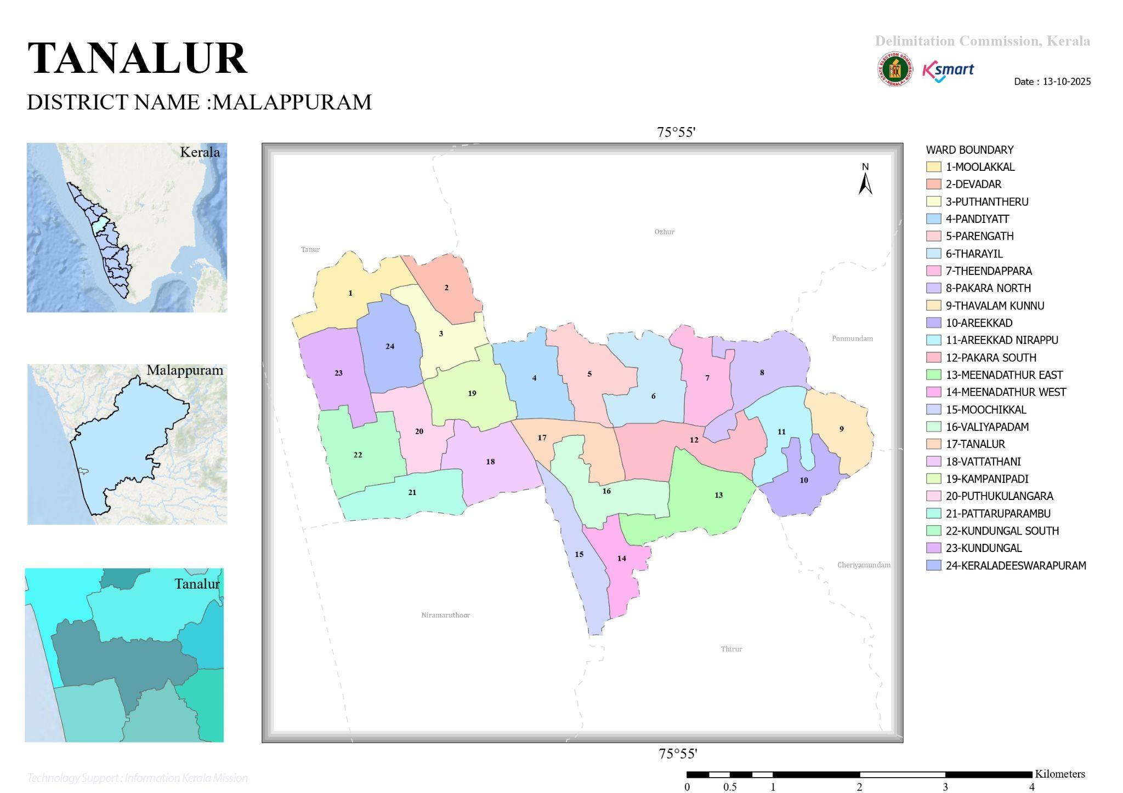

INTEGRATED HEALTH INFRASTRUCTURE MAP OF TANALUR PANCHAYAT

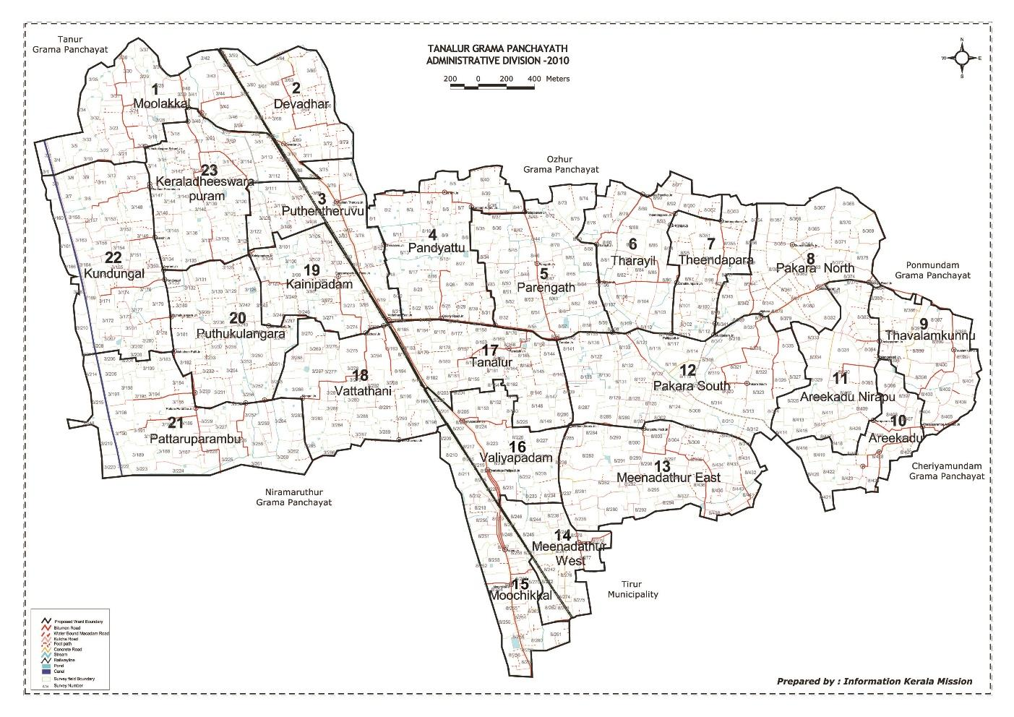

Transportation Map of Tanalur LSGD

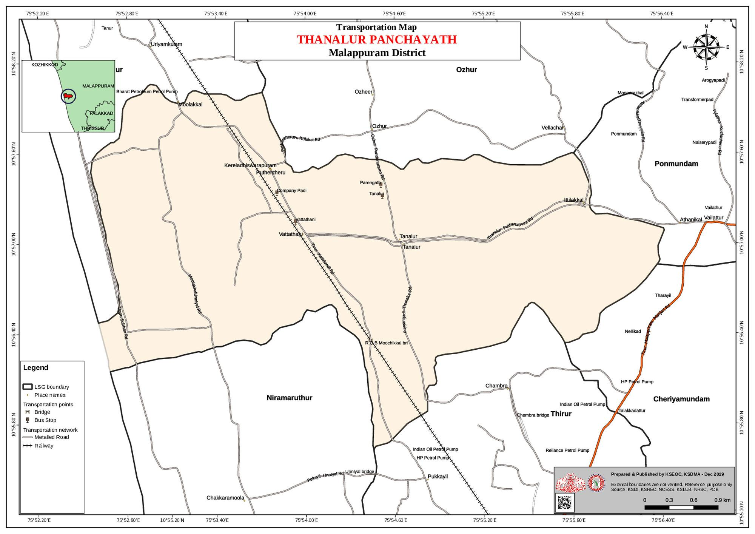

Disaster-Prone areas map of Tanalur LSGD
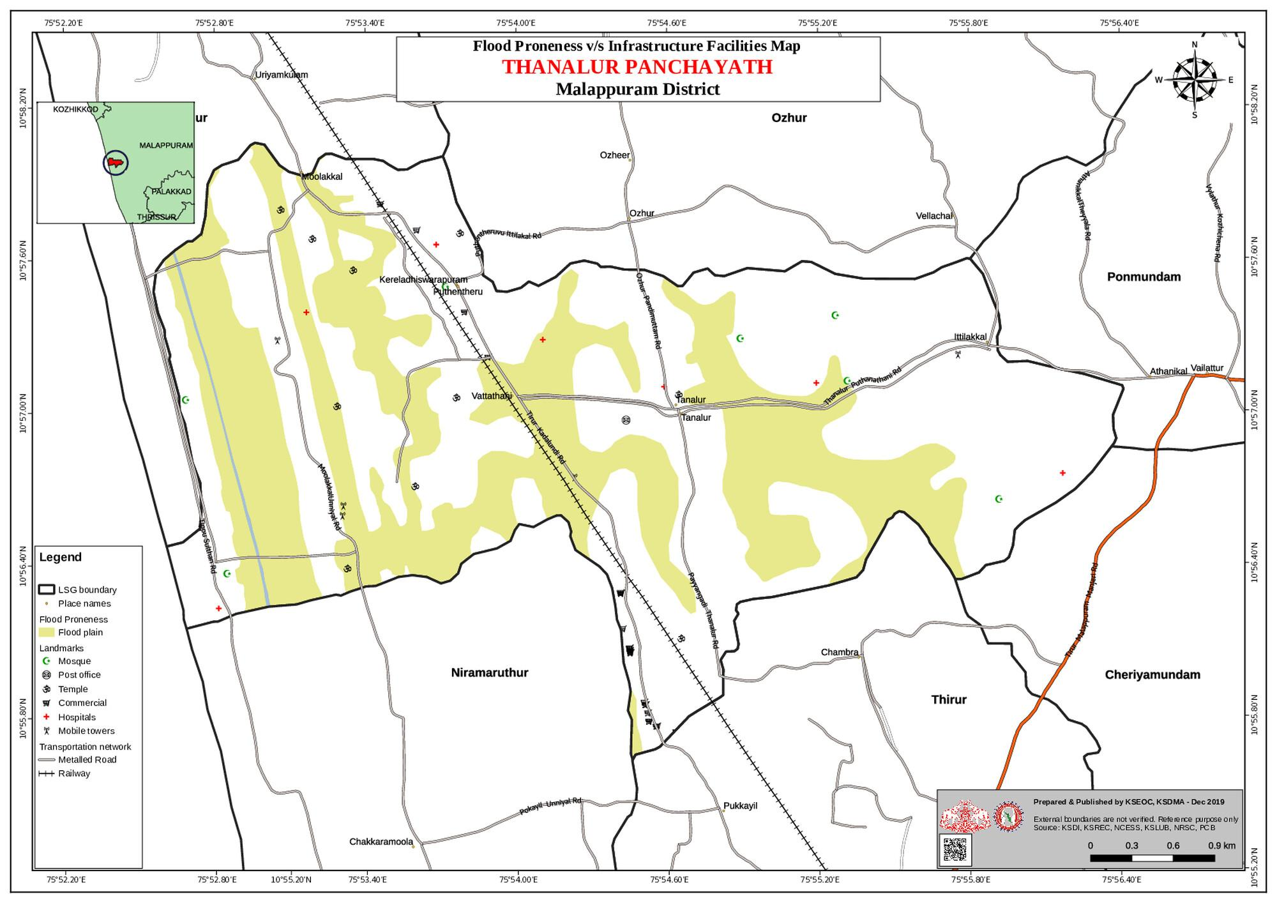

Disease Hotspot map of Tanalur LSGD
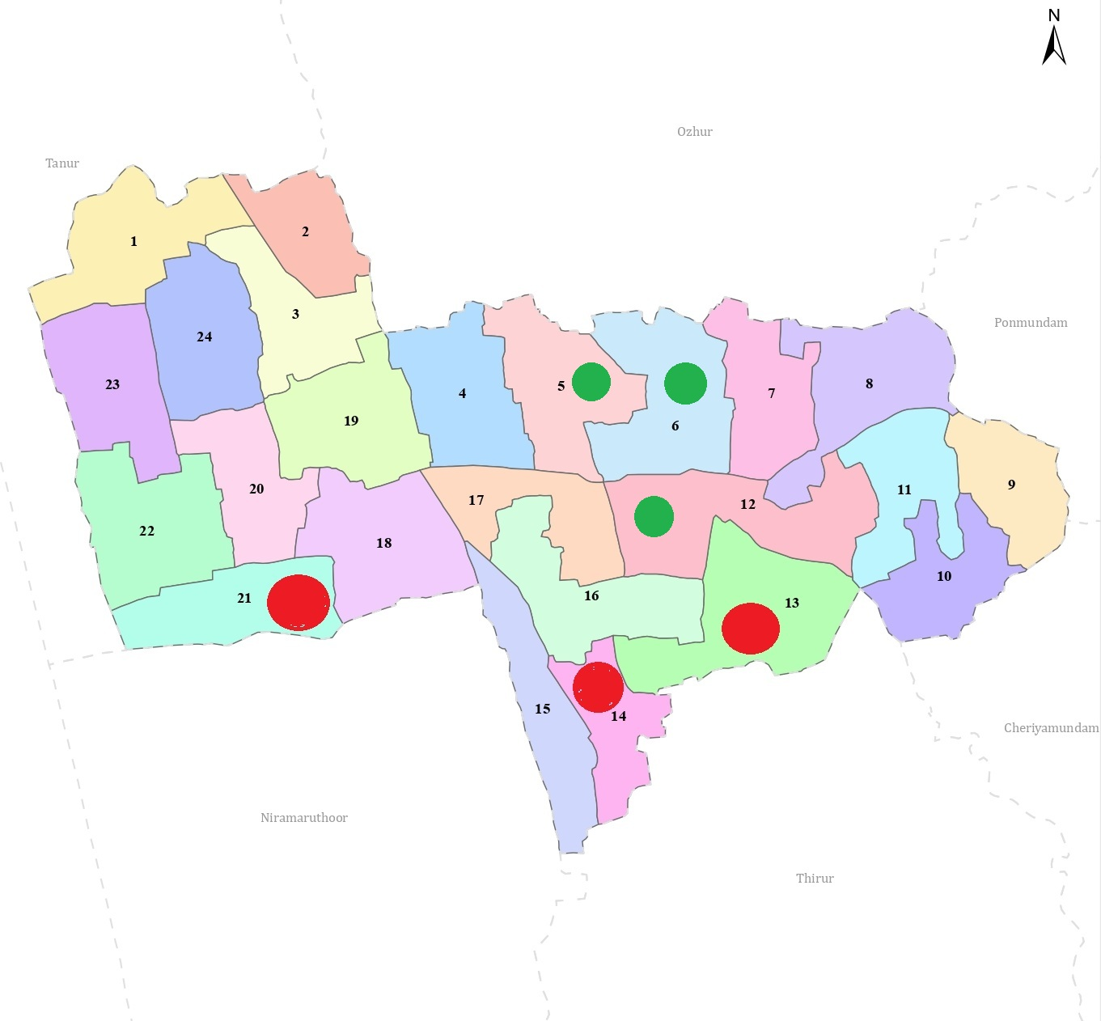

: LEPTOSPIROSIS HOTSPOT

: DENGUE FEVER HOTSPOT

GENERAL PROFILE OF THE LSGI’S

Background of the LSGI
Tanalur Grama Panchayat is situated in the Tirur Taluk of Malappuram district, Kerala. The geographical landscape of the Panchayat is predominantly low-lying, characterized by extensive paddy fields (Kole lands). This unique terrain plays a significant role in shaping the local micro climate and poses distinct challenges to transportation, emergency response, and service delivery, particularly during monsoon seasons and flood events.
The Panchayat is administratively divided into multiple wards, with a population largely dependent on traditional livelihoods. Agriculture—especially paddy cultivation—allied activities form the backbone of the local economy.. The area hosts a diverse workforce, including a notable presence of migrant labourers, particularly in construction, agriculture, and allied sectors.
From a public health and disaster management perspective, Tanalur LSGI has historically been vulnerable to seasonal flooding, waterborne diseases, and vector-borne illnesses such as Dengue and Leptospirosis. The severe floods experienced during recent years, including the 2018 flood disaster, significantly impacted life, livelihoods, and infrastructure within the Panchayat. These recurring emergencies have underscored the importance of strengthening local preparedness, response mechanisms, and inter-departmental coordination.
In this context, the development of a localized, data-driven Auxiliary Infrastructure and Logistical Resource Map is essential to support effective planning, timely emergency response, and sustainable development initiatives. Such mapping enables the Panchayat to identify critical resources, improve accessibility during disasters, and enhance overall resilience of the community.

Table 1: Background of LSGD
Description | Details
Name of LSGI | Tanalur
Type (GP/Municipality / Corporation etc.) | Grama Panchayath
Block | Tanur
District | Malappuram
Number of wards | 23
Total area (sq. km) | 15.2 sq. km
Population(Projected) | 68383
Population density | 3173.02 persons/sq km
Terrain (coastal/low-lying/backwaters/foothills, etc.) | 4558
Number of rivers passing through LSGI | River Nil Canal 1
Number of water bodies in the LSGI | 29
Number of educational institutions | 20
Factories / small-scale industries | 5
Flood-prone wards | Nil
Landslide-prone wards | Nil
Death Management and Disposal Facilities (mortuaries/crematorium, including electric) | Nil
Auditoriums/Marriage halls/convention centres/community halls | 10

Demographic and Vulnerable Population
Understanding the demographic composition and vulnerable population groups is essential for pandemic preparedness. Children, elderly, economically deprived families, migrant workers, and socially vulnerable groups are at increased risk during public health emergencies due to higher exposure, limited access to services, and dependency on public systems..

Description |  | Details (in numbers)
DEMOGRAPHIC PROFILE
Total population |  | 68383
Male |  | 35192
Female |  | 33191
Transgender |  | 0
Children under 5 |  | 5157
Adolescent |  | 10815
Elderly (>60) |  | 3246
SOCIAL/LIVELIHOOD VULNERABILITY
Previous EPEP family |  | 55
BPL family |  | 3115
Tribal communities |  | 0
Migration | Immigrant | 342
Migration | Emigrant | 6812
Socio-economically deprived |  | 0
Fisherfolk |  | Nil
SC Community |  | 918
ST Community |  | Nil

Graphs: Population pyramid (if possible) for seeing if your LSGI has a high "dependency ratio" (lots of children and elderly compared to working adults).

Clinical Vulnerability
Certain population groups needs priority healthcare & are at higher risk of severe illness, complications, and mortality during pandemics. Patients with chronic diseases, those requiring regular medical care, and individuals with mobility or functional limitations face challenges in accessing timely care during emergencies. Mapping these groups helps in prioritizing continuity of treatment, medicine stock planning, oxygen support, referral transport, and targeted home-based care.
Description | Details in numbers
Pregnant women | 743
Lactating mothers | 745
Bedbound patients | 178
Patients under palliative care other than bedbound | 273
Patients on Haemodialysis | 42
Patients on CAPD | 0
Cancer patients (currently on treatment) | 70
Haemophilic patients | 0
Mentally challenged | 92
Differently abled | 470
Diabetic patients | 2014
Hypertensive patients | 2010
TB patients | 13

Major Festivals & Events specific to the LSGI
(with the possibility of a public gathering)

Sl. No. | Name of festival | Month detailing the periodicity
1 | Krishna Temple | December

INFRASTRUCTURE & RESOURCE INVENTORY

Health Facility Directory & Basic Capacity in the LSGD
This section provides an overview of the healthcare infrastructure available within the LSGD area. It outlines the distribution and basic capacity of health facilities that form the backbone of service delivery during routine times and public health emergencies.

Family Health Centres (FHCs) and Community Health Centres (CHCs) generally function as the first point of contact for the community, providing essential outpatient and inpatient services. General Hospitals (GH) and Medical College Hospitals (MCH), where accessible, serve as the main referral centres for advanced diagnostics, specialist care, and critical services during public health emergencies. This inventory helps identify existing strengths, gaps, and potential surge capacity that can be mobilised during a pandemic or disaster.

Table 5. Health Facility Resource Summary
Sl.no. | Health Facility | Type of Facility (MCH/GH/CHC/FHC/SC etc.) | Contact Number | Total beds | ICU Beds | Oxygen-Supported Beds | No. of Ventilator Support Beds | No. of ambulances
Government Healthcare Facilities
1 | FHC Tanalur | FHC | 04942582700 | 3 | 0 | 0 | 0 | 0
Private Healthcare Facilities
1 | Sabine Hospital | PVT Hospital | PRO Shaji 8606434858 | 150 | 0 | 50 | 0 | 0
AYUSH Healthcare Facilities
1 | Gvt Ayurveda Dispensary Thanalur | Gvt | Thahira 9497114963 | 0 | 0 | 0 | 0 | 0
2 | Ayur Kendra Clinic, Moochikkal, Ward 15, Postnatal Care | PVT | 9567395034, 8943335034 | 0 | 0 | 0 | 0 | 0

Private Clinics
Private clinics are an essential part of pandemic preparedness, as they are often the first place people seek care when symptoms begin. In many communities, private clinics manage a significant share of outpatient visits and therefore play a critical role in early case detection, timely referrals, and disease surveillance. Having an up-to-date understanding of where these clinics are located, the services they provide, and how they are linked to the public health system helps ensure that no cases are missed during an outbreak. It also allows health authorities to engage private practitioners more effectively for reporting, risk communication, and coordinated response, strengthening the overall capacity of the health system to manage public health emergencies.

Table 6. Private Clinic Resource Summary
Sl No. | Name of Clinic | Registered (Y/N) | Clinic (General / Speciality) | Speciality (if any) | Address | Contact Number | Diagnostic Facility (Y/N) | Ambulance Linkage (Y/N)
1 | Medicity | Y | General | Nil | Tanalur | 9645059890 | Yes | Y
2 | City Clinic | Y | General | Nil | Tanalur | 7593010738 | Yes | Y
3 | Life Care | Y | General | Nil | Tanalur | 8138044044 | Yes | Y
4 | Aymer clinic | Y | General | Nil | Tanalur | 7034710555 | Yes | Y
5 | Ina Lab | Y | General | Nil | Tanalur | 8714852201 | Yes | Y
6 | Alshifa | Y | General | Nil | Tanalur | 8089115226 | Yes | Y

Healthcare Education & Training Institutions
This section tracks the educational infrastructure available, which is vital for human resource planning in the health sector.

Category of Institution | Govt | Private | AYUSH | Total
Medical Colleges | Nil | Nil | Nil | Nil
Nursing Colleges | Nil | Nil | Nil | Nil
Dental Colleges | Nil | Nil | Nil | Nil
Para-medical / Allied Health | Nil | Nil | Nil | Nil
Pharmacy Colleges | Nil | Nil | Nil | Nil

Specialized Services & Emergency Inventory
This section provides a detailed view of the specialized medical resources available to the community, focusing on emergency response and critical care capabilities. This table tracks the vital assets required for managing severe illnesses and emergencies across Government, Private, and AYUSH sectors.

Item | Govt | Private | AYUSH | Total
Hospital beds | 3 | 150 | 0 | 153
Oxygen-generating systems(Y/N) | 0 | 0 | 0 | 0
Oxygen-supported beds(Numbers) | 0 | 10 | 0 | 10
Ventilator-supported beds | 0 | 1 | 0 | 1
ICU beds | 0 | 0 | 0 | 0
Burns units | 0 | 0 | 0 | 0
Blood centres | 0 | 0 | 0 | 0
BLS ambulances | 0 | 0 | 0 | 0
ALS ambulances | 0 | 0 | 0 | 0
Dialysis facilities | 0 | 1 | 0 | 1
Dispensaries | 1 | 2 | 0 | 3
Medical store | 1 | 1 | 0 | 2
Industrial establishments(Medium-scale industries/small-scale industries establishments to whom we can depend in a worst-case scenario) | small-scale | small-scale | small-scale

Oxygen & Diagnostic Capacity
Monitoring oxygen and diagnostic capacity is a critical component of public health preparedness, ensuring that the LSGD can handle both chronic care and sudden surges in respiratory or infectious diseases.
Name of Health Facility | Oxygen-generating System (Y/N) | Backup Oxygen Source (Y/N) | Diagnostic Facilities Available(Y/N)
Name of Health Facility | Oxygen-generating System (Y/N) | Backup Oxygen Source (Y/N) | Lab | USG | X-ray | CT/MRI | RT-PCR
Government Healthcare Facilities
FHC Thanalur | No | Y | Yes | N0 | N0 | N0 | N0
Private Healthcare Facilities
Sabine Hospital | No | Y | Yes | Yes | Yes | No | No

Diagnostics facility mapping at the LSGI level
The diagnostic capacity of Tanalur G.P represents the "intelligence network" of our healthcare system. The speed and accuracy of disease identification depend entirely on the distribution and technical level of these facilities.

Item | Govt | Private | AYUSH | Total
General labs | 0 | 0 | 0 | 0
Microbiology labs | 1 | 7 | 0 | 8
RT-PCR labs | 0 | 0 | 0 | 0
USG units | 0 | 1 | 0 | 1
CT/MRI units | 0 | 0 | 0 | 0
Research labs | 0 | 0 | 0 | 0
Labs of other departments that can be repurposed | 0 | 0 | 0 | 0

Laboratory Identification & Basic Details
Sl. No. | Name of Laboratory | Ownership (Govt / Private / Academic) | Address | Contact No. | 24×7 Services (Yes/No) | NABL / Govt Approved (Yes/No)
1 | Ina Lab | Pvt | Chungam | 8714852201 | NO | No
2 | Medicity Lab | Pvt | Tanalur | 9645059890 | Yes | No
3 | Life Care Lab | Pvt | Tanalur | 8138044044. | NO | NO
4 | City Clinic Lab | Pvt | Tanalur | 75930 10738 | NO | NO
5 | Aymer Clinic | Pvt | Chembra | 7034710555 | NO | NO
6 | Al shifa | Pvt | Ayyaya | 80891 15226 | NO | NO

Social and Community Infrastructure for surge plan
This table serves as our logistics and shelter inventory. By mapping these locations, quickly we can identify where to house displaced citizens, where to set up temporary medical clinics, and how to manage the deceased with dignity during a crisis.

Category | Total Count | Ward | Est. Capacity (Persons) | Contact details
Educational Institutions
Anganwadis | 40 | 1-24 | 200 | ICDS Officer 7994907025
Schools (Gvt, Aided, PvT) | 20 | 3,4,5,6,8,9,13,15,16, 19,20,21,22 | 1000 | AMLPS Tanalur 9895318019, SMUP Tanur9539919533, Manarul Huda9995130613, Al Manara9567712028, Butterfly6235740850, Bayanul Huda7594945495, Islahi U P School9847530623, AMLPS Pakara9895113142, GH Meenadathur9495293696, Crescent English medium School7736636656, Shihab Thangal947283805, AMUPS Areekkad9747659556, Al Huda Valiyapadam8129642142, DGHSS9947057523, AMLPS Puthentheru9961971355, Ideal Pre School9605349362, Munavural Madrasa School9633869039, GLPS Vattathani9446581140, NMALPS Pattaruparambu9354513109, AMLPS Puthukulangara9497882404.
Colleges  CHMKM Government Arts & Science College Puthentheru | 1 | Ward 18 | 200 | 0494 2582800
Healthcare Educational Institutions
Medical colleges (Govt/Private) | 0 | 0 | 0 | 0
Nursing colleges (Govt/Private) | 0 | 0 | 0 | 0
Dental colleges (Govt/Private) | 0 | 0 | 0 | 0
Paramedical institutes (Govt/Private) | 0 | 0 | 0 | 0
Community Gathering Spaces
Community halls | 1 | Ward 5 | 10 | President 9946447999
Auditoriums | 10 | 11,17,15, 16, 18 | 700 | Crown Convention Center, Tanur Road, Moochikal,9567281280, 75599 86669 100bed, Hooriya Auditorium in Puthantheru 75 bed 75103 33005, firdouz auditorium, 75 bed 9995504777puthantharu 04942982041, firdouz auditorium Thanalur 100 bed 9895626743, Km Auditorium 9544178248, 85906 57673 75 bed, Arabian Plaza Auditorium Moolakkal, 95679 90501, CK Convention Centerconvention center Chemmad Road, vattathani, Nellikkal Auditorium Vailatur - Tanalur Rd, Tanalur Town, 98953 56166, EC Hall, moonnammoola, Thanalur 94965 23510, Master Auditorium Areekkad Road ITTILAKKAL 90480 02213
Religious buildings | 10 | Madrassa | 100 | Ward members
Vulnerable Group Support Facility
Destitute homes | 0 | 0 | 0 | 0
Elderly homes | 0 | 0 | 0 | 0
LSGD owned other buildings | 0 | 0 | 0 | 0
Mass Fatality Management (MFM) Infrastructure
Mortuary | 0 | 0 | 0 | 0
Crematorium | 0 | 0 | 0 | 0
*refer annexure 1 for contact details

Human resources
This section focuses on the human capital available within the LSGI. In any emergency—be it a pandemic, flood, or industrial accident—infrastructure is only as effective as the people operating it.

Medical & Clinical Personnel
This table tracks the "Frontline" providers responsible for diagnosis, treatment, and clinical management. Narrative sentence: eg., "Total health workforce: 450 personnel, with 60% in government facilities serving as primary surge capacity." A detailed directory with the contact numbers of all workers is maintained (Annexure in 1).

Cadre | Govt (No.) | Private (No.) | Total
Doctors—Modern Medicine | 5 | 6 | 11
Doctors – AYUSH | 1 | 1 | 2
Doctors – Veterinary | 1 | 0 | 0
Doctors – Dental | 0 | 12 | 12
Nursing officers | 2 | 25 | 27
Lab technicians | 1 | 12 | 13
Optometrist | 1 | 4 | 5
Pharmacists | 1 | 18 | 19
Psychologists | 0 | 3 | 3
Counsellors | 0 | 4 | 4

Public Health & Field-Level Workforce
These individuals are the backbone of surveillance, maternal-child health, and decentralized care.

Cadre | Health services | Municipal common services | Total
HS (Health Supervisors) | 0 | 0 | 0
HI (Health Inspectors) | 1 | 1 | 2
LHS (Lady Health Supervisor) | 0 | 0 | 0
LHI (Lady Health Inspectors) | 1 | 0 | 1
JPHN (Jr Public Health Nurses) | 6 | 0 | 6
JHI (Jr Health Inspectors) | 3 | 0 | 3
MLSP (Mid-Level Service Providers) | 4 | 0 | 4
Palliative Nurses | 2 | 0 | 2
RBSK Nurses | 0 | 0 | 0
PRO | 0 | 0 | 0
Epidemiologist | 0 | 0 | 0
Data Manager | 0 | 0 | 0

Community & Support Cadre
This group represents the surge capacity of the LSGI—people who can be called upon for logistics, rescue, and specialized support.

Cadre | Number
ASHA Workers | 27
AWW (Anganwadi Workers) | 40
Emergency Medical Volunteers (Trained) | 4
Kudumbashree | 412 Unit, 4856 members
MNREGS | Workers 287 , No of MAT 15
Purusha Swayam Sahaya Sangham | 0
Ex-Servicemen | 2
Retired Police Officers | 4
NCC/NSS Volunteers | 50
Red Cross volunteers | 28
One Health Community Volunteers | 0
One Health Community Mentors | 0

Community Organizations
This section details the presence of community-based organisations (CBOs), non-governmental organisations (NGOs), faith-based organisations (FBOs), Kudumbashree Self-Help Groups (SHGs), and Ayalkootams within the Local Self-Government Institution (LSGI). These groups enhance grassroots mobilization, resource distribution, and support networks crucial for pandemic response and community resilience.

Category | Total Count
NGOs | 0
Religious based organizations | 4
Foreign based organizations | 1
Sports Club/youth clubs | 5
Kudumbashree SHGs | 2
Ayalkootams | 412
Political organizations | 3
Residential organizations | 2

Administrative & Emergency Services
This section outlines the availability of key non-health emergency support services and infrastructure within the LSGI, which are essential for effective pandemic preparedness and response. These facilities support law enforcement, disaster response, water supply, logistics, mobility, and community-level interventions during public health emergencies.

Category | Total Count | Contact details
Police Stations | 0
Fire & Rescue Stations | 0
Water Pumping Points | 0
Public Distribution System (PDS) | 2 | 9349116348 Chandran

Information regarding resources
The availability of essential transport and support resources plays a quiet but critical role in saving lives. Equipment such as ambulances, mobile mortuaries, amphibian ambulances, and motorized boats ensures that patients, samples, and healthcare teams can move swiftly—even in flooded, remote, or difficult terrains. Heavy vehicles like JCBs, cranes, tractors, and torus lorries support logistics, waste management, emergency infrastructure, and rapid conversion of spaces into care or isolation facilities. Taxis, four-wheel-drive vehicles, and trucks help maintain continuity of essential services, reach vulnerable populations, and support home-based care and supply delivery.

Means of transportation | Total Count
JCB | 5
Crane | 0
Heavy Trucks | 10
Tractor | 6
Ambulances | 2
Mobile mortuaries | 0
Boats | 0
Taxi service | 25
Note: For specific details regarding vehicle owners and contact information, please refer to Annexure [X].

ONE HEALTH & ENVIRONMENTAL SURVEILLANCE
The One Health method integrates environmental, animal, and human health to enable proactive pandemic preparedness. Panchayat-level surveillance needs to be improved in order to detect and treat zoonotic and environmentally generated diseases early. Surveillance is strengthened through systematic assessment of animal populations, veterinary infrastructure, poultry and slaughter facilities, inter-sectoral coordination, and specialised tools like avian influenza seasonality mapping using GIS in previous outbreaks to enable predictive alerts and ward-specific sampling to support effective pandemic preparedness in high-risk areas like ______nil______.

Animal & Bird Population
Mapping animal and bird populations at the Panchayat level is essential for identifying and prioritising zoonotic disease hazards like rabies, avian influenza (H5N1), leptospirosis, anthrax, and Nipah-like spillover occurrences. Risk classification, targeted surveillance, vaccination planning, and early epidemic detection made feasible by comprehensive population mapping all enhance One Health-based pandemic preparedness.

Category | Item | Estimated Population | Wards
Animal Population | Livestock (Cattle/Goats/Buffalo) | 1983 | 1-23
Animal Population | Pet Animals (Dogs/Cats) | 574 | 1-23
Animal Population | Stray Dog Population | 231 | 1-23
Animal Population | Pig Farms (Number of heads) | 0 | 0
 | Small Units (Sheep / Goats – clustered) | 2 (Goats) | Ward 21 Shareef Neduvancheeri 33 Nos,  Ward 22 M-Aneefa 50Nos
Bird Population | Poultry Units (Birds) | 2(Broiler chicken) | Ward 21 Shareef Neduvancheeri 1000 Nos,  Ward 22 M-Aneefa 1500Nos
Bird Population | Poultry- (FOWL) | 0 | 0
Bird Population | Wild/Migratory Birds (Observed) | 0 | 0
Bird Population | Crow Mortality Events (Reported) | 0 | 0

Veterinary Infrastructure
Veterinary institutions are a core pillar of One Health surveillance, enabling early zoonotic disease detection through vaccination, investigation of unusual animal illness or deaths, sample collection, and timely outbreak reporting. A well-mapped and responsive veterinary network strengthens coordination with human health and LSGI systems, ensuring rapid response during zoonotic events and pandemics.
Facility Type | Name of Facility | Ownership Govt / Pvt | Location(Ward No) | Contact number
Veterinary Dispensary | Govt Veterinary Dispensary | GOVT | 11 | Dr Sagir 9048297535,  Live stock Inspector Bijula 9020706015
Veterinary Hospital / Polyclinic | NA | 0 | 0 | 0
Private Veterinary Clinics | NA | 0 | 0 | 0
Mobile / Emergency Vet Service (incl. night services) | NA | 0 | 0 | 0
Pet Homes / Animal Shelters | NA | 0 | 0 | 0
Slaughterhouse-linked Veterinary Inspection Unit | NA | 0 | 0 | 0

Veterinary Doctors & Workforce
Early detection, diagnosis, reporting, and reaction to animal illness epidemics depend on the availability and accessibility of qualified veterinary specialists. By identifying unusual animal morbidity or mortality promptly, collecting samples promptly, and coordinating efficiently with human health and LSGI systems—especially during zoonotic outbreaks and pandemic-prone situations—a clearly defined veterinary workforce enhances One Health surveillance.

Category | Number Available | Type (Govt/Pvt) | Contact number
Government Veterinary Doctors | 1 | Govt | Dr Sagir 9048297535
Private Veterinary Doctors | NA | 0 | 0
Livestock Inspectors | 1 | Govt | Bijula 9020706015
Para-veterinary Staff / Attenders | 1 | Govt | 9847477893
Contract / On-call Veterinary Support (if any) | NA | 0 | 0

High-Risk Interface Points (Surveillance Sites)
High-risk interface points for zoonotic disease surveillance in Tanalur Grama Panchayath include wetland–livestock–human contact zones, backyard poultry farms, cattle sheds near water bodies, fish markets, and areas of high human–animal interaction such as community slaughter points and migratory bird congregation sites. These are the primary surveillance sites where zoonotic spillover risks are elevated.

Type of Habitat | Type of High risk interface | Geographical vulnerability
Wetlands & Backwaters | Nil | 0
Backyard Poultry Farms | Nil | 0
Cattle Sheds near Water Bodies | Nil | 0
Fish & Meat Markets | 7(Small Shop) | Vattathani, Thanalur Jn, Moolakkal, Moochikkal
Community Slaughter Sites | Nil | 0
Migratory Bird Congregation Areas | Nil | 0
Rodent-Infested Grain Storage | Nil | 0

Category | Total Count | Key Locations (wards)
Poultry Farms | 2(Broiler Chicken) | Ward 21 Shareef Neduvancheeri 1000 Nos,  Ward 22 M-Aneefa 1500Nos
Backyard / Clustered Poultry Units | 0 | 0
Duck Rearing Units (open water access) | 0 | 0
Slaughterhouses/ Slaughter Points | 0 | 0
Meat/Fish Markets | 7(Small Shop) | Vattathani, Thanalur Jn, Moolakkal, Moochikkal
Live Bird Sale Points | 1 | Moochikkal
Cattle Markets / Weekly Animal Fairs | 0 | 0
Pet Shops / Breeders | 1 ((കോഴി കുഞ്ഞുങ്ങൾ) | Puthentheru
Animal Shelters / Pet Homes | 2(Goat) | Ward 21 Shareef Neduvancheeri 33Nos,  Ward 22 M-Aneefa 50Nos
Waste Disposal Sites near Animal Units | 0 | 0

Environmental Risk Mapping
Environmental risk mapping identifies monsoon/flood hotspots for vector-borne (dengue, chikungunya), water-borne (leptospirosis, diarrhoea), and zoonotic diseases in Kerala's wetlands. Systematic surveillance supports early warnings, targeted interventions, and Panchayat pandemic preparedness.
Waterborne exposure: Flood-prone areas and stagnant water bodies facilitate leptospira survival, raising leptospirosis risk.

Traditional practices: Informal slaughter and fish markets lack standardized hygiene, creating spillover opportunities.

Risk Factor | High-Risk Wards | Key Locations | Risk Level (High/Med/Low)
Flood-prone areas | 20 Locality and 188 Houses | വാർഡ് - 1, ചന്ദ്രശഖരൻ റോഡ് പടിഞ്ഞാറ് ഭാഗം 9 വീട്, പണ്ടാരവളപ്പ് പടിഞ്ഞാറ് ഭാഗം 5 വീട്, പാലക്കുറ്റിഴി തോട് ഭാഗം - 1 വീട്, വാർഡ് -2 - ൽ, പാലകുറ്റ്യാഴി തോട് ഭാഗം 14 വീട്, വാർഡ് - 4 ൽ - പുതിയ കടപ്പുറം സബ് സെൻ്റർ അടുത്ത് 1 വീട്, കേലപുരം - വെട്ടുകുളം ഭാഗത്ത് 2 വീട്, ജാറം പള്ളിയുടെ അടുത്ത് 1 വീട്, വാർഡ് - 5 ചരെങ്ങത്ത് 10 വീട്, പണ്ടിയാട് 6 വീട്, , ഒഴൂർ ൻ്റെ കളത്തിൻ്റെ അടുത്ത് 10 വീട്, വാർഡ്. 10 മങ്കലപ്പള്ളി ഭാഗം 5 വീട്, Ward 12 Pakara 10, പെരുമണൽ to മുട്ടിപ്പാലം 40, Ward13 KORAKAVE padam - Chembra padam 21വീട്, വാർഡ് 15 കൂരി പാടം ഭാഗം-മൂച്ചിക്കൽ പടിഞ്ഞാറുഭാഗം വീടുകൾ 8, വാർഡ് 17 ൽ, വട്ടത്താണി 1 വീട്, വലിയ പാടം Alw അടുത്ത് വീട, ചേനിയേരിപ്പാടം Alw അടുത്ത് 1 വിട്,, വാർഡ് 21, പട്ടരു പറ മ്പ് പടിഞ്ഞാറ് ഭാഗം - 10, Ward:22 താടിപ്പടി പടിഞ്ഞാറ് ഭാഗം കുണ്ടുങ്ങൽ തോട് 5 വീട്, ചന്ദ്രശേഖര റോഡ്കനോലികനാൽ-7 വീട്. | Low Risk
Water bodies/wetlands | Nil | 0 | 0
Solid waste accumulation | Nil | 0 | 0
Animal waste disposal issues | Nil | 0 | 0
Rodent infestation zones | Nil | 0 | 0
Industrial effluent discharge | Nil | 0 | 0
Construction sites / abandoned buildings | Nil | 0 | 0
Poor drainage/blocked canals | Nil | 0 | 0
Drinking water source contamination risk | Nil | 0 | 0

Disease Seasonality Mapping
1, Flooding & waterlogging → amplifies leptospirosis, malaria, diarrheal diseases.
·
2, Migratory bird influx (Nov–Feb) → avian influenza risk.

3, Mosquito breeding cycles → vector-borne disease peaks in monsoon.

4, Agricultural practices → close human–animal contact in paddy fields.

Disease | Peak Risk Season | Key Drivers | High-Risk Locations | Surveillance Focus
Avian Influenza | Nil | 0 | 0 | 0
Leptospirosis | August,-November | Pady | W-5, 20. 22 | Doxy prophylaxis
Dengue/Chikungunya | June -November | Plastic cups | Ward 3,4,5,6,7,16,17 | Vector study and Source Reduction
Acute Diarrheal Diseases | Feb,March | Raw water, food | 0 | Health Education Class
Rabies | Nil | 0 | 0 | 0
Anthrax (rare) | Nil | 0 | 0 | 0

Vulnerability Mapping
Vulnerability mapping pinpoints high-risk populations, occupations, and areas exposed via environment, livelihoods, socio-economics, and poor service access. Paired with environmental/seasonality mapping, it enables risk-based surveillance, targeted actions, and optimal resource use in One Health and pandemic planning.
Vulnerability Factor | High-Risk Wards | Key Groups / Locations | Risk Level
Flood-prone households | Ward 1,2,4,5,10,11,12,13,15,17,21,22 | വാർഡ് - 1, ചന്ദ്രശഖരൻ റോഡ് പടിഞ്ഞാറ് ഭാഗം 9 വീട്, പണ്ടാരവളപ്പ് പടിഞ്ഞാറ് ഭാഗം 5 വീട്, പാലക്കുറ്റിഴി തോട് ഭാഗം - 1 വീട്, വാർഡ് -2 - ൽ, പാലകുറ്റ്യാഴി തോട് ഭാഗം 14 വീട്, വാർഡ് - 4 ൽ - പുതിയ കടപ്പുറം സബ് സെൻ്റർ അടുത്ത് 1 വീട്, കേലപുരം - വെട്ടുകുളം ഭാഗത്ത് 2 വീട്, ജാറം പള്ളിയുടെ അടുത്ത് 1 വീട്, വാർഡ് - 5 ചരെങ്ങത്ത് 10 വീട്, പണ്ടിയാട് 6 വീട്, , ഒഴൂർ ൻ്റെ കളത്തിൻ്റെ അടുത്ത് 10 വീട്, വാർഡ്. 10 മങ്കലപ്പള്ളി ഭാഗം 5 വീട്, Ward 11  K V പാറപ്പുറം താഴെ ഭാഗം 20 veed  Ward 12 Pakara 10, പെരുമണൽ to മുട്ടിപ്പാലം 40, Ward13 KORAKAVE padam - Chembra padam 21വീട്, വാർഡ് 15 കൂരി പാടം ഭാഗം-മൂച്ചിക്കൽ പടിഞ്ഞാറുഭാഗം വീടുകൾ 8, വാർഡ് 17 ൽ, വട്ടത്താണി 1 വീട്, വലിയ പാടം Alw അടുത്ത് വീട, ചേനിയേരിപ്പാടം Alw അടുത്ത് 1 വിട്,, വാർഡ് 21, പട്ടരു പറ മ്പ് പടിഞ്ഞാറ് ഭാഗം - 10, Ward:22 താടിപ്പടി പടിഞ്ഞാറ് ഭാഗം കുണ്ടുങ്ങൽ തോട് 5 വീട്, ചന്ദ്രശേഖര റോഡ്കനോലികനാൽ-7 വീട്. | Low
Wetland-adjacent communities | 0 | 0 | 0
Backyard poultry / duck rearing households | Paultry 3631 House  Duck 210 House | All Wards | Low
Livestock-rearing households | Cow 98 House, Buffalo & Bull 96 House, Goat-88 Houses. | All Wards | Low
Slaughterhouse & meat market workers | 0 | 0 | NA
Fisherfolk & fish market workers | 0 | 0 | NA
Sanitation workers | 287 | Panchayat area | Low
Daily wage / migrant workers | 342 | Panchayat area | Low
Elderly & chronically ill populations | 3246 | Panchayat area | Low
Pregnant Women | 743 | Panchayat area | Low
Children (schools, Anganwadi’s) | 14560 | 20 School, 40 Anganwadi | Low
Limited access to safe water & sanitation | 0 | NA | NA

EPIDEMIOLOGICAL TRENDS (2021–2025)

Disease surveillance is the systematic collection, analysis, and interpretation of health data for planning, implementation, and evaluation of public health practice. This section presents the disease surveillance profile of the LSGI based on routine reporting systems and outbreak investigations to identify priority diseases, seasonal patterns, and emerging public health threats.

Disease Burden among human beings(Last 5 Years)
Analysis of disease-wise data for the last five years helps identify persistent public health problems, emerging diseases, and changes in disease burden. This information supports prioritisation of prevention, preparedness, and response activities at the Panchayat level.

Disease | 2021 | 2022 | 2023 | 2024 | 2025 | Trend(Increasing/Stable/Decreasing)
Dengue | 0 | 3 | 41 | 32 | 154 | Increasing
Leptospirosis | 0 | 3 | 5 | 3 | 5 | Stable
Hepatitis A | 0 | 1 | 8 | 193 | 128 | Increasing
Malaria | 0 | 1 | 0 | 1 | 0 | Decreasing
Scrub Typhus | 0 | 0 | 0 | 0 | 0 | Not reported
Typhoid | 0 | 0 | 0 | 1 | 4 | Increasing
H1N1 | 0 | 0 | 1 | 0 | 0 | Not reported
H3N2 | 0 | 0 | 0 | 0 | 0 | Not reported
ADD | 25 | 43 | 79 | 106 | 84 | Stable
Mumps | 0 | 0 | 13 | 0 | 0 | Decreasing
Measles | 0 | 0 | 37 | 6 | 0 | Decreasing
Hepatitis B | 0 | 0 | 0 | 0 | 0 | Not reported
Hepatitis C | 0 | 0 | 0 | 0 | 0 | Not reported
Tuberculosis | 0 | 25 | 28 | 12 | 11 | Stable
Leprosy | 0 | 1 | 0 | 1 | 1 | Stable
COVID-19 | 0 | 0 | 0 | 0 | 0 | Decreasing

*(use the above table data to create the graph/diagram)

Seasonal Trend Analysis
Seasonal analysis helps anticipate surges (e.g. dengue in monsoon, leptospirosis after floods, influenza in cooler months) and plan pre‑emptive vector control, stockpiling of IV fluids, and awareness campaigns at Panchayat level.

DENGUE
Dengue is a major seasonal vector-borne disease strongly associated with rainfall, water stagnation, and increased mosquito breeding during the monsoon period.

Peak: July–November

Dengue – Ward-wise Yearly Distribution (2021–2025)

Ward | Dengue – Ward-wise Yearly Distribution
Ward | 2021 | 2022 | 2023 | 2024 | 2025 | Total
1 | 0 | 0 | 0 | 0 | 0 | 0
2 | 0 | 0 | 0 | 0 | 2 | 2
3 | 0 | 0 | 2 | 1 | 8 | 11
4 | 0 | 0 | 2 | 3 | 14 | 19
5 | 0 | 0 | 2 | 5 | 15 | 22
6 | 0 | 1 | 4 | 2 | 11 | 18
7 | 0 | 0 | 4 | 0 | 7 | 11
8 | 0 | 0 | 2 | 1 | 3 | 6
9 | 0 | 0 | 2 | 2 | 4 | 8
10 | 0 | 1 | 4 | 1 | 3 | 9
11 | 0 | 0 | 1 | 2 | 2 | 5
12 | 0 | 1 | 1 | 6 | 6 | 14
13 | 0 | 0 | 2 | 2 | 8 | 12
14 | 0 | 0 | 4 | 0 | 2 | 6
15 | 0 | 0 | 2 | 1 | 3 | 6
16 | 0 | 0 | 2 | 0 | 18 | 20
17 | 0 | 0 | 3 | 0 | 19 | 22
18 | 0 | 0 | 2 | 2 | 4 | 8
19 | 0 | 0 | 2 | 2 | 6 | 10
20 | 0 | 0 | 0 | 2 | 4 | 6
21 | 0 | 0 | 0 | 0 | 4 | 4
22 | 0 | 0 | 0 | 0 | 5 | 5
23 | 0 | 0 | 0 | 0 | 2 | 2

LEPTOSPIROSIS
Leptospirosis cases are closely linked to monsoon rains, flooding, and occupational exposure, particularly in low-lying and waterlogged areas.

Peak: June - August

Leptospirosis – Ward-wise Yearly Distribution (2021–2025)

Ward | Leptospirosis – Ward-wise Yearly Distribution
Ward | 2021 | 2022 | 2023 | 2024 | 2025 | Total
1 | 0 | 0 | 0 | 0 | 0 | 0
2 | 0 | 0 | 0 | 0 | 0 | 0
3 | 0 | 1 | 0 | 0 | 0 | 1
4 | 0 | 0 | 0 | 0 | 0 | 0
5 | 0 | 0 | 0 | 0 | 2 | 2
6 | 0 | 1 | 0 | 0 | 0 | 1
7 | 0 | 0 | 0 | 0 | 0 | 0
8 | 0 | 0 | 0 | 0 | 2 | 2
9 | 0 | 0 | 0 | 0 | 1 | 1
10 | 0 | 0 | 0 | 0 | 0 | 0
11 | 0 | 0 | 0 | 0 | 0 | 0
12 | 0 | 0 | 0 | 0 | 0 | 0
13 | 0 | 0 | 0 | 1 | 0 | 1
14 | 0 | 0 | 0 | 1 | 0 | 1
15 | 0 | 0 | 0 | 0 | 0 | 0
16 | 0 | 0 | 0 | 0 | 0 | 0
17 | 0 | 1 | 0 | 0 | 0 | 1
18 | 0 | 0 | 0 | 0 | 0 | 0
19 | 0 | 0 | 2 | 0 | 0 | 2
20 | 0 | 0 | 1 | 0 | 1 | 2
21 | 0 | 0 | 2 | 1 | 0 | 3
22 | 0 | 0 | 0 | 0 | 1 | 1
23 | 0 | 0 | 0 | 0 | 0 | 0

VIRAL HEPATITIS - A
Hepatitis A cases are commonly associated with unsafe drinking water, food contamination, and breakdowns in sanitation, often presenting as clusters or outbreaks.

Peak: October - December

Hepatitis A – Ward-wise Yearly Distribution (2021–2025)

Ward | Hep A – Ward-wise Yearly Distribution
Ward | 2021 | 2022 | 2023 | 2024 | 2025 | Total
1 | 0 | 0 | 0 | 0 | 0 | 0
2 | 0 | 0 | 0 | 0 | 0 | 0
3 | 0 | 0 | 0 | 2 | 0 | 2
4 | 0 | 0 | 0 | 7 | 7 | 14
5 | 0 | 1 | 0 | 14 | 6 | 21
6 | 0 | 0 | 1 | 43 | 12 | 56
7 | 0 | 0 | 0 | 31 | 30 | 61
8 | 0 | 0 | 0 | 18 | 16 | 34
9 | 0 | 0 | 0 | 4 | 4 | 8
10 | 0 | 0 | 0 | 4 | 7 | 11
11 | 0 | 0 | 0 | 5 | 6 | 11
12 | 0 | 0 | 1 | 15 | 12 | 28
13 | 0 | 0 | 2 | 8 | 5 | 15
14 | 0 | 0 | 0 | 0 | 0 | 0
15 | 0 | 0 | 0 | 7 | 1 | 8
16 | 0 | 0 | 0 | 0 | 9 | 9
17 | 0 | 0 | 0 | 8 | 8 | 16
18 | 0 | 0 | 2 | 5 | 0 | 7
19 | 0 | 0 | 0 | 1 | 0 | 1
20 | 0 | 0 | 2 | 6 | 3 | 11
21 | 0 | 0 | 0 | 7 | 2 | 9
22 | 0 | 0 | 0 | 8 | 0 | 8
23 | 0 | 0 | 0 | 0 | 0 | 0

Outcome-Based Trend Analysis- 2025

Transmission Trend- 2025
For effective management of public health issues, it is important to track the trend of disease transmission mode. It helps identify the population or place at high risk that can be used to predict outbreaks and implement targeted interventions as quickly as possible. Understanding these kinds of trends enables authorities to allocate resources efficiently and change the strategies adequately based on the trend that follows.

Mode of Transmission | No. of cases | No. of Deaths
Vector Borne Diseases | 154 | 1
Water Borne Diseases | 132 | 0
Air Borne Diseases | 41 | 1 (TB)
Blood Borne Diseases | 0 | 0
Food Borne Diseases | 0 | 0

Vector-Borne Disease

Disease | No. of Cases | No. of Deaths
Dengue | 154 | 1
Malaria | 0 | 0
Chikungunya | 0 | 0

Water Borne Disease

Disease | No. of Cases | No. of Deaths
Cholera | 0 | 0
Typhoid | 4 | 0
Hep- A | 128 | 0
Dysentery | 0 | 0
Amoebiasis | 0 | 0
E- Coli infections | 0 | 0
Air Borne Disease

Disease | No. of Cases | No. of Deaths
Influenza | 0 | 0
H1N1 | 0 | 0
TB | 11 | 1
Chickenpox | 30 | 0
Measles | 0 | 0
Covid-19 | 0 | 0
Pertussis | 0 | 0
Mumps | 0 | 0

Blood-Borne Disease

Disease | No. of Cases | No. of Deaths
AIDS | 0 | 0
Hep- B | 0 | 0
Hep- C | 0 | 0

Zoonotic Disease

Disease | No. of Cases | No. of Deaths
Rabies | 0 | 0
Leptospirosis | 7 | 1
Avian influenza | 0 | 0
West nile | 0 | 0
Anthrax | 0 | 0
Nipah | 0 | 0
Scrub Typhus | 0 | 0

Integrated Disease Hotspot Map (2021–2025)

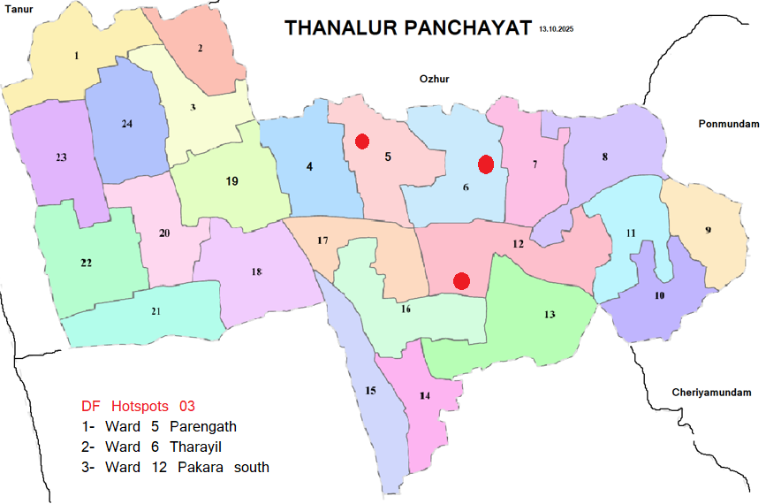
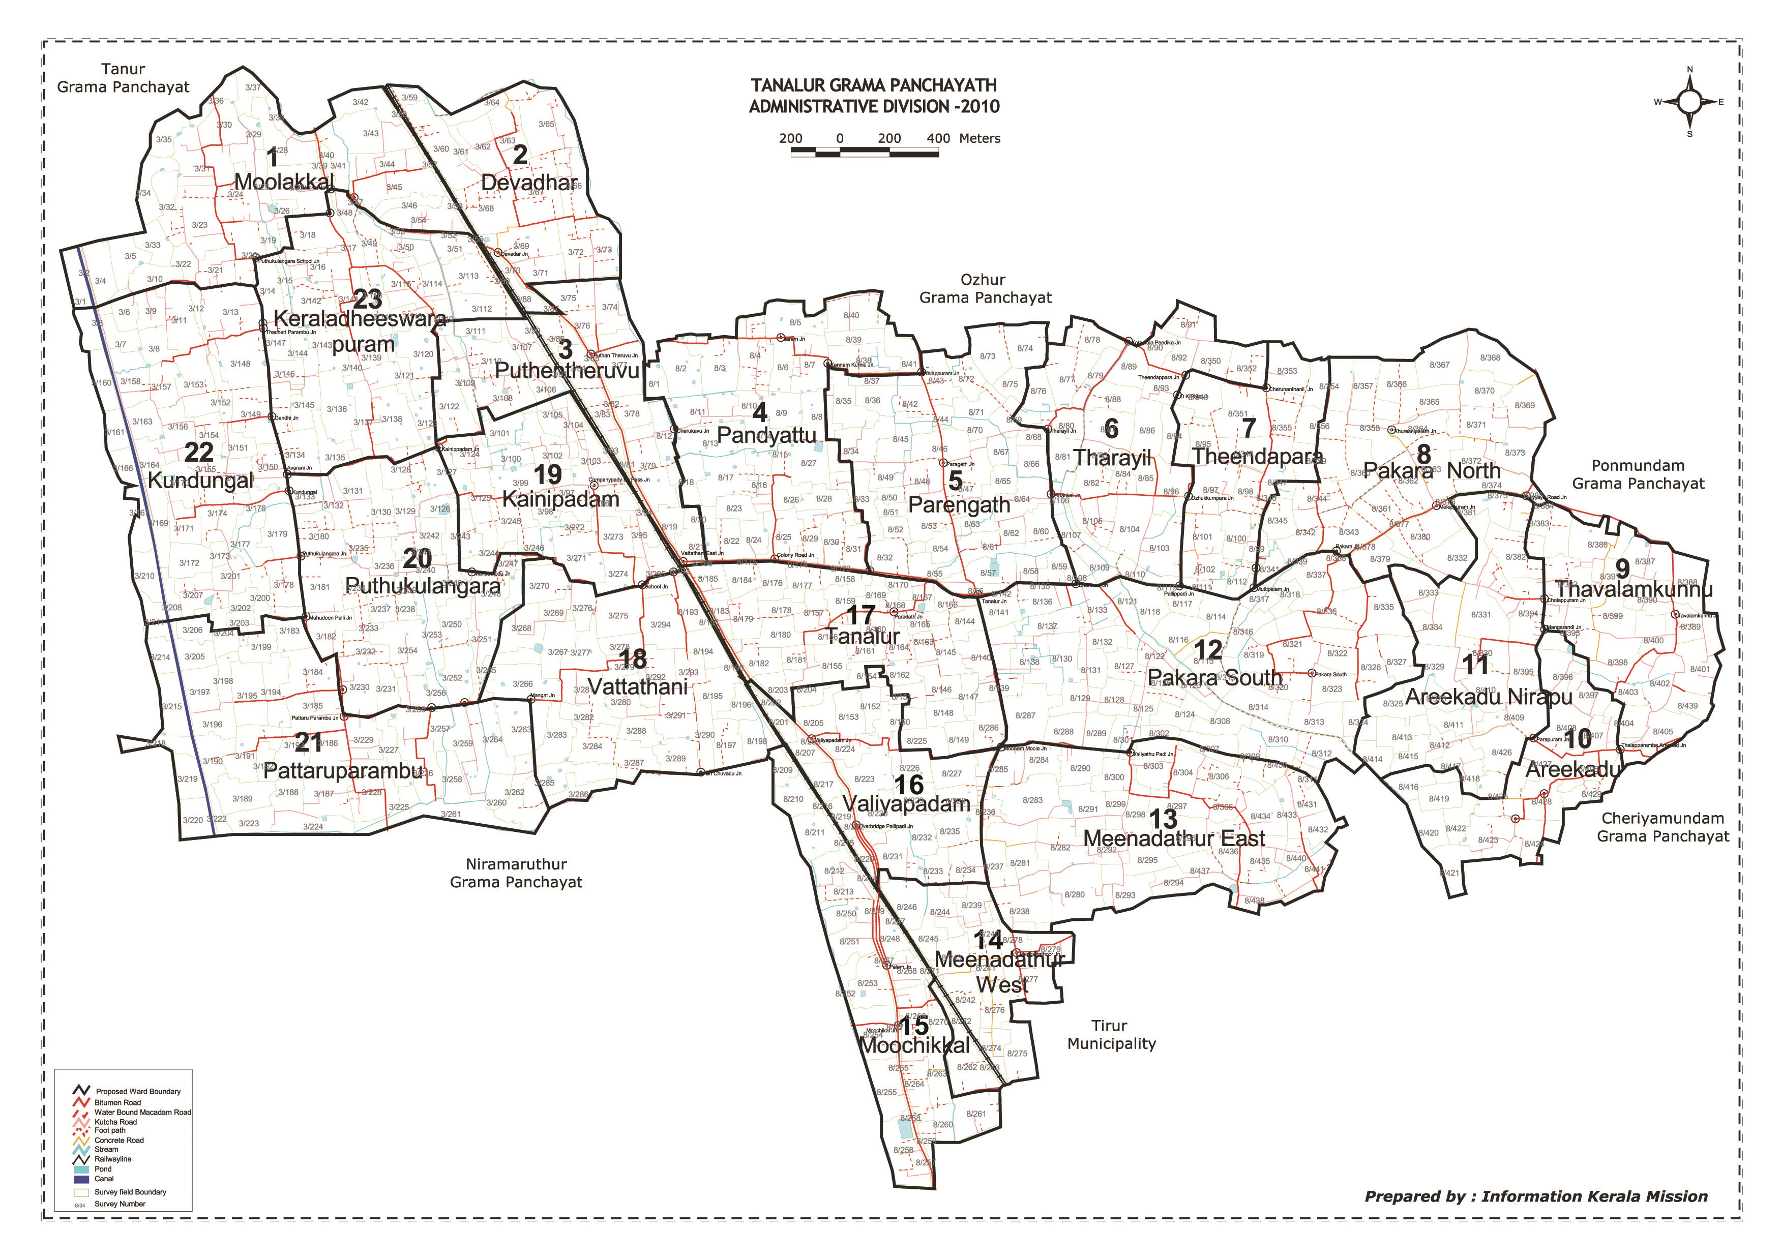

Ward No | Dengue Total (2021-25) | Leptospirosis Total (2021-25) | Hepatitis A Total (2021-25) | Mumps (2021-25) | ADD (2021-25) | Total Cases
1 | 0 | 0 | 0 | 0 | 8 | 8
2 | 2 | 0 | 0 | 0 | 7 | 9
3 | 11 | 1 | 2 | 0 | 11 | 25
4 | 19 | 0 | 14 | 2 | 12 | 47
5 | 22 | 2 | 21 | 0 | 20 | 65
6 | 18 | 1 | 56 | 2 | 19 | 96
7 | 11 | 0 | 61 | 0 | 25 | 97
8 | 6 | 2 | 34 | 0 | 26 | 68
9 | 8 | 1 | 8 | 0 | 22 | 39
10 | 9 | 0 | 11 | 0 | 10 | 30
11 | 5 | 0 | 11 | 0 | 20 | 36
12 | 14 | 0 | 28 | 0 | 18 | 60
13 | 12 | 1 | 15 | 3 | 11 | 42
14 | 6 | 1 | 0 | 0 | 14 | 21
15 | 6 | 0 | 8 | 3 | 16 | 33
16 | 20 | 0 | 9 | 0 | 21 | 50
17 | 22 | 1 | 16 | 0 | 19 | 58
18 | 8 | 0 | 7 | 0 | 12 | 27
19 | 10 | 2 | 1 | 0 | 18 | 31
20 | 6 | 2 | 11 | 1 | 18 | 38
21 | 4 | 3 | 9 | 2 | 12 | 30
22 | 5 | 1 | 8 | 0 | 8 | 22
23 | 2 | 0 | 0 | 0 | 9 | 11

By overlaying five years of data, we have identified ……03……..'Red Zone' Wards. These are wards where at least two different categories of diseases (e.g., Dengue and Lepto) recurred in consecutive years. Ward 4 is categorized as the Highest Priority Hotspot due to its combination of flood vulnerability and high vector density. Future health infrastructure, such as the proposed R.O plants at ………should be prioritized.

Preparedness and Response Protocol at LSG Level
This section describes the operational framework for the LSGI once a pandemic is declared. It explains how the LSGI and health system will move from routine data collection to active response, using a One Health approach.

Constitution of One Health Committee
The LSGD shall constitute a One Health Committee comprising the LSGI President, Medical Officers (Modern Medicine, AYUSH, and Veterinary), the Health Inspector, and the Veterinary Surgeon.

Objective: The One Health Committee coordinates human, animal, and environmental health to prevent and control pandemics.

Sl No | Name | Designation | Department/Institution | Role in Committee | Contact Number
1 | Askar Mash | Panchayat President | LSGD | Chairperson | 9946447999
2 | Dr Nigar Kasim | Medical Officer (PHC/CHC) | Health Dept | Member Secretary | 9526623343
3 | Dr Sagir | Veterinary Officer | Animal Husbandry | Member | 9048297535
4 | Fathima Nasreen | Epidemiologist | Health Dept | Member | 9567253148
5 | Abdussalam Elankeyil | Health Inspector | Health Dept | Surveillance | 9539114990
6 | Pushpalatha | ASHA Supervisor | Health Dept | Community link | 9895689548
7 | Sareena | ICDS Supervisor | Social Welfare | Vulnerable groups | 7994907025
8 | Tanur | Police Station Officer | Police Dept | Law & order | 0494-2440221  SI-Shijith 8075637979
9 | TK Naseer | Ward Councillor Representative | LSGD | Community coordination | 9895161700
10 | Jini V (CDS) | Kudumbashree CDO | Kudumbashree | Community mobilisation | 9526678310
11 |  | NGO/Volunteer rep | Civil Society | Support services
12 |  | Line Department representations

Key Responsibilities:
- Review disease surveillance data (human + animal)
- Conduct ward-wise risk assessment and vulnerability mapping
- Approve quarantine/isolation centre locations
- Coordinate with district for resources (PPE, oxygen, ambulances)
- Periodically review health system surge capacity, including beds, oxygen, human resources, and ambulances.
- Approve and monitor risk communication and community engagement strategies, including rumour management.
- Ensure protection and service continuity for vulnerable groups (elderly, persons with disabilities, dialysis patients, coastal populations).
- Conduct quarterly mock drills
- Monitor equity measures for vulnerable groups

Meeting Schedule:
Quarterly (normal times) | Weekly (outbreak alert) | Daily (pandemic phase)

Pandemic Response Workforce
To ensure a coordinated and timely response during a pandemic, a dedicated Pandemic Response Workforce shall be constituted at the LSG level. The workforce will function under the overall supervision of the One Health Committee and in close coordination with the health authorities. Team-based deployment will enable efficient surveillance, case management, quarantine and isolation management, logistics support, and risk communication. Each team shall have a clearly designated team leader, defined roles, and an identified pool of personnel to allow rapid activation, rotation of duties, and continuity of services during prolonged emergencies.

Total Response Workforce Available: 300 persons

Team Name | Composition | Key Responsibilities | Team Leader
Surveillance and Contact Tracing Team | HI, JHI, JPHN, ASHAs and Volunteers | Case detection, contact listing, home visits, reporting | HI
Case Management Team | Doctors, Nurses, MLSP, Palliative Nurses | Patient care & referral | DOCTOR
Quarantine & Isolation Team | LSGD staff, Volunteers | Facility management | JHI
Psychosocial support
Logistics & supply chain Team | LSGD staff, Storekeepers, Drivers 3 | Supplies & transport [PPE, medicines, oxygen, transport, waste management] | Ward Member
Communication Team | Ward members, Kudumbashree, Youth clubs,  AWW workers and other self help groups | IEC, community meetings, countering misinformation | M.O in charge
Transportation | KSRTC, educational institutional buses
Media Surveillance
Intersectoral coordination and convergence
Collaborative surveillance

All teams shall be activated immediately upon outbreak alert or pandemic declaration and shall report daily to the LSG Incident Commander/Medical Officer, with consolidated reporting to the Block PHC. Duty rosters and alternate personnel shall be maintained to ensure uninterrupted services during staff shortages or prolonged response periods. Team composition and numbers may be revised based on the magnitude of the outbreak and availability of human resources.

Activities and Measures before and during Pandemic

PHASE 1 - Alert / Preparation
Surveillance and Reporting-Enhanced syndromic surveillance:
- Data sources for surveillance:
- Event-based triggers (to be monitored and reported):
- Zoonotic and animal health surveillance
- Logistics and Stock Preparedness
  - Identify and empanel local vendors and define emergency procurement mechanisms in accordance with existing LSGD and Health Department norms.
  - Prepare and maintain an essential logistics checklist covering medical supplies, consumables, and support equipment.
  - Pre-identify secure storage locations for emergency stocks and ensure maintenance of stock registers with regular updating.
  - Finalise emergency transport arrangements, including availability of vehicles and identified drivers for rapid deployment during alerts.
  - Designate a Nodal Officer for Logistics to enable prompt decision-making, coordination, and communication during emergencies.
  - Conduct rapid stock verification and ensure availability of minimum buffer stock, including:
- PPE kits – numbers
- Pulse oximeters – ___ numbers
- Hand sanitizers – ___ litres
- Masks, gloves, disinfectants – adequate quantity
Identify critical gaps in logistics and immediately communicate requirements to the Block and District authorities for timely replenishment and support. Monitor expiry dates and stock rotation.

Identification of Quarantine and Isolation Facilities
  - Identify and list suitable buildings for quarantine and isolation (schools, hostels, community halls, etc.).
  - Categorise cases as per the severity and allocate to appropriate facilities (for instance, severe cases to classrooms, mild cases to an assembly hall in case of a school).
  - Facility readiness checklist needed (beds, toilets, ventilation) etc.
  - Find an alternate site if the primary sites are not available or not in use.
  - Identify facility managers and support staff
  - Prepare basic SOPs for:
    - Admission and discharge
    - Food, water, sanitation
    - Infection prevention and waste disposal
  - Ensure availability of basic amenities: water, sanitation, electricity, ventilation, and waste disposal. Prepare a rapid activation plan for these facilities if case numbers increase.

Risk Communication and Community Preparedness
  - Disseminate early warning messages on symptoms, preventive measures, and reporting mechanisms. Display IEC materials both in English and the local language in public places and ensure ward-level awareness.
  - Sensitize elected representatives and community leaders on preparedness measures.
  - Establish a rumour tracking and misinformation response mechanism to identify, verify, and promptly counter false or misleading information.
  - Engage trusted local persons (ward members, ASHA workers, religious leaders, teachers, community volunteers) to communicate official public health messages and reinforce correct practices.
  - Develop and deploy targeted IEC materials for:
    - Schools and educational institutions
    - Markets and commercial areas
    - Work sites and labour settings
  - Conduct community sensitization meetings at the ward level to promote preventive behaviors, address concerns, and strengthen community participation in preparedness and response.

Protection of Vulnerable Groups
Vulnerable populations require priority protection through targeted line-listing, service continuity, and delivery mechanisms.
- Prepare and regularly update line-lists of vulnerable populations, including:
  - Elderly persons living alone
  - Persons with disabilities
  - Pregnant women
  - Migrant workers
  - Dialysis patients
The detailed line-lists shall be maintained as Annexure ___ and updated periodically.

Clinical Dependency Mapping
Develop ward-wise dependency and vulnerability maps to identify households requiring regular support during emergencies. Ensure continuity of essential health services for vulnerable groups, including
- Dialysis services (facility mapping, transport arrangements, and scheduling)
- Continuity of treatment for TB, HIV, and other chronic conditions requiring uninterrupted medication
- Mental health and psychosocial support services
Establish delivery mechanisms for food, essential commodities, and medicines to vulnerable households through coordinated action involving ASHAs, JPHNs, Kudumbashree, volunteers, and local administration.

PHASE 2 - Active Response

Case Identification and Contact Tracing
Case detection and contact tracing activities will be carried out in coordination with the Health authorities, following disease-specific SOPs and IDSP guidelines.
Field Staff Involved
- Health Inspector (HI)
- Junior Health Inspector (JHI)
- Junior Public Health Nurse (JPHN)
- ASHAs and ASHA Supervisors
- Ward-level volunteers and Kudumbashree members (as required)

Screening Checkpoints
Screening checkpoints at high-traffic locations (transport hubs, markets, religious gatherings) for early detection of symptomatic travellers and crowd screening during outbreaks. Potential locations include bus stands, market entry points, and boat jetties, based on local context and risk assessment.
Screening activities will be carried out by trained personnel such as ASHAs, ward members, and volunteers, with support from Health Department staff. Necessary equipment, including non-contact thermometers and appropriate PPE, shall be ensured prior to activation.

Location | Type (Bus stand/Jetty/Market/Railway) | Staff Deployed (ASHAs/Volunteers) | Screening Method | Reporting authority
Bus stand | Transport hub | One JHI  One ASHA  One health Mentors | 1.Swab Collection.  2. Blood smears collection (RDT)  3.Thermal Scanners | Surveillance Nodal Officer in control room
Market entry | Market | One JHI  One ASHA  Male health volunteers | 1.Swab Collection.  2. Blood smears collection (RDT)  3.Thermal Scanners | Surveillance Nodal Officer in control room
Boat jetty | Water transport | One JHI  One ASHA  Male health volunteers | 1.Swab Collection.  2. Blood smears collection (RDT)  3.Thermal Scanners | Surveillance Nodal Officer in control room

Standard Screening Protocol

The screening protocol shall include temperature screening, observation for visible symptoms, and inquiry regarding recent travel or exposure history. Individuals identified as suspects during screening shall be immediately referred to the nearest PHC/FHC for further evaluation, testing, and appropriate action as per prevailing guidelines.

Pandemic Control Room
The Pandemic Control Room (PCR) serves as the central nerve center for real-time coordination, data aggregation, decision support, and communication during outbreaks. It consolidates information from all LSGD teams, health facilities and community sources to enable rapid response decisions.

Control Room Infrastructure and Location
Primary Location: Tanalur Panchayath Office.
Backup Location: Community Hall in Tanalur G.P.

Health System Control Room Framework
The PCR is organized into seven functional pillars to ensure no aspect of the response is overlooked:

Rapid Response Team (RRT)
  - Provides immediate intervention during emergencies, clusters, and field alerts.​
  - Coordinates urgent actions such as case investigation, contact tracing, isolation, and inter‑facility referrals.

Data Management & Analytics Team
  - Collects, validates, and manages key health system indicators (cases, tests, beds, HR, supplies).​
  - Analyzes data trends, generates projections, and supports evidence‑based decision‑making for local authorities.

Human Resource Deployment Team
  - Allocates healthcare staff efficiently based on workload and need
  - Ensures adequate and equitable workforce distribution across facilities

Laboratory Surveillance Team
  - Oversees diagnostic testing coordination, sample transport, and timely reporting of results.​
  - Monitors lab indicators (testing volume, positivity rate, turnaround time) for early detection of outbreaks

Vaccination Cell (If Required)
  - Plans and executes vaccination campaigns, including micro‑planning and session scheduling.​
  - Tracks coverage, identifies gaps, and coordinates corrective actions with field teams and outreach services.

Infrastructure & Patient Occupancy Team
  - Monitors facility capacity, earmarked beds, oxygen and critical care resources across all linked facilities.​
  - Ensures optimal patient distribution and referral management using updated bed‑status and resource data.
  - BMWM

Communication team
- Logistics and supply chain
- Transportation (interfacility & emergency transport)
- Media surveillance Call centre
- Management of the deceased
- Intersectoral coordination and convergence

Key Control Room Team
The Control Room Team coordinates all pandemic response activities within the LSGD and serves as the single command and communication hub during activation. It integrates information, field actions, logistics, and policy execution across all participating departments and health facilities.

Role | Name | Designation | Contact Number | Responsibility
In-charge/Nodal Officer | Dr Nigar Kasim | MO | 9526623343 | Overall coordination, decision-making, and reporting to the District level.
Data Entry Operator | Sheeja | Clerk | 9745068914 | Managing the line list, updating dashboards, and tracking testing results.
Communication Officer | Abdussalam | HI | 9539114990 | Handling the public helpline, coordinating ambulance dispatch, and contact tracing calls.
Logistics Coordinator | Fairuza | Pharmasist | 8547240755
Technical Support (IT/Data) | Abijith | OA | 9497141400

SOP for alert escalation/trigger point with mapping of responsibilities.
Key Points:
- The Control Room shall be staffed with a designated In-charge, data entry personnel, and communication staff with clearly defined roles and shift arrangements.
- It shall maintain updated records on daily monitoring indicators including new cases, persons under active quarantine, and hospital bed occupancy.
- All reports and situation updates shall be shared daily with the Block and District Surveillance Unit.
- The Control Room shall act as a single point of contact for coordination with response teams, health institutions, and other departments.
- Contact details of the Control Room shall be widely communicated to field staff and stakeholders during activation.

Daily Monitoring Indicators
To ensure timely decision-making and effective response, the following key indicators shall be monitored and updated on a daily basis by the Pandemic Control Room:

Epidemiological Indicators:
New cases reported today, Total active cases, Test Positivity Rate (TPR), Case Fatality Rate (CFR)
- Surveillance Indicators:
Persons under home quarantine, High-risk contacts identified, Fever, ILI, SARI or other symptoms (syndromic surges), Travellers (symptomatic or high-risk arrivals),Animal husbandry surveillance (zoonotic alerts, unusual animal deaths, poultry/bird flu signals), Mortality surveillance (excess deaths, unexplained fatalities, verbal autopsy reports)
- Logistics and Infrastructure Indicators:
Hospital / CFLTC beds occupied, Oxygen cylinders/concentrators available, Ambulances on standby
- Alert Findings
The following table outlines category-specific trigger points (red flags) from surveillance indicators and corresponding immediate actions for the Pandemic Control Room. These enable rapid response to alert findings like testing anomalies, positive cases exceeding thresholds, clusters, and WGS reports.

Category | Trigger Pophint (Red Flag) | Immediate Action
Clusters | Geographical or facility-based: 5+ cases linked to one location (office, school, street). | Declare a micro-containment zone; perimeter control and active case finding.
Testing | Sudden drop in testing volume / delay in reporting / unusual testing trends | Review the sample collection process, address lab bottlenecks, deploy additional testing teams, and notify the District Lab.
Lab | Test Positivity rate increases | Increase testing sites in that ward.
Hospital | >80% Oxygen bed occupancy | Activate backup/CFLTC beds.
Travel | Cluster of cases from a single flight/train or high-risk arrival group. | Trace all passengers in adjacent seats; implement mandatory institutional quarantine.
Animal | Mass poultry/wildlife death or unusual sickness | Notify Animal Husbandry, sample the area, and dispatch RRT for environmental sampling and zoonotic check.
Mortality | Sudden spike in home deaths or brought-in-dead (BID) cases | Audit the deaths and Active Case Search drive
Additional investigations like Whole Genome Sequencing (WGS) | Detection of a Variant of Concern (VOC) or Variant of Interest (VOI) | Implement strict micro-containment; update clinical protocols to match variant severity.

Communication of Public Health Information
A Community Communication Hub shall be established to ensure timely, accurate, and consistent dissemination of information during a pandemic. The Hub will function under the coordination of Nodal officers of the control room and act as the nodal point for public communication, risk messaging, and community engagement. It will support dissemination of official advisories, promote preventive behaviors, address rumors and misinformation, and ensure that messages reach all sections of the population through trusted local channels and leaders.

Key communicators
Channel | Responsible Person | Contact
Ward-level announcements | Sundaran | 9846502618
Social media | Mujeeb Tanalur | 9645100000
Local Cable TV/Radio | Shafeek | 9995943284

- All messages disseminated through the Hub shall align with advisories issued by the Health Department and District authorities.
- Community leaders shall be sensitized to support behavior change, reduce stigma, and counter misinformation.
- Special efforts shall be made to reach vulnerable and hard-to-reach populations using locally appropriate communication methods.

Rumor Tracking: A designated volunteer will monitor local social media/WhatsApp groups daily to identify misinformation and issue official clarifications via the Communication Hub.

Coordination with District/State Authorities & Other Organisations
Effective coordination with Block, District, and State authorities is essential to ensure timely reporting, technical guidance, and uninterrupted supply of essential resources during a pandemic. The LSG shall establish clear communication channels, designate responsible officers, and adhere to prescribed reporting timelines to support coordinated public health action and efficient resource mobilisation.

Key Details:
- Nodal Officer for Reporting:
- Contact Number:
Reporting Schedule and Protocols:

To Whom | What to Report | Frequency | Nodal Person
Block PHC | Complete Situation Report (Cases, Quarantine, Beds, Screening, Deaths) | Nil | Block MO/HI
District IDSP Unit | Outbreaks/Clusters/Unusual Events (>5 cases same ward) | Nil | Medical Officer
Veterinary Officer | Animal health events/Zoonotic alerts | Nil | Veterinary surgeon Sagir 9048297535
State Cell | Zoonotic cross-sector events

Supply Chain Coordination
The LSG shall coordinate closely with Block, District, and State authorities (KMSCL) to ensure uninterrupted availability of essential goods, medical supplies, and logistics during a pandemic. Supply requirements shall be assessed regularly based on case load and communicated promptly to the appropriate authorities for timely replenishment.
Key Points:
- Maintain updated contact details of District and Block nodal officers for health logistics, oxygen supply, ambulances, and essential medicines.
- Submit timely indent requests for PPE, testing kits, medicines, oxygen, and other critical supplies through prescribed channels.
- Monitor stock levels at LSGD facilities, quarantine/isolation centres, and field teams through daily stock registers and dispensing logs to prevent shortages.
- Coordinate with District authorities, Karunya/Neethi medical shops, and local purchase committees for funds allocation and emergency procurement.

- Ensure regular monitoring of dispensing registers at all facilities to track usage, expiry, and pilferage—shortages being a perennial issue requiring proactive weekly audits.

- Activate surge procurement protocols during high caseloads, leveraging local purchase powers under LSGD funds alongside state supplies.

Resource Inventory and Contacts
Resource Category | Source  (District/State/Private) | Contact
PPE Kits/Masks/Gloves | KMSCL | Sujinapal 9744459914
PPE Kits/Masks/Gloves | Neethi Shops | Anjali 9526151923
Oxygen  Cylinders/Concentrators | KMSCL | Sujinapal 9744459914
Medicines/Antivirals | KMSCL | Sujinapal 9744459914
Medicines/Antivirals | Neethi Shops | Anjali 9526151923
Test Kits (RTPCR/Rapid) | KMSCL | Sujinapal 9744459914

Collaboration with NGOs, PPP, and CSR
To augment government efforts during a pandemic, the LSG shall collaborate with NGOs, voluntary organisations, and private sector partners through public–private partnerships and Corporate Social Responsibility (CSR) initiatives, in coordination with District authorities.

Key Points:
- Engage NGOs and community-based organisations for community outreach, awareness, and support to vulnerable populations.
- Leverage CSR support for procurement of medical equipment, PPE, oxygen concentrators, food kits, and sanitation materials, as permitted.
- Ensure all collaborations align with government guidelines and are routed through approved administrative and financial procedures.
- Maintain transparency and documentation for all external support received and utilised.
Organization | Type | Support Offered | Contact Person
Youth Clubs/Student Unions | CBO | Disaster relief, assistance | Clubs:- Victory club Fayis 9744611345  Citizen club Ayyaya-9562740031, Asco areekad ward -9 Haris 8590848497, Miraniya Club W-13 Meenadathoor 7510223853, Team City Areekad- Shukoor 9746363067.

Interdepartmental Coordination
Coordination among departments during a pandemic shall be ensured through regular review meetings convened by the LSGD President. These meetings will provide a structured platform for sharing situational updates, assessing resource availability, resolving operational gaps, and taking joint decisions to ensure a coordinated and timely response.

Department | Representative | Key Role | Contact
Health (PHC) | Staff Nurse : Dhanya | Case management | 9744817963
Veterinary | Veterinary Surgeon: Sagir | Animal surveillance | 9048297535
ICDS | Supervisor: Sareena | Nutrition support | 7994907025
Education | Head Teacher: | School coordination | Abdurahiman Mash 9946266446
Police | Police Officer Tanur | Containment enforcement | _04942440221_Police station Tanur________
Water Authority | __________ | Water supply | __________
LSGD Engineering | __AE__Mahesh______ | Quarantine infrastructure | _9447666162__Thanalur G.P_______

PHASE 3 - Surge Capacity
Phase 3 is activated when there is a rapid increase in cases, high test positivity rates, or when existing health facilities and quarantine arrangements approach saturation. The focus of this phase is to expand isolation capacity, augment clinical care services, and mobilise additional resources through district and state support mechanisms.

Conversion of Community Facilities
To manage increased case load, the LSGD shall activate additional isolation facilities by repurposing identified community infrastructure such as community halls, auditoriums, schools, hostels, or other suitable buildings.

Name of facility | Facility Type | No. of Buildings | Ward | Surge Capacity (Beds) | Nodal Person
Community Hall | Panchayat | 1 | 5 | 10 | President 9946447999
School | Gvt, Aided, Pvt | 20 | Panchayat area | 1000 | HM coordinator Abdurahiman Mash 9946266446
Crown Convention Center, Moochikal, | Pvt | 1 | 15 | 100 | 9567281280, 75599 86669
Hooriya Auditorium in Puthantheru | Pvt | 1 | 3 | 75 | 75103 33005,
Firdouz auditorium puthantharu | Pvt | 1 | 3 | 75 | 995504777
firdouz auditorium Thanalur | Pvt | 1 | 3 | 100 | 9895626743,
Km Auditorium | Pvt | 1 | 4 | 75 | 85906 57673
Arabian Plaza Auditorium Moolakkal, | Pvt | 1 | 2 | 50 | 95679 90501,
Nellikkal Auditorium Vailatur - Tanalur Rd, Tanalur | Pvt | 1 | 17 | 50 | 98953 56166
EC Hall, moonnammoola, Thanalur | Pvt | 1 | 17 | 75 | 94965 23510
Master Auditorium Areekkad Road ITTILAKKAL | Pvt | 1 | 11 | 100 | 90480 02213

- Recovery and rehabilitation phase
- Recovery
  - Damage & impact assessment
  - Restoration of health services
  - Rehabilitation of affected population
  - Psychosocial & mental health support
  - Disease surveillance during recovery phase
  - Environmental cleanup & sanitation
  - Livelihood restoration
  - Community engagement & confidence building
  - Documentation & after-action review
  - Lessons learned & best practices
  - Health system strengthening
  - Policy revision & preparedness enhancement
  - Research

CONCLUSION

Additional points
- tech support
- relief based commodities
- ham reading operators
- hazard vulnerability mapping
- Kseb & other power source
- HR specific responsibility

RECOMMENDATIONS

Strengthening Healthcare Infrastructure
- Establish a primary health response unit within the Panchayat with trained staff.
- Ensure availability of basic medical supplies (masks, sanitizers, PPE kits, oxygen cylinders).
- Create tie-ups with nearby hospitals in ___Tirur_________ for emergency referral and transport.

2. Community Awareness & Education
- Conduct regular awareness campaigns on hygiene, vaccination, and preventive measures.
- Use local communication channels (community radio, WhatsApp groups, notice boards) to spread verified information.
- Train volunteers to act as health ambassadors in each ward.

3. Emergency Response & Coordination
- Form a Pandemic Preparedness Committee at Panchayat level including health workers, ward members, and NGOs.
- Develop a clear action plan for lockdowns, quarantine, and distribution of essentials.
- Maintain a database of vulnerable groups (elderly, differently-abled, chronically ill) for targeted support.

4. Supply Chain & Food Security
- Identify and support local suppliers and farmers to ensure uninterrupted food supply.
- Create community kitchens during emergencies to serve vulnerable populations.
- Stockpile essential commodities in Panchayat-run outlets for crisis periods.

5. Digital Preparedness
- Promote digital platforms for telemedicine consultations.
- Use Panchayat’s website/social media for real-time updates on health advisories.
- Encourage online grievance redressal to reduce crowding in offices.

6. Training & Capacity Building
- Organize mock drills for pandemic response in schools, offices, and public spaces.
- Train Panchayat staff and volunteers in first aid, infection control, and crowd management.
- Collaborate with NGOs and health departments for capacity-building workshops.

7. Long-Term Resilience
- Integrate pandemic preparedness into the Panchayat Development Plan.
- Allocate a dedicated budget for health emergencies.
- Encourage community participation in planning and monitoring preparedness measures.

MOCKDRILL SCENARIOS
Mock Drill Report – Fire Emergency Scenario
Tanalur Grama Panchayath
A fire emergency mock drill was conducted in Tanalur Grama Panchayat as part of strengthening local disaster preparedness and response capacity under the pandemic preparedness framework. The drill simulated a fire outbreak in a public facility, aiming to assess the readiness and coordination of various stakeholders including health staff, local self-government representatives, emergency services, and community volunteers. Upon activation of the alarm, evacuation procedures were initiated, and participants demonstrated safe exit practices, crowd management, and first aid response. Coordination with fire and rescue services was also practiced to ensure timely emergency response.
The drill highlighted the importance of clear communication, defined roles, and rapid response mechanisms during emergencies. Basic fire safety measures, use of fire extinguishers, and triage of affected individuals were demonstrated effectively. Post-drill evaluation identified strengths such as active community participation and prompt evacuation, while also noting areas for improvement including better signage, role clarity, and emergency contact dissemination. Overall, the mock drill enhanced awareness, preparedness, and confidence among stakeholders, contributing to improved emergency response capacity in Tanalur

ANNEXURE

IMPORTANT PHONE NUMBERS

Phone numbers and particulars of persons responsible for providing guidance, assistance, and support for pandemic preparedness operations may be provided here in a manner that allows easy reference at a glance. The information recorded here could be exhibited elsewhere at the time of emergencies. LSG institutions shall give special attention to collect and record the above data of persons and institutions who/which are supposed to give technical and co-ordination support to reduce the impact of pandemic.

1.1. Details of grama panchayat/municipality/corporation wards
Sl.No | Name of the ward | Ward number | Name of the ward  member | Contact number
1 | Moolakkal | 1 | Askar Mash | 9946447999
2 | Devadhar | 2 | Pushpalatha | 9895689548
3 | Puthentheru | 3 | Fathimabeevi | 9061073384
4 | Pandiyat | 4 | Abdul Razack | 8848629587
5 | Parengath | 5 | Muhammed Yahiya | 9645459548
6 | Tharayil | 6 | Asma | 9895983324
7 | Theendapara | 7 | Sajitha Teacher | 8086163764
8 | Pakara North | 8 | Moinudheen | 7511144000
9 | Thavalamkunnu | 9 | Raihanath | 9496267931
10 | Areekkad | 10 | Saithalavi | 9847666991
11 | Nirapp | 11 | Rasiya | 8593800305
12 | Pakara South | 12 | Hrishikesh | 9048515558
13 | Meenadathur East | 13 | Aslam | 9072984198
14 | Meenadathur West | 14 | Sameer | 9895587121
15 | Moochikkal | 15 | Jineesh | 9895445051
16 | Valiyapaadam | 16 | Naseer | 9895161700
17 | Tanalur | 17 | Mubashira | 7025567696
18 | Vattathani | 18 | Usha | 9895425919
19 | Kainipadam | 19 | Jyothi | 9747558824
20 | Puthukulangara | 20 | Ajitha | 9539108442
21 | Pattaraparambu | 21 | Pushpalatha | 9846431835
22 | Kundungal | 22 | Salmath | 9645727243
23 | K Puram | 23 | Kaderkutty | 7025827875

1.2. Other important phone numbers of grama panchayat/municipality/corporation area
Sl. No. | Name | Contact number
1 | Excise department | Excise Office Tirur 0494-2424180,
2 | Forest department | Forest Office, Nilambur 04931-220233

1.3. Important offices of grama panchayat/municipality/ corporation
Sl.No | Name of the office | Contact person | Contact number
1. | Village Office | Village Officer | 8547615511
2. | Agriculture Office | Agriculture Officer | 7994054706
3. | Animal Husbandry Office | Animal Husbandry Doctor-Sagir | 9048297535
4. | Police Station | Police Officer,Tanur | 0494-2440221.
5. | BSNL Office | Officer Thanalur | 0494 2670400
6. | Block Office | Officer, Tanur | 0494 2440297
7. | KSEB Office | A.E Thanalur | 0494 258 0300
8. | Fisheries Office | Officer | NA
9. | Fire and Rescue | Officer Tirur | 0494 2422333

1.4. Health Services

Sl. No | Name of the hospital/institution | Location | Phone number
1. | Government hospitals/PHC | Chungam | MO Nigar Kasim 9526623343
2. | Private hospitals | Sabine Hospitals  Moolakkal | PRO Shaji 8606434858
3. | Clinical laboratories | Tanalur
4. | Chemist/pharmacy | Tanalur | Lab technician Mubarak 9847151879
5. | Blood donors | Nil
6. | Other language experts (Bihari, Hindi, Bengali,  Asamees ………) | Hindi 1 | Vivekanand 9037164531

1.5. Veterinary Services
Sl.No | Name of the Clinic | Name of the  Surgeon/Doctor | Place/location | Phone  number
1 | Govt.Veterinary Hospital | Dr.Sagir | Areekkad | 9048297535

1.6. Helpline numbers
Helpline | Phone number
Police | Tanur 0494-2440221
Fire and Rescue | Fire Station Thirur 0494 2422333
KSEB | Thanalur 049402580300

1.7. Public and Private Schools Contact details

S.No | Name of School | Institution type | Phone number
1 | AMLPS Tanalur | Aided | 9895318019
2 | SMUP Tanur | Aided | 9539919533
3 | Manarul Huda | Private | 9995130613
4 | Al Manara | Private | 9567712028
5 | Butterfly | Private | 6235740850
6 | Bayanul Huda | Private | 7594945495
7 | Islahi U P School | Private | 9847530623
8 | AMLPS Pakara | Aided | 9895113142
9 | GH Meenadathur | Govt | 9495293696
10 | Crescent English medium School | Private | 7736636656
11 | Shihab Thangal | Private | 947283805
12 | AMUPS Areekkad | Aided | 9747659556
13 | Al Huda Valiyapadam | Private | 8129642142
14 | DGHSS | Govt | 9947057523
15 | AMLPS Puthentheru | Aided | 9961971355
16 | Ideal Pre School | Private | 9605349362
17 | Munavural Madrasa School | Private | 9633869039
18 | GLPS Vattathani | Govt | 9446581140
19 | NMALPS Pattaruparambu | Aided | 9354513109
20 | AMLPS Puthukulangara | Aided | 9497882404

1.9. Anganwadi Contact Details

Ward No | Name of Anganwadi Teachers | Phone number
1 | Moolakkal 1 Leena | 9142686003
1 | Moolakkal 2 Reena p | 9073907334
1 | Moolakkal Dayapuram Neethu | 7356153117
2 | Puthantheru Parvathi C | 9656997528
3 | Combnipadi T. Durgadevi | 9656997528
3 | K Puram Model Sreeja M | 7034108462
4 | Jaram, Laila K T | 9746612315
4 | Vattathani Eeasy Ganga P | 8129137672
5 | Parengath Devaki | 9656997528
6 | OzhukkumPara Sheeja P | 7034108462
6 | Tharayil Bindu kp | 7025729840
7 | Cherunandanil Bindu M k | 9633182352
8 | Pakarakund Reena.T | 9746304953
8 | Pakara chakkiyathil Sudha v | 9746753810
9 | Parengath Jinsi N | 9048494561
10 | Thalaparambu Sheeba P T | 8921058187
11 | Areekkad Nalini K P | 7594823446
12 | Perumanal Geetha C | 9746038586
12 | Kanjirathingal Sumalatha C | 7034938269
13 | Koramkavu Rema | 9656668592
14 | Meendathoor west Remya. O. M | 8129902040
15 | Over Bridge Moochikkal Latha K | 9895684305
15 | Moochikkal Sita Lakshmi A V | 9895191280
16 | Pallippadi Bharathi | 9895295792
16 | Meenadathur Subhadra P | 9495531144
17 | Cheneripadam Fathimath Suhara K M | 9633789321
17 | Valiyapadam Bijidas. KP | 9539178845
18 | Vattathani School Jayageetha | 9645663058
18 | Manchadikkal Sindhu C P | 9847092029
18 | Ambalakulangara Subhadra | 7034574485
19 | Vattathani west Sandhya M | 9567496413
19 | Mundathodu Sandhya in Charge | 9567496413
20 | Puthookulangara Subaja M K | 9746994228
21 | Pattaruparambu Rajitha | 7592959803
21 | Thachapparamp Shyba | 9633006226
22 | Thamarakulam Suma K | 9544246059
22 | Thadippadi Reeja k p | 9895325406
22 | Puthukulangara Sheeja mp | 9288909937
22 | Kundungal Geetha. K | 9496496143
23 | Moolakkal 3 Usha | 9633911749

1.12. Information regarding resources

Means of transportation | Name of Owner | Phone Number
Heavy Trucks | Nil
Tractor | Nil
Ambulances | Sundaran | 9846502618
Boats | Nil
Taxi service | Sundaran | 9846502618

Annexure 1: LSG Baseline Data Collection Format
A. Baseline data
Sl. No. | Indicator / Field | Baseline Data | Source / Remarks
1 | Name of LSG | Thanalur
2 | District | Malappuram
3 | Block / Taluk | Block Tanur  Taluk -Tanur
4 | Type of LSG (Gram Panchayat / Municipality / Corporation) | Panchayat
5 | Area (sq. km) | 15.2 sq Km
6 | No. of wards | 24
7 | GIS boundary file available | (Yes/No) Yes
8 | Key contact person & phone | President 9946447999

B. Demography
Indicator / Field | Baseline Data | Source / Remarks
Total population | 68383
Males | 35192
Females | 33191
Transgender population | 0
Age distribution  (<5, 5–14, 15–59, ≥60) | <5=5157  >60=3246
No. of households | 12628
Population density (persons/sq.km) | 3,173 people per square kilometer.
No. of migrant workers | 342
Major occupational groups | Abroad, Business

C. Vulnerable Populations & Social Risks
Sl. No. | Indicator / Field | Baseline Data (Value / Description) | Source / Remarks
1 | No. of elderly (≥60) | 3246
2 | No. of persons with disability | 470
3 | No. of bedridden persons | 178
4 | No. of chronic disease cases (DM/HTN/COPD/CKD etc.) | 4409
5 | Pregnant women (current estimate) | 745
6 | Children <5 years | 5157
7 | Tribal population (if any) | 0
8 | Fisherfolk / coastal vulnerable groups (if any) | NA
9 | Urban slums / unnotified settlements (if any) | Na
10 | Homeless population | No
11 | Orphanages / old age homes (number & capacity) | No
12 | Hostels / prisons / shelters (number & capacity) | No
13 | Poverty / BPL estimate | 5390
14 | Food insecurity hotspots | No
15 | Any history of stigma/discrimination issues (Yes/No) | No

D. Health System & Service Readiness
Sl. No. | Indicator / Field | Baseline Data (Value / Description) | Source / Remarks
1 | No. of health facilities in LSG (PHC/CHC/TH/DH/Private) | FHC | FHC Thanalur
2 | PHC/Family Health Centre details (name, location) | FHC Thanalur , Chungam Thanalur
3 | Subcentres / Health & Wellness Centres (number) | 6 Nos | 1-JAK Main Centre Tanalur W12,  2-JAK Puthiyakadappuram W4,  3-JAK K Puram ward18,  4-JAK Moolakkal W22,  5-JAK Meenadathoor W14,  6-JAK Pakara W11
4 | Private clinics / hospitals (number) | Hospital 1, Clinic 6 | Sabine Hospital Moolakkal
5 | Labs available (public/private) | Public 1, Pvt 5 | Public=FHC
6 | Availability of ambulance services (Yes/No, number) | Nil
7 | Availability of isolation/quarantine facilities (Yes/No, details) | Nil
8 | Cold chain facilities (Yes/No, details) | yes | FHC Thanalur
9 | Stockpile space available (Yes/No) | No
10 | PPE / mask / sanitizer availability plan (Yes/No) | Yes
11 | Surveillance staff available (JHI/JPHN/ASHA count) | JHI 2, JPHN 6, Asha 27
12 | Existing emergency referral pathways (Yes/No) | yes

E. Points of Entry & Mobility
Sl. No. | Indicator / Field | Baseline Data (Value / Description) | Source / Remarks
1 | Bus stands / depots (number) | nil
2 | Railway stations (number) | nil
3 | Boat jetties / fishing harbours (number) | nil
4 | Ports / airports nearby (specify distance) | nil
5 | Major highways/roads passing through | nil
6 | Border crossings (state/district) | nil
7 | Major markets / weekly markets | nil
8 | Tourism hubs / major event venues | nil
9 | Schools/colleges with hostels (number) | nil
10 | Factories / large workplaces (number) | nil
F. Water, Sanitation & Hygiene (WASH)
Sl. No. | Indicator / Field | Baseline Data (Value / Description) | Source / Remarks
1 | Major drinking water sources (piped / wells / borewells / springs) | wells
2 | No. of public wells | 29 | Jalanithi well, Other Public well
3 | No. of households with piped water connection | 649
4 | Water quality testing routine (Yes/No) | no
5 | Common contamination risks (flooding, salinity, industrial waste) | no
6 | Open defecation free status (Yes/No) | no
7 | Solid waste management system (Yes/No) | yes | Haritha karma sena collecting from House and Institution
8 | Bio-medical waste disposal mechanism (Yes/No) | yes | Waste from FHC Agenci: KEIL (  Kerala Enviro Infrastructure Ltd Ambalamedu, Kochi,  Contact No 0484 2722141
9 | No. of public toilets | 1 | FHC Compound
10 | Handwashing stations in public places (Yes/No) | no
G. Zoonotic Risks & One Health
Sl. No. | Indicator / Field | Baseline Data (Value / Description) | Source / Remarks
1 | Livestock population (cattle/goats/pigs/poultry) – estimates | 1983
2 | No. of dairy farms / poultry farms / pig farms | 0
3 | Slaughterhouses / meat shops (number) | 3
4 | Animal markets (Yes/No, details) | no
5 | Veterinary dispensaries (number) | 1
6 | History of zoonotic outbreaks (rabies, leptospirosis, avian flu etc.) | no
7 | Stray dog population management measures (Yes/No) | no
8 | Rodent infestation hotspots (Yes/No) | no
9 | Wetlands / waterlogged areas prone to leptospirosis | yes
10 | Bat roosting areas / caves / fruit orchards (if any) | no
11 | Human-animal interface hotspots (farms near residences) | no
H. Climate & Disaster Risks (Pandemic Amplifiers)
Sl. No. | Indicator / Field | Baseline Data (Value / Description) | Source / Remarks
1 | Flood-prone wards (list) | no
2 | Landslide-prone wards (list) | no
3 | Cyclone/sea surge risk (Yes/No) | no
4 | Heatwave risk zones (Yes/No) | no
5 | Waterlogging areas (list) | no
6 | Shelter homes / relief camps (number, capacity) | no
7 | Past disaster displacement history | no
8 | Disruption to water supply/transport common (Yes/No) | no
I. Critical Infrastructure & Logistics
Sl. No. | Indicator / Field | Baseline Data (Value / Description) | Source / Remarks
1 | Schools (number) | 20
2 | Anganwadis (number) | 40
3 | Colleges (number) | 1
4 | Community halls (number) | 9
5 | Places of worship with large gatherings (number) | 2
6 | Large markets / shopping areas (number) | no
7 | Warehouses / cold storages (number) | no
8 | Telecom/mobile network coverage gaps (Yes/No) | no
9 | Power outage frequency (high/medium/low) | medium
10 | Availability of generators in key facilities | yes

J. Risk Communication & Community Networks
Sl. No. | Indicator / Field | Baseline Data (Value / Description) | Source / Remarks
1 | Ward-level rapid response teams (Yes/No) | yes
2 | Jagratha samithis / committees active (Yes/No) | yes
3 | Kudumbashree presence and strength (number of units) | yes 378
4 | Volunteer network (number, coverage) | 52
5 | Community-based surveillance mechanisms (Yes/No) | yes
6 | IEC dissemination channels (WhatsApp groups, community radio, PA systems) | yes
7 | Rumour tracking mechanisms (Yes/No) | yes
8 | Languages spoken / literacy considerations | yes
9 | Vulnerable groups communication strategy available (Yes/No) | yes

K. Preparedness Planning & Governance
Sl. No. | Indicator / Field | Baseline Data (Value / Description) | Source / Remarks
1 | LSG emergency plan available (Yes/No) | yes
2 | Pandemic preparedness plan available (Yes/No) | yes
3 | Incident Command System identified (Yes/No) | No
4 | Rapid procurement mechanism available (Yes/No) | No
5 | Emergency fund available (Yes/No, amount) | No
6 | Past outbreak response experience (Yes/No, details) | Yes
7 | Intersectoral coordination mechanism (Health, Police, LSG, Veterinary, Education) | yes
8 | Mock drills conducted in last 12 months (Yes/No) | No
9 | Training coverage for staff/volunteers (Yes/No) | No

L. Surveillance & Data Systems
Sl. No. | Indicator / Field | Baseline Data (Value / Description) | Source / Remarks
1 | Digital reporting tools used (e.g., DHIS2, portals) | yes
2 | Availability of line-listing format (Yes/No) | yes
3 | Contact tracing team identified (Yes/No) | yes
4 | Mapping of high-risk households available (Yes/No) | yes
5 | Testing sample transport mechanism (Yes/No) | yes
6 | Reporting timeline adherence (good/average/poor) | Average
7 | Data sharing between departments (Yes/No) | Yes
8 | Availability of dashboard for monitoring (Yes/No) | Yes

M. Additional Notes & Observations
Sl. No. | Indicator / Field | Baseline Data (Value / Description) | Source / Remarks
1 | Key challenges perceived by LSG | NA
2 | Top 5 high-risk wards (reason) | 5,6,12, 16, 22 | DF, Hepatitis
3 | Any unique local risks (industrial pollution, refugee camps, etc.) | No
4 | Recommendations for preparedness strengthening | No

