Pandemic Preparedness Plan
Community Health Centre Andoorkonam
Puthenthope Health Block

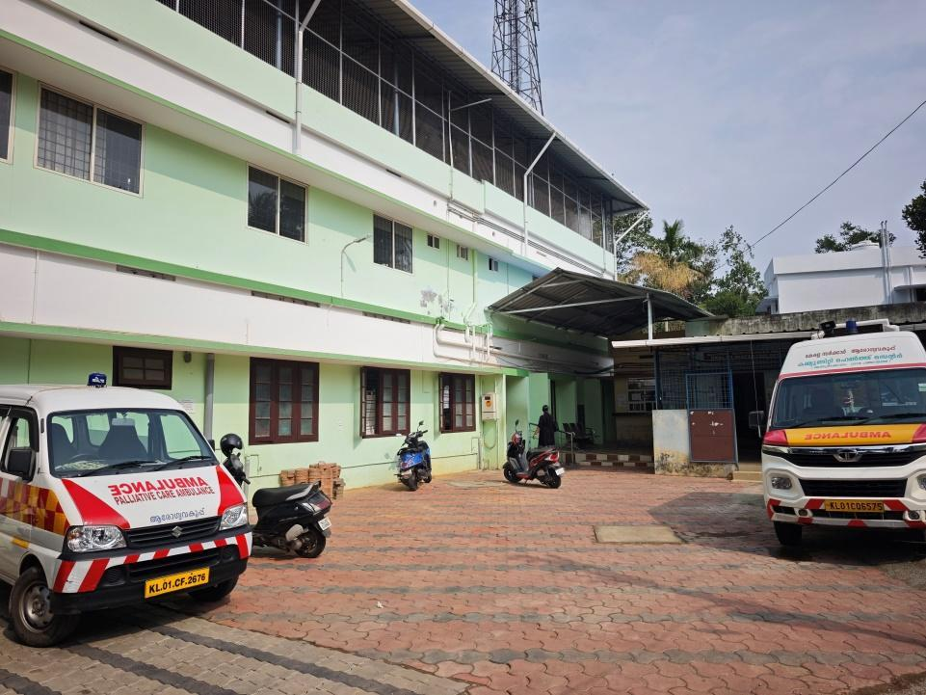
Andoorkonam Grama Panchayat
CHC ANDOORKONAM-phcandoorkonam@gmail.com

MESSAGE FROM PRESIDENT/CHAIR LSGI
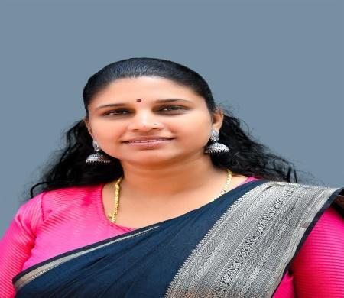

In Andoorkonam Grama Panchayath, our approach to pandemic preparedness is built on a foundation of proactive community resilience and decentralized healthcare. As President, my priority is the seamless integration of our Ward-level Health Committees with the Primary Health Centre to ensure real-time monitoring and rapid response capabilities. We have established a robust "Arogya Sena" (Health Volunteers) network trained in contact tracing and essential supply delivery, ensuring that no household is left isolated during a crisis. By investing in modernizing our local dispensaries and maintaining a digitized database of vulnerable populations—including the elderly and migrant laborers—Andoorkonam is moving beyond reactive measures toward a sustainable model of public health vigilance. Our commitment remains steadfast: to protect every citizen through transparent communication, localized resource management, and unwavering community support.

Archana R
Panchayat President

MESSAGE FROM HEALTH STANDING COMMITTEE CHAIR

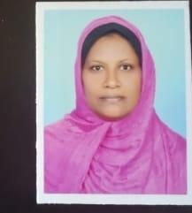

As the Chairperson of the Health Standing Committee, my commitment is to ensure that Andoorkonam remains a resilient and health-conscious community. Our strategy for pandemic preparedness is rooted in the "Prevention is Better than Cure" philosophy, focusing on the grassroots strengthening of our local healthcare infrastructure. We have prioritized the empowerment of our ASHA workers and the streamlining of our Primary Health Centre (PHC) operations to ensure they serve as the first line of defense against any budding health threat.

Jaasi M
Health Standing Committee Chairperson

MESSAGE BY MEDICAL OFFICER

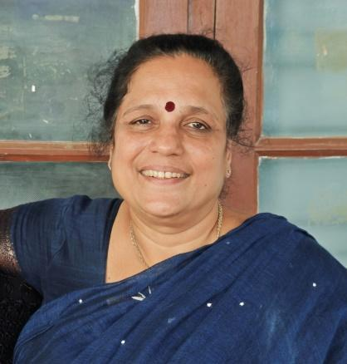

Understanding that preventive measures are more important than medical treatment for public health protection and acting accordingly will help in avoiding situations like future pandemics.Maintaining good health is possible through the strict adherence to a proper lifestyle. However, modern lifestyles often disrupt the rhythm of a healthy life. By equipping health systems, coordinating various departments, and ensuring the participation of volunteers and ASHA workers, I believe we can create a better environment free from pandemics by increasing our capacity for preventive activities and their control. Sharing this message with the idea that this project document, formed at the Panchayat level by assessing the current situation, will be an asset to health protection.

Dr Elizabeth Cheeran
Medical Officer
CHC Andoorkonam
EXECUTIVE SUMMARY

Andoorkonam Community Health Centre (CHC) functions as the primary public healthcare institution serving the population of Andoorkonam Grama Panchayath. The CHC plays a pivotal role in delivering comprehensive, accessible, and affordable healthcare services, with a strong focus on preventive, promotive, curative, and rehabilitative care in accordance with national and state health programmes.
The CHC Andoorkonam caters to a predominantly rural population, addressing key public health priorities such as maternal and child health, communicable and non-communicable disease control, immunization, family welfare, adolescent health, and geriatric care. Regular outpatient services, home-based care through field health staff, and outreach activities ensure healthcare coverage even in geographically challenging areas. The institution actively implements national health missions, including the National Health Mission (NHM), National Tuberculosis Elimination Programme, National Programme for Prevention and Control of Cancer, Diabetes, Cardiovascular Diseases and Stroke (NPCDCS), and other disease surveillance initiatives.
CHC Andoorkonam works in close coordination with the Andoorkonam Grama Panchayath, ASHA workers, Anganwadi centres, schools, and community-based organizations to strengthen community participation and improve health awareness. Emphasis is placed on early detection, timely referral, health education, and lifestyle modification to reduce disease burden and improve overall health outcomes.
Despite constraints related to infrastructure, manpower, and increasing service demand, the CHC Andoorkonam continues to enhance service delivery through effective planning, data-driven decision-making, and community engagement. Strengthening facilities, upgrading digital health systems, and expanding preventive services remain key focus areas for future development.
Overall, Andoorkonam Community Health Centre stands as a vital institution in safeguarding public health and improving the quality of life of the residents of Andoorkonam Grama Panchayath.

LIST OF ABBREVIATIONS

LSGD/LSGI | Local Self Government Department / Local Self Government Institution
BMO | Block Medical Officer
IDSP | Integrated Disease Surveillance Programme
NDMA | National Disaster Management Authority
PPE | Personal Protective Equipment
ICMR | Indian Council of Medical Research
CD | Communicable Diseases
NCD | NON-COMMUNICABLE Diseases

TABLE OF CONTENTS

INTRODUCTION 8
Background of the PPP 8
LSGD AT A GLANCE 9
INTEGRATED HEALTH INFRASTRUCTURE MAP OF ANDOORKONAM PANCHAYAT 19
GENERAL PROFILE OF THE LSGI’S 19
Background of the LSGI 19
Demographic and Vulnerable Population 20
Clinical Vulnerability 22
INFRASTRUCTURE & RESOURCE INVENTORY 24
Health Facility Directory & Basic Capacity in the LSGD 24
Private Clinics 25
Healthcare Education & Training Institutions 26
Specialized Services & Emergency Inventory 26
Oxygen & Diagnostic Capacity 27
Diagnostics facility mapping at the LSGI level 28
Laboratory Identification & Basic Details 28
Social and Community Infrastructure for surge plan 29
Human resources 31
Community & Support Cadre 33
Community Organizations 34
Administrative & Emergency Services 35
Information regarding resources 35
ONE HEALTH & ENVIRONMENTAL SURVEILLANCE 36
Animal & Bird Population 36
Veterinary Infrastructure 37
Veterinary Doctors & Workforce 38
Environmental Risk Mapping 42
Disease Seasonality Mapping 43
Vulnerability Mapping 45
EPIDEMIOLOGICAL TRENDS (2021–2025) 47
Disease Burden among human beings (Last 5 Years) 47
Seasonal Trend Analysis 50
Outcome-Based Trend Analysis- 2025 55
Transmission Trend- 2025 56
Integrated Disease Hotspot Map (2021–2025) 61
Preparedness and Response Protocol at LSG Level 65
Constitution of One Health Committee 66
Pandemic Response Workforce 67
Activities and Measures before and during Pandemic 69
PHASE 1 - Alert / Preparation 69
PHASE 2 - Active Response 72
Standard Screening Protocol 74
PHASE 3 - Surge Capacity 83
Conversion of Community Facilities 84
CONCLUSION 92
RECOMMENDATIONS 93
ANNEXURE 96
1. IMPORTANT PHONE NUMBERS 96

INTRODUCTION

Background of the PPP

The demographic profile of Andoorkonam panchayat emphasizes the need for a highly structured and inclusive preparedness plan. The panchayat is home to a significant number of vulnerable individuals. These groups often face increased risk during public health emergencies due to higher exposure levels and a heavier dependency on public support systems. These demographic and socio-economic characteristics underscore the need to prioritize high-risk populations and those dependent on regular medical treatment are at increased risk during pandemics due to potential service disruptions and heightened exposure risks.

The Andoorkonam Grama Panchayat Pandemic Preparedness Plan serves as a strategic blueprint to safeguard our community during public health emergencies. This document is designed to
- Create a baseline for rapid mobilization: Establishing a data-driven framework to activate resources and personnel immediately at the first sign of a health threat.
- Identify gaps in resources and high-risk populations: Systematically mapping our 4278 elderly residents, 122 bedbound patients, and 246 palliative care patients to ensure targeted support.
- Ensure coordinated action between the Government, Private, and AYUSH sectors: Synchronizing efforts across our 1 Government hospital, 1 private hospital, and 2 total AYUSH centers and also all the private clinics and Laboratories

This Pandemic Preparedness Plan for Andoorkonam panchayat has been developed to strengthen the Health Block’s capacity to prevent, detect, and respond effectively to pandemics and large-scale infectious disease outbreaks. The plan emphasizes early warning systems, protection of vulnerable populations, continuity of essential health and social services, surge capacity planning, environmental health management, and coordinated action across health, local governance, disaster management, animal health, and community sectors.

LSGD AT A GLANCE
Geographical boundaries with political map ( based on latest delimitation)

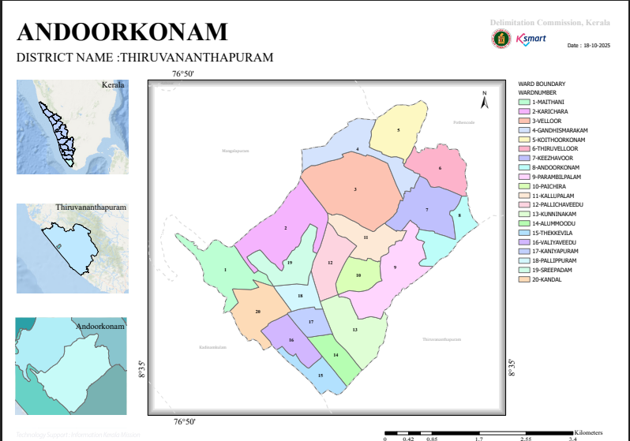

Source:-https://wardmap.ksmart.live/FinalN/FinalN_Thiruvanathapuram_Andoorkonam.html

Baseline data

- Ward division -
Ward | Houses | Population | Migrants | Wells | Hot  spots | Ed. Institutions | Hosp pvt/govt.
20 | 8505 | 30553 | 515 | 4968 | 2 | 53 | 9

Risk stratification among wards in the context of Communicable diseases and hazards
Risk stratification of wards within Andoorkonam Grama Panchayat has been carried out based on recent trends of communicable diseases, environmental conditions, and local vulnerability factors. Ward 1 (Apollo Colony, Karichara) has been identified as a hotspot for leptospirosis, likely due to environmental factors such as water stagnation, poor drainage, and increased human exposure to contaminated water sources, especially during monsoon periods. Enhanced surveillance and preventive measures are essential in this area.
Ward 9 (Pallicha Veedu) reported a higher number of dengue cases during the year 2024, indicating increased vector density and possible breeding sites in and around residential areas. Factors such as improper waste management, water storage practices, and peri-domestic mosquito breeding may contribute to this elevated risk.
In general, wards with high population density, inadequate sanitation, water stagnation, and occupational exposure (such as agricultural and manual labor activities) are considered high-risk zones for communicable diseases. Seasonal variations, particularly during the monsoon, further amplify the risk of vector-borne and water-borne diseases across vulnerable wards.
This stratification enables prioritization of targeted interventions, including intensified vector control measures, health education, environmental sanitation, and early disease surveillance, thereby strengthening pandemic preparedness and response at the ward level.
- Major Roads/rivers-

Andoorkonam Grama Panchayat is well connected by major transportation routes, with National Highway 66 (NH 66) passing in close proximity, facilitating movement of people and goods. The presence of this major highway enhances accessibility but also increases population mobility, which is a relevant factor in the spread of communicable diseases.
Thettiyar Thodu is the major water body flowing through Wards 14, 13, and 16, contributing to local drainage and water flow patterns. During periods of heavy rainfall, this river may overflow, leading to water stagnation and increased risk of water-borne and vector-borne diseases in adjacent areas. These features necessitate focused surveillance and preventive measures in nearby wards as part of pandemic preparedness planning.

- Major establishments with geospatial mapping
  - Andookonam Panchayath office- Ward 12
  - CHC Andoorkonam - Ward 5
  - Krishi Bhavan - Ward 12
  - Veterinary Hospital- Ward 3
  - Ayurveda dispensary-3
  - Homeo Dispensary - Ward 18
  - Railway station - Ward 12
  - Village Office - Ward 5
  - CRPF Camp - Ward 17
  - Power Grid Cooperation - Ward 2

- Occupational groups- Socio Cultural groups, migration and mobility patterns
Andoorkonam Grama Panchayat has a diverse occupational profile including workers in construction, small-scale industries, services, and agriculture. The Panchayat also hosts more than 500 interstate migrant labourers employed in construction sites, restaurants, and food manufacturing units. This migrant population has high mobility and may face challenges such as language barriers and limited access to healthcare, increasing their vulnerability to communicable diseases. Their living and working conditions, along with frequent movement, necessitate targeted public health interventions, including surveillance, health education, and improved access to healthcare services for effective pandemic preparedness.
- Vulnerability mapping

  - Above 60:-4278
  - Hypertensive:-2371
  - Diabetic:-1975
  - Cancer Patients:-104
  - Bedridden:-122
  - Other than bedbound:-246

- Disaster prone areas (geographic vulnerability)
Certain wards in Andoorkonam Grama Panchayat are identified as geographically vulnerable to disasters, particularly flooding. Wards 14 (Chalile), 13 (Thekkevila), 17 (Sreepadam), and Kaniyapuram are recognized as disaster-prone areas due to their terrain and susceptibility to waterlogging during heavy rainfall. These geographic vulnerabilities increase the risk of communicable diseases, especially water-borne and vector-borne infections, and highlight the need for focused preparedness measures, including drainage management, early warning systems, and strengthened surveillance in these high-risk areas.

Maps - ward-based (Mention source also)

- Geographical boundaries - ward boundaries map
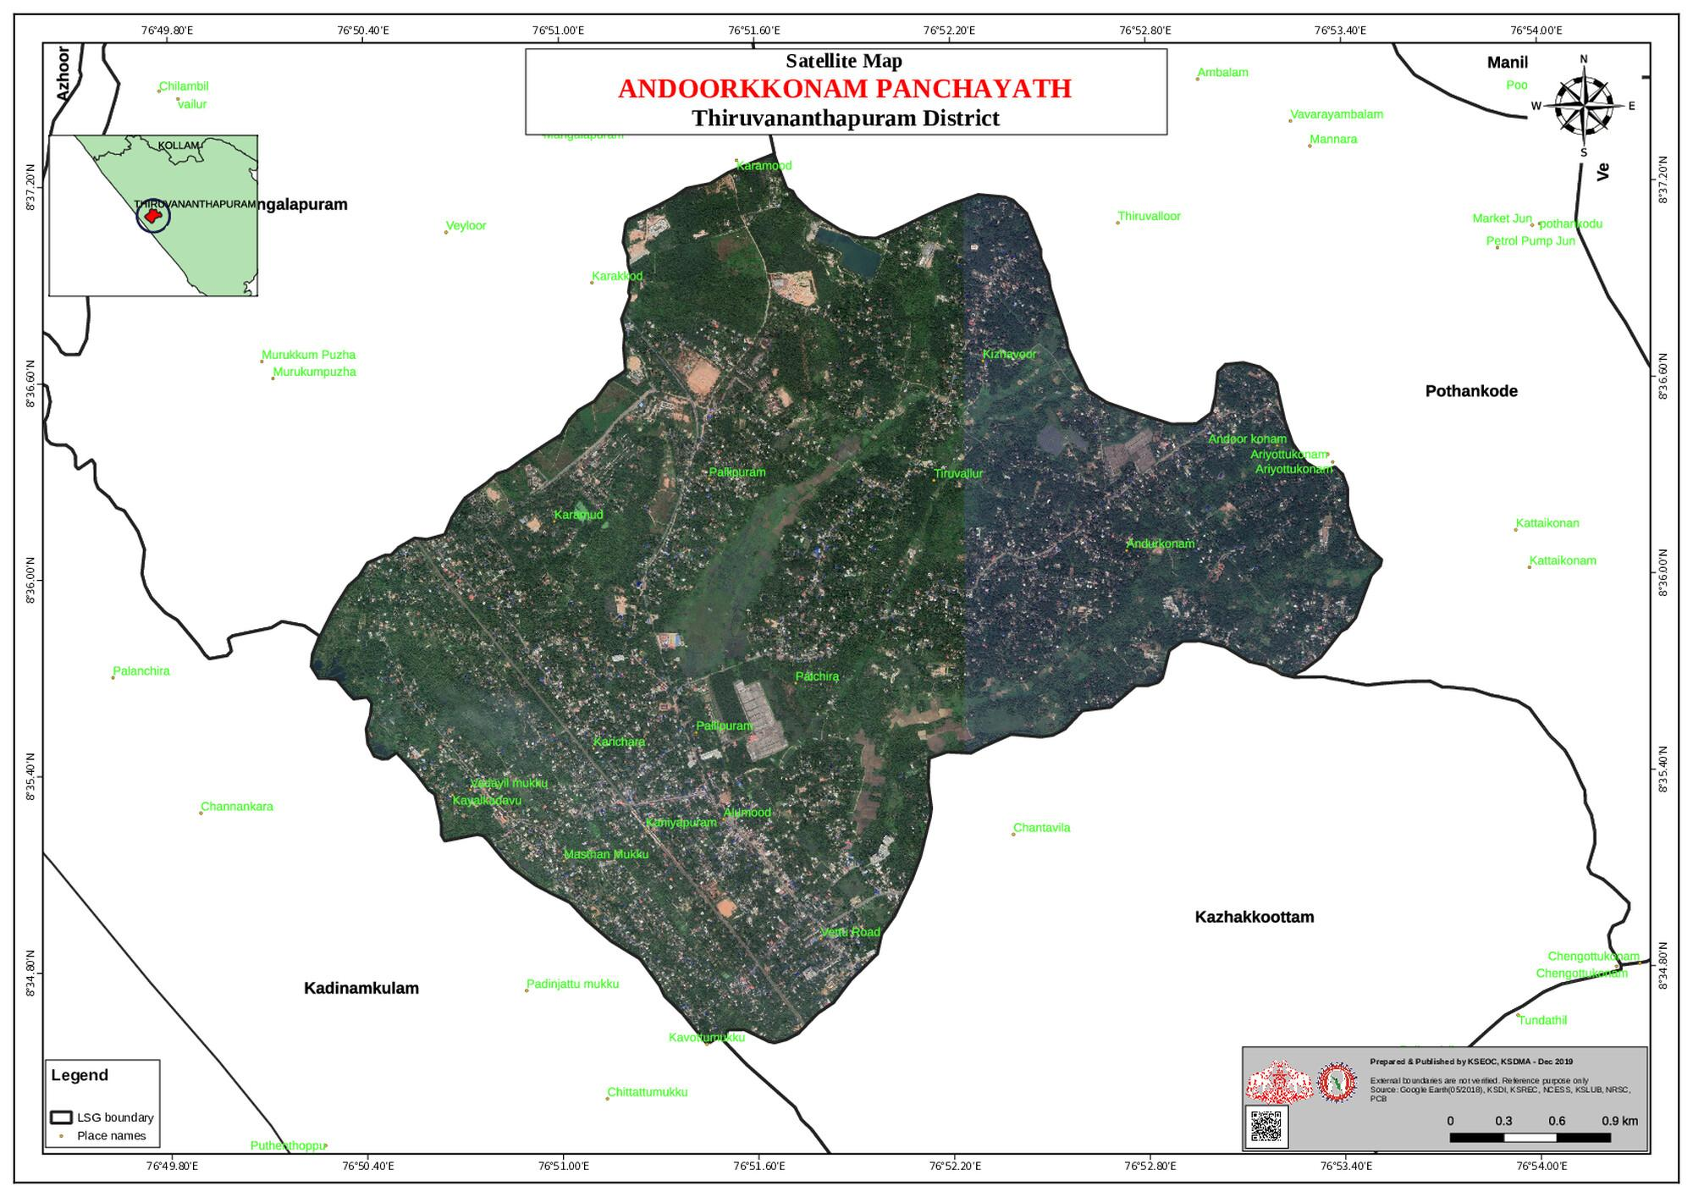

North- Mangalapuram panchayat
South - Thiruvananthapuram Corporation
East -Pothencode Panchayat
West- Kadinamkulam Panchayat

- Health infrastructure map

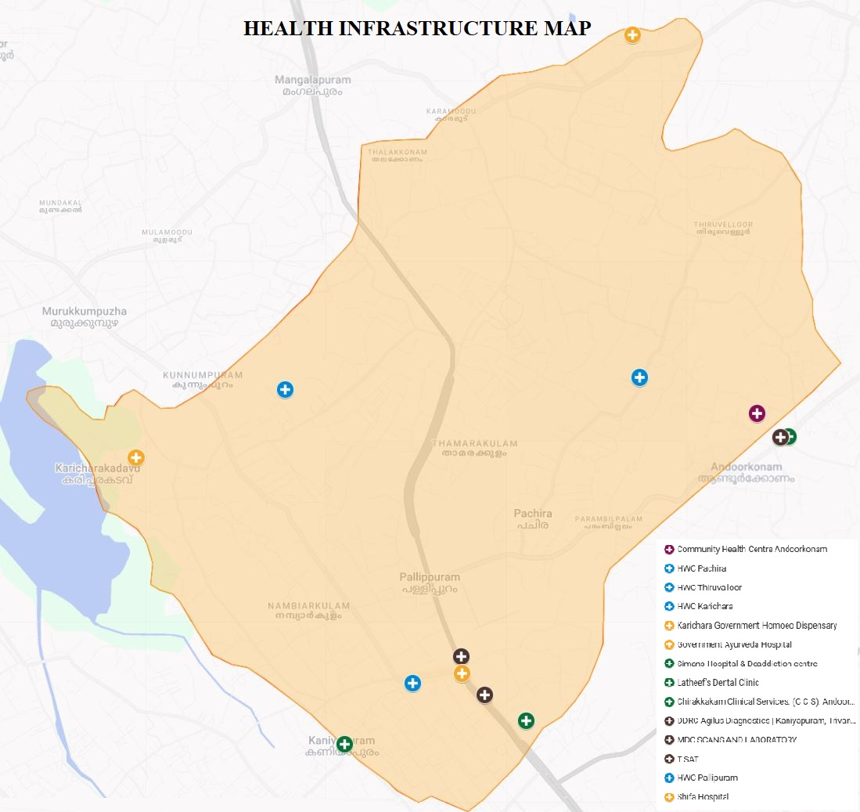

- Roads and rivers map
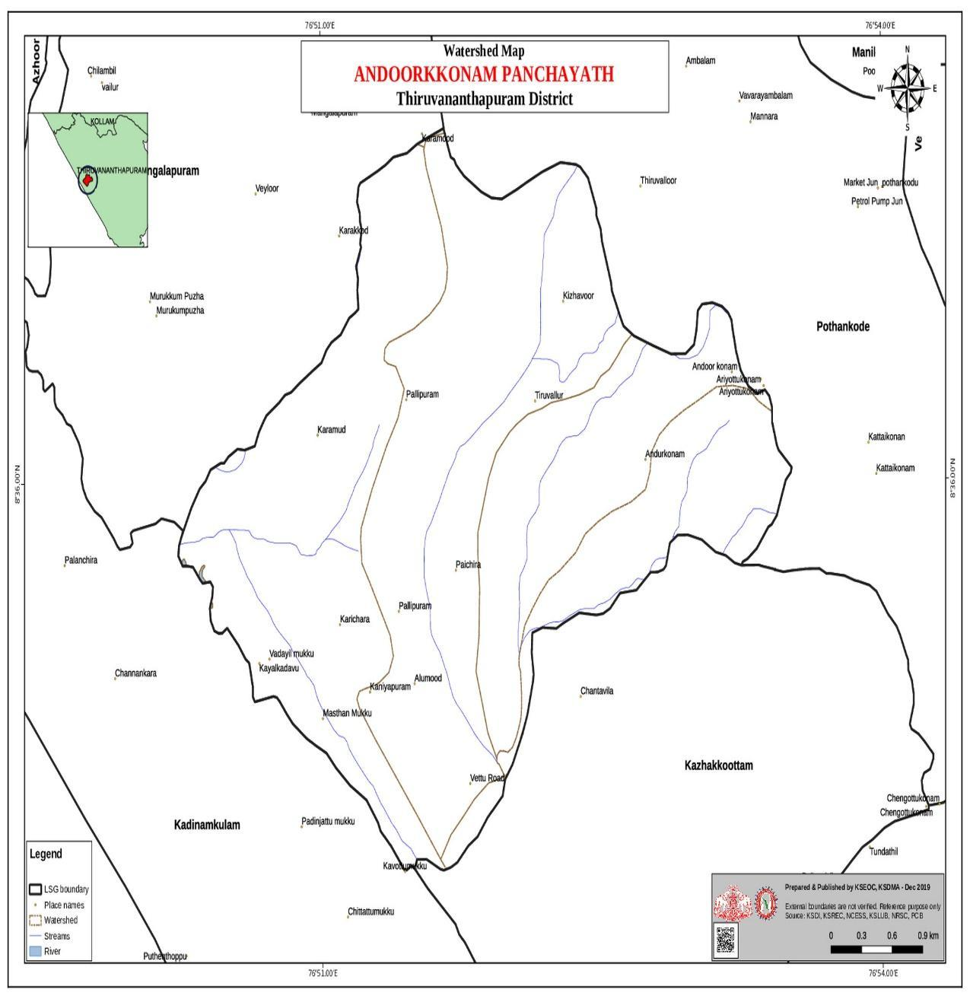

Source:- https://dmp.kila.ac.in/

Thettiyar Thodu is the major river passes through the wards 14,13,16.

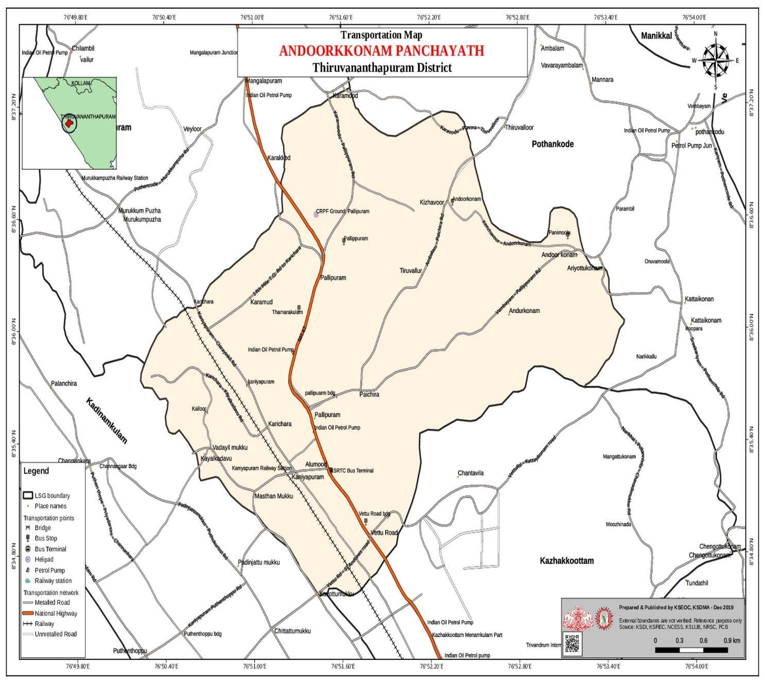
Transportation Map

Source:- https://dmp.kila.ac.in/

- Major Establishments Map

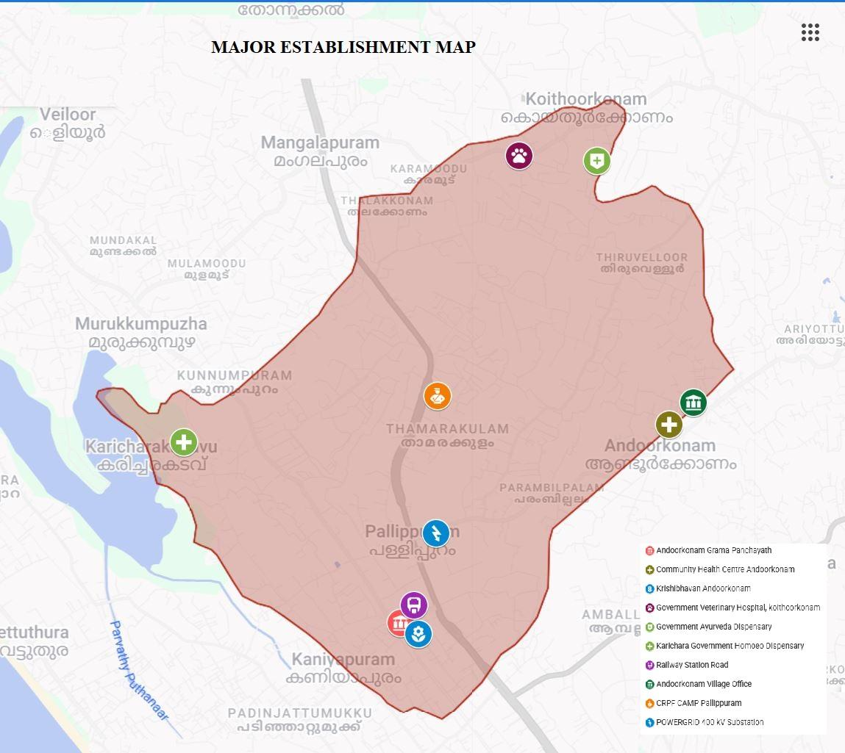

Source:-https://www.google.com/maps/about/mymaps/

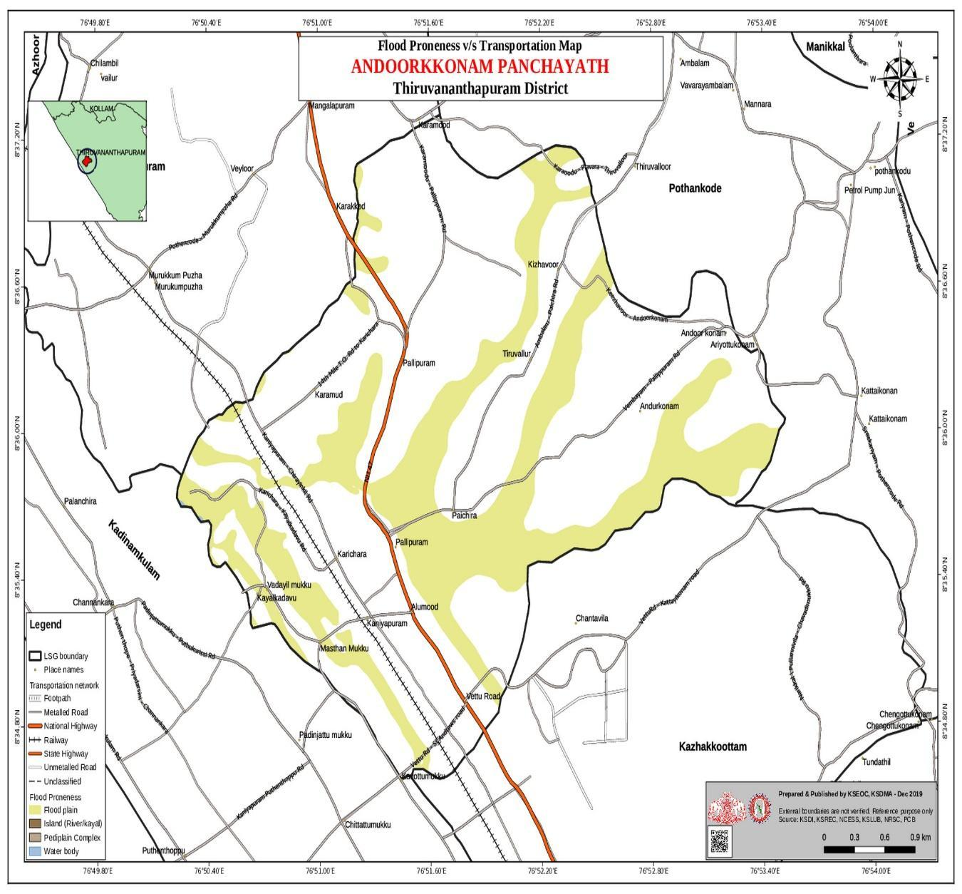
- Disaster-prone areas map

Source:-https://dmp.kila.ac.in/

6.Hotspot map - CD & disasters

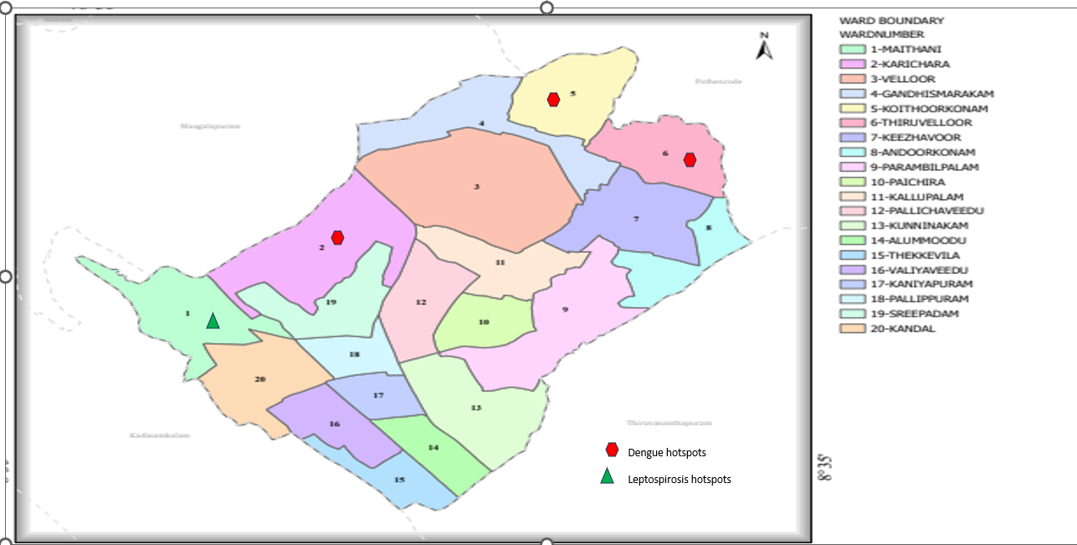

INTEGRATED HEALTH INFRASTRUCTURE MAP OF ANDOORKONAM PANCHAYAT
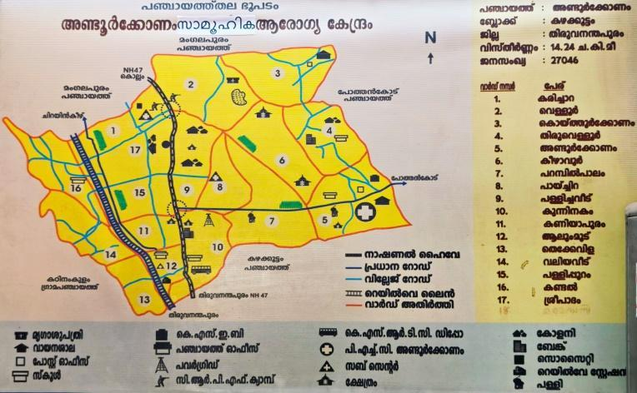

GENERAL PROFILE OF THE LSGI’S

Background of the LSGI
Andoorkonam Grama Panchayat is a prominent Local Self Government Institution situated in the Thiruvananthapuram Taluk of Kerala, approximately 20 km from the state capital, Thiruvananthapuram. The Panchayat represents a semi-urban setting, characterized by a transition from traditional agrarian practices to a more service-oriented and peri-urban economy, influenced by its proximity to major urban, IT, and educational hubs.
Geographically, the Panchayat spans an area of approximately 9.24 square kilometers. It is bounded by neighboring Panchayats such as Pallippuram, Iroopara, and Kazhakoottam, contributing to its strategic connectivity and developmental potential. The region exhibits a mix of residential areas, agricultural lands, and emerging small-scale industrial activities.
As per the 2011 Census, Andoorkonam Grama Panchayat has a population of around 15,557, with a high literacy rate of approximately 93.7%, reflecting the strong educational status of the community. The population distribution indicates a balanced mix of different socio-economic groups, with increasing urbanization trends observed in recent years.
Administratively, the Panchayat falls under the Pothencode Block Panchayat and is part of the Nedumangad Legislative Assembly Constituency. The local governance system is actively engaged in implementing public health initiatives, social welfare schemes, and infrastructure development programs, thereby playing a critical role in community-level planning and pandemic preparedness.
The occupational profile of the Panchayat reflects a diversified workforce. While a segment of the population continues to depend on agriculture, there is a noticeable shift towards service sector employment and allied activities. Coconut cultivation remains the predominant agricultural practice. In addition, initiatives such as “Andoorkonam Gramya Vegetables” promote organic farming and utilization of fallow land, contributing to local food security and sustainable practices.
Agricultural laborers and small-scale farmers form an integral part of the workforce. The integration of Mahatma Gandhi National Rural Employment Guarantee Scheme (MGNREGS) workers into structured agricultural activities, including through organized groups like the Karshika Sena, has enhanced productivity and livelihood opportunities.
Overall, Andoorkonam Grama Panchayat demonstrates a dynamic socio-economic profile with evolving developmental characteristics. Its semi-urban nature, high literacy, and active governance framework provide a strong foundation for effective public health planning, including pandemic preparedness, surveillance, and response mechanisms.

Demographic and Vulnerable Population
Understanding the demographic composition and vulnerable population groups is essential for pandemic preparedness. Children, elderly, economically deprived families, migrant workers, and socially vulnerable groups are at increased risk during public health emergencies due to higher exposure, limited access to services, and dependency on public systems..

Description |  | Details (in numbers)
DEMOGRAPHIC PROFILE
Total population |  | 31393
Male |  | 14951
Female |  | 16442
Transgender |  | 0
Children under 5 |  | 1367
Adolescent |  | 1863
Elderly (>60) |  | 4278
SOCIAL/LIVELIHOOD VULNERABILITY
Previous EPEP family |  | 4
BPL family |  | 3710
Tribal communities |  | 0
Migration | Immigrant | 515
Migration | Emigrant | 0
Socio-economically deprived |  | 182
Fisherfolk |  | 0
SC Community |  | 468
ST Community |  | 8
Ward |  | 18
houses |  | 8826
population |  | 31393
migrant |  | 515
wells |  | 4968
Hot spots |  | 2
Ed. |  | 25

Graphs: Population pyramid (if possible) for seeing if your LSGI has a high "dependency ratio" (lots of children and elderly compared to working adults).

Clinical Vulnerability
Certain population groups need priority healthcare & are at higher risk of severe illness, complications, and mortality during pandemics. Patients with chronic diseases, those requiring regular medical care, and individuals with mobility or functional limitations face challenges in accessing timely care during emergencies. Mapping these groups helps in prioritizing continuity of treatment, medicine stock planning, oxygen support, referral transport, and targeted home-based care.
Description | Details in numbers
Pregnant women | 152
Lactating mothers | 483
Bedbound patients | 122
Patients under palliative care other than bedbound | 246
Patients on Haemodialysis | 18
Patients on CAPD | 0
Cancer patients (currently on treatment) | 104
Haemophilic patients | 1
Mentally challenged | 63
Differently abled | 70
Diabetic patients | 1975
Hypertensive patients | 2371
TB patients | 8

Major Festivals & Events specific to the LSGI
(with the possibility of a public gathering)

Sl. No. | Name of festival | Month detailing the periodicity
1 | THONNAL TEMPLE FESTIVAL | JANUARY
2 | KARICHARA DEVI TEMPLE FESTIVAL | FEBRUARY
3 | THALIYIL TEMPLE FESTIVAL | MARCH
4 | THAMARAKULAM TEMPLE FESTIVAL | MARCH
5 | KANIYAPURAM NAGARUKAVU | MARCH
6 | KANDAL DEVI TEMPLE | MARCH
7 | PANDARAKARI TEMPLE | JANUARY
8 | SREEDHARAMNGALAM MAHA VISHNU TEMPLE | MARCH
9 | THALIYIL MAHADEVA TEMPLE | FEBRUARY
10 | THIRUVALLOOR MAHDEVA TEMPLE | MARCH
11 | KARICHALLOOR KAVU TEMPLE

INFRASTRUCTURE & RESOURCE INVENTORY

Health Facility Directory & Basic Capacity in the LSGD
This section provides an overview of the healthcare infrastructure available within the LSGD area. It outlines the distribution and basic capacity of health facilities that form the backbone of service delivery during routine times and public health emergencies.

Family Health Centres (FHCs) and Community Health Centres (CHCs) generally function as the first point of contact for the community, providing essential outpatient and inpatient services. General Hospitals (GH) and Medical College Hospitals (MCH), where accessible, serve as the main referral centres for advanced diagnostics, specialist care, and critical services during public health emergencies. This inventory helps identify existing strengths, gaps, and potential surge capacity that can be mobilised during a pandemic or disaster.

Table 5. Health Facility Resource Summary
Sl.no. | Health Facility | Type of Facility (MCH/GH/CHC/FHC/SC etc.) | Contact Number | Total beds | ICU Beds | Oxygen-Supported Beds | No. of Ventilator Support Beds | No. of ambulances
Government Healthcare Facilities
1 | CHC ANDOORKONAM | CHC | 04712751397 | 14 | 0 | 0 | 0 | 2
2 | PACHIRA | SC | 9497011445 | 0 | 0 | 0 | 0 | 0
3 | THIRUVALLOOR | SC | 9447135453 | 0 | 0 | 0 | 0 | 0
4 | KARICHARA | SC | 8111862652 | 0 | 0 | 0 | 0 | 0
5 | PALLIPURAM | SC | 8111862652 | 0 | 0 | 0 | 0 | 0
Private Healthcare Facilities
1 | SHIFA HOSPITAL | PVT | 9846046936 | 20 | 0 | 20 | 0 | 1
AYUSH Healthcare Facilities
1 | Govt Ayurveda hospital | GH | 9495123453 | 0 | 0 | 0 | 0 | 0
2 | Govt Homoeo hospital | GH | 9495271314 | 0 | 0 | 0 | 0 | 0

Private Clinics
Private clinics are an essential part of pandemic preparedness, as they are often the first place people seek care when symptoms begin. In many communities, private clinics manage a significant share of outpatient visits and therefore play a critical role in early case detection, timely referrals, and disease surveillance. Having an up-to-date understanding of where these clinics are located, the services they provide, and how they are linked to the public health system helps ensure that no cases are missed during an outbreak. It also allows health authorities to engage private practitioners more effectively for reporting, risk communication, and coordinated response, strengthening the overall capacity of the health system to manage public health emergencies.

Table 6. Private Clinic Resource Summary
Sl No. | Name of Clinic | Registered (Y/N) | Clinic (General / Speciality) | Speciality (if any) | Address | Contact Number | Diagnostic Facility (Y/N) | Ambulance Linkage (Y/N)
1 | Simans councelling centre | N | Clinic | Councelling centre | Vetturoad , Kaniyapuram | 9495121608 | N | N
2 | Latheefs Dental clinic | N | Clinic | Dental | Arakkal, Kaniyapuram | 9746318775 | Y | N
3 | Chirakkakam clinic service | N | clinic | N | Andoorkonam, Andoorkonam P O | 9495969081 | Y | N

Healthcare Education & Training Institutions
This section tracks the educational infrastructure available, which is vital for human resource planning in the health sector.

Category of Institution | Govt | Private | AYUSH | Total
Medical Colleges | N | N | N | N
Nursing Colleges | N | N | N | N
Dental Colleges | N | N | N | N
Para-medical / Allied Health | N | N | N | N
Pharmacy Colleges | N | N | N | N

Specialized Services & Emergency Inventory
This section provides a detailed view of the specialized medical resources available to the community, focusing on emergency response and critical care capabilities. This table tracks the vital assets required for managing severe illnesses and emergencies across Government, Private, and AYUSH sectors.

Item | Govt | Private | AYUSH | Total
Hospital beds | 14 | 20 | 0 | 34
Oxygen-generating systems(Y/N) | N | N | N | 0
Oxygen-supported beds(Numbers) | 0 | 20 | 0 | 20
Ventilator-supported beds | 0 | 0 | 0 | 0
ICU beds | 0 | 0 | 0 | 0
Burns units | 0 | 0 | 0 | 0
Blood centres | 0 | 0 | 0 | 0
BLS ambulances | 2 | 1 | 0 | 3
ALS ambulances | 0 | 0 | 0 | 0
Dialysis facilities | 0 | 0 | 0 | 0
Dispensaries | 0 | 0 | 0 | 0
Medical store | 1 | 9 | 0 | 10
Industrial establishments (Medium-scale industries/small-scale industries establishments to whom we can depend in a worst-case scenario) | 0 | 5 | 0 | 5

Oxygen & Diagnostic Capacity
Monitoring oxygen and diagnostic capacity is a critical component of public health preparedness, ensuring that the LSGD can handle both chronic care and sudden surges in respiratory or infectious diseases.
Name of Health Facility | Oxygen-generating System (Y/N) | Backup Oxygen Source (Y/N) | Diagnostic Facilities Available(Y/N)
Name of Health Facility | Oxygen-generating System (Y/N) | Backup Oxygen Source (Y/N) | Lab | USG | X-ray | CT/MRI | RT-PCR
Government Healthcare Facilities
CHC ANDOORKONAM | N | N | 1 | 0 | 0 | 0 | 0

Diagnostics facility mapping at the LSGI level
The diagnostic capacity of Andoorkonam G.P represents the "intelligence network" of our healthcare system. The speed and accuracy of disease identification depend entirely on the distribution and technical level of these facilities.
Item | Govt | Private | AYUSH | Total
General labs | 1 | 4 | 0 | 5
Microbiology labs | 1 | 2 | 0 | 2
RT-PCR labs | 0 | 2 | 0 | 2
USG units | 0 | 2 | 0 | 2
CT/MRI units | 0 | 0 | 0 | 0
Research labs | 0 | 0 | 0 | 0
Labs of other departments that can be repurposed | 0 | 0 | 0 | 0

Laboratory Identification & Basic Details
Sl. No. | Name of Laboratory | Ownership (Govt / Private / Academic) | Address | Contact No. | 24×7 Services (Yes/No) | NABL / Govt Approved (Yes/No)
1 | DDRC | PRIVATE | DDRC KANIYAPURAM | 9778421665 | NO | YES
2 | MDC | PRIVATE | MDC KANIYAPURAM | 9446700449 | NO | YES
3 | T SAT | PRIVATE | T.SAT ANDOORKONAM | 9744560768 | NO | YES
4 | SHIFA | PRIVATE | SHIFA KANIYAPURAM | 9846046936 | YES | YES

Social and Community Infrastructure for surge plan
This table serves as our logistics and shelter inventory. By mapping these locations, quickly we can identify where to house displaced citizens, where to set up temporary medical clinics, and how to manage the deceased with dignity during a crisis.

Category | Total Count | Ward | Est. Capacity (Persons) | Contact details
Educational Institutions
Anganwadis | 30 | 1-18 | 272 | 7306836008
Schools | 25 | 1-18 | 10677 | 9495408152
Colleges | 0 | 0 | 0 | NIL
Healthcare Educational Institutions
Medical colleges (Govt/Private) | 0 | 0 | 0 | NIL
Nursing colleges (Govt/Private) | 0 | 0 | 0 | NIL
Dental colleges (Govt/Private) | 0 | 0 | 0 | NIL
Paramedical institutes (Govt/Private) | 0 | 0 | 0 | NIL
Community Gathering Spaces
Community halls | 8 | 1,12,5,2,14 | 1500 | 9495408152
Auditoriums | 7 | 14,12,5,7 | 2000 | 04712412361
Religious buildings | 69 | 1 to 18 | 526 | 8714189005
Vulnerable Group Support Facility
Destitute homes | 0 | 0 | 0 | NIL
Elderly homes | 1 | 14 | 20 | 9072447445
LSGD owned other buildings | 0 | 0 | 0 | NIL
Mass Fatality Management (MFM) Infrastructure
Mortuary | 0 | 0 | NIL | NIL
Crematorium | 1 | 14 | 30 | 04712750256
*refer annexure 1 for contact details

Human resources
This section focuses on the human capital available within the LSGI. In any emergency be it a pandemic, flood, or industrial accident infrastructure is only as effective as the people operating it.

Medical & Clinical Personnel
This table tracks the "Frontline" providers responsible for diagnosis, treatment, and clinical management. Narrative sentence: eg., "Total health workforce: 450 personnel, with 60% in government facilities serving as primary surge capacity." A detailed directory with the contact numbers of all workers is maintained (Annexure in 1).

Cadre | Govt (No.) | Private (No.) | Total
Doctors—Modern Medicine | 7 | 20 | 27
Doctors – AYUSH | 2 | 1 | 3
Doctors – Veterinary | 1 | 0 | 1
Doctors – Dental | 0 | 3 | 3
Nursing officers | 2 | 8 | 10
Lab technicians | 1 | 5 | 6
Optometrist | 0 | 0 | 0
Pharmacists | 1 | 12 | 13
Psychologists | 0 | 0 | 0
Counsellors | 0 | 0 | 0

Public Health & Field-Level Workforce
These individuals are the backbone of surveillance, maternal-child health, and decentralized care.

Cadre | Health services | Municipal common services | Total
HS (Health Supervisors) | 0 | 0 | 0
HI (Health Inspectors) | 1 | 0 | 1
LHS (Lady Health Supervisor) | 0 | 0 | 0
LHI (Lady Health Inspectors) | 1 | 0 | 1
JPHN (Jr Public Health Nurses) | 4 | 0 | 4
JHI (Jr Health Inspectors) | 3 | 0 | 3
MLSP (Mid-Level Service Providers) | 5 | 0 | 5
Palliative Nurses | 1 | 0 | 1
RBSK Nurses | 1 | 0 | 1
PRO | 0 | 0 | 0
Epidemiologist | 0 | 0 | 0
Data Manager | 0 | 0 | 0

Community & Support Cadre
This group represents the surge capacity of the LSGI—people who can be called upon for logistics, rescue, and specialized support.

Cadre | Number
ASHA Workers | 18
AWW (Anganwadi Workers) | 30
Emergency Medical Volunteers (Trained) | 18
Kudumbashree | 180
MNREGS | 476
Purusha Swayam Sahaya Sangham | 12
Ex-Servicemen | 36
Retired Police Officers | 26
NCC/NSS Volunteers | 8
Red Cross volunteers | 0
One Health Community Volunteers | 18
One Health Community Mentors | 9

Community Organizations
This section details the presence of community-based organisations (CBOs), non-governmental organisations (NGOs), faith-based organisations (FBOs), Kudumbashree Self-Help Groups (SHGs), and Ayalkootams within the Local Self-Government Institution (LSGI). These groups enhance grassroots mobilization, resource distribution, and support networks crucial for pandemic response and community resilience.

Category | Total Count
NGOs | 18
Religious based organizations | 12
Foreign based organizations | 0
Sports Club/youth clubs | 22
Kudumbashree SHGs | 480
Ayalkootams | 480
Political organizations | 8
Residential organizations | 18

Administrative & Emergency Services
This section outlines the availability of key non-health emergency support services and infrastructure within the LSGI, which are essential for effective pandemic preparedness and response. These facilities support law enforcement, disaster response, water supply, logistics, mobility, and community-level interventions during public health emergencies.

Category | Total Count | Contact details
Police Stations | 1(Nearest) | 04712716100
Fire & Rescue Stations | 1 | 04714127000
Water Pumping Points | 3 | 08547638189
Public Distribution System (PDS) | 18 | 9847818743

Information regarding resources
The availability of essential transport and support resources plays a quiet but critical role in saving lives. Equipment such as ambulances, mobile mortuaries, amphibian ambulances, and motorized boats ensures that patients, samples, and healthcare teams can move swiftly—even in flooded, remote, or difficult terrains. Heavy vehicles like JCBs, cranes, tractors, and torus lorries support logistics, waste management, emergency infrastructure, and rapid conversion of spaces into care or isolation facilities. Taxis, four-wheel-drive vehicles, and trucks help maintain continuity of essential services, reach vulnerable populations, and support home-based care and supply delivery.

Means of transportation | Total Count
JCB | 2
Crane | 1
Heavy Trucks | 1
Tractor | 2
Ambulances | 2
Mobile mortuaries | 2
Boats | 0
Taxi service | 2
Note: For specific details regarding vehicle owners and contact information, please refer to Annexure [X].

ONE HEALTH & ENVIRONMENTAL SURVEILLANCE
The One Health method integrates environmental, animal, and human health to enable proactive pandemic preparedness. Panchayat-level surveillance needs to be improved in order to detect and treat zoonotic and environmentally generated diseases early. Surveillance is strengthened through systematic assessment of animal populations, veterinary infrastructure, poultry and slaughter facilities, inter-sectoral coordination, and specialised tools like avian influenza seasonality mapping using GIS in previous outbreaks to enable predictive alerts and ward-specific sampling to support effective pandemic preparedness in high-risk areas like colonies (Apollo colony, Sreepadam,Lakshamveedu).

Animal & Bird Population
Mapping animal and bird populations at the Panchayat level is essential for identifying and prioritising zoonotic disease hazards like rabies, avian influenza (H5N1), leptospirosis, anthrax, and Nipah-like spillover occurrences. Risk classification, targeted surveillance, vaccination planning, and early epidemic detection made feasible by comprehensive population mapping all enhance One Health-based pandemic preparedness.

Category | Item | Estimated Population | Wards
Animal Population | Livestock (Cattle/Goats/Buffalo) | 1500 | ALL WARDS
Animal Population | Pet Animals (Dogs/Cats) | 3200 | ALL WARDS
Animal Population | Stray Dog Population | 960 | ALL WARDS
Animal Population | Pig Farms (Number of heads) | 0 | Nil
 | Small Units (Sheep / Goats – clustered) | 20 | Ward 9 Pallicha veedu, Ward 18 maithani, Ward 4 Keezhavoor.
Bird Population | Poultry Units (Birds) | 1352 | ALL WARDS
Bird Population | Poultry- (FOWL) | 10000 | ALL WARDS
Bird Population | Wild/Migratory Birds (Observed) | 0 | ALL WARDS
Bird Population | Crow Mortality Events (Reported) | 0 | NIL
The stray dog population in market areas, fish landing sites, bus stations continues to be a substantial problem for rabies surveillance and bite prevention. There is a considerable risk of avian influenza introduction and amplification during November - December due to the seasonal presence of migratory and resident water birds near ponds/ canal / river / backwater / paddy field. Clusters of pig farms and animal shelters vulnerable to flooding further raise the risk of leptospirosis and other zoonoses mediated by the environment, especially during monsoon floods.

Veterinary Infrastructure
Veterinary institutions are a core pillar of One Health surveillance, enabling early zoonotic disease detection through vaccination, investigation of unusual animal illness or deaths, sample collection, and timely outbreak reporting. A well-mapped and responsive veterinary network strengthens coordination with human health and LSGI systems, ensuring rapid response during zoonotic events and pandemics.
Facility Type | Name of Facility | Ownership Govt / Pvt | Location(Ward No) | Contact number
Veterinary Dispensary | Govt Dispensary Koithoorkonam | Govt | 4 Koithoorkonam | 8086361900
Veterinary Hospital / Polyclinic | Govt Dispensary Koithoorkonam | Govt | Koithoorkonam | 8086361900
Private Veterinary Clinics | 0 | 0 | 0 | 0
Mobile / Emergency Vet Service (incl. night services) | 0 | 0 | 0 | 0
Pet Homes / Animal Shelters | 0 | 0 | 0 | 0
Slaughterhouse-linked Veterinary Inspection Unit | 0 | 0 | 0 | 0

Veterinary Doctors & Workforce
Early detection, diagnosis, reporting, and reaction to animal illness epidemics depend on the availability and accessibility of qualified veterinary specialists. By identifying unusual animal morbidity or mortality promptly, collecting samples promptly, and coordinating efficiently with human health and LSGI systems—especially during zoonotic outbreaks and pandemic-prone situations—a clearly defined veterinary workforce enhances One Health surveillance.

Category | Number Available | Type (Govt/Pvt) | Contact number
Government Veterinary Doctors | 1 | govt | 8086361900
Private Veterinary Doctors | 0 | Nil | 0
Livestock Inspectors | 3 | govt | 7907605595  9496100450  9037299753
Para-veterinary Staff / Attenders | 0 | Nil | 0
Contract / On-call Veterinary Support (if any) | 0 | 0 | 0

High-risk interface points for zoonotic disease surveillance in Andoorkonam Grama Panchayath i
Type of Habitat | Type of High risk interface | Geographical vulnerability
Wetlands & Backwaters | 2 nos  -Human–water interface / Flood-prone habitation | Flooding
Backyard Poultry Farms | 11 nos-Human-Poultry interface | Airborne / Zoonotic disease risk
Cattle Sheds near Water Bodies | 0-Animal–water–human interface | Water contamination
Fish & Meat Markets | 1-Human–animal product handling interface | Waste Management issues
Community Slaughter Sites | 2-Human–animal interface (slaughter exposure) | Water pollution / Zoonotic risk
Migratory Bird Congregation Areas | 1-Wildlife–human interface | Avian Pathogen Spread
Rodent-Infested Grain Storage | 0-Rodent–human interface | Vector borne disease risk
High-risk interface points for zoonotic disease surveillance in Andoorkonam Grama Panchayath include wetland–livestock–human contact zones, backyard poultry farms, cattle sheds near water bodies, fish markets, and areas of high human–animal interaction such as community slaughter points and migratory bird congregation sites. These are the primary surveillance sites where zoonotic spill over risks are elevated.

Category | Total Count | Key Locations (wards)
Poultry Farms | 8 | Karichara kadavu,chempala
Backyard / Clustered Poultry Units | 11 | Andoorkonam,Paichira,Karichara,Thiruvalloor
Duck Rearing Units (open water access) | 0 | Nil
Slaughterhouses/ Slaughter Points | 5 | Kaniyapuram,Andoorkonam
Meat/Fish Markets | 1 | Kaniyapuram
Live Bird Sale Points | 1 | Kaniyapuram
Cattle Markets / Weekly Animal Fairs | 0 | 0
Pet Shops / Breeders | 4 | Kaniyapuram,Pallippuram
Animal Shelters / Pet Homes | 0 | 0
Waste Disposal Sites near Animal Units | 0 | 0

Environmental Risk Mapping
Environmental risk mapping identifies monsoon/flood hotspots for vector-borne (dengue, chikungunya), water-borne (leptospirosis, diarrhoea), and zoonotic diseases in Kerala's wetlands. Systematic surveillance supports early warnings, targeted interventions, and Panchayat pandemic preparedness.
Waterborne exposure: Flood-prone areas and stagnant water bodies facilitate leptospira survival, raising leptospirosis risk.

Traditional practices: Informal slaughter and fish markets lack standardized hygiene, creating spillover opportunities.

Risk Factor | High-Risk Wards | Key Locations | Risk Level (High/Med/Low)
Flood-prone areas | 4 | Chalil,thekathilveedu,parambilpalam,chempala | Medium,low
Water bodies/wetlands | 3 | Anatazhchira,Thekevila,Pallippuram | LOW
Solid waste accumulation | 2 | Pallippuram,Chempala,Andoorkonam | LOW
Animal waste disposal issues | 2 | Old NH Road Pallippuram | LOW
Rodent infestation zones | 1 | Apolocolony | LOW
Industrial effluent discharge | NIL | NIL | NIL
Construction sites / abandoned buildings | 10 | Pallippuram,Sreepadam | LOW
Poor drainage/blocked canals | 2 | Apolocolony,Vetturoad | LOW
Drinking water source contamination risk | 2 | Apolocolony,Thekathilvedu | LOW

Disease Seasonality Mapping
1, Flooding & waterlogging → amplifies leptospirosis, malaria, diarrheal diseases.
·
2, Migratory bird influx (Nov–Feb) → avian influenza risk.

3, Mosquito breeding cycles → vector-borne disease peaks in monsoon.

4, Agricultural practices → close human–animal contact in paddy fields

Disease | Peak Risk Season | Key Drivers | High-Risk Locations | Surveillance Focus
Avian Influenza | Nov–Feb | Poultry, migratory birds | Poultry farms | Poultry farms, bird die-offs
Leptospirosis | Monsoon | Rodents, cattle, contaminated water | Low-lying colonies | Fever with myalgia, water exposure history
Dengue / Chikungunya | Monsoon | Mosquito breeding (Aedes) | Colonies, paddy field areas | Fever with thrombocytopenia, clustering
Acute Diarrheal Diseases | Jan–Apr | Flies, contaminated food & water | Thiruvalloor, Apollo Colony | Diarrhea clusters, water quality issues
Rabies | All seasons | Dog bites (stray/domestic) | All wards | Animal bite cases, PEP initiation
Anthrax (rare) | Not seasonal | Animal exposure (livestock) | Not reported | Sudden animal deaths, occupational exposure

Vulnerability Mapping
Vulnerability mapping pinpoints high-risk populations, occupations, and areas exposed via environment, livelihoods, socio-economics, and poor service access. Paired with environmental/seasonality mapping, it enables risk-based surveillance, targeted actions, and optimal resource use in One Health and pandemic planning.
Vulnerability Factor | High-Risk Wards | Key Groups / Locations | Risk Level
Flood-prone households | 5 | Chalil,thekathilveedu,parambilpalam,chempala | Medium/low
Wetland-adjacent communities | 3 | Anatazhchira,Thekevila,Pallippuram | Medium/low
Backyard poultry / duck rearing households | 0 | 0 | 0
Livestock-rearing households | 10 | Andoorkonam,karichara,maithani,sreepadam,Thiruvalloor | Medium/low
Slaughterhouse & meat market workers | 5 | Kaniyapuram | Low
Fisherfolk & fish market workers | 1 | kaniyapuram | Low
Sanitation workers | 18 | Distributed at all wards | Low
Daily wage / migrant workers | 1,2 | Apollo colony/crpf junction | Low
Elderly & chronically ill populations | 7,8 | All Wards | Low
Pregnant Women | All Wards | All Wards | Low
Children (schools, Anganwadi’s) | All wards | All wards | Low
Limited access to safe water & sanitation | 1 | Apollo Colony | Low

EPIDEMIOLOGICAL TRENDS (2021–2025)

Disease surveillance is the systematic collection, analysis, and interpretation of health data for planning, implementation, and evaluation of public health practice. This section presents the disease surveillance profile of the LSGI based on routine reporting systems and outbreak investigations to identify priority diseases, seasonal patterns, and emerging public health threats.

Disease Burden among human beings (Last 5 Years)
Analysis of disease-wise data for the last five years helps identify persistent public health problems, emerging diseases, and changes in disease burden. This information supports prioritisation of prevention, preparedness, and response activities at the Panchayat level.

Disease | 2021 | 2022 | 2023 | 2024 | 2025 | Trend(Increasing/Stable/Decreasing)
Dengue | 4 | 4 | 24 | 58 | 11 | Fluctuating (recent decline)
Leptospirosis | 1 | 0 | 1 | 6 | 3 | Fluctuating
Hepatitis A | 0 | 0 | 1 | 0 | 0 | stable
Malaria | 0 | 0 | 1 | 1 | 1 | stable
Scrub Typhus | 1 | 1 | 4 | 1 | 4 | Fluctuating (increasing tendency)
Typhoid | 0 | 0 | 0 | 0 | 0 | Nil
H1N1 | 0 | 0 | 3 | 7 | 0 | Fluctuating
H3N2 | 0 | 0 | 0 | 1 | 0 | Sporadic
ADD | 51 | 58 | 68 | 56 | 65 | Fluctuating (high burden)
Mumps | 6 | 8 | 12 | 19 | 24 | Increasing
Measles | 0 | 0 | 0 | 0 | 0 | Nil
Hepatitis B | 0 | 0 | 0 | 0 | 0 | Nil
Hepatitis C | 0 | 0 | 0 | 0 | 0 | Nil
Tuberculosis | 3 | 2 | 12 | 16 | 8 | Fluctuating
Leprosy | 0 | 0 | 0 | 0 | 0 | Nil
COVID-19 | 0 | 0 | 0 | 0 | 0 | Nil

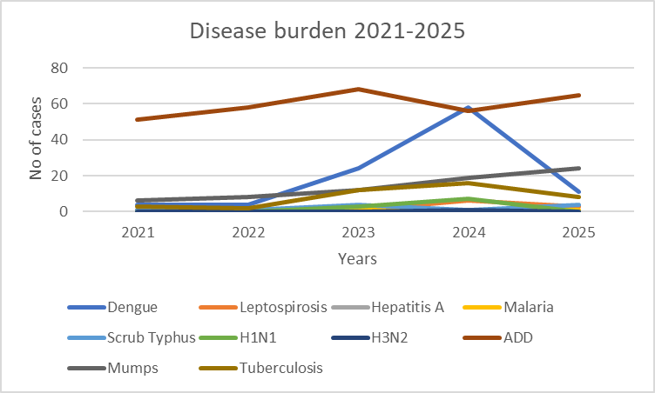

The line graph illustrates the trend of major communicable diseases over a five-year period from 2021 to 2025. Among the diseases, Acute Diarrheal Disease (ADD) consistently shows the highest burden, with fluctuations but remaining elevated throughout the period, indicating its persistent public health significance.
Dengue demonstrates a sharp increase from 2022 to 2024, reaching a peak in 2024, followed by a noticeable decline in 2025, suggesting possible improvement in vector control measures or seasonal variation. Leptospirosis and Scrub Typhus exhibit fluctuating trends, with intermittent rises indicating sporadic outbreaks and environmental influences.
Mumps shows a steady increasing trend over the years, highlighting a potential gap in immunization coverage or outbreak clustering. Tuberculosis displays variability with a peak in 2024 followed by a decline in 2025, which may reflect improved detection and treatment efforts.
Diseases such as Hepatitis A, Malaria, and H1N1 remain low or stable, while several others (Measles, Hepatitis B, Hepatitis C, Typhoid, COVID-19) report no cases during the period, indicating effective control or absence of outbreaks.
Overall, the graph indicates a mix of fluctuating and emerging trends, with a few diseases showing increasing patterns that require targeted surveillance and intervention.

Seasonal Trend Analysis
Seasonal analysis helps anticipate surges (e.g. dengue in monsoon, leptospirosis after floods, influenza in cooler months) and plan pre‑emptive vector control, stockpiling of IV fluids, and awareness campaigns at Panchayat level.

DENGUE
Dengue is a major seasonal vector-borne disease strongly associated with rainfall, water stagnation, and increased mosquito breeding during the monsoon period.

Peak: July–November

Dengue – Ward-wise Yearly Distribution (2021–2025)

Ward | Dengue – Ward-wise Yearly Distribution
Ward | 2021 | 2022 | 2023 | 2024 | 2025 | Total
1 | 0 | 0 | 1 | 2 | 0 | 3
2 | 2 | 1 | 4 | 4 | 0 | 11
3 | 0 | 0 | 1 | 3 | 1 | 5
4 | 1 | 0 | 0 | 1 | 0 | 2
5 | 0 | 1 | 5 | 7 | 2 | 15
6 | 0 | 0 | 6 | 4 | 0 | 10
7 | 0 | 0 | 0 | 1 | 0 | 1
8 | 0 | 0 | 2 | 2 | 1 | 5
9 | 1 | 2 | 0 | 4 | 1 | 8
10 | 0 | 0 | 1 | 5 | 2 | 8
11 | 0 | 0 | 1 | 3 | 0 | 4
12 | 0 | 0 | 1 | 6 | 1 | 8
13 | 0 | 0 | 1 | 1 | 0 | 2
14 | 0 | 0 | 0 | 3 | 1 | 4
15 | 0 | 0 | 1 | 2 | 0 | 3
16 | 0 | 0 | 2 | 3 | 1 | 6
17 | 0 | 0 | 3 | 2 | 0 | 5
18 | 0 | 0 | 2 | 0 | 1 | 3

LEPTOSPIROSIS
Leptospirosis cases are closely linked to monsoon rains, flooding, and occupational exposure, particularly in low-lying and waterlogged areas.

Peak: June - August

Leptospirosis – Ward-wise Yearly Distribution (2021–2025)

Ward | Leptospirosis – Ward-wise Yearly Distribution
Ward | 2021 | 2022 | 2023 | 2024 | 2025 | Total
1 | 1 | 0 | 1 | 1 | 0 | 3
9 | 0 | 0 | 0 | 1 | 1 | 2
8 | 0 | 0 | 0 | 2 | 1 | 3
The following ward no 2,3,4,5,6,7,10,11,12,13,14,15,16,17,18 don’t have any leptospirosis case reported during the year 2021-2025.

VIRAL HEPATITIS - A

Hepatitis A cases are commonly associated with unsafe drinking water, food contamination, and breakdowns in sanitation, often presenting as clusters or outbreaks.

Peak: October - December

Hepatitis A – Ward-wise Yearly Distribution (2021–2025)

Ward | Hep A – Ward-wise Yearly Distribution
Ward | 2021 | 2022 | 2023 | 2024 | 2025 | Total
1 | 1 | 0 | 0 | 0 | 0 | 2
2 | 0 | 0 | 0 | 0 | 0 | 0
3 | 1 | 0 | 0 | 0 | 0 | 1
4 | 0 | 0 | 0 | 0 | 0 | 0
5 | 0 | 0 | 0 | 0 | 0 | 0
6 | 0 | 0 | 0 | 0 | 0 | 0
7 | 0 | 0 | 0 | 0 | 0 | 0
8 | 0 | 0 | 0 | 0 | 0 | 0
9 | 0 | 0 | 0 | 0 | 0 | 0
10 | 0 | 0 | 0 | 0 | 0 | 0
11 | 0 | 0 | 0 | 0 | 0 | 0
12 | 0 | 0 | 0 | 0 | 0 | 0
13 | 0 | 0 | 0 | 0 | 0 | 0

The graph shows the disease trend over the last 5 years for Dengue, Leptospirosis (Lepto), and Hepatitis A (Hep A), across 18 wards.
The analysis of reported cases across the 18 wards indicates that Dengue was the most frequently reported disease, while Leptospirosis and Hepatitis A were reported in only a few wards.
Dengue:
Dengue cases were reported in all 18 wards, indicating widespread occurrence throughout the area. The number of cases varied considerably between wards, ranging from 1 case in Ward 7 to 15 cases in Ward 5. Higher case loads were observed in Ward 5 (15 cases), Ward 2 (11 cases), and Ward 6 (10 cases), suggesting possible clustering or higher transmission risk in these locations. Several wards reported moderate numbers of cases (5–8 cases), indicating a consistent presence of dengue across the region.
Leptospirosis:
Leptospirosis cases were limited to only three wards. Ward 1 and Ward 8 reported the highest number (3 cases each), while Ward 9 reported 2 cases. All other wards reported no leptospirosis cases, suggesting a localized distribution rather than widespread transmission.
Hepatitis A:
Hepatitis A cases were very few and sporadic, with only two wards reporting cases. Ward 1 and Ward 3 each reported 1 case, while the remaining wards reported none. This indicates minimal occurrence without any clear clustering pattern.
Overall, dengue represents the predominant communicable disease burden across wards, showing widespread distribution with varying intensity. In contrast, leptospirosis and hepatitis A appear to be sporadic and geographically limited, affecting only a small number of wards.

Outcome-Based Trend Analysis- 2025
The outcome-based trend analysis for 2025 indicates a largely controlled infectious disease situation with a few areas needing attention. Several diseases show low or declining case numbers in 2025, such as Dengue, which decreased significantly from 58 cases in 2024 to 11 in 2025, and H1N1, which dropped from 7 cases to 0, suggesting effective outbreak control and preventive measures. Leptospirosis also declined from 6 to 3 cases, while Tuberculosis reduced from 16 to 8 cases, indicating improvement in disease management and treatment outcomes.
However, some diseases continue to show fluctuating or increasing patterns. Scrub Typhus increased again from 1 case in 2024 to 4 in 2025, reflecting an inconsistent but upward tendency, and ADD remains a high-burden condition with 65 cases in 2025 compared to 56 in 2024. Mumps shows a steady rise over the years, reaching 24 cases in 2025 from 19 in 2024, indicating a continuous increasing trend and possible gaps in immunization coverage. Meanwhile, several diseases such as Typhoid, Measles, Hepatitis B, Hepatitis C, Leprosy, and COVID-19 reported zero cases throughout, reflecting strong control or absence of transmission. Overall, the 2025 outcome suggests that while most epidemic-prone diseases are well controlled or declining, the persistence of fluctuating diseases and the steady increase in Mumps and high ADD burden highlight the need for sustained surveillance, immunization strengthening, and targeted public health interventions.

Transmission Trend- 2025
For effective management of public health issues, it is important to track the trend of disease transmission mode. It helps identify the population or place at high risk that can be used to predict outbreaks and implement targeted interventions as quickly as possible. Understanding these kinds of trends enables authorities to allocate resources efficiently and change the strategies adequately based on the trend that follows.

Mode of Transmission | No. of cases | No. of Deaths
Vector Borne Diseases | 17 | 0
Water Borne Diseases | 6 | 0
Air Borne Diseases | 10 | 0
Blood Borne Diseases | 0 | 0
Food Borne Diseases | 0 | 0

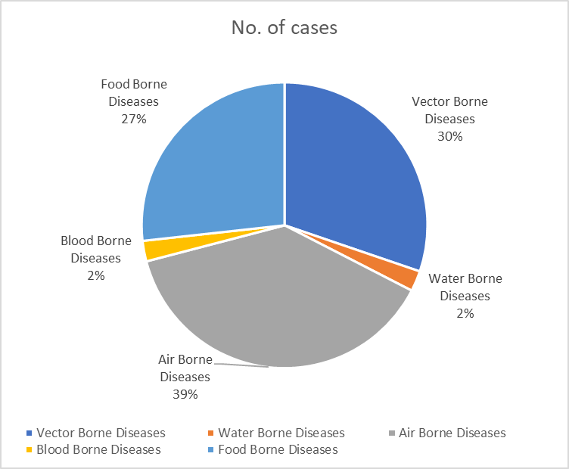

The pie chart illustrates the distribution of communicable diseases by mode of transmission in 2025. A total of 86 cases were reported across different transmission categories.
Air-borne diseases accounted for the largest proportion, with 33 cases (38.4%), indicating that respiratory transmission remains the most significant contributor to the communicable disease burden in the area.
Vector-borne diseases were the second most common, with 26 cases (30.2%), reflecting the continued presence of vector-related illnesses such as mosquito-borne diseases in the community.
Food-borne diseases constituted 23 cases (26.7%), representing a considerable share of cases and highlighting the importance of food hygiene and safety practices.
In contrast, water-borne diseases and blood-borne diseases each accounted for only 2 cases (2.3%), indicating relatively low occurrence during the reporting period.
Key Observation
Overall, the disease pattern shows that air-borne, vector-borne, and food-borne diseases together constitute the majority of communicable disease cases, while water-borne and blood-borne diseases contribute only a small proportion of the total disease burden in 2025.

Vector-Borne Disease

Disease | No. of Cases | No. of Deaths
Dengue | 11 | 0
Malaria | 1 | 0
Chikungunya | 0 | 0

Water Borne Disease

Disease | No. of Cases | No. of Deaths
Cholera | 0 | 0
Typhoid | 0 | 0
Hep- A | 0 | 0
Dysentery | 0 | 0
Amoebiasis | 0 | 0
E- Coli infections | 0 | 0

Air Borne Disease

Disease | No. of Cases | No. of Deaths
Influenza | 0 | 0
H1N1 |  | 0
TB | 8 | 0
Chickenpox | 3 | 0
Measles | 0 | 0
Covid-19 | 0 | 0
Pertussis | 0 | 0
Mumps | 0 | 0

Blood-Borne Disease

Disease | No. of Cases | No. of Deaths
AIDS | 0 | 0
Hep- B | 0 | 0
Hep- C | 0 | 0

Zoonotic Disease

Disease | No. of Cases | No. of Deaths
Rabies | 0 | 0
Leptospirosis | 3 | 0
Avian influenza | 0 | 0
West nile | 0 | 0
Anthrax | 0 | 0
Nipah | 0 | 0
Scrub Typhus | 4 | 0

Integrated Disease Hotspot Map (2021–2025)
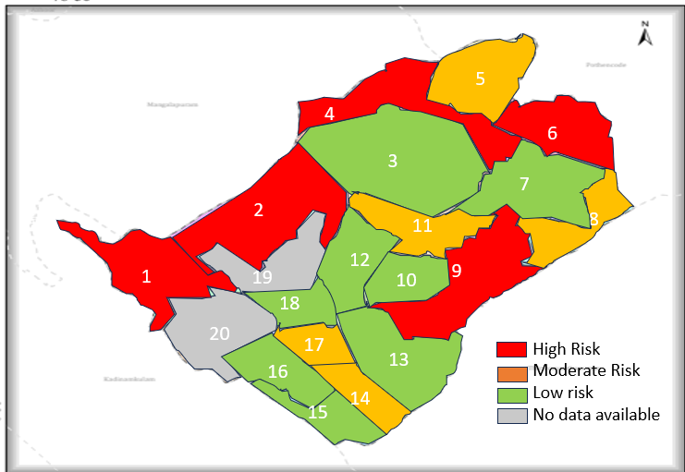

🔴 High Hotspot (≥23 cases)- These wards contribute the highest disease burden and should be priority areas for intervention.
Ward: 1, 2, 4, 6, 9
🟠 Medium Hotspot (10–22 cases)- Moderate disease occurrence; require routine surveillance and preventive measures.
Ward: 5, 8, 11, 14, 17
🟡 Low Hotspot (<10 cases)- Relatively lower disease occurrence but still require continued monitoring.
Ward: 3, 7, 10, 12, 13, 15, 16, 18
Grey -Newly formed wards (post-delimitation); risk classification not directly comparable with previous data
- The integrated hotspot analysis (2021–2025) based on cumulative cases of Dengue, Leptospirosis, Hepatitis A, Mumps, and Acute Diarrhoeal Disease shows five wards (1, 2, 4, 6, and 9) as high-burden hotspots.
- Five wards fall under the medium hotspot category, indicating moderate disease occurrence.
- The remaining wards show relatively lower disease burden, though continued surveillance is essential to prevent outbreaks.
- The clustering suggests that targeted public health interventions in high-risk wards could significantly reduce the overall disease burden in the panchayat.
Ward No | Dengue Total (2021-25) | Leptospirosis Total (2021-25) | Hepatitis A Total (2021-25) | Mumps (2021-25) | ADD (2021-25) | Total Cases
1 | 3 | 4 | 0 | 3 | 20 | 30
2 | 11 | 0 | 0 | 2 | 12 | 25
3 | 5 | 0 | 0 | 0 | 2 | 7
4 | 2 | 0 | 0 | 0 | 22 | 24
5 | 15 | 0 | 1 | 0 | 6 | 22
6 | 10 | 0 | 0 | 0 | 17 | 27
7 | 1 | 0 | 0 | 0 | 2 | 3
8 | 5 | 1 | 2 | 4 | 2 | 14
9 | 8 | 1 | 0 | 2 | 12 | 23
10 | 8 | 1 | 0 | 0 | 0 | 9
11 | 4 | 0 | 0 | 0 | 12 | 16
12 | 8 | 0 | 0 | 0 | 0 | 8
13 | 2 | 1 | 0 | 0 | 2 | 5
14 | 4 | 0 | 0 | 0 | 6 | 10
15 | 3 | 0 | 0 | 0 | 4 | 7
16 | 6 | 0 | 0 | 0 | 2 | 8
17 | 5 | 0 | 0 | 0 | 5 | 10
18 | 3 | 0 | 0 | 0 | 6 | 9

By overlaying five years of data, we have identified.ward 1 as.'Red Zone' Wards. These are wards where at least two different categories of diseases (e.g., Dengue and Lepto) recurred in consecutive years. Ward 2,4,6,9 is categorized as the Highest Priority Hotspot due to its combination of flood vulnerability and high vector density. Future health infrastructure, such as the proposed R.O plants at Andoorkonam should be prioritized.

Preparedness and Response Protocol at LSG Level
This section describes the operational framework for the LSGI once a pandemic is declared. It explains how the LSGI and health system will move from routine data collection to active response, using a One Health approach.

PREPAREDNESS PROTOCOL (PRE-OUTBREAK)

Focuses on strengthening the "First Line of Défense" based on the identified vulnerabilities of the 7,090 elderly residents and 98 bedbound patients.
- Risk Categorization: Establish ward-level risk profiles using the 2025 data, prioritizing Ward 5,1 (Dengue/Lepto/TB hotspot) and Wards 2.4,6, and 9.
- Resource Mapping: Update the "Vulnerability Register" for the 25 dialysis patients and ensure transport agreements with the 1 private hospital.
- Environmental Sanitation: Conduct mass well-chlorination drives for all 911 wells and 250 ponds, specifically targeting the surge in Acute Diarrheal Disease (ADD) seen in 2025.
- One Health Surveillance: Veterinary wing to monitor the 3,622 birds and 859 animals for zoonotic indicators, feeding data to the 1 Government Hospital.

RESPONSE PROTOCOL (DURING OUTBREAK)

Activated immediately upon the detection of a cluster.
A. Command & Coordination
- Rapid Response Team (RRT): Activation of the RRT led by the Medical Officer and Panchayat Secretary.
- Communication Hub: Utilization of the 30 Anganwadi workers and 9 One Health Mentors for real-time community messaging.
B. Field Operations
- Containment: If a ward (like Ward 2) becomes a hotspot, seal entry points if necessary for strict quarantine
- Contact Tracing: ASHA workers to initiate trace-and-test protocols for Tuberculosis and Dengue clusters.
- Facility Management: Convert identified 5 schools or 4 auditoriums into First Line Treatment Centres (CFLTCs) as required.

POST-OUTBREAK PROTOCOL (RECOVERY)

- Impact Assessment: Analyze why cases spiked and identify specific well-contamination points.
- Continuity of Care: Ensure the 122 bedbound patients and 246 palliative care patients resume regular home-visits that may have been disrupted.
- Financial Review: Audit the utilization of local funds and emigrant remittances used for community kitchens or medical supplies.

Constitution of One Health Committee
The LSGD shall constitute a One Health Committee comprising the LSGI President, Medical Officers (Modern Medicine, AYUSH, and Veterinary), the Health Inspector, and the Veterinary Surgeon.

Objective: The One Health Committee coordinates human, animal, and environmental health to prevent and control pandemics.

Sl No | Name | Designation | Department/Institution | Role in Committee | Contact Number
1 | Archana | Panchayat President | LSGD | Chairperson | 9447734879
2 | Dr.Elizabeth Cheeran | Medical Officer (PHC/CHC) | Health Dept | Member Secretary | 9446467090
3 | John | Veterinary Officer | Animal Husbandry | Member | 8086361900
4 | Jessy | Epidemiologist | Health Dept | Member | 9995215778
5 | Biju | Health Inspector/PHN | Health Dept | Surveillance | 9747343758
6 | Thressa | ASHA Supervisor | Health Dept | Community link | 9061421293
7 | Biju | ICDS Supervisor | Social Welfare | Vulnerable groups | 9747343758
8 | SHO | Police Station Officer | Police Dept | Law & order | 04712716100
9 | Shaji | Ward Councillor Representative | LSGD | Community coordination | 9497468245
10 | Beena subash | Kudumbashree CDO | Kudumbashree | Community mobilisation | 9745179217
11 | Afsal | NGO/Volunteer rep | Civil Society | Support services | 940027876
12 | Nijath | Line Department representations | Civil society | Support services | 9746145252

Key Responsibilities:
- Review disease surveillance data (human + animal)
- Conduct ward-wise risk assessment and vulnerability mapping
- Approve quarantine/isolation centre locations
- Coordinate with district for resources (PPE, oxygen, ambulances)
- Periodically review health system surge capacity, including beds, oxygen, human resources, and ambulances.
- Approve and monitor risk communication and community engagement strategies, including rumour management.
- Ensure protection and service continuity for vulnerable groups (elderly, persons with disabilities, dialysis patients, coastal populations).
- Conduct quarterly mock drills
- Monitor equity measures for vulnerable groups

Meeting Schedule:
Quarterly (normal times) | Weekly (outbreak alert) | Daily (pandemic phase)

Pandemic Response Workforce
To ensure a coordinated and timely response during a pandemic, a dedicated Pandemic Response Workforce shall be constituted at the LSG level. The workforce will function under the overall supervision of the One Health Committee and in close coordination with the health authorities. Team-based deployment will enable efficient surveillance, case management, quarantine and isolation management, logistics support, and risk communication. Each team shall have a clearly designated team leader, defined roles, and an identified pool of personnel to allow rapid activation, rotation of duties, and continuity of services during prolonged emergencies.

Total Response Workforce Available: 300 persons

Team Name | Composition | Key Responsibilities | Team Leader
Surveillance and Contact Tracing Team | HI, JHI, JPHN, ASHAs and Volunteers | Case detection, contact listing, home visits, reporting | HI
Case Management Team | Doctors, Nurses, MLSP, Palliative Nurses | Patient care & referral | DOCTOR
Quarantine & Isolation Team | LSGD staff, Volunteers | Facility management | JHI
Psychosocial support | ASHA,MLSP,JHPN | Social psychological medical support | HI
Logistics & supply chain Team | LSGD staff, Storekeepers, Drivers 3 | Supplies & transport [PPE, medicines, oxygen, transport, waste management] | Ward Member
Communication Team | Ward members, Kudumbashree, Youth clubs,  AWW workers and other self-help groups | IEC, community meetings, countering misinformation | M.O in charge
Transportation | KSRTC, educational institutional buses | Transportation | Station master
Media Surveillance | Panchayath LSGD | Social medias | President
Intersectoral coordination and convergence | LSGD | Coordination among all departments | President
Collaborative surveillance | Veterinary Doctor | Animal Care | Doctor

All teams shall be activated immediately upon outbreak alert or pandemic declaration and shall report daily to the LSG Incident Commander/Medical Officer, with consolidated reporting to the Block PHC. Duty rosters and alternate personnel shall be maintained to ensure uninterrupted services during staff shortages or prolonged response periods. Team composition and numbers may be revised based on the magnitude of the outbreak and availability of human resources.

Activities and Measures before and during Pandemic

PHASE 1 - Alert / Preparation
Surveillance and Reporting-Enhanced syndromic surveillance:
- Data sources for surveillance:
- Routine surveillance data from health institutions including PHCs, subcentres, private hospitals, and laboratories.
- Reports from field-level health workers such as ASHAs, JPHNs, and Anganwadi workers.
- Data from allied sectors including water supply, sanitation, veterinary services, and local self-government records.
- Event-based triggers (to be monitored and reported):
- Sudden increase or clustering of fever, diarrhoeal diseases, respiratory illness, or unusual symptoms in the community.
- Occurrence of deaths due to unknown causes or unusual severity of common diseases.
- Reports of outbreaks, mass absenteeism (schools/workplaces), or unusual animal deaths.

- Zoonotic and animal health surveillance
- Regular monitoring of animal health status in coordination with the veterinary department.
- Reporting of unusual illness or deaths among domestic animals, poultry, and stray animals.
- Strengthening intersectoral coordination (One Health approach) for early detection and control of zoonotic diseases.

- Logistics and Stock Preparedness
  - Identify and empanel local vendors and define emergency procurement mechanisms in accordance with existing LSGD and Health Department norms.
  - Prepare and maintain an essential logistics checklist covering medical supplies, consumables, and support equipment.
  - Pre-identify secure storage locations for emergency stocks and ensure maintenance of stock registers with regular updating.
  - Finalise emergency transport arrangements, including availability of vehicles and identified drivers for rapid deployment during alerts.
  - Designate a Nodal Officer for Logistics to enable prompt decision-making, coordination, and communication during emergencies.
  - Conduct rapid stock verification and ensure availability of minimum buffer stock, including:
- PPE kits | - 0 numbers
- Pulse oximeter | - 2 numbers
- Hand sanitizers | - 10 litres
- Masks | - 700 nos
- Disinfectants | - adequate quantity
- Gloves | - 600 nos

Identify critical gaps in logistics and immediately communicate requirements to the Block and District authorities for timely replenishment and support. Monitor expiry dates and stock rotation.

Identification of Quarantine and Isolation Facilities
  - Identify and list suitable buildings for quarantine and isolation (schools, hostels, community halls, etc.).
  - Categorise cases as per the severity and allocate to appropriate facilities (for instance, severe cases to classrooms, mild cases to an assembly hall in case of a school).
  - Facility readiness checklist needed (beds, toilets, ventilation) etc.
  - Find an alternate site if the primary sites are not available or not in use.
  - Identify facility managers and support staff
  - Prepare basic SOPs for:
    - Admission and discharge
    - Food, water, sanitation
    - Infection prevention and waste disposal
  - Ensure availability of basic amenities: water, sanitation, electricity, ventilation, and waste disposal. Prepare a rapid activation plan for these facilities if case numbers increase.

Risk Communication and Community Preparedness
  - Disseminate early warning messages on symptoms, preventive measures, and reporting mechanisms. Display IEC materials both in English and the local language in public places and ensure ward-level awareness.
  - Sensitize elected representatives and community leaders on preparedness measures.
  - Establish a rumour tracking and misinformation response mechanism to identify, verify, and promptly counter false or misleading information.
  - Engage trusted local persons (ward members, ASHA workers, religious leaders, teachers, community volunteers) to communicate official public health messages and reinforce correct practices.
  - Develop and deploy targeted IEC materials for:
    - Schools and educational institutions
    - Markets and commercial areas
    - Work sites and labour settings
  - Conduct community sensitization meetings at the ward level to promote preventive behaviours, address concerns, and strengthen community participation in preparedness and response.

Protection of Vulnerable Groups
Vulnerable populations require priority protection through targeted line-listing, service continuity, and delivery mechanisms.
- Prepare and regularly update line-lists of vulnerable populations, including:
  - Elderly persons living alone
  - Persons with disabilities
  - Pregnant women
  - Migrant workers
  - Dialysis patients
The detailed line-lists shall be maintained as Annexure and updated periodically.

Clinical Dependency Mapping
Develop ward-wise dependency and vulnerability maps to identify households requiring regular support during emergencies. Ensure continuity of essential health services for vulnerable groups, including
- Dialysis services (facility mapping, transport arrangements, and scheduling)
- Continuity of treatment for TB, HIV, and other chronic conditions requiring uninterrupted medication
- Mental health and psychosocial support services
Establish delivery mechanisms for food, essential commodities, and medicines to vulnerable households through coordinated action involving ASHAs, JPHNs, Kudumbashree, volunteers, and local administration.

PHASE 2 - Active Response

Case Identification and Contact Tracing
Case detection and contact tracing activities will be carried out in coordination with the Health authorities, following disease-specific SOPs and IDSP guidelines.
Field Staff Involved
- Health Inspector (HI)
- Junior Health Inspector (JHI)
- Junior Public Health Nurse (JPHN)
- ASHAs and ASHA Supervisors
- Ward-level volunteers and Kudumbashree members (as required)

Screening Checkpoints
Screening checkpoints at high-traffic locations (transport hubs, markets, religious gatherings) for early detection of symptomatic travellers and crowd screening during outbreaks. Potential locations include bus stands, market entry points, and boat jetties, based on local context and risk assessment.
Screening activities will be carried out by trained personnel such as ASHAs, ward members, and volunteers, with support from Health Department staff. Necessary equipment, including non-contact thermometers and appropriate PPE, shall be ensured prior to activation.

Location | Type (Bus stand/Jetty/Market/Railway) | Staff Deployed (ASHAs/Volunteers) | Screening Method | Reporting authority
Bus stand | Transport hub | One JHI  One ASHA  One health Mentors | 1.Swab Collection.  2. Blood smears collection (RDT)  3.Thermal Scanners | Surveillance Nodal Officer in control room
Market entry | Market | One JHI  One ASHA  Male health volunteers | 1.Swab Collection.  2. Blood smears collection (RDT)  3.Thermal Scanners | Surveillance Nodal Officer in control room
Boat jetty | Water transport | One JHI  One ASHA  Male health volunteers | 1.Swab Collection.  2. Blood smears collection (RDT)  3.Thermal Scanners | Surveillance Nodal Officer in control room

Standard Screening Protocol

The screening protocol shall include temperature screening, observation for visible symptoms, and inquiry regarding recent travel or exposure history. Individuals identified as suspects during screening shall be immediately referred to the nearest PHC/FHC for further evaluation, testing, and appropriate action as per prevailing guidelines.

Pandemic Control Room
The Pandemic Control Room (PCR) serves as the central nerve center for real-time coordination, data aggregation, decision support, and communication during outbreaks. It consolidates information from all LSGD teams, health facilities and community sources to enable rapid response decisions.

Control Room Infrastructure and Location
Primary Location: Andoorkonam Panchayath Office.
The Panchayath Office functions as the main Pandemic Control Room (PCR), serving as the central hub for coordination, monitoring, and decision-making. It houses core response teams, data management units, and communication systems. Being centrally located within the Panchayath ensures accessibility and administrative control. All emergency planning, review meetings, and reporting mechanisms are coordinated from this site.

Backup Location: Community Hall in AndoorkonamG.P.
The Community Hall serves as an alternate control room during contingencies such as infrastructure failure or surge situations. It is equipped to accommodate extended teams and emergency operations. This ensures uninterrupted functioning of pandemic response activities. The backup facility strengthens resilience and continuity planning within the health emergency framework.

Health System Control Room Framework
The PCR is organized into seven functional pillars to ensure no aspect of the response is overlooked:

Rapid Response Team (RRT)
  - Provides immediate intervention during emergencies, clusters, and field alerts.​
  - Coordinates urgent actions such as case investigation, contact tracing, isolation, and inter‑facility referrals.

Data Management & Analytics Team
  - Collects, validates, and manages key health system indicators (cases, tests, beds, HR, supplies).​
  - Analyses data trends, generates projections, and supports evidence‑based decision‑making for local authorities.

Human Resource Deployment Team
  - Allocates healthcare staff efficiently based on workload and need
  - Ensures adequate and equitable workforce distribution across facilities

Laboratory Surveillance Team
  - Oversees diagnostic testing coordination, sample transport, and timely reporting of results.​
  - Monitors lab indicators (testing volume, positivity rate, turnaround time) for early detection of outbreaks

Vaccination Cell (If Required)
  - Plans and executes vaccination campaigns, including micro‑planning and session scheduling.​
  - Tracks coverage, identifies gaps, and coordinates corrective actions with field teams and outreach services.

Infrastructure & Patient Occupancy Team
  - Monitors facility capacity, earmarked beds, oxygen and critical care resources across all linked facilities.​
  - Ensures optimal patient distribution and referral management using updated bed‑status and resource data.

- BMWM
The BMWM team ensures safe segregation, collection, transportation, and disposal of biomedical waste as per regulatory norms. It monitors compliance in all healthcare facilities and temporary care centers. Proper waste management reduces environmental contamination and infection risk. Training and supervision are integral components of this pillar.

Communication team

The Communication Team manages public information dissemination, awareness campaigns, and official advisories. It ensures transparent and accurate messaging to prevent misinformation and panic. Regular updates are shared through local media, social platforms, and community networks. Effective communication builds public trust and cooperation.
- Logistics and supply chain
This team manages procurement, storage, and distribution of essential supplies such as PPE, medicines, oxygen, and equipment. It monitors stock levels and prevents shortages through advance planning. Efficient supply chain management ensures uninterrupted healthcare delivery. Coordination with district authorities strengthens resource mobilization.
- Transportation (interfacility & emergency transport)
The transportation unit coordinates ambulance services and patient transfers between facilities. It ensures timely referral transport for critical cases. The team maintains vehicle readiness and communication with hospitals. Efficient transport systems reduce treatment delays and improve survival outcomes
- Media surveillance Call centre
This unit monitors media reports and social media trends for outbreak signals or misinformation. The call centre addresses public queries, complaints, and emergency support requests. It provides guidance on testing, treatment, and vaccination services. Active surveillance improves community engagement and responsiveness.
- Management of the deceased
This team ensures dignified and safe handling of deceased persons as per public health guidelines. It coordinates documentation, transport, and support to families. Infection prevention protocols are strictly followed. Proper management upholds public health safety and humanitarian values.
- Intersectoral coordination and convergence
This pillar ensures collaboration among health, local self-government, police, education, social welfare, and other departments. Regular coordination meetings align strategies and share responsibilities. Convergence enhances resource utilization and community outreach. Integrated action strengthens the overall pandemic preparedness and response system.

Key Control Room Team
The Control Room Team coordinates all pandemic response activities within the LSGD and serves as the single command and communication hub during activation. It integrates information, field actions, logistics, and policy execution across all participating departments and health facilities.

Role | Name | Designation | Contact Number | Responsibility
In-charge/Nodal Officer | Dawn | Nodal officer | 97454012421 | Overall coordination, decision-making, and reporting to the District level.
Data Entry Operator | Shabana | Clerk | 9947841378 | Managing the line list, updating dashboards, and tracking testing results.
Communication Officer | Dawn | Nodel  officer | 97454012421 | Handling the public helpline, coordinating ambulance dispatch, and contact tracing calls.
Logistics Coordinator | Geetha | AN | 9495408152 | Helping the movement of Logistics items.
Technical Support (IT/Data) | Unnais | IT | 9746024132 | Provide Technical support

SOP for alert escalation/trigger point with mapping of responsibilities.
Key Points:
- The Control Room shall be staffed with a designated In-charge, data entry personnel, and communication staff with clearly defined roles and shift arrangements.
- It shall maintain updated records on daily monitoring indicators including new cases, persons under active quarantine, and hospital bed occupancy.
- All reports and situation updates shall be shared daily with the Block and District Surveillance Unit.
- The Control Room shall act as a single point of contact for coordination with response teams, health institutions, and other departments.
- Contact details of the Control Room shall be widely communicated to field staff and stakeholders during activation.

Daily Monitoring Indicators
To ensure timely decision-making and effective response, the following key indicators shall be monitored and updated on a daily basis by the Pandemic Control Room:

Epidemiological Indicators:
New cases reported today, Total active cases, Test Positivity Rate (TPR), Case Fatality Rate (CFR)
- Surveillance Indicators:
Persons under home quarantine, High-risk contacts identified, Fever, ILI, SARI or other symptoms (syndromic surges), Travellers (symptomatic or high-risk arrivals),Animal husbandry surveillance (zoonotic alerts, unusual animal deaths, poultry/bird flu signals), Mortality surveillance (excess deaths, unexplained fatalities, verbal autopsy reports)
- Logistics and Infrastructure Indicators:
Hospital / CFLTC beds occupied, Oxygen cylinders/concentrators available, Ambulances on standby
- Alert Findings
The following table outlines category-specific trigger points (red flags) from surveillance indicators and corresponding immediate actions for the Pandemic Control Room. These enable rapid response to alert findings like testing anomalies, positive cases exceeding thresholds, clusters, and WGS reports.

Category | Trigger Pop hint (Red Flag) | Immediate Action
Clusters | Geographical or facility-based: 5+ cases linked to one location (office, school, street). | Declare a micro-containment zone; perimeter control and active case finding.
Testing | Sudden drop in testing volume / delay in reporting / unusual testing trends | Review the sample collection process, address lab bottlenecks, deploy additional testing teams, and notify the District Lab.
Lab | Test Positivity rate increases | Increase testing sites in that ward.
Hospital | >80% Oxygen bed occupancy | Activate backup/CFLTC beds.
Travel | Cluster of cases from a single flight/train or high-risk arrival group. | Trace all passengers in adjacent seats; implement mandatory institutional quarantine.
Animal | Mass poultry/wildlife death or unusual sickness | Notify Animal Husbandry, sample the area, and dispatch RRT for environmental sampling and zoonotic check.
Mortality | Sudden spike in home deaths or brought-in-dead (BID) cases | Audit the deaths and Active Case Search drive
Additional investigations like Whole Genome Sequencing (WGS) | Detection of a Variant of Concern (VOC) or Variant of Interest (VOI) | Implement strict micro-containment; update clinical protocols to match variant severity.

Communication of Public Health Information
A Community Communication Hub shall be established to ensure timely, accurate, and consistent dissemination of information during a pandemic. The Hub will function under the coordination of Nodal officers of the control room and act as the nodal point for public communication, risk messaging, and community engagement. It will support dissemination of official advisories, promote preventive behaviours, address rumours and misinformation, and ensure that messages reach all sections of the population through trusted local channels and leaders.

Key communicators
Channel | Responsible Person | Contact
Ward-level announcements | ASHA | 9846204691
Social media | Jabu,  Navas | 9895883456  9539066251
Local Cable TV/Radio | Suresh Najeeb | 9895464050

- All messages disseminated through the Hub shall align with advisories issued by the Health Department and District authorities.
- Community leaders shall be sensitized to support behaviour change, reduce stigma, and counter misinformation.
- Special efforts shall be made to reach vulnerable and hard-to-reach populations using locally appropriate communication methods.

Rumour Tracking: A designated volunteer will monitor local social media/WhatsApp groups daily to identify misinformation and issue official clarifications via the Communication Hub.

Coordination with District/State Authorities & Other Organisations
Effective coordination with Block, District, and State authorities is essential to ensure timely reporting, technical guidance, and uninterrupted supply of essential resources during a pandemic. The LSG shall establish clear communication channels, designate responsible officers, and adhere to prescribed reporting timelines to support coordinated public health action and efficient resource mobilisation.

Key Details:
- Nodal Officer for Reporting: MO i/c Dr Elizabeth
- Contact Number: 9446467090
Reporting Schedule and Protocols:

To Whom | What to Report | Frequency | Nodal Person
Block PHC | Complete Situation Report (Cases, Quarantine, Beds, Screening, Deaths) | Once in a month | SNO
District IDSP Unit | Outbreaks/Clusters/Unusual Events (>5 cases same ward) | Weekly | HI
Veterinary Officer | Animal health events/Zoonotic alerts | AN EVENT OCCUR | LI
State Cell | Zoonotic cross-sector events | AN EVENT OCCUR | MO

Supply Chain Coordination
The LSG shall coordinate closely with Block, District, and State authorities (KMSCL) to ensure uninterrupted availability of essential goods, medical supplies, and logistics during a pandemic. Supply requirements shall be assessed regularly based on case load and communicated promptly to the appropriate authorities for timely replenishment.
Key Points:
- Maintain updated contact details of District and Block nodal officers for health logistics, oxygen supply, ambulances, and essential medicines.
- Submit timely indent requests for PPE, testing kits, medicines, oxygen, and other critical supplies through prescribed channels.
- Monitor stock levels at LSGD facilities, quarantine/isolation centres, and field teams through daily stock registers and dispensing logs to prevent shortages.
- Coordinate with District authorities, Karunya /Neethi medical shops, and local purchase committees for funds allocation and emergency procurement.

- Ensure regular monitoring of dispensing registers at all facilities to track usage, expiry, and pilferage—shortages being a perennial issue requiring proactive weekly audits.

- Activate surge procurement protocols during high caseloads, leveraging local purchase powers under LSGD funds alongside state supplies.

Resource Inventory and Contacts

Resource Category | Source  (District/State/Private) | Contact
PPE Kits/Masks/Gloves | KMSCL | 9446902086
Oxygen  Cylinders/Concentrators | KMSCL | 9446902086
Medicines/Antivirals | KMSCL | 9446902086
Test Kits (RTPCR/Rapid) | KMSCL | 9446902086

Collaboration with NGOs, PPP, and CSR
To augment government efforts during a pandemic, the LSG shall collaborate with NGOs, voluntary organisations, and private sector partners through public–private partnerships and Corporate Social Responsibility (CSR) initiatives, in coordination with District authorities.

Key Points:
- Engage NGOs and community-based organisations for community outreach, awareness, and support to vulnerable populations.
- Leverage CSR support for procurement of medical equipment, PPE, oxygen concentrators, food kits, and sanitation materials, as permitted.
- Ensure all collaborations align with government guidelines and are routed through approved administrative and financial procedures.
- Maintain transparency and documentation for all external support received and utilised.

Organization | Type | Support Offered | Contact Person
Youth Clubs/Student Unions | CBO | Volunteering | 9539762307
Youth Clubs/Student Unions | NGO | First Aid | 9400278760

Interdepartmental Coordination
Coordination among departments during a pandemic shall be ensured through regular review meetings convened by the LSGD President. These meetings will provide a structured platform for sharing situational updates, assessing resource availability, resolving operational gaps, and taking joint decisions to ensure a coordinated and timely response.

Department | Representative | Key Role | Contact
Health (CHC) | Staff Nurse | Case management | 9496545190
Veterinary | Veterinary Surgeon | Animal surveillance | 8086361900
ICDS | Supervisor | Nutrition support | 9656940584
Education | Head Teacher | School coordination | 9496368632
Police | SHO | Containment enforcement | 0471 271 6100
Water Authority | Engineer | Water supply | 8547638189
LSGD Engineering | AE | Quarantine infrastructure | 9495121876

PHASE 3 - Surge Capacity
Phase 3 is activated when there is a rapid increase in cases, high test positivity rates, or when existing health facilities and quarantine arrangements approach saturation. The focus of this phase is to expand isolation capacity, augment clinical care services, and mobilise additional resources through district and state support mechanisms.

Conversion of Community Facilities
To manage increased case load, the LSGD shall activate additional isolation facilities by repurposing identified community infrastructure such as community halls, auditoriums, schools, hostels, or other suitable buildings.

Name of facility | Facility Type | No. of Buildings | Ward | Surge Capacity (Beds) | Nodal Person
GLPS Alumoodu | School | 4 | 4 | 100 | HM  0471-2750276
GLPS Karichara | School | 5 | 18 | 120 | HM  9496368632
GLPS  Thiruvaloor | School | 2 | 4 | 80 | HM  8547345053
GUPS  Kaniyapuram | School | 7 | 14 | 300 | HM  9497782525
MBHSS  Kaniyapuram | School | 5 | 12 | 150 | HM  9446495626
Harisree  vetturoad | Theatre | 1 | 12 | 50 | Manager  9847561248
Raha | Auditorium | 1 | 14 | 500 | Manager  9746145252
Chalil  Samskarikanilayam | Hall | 1 | 14 | 50 | 9745450995
Temple Auditorium  Karichara | Auditorium | 1 | 18 | 70 | 9645814130

Recovery and rehabilitation phase

After the peak of the pandemic, recovery measures will focus on restoring normal health and socio-economic conditions across all 20 Panchayat wards.
- Recovery
The recovery phase in Azhoor will focus on restoring routine health services, safely reopening institutions, and stabilising community livelihoods. The recovery phase centres on the protracted endeavour to reconstruct and restore pre-pandemic circumstances. This entails revitalizing healthcare infrastructure, economic systems, and public service provisions. Successful recovery requires meticulous planning, coordinated efforts, and the strategic allocation of resources to facilitate recovery across all sectors. Prioritizing the delivery of essential healthcare, addressing economic challenges, and protecting the well-being of affected communities are of utmost importance.
Priority areas include:
- Restoration of primary healthcare services
- Safe reopening of schools
- Economic stabilization
- Strengthening local health systems
Block-level coordination will be ensured between:
- Panchayaths
- Health Department
- ICDS
- Veterinary Department
- Community organisations
- Damage and Impact Assessment

A thorough assessment of the damage to public health, infrastructure, and the economy is crucial after a pandemic. This evaluation is essential for identifying both immediate and long-term intervention needs. A detailed examination of the harm and its consequences provide vital information for resource allocation, inform policy development, and enable the precise targeting of recovery efforts. Therefore, a thorough situational analysis requires gathering real-time data and working closely with local authorities.
A ward-wise assessment will be conducted across all Panchayaths.
Areas Assessed
- Disease burden
- Deaths
- Livelihood losses
- School disruptions
- Service interruptions
- Vulnerable households
Data Sources
- Health facility records
- Household surveys
- ASHA reports
- Panchayat registers
The findings will guide recovery planning.
- Restoration of Health Services
Rebuilding healthcare infrastructure is crucial for guaranteeing the continued availability of essential medical services after a pandemic. The recovery process requires a step-by-step approach, starting with the most important services. These include emergency care, essential treatments, and vaccination programs. A key part of this restoration involves addressing staff shortages, securing enough medical supplies, and prioritizing the healthcare needs of vulnerable groups. Consequently, a meticulously devised strategy will facilitate the uninterrupted operation of the healthcare system throughout the recovery period.
Priority services to be restored:
- Maternal and child health services
- Immunization
- NCD treatment
- Dialysis support
- TB and HIV treatment
- Emergency care
Outreach services will be strengthened.

- Rehabilitation of Affected Population
The rehabilitation of the affected population constitutes a critical element of the comprehensive recovery strategy. This process involves physical rehabilitation, healthcare evaluations, and social welfare support for those who suffered the most severe pandemic-related repercussions. Moreover, it is essential to address the mental, emotional, and social aspects of those impacted's lives. Therefore, ensuring access to medical services, social support systems, and economic assistance will help restore stability and resilience to the population.
Rehabilitation measures will include:
- Medical follow-up for recovered patients
- Social welfare support
- Food security support
- Livelihood support

Priority Groups:
- Elderly persons
- Daily wage workers
- Migrant workers
- Poor households
- Persons with disabilities
Convergence with Government schemes will be ensured.

- Psychosocial and Mental Health Support
The psychological effects of a pandemic can be significant, underscoring the need to pay closer attention to psychosocial health. Offering mental health resources, such as counselling and psychological therapies, assists individuals in managing the trauma and stress associated with the pandemic. Community-based mental health services and telemedicine can enhance access to mental health resources, especially for those facing isolation or in need of immediate support. Therefore, cultivating mental resilience will contribute to the wider recovery of both individuals and communities. Mental health support will include:
- Counselling services
- Tele-counselling
- Ward-level support
- Awareness programs
Priority Groups:
- Children
- Frontline workers
- Bereaved families
- Isolated elderly persons
- Disease Surveillance
During Recovery Disease surveillance is a vital element of the recovery phase, monitoring potential resurgences or new outbreaks. Continuous monitoring, including testing, contact tracing, and reporting protocols, enables health authorities to identify and manage newly emerging cases swiftly. The fortification of the surveillance system facilitates early detection, the implementation of more effective control measures, and a more streamlined response to prospective new threats. Consequently, maintaining vigilance throughout the recovery period is essential to avert a secondary wave of infection.
Surveillance will continue across the wards
Activities
- Fever surveillance
- Syndromic surveillance
- Animal surveillance
- Mortality monitoring
Field Teams
- ASHA Workers
- JHI
- JPHN
- Health Inspectors
Early detection will prevent resurgence.
- Environmental Cleanup and Sanitation After a pandemic, environmental restoration and sanitation are crucial for keeping public areas safe and clean. Inadequate sanitation can precipitate secondary health crises, such as the spread of waterborne illnesses. Consequently, the orchestration of extensive cleanup initiatives, the enhancement of waste-disposal systems, and the dissemination of hygiene education to the populace will be indispensable for mitigating future health hazards. Furthermore, restoring sanitation systems and ensuring access to clean water are crucial for protecting public health during the recovery phase.
Block-wide sanitation drives will be conducted.
Activities
- Disinfection of public places
- Market sanitation
- Water source cleaning
- Waste removal
- Canal cleaning Safe drinking water supply will be ensured.
- Livelihood Restoration

Rebuilding the economic well-being of individuals and businesses affected by the pandemic is essential for economic recovery. Numerous workers have experienced unemployment or financial distress, while businesses have been forced to close. Providing financial assistance, vocational training, and support for small and medium-sized enterprises will help restore economic stability. Consequently, livelihood restoration initiatives should prioritize support for vulnerable populations and stimulate economic expansion by generating employment opportunities and providing income support mechanisms.
Livelihood restoration will focus on:
- Fisherfolk
- Agricultural workers
- Daily wage workers
- Kudumbashree units
- Small businesses Support Measures
- Employment schemes
- Financial assistance
- Skill training
- Self-employment support
- Community Engagement and Confidence Building
Restoring faith in the recovery process hinges on robust community involvement. Involving communities in decision-making, coupled with transparent communication and the cultivation of local leadership, can foster a sense of support and inclusion. Furthermore, fostering trust through community-based programs and open communication strengthens relationships and encourages adherence to public health guidelines. As a result, building confidence in the recovery process is crucial for promoting collective action and social cohesion.
Community participation will be encouraged through:
- Ward Sabhas
- Volunteer groups
- Kudumbashree units
- Youth clubs
Transparent communication will build trust.
- Documentation and After-Action Review
Documentation and subsequent evaluations provide crucial insights into the pandemic response. Analyzing successes and challenges during the crisis enables health officials and policymakers to improve future preparedness strategies. A comprehensive after-action report facilitates the identification of both advantages and disadvantages, as well as areas requiring improvement, thereby informing the strengthening of future response plans. This assessment is essential for gauging the overall impact and efficacy of recovery initiatives.
A comprehensive report will be prepared covering:
- Actions taken
- Challenges faced
- Outcomes achieved
Review meetings will include:
- Panchayath officials
- Health staff
- Community representatives
- Lessons Learned and Best Practices
The lessons from the pandemic provide crucial insights that can enhance how we prepare for and respond to future crises. Identifying successful strategies and key takeaways from the recovery phase enables enhancements to processes, policies, and protocols for future health emergencies. Sharing these lessons with local, national, and international partners will, in turn, strengthen the global community's ability to respond to subsequent crises. Furthermore, integrating these insights into current health systems and training initiatives will reinforce both resilience and response capabilities.
Key successful strategies will be documented:
- Ward-level coordination
- Volunteer mobilisation
- IEC campaigns
- Surveillance systems
Lessons learned will improve future preparedness.
- Health System Strengthening Strengthening the health system represents a continuous strategy to enhance preparedness for future pandemics. This necessitates allocating resources to healthcare infrastructure, providing training for healthcare professionals, and ensuring essential resources, including medical supplies, vaccines, and therapeutic interventions. A resilient health system is essential for an effective response to both current and future health emergencies. Furthermore, fortifying health systems not only improves pandemic response capabilities but also elevates the overall quality of healthcare delivery for the population.
Post-pandemic strengthening measures:
- Improve infrastructure
- Digital reporting systems
- Staff training
- Stockpile essential supplies
This will improve long-term resilience.
- Policy Revision and Preparedness Enhancement Policy adjustments and preparedness improvements are essential for bolstering the health system's capacity to manage future pandemics. This necessitates revising public health policies, enhancing inter-agency coordination, and aligning legal structures with the demands of swift response initiatives. By incorporating insights from the ongoing pandemic into policy revisions, governments can fortify their readiness for forthcoming crises, thereby strengthening the resilience of health systems, supply chains, and community involvement.
Plans will be updated based on experience.
Actions
- Revise pandemic plans
- Improve coordination mechanisms
- Update SOPs
- Align with State guidelines
- Research
Research is a crucial component in advancing pandemic preparedness and response strategies. In the wake of a pandemic, research endeavours should prioritize elucidating the disease's characteristics, formulating vaccines and therapeutic interventions, and refining diagnostic methodologies. Furthermore, scientific investigations can facilitate the identification of risk factors, the elucidation of transmission patterns, and the development of efficacious intervention strategies. Strengthening response capacities and expediting recovery require collaboration with international research networks, allocating resources to foster innovation, and prioritizing public health research initiatives.
The Block will encourage research on:
- Disease trends
- Vulnerability patterns
- Health service gaps Collaboration
Research findings will support future preparedness.

CONCLUSION
In conclusion, a comprehensive Pandemic Preparedness Plan (PPP) serves as a vital framework to safeguard the health, well-being, and socio-economic stability of the community at all times. By systematically analyzing ward-wise demographic data, identifying high-risk and vulnerable populations such as the elderly, children, migrants, and individuals with chronic illnesses, and strengthening the capacity of Family Health Centres, private clinics, and referral hospitals, the Panchayat can establish a resilient and responsive local health system. Clear referral linkages, uninterrupted essential services, and effective coordination between health institutions ensure that emergencies are managed in a timely and organized manner without overwhelming existing facilities. Pandemic preparedness extends beyond medical treatment and hospital care. It demands strong interdepartmental coordination among health, sanitation, education, social welfare, and local self-government departments. Active community participation, involvement of ASHA workers, Anganwadi staff, volunteers, and ward-level committees, along with robust disease surveillance and early warning systems, play a crucial role in early detection and containment. Well-planned risk communication strategies help prevent misinformation and panic, while continuous training and capacity building of healthcare workers and frontline responders enhance efficiency and confidence.
Special focus on resource mapping, emergency stockpiling of medicines and PPE, ambulance services, isolation facilities, and surge capacity planning ensures equitable access and leaves no segment of the population unattended. Through proactive planning, periodic review meetings, simulation exercises, mock drills, and strong community engagement, the Panchayat can continuously refine and strengthen its preparedness mechanisms. A structured and regularly updated preparedness framework builds public trust, reduces morbidity and mortality, and ensures continuity of essential services even during crises. Ultimately, such a forward-looking and inclusive approach promotes sustainable community resilience, enabling the Panchayat to effectively prevent, detect, respond to, and recover from future pandemics or public health emergencies.

Additional points

- tech support
- relief based commodities
- ham reading operators
- hazard vulnerability mapping
- Kseb & other power source
- HR specific responsibility

RECOMMENDATIONS

Strengthening Healthcare Infrastructure
- Establish a primary health response unit within the Panchayat with trained staff.
- Ensure availability of basic medical supplies (masks, sanitizers, PPE kits, oxygen cylinders).
- Create tie-ups with nearby hospitals like Shifa Hospital for emergency referral and transport.

2. Community Awareness & Education
- Conduct regular awareness campaigns on hygiene, vaccination, and preventive measures.
- Use local communication channels (community radio, WhatsApp groups, notice boards) to spread verified information.
- Train volunteers to act as health ambassadors in each ward.

3. Emergency Response & Coordination
- Form a Pandemic Preparedness Committee at Panchayat level including health workers, ward members, and NGOs.
- Develop a clear action plan for lockdowns, quarantine, and distribution of essentials.
- Maintain a database of vulnerable groups (elderly, differently-abled, chronically ill) for targeted support.

4. Supply Chain & Food Security
- Identify and support local suppliers and farmers to ensure uninterrupted food supply.
- Create community kitchens during emergencies to serve vulnerable populations.
- Stockpile essential commodities in Panchayat-run outlets for crisis periods.

5. Digital Preparedness
- Promote digital platforms for telemedicine consultations.
- Use Panchayat’s website/social media for real-time updates on health advisories.
- Encourage online grievance redressal to reduce crowding in offices.

6. Training & Capacity Building
- Organize mock drills for pandemic response in schools, offices, and public spaces.
- Train Panchayat staff and volunteers in first aid, infection control, and crowd management.
- Collaborate with NGOs and health departments for capacity-building workshops.

7. Long-Term Resilience
- Integrate pandemic preparedness into the Panchayat Development Plan.
- Allocate a dedicated budget for health emergencies.
- Encourage community participation in planning and monitoring preparedness measures.

MOCKDRILL SCENARIOS
Scenario 1:.Influenza-like Illness Cluster in a School
Context: Within a week, several students and teachers develop fever, cough, and sore throat. Absenteeism in the school rises sharply.
Objectives:
- Test early outbreak detection through school health monitoring.
- Assess communication between school authorities and the health department.
- Evaluate implementation of infection prevention measures in the school setting.
Scenario 2: Dengue Surge after Unseasonal Rain
Context: After two weeks of unseasonal rainfall, multiple wards report a sudden increase in fever cases. Health workers identify several suspected dengue cases, and mosquito breeding is observed near construction sites and household water storage containers.
Objectives:
- Test early case reporting from ASHA workers and One Health volunteers to the health institution.
- Assess the coordination between health, sanitation, and LSGI teams for vector source reduction.
- Evaluate community awareness and rapid response for household mosquito control.
Scenario 3: Drinking Water Contamination after Flooding
Context: Following heavy rainfall and flooding, residents report foul-smelling drinking water and multiple cases of gastrointestinal illness.
Objectives:
- Test coordination between health, water authority, and LSGI for water quality assessment.
- Evaluate emergency measures such as chlorination and safe drinking water distribution.
- Assess risk communication to the community on safe water practices.
Scenario 4: Suspected Nipah-like Illness in a Rural Ward
Context: A patient admitted with high fever, headache, and altered sensorium has a history of contact with fruit bats in a farm area. The case raises suspicion of a zoonotic infection.
Objectives:
- Test rapid notification to district surveillance units and higher authorities.
- Evaluate coordination between health, veterinary, and forest departments under the One Health approach.
- Assess preparedness for isolation, contact tracing, and risk communication.

Scenario 5: Post-Flood Leptospirosis Alert
Context: After continuous monsoon rains and waterlogging in several low-lying wards, farmers and sanitation workers report fever with severe body pain. A few suspected leptospirosis cases are detected in the health institution.
Objectives:
- Test early detection and reporting of suspected cases by field health staff and One Health volunteers.
- Assess coordination between health, veterinary, and sanitation departments for risk reduction.
Evaluate distribution of prophylactic doxycycline and public awareness in high-risk wards

ANNEXURE

IMPORTANT PHONE NUMBERS

Phone numbers and particulars of persons responsible for providing guidance, assistance, and support for pandemic preparedness operations may be provided here in a manner that allows easy reference at a glance. The information recorded here could be exhibited elsewhere at the time of emergencies. LSG institutions shall give special attention to collect and record the above data of persons and institutions who/which are supposed to give technical and co-ordination support to reduce the impact of pandemic.

1.1. Details of grama panchayat/municipality/corporation wards
Sl.No | Name of the ward | Ward number | Name of the ward  member | Contact number
1 | Karichara | 1 | Bibin | 8547109198
2 | Velloor | 2 | Jayachandran | 9446558490
3 | Koithoorkonam | 3 | Jumina | 7736886161
4 | Thiruvalloor | 4 | Geetha | 9847757130
5 | Andoorkonam | 5 | Shaji | 9497468245
6 | Keezhavoor | 6 | Priya | 9645498855
7 | Parambilpalam | 7 | Jasi | 9746415919
8 | Pachira | 8 | Rafeek | 9895241412
9 | Pallichaveedu | 9 | Vivek | 9745445642
10 | Kunninakam | 10 | Seena | 9847561248
11 | Kaniyapuram | 11 | Predeep | 9995403025
12 | Alumoodu | 12 | Manimadhu | 7736736679
13 | Thekkevila | 13 | Sham | 9847272161
14 | Valiyaveedu | 14 | Nijath | 9746145252
15 | Pallipuram | 15 | Sham | 9746464150

16 | Kandal | 16 | Noufa | 8848931613
17 | Sreepatham | 17 | lekshmi | 9061528371
18 | Mythani | 18 | Akbar | 9809999912

1.2. Other important phone numbers of grama panchayat/municipality/corporation area
Sl. No. | Name | Contact number
1. | Archana President Andoorkonam | 9447734879
2. | Vipin vice president andoorkonam | 8547109198
3. | Akbar health committee | 9809999912
4. | Excise department | 9400069414
5. | Forest department | 04712416644

1.3. Important offices of grama panchayat/municipality/ corporation
Sl.No | Name of the office | Contact person | Contact number
1. | Village Office | Village Officer | 8547610120
2. | Agriculture Office | Agriculture Officer | 0471-2754022
3. | Animal Husbandry Office | Animal Husbandry Doctor | 8086361900
4. | Police Station | Police Officer | 04712716100
5. | BSNL Office | Officer | 1800 345 1500
6. | Block Office | Officer | 9496040668
7. | KSEB Office | Officer | 9037037373
8. | Fisheries Office | Officer | Nil
9. | Fire and Rescue | Officer | 0471270099

1.4. Health Services

Sl. No | Name of the hospital/institution | Location | Phone number
1. | Government hospitals/CHC | Andoorkonam | 04712751397
2. | Private hospitals | Kaniyapuram | 9846046936
3. | Clinical laboratories | Kaniyapuram | 9778421665
4. | Chemist/pharmacy | Andoorkonam | 9446418922
5. | Blood donors | Pallipuram | 9895385151
6. | Other language experts (Bihari, Hindi, Bengali,  Asamees ………) | Mujeeb | 9656263151

1.5. Veterinary Services
Sl.No | Name of the Clinic | Name of the  Surgeon/Doctor | Place/location | Phone  number
1 | Govt.Veterinary Hospital | Manoj Jhonson | Koithoorkonam | 8086361900

1.6. Helpline numbers
Helpline | Phone number
Police | 04712716100
Fire and Rescue | 0471270099
KSEB | 9037037373

1.7. Public and Private Schools Contact details

S.No | Name of School | Institution type | Phone number
1 | MBHSS Kaniyapuram | Aided | 9495297912
2 | MGHSS Kaniyapuram | Aided | 9633214925
3 | Blue Mount | Private | 9947742518
4 | GLPS Alumoodu | Govt | 9633833484
5 | BPM Karamoodu | Private | 9495963660
6 | Model Public School Pallipuram | Private | 9207913411
7 | Oxford School Kaniyapuram | Private | 9633688242
8 | GLPS Thiruvalloor | Govt | 8891416041
9 | KV Pallipuram | Govt | 8113039092
10 | GLPS Karichara | Govt | 9496368632

1.9. Anganwadi Contact Details

Ward No | Name of Anganwadi Teachers | Phone number
6 | Veena | 9656940584
1 | Sooriya,  Jayalekshmi | 9526974512  9995277450
15 | Binitha kumari | 8089545606
6 | Ajitha Kumari | 9847337167
4 | Sheeja | 7403608438
3 | Sreekala | 9947196485

Ward No | Anganwadi No and Name of Teacher | Phone number
7  8 | - Sheeba | 9895173805
7  8 | 1.lalithambika | 8086338568
18 | Manjusha | 9946690096
16  15 | - Usha | 8136995538
16  15 | Ward 8 Sowmiya | 7075974223
16  15 | 1.Sreedevi | 9846261848
15 | 2.Jayalekshmi | 9645088080
9 | Jaya | 6235886484
9 | Vinitha | 8089545606
5 | Sheeja Beegam | 9995000279

1.12. Information regarding resources

Means of transportation | Name of Owner | Phone Number
Heavy Trucks | Shaji | 9846070357
Tractor | Shibu | 9946865454
Ambulances | CHC Andoorkonam | 7994166616
Boats | Nil | Nil
Taxi service | Azim | 9895256137

Annexure 1: LSG Baseline Data Collection Format
A. Baseline data
Sl. No. | Indicator / Field | Baseline Data | Source / Remarks
1 | Name of LSG | Andoorkonam | Disaster Plan LSGD
2 | District | Thiruvananthapuram | Disaster Plan LSGD
3 | Block / Taluk | Pothencode | Disaster Plan LSGD
4 | Type of LSG (Gram Panchayat / Municipality / Corporation) | Gramapanchayath | Disaster Plan LSGD
5 | Area (sq. km) | 14.24 | Disaster Plan LSGD
6 | No. of wards | 18 | Disaster Plan LSGD
7 | GIS boundary file available | (Yes/No) | Disaster Plan LSGD
8 | Key contact person & phone | President 9447734879 | Disaster Plan LSGD

B. Demography
Indicator / Field | Baseline Data | Source / Remarks
Total population | 30553 | CHC Baseline
Males | 14951 | CHC Baseline
Females | 16442 | CHC Baseline
Transgender population | 0 | CHC Baseline
Age distribution  (<5, 5–14, 15–59, ≥60) | Below 5-1367  Above 60-4278 | CHC Baseline
No. of households | 8505 | CHC Baseline
Population density (persons/sq.km) | 224 | CHC Baseline
No. of migrant workers | 515 | CHC Baseline
Major occupational groups | Construction/farmers | CHC Baseline

C. Vulnerable Populations & Social Risks
Sl. No. | Indicator / Field | Baseline Data (Value / Description) | Source / Remarks
1 | No. of elderly (≥60) | 4278 | CHC Baseline
2 | No. of persons with disability | 133 | CHC Baseline
3 | No. of bedridden persons | 103 | CHC Baseline
4 | No. of chronic disease cases (DM/HTN/COPD/CKD etc.) | DM-1975  HT-2371  CKD-38 | CHC Baseline
5 | Pregnant women (current estimate) | 152 | CHC Baseline
6 | Children <5 years | 1367 | CHC Baseline
7 | Tribal population (if any) | 0 | CHC Baseline
8 | Fisherfolk / coastal vulnerable groups (if any) | 0 | CHC Baseline
9 | Urban slums / unnotified settlements (if any) | 0 | CHC Baseline
10 | Homeless population | 1 | CHC Baseline
11 | Orphanages / old age homes (number & capacity) | 1 | CHC Baseline
12 | Hostels / prisons / shelters (number & capacity) | 2 | CHC Baseline
13 | Poverty / BPL estimate | 3710 | CHC Baseline
14 | Food insecurity hotspots | 5 | CHC Baseline
15 | Any history of stigma/discrimination issues (Yes/No) | 0 | CHC Baseline

D. Health System & Service Readiness
Sl. No. | Indicator / Field | Baseline Data (Value / Description) | Source / Remarks
1 | No. of health facilities in LSG (PHC/CHC/TH/DH/Private) | CHC 1,Private hospital 7. | CHC Baseline
2 | PHC/Family Health Centre details (name, location) | 0 | CHC Baseline
3 | Subcentres / Health & Wellness Centres (number) | 5 | CHC Baseline
4 | Private clinics / hospitals (number) | 13 | CHC Baseline
5 | Labs available (public/private) | 4 | CHC Baseline
6 | Availability of ambulance services (Yes/No, number) | Yes, 2 | CHC Baseline
7 | Availability of isolation/quarantine facilities (Yes/No, details) | Yes | CHC Baseline
8 | Cold chain facilities (Yes/No, details) | Yes | CHC Andoorkonam
9 | Stockpile space available (Yes/No) | Yes | Junk Room
10 | PPE / mask / sanitizer availability plan (Yes/No) | Yes | Pharmacy
11 | Surveillance staff available (JHI/JPHN/ASHA count) | Yes | JHI 3,JPHN 4,ASHA 18.
12 | Existing emergency referral pathways (Yes/No) | Yes | THQ

E. Points of Entry & Mobility
Sl. No. | Indicator / Field | Baseline Data (Value / Description) | Source / Remarks
1 | Bus stands / depots (number) | 1 | Kaniyapuram KSRTC depot
2 | Railway stations (number) | 1 | Kaniyapuram
3 | Boat jetties / fishing harbours (number) | 0 | LSGD Disaster Plan
4 | Ports / airports nearby (specify distance) | 18km | CHC Baseline
5 | Major highways/roads passing through | NH | CHC Baseline
6 | Border crossings (state/district) | No | CHC Baseline
7 | Major markets / weekly markets | 1 | Public Market Kaniyapuram
8 | Tourism hubs / major event venues | 0
9 | Schools/colleges with hostels (number) | 1 | Asian School of Business Pallipuram
10 | Factories / large workplaces (number) | 2 | Tata Construction,Unity Mall Pallipuram.
F. Water, Sanitation & Hygiene (WASH)
Sl. No. | Indicator / Field | Baseline Data (Value / Description) | Source / Remarks
1 | Major drinking water sources (piped / wells / borewells / springs) | Wells 4968 | CHC Baseline
2 | No. of public wells | 20 | CHC Baseline
3 | No. of households with piped water connection | 5365 | CHC Baseline
4 | Water quality testing routine (Yes/No) | Yes | CHC Baseline
5 | Common contamination risks (flooding, salinity, industrial waste) | Flooding | CHC Baseline
6 | Open defecation free status (Yes/No) | Yes | CHC Baseline
7 | Solid waste management system (Yes/No) | Yes | CHC Baseline
8 | Bio-medical waste disposal mechanism (Yes/No) | Yes | IMAGE
9 | No. of public toilets | 5 | LSGD Disaster Plan
10 | Handwashing stations in public places (Yes/No) | No | CHC Baseline

G. Zoonotic Risks & One Health
Sl. No. | Indicator / Field | Baseline Data (Value / Description) | Source / Remarks
1 | Livestock population (cattle/goats/pigs/poultry) – estimates | 1566 | CHC Baseline
2 | No. of dairy farms / poultry farms / pig farms | 10 | CHC Baseline
3 | Slaughterhouses / meat shops (number) | 5 | CHC Baseline
4 | Animal markets (Yes/No, details) | No | CHC Baseline
5 | Veterinary dispensaries (number) | 1 | CHC Baseline
6 | History of zoonotic outbreaks (rabies, leptospirosis, avian flu etc.) | No | CHC Baseline
7 | Stray dog population management measures (Yes/No) | Yes | CHC Baseline
8 | Rodent infestation hotspots (Yes/No) | Yes | Apollo colony
9 | Wetlands / waterlogged areas prone to leptospirosis | Yes | Ward 13,18
10 | Bat roosting areas / caves / fruit orchards (if any) | No | CHC Baseline
11 | Human-animal interface hotspots (farms near residences) | No | CHC Baseline
H. Climate & Disaster Risks (Pandemic Amplifiers)
Sl. No. | Indicator / Field | Baseline Data (Value / Description) | Source / Remarks
1 | Flood-prone wards (list) | 18,14,17 | CHC Baseline
2 | Landslide-prone wards (list) | 0 | CHC Baseline
3 | Cyclone/sea surge risk (Yes/No) | No | CHC Baseline
4 | Heatwave risk zones (Yes/No) | No | CHC Baseline
5 | Waterlogging areas (list) | Mythani,Pallipuram,thekkavila | CHC Baseline
6 | Shelter homes / relief camps (number, capacity) | 6 | Schools ,Auditorium,halls
7 | Past disaster displacement history | No | LSGD Disaster Plan
8 | Disruption to water supply/transport common (Yes/No) | No | LSGD Disaster Plan

I. Critical Infrastructure & Logistics
Sl. No. | Indicator / Field | Baseline Data (Value / Description) | Source / Remarks
1 | Schools (number) | 22 | CHC Baseline
2 | Anganwadis (number) | 30 | CHC Baseline
3 | Colleges (number) | 1 | CHC Baseline
4 | Community halls (number) | 8 | CHC Baseline
5 | Places of worship with large gatherings (number) | 3 | CHC Baseline
6 | Large markets / shopping areas (number) | 2 | Kunnil Hypermarket,Ramachandran
7 | Warehouses / cold storages (number) | 1 | Andoorkonam
8 | Telecom/mobile network coverage gaps (Yes/No) | No | CHC Baseline
9 | Power outage frequency (high/medium/low) | Low | CHC Baseline
10 | Availability of generators in key facilities | No | CHC Baseline

J. Risk Communication & Community Networks
Sl. No. | Indicator / Field | Baseline Data (Value / Description) | Source / Remarks
1 | Ward-level rapid response teams (Yes/No) | Yes | CHC Baseline
2 | Jagratha samithis / committees active (Yes/No) | Yes | CHC Baseline
3 | Kudumbashree presence and strength (number of units) | Yes | CHC Baseline
4 | Volunteer network (number, coverage) | Yes | CHC Baseline
5 | Community-based surveillance mechanisms (Yes/No) | Yes | CHC Baseline
6 | IEC dissemination channels (WhatsApp groups, community radio, PA systems) | Yes | CHC Baseline
7 | Rumour tracking mechanisms (Yes/No) | Yes | CHC Baseline
8 | Languages spoken / literacy considerations | Nil | CHC Baseline
9 | Vulnerable groups communication strategy available (Yes/No) | Yes | CHC Baseline

K. Preparedness Planning & Governance
Sl. No. | Indicator / Field | Baseline Data (Value / Description) | Source / Remarks
1 | LSG emergency plan available (Yes/No) | Yes | LSGD Disaster Plan
2 | Pandemic preparedness plan available (Yes/No) | Yes | LSGD Disaster Plan
3 | Incident Command System identified (Yes/No) | Yes | LSGD Disaster Plan
4 | Rapid procurement mechanism available (Yes/No) | Yes | LSGD Disaster Plan
5 | Emergency fund available (Yes/No, amount) | Yes | LSGD Disaster Plan
6 | Past outbreak response experience (Yes/No, details) | No | LSGD Disaster Plan
7 | Intersectoral coordination mechanism (Health, Police, LSG, Veterinary, Education) | Yes | LSGD Disaster Plan
8 | Mock drills conducted in last 12 months (Yes/No) | Yes | LSGD Disaster Plan
9 | Training coverage for staff/volunteers (Yes/No) | Yes` | LSGD Disaster Plan

L. Surveillance & Data Systems
Sl. No. | Indicator / Field | Baseline Data (Value / Description) | Source / Remarks
1 | Digital reporting tools used (e.g., DHIS2, portals) | Yes | CHC Baseline
2 | Availability of line-listing format (Yes/No) | Yes | CHC Baseline
3 | Contact tracing team identified (Yes/No) | Yes | CHC Baseline
4 | Mapping of high-risk households available (Yes/No) | Yes | CHC Baseline
5 | Testing sample transport mechanism (Yes/No) | Yes | CHC Baseline
6 | Reporting timeline adherence (good/average/poor) | Good | CHC Baseline
7 | Data sharing between departments (Yes/No) | Yes | CHC Baseline
8 | Availability of dashboard for monitoring (Yes/No) | Yes | CHC Baseline

M. Additional Notes & Observations
Sl. No. | Indicator / Field | Baseline Data (Value / Description) | Source / Remarks
1 | Key challenges perceived by LSG | No | Disaster Plan LSGD
2 | Top 5 high-risk wards (reason) | 1,13,7 | Apollo Colony,Thekkevila,Parambilpalam
3 | Any unique local risks (industrial pollution, refugee camps, etc.) | No | CHC Baseline
4 | Recommendations for preparedness strengthening | No | CHC Baseline

