0

Pandemic Preparedness Plan

Family Health Centre Thonnakkal

Puthenthope Health Block

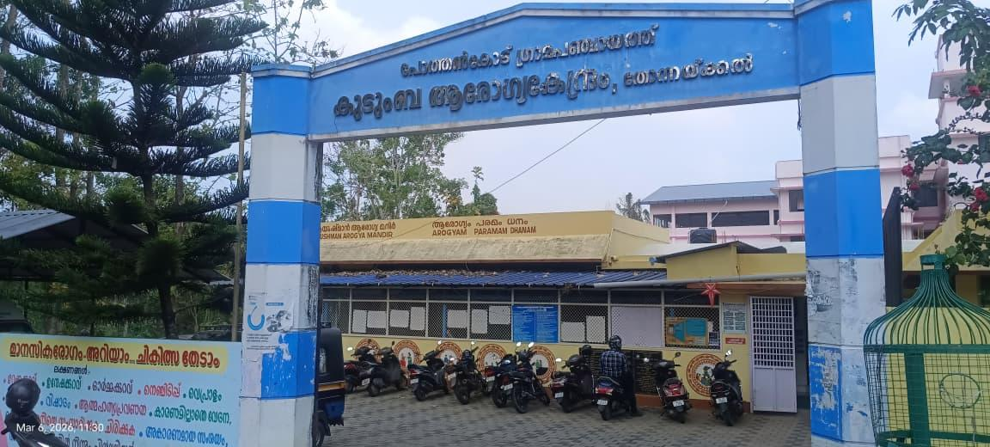
Pothencode Grama Panchayat

phcthonnakkal@gmail.com

MESSAGE FROM PRESIDENT/CHAIR LSGI
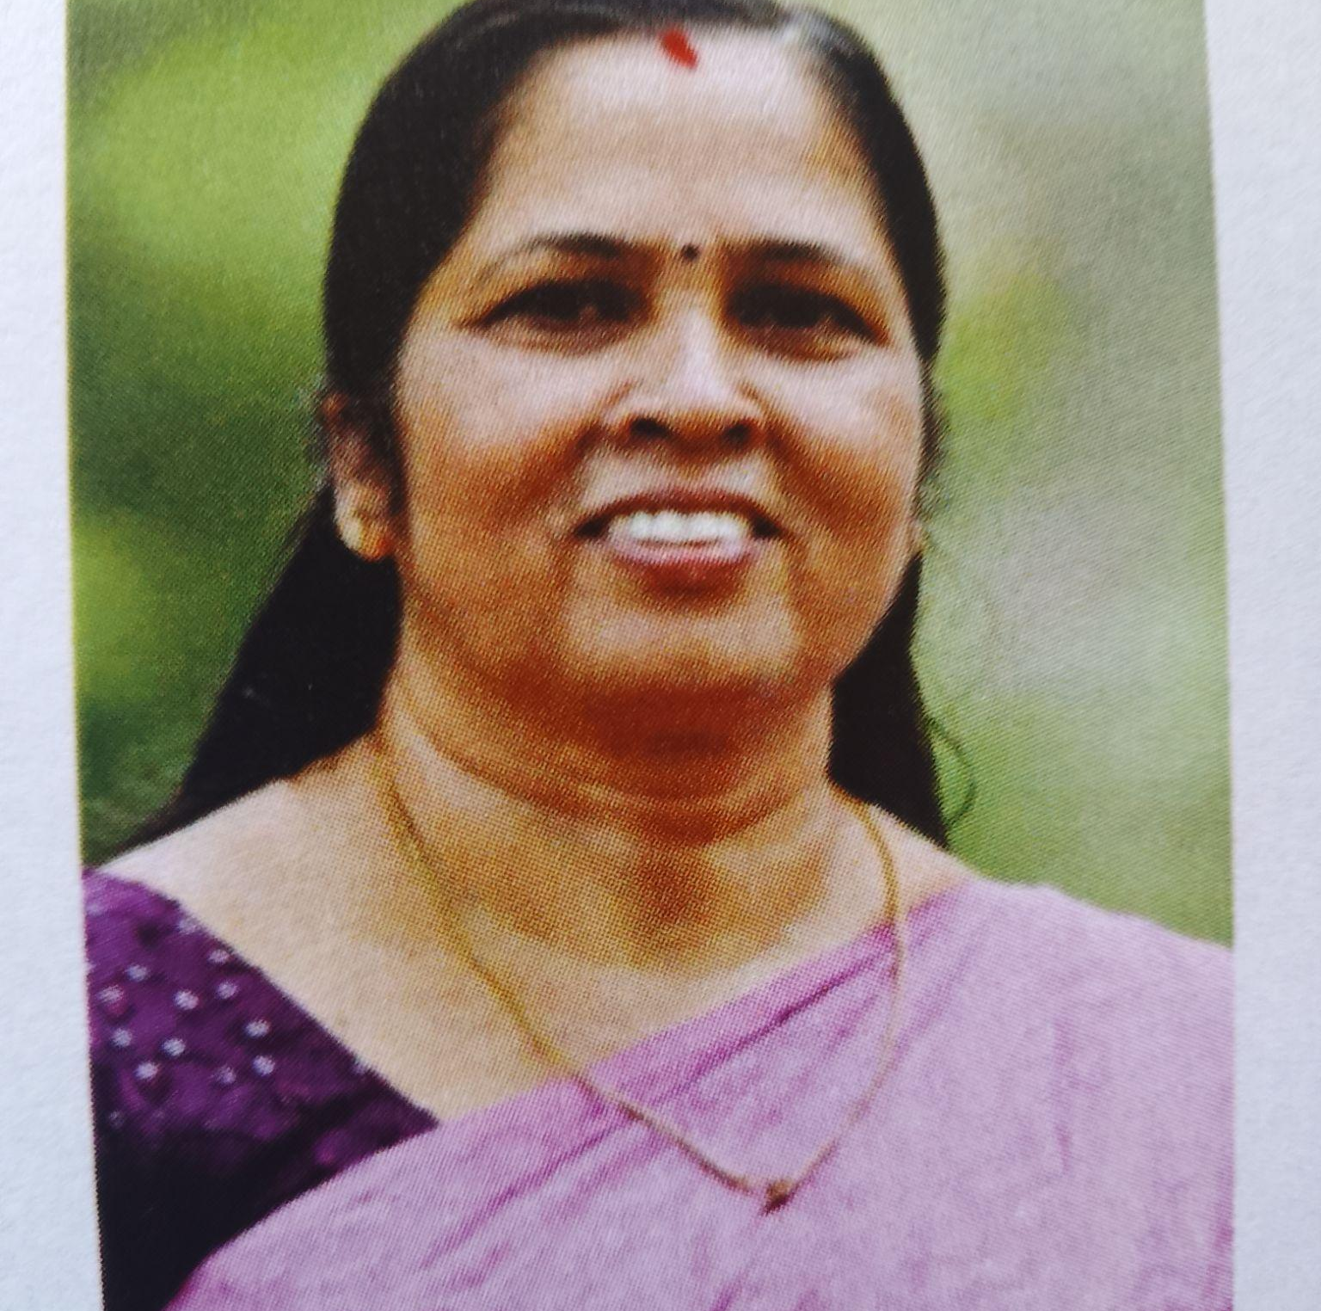

Understanding that preventive measures are more important than cure for public health protection will help avoid future pandemic- like situations.
Health can be maintained by following proper lifestyle habits, but modern lifestyles. By strengthening health systems, coordinating various departments, increasing the capacity for prevention and control with the participation of volunteers and ASHA workers, we can create a good situation free from epidemic.
This message is shared with the idea that this plan document, prepared at the panchayat level after assessing the current situation, will contribute to healthcare.
BINDHU V
President Pothencode
Panchayat

MESSAGE FROM HEALTH STANDING COMMITTEE CHAIR
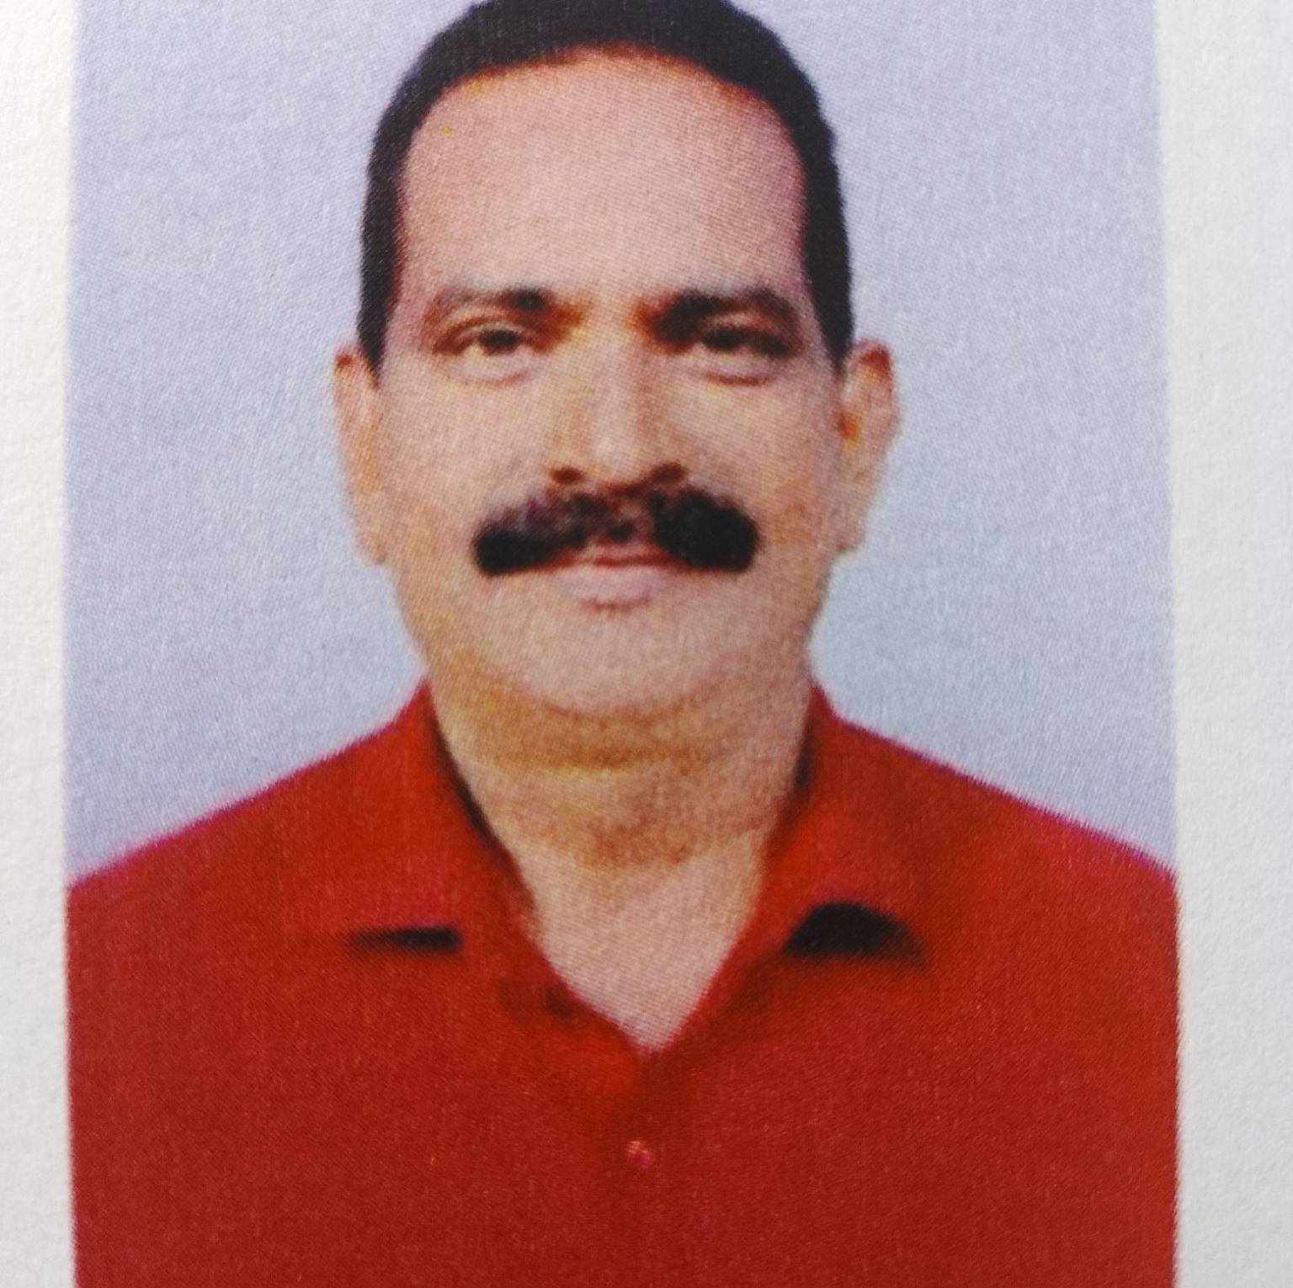

It is certain that continued work with the goal of maintaining by increasing knowledge and health habits will form the foundation for preventing and controlling epidemic like diseases in the general public.
This plan has been prepared through the collective efforts of public representatives, the health departments, volunteers from various departments, ASHA workers, Kudumbasree workers.
I hope that we can move activities that are aligned with public health protection and healthy living.

K P Purushothamman
Health Standing Committee
Chairman,Pothencode Panchayath

MESSAGE BY MEDICAL OFFICER
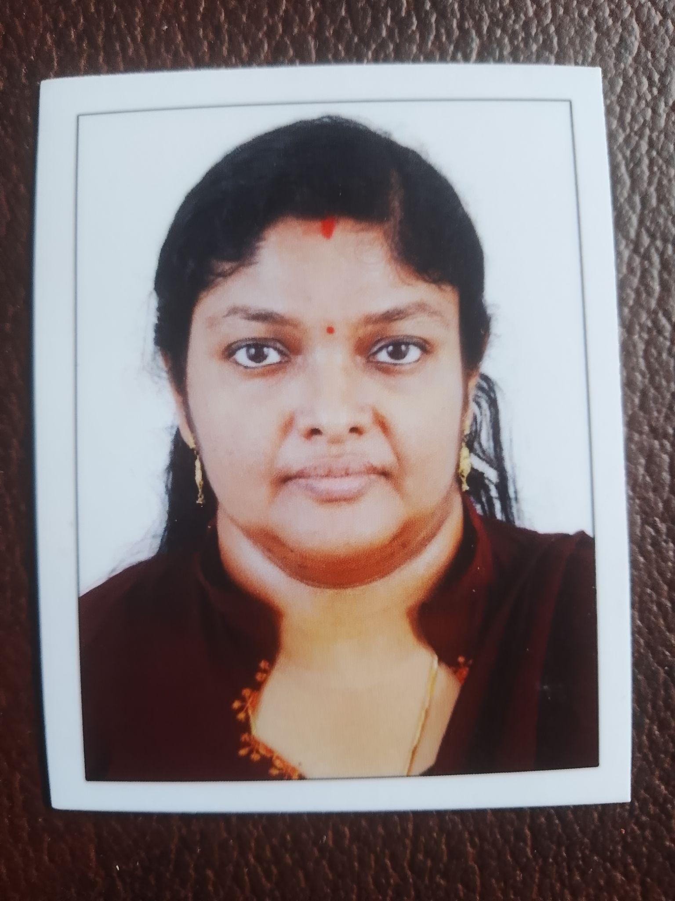

In the wake of the current pandemic situation reported in the country and the state, everyone should be extremely vigilant to ensure the health of the public. The public should strictly follow the instructions from the health department and avoid self medication which will help in achieving a pandemic free environment.
Advance preparedness, strategic planning and information gathering are essential to enable public health to mitigate contain and prevent outbreak of pandemic.
This message is a special reminder that public cooperation is crucial to preventing the spread of pandemic.

Dr Sony Raj
Medical Officer
FHC Thonnakkal
EXECUTIVE SUMMARY

Primary Health Centre (PHC) functions as the primary public healthcare institution serving the population of Pothencode Grama Panchayath. The PHC plays a pivotal role in delivering comprehensive, accessible, and affordable healthcare services, with a strong focus on preventive, promotive, curative, and rehabilitative care in accordance with national and state health programmes.
The PHC caters to a predominantly rural population, addressing key public health priorities such as maternal and child health, communicable and non-communicable disease control, immunization, family welfare, adolescent health, and geriatric care. Regular outpatient services, home-based care through field health staff, and outreach activities ensure healthcare coverage even in geographically challenging areas. The institution actively implements national health missions, including the National Health Mission (NHM), National Tuberculosis Elimination Programme, National Programme for Prevention and Control of Cancer, Diabetes, Cardiovascular Diseases and Stroke (NPCDCS), and other disease surveillance initiatives.
Thonnakkal PHC works in close coordination with the Grama Panchayath, ASHA workers, Anganwadi centres, schools, and community-based organizations to strengthen community participation and improve health awareness. Emphasis is placed on early detection, timely referral, health education, and lifestyle modification to reduce disease burden and improve overall health outcomes.
Despite constraints related to infrastructure, manpower, and increasing service demand, the PHC continues to enhance service delivery through effective planning, data-driven decision-making, and community engagement. Strengthening facilities, upgrading digital health systems, and expanding preventive services remain key focus areas for future development.
Overall, Thonnakkal Primary Health Centre stands as a vital institution in safeguarding public health and improving the quality of life of the residents of Pothencode Grama Panchayath.

LIST OF ABBREVIATIONS

LSGD/LSGI | Local Self Government Department / Local Self Government Institution
BMO | Block Medical Officer
IDSP | Integrated Disease Surveillance Programme
NDMA | National Disaster Management Authority
PPE | Personal Protective Equipment
ICMR | Indian Council of Medical Research
CD | Communicable Diseases
NCD | NON-COMMUNICABLE Diseases

TABLE OF CONTENTS

3
INTRODUCTION 9
● Background of the PPP 9
LSGD AT A GLANCE 9
INTEGRATED HEALTH INFRASTRUCTURE MAP OF POTHENCODE PANCHAYAT 10
GENERAL PROFILE OF THE LSGI’S 13
Background of the LSGI 13
Demographic and Vulnerable Population 14
Clinical Vulnerability 16
INFRASTRUCTURE & RESOURCE INVENTORY 18
Health Facility Directory & Basic Capacity in the LSGD 18
Private Clinics 19
Healthcare Education & Training Institutions 20
Specialized Services & Emergency Inventory 20
Oxygen & Diagnostic Capacity 21
Diagnostics facility mapping at the LSGI level 22
Laboratory Identification & Basic Details 22
Social and Community Infrastructure for surge plan 22
Human resources 24
Community & Support Cadre 25
Community Organizations 26
Administrative & Emergency Services 27
Information regarding resources 27
ONE HEALTH & ENVIRONMENTAL SURVEILLANCE 28
Animal & Bird Population 28
Veterinary Infrastructure 29
Veterinary Doctors & Workforce 30
High-Risk Interface Points (Surveillance Sites) 30
Environmental Risk Mapping 31
Disease Seasonality Mapping 32
Vulnerability Mapping 33
EPIDEMIOLOGICAL TRENDS (2021–2025) 34
Disease Burden among human beings(Last 5 Years) 34
*(use the above table data to create the graph/diagram) 36
Seasonal Trend Analysis 37
Outcome-Based Trend Analysis- 2025 39
Transmission Trend- 2025 40
Integrated Disease Hotspot Map (2021–2025) 42
Preparedness and Response Protocol at LSG Level 44
Constitution of One Health Committee 44
Pandemic Response Workforce 45
Activities and Measures before and during Pandemic 47
PHASE 1 - Alert / Preparation 47
PHASE 2 - Active Response 50
Standard Screening Protocol 51
PHASE 3 - Surge Capacity 60
Conversion of Community Facilities 60
CONCLUSION 61
RECOMMENDATIONS 62
ANNEXURE 63
1. IMPORTANT PHONE NUMBERS 63

INTRODUCTION

Background of the PPP
This Pandemic Preparedness Plan for Pothencode panchayat has been developed to strengthen the Health Block’s capacity to prevent, detect, and respond effectively to pandemics and large-scale infectious disease outbreaks. The plan emphasizes early warning systems, protection of vulnerable populations, continuity of essential health and social services, surge capacity planning, environmental health management, and coordinated action across health, local governance, disaster management, animal health, and community sectors.
The demographic profile of Pothencode panchayat further emphasizes the need for a highly structured and inclusive preparedness plan. The panchayat is home to a significant number of vulnerable individuals. These groups often face increased risk during public health emergencies due to higher exposure levels and a heavier dependency on public support systems. These demographic and socio-economic characteristics underscore the need to prioritize high-risk populations and those dependent on regular medical treatment are at increased risk during pandemics due to potential service disruptions and heightened exposure risks.
The Pothencode Grama Panchayat Pandemic Preparedness Plan serves as a strategic blueprint to safeguard our community during public health emergencies. This document is designed to
- Create a baseline for rapid mobilization: Establishing a data-driven framework to activate resources and personnel immediately at the first sign of a health threat.
- Identify gaps in resources and high-risk populations: Systematically mapping our 8455 elderly residents, 145 bedbound patients, and 483 palliative care patients to ensure targeted support.
- Ensure coordinated action between the Government, Private, and AYUSH sectors: Synchronizing efforts across our 1 Government hospital, 3 private hospitals, and 3 total AYUSH centers

LSGD AT A GLANCE
- Geographical boundaries with political map ( based on latest delimitation)

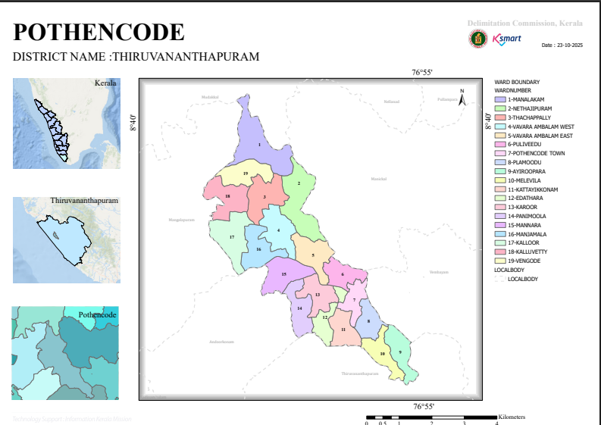

Source:-https://wardmap.ksmart.live/FinalN/FinalN_Thiruvanathapuram_Pothencode..html

Baseline data
- Ward division -
Ward | Houses | Population | Migrants | Wells | Hot  spots | Ed. Institutions | Hosp pvt/govt.
19 | 9468 | 35739 | 721 | 7884 | 1 | 16 | 5/3

- Risk stratification among wards in the context of Communicable diseases and hazards
The wards of Pothencode Panchayat have been broadly stratified into high, medium, and low-risk categories based on local vulnerability factors such as population density, environmental conditions, presence of migrant populations, sanitation status, and access to healthcare services. Accordingly, high-risk wards include Wards 18, 3, 13, 4, 5, 12, and 16, which have relatively higher vulnerability due to a combination of these risk factors. Medium-risk wards include Wards 6, 15, 17, 10, 1, 14, 2, and 9, where moderate levels of risk factors are present. Low-risk wards include Wards 7, 8, and 11, which have comparatively lower vulnerability and better environmental conditions.
- Major Roads/rivers
Road Mangalapuram Pothencode road
- Major establishments with geospatial mapping
Govt Panchayath office, FHC Thonnakkal,Civil station, Ayurveda Hospital, Homeo hospital,Veterinary Hospital
- Occupational groups, socio cultural groups, migration & mobility patterns
Pothencode Panchayat has a diverse occupational structure comprising agricultural workers, daily wage labourers, construction workers, small-scale vendors, and service sector employees including those working in restaurants and retail outlets. A significant feature is the presence of more than 700 migrant labourers from other states, predominantly engaged in construction activities, eateries, chicken stalls, and allied informal sectors. This population often resides in shared or congested accommodations, which may increase vulnerability to communicable disease transmission. Socio-culturally, the Panchayat consists of a mix of local residents with established community networks and migrant populations with varied linguistic and cultural backgrounds, potentially posing challenges in risk communication and health outreach. In terms of migration and mobility patterns, there is frequent movement of labourers between worksites and periodic interstate travel, especially during festive seasons or employment transitions. Such mobility patterns necessitate targeted surveillance, culturally appropriate health education, and strengthened inter-sectoral coordination to ensure effective pandemic preparedness and response.
- Vulnerability mapping -
Pothencode Panchayat has a significant number of vulnerable populations requiring focused attention in pandemic preparedness. This includes 167 pregnant women and 195 lactating mothers who need continuous maternal and child health services. There are 147 bedbound patients and 236 individuals under palliative care, requiring uninterrupted home-based care and support. The elderly population is notably high at 5,562, making them a major high-risk group.
Additionally, 36 patients on haemodialysis and 202 cancer patients on active treatment require regular healthcare access and protection from infections. The Panchayat also includes 36 mentally challenged individuals and 149 differently abled persons, who may face challenges in accessing services. A high burden of chronic diseases is seen with 1,869 diabetic and 2,274 hypertensive patients, along with 9 TB patients requiring continued care. These groups need targeted interventions, including priority healthcare access, surveillance, and support systems during pandemics.

- Disaster prone areas (geographic vulnerability) Nil

Maps - ward-based (Mention source also)
- Geographical boundaries - ward boundaries map

North-Mudakkal
East-Manikkal,Vembayam
West-Andoorkonam , Mangalapuram
South-Thiruvananthapuram corporation

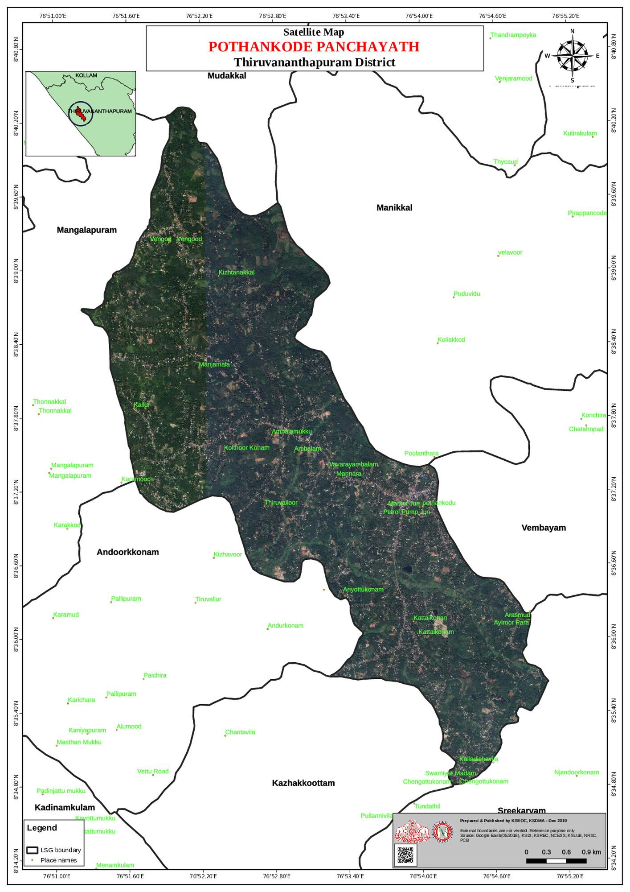
Source:- https://dmp.kila.ac.in/

- Health infrastructure map
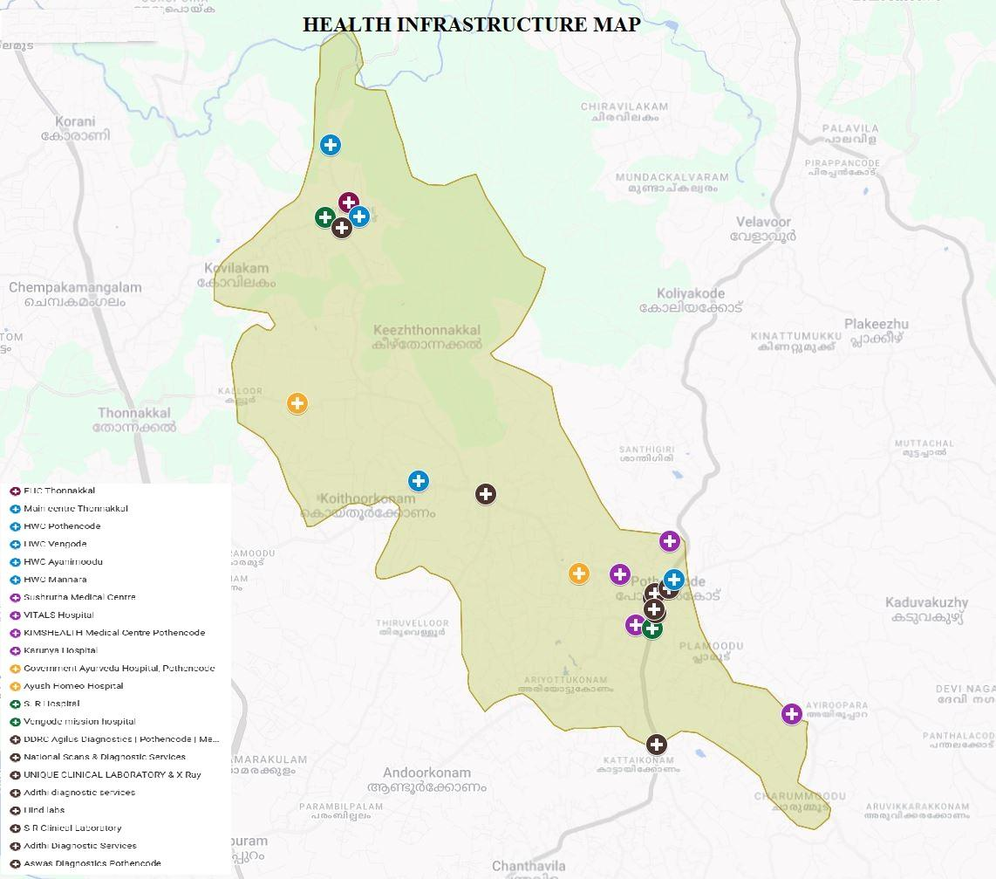

3.Roads and rivers map
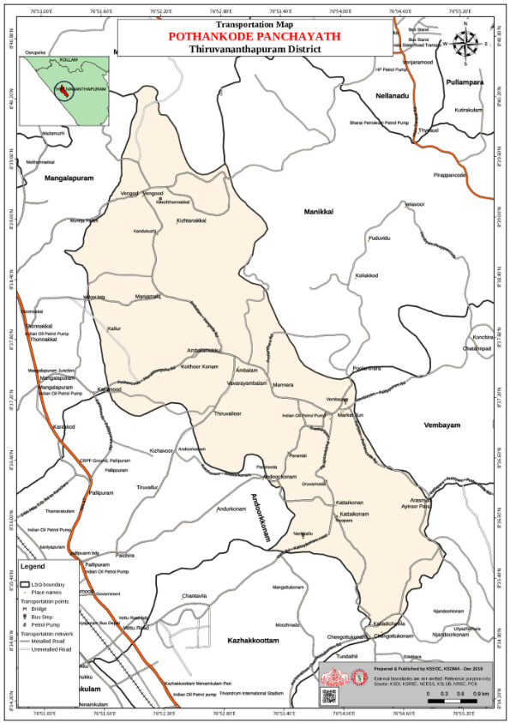
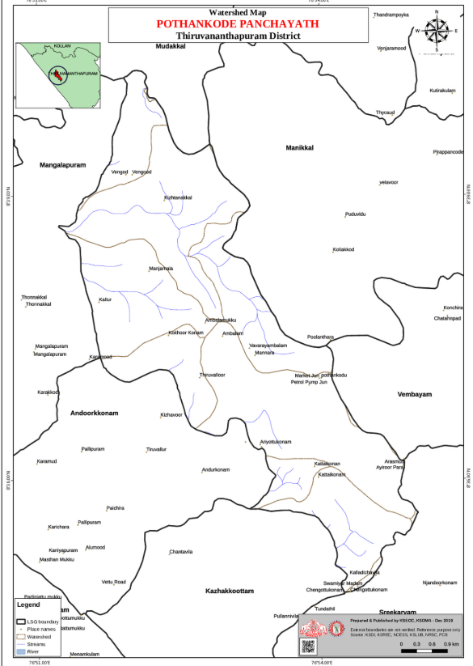

Source:- https://dmp.kila.ac.in/

- Major establishments map

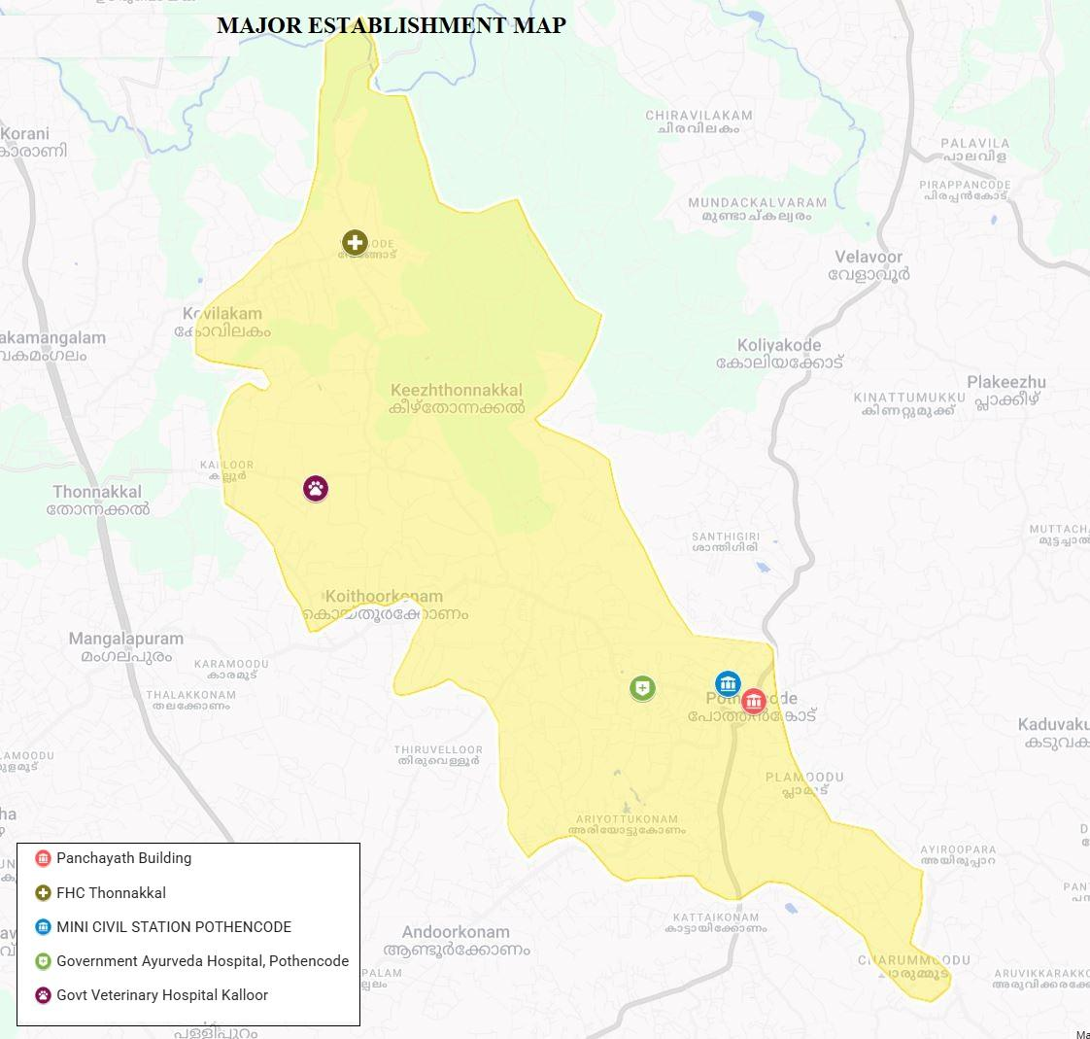

- Disaster-prone areas map
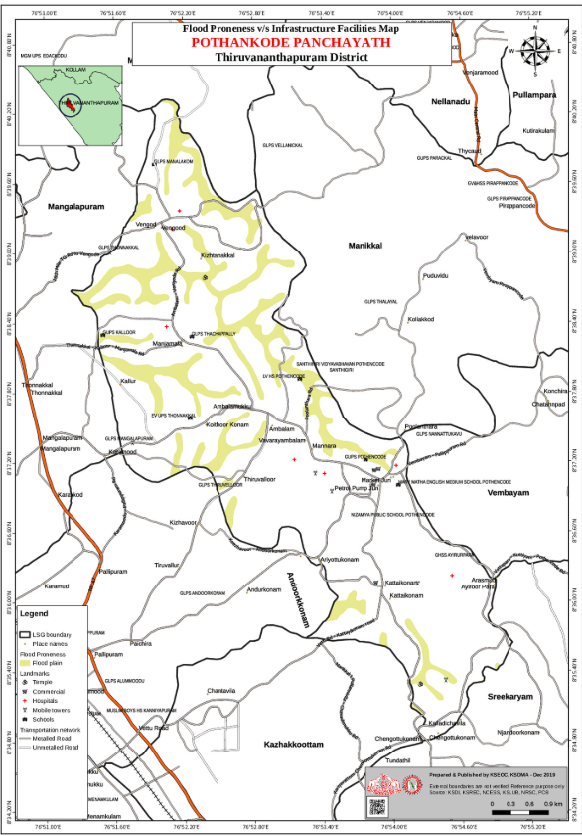

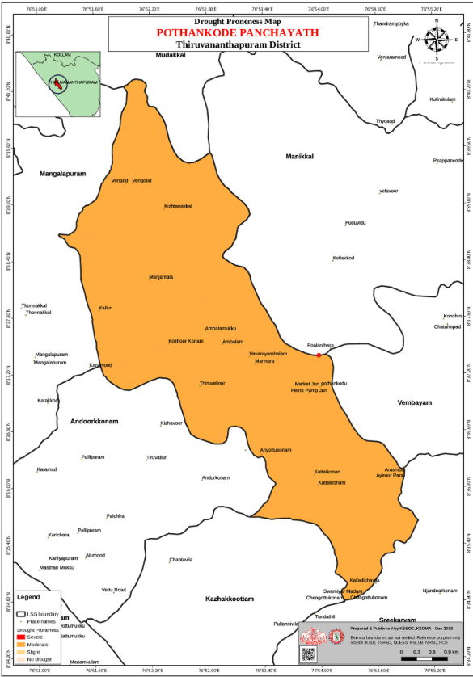

- Hotspot map - CD & disasters

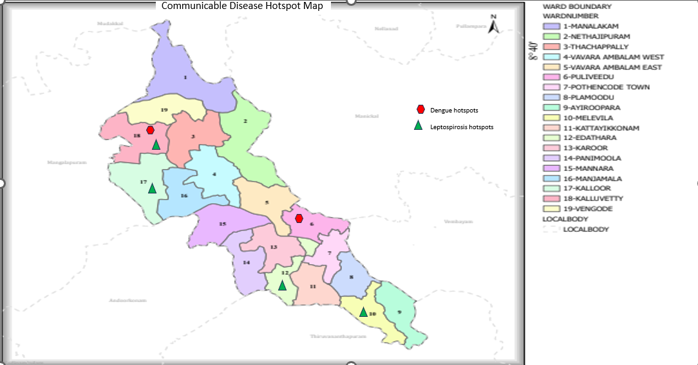

INTEGRATED HEALTH INFRASTRUCTURE MAP OF POTHENCODE PANCHAYATH

GENERAL PROFILE OF THE LSGI’S

Background of the LSGI
Pothencode Grama Panchayat is a Special Grade Grama Panchayat situated in the northernmost part of Thiruvananthapuram Taluk in Thiruvananthapuram District. It spans an area of approximately 20.8 sq. km and comprises the villages of Melethonnakkal, Keezhthonnakkal, Ayrooppara, and Andoorkonam. The Panchayat is bounded by Mudakkal to the north, Manikkal to the northeast, Vembayam to the east, Andoorkonam to the southwest, and Mangalapuram nearby.
Pothencode is primarily an agrarian region with hills, plains, and low-lying areas. It falls under the Pothencode Block Panchayat and the Thiruvananthapuram District Panchayat, and has 19 wards. It is part of the Nedumangad Legislative Assembly Constituency.
Rapid urbanization due to its proximity to Thiruvananthapuram and IT sector growth has led to the conversion of agricultural land into residential areas, reducing paddy cultivation and altering traditional land use. The Panchayat has 30 Anganwadis, along with Shishu Vihar and Karunya Special School supporting child development.
A major portion of the area consists of plains and faces seasonal drought, leading to water scarcity as wells and ponds dry up. Around 28 ponds, streams, and other sources form the main water resources, with monsoon rainfall sustaining agriculture.
The Panchayat also holds cultural importance, with Chempazhanthy, the birthplace of Sree Narayana Guru, and Thonnakkal, associated with poet Kumaran Asan. Shanthigiri Ashram is located in its eastern part.

Table 1: Background of LSGD
Description | Details
Name of LSGI | POTHENCODE
Type (GP/Municipality / Corporation etc.) | Grama Panchayath
Block | POTHENCODE
District | TRIVANDRUM
Number of wards | 19
Total area (sq. km) | 20.85 Sq Km
Population(Projected) | 35739
Population density | 1714 persons/sq km
Terrain (coastal/low-lying/backwaters/foothills, etc.) | Midland
Number of rivers passing through LSGI | 0
Number of water bodies in the LSGI | 12
Number of educational institutions | 16
Factories / small-scale industries | 4
Flood-prone wards | 0
Landslide-prone wards | 0
Death Management and Disposal Facilities (mortuaries/crematorium, including electric) | 0
Auditoriums/Marriage halls/convention centres/community halls | 5

Demographic and Vulnerable Population
Understanding the demographic composition and vulnerable population groups is essential for pandemic preparedness. Children, elderly, economically deprived families, migrant workers, and socially vulnerable groups are at increased risk during public health emergencies due to higher exposure, limited access to services, and dependency on public systems..

Description |  | Details (in numbers)
DEMOGRAPHIC PROFILE
Total population |  | 35739
Male |  | 17415
Female |  | 18324
Transgender |  | 0
Children under 5 |  | 1726
Adolescent |  | 2018
Elderly (>60) |  | 5562
SOCIAL/LIVELIHOOD VULNERABILITY
Previous EPEP family |  | 19
BPL family |  | 5702
Tribal communities |  | 0
Migration | Immigrant | 312
Migration | Emigrant | 287
Socio-economically deprived |  | 34
Fisherfolk |  | 0
SC Community |  | 3218
ST Community |  | 0

Graphs: Population pyramid (if possible) for seeing if your LSGI has a high "dependency ratio" (lots of children and elderly compared to working adults).

Clinical Vulnerability
Certain population groups needs priority healthcare & are at higher risk of severe illness, complications, and mortality during pandemics. Patients with chronic diseases, those requiring regular medical care, and individuals with mobility or functional limitations face challenges in accessing timely care during emergencies. Mapping these groups helps in prioritizing continuity of treatment, medicine stock planning, oxygen support, referral transport, and targeted home-based care.
Description | Details in numbers
Pregnant women | 167
Lactating mothers | 195
Bedbound patients | 147
Patients under palliative care other than bedbound | 236
Patients on Haemodialysis | 36
Patients on CAPD | 0
Cancer patients (currently on treatment) | 202
Haemophilic patients | 0
Mentally challenged | 36
Differently abled | 149
Diabetic patients | 1869
Hypertensive patients | 2274
TB patients | 9

Major Festivals & Events specific to the LSGI
(with the possibility of a public gathering)

Sl. No. | Name of festival | Month detailing the periodicity
1 | PANIMOOLA FESTIVAL | APRIL ( EVERY 2 YEAR)
2 | Adappinakathu Temple | MARCH
3 | Edathara sree bhadrakali Temple | MARCH

INFRASTRUCTURE & RESOURCE INVENTORY

Health Facility Directory & Basic Capacity in the LSGD
This section provides an overview of the healthcare infrastructure available within the LSGD area. It outlines the distribution and basic capacity of health facilities that form the backbone of service delivery during routine times and public health emergencies.

Family Health Centres (FHCs) and Community Health Centres (CHCs) generally function as the first point of contact for the community, providing essential outpatient and inpatient services. General Hospitals (GH) and Medical College Hospitals (MCH), where accessible, serve as the main referral centres for advanced diagnostics, specialist care, and critical services during public health emergencies. This inventory helps identify existing strengths, gaps, and potential surge capacity that can be mobilised during a pandemic or disaster.

Table 5. Health Facility Resource Summary
Sl.no. | Health Facility | Type of Facility (MCH/GH/CHC/FHC/SC etc.) | Contact Number | Total beds | ICU Beds | Oxygen-Supported Beds | No. of Ventilator Support Beds | No. of ambulances
Government Healthcare Facilities
1 | FHC THONNAKKAL | FHC | 7736585995 | 2 | 0 | 0 | 0 | 1
2 | AAM MAINCENTRE | SC | 7306187544 | 1 | 0 | 0 | 0 | 0
3 | AAM VENGODE | SC | 7561848029 | 1 | 0 | 0 | 0 | 0
4 | AAM MANNARA | SC | 8921825537 | 1 | 0 | 0 | 0 | 0
5 | AAM AYANIMOODU | SC | 8921825537 | 1 | 0 | 0 | 0 | 0
6 | AAM POTHENCODE | SC | 9072852425 | 1 | 0 | 0 | 0 | 0
Private Healthcare Facilities
1 | SUSRUDA MEDICAL CENTRE | PRIVATE HOSPITAL | 9446173737 | 34 | 0 | 1 | 0 | 2
2 | VITALS HOSPITAL | PRIVATE HOSPITAL | 8095663832 | 6 | 0 | 0 | 0 | 1
3 | KIMS HEALTH | PRIVATE HOSPITAL | 9074556879 | 4 | 0 | 0 | 0 | 1
4 | KARUNYA HOSPITAL | PRIVATE HOSPITAL | 9349494968 | 3 | 0 | 0 | 0 | 1
AYUSH Healthcare Facilities
1 | AYURVEDA HOSPITAL | AYUSH | 9447697839 | 10 | 0 | 0 | 0 | 0
2 | HOMEO DISPENSARY | HOMEO | 7736880065 | 0 | 0 | 0 | 0 | 0

Private Clinics
Private clinics are an essential part of pandemic preparedness, as they are often the first place people seek care when symptoms begin. In many communities, private clinics manage a significant share of outpatient visits and therefore play a critical role in early case detection, timely referrals, and disease surveillance. Having an up-to-date understanding of where these clinics are located, the services they provide, and how they are linked to the public health system helps ensure that no cases are missed during an outbreak. It also allows health authorities to engage private practitioners more effectively for reporting, risk communication, and coordinated response, strengthening the overall capacity of the health system to manage public health emergencies.

Table 6. Private Clinic Resource Summary
Sl No. | Name of Clinic | Registered (Y/N) | Clinic (General / Speciality) | Speciality (if any) | Address | Contact Number | Diagnostic Facility (Y/N) | Ambulance Linkage (Y/N)
1 | SR HOSPITAL | Y | GENEREAL | N | SR CLINIC,POTHENCODE | 9847287550 | N | N
2 | MEDICAL MISSION CLINIC | N | GENERAL | N | MEDICAL MISSION CLINIC, VENGODE | 9544003939 | N | N

Healthcare Education & Training Institutions
This section tracks the educational infrastructure available, which is vital for human resource planning in the health sector.

Category of Institution | Govt | Private | AYUSH | Total
Medical Colleges | 0 | 0 | 0 | 0
Nursing Colleges | 0 | 0 | 0 | 0
Dental Colleges | 0 | 0 | 0 | 0
Para-medical / Allied Health | 0 | 0 | 0 | 0
Pharmacy Colleges | 0 | 0 | 0 | 0

Specialized Services & Emergency Inventory
This section provides a detailed view of the specialized medical resources available to the community, focusing on emergency response and critical care capabilities. This table tracks the vital assets required for managing severe illnesses and emergencies across Government, Private, and AYUSH sectors.

Item | Govt | Private | AYUSH | Total
Hospital beds | 2 | 47 | 10 | 59
Oxygen-generating systems(Y/N) | N | N | N | 0
Oxygen-supported beds(Numbers) | 0 | 1 | 0 | 1
Ventilator-supported beds | 0 | 0 | 0 | 0
ICU beds | 0 | 0 | 0 | 0
Burns units | 0 | 0 | 0 | 0
Blood centres | 0 | 0 | 0 | 0
BLS ambulances | 1 | 2 | 0 | 3
ALS ambulances | 0 | 0 | 0 | 0
Dialysis facilities | 0 | 0 | 0 | 0
Dispensaries | 0 | 0 | 1 | 1
Medical store | 0 | 14 | 0 | 14
Industrial establishments(Medium-scale industries/small-scale industries establishments to whom we can depend in a worst-case scenario) | 0 | 0 | 0 | 0

Oxygen & Diagnostic Capacity
Monitoring oxygen and diagnostic capacity is a critical component of public health preparedness, ensuring that the LSGD can handle both chronic care and sudden surges in respiratory or infectious diseases.
Name of Health Facility | Oxygen-generating System (Y/N) | Backup Oxygen Source (Y/N) | Diagnostic Facilities Available(Y/N)
Name of Health Facility | Oxygen-generating System (Y/N) | Backup Oxygen Source (Y/N) | Lab | USG | X-ray | CT/MRI | RT-PCR
Government Healthcare Facilities
PHC THONNAKKAL | N | N | Y | N | N | N | N
Vitals,Ayiroopara | N | N | Y | N | N | N | N
SUSRUTHA Health Care | N | N | Y | N | N | N | N

Diagnostics facility mapping at the LSGI level
The diagnostic capacity of POTHENCODE G.P represents the "intelligence network" of our healthcare system. The speed and accuracy of disease identification depend entirely on the distribution and technical level of these facilities.

Item | Govt | Private | AYUSH | Total
General labs | 1 | 13 | 0 | 14
Microbiology labs | 0 | 4 | 0 | 4
RT-PCR labs | 0 | 3 | 0 | 3
USG units | 0 | 2 | 0 | 3
CT/MRI units | 0 | 0 | 0 | 0
Research labs | 0 | 0 | 0 | 0
Labs of other departments that can be repurposed | 0 | 0 | 0 | 0

Laboratory Identification & Basic Details
Sl. No. | Name of Laboratory | Ownership (Govt / Private / Academic) | Address | Contact No. | 24×7 Services (Yes/No) | NABL / Govt Approved (Yes/No)
1 | FHC THONNAKKAL | GOVT | FHC THONNAKKAL | 9947803618 | NO | YES
2 | ASWAS DIAGNOSTIC CENTRE | PRIVATE | POTHENCODE | 8590959201 | NO | YES
3 | DDRC AGILUS DIAGNOSTICS | PRIVATE | POTHENCODE | 9497717839 | NO | YES
4 | NATIONAL SCANS | PRIVATE | POTHENCODE | 9847490660 | NO | YES
5 | UNIQUE LAB | PRIVATE | ARIYOTTUKONAM | 9895155890 | NO | NO
6 | ADHITI DIAGNOSTIC LAB | PRIVATE | VENGODE | 8893777617 | NO | NO
7 | HIND LAB | PRIVATE | POTHENCODE | 9188401126 | NO | YES
8 | KIMS HEALTH | PRIVATE | POTHENCODE | 9074556879 | NO | YES
9 | SUSRUDA MEDICAL CENTRE | PRIVATE | POTHENCODE | 9446173731 | NO | YES
10 | SR CLINIC | PRIVATE | POTHENCODE | 9847287550 | NO | NO
11 | VITALS HOSPITAL | PRIVATE | AYIROOPPARA | 8095663832 | NO | NO
12 | KARUNYA HOSPITAL | PRIVATE | POTHENCODE | 9349494968 | NO | NO
13 | ADITHI DIAGNOSTICS | PRIVATE | VAVARAMBALAM | 8893777617 | NO | NO

Social and Community Infrastructure for surge plan
This table serves as our logistics and shelter inventory. By mapping these locations, quickly we can identify where to house displaced citizens, where to set up temporary medical clinics, and how to manage the deceased with dignity during a crisis.

Category | Total Count | Ward | Est. Capacity (Persons) | Contact details
Educational Institutions
Anganwadis | 30 | 19 | 242 | 9895450724
Schools | 15 | 14 | 3865 | 9497851737
Colleges | 1 | 1 | 81 | 9895809060
Healthcare Educational Institutions
Medical colleges (Govt/Private) | 0 | 0 | 0 | 0
Nursing colleges (Govt/Private) | 0 | 0 | 0 | 0
Dental colleges (Govt/Private) | 0 | 0 | 0 | 0
Paramedical institutes (Govt/Private) | 0 | 0 | 0 | 0
Community Gathering Spaces
Community halls | 4 | 4 | 1200 | 9037112329
Auditoriums | 4 | 3 | 4500 | 7012838833
Religious buildings | 73 | 19 | 365 | 94475867641
Vulnerable Group Support Facility
Destitute homes | 0 | 0 | 0 | 0
Elderly homes | 1 | 1 | 60 | 9074536735
LSGD owned other buildings | 1 | 1 | 35 | 9446271895
Mass Fatality Management (MFM) Infrastructure
Mortuary | 0 | 0 | 0 | 0
Crematorium | 0 | 0 | 0 | 0
*refer annexure 1 for contact details

Human resources
This section focuses on the human capital available within the LSGI. In any emergency—be it a pandemic, flood, or industrial accident—infrastructure is only as effective as the people operating it.

Medical & Clinical Personnel
This table tracks the "Frontline" providers responsible for diagnosis, treatment, and clinical management. Narrative sentence: eg., "Total health workforce: 450 personnel, with 60% in government facilities serving as primary surge capacity." A detailed directory with the contact numbers of all workers is maintained (Annexure in 1).

Cadre | Govt (No.) | Private (No.) | Total
Doctors—Modern Medicine | 3 | 16 | 19
Doctors – AYUSH | 3 | 2 | 6
Doctors – Veterinary | 1 | 1 | 2
Doctors – Dental | 0 | 12 | 12
Nursing officers | 3 | 29 | 32
Lab technicians | 4 | 18 | 22
Optometrist | 1 | 3 | 4
Pharmacists | 3 | 7 | 10
Psychologists | 0 | 0 | 0
Counsellors | 0 | 0 | 0

Public Health & Field-Level Workforce
These individuals are the backbone of surveillance, maternal-child health, and decentralized care.

Cadre | Health services | Municipal common services | Total
HS (Health Supervisors) | 0 | 0 | 0
HI (Health Inspectors) | 1 | 0 | 1
LHS (Lady Health Supervisor) | 0 | 0 | 0
LHI (Lady Health Inspectors) | 1 | 0 | 1
JPHN (Jr Public Health Nurses) | 5 | 0 | 5
JHI (Jr Health Inspectors) | 3 | 0 | 3
MLSP (Mid-Level Service Providers) | 5 | 0 | 5
Palliative Nurses | 1 | 0 | 1
RBSK Nurses | 1 | 0 | 1
PRO | 1 | 0 | 0
Epidemiologist | 1 | 0 | 0
Data Manager | 1 | 0 | 0

Community & Support Cadre
This group represents the surge capacity of the LSGI—people who can be called upon for logistics, rescue, and specialized support.

Cadre | Number
ASHA Workers | 31
AWW (Anganwadi Workers) | 30
Emergency Medical Volunteers (Trained) | 90
Kudumbashree | 421
MNREGS | 3080
Purusha Swayam Sahaya Sangham | 32
Ex-Servicemen | 74
Retired Police Officers | 64
NCC/NSS Volunteers | 118
Red Cross volunteers | 11
One Health Community Volunteers | 31
One Health Community Mentors | 03

Community Organizations
This section details the presence of community-based organisations (CBOs), non-governmental organisations (NGOs), faith-based organisations (FBOs), Kudumbashree Self-Help Groups (SHGs), and Ayalkootams within the Local Self-Government Institution (LSGI). These groups enhance grassroots mobilization, resource distribution, and support networks crucial for pandemic response and community resilience.

Category | Total Count
NGOs | 1
Religious based organizations | 5
Foreign based organizations | 0
Sports Club/youth clubs | 6
Kudumbashree SHGs | 355
Ayalkootams | 142
Political organizations | 4
Residential organizations | 18

Administrative & Emergency Services
This section outlines the availability of key non-health emergency support services and infrastructure within the LSGI, which are essential for effective pandemic preparedness and response. These facilities support law enforcement, disaster response, water supply, logistics, mobility, and community-level interventions during public health emergencies.

Category | Total Count | Contact details
Police Stations | 1 | 0471 2716100
Fire & Rescue Stations | 0 | NA
Water Pumping Points | 0 | NA
Public Distribution System (PDS) | 16 | 9400716505

Information regarding resources
The availability of essential transport and support resources plays a quiet but critical role in saving lives. Equipment such as ambulances, mobile mortuaries, amphibian ambulances, and motorized boats ensures that patients, samples, and healthcare teams can move swiftly—even in flooded, remote, or difficult terrains. Heavy vehicles like JCBs, cranes, tractors, and torus lorries support logistics, waste management, emergency infrastructure, and rapid conversion of spaces into care or isolation facilities. Taxis, four-wheel-drive vehicles, and trucks help maintain continuity of essential services, reach vulnerable populations, and support home-based care and supply delivery.

Means of transportation | Total Count
JCB | 4
Crane | 0
Heavy Trucks | 2
Tractor | 0
Ambulances | 3
Mobile mortuaries | 0
Boats | 0
Taxi service | 4
Note: For specific details regarding vehicle owners and contact information, please refer to Annexure [X].

ONE HEALTH & ENVIRONMENTAL SURVEILLANCE
The One Health method integrates environmental, animal, and human health to enable proactive pandemic preparedness. Panchayat-level surveillance needs to be improved in order to detect and treat zoonotic and environmentally generated diseases early. Surveillance is strengthened through systematic assessment of animal populations, veterinary infrastructure, poultry and slaughter facilities, inter-sectoral coordination, and specialised tools like avian influenza seasonality mapping using GIS in previous outbreaks to enable predictive alerts and ward-specific sampling to support effective pandemic preparedness in high-risk areas is nil.

Animal & Bird Population
Mapping animal and bird populations at the Panchayat level is essential for identifying and prioritising zoonotic disease hazards like rabies, avian influenza (H5N1), leptospirosis, anthrax, and Nipah-like spillover occurrences. Risk classification, targeted surveillance, vaccination planning, and early epidemic detection made feasible by comprehensive population mapping all enhance One Health-based pandemic preparedness.

Category | Item | Estimated Population | Wards
Animal Population | Livestock (Cattle/Goats/Buffalo) | 1874 | All Wards
Animal Population | Pet Animals (Dogs/Cats) | 1483 | All Wards
Animal Population | Stray Dog Population | 778 | All Wards
Animal Population | Pig Farms (Number of heads) | 0 | 0
 | Small Units (Sheep / Goats – clustered) | 0 | 0
Bird Population | Poultry Units (Birds) | 4 | Melevila, Kaloor, Thachapally, Kalluvetty
Bird Population | Poultry- (FOWL) | 1932 | All wards
Bird Population | Wild/Migratory Birds (Observed) | no | 0
Bird Population | Crow Mortality Events (Reported) | no | 0

The main risk of zoonotic diseases in Pothencode is concentrated in Ward 6 which is explained by the high density of cattle congregation areas, and poultry units. The stray dog population in market areas, fish landing sites, bus stations continues to be a substantial problem for rabies surveillance and bite prevention. There is a considerable risk of avian influenza introduction and amplification during November - December due to the seasonal presence of migratory and resident water birds near ponds/ canal / river / backwater / paddy field. Clusters of pig farms and animal shelters vulnerable to flooding further raise the risk of leptospirosis and other zoonoses mediated by the environment, especially during monsoon floods.

Veterinary Infrastructure
Veterinary institutions are a core pillar of One Health surveillance, enabling early zoonotic disease detection through vaccination, investigation of unusual animal illness or deaths, sample collection, and timely outbreak reporting. A well-mapped and responsive veterinary network strengthens coordination with human health and LSGI systems, ensuring rapid response during zoonotic events and pandemics.
Facility Type | Name of Facility | Ownership Govt / Pvt | Location(Ward No) | Contact number
Veterinary Dispensary | Veterinary Dispensary, Pothencode | Govt | 16 | 8848769191
Veterinary Hospital / Polyclinic | 0 | 0 | 0 | 0
Private Veterinary Clinics | 1 | PVT | 5 | 9633222085
Mobile / Emergency Vet Service (incl. night services) | 0 | 0 | 0 | 0
Pet Homes / Animal Shelters | 0 | 0 | 0 | 0
Slaughterhouse-linked Veterinary Inspection Unit | 0 | 0 | 0 | 0

Veterinary Doctors & Workforce
Early detection, diagnosis, reporting, and reaction to animal illness epidemics depend on the availability and accessibility of qualified veterinary specialists. By identifying unusual animal morbidity or mortality promptly, collecting samples promptly, and coordinating efficiently with human health and LSGI systems—especially during zoonotic outbreaks and pandemic-prone situations—a clearly defined veterinary workforce enhances One Health surveillance.

Category | Number Available | Type (Govt/Pvt) | Contact number
Government Veterinary Doctors | 1 | Govt | 8848769191
Private Veterinary Doctors | 1 | Pvt | 9633222085
Livestock Inspectors | 1 | Govt | 8848769191
Para-veterinary Staff / Attenders | 0 | 0 | 0
Contract / On-call Veterinary Support (if any) | 0 | 0 | 0

High-Risk Interface Points (Surveillance Sites)
High-risk interface points for zoonotic disease surveillance in Pothencode Grama Panchayath include wetland–livestock–human contact zones, backyard poultry farms, cattle sheds near water bodies, fish markets, and areas of high human–animal interaction such as community slaughter points and migratory bird congregation sites. These are the primary surveillance sites where zoonotic spillover risks are elevated.

Type of Habitat | Type of High risk interface | Geographical vulnerability
Wetlands & Backwaters | 0 | 0
Backyard Poultry Farms | 0 | 0
Cattle Sheds near Water Bodies | 0 | 0
Fish & Meat Markets | 2 | nil
Community Slaughter Sites | 0 | 0
Migratory Bird Congregation Areas | 0 | 0
Rodent-Infested Grain Storage | 0 | 0

Category | Total Count | Key Locations (wards)
Poultry Farms | 2 | 3,9
Backyard / Clustered Poultry Units | 0 | 0
Duck Rearing Units (open water access) | 0 | 0
Slaughterhouses/ Slaughter Points | 2 | 6,18
Meat/Fish Markets | 2 | 6,18
Live Bird Sale Points | 1 | 12
Cattle Markets / Weekly Animal Fairs | 0 | 0
Pet Shops / Breeders | 1 | 6
Animal Shelters / Pet Homes | 0 | 0
Waste Disposal Sites near Animal Units | 0 | 0

Environmental Risk Mapping
Environmental risk mapping identifies monsoon/flood hotspots for vector-borne (dengue, chikungunya), water-borne (leptospirosis, diarrhoea), and zoonotic diseases in Kerala's wetlands. Systematic surveillance supports early warnings, targeted interventions, and Panchayat pandemic preparedness.
Waterborne exposure: Flood-prone areas and stagnant water bodies facilitate leptospira survival, raising leptospirosis risk.

Traditional practices: Informal slaughter and fish markets lack standardized hygiene, creating spillover opportunities.

Risk Factor | High-Risk Wards | Key Locations | Risk Level (High/Med/Low)
Flood-prone areas | 0 | 0 | Low
Water bodies/wetlands | 0 | 0 | Low
Solid waste accumulation | 1 | Pothencode Town | Low
Animal waste disposal issues | 1 | Manalakom | Low
Rodent infestation zones | 1 | Kalloor | Low
Industrial effluent discharge | 0 | 0 | low
Construction sites / abandoned buildings | 1 | Pothencode | Low
Poor drainage/blocked canals | 1 | Kattayikonam | low
Drinking water source contamination risk | 0 | 0 | low

Disease Seasonality Mapping
1, Flooding & waterlogging → amplifies leptospirosis, malaria, diarrheal diseases.
·
2, Migratory bird influx (Nov–Feb) → avian influenza risk.

3, Mosquito breeding cycles → vector-borne disease peaks in monsoon.

4, Agricultural practices → close human–animal contact in paddy fields.

Disease | Peak Risk Season | Key Drivers | High-Risk Locations | Surveillance Focus
Avian Influenza | NOVEMBER  DECEMBER | POULTRY FARM | KALLUVETTY | POULTRY FARM
Leptospirosis | MONSOON | MNREGS WORKERS | ALL WARDS | WATER BODIES
Dengue/Chikungunya | MONSOON | PLANTATION  WATER SCARCITY AREA | ALL WARDS | RUBBER PLANTATION,WATER SCARCITY AREA
Acute Diarrheal Diseases | ALL SEASON | CONDAMINATED WATER | ALL WARDS | WATER QUALITY TESTING AND CHLORINATION
Rabies | ALL SEASON | STRAY DOG | ALL WARD | WASTE MANAGEMENT
Anthrax (rare) | 0 | 0 | 0 | 0

Vulnerability Mapping
Vulnerability mapping pinpoints high-risk populations, occupations, and areas exposed via environment, livelihoods, socio-economics, and poor service access. Paired with environmental/seasonality mapping, it enables risk-based surveillance, targeted actions, and optimal resource use in One Health and pandemic planning.
Vulnerability Factor | High-Risk Wards | Key Groups / Locations | Risk Level
Flood-prone households | 0 | 0 | low
Wetland-adjacent communities | 0 | 0 | low
Backyard poultry / duck rearing households | 0 | 0 | low
Livestock-rearing households | 0 | 0 | low
Slaughterhouse & meat market workers | 2 | 2 | low
Fisherfolk & fish market workers | 0 | 0 | 0
Sanitation workers | 160 | 0 | 0
Daily wage / migrant workers | 721 | 1 | 0
Elderly & chronically ill populations | 1211 | 0 | 0
Pregnant Women | 167 | 0 | 0
Children (schools, Anganwadi’s) | 4400 | 0 | 0
Limited access to safe water & sanitation | 1 | 0 | 0

EPIDEMIOLOGICAL TRENDS (2021–2025)

Disease surveillance is the systematic collection, analysis, and interpretation of health data for planning, implementation, and evaluation of public health practice. This section presents the disease surveillance profile of the LSGI based on routine reporting systems and outbreak investigations to identify priority diseases, seasonal patterns, and emerging public health threats.

Disease Burden among human beings(Last 5 Years)
Analysis of disease-wise data for the last five years helps identify persistent public health problems, emerging diseases, and changes in disease burden. This information supports prioritisation of prevention, preparedness, and response activities at the Panchayat level.

Disease | 2021 | 2022 | 2023 | 2024 | 2025 | Trend(Increasing/Stable/Decreasing)
Dengue | 3 | 8 | 27 | 39 | 38 | stable
Leptospirosis | 3 | 0 | 5 | 4 | 5 | stable
Hepatitis A | 0 | 3 | 1 | 8 | 1 | decreasing
Malaria | 0 | 0 | 0 | 0 | 0 | no case
Scrub Typhus | 0 | 9 | 2 | 5 | 3 | decreasing
Typhoid | 0 | 2 | 0 | 0 | 2 | stable
H1N1 | 0 | 0 | 0 | 0 | 1 | stable
H3N2 | 0 | 0 | 0 | 0 | 3 | increasing
ADD | 3 | 72 | 27 | 48 | 122 | increasing
Mumps | 0 | 0 | 0 | 5 | 13 | increasing
Measles | 0 | 0 | 0 | 0 | 0 | no case
Hepatitis B | 0 | 0 | 0 | 0 | 3 | increasing
Hepatitis C | 0 | 0 | 0 | 0 | 0 | no case
Tuberculosis | 3 | 14 | 9 | 9 | 9 | stable
Leprosy | 0 | 0 | 0 | 0 | 0 | no case
COVID-19 | 114 | 541 | 0 | 0 | 0 | decreasing

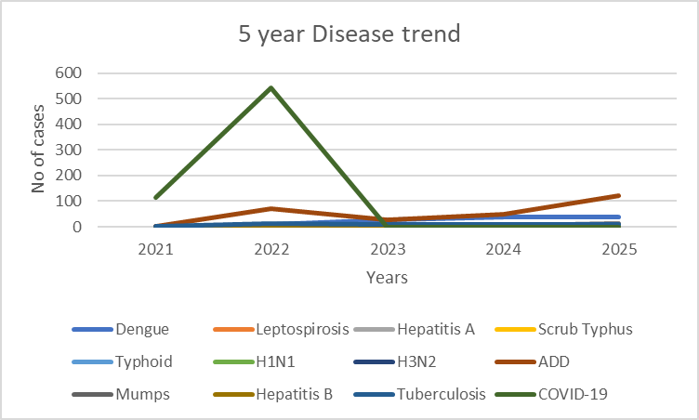

The five-year disease trend (2021–2025) in Pothencode Panchayat shows a mixed pattern with both emerging and persistent public health concerns. Vector-borne diseases like dengue show a clear increasing trend, rising from 3 cases in 2021 to 38 cases in 2025, indicating growing transmission risk. Leptospirosis remains relatively stable with minor fluctuations. Acute Diarrhoeal Diseases (ADD) demonstrate a significant increasing trend, with a sharp rise to 122 cases in 2025, highlighting concerns related to water quality and sanitation.

Vaccine-preventable diseases such as mumps show a recent increasing trend, suggesting possible immunity gaps. Tuberculosis remains stable over the years, indicating consistent detection and treatment but continued disease presence. Hepatitis A shows a fluctuating pattern with no clear trend. Notably, COVID-19 cases sharply declined after peaking in 2022, with no reported cases from 2023 onwards, reflecting effective control measures.

Overall, the Panchayat shows increasing trends in communicable diseases linked to environmental and sanitation factors, emphasizing the nee

d for strengthened surveillance, vector control, water safety measures, and immunization coverage as part of pandemic preparedness planning.

Seasonal Trend Analysis
Seasonal analysis helps anticipate surges (e.g. dengue in monsoon, leptospirosis after floods, influenza in cooler months) and plan pre‑emptive vector control, stockpiling of IV fluids, and awareness campaigns at Panchayat level.

DENGUE
Dengue is a major seasonal vector-borne disease strongly associated with rainfall, water stagnation, and increased mosquito breeding during the monsoon period.

Peak: July–November

Dengue – Ward-wise Yearly Distribution (2021–2025)

Ward | Dengue – Ward-wise Yearly Distribution
Ward | 2021 | 2022 | 2023 | 2024 | 2025 | Total
1 | 0 | 0 | 0 | 1 | 2 | 3
2 | 0 | 0 | 0 | 2 | 1 | 3
3 | 0 | 0 | 0 | 2 | 5 | 7
4 | 0 | 0 | 6 | 1 | 1 | 8
5 | 0 | 0 | 2 | 3 | 1 | 6
6 | 1 | 2 | 3 | 5 | 1 | 12
7 | 0 | 0 | 1 | 1 | 0 | 2
8 | 0 | 0 | 2 | 0 | 1 | 3
9 | 0 | 1 | 0 | 0 | 0 | 1
10 | 0 | 0 | 1 | 1 | 1 | 3
11 | 0 | 1 | 2 | 2 | 1 | 6
12 | 0 | 0 | 2 | 0 | 3 | 5
13 | 0 | 0 | 5 | 1 | 3 | 9
14 | 0 | 0 | 0 | 1 | 2 | 3
15 | 0 | 0 | 0 | 1 | 2 | 3
16 | 0 | 0 | 0 | 1 | 0 | 1
17 | 1 | 0 | 0 | 0 | 2 | 3
18 | 1 | 2 | 0 | 2 | 5 | 10

LEPTOSPIROSIS
Leptospirosis cases are closely linked to monsoon rains, flooding, and occupational exposure, particularly in low-lying and waterlogged areas.

Peak: June - August

Leptospirosis – Ward-wise Yearly Distribution (2021–2025)

Ward | Leptospirosis – Ward-wise Yearly Distribution
Ward | 2021 | 2022 | 2023 | 2024 | 2025 | Total
1 | 0 | 0 | 0 | 0 | 0 | 0
2 | 0 | 0 | 0 | 0 | 0 | 0
3 | 0 | 0 | 0 | 0 | 1 | 1
4 | 0 | 0 | 0 | 0 | 0 | 0
5 | 0 | 0 | 0 | 0 | 1 | 1
6 | 0 | 0 | 0 | 0 | 0 | 0
7 | 0 | 0 | 0 | 0 | 0 | 0
8 | 0 | 0 | 0 | 0 | 0 | 0
9 | 0 | 0 | 0 | 0 | 1 | 1
10 | 0 | 0 | 1 | 0 | 1 | 2
11 | 0 | 0 | 0 | 1 | 0 | 1
12 | 0 | 0 | 0 | 1 | 1 | 2
13 | 0 | 0 | 0 | 0 | 0 | 0
14 | 0 | 0 | 0 | 0 | 0 | 0
15 | 0 | 0 | 0 | 0 | 0 | 0
16 | 0 | 0 | 0 | 0 | 0 | 0
17 | 0 | 0 | 0 | 1 | 1 | 2
18 | 1 | 0 | 0 | 0 | 1 | 2
TOTAL | 1 | 0 | 1 | 3 | 7 | 12

VIRAL HEPATITIS - A
Hepatitis A cases are commonly associated with unsafe drinking water, food contamination, and breakdowns in sanitation, often presenting as clusters or outbreaks.

Peak: October - December

Hepatitis A – Ward-wise Yearly Distribution (2021–2025)

Ward | Hep A – Ward-wise Yearly Distribution
Ward | 2021 | 2022 | 2023 | 2024 | 2025 | Total
1 | 0 | 0 | 0 | 0 | 0 | 0
2 | 0 | 0 | 0 | 0 | 0 | 0
3 | 0 | 0 | 0 | 0 | 0 | 0
4 | 0 | 0 | 0 | 0 | 0 | 0
5 | 0 | 0 | 0 | 0 | 0 | 0
6 | 0 | 0 | 0 | 0 | 0 | 0
7 | 0 | 0 | 0 | 0 | 0 | 0
8 | 0 | 0 | 0 | 0 | 0 | 0
9 | 0 | 0 | 0 | 0 | 0 | 0
10 | 0 | 0 | 0 | 0 | 0 | 0
11 | 0 | 0 | 0 | 0 | 0 | 0
12 | 0 | 0 | 0 | 0 | 0 | 0
13 | 0 | 0 | 0 | 0 | 1 | 1
14 | 0 | 0 | 0 | 0 | 0 | 0
15 | 0 | 0 | 0 | 0 | 0 | 0
16 | 0 | 0 | 0 | 0 | 0 | 0
17 | 0 | 0 | 0 | 0 | 0 | 0
18 | 0 | 0 | 0 | 0 | 0 | 0
TOTAL | 0 | 0 | 0 | 0 | 1 | 1

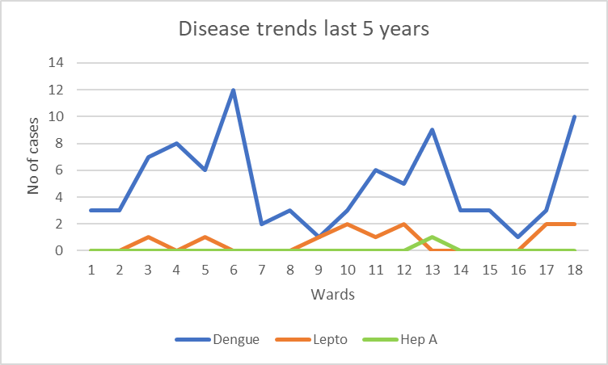

The line chart illustrates the trend of Dengue, Leptospirosis, and Hepatitis A cases from 2021 to 2025, along with their distribution across the wards. Dengue shows the highest burden among the three diseases, with cases reported in most wards. Over the five-year period, Dengue demonstrates a noticeable increase, with a sharp rise during the middle years and a slight decline in the most recent year, though the numbers remain higher compared to the earlier years. Across wards, the number of Dengue cases ranges from 1 to 12, with the highest cases reported in Ward 6 (12 cases), followed by Ward 18 (10 cases) and Ward 13 (9 cases), indicating clustering in certain wards.
Leptospirosis cases are comparatively fewer and show a gradual increase toward the later years, suggesting an emerging trend that requires continued surveillance. At the ward level, cases are reported only in selected wards, with the highest number (2 cases each) observed in Wards 10, 12, 17, and 18, while several wards reported no cases.
Hepatitis A incidence remains very low throughout the period, with only one case reported in Ward 13, indicating sporadic occurrence without widespread transmission.
Overall, the graph indicates that Dengue constitutes the major disease burden during the five-year period, while Leptospirosis occurs sporadically with a mild increasing tendency, and Hepatitis A remains minimal in occurrence.

Outcome-Based Trend Analysis- 2025

The disease pattern in 2025 indicates a shift towards environmental and sanitation-related illnesses, with Acute Diarrhoeal Diseases (ADD) emerging as the major contributor (122 cases), reflecting concerns in water quality, hygiene, and waste management. Vector-borne diseases, particularly dengue (38 cases), continue to show a sustained high burden, indicating ongoing transmission risk and the need for strengthened vector control measures. Leptospirosis (5 cases) remains present at a low but consistent level, suggesting continued exposure to contaminated environments.
There is a noticeable emergence of respiratory viral infections, including H3N2 (3 cases) and H1N1 (1 case), along with a rising trend in mumps (13 cases), pointing towards gaps in respiratory hygiene and possible immunization coverage. Chronic infectious diseases like tuberculosis (9 cases) remain stable, requiring continued surveillance and adherence to treatment protocols.
Hepatitis B (3 cases) appearing in 2025 indicates a need for enhanced screening and preventive strategies, while Hepatitis A shows a decline compared to previous years. Importantly, no cases were reported for malaria, measles, leprosy, and Hepatitis C, reflecting effective control measures in these areas. COVID-19 cases have reduced to zero, indicating successful containment.
Overall, the 2025 outcomes highlight the need to prioritize water and sanitation interventions, vector control, respiratory disease surveillance, and immunization strengthening, while maintaining vigilance for emerging infections and sustaining gains in disease elimination.

Transmission Trend- 2025
For effective management of public health issues, it is important to track the trend of disease transmission mode. It helps identify the population or place at high risk that can be used to predict outbreaks and implement targeted interventions as quickly as possible. Understanding these kinds of trends enables authorities to allocate resources efficiently and change the strategies adequately based on the trend that follows.

Mode of Transmission | No. of cases | No. of Deaths
Vector Borne Diseases | 47 | 0
Water Borne Diseases | 138 | 2
Air Borne Diseases | 58 | 0
Blood Borne Diseases | 1 | 0
Food Borne Diseases | 0 | 0

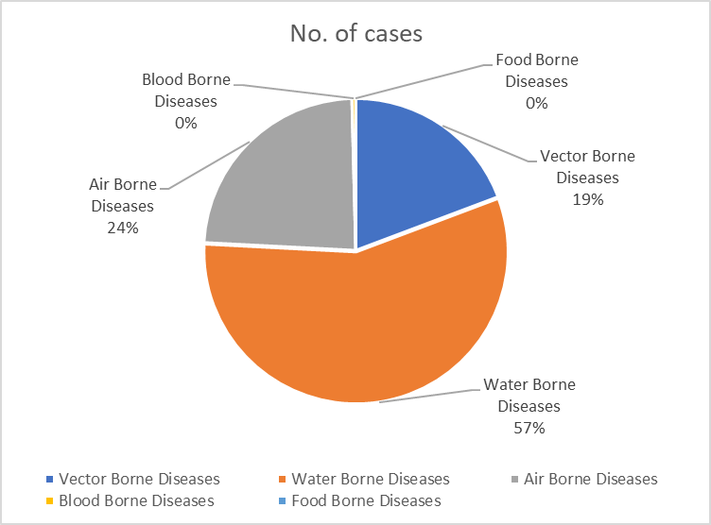

The pie chart illustrates the distribution of communicable diseases by mode of transmission in 2025. Water-borne diseases constitute the largest proportion of cases, with 138 cases, indicating that diseases transmitted through contaminated water remain the most significant public health concern during the year.
Air-borne diseases account for the second highest number of cases (58 cases), highlighting the continued presence of infections transmitted through respiratory routes. Vector-borne diseases contribute 47 cases, indicating ongoing transmission through vectors such as mosquitoes.
Blood-borne diseases were minimal, with only 1 reported case, while no cases of food-borne diseases were reported during the year.
Overall, the distribution shows that water-borne diseases form the major share of the disease burden in 2025, followed by air-borne and vector-borne diseases, while blood-borne and food-borne diseases contributed minimally to the total reported cases.

Vector-Borne Disease

Disease | No. of Cases | No. of Deaths
Dengue | 38 | 0
Malaria | 0 | 0
Chikungunya | 0 | 0

Water Borne Disease

Disease | No. of Cases | No. of Deaths
Cholera | 0 | 0
Typhoid | 2 | 0
Hep- A | 1 | 0
Dysentery | 0 | 0
Amoebiasis | 2 | 1
E- Coli infections | 0 | 0
Air Borne Disease

Disease | No. of Cases | No. of Deaths
Influenza | 7 | 0
H1N1 | 1 | 0
TB | 9 | 2
Chickenpox | 14 | 0
Measles | 0 | 0
Covid-19 | 0 | 0
Pertussis | 0 | 0
Mumps | 12 | 0

Blood-Borne Disease

Disease | No. of Cases | No. of Deaths
AIDS | 0 | 0
Hep- B | 3 | 0
Hep- C | 0 | 0

Zoonotic Disease

Disease | No. of Cases | No. of Deaths
Rabies | 0 | 0
Leptospirosis | 5 | 2
Avian influenza | 0 | 0
West nile | 0 | 0
Anthrax | 0 | 0
Nipah | 0 | 0
Scrub Typhus | 3 | 0

Integrated Disease Hotspot Map (2021–2025)

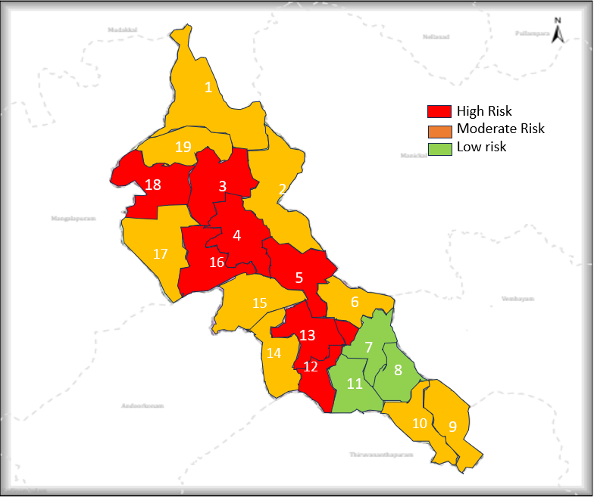

Ward No | Dengue Total (2021-25) | Leptospirosis Total (2021-25) | Hepatitis A Total (2021-25) | Mumps (2021-25) | ADD (2021-25) | Total Cases
1 | 7 | 0 | 0 | 0 | 0 | 7
2 | 5 | 0 | 0 | 0 | 1 | 6
3 | 16 | 1 | 0 | 0 | 1 | 18
4 | 11 | 0 | 0 | 0 | 1 | 12
5 | 5 | 1 | 0 | 0 | 4 | 10
6 | 8 | 0 | 0 | 0 | 1 | 9
7 | 1 | 0 | 0 | 0 | 4 | 5
8 | 3 | 0 | 0 | 0 | 2 | 5
9 | 1 | 1 | 0 | 2 | 2 | 6
10 | 5 | 2 | 0 | 0 | 0 | 7
11 | 4 | 0 | 0 | 0 | 0 | 4
12 | 7 | 2 | 0 | 0 | 1 | 10
13 | 9 | 0 | 0 | 0 | 7 | 16
14 | 2 | 0 | 0 | 0 | 5 | 7
15 | 6 | 0 | 0 | 0 | 3 | 9
16 | 4 | 0 | 0 | 0 | 6 | 10
17 | 4 | 1 | 0 | 0 | 4 | 9
18 | 12 | 2 | 0 | 0 | 7 | 21

Based on the analysis of five-year cumulative data (2021–2025), wards in Pothencode Panchayat have been stratified into high, medium, and low-risk categories considering total disease burden, clustering of cases, and presence of multiple communicable diseases. High-risk wards, including Wards 18, 3, 13, 4, 5, 12, and 16, demonstrate higher case loads and evidence of disease clustering, indicating increased vulnerability to outbreaks and environmental health hazards. Medium-risk wards show moderate case burden with sporadic occurrence of diseases, requiring strengthened surveillance and preventive measures. Low-risk wards report minimal cases with no significant clustering, indicating relatively lower transmission risk. Although no ward meets strict “red zone” criteria based on multi-disease recurrence across consecutive years, the identified high-risk wards function as potential hotspots. This stratification supports targeted interventions such as intensified surveillance, vector control, water and sanitation improvements, and focused risk communication to enhance pandemic preparedness and response at the ward level. purposes.

Preparedness and Response Protocol at LSG Level
This section describes the operational framework for the LSGI once a pandemic is declared. It explains how the LSGI and health system will move from routine data collection to active response, using a One Health approach.
PREPAREDNESS PROTOCOL (PRE-OUTBREAK)
Focuses on strengthening the "First Line of Défense" based on the identified vulnerabilities of the 5,562 elderly residents and 147 bedbound patients.
- Risk Categorization: Establish ward-level risk profiles using the 2025 data, prioritizing Ward 18 (Dengue/Lepto/TB hotspot) and Wards 3, 13,4,5,12, and 16.
- Resource Mapping: Update the "Vulnerability Register" for the 25 dialysis patients and ensure transport agreements with the referral hospitals.
- Environmental Sanitation: Conduct mass well-chlorination drives for all 7884 wells and ponds, specifically targeting the surge in Acute Diarrheal Disease (ADD) seen in 2025.
- One Health Surveillance: Veterinary wing to monitor the 1932 birds and 4135 animals for zoonotic indicators, feeding data to the 1 Government Hospital.
RESPONSE PROTOCOL (DURING OUTBREAK)
Activated immediately upon the detection of a cluster .
A. Command & Coordination
- Rapid Response Team (RRT): Activation of the RRT led by the Medical Officer and Panchayat Secretary.
- Communication Hub: Utilization of the 30 Anganwadi workers and 03 One Health Mentors for real-time community messaging.
B. Field Operations
- Containment: If a ward (like Ward 18) becomes a hotspot, seal entry points if necessary for strict quarantine
- Contact Tracing: ASHA workers to initiate trace-and-test protocols for Tuberculosis and Dengue clusters.
- Facility Management: Convert identified 6 schools and 3 auditoriums into First Line Treatment Centres (CFLTCs) as required.

POST-OUTBREAK PROTOCOL (RECOVERY)
- Impact Assessment: Analyze why cases spiked and identify specific well-contamination points.
- Continuity of Care: Ensure the 147 bedbound patients and 236 palliative care patients resume regular home-visits that may have been disrupted.
- Financial Review: Audit the utilization of local funds and emigrant remittances used for community kitchens or medical supplies.

Constitution of One Health Committee
The LSGD shall constitute a One Health Committee comprising the LSGI President, Medical Officers (Modern Medicine, AYUSH, and Veterinary), the Health Inspector, and the Veterinary Surgeon.

Objective: The One Health Committee coordinates human, animal, and environmental health to prevent and control pandemics.

Sl No | Name | Designation | Department/Institution | Role in Committee | Contact Number
1 | BINDHU | Panchayat President | LSGD | Chairperson | 8547309632
2 | DR SONY RAJ | Medical Officer (PHC/CHC) | Health Dept | Member Secretary | 7736585995
3 | DR UDAYA | Veterinary Officer | Animal Husbandry | Member | 8848769191
4 | Dr. JESSY | Epidemiologist | Health Dept | Member | 9995215578
5 | SHANIFA | Health Inspector/PHN | Health Dept | Surveillance | 9446174020
6 | ASHKA | ASHA Supervisor | Health Dept | Community link | 9946766322
7 | ROHINI | ICDS Supervisor | Social Welfare | Vulnerable groups | 9895450724
8 | UDAYAKUMAR | Police Station Officer | Police Dept | Law & order | 9747124656
9 | BINDHU | Ward Councillor Representative | LSGD | Community coordination | 85473009632
10 | SHEEJA | Kudumbashree CDO | Kudumbashree | Community mobilisation | 9744113531
11 | ABHILASH | NGO/Volunteer rep | Civil Society | Support services | 9995466620
12 | Bindhu | Line Department representative | LSGD | community coordination | 8547309632
13 | Pravitha | Medical Officer Ayurvedam | Ayurveda Hospital | Support service | 9447697839
14 | Gayathri | Medical Officer Homeo | Homeo Hospital | Support service | 7736880065

Key Responsibilities:
- Review disease surveillance data (human + animal)
- Conduct ward-wise risk assessment and vulnerability mapping
- Approve quarantine/isolation centre locations
- Coordinate with district for resources (PPE, oxygen, ambulances)
- Periodically review health system surge capacity, including beds, oxygen, human resources, and ambulances.
- Approve and monitor risk communication and community engagement strategies, including rumour management.
- Ensure protection and service continuity for vulnerable groups (elderly, persons with disabilities, dialysis patients, coastal populations).
- Conduct quarterly mock drills
- Monitor equity measures for vulnerable groups

Meeting Schedule:
Quarterly (normal times) | Weekly (outbreak alert) | Daily (pandemic phase)

Pandemic Response Workforce
To ensure a coordinated and timely response during a pandemic, a dedicated Pandemic Response Workforce shall be constituted at the LSG level. The workforce will function under the overall supervision of the One Health Committee and in close coordination with the health authorities. Team-based deployment will enable efficient surveillance, case management, quarantine and isolation management, logistics support, and risk communication. Each team shall have a clearly designated team leader, defined roles, and an identified pool of personnel to allow rapid activation, rotation of duties, and continuity of services during prolonged emergencies.

Total Response Workforce Available: 300 persons

Team Name | Composition | Key Responsibilities | Team Leader
Surveillance and Contact Tracing Team | HI, JHI, JPHN, ASHAs and Volunteers | Case detection, contact listing, home visits, reporting | HI
Case Management Team | Doctors, Nurses, MLSP, Palliative Nurses | Patient care & referral | DOCTOR
Quarantine & Isolation Team | LSGD staff, Volunteers | Facility management | JHI
Psychosocial support | DOCTOR | Patient care | doctor
Logistics & supply chain Team | LSGD staff, Storekeepers, Drivers 3 | Supplies & transport [PPE, medicines, oxygen, transport, waste management] | Ward Member
Communication Team | Ward members, Kudumbashree, Youth clubs,  AWW workers and other self help groups | IEC, community meetings, countering misinformation | M.O in charge
Transportation | KSRTC, educational institutional buses | transportation | president
Media Surveillance | field staff | awareness | jhi
Intersectoral coordination and convergence | LSGD | coordination | secretary
Collaborative surveillance | LSGD | facility management | president

All teams shall be activated immediately upon outbreak alert or pandemic declaration and shall report daily to the LSG Incident Commander/Medical Officer, with consolidated reporting to the Block PHC. Duty rosters and alternate personnel shall be maintained to ensure uninterrupted services during staff shortages or prolonged response periods. Team composition and numbers may be revised based on the magnitude of the outbreak and availability of human resources.

Activities and Measures before and during Pandemic

PHASE 1 - Alert / Preparation
Surveillance and Reporting-Enhanced syndromic surveillance:
- Data sources for surveillance:
- Routine surveillance data from health institutions including PHCs, subcentres, private hospitals, and laboratories.
- Reports from field-level health workers such as ASHAs, JPHNs, and Anganwadi workers.
- Data from allied sectors including water supply, sanitation, veterinary services, and local self-government records.
- Event-based triggers (to be monitored and reported):
- Sudden increase or clustering of fever, diarrhoeal diseases, respiratory illness, or unusual symptoms in the community.
- Occurrence of deaths due to unknown causes or unusual severity of common diseases.
- Reports of outbreaks, mass absenteeism (schools/workplaces), or unusual animal deaths.

- Zoonotic and animal health surveillance
- Regular monitoring of animal health status in coordination with the veterinary department.
- Reporting of unusual illness or deaths among domestic animals, poultry, and stray animals.
- Strengthening intersectoral coordination (One Health approach) for early detection and control of zoonotic diseases.

- Logistics and Stock Preparedness
  - Identify and empanel local vendors and define emergency procurement mechanisms in accordance with existing LSGD and Health Department norms.
  - Prepare and maintain an essential logistics checklist covering medical supplies, consumables, and support equipment.
  - Pre-identify secure storage locations for emergency stocks and ensure maintenance of stock registers with regular updating.
  - Finalise emergency transport arrangements, including availability of vehicles and identified drivers for rapid deployment during alerts.
  - Designate a Nodal Officer for Logistics to enable prompt decision-making, coordination, and communication during emergencies.
  - Conduct rapid stock verification and ensure availability of minimum buffer stock, including:
- PPE kit | - 0 numbers
- Pulse oximeters | - 4 numbers
- Hand sanitizer | - 3 litres
- Masks, gloves, disinfectants | - adequate quantity

Identify critical gaps in logistics and immediately communicate requirements to the Block and District authorities for timely replenishment and support. Monitor expiry dates and stock rotation.

Identification of Quarantine and Isolation Facilities
  - Identify and list suitable buildings for quarantine and isolation (schools, hostels, community halls, etc.).
  - Categorise cases as per the severity and allocate to appropriate facilities (for instance, severe cases to classrooms, mild cases to an assembly hall in case of a school).
  - Facility readiness checklist needed (beds, toilets, ventilation) etc.
  - Find an alternate site if the primary sites are not available or not in use.
  - Identify facility managers and support staff
  - Prepare basic SOPs for:
    - Admission and discharge
    - Food, water, sanitation
    - Infection prevention and waste disposal
  - Ensure availability of basic amenities: water, sanitation, electricity, ventilation, and waste disposal. Prepare a rapid activation plan for these facilities if case numbers increase.

Risk Communication and Community Preparedness
  - Disseminate early warning messages on symptoms, preventive measures, and reporting mechanisms. Display IEC materials both in English and the local language in public places and ensure ward-level awareness.
  - Sensitize elected representatives and community leaders on preparedness measures.
  - Establish a rumour tracking and misinformation response mechanism to identify, verify, and promptly counter false or misleading information.
  - Engage trusted local persons (ward members, ASHA workers, religious leaders, teachers, community volunteers) to communicate official public health messages and reinforce correct practices.
  - Develop and deploy targeted IEC materials for:
    - Schools and educational institutions
    - Markets and commercial areas
    - Work sites and labour settings
  - Conduct community sensitization meetings at the ward level to promote preventive behaviors, address concerns, and strengthen community participation in preparedness and response.

Protection of Vulnerable Groups
Vulnerable populations require priority protection through targeted line-listing, service continuity, and delivery mechanisms.
- Prepare and regularly update line-lists of vulnerable populations, including:
  - Elderly persons living alone
  - Persons with disabilities
  - Pregnant women
  - Migrant workers
  - Dialysis patients
The detailed line-lists shall be maintained as Annexure ___ and updated periodically.

Clinical Dependency Mapping
Develop ward-wise dependency and vulnerability maps to identify households requiring regular support during emergencies. Ensure continuity of essential health services for vulnerable groups, including
- Dialysis services (facility mapping, transport arrangements, and scheduling)
- Continuity of treatment for TB, HIV, and other chronic conditions requiring uninterrupted medication
- Mental health and psychosocial support services
Establish delivery mechanisms for food, essential commodities, and medicines to vulnerable households through coordinated action involving ASHAs, JPHNs, Kudumbashree, volunteers, and local administration.

PHASE 2 - Active Response

Case Identification and Contact Tracing
Case detection and contact tracing activities will be carried out in coordination with the Health authorities, following disease-specific SOPs and IDSP guidelines.
Field Staff Involved
- Health Inspector (HI)
- Junior Health Inspector (JHI)
- Junior Public Health Nurse (JPHN)
- ASHAs and ASHA Supervisors
- Ward-level volunteers and Kudumbashree members (as required)

Screening Checkpoints
Screening checkpoints at high-traffic locations (transport hubs, markets, religious gatherings) for early detection of symptomatic travellers and crowd screening during outbreaks. Potential locations include bus stands, market entry points, and boat jetties, based on local context and risk assessment.
Screening activities will be carried out by trained personnel such as ASHAs, ward members, and volunteers, with support from Health Department staff. Necessary equipment, including non-contact thermometers and appropriate PPE, shall be ensured prior to activation.
Location | Type (Bus stand/Jetty/Market/Railway) | Staff Deployed (ASHAs/Volunteers) | Screening Method | Reporting authority
Bus stand | Transport hub | One JHI  One ASHA  One health Mentors | 1.Swab Collection.  2. Blood smears collection (RDT)  3.Thermal Scanners | Surveillance Nodal Officer in control room
Market entry | Market | One JHI  One ASHA  Male health volunteers | 1.Swab Collection.  2. Blood smears collection (RDT)  3.Thermal Scanners | Surveillance Nodal Officer in control room
Boat jetty | Water transport | One JHI  One ASHA  Male health volunteers | 1.Swab Collection.  2. Blood smears collection (RDT)  3.Thermal Scanners | Surveillance Nodal Officer in control room

Standard Screening Protocol

The screening protocol shall include temperature screening, observation for visible symptoms, and inquiry regarding recent travel or exposure history. Individuals identified as suspects during screening shall be immediately referred to the nearest PHC/FHC for further evaluation, testing, and appropriate action as per prevailing guidelines.

Pandemic Control Room
The Pandemic Control Room (PCR) serves as the central nerve center for real-time coordination, data aggregation, decision support, and communication during outbreaks. It consolidates information from all LSGD teams, health facilities and community sources to enable rapid response decisions.

Control Room Infrastructure and Location
Primary Location: _Pothencode Panchayath Office.
The Panchayat Office functions as the main Pandemic Control Room (PCR), serving as the central hub for coordination, monitoring, and decision-making. It houses core response teams, data management units, and communication systems. Being centrally located within the Panchayat ensures accessibility and administrative control. All emergency planning, review meetings, and reporting mechanisms are coordinated from this site.
Backup Location: Community Hall in G.P.
The Community Hall serves as an alternate control room during contingencies such as infrastructure failure or surge situations. It is equipped to accommodate extended teams and emergency operations. This ensures uninterrupted functioning of pandemic response activities. The backup facility strengthens resilience and continuity planning within the health emergency framework.

Health System Control Room Framework
The PCR is organized into seven functional pillars to ensure no aspect of the response is overlooked:

Rapid Response Team (RRT)
  - Provides immediate intervention during emergencies, clusters, and field alerts.​
  - Coordinates urgent actions such as case investigation, contact tracing, isolation, and inter‑facility referrals.

Data Management & Analytics Team
  - Collects, validates, and manages key health system indicators (cases, tests, beds, HR, supplies).​
  - Analyzes data trends, generates projections, and supports evidence‑based decision‑making for local authorities.

Human Resource Deployment Team
  - Allocates healthcare staff efficiently based on workload and need
  - Ensures adequate and equitable workforce distribution across facilities

Laboratory Surveillance Team
  - Oversees diagnostic testing coordination, sample transport, and timely reporting of results.​
  - Monitors lab indicators (testing volume, positivity rate, turnaround time) for early detection of outbreaks

Vaccination Cell (If Required)
  - Plans and executes vaccination campaigns, including micro‑planning and session scheduling.​
  - Tracks coverage, identifies gaps, and coordinates corrective actions with field teams and outreach services.

Infrastructure & Patient Occupancy Team
  - Monitors facility capacity, earmarked beds, oxygen and critical care resources across all linked facilities.​
  - Ensures optimal patient distribution and referral management using updated bed‑status and resource data.
- BMWM
The BMWM team ensures safe segregation, collection, transportation, and disposal of biomedical waste as per regulatory norms. It monitors compliance in all healthcare facilities and temporary care centers. Proper waste management reduces environmental contamination and infection risk. Training and supervision are integral components of this pillar.
- Communication team
The Communication Team manages public information dissemination, awareness campaigns, and official advisories. It ensures transparent and accurate messaging to prevent misinformation and panic. Regular updates are shared through local media, social platforms, and community networks. Effective communication builds public trust and cooperation.
- Logistics and supply chain
This team manages procurement, storage, and distribution of essential supplies such as PPE, medicines, oxygen, and equipment. It monitors stock levels and prevents shortages through advance planning. Efficient supply chain management ensures uninterrupted healthcare delivery. Coordination with district authorities strengthens resource mobilization.
- . Transportation (interfacility & emergency transport)
The transportation unit coordinates ambulance services and patient transfers between facilities. It ensures timely referral transport for critical cases. The team maintains vehicle readiness and communication with hospitals. Efficient transport systems reduce treatment delays and improve survival outcomes
- Media surveillance Call centre
This unit monitors media reports and social media trends for outbreak signals or misinformation. The call centre addresses public queries, complaints, and emergency support requests. It provides guidance on testing, treatment, and vaccination services. Active surveillance improves community engagement and responsiveness.
- Management of the deceased
This team ensures dignified and safe handling of deceased persons as per public health guidelines. It coordinates documentation, transport, and support to families. Infection prevention protocols are strictly followed. Proper management upholds public health safety and humanitarian values.
- Intersectoral coordination and convergence
This pillar ensures collaboration among health, local self-government, police, education, social welfare, and other departments. Regular coordination meetings align strategies and share responsibilities. Convergence enhances resource utilization and community outreach. Integrated action strengthens the overall pandemic preparedness and response system.

Key Control Room Team
The Control Room Team coordinates all pandemic response activities within the LSGD and serves as the single command and communication hub during activation. It integrates information, field actions, logistics, and policy execution across all participating departments and health facilities.

Role | Name | Designation | Contact Number | Responsibility
In-charge/Nodal Officer | SONY RAJ | MO | 7736585995 | Overall coordination, decision-making, and reporting to the District level.
Data Entry Operator | Shahin | Clerk | 9847195759 | Managing the line list, updating dashboards, and tracking testing results.
Communication Officer | SHINCY | JHI | 8289818685 | Handling the public helpline, coordinating ambulance dispatch, and contact tracing calls.
Logistics Coordinator | Priyanka | JHI | 8281562762 | coordination dispatch
Technical Support (IT/Data) | AJITHA | JHI | 9497795902 | data entry

SOP for alert escalation/trigger point with mapping of responsibilities.
Key Points:
- The Control Room shall be staffed with a designated In-charge, data entry personnel, and communication staff with clearly defined roles and shift arrangements.
- It shall maintain updated records on daily monitoring indicators including new cases, persons under active quarantine, and hospital bed occupancy.
- All reports and situation updates shall be shared daily with the Block and District Surveillance Unit.
- The Control Room shall act as a single point of contact for coordination with response teams, health institutions, and other departments.
- Contact details of the Control Room shall be widely communicated to field staff and stakeholders during activation.

Daily Monitoring Indicators
To ensure timely decision-making and effective response, the following key indicators shall be monitored and updated on a daily basis by the Pandemic Control Room:

Epidemiological Indicators:
New cases reported today, Total active cases, Test Positivity Rate (TPR), Case Fatality Rate (CFR)
- Surveillance Indicators:
Persons under home quarantine, High-risk contacts identified, Fever, ILI, SARI or other symptoms (syndromic surges), Travellers (symptomatic or high-risk arrivals),Animal husbandry surveillance (zoonotic alerts, unusual animal deaths, poultry/bird flu signals), Mortality surveillance (excess deaths, unexplained fatalities, verbal autopsy reports)
- Logistics and Infrastructure Indicators:
Hospital / CFLTC beds occupied, Oxygen cylinders/concentrators available, Ambulances on standby
- Alert Findings
The following table outlines category-specific trigger points (red flags) from surveillance indicators and corresponding immediate actions for the Pandemic Control Room. These enable rapid response to alert findings like testing anomalies, positive cases exceeding thresholds, clusters, and WGS reports.

Category | Trigger Pophint (Red Flag) | Immediate Action
Clusters | Geographical or facility-based: 5+ cases linked to one location (office, school, street). | Declare a micro-containment zone; perimeter control and active case finding.
Testing | Sudden drop in testing volume / delay in reporting / unusual testing trends | Review the sample collection process, address lab bottlenecks, deploy additional testing teams, and notify the District Lab.
Lab | Test Positivity rate increases | Increase testing sites in that ward.
Hospital | >80% Oxygen bed occupancy | Activate backup/CFLTC beds.
Travel | Cluster of cases from a single flight/train or high-risk arrival group. | Trace all passengers in adjacent seats; implement mandatory institutional quarantine.
Animal | Mass poultry/wildlife death or unusual sickness | Notify Animal Husbandry, sample the area, and dispatch RRT for environmental sampling and zoonotic check.
Mortality | Sudden spike in home deaths or brought-in-dead (BID) cases | Audit the deaths and Active Case Search drive
Additional investigations like Whole Genome Sequencing (WGS) | Detection of a Variant of Concern (VOC) or Variant of Interest (VOI) | Implement strict micro-containment; update clinical protocols to match variant severity.

Communication of Public Health Information
A Community Communication Hub shall be established to ensure timely, accurate, and consistent dissemination of information during a pandemic. The Hub will function under the coordination of Nodal officers of the control room and act as the nodal point for public communication, risk messaging, and community engagement. It will support dissemination of official advisories, promote preventive behaviors, address rumors and misinformation, and ensure that messages reach all sections of the population through trusted local channels and leaders.

Key communicators
Channel | Responsible Person | Contact
Ward-level announcements | Shincy | 8289818685
Social media | Priyanka | 8281562762
Local Cable TV/Radio | Ajitha | 9497795902

- All messages disseminated through the Hub shall align with advisories issued by the Health Department and District authorities.
- Community leaders shall be sensitized to support behavior change, reduce stigma, and counter misinformation.
- Special efforts shall be made to reach vulnerable and hard-to-reach populations using locally appropriate communication methods.

Rumor Tracking: A designated volunteer will monitor local social media/WhatsApp groups daily to identify misinformation and issue official clarifications via the Communication Hub.

Coordination with District/State Authorities & Other Organisations
Effective coordination with Block, District, and State authorities is essential to ensure timely reporting, technical guidance, and uninterrupted supply of essential resources during a pandemic. The LSG shall establish clear communication channels, designate responsible officers, and adhere to prescribed reporting timelines to support coordinated public health action and efficient resource mobilisation.

Key Details:
- Nodal Officer for Reporting: Block Medical Officer
- Contact Number: 9496102884
Reporting Schedule and Protocols:

To Whom | What to Report | Frequency | Nodal Person
Block PHC | Complete Situation Report (Cases, Quarantine, Beds, Screening, Deaths) | DAILY REPORTING | BLOCK MEDICAL OFFICER
District IDSP Unit | Outbreaks/Clusters/Unusual Events (>5 cases same ward) | DAILY REPORTING | DSO
Veterinary Officer | Animal health events/Zoonotic alerts | AN EVENT OCCUR | DOCTOR
State Cell | Zoonotic cross-sector events | AN EVENT OCCUR | DOCTOR

Supply Chain Coordination
The LSG shall coordinate closely with Block, District, and State authorities (KMSCL) to ensure uninterrupted availability of essential goods, medical supplies, and logistics during a pandemic. Supply requirements shall be assessed regularly based on case load and communicated promptly to the appropriate authorities for timely replenishment.
Key Points:
- Maintain updated contact details of District and Block nodal officers for health logistics, oxygen supply, ambulances, and essential medicines.
- Submit timely indent requests for PPE, testing kits, medicines, oxygen, and other critical supplies through prescribed channels.
- Monitor stock levels at LSGD facilities, quarantine/isolation centres, and field teams through daily stock registers and dispensing logs to prevent shortages.
- Coordinate with District authorities, Karunya/Neethi medical shops, and local purchase committees for funds allocation and emergency procurement.

- Ensure regular monitoring of dispensing registers at all facilities to track usage, expiry, and pilferage—shortages being a perennial issue requiring proactive weekly audits.

- Activate surge procurement protocols during high caseloads, leveraging local purchase powers under LSGD funds alongside state supplies.

Resource Inventory and Contacts
Resource Category | Source  (District/State/Private) | Contact
PPE Kits/Masks/Gloves | KMSCL | 04712470222
PPE Kits/Masks/Gloves | Local Vendors | 8281069170
Oxygen  Cylinders/Concentrators | KMSCL | 04712470222
Medicines/Antivirals | KMSCL | 04712470222
Medicines/Antivirals | Neethi Shops | 9447251269
Test Kits (RTPCR/Rapid) | KMSCL | 04712470222

Collaboration with NGOs, PPP, and CSR
To augment government efforts during a pandemic, the LSG shall collaborate with NGOs, voluntary organisations, and private sector partners through public–private partnerships and Corporate Social Responsibility (CSR) initiatives, in coordination with District authorities.

Key Points:
- Engage NGOs and community-based organisations for community outreach, awareness, and support to vulnerable populations.
- Leverage CSR support for procurement of medical equipment, PPE, oxygen concentrators, food kits, and sanitation materials, as permitted.
- Ensure all collaborations align with government guidelines and are routed through approved administrative and financial procedures.
- Maintain transparency and documentation for all external support received and utilised.
Organization | Type | Support Offered | Contact Person
Youth Clubs/Student Unions | National Service Scheme | Man power | 9495151885

Interdepartmental Coordination
Coordination among departments during a pandemic shall be ensured through regular review meetings convened by the LSGD President. These meetings will provide a structured platform for sharing situational updates, assessing resource availability, resolving operational gaps, and taking joint decisions to ensure a coordinated and timely response.

Department | Representative | Key Role | Contact
Health (PHC) | Staff Nurse : Summayya | Case management | 9744162526
Veterinary | Veterinary Surgeon:Udaya | Animal surveillance | 8848769191
ICDS | Supervisor: Rohini | Nutrition support | 9895450724
Education | Head Teacher: | School coordination | 9074038156
Police | SI;Bineesh | Containment enforcement | 7025124656
Water Authority | Jeeva | Water supply | 8606007377
LSGD Engineering | AE | Quarantine infrastructure | 9496370997

PHASE 3 - Surge Capacity
Phase 3 is activated when there is a rapid increase in cases, high test positivity rates, or when existing health facilities and quarantine arrangements approach saturation. The focus of this phase is to expand isolation capacity, augment clinical care services, and mobilise additional resources through district and state support mechanisms.

Conversion of Community Facilities
To manage increased case load, the LSGD shall activate additional isolation facilities by repurposing identified community infrastructure such as community halls, auditoriums, schools, hostels, or other suitable buildings.

Name of facility | Facility Type | No. of Buildings | Ward | Surge Capacity (Beds) | Nodal Person
RAJASREE | Auditorium | 1 | Edathara ward | 10 | Manager
GOVT UPS Pothencode | School | 3 | Town Ward | 20 | HM
Ayiroopara HSS | School | 6 | Ayiroopara Ward | 30 | principal
LVHS | School | 5 | Karoor Ward | 30 | principal
Vengode Public Hall | AUDITORIUM | 1 | Vengode Ward | 10 | Satheesh Babu
Kalloor GOVT UPS | School | 2 | Kalloor Ward | 10 | HM
LPS Thachappally | School | 2 | Thachappally Ward | 10 | HM
MT Auditorium | Auditorium | 1 | Town Ward | 30 | Manager
Manalakam LPS | School | 1 | Manalakom ward | 10 | HM

Recovery and rehabilitation phase
After the peak of the pandemic, recovery measures will focus on restoring normal health and socio-economic conditions across all 20 Panchayat wards.
- Recovery
The recovery phase in Mangalapuram will focus on restoring routine health services, safely reopening institutions, and stabilising community livelihoods. The recovery phase centres on the protracted endeavour to reconstruct and restore pre-pandemic circumstances. This entails revitalizing healthcare infrastructure, economic systems, and public service provisions. Successful recovery requires meticulous planning, coordinated efforts, and the strategic allocation of resources to facilitate recovery across all sectors. Prioritizing the delivery of essential healthcare, addressing economic challenges, and protecting the well-being of affected communities are of utmost importance.
Priority areas include:
- Restoration of primary healthcare services
- Safe reopening of schools
- Economic stabilization
- Strengthening local health systems
Block-level coordination will be ensured between:
- Panchayaths
- Health Department
- ICDS
- Veterinary Department
- Community organisations
- Damage and Impact Assessment

A thorough assessment of the damage to public health, infrastructure, and the economy is crucial after a pandemic. This evaluation is essential for identifying both immediate and long-term intervention needs. A detailed examination of the harm and its consequences provide vital information for resource allocation, informs policy development, and enables the precise targeting of recovery efforts. Therefore, a thorough situational analysis requires gathering real-time data and working closely with local authorities.
A ward-wise assessment will be conducted across all Panchayaths.
Areas Assessed
- Disease burden
- Deaths
- Livelihood losses
- School disruptions
- Service interruptions
- Vulnerable households
Data Sources
- Health facility records
- Household surveys
- ASHA reports
- Panchayat registers
The findings will guide recovery planning.
- Restoration of Health Services
Rebuilding healthcare infrastructure is crucial for guaranteeing the continued availability of essential medical services after a pandemic. The recovery process requires a step-by-step approach, starting with the most important services. These include emergency care, essential treatments, and vaccination programs. A key part of this restoration involves addressing staff shortages, securing enough medical supplies, and prioritizing the healthcare needs of vulnerable groups. Consequently, a meticulously devised strategy will facilitate the uninterrupted operation of the healthcare system throughout the recovery period.
Priority services to be restored:
- Maternal and child health services
- Immunization
- NCD treatment
- Dialysis support
- TB and HIV treatment
- Emergency care
Outreach services will be strengthened.

- Rehabilitation of Affected Population
The rehabilitation of the affected population constitutes a critical element of the comprehensive recovery strategy. This process involves physical rehabilitation, healthcare evaluations, and social welfare support for those who suffered the most severe pandemic-related repercussions. Moreover, it is essential to address the mental, emotional, and social aspects of those impacted's lives. Therefore, ensuring access to medical services, social support systems, and economic assistance will help restore stability and resilience to the population.
Rehabilitation measures will include:
- Medical follow-up for recovered patients
- Social welfare support
- Food security support
- Livelihood support

Priority Groups:
- Elderly persons
- Daily wage workers
- Migrant workers
- Poor households
- Persons with disabilities
Convergence with Government schemes will be ensured.

- Psychosocial and Mental Health Support
The psychological effects of a pandemic can be significant, underscoring the need to pay closer attention to psychosocial health. Offering mental health resources, such as counselling and psychological therapies, assists individuals in managing the trauma and stress associated with the pandemic. Community-based mental health services and telemedicine can enhance access to mental health resources, especially for those facing isolation or in need of immediate support. Therefore, cultivating mental resilience will contribute to the wider recovery of both individuals and communities. Mental health support will include:
- Counselling services
- Tele-counselling
- Ward-level support
- Awareness programs
Priority Groups:
- Children
- Frontline workers
- Bereaved families
- Isolated elderly persons
- Disease Surveillance
During Recovery Disease surveillance is a vital element of the recovery phase, monitoring potential resurgences or new outbreaks. Continuous monitoring, including testing, contact tracing, and reporting protocols, enables health authorities to identify and manage newly emerging cases swiftly. The fortification of the surveillance system facilitates early detection, the implementation of more effective control measures, and a more streamlined response to prospective new threats. Consequently, maintaining vigilance throughout the recovery period is essential to avert a secondary wave of infection.
Surveillance will continue across the wards
Activities
- Fever surveillance
- Syndromic surveillance
- Animal surveillance
- Mortality monitoring
Field Teams
- ASHA Workers
- JHI
- JPHN
- Health Inspectors
Early detection will prevent resurgence.
- Environmental Cleanup and Sanitation After a pandemic, environmental restoration and sanitation are crucial for keeping public areas safe and clean. Inadequate sanitation can precipitate secondary health crises, such as the spread of waterborne illnesses. Consequently, the orchestration of extensive cleanup initiatives, the enhancement of waste-disposal systems, and the dissemination of hygiene education to the populace will be indispensable for mitigating future health hazards. Furthermore, restoring sanitation systems and ensuring access to clean water are crucial for protecting public health during the recovery phase.
Block-wide sanitation drives will be conducted.
Activities
- Disinfection of public places
- Market sanitation
- Water source cleaning
- Waste removal
- Canal cleaning Safe drinking water supply will be ensured.
- Livelihood Restoration

Rebuilding the economic well-being of individuals and businesses affected by the pandemic is essential for economic recovery. Numerous workers have experienced unemployment or financial distress, while businesses have been forced to close. Providing financial assistance, vocational training, and support for small and medium-sized enterprises will help restore economic stability. Consequently, livelihood restoration initiatives should prioritize support for vulnerable populations and stimulate economic expansion by generating employment opportunities and providing income support mechanisms.
Livelihood restoration will focus on:
- Fisherfolk
- Agricultural workers
- Daily wage workers
- Kudumbashree units
- Small businesses Support Measures
- Employment schemes
- Financial assistance
- Skill training
- Self-employment support
- Community Engagement and Confidence Building
Restoring faith in the recovery process hinges on robust community involvement. Involving communities in decision-making, coupled with transparent communication and the cultivation of local leadership, can foster a sense of support and inclusion. Furthermore, fostering trust through community-based programs and open communication strengthens relationships and encourages adherence to public health guidelines. As a result, building confidence in the recovery process is crucial for promoting collective action and social cohesion.
Community participation will be encouraged through:
- Ward Sabhas
- Volunteer groups
- Kudumbashree units
- Youth clubs
Transparent communication will build trust.
- Documentation and After-Action Review
Documentation and subsequent evaluations provide crucial insights into the pandemic response. Analyzing successes and challenges during the crisis enables health officials and policymakers to improve future preparedness strategies. A comprehensive after-action report facilitates the identification of both advantages and disadvantages, as well as areas requiring improvement, thereby informing the strengthening of future response plans. This assessment is essential for gauging the overall impact and efficacy of recovery initiatives.
A comprehensive report will be prepared covering:
- Actions taken
- Challenges faced
- Outcomes achieved
Review meetings will include:
- Panchayath officials
- Health staff
- Community representatives
- Lessons Learned and Best Practices
The lessons from the pandemic provide crucial insights that can enhance how we prepare for and respond to future crises. Identifying successful strategies and key takeaways from the recovery phase enables enhancements to processes, policies, and protocols for future health emergencies. Sharing these lessons with local, national, and international partners will, in turn, strengthen the global community's ability to respond to subsequent crises. Furthermore, integrating these insights into current health systems and training initiatives will reinforce both resilience and response capabilities.
Key successful strategies will be documented:
- Ward-level coordination
- Volunteer mobilisation
- IEC campaigns
- Surveillance systems
Lessons learned will improve future preparedness.
- Health System Strengthening Strengthening the health system represents a continuous strategy to enhance preparedness for future pandemics. This necessitates allocating resources to healthcare infrastructure, providing training for healthcare professionals, and ensuring essential resources, including medical supplies, vaccines, and therapeutic interventions. A resilient health system is essential for an effective response to both current and future health emergencies. Furthermore, fortifying health systems not only improves pandemic response capabilities but also elevates the overall quality of healthcare delivery for the population.
Post-pandemic strengthening measures:
- Improve infrastructure
- Digital reporting systems
- Staff training
- Stockpile essential supplies
This will improve long-term resilience.
- Policy Revision and Preparedness Enhancement Policy adjustments and preparedness improvements are essential for bolstering the health system's capacity to manage future pandemics. This necessitates revising public health policies, enhancing inter-agency coordination, and aligning legal structures with the demands of swift response initiatives. By incorporating insights from the ongoing pandemic into policy revisions, governments can fortify their readiness for forthcoming crises, thereby strengthening the resilience of health systems, supply chains, and community involvement.
Plans will be updated based on experience.
Actions
- Revise pandemic plans
- Improve coordination mechanisms
- Update SOPs
- Align with State guidelines
- Research
Research is a crucial component in advancing pandemic preparedness and response strategies. In the wake of a pandemic, research endeavours should prioritize elucidating the disease's characteristics, formulating vaccines and therapeutic interventions, and refining diagnostic methodologies. Furthermore, scientific investigations can facilitate the identification of risk factors, the elucidation of transmission patterns, and the development of efficacious intervention strategies. Strengthening response capacities and expediting recovery require collaboration with international research networks, allocating resources to foster innovation, and prioritizing public health research initiatives.
The Block will encourage research on:
- Disease trends
- Vulnerability patterns
- Health service gaps Collaboration
Research findings will support future preparedness.

CONCLUSION
In conclusion, a comprehensive Pandemic Preparedness Plan (PPP) serves as a vital framework to safeguard the health, well-being, and socio-economic stability of the community at all times. By systematically analyzing ward-wise demographic data, identifying high-risk and vulnerable populations such as the elderly, children, migrants, and individuals with chronic illnesses, and strengthening the capacity of Family Health Centres, private clinics, and referral hospitals, the Panchayat can establish a resilient and responsive local health system. Clear referral linkages, uninterrupted essential services, and effective coordination between health institutions ensure that emergencies are managed in a timely and organized manner without overwhelming existing facilities. Pandemic preparedness extends beyond medical treatment and hospital care. It demands strong interdepartmental coordination among health, sanitation, education, social welfare, and local self-government departments. Active community participation, involvement of ASHA workers, Anganwadi staff, volunteers, and ward-level committees, along with robust disease surveillance and early warning systems, play a crucial role in early detection and containment. Well-planned risk communication strategies help prevent misinformation and panic, while continuous training and capacity building of healthcare workers and frontline responders enhance efficiency and confidence. Special focus on resource mapping, emergency stockpiling of medicines and PPE, ambulance services, isolation facilities, and surge capacity planning ensures equitable access and leaves no segment of the population unattended. Through proactive planning, periodic review meetings, simulation exercises, mock drills, and strong community engagement, the Panchayat can continuously refine and strengthen its preparedness mechanisms. A structured and regularly updated preparedness framework builds public trust, reduces morbidity and mortality, and ensures continuity of essential services even during crises. Ultimately, such a forward-looking and inclusive approach promotes sustainable community resilience, enabling the Panchayat to effectively prevent, detect, respond to, and recover from future pandemics or public health emergencies.

Additional points
- tech support -BSNL Office,18003451500
- relief based commodities-Village Office,9446551429
- ham reading operators-Local Media ‘8848997241
- hazard vulnerability mapping,HI-9446174020
- Kseb & other power source,KSEB Office-04712411990
- HR specific responsibility,Medical Officer-7736585995

RECOMMENDATIONS

Strengthening Healthcare Infrastructure
- Establish a primary health response unit within the Panchayat with trained staff.
- Ensure availability of basic medical supplies (masks, sanitizers, PPE kits, oxygen cylinders).
- Create tie-ups with nearby hospitals in Pothencode for emergency referral and transport.

2. Community Awareness & Education
- Conduct regular awareness campaigns on hygiene, vaccination, and preventive measures.
- Use local communication channels (community radio, WhatsApp groups, notice boards) to spread verified information.
- Train volunteers to act as health ambassadors in each ward.

3. Emergency Response & Coordination
- Form a Pandemic Preparedness Committee at Panchayat level including health workers, ward members, and NGOs.
- Develop a clear action plan for lockdowns, quarantine, and distribution of essentials.
- Maintain a database of vulnerable groups (elderly, differently-abled, chronically ill) for targeted support.

4. Supply Chain & Food Security
- Identify and support local suppliers and farmers to ensure uninterrupted food supply.
- Create community kitchens during emergencies to serve vulnerable populations.
- Stockpile essential commodities in Panchayat-run outlets for crisis periods.

5. Digital Preparedness
- Promote digital platforms for telemedicine consultations.
- Use Panchayat’s website/social media for real-time updates on health advisories.
- Encourage online grievance redressal to reduce crowding in offices.

6. Training & Capacity Building
- Organize mock drills for pandemic response in schools, offices, and public spaces.
- Train Panchayat staff and volunteers in first aid, infection control, and crowd management.
- Collaborate with NGOs and health departments for capacity-building workshops.

7. Long-Term Resilience
- Integrate pandemic preparedness into the Panchayat Development Plan.
- Allocate a dedicated budget for health emergencies.
- Encourage community participation in planning and monitoring preparedness measures.

MOCKDRILL SCENARIOS

Scenario 1:.Influenza-like Illness Cluster in a School
Context: Within a week, several students and teachers develop fever, cough, and sore throat. Absenteeism in the school rises sharply.
Objectives:
- Test early outbreak detection through school health monitoring.
- Assess communication between school authorities and the health department.
- Evaluate implementation of infection prevention measures in the school setting.
Scenario 2: Dengue Surge after Unseasonal Rain
Context: After two weeks of unseasonal rainfall, multiple wards report a sudden increase in fever cases. Health workers identify several suspected dengue cases, and mosquito breeding is observed near construction sites and household water storage containers.
Objectives:
- Test early case reporting from ASHA workers and One Health volunteers to the health institution.
- Assess the coordination between health, sanitation, and LSGI teams for vector source reduction.
- Evaluate community awareness and rapid response for household mosquito control.
Scenario 3: Drinking Water Contamination after Flooding
Context: Following heavy rainfall and flooding, residents report foul-smelling drinking water and multiple cases of gastrointestinal illness.
Objectives:
- Test coordination between health, water authority, and LSGI for water quality assessment.
- Evaluate emergency measures such as chlorination and safe drinking water distribution.
- Assess risk communication to the community on safe water practices.
Scenario 4: Suspected Nipah-like Illness in a Rural Ward
Context: A patient admitted with high fever, headache, and altered sensorium has a history of contact with fruit bats in a farm area. The case raises suspicion of a zoonotic infection.
Objectives:
- Test rapid notification to district surveillance units and higher authorities.
- Evaluate coordination between health, veterinary, and forest departments under the One Health approach.
- Assess preparedness for isolation, contact tracing, and risk communication.

Scenario 5: Post-Flood Leptospirosis Alert
Context: After continuous monsoon rains and waterlogging in several low-lying wards, farmers and sanitation workers report fever with severe body pain. A few suspected leptospirosis cases are detected in the health institution.
Objectives:
- Test early detection and reporting of suspected cases by field health staff and One Health volunteers.
- Assess coordination between health, veterinary, and sanitation departments for risk reduction.
- Evaluate distribution of prophylactic doxycycline and public awareness in high-risk wards.

ANNEXURE

IMPORTANT PHONE NUMBERS

Phone numbers and particulars of persons responsible for providing guidance, assistance, and support for pandemic preparedness operations may be provided here in a manner that allows easy reference at a glance. The information recorded here could be exhibited elsewhere at the time of emergencies. LSG institutions shall give special attention to collect and record the above data of persons and institutions who/which are supposed to give technical and co-ordination support to reduce the impact of pandemic.

1.1. Details of grama panchayat/municipality/corporation wards
Sl.No | Name of the ward | Ward number | Name of the ward  member | Contact number
1 | MANALAKOM | 1 | PURUSHOTHAMAN | 9496571204
2 | NETHAJIPURAM | 2 | LIGEESH V G | 9562473684
3 | THACHAPALLY | 3 | BEENA KUMARI | 8606867821
4 | VAVARAMBALAM WEST | 4 | SRUTHI | 8921752084
5 | VAVARAMBALAM EAST | 5 | VARNA LATHEESH | 8547056949
6 | PULIVEEDU | 6 | P S BINU | 9400001295
7 | POTHENCODE TOWN | 7 | SAJAN LAL | 9037112329
8 | PLAMOODU | 8 | GIRIJA C | 9539293736
9 | AYIROOPPARA | 9 | SUHAIL | 8606018454
10 | MELEVILA | 10 | AMBILI L | 9539055101
11 | KATTAYIKONAM | 11 | BINDHU V | 8547309632
12 | EDATHARA | 12 | SIJI S V | 7012837833
13 | KAROOR | 13 | BABY SALINI | 9747710236
14 | PANIMOOLA | 14 | DELEEP KUMAR | 9656468801
15 | MANNARA | 15 | THULASEEDARAN | 9846374233
16 | MANJAMALA | 16 | SAYOOJA | 9495495854
17 | KALLOOR | 17 | SEENATH BEEVI | 9544245058
18 | KALLUVETTY | 18 | SHIBU S | 9496669395
19 | VENGODE | 19 | THONNAKKAL RASHEED | 9847709919

1.2. Other important phone numbers of grama panchayat/municipality/corporation area
Sl. No. | Name | Contact number
1. | BINDHU V (PRESIDENT) | 8547309632
2. | MUHAMMED SHAFI (SECRETARY) | 9446271895
3. | Shibu S (Vice President) | 9496669395
4. | VARNA LATHEESH | 8547056944
5. | BABY SALINI | 9747710236
6. | PURUSHOTHAMAN | 9496571204
7. | Excise department | NIL
8. | Forest department | NIL

1.3. Important offices of grama panchayat/municipality/ corporation
Sl.No | Name of the office | Contact person | Contact number
1. | Village Office | Village Officer | 9446551429
2. | Agriculture Office | Agriculture Officer | 7559971181
3. | Animal Husbandry Office | Animal Husbandry Doctor | 8848769191
4. | Police Station | Police Officer | 9497960428
5. | BSNL Office | Officer | 18003451500
6. | Block Office | Officer | 04712417026
7. | KSEB Office | Officer | 0471 2411990
8. | Fisheries Office | Officer | NIL
9. | Fire and Rescue | Officer | NIL

1.4. Health Services

Sl. No | Name of the hospital/institution | Location | Phone number
1. | Government hospitals/PHC | VENGODE | 9847195759
2. | Private hospitals | POTHENCODE | 7907889204
3. | Clinical laboratories | POTHENCODE | 9947803618
4. | Chemist/pharmacy | VENGODE | 9947854948
5. | Blood donors | 0 | 0
6. | Other language experts (Bihari, Hindi, Bengali,  Asamees ………) | 0 | 0

1.5. Veterinary Services
Sl.No | Name of the Clinic | Name of the  Surgeon/Doctor | Place/location | Phone  number
1 | Govt.Veterinary Hospital | DR UDAYA | KALLOOR | 8848769191

1.6. Helpline numbers
Helpline | Phone number
Police | 0471 2716100
Fire and Rescue | NIL
KSEB | 0471 2411990

1.7. Public and Private Schools Contact details

S.No | Name of School | Institution type | Phone number
1 | GLPS MANALAKOM | GOVT | 9048644778
2 | GLPS THACHAPPALLY | GOVT | 9895060786
3 | GUPS KALLOOR | GOVT | 9074038156
4 | GUPS POTHENCODE | Govt | 9446849349
5 | GHSS AYIROOPPARA | GOVT | 9995428685
6 | MARY MATHA | Private | 9074536735
7 | MOTHER LAND | Private | 7560885747
8 | NIZAMIA | PRIVATE | 9447009480
9 | DRS KIDS | PRIVATE | 9074077807
10 | LVHS | AIDED | 8590868833
11 | EVUPS | AIDED | 9495404540
12 | JYOTHIS PUBLIC SCHOOL | PRIVATE | 6282878209
13 | GOVT MODEL RESIDENTIAL SCHOOL | GOVT | 6282191159
14 | HONEY BEE | PRIVATE | 9061685750

1.9. Anganwadi Contact Details

Ward No | Name of Anganwadi Teachers | Phone number
1 | LISI | 9895450724
2 | LATHIKA DAS | 6235206870
3 | KANAKA LATHA | 9400827420
4 | KUMARI JAYA | 9747253869
5 | GIRIJA | 9744766975
6 | GEETHAKUMARI | 9526492559
7 | SULOCHANA | 9744357667
8 | DEEPIKA V S | 9495253436
9 | SOBHANAKUMARI | 8943401914
10 | SAJARATH | 9746814965
11 | BINEETHA S | 7012406165
12 | GEETHAMMA R | 9744539279
13 | JAYAKUMARI G | 9048534041
14 | VINEETHA S | 9605890356
15 | SAJITHA A | 9207112074
16 | SREELATHA L | 7902347386
17 | SREEDEVI K S | 8078236803
18 | BEENA | 9961566019
19 | SHAHIDA BEEVI | 9961230419
21 | AJITHAKUMARI K | 9544508561
22 | SEETHA S | 9961087208
23 | MANJU | 8848560021
24 | AJITHAKUMARI P | 6282819003
25 | AMMUMMOL V B | 8075883306
26 | KUMARI LEKHA | 9656461142
27 | KAIRALI | 9539526172
28 | SARANYA | 7907151684
29 | SHEELA | 7306525517
30 | SHEEBA | 9745489616

Ward No | Anganwadi No and Name of Teacher | Phone number
1 | 31& Lethika Das | 6235206870
1 | 32 & Geetha Kumari | 9526492559
2 | & Kairali | 9539526172
3 | 35 & Shahida Beevi | 9961230419
4  5 | 34 & Shajarath | 9746814965
4  5 | LISI | 9895450724
4  5 | LATHIKA DAS | 6235206870
4  5 | KANAKA LATHA | 9400827420
4  5 | KUMARI JAYA | 9747253869
4  5 | GIRIJA | 9744766975
4  5 | GEETHAKUMARI | 9526492559
 | SULOCHANA | 9744357667
 | DEEPIKA V S | 9495253436
 | SOBHANAKUMARI | 8943401914

1.12. Information regarding resources

Means of transportation | Name of Owner | Phone Number
Heavy Trucks | Mohanan | 9633570761
Tractor | Nil | Nil
Ambulances | Sajeev | 9746080161
Boats | NIL | Nil
Taxi service | Sidheeq | 7025293707

Annexure 1: LSG Baseline Data Collection Format
A. Baseline data
Sl. No. | Indicator / Field | Baseline Data | Source / Remarks
1 | Name of LSG | POTHENCODE | LSGD
2 | District | TRIVANDRUM | LSGD
3 | Block / Taluk | POTHENCODE | LSGD
4 | Type of LSG (Gram Panchayat / Municipality / Corporation) | GRAMAPANCHAYATH | LSGD
5 | Area (sq. km) | 20.85 | LSGD
6 | No. of wards | 19 | LSGD
7 | GIS boundary file available | (Yes/No) | YES
8 | Key contact person & phone | BINDHU V & 8547309632 | LSGD

B. Demography
Indicator / Field | Baseline Data | Source / Remarks
Total population | 35739 | FIELD SURVEY
Males | 17415 | FIELD SURVEY
Females | 18324 | FIELD SURVEY
Transgender population | 0 | FIELD SURVEY
Age distribution  (<5, 5–14, 15–59, ≥60) | <5- 1726  > 60 5542 | FIELD SURVEY
No. of households | 9468 | FIELD SURVEY
Population density (persons/sq.km) | 1714 | LSGD
No. of migrant workers | 721 | LSGD
Major occupational groups | MNREGS | LSGD

C. Vulnerable Populations & Social Risks
Sl. No. | Indicator / Field | Baseline Data (Value / Description) | Source / Remarks
1 | No. of elderly (≥60) | 5542 | SURVEY
2 | No. of persons with disability | 122 | ICDS
3 | No. of bedridden persons | 147 | PALIATIVE REGISTER
4 | No. of chronic disease cases (DM/HTN/COPD/CKD etc.) | 4284 | NCD REGISTER
5 | Pregnant women (current estimate) | 167 | PHN REGISTER
6 | Children <5 years | 1726 | PHN REGISTER
7 | Tribal population (if any) | 0 | LSGD
8 | Fisherfolk / coastal vulnerable groups (if any) | 0 | LSGD
9 | Urban slums / unnotified settlements (if any) | 0 | LSGD
10 | Homeless population | 671 | LSGD
11 | Orphanages / old age homes (number & capacity) | 1 | SURVEY
12 | Hostels / prisons / shelters (number & capacity) | 0 | LSGD
13 | Poverty / BPL estimate | 5702 | LSGD
14 | Food insecurity hotspots | 0 | LSGD
15 | Any history of stigma/discrimination issues (Yes/No) | NO | LSGD

D. Health System & Service Readiness
Sl. No. | Indicator / Field | Baseline Data (Value / Description) | Source / Remarks
1 | No. of health facilities in LSG (PHC/CHC/TH/DH/Private) | 6 | LSGD
2 | PHC/Family Health Centre details (name, location) | FHC THONNAKKAL,VENGODE JUNCTION | PHC
3 | Subcentres / Health & Wellness Centres (number) | 5 | PHC
4 | Private clinics / hospitals (number) | 6 | PHC
5 | Labs available (public/private) | 13 | SURVEY
6 | Availability of ambulance services (Yes/No, number) | 6 | LSGD
7 | Availability of isolation/quarantine facilities (Yes/No, details) | YES | LSGD
8 | Cold chain facilities (Yes/No, details) | YES | LSGD
9 | Stockpile space available (Yes/No) | NO | LSGD
10 | PPE / mask / sanitizer availability plan (Yes/No) | YES | PHC PHARMACY
11 | Surveillance staff available (JHI/JPHN/ASHA count) | 38 | PHC
12 | Existing emergency referral pathways (Yes/No) | YES | PHC

E. Points of Entry & Mobility
Sl. No. | Indicator / Field | Baseline Data (Value / Description) | Source / Remarks
1 | Bus stands / depots (number) | 1 | SURVEY
2 | Railway stations (number) | 0 | LSGD
3 | Boat jetties / fishing harbours (number) | 0 | LSGD
4 | Ports / airports nearby (specify distance) | 0 | LSGD
5 | Major highways/roads passing through | 0 | LSGD
6 | Border crossings (state/district) | 0 | LSGD
7 | Major markets / weekly markets | 2 | LSGD
8 | Tourism hubs / major event venues | 0 | LSGD
9 | Schools/colleges with hostels (number) | 20 | PHC
10 | Factories / large workplaces (number) | 4 | LSGD
F. Water, Sanitation & Hygiene (WASH)
Sl. No. | Indicator / Field | Baseline Data (Value / Description) | Source / Remarks
1 | Major drinking water sources (piped / wells / borewells / springs) | WELL | LSGD
2 | No. of public wells | 47 | LSGD
3 | No. of households with piped water connection | 3451 | LSGD
4 | Water quality testing routine (Yes/No) | YES | PHC
5 | Common contamination risks (flooding, salinity, industrial waste) | NIL | PHC
6 | Open defecation free status (Yes/No) | YES | LSGD
7 | Solid waste management system (Yes/No) | YES | LSGD
8 | Bio-medical waste disposal mechanism (Yes/No) | YES | PHC
9 | No. of public toilets | 2 | LSGD
10 | Handwashing stations in public places (Yes/No) | YES | LSGD
G. Zoonotic Risks & One Health
Sl. No. | Indicator / Field | Baseline Data (Value / Description) | Source / Remarks
1 | Livestock population (cattle/goats/pigs/poultry) – estimates | 23724 | VETERINARY HOSPITAL
2 | No. of dairy farms / poultry farms / pig farms | 14 | VETERINARY
3 | Slaughterhouses / meat shops (number) | 4 | VETERINARY
4 | Animal markets (Yes/No, details) | NO | VETERINARY
5 | Veterinary dispensaries (number) | 1 | VETERINARY
6 | History of zoonotic outbreaks (rabies, leptospirosis, avian flu etc.) | NIL | VETERINARY
7 | Stray dog population management measures (Yes/No) | NO | VETERINARY
8 | Rodent infestation hotspots (Yes/No) | NO | VETERINARY
9 | Wetlands / waterlogged areas prone to leptospirosis | NO | LSGD
10 | Bat roosting areas / caves / fruit orchards (if any) | NO | ANIMAL HUSBANDARY
11 | Human-animal interface hotspots (farms near residences) | NO | VETERINARY
H. Climate & Disaster Risks (Pandemic Amplifiers)
Sl. No. | Indicator / Field | Baseline Data (Value / Description) | Source / Remarks
1 | Flood-prone wards (list) | NO | LSGD
2 | Landslide-prone wards (list) | NO | LSGD
3 | Cyclone/sea surge risk (Yes/No) | NO | LSGD
4 | Heatwave risk zones (Yes/No) | NO | LSGD
5 | Waterlogging areas (list) | NO | LSGD
6 | Shelter homes / relief camps (number, capacity) | NO | LSGD
7 | Past disaster displacement history | NO | LSGD
8 | Disruption to water supply/transport common (Yes/No) | NO | LSGD
I. Critical Infrastructure & Logistics
Sl. No. | Indicator / Field | Baseline Data (Value / Description) | Source / Remarks
1 | Schools (number) | 15 | EDUCATION DEPARTMENT
2 | Anganwadis (number) | 30 | ICDS
3 | Colleges (number) | 1 | LSGD
4 | Community halls (number) | 4 | LSGD
5 | Places of worship with large gatherings (number) | 1 | LSGD
6 | Large markets / shopping areas (number) | 1 | LSGD
7 | Warehouses / cold storages (number) | 0 | LSGD
8 | Telecom/mobile network coverage gaps (Yes/No) | NO | LSGD
9 | Power outage frequency (high/medium/low) | medium | LSGD
10 | Availability of generators in key facilities | no | LSGD

J. Risk Communication & Community Networks
Sl. No. | Indicator / Field | Baseline Data (Value / Description) | Source / Remarks
1 | Ward-level rapid response teams (Yes/No) | YES | WHSC
2 | Jagratha samithis / committees active (Yes/No) | YES | ICDS
3 | Kudumbashree presence and strength (number of units) | 421 | LSGD
4 | Volunteer network (number, coverage) | 360 | LSGD
5 | Community-based surveillance mechanisms (Yes/No) | YES | PHC
6 | IEC dissemination channels (WhatsApp groups, community radio, PA systems) | YES | PHC
7 | Rumour tracking mechanisms (Yes/No) | YES | LSGD
8 | Languages spoken / literacy considerations | YES | LSGD
9 | Vulnerable groups communication strategy available (Yes/No) | YES | LSGD

K. Preparedness Planning & Governance
Sl. No. | Indicator / Field | Baseline Data (Value / Description) | Source / Remarks
1 | LSG emergency plan available (Yes/No) | YES | LSGD
2 | Pandemic preparedness plan available (Yes/No) | YES | PHC
3 | Incident Command System identified (Yes/No) | NO | LSGD
4 | Rapid procurement mechanism available (Yes/No) | NO | PHC
5 | Emergency fund available (Yes/No, amount) | NO | PHC
6 | Past outbreak response experience (Yes/No, details) | YES | PHC
7 | Intersectoral coordination mechanism (Health, Police, LSG, Veterinary, Education) | YES | PHC
8 | Mock drills conducted in last 12 months (Yes/No) | YES | PHC
9 | Training coverage for staff/volunteers (Yes/No) | YES | PHC

L. Surveillance & Data Systems
Sl. No. | Indicator / Field | Baseline Data (Value / Description) | Source / Remarks
1 | Digital reporting tools used (e.g., DHIS2, portals) | PORTAL | PHC
2 | Availability of line-listing format (Yes/No) | YES | PHC
3 | Contact tracing team identified (Yes/No) | YES | PHC
4 | Mapping of high-risk households available (Yes/No) | YES | PHC
5 | Testing sample transport mechanism (Yes/No) | YES | PHC
6 | Reporting timeline adherence (good/average/poor) | GOOD | LSGD
7 | Data sharing between departments (Yes/No) | YES | LSGD
8 | Availability of dashboard for monitoring (Yes/No) | YES | DATA ENTRY

M. Additional Notes & Observations
Sl. No. | Indicator / Field | Baseline Data (Value / Description) | Source / Remarks
1 | Key challenges perceived by LSG | Waste Management | LSGD
2 | Top 5 high-risk wards (reason) | Migrating Population(6) | LSGD
3 | Any unique local risks (industrial pollution, refugee camps, etc.) | Refugee Camp | LSGD
4 | Recommendations for preparedness strengthening | Volunteer Support | LSGD

