PHH

Pandemic Preparedness Plan
Family Health Centre Mangalapuram
Puthenthope Health Block

Mangalapuram Grama Panchayat

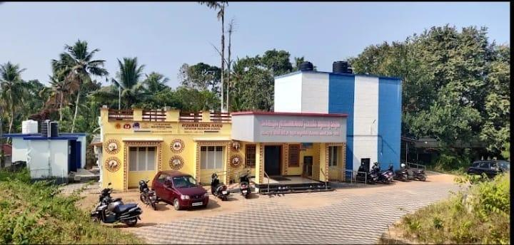

phcentremangalapuram@gmail.com

MESSAGE FROM PRESIDENT
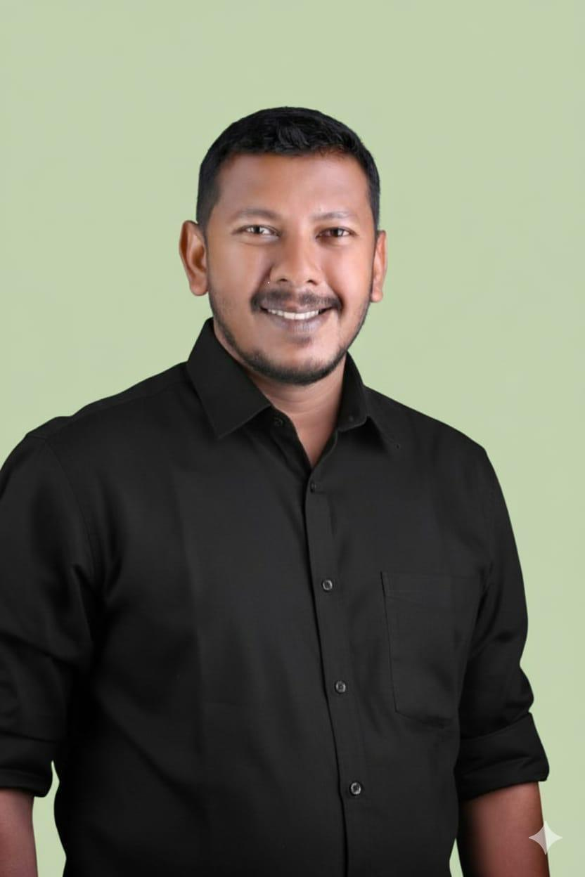

സന്ദേശം

പൊതുജനാരോഗ്യ സംരക്ഷണത്തിന് ചികിത്സയെക്കാള്‍ പ്രാധാന്യം മുന്‍കൂട്ടിയുള്ള പ്രതിരോധ പ്രവര്‍ത്തനം ആണെന്നുള്ളത് മനസിലാക്കി പ്രവര്‍ത്തിക്കേണ്ടത് ഭാവിയില്‍ ഉണ്ടാകുന്ന മഹാമാരി പോലെയുള്ള സാഹചര്യങ്ങളെ ഒഴിവാക്കുന്നതിനു സഹായകമാകുന്നു.
ആരോഗ്യം നിലനിര്‍ത്താന്‍ കഴിയുന്നത് ജീവിതചര്യങ്ങള്‍ കൃത്യമായി പാലിക്കുന്നതിലൂടെയാണ്. എന്നാല്‍ ആധുനിക ജീവിത രീതി പലപ്പോഴും ആരോഗ്യപൂര്‍ണമായ ജീവിതത്തിന്‍റെ താളം തെറ്റിക്കുന്നു. ആരോഗ്യ സംവിധാനങ്ങളുടെ സജീകരണത്തിലൂടെയും വിവിധ വകുപ്പുകളുടെ എകോപനത്തി ലൂടെയും , സന്നദ്ധപ്രവര്‍ത്തകര്‍, ആശപ്രവര്‍ത്തകര്‍ എന്നിവരുടെ പങ്കാളിത്തത്തോടെയും പ്രതിരോധപ്രവര്‍ത്തനത്തിനും അവയുടെ നിയന്ത്രണതിനുമുള്ള പ്രവര്‍ത്തനശേഷി വര്‍ധിപ്പിച്ചുകൊണ്ട് മഹാമാരി ഇല്ലാത്ത നല്ലൊരു സാഹചര്യം സൃഷ്ടിക്കാന്‍ കഴിയുമെന്ന് വിശ്വസിക്കുന്നു.
നിലവിലുള്ള സാഹചര്യങ്ങളെ വിലയിരുത്തി പഞ്ചായത്ത്‌ തലത്തില്‍ രൂപീകരിച്ച ഈ പദ്ധതിരേഖ ആരോഗ്യസംരക്ഷണത്തിന് മുതല്‍കൂട്ടാകും എന്നുള്ള ആശയം മുന്‍ നിര്‍ത്തി ഈ സന്ദേശം പങ്കുവെയ്ക്കുന്നു.

ശ്രീചന്ദ്
പ്രസിഡന്റ്റ്
മംഗലപുരം ഗ്രാമ പഞ്ചായത്ത്‌

MESSAGE BY MEDICAL OFFICER
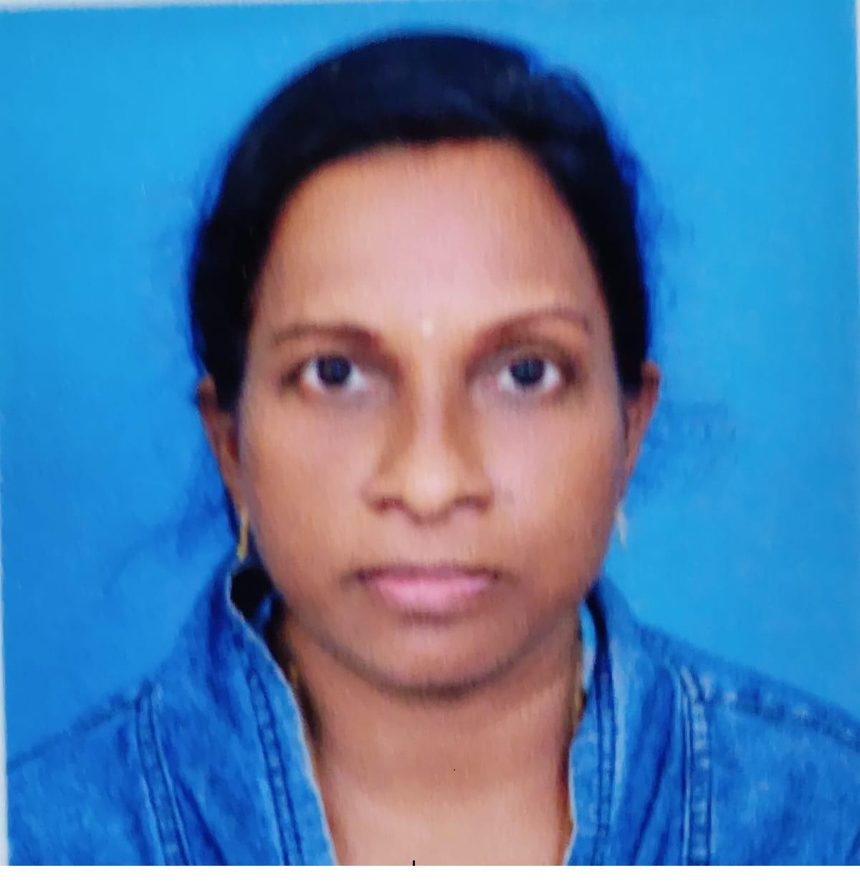

സന്ദേശം

നിലവില്‍ രാജ്യത്തും സംസ്ഥാനത്തും റിപ്പോര്‍ട്ട്‌ ചെയ്യപ്പെടുന്ന മഹാമാരി സാഹചര്യത്തിന്‍റെ പശ്ചാതലത്തില്‍ പൊതുജനങ്ങളുടെ ആരോഗ്യ സംരക്ഷണം ഉറപ്പാക്കുന്നതിനായി എല്ലാവരും അതീവ ജാഗ്രത പാലിക്കേണ്ടതാണ്. ആരോഗ്യ വകുപ്പില്‍ നിന്നുള്ള നിര്‍ദ്ദേശങ്ങള്‍ പൊതുജനങ്ങള്‍ കൃത്യമായി പാലിക്കേണ്ടതും സ്വയം ചികിത്സ ഒഴിവാക്കേണ്ടതും മഹാമാരി ഇല്ലാത്ത ഒരു ലോകം വാര്‍ത്തെടുക്കുന്നത്തിനു സഹായകരമാകും.

ഒരു മഹാമാരി പൊട്ടി പുറപ്പെടുന്നത് കുറക്കുന്നതിനും അത് നിയന്ത്രണാതീതമാക്കുന്നതിനും , തടയുന്നതിനും വേണ്ടി ലക്ഷ്യമിട്ട് മുന്‍കൂട്ടിയുള്ള തയ്യാറെടുപ്പ്, തന്ത്ര പരമായ ആസൂത്രണം, വിവര ശേഖരണം, പൊതുജനാരോഗ്യ ബോധവത്കരണം ഇവ സാധ്യമാക്കേണ്ടതുണ്ട്.

പൊതുജനങ്ങളുടെ സഹകരണം മഹാമാരിയുടെ വ്യാപനം തടയുന്നതിന് നിര്‍ണായകം ആണെന്ന് പ്രത്യേകം ഓര്‍മിപ്പിച്ചുകൊണ്ട് ഈ സന്ദേശം പങ്കുവെയ്ക്കുന്നു.
DR. കവിതമോള്‍
മെഡിക്കല്‍ ഓഫീസര്‍
കുടുംബരോഗ്യകേന്ദ്രം മംഗലപുരം
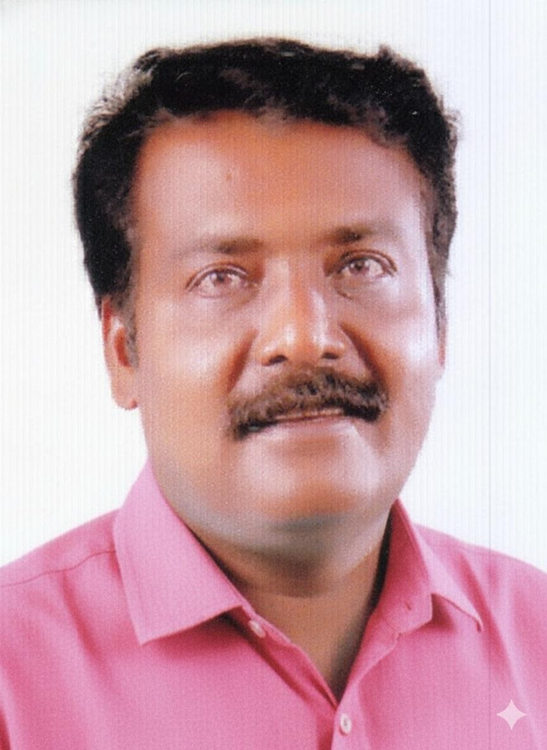
MESSAGE FROM HEALTH STANDING COMMITTEE CHAIR

സന്ദേശം
അറിവിനോപ്പം ആരോഗ്യ ശീലവും വര്‍ധിപ്പിച്ചു ആരോഗ്യപരമായ സാഹചര്യങ്ങള്‍ നിലനിര്‍ത്തുക, പൊതുസമൂഹത്തില്‍ മഹാമാരി പോലുള്ള രോഗങ്ങളെ പ്രതിരോധിച്ചു നിയന്ത്രിക്കുക എന്നീ ലക്ഷ്യബോധത്തോടെ ഉള്ള തുടര്‍പ്രവര്‍ത്തനം അടിത്തറയാകുമെന്ന് ഉറപ്പാണ്‌.

ജനപ്രതിനിധികള്‍, ആരോഗ്യ വകുപ്പ്, വിവിധ വകുപ്പുകള്‍, സന്നദ്ധപ്രവര്‍ത്തകര്‍, ആശപ്രവര്‍ത്തകര്‍, കുടുംബശ്രീ പ്രവര്‍ത്തകര്‍ എന്നിവരുടെ കൂട്ടായ പരിശ്രമത്തിലൂടെ ആണ് ഈ രൂപരേഖ തയ്യാറാക്കിയിരിക്കുന്നത്.

പൊതുജനാരോഗ്യസംരക്ഷണത്തിനും ആരോഗ്യപരമായ ജീവിതത്തിനും ഒന്നായ പ്രവര്‍ത്തനങ്ങളുമായി മുന്നോട്ട് പോകാന്‍ കഴിയട്ടെ എന്ന ആശംസിക്കുന്നു.

വി അജികുമാര്‍

ആരോഗ്യ സ്റ്റാന്‍റ്റിംഗ് കമ്മിറ്റി ചെയര്‍മാന്‍
മംഗലപുരം പഞ്ചായത്ത്

EXECUTIVE SUMMARY

Mangalapuram Family Health Centre (FHC) functions as the primary public healthcare institution serving the population of 41833 in the Mangalapuram Grama Panchayat. The PHC plays a pivotal role in delivering comprehensive, accessible, and affordable healthcare services, with a strong focus on preventive, promotive, curative, and rehabilitative care in accordance with national and state health programmes.
The FHC caters to a predominantly rural population, addressing key public health priorities such as maternal and child health, communicable and non-communicable disease control, immunization, family welfare, adolescent health, and geriatric care. Regular outpatient services, home-based care through field health staff, and outreach activities ensure healthcare coverage even in geographically challenging areas. The institution actively implements national health missions, including the National Health Mission (NHM), National Tuberculosis Elimination Programme, National Programme for Prevention and Control of Cancer, Diabetes, Cardiovascular Diseases and Stroke (NPCDCS), and other disease surveillance initiatives.
Mangalapuram fHC works in close coordination with the Grama Panchayat, ASHA workers, Anganwadi centres, schools, and community-based organizations to strengthen community participation and improve health awareness. Emphasis is placed on early detection, timely referral, health education, and lifestyle modification to reduce disease burden and improve overall health outcomes.
Despite constraints related to infrastructure, manpower, and increasing service demand, the PHC continues to enhance service delivery through effective planning, data-driven decision-making, and community engagement. Strengthening facilities, upgrading digital health systems, and expanding preventive services remain key focus areas for future development.
Overall, Mangalapuram Family Health Centre stands as a vital institution in safeguarding public health and improving the quality of life of the residents of Mangalapuram Grama Panchayath

LIST OF ABBREVIATIONS

LSGD/LSGI | Local Self Government Department / Local Self Government Institution
BMO | Block Medical Officer
IDSP | Integrated Disease Surveillance Programme
NDMA | National Disaster Management Authority
PPE | Personal Protective Equipment
ICMR | Indian Council of Medical Research
CD | Communicable Diseases
NCD | NON-COMMUNICABLE Diseases

TABLE OF CONTENTS

INTRODUCTION 9
● Background of the PPP 9
LSGD AT A GLANCE 9
INTEGRATED HEALTH INFRASTRUCTURE MAP OF MANGALAPURAM GRAMA PANCHAYAT 16
GENERAL PROFILE OF THE LSGI’S 18
Background of the LSGI 18
Demographic and Vulnerable Population 20
Clinical Vulnerability 21
INFRASTRUCTURE & RESOURCE INVENTORY 24
Health Facility Directory & Basic Capacity in the LSGD 24
Private Clinics 26
Healthcare Education & Training Institutions 27
Specialized Services & Emergency Inventory 28
Oxygen & Diagnostic Capacity 28
Diagnostics facility mapping at the LSGI level 29
Laboratory Identification & Basic Details 30
Social and Community Infrastructure for surge plan 31
Human resources 34
Community & Support Cadre 36
Community Organizations 37
Administrative & Emergency Services 38
Information regarding resources 38
ONE HEALTH & ENVIRONMENTAL SURVEILLANCE 40
Veterinary Infrastructure 41
Veterinary Doctors & Workforce 42
High-Risk Interface Points (Surveillance Sites) 43
Environmental Risk Mapping 46
Disease Seasonality Mapping 48
Vulnerability Mapping 50
EPIDEMIOLOGICAL TRENDS (2021–2025) 51
Disease Burden among human beings(Last 5 Years) 51
*(use the above table data to create the graph/diagram) 54
Seasonal Trend Analysis 55
Outcome-Based Trend Analysis- 2025 61
Transmission Trend- 2025 62
Integrated Disease Hotspot Map (2021–2025) 65
Preparedness and Response Protocol at LSG Level 70
Constitution of One Health Committee 70
Pandemic Response Workforce 71
Activities and Measures before and during Pandemic 73
PHASE 1 - Alert / Preparation 73
PHASE 2 - Active Response 76
Standard Screening Protocol 77
PHASE 3 - Surge Capacity 89
Conversion of Community Facilities 89
CONCLUSION 90
RECOMMENDATIONS 92
ANNEXURE 93
1. IMPORTANT PHONE NUMBERS 93

INTRODUCTION

Background of the PPP

The demographic profile of Mangalapuram panchayat further emphasizes the need for a highly structured and inclusive preparedness plan. The panchayat is home to a significant number of vulnerable individuals. These groups often face increased risk during public health emergencies due to higher exposure levels and a heavier dependency on public support systems. These demographic and socio-economic characteristics underscore the need to prioritize high-risk populations and those dependent on regular medical treatment are at increased risk during pandemics due to potential service disruptions and heightened exposure risks.

The Mangalapuram Grama Panchayat Pandemic Preparedness Plan serves as a strategic blueprint to safeguard our community during public health emergencies. This document is designed to
- Create a baseline for rapid mobilization: Establishing a data-driven framework to activate resources and personnel immediately at the first sign of a health threat.
- Identify gaps in resources and high-risk populations: Systematically mapping our 8455 elderly residents, 145 bedbound patients, and 1893 palliative care patients to ensure targeted support.
- Ensure coordinated action between the Government, Private, and AYUSH sectors: Synchronizing efforts across our 1 Government hospital, 3 private hospitals, and 3 total AYUSH centers

This Pandemic Preparedness Plan for Manglapuram panchayat has been developed to strengthen the Health Block’s capacity to prevent, detect, and respond effectively to pandemics and large-scale infectious disease outbreaks. The plan emphasizes early warning systems, protection of vulnerable populations, continuity of essential health and social services, surge capacity planning, environmental health management, and coordinated action across health, local governance, disaster management, animal health, and community sectors.

LSGD AT A GLANCE

- Geographical boundaries with political map ( based on latest delimitation)

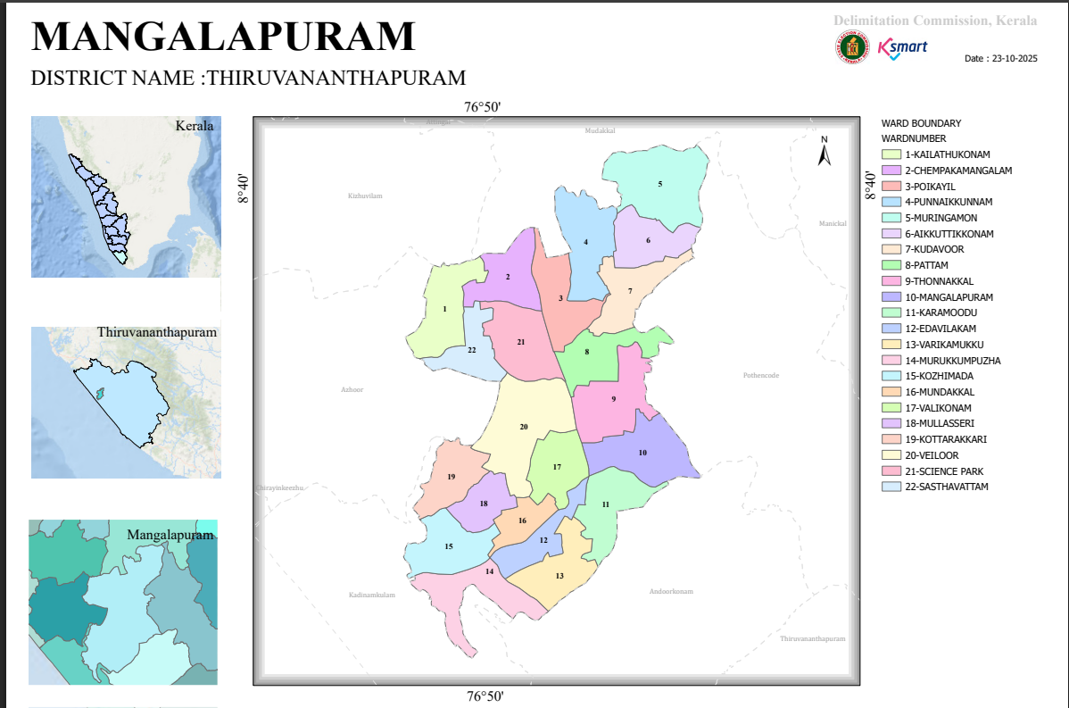

Source:-https://wardmap.ksmart.live/FinalN/FinalN_Thiruvanathapuram_Mangalapuram.html

Baseline data
- Ward division -
Ward | Houses | Population | Migrants | Wells | Hot  spots | Ed. Institutions | Hosp pvt/govt.
22 | 11707 | 41833 | 631 | 9642 | 6 | 20 | 9

- Risk stratification among wards in the context of Communicable diseases and hazards –
Risk stratification among wards was undertaken to identify areas with varying levels of vulnerability to communicable diseases and public health hazards within the Panchayat. This process considers factors such as past disease occurrence, environmental conditions, population characteristics, and potential exposure to hazards like flooding, water stagnation, and sanitation issues. .Based on the number of reported cases of major communicable diseases such as Dengue, Leptospirosis, Hepatitis A, Mumps, and Acute Diarrhoeal Disease during the period 2021–2025,wards were categorized into three risk levels, to facilitate targeted surveillance, preparedness planning, and effective allocation of resources for prevention and response to communicable disease outbreaks. High-risk wards included Ward 1, 2, 11, and 20 (15–20 cases). Moderate-risk wards included Ward 3, 6, 8, 9, 10, 13, 15, 17, 18, and 19 (12–14 cases). Low-risk wards included Ward 4, 5, 7, 12, 14, and 16 (9–11 cases).
- Major Roads/rivers -
The Panchayat is geographically supported by key natural and transport networks that influence mobility and access during emergencies. The Kadinamkulam Backwater is a major water body in the area, contributing to local ecology and posing potential flood-related risks in vulnerable regions. The presence of major roadways, including NH 66 and the Mangalapuram–Chirayinkeezhu Road, ensures strong connectivity within and outside the Panchayat. These transport routes play a crucial role in facilitating movement of people, emergency services, and essential supplies during pandemic situations
- Major establishments with geospatial mapping
Govt- Panchayat Mangalapuram FHC Mangapalapuram Village Office- Melthonnakkal Veiloor, Police station Mangalapuram, KSEB-Mangalapuram, Vetenary dispensary- Kandukrishi, Homeo Dispensary- Murukkumpuzha, Ayurveda Hospital - Kozhimada, Railway station - Murukkumpuzha.
Virology Institute of Life Science Thonnakkal, Kumaranasan Smarakam Thonnakkal, Digital University Technopark Phase 4. EICL company.
- Occupational groups, socio cultural groups, migration & mobility patterns-
The Panchayat has a diverse occupational profile, with a significant proportion of the workforce engaged in construction, hospitality services (including restaurants), poultry-related activities, and other informal sector jobs. Notably, more than 600 migrant labourers from other states are employed across these sectors, contributing to increased population mobility and interaction. This transient workforce may pose challenges for disease surveillance, risk communication, and continuity of healthcare services during a pandemic. In addition, approximately 9% of the native population consists of Non-Resident Indians (NRIs), indicating periodic international travel and cross-border movement. These migration and mobility patterns, combined with varying socio-cultural practices, can influence health-seeking behaviour, compliance with public health measures, and potential disease transmission dynamics. Therefore, targeted strategies focusing on migrant populations, culturally appropriate communication, and monitoring of travel-related risks are essential components of pandemic preparedness and response planning..
- Vulnerability mapping –
The Panchayat has a well-defined pool of vulnerable populations requiring prioritized attention during pandemic preparedness and response. This includes 196 pregnant women and 402 lactating mothers who need continuous maternal and child health services. A total of 145 bedbound patients and 1,893 individuals receiving palliative care (excluding bedbound cases) require sustained home-based and supportive care. Among those with chronic and severe illnesses, there are 4,262 diabetic patients and 5,373 hypertensive patients, along with 139 cancer patients currently on treatment, 25 individuals on haemodialysis, and 11 tuberculosis patients. Additionally, 137 mentally challenged individuals and 107 differently abled persons form part of the vulnerable population requiring special assistance and tailored communication strategies. No cases of CAPD or haemophilia have been reported.
These groups are at increased risk of complications, interruptions in treatment, and reduced access to healthcare services during a pandemic. Therefore, ensuring continuity of care, strengthening outreach services, maintaining drug supply chains, and implementing targeted surveillance and follow-up mechanisms are critical components of preparedness planning.

- Disaster prone areas (geographic vulnerability)-
Ward 19 (Veiloor) and Ward Sasthavattom are identified as geographically vulnerable areas within the Panchayat. While no major recent disasters have been reported, the region has a history of droughts and occasional flooding, leading to significant agricultural losses.
During the 1978 flood, low-lying areas such as Kandukrishi Ela, Madaman Ela, and Kudavoor Ela were inundated due to overflow of tributaries of the Vamanapuram River, causing crop damage and structural losses. Drought conditions have also been reported in the past, including during 2014–2015, with increasing intensity observed in recent years.
Factors such as stone quarrying, changes in soil structure, and the presence of elevated boundary areas (Karumoodu, Bhoodan Colony, Vennur, and Sasthavattom) contribute to water runoff and localized flooding risks. These conditions necessitate targeted mitigation and preparedness measures.

Maps - ward-based (Mention source also)
- Geographical boundaries - ward boundaries map
North Mudakkal- Kizhuvilam Gramapanchayath
East- Pothencode Gramapanchayath
West- Azhoor-Kadinamkulam Gramapanchayath
South- Andoorkonam Gramapanchayat
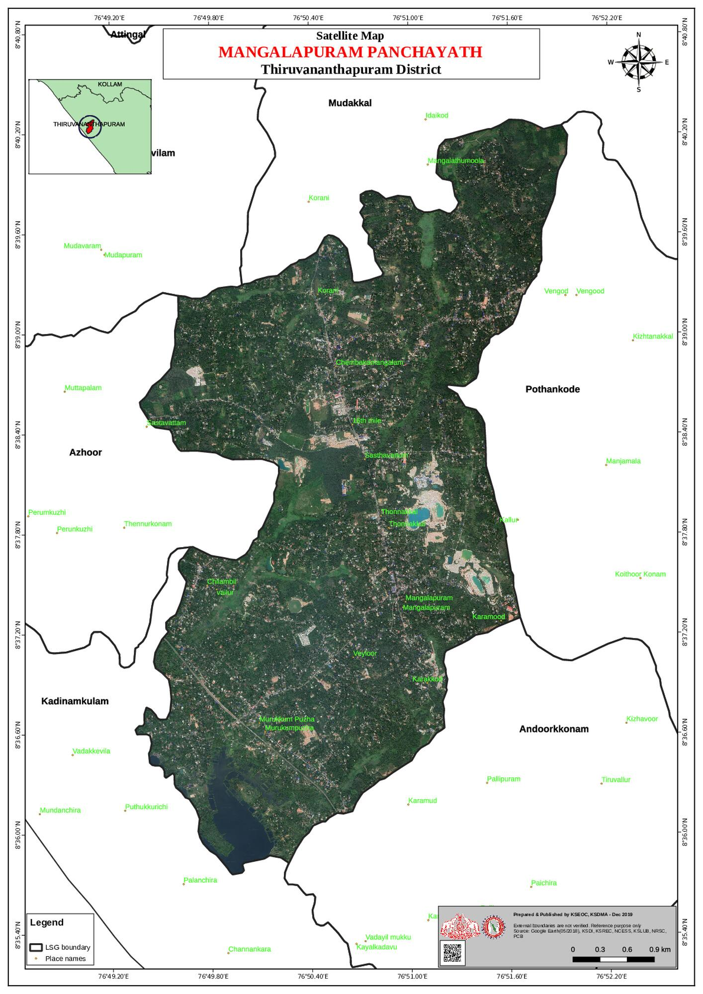

Source:-https://dmp.kila.ac.in/

- Roads and rivers map
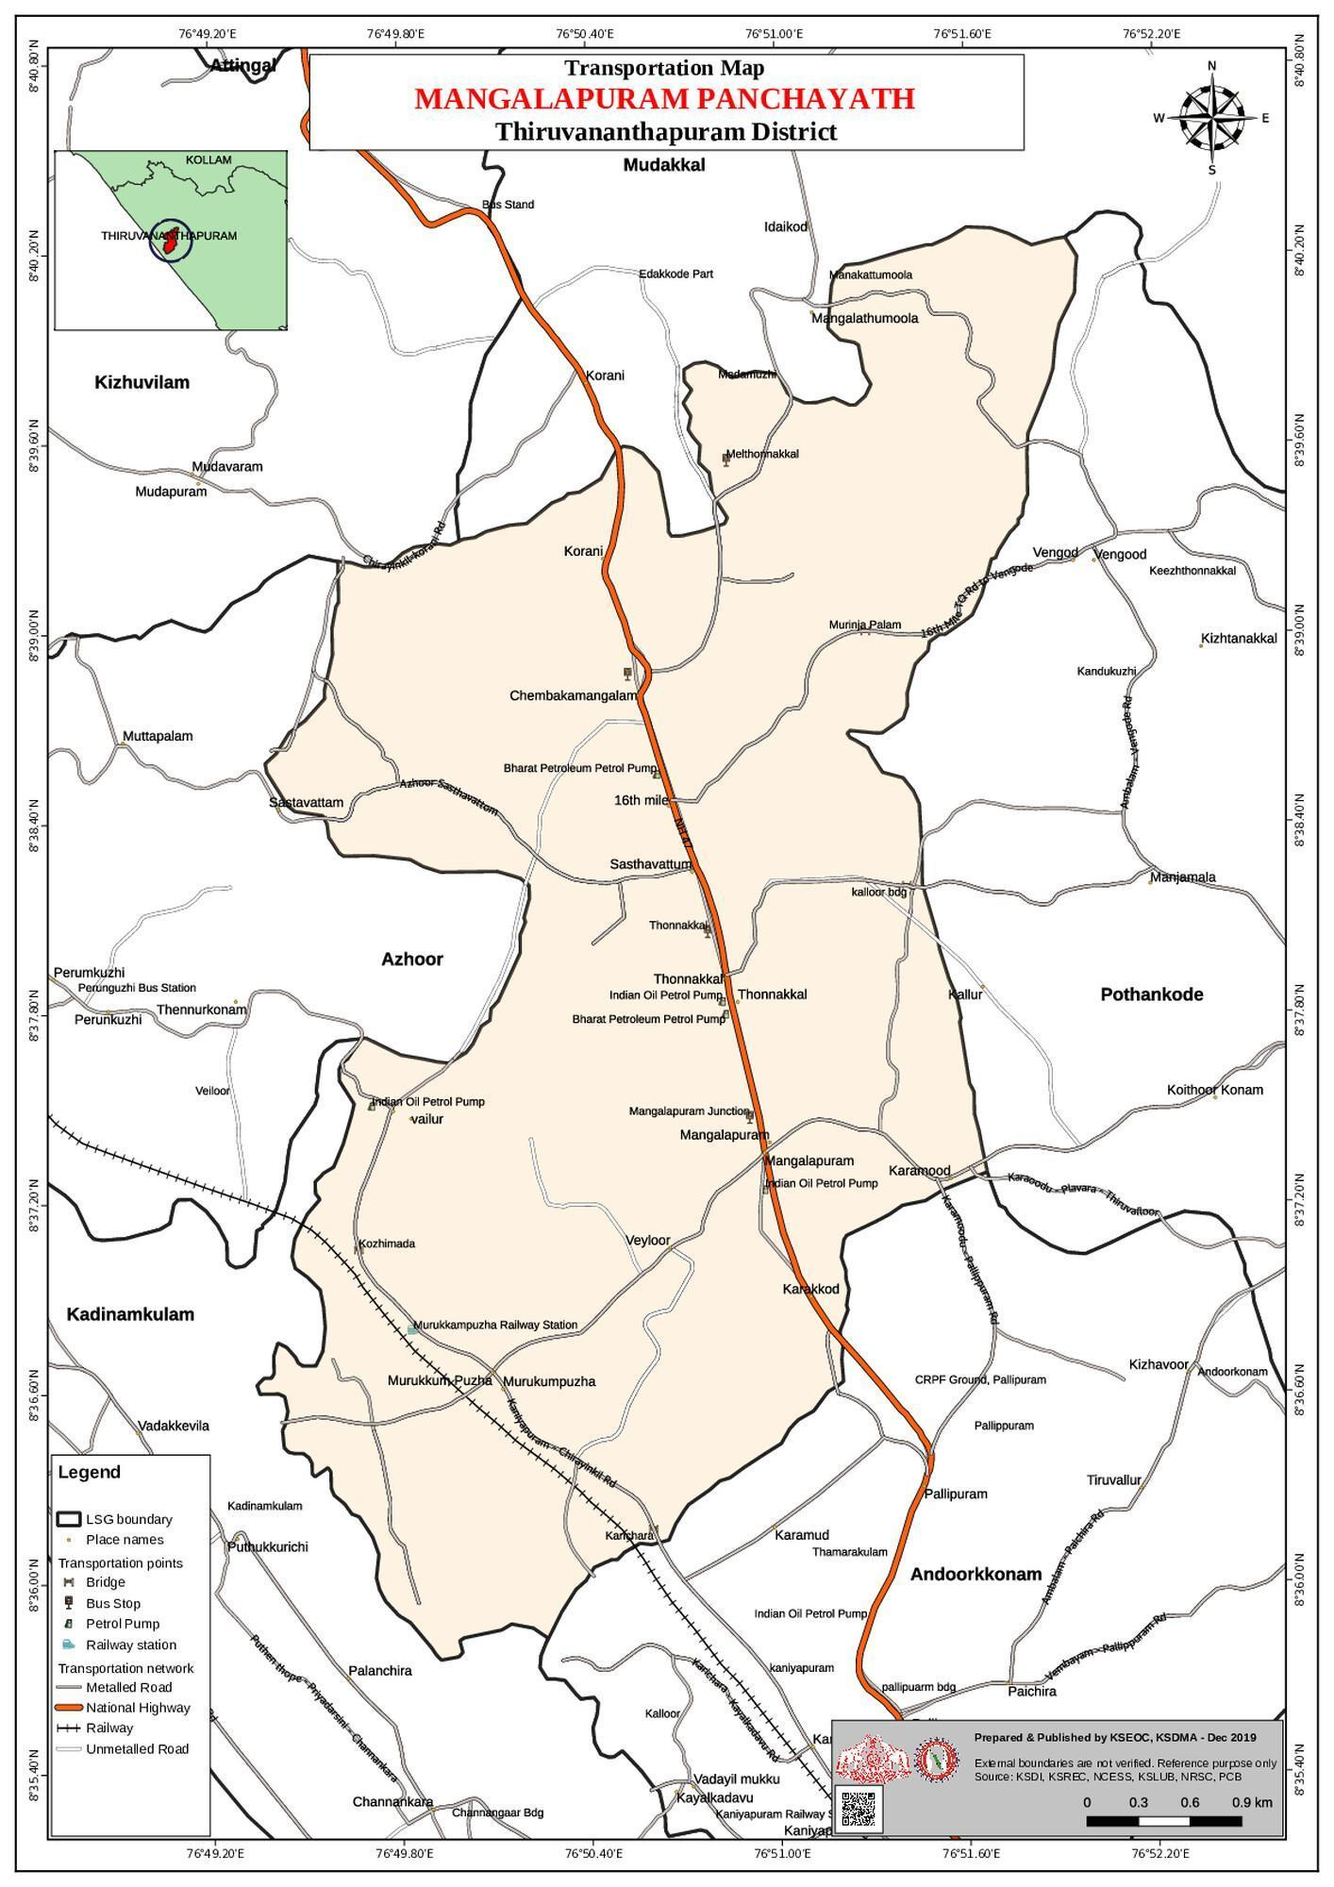

Source:-https://dmp.kila.ac.in/
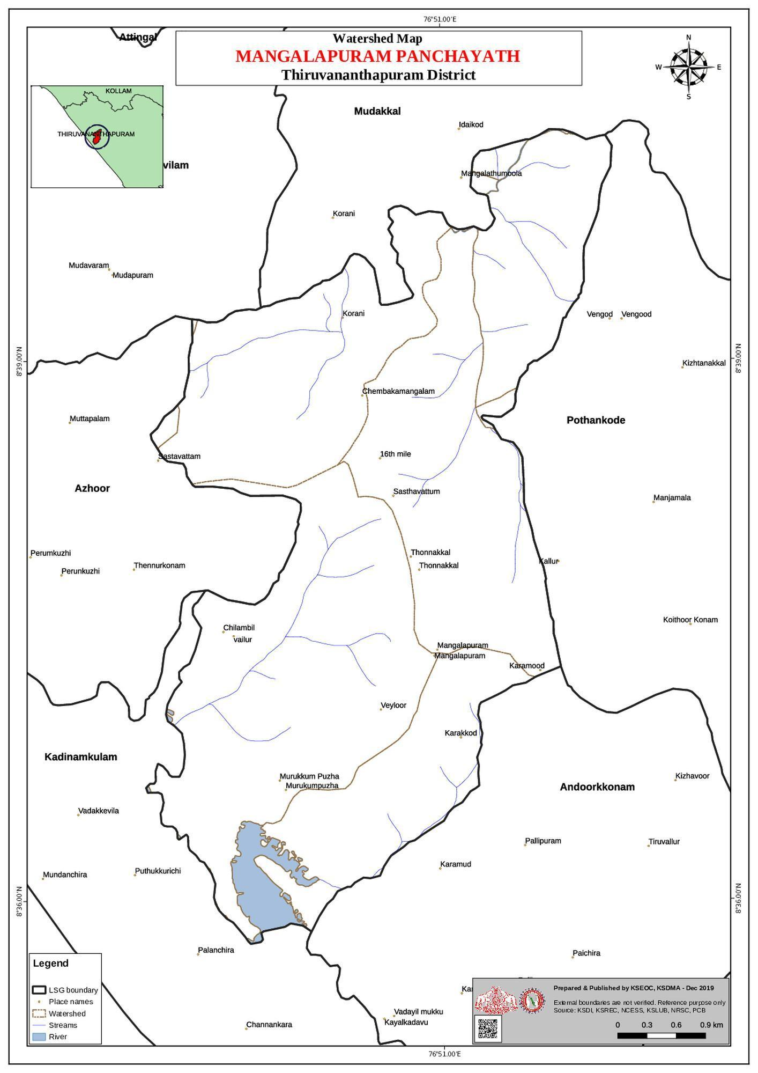

Source:-https://dmp.kila.ac.in/

- Major establishments map

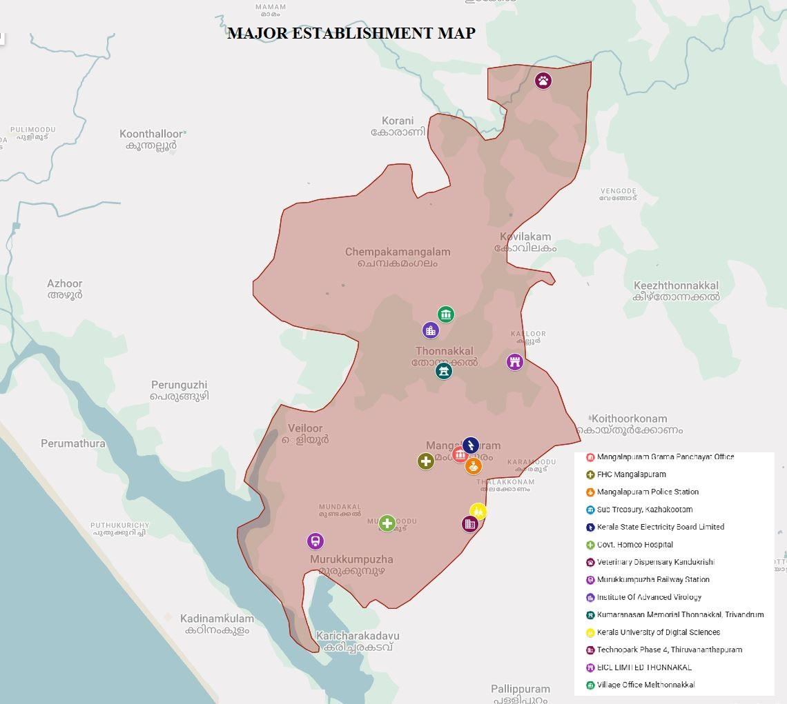

Source:-Google mymaps

- Disaster-prone areas map
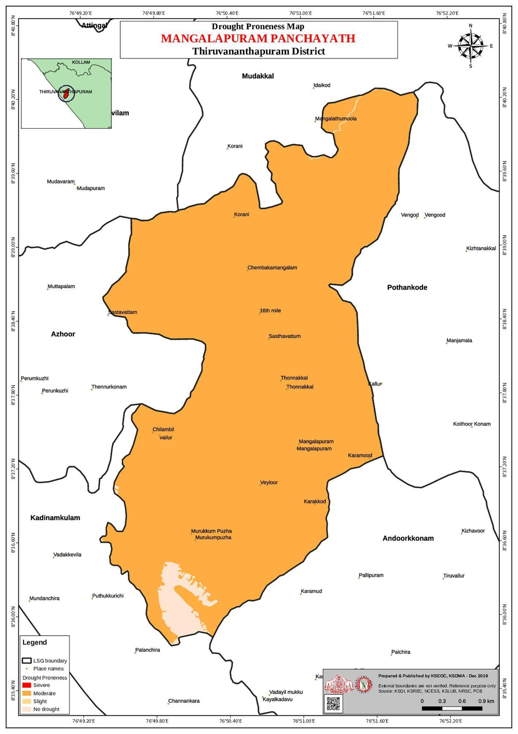

Source:-https://dmp.kila.ac.in/

- Hotspot map - CD & disasters

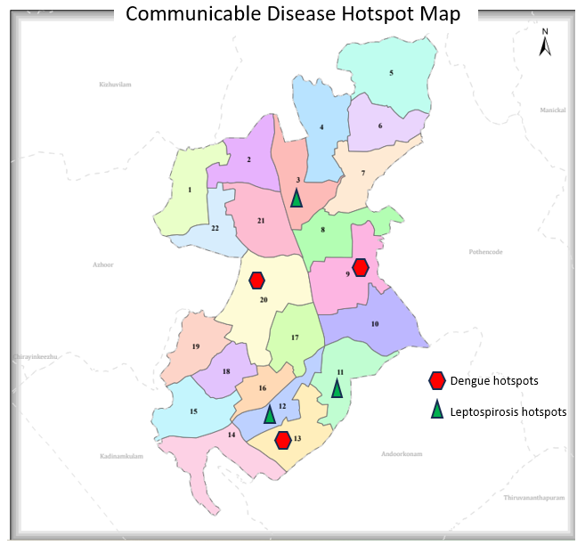

Source:-Map prepared from past 5 years communicable diseases from the CD register of the instituion

INTEGRATED HEALTH INFRASTRUCTURE MAP OF MANGALAPURAM GRAMA PANCHAYAT

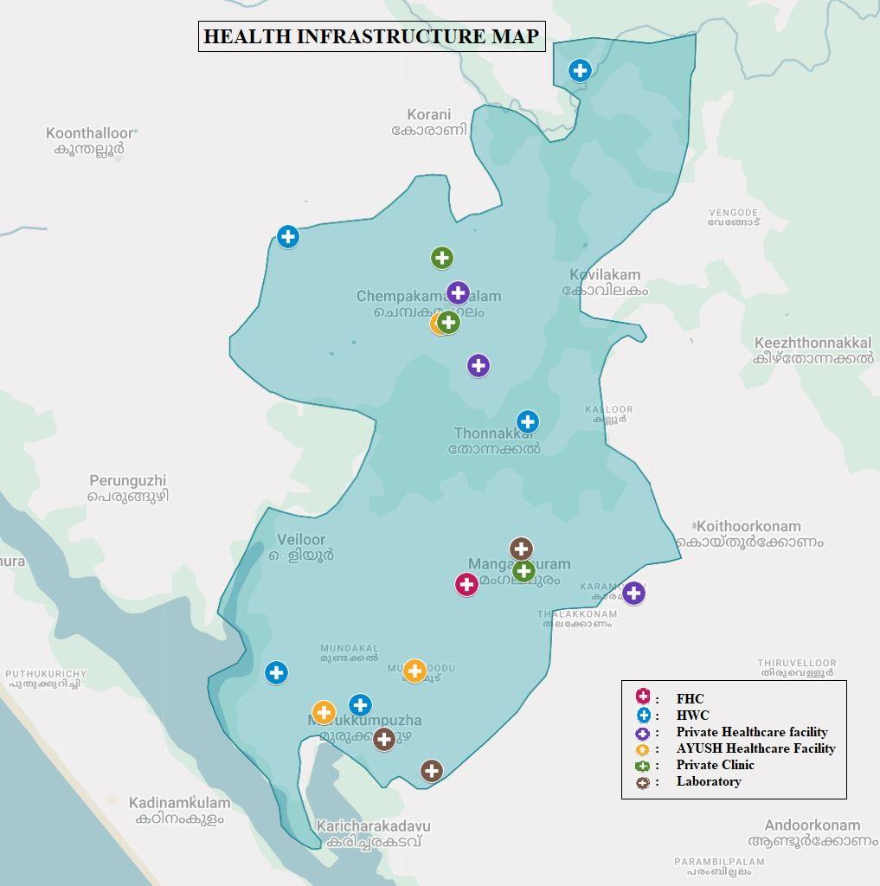

GENERAL PROFILE OF THE LSGI’S

Background of the LSGI
Mangalapuram Grama Panchayat is situated in the northern part of Thiruvananthapuram district, Kerala. Mangalapuram Grama Panchayat is a rural local self government institution situated in Thiruvanthapuram District of Kerala. It functions as the lowest tier of the Panchayath Raj system responsible for local governance, planning and development activities at the village level. Panchayat comes under Pothencode block panchayat and is the part of the decentralized governance system strengthened after the 73 rd constitutional amendment act. Mangalapuram Grama panchayat administers areas such as Melthonakkal and Veiloor villages and consist of several wards represented by elected members as an LSGI, it places an important role in implementing development programmes , providing public services, improving infrastructure and promoting social welfare for local communities.
This region is historically significant and forms part of Mangalapuram Grama Panchayat. The Murukkumpuzha area of the Panchayat was once under the influence of the Portuguese. The St. Augustine’s Church established here by the Portuguese has a long-standing history of centuries.
Murukkumpuzha is also home to the Sreekandeswaram Temple, where Sree Narayana Guru consecrated a mirror idol. This place played an important role in the activities and influence of Narayana Guru.
The Thonnakkal area of the Panchayat was the workplace of Kumaran Asan, a prominent disciple of Sree Narayana Guru, a social reformer, and a leading figure in modern Malayalam poetry
Mangalapuram Grama Panchayat is located near National Highway 66 (NH 66), about 20 km from Thiruvananthapuram city.
Development: The fourth phase of Technopark (Technocity), one of the largest IT parks in Asia, is mainly located within Mangalapuram Panchayat limits. This has changed the face of the area and led to major development

Table 1: Background of LSGD
Description | Details
Name of LSGI | Mangalapuram
Type (GP/Municipality / Corporation etc.) | Grama Panchayath
Block | Pothencode
District | Thiruvanathapuram
Number of wards | 22
Total area (sq. km) | 21.66 Sq.Km
Population(Projected) | 41833
Population density | persons/sq km
Terrain (coastal/low-lying/backwaters/foothills, etc.) | 0
Number of rivers passing through LSGI | NIL
Number of water bodies in the LSGI | 1
Number of educational institutions | 20
Factories / small-scale industries | 3
Flood-prone wards | 2
Landslide-prone wards | 0
Death Management and Disposal Facilities (mortuaries/crematorium, including electric) | 0
Auditoriums/Marriage halls/convention centres/community halls | 9

Demographic and Vulnerable Population
Understanding the demographic composition and vulnerable population groups is essential for pandemic preparedness. Children, elderly, economically deprived families, migrant workers, and socially vulnerable groups are at increased risk during public health emergencies due to higher exposure, limited access to services, and dependency on public systems..

Description |  | Details (in numbers)
DEMOGRAPHIC PROFILE
Total population |  | 41833
Male |  | 20336
Female |  | 21497
Transgender |  | 0
Children under 5 |  | 1839
Adolescent |  | 2871
Elderly (>60) |  | 8455
SOCIAL/LIVELIHOOD VULNERABILITY
Previous EPEP family |  | 47
BPL family |  | 6418
Tribal communities |  | 0
Migration | Immigrant | 631
Migration | Emigrant | 0
Socio-economically deprived |  | 47
Fisherfolk |  | 0
SC Community |  | 8003
ST Community |  | 1

Graphs: Population pyramid (if possible) for seeing if your LSGI has a high "dependency ratio" (lots of children and elderly compared to working adults).

Clinical Vulnerability
Certain population groups needs priority healthcare & are at higher risk of severe illness, complications, and mortality during pandemics. Patients with chronic diseases, those requiring regular medical care, and individuals with mobility or functional limitations face challenges in accessing timely care during emergencies. Mapping these groups helps in prioritizing continuity of treatment, medicine stock planning, oxygen support, referral transport, and targeted home-based care.
Description | Details in numbers
Pregnant women | 196
Lactating mothers | 402
Bedbound patients | 145
Patients under palliative care other than bedbound | 0
Patients on Haemodialysis | 25
Patients on CAPD | 0
Cancer patients (currently on treatment) | 139
Haemophilic patients | 0
Mentally challenged | 137
Differently abled | 107
Diabetic patients | 4262
Hypertensive patients | 5373
TB patients | 11

Major Festivals & Events specific to the LSGI
(with the possibility of a public gathering)

Sl. No. | Name of festival | Month detailing the periodicity
1 | Edayavanam Thookam | FEBRUARY
2 | KAILATHUKONAM MADAN NADA | FEBRUARY
3 | THONNAKKAL THUDIYAVOOR | MARCH
4 | ERATTAKULANGARA TEMPLE | FEBRUARY
5 | PUTHENCOVIL | FEBRUARY
6 | THUNDIL SREE DURGA BHAGAVATHY | FEBRUARY
7 | KOZHIMADA SREE DHARMA SASTHA KSHETHRAM | FEBRUARY
8 | SASTHAVATOM SREEDHARMA SASTHA TEMPLE | FEBRUARY
9 | ELANJIMOODU SREE DURGA BHAGAVATHI KSHETHRAM | MARCH
10 | KUDAVOOR MAHADEVA TEMPLE | FEBRUARY
11 | SREE DHARMA SASTHA TEMPLE VENGODE | FEBRUARY
12 | MULLASSERI SREEKRISHNA TEMPLE | FEBRUARY
13 | KARIKKAKATHIL TEMPLE KOTRAKKARI | FEBRUARY
14 | KANDUKRISHI DEVI TEMPLE | MARCH
15 | VARUVILAKOM SREE BHALA BHADRA DEVI | FEBRUARY

INFRASTRUCTURE & RESOURCE INVENTORY

Health Facility Directory & Basic Capacity in the LSGD
This section provides an overview of the healthcare infrastructure available within the LSGD area. It outlines the distribution and basic capacity of health facilities that form the backbone of service delivery during routine times and public health emergencies.

Family Health Centres (FHCs) and Community Health Centres (CHCs) generally function as the first point of contact for the community, providing essential outpatient and inpatient services. General Hospitals (GH) and Medical College Hospitals (MCH), where accessible, serve as the main referral centres for advanced diagnostics, specialist care, and critical services during public health emergencies. This inventory helps identify existing strengths, gaps, and potential surge capacity that can be mobilised during a pandemic or disaster.

Table 5. Health Facility Resource Summary
Sl.no. | Health Facility | Type of Facility (MCH/GH/CHC/FHC/SC etc.) | Contact Number | Total beds | ICU Beds | Oxygen-Supported Beds | No. of Ventilator Support Beds | No. of ambulances
Government Healthcare Facilities
1 | FHC Mangalapuram | FHC | 9495911252 | 0 | 0 | 0 | 0 | 2
2 | AAM Maincentre | SC | 8943390808  8943390808 | 0 | 0 | 0 | 0 | 0
3 | AAM Kozhimada | SC | 8606149978  8606149978 | 0 | 0 | 0 | 0 | 0
4 | AAM Sasthavattom | SC | 86061499788606149978 | 0 | 0 | 0 | 0 | 0
5 | AAM Murukkumpuzha | SC | 86061499788606149978 | 0 | 0 | 0 | 0 | 0
6 | AAM Punnaikunnam | SC | 89433908088943390808 | 0 | 0 | 0 | 0 | 0
7 | AAM Thonnakkal | SC | 7559037596  7559037596 | 0 | 0 | 0 | 0 | 0
Private Healthcare Facilities
1 | AL NIYADI HOSPITAL 16TH MILE | HOSPITAL | 04712427999 | 23 | 0 | 0 | 0 | 1
2 | MEDICARE | HOSPITAL | 9539228455 | 0 | 0 | 0 | 0 | 0
3 | ST. JOHNS COMMUNITY HOSPITAL KARAMOODU MANGALAPURAM | HOSPITAL | 8075420034 | 10 | 0 | 0 | 0 | 0
AYUSH Healthcare Facilities
1 | GOVT. AYURVEDA HOSPITAL MURUKKUMPUZHA | HOSPITAL | 9746056543 | 0 | 0 | 0 | 0 | 0
2 | GOVT. HOMOEO HOSPITAL MURUKKUMPUZHA | HOSPITAL | 9496285418 | 0 | 0 | 0 | 0 | 0
3 | AYUSH NHM Siddha PHC Mangalapuram | HOSPITAL | 9447427735 | 0 | 0 | 0 | 0 | 0

Private Clinics
Private clinics are an essential part of pandemic preparedness, as they are often the first place people seek care when symptoms begin. In many communities, private clinics manage a significant share of outpatient visits and therefore play a critical role in early case detection, timely referrals, and disease surveillance. Having an up-to-date understanding of where these clinics are located, the services they provide, and how they are linked to the public health system helps ensure that no cases are missed during an outbreak. It also allows health authorities to engage private practitioners more effectively for reporting, risk communication, and coordinated response, strengthening the overall capacity of the health system to manage public health emergencies.

Table 6. Private Clinic Resource Summary
Sl No. | Name of Clinic | Registered (Y/N) | Clinic (General / Speciality) | Speciality (if any) | Address | Contact Number | Diagnostic Facility (Y/N) | Ambulance Linkage (Y/N)
1 | Shilajith poly clinic | Y | G | N | Shilajith poly clinic,MURUKKUMPUZHA | 9249453734 | N | N
2 | SANTHIGIRI AYURVEDA SIDDHA VAIDHYA SALA | Y | G | N | SANTHIGIRI AYURVEDA SIDDHA VAIDHYA SALA,MULAMOODU,MURUKKUMPUZHA | 9400720859 | N | N
3 | PYUSH HOMEO CLINIC | Y | G | N | PYUSH HOMEO CLINIC, MULAMOODU, MURUKKUMPUZHA | 9895227850 | N | N
4 | MULTI SPECIALITY DENTAL CLINIC MANGALAPURAM | Y | G | N | MULTI SPECIALITY DENTAL CLINIC MANGALAPURAM | 8547471000 | N | N

Healthcare Education & Training Institutions
This section tracks the educational infrastructure available, which is vital for human resource planning in the health sector.

Category of Institution | Govt | Private | AYUSH | Total
Medical Colleges | 0 | 0 | 0 | 0
Nursing Colleges | 0 | 1 | 0 | 1
Dental Colleges | 0 | 0 | 0 | 0
Para-medical / Allied Health | 0 | 0 | 0 | 0
Pharmacy Colleges | 0 | 1 | 0 | 1

Specialized Services & Emergency Inventory
This section provides a detailed view of the specialized medical resources available to the community, focusing on emergency response and critical care capabilities. This table tracks the vital assets required for managing severe illnesses and emergencies across Government, Private, and AYUSH sectors.

Item | Govt | Private | AYUSH | Total
Hospital beds | 0 | 3 | 0 | 3
Oxygen-generating systems(Y/N) | 0 | 0 | 0 | 0
Oxygen-supported beds(Numbers) | 0 | 2 | 0 | 2
Ventilator-supported beds | 0 | 0 | 0 | 0
ICU beds | 0 | 0 | 0 | 0
Burns units | 0 | 0 | 0 | 0
Blood centres | 0 | 0 | 0 | 0
BLS ambulances | 1 | 2 | 0 | 3
ALS ambulances | 0 | 0 | 0 | 0
Dialysis facilities | 0 | 0 | 0 | 0
Dispensaries | 0 | 0 | 0 | 0
Medical store | 0 | 13 | 0 | 13
Industrial establishments(Medium-scale industries/small-scale industries establishments to whom we can depend in a worst-case scenario) | 0 | 3 | 0 | 3

Oxygen & Diagnostic Capacity
Monitoring oxygen and diagnostic capacity is a critical component of public health preparedness, ensuring that the LSGD can handle both chronic care and sudden surges in respiratory or infectious diseases.
Name of Health Facility | Oxygen-generating System (Y/N) | Backup Oxygen Source (Y/N) | Diagnostic Facilities Available(Y/N)
Name of Health Facility | Oxygen-generating System (Y/N) | Backup Oxygen Source (Y/N) | Lab | USG | X-ray | CT/MRI | RT-PCR
Government Healthcare Facilities
FHC Mangalapuram | NO | NO | YES | NO | NO | NO | NO
Ayurvedha Hospital | NO | NO | NO | NO | NO | NO | NO
Homeo | NO | NO | NO | NO | NO | NO | NO
Sidha | NO | NO | NO | NO | NO | NON | NO

Diagnostics facility mapping at the LSGI level
The diagnostic capacity of MANGALAPURAM G.P represents the "intelligence network" of our healthcare system. The speed and accuracy of disease identification depend entirely on the distribution and technical level of these facilities.

Item | Govt | Private | AYUSH | Total
General labs | 1 | 10 | 0 | 11
Microbiology labs | 0 | 1 | 0 | 1
RT-PCR labs | 1 | 1 | 0 | 2
USG units | 0 | 0 | 0 | 0
CT/MRI units | 0 | 0 | 0 | 0
Research labs | 1 | 0 | 0 | 1
Labs of other departments that can be repurposed | 0 | 0 | 0 | 0

Laboratory Identification & Basic Details
Sl. No. | Name of Laboratory | Ownership (Govt / Private / Academic) | Address | Contact No. | 24×7 Services (Yes/No) | NABL / Govt Approved (Yes/No)
1 | Ev Dignostic Labourty,Thoppumukku | Pvt | Ev Dignostic Labourty,Thoppumukku,Murukkumpuzha | 9846200599 | NO | YES
2 | Ddrc Agilun Diagnostic | Pvt | Ddrc Agilun Labourt.Murukkumpuzha | 9746499337 | NO | YES
3 | Merit Laboratory | Pvt | Merit Laboratory | 7902617646 | NO | YES
4 | Ddrc Agilun Diagnostic | Pvt | Ddrc Agilun Laboratory Mangalapuram | 9496005101 | NO | YES
5 | S V Diagnostic Laboratory | Pvt | S V Diagnostic Laboratory Chempakamangalam | 9605244262 | NO | YES
6 | Devi Scan And Laboratory | Pvt | Devi Scan And Laboratory Mangalapuram | 9745444494 | NO | YES

Social and Community Infrastructure for surge plan
This table serves as our logistics and shelter inventory. By mapping these locations, quickly we can identify where to house displaced citizens, where to set up temporary medical clinics, and how to manage the deceased with dignity during a crisis.

Category | Total Count | Ward | Est. Capacity (Persons) | Contact details
Educational Institutions
Anganwadis | 42 | 22 | 358
Schools | 20 | 1,2,3,5,15,13,14,7,20 | 8200
Colleges | 2 | 8, 10 | 700 | 94472476173
Healthcare Educational Institutions
Medical colleges (Govt/Private) | 0
Nursing colleges (Govt/Private) | 1 | 3 | 402 | 9446177536
Dental colleges (Govt/Private) | 0
Paramedical institutes (Govt/Private) | 1 | 8 | 120 | 94472476173
Community Gathering Spaces
Community halls | 7 | 7,11,5,15
Auditoriums | 9 | 14,2,19,7,20
Religious buildings | 90 | ALL WARDS
Vulnerable Group Support Facility
Destitute homes | 0
Elderly homes | 1 | 20
LSGD owned other buildings | 7 | 14,15,4,11,17,20,
Mass Fatality Management (MFM) Infrastructure
Mortuary | 0
Crematorium | 0
*refer annexure 1 for contact details

Human resources
This section focuses on the human capital available within the LSGI. In any emergency—be it a pandemic, flood, or industrial accident—infrastructure is only as effective as the people operating it.

Medical & Clinical Personnel
This table tracks the "Frontline" providers responsible for diagnosis, treatment, and clinical management. Narrative sentence: eg., "Total health workforce: 450 personnel, with 60% in government facilities serving as primary surge capacity." A detailed directory with the contact numbers of all workers is maintained (Annexure in 1).

Cadre | Govt (No.) | Private (No.) | Total
Doctors—Modern Medicine | 3 | 18 | 21
Doctors – AYUSH | 3 | 0 | 3
Doctors – Veterinary | 1 | 1 | 1
Doctors – Dental | 0 | 2 | 2
Nursing officers | 3 | 56 | 59
Lab technicians | 2 | 27 | 29
Optometrist | 0 | 0 | 0
Pharmacists | 3 | 10 | 13
Psychologists | 0 | 0 | 0
Counsellors | 0 | 0 | 0

Public Health & Field-Level Workforce
These individuals are the backbone of surveillance, maternal-child health, and decentralized care.

Cadre | Health services | Municipal common services | Total
HS (Health Supervisors) | 0 | 0 | 0
HI (Health Inspectors) | 1 | 0 | 1
LHS (Lady Health Supervisor) | 0 | 0 | 0
LHI (Lady Health Inspectors) | 0 | 0 | 0
JPHN (Jr Public Health Nurses) | 6 | 0 | 6
JHI (Jr Health Inspectors) | 4 | 0 | 4
MLSP (Mid-Level Service Providers) | 6 | 0 | 6
Palliative Nurses | 1 | 0 | 0
RBSK Nurses | 0 | 0 | 0
PRO | 0 | 0 | 0
Epidemiologist | 0 | 0 | 0
Data Manager | 0 | 0 | 0

Community & Support Cadre
This group represents the surge capacity of the LSGI—people who can be called upon for logistics, rescue, and specialized support.

Cadre | Number
ASHA Workers | 29
AWW (Anganwadi Workers) | 42
Emergency Medical Volunteers (Trained) | 0
Kudumbashree | 18
MNREGS | 2950
Purusha Swayam Sahaya Sangham | 0
Ex-Servicemen | 101
Retired Police Officers | 26
NCC/NSS Volunteers | 246
Red Cross volunteers | 0
One Health Community Volunteers | 40
One Health Community Mentors | 0

Community Organizations
This section details the presence of community-based organisations (CBOs), non-governmental organisations (NGOs), faith-based organisations (FBOs), Kudumbashree Self-Help Groups (SHGs), and Ayalkootams within the Local Self-Government Institution (LSGI). These groups enhance grassroots mobilization, resource distribution, and support networks crucial for pandemic response and community resilience.

Category | Total Count
NGOs | 3
Religious based organizations | 90
Foreign based organizations | 0
Sports Club/youth clubs | 8
Kudumbashree SHGs | 18
Ayalkootams | 345
Political organizations | 4
Residential organizations | 2

Administrative & Emergency Services
This section outlines the availability of key non-health emergency support services and infrastructure within the LSGI, which are essential for effective pandemic preparedness and response. These facilities support law enforcement, disaster response, water supply, logistics, mobility, and community-level interventions during public health emergencies.

Category | Total Count | Contact details
Police Stations | 1 | 0471-2420275
Fire & Rescue Stations | 0 | 0
Water Pumping Points | 0 | 0
Public Distribution System (PDS) | 21

Information regarding resources
The availability of essential transport and support resources plays a quiet but critical role in saving lives. Equipment such as ambulances, mobile mortuaries, amphibian ambulances, and motorized boats ensures that patients, samples, and healthcare teams can move swiftly—even in flooded, remote, or difficult terrains. Heavy vehicles like JCBs, cranes, tractors, and torus lorries support logistics, waste management, emergency infrastructure, and rapid conversion of spaces into care or isolation facilities. Taxis, four-wheel-drive vehicles, and trucks help maintain continuity of essential services, reach vulnerable populations, and support home-based care and supply delivery.

Means of transportation | Total Count
JCB | 3- MANOJ 9072626385 EICL COMPANY  1- BINU 9847592875  1-ANIL 9961214131  1-VIJAYAN 9447264051  1-THARIF 8129945652  1-SANTHOSH 8129582959  1- ANEESH 9746191725  1-ANI 9539107867  1-AJI 9846182760
Crane | NIL
Heavy Trucks | AKHIL 7356768164
Tractor | NIL
Ambulances | ANIL KUMAR 9447656535,  SAJEEV 9562871235
Mobile mortuaries | NIL
Boats | NIL
Taxi service | NIL
Note: For specific details regarding vehicle owners and contact information, please refer to Annexure [X].

ONE HEALTH & ENVIRONMENTAL SURVEILLANCE
The One Health method integrates environmental, animal, and human health to enable proactive pandemic preparedness. Panchayat-level surveillance needs to be improved in order to detect and treat zoonotic and environmentally generated diseases early. Surveillance is strengthened through systematic assessment of animal populations, veterinary infrastructure, poultry and slaughter facilities, inter-sectoral coordination, and specialised tools like avian influenza seasonality mapping using GIS in previous outbreaks to enable predictive alerts and ward-specific sampling to support effective pandemic preparedness in high-risk areas like .
Animal & Bird Population
Mapping animal and bird populations at the Panchayat level is essential for identifying and prioritising zoonotic disease hazards like rabies, avian influenza (H5N1), leptospirosis, anthrax, and Nipah-like spillover occurrences. Risk classification, targeted surveillance, vaccination planning, and early epidemic detection made feasible by comprehensive population mapping all enhance One Health-based pandemic preparedness.

Category | Item | Estimated Population | Wards
Animal Population | Livestock (Cattle/Goats/Buffalo) | 318 | INCLUDING ALL WARDS
Animal Population | Pet Animals (Dogs/Cats) | 901 | ALL WARDS
Animal Population | Stray Dog Population | 143 | ALL WARDS
Animal Population | Pig Farms (Number of heads) | 0 | 0
 | Small Units (Sheep / Goats – clustered) | 0 | 0
Bird Population | Poultry Units (Birds) | 7 | WARD12, 13, WARD 7
Bird Population | Poultry- (FOWL) | 1700 | WARD12, 13, WARD 7
Bird Population | Wild/Migratory Birds (Observed) | 0 | 0
Bird Population | Crow Mortality Events (Reported) | 0 | 0

The main risk of zoonotic diseases in WARD 12 AND 13 concentrated in Wards, which is explained by the high density of pig farms, cattle congregation areas, and poultry units. The stray dog population in market areas, fish landing sites, bus stations continues to be a substantial problem for rabies surveillance and bite prevention. There is a considerable risk of avian influenza introduction and amplification during November - December due to the seasonal presence of migratory and resident water birds near ponds/ canal / river / backwater / paddy field. Clusters of pig farms and animal shelters vulnerable to flooding further raise the risk of leptospirosis and other zoonoses mediated by the environment, especially during monsoon floods.

Veterinary Infrastructure
Veterinary institutions are a core pillar of One Health surveillance, enabling early zoonotic disease detection through vaccination, investigation of unusual animal illness or deaths, sample collection, and timely outbreak reporting. A well-mapped and responsive veterinary network strengthens coordination with human health and LSGI systems, ensuring rapid response during zoonotic events and pandemics.
Facility Type | Name of Facility | Ownership Govt / Pvt | Location(Ward No) | Contact number
Veterinary Dispensary | Veterinary Dispensary | Govt | 5 | 9605491368
Veterinary Hospital / Polyclinic | 0 | 0 | 0 | 0
Private Veterinary Clinics | 0 | 0 | 0 | 0
Mobile / Emergency Vet Service (incl. night services) | 0 | 0 | 0 | 0
Pet Homes / Animal Shelters | 0 | 0 | 0 | 0
Slaughterhouse-linked Veterinary Inspection Unit | 0 | 0 | 0 | 0

Veterinary Doctors & Workforce
Early detection, diagnosis, reporting, and reaction to animal illness epidemics depend on the availability and accessibility of qualified veterinary specialists. By identifying unusual animal morbidity or mortality promptly, collecting samples promptly, and coordinating efficiently with human health and LSGI systems—especially during zoonotic outbreaks and pandemic-prone situations—a clearly defined veterinary workforce enhances One Health surveillance.

Category | Number Available | Type (Govt/Pvt) | Contact number
Government Veterinary Doctors | 1 | Govt | 9495829874
Private Veterinary Doctors | 0 | 0 | 0
Livestock Inspectors | 2 | Govt | 9605491368 8129617586
Para-veterinary Staff / Attenders | 0 | 0 | 0
Contract / On-call Veterinary Support (if any) | 0 | 0 | 0

High-Risk Interface Points (Surveillance Sites)
High-risk interface points for zoonotic disease surveillance in Mangalapuram Grama Panchayath include wetland–livestock–human contact zones, backyard poultry farms, cattle sheds near water bodies, fish markets, and areas of high human–animal interaction such as community slaughter points and migratory bird congregation sites. These are the primary surveillance sites where zoonotic spillover risks are elevated.

Type of Habitat | Type of High risk interface | Geographical vulnerability
Wetlands & Backwaters | 0 | 0
Backyard Poultry Farms | 0 | 0
Cattle Sheds near Water Bodies | 0 | 0
Fish & Meat Markets | 3-Human–animal product handling interface | Areas with poor drainage and high organic waste; potential for food-borne pathogens  Murukkumpuzha, Kurakkada , Chempakamangalam
Community Slaughter Sites | Human–animal interface (slaughter exposure) | Potential for zoonotic transmission; requires monitoring by the 1 Veterinary Dispensary
Migratory Bird Congregation Areas | 0 | 0
Rodent-Infested Grain Storage | 0 | 0

Category | Total Count | Key Locations (wards)
Poultry Farms | 7 | 12,13,8,7
Backyard / Clustered Poultry Units | 0 | 0
Duck Rearing Units (open water access) | 0 | 0
Slaughterhouses/ Slaughter Points | 0 | 0
Meat/Fish Markets | 3 | 3,1,13
Live Bird Sale Points | 0 | 0
Cattle Markets / Weekly Animal Fairs | 0 | 0
Pet Shops / Breeders | 0 | 0
Animal Shelters / Pet Homes | 0 | 0
Waste Disposal Sites near Animal Units | 0 | 0

Environmental Risk Mapping
Environmental risk mapping identifies monsoon/flood hot spots for vector-borne (dengue, chikungunya), water-borne (leptospirosis, diarrhoea), and zoonotic diseases in Kerala's wetlands. Systematic surveillance supports early warnings, targeted interventions, and Panchayat pandemic preparedness.
Waterborne exposure: Flood-prone areas and stagnant water bodies facilitate leptospira survival, raising leptospirosis risk.

Traditional practices: Informal slaughter and fish markets lack standardized hygiene, creating spillover opportunities.

Risk Factor | High-Risk Wards | Key Locations | Risk Level (High/Med/Low)
Flood-prone areas | 19,20 | VEILOOR, SASTHAVATTOM | MEDIUM
Water bodies/wetlands | NIL | NIL | NIL
Solid waste accumulation | NIL | NIL | NIL
Animal waste disposal issues | NIL | NIL | NIL
Rodent infestation zones | NIL | NIL | NIL
Industrial effluent discharge | NIL | NIL | NIL
Construction sites / abandoned buildings | WARD 11,20,9,4,5 | VARIKKAMUKKU, SASTHAVATTOM THONNAKKAL | LOW RISK
Poor drainage/blocked canals | NIL | NIL | NIL
Drinking water source contamination risk | NIL | NIL | NIL

Disease Seasonality Mapping
1, Flooding & waterlogging → amplifies leptospirosis, malaria, diarrheal diseases.
·
2, Migratory bird influx (Nov–Feb) → avian influenza risk.

3, Mosquito breeding cycles → vector-borne disease peaks in monsoon.

4, Agricultural practices → close human–animal contact in paddy fields.

Disease | Peak Risk Season | Key Drivers | High-Risk Locations | Surveillance Focus
Avian Influenza | NOVEMBER- FEBRUARY | POULTRY FARM | WARD 13 | POULTRY FARMS ,bird die-offs
Leptospirosis | MONSOON | MGNREG WORKERS FARMERS | ALL WARDS | Fever with myalgia, water exposure history
Dengue/Chikungunya | MONSOON | PLANTATION WORKERS,  WARD WITH WATER SCARCITY | ALL WARDS  WATER SCARCITY IN WARD 1 | RUBBER PLANTANTION , INDOOR SPACE, CONSTRUCTION SITE, WATER SCARCITY AREAS (WATER STORED IN CONTAINERS)
Acute Diarrheal Diseases | ALL SEASON | Contamination of wells and ponds | Low-lying areas near backwaters. | Water quality testing and chlorination,Diarrhea clusters
Rabies | All seasons | Dog bites (stray/domestic) | All wards | Dog bite cases, PEP
Anthrax (rare) | Not seasonal | Animal exposure (livestock) | Not reported | Sudden animal deaths, occupational exposure

Vulnerability Mapping
Vulnerability mapping pinpoints high-risk populations, occupations, and areas exposed via environment, livelihoods, socio-economics, and poor service access. Paired with environmental/seasonality mapping, it enables risk-based surveillance, targeted actions, and optimal resource use in One Health and pandemic planning.
Vulnerability Factor | High-Risk Wards | Key Groups / Locations | Risk Level
Flood-prone households | 19,20 | VEILOOR SASTHAVATTOM | MEDIUM
Wetland-adjacent communities | 0 | 0 | 0
Backyard poultry / duck rearing households | 13 | MURUKKUMPUZHA | MEDIUM
Livestock-rearing households | 0 | 0 | 0
Slaughterhouse & meat market workers | WARD 3, 12 | CHEMPAKAMANGALAM POYKAIL | MEDIUM
Fisherfolk & fish market workers | NIL | NIL | NIL
Sanitation workers | ALL | HARITHA KARMASENA | MEDIUM
Daily wage / migrant workers | ALL | CONSTRUCTION SITE, HOTEL | MEDIUM
Elderly & chronically ill populations | ALL | ALL WARDS | MEDIUM
Pregnant Women | 3 | ALL WARDS | MEDIUM
Children (schools, Anganwadi’s) | ALL WARDS | ALL WARDS | LOW
Limited access to safe water & sanitation | WARD 1 | ALAPPURAM KUNNU | MEDIUM

EPIDEMIOLOGICAL TRENDS (2021–2025)

Disease surveillance is the systematic collection, analysis, and interpretation of health data for planning, implementation, and evaluation of public health practice. This section presents the disease surveillance profile of the LSGI based on routine reporting systems and outbreak investigations to identify priority diseases, seasonal patterns, and emerging public health threats.

Disease Burden among human beings(Last 5 Years)
Analysis of disease-wise data for the last five years helps identify persistent public health problems, emerging diseases, and changes in disease burden. This information supports prioritisation of prevention, preparedness, and response activities at the Panchayat level.

Disease | 2021 | 2022 | 2023 | 2024 | 2025 | Trend(Increasing/Stable/Decreasing)
Dengue | 8 | 7 | 24 | 32 | 20 | Increasing
Leptospirosis | 1 | 1 | 1 | 5 | 9 | Increasing
Hepatitis A | 0 | 0 | 0 | 1 | 1 | Stable
Malaria | 0 | 0 | 1 | 0 | 0 | Sporadic/stable
Scrub Typhus | 1 | 2 | 0 | 5 | 6 | Increasing
Typhoid | 0 | 0 | 1 | 0 | 0 | Decreasing
H1N1 | 0 | 0 | 7 | 3 | 4 | Fluctuating
H3N2 | 0 | 0 | 0 | 0 | 1 | Increasing
ADD | 24 | 32 | 43 | 13 | 23 | Fluctuating
Mumps | 0 | 0 | 0 | 0 | 6 | Increasing
Measles | 0 | 0 | 0 | 0 | 0 | Stable
Hepatitis B | 0 | 1 | 1 | 0 | 2 | Increasing
Hepatitis C | 0 | 0 | 0 | 0 | 0 | stable
Tuberculosis | 9 | 11 | 14 | 21 | 16 | Increasing with recent decline
Leprosy | 0 | 0 | 0 | 0 | 0 | Stable
COVID-19 | 306 | 124 | 0 | 0 | 0 | Decreasing
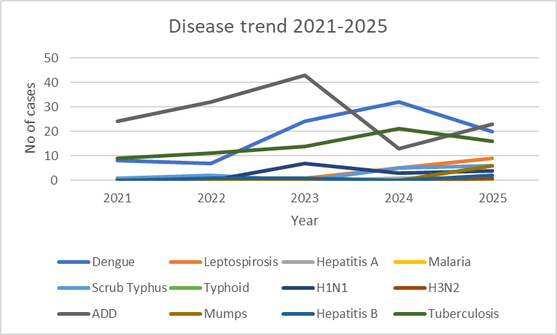

The line graph depicts the trend of major communicable diseases from 2021 to 2025. Overall, the data shows a mix of increasing trends, fluctuations, and decline in certain diseases, reflecting changing epidemiological patterns.

Dengue shows a marked increase from 2022 to 2024, peaking in 2024, followed by a decline in 2025, but still remaining higher than initial years, indicating an overall rising trend with recent reduction. Leptospirosis demonstrates a steady increase, particularly after 2023, suggesting growing environmental or exposure-related risks.

Scrub Typhus shows an increasing trend with a sharp rise after 2023, while Tuberculosis also demonstrates a gradual increase up to 2024, followed by a slight decline in 2025, indicating overall higher burden compared to earlier years.

Acute Diarrhoeal Disease (ADD), although fluctuating, remains a significant contributor to disease burden, with a peak in 2023, a dip in 2024, and a rise again in 2025. H1N1 shows a fluctuating but overall increasing pattern since its emergence in 2023.

Diseases such as Hepatitis A remain stable with very low case numbers. Hepatitis B shows a slight increasing tendency, while Mumps emerges in 2025, indicating a recent rise. H3N2 also appears in 2025, suggesting sporadic occurrence.

COVID-19 shows a clear decreasing trend, with a sharp decline from 2021 to complete absence of reported cases from 2023 onwards, reflecting effective control measures or reduced transmission.

Other diseases like Measles, Hepatitis C, and Leprosy remain stable with no reported cases throughout the period, indicating either absence or effective control

Seasonal Trend Analysis
Seasonal analysis helps anticipate surges (e.g. dengue in monsoon, leptospirosis after floods, influenza in cooler months) and plan pre‑emptive vector control, stockpiling of IV fluids, and awareness campaigns at Panchayat level.

DENGUE
Dengue is a major seasonal vector-borne disease strongly associated with rainfall, water stagnation, and increased mosquito breeding during the monsoon period.

Peak: July–November

Dengue – Ward-wise Yearly Distribution (2021–2025)

Ward | Dengue – Ward-wise Yearly Distribution
Ward | 2021 | 2022 | 2023 | 2024 | 2025 | Total
1 | 1 | 0 | 0 | 1 | 2 | 4
2 | 1 | 1 | 0 | 2 | 3 | 7
3 | 1 | 0 | 0 | 2 | 0 | 3
4 | 0 | 0 | 0 | 0 | 1 | 1
5 | 1 | 0 | 0 | 5 | 0 | 6
6 | 0 | 0 | 0 | 3 | 1 | 4
7 | 0 | 2 | 2 | 1 | 0 | 5
8 | 0 | 0 | 1 | 1 | 1 | 3
9 | 1 | 0 | 4 | 1 | 2 | 8
10 | 0 | 1 | 1 | 1 | 0 | 3
11 | 0 | 1 | 2 | 1 | 2 | 6
12 | 1 | 1 | 2 | 0 | 2 | 6
13 | 1 | 1 | 3 | 3 | 2 | 10
14 | 1 | 0 | 0 | 0 | 0 | 1
15 | 0 | 0 | 2 | 2 | 0 | 4
16 | 0 | 1 | 0 | 0 | 1 | 2
17 | 0 | 0 | 0 | 2 | 2 | 4
18 | 0 | 0 | 1 | 2 | 0 | 3
19 | 1 | 0 | 0 | 1 | 1 | 3
20 | 0 | 0 | 4 | 4 | 0 | 8

LEPTOSPIROSIS
Leptospirosis cases are closely linked to monsoon rains, flooding, and occupational exposure, particularly in low-lying and waterlogged areas.

Peak: June - August

Leptospirosis – Ward-wise Yearly Distribution (2021–2025)

Ward | Leptospirosis – Ward-wise Yearly Distribution
Ward | 2021 | 2022 | 2023 | 2024 | 2025 | Total
1 | 0 | 0 | 0 | 0 | 1 | 1
2 | 0 | 0 | 1 | 0 | 0 | 1
3 | 0 | 0 | 1 | 0 | 2 | 3
4 | 0 | 0 | 1 | 0 | 0 | 1
5 | 0 | 0 | 0 | 0 | 0 | 0
6 | 0 | 0 | 0 | 0 | 1 | 1
7 | 0 | 0 | 0 | 0 | 0 | 0
8 | 0 | 0 | 0 | 0 | 0 | 0
9 | 0 | 0 | 0 | 0 | 0 | 0
10 | 0 | 0 | 0 | 0 | 1 | 1
11 | 0 | 1 | 0 | 1 | 1 | 3
12 | 0 | 0 | 1 | 2 | 0 | 3
13 | 0 | 0 | 1 | 0 | 0 | 1
14 | 0 | 0 | 0 | 0 | 0 | 0
15 | 0 | 0 | 1 | 1 | 0 | 2
16 | 0 | 0 | 0 | 0 | 0 | 0
17 | 1 | 0 | 0 | 0 | 1 | 2
18 | 0 | 0 | 0 | 0 | 0 | 0
19 | 0 | 0 | 0 | 0 | 0 | 0
20 | 0 | 1 | 1 | 0 | 0 | 2

VIRAL HEPATITIS - A
Hepatitis A cases are commonly associated with unsafe drinking water, food contamination, and breakdowns in sanitation, often presenting as clusters or outbreaks.

Peak: October - December

Hepatitis A – Ward-wise Yearly Distribution (2021–2025)

Ward | Hep A – Ward-wise Yearly Distribution
Ward | 2021 | 2022 | 2023 | 2024 | 2025 | Total
1 | 0 | 0 | 0 | 0 | 0 | 0
2 | 0 | 0 | 0 | 0 | 0 | 0
3 | 0 | 0 | 0 | 0 | 0 | 0
4 | 0 | 0 | 0 | 1 | 0 | 1
5 | 0 | 0 | 0 | 0 | 0 | 0
6 | 0 | 0 | 0 | 0 | 0 | 0
7 | 0 | 0 | 0 | 0 | 0 | 0
8 | 0 | 0 | 0 | 0 | 0 | 0
9 | 0 | 0 | 0 | 0 | 0 | 0
10 | 0 | 0 | 0 | 0 | 0 | 0
11 | 0 | 0 | 0 | 0 | 0 | 0
12 | 0 | 0 | 0 | 0 | 0 | 0
13 | 0 | 0 | 0 | 0 | 0 | 0
14 | 0 | 0 | 0 | 0 | 0 | 0
15 | 0 | 0 | 0 | 0 | 0 | 0
16 | 0 | 0 | 0 | 0 | 0 | 0
17 | 0 | 0 | 0 | 0 | 0 | 0
18 | 0 | 0 | 0 | 0 | 0 | 0
19 | 0 | 0 | 0 | 0 | 0 | 0
20 | 0 | 0 | 0 | 0 | 0 | 0

The graph shows the disease trend over the last 5 years for Dengue, Leptospirosis (Lepto), and Hepatitis A (Hep A), across 20 wards.

- Dengue Trend (represented by the blue line) shows the highest number of cases among the three diseases and is reported in all wards, indicating widespread occurrence across the area. The highest numbers are seen in Ward 13 (10 cases), Ward 9 and Ward 20 (8 cases each).
- Leptospirosis trend (represented by the orange line)cases are comparatively fewer and scattered across some wards, with the highest number reported in Wards 3, 11 and 12 (3 cases each).
- Hepatitis A trend (represented by the green line)shows very minimal occurrence, with only one case reported from Ward 4.
Overall, the data indicates that dengue is the predominant disease in the area, while leptospirosis occurs sporadically and Hepatitis A cases are very low.

Outcome-Based Trend Analysis- 2025

The disease trend analysis for 2025 indicates a mixed pattern with a predominance of increasing trends in communicable diseases, suggesting the need for strengthened surveillance and preventive measures. Vector-borne diseases such as dengue (20 cases) and scrub typhus (6 cases), along with leptospirosis (9 cases), continue to show an overall increasing trend compared to previous years, despite a slight decline in dengue from 2024.
Water- and food-borne diseases such as acute diarrhoeal diseases (ADD) (23 cases) have shown a rise again after a dip in 2024, indicating persistent environmental and sanitation challenges. Typhoid and malaria remain low with a decreasing or minimal trend, while hepatitis A remains stable with very few cases.
Among airborne diseases, tuberculosis (16 cases) continues to show an increasing long-term trend, though with a slight reduction from 2024. The emergence of cases like H1N1 (4 cases), H3N2 (1 case), and mumps (6 cases) in recent years highlights the reappearance or detection of respiratory and vaccine-preventable diseases. Hepatitis B cases have also shown a gradual increase.
Notably, COVID-19 cases have declined to zero since 2023, indicating effective control measures. However, the overall increase in multiple communicable diseases in 2025 suggests a shift in disease burden, emphasizing the importance of sustained public health interventions, improved sanitation, vector control, immunization, and early detection strategies to prevent outbreaks.

Transmission Trend- 2025
For effective management of public health issues, it is important to track the trend of disease transmission mode. It helps identify the population or place at high risk that can be used to predict outbreaks and implement targeted interventions as quickly as possible. Understanding these kinds of trends enables authorities to allocate resources efficiently and change the strategies adequately based on the trend that follows.

Mode of Transmission | No. of cases | No. of Deaths
Vector Borne Diseases | 26 | 0
Water Borne Diseases | 2 | 0
Air Borne Diseases | 33 | 0
Blood Borne Diseases | 2 | 2
Food Borne Diseases | 23 | 0

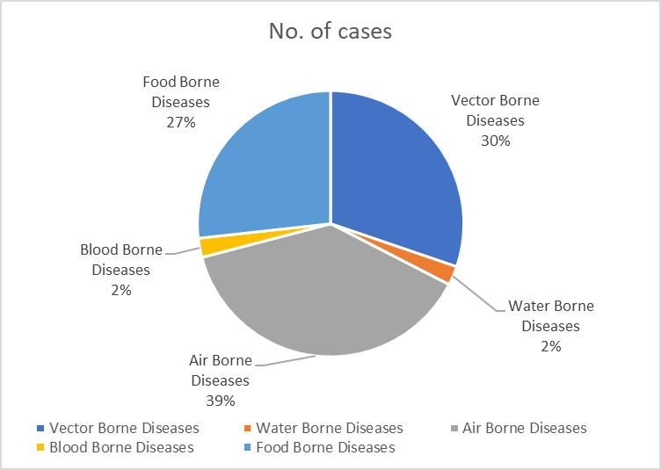

The pie chart illustrates the distribution of diseases based on their mode of transmission:
- Air-borne diseases constitute the highest proportion of cases (33) in 2025, indicating that respiratory infections form the major disease burden.
- Vector-borne diseases account for 26 cases, representing the second largest share.
- Food-borne diseases also contribute a considerable number of cases (23).
- Water-borne and blood-borne diseases are comparatively low, with 2 cases each.
- Overall, the trend shows that air-borne diseases are the predominant mode of transmission, followed by vector-borne and food-borne diseases

This chart shows that most diseases are air borne, with vector borne diseases the next most common mode of transmission.

Vector-Borne Disease

Disease | No. of Cases | No. of Deaths
Dengue | 26 | 0
Malaria | 0 | 0
Chikungunya | 0 | 0

Water Borne Disease

Disease | No. of Cases | No. of Deaths
Cholera | 0 | 0
Typhoid | 0 | 0
Hep- A | 1 | 0
Dysentery | 0 | 0
Amoebiasis | 1 | 0
E- Coli infections | 0 | 0
Air Borne Disease

Disease | No. of Cases | No. of Deaths
Influenza | 0 | 0
H1N1 | 4 | 0
TB | 17 | 1
Chickenpox | 27 | 0
Measles | 0 | 0
Covid-19 | 0 | 0
Pertussis | 0 | 0
Mumps | 6 | 0

Blood-Borne Disease

Disease | No. of Cases | No. of Deaths
AIDS | 0 | 0
Hep- B | 2 | 0
Hep- C | 0 | 0

Zoonotic Disease

Disease | No. of Cases | No. of Deaths
Rabies | 0 | 0
Leptospirosis | 6 | 1
Avian influenza | 0 | 0
West nile | 0 | 0
Anthrax | 0 | 0
Nipah | 0 | 0
Scrub Typhus | 6 | 0

Integrated Disease Hotspot Map (2021–2025)
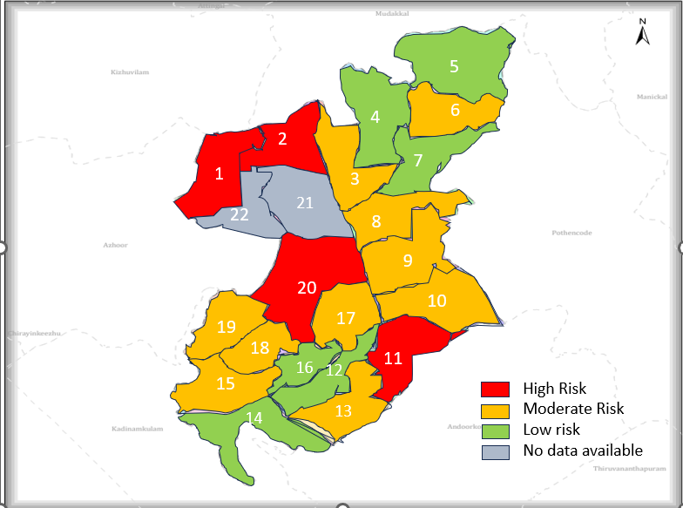

The area in grey shows newly formed wards.

Ward No | Dengue Total (2021-25) | Leptospirosis Total (2021-25) | Hepatitis A Total (2021-25) | Mumps (2021-25) | ADD (2021-25) | Total Cases
1 | 4 | 1 | 0 | 2 | 8 | 15
2 | 7 | 1 | 0 | 0 | 12 | 20
3 | 3 | 3 | 0 | 0 | 6 | 12
4 | 1 | 1 | 1 | 0 | 6 | 9
5 | 6 | 0 | 0 | 0 | 5 | 11
6 | 4 | 1 | 0 | 0 | 7 | 12
7 | 5 | 0 | 0 | 0 | 6 | 11
8 | 3 | 0 | 0 | 0 | 9 | 12
9 | 8 | 0 | 0 | 1 | 5 | 14
10 | 3 | 1 | 0 | 2 | 6 | 12
11 | 6 | 3 | 0 | 0 | 6 | 15
12 | 6 | 3 | 0 | 0 | 2 | 11
13 | 10 | 1 | 0 | 0 | 3 | 14
14 | 1 | 0 | 0 | 0 | 5 | 11
15 | 4 | 2 | 0 | 0 | 6 | 12
16 | 2 | 0 | 0 | 1 | 7 | 10
17 | 4 | 2 | 0 | 0 | 8 | 14
18 | 3 | 0 | 0 | 0 | 10 | 13
19 | 3 | 0 | 0 | 0 | 9 | 12
20 | 8 | 2 | 0 | 0 | 7 | 17

By overlaying five years of data, we have identified Ward 1, 2, 11, and 20 (15–20 cases) 'Red Zone' Wards. These are wards where at least two different categories of diseases (e.g., Dengue and Lepto) recurred in consecutive years. Ward 2 is categorized as the Highest Priority Hotspot due to its combination of flood vulnerability and high vector density. Future health infrastructure, such as the proposed R.O plants at should be prioritized.
High risk wards included Ward 1, 2, 11, and 20 (15–20 cases)
Moderate-risk wards included Ward 3, 6, 8, 9, 10, 13, 15, 17, 18, and 19 (12–14 cases).
Low-risk wards included Ward 4, 5, 7, 12, 14, and 16 (9–11 cases).
Ward 21 and Ward 22 had no reported data as it is newly formed.

Preparedness and Response Protocol at LSG Level
This section describes the operational framework for the LSGI once a pandemic is declared. It explains how the LSGI and health system will move from routine data collection to active response, using a One Health approach.

PREPAREDNESS PROTOCOL (PRE-OUTBREAK)
Focuses on strengthening the "First Line of Défense" based on the identified vulnerabilities of the 7,090 elderly residents and 98 bedbound patients.
- Risk Categorization: Establish ward-level risk profiles using the 2025 data, prioritizing Ward 2 (Dengue/Lepto/TB hotspot) and Wards 1, 11, and 20.
- Resource Mapping: Update the "Vulnerability Register" for the 25 dialysis patients and ensure transport agreements with the 3 private hospitals.
- Environmental Sanitation: Conduct mass well-chlorination drives for all 911 wells and 250 ponds, specifically targeting the surge in Acute Diarrheal Disease (ADD) seen in 2025.
- One Health Surveillance: Veterinary wing to monitor the 3,622 birds and 859 animals for zoonotic indicators, feeding data to the 1 Government Hospital.

RESPONSE PROTOCOL (DURING OUTBREAK)
Activated immediately upon the detection of a cluster (e.g., the 2024 spike of 65 Dengue cases).
A. Command & Coordination
- Rapid Response Team (RRT): Activation of the RRT led by the Medical Officer and Panchayat Secretary.
- Communication Hub: Utilization of the 32 Anganwadi workers and 91 One Health Mentors for real-time community messaging.
B. Field Operations
- Containment: If a ward (like Ward 2) becomes a hotspot, seal entry points if necessary for strict quarantine
- Contact Tracing: ASHA workers to initiate trace-and-test protocols for Tuberculosis and Dengue clusters.
- Facility Management: Convert identified 13 schools or 7 auditoriums into First Line Treatment Centres (CFLTCs) as required.

POST-OUTBREAK PROTOCOL (RECOVERY)
- Impact Assessment: Analyze why cases spiked and identify specific well-contamination points.
- Continuity of Care: Ensure the 145 bedbound patients and 1893 palliative care patients resume regular home-visits that may have been disrupted.
- Financial Review: Audit the utilization of local funds and emigrant remittances used for community kitchens or medical supplies.

Constitution of One Health Committee
The LSGD shall constitute a One Health Committee comprising the LSGI President, Medical Officers (Modern Medicine, AYUSH, and Veterinary), the Health Inspector, and the Veterinary Surgeon.

Objective: The One Health Committee coordinates human, animal, and environmental health to prevent and control pandemics.

Sl No | Name | Designation | Department/Institution | Role in Committee | Contact Number
1 | SREE CHAND | Panchayat President | LSGD | Chairperson | 8907046853
2 | DR KAVITHA MOL | Medical Officer (PHC/CHC) | Health Dept | Member Secretary | 9495911252
3 | DR.DALIYA | Veterinary Officer | Animal Husbandry | Member | 9495829874
4 | Dr.JESSY | Epidemiologist | Health Dept | Member | 9995215578
5 | VINOD HI | Health Inspector/PHN | Health Dept | Surveillance | 8089228375
6 | ASHIJA | ASHA Supervisor | Health Dept | Community link | 9895066965
7 | SHYBI | ICDS Supervisor | Social Welfare | Vulnerable groups | 9995052896
8 |  | Police Station Officer | Police Dept | Law & order | 0471 2420275
9 | AJI KUMAR HEALTH STANDING COMMITTEE CHAIRMAN | Ward Councillor Representative | LSGD | Community coordination | 9847890876
10 | PREMA | Kudumbashree CDO | Kudumbashree | Community mobilisation | 9995581311
11 |  | NGO/Volunteer rep | Civil Society | Support services
12 |  | Line Department representations

Key Responsibilities:
- Review disease surveillance data (human + animal)
- Conduct ward-wise risk assessment and vulnerability mapping
- Approve quarantine/isolation centre locations
- Coordinate with district for resources (PPE, oxygen, ambulances)
- Periodically review health system surge capacity, including beds, oxygen, human resources, and ambulances.
- Approve and monitor risk communication and community engagement strategies, including rumour management.
- Ensure protection and service continuity for vulnerable groups (elderly, persons with disabilities, dialysis patients, coastal populations).
- Conduct quarterly mock drills
- Monitor equity measures for vulnerable groups

Meeting Schedule:
Quarterly (normal times) | Weekly (outbreak alert) | Daily (pandemic phase)

Pandemic Response Workforce
To ensure a coordinated and timely response during a pandemic, a dedicated Pandemic Response Workforce shall be constituted at the LSG level. The workforce will function under the overall supervision of the One Health Committee and in close coordination with the health authorities. Team-based deployment will enable efficient surveillance, case management, quarantine and isolation management, logistics support, and risk communication. Each team shall have a clearly designated team leader, defined roles, and an identified pool of personnel to allow rapid activation, rotation of duties, and continuity of services during prolonged emergencies.

Total Response Workforce Available: 300 persons

Team Name | Composition | Key Responsibilities | Team Leader
Surveillance and Contact Tracing Team | HI, JHI, JPHN, ASHAs and Volunteers | Case detection, contact listing, home visits, reporting | HI
Case Management Team | Doctors, Nurses, MLSP, Palliative Nurses | Patient care & referral | DOCTOR
Quarantine & Isolation Team | LSGD staff, Volunteers | Facility management | JHI
Psychosocial support | HEALTH STAFF, DMHP TEAM | Facility management | MO
Logistics & supply chain Team | LSGD staff, Storekeepers, Drivers 3 | Supplies & transport [PPE, medicines, oxygen, transport, waste management] | Ward Member
Communication Team | Ward members, Kudumbashree, Youth clubs,  AWW workers and other self help groups | IEC, community meetings, countering misinformation | M.O in charge
Transportation | KSRTC, educational institutional buses | Transportation | GP- President/JHI
Media Surveillance | Social media, mass media | IEC, Line list of case, analysis of situation | HI
Intersectoral coordination and convergence | Panchayath level and Public Health team | Co-ordination of panchayath level activities | GP level-Interdepartment head
Collaborative surveillance | Panchayath level | Monitoring and evaluation | Medical officer

All teams shall be activated immediately upon outbreak alert or pandemic declaration and shall report daily to the LSG Incident Commander/Medical Officer, with consolidated reporting to the Block PHC. Duty rosters and alternate personnel shall be maintained to ensure uninterrupted services during staff shortages or prolonged response periods. Team composition and numbers may be revised based on the magnitude of the outbreak and availability of human resources.

Activities and Measures before and during Pandemic

PHASE 1 - Alert / Preparation
Surveillance and Reporting-Enhanced syndromic surveillance:
- Data sources for surveillance:
- Routine surveillance data from health institutions including PHCs, subcentres, private hospitals, and laboratories.
- Reports from field-level health workers such as ASHAs, JPHNs, and Anganwadi workers.
- Data from allied sectors including water supply, sanitation, veterinary services, and local self-government records.
- Event-based triggers (to be monitored and reported):
- Sudden increase or clustering of fever, diarrhoeal diseases, respiratory illness, or unusual symptoms in the community.
- Occurrence of deaths due to unknown causes or unusual severity of common diseases.
- Reports of outbreaks, mass absenteeism (schools/workplaces), or unusual animal deaths.
- Zoonotic and animal health surveillance
- Regular monitoring of animal health status in coordination with the veterinary department.
- Reporting of unusual illness or deaths among domestic animals, poultry, and stray animals.
- Strengthening intersectoral coordination (One Health approach) for early detection and control of zoonotic diseases.
- Logistics and Stock Preparedness
  - Identify and empanel local vendors and define emergency procurement mechanisms in accordance with existing LSGD and Health Department norms.
  - Prepare and maintain an essential logistics checklist covering medical supplies, consumables, and support equipment.
  - Pre-identify secure storage locations for emergency stocks and ensure maintenance of stock registers with regular updating.
  - Finalise emergency transport arrangements, including availability of vehicles and identified drivers for rapid deployment during alerts.
  - Designate a Nodal Officer for Logistics to enable prompt decision-making, coordination, and communication during emergencies.
  - Conduct rapid stock verification and ensure availability of minimum buffer stock, including:

- PPE | - 3 kits
- Pulse oximeters | - 3 numbers
- Hand sanitizers | - 5 litres
- Mask | - 750
- Glouse | - 200
- Disinfectant | - 2 litre

Identify critical gaps in logistics and immediately communicate requirements to the Block and District authorities for timely replenishment and support. Monitor expiry dates and stock rotation.

Identification of Quarantine and Isolation Facilities
  - Identify and list suitable buildings for quarantine and isolation (schools, hostels, community halls, etc.).
  - Categorise cases as per the severity and allocate to appropriate facilities (for instance, severe cases to classrooms, mild cases to an assembly hall in case of a school).
  - Facility readiness checklist needed (beds, toilets, ventilation) etc.
  - Find an alternate site if the primary sites are not available or not in use.
  - Identify facility managers and support staff
  - Prepare basic SOPs for:
    - Admission and discharge
    - Food, water, sanitation
    - Infection prevention and waste disposal
  - Ensure availability of basic amenities: water, sanitation, electricity, ventilation, and waste disposal. Prepare a rapid activation plan for these facilities if case numbers increase.

Risk Communication and Community Preparedness
  - Disseminate early warning messages on symptoms, preventive measures, and reporting mechanisms. Display IEC materials both in English and the local language in public places and ensure ward-level awareness.
  - Sensitize elected representatives and community leaders on preparedness measures.
  - Establish a rumour tracking and misinformation response mechanism to identify, verify, and promptly counter false or misleading information.
  - Engage trusted local persons (ward members, ASHA workers, religious leaders, teachers, community volunteers) to communicate official public health messages and reinforce correct practices.
  - Develop and deploy targeted IEC materials for:
    - Schools and educational institutions
    - Markets and commercial areas
    - Work sites and labour settings
  - Conduct community sensitization meetings at the ward level to promote preventive behaviors, address concerns, and strengthen community participation in preparedness and response.

Protection of Vulnerable Groups
Vulnerable populations require priority protection through targeted line-listing, service continuity, and delivery mechanisms.
- Prepare and regularly update line-lists of vulnerable populations, including:
  - Elderly persons living alone
  - Persons with disabilities
  - Pregnant women
  - Migrant workers
  - Dialysis patients
The detailed line-lists shall be maintained as Annexure 1_ and updated periodically.

Clinical Dependency Mapping
Develop ward-wise dependency and vulnerability maps to identify households requiring regular support during emergencies. Ensure continuity of essential health services for vulnerable groups, including
- Dialysis services (facility mapping, transport arrangements, and scheduling)
- Continuity of treatment for TB, HIV, and other chronic conditions requiring uninterrupted medication
- Mental health and psychosocial support services
Establish delivery mechanisms for food, essential commodities, and medicines to vulnerable households through coordinated action involving ASHAs, JPHNs, Kudumbashree, volunteers, and local administration.

PHASE 2 - Active Response

Case Identification and Contact Tracing
Case detection and contact tracing activities will be carried out in coordination with the Health authorities, following disease-specific SOPs and IDSP guidelines.
Field Staff Involved
- Health Inspector (HI)
- Junior Health Inspector (JHI)
- Junior Public Health Nurse (JPHN)
- ASHAs and ASHA Supervisors
- Ward-level volunteers and Kudumbashree members (as required)

Screening Checkpoints
Screening checkpoints at high-traffic locations (transport hubs, markets, religious gatherings) for early detection of symptomatic travellers and crowd screening during outbreaks. Potential locations include bus stands, market entry points, and boat jetties, based on local context and risk assessment.
Screening activities will be carried out by trained personnel such as ASHAs, ward members, and volunteers, with support from Health Department staff. Necessary equipment, including non-contact thermometers and appropriate PPE, shall be ensured prior to activation.
Location | Type (Bus stand/Jetty/Market/Railway) | Staff Deployed (ASHAs/Volunteers) | Screening Method | Reporting authority
Bus stand | Transport hub | One JHI  One ASHA  One health Mentors | 1.Swab Collection.  2. Blood smears collection (RDT)  3.Thermal Scanners | Surveillance Nodal Officer in control room
Market entry | Market | One JHI  One ASHA  Male health volunteers | 1.Swab Collection.  2. Blood smears collection (RDT)  3.Thermal Scanners | Surveillance Nodal Officer in control room
Boat jetty | Water transport | One JHI  One ASHA  Male health volunteers | 1.Swab Collection.  2. Blood smears collection (RDT)  3.Thermal Scanners | Surveillance Nodal Officer in control room

Standard Screening Protocol

The screening protocol shall include temperature screening, observation for visible symptoms, and inquiry regarding recent travel or exposure history. Individuals identified as suspects during screening shall be immediately referred to the nearest PHC/FHC for further evaluation, testing, and appropriate action as per prevailing guidelines.

Pandemic Control Room
The Pandemic Control Room (PCR) serves as the central nerve center for real-time coordination, data aggregation, decision support, and communication during outbreaks. It consolidates information from all LSGD teams, health facilities and community sources to enable rapid response decisions.

Control Room Infrastructure and Location
Primary Location: Mangalapuram Panchayath Office.
The Panchayat Office functions as the main Pandemic Control Room (PCR), serving as the central hub for coordination, monitoring, and decision-making. It houses core response teams, data management units, and communication systems. Being centrally located within the Panchayat ensures accessibility and administrative control. All emergency planning, review meetings, and reporting mechanisms are coordinated from this site.
Backup Location: Community Hall in Mangalapuram G.P.
The Community Hall serves as an alternate control room during contingencies such as infrastructure failure or surge situations. It is equipped to accommodate extended teams and emergency operations. This ensures uninterrupted functioning of pandemic response activities. The backup facility strengthens resilience and continuity planning within the health emergency framework.

Health System Control Room Framework
The PCR is organized into seven functional pillars to ensure no aspect of the response is overlooked:

Rapid Response Team (RRT)
  - Provides immediate intervention during emergencies, clusters, and field alerts.​
  - Coordinates urgent actions such as case investigation, contact tracing, isolation, and inter‑facility referrals.

Data Management & Analytics Team
  - Collects, validates, and manages key health system indicators (cases, tests, beds, HR, supplies).​
  - Analyzes data trends, generates projections, and supports evidence‑based decision‑making for local authorities.

Human Resource Deployment Team
  - Allocates healthcare staff efficiently based on workload and need
  - Ensures adequate and equitable workforce distribution across facilities

Laboratory Surveillance Team
  - Oversees diagnostic testing coordination, sample transport, and timely reporting of results.​
  - Monitors lab indicators (testing volume, positivity rate, turnaround time) for early detection of outbreaks

Vaccination Cell (If Required)
  - Plans and executes vaccination campaigns, including micro‑planning and session scheduling.​
  - Tracks coverage, identifies gaps, and coordinates corrective actions with field teams and outreach services.

Infrastructure & Patient Occupancy Team
  - Monitors facility capacity, earmarked beds, oxygen and critical care resources across all linked facilities.​
  - Ensures optimal patient distribution and referral management using updated bed‑status and resource data.
- BMWM
The BMWM team ensures safe segregation, collection, transportation, and disposal of biomedical waste as per regulatory norms. It monitors compliance in all healthcare facilities and temporary care centers. Proper waste management reduces environmental contamination and infection risk. Training and supervision are integral components of this pillar.

Communication team

The Communication Team manages public information dissemination, awareness campaigns, and official advisories. It ensures transparent and accurate messaging to prevent misinformation and panic. Regular updates are shared through local media, social platforms, and community networks. Effective communication builds public trust and cooperation.
- Logistics and supply chain
This team manages procurement, storage, and distribution of essential supplies such as PPE, medicines, oxygen, and equipment. It monitors stock levels and prevents shortages through advance planning. Efficient supply chain management ensures uninterrupted healthcare delivery. Coordination with district authorities strengthens resource mobilization.
- Transportation (interfacility & emergency transport)
The transportation unit coordinates ambulance services and patient transfers between facilities. It ensures timely referral transport for critical cases. The team maintains vehicle readiness and communication with hospitals. Efficient transport systems reduce treatment delays and improve survival outcomes
- Media surveillance Call centre
This unit monitors media reports and social media trends for outbreak signals or misinformation. The call centre addresses public queries, complaints, and emergency support requests. It provides guidance on testing, treatment, and vaccination services. Active surveillance improves community engagement and responsiveness.
- Management of the deceased
This team ensures dignified and safe handling of deceased persons as per public health guidelines. It coordinates documentation, transport, and support to families. Infection prevention protocols are strictly followed. Proper management upholds public health safety and humanitarian values.
- Intersectoral coordination and convergence
This pillar ensures collaboration among health, local self-government, police, education, social welfare, and other departments. Regular coordination meetings align strategies and share responsibilities. Convergence enhances resource utilization and community outreach. Integrated action strengthens the overall pandemic preparedness and response system.

Key Control Room Team
The Control Room Team coordinates all pandemic response activities within the LSGD and serves as the single command and communication hub during activation. It integrates information, field actions, logistics, and policy execution across all participating departments and health facilities.

Role | Name | Designation | Contact Number | Responsibility
In-charge/Nodal Officer | Dr. Kavitha Mol | Medical Officer | 9495911252 | Overall coordination, decision-making, and reporting to the District level.
Data Entry Operator | Aneesha | CLERK | 7012050396 | Managing the line list, updating dashboards, and tracking testing results.
Communication Officer | Preetha S | H I | 9446845266 | Handling the public helpline, coordinating ambulance dispatch, and contact tracing calls.
Logistics Coordinator | Sreechand | PRESIDENT | 8907046853 | Helping the movement of Logistics items.
Technical Support (IT/Data) | Preetha S | HI | 9446845266 | Provide Technical support

SOP for alert escalation/trigger point with mapping of responsibilities.

Key Points:
- The Control Room shall be staffed with a designated In-charge, data entry personnel, and communication staff with clearly defined roles and shift arrangements.
- It shall maintain updated records on daily monitoring indicators including new cases, persons under active quarantine, and hospital bed occupancy.
- All reports and situation updates shall be shared daily with the Block and District Surveillance Unit.
- The Control Room shall act as a single point of contact for coordination with response teams, health institutions, and other departments.
- Contact details of the Control Room shall be widely communicated to field staff and stakeholders during activation.

Daily Monitoring Indicators
To ensure timely decision-making and effective response, the following key indicators shall be monitored and updated on a daily basis by the Pandemic Control Room:

Epidemiological Indicators:
New cases reported today, Total active cases, Test Positivity Rate (TPR), Case Fatality Rate (CFR)
- Surveillance Indicators:
Persons under home quarantine, High-risk contacts identified, Fever, ILI, SARI or other symptoms (syndromic surges), Travellers (symptomatic or high-risk arrivals),Animal husbandry surveillance (zoonotic alerts, unusual animal deaths, poultry/bird flu signals), Mortality surveillance (excess deaths, unexplained fatalities, verbal autopsy reports)
- Logistics and Infrastructure Indicators:
Hospital / CFLTC beds occupied, Oxygen cylinders/concentrators available, Ambulances on standby
- Alert Findings
The following table outlines category-specific trigger points (red flags) from surveillance indicators and corresponding immediate actions for the Pandemic Control Room. These enable rapid response to alert findings like testing anomalies, positive cases exceeding thresholds, clusters, and WGS reports.

Category | Trigger Pophint (Red Flag) | Immediate Action
Clusters | Geographical or facility-based: 5+ cases linked to one location (office, school, street). | Declare a micro-containment zone; perimeter control and active case finding.
Testing | Sudden drop in testing volume / delay in reporting / unusual testing trends | Review the sample collection process, address lab bottlenecks, deploy additional testing teams, and notify the District Lab.
Lab | Test Positivity rate increases | Increase testing sites in that ward.
Hospital | >80% Oxygen bed occupancy | Activate backup/CFLTC beds.
Travel | Cluster of cases from a single flight/train or high-risk arrival group. | Trace all passengers in adjacent seats; implement mandatory institutional quarantine.
Animal | Mass poultry/wildlife death or unusual sickness | Notify Animal Husbandry, sample the area, and dispatch RRT for environmental sampling and zoonotic check.
Mortality | Sudden spike in home deaths or brought-in-dead (BID) cases | Audit the deaths and Active Case Search drive
Additional investigations like Whole Genome Sequencing (WGS) | Detection of a Variant of Concern (VOC) or Variant of Interest (VOI) | Implement strict micro-containment; update clinical protocols to match variant severity.

Communication of Public Health Information
A Community Communication Hub shall be established to ensure timely, accurate, and consistent dissemination of information during a pandemic. The Hub will function under the coordination of Nodal officers of the control room and act as the nodal point for public communication, risk messaging, and community engagement. It will support dissemination of official advisories, promote preventive behaviors, address rumors and misinformation, and ensure that messages reach all sections of the population through trusted local channels and leaders.

Key communicators
Channel | Responsible Person | Contact
Ward-level announcements | SYAM SECRETARY GRAMA PANCHAYATH | 9496402329
Social media | SYAM SECRETARY GRAMA PANCHAYATH  AJI KUMAR HEALTH STANDING COMMITTEE CHAIRMAN | 9496402329  9847890876
Local Cable TV/Radio | SYAM SECRETARY GRAMA PANCHAYATH | 9496402329

- All messages disseminated through the Hub shall align with advisories issued by the Health Department and District authorities.
- Community leaders shall be sensitized to support behavior change, reduce stigma, and counter misinformation.
- Special efforts shall be made to reach vulnerable and hard-to-reach populations using locally appropriate communication methods.

Rumor Tracking: A designated volunteer will monitor local social media/WhatsApp groups daily to identify misinformation and issue official clarifications via the Communication Hub.

Coordination with District/State Authorities & Other Organisations
Effective coordination with Block, District, and State authorities is essential to ensure timely reporting, technical guidance, and uninterrupted supply of essential resources during a pandemic. The LSG shall establish clear communication channels, designate responsible officers, and adhere to prescribed reporting timelines to support coordinated public health action and efficient resource mobilisation.

Key Details:
- Nodal Officer for Reporting: MO i/c
- Contact Number:
Reporting Schedule and Protocols:

To Whom | What to Report | Frequency | Nodal Person
Block PHC | Complete Situation Report (Cases, Quarantine, Beds, Screening, Deaths) | DAILY REPORTING | HI
District IDSP Unit | Outbreaks/Clusters/Unusual Events (>5 cases same ward) | DAILY REPORTING | JHI
Veterinary Officer | Animal health events/Zoonotic alerts | AN EVENT OCCUR | HI
State Cell | Zoonotic cross-sector events | AN EVENT OCCUR | HI-

Supply Chain Coordination
The LSG shall coordinate closely with Block, District, and State authorities (KMSCL) to ensure uninterrupted availability of essential goods, medical supplies, and logistics during a pandemic. Supply requirements shall be assessed regularly based on case load and communicated promptly to the appropriate authorities for timely replenishment.
Key Points:
- Maintain updated contact details of District and Block nodal officers for health logistics, oxygen supply, ambulances, and essential medicines.
- Submit timely indent requests for PPE, testing kits, medicines, oxygen, and other critical supplies through prescribed channels.
- Monitor stock levels at LSGD facilities, quarantine/isolation centres, and field teams through daily stock registers and dispensing logs to prevent shortages.
- Coordinate with District authorities, Karunya/Neethi medical shops, and local purchase committees for funds allocation and emergency procurement.

- Ensure regular monitoring of dispensing registers at all facilities to track usage, expiry, and pilferage—shortages being a perennial issue requiring proactive weekly audits.

- Activate surge procurement protocols during high caseloads, leveraging local purchase powers under LSGD funds alongside state supplies.

Resource Inventory and Contacts
Resource Category | Source  (District/State/Private) | Contact
PPE Kits/Masks/Gloves | KMSCL | 9446902086
PPE Kits/Masks/Gloves | Local Vendors
Oxygen  Cylinders/Concentrators | KMSCL | 9446902086
Medicines/Antivirals | KMSCL | 9446902086
Medicines/Antivirals | Neethi Shops | 9447065063
Test Kits (RTPCR/Rapid) | KMSCL | 9446902086

Collaboration with NGOs, PPP, and CSR
To augment government efforts during a pandemic, the LSG shall collaborate with NGOs, voluntary organisations, and private sector partners through public–private partnerships and Corporate Social Responsibility (CSR) initiatives, in coordination with District authorities.

Key Points:
- Engage NGOs and community-based organisations for community outreach, awareness, and support to vulnerable populations.
- Leverage CSR support for procurement of medical equipment, PPE, oxygen concentrators, food kits, and sanitation materials, as permitted.
- Ensure all collaborations align with government guidelines and are routed through approved administrative and financial procedures.
- Maintain transparency and documentation for all external support received and utilised.
Organization | Type | Support Offered | Contact Person
INDOOR STADIUM | CBO | ACCOMODATION | PANCHAYATH
A T COVOOR | CBO | STRENGTHEN MAN POWER | LISSY 9526985450
EICL | PRIVATE INSTITUTION | SUPPORT FOR FOOD KITS | MANOJ 9072626385

Interdepartmental Coordination
Coordination among departments during a pandemic shall be ensured through regular review meetings convened by the LSGD President. These meetings will provide a structured platform for sharing situational updates, assessing resource availability, resolving operational gaps, and taking joint decisions to ensure a coordinated and timely response.

Department | Representative | Key Role | Contact
Health (PHC) | Staff Nurse : Suchithra | Case management | 9656411817
Veterinary | Veterinary Surgeon: DR.DALIYA | Animal surveillance | 9495829874
ICDS | Supervisor: Sindhu | Nutrition support | 9995052896
Education | Head Teacher: | School coordination
Police | SI | Containment enforcement | 0471 2420275
Water Authority | AE | Water supply | 04702620574
LSGD Engineering | AE | Quarantine infrastructure | 9744262966

PHASE 3 - Surge Capacity
Phase 3 is activated when there is a rapid increase in cases, high test positivity rates, or when existing health facilities and quarantine arrangements approach saturation. The focus of this phase is to expand isolation capacity, augment clinical care services, and mobilise additional resources through district and state support mechanisms.

Conversion of Community Facilities
To manage increased case load, the LSGD shall activate additional isolation facilities by repurposing identified community infrastructure such as community halls, auditoriums, schools, hostels, or other suitable buildings.

Name of facility | Facility Type | No. of Buildings | Ward | Surge Capacity (Beds) | Nodal Person
INDOOR STADIUM | SPORTS PURPOSE | 1 | 8 | 100 | Medical Officer
GLPS PATTATHIL | Educational Institution | 2 | 7 | 20 | Medical Officer
EDAVILAKOM LPS SCHOOL | Educational Istitution | 3 | 12 | 35 | Medical Officer

- Recovery and rehabilitation phase
After the peak of the pandemic, recovery measures will focus on restoring normal health and socio-economic conditions across all 20 Panchayat wards.
- Recovery
The recovery phase in Mangalapuram will focus on restoring routine health services, safely reopening institutions, and stabilising community livelihoods. The recovery phase centres on the protracted endeavour to reconstruct and restore pre-pandemic circumstances. This entails revitalizing healthcare infrastructure, economic systems, and public service provisions. Successful recovery requires meticulous planning, coordinated efforts, and the strategic allocation of resources to facilitate recovery across all sectors. Prioritizing the delivery of essential healthcare, addressing economic challenges, and protecting the well-being of affected communities are of utmost importance.
Priority areas include:
- Restoration of primary healthcare services
- Safe reopening of schools
- Economic stabilization
- Strengthening local health systems
Block-level coordination will be ensured between:
- Panchayaths
- Health Department
- ICDS
- Veterinary Department
- Community organisations
- Damage and Impact Assessment

A thorough assessment of the damage to public health, infrastructure, and the economy is crucial after a pandemic. This evaluation is essential for identifying both immediate and long-term intervention needs. A detailed examination of the harm and its consequences provide vital information for resource allocation, informs policy development, and enables the precise targeting of recovery efforts. Therefore, a thorough situational analysis requires gathering real-time data and working closely with local authorities.
A ward-wise assessment will be conducted across all Panchayaths.
Areas Assessed
- Disease burden
- Deaths
- Livelihood losses
- School disruptions
- Service interruptions
- Vulnerable households
Data Sources
- Health facility records
- Household surveys
- ASHA reports
- Panchayat registers
The findings will guide recovery planning.
- Restoration of Health Services
Rebuilding healthcare infrastructure is crucial for guaranteeing the continued availability of essential medical services after a pandemic. The recovery process requires a step-by-step approach, starting with the most important services. These include emergency care, essential treatments, and vaccination programs. A key part of this restoration involves addressing staff shortages, securing enough medical supplies, and prioritizing the healthcare needs of vulnerable groups. Consequently, a meticulously devised strategy will facilitate the uninterrupted operation of the healthcare system throughout the recovery period.
Priority services to be restored:
- Maternal and child health services
- Immunization
- NCD treatment
- Dialysis support
- TB and HIV treatment
- Emergency care
Outreach services will be strengthened.

- Rehabilitation of Affected Population
The rehabilitation of the affected population constitutes a critical element of the comprehensive recovery strategy. This process involves physical rehabilitation, healthcare evaluations, and social welfare support for those who suffered the most severe pandemic-related repercussions. Moreover, it is essential to address the mental, emotional, and social aspects of those impacted's lives. Therefore, ensuring access to medical services, social support systems, and economic assistance will help restore stability and resilience to the population.
Rehabilitation measures will include:
- Medical follow-up for recovered patients
- Social welfare support
- Food security support
- Livelihood support

Priority Groups:
- Elderly persons
- Daily wage workers
- Migrant workers
- Poor households
- Persons with disabilities
Convergence with Government schemes will be ensured.

- Psychosocial and Mental Health Support
The psychological effects of a pandemic can be significant, underscoring the need to pay closer attention to psychosocial health. Offering mental health resources, such as counselling and psychological therapies, assists individuals in managing the trauma and stress associated with the pandemic. Community-based mental health services and telemedicine can enhance access to mental health resources, especially for those facing isolation or in need of immediate support. Therefore, cultivating mental resilience will contribute to the wider recovery of both individuals and communities. Mental health support will include:
- Counselling services
- Tele-counselling
- Ward-level support
- Awareness programs
Priority Groups:
- Children
- Frontline workers
- Bereaved families
- Isolated elderly persons
- Disease Surveillance
During Recovery Disease surveillance is a vital element of the recovery phase, monitoring potential resurgences or new outbreaks. Continuous monitoring, including testing, contact tracing, and reporting protocols, enables health authorities to identify and manage newly emerging cases swiftly. The fortification of the surveillance system facilitates early detection, the implementation of more effective control measures, and a more streamlined response to prospective new threats. Consequently, maintaining vigilance throughout the recovery period is essential to avert a secondary wave of infection.
Surveillance will continue across the wards
Activities
- Fever surveillance
- Syndromic surveillance
- Animal surveillance
- Mortality monitoring
Field Teams
- ASHA Workers
- JHI
- JPHN
- Health Inspectors
Early detection will prevent resurgence.
- Environmental Cleanup and Sanitation After a pandemic, environmental restoration and sanitation are crucial for keeping public areas safe and clean. Inadequate sanitation can precipitate secondary health crises, such as the spread of waterborne illnesses. Consequently, the orchestration of extensive cleanup initiatives, the enhancement of waste-disposal systems, and the dissemination of hygiene education to the populace will be indispensable for mitigating future health hazards. Furthermore, restoring sanitation systems and ensuring access to clean water are crucial for protecting public health during the recovery phase.
Block-wide sanitation drives will be conducted.
Activities
- Disinfection of public places
- Market sanitation
- Water source cleaning
- Waste removal
- Canal cleaning Safe drinking water supply will be ensured.
- Livelihood Restoration

Rebuilding the economic well-being of individuals and businesses affected by the pandemic is essential for economic recovery. Numerous workers have experienced unemployment or financial distress, while businesses have been forced to close. Providing financial assistance, vocational training, and support for small and medium-sized enterprises will help restore economic stability. Consequently, livelihood restoration initiatives should prioritize support for vulnerable populations and stimulate economic expansion by generating employment opportunities and providing income support mechanisms.
Livelihood restoration will focus on:
- Fisherfolk
- Agricultural workers
- Daily wage workers
- Kudumbashree units
- Small businesses Support Measures
- Employment schemes
- Financial assistance
- Skill training
- Self-employment support
- Community Engagement and Confidence Building
Restoring faith in the recovery process hinges on robust community involvement. Involving communities in decision-making, coupled with transparent communication and the cultivation of local leadership, can foster a sense of support and inclusion. Furthermore, fostering trust through community-based programs and open communication strengthens relationships and encourages adherence to public health guidelines. As a result, building confidence in the recovery process is crucial for promoting collective action and social cohesion.
Community participation will be encouraged through:
- Ward Sabhas
- Volunteer groups
- Kudumbashree units
- Youth clubs
Transparent communication will build trust.
- Documentation and After-Action Review
Documentation and subsequent evaluations provide crucial insights into the pandemic response. Analyzing successes and challenges during the crisis enables health officials and policymakers to improve future preparedness strategies. A comprehensive after-action report facilitates the identification of both advantages and disadvantages, as well as areas requiring improvement, thereby informing the strengthening of future response plans. This assessment is essential for gauging the overall impact and efficacy of recovery initiatives.
A comprehensive report will be prepared covering:
- Actions taken
- Challenges faced
- Outcomes achieved
Review meetings will include:
- Panchayath officials
- Health staff
- Community representatives
- Lessons Learned and Best Practices
The lessons from the pandemic provide crucial insights that can enhance how we prepare for and respond to future crises. Identifying successful strategies and key takeaways from the recovery phase enables enhancements to processes, policies, and protocols for future health emergencies. Sharing these lessons with local, national, and international partners will, in turn, strengthen the global community's ability to respond to subsequent crises. Furthermore, integrating these insights into current health systems and training initiatives will reinforce both resilience and response capabilities.
Key successful strategies will be documented:
- Ward-level coordination
- Volunteer mobilisation
- IEC campaigns
- Surveillance systems
Lessons learned will improve future preparedness.
- Health System Strengthening Strengthening the health system represents a continuous strategy to enhance preparedness for future pandemics. This necessitates allocating resources to healthcare infrastructure, providing training for healthcare professionals, and ensuring essential resources, including medical supplies, vaccines, and therapeutic interventions. A resilient health system is essential for an effective response to both current and future health emergencies. Furthermore, fortifying health systems not only improves pandemic response capabilities but also elevates the overall quality of healthcare delivery for the population.
Post-pandemic strengthening measures:
- Improve infrastructure
- Digital reporting systems
- Staff training
- Stockpile essential supplies
This will improve long-term resilience.
- Policy Revision and Preparedness Enhancement Policy adjustments and preparedness improvements are essential for bolstering the health system's capacity to manage future pandemics. This necessitates revising public health policies, enhancing inter-agency coordination, and aligning legal structures with the demands of swift response initiatives. By incorporating insights from the ongoing pandemic into policy revisions, governments can fortify their readiness for forthcoming crises, thereby strengthening the resilience of health systems, supply chains, and community involvement.
Plans will be updated based on experience.
Actions
- Revise pandemic plans
- Improve coordination mechanisms
- Update SOPs
- Align with State guidelines
- Research
Research is a crucial component in advancing pandemic preparedness and response strategies. In the wake of a pandemic, research endeavours should prioritize elucidating the disease's characteristics, formulating vaccines and therapeutic interventions, and refining diagnostic methodologies. Furthermore, scientific investigations can facilitate the identification of risk factors, the elucidation of transmission patterns, and the development of efficacious intervention strategies. Strengthening response capacities and expediting recovery require collaboration with international research networks, allocating resources to foster innovation, and prioritizing public health research initiatives.
The Block will encourage research on:
- Disease trends
- Vulnerability patterns
- Health service gaps Collaboration
Research findings will support future preparedness.

CONCLUSION
In conclusion, a comprehensive Pandemic Preparedness Plan (PPP) serves as a vital framework to safeguard the health, well-being, and socio-economic stability of the community at all times. By systematically analyzing ward-wise demographic data, identifying high-risk and vulnerable populations such as the elderly, children, migrants, and individuals with chronic illnesses, and strengthening the capacity of Family Health Centres, private clinics, and referral hospitals, the Panchayat can establish a resilient and responsive local health system. Clear referral linkages, uninterrupted essential services, and effective coordination between health institutions ensure that emergencies are managed in a timely and organized manner without overwhelming existing facilities. Pandemic preparedness extends beyond medical treatment and hospital care. It demands strong interdepartmental coordination among health, sanitation, education, social welfare, and local self-government departments. Active community participation, involvement of ASHA workers, Anganwadi staff, volunteers, and ward-level committees, along with robust disease surveillance and early warning systems, play a crucial role in early detection and containment. Well-planned risk communication strategies help prevent misinformation and panic, while continuous training and capacity building of healthcare workers and frontline responders enhance efficiency and confidence. Special focus on resource mapping, emergency stockpiling of medicines and PPE, ambulance services, isolation facilities, and surge capacity planning ensures equitable access and leaves no segment of the population unattended. Through proactive planning, periodic review meetings, simulation exercises, mock drills, and strong community engagement, the Panchayat can continuously refine and strengthen its preparedness mechanisms. A structured and regularly updated preparedness framework builds public trust, reduces morbidity and mortality, and ensures continuity of essential services even during crises. Ultimately, such a forward-looking and inclusive approach promotes sustainable community resilience, enabling the Panchayat to effectively prevent, detect, respond to, and recover from future pandemics or public health emergencies.

Additional points
- tech support
- LSGD
- Public Health Staff
- Various Department
- relief based commodities
- NGO
- Volunteers
- ham reading operators
- LSGD
- Revenue Department
- hazard vulnerability mapping
- Revenue Department
- Kseb & other power source
- HR specific responsibility
- Youth Clubs

RECOMMENDATIONS

Strengthening Healthcare Infrastructure
- Establish a primary health response unit within the Panchayat with trained staff.
- Ensure availability of basic medical supplies (masks, sanitizers, PPE kits, oxygen cylinders).
- Create tie-ups with nearby private and government hospitals in Mangalapuram panchayat and nearby panchayat for emergency referral and transport.

2. Community Awareness & Education
- Conduct regular awareness campaigns on hygiene, vaccination, and preventive measures.
- Use local communication channels (community radio, WhatsApp groups, notice boards) to spread verified information.
- Train volunteers to act as health ambassadors in each ward.

3. Emergency Response & Coordination
- Form a Pandemic Preparedness Committee at Panchayat level including health workers, ward members, and NGOs.
- Develop a clear action plan for lockdowns, quarantine, and distribution of essentials.
- Maintain a database of vulnerable groups (elderly, differently-abled, chronically ill) for targeted support.

4. Supply Chain & Food Security
- Identify and support local suppliers and farmers to ensure uninterrupted food supply.
- Create community kitchens during emergencies to serve vulnerable populations.
- Stockpile essential commodities in Panchayat-run outlets for crisis periods.

5. Digital Preparedness
- Promote digital platforms for telemedicine consultations.
- Use Panchayat’s website/social media for real-time updates on health advisories.
- Encourage online grievance redressal to reduce crowding in offices.

6. Training & Capacity Building
- Organize mock drills for pandemic response in schools, offices, and public spaces.
- Train Panchayat staff and volunteers in first aid, infection control, and crowd management.
- Collaborate with NGOs and health departments for capacity-building workshops.

7. Long-Term Resilience
- Integrate pandemic preparedness into the Panchayat Development Plan.
- Allocate a dedicated budget for health emergencies.
- Encourage community participation in planning and monitoring preparedness measures.

MOCKDRILL SCENARIOS
Scenario 1:.Influenza-like Illness Cluster in a School
Context: Within a week, several students and teachers develop fever, cough, and sore throat. Absenteeism in the school rises sharply.
Objectives:
- Test early outbreak detection through school health monitoring.
- Assess communication between school authorities and the health department.
- Evaluate implementation of infection prevention measures in the school setting.
Scenario 2: Dengue Surge after Unseasonal Rain
Context: After two weeks of unseasonal rainfall, multiple wards report a sudden increase in fever cases. Health workers identify several suspected dengue cases, and mosquito breeding is observed near construction sites and household water storage containers.
Objectives:
- Test early case reporting from ASHA workers and One Health volunteers to the health institution.
- Assess the coordination between health, sanitation, and LSGI teams for vector source reduction.
- Evaluate community awareness and rapid response for household mosquito control.
Scenario 3: Drinking Water Contamination after Flooding
Context: Following heavy rainfall and flooding, residents report foul-smelling drinking water and multiple cases of gastrointestinal illness.
Objectives:
- Test coordination between health, water authority, and LSGI for water quality assessment.
- Evaluate emergency measures such as chlorination and safe drinking water distribution.
- Assess risk communication to the community on safe water practices.
Scenario 4: Suspected Nipah-like Illness in a Rural Ward
Context: A patient admitted with high fever, headache, and altered sensorium has a history of contact with fruit bats in a farm area. The case raises suspicion of a zoonotic infection.
Objectives:
- Test rapid notification to district surveillance units and higher authorities.
- Evaluate coordination between health, veterinary, and forest departments under the One Health approach.
- Assess preparedness for isolation, contact tracing, and risk communication.

Scenario 5: Post-Flood Leptospirosis Alert
Context: After continuous monsoon rains and waterlogging in several low-lying wards, farmers and sanitation workers report fever with severe body pain. A few suspected leptospirosis cases are detected in the health institution.
Objectives:
- Test early detection and reporting of suspected cases by field health staff and One Health volunteers.
- Assess coordination between health, veterinary, and sanitation departments for risk reduction.
- Evaluate distribution of prophylactic doxycycline and public awareness in high-risk wards.

ANNEXURE

IMPORTANT PHONE NUMBERS

Phone numbers and particulars of persons responsible for providing guidance, assistance, and support for pandemic preparedness operations may be provided here in a manner that allows easy reference at a glance. The information recorded here could be exhibited elsewhere at the time of emergencies. LSG institutions shall give special attention to collect and record the above data of persons and institutions who/which are supposed to give technical and co-ordination support to reduce the impact of pandemic.

1.1. Details of grama panchayat/municipality/corporation wards
Sl.No | Name of the ward | Ward number | Name of the ward  member | Contact number
1 | KAILATHUKONAM | 1 | DEEPA SURESH | 9633666178
2 | CHEMBAKAMANGALAM | 2 | V AJIKUMAR | 9847890876
3 | POIKAYIL | 3 | JUMAILA BEEVI | 9567148176
4 | PUNNAIKUNNAM | 4 | C MADHU | 9847312252
5 | MURINGAMON | 5 | VINOD K R | 1136618603
6 | AIKUTTIKONAM | 6 | REENA R D | 8891415082
7 | KUDAVOOR | 7 | UDAYAKUMARI N S | 9995462467
8 | PATTOM | 8 | AJITH KUMAR | 9847565147
9 | THONNAKKAL | 9 | SUDHEESH LAL S | 7356505435
10 | MANGALAPURAM | 10 | SHAJEER | 9847029580
11 | KARAMOOD | 11 | MANSOOR A | 8606839688
12 | EDAVILAKOM | 12 | REJANI | 9645519104
13 | VARIKKAMUKKU | 13 | KAVITHA S | 9539086333
14 | MURUKKUMPUZHA | 14 | SREECHAND S | 8907046853
15 | KOZHIMADA | 15 | MURIAL H PEREIRA | 9746266514
16 | MUNDAKKAL | 16 | KAVITHA S R | 9746754582
17 | VALIKONAM | 17 | ARUN KUMAR A | 9895886892
18 | MULLASSERI | 18 | MEENA R R | 8129454949
19 | KOTTRAKKARI | 19 | REENA PRASAD | 9746110071
20 | VEILOOR | 20 | GEENA | 9074593326
21 | SCIENCE PARK | 21 | LALITHAMBIKA | 9895320704
22 | SASTHAVATTOM | 22 | BEENA KUMARI | 9747111384

1.2. Other important phone numbers of grama panchayat/municipality/corporation area
Sl. No. | Name | Contact number
1. | SYAM SECRETARY OF MANGALAPURAM GRAMA PANCHAYATH | 9496402329
2.
3.
4.
5.
6.
7. | Excise department
8. | Forest department

1.3. Important offices of grama panchayat/municipality/ corporation
Sl.No | Name of the office | Contact person | Contact number
1. | Village Office | Village Officer | 8547610124
2. | Agriculture Office | Agriculture Officer
3. | Animal Husbandry Office | Animal Husbandry Doctor | DR.DALIYA 9495829874
4. | Police Station | Police Officer | 04712420275
5. | BSNL Office | Officer
6. | Block Office | Officer | 04712417026
7. | KSEB Office | Officer | 0471 261 8291
8. | Fisheries Office | Officer
9. | Fire and Rescue | Officer | 04702622000

1.4. Health Services

Sl. No | Name of the hospital/institution | Location | Phone number
1. | Government hospitals/PHC | MANGALAPURAM | 9495911252
2. | Private hospitals | AL NIYADI | 9847607739
3. | Clinical laboratories | FHC MANGALAPURAM | 9995042656
4. | Chemist/pharmacy | MANGALAPURAM | 9995042656
5. | Blood donors | SADEEP | 9446404078
6. | Other language experts (Bihari, Hindi, Bengali,  Asamees ………)

1.5. Veterinary Services
Sl.No | Name of the Clinic | Name of the  Surgeon/Doctor | Place/location | Phone  number
1 | Govt.Veterinary Hospital | DR. DALIYA | THONNAKKAL | 9495829874

1.6. Helpline numbers
Helpline | Phone number
Police | 04712420275
Fire and Rescue | 04702622000
KSEB | 04712618291

1.7. Public and Private Schools Contact details

S.No | Name of School | Institution type | Phone number
1 | MGM PUBLIC SCHOOL MURUKKUMPUZHA | PRIVATE | 95625788883
2 | ST AUGUSTINE HS | Aided | 9447008447
3 | ST AUGUSTINE LP | Private | 9961262569
4 | GOVT H S S THONNAKKAL | Govt | 9400429664
5 | BLUE MOUNT PRIVATE | Private | 9605959483
6 | KH M J PUBLIC SCHOOL KABARADI | Private | 9947055616
7 | TVM INTERNATIONAL SCHOOL KORANI | Private | 9947066646
8 | GLPS PAATTOM | Govt | 9847559592
9 | GLPS KAILATHUKONAM | Govt | 8547139319
10 | GLPS KARAMOODU | GOVT | 9400431807
11 | GOVT L PS THONNAKKAL | GOVT | 9496246791
12 | GOVT L PS KORANI | GOVT | 9846415445
13 | JYOTHIS CENTRAL SCHOOL | PRIVATE | 9048465770
14 | ANGEL CENTRAL SCHOOL | PRIVATE | 9656283340
15 | GUPS EDAVILAKOM | GOVT | 9497849065
16 | GVT LPS MURUKKUMPUZHA | GOVT | 9995035589
17 | INFANT JESUS CONVENT ISC SCHOOL | PRIVATE | 9995725338
18 | HEAVENS PRESCHOOL THOPPUMUKKU | PRIVATE | 8714521501
19 | RAVISANKAR SCHOOL | PRIVATE | 9961495493
20 | GVT HS THONNAKKAL | GOVT | 9496482745

1.9. Anganwadi Contact Details

Ward No | Name of Anganwadi Teachers | Phone number
1 | SHEENA | 8137838196
1 | PREETHA | 8089213505
2 | SUSOBHANA | 9946768013
2 | PREETHA | 9961964380
3 | KOMALAVALLI | 9745197787,
3 | SREEJA | 9605913674
3 | SANTHA KUMARI | 8139021471
4 | ARATHY | 7909182704
4 | LEELAMANI | 9526227941
4 | JAYA S | 8111877514
5 | SINDHU | 6282026676
5 | SOBHANA | 9995580331
6 | LATHA | 9497688941
6 | SAJITHA | 9645172074
6 | SHEEJA | 9645410646
7 | NASIYA | 9846475291
7 | SHOFITHA | 7306588679
8 | SARITHA | 9961261739
8 | AMBIKA KUMARI | 9656263295
9 | GIRTIJA | 9946236180
9 | DEEPA | 9633182116
10 | M K NAGAR JASMIN | 8086539911
11 | ZEENA | 8129245564
12 | MINI | 9567617896
12 | SAMEEDA | 8893841536
13 | SHEEJA UNNI | 62388242743
14 | BINU | 9895958165
14 | SHIFA | 8848786618
15 | SREELATHA | 9605451292
16 | NAJEEB ROAD AW REMYA | 9495138421
16 | VALIKONAM VINODA | 8891595833
17 | MULLASSERI REENA | 9846518986
17 | PANIKKAN VILAKOM MANJU | 8593831293
17 | LAKSHAM VEEDU SOBHANA | 8139080656
18 | VEILOOR GEETHA | 9048937181
19 | PARAYIL GIRIJA | 6282930348
19 | SASTHAVATOM BINDHU | 8138030574
20 | VALSALA | 9526886627
20 | NASIYA | 9544070849

Ward No | Anganwadi No and Name of Teacher | Phone number
4 | ASSEMBLY MUKKU ARATHY | 7909182704
4 | PURAMBAN CHANI AW LEELAMANI  OORUKONAM JAYA S | 9526227941  8111877514
6 | - KANDUKRISHI LATHA 2. MAVUVILA AW SAJITHA  3 MANJADIKUNNU SHEEJA | 9497688941 9645172074  9645410646
5 | - KOTTARATHALA SINDHU | 6282026676
5 | - AIKUTTIKONAM SOBHANA | 9995580331
3 | - POIKAYIL KOMALAVALLI 2.VATTATHARAKUNNU SREEJA  3.EDAYAVANAM SANTHA KUMARI | 9745197787,  9605913674  8139021471
11 | C NO 124 EDAVILAKOM LAKSHAM VEEDU AW ZEENA | 8129245564
12 | C NO 125 MINI | 9567617896
12 | C NO 123 SAMEEDA | 8893841536
13 | C NO 145 SHEEJA UNNI | 62388242743
14 | C NO 126 BINU | 9895958165
14 | C NO 130 SHIFA | 8848786618
15 | C NO 131 SREELATHA | 9605451292
7 | C NO 147 NASIYA | 9846475291
7 | C NO 116 SHOBITHA | 7306588679
8 | C NO 119 SARITHA | 9961261739
8 | C NO 144 AMBIKA KUMARI | 9656263295
9 | C NO 120 GIRTIJA | 9946236180
9 | C NO 121 DEEPA | 9633182116
10 | KARAMOODU AW RADHIKA | 9605152531
10 | M K NAGAR JASMIN | 8086539911
11 | ZEENA NAJEEB ROAD | 8129245564
12 | MINI | 9567617896
12 | SAMEEDA | 8893841536
13 | SHEEJA UNNI | 62388242743
14 | BINU | 9895958165
14 | SHIFA | 8848786618
15 | SREELATHA | 9605451292
16 | NAJEEB ROAD AW REMYA | 9495138421
16 | VALIKONAM VINODA | 8891595833
17 | MULLASSERI REENA | 9846518986
17 | PANIKKAN VILAKOM MANJU | 8593831293
17 | LAKSHAM VEEDU SOBHANA | 8139080656
18 | VEILOOR GEETHA | 9048937181
19 | PARAYIL GIRIJA | 6282930348
19 | SASTHAVATOM BINDHU | 8138030574
20 | VALSALA | 9526886627
20 | NASIYA | 9544070849

1.12. Information regarding resources

Means of transportation | Name of Owner | Phone Number
Heavy Trucks
Tractor
Ambulances | SAJEEV | 9562871235
Boats
Taxi service

Annexure 1: LSG Baseline Data Collection Format
A. Baseline data
Sl. No. | Indicator / Field | Baseline Data | Source / Remarks
1 | Name of LSG | MANGALAPURAM | Disaster Plan LSGD
2 | District | THIRUVANATHAPURAM | Disaster Plan LSGD
3 | Block / Taluk | POTHENCODE | Disaster Plan LSGD
4 | Type of LSG (Gram Panchayat / Municipality / Corporation) | GRAMA PANCHAYATH | Disaster Plan LSGD
5 | Area (sq. km) | 21.66 Sq Km | Disaster Plan LSGD
6 | No. of wards | 222 | Disaster Plan LSGD
7 | GIS boundary file available | (Yes/No) | Disaster Plan LSGD
8 | Key contact person & phone | VINOD HI -8089228375 | Disaster Plan LSGD

B. Demography
Indicator / Field | Baseline Data | Source / Remarks
Total population | 41833 | CHC Baseline
Males | 20336 | CHC Baseline
Females | 21497 | CHC Baseline
Transgender population | 0 | CHC Baseline
Age distribution  (<5, 5–14, 15–59, ≥60) | <5 1839, > 60- 8455 | CHC Baseline
No. of households | 11542 | CHC Baseline
Population density (persons/sq.km) | 1951 | CHC Baseline
No. of migrant workers | 610 | CHC Baseline
Major occupational groups | 8 | CHC Baseline

C. Vulnerable Populations & Social Risks
Sl. No. | Indicator / Field | Baseline Data (Value / Description) | Source / Remarks
1 | No. of elderly (≥60) | 8455 | CHC Baseline
2 | No. of persons with disability | 137 | CHC Baseline
3 | No. of bedridden persons | 183 | CHC Baseline
4 | No. of chronic disease cases (DM/HTN/COPD/CKD etc.) | 9635 | CHC Baseline
5 | Pregnant women (current estimate) | 196 | CHC Baseline
6 | Children <5 years | 1839 | CHC Baseline
7 | Tribal population (if any) | NIL | CHC Baseline
8 | Fisherfolk / coastal vulnerable groups (if any) | NIL | CHC Baseline
9 | Urban slums / unnotified settlements (if any) | NIL | CHC Baseline
10 | Homeless population | 5 | CHC Baseline
11 | Orphanages / old age homes (number & capacity) | 1/19 | CHC Baseline
12 | Hostels / prisons / shelters (number & capacity) |  | CHC Baseline
13 | Poverty / BPL estimate | 6418 | CHC Baseline
14 | Food insecurity hotspots | NIL | CHC Baseline
15 | Any history of stigma/discrimination issues (Yes/No) | NIL | CHC Baseline

D. Health System & Service Readiness
Sl. No. | Indicator / Field | Baseline Data (Value / Description) | Source / Remarks
1 | No. of health facilities in LSG (PHC/CHC/TH/DH/Private) | 5 | CHC Baseline
2 | PHC/Family Health Centre details (name, location) | 1 | CHC Baseline
3 | Subcentres / Health & Wellness Centres (number) | 6 | CHC Baseline
4 | Private clinics / hospitals (number) | 7 | CHC Baseline
5 | Labs available (public/private) | 10 | CHC Baseline
6 | Availability of ambulance services (Yes/No, number) | YES 9447656535 | CHC Baseline
7 | Availability of isolation/quarantine facilities (Yes/No, details) | YES | Disaster Plan LSGD
8 | Cold chain facilities (Yes/No, details) | YES | CHC Baseline
9 | Stockpile space available (Yes/No) | YES
10 | PPE / mask / sanitizer availability plan (Yes/No) | YES
11 | Surveillance staff available (JHI/JPHN/ASHA count) | YES
12 | Existing emergency referral pathways (Yes/No) | YES

E. Points of Entry & Mobility
Sl. No. | Indicator / Field | Baseline Data (Value / Description) | Source / Remarks
1 | Bus stands / depots (number) | 0
2 | Railway stations (number) | 1, 04712418242
3 | Boat jetties / fishing harbours (number) | 0
4 | Ports / airports nearby (specify distance) | 0
5 | Major highways/roads passing through | 1/ NH47
6 | Border crossings (state/district) | 0
7 | Major markets / weekly markets | 0
8 | Tourism hubs / major event venues | 1/ KUMARANASAN SMARAKAM
9 | Schools/colleges with hostels (number) | 22
10 | Factories / large workplaces (number) | 1
F. Water, Sanitation & Hygiene (WASH)
Sl. No. | Indicator / Field | Baseline Data (Value / Description) | Source / Remarks
1 | Major drinking water sources (piped / wells / borewells / springs) | WELLS | CHC Baseline
2 | No. of public wells | 26 | CHC Baseline
3 | No. of households with piped water connection |  | CHC Baseline
4 | Water quality testing routine (Yes/No) | YES | CHC Baseline
5 | Common contamination risks (flooding, salinity, industrial waste) | NO | CHC Baseline
6 | Open defecation free status (Yes/No) | YES | CHC Baseline
7 | Solid waste management system (Yes/No) | YES | CHC Baseline
8 | Bio-medical waste disposal mechanism (Yes/No) | YES | IMAGE
9 | No. of public toilets | 11602 | LSGD Disaster Plan
10 | Handwashing stations in public places (Yes/No) | YES | CHC Baseline
G. Zoonotic Risks & One Health
Sl. No. | Indicator / Field | Baseline Data (Value / Description) | Source / Remarks
1 | Livestock population (cattle/goats/pigs/poultry) – estimates | 6917 | FROM FIELD WORKERS
2 | No. of dairy farms / poultry farms / pig farms | 15
3 | Slaughterhouses / meat shops (number) | 0
4 | Animal markets (Yes/No, details) | 0
5 | Veterinary dispensaries (number) | 1
6 | History of zoonotic outbreaks (rabies, leptospirosis, avian flu etc.) | 0
7 | Stray dog population management measures (Yes/No) | YES
8 | Rodent infestation hotspots (Yes/No) | YES
9 | Wetlands / waterlogged areas prone to leptospirosis | NO
10 | Bat roosting areas / caves / fruit orchards (if any) | NO
11 | Human-animal interface hotspots (farms near residences) | NO
H. Climate & Disaster Risks (Pandemic Amplifiers)
Sl. No. | Indicator / Field | Baseline Data (Value / Description) | Source / Remarks
1 | Flood-prone wards (list) | NO | CHC Baseline
2 | Landslide-prone wards (list) | NO | CHC Baseline
3 | Cyclone/sea surge risk (Yes/No) | NO | CHC Baseline
4 | Heatwave risk zones (Yes/No) | NO | CHC Baseline
5 | Waterlogging areas (list) | NO | CHC Baseline
6 | Shelter homes / relief camps (number, capacity) | NO | Schools ,Auditorium,halls
7 | Past disaster displacement history | NO | LSGD Disaster Plan
8 | Disruption to water supply/transport common (Yes/No) | NO | LSGD Disaster Plan
I. Critical Infrastructure & Logistics
Sl. No. | Indicator / Field | Baseline Data (Value / Description) | Source / Remarks
1 | Schools (number) | 20
2 | Anganwadis (number) | 42
3 | Colleges (number) | 2
4 | Community halls (number) | 7
5 | Places of worship with large gatherings (number) | no
6 | Large markets / shopping areas (number) | no
7 | Warehouses / cold storages (number) | no
8 | Telecom/mobile network coverage gaps (Yes/No) | no
9 | Power outage frequency (high/medium/low) | low
10 | Availability of generators in key facilities | yes

J. Risk Communication & Community Networks
Sl. No. | Indicator / Field | Baseline Data (Value / Description) | Source / Remarks
1 | Ward-level rapid response teams (Yes/No) | YES | CHC Baseline
2 | Jagratha samithis / committees active (Yes/No) | YES | CHC Baseline
3 | Kudumbashree presence and strength (number of units) | 16 | CHC Baseline
4 | Volunteer network (number, coverage) | 32 | CHC Baseline
5 | Community-based surveillance mechanisms (Yes/No) | YES | CHC Baseline
6 | IEC dissemination channels (WhatsApp groups, community radio, PA systems) | WHATSAPP GROUPS | CHC Baseline
7 | Rumour tracking mechanisms (Yes/No) | YES | CHC Baseline
8 | Languages spoken / literacy considerations | YES | CHC Baseline
9 | Vulnerable groups communication strategy available (Yes/No) | YES | CHC Baseline

K. Preparedness Planning & Governance
Sl. No. | Indicator / Field | Baseline Data (Value / Description) | Source / Remarks
1 | LSG emergency plan available (Yes/No) | YES | FROM PANCHAYATH
2 | Pandemic preparedness plan available (Yes/No) | YES
3 | Incident Command System identified (Yes/No) | YES
4 | Rapid procurement mechanism available (Yes/No) | YES
5 | Emergency fund available (Yes/No, amount) | YES | FROM GRAMAPANCHAYATH
6 | Past outbreak response experience (Yes/No, details) | YES IN COVID PERIOD
7 | Intersectoral coordination mechanism (Health, Police, LSG, Veterinary, Education) | YES
8 | Mock drills conducted in last 12 months (Yes/No) | YES | INSTRUCTION FROM DMO
9 | Training coverage for staff/volunteers (Yes/No) | YES

L. Surveillance & Data Systems
Sl. No. | Indicator / Field | Baseline Data (Value / Description) | Source / Remarks
1 | Digital reporting tools used (e.g., DHIS2, portals) | YES | PORTALS
2 | Availability of line-listing format (Yes/No) | YES
3 | Contact tracing team identified (Yes/No) | YES
4 | Mapping of high-risk households available (Yes/No) | YES
5 | Testing sample transport mechanism (Yes/No) | YES
6 | Reporting timeline adherence (good/average/poor) | GOOD
7 | Data sharing between departments (Yes/No) | YES
8 | Availability of dashboard for monitoring (Yes/No) | NO

M. Additional Notes & Observations
Sl. No. | Indicator / Field | Baseline Data (Value / Description) | Source / Remarks
1 | Key challenges perceived by LSG
2 | Top 5 high-risk wards (reason) | NO
3 | Any unique local risks (industrial pollution, refugee camps, etc.) | NO
4 | Recommendations for preparedness strengthening
PREPARED BY
PUBLIC HEALTH WING
FHC MANGAPURAM
MANGALAPURAM GRAMA PANCHAYATH

