PANDEMIC PREPAREDNESS PLAN

VAMANAPURAM BLOCK PANCHAYAT
MESSAGE FROM THE PRESIDENT
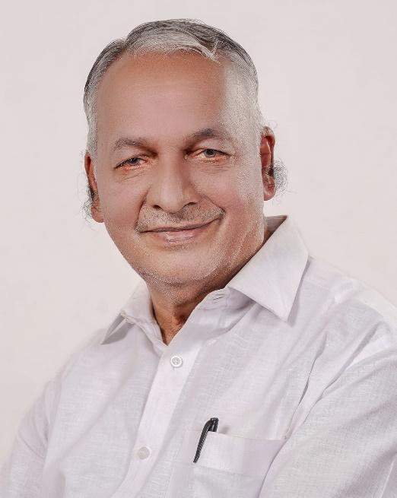
പാൻഡെമിക്കുകൾ പൊതുജനാരോഗ്യത്തിനും സമൂഹത്തിന്റെ സാധാരണ ജീവിതക്രമത്തിനും വലിയ വെല്ലുവിളികൾ സൃഷ്ടിക്കുന്ന സാഹചര്യങ്ങളാണ്. ഇത്തരത്തിലുള്ള ആരോഗ്യ അടിയന്തരാവസ്ഥകളെ ഫലപ്രദമായി നേരിടുന്നതിനായി മുൻകൂട്ടിയുള്ള തയ്യാറെടുപ്പും ശക്തമായ ഏകോപനവും അനിവാര്യമാണ്.
ബ്ലോക്ക് പഞ്ചായത്തിന്റെ നേതൃത്വത്തിൽ തയ്യാറാക്കിയിരിക്കുന്ന ഈ പാൻഡെമിക് തയ്യാറെടുപ്പ് പദ്ധതി, പ്രാദേശിക തലത്തിൽ പ്രതിരോധ ശേഷി വർധിപ്പിക്കുന്നതിനും രോഗവ്യാപനം നിയന്ത്രിക്കുന്നതിനും സഹായകരമായ മാർഗ്ഗനിർദ്ദേശങ്ങൾ ഉൾക്കൊള്ളുന്നു. ആരോഗ്യ വകുപ്പ്, പ്രാദേശിക സ്വയംഭരണ സ്ഥാപനങ്ങൾ, വിവിധ വകുപ്പുകൾ എന്നിവ തമ്മിലുള്ള ഏകോപിത പ്രവർത്തനമാണ് ഇത്തരം സാഹചര്യങ്ങളിൽ വിജയത്തിന്റെ അടിസ്ഥാനം.
സമൂഹത്തിന്റെ സജീവ പങ്കാളിത്തവും ഉത്തരവാദിത്വബോധവും ഈ പദ്ധതിയുടെ വിജയത്തിന് നിർണായകമാണ്. എല്ലാ ബന്ധപ്പെട്ട വിഭാഗങ്ങളും ഒന്നിച്ച് പ്രവർത്തിച്ചാൽ, ഏതു ആരോഗ്യ പ്രതിസന്ധിയെയും ഫലപ്രദമായി നേരിടാൻ നമുക്ക് കഴിയും.
ഡി. രഘുനാഥൻ നായർ
പ്രസിഡന്റ്
ബ്ലോക്ക് പഞ്ചായത്ത്

MESSAGE FROM HEALTH STANDING COMMITTEE CHAIR
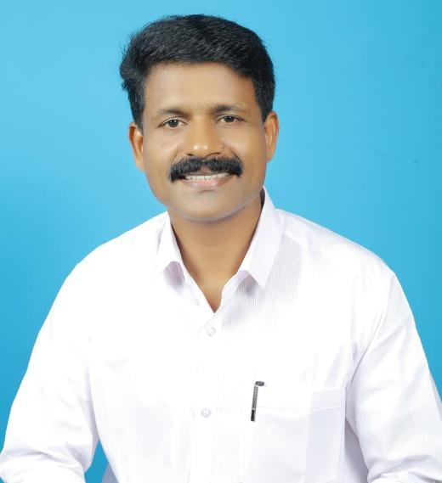
പാൻഡെമിക്കുകൾ ആരോഗ്യ സംവിധാനങ്ങൾക്ക് വലിയ സമ്മർദ്ദം സൃഷ്ടിക്കുന്ന സാഹചര്യങ്ങളാണ്. ഇത്തരം സാഹചര്യങ്ങളിൽ രോഗ നിരീക്ഷണം, നിയന്ത്രണം, ചികിത്സാ സേവനങ്ങളുടെ തുടർച്ച എന്നിവ ഉറപ്പാക്കുന്നതിന് ശാസ്ത്രീയവും ക്രമബദ്ധവുമായ തയ്യാറെടുപ്പ് അനിവാര്യമാണ്.
ഈ പാൻഡെമിക് തയ്യാറെടുപ്പ് പദ്ധതി, രോഗവ്യാപനം പ്രാരംഭ ഘട്ടത്തിൽ തന്നെ കണ്ടെത്തുന്നതിനും സമയോചിതമായ ഇടപെടലുകൾ നടപ്പിലാക്കുന്നതിനും ആവശ്യമായ മാർഗ്ഗനിർദ്ദേശങ്ങൾ നൽകുന്നു. കൂടാതെ, സമൂഹത്തിൽ അവബോധം വർധിപ്പിക്കുകയും ആരോഗ്യപരമായ സുരക്ഷാ നടപടികൾ പ്രാവർത്തികമാക്കുകയും ചെയ്യുന്നതിലും ഇത് സഹായകരമാണ്.
ആരോഗ്യ പ്രവർത്തകരുടെയും പ്രാദേശിക ഭരണ സംവിധാനങ്ങളുടെയും പൊതുജനങ്ങളുടെയും ഏകോപിതമായ ശ്രമങ്ങളിലൂടെ മാത്രമേ ഇത്തരം ആരോഗ്യ പ്രതിസന്ധികളെ ഫലപ്രദമായി നിയന്ത്രിക്കാൻ കഴിയൂ. ഈ പദ്ധതിയുടെ വിജയകരമായ നടപ്പാക്കലിന് എല്ലാ വിഭാഗങ്ങളുടെയും സഹകരണം അഭ്യർത്ഥിക്കുന്നു.

കാനാവിൽ ഷിബു
ആരോഗ്യ സ്റ്റാൻഡിംഗ് കമ്മിറ്റി ചെയർമാൻ
ബ്ലോക്ക് പഞ്ചായത്ത്

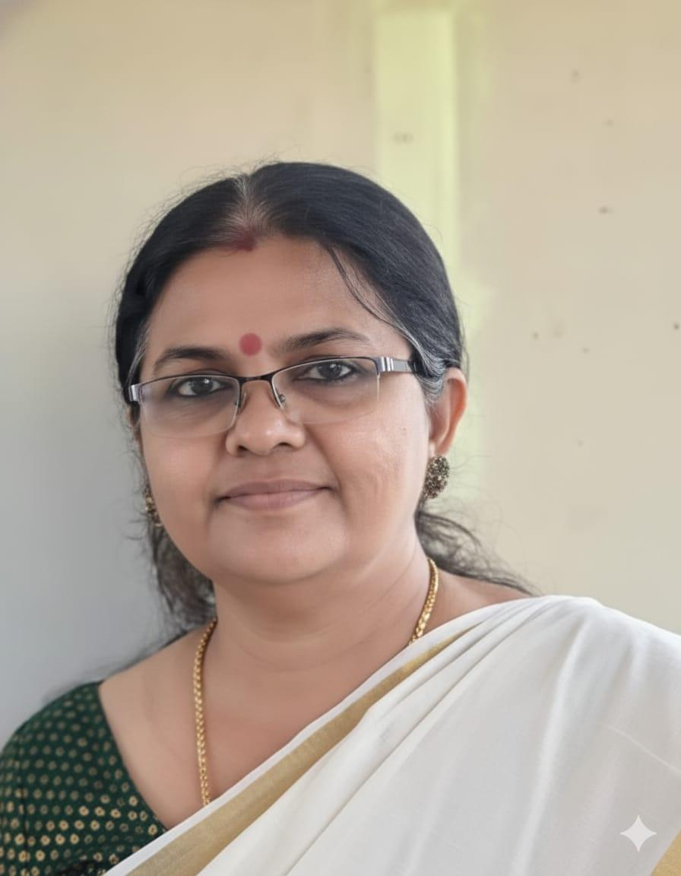
MESSAGE BY BLOCK MEDICAL OFFICER (KALLARA HEALTH BLOCK)
Pandemics pose significant challenges to public health systems, often requiring swift, coordinated, and well-structured responses at all levels of governance. Strengthening preparedness at the Panchayat level is crucial, as local self-government institutions serve as the first point of contact with the community and play a vital role in early detection and response.
This Panchayat-level Pandemic Preparedness Plan has been developed to enhance local capacity for prevention, surveillance, and effective management of potential disease outbreaks. It provides a structured framework for coordinated action involving the health department, local self-government institutions, and other stakeholders to ensure timely interventions and continuity of essential health services.
The plan emphasizes the importance of community awareness, risk communication, and active public participation in implementing preventive measures. Early identification of risks, prompt reporting, and adherence to public health guidelines are essential to minimize the impact of any outbreak.
I appreciate the collaborative efforts of all departments and stakeholders involved in the preparation of this plan and encourage continued commitment towards safeguarding the health and wellbeing of our communities.

Dr. P Ajitha
Block Medical Officer
Community Health Centre, Kallara

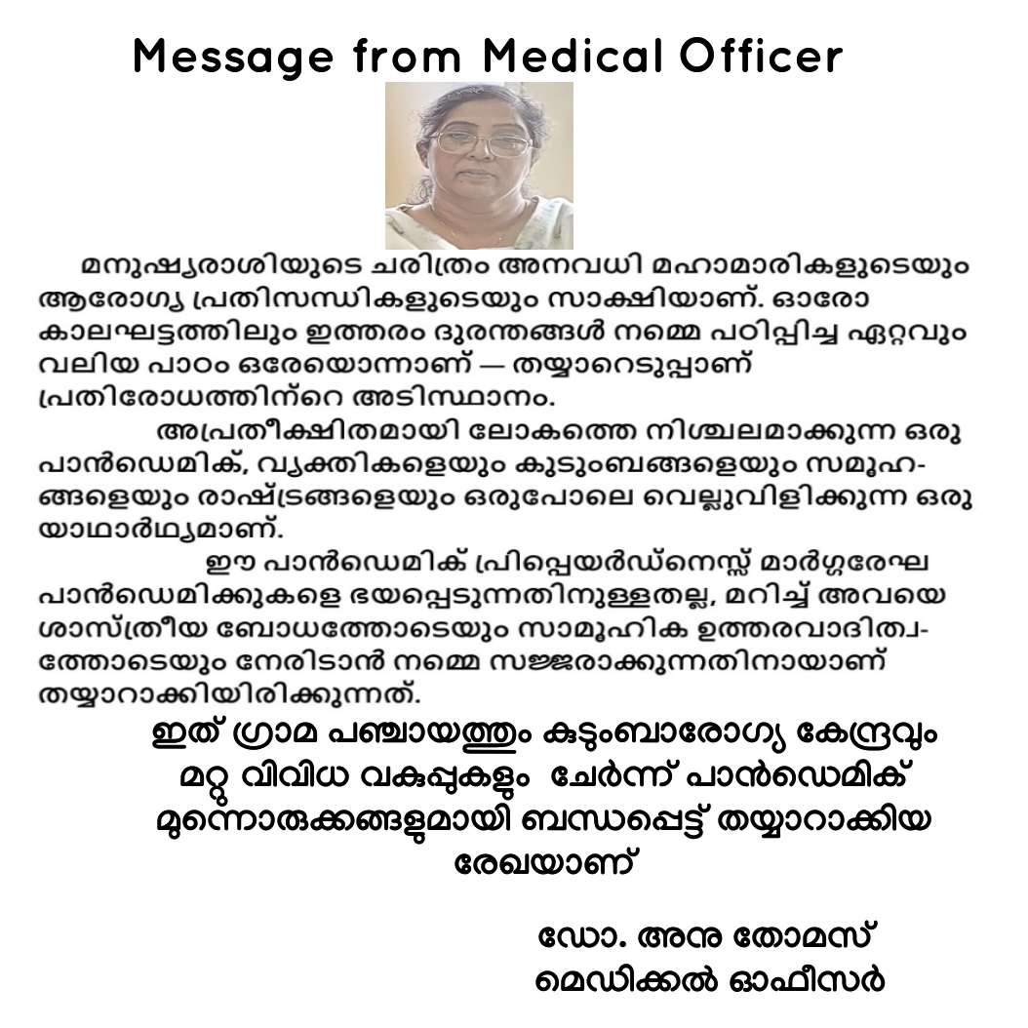
MESSAGE BY BLOCK MEDICAL OFFICER (VAMANAPURAM HEALTH BLOCK)

EXECUTIVE SUMMARY

The Block Panchayat Level Pandemic Preparedness Plan is a strategic framework designed to strengthen the capacity of local self-government institutions to effectively prevent, detect, and respond to public health emergencies. Recognizing the critical role of decentralized governance, the plan emphasizes coordinated action at the block level to ensure timely interventions and efficient resource utilization during a pandemic.
The plan outlines key components including surveillance and early warning systems, risk assessment and vulnerability mapping, strengthening of healthcare infrastructure, and ensuring continuity of essential health services. It also highlights the importance of intersectoral coordination among health departments, local self-government institutions, and other line departments for a unified response.
A major focus is placed on community engagement and risk communication to promote awareness, responsible behavior, and adherence to public health measures. The plan also includes provisions for rapid activation of quarantine and isolation facilities, resource mobilization, and clear delineation of roles and responsibilities for all stakeholders.
By adopting a proactive and structured approach, this preparedness plan aims to minimize the impact of pandemics, enhance resilience at the community level, and ensure the protection of public health and wellbeing.

LIST OF ABBREVIATIONS

LSGD/LSGI | Local Self Government Department / Local Self Government Institution
BMO | Block Medical Officer
IDSP | Integrated Disease Surveillance Programme
NDMA | National Disaster Management Authority
PPE | Personal Protective Equipment
ICMR | Indian Council of Medical Research
CD | Communicable Diseases
NCD | NON-COMMUNICABLE Diseases

TABLE OF CONTENTS

INTRODUCTION 8
LSGD AT A GLANCE 12
Geographical boundaries 15
GENERAL PROFILE OF THE VAMANAPURAM BLOCK PANCHAYATH 20
Background of the Vamanapuram block panchayath 20
Demographic and Vulnerable Population 22
Clinical Vulnerability 23
Major Festivals & Events specific to the LSGI 23
INFRASTRUCTURE & RESOURCE INVENTORY 25
Health Facility Directory & Basic Capacity in the LSGD 25
Private Clinics 28
Healthcare Education & Training Institutions 30
Specialized Services & Emergency Inventory 30
Oxygen & Diagnostic Capacity 31
Diagnostics facility mapping at the LSGI level 32
Laboratory Identification & Basic Details 33
Social and Community Infrastructure for surge plan 35
Human resources 37
Community & Support Cadre 38
Community Organizations 39
Administrative & Emergency Services 39
Information regarding resources 40
ONE HEALTH & ENVIRONMENTAL SURVEILLANCE 40
Animal & Bird Population 41
Veterinary Infrastructure 42
Veterinary Doctors & Workforce 42
High-Risk Interface Points (Surveillance Sites) 43
Environmental Risk Mapping 44
Disease Seasonality Mapping 45
Vulnerability Mapping 46
EPIDEMIOLOGICAL TRENDS (2021–2025) 47
Disease Burden among human beings(Last 5 Years) 47
Seasonal Trend Analysis 52
Transmission Trend- 2025 54
Integrated Disease Burden Map (2021–2025) 56
Preparedness and Response Protocol 59
Constitution of One Health Committee 59
Pandemic Response Workforce 61
Activities and Measures before and during Pandemic 62
PHASE 1 - Alert / Preparation 62
PHASE 2 - Active Response 71
Standard Screening Protocol 73
PHASE 3 - Surge Capacity 86
Conversion of Community Facilities 86
CONCLUSION 89
RECOMMENDATIONS 90
ANNEXURE 92
1. IMPORTANT PHONE NUMBERS 92

INTRODUCTION

Background of the Pandemic Preparedness Plan

Pandemics have historically posed significant threats to public health, socio-economic stability, and overall well-being of communities across the globe. Events such as the COVID-19 pandemic have demonstrated the rapidity with which infectious diseases can spread, overwhelming health systems and disrupting essential services at all levels of governance. These experiences have highlighted the critical need for preparedness, early response, and coordinated action, particularly at the grassroots level.
Local Self Government Institutions (LSGIs), including Grama Panchayats, play a pivotal role in community-level public health management. Being the closest administrative unit to the population, LSGIs are uniquely positioned to implement timely interventions such as surveillance, risk communication, quarantine and isolation management, and essential service delivery during public health emergencies.
The State of Kerala, through its strong public health system and decentralized governance model, has consistently emphasized preparedness and resilience in managing health emergencies. However, the increasing risk of emerging and re-emerging infectious diseases necessitates the development of structured, locally adaptable pandemic preparedness plans at the Panchayat level.
This Pandemic Preparedness Plan has been developed to establish a comprehensive framework for prevention, preparedness, response, and recovery in the event of a pandemic. The plan focuses on:
- Strengthening early detection and surveillance systems
- Ensuring readiness of quarantine and isolation facilities
- Defining roles and responsibilities of various stakeholders
- Enhancing inter-departmental coordination
- Ensuring uninterrupted provision of essential services and logistics support
The plan adopts an all-hazard and multi-sectoral approach, integrating health, disaster management, local governance, and community participation. It also aligns with national and state guidelines to ensure uniformity and effectiveness in implementation.
By institutionalizing preparedness measures and clearly defining operational protocols, this plan aims to minimize morbidity and mortality, prevent community transmission, and ensure a coordinated and efficient response to any future pandemic situation at the Panchayat level.

Objectives of the Pandemic Preparedness Plan

General Objective
To establish a structured and coordinated framework at the Local Self Government Department (LSGD) level for effective prevention, preparedness, response, and recovery during pandemic situations, thereby minimizing health, social, and economic impacts on the community.

Specific Objectives
- To strengthen early detection, surveillance, and reporting systems for timely identification of infectious disease outbreaks
- To ensure readiness and rapid operationalization of quarantine and isolation facilities at the community level
- To define clear roles and responsibilities of all stakeholders, including Health Department, LSGD, and line departments
- To enhance inter-sectoral coordination among various government departments and agencies
- To ensure uninterrupted delivery of essential services, including food, water, sanitation, and healthcare
- To promote infection prevention and control (IPC) practices within the community
- To build capacity of human resources through training, mock drills, and awareness programs
- To strengthen risk communication and community engagement for improved public compliance and awareness
- To establish mechanisms for logistics management and resource allocation during emergencies
- To ensure effective referral systems and linkage with higher healthcare facilities

Need and Justification of the Plan

The occurrence of pandemics, including the recent COVID-19 outbreak, has underscored the vulnerabilities in public health systems and the critical importance of preparedness at all administrative levels, especially at the grassroots.
At the Panchayat level, several challenges were observed during previous public health emergencies, including:
- Delays in early identification and reporting of cases
- Limited availability of designated quarantine and isolation facilities
- Gaps in coordination between departments and agencies
- Inadequate preparedness for surge in cases and resource demand
- Challenges in ensuring continuous essential service delivery
Given these challenges, there is a clear need for a comprehensive and standardized Pandemic Preparedness Plan that:
- Provides clear operational guidelines and SOPs
- Enhances local capacity for emergency response
- Facilitates rapid decision-making and implementation
- Strengthens community resilience and participation
In the context of Kerala’s decentralized governance system, empowering LSGIs with a structured preparedness plan is essential to ensure timely, efficient, and locally appropriate responses to pandemic situations.

Scope and Coverage of the Plan

This Pandemic Preparedness Plan is designed to cover all aspects of pandemic management at the LSGD/Panchayat level, ensuring a comprehensive and integrated approach.
Geographical Scope
- Applicable to the entire jurisdiction of the concerned Grama Panchayat/Block Panchayat
- Covers all wards, habitations, and institutions within the administrative boundary
Functional Scope
The plan includes preparedness and response measures related to:
- Surveillance and early warning systems
- Quarantine and isolation facility management (non-hospital settings)
- Infection prevention and control measures
- Case management and referral linkages
- Logistics and supply chain management
- Human resource deployment and capacity building
- Risk communication and community engagement
- Essential services continuity (food, water, sanitation, electricity, etc.)
- Waste management and environmental sanitation
Institutional Coverage
The plan encompasses coordination and involvement of:
- Health Department (Primary Health Centres, Sub Centres, etc.)
- Local Self Government Department (LSGDs)
- Line departments (Police, Fire & Rescue, Revenue, KSEB, Water Authority, etc.)
- Community-based organizations (e.g., Kudumbashree units, volunteers)
- Private sector and non-governmental organizations (as applicable)

Population Coverage
- All residents within the Panchayat jurisdiction
- Special focus on vulnerable populations, including:
  - Elderly persons
  - Individuals with comorbidities
  - Persons with disabilities
  - Socio-economically disadvantaged groups

Temporal Scope
- Applicable across all phases of a pandemic:
  - Preparedness phase
  - Response phase
  - Recovery and post-pandemic phase

This plan serves as a comprehensive operational guide for all stakeholders involved in pandemic management at the local level, ensuring a coordinated, efficient, and resilient response.

LSGD AT A GLANCE

Panchayats | Ward | Houses | Population | Migrants | Wells | Hot spots | Ed. Institutions | Hosp pvt/govt.
8 | 144 | 69826 | 243061 | 1033 | 59757 | 10 | 147 | 42

- Panchayats/LSGDs
- Vamanapuram
- Kallara
- Pangode
- Peringammala
- Nanniyode
- Pullampara
- Manickal
- Nellanad

- Major Govt Hospitals - 9
- Block Family Health Centre, Palode
- Community Health Centre, Kallara
- Block Primary Health Centre, Vamanapuram
- Community Health Centre, Kanyakulangara
- Family Health Centre, Anakudy
- Family Health Centre, Pullampara
- Family Health Centre, Manickal
- Family Health Centre, Bharathannoor
- Family Health Centre, Peringammala

- Total Subcentres/Ayushman Arogya Mandir/Health&Wellness Centres
41

- Medical College
Gokulam Medical College, Venjarammood

- Risk stratification among wards in the context of Communicable diseases and hazards

High Risk ward | Key Issues | Action
Nellanad Panchayat Ward 1 | High risk for leptospirosis | Surveillance of MGNRE Workers, farmers, harithakarma sena
Nellanad Ward 16 | High risk for Dengue fever | Dengue prevention strategies

- Major Roads:
Main Central (MC) Road (SH-1): This is the most critical road passing through the block, connecting Thiruvananthapuram to northern districts like Kottayam and Ernakulam. It crosses the Vamanapuram River at the town of Vamanapuram.
Vamanapuram–Chittar (V-C) Road: A major district road (MDR 7) that is 22.5 km long. It provides improved connectivity for several villages, including those in Kallara, Pangode, and Pulimath.
State Highway 2 (SH-2): Known as the Thiruvananthapuram–Thenmala Road, it passes through nearby areas like Palode and Vithura, which are integral to the Vamanapuram watershed and block economy.
Vembayam–Pallippuram Road: A significant district road (MDR 47) that connects the block's southern reaches to the NH-66 corridor.

- Rivers
Vamanapuram River: The Vamanapuram block panchayat is dominated by the Vamanapuram River, the longest river in the Thiruvananthapuram district. This 88 km long river originates from Chemmunji Motai in the Western Ghats and flows through the block before emptying into Anchuthengu (Anjengo) Lake. It is unique for being the only major river in the district without a dam.
Key Tributaries: Within the broader watershed, the river is fed by several streams including:
    - Kallar River: Known for its scenic beauty and the Meenmutty Falls.
    - Chittar Ar (Upper & Lower): Major tributaries originating near hill stations like Ponmudi and Braemore.
    - Other Streams: Kalaiparai Ar, Manjappara River, and various thodus (canals) such as Manjadimoodu and Tholikuzhi.
Water Infrastructure: Important bridges crossing the river include the Vamanapuram Bridge, Kallar Bridge, and Palode Bridge.

- Occupational groups, socio-cultural groups, migration & mobility patterns

Category | Groups
Occupational | Healthcare workers, labourers, vendors
Socio-Cultural | Gathering-based communities
Migration | Migrants, returnees
Mobility | Commuters, travellers

- Disaster-prone areas (geographic vulnerability)
- The Mylamoodu area has a history of wildfire
- Firecracker manufacturing units at Nanniyode
- Mass casualty by Road traffic accident at State Highway 1

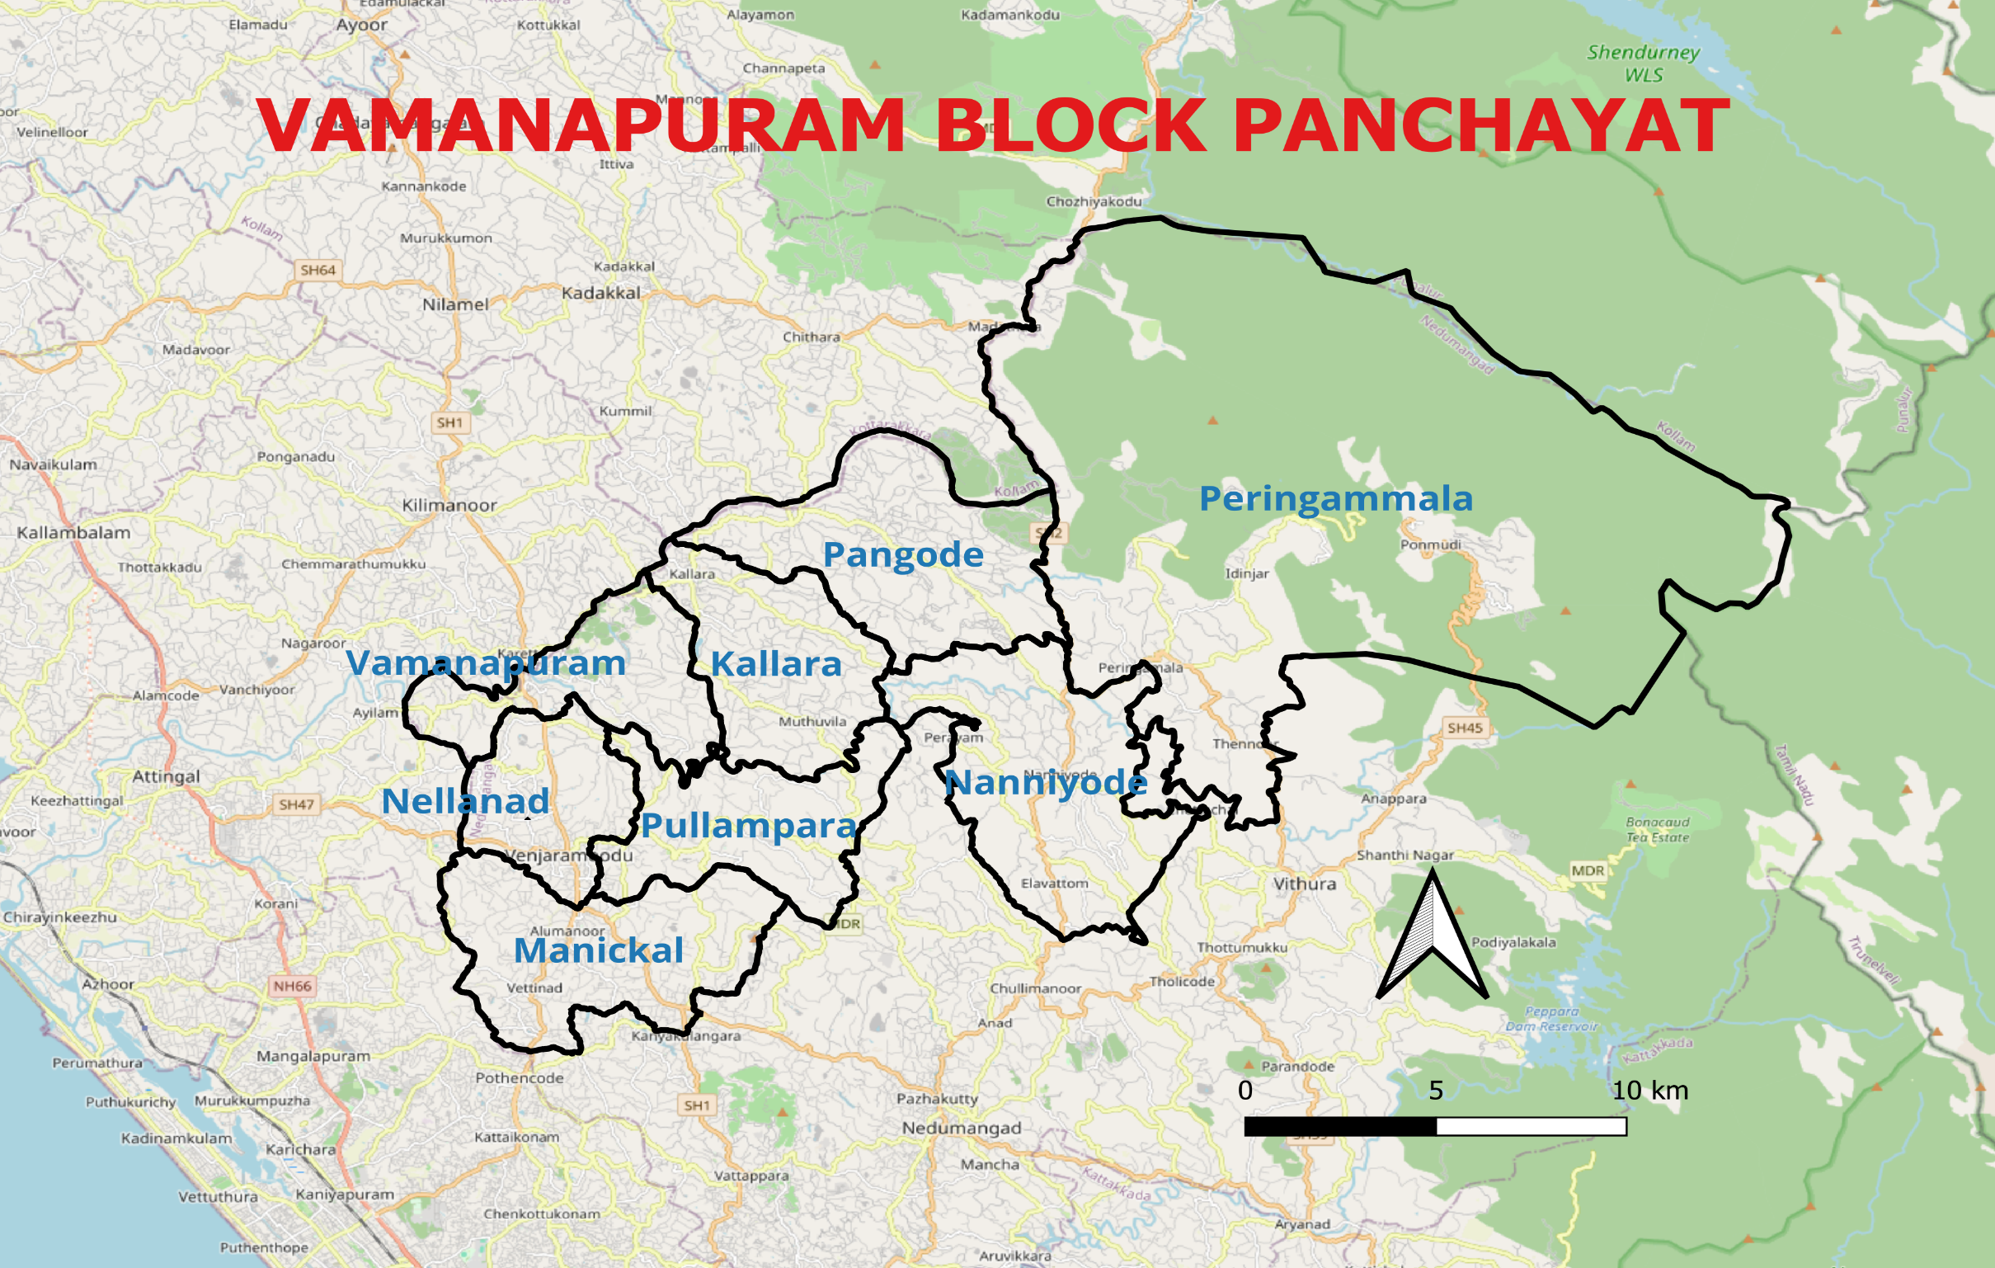

Geographical boundaries

Panchayath boundaries map

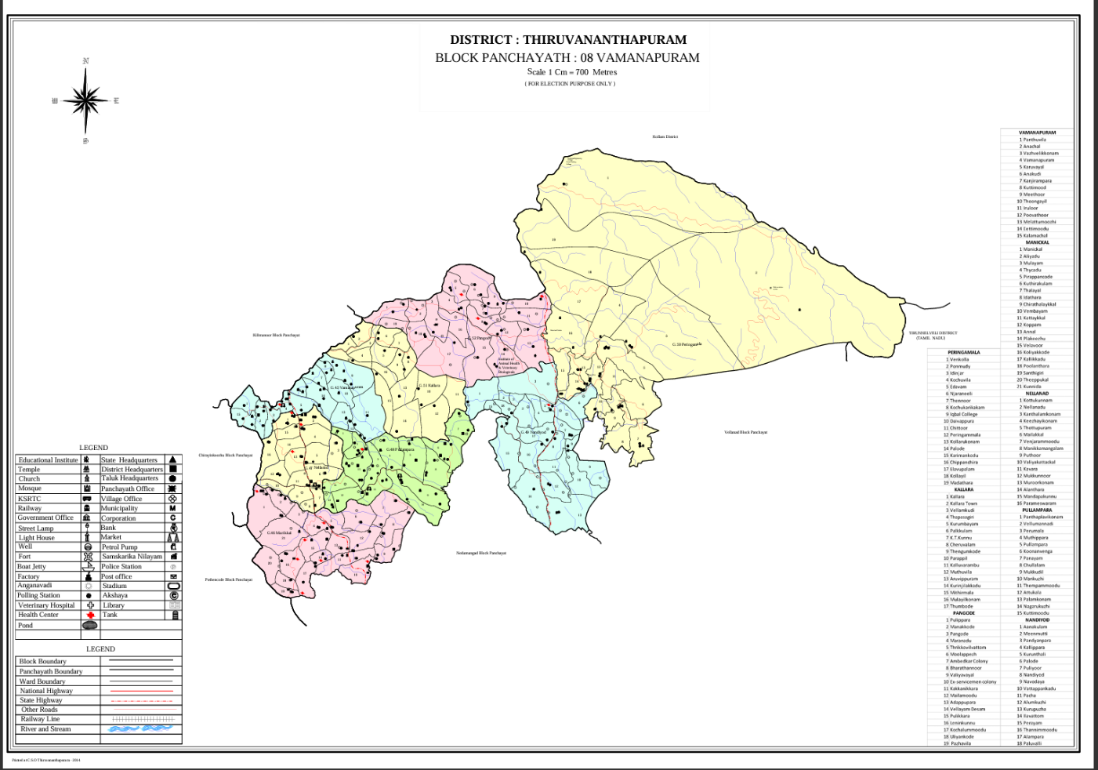
VAMANAPURAM BLOCK PANCHAYAT MAJOR ESTABLISHMENTS MAP

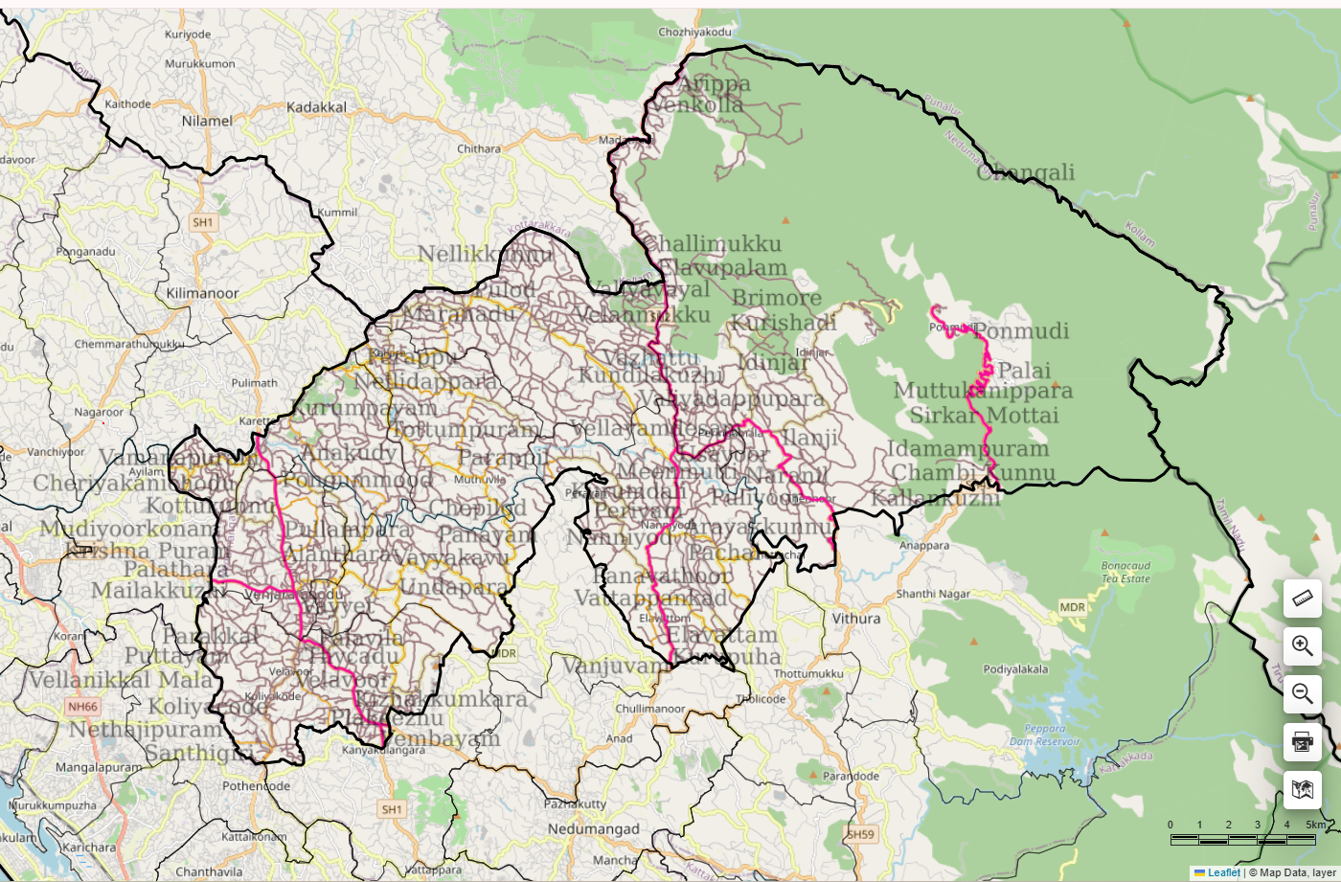
VAMANAPURAM BLOCK PANCHAYATH

ROAD MAP

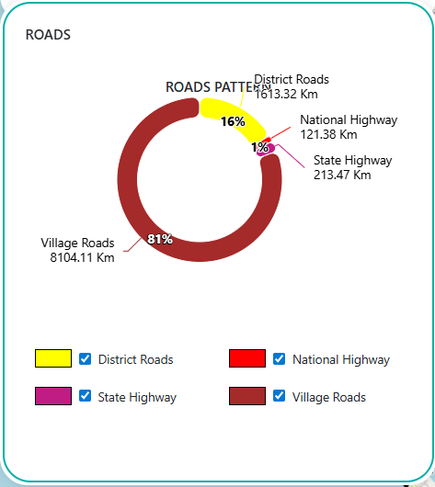

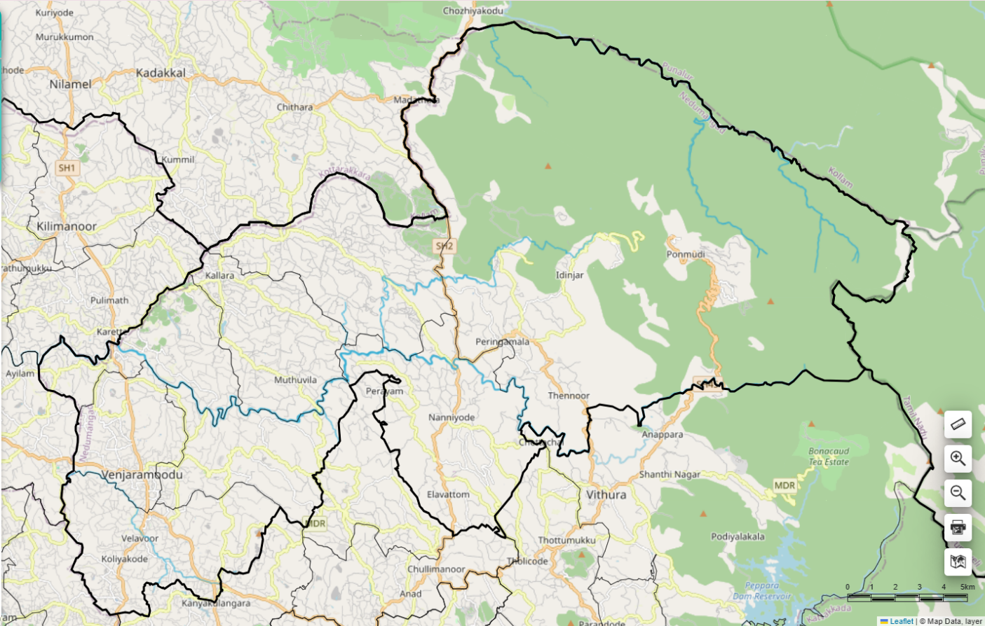
VAMANAPURAM BLOCK PANCHAYATH

RIVER MAP

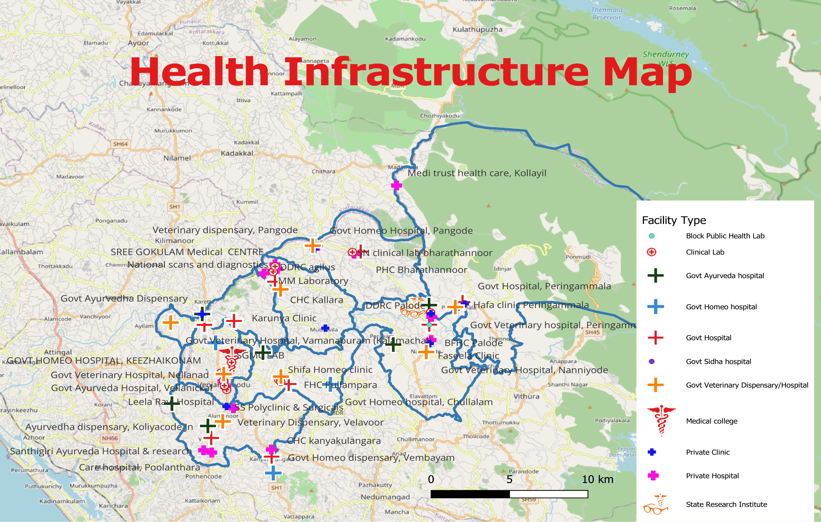

GENERAL PROFILE OF THE VAMANAPURAM BLOCK PANCHAYATH

Background of the Vamanapuram block panchayath

Vamanapuram Block Panchayat is located in the eastern part of Thiruvananthapuram district, extending across the midland and highland regions near the foothills of the Western Ghats. The block is characterized by a diverse terrain that includes gently undulating midlands, hilly landscapes, forest fringes, agricultural fields, and rural settlements. The Vamanapuram River and its tributaries play a significant role in shaping the hydrology, irrigation systems, and agricultural activities across the block. The region experiences a tropical monsoon climate, with heavy rainfall during the southwest and northeast monsoon seasons. While the abundant rainfall supports agriculture and water resources, it also occasionally leads to localized flooding, landslides in highland areas, and waterlogging in certain low-lying regions.
Administratively, Vamanapuram Block Panchayat functions under the decentralized governance system of Kerala and falls within Nedumangad Taluk of Thiruvananthapuram district. The block consists of eight Grama Panchayats: Nellanad, Vamanapuram, Manickal, Pullampara, Kallara, Pangode, Nanniyode, and Peringammala. These panchayats collectively represent a mix of midland agricultural communities and highland settlements near forest areas. The Block Panchayat plays an important coordinating role in planning and implementing development programs, supporting local self-governments, and facilitating inter-departmental collaboration for infrastructure development, social welfare, and public service delivery.
The livelihood of the population across the block is largely based on agriculture, plantation activities, livestock rearing, small-scale trade, and wage labour. Major crops cultivated in the region include rubber, coconut, banana, tapioca, pepper, and other spices, while dairy farming and animal husbandry contribute to rural livelihoods. From a public health and disaster management perspective, the block benefits from Kerala’s well-developed primary healthcare system and community-based health initiatives. However, the region faces several challenges such as vector-borne diseases during monsoon seasons, increasing burden of lifestyle diseases, seasonal water scarcity in certain areas, flooding along river basins, and landslide risks in highland and forest-fringe regions. The geographical diversity and population distribution across the eight panchayats require coordinated planning and effective emergency response mechanisms.
In this context, the development of a localized, data-driven Auxiliary Infrastructure and Logistical Resource Map at the block level is essential to support effective planning, timely emergency response, and sustainable development initiatives. Such mapping enables the Block Panchayat and the constituent Grama Panchayats to identify critical infrastructure and resources, strengthen coordination among departments, improve accessibility during emergencies, and enhance the overall resilience and preparedness of communities across the Vamanapuram Block.

Table 1: Background of LSGD
Description | Details
Name of LSGD | Vamanapuram
Type (GP/Municipality / Corporation etc.) | Block Panchayath
Taluk | Nedumangad
District | Thiruvananthapuram
Number of Panchayats | 8
Number of wards | 144
Total area (sq. km) | 401.35
Population(Projected) | 244279
Population density | persons/sq km
Terrain (coastal/low-lying/backwaters/foothills, etc.) | Midland terrain
Number of rivers passing through LSGI | 1
Number of water bodies in the LSGI | 5327
Number of educational institutions | 147
Factories / small-scale industries | 10
Flood-prone wards | 12
Landslide-prone wards | 15
Death Management and Disposal Facilities (mortuaries/crematorium, including electric) | 1
Auditoriums/Marriage halls/convention centres/community halls | 62

Demographic and Vulnerable Population
Understanding the demographic composition and vulnerable population groups is essential for pandemic preparedness. Children, elderly, economically deprived families, migrant workers, and socially vulnerable groups are at increased risk during public health emergencies due to higher exposure, limited access to services, and dependency on public systems..

Description |  | Details (in numbers)
DEMOGRAPHIC PROFILE
Total population |  | 244289
Male |  | 119200
Female |  | 124840
Transgender |  | 1151
Children under 5 |  | 12364
Adolescent |  | 29275
Elderly (>60) |  | 41803
SOCIAL/LIVELIHOOD VULNERABILITY
Previous EPEP family |  | 709
BPL family |  | 26687
Tribal communities |  | 1607
Migration | Immigrant | 953
Migration | Emigrant | 5477
Socio-economically deprived |  | 1173
Fisherfolk |  | 9
SC Community |  | 19929
ST Community |  | 2674

Clinical Vulnerability
Certain population groups needs priority healthcare & are at higher risk of severe illness, complications, and mortality during pandemics. Patients with chronic diseases, those requiring regular medical care, and individuals with mobility or functional limitations face challenges in accessing timely care during emergencies. Mapping these groups helps in prioritizing continuity of treatment, medicine stock planning, oxygen support, referral transport, and targeted home-based care.
Description | Details in numbers
Pregnant women | 1096
Lactating mothers | 1509
Bedbound patients | 1003
Patients under palliative care other than bedbound | 1652
Patients on Haemodialysis | 104
Patients on CAPD | 104
Cancer patients (currently on treatment) | 775
Haemophilic patients | 9
Mentally challenged | 961
Differently abled | 874
Diabetic patients | 22397
Hypertensive patients | 27978
TB patients | 58

Major Festivals & Events specific to the LSGI
(with the possibility of a public gathering)

Sl. No. | Name of festival | Month, detailing the periodicity
1 | Thumbode devi temple festival, Kallara | March
 | Sreekrishna swami temple, Pirappancode | March, 10 days
 | Vaidyankavu Devi Temple, Vaidyankavu | May, 10 days
 | Thampuran temple, Aliyad | March, 7 days
 | Kuthirakulam temple | March, 7 days
 | Keezhmalakkal Siva temple | February
 | Mathanadu Devi temple | Nov-Dec
 | Velavoor temple | February
 | Poolanthara Sree Dharma Sastha Temple | March
 | Thiruvattathala Temple | May
 | Pacha Temple Festival | March, 10 days
 | Aalampara temple festival | March , 10 days

 | Palode mela | February(1st-14th)
 | Kallumala Temple Festival | January (14th-17th)
 | Seetha Theertha Ponmudi festival | January -15
 | Manthurathi deva temple Festival | February -15
 | Manikode Temple Fair and Festival | February
 | Shivaratri at Bharathannoor | February, 2 days

INFRASTRUCTURE & RESOURCE INVENTORY

Health Facility Directory & Basic Capacity in the LSGD
This section provides an overview of the healthcare infrastructure available within the LSGD area. It outlines the distribution and basic capacity of health facilities that form the backbone of service delivery during routine times and public health emergencies.

Family Health Centres (FHCs) and Community Health Centres (CHCs) generally function as the first point of contact for the community, providing essential outpatient and inpatient services. General Hospitals (GH) and Medical College Hospitals (MCH), where accessible, serve as the main referral centres for advanced diagnostics, specialist care, and critical services during public health emergencies. This inventory helps identify existing strengths, gaps, and potential surge capacity that can be mobilised during a pandemic or disaster.

Health Facility | Type of Facility (MCH/GH/CHC/FHC/SC etc.) | Contact Number | Total beds | ICU Beds | Oxygen-Supported Beds | No. of Ventilator Support Beds | No. of ambulances
Government Healthcare Facilities
CHC Kallara | CHC |  | 32 | 0 | 0 | 0 | 0
FHC Manickal | FHC | 8547237390 | 2 | 0 | 0 | 0 | 0
CHC kanyakulangara | CHC | 8086314783 | 20 |  | 3 | 0 | 1
BFHC Palode | BFHC | 9447128584 | 31 | 0 | 0 (Available only cylinder oxygen support) | 0 | 1

FHC VAMANAPURAM |  | FHC |  | 9895095018 |  | 14 |  | NIL |  | NIL |  | NIL |  | NIL
 | PHC Bharathannoor |  | PHC |  | 9400881060 |  | 1 |  | 0 |  | 0 |  | 0 |  | 0
 | Govt Hospital, Peringammala |  | FHC |  | 9447883390 |  | 3 |  | 0 |  | 0 |  | 0 |  | 0
 | FHC Anakudy |  | FHC |  | 0472 2837790 |  | 2 |  | 0 |  | 0 |  | 0 |  | 1 (Palliative)
 | FHC Pullampara |  | FHC |  | 9447152014 |  | 0 |  | 0 |  | 0 |  | 0 |  | 1

Private Healthcare Facilities

BRIGHT MEDICAL CENTRE, KALLARA |  | 9567195393 | 0 | 0 | 0 | 0 | 0
SREE GOKULAM HEALTH CENTRE |  | 9447322168 | 0 | 0 | 0 | 0 | 0
AIMA HOSPITAL, MUTHUVILA |  | 8848891400 | 0 | 0 | 0 | 0 | 0
KARUNYA HOSPITAL, KALLARA |  | 8113842108 | 0 | 0 | 0 | 0 | 0
NISHA HOSPITAL, KALLARA |  | 8921444975 | 0 | 0 | 0 | 0 | 0
Family hospital, Vembayam | pvt | 9061411003 – Dr. Thasleem | 7 | 0 | 0 | 0 | 0
Care hospital, Poolanthara | pvt | 8089993367 | 10 | 0 | 0 | 0 | 0
Consumer Hospital, Velavoor junction | pvt | 9447052035 – Santhosh | 7 | 0 | 0 | 0 | 1
St. Johns Community Hospital, Thycaudl | Community Hospital | 9400502159  9847160608 | 105 (80 bed + 25 Leprosy beds) | 5 | 8 | 0 | 1
BMC Hospital Palode | Pvt. Hospital | 9747971811 | 16 | 0 | 0 | 0 | 1
White Fort hospital, Plavara | Pvt. Hospital | 9207640278 | 18 | 0 | 0 | 0 | 1
SREE GOKULAM MEDICAL COLLEGE AND RESEARCH CENTER | MCH | 9446153400 | 60 | 5 | 20 | 3 | 2
Hyatt Hospital | Hospital | 9895681400 | 0 | 0 | 0 | 0 | 0
Mitra Hospital | Hospital | 9048989386 | 0 | 0 | 0 | 0 | 0
Jizan clinical &ECG Thennoor | Clinic | 9633666969 | 0 | 0 | 0 | 0 | 0
Hafa clinic Peringammala | Clinic | 9074044254 | 0 | 0 | 0 | 0 | 0
Homeopathic Consultant | Clinic | 9446747879 | 0 | 0 | 0 | 0 | 0
Medi trust health care | Clinic | 8075838457 | 0 | 0 | 0 | 0 | 0
Janamaithri Hospital | Hospital | 9495314858 | 15 | 0 | 0 | 0 | 0
Sini Clinic Home | Clinic | 9447904544 | 0 | 0 | 0 | 0 | 0
Anaswara Homeo Clinic | Clinic | 9446747879 | 0 | 0 | 0 | 0 | 0
G M Polyclinic, Vamanapuram | Day Clinic | 7056328679 | 1 | 0 | 0 | 0 | 0
AYUSH Healthcare Facilities

Govt Ayurveda Hospital |  | DR. SUBHASH 8089263901 | 0 | 0 | 0 | 0 | 0
Govt Ayurveda Hospital, Vellanickal | Dispensary | Dr. Priyesh P U - 9446758290 | 0 | 0 | 0 | 0 | 0
Govt Homeo dispensary | Dispensary |  | 0 | 0 | 0 | 0 | 0
Govt Sidha dispensary | Dispensary | Dr. Neelavathy – 9443597157 | 0 | 0 | 0 | 0 | 0
Santhigiri Ayurveda Hospital & research | Hospital | 9947356203
Ayurvedha dispensary, Koliyacode Jn | Dispensary | Dr. Manasa - 8848277781 | 0 | 0 | 0 | 0 | 0

Govt Ayurveda hospital Palode | Dispensary | 9745127722 | 0 | 0 | 0 | 0 | 0
Govt Homeo hospital Palode | Dispensary | 9947728891 | 0 | 0 | 0 | 0 | 0

GOVT HOMEO HOSPITAL, KEEZHAIKONAM |  | OTHER |  |  |  | 0 |  | 0 |  | 0 |  | 0 |  | 00
 | Govt AYUSH |  | Dispensary |  | 9447858194 |  | 0 |  | 0 |  | 0 |  | 0 |  | 0
 | Govt hospital Ayur Vedha |  | Hospital |  | 04722840050 |  | 5 |  | 0 |  | 0 |  | 0 |  | 0
 | Govt hospital Homeo |  | Hospital |  | 8075532373 |  | 0 |  | 0 |  | 0 |  | 0 |  | 0
 | Govt Ayurvedha Dispensary |  | Govt |  | 9400523425 |  | 1 |  | 0 |  | 0 |  | 0 |  | 0
 | Ayush PHC Homeo |  | PHC |  | 9497783599 |  | 0 |  | 0 |  | 0 |  | 0 |  | 0
 | Govt Home Hospital, Chullalam |  | Hospital |  | 7012773567 |  | 0 |  | 0 |  | 0 |  | 0 |  | 0
 | Govt Ayurveda hospital, Vellumannadi |  | Hospital |  | 8086306310 |  | 0 |  | 0 |  | 0 |  | 0 |  | 0

Private Clinics
Private clinics are an essential part of pandemic preparedness, as they are often the first place people seek care when symptoms begin. In many communities, private clinics manage a significant share of outpatient visits and therefore play a critical role in early case detection, timely referrals, and disease surveillance. Having an up-to-date understanding of where these clinics are located, the services they provide, and how they are linked to the public health system helps ensure that no cases are missed during an outbreak. It also allows health authorities to engage private practitioners more effectively for reporting, risk communication, and coordinated response, strengthening the overall capacity of the health system to manage public health emergencies.

Table 6. Private Clinic Resource Summary
Sl No. | Name of Clinic | Registered (Y/N) | Clinic (General / Speciality) | Speciality (if any) | Address | Contact Number | Diagnostic Facility (Y/N) | Ambulance Linkage (Y/N)
1 | Karunya Clinic | Y | OP Clinic | - | Kallara near sreyas junction | 9946509466 | Y | N
2 | Karunya Clinic | Y | OP Clinic | - | Muthuvila | 9946509466 | Y | N
3 | Nisha hospital | Y | OP Clinic & observatiion | - | Kallara near sreyas junction | 8921444975 | Y | N
4 | Bright medical centre | Y | OP Clinic | - | Near kallara ksrtc bus stand | 7902607007 | Y | N
5 | Gokulam | Y | OP & IP | - | Near Saravana Jn | 9447322168 | Y | Y

1 | Homeo clinic | Y | Homeo |  | Thalayil kunnu | 9656480917– Dr. Sijina | N | N
2 | Gurukripa Dental clinic | Y | Dental |  | Cherathalakkal | 9249863403 – Dr. Rajesh | N | N
3 | Private clinic, Koliyacode | Y | General |  | Koliyacode | 7592022891 | N | N

1 | Francis Clinic, Palode | Y | General | - | Plavara, Palode, Pacha P. O. | 9447342390 | N | N
2 | Faseela Clinic | Y | General | - | Plavara, Palode, Pacha P. O. | 9946113705 | N | N

1. | Releif Hospital, Venjaramoodu | yes | General |  | Releif hospital , venjaramoodu | 047222872035 | yes | yes
2. | Leela Ravi Hospital | yes | General |  | Leela Ravi Hospital, Venjarmoodu | 7012587408 | yes | yes
1 | Hayath medical centre and clinical lab pangodu | Y | Gen | No | Pangodu | 9895691400 | Y | N
 | Upasana homeo clinic |  |  |  | Bharathannoor
2 |  |  |  |  |  | 9048479285 | N
 |  | N | Gen | No |  |  |  | N
1 | Jizan clinical &ECG Thennoor | NA | general | NA | Jizan clinical &ECG Thennoor | 9633666969 | No. | NA
 |  |  |  |  | Hafa clinic Peringammala | 9074044254 | No | NA
2 | Hafa clinic Peringammala | NA | General | NA
3 | Homeopathic Consultant | NA | General | NA | Homeopathic Consultant palode | 9446747879 | No | NA
4 | Medi trust health care | NA | General | NA | Medi trust health care kalayapuram | 8075838457 | NO | NA
1 | G M Polyclinic | N | General | Nil | Vamanapuram | 7056328679 | Y | N
1 | Dr. Satheesh clinic | Y | General | Nil | Thembamoode | 9447761959 | Y | N
2 | Shifa homeo clinic | Y | General | NIL | Thembamoode | 9995114883 | N | N
3 | Smile dental Clinic | Y | General | Nil | Manickal palli | 994620307 | N | N

Healthcare Education & Training Institutions
This section tracks the educational infrastructure available, which is vital for human resource planning in the health sector.

Category of Institution | Govt | Private | AYUSH | Total
Medical Colleges | 0 | 1 | 1 | 2
Nursing Colleges | 0 | 1 | 0 | 1
Dental Colleges | 0 | 0 | 0 | 0
Para-medical / Allied Health | 1 | 0 | 0 | 1
Pharmacy Colleges | 0 | 0 | 0 | 0

Specialized Services & Emergency Inventory
This section provides a detailed view of the specialized medical resources available to the community, focusing on emergency response and critical care capabilities. This table tracks the vital assets required for managing severe illnesses and emergencies across Government, Private, and AYUSH sectors.

Item | Govt | Private | AYUSH | Total
Hospital beds | 100 | 137 | 1 | 238
Oxygen-generating systems(Y/N) | 0 | 0 | 0 | 4
Oxygen-supported beds(Numbers) | 3 | 36 | 0 | 39
Ventilator-supported beds | 0 | 3 | 0 | 3
ICU beds | 0 | 11 | 0 | 11
Burns units | 0 | 0 | 0 | 0
Blood centres | 0 | 1 | 0 | 1
BLS ambulances | 3 | 6 | 0 | 9
ALS ambulances | 0 | 0 | 0 | 0
Dialysis facilities | 0 | 2 | 0 | 2
Dispensaries | 3 | 4 | 9 | 16
Medical store | 9 | 68 | 10 | 87
Industrial establishments(Medium-scale industries/small-scale industries establishments to whom we can depend in a worst-case scenario) | 1 | 3 | 0 | 4

Oxygen & Diagnostic Capacity
Monitoring oxygen and diagnostic capacity is a critical component of public health preparedness, ensuring that the LSGD can handle both chronic care and sudden surges in respiratory or infectious diseases.
Name of Health Facility | Oxygen-generating System (Y/N) | Backup Oxygen Source (Y/N) | Diagnostic Facilities Available(Y/N)
Name of Health Facility | Oxygen-generating System (Y/N) | Backup Oxygen Source (Y/N) | Lab | USG | X-ray | CT/MRI | RT-PCR
Government Healthcare Facilities
FHC Manickal | Y | Y | 1 | N | N | N | N

CHC Kanyakulangara | Y | Y | Y | Y | Y | N | Y
PHC Bharathannoor | Y | Y | Y | N |  | N | N

Private Healthcare Facilities

 | St Johns |  | Y |  | Y |  | Y |  | Y |  | Y |  | N |  | Y
 | Care Hospital |  | Y |  | Y |  | Y |  | Y |  | Y |  | N |  | Y
 | Consumer fed, Koliyakkode |  | Y |  | Y |  | Y |  | Y |  | Y |  | N |  | Y
 | Family hospital |  | Y |  | Y |  | Y |  | Y |  | Y |  | N |  | Y
Gokulam medical college |  | YES |  | YES |  | YES |  | YES |  | YES |  | YES |  | YES

Diagnostics facility mapping at the LSGI level
The diagnostic capacity of Vamanapuram Block Panchayat represents the "intelligence network" of our healthcare system. The speed and accuracy of disease identification depend entirely on the distribution and technical level of these facilities.

Item | Govt | Private | AYUSH | Total
General labs | 8 | 43 | 0 | 51
Microbiology labs | 1 | 5 | 0 | 6
RT-PCR labs | 0 | 1 | 0 | 1
USG units | 0 | 3 | 0 | 3
CT/MRI units | 0 | 3 | 0 | 3
Research labs | 1 | 0 | 0 | 1
Labs of other departments that can be repurposed | 0 | 0 | 0 | 0

Laboratory Identification & Basic Details
Sl. No. | Name of Laboratory | Ownership (Govt / Private / Academic) | Address | Contact No. | 24×7 Services (Yes/No) | NABL / Govt Approved (Yes/No)

1 | CHC Kallara | Govt | CHC Kallara |  | No | No
2 | National scans and diagnostics | Private | Sreyas jn | 9847490660 | No | Yes
3 | MM Laboratory | Private | Tharatta | 9847892940 | No | Yes
4 | DDRC agilus | Private | Opposite ARS auditorium Kallara | 8075874454 | No | Yes

1 | FHC Manickal | Govt. | FHC Manickal |  | No | Yes
3 | DDRC SRL Diagnostic pvt ltd | Private | BuildingNo MP IX/930 - C Ground Floor, Majid Plaza, Opposite PHC MC road, Kanyakulangara
4 | MPK Medicare Multi Speciality Laboratory | Private | MP IX 340 Opposite SBI Bank Vembayam | 9620433311
5 | Modern lab | Private | Kanyakulangara | 9447421411 – Mohanan | No | Yes
6 | Metro lab | Private |  | 8921324326
7 | Life line | Private | Near FHC Manickal | Pavithra J - 7025212181 | No | No

1 | Block Public Health Lab, BFHC Palode | Govt | BFHC Palode | 9645195459 | No | No
2 | Devi Clinical Lab | Private | Opp. BFHC Palode | 9745133949 | No | No
3 | DDRC Palode | Private | Palode | 9778811692 | No | Yes
1 | Clinical Laboratary | Private | Thandrampoyika | 9447045834 | No | No
2 | Devi Lab | Private | Venjaramoodu | 8281882883 | No | YES
3 | SGMC LAB | PRIVATE | Venjaramoodu | 9745864899 | yes | yes
4 | Dianova laboratory | Private | Venjaramoodu | 9778732254 | no | no
5 | Leela Ravi | Private | Venjaramoodu | 7012587408 | yes | No
6 | DDRC | Private | Venjaramoodu | 8075874454 | No | No
7 | Aameez Universal clincal lab and ECG | Private | Venjaramoodu | 9446102709 | N0 | No
8. | Releif hospital clinical and laboratory | Private | Venjaramoodu | 9497642554 | Yes | Yes
9. | Bfhc vamanapuram | Govt | Vamanapuram | 0472 2835810 | No | Yes
10 | National scans and diagnosis center | Private | venjaramoodu | 9847490660 | No | Yes
11 | Medi tech lab | Private | Venjaramoodu | 8606302403 | No | No
12 | Viswas lab | Private | Venjaramoodu | 8714129065 | No | Yes

1 | Phc bharathannoor | Govt. | Bharathannoor | 9400885060 | No | Yes
2 | Noora clinical lab | Pvt | Pangodu | 8086713445 | No | No
3 | Optum labs & scans | Pvt | Pangodu | 9207061250 | No | Yes
4 | Ss clinical lab | Pvt | Pangodu | 7025146089 | N0 | Yes
1 | Peringammala FHC lab | Govt | FHC Peringammala | 9074805440 | No | No
2 | DDRC | Private | DDRC Agilus Palode | 8590603317 | No | NA
1 | Anakudy FHC Lab | Govt | Eettimoodu | 0472 2837790 | No | No
2 | Galaxy Diagnostics | Pvt | Vamanpauram | 7025335992 | No | No
3 | Meditech Laboratory | Pvt | Vamanapuram | 8139010513 | No | No
4 | Meditech Laboratory | Pvt | Vamanapuram | 8139010513 | No | No
5 | Unity Diagnostics | Pvt | Eettimoodu | 702435991 | No | No
1 | Devi scans & laboratories | Pvt | Kalunginmigham | 984631299 | N | N
 | Devi computerized clinical laboratories | Pvt | Thembamoode | 9605507354 | N | N
 | Karthika diagnostic centre | Pvt | Thembamoode | 9745428584 | N | N

Social and Community Infrastructure for surge plan
This table serves as our logistics and shelter inventory. By mapping these locations, quickly we can identify where to house displaced citizens, where to set up temporary medical clinics, and how to manage the deceased with dignity during a crisis.

Category | Total Count | Est. Capacity (Persons) | Contact details
Educational Institutions
Anganwadis | 232 | 900 | ICDS Supervisor – Prema L -9400598617
Schools | 126 | 1300+1300+5300+132 | *Given in annexure
Colleges | 7 | 100+200+450 | *Given in annexure
Healthcare Educational Institutions
Medical colleges (Govt/Private) | 1 (Private) | 1046
Nursing colleges (Govt/Private) | 1 (Private) | 180 | Sree Gokulam Medical - 9446153400
Dental colleges (Govt/Private) | 0 | 0 | -
Paramedical institutes (Govt/Private) | 0 | 0 | -
Community Gathering Spaces

Community halls | 54 |  | *Given in annexure
Auditoriums | 30 | 700 | *Given in annexure
Religious buildings | 106 | 80 | *Given in annexure
Vulnerable Group Support Facility
Destitute homes | 3 | 90 | Snehatheeram, Kallara – 9061872762 (staff nurse)  Sradha Care home – 9544947546  Charity village-9895576631
Elderly homes | 3
LSGD owned other buildings | 44
Mass Fatality Management (MFM) Infrastructure
Mortuary | 0
Crematorium | 2 (Kallara Panchayat, | 2+ | Shyju (Kallara):  8129136874
*refer annexure 1 for contact details

Human resources
This section focuses on the human capital available within the LSGI. In any emergency—be it a pandemic, flood, or industrial accident—infrastructure is only as effective as the people operating it.

Medical & Clinical Personnel
This table tracks the "Frontline" providers responsible for diagnosis, treatment, and clinical management. Narrative sentence: eg., "Total health workforce: 450 personnel, with 60% in government facilities serving as primary surge capacity." A detailed directory with the contact numbers of all workers is maintained (Annexure in 1).

Cadre | Govt (No.) | Private (No.) | Total
Doctors—Modern Medicine | 29 | 121 | 150
Doctors – AYUSH | 12 | 2 | 14
Doctors – Veterinary | 8 | 0 | 8
Doctors – Dental | 0 | 25 | 25
Nursing officers | 28 | 91 | 119
Lab technicians | 17 | 65 | 82
Optometrist | 5 | 4 | 9
Pharmacists | 15 | 44 | 59
Psychologists | 0 | 3 | 3
Counsellors | 4 | 2 | 6

Public Health & Field-Level Workforce
These individuals are the backbone of surveillance, maternal-child health, and decentralized care.

Cadre | Health services | Municipal common services | Total
HS (Health Supervisors) | 3 | 0 | 3
HI (Health Inspectors) | 8 | 0 | 8
LHS (Lady Health Supervisor) | 2 | 0 | 2
LHI (Lady Health Inspectors) | 4 | 0 | 4
JPHN (Jr Public Health Nurses) | 35 | 0 | 35
JHI (Jr Health Inspectors) | 27 | 0 | 27
MLSP (Mid-Level Service Providers) | 27 | 0 | 27
Palliative Nurses | 10 | 0 | 10
RBSK Nurses | 7 | 0 | 7
PRO | 3 | 0 | 3
Epidemiologist | 1 | 0 | 1
Data Manager | 1 | 0 | 1

Community & Support Cadre
This group represents the surge capacity of the LSGI—people who can be called upon for logistics, rescue, and specialized support.

Cadre | Number
ASHA Workers | 232
AWW (Anganwadi Workers) | 288
Emergency Medical Volunteers (Trained) | 69
Kudumbashree | 1842 units
MNREGS | 18288
Purusha Swayam Sahaya Sangham | 167
Ex-Servicemen | 693
Retired Police Officers | 503
NCC/NSS Volunteers | 929
Red Cross volunteers | 120
One Health Community Volunteers | 961
One Health Community Mentors | 112

Community Organizations
This section details the presence of community-based organisations (CBOs), non-governmental organisations (NGOs), faith-based organisations (FBOs), Kudumbashree Self-Help Groups (SHGs), and Ayalkootams within the Local Self-Government Institution (LSGI). These groups enhance grassroots mobilization, resource distribution, and support networks crucial for pandemic response and community resilience.

Category | Total Count
NGOs | 15
Religious based organizations | 28
Foreign based organizations | 1
Sports Club/youth clubs | 105
Kudumbashree SHGs | 1317
Ayalkootams | 2427
Political organizations | 40
Residential organizations | 93

Administrative & Emergency Services
This section outlines the availability of key non-health emergency support services and infrastructure within the LSGI, which are essential for effective pandemic preparedness and response. These facilities support law enforcement, disaster response, water supply, logistics, mobility, and community-level interventions during public health emergencies.

Category | Total Count | Contact details
Police Stations | 3 | Venjaramoodu- 0472-2872023  Palode - 0472-2840260
Fire & Rescue Stations | 3 | Venjaramoodu- 0472-2871101
Water Pumping Points | 14 | *Given in annexure
Public Distribution System (PDS) | 66 | *Given in annexure

Information regarding resources
The availability of essential transport and support resources plays a quiet but critical role in saving lives. Equipment such as ambulances, mobile mortuaries, amphibian ambulances, and motorized boats ensures that patients, samples, and healthcare teams can move swiftly—even in flooded, remote, or difficult terrains. Heavy vehicles like JCBs, cranes, tractors, and torus lorries support logistics, waste management, emergency infrastructure, and rapid conversion of spaces into care or isolation facilities. Taxis, four-wheel-drive vehicles, and trucks help maintain continuity of essential services, reach vulnerable populations, and support home-based care and supply delivery.

Means of transportation | Total Count
JCB | 27
Crane | 4
Heavy Trucks | 5
Tractor | 4
Ambulances | 15
Mobile mortuaries | 2
Boats | 0
Taxi service | 58
Note: For specific details regarding vehicle owners and contact information, please refer to Annexure [X].

ONE HEALTH & ENVIRONMENTAL SURVEILLANCE
The One Health method integrates environmental, animal, and human health to enable proactive pandemic preparedness. Panchayat-level surveillance needs to be improved in order to detect and treat zoonotic and environmentally generated diseases early. Surveillance is strengthened through systematic assessment of animal populations, veterinary infrastructure, poultry and slaughter facilities, inter-sectoral coordination, and specialised tools like avian influenza seasonality mapping using GIS in previous outbreaks to enable predictive alerts and ward-specific sampling to support effective pandemic preparedness in high-risk areas.

Animal & Bird Population
Mapping animal and bird populations at the Panchayat level is essential for identifying and prioritising zoonotic disease hazards like rabies, avian influenza (H5N1), leptospirosis, anthrax, and Nipah-like spillover occurrences. Risk classification, targeted surveillance, vaccination planning, and early epidemic detection made feasible by comprehensive population mapping all enhance One Health-based pandemic preparedness.

Category | Item | Estimated Population
Animal Population | Livestock (Cattle/Goats/Buffalo) | 12785
Animal Population | Pet Animals (Dogs/Cats) | 12701
Animal Population | Stray Dog Population | 3750
Animal Population | Pig Farms (Number of heads) | 6 (691)
 | Small Units (Sheep / Goats – clustered) | 25
Bird Population | Poultry Units (Birds) | 59
Bird Population | Poultry- (FOWL) | 264696
Bird Population | Wild/Migratory Birds (Observed) | NA
Bird Population | Crow Mortality Events (Reported) | 4/year

The stray dog population in market areas, fish landing sites, bus stations continues to be a substantial problem for rabies surveillance and bite prevention.

Veterinary Infrastructure
Veterinary institutions are a core pillar of One Health surveillance, enabling early zoonotic disease detection through vaccination, investigation of unusual animal illness or deaths, sample collection, and timely outbreak reporting. A well-mapped and responsive veterinary network strengthens coordination with human health and LSGI systems, ensuring rapid response during zoonotic events and pandemics.
Facility Type | Name of Facility | Ownership Govt / Pvt | Location (Panchayat) | Contact number
Veterinary Dispensary | - Veterinary Dispensary, Velavoor  - Govt Veterinary Dispensary Palode  - Veterinary dispensary, Pangode | Govt  Govt  Govt | Manickal  Nanniyode  Pangode | 7012062426  9496480842  6238002133
Veterinary Hospital / Polyclinic | - Veterinary Hospital, Mithirmala  - Veterinary Hospital, Nellanad | Govt  Govt | Kallara  Nellanad | 9447533684  9447762257
Private Veterinary Clinics
Mobile / Emergency Vet Service (incl. night services) | - Emergency Night Veterinary service  - Milma Vet | Govt  Govt undertaking | Kallara  Nanniyode | 9847991668  8281375318
Pet Homes / Animal Shelters
Slaughterhouse-linked Veterinary Inspection Unit

Veterinary Doctors & Workforce
Early detection, diagnosis, reporting, and reaction to animal illness epidemics depend on the availability and accessibility of qualified veterinary specialists. By identifying unusual animal morbidity or mortality promptly, collecting samples promptly, and coordinating efficiently with human health and LSGI systems—especially during zoonotic outbreaks and pandemic-prone situations—a clearly defined veterinary workforce enhances One Health surveillance.

Category | Number Available | Type (Govt/Pvt) | Contact number
Government Veterinary Doctors | 9 | Govt | 9447533684, 9847991668,  7012062426,  9496480842,  8547980675
Private Veterinary Doctors | 4 | Pvt | 8590526341, 9496157408
Livestock Inspectors | 13 |  | 8121961204, 9447324986,  9744125078, 79079722500, 9496776323,  9495712265,  9995039036  9847213095  8590444150
Para-veterinary Staff / Attenders | 11 |  | 9497253227,  9645121893, 8943957441, 8590526341, 9496157408
Contract / On-call Veterinary Support (if any) | 3 |  | 8281375318, 9447762257

High-Risk Interface Points (Surveillance Sites)
High-risk interface points for zoonotic disease surveillance in Vamanapuram Block Panchayath include wetland–livestock–human contact zones, backyard poultry farms, cattle sheds near water bodies, fish markets, and areas of high human–animal interaction such as community slaughter points and migratory bird congregation sites. These are the primary surveillance sites where zoonotic spillover risks are elevated.

Type of Habitat | Type of High risk interface | Geographical vulnerability
Wetlands & Backwaters | Low | Low
Backyard Poultry Farms | Low | Low
Cattle Sheds near Water Bodies | Low | Low
Fish & Meat Markets | Low | Low
Community Slaughter Sites | Low | Low
Migratory Bird Congregation Areas | Low | Low
Rodent-Infested Grain Storage | Low | Low

Category | Total Count | Key Locations (wards)
Poultry Farms | 46
Backyard / Clustered Poultry Units | 51
Duck Rearing Units (open water access) | 1
Slaughterhouses/ Slaughter Points | 16
Meat/Fish Markets | 5
Live Bird Sale Points | 3
Cattle Markets / Weekly Animal Fairs | 0
Pet Shops / Breeders | 1
Animal Shelters / Pet Homes | 0
Waste Disposal Sites near Animal Units | 1

Environmental Risk Mapping
Environmental risk mapping identifies monsoon/flood hotspots for vector-borne (dengue, chikungunya), water-borne (leptospirosis, diarrhoea), and zoonotic diseases in Kerala's wetlands. Systematic surveillance supports early warnings, targeted interventions, and Panchayat pandemic preparedness.
Waterborne exposure: Flood-prone areas and stagnant water bodies facilitate leptospira survival, raising leptospirosis risk.

Traditional practices: Informal slaughter and fish markets lack standardized hygiene, creating spillover opportunities.

Risk Factor | High-Risk Wards | Key Locations | Risk Level (High/Med/Low)
Flood-prone areas | Ward 14 (Pangode) | Vellayamdesam | Low
Water bodies/wetlands |  | Moolayam, Thamarakkulam | Medium
Solid waste accumulation |  | Pandiyanpara Forest area | Low
Animal waste disposal issues | Ward 1 (Nellanad) | Valiyakattakal | Medium
Rodent infestation zones | ward 10, Manickal | Vembayam | High
Industrial effluent discharge | (wards 10, 14, 6, 12, 3), Manickal  (Ward 1) Nellanad | Vembayam stream, Plakeezhu, Kuthirakulam, pirappancode behind international swimming pool, behind aliyad subcentre  Valiyakattakal tar plant unit | High
Construction sites / abandoned buildings | Ward 5(Nellanad) | Ward 5,7,9,16(Nellanad) | Medium
Poor drainage/blocked canals | ward 10, Manickal | Vembayad stream | Medium
Drinking water source contamination risk | Ward 1(Nellanad) | Ward 13(Nellanad) | Medium

Disease Seasonality Mapping
1, Flooding & waterlogging → amplifies leptospirosis, malaria, diarrheal diseases.
·
2, Migratory bird influx (Nov–Feb) → avian influenza risk.

3, Mosquito breeding cycles → vector-borne disease peaks in monsoon.

4, Agricultural practices → close human–animal contact in paddy fields.

Disease | Peak Risk Season | Key Drivers | High-Risk Locations | Surveillance Focus
Avian Influenza | Nil | Nil | Nil | Poultry Farms, Migratory birds
Leptospirosis | Jan- March  Oct - Dec | Rodents, | thayalil, cheruthalakkal (Manickal)  Ward 1(Nellanad) | MGNREG, MGNRE Workers, farmers, harithakarma sena
Dengue/Chikungunya | Rainy | Rubber plantation | Ward 1(Nellanad) | Rubber plantation area
Acute Diarrheal Diseases | Rainy | Poor sanitation and waste management  Poor hygiene practices  Food contamination | All Wards | All population
Rabies | Sporadic | _ | All Wards | All population
Anthrax (rare) | Nil | Nil | Nil | Cattle farms

Vulnerability Mapping
Vulnerability mapping pinpoints high-risk populations, occupations, and areas exposed via environment, livelihoods, socio-economics, and poor service access. Paired with environmental/seasonality mapping, it enables risk-based surveillance, targeted actions, and optimal resource use in One Health and pandemic planning.
Vulnerability Factor | High-Risk Wards | Key Groups / Locations | Risk Level
Flood-prone households | Ward 14 (Pangode) | Vellayamdesam | Low
Wetland-adjacent communities
Backyard poultry / duck rearing households | Ward 2(Nellanad) | Farmers, Ward 6,4(Nellanad) | Medium
Livestock-rearing households | Ward 2(Nellanad) | Ward 9,6 (Nellanad) | Medium
Slaughterhouse & meat market workers | Ward 1(Nellanad)  Ward 10 Manickal | Mylackal, ward 6(Nellanad)  Kanyakulangara market | Medium  High
Fisherfolk & fish market workers | Ward 2(Nellanad)  Ward 10 Manickal | Workers, ward 6,13,10 (Nellanad)  Kanyakulangara market | Low  High
Sanitation workers
Daily wage / migrant workers | Ward 10 Manickal | Vemabayam jn
Elderly & chronically ill populations |  | All wards
Pregnant Women |  | All wards | Low
Children (schools, Anganwadi’s) |  | All wards | Low
Limited access to safe water & sanitation | Ward 1(Nellanad) | Ward 1(Nellanad) | Medium

EPIDEMIOLOGICAL TRENDS (2021–2025)

Disease surveillance is the systematic collection, analysis, and interpretation of health data for planning, implementation, and evaluation of public health practice. This section presents the disease surveillance profile of the LSGI based on routine reporting systems and outbreak investigations to identify priority diseases, seasonal patterns, and emerging public health threats.

Disease Burden among human beings(Last 5 Years)
Analysis of disease-wise data for the last five years helps identify persistent public health problems, emerging diseases, and changes in disease burden. This information supports prioritisation of prevention, preparedness, and response activities at the Panchayat level.

Disease | 2021 | 2022 | 2023 | 2024 | 2025 | Trend(Increasing/Stable/Decreasing)
Dengue | 27 | 49 | 139 | 191 | 186 | Increasing
Leptospirosis | 12 | 24 | 28 | 28 | 36 | Increasing
Hepatitis A | 2 | 4 | 26 | 10 | 2 | Decreasing
Malaria | 0 | 1 | 1 | 0 | 2 | Stable
Scrub Typhus | 3 | 11 | 15 | 28 | 18 | Stable
Typhoid | 1 | 1 | 2 | 1 | 4 | Stable
H1N1 | 0 | 1 | 0 | 12 | 3 | Decreasing
H3N2 | 0 | 0 | 0 | 1 | 1 | Stable
ADD | 250 | 323 | 593 | 1474 | 855 | Stable
Mumps | 5 | 8 | 6 | 15 | 141 | Increasing
Measles | 0 | 0 | 3 | 3 | 1 | Decreasing
Hepatitis B | 4 | 5 | 4 | 7 | 9 | Increasing
Hepatitis C | 0 | 0 | 0 | 1 | 0 | Decreasing
Tuberculosis | 35 | 48 | 50 | 68 | 79 | Increasing
Leprosy | 1 | 0 | 0 | 0 | 1 | Stable
Influenza | 0 | 0 | 0 | 3 | 3 | Stable
Amoebic Meningoencephalitis/ PAM | 0 | 0 | 0 | 0 | 5 | Increasing
COVID-19 | 5193 | 617 | 70 | 12 | 0 | Decreasing

Outcome-Based Trend Analysis- 2021- 2025
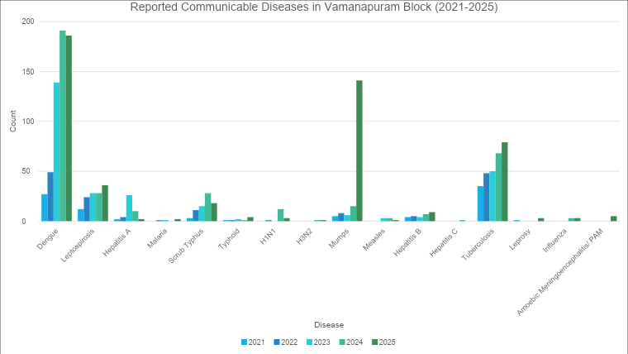

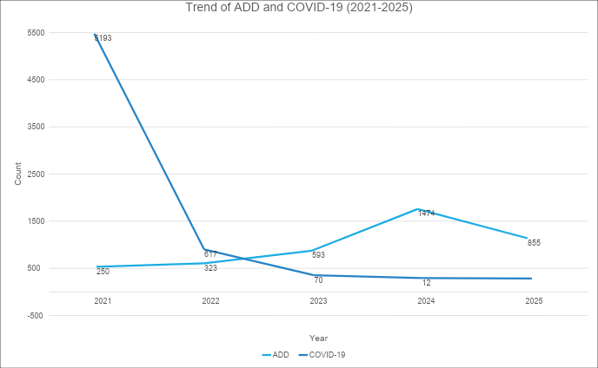
Outcome-Based Trend Analysis- 2021- 2025

Seasonal Trend Analysis
Seasonal analysis helps anticipate surges (e.g. dengue in monsoon, leptospirosis after floods, influenza in cooler months) and plan pre‑emptive vector control, stockpiling of IV fluids, and awareness campaigns at Panchayat level.

DENGUE
Dengue is a major seasonal vector-borne disease strongly associated with rainfall, water stagnation, and increased mosquito breeding during the monsoon period.

Peak: July–November

Dengue – Panchayat-wise Yearly Distribution (2021–2025)

Panchayat | Dengue – Panchayat-wise Yearly Distribution
Panchayat | 2021 | 2022 | 2023 | 2024 | 2025 | Total
Nanniyode | 0 | 6 | 7 | 6 | 51 | 70
Kallara | NA | NA | 7 | 5 | 18 | 30
Pangode | 2 | 6 | 10 | 15 | 22 | 55
Nellanad | 2 | 7 | 5 | 49 | 16 | 79
Vamanapuram | 5 | 1 | 22 | 31 | 14 | 73
Pullampara | 15 | 16 | 11 | 15 | 20 | 77
Manickal | 3 | 13 | 54 | 48 | 30 | 148
Peringammala | 0 | 0 | 3 | 4 | 15 | 22
Total | 27 | 49 | 119 | 173 | 186 | 554

LEPTOSPIROSIS
Leptospirosis cases are closely linked to monsoon rains, flooding, and occupational exposure, particularly in low-lying and waterlogged areas.

Peak: June - August

Leptospirosis – Panchayat-wise Yearly Distribution (2021–2025)

Panchayat | Leptospirosis – Panchayat-wise Yearly Distribution
Panchayat | 2021 | 2022 | 2023 | 2024 | 2025 | Total
Nanniyode | 2 | 2 | 3 | 2 | 0 | 9
Kallara | NA | NA | 7 | 5 | 1 | 13
Pangode | 4 | 3 | 1 | 3 | 4 | 15
Nellanad | 0 | 2 | 2 | 4 | 7 | 15
Vamanapuram | 1 | 6 | 7 | 4 | 6 | 24
Pullampara | 3 | 4 | 3 | 4 | 4 | 18
Manickal | 2 | 6 | 4 | 6 | 14 | 32
Peringammala | 0 | 1 | 1 | 0 | 0 | 2
Total | 12 | 24 | 28 | 28 | 36 | 128

VIRAL HEPATITIS - A
Hepatitis A cases are commonly associated with unsafe drinking water, food contamination, and breakdowns in sanitation, often presenting as clusters or outbreaks.

Peak: October - December

Hepatitis A – Panchayat-wise Yearly Distribution (2021–2025)
Panchayat | Hep A – Ward-wise Yearly Distribution
Panchayat | 2021 | 2022 | 2023 | 2024 | 2025 | Total
Nanniyode | 2 | 4 | 3 | 4 | 0 | 13
Kallara | NA | NA | 4 | 0 | 0 | 4
Pangode | 0 | 0 | 4 | 3 | 0 | 7
Nellanad | 0 | 0 | 0 | 1 | 1 | 2
Vamanapuram | 0 | 0 | 3 | 0 | 0 | 3
Pullampara | 0 | 0 | 7 | 0 | 0 | 7
Manickal | 0 | 0 | 5 | 2 | 1 | 8
Peringammala | 0 | 0 | 0 | 0 | 0 | 0
Total | 2 | 4 | 26 | 10 | 2 | 44

Transmission Trend- 2025
For effective management of public health issues, it is important to track the trend of disease transmission mode. It helps identify the population or place at high risk that can be used to predict outbreaks and implement targeted interventions as quickly as possible. Understanding these kinds of trends enables authorities to allocate resources efficiently and change the strategies adequately based on the trend that follows.

Mode of Transmission | No. of cases | No. of Deaths
Vector Borne Diseases | 183 | 7
Water Borne Diseases | 257 | 1
Air Borne Diseases | 133 | 8
Blood Borne Diseases | 15 | 1
Food Borne Diseases | 29 | 7

Vector-Borne Disease

Disease | No. of Cases | No. of Deaths
Dengue | 179 | 7
Malaria | 2 | 0
Chikungunya | 0 | 0

Water Borne Disease

Disease | No. of Cases | No. of Deaths
Cholera | 0 | 0
Typhoid | 5 | 0
Hep- A | 2 | 0
Dysentery | 49 | 0
Amoebiasis | 5 | 1
E- Coli infections | 0 | 0

Airborne Disease

Disease | No. of Cases | No. of Deaths
Influenza | 3 | 0
H1N1 | 1 | 0
TB | 89 | 8
Chickenpox | 227 | 0
Measles | 4 | 0
Covid-19 | 0 | 0
Pertussis | 0 | 0
Mumps | 159 | 1

Blood-Borne Disease

Disease | No. of Cases | No. of Deaths
AIDS | 2 | 1
Hep- B | 15 | 0
Hep- C | 0 | 0

Zoonotic Disease

Disease | No. of Cases | No. of Deaths
Rabies | 0 | 0
Leptospirosis | 32 | 8
Avian influenza | 1 | 0
West nile | 0 | 0
Anthrax | 0 | 0
Nipah | 0 | 0
Scrub Typhus | 22 | 0

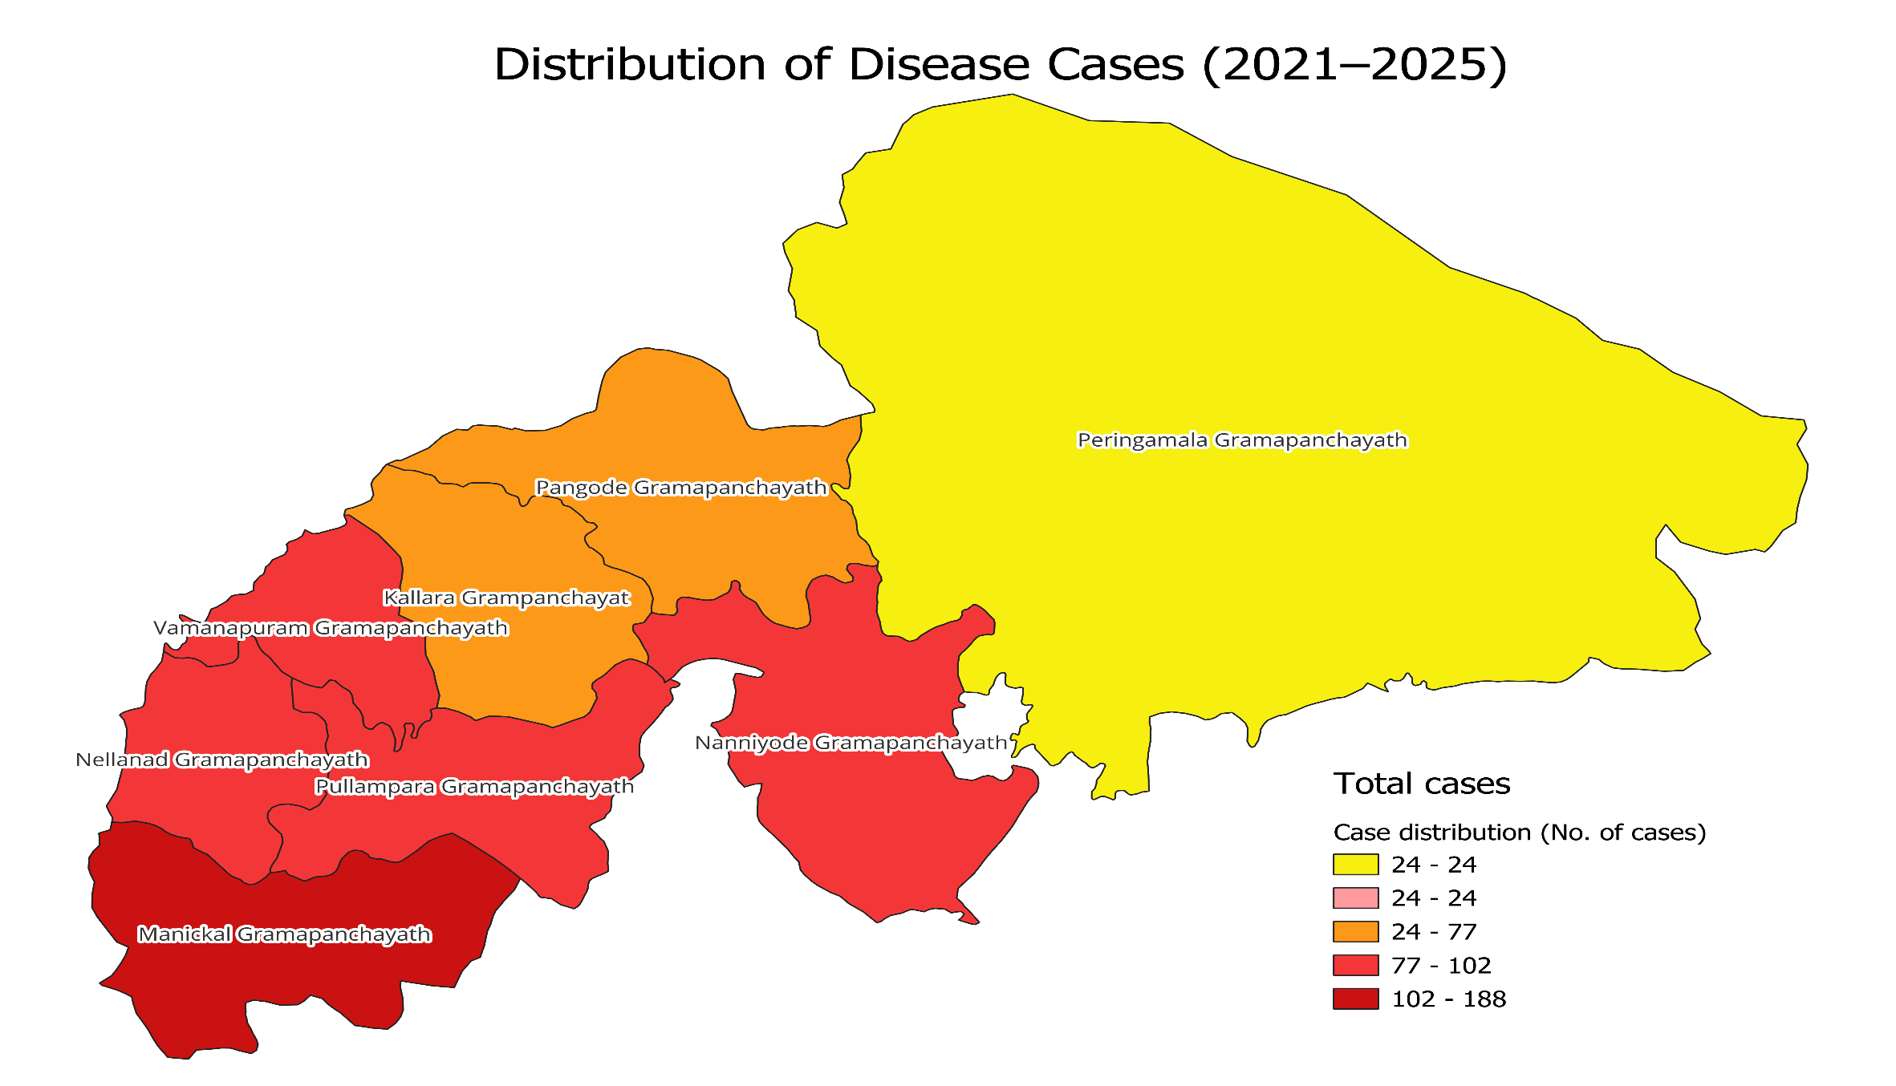
Integrated Disease Burden Map (2021–2025)

Panchayat | Dengue Total (2021-25) | Leptospirosis Total (2021-25) | Hepatitis A Total (2021-25) | Total Cases  (2021-2025)
Nanniyode | 70 | 9 | 13 | 92
Kallara | 30 | 13 | 4 | 47
Pangode | 55 | 15 | 7 | 77
Nellanad | 79 | 15 | 2 | 96
Vamanapuram | 73 | 24 | 3 | 100
Pullampara | 77 | 18 | 7 | 102
Manickal | 148 | 32 | 8 | 188
Peringammala | 22 | 2 | 0 | 24
Total | 554 | 128 | 44 | 726

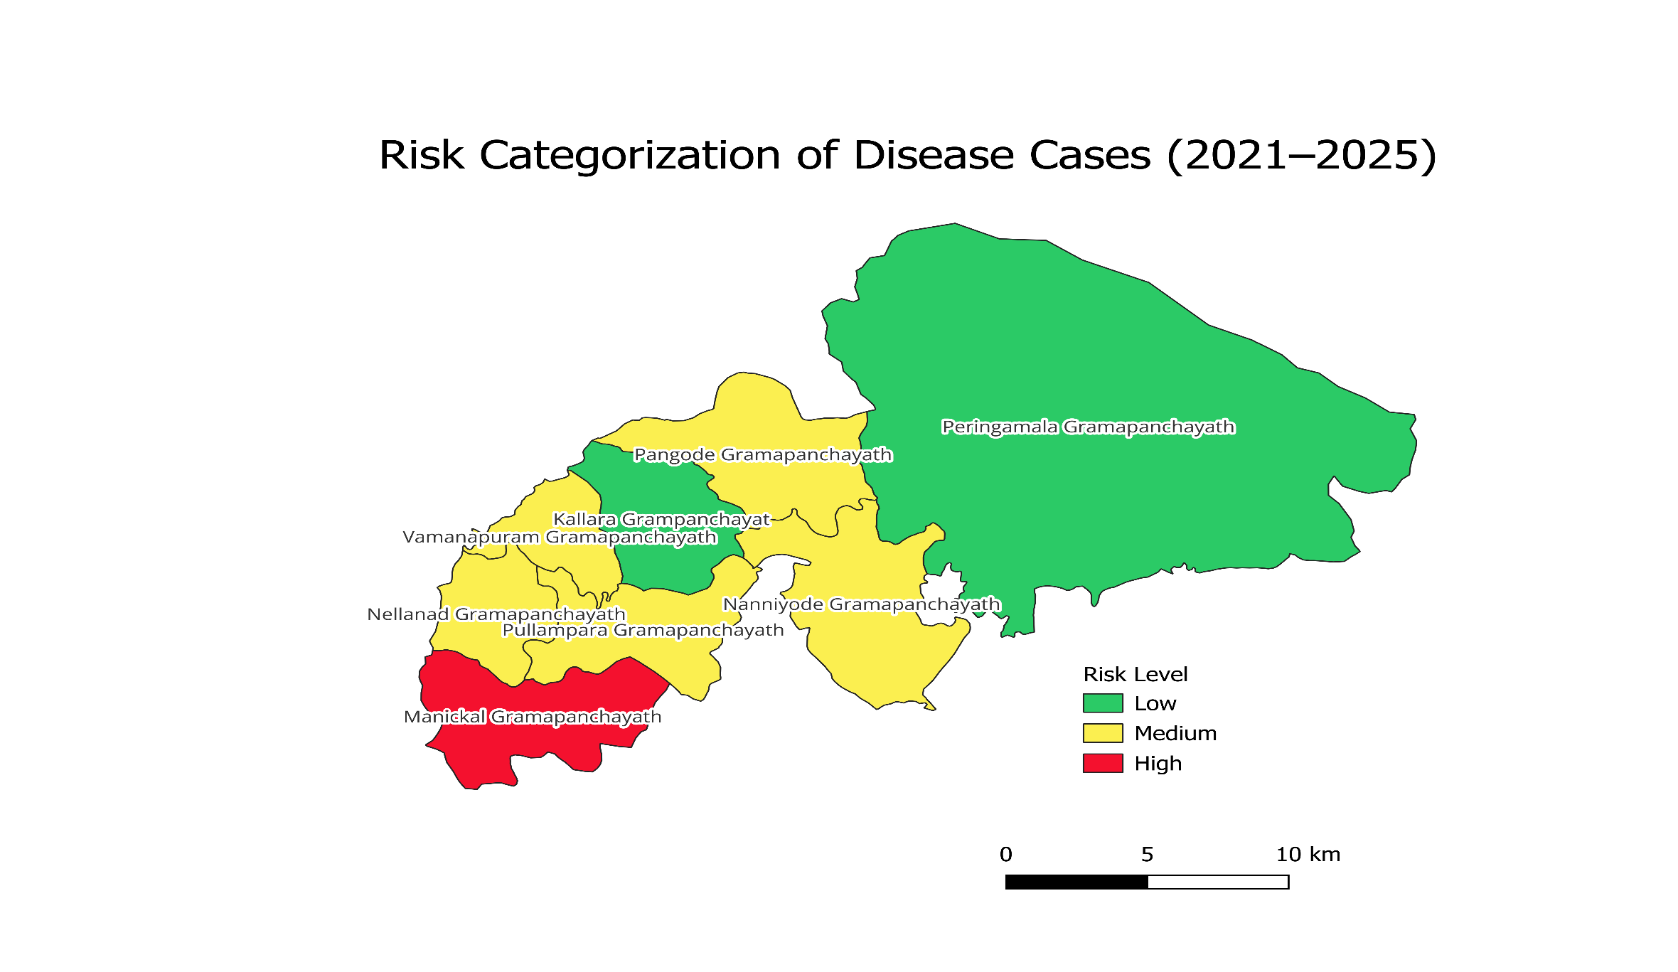
Integrated Disease Risk Mapping (2021–2025)
By aggregating five years of data (2021–2025), disease risk levels have been categorized, presenting the panchayat-wise distribution of total reported cases within the Block Panchayat area as Low, Medium, and High risk.

Preparedness and Response Protocol
at LSG Level

This section describes the operational framework for the LSGI once a pandemic is declared. It explains how the LSGI and health system will move from routine data collection to active response, using a One Health approach.

Constitution of One Health Committee
The LSGD shall constitute a One Health Committee comprising the LSGI President, Medical Officers (Modern Medicine, AYUSH, and Veterinary), the Block Epidemiologist, the Health Inspector, and the Veterinary Surgeon.

Objective: The One Health Committee coordinates human, animal, and environmental health to prevent and control pandemics.

Sl No | Name | Designation | Department/Institution | Role in Committee | Contact Number
1 | D. Reghunadhan Nair | Block Panchayat President | LSGD | Chairperson | 9447743303
2 | Kanavil Shibu | Health Standing Committee Chair | LSGD | Member Secretary | 9446462042
3 | Dr. P Ajitha,  Dr. Anu Thomas | Block Medical Officers (PHC/CHC) | Health Dept | Nodal officers | 9446076350,  9895095018
4 | Dr. Aju | Veterinary Officer | Animal Husbandry | Member | 9447533684
5 | Amaljith A B | Epidemiologist | Health Dept | Member | 7907392933
6 | Ambika | Health Supervisor | Health Dept | Surveillance | 9495138230
7 | Sajitha | ASHA Supervisor | Health Dept | Community link | 9946867386
8 | ANEESA | ICDS Supervisor | Social Welfare | Vulnerable groups | 9497851722
9 | Jinesh | Police Station Officer | Police Dept | Law & order | 9497947125
10 | T Pradeesh | Ward Councillor Representative | LSGD | Community coordination | 9745826475
11 | Haseena | Kudumbashree CDO | Kudumbashree | Community mobilisation | 8590791110
12 | Rajeev | Block Panchayat Secretary | LSGD | Member | 9895908658
13 | Arjun | NGO/Volunteer rep | Civil Society | Support services | 9074244299
14 | Vipin Chandran V. | Line Department representations | Range Forest Officer | Support services | 8547600991

Key Responsibilities:
- Review disease surveillance data (human + animal)
- Conduct ward-wise risk assessment and vulnerability mapping
- Approve quarantine/isolation centre locations
- Coordinate with district for resources (PPE, oxygen, ambulances)
- Periodically review health system surge capacity, including beds, oxygen, human resources, and ambulances.
- Approve and monitor risk communication and community engagement strategies, including rumour management.
- Ensure protection and service continuity for vulnerable groups (elderly, persons with disabilities, dialysis patients, coastal populations).
- Conduct quarterly mock drills
- Monitor equity measures for vulnerable groups

Meeting Schedule:
Quarterly (normal times) | Weekly (outbreak alert) | Daily (pandemic phase)

Pandemic Response Workforce
To ensure a coordinated and timely response during a pandemic, a dedicated Pandemic Response Workforce shall be constituted at the LSG level. The workforce will function under the overall supervision of the One Health Committee and in close coordination with the health authorities. Team-based deployment will enable efficient surveillance, case management, quarantine and isolation management, logistics support, and risk communication. Each team shall have a clearly designated team leader, defined roles, and an identified pool of personnel to allow rapid activation, rotation of duties, and continuity of services during prolonged emergencies.

Total Response Workforce Available: 300 persons

Team Name | Composition | Key Responsibilities | Team Leader
Surveillance and Contact Tracing Team | HI, JHI, JPHN, ASHAs and Volunteers | Case detection, contact listing, home visits, reporting | HI
Case Management Team | Doctors, Nurses, MLSP, Palliative Nurses | Patient care & referral | DOCTOR
Quarantine & Isolation Team | LSGD staff, Volunteers | Facility management | JHI
Psychosocial support | Counsellor: Sreeja Jayakumar, 94954015  JPHN | Counselling | Counsellor
Logistics & supply chain Team | LSGD staff, Storekeepers, Drivers 3 | Supplies & transport [PPE, medicines, oxygen, transport, waste management] | Ward Member
Communication Team | Ward members, Kudumbashree, Youth clubs,  AWW workers and other self help groups | IEC, community meetings, countering misinformation | M.O in charge
Transportation | KSRTC, educational institutional buses | Transportation | HI
Media Surveillance | Venjaramoodu Press Club, IT, ASHA Coordinator | Support helpline and public communication | HI
Intersectoral coordination and convergence | Block Panchayat President: D. Reghunadhan Nair (9447743303),  Block Medical Officer: Dr. P Ajitha (9446076350),  Panchayat Secretary: Rajeev (9895908658) | Ensure essential services and logistics | Block Panchayat President
Collaborative surveillance | Block Medical Officer: Dr. P Ajitha (9446076350),  JHI: Aagneya Vaman (8592929219)  JPHN: Lekshmi (9061686717) | Support outbreak investigation | Block Medical Officer

All teams shall be activated immediately upon outbreak alert or pandemic declaration and shall report daily to the LSG Incident Commander/Medical Officer, with consolidated reporting to the Block PHC. Duty rosters and alternate personnel shall be maintained to ensure uninterrupted services during staff shortages or prolonged response periods. Team composition and numbers may be revised based on the magnitude of the outbreak and availability of human resources.

Activities and Measures before and during Pandemic

PHASE 1 - Alert / Preparation
Surveillance and Reporting-Enhanced syndromic surveillance:
- Data sources for surveillance:
- Health facility records (OPD, IPD, emergency visits)
- Laboratory reports and diagnostic data
- Community health worker reports (ASHA, ANM, volunteers)
- Pharmacy and drug sales data
- School and workplace absenteeism records
- Veterinary and animal health reports
- Mortality and death registration data
- Media reports and social media monitoring
- Community complaints and rumor reporting systems
- Private healthcare provider reports

- Event-based triggers (to be monitored and reported):
- Unusual clusters of illness
- Unexplained severe illness or deaths
- Sudden increase in OPD visits or hospital admissions
- Unusual clinical presentations or treatment-resistant cases
- Sudden deaths or disease outbreaks in animals/birds
- Community rumors or informal reports of unusual illness
- Suspected cases with travel history to affected areas
- Detection of unusual or unknown pathogens in laboratories
- Sudden increase in absenteeism in schools/workplaces
- Zoonotic and animal health surveillance
- Monitor and report unusual illness or deaths in animals and birds.
- Strengthen coordination between Health, Veterinary, and Forest departments (One Health approach).
- Conduct investigation and laboratory testing of suspected animal disease events.
- Implement active surveillance in high-risk areas such as farms, poultry markets, and wildlife zones.
- Promote community reporting and biosecurity measures to prevent zoonotic transmission.
- Logistics and Stock Preparedness
  - Identify and empanel local vendors and define emergency procurement mechanisms in accordance with existing LSGD and Health Department norms.
  - Prepare and maintain an essential logistics checklist covering medical supplies, consumables, and support equipment.
  - Pre-identify secure storage locations for emergency stocks and ensure maintenance of stock registers with regular updating.
  - Finalise emergency transport arrangements, including availability of vehicles and identified drivers for rapid deployment during alerts.
  - Designate a Nodal Officer for Logistics to enable prompt decision-making, coordination, and communication during emergencies.
  - Conduct rapid stock verification and ensure availability of minimum buffer stock, including:
- PPE kits - numbers
- Pulse oximeters – numbers
- Hand sanitizers – ___ litres
- Masks, gloves, disinfectants – adequate quantity
Identify critical gaps in logistics and immediately communicate requirements to the Block and District authorities for timely replenishment and support. Monitor expiry dates and stock rotation.

Identification of Quarantine and Isolation Facilities
  - Identify and list suitable buildings for quarantine and isolation (schools, hostels, community halls, etc.).
  - Categorise cases as per the severity and allocate to appropriate facilities (for instance, severe cases to classrooms, mild cases to an assembly hall in case of a school).
  - Facility readiness checklist needed (beds, toilets, ventilation) etc.
  - Find an alternate site if the primary sites are not available or not in use.
  - Identify facility managers and support staff
- SOP for Admission and Discharge
Admission Protocol
- Admission to the facility shall be strictly based on the direction of the Medical Officer/Competent Health Authority.
- The categories eligible for admission include:
  - Suspected cases
  - Mild/asymptomatic confirmed cases
  - High-risk contacts requiring quarantine, as per prevailing guidelines
- A designated entry and registration area shall be established at the facility.
- Mandatory registration details shall include:
  - Name, age, gender, address, and contact details
  - Travel/contact history
  - Presenting symptoms and comorbid conditions
- Initial screening and triage shall be conducted by trained health personnel.
- Each admitted individual shall be:
  - Assigned a unique identification number
  - Oriented regarding facility protocols, infection prevention practices, and reporting procedures
- Movement of individuals within the facility shall be restricted and monitored.

Discharge Protocol
- Discharge shall be carried out strictly in accordance with State/National Health Guidelines.
- Final clinical assessment shall be undertaken by the Medical Officer or authorized health personnel.
- A discharge summary shall be issued including:
  - Duration of stay
  - Clinical status at discharge
  - Post-discharge instructions
- Individuals shall be advised on:
  - Home isolation (if required)
  - Self-monitoring and warning signs
  - Follow-up mechanisms
- Transportation arrangements shall be made ensuring minimal risk of disease transmission.

- SOP for Food, Water, and Sanitation
Food and Nutrition
- Provision of safe, nutritious, and hygienically prepared food shall be ensured at regular intervals (minimum three meals per day).
- Food preparation and distribution shall adhere to Food Safety Standards.
- Distribution shall be organized in a staggered/contactless manner to prevent crowding.
- Special provisions shall be made, where feasible, for:
  - Elderly persons
  - Children
  - Individuals with comorbidities or special dietary requirements
Water Supply
- Adequate supply of safe drinking water shall be ensured at all times.
- Water storage systems shall be:
  - Covered and protected
  - Cleaned and disinfected regularly
- Individual or designated drinking arrangements shall be encouraged to prevent cross-contamination.
Sanitation and Hygiene
- Adequate number of toilets and bathing facilities shall be provided, with gender segregation.
- Toilets shall be cleaned and disinfected at least twice daily or more frequently as required.
- Continuous availability of:
  - Soap/handwashing facilities
  - Alcohol-based hand sanitizers
- Routine cleaning and disinfection shall be carried out for:
  - Floors and common areas
  - Frequently touched surfaces (door handles, switches, railings, etc.)
- Proper ventilation shall be ensured in all rooms and common areas.
- Linen and laundry shall be handled with appropriate precautions and cleaned separately.

- SOP for Infection Prevention and Waste Management
Infection Prevention and Control (IPC) Measures
- Mandatory use of face masks by all occupants and staff.
- Strict adherence to hand hygiene practices.
- Maintenance of physical distancing (minimum 1–2 meters).
- Facility zoning shall be ensured to:
  - Segregate different categories of occupants (where applicable)
  - Maintain controlled entry and exit points
- Daily health monitoring of all occupants shall be conducted and recorded.
- All staff shall be provided with appropriate Personal Protective Equipment (PPE) based on risk exposure.
- Entry of visitors shall be restricted or prohibited.

Waste Management
- Waste shall be segregated at source into:
  - Biomedical waste
  - General waste
- Color-coded bins with liners shall be placed at designated locations.
- Biomedical waste (such as masks, gloves, tissues) shall be managed as per Biomedical Waste Management Rules, Government of India.
- Waste shall be:
  - Collected daily
  - Stored securely
  - Transported to authorized disposal facilities
- Sanitation workers shall be provided with:
  - Appropriate PPE
  - Training on safe waste handling and disposal practices

Administrative and Support Systems
- A Facility Nodal Officer/In-charge shall be designated for overall supervision and coordination.
- Duty rosters shall be maintained for:
  - Health personnel
  - Sanitation staff
  - Support staff
- Functional linkages shall be established with:
  - Nearest designated health facilities for referral and emergency care
- Adequate logistics shall be ensured, including:
  - Essential medicines
  - PPE kits
  - Cleaning and disinfection supplies
- A system for grievance redressal and psychosocial support shall be made available to occupants.
- Coordination shall be maintained with:
  - Local Self Government Institution (LSGI)
  - Police, Fire & Rescue, and other line departments

Compliance and Monitoring
- Regular monitoring and supervision shall be carried out by the Health Department and LSGI authorities.
- Periodic review of facility operations shall be undertaken to ensure adherence to SOPs.
- Any deviations or issues shall be promptly addressed and reported to higher authorities.

Rapid Activation Plan for Quarantine and Isolation Facilities (Non-Hospital Settings) (To be implemented during surge in case load)

This Rapid Activation Plan provides a structured approach for the swift operationalization and expansion of designated quarantine and isolation facilities in response to a surge in cases during a pandemic, ensuring prompt containment and uninterrupted care at the community level. It enables timely scaling and readiness of these facilities, thereby reinforcing decentralized response mechanisms and alleviating pressure on higher-level healthcare institutions.

Trigger for Activation
Activation of additional facilities shall be initiated under the following conditions:
- Rapid increase in number of suspected/confirmed cases within the Panchayat/Block
- Exceeding occupancy capacity of existing quarantine/isolation facilities
- Direction from District Health Authority / Incident Command System (ICS)
- Identification of cluster outbreaks or community transmission
Activation Process
Decision and Authorization
- Activation shall be approved by:
  - District Administration / Health Department, in coordination with LSGI
- Facility In-charge shall be immediately notified.
Rapid Mobilization (Within 24–48 Hours)
- Deployment of:
  - Health staff
  - Support staff (cleaning, security, food supply)
- Arrangement of:
  - Beds, mattresses, linens
  - Drinking water supply
  - Toilets and sanitation facilities
- Installation of:
  - Signage (entry/exit, zoning, infection control instructions)
  - Registration and screening desk
Zoning and Layout Setup
- The facility shall be demarcated into:
  - Entry and screening area
  - Isolation/quarantine wards
  - Staff area
  - Waste collection area
- Separate pathways shall be created to minimize cross-movement.

Human Resource Deployment
- A pre-designated HR pool shall be activated, including:
  - Medical Officer (overall supervision)
  - Staff nurses/health workers
  - ASHA/field workers for coordination
  - Sanitation staff
  - Volunteers (for logistics and support)
- Duty rosters shall be implemented on a shift basis to ensure 24×7 functioning.
- All personnel shall receive rapid orientation on SOPs and IPC measures before deployment.

Logistics and Supply Chain Management
- Immediate provisioning of:
  - PPE kits, masks, gloves
  - Medicines and basic medical equipment
  - Cleaning and disinfection materials
- Food and water supply shall be arranged through:
  - LSGI/local contractors/self-help groups (e.g., Kudumbashree units)
- Buffer stock for a minimum 7 days shall be maintained.

Infection Prevention and Control Measures
- Strict implementation of:
  - Mask usage
  - Hand hygiene
  - Physical distancing
- Regular cleaning and disinfection of:
  - Common areas
  - High-touch surfaces
- Biomedical waste management shall be ensured as per guidelines.
- Health monitoring of staff and occupants shall be conducted daily.

Communication and Coordination
- A central control room/coordination unit at Panchayat/Block level shall:
  - Monitor bed occupancy
  - Coordinate admissions and referrals
- Regular reporting shall be made to:
  - District Health Authorities
- Public communication shall be carried out to:
  - Inform about facility availability
  - Avoid panic and misinformation

Referral and Emergency Linkages
- Functional linkage shall be established with:
  - Nearest designated treatment hospitals
- Ambulance services shall be kept on standby.
- Clear protocols shall be followed for:
  - Referral of moderate/severe cases
  - Emergency evacuation

Monitoring and Supervision
- Daily review of:
  - Occupancy status
  - Resource availability
  - Health status of occupants
- Periodic inspection by:
  - Health Department officials
  - LSGI representatives
- Immediate corrective action shall be taken for any gaps identified.

Deactivation and Standby Maintenance
- Facilities may be deactivated based on:
  - Decline in case numbers
  - Direction from competent authority
- Post-deactivation:
  - Deep cleaning and disinfection shall be carried out
  - Inventory shall be documented and stored
  - Facility shall be maintained in ready-to-activate condition

Risk Communication and Community Preparedness
  - Disseminate early warning messages on symptoms, preventive measures, and reporting mechanisms. Display IEC materials both in English and the local language in public places and ensure ward-level awareness.
  - Sensitize elected representatives and community leaders on preparedness measures.
  - Establish a rumour tracking and misinformation response mechanism to identify, verify, and promptly counter false or misleading information.
  - Engage trusted local persons (ward members, ASHA workers, religious leaders, teachers, community volunteers) to communicate official public health messages and reinforce correct practices.
  - Develop and deploy targeted IEC materials for:
    - Schools and educational institutions
    - Markets and commercial areas
    - Work sites and labour settings
  - Conduct community sensitization meetings at the ward level to promote preventive behaviors, address concerns, and strengthen community participation in preparedness and response.

Protection of Vulnerable Groups
Vulnerable populations require priority protection through targeted line-listing, service continuity, and delivery mechanisms.
- Prepare and regularly update line-lists of vulnerable populations, including:
  - Elderly persons living alone
  - Persons with disabilities
  - Pregnant women
  - Migrant workers
  - Dialysis patients
The detailed line-lists shall be maintained as Annexure ___ and updated periodically.

Clinical Dependency Mapping
Develop ward-wise dependency and vulnerability maps to identify households requiring regular support during emergencies. Ensure continuity of essential health services for vulnerable groups, including
- Dialysis services (facility mapping, transport arrangements, and scheduling)
- Continuity of treatment for TB, HIV, and other chronic conditions requiring uninterrupted medication
- Mental health and psychosocial support services
Establish delivery mechanisms for food, essential commodities, and medicines to vulnerable households through coordinated action involving ASHAs, JPHNs, Kudumbashree, volunteers, and local administration.

PHASE 2 - Active Response

Case Identification and Contact Tracing
Case detection and contact tracing activities will be carried out in coordination with the Health authorities, following disease-specific SOPs and IDSP guidelines.
Field Staff Involved
- Health Inspector (HI)
- Junior Health Inspector (JHI)
- Junior Public Health Nurse (JPHN)
- ASHAs and ASHA Supervisors
- Ward-level volunteers and Kudumbashree members (as required)

Screening Checkpoints
Screening checkpoints at high-traffic locations (transport hubs, markets, religious gatherings) for early detection of symptomatic travellers and crowd screening during outbreaks. Potential locations include bus stands, market entry points, and boat jetties, based on local context and risk assessment.
Screening activities will be carried out by trained personnel such as ASHAs, ward members, and volunteers, with support from Health Department staff. Necessary equipment, including non-contact thermometers and appropriate PPE, shall be ensured prior to activation.

Location | Type (Bus stand/Jetty/Market/Railway) | Staff Deployed (ASHAs/Volunteers) | Screening Method | Reporting authority
Bus stand | Transport hub | One JHI  One ASHA  One health Mentors | 1.Swab Collection.  2. Blood smears collection (RDT)  3.Thermal Scanners | Surveillance Nodal Officer in control room
Market entry | Market | One JHI  One ASHA  Male health volunteers | 1.Swab Collection.  2. Blood smears collection (RDT)  3.Thermal Scanners | Surveillance Nodal Officer in control room


Standard Screening Protocol

The screening protocol shall include temperature screening, observation for visible symptoms, and inquiry regarding recent travel or exposure history. Individuals identified as suspects during screening shall be immediately referred to the nearest PHC/FHC for further evaluation, testing, and appropriate action as per prevailing guidelines.

Pandemic Control Room
The Pandemic Control Room (PCR) serves as the central nerve center for real-time coordination, data aggregation, decision support, and communication during outbreaks. It consolidates information from all LSGD teams, health facilities and community sources to enable rapid response decisions.

Control Room Infrastructure and Location
Primary Location: Vamanapuram Block Panchayath Office.
Backup Location: Community Hall in Vamanapuram Block Panchayath

Health System Control Room Framework
The PCR is organized into seven functional pillars to ensure no aspect of the response is overlooked:

Rapid Response Team (RRT)
  - Provides immediate intervention during emergencies, clusters, and field alerts.​
  - Coordinates urgent actions such as case investigation, contact tracing, isolation, and inter‑facility referrals.

Designation | Name | Contact Number
Medical Officer | Dr. Anu Thomas  Dr. Ajitha P | 9895095018  9446076350
Nursing Officer | Anusha  Lisamol | 9495534124  8848204739
Health Inspector | Sony  Joy John | 9496468061  9497851827
Public Health Nurse | Sajitha  Sindhu | 9946867386  9446952821
Junior Health Inspector | Aagneya  Haseem A. K. | 8592929219  9447523996
Epidemiologist | Amaljith A. B. | 7907392933
Pharmacist | Jitha  Silpa | 8547375596  9074505236
Lab Technician | Anu Philip  Archana | 9539320164  9846581269
JPHN | Lekshmi  Bindhu | 9061686717  9745781357
Nursing Assistant | Ajitha kumari  Pushpalatha | 9633970951  9656156354
Veterinary Surgeon | Dr. Asha  Dr Aju | 9447762257  9447533684
Panchayat President | Baburaj  Vijitha | 9446900486  8086965394
Ward Member | K Ramesan Nair  A Noushad | 7559059168  9497265593
Panchayat Secretary | Sreekala  Krishnakumar | 9496040711  8921574580
Village Officer | Sreekala | 9496131542
Agriculture Officer | Vinod  Chandana | 9446491975  9496281112
SHO | Jinesh J  Suneesh | 9497947125  9447280482
Range Forest Officer | Vipin Chandran V.  Benzilal | 8547600991  9745826107
Ambulance | Mother Ambulance  Welfare ambulance service | 9447774624  7907113104
Driver | Sanu  Prem Shankar | 9447862812  9048778042
ASHA | Ambika  Ragini | 9447251971  8593931765
Electrician | Ambujakumar  Hari | 9497947125  9447496343
Grade II Attender | Sasikuttan  Renji | 9048370902  9645541908

Data Management & Analytics Team
  - Collects, validates, and manages key health system indicators (cases, tests, beds, HR, supplies).​
  - Analyzes data trends, generates projections, and supports evidence‑based decision‑making for local authorities.
Designation | Name | Contact
Epidemiologist | Amaljith A B | 7907392933
Data Manager | Anupriya U. | 9747767626
Data entry operator | Ramsy | 8590194848

Human Resource Deployment Team
  - Allocates healthcare staff efficiently based on workload and need
  - Ensures adequate and equitable workforce distribution across facilities
Designation | Name | Contact
MO | Dr. P. R. Manoj Kumar | 9447128584
Panchayat Secretary | Benzilal | 9745826107
MO Ayurveda | Dr Subhash | 8089263901
MO Homeo | Dr Chithra | 9497689884
Veterinary Surgeon | Dr. Divya | 9496480842
SHO | Suneesh | 9447280482
Forest Range Officer | Dr. Deepthy | 854780675
Agricultural Officer | Vinod | 9446491975
Village Officer | Sreekala | 9496131542
ICDS Supervisor | Prema L | 9400598617
CDO | Geetha | 6282838982

Laboratory Surveillance Team
  - Oversees diagnostic testing coordination, sample transport, and timely reporting of results.​
  - Monitors lab indicators (testing volume, positivity rate, turnaround time) for early detection of outbreaks

Designation | Name | Contact
MO | Dr. Nivin Christo | 8547326217
Lab Technicians | Abhiremya | 7356783733
Lab Assistant | Asiya | 9633568539
HI | Joy John | 9497851827
Staff Nurse | Nisha | 9745282709

Vaccination Cell (If Required)
  - Plans and executes vaccination campaigns, including micro‑planning and session scheduling.​
  - Tracks coverage, identifies gaps, and coordinates corrective actions with field teams and outreach services
Designation | Name | Contact
MO | Dr. Arjun S Chand | 9400885060
PHN | Sathi | 9446874973
JPHN | Sofiya S | 8606464735
ASHA | Ambili | 9526711439
JHI | Amritha J Prakash | 7736925200

Infrastructure & Patient Occupancy Team
  - Monitors facility capacity, earmarked beds, oxygen and critical care resources across all linked facilities.​
  - Ensures optimal patient distribution and referral management using updated bed‑status and resource data.
  - BMWM
Designation | Name | Contact
MO | Ajitha | 9446076350
Staff Nurse | Sreelekshmi | 956295156
PRO | Anil Philipose | 9745833927
Pharmacist | Silpa | 9074505236
HI | Joy John | 9447586827
Nursing Assistant | Pushpalatha | 9656156354
Grade II Attender | Sreekala | 8086307301

*(Communication team, Logistics and supply chain, Transportation (interfacility & emergency transport), Media surveillance Call centre, Management of the deceased, Intersectoral coordination and convergence – Already mentioned on previous phase)

Key Control Room Team
The Control Room Team coordinates all pandemic response activities within the LSGD and serves as the single command and communication hub during activation. It integrates information, field actions, logistics, and policy execution across all participating departments and health facilities.

Role | Name | Designation | Contact Number | Responsibility
In-charge/Nodal Officer | Dr. Anu Thomas | Health Block MO in charge | 9895095018 | Overall coordination, decision-making, and reporting to the District level.
Data Entry Operator | Ajith | Panchayat Project Assistant | 9745993854 | Managing the line list, updating dashboards, and tracking testing results.
Communication Officer | Gokul Raj | Village Extension Officer | 9745090489 | Handling the public helpline, coordinating ambulance dispatch, and contact tracing calls.
Logistics Coordinator | Anil Philipose | PRO | 9745833927 | Coordination
Technical Support (IT/Data) | Sindhya | Technical Assistant | 9061409111 | Technical support

SOP for Alert Escalation and Trigger Points with Mapping of Responsibilities

This Standard Operating Procedure (SOP) establishes a clear alert escalation mechanism, defined trigger points, and delineated roles and responsibilities to ensure a timely and coordinated response during the Response Phase (Phase 2) of a pandemic. It facilitates early detection of risk escalation and enables the prompt activation of appropriate control measures at the LSGI/Panchayat level.
The SOP provides a structured and responsive escalation framework that supports timely decision-making, optimal utilization of resources, and effective coordination among all stakeholders, thereby strengthening the overall pandemic response at the local level.

Alert Levels and Trigger Points

Pandemic response at the Panchayat level shall be guided by a graded alert system, based on epidemiological indicators and situational assessment.

Level 1: Alert (Preparedness Reinforcement Stage)
Trigger Points:
- Reporting of sporadic suspected or confirmed cases within the Panchayat
- Cases reported in neighboring Panchayats/Block
- Advisory issued by District Health Authorities
Key Actions:
- Intensification of surveillance and contact tracing
- Readiness check of quarantine/isolation facilities
- Public awareness and risk communication activation

Level 2: Moderate Alert (Local Transmission Stage)
Trigger Points:
- Clustering of cases within specific wards/localities
- Increase in test positivity rate or symptomatic cases
- Partial occupancy of existing quarantine/isolation facilities
Key Actions:
- Activation of additional quarantine/isolation facilities
- Restriction of gatherings and localized containment measures
- Strengthening of field-level monitoring and enforcement

Level 3: High Alert (Community Transmission/Surge Stage)
Trigger Points:
- Rapid increase in number of cases across multiple wards
- Full occupancy or overburdening of existing facilities
- Evidence of community transmission
- Direction from District Administration for escalation
Key Actions:
- Full-scale activation of all identified facilities
- Strict containment measures and mobility restrictions
- Emergency resource mobilization and inter-departmental coordination

Escalation Mechanism
- Alert escalation shall be initiated based on real-time data from surveillance systems, field reports, and directives from higher authorities.
- The Medical Officer (PHC) shall assess the situation and recommend escalation.
- Final decision for escalation shall be taken by:
  - Block/District Health Authorities in coordination with LSGI
- Each escalation level shall trigger pre-defined actions without delay.

Mapping of Roles and Responsibilities

Health Department (Medical Officer & Health Staff)
- Lead surveillance, case detection, and reporting
- Recommend alert level escalation based on epidemiological data
- Supervise quarantine/isolation facilities
- Ensure clinical monitoring and referral services
Local Self Government Institution (LSGI)
- Overall coordination and administrative support
- Activation and management of quarantine/isolation facilities
- Ensure provision of food, water, sanitation, and essential services
- Mobilize local resources and community support
Police Department
- Enforce containment measures and movement restrictions
- Support crowd control and ensure compliance with guidelines
Revenue Department
- Support implementation of containment zones
- Assist in emergency coordination and resource mobilization
Fire and Rescue Services
- Provide support for emergency response and disinfection activities (as required)
KSEB and Water Authority
- Ensure uninterrupted supply of electricity and water to facilities
- Provide emergency restoration services
Community-Based Organizations (e.g., Kudumbashree, Volunteers)
- Support food distribution, logistics, and community awareness
- Assist in monitoring vulnerable populations
Facility In-charge/Nodal Officer
- Implement SOPs at facility level
- Maintain records, reporting, and coordination with LSGI and Health Department
Communication and Reporting
- Daily situation reports shall be submitted by:
  - Health staff to Medical Officer
  - Facility In-charge to LSGI
- Consolidated reports shall be forwarded to:
  - Block and District Authorities
- Public communication shall be carried out in a timely, transparent, and responsible manner to avoid misinformation and panic.

Monitoring and Review
- Continuous monitoring of epidemiological trends and facility status shall be undertaken.
- Alert levels shall be reviewed periodically and de-escalation shall be considered based on improvement in indicators.
- Any deviations or operational challenges shall be immediately addressed and reported.

.
Trigger Indicators | Alert Level | Key Actions to be Initiated | Lead Department/Officer | Supporting Departments/Agencies
Sporadic suspected/confirmed cases within Panchayat Cases in neighboring areas Advisory from higher authorities | Level 1: Alert (Preparedness Reinforcement) | Intensify surveillance and contact tracing- Verify readiness of quarantine/isolation facilities- Initiate public awareness and IEC activities- Prepare HR and logistics standby | Health Department (Medical Officer, PHC) | LSGI, ASHA Workers, Kudumbashree, Volunteers
Clustering of cases in specific wards/localities Increase in symptomatic cases or test positivity Partial occupancy of facilities | Level 2: Moderate Alert (Local Transmission) | Activate additional quarantine/isolation facilities- Implement localized containment measures- Restrict gatherings and enforce IPC measures- Strengthen field monitoring and reporting | Health Department + LSGI (Joint Coordination) | Police Department, Revenue Department, Kudumbashree, Volunteers
Rapid increase in cases across multiple wards Full occupancy/overburdened facilities Evidence of community transmission Direction from District Authorities | Level 3: High Alert (Community Transmission/Surge) | Full-scale activation of all identified facilities- Enforce strict containment and mobility restrictions- Mobilize emergency resources and HR- Strengthen referral and emergency transport systems- Ensure uninterrupted essential services | District Administration + Health Department | LSGI, Police, Revenue, Fire & Rescue, KSEB, Water Authority, NGOs
Decline in cases and reduced facility occupancy Improved epidemiological indicators | De-escalation Phase | Gradual scaling down of facilities- Continued surveillance and monitoring- Maintain readiness for reactivation- Documentation and review of response | Health Department (Medical Officer) | LSGI, All Line Departments

Key Points:
- The Control Room shall be staffed with a designated In-charge, data entry personnel, and communication staff with clearly defined roles and shift arrangements.
- It shall maintain updated records on daily monitoring indicators including new cases, persons under active quarantine, and hospital bed occupancy.
- All reports and situation updates shall be shared daily with the Block and District Surveillance Unit.
- The Control Room shall act as a single point of contact for coordination with response teams, health institutions, and other departments.
- Contact details of the Control Room shall be widely communicated to field staff and stakeholders during activation.

Daily Monitoring Indicators
To ensure timely decision-making and effective response, the following key indicators shall be monitored and updated on a daily basis by the Pandemic Control Room:

Epidemiological Indicators:
New cases reported today, Total active cases, Test Positivity Rate (TPR), Case Fatality Rate (CFR)
- Surveillance Indicators:
Persons under home quarantine, High-risk contacts identified, Fever, ILI, SARI or other symptoms (syndromic surges), Travellers (symptomatic or high-risk arrivals),Animal husbandry surveillance (zoonotic alerts, unusual animal deaths, poultry/bird flu signals), Mortality surveillance (excess deaths, unexplained fatalities, verbal autopsy reports)
- Logistics and Infrastructure Indicators:
Hospital / CFLTC beds occupied, Oxygen cylinders/concentrators available, Ambulances on standby
- Alert Findings
The following table outlines category-specific trigger points (red flags) from surveillance indicators and corresponding immediate actions for the Pandemic Control Room. These enable rapid response to alert findings like testing anomalies, positive cases exceeding thresholds, clusters, and WGS reports.

Category | Trigger Pophint (Red Flag) | Immediate Action
Clusters | Geographical or facility-based: 5+ cases linked to one location (office, school, street). | Declare a micro-containment zone; perimeter control and active case finding.
Testing | Sudden drop in testing volume / delay in reporting / unusual testing trends | Review the sample collection process, address lab bottlenecks, deploy additional testing teams, and notify the District Lab.
Lab | Test Positivity rate increases | Increase testing sites in that ward.
Hospital | >80% Oxygen bed occupancy | Activate backup/CFLTC beds.
Travel | Cluster of cases from a single flight/train or high-risk arrival group. | Trace all passengers in adjacent seats; implement mandatory institutional quarantine.
Animal | Mass poultry/wildlife death or unusual sickness | Notify Animal Husbandry, sample the area, and dispatch RRT for environmental sampling and zoonotic check.
Mortality | Sudden spike in home deaths or brought-in-dead (BID) cases | Audit the deaths and Active Case Search drive
Additional investigations like Whole Genome Sequencing (WGS) | Detection of a Variant of Concern (VOC) or Variant of Interest (VOI) | Implement strict micro-containment; update clinical protocols to match variant severity.

Communication of Public Health Information
A Community Communication Hub shall be established to ensure timely, accurate, and consistent dissemination of information during a pandemic. The Hub will function under the coordination of Nodal officers of the control room and act as the nodal point for public communication, risk messaging, and community engagement. It will support dissemination of official advisories, promote preventive behaviors, address rumors and misinformation, and ensure that messages reach all sections of the population through trusted local channels and leaders.

Key communicators
Channel | Responsible Person | Contact
Ward-level announcements | JPHN | Jhansi R., 9447540101
Social media | MLSP | Sangeetha, 9400840914
Local Cable TV/Radio | MLSP | Priyanka, 9656264523

- All messages disseminated through the Hub shall align with advisories issued by the Health Department and District authorities.
- Community leaders shall be sensitized to support behavior change, reduce stigma, and counter misinformation.
- Special efforts shall be made to reach vulnerable and hard-to-reach populations using locally appropriate communication methods.

Rumor Tracking: A designated volunteer will monitor local social media/WhatsApp groups daily to identify misinformation and issue official clarifications via the Communication Hub.

Coordination with District/State Authorities & Other Organisations
Effective coordination with Block, District, and State authorities is essential to ensure timely reporting, technical guidance, and uninterrupted supply of essential resources during a pandemic. The LSG shall establish clear communication channels, designate responsible officers, and adhere to prescribed reporting timelines to support coordinated public health action and efficient resource mobilisation.

Key Details:
- Nodal Officer for Reporting:
- Contact Number:
Reporting Schedule and Protocols:

To Whom | What to Report | Frequency | Nodal Person
Block PHC | Complete Situation Report (Cases, Quarantine, Beds, Screening, Deaths) | Daily | Health supervisor
District IDSP Unit | Outbreaks/Clusters/Unusual Events (>5 cases same ward) | Daily | Block Epidemiologist
Veterinary Officer | Animal health events/Zoonotic alerts | Daily | Veterinary Doctor
State Cell | Zoonotic cross-sector events | Daily | Medical Officer

Supply Chain Coordination
The LSG shall coordinate closely with Block, District, and State authorities (KMSCL) to ensure uninterrupted availability of essential goods, medical supplies, and logistics during a pandemic. Supply requirements shall be assessed regularly based on case load and communicated promptly to the appropriate authorities for timely replenishment.
Key Points:
- Maintain updated contact details of District and Block nodal officers for health logistics, oxygen supply, ambulances, and essential medicines.
- Submit timely indent requests for PPE, testing kits, medicines, oxygen, and other critical supplies through prescribed channels.
- Monitor stock levels at LSGD facilities, quarantine/isolation centres, and field teams through daily stock registers and dispensing logs to prevent shortages.
- Coordinate with District authorities, Karunya/Neethi medical shops, and local purchase committees for funds allocation and emergency procurement.

- Ensure regular monitoring of dispensing registers at all facilities to track usage, expiry, and pilferage—shortages being a perennial issue requiring proactive weekly audits.

- Activate surge procurement protocols during high caseloads, leveraging local purchase powers under LSGD funds alongside state supplies.

Resource Inventory and Contacts
Resource Category | Source  (District/State/Private) | Contact
PPE Kits/Masks/Gloves | KMSCL | 0471-2945757, 9496003900
PPE Kits/Masks/Gloves | Local Vendors | 8943889076 (Kallara Supplyco)
Oxygen  Cylinders/Concentrators | KMSCL | 0471-2945757, 9496003900
Medicines/Antivirals | KMSCL | 0471-2945757, 9496003900
Medicines/Antivirals | Neethi Shops | 9746750309, 8848627525, 6282633307, 8086690386,
Test Kits (RTPCR/Rapid) | KMSCL | 0471-2945757, 9496003900

Collaboration with NGOs, PPP, and CSR
To augment government efforts during a pandemic, the LSG shall collaborate with NGOs, voluntary organisations, and private sector partners through public–private partnerships and Corporate Social Responsibility (CSR) initiatives, in coordination with District authorities.

Key Points:
- Engage NGOs and community-based organisations for community outreach, awareness, and support to vulnerable populations.
- Leverage CSR support for procurement of medical equipment, PPE, oxygen concentrators, food kits, and sanitation materials, as permitted.
- Ensure all collaborations align with government guidelines and are routed through approved administrative and financial procedures.
- Maintain transparency and documentation for all external support received and utilised.
Organization | Type | Support Offered | Contact Person
Youth Clubs/Student Unions | CBO | Volunteer Work | Arjun, 9074244299  Vimalraj, Navabharath Samskarika Vedhi, 6238658330  Santhosh Mohan, 9400184110  Ajmal Shinas, 9526391366

Interdepartmental Coordination
Coordination among departments during a pandemic shall be ensured through regular review meetings convened by the LSGD President. These meetings will provide a structured platform for sharing situational updates, assessing resource availability, resolving operational gaps, and taking joint decisions to ensure a coordinated and timely response.

Department | Representative | Key Role | Contact
Health (PHC) | Staff Nurse : Lisamol | Case management | 8848204739
Veterinary | Veterinary Surgeon: Dr. Aju | Animal surveillance | 9447533684
ICDS | Supervisor: Prema L | Nutrition support | 9400598617
Education | Head Teacher: Sunil | School coordination | 9846557594
Police | SHO: Jinesh J | Containment enforcement | 9497947125
Water Authority | Water Authority Executive Engineer: Binu S. | Water supply | 8289940551
LSGD Engineering | Mohammad Bihu | Quarantine infrastructure | 9526803461

PHASE 3 - Surge Capacity
Phase 3 is activated when there is a rapid increase in cases, high test positivity rates, or when existing health facilities and quarantine arrangements approach saturation. The focus of this phase is to expand isolation capacity, augment clinical care services, and mobilise additional resources through district and state support mechanisms.

Conversion of Community Facilities
To manage increased case load, the LSGD shall activate additional isolation facilities by repurposing identified community infrastructure such as community halls, auditoriums, schools, hostels, or other suitable buildings.

Name of facility | Facility Type | No. of Buildings | Panchayat | Surge Capacity (Beds) | Nodal Person
Nafas Auditorium | Auditorium | 1 | Kallara | 100 | Latheef: 9846289779
Happy convention centre | Auditorium | 1 | Kallara | 200 | Ajayan:  9946508031
Saravana Auditorium | Auditorium | 1 | Kallara | 100 | Manu: 9846586003
Geethanjali Auditorium | Auditorium | 1 | Kallara | 100 | Bahuleyan: 8943670013
MS Auditorium | Auditorium | 1 | Kallara | 100 | Thahirudheen: 9595193039
ARS Auditorium | Auditorium | 1 | Kallara | 100 | Hakeem:  8111813074
Kairali Auditorium, Vembayam | Auditorium | 1 | Manickal | 50
Royal Kerala Auditorium | Auditorium | 1 | Manickal | 100
Society hall, Koliyacode Society Junction | Auditorium | 1 | Manickal | 100 | Govindhan (9562307822)
Neelakanda Memorial hall, Koliyacode | Auditorium | 1 | Manickal | 100 | 9562307822
SAF auditorium, Poolanthara | Auditorium | 1 | Manickal | 100 | 9441413283
TK Convention centre, Poolanthara | Auditorium | 1 | Manickal | 100 | 9447093228
Govt Girls HSS, Kanyakulangara | School | 3 | Manickal | 250 | Noushad  8921566940
Govt hss Pirappankodu | School | 3 | Manickal | 100 | Vimala, 9496201493
Santhigiri HSS | School | 3 | Manickal | 150 | Bijukumar  9526891808
Vrindavanam | Auditorium | 1 | Nanniyode | 200
Green | Auditorium | 1 | Nanniyode | 50
Vinayaka | Auditorium | 1 | Nanniyode | 50
A. A. | Auditorium | 1 | Nanniyode | 40 | Shukkoor -9605009087
Gokulam Medical College PG Hostel | Medical College PG Hostel | 1 | Nellanad | 100 | 94466153400
Muslim Engineering college | Educational institute | 3 | Nellanad | 300 | 79077573227
Suhas Auditorium | Auditorium | 1 | Nellanad | 100 | 9495824497

Recovery and Rehabilitation Phase

The recovery and rehabilitation phase begins after the pandemic situation stabilizes and the immediate public health emergency is controlled. The objective of this phase is to restore essential health services, support affected populations, rebuild community confidence, and strengthen systems to improve preparedness for future public health emergencies.

Recovery
Efforts shall be undertaken to gradually transition from emergency response to the routine functioning of health systems and public services. Coordination between the Health Department, Local Self Government Institutions (LSGIs), and other relevant departments shall be ensured to facilitate the safe resumption of normal activities while maintaining necessary surveillance and preventive measures.

Damage and Impact Assessment
A comprehensive assessment shall be conducted to evaluate the health, social, and economic impacts of the pandemic. This includes assessment of morbidity and mortality, disruption of essential health services, strain on health infrastructure, impact on vulnerable populations, and overall community-level consequences.

Restoration of Health Services
Priority shall be given to restoring routine healthcare services that may have been disrupted during the response phase. This includes outpatient services, maternal and child health services, immunization programs, management of non-communicable diseases, rehabilitation services, and elective procedures. Strengthening service delivery at primary health care institutions shall be emphasized.

Rehabilitation of Affected Population
Appropriate support mechanisms shall be provided for individuals and families affected by the pandemic, including those who experienced severe illness, long-term complications, disability, or loss of family members. Rehabilitation services may include medical follow-up, social support, and linkage with welfare schemes.

Psychosocial and Mental Health Support

Psychosocial support services shall be strengthened to address stress, grief, anxiety, and other mental health concerns arising from the pandemic. Counselling services and community mental health programs should be made available for affected individuals, families, and healthcare workers.

Disease Surveillance During Recovery Phase
Disease surveillance shall continue to be strengthened during the recovery phase to detect any resurgence or new clusters of infection. Routine surveillance, laboratory monitoring, and reporting systems should remain active to ensure early detection and timely response to potential outbreaks.

Environmental Cleanup and Sanitation
Local authorities shall ensure environmental sanitation and hygiene in affected areas. This includes proper waste management, safe disposal of biomedical waste, disinfection of healthcare facilities and quarantine centers, and maintaining sanitation in public places.

Livelihood Restoration
Efforts shall be undertaken in coordination with relevant departments to support livelihood restoration, particularly among vulnerable populations affected by the pandemic. Linkages with social protection schemes and local economic recovery initiatives should be facilitated.

Community Engagement and Confidence Building
Community engagement shall be strengthened through transparent communication and awareness activities. Public information campaigns should promote health-seeking behaviour, address misinformation, and rebuild trust in health systems and public institutions.

Documentation and After-Action Review
All activities, response strategies, operational challenges, and outcomes during the pandemic response shall be systematically documented. An after-action review should be conducted to evaluate the effectiveness of the response and identify gaps in preparedness and response mechanisms.

Lessons Learned and Best Practices
Experiences from the pandemic response shall be analysed to identify key lessons learned and best practices. These findings should be documented and disseminated to guide future public health preparedness and response strategies.

Health System Strengthening
Recovery efforts shall focus on strengthening health system capacities, including human resources, infrastructure, supply chain management, laboratory capacity, surveillance systems, and emergency preparedness mechanisms.

Policy Revision and Preparedness Enhancement
Relevant policies, guidelines, and operational protocols should be reviewed and updated based on the lessons learned from the pandemic. This will enhance preparedness and ensure improved response mechanisms for future health emergencies.

Research
Operational and public health research should be encouraged to understand the epidemiological patterns, effectiveness of response strategies, health system performance, and long-term impacts of the pandemic. Research findings should be used to support evidence-based policy and planning.

CONCLUSION
This Pandemic Preparedness Plan for the Local Self Government Institution (LSGI) provides a structured and systematic framework for the prevention, early detection, and effective management of pandemics and public health emergencies at the Panchayat level. The plan outlines clearly defined roles, responsibilities, and standard operating procedures to ensure coordinated and timely action across all concerned sectors.
Effective implementation of this plan requires sustained interdepartmental coordination among the Health Department, Local Self Government Institutions, and other line departments, along with active participation of healthcare providers and the community. Strengthening of surveillance systems, capacity building of human resources, regular mock drills, and efficient resource management are critical components to ensure operational readiness.
This plan shall be implemented in alignment with the guidelines issued by the State and Government of India, and shall be subject to periodic review and updating based on evolving situations, lessons learned, and emerging evidence.
The LSGI is committed to ensuring a proactive, integrated, and resilient public health system capable of mitigating the impact of pandemics, safeguarding the health of the population, and ensuring continuity of essential services during public health emergencies.

Additional points
The following additional components shall be incorporated to further strengthen pandemic preparedness and response at the LSGI level:
- Technical Support:
Provision of technical support through coordination with district/state authorities, technical agencies, and expert institutions for surveillance, data management, telemedicine, and decision-making.
- Relief-Based Commodities:
Ensuring availability and timely distribution of essential relief materials such as food supplies, medicines, PPE, and other emergency commodities for affected populations.
- HAM Radio Operators:
Engagement of HAM radio operators as an alternative communication mechanism to ensure uninterrupted communication during network failures or emergency situations.
- Hazard Vulnerability Mapping:
Preparation and periodic updating of hazard vulnerability maps to identify high-risk areas, vulnerable populations, and resource gaps within the Panchayat.
- KSEB and Alternate Power Sources:
Coordination with Kerala State Electricity Board (KSEB) and arrangements for backup power sources such as generators and inverters to ensure uninterrupted functioning of health facilities and control rooms.
- Human Resource (HR) Specific Responsibilities:
Clear delineation of roles and responsibilities for all categories of personnel involved, including healthcare workers, field staff, volunteers, and support staff, to ensure accountability and efficient service delivery

RECOMMENDATIONS

Strengthening Healthcare Infrastructure
- Establish a primary health response unit within the Panchayat with trained staff.
- Ensure availability of basic medical supplies (masks, sanitizers, PPE kits, oxygen cylinders).
- Create tie-ups with nearby hospitals in Thiruvananthapuram district for emergency referral and transport.

2. Community Awareness & Education
- Conduct regular awareness campaigns on hygiene, vaccination, and preventive measures.
- Use local communication channels (community radio, WhatsApp groups, notice boards) to spread verified information.
- Train volunteers to act as health ambassadors in each ward.

3. Emergency Response & Coordination
- Form a Pandemic Preparedness Committee at Panchayat level including health workers, ward members, and NGOs.
- Develop a clear action plan for lockdowns, quarantine, and distribution of essentials.
- Maintain a database of vulnerable groups (elderly, differently-abled, chronically ill) for targeted support.

4. Supply Chain & Food Security
- Identify and support local suppliers and farmers to ensure uninterrupted food supply.
- Create community kitchens during emergencies to serve vulnerable populations.
- Stockpile essential commodities in Panchayat-run outlets for crisis periods.

5. Digital Preparedness
- Promote digital platforms for telemedicine consultations.
- Use Panchayat’s website/social media for real-time updates on health advisories.
- Encourage online grievance redressal to reduce crowding in offices.

6. Training & Capacity Building
- Organize mock drills for pandemic response in schools, offices, and public spaces.
- Train Panchayat staff and volunteers in first aid, infection control, and crowd management.
- Collaborate with NGOs and health departments for capacity-building workshops.

7. Long-Term Resilience
- Integrate pandemic preparedness into the Panchayat Development Plan.
- Allocate a dedicated budget for health emergencies.
- Encourage community participation in planning and monitoring preparedness measures.
MOCKDRILL SCENARIOS
Periodic mock drills shall be conducted to assess the preparedness and response capacity of the health system and associated departments in the event of a pandemic or major disaster. The mock drill will simulate a realistic public health emergency scenario, such as the sudden detection of a cluster of severe respiratory illness or another communicable disease with potential for rapid spread within the community.
The objective of the mock drill is to test the effectiveness of surveillance systems, early warning mechanisms, reporting procedures, interdepartmental coordination, and response strategies. The exercise shall involve the participation of key stakeholders, including the Health Department, Local Self Government Institutions (LSGIs), Police Department, Fire and Rescue Services, Veterinary Department, and other relevant agencies.
During the mock drill, activities such as identification and reporting of suspected cases, activation of rapid response mechanisms, field investigation, contact tracing, implementation of infection prevention and control measures, and referral of suspected cases to designated healthcare facilities shall be simulated. The drill shall also assess logistics management, communication systems, and community-level coordination.
Following the completion of the exercise, a structured review and evaluation shall be conducted to identify operational gaps, challenges, and areas for improvement. The findings from the mock drill shall be documented and incorporated into the pandemic preparedness plan to strengthen future response capacity.

ANNEXURE

IMPORTANT PHONE NUMBERS

Phone numbers and particulars of persons responsible for providing guidance, assistance, and support for pandemic preparedness operations may be provided here in a manner that allows easy reference at a glance. The information recorded here could be exhibited elsewhere at the time of emergencies. LSG institutions shall give special attention to collect and record the above data of persons and institutions who/which are supposed to give technical and co-ordination support to reduce the impact of pandemic.

1.1. Details of Block Panchayat Divisions
Sl.No | Division | Name of the ward  member | Contact number
1 | Vamanapuram | Anil kumar S R | 9496817305,  8848758686
2 | Kuttimoode | Girija Vijayan | 9995637854
3 | Kallara | Amina mol A | 8921044981
4 | Mithirmala | KS Pathmesh | 8086364334
5 | Pangode | Kanavil Shibu | 9446462042
6 | Bharathannoor | Sreemani S | 9447713285  8921738154
7 | Idinjar | Geetha Priji | 9847327779
8 | Peringammala | D. Reghunadhan Nair | 9447743303
9 | Palode | T Pradeesh | 9745826475
10 | Nanniyode | G Komalam | 8606540552
11 | Pullampara | K Ramesan Nair | 7559059168
12 | Vembayam | A Noushad | 9497265593
13 | Pirappancode | R Rejani | 8943387565
14 | Koliyacode | Bindhu Pillai I P | 9656812361
15 | Venjaramood | Sandhya C | 9400772426
16 | Nellanad | Ardra B S | 9207419306

1.2. Other important phone numbers of grama panchayat/municipality/corporation area
Sl. No. | Name | Contact number
1. | State Institute of Animal Disease | 0472 2840252
2. | Institute of Animal Health & Veterinary | 0472 2840262
3. | Scout centre Palode | 0472 2841469
4. | PWD Rest house, Palode | 7594970452
5. | PWD Palode | 9605292404
6. | Tribal Hostel, Plavara | 8129529879
7. | Range Office, Palode | 8547601000
8. | Forest Office, Pacha | 9446178866

1.3. Important offices of Block Panchayat
Sl.No | Name of the office | Contact person | Contact number
1. | Village Office | Village Officer | 8547610312 (Kallara), 0472 2869241 (Pangode), 8547610311 (Nanniyode), 0472-2875644, 9745776596 (Nellanad), 85476-10318 (Vamanapuram), 04722581224, 8547610320 (Manickal), 0472-2875244, 9447822611 (Pullampara), 0472-2846944, 9074642214 (Peringammala)
2. | Agriculture Office | Agriculture Officer | 9446491975 (Kallara), 0472 2868422 (Pangode), 0471 2841022 (Nanniyode), 0472-2883722, 9383470144 (Nellanad),  0472-2837172 (Assistant Director of Vamanapuram Block), 04722835122, 9383470148 (Vamanapuram), 0472-2582822, 9383470142 (Manickal), 0472-2829922, 9383470147 (Pullampara), 0472-2840823, 9383470146 (Peringammala)
3. | Animal Husbandry Office | Animal Husbandry Doctor | Dr. Aju 9447533684 (Kallara),  Dr. Deepthi 8547980675 (Pangode),  Dr. Divya 9496480842 (Nanniyode),  Dr. Asha 9447762257 (Nellanad)  (Vamanapuram)  Dr. Abhilash 9447591443 (Pullampara)  Dr. Renjith 7012062426 (Manickal)  Dr. Niyas 6282429019 (Peringammala)
4. | Police Station | Police Officer | 9497947125 (Kallara), 0472 2869223 (Pangode), 0472 2840260 (Nanniyode)
5. | BSNL Office | Officer | 0472-2861000 (Kallara)
6. | Block Office | Officer | 8281040111 (Kallara), 0472 2872062 (Pangode), 9895908658 (Nanniyode)
7. | KSEB Office | Officer | 0472-2860600 (Kallara), 0472 2840231 (Nanniyode)
8. | Fisheries Office | Officer | Nil
9. | Fire and Rescue | Officer | 0472-2871101 (Venjaramoodu)

1.4. Health Services

Sl. No | Name of the hospital/institution | Location | Phone number
1. | Government hospitals/PHC | - CHC, Tharatta  - FHC Manickal, Koliyacode  - CHC Kanyakulangara, Kanyakulangara  - Govt Ayurveda Hospital, Vellanickal  - Govt Homeo dispensary  - Govt Sidha dispensary  - BFHC Palode, Hospital Jn., Palode  - BPHC Vamanapuram | 0472-2860857  8086314783  Dr. Priyesh P U – 9446758290  Dr. Neelavathy – 9443597157  9447128584  9895095018
2. | Private hospitals  - Bright medical centre, Kallara  - Sree gokulam health centre  - Aima hospital, muthuvila  - Karunya hospital, Kallara  - Nisha hospital, kallara  - Family hospital  - Care hospital  - Consumer Hospital  - St. Johns Community Hospital,  - Santhigiri Ayurveda Hospital & research  - Ayurvedha dispensary  - BMC Hospital  - White Fort hospital  - SREE GOKULAM MEDICAL COLLEGE AND RESEARCH CENTER | Kallara  Kallara  Muthuvila  Kallara  Kallara  Vembayam  Poolanthara  Velavoor junction  Thycaud  Thycaud  Koliyacode Jn  Palode  Plavara  Venjaramoode | 9567195393  9447322168  8848891400  8113842108  8113842108  9061411003 – Dr. Thasleem  8089993367  9447052035 – Santhosh  9400502159, 9847160608  9947356203  Dr. Manasa - 8848277781  9747971811  9207640278  9446153400
3. | Clinical laboratories  - CHC Kallara  - National scans and diagnostics  - MM Laboratory  - DDRC agilus  - FHC Manickal  - Metro Medicare Lab  - DDRC SRL Diagnostic pvt ltd  - MPK Medicare Multi Speciality Laboratory  - Metro lab,  - Life line  - Block Public Health Lab  - Devi Clinical Lab  - DDRC Palode  - V. G. Clinic | Kallara  Sreyas Junction  Tharatta  Opposite ARS auditorium Kallara  Koliyacode  Near Govt hospital, Kanyakulangara,Vembayam  BuildingNo MP IX/930 - C Ground Floor, Majid Plaza, Opposite PHC MC road, Kanyakulangara  MP IX 340 Opposite SBI Bank Vembayam  Near FHC Manickal  BFHC Palode  Palode  Peringammala | 9847490660  9847892940  8075874454  9526245206  9620433311-Mohanan  8921324326  Pavithra J – 7025212181  7994085697  9745133949  9778811692  9496812208
4. | Chemist/pharmacy  - Raji, Karunya pharmacy  - Pharmacy, BFHC Palode  - Pharmacy, BMC Hospital, Palode  - Neethi Medicals, Palode  - Jan Aushadhi, Nanniyode | Kallara  Palode  Palode  Palode  Palode | 9745405748  9645195459  9747971811  6282633307  9745419093
5. | Blood donors | Palode (Rajkumar, Santhosh) | 9605496210,  9447928686
6. | Other language experts (Bihari, Hindi, Bengali,  Asamees ………)

1.5. Veterinary Services
Sl.No | Name of the Clinic | Name of the  Surgeon/Doctor | Place/location | Phone  number
1 | Govt.Veterinary Hospital | Dr. Aju | Mithirmala | 9447533684
2 | Govt.Veterinary Hospital | Dr. Renjith | Velavoor | 7012062426
3 | Govt.Veterinary Hospital | Dr. Divya | Nanniyode | 9496480842
4 | Govt.Veterinary Hospital | Dr ASHA S J | VENJARAMOODU | 9447762257

1.6. Helpline numbers
Helpline | Phone number
Police | 112
Fire and Rescue | 102
KSEB | 1912

1.7. Public and Private Schools Contact details

Sl.No | Name of School | Institution type | Phone number
1 | GVHSS Kallara | Govt | 9645381976
2 | SNVLPS Kallara | Aided | 9946111983
3 | GLPS Parappil | Govt | 7356384933
4 | GLPS Muthuvila | Govt | 9809747140
5 | SKVUPS Muthuvila | Aided | 9496747266
6 | Vinayaka English Medium School | Private | 8590454119
7 | GBHSS Mithirmala | Govt | 9048144775
8 | GGHSS Mithirmala | Govt | 9446481314
9 | GLPS Aruvipuram | Govt | 9846973605
10 | GLPS Themgumcode | Govt | 9495241921
 | GUPS Thengumcode | Govt | 9495652937
 | GLPS Kurumbayam | Govt | 9946607755
 | SKVLPS Venkittamoodu | Unaided | 9745771669
 | Govt LPS VELLANIKKAL | Aided | 9496195806  SINDU
 | GOVT VHSE PIRAPPANKODU | Aided | ANWAR,9655206011
 | NAYANA | Private | NAYANA  9847449686
 | GOVT LPS THALAYIL | Govt | 9745715793  BINITHA KUMARI
 | ST JOHNS PUBLIC SCHOOL | Private | DEEPA  8606287587
 | UIT PIRAPPANKODU | GOVT | THARA  9048742106
 | GOVT UPS PARAKKAL | GOVT | MANJU  9497848297
 | GOVT GIRLS HSS,KANYAKULANGARA | Govt | NOUSHAD  8921566940
 | OXFORD VEMBAYAM | Govt | BUSHRA  8848192795
 | NEW INDIA | PVT | ANOOPKUMAR 9447699383
 | HARISREE | PVT | ANITHA  9072191352
 | ZIYA KID | PVT | 9074594857  ZIYA
 | ROYAL CARE COLLEGE | PVT | ASWATHY  9037168656
 | GOVT HSS PIRAPPANKODU | GOVT | VIMALA, 9496201493
 | GOVT HIGH SCHOOL PIRAPPANKODU | GOVT | KALA,  9400518229
 | GLPS KOPPAM | GOVT | SAJEENA  9446444489
 | GLPS PIRAPPANKODU | GOVT | NASARUDEEN  9446555329
 | VIDYABHARATHI | PVT | ANILKUMAR  9847501401
 | SILVER LEAF  MANJADIMOODU | PVT | SARANYA  8281492053
 | GOVT UPS KOLIYAKODU | GOVT | REMA  6282699254
 | BBM ENGLISH MEDIUM | PVT | JAYACHANDRAN  8547576712
 | SANTHIGIRI HSS | PVT | BIJUKUMAR  9526891808
 | Govt LPS Palode, Pacha | Govt | 9495303476
 | Govt LPS Nanniyode, Pacha | Govt | 8606565011
 | DB LPS Pacha | Govt Aided | 9526236365
 | Darsana English Medium School, Pappanamcode | Private | 9446484293
 | SKV HSS Nanniyode | Govt | 94467656144
 | Nalanda TTI Nanniyode | Govt | 9495345233
 | Govt LPS Elavattom | Govt | 9497154217
 | Govt LPS Kurupuzha | Govt | 8848691298
 | BRM HSS, Elavattom | Govt | 9946607752
 | Paluvalli UPS, Paluvally | Govt | 9633725391
 | Govt UPS Venjaramoodu | Govt | 8086835769
 | GOVT LPS POOVANATHUMOODU | GOVT | 9947721959
 | SHALINI BHAVAN SCHOOL | Private | 9496712142
 | GOVT LPS PARAMESWARAM | Govt | 949776146
 | GOVT UPS ALAMTHARA | GOVT | 9495387853
 | RAHMANIYA ENGLISH MEDIUM SCHOOL | Private | 8111964807
 | GOVT UPS NELLANADU | GOVT | 9497878651
 | GOVT HSS VENJARAMOODU | Govt | 9447072925
 | MAAKAM SCHOOL | PRIVATE | 7440772200
 | NIZAMIYA ROYAL KIDS SCHOOL | PRIVATE | 8589022122

1.9. Anganwadi Contact Details

Sl No | Name of Anganwadi | Name of Worker | Mobile Number
1 | PAZHAYACHANTHA ANGANWADI | SIMI | 7356804605
2 | VALAKUZHIPACHA ANGANWADI | BINDHU | 9539923945
3 | MUNDONIKKARA ANGANWADI | SARITHA | 9846742697
4 | PARAMUKAL ANGANWADI | BEENA | 9495186912
5 | A K G COLONY | ANILA | 9544952847
6 | THUMBOD ANGANWADI | RAJI | 9048414319
7 | KURUMBAYAM ANGANWADI | PRABHAVATHI | 8086631579
8 | KAZHUGANPACHA ANGANWADI | RAHEENA | 9544738580
9 | PATTARA ANGANWADI | PRADULA | 8086139344
10 | PALKKULAM ANGANWADI | SHAILAJA | 9778523022
11 | K T KUNNU ANGANWADI | SHYNI | 9656985362
12 | CHERUVALAM ANGANWADI | ASUMA BEEVI | 9645955485
13 | NEDUNTHERI ANGANWADI | SREELATHA | 6235862364
14 | PERUMBELI ANGANWADI | REMADEVI | 9645340919
15 | MULAYILKONAM ANGANWADI | BINDHULEKHA | 7034793015
16 | PLAKODU ANGANWADI | SHEELAJA | 9946574553
17 | VETTUVILA ANGANWADI | BINDHU | 9526690852
18 | KATHITHEKUMPARA ANGANWADI | DILLY | 9946923688
19 | CHANDAYILKKADU ANGANWADI | SUSHA | 8075932574
20 | PARAPPIL ANGANWADI | SUSHAMA | 9048771209
21 | KEEZHAR ANGANWADI | SHYNI | 9656985362
22 | MUTHUVILA ANGANWADI | ANILA | 9048855806
23 | KALLUVARAMBU ANGANWADI | SREEJA | 7510866516
24 | MARUTHUMOODU ANGANWADI | SULAIKHA BEEVI | 9645010267
25 | NEERAMANKADAVU ANGANWADI | JAMEELA | 7907443834
26 | KURINJILAKKAD ANGANWADI | REENA KUMARI | 9645112975
27 | MADANKAVU ANGANWADI | JAYAKUMARI | 8330002642
28 | KOTOOR ANGANWADI | LEENA | 9946137212
 | AW VADYARUKONAM | MANJUSHA, | 7012831826
 | AW KUTHIRAKULAM | SUDHA | 9745562057
 | AW NEDUMKANI | PRABHA DEVI , | 9645632274
 | AW THALAYIL | JALAJA | 9048917181
 | AW MOTTAKAVU | THANKAMANI | 9495833541
 | AW MADAPURAM | PREMA | 8157011833
 | AW EENTHYIKADU | LATHAKUMARI, | 9746962192
 | AW GANDHINAGAR | SHEENA | 7561838312
 | AW CHEMMANOORKONAM | REJANI | 8606633410
 | AW MAVUNILKKUNNA VILA | PARIMALAKUMARI | 8848711532
 | AW VELLANIKKAL | SHEEBA | 8943614895
 | AW ALIADU | SUDHA | 9400922383
 | AW CHELAYAM | UDAYAKUMARI | 8547118720
 | AW MOOLAYAM | SALINI | 9539259072
 | AW THYCADU | BABY SUDHA | 8606208986
 | AW PONGUVILA | SUFAJA | 9847956885
 | AW MENAMKOTTUKONAM | MINIKUMARI | 9645512405
 | AW PALAVILA | ASHA | 9946227712
 | AW THANKAMALA | REJANI | 8943887566
 | AW MUNDAKKALVARAM | AW THANKAMANI | 9495745210
 | AW KALLIKADU | JOTHILEKSHMI | 8893417087
 | AW PALLIVILA | DHARMIS | 8606702366
 | AW KOPPAMM | BINDU | 9562224325
 | AW ANNAL | VIJAYAKUMARI | 7306411905
 | AW CHITTOORKONAM | LATHAKUMARI | 9567084378
 | AW PIRAPPANKODU | VIJAYAKUMARI | 9539155891
 | AW KUNNIDA | SUMAYYA | 9567703289
 | AW VATTAVILA | ABIDABEEVI | 7561050432
 | AW KINATTUMUKKU | GEETHA KUMARI | 6282319458
 | AW MANVILAMUKAL | BEENA | 9744418754
 | AW LEKSHMIPURAM | SUNITHA | 8943315164
 | AW POOLANTHARA | GEETHA | 8590815460
 | AW KANJAMPARA | DEEPA | 8156973211
 | AW KOLIYAKOU | USHA | 8714110140
 | AW Paluvalli | Vijayakumari | 9645838557
 | AW Kudavanadu | Pushpa chandrika | 6235638077
 | AW Anakulam | Prasanna | 9544771960
 | AW Chellanchi | Chandrika | 8943073471
 | AW Sathramkuzhy | Chandralekha | 7902742311
 | AW Kurunthaly | Lathika | 9400303854
 | AW Michabhoomy | Sobhana | 9048316127
 | AW Alumoodu | Sobha | 9946155291
 | AW Payattadi | Prameela | 9747278496
 | AW Pachakkadu | Geetha | 9745610405
 | AW Panangode | Rema | 9744611279
 | AW Pandiyanpara | Sanalkumari | 8943841812
 | AW Alampara | Anitha | 9747347538
 | AW Kaduvapara | Sona | 9562325589
 | AW Thottumukku | Sakunthala | 6282563068
 | AW Kochuthannimoodu | Adershana | 884859937
 | AW Meenmutty | Sugatha | 9744561719
 | AW Valiyathannimoodu | Remya | 9497013318
 | AW Elavattom | Libi | 7012071373
 | AW Pachamala | Girija | 8547019460
 | AW Alumkuzhy | Latha | 9645796733
 | AW Kurupuzha | Vijaya kumari | 9745747161
 | AW Poriyam | Prasanna | 9400183418
 | AW Panayamuttom | Ajitha | 8593934909
 | AW Powathoor | Sobhana | 9400183418
 | AW Vattappankadu | Radhamani | 9946704438
 | AW Nagara | Sujitha | 9048989627
 | AW Navodaya | Remya | 8606176015
 | AW Kidarakkuzhi | Sunila | 8590399287

1.12. Information regarding resources

Means of transportation | Name of Owner | Phone Number
Heavy Trucks | Ananthu (Kallara)  Deepu (Velavoor)  Akhil (Velavoor)  Siyad (Velavoor)  Raj Kumar (Palode) | 8078414241  9847959596  9037832301  9526166661  960549210
Tractor | Ananthu (Kallara)  Deepu (Velavoor)  Akhil (Velavoor)  Siyad (Velavoor)  Raj Kumar (Palode) | 8078414241  9847959596  9037832301  9526166661  960549210
Ambulances | Mother Ambulance Service- Kallara  Raja ambulance - Manickal  Ruby ambulance -Manickal  Suraksha ambulance -Manickal  Raj Kumar (Palode) | 9447774624, 7592072714  7034235954  7736022108  8089500108, 8848683340  960549210
Boats | - | -
Taxi service | Ananthu (Kallara)  Anil kumar  Sasi  Indrajith (Velavoor)  Lavan (Velavoor)  Selvaraj (Koliyacode)  Jayakumar (Poolanthara) Ashraf (Santhigiri)  Raj Kumar (Palode) | 8078414241  9495123525  9946866550  7034547020  9650768088  989599204  9747106021  9605934951  960549210
JCB | Ananthu (Kallara)  Biju (Manickal)  Raj Kumar (Manickal)  Ambu (Manickal)  Hafis (Manickal)  Aswathy (Manickal)  Deepu (Velavoor) | 8078414241  954495034  965681312  8590631123  9995112254  8078496434  984795956
Crane | Ananthu (Kallara)  Deepu (Velavoor)  Akhil (Velavoor)  Siyad (Velavoor)  Raj Kumar (Palode) | 8078414241  9847959596  9037832301  9526166661  960549210

Annexure 1: LSG Baseline Data Collection Format
A. Baseline data
Sl. No. | Indicator / Field | Baseline Data | Source / Remarks
1 | Name of LSG | Vamanapuram Block Panchayat | Vamanapuram Block Panchayat
2 | District | Thiruvananthapuram
3 | Taluk | Nedumangadu
4 | Type of LSG | Block Panchayat
5 | Area (sq. km)
6 | No. of wards | 144
7 | GIS boundary file available | Yes
8 | Key contact person & phone

B. Demography
Indicator / Field | Baseline Data | Source / Remarks
Total population
Males
Females
Transgender population
Age distribution
(<5, 5–14, 15–59, ≥60)
No. of households
Population density (persons/sq.km)
No. of migrant workers
Major occupational groups

C. Vulnerable Populations & Social Risks
Sl. No. | Indicator / Field | Baseline Data (Value / Description) | Source / Remarks
1 | No. of elderly (≥60)
2 | No. of persons with disability
3 | No. of bedridden persons
4 | No. of chronic disease cases (DM/HTN/COPD/CKD etc.)
5 | Pregnant women (current estimate)
6 | Children <5 years
7 | Tribal population (if any)
8 | Fisherfolk / coastal vulnerable groups (if any)
9 | Urban slums / unnotified settlements (if any)
10 | Homeless population
11 | Orphanages / old age homes (number & capacity)
12 | Hostels / prisons / shelters (number & capacity)
13 | Poverty / BPL estimate
14 | Food insecurity hotspots
15 | Any history of stigma/discrimination issues (Yes/No)

D. Health System & Service Readiness
Sl. No. | Indicator / Field | Baseline Data (Value / Description) | Source / Remarks
1 | No. of health facilities in LSG (PHC/CHC/TH/DH/Private) | 6+
2 | PHC/Family Health Centre details (name, location) | 1+
3 | Subcentres / Health & Wellness Centres (number) | 6+
4 | Private clinics / hospitals (number) | 4+
5 | Labs available (public/private) | 4+
6 | Availability of ambulance services (Yes/No, number) | Yes
7 | Availability of isolation/quarantine facilities (Yes/No, details) | Yes
8 | Cold chain facilities (Yes/No, details) | Yes
9 | Stockpile space available (Yes/No) | Yes
10 | PPE / mask / sanitizer availability plan (Yes/No) | Yes
11 | Surveillance staff available (JHI/JPHN/ASHA count) | Yes
12 | Existing emergency referral pathways (Yes/No) | Yes

E. Points of Entry & Mobility
Sl. No. | Indicator / Field | Baseline Data (Value / Description) | Source / Remarks
1 | Bus stands / depots (number) | 1+
2 | Railway stations (number)
3 | Boat jetties / fishing harbours (number)
4 | Ports / airports nearby (specify distance)
5 | Major highways/roads passing through | Karette – Palode road
6 | Border crossings (state/district) | Kollam
7 | Major markets / weekly markets | Kallara Market
8 | Tourism hubs / major event venues
9 | Schools/colleges with hostels (number)
10 | Factories / large workplaces (number)

F. Water, Sanitation & Hygiene (WASH)
Sl. No. | Indicator / Field | Baseline Data (Value / Description) | Source / Remarks
1 | Major drinking water sources (piped / wells / borewells / springs) | Wells, piped, borewell
2 | No. of public wells | 2+
3 | No. of households with piped water connection | 1328+
4 | Water quality testing routine (Yes/No) | Yes
5 | Common contamination risks (flooding, salinity, industrial waste) | Nil
6 | Open defecation free status (Yes/No) | Yes
7 | Solid waste management system (Yes/No) | Yes
8 | Bio-medical waste disposal mechanism (Yes/No) | Yes
9 | No. of public toilets | 2+
10 | Handwashing stations in public places (Yes/No) | No

G. Zoonotic Risks & One Health
Sl. No. | Indicator / Field | Baseline Data (Value / Description) | Source / Remarks
1 | Livestock population (cattle/goats/pigs/poultry) – estimates
2 | No. of dairy farms / poultry farms / pig farms
3 | Slaughterhouses / meat shops (number)
4 | Animal markets (Yes/No, details)
5 | Veterinary dispensaries (number)
6 | History of zoonotic outbreaks (rabies, leptospirosis, avian flu etc.)
7 | Stray dog population management measures (Yes/No)
8 | Rodent infestation hotspots (Yes/No)
9 | Wetlands / waterlogged areas prone to leptospirosis
10 | Bat roosting areas / caves / fruit orchards (if any)
11 | Human-animal interface hotspots (farms near residences)

H. Climate & Disaster Risks (Pandemic Amplifiers)
Sl. No. | Indicator / Field | Baseline Data (Value / Description) | Source / Remarks
1 | Flood-prone wards (list)
2 | Landslide-prone wards (list)
3 | Cyclone/sea surge risk (Yes/No)
4 | Heatwave risk zones (Yes/No)
5 | Waterlogging areas (list)
6 | Shelter homes / relief camps (number, capacity)
7 | Past disaster displacement history
8 | Disruption to water supply/transport common (Yes/No)
I. Critical Infrastructure & Logistics
Sl. No. | Indicator / Field | Baseline Data (Value / Description) | Source / Remarks
1 | Schools (number)
2 | Anganwadis (number)
3 | Colleges (number)
4 | Community halls (number)
5 | Places of worship with large gatherings (number)
6 | Large markets / shopping areas (number)
7 | Warehouses / cold storages (number)
8 | Telecom/mobile network coverage gaps (Yes/No)
9 | Power outage frequency (high/medium/low)
10 | Availability of generators in key facilities

J. Risk Communication & Community Networks
Sl. No. | Indicator / Field | Baseline Data (Value / Description) | Source / Remarks
1 | Ward-level rapid response teams (Yes/No)
2 | Jagratha samithis / committees active (Yes/No)
3 | Kudumbashree presence and strength (number of units)
4 | Volunteer network (number, coverage)
5 | Community-based surveillance mechanisms (Yes/No)
6 | IEC dissemination channels (WhatsApp groups, community radio, PA systems)
7 | Rumour tracking mechanisms (Yes/No)
8 | Languages spoken / literacy considerations
9 | Vulnerable groups communication strategy available (Yes/No)

K. Preparedness Planning & Governance
Sl. No. | Indicator / Field | Baseline Data (Value / Description) | Source / Remarks
1 | LSG emergency plan available (Yes/No)
2 | Pandemic preparedness plan available (Yes/No)
3 | Incident Command System identified (Yes/No)
4 | Rapid procurement mechanism available (Yes/No)
5 | Emergency fund available (Yes/No, amount)
6 | Past outbreak response experience (Yes/No, details)
7 | Intersectoral coordination mechanism (Health, Police, LSG, Veterinary, Education)
8 | Mock drills conducted in last 12 months (Yes/No)
9 | Training coverage for staff/volunteers (Yes/No)

L. Surveillance & Data Systems
Sl. No. | Indicator / Field | Baseline Data (Value / Description) | Source / Remarks
1 | Digital reporting tools used (e.g., DHIS2, portals)
2 | Availability of line-listing format (Yes/No)
3 | Contact tracing team identified (Yes/No)
4 | Mapping of high-risk households available (Yes/No)
5 | Testing sample transport mechanism (Yes/No)
6 | Reporting timeline adherence (good/average/poor)
7 | Data sharing between departments (Yes/No)
8 | Availability of dashboard for monitoring (Yes/No)

M. Additional Notes & Observations
Sl. No. | Indicator / Field | Baseline Data (Value / Description) | Source / Remarks
1 | Key challenges perceived by LSG
2 | Top 5 high-risk wards (reason)
3 | Any unique local risks (industrial pollution, refugee camps, etc.)
4 | Recommendations for preparedness strengthening

