PANDEMIC PREPAREDNESS

LAKKIDI PERUR
GRAMA PANCHAYATH

MESSAGE FROM PRESIDENT/CHAIR LSGI
Dear Residents,
Warm greetings to all members of our Panchayat community.
Over the past few years, the world has learned valuable lessons about how quickly a health crisis can affect every aspect of our lives. Pandemics do not only challenge hospitals and governments; they test the strength, awareness, and unity of local communities like ours. As your Panchayat President, I would like to emphasize the importance of preparedness so that we can face any future public health emergency with confidence, resilience, and collective responsibility.
Preparedness begins with awareness. Every household should stay informed about basic health guidelines such as hygiene practices, vaccination schedules, and early symptom recognition. Simple habits like frequent handwashing, maintaining cleanliness in surroundings, and following medical advice can prevent the spread of infectious diseases. The Panchayat is committed to conducting awareness campaigns, distributing informational materials, and coordinating with health workers to ensure that accurate and timely information reaches all residents.
Community cooperation is our greatest strength. During a pandemic, supporting one another—especially the elderly, children, and people with health conditions—is essential. Volunteers, youth groups, and self-help organizations play a vital role in delivering medicines, food supplies, and essential services to those in need. We encourage all citizens to participate in community support initiatives and emergency response training programs organized by the Panchayat.
I request every resident to remain vigilant, proactive, and united. Your cooperation is the key to safeguarding our shared future.

With sincere regards,

Panchayat President

MESSAGE FROM HEALTH STANDING COMMITTEE CHAIR
Dear residents
pandemics remind us that public health preparedness is not an option but a responsibility. As Chairman of the Health Standing Committee, I emphasize that safeguarding community health requires foresight, coordination, and sustained investment. Strengthening surveillance systems, improving laboratory capacity, ensuring availability of essential medicines, and training healthcare personnel are critical pillars of readiness. Equally important is public awareness, as informed citizens play a vital role in prevention and early response.
Our committee is committed to promoting policies that enhance emergency preparedness, support research, and build resilient healthcare infrastructure capable of responding swiftly to emerging health threats. Collaboration between government agencies, healthcare institutions, and local communities remains central to this effort.
Preparedness today prevents crisis tomorrow. Let us work together to foster a culture of vigilance, scientific responsibility, and collective action so that our society remains protected, resilient, and ready to face any future public health challenge.

With regards
Standing committe chairman (health)

MESSAGE BY MEDICAL OFFICER
Dear residents
Pandemic preparedness is a vital component of protecting public health and ensuring community safety. As a Medical Officer, I strongly believe that early planning, timely detection, and coordinated response are the cornerstones of effective disease control. Strengthening primary healthcare systems, maintaining adequate medical supplies, and training healthcare workers enable us to respond quickly and efficiently when health emergencies arise.
Public cooperation is equally essential. Practicing hygiene, following health advisories, and supporting vaccination initiatives significantly reduce the spread of infectious diseases. Awareness and responsible behavior can make a decisive difference in protecting not only individuals but also the wider community.
Our healthcare system remains committed to vigilance, rapid action, and continuous improvement in preparedness strategies. By working together—health authorities, frontline workers, and citizens—we can build a resilient health network capable of facing future pandemics with confidence, compassion, and competence.

Medical officer
FHC Perur

EXECUTIVE SUMMARY

Family Health Centre (FHC) functions as the primary public healthcare institution serving the population of Lakkidi Perur Grama Panchayath. The FHC plays a pivotal role in delivering comprehensive, accessible, and affordable healthcare services, with a strong focus on preventive, promotive, curative, and rehabilitative care in accordance with national and state health programmes.
The FHC caters to a predominantly rural population, addressing key public health priorities such as maternal and child health, communicable and non-communicable disease control, immunization, family welfare, adolescent health, and geriatric care. Regular outpatient services, home-based care through field health staff, and outreach activities ensure healthcare coverage even in geographically challenging areas. The institution actively implements national health missions, including the National Health Mission (NHM), National Tuberculosis Elimination Programme, National Programme for Prevention and Control of Cancer, Diabetes, Cardiovascular Diseases and Stroke (NPCDCS), and other disease surveillance initiatives.
FHC works in close coordination with the Grama Panchayath, ASHA workers, Anganwadi centres, schools, and community-based organizations to strengthen community participation and improve health awareness. Emphasis is placed on early detection, timely referral, health education, and lifestyle modification to reduce disease burden and improve overall health outcomes.
Despite constraints related to infrastructure, manpower, and increasing service demand, the FHC continues to enhance service delivery through effective planning, data-driven decision-making, and community engagement. Strengthening facilities, upgrading digital health systems, and expanding preventive services remain key focus areas for future development.
Overall, Perur Family Health Centre stands as a vital institution in safeguarding public health and improving the quality of life of the residents of Lakkidi Perur Grama Panchayath

LIST OF ABBREVIATIONS

LSGD/LSGI | Local Self Government Department / Local Self Government Institution
BMO | Block Medical Officer
IDSP | Integrated Disease Surveillance Programme
NDMA | National Disaster Management Authority
PPE | Personal Protective Equipment
ICMR | Indian Council of Medical Research
CD | Communicable Diseases
NCD | NON-COMMUNICABLE Diseases

TABLE OF CONTENTS

INTRODUCTION 9
● Background of the PPP 9
LSGD AT A GLANCE 9
INTEGRATED HEALTH INFRASTRUCTURE MAP OF ____________ PANCHAYAT 11
GENERAL PROFILE OF THE LSGI’S 24
Background of the LSGI 24
Demographic and Vulnerable Population 25
Clinical Vulnerability 27
INFRASTRUCTURE & RESOURCE INVENTORY 29
Health Facility Directory & Basic Capacity in the LSGD 29
Private Clinics 30
Healthcare Education & Training Institutions 30
Specialized Services & Emergency Inventory 31
Oxygen & Diagnostic Capacity 32
Diagnostics facility mapping at the LSGI level 32
Laboratory Identification & Basic Details 33
Social and Community Infrastructure for surge plan 34
Human resources 36
Community & Support Cadre 36
Community Organizations 38
Administrative & Emergency Services 39
Information regarding resources 40
ONE HEALTH & ENVIRONMENTAL SURVEILLANCE 40
Animal & Bird Population 41
Veterinary Infrastructure 42
Veterinary Doctors & Workforce 43
High-Risk Interface Points (Surveillance Sites) 44
Environmental Risk Mapping 46
Disease Seasonality Mapping 48
Vulnerability Mapping 49
EPIDEMIOLOGICAL TRENDS (2021–2025) 51
Disease Burden among human beings(Last 5 Years) 51
*(use the above table data to create the graph/diagram) 53
Seasonal Trend Analysis 54
Outcome-Based Trend Analysis- 2025 59
Transmission Trend- 2025 61
Integrated Disease Hotspot Map (2021–2025) 64
Preparedness and Response Protocol at LSG Level 69
Constitution of One Health Committee 69
Pandemic Response Workforce 69
Activities and Measures before and during Pandemic 71
PHASE 1 - Alert / Preparation 71
PHASE 2 - Active Response 73
Standard Screening Protocol 74
PHASE 3 - Surge Capacity 85
Conversion of Community Facilities 85
CONCLUSION 86
RECOMMENDATIONS 87
ANNEXURE 89

INTRODUCTION

Background of the PPP
- LSGD at a glance

LSGD AT A GLANCE
- Geographical boundaries with political map ( based on latest delimitation)
- Baseline data
- Ward division -
Ward | Houses | Population | Migrants | Wells | Hot  spots | Ed. Institutions | Hosp pvt/govt.
21 | 9784 | 39474 | 165 | 4915 | 4 | 21 | 11
Ward | Houses | Population | Migrants | Wells | Hot  spots | Ed. Institutions | Hosp pvt/govt.
1 | 510 | 1983 | 36 | 232 |  | 0 | 0
2 | 464 | 1995 | 0 | 234 |  | 0 | 0
3 | 488 | 1965 | 3 | 238 | HOTSPOT | 1 | 0
4 | 431 | 1765 | 26 | 221 |  | 1 | 1
5 | 495 | 1986 | 9 | 275 |  | 2 | 0
6 | 459 | 1865 | 0 | 238 |  | 5 | 5
7 | 475 | 1784 | 0 | 247 |  | 0 | 0
8 | 487 | 1763 | 0 | 268 | HOTSPOT | 0 | 0
9 | 451 | 1709 | 0 | 235 |  | 0 | 0
10 | 486 | 1825 | 0 | 259 |  | 0 | 0
11 | 412 | 1625 | 15 | 245 | HOTSPOT | 1 | 0
12 | 487 | 2028 | 0 | 255 |  | 0 | 0
13 | 427 | 1897 | 0 | 198 |  | 0 | 0
14 | 435 | 1639 | 9 | 236 |  | 2 | 0
15 | 482 | 1995 | 8 | 224 |  | 0 | 3
16 | 478 | 2029 | 13 | 257 |  | 1 | 1
17 | 482 | 1903 | 4 | 221 |  | 4 | 0
18 | 470 | 1838 | 0 | 218 | HOTSPOT | 0 | 0
19 | 425 | 1979 | 7 | 188 |  | 1 | 0
20 | 478 | 2005 | 35 | 216 |  | 2 | 1
21 | 462 | 1896 | 0 | 210 |  | 1 | 0

- Risk stratification among wards in the context of Communicable diseases and hazards
Engora of ward 3 is a flood prone area and is at the most risk of communicable diseases
- Major Roads/rivers
- Major river is bharathapuzha , the major road passing through is SH 23(STATE HIGHWAY)
- Major establishments with geospatial mapping
- occupational groups, socio cultural groups, migration & mobility patterns
- Vulnerability mapping
- Disaster prone areas (geographic vulnerability)

Maps - ward-based (Mention source also)

- Geographical boundaries - ward boundaries map
- Health infrastructure map
- roads and rivers map
- major establishments map
- disaster-prone areas map
- hotspot map - CD & disasters

GEOGRAPHICAL BOUNDARIES OF LAKKIDI-PERUR PANCHAYATH

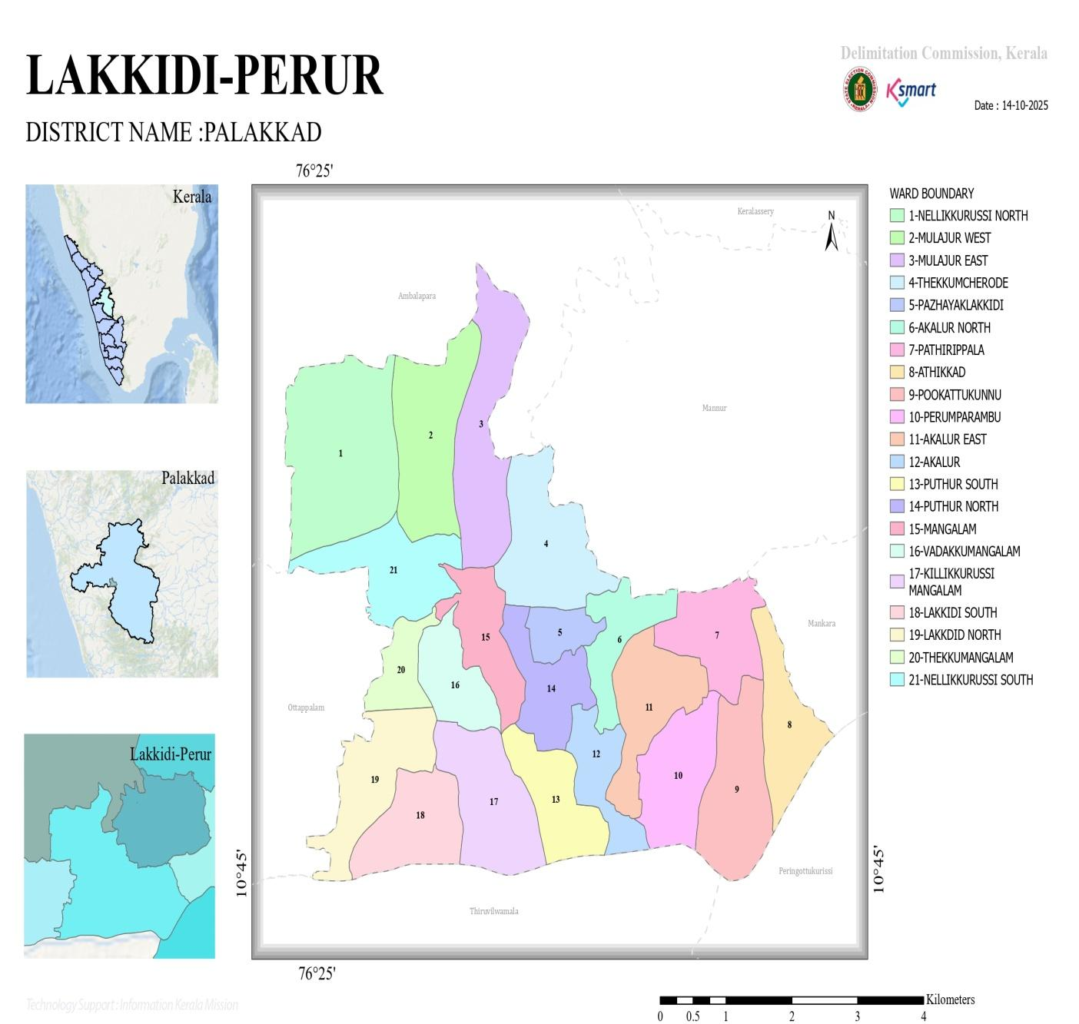

HOT SPOT WARD MAP OF LAKKIDI PERUR

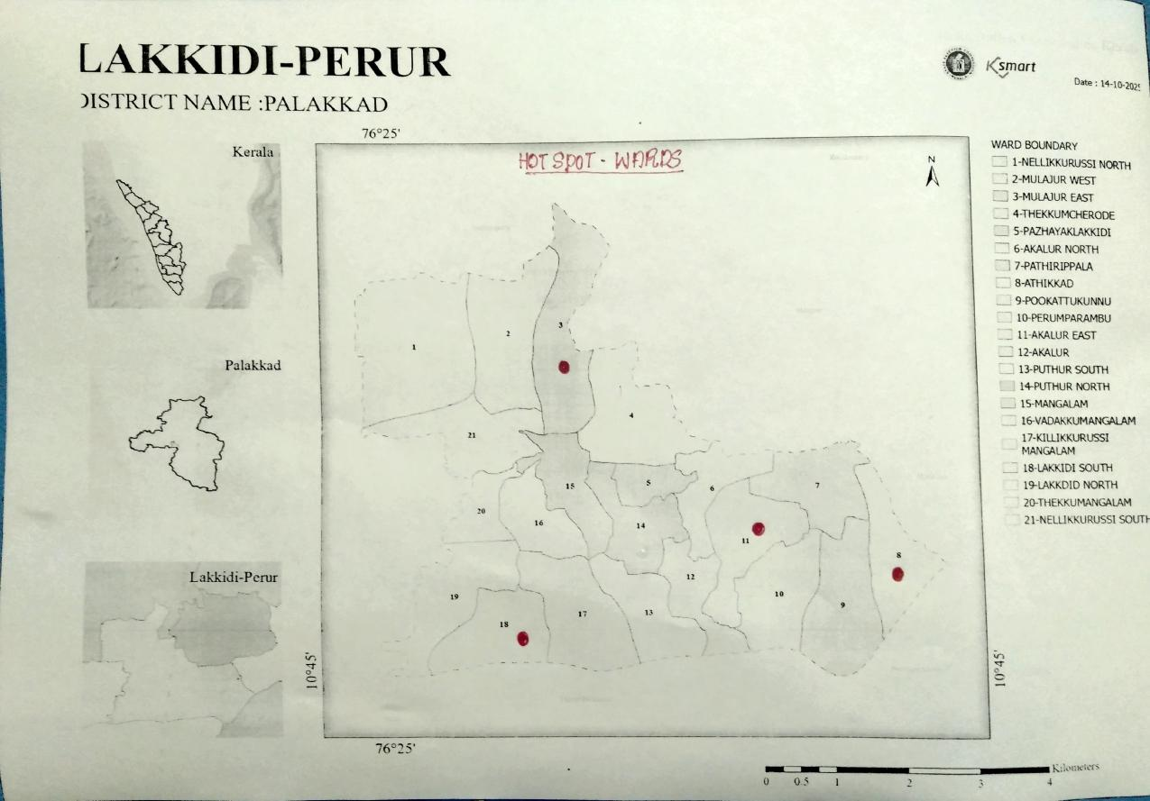

DISASTER PRONE AREA MAP OF LAKKIDI PERUR

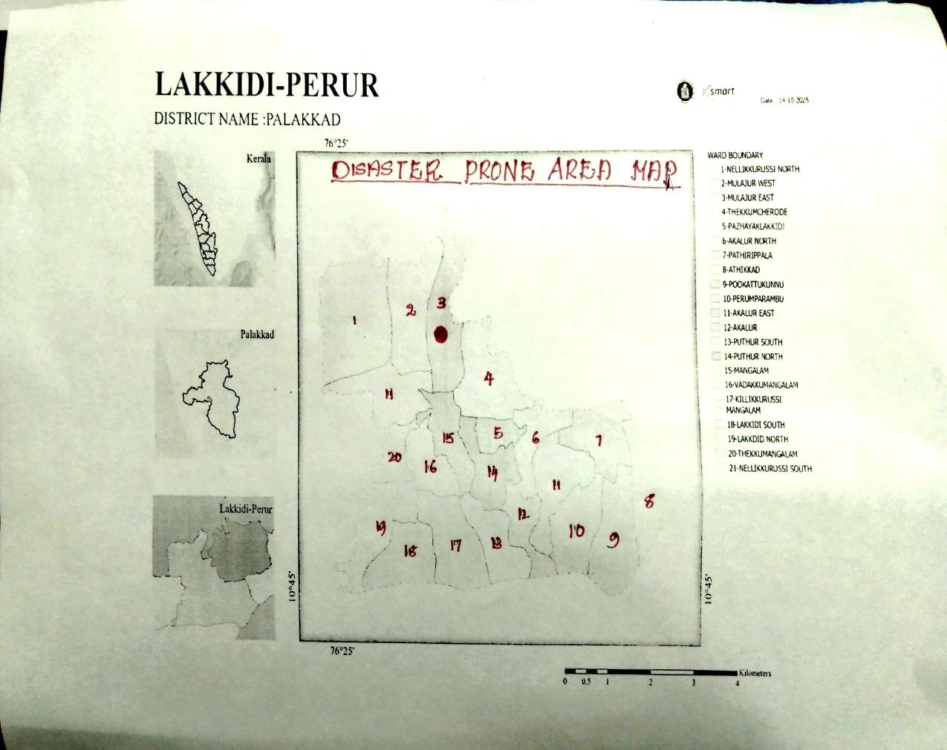

INTEGRATED HEALTH INFRASTRUCTURE MAP OF LAKKIDI-PERUR PANCHAYAT
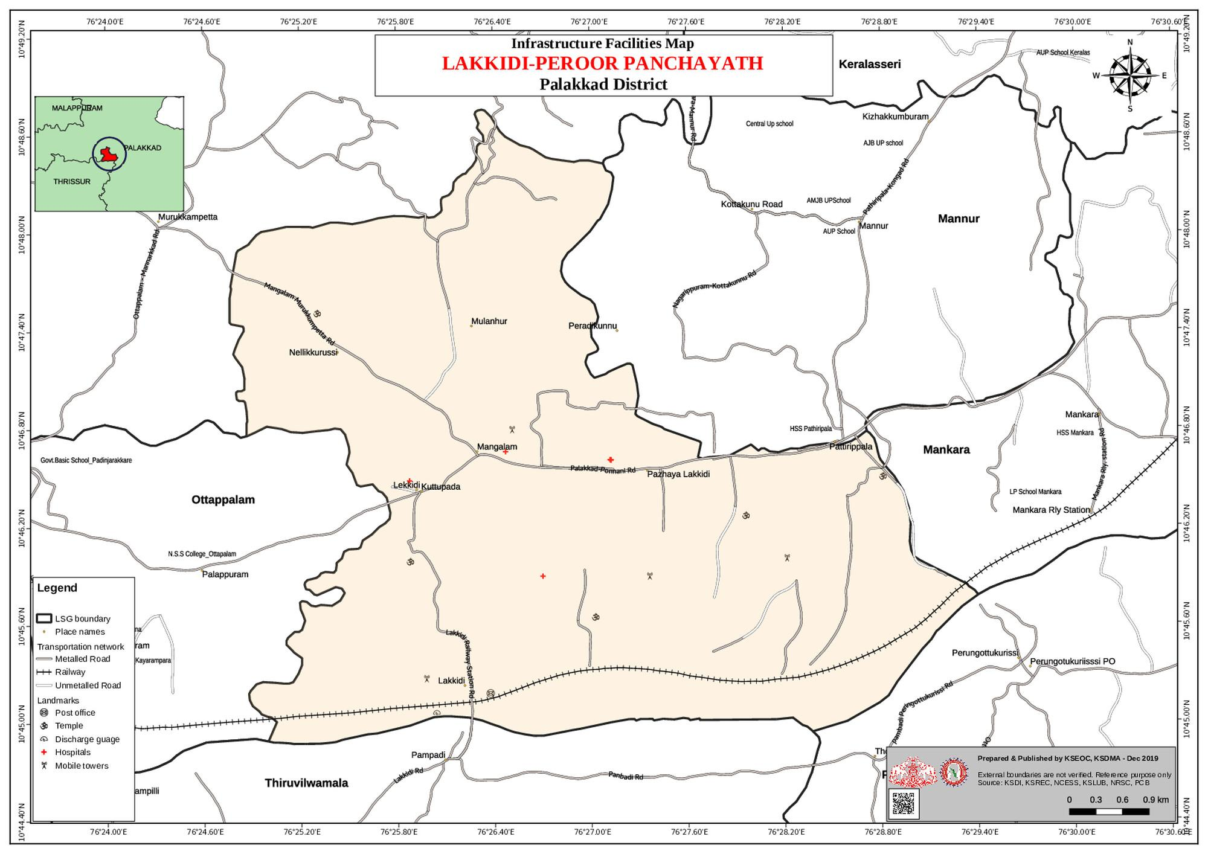

COMMUNICATION MAP OF LAKKIDI-PERUR PANCHAYAT
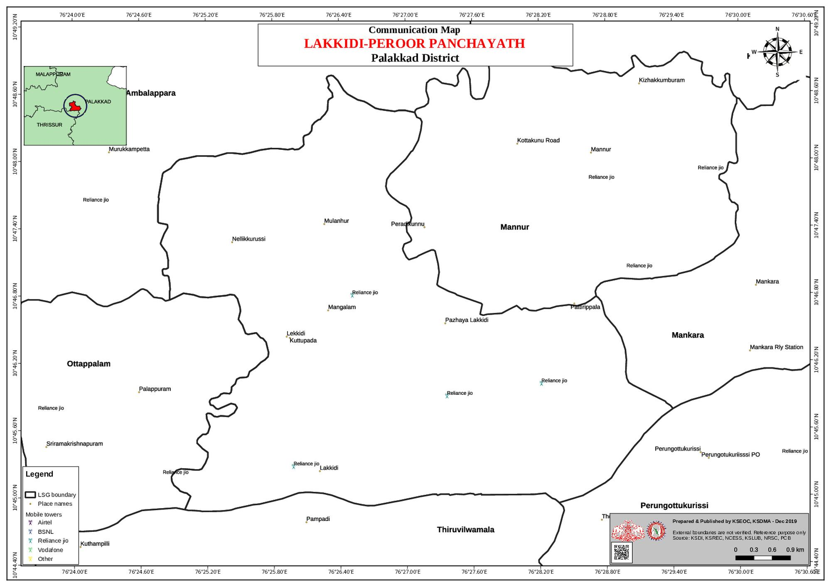

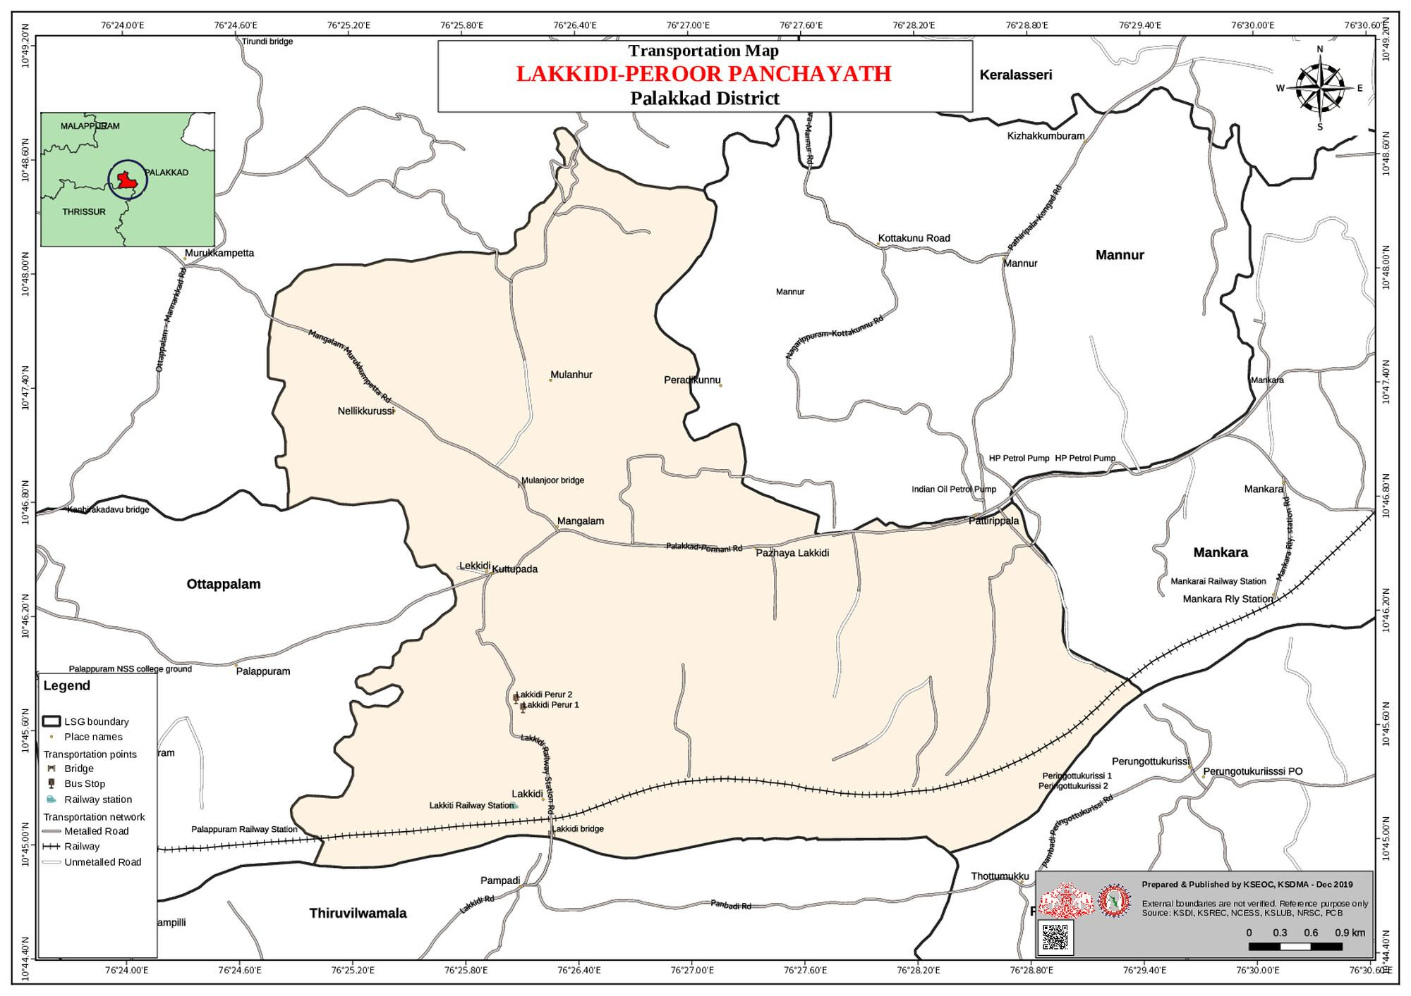
ROAD MAP OF LAKKIDI-PERUR PANCHAYAT

FLOOD PRONENESS VS INFRASTRUCTURE FACILITIES MAP OF LAKKIDI-PERUR PANCHAYAT
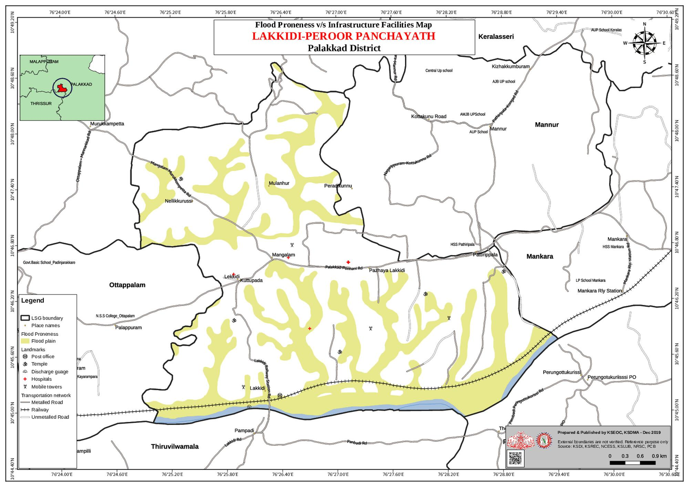

FLOOD PRONENESS VS COMMUNICATION MAP OF LAKKIDI-PERUR PANCHAYAT
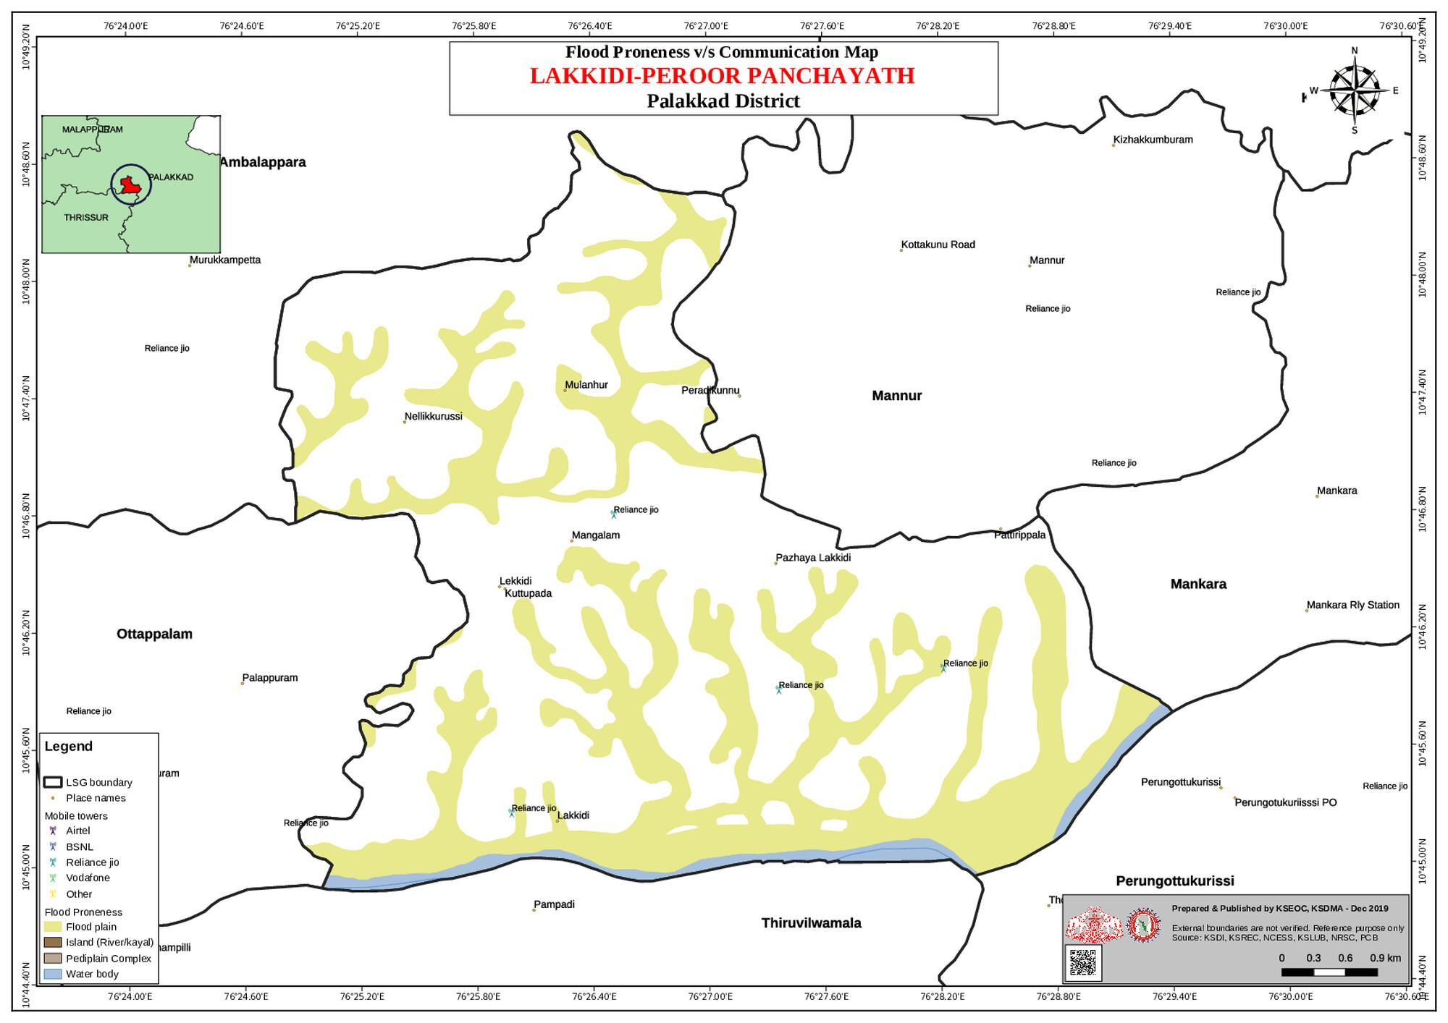

FLOOD PRONENESS VS TRANSPORTATION MAP OF LAKKIDI-PERUR PANCHAYAT
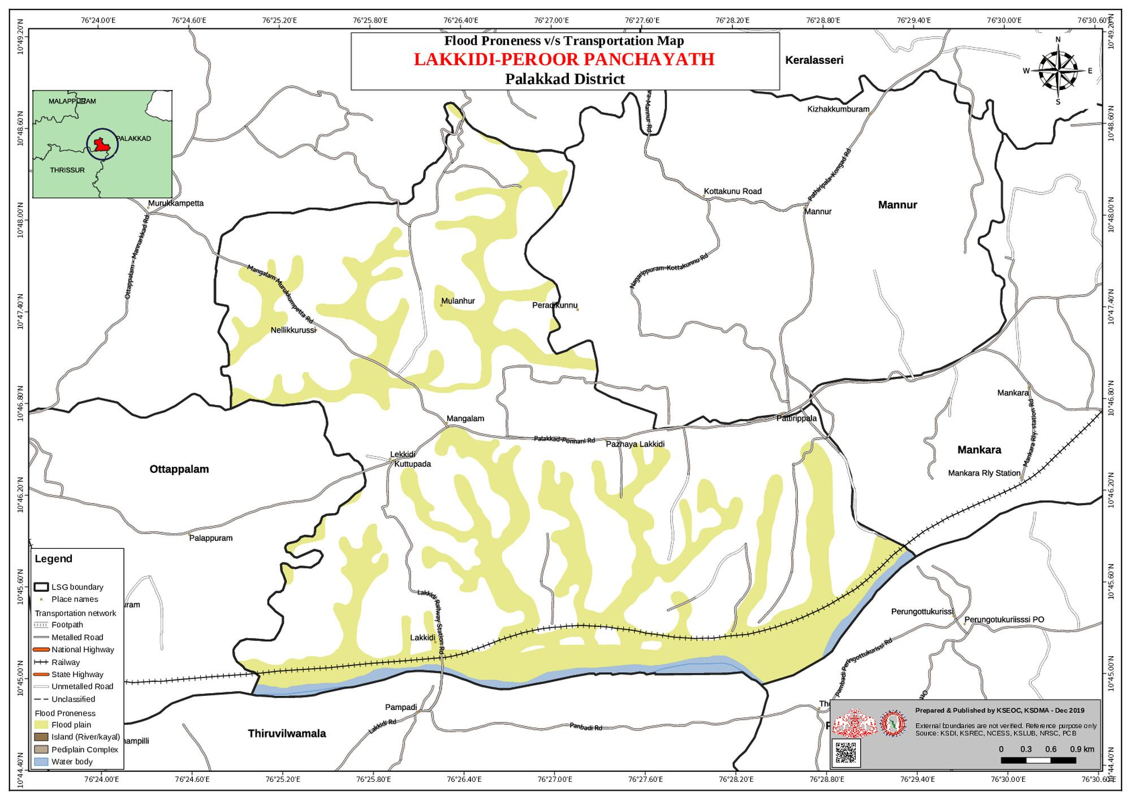

LANDSLIDE PRONENESS VS INFRASTRUCTURE MAP OF LAKKIDI-PERUR PANCHAYAT

LANDSLIDE PRONENESS VS COMMUNICATION MAP OF LAKKIDI-PERUR PANCHAYAT
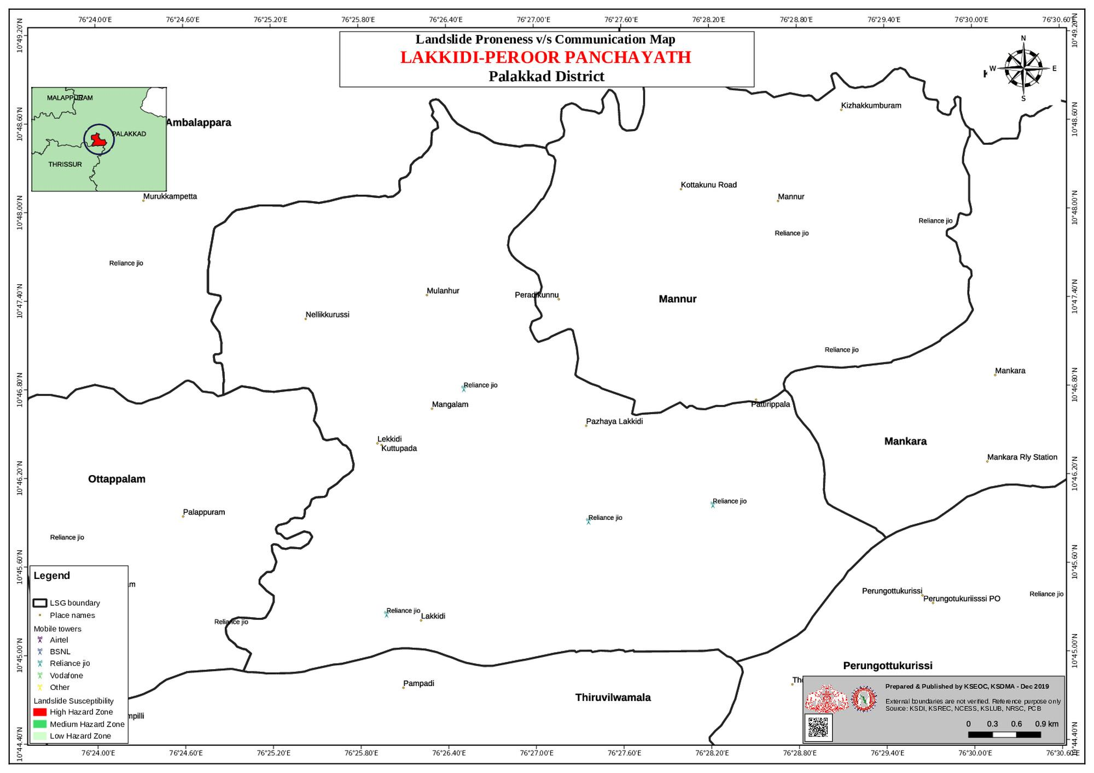

LANDSLIDE PRONENESS VS TRANSPORTATION MAP OF LAKKIDI-PERUR PANCHAYAT
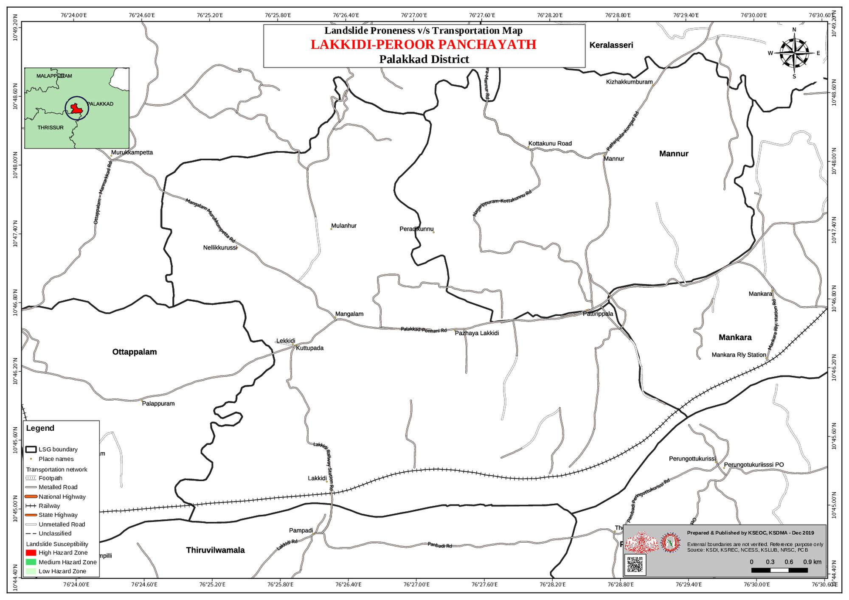

WATER SHED MAP OF LAKKIDI-PERUR PANCHAYAT
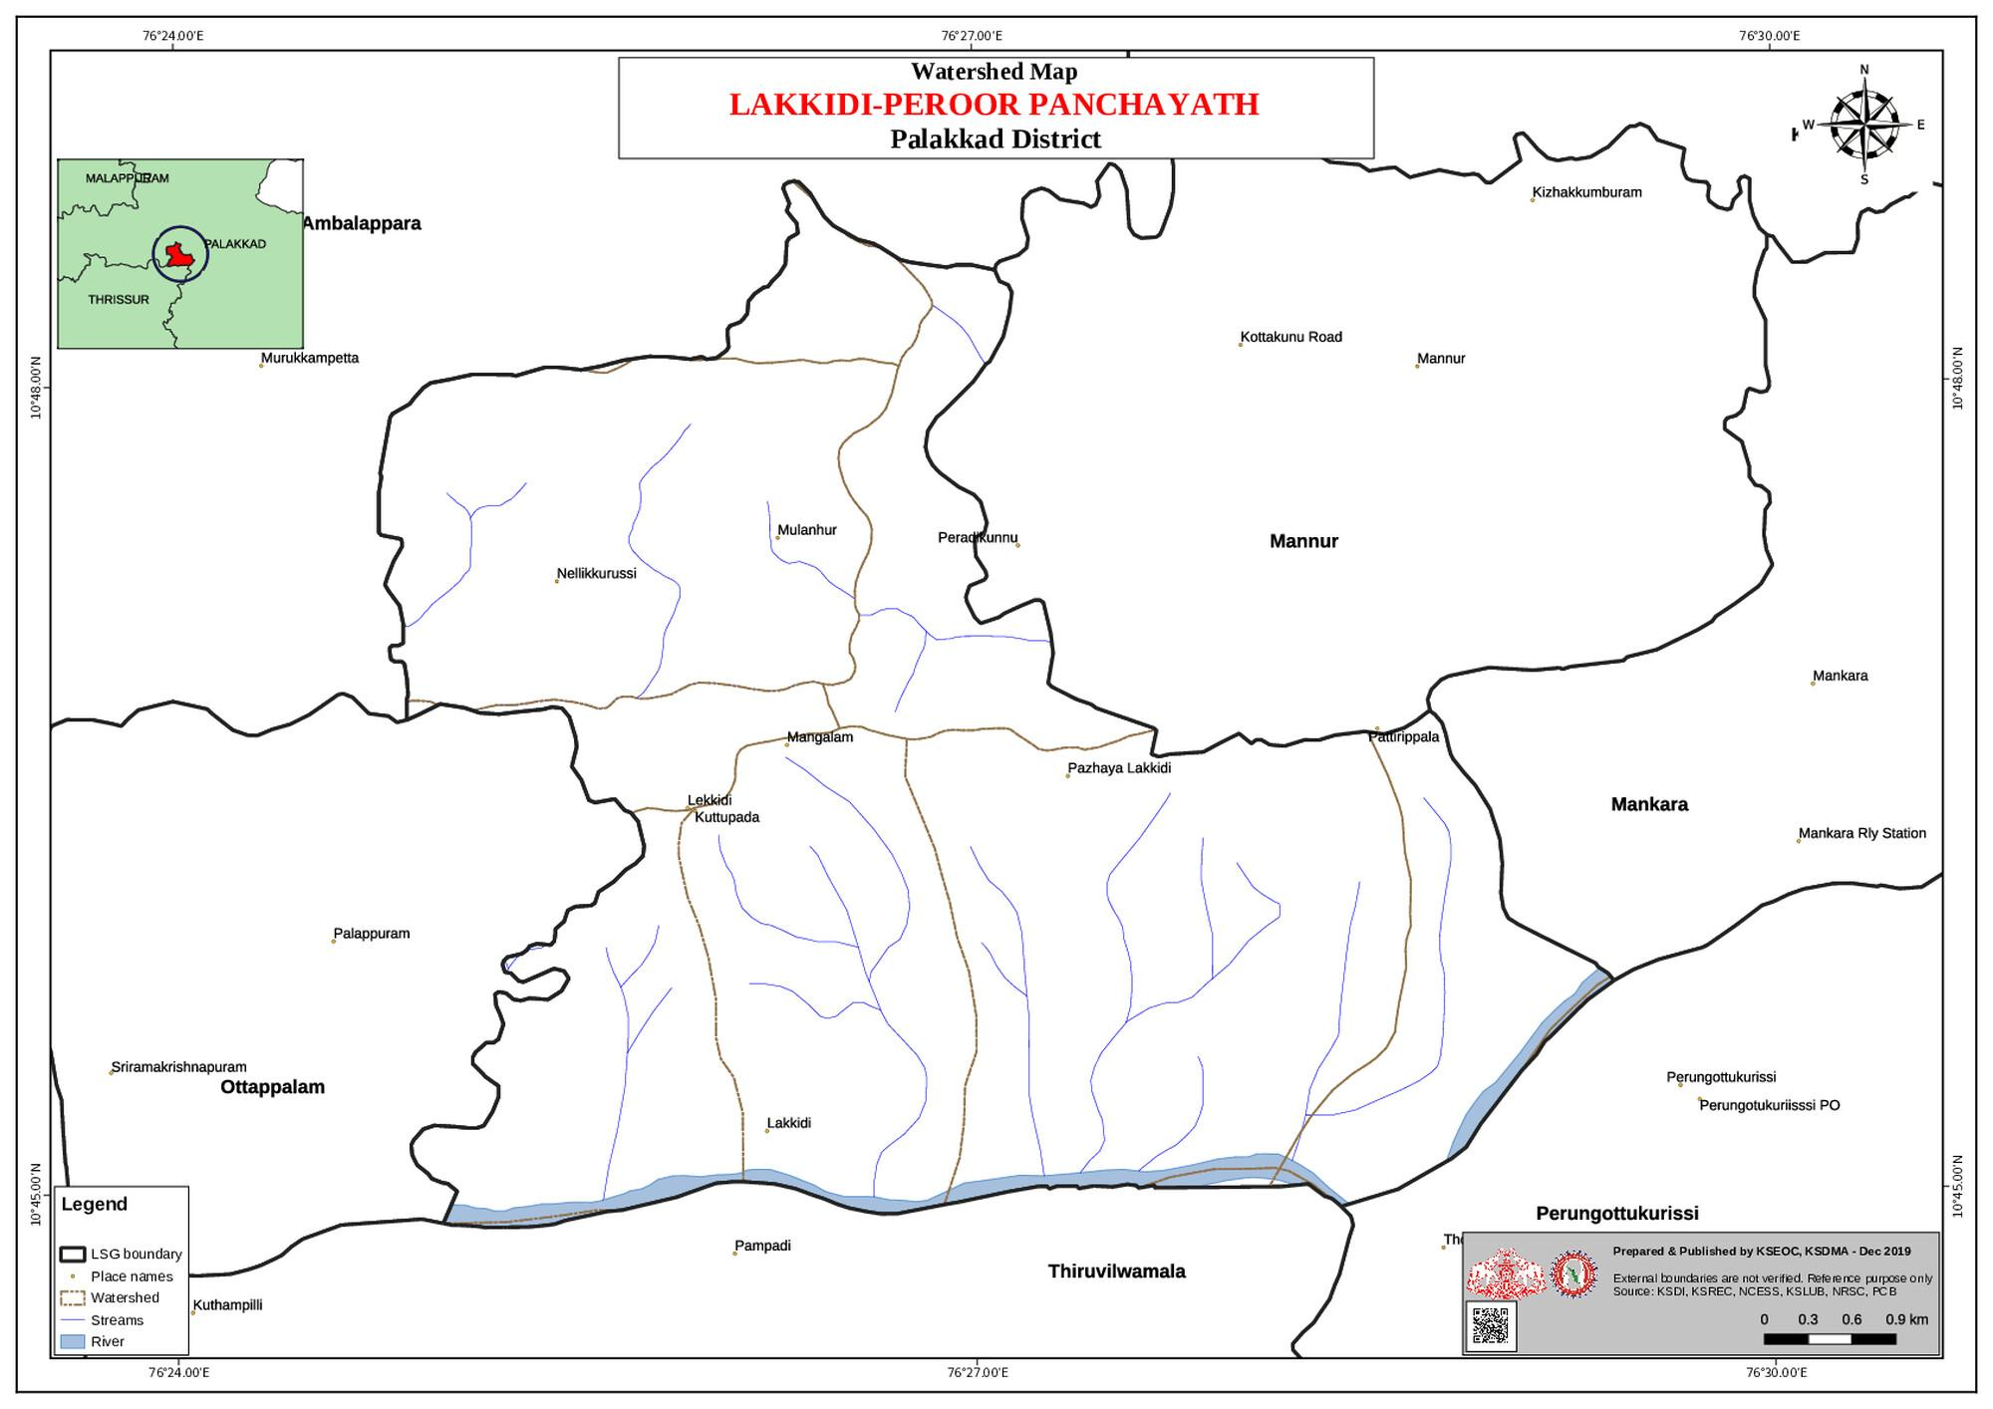

GENERAL PROFILE OF THE LSGI’S

Background of the LSGI
The geographical landscape of Lakkidi–Perur Grama Panchayat is characterized by a mix of low-lying agricultural lands, gently undulating terrain, and scattered water bodies. The presence of paddy fields, canals, streams, and seasonal drainage channels significantly influences the local microclimate and hydrological conditions. During the monsoon season, these natural features contribute to waterlogging and localized flooding in certain pockets, creating challenges for transportation, accessibility, and timely delivery of essential services.
Administratively, the Panchayat is divided into multiple wards with a predominantly rural population. Agriculture continues to be the primary livelihood, with paddy cultivation, coconut farming, banana cultivation, and allied agricultural activities forming the core of the local economy. In addition, small-scale trade, daily wage labour, construction work, and employment in nearby towns contribute significantly to household income. The Panchayat also hosts migrant labourers engaged in construction, agriculture, and service-related sectors, adding to the diversity of the local workforce.
From a public health and disaster management perspective, Lakkidi–Perur Grama Panchayat remains vulnerable to seasonal flooding, water stagnation, and climate-related risks. Post-monsoon periods often witness an increase in waterborne and vector-borne diseases such as Dengue, and Leptospirosis. The severe floods experienced across Kerala in 2018 had indirect and localized impacts within the Panchayat, affecting agriculture, connectivity, and essential services. These recurring environmental challenges underscore the need for strengthened preparedness measures, improved surveillance systems, and effective inter-departmental coordination at the local self-government level.
In this context, the preparation of a localized, data-driven Auxiliary Infrastructure and Logistical Resource Map is essential for Lakkidi–Perur Grama Panchayat. Such a mapping framework will facilitate systematic identification of critical infrastructure, health facilities, evacuation points, transportation routes, and vulnerable zones. It will enhance disaster response efficiency, support evidence-based planning, and contribute to building long-term resilience and sustainable development within the Panchayat.

Table 1: Background of LSGD
Description | Details
Name of LSGI | LAKKIDI PERUR
Type (GP/Municipality / Corporation etc.) | Grama Panchayath
Block | OTTAPALAM
District | PALAKKADU
Number of wards | 21
Total area (sq. km) | 30.79 sq.km
Population(Projected) | 39474
Population density | 1097 persons/sq km
Terrain (coastal/low-lying/backwaters/foothills, etc.) | LOW-LYING
Number of rivers passing through LSGI | 1
Number of water bodies in the LSGI | 32
Number of educational institutions | 20
Factories / small-scale industries | 12
Flood-prone wards | 4
Landslide-prone wards | 1
Death Management and Disposal Facilities (mortuaries/crematorium, including electric) | 0
Auditoriums/Marriage halls/convention centres/community halls | 8
plantations | 25

Demographic and Vulnerable Population
Understanding the demographic composition and vulnerable population groups is essential for pandemic preparedness. Children, elderly, economically deprived families, migrant workers, and socially vulnerable groups are at increased risk during public health emergencies due to higher exposure, limited access to services, and dependency on public systems..

Description |  | Details (in numbers)
DEMOGRAPHIC PROFILE
Total population |  | 39474
Male |  | 18974
Female |  | 20500
Transgender |  | 0
Children under 5 |  | 3124
Adolescent |  | 7142
Elderly (>60) |  | 5564
SOCIAL/LIVELIHOOD VULNERABILITY
Previous EPEP family |  | 44
BPL family |  | 4249
Tribal communities |  | 0
Migration | Immigrant | 194
Migration | Emigrant | 345
Socio-economically deprived |  | 35
Fisherfolk |  | 0
SC Community |  | 2142
ST Community |  | 0

Graphs: Population pyramid (if possible) for seeing if your LSGI has a high "dependency ratio" (lots of children and elderly compared to working adults).

Clinical Vulnerability
Certain population groups needs priority healthcare & are at higher risk of severe illness, complications, and mortality during pandemics. Patients with chronic diseases, those requiring regular medical care, and individuals with mobility or functional limitations face challenges in accessing timely care during emergencies. Mapping these groups helps in prioritizing continuity of treatment, medicine stock planning, oxygen support, referral transport, and targeted home-based care.
Description | Details in numbers
Pregnant women | 121
Lactating mothers | 478
Bedbound patients | 73
Patients under palliative care other than bedbound | 89
Patients on Haemodialysis | 7
Patients on CAPD | 0
Cancer patients (currently on treatment) | 12
Haemophilic patients | 0
Mentally challenged | 18
Differently abled | 210
Diabetic patients | 2312
Hypertensive patients | 2654
TB patients | 14 ( as on February 2026)

Major Festivals & Events specific to the LSGI
(with the possibility of a public gathering)

Sl. No. | Name of festival | Month detailing the periodicity
1 | Kaipekkavil pporam | May
2 | Thekkini ammankavu pooram | april
3 | Moonunnikavu pooram | march
4 | Akaloor kavu Pooram | April
5 | Mulanjoor kavu pooram | february

INFRASTRUCTURE & RESOURCE INVENTORY

Health Facility Directory & Basic Capacity in the LSGD
This section provides an overview of the healthcare infrastructure available within the LSGD area. It outlines the distribution and basic capacity of health facilities that form the backbone of service delivery during routine times and public health emergencies.

Family Health Centres (FHCs) and Community Health Centres (CHCs) generally function as the first point of contact for the community, providing essential outpatient and inpatient services. General Hospitals (GH) and Medical College Hospitals (MCH), where accessible, serve as the main referral centres for advanced diagnostics, specialist care, and critical services during public health emergencies. This inventory helps identify existing strengths, gaps, and potential surge capacity that can be mobilised during a pandemic or disaster.

Table 5. Health Facility Resource Summary
Sl.no. | Health Facility | Type of Facility (MCH/GH/CHC/FHC/SC etc.) | Contact Number | Total beds | ICU Beds | Oxygen-Supported Beds | No. of Ventilator Support Beds | No. of ambulances
Government Healthcare Facilities
1 | FHC Perur | FHC | 9744460011 | 0 | 0 | 0 | 0 | 1
2 | MAIN CENTER | HWC | 7034946415 | 0 | 0 | 0 | 0 | 0
3 | AKALOOR | HWC | 8943558634 | 0 | 0 | 0 | 0 | 0
4 | LAKKIDI | HWC | 9961636110 | 0 | 0 | 0 | 0 | 0
5 | PUTHUR | HWC | 9072792606 | 0 | 0 | 0 | 0 | 0
6 | MULANJUR | HWC | 8606334867 | 0 | 0 | 0 | 0 | 0
7 | FHC LAKKIDI | GOVT | 9497368959 | 0 | 0 | 0 | 0 | 0
Private Healthcare Facilities
1 | MITHRA | PVT | 8848540455 | 0 | 0 | 0 | 0 | 1
2 | DAYA CLINIC | PVT | 9495607498 | 0 | 0 | 0 | 0 | 0
3 | MIND CARE REHABILITATION CENTER | PVT | 9745444100 | 0 | 0 | 0 | 0 | 0
4 | SATHYA MEDICAL CENTER | PVT | 9745988869 | 0 | 0 | 0 | 0 | 0
5 | THAIKKATTIL | PVT | 9745650155 | 0 | 0 | 0 | 0 | 0
AYUSH Healthcare Facilities
1 | AYURVEDA HOSPITAL | GOVT | 9447344793 | 0 | 0 | 0 | 0 | 0
2 | HOMEO HOSPITAL | GOVT | 9446157008 | 0 | 0 | 0 | 0 | 0

Private Clinics
Private clinics are an essential part of pandemic preparedness, as they are often the first place people seek care when symptoms begin. In many communities, private clinics manage a significant share of outpatient visits and therefore play a critical role in early case detection, timely referrals, and disease surveillance. Having an up-to-date understanding of where these clinics are located, the services they provide, and how they are linked to the public health system helps ensure that no cases are missed during an outbreak. It also allows health authorities to engage private practitioners more effectively for reporting, risk communication, and coordinated response, strengthening the overall capacity of the health system to manage public health emergencies.

Table 6. Private Clinic Resource Summary
Sl No. | Name of Clinic | Registered (Y/N) | Clinic (General / Speciality) | Speciality (if any) | Address | Contact Number | Diagnostic Facility (Y/N) | Ambulance Linkage (Y/N)
 | mithra | y | general | NA | PERUR | 8848540455 | Y | Y
 | DAYA CLINIC | Y | general | NA | PERUR | 9495607498 | N | N
 | SATHYA MEDICAL CENTER | Y | general | NA | PERUR | 9745988869 | N | N
T | THAIKKATTIL | N | general | NA | LAKKIDI | 9745650155 | Y | N

Healthcare Education & Training Institutions
This section tracks the educational infrastructure available, which is vital for human resource planning in the health sector.

Category of Institution | Govt | Private | AYUSH | Total
Medical Colleges | 0 | 0 | 0 | 0
Nursing Colleges | 0 | 0 | 0 | 0
Dental Colleges | 0 | 0 | 0 | 0
Para-medical / Allied Health | 0 | 1 | 0 | 1
Pharmacy Colleges | 0 | 0 | 0 | 0

Specialized Services & Emergency Inventory
This section provides a detailed view of the specialized medical resources available to the community, focusing on emergency response and critical care capabilities. This table tracks the vital assets required for managing severe illnesses and emergencies across Government, Private, and AYUSH sectors.

Item | Govt | Private | AYUSH | Total
Hospital beds | 2 | 2 | 0 | 4
Oxygen-generating systems(Y/N) | 0 | 0 | 0 | 0
Oxygen-supported beds(Numbers) | 0 | 0 | 0 | 0
Ventilator-supported beds | 0 | 0 | 0 | 0
ICU beds | 0 | 0 | 0 | 0
Burns units | 0 | 0 | 0 | 0
Blood centres | 0 | 0 | 0 | 0
BLS ambulances | 0 | 0 | 0 | 0
ALS ambulances | 0 | 0 | 0 | 0
Dialysis facilities | 0 | 0 | 0 | 0
Dispensaries | 0 | 0 | 0 | 0
Medical store | 2 | 0 | 0 | 0
Industrial establishments(Medium-scale industries/small-scale industries establishments to whom we can depend in a worst-case scenario) | 0 | 1 | 0 | 1
00 2 0 2

Oxygen & Diagnostic Capacity
Monitoring oxygen and diagnostic capacity is a critical component of public health preparedness, ensuring that the LSGD can handle both chronic care and sudden surges in respiratory or infectious diseases.
Name of Health Facility | Oxygen-generating System (Y/N) | Backup Oxygen Source (Y/N) | Diagnostic Facilities Available(Y/N)
Name of Health Facility | Oxygen-generating System (Y/N) | Backup Oxygen Source (Y/N) | Lab | USG | X-ray | CT/MRI | RT-PCR
Government Healthcare Facilities
FHC PERUR | NO | YES | YES | NO | NO | NO | NO
FHC LAKKIDI | NO | YES | YES | NO | NO | NO | NO

Diagnostics facility mapping at the LSGI level
The diagnostic capacity of Lakkidi perur G.P represents the "intelligence network" of our healthcare system. The speed and accuracy of disease identification depend entirely on the distribution and technical level of these facilities.

Item | Govt | Private | AYUSH | Total
General labs | 2 | 8 | 0 | 10
Microbiology labs | 0 | 0 | 0 | 0
RT-PCR labs | 0 | 0 | 0 | 0
USG units | 0 | 0 | 0 | 0
CT/MRI units | 0 | 0 | 0 | 0
Research labs | 0 | 0 | 0 | 0
Labs of other departments that can be repurposed | 0 | 0 | 0 | 0

Laboratory Identification & Basic Details
Sl. No. | Name of Laboratory | Ownership (Govt / Private / Academic) | Address | Contact No. | 24×7 Services (Yes/No) | NABL / Govt Approved (Yes/No)
1 | FHC PERUR | GOVT | PATHIRIPPALA | 9744460011 | NO | NO
2 | FHC LAKKIDI | GOVT | KOOTTUPATHA | 9497368959 | NO | NO
3 | JOTHIS | PVT | KOOTTUPATHA | 9847941599 | NO | NO
4 | THAIKKATIL | PVT | PATHIRIPPALA | 9745650155 | NO | NO
5 | HABIS | PVT | OLD LAKKIDI | 9946425342 | NO | NO

Social and Community Infrastructure for surge plan
This table serves as our logistics and shelter inventory. By mapping these locations, quickly we can identify where to house displaced citizens, where to set up temporary medical clinics, and how to manage the deceased with dignity during a crisis.

Category | Total Count | Ward | Est. Capacity (Persons) | Contact details
Educational Institutions
Anganwadis | 33 | 20 | 5 | 8089337345
Schools | 20 | 18 | 2000 | 8304971839
Colleges | 4 | 4 | 5000 | 9746107487
Healthcare Educational Institutions
Medical colleges (Govt/Private) | 0 | NA | NA | NA
Nursing colleges (Govt/Private) | 0 | NA | NA | NA
Dental colleges (Govt/Private) | 0 | NA | NA | NA
Paramedical institutes (Govt/Private) | 0 | NA | NA | NA
Community Gathering Spaces
Community halls | 2 | 2 | 200 | 9746107487
Auditoriums | 1 | 1 | 100 | 8304971839
Religious buildings | 10 | 8 | 700 | NA
Vulnerable Group Support Facility
Destitute homes | 0 | 0 | 0 | 0
Elderly homes | 0 | 0 | 0 | 0
LSGD owned other buildings
Mass Fatality Management (MFM) Infrastructure
Mortuary | 0 | 0 | 0 | 0
Crematorium | 0 | 0 | 0 | 0
*refer annexure 1 for contact details

Human resources
This section focuses on the human capital available within the LSGI. In any emergency—be it a pandemic, flood, or industrial accident—infrastructure is only as effective as the people operating it.

Medical & Clinical Personnel
This table tracks the "Frontline" providers responsible for diagnosis, treatment, and clinical management. Narrative sentence: eg., "Total health workforce: 450 personnel, with 60% in government facilities serving as primary surge capacity." A detailed directory with the contact numbers of all workers is maintained (Annexure in 1).

Cadre | Govt (No.) | Private (No.) | Total
Doctors—Modern Medicine | 2 | 5 | 2
Doctors – AYUSH | 1 | 0 | 1
Doctors – Veterinary | 1 | 0 | 1
Doctors – Dental | 0 | 3 | 3
Nursing officers | 0 | 0 | 0
Lab technicians | 1 | 14 | 15
Optometrist | 0 | 0 | 0
Pharmacists | 2 | 10 | 12
Psychologists | 0 | 0 | 0
Counsellors | 0 | 0 | 0

Public Health & Field-Level Workforce
These individuals are the backbone of surveillance, maternal-child health, and decentralized care.

Cadre | Health services | Municipal common services | Total
HS (Health Supervisors) | 0 | 0 | 0
HI (Health Inspectors) | 1 | 0 | 1
LHS (Lady Health Supervisor) | 0 | 0 | 0
LHI (Lady Health Inspectors) | 1 | 0 | 1
JPHN (Jr Public Health Nurses) | 6 | 0 | 6
JHI (Jr Health Inspectors) | 3 | 0 | 3
MLSP (Mid-Level Service Providers) | 6 | 0 | 6
Palliative Nurses | 1 | 0 | 1
RBSK Nurses | 1 | 0 | 1
PRO | 0 | 0 | 0
Epidemiologist | 0 | 0 | 0
Data Manager | 0 | 0 | 0

Community & Support Cadre
This group represents the surge capacity of the LSGI—people who can be called upon for logistics, rescue, and specialized support.

Cadre | Number
ASHA Workers | 19
AWW (Anganwadi Workers) | 32
Emergency Medical Volunteers (Trained) | 0
Kudumbashree | 310
MNREGS | 565
Purusha Swayam Sahaya Sangham | 0
Ex-Servicemen | 54
Retired Police Officers | 32
NCC/NSS Volunteers | 178
Red Cross volunteers | 0
One Health Community Volunteers | 171
One Health Community Mentors

Community Organizations
This section details the presence of community-based organisations (CBOs), non-governmental organisations (NGOs), faith-based organisations (FBOs), Kudumbashree Self-Help Groups (SHGs), and Ayalkootams within the Local Self-Government Institution (LSGI). These groups enhance grassroots mobilization, resource distribution, and support networks crucial for pandemic response and community resilience.

Category | Total Count
NGOs | 1
Religious based organizations | 18
Foreign based organizations | 0
Sports Club/youth clubs | 37
Kudumbashree SHGs | 310
Ayalkootams | 310
Political organizations | 21
Residential organizations | 43

Administrative & Emergency Services
This section outlines the availability of key non-health emergency support services and infrastructure within the LSGI, which are essential for effective pandemic preparedness and response. These facilities support law enforcement, disaster response, water supply, logistics, mobility, and community-level interventions during public health emergencies.

Category | Total Count | Contact details
Police Stations | 0 | NA
Fire & Rescue Stations | 0 | NA
Water Pumping Points | 1 | 9847541247
Public Distribution System (PDS) | 12 | NA

Information regarding resources
The availability of essential transport and support resources plays a quiet but critical role in saving lives. Equipment such as ambulances, mobile mortuaries, amphibian ambulances, and motorized boats ensures that patients, samples, and healthcare teams can move swiftly—even in flooded, remote, or difficult terrains. Heavy vehicles like JCBs, cranes, tractors, and torus lorries support logistics, waste management, emergency infrastructure, and rapid conversion of spaces into care or isolation facilities. Taxis, four-wheel-drive vehicles, and trucks help maintain continuity of essential services, reach vulnerable populations, and support home-based care and supply delivery.

Means of transportation | Total Count
JCB | 8
Crane | 0
Heavy Trucks | 3
Tractor | 3
Ambulances | 5
Mobile mortuaries | 0
Boats | 0
Taxi service | 38
Note: For specific details regarding vehicle owners and contact information, please refer to Annexure [X].

ONE HEALTH & ENVIRONMENTAL SURVEILLANCE
The One Health method integrates environmental, animal, and human health to enable proactive pandemic preparedness. Panchayat-level surveillance needs to be improved in order to detect and treat zoonotic and environmentally generated diseases early. Surveillance is strengthened through systematic assessment of animal populations, veterinary infrastructure, poultry and slaughter facilities, inter-sectoral coordination, and specialised tools like avian influenza seasonality mapping using GIS in previous outbreaks to enable predictive alerts and ward-specific sampling to support effective pandemic preparedness in high-risk areas.

Animal & Bird Population
Mapping animal and bird populations at the Panchayat level is essential for identifying and prioritising zoonotic disease hazards like rabies, avian influenza (H5N1), leptospirosis, anthrax, and Nipah-like spillover occurrences. Risk classification, targeted surveillance, vaccination planning, and early epidemic detection made feasible by comprehensive population mapping all enhance One Health-based pandemic preparedness.

Category | Item | Estimated Population | Wards
Animal Population | Livestock (Cattle/Goats/Buffalo) | 2334 | ALL WARDS
Animal Population | Pet Animals (Dogs/Cats) | 3547 | ALL WARDS
Animal Population | Stray Dog Population | 54 | ALL WARDS
Animal Population | Pig Farms (Number of heads) | 0
 | Small Units (Sheep / Goats – clustered) | 0
Bird Population | Poultry Units (Birds) | 0
Bird Population | Poultry- (FOWL) | 12021 | ALL WARDS
Bird Population | Wild/Migratory Birds (Observed) | 200 | ALL WARDS
Bird Population | Crow Mortality Events (Reported) | NIL

The stray dog population in market areas, fish landing sites, bus stations continues to be a substantial problem for rabies surveillance and bite prevention. There is a considerable risk of avian influenza introduction and amplification during November - December due to the seasonal presence of migratory and resident water birds near ponds/ canal / river / backwater / paddy field.

Veterinary Infrastructure
Veterinary institutions are a core pillar of One Health surveillance, enabling early zoonotic disease detection through vaccination, investigation of unusual animal illness or deaths, sample collection, and timely outbreak reporting. A well-mapped and responsive veterinary network strengthens coordination with human health and LSGI systems, ensuring rapid response during zoonotic events and pandemics.
Facility Type | Name of Facility | Ownership Govt / Pvt | Location(Ward No) | Contact number
Veterinary Dispensary | 0 | 0 | 0 | NA
Veterinary Hospital / Polyclinic | 1 | GOVT | 15 | 9447968843
Private Veterinary Clinics | 0 | 0 | 0 | NA
Mobile / Emergency Vet Service (incl. night services) | 0 | 0 | 0 | NA
Pet Homes / Animal Shelters | 0 | 0 | 0 | NA
Slaughterhouse-linked Veterinary Inspection Unit | 0 | 0 | 0 | NA

Veterinary Doctors & Workforce
Early detection, diagnosis, reporting, and reaction to animal illness epidemics depend on the availability and accessibility of qualified veterinary specialists. By identifying unusual animal morbidity or mortality promptly, collecting samples promptly, and coordinating efficiently with human health and LSGI systems—especially during zoonotic outbreaks and pandemic-prone situations—a clearly defined veterinary workforce enhances One Health surveillance.

Category | Number Available | Type (Govt/Pvt) | Contact number
Government Veterinary Doctors | 1 | GOVT | 9447968843
Private Veterinary Doctors | 0 | 0 | 0
Livestock Inspectors | 2 | GOVT | 9447968843
Para-veterinary Staff / Attenders | 0 | 0 | 0
Contract / On-call Veterinary Support (if any) | 0 | 0 | 0

High-Risk Interface Points (Surveillance Sites)
High-risk interface points for zoonotic disease surveillance in Lakkidi Perur Grama Panchayath include wetland–livestock–human contact zones, backyard poultry farms, cattle sheds near water bodies, fish markets, and areas of high human–animal interaction such as community slaughter points and migratory bird congregation sites. These are the primary surveillance sites where zoonotic spillover risks are elevated.

Type of Habitat | Type of High risk interface | Geographical vulnerability
Wetlands & Backwaters | 0 | 0
Backyard Poultry Farms | 0 | 0
Cattle Sheds near Water Bodies | 0 | 0
Fish & Meat Markets | 0 | 0
Community Slaughter Sites | 0 | 0
Migratory Bird Congregation Areas | 2 | LOW
Rodent-Infested Grain Storage | 0 | 0

Category | Total Count | Key Locations (wards)
Poultry Farms | 0 | 0
Backyard / Clustered Poultry Units | 0 | 0
Duck Rearing Units (open water access) | 0 | 0
Slaughterhouses/ Slaughter Points | 0 | 0
Meat/Fish Markets | 0 | 0
Live Bird Sale Points | 0 | 0
Cattle Markets / Weekly Animal Fairs | 1 | 6
Pet Shops / Breeders | 0 | 0
Animal Shelters / Pet Homes | 0 | 0
Waste Disposal Sites near Animal Units | 0 | 0

Environmental Risk Mapping
Environmental risk mapping identifies monsoon/flood hotspots for vector-borne (dengue, chikungunya), water-borne (leptospirosis, diarrhoea), and zoonotic diseases in Kerala's wetlands. Systematic surveillance supports early warnings, targeted interventions, and Panchayat pandemic preparedness.
Waterborne exposure: Flood-prone areas and stagnant water bodies facilitate leptospira survival, raising leptospirosis risk.

Traditional practices: Informal slaughter and fish markets lack standardized hygiene, creating spillover opportunities.

Risk Factor | High-Risk Wards | Key Locations | Risk Level (High/Med/Low)
Flood-prone areas | 1 | ENGORA | MEDIUM
Water bodies/wetlands | 1 | PALLAM | HIGH RISK
Solid waste accumulation | 1 | ATHIRKADU | MEDIUM
Animal waste disposal issues | 0 | NA | NA
Rodent infestation zones | 3 | KALLAMPARAMBU,PALLAM,MULANJUR,  KATHIRPARAMBU | MEDIUM
Industrial effluent discharge | 0 | NA | NA
Construction sites / abandoned buildings | 8 | MULAJUR,PUTHUR,AKALUR,LAKKIDI | LOW
Poor drainage/blocked canals | 3 | POOOKATTUKUNNU ROAD,LAKKIDI GATE,OLD LAKKIDI | HIGH
Drinking water source contamination risk | 0 | NA | 0

Disease Seasonality Mapping
1, Flooding & waterlogging → amplifies leptospirosis, malaria, diarrheal diseases.
·
2, Migratory bird influx (Nov–Feb) → avian influenza risk.

3, Mosquito breeding cycles → vector-borne disease peaks in monsoon.

4, Agricultural practices → close human–animal contact in paddy fields.

Disease | Peak Risk Season | Key Drivers | High-Risk Locations | Surveillance Focus
Avian Influenza | SUMMER | MIGRATORY BIRDS | KATHIRPARAMBUPADDY ,THEKKUMCHIRODE | ONE HEALTH
Leptospirosis | Monsoon | Rain, unhygienic conditions | PALLAM,KALLAMPARAMBU | Ihip, private clinics fever cases
Dengue/Chikungunya | Monsoon | Rainy sseason,lack of waste mangement | KOZHISSERIKALAMPADI,KATHIRPARAMBU | Ihip, private clinics fever cases
Acute Diarrheal Diseases | Monsoon | Rain , fesitalvs | ALL WARD, | Ihip, private clinics fever cases
Rabies | All season | NA | NA | Op reports
Anthrax (rare) | All season | NA | NA | Ihip,

Vulnerability Mapping
Vulnerability mapping pinpoints high-risk populations, occupations, and areas exposed via environment, livelihoods, socio-economics, and poor service access. Paired with environmental/seasonality mapping, it enables risk-based surveillance, targeted actions, and optimal resource use in One Health and pandemic planning.

Vulnerability Factor | High-Risk Wards | Key Groups / Locations | Risk Level
Flood-prone households | 8,3 | PALLAM,MULANJUR | MEDIUM
Wetland-adjacent communities | NA
Backyard poultry / duck rearing households | NA
Livestock-rearing households | 45 | POOKATTUKUUNNU,LAKKIDI,PERUR | LOW
Slaughterhouse & meat market workers | NA
Fisherfolk & fish market workers | NA
Sanitation workers
Daily wage / migrant workers | 197 | LAKKIDI,PUTHUR,ATHIRKADU,MULANJUR, | LOW
Elderly & chronically ill populations | 5391 | ALL WARD | MEDIUM
Pregnant Women | 57 | ALL WARDS | MEDIUM
Children (schools, Anganwadi’s)
Limited access to safe water & sanitation | 3 | KOZHISSERIKALAMPADI,KATHIRPARAMBU,LAKKIDI NORT,LEKSHAMVEEDU COLONY | MEDIUM

EPIDEMIOLOGICAL TRENDS (2021–2025)

Disease surveillance is the systematic collection, analysis, and interpretation of health data for planning, implementation, and evaluation of public health practice. This section presents the disease surveillance profile of the LSGI based on routine reporting systems and outbreak investigations to identify priority diseases, seasonal patterns, and emerging public health threats.

Disease Burden among human beings(Last 5 Years)
Analysis of disease-wise data for the last five years helps identify persistent public health problems, emerging diseases, and changes in disease burden. This information supports prioritisation of prevention, preparedness, and response activities at the Panchayat level.

Disease | 2021 | 2022 | 2023 | 2024 | 2025 | Trend(Increasing/Stable/Decreasing)
Dengue | 8 | 5 | 62 | 29 | 14 | Decrease
Leptospirosis | nil | 2 | 4 | 2 | 2 | Decrease
Hepatitis A | 0 | 0 | 8 | 1 | 12 | Increase
Malaria | 2 | 1 | 0 | 2 | 1 | decrease
Scrub Typhus | 0 | 0 | 0 | 1 | 0 | decrease
Typhoid | 0 | 3 | 4 | 2 | 1 | decrease
H1N1 | 0 | 0 | 3 | 3 | 0 | decrease
H3N2 | 0 | 0 | 0 | 0 | 0 | na
ADD | 29 | 35 | 37 | 42 | 97 | increase
Mumps | 0 | 0 | 1 | 104 | 3 | decrease
Measles | 0 | 0 | 6 | 10 | 1 | decrease
Hepatitis B | 0 | 0 | 0 | 2 | 0 | decrease
Hepatitis C | 0 | 0 | 0 | 0 | 0 | na
Tuberculosis | 19 | 23 | 20 | 20 | 28 | increase
Leprosy | 0 | 0 | 1 | 1 | 0 | decrease
COVID-19 | 0 | 0 | 0 | 0 | 0 | decrease

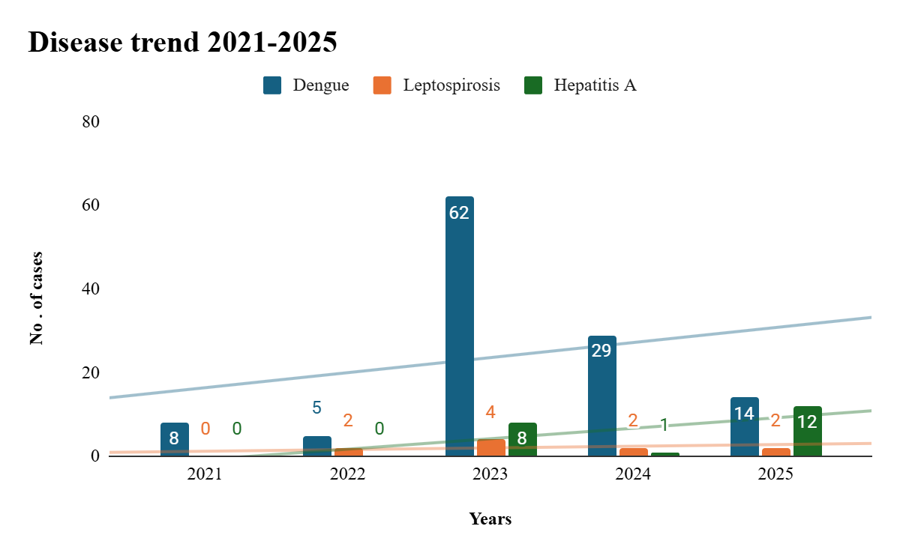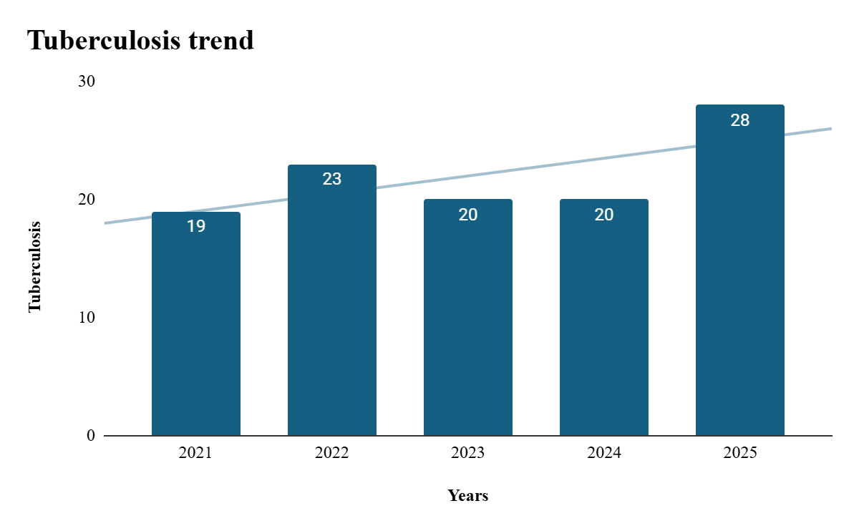

Seasonal Trend Analysis
Seasonal analysis helps anticipate surges (e.g. dengue in monsoon, leptospirosis after floods, influenza in cooler months) and plan pre-emptive vector control, stockpiling of IV fluids, and awareness campaigns at Panchayat level.

DENGUE
Dengue is a major seasonal vector-borne disease strongly associated with rainfall, water stagnation, and increased mosquito breeding during the monsoon period.

Peak: July–November

Dengue – Ward-wise Yearly Distribution (2021–2025)

Ward | Dengue – Ward-wise Yearly Distribution
Ward | 2021 | 2022 | 2023 | 2024 | 2025 | Total
1 | 0 | 0 | 1 | 1 | 0 | 2
2 | 1 | 0 | 3 | 3 | 0 | 7
3 | 0 | 0 | 3 | 2 | 3 | 8
4 | 1 | 0 | 7 | 0 | 0 | 8
5 | 1 | 0 | 3 | 2 | 0 | 6
6 | 0 | 0 | 8 | 0 | 0 | 8
7 | 0 | 0 | 5 | 0 | 0 | 5
8 | 0 | 1 | 8 | 1 | 2 | 12
9 | 0 | 0 | 0 | 2 | 1 | 3
10 | 0 | 0 | 1 | 3 | 0 | 4
11 | 0 | 1 | 10 | 4 | 3 | 18
12 | 1 | 0 | 3 | 0 | 0 | 4
13 | 0 | 1 | 0 | 3 | 0 | 4
14 | 0 | 0 | 2 | 1 | 0 | 3
15 | 0 | 0 | 2 | 2 | 1 | 5
16 | 1 | 1 | 0 | 0 | 0 | 2
17 | 3 | 0 | 2 | 1 | 1 | 7
18 | 0 | 0 | 2 | 3 | 2 | 7
19 | 0 | 1 | 2 | 1 | 1 | 5

LEPTOSPIROSIS
Leptospirosis cases are closely linked to monsoon rains, flooding, and occupational exposure, particularly in low-lying and waterlogged areas.

Peak: June - August

Leptospirosis – Ward-wise Yearly Distribution (2021–2025)

ward |  | Leptospirosis – Ward-wise Yearly Distribution
ward | 2021 |  | 2022 | 2023 | 2024 | 2025 | Total
1 | 0 |  | 0 | 0 | 0 | 0 |  | 0
2 | 0 |  | 0 | 0 | 0 | 1 |  | 1
3 | 0 |  | 1 | 1 | 1 | 0 |  | 3
4 | 0 |  | 0 | 1 | 0 | 0 |  | 1
5 | 0 |  | 0 | 0 | 0 | 0 |  | 0
6 | 0 |  | 0 | 0 | 0 | 0 | 0
7 | 0 |  | 1 | 0 | 0 | 1 | 2
8 | 0 |  | 1 | 0 | 0 | 0 | 1
9 | 0 |  | 0 | 1 | 0 | 0 | 1
10 | 0 |  | 0 | 1 | 0 | 0 | 1
11 | 0 |  | 0 | 0 | 0 | 0 | 0
12 | 0 |  | 0 | 0 | 0 | 0 | 0
13 | 0 |  | 0 | 0 | 0 | 0 | 0
14 | 0 |  | 0 | 0 | 0 | 0 | 0
15 | 0 |  | 0 | 0 | 0 | 0 | 0
16 | 0 |  | 0 | 0 | 0 | 0 | 0
17 | 0 |  | 1 | 0 | 0 | 0 | 1
18 | 0 |  | 0 | 0 | 0 | 0 | 0
19 | 0 |  | 0 | 0 | 0 | 0 | 0

VIRAL HEPATITIS - A
Hepatitis A cases are commonly associated with unsafe drinking water, food contamination, and breakdowns in sanitation, often presenting as clusters or outbreaks.

Peak: October - December

Hepatitis A – Ward-wise Yearly Distribution (2021–2025)

Ward |  |  | Hep A – Ward-wise Yearly Distribution
Ward | 2021 | 2022 |  | 2023 | 2024 | 2025 |  | Total
1 | 0 | 0 |  | 0 | 0 | 0 |  | 0
2 | 0 | 0 |  | 0 | 0 | 0 |  | 0
3 | 0 | 0 |  | 3 | 0 | 0 | 3
4 | 0 | 0 |  | 2 | 0 | 0 | 2
5 | 0 | 0 |  | 0 | 4 | 2 | 6
6 | 0 | 2 |  | 1 | 0 | 0 | 3
7 | 0 | 0 |  | 0 | 0 | 0 | 0
8 | 0 | 0 |  | 0 | 5 | 0 | 5
9 | 0 | 0 |  | 0 | 2 | 0 | 2
10 | 0 | 0 |  | 0 | 1 | 0 | 1
11 | 0 | 0 |  | 0 | 0 | 1 | 1
13 | 0 | 0 |  | 1 | 0 | 0 | 1
14 | 0 | 0 |  | 0 | 1 | 0 | 1
15 | 0 | 0 |  | 0 | 0 | 0 | 0
16 | 0 | 0 |  | 1 | 0 | 0 | 1
17 | 0 | 0 |  | 0 | 0 | 0 | 0
18 | 0 | 0 |  | 1 | 0 | 0 | 1
19 | 0 | 0 |  | 0 | 1 | 0 | 1

Outcome-Based Trend Analysis- 2025
The five-year disease trend analysis across wards shows a predominance of water-borne diseases (108 cases), followed by air-borne diseases (31 cases) and vector-borne diseases (15 cases), indicating that environmental sanitation and water quality are the major public health concerns in the area.
Ward-wise analysis identified Wards 3, 8, 11, and 18 as Red Zone wards, where multiple categories of diseases have recurred over consecutive years, highlighting persistent vulnerability due to environmental and vector-related factors. These wards consistently reported higher total case loads, with Ward 3 (50 cases) and Ward 11 (47 cases) among the most affected.
Among specific diseases:
- Acute Diarrhoeal Diseases (ADD) and Mumps contributed significantly to the overall burden across wards.
- Dengue remains the leading vector-borne disease, indicating ongoing vector breeding and control challenges.
- Hepatitis A cases reflect continued issues with unsafe water and food contamination.
- Tuberculosis (28 cases, 4 deaths) represents the most significant contributor to mortality, emphasizing the need for strengthened long-term disease control measures.
- Leptospirosis, though low in number, resulted in mortality (1 death), indicating high severity despite low incidence.
Overall, the trend indicates a mixed pattern of endemic transmission, with water-borne diseases driving morbidity, air-borne diseases contributing to mortality, and vector-borne diseases persisting due to ecological and environmental conditions. The identification of hotspot wards suggests the need for targeted, ward-specific interventions, including improved water quality management, vector control measures, and strengthening of primary healthcare services.

Transmission Trend- 2025
For effective management of public health issues, it is important to track the trend of disease transmission mode. It helps identify the population or place at high risk that can be used to predict outbreaks and implement targeted interventions as quickly as possible. Understanding these kinds of trends enables authorities to allocate resources efficiently and change the strategies adequately based on the trend that follows.

Mode of Transmission | No. of cases | No. of Deaths
Vector Borne Diseases | 15 | 0
Water Borne Diseases | 108 | 0
Air Borne Diseases | 31 | 0
Blood Borne Diseases | 0 | 0
Food Borne Diseases | 0 | 0

Vector-Borne Disease

Disease | No. of Cases | No. of Deaths
Dengue | 14 | 0
Malaria | 1 | 0
Chikungunya | 0 | 0

Water Borne Disease

Disease | No. of Cases | No. of Deaths
Cholera | 0 | 0
Typhoid | 1 | 0
Hep- A | 12 | 0
Dysentery | 0 | 0
Amoebiasis | 0 | 0
E- Coli infections | 0 | 0
Air Borne Disease

Disease | No. of Cases | No. of Deaths
Influenza | 0 | 0
H1N1 | 0 | 0
TB | 28 | 4
Chickenpox | 18 | 0
Measles | 1 | 0
Covid-19 | 0 | 0
Pertussis | 0 | 0
Mumps | 3 | 0

Blood-Borne Disease

Disease | No. of Cases | No. of Deaths
AIDS | 0 | 0
Hep- B | 0 | 0
Hep- C | 1 | 0

Zoonotic Disease

Disease | No. of Cases | No. of Deaths
Rabies | 0 | 0
Leptospirosis | 2 | 1
Avian influenza | 0 | 0
West nile | 0 | 0
Anthrax | 0 | 0
Nipah | 0 | 0
Scrub Typhus | 0 | 0

Integrated Disease Hotspot Map (2021–2025)
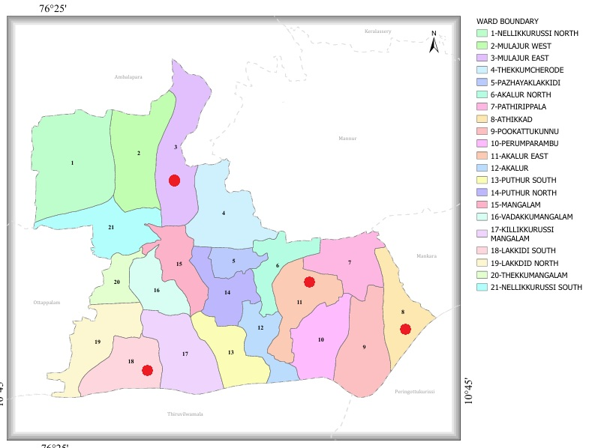

Ward No | Dengue Total (2021-25) | Leptospirosis Total (2021-25) | Hepatitis A Total (2021-25) | Mumps (2021-25) | ADD (2021-25) | Total Cases
1 | 2 | 0 | 0 | 7 | 11 | 20
2 | 7 | 1 | 0 | 8 | 22 | 38
3 | 8 | 3 | 3 | 7 | 29 | 50
4 | 8 | 1 | 2 | 9 | 20 | 40
5 | 6 | 0 | 4 | 8 | 24 | 42
6 | 8 | 0 | 3 | 6 | 26 | 43
7 | 5 | 1 | 0 | 7 | 23 | 36
8 | 12 | 1 | 5 | 6 | 18 | 42
9 | 3 | 1 | 2 | 5 | 24 | 35
10 | 4 | 1 | 1 | 4 | 27 | 35
11 | 18 | 0 | 0 | 5 | 24 | 47
12 | 4 | 0 | 1 | 7 | 26 | 48
13 | 4 | 0 | 1 | 6 | 22 | 33
14 | 3 | 0 | 0 | 4 | 25 | 32
15 | 5 | 0 | 1 | 7 | 24 | 37
16 | 2 | 0 | 0 | 5 | 22 | 29
17 | 7 | 1 | 0 | 6 | 32 | 46
18 | 7 | 0 | 1 | 4 | 34 | 45
19 | 5 | 0 | 1 | 6 | 28 | 40
By overlaying five years of data, we have identified 4 'Red Zone' Wards. These are wards where at least two different categories of diseases (e.g., Dengue and Lepto) recurred in consecutive years. Ward 3,11,18,8 is categorized as the Highest Priority Hotspot due to its combination of vulnerability and high vector density. Future health infrastructure, such as the proposed R.O plants at these wards should be prioritized.

Preparedness and Response Protocol at LSG Level
This section describes the operational framework for the LSGI once a pandemic is declared. It explains how the LSGI and health system will move from routine data collection to active response, using a One Health approach.

Constitution of One Health Committee
The LSGD shall constitute a One Health Committee comprising the LSGI President, Medical Officers (Modern Medicine, AYUSH, and Veterinary), the Health Inspector, and the Veterinary Surgeon.

Objective: The One Health Committee coordinates human, animal, and environmental health to prevent and control pandemics.

Sl No | Name | Designation | Department/Institution | Role in Committee | Contact Number
1 | CHITHRA | Panchayat President | LSGD | Chairperson | 9562550491
2 | DR.ARCHANA | Medical Officer (PHC/CHC) | Health Dept | Member Secretary | 9744460011
3 | Dr.Chithrima | Veterinary Officer | Animal Husbandry | Member | 6282118919
4 | Nil | Epidemiologist | Health Dept | Member | nil
5 | PRADEEP | Health Inspector/PHN | Health Dept | Surveillance | 9207035845
6 | SOLLY THOMAS | ASHA Supervisor | Health Dept | Community link | 94462559537
7 | DHANYA | ICDS Supervisor | Social Welfare | Vulnerable groups
8 | Subhash | Police Station Officer | Police Dept | Law & order | 9497980621
9 | RAMAKRISHNAN | Ward Councillor Representative | LSGD | Community coordination | 9846607948
10 | SINDHU | Kudumbashree CDO | Kudumbashree | Community mobilisation | 9846678412
11 | Vijayakumar | NGO/Volunteer rep | Civil Society | Support services | 9447839077
12 | NIL | Line Department representations

Key Responsibilities:
- Review disease surveillance data (human + animal)
- Conduct ward-wise risk assessment and vulnerability mapping
- Approve quarantine/isolation centre locations
- Coordinate with district for resources (PPE, oxygen, ambulances)
- Periodically review health system surge capacity, including beds, oxygen, human resources, and ambulances.
- Approve and monitor risk communication and community engagement strategies, including rumour management.
- Ensure protection and service continuity for vulnerable groups (elderly, persons with disabilities, dialysis patients, coastal populations).
- Conduct quarterly mock drills
- Monitor equity measures for vulnerable groups

Meeting Schedule:
Quarterly (normal times) | Weekly (outbreak alert) | Daily (pandemic phase)

Pandemic Response Workforce
To ensure a coordinated and timely response during a pandemic, a dedicated Pandemic Response Workforce shall be constituted at the LSG level. The workforce will function under the overall supervision of the One Health Committee and in close coordination with the health authorities. Team-based deployment will enable efficient surveillance, case management, quarantine and isolation management, logistics support, and risk communication. Each team shall have a clearly designated team leader, defined roles, and an identified pool of personnel to allow rapid activation, rotation of duties, and continuity of services during prolonged emergencies.

Total Response Workforce Available: 300 persons

Team Name | Composition | Key Responsibilities | Team Leader
Surveillance and Contact Tracing Team | HI, JHI, JPHN, ASHAs and Volunteers | Case detection, contact listing, home visits, reporting | HI
Case Management Team | Doctors, Nurses, MLSP, Palliative Nurses | Patient care & referral | DOCTOR
Quarantine & Isolation Team | LSGD staff, Volunteers | Facility management | JHI
Psychosocial support | Counsilors of kudumbasree, ICDS and CHC | Counsilling services | CHC counsellor
Logistics & supply chain Team | LSGD staff, Storekeepers, Drivers 3 | Supplies & transport [PPE, medicines, oxygen, transport, waste management] | Ward Member
Communication Team | Ward members, Kudumbashree, Youth clubs,  AWW workers and other self help groups | IEC, community meetings, countering misinformation | M.O in charge
Transportation | KSRTC, educational institutional buses | transportation | Driver
Media Surveillance | GP secretary and GP staff | Management of communication and media | Secretary GP
Intersectoral coordination and convergence | Head of Instution of all institution in GP | Activity coordination | Secretary GP
Collaborative surveillance | Public health staff | Surveillance coordination | Medical officer ,CHC

All teams shall be activated immediately upon outbreak alert or pandemic declaration and shall report daily to the LSG Incident Commander/Medical Officer, with consolidated reporting to the Block PHC. Duty rosters and alternate personnel shall be maintained to ensure uninterrupted services during staff shortages or prolonged response periods. Team composition and numbers may be revised based on the magnitude of the outbreak and availability of human resources.

Activities and Measures before and during Pandemic

PHASE 1 - Alert / Preparation
Surveillance and Reporting-Enhanced syndromic surveillance:
- Data sources for surveillance: IHIP,Veterinary surveillance
- Event-based triggers (to be monitored and reported): Event-based surveillance will focus on the early identification and prompt reporting of unusual or unexpected public health events that may signal the emergence of a pandemic threat. The following triggers will be actively monitored and immediately reported through appropriate channels, including the Integrated Health Information Platform (IHIP): sudden clustering of fever, respiratory illness (ILI/SARI), diarrhoeal disease, or other similar syndromes within a locality; two or more epidemiologically linked cases occurring within households, institutions, schools, hostels, migrant labour camps, or elderly care facilities; unexplained severe illness, rapid clinical deterioration, or deaths due to unknown causes; a noticeable increase in hospital admissions for respiratory or febrile illnesses beyond the expected baseline; illness among healthcare workers or frontline staff; reports of unusual clinical presentations or lack of response to standard treatment; and rumours or community reports suggesting sudden outbreaks of illness. All such events will be promptly verified by field staff, properly documented, and escalated to higher authorities to enable timely outbreak investigation and implementation of appropriate control measures.
- Zoonotic and animal health surveillance: Zoonotic and animal health surveillance will be reinforced during the alert and preparedness phase through coordinated efforts between the Health Department, Animal Husbandry Department, and local Panchayat authorities, adopting a One Health approach. Continuous monitoring will be carried out to identify unusual illness, sudden deaths, or changes in disease patterns among domestic animals, poultry, and wildlife, especially in areas with close human–animal interaction such as livestock farms, backyard poultry units, animal markets, slaughter sites, and forest fringe regions. Information from livestock owners, poultry farmers, veterinary staff, and community informants will be systematically collected, verified, and integrated into the public health surveillance system. Any suspected zoonotic events, including clusters of illness or deaths among animals with possible human exposure, will be immediately reported and jointly investigated. Insights from integrated human and animal surveillance will aid in early risk assessment, targeted preventive actions, and timely containment strategies to minimize the risk of zoonotic spillover and potential pandemic emergence.
- Logistics and Stock Preparedness
  - Identify and empanel local vendors and define emergency procurement mechanisms in accordance with existing LSGD and Health Department norms.
  - Prepare and maintain an essential logistics checklist covering medical supplies, consumables, and support equipment.
  - Pre-identify secure storage locations for emergency stocks and ensure maintenance of stock registers with regular updating.
  - Finalise emergency transport arrangements, including availability of vehicles and identified drivers for rapid deployment during alerts.
  - Designate a Nodal Officer for Logistics to enable prompt decision-making, coordination, and communication during emergencies.
  - Conduct rapid stock verification and ensure availability of minimum buffer stock, including:
- PPE kits 0 numbers
- Pulse oximeters – 2 numbers
- Hand sanitizers – 20 litres
- Masks, gloves, disinfectants – adequate quantity
Identify critical gaps in logistics and immediately communicate requirements to the Block and District authorities for timely replenishment and support. Monitor expiry dates and stock rotation.

Identification of Quarantine and Isolation Facilities
  - Identify and list suitable buildings for quarantine and isolation (schools, hostels, community halls, etc.).
  - Categorise cases as per the severity and allocate to appropriate facilities (for instance, severe cases to classrooms, mild cases to an assembly hall in case of a school).
  - Facility readiness checklist needed (beds, toilets, ventilation) etc.
  - Find an alternate site if the primary sites are not available or not in use.
  - Identify facility managers and support staff
  - Prepare basic SOPs for:
    - Admission and discharge
    - Food, water, sanitation
    - Infection prevention and waste disposal
  - Ensure availability of basic amenities: water, sanitation, electricity, ventilation, and waste disposal. Prepare a rapid activation plan for these facilities if case numbers increase.

Risk Communication and Community Preparedness
  - Disseminate early warning messages on symptoms, preventive measures, and reporting mechanisms. Display IEC materials both in English and the local language in public places and ensure ward-level awareness.
  - Sensitize elected representatives and community leaders on preparedness measures.
  - Establish a rumour tracking and misinformation response mechanism to identify, verify, and promptly counter false or misleading information.
  - Engage trusted local persons (ward members, ASHA workers, religious leaders, teachers, community volunteers) to communicate official public health messages and reinforce correct practices.
  - Develop and deploy targeted IEC materials for:
    - Schools and educational institutions
    - Markets and commercial areas
    - Work sites and labour settings
  - Conduct community sensitization meetings at the ward level to promote preventive behaviors, address concerns, and strengthen community participation in preparedness and response.

Protection of Vulnerable Groups
Vulnerable populations require priority protection through targeted line-listing, service continuity, and delivery mechanisms.
- Prepare and regularly update line-lists of vulnerable populations, including:
  - Elderly persons living alone
  - Persons with disabilities
  - Pregnant women
  - Migrant workers
  - Dialysis patients
The detailed line-lists shall be maintained as Annexure ___ and updated periodically.

Clinical Dependency Mapping
Develop ward-wise dependency and vulnerability maps to identify households requiring regular support during emergencies. Ensure continuity of essential health services for vulnerable groups, including
- Dialysis services (facility mapping, transport arrangements, and scheduling)
- Continuity of treatment for TB, HIV, and other chronic conditions requiring uninterrupted medication
- Mental health and psychosocial support services
Establish delivery mechanisms for food, essential commodities, and medicines to vulnerable households through coordinated action involving ASHAs, JPHNs, Kudumbashree, volunteers, and local administration.

PHASE 2 - Active Response

Case Identification and Contact Tracing
Case detection and contact tracing activities will be carried out in coordination with the Health authorities, following disease-specific SOPs and IDSP guidelines.
Field Staff Involved
- Health Inspector (HI)
- Junior Health Inspector (JHI)
- Junior Public Health Nurse (JPHN)
- ASHAs and ASHA Supervisors
- Ward-level volunteers and Kudumbashree members (as required)

Screening Checkpoints
Screening checkpoints at high-traffic locations (transport hubs, markets, religious gatherings) for early detection of symptomatic travellers and crowd screening during outbreaks. Potential locations include bus stands, market entry points, and boat jetties, based on local context and risk assessment.
Screening activities will be carried out by trained personnel such as ASHAs, ward members, and volunteers, with support from Health Department staff. Necessary equipment, including non-contact thermometers and appropriate PPE, shall be ensured prior to activation.
Location | Type (Bus stand/Jetty/Market/Railway) | Staff Deployed (ASHAs/Volunteers) | Screening Method | Reporting authority
Bus stand | Transport hub | One JHI  One ASHA  One health Mentors | 1.Swab Collection.  2. Blood smears collection (RDT)  3.Thermal Scanners | Surveillance Nodal Officer in control room
Market entry | Market | One JHI  One ASHA  Male health volunteers | 1.Swab Collection.  2. Blood smears collection (RDT)  3.Thermal Scanners | Surveillance Nodal Officer in control room
Boat jetty | Water transport | One JHI  One ASHA  Male health volunteers | 1.Swab Collection.  2. Blood smears collection (RDT)  3.Thermal Scanners | Surveillance Nodal Officer in control room

Standard Screening Protocol

The screening protocol shall include temperature screening, observation for visible symptoms, and inquiry regarding recent travel or exposure history. Individuals identified as suspects during screening shall be immediately referred to the nearest PHC/FHC for further evaluation, testing, and appropriate action as per prevailing guidelines.

Pandemic Control Room
The Pandemic Control Room (PCR) serves as the central nerve center for real-time coordination, data aggregation, decision support, and communication during outbreaks. It consolidates information from all LSGD teams, health facilities and community sources to enable rapid response decisions.

Control Room Infrastructure and Location
Primary Location:Lakkidi perur Panchayath Office.
Backup Location: Community Hall in Lakkidi perur G.P.

Health System Control Room Framework
The PCR is organized into seven functional pillars to ensure no aspect of the response is overlooked:

Rapid Response Team (RRT)
  - Provides immediate intervention during emergencies, clusters, and field alerts.​
  - Coordinates urgent actions such as case investigation, contact tracing, isolation, and inter-facility referrals.

Data Management & Analytics Team
  - Collects, validates, and manages key health system indicators (cases, tests, beds, HR, supplies).​
  - Analyzes data trends, generates projections, and supports evidence-based decision-making for local authorities.

Human Resource Deployment Team
  - Allocates healthcare staff efficiently based on workload and need
  - Ensures adequate and equitable workforce distribution across facilities

Laboratory Surveillance Team
  - Oversees diagnostic testing coordination, sample transport, and timely reporting of results.​
  - Monitors lab indicators (testing volume, positivity rate, turnaround time) for early detection of outbreaks

Vaccination Cell (If Required)
  - Plans and executes vaccination campaigns, including micro-planning and session scheduling.​
  - Tracks coverage, identifies gaps, and coordinates corrective actions with field teams and outreach services.

Infrastructure & Patient Occupancy Team
  - Monitors facility capacity, earmarked beds, oxygen and critical care resources across all linked facilities.​
  - Ensures optimal patient distribution and referral management using updated bed-status and resource data.
  - BMWM

Communication team
- Logistics and supply chain
- Transportation (interfacility & emergency transport)
- Media surveillance Call centre
- Management of the deceased
- Intersectoral coordination and convergence

Key Control Room Team
The Control Room Team coordinates all pandemic response activities within the LSGD and serves as the single command and communication hub during activation. It integrates information, field actions, logistics, and policy execution across all participating departments and health facilities.

Role | Name | Designation | Contact Number | Responsibility
In-charge/Nodal Officer | Dr Archana | Medical officer | 9744460011 | Overall coordination, decision-making, and reporting to the District level.
Data Entry Operator | Sudheesh s | Jhi | 9746107487 | Managing the line list, updating dashboards, and tracking testing results.
Communication Officer | Pradeep | HI | 9207035845 | Handling the public helpline, coordinating ambulance dispatch, and contact tracing calls.
Logistics Coordinator | Solly Thomas | PHN | 9446259537 | Logistics transport & coordinaation
Technical Support(IT/Data) | Lekshmi | Clerk | 9995763622 | Data analysis

SOP for alert escalation/trigger point with mapping of responsibilities.
Key Points:
- The Control Room shall be staffed with a designated In-charge, data entry personnel, and communication staff with clearly defined roles and shift arrangements.
- It shall maintain updated records on daily monitoring indicators including new cases, persons under active quarantine, and hospital bed occupancy.
- All reports and situation updates shall be shared daily with the Block and District Surveillance Unit.
- The Control Room shall act as a single point of contact for coordination with response teams, health institutions, and other departments.
- Contact details of the Control Room shall be widely communicated to field staff and stakeholders during activation.

Daily Monitoring Indicators
To ensure timely decision-making and effective response, the following key indicators shall be monitored and updated on a daily basis by the Pandemic Control Room:

Epidemiological Indicators:
New cases reported today, Total active cases, Test Positivity Rate (TPR), Case Fatality Rate (CFR)
- Surveillance Indicators:
Persons under home quarantine, High-risk contacts identified, Fever, ILI, SARI or other symptoms (syndromic surges), Travellers (symptomatic or high-risk arrivals),Animal husbandry surveillance (zoonotic alerts, unusual animal deaths, poultry/bird flu signals), Mortality surveillance (excess deaths, unexplained fatalities, verbal autopsy reports)
- Logistics and Infrastructure Indicators:
Hospital / CFLTC beds occupied, Oxygen cylinders/concentrators available, Ambulances on standby
- Alert Findings
The following table outlines category-specific trigger points (red flags) from surveillance indicators and corresponding immediate actions for the Pandemic Control Room. These enable rapid response to alert findings like testing anomalies, positive cases exceeding thresholds, clusters, and WGS reports.

Category | Trigger Pophint (Red Flag) | Immediate Action
Clusters | Geographical or facility-based: 5+ cases linked to one location (office, school, street). | Declare a micro-containment zone; perimeter control and active case finding.
Testing | Sudden drop in testing volume / delay in reporting / unusual testing trends | Review the sample collection process, address lab bottlenecks, deploy additional testing teams, and notify the District Lab.
Lab | Test Positivity rate increases | Increase testing sites in that ward.
Hospital | >80% Oxygen bed occupancy | Activate backup/CFLTC beds.
Travel | Cluster of cases from a single flight/train or high-risk arrival group. | Trace all passengers in adjacent seats; implement mandatory institutional quarantine.
Animal | Mass poultry/wildlife death or unusual sickness | Notify Animal Husbandry, sample the area, and dispatch RRT for environmental sampling and zoonotic check.
Mortality | Sudden spike in home deaths or brought-in-dead (BID) cases | Audit the deaths and Active Case Search drive
Additional investigations like Whole Genome Sequencing (WGS) | Detection of a Variant of Concern (VOC) or Variant of Interest (VOI) | Implement strict micro-containment; update clinical protocols to match variant severity.

Communication of Public Health Information
A Community Communication Hub shall be established to ensure timely, accurate, and consistent dissemination of information during a pandemic. The Hub will function under the coordination of Nodal officers of the control room and act as the nodal point for public communication, risk messaging, and community engagement. It will support dissemination of official advisories, promote preventive behaviors, address rumors and misinformation, and ensure that messages reach all sections of the population through trusted local channels and leaders.

Key communicators
Channel | Responsible Person | Contact
Ward-level announcements | Pradeep | 9207035845
Social media | Sudheesh | 9746107487
Local Cable TV/Radio | Vijay | 7902816945

- All messages disseminated through the Hub shall align with advisories issued by the Health Department and District authorities.
- Community leaders shall be sensitized to support behavior change, reduce stigma, and counter misinformation.
- Special efforts shall be made to reach vulnerable and hard-to-reach populations using locally appropriate communication methods.

Rumor Tracking: A designated volunteer will monitor local social media/WhatsApp groups daily to identify misinformation and issue official clarifications via the Communication Hub.

Coordination with District/State Authorities & Other Organisations
Effective coordination with Block, District, and State authorities is essential to ensure timely reporting, technical guidance, and uninterrupted supply of essential resources during a pandemic. The LSG shall establish clear communication channels, designate responsible officers, and adhere to prescribed reporting timelines to support coordinated public health action and efficient resource mobilisation.

Key Details:
- Nodal Officer for Reporting:
- Contact Number:
Reporting Schedule and Protocols:

To Whom | What to Report | Frequency | Nodal Person
Block PHC | Complete Situation Report (Cases, Quarantine, Beds, Screening, Deaths) | Daily | pradeep
District IDSP Unit | Outbreaks/Clusters/Unusual Events (>5 cases same ward) | Daily | Sudheesh
Veterinary Officer | Animal health events/Zoonotic alerts | daily | pradeep
State Cell | Zoonotic cross-sector events | daily | Dr Archana

Supply Chain Coordination
The LSG shall coordinate closely with Block, District, and State authorities (KMSCL) to ensure uninterrupted availability of essential goods, medical supplies, and logistics during a pandemic. Supply requirements shall be assessed regularly based on case load and communicated promptly to the appropriate authorities for timely replenishment.
Key Points:
- Maintain updated contact details of District and Block nodal officers for health logistics, oxygen supply, ambulances, and essential medicines.
- Submit timely indent requests for PPE, testing kits, medicines, oxygen, and other critical supplies through prescribed channels.
- Monitor stock levels at LSGD facilities, quarantine/isolation centres, and field teams through daily stock registers and dispensing logs to prevent shortages.
- Coordinate with District authorities, Karunya/Neethi medical shops, and local purchase committees for funds allocation and emergency procurement.

- Ensure regular monitoring of dispensing registers at all facilities to track usage, expiry, and pilferage—shortages being a perennial issue requiring proactive weekly audits.

- Activate surge procurement protocols during high caseloads, leveraging local purchase powers under LSGD funds alongside state supplies.

Resource Inventory and Contacts
Resource Category | Source  (District/State/Private) | Contact
PPE Kits/Masks/Gloves | KMSCL | 04912533336
PPE Kits/Masks/Gloves | Local Vendors | 94001300002
Oxygen  Cylinders/Concentrators | KMSCL | 04912533336
Medicines/Antivirals | KMSCL | 04912533336
Medicines/Antivirals | Neethi Shops | NA
Test Kits (RTPCR/Rapid) | KMSCL | 04912533336

Collaboration with NGOs, PPP, and CSR
To augment government efforts during a pandemic, the LSG shall collaborate with NGOs, voluntary organisations, and private sector partners through public–private partnerships and Corporate Social Responsibility (CSR) initiatives, in coordination with District authorities.

Key Points:
- Engage NGOs and community-based organisations for community outreach, awareness, and support to vulnerable populations.
- Leverage CSR support for procurement of medical equipment, PPE, oxygen concentrators, food kits, and sanitation materials, as permitted.
- Ensure all collaborations align with government guidelines and are routed through approved administrative and financial procedures.
- Maintain transparency and documentation for all external support received and utilised.
Organization | Type | Support Offered | Contact Person
Youth Clubs/Student Unions | CBO | Man power (social service) | 9746107487

Interdepartmental Coordination
Coordination among departments during a pandemic shall be ensured through regular review meetings convened by the LSGD President. These meetings will provide a structured platform for sharing situational updates, assessing resource availability, resolving operational gaps, and taking joint decisions to ensure a coordinated and timely response.

Department | Representative | Key Role | Contact
Health (PHC) | Staff Nurse : | Case management | 9895516122
Veterinary | Veterinary Surgeon: | Animal surveillance | 6282118919
ICDS | Supervisor: Sindhu | Nutrition support | 8089337345
Education | Head Teacher: | School coordination
Police | SHO | Containment enforcement | ___9497980621_______
Water Authority | OPERATOR | Water supply | 8891139030
LSGD Engineering | AE | Quarantine infrastructure | 9400805691

PHASE 3 - Surge Capacity
Phase 3 is activated when there is a rapid increase in cases, high test positivity rates, or when existing health facilities and quarantine arrangements approach saturation. The focus of this phase is to expand isolation capacity, augment clinical care services, and mobilise additional resources through district and state support mechanisms.

Conversion of Community Facilities
To manage increased case load, the LSGD shall activate additional isolation facilities by repurposing identified community infrastructure such as community halls, auditoriums, schools, hostels, or other suitable buildings.

Name of facility | Facility Type | No. of Buildings | Ward | Surge Capacity (Beds) | Nodal Person
Panjayath hall | Hall | 2 | 13 | 200 | 9562550491
Galaxy auditorium | Auditorium | 1 | 6 | 500 | 8304971839
Panchayth Auditorium | Auditorium | 1 | 18 | 500 | 9562550491
United convention center | Hall | 1 | 4 | 1000 | 9746107487

- Recovery and rehabilitation phase
- Recovery
  - Damage & impact assessment
  - Restoration of health services
  - Rehabilitation of affected population
  - Psychosocial & mental health support
  - Disease surveillance during recovery phase
  - Environmental cleanup & sanitation
  - Livelihood restoration
  - Community engagement & confidence building
  - Documentation & after-action review
  - Lessons learned & best practices
  - Health system strengthening
  - Policy revision & preparedness enhancement
  - Research

CONCLUSION
The Overall Pandemic Preparedness Plan of Lakkidi-Perur Grama Panchayat provides a comprehensive, risk-based, and community-centred framework to prevent, prepare for, and respond effectively to public health emergencies. By integrating ward-level risk assessments, local disease patterns, and systematic mapping of vulnerable populations, the plan strengthens early detection, timely reporting, and rapid response mechanisms. It emphasizes robust disease surveillance, healthcare system readiness, and coordinated action between public and private health sectors. Special focus is given to high-risk settings such as water bodies, sanitation-deficient areas, vector breeding sites, and potential zoonotic transmission points, along with targeted protection of vulnerable groups. The plan also prioritizes community participation, health awareness, and sustainable water, sanitation, and environmental management practices. Through decentralized governance, evidence-based interventions, and strong intersectoral collaboration, Lakkidi-Perur Grama Panchayat is well-prepared to mitigate public health risks, ensure continuity of essential services, and strengthen community resilience against future pandemics.

Additional points
- tech support
- relief based commodities
- ham reading operators
- hazard vulnerability mapping
- Kseb & other power source
- HR specific responsibility

RECOMMENDATIONS

Strengthening Healthcare Infrastructure
- Establish a primary health response unit within the Panchayat with trained staff.
- Ensure availability of basic medical supplies (masks, sanitizers, PPE kits, oxygen cylinders).
- Create tie-ups with nearby hospitals in for emergency referral and transport.

2. Community Awareness & Education
- Conduct regular awareness campaigns on hygiene, vaccination, and preventive measures.
- Use local communication channels (community radio, WhatsApp groups, notice boards) to spread verified information.
- Train volunteers to act as health ambassadors in each ward.

3. Emergency Response & Coordination
- Form a Pandemic Preparedness Committee at Panchayat level including health workers, ward members, and NGOs.
- Develop a clear action plan for lockdowns, quarantine, and distribution of essentials.
- Maintain a database of vulnerable groups (elderly, differently-abled, chronically ill) for targeted support.

4. Supply Chain & Food Security
- Identify and support local suppliers and farmers to ensure uninterrupted food supply.
- Create community kitchens during emergencies to serve vulnerable populations.
- Stockpile essential commodities in Panchayat-run outlets for crisis periods.

5. Digital Preparedness
- Promote digital platforms for telemedicine consultations.
- Use Panchayat’s website/social media for real-time updates on health advisories.
- Encourage online grievance redressal to reduce crowding in offices.

6. Training & Capacity Building
- Organize mock drills for pandemic response in schools, offices, and public spaces.
- Train Panchayat staff and volunteers in first aid, infection control, and crowd management.
- Collaborate with NGOs and health departments for capacity-building workshops.

7. Long-Term Resilience
- Integrate pandemic preparedness into the Panchayat Development Plan.
- Allocate a dedicated budget for health emergencies.
- Encourage community participation in planning and monitoring preparedness measures.

MOCKDRILL SCENARIOS
Mock drill scenarios for public health emergencies, including outbreak response, mass casualty management, and pandemic preparedness, have been identified to strengthen institutional readiness and coordinated response mechanisms; however, implementation is pending across institutions and will be conducted in a phased manner to strengthen emergency response capacity.

ANNEXURE

IMPORTANT PHONE NUMBERS

Phone numbers and particulars of persons responsible for providing guidance, assistance, and support for pandemic preparedness operations may be provided here in a manner that allows easy reference at a glance.The information recorded here could be exhibited elsewhere at the time of emergencies. LSG institutions shall give special attention to collect and record the above data of persons and institutions who/which are supposed to give technical and co-ordination support to reduce the impact of pandemic.

1.1. Details of grama panchayat/municipality/corporation wards
Sl.No | Name of the ward | Ward number | Name of the ward  member | Contact number
1 | Nelikurihi north | 1 | Sojan | 9846061639
2 | Mulanjoor west | 2 | Suhitha | 8943105741
3 | Mulanjoor East | 3 | T GSagar | 9747775229
4 | Thekkum chirod | 4 | Shamla showkath | 7034066505
5 | Pazhaya Lakkidi | 5 | Nabeeza shereef | 7034526326
6 | Akaloor north | 6 | Ayisha Baheer | 7736615727
7 | Pathiri pala | 7 | Ravi up | 9946829935
8 | Athirkkad | 8 | Sujini k g | 9656793699
9 | Pookatukunnu | 9 | Vasanthi | 9539420749
10 | Perumparamb | 10 | Manikandan k | 9447277469
11 | Akaloor East | 11 | Chithra | 9562550491
12 | Akaloor | 12 | Thushara Prasad | 9744175301
13 | Puthoor south | 13 | Ambika anil | 9072285311
14 | Puthoor north | 14 | Raveendran p | 9037502863
15 | MangalM | 15 | Remya krishnan | 9544765663
16 | Vadakk Mangalam | 16 | Vinod | 7736389279
17 | Killikurishi mangalm | 17 | RamaKrishnan | 9846607948
18 | Lakkidi South | 18 | Baby k | 9048276163
19 | Lakkidi north | 19 | Sheejamol | 9947334376
20 | Thekkumangalam | 20 | Susheela p | 8086714583
21 | Nellikurishi south | 21 | Shamsudeen cp | 8848816622

1.2. Other important phone numbers of grama panchayat/municipality/corporation area
Sl. No. | Name | Contact number
1. | Panchayath Secretery | 9447325633
2.
3.
4.
5.
6.
7.
8.

1.3. Important offices of grama panchayat/municipality/ corporation
Sl.No | Name of the office | Contact person | Contact number
1. | Village Office | Village Officer | 8547615110
2. | Agriculture Office | Agriculture Officer | 9383471510
3. | Animal Husbandry Office | Animal Husbandry Doctor | 6282118919
4. | Police Station | Police Officer | 04662244325
5. | BSNL Office | Officer | 04924222800
6. | Block Office | Officer
7. | KSEB Office | Officer | 8547162723
8. | Fisheries Office | Officer | 04712525200
9. | Fire and Rescue | Officer | 04662222501

1.4. Health Services

Sl. No | Name of the hospital/institution | Location | Phone number
1. | Government hospitals/PHC | Athirkadu | 0491287802
2. | Private hospitals | Pathirippala | 8848540455
3. | Clinical laboratories | Pathirippala | 9745650155
4. | Chemist/pharmacy | NA
5. | Blood donors | Perur | 7902816945
6. | Other language experts (Bihari, Hindi, Bengali,  Asamees ………)

1.5. Veterinary Services
Sl.No | Name of the Clinic | Name of the  Surgeon/Doctor | Place/location | Phone  number
1 | Govt.Veterinary Hospital | Dr chithrima | Mangalam | 6282118919

1.6. Helpline numbers
Helpline | Phone number
Police | 9497934004
Fire and Rescue | 0466 2222501
KSEB | 8547162723

1.7. Public and Private Schools Contact details

S.No | Name of School | Institution type | Phone number
1 | ASBS PERUR | Aided | 9400457182
2 | SKHSS | Aided | 9447216080
3 | MONTISSORI | Private | 9605152494
4 | SBS | Govt | 9495451134
5 | DVJBS | Private | 9496147292
6 | SRVJBS | Private | 790799490
7 | GHS AKALUR | Govt | 9495946066
8 | Kanikkmatha | Pvt | 7598512120
9 | Gsbs old lakkidi | Govt | 7025184226
10 | Crescent | Pvt | 9048075185
11 | Ghs nellikurissi | Govt | 9447979817
12 | Smlps mulanjur | Aided | 9496532142
13 | Ssohss | Aided | 9947424111
14 | Ajbs lakkidi | aided | 9495997053
15 | Sreekrishna | pvt | 9495229098
16 | Kmsp | Aided | 9074571668
17 | Jbs thekkumanagalam | Aided | 9446147581
18 | Ssohs | Aided | 9496838428
19 | SEVA SADAN SCHOOL | PVT
20 | SEVA SADAN HSS | PVT

1.9. Anganwadi Contact Details

Ward No | Name of Anganwadi Teachers/ AWNO | Phone number
1 | KANAKAKUMARI- C NO 3 | 8606189616
1 | ANITHA- CNO 26 | 96561559804
2 | USHAKUMARI CNO-2 | 9747850437
3 | PRAVEENA | 8086522606
4 | LEELAVATHY | 9605021217
4 | DHANALEKSHMI | 9539219021
6 | BINDHU K R | 9645525595
6 | KRISHNAKUMARI | 7306753522
7 | RAJANI | 9048756554
8 | RATHI | 9744627281
9 | PRAMEELA | 9497235745
9 | SOUBHAGYAVATHI | 9207828387
10 | NIRMALADEVI | 9048238316
11 | CHANDRIKA | 8848170224
12 | MINI | 7909142234
12 | GAYATHRI | 9562871147
12 | ATHIRA | 8157873371
13 | RUGMINI | 9539554203
13 | AMBIKA | 9074198610
14 | PREETHA | 9526928019

15 | Sujatha | 9846529124
15 | Sumangala | 9048732978
16 | Rema | 9539611326
17 | Susheela | 8289827455
17 | Vijayalekshmi | 96055640888
18 | Vijayalekshmi k | 9048621853
18 | Rema devi | 9745802577
19 | Suma | 9846589626
20 | Parvathykutty | 80868775579
20 | Vasanthi | 9744873702
21 | Nisha | 9656893496
21 | Jijithra | 9995402002

1.12. Information regarding resources

Means of transportation | Name of Owner | Phone Number
Heavy Trucks | mukundan | 8129493328
Tractor | hari | 8304971839
Ambulances | Vijay | 7902816945
Boats | Nil | Nil
Taxi service | Mukundan | 8129493328

Annexure 1: LSG Baseline Data Collection Format
A. Baseline data
Sl. No. | Indicator / Field | Baseline Data | Source / Remarks
1 | Name of LSG | Lakkidi perur | base line data register
2 | District | Palakkadu | base line data register
3 | Block / Taluk | Ottapalam | base line data register
4 | Type of LSG (Gram Panchayat / Municipality / Corporation) | Gram Panchayat | base line data register
5 | Area (sq. km) | 30.79 | base line data register
6 | No. of wards | 21 | base line data register
7 | GIS boundary file available | (Yes/No) - yes | base line data register
8 | Key contact person & phone | Chithra (president) | 9562550491

B. Demography
Indicator / Field | Baseline Data | Source / Remarks
Total population | 39474 | base line data register
Males | 18974 | base line data register
Females | 20500 | base line data register
Transgender population | 0 | base line data register
Age distribution  (<5, 5–14, 15–59, ≥60) | 3124,5246,25540,5564 | base line data register
No. of households | 9784 | base line data register
Population density (persons/sq.km) | 788 | base line data register
No. of migrant workers | 194 | base line data register
Major occupational groups | agriculture | base line data register

C. Vulnerable Populations & Social Risks
Sl. No. | Indicator / Field | Baseline Data (Value / Description) | Source / Remarks
1 | No. of elderly (≥60) | 5564 | base line data register
2 | No. of persons with disability | 210 | base line data register
3 | No. of bedridden persons | 73 | base line data register
4 | No. of chronic disease cases (DM/HTN/COPD/CKD etc.) | 10421 | base line data register
5 | Pregnant women (current estimate) | 121 | base line data register
6 | Children <5 years | 3124 | base line data register
7 | Tribal population (if any) | 0 | base line data register
8 | Fisherfolk / coastal vulnerable groups (if any) | 0 | base line data register
9 | Urban slums / unnotified settlements (if any) | 0 | base line data register
10 | Homeless population | 0 | base line data register
11 | Orphanages / old age homes (number & capacity) | 0 | base line data register
12 | Hostels / prisons / shelters (number & capacity) | 1 (500 capasity) | base line data register
13 | Poverty / BPL estimate | 4741 | base line data register
14 | Food insecurity hotspots | 0 | base line data register
15 | Any history of stigma/discrimination issues (Yes/No) | 0 | base line data register

D. Health System & Service Readiness
Sl. No. | Indicator / Field | Baseline Data (Value / Description) | Source / Remarks
1 | No. of health facilities in LSG (PHC/CHC/TH/DH/Private) | 2 | base line data register
2 | PHC/Family Health Centre details (name, location) | Fhc perur- (at athirkadu)  Fhclakkidi (at koottupaatha) | base line data register
3 | Subcentres / Health & Wellness Centres (number) | 6 | base line data register
4 | Private clinics / hospitals (number) | 8 | base line data register
5 | Labs available (public/private) | 10 | base line data register
6 | Availability of ambulance services (Yes/No, number) | yes | base line data register
7 | Availability of isolation/quarantine facilities (Yes/No, details) | Yes | base line data register
8 | Cold chain facilities (Yes/No, details) | Yes | base line data register
9 | Stockpile space available (Yes/No) | Yes | base line data register
10 | PPE / mask / sanitizer availability plan (Yes/No) | Yes | base line data register
11 | Surveillance staff available (JHI/JPHN/ASHA count)3/6/21 | yes | base line data register
12 | Existing emergency referral pathways (Yes/No) | yes | base line data register

E. Points of Entry & Mobility
Sl. No. | Indicator / Field | Baseline Data (Value / Description) | Source / Remarks
1 | Bus stands / depots (number) | Nil | base line data register
2 | Railway stations (number) | 1 | Lakkidi station
3 | Boat jetties / fishing harbours (number) | Nil | base line data register
4 | Ports / airports nearby (specify distance) | Nil | base line data register
5 | Major highways/roads passing through | 1 | Ponnani- palakkadu
6 | Border crossings (state/district) | 1 | trissur
7 | Major markets / weekly markets | Nil
8 | Tourism hubs / major event venues | Nil
9 | Schools/colleges with hostels (number) | 1 | Nehru college
10 | Factories / large workplaces (number) | 1 | kinfra
F. Water, Sanitation & Hygiene (WASH)
Sl. No. | Indicator / Field | Baseline Data (Value / Description) | Source / Remarks
1 | Major drinking water sources (piped / wells / borewells / springs) | Well, | base line data register
2 | No. of public wells | 152 | panjayath data
3 | No. of households with piped water connection | 3142 | Water authority data
4 | Water quality testing routine (Yes/No) | yes | register
5 | Common contamination risks (flooding, salinity, industrial waste) | NA
6 | Open defecation free status (Yes/No) | YES | Panjayath data
7 | Solid waste management system (Yes/No) | YES | BIO BIN
8 | Bio-medical waste disposal mechanism (Yes/No) | YES | linked with IMAGE
9 | No. of public toilets | 1 | old lakkidi area
10 | Handwashing stations in public places (Yes/No) | YES | phc perur
G. Zoonotic Risks & One Health
Sl. No. | Indicator / Field | Baseline Data (Value / Description) | Source / Remarks
1 | Livestock population (cattle/goats/pigs/poultry) – estimates | 14111 | Vetenery dept
2 | No. of dairy farms / poultry farms / pig farms | 0
3 | Slaughterhouses / meat shops (number) | 0
4 | Animal markets (Yes/No, details) | 0
5 | Veterinary dispensaries (number) | 0
6 | History of zoonotic outbreaks (rabies, leptospirosis, avian flu etc.) | 0
7 | Stray dog population management measures (Yes/No) | Yes | vetenary data
8 | Rodent infestation hotspots (Yes/No) | No
9 | Wetlands / waterlogged areas prone to leptospirosis | No
10 | Bat roosting areas / caves / fruit orchards (if any) | No
11 | Human-animal interface hotspots (farms near residences) | No
H. Climate & Disaster Risks (Pandemic Amplifiers)
Sl. No. | Indicator / Field | Baseline Data (Value / Description) | Source / Remarks
1 | Flood-prone wards (list) | 4 | base line data register
2 | Landslide-prone wards (list) | 0
3 | Cyclone/sea surge risk (Yes/No) | 0
4 | Heatwave risk zones (Yes/No) | 1 | data from higher authorities
5 | Waterlogging areas (list) | 4 | base line data register
6 | Shelter homes / relief camps (number, capacity) | 0
7 | Past disaster displacement history | 0
8 | Disruption to water supply/transport common (Yes/No) | YES | panjyath data

I. Critical Infrastructure & Logistics
Sl. No. | Indicator / Field | Baseline Data (Value / Description) | Source / Remarks
1 | Schools (number) | 20 | base line data register
2 | Anganwadis (number) | 32 | base line data register
3 | Colleges (number) | 4 | base line data register
4 | Community halls (number) | 1 | base line data register
5 | Places of worship with large gatherings (number) | 1 | Akaloor kavu
6 | Large markets / shopping areas (number) | 0
7 | Warehouses / cold storages (number) | 0
8 | Telecom/mobile network coverage gaps (Yes/No) | yes
9 | Power outage frequency (high/medium/low) | low
10 | Availability of generators in key facilities | No

J. Risk Communication & Community Networks
Sl. No. | Indicator / Field | Baseline Data (Value / Description) | Source / Remarks
1 | Ward-level rapid response teams (Yes/No) | yes | kept minutes book
2 | Jagratha samithis / committees active (Yes/No) | yes | kept minutes book
3 | Kudumbashree presence and strength (number of units) | 12 | data from panjayath
4 | Volunteer network (number, coverage) | 179 | base line data reg
5 | Community-based surveillance mechanisms (Yes/No) | Yes | health volunteers
6 | IEC dissemination channels (WhatsApp groups, community radio, PA systems) | yes | created community groups
7 | Rumour tracking mechanisms (Yes/No) | Yes | registers kept
8 | Languages spoken / literacy considerations | Yes
9 | Vulnerable groups communication strategy available (Yes/No) | yes

K. Preparedness Planning & Governance
Sl. No. | Indicator / Field | Baseline Data (Value / Description) | Source / Remarks
1 | LSG emergency plan available (Yes/No) | Yes | committe
2 | Pandemic preparedness plan available (Yes/No) | Yes | data from all departments
3 | Incident Command System identified (Yes/No) | No
4 | Rapid procurement mechanism available (Yes/No) | No
5 | Emergency fund available (Yes/No, amount) | No
6 | Past outbreak response experience (Yes/No, details) | Yes | registers
7 | Intersectoral coordination mechanism (Health, Police, LSG, Veterinary, Education) | Yes | minutes book
8 | Mock drills conducted in last 12 months (Yes/No) | Yes | minutes book
9 | Training coverage for staff/volunteers (Yes/No) | yes | attendance kept

L. Surveillance & Data Systems
Sl. No. | Indicator / Field | Baseline Data (Value / Description) | Source / Remarks
1 | Digital reporting tools used (e.g., DHIS2, portals) | Ihip | department app
2 | Availability of line-listing format (Yes/No) | yes | weekly updating
3 | Contact tracing team identified (Yes/No) | Yes | registers kept
4 | Mapping of high-risk households available (Yes/No) | Yes | base line data reg
5 | Testing sample transport mechanism (Yes/No) | Yes | hub and spoke
6 | Reporting timeline adherence (good/average/poor) | Good | email
7 | Data sharing between departments (Yes/No) | Yes | email
8 | Availability of dashboard for monitoring (Yes/No) | Yes | spread sheet

M. Additional Notes & Observations
Sl. No. | Indicator / Field | Baseline Data (Value / Description) | Source / Remarks
1 | Key challenges perceived by LSG | Fund unavailability
2 | Top 5 high-risk wards (reason) | 8,3,4,12,11,13 | Cd register
3 | Any unique local risks (industrial pollution, refugee camps, etc.) | NA
4 | Recommendations for preparedness strengthening | Avail fund

