PANDEMIC PREPAREDNESS PLAN
KOLLENGODE

MESSAGE FROM PRESIDENT
It is my great pleasure to know that our Panchayath now has a Pandemic Preparedness Plan to tackle any kind of pandemic or other health-related emergencies. In recent years, we have faced many health challenges, including COVID-19 and the emergence of new diseases. These experiences have shown us how important it is to be prepared for pandemics and other health emergencies.
This plan is not only useful for managing pandemics, but it will also help us respond effectively to any health crisis in the future. It provides clear guidance on prevention, early detection, response, and recovery. Proper planning can reduce confusion, save time, and most importantly, protect lives.
I am very happy that Family Health Centre Kollengode has taken the initiative to develop this important document. Preparing such a plan requires hard work, careful study, and coordination. The team has made sincere efforts to gather information from various sources and assess the needs of our local community.
I sincerely appreciate everyone who contributed to this effort. Together, let us continue to work towards building a healthy and safe community.

President
Kollengode Grama Panchayath

MESSAGE FROM HEALTH STANDING COMMITTEE CHAIR
It gives me immense pleasure that our Panchayath has developed a comprehensive Pandemic Preparedness Plan to strengthen our response to public health emergencies. As Chairperson of the Health Standing Committee, I strongly believe that preparedness is the key to protecting our community from unforeseen health threats.
The recent pandemic and the emergence of new diseases have clearly shown us the importance of early planning, coordination, and awareness. This plan provides a clear framework for prevention, timely identification of risks, effective response, and proper recovery measures. It will guide our health workers, local authorities, and community members in working together during times of crisis.
I sincerely appreciate the dedicated efforts of the Kollengode FHC staff who contributed to the preparation of this important document. Their commitment, hard work, and teamwork have made this initiative possible.
Chairperson
Health Standing Committee
Kollengode Gramapanchayath

MESSAGE BY MEDICAL OFFICER

I am happy to present the Pandemic Preparedness Plan document for Kollengode Grama Panchayath. In recent years, we have faced various health challenges, including pandemics, the emergence of new diseases, and multiple outbreaks. These experiences have clearly shown the need for proper planning and preparedness at the local level.
This document provides simple and clear guidance on how to respond during health emergencies. It includes important baseline data of the Local Self Government, communicable disease trends, environmental risk profiles, identified hotspots, key contact information, and details of available health facilities etc. The plan also explains the steps for prevention, early detection, reporting, treatment, and community awareness.
This preparedness plan will serve as a practical guide for organized action during any public health emergency. I sincerely thank all the departments, staff members, and stakeholders who contributed their time and effort to prepare this valuable document.

Medical Officer
FHC Kollengode

EXECUTIVE SUMMARY
The Family Health Centre (FHC), Kollengode, provides essential and affordable healthcare services to the community, focusing on prevention, health promotion, treatment, and recovery, in line with national and state health programmes for Kollengode Grama Panchayath.
The FHC caters to a predominantly rural population, addressing key public health priorities such as maternal and child health, communicable and non-communicable disease control, immunization, family welfare, adolescent health, and geriatric care. Regular outpatient services, home-based care through field health staff, and outreach activities ensure healthcare coverage even in geographically challenging areas. The institution actively implements national health missions, including the National Health Mission (NHM), National Tuberculosis Elimination Programme, National Programme for Prevention and Control of Cancer, Diabetes, Cardiovascular Diseases and Stroke (NPCDCS), and other disease surveillance initiatives.
Kollengode FHC works in close coordination with the Grama Panchayath, ASHA workers, Anganwadi centres, schools, and community-based organizations to strengthen community participation and improve health awareness. Emphasis is placed on early detection, timely referral, health education, and lifestyle modification to reduce disease burden and improve overall health outcomes.
Despite constraints related to infrastructure, manpower, and increasing service demand, the FHC continues to enhance service delivery through effective planning, data-driven decision-making, and community engagement. Strengthening facilities, upgrading digital health systems, and expanding preventive services remain key focus areas for future development.
LIST OF ABBREVIATIONS

LSGD/LSGI | Local Self Government Department / Local Self Government Institution
BMO | Block Medical Officer
IDSP | Integrated Disease Surveillance Programme
NDMA | NationalDisaster Management Authority
PPE | Personal Protective Equipment
ICMR | IndianCouncil of Medical Research
CD | Communicable Diseases
NCD | NON-COMMUNICABLE Diseases

TABLE OF CONTENTS

INTRODUCTION 9
● Background of the PPP 9
LSGD AT A GLANCE 9
INTEGRATED HEALTH INFRASTRUCTURE MAP OF Kollengode 10
GENERAL PROFILE OF THE LSGI’S 13
Background of the LSGI 13
Demographic and Vulnerable Population 14
Clinical Vulnerability 16
INFRASTRUCTURE & RESOURCE INVENTORY 18
Health Facility Directory & Basic Capacity in the LSGD 18
Private Clinics 19
Healthcare Education & Training Institutions 19
Specialized Services & Emergency Inventory 20
Oxygen & Diagnostic Capacity 20
Diagnostics facility mapping at the LSGI level 21
Laboratory Identification & Basic Details 21
Social and Community Infrastructure for surge plan 22
Human resources 24
Community & Support Cadre 25
Community Organizations 26
Administrative & Emergency Services 27
Information regarding resources 27
ONE HEALTH & ENVIRONMENTAL SURVEILLANCE 28
Animal & Bird Population 28
Veterinary Infrastructure 29
Veterinary Doctors & Workforce 30
High-Risk Interface Points (Surveillance Sites) 30
Environmental Risk Mapping 31
Disease Seasonality Mapping 32
Vulnerability Mapping 33
EPIDEMIOLOGICAL TRENDS (2021–2025) 34
Disease Burden among human beings(Last 5 Years) 34
*(use the above table data to create the graph/diagram) 35
Seasonal Trend Analysis 36
Outcome-Based Trend Analysis- 2025 39
Transmission Trend- 2025 40
Integrated Disease Hotspot Map (2021–2025) 42
Preparedness and Response Protocol at LSG Level 44
Constitution of One Health Committee 44
Pandemic Response Workforce 45
Activities and Measures before and during Pandemic 47
PHASE 1 - Alert / Preparation 47
PHASE 2 - Active Response 49
Standard Screening Protocol 51
PHASE 3 - Surge Capacity 60
Conversion of Community Facilities 60
CONCLUSION 61
RECOMMENDATIONS 62
ANNEXURE 63
1. IMPORTANT PHONE NUMBERS 63

INTRODUCTION

Background of the Pandemic Preparedness Plan

LSGD at a Glance
Kollengode Grama Panchayath, established on July 30, 1938, is located about 25 km from Palakkad town in Kerala and falls under the jurisdiction of Chittur Taluk in Palakkad district. The Panchayath covers an area of 49.33 sq. km, comprising the revenue villages of Kollengode-I and Kollengode-II. It is geographically situated at the base of the Nelliyampathy hills, part of the Western Ghats, and is bordered by the Gayathripuzha River to the north, Elavancherry Panchayat to the west, Muthalamada to the east, and Thenmala to the south.
Agriculture is the primary livelihood, with the region specializing in paddy, coconut, and other crops. Kollengode is also a popular location for film shootings and eco-tourism. The Gayathripuzha River, fed by local streams and waterfalls such as Seetharkundu, adds to the area’s natural beauty. Kollengode railway station is located at Oottara, and State Highway SH-58 passes through the Panchayath, ensuring good connectivity. Culturally, Kollengode is known for the historic Kollengode Palace, the ancient Kachamkurissi Temple, and its “Old World” charm, making it a prominent destination for rural tourism.

Geographical boundaries with political map (Based on latest delimitation)

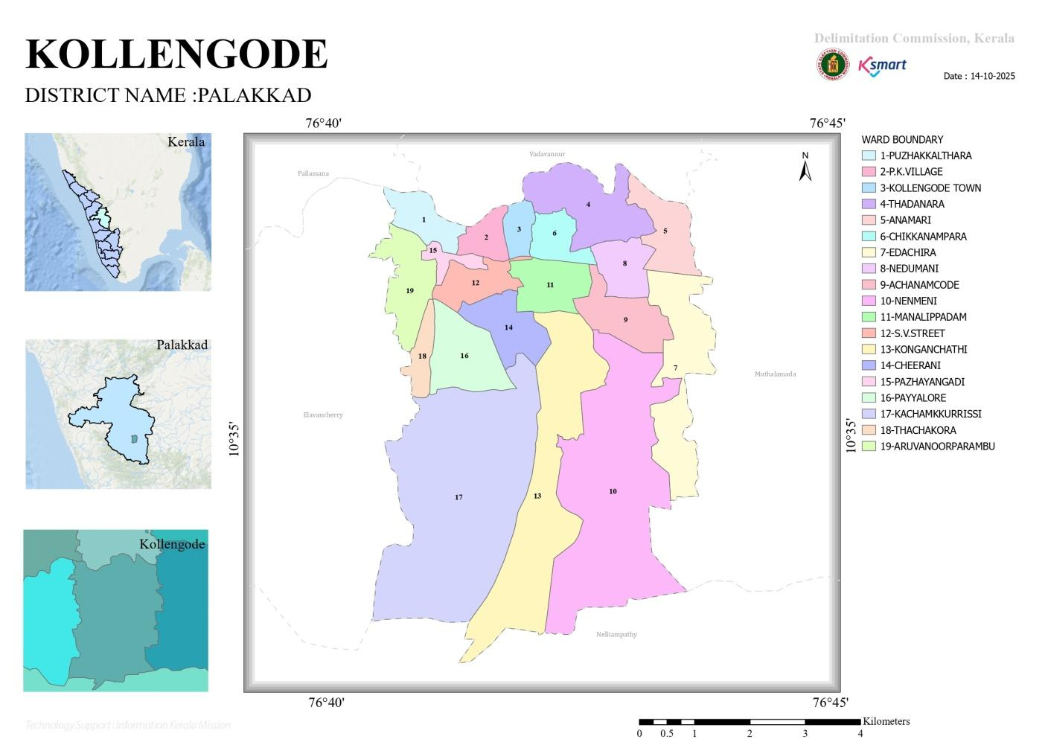
Source: https://wardmap.ksmart.live/

- Baseline data
- Ward division -
Ward | Houses | Population | Migrants | Wells | Hot  spots | Ed. Institutions | Hosp pvt/govt.
1 | 461 | 1562 | 0 | 42 | 0 | 2 | 2
2 | 499 | 1138 | 0 | 56 | 0 | 1
3 | 440 | 1425 | 0 | 49 | 0 | 1
4 | 468 | 1835 | 0 | 68 | 0 | 0
5 | 525 | 2082 | 0 | 56 | 0 | 0
6 | 602 | 2019 | 0 | 62 | 0 | 1
7 | 523 | 2500 | 92 | 74 | 1 | 0
8 | 520 | 2862 | 0 | 98 | 1 | 1
9 | 528 | 1919 | 0 | 54 | 0 | 0
10 | 546 | 2133 | 0 | 60 | 1 | 0
11 | 483 | 1765 | 0 | 54 | 0 | 0
12 | 448 | 1802 | 0 | 57 | 0 | 0
13 | 458 | 1972 | 0 | 64 | 0 | 0
14 | 475 | 1365 | 12 | 56 | 1 | 0
15 | 411 | 1413 | 0 | 68 | 0 | 0
16 | 382 | 1447 | 42 | 53 | 0 | 0
17 | 430 | 1497 | 0 | 39 | 0 | 0
18 | 516 | 1938 | 14 | 34 | 0 | 0

- Risk stratification among wards in the context of Communicable diseases and hazards

Sl. no | Ward No | Risk category | Key risk factor identified
1 | 2 | Medium | Flood-prone wards, Leptospirosis Vulnerability
2 | 9 | Mil | Land slide
3 | 15 | High | Land slide
4 | 17 | Medium | Land slide
5 | 9 | Medium | Flood prone area
6 | 16 | Medium | Flood prone area
7 | 17 | Medium | Flood prone area

- Major Roads

Palakkad - Kollengode Road: Main connector for regional access. connecting to the town centre.
Kollengode - Pylore - Panangatri - Elavanchery Road: Key connecting road spanning 8.8 km.
Kollengode - Kunissery Road
- Rivers
Gayathripuzha-Ward -3
- Major establishments with geospatial mapping
Sl. no | Category | Type of establishment | Ward | Public health relevance
1 | Health facility | Family Health centre | 3 | Comprehensive Primary Care, Disese prevention and control, Community health support
2 | Health facility | Govt. Ayurveda dispensaries | 2 | Supportive care services
3 | Health facility | Homeo dispensaries | 2 | Supportive care services
4 | Veterinary health facility | Govt. Veterinary clinic | 6 | Animal Health Services, Zoonotic Disease Control, Community Support and Awareness

- occupational groups, socio cultural groups, migration & mobility patterns
- Agriculture is the main livelihood of more than 70% of the population.The major cultivated crops include paddy and coconut. Cattle rearing especially cows and goats also a common practice in the community
- Kollengode is one of the major tourist destinations in Palakkad district.The Place attracts a large number of visitors and is known for its eco tourism spots. Major tourism attraction points in Kollengode panchayat are
Sl no | Name of the place | Ward no | Features | Public health importance
1 | Kudilidam Tourist Point | 8 | Scenic eco tourism spot | High visitors movement ,Need for sanitation and hygiene measures
2 | Seetharkundu Waterfalls | 10 | Natural waterfall and view point | Tourist influx, need for sanitation and hygiene
3 | Thamarakulam View Point | 10 | Hill top view point | Tourist influx, need for sanitation and hygiene
4 | Vellirimedu waterfall | 17 | Waterfall view point (seasonal, monsoon-driven waterfall) | Tourist influx, need for sanitation and hygiene
5 | Thamarapadam View Point | 10 | Agricultural landscape view point | Tourist influx, need for sanitation and hygiene
5 | Chinganchira Karuppuswamy Temple |  | Religious Pilligrimage site and  Natural panoramic view | Tourist influx, Large gathering during festivals

- Vulnerability mapping
Sl. No. | Category | Details | Public Health Significance
1 | Major Occupations | Agriculture and Animal husbandary | High mobility & exposure
3 | Socio-Economic Group | 3494 BPL families | Increased vulnerability
4 | Elderly Population | 4670 individuals | High-risk for severe illness
5 | Chronic Disease Population | HTN – 1174; DM – 982 | High-risk during pandemics

- Disaster prone areas (geographic vulnerability)
Sl. No. | Area / Factor | Description
1 | Flood-Prone Wards | 9,16,17
2 | Landslide wards | 9,12,15,16,17
3 | Human wildlife conflict | 7,9,12,16

Source:https://dmp.kila.ac.in/mnt/assets/dmp.kila.ac.in/maps/Palakkad/818-Kollengode_GP/Disaster_Management_Plan_Document_2019.pdf.

Maps - ward-based (Mention source also)

- Geographical boundaries - ward boundaries map

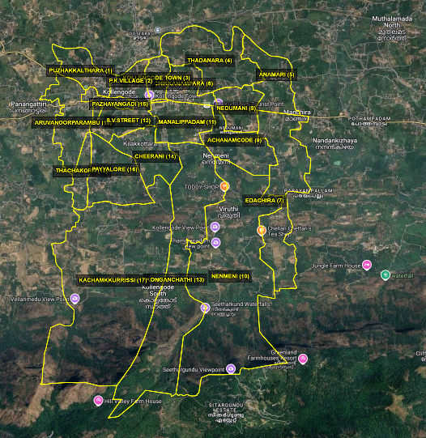

Source: https://wardmap.ksmart.live/

- Health infrastructure map

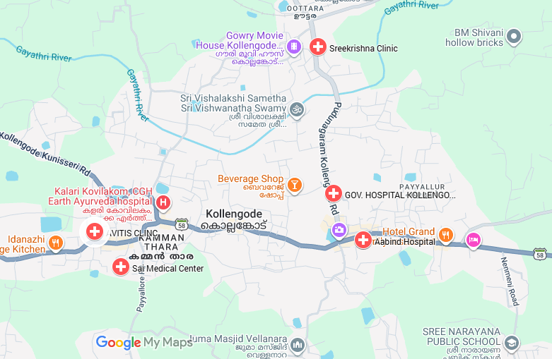
Source: Google maps

- Roads map

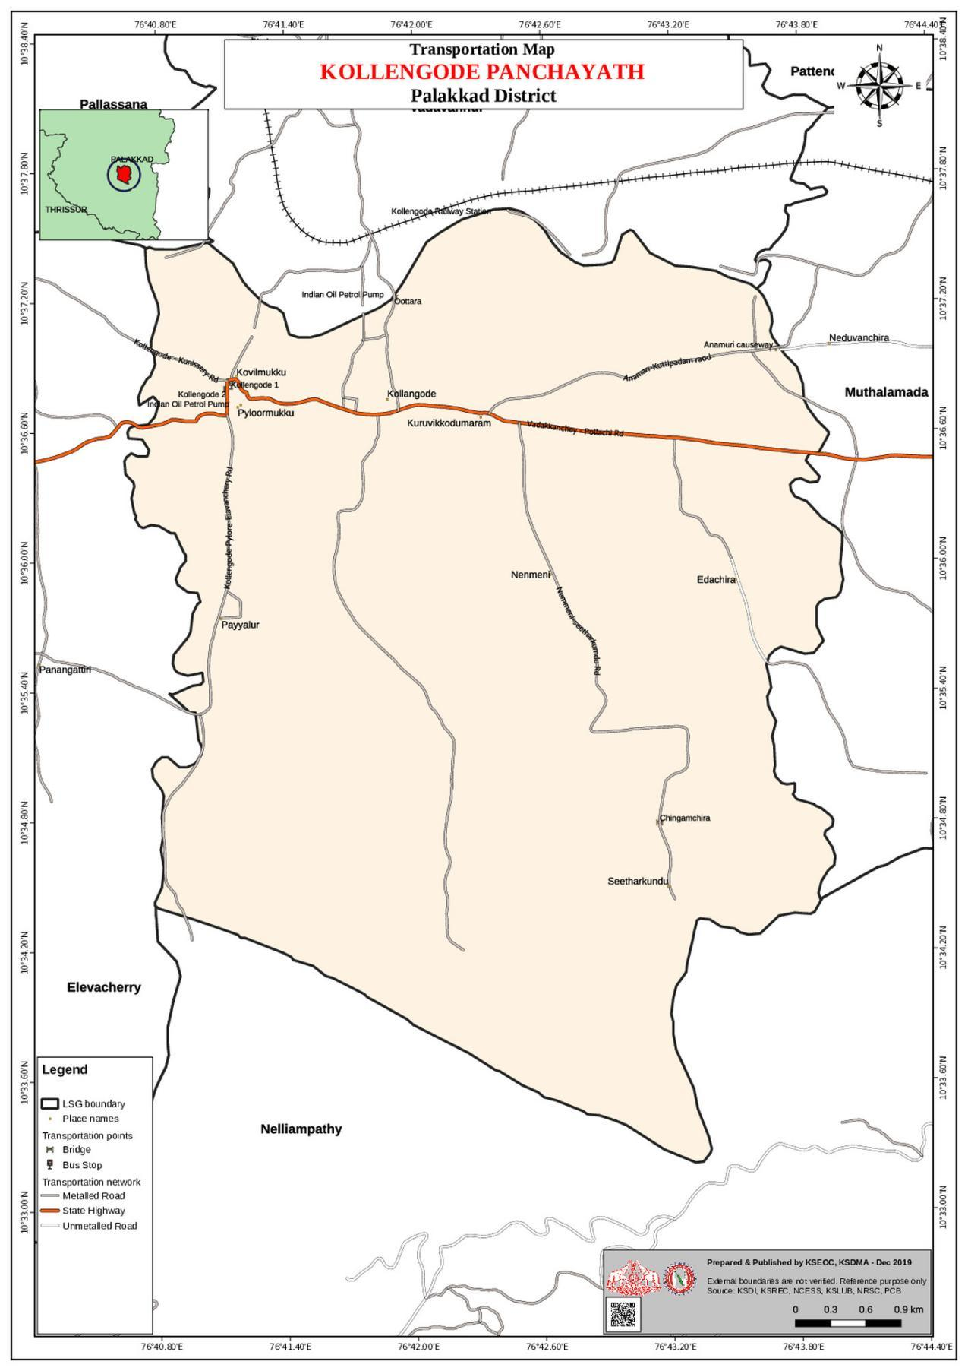
Source: https://dmp.kila.ac.in/

- watershed maps
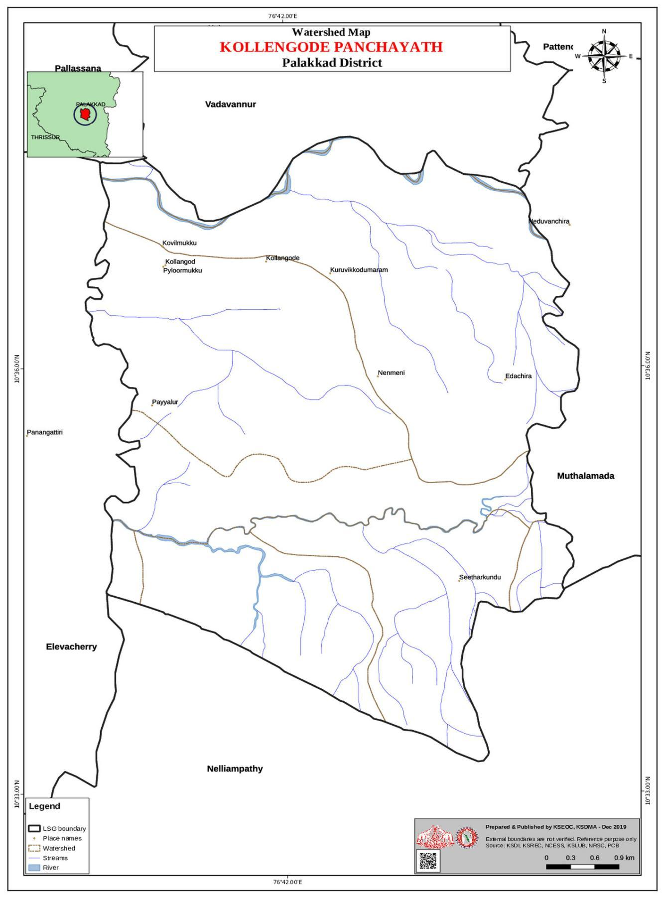

Source: https://dmp.kila.ac.in/

- Major establishments map
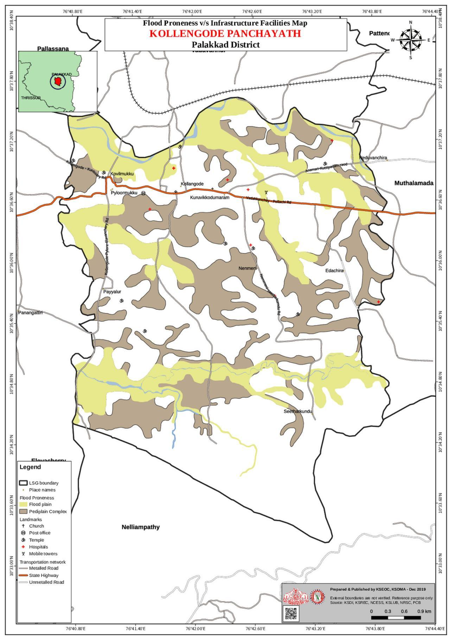
Source: https://dmp.kila.ac.in/

- Disaster-prone areas map-Flood affected Map

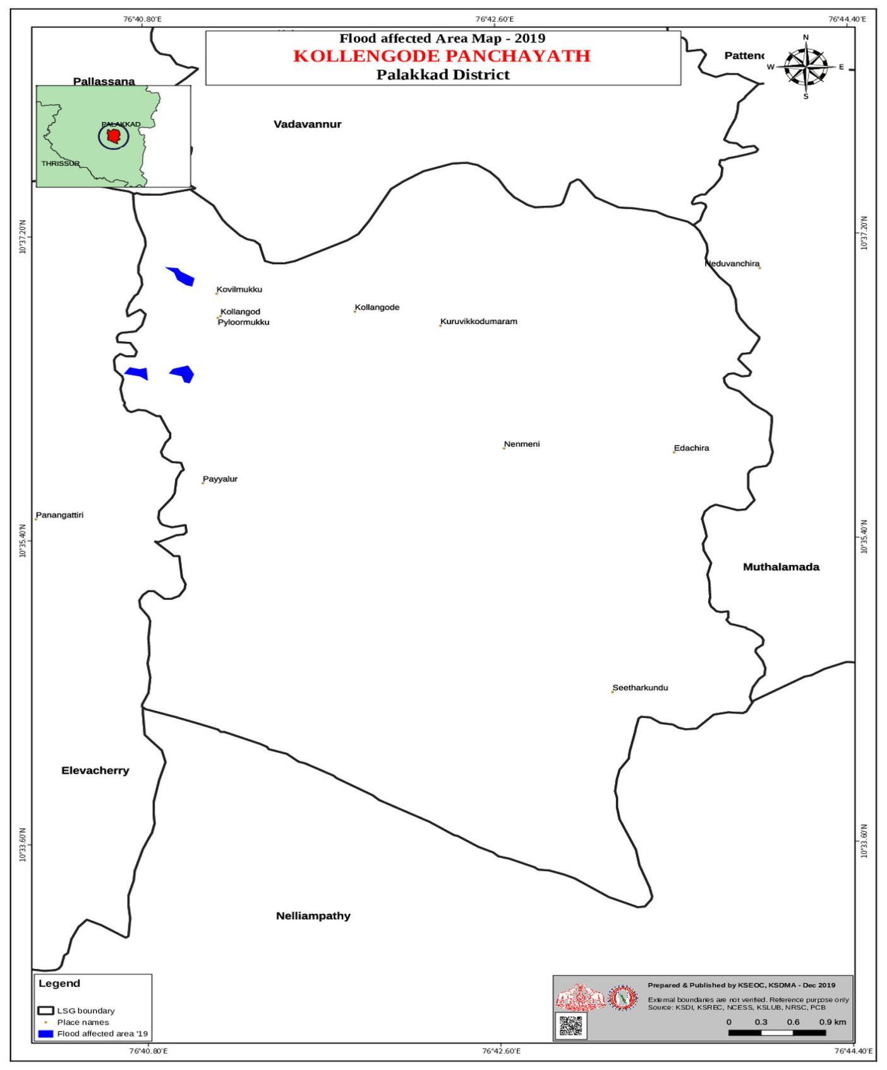
Source: https://dmp.kila.ac.in/

- Landslide affected map
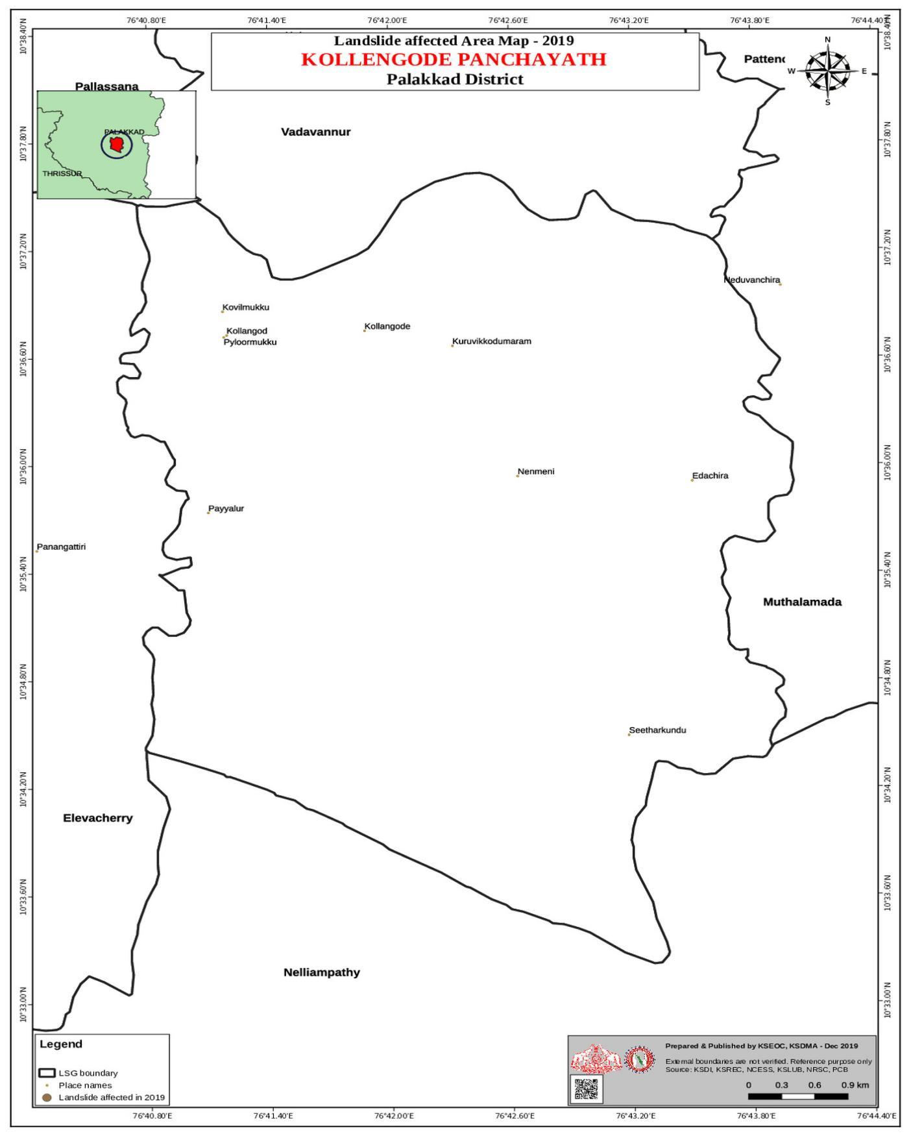
Source: https://dmp.kila.ac.in/

- Drought Proneness map

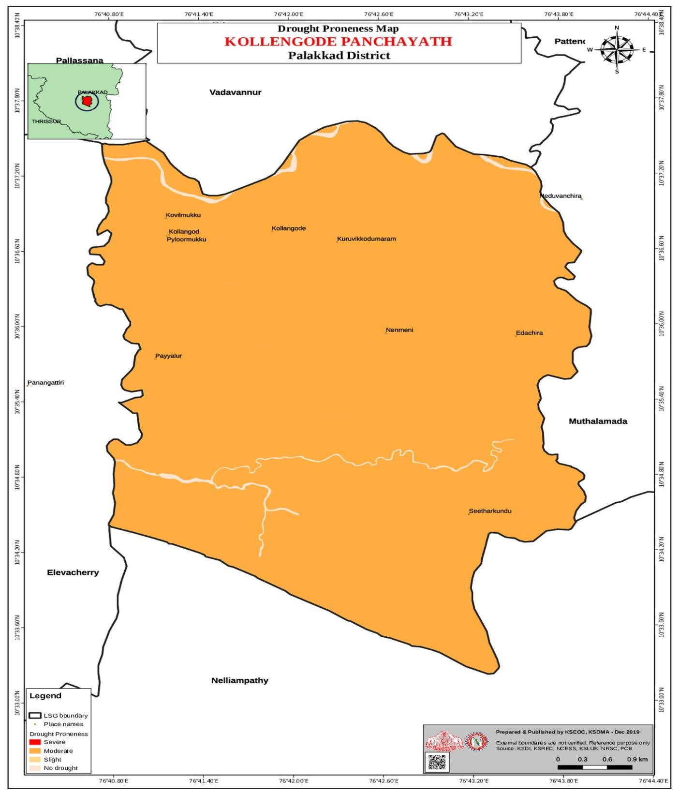
Source:https://dmp.kila.ac.in/

- hotspot map – Dengue fever

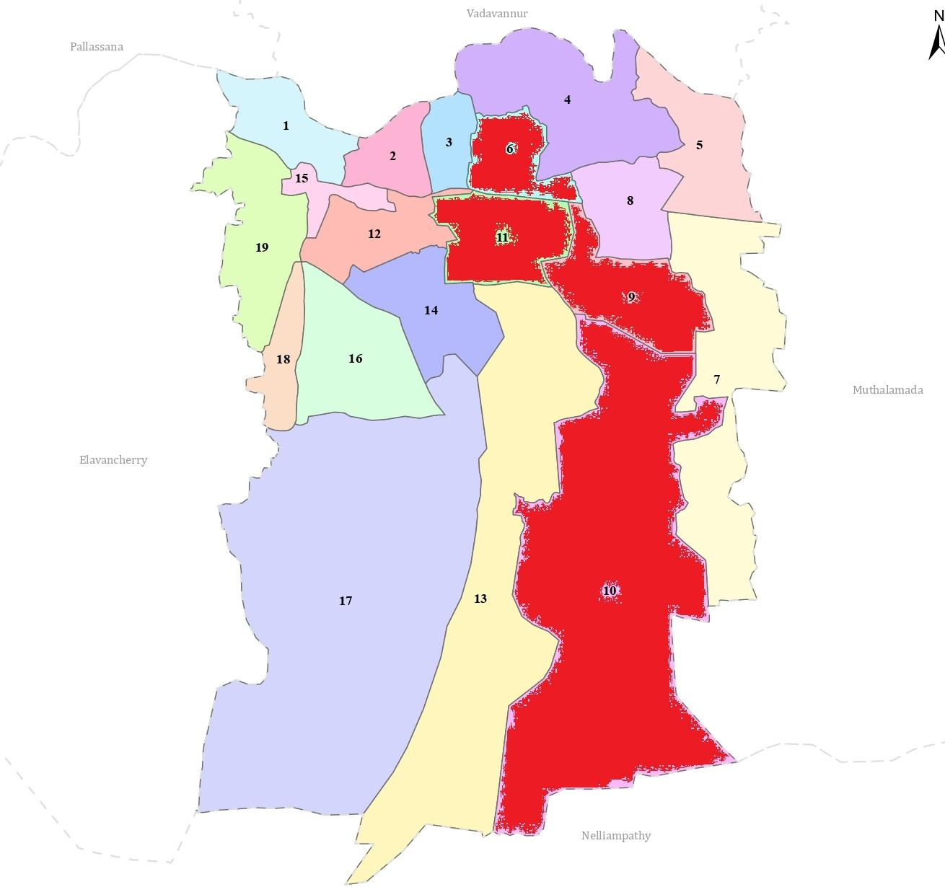

Source: Communicable Disease data 2021-2025-FHC Kollengode

INTEGRATED HEALTH INFRASTRUCTURE MAP OF KOLLENGODE PANCHAYAT

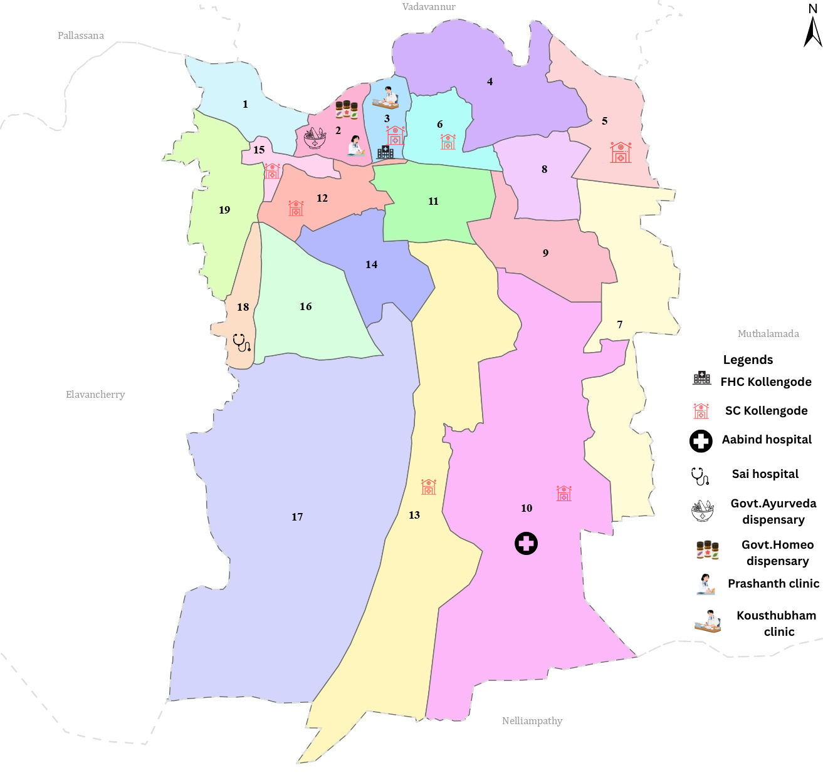

Health Infrastructure Map

GENERAL PROFILE OF THE LSGI’S

Background of the LSGI
Kollengode Grama Panchayat is situated in the eastern part of Palakkad, close to the Kerala–Tamil Nadu border, at the foothills of the Western Ghats. The geographical landscape is characterized as a transitional zone between the Palakkad plains and the forested highlands, with flat agricultural land surrounded by high-range mountains.
The Panchayat is administratively divided into eighteen wards, with a population largely dependent on traditional livelihoods, especially agriculture and paddy cultivation. In recent years, tourism-related activities have emerged. The area also hosts a diverse workforce, including a notable presence of migrant labourers, particularly in construction, agriculture, and allied sectors.
From a public health and disaster management perspective, Kollengode LSGI has historically been vulnerable to seasonal flooding and landslides, although certain parts of the LSGI remain relatively safe. The major communicable diseases reported in the area include dengue, leptospirosis, and Hepatitis A.
In this context, the development of a localized, data-driven Auxiliary Infrastructure and Logistical Resource Map is essential to support effective planning, timely emergency response, and sustainable development initiatives. Such mapping enables the Panchayat to identify critical resources, improve accessibility during disasters, and enhance the overall resilience of the community.

Table 1: Background of LSGD
Description | Details
Name of LSGI | Kollengode
Type (GP/Municipality / Corporation etc.) | Grama Panchayath
Block | Koduvayur
District | Palakkad
Number of wards | 18
Total area (sq. km) | 45
Population(Projected) | 32674
Population density | 726 persons/sq km
Terrain (coastal/low-lying/backwaters/foothills, etc.) | Low lying and foothills
Number of rivers passing through LSGI | 1
Number of water bodies in the LSGI | 36
Number of educational institutions | 14
Factories / small-scale industries | 2
Flood-prone wards | 9,16,17
Landslide-prone wards | 9,12,15,16,7
Death Management and Disposal Facilities (mortuaries/crematorium, including electric) | 1
Auditoriums/Marriage halls/convention centres/community halls | 4

Demographic and Vulnerable Population
Understanding the demographic composition and vulnerable population groups is essential for pandemic preparedness. Children, elderly, economically deprived families, migrant workers, and socially vulnerable groups are at increased risk during public health emergencies due to higher exposure, limited access to services, and dependency on public systems.

Description |  | Details (in numbers)
DEMOGRAPHIC PROFILE
Total population |  | 32674
Male |  | 16632
Female |  | 16042
Transgender |  | Nil
Children under 5 |  | 1571
Adolescent |  | 2959
Elderly (>60) |  | 3536
SOCIAL/LIVELIHOOD VULNERABILITY
Previous EPEP family |  | 85
BPL family |  | 3494
Tribal communities |  | 116
Migration | Immigrant | 135
Migration | Emigrant | 455
Socio-economically deprived |  | 0
Fisherfolk |  | Nil
SC Community |  | 33
ST Community |  | 4

Population pyramid

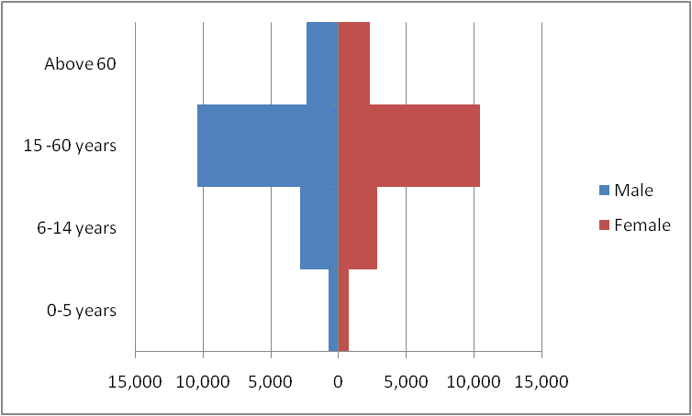

Category | Male | Female
0 to 5 years | 707 | 768
6 to 15 years | 2832 | 2861
16 to 60 years | 10390 | 10447
Greater than 60 years | 2330 | 2340

Clinical Vulnerability
Certain population groups needs priority healthcare & are at higher risk of severe illness, complications, and mortality during pandemics. Patients with chronic diseases, those requiring regular medical care, and individuals with mobility or functional limitations face challenges in accessing timely care during emergencies. Mapping these groups helps in prioritizing continuity of treatment, medicine stock planning, oxygen support, referral transport, and targeted home-based care.
Description | Details in numbers
Pregnant women | 198
Lactating mothers | 187
Bedbound patients | 94
Patients under palliative care other than bedbound | 84
Patients on Haemodialysis | 9
Patients on CAPD | 0
Cancer patients (currently on treatment) | 92
Haemophilic patients | 0
Mentally challenged | 10
Differently abled | 60
Diabetic patients | 982
Hypertensive patients | 1174
TB patients | 29

Major Festivals & Events specific to the LSGI

Sl. No. | Name of festival | Month detailing the periodicity
1 | Ayyappan vilakku | December, Annually
2 | Aarattu | December/January, Annually
3 | Maha Utsavam and Aarattu- Thiru Kachamkurissi Maha Vishnu Temple | November, Annually

INFRASTRUCTURE & RESOURCE INVENTORY

Health Facility Directory & Basic Capacity in the LSGD
This section provides an overview of the healthcare infrastructure available within the LSGD area. It outlines the distribution and basic capacity of health facilities that form the backbone of service delivery during routine times and public health emergencies.
Family Health Centres (FHCs) and Community Health Centres (CHCs) generally function as the first point of contact for the community, providing essential outpatient and inpatient services. General Hospitals (GH) and Medical College Hospitals (MCH), where accessible, serve as the main referral centres for advanced diagnostics, specialist care, and critical services during public health emergencies. This inventory helps identify existing strengths, gaps, and potential surge capacity that can be mobilised during a pandemic or disaster.

Table 5 . Health Facility Resource Summary
Sl.no. | Health Facility | Type of Facility (MCH/GH/CHC/FHC/SC etc.) | Contact Number |  | Total beds | ICU Beds | Oxygen-Supported Beds | No. of Ventilator Support Beds | No. of ambulance
Government Healthcare Facilities
1 | FHC Kollengode | FHC | 04923 264352 |  | 4 | 0 | 0 | 0 | 1
2 | HWC Anamari IPP | SC | 7012511329 |  | 0 | 0 | 0 | 0 | 0
3 | HWC Cheerani | SC | 9061951168 |  | 0 | 0 | 0 | 0 | 0
4 | HWC Kollengode | SC | 9961782387 |  | 0 | 0 | 0 | 0 | 0
5 | HWC Nedumani | SC | 9447188936 |  | 0 | 0 | 0 | 0 | 0
6 | HWC Nenmeni | SC | 9072022114 |  | 0 | 0 | 0 | 0 | 0
7 | HWC Pylore | SC | 9778380385 |  | 0 | 0 | 0 | 0 | 0
9 | HWC Thekkumchira | SC | 8129779705 |  | 0 | 0 | 0 | 0 | 0
Private Healthcare Facilities
1 | Aabind hospital | Hospital | 9447277882 |  | 30 | 3 | 0 | 0 | 1
2 | Sai Hospital | Hospital | 6282175141 |  | 27 | 0 | 0 | 0 | 0
AYUSH Healthcare Facilities
1 | Kovilakam | Hospital |  | 6238500970 | 5 | 0 | 0 | 0 | 0
2 | Govt. Ayurveda dispensary | dispensary |  | 9496174712 | 0 | 0 | 0 | 0 | 0
3 | Govt .Homoeo dispensary | dispensary |  | 04923 264001 | 0 | 0 | 0 | 0 | 0
4 | Prashanth Homeo clinic | Clinic |  | 04923 262318 | 0 | 0 | 0 | 0 | 0

Private Clinics
Private clinics are an essential part of pandemic preparedness, as they are often the first place people seeks care when symptoms begin. In many communities, private clinics manage a significant share of outpatient visits and therefore play a critical role in early case detection, timely referrals, and disease surveillance. Having an up-to-date understanding of where these clinics are located, the services they provide, and how they are linked to the public health system helps ensure that no cases are missed during an outbreak. It also allows health authorities to engage private practitioners more effectively for reporting, risk communication, and coordinated response, strengthening the overall capacity of the health system to manage public health emergencies.

Table 6. Private Clinic Resource Summary
Sl No. | Name of Clinic | Registered (Y/N) | Clinic (General / Speciality) | Speciality (if any) | Address | Contact Number | Diagnostic Facility (Y/N) | Ambulance Linykage (Y/N)
1 | Kouthubam | Y | speciality | Gynaec/Peadiac | Kollegode | 9947783102 | Y | Y
2 | Avitis Clinic | Y | General | Nil | Payalur mukk, Kollengode | 04923263735 | Y | Y
3 | Smile Care, Dental Clinic | Y | Speciality | Dental clinic | CT palayam road ,Kollengode | 9447422297 | N | N

Healthcare Education & Training Institutions
This section tracks the educational infrastructure available, which is vital for human resource planning in the health sector.

Category of Institution | Govt | Private | AYUSH | Total
Medical Colleges | 0 | 0 | 0 | 0
Nursing Colleges | 0 | 0 | 0 | 0
Dental Colleges | 0 | 0 | 0 | 0
Para-medical / Allied Health | 0 | 0 | 0 | 0
Pharmacy Colleges | 0 | 0 | 0 | 0

Specialized Services & Emergency Inventory
This section provides a detailed view of the specialized medical resources available to the community, focusing on emergency response and critical care capabilities. This table tracks the vital assets required for managing severe illnesses and emergencies across Government, Private, and AYUSH sectors.

Item | Govt | Private | AYUSH | Total
Hospital beds | 4 | 50 | 5 | 40
Oxygen-generating systems(Y/N) | 0 | 0 | 0 | 0
Oxygen-supported beds(Numbers) | 0 | 0 | 0 | 0
Ventilator-supported beds | 0 | 0 | 0 | 0
ICU beds | 0 | 0 | 0 | 0
Burns units | 0 | 0 | 0 | 0
Blood centres | 0 | 0 | 0 | 0
BLS ambulances | 0 | 1 | 0 | 0
ALS ambulances | 0 | 0 | 0 | 0
Dialysis facilities | 0 | 0 | 0 | 0
Dispensaries | 0 | 2 | 0 | 2
Medical store | 1 | 10 | 0 | 11
Industrial establishments(Medium-scale industries/small-scale industries establishments to whom we can depend in a worst-case scenario) | 0 | 2 | 0 | 2

Oxygen & Diagnostic Capacity
Monitoring oxygen and diagnostic capacity is a critical component of public health preparedness, ensuring that the LSGD can handle both chronic care and sudden surges in respiratory or infectious diseases.
Name of Health Facility | Oxygen-generating System (Y/N) | Backup Oxygen Source (Y/N) | Diagnostic Facilities Available(Y/N)
Name of Health Facility | Oxygen-generating System (Y/N) | Backup Oxygen Source (Y/N) | Lab | USG | X-ray | CT/MRI | RT-PCR
Government Healthcare Facilities
FHC Kollengode | N | Y | Y | N | N | N | N
Private Healthcare Facilities
Aabind hospital | N | N | Y | Y | Y | N | N
Sai Hospital | N | N | Y | N | Y | N | N
Kouthubam | N | N | N | N | N | N | N

Diagnostics facility mapping at the LSGI level
The diagnostic capacity of Kollengode G.P represents the "intelligence network" of our healthcare system. The speed and accuracy of disease identification depend entirely on the distribution and technical level of these facilities.

Item | Govt | Private | AYUSH | Total
General labs | 1 | 9 | 0 | 12
Microbiology labs | 0 | 0 | 0 | 0
RT-PCR labs | 0 | 0 | 0 | 0
USG units | 0 | 2 | 0 | 0
CT/MRI units | 0 | 0 | 0 | 0
Research labs | 0 | 0 | 0 | 0
Labs of other departments that can be repurposed | 0 | 0 | 0 | 0

Laboratory Identification & Basic Details
Sl. No. | Name of Laboratory | Ownership (Govt / Private / Academic) | Address | Contact No. | 24×7 Services (Yes/No) | NABL / Govt Approved (Yes/No)
1 | FHC Kolengode | Govt | Kollengode | 04923 264352 | N | Y
2 | Abind Hospital | Private | Pollachi Road,Kollengode | 9447277882 | Y | Y
3 | Sai Hospital | Private | Payyalore | 6282175141 | Y | Y
4 | Elite Lab | Private | Opesite FHC Kollengode | 9446382161 | N | Y
5 | Neethi Lab | Private | Kollengode | 9074441378 | N | Y
6 | New Elite | Private | Near Police Station | 9446321161 | N | Y
7 |  | Private | Behind Police Station | *** | N | Y
  Kousthubam | Private | Behind Police Station
8 | Nirmal | Private | Nenmara road | 81139 41584 | N | Y
9 | Avitis Lab | Private | Payyalore | 0492326 3735 | N | y

Social and Community Infrastructure for surge plan
This table serves as our logistics and shelter inventory. By mapping these locations, quickly we can identify where to house displaced citizens, where to set up temporary medical clinics, and how to manage the deceased with dignity during a crisis.

Category | Total Count | Ward | Est. Capacity (Persons) | Contact details
Educational Institutions
Anganwadis | 29 | All wards | 145 | See Annexure
Schools | 14 | 2,6,8,9,10,11,17,18 | 2205 | See Annexure
Colleges | 2 | 8,12, | 150 | See Annexure
Healthcare Educational Institutions
Medical colleges (Govt/Private) | 0
Nursing colleges (Govt/Private) | 0
Dental colleges (Govt/Private) | 0
Paramedical institutes (Govt/Private) | 0
Community Gathering Spaces
Community halls | 1 |  | 200 | See Annexure
Auditoriums | 4 |  | 800 | See Annexure
Religious buildings | 22 |  | 400
Vulnerable Group Support Facility
Destitute homes | 0
Elderly homes | 0
LSGD owned other buildings | 0
Mass Fatality Management (MFM) Infrastructure
Mortuary | 0
Crematorium | 1
*refer annexure 1 for contact details

Human resources
This section focuses on the human capital available within the LSGI. In any emergency—be it a pandemic, flood, or industrial accident—infrastructure is only as effective as the people operating it.

Medical & Clinical Personnel
This table tracks the "Frontline" providers responsible for diagnosis, treatment, and clinical management. Narrative sentence: eg., "Total health workforce: 450 personnel, with 60% in government facilities serving as primary surge capacity." A detailed directory with the contact numbers of all workers is maintained (Annexure in 1).

Cadre | Govt (No.) | Private (No.) | Total
Doctors—Modern Medicine | 4 | 4 | 8
Doctors – AYUSH | 1 | 1 | 2
Doctors – Veterinary | 1 | 0 | 1
Doctors – Dental | 0 | 1 | 1
Nursing officers | 4 | 25 | 29
Lab technicians | 2 | 9 | 11
Optometrist | 0 | 0 | 0
Pharmacists | 2 | 10 | 12
Psychologists | 0 | 0 | 0
Counsellors | 0 | 0 | 0

Public Health & Field-Level Workforce
These individuals are the backbone of surveillance, maternal-child health, and decentralized care.

Cadre | Health services | Municipal common services | Total
HS (Health Supervisors-CHC) | 1 | 0 | 1
HI (Health Inspectors) | 1 | 0 | 1
LHS (Lady Health Supervisor-CHC) | 0 | 0 | 0
LHI (Lady Health Inspectors) | 1 | 0 | 1
JPHN (Jr Public Health Nurses) | 7 | 0 | 7
JHI (Jr Health Inspectors) | 3 | 0 | 3
MLSP (Mid-Level Service Providers) | 5 | 0 | 5
Palliative Nurses | 1 | 0 | 1
RBSK Nurses | 1 | 0 | 1
PRO (CHC) | 1 | 0 | 0
Epidemiologist (CHC) | 1 | 0 | 0
Data Manager (CHC) | 1 | 0 | 0

Community & Support Cadre
This group represents the surge capacity of the LSGI—people who can be called upon for logistics, rescue, and specialized support.

Cadre | Number
ASHA Workers | 20
AWW (Anganwadi Workers) | 29
Emergency Medical Volunteers (Trained) | 0
Kudumbashree | 315 units (3600)
MNREGS | 6210 registered (Active -3193)
Purusha Swayam Sahaya Sangham | 0
Ex-Servicemen | 36
Retired Police Officers | 42
NCC/NSS Volunteers | 40
Red Cross volunteers | 30
One Health Community Volunteers | 40
One Health Community Mentors | 7

Community Organizations
This section details the presence of community-based organisations (CBOs), non-governmental organisations (NGOs), faith-based organisations (FBOs), Kudumbashree Self-Help Groups (SHGs), and Ayalkootams within the Local Self-Government Institution (LSGI). These groups enhance grassroots mobilization, resource distribution, and support networks crucial for pandemic response and community resilience.

Category | Total Count
NGOs | 0
Religious based organizations | 1
Foreign based organizations | 0
Sports Club/youth clubs | 11
Kudumbashree SHGs | 315
Political organizations | 5
Residential organizations | 4

Administrative & Emergency Services
This section outlines the availability of key non-health emergency support services and infrastructure within the LSGI, which are essential for effective pandemic preparedness and response. These facilities support law enforcement, disaster response, water supply, logistics, mobility, and community-level interventions during public health emergencies.

Category | Total Count | Contact details
Police Stations | 1 | 04923 262329
Fire & Rescue Stations | 1 | 04923 262101
Water Pumping Points | 1 | 8547638312
Public Distribution System (PDS) | 11

Information regarding resources
The availability of essential transport and support resources plays a quiet but critical role in saving lives. Equipment such as ambulances, mobile mortuaries, amphibian ambulances, and motorized boats ensures that patients, samples, and healthcare teams can move swiftly—even in flooded, remote, or difficult terrains. Heavy vehicles like JCBs, cranes, tractors, and torus Lorries support logistics, waste management, emergency infrastructure, and rapid conversion of spaces into care or isolation facilities. Taxis, four-wheel-drive vehicles, and trucks help maintain continuity of essential services, reach vulnerable populations, and support home-based care and supply delivery.

Means of transportation | Total Count
JCB | 7
Crane | 1
Heavy Trucks | 6
Tractor | 14
Ambulances | 7
Mobile mortuaries | 4
Boats | 0
Taxi service | 40
Note: For specific details regarding vehicle owners and contact information, please refer to Annexure [X].

ONE HEALTH & ENVIRONMENTAL SURVEILLANCE
The One Health method integrates environmental, animal, and human health to enable proactive pandemic preparedness. Panchayat-level surveillance needs to be improved in order to detect and treat zoonotic and environmentally generated diseases early. Surveillance is strengthened through systematic assessment of animal populations, veterinary infrastructure, poultry and slaughter facilities, inter-sectoral coordination, and specialised tools like avian influenza seasonality mapping.

Animal & Bird Population
Mapping animal and bird populations at the Panchayat level is essential for identifying and prioritising zoonotic disease hazards like rabies, avian influenza (H5N1), leptospirosis, anthrax, and Nipah-like spillover occurrences. Risk classification, targeted surveillance, vaccination planning, and early epidemic detection made feasible by comprehensive population mapping all enhance One Health-based pandemic preparedness.

Category | Item | Estimated Population | Wards
Animal Population | Livestock (Cattle/Goats/Buffalo) | 2355/2540/229 | All ward
Animal Population | Pet Animals (Dogs/Cats) | 1254/160 | All wards
Animal Population | Stray Dog Population | 42 | All wards
Animal Population | Pig Farms (Number of heads) | 1/150 | 7
 | Small Units (Sheep / Goats – clustered) | 12 | 1,6,9,12,18
Bird Population | Poultry Units (Birds) | 4/12500 | 10,11
Bird Population | Poultry- (FOWL) | 5232 | All ward
Bird Population | Wild/Migratory Birds (Observed) | 0 | 0
Bird Population | Crow Mortality Events (Reported) | 0 | 0

Veterinary Infrastructure
Veterinary institutions are a core pillar of One Health surveillance, enabling early zoonotic disease detection through vaccination, investigation of unusual animal illness or deaths, sample collection, and timely outbreak reporting. A well-mapped and responsive veterinary network strengthens coordination with human health and LSGI systems, ensuring rapid response during zoonotic events and pandemics.
Facility Type | Name of Facility | Ownership Govt / Pvt | Location(Ward No) | Contact number
Veterinary Dispensary | 0 | 0 | 0 | 0
Veterinary Hospital / Polyclinic | Hospital | Govt | 0
Private Veterinary Clinics | 0 | 0 | 0 | 0
Mobile / Emergency Vet Service (incl. night services) | 0 | 0 | 0 | 0
Pet Homes / Animal Shelters | 0 | 0 | 0 | 0
Slaughterhouse-linked Veterinary Inspection Unit | 0 | 0 | 0 | 0

Veterinary Doctors & Workforce
Early detection, diagnosis, reporting, and reaction to animal illness epidemics depend on the availability and accessibility of qualified veterinary specialists. By identifying unusual animal morbidity or mortality promptly, collecting samples promptly, and coordinating efficiently with human health and LSGI systems—especially during zoonotic outbreaks and pandemic-prone situations—a clearly defined veterinary workforce enhances One Health surveillance.

Category | Number Available | Type (Govt/Pvt) | Contact number
Government Veterinary Doctors | 1 | Govt | 9496194384
Private Veterinary Doctors | 0 | 0 | 0
Livestock Inspectors | 2 | Govt | 6282200690
Para-veterinary Staff / Attenders | 3 | Govt | 04923 262970
Contract / On-call Veterinary Support (if any) | 1 | Private | 8848527997

High-Risk Interface Points (Surveillance Sites)
High-risk interface points for zoonotic disease surveillance in Kollengode Grama Panchayath include wetland–livestock–human contact zones, backyard poultry farms, cattle sheds near water bodies, fish markets, and areas of high human–animal interaction such as community slaughter points and migratory bird congregation sites. These are the primary surveillance sites where zoonotic spillover risks are elevated.

Type of Habitat | Type of High risk interface | Geographical vulnerability
Wetlands & Backwaters | 0 | 0
Backyard Poultry Farms | 0 | 0
Cattle Sheds near Water Bodies | 0 | 0
Fish & Meat Markets | 0 | 0
Community Slaughter Sites | 0 | 0
Migratory Bird Congregation Areas | 0 | 0
Rodent-Infested Grain Storage | 0 | 0

Category | Total Count | Key Locations (wards)
Poultry Farms | 4 | 9,10
Backyard / Clustered Poultry Units | 0
Duck Rearing Units (open water access) | 0
Slaughterhouses/ Slaughter Points | 0
Meat/Fish Markets | 0
Live Bird Sale Points | 1 | 2
Cattle Markets / Weekly Animal Fairs | 0
Pet Shops / Breeders | 0
Animal Shelters / Pet Homes | 0
Waste Disposal Sites near Animal Units | 0

Environmental Risk Mapping
Environmental risk mapping identifies monsoon/flood hotspots for vector-borne (dengue, chikungunya), water-borne (leptospirosis, diarrhoea), and zoonotic diseases in Kerala's wetlands. Systematic surveillance supports early warnings, targeted interventions, and Panchayat pandemic preparedness.
Waterborne exposure: Flood-prone areas and stagnant water bodies facilitate leptospira survival, raising leptospirosis risk.

Traditional practices: Informal slaughter and fish markets lack standardized hygiene, creating spillover opportunities.
Risk Factor | High-Risk Wards | Key Locations | Risk Level (High/Med/Low)
Flood-prone areas | 9,16,17 | Puzhakkalthara | Med
Water bodies/wetlands | 3 | 0 | 0
Solid waste accumulation | 18 | Perithirakovil | Med
Animal waste disposal issues | 0 | 0 | 0
Rodent infestation zones | 0 | 0 | 0
Industrial effluent discharge | 0 | 0 | 0
Construction sites / abandoned buildings | 0 | 0 | 0
Poor drainage/blocked canals | 2,3,10,11, | Mapara padam Near Petrol pump Near HWC Nenmeni Near Abinth Hospital | Med
Drinking water source contamination risk | 0 | 0 | 0

Disease Seasonality Mapping
1, Flooding & waterlogging → amplifies leptospirosis, malaria, diarrheal diseases.
·
2, Migratory bird influx (Nov–Feb) → avian influenza risk.

3, Mosquito breeding cycles → vector-borne disease peaks in monsoon.

4, Agricultural practices → close human–animal contact in paddy fields.

Disease | Peak Risk Season | Key Drivers | High-Risk Locations | Surveillance Focus
Avian Influenza | 0 | 0 | 0 | 0
Leptospirosis | May to October | Agriculture related work | Nilil
Dengue/Chikungunya | June to November | Water scarcity and storage | Thekkethara,Edachara,palakode, | Vector index,  Syndromic surveillance
Acute Diarrheal Diseases | June to November | Poor drainage ,Low lying territorial | All wards | Water quality testing,Syndromic surveillance
Rabies | All season |  | All wards | Animal bite cases, dog vaccination coverage, laboratory confirmation of suspected rabies
Anthrax (rare) | All season |  | All wards | Sudden livestock deaths, cutaneous lesions in exposed persons, lab confirmation of Bacillus anthracis

Vulnerability Mapping
Vulnerability mapping pinpoints high-risk populations, occupations, and areas exposed via environment, livelihoods, socio-economics, and poor service access. Paired with environmental/seasonality mapping, it enables risk-based surveillance, targeted actions, and optimal resource use in One Health and pandemic planning.
Vulnerability Factor | High-Risk Wards | Key Groups / Locations | Risk Level
Flood-prone households | 9,16,17 | Pulingottuthara | Medium
Wetland-adjacent communities | 0
Backyard poultry / duck rearing households | 0 | 0 | 0
Livestock-rearing households | 0 | 0 | 0
Slaughterhouse & meat market workers | 0 | 0 | 0
Fisherfolk & fish market workers | 0 | 0 | 0
Sanitation workers | 0 | 0 | 0
Daily wage / migrant workers | 7,9,12,15 | Edachara,Thekkinchiara,Nenmeni,Payyalore | Med
Elderly & chronically ill populations | All Ward | 0 | 0
Pregnant Women | 0 | 0 | 0
Children (schools, Anganwadi’s) | 0 | 0 | 0
Limited access to safe water & sanitation | 0 | 0 | 0

EPIDEMIOLOGICAL TRENDS (2021–2025)

Disease surveillance is the systematic collection, analysis, and interpretation of health data for planning, implementation, and evaluation of public health practice. This section presents the disease surveillance profile of the LSGI based on routine reporting systems and outbreak investigations to identify priority diseases, seasonal patterns, and emerging public health threats.

Disease Burden among human beings (Last 5 Years)
Analysis of disease-wise data for the last five years helps identify persistent public health problems, emerging diseases, and changes in disease burden. This information supports prioritisation of prevention, preparedness, and response activities at the Panchayat level.

Disease | 2021 | 2022 | 2023 | 2024 | 2025 | Trend(Increasing/Stable/Decreasing)
Dengue | 23 | 12 | 26 | 73 | 10 | Decreasing
Leptospirosis | 1 | 2 | 1 | 2 | 1 | Stable
Hepatitis A | 0 | 1 | 1 | 1 | 5 | Increasing
Malaria | 0 | 1 | 0 | 0 | 0 | Stable
Scrub Typhus | 0 | 0 | 0 | 0 | 0 | Stable
Typhoid | 0 | 1 | 0 | 0 | 1 | Stable
H1N1 | 0 | 0 | 0 | 1 | 0 | Stable
H3N2 | 0 | 0 | 0 | 0 | 0 | Stable
ADD | 72 | 80 | 68 | 48 | 82 | Increasing
Mumps | 0 | 1 | 0 | 7 | 27 | Increasing
Measles | 0 | 0 | 0 | 0 | 0 | Stable
Hepatitis B | 0 | 4 | 0 | 3 | 2 | Stable
Hepatitis C | 0 | 0 | 0 | 0 | 0 | Stable
Tuberculosis | 20 | 30 | 25 | 24 | 29 | Increasing
Leprosy | 0 | 1 | 0 | 0 | 1 | Increasing
COVID-19

Annual Incidence of Selected Communicable Diseases in Kollengode Panchayath, 2021–2025
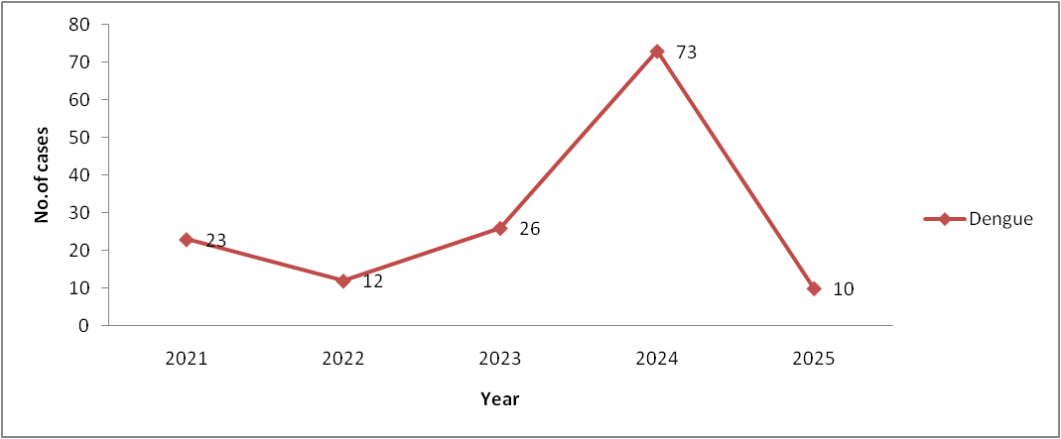

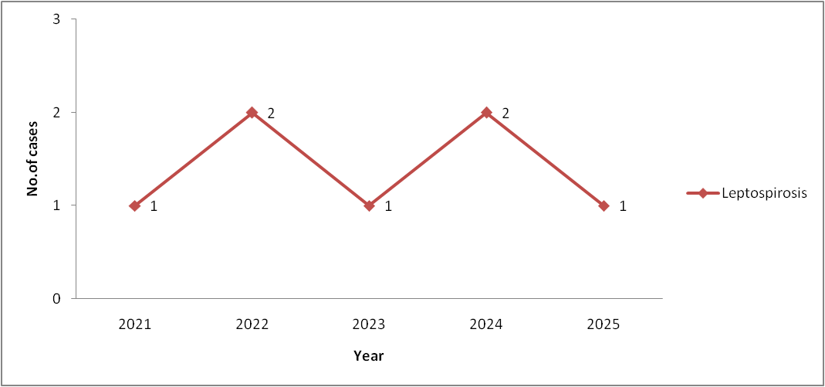
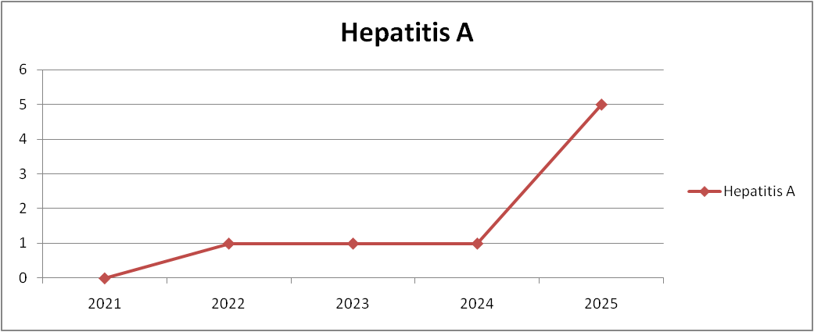

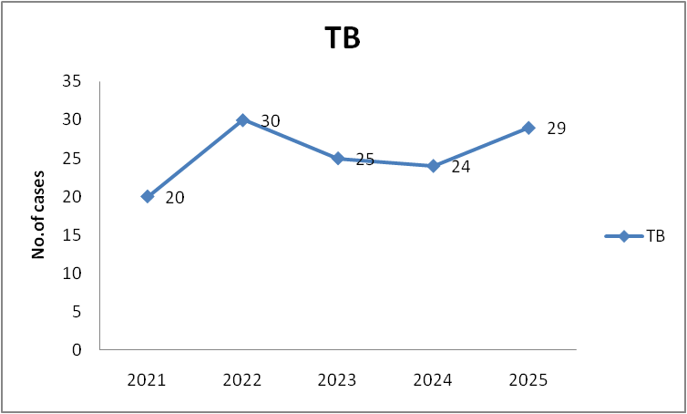

Seasonal Trend Analysis
Seasonal analysis helps anticipate surges (e.g. dengue in monsoon, leptospirosis after floods, influenza in cooler months) and plan pre‑emptive vector control, stockpiling of IV fluids, and awareness campaigns at Panchayath level.

DENGUE
Dengue is a major seasonal vector-borne disease strongly associated with rainfall, water stagnation, and increased mosquito breeding during the monsoon period.

Peak: July–November

Dengue – Ward-wise Yearly Distribution (2021–2025)

Ward | Dengue – Ward-wise Yearly Distribution
Ward | 2021 | 2022 | 2023 | 2024 | 2025 | Total
1 | 2 | ,0 | 0 | 2 | 0 | 4
2 | 0 | 0 | 2 | 0 | 0 | 2
3 | 2 | 0 | 0 | 2 | 1 | 5
4 | 3 | 1 | 0 | 0 | 0 | 4
5 | 0 | 0 | 0 | 0 | 0 | 0
6 | 2 | 4 | 0 | 8 | 1 | 15
7 | 2 | 0 | 0 | 0 | 0 | 2
8 | 2 | 0 | 0 | 0 | 0 | 2
9 | 2 | 2 | 4 | 16 | 1 | 25
10 | 3 | 1 | 7 | 22 | 0 | 33
11 | 2 | 2 | 5 | 9 | 0 | 18
12 | 1 | 2 | 3 | 1 | 0 | 7
13 | 0 | 0 | 0 | 0 | 0 | 0
14 | 0 | 0 | 0 | 10 | 0 | 10
15 | 2 | 0 | 0 | 0 | 0 | 0
16 | 0 | 0 | 0 | 1 | 0 | 1
17 | 0 | 0 | 0 | 0 | 0 | 0
18 | 0 | 0 | 3 | 2 | 0 | 5

LEPTOSPIROSIS
Leptospirosis cases are closely linked to monsoon rains, flooding, and occupational exposure, particularly in low-lying and waterlogged areas.

Peak: June - August

Leptospirosis – Ward-wise Yearly Distribution (2021–2025)

Ward | Leptospirosis – Ward-wise Yearly Distribution
Ward | 2021 | 2022 | 2023 | 2024 | 2025 | Total
1 | 0 | 0 | 0 | 0 | 0 | 0
2 | 0 | 0 | 0 | 0 | 0 | 0
3 | 0 | 0 | 0 | 1 | 0 | 1
4 | 0 | 0 | 0 | 0 | 0 | 0
5 | 0 | 0 | 0 | 0 | 0 | 0
6 | 0 | 0 | 0 | 1 | 0 | 0
7 | 1 | 0 | 0 | 0 | 0 | 1
8 | 0 | 0 | 1 | 0 | 0 | 1
9 | 0 | 0 | 0 | 0 | 0 | 0
10 | 0 | 1 | 0 | 0 | 0 | 0
11 | 0 | 0 | 0 | 0 | 0 | 0
12 | 0 | 0 | 0 | 0 | 1 | 1
13 | 0 | 0 | 0 | 0 | 0 | 0
14 | 0 | 0 | 0 | 0 | 0 | 0
15 | 0 | 1 | 0 | 0 | 0 | 0
16 | 0 | 0 | 0 | 0 | 0 | 0
17 | 0 | 0 | 0 | 0 | 0 | 0
18 | 0 | 0 | 0 | 0 | 0 | 0

VIRAL HEPATITIS - A
Hepatitis A cases are commonly associated with unsafe drinking water, food contamination, and breakdowns in sanitation, often presenting as clusters or outbreaks.

Peak: October - December

Hepatitis A – Ward-wise Yearly Distribution (2021–2025)

Ward | Hep A – Ward-wise Yearly Distribution
Ward | 2021 | 2022 | 2023 | 2024 | 2025 | Total
1 | 0 | 0 | 0 | 0 | 0 | 0
2 | 0 | 0 | 0 | 0 | 0 | 0
3 | 0 | 0 | 0 | 0 | 0 | 0
4 | 0 | 0 | 0 | 0 | 0 | 0
5 | 0 | 1 | 0 | 0 | 0 | 1
6 | 0 | 0 | 0 | 0 | 0 | 0
7 | 0 | 0 | 0 | 0 | 0 | 0
8 | 0 | 0 | 1 | 0 | 1 | 2
9 | 0 | 0 | 0 | 0 | 0 | 0
10 | 0 | 0 | 0 | 0 | 1 | 1
11 | 0 | 0 | 0 | 0 | 0 | 0
12 | 0 | 0 | 0 | 1 | 1 | 2
13 | 0 | 0 | 0 | 0 | 0 | 0
14 | 0 | 0 | 0 | 0 | 0 | 0
15 | 0 | 0 | 0 | 0 | 0 | 0
16 | 0 | 0 | 0 | 0 | 0 | 0
17 | 0 | 0 | 0 | 0 | 1 | 1
18 | 0 | 0 | 0 | 0 | 1 | 1

Outcome-Based Trend Analysis- 2025

Transmission Trend- 2025
For effective management of public health issues, it is important to track the trend of disease transmission mode. It helps identify the population or place at high risk that can be used to predict outbreaks and implement targeted interventions as quickly as possible. Understanding these kinds of trends enables authorities to allocate resources efficiently and change the strategies adequately based on the trend that follows.

Mode of Transmission | No. of cases | No. of Deaths
Vector Borne Diseases | 3 | 0
Water Borne Diseases | 82 | 0
Air Borne Diseases | 37 | 0
Blood Borne Diseases | 0 | 0
Food Borne Diseases | 1 | 0

Vector-Borne Disease

Disease | No. of Cases | No. of Deaths
Dengue | 3 | 0
Malaria | 0 | 0
Chikungunya | 0 | 0

Water Borne Disease

Disease | No. of Cases | No. of Deaths
Cholera | 0 | 0
Typhoid | 1 | 0
Hep- A | 5 | 0
Dysentery | 0 | 0
Amoebiasis | 0 | 0
E- Coli infections | 0 | 0
Air Borne Disease

Disease | No. of Cases | No. of Deaths
Influenza | 0 | 0
H1N1 | 0 | 0
TB | 29 | 0
Chickenpox | 37 | 0
Measles | 0 | 0
Covid-19 | 0 | 0
Pertussis | 0 | 0
Mumps | 27 | 0

Blood-Borne Disease

Disease | No. of Cases | No. of Deaths
AIDS | 0 | 0
Hep- B | 2 | 0
Hep- C | 0 | 0

Zoonotic Disease

Disease | No. of Cases | No. of Deaths
Rabies | 0 | 0
Leptospirosis | 1 | 0
Avian influenza | 0 | 0
West nile | 0 | 0
Anthrax | 0 | 0
Nipah | 0 | 0
Scrub Typhus | 0 | 0

Integrated Disease Hotspot Map (2021–2025)

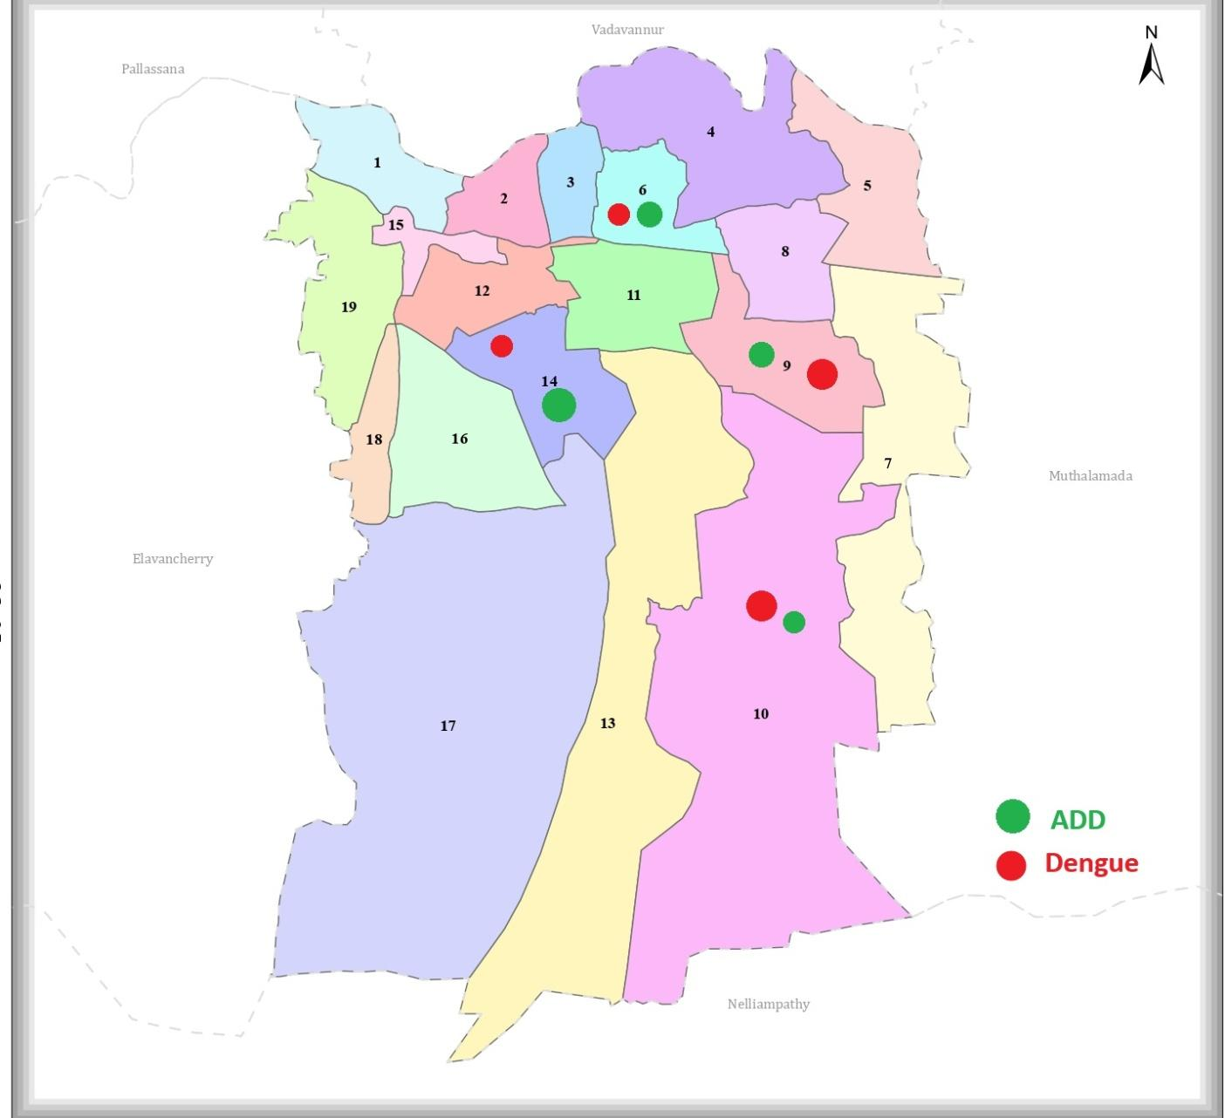

Ward-wise Total Reported Cases of Selected Communicable Diseases in Kollengode Panchayath-2021 to 2025

Ward No | Dengue Total (2021-25) | Leptospirosis Total (2021-25) | Hepatitis A Total (2021-25) | Mumps (2021-25) | ADD (2021-25) | Total Cases
1 | 4 | 0 | 0 | 3 | 18 | 25
2 | 2 | 0 | 0 | 2 | 22 | 26
3 | 5 | 1 | 0 | 3 | 24 | 33
4 | 4 | 0 | 0 | 3 | 17 | 24
5 | 0 | 0 | 1 | 0 | 22 | 23
6 | 15 | 0 | 0 | 2 | 21 | 38
7 | 2 | 1 | 0 | 0 | 25 | 28
8 | 2 | 1 | 2 | 3 | 28 | 36
9 | 25 | 0 | 0 | 0 | 26 | 51
10 | 33 | 0 | 1 | 0 | 17 | 50
11 | 18 | 0 | 0 | 2 | 16 | 34
12 | 7 | 1 | 2 | 0 | 14 | 24
13 | 0 | 0 | 0 | 3 | 18 | 21
14 | 10 | 0 | 0 | 0 | 30 | 40
15 | 0 | 0 | 0 | 2 | 31 | 33
16 | 1 | 0 | 0 | 4 | 18 | 23
17 | 0 | 0 | 1 | 0 | 120 | 121
18 | 5 | 0 | 1 | 0 | 16 | 22
13
By overlaying five years of data, we have identified 3 .'Red Zone' Wards. These are wards where at least two different categories of diseases (e.g., Dengue and ADD) recurred in consecutive years. Ward 10,9 and 8 is categorized as the Highest Priority Hotspot

Preparedness and Response Protocol at LSG Level
This section describes the operational framework for the LSGI once a pandemic is declared. It explains how the LSGI and health system will move from routine data collection to active response, using a One Health approach.

Constitution of One Health Committee
The LSGD shall constitute a One Health Committee comprising the LSGI President, Medical Officers (Modern Medicine, AYUSH, and Veterinary), the Health Inspector, and the Veterinary Surgeon.

Objective: The One Health Committee coordinates human, animal, and environmental health to prevent and control pandemics.

Sl No | Name | Designation | Department/Institution | Role in Committee | Contact Number
1 | Aswathy das | Panchayat President | LSGD | Chairperson
2 | Dr.Boby Mani | Medical Officer (PHC/CHC) | Health Dept | Member Secretary | 9447724313
3 | Dr. Ramkumar | Veterinary Officer | Animal Husbandry | Member | 9496194384
4 | Dr. Sreeja M | Epidemiologist | Health Dept | Member | 9846594307
5 | Vinod kumar | Health Inspector/PHN | Health Dept | Surveillance | 9447718935
6 | Chandrika | ASHA Supervisor | Health Dept | Community link | 9074446117
8 | Manikandan. K | Police Station Officer | Police Dept | Law & order | 9497987154
11 | Sakker Hussain | NGO/Volunteer rep | Civil Society | Support services
12 | Radha | ICDS Supervisor |  |  | 8547398210

Key Responsibilities:
- Review disease surveillance data (human + animal)
- Conduct ward-wise risk assessment and vulnerability mapping
- Approve quarantine/isolation centre locations
- Coordinate with district for resources (PPE, oxygen, ambulances)
- Periodically review health system surge capacity, including beds, oxygen, human resources, and ambulances.
- Approve and monitor risk communication and community engagement strategies, including rumour management.
- Ensure protection and service continuity for vulnerable groups (elderly, persons with disabilities, dialysis patients, coastal populations).
- Conduct quarterly mock drills
- Monitor equity measures for vulnerable groups

Meeting Schedule:
Quarterly (normal times) | Weekly (outbreak alert) | Daily (pandemic phase)

Pandemic Response Workforce
To ensure a coordinated and timely response during a pandemic, a dedicated Pandemic Response Workforce shall be constituted at the LSG level. The workforce will function under the overall supervision of the One Health Committee and in close coordination with the health authorities. Team-based deployment will enable efficient surveillance, case management, quarantine and isolation management, logistics support, and risk communication. Each team shall have a clearly designated team leader, defined roles, and an identified pool of personnel to allow rapid activation, rotation of duties, and continuity of services during prolonged emergencies.

Total Response Workforce Available: 300 persons

Team Name | Composition | Key Responsibilities | Team Leader
Surveillance and Contact Tracing Team | HI, JHI, JPHN, MLSP, ASHAs and Volunteers | Case detection, contact listing, home visits, reporting | HI
Case Management Team | Doctors, Nurses, MLSP, Palliative Nurses | Patient care & referral | DOCTOR
Quarantine & Isolation Team | LSGD staff, Volunteers | Facility management | JHI
Psychosocial support | MLSP |  | MLSP
Logistics & supply chain Team | LSGD staff, Storekeepers, Drivers 3 | Supplies & transport [PPE, medicines, oxygen, transport, waste management] | Ward Member
Communication Team | Ward members, Kudumbashree, Youth clubs,  AWW workers and other self help groups | IEC, community meetings, countering misinformation | M.O in charge
Transportation | KSRTC, educational institutional buses | Arrange transportation facility | HI
Media Surveillance | JHI,HI | Active search of medias for updates | HI
Intersectoral coordination and convergence | JHI |  | HI
Collaborative surveillance | JHI, LivestockInspector , veterinary doctor, AYUSH medical officers | Active search of cases ,risk communication | MO incharge

All teams shall be activated immediately upon outbreak alert or pandemic declaration and shall report daily to the LSG Incident Commander/Medical Officer, with consolidated reporting to the Block PHC. Duty rosters and alternate personnel shall be maintained to ensure uninterrupted services during staff shortages or prolonged response periods. Team composition and numbers may be revised based on the magnitude of the outbreak and availability of human resources.

Activities and Measures before and during Pandemic

PHASE 1 - Alert / Preparation
Surveillance and Reporting-Enhanced syndromic surveillance:
- Data sources for surveillance:
- Event-based triggers (to be monitored and reported):
- Zoonotic and animal health surveillance
- Logistics and Stock Preparedness
  - Identify and empanel local vendors and define emergency procurement mechanisms in accordance with existing LSGD and Health Department norms.
  - Prepare and maintain an essential logistics checklist covering medical supplies, consumables, and support equipment.
  - Pre-identify secure storage locations for emergency stocks and ensure maintenance of stock registers with regular updating.
  - Finalise emergency transport arrangements, including availability of vehicles and identified drivers for rapid deployment during alerts.
  - Designate a Nodal Officer for Logistics to enable prompt decision-making, coordination, and communication during emergencies.
  - Conduct rapid stock verification and ensure availability of minimum buffer stock, including:
- PPE kits – numbers
- Pulse oximeters – ___ numbers
- Hand sanitizers – ___ litres
- Masks, gloves, disinfectants – adequate quantity
Identify critical gaps in logistics and immediately communicate requirements to the Block and District authorities for timely replenishment and support. Monitor expiry dates and stock rotation.

Identification of Quarantine and Isolation Facilities
  - Identify and list suitable buildings for quarantine and isolation (schools, hostels, community halls, etc.).
  - Categorise cases as per the severity and allocate to appropriate facilities (for instance, severe cases to classrooms, mild cases to an assembly hall in case of a school).
  - Facility readiness checklist needed (beds, toilets, ventilation) etc.
  - Find an alternate site if the primary sites are not available or not in use.
  - Identify facility managers and support staff
  - Prepare basic SOPs for:
    - Admission and discharge
    - Food, water, sanitation
    - Infection prevention and waste disposal
  - Ensure availability of basic amenities: water, sanitation, electricity, ventilation, and waste disposal. Prepare a rapid activation plan for these facilities if case numbers increase.

Risk Communication and Community Preparedness
  - Disseminate early warning messages on symptoms, preventive measures, and reporting mechanisms. Display IEC materials both in English and the local language in public places and ensure ward-level awareness.
  - Sensitize elected representatives and community leaders on preparedness measures.
  - Establish a rumour tracking and misinformation response mechanism to identify, verify, and promptly counter false or misleading information.
  - Engage trusted local persons (ward members, ASHA workers, religious leaders, teachers, community volunteers) to communicate official public health messages and reinforce correct practices.
  - Develop and deploy targeted IEC materials for:
    - Schools and educational institutions
    - Markets and commercial areas
    - Work sites and labour settings
  - Conduct community sensitization meetings at the ward level to promote preventive behaviors, address concerns, and strengthen community participation in preparedness and response.

Protection of Vulnerable Groups
Vulnerable populations require priority protection through targeted line-listing, service continuity, and delivery mechanisms.
- Prepare and regularly update line-lists of vulnerable populations, including:
  - Elderly persons living alone
  - Persons with disabilities
  - Pregnant women
  - Migrant workers
  - Dialysis patients
The detailed line-lists shall be maintained as Annexure ___ and updated periodically.

Clinical Dependency Mapping
Develop ward-wise dependency and vulnerability maps to identify households requiring regular support during emergencies. Ensure continuity of essential health services for vulnerable groups, including
- Dialysis services (facility mapping, transport arrangements, and scheduling)
- Continuity of treatment for TB, HIV, and other chronic conditions requiring uninterrupted medication
- Mental health and psychosocial support services
Establish delivery mechanisms for food, essential commodities, and medicines to vulnerable households through coordinated action involving ASHAs, JPHNs, Kudumbashree, volunteers, and local administration.

PHASE 2 - Active Response

Case Identification and Contact Tracing
Case detection and contact tracing activities will be carried out in coordination with the Health authorities, following disease-specific SOPs and IDSP guidelines.
Field Staff Involved
- Health Inspector (HI)
- Junior Health Inspector (JHI)
- Junior Public Health Nurse (JPHN)
- ASHAs and ASHA Supervisors
- Ward-level volunteers and Kudumbashree members (as required)

Screening Checkpoints
Screening checkpoints at high-traffic locations (transport hubs, markets, religious gatherings) for early detection of symptomatic travellers and crowd screening during outbreaks. Potential locations include bus stands, market entry points, and boat jetties, based on local context and risk assessment.
Screening activities will be carried out by trained personnel such as ASHAs, ward members, and volunteers, with support from Health Department staff. Necessary equipment, including non-contact thermometers and appropriate PPE, shall be ensured prior to activation.

Location | Type (Bus stand/Jetty/Market/Railway) | Staff Deployed (ASHAs/Volunteers) | Screening Method | Reporting authority
Bus stop | Transport hub | One JHI  One ASHA  One health Mentors | 1.Swab Collection.  2. Blood smears collection (RDT)  3.Thermal Scanners | Surveillance Nodal Officer in control room
Market entry | Market | One JHI  One ASHA  Male health volunteers | 1.Swab Collection.  2. Blood smears collection (RDT)  3.Thermal Scanners | Surveillance Nodal Officer in control room

Standard Screening Protocol
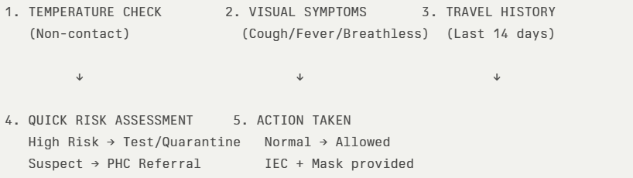
The screening protocol shall include temperature screening, observation for visible symptoms, and inquiry regarding recent travel or exposure history. Individuals identified as suspects during screening shall be immediately referred to the nearest PHC/FHC for further evaluation, testing, and appropriate action as per prevailing guidelines.

Pandemic Control Room
The Pandemic Control Room (PCR) serves as the central nerve center for real-time coordination, data aggregation, decision support, and communication during outbreaks. It consolidates information from all LSGD teams, health facilities and community sources to enable rapid response decisions.

Control Room Infrastructure and Location
Primary Location: Kollengode Panchayath Office.
Backup Location: Conference hall Kollengode family health centre

Health System Control Room Framework
The PCR is organized into seven functional pillars to ensure no aspect of the response is overlooked:

Rapid Response Team (RRT)
  - Provides immediate intervention during emergencies, clusters, and field alerts.​
  - Coordinates urgent actions such as case investigation, contact tracing, isolation, and inter‑facility referrals.

Data Management & Analytics Team
  - Collects, validates, and manages key health system indicators (cases, tests, beds, HR, supplies).​
  - Analyzes data trends, generates projections, and supports evidence‑based decision‑making for local authorities.

Human Resource Deployment Team
  - Allocates healthcare staff efficiently based on workload and need
  - Ensures adequate and equitable workforce distribution across facilities

Laboratory Surveillance Team
  - Oversees diagnostic testing coordination, sample transport, and timely reporting of results.​
  - Monitors lab indicators (testing volume, positivity rate, turnaround time) for early detection of outbreaks

Vaccination Cell (If Required)
  - Plans and executes vaccination campaigns, including micro‑planning and session scheduling.​
  - Tracks coverage, identifies gaps, and coordinates corrective actions with field teams and outreach services.

Infrastructure & Patient Occupancy Team
  - Monitors facility capacity, earmarked beds, oxygen and critical care resources across all linked facilities.​
  - Ensures optimal patient distribution and referral management using updated bed‑status and resource data.
  - BMWM

Communication team
- Logistics and supply chain
- Transportation (interfacility & emergency transport)
- Media surveillance Call centre
- Management of the deceased
- Intersectoral coordination and convergence

Key Control Room Team
The Control Room Team coordinates all pandemic response activities within the LSGD and serves as the single command and communication hub during activation. It integrates information, field actions, logistics, and policy execution across all participating departments and health facilities.

Role | Name | Designation | Contact Number | Responsibility
In-charge/Nodal Officer | Boby Maani | MO | 9447724313 | Overall coordination, decision-making, and reporting to the District level.
Data Entry | Swetha | Data entry | 7736574213 | Managing the line list, updating dashboards, and tracking testing results.
Communication Officer | Vinod kumar | HI | 9447718935 | Handling the public helpline, coordinating ambulance dispatch, and contact tracing calls.
Logistics Coordinator | Ramesh | JHI | 9447037690 | Coordinate transportation, inventory management, and supply chain operations
Technical Support(IT/Data) | Salini | Datamanger (CHC) | 7510241624 | Provide technical support for digital tools, dashboards, and communication systems used in pandemic response.

Key Points:
- The Control Room shall be staffed with a designated In-charge, data entry personnel, and communication staff with clearly defined roles and shift arrangements.
- It shall maintain updated records on daily monitoring indicators including new cases, persons under active quarantine, and hospital bed occupancy.
- All reports and situation updates shall be shared daily with the Block and District Surveillance Unit.
- The Control Room shall act as a single point of contact for coordination with response teams, health institutions, and other departments.
- Contact details of the Control Room shall be widely communicated to field staff and stakeholders during activation.

Daily Monitoring Indicators
To ensure timely decision-making and effective response, the following key indicators shall be monitored and updated on a daily basis by the Pandemic Control Room:

Epidemiological Indicators:
New cases reported today, Total active cases, Test Positivity Rate (TPR), Case Fatality Rate (CFR)
- Surveillance Indicators:
Persons under home quarantine, High-risk contacts identified, Fever, ILI, SARI or other symptoms (syndromic surges), Travellers (symptomatic or high-risk arrivals),Animal husbandry surveillance (zoonotic alerts, unusual animal deaths, poultry/bird flu signals), Mortality surveillance (excess deaths, unexplained fatalities, verbal autopsy reports)
- Logistics and Infrastructure Indicators:
Hospital / CFLTC beds occupied, Oxygen cylinders/concentrators available, Ambulances on standby
- Alert Findings
The following table outlines category-specific trigger points (red flags) from surveillance indicators and corresponding immediate actions for the Pandemic Control Room. These enable rapid response to alert findings like testing anomalies, positive cases exceeding thresholds, clusters, and WGS reports.

Category | Trigger Pophint (Red Flag) | Immediate Action
Clusters | Geographical or facility-based: 5+ cases linked to one location (office, school, street). | Declare a micro-containment zone; perimeter control and active case finding.
Testing | Sudden drop in testing volume / delay in reporting / unusual testing trends | Review the sample collection process, address lab bottlenecks, deploy additional testing teams, and notify the District Lab.
Lab | Test Positivity rate increases | Increase testing sites in that ward.
Hospital | >80% Oxygen bed occupancy | Activate backup/CFLTC beds.
Travel | Cluster of cases from a single flight/train or high-risk arrival group. | Trace all passengers in adjacent seats; implement mandatory institutional quarantine.
Animal | Mass poultry/wildlife death or unusual sickness | Notify Animal Husbandry, sample the area, and dispatch RRT for environmental sampling and zoonotic check.
Mortality | Sudden spike in home deaths or brought-in-dead (BID) cases | Audit the deaths and Active Case Search drive
Additional investigations like Whole Genome Sequencing (WGS) | Detection of a Variant of Concern (VOC) or Variant of Interest (VOI) | Implement strict micro-containment; update clinical protocols to match variant severity.

Communication of Public Health Information
A Community Communication Hub shall be established to ensure timely, accurate, and consistent dissemination of information during a pandemic. The Hub will function under the coordination of Nodal officers of the control room and act as the nodal point for public communication, risk messaging, and community engagement. It will support dissemination of official advisories, promote preventive behaviors, address rumors and misinformation, and ensure that messages reach all sections of the population through trusted local channels and leaders.

Key communicators
Channel | Responsible Person | Contact
Ward-level announcements | Vinodh (HI) | 9447718935
Social media | Aji anand(HS) | 9446026010
Local Cable TV/Radio | Ramesh (JHI) | 9447037690

- All messages disseminated through the Hub shall align with advisories issued by the Health Department and District authorities.
- Community leaders shall be sensitized to support behavior change, reduce stigma, and counter misinformation.
- Special efforts shall be made to reach vulnerable and hard-to-reach populations using locally appropriate communication methods.

Rumor Tracking: A designated volunteer will monitor local social media/WhatsApp groups daily to identify misinformation and issue official clarifications via the Communication Hub.

Coordination with District/State Authorities & Other Organisations
Effective coordination with Block, District, and State authorities is essential to ensure timely reporting, technical guidance, and uninterrupted supply of essential resources during a pandemic. The LSG shall establish clear communication channels, designate responsible officers, and adhere to prescribed reporting timelines to support coordinated public health action and efficient resource mobilisation.

Key Details:
- Nodal Officer for Reporting: Medical officer, Kollengode FHC
- Contact Number:
Reporting Schedule and Protocols:

To Whom | What to Report | Frequency | Nodal Person
Block PHC | Complete Situation Report (Cases, Quarantine, Beds, Screening, Deaths) | Daily / As directed during outbreak | MO
District IDSP Unit | Outbreaks/Clusters/Unusual Events (>5 cases same ward) | Immediately | MO
Veterinary Officer | Animal health events/Zoonotic alerts | Immediately upon detection | Veterinary Inspector / Livestock Inspector
State Cell | Zoonotic cross-sector events | As directed / Immediate during major outbreak | DMO/DSO (through Block PHC)

Supply Chain Coordination
The LSG shall coordinate closely with Block, District, and State authorities (KMSCL) to ensure uninterrupted availability of essential goods, medical supplies, and logistics during a pandemic. Supply requirements shall be assessed regularly based on case load and communicated promptly to the appropriate authorities for timely replenishment.
Key Points:
- Maintain updated contact details of District and Block nodal officers for health logistics, oxygen supply, ambulances, and essential medicines.
- Submit timely indent requests for PPE, testing kits, medicines, oxygen, and other critical supplies through prescribed channels.
- Monitor stock levels at LSGD facilities, quarantine/isolation centres, and field teams through daily stock registers and dispensing logs to prevent shortages.
- Coordinate with District authorities, Karunya/Neethi medical shops, and local purchase committees for funds allocation and emergency procurement.

- Ensure regular monitoring of dispensing registers at all facilities to track usage, expiry, and pilferage—shortages being a perennial issue requiring proactive weekly audits.

- Activate surge procurement protocols during high caseloads, leveraging local purchase powers under LSGD funds alongside state supplies.

Resource Inventory and Contacts
Resource Category | Source  (District/State/Private) | Contact
PPE Kits/Masks/Gloves | KMSCL | 9745783453
PPE Kits/Masks/Gloves | Local Vendors | ,,
Oxygen  Cylinders/Concentrators | KMSCL
Medicines/Antivirals | KMSCL
Medicines/Antivirals | Neethi Shops
Test Kits (RTPCR/Rapid) | KMSCL

Collaboration with NGOs, PPP, and CSR
To augment government efforts during a pandemic, the LSG shall collaborate with NGOs, voluntary organisations, and private sector partners through public–private partnerships and Corporate Social Responsibility (CSR) initiatives, in coordination with District authorities.

Key Points:
- Engage NGOs and community-based organisations for community outreach, awareness, and support to vulnerable populations.
- Leverage CSR support for procurement of medical equipment, PPE, oxygen concentrators, food kits, and sanitation materials, as permitted.
- Ensure all collaborations align with government guidelines and are routed through approved administrative and financial procedures.
- Maintain transparency and documentation for all external support received and utilised.
Organization | Type | Support Offered | Contact Person
Youth Clubs/Student Unions | CBO | Nil

Interdepartmental Coordination
Coordination among departments during a pandemic shall be ensured through regular review meetings convened by the LSGD President. These meetings will provide a structured platform for sharing situational updates, assessing resource availability, resolving operational gaps, and taking joint decisions to ensure a coordinated and timely response.

Department | Representative | Key Role | Contact
Health (PHC) | Staff Nurse : | Case management | 04923264352
Veterinary | Veterinary Surgeon: | Animal surveillance | 9496194384
ICDS | Supervisor: Radha | Nutrition support | 8547398210
Education | Head Teacher: | School coordination | See Annexure-1.7
Police |  | Containment enforcement | 7012071878
Water Authority | __________ | Water supply | 04923 222429
LSGD Engineering | __________ | Quarantine infrastructure | 04923262324

PHASE 3 - Surge Capacity
Phase 3 is activated when there is a rapid increase in cases, high test positivity rates, or when existing health facilities and quarantine arrangements approach saturation. The focus of this phase is to expand isolation capacity, augment clinical care services, and mobilise additional resources through district and state support mechanisms.

Conversion of Community Facilities
To manage increased case load, the LSGD shall activate additional isolation facilities by repurposing identified community infrastructure such as community halls, auditoriums, schools, hostels, or other suitable buildings.

Name of facility | Facility Type | No. of Buildings | Ward | Surge Capacity (Beds) | Nodal Person
Rajas | School | 4 | 9 | 200 | HM

- Recovery and rehabilitation phase
- Recovery
  - Damage & impact assessment
  - Restoration of health services
  - Rehabilitation of affected population
  - Psychosocial & mental health support
  - Disease surveillance during recovery phase
  - Environmental cleanup & sanitation
  - Livelihood restoration
  - Community engagement & confidence building
  - Documentation & after-action review
  - Lessons learned & best practices
  - Health system strengthening
  - Policy revision & preparedness enhancement
  - Research

CONCLUSION
Kollengode Panchayat involves several high-risk factors that make it particularly vulnerable during a pandemic. As a tourist village, it experiences frequent movement of people, which increases the risk of rapid disease transmission. Additionally, its location at the foothills makes it prone to natural disasters such as landslides. The Gayathri River flowing through multiple wards also raises the risk of flooding, further complicating emergency response and public health management.
Considering these vulnerabilities, Kollengode Panchayat requires special attention in pandemic preparedness and response planning. Effective preparedness should include coordinated efforts such as data collection and integration from various departments including Health, Local Self Government (LSG), and Veterinary services. Reference to existing frameworks like the Kerala Disaster Management Plan (Kollengode, 2019) is essential to ensure a comprehensive and structured approach.
A multi-sectoral strategy focusing on surveillance, rapid response, risk communication, and community participation will strengthen the Panchayat’s resilience. Proper planning and interdepartmental coordination will help in minimizing the impact of pandemics and other concurrent disasters in the region.

Additional points
- tech support
- relief based commodities
- ham reading operators
- hazard vulnerability mapping
- Kseb& other power source
- HR specific responsibility

RECOMMENDATIONS

Strengthening Healthcare Infrastructure
- Establish a primary health response unit within the Panchayat with trained staff.
- Ensure availability of basic medical supplies (masks, sanitizers, PPE kits, oxygen cylinders).
- Create tie-ups with nearby hospitals in Kollengode LSG for emergency referral and transport.

2. Community Awareness & Education
- Conduct regular awareness campaigns on hygiene, vaccination, and preventive measures.
- Use local communication channels (community radio, WhatsApp groups, notice boards) to spread verified information.
- Train volunteers to act as health ambassadors in each ward.

3. Emergency Response & Coordination
- Form a Pandemic Preparedness Committee at Panchayat level including health workers, ward members, and NGOs.
- Develop a clear action plan for lockdowns, quarantine, and distribution of essentials.
- Maintain a database of vulnerable groups (elderly, differently-abled, chronically ill) for targeted support.

4. Supply Chain & Food Security
- Identify and support local suppliers and farmers to ensure uninterrupted food supply.
- Create community kitchens during emergencies to serve vulnerable populations.
- Stockpile essential commodities in Panchayat-run outlets for crisis periods.

5. Digital Preparedness
- Promote digital platforms for telemedicine consultations.
- Use Panchayat’s website/social media for real-time updates on health advisories.
- Encourage online grievance redressal to reduce crowding in offices.

6. Training & Capacity Building
- Organize mock drills for pandemic response in schools, offices, and public spaces.
- Train Panchayat staff and volunteers in first aid, infection control, and crowd management.
- Collaborate with NGOs and health departments for capacity-building workshops.

7. Long-Term Resilience
- Integrate pandemic preparedness into the Panchayat Development Plan.
- Allocate a dedicated budget for health emergencies.
- Encourage community participation in planning and monitoring preparedness measures.

MOCKDRILL SCENARIOS

ANNEXURE

IMPORTANT PHONE NUMBERS

Phone numbers and particulars of persons responsible for providing guidance, assistance, and support for pandemic preparedness operations may be provided here in a manner that allows easy reference at a glance.The information recorded here could be exhibited elsewhere at the time of emergencies. LSG institutions shall give special attention to collect and record the above data of persons and institutions who/which are supposed to give technical and co-ordination support to reduce the impact of pandemic.

1.1. Details of grama panchayat/municipality/corporation wards
Sl.No | Name of the ward | Ward number | Name of the ward  member | Contact number
1 | PUZHAKKAL THARA | 1 | RAMESAN T A | 9895201541
2 | P K VILLAGE | 2 | JAYASREE | 6282526409
3 | KOLLEGODE TOWN | 3 | RAMESH | 9388268838
4 | THADANARA | 4 | LEENA | 99614569731
5 | ANAMARI | 5 | PRAKASAN | 8943018572
6 | CHIKNAMPARA | 6 | ASWATHY DAS | 9947666732
7 | EDACHIRA | 7 | VIJITHA | 9745366330
8 | NEDUMANI | 8 | SARITHA | 9495704967
9 | ACHANAMKODE | 9 | THUSHARA | 9745943811
10 | NENMENI | 10 | SIVAN | 960541529
11 | MANALIPADAM | 11 | GIRIJA | 9497660683
12 | S V STRRET | 12 |  | 99477959339
  SUKANYA
  MURALEEDHARAN
 | KONGANCHATHI | 13 |  | 8943962266
13 |  |  | SHEEJA
14 | CHEERANI | 14 | ABDUL KHADER | 9447062393
15 | PAZHAYANGADI | 15 | PRATHEEPA | 9544984909
16 | PAYYALORE | 16 | PRAVEEN | 9387430735
17 | KACHAMKURRISI | 17 | SIVADASAN | 9562143058
18 | THACHKORA | 18 | PONNAPPAN | 9567919202
19 | ARUVAURPARAMBU | 19 | RAVEENDRAN | 8921389942

1.3. Important offices of grama panchayat/municipality/ corporation
Sl.No | Name of the office | Contact person | Contact number
1. | Village Office | Village Officer | 04923 262704
2. | Agriculture Office | Agriculture Officer | 04923 262072
3. | Animal Husbandry Office | Animal Husbandry Doctor | 9443204333
4. | Police Station | Police Officer | 04923 262329
5. | BSNL Office | Officer | 04923 262320
6. | Block Office | Officer | 04923 262373
7. | KSEB Office | Officer | 04923 263378
8. | Fisheries Office | Officer | Nil
9. | Fire and Rescue | Officer | 04923 262101

1.4. Health Services

Sl. No | Name of the hospital/institution | Location | Phone number
1. | Government hospitals/PHC | Kollengode | 04923 264352
2. | Private hospitals | Kollengode | See Table 6. Private Clinic Resource Summary
3. | Clinical laboratories | kollengode | See Laboratory Identification & Basic Details
4. | Chemist/pharmacy | Kollengode | SHAJI MEDICAS-  04923262120  Jannaoushadhi-99466 19945  Needhi Medicals-  90744 41378
5. | Blood donors | Kollengode | nil
6. | Other language experts (Bihari, Hindi, Bengali,  Asamees ………) | kollengode | Could not identified

1.5. Veterinary Services
Sl.No | Name of the Clinic | Name of the  Surgeon/Doctor | Place/location | Phone  Number
1 | Govt.Veterinary Hospital | Mo | Kollengode | 9496194384

1.6. Helpline numbers
Helpline | Phone number
Police | 7012071878
Fire and Rescue | 04923 262101
KSEB | 04923 262378

1.7. Public and Private Schools Contact details

S.No | Name of School | Institution type | Phone number
1 | B S S SCHOOL | Aided | 9495230250
2 | YOGINIMATHA SCHOOL | Aided | 9567488526
3 | CHINMAYA SCHOOL | Private | 9074140357
4 | PKD SCHOOL | Aided | 9446878831
5 | ST.PAULS EAST VILLAGE SCHOOL | Private | 9995681665
6 | SREENARAYANA SCHOOL | Private | 9995616937
7 | SREEVIDHYA SCHOOL | Private | 04923263059
8 | ALPS PUTHUGRAMAM | Aided | 9400867656
9 | ST.JOSEPH SCHOOL | Aided | 9744886222
10 | ALPS NENMENI | Aided | 8281858099
11 | ALP ACHANAMKODE | Aided | 9495822974
12 | KASIPASRAMAM | Private | 9388711442

1.8 Community Hall/Auditorium contact Details
Sl. No | Name of the Institute | Address | Contact number
1 | Shri. Vasudeva Menon Community Hall | Bus Stand, Kollengode
2 | Dolphin Auditorium & Marriage Hall | Manchira,Kollengode | 85929 29284
3 | Gayathri Kalyana Mandapam | Payyallur, Kollengode
4 | Sangamam Auditorium | Kollengode road | 7034963586

1.9. Anganwadi Contact Details

Ward No | Name of Anganwadi Teachers | Phone number
1 | RUGMINI | 9995639722
2 | SUDHIMOL | 9895734303
3 | AJITHA | 9048798810
4 | SERENA | 9947680065
5 | JALAJA | 9496516268
6 | SUMATHY | 9497628190
7 | PRIYA LATHA | 9497524609
8 | JYOTHI | 9544676761
9 | SHEEJA | 9744803598
10 | RADHA | 9446385790
11 | GOMATHY SANKAR | 8156943486
12 | CHANDRIKA | 9645362642
13 | RASHEEDHABHANU | 9497351781
14 | BABY | 9495726855
15 | HEETHA ARAVIND | 9497628049
16 | ARCHANA | 7736430136
17 | LATHA | 7994935090
18 | SUDHA | 8606850476
19 | ANITHA | 8921785261
20 | ASWATHY | 9656748493
21 | PADMAJA | 8129993395
22 | AMBIKA | 9744794020
23 | SHAKEELA | 8606481645
24 | JANAKI | 8606304291
25 | ANITHA | 9947061014
26 | SUJATHA | 9544470083
27 | GIRIJA | 9388730093
28 | SHAKUNTHALA | 6238797540
29 | CHEMBAKAM | 9744896475

1.12. Information regarding resources

Means of transportation | Name of Owner | Phone Number
Heavy Trucks | Chndran | 9447216106
Tractor | Krishnan | 9497413935
Ambulances | Sreenivasan | 7025517601
Boats | Nil
Taxi service | M Arumughan | 9447216106

Annexure 1: LSG Baseline Data Collection Format
A. Baseline data
Sl. No. | Indicator / Field | Baseline Data | Source / Remarks
1 | Name of LSG | Kollengode | LSG records
2 | District | Palakkad | LSG records
3 | Block / Taluk | Kollengode | LSG records
4 | Type of LSG (Gram Panchayat / Municipality / Corporation) | Grama panchayath | LSG records
5 | Area (sq. km) | 45 | LSG records
6 | No. of wards | 19 | LSG records
7 | GIS boundary file available | (Yes/No) | LSG records
8 | Key contact person & phone

B. Demography
Indicator / Field | Baseline Data | Source / Remarks
Total population | 32674 | FHC database
Males | 16632 | FHC database
Females | 16042 | FHC database
Transgender population | Nil | LSG records
Age distribution  (<5, 5–14, 15–59, ≥60) | <5-1571,>60-4670 | FHC database
No. of households | 8715 | LSG records
Population density (persons/sq.km) |  | LSG records
No. of migrant workers | 135 | LSG records
Major occupational groups | Agriclture | LSG records

C. Vulnerable Populations & Social Risks
Sl. No. | Indicator / Field | Baseline Data (Value / Description) | Source / Remarks
1 | No. of elderly (≥60) | 4670 | LSG records
2 | No. of persons with disability | 71 | LSG records
3 | No. of bedridden persons | 94 | FHC database
4 | No. of chronic disease cases (DM/HTN/COPD/CKD etc.) | 912/1178/29 | FHC database
5 | Pregnant women (current estimate) | 198 | FHC database
6 | Children <5 years | 1571 | FHC database
7 | Tribal population (if any) | 166 | LSG records
8 | Fisherfolk / coastal vulnerable groups (if any) | Nil | LSG records
9 | Urban slums / unnotified settlements (if any) | Nil | LSG records
210 | Homeless population | Nil | LSG records
11 | Orphanages / old age homes (number & capacity) | 0 | LSG records
12 | Hostels / prisons / shelters (number & capacity) | 28 | LSG records
13 | Poverty / BPL estimate | 3494 | LSG records
14 | Food insecurity hotspots | Nil
15 | Any history of stigma/discrimination issues (Yes/No) | No

D. Health System & Service Readiness
Sl. No. | Indicator / Field | Baseline Data (Value / Description) | Source / Remarks
1 | No. of health facilities in LSG (PHC/CHC/TH/DH/Private) | FHC | FHC records
2 | PHC/Family Health Centre details (name, location) | FHCKollengode | FHC records
3 | Subcentres / Health & Wellness Centres (number) | 7 | FHC records
4 | Private clinics / hospitals (number) | 3 | FHC records
5 | Labs available (public/private) | Yes | FHC records
6 | Availability of ambulance services (Yes/No, number) | Yes | FHC records
7 | Availability of isolation/quarantine facilities (Yes/No, details) | Yes | FHC records
8 | Cold chain facilities (Yes/No, details) | Y | FHC records
9 | Stockpile space available (Yes/No) | Y | FHC records
10 | PPE / mask / sanitizer availability plan (Yes/No) | Y | FHC records
11 | Surveillance staff available (JHI/JPHN/ASHA count) | Y | FHC records
12 | Existing emergency referral pathways (Yes/No) | Y | FHC records

E. Points of Entry & Mobility
Sl. No. | Indicator / Field | Baseline Data (Value / Description) | Source / Remarks
1 | Bus stands / depots (number) | 0
2 | Railway stations (number) | 0
3 | Boat jetties / fishing harbours (number) | Nil
4 | Ports / airports nearby (specify distance) | Nil
5 | Major highways/roads passing through | Nil
6 | Border crossings (state/district) | Nil
7 | Major markets / weekly markets | Nil
8 | Tourism hubs / major event venues | 3 | LSG records
9 | Schools/colleges with hostels (number) | 14/2/1 | FHC records
10 | Factories / large workplaces (number) | 2 | FHC records
F. Water, Sanitation & Hygiene (WASH)
Sl. No. | Indicator / Field | Baseline Data (Value / Description) | Source / Remarks
1 | Major drinking water sources (piped / wells / borewells / springs) | 7995/1044/1440 | FHC records
2 | No. of public wells | 62 | FHC records
3 | No. of households with piped water connection | 7995 | FHC records
4 | Water quality testing routine (Yes/No) | Yes | FHC records
5 | Common contamination risks (flooding, salinity, industrial waste) | Nil | FHC records
6 | Open defecation free status (Yes/No) | No | FHC records
7 | Solid waste management system (Yes/No) | Y | FHC records
8 | Bio-medical waste disposal mechanism (Yes/No) | Y | FHC records
9 | No. of public toilets | 4 | FHC records
10 | Handwashing stations in public places (Yes/No) | Yes | FHC records
G. Zoonotic Risks & One Health
Sl. No. | Indicator / Field | Baseline Data (Value / Description) | Source / Remarks
1 | Livestock population (cattle/goats/pigs/poultry) – estimates | 2355/2540/150/5232 | Veterinary Department Record
2 | No. of dairy farms / poultry farms / pig farms | 0 | Veterinary Department Record
3 | Slaughterhouses / meat shops (number) | 0 | Veterinary Department Record
4 | Animal markets (Yes/No, details) | No
5 | Veterinary dispensaries (number)
6 | History of zoonotic outbreaks (rabies, leptospirosis, avian flu etc.) | Nil
7 | Stray dog population management measures (Yes/No) | No
8 | Rodent infestation hotspots (Yes/No) | 0
9 | Wetlands / waterlogged areas prone to leptospirosis | 0
10 | Bat roosting areas / caves / fruit orchards (if any) | 0
11 | Human-animal interface hotspots (farms near residences) | 0
H. Climate & Disaster Risks (Pandemic Amplifiers)
Sl. No. | Indicator / Field | Baseline Data (Value / Description) | Source / Remarks
1 | Flood-prone wards (list) | 9,16,17 | KILA Disaster Management Plan (Updated 2019
2 | Landslide-prone wards (list) | 9,12,15,16,17 | KILA Disaster Management Plan (Updated 2019
3 | Cyclone/sea surge risk (Yes/No) | 0 | KILA Disaster Management Plan (Updated 2019
4 | Heatwave risk zones (Yes/No) | Yes
5 | Waterlogging areas (list)
6 | Shelter homes / relief camps (number, capacity) | 1 | Rajasa higher secondary school
7 | Past disaster displacement history | Yes
8 | Disruption to water supply/transport common (Yes/No) | NO
I. Critical Infrastructure & Logistics
Sl. No. | Indicator / Field | Baseline Data (Value / Description) | Source / Remarks
1 | Schools (number) | 14 | FHC records
2 | Anganwadis (number) | 29 | FHC records
3 | Colleges (number) | 2 | FHC records
4 | Community halls (number) | 4 | FHC records
5 | Places of worship with large gatherings (number) | 0 | FHC records
6 | Large markets / shopping areas (number) | 0 | FHC records
7 | Warehouses / cold storages (number) | 0 | FHC records
8 | Telecom/mobile network coverage gaps (Yes/No) | Yes | FHC records
9 | Power outage frequency (high/medium/low) | medium | FHC records
10 | Availability of generators in key facilities | yes | FHC records

J. Risk Communication & Community Networks
Sl. No. | Indicator / Field | Baseline Data (Value / Description) | Source / Remarks
1 | Ward-level rapid response teams (Yes/No) | Yes | FHC records
2 | Jagrathasamithis / committees active (Yes/No) | Yes | FHC records
3 | Kudumbashree presence and strength (number of units) | 315 | LSG records
4 | Volunteer network (number, coverage)
5 | Community-based surveillance mechanisms (Yes/No) | Yes | FHC records
6 | IEC dissemination channels (WhatsApp groups, community radio, PA systems) | Yes | FHC records
7 | Rumour tracking mechanisms (Yes/No) | Yes | FHC records
8 | Languages spoken / literacy considerations |  | FHC records
9 | Vulnerable groups communication strategy available (Yes/No) | Yes | FHC records

K. Preparedness Planning & Governance
Sl. No. | Indicator / Field | Baseline Data (Value / Description) | Source / Remarks
1 | LSG emergency plan available (Yes/No) | Yes | FHC records
2 | Pandemic preparedness plan available (Yes/No) | Yes | FHC records
3 | Incident Command System identified (Yes/No) | Yes | FHC records
4 | Rapid procurement mechanism available (Yes/No) | Yes | FHC records
5 | Emergency fund available (Yes/No, amount) | No
6 | Past outbreak response experience (Yes/No, details) | No
7 | Intersectoral coordination mechanism (Health, Police, LSG, Veterinary, Education) | Yes
8 | Mock drills conducted in last 12 months (Yes/No) | No
9 | Training coverage for staff/volunteers (Yes/No) | No

L. Surveillance & Data Systems
Sl. No. | Indicator / Field | Baseline Data (Value / Description) | Source / Remarks
1 | Digital reporting tools used (e.g., DHIS2, portals) | NO
2 | Availability of line-listing format (Yes/No) | Yes | FHC records
3 | Contact tracing team identified (Yes/No) | Yes | FHC records
4 | Mapping of high-risk households available (Yes/No) | Yes | FHC records
5 | Testing sample transport mechanism (Yes/No) | Yes | FHC records
6 | Reporting timeline adherence (good/average/poor) | Good | FHC records
7 | Data sharing between departments (Yes/No) | Yes | FHC records
8 | Availability of dashboard for monitoring (Yes/No) | Yes | FHC records

M. Additional Notes & Observations
Sl. No. | Indicator / Field | Baseline Data (Value / Description) | Source / Remarks
1 | Key challenges perceived by LSG | Crowd gatherings common since the Panchayath one of the eco tourist point
2 | Top 5 high-risk wards (reason) | 8,9,10 | Higher incidence of CD cases such as Dengue ,ADD and Mumps
3 | Any unique local risks (industrial pollution, refugee camps, etc.) | Nil
4 | Recommendations for preparedness strengthening | No

