–

PANDEMIC PREPAREDNESS PLAN
MODEL OF ongallur LSG

MESSAGE FROM PRESIDENT/CHAIR LSGI
Safeguarding the health and well-being of our community is one of the foremost responsibilities of Ongallur Grama Panchayat. The development of this Pandemic Preparedness and Response Plan reflects our firm commitment to strengthening local systems and ensuring that our Panchayat remains ready to effectively respond to any public health emergency.
Ongallur, with its mix of residential areas, agricultural activities, educational institutions, and active community gatherings, faces specific public health challenges. Seasonal variations, vector breeding, water safety concerns, and increasing mobility require a proactive and coordinated preparedness approach. This plan has therefore been designed as a practical and structured framework to guide prevention, preparedness, response, and recovery measures at the grassroots level.
The Panchayat will ensure strong interdepartmental coordination involving the Health Department, Veterinary Services, ICDS, Education Department, Agriculture Department, Kudumbashree units, sanitation teams, and Disaster Management authorities. Special priority will be given to strengthening sanitation systems, ensuring safe drinking water, protecting vulnerable populations, supporting health infrastructure, and maintaining continuity of essential services during emergencies.
Ward-level monitoring, community awareness initiatives, and regular review mechanisms will be strengthened to ensure timely detection and rapid response to emerging threats. Preparedness will not be treated as a one-time activity but as a continuous process of assessment, planning, and improvement.
Pandemic preparedness is a shared responsibility. With coordinated governance, scientific guidance from the health system, and active participation of our community members, Ongallur Grama Panchayat will remain resilient and capable of meeting future public health challenges with confidence and responsibility.

President
Ongallur Grama Panchayat

MESSAGE FROM HEALTH STANDING COMMITTEE CHAIR
The health, safety, and well-being of our community continue to be our foremost priority. The development of this Pandemic Preparedness and Response Plan reflects Ongallur Grama Panchayat’s commitment to strengthening our local public health systems and ensuring readiness to effectively manage any public health emergency.
Pandemics create far-reaching challenges that extend beyond healthcare services, affecting livelihoods, education, and social stability. Effective preparedness depends on vigilant surveillance, early identification of health threats, coordinated interdepartmental action, and timely communication with the public. This plan provides a structured framework for prevention, preparedness, containment, and recovery, with particular emphasis on safeguarding vulnerable sections of the community.
The Health Standing Committee will work closely with the Health Department, frontline workers, Veterinary Services, ICDS, educational institutions, Kudumbashree units, sanitation teams, and community-based organizations to ensure that preparedness activities are implemented in a coordinated and sustainable manner. Regular review and monitoring will be undertaken to maintain operational readiness.
I sincerely acknowledge the efforts of all departments and stakeholders who have contributed to the preparation of this comprehensive plan and reaffirm our commitment to protecting the health and well-being of every resident of Ongallur

Chairperson
Health Standing Committee
Ongallur Grama Panchayat
MESSAGE BY MEDICAL OFFICER
Strengthening public health preparedness at the grassroots level is fundamental to an effective pandemic response. The formulation of this Pandemic Preparedness and Response Plan for Ongallur Grama Panchayat marks a significant step toward reinforcing our local health system and establishing a coordinated framework to address public health emergencies.
Recent global and national health events have underscored the critical need for robust surveillance systems, timely case identification, laboratory collaboration, stringent infection prevention and control practices, and clear risk communication. A comprehensive preparedness strategy ensures early recognition of potential threats, optimal utilization of available resources, and systematic implementation of control measures to reduce morbidity and mortality.
This plan sets forth defined operational procedures for disease surveillance, outbreak investigation, clinical management, referral linkages, logistics coordination, and community engagement. Particular emphasis has been placed on safeguarding high-risk groups, ensuring uninterrupted essential health services, and strengthening coordination among various departments and stakeholders.
As the Medical Officer, I reaffirm the dedication of our health team—including medical officers, nursing staff, health inspectors, ASHA workers, and other frontline personnel—to execute this plan with professionalism, efficiency, and accountability. At the same time, successful pandemic management depends on collective responsibility and active cooperation from all sectors of society.
Through preparedness, coordinated action, and sustained vigilance, we can ensure that Ongallur Grama Panchayat remains resilient and well-equipped to face future public health challenges.
Medical Officer
FHC Ongallur
EXECUTIVE SUMMARY

Primary Health Centre (PHC) functions as the primary public healthcare institution serving the 52079 population of ONGALLUR Grama Panchayath. The PHC plays a pivotal role in delivering comprehensive, accessible, and affordable healthcare services, with a strong focus on preventive, promotive, curative, and rehabilitative care in accordance with national and state health programmes.
The PHC caters to a predominantly rural population, addressing key public health priorities such as maternal and child health, communicable and non-communicable disease control, immunization, family welfare, adolescent health, and geriatric care. Regular outpatient services, home-based care through field health staff, and outreach activities ensure healthcare coverage even in geographically challenging areas. The institution actively implements national health missions, including the National Health Mission (NHM), National Tuberculosis Elimination Programme, National Programme for Prevention and Control of Cancer, Diabetes, Cardiovascular Diseases and Stroke (NPCDCS), and other disease surveillance initiatives.
ONGALLUR PHC works in close coordination with the Grama Panchayath, ASHA workers, Anganwadi centres, schools, and community-based organizations to strengthen community participation and improve health awareness. Emphasis is placed on early detection, timely referral, health education, and lifestyle modification to reduce disease burden and improve overall health outcomes.
Despite constraints related to infrastructure, manpower, and increasing service demand, the PHC continues to enhance service delivery through effective planning, data-driven decision-making, and community engagement. Strengthening facilities, upgrading digital health systems, and expanding preventive services remain key focus areas for future development.
Overall ONGALLUR Primary Health Centre stands as a vital institution in safeguarding public health and improving the quality of life of the residents of ONGALLUR Grama Panchayath

LIST OF ABBREVIATIONS

LSGD/LSGI | Local Self Government Department / Local Self Government Institution
BMO | Block Medical Officer
IDSP | Integrated Disease Surveillance Programme
NDMA | National Disaster Management Authority
PPE | Personal Protective Equipment
ICMR | Indian Council of Medical Research
CD | Communicable Diseases
NCD | NON-COMMUNICABLE Diseases

TABLE OF CONTENTS

3
INTRODUCTION 9
● Background of the PPP 9
LSGD AT A GLANCE 9
INTEGRATED HEALTH INFRASTRUCTURE MAP OF ONGALLUR PANCHAYAT 10
GENERAL PROFILE OF THE LSGI’S 13
Background of the LSGI 13
Demographic and Vulnerable Population 14
Clinical Vulnerability 16
INFRASTRUCTURE & RESOURCE INVENTORY 18
Health Facility Directory & Basic Capacity in the LSGD 18
Private Clinics 19
Healthcare Education & Training Institutions 20
Specialized Services & Emergency Inventory 20
Oxygen & Diagnostic Capacity 21
Diagnostics facility mapping at the LSGI level 22
Laboratory Identification & Basic Details 22
Social and Community Infrastructure for surge plan 22
Human resources 24
Community & Support Cadre 25
Community Organizations 26
Administrative & Emergency Services 27
Information regarding resources 27
ONE HEALTH & ENVIRONMENTAL SURVEILLANCE 28
Animal & Bird Population 28
Veterinary Infrastructure 29
Veterinary Doctors & Workforce 30
High-Risk Interface Points (Surveillance Sites) 30
Environmental Risk Mapping 31
Disease Seasonality Mapping 32
Vulnerability Mapping 33
EPIDEMIOLOGICAL TRENDS (2021–2025) 34
Disease Burden among human beings(Last 5 Years) 34
*(use the above table data to create the graph/diagram) 36
Seasonal Trend Analysis 37
Outcome-Based Trend Analysis- 2025 39
Transmission Trend- 2025 40
Integrated Disease Hotspot Map (2021–2025) 42
Preparedness and Response Protocol at LSG Level 44
Constitution of One Health Committee 44
Pandemic Response Workforce 45
Activities and Measures before and during Pandemic 47
PHASE 1 - Alert / Preparation 47
PHASE 2 - Active Response 50
Standard Screening Protocol 51
PHASE 3 - Surge Capacity 60
Conversion of Community Facilities 60
CONCLUSION 61
RECOMMENDATIONS 62
ANNEXURE 63
1. IMPORTANT PHONE NUMBERS 63

INTRODUCTION

Background of the PPP
- LSGD at a glance

GEOGRAPHICAL BOUNDARIES OF ONGALLUR PANCHAYAT
(Source: https://wardmap.ksmart.live/)

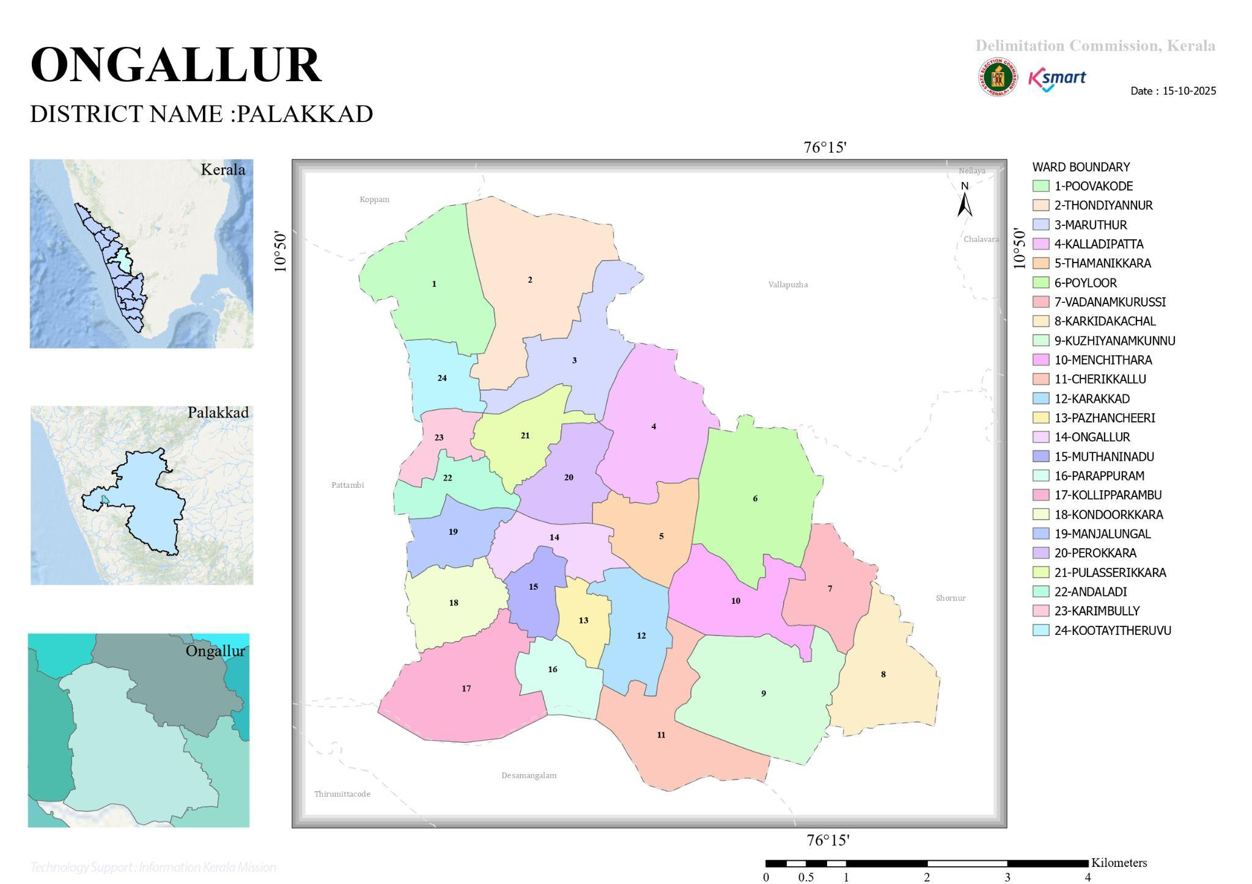

LSGD AT A GLANCE

- Geographical boundaries with political map ( based on latest delimitation)
- Baseline data
- Ward division -
Ward | Houses | Population | Migrants | Wells | Hot  spots | Ed. Institutions | Hosp pvt/govt.
1 | 712 | 3202 |  | 381 |  | 0
2 | 457 | 1947 |  | 273 |  | 2 | Ayur-Govt.
3 | 591 | 3753 |  | 392 |  | 0
4 | 510 | 2598 |  |  |  | 1
5 | 485 | 2143 |  |  |  | 0
6 | 480 | 2161 |  |  |  | 1
7 | 400 | 1730 |  |  |  | 0
8 | 372 | 1788 |  |  |  | 0
9 | 505 | 1591 |  |  |  | 0
10 | 620 | 2164 |  |  |  | 3
11 | 610 | 3137 |  |  |  | 0
12 | 567 | 2930 |  |  |  | 2 | Homoeo-Govt
13 | 275 | 2909 |  |  |  | 0
14 | 312 | 1325 |  |  |  | 3 | FHC
15 | 465 | 1162 |  |  |  | 0
16 | 634 | 2365 |  |  |  | 1
17 | 680 | 2809 |  |  |  | 0
18 | 683 | 2899 |  | 243 |  | 5
19 | 640 | 2822 |  | 245 |  | 1 | Privet
20 | 329 | 1542 |  |  |  | 0 | Sidha yunani-Govt.
21 | 550 | 2507 |  | 300 |  | 1
22 | 611 | 2595 |  | 455 |  | 0 | Vet. Govt.
Total | 11331 | 52079 | 798 | 6952 | 2 | 19 | 2

- Risk stratification among wards in the context of Communicable diseases and hazards
- Major Roads/rivers
- Major establishments with geospatial mapping
- occupational groups, socio cultural groups, migration & mobility patterns
- Vulnerability mapping
- Disaster prone areas (geographic vulnerability)

Maps - ward-based (Mention source also)

- Geographical boundaries - ward boundaries map
- Health infrastructure map
- roads and rivers map
- major establishments map
- disaster-prone areas map
- hotspot map - CD & disasters

SATELLITE MAP OF ONGALLUR PANCHAYAT
(Source: https://dmp.kila.ac.in/)

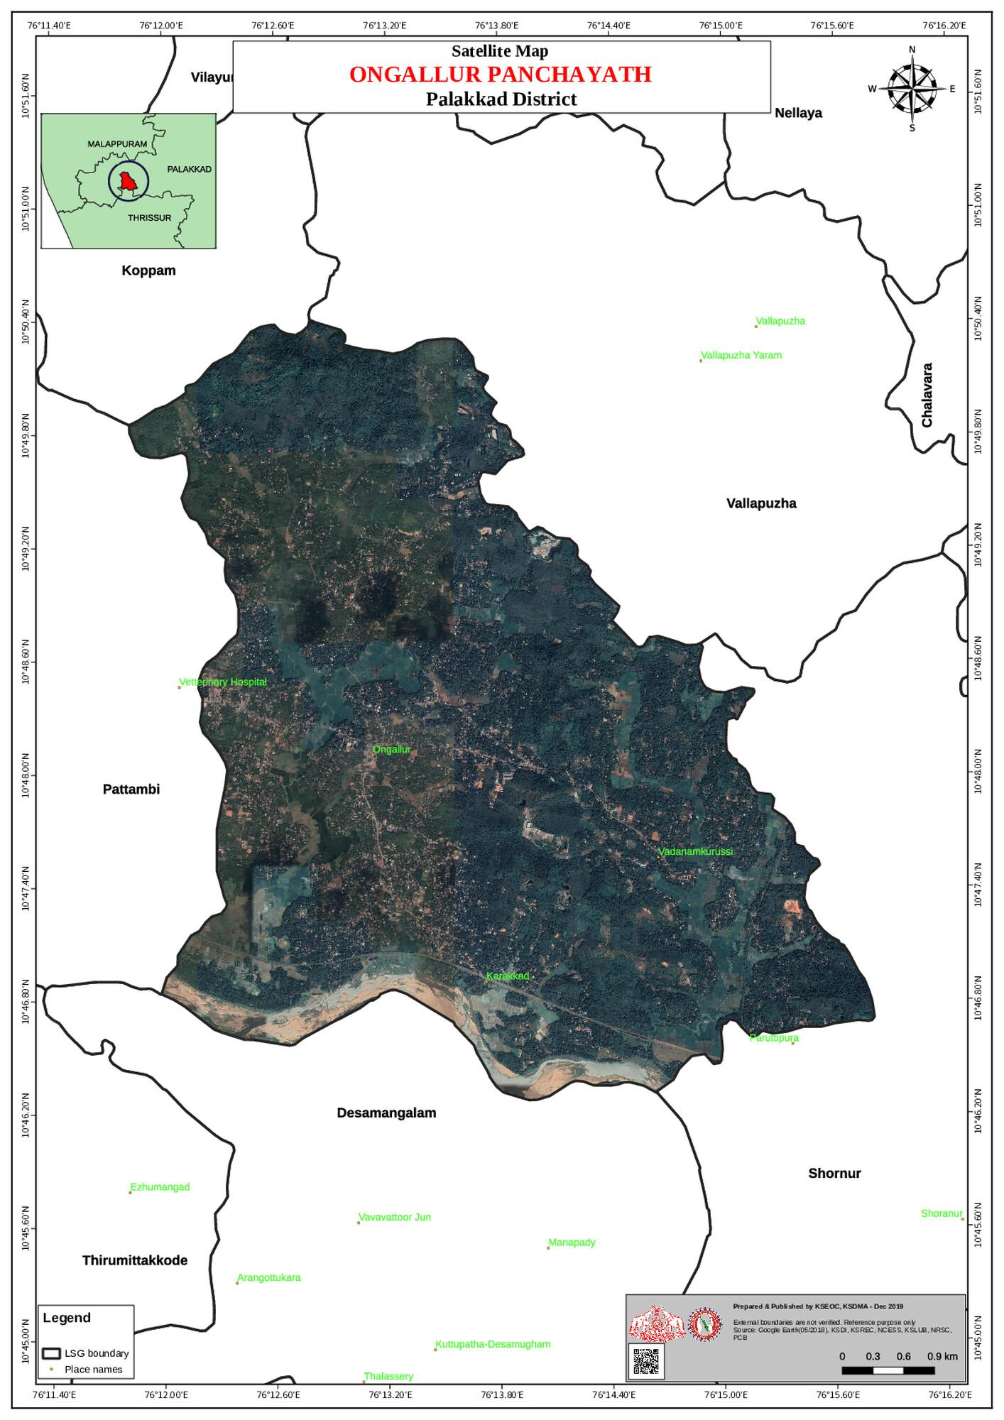

INTEGRATED HEALTH INFRASTRUCTURE MAP OF ONGALLUR PANCHAYAT
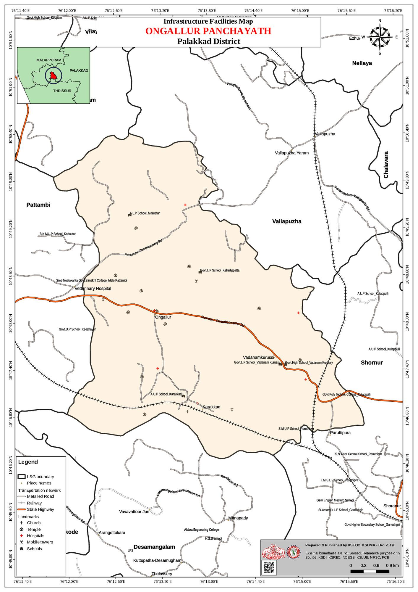
Health Infrastructure Map

COMMUNICATION MAP OF ONGALLUR PANCHAYAT

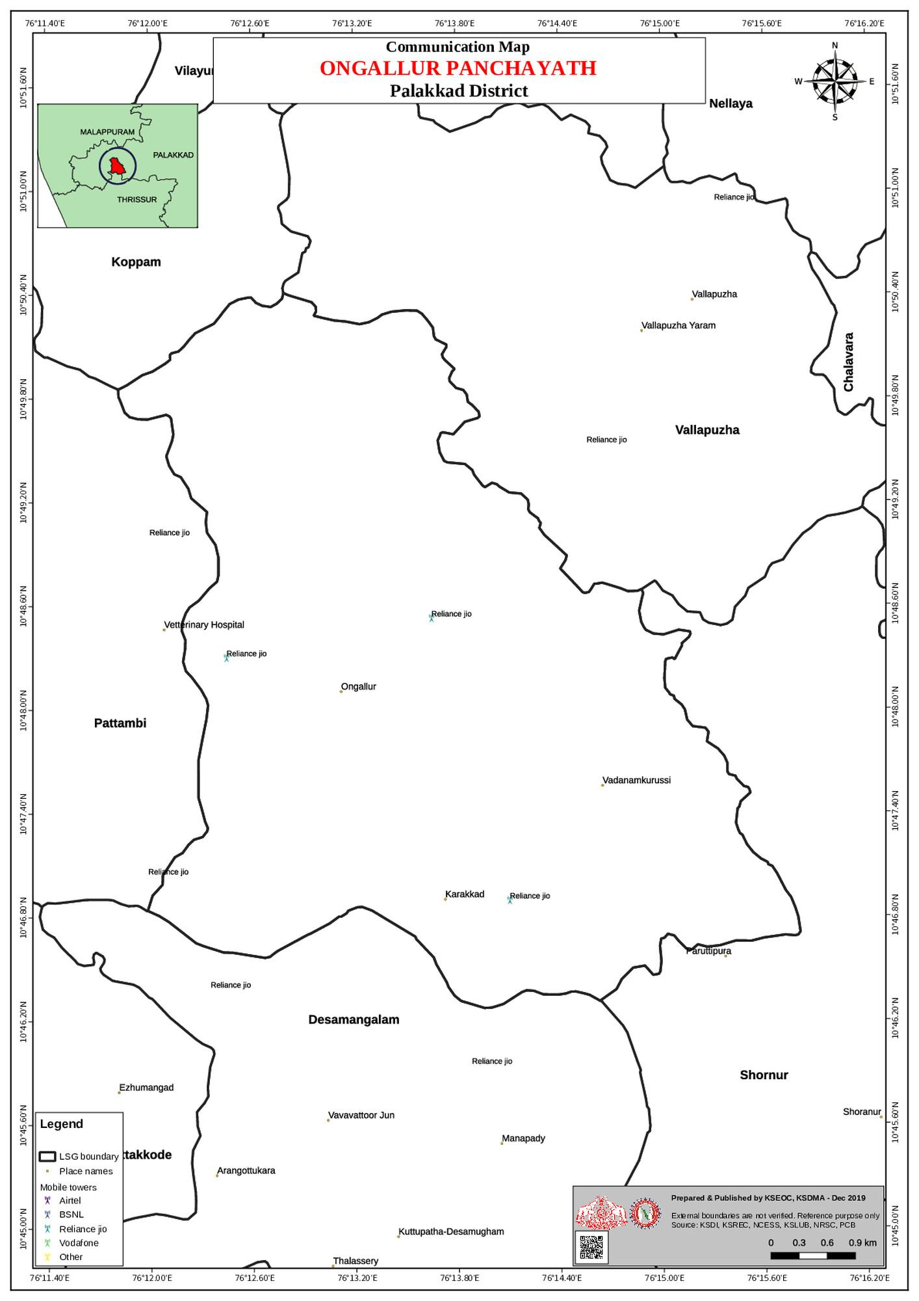

FLOOD PRONENESS V/S TRANSPORTATION MAP OF ONGALLUR PANCHAYAT

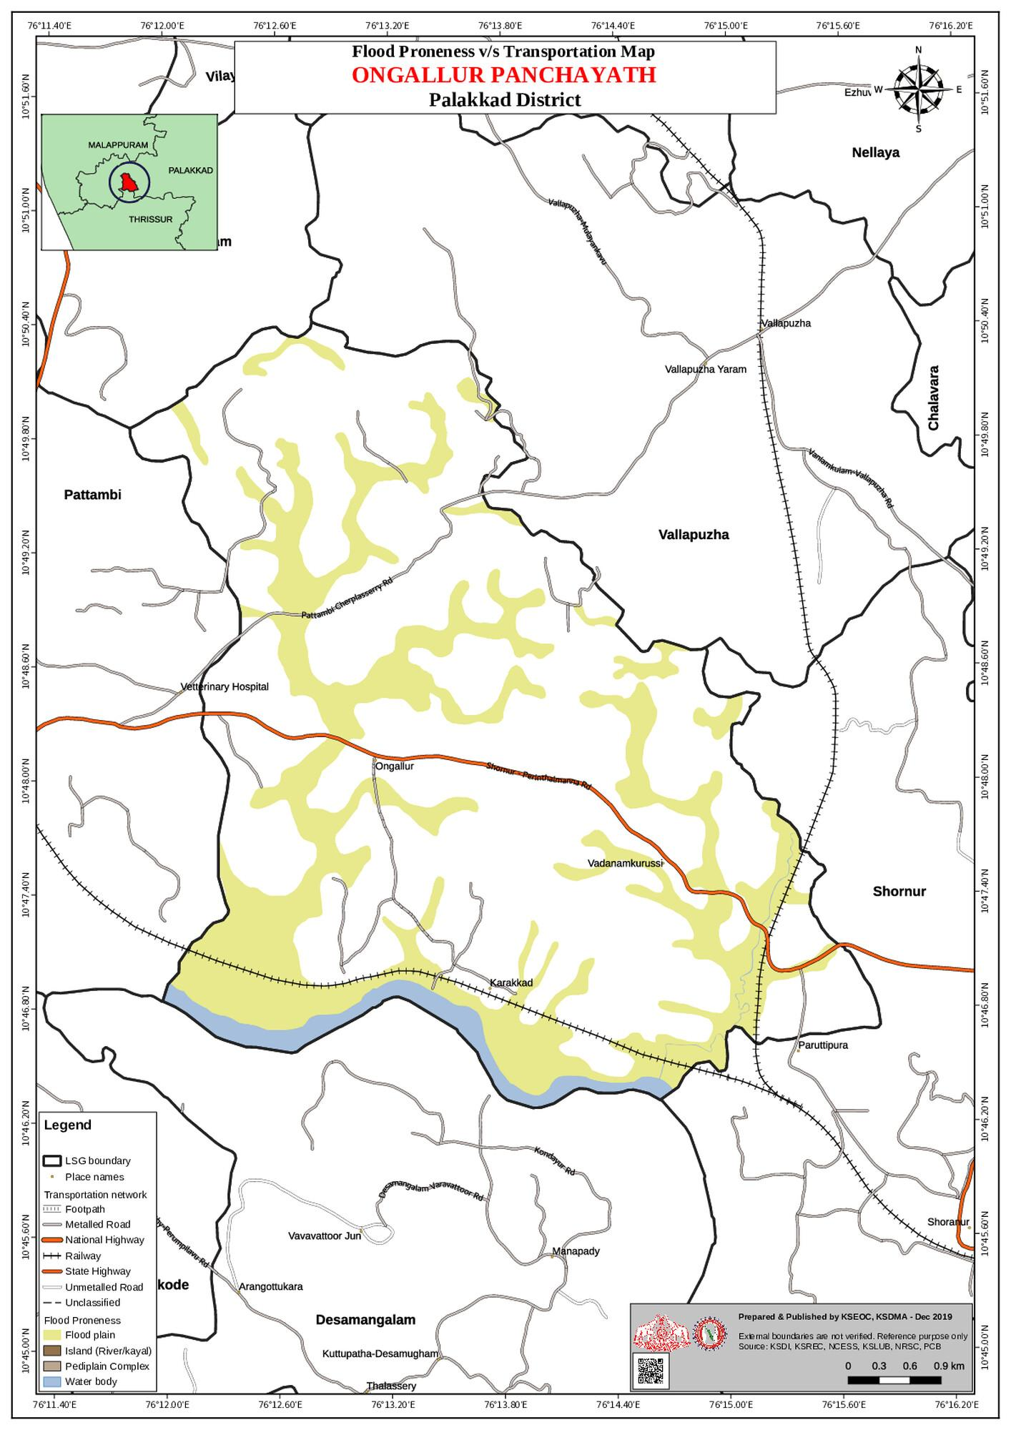

EARTHQUAKE MAP OF ONGALLUR PANCHAYAT
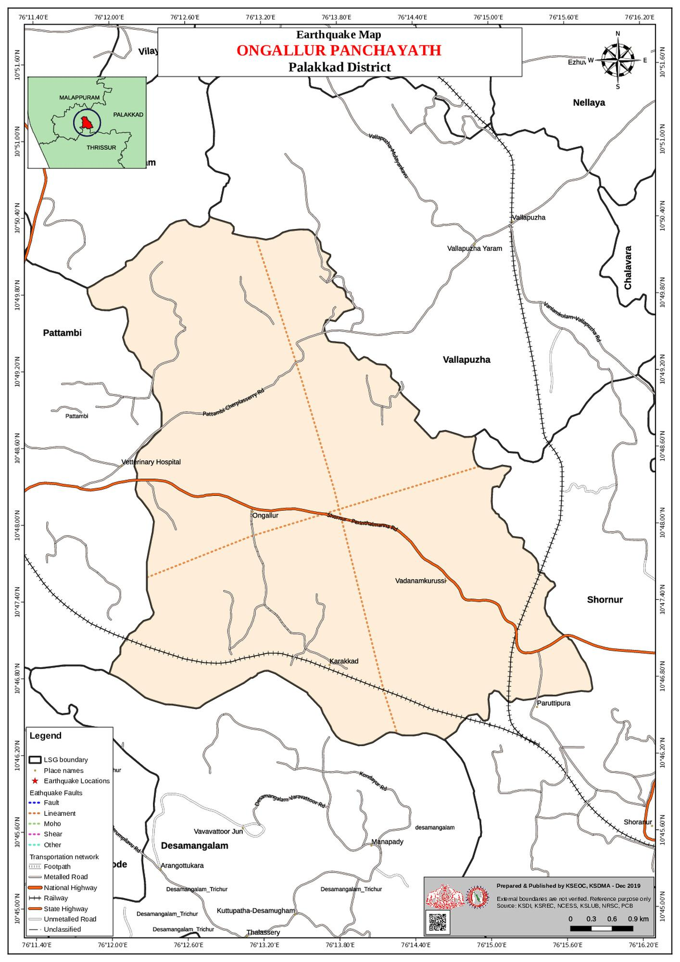

DROUGHT PRONENESS MAP OF ONGALLUR PANCHAYAT
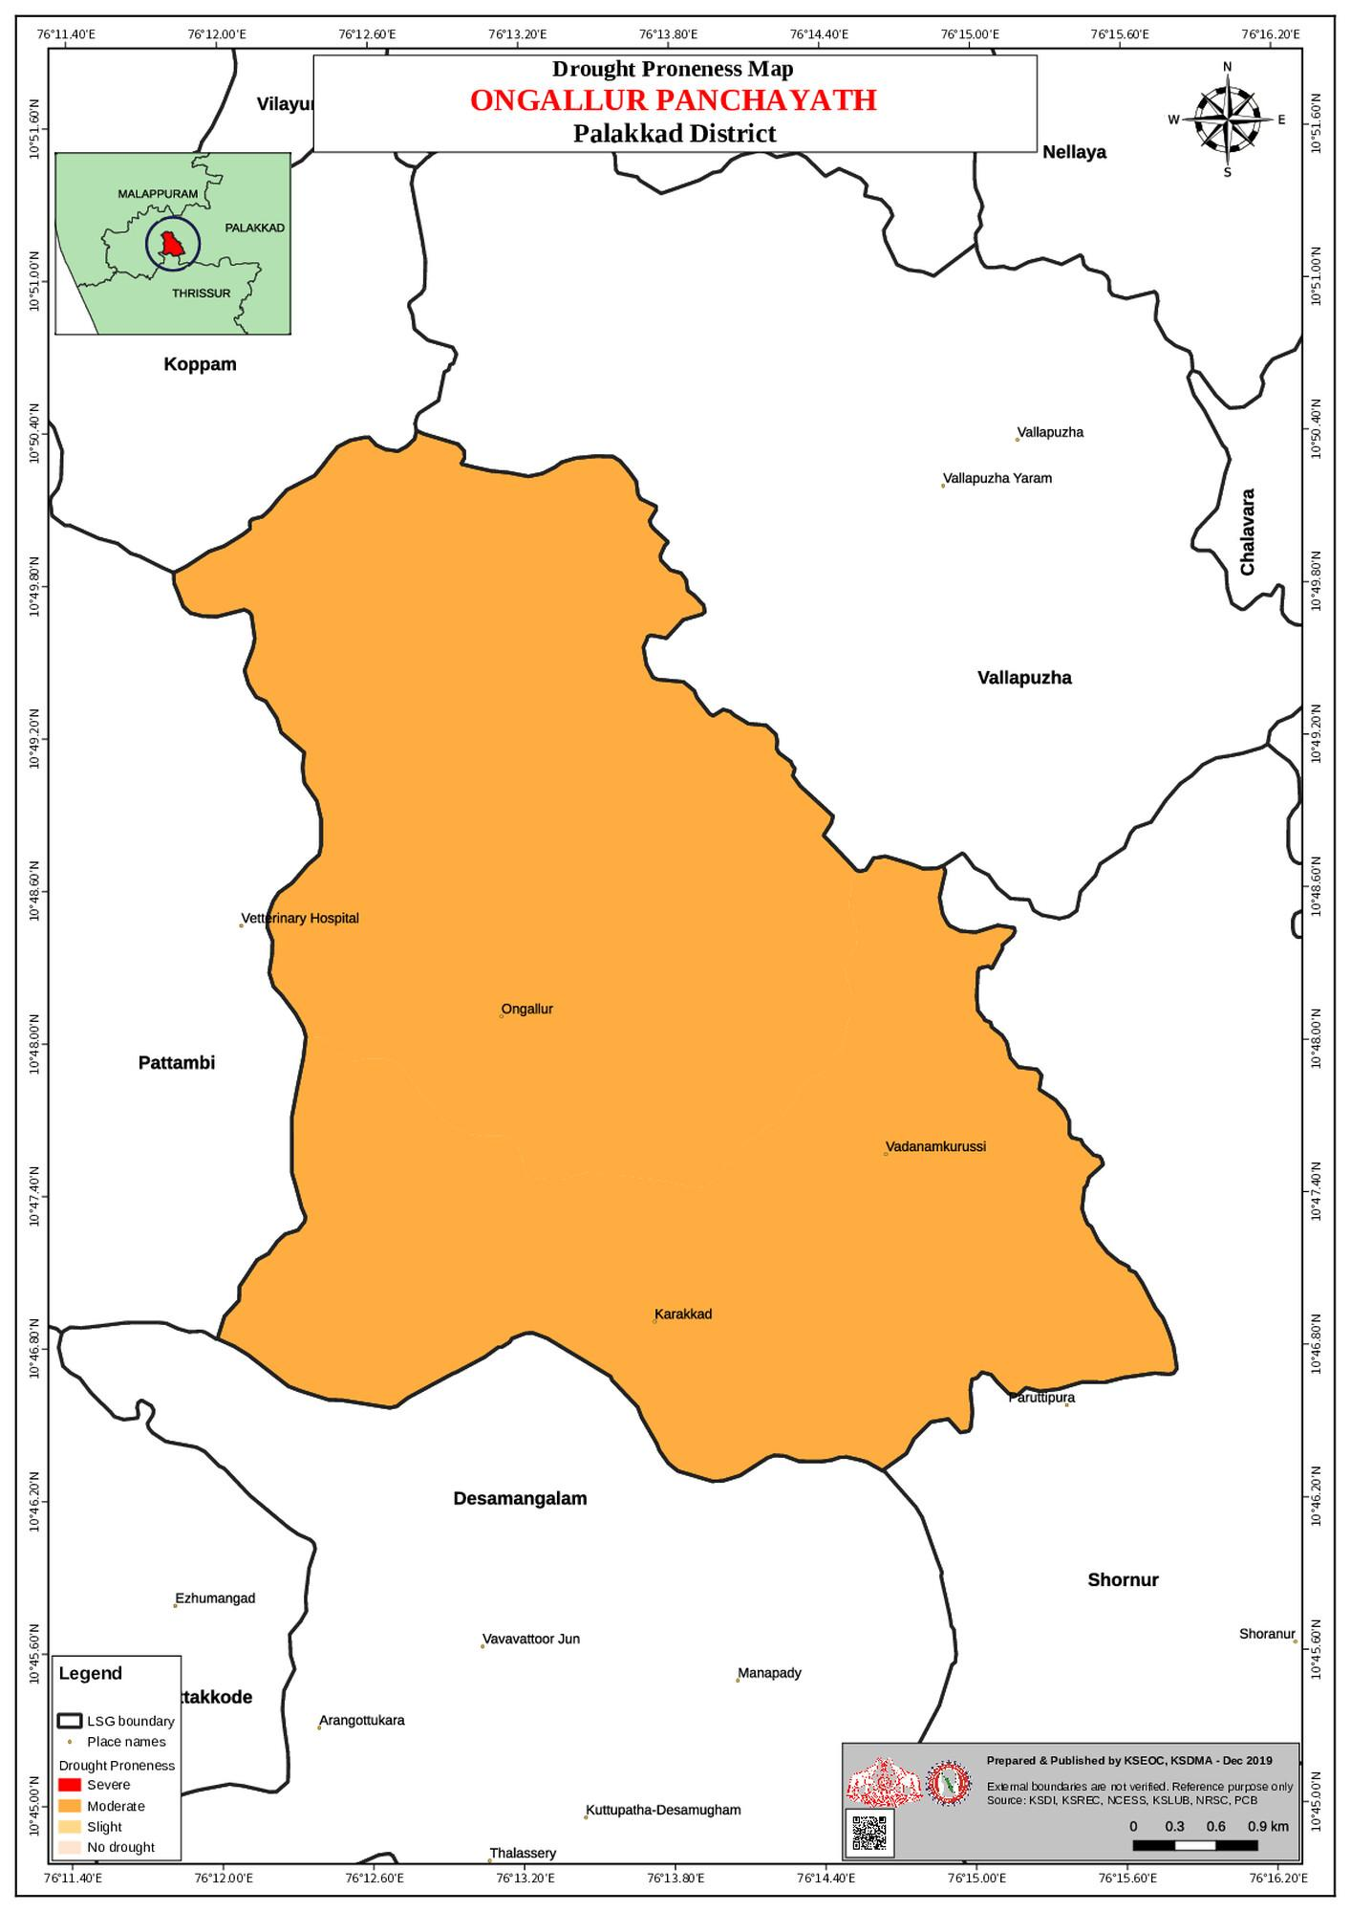

GENERAL PROFILE OF THE LSGI’S

Background of the LSGI
Ongallur Grama Panchayat is situated in the west of Palakkad district, Kerala. The geographical landscape of the Panchayat is predominantly low-lying, characterized by extensive paddy fields (Kole lands) and a dense network of rivers, canals, and backwaters. This unique terrain plays a significant role in shaping the local microclimate and poses distinct challenges to transportation, emergency response, and service delivery, particularly during monsoon seasons and flood events.
The Panchayat is administratively divided into multiple wards, with a population largely dependent on traditional livelihoods. Agriculture—especially paddy cultivation—fishing, coir and coconut husk processing, and allied activities form the backbone of the local economy. In recent years, tourism-related activities and service-sector employment have also shown gradual growth. The area hosts a diverse workforce, including a notable presence of migrant labourers, particularly in construction, agriculture, and allied sectors.
From a public health and disaster management perspective, ONGALLUR LSGI has historically been vulnerable to seasonal flooding, waterborne diseases, and vector-borne illnesses such as Dengue and Leptospirosis. The severe floods experienced during recent years, including the 2018 flood disaster, significantly impacted life, livelihoods, and infrastructure within the Panchayat. These recurring emergencies have underscored the importance of strengthening local preparedness, response mechanisms, and inter-departmental coordination.
In this context, the development of a localized, data-driven Auxiliary Infrastructure and Logistical Resource Map is essential to support effective planning, timely emergency response, and sustainable development initiatives. Such mapping enables the Panchayat to identify critical resources, improve accessibility during disasters, and enhance overall resilience of the community.

Table 1: Background of LSGD
Description | Details
Name of LSGI | ONGALLUR
Type (GP/Municipality / Corporation etc.) | Grama Panchayath
Block | PATTAMBI
District | PALAKKAD
Number of wards | 24
Total area (sq. km) | 32.14
Population(Projected) | 52079
Population density | 1365.88
Terrain (coastal/low-lying/backwaters/foothills, etc.) | 0
Number of rivers passing through LSGI | 0
Number of water bodies in the LSGI | 76
Number of educational institutions | 19
Factories / small-scale industries | 4
Flood-prone wards | 11;12
Landslide-prone wards | Nil
Death Management and Disposal Facilities (mortuaries/crematorium, including electric) | 1
Auditoriums/Marriage halls/convention centres/community halls | 9

Demographic and Vulnerable Population
Understanding the demographic composition and vulnerable population groups is essential for pandemic preparedness. Children, elderly, economically deprived families, migrant workers, and socially vulnerable groups are at increased risk during public health emergencies due to higher exposure, limited access to services, and dependency on public systems..

Description |  | Details (in numbers)
DEMOGRAPHIC PROFILE
Total population |  | 52079
Male |  | 25151
Female |  | 26928
Transgender |  | NIL
Children under 5 |  | 4910
Adolescent |  | 7894
Elderly (>60) |  | 5533
SOCIAL/LIVELIHOOD VULNERABILITY
Previous EPEP family |  | 4
BPL family |  | 5035
Tribal communities |  | 0
Migration | Immigrant | 18
Migration | Emigrant | 798
Socio-economically deprived |  | 0
Fisherfolk |  | 0
SC Community |  | 5651
ST Community |  | 0

Graphs: Population pyramid (if possible) for seeing if your LSGI has a high "dependency ratio" (lots of children and elderly compared to working adults).

Clinical Vulnerability
Certain population groups needs priority healthcare & are at higher risk of severe illness, complications, and mortality during pandemics. Patients with chronic diseases, those requiring regular medical care, and individuals with mobility or functional limitations face challenges in accessing timely care during emergencies. Mapping these groups helps in prioritizing continuity of treatment, medicine stock planning, oxygen support, referral transport, and targeted home-based care.
Description | Details in numbers
Pregnant women | 346
Lactating mothers | 351
Bedbound patients | 257
Patients under palliative care other than bedbound | 1165
Patients on Haemodialysis | 43
Patients on CAPD | 2
Cancer patients (currently on treatment) | 112
Haemophilic patients | 0
Mentally challenged | 160
Differently abled | 416
Diabetic patients | 1068
Hypertensive patients | 1236
TB patients | 9

Major Festivals & Events specific to the LSGI
(with the possibility of a public gathering)

Sl. No. | Name of festival | Month detailing the periodicity
1 | Kadaparambathu kavu vela | February

INFRASTRUCTURE & RESOURCE INVENTORY

Health Facility Directory & Basic Capacity in the LSGD
This section provides an overview of the healthcare infrastructure available within the LSGD area. It outlines the distribution and basic capacity of health facilities that form the backbone of service delivery during routine times and public health emergencies.

Family Health Centres (FHCs) and Community Health Centres (CHCs) generally function as the first point of contact for the community, providing essential outpatient and inpatient services. General Hospitals (GH) and Medical College Hospitals (MCH), where accessible, serve as the main referral centres for advanced diagnostics, specialist care, and critical services during public health emergencies. This inventory helps identify existing strengths, gaps, and potential surge capacity that can be mobilised during a pandemic or disaster.

Table 5. Health Facility Resource Summary
Sl.no. | Health Facility | Type of Facility (MCH/GH/CHC/FHC/SC etc.) | Contact Number | Total beds | ICU Beds | Oxygen-Supported Beds | No. of Ventilator Support Beds | No. of ambulances
Government Healthcare Facilities
1 | FHC ONGALLUR | FHC | 0466-234665 | 4 | 0 | 0 | 0 | 0
2 | HWC MAINCENTRE | SC | 0466-234665 | 0 | 0 | 0 | 0 | 0
3 | HWC KALLADIPATTA | SC | 0466-234665 | 0 | 0 | 0 | 0 | 0
4 | HWC KAREKKAD | SC | 0466-234665 | 0 | 0 | 0 | 0 | 0
5 | HWC MARUTHUR | S | 0466-234665 | 0 | 0 | 0 | 0 | 0
6 | HWC KONDURKARA | SC | 0466-234665 | 0 | 0 | 0 | 0 | 0
Private Healthcare Facilities
1 | SEVANA HOSPITAL |  | 0466 234 5000 | 175 | 12 | 9 | 2 | 1
AYUSH Healthcare Facilities
1 | Govt,Ayurveda hospital |  | 9947578229 | 0 | 0 | 0 | 0 | 0
2 | Govt.Homio Dispencary |  | 9496809660 | 0 | 0 | 0 | 0 | 0

Private Clinics
Private clinics are an essential part of pandemic preparedness, as they are often the first place people seek care when symptoms begin. In many communities, private clinics manage a significant share of outpatient visits and therefore play a critical role in early case detection, timely referrals, and disease surveillance. Having an up-to-date understanding of where these clinics are located, the services they provide, and how they are linked to the public health system helps ensure that no cases are missed during an outbreak. It also allows health authorities to engage private practitioners more effectively for reporting, risk communication, and coordinated response, strengthening the overall capacity of the health system to manage public health emergencies.

Table 6. Private Clinic Resource Summary
Sl No. | Name of Clinic | Registered (Y/N) | Clinic (General / Speciality) | Speciality (if any) | Address | Contact Number | Diagnostic Facility (Y/N) | Ambulance Linkage (Y/N)
1 | Medstar | N | Genaral | Nil | ongallur | 9400047842 | Y | N
2 | Janakeeyam Medicls and Lab | N | G | N | Wadanamkurussi | 7907414796 | Y | N
3 | Varada speciality & laboratary | N | G | N | Ongallur | 9447230307 | Y | N
4 | ASPEL Health care | N | G | N | Ongallur | 9048264000 | Y | N
5 | Medi Pic Health centre | N | G | N | Ongallur | 7907398926 | Y | N
6 | JEEVA Clinic | N | G | N | Ongallur | 9846492125 | Y | N
7 | DAYA Medicare | N | G | N | Ongallur | 7557616616 | Y | N
8

Healthcare Education & Training Institutions
This section tracks the educational infrastructure available, which is vital for human resource planning in the health sector.

Category of Institution | Govt | Private | AYUSH | Total
Medical Colleges | Nil | Nil | Nil | NIl
Nursing Colleges | Nil | 1 | Nil | 1
Dental Colleges | 0 | 0 | 0 | 0
Para-medical / Allied Health | 0 | 0 | 0 | 0
Pharmacy Colleges | 0 | 0 | 0 | 0

Specialized Services & Emergency Inventory
This section provides a detailed view of the specialized medical resources available to the community, focusing on emergency response and critical care capabilities. This table tracks the vital assets required for managing severe illnesses and emergencies across Government, Private, and AYUSH sectors.

Item | Govt | Private | AYUSH | Total
Hospital beds | 4 | 175 | 0 | 179
Oxygen-generating systems(Y/N) | N | Y | N
Oxygen-supported beds(Numbers) | 0 | 9 | 0 | 9
Ventilator-supported beds | 0 | 2 | 0 | 2
ICU beds | 0 | 12 | 0 | 12
Burns units | 0 | 0 | 0 | 0
Blood centres | 0 | 0 | 0 | 0
BLS ambulances | 0 | 0 | 0 | 0
ALS ambulances | 0 | 0 | 0 | 0
Dialysis facilities | 0 | 1 | 0 | 1
Dispensaries | 1 | 0 | 2 | 3
Medical store | 1 | 12 | 2 | 15
Industrial establishments(Medium-scale industries/small-scale industries establishments to whom we can depend in a worst-case scenario) | 0 | 1 | 0 | 1

Oxygen & Diagnostic Capacity
Monitoring oxygen and diagnostic capacity is a critical component of public health preparedness, ensuring that the LSGD can handle both chronic care and sudden surges in respiratory or infectious diseases.
Name of Health Facility | Oxygen-generating System (Y/N) | Backup Oxygen Source (Y/N) | Diagnostic Facilities Available(Y/N)
Name of Health Facility | Oxygen-generating System (Y/N) | Backup Oxygen Source (Y/N) | Lab | USG | X-ray | CT/MRI | RT-PCR
Government Healthcare Facilities
FHC Ongallur | N | N | Y | N | N | N | N

Diagnostics facility mapping at the LSGI level
The diagnostic capacity of Ongallur G.P represents the "intelligence network" of our healthcare system. The speed and accuracy of disease identification depend entirely on the distribution and technical level of these facilities.

Item | Govt | Private | AYUSH | Total
General labs | 1 | 7 | 0 | 8
Microbiology labs | 0 | 0 | 0 | 0
RT-PCR labs | 0 | 0 | 0 | 0
USG units | 0 | 1 | 0 | 1
CT/MRI units | 0 | 1 | 0 | 1
Research labs | 0 | 0 | 0 | 0
Labs of other departments that can be repurposed

Laboratory Identification & Basic Details
Sl. No. | Name of Laboratory | Ownership (Govt / Private / Academic) | Address | Contact No. | 24×7 Services (Yes/No) | NABL / Govt Approved (Yes/No)
1 | FHC Lab | Govt. | FHC Ongallur,Pokupadi | 9809553119 | No | No
2 | Medstar | Privet | ongallur | 9400047842 | No | No
3 | Janakeeyam Medicls and Lab | Privet | Wadanamkurussi | 7907414796 | No | No
4 | Varada speciality & laboratary | Privet | Ongallur | 9447230307 | No | No
5 | ASPEL Health care | Privet | Ongallur | 9048264000 | No | No
6 | Medi Pic Health centre | Privet | Ongallur | 7907398926 | No | No
7 | JEEVA Clinic | Privet | Ongallur | 9846492125 | No | No
8 | DAYA Medicare | Privet | Ongallur | 7557616616 | No | No

Social and Community Infrastructure for surge plan
This table serves as our logistics and shelter inventory. By mapping these locations, quickly we can identify where to house displaced citizens, where to set up temporary medical clinics, and how to manage the deceased with dignity during a crisis.

Category | Total Count | Ward | Est. Capacity (Persons) | Contact details
Educational Institutions
Anganwadis | 40 | All wards | 200
Schools | 19 | 9 wrds | 1500
Colleges | 0 | 0 | 0 | 0
Healthcare Educational Institutions
Medical colleges (Govt/Private) | 0 | 0 | 0 | 0
Nursing colleges (Govt/Private) | 1 | 0 | 0 | 0
Dental colleges (Govt/Private) | 0 | 0 | 0 | 0
Paramedical institutes (Govt/Private) | 0 | 0 | 0 | 0
Community Gathering Spaces
Community halls | 2 |  | 100
Auditoriums |  |  | 700
Religious buildings | 92 |  | 920
Vulnerable Group Support Facility
Destitute homes | 0
Elderly homes | 0 |  | 10
LSGD owned other buildings | 2 |  | 100
Mass Fatality Management (MFM) Infrastructure
Mortuary | 0
Crematorium | 0
Public burial grounds | 1
*refer annexure 1 for contact details

Human resources
This section focuses on the human capital available within the LSGI. In any emergency—be it a pandemic, flood, or industrial accident—infrastructure is only as effective as the people operating it.

Medical & Clinical Personnel
This table tracks the "Frontline" providers responsible for diagnosis, treatment, and clinical management. Narrative sentence: eg., "Total health workforce: 450 personnel, with 60% in government facilities serving as primary surge capacity." A detailed directory with the contact numbers of all workers is maintained (Annexure in 1).

Cadre | Govt (No.) | Private (No.) | Total
Doctors—Modern Medicine | 3 | 12 | 15
Doctors – AYUSH | 2 | 3 | 5
Doctors – Veterinary | 1 | 0 | 1
Doctors – Dental | 0 | 2 | 2
Nursing officers | 3 | 20 | 23
Lab technicians | 1 | 7 | 8
Optometrist | 0 | 2 | 2
Pharmacists | 2 | 8 | 10
Psychologists | 0 | 0 | 0
Counsellors | 0 | 0 | 0

Public Health & Field-Level Workforce
These individuals are the backbone of surveillance, maternal-child health, and decentralized care.

Cadre | Health services | Municipal common services | Total
HS (Health Supervisors) | 0 | 0 | 0
HI (Health Inspectors) | 1 | 0 | 1
LHS (Lady Health Supervisor) | 0 | 0 | 0
LHI (Lady Health Inspectors) | 0 | 0 | 0
JPHN (Jr Public Health Nurses) | 5 | 0 | 5
JHI (Jr Health Inspectors) | 4 | 0 | 4
MLSP (Mid-Level Service Providers) | 5 | 0 | 5
Palliative Nurses | 2 | 0 | 2
RBSK Nurses | 2 | 0 | 2
PRO | 0 | 0 | 0
Epidemiologist | 0 | 0 | 0
Data Manager | 1 | 0 | 1

Community & Support Cadre
This group represents the surge capacity of the LSGI—people who can be called upon for logistics, rescue, and specialized support.

Cadre | Number
ASHA Workers | 28
AWW (Anganwadi Workers) | 40
Emergency Medical Volunteers (Trained) | 0
Kudumbashree | 260
MNREGS | 830
Purusha Swayam Sahaya Sangham | 0
Ex-Servicemen | 14
Retired Police Officers | 7
NCC/NSS Volunteers | 30
Red Cross volunteers | 20
One Health Community Volunteers | 0
One Health Community Mentors | 0

Community Organizations
This section details the presence of community-based organisations (CBOs), non-governmental organisations (NGOs), faith-based organisations (FBOs), Kudumbashree Self-Help Groups (SHGs), and Ayalkootams within the Local Self-Government Institution (LSGI). These groups enhance grassroots mobilization, resource distribution, and support networks crucial for pandemic response and community resilience.

Category | Total Count
NGOs | 0
Religious based organizations | 1
Foreign based organizations | 0
Sports Club/youth clubs | 10
Kudumbashree SHGs | 260
Ayalkootams | 260
Political organizations | 6
Residential organizations | 0

Administrative & Emergency Services
This section outlines the availability of key non-health emergency support services and infrastructure within the LSGI, which are essential for effective pandemic preparedness and response. These facilities support law enforcement, disaster response, water supply, logistics, mobility, and community-level interventions during public health emergencies.

Category | Total Count | Contact details
Police Stations | 0 | 0
Fire & Rescue Stations | 0 | 0
Water Pumping Points | 1 | 9846915913
Public Distribution System (PDS) | 12 | 04662970300

Information regarding resources
The availability of essential transport and support resources plays a quiet but critical role in saving lives. Equipment such as ambulances, mobile mortuaries, amphibian ambulances, and motorized boats ensures that patients, samples, and healthcare teams can move swiftly—even in flooded, remote, or difficult terrains. Heavy vehicles like JCBs, cranes, tractors, and torus lorries support logistics, waste management, emergency infrastructure, and rapid conversion of spaces into care or isolation facilities. Taxis, four-wheel-drive vehicles, and trucks help maintain continuity of essential services, reach vulnerable populations, and support home-based care and supply delivery.

Means of transportation | Total Count
JCB | 2
Crane | 1
Heavy Trucks | 0
Tractor | 2
Ambulances | 1
Mobile mortuaries | 0
Boats | 0
Taxi service | 14
Note: For specific details regarding vehicle owners and contact information, please refer to Annexure [X].

ONE HEALTH & ENVIRONMENTAL SURVEILLANCE
The One Health method integrates environmental, animal, and human health to enable proactive pandemic preparedness. Panchayat-level surveillance needs to be improved in order to detect and treat zoonotic and environmentally generated diseases early. Surveillance is strengthened through systematic assessment of animal populations, veterinary infrastructure, poultry and slaughter facilities, inter-sectoral coordination, and specialised tools like avian influenza seasonality mapping using GIS in previous outbreaks to enable predictive alerts and ward-specific sampling to support effective pandemic preparedness in high-risk areas.

Animal & Bird Population
Mapping animal and bird populations at the Panchayat level is essential for identifying and prioritising zoonotic disease hazards like rabies, avian influenza (H5N1), leptospirosis, anthrax, and Nipah-like spillover occurrences. Risk classification, targeted surveillance, vaccination planning, and early epidemic detection made feasible by comprehensive population mapping all enhance One Health-based pandemic preparedness.

Category | Item | Estimated Population | Wards
Animal Population | Livestock (Cattle/Goats/Buffalo) | 1728. 818/126/784
Animal Population | Pet Animals (Dogs/Cats) | 170
Animal Population | Stray Dog Population | 612
Animal Population | Pig Farms (Number of heads) | 0
 | Small Units (Sheep / Goats – clustered) | 784
Bird Population | Poultry Units (Birds) | 7019
Bird Population | Poultry- (FOWL) | 116
Bird Population | Wild/Migratory Birds (Observed) | 0
Bird Population | Crow Mortality Events (Reported) | 0

The main risk of zoonotic diseases concentrated in Wards: Nil, which is explained by the high density of pig farms, cattle congregation areas, and poultry units. The stray dog population in market areas, fish landing sites, bus stations continues to be a substantial problem for rabies surveillance and bite prevention. There is a considerable risk of avian influenza introduction and amplification during November - December due to the seasonal presence of migratory and resident water birds near ponds/ canal / river / backwater / paddy field. Clusters of pig farms and animal shelters vulnerable to flooding further raise the risk of leptospirosis and other zoonoses mediated by the environment, especially during monsoon floods.

Veterinary Infrastructure
Veterinary institutions are a core pillar of One Health surveillance, enabling early zoonotic disease detection through vaccination, investigation of unusual animal illness or deaths, sample collection, and timely outbreak reporting. A well-mapped and responsive veterinary network strengthens coordination with human health and LSGI systems, ensuring rapid response during zoonotic events and pandemics.
Facility Type | Name of Facility | Ownership Govt / Pvt | Location(Ward No) | Contact number
Veterinary Dispensary | Veterinary subcentre | Govt. | Vadanamkurussi | 9446531429
Veterinary Hospital / Polyclinic | Veterinary Hospital Pattambi | Govt. | Pattambi | 9447945327
Private Veterinary Clinics | Nil
Mobile / Emergency Vet Service (incl. night services) | Nil
Pet Homes / Animal Shelters | Nil
Slaughterhouse-linked Veterinary Inspection Unit | Nil

Veterinary Doctors & Workforce
Early detection, diagnosis, reporting, and reaction to animal illness epidemics depend on the availability and accessibility of qualified veterinary specialists. By identifying unusual animal morbidity or mortality promptly, collecting samples promptly, and coordinating efficiently with human health and LSGI systems—especially during zoonotic outbreaks and pandemic-prone situations—a clearly defined veterinary workforce enhances One Health surveillance.

Category | Number Available | Type (Govt/Pvt) | Contact number
Government Veterinary Doctors | 1 | Govt. | 9447945327
Private Veterinary Doctors | 0
Livestock Inspectors | 1 | Govt. | 9946825252
Para-veterinary Staff / Attenders | 2 | Govt. | 9446531429  8281001894
Contract / On-call Veterinary Support (if any) | 1 | Govt. | 9400789822

High-Risk Interface Points (Surveillance Sites)
High-risk interface points for zoonotic disease surveillance in ____________ Grama Panchayath include wetland–livestock–human contact zones, backyard poultry farms, cattle sheds near water bodies, fish markets, and areas of high human–animal interaction such as community slaughter points and migratory bird congregation sites. These are the primary surveillance sites where zoonotic spillover risks are elevated.

Type of Habitat | Type of High risk interface | Geographical vulnerability
Wetlands & Backwaters | 0
Backyard Poultry Farms | 0
Cattle Sheds near Water Bodies | 0
Fish & Meat Markets | 0
Community Slaughter Sites | 0
Migratory Bird Congregation Areas | 0
Rodent-Infested Grain Storage | 0

Category | Total Count | Key Locations (wards)
Poultry Farms | 0
Backyard / Clustered Poultry Units | 0
Duck Rearing Units (open water access) | 0
Slaughterhouses/ Slaughter Points | 0
Meat/Fish Markets | 0
Live Bird Sale Points | 0
Cattle Markets / Weekly Animal Fairs | 0
Pet Shops / Breeders | 0
Animal Shelters / Pet Homes | 0
Waste Disposal Sites near Animal Units | 0

Environmental Risk Mapping
Environmental risk mapping identifies monsoon/flood hotspots for vector-borne (dengue, chikungunya), water-borne (leptospirosis, diarrhoea), and zoonotic diseases in Kerala's wetlands. Systematic surveillance supports early warnings, targeted interventions, and Panchayat pandemic preparedness.
Waterborne exposure: Flood-prone areas and stagnant water bodies facilitate leptospira survival, raising leptospirosis risk.

Traditional practices: Informal slaughter and fish markets lack standardized hygiene, creating spillover opportunities.

Risk Factor | High-Risk Wards | Key Locations | Risk Level (High/Med/Low)
Flood-prone areas | 2 | Karakkad | low
Water bodies/wetlands | 0
Solid waste accumulation | 0
Animal waste disposal issues | 0
Rodent infestation zones | 0
Industrial effluent discharge | 0
Construction sites / abandoned buildings | 0
Poor drainage/blocked canals | 0
Drinking water source contamination risk | 0

Disease Seasonality Mapping
1, Flooding & waterlogging → amplifies leptospirosis, malaria, diarrheal diseases.
·
2, Migratory bird influx (Nov–Feb) → avian influenza risk.

3, Mosquito breeding cycles → vector-borne disease peaks in monsoon.

4, Agricultural practices → close human–animal contact in paddy fields.

Disease | Peak Risk Season | Key Drivers | High-Risk Locations | Surveillance Focus
Avian Influenza | 0
Leptospirosis | monsoon | MNREGS and Farmers etc. | 0 | Doxycycline distribution
Dengue/Chikungunya | monsoon | Scraps shops | Karakkad | Source elimination
Acute Diarrheal Diseases | 0
Rabies | 0
Anthrax (rare) | 0

Vulnerability Mapping
Vulnerability mapping pinpoints high-risk populations, occupations, and areas exposed via environment, livelihoods, socio-economics, and poor service access. Paired with environmental/seasonality mapping, it enables risk-based surveillance, targeted actions, and optimal resource use in One Health and pandemic planning.
Vulnerability Factor | High-Risk Wards | Key Groups / Locations | Risk Level
Flood-prone households | 11,12 | Karakkad | low
Wetland-adjacent communities | Nil
Backyard poultry / duck rearing households | Nil
Livestock-rearing households | Nil
Slaughterhouse & meat market workers | Nil
Fisherfolk & fish market workers | 0
Sanitation workers | Nil
Daily wage / migrant workers | Nil
Elderly & chronically ill populations | Nil
Pregnant Women | Nil
Children (schools, Anganwadi’s) | Nil
Limited access to safe water & sanitation | Nil

EPIDEMIOLOGICAL TRENDS (2021–2025)

Disease surveillance is the systematic collection, analysis, and interpretation of health data for planning, implementation, and evaluation of public health practice. This section presents the disease surveillance profile of the LSGI based on routine reporting systems and outbreak investigations to identify priority diseases, seasonal patterns, and emerging public health threats.

Disease Burden among human beings(Last 5 Years)
Analysis of disease-wise data for the last five years helps identify persistent public health problems, emerging diseases, and changes in disease burden. This information supports prioritisation of prevention, preparedness, and response activities at the Panchayat level.

Disease | 2021 | 2022 | 2023 | 2024 | 2025 | Trend(Increasing/Stable/Decreasing)
Dengue | 1 | 15 | 14 | 127 | 149 | Increasing
Leptospirosis | 1 | 1 | 0 | 5 | 0 | Increasing
Hepatitis A | 2 | 4 | 2 | 9 | 59 | Increasing
Malaria | 1 | 0 | 0 | 4 | 0 | Decreasing
Scrub Typhus | 0 | 0 | 0 | 0 | 0 | Stable
Typhoid | 1 | 0 | 0 | 0 | 1 | Increasing
H1N1 | 0 | 0 | 2 | 1 | 0 | Decreasing
H3N2 | 0 | 0 | 0 | 0 | 0 | Stable
ADD | 36 | 41 | 52 | 58 | 48 | Decreasing
Mumps | 0 | 0 | 0 | 67 | 0 | Stable
Measles | 0 | 0 | 2 | 4 | 2 | Decreasing
Hepatitis B | 0 | 1 | 0 | 0 | 0 | Stable
Hepatitis C | 0 | 0 | 0 | 0 | 0 | Stable
Tuberculosis | 12 | 20 | 1 | 4 | 9 | Increasing
Leprosy | 0 | 1 | 0 | 0 | 0 | Stable
COVID-19 | 0 | 0 | 3 | 0 | 0 | Decreasing

*(use the above table data to create the graph/diagram)

Seasonal Trend Analysis
Seasonal analysis helps anticipate surges (e.g. dengue in monsoon, leptospirosis after floods, influenza in cooler months) and plan pre‑emptive vector control, stockpiling of IV fluids, and awareness campaigns at Panchayat level.

DENGUE
Dengue is a major seasonal vector-borne disease strongly associated with rainfall, water stagnation, and increased mosquito breeding during the monsoon period.

Peak: July–November

Dengue – Ward-wise Yearly Distribution (2021–2025)

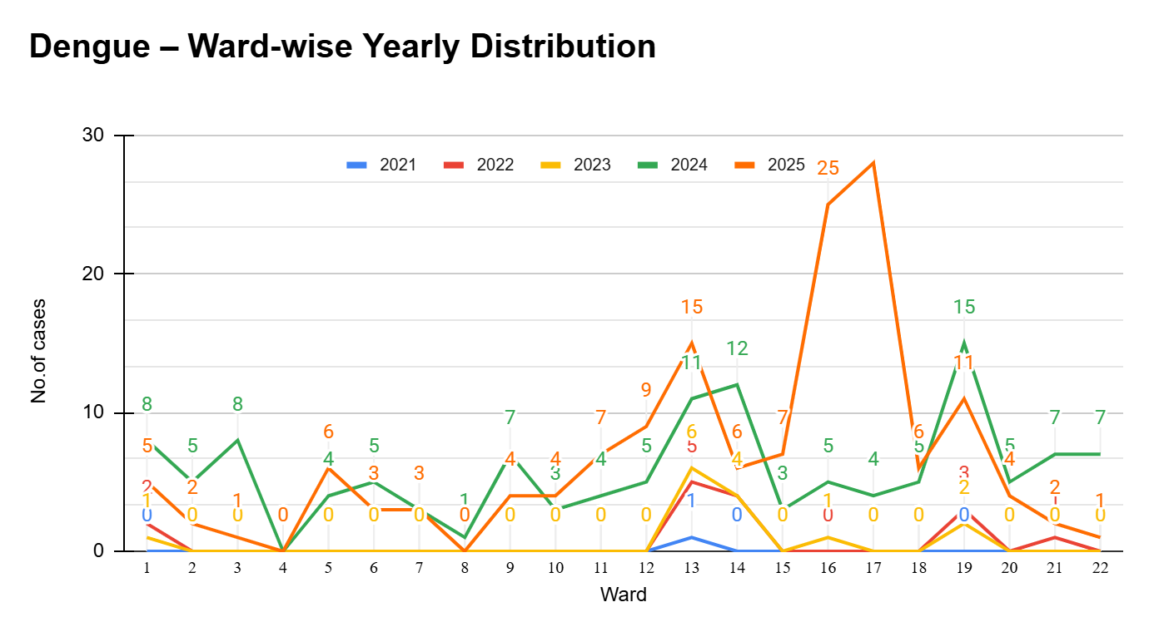

Ward | Dengue – Ward-wise Yearly Distribution
Ward | 2021 | 2022 | 2023 | 2024 | 2025 | Total
1 | 0 | 2 | 1 | 8 | 5 | 16
2 | 0 | 0 | 0 | 5 | 2 | 7
3 | 0 | 0 | 0 | 8 | 1 | 9
4 | 0 | 0 | 0 | 0 | 0 | 0
5 | 0 | 0 | 0 | 4 | 6 | 10
6 | 0 | 0 | 0 | 5 | 3 | 8
7 | 0 | 0 | 0 | 3 | 3 | 6
8 | 0 | 0 | 0 | 1 | 0 | 1
9 | 0 | 0 | 0 | 7 | 4 | 11
10 | 0 | 0 | 0 | 3 | 4 | 7
11 | 0 | 0 | 0 | 4 | 7 | 11
12 | 0 | 0 | 0 | 5 | 9 | 14
13 | 1 | 5 | 6 | 11 | 15 | 38
14 | 0 | 4 | 4 | 12 | 6 | 26
15 | 0 | 0 | 0 | 3 | 7 | 10
16 | 0 | 0 | 1 | 5 | 25 | 31
17 | 0 | 0 | 0 | 4 | 28 | 32
18 | 0 | 0 | 0 | 5 | 6 | 11
19 | 0 | 3 | 2 | 15 | 11 | 31
20 | 0 | 0 | 0 | 5 | 4 | 9
21 | 0 | 1 | 0 | 7 | 2 | 10
22 | 0 | 0 | 0 | 7 | 1 | 8

LEPTOSPIROSIS
Leptospirosis cases are closely linked to monsoon rains, flooding, and occupational exposure, particularly in low-lying and waterlogged areas.

Peak: June - August

Leptospirosis – Ward-wise Yearly Distribution (2021–2025)

Ward | Leptospirosis – Ward-wise Yearly Distribution
Ward | 2021 | 2022 | 2023 | 2024 | 2025 | Total
1 | 0 | 0 | 0 | 0 | 0 | 0
2 | 0 | 0 | 0 | 0 | 0 | 0
3 | 0 | 0 | 0 | 0 | 0 | 0
4 | 0 | 0 | 0 | 0 | 0 | 0
5 | 0 | 0 | 0 | 0 | 0 | 0
6 | 0 | 0 | 0 | 0 | 0 | 0
7 | 0 | 0 | 0 | 1 | 0 | 1
8 | 0 | 0 | 0 | 0 | 0 | 0
9 | 0 | 0 | 0 | 0 | 0 | 0
10 | 1 | 0 | 0 | 1 | 0 | 2
11 | 0 | 0 | 0 | 1 | 0 | 1
12 | 0 | 0 | 0 | 0 | 0 | 0
13 | 0 | 0 | 0 | 0 | 0 | 0
14 | 0 | 0 | 0 | 0 | 0 | 0
15 | 0 | 0 | 0 | 0 | 0 | 0
16 | 0 | 0 | 0 | 0 | 0 | 0
17 | 0 | 0 | 0 | 0 | 0 | 0
18 | 0 | 0 | 0 | 1 | 0 | 1
19 | 0 | 1 | 0 | 0 | 0 | 1
20 | 0 | 0 | 0 | 1 | 0 | 1
21 | 0 | 0 | 0 | 0 | 0 | 0
22 | 0 | 0 | 0 | 0 | 0 | 0
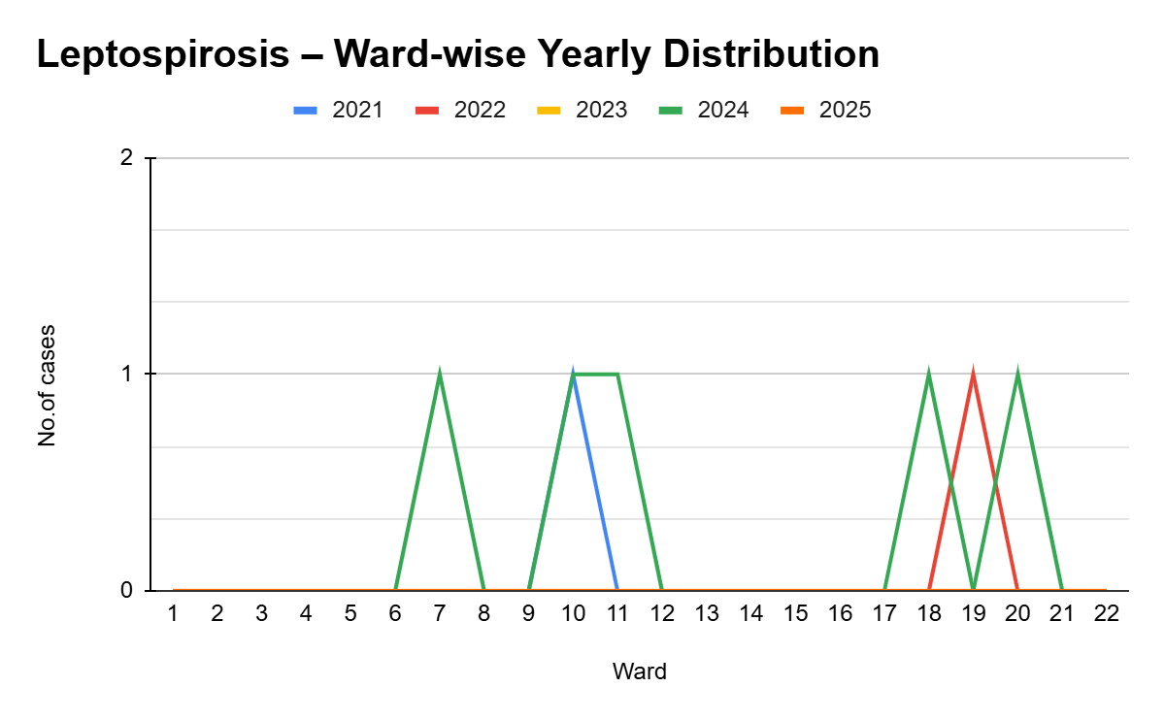

VIRAL HEPATITIS - A
Hepatitis A cases are commonly associated with unsafe drinking water, food contamination, and breakdowns in sanitation, often presenting as clusters or outbreaks.

Peak: October - December

Hepatitis A – Ward-wise Yearly Distribution (2021–2025)

Ward | Hep A – Ward-wise Yearly Distribution
Ward | 2021 | 2022 | 2023 | 2024 | 2025 | Total
1 | 1 | 0 | 0 | 1 | 3 | 5
2 | 0 | 0 | 0 | 0 | 0 | 0
3 | 0 | 0 | 0 | 0 | 0 | 0
4 | 0 | 0 | 0 | 0 | 0 | 0
5 | 0 | 0 | 1 | 0 | 1 | 2
6 | 0 | 0 | 0 | 0 | 0 | 0
7 | 0 | 0 | 0 | 0 | 0 | 0
8 | 0 | 0 | 0 | 1 | 0 | 1
9 | 0 | 0 | 0 | 0 | 0 | 0
10 | 0 | 0 | 0 | 0 | 1 | 1
11 | 0 | 1 | 0 | 1 | 1 | 3
12 | 0 | 2 | 0 | 2 | 1 | 5
13 | 1 | 1 | 0 | 0 | 42 | 44
14 | 0 | 0 | 0 | 1 | 1 | 2
15 | 0 | 0 | 0 | 0 | 0 | 0
16 | 0 | 0 | 0 | 0 | 1 | 1
17 | 0 | 0 | 0 | 1 | 0 | 1
18 | 0 | 0 | 0 | 1 | 1 | 2
19 | 0 | 0 | 1 | 0 | 3 | 4
20 | 0 | 0 | 0 | 0 | 1 | 1
21 | 0 | 0 | 0 | 1 | 2 | 3
22 | 0 | 0 | 0 | 0 | 1 | 1

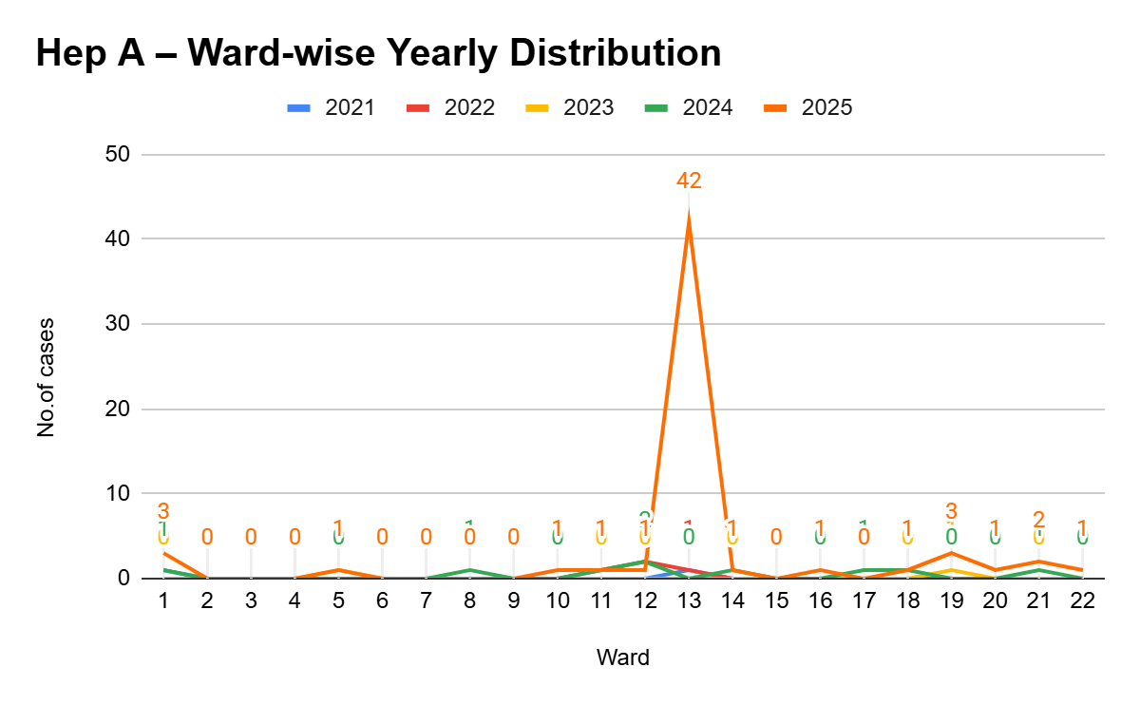

Outcome-Based Trend Analysis- 2025

Transmission Trend- 2025
For effective management of public health issues, it is important to track the trend of disease transmission mode. It helps identify the population or place at high risk that can be used to predict outbreaks and implement targeted interventions as quickly as possible. Understanding these kinds of trends enables authorities to allocate resources efficiently and change the strategies adequately based on the trend that follows.

Mode of Transmission | No. of cases | No. of Deaths
Vector Borne Diseases | 149 | 0
Water Borne Diseases | 60 | 0
Air Borne Diseases | 0 | 0
Blood Borne Diseases | 0 | 0
Food Borne Diseases | 0 | 0

Vector-Borne Disease

Disease | No. of Cases | No. of Deaths
Dengue | 149 | 0
Malaria | 0 | 0
Chikungunya | 0 | 0

Water Borne Disease

Disease | No. of Cases | No. of Deaths
Cholera | 0 | 0
Typhoid | 1 | 0
Hep- A | 59 | 0
Dysentery | 0 | 0
Amoebiasis | 0 | 0
E- Coli infections | 0 | 0
Air Borne Disease

Disease | No. of Cases | No. of Deaths
Influenza | 0 | 0
H1N1 | 0 | 0
TB | 9 | 0
Chickenpox | 18 | 0
Measles | 2 | 0
Covid-19 | 0 | 0
Pertussis | 0 | 0
Mumps | 9 | 0

Blood-Borne Disease

Disease | No. of Cases | No. of Deaths
AIDS | 0 | 0
Hep- B | 0 | 0
Hep- C | 0 | 0

Zoonotic Disease

Disease | No. of Cases | No. of Deaths
Rabies | 0 | 0
Leptospirosis | 0 | 0
Avian influenza | 0 | 0
West nile | 0 | 0
Anthrax | 0 | 0
Nipah | 0 | 0
Scrub Typhus | 0 | 0

Integrated Disease Hotspot Map (2021–2025)

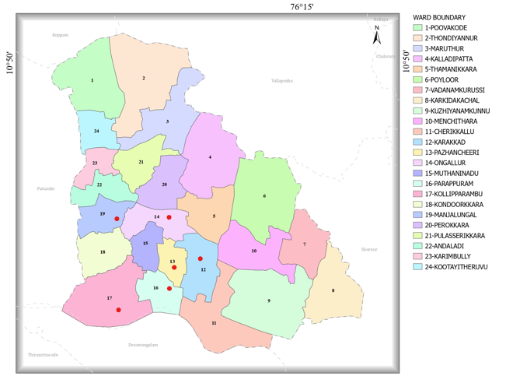

Ward No | Dengue Total (2021-25) | Leptospirosis Total (2021-25) | Hepatitis A Total (2021-25) | Mumps (2021-25) | ADD (2021-25) | Total Cases
1 | 16 | 0 | 5 | 0 | NA | 21
2 | 7 | 0 | 0 | 0 | NA | 7
3 | 9 | 0 | 0 | 0 | NA | 9
4 | 0 | 0 | 0 | 6 | NA | 6
5 | 10 | 0 | 2 | 6 | NA | 18
6 | 8 | 0 | 0 | 4 | NA | 12
7 | 6 | 1 | 0 | 2 | NA | 9
8 | 1 | 0 | 1 | 0 | NA | 2
9 | 11 | 0 | 0 | 0 | NA | 11
10 | 7 | 2 | 1 | 4 | NA | 14
11 | 11 | 1 | 3 | 3 | NA | 18
12 | 14 | 0 | 5 | 15 | NA | 34
13 | 38 | 0 | 44 | 6 | NA | 88
14 | 26 | 0 | 2 | 12 | NA | 40
15 | 10 | 0 | 0 | 3 | NA | 13
16 | 31 | 0 | 1 | 3 | NA | 35
17 | 32 | 0 | 1 | 2 | NA | 35
18 | 11 | 1 | 2 | 0 | NA | 14
19 | 31 | 1 | 4 | 0 | NA | 37
20 | 9 | 1 | 1 | 2 | NA | 13
21 | 10 | 0 | 3 | 1 | NA | 14
22 | 8 | 0 | 1 | 0 | NA | 9

By overlaying five years of data, we have identified 6 'Red Zone' Wards. These are wards where at least two different categories of diseases (e.g., Dengue and Lepto) recurred in consecutive years. Ward 13 is categorized as the Highest Priority Hotspot due to its high burden of communicable diseases.

Preparedness and Response Protocol at LSG Level
This section describes the operational framework for the LSGI once a pandemic is declared. It explains how the LSGI and health system will move from routine data collection to active response, using a One Health approach.

Constitution of One Health Committee
The LSGD shall constitute a One Health Committee comprising the LSGI President, Medical Officers (Modern Medicine, AYUSH, and Veterinary), the Health Inspector, and the Veterinary Surgeon.

Objective: The One Health Committee coordinates human, animal, and environmental health to prevent and control pandemics.

Sl No | Name | Designation | Department/Institution | Role in Committee | Contact Number
1 | Vijayan | Panchayat President | LSGD | Chairperson | 9946127244
2 | Dr. Rayees | Medical Officer (PHC/CHC) | Health Dept | Member Secretary | 9746769464
3 | Dr S Ponmurugan | Veterinary Officer | Animal Husbandry | Member | 9447945327
4 | Floriya | Epidemiologist | Health Dept | Member | 7994053272
5 | Nidheesh babu | Health Inspector | Health Dept | Surveillance | 9946559897
6 | Prabha | ASHA Supervisor | Health Dept | Community link | 8086683640
7 | Syamily | ICDS Supervisor | Social Welfare | Vulnerable groups | 9995468353
8 | Unnikrishnan | Police Station Officer | Police Dept | Law & order | 9947541082
9 | Vijayan | Ward Councillor Representative | LSGD | Community coordination | 9497124697
10 | Sandhya | Kudumbashree CDS | Kudumbashree | Community mobilisation | 8943577037
11 | Sathyanathan | NGO/Volunteer rep | Civil Society | Support services | 9847622291
12 |  | Line Department representations

Key Responsibilities:
- Review disease surveillance data (human + animal)
- Conduct ward-wise risk assessment and vulnerability mapping
- Approve quarantine/isolation centre locations
- Coordinate with district for resources (PPE, oxygen, ambulances)
- Periodically review health system surge capacity, including beds, oxygen, human resources, and ambulances.
- Approve and monitor risk communication and community engagement strategies, including rumour management.
- Ensure protection and service continuity for vulnerable groups (elderly, persons with disabilities, dialysis patients, coastal populations).
- Conduct quarterly mock drills
- Monitor equity measures for vulnerable groups

Meeting Schedule:
Quarterly (normal times) | Weekly (outbreak alert) | Daily (pandemic phase)

Pandemic Response Workforce
To ensure a coordinated and timely response during a pandemic, a dedicated Pandemic Response Workforce shall be constituted at the LSG level. The workforce will function under the overall supervision of the One Health Committee and in close coordination with the health authorities. Team-based deployment will enable efficient surveillance, case management, quarantine and isolation management, logistics support, and risk communication. Each team shall have a clearly designated team leader, defined roles, and an identified pool of personnel to allow rapid activation, rotation of duties, and continuity of services during prolonged emergencies.

Total Response Workforce Available: 300 persons

Team Name | Composition | Key Responsibilities | Team Leader
Surveillance and Contact Tracing Team | HI, JHI, JPHN, ASHAs and Volunteers | Case detection, contact listing, home visits, reporting | HI
Case Management Team | Doctors, Nurses, MLSP, Palliative Nurses | Patient care & referral | DOCTOR
Quarantine & Isolation Team | LSGD staff, Volunteers | Facility management | JHI
Psychosocial support | Community counselor | counselling service | Doctor
Logistics & supply chain Team | LSGD staff, Storekeepers, Drivers 3 | Supplies & transport [PPE, medicines, oxygen, transport, waste management] | Ward Member
Communication Team | Ward members, Kudumbashree, Youth clubs,  AWW workers and other self help groups | IEC, community meetings, countering misinformation | M.O in charge
Transportation | KSRTC, educational institutional buses | Transporting | Vise president
Media Surveillance | ACV | Communication | Health Standing committee
Intersectoral coordination and convergence
Collaborative surveillance

All teams shall be activated immediately upon outbreak alert or pandemic declaration and shall report daily to the LSG Incident Commander/Medical Officer, with consolidated reporting to the Block PHC. Duty rosters and alternate personnel shall be maintained to ensure uninterrupted services during staff shortages or prolonged response periods. Team composition and numbers may be revised based on the magnitude of the outbreak and availability of human resources.

Activities and Measures before and during Pandemic

PHASE 1 - Alert / Preparation
Surveillance and Reporting-Enhanced syndromic surveillance:
- Data sources for surveillance:
- Event-based triggers (to be monitored and reported):
- Zoonotic and animal health surveillance
- Logistics and Stock Preparedness
  - Identify and empanel local vendors and define emergency procurement mechanisms in accordance with existing LSGD and Health Department norms.
  - Prepare and maintain an essential logistics checklist covering medical supplies, consumables, and support equipment.
  - Pre-identify secure storage locations for emergency stocks and ensure maintenance of stock registers with regular updating.
  - Finalise emergency transport arrangements, including availability of vehicles and identified drivers for rapid deployment during alerts.
  - Designate a Nodal Officer for Logistics to enable prompt decision-making, coordination, and communication during emergencies.
  - Conduct rapid stock verification and ensure availability of minimum buffer stock, including:
- PPE kits – numbers
- Pulse oximeters – ___ numbers
- Hand sanitizers – ___ litres
- Masks, gloves, disinfectants – adequate quantity
Identify critical gaps in logistics and immediately communicate requirements to the Block and District authorities for timely replenishment and support. Monitor expiry dates and stock rotation.

Identification of Quarantine and Isolation Facilities
  - Identify and list suitable buildings for quarantine and isolation (schools, hostels, community halls, etc.).
  - Categorise cases as per the severity and allocate to appropriate facilities (for instance, severe cases to classrooms, mild cases to an assembly hall in case of a school).
  - Facility readiness checklist needed (beds, toilets, ventilation) etc.
  - Find an alternate site if the primary sites are not available or not in use.
  - Identify facility managers and support staff
  - Prepare basic SOPs for:
    - Admission and discharge
    - Food, water, sanitation
    - Infection prevention and waste disposal
  - Ensure availability of basic amenities: water, sanitation, electricity, ventilation, and waste disposal. Prepare a rapid activation plan for these facilities if case numbers increase.

Risk Communication and Community Preparedness
  - Disseminate early warning messages on symptoms, preventive measures, and reporting mechanisms. Display IEC materials both in English and the local language in public places and ensure ward-level awareness.
  - Sensitize elected representatives and community leaders on preparedness measures.
  - Establish a rumour tracking and misinformation response mechanism to identify, verify, and promptly counter false or misleading information.
  - Engage trusted local persons (ward members, ASHA workers, religious leaders, teachers, community volunteers) to communicate official public health messages and reinforce correct practices.
  - Develop and deploy targeted IEC materials for:
    - Schools and educational institutions
    - Markets and commercial areas
    - Work sites and labour settings
  - Conduct community sensitization meetings at the ward level to promote preventive behaviors, address concerns, and strengthen community participation in preparedness and response.

Protection of Vulnerable Groups
Vulnerable populations require priority protection through targeted line-listing, service continuity, and delivery mechanisms.
- Prepare and regularly update line-lists of vulnerable populations, including:
  - Elderly persons living alone
  - Persons with disabilities
  - Pregnant women
  - Migrant workers
  - Dialysis patients
The detailed line-lists shall be maintained as Annexure ___ and updated periodically.

Clinical Dependency Mapping
Develop ward-wise dependency and vulnerability maps to identify households requiring regular support during emergencies. Ensure continuity of essential health services for vulnerable groups, including
- Dialysis services (facility mapping, transport arrangements, and scheduling)
- Continuity of treatment for TB, HIV, and other chronic conditions requiring uninterrupted medication
- Mental health and psychosocial support services
Establish delivery mechanisms for food, essential commodities, and medicines to vulnerable households through coordinated action involving ASHAs, JPHNs, Kudumbashree, volunteers, and local administration.

PHASE 2 - Active Response

Case Identification and Contact Tracing
Case detection and contact tracing activities will be carried out in coordination with the Health authorities, following disease-specific SOPs and IDSP guidelines.
Field Staff Involved
- Health Inspector (HI)
- Junior Health Inspector (JHI)
- Junior Public Health Nurse (JPHN)
- ASHAs and ASHA Supervisors
- Ward-level volunteers and Kudumbashree members (as required)

Screening Checkpoints
Screening checkpoints at high-traffic locations (transport hubs, markets, religious gatherings) for early detection of symptomatic travellers and crowd screening during outbreaks. Potential locations include bus stands, market entry points, and boat jetties, based on local context and risk assessment.
Screening activities will be carried out by trained personnel such as ASHAs, ward members, and volunteers, with support from Health Department staff. Necessary equipment, including non-contact thermometers and appropriate PPE, shall be ensured prior to activation.
Location | Type (Bus stand/Jetty/Market/Railway) | Staff Deployed (ASHAs/Volunteers) | Screening Method | Reporting authority
Bus stand | Transport hub | One JHI  One ASHA  One health Mentors | 1.Swab Collection.  2. Blood smears collection (RDT)  3.Thermal Scanners | Surveillance Nodal Officer in control room
Market entry | Market | One JHI  One ASHA  Male health volunteers | 1.Swab Collection.  2. Blood smears collection (RDT)  3.Thermal Scanners | Surveillance Nodal Officer in control room
Boat jetty | Water transport | One JHI  One ASHA  Male health volunteers | 1.Swab Collection.  2. Blood smears collection (RDT)  3.Thermal Scanners | Surveillance Nodal Officer in control room

Standard Screening Protocol

The screening protocol shall include temperature screening, observation for visible symptoms, and inquiry regarding recent travel or exposure history. Individuals identified as suspects during screening shall be immediately referred to the nearest PHC/FHC for further evaluation, testing, and appropriate action as per prevailing guidelines.

Pandemic Control Room
The Pandemic Control Room (PCR) serves as the central nerve center for real-time coordination, data aggregation, decision support, and communication during outbreaks. It consolidates information from all LSGD teams, health facilities and community sources to enable rapid response decisions.

Control Room Infrastructure and Location
Primary Location: Ongallur Panchayath Office.
Backup Location: Community Hall in Ongallur G.P.

Health System Control Room Framework
The PCR is organized into seven functional pillars to ensure no aspect of the response is overlooked:

Rapid Response Team (RRT)
  - Provides immediate intervention during emergencies, clusters, and field alerts.​
  - Coordinates urgent actions such as case investigation, contact tracing, isolation, and inter‑facility referrals.

Data Management & Analytics Team
  - Collects, validates, and manages key health system indicators (cases, tests, beds, HR, supplies).​
  - Analyzes data trends, generates projections, and supports evidence‑based decision‑making for local authorities.

Human Resource Deployment Team
  - Allocates healthcare staff efficiently based on workload and need
  - Ensures adequate and equitable workforce distribution across facilities

Laboratory Surveillance Team
  - Oversees diagnostic testing coordination, sample transport, and timely reporting of results.​
  - Monitors lab indicators (testing volume, positivity rate, turnaround time) for early detection of outbreaks

Vaccination Cell (If Required)
  - Plans and executes vaccination campaigns, including micro‑planning and session scheduling.​
  - Tracks coverage, identifies gaps, and coordinates corrective actions with field teams and outreach services.

Infrastructure & Patient Occupancy Team
  - Monitors facility capacity, earmarked beds, oxygen and critical care resources across all linked facilities.​
  - Ensures optimal patient distribution and referral management using updated bed‑status and resource data.
  - BMWM

Communication team
- Logistics and supply chain
- Transportation (interfacility & emergency transport)
- Media surveillance Call centre
- Management of the deceased
- Intersectoral coordination and convergence

Key Control Room Team
The Control Room Team coordinates all pandemic response activities within the LSGD and serves as the single command and communication hub during activation. It integrates information, field actions, logistics, and policy execution across all participating departments and health facilities.

Role | Name | Designation | Contact Number | Responsibility
In-charge/Nodal Officer | Dr Rayees | Medical Officer | 9746769464 | Overall coordination, decision-making, and reporting to the District level.
Data Entry Operator | Suprabha | Data entry operator | 9074428540 | Managing the line list, updating dashboards, and tracking testing results.
Communication Officer | Nidheesh babu | Health Inspector | 9946559897 | Handling the public helpline, coordinating ambulance dispatch, and contact tracing calls.
Logistics Coordinator | Narayana Moorthi | JHI | 8113011159 | Transportation of medicine and equipments
Technical Support (IT/Data) | Sreejith | TA Panchayath | 9496562167 | Data management

SOP for alert escalation/trigger point with mapping of responsibilities.
Key Points:
- The Control Room shall be staffed with a designated In-charge, data entry personnel, and communication staff with clearly defined roles and shift arrangements.
- It shall maintain updated records on daily monitoring indicators including new cases, persons under active quarantine, and hospital bed occupancy.
- All reports and situation updates shall be shared daily with the Block and District Surveillance Unit.
- The Control Room shall act as a single point of contact for coordination with response teams, health institutions, and other departments.
- Contact details of the Control Room shall be widely communicated to field staff and stakeholders during activation.

Daily Monitoring Indicators
To ensure timely decision-making and effective response, the following key indicators shall be monitored and updated on a daily basis by the Pandemic Control Room:

Epidemiological Indicators:
New cases reported today, Total active cases, Test Positivity Rate (TPR), Case Fatality Rate (CFR)
- Surveillance Indicators:
Persons under home quarantine, High-risk contacts identified, Fever, ILI, SARI or other symptoms (syndromic surges), Travellers (symptomatic or high-risk arrivals),Animal husbandry surveillance (zoonotic alerts, unusual animal deaths, poultry/bird flu signals), Mortality surveillance (excess deaths, unexplained fatalities, verbal autopsy reports)
- Logistics and Infrastructure Indicators:
Hospital / CFLTC beds occupied, Oxygen cylinders/concentrators available, Ambulances on standby
- Alert Findings
The following table outlines category-specific trigger points (red flags) from surveillance indicators and corresponding immediate actions for the Pandemic Control Room. These enable rapid response to alert findings like testing anomalies, positive cases exceeding thresholds, clusters, and WGS reports.

Category | Trigger Pophint (Red Flag) | Immediate Action
Clusters | Geographical or facility-based: 5+ cases linked to one location (office, school, street). | Declare a micro-containment zone; perimeter control and active case finding.
Testing | Sudden drop in testing volume / delay in reporting / unusual testing trends | Review the sample collection process, address lab bottlenecks, deploy additional testing teams, and notify the District Lab.
Lab | Test Positivity rate increases | Increase testing sites in that ward.
Hospital | >80% Oxygen bed occupancy | Activate backup/CFLTC beds.
Travel | Cluster of cases from a single flight/train or high-risk arrival group. | Trace all passengers in adjacent seats; implement mandatory institutional quarantine.
Animal | Mass poultry/wildlife death or unusual sickness | Notify Animal Husbandry, sample the area, and dispatch RRT for environmental sampling and zoonotic check.
Mortality | Sudden spike in home deaths or brought-in-dead (BID) cases | Audit the deaths and Active Case Search drive
Additional investigations like Whole Genome Sequencing (WGS) | Detection of a Variant of Concern (VOC) or Variant of Interest (VOI) | Implement strict micro-containment; update clinical protocols to match variant severity.

Communication of Public Health Information
A Community Communication Hub shall be established to ensure timely, accurate, and consistent dissemination of information during a pandemic. The Hub will function under the coordination of Nodal officers of the control room and act as the nodal point for public communication, risk messaging, and community engagement. It will support dissemination of official advisories, promote preventive behaviors, address rumors and misinformation, and ensure that messages reach all sections of the population through trusted local channels and leaders.

Key communicators
Channel | Responsible Person | Contact
Ward-level announcements | SATHYAJITH P V | 9633357573
Social media | SUDHEESH N P | 9847975744
Local Cable TV/Radio | RAFI

- All messages disseminated through the Hub shall align with advisories issued by the Health Department and District authorities.
- Community leaders shall be sensitized to support behavior change, reduce stigma, and counter misinformation.
- Special efforts shall be made to reach vulnerable and hard-to-reach populations using locally appropriate communication methods.

Rumor Tracking: A designated volunteer will monitor local social media/WhatsApp groups daily to identify misinformation and issue official clarifications via the Communication Hub.

Coordination with District/State Authorities & Other Organisations
Effective coordination with Block, District, and State authorities is essential to ensure timely reporting, technical guidance, and uninterrupted supply of essential resources during a pandemic. The LSG shall establish clear communication channels, designate responsible officers, and adhere to prescribed reporting timelines to support coordinated public health action and efficient resource mobilisation.

Key Details:
- Nodal Officer for Reporting:
- Contact Number:
Reporting Schedule and Protocols:

To Whom | What to Report | Frequency | Nodal Person
Block PHC | Complete Situation Report (Cases, Quarantine, Beds, Screening, Deaths) | Daily | Block Medical Officer
District IDSP Unit | Outbreaks/Clusters/Unusual Events (>5 cases same ward) | Daily | District Surveillance Officer
Veterinary Officer | Animal health events/Zoonotic alerts | Daily | Veterinary Surgeon
State Cell | Zoonotic cross-sector events

Supply Chain Coordination
The LSG shall coordinate closely with Block, District, and State authorities (KMSCL) to ensure uninterrupted availability of essential goods, medical supplies, and logistics during a pandemic. Supply requirements shall be assessed regularly based on case load and communicated promptly to the appropriate authorities for timely replenishment.
Key Points:
- Maintain updated contact details of District and Block nodal officers for health logistics, oxygen supply, ambulances, and essential medicines.
- Submit timely indent requests for PPE, testing kits, medicines, oxygen, and other critical supplies through prescribed channels.
- Monitor stock levels at LSGD facilities, quarantine/isolation centres, and field teams through daily stock registers and dispensing logs to prevent shortages.
- Coordinate with District authorities, Karunya/Neethi medical shops, and local purchase committees for funds allocation and emergency procurement.

- Ensure regular monitoring of dispensing registers at all facilities to track usage, expiry, and pilferage—shortages being a perennial issue requiring proactive weekly audits.

- Activate surge procurement protocols during high caseloads, leveraging local purchase powers under LSGD funds alongside state supplies.

Resource Inventory and Contacts
Resource Category | Source  (District/State/Private) | Contact
PPE Kits/Masks/Gloves | KMSCL | 4912533336
PPE Kits/Masks/Gloves | Local Vendors | 9871244044
Oxygen  Cylinders/Concentrators | KMSCL | 4912533336
Medicines/Antivirals | KMSCL | 4912533336
Medicines/Antivirals | Neethi Shops | 9747494005
Test Kits (RTPCR/Rapid) | KMSCL | 4912533336

Collaboration with NGOs, PPP, and CSR
To augment government efforts during a pandemic, the LSG shall collaborate with NGOs, voluntary organisations, and private sector partners through public–private partnerships and Corporate Social Responsibility (CSR) initiatives, in coordination with District authorities.

Key Points:
- Engage NGOs and community-based organisations for community outreach, awareness, and support to vulnerable populations.
- Leverage CSR support for procurement of medical equipment, PPE, oxygen concentrators, food kits, and sanitation materials, as permitted.
- Ensure all collaborations align with government guidelines and are routed through approved administrative and financial procedures.
- Maintain transparency and documentation for all external support received and utilised.
Organization | Type | Support Offered | Contact Person
Youth Clubs/Student Unions | CBO | Svana hospital Nursing students- Medical support | 9745726225

Interdepartmental Coordination
Coordination among departments during a pandemic shall be ensured through regular review meetings convened by the LSGD President. These meetings will provide a structured platform for sharing situational updates, assessing resource availability, resolving operational gaps, and taking joint decisions to ensure a coordinated and timely response.

Department | Representative | Key Role | Contact
Health (PHC) | Staff Nurse : ambily | Case management | 9633898860
Veterinary | Veterinary Surgeon: Dr S Ponmurugan | Animal surveillance | 9447945327
ICDS | Supervisor: Syamli | Nutrition support | 9995468353
Education | Teacher  Narayanan Master | School coordination | 9447571346
Police | SI Unnikrishnan | Containment enforcement | 9947541082
Water Authority | Office no. | Water supply | 9495998258
LSGD Engineering | Jayasree | Quarantine infrastructure | 9447086855

PHASE 3 - Surge Capacity
Phase 3 is activated when there is a rapid increase in cases, high test positivity rates, or when existing health facilities and quarantine arrangements approach saturation. The focus of this phase is to expand isolation capacity, augment clinical care services, and mobilise additional resources through district and state support mechanisms.

Conversion of Community Facilities
To manage increased case load, the LSGD shall activate additional isolation facilities by repurposing identified community infrastructure such as community halls, auditoriums, schools, hostels, or other suitable buildings.

Name of facility | Facility Type | No. of Buildings | Ward | Surge Capacity (Beds) | Nodal Person
Blue Diamond Sreenarayana stop | Convention centre | 1 | 8 | 100 | 097470 18221
BLUE DIAMOND , ONGALLUR | Auditorium |  | 8 | 50 | Moideenkutty 9747018221
MISK AUDITORIUM ONGALLUR | Auditorium | 1 | 20 | 75 | Ibrahim 8086288668
ANUGRAHA MARUTHUR | Auditorium | 1 | 21 | 50 | Sreejith N P 9946660044
PANCHAYATH AUDITORIUM | Auditorium | 1 | 10 | 75 | Secratary 9947630443
PAM KARAKKAD | Auditorium |  | 15 | 75 | muhammed 9400910926
YEM TEES  VADANAMKURUSSI | Auditorium |  | 8 | 50
AMC ANDALADI | Auditorium |  | 22 | 50 | Narayanan namboodiri 9447476980
PISHARODY MANJALUNGAL | Auditorium |  | 19 | 50
PLAZA ONGALLUR | Auditorium |  | 5 | 75 | Muhamed kutti 8593960433
GRAND ONGALLUR Nr Famous | Auditorium |  | 13 | 75 | Moideenkutty  9746080401

- Recovery and rehabilitation phase
- Recovery
  - Damage & impact assessment
  - Restoration of health services
  - Rehabilitation of affected population
  - Psychosocial & mental health support
  - Disease surveillance during recovery phase
  - Environmental cleanup & sanitation
  - Livelihood restoration
  - Community engagement & confidence building
  - Documentation & after-action review
  - Lessons learned & best practices
  - Health system strengthening
  - Policy revision & preparedness enhancement
  - Research

CONCLUSION

Additional points
- tech support
- relief based commodities
- ham reading operators
- hazard vulnerability mapping
- Kseb & other power source
- HR specific responsibility

RECOMMENDATIONS

Strengthening Healthcare Infrastructure
- Establish a primary health response unit within the Panchayat with trained staff.
- Ensure availability of basic medical supplies (masks, sanitizers, PPE kits, oxygen cylinders).
- Create tie-ups with nearby hospitals in Pattambi for emergency referral and transport.

2. Community Awareness & Education
- Conduct regular awareness campaigns on hygiene, vaccination, and preventive measures.
- Use local communication channels (community radio, WhatsApp groups, notice boards) to spread verified information.
- Train volunteers to act as health ambassadors in each ward.

3. Emergency Response & Coordination
- Form a Pandemic Preparedness Committee at Panchayat level including health workers, ward members, and NGOs.
- Develop a clear action plan for lockdowns, quarantine, and distribution of essentials.
- Maintain a database of vulnerable groups (elderly, differently-abled, chronically ill) for targeted support.

4. Supply Chain & Food Security
- Identify and support local suppliers and farmers to ensure uninterrupted food supply.
- Create community kitchens during emergencies to serve vulnerable populations.
- Stockpile essential commodities in Panchayat-run outlets for crisis periods.

5. Digital Preparedness
- Promote digital platforms for telemedicine consultations.
- Use Panchayat’s website/social media for real-time updates on health advisories.
- Encourage online grievance redressal to reduce crowding in offices.

6. Training & Capacity Building
- Organize mock drills for pandemic response in schools, offices, and public spaces.
- Train Panchayat staff and volunteers in first aid, infection control, and crowd management.
- Collaborate with NGOs and health departments for capacity-building workshops.

7. Long-Term Resilience
- Integrate pandemic preparedness into the Panchayat Development Plan.
- Allocate a dedicated budget for health emergencies.
- Encourage community participation in planning and monitoring preparedness measures.

MOCKDRILL SCENARIOS

ANNEXURE

IMPORTANT PHONE NUMBERS

Phone numbers and particulars of persons responsible for providing guidance, assistance, and support for pandemic preparedness operations may be provided here in a manner that allows easy reference at a glance. The information recorded here could be exhibited elsewhere at the time of emergencies. LSG institutions shall give special attention to collect and record the above data of persons and institutions who/which are supposed to give technical and co-ordination support to reduce the impact of pandemic.

1.1. Details of grama panchayat/municipality/corporation wards
Sl.No | Name of the ward | Ward number | Name of the ward  member | Contact number
1 | POOVAKODE | 1 | SAJITHA P | 9745802396
2 | THONDIYANNUR | 2 | SREEKUTTAN K | 9539207842
3 | MARUTHUR | 3 | SHEKKEELA | 9946792915
4 | KALLADIPATTA | 4 | GEETHA E | 9995146057
5 | THAMANIKKARA | 5 | RAJILA | 8589906596
6 | POYLOOR | 6 | P P VIJAYAN | 9946127244
7 | VADANAMKURUSSI | 7 | PRIYA PRASANTH | 9562077422
8 | KARKIDAKACHAL | 8 | VINITHA V R | 9074355877
9 | KUZHIYANAMKUNNU | 9 | ASOKAN K | 9447531037
10 | MENCHITHARA | 10 | JUNAID C K | 8921070688
11 | CHERIKKALLU | 11 | FASALUL ABID | 9846156989
12 | KARAKKAD | 12 | SUDHEESH N P | 9847975744
13 | PAZHANCHEERI | 13 | ANILA ASHOKAN V K | 8089706267
14 | ONGALLUR | 14 | SATHYAJITH P V | 9633357573
15 | MUTHANINADU | 15 | PARAMBIL SALMATH | 9946184251
16 | PARAPPURAM | 16 | MUHAMMED SHAFEEK | 9846824228
17 | KOLLIPARAMBU | 17 | MUHAMMAD SUBAIR K | 7012564612
18 | KONDOORKKARA | 18 | AHAMMED KABEER | 8113937372
19 | MANJALUNGAL | 19 | GIRIJA V K | 9539773200
20 | PEROKKARA | 20 | UNNIKRISHNAN P K | 9846822511
21 | PULASSERIKKARA | 21 | VIJAYAKUMAR M P | 9497124697
22 | ANDALADI | 22 | SHAHINA HABEEB | 9846116223
23 | KARIMBULLY | 23 | YAMUNA DEVI K | 9747610188
24 | KOOTAYITHERUVU | 24 | SAHEENA | 9207877912

1.2. Other important phone numbers of grama panchayat/municipality/corporation area
Sl. No. | Name | Contact number
1. | Hakeem - Secretary LSGD | 9447658229
2. | P P VIJAYAN President LSGD | 9946127244
3. | Dr. RAYEES Medical Officer | 9746769464
4. | PRIYA PRASANTH - Vise president | 9562077422
5. | SATHYA JITH P V | 9633357573
6. | NIDHEESH BABU Health inspector | 9946559897
7. | Excise department
8. | Forest department -Sajayan Pattambi SFO | 8075853958

1.3. Important offices of grama panchayat/municipality/ corporation
Sl.No | Name of the office | Contact person | Contact number
1. | Village Office | Village Officer | I-8547615125  II-8547615126
2. | Agriculture Office | Agriculture Officer | 8943241923
3. | Animal Husbandry Office | Animal Husbandry Doctor | 9447945327
4. | Police Station | Police Officer | 9947541082
5. | BSNL Office | Officer | Nil
6. | Block Office | Officer | 0466 2212254
7. | KSEB Office | Officer | 9496001912
8. | Fisheries Office | Officer | Nil
9. | Fire and Rescue | Officer | Nil

1.4. Health Services

Sl. No | Name of the hospital/institution | Location | Phone number
1. | Government hospitals/PHC | Pokupadi | 9746769464
2. | Private hospitals | Pattambi | 04662345000
3. | Clinical laboratories | Nil
4. | Chemist/pharmacy | Nil
5. | Blood donors | Blood bank | 9895357958
6. | Other language experts (Bihari, Hindi, Bengali,  Asamees ………) | Nil

1.5. Veterinary Services
Sl.No | Name of the Clinic | Name of the  Surgeon/Doctor | Place/location | Phone  number
1 | Govt.Veterinary Hospital | Dr. S Ponmurugan | Pattambi | 9447945327

1.6. Helpline numbers
Helpline | Phone number
Police | 0466 2212224
Fire and Rescue | 0466 2955101
KSEB | 0466 2233190

1.7. Public and Private Schools Contact details

S.No | Name of School | Institution type | Phone number
1 | CGM ENGLISH MEDIUM SCHOOL PATTAMBI | Private | 9388369404
2 | AI HUDA ENGLISH MEDIUM SCHOOL | Private | 9847987549
3 | AL HIDAYA KONDURKKARA | Private | 9495734473
4 | GHSS VADANAMKURUSSI | Govt. | 7306756683
5 | GHS VADANAMKURUSSI | Govt. | 8281826558
6 | AMLPS KONDOORKKARA | Aided | 8086369594
7 | AUPS PULASSERIKKARA | Aided | 9961491064
8 | ALPS MARUTHUR | Aided | 9605355567
9 | GLPS VADANAMKURUSSI | Govt | 7025890741
10 | ALPS MOOLURKKARA | Aided | 9446902342
11 | AMUPS KARAKKAD | Aided | 9947410135
12 | AMLPS PALLIPPURAM | Aided | 9447547500
13 | AMLPS KALLADIPPATTA | Aided | 9544908528
14 | GLPS KALLADIPATTA | Govt. | 8547427933
15 | ALPS VADANAMKURUSSI | Aided | 8848536710
16 | MORNING STAR SCHOOL KARAKKAD | Privet | 8590698445
17 | NOORUL HIDAYA ARABIC | Privet | 9447973393
18 | BUDS SCHOOL MARUTHUR | Govt. | 9562163274
19 | MOUNT HIRA ENGLISH SCHOOL KONDOORKKARA | Privet | 8848454180

1.9. Anganwadi Contact Details

Ward No | Name of Anganwadi Teachers | Phone number
6 | GEETHA | 9656745169
6 | LEELA | 9747472165
6 | RAMADEVI | 9048487570
7 | SATHYABHAMA | 9846254492
8 | JYOTHILAKSHMI | 9747953932
4 | GEETHA | 9995146057
4 | JAYALAKSHMI | 9946606370
5 | SAVITHRI | 9400729011
9 | AHOBHANA | 9846067055
9 | VIJAYALAKSHMI | 9846465996
10 | RAMADEVI | 9497597270
10 | THANKAMMA | 9048572522
13 | RAMADEVI | 9656748459
13 | RATHIDEVI | 9747042920
14 | RAJESWARI | 8089470675
20 | BEENA | 9567747279
11 | USHA | 9048150709
11 | SOBHANA | 9747732398
11 | SARADHA | 9744629038
12 | THANKAMANI | 9447623102
12 | RADAHA | 7593048708
15 | MINI | 9447443340
16 | ANJANA | 9495186876
17 | SUMAJA | 9947724412
17 | SUNITHA | 9961656925
17 | USHA BABU | 9656871540
18 | GIRIJA | 9539773200
18 | SULAIKHA | 9846863544
18 | KAVYA | 6235830831
19 | RAMANI | 9656744784
21 | JAYALAKSHMI | 9744907185
21 | SUSEELA | 9605608143
1 | PADMINI | 9961901292
1 | SARALADEVI | 8086614460
1 | NALINI | 9846754923
2 | SAROJINI | 9539801159
2 | SREELATHA | 8075971659
2 | GEETHA | 7594859130
22 | SYAMALA | 7510566672
22 | KUNJUKUTTY | 9946050983

1.12. Information regarding resources

Means of transportation | Name of Owner | Phone Number
Heavy Trucks | 0 | —---
Tractor | 2
Ambulances | 1
Boats | 0 | —
Taxi service | 12 | 9539939262

Annexure 1: LSG Baseline Data Collection Format
A. Baseline data
Sl. No. | Indicator / Field | Baseline Data | Source / Remarks
1 | Name of LSG | Ongallur
2 | District | Palakkad
3 | Block / Taluk | Koppam
4 | Type of LSG (Gram Panchayat / Municipality / Corporation) | Gramapanchayath
5 | Area (sq. km) | 32.14 sq. km.
6 | No. of wards | 24
7 | GIS boundary file available | (Yes/No)
8 | Key contact person & phone | 9946127244,president

B. Demography
Indicator / Field | Baseline Data | Source / Remarks
Total population | 52079
Males | 25151
Females | 26928
Transgender population | 0
Age distribution
(<5, 5–14, 15–59, ≥60)
No. of households | 11105
Population density (persons/sq.km) | 1365.88
No. of migrant workers | 798
Major occupational groups | Agriculture,Scrap

C. Vulnerable Populations & Social Risks
Sl. No. | Indicator / Field | Baseline Data (Value / Description) | Source / Remarks
1 | No. of elderly (≥60)
2 | No. of persons with disability | 576
3 | No. of bedridden persons | 257
4 | No. of chronic disease cases (DM/HTN/COPD/CKD etc.) | 1165
5 | Pregnant women (current estimate)
6 | Children <5 years
7 | Tribal population (if any) | Nil
8 | Fisherfolk / coastal vulnerable groups (if any) | Nil
9 | Urban slums / unnotified settlements (if any) | Nil
10 | Homeless population | Nil
11 | Orphanages / old age homes (number & capacity) | Nil
12 | Hostels / prisons / shelters (number & capacity) | Nil
13 | Poverty / BPL estimate | 5543
14 | Food insecurity hotspots | Nil
15 | Any history of stigma/discrimination issues (Yes/No) | No

D. Health System & Service Readiness
Sl. No. | Indicator / Field | Baseline Data (Value / Description) | Source / Remarks
1 | No. of health facilities in LSG (PHC/CHC/TH/DH/Private) | 2
2 | PHC/Family Health Centre details (name, location) | FHC Ongallur
3 | Subcentres / Health & Wellness Centres (number) | 6
4 | Private clinics / hospitals (number) | 8
5 | Labs available (public/private)
6 | Availability of ambulance services (Yes/No, number) | Yes
7 | Availability of isolation/quarantine facilities (Yes/No, details) | No
8 | Cold chain facilities (Yes/No, details) | Yes
9 | Stockpile space available (Yes/No) | No
10 | PPE / mask / sanitizer availability plan (Yes/No) | Yes
11 | Surveillance staff available (JHI/JPHN/ASHA count) | 37
12 | Existing emergency referral pathways (Yes/No) | Yes

E. Points of Entry & Mobility
Sl. No. | Indicator / Field | Baseline Data (Value / Description) | Source / Remarks
1 | Bus stands / depots (number) | Nil
2 | Railway stations (number) | 2
3 | Boat jetties / fishing harbours (number) | Nil
4 | Ports / airports nearby (specify distance) | Nil
5 | Major highways/roads passing through | Ponnani - Palakkad Highway
6 | Border crossings (state/district) | Nil
7 | Major markets / weekly markets | Ongallur market
8 | Tourism hubs / major event venues | Nil
9 | Schools/colleges with hostels (number) | 19
10 | Factories / large workplaces (number) | 1
F. Water, Sanitation & Hygiene (WASH)
Sl. No. | Indicator / Field | Baseline Data (Value / Description) | Source / Remarks
1 | Major drinking water sources (piped / wells / borewells / springs) | Piped,Wells,Borewells
2 | No. of public wells
3 | No. of households with piped water connection
4 | Water quality testing routine (Yes/No) | No
5 | Common contamination risks (flooding, salinity, industrial waste) | NIl
6 | Open defecation free status (Yes/No) | No
7 | Solid waste management system (Yes/No) | Yes
8 | Bio-medical waste disposal mechanism (Yes/No) | Yes
9 | No. of public toilets | Nil
10 | Handwashing stations in public places (Yes/No) | Nil
G. Zoonotic Risks & One Health
Sl. No. | Indicator / Field | Baseline Data (Value / Description) | Source / Remarks
1 | Livestock population (cattle/goats/pigs/poultry) – estimates | 1728
2 | No. of dairy farms / poultry farms / pig farms | 70
3 | Slaughterhouses / meat shops (number) | 0
4 | Animal markets (Yes/No, details) | No
5 | Veterinary dispensaries (number) | 1
6 | History of zoonotic outbreaks (rabies, leptospirosis, avian flu etc.) | No
7 | Stray dog population management measures (Yes/No) | Yes
8 | Rodent infestation hotspots (Yes/No) | No
9 | Wetlands / waterlogged areas prone to leptospirosis | No
10 | Bat roosting areas / caves / fruit orchards (if any) | No
11 | Human-animal interface hotspots (farms near residences) | No
H. Climate & Disaster Risks (Pandemic Amplifiers)
Sl. No. | Indicator / Field | Baseline Data (Value / Description) | Source / Remarks
1 | Flood-prone wards (list)
2 | Landslide-prone wards (list) | Nil
3 | Cyclone/sea surge risk (Yes/No) | No
4 | Heatwave risk zones (Yes/No) | Yes
5 | Waterlogging areas (list) | Nil
6 | Shelter homes / relief camps (number, capacity) | Nil
7 | Past disaster displacement history | Nil
8 | Disruption to water supply/transport common (Yes/No) | Yes
I. Critical Infrastructure & Logistics
Sl. No. | Indicator / Field | Baseline Data (Value / Description) | Source / Remarks
1 | Schools (number) | 19
2 | Anganwadis (number) | 40
3 | Colleges (number) | 0
4 | Community halls (number)
5 | Places of worship with large gatherings (number) | 0
6 | Large markets / shopping areas (number) | 0
7 | Warehouses / cold storages (number) | 0
8 | Telecom/mobile network coverage gaps (Yes/No) | N
9 | Power outage frequency (high/medium/low) | M
10 | Availability of generators in key facilities | Y

J. Risk Communication & Community Networks
Sl. No. | Indicator / Field | Baseline Data (Value / Description) | Source / Remarks
1 | Ward-level rapid response teams (Yes/No) | Y
2 | Jagratha samithis / committees active (Yes/No) | Y
3 | Kudumbashree presence and strength (number of units) | Y
4 | Volunteer network (number, coverage) | Y
5 | Community-based surveillance mechanisms (Yes/No) | N
6 | IEC dissemination channels (WhatsApp groups, community radio, PA systems) | Y
7 | Rumour tracking mechanisms (Yes/No) | Y
8 | Languages spoken / literacy considerations | Y
9 | Vulnerable groups communication strategy available (Yes/No) | Y

K. Preparedness Planning & Governance
Sl. No. | Indicator / Field | Baseline Data (Value / Description) | Source / Remarks
1 | LSG emergency plan available (Yes/No) | N
2 | Pandemic preparedness plan available (Yes/No) | Y
3 | Incident Command System identified (Yes/No) | N
4 | Rapid procurement mechanism available (Yes/No) | Y
5 | Emergency fund available (Yes/No, amount) | N
6 | Past outbreak response experience (Yes/No, details) | N
7 | Intersectoral coordination mechanism (Health, Police, LSG, Veterinary, Education) | Y
8 | Mock drills conducted in last 12 months (Yes/No) | N
9 | Training coverage for staff/volunteers (Yes/No) | N

L. Surveillance & Data Systems
Sl. No. | Indicator / Field | Baseline Data (Value / Description) | Source / Remarks
1 | Digital reporting tools used (e.g., DHIS2, portals) | Y
2 | Availability of line-listing format (Yes/No) | Y
3 | Contact tracing team identified (Yes/No) | Y
4 | Mapping of high-risk households available (Yes/No) | Y
5 | Testing sample transport mechanism (Yes/No) | N
6 | Reporting timeline adherence (good/average/poor) | Average
7 | Data sharing between departments (Yes/No) | Y
8 | Availability of dashboard for monitoring (Yes/No) | N

M. Additional Notes & Observations
Sl. No. | Indicator / Field | Baseline Data (Value / Description) | Source / Remarks
1 | Key challenges perceived by LSG | Nil
2 | Top 5 high-risk wards (reason) | 16,17,19 | Dengue prone area  Scrap shops
3 | Any unique local risks (industrial pollution, refugee camps, etc.) | Nil
4 | Recommendations for preparedness strengthening | Nil

